Registered at the dfeneral Post Office, Sydney, for transmission by post as a periodical.
"AUSTRALIA FOR CHRIST."
The Real Australian
Organ of the Bush Church Aid Society for Australia and Tasmania.

No. 48.
APRIL 5, 1933.
1/6 per annum (post free).

THE BUSH CHURCH AID SOCIETY OF AUSTRALIA AND TASMANIA.
Headquarters Office:
Diocesan Church House, St. Andrew's Cath' edral, George Street, Sydney.
Telephone : M'3164.
Cable Address: "Chaplaincy, Sydney.¹*
Victorian Office:
St. Paul's Cathedral Buildings, Flinders Lane, Melbourne.
President : The Eight Reverend Bishop KIRKBY.
Hon. Clerical Secretary : Rev. Canon W. L. LANGLEY.
Hon. Treasurer: T. S. HOLT, Esq.
Victorian Hon. Treasurer : G. H. DOWNER, Esq., Carmyle Road, Toorak.
South Australian Hon. Secretary: Rev. R. H. FULFORD, Holy Trinity Rectory, Adelaide.
Organising Missioned of B.C.A. : Rev. T. Terry.
Victorian Deputation Secretary : Rev. T. Jones, Th.L., St. Paul's Cathedral, Melbourne.
The Victorian Rally
OF THE BUSH CHURCH AID SOCIETY IS TO BE HELD I3ST THE
Chapter House,
ON
Wednesday, May 10th
at 7.45 p.m.
B.C.A. Rallies have always been something to look forward to—and remember this year we are looking forward to the greatest gathering of B.C.A. friends ever held in Victoria. The Bishop of St. Arnaud is to be the Chairman. He is a real out-back Bishop, and a good friend of B.C.A.. The Rev. T. Terry will also be meeting the B.C.A. friends of Victoria for the first time. Come and give him a great welcome!
REMEMBER, YOU MUST BE EARLY IF YOU WANT A SEAT !

'THE REAL AUSTRALIAN.'
WE ASK FOR £100 THANK OFFERING.

PRAY FOR THE RALLY ! - TELL YOUR FRIENDS OF THE RALLY. COME TO THE RALLY !
Dear Friends of the B.C.A.,
I might almost feel afraid to send my first issue of "The Real Asutralian" to the printer, if I did not feel behind me such a wealth of interest and of prayer. So it is rather with a happy anticipation of a great deal of pleasure in our work together in the B.C.A. that I venture to write to you. First of all, may I say that I labour under a sense of inadequacy in following Bishop Kirkby in this work. The Bishop, I know, will pardon me when he reads this, but we all feel very humble when we think of the great work which, by God's grace, he was enabled to construct during his thirteen years as Organising Missioner. The good wishes of the B.C.A. have already been conveyed to the Bishop, but we wish to assure him of our love and prayer in the great and responsible office to which he has been called.
Then, may I sound the personal note in thanking all who have written such brotheTly and encouraging and inspiring
letters to me on my appointment as Organising Missioner. I do realise that the B.C.A. plan of campaign has laid hold of Australians with a very strong grip, and that, despite the human limitations of its agents, it has carried with it a tremendously strong appeal to all classes. May God bless the appeal, and make it even more fruitful than before.
It is interesting to note that the B.C.A. was without an official leader for six months, and for that reason there were not wanting those who prophesied the complete failure of the whole organisation. I want you all to know that not only has the work gone on steadily during that time, but it has prospered, and
for this fact we should all be most grateful. I cannot sufficiently thank all the workers who, in the biggest or in the smallest tasks, have been so faithful in work and prayer, and I wish to include you all in one very big and comprehensive "Thank you!"
There have been many vexing problems in the B.C.A. in the past, and we should be very foolish not to expect similar problems in the future. If our work is of God, we may surely expect the devil to take a hand in trying to upset the work, and, though he may even succeed for a time, it is only by very strong and determined prayer that we can hope to prevail. Pray then, my friends, and

THE REAL AUSTRALIAN,
April 5, 1933.

keep on praying every day for the B.C.A. in all its varied activities, that it may not fail to carry the message of salvation most faithfully to all those scattered Australians to whom its ministry is chiefly directed.
Last of all, I would direct your attention to the information published in this number concerning the Mail-Bag Sunday School. This work is worthy of all our prayer and interest, and I trust you will be greatly touched by its appeal.
With best wishes to you all, Your friend,
T. TERRY.
THE LATE ARCHBISHOP OF SYDNEY.
The unexpected death of the Archbishop while on a holiday in New Zealand has removed from our midst a great Chief. In his earlier years in Sydney Diocese the genius of the Archbishop's leadership meant very much to the whole Church in Australia. He was a capable and fear-
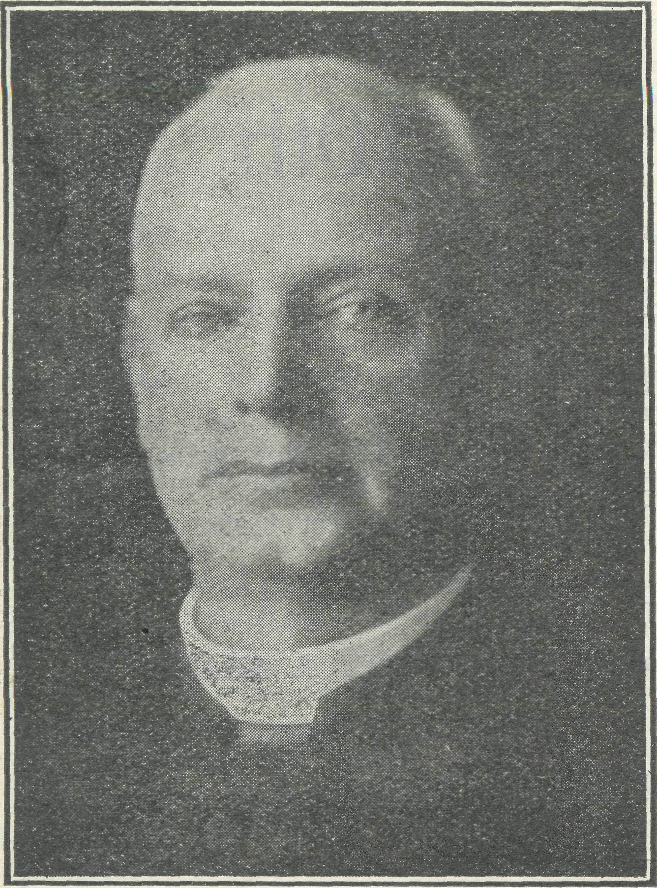
The late Archbishop of Sydney.
less Administrator, yet withal quiet and unobtrusive, but a great deal of his work laid the foundation for large extension in the future. Like a wise master-builder, his work always had a vision of to-morrow in it, and Church life in Australia cannot readily estimate all that it owes to him for his splendid foresight. In his later years, though obviously embarrassed by ill-health, he retained to the end a high standard of personal duty and a very simple faith in God, for both of which he will never be forgotten. The vast concourse of people of every denomination at the funeral was a unique tribute from Church people to a great leader. We earnestly pray that God will grant to the members of the bereaved family alj Mw Divine comfort,
The death of Mr. Edgar H. Bragg, of Sydney, on the night of March 14, has taken away a very warm friend of the B.C.A. For many years Mr. and Mrs. Bragg and their sons have been intimately associated with Church life, and especially with the work of the C.M.S. and the B.C.A., and the passing of Mr. Bragg will be felt most deeply by the whole Church life of the Diocese. He was a " Kookaburra," and was warm in his appreciation of the greeting which came to him each birthday. We thank God for His servant's splendid record of untiring and unselfish Christian service, and we commend Mrs. Bragg and her sons to the consolation of Divine Grace to comfort them in their sorrow.
WELCOME AND FAREWELL.
Tuesday evening, March 14, witnessed a wonderful gathering in the Chapter House to welcome the new Organising Missioner, and to farewell the two Van Sisters, Deaconess Dorothy Harris and Sister Caroline Ross. The Bishop-Coadjutor presided, and was supported on the platform by Canon Langley, Hon. Clerical Secretary, and a number of B.C.A. officebearers and supporters. The whole evening was an inspiration to all present, and spoke eloquently of the strong enthusiasm wiiich is behind the work of the Society. Very many messages of goodwill—so many indeed that it was impossible to read them _{a}|]—were received from all parts of Australia where the B.C.A. operates, a fact which speaks of the strong affection entertained for the Society and its work.
The Bishop spoke of an intimate relationship with the new Organising Missioner, Rev. T. Terry, extending over a considerable period of years, and of his own busy but happy thirteen years in the work of the B.C.A. His words of welcome were warmly endorsed by the audience.
Canon Langley supported the Bishop's remarks, and the Rev. T. Terry replied with thanks for the wonderful welcome, re-emphasising the plea of the Bishop for more earnest prayer and service, in order that God's blessing might be upon the work.
The Bishop then made telling reference to the value of the Van work in far-out country districts where settlers are isolated and Church privileges are few, and tendered to the Van Sisters the earnest wishes of the meeting for the blessing of their travelling ministry. Sister Dorothy and Sister Caroline responded briefly, after which Canon Begbie offered prayer commending the Sisters and their work to God's care and protection.
The Benediction was then pronounced, and the meeting proceeded to the Cathedral grounds, where the Van waited, and where the Bishop dedicated it. The Van consists of the old body upon an entirely new chassis, and with a new engine. The Sisters will leave Sydney on about the 22nd March for a visit to Picton Parish and tke Burragorang Valley, and
then on to the Shoalhaven Parish with its many and difficult hills and valleys and wild places. These two parishes should try out the Van before the Sisters proceed farther afield to the Diocese of Armidaie, where they will proceed with definite evangelistic work. Our best thanks to the Eectors of Picton and Nowra for their ready co-operation in our plans for the Van.
PERSONAL NOTES.
The Rev. C. M. Kemmis, of Wilcannia, was married at St. Andrew's, Summer Hill, to Miss Edith Fitz Roy, of Buxton. Mr and Mrs. Kemmis have been staying at 'Avalon for a short holiday, during which the car from Wilcannia has had a thorough overhaul. They hope to return to the Big West about 22nd March, o o o'o
Miss Reece, of the Cann River Mission, has tendered her resignation, and expects to leave shortly for England. We must place on record here our sense of deep indebtedness to Miss Reece for her splendid work in that district. She will be greatly missed, and we do not doubt that she will miss the work, but we pray that Gcd's richest blessing will be upon her in all her future life and work. What a wonderful deputationist in England she should prove for Australia! o o o o
Mrs. Mann writes cheerfully from Wilcannia, despite the severe heat and the drought and the rabbits. The latter have eaten nearly everything except the Hostel, and cheerfulness on the part of the workers under existing conditions is a Chrxstian grace for winch we thank God. At all events, nobody (an deny that Wilcannia is healthy.
o o o o
The Editor regrets that, through lack of knowledge, reports were not gathered in from the various centres of B.C.A. activities. The Organising Missioner is about to set out on an extensive tour, and is hopeful of touching every centre of work before the date of the B.C.A. Rally in Melbourne, 10th May. c o o o
Rev. S. G. Stewart has been carrying on a most useful deputation work in the parishes, though he will be leaving B.C.A. work for other fields about the end of April. Our warmest congratulations to him on his engagement to Miss Grace Brownrigg, of Sydney, o o o o
It is impossible to state how very much we all owe to the Hon. Clerical Secretary, the Hon. Treasurer, and the office staff, supported by the voluntary labour of friends, for all the self-sacrificing^ work they have done since the resignation of the late Organising Missioner. May they all be spared long to continue the work that they love.
o o o o
The R§¥, T. Jones and the Victorian Committee have a gheering report of work

April 5, 1933.
THE REAL AUSTRALIAN.

and progress, and are looking forward to a splendid Eally on 10th May. Our warmest congratulations to them and to all B.C.A. supporters in Victoria, o o c o
In St. Andrew's Cathedral on 20th March, friends of the B.C.A. met in a beautiful Service of Holy Communion before the departure of Deaconess Dorothy Harris and Sister Caroline Ross. Canon Langley was the celebrant, and a brief devotional address was given by the Organising Missioner.
WOMEN'S AUXILIARY OF THE B.C.A.
The Auxiliary was in recess for three months, and met on the third Wednesday in February. We resolved then to call another General Committee Meeting for - March. This meeting was held, and the new Organising Missioner, the Rev. T. Terry, was present, when arrangements were made for the Annual Meeting. We do trust that every member will do her utmost to make that gathering a memorable one. We need many more members, and would welcome above all the formation of branches of the Auxiliary in different parishes similar to that formed in the Parish of All Saints, Woollahra. A local secretary then takes charge of her workers and secures all results of aroused interests, and supplies a special centre' for either Hospital or Hostel wants.
At the close of the year cases of Christmas gifts were sent to all stations and to the isolated workers.
Mrs. W. E. Gates received a hearty vote of thanks at the Executive meeting for her strenuous work in despatching all the gifts, in addition to undertaking all the shopping and packing. Most grateful letters were received from the recipients of gifts.
The Auxiliary often receives from the bush requests of a wide variety, but cannot always supply them. We need a much larger membership and a heavier purse, but we thank God and take courage, remembering how great things come from small beginnings.
Already Penong Hospital has had a most generous donation of linen, lamps for the operating theatre donated by Mrs. Gates, and a liberal supply of cups and saucers. Sister Sowter, of Cann River, has had, in addition to the Christmas gift, a reading lamp and some irons. Each centre will have its needs attended to as the money comes in
We were pleased to have the Rev. S. G. Stewart at our February meeting, and to hear from him some out-back experiences.
In conclusion, may we extend a very warm welcome to the Rev. T. Terry, rejoicing that we have with us one to whom we can look with confidence that he will further the work so dear to Bishop Kirkby. As we commence the new year of work, may each one of us strive to share in the care of the bush folk, so that it may be said of each of us, "She hath done what she could."
Beginning with June, the Women's Auxiliary will be pleased to meet Church women from any parish at the Church House on "me third Wednesday, at 3 p.m. Afternoon tea will be provided by the members, and visitors are invited to make every possible inquiry into the work of the B.C.A. with a view to becoming supporters.
o o o o
The Annual Meeting of the Women's Auxiliary will be held in the Chapter House on 17th May, at 3 p.m. All
Church women earnestly invited to be present. Further notice will be given in the parishes.
VICTORIAN NOTES.
Christmas Fund.
The Christmas Gift Fund was again a huge success, and we are indeed happy to be able to record thai all our needs were met and the blessed season of Christmas was made brighter for many kiddies of the out-back. To all those who so generously helped to make the venture a success we tender our thanks.
Adoption of a Child.
Since the last issue of this little paper, the sum cf £4 has come to hand towards sending a child to one of the B.C.A. Hostels We still need £21. Think what it means to have the privilege of attending school when one lives in the lonely places! Twenty-one more donations are needed. Will you be one?
Victorian Deputation Work.
Constant deputation work is necessary to the progress of B.C.A. work, and for this purpose a reliable means of transport is necessary. Unfortunately the Victorian work is at present badly hampered by the breakdown of our car. It has done six years' service, and the Victorian Committee feel that a new car is very necessary if the Secretary is to fulfil his many engagements. Here is a real piece of service for the home base. Will someone meet the need?
Garden Party at Heidleberg.
The Garden Party for B.C.A. funds given by Mrs. Price at her home in Heidleberg is now a well established institution. We are deeply grateful to Mrs. Price for her last effort in October, which resulted in £27 being added to our funds. We say a very real " Thank you!" also to all those friends who so ably helped Mrs Price to make the venture a success, Although it did rain, a very pleasant afternoon was spent in that beautiful garden of our old friend. We wonder if there are not others in Melbourne who would help in this way!
St. Barnabas', Montague.
It is not possible to mention all who helped the work last year, but the efforts of St. Barnabas' must be mentioned here. During November the Deputation Secretary attended a special Children's Service,
at which the kiddies brought their gifts for the kiddies out-back. This, in itself, was really splendid, but later on in the month it was very humbling to receive a donation of £5 from the Vestry of Montague as a gift to B.C.A. for their special Parochial Effort—and this from an industrial parish badly hit by the depression. We praise God for such a spirit of self-sacrifice.
St. Thomas' Auxiliary.
During December, Miss I. Woods, the enthusiastic Secretary of St. Thomas', brought to the office £5 for a cot at Penong Hospital, £1/2/2 for the purchase of Bibles, and £1/10/- for Hospital needs. Well done, Essendon!
We Tender cur Thanks to :
Messrs. Hoadleys', foi a gift of chocolates: Messrs Laxettes Ltd., for 400 comic masks; Messrs. Ball & Welch, for gift of toys; Messrs. Anglo Dominion Soaps, for 3 dozen bars of soap; Messrs. Nicholas Aspro, for 1 gross of aspros.; Messrs. Bushells Tea Co., for gift of toys; Messrs. Ferguson & Co., of Adelaide, for attending to the transport of our cases to^ the West Coast; the Premier of Victoria, for free railway facilities for Christmas; Messrs. Huddart, Parker, Adelaide Steam-, srrip Co., and Mcllwraith, McEacharn, for free shipment of cases to Penong and Ceduna.
We desire to acknowledge donations to our Christmas Appeal from the following business houses:—Messrs. Allan & Co. Pty. Ltd., Melbourne; Mr. S. B. Myer, Melbourne; Mr. R. M. Mackenzie, Melbourne; Messrs. Dodd & McKinnon, Melbourne; Messrs. Baker, Perkins, Melbourne; Mr. O. J. Nilson, Melbourne; Messrs. T. W. Apps & Sons, Fitzroy; Eagle & Globe Steel Co,, Ltd., Melbourne; Messrs. Barrett Bros., Melbourne; E.M.F. Electric Co., North Carlton; Messrs. Glover & Good, Melbourne; Messrs. Bar-nett Glass Rubber Co., Melbourne; Messrs. Kraft Cheese Co. Pty. Ltd., South Melbourne; Messrs. Lyall & Sons, North Melbourne; Messrs. J. Kitchen & Sons, Melbourne; H. V. McKay Charitable Trust; Electrolytic Refining & Smelting Co., Melbourne; Laconia Woollen Mills, South Melbourne; Messrs. Wm. Crosby and Co., Melbourne; Northcote & District Ice Works, Northcote; Messrs. G. J. Coles and Co., Melbourne; Mr. A. M. Monk-house, Brighton; "Sympathetic"; Sir William Brunton, Malvern; Dr. H. C. Lloyd, Melbourne; Mr. H. J R. Lewis, Fitzroy.
Also publicity from "Argus" and "Herald."
G.F.S.
During 1932 many of our G.F.S. branches helped in various ways, and we are glad to know that more branches have decided to include B C.A. in their activities. We look forward to the time when all branches will enter into our work.
Organising Missioner.
All B.C.A. friends in Victoria extend to the Rev. T. Terry their best wishes on his appointment to the office of Organising

THE REAL AUSTRALIAN.
April 5, 1933.

Missioner. We pray that God will richly bless him in his work, and prosper the work of B.C.A. under his guidance.
When Making Your Will.
Legacies for small sums, as well as large, are thankfully received by the Society, and we ask our friends, while they are happily still with us, to remember the work of the Bush Church Aid Society when considering the ultimate disposition of their property.
It is usually wise to consult a solicitor in an important matter of this kind. A will must be in writing, and signed at the foot or end in the presence of two witnesses, who must be present at the same time, and must sign the will as witnesses in the presence of the person who is making it.
All kinds of property, without exception, can be legally bequeathed for charitable purposes. Where a legacy does not consist of a sum of money, care should be taken to identify clearly the property, or mortgage, or share, or stock (whatever it is) intended to be bequeathed.
Ladies' Auxiliary.
The ladies held their first meeting of the year in the Chapter House on Thursday, March 9th. Future meetings will be held on the first Tuesday of each month at 2.30 p.m. We are hoping for big things from the Auxiliary this year. Will all the ladies interested in this work do their utmost to be present at the next meeting?
EASTER CAROL.
I see outlined against the western sky A wooden Cross whereon a Man must die; I see the people always passing by, Nor recking of the Cross nor of its load.
I see a garden that is bathed in shade; I see three sleepers in the shadows laid; And lo! a Man rise up from where He
prayed In agony, to mourn the sleepers' fate.
I see a Man in agony o'erthrown,
His grief in bitter blood-drops pouring
down : And prayer so sorrowful its tears can
drown The very woe 'neath which the Prayer
bows.
I see a noisy tumult at the gate,
And lo! I see the Man arise and wait
To meet" the traitors' traitorous kiss of
hate, His face, mid all the rabble, still and
calm.
I see a crowd around a palace door : I see their crying as a murderous roar Go up, as lo! a Man is led before Their tribuned crying, which doth bid Him die.
I see a buffeting and hateful spite Through all the long, long hours of that long night;
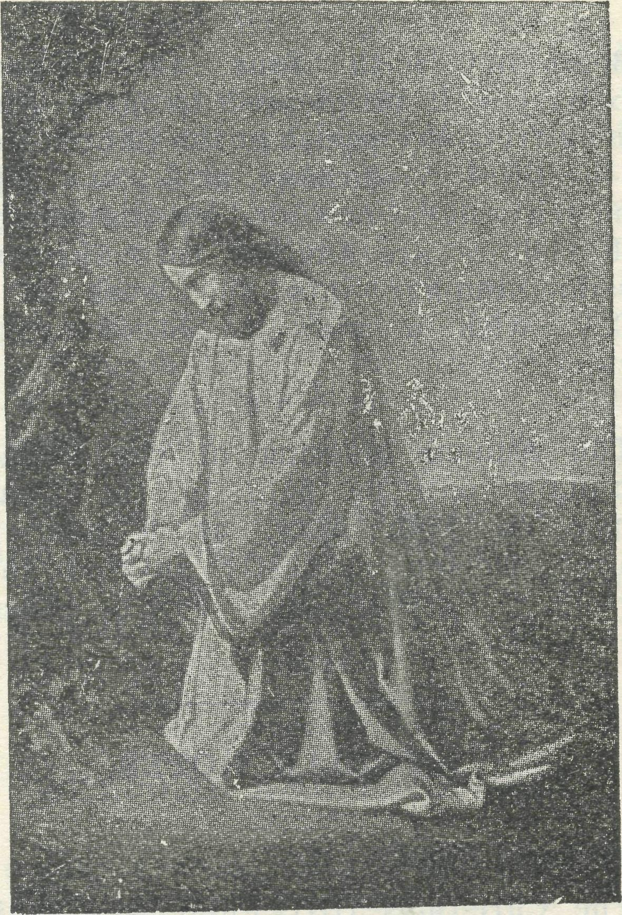
I see the sentence as the dawn grows
light, And lo! they lead Him forth that He
may die.
I see a Cross against the night-sky etched, I see a Man Who hangeth there outstretched, And from His hands and feet and side is
fetched The blessing in the red road He hath trod.
I see it hanging black in th' eventide— A wooden Cross whereon a Man hath died, And people passing still the Crucified, Nor recking of the Cross nor of its load. —Francis John Brerly.
MRS. DAISY BATES.
AN APPEECIATION.
As the Padres of the B.C.A. travel about their extensive '^{i} parishes," covering thousands of square miles, they quite frequently meet some very interesting and fascinating people who for some reason or other desire to dwell in the more remote parts of our land.
In this article I wish to tell you of one of the bravest women whom it has been my privilege to meet whilst journeying about in the Far West Mission.
Away towards the heart of South Australia, near the historic siding of Ooldea, on the Trans-Australian Eailway Line, there lives this courageous little English lady, whose name is Mrs. Daisy Bates, and her life is devoted to the uplift and preservation of the Australian aboriginal.
Mrs. Bates lives alone in her camp, which consists of a tent and brush house erected on the side of one of the many sandhills that surround Ooldea. The camp is encompassed by a brush fence. As Mrs. Bates is an authoress and possesses many valuable papers and documents, she has found it necessary to secure these against fire by placing them
in old galvanised water-tanks and petrol tins. Mrs. Bates lives here all alone right through the cold, bleak winter months and burning hot summer suns.
Ooldea has become famous because of the beautiful fresh water that can be had from the '^{l} soaks "in the sandhills, and this is known to the aborigines throughout the length and breadth of Australia. Because of the assurance of water, iarge tribes of blacks travel to Ooldea, and it has thus become one of the "gates of entrance" for them from the wild, desolate interior into our civilised world. Here they come, as it were, direct from the stone age into contact with our 20th century civilisation in the form of wireless and up-to-date East-West Eailway. People who have met the aboriginal at these outposts of civilisation are familiar with a degraded looking type of black, generally wearing the cast off clothing of the whites. Somehow the aborigines seem to copy so readily the bad habits of the white people, but not their good ones, unless they have been fortunate enough to receive a thorough training at some Christian Mission Station.
So the brave task that this cultured and refined lady has set herself is to persuade the blacks coming down to Ooldea from the north to return to their unin-truded interior. Failing in this, she covers their naked bodies with articles of clothing sent to her by many kind friends from all over Australia. But it should be remembered that Mrs. Bates is not a Missionary, and so there seems to be a brilliant opportunity at Ooldea for such, to tell these outcasts of humanity of a loving Saviour.
Mrs. Bates speaks all the many dialects (well over one hundred) of the various tribes, and has an almost complete vocabulary of words in each dialect. From time to time she is called upon to settle quarrels among the natives, and has often tramped many miles at all hours of the night to act as peacemaker. Warring tribes have been persuaded to lay down their boomerangs, spears, shoulder-breakers, and clubs at the feet of the brave little lady whom hey love and whom they call "Kabbarli'' (grandmother). Often long walks have to be undertaken across the sandhills in summer and in winter, night or day, in doing loving service to some sick or dying native.
Truly is some ways Mrs. Daisy Bates is indeed a modern Mary Slessor, and her life is well worthy of the highest admiration for its bravery and self-sacrifice in the interests of a race that is fast becoming extinct, and to which we owe such a debt of service for the Master.
THE KOOKABURRA BIRTHDAY BAND.
My dear Kookaburras,
Now that Christmas is over most of you Kookaburras will be back at school again, or will be busily engaged in whatever work you have to do. I do hope this is going to be a very happy year for everyone. I'm sure it is going to be

April 5, 1933.
THE REAL AUSTRALIAN.

very, very happy for the B.C.A., for we have our new Organising Missioner now, and we of the Kookaburra Birthday Band are going to give him a hearty welcome and tell him how glad we are that he is with us.
There is just one thing I want to say, and that is this. There are such a lot of Kookaburras who are unfinancial; that means, that although some of the names have been in our Birthday Book since 1929, we haven't received any subscriptions from them all these years. Most of the Kookaburras are very good and send in their shillings every year, but there are a few who receive their birthday cards year after year and never send in their subscriptions at all. And we do need the money so badly! If you only knew how much we have to do with it, and what a great parish our B.C.A. Parish is, and how many people—little girls and boys, and bigger girls and boys, and grown-up men and women, and old, old people—are waiting .for the B.C.A. Mission Van, or the B.C.A. Padre, or the B.C.A. Aeroplane, or the Deaconesses and Nurses to go to them, you'd all send your shillings every year you could. A lot of Kookaburras, we know, have suffered very badly from the depression, but a lot of you could send in your shillings if you remembered or thought about us. So now that Mr. Terry is here, let us all begin again, and if you're beginning to think that any time will do to get the postal orders or the stamps, just remember that that means that someone out-back who hasn't got all the nice things we have in the city—regular Church services and Holy Communion every Sunday, and hospitals and doctors and chemists, and books and toys, and all those other things that we need and have—that someone else out-back will have to wait still longer before we can get out to them. Don't deprive the out-back people of the things you can give. One shilling a year—it isn't very much, is it? And it means such a lot.
And now that is enough scolding for one letter, isn't it?
Such a lot of people have been telling us that they enjoyed the story in our last letter, so I'm going to tell you another one now. But this time we're going to give it a name; for w^{T}e didn't give the last one any Tiame at all, and that was a very silly thing to do, wasn't it? So we're going to call this one "The Singing Man," and it begins like this :
Once upon a time there was a man who had a wife and seven sons, but he didn't have any daughters at all; and he had always wanted a little daughter—a little girl with whom he could play, and whom he could watch growing up into the loveliness of young maidenhood and the purity of girlhood. And he dreamed and dreamed of this child whom he desired, so greatly, so that his wife called him a dreamer of strange, fantastic dreams, and she laughed at him in a gentle way, for she knew that his desire was very great, and she loved him dearly; and she com-
forted him in his loneliness, and cared for him more dearly still.
At last one day.a little child was born to them, and to the man's great joy it was a little girl. His daughter was born, and he began at once to weave around her tiny form the dreams he had dreamed through all the empty years. But who shall say how it was? Even his longing and his joy and his love for the child were not enough to keep her, and from the first she began to fade as a little flower will fade, and in a day or two she wilted and died. And the grief of the man w^as greater than his joy had been, and his tears flowed faster than his laughter in the few days he had known her. And he was left alone again, alone save for his dreams, now all torn asunder as a spider's gossamer webb is shattered by a ruthless hand, or as the petals of a flower that are split and torn by the mighty wind that hath passed them by.
And he tried in vain to believe that this child he had loved was dead and lost to him, and he could not believe it, though he tried in his grief to do so, and at last it came to him that perchance she was not dead at all, but only lost, that, she was without somewhere wandering in the day or the night, and that if he sought he might find her still. And so he called to him his seven sons, and he bade them care for their mother while he was gone, and to the first he gave the care of his mother's name, and to the second the care of her honour, and to the third the care of her houses and lands, and to the fourth the care of her gold and silver, and to the fifth the care of her tears, and to the sixth the care of her joy; but the seventh he gave into the care of his mother, for he said, "What woman is there who could find happiness not caring for anything?" And he kissed them all and blessed them, and, commending them to the care of God, he set off on his long journey seeking the spirit of his little lost child.
Now the man had ofttimes loved to play upon his harp or lyre, and to sing sweet songs to the melodies of it, and as he set out he asked himself how should he seek the spirit of his little lost child. The answer seemed borne upon the wind and seemed to whisper and mingle amid the tree tops that there was no way she would love more to be sought and found
than to hear her father's fingers upon the strings of his harp and her father's voice singing upon the breeze. So he gathered up his harp and he raised his voice in blessing, and he went away singing down the long road.
On -ana on he travelled, day by day, year by year, never ceasing, never travelling the same road twice. Over all the world he went singing and playing upon the strings of his harp. And the fame of him went abroad and travelled even faster than he, and men began to call him "The Singing Man," and in the cities and the towns, and the villages and the hamlets and the crofts, they watched for him, saying as he passed, "It is the Singing Man! "
And the Singing Man grew to be greatly beloved by the children, for of them all, and particularly of the little girl children, he would say, " Perchance the spirit of my little lost child is even as these children; perchance she is amongst them!" And when he found that she was not, he would sigh sadly and say, "Mayhap shq, too, is lonely, or hungry or sad, and would that someone were kind to her! I shall be gentle with these little ones for her sake." And he would weep in his grief and be very, very kind, and very, very gentle.
And he was beloved by young men and maidens, for of them he would say : "Were my little one to grow to young maidenhood, I would that she were pure and true and good even as the day; I would that no harm might draw nigh her." And as the years passed on, he would add: "Perchance she is amongst these maidens! I shall not pass them by unsinging lest she waits to hear my voice and all is still." And so he would stifle the tears in his singing, and sing to the melodies he played upon his harp; and when he found that his child was not there, he would say, sighing sadly and sorrowfully: "She is not here, but mayhap she frets or is lonely, or perchance evil draws near to harm her! I shall be kind to these young men and young maidens as I would someone might be kind to her."
And the old people loved him—and he was especially dear to old ladies, for of them he woud say: "Had she lived these many years as they have, she, too, would have grown old and frail; and when I could no longer care for her, for that I had travelled the road all men must go, and were I but a handful of lingering dust in some green grave, I would that someone might have cared for her and been gentle with her, and helped her frail footsteps along the way." And as the years passed on he would linger beside the old ladies, saying : "Perchance she may even be here, seeming old, with her dear hair, too, quickly silvered; for she may have longed for me even as I have longed for her." And when he found she was not, he would sigh gently and say : "I would not that she be too quickly old, but oh! I would that I might find her; and it seems I may not, but to these old ladies and to the old people I shall

THE REAL AUSTRALIAN.
April 5, 1933.

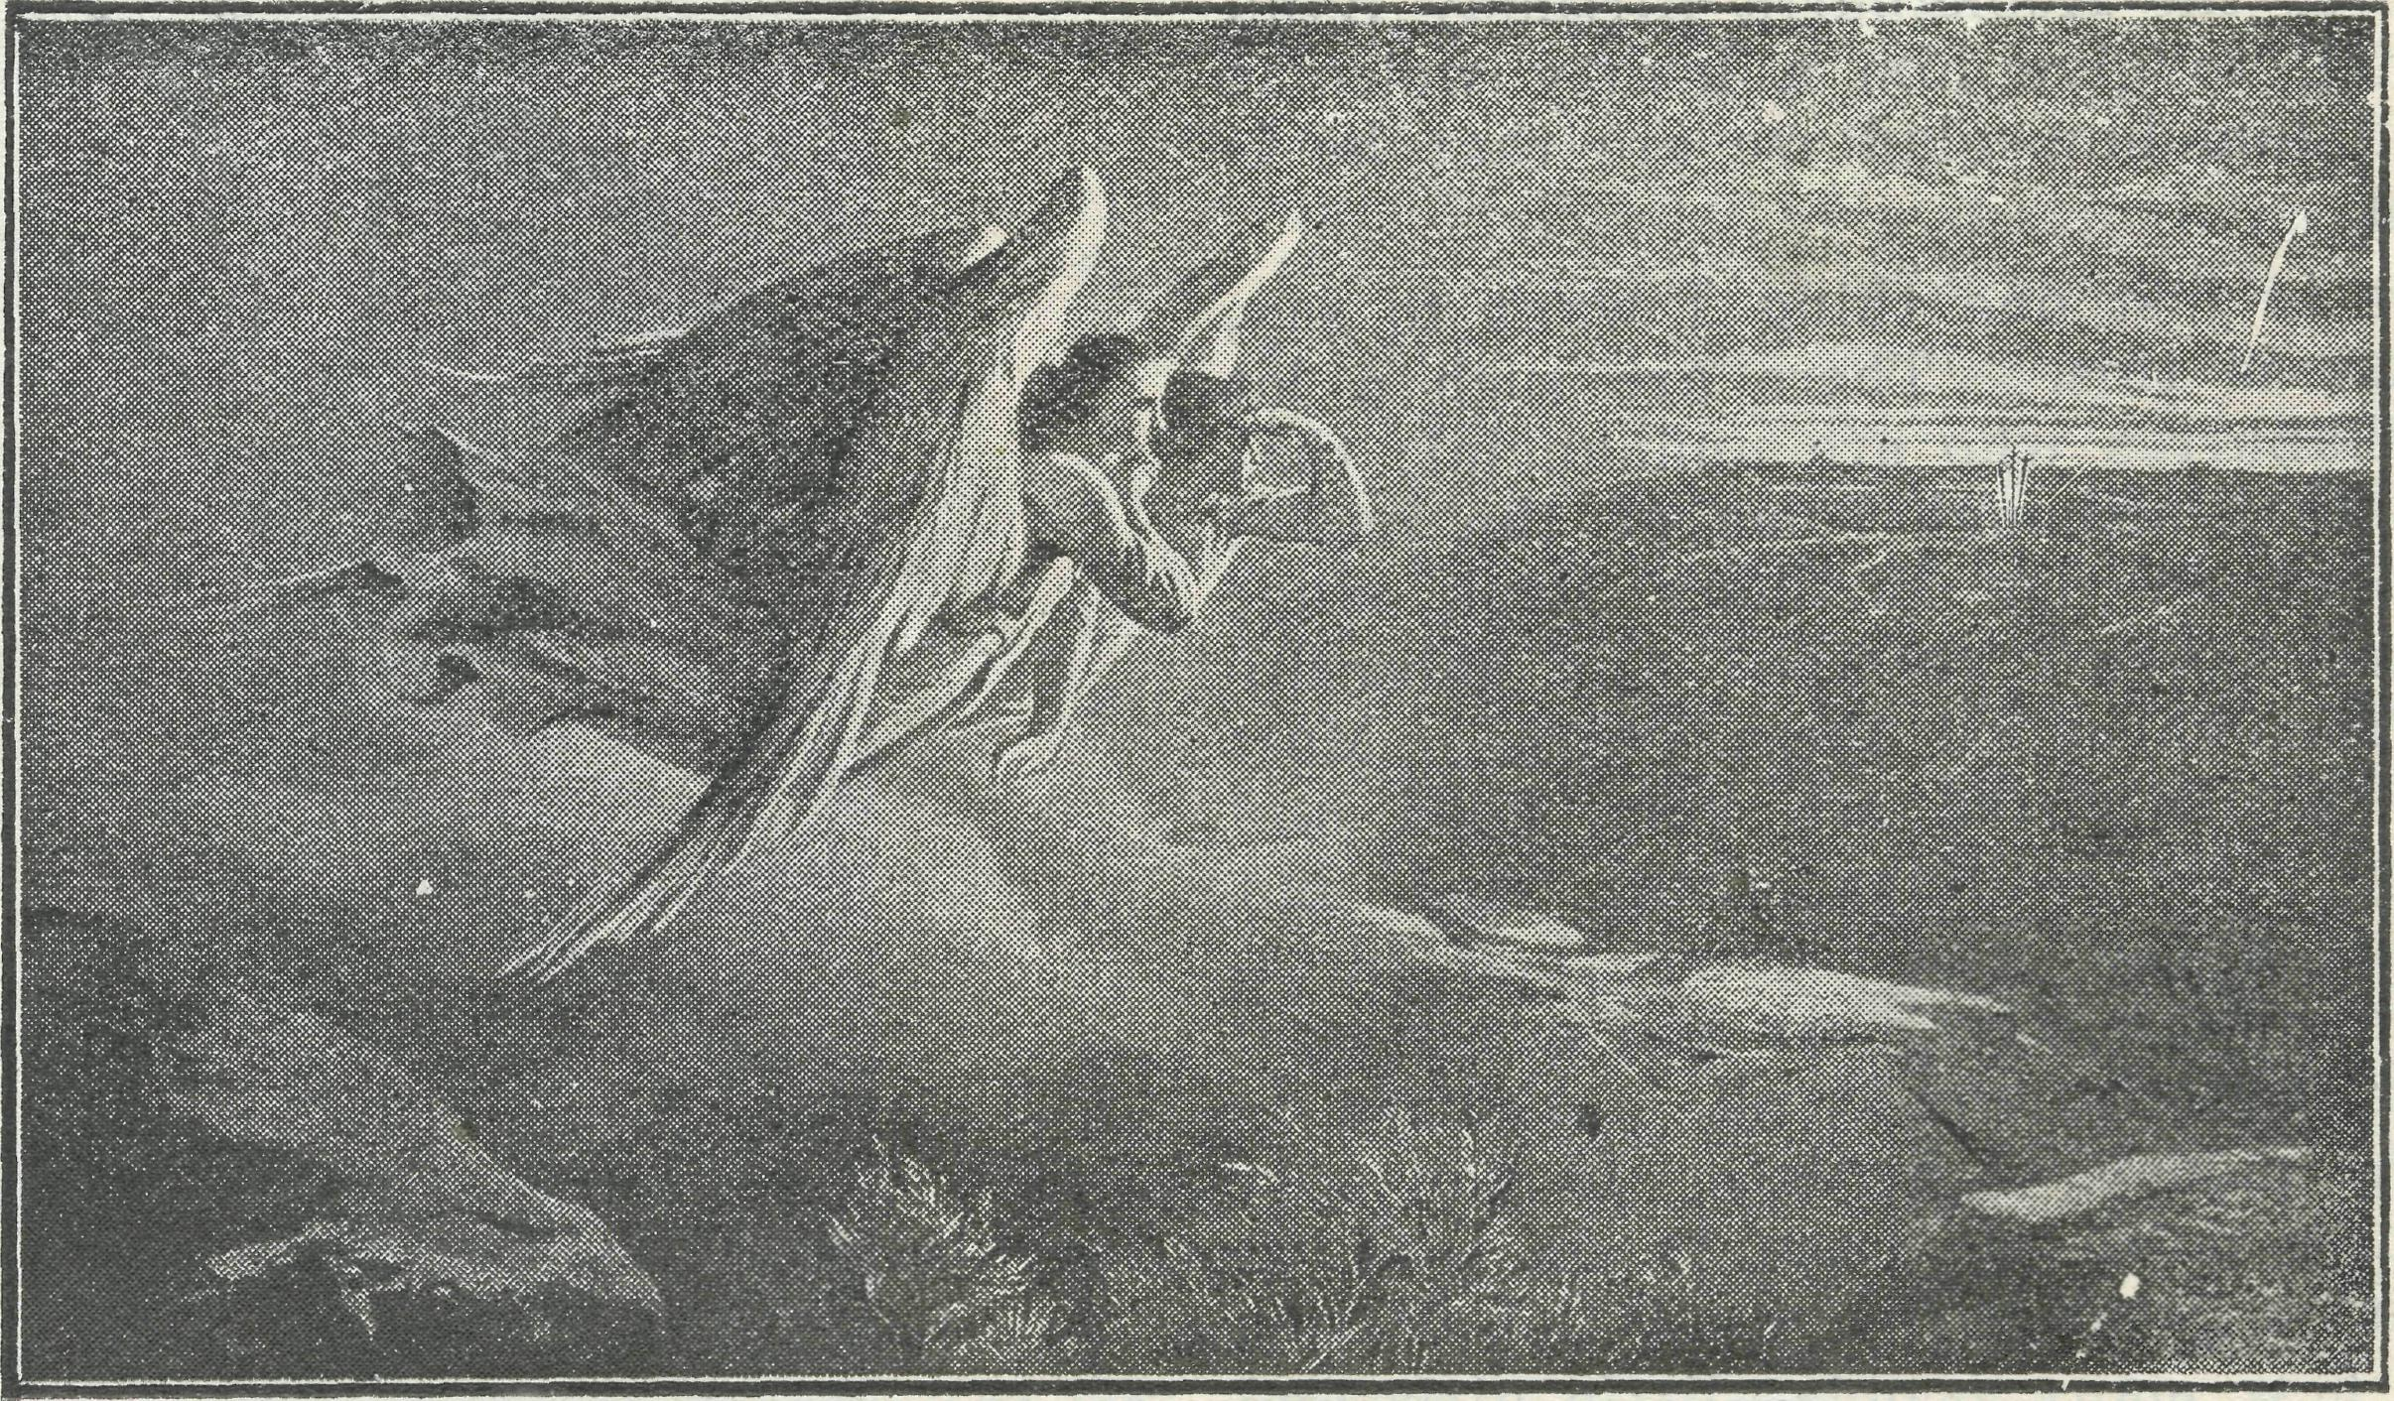
The first Easter Morn*
be kind, even as I would someone should be kind to her when her hour of age draws nigh. '>
And so he went about, never travelling the same road twice, being kind and gentle and very, very good to everyone; so that everyone loved "The Singing Man," for his voice was never still as he passed from town to town.
And years and years passed by, and always he went singing and playing upon his harp—The springtime brought the summer and die autumn brought the wintcrtide, and winter gave new spring again. And one day—a beautiful day in the springtime—he lay down to rest in a beautiful green field and under the shelter of a not far distant hill, and he slept; and as he slept he smiled in his sleep, and his hand lay still on his harp, and the day closed, and the evening came, and with thfl twilight the night, And early the next morning there came two little girls holding hands and swinging them gaily, while they chattered to each other by the way. And they came and looked on him, and said in hushed voices, "It is the Singing Man, and lo! he sleeps !" and they tip-toed away lest they might awaken him; and towards noon-day there came two young maidens with arms intertwined and love and laughter in their voices, and they came and looked on him and said, "It is the Singing Man, and lo! he sleeps" and they, too, hushed their voices and went softly away. And at eventide there came an old woman, with silver hair and frail body and broken footsteps, and she, too, looked on him and said, "It is the Singing Man, and lo! he sleeps! Sleep on, oh! Singing Man, sleep on forever, and forever sleep!"
And I, as I passed by, looked on him, too, and who shall say if he had not found the spirit of his child at last?
That is the story, Kookaburras, of "The Singing Man," and I'm only glad that he was so kind to everyone; for if he had been selfish and hadn't bothered being nice to people, he might not have found his little daughter even at the last, might he?
Goodbye everyone! Lots of love to you all.
Kookaburra Francis John Brerly.
A WORK UNIQUE AND VARIED.
The great thing about the B.C.A. which must impress everyone interested in its welfare is its spiritual impetus, plus its many and varied activities, which are being used for the advancement of Christ's Kingdom in this fair land of Australia.
As the reader may not be familiar with all the Society's work, here is a broad outline of it set out in question form.
DID YOIT KNOW—
1. That the activities of the B.C.A. are of a most varied nature, ministering to the soul and body of the out-back settlers scattered throughout the distant parts of the Commonwealth?

- That the Society commences its work where the railway ends ?
- That through the extensive labours and untiring efforts of our Padres the Society is working in the five States of this great continent?
- That at present there are nine Padres working in Australia under the auspices of the B.C.A.?
- That each of the B.C.A. Mission areas is so situated that everyone crosses into the territory of an adjoining State, or even of States?
- That the daring Aeroplane Ministry carried on in the Far W^est of New South Wales is the only one of its type seeking solely to minister God's Word and Sacraments in Out-back Australia?
- That the two B.C.A. Hospitals of the Far Western Mission of South Australia are the only Church Hospitals in tihat State to give a living expression to the Gospel of the Good Samaritan?
- That these noble institutions are the Hospitals furthest west in South Australia and are 336 and 286 miles respectively from the border of Western Australia, and that it is about 500 miles to the nearest hospital in Western Australia after crossing the border?
- That our Hospitals are staffed by three fully qualified Nurses, plus domestics—all women with cheerful Christian characters?

- That our Sunday School by Post has over 600 pupils scattered throughout the Commonwealth doing their lessons regularly, and thus learning more and more of the love of Christ, and of His purpose in life for them?
- That this fine piece of constructive work is being carried on by a band of 40 voluntary helpers?
- That the Children's Hostels at Wilcannia and Mungindi give 60 to 70 out-back boys and girls splendid opportunities of receiving a fine Christian training and secular education which otherwise they would be deprived of were
it not for the enterprise of the B.C.A. in this connection?
- That in New South Wales and Victoria there are six Deaconesses sent out by the B.C.A. working among the isolated and lonely women folk and children of the out-back?
- That the two Deaconesses in charge of the Ladies' B.C.A. Mission Van do regular visitation in various remote parishes in New South Wales and Victoria, as well as holding services for adults and religious instruction classes for boys and girls?
- That our Cottage Dispensary in Croajingalong, in charge of a fully qualified nurse, also serves the purpose of Hospital?
- That in all B.C.A. centres where, women's work is being conducted it has the backing of the Women's Auxiliary?
Is not this great work worthy of our-
Most prayerful interest ? Keenest enthusiasm ? Sacrificial giving ?
MAIL-BAG SUNDAY SCHOOL.
[We earnestly commend the following report to all B.C.A. supporters.—Editor.]
We have now completed compiling our records for 1932, and they are so gratifying that we feel we want to share a few of the pleasing facts with our readers.
In our '^{l} Little Ones' Paper'' Primary Department there is given every Sunday some simple work, such as drawing, filling in of outlined pictures, or directions for planning out the story, to illustrate the lessons. This work the children are I asked to do and to send in to us every month. During last year 44 per cent, of the children receiving our ^{i{}Little Ones' Papers" sent in the work. Considering that many of the children receiving these papers are unable to write, or are too young to do the work without the supervision of the parents or older children in

April 5, 1933.
THE REAL AUSTRALIAN.

the family, we consider this result splendid.
In the papers for the next two grades I. and II.) there are questions set and handwork, such as drawing, copying of pictures given in the papers, or finding and copying out of certain Bible texts, etc. During last year something like one-third of the children who received the lesson papers sent in their completed work, and, considering that there is no compulsion, so long as the papers are read Sunday by Sunday, we think this result very good.
But what we think is really magnificent is that out of about 200 children who sent in the answers to the questions, and in almost every case the handwork as well, no less than 40 did the work for every Sunday in the year, and 13 missed one Sunday only. We think this is a record which very few city Sunday Schools could put up, and is especially commendable when it is remembered that those children have not the help and encouragement of a teacher with them on Sundays. It speaks volumes, too, for the parents who, with the cares of their homes and families, and often the supervision of school correspondence lessons as well, are yet able to keep up their children's interest in this voluntary Sunday School work.
In addition, too, to the work sent in, we know there are many families where the children answer the questions regularly, and their work is corrected at home or by their teacher or Rector, this being quite permissible.
In the case of the Kindergarten Department no questions are given, and so the work the children send in is simply commented upon by the teacher, and the work is then returned to the child. Each of these younger children receives a small gift at Christmas time. In the case of the two higher grades, the questions are corrected and marked by the teacher and then returned, after a record of the marks has been taken. On these records rewards are sent at the end of the year to the best workers, and we think all our readers will agree» that those children who have not missed one Sunday's work during last year well deserve some little recognition. We are able to send them Bibles, Prayer Books, story books, etc., through the generosity of friends and teachers.
We have now quite a little army of voluntary workers connected with our Mail-Bag Sunday School, numbering actually 40. After the papers have been written there is the publishing to be done, and as there are more than 750 sets of papers sent away each, month, for which of course envelopes have to be addressed, it is necessary to have regular and careful helpers for this branch of the work. Then there are the teachers, of whose enthusiastic support and interest we cannot speak too highly. In all three grades the children, as they send in their work, are allotted to certain teachers, who look over and correct the work and keep in personal touch with the children. This
latter we feel to be most important, and certainly well worth while, if we judge by letters which the children, and often the parents, write to the teachers.
In the older grades it has been our custom for some years, on the Sunday following Christmas Day, to give the children a holiday from questions and handwork, asking only for a Christmas letter to the Superintendent telling how the Christmas has been spent. The sheaf of letters that came in again last year truly made our hearts glad, and we are only sorry that we are not able to share them with you all. They were just beautiful!
We Mail-Bag people do not like the beginning of a new year, for the reason that we must always be prepared to lose some of our older scholars on account of their having passed into High Schools, necessitating their leaving home in many cases. Others reach the stage when they have to start out in the world of work, and so pass out of touch with our Sunday School. Naturally we are reluctant to lose them, still we realise it has to be, and there is often compensation in the fact that these older children interest their younger brothers and sisters in the lessons, and encourage them to be enrolled. And so the work goes on, some having to discontinue, but new ones always coming on.
Knowing that, with the end of the year, some of our children may no longer be able to make use of the papers, we have again this year, as before, sent a circular letter to every family receiving the older grade papers asking them to return the slip attached if the papers should no longer be needed. By so doing we have the satisfaction of knowing that all the papers sent out are being used. The letters which have accompanied some of the returned slips have been a tremendous encouragement to us all, and only make us long to extend this work further, as it would seem to be the only source through which many of our out-back chil-Iren, and the grown-ups too, receive any help about the things that really matter —the things of God.
Each year we aim at some extension in our Mail-Bag work, and this year we are instituting a Cradle Eoll. Our Van Sisters, who do much in the way of interesting our bush people in our Sunday School, will take with them a Cradle Boll-book in which they will enter the names, ages, and birthdays of all babies and quite young children in the homes visited as they travel from place to place. In our lesson papers, too, we ask for such particulars of the small children in the family. These names will be all recorded by a Cradle Eoll Secretary here, whose work it will be to send a birthday card—unless the child already belongs to our "Kookaburra Birthday Club"—as the birthdays come round, until the child is old enough to be enrolled in our Sunday School. This should prove a valuable link between our bush families, our Sunday School, and B.C.A. work generally.
A rather interesting fact is that the girl who won top place in pur Cfracle I?
lessons last year has been doing our Sunday School work, to our knowledge, since she was eight years old. She is now 14, and has always done splendid work. Of another family, some of whom have been doing the work for the same time, we have now enrolled the eighth child. These facts alone speak well of the worthwhile-ness of this branch of our B.C.A. work. One of our boys of whom any Sunday School might be proud, and who has been doing the work for at - least the same length of time, gave it up only last year, having written a year earlier asking that he might continue for another year; he was then 38.
The following are some brief extracts from letters sent by parents:—
"I certainly do not wish you to discontinue the papers sent. I cannot tell you how we appreciate these papers. We have a Church near us, but no -Sunday School. We are grateful for the papers and beautiful lessons. Wishing you success in your splendid achievement."
"I wish to thank you and the teachers of the Mail-Bag Sunday School for the great amount of good that the lessons have done. What a blessing the Mail-Bag Sunday School must be to many families! It hai been to us. Wishing you every success and blessing."
"I enjoyed answering the questions, and would do them again if I had the time. Thank you very much for the pain you have taken in marking my papers. I have learned much more about the Bible since I have taken the lessons."
Any special donations or gifts of books to be used for prizes in connection with the above work will be very gratefully received by the Mail-Bag Sunday School Superintendent.
We also make an appeal for gifts of Prayer Books, either alone or in conjunction with Hymns Ancient and Modern. Quite a number of bush children would like to have their own Prayer Books and hymn books, and we shall be most grateful for any copies, either new or used, which our friends can send to us.
PARENTS!
ARE YOU THINKING OF A DRY, BRACING INLAND CLIMATE TOR YOUR CHILD ?
IF SO, CAN THE B.C.A. HELP YOU?
We have Hostels for Girls and Boys,
where their spiritual, physical, and educational needs can be met.
For further information apply to—
The Rev. L. DANIELS,
The Rectory, Lithgow,
Or to the Organising Missioner, Church House, George Street, Sydney.

THE REAL AUSTRALIAN.
ApriL5, 1933.

HAVE YOU PAID UP ?
Once again we make record of "Real Australian" subscriptions received. To all we are grateful. There are still some of our readers who fail to find our little subscription reminder. May we ask for prompt attention? Eighteenpence a year is the amount. Please send stamps or postal notes to our Office. The address is on the front page of this issue. Thank you !
Names of "Real Australian*' Subscribers. Miss K. Allen, Mrs. W. Dunster, Mrs. R. M. Pry, Miss Woore, Miss Killinger, Rev. F. Jones, Mrs. E. W. Hughes, Dr. Joan Taylor, Rev, S. Tavlor, Mrs. R. Ings, Miss S. P. Fry, A. J." Jeffery, Mrs. H. Walker, Miss P. Cottam, Mrs. Moir, Sister Kathleen, Mrs. MacKenzie, Mrs. Tingle, K. M. Moule, Mrs. C. M. Walker, Miss Beavan, Mrs. A. E. Crane, Miss J. Donnelly, I. Smalley, Mrs. M. Rush, Mrs. H. W. Chapman, Miss Dell, C. M. Harvey, Miss E. Dennett, Lady Fairlie Cuning-hame, Mrs. A. M. Nicholas, Miss R. Har-grave, P. B. Fenwick, H. A. Hipwell, A. F. Osborn, Miss E. Cowcher, Miss E. Peterkin, Mrs. Frisken, Mrs. A. J. Wilson, Mrs. J. Aitken, Mrs. Carlson, Mrs. E. Shaw, senr., Miss Gurney, F. R. Gurney, Miss G. Cook, Miss M. E. Cabrera, H. H. Davison, Miss F. D. Watson, Mrs. Lawrence, Mrs. Pearce, Mrs. G. Hughes, Mrs. Hollibone, Miss M. Redfearn, Miss S. Ware, Mrs. McElroy, Miss Cochrane, Mrs. White, Miss E. L. Lowe, Miss M. Olley, George Hedge, Miss Thorpe, Miss Were, Mrs. Jones, Miss G. Hitchcock, Mrs. Dougherty, Mr. R. Clarke, Miss M. Boldt, Mrs. A. Moog, Mrs. Gilbert, Mr. H. Curtis, Mrs. Dunbar, Miss O. E. Farrar, Miss R. S. Power, Miss Stringer, Mrs. A. Noble, Miss V. M. Palmer, Mrs. S. Chilman, Miss A. B. Robertson, Miss N. Seedsman, Mrs. M. I. Maguire, Miss E. Richards, Miss J. Broadhead, M. C. Salvia, Mrs. Harding, Mrs. J. Harris, Mrs. F. Gunning, Miss XJ. Murray, Mrs. Edwards, Mrs. Peadon, Miss Cutler, Mrs. Porman, Rev. C. E. Burgess, Miss M. Phillips, Mrs. Maitland, Miss Kendall, Sister Hudson, R. B. Coates, M. Andrew, Mrs. Dykes, Mrs. H. F. Starling, Miss M. Morris, H. J. Ford, Miss D. Smith, Miss D. Trusty, E. Paton, G. Ans-dell, Mrs. W. J. Clarke, Miss I. Dutton, Mrs. I. Burleigh, Mrs. G. M. Morgan, Miss Cheffins, Mrs. Coogan, Miss Barling, Miss
E. M. Squires, Mrs. Luckie, Mrs. J. E.
Hill, Mrs. Houstoun, C. Justlins, Miss M.
Matthews, Miss B. Wotton, A. Hardy, J.
Knox, Miss Kidner, Miss D. Walker, Miss
Elkington, Miss A. Stevens, Miss A. Muir,
Mrs. Alsop, Miss M. E. Dawkins, Miss
F. M. Copperthwaite, Mrs. D. Small, Mrs.
Ward, Miss Clark, Miss M. L. Lane, Mrs.
A. Tabeteau, Miss F. Scott, Sister D.
Wilkes, Miss J. F. Watson, Miss E. Clif
ford, Mrs. Littleiield, Miss Piatt, Mrs.
Johnson, Miss Beckett, Miss C. M. Locke,
Mrs. C. M. Nutting, A. J. Wright, Miss
E. Rowe, Miss Gibbon, Miss Sonnenberg,
Miss C. R. Powell, Mrs. Brook Hansen,
Mrs. Donaldson, Mrs. Winter, Miss J.
Southam, Miss N. Godsall/ Mrs, Hindley,
Miss M. Baker, Miss E. Vaughan, Miss A. Harris, Mrs. Longfield, Mrs. F. M. Thomas, Miss L. Robertson, Miss A. Kemmis, Mrs. Kemmis.
o o o o We acknowledge with gratitude the following gifts:—Three anonymous donations of 5/- each, one bearing the city post mark and one from Crow's Nest; "E.G.," 10/-; "E.F.," 4/-; "E.F.D." ("Suffer little children to come unto Me"), 5/-; Mrs. F. J. Marshall (Bexley-Rockdale). £15. Special gift from Cathedral Choir boys through Mrs. Law-son and the Rev. L. Sutton : 31 Bibles donated by a friend; scrap books from Mrs. Strickland and "Pat" (English friends).
o o o o
Our Parish
We acknowledge with gratitude donations to the special Children's Christmas Fund from the following through Mrs. Howard Gill;—Lady Gordon, Mrs. Moody, Mrs. Taylor, Mrs. Mackay, Mrs. Henty, Mrs. Boyd, Miss McMurrich, Mrs. Glover, Miss More, Mrs. Toms, Mrs. Newby-Fraser, Miss Bellingham, Mrs. Millingens.
MY FATHER'S WORLD.
This is my Father's world :
And to my listening ears All nature sings, and round me rings
The music of the spheres. This is my Father's world :
I rest me in the thought Of rocks and trees, of skies and seas-
His hand the wonders wrought. This is my Father's world :
The birds their carols raise; The morning light, the lily white,
Declare their Maker's praise. This is my Father's world :
He shines in all that's fair; In the rustling grass I hear Him pass-He speaks to me everywhere.
—Maltbie D. Badcock.
THE PLACE OF PRAYER.
True prayer must be universal in its range and instincts. It must be spread over the whole earth. It must have the vision of God Who "so loved the world."
When our prayers begin to centre upon ourselves, then they are no longer pravers, but rather selfish mumblings,
which prevail neither with God nor with man. Prayer must take in all classes, all needs. The Book of Common Prayer rightly bids us to pray for <' all sorts and conditions of men." The very phrase is significant of bigness and unselfishness. It is Missionary-spirited in its comprehensiveness. Let us then be varied in our prayer interests, deeming nothing too small or too large, nothing too distant or too near.
Pray for—
The Missions of the B.C.A. in various parts of Australia, especially remembering the workers who indeed belong to the household of faith.
Pray for—
The Aeroplane Mission, that the Missioner be kept in his difficult and daring work.
Pray for—
The extension of this work through the in' troduction of a second 'plane, that the Council may be rightly guided in its loca' tion and staffing.
Pray for—
B.C.A. Hospital work in the Far Country, where patients must be received in spite of their inability to make any return for 6er' vice. Pray that God's good cheer be with the Sisters and their helpers. Remember the nursing work at Croajingalong and its difficulties.
Pray for—
The B.C.A. Children's Hostels at Wilcan-nia and Mungindi, that the work be in' creased of God, and that we persevere knowing that such ministry to little ones cannot be in vain in the Lord.
Pray for—
The Sisters' Mission Van in its itinerations in unlikely and out'of'theway places ; also for the Sunday School by Post with its Gospel message for little children.
Pray for—
All Students, Deaconesses, and Nurses in training and preparing for B.C.A. work in the Bush, that they may be equipped with power, wisdom, and zeal, and become "able ministers of the New Covenant." Also re member the Council, Committees, Women's Auxiliary, and workers on the Home Base Staff.
Pray for—
The new Organizing Missioner, that he find encouraging welcome as he undertakes his work.
Pray for—
A spirit of thankful giving to be upon all B.C.A. friends, that the Society be kept out of all God'dishonouring debt.
Forget not to give thanks—
For kindly givers who have helped us with their self-denials.
For friends, known and unknown, who have rallied at our call to keep our min' istries going.
For cheering reports from fields that God's Word is still with power.
For offers of service for the filling of pending vacancies in our work.
Wholly set up and printed in Australia, bv D. §• Ford, 44'5Q Reservoir Street, Sydney

