Registered at the General Poet Office, Sydney, for tranamiaeion by port aa a periodical.
"AUSTRALIA FOR CHRIST."
The Real Australian
Organ of the Bush Church Aid Society for Australia and Tasmania.

No. 53.
JUNE 14, 1934.
1/6 per annum (post free).

ue**
one of us can remember with profit every day :
PRAY — GIVE SERVE.
Will you remember the Annual Rally in Sydney next August and do everything in your power to make it an occasion of blessing and inspiration to all B.C.A. work and workers ?
With every good wish,
Yours in the Master's Service,
T. TERRY.
"IN JOTJRNEYINGS OFTEN"."
Early in May, with the Melbourne Rally in view, it became necessary to make a hurried trip to the southern city. Mr. A. L. Short of Sydney, accompanied me on the trip which became a tour of the B.C.A. districts in the Millewa and the West Darling country. The Melbourne
THE BUSH CHURCH AID SOCIETY OF AUSTRALIA AND TASMANIA.
Headquarters Office :
Diocesan Church House, St. Andrew's Cath'
eckal, George Street, Sydney.
Telephone : M-3164.
Cable Address : "Chaplaincy, Sydney."
Victorian Office :
St. Paul's Cathedral Buildings, Flinders Lane, Melbourne.
President: The Right Reverend BISHOP KIRKBY.
Hon. Clerical Secretary: Rev. CANON W. L. LANGLEY.
Hon. Treasurer: T. S. HOLT, Esq.
Victorian Hon. Treasurer:
South Australian Hon. Secretary: Rev. R. H. FULFORD, Holy Trinity Rectory, Adelaide.
Organising Missioner of B.C.A. :» Rev. T. TERRY.
Victorian Deputation Secretary: Rev. T. TONES, Th.L., St. Paul's Cathedral, Melbourne.
My dear B.C.A. Friends,
This letter is commenced, arid probably will be finished at Wilcaunia. the last of our B.C.A. stations to be visited during a somewhat hurried tour in May. It might appear ungrateful to emphasise the difficulties of our agents and the many problems of the outback work when there is so much for which we should be thankful in our work, and in this letter, as on previous occasions, I would first of all sound that note of deer) thankfulness to G-od for His mercies and for much encouragement in days of great difficulty. With each successive visit to the lonely and remote parts of this country one is more strongly imnressed with the need of maintaining a definitely soiritual ministry in such places, where, it is almost unnecessary to state, the work "Has never failed to pay a spiritual dividend of some kind. Prob-ablv nobody in the citv can ar>T)reciatp. as does the country farmer or the outback settler, the regular and devoted ministry of the Church. Few, indeed, can sense the toil and the pain which the outback Padre shares with his people, nor yet the dangers of flood or fire or drought, any one of which may be his portion at any ti7ne in the course of his work. Fewer still realise the importance of him whom we call "the man on the land/' and of his relation to the stability of our
&m
I I
s
I
i
1 I
I
I
i
i
1
The Annual Rally
OF THE
Bush Church Aid Society
WILL BE HELD (D.V.) IN THE
CHAPTER HOUSE, ST. ANDREW'S CATHEDRAL, GEORGE STREET,
SYDNEY,
— ON —
TUESDAY, 21st AUGUST, 1934.
Chairman : The Most Reverend the Archbishop of Sydney. Book the date now, and come early if you want a seat !
A GENEROUS THANK-OFFERING IS ASKED.
NO CHARGE FOB ADMISSION.
A BIG B.C.A. TEA will be served in the Basement of the Chapter House. First Sitting (for about 200) at 6.15 p.m.
TICKETS FOR THE TEA, 1/3—to be procured from all Parish Representatives, or from B.C.A. Office, Church House.
MEETING TO COMMENCE AT 7.45 p.m.
A MUSICAL PROGRAMME FROM 7.15 TO 7.40 p.m.
country, although the very food we eat and the clothe? we wear are the God-given fruit of his labour.
"Some people can never see a tree for the leaves'' said a Victorian wheat-farmer about a week ago, so, even though our vision and our knowledge are limited, we must try to realise how vital to the best interests of our land is the maintenance of Spiritual work in the great areas far removed from the City life, and how great are the opportunities presented to us all, of co-operation m so splendid a ministry. Our B.C.A. motto "Australia for Christ" can mean but little unless we commit ourselves to the task of winning a whole continent to be laid as a trophy at the Master's feet, and your devoted prayer and consecrated service can help so much toward the realisation of that ideal. There are three words which each

THE REAL AUSTRALIAN.
June 14, 1934.

weather treated us well, and what we jokingly call 'B.C.A. weather" was not included in the programme. A reference to the Rally is found in the Melbourne notes. Though the attendance was considerably smaller than in past years, air those who were present will admit that there is always a " something'> in B.C.A. Rallies which is a real antidote for the " blues" and an inspiration for the job which we are called to do. We owe very much to our Melbourne friends for all the friendship and hospitality which were so graciously offered, and for opportunities of addresses and lectures, and of meeting friends and supporters who had gathered on various occasions to help our work.
We left Melbourne en route for Wer-rimull by way of Bendigo and Sea Lake, Rev. T. Jones leaving at the same time for a deputation tour in the Diocese of Bendigo. After leaving that city, where I had the pleasure of meeting Deaconess Fleck and of having a talk with her about the work, we pushed on through country which showed clearly the desperate need of rain. Indeed from Bendigo to Werrimull, and all through the Millewa, the drought conditions are very marked. A warm welcome awaited us from Rev. T. and Mrs. Gee who are, by this time, well established in the work. Many changes have taken place in that parish during the last few months, and many of the brave-hearted English settlers have left the district, some for England and others for other Australian fields. It is pathetic to see the empty homesteads and the weed-grown paddocks, and to think of the long years of fruitless toil which were the experience of wheat farmers in that area. And still those who remain are sowing in faith and in hope. It would be •a joy to us all if we could hear that a bounteous rain had fallen after the mowing. Such Spartan endurance in these farmers almost demands our prayers for them.
Mr. and Mrs. Gee are slowly gripping the young life of the Parish, and the growth of their Sunday School is in itself a healthy sign of progress in the midst of tremendous difficulty. We thank God for the work of Mr. and' Mrs. Gee and not less for the splendid foundation laid by their predecessors in that place. It is our desire to place on record here too, our appreciation of the deep interest maintained by the Bishop of St. Arnaud in B.C.A. activities. His visit to Werrimull for the purpose of instituting Mr. Gee in the work was a tremendous inspiration to the "Parish and to its new Priest-in-charge.
.From Werrimull we proceeded by easy stages slowly along the East bank of the Darling, and here again the whole route was marked by endless dust. Not the least enjoyable experience of the whole tour was the camping out at night. "Roughing-it" may have disadvantages, but to those who can ignore the inconvenience and roughness of camping out, there is sheer joy in the experience. Nothing can efface those pictures of the banks of the Murray and of the Darling Rivers, particularly at night; the remembrance of the giant gums showing clearly in the light of the camp fire, and the sky
overhead brilliant with stars, and the call of night-birds so plainly heard in the
keen, clear, outback night air these are
happy memories over which one lingers with real pleasure.
A warm welcome from Mr. and Mrs. W. • Cordell at Menindie was a further glad experience. The genuineness of these wayside welcomes stirs the heart with thankfulness and appreciation, and' the friendly greetings, and the glimpses of friendly faces, only infrequently seen, are more than a compensation for the hundreds of weary miles of travel in the heat and dust of the outback. Our welcome at Wilcannia was entirely up to the Hostel standard. The children were not yet back from school holidays, but there was nothing lacking in the welcome from the staff. We were delighted to meet the Rev. L. T. Lambert who had preceded us by a week only. A brief stay of a few ' days here placed us in touch with all the activities and the hopes of the staff and the Parish, and a very happy Sunday contributed its share to our general pleasure. A meeting with the Parochial Council made me feel how determined the men are to stand behind Mr. Lambert and to aid him in his big task, and a social gathering at the Hostel the same evening helped us all to realise with thankfulness the joy of men "dwelling together with one mind." We parted the next day with real regret, and I can never forget the tokens of warm friendship from townspeople, and not least from the Returned Soldiers and their friends. And so we set out on the last stage toward Sydney, over the first 160 miles of dust and' scrub en route for Cobar. It is well worth mentioning here that in the whole of the long tour in the outback, involving several thousands of miles of car travel, we did not see a single kangaroo nor an emu, and' only two hawks, and two live rabbits. To most country people this statement would be incredible, but it serves to emphasise the intensity of drought conditions, when the wild game moves away in its search for food.
The return home has been no hardship, particularly as it brought "good tidings of great joy" from other B.C.A. centres. Miss Cheers sends splendid news of Hostel life at Mungindi, the Rev. L. M. Dun-stan's article speaks for itself, and the Rev. H. R. Smith says that at Penong and Ceduna there is "rejoicing in Christ.\\ The Wilcannia Hostel under Mrs. Mann's happy supervision is flourishing and we look for a good year in its life and work. The Sunday School at Wilcannia owes much to the patient work of Sister Winifred who has maintained its work in the face of big difficulties Revs. T. Gee and G. C. Woolf are rendering inestimable service in the training of young people as teachers with a vision of the work in the years to come.
To all our many friends in the outback
I would express my keen appreciation of
their kindness and hospitality, and my
last word here is one of deep thankfulness
to God for many answers to prayers and
for the blessings which He has bestowed
upon this work in the far-scattered centres
of B.C.A. activity , T.T.
MELBOURNE LETTER.
The Melbourne Rally was held on May 9th and although the attendance was not up to that of previous years, the interest was well maintained.
Archdeacon. Booth was our chairman and the Organising Missioner came over from Sydney to be our principal speaker. Mr. Terry spoke of the growing needs of B.C. A. >s great work and of its deep spiritual value in these days of difficulty.
It cannot be too greatly emphasised that B.C.A. 's primary work is the spiritual care of those, who because they live in distant and lonely places, receive so very few opportunities of hearing the word of God preached. Our first and most important job is to preach the Gospel of the Kingdom of God. Hospital and Hostel work is done as the natural outcome of the preaching of God's work. Salvation means service.
The day following the Rally saw one of the finest Drawing Room gatherings we have had for some time.
Mrs. H. Spry of Herinington Place, Toorak, very kindly placed her home at our disposal and some 60 guests listened to the story of the B.C.A. ,illustrated by some new slides. The full financial result is not yet to hand', but we were conscious that new friends had been made for B.C. A. as a result of the afternoon.
We do thank Mrs. Spry for her home for the afternoon and Dr. Law for his keen interest and very real help.
The Ladies' Auxiliary held an Afternoon at the home of the President, Mrs. Lang-ley, on May 17 and although the preliminary heats of the boat race were held that day, a good gathering resulted. Sister Caroline Ross told of her van experiences and presented this skle of B.C.A. work from a new and interesting angle. As a result of the days effort the funds of the Auxiliary were swelled by some £13. Thank you, Mrs. Langky
Sister Caroline Ross has been doing some splendid work about Melbourne. Sister was trained in Victoria and we feel very proud cf her and the work that she has done these last two years.
The deputation Secretary is having six weeks deputation work in Bendigo and is having quite good gatherings at many centres, but regrets that owing to his absence from the office, many items of Victorian news have had to be held over for our next isue.
T.E.X
A CLUSTER OF RADIANCE.
I. "Clear Shining after Rain."
It was a Sunday morning. The leafy trees of the forest shone and glittered in the welcome sunlight and after weeks of rain .and drenching mist, the tiny Church in the little village, nestling in one of the rare open spaces which occur in the broad timber belt had already held a few worshippers, those who had gathered together at 9.30 ''in communion, clearest, sweetest,.'-' around' the Table of the Lord. Now the busy country Padre was preparing for a long drive to one of his out-centres for service in the afternoon. Some

June 14, 1934.
THE HEAL AUSTRALIAN.

errand called him out of his little cottage and glancing over toward the Church, he noticed someone standing outside the closed door. Recognising one of his parishioners from a little hamlet about seventeen miles away, he went over to speak to him. He was an old man of nearly eighty year3 of age, tall, even now in his stooping gait, checks touched with crimson through years of acquaintance with the country sunshine, a long white beard falling down over an ancient pullover, and a blue serge "Sunday coat," and the bluest of blue eyes looking out of a thin spare face. "Good-morning, Padre," said he, "what time does Church begin this morning fM "Our service is over,'-' came the answer. "I am preparing to go to another centre and hope to be back for a gathering here to-night." The veteran's face fell. "Service is ever!" he exclaimed. "Oh! I am so disappointed. It is my birthday to-day so I thought I would celebrate by coming to church. I have not attended a service in a real church building for forty years.'; The Padre expressed his regret and offered him hospitality if he would care to remain for the evening gathering. But, no! He was a long way from home and felt that he must get back. So they both entered the church and kneeling together, the Padre prayed for the rich blessing of the Heavenly Father on this humble seeker after Him.
His life story ? Space will not permit to relate it here, but suffice it to say that he has seen many years of more than ordinary wealth and comfort. What if the failure of these luxuries of life lies within the compass of his own indiscretions ? It is not for us to judge, for we do not know. Now living alone in a tiny bark hut with scarcely enough for his sustenance, he sits and dreams of the days gone by-—days of sunshine and of cloud, of the storms he has weathered and the joys he has experienced in the varied years of his long life.
For myself, I like to think that the Lord and Lover of us all looks down in infinite tenderness and compassion, surrounding with the soft beams of His Love this one, whose heart in the evening time of his life is turned towards his Maker, and reflects the glory of "clear shining after rain."
II. Glowing Gratitude.
A day of golden sunshine had lured the Sister out for one of her long walks clown the country road, terminating in a long-promised visit. All was quite as is usual " outback," save for the rustle of leaves in answer to the whisper of the breeze, the twitter of birds in the thick fonage, and an occasional sound of the lowing of cattle or the crack of a stockman's whip. '' What a glorious day ! " said her companion, "it makes one glad to be alive and able to be out in the lovely freshness, doesn't it V? "Yes, indeed," answered the Sister, "the weather makes all the difference in the world to one's work in the country.
"Oh, here come Mrs. on her
way home !''—as she caught sight of an ancient sulky in the distance, "I am glad we had not left home before she called
with our goods." Of Mrs. — and
her mare it could be said that they are growing old together. I feel sure that each thoroughly understands the other, a friendship born of long miles traversed in silent companionship.
According to her own story, the years have dealt nardly with her. She tells of the struggles against the vagaries of fire, flood, drought and pests on their little bushland farm, of a family with hungry mouths to feed, and for herself, of long months of weariness and illness. Enougn to make a pessimist of anybody who has not the faculty of sometimes finding the hidden treasures so often unrecognised in the trivial round of daily life.
"Good afternoon,'? said Sister, as the sulky drew up in front of her. '' How has business been to-day f "I've had a rare bit of luck this afternoon," she replied. "I was down to the store when a man came in and asked me if I had any apples to sell. I told him I hadn't many with me, and I was. just going out of the shop when he called me back and he said to me, 'Here are a couple of loaves of stale bread, perhaps they'll come in useful for your fowls' feed ! Now what do you think of that for a stroke of luck ? The fowls get tired of picking about on the grass day after day, and to-night they w^{r}on't be going to bed supperless."
The sulky drove on and Sister and her companion stood for a few moments looking after the reti eating vehicle. Then silently they went on their way, searching within themselves that they might not fail of the glowing gratitude for God's gracious gifts to them, so brightly reflected in the heart of this woman of the bush.
III. Quiet Afterglow.
Aw^{T}ay in the heat of the Australian bush, hidden in the maze of forest, field and hill, lies a tiny school-house. It is built of bark in a very primitive fashion, and has been standing so long that it is now in a very bad state of dilapidation The teacher, w^{r}ith her womanly instinct, has sought to cover some of the discrepancies of the interim with bright pictures, mottoes and maps which adorn the walls, by bush flowers and lovely crimson gum-tips standing bravely in glass bottles on the desk and before the great open fire place. But, alas ! The roof leaks, and in comes the drenching, dripping rain of the forests, and the flooring boards along the back w^{T}all are crumpling and' crumbling with dryrot and age. In fact, the Padre's foot, on the very morning of which we are writing, went right through the second board from the wall, and he realises that his congregation must perforce be seated near to the front part of the building. For the day is a Sunday and a little service has been advertised for eleven o'clock that morning. The Padre and his helper, who have come many miles, set up the little baby organ, distribute the supply- of books they have brought, choose the hymns, and all is ready.
Will you come with me very quietly into that little bark shanty just fifteen minutes later ! The congregation has gathered and is at prayer. We hear the familiar words of that most wonderful of
petitions, the Lord's JPrayer, and, as we listen, we realise that there is a quavering note in the voices of those who join in supplication to the Heavenly Father. The congregation consists of three, and as it rises, we can see that it is a very unique gathering. The three worshippers sit side by side, each bowed head is snow-white wdth age, each shoulder is bent with the burden of years, for every one of these dear old men is nearly eighty years of age ! Two have never known the joy of wife, family and' home, "they live solitary but not friendless, for still their souls' longing reaches out after that "Friend which sticketh closer than a brother."
See this one on the left hand end of the wooden bench which serves as a pew, his long white beard falling almost to his waist ? He has been well educated, an Englishman, out of whose thin, tanned face shines a wealth of humour and goodwill. The next face is rugged and weather beaten, his thick white moustache and overhanging eyebrows lending a blunt fierceness to his expression which is redeemed' by the deep-set, kindly eyes. The third member of that congregation has lived and brought up his family, many of whom, including his wife, have "gone on" before him. His face is clean-shaven and rather white, but one can read in it the strength of victories won, and the tenderness of sympathy born of the experiences of cloud and sunshine, the level rays of which shine with a peaceful serenity as the life draws near to the setting.
Let us linger for a little while longer. Once again the voice of the Padre is heard, and in those exquisite words which have brought such infinite comfort to countless thousands, we catch the afterglow of quiet joy in the travel w^orn hearts of that little congregation :— "And now may the peace of God which passeth all understanding, keep your hearts and minds in the knowledge and love of God and of His Son Jesus Christ our Lord and the blessing of God Almighty, the Father, the Son? and the Holy Ghost, be amongst you and remain with you always." Amen.
NEWS FROM THE OUTPOSTS.
DENMARK, W.A.
It seems no time since I wrote and told readers about our Christmas eve in the heart of the big timber and now a little note has come from the Organising Mis-sioner telling us it is nearly time for the "Eeal Australian" again and we cannot ignore a request from headquarters.
It is good to know that so many interested people read the "Eeal Australian." A few Saturdays ago a lady who had been connected with St. Clement's, Mos-man, and whose two girls had been active members of the Y.P.U., called to see us. Unfortunately we were away at a church picnic about 25 miles out, so we missed her. She afterwards wrote from Perth and said that she had read in the "Real Australian" about our Christmas Eve. The little paper is a link which joins all B.C.A. workers together. It is so interesting to read that Miss Charys Begbie,

KIE REAL AUSTRALIAN.
June 14, 1934.

who was associated with me in Y.P.U. work, is now carrying on the good work at Cann Eiver and that the Van Sisters have* been pulled out of a bog somewhere in G-ippsland. "A fellow feeling makes us wonderous kind." We had to be
pulled out of a ditch a little time ago .
no damage done though, and on we went.
You have heard' a little about Nornalup and when you are reading this, our two workers there, Sister Anderson and Miss Bazett, will be on the sea bound for home. Miss Bazett goes to Guildford, not very far from London and our Irish nurse goes back to Erin's Land. From England and Ireland to the heart of the real Australian bush, is a far cry, and whilst we are sorry to lose them, we rejoice with them that they are going home. They have both given 5^ years of faithful service— they have both made a great contribution to the out-back work. Australian people should be grateful to workers who are prepared to "come over and help us." We say "good-by" to them in its deepest sense. Perhaps they will come back, perhaps not ; but wherever God leads them in the future they will have the prayers and b§st wishes of many people in the bush whose lives they have helped to brighten and cheer. Wherever they may •be their ^thoughts will often fly back to the little homes nestling among the tall trees at Normalup, and their prayers will often be with the women outback.
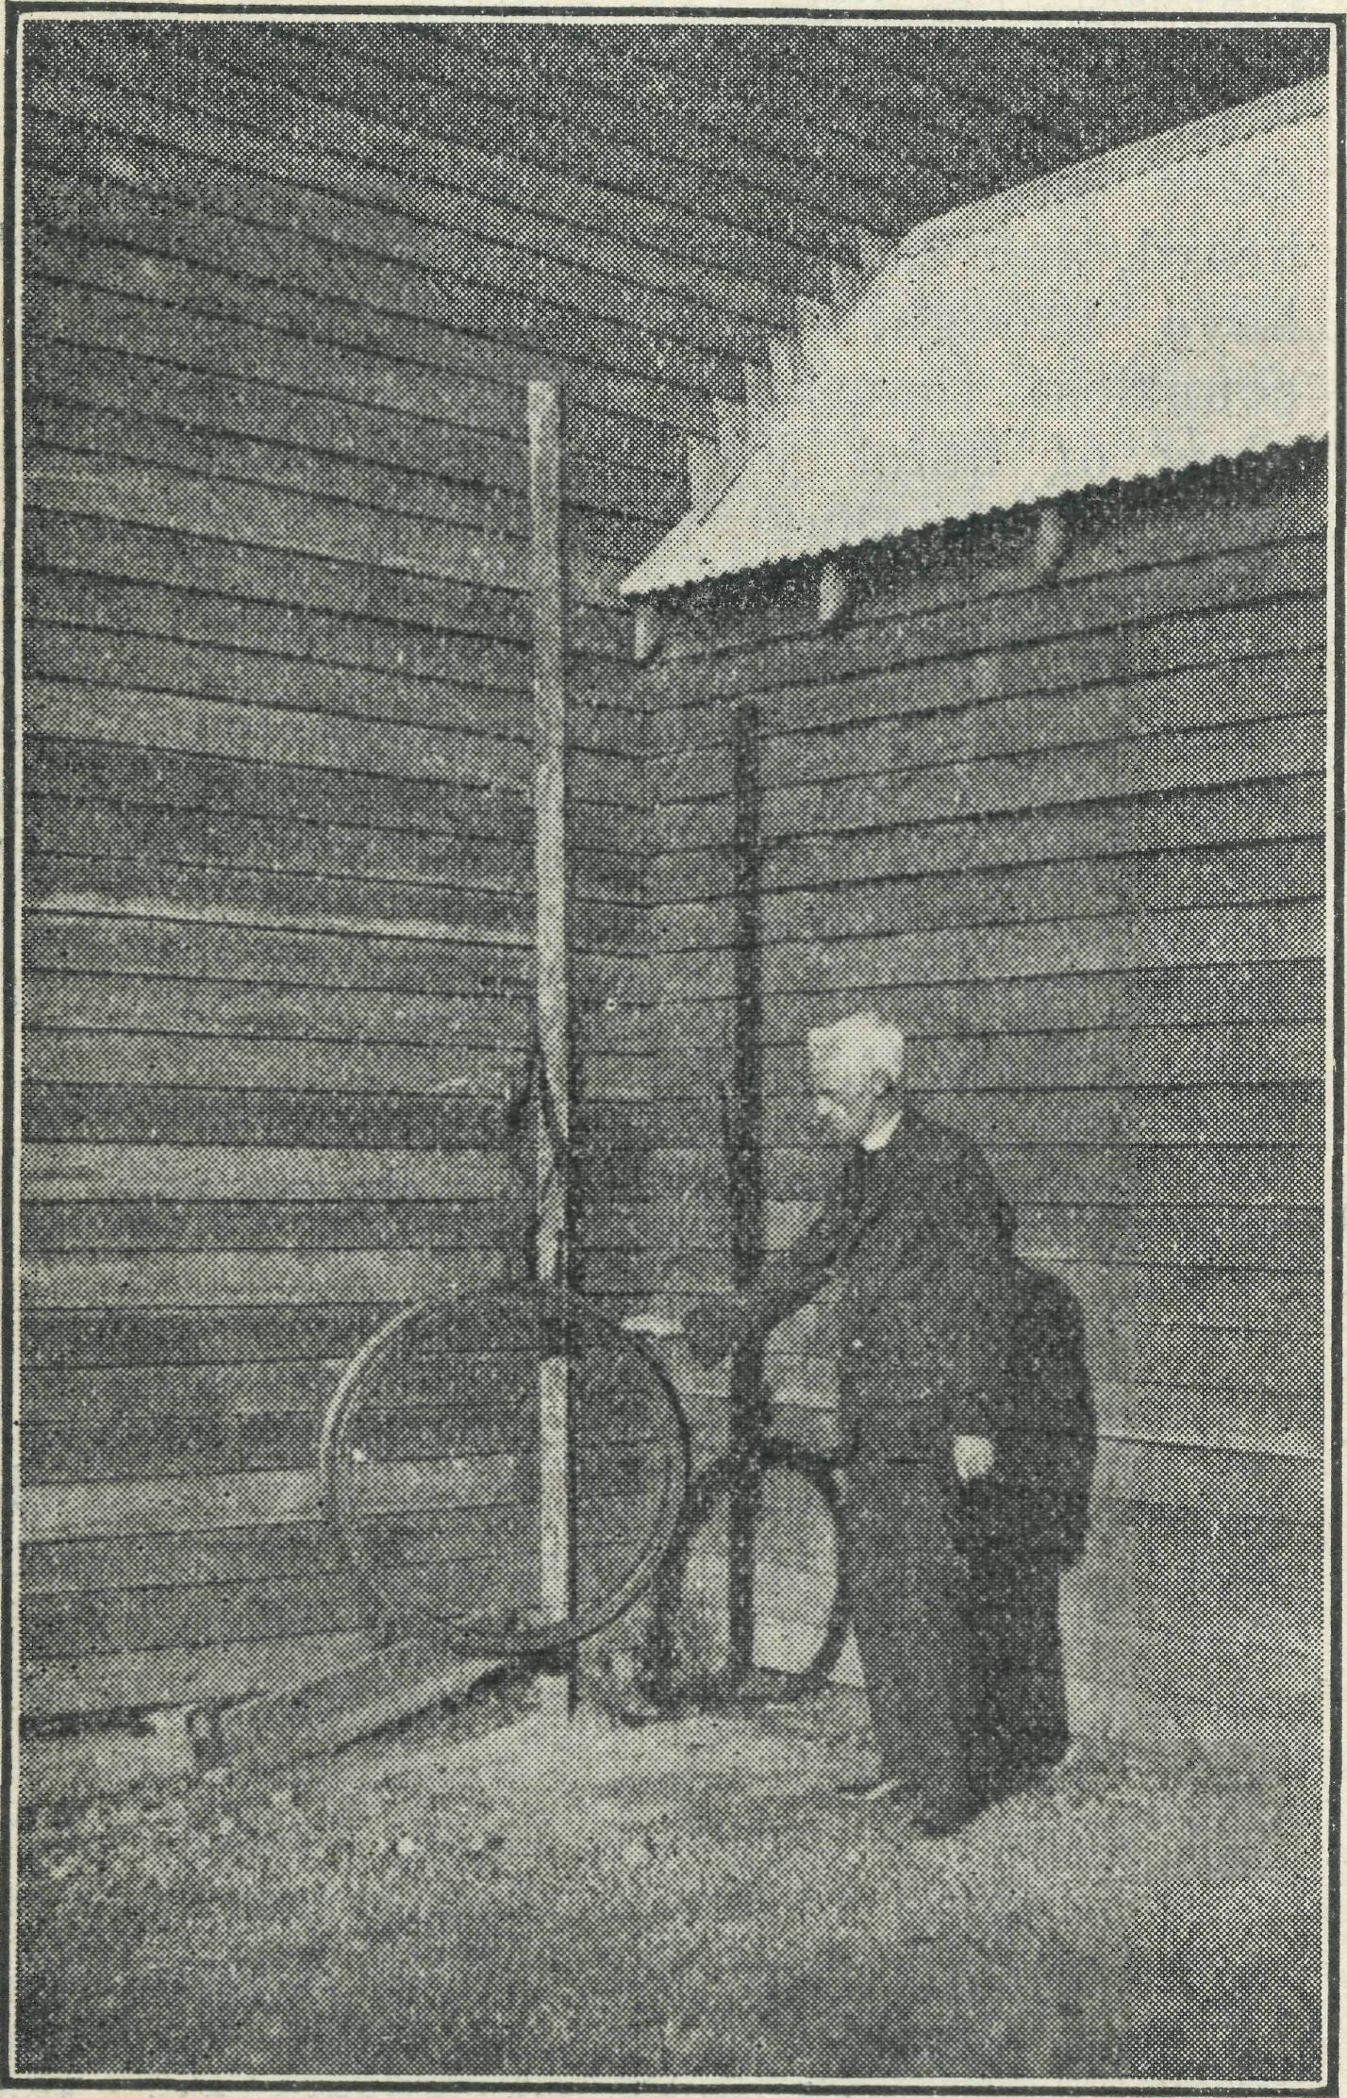
Denmark Church Bell.
You have been told about the work at Nornalup but there are just a few more places in this parish. In the first place, Denmark itself is quite a little parish. You would not be impressed, perhaps, with an outside glance at the little church of St. Leonard, but is is quite nice when you 3nter. Just lately we have had a
new fence put up and people have been busy making new paths. When the Bishop comes in June for Confirmation, we know he will be pleased to see the improvements.
Our bell is rather unique. It is just a wheel from a railway truck, suspended a short distance from the ground—we hit it with a hammer and you would be surprised at the tone. We have heard far worse bells in respectable suburban parishes. A protograph of the bell is being sent to the editor. If space can be found, you will be interested to see it.
Easter time was a happy time in the little parish church. A splendid number of communicants and a great crowd at the evening service. Last year the church was closed and as it is two years since an ordained man was stationed at Denmark, you can imagine what it meant to the faithful to have their Easter celebrations again.
We have a small debt on the Rectory and in April we had' an effort to reduce this. Nothing so ordinary as a sale of work, but a "Rose Fete." It was organised by our Women's Guild, which is a really live body and in spite of the hard times we made nearly £40. Soon, we hope, our parish will be free of debt.
Our Sunday School is going well and my wife has over 30 little ones in the Kindergarten.
Denmark is the centre of what is known as the "Group System'' and all around it groups 107, 111, and so on. These groups consist mostly of people from England who have been brought out and placed on the land. Owing to the depression and the low prices received for produce, many of them have had a very hard struggle. Dairying of course, is the chief industry but owing to the low prices during the last few months, the great majority have been getting very little return. The old saying is true : "One half of the world doesn't know how the other half is living," and people who live in the cities do not always realise the hard struggle of the people in the country. Did' you know the price of butter has gone up f Well, if you are paying a little more, don't complain, because you won't have our sympathy, for it means much to the people in the country. No, we haven't taken up a Group block, and we don't own any cows, but we work amongst the people and when the struggle for existence is lightened and people are happier, so the opportunity for spiritual work increases. All this may sound very material but true nevertheless.
There are fifteen Groups in the Denmark district and each one has a school. We have to cover about 250 spuare miles of roads in the parishes. It may not seem much compared with distances "outback" but it must be remembered that there are homes tucked away everywhere, and reaching all the people is the great difficulty.
Fortunately the main roads are good, but many of the tracks into the homes are difficult to negotiate. However, when we do get to the homes we get a warm welcome which compensates for the rough track. The sad Dart of the work is that
when you visit a home, say, 30 miles away, the people say, "Do come again soon,'' but you know quite well that if you do your duty and visit all the people, it will be many a long day before you can re-visit that home. Denmark's great need is for another man—a young, energetic one, who is not afraid of hard work. Perhaps the day will come when someone will be prepared to make some sacrifice and come.
Reaching the children is perhaps the most important part of the work. Half-an-hour once a month in the school is very little, so we are trying to solve the problem in this way. Every place where we hold a service, we go earlier and conduct a Sunday School. Last Sunday morning we went 25 miles to Group 105, Arrived at 10.15 am., held the S.S., and service at 11 a..m. Next Sunday, off to Group 92, 10 miles away and do the same thing. In two places the services are at night, this makes no difference to the children in the bush, they came along. In this way we are establishing a number of little Sunday Schools over the parish. We use the O.S.S.M. choruses a great deal. These are quite new to most of the children, who love them. Their eyes just sparkle when they sing the ones with action. If you should feel a slight earth-tremor you will know that it is probably the children in Denmark, W.A., singing "You need not fear the storm nor the earthquake shock," with actions.
Well, cheerio, all B.C.A. friends and workers. We hope this little account of our work will be interesting. Wc are quite a respectable country parish and don't have very many really exciting adventures. We just keep plodding along, trying to re-build the Kingdom of God in this part of His Vineyard
THE TAR WEST MISSION. CEDUNA.
Rev. G-. C. Woolf.
We have just received some delightful booklets, typewritten, with hand painted covers entitled, "Little Prayers for Little People." They were sent to us by Deaconess Currie, of Strathfield, N.S.W., and are work of one, the Deaconess tells us, who in the midst of a busy life, for she has to* work hard to keep her family, made the time to compile these delightful booklets. We were very glad' to receive them, and will find them of great use.
Preparation for Confirmation has kept one very busy over a period of months. It has been the aim to give regular weekly instruction to as many candidates as possible, and this was accomplished in thirty-three candidates. This meant that the car, not mentioning the writer, was hard put to it at times. Even in the heat waves of February and March we had to travel long distances in the blistering heat with the thermometer bubbling round about 120 in the shade, to meet the candidates. If we had only a little bit of shade it would have been almost bearable. At Nunji-kompita the classes were often held in the little school, and the rapt attention and earnestness of the candidates were a great reward as one unfolded to them "the

June 14, 1934
THE REAL AUSTRALIAN.

things pertaining to the Kingdom of God."
The time for the Confirmation of this particular group of candidates came on 8th May. I had to travel to Streaky Bay, 78 miles away to meet the Bishop. He arrived' at 5 o'clock in the afternoon, and after refreshments, we set out for Carawa, 40 miles from Streaky Bay, for the Confirmation Service. The day had been far from pleasant from the weather point of view. An unseasonably warm, fierce wind managed to gather up (it seemed to us) all the spare dust and sand on the West Coast and fling it in our faces." We were rather glad that conditions had reverted to normal for the journey to Carawa
Fourteen candidates were presented to the Bishop at this centre, each one fully conscious of the redemption wrought in them by God through Jesus Christ, and each one eagerly expecting the Gift of the Holy Spirit, who would come to them in a fuller and richer sense than ever before.
The visit or our Bishop, the Bishop of Willochra; and Confirmations were indeed an encouragement and inspiration to all of us. Besides these Confirmation Services, the Bishop dedicated the new Church furniture at Laura Bay.
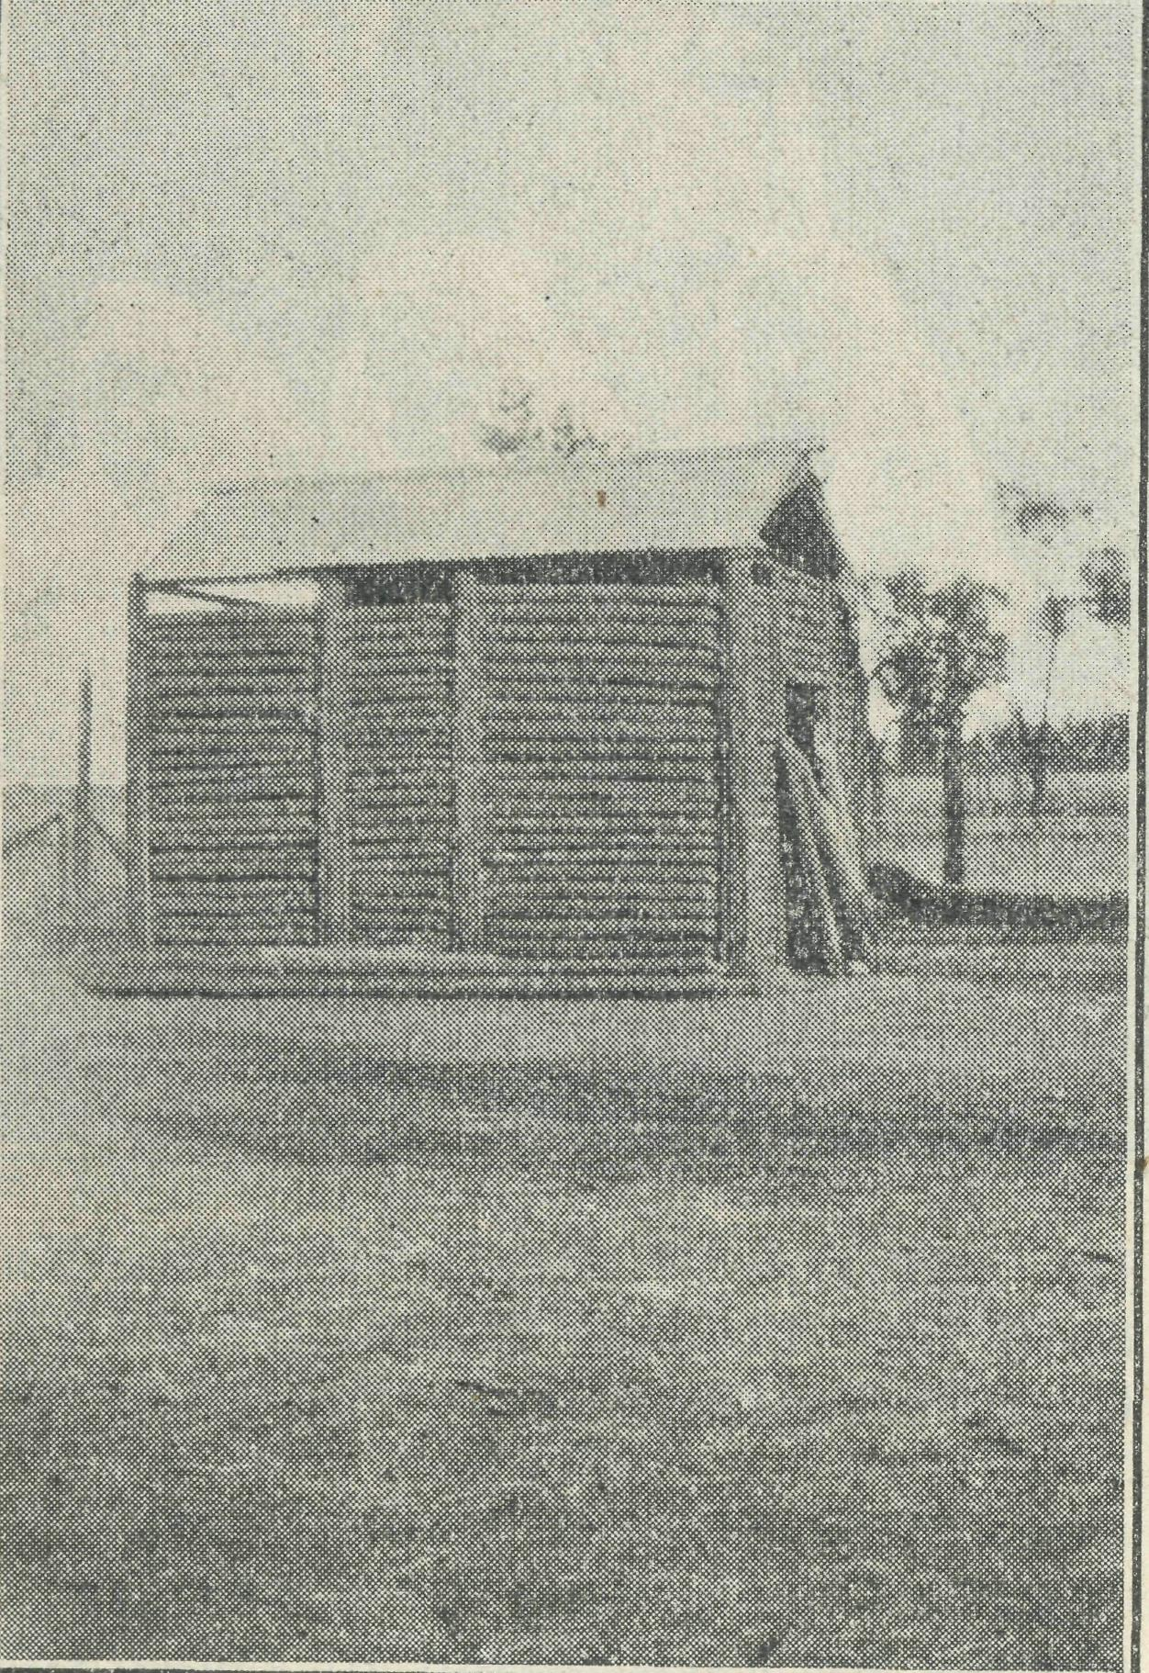
This log hut now houses the Sunday School at Werrimull South (Victoria). The parents and their children gather for Divine Service in the school near-by, and at the close of the prayers, the children are taken by vheir teachers to the log hut, where the Sunday School is conducted.
Readers may remember that at this centre, services were held on the beach under all sorts of conditions. Through the generosity of the Bishop's Home Mission Society in Adelaide, which gave us £20, and the Colonial and Continental Church Society, which donated a further £60, as well as soft furnishings and linen, added to the amount of £15 collected locally, the purchase and furnishing of a Church Hall were made possible. The
local people have expended a great deal of labour and time in placing the Hall in position, all glad that the rough conditions which accompanied the worship on the beach are now at an end. No more will they need to endure the icy blasts which were the accompaniment of winter months ; no more will they need to watch the tide lest it should come in before the service was ever ; no more will the linen and vessels be blown off the petrol case, which, on occasions, had to serve as a Holy Table; but all things now can be done decently and in order, for which our hearts arc filled with gratitude.
PENOISTG, S.A. Jehovah Jireli.
Many years have elapsed since Hudson Taylor went out to China with just £10 and all the promises of God. The history of the China Inland Mission has proved and is proving daily that, however sterling values may fluctuate, God is never less faithful than His word. "My God shall supply all your need/' should burn deeply into every Christian heart as the promise which enables. The God who supplied the needs—spiritual and material —of that great man of faith and the Holy Ghost, are no more likely to fail than before.
The one thing which would appear more than any to be a hardship to a mis-sioner in the field is the lack of opportunity for real Christian fellowship. Bible Classes, Prayer Meetings, Conventions and C.S.S.M. "Squashes" are blessed and hallowed memories of the past. There are numerous difficulties in the work but, with the exception of such as is common to all Christian work, these are small in comparison. Perhaps nothing save his own sin distresses a Christian more than hardness of the heart of the natural man, the coldness and indifference to the Lord Jesus Christ, the blindness to sin and to the beauty of the altogether lovely One, but even here the city shows at least one apparent advantage. The matter can at least be brought before the Throne of Grace by two or three gathered in the Name of Christ Jesus,
Recent letters from the saints in Sydney speak much of the spiritual feasts at home. May God's Name be praised for the real man of His own heart He has sent in Archbishop Mowll—one who glories in the Cross of Calvary and preaches Christ crucified. They tell too of Bishop Taylor Smith, well-known as the President of the Scripture Union and a soul winner. Surely the B.C.A. missionaries are the losers while they are so unable to enjoy such opportunities for spiritual refreshment and strengthening. The Seal of the Holy Spirit has indeed been upon the Christian activities in Sydney of late, and there comes the desire to be in the midst of it.
Man walks much by sight and little by faith. Has not God promised that 'ail things work together for good' to them that love Him' ? The following little incident which is one—though the greatest —of the many ' all things' which have been turned into a source of blessing for many souls.
Both the hospital Sisters and the Mis-
sioner and his wife were newcomers to
the district, though the Sister had pre
ceded the latter by a few weeks. The
absence of patients at the hospital made
life there rather lonely and the fact that
the beloved in the Lord were far away,
was felt by all. A traveller who was
passing through with his wife contracted
pleurisy and was confined to hospital.
They proved to be two who had set their
faces Zionwards and though their stay was
not unaccompanied by danger, the B.C.A.
staff have had much cause to be deeply
grateful to God. The little Bible read
ings and seasons of prayer, the simple
and effective talk in the Sunday School,
the solos sung by a voice consecrated to
the Lord's Service will live in many
hearts. Nor was that all. Lost sinners
were converted by the Holy Spirit
through His two servants and the glorious
light of the Gospel has shined into more
than^ one heart. The Far West
Mission has profited in no uncertain way by this gracious fulfilment of what had seemed to be our greatest need.
There is an optimism in the world which is simply _{a} refusal to face facts. It was not this which inspired Abraham and Paul, Muller and Hudson Taylor, but the realisation given to every precious blood-bought child of God, that whether there be fightings without or fears within, tribulation or distress or persecution or famine of nakedness or peril or sword, God is faithful and God will provide.
H.E.S.
MAIL BAG- SUNDAY SCHOOL.
On Saturday afternoon, 22nd inst., the
teachers of the two upper Grades of our
Mail Bag Sunday School held their
Quarterly gathering, through the kindness
of Mrs. Bates, at her home in Shirley
Eoad, Wollstonecraft. Unfortunately,
our Organising Missioner, Eev. T_{c} Terry, was unable to be present, so Eev. W. Ger-rard, of Pennant Hills, who with Mrs. Gerrard, is an ardent helper in our Mail Bag work, opened the meeting with prayer. With the exception of about five of our twenty or so teachers, all were present, including Mrs.. James, who has just returned from a twelve months' trip abroad.
A very happy afternoon was spent, when the work generally was discussed, and suggestions put forward for its advancement.
Amongst other things, ways and means were considered of raising funds for prizes for this year's work. Thanks to the generosity mostly of friends of our teachers, some of whom subscribed regularly during last year towards our prize fund, we were afcle during last quarter to send out a fine lot of prizes to the Upper grade children, and when it is realised that about one third of the children who sent in answers and handwork during last year sent it in for every Sunday of the year, we think all will recognise that some little recognition had been well earned. This percentage we consider remarkable, and as we have said before, it

THE HEAL AUSTRALIAN.
June 14, 1934.

speaks volumes for the work of the teachers and the interest of the parents.
We were particularly pleased that so many of the children, all of whom were given their choice, chose Bibles and Prayer Books for their prizes.
Our little "Penny Bag" Idea.
At the beginning of the year a small coloured bag was sent to each family, with a note to the children, suggesting they should put a penny in the bag each Sunday where practicable, to help towards the expenses of the Mail Bag work, and so make it possible to extend the work, much the same as Sunday School children take their pennies to school on Sunday. The idea has met with great approval, and is beginning to bear fruit. One of our boys sent in 1/6 earned by trapping rabbits. And he hoped to send more, he said.
We might say that, owing to the Rector of one of our out-back parishes having asked for 70 sets of our papers to be sent to him—through which he expects to get in touch with about 200 children with no opportunity of Sunday School teaching— last month we sent out about 730 sets'of our upper grades paper, which speaks well for the contiued progress of the work.
A meeting of the Mail Bag Primary Teachers took place in the Church House, on 21st May. Twenty teachers were present and Deaconess Dorothy Harris addressed the gathering, giving the events of a typical day's visitation amongst farms and in mining centres. An instructive evening was greatly helped by the playing of two of the lessons sent to the Mail Bag children. Both stories were played without the addition of any "properties,' ' the story of Dorcas first having been told to the teachers by Miss Mann, while that of Joseph was played from the teachers' own knowledge of the story. Such experience, in the happy atmosphere of a meeting of teachers helps them to appreciate the value of "playing" in presenting Bible stories to the minds of children. Those who read with interest the doings of our Mail Bag Sunday School will realise the painstaking care which the teachers manifest in the preparation of all their lessons.
Will any girls and boys from "outback" who like to receive letters from girls and boys in the city, please tell their teachers when they send in their lessons, and give their name, age and address. Quite a number of girls and boys in the city have expressed the wish to make "pen friends" in the country.
One of the Mail Bag Sunday School teachers writes :—One gets inspiration from children every time ! A delightful letter from one of the bush girls of eleven years. "Mother has a new baby. I am minding him and looking after the other children (4 or 5 says the teacher). Am sorry, but I cannot do my papers this month—no time, but next month I hope to send them."
What a spirit of splendid service, writes the teacher, "a little child shall lead them." And then at the end of the child's letter, "Can you let me have the
names of some "pen children,'' I would like to write to them." Can you not picture the little mother (the teacher writes) —the worker—the unselfish % Who shall say that the spirit of the Master is not among His own in the Bush !
KOOKABXJEKA BIRTHDAY CLUB.
Dear Kookaburras,
While on the way "out-back" recently, I had a very happy experience. Out in the country in Victoria my friends and I had climbed to the top of a very high hill. While we were enjoying the view, we saw a woman come out of a lonely cottage which was standing right on the edge of a deep gully. She went over to a big gum tree and sat on the ground some distance from the tree and began to talk. We watched her, wondering what she could be doing, when suddenly a Kookaburra flew out of the tree and seated itself on the ground at the woman's feet. The woman kept on calling quietly, until no less than eight Kookaburras had come to her, one was on each of her shoulders, one on each knee, and four others on the ground beside her, and there she fed them, giving each one in turn its food, checking them when they tried to push or snatch, and talking to them all the time just as a real friend, and we all felt that the Kookaburras understood her just as perfectly as she understood them. It was a marvellous sight to see these wild birds—amongst the freest of all our birds—so ready to respond to a kind human voice and a kind touch. And I have known other Kookaburras, wild and hard, and savage, who have been won and made useful, and joyous and free with a freedom which oaiy God's dear children can know, just by means of a kind word and a kind hand given to them. Now, Kookaburras, you will find many such as you live your life day by day, and I want you to try what the kind word and the friendly hand can do. I don't think you will ever fail to reach them, for there is something down in the depths of the human heart which always answers to a kind word, or a kind deed. It is worth trying. So try it ! Yours affectionately, THE OLD KOOKABUBBA.
SOME OF OUR NEEDS.
Can any of our friends help us by supplying any of the following :— A. and M. Hymn Books and Prayer Books
combined or separate. We need a good
number of both. New Bibles for members of our Sunday
School. A Typewriter new or old, provided it is
capable of hard work. A Small Portable Harmonium for use in
Werrimull Parish.
A most urgent need is that of a new Duplicator for producing Mail Bag Sunday School lessons. Our workers are greatly handicapped by the old machine which is wasteful of time and material. We shall be grateful if our friends will arrange in their parishes Grocery After-
noons or Evenings. These are of untold value to our Hospitals and Hostels.
It will be greatly appreciated if Women's Guilds will arrange for a visit from Miss Vaughan Jenkins or our Deaconess for the purpose of placing before them the appeal of Women's Work.
To those who wish to hear of a fine Private Hospital or Rest Home, we can confidently recommend "Tuerong," Campbell St., Eastwood, N.S.W., conducted by Sister Harvey, A.T.N.A. (General and Obstetric). 'Phone : Epping 1034.
CEDUNA-THEVEKARD HOSPITAL.
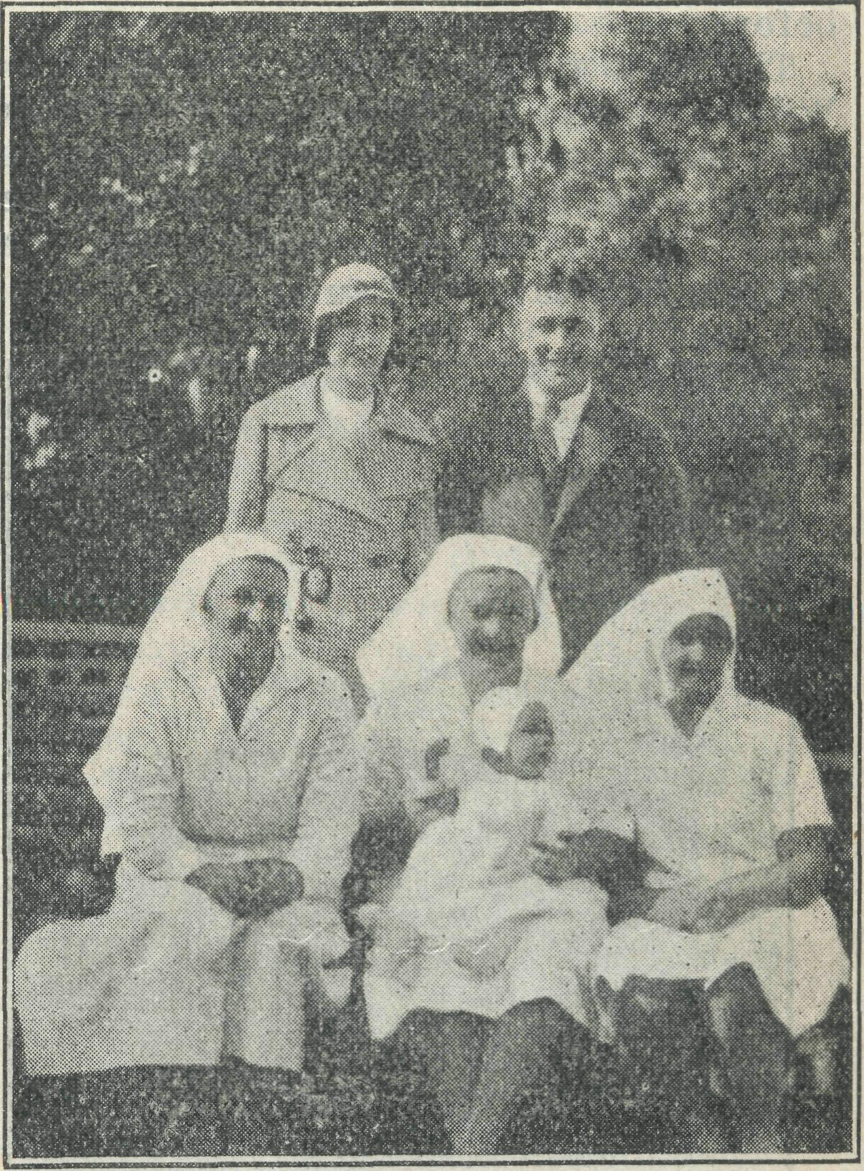
Dr. and Mrs. E. Gibson and the Nursing
Staff of Ceduna Hospital, with Baby
George Gibson. Mrs. Gibson is also a
doctor.
As we look back over the last three months we have reason to thank God for all His goodness towards us. We have been able to keep going in spite of the bad times which the farmers and everyone in general are passing through, and all at present are anxiously looking for rain to save this season's crops.
We have been comfortably busy in the hospital and have had some very interesting cases. In one case the woman had to travel 80 miles over abominable roads before reaching here. The ease was an abnormality, occurring about 1-1000, with a high mortality rate, but owing to the skill of our doctor, a bonnie baby boy was born safely and neither mother nor babe suffered any ill consequences.
One dear old soul of 74 years of age was brought into hospital in a serious condition and had an immediate operation.

June 14, 1934.
THE REAL AUSTRALIAN.

Her first two weeks in bed were during a terrific heat wave, the temperature never dropping below 100 degrees. In spite of all this the old warrior never complained, and after three weeks with us left us as hale and hearty as we could wish. One cannot but admire the sterling qualities of such women. Their lives on the farms are anything but enviable and when one sees the houses that stand for home, it makes one realise that city folk with all the comforts of home life, could never fully appreciate the sacrifices made by these women who have come out to settle in out-back areas. It is a great joy to us to be able to minister to them, and the comforts bestowed are generally appreciated. Cases such as these do make one feel that the B.C.A., in providing hospitals in remote areas, is meeting a real need of the people.
We were favoured with a visit from the Melbourne Secretary, Rev. T. Jones, last February. Such visitors to the hospital are regarded as a real treat, and a blank is always felt after their departure. Visitors are always assured of a hearty welcome here.
During this month we have had' the pleasure of the company of Mr. and Mrs. Derbyshire of Port Lincoln. Mr. Derbyshire unfortunately was admitted as a patient, but this seeming misfortune God used as a great blessing to us all. Both are earnest Christians whose lives are spent in seeking souls for Jesus Christ, Mrs. Derbyshire is a keen Bible student, with a remarkable knowledge of the Scriptures and gave us many happy hours opening the Word of God to us. Our greatest joy was to see two of our staff surrender their hearts to Jesus Christ, both during a Bible talk at the meal table. The power of the Holy Spirit was truly manifested, and indeed it is a joy to know that now our entire staff has accepted Christ as Saviour and Friend. We thank God for the encouragement and help we have received and we continue with a greater desire to bring souls to Him.
One patient who is at present in hospital, was converted many years ago, but during the last few years became careless end has been living a godless life. By the reading of God's word and by prayer with her she has been brought back again to the Master.
It is going to be an uphill fight for her when she goes home and we do ask your earnest prayers for this woman. Her family and friends live for the world and we believe if she remains faithful to Him, a great work can be done in their midst.
F.D.
PENONG HOSPITAL.
When last I wrote to you through the '' Real Australian, ' ' it was from Croa-jingalong, that veritable fairyland of jungle and wild flow^{T}ers, of mountains and gullies, of tall timbers and wet seasons, and now by way of contrast, I would like to tell you something of the Far West Coast of South Australia.
On arriving in Adelaide I encountered one of the hottest days of the year, when
neither inside nor out was there a breath of fresh air; this heat continued until 11 a.m. the following day. A warm reception to S.A., was it not %
Saturday morning T left Adelaide by plane for Ceduna, some 500 miles, where I arrived in about four hours.
Ceduna, a small town on the coast, is somewhat compensated for its dust and dirt by a very nice beach.
At Ceduna, I enjoyed the hospitality of the Sisters at the B.C.A. Hospital and two days later I was collected by the Rev. A. H. Edwards and taken on to Penong by car. Many times on that journey of 45 miles, my thoughts wandered back to the beauties of Gippsland in comparison with what appeared to me then as an almost desert land of sand, mallee and rabbits. At last we arrived at Penong, which consists of one street with a . f ew shops, two churches, a police station, and scattered dwellings, and here also is the railway terminus, where once a week the train comes in carrying amongst other things, the mail. "Mail day" in Pencng is the business day of the week.
But I am anxious to set my eyes on the hospital, for I have been told it is something very nice, and so we leave the main street and around a clump of mallee, about a quarter of a mile from the town, in a picked spot stands the Penong Memorial Hospital, a building of which any city could be proud. Built mainly of stone and concrete with a 10 ft. verandah right round, and a hall 9 ft. wide from front to back of the. building, with men 's and women's wards, operating theatre very well equipped, Sisters' bedroom, dining room, office, maids' rooms, bathroom and kitchen and laundry, all adequately furnished' and mainly by the people of the district, each piece of furniture bearing a plate with the name of the donor.
I w^{T}as not long in Penong before I realised the place was not without its beauties, and that even out here God had not left Himself without witness. There ii no fern life, no forest, no trees, not even grass, but come with me to the east verandah a half hour before sunrise and watch the changing beauty of the sky as the sun gradually appears and one remembers the words of the 19th Psalm : "The Heavens declare the Glory of God."
As the sun fully appears, how wonderfully the Psalm continues to describe it, "Which is as the bridegroom coming out of his chamber, and' rejoiceth as a strong man to run a race."
Again in the late afternoon, come to the west verandah and watch something even more beautiful, if it were possible—the sun-set, with its ever changing colors above and beneath, miles of landscape with only an occasional mallee and grazing stock to be seen, until it sinks beyond the horizon.
The old moon, too, is not less beautiful by night than the sun of morning. How boundless are God's mercies that He should have set us about with so much that is beautiful.''
Then we think of God's provision for man in building material, no timber but stone in plenty. The stone houses are
a great protection from the heat and also baffle the white ants.
But with it all the people out here experience most difficult times such as they are going through now. Three years in succession of drought, then a mouse plague when almost thousands of acres of wheat were spoilt in the paddocks, and last year the price of wheat so low that it did not pay for the production and the prospects for this year are not encouraging as another dry season seems to be threatening.
These people out here are brave, to say the least of it, and, dear readers, they enjoy few of the comforts and luxuries which the people nearer the cities enjoy. Mail in many places comes only once a week, at the most twice, and only in the cooler months can vegetables be grown.
There are people who, when they had a good harvest, gave liberally towards the building of a hospital for their sick, but now it is impossible for them to maintain it without the assistance of the Bush Church Aid Society.
And so we urge our readers and their friends to make some sacrifice for their big hearted people by perhaps the giving up of a theatre party or picture show and by sending a donation to the B.C.A., to whom at the present time these people are looking to keep their doors open for them.
And now I would like to thank all those who have helped so generously by sending along supplies to the hospital. The groceries have been a splendid help and were used to great advantage.
H. E. SOWTER.
PERSONAL.
Miss M. Vaughan Jenkins, of Sydney, is about to leave on a comprehensive tour of B.C.A. centres, and especially of the camps along the Transcontinental Line, for the purpose cf ascertaining the needs of women and children in the more remote areas, and the possibility of establishing Nursing Centres amorigst them. Will B.C.A. friends pray for this venture of faith ?
The Right Reverond the President of the B.C.A. is absent on a much needed holiday and is greatly enjoying the rest from busy Diocesan and Parish work.
We are thankful to record the recovery of the Rev. A. L. Wade after his serious accident and pray that God will give him a full return of health for his many activities.
All B.C.A. friends join in a hearty welcome to Mr. E. V.' Panelli, who has kindly accepted the office of Hen. Treasurer for Victoria
Our warmest congratulations to Archdeacon W. L. Langley, of Sydney, on his preferment to the Archdeaconry of Cumberland.
The Rev. L. T. Lambert, formerly curate of St. Paul's, Wahroonga, is now installed as priest-in-charge of the West Darling Mission, and is settled at Wil-cannia, N.S.W.. Our prayers and best wishes will be with him in his tremendous parish.

THE REAL AUSTRALIAN.
June 14, 1934.

THE LUSTRELESS STONE.
lineup unpolished, dim and valueless, With little grace or beauty of its own,
We thought that few were anxious to possess 80 plain, unlovely, lustreless a stone.
The Master smiled, and bade me grasp the stone, 'Tillj 'neath the warmth and pressure of my hand, With all the rainbow's radiance it outshone The purest, loveliest jewel in the land. "This stone thou wast so ready to despise, Is called 'the sympathetic jewel\ and Its latent beauty, hidden from thine eyes, Wakes to the pressure of the human hand.
"And there are lives as dull and valueless,
Whose beauty is as hard to understand,
Which wake responsive to a touch, and
bless
The warmth and pressure of a human
hand.
"For human sympathy is from above, A light to make the darkest lives to shine, And beauty is the heart's response to love, The radiant reflex of the Love Divine." John Howard Cock.
AN APPRECIATION.
Mr. E. F. Derbyshire, of Port Lincoln, whites, "I feel under an obligation to the B.C.A. for the splendid services rendered during the past few weeks, through the medium of its hospitals in the Far West of this state. I became seriously ill and Sister Sowter of Penong was called in, and under her careful nursing T was enabled to make the journey to Ceduna for a medical examination. Here again the splendid care and efforts of the Sisters combined with the local Doctor's treatment brought about a quick recovery. I wish to emphasize the wonderful combination of physical and spiritual. It has been a source of great joy to mv wife and to myself to learn of the great work that is being done by the B.C.A. The vork of this Society has endeared itself to our hearts and we feel that the spirit which actuates the movement is in emulation of our Lord Jesus Christ Himself, Who went about doing good. We join with the workers of the B.C.A. in earnest prayers that God will own and bless their work."
Mrs. Heinrich, of Yorkes⁷ Peninsular, S.A., writes : "I have quite often thought of your good work at Penong, and it is only now that I realise what is meant by the Bush Church Aid work. I would just like to sav that I have not entered a hospital which has appealed to me more than the one at Penong. Apart from being helped in sickness. I feel that patients can be helped spirituallv as well."
HAVE YOU PAID UP ?
Once again we make record of "Real Australian" subscriptions received. To all we are grateful There are still some of our readers who fail to find cur little subscription remidner. May we ask for prompt attention ? Eighteenpence a year is the amount. Please send stamps or
postal notes to our Office. The address is on the front page of this issue. Thank you !
We acknowledge with gratitude the following subscriptions received during the past three months :—Mrs. J. W. Melville, Miss Johnson, Miss M. Taylor,P. Goulding, Miss M. Chambers^ Miss M. E. Cabrera, Miss Schleicher, Mrs Wilson, Mrs. F. M. Thomas, Miss A. Marks, Miss D. Smith, Miss A. L. Toye, Miss G. Symons, Miss E. Downey, Mrs, W. Dunster, Miss K. Allen, Miss J. Johnstone. Mrs. H. Thomas, Miss
E. Hemsley, J. Hill, Miss D. Vanderfield,
Mrs. A. M. Nicholas^ Mr. McDonald, Mrs.
L. Crawford, Miss Kendall, A. D. Johnson,
G. Dunstan, Miss N. Starkey, Miss A. R.
Hogg, Miss Lambert, Mrs. Todhunter, Rev.
F. Wilde, Mrs. Armstrcng, Mrs. Shearman,
Miss M. M. Rouse, Mrs. R. A.. Spring, A.
J. Jeffery, Mrs. J. Grant, Mrs. Berry, Miss
M. Harman, Mrs. Mettam, Rev. H, G. S.
Begbie, Mrs. A. Smith. Mrs. Kilby, Mrs.
T. F. Wade, Miss J. Motta, Miss M. Har
per, Miss Grace Mills, Mrs. Dim en t, Mrs.
Palmer, Mrs. H. Ellis, Mrs. E. Richards,
R. Hennikei'j Mrs. Doalman, Mrs. J.
Palmer, F. 0. Powys, Mrs. East, Miss
Kemmis, M. K. Faram, Mrs. F. B. Mul
lens, Miss A. Carter, Miss E. Vaughan,
Miss A. D. Walker, Mrs. J. A. McElroy,
L. M. Phair, Mrs. W. J. Miller, Miss Ruth
Hargrave, Rev, R. A. Pollard, J. H. Jaques,
Mrs. H. Walker^ Mrs. Luckie, Mrs. J Rob
ertson, Miss Ruth Hargrave, Mrs. R. Trem-
bearth, Miss L. Brown, Mrs. W. Beattie,
Sister U. Selby, T. W. Beavan, Mrs.
Simons, Miss Lowe, Rev. L. T. Lambert,
E. H. Lack, J. Carlton, R. E. Furnell. Miss
E. D. Nash, Mrs. J. L. Affleck, Mrs J.
Shaw, Mrs. J. Duncan, Mrs. E. A. Lovell,
Rev. A. H. Edwards, Rev. A. E Hodgson,
Miss G. Grieve, Mrs. McAuliffe, Miss 0.
Spies, Miss Clent, Mrs. B. B. O'Connor,
Mrs. J. A. Turner, Miss E. Kemp, Miss
Shekleton, Mrs. Shekleton, Miss Clode,
Miss Olds, E. F. Derbyshire, Mrs. R, Harris,
Miss C. Begbie, Mrs. L. Richardson, Mrs.
A. M. Hale,¹ Miss A.limn, Miss C. Forrest,
Mrs. Moir, G. Savage, Miss Edwards, Mrs.
E. Pretyman, Rev. J. H. Willcoxson, Miss
M. C. Luscombe, Mrs. Dennis, Mrs. J. C
Rogers, H. Mann? Rev. B. Lousada, Miss
Crae, Mrs. Flude, Mrs. Griffiths, Mrs.
night, Miss Uebergang, Mrs. Rumble, I.
Boddy, H. Ward, L. 0. Rogers, Miss Oel-
rich, R. Clarke Miss E. Martyr, J. Mc
Crae, Mrs. Flude, Mrs. "Griffiths, Mrs.
B. Pell, Miss C. M. Locke, Miss Gason,
Miss Ivnowling, Mis A. J. Watts, Mrs. F.
Gillam, Miss Walch, Miss Dowling, Mrs.
Price, Mrs. Chilham, Mrs. Dougherty, Miss
E. Rowe, Mr. .A. J. Graham, Miss R. M.
Watt, Miss E. Mann, Mrs. Bishop, Mrs. T.
Poole, Miss E. Hooley, Jean Watson, H.
W. Fitzmaurice, Mrs. Hellick. Mrs. L.
Panelli, B. Friend, Miss Christie, Miss
Ridgway, Miss E. Neath, Mrs, Romanis,
Mrs. M. Andrews, Mrs. Read, Mrs. Brown,
Miss E. A. Scott. Mrs, Moog, Rev. Canon
Batten, Mrs G. F. Evans.
We acknowledge with gratitude the following donations and gifts :—Anonymous C Central Concord Postmark) 13/-;' St. John's Sunday School. Beecroft, (per Mr. E. H. Lack) £5; Handed in at Svdney Office (Receipt No. 584) £5; "Unworthy" £1; "Anonymous friend" (St. Alban's Five Dock) 10/- and £1; "Thank-offering
for the spreading of the Gospel" 5/-.
Per Rev. S. G. Stewart, eight pairs hand knitted socks: from Miss Cabrera (Thirl-merc) Text cards, magazines and papers; from Beecroft School of Arts (per Mr. T. Skellet) boxes of library books; from Mrs. Bohle (Eastwood) an organ; papers from St. John's, Rockdale; books from the Misses Watknu (Parramatta); Gramophones from Mrs. Johnson (Chiswick) and Miss Dorothy A. Smith ; Gramophones and Records from Miss Ruth Hargraves, Blaxland.
Thank you !
THE PLACE OF PRAYER.
Pray for—
The Missions of the B.C.A. in various parts of Australia, especially remembering the workers who indeed belong to the household of faith.
Pray for—
The Aeroplane Mission, that the Missioner be kept in his difficult and daring work.
Pray for—
The extension of this work through the in' troduction of a second 'plane, that the Council may be rightly guided in its loca' tion and staffing.
Pray for—
B.C.A. Hospital work in the Far Country, where patients must* be received in spite of their inability to make any return for ser' vice. Pray that God's good cheer be with the Sisters at*d their helpers. Remember the nursing work at Croajingalong and its difficulties.
Pray for—
The B.C.A. Children's Hostels at Wilcan-nia and Mungindi, that the work be in' creased of God, and that we persevere knowing that such ministry to little ones cannot be in vain in the Lord.
Pray for—
The Sisters' Mission Van in it; itinerations in unlikely and out'of'the'way places ; also for the Sunday School by Post with its Gospel message for little children.
Pray for—
All Students, Deaconesses, and Nurses in training and preparation for B.C.A. work in the Bush, that they may be equipped with power, wisdom, and zeal, and become "able ministers of the New Covenant." Also re' member the Council, Committees, Women's Auxiliary, and workers on the Home Base staff.
Pray for—
The new Organizing Missioner, that he find encouraging welcome as he undertakes his work.
Pray for—
A spirit of thankful giving to be upon all B.C.A. friends, that the Society be kept out of all God'dishonouring debt.
Forget not to give thanks—
For kindly givers who have helped us with
their self-denials. For friends, known and unknown, who have rallied at our call to keep our min' istries going. For cheering reports from fields that God's
Word is still with power. For offers of service for the filling of pend' ing vacancies in our work.
VT,₀i1_{y} _{set} _{up} _{anc}j printed in Australia, by D. S. Ford, 44'50 Reservoir Street, Sydney.

