Registered at the General Post Office, Sydney, for transmission by post as a periodical.
"AUSTRALIA FOR CHRIST."
The Real Australian
Organ of the Bush Church Aid Society for Australia and Tasmania.

No. 55.
DECEMBER 30, 1934.
1/6 per annum (post free).

THE BUSH CHURCH AID SOCIETY OF AUSTRALIA AND TASMANIA.

Warmest Thanks!
| TO ALL WHO GAVE SO SPLENDIDLY TO OUR CHRISTMAS APPEAL. §
| Greetings! j
I TO ALL OUR GOOD FRIENDS FOR THE COMING DAYS. §
Pray for us!
Headquarters Office :
Diocesan Church House, St. Andrew's
Cathedral, George Street, Sydney.
(Telephone : M-3164.)
Cable Address : "Chaplaincy, Sydney."
Victorian Office :
St. Paul's Cathedral Buildings, Flinders Lane, Melbourne.
President: The Right Reverend Bishop KIRKBY.
Hon. Clerical Secretary : Ven. Archdeacon W. L. LANGLEY.
Hon. Treasurer : T. S. HOLT, Esq.
Victorian Hon. Treasurer : E. V. PAN-ELLI, Esq.
South Australian Hon. Secretary: Rev. R. H. FULFORD, Holy Trinity Rectory, Adelaide.
Organising Missioner of B.C.A. :
Victorian Deputation Secretary : Rev. T. JONES, Th.L., St. Paul's Cathedral, Melbourne. (Tel. : F-5675.)
A REAL, NEED.
From time to time we receive urgent appeals for good secend-hand clothing, especially for the Victorian Mallee. We would be glad if our friends will send to the Victorian Office any garments that they may be able to spare.
We specially need boys' clothing— trousers, shirts, and sox—and we ask that they be clean and in good condition. Thank you!
My dear B.C.A. Friends,
It is with real pleasure that I avail myself of the kind offer that I should write this letter to you, although having severed my official connection with B.C.A. work. It is a genuine hardship for me to give up a work which always has meant so much to me. Before closing this brief letter, however, I do urge you all, with deepest feeling, to join in the venture of faith which this work supplies by generous service and by more systematic giving. In the fifteen years of this Society's life national circumstances have undergone a remarkable change, but the needs of our inland kinsfolk have known no change except for the worse, and we must try to realise
our privileges by seeing that their needs are met. It would be, indeed, a lasting dishonour to allow this work to suffer because of apathy on the part of Christian people, but, unless fifteen years represent the completed sum of B.C.A. activities in our continent, Christian people will need their enthusiasm stirred. Since the year 1907 I have spent many years in country work of various types, and in every State in Australia, and my knowledge and experience have increased by association with the sturdy, big-hearted independent folk in the inland. Their point of view is always of value, and their contribution to the nation's life is made very often in the throes of suffering and hardship of which the city knows nothing. The grasshopper plague In New South Wales and the disastrous floods in Victoria are but incidents to us, but to the country dweller they are his daily portion, and yet too often in church life as well as in commercial life the country "has no voice to sing its song."
I offer you all my sincere thanks for so many tokens of friendship and for loyalty in difficult days, and plead for the continuance of your help in friendship for B.C.A. in the days to come.
With warmest wishes for a happy Christmastide and New Year,
Yours in B.C.A. bonds.
T. TERRY.
My dear Friends,
It is with some regret that I write you through medium of our "Real Australian" that our Organising Missioner, the Rev. Thomas Terry, was compelled some three months ago to resign from his post. His health was becoming impaired, and a quieter sphere of ministry was really necessary. The B.C.A. Council felt that the seriousness of the case had to be faced, hence the action which both they and Mr. Terry felt had to be taken.
The goodwill of the entire Council and all the friends and supporters of the B.C.A. are tendered to him, together With appreciation of his most useful ministry that he gave to the organisation. The bright and sparkling personality of Mr. Terry's has not been without its happy results among our workers, both in the field and in the home base, and his presentation of the B.C.A. call in the various parishes has met with very worthy result. It will not be easy to find a successor prepared to do the work which he so splendidly has done.
I, for one, am glad to intimate that as soon as Mr. Terry was relieved from his exacting duties by the Council some three months or more ago, and was enabled to take a badly needed rest, his health generally improved. All B.C.A. will rejoice to hear this concerning such a worker.

THE REAL AUSTRALIAN.
December 30, 1934.

His Grace the Archbishop of Sydney has now nominated him to the historic Parish of Prospect and Seven Hills. In that rural area his recovery will be completed.
The added good wishes of the B.G.A. are given to him on account of his marriage just a week or so ago. Together with Rev. Canon Begbie, of St. Andrew's Cathedral, I had the pleasure of joining in the happy ceremony at old St. Philip's Church, Church Hill. It was nice to give the blessing of the B.C.A. to our friend and to his charming bride.
With all good wishes to you all for the New Year,
Yours sincerely,
S. J. KIRKBY,
President.
MELBOURNE NOTES.
Heidelberg Garden Party.
The annual Heidelberg Garden Party was to have been held this year in the home of Miss Chambers, but as October 11 was a very wet day the function was transferred to St. John's Parish Hall.
Despite the inclement weather, quite a good number of supporters attended and found a goodly array of work and cakes awaiting them, as well as a collection of "antiques" on the "I. Cohen" stall.
The Rev. W. T. C. Storrs presided, and offered a welcome to the Rev. W. I. Fleming, who spoke to those present on various aspects of B.C.A. work and needs.
As a result of the afternoon, the sum of £28/12/6 was sent in to B.C.A. funds. This year we missed the face of our very old friend, Mrs. Price. In the very early days of B.C.A., Mrs. Price began her annual effort for the Society. As the years went by she gathered around her a band of friends, who helped her to make the Annual Garden Party the success it has always been. This year she passed on to her rest just a few weeks before the effort was to be held, but remembering the work even in her illness, she asked that the effort be held as usual this year. We have very fragrant memories of our late friend, and will always look upon the annual effort at Heidelberg as her memorial.
Ladies' Auxiliary.
On November 13th, Mrs. L. J. Adam held an Australian Tea in the Fellowship Room of C.M.S. Heavy rain fell for most of the day, but despite this quite a large number attended.
Archdeacon and Mrs. Langley of Sydney were present, and spoke of B.C.A. work. The Rev. T. Gee, B.C.A. Mis-sioner at Merrimull, and Rev. W. I. Fleming also spoke.
The afternoon resulted in some £8
being added to the Auxiliary funds, and
Mr. and Mrs. Adam donated a flour bin
and aluminium teapot for Penong
Hospital. !
During October, Mrs. Goodwin of the Central Ladies' Auxiliary, held an afternoon at her home, at which Mrs. A. Langley, President of the Auxiliary, spoke of the Auxiliary's work. Some
thirty towels were given for hospital use as a result.
St. Thomas', Essendon.
That indefatigable Secretary, Miss I. Woods, is still working hard. The Auxiliary at St. Thomas', Essendon, has again sent in £5 for the upkeep of a cot at Penong, as well as some fine parcels of clothing; as an extra special effort, they have also supplied six splendid white quilts for Ceduna Hospital.
Healesville.
Miss C. M. Hancock and friends held a very successful Grocery and Linen Afternoon at St. John's Hall, Healesville, on December 11th. The Rev. W. I. Fleming attended, and told the gathering something of B.C.A.'s work. A good supply of groceries, new and old linen, and some donations were received.
St. Paul's, Canterbury.
The ladies, young, and not so young, of St. Paul's again remembered our work and sent in some large parcels of toys and hospital needs. It is always a joy to receive these gifts, which are the result of much work and self-sacrificing effort.
St. Barnabas', Montague.
No December issue of the "Real Australian" would be complete without a reference to the children's Gift Day at St. Barnabas'.
. Mr. Jones was present for the morning service on Sunday, November 25th, and spoke to the children in the afternoon, when many gifts were received. A few days later the usual £5 donation was received from the Churchwardens of St. Barnabas'. The kindness of the Vicar and people of this struggling parish cheers us greatly.
To all these good friends, and to many others, we say a real heartfelt "Thank you" for their sympathetic interest and practical help in our great work for our pioneering men and women.
THE KOOKABURRA BIRTHDAY BAND.
My dear Kookaburras,
By the time you read this letter it will be 1935—a New Year in which to do things. Perhaps you think that Kookaburras are not very big fellows, and the things that 'they can do are only very little things after all. Well, I want to tell you of a little chap who did something that at first was very small, but later grew to be a very big thing indeed.
One day a visitor was walking down the main street of a large town, when he noticed a very beautiful church. He so admired the beautiful building that he stopped one of the men he saw in the street and asked him the name of the church. Well I don't think that you would ever guess that man's reply, so I had better tell you. "Why," said the man, "that is Willie's church." "What a funny name to give a church!" said our friend.
"Well, it's like this," said the man. "Many years ago, the vicar of this parish
gathered the townspeople together and told them that he was very sad because the old church was falling down, and would not last much longer. He asked them to help him build a new church. But the people did not care, and none of them woud help. Some days after, a little boy was seen pushing a toy wheelbarrow up the steep hill towards the vicar's house, and do you know what he had in that wheelbarrow? Just four bricks! When Willie arrived at the vicarage, the vicar found him puffing and blowing and very tired. 'Please sir/ said Willie, 'I have brought you four bricks to start the new church, just for a beginning!'
"The next Sunday night the vicar asked the people to stay behind for a wee while after service. He told them the story of Willie's four bricks. And that," said the man, "is why we have such a beautiful church, and we always call it 'Willie's Church'."
Lots of love to you all.
THE OLD KOOKABURRA.
NEWS FROM THE OUTPOSTS.
THE FAR WEST MISSION (S.A.). (Rev. G. C. Woolf.)
Once more harvest time has come to the West Coast, and there is hardly anything to harvest! I wonder if there can be a more heartbreaking job anywhere than wheatgrowing in a country which would be marvellous if it got the rain. Year after year the land is ploughed (but not too deeply, lest the wind should blow the sandy soil away) and the seed is sown, and, if the farmer is lucky, he gets a crop. There might have been a crop of sorts this year but for the fact that the countryside is swarming with grasshoppers, who have, in many cases, cleared the ground of every vestige of vegetation. Unless one had seen the sight it would be impossible to imagine the black hordes as they, in their early stages, moved from one paddock to another, and in their later stages, when wings developed, as they filled the air like some silver cloud. Because of this visitation farmers will find it very difficult to exist during this next year. In fact, the position is most alarming, because death is hovering over many of the flocks of sheep and other live stock. Farmers who have a little crop to reap are in some cases forced to borrow horses in order that they might gather it in. Their own horses are too weak to do the work. There are cases where lack of fit horses is preventing families from attending Church services. The Real Australian—the man on the land—needs the prayers of the faithful, as well as their practical sympathy, more than ever during these difficult days.
From time to time Deaconess Currie has been sending us little booklets of children's prayers, as well as small pictures and texts. We appreciate these things immensely, for they are very useful indeed. B.C.A. friends can be a wonderful help to us at this time by emulating Deaconess Currie's fine ex-

December 30, 1934.
THE EEAL AUSTRALIAN.

ample. We are in need of materials for our out-back Sunday Schools. Anything to aid the teachers in their work wiil be most acceptable. Particularly do we need Harold Copping pictures, crayons, stamps, and scribbling blocks. Our outback Sunday Schools are now independent of Mrs. Woolf's teaching services, and local teachers are carrying on in her stead, and under her guidance. Whereas one set of equipment sufficed under the old arrangement, it is now necessary that each centre possesses its own.
Sister Hitchcock is, at the time of going to press, returning after a well earned holiday. Sister Dowling is leaving shortly for her first holiday in three years. It is only by the grace of God? that she possesses the strength to carry on as she does. I often wish that B.C.A. friends in the cities could see that work that is being done in our Ceduna Hospital by the B.C.A. Sisters. If they did, depu-tationists would not have to spend their time begging for funds. Not only are bodies healed, and, in some cases, miracles wrought, but all patients, as they are able to comprehend it, experience the love of God and the tender healing touch of Christ on their souls as the Great Physician accomplishes His work through our noble Sisters, whose very countenances radiate the Light and the Life of Christ which is in them. Praise God for our B.C.A. Sisters!
From 20th to 28th October the Lord Bishop of Willochra conducted a Mission at St. Michael and All Angels' Church, Ceduna. The Mission was a time of great refreshment and inspiration for us all as the Bishop unfolded and reminded us of the things pertaining to the Kingdom of God. His addresses were simple, yet very deep and thought provoking. Many questions were asked and answered at the services. The Bishop made continued personal contact with all who attended, and in this way, as well as by his evangelical preaching, was made the instrument of adding to the Church daily those that were being saved. The prayers of the faithful are asked on behalf of those who were definitely blessed through the Mission, as well as for those who were touched, but who made no definite decision. Pray also that guidance might be given to the Priest as he follows up the work begun at this time.
CANN RIVER.
The Hands of God.
It was a very wet week in mid-winter. Away up on the Monaro tableland the B.C.A. padre and his helper were busy with the little monthly services in the various isolated centres. Rain, rain, rain had been the order of the weather for weeks, interspersed with snow and sleet, just to make a little variety! The roads were merely passable—that was all! Some fainter hearts than the indefatigable Padre would not have attempted to negotiate the sharp, dangerous curves of the mountain road whose surface was several inches of mud, and whose boundaries in many parts were deep culverts and threatening ravines. However,
Thursday morning found four of the appointments already fulfilled, and the
iiitn due that afternoon at G , nearly
twenty miles to the south-west. "Don't you go, Sister, whatever you do," pleaded ner nostess, as the car drew up at the tiny farmhouse where Sister haa enjoyed tne usual wonderful country hospitality, arid tne Padre had intimated his intention of further pursuing his labours. "Let tne Padre go alone if he wants to risk
it; he's used to it! The road to G
is simply dreadful." The Padre laughed. "Oh! we'll manage alright," he said; "nevertheless, Sister may do as she pleases." So the choice was made, for to stay behind would mean that the tiny congregation would be without an organist and the added joy of a service with proper music, and Sister set off with a prayer on her lips : "Lord, keep Thy servants on this road as they go to do Thy will." What rest it is to be able to trust the never-failing hand of the Heavenly Father! For without the priceless gift of peace given to His own by the Lord Himself that journey would have been a nightmare. As it was, uppermost in her mind was the sweet promise, "My peace I give unto you"; and from her heart's depths rose this other petition, "Lord, make this going worth while for Thyself."
One passenger in that car will never forget that afternoon, not only because of the hazardous travelling, but because, right at the end of the long, slippery miles, she found a hungry soul waiting only for a humble disciple, ready , and willing to carry the blessed and broken Bread from the Hand of the Lord of the Galilee hillsides.
Arrived at G , the travellers found
the river so swollen that they could not cross as usual. On the other side of the rushing stream lay the little homestead where the service was usually held. What was to be done? A few moments' chat with a farmer on the roadside, and a suggestion was made to ask Mrs. X for the loan of her tiny bark cabin. "She is a Roman Catholic, but I am sure she will not mind," finished the cheery informant; so about two miles back on the road went the travellers, and found that the Lord had been there before them, and had made ready the place for His worship.
It is difficult to adequately describe that little home. Built of bark, it consisted of two rooms. The approach to the door was bright with flowers, for a tiny garden had been made, and even an arch for climbing roses had been constructed. Having been made welcome by our hostess and her four little children (the eldest a girlie of eight years old, the youngest a bouncing boy of a few months), we set up the folding organ near the small square mindow; the Padre took his place at the spotless little table in the centre of the room, while the congregation gathered round the huge fire, which consisted of a great log glowing with crimson heat, placed in the fireplace which took up the whole length of one end of the cabin.
For ten minutes the mother and her baoeri were tne oniy ones present, so wmie waiting lor otners to arrive the little ones \vcre gatnered round tne organ tor some cxioruses. '"xney only know two nyiims," saia Mrs. .X. "we nave no pictxio ana no hymn Dooks, out we have a gramopnone, and one record is of two hymns. Although I am a Roman Uathonc, I like tnem to know some sha#-iiig, and they aiways say their prayers. Tell the lady, Joyce, wnat you say at nignt,*' she said, turning to her little aaugnter. Two little hands were put togeuier, the little nead reverently bowed, eyes tignt shut, and a shy, soft voice repeated : "Please God, bless mother and latner, little brothers and sister. Take care of us during the night. Help me to De a good girl, and forgive me ail my sins. Amen."
Very soon, one by one, the elder children picKed up the words and tune of "¥es, Jesus loves me"; then tne organist found m her hymn oook one of the hymns on the record, and no lovelier one could tnere De to tell of the love of the Saviour and our need of Him than "rell me tne oia, old story."
Meantime the congregation had arrived, consisting of one more, so there were eight—two women, the four little children, the Padre and his helper—and the service began! Ah, the beauty and the reverence of that hallowed hour! Even tiiough Master Baby greedily enjoyed the aelignts of his bottle during the whole process, it detracted not one whit from the sense of the nearness of the One Who is with us always, though we dwell in the uttermost parts of the earth!!
The Padre conducted the service, but he had given his helper the privilege of taking the short address, and it was a privilege that will ever remain with her as an inspiration and joy. The subject was "The Hands of God," taken from Ezekiel 3 : 32, and as the speaker told of those Hands fashioning us, of their unerring power of guidance in perplexities, their comfort in sorrow, their bountiful supplying of every need—aye, and the sight of those Hands stretched out on the Cross of shame, pierced for our sins—the eyes of that little "bush" mother never once left her face. Her soul seemed to drink in every word, to notice every gesture; and the same quiet hush pervaded the whole room. One's own heart could only echo, "Surely the Lord is in this place," and one could see with the vision of the heart those same scar-marked Hands uplifted in blessing.
Was it worth while? Yet, abundantly so! For has He not promised that His Word will never return unto Him void? And we know, too, that His Word has the power to turn the water of earthly lives into the wine of heavenly joy, not only for ourselves who know Him, but for those who by God's infinite grace come to the feet of the Christ of Calvary and receive pardon, peace, and-everlasting blessing from the gracious hands of our Father—God.
C. E. B.

THE REAL AUSTRALIAN.
December 30, 1934.

DENMARK (W.A.).
"God is good, the skies are saying; God is great, the hills declare; God is love, the flowers are telling— God around us everywhere."
This is a little verse we teach the children, and if you lived in this part of the Commonwealth surrounded by some of nature's most beautiful scenery you would certainly be impressed with the truth and beauty of the words. Round this district is to be found some of the most magnificent forest scenery in Australia. The jarrah and karri forests are amazing in their picturesque and stately grandeur. Column like, the mighty white trunks of the karri rise in symmetrical beauty up to 150 feet to the first limb. Western Australia is, of course, noted for the beauty and profusion of its wild flowers, and at the present time the bush is a blaze of glory, with the flowers forming a carpet for the great trees. Only last Sunday one of my congregation, at a group service, remarking about the beauties of the district, said : "If only people were in keeping with the surroundings, we would all be very near to God."
It may seem easier to worship God amidst the beauties of nature rather than in the rush and bustle of a great city, but we must remember that the isolation and hardness of people's lives and the struggle to eke out an existence tends to keep their minds fixed on material things, and the spiritual side is crowded out. However, that is surely what the B.C.A. stands for—to carry the glad tidings of the message of life to those whose lives are lonely and hard. It is nice to drive along the road and admire the beauties of nature, especially the giant forest trees; but then one comes across a little box with a name on it. A drive of perhaps two or three miles over an atrocious track brings one to a little farm where some brave spirits are trying to carve a home amidst these big trees. Remember that many of these people come from big cities in England, and were totally unused to the conditions. Many who came out have given up in despair, and are now living in the towns; but others with the truer pioneer spirit are "sticking it out," and these are the folk who so appreciate your visit and a word of cheer. As one woman said : "Come again soon. We don't often get a cheerful word out here!" If any reader of the "Real Australian" finds interest waning in the great work of B.C.A., then in amagination change places with a woman we met some 60 miles from here jogging along in a spring cart behind a slow horse. Pulling up to have a talk with her, we find her home is 15 miles from the nearest little store. Every time she wants anything she has to do a journey of 30 miles in a spring cart. Did you ever ride 30 miles in a spring cart? Try it if you get the opportunity, and then your sympathy and help will go out to these women in the lonely parts of the bush. Still some of them have wonderful spirit. Calling at
a place one day, the wife informed us that they had to get up every morning about 4.30 o'clock. Her husband milked ten cows, did the separating, washing up, etc. "Then, you see," she said, "he is ready for work by 9 o'clock!" Work means the felling of trees, etc., to clear more land. Personally, I thought the little recreation before 9 a.m. would be a fair day's work for some people! Still that shows you the spirit of some of these people.
We have a long winter in this part of
the world, and so many Sundays have
been spoiled with rain, which makes the
work more difficult. Still we go just
the same. One never knows what will
happen in the bush! God knows better
than we do. The Sunday before the
workers at Nornalup left for England we
were due to go to a service 23 miles from
Nornalup. It was a terrible morning,
pouring with rain. We nearly decided
not to go, but went. Only one woman
came to the service, but Sister Anderson
went to visit a little home nearby and
found a little boy, an only son, in the last
stages of diphtheria. The mother, not
knowing what was the matter, had no
intention of taking him to the hospital
in the near future. Into the car he went
to the doctor 23 miles away at Nornalup.
The end of it was that he had to be
taken in the Church car to Albany, an
other 70 miles away. The doctor said
the little chap could not have lived an
other two days. Still little Bobby is back
home again to-day, and better than ever.
Our work in the bush is not only con
ducting services. My wife always carries
the medicine chest which some kind
friend in Sydney gave her. Sometimes
it is a toothache or an earache that can
be relieved. We act as messengers and
postmen. One man stopped us by the
roadside and asked us to be sure and
send out a dummy for the baby! I
understand that according to Health
Centre rules this is not allowed, but
One Sunday evening we were driving through the "Valley of the Giants." It was pouring with rain. The "Valley of the Giants" contains some of the biggest timber in the World. If you wish for a weird experience, drive through these great trees on a dark, wet winter's night. We were going to take a service at a group school. I remarked : "Well, we won't get anyone to-night!" However, on arriving at the school about a dozen heads came out to see if we were coming. Inside a cheerful fire was burning, and a congregation of forty to greet us. Some of them looked half drowned, but their enthusiasm was not dampened.
Another wet morning we went to a service some 16 miles away, which, of course, is one of our short journeys. There was a congregation of fifty people despite the rain. Some of them had come ten miles to the service.
Some of the places are difficult, but others are most encouraging, and, as we said, conducting services is not the only way of taking the Gospel to the people in the bush.
The difficulty in the winter is, of course,
getting to the homes of the people. The main roads are good, but the tracks to the homes are not passable for a car, and the only way is to walk.
Not long ago I went to give Communion to a woman who has been an invalid for some years. She said that this was only the third time in 21 years that she had been able to have her Communion. This will give you some idea of the isolated lives of some of these people. Another time we walked two miles through the bush to see a woman who had been bedridden for two years. This is the kind of thing that makes the work worth while.
Last September we journeyed to Bun-bury, which, as you perhaps Know, is the Cathedral town. We drove by car a distance of over 200 miles to attend the Synod. We had a very happy time, and were well repaid for our long journey by meeting for the first time the other clergy of the diocese. They gave us a warm welcome. Denmark is right at the far end of the diocese, and one does not often see a brother clergyman. It is always good to meet others and see the work they are doing. One is inclined to feel that all the difficulties and hard work are concentrated in one's own parish, but when you meet others and talk with them and hear of the long distances they have to travel as well, and the difficulties they have to meet, you come back more reconciled to the work. There are no easy parishes in the Bun-bury Diocese.
Since we last wrote changes have taken place. The Church, after establishing the hospital at Nornalup, has now handed it over to the Government. The people still have the hospital, which they would not have had except for the Church. Sister Grieve is now in charge of the hospital, and is doing very well.
The work in the parish has been considerably increased since the workers at Nornalup have left. The parish is over 100 miles in length, with 18 schools to be visited, in addition to the services, visiting, etc., to be done. Still we can't sit down wondering how it can be done. We must just keep on going!
The Bishop paid us a visit during the year for Confirmation. Despite the short time we had for preparation, twenty young people were confirmed. We are hoping to have more next year.
We must close this short account of our work, hoping it will be of interest to the friends of B.C.A. We will soon be in the midst of Christmas services throughout the parish. A word of thanks to those kind friends who sent Christmas cards for the children in the bush; they will be much appreciated when given away during the next few weeks. To all fellow-workers and friends of B.C.A. we send Christmas greetings.
We commenced with a little verse, so we will finish with one, which is surely applicable to all those who are helping the great work of B.C.A.:—
"For somehow, not only for Christmas, But all the long year through,

December 30, 1934.
THE REAL AUSTRALIAN.

The joy that you give to others Is the joy that comes back to you;
And the more you spend in blessing The poor and the lonely and sad,
The more of your heart's possessing Returns to make you glad."
WITH THE VAN SISTERS.
The day was hot and still, and the only sounds the traveller heard were the crunching wheels in the gravel. He stopped to open a gate, and the burning rays of the sun penetrated his clothing almost instantaneously. For a few moments the hum of active nature became apparent to him. Bees, birds, and insects of various kinds were at work, and he heard the happy sound of the running creek, after rain. The warm smell of drying grass was soothing.
Presently he came to another gate, and saw something unusual on the verandah of the little house beyond. He moved slowly to take in the scene. Eight or nine children were seated on forms, all looking at a large picture hanging on the wall beside the front door. A teacher was explaining to them and pointing out something in the picture. Nearby stood a small organ with an open book upon it.
Seeing the traveller at the gate, a man came from the back of the house and greeted him. "What have you got there?" asked the traveller. "That's Sunday School; the Missionary ladies are teaching it. Our kids have never had Sunday School before. If I had enough money, I'd keep them here always to teach the kids. We're having church to-night. Coming?"
"Yeah, I'll come," was the reply. They parted, and the traveller stopped on his way back that evening. The burning sun had set behind the hills, and a light breeze freshened the air. The traveller watched with interest preparations for the evening service; the forms were brought out, and children from the neighbouring house brought chairs and put them in place. A few boxes and a couple of camp stools and two armchairs were brought, and a big light hung for the congregation. A commotion was heard along the track, and a small, battered truck chugged across the creek and unloaded. It set off again for some neighbours. A table stood beside the organ, and a lamp on it gave light to the organist. A couple of hurricane lamps were hung up, and the congregation began to take their choice of seats. The truck returned, and the back seat was brought in for some of the children. There was one child too many for the seat, and, after a great deal of packing and sorting, they managed to fix themselves.
As the service was about to commence five men appeared. There were only seats for four, and a voice called out : "Give him yours, Jack; you can sit on the step!" At last all were settled, and the number of the first hymn given out. A large white dog sat solemnly in the gateway watching^ and two small chil-
dren stood up close to the organ to see how it worked. During the singing of the hymn the table lamp blew out, so a torch was used instead. With great reverence the congregation joined in the service, and, although everybody made the responses at their own time, they were very hearty and sincere. They joined in the singing of "Tell me the old, old story," and listened to the message of the Gospel of salvation through Jesus Christ.
After the service was over, one was heard to enquire for particulars of Mail-Bag Sunday School lessons for her child. Another said, "Will you be back next month?" and was amazed when she heard that they might never have another visit and service such as they had had. "Good-bye, lady," said a man extending his hand, "and thank you." The traveller, too, went on his way.
D. H.
A VISIT TO THE BURRAGORANG VALLEY.
Jogging along through the bush in a sulky with a good horse proves most restful when tired with the rush of the city. We were on a trip to the Burra-gorang. On every side was the charm of the Valley, with its rugged mountain walls and peaceful farms lying beside the Wollondilly River. Here cares slipped from one, and time did not count. The horse was a means of bringing us into contact with the people living in the Valley; for where is the country man who does not love a horse?
This assisted us in our object—to pay unofficial visits to Mail-Bag Sunday School children. We received a hearty welcome, as many of the parents recall with joy the visit last year of the Deaconesses in the B.C.A. Mission Van. The children, some living under very adverse conditions, are reading their Bible stories each Sunday, and doing their expression work of colouring outline pictures, writing texts, or "playing" the stories. The children are eager to learn, although their mothers are often too busy to give them much help. We were sorry we could not stay longer to help them. Here and there new children were enrolled.
In the Valley children think nothing of walking four miles each way to school. Though some* of course, ride on bikes or horses. Here, too, good work is being done by school teachers, who, lone-handed, are endeavouring to teach as many as thirty children in five different grades.
A long steep pull of ten miles brought us to Yeranderie, at one time a silver mining town. It reminded one of forgotten towns read of in novels. The whole place had a dilapidated appearance; tourists are so rare that it was practically impossible to get accommodation, and then only of the roughest kind. A very small percentage of the male population are in employment; the rest are doing relief work. Over all there is an air of decay and hopelessness.
It is frequently said nowadays that we Australians are not built of the same sturdy material as our pioneer forefathers, and perhaps there is truth in this. Though here and there one does see a man and wife courageously making a home in a
"Slab-built, zinc-roofed homestead On some lately taken run,"
and by sheer hard work providing for themselves and their children.
At another place, far back off the road, there is a woman who for three years has lived alone in a quaint but modern cottage. To her own satisfaction ane is proving that a house planned on mudern labour-saving lines is as practical m the heart of the bush as in the city.
No fear of damaged tyres or springs keeps us from exploring this bye-crack! Couid a track so overgrown and strewn with boulders do anything but lose itself? After about a mile of tipping, first to one side and then to the other, slip-rails appeared, and, further on, a one-roomed galvanised iron house, with chaff sacks doing duty for windows. Here lives a family who, overtaken by the depression in the city, have struck out for themselves by taking up a selection, and are making a living growing vegetables for city markets. The wife, working side by side with her husband, is accounted by him "as good as any man." What if they are isolated and living under rough conditions! They are happy, healthy, and independent, with a prospect of better days ahead.
So we leave the Burragorang Valley, carrying with us happy memories of the ready hospitality of its people and the beauty of its scenery—a typical field of B.C.A. activity; and we feel that such a trip inspires us with the possibilities of the work.
THE NUIXARBOR.
(H. R. S.) The word Nullarbor (not Nullabor) is suggestive of deserts, and the plain is true to its name, though very different to the conception often held concerning those dry areas. In early winter, especially after a long, hot summer, it is cold and barren, but soon after the rain has descended—even a few showers—an almost unbelievable transformation takes place. Grass, especially spear grass, soon covers the places where before nothing but stones could be seen, and ere long it may be so high that parts of the track can only be seen with great difficulty. Daisies, particularly the white everlasting type, make the whole circle within the horizon like a white carpet. I remember well on one occasion, when I stopped for lunch between Nullarbor Station and Cook, the car seemed to be in the centre of an almost flat, yellow (not white this time) circular plane. It was a real inspiration to be alone with God in the midst of such a manifestation of His creative power. In all probability, almost certainty, there was no other living soul within 40 miles, and I could have wished for hours to spend there.

THE HEAL AUSTRALIAN.
December 30, 1934.

The distinctive feature of the Nullarbor which illustrates the name is the absence of trees (nullus being the Latin for none or not any, and arbor for tree). With the exception of a number of little hollows—where probably the moisture collects and trees may be seen up to about eight feet high—there is nothing higher than three or four feet. These small shrubs or miniature trees stand out on the horizon in such a way as to greatly deceive the unwary.
The Nullarbor endeavours to make up for its treelessness by showing the travellers and inhabitants a most beautiful mirage effect. Like so much in the world to-day, it proves to be only a deception, and still worse is the fact that it promises exactly what would be most acceptable—a lake of beautiful clear water and shelter amongst the trees from the burning heat of the sun.
AFTER FIVE YEARS.
The 13th of this month marks the end of the fifth year of Hostel life at Mungindi.
That the Hostel has proved its usefulness is without a doubt, and one often hears expressions of gratitude to the B.C.A. from parents whose children have benefited by its existence in Mungindi.
Numbers have kept up, and, while some children have left the district, and others, after being with us for three and four years and have gone on to higher schools, we have now seventeen in residence (twelve boys and five girls).
This year has been a very happy one. Our friends, both in Sydney and Mungindi, have been very good to us. At this juncture I would mention that, through the kindness of Mr. G. Paul, of Mungindi, there is now a permanent water supply at the Hostel, and gardening has become a great hobby with the children. Already the result is pleasing, and we can boast a nice hedge and lawn, and the tomatoes grown would be the envy of any market gardener.
The Bishop of Armidale came in October and confirmed about twenty children, including four "Hostellers." After Communion the following morning, the Bishop, together with the newly confirmed, came to breakfast at the Hostel. It is a great happiness to have the four children coming to Holy Communion with me each Sunday.
School reports are very encouraging. Four Hostellers sat for the primary final; all were successful, and one boy has gained his High School entrance. Two others have carried off first prize for highest marks in the half-yearly test.
Rev. Shaw kindly offered and has taken the children for Morning Prayer every morning at the Church, and our little evening talk goes on as usual at the Hostel.
Archdeacon Fairbrother was the guest of the Hosel for ten days at Easter, and we appreciated his work among the children.
The Christmas gifts this year are a revelation, and our abundant thanks go
out to all who have sent gifts; and to the Women's Auxiliary, who have helped us so much during the year.
ELLA M. CHEERS.
PERSONAL NOTES.
Our late Organising Missioner, Rev. T. Terry, was married to Miss F. Begbie on Friday, December 7th, at St. Philip's Church, York Street. We extend to Mr. and Mrs. Terry our best wishes for the future days, and assure them of our prayers that God will abundantly bless them. Mr. Terry has been appointed to the Parish of Prospect and Seven Hills, and takes up his work there during January next.
* * * *
Some of our workers have been enjoying a much needed holiday. Sister G. Hitchcock spent November viewing the sights of Melbourne. Sister Dowling is at present in Sydney, after three years spent at Ceduna; she will resume her work early in the New Year.
Mrs. Mann, who for ten years has done a really wonderful work in the Hostel at Wilcannia, is spending her vacation in Adelaide. We trust that these workers will have a refreshing holiday.
* # * #
Miss H. Gason, who has just finished her training, has offered to B.C.A. for nursing service. We are glad to be able to accept Miss Gason's service and welcome her into the B.C.A. family. She will be proceeding shortly to one of the Society's fields. Miss Gason is the daughter of the Rev. E. I. Gason, Vicar of Mornington, Victoria.
* * * *
With the close of the year we say "Good-bye" to Sister K. Grainger and Miss C. Begbie, who for the past year have given wonderful service at the Dispensary at Cann River. We are always sad at losing valued workers, though in this case we feel that the loss may only be temporary. We pray it may be so.
* * * *
Since our last issue, Sister Winifred Potiphar has returned to England. Sister came out from the Homeland for five years' service. Part of that time she spent on the Van with Sister Kath-erine Northcott, and the last two years as assistant at the Hostel at Wilcannia. Sister hopes that she may be able to return to the work she has learned to
love.
* * * *
Our Van Sisters, Deaconess Harris and Sister Ross, had an adventurous trip to the north-west of New South Wales. They met quite a lot of rain, and, of course, had a really "boggy" time. Having got as far as Narrabri, Sister Caroline Ross had to be taken to hospital for an appendix operation. We are glad to be able to say that Sister is well on the way to health now, and will be holidaying in Melbourne during January. Deaconess Harris has also been ill, and accompanies Miss Ross to Melbourne. We hope that both these sterling workers will be much benefited by their holiday.
MAIL-BAG SUNDAY SCHOOL.
Extract of Letter received from a School Teacher.
Dear Sir,
Herewith please find ten shillings towards the cost of printing the correspondence papers. We are very grateful indeed for the help given by the correspondence courses. When I entered on duty here, I happened to give a writing test to eighty pupils. One test question was, "Write six lines of the Lord's Prayer." The best attempt was :
"Hullo! Father who are in Heaven Harold be Thy name, give us this day our daily bread and lead us not into temptation For Christ sake.
Amen." Some of the parents told me that the only time many of the children had heard about God was when the local teamsters flogged their bullocks through Dirty Creek. I happened to ask the children if they prayed, and one girl remarked : "I prayed a long time ago, Teacher, but as I did not get what I prayed for I gave it up."
The reasons for this state of affairs are:—
(a) W has always been twenty to
forty miles from the nearest clergyman. In view of the cost of transport, etc., it has only been possible for the clergyman to rush into the district eight or nine times a year, give a brief service at the local church, and then rush off to some other centre as soon as the service is over.
With no Sunday School to back up the work of the clergyman, the present drift from the Church, which the children and their parents have really never known, may be readily appreciated.
(b) Even when the Church and Sunday
School facilities are available, it is only
practicable for the comparatively well-to-
do of the district to take advantage of
such facilities. Many country people live
under conditions of extreme poverty, and
have no suitable clothes to wear for
either church or Sunday school. I have
noticed that the girls often come to
school here without shoes or hats, and,
on account of an age old custom, it is
not possible to get them to come to
Sunday School without such things.
The value of the correspondence papers under such conditions will be appreciated. Indeed, in some homes in this district the people are too poor to buy a newspaper, so the church papers are not only read and re-read by the children, but also by the parents as well.
In conclusion, I thought you might care to know something of the life and conditions in these parts, and of the excellent work you are doing to help keep the church ideals alive under the difficult and trying times through which we are passing.
With all good wishes,

December 30, 1934.
THE REAL AUSTRALIAN.
SOME OF B.C.A's. ACTIVITIES.

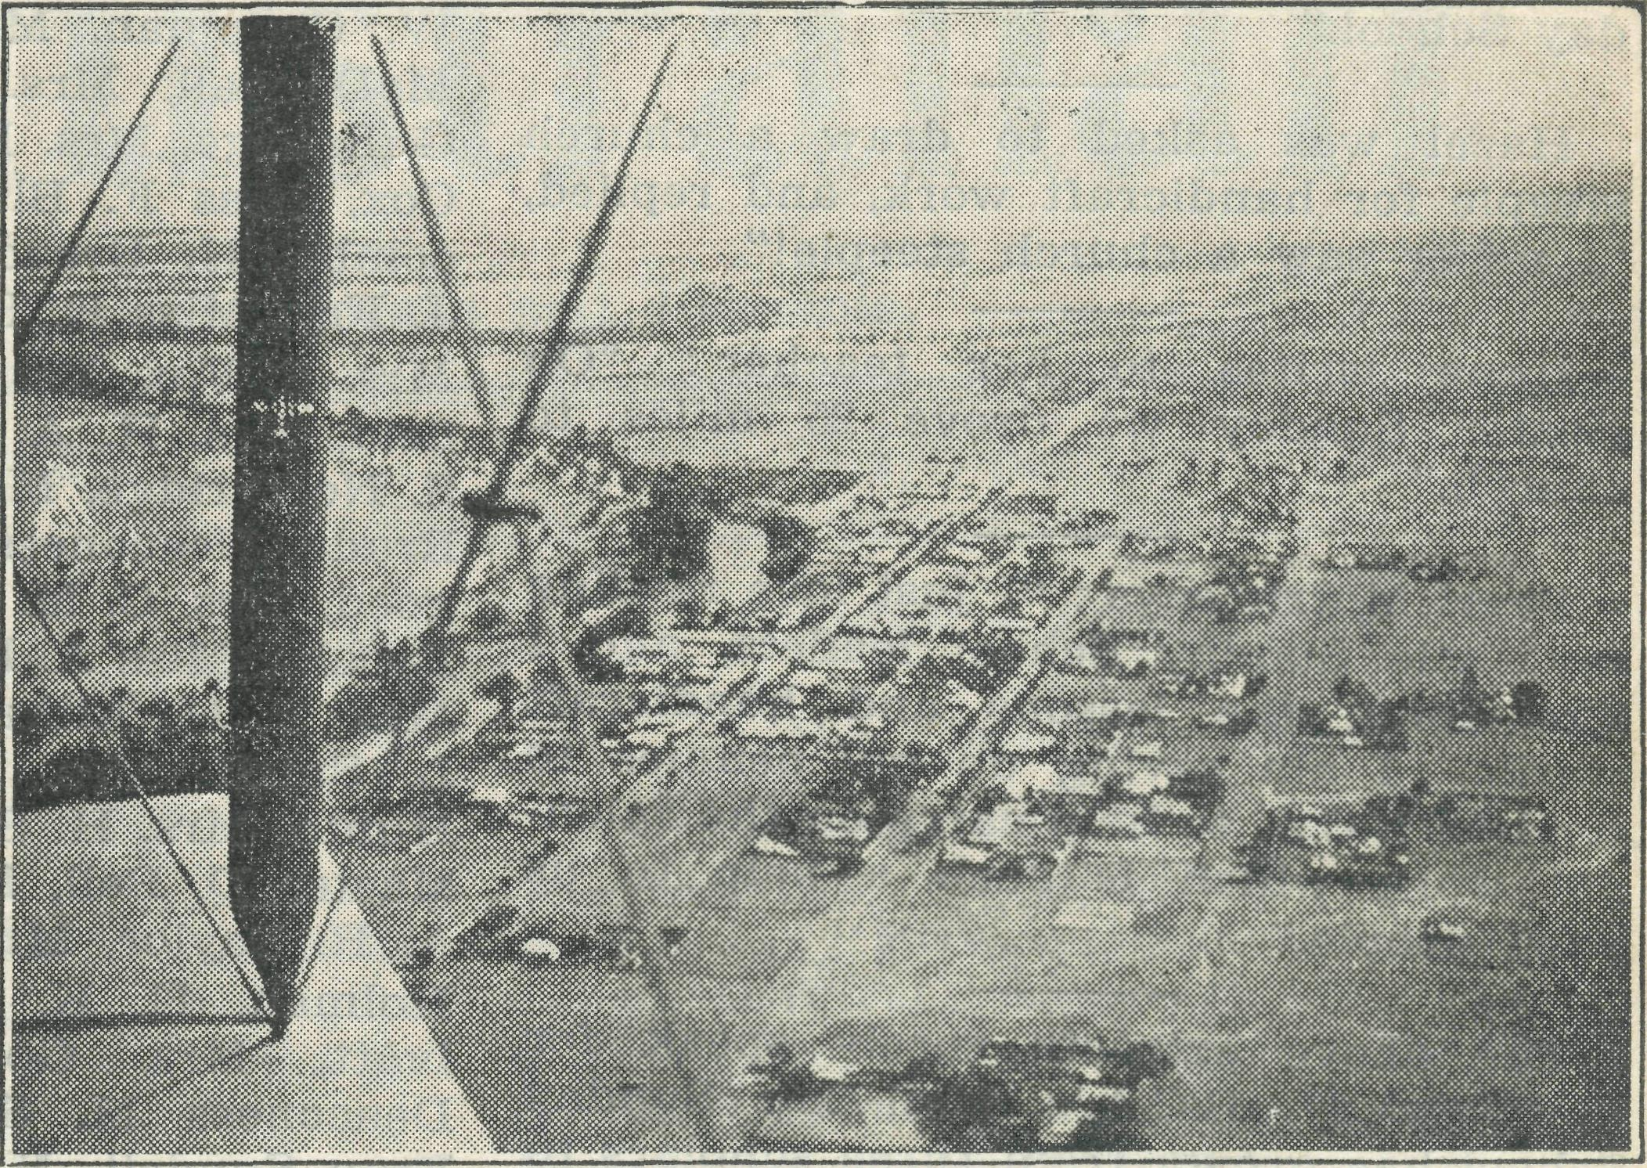
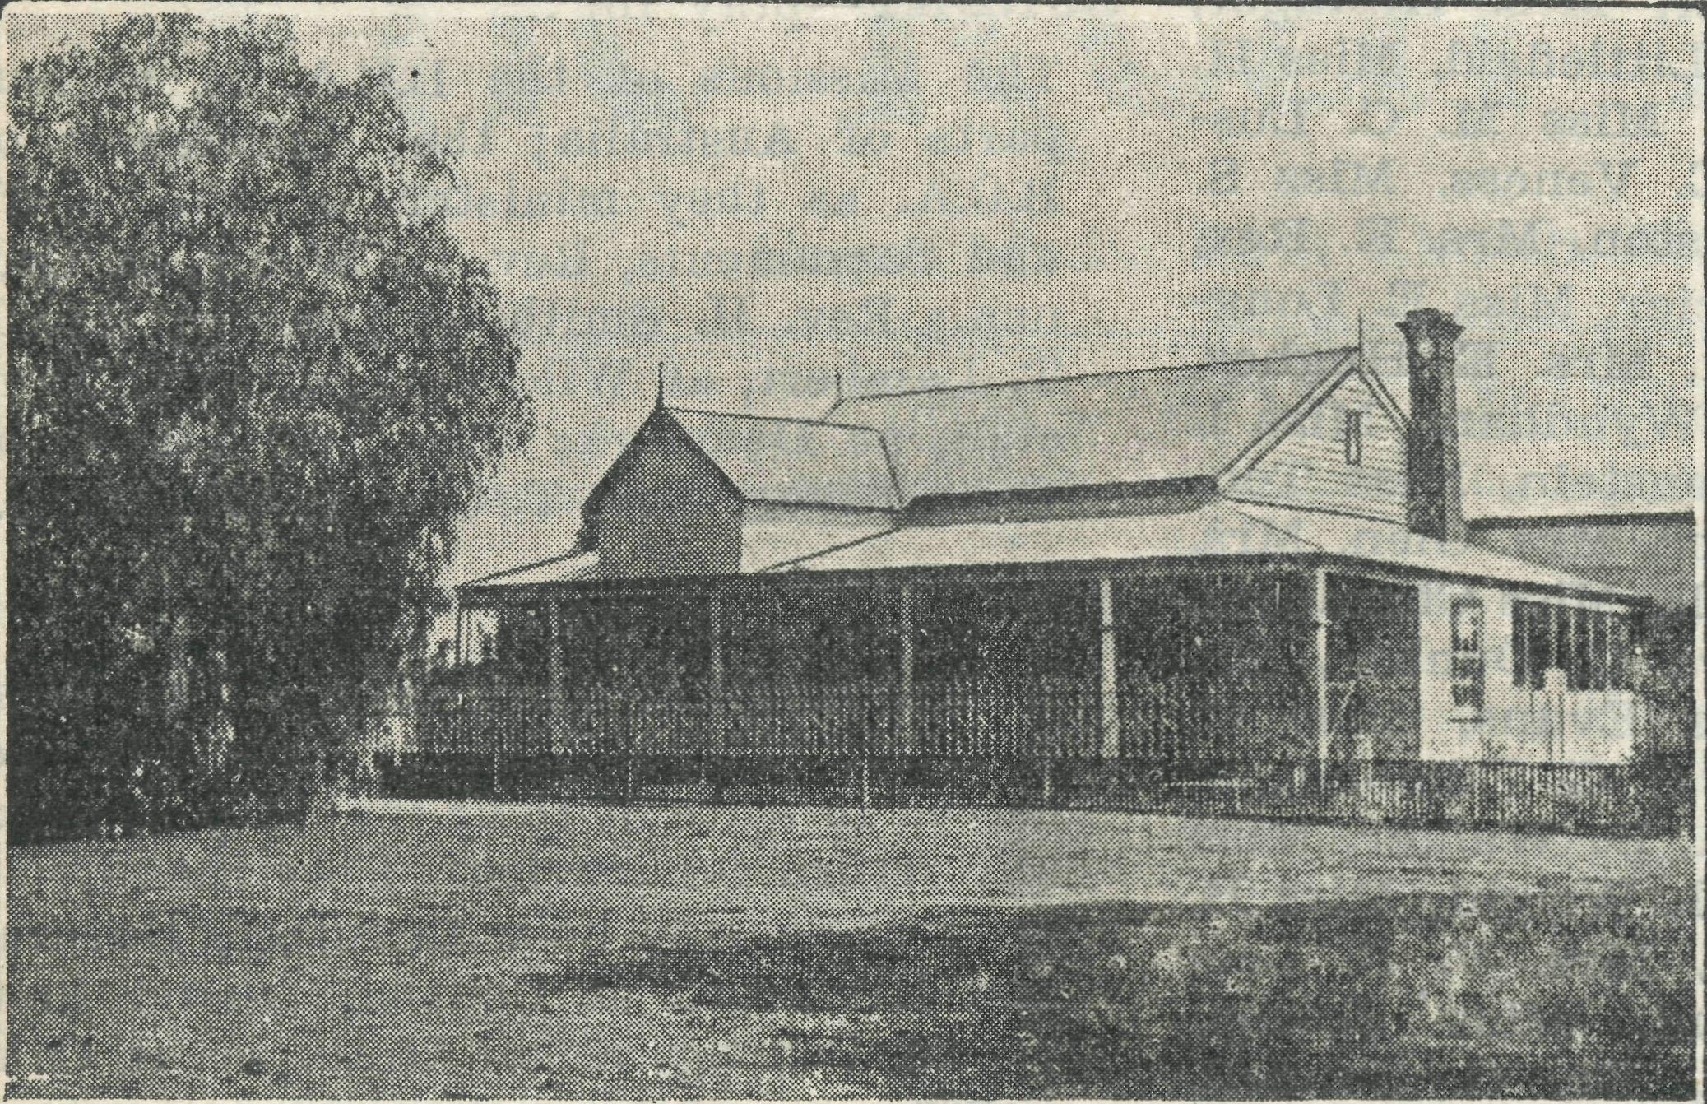

B.C.A. Hostel at Wilcannia, N.S.W.
General View of Township of Wilcannia, N.S.W.

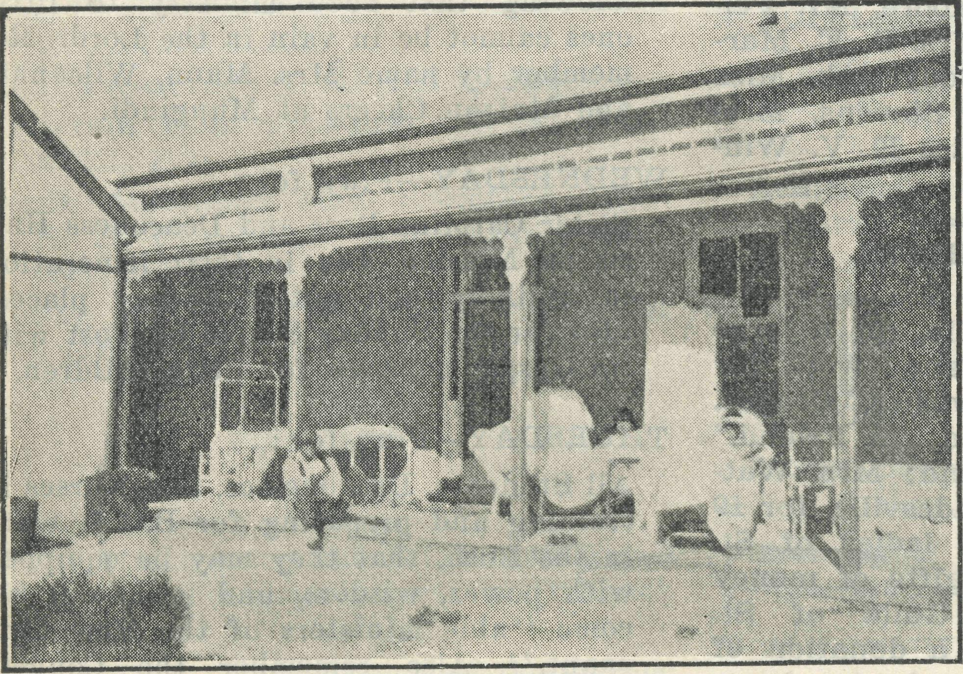
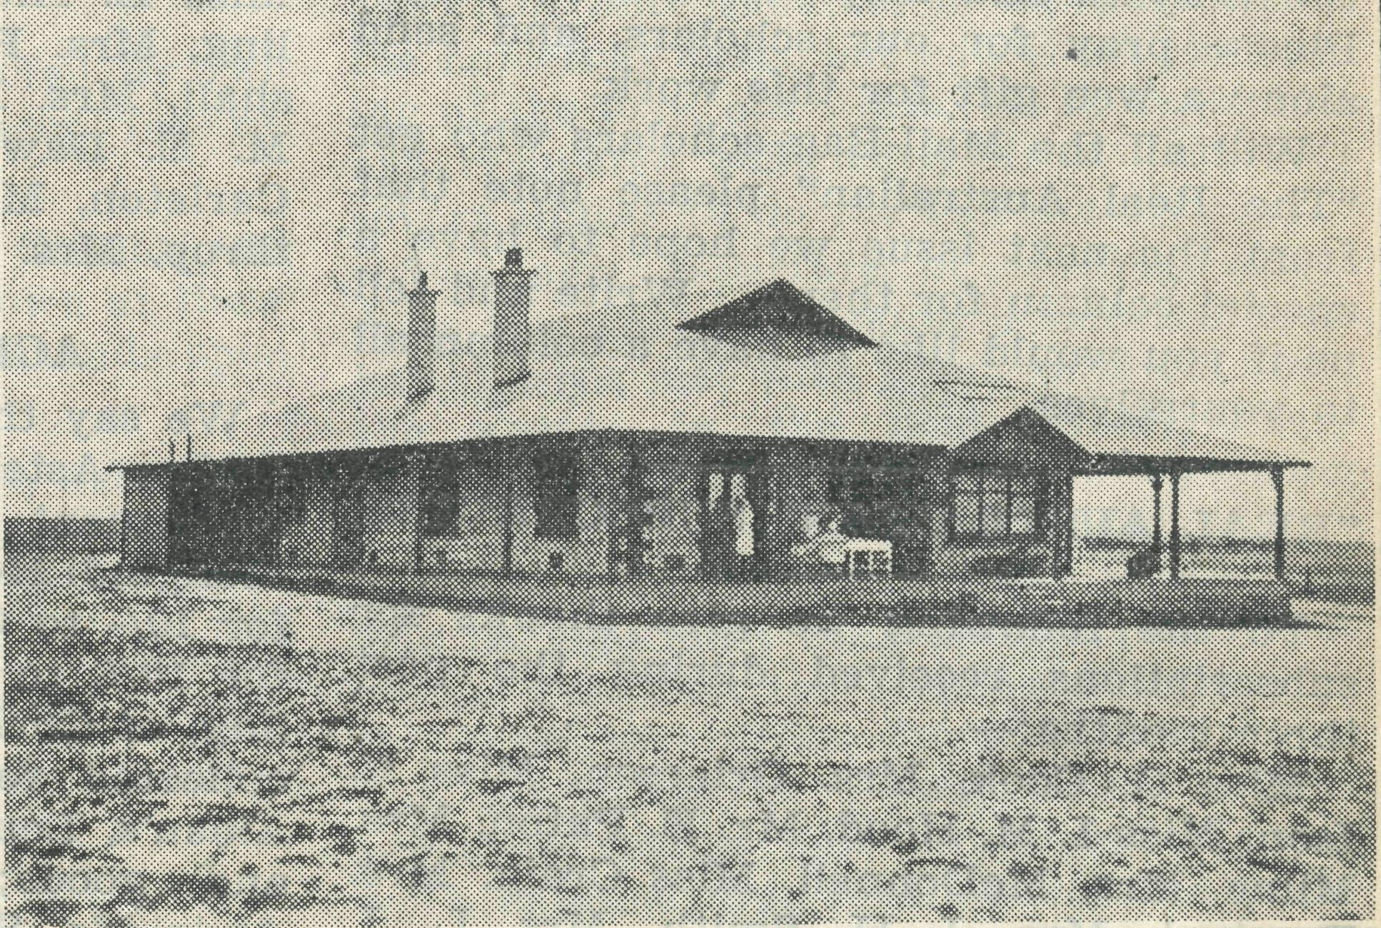

Patients at Ceduna Hospital, South Australia.
B.C.A. Hospital at Penong, South Australia.

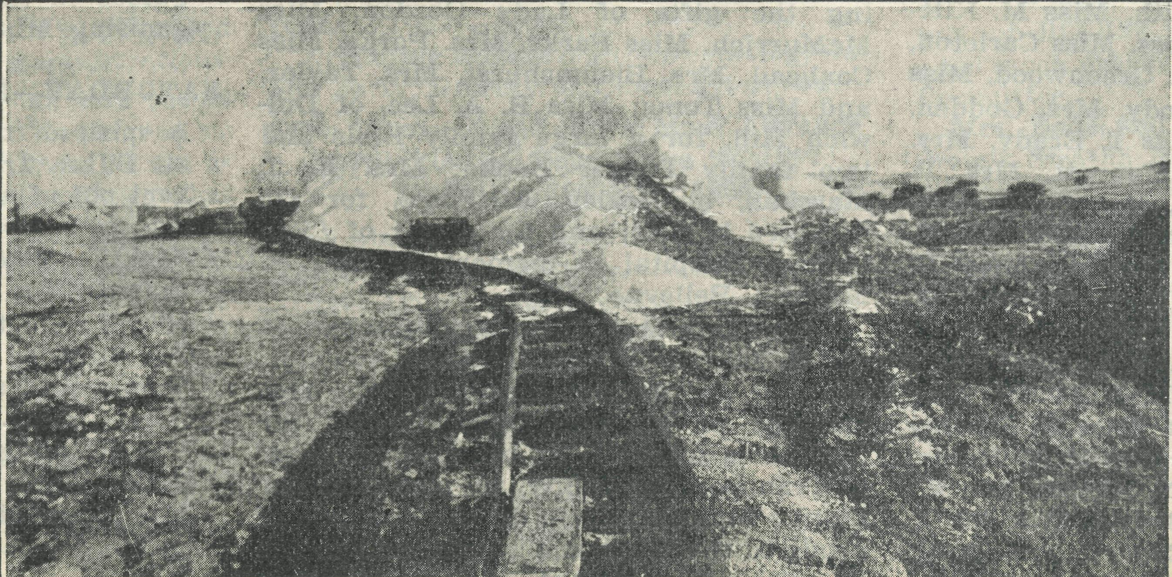
Some South Australian Scenery.

THE REAL AUSTRALIAN.
December 30, 1934.

A scholar writes:—
"During school holidays my brother and I caught over 200 rabbits, using 20 traps. When we sell them we will send in some money for B.C.A. Mail-Bag Sunday School."
Hazel was asked to draw a church steeple for handicraft work, and replied, "I never saw a church steeple!"
Irene writes to her teacher : "On Easter Sunday we drove 25 miles to church."
Pearl Morris says : "I just love reading my little Sunday School leaflets, and I like doing the lessons and handicraft work. I am saving up my pennies to send to B.C.A. to help carry on the splendid work which is such a help to us bush people."
The above extracts surely speak for themselves. B.C.A.'s Mail-Bag Sunday School has grown from three scholars to 3000 in ten years, and is a very important department of our work.
We hope that we will soon be able to exterd the activities of our Sunday School. In order to do this, we need the prayers' and help of all our friends. Please pray for our scholars, and send alonr a wee gift for this work.
Will all the Mail-Bag scholars who get "The Real Australian" please note that from the next issue we hope to have a special column for them. Write and tell us if you would like to have a column all to yourselves.
"BEAL AUSTRALIAN" SUBSCRIBERS.
To the following we give thanks for subscriptions received during the past three months:—
Miss G. Cook, Mrs. Grierson, Miss E. Ison, Miss I. M. Hood, Mr. E. Paton, Mrs. Milne, Mrs. McDonnell, Miss Craig, Mrs. Percival, Mrs. J. H. Smith, Mrs. L. J. Williams, Mr. C. H. Skinner, -Mrs. H. Brown, Mr. W. E. Cox, Miss E. Wells, Miss Gilman, Miss M. E. Taylor, Mrs. G. Hughes, Mr. H. F. Arnold, Miss F. McDougall, Miss M. L. Kent, Mrs. Clegg, Miss F. Barker, H. A. Hipwell, Miss A. Allnutt, Mrs. E. W. Smith, Miss M. Kittson, Mrs. K. Buchan-Cross, Miss Carleton, Miss M. Rush, Mr. R. E. Greenwood, Miss
C. Chaffer, Mrs. M. Moody, Mrs. Godden,
Mrs. E. E. Bennett, Miss I. Brady, Mrs.
Houston, Miss E. M. Moppett, Mrs. Li.
Bidwell, Miss V. Lewis, Mrs. J. Vincent-
Nevell, Mrs. E. Hilliard, Miss F. G.
Gardner, Mrs. W. F. George, Miss R.
King Brown, Mrs. C. V. Digby-Smith, Mrs.
J. Rainsford, Mrs. A. Horman, Miss F.
V. Hooke, Miss I. Bishop, Lady Gordon,
Mrs. J. B. Bulley, Miss M. L. Tavlor, Mrs.
Jenkyn, Mrs. Wyndham, Miss N. Murray
Prior. Miss M. P. Ingle, Mrs. M. E. Henty,
Miss I. Parsons, Miss N. Alcock, Mr. W.
D. Scott, Mrs. L. M. Binnie, Mrs. W. J.
Williams, Mrs. C. H. Brown, Mrs. G. H.
Jones, Miss Heuston, Mrs. L. Heuston,
Mrs. Noakes, Miss Woore, Mrs. Mulray,
Miss J. M. Doak, Miss Doust, Mrs. Tingle,
Mrs. Crane, Miss J. Bayley, Rev. B. V. Davis, Mrs. Sinclair, Miss E. Hall, Miss Miller, Mrs. R. McDougall, Mrs. Dodd, Miss M. McGregor, Mr. Colin Justelins, Mrs. J. Cook, Mrs. P. S. Kemp, Mrs. H. W. Chapman, Mrs. Stanger, Mrs. A. M. McDougall, Mrs. Baker, Mrs. Killinger, G. Savage, Mrs. H. H. Littlefield, Miss H. Cox, Miss F. Blundell, Miss M. C. Lus-combe, H. Broadley, E. Veness, Miss S. J. Fry, Miss E. L. Heuston, Mrs. E. Rex, Mrs. A. Fox, Miss Mercier, Miss E. Long-field, Mrs. H. A. Black, Mrs. E. Hughes, S. Northridge, Mrs. F. Wyndham, Miss I. Brade, Deaconess Lowenstein, Miss Too-good, Mrs. C. M. Walker, Mrs. Glen, Mrs. Brooks, Miss A. E. Poole, Miss Chambers, Mjrs. T. H. Aitken, Mrs. C. Dunbar, Mr. L. Small, Mrs. Dacres Evans, Miss C. Hunto, Mrs. H. Stellin, C. G. Edmondson, Master D. Bell, Miss A. D. Walker, Miss A. R. Taylor, Mrs. A. J. Wright, Miss B. Holman, E. K. Lamb, Mrs. F. S. Lee-Ivatt, Mrs. Goodbrand, Miss Jessop, Deaconess M. Sundell, Dr. C. Sundell, Frau Sundell, Mrs. Feathers, Miss L. B. Newman, Mrs. Mercer, Mr. C. Nellor, Mrs. Brooks, Miss M. F. Mackay, Miss A. Dicker, Miss Were, Mrs. Wise, Mrs. Malone, Mrs. J. de Frederick, Miss B. McKnight, Miss Kitchen, Miss Wilson, Miss E. Hicks, Mrs. G. Moore, Mr. Pel-ling, Mrs. R. H. Green, Mrs. S. E. Marshall, Mrs. Evans, Miss Bodycomb, Miss M. E. Dawkins, Miss A. Stevens, Miss Carleton, Mrs. Hansen, Miss E. V. Win-throp, Mrs. Bartlemann.
ACKNOWLEDGMENTS.
We say thank you to:—
Miss Astell, of Gladesville, for a large assortment of dolls and fancy work for Mungindi Hostel; "A Wellwisher," Coogee, for 10/- to Christmas Fund; "A Friend," for 10/6 to Christmas Fund; Mrs. Wat-ling, of Christ Church, Gladesville, for £9 collected for B.C.A.; the ladies of St. Alban's, Leura, for many gifts of money and goods; the Girls' Guild of St. Andrew's, Strathfield, for a donation of £5; Mrs. Rose and her friends, for donation of gifts and £1/2/-; "H.Q.M.," of Randwick, for gifts of good things for Ceduna Hospital; Mrs. Wear, of Maroubra, for a splendid Grocery Afternoon; Mrs. Howard Gell, for her kindness in collecting the gifts of Lady Gordon, Miss McMurrich, Miss Parks, Mrs. Parks, Miss Coxhead, Mrs. Bleumshurst, Mrs. Taylor, and Miss Toms; Miss B. A. Lee, of Dul-wich Hill, for a large family Bible and two family Prayer Books; Mrs. F. J. Marshall, of Bexley, Rockdale, for £15 collected by her; and for a gift of £5 to Ceduna Hospital in memory of Mrs. F. Murphy, Bellevue Hill.
To the Interstate Steamship Companies, and to Messrs. George Ferguson, Adelaide, we offer our deepest thanks for the free carriage of all our goods during the Christmas season. To the Commissioner of Transport for N.S.W. we also offer our thanks for concessions in the carriage of goods to the West and North; and to the Premier's Department, Victoria, for free carriage of goods at Christmastide to our Victorian stations.
THE PLACE OF PRAYER.
All B.C.A. friends are invited earnestly to use in daily prayer the suggestions made in the following list of subjects:—
SUNDAY—pray for :
The Missions of the B.C.A. in various parts of Australia; the. Missioners of B.C.A. as they minister of the Word and Sacraments, Bev. G. Woolf, at Ceduna.; Rev. H. Smith, at Penong; Rev.L. T. Lambert, at Wilcannia; Bev. L. Dun-stan, at Denmark; Eev. S. Viney, at Cann River; Rev. ^T. Gee, at Werrimull.
MONDAY—Pray for :
B,C.A. Hospital work in the Far West country, where patients must be received in spite of their inability to make any return for service. Pray that God >s good cheer may be with Sisters Dowling and Hitchcock at Ceduna, Sister Sow-ter at Penong, Sister Grainger at Cann River.
TUESDAY—Pray for :
The B.C.A. Children's Hostels at Wilcannia and Mungindi, that the work be increased of God, and that we persevere knowing that such ministry to little ones cannot be in vain in the Lord. Remember by name Mrs. Mann, Wilcannia and' Matron Cheers at Mungindi.
WEDNESDAY—Pray for :
Sister Caroline Ross and Deaconess Harris on Mission Van in their itineration in unlikely and out-of-the-way places; also for the Sunday School by Post with its Gospel message for little children.
THURSDAY—Pray for :
All Students, Deaconesses, and Nurses in training and preparing for B.C.A. work in the Bush, that they may be equipped with power, wisdom, and zeal^ and become "able ministers of the New Covenant." Also remember the Council, Committees, Women's Auxiliary, and workers on the Home Base Staff.
FRIDAY—Pray for :
The Council, that it may be specially guided in the appointing of a new Organising Missioner.
SATURDAY—Pray for :
A spirit of thankful giving to be upon all B.C.A. friends, that the Society be kept out of all God-dishonouring debt.
AT ALL TIMES—Forget not to give thanks: for kindly givers who have helped us with their self-denials. For friends, known and unknown, who have rallied at our call to keep our ministries going.
For cheering reports from fields that God's Word is still with power. For offers of service for the filling of pending vacancies in our work.
Wholly set up and printed in Australia by D. S. .Ford, 44'50 Reservoir Street, Sydney.

