Registered at the General Post Office, Sydney, for transmission by post as a periodical.
"AUSTRALIA FOR CHRIST."
The Real Australian
Organ of the Bush Church Aid Society for Australia and Tasmania.

No. 56.
MARCH 30, 1935.
1/6 per annum (post free).

THE BUSH CHURCH AID SOCIETY OF AUSTRALIA AND TASMANIA.
Headquarters Office :
Diocesan Church House, St. Andrew's
Cathedral, George Street, Sydney.
(Telephone : M-3164.)
Cable Address : "Chaplaincy, Sydney."
Victorian Office :
St. Paul's Cathedral Buildings, Flinders Lane, Melbourne.
President: The Right Reverend Bishop KIRKBY.
Hon. Clerical Secretary : Ven. Archdeacon W. L. LANGLEY.
Hon. Treasurer : T. S. HOLT, Esq.
Victorian Hon. Treasurer : E. V. PAN-ELLI, Esq.
South Australian Hon. Secretary : Rev. R. H. FULFORD, Holy Trinity Rectory, Adelaide.
Acting Organising Missioner : Kev. T. E. JONES, Th.L.
FORWARD !
Dear Friends of B.C.A.,
For fifteen years the B.C.A. has served the needy and difficult areas of Out-back Australia.
In the Far West Mission of South Australia, in the Denmark Settlement in Western Australia, in East Gippsland, Victoria, in the West Darling Mission in the far north-west of N.S.W., in the north-western Mallee, Victoria, B.C.A. has sought to do the work of the Church. Men, women and means have been supplied. Almighty God has wondrously blessed their ministrations.
The bodily needs of the out-back people have not been forgotten. It is because we believe that the Gospel of Jesus Christ is the "Gospel of the Good Samaritan" that we have sought to take the blessings of medicine and nursing to the lonely people.
The Hostels of B.C.A. have saved' many of our own children from drifting away from their Church, and have enabled a goodly number to better fit themselves for the journey of life.
The Mail-bag Sunday School has rendered telling service in the religious education of many out-back children.
The Motor Mission Van has been a veritable blessing on wheels to many of our lonely out-back folk.
B.C.A. 's aim has always been "Australia for Christ." The work has been nobly done in the past. It must go on to greater things in the future days.
Thus we appeal for :—
1. Your Prayers and Definite Spiritual
Interest.—We believe that God will grant to us power and wisdom to think, plan and act as people pray for us.
2. Your Gifts and Practical Interest.—
We need substantial support to maintain
our position. Something extra is needed
if we are to advance in new and needy
works.
SPECIAL NEEDS ARE :—
A Medical Mission Van staffed by two nurses, for itineration in places far removed' from hospitals.
Additional Nursing Staff at Ceduna and Cann River. The work has grown at these centres and has made heavy demands upon the existing staffs.
Mail Bag Sunday School.—To extend its activities and to cope with the big demands already made upon it.
Motor Maintenance for the incessant and necessary travels in the Far Country.
Training of Meai and Women.—Always a big drain upon our resources.
YOU CAN HELP BY—
Giving a Special Donation.
Becoming a member of B.C.A. (minimum subscription, 12/- p.a.)
Taking a Bark Hut collecting box for your self-denials.
Organising a Sale of Work in your district.
Arranging a Drawing-room meeting, Garden Party, Grocery or Linen Afternoon.
The Whole of the Work Must Advance.
Will You do Your Share To-day?
An Extra £1000 for 1935.
Send your gift to :—
The Victorian Secretary,
Bush Church Aid Society,
Cathedral Buildings,
Flinders Lane,
Melbourne, C.I.,
Victoria. Tel. F-5675.
The Acting Organising Missioner, Bush Church Aid Society, Church House, George Street,
Sydney, Tel, M-3164.
WOMEN'S AUXILIARY.
Ladies' Auxiliary, Sydney.
We regret that through an oversight, our Auxiliary was not mentioned in the last issue of the '' Eeal Australian.'' This was a real misfortune, as we wanted to sound a most grateful "thank you" to the many friends who helped us to give a joyous Christmas to our bush folk.
The articles sent in were of excellent quality.
A very special vote of thanks must go to Mrs. Lee Smith and her helpers, Mrs. Osborn and Misses Haley and Bennett. They not only shouldered the packing of the numerous cases, but undertook the buying of the toys, etc. Mrs. W. E. Gates had not recovered sufficiently from her very severe illness to do so, as formerly.
The new departure of sending direct from the wholesale houses a selected number of toys, met with great approval from the agents in the field. Nearly every letter of thanks mentioned it as being most satisfactory, as they appreciated being able to allocate the gifts themselves. The packers must congratulate themselves on the fact that the breakages occured in the cases sent direct from the warehouse and not in theirs. Few of our readers probably realise how strenuous was the work entailed, but contributors and packers alike share in the joy of the recipients.
Mrs. Dixcn Hudson, a regular and generous helper of our Auxiliary, sent from St. Alban's, Leura, a cheque for £7/10/-for the little ones at Menindie. Surely a big "Inasmuch" awaits these givers.
Miss Paton, of Summer Hill, added her gift of life-like animals. Her parcel excited much enthusiasm when viewed by the Committee.
Mrs. Bode and Miss Currie, of St. Andrew's Strathfield, also gave their annual generous help, and so they, too, must be looked upon with gratitude.
Mrs. McEnally, with her Circle at Gladesville, sent in many garments, beautifully cut and finished. We understand that she is responsible for the cutting out herself—a real labour of love.
Miss Richard Jones and Mrs. Richmond undertook the buying of the gifts for the agents, as this year the Auxiliary wished to send' each a memento. Books for the men and scarves, etc., for the women. Letters show us that the thought was a happy one.

THE REAL AUSTRALIAN.
March 30, 1935.

We start our New Year's work on the third Wednesday in March and extend a warm welcome to every woman to join us. A simple payment of 2/- a year binds us up in fellowship. Surely all must be drawn by the need of our bush people, and surely all of us can give of our sympathy and our help to our less fortunate sisters.
Mrs. W. L. Langley still is our very interested Acting-President. We have good accounts of Mrs. D 'Arcy Irvine, and she sent all the members her good wishes for Christmas.
St, Thomas—Moonee Poinds, Women's Auxiliary.
We reassembled on the evening of March 12, with a good attendance of members. The President, Mrs. G. H. Raymond, presided, and our syllabus of meetings for the ensuing year was discussed. We are grateful for the help that was accorded us last year by our friends in the parish and we feel sure that this year we will be able to do even a little more for the Church militant in the out-back country.
We appreciated receiving a letter from Sister Grace Hitchcock (for Sister Dow-ling), in which she said how very acceptable the six marcelle quilts were, which we had the joy of sending. Sister Sowter also keeps in touch and sends us news of the occupant of our "Cot."
We purchased material for children's garments and this is now being made up by the members and also by the G.F.S. We have very staunch supporters in our branch of the G.F.S., and we are greatly encouraged by their help.
Melbourne.
The Central Ladies' Auxiliary re-as sembled in the Chapter House on 12th March. There was a good attendance of members, and the President, Mrs. A. Lang-ley, was in the chair. The election of Office Bearers for the ensuing year took place. Mrs. Langley was unanimously reelected, and Miss Woods, who had been Acting Hon. Secretary last year, was elected Hon. Secretary.
Letters received just recently from Sister Sowter and Sister Grace Hitchcock were listened to with great interest. It is such a help and pleasure to us to get these letters, as they prove such a guide to us in our work. We can concentrate on what their needs are at the moment, and so justify our existence, if only in a small way, although we really feel modestly proud of the help we were able to render last year. Our members are very keen and our membership steadily contines to grow. A well-filled case had been sent to Penong just prior to our meeting. The needs were urgent and so we attended to it while we were in recess.
The programme of meetings for the half-year was discussed and the result should prove interesting to all, and profitable to our cause.
Material for children's garments had been purchased and this was taken home hy members to be made up. We would
gladly welcome any new members on the second Tuesday in the month, at the Chapter House, Cathedral Buildings, Melbourne.
CANN RIVBB. Sister H. Gason.
The work at Cann Eiver is very interesting, and the patients seem to have fighting power in their systems, due, no doubt, to the fresh air. As a rule they respond very well to treatment.
One of my first cases was a very unfortunate one. The patient, who had been out of work for a long time, was a married man with a young family. He had been engaged for a spell of work to start on Monday and decided to give his wife and' children a week-end holiday at the lakes before he left them. Unfortunately, while cranking up the old truck, the engine back-fired and fractured his right arm. After treating him, it became necessary to take him into Orbost hospital. This meant the loss of the use of his arm, the loss of his job and the payment of hospital expenses. The brave little wife is trying to make a few pence selling vegetables. Their baby, only a few months old, was baptised last Sunday.
Cann Eiver must be a very healthy place, for many of the inhabitants live to a good old age. Several are over eighty years, and there are two who are over ninety. The babies are dear little dumplings, fat, rosy cheeks and strong sturdy limbs.
One little fellow developed an infected foot. I treated it at his home every two hours and became great friends with him. It is a source of great wonder to me how such baby legs can support such a fat, heavy body. When the foot was cured and' I said good-bye, he said, "Me kiss sister.'' His mouth was a mixture of dirt, jam, and orange juice, but I don't think that I carried away very much dirt.
Eecently a man, living at Genoa, was gored by a bull, and I was asked to go and see him. When I arrived I realised that he was suffering very much from shock, so I gave him an injection. On examination he proved to be very badly bruised, but had not broken every bone in his body, as he had thought.
Another little fat baby jambed his hand in a window, and it was necessary to stitch the torn flesh together. The little chap was as good as could be, and did not cry at all. The hand is quite well again now, and baby and I are still the best of friends.
Quite a number of my patients come in with infections of either the hands or legs, but, I am glad to say, once started on treatment, they heal quickly. The men are cutting timber, working on the roads or building bridges and wait until Saturday before coming in to report their trouble.
Can you imagine a long ribbon of road winding in and out through dense forest, climbing over the mountains, with the scent of gum leaves and damp undergrowth from the gullies, suddenly entering into a
pretty little green valley ? That valley is Cann Eiver. A long way from civilisation, yet there live here a happy, contented little community of gentle, big-hearted, bush folk. In times of sickness or distress, they place their all at their neighbour's disposal, and in cases of success they share their harvest with us all. "Come and have a cup of tea and' some bread and jam, Sister/' is their everyday greeting. Their informality and absolute sincerity wins one's love.
Each week, after Sunday School, the children take me for a walk. Sometimes I have eleven or twelve escorts, each one anxious to show me a kangaroo, a wallaby or a goanna, and all talking at once. They love to point out the tracks of the different bush creatures, and they can name birds of all shapes and sizes. Some plants, I am told, burn, some sting, and some are pleasant to eat. But I am not very confident of my knowledge yet, so I will not sample any green leaves.
I promised to take eight little people out for a picnic, to pick blackberries, one Saturday afternoon. By 10 a.m. some of the kiddies arrived with their billies. The chief drawback to these picnics is the amazing persistence of the flies. The March flies sit two or three on each arm and leg and mosquitoes inhabit every swimming pool, and big bull-ants are to be found on every soft bank where weary walkers like to rest.
BACK TO CEDUNA.
After spending a month's holiday in Melbourne at the height of the Centenary celebrations, and when there seemed to be hardly a day without rain, the contrast seemed' very great on returning to the dry and parched land of the far west coast of South Australia.
Although the difference was so marked, it was good to be back again. The last stage of the journey back, from Port Lincoln to Ceduna, is full of interest. The Motor train is a converted bus, the seats being closely packed behind' each other, two persons sitting in each seat, making it rather difficult to stretch one's legs. The train pulled up at every little siding on the way and at most of them there gathered a little collection of people who gazed, w^{r}ith extreme satisfaction, at the many mangled bodies of grasshoppers which had collected on the radiator of the train.
The train passes through from Lincoln to Ceduna twice weekly, and as the people have no other entertainment, everyone tries to get down to see the train come in and to collect their mail. It is hard to realise the interest that is afforded these people by things which seem to us so trivial.
Arriving at Ceduna at 10.30 p.m., I was surprised and pleased to find the whole of the B.C.A. staff, including the Eev. H. Smith, Mrs. Smith and Sister Sowter from Penong, were there to meet me. It was a
real home-coming.

March 30, 1935.
THE REAL AUSTRALIAN.

It seems a very long time since Christmas, but I suppose that you will be interested to hear how the children and their parents enjoyed the Christmas Tree. If the friends of B.C.A. could have taken a peep at the happy expectant faces of the children as tney waited their turn to receive a gift from the Christmas Tree, they would have felt amply repaid for all time and patience given to preparing them.
We had quite a large number of patients in hospital at Christmas and were able to cheer them by giving each a gift and a parcel of clothing and toys for their kiddies. The extra delicacies, such as preserved fruit and nuts, included in the boxes from our friends in Melbourne and Sydney, helped to improve the Christmas fare.
Of late we have been kept quite busy with accident cases. A boy of twenty had an accident with his motor cycle, resulting in a fractured thigh and twelve weeks in hospital. A wee child of two was brought to us with a broken thigh caused by a kick from a horse. Even our baker managed to meet with trouble and was brought to hospital with a fractured skull, after having collided with the rail car.
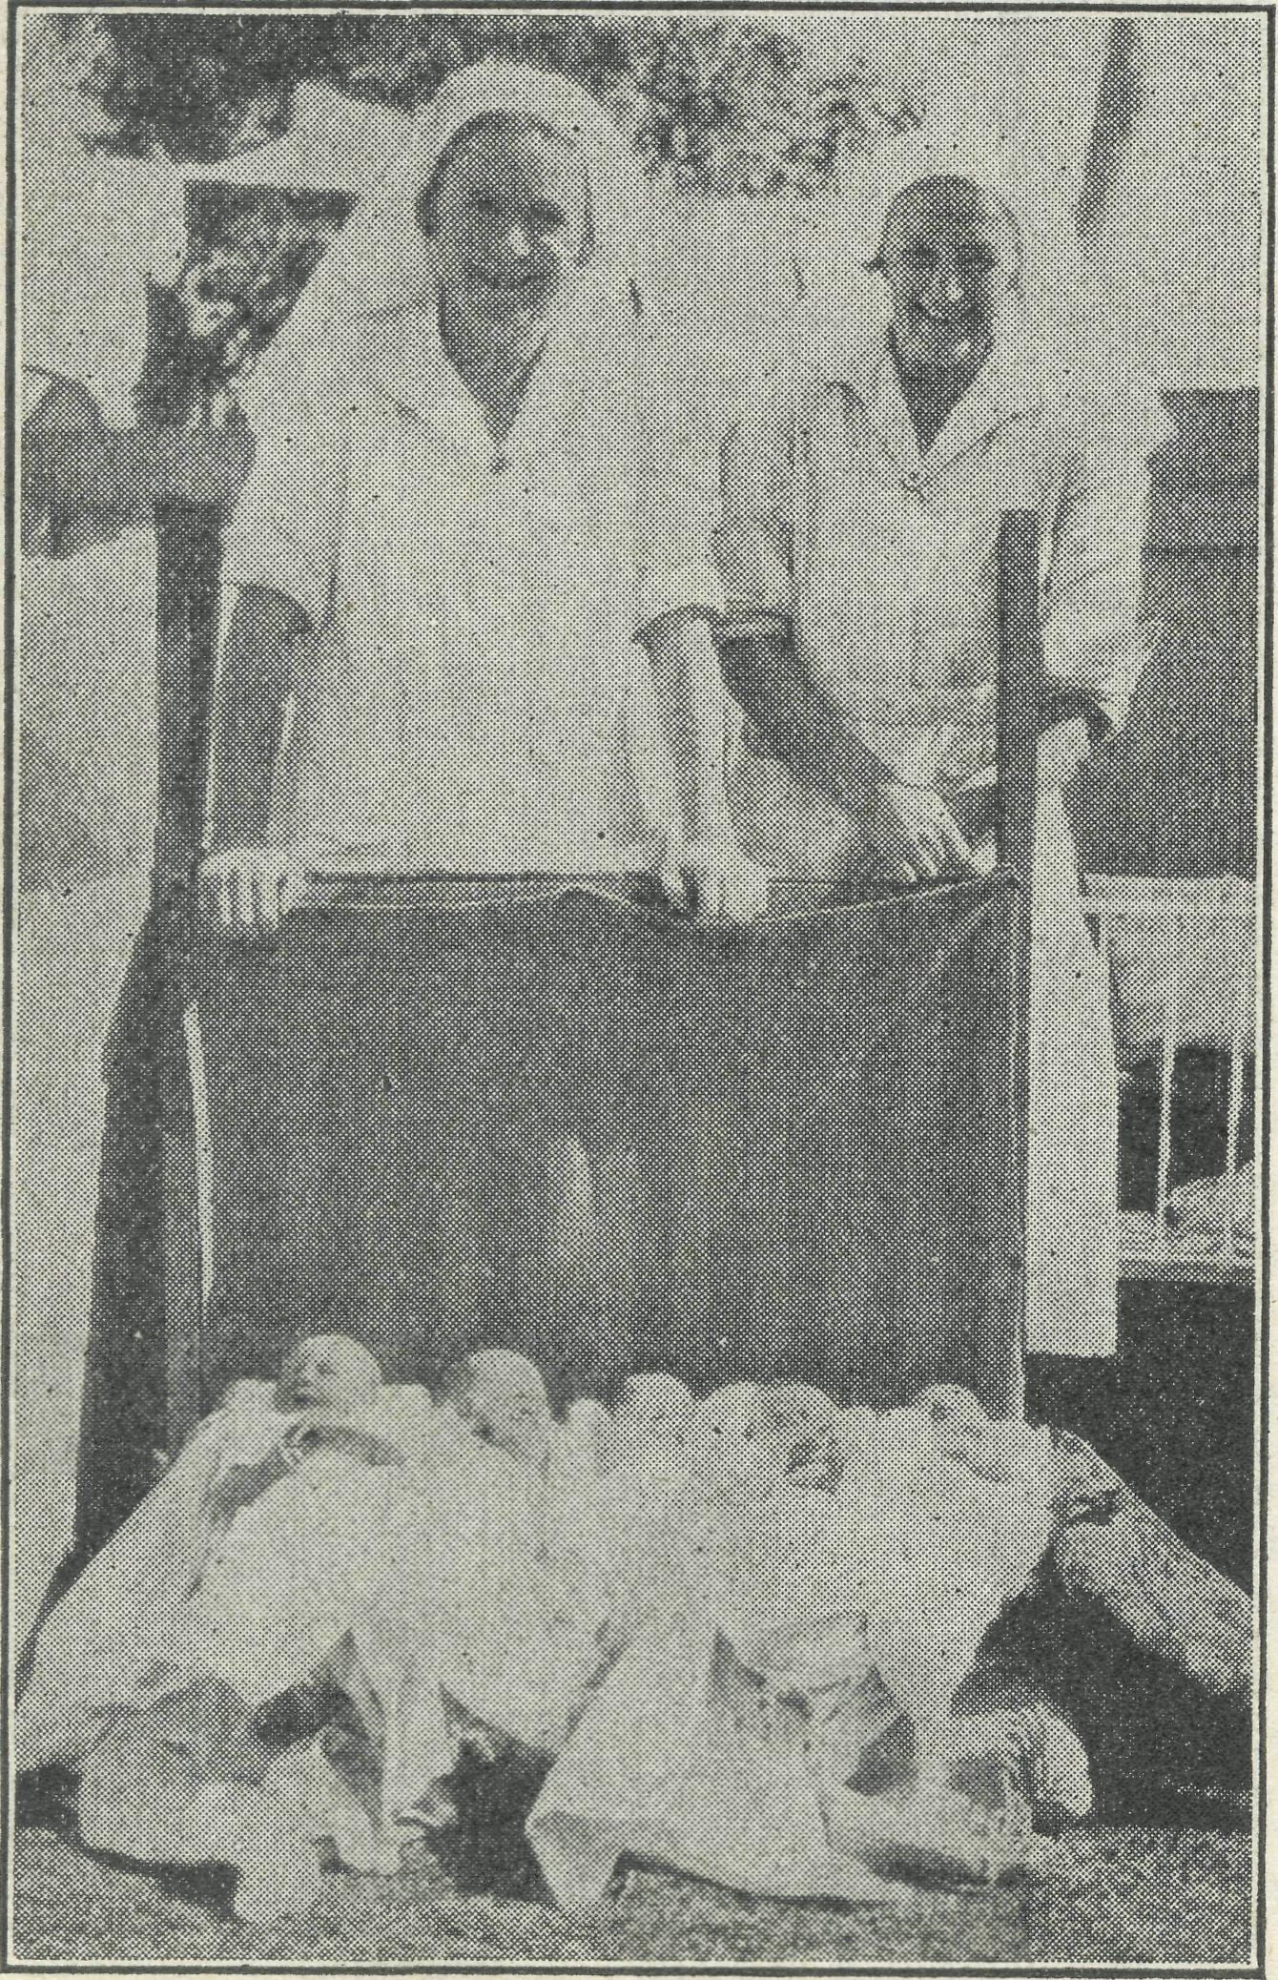
Sisters F. Dowling and Cr. Hitchcock with a Bundle of New Australians.
The prayers of the B.C.A. friends, which are greatly valued, are asked for a lad who has no real upbringing, and who, since being in hospital, has been thinking deeply, or rather (as so many of us do) while he was ill, began to think of spiritual things, but on recovering has been inclined to forget his Father's goodness to him. When asked what he intended to do after he left the hospital, he replied that he intended to stay in Adelaide with an Aunt, who owned a bookmaker's business, and to act as her clerk. We urged him strongly to take up some more worthy work, and we pray that God will lead him in the right direction.
Despite the many difficulties and anxieties which have assailed us during the past months, we thank God that He has carried us through. We thank Him for all our praying friends everywhere. Will they keep on praying that as well as trying to .heal bodies, we may be enabled to bring souls to Him.
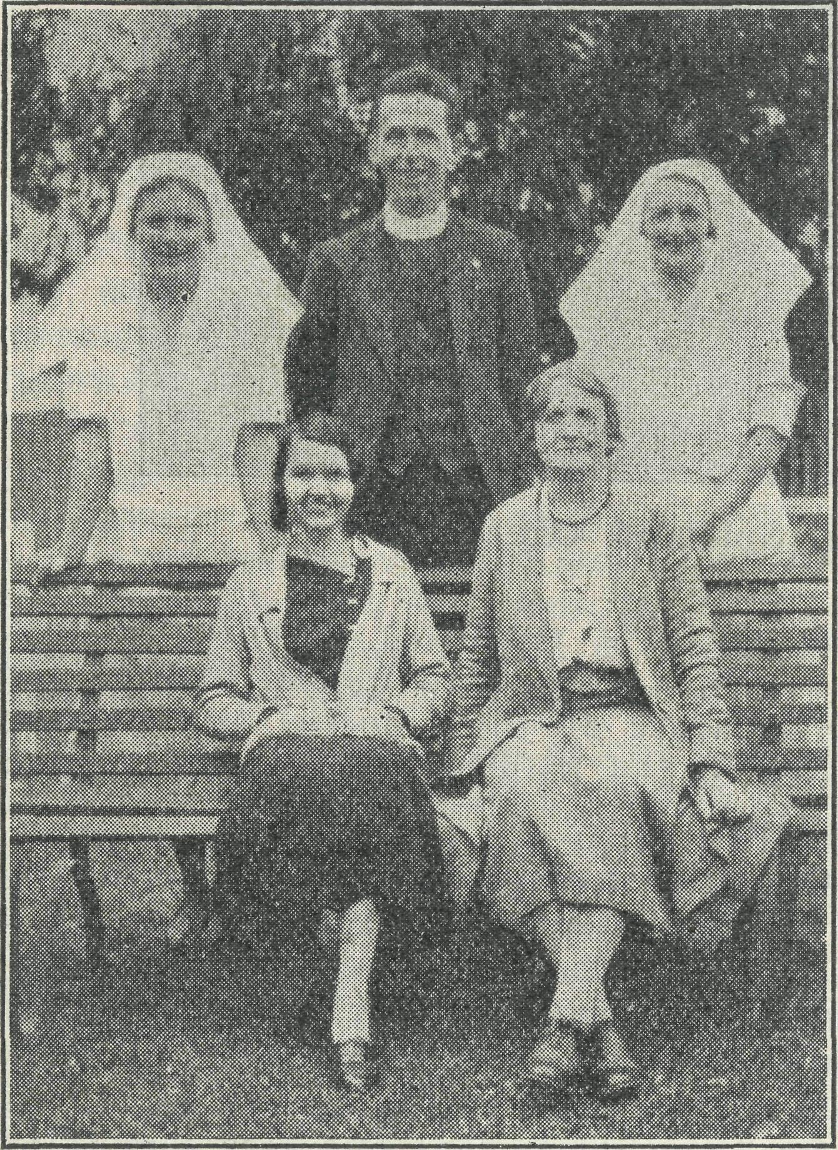
Miss Vaugflhiaai Jenkins with some of the Workers in the Far West.
WANTED
Double Certificated Nurses for Service in the Out-hack.
Our waiting list is exhausted and soon there will be vacancies on our staff. We shall be glad to receive offers of service from qualified nurses. Write to .
The Acting Organising Missioner, The Bush Church Aid Society, Church House, George Street, Sydney, N.S.W,
CLOTHING.
We still need good second-hand clothing for the Mallee, especially boys' wear. The Victorian office will be glad to receive your parcels.
To those who wish to hear of a fine Private Hospital or Rest Home, we can confidently re-commeaid ''Tuerongf,'' Campbell Street, Eastwood, NS..W., conducted by Sister Harvey, A.T.N.A. ^General and Obstetric). 'Phone : Epping 1034.
A BIG PARISH.
Rev. L. Lambert.
The Parish of Wilcannia ! But what a Parish !, The size of England or a little larger, with a population of approximately 5,000 people; it is a parish of large distances, where a trip of a hundred miles or so to take a service is the usual thing.
The headquarters of the work is, of course, at Wilcannia. Thanks to the zeal of a former generation we are privileged to worship in a beautiful old stone church, which for over fifty years has stood as a silent witness to God in the far west.
From Wilcannia, regular trips are made in all directions. 100 miles down the Darling is the township of Menindie. Not a large community, but yet they have their own church, a mud-brick building of substantial size and fine appearance, where an earnest band of men and women come regularly to worship.
One hundred and twenty-six miles southeast from Wilcannia lies Ivanhoe. Here there is only a small Anglican population and it has not been possible, as yet, to erect a church. Services are held in a hall, and' though conducted under difficulties, yet attendances show that they are. appreciated.
In the days before the war, White Cliffs was the centre of a thriving Opal-mining industry, employing some thousands of men. With the war came the sudden cessation of the Opal trade with Germany, and White Cliffs became a dead city almost overnight. To-day, about a dozen houses are inhabited. The Anglican Church still stands, although badly in need of repair, and to the services come the few townspeople and settlers from the district roundabout.
About thirty miles from the Queensland border, and about 230 miles north-west from Wilcannia, is. Tibooburra. A quaint town standing in the midst of rocky outcrops it is far removed from the rush and bustle of life. Time is of no account here, and when services are held in the local hall, after frantic ringing of a large dinner bell, usually a start is made some time within an hour of the advertised time.
In addition to regular visits to these centres, services are held in the homes of lonely selectors, and as much visiting as possible is done among the scattered homes in the parish.
The education of the children is perhaps the biggest problem that out back people have to face. The Government does good work with its Correspondence School, but this makes big, and sometimes impossible demands on the time and knowledge of the parents. In order to help the children of the out-back, the B.C.A. has established a children's Hostel at Wilcannia. Here, for a nominal sum, children are given a home and educated at the local public school. The work is a tremendously important one, and is making a big contribution to God's Kingdom and to the welfare of the country.

THE REAL AUSTRALIAN.
March 30, 1935.

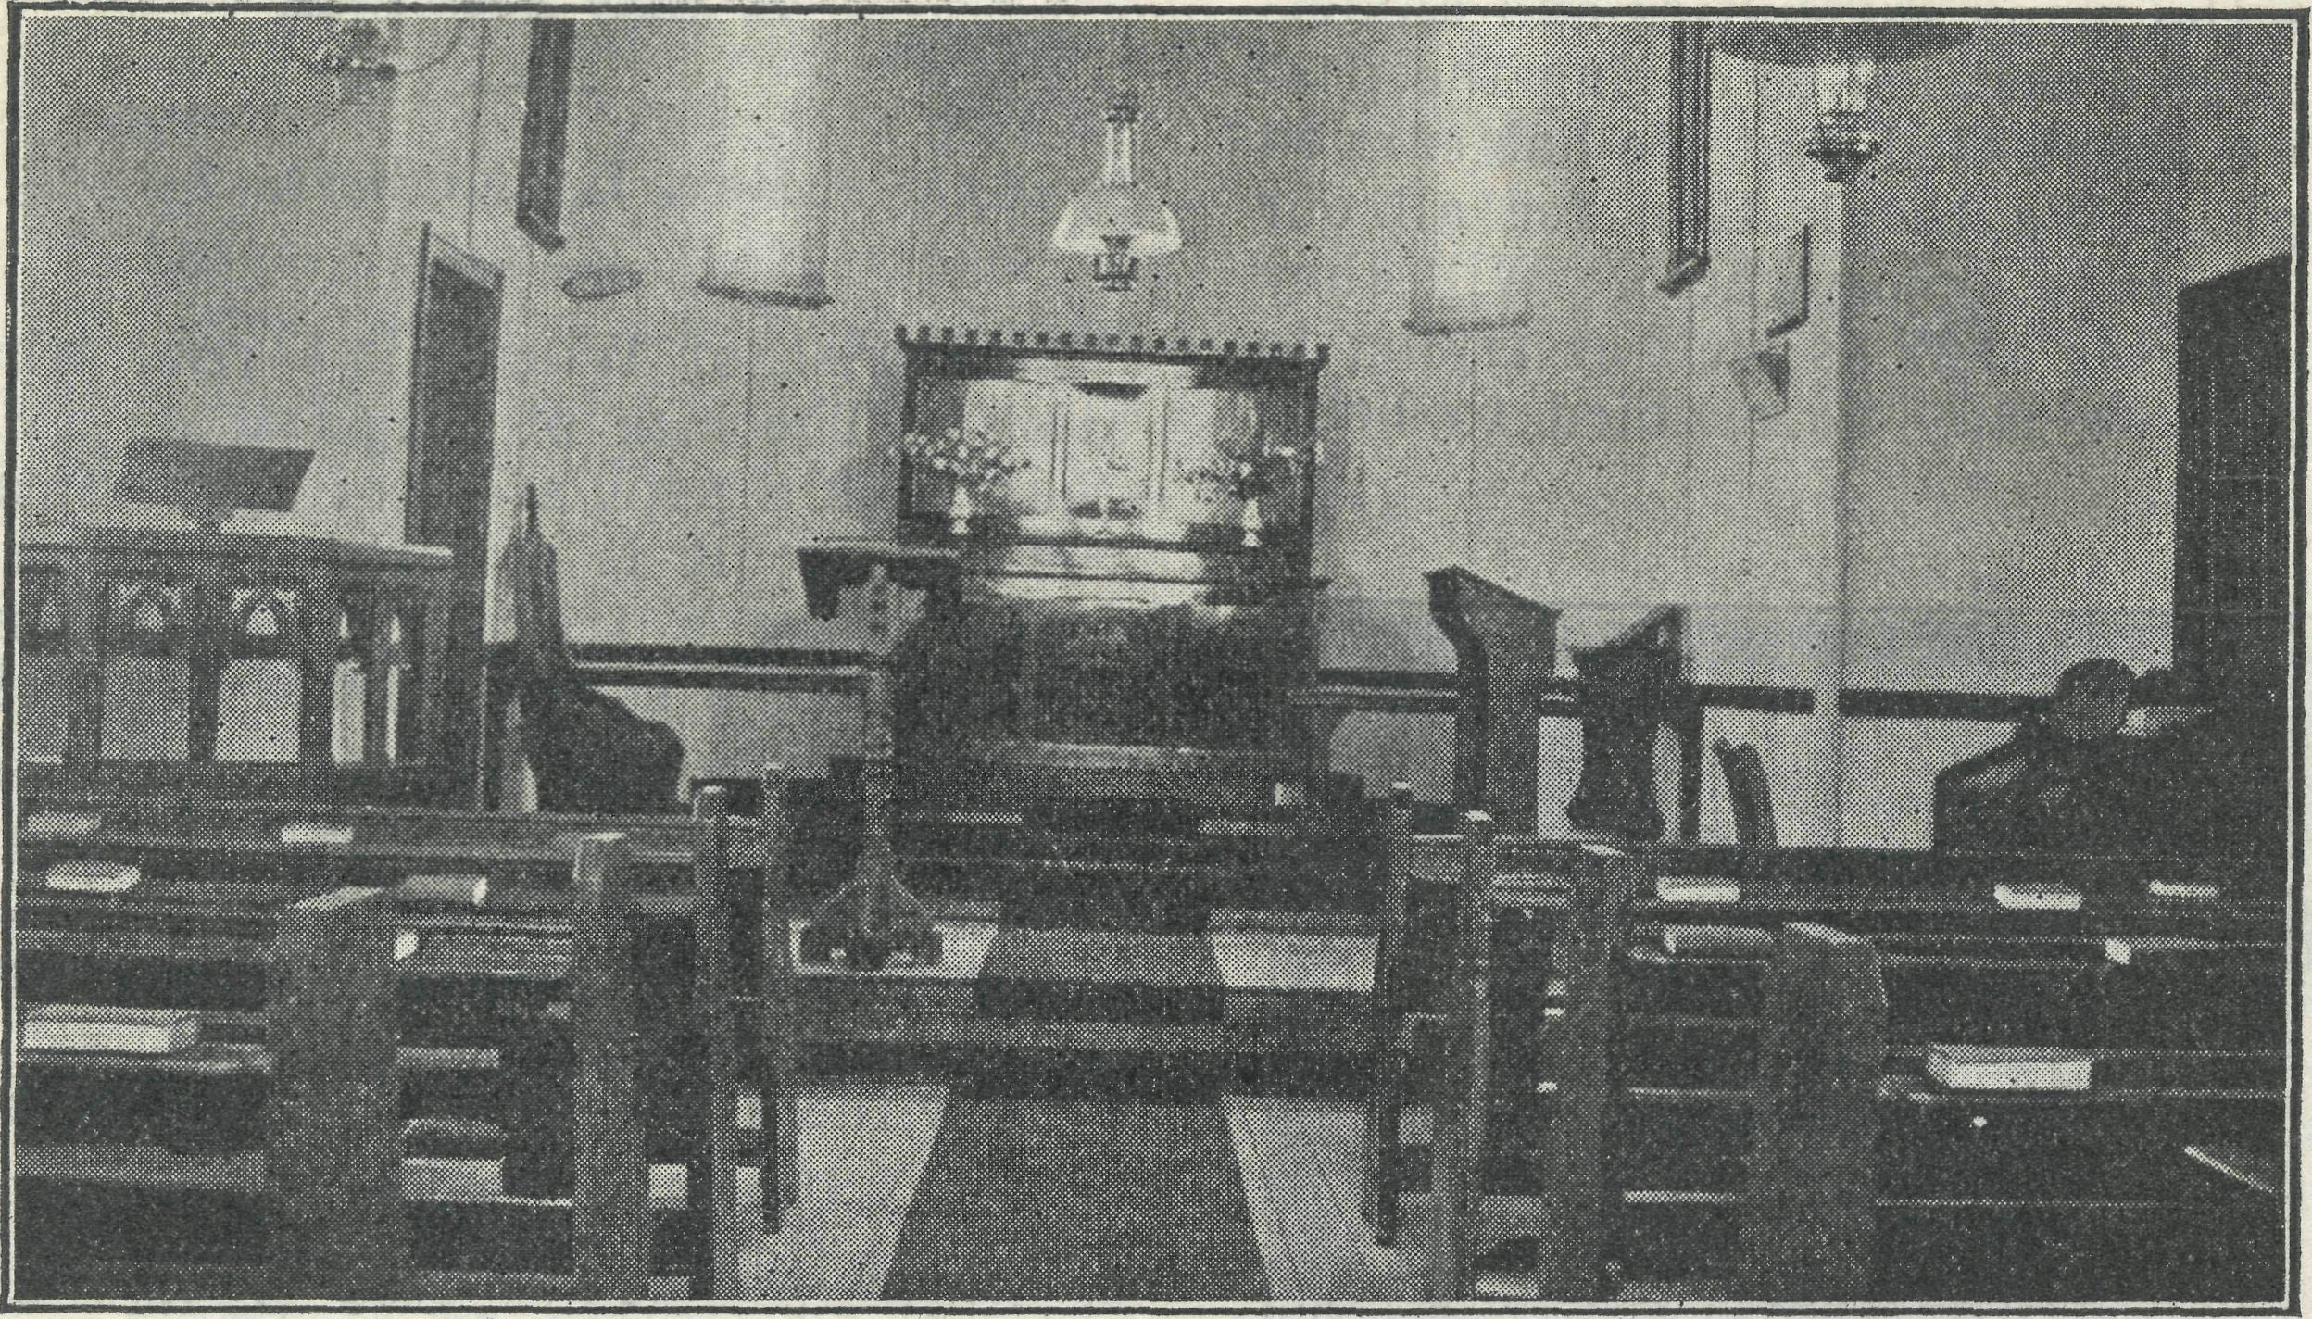
The Interior of Menindie's Splendid Church.
At present there is only one man stationed at Wilcannia, and in the tremendous task of ministering to the parish you can take your part if you will. Your prayers, your interest and your gifts are needed. Will you help?
PENONG HOSPITAL.
Sister H. Sowter.
Christmas has come and' gone again, and with Christmas came the excitement of watching for the "Yandra" coming into Port le Hunt, and with each truck load of cases up to Penong, the question was, are the cases for the hospital on this truck, cases which not only cheer the hospital staff but many outside as well.
One of the most interested in the arrival of the cases was Lucy, a regular visitor to the hospital when occupying her wurley on the Park lands of Penong. When eventually the cases arrived, Lucy sat and watched the unpacking with great interest. (Lucy had visions of old, but still pretty dresses for herself). Poor Lucy, on account of her rather large proportions, there was nothing in the box to fit her, but she went off feeling very pleased' with a handkerchief to adorn her black curls, and a tin of talc powder.
The gifts were all very much appreciated, and I would like here to thank those ladies who were responsible for sending _{a} beautiful canvas blind, which is such a comfort to patients in the ward, when the sun is doing its best at 108 degrees and 112 degrees, to make everybody and everything shrivel up.
I would like also to thank Mr. and Mrs. Adam for a flour-bin and tea-pot, both of which are doing good service, also pillows, clothes for the children, and last but not least, the groceries, which are such a help to the upkeep of the hospital.
The people of Penong and those up the road ("up the road'" means to the border of Western Australia), are still living in hope of having another resident doctor at Penong; it does seem a shame having a
nice doctor's residence standing empty. The people here have indeed catered for the comfort of their doctor and nursing Sister in the building of a residence and hospital.
One cannot claim to have a hospital full of patients, owing to the absence of a doctor, still the work is varied and numerous people call for advice or sometimes the sister has a call to go out and see a case at any hour of the day or night. It is on these visits that one sees something of the hardship and poverty of some of the people.
A few days ago a party of us attended a fruit social, fifty miles up the road, to which most of the people of the district came in vehicles of all descriptions, sizes and shapes, our party no sooner arrived than there was the inquiry, "Did Sister come ?" Someone had had no rest for many nights w^{r}ith septic fingers, to which I was able to give temporary relief; a child had fallen on a stick and staked the roof of his mouth; numerous people had pains and aches, and one had the worst skin infection I have seen. Then, also, there were the babies to be seen, who had' had their first birthday at Penong Hospital.
Many of these people endure much pain because it means 200 miles travelling to see a doctor.
Then, too, there are our dear old dark friends, who often find their way to hospital. They will come along, "want medicine weir, mucka good minga all atime, any rubon medicine weir 1''
One evening, a few weeks ago, I was called up to one of the camps, a little "kitcher" had arrived, but the mother was only semi-conscious and bleeding. After spending about one and a half hours on my knees in the dirt, with a neighbour to hold a lantern for me, I was able to leave the patient in charge of old granny, the dirtiest and ugliest I have seen, but who would keep a faithful watch on the patient and the fire all night.
Maudie now walks round with a big fat baby on her back, who does not seem to suffer any ill effect from being fed every half-hour, or more often if he cries.
WE GO TO WILCANNIA.
Deaconess D. Harris.
First impressions of Wilcannia began for me when we boarded the Broken Hill Express. It was exciting, as I had, as a schoolgirl, watched the far-western trains with longing eyes, and tried to imagine "the great open spaces" of which we hear so much.
After the train left Parkes, we began to taste, in more ways than one, the fine red dust, which is such a big factor in the discomfort of the dweller in the far-west. The porter provided us with hat bags as the dust penetrates every crack and crevice. We reached Ivanhoe at 1 a.m. and were fortunate in finding a car there. The hotel is a mile away and invisible from the station. There is nothing visible to the unaccustomed eye. We stayed at the hotel the next day and all the next night, and boarded the mail lorry for Wilcannia at 8 a.m. the following day. There we stayed until 5 p.m., having covered 135 miles of very hot sandy country. There is no provision made for refreshments, and passengers are dependant upon the occasional hospitality given at homesteads.
The scenery consists of red sand, blue sky and tufts of green bush, with a few low trees. I used to think the lantern slides shown of these areas slightly too brilliant in hue, but must confess with apologies that they are very true to nature. The natural colours are brilliant but very beautiful.
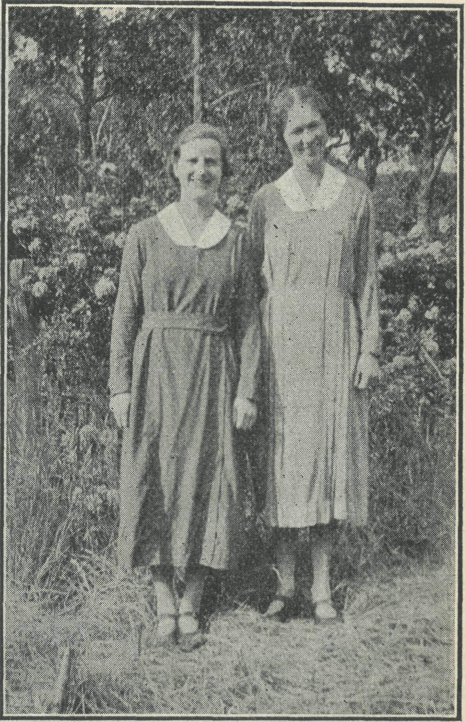
Deaconess Harris and Sister Ross who
are now at Wilcannia Hostel after two
strenuous years on the Van.
About 9 a.m. we came to a car which had broken down at 12 o'clock the previous night. We were the first people to pass. During the day we passed through

March 30, 1935.
THE REAL AUSTRALIAN,

a narrow line of hills, otherwise the country is flat.
Just as w^{T}e were starting to be thankful that our journey was nearly over, the most interesting part began. We came to the Darling River flats, seven or eight miles out of Wilcannia. To our surprise we found that Wilcannia is on the western side of the river. The western bank is higher than the eastern, and when the river floods it runs over the lower bank on to the flats.
Abruptly, at the foot of a slight decline, the ground changed to a perfectly level stretch of greyish sandy flat. The road is built up for miles, straight across the flats. Bridges span parts which are particularly low-lying, presumably where there is a strong current in flood time. These flats cause heavy losses to graziers when the floods come. As the waters recede, sheep coming to drink are bogged in the sticky mud and are unable to extricate themselves.
At last we came to the outskirts of the town and endeavoured to put our hot, dusty and thirsty persons in order. The entrance to the town is very pretty; there are lovely trees near the river and at the bridge approach. It looks strange to see the smooth, bare red banks with a wide expanse of dirty water flowing swiftly between. The river is high owning to rains in the north. The town is pretty, too, with pepper trees along the streets. These do not easily snap in the terrific windstorms which come.
The majority of fences are made of galvanised iron, except the pieces immediately in front of some of the houses. Many of the fences have sandhills more than halfway to the top. They disappear in time.
Walking through Wilcannia streets may be compared to walking along that part of a beach which is not often reached by the tide—a most difficult procedure when hurrying to church.
The town greeted us with moderate heat, according to the oldest residents, but to us it was very hot and we were glad to end our first impressions on arrival at the hostel, with the usual welcome cup of tea.
PENONG NEWS.
H. R. Smith)
The Christmas season proved to be a very busy time here. Though the summer has been very dry we were mercifully preserved from extreme heat, and consequently have felt more fit for work than we may have otherwise been.
Christmas itself came very soon after the last Nullarbor trip, so that there was very little opportunity for rest of body or soul for a while. The Christmas Tree at Penong was the source of much happiness. The Sunday School children gathered at the hospital and spent part of an afternoon in games, after which they enjoyed some good things to eat, prepared by the Sister and' teachers, and then the presents were given out. We were all very happy indeed, and very grateful to
our good friends for .their kindness. Unfortunately, part of the presents went astray, and we have had some difficulty in providing for the outcentres, and especially for Cook.
On 21st January, five junior members of the Scripture Union, with Mrs. Smith and myself in charge, went to Sinclair (on the coast near Penong), for a few days; camp. As far as practicable, the camp was conducted after the pattern of similar C.S.S.M camps near Sydney and elsewhere. We were not so privileged as our brothers and sisters at Austinmer this year, who had "Father Neptune" to deliver a birthday cake and the Archbishop to give a message on the beach, but we enjoyed the fellowship in the Lord. The periods of Bible study from Daniel, and the short readings after breakfast and the evening meal, were very helpful to us all, and we hope some lasting work of grace may have been begun by the Holy Spirit. Sufficient food was sent down to last at least twice as long as we were able to stay.
We had a new venture at our last fete, in the form of a book stall for the selling of Bibles and religious literature. Financially, it was not part of the Fete as the books were not sold for profit. By the courtesy and kindness of a Sydney firm, we were able to sell at Sydney prices, and while we only sold about one-third of our stock, w^{T}e are deeply thankful to God that every Bible and portion of Scripture but one was sold. Where the Word of God is read we have much encouragement to hope for real results.
Driving is very tiring now, with the roads as they are. Most families are carting water for stock and many for drinking purposes. Some are looking for rain and others are hoping it will hold off until April to give the ground a good soaking before seeding. One really wonders what will be the future of the farmers if we have another dry season. Most of them have not got over the long drought of a few days ago.
We thank God that there is a land where droughts and sorrows and sin shall have fled away, a land kept cool and green by the pure river of the water of life. To this heavenly Canaan can w^{T}e look with joy and a new song in our mouth even praise to the Lord Jesus for His love on Calvary.
Note.—I would be very grateful if some friend's could send for distribution, tracts, Bibles, or portions of Scripture and' New Testaments in Maltese.
THE MALLEE.
Summer. Rev. Tom Gee.
Apparently Summer is over, for we are now enjoying a very welcome cool change. On the whole, however, we have had a fairly mild Summer—mild that is, for the Millewa, although people from other parts would doubtless have thought it very hot and dusty and generally unpleasant.
Last year at this time we were sweltering in a "heat-wave," in fact we arrived in the Mallee in time to receive the full force of it, and we soon realised that a heat-wave here is an evil thing. Day after day the sun shines out of a cloudless sky with a burning intensity, and soon everything is hot to the touch, and it is impossible to find a cool spot. Then, usually, the wind rises, blowing dust and smoke from the north, and the temperature goes steadily up and up. Houses are shut up in a vain endeavour to keep the dust out, and soon the heat w^{T}ithin is intense. The worst storm in the history of this settlement struck us just a week before Christmas. After raging all day, it did not cease at sun-down, as is usually the case, but kept up its onslaught all night. The very fine, choking dust continued to penetrate through the many cracks and cran-
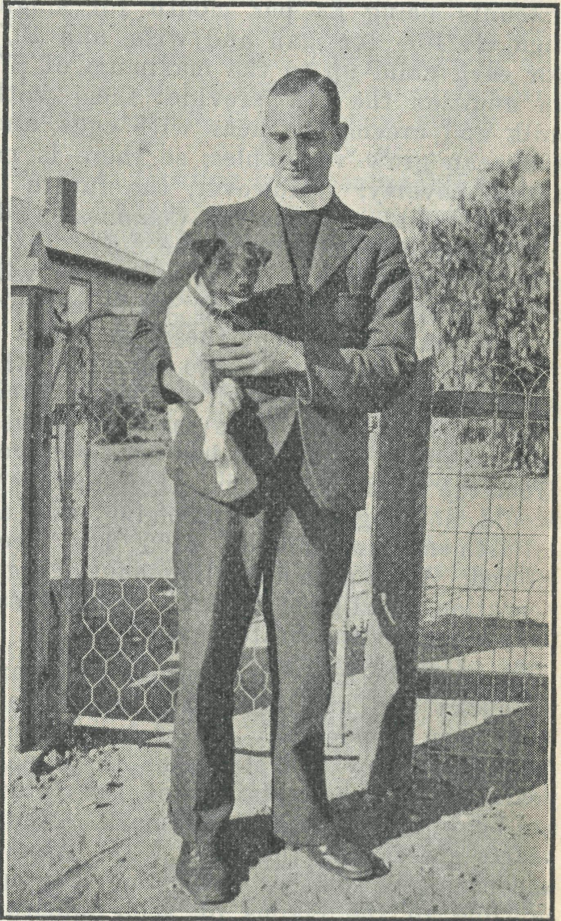
Rev. Toim Gee, Mallee Missioner, and "Patches."
nies in walls and roof and floor. "Patches," the terrier, had long since dug herself a hole in the ground under the house, and there she spent the day fairly comfortably. "Baby" lay between wet-sheets, and w^{T}e went about with wet bandages over nose and mouth. Very few people retired to bed before 2 o'clock in the morning, and even then the temperature was 92 degrees.
Our beautiful church was in a deplorable state when the storm ceased, and it took three teams of our church-people to get the interior back to its well-cared-for appearance.
The Millewa.
The Millewa Settlement is passing through the worst period experienced since

THE REAL AUSTRALIAN.
March 30, 1935

it was opened up 12-14 years ago. The continued dry seasons, the severe and variable wind storms, and the destructive grasshopper onslaught have resulted in another poor harvest. To make matters worse, the price of wheat remains low.
Many of the settlers have realised that it is unwise to rely solely on wheat, so they have side lines such as sheep and pigs. Unfortunately, they are now finding great difficulty in providing feed for the extra stock. A suggestion has been made recently to irrigate small blocks on the dry holdings for purposes of grazing and fodder provision. The idea seems a good one, and if carried out will probably be the means of stemming the exodus of starved-out wheat farmers.
The Millewa is being administered by the Closer Settlement Commission, and settlers receive sustenance monthly, the amounts being £3 per month for single men, £4/10/- for man and wife, and 10/-f or each child up to the maximum of £7. In addition the cow provider them with milk and cream, the hens with eggs, and they can grow vegetables, so there is no actual poverty. However, the future is most uncertain, for the C.S. Commission administration terminates at the end of 1937; then sustenance and' other advances will stop. It is apparent that many settlers cannot manage without these, so unless a new scheme is brought into operation, the sottlers will be obliged to leave their blocks. Already in some cases of proven un suitability, intimation has been received from the Commission that their advances would no longer be forthcoming, and an adjustment amount of £100 has been offered. With such a small amount of compensation it will not be long before these people are on the State again.
Through the many dry seasons with bare paddocks and swirling dust, the settlers have been wonderfully cheerful and hopeful. But now the strain of those past years and the uncertainty of the future are beginning to make their mark. Men's hearts are failing them for fear. Almost unconsciously some are becoming less susceptible to the claims of their spiritual nature, and in the stress of things forgetting from whence all help comes. So the work which the B.C.A. is attempting to do is to help renew faith in God's overruling providence, to point these people to the comfort to be found in the fact that through all the changing scenes of life, in trouble and in joy, God is working His purpose out, and that He has not left us to be the sport of circumstance. Mysteries there are, and they baffle us, but God rules in His own world and His rule will be vindicated.
ST. MICHAEL'S, WERRIMULL.
St. Nicholas' Church, Werrimull, owes its existence to the widespread regard which members of the Church of England have for the less fortunate brethren of their own communion. It is truly a monument to the reality of the doctrine of the
communion of saints in its practical manifestation.
Before it was built, there were some hundreds of Anglican families scattered over an area of 100 miles by 50, of which the township of Werrimull is the centre, whose only place of worship was the home of a godly-minded settler, or the little corrugated iron school building.
When the Bishop of St. Arnaud was home in England at the Lambeth Conference of 1930, much of his spare time was given to the task of describing the difficulties which confronted these settlers, many of whom were immigrants. A succession of droughts for the initial three years of their tenure, followed by a slump in wheat prices, coincident with the advent of a few good seasons, left all alike dependent on a ration allowance of £5 monthly per man, wife and child. The maintenance of a regular ministry was only made possible through the good offices of the Colonial and Continental and the B.C.A. Societies' provision of money and men.
A church building seemed an impossibility, yet folk at home and in Australia succeeded in raising the necessary £500 for its erection.
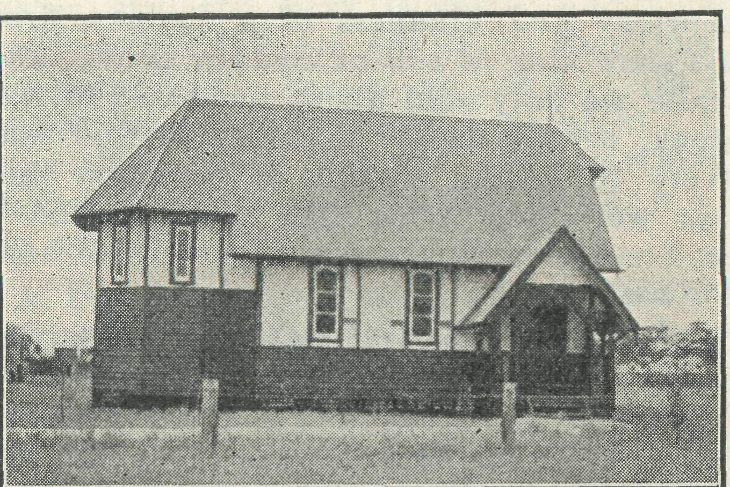
St. Michael's Church Werrimull. Vic.
Next came the question of furnishing. Again thanks to the Bishop's wide knowledge of clergy in Australia, this was made possible.
The organ and six pews were the gift of the church at Avoca. The Holy Table is a memorial gift of the parishioners and the Rev. R. T. Hallahan. The Credence Table is a gift of a lady in America, whose interest was obtained through her brother, the Rev. Canon Horner, Rural Dean of Mild'ura. The Lectern and Sanctuary Chair are gifts from St. Mark's, Fitzroy. The carpets for the aisle and Sanctuary came from St. George's, Queenscliff.
The money that enabled a specially designed Chancel to be built as a memorial to the late Rev. Reginald Tuck, was the gift of a local family greatly devoted to him, and in whose company he was at the time of his tragic death by drowning.
Sitting in the beautifully completed little building on the day of its consecration, 30th May, 1932, one could not help but feel the Presence of Him from Whom flowed all those gifts of life and love, and one prays that a continual remembrance of His Presence may be felt by those struggling settlers in this, their day of trial.
KOOKABURRA CLUB.
Dear Kookaburras,
You will notice by the message on the front page that we desire to go forward and do bigger and better things for the boys and girls in the out-back. I want all members of our Birthday Band to help. One of the best ways of helping is by getting new members to join our Kookaburra Club. Will you tell your friends about B.C.A. and get them to join our Club f
Perhaps you could give them a happy surprise by sending along one shilling and the name, age and' address, of one of your friends. We could then send along one of those very nice birthday cards. What a surprise it would be. Then there are quite a lot of Kookaburras who forget to send in their shillings each year. Please don 't forget to send in yours to the office. It is such a help to us and cheers us up very much to know that all our friends are remembering our great work. Yours sincerely,
THE OLD KOOKABURRA.
MAIL-BAG SUNDAY SCHOOL.
Our Mail-Bag Sunday School continues with, if anything, greater zest than ever on the part of both the workers and scholars. For the month of April we have found' it necessary to increase the number of our Upper Grade Lesson papers by fifty, making the total number required for each Sunday, 775, with a proportionate increase in the Primary Grade papers.
It is, indeed, gratifying to have received further names of children for enrolment from several clergy in country districts, including two from Victoria.
Our Secretary, assisted by a number of teachers, has had the very happy, though big task, of choosing and' despatching 112 books, including Bibles and Prayer Books, to the children to whom we found it possible to send Rewards for their last year's work. The Society is deeply indebted to those teachers who so generously donated the prizes, or the cost of same, for their classes, making it possible, with the assistance of donations from several good friends, to defray the whole of the cost

March 30- 1935.
of about Ten Guineas, without having to call on the funds of the Society. And we think they are more than repaid by the appreciation expressed by both children and parents.
Is there any wonder that the prize list passed the nundred mark, when it is known that in the Upper Grades alone, just on seventy children sent in work for every Sunday of the year ? This we consider magnificent, and reflects great credit on the splendid band of teachers, who, in their zeal and enthusiasm in this little branch of our Master's work, obtain such fine results from their pupils. It also speaks volumes for the untiring interest shown by so many of the parents, who, in many cases, and often at great sacrifice, conduct their little home Sunday Schools with the assistance of our lesson papers.
Another very encouraging part of our Mail-Bag work is the conducting, in many districts, of little Sunday Schools ; often by some of our-older scholars. The letters we receive from time to time do certainly stir up feelings of real joy and thankfulness. Here is one of them :
"lam very interested in the Mail-Bag
Sunday School. I first learned of its ex
istence from a friend who uses these les
sons very satisfactorily in her beginners'
class at .
I have a class of ten young children and have difficulty in really impressing their young minds with a message each Sunday, having seen the Mail-Bag Sunday School Lessons for Beginners, I feel sure that at last I have found something to keep my small children interested from Sunday to Sunday, also it will help them to remember and understand the works of our Heavenly Father.
Perhaps you would' like to know something about our little Sunday School and where it is situated.
We hold our class in the little weather
board Church of St. Barnabas, .
It is situated at the furthermost end of the
Parish of .
Sunday School is always three-quarters of an hour before Church service because everyone has to walk some distance across the paddocks and the children stay for Church and then go home with their parents.
Thanking you, and hoping I am not causing you any great inconvenience, Yours faithfully,
Since our last issue the Primary and Upper Grade Departments have held their Quarterly Meetings, both of which were well attended, and besides being very happy gatherings, it was felt that much was accomplished' in suggestions put forward and discussed for the furthering of ,,the work.
We say, unhesitatingly, that we believe God has been able to bless this work because of the earnestness and prayfulness of our workers and friends.
THE REAL AUSTRALIAN.
QUARTERLY CONFERENCE.
Primary Grade Mail-Bag Sunday School Teachers.
The Quarterly Conference of the Primary Grade teachers and workers of the Mail-Bag Sunday School, was held amidst the delightful ' bushland surroundings of Bradley's Head.
It was a very fitting setting for such a Conference, and seemed to bring us so much nearer to our children, many of whom spend their whole lives in a similar environment.
The absence, through illness, of our guest of honour, Miss Yaughan-Jenkins, was a sad disappointment, for we had hoped' to hear much of her recent trip through the out-back. The meeting expressed sorrow at her absence and hope to meet her at the May meeting.
After the routine business had been disposed of, Miss Foster led a discussion on the lesson papers for the next month, emphasising the need of a careful and' regular plan of study on the teachers' part, of each week's lessons.
A happy picnic tea in the calm Autumn evening brought to a close a most enjoyable and helpful gathering, and sent us home eagerly looking forward to our next meeting in May.
MAIL-BAG SUNDAY SCHOOL.
Primary Grade.
From time to time gifts of Bibles, Prayer and Hymn Books, pencils, crayons and other materials are left at the B.C.A. office. We appreciate the thought of those, often unknown to us, who co-operate with us in helping the children in the country.
We have received packets of gum-backed Bible Picture Stamps, apparently from Sunday Schools who have no further use for them. We feel that there may be other people who read' this paper and would like to help us by giving their surplus stamps.
These can be used to illustrate the Mail-Bag lessons, provided we have sufficient of the one subject. For this reason we are collecting these stamps in the hope of being able to send them to our children. The majority of our scholars do not see or possess any Bible pictures, so these stamps should give them a great deal of pleasure.
PERSONAL NOTES.
The marriage was celebrated at St. Cuth-bert's, South Kogarah, on Saturday, January 26, of the Eev. L. Lambert, Missioner at Wilcannia, and Miss E. Fountain. Mr. and' Mrs. Lambert left for Wilcannia early in February. We pray that God will abundantly bless them as they witness for Him in the Far West.
# # #
Sister H. Gason has taken up work at the Cann River Dispensary in the place of Sister K. Grainger. Miss Gason writes to say that she has found plenty of work to do and that already she loves the homely people and the big gum trees of Croajing-along.
# # #
B.C.A. has, at the invitation of the Bishop of Willochra, appointed the Eev. K. Luders to the charge of Kirton Point, S.A. Kirton Point has had no regular services for seven years. The prayers of all B.C.A. friends are specially asked for Mr. and Mrs. Luders in their new sphere.
# # #
Sister F. Dowling has been unable to return to Ceduna and has been granted a further month's leave in order to nurse her father, who has been seriously ill. Our prayers are offered for the speedy return to health of Mr. Dowling.
# # *
Mrs. Mann, who has so nobly built up the Hostel work at Wilcannia, leaves for England during March. During Mrs. Mann's absence the Hostel will be in the capable hands of Deaconess Harris, who will be assisted by Miss C. Ross. These two splendid workers are well known for their Mission Van Service.
# # •
B.C.A. offers its congratulations to the Rev. S. H. Denman on his recent preferment. The Canon has always been a B.C.A. stalwart and' is a member of the council of the Society.
www
The Rev. G. Woolf has been unable to contribute his usual interesting article for this issue because of illness. We ask all the friends of B.C.A. to remember Mr. Woolf in their prayers, that he may speedily be restored.
POST AND RAILS.
The Acting Organising Missioner spent a very happy week-end, with much profit to B.C.A., at Leura. Much interest was shown in B.C.A. and its work by the people of this country parish. The Rev. and Mrs. Dixson Hudson are keen supporters of B.C.A. and have done much to increase the interest of the folk at Leura in the Society's work. We offer to them our very real thanks and also to Mrs. Newmarch for her untiring efforts as Box Secretary.
A visit to St. John's, Ashfield, found many interested" in B.C.A. Retiring collections at church services and a Travel Talk set a record for B.C.A. contributions from this parish. Thank you, Mr. Cocks. We hope to do even better next year.

8
THE REAL AUSTRALIAN.
March 30, 1935.

Matron Cheers, of Mungindi Hostel, writes: ''Send us groceries, more groceries and still more groceries." May we appeal to all our supporters for more Grocery and Linen Afternoons or Evenings ? A Grocery Effort in each parish would solve our Hostel problem. Mr. Jones will very gladly come out and speak to your friends at such events.
a tik" " ■■ 'ik
The Eev. L. Lambert writes : *' Do you think some city church would donate a pulpit for our church at Menindie ? We are now doing the best we can with a packing case covered with a red cloth." We publish this appeal in the hope that it may catch the eye of some Rector whose parish is refurnishing. Some A. & M. Hymn Books would also be very acceptable for use at Menindie.
m # ' #
Visits to Holy Trinity, Dulwich Hill; St. Clement's, Marrickville; St. Andrew's, Wahroonga; St. Matthew's, Bondi; St. John's, Rockdale; St. Mark's, Brighton and St. Michael's, Woollongong, have been of great profit to B.C.A. We rejoice to find that much keen interest is taken in the work out-back by many of our church-people. We would say a sincere "thank you" to the Rectors of these, and other parishes, for so willingly giving the freedom of their pulpits for our cause.
-if # *
We wish to acknowledge the following
anonymous gifts : £,5, handed to the Act
ing Organising Missioner at Leura; a £1
note received in an envelope with a Syd
ney postmark; a 10/- postal note, number
B-520757, received from "Anon./' Sydney.
# # #
We tender our thanks to the ladies of St. Stephen's Guild, Normanhurst, for a very nice parcel of groceries, the result of a Grocery Afternoon.
¹ <REAL AUSTRALIAN" SUBSCRIBERS.
To the following we give thanks for subscriptions received during the past three month :—
Miss Walker, Miss T. Tremlett, Miss D. Baker, Mrs. R. Swift, Mrs. E. W. Hughes, Rev. Owens, Miss Palmer, G. Ansdell, Mrs. Hill, W. E. Bannister, Mrs. Lawrence, Miss E. Cowcher, Mrs. H. Thomas, Mrs. A. E. Owen, Miss E. Gurney, Miss M. Dell, Mr. Short, Mrs. A. M. Nicholas, Miss A. Clark, Miss M. A. Allen, Mrs. Holroyde, Mrs. E. S. Alford, E. Taylor, Miss M. Pease, Mrs.
E. A. Frisken, H. Morgan, Mrs. S. Mills,
Mrs. Manning, T. W. Holesgrove, Mrs. F.
A. Mitchell, Mrs. P. A. Whitfield, Miss E.
Hartley, Miss M. Jamieson, G. A. Smith,
Miss F. Spencer, Lady Fairlie Cunning-
hame, H. A. Corish, Rev. H. Ham, Miss
F. M. Rudd, Mrs. Cramer, S. Horn, Mrs.
H Baker, Mrs. E. Marchbank, Mrs. J. B.
Bully, Mrs. J. V. Morgan, Mrs. Weir, Mrs.
Ree, Mrs. F. M. Chapman, Mrs. Napper,
Mrs. A. Gregory, Mrs. A. M. Thorn, Mrs.
M. Wilson, Mrs. R. Kimpton, Mrs. A. H.
Brady, Miss M. Sowter, J. G. V. Try, Miss
E. Hassall, Mrs. E. Bennett, Rev. J. B.
Montgomerie, Mrs, E, Mcintosh, Mrs. Mau,
J. Hammerton, Mrs. F. Benson, J. Linwood, Miss F. G. Gardner, Miss V. Slade, Miss Emmerson, Miss Vaughan Jenkin, Mrs. E. A. Brocklebank, Mrs. G. Elston, Miss Barling, Miss I. Thomson, Mrs. L. J. Hurst,
E. Allman, Mrs. W. Alison, W. England,
Mrs. H. Peadon, Miss A. Carter, A. Tren-
erry, Mrs. Howieson, Mrs. E. Moore, Miss
K. Howard, Mrs. Field', Miss A. Wilkins,
Mrs. B. Dew, Miss Hardy, R. B. Coates,
Mrs. Bland, Mrs. A. Theobald, G. H. Win-
ton, Miss Kinder, Miss Cox, Miss Clarke,
Miss Cochrane, Miss M. Nicol, Miss J.
Watt, Miss 0. Watt, Mrs. Coogan, Miss M.
Davey, E. Smith, Miss M. Matthews, Miss
I. Way, Miss E. Scott, Mrs. H. B. Cox,
Miss V. F. Windon, Mrs. I. Anderson, Mrs.
Mackenzie, Sister Kathleen, Miss L. Jones,
H. Elyard, Mrs. Caldecott, J. Knox, Mrs.
J. W. C. Adam, Mrs. Evans, Mr. Wareham,
Miss Dowling, Miss N". Seedsman, Mrs.
Littlefield, Mrs. Boyce, Miss B. Hansen,
Miss F. Scott, Mrs. Russell, Miss E. Orm-
'erod, Mrs. Gason, Mrs. M. Costello, Mrs.
F. Clevendon-Smith, Mrs. J. C. Rogers,
Miss M. Whittakers, Miss B. Dowling, Miss
J. F. Watson, Mrs. Dougherty, Miss S. L.
Dickson, Miss Hester, Mrs. Purbrick, Miss
D. Lawrence, Miss E. Clifford, S. Dodg-
shun, Mrs. Chase, Jas Connor, Mrs. Dun
bar, Mrs. Moog, Capt. S. G. Hooper, Miss
E. Hooper, G. F. W. Hedge, Mrs. and Miss
R. B. Hill, Miss M. G. Thompson, Mrs.
Fletcher, Mrs. Sydney Bradshaw, Mrs.
Heritage, Mrs. Alexander, Mrs. Dalway,
Mrs. Jennings, Miss Hancock, Mrs. A.
Tabeteau, Mrs. Noble, Mrs. Prewett, Miss
J. Southam, Mrs. Hindley, Mrs. Winter,
Miss N. Godsall, Miss M. Baker, Miss R.
Hargreave, Mrs. Gray, Mrs. A. E. Nixon,
Mrs. E. W. Hurst, Mrs. A. Marchant, Miss
C. Schleicher, F. H. Lewis, Mrs. W. M.
Clarke, Miss E. Dennett, Miss A. Richards,
Miss Stephens, Miss H. Fischer, Rev. W.
M. Wilkinson, N. B. Newland, Mrs. H.
Watson, Miss A. I. Morris, Miss B. Stein
beck, Miss M. Pritchard, Mrs. F. Fazaker-
ley, Mrs. M. Hopkins, Miss Alkin, Mrs.
Porinan, Miss L. Bank-Smith, Miss C. Alan-
son, Miss F. Cox, Mrs. Luckie, Miss K.
Buscarlet, Mrs. D. McKerrow, Mrs. Rich
ards, Rev. G. R. Beatty, Miss Mitchell,
Mrs. W. J. Clarke, Miss E. Downey, Miss
Johnston, Mr. Butcher, G. Porter, Miss E'.
Austin, Mrs. A. S. Smith, Miss S. A. Cheff-
ins.
A PRAYER FOR USE WITH OUR PRAYER LIST.
O Lord God of our nation, Who has commanded men to subdue and replenish the earth, look in Thy love upon all those who in the distant parts of our land' are striving against many difficulties, and arc deprived the access to the means of grace. Strengthen and guide the Bush Church Aid Society and its Clergy, Nurses, Deaconesses and Students. Cheer and encourage them in discouragements and loneliness, and bless their ministrations to the good of those they serve, and grant that the message of redeeming love may thus be rooted and grounded in our national life, to the glory of Thy Great Name, through Jesus Christ our Lord, Amen,
THE PLACE OF PRAYER.
All B.C.A. friends are invited earnestly to use in daily prayer the suggestions made in the following list of subjects:—
SUNDAY—pray for :
The Missions of the B.C.A. in various parts of Australia; the Missioners of B.C.A. as they minister of the Word and Sacraments, Rev. G. Woolf, at Ced-una.; Rev. H. Smith, at Penong; Rev.L. T. Lambert, at Wilcannia; Rev. L. Dun-stan, at Denmark; Rev. S. Viney, at Cann River ; Rev. T. Gee, at Werrimull; Rev. K. Luders, at Kirton Point, S.A.
MONDAY—Pray for :
B,C.A. Hospital work in the Far West country, where patients must be received in spite of their inability to make any return for service. Pray that God's good cheer may be with Sisters Dowling and Hitchcock at Ceduna, Sister Sowter at Penong, Sister Gason, at Cann River.
TUESDAY—Pray for :
The B.C.A. Children's Hostels at Wil-cannia and Mungindi, that the work be increased of God, and that we persevere knowing that such ministry to little ones cannot be in vain in the Lord. Remember by name Deaconess Harris and Miss C. Ross, Wilcannia, and Matron Cheers, at Mungindi.
WEDNESDAY—Pray for :
The Sunday School by Post with its Gospel message for little children; also for the teachers of this department.
THURSDAY—Pray for :
All Students, Deaconesses, and Nurses in training and preparing for B.C.A. work in the Bush, that they may be equipped with power, wisdom, and zeal, and become "able ministers of the New Covenant. '* Also remember the Council, Committees, Women's Auxiliary, and workers on the Home Base Staff.
FRIDAY—Pray for :
The Council, that it may be specially guided in the appointing of a new Organising Missioner.
SATURDAY—Pray for :
A spirit of thankful giving to be upon all B.C.A. friends, that the Society be kept out of all God-dishonouring debt.
AT ALL TIMES—Forget not to give
thanks: for kindly givers who have helped us with their self-denials. For friends, known and unknown, who have rallied at our call to keep our ministries going.
For cheering reports from fields that God's Word is still with power. For offers of service for the filling of pending vacancies in our work.
Wholly set up and printed in Australia by D. S. Ford, 44'50 Reservoir Street, Sydney.

