Registered at the G.P.O., Sydney, for transmission by post as a periodical.
"AUSTRALIA FOR CHRIST."
The Real Australian
Organ of the Bush Church Aid Society for Australia and Tasmania*

No. 57.
JUNE 30, 1935.
1/6 per annum (post free).

THE BUSH CHURCH AID SOCIETY OF AUSTRALIA AND TASMANIA.
Headquarters Office :
Diocesan Church House, St. Andrew'*
Cathedral, George Street, Sydney.
(Telephone : M-3164.)
Cable Address : "Chaplaincy, Sydney."
Victorian Office :
St. Paul's Cathedral Buildings, Flinders Lane, Melbourne.
President: The Right Reverend Bishop
KIRKBY. Hon. Clerical Secretary : Ven. Archdeacon
W. L. LANGLEY. Hon. Treasurer : T. S. HOLT, Esq. Victorian Hon. Treasurer : E. V. PAN-
ELLI, Esq. South Australian Hon. Secretary: Rev.
R. H. FULFORD, Holy Trinity Rectory, Adelaide. Acting: Organising Missioner : Rev. T. E.
JONES, Th.L. Victorian Deputation Secretary : Rev. J.
H. VAUGHAN.
My dear B.C.A. Friends,
In the last issue of our paper I ventured to place before you the pressing needs of our work. We have been lifted up by the assurances of prayer and by gifts from many of our good people. It is, therefore, with greater faith and confidence that we look forward to the future days.
Nevertheless, while we are thankful indeed for the response already received, we would have all our good friends know that if we are to go forward we still need more "extra" help this year.
The Wilcannia Hostel, which has been a mighty witness for God in the northwest of New South Wales these fifteen y^ars, sorely needed improvements. New fencing, a new bathroom and dormitory, as "^ell as repairs to concrete flooring and Grains, have required a sum of £60 to be scent. This amount is to be paid in the ^belief that some of our good friends wiji assist us. Already £25 has been received.
Sister GaSo_{n} at Cann River is manfully doing tho work of two nurses, but this cannot go\p_{n}. She must have an assistant.
Sisters Dowling _{an}a Hitchcock at Ceduna also need another nurse to aid
them in the big task they are doing for the Kingdom of God.
We must not let these splendid workers down.
The Medical Mission Van is still a dream to be realised. Can you not visualise what a blessing it would be to many lonely folk out-back just to know that at regular intervals two trained Christian nurses would call? What a lot of sickness and pain such a ministry would save!
The Mail-Bag Sunday School furnishes Christian teaching to over three thousand young Australians. Letters received from time to time from scholars, parents, and old scholars bear wonderful testimony to the usefulness of this ministry. The Sunday School is suffering from "growing pains," and really needs extension and improvement.
For fifteen years B.C.A. has ministered to our brothers and sisters in the lonely places of our land. Almighty God has been very good to us; never once has He failed. Men, women, money and opportunities for service have always been found by faith and prayer. We are proud that deficits and overdrafts are nightmares of finance unknown to B.C.A., not because of any merit on our part, but be dm ,e people of God have always fully maintained this work for His Kingdom.
Now that the time has come to extend its scope, we are fully confident that the God Whom we serve will, through His people, supply all and every need.
For the convenience of those who have not already sent in their gifts, a form has been printed on the back page of this issue. Just fill it in and post with your "extra" gift.
Yours in His glorious service, TOM E. JONES, Acting Organising Missioner.
MOVEMENTS OF WORKERS.
The Rev. J. H. Vaughan will take up his duties as Victorian Deputation Secretary on the 1st August. Mr. Vaughan is not new to B.C.A. work. Before his college days he served as a lay worker in the Far West Mission of South Australia, and later he relieved at Wilcannia, N.S.W. On his way to Melbourne, Mr. Vaughan will visit Cann River in order to see the work at that centre. He will thus be able to speak of B.C.A. activities
from first hand knowledge. We would commend him and his message to all our Victorian friends, and pray that under his ministry the work may grow and be blessed in Victoria.
The Rev. T. R. Fleming has taken up his work at Cann River. Mr. Fleming has already had out-back experience, having served in the Far West Mission before going into Ridley College for his theological training. The new Missioner is brother to the Rev. W. I. Fleming, who did splendid service as Mallee Missioner from 1929 to 1931, and who was also B.C.A.'s first Missioner at Cann River away back in 1926. Mr. Fleming succeeds the Rev. S. Viney, who, after three years' service at Cann, has been appointed to Raywood, in the Diocese of Bendigo.
The Rev. Geo. Woolf also returns from the field, having been offered a parish in the Melbourne Diocese. Mr. Woolf has been in charge of Ceduna for two years, and will be remembered by our readers for his excellent articles graphically describing the work in the Far West Mission.
We ask for the prayers of all our friends for these workers, new and old, as they go to their work in new spheres.
IN MEMORIAM.
The Ven. Archdeacon Davies.
B.C.A. joins with the whole Church of Australia* in expressing its sense of loss in tk-si "Home Call" of Archdeacon Davie
The Archdeacon was one of the earliest of B.C.A. Council members, and always took a keen interest in the Society's doings. As Principal of Moore College he had much to do in the training of a great number of B.C.A. students who, over the years, have witnessed for God in all parts of the continent.
We tender our very real sympathy to his widow and children, and pray that Almighty God will be near and bless them in thkr their day of sadness.
ALICE SPRINGS.
Alice Springs, right in the centre of Australia, hundreds of miles from the coast, the real out-back!
B.C.A. has received an appeal for assistance from the Bishop of Carpen-

2
THE REAL AUSTRALIAN.
June 30, 1935.

taria, in whose diocese Alice Springs is. Mr. Smith, the Missioner, * is working under conditions of very real difficulty. He has no church buildings of any sort, and no means of transport. Mr. Smith is trying to visit his people—on foot, an impossible task.
In order to erect a suitable building in which services may be held, and to provide a place in which the Missioner may live, the sum of £1000 is required. A good four-cylinder truck is needed to allow him to visit his people. We of B.C.A. have promised to make this need known to our friends, and to forward any gift received on to the Bishop. We commend the appeal to all our friends for their earnest prayers and support.
KIRTON POINT, S.A.
Rev. K. Luders.
I regret not being able to write a really heartrending report of the difficulties encountered in the work here, but, as a matter of fact, things are going along quite satisfactorily.
Before leaving Sydney, I enquired of the Tourist Bureau as to the whereabouts of Kirton Point. After various books, directories and maps had been consulted, it was confessed that at last someone had asked the Bureau something it did not know. For the sake of those who know as much as that wonderful institution, it may be advisable to state that Kirton Point is now on the map. It always has been, of course, but not so far as "Real Australian" readers are concerned.
Now, just dig out a map of South Australia and find Eyres Peninsular. Look at the nobbley bit on the Spencer's Gulf side of the Peninsular end. Trace a line from just above the nobbley bit, bearing north until due east of Mount Greenly, then change direction east to meet the coastline. This gives very roughly the boundaries of our parish, which is approximately 45 miles long by an average of 15 miles broad, and includes the two country centres of Lake Wangary and Coulta. Kirton Point is simply a local name for a small residential district just across the railway line from Port Lincoln township, and beautifully situated on the western shore of Boston Bay—an anchorage that as such surpasses "our Harbour."
At Kirton Point, services are held in the Missions to Seamen Hall—a healthy little church promising vigorous growth in the future. Our first group of eight young people was confirmed in May. We are fortunate to have the services of three licensed lay readers. The organisations at headquarters are Women's Guild, G.F.S., Choir, Sunday School and Kindergarten, and fortnightly week-night Bible Study Circle, all going strongly.
At Lake Wengany things are not so good, though services are well attended.
Coulta church life is very satisfactory. More men than women attend services here. Occasionally we have two car loads of visitors all the way from Mount
Hope for Holy Communion. Just now the district is infested with a type of pest called "Cooneyitis," some new brand of American novelty religion, the details of which are a mystery.
At the "country" centres, Holy Communion is celebrated once per month— in St. Matthias' Church at Wongany, and a public hall at Coulta.
Just lately we have been experimenting with an "Instructional Service," with which it is hoped to meet the needs of the young people who, for the most part, have had no Sunday School training, and are woefully ignorant of the rudiments of the Christian Faith. These services are made bright and cheery with plenty of singing. Instruction is given with the aid of a portable blackboard, illustrations, etc. Time is afforded for questions and discussions. The adults are as keen as the young folk.
Distance is one of the handicaps here, though a man from further north or west would laugh at the idea of forty miles being any distance. This will be better realised when I state that in four months "Pearl" and I have covered 3400 miles. "Pearl" is the car. Part of that mileage went in taking the Bishop on tour to visit some of our country people. It is not until we have used the tracks and traversed the distances that we can appreciate the spirit of these people as they congregate for public worship.
CANN RIVER.
Rev. T. R. Fleming.
Soon after my arrival in Australia, I went to the Far West Mission of B.C.A. in South Australia, with its never ending plains, salt bush and stunted scrub. Today I find myself again with B.C.A., but this time amongst the mountains and big timber of the Croajingalong forests. The contrast in the scenery is very marked—indeed, it could not be greater —but the lives of the people hold a similar loneliness and the same great longing and welcome for the visits of the Missioner.
Our beautiful little Church at Cann, the gift of that devoted worker, Miss Reece, stands out in great contrast to the rest of the buildings in this large district, in which services are held.
Some two years ago there was added to the Croajingalong district an area on the northern side known as the Bonang-Bendoc district, on the edge of the Monaro tableland. On the extreme edge of this district is a little place called Tubbut. The opening of a new road from Buchan to Bonang made settlement here possible, and a big area has been divided into smaller blocks. Some nine blocks have been opened, and a hard struggle is being experienced, and some fine pioneering work being done by the new settlers.
After a day's visiting of homes in all stages of completion, many lined by newspapers, a service is held in the old original homestead, The portable organ
carried by the Missioner, though very wheezy, supplies the music. The room is lit by a number of home-made candles, which someone has to clip at regular intervals during the service, and in this "dim religious light" the old hymns are sung with more gusto than tune. It would perhaps not appeal to many of our city congregations, but it has a great appeal to these lonely settlers.
Eighteen miles from Tubbut is Bonang, where a goodly congregation gathers from many miles around. Service is held in a small State school, but they are seeking to build a wee Church for themselves. They are a very mixed group of all denominations, but only B.CA.'s Missioner ever visits them. Even when they build their Church they will only have one service per month, and, because of the long distance from Cann River, that will have to be in midweek.
Scattered about the district are lonely farms, where one calls for a short time and must pass on. How gladly they welcome the Missioner, and look for the prayers before he departs! One typical case comes to mind. I had called at the home, and on my way back I met the farmer. He thanked me for calling, and then said : "Call as often as you can. It is not so bad for us men, but the women at home all day—you know . . ." That "you know" rings in my ears, for I know that there is little hope of calling again for several months. The winter makes entry up these small tracks an impossible task.
BISHOP KIRKBY.
Our beloved President is at present recovering from his illness.
The Bishop is very grateful for the many assurances of love and prayer sent by many of his friends from all parts of Australia. They have greatly cheered him.
THE MUSINGS OF A CAT.
It was just at the end of January when the two Sisters arrived here. I remember, because my kittens were born the day before, and I was busy giving them their evening wash at the time. I heard the lorry pull up and the bumping of baggage.
Things were very quiet for a day or two. The newcomers cooked a dinner on the range, and had frequent glance? at the thermometer. It registered IIP⁰ once to their great delight! They heard my kittens crying and tried to find them, but they were safely hidden unde-" the kitchen.
Children began to come back shortly after, and in a fortnight there were nine of them, seven of whom were boys. They all had their jobs to do. In the morning they carried chips and wood, set the table, fed the fowls, etc. They took turn about to clear tables and wipe dishes. In the afternoons they played and made a great noise. Then they all

June 30, 1935.
THE EEAL AUSTRALIAN.

had a shower before tea, and enjoyed it as much as city boys enjoy the surf, I believe.
One evening I saw a cake with candles on it being carried inside. At tea time, however, the little boy was too sick to enjoy his cake, and was put to bed. Later in the evening I heard a car pull up, and, having attended to my family, went for a prowl.
"Yes," said a man's voice, "it's dip. alright! You'll have to go into quarantine. You'd better bail up the knives and forks! When the fumigation is over you'll be free to go about again."
Aren't I glad I'm a cat!
There was school at home for a few days then. I was away myself a good deal hunting, but noticed some meals being carried about. Then one very hot day some more boys arrived. They said they had been travelling all night.
After that day there was more school at home. Somebody said, "Sister's gone to the hospital," so I gathered we were in quarantine again. This time there was Sunday School and service at home. I heard the hearty singing and wished I could join in, but my voice is really at its best about three o'clock in the morning, and it was all over by then.
One day there was a knock at the back door, and a man offered some things for sale. "I'm sorry! Didn't you see the notice? We're in quarantine," said someone. "Oh!" said, the man, and, picking up his bag, went round the tank at a run. I joined in the hearty laugh which followed. He did look frightened!
My family were beginning to need more space, so I moved them to the main building. Here they could run under the dining-room, sitting-room, three bedrooms and verandahs, and even get into the store-room.
As soon as the fumigations were over the Bishop arrived. There was a Confirmation. I think that's right, but heard one of the boys asking, "Is that her composition dress?"—so am in doubt. It's just as well he came that week-end, as another little boy went off to hospital, and we had another spell of quarantine.
Sister came home, and had quite an exciting time the following evening. One of the boys killed a little scorpion in the dining-room, and, of course, she was on the lookout for more. A spider ran across the floor, and, while Deaconess was trying to find it, she killed another scorpion. She opened the door to put it out, and a large whitish spider con Wonted her from the gauze. This disposed of, things calmed down a little. Aft^r a while I heard two heavy bangs in the dining-room. A little storm was brewing, and all the crawling creatures were looking for a dry place. I saw a centipede make its way under the door. Now there'll be some fun, I thought, and sure enough there was a yell. A great hunt went on, without success. There was only one bang after that, and the lights went out it's just as well they couldn't see what i could!
Shortly after this the children started
packing to go home, and the last three left in a terrible dust storm. It came up the day before in a wide red bank, which mounted higher and higher. Everybody rushed round shutting doors and windows, and suddenly it was upon us. For a while a red glow coloured everything, but it passed, and swirling gusts of sand covered everything in the house with a coating of rich red-brown.
Things were very quiet for the following fortnight, and then began such a commotion. It started in the kitchen. Scrubbing, painting, and hammering replaced the usual calm. Later on some men appeared, and one day I counted seven of them at work. They spent most of their time in the dormitory buildings. Two worked with concrete, one hammered in a bathroom, and two in a dormitory.. The other two didn't stay long, but spent their time on the roof fixing wires for lights. Painting and hammering continued near the kitchen, and I had to be very careful where I went at night.
Soon the boys began to return, and rushed about in great excitement from one place to another to see everything. Quite a number of packing cases have come lately. I heard cheering from the kitchen the other night when something was opened.
Well, I have been talking quite a time, so must go now and attend to my family. We are giving a concert just after midnight, and must be prepared!
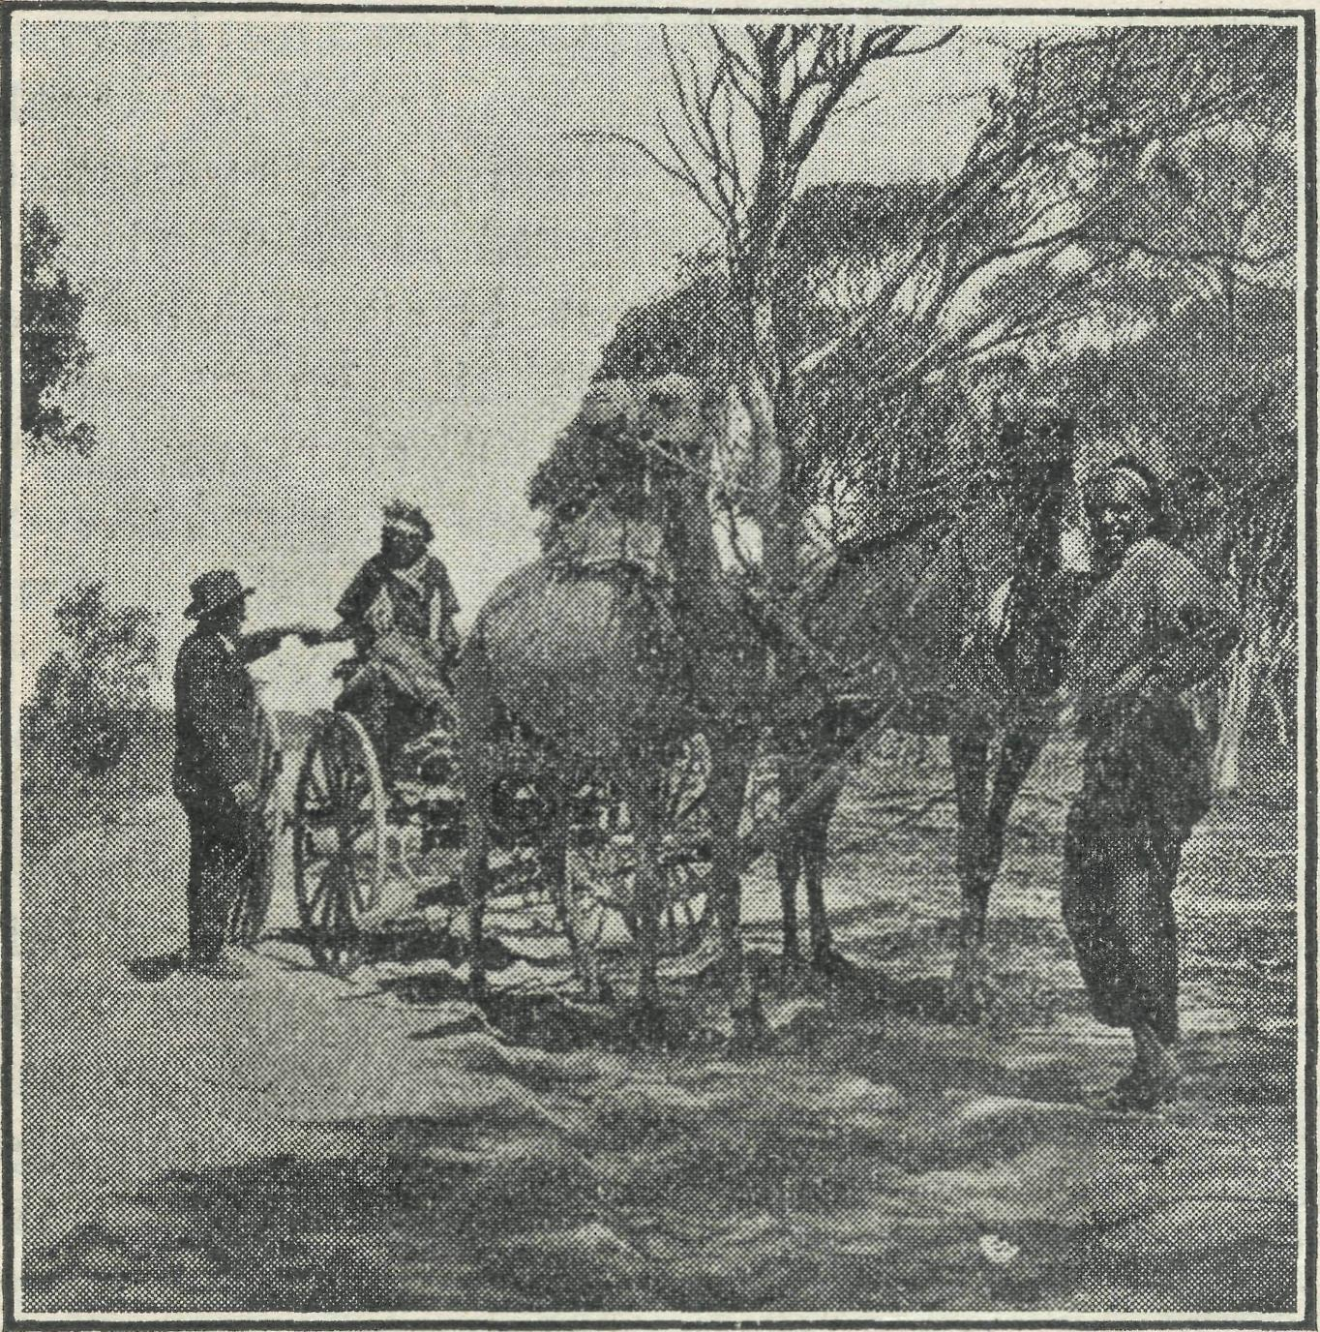
Yanie-Tuna, a native of great influence at Fowler's
Bay, receiving a gift of tobacco from a resident at
Ceduna.
MELBOURNE NOTES.
The Annual Rally of the Victorian branch was held in St. Paul's Chapter House on the evening of June 11th. The large gathering was a splendid tribute to the manner in which the foundations of the Society have been laid in Victoria. For the past eight months Melbourne has been without a Secretary, and this, it was thought, would have an adverse effect upon the Rally numbers. Instead, the gathering was bigger than last year, and the thankoffering reached £62, a pound or two over that of 1934.
We were all very sorry to find that our beloved President, Bishop Kirkby, was still too ill to be present, though we rejoice to know that his condition shows improvement. We pray that he will be in the chair for the Rally of 1936.
Bishop Baker, of Bendigo, was our Chairman. The Bishop has always tak^n a keen interest in B.C.A., and is ever ready to help the Society. The Bishop spoke of the needs of the outback people, stressing that, above all else, they needed God. This need, he said, B.C.A. existed to supply, and was doing the job very well.
The Rev. Tom Gee, our Missioner in the north-west Victorian Mallee, told of the work in his district. Mr. Gee said that, although life was far from easy and there were many things that had to be done without, the man who was prepared to adapt himself to the conditions of the country had nothing to fear in the Mallee. The people of his district, Mr. Gee continued, appreciated what B.C.A. was doing for them, and gratefully received the ministry given them.
Mr. Gee's parish is just over nine hundred square miles in area, and demands much work and travelling in order to visit and minister to these pioneering settlers.
The Acting Organising Missionenr (Rev. Tom Jones) screened and described many new pictures of the work.
At the conclusion of the meeting, many were heard to remark that it was the best Rally they remembered. Such gatherings give us renewed confidence for the future days.
•^ *£• +£l +£t ^
Mrs. Payne, of "Leura," Toorak, has always been a good friend to the Society. On many occasions she has sent in very generous gifts to the work. We thank her for £10/10/- sent to the Acting Organising Missioner during his stay in MelDourne. Dr. and Mrs. Green, of Moonee Ponds, also sent £10 as a result of Mr. Jones' visit to St. Thomas', Moonee Ponds. To these friends we offer a very sincere "thank you." Such gifts encourage us in our endeavours.
* # & % %
The Society owes a debt of gratitude to Miss Beryl Lmxmore, who has so ably looked after the office in Melbourne since Mr. Jones left us for Sydney. Miss Luxmore has been a tower of strength to B.C.A. since she came into the office, over two years ago. We are indeed fortunate to have so efficient and willing a worker.
# * # # #
This issue cannot pass without a word of thanks to the Rev. W. I. Fleming, of Mitcham. Mr. Fleming has been coming into the office two or three times a week to supervise the work at the office, and has also taken deputation work where possible. Mr. Fleming will be remembered by many as B.C.A/s first Missioner at Cann River, and later as the Mallee Missioner at Werrimull, Victoria. Thank you, Mr. Fleming!

THE REAL AUSTRALIAN.
June 30, 1935.

N.S.W. WOMEN'S AUXILIARY.
This month we have made another forward movement by the formation of a "Central Members' Branch."
A need has long been felt of keeping in touch with members, not elected to the Committee, and who were apt to look upon themselves as "only 2/-members"!
Miss Richard Jones, Mrs. Osborne, and Miss Kirkby have been elected as the Committee, and two very successful meetings have already been held at St. Philip's Rectory, at the kind invitation of Mrs. Kirkby. They have arranged to hold two meetings a year, and the next meeting is to take place on Thursday, September 12th. At present they are busily working on behalf of Wilcannia.
We believe that the formation of this branch will have far-reaching results, as many more women will thus unite their energies, and the lonely women of the bush will have cause to rejoice.
During the month of June the members of the Mail-Bag Sunday School Committee invited a deputation from our Auxiliary to meet them in order that we might have a closer knowledge of each other's work. Mrs. W. L. Langley (Vice-President) and Miss Ashe (Hon. Secretary) spent a very happy afternoon at Mrs. Hogg's, Mosman, with them, and we believe much good will come from it. Few of our readers can realise the magnitude of the work carried on by these devoted teachers, or how deeply it may affect the lives and characters of our outback children.
A long desired object has at last been achieved. The Council of B.C.A., recognising the value of women, has invited Mrs. W. L. Langley and Miss Ashe to become members of the Council. This will lead to clearer knowledge and closer unity of purpose.
Through the Auxiliaries much help has been given to all branches of the work. Mrs. Lee Smith and Miss Hayley have continued to despatch cases as the goods have come in. Many letters of thanks have been received from the agents in the field for gifts that have varied from blood-transfusion sets to blankets.
The All Saints', Woollahra, branch have sent a sewing machine to Sister Sowter at Penong, and are now busy buying an obstetric bed for Sister Dowling at Ceduna.
The Auxiliary at St. Alban's, Leura, has continued to send in regularly parcels of beautiful clothing.
On July 3rd, Mrs. Langley and Miss Ashe journeyed to Leura, and had the pleasure of addressing a large number of ladies.
We cannot overestimate the interest and earnest self-denying efforts given by this branch. Mrs. Dixon Hudson (President), Mrs. Newmarch (Hon. Treasurer), and Mrs. Osborne (Hon. Secretary) are untiring in their efforts. Their enthusiasm and keenness has a lot to do with the generous support we receive from this branch.
The Girls' Club of St. John's, Darling-hurst, again invited Miss Ashe to speak to them. This is an opportunity much valued by our Secretary. The girls have supplied cups, saucers and spoons, and this year have promised knives. These gifts give real pleasure to the staffs of the Hostels and Hospitals.
PENONG NOTES.
Rev. H. R. Smith.
I am writing this on the eve of my departure for Nullarbor, Forrest, Cook, and Ooldea. The last trip was interrupted by rain, so that I did not reach Forrest. I left Penong with two passengers for Cook, and after three days then followed the line west, but ran into heavy rain just near the Western Australian border. We managed to push on some 30-40 miles (that is, myself and a tramp), and, after two boggings, came to rest in soft mud about 100 yards from Camp 632. We were helped out, and stayed at the camp until the Friday before I was due at Penong. Neither time nor petrol would allow me to go further on, for I had to be back for two baptisms at Penong on the Sunday, and, as the coast had had more rain than the line, we followed the line back to Cook, and finally arrived home at about midnight on Saturday.
The hospitality of the people at "632" was noteworthy. Each family seemed to vie with each other in an endeavour to care for our bodily comfort, and the supreme end of our stay was the largest service I have yet had on the line, Cook excepted. Even the floods can be turned to good by the mighty hand of God.
I am deeply grateful to the Adelaide and Sydney branches of the British and Foreign Bible Society for their kind gifts of one dozen (each) copies of portions of Scripture in Maltese, and for the offers of tracts (in English) by other friends.
There are often discouragements in the lack of visible fruit or of the seed taking root, but the Lord has seen fit to send some little reminders of the truth of His promise : "Cast thy bread upon the waters, for thou shalt find it after many days." I had a letter some time ago from a young lady, telling me of the conversion of her sister through a tract which I had given to her father. More recently, a man came to me and asked me if I would help him find the verses mentioned in a tract. He had read it through a number of times, and wanted to find each reference in the Bible, but the Roman numerals had baffled him. This man had registered a decision on the back of the tract. By the last mail a letter arrived with the address : "Rev. Smith, Church of England Missionary, Eucla or in vicinity of Eucla, Australia." It was from a Christian woman whom I had met somewhere and passed on a "Reason Why." She was so struck with its evident value that she straightway went and bought twenty-five, and gave them all as silent messengers for the Lord. Only time and eternity will show what an enormous amount of good is
done daily by the ministry of suitable tracts.
It is customary in certain circles to disparage tract distribution, but the simple, undeniable fact is that these silent messengers have the seal of the Spirit of God upon their ministry. We may all lift up our heads in gratitude and praise to God for at least some precious souls redeemed who learned the glorious truth of the Gospel through a tract.
DENMARK, W.A.
Rev. L. M. Dunstan.
Since we last wrote for the paper we have been having a very busy time, and the months slip quickly by. At the end of this month we will have been in Denmark sixteen months, and it seems only yesterday that we left Sydney.
Enquiries have come from friends in the East as to how we are standing the heat, but the climate in this part of Western Australia has been compared to the South of France—no extremes. But from now on we have to look forward to many wet trips, and many services spoilt with rain. We do not get extreme cold, but we certainly do get the rain, and a journey home of forty miles on a wet night after a service is not exactly a pleasure trip. Then, again, the tracks into some of the homes are so bad in the winter time, that visiting the people is almost an impossibility. However, it is all part of the job, and we never stay at home because of the rain. Where we can't drive, we have to walk. The people in the bush very often set a good example to those in the town, by coming to their services, despite the weather.
Christmas time was a busy time. We cannot possibly go to all the centres on Christmas Day, so we have to start well before the day itself, and hold services and Celebrations on the nearest Sunday. Sometimes we are singing our Christmas hymns a month before, but that does not worry the people in the bush at all. Most of the people just love their Christmas services. Most of them have come from the Old Country, and Christmas time is a time when naturally their thoughts are centred on their home land. They have left so many friends and relatives behind, and feel as they take part in the services, that they, by "drawing near to God, are drawing nearer to each other, bound by the unseen cords of love."
In Denmark itself my wife gave a Christmas Tree to her Kindergarten class. There was great excitement amongst the small fry. Numerous questions had to be answered as to what would happen if Father Christmas died before the event, but we are thankful to say he was very much alive that evening. He arrived by "special 'plane," and was driven to the Rectory in a car.
On the Sunday before Christmas we journeyed to Nornalup, and had a Celebration at the Hospital. Sister Grieve always gives us a warm welcome, and

June 30, 1935.
THE REAL AUSTRALIAN.
5

arranges everything very nicely on the Hospital verandah. A visitor from Perth, who does bush work with the G.F.S. Caravan, was very intrigued with the service on the verandah, and took a photograph of it. She had never taken part in a Celebration on a hospital verandah before. We are fortunate in having such a sympathetic person as Sister Grieve in charge of the Hospital, otherwise we would have difficulty in finding a place to hold a service. In the afternoon we went to Group 139 for a Christmas service, and to Group 116 at night. This is a service which is very well attended; we get as many as 20-25 men, and it is great to hear them singing the old Christmas hymns.
The work is difficult in this large parish, and in some places the response is poor; but we have our bright patches, which cheer us on our way and make us feel it is well worth while.
May we say just here, how we appreciate the kindness of those friends who sent us used Christmas cards. We were able to give a card to every child who comes to our schools and Sunday Schools. If those who sent them could see their little faces light up with joy when they get the card, they would be amply repaid. Will friends please do the same again this year? We can't have too many. Send them to B.C.A. Office, and we know they will send them on.
January is an easier month than others, as the schools are in vacation. We exchanged parishes with our next door neighbour on one side—130 miles away. Mr. Bushell, the Rector of Mangimup, spent twelve months in Denmark some years ago as a lay reader, and was glad to come back for two Sundays and meet his old friends. The journey to Mangimup is very interesting, as a new road has been cut through the big timber. The only thing is you want to make sure that the petrol supply is right, as you journey for eighty miles through the timber without sign of a house.
One thing we miss here is fellowship with other clergy, and we were cheered by the visit for a week from a brother clergyman and his wife from the Parish of Harvey. The ^raTi&a-y V\i^ -N^st Yv&x^ happened to be one of our longest trips. We left early in the morning, travelled 120 miles, and back to Denmark for the evening service. They were certainly astonished at the distance we had to travel in the one day. Some of our bush services are conducted under difficulties. At this service there were no men—in this part of the parish the Christian soldier is certainly represented by his wife. However, there was a good crowd of children, and seven babies to baptize. We feel if we get the children, it is worth while. We can only sow the seed and leave the rest to God. Our Harvest Festival services throughout the parish were good, and our Empire Fete held recently realised about £35, which goes towards liquidating the debt on the Rectoty. We have not much more to pay off now.
As we write this, we are just about to leave for our country residence, about 40 miles from here. We go there for a week to visit the people at that end of the parish. It is not every clergyman who has two residences! The Mission House at Nornalup has been vacant for some time now, but it is very useful for us to stay there when we have to minister to that portion of the parish.
As I have said before, we cannot relate any very exciting adventures. We just "carry on" and try to be optimistic in spite of difficulties. One of my Sunday School scholars last Sunday, in learning her Catechism, said, "And I heartily thank our Heavenly Father that He hath called me to this state of starvation!" But things are not really as bad as that!
We send greetings to our B.C.A. friends and fellow-workers. The more we work in the bush the more we realise the great need and appreciate the great work the B.C.A. is doing.
(The foregoing arrived from Mr. Dun-stan too late for our last issue, but we print it because of its interesting description of events at Denmark, though they are somewhat old now.—Ed.)
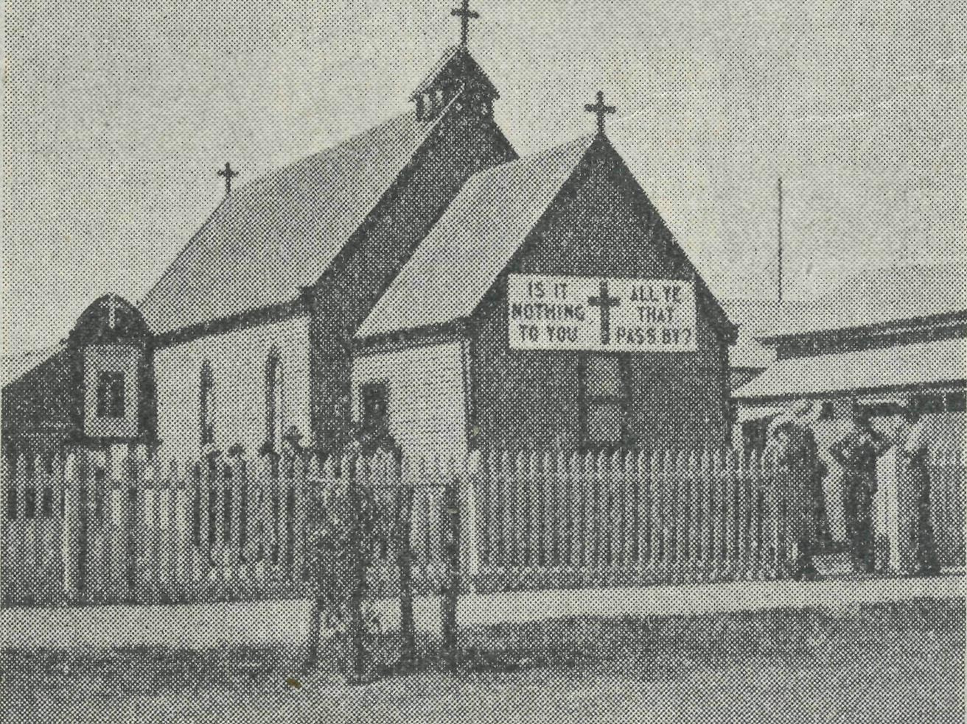
St. Michael's and All Angels' Church, Ceduna. CANN RIVER.
SISTER GASON.
Cann River is in flood again! It seems to be a ^feit, oaoArcrmg, every fortnight. The few dry days we do have are spent trying to dry the clothes. Every housewife has the same cry : "I can't get the clothes dry!" And yet, once inside the cosy homes with big, open, log fires, the wind and rain are forgotten over a hot cup of tea and friendly chat.
For the past few weeks we have had several cases of whooping cough. So far, all the children who have it, are under school jage, due to the fact that there was a similar epidemic about four years ago. Of course, the brothers and sisters of a patient cannot go to school, unless they have had it themselves previously, so the little school is suffering, too. I overheard one boy say to his sister : "I wish you'd catch the whooping cough; then I needn't go to school!" But I am glad to say his sister has not obliged him so far. If the coughs hang about during
the winter the little people will have a hard fight, as it is so cold and wet here.
Some time ago I was called out to a man fifty miles away, who was reported to have a bad cough. When I saw him I realised he was very sick indeed; he had pneumonia-pleurisy, and he was very weak. It was a very wet and cold day, so I stayed with him all night, and then I simply had to return to Cann River. I was needed urgently there. So I arranged to take the sick man to Orbost—over 100 miles. I am thankful to say that he was able to stand the journey; but cases like that show the necessity of an assistant at Cann, so that in cases of emergency there shall be someone to carry on at the nursing centre. The distances are great, and the means of transport so difficult, that it makes a whole day job of simple administration.
The roads are slippery and muddy owing to the persistent rain, and several cars have had slight accidents. I have had to attend to people who did not know of the existence of the B.C.A. at Cann River, but who are grateful now, and realise what is being done for the isolated people here.
One little boy fell off a bike on which he was being "dinked" by his brother. He was very interested in my work while I cleaned up his leg, and appeared proud of the fact that he broke fourteen spokes in the wheel! Fortunately his pain was forgotten momentarily while he described his actions to his many listeners.
One wet evening two little boys asked if they could come and listen to my wireless. I said, "Certainly!" And could they bring their brothers; so I said, "Yes." About half an hour later someone asked if there was a party at my place, as the children were all talking about a party. I returned to the Dispensary to find fourteen children waiting for me. News spreads quickly in the bush! We lit a fire and played games, then we had a sing-song. Finally, after a bedtime story in front of the fire, the children were taken home. A great deal could be done for the children here if there was only someone to attend patients, while the other helped the young Australians.
The last few weeks at Cann River "nave been very cold and wet, consequently quite a number of people have colds and coughs, which are both infectious and hard to get rid of. We speak of both in terms of doubtful affection as the "Cann cold."
Although most of the bushmen do as they are told, there are some that do not. I was treating a young man with acute tonsilitis, and when he was on the way to recovery I said he could sit out in the sun for half an hour after lunch. Unfortunately, while he was there a friend of his rode up to see him. Seeing the horse standing idle was too much for Lindsay. He got into the saddle, and wasn't heard of until after dark. His mother was very worried about him, and next day he had a relapse, and I was sent for again. This young man also

(i
THE REAL AUSTRALIAN.
June 30, 1935.

owned up to receiving scones and cakes through the bedroom window when both his mother and I thought he was on a strictly fluid diet. I was more severe with his further treatment, and made sure he stayed in bed his full time.
One dear old woman I was attending one morning became tired of my examination. She asked me to stop feeling her all over. I answered her, as nurses have a habit of doing, and said, "I will be finished in a minute." To my surprise she started counting : "1, 2 3.... 20—once; 1, 2, 3 ... . 20—two times; 1, 2, 3 ... . 20—three times—60. One minute is up, Sister!" So I had to give up. She was a case for doctor and the hospital, and is now awaiting operation.
On about the frostiest and coldest morning of the year I was called up early in the morning to see a man who was very bad with pneumonia. His brother said he could hardly breathe, and was quickly getting worse. It sounded a severe case, so I dressed as quickly as my cold fingers would let me, took a few things that might prove useful, and we hurried to the sick man. I sighed with relief when I saw the patient, as it was not pneumonia, but asthma. Half an hour after an injection, the patient walked into the kitchen, where we were having morning tea, and asked for a good breakfast.
Last week it became necessary to move our two oldest inhabitants from their own home to their married daughter's home. They are both getting very frail, and at times suffer from mental relapses. I was dreading the journey, but it proved to be more of an entertainment than an anxiety. Old Mr. Smith sat in the front with the driver, and was very interested in all the new homes and improved properties. His memory is wonderful, and he thoroughly enjoyed the trip. His wife sat in the back with her niece and myself. As she suffers a good deal, I had something ready for her in case of emergency. But she was very indignant. "Put that stuff away," she said; "these roads are as good as the passage at home!" It is so long since the little woman has been on the road that she was amazed to find that there were no trees to be dodged or stumps to be cut away. There is a car and a telephone at the new home, so I am able to get to her in a very short time when she does take the bad turns.
The weather has turned so cold that I am not able to take the children for many outdoor picnics; but we sometimes have little evenings at the Nursing Centre, and we still have our after Sunday School walks. Unfortunately I have just lost my wireless, but I hope that I will have another one some time soon. The children love to listen-in in the evenings.
QUARTERLY CONFERENCE.
Primary Grade Mail-Bag Sunday School Teachers.
Another happy evening was spent by Primary Grade teachers and workers at
the G.F.S. Tea Rooms on Monday, 20th May. Miss Vaughan-Jenkins and the Rev. T. Jones joined us at our evening meal—a delightfully chatty, informal affair.
Tea over, routine business was quickly disposed of, so that we might enjoy to the full the long looked for talk by Miss Vaughan-Jenkins on her experiences during her recent tour of the out-back. It was a most interesting talk, calculated to stimulate the most lax of us to further effort in making life just a little brighter for those brave out-back settlers.
The foundation of a small circulating library of books dealing with Australian bush life will also be a great aid, and give us better understanding of the conditions of life under which so many of our children live.
A helpful little talk on the working of
lesson papers, illustrated by the methods
used by various teachers, brought to a
close our Quarterly Conference. •
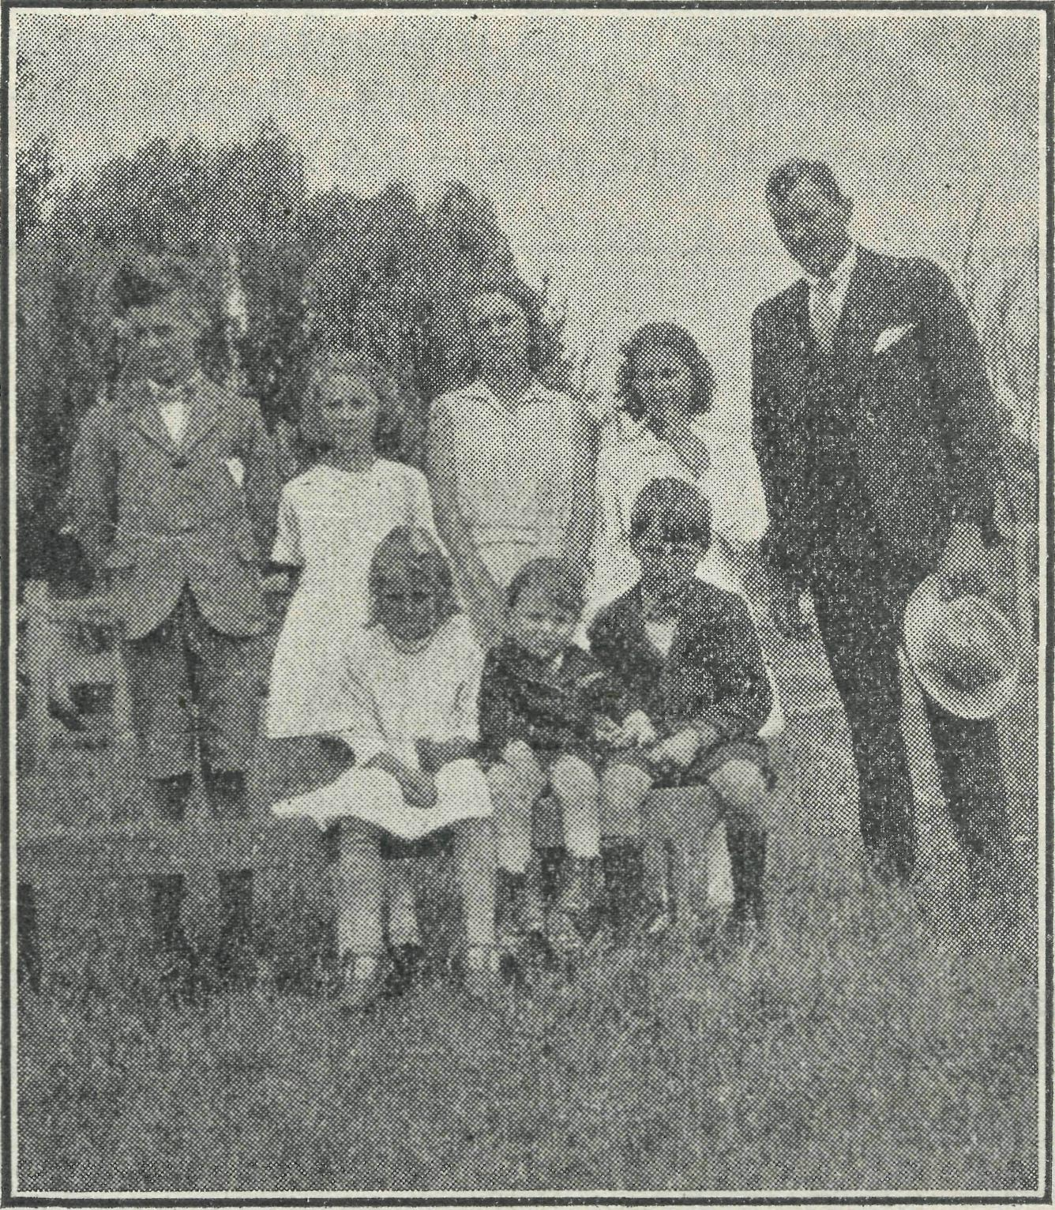
A family of Mail-Bag Sunday School scholars. MAIL-BAG SUNDAY SCHOOL.
Extract from Letter of 10th February, 1935, received from a former Mail-Bag Sunday School Scholar :—
"The Sunday School Superinten
dent has resigned owing to severe illness,
and a friend of mine has enlisted my
help as a teacher, rather than see the
Sunday School close. At present there
are forty children attending, and it seems
a pity to close for the lack of teachers.
"Remembering the valued help and spiritual guidance I received from the Mail-Bag Sunday School when I was a child, I want to know if you will forward the story lesson sheets each month, to give us a helping hand? I have found the old lesson sheets of 1931 a great help, and they interest the kiddies. If you have back sheets that are not wanted, they would do splendidly. I will gladly pay postage, etc., if you would be so kind to render us this service.
"Yours sincerely,
Extract from Letter of March 3rd :—
"Dear Sir,—We have a small Sunday School, and find it very difficult to get suitable material for organised and progressive lessons, and I wondered if w^{T}e could get your 'Mail-Bag Sunday School' lessons each week. If so, would you forward two dozen of the junior grade and one and a half dozen for children under nine years of age?
"If this is possible, I would be pleased to receive same each week.
"I am, yours sincerely,
Such requests, as are contained in the above two letters, continue to come in to us, and cause us to rejoice at the success of our humble efforts for the children in lonely places.
Our Mail-Bag Sunday School is now one of the most important branches of B.C.A.'s activities, and is doing inestimable good in the lives and characters of many out-back children. We need your prayers for this work in order that we shall be guided along the right lines, and your small gifts in order that our efforts for God in this sphere may continue.
THE FAR WEST MISSION, CEDUNA.
REV. GEO. C. WCOLF.
One usually reserves that well worn topic, the weather, for the time when a change of subject is necessary; but I really must mention it first of all, for prospects for a good season have never been so rosy as they appear now in this semi-parched region. Good rains have fallen throughout the large area covered by this Mission, and farmers have wasted no time in sowing their seed. One prays that the ensuing harvest may be a bountiful one.
Rogation-tide was made the occasion for special prayers for God's blessing on the fruits of the earth, and various farms were visited on the Rogation days, short services being held at each place. After the experience of such services, one wishes that more of a similar nature might be held. Rain was falling even while these visits were being held, and wherever the farmers happened to be— in stables, in the house, or in sheds— little gatherings besought God that He might give us His blessing, and the earth bring forth her increase abundantly, that the sower might sow in joy and the reapers gather *their sheaves in gladness, and ever bless His Name.
Speaking of seed-time and harvest reminds me of our services during Lent Holy Week, and Easter. The whole of Lent was used for teaching in the Faith. The teaching given whetted the appetites of some for more; several young people requested that Bible classes might be held after Easter.
Good week-day congregations attended during the whole of Lent and Holy Week. On Good Friday morning, St. Michael's was almost full for Litany and Ante-Communion. The evening service took the form of shortened Evening Prayer,

June 30, 1935.
THE REAL AUSTRALIAN.
i

The Birthday Band is a very real help to B.C.A. work. The annual contribution is only one shilling, and you can become a life member for £3/10/-. If father, mother, sister or brother should
which was followed by a sermon and a Service of Witness. The sermon dealt with our redemption through Christ and our response to the Cross. After a short interval, during which the congregation was asked to consider their attitude to Christ, those who were living in a state of salvation were asked to stand and witness to the fact in the face of the congregation. An appeal was then made to the remainder of the congregation to turn to Christ in repentance and faith, asking for forgiveness of sins and salvation through His Precious Blood shed upon the Cross. They were asked to stand and join those who were already standing, in token that they were prepared to forsake sin and receive Jesus Christ as their personal Saviour. Of the sixty people who vwere packed into the tiny Church, all but eight stood.
As a consequence of the special campaign, Easter Day was the most joyous that Ceduna has experienced for many years. The celebration of the Holy Communion was timed for 6.30 a.m., and at this early hour, while it was yet dark, a record number of communicants flocked, not to behold the place where Jesus lay, but to receive the Risen Lord into their hearts.
MINISTERING IN THE OUT-BACK.
A MINISTRY OF LOVE.
"Ye that do truly and earnestly repent you of your sins, draw near with faith and take this holy sacrament to your comfort."
The words are spoken by the minister, not in a great and beautiful cathedral with its solemnity and reverent atmosphere, nor to a well-dressed congregation of many hundreds.
The "church" is a small four-roomed homestead, 85 miles from its nearest neighbour. The congregation consists of the station manager, his wife, and the wife of the missioner.
The "chapel" is the humble kitchen, papered with the pages of old stock journals, long since gone yellow with age. The kitchen table has been requisitioned and covered with a "fair white linen cloth." The furnishings of the room, though neat and clean, show signs of many years of hard wear. Nevertheless there is present an atmosphere of reverence and worship, for here in this simple home, many hundreds of miles from the large towns of this fair land, God is present and earnest hearts kneel before Him.
After the service the Missioner commences his long journey to the next home, 150 miles away. The journey will occupy most of the daylight hours—the roads are only wheel pads over very bumpy tracks. Here three children await their quarterly "Sunday School."
One service, one Sunday School lesson per quarter, is all the Missioner can give these people. His parish is 200 miles wide, making it impossible for him to visit these lonely folk more than four times per year
THE MINISTRY OF HEALING.
The sun is sinking beyond the edge of the vast plain made bare by the heat of a blazing sun shining down day after day from a cloudless blue sky. For two long and weary years no rain has fallen to refresh the hard dry earth, and even the "old-man saltbush" is beginning to wilt.
On the wide verandah of a fine stone hospital, Sister stands and surveys the heavens. "Do those small dark clouds, just peeping over the horizon, mean rain?" She offers up a silent prayer that it might be so. As she wonders and prays, the telephone bell tinkles. The postmistress has a telegram to deliver : "Will sister come at once? Baby is very ill." It means a trip of 350 miles over the endless plain, at night. She must go.
The missioner is informed, and gets out his car, loading her up with the many things necessary for a long trip in a land where there are no garages or refreshment rooms.
When all is ready, the long journey is begun. The night is hot and sultry, and the clouds, now growing larger, threaten to rob the travellers of the welcome moonlight. Slowly the mile's are ticked off, while anxious eyes watch the clouds above, with hearts that hope for rain, but desire to get to their destination first.
Only eighty miles to go, now sixty, now forty! Will they do it? Here she comes, big drops at first, then a steady downpour. The last forty miles of that journey are more trying than the first three hundred.
It is the late afternoon of the next day when our travellers arrive at their destination. Twenty hours to travel 350 miles! Good time under the circumstances.
KOOKABURRA CLUB.
The wee patient is found with life just smouldering within her small body. Much patient nursing will be necessary to fan the spark of life back into flame. Sister later rejoiced that she had been able to save the wee life.
forget your birthday, it does not really matter, because the "Old Kookaburra" is sure to remember and send you a very nice card on the morning of your birthday. Adults can join, too, and have the thrill of receiving a birthday card from the "Old Kookaburra."
If you are not already a member of our happy Birthday Band, hurry up and send your shilling, with name and address, age and birthday.
The "Old Kookaburra" will be glad to receive letters from any of the members of the Band, and he will be always glad to reply to them in this column.
"THE OLD KOOKABURRA."
ACKNOWLEDGMENTS.
We tender our thanks to the following business firms for generous gifts of foodstuffs and other useful articles for our Hostels and Hospitals:—
The Rozella Preserving Co., for four dozen large tins of jam.
Parke, Davis & Co., for one dozen bottles of cod liver oil.
Purina Grain Food Co., for six dozen packets of crispies.
Wm. Arnott Ltd., for a large tin of biscuits.
Peek, Frean Ltd., for a large tin of biscuits.
Australian Soaps Ltd., for four dozen assorted soaps.
Kraft Walker Cheese Co., for eight dozen "Bonox" and 5 lbs. "Kraft" cheese.
Joyce Biscuits Ltd., for a large tin of biscuits.
Pearson's Sandsoap Co., for a case of sandsoap.
Mungo Scott Ltd., for a donation of £1,
Harrison & Ramsey Ltd., for two cases of rusks and three cases of malt extract.
Per Y.P.U., St. Alban's, Fivedock, for the sum of 14/- and a large box of groceries.
Anonymous gifts of f 1 and £2.
"REAL AUSTRALIAN" SUBSCRIBERS.
To the following we give thanks for subscriptions received during the past three months:—
Mrs. P. Hall, Miss Johnson, Miss E. Jacobs, Mrs. F. Dillon, Miss A. Marks, Mrs. L. Richardson, Miss E. Hemsley, Miss M. Olley, Mrs. J. Withington, Miss T. Wirth, Mrs. F. W. Wray, Mrs. Law-ranee, Miss I. M. Lucas, Mrs. M. M. Wall, Miss E. C. Warskitt, A. F. Osborn, M. G. Hopkins, Miss I. Dutton, Miss K. N. Moule, Mr. J. Standen, Miss K. Cadwal-lader, Mrs. J. Motta, Miss A. D. Walker, Miss Railton, Mr. J. W. Boyer, Miss D. D'Arcy-Irvine, Miss C. Burchell, Mrs. H. S. Webb, Miss M. Arndell, Mrs. Beattie, Miss A. Philpot, Miss M. Hobart Studds, Mrs. Colin Davidson, Mrs. Wannan, Miss Kendall, Mrs. Palmer, Mr. I. E. Greenfield, Miss N. Tress, H. Percival, Mrs. Shekelton, Mrs. Barton, Miss E. O. Bur-vill, Mrs. J. A. McElroy, Miss E. K. Daish, Miss Turtle, Miss G. Grieve, Miss L. M. Grieve, Mrs. C. L. Thomas, Mrs. M. Littler, Mrs. J. Knight, Mrs. T. J. Clay-

8
THE REAL AUSTRALIAN.
June 30, 1935.

TO THE ACTING ORGANISING MISSIONER,
BUSH CHURCH AID SOCIETY,
CHURCH HOUSE,
GEORGE STREET,
SYDNEY
uj-u±i±j-L. _{AT} _{ALL} _{TIM}ES—Forget not to give
thanks: for kindly givers who have
I have much pleasure in enclosing ■ helped us with their self-denials.
_{l(} . •>, -<>., j> „ iQor -^^{or} f^{r}i^{en}^^{s}^ known and unknown, «vho
as my extra gijt JOT Udo. _{have} _{ra}iQied _{a}t our call to keep our min-
istries going.
Stoned -^^{or} cheering reports from fields that
God's Word is still with power.
For offers of service for the filling of
Address • pending vacancies in our wor^.
Wholly set up and printed ir Australia
' by D. S. Ford, 44-50 Reservoir Street, Sydney.
ton, Miss Mumford, Mrs. James, Mrs. E. Young, Miss R. Why Foon, Mrs. J. Wilson, Miss E. Peterkin, Mrs. W. E. Percival, Miss C. J. Senogles, Mrs. Moore, Mrs. W. Pont, Rev. R. A. Pollard, Mrs. Watson, Miss Fetherstone, Miss D. M. Williamson, Miss Clent, Mrs. R. Harris, Miss J. Webber, Miss A. Riley, Mrs. M. S. Sim-cocks, Mrs. L. Audubon, Mrs. E. J. Scholes, V. F. Filby, Miss D. Wheatley, Miss F. G. Gardner, Miss E. C. Summer-bell, Miss Estelle Hegarty, Deaconess M. Currie, Miss Shekleton, Miss E. G. Lowe, Miss W. Jarrett, Mrs. E. Plumb, Mrs. H. T. Currell, Miss M. Matthews, Mrs. C. Holbrook, Miss Goodshaw, Mr. Rogers, Mrs. J. Pearce, Mrs. Bertha Pell, Miss Thorp, Mrs. C. Uebergang, Miss S. Hannah, Miss C. R. Powell, Mrs. Boddy, Miss A. J. Watts, Mrs. A. Muir, Mrs. King, Miss F. D. Watson, Miss Oelrich, Miss Thorp, Mrs. Maddison, Mrs. Bishop, Mrs. Brockman, Miss H. Wilson, Deaconess M. Fulton, Misses Barrow-clough, Miss L. Hearle, Mrs. Thomson, Miss J. Tallent, Miss Walch, Miss Mann, Mrs. A. Steele, A. Smith, Mrs. Gillam, Miss Hedderick, Mrs. Waltham, Miss U. Roadknight, Mrs. Coburn, Miss Turnbull, Miss M. Macks, Mrs. L. G. Hall, Mrs. Hurren, Mrs. Dalton, Mr. Fitzmaurice, Mrs. Andrews, Miss Calcutt, Miss T. M. Rule, Master R. Clamp, Miss Vear, Mrs. Romanis, Miss Ridgway, Mrs. Finlay, Miss M. G. Thompson, Miss L. Bryant, Mrs. Hardcastle, Mrs. Harvey, Mrs. Hatch, Miss H. Hocking, Miss E. Burr, N. Brown, Mrs. Brown senr., Mrs. Ashton, Miss J. Gelletly, Mrs. Graves, B. Garth, Miss J. Grey, Miss Coban, Miss Parsons, Mrs. Wood, Miss P. Woosman, Master B. Daniells, Masters J. and P. Molyneaux, Mrs. Mackay, Mrs. Morris, Miss J. McLeod, Master K. McKelvie, Miss J. E. Lysterfield, Mrs. Reynolds, Master N. Richardson, Master N. Sherwood, E. R. Fletcher.
CLOTHING.
We still need good second-hand clothing for the Mallee, especially boys' wear. The Victorian Office will be glad to receive your parcels.
WANTED !
Double Certificated Nurses for Service in the Out-back.
Our waiting list is exhausted, and soon
there will be vacancies on our staff.
We shall be glad to receive offers of
service from qualified nurses. Write to :
The Acting Organising Missioner,
The Bush Church Aid Society,
Church House,
George Street,
Sydney, N.S.W.
A PRAYER FOR USE WITH OUR PRAYER LIST.
O Lord God of our nation, Who has commanded men to subdue and replenish the earth : Look in Thy love upon all those who in the distant parts of our land are striving against many difficulties, and are deprived the access of the means of grace. Strengthen and guide the Bush Church Aid Society and its Clergy, Nurses, Deaconesses, and Students. Cheer and encourage them in discouragements and loneliness, and bless their ministrations to the good of those they serve, and grant that the message of redeeming love may thus be rooted and grounded in our national life, to the glory of Thy Great Name, through Jesus Christ our Lord. Amen.
The devil loves to fish in muddy water.
Misery lies not in God's making, but in Satan's marring.
It is not God that requires a man to make bricks without straw.
To those who wish to hear of a fine Private Hospital or Rest Home, we can confidently recommend "Tuerong," Campbell Street, Eastwood, N.S.W., conducted by Sister Harvey, A.T.N.A. (General and Obstetric). 'Phone : Epping 1034.
THE PLACE OF PRAYER.
All B.C.A. friends are invited earnestly to use in daily prayer the suggestions made in the following list of subjects:—
SUNDAY—pray for :
The Missions of the B.C.A. in various parts of Australia; the Missioners of B.C.A. as they minister of the Word and Sacraments, Eev. G. Woolf, at Ced-una.; Rev. H. Smith, at Penong; Rev.L. T. Lambert, at Wilcannia; Eev. L. Dun-stan, at Denmark; Eev. T. Gee, at Werrimull; Eev. K. Luders, at Kirton Point, S.A.; and Eev. T. E. Fleming, at Cann River.
MONDAY—Pray for :
B.C.A. Hospital work in the Far West country, where patients must be received in spite of their inability to make any return for service. Pray that God's good cheer may be with Sisters Dowling and Hitchcock at Ceduna, Sister Sow-ter at Penong, Sister Gason, at Cann Eiver.
TUESDAY—Pray for :
The B.C.A. Children's Hostels, at Wilcannia and Mungindi, that the work be increased of God, and that we persevere knowing that such ministry to little ones cannot be in vain in the Lord. Ee-member by name Deaconess Harris and Miss C. Ross, Wilcannia, and Matron Cheers, at Mungindi.
WEDNESDAY—Pray for :
The Sunday School by Post with its Gospel message for little children; also for the teachers of this department.
THURSDAY—Pray for :
All Students, Deaconesses, and Nurses in training and preparing for B.C.A. work in the Bush, that they may be equipped with power, wisdom, and zeal, and become "able ministers of the New Covenant. ' > Also remember the Council, Committees, Women's Auxiliary, and workers on the Home Base Staff.
FRIDAY—Pray for :
SATURDAY—Pray for :
A spirit of thankful giving to be upon all B.C.A. friends, that the Society be kept out of all God-dishonouring debt.
The Council, that it may be specially guided in the appointing ef a new Organising Missioner.

