Registered at the G.P.O., Sydney, for transmission by post as a periodical.
"AUSTRALIA FOR CHRIST."
The Real Australian
Organ of the Bush Church Aid Society for Australia and Tasmania-

No. 66.
NOVEMBER 8, 1937.
1/6 per annum (post free).

THE BUSH CHURCH AID SOCIETY OF AUSTRALIA AND TASMANIA.
Headquarters Office :
Diocesan Church House, St. Andrew's Cathedral,
George Street, Sydney.
(Telephone : M 3164.)
Cable Address : "Chaplaincy, Sydney."
Victorian Office :
St. Paul's Cathedral Buildings, Flinders Lane, Melbourne. (Telephone : F 5675.) President: The ARCHBISHOP OF SYDNEY. Hon. Clerical Secretary : Ven. Archdeacon W. L. LANGLEY. Hon. Treasurer: T. S. HOLT, Esq.
STAFF.
Organising Missioner : Rev. T. E. JONES, Th.L., Church
House, George Street, Sydney. Victorian Secretary : (Tel. : F 5675.) South Australian Secretary : Rev. R. M. FULFORD, North
Terrace, Adelaide, S.A. Far West Mission—Field Workers :
CEDUNA—
Rev. H. BROADLY, The Rectory, Ceduna, S.A. Sister F. DOWLING, Hospital, Ceduna, S.A. Sister V. PAGE Sister PRITCHARD Sister B. BOSSLEY Miss I. ANDREWS
Nurse J. BRANFORD „ BP. kirkby memorial hospital— Sister D. TODD, Cook, S.A.
PENONG—
Rev. E. CONSTABLE, The Rectory, Penong, S.A. Sister G. HITCHCOCK, Hospital, Penong, S.A. Sister M. MEADS. Western Australia : Rev. B. LOUSADA, Denmark, W.A. Kirton Point : Rev. K. LUDERS, Port Lincoln, S.A. N.-W. Mallee : Rev. F. BAYLY, Clergyhouse, Werrimull, Vic. Kyancutta, S.A. : Rev. W. McLEOD, Kyancutta, S.A. Croajingalong :
Rev. H. R. SMITH, Cann River, Victoria. Sister HUTCHINSON, Dispensary, Cann River, Vic. Delegate-Bonang Mission : Rev. T. R. FLEMING, Th.L.,
Delegate, N.S.W. Mungindi : Miss E. M. CHEERS, Hostel, Mungindi, N.S.W. West Darling Mission :
Rev. R. LANGSHAW, Wilcannia, N.S.W. Mrs. MANN, Hostel, Wilcannia, N.S.W. Miss A. E. TAYLOR, Hostel, Wilcannia, N.S.W. Menindie Mission : Rev. C. BAKER, Menindie, N.S.W.
Awaiting Location : Students :
Rev. N. CHAMBERS. Mr. BRIAN BRAY.
Rev. G. BROWNE CALDER- Mr. MELVILLE BECK.
WOOD, Miss C. ROSS.
Miss G. MOODY.
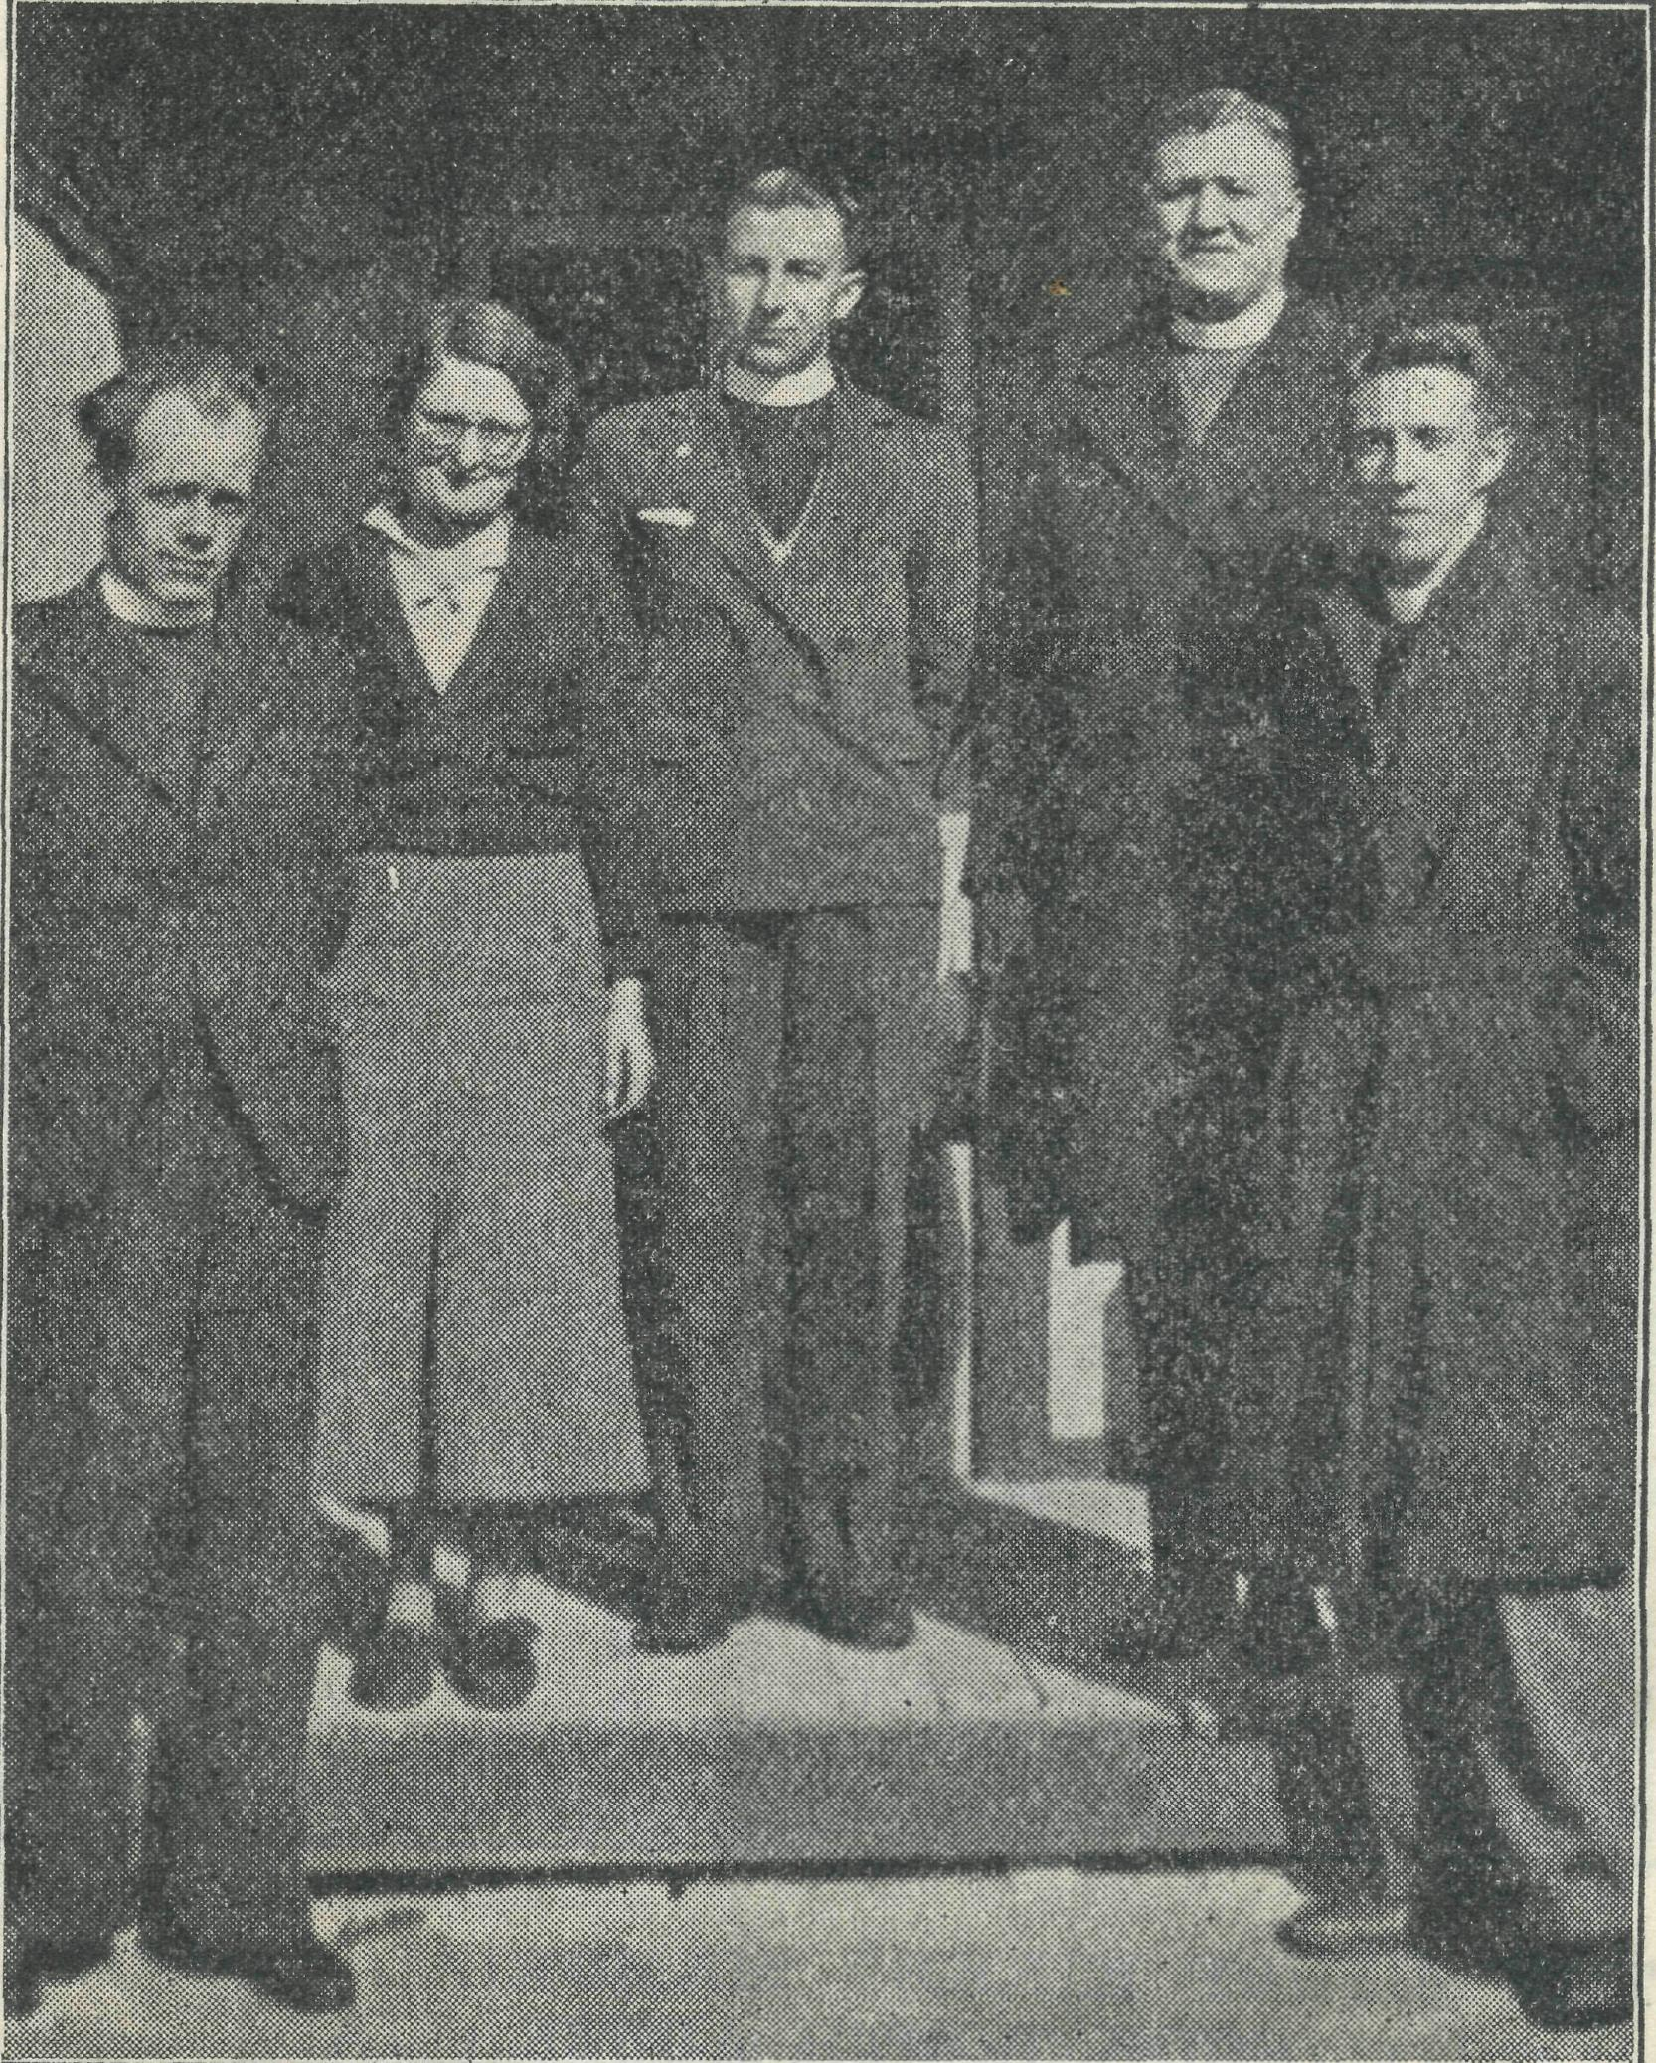
The Archbishop and some of the South Australian Staff.
VISION ADVENTURE
FAITH
THESE ARE THE FORCES THAT HAVE COMPELLED THE B.C.A. TO LAUNCH OUT INTO BIG RESPONSIBILITIES FOR GOD AND OUR PEOPLE.
WILL YOU HELP OUR ANNUAL CHRISTMAS APPEAL IN ORDER THAT THOSE RESPONSIBILITIES MAY BE MET ?
SHALL WE FINISH 1937 WITH A DEFICIT, OR SHALL WE VINDICATE THAT SAME VISION, ADVENTURE, AND FAITH ?
Send your gift
THE BUSH CHURCH AID SOCIETY
— at —
Cathedral Buildings, Hinders Lane, Melbourne, Vic.
Church House, 'George Street,
Sydney, N.S.W.

THE REAL AUSTRALIAN.
November 8, 1937.

The Organising Missioner s Letter

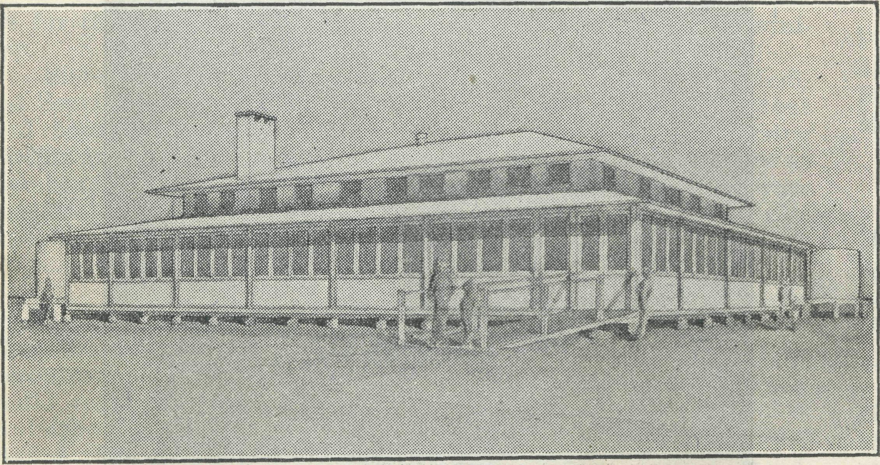
On my desk is a small card sent to me some years ago by one of our missioners. On it are printed the words, "Prove me now," from Mai. 3 : 10. They have spoken to me silently for many months. As each problem and task of B.C.A. has come forward I have been reminded that they are but opportunities for proving that the Lord we serve is able to do all we ask.
On Friday, September 17, I stepped out of Doctor's car at Cook, after a long trip of 300 miles through an unpleasant dust storm, into the new Cook Hospital. The first half hour was spent prying into cupboards, inspecting wards, kitchen, bathroom, etc. As we sat down for tea, Sisters, Doctor, Mr. Broadley and myself, our hearts were indeed full. Years of prayer and endeavour now happily realised. Surely once again we had "proved Him" to be ready and able to bless our work for His Kingdom.
No finer memorial could have been built to the memory of our late Bishop. It is a building worthy of his memory, worthy of B.C.A., but above all, worthy of the Christian service which, through the years that lie ahead, will, please God, flow from it
THE BISHOP KIRKBY MEMORIAL HOSPITAL, COOK, SOUTH AUSTRALIA.
Erected "by the Bush Church Aid Society from funds subscribed
by friends of the late Bishop and of the Society, at a
total cost of £2 900.
Opened on Saturday, September 18th, "by His Grace
The Archbishop of Sydney.
Architect : Mr. LINDSAY THOMPSON, of Sydney.
We are deeply grateful to our President, the Archbishop of Sydney, for journeying so far in order that he might open and dedicate the building.
The service at the opening was simple and impressive and the folk present felt that now they had for their use a hospital that will always remind them that their Christian brethren in the more populated areas remembered their needs.
I feel that there is no need to say "thank you" to those many hundreds of our friends who have made this memorial possible. Their gifts have been rendered to God and for such there is no need of thanks.
I would rather say, remember that Cook Hospital is not now finished—it has only just begun. The years that lie ahead mean more prayers, more generous giving, that the work and witness may be maintained in this lonely place. Our next task is to perfect the medical service by providing a 'plane. To do this £500 is yet needed. Believing that the money will come we have placed the order for a He Haviland Fox Moth, such as is being supplied for the use of Dr. Fenton, at Darwin. It is hoped that this part of the work will be inaugurated early in the new year. Please pray that this, too, will be effected free of any debt.
Annual Eally.
Our Thanksgiving Day on Tuesday, September 28th, was a tremendous blessing to all. We began with a service in the Cathedral at 1.15 p.m., at which the Eev. E. L. Panelli, our first Van Missioner, preached the sermon.
" In the afternoon the ladies of the Auxiliaries and Mail Bag Sunday School enticed £83 from the pockets of our friends, who attended the Fair in the Lower Town Hall.
We had desired that the Annual Eally tea should be a real family party. It was. Three hundred people sat down and enjoyed a very fine meal.
It was somewhat of a venture to have our Rally in the Lower Town Hall, but when we realised that considerably more were present than could have been packed into the Chapter House we were glad that the venture had been made.
The Archbishop and Rev. R. B. Robinson gave graphic descriptions of their recent tour of the B.C.A. fields. The Rev. Dr. Law spoke of the need of such work as B.C.A., and th«e Organising Missioner also had a word to say.
Some colour movie films of the opening of Ceduna Hospital brought to a close a meeting in which dull moments were absent.
To all those who by hard work and gifts made the success of the day possible I would say a very real ^{lt}thank you." So many helped that it would be unfair to single any few out by name. I am conscious that the success of the day resulted from the efforts and prayers of this wonderful band of workers God has given us. The Rally offering amounted to £118, making a total of a little over £200 for the day. The Rally gave us great blessing—let us go forward to still greater things for our God.
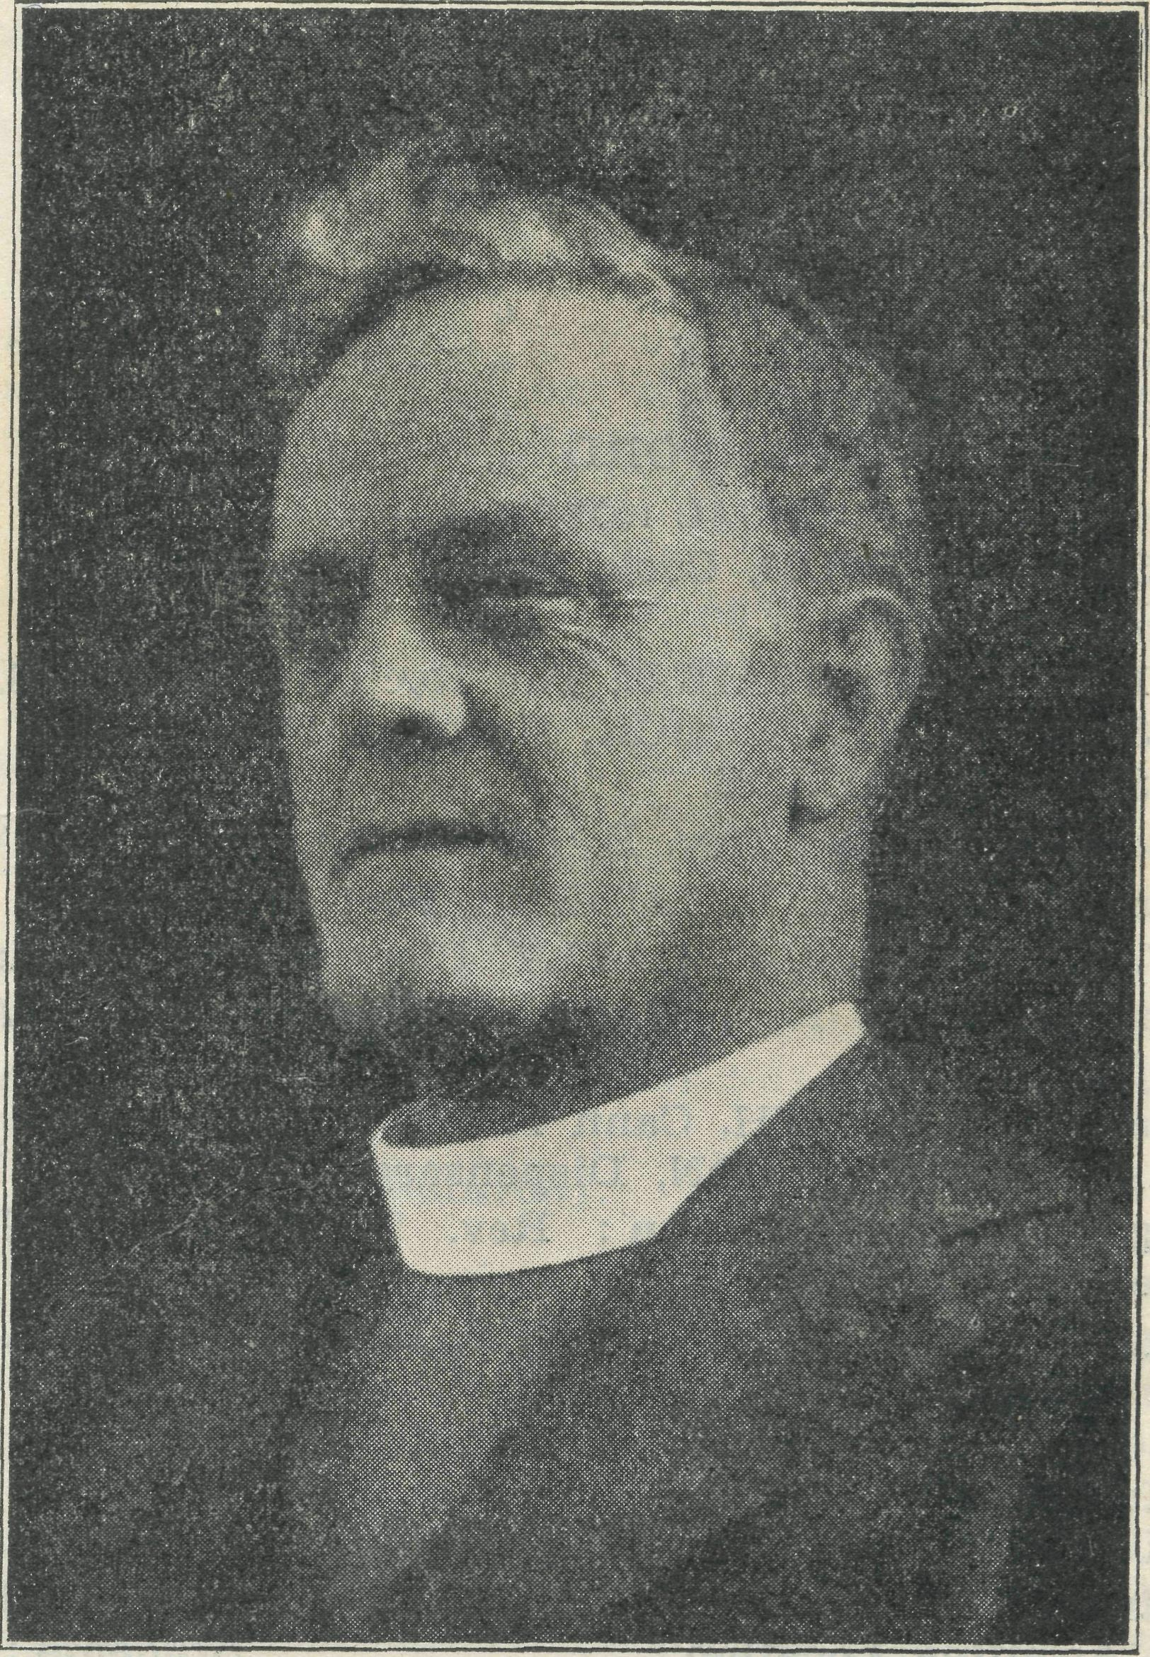
THE LATE BISHOP S. J. KIRKBY.
Organising Missioner of B.C.A., 1920-1932.
Co-ad jutor Bishop of Sydney, 1932-35.
TOM JONES, Organising Missioner.

November 8, 1937. THE REAL AUSTRALIAN. ;
FACTS YOU SHOULD KNOW
B.C.A. was born on May 26, 1919.
Since that date its friends have given £93,000 for the work of evangelization in the outback,
Of this sum £70,000 was raised in Australia.
Thirty-five clergymen have served as B.C.A. missioners.
Twenty-two of these have been trained by the Society.
Ten missioners are now serving in the out-back.
Three women workers are ministering in the Society's Hostels.
Sixty voluntary workers maintain a Mail-Bag Sunday School of 4,000 scholars.
Three modern Hospitls and one Nursing Home are now managed by the Society. They are staffed by ten nurses.
Two Children's Hostels are also in our care.
A staff of five workers attend to the organising and administrative work of the Society.
THE COST? £24 will maintain the work for one day. £1 will keep it going for one hour—
If backed by your earnest
PRAYERS.

CHRISTMAS NEEDS. friends for their splendid help. These Adelaide friends sup-
. — plied all the hospital cutlery and much of the crockery needed
As our friends know, we have always remembered the for Cook Hospital,
children of our Mission districts at Christmas time. This year, It is indeed good to know that our South Australian
as before, we want to send each a small gift or toy. As some friends shared in this work.
3,000 gifts have to be sent a great deal of work is involved in To our N.S.W. ladies also we tender our thanks. Their
packing and despatch of the boxes. labours eased the burden a great deal. Nothing was too big
Will our friends send in their gifts for this purpose as ^{for} them to undertake, and as a result, only the very best
early as possible, so that we can get all boxes away not later hospital equipment was installed at Cook.
than the middle of November? Gifts will be gratefully re- Wanted.—All 'your used postage stamps and old picture
ceived and acknowledged from the Sydney and Melbourne P^{ost} ^{corc]s}- Please send them to the office in Melbourne or
URGENTLY NEEDED!
Offices. Please remember that we can buy at a considerable Sydney,
discount, and for this reason it is better to send money rather
than toys.
Consecrated men for training for outback ministries. Also three clergymen in priest's orders to undertake difficult outback
We owe a great debt of thanks to the members of the Vic- Applv to •
torian Auxiliaries at headquarters and Moonee Ponds for their ' rp^_{e} Organising" Missioner
splendid help with the Cook Hospital furnishing. They sup- _{Bush} o_{hurch} _{Aid}' _{Socie}t_{y}
plied the dining room and nurses' bedroom furniture, together Church House
with a considerable amount of linen. In this way some £50 George'Street
was subscribed by them for this purpose. It is good to know Svdnev
that we possess such bands of splendid helpers. '
The Victorian ladies are holding their Annual Outback "R.A." SUBSCRIPTIONS,
Fair in the Y.W.C.A. Hall, on Tuesday, November 16. Mrs. .
Head, the wife of the Archbishop, is to open the Fair at 2.30 Have you paid your subscription to our small paper ? We
p.m. An afternoon and evening session is to be held. Please are glad for you to receive the paper but would remind you
come and bring your friends to this splendid effort. that your 1/6 helps a great deal to make its publication pos-
Our thanks are also due to Mrs. Fulford and her circle of sible.
NOTES.

THE REAL AUSTRALIAN.
November 8. 1937.

THE NEW MINISTRY ON THE NULLARBOR
Sister B. Bossley.

As the opening and dedication of the Bishop Kirkby Memorial Hospital commenced with the.Doxology, so does this first report from Cook open with a note of praise and thanksgiving to Him Who has made all things possible.
It is indeed a privilege to be able to send this message to you people of Australia from this place which has held such a prominent position in our thoughts and in our prayers for the past year or two; and, indeed, many years, in the hearts of some of us. It was the great desire of him, to whose memory t- is hospital is dedicated, that such a place may be here to meet the needs of the people; and it is only after many yoars of waiting upon the Lord, and following up the openings He has given, that all hindrances and seeming impossibilities have been swept awa'y, and this building now stands to the memory of him who first had the vision of such a need, and to the Glory of God, Who hath ^{i} ^{l} done all things well.''
And what of Cook f I expect many of you know practically nothing of it. It is just a small "camp" on the Trans-Australian line, roughly 500 miles from Port Augusta, and the same distance from Kalgoorlie, situated right in the heart of the Nullarbor Plains. The population is about 140, including children, and with the exception of the postal authorities, all the men are employed on the "line," in some capacity or other. The Plains stretch for miles (300 miles West) all around, and after the dry season there is not a blade of grass to be seen anywhere, and the wild flowers, which are usually prevalent at this time of the year, are absent. Truly, the poet was right when he said, "The everlasting sameness of the never-ending Plains." And 'yet, in the midst of this environment, there is an hospitable people, ready to welcome those who come in their midst, to work amongst them, and to minister to their needs, both physically and spiritually.
It was a real joy, after the long motor trip from Ceduna (300 miles) to be met by those who were in sympathy with the work, and who opened their homes to us, until such time as the hospital was made "livable," and who came to help with the unpacking of the furniture, etc., and lend a hand wherever it was needed. We do thank all those who lightened the burden of the work in any way, and for their friendly spirit, which is especially appreciated during this time of being here alone.
After the Ceduna party had returned, came a period of three weeks' preparation for the long-looked-for opening day. There was much to do in opening cases, sorting out many and varied articles, washing, ironing, and marking linen, and trying to get things in "spic-and-span'' order as the day approached.
On the night of the 16th September, two days before the opening, a terrific dust storm arose, which continued at its height all through the night and all the next day, until 6 p.m. It was utterly impossible to attempt to do anything until it had abated, so you can imagine a little of the work we had ahead of us to get the dust out, although generally speaking, the hospital had fared very well, in comparison to other homes. That same evening, about 6.30 p.m., the car from Ceduna arrived with the Organising Missioner, Sister Bowling, Dr. R. W. Gibson, and the Rev. H. Broadley aboard. The'y had had a day of it, travelling against the dust and wind, but despite their tiredness and their ravenous appetites it was impossible to get them to partake of the waiting meal, until the Organising Missioner had done a full tour of inspection. (I might add that the others had all been over three weeks previously, but were still keen to see things in readiness for the Opening).
After tea a short time of happy fellowship was spent, and then an early night for all.
The following day the dust had ceased, but the wind had not. However, we managed to get things in order once more. The men spent the morning mending tyres, re-fuelling, etc., ready for the return trip. That afternoon the Rev. and Mrs! E. Constable, from Penong, arrived, accompanied by Rev. and Mrs. Constable, senr., from Melbourne, who w^ere staying with them. The'y had spent the night at Nullarbor Station, 90 miles away, and came on that afternoon.
wonderful to think that although we were from all parts of Australia, Sydney, Melbourne, Ceduna, Penong, we were all one in the Lord Jesus, and had all met in this one little, insignificant place of Cook, to honour him to whose memory this hospital was built, and to give praise and glory to Him Who had brought it about.
At 7.30 p.m. we welcomed His Grace the Archbishop of Sydney, and the Rev. R. B. Robinson, also of Sydney. At 5.30 p.m., the Dedication Ceremony was performed by His Grace the Archbishop, each of the other six clergy taking part, all representatives of the B.C.A. Society. We then all adjourned to the local hall for a very pleasant social hour together, when the Archbishop met the people of Cook, and in the interesting speeches given the people learned more of the B.C.A. work and aims, especially in connection with their own hospital, and we learnt more of the needs of the people, and of the benefit which this hospital will be to them.
The Penong party left for Nullarbor late that night, and the Ceduna party, including the Archbishop and Rev. R. B. Robinson, at 5 a.m., the following morning.
Since the opening things have settled down quietly again, but one has been kept busy in seeing to the many details which are necessary that a place such as this may be kept in running order.
One in-patient, and over seventy out-patients have been treated during the month. Several visits have been made to the train to see patients going through from the West to hospital in Port Augusta. It is hoped that when the 'plane service is established that all these patients will come here, but until a Doctor is available at short notice there are certain patients who will have to continue to go to the larger towns, even at the cost of many hundreds of miles' travelling.
,We do ask 'your prayers for this new sphere of work, that as we come into contact with the people here they may be brought into contact with Christ Himself. May the witness here stand sure for Him. One big thing we are up against is Sunday sport and desecration of the Lord's Day, but let us have faith, for the battle is not ours, but His.
A Sunday School has been commenced, and there are twenty regular attendants, some of whom are very keen. May we, through the children, be able to influence the parents, and bring them to a knowledge and love of Jesus Christ.
We await Sister Todd, from Sydney, who is to take over the work here. May she be abundantly blessed and upheld in her work for Him.
We wish to thank all those who have given, whether it be little or much, to the cause of this hospital, and may they just realise some of the joy and the praise that it has brought to many hearts. May we, each one, thank God for what has already been accomplished, and look to Him for greater things yet to be done in His Name, and to His Glory.
MR. A. ». IRVINE.
It is with real sorrow that we record the death of Mr. A. G. Irvine, of '' Braeside,'' West Pennant Hills. Mr. Irvine and his wife have always been very good friends of B.C.A., taking a special interest in the Hostel and other children's work. From time to time Mr. Irvine has given very generously to our work but insisted that his gifts should remain anonymous.
We offer to Mrs. Irvine and family our very real sympathy in their loss and assure them of our prayers.
ANNUAL SUBSCRIPTIONS.
You will notice, on another page, that we draw your attention to the fact that the sum of £1 will keep B.C.A. going for one hour.
If you are not already an annual subscriber why not send the sum of £1 per annum, so that you can be responsible for the upkeep of B.C.A.s many activities for one hour in the year!

November 8, 1937.
Him REAL AUSTRALIAN.

News from the West

There have been several changes in the staff in the last few months. Sister Meades, we regret to say, is still on sick leave in Adelaide, after many months of absence; we do commend her to your prayers that the Lord will restore her to health and strength again. Her place has been temporarily filled by Sister Bruce, of Adelaide, whom we were pleased to welcome to our staff several weeks ago.
Another change has been the departure^of Nurse G. Moody, who has been with us for over three years, and proved her worth. One day she hopes to become a B.C.A. Sister, and has commenced her training at the Adelaide hospital. Many of our Christian friends over there are a great help to her and we feel she is in good hands. Nurse J. Branford has taken her place on the staff.
Miss Andrews continues to give faithful service in the domestic part of our work. This is not the easiest of tasks to take up and one which needs a great deal of grace, and we do thank God for sending her out to us.
Since last writing we have had a very fine X-Kay plant installed, which is going to be of great benefit in our work here. We have waited upon God for all these needs and we do thank Him for the wonderful way in which He has supplied the different things.
Our Bible class continues every Monday night and the weekly services in the wards. The hymn-singing continues to be very favourable amongst the patients and effects many openings to speak a word for the Lord. This last fortnight we have had a very bright time with the men. One lad of twenty two showed great interest in the things of the Lord, and he was very keen to gain further knowledge. His influence told on the other men in the ward, and how readily they joined us morning and evening in singing Alexander's hymns, and what a message there is in these hymns ! Even, the relatives were making it their business to come at these times to join in. They have also come into the Bible class of a Monday evening. Some of these people seldom ever give God a thought in their lives, and these opportunities at least give them the chance of hearing the Gospel message. The young lad, mentioned previously,, came into the office prior to going home. He said, "Last time I came into this hospital it was only for a few days, but in that time I felt different; I couldn't tell what the feeling was, but somehow I wanted to be different to what I had been. This time, the first day T came in I had the same feeling come over me, and I wanted to find out something more about the things that really matter." He said, on being questioned about a prayer, that he had only prayed for one thing in his life, and that was that he might have a mother's love. What a joy to be able to tell him of the wonderful love of his Heavenly Father Who was waiting and longing to receive him to Himself. He drank in the Gospel message and after a prayer together he went home, armed with a Schofield Bible, to study the Word further and finally make his decision. May the Holy Spirit lead him into all truth.
A very bright youngster of eight years of age was in hospital for several weeks. She loved hearing the stories from God's Book, and took a keen delight in the hymns and choruses. She was discharged from hospital, and after a short period, was re-admitted, and it was very evident how happy she was to be back with us again. Admitted during the night, with eye trouble, she was found first thing in the morning, sitting up in bed, busily making a list of hymns and choruses which she was going to ask us to sing. This completed, she takes the Word of God, which is placed on each locker at the patient's bedside, and quite unconscious of the fact that some might not welcome it, she commences reading to the other women-in the ward, the stories of Jesus! *<A little child shall lead them." The Bible reading was only stopped by the installation of drops in the eyes, which blurred the vision, and then the Skiers were requested to continue the stories. Chris, has been g>ven a Bible all for herself, which she treasures, and who knows but where
her influence will end in her own home and those she comes in contact with.
During an evening service at the Lutheran Mission Station for Aborigines, at Koonibba, one of the natives was asked to sing a hymn. The particular one he asked for was not in the Church's hymn book, but it was found in one of Sankey's, which happened to be handy. After the service the Pastor asked the native where he had learnt the hymn. He learnt it hearing the Sisters at the hospital singing it while he was sitting with his little, sick baby ! One never knows how often the seed is sown.
Another little babe was admitted to hospital in rather a hopeless condition. At first he responded to treatment and the mother's hopes were raised. Before long, however, it became very evident that the little life was slipping back, and there followed many weeks of anxious watching. During this time we concentrated on prayer for the mother as she was brought in such close contact with us. She often joined in our prayers and attended the Bible class, and read many helpful books placed in her way. The day came when the little life was taken by the Lord to Himself. As the grief stricken mother of the only child sat in front of our fire, she was asked if her time amongst us had been of any help to her. She replied : "To me it has just been like a big exchange. I have given my little one back to God, but He has given His only Son to me and it makes all the difference."
One often thinks of such as these, as they go back to their homes, away from spiritual help and fellowship. What a responsibility is ours to uphold them in prayer !
Once again we had the great pleasure of a visit from our Organising Missioner, whom we are always glad to welcome to our midst. These visits always seem to give a closer link with the workers at the home base and those in other B.C.A. centres. As we hear the way the work is progressing, how everyone seems so willing to pull together for the furtherance of the Kingdom of God on earth, our hearts are just full of praise and thanksgiving to God for the answer to the prayer that the spiritual side of the B.C.A. work might ever predominate.
Our friends at home will realise what an event it was for us to welcome to our midst His Grace the Archbishop of Sydney. Our only regret was that his stay was so short, but short as it was we did appreciate the fellowship. The Communion Service, held in our operating theatre, made the Presence of God very real to all of us. What a privilege is ours to be called in the service • of Jesus Christ and proclaim Him as Saviour and Lord.
The Eev. R. B. Robinson, who accompanied His Grace, is well-known to Sydney folk as one of our Church's stalwarts, and we were pleased to welcome him.
We also had a visit from the Rev. and Mrs. Constable, of Melbourne, who were on a visit to their son. Our short time of fellowship together made us realise we had made new friends in the Lord.
Our one big regret was that no' representatives of the Women's Auxiliaries were able to come over. We did hope that some of them might be able to come across for the opening of the hospital at Cook, and to see and hear how their share in the work is appreciated.
It was indeed a privilege to be present at the dedication of the Bishop Kirkby Memorial Hospital at Cook, and every B.C.A. worker present did feel what a fitting memorial the hospital is to the memory of our late beloved Bishop. At the same time there also came the realisation to some degree of just how much prayer, hard work and sacrifice had been . offered in order to make the hospital an accomplished fact, and as we sang the Doxology at the beginning of the service it surely came from the depths of our hearts.
It seems as if those who are leading the Society's work realise the fact that God is in control and can supply all the needs for the furtherance of the work.

fitE REAL ACSfEALIAN.
November 8, 1937.

A BRIGHT SPOT IN THE DAY'S WOEK AT PENONG.
Sister Page.
It was Thursday afternoon at the Penong Hospital—outpatients ' day—and Sister was busily getting patients ready for Doctor to examine. Having got one patient ready for an injection she hurried into the kitchen for the gloves, which were boiling in a saucepan on the stove—there being no sterilizer at the above hospital.
On arriving at the theatre and taking off the lid, an expression of horror passed over her face. What could have happened to the gloves ? Could this conglomeration possibly be the gloves ? A faint aroma assailed her nostrils, becoming stronger and stronger. Onions! ! Another look into the saucepan and the mystery was solved. The shank of mutton cooking for the patients' tea was in the twin saucepan to the gloves. For the re-assurance of any who may at some time be partaking of shank broth, etc., at the above hospital, I would like to say that a saucepan is kept specially for the purpose of boiling gloves ! !
Before buying us too many sterilizers it would be advisable to write the Organising Missioner re type required. Thank you.
kept them singing hymns and choruses until 4 p.m., when he was just preparing to dismiss them. However, just at the right moment doctor's car arrived and deposited His Grace at the church, and the people very much enjoyed the address they had waited so long to hear.
COOK HOSPITAL.
There are still one or two needs to be met.
Floor coverings are needed for all floors and rubber covering for the operating theatre. .
A small mobile table is required for doctor's use in the theatre and blinds are also required. Your prayers and gifts are asked for that these finishing touches may be put to our new hospital.
Our friends will rejoice to know that the kerosene Refrigerator, needed for Cook Hospital, has been supplied by the Sydney Women's Auxiliary. We are grateful to our ladies for this further illustration of their very valuable help.
CROAJINGAIiONG.

PENONG.
Sister G. Hitchcock.
When asked to write an article for the "Real Australian" about the work in the hospital at Penong, the first thing one thinks, is, ^{l}' Whatever can I write about ?''
Penong is the sort of place where very little happens from one year's end to another, and one begins to find oneself developing a very keen interest in everyone else's affairs; is it any wonder the inhabitants of the village are so interested when they have lived here all their lives 1 There is very little traffic, except on special occasions, and it is with quite keen interest any motor car is watched coming along the Ceduna Road.
Doctor's day, Thursday, is the busiest of the week, and people arrive in carts and cars, and all sorts of conveyances.
Sometimes things are so quite one is inclined to feel it is not much use being here just to nurse an odd one that comes in, but ever since I came up from Ceduna, six weeks ago, we have not been without at least one patient even for one night; each time one has gone home another has come in immediately. At times, of course, things become quite busy, and*there are as many as four or five sick people in at once. There are times, too, when someone has been taken ill suddenly, and have needed assistance until doctor can be called, and we realise the servants of the Lord can be faithful in the little things as well as in the big things. As regards spiritual things there may be weeks when the patients in hospital seem to be not at all interested in the things of God, but although there are no apparent results, at least the seed can be sown in their hearts.
During the week we receive visits from quite a number of natives who have their camp quite close. They come with various ailments, and are usually quite satisfied with the medicine they are given. I do not think any have ever come back and said the medicine was "no good."
The work of the Sunday School here is one way in which the Sister can assist in spiritual things. We hold Sunday School in the hospital on Sunday afternoons, and at present have seventeen children who attend fairly regularly. There are a few drawbacks, the chief one being that the present Sister cannot play a note of music, and if there happened to be any audience they would be horrified at the discord Of sound that rends the air. However, the children immensely enjoy the hymns, and what does it matter if they are not quite in tune ? They are keenly interested in the Gospel stories, and as some kind friends in Melbourne sent Mr. Constable some Bibles to distribute, each child has a much treasured Bible in his or her possession.
One otf the interesting happenings, of course, was the visit of the Archbishop of Sydney, and although things did not quite fit in to schedule, owing to unfavourable travelling conditions, including several punctures, we much enjoyed his short visit.
The people met for service at 3 p.m. and Mr. Constable
We do rejoice that the warm weather is now coming back and services should improve, though on the whole we have had much for which to be thankful during the cold, wet winter months.
Encouragement comes in various ways. Some months ago I was going out to Sunday service in a small valley, where there are only three families and a bachelor. During the last three miles down a pass the rain simply poured and I thought to myself, this is an end to our service. I had about half a mile to walk myself to the house, but, soon after I arrived, in came another family, mother, father and two boys, who had walked the two miles in the rain. Soon afterwards a representative of the third family came.
I w^{T}ent to service in our valley last Sunday and found that had I attempted to go there the Sunday before I would have found eight trees across the road, one measuring 7ft. 6in. in circumference. As it was I had to cut one through and clear many branches off the way. These falls were due to violent wind. Last night trees commenced to fall through bush fires by way of variation.
We have representatives of many cults here, particularly Seventh Day Adventists, Mormons. British Israelism has taken hold of some families. I was talking to a woman recently who disbelieved in heaven and hell, but was interested in British Israel teaching. I said, '' What good will that do you?" She replied, "Oh, it gives me much comfort to think that if Britain is in another war we are descended from David.'' (I confess this may or may not be official B.I. teaching). Oh, how so many souls will cling to anything but the Only Hope. Oh, how they will try to build upon a thousand and one foundations and neglect the Rock—the Lord Jesus Christ. Thank God we are safe in peace as in war in Him.
Sister Todd has left us and Sister Hutchison now completes our very happy family in the Lord. On Monday evenings the Methodist missioner joins us three in fellowship around the Word of God or in prayer. At present we are gathering a few gems from Philippians, and the Lord is leading us up to the unsearchable riches while we sit at His feet. We w^{r}ould all value prayer for our little time of fellowship. Our Methodist brother is full of love for the Lord and His Word. It 1ms been a great joy and encouragement to be able to work in wholehearted unity. We praise God for His love and grace m this.
REV. L. DUNSTAN.
Mr. Dunstan 's friends will be glad to kmow that he is making satisfactory progress to full health.
Mr. and Mrs. Dunstan are residing at "Braeside," New Line Road, West Pennant Hills, and will be very happy to see any B.C.A. friends who care to visit them.
The 'bus to *' Koala Bear Farm'' is the best means of getting to New Line Road.

November 8, 1937.
THE HEAL AUSTRALIAN.

Watchman, What of the West ?
Rev. C. Baker.

There is a throbbing in the steel rails, and a trembling of the ground. A miniature dust storm approaches with terrifying velocity, and passes, a mixture of red and silver. A fainr humming sound lingers for a few moments, then ceases. The Silver City Comet, fast diesel train of the West, rapidly vanishes from sight. The passengers are seated comfortably in the carriages, free from the dust which cannot penetrate, and enjoying a regulated cool temperature. They are borne swiftly forward to their destination.
This is the latest of the achievements of scientific engineering which have made such a difference in the lives of the people of the West. No longer are they cut off from the busier parts of the world, as they were a decade or two ago. The motor car, the telephone, the wireless receiving set, regular mails and newspapers, the aeroplane, the mail order service, the railway, modern conveniences, such as electric light plants and kerosene burning refrigerators, have brought the Western people into close touch with civilization and made their lives more comfortable and enjoyable.
Have these things not made the ministrations of the B.C.A. Missioner less necessary ? Indeed, no, on the contrary his work is of more importance than ever. Modern inventions, though of material benefit to the people of t^e out-back, have, if anything, led them away from the contemplation of spiritual realities. Life has become for them more a thing of the body and of the world, and less a thing of the spirit. Their way of life is no longer quiet and slow and conducive to thought and strengthening of character. In the past, when Western neighbours passed each other on the road riding in buggies, they stopped and chatted for an hour. Now they flash past each other in fast cars and barely have time to wave a hand. Life has speeded up all round. Once, out-back people drove to Church services in the family buggy, but now they have not time or inclination to drive into town in the car. True, the wireless set brings Church services to them over the air. But this cannot take the place of interest in their local church. Besides, there are many other things than services to listen to on Sundays over the air. What is needed more than ever is the personal contact of the Missioner with the people. His personal influence can and does accomplish what no other influence can accomplish. Then there are large numbers of people in the West who cannot afford to make use of modern inventions and conveniences and in many cases will never be able to do so. What of these ? The ministry of the Church means much to many of them and to their children.
The life and work of many of the people of the West brings experiences which are deadening to the soul, and instrumental in hindering them from having a spiritual outlook. For example, quite recently I called at a settler's home. The whole family was in the sheep yard near by. I walked over to the shearing shed, barely larger than a hut. A howding wind blew clouds of suffocating dust along the ground and through the yards, where about two thousand sheep were enclosed. In the midst of this dust the settler's wife and daughter of ten were drafting the sheep and had been doing so all day. A heartbreaking task. In the shed, the settler, a young man, and the settler '$ two young boys were all taking their share in treating fly-blown sheep. This is a most revolting job. The unfortunate sheep were being literally eaten alive by large maggots. These and the surrounding wool were being removed by hand shears, and a coating of special sheep dip was then applied. The stench, the noise, the roaring wind, and blinding dust were unbearable. But it had to be done. The next day the remainder of the sheep had to be treated, with the dust storm blowing harder than ever. These and similar conditions seem more than people can bear. But they have to be faced again and again. Think of the effect of these things upon the mind, and the soul. There is abundant evidence that such experiences harden people against the message of the Gospel and the things of the spirit. It is a solemn fact that the Missioner
may be the only person who is likely to influence many of the out-back people spiritually, the only one likely to lead them to Jesus Christ, so that He becomes their Saviour and Lord. What a responsibility for the Missioner, and how essential it is that there should be those faithful B.C.A. helpers and supporters who make it possible for the Missioner to seek to fulfil'his responsibility. If ever there was a time when the ministry of B.C.A. was needed most, it is now.
WILCANNIA HOSTEL,
Much has been done to improve the Wilcannia Hostel building. The interior and exterior walls have been renewed and to-day the place has a very attractive appearance. The first part of the work was carried out at a cost of £154 and our friends quietly gave this amount/
Some two months ago the s'econd portion was put in hand and the estimated cost was £185. The work is almost completed and soon it will be necessary to pay the bill.
Some time ago a lady friend came into the office and wa^ keen to know all about the Hostel and its work. A day of two afterwards a certain firm of solicitors rang up to say that a lady client had given instructions for them to pay B.C.A, any amount which the Organising Missioner deemed necessary to finish the building—but the gift was to be anonymous. The result was that a cheque for £132 was received by the Organising Missioner for this work.
We are deeply grateful for this splendid gift and praise God for His gracious provision for this important work of His.
The Art of Giving at Christmas-tide
By the late Bishop Kirkby.
Just let our imagination run riot for a brief moment or two, as we ponder the Christmas season in all its deep meaning, and we shall find ourselves reminded of certain abiding facts. Christmas is the festival of the child. It is the festival of the home. Because of Him Who came as the Infant Babe of Bethlehem, the home became sanctified and the child came into its own. Christmas is the festival of peace, a time of goodwill to all men. Would that its spirit were written indelibly on the conscience of mankind !
But above and beyond these great facts, Christmas is the festival of giving, for God so loved that He gave on this day, and we who know the. Love of God thank Him then and always for the unspeakable Gift of His Son. And so it has been for many a long day, that Christmas-tide and giving stand as synonymous terms. That is, we cannot think of the season without thinking of gifts, even the most careful are tempted to loosen their purse-strings and freely give. There is, however, an art in knowing how to give well !
First of all, all Christians, adults and children alike, will miss the spirit of Christmas if they only think of what they themselves hope to receive. All must be prepared to give something. God set us an example in the perfect gift of His Son Jesus Christ on the first Christmas Day. But apart from "the mere fact of giving,^{M} Christian people need to study the true art of giving, just as much as the singer needs to study the art of music or the art of teaching. And where do we find guidance ? The finest example in the art of giving is in the pages of the New Testament.
"And Jesus sat over against the treasury, and "beheld iiow the people cast money into the treasury ; and many that were rich cast in much. And there came a certain poor widow, and she threw in two mites, which maketh a farthing.''—St. Mark xii., 41-42.

8
THE REAL AUSTRALIAN.
November 8, 1937.

There is no clearer lesson or example than in this story of the poor widow on the Temple steps. Amidst the crowds streaming up the Temple steps, pouring their alms into the great horns of the treasury, was one who set the greatest example to them all—a certain poor widow, and she cast into the treasury two mites, which make a farthing. It is well, when studying this passage of .Scripture to notice, fifst of all, the gift was not seen by the people ; secondly, the gift was not of much value, but cost her much; thirdly, she was not praised for her gift. There was, however, One Who saw the widow's offering and the spirit in which it was given. Jesus saw it. He was pleased. The most acceptable and greatest gift of all. You can see God prefers gifts given in secret ; there is, then, an art of giving.
What, then, is your gift and mine towards God to be this Christmas-tide ? Do you recollect what David said ? 'Neither will I offer burnt offerings unto the Lord my God of that which cost me nothing." Let me suggest a few gifts : (1) The very best of our lives. Not a religious life only at the end of life, but an open witness for Christ all the days. (2) The first and freshest moments of each day in prayer. (3) Christian acts of
generosity and sympathy for His sake. St. Paul said, '' Whether ye eat or drink—do all to the glory of God." The greatest gift of all. Let us offer to God our hearts and consciences, purified and clean, at the Holy Communion on Christmas Day. Let no unrepented sin around this Christmas home festival mar the sweet communion of saints at Christmas-tide.
The art of giving ! Why not give yourself to Christ %
O blest Communion ! Fellowship Divine ! We feebly struggle, they in glory shine ; Yet all are one in Thee, for all are Thine.
Alleluia !
*
And note, too, that the ultimate reward of all loving and sacrificial service is still sure. Though the world may take no notice, the record of all faithful loving service is kept in Heaven. Every offering of love is down in the Lamb's Book of Life. Acts as simple and lowly as this widow's gift, acts which had passed clean out of mind and memory, will be recalled to us then, and Christ, Who came as at this time as God's Gift—Jesus our Saviour, will say: "Inasmuch as ye did it to the least of one of these, ye did it unto Me."

Bush Church Aid Society of Australia and Tasmania
Statement of Receipts and Payments for the Year ended 31st December, 1936.—SIDNEY.
EECEIPTS. £ s. d. £ s. d. PAYMENTS. £ s. d. £ s. d.
1936—Jan. 1, Dec. 31.— 1936—Dec. 31—
To Balance , 895 10 4 By Grants to Hospitals and Hostels for
„ Subscriptions 184 12 6 Salaries and Subsidy 883 2 9
„ Donations 663 1 7 „ Grants—General .. .. 1525 7 9
„ Legacies .. 43 6 0 „ „ Col. and Con.
„ Bishop Broughton Centenary Fund 73 4 4 Church Society .. .. 581 7 11
„ Walter and Eliza Hall Trust .... 54 0 0 ■ 2989 18 5
„ Proceeds of Exhibition and Fete 66 4 10 „ Stipends and Salaries ........ 775 0 0
„ Collections—General and Eally .... 242 38 „ Travelling Expenses—Field and De-
„ Box Openings 403 10 2 putation 113 11 5
„ "Eeal Australian⁷' Eeceipts .... 47 4 6 „ Grants Specially Allocated 352 3 8
„ "Kookaburra Club" Eeceipts .... 16 16 5 „ Memorial Fund Appeal Expenses .'. 51 12 7
„ Book Sales 14 1 5 J808 5 5 „ Purchase and Maintenance of Motor
„ Donations Specially Allocated .... 433 1 0 Vehicles 168 19 10
„ Bishop Kirkby Memorial Fund .. .. 1630 16 10 „ Insurance 54 3 0
„ Menindie Church—Mission Van Con- „ Eates and Taxes .. 24 9 2.
tribution 50 0 0 „ "Eeal Australian"—Printing and
„ Interest and Insurance Eebate .... 89 13 3 Postage 80 14 10
„ Sale of Furnishings—Ceduna Hos- „ Telegrams and Postages 82 3 1
pital 80 0 0 „ Printing, Stationery, Telephone,
„ Eemittances : General Expenses and Office
Hospitals and Cann Eiver Dis- Equipment 363 5 6
pensary 606 18 8 „ Advance 17 12 8 791 8 1
Victorian Branch .. 1096 14 9 „ Bank Balance—Trust Account .... 1867 18 1
Less Donations spec- „ „ ,, General Account and
ially allocated .. 351 1 0 745 13 9 Cash on Hand .. 508 8 0 2376 6 1
Col. and Con. Church
Society 1161 9 6
Less Special contri
butions to B.C.A. • 51 8 6 1110 1 0 2462 13 5
l7~^To~~~3 . £7,450 0_J
Audited and found correct.
E. N. AUSTIN & CO.,
Chartered Accountants (Aust.)
Hon. Auditors.
ANNUAL REPORT, 1936

ACTIVITIES.
Far West Mission of South Australia.—In October of 1936 this sphere of our activity was enlarged by the addition of the Minnipa Mission, lying on the eastern side of Ceduna.
The Eev. Wm. McLeod was appointed to take charge of this new work. He and his wife have faced bravely what has proved to be the most difficult task in B.C.A. to -day.
At Ceduna the Eev. H. Broadley continues his splendid
work. Under his guidance Ceduna has become a strong spiritual centre on the West Coast and his ministry has proved one of the most fruitful. His weekly Bible class has been the means of winning many into the Kingdom of God.
Towards the end of the year the Eev. H. E. Smith was transferred from Penong to Cann Eiver and was succeeded by the Eev. E. Constable.
The Penong end of the Far West Mission has been no easy

November 8, 1937.
THE REAL AUSTRALIAN.
9

sphere. This area, which includes Fowlers Bay, Nullarbor and the East-West Line, consists largely of plain country with very little rainfall.
Towards Nullarbor, on the Western end of the Mission, only six inches of rain have fallen in two years. Such conditions require faith and courage in those who minister. Mr. Smith and Mr. Constable have demonstrated that they have both.
Kirton Point.—The Eev. K. Luders is fortunate in that he has the facilities of a large township and a larger number of parishioners than in any other B.C.A. district. Nevertheless he has had his difficulties. Mr. Luders has won the respect and esteem of the folk at Port Lincoln and has built up a splendid church life, and many healthy parish organisations are now contributing to the success, of his work.
The country district of Mount Hope, some sixty miles from Kirton Point, has been added to his area, giving him now three country centres in addition to Kirton Point.
N.W. Mallee.—In August the Eev. Tom Gee returned to Sydney to take over the Parish of Dapto. Some of the Society's outstanding men have ministered in the Mallee, Mr. Gee has not been least among them. His untiring efforts, his happy personality and his readiness to go the second mile have left behind at Werrimull the marks of a really splendid ministry.
The Eev. F. Bayly succeeded Mr. Gee and already he has shown that he is w^{T}ell fitted to carry on the fine tradition B.C.A. men have built up in the Victorian Mallee.
The people of this district are fully appreciative of B.C.A. ministry and have, during my visits, told me of their thankfulness for it.
Garm River.—In December, the Eev. T. E. Fleming was transferred from Cann Eiver to the new. Delegate-Bonang Mission, and the Eev. H. E. Smith took over at Cann.
For five years we worked this area east of Orbost with one Missioner, but it was obvious that a district with twenty-eight service centres 'could not be served by one man. With the consent of the Bishop of Goulburn, Delegate was incorporated in the Mission district, and this town provided a suitable headquarters for a second minister. The Delegate-Bonang area consists of the northern end of the Croajingalong Mission, while Cann Eiver retains the country around Princes Highway and the coastal settlements.
West Barling Mission.—In this area also a progressive step
has been made. In area this mission has long been the largest
single B.C.A. station, Wilcannia being the headquarters, with
Tibooburra, 230 miles away, White Cliffs, 60, Ivanhoe, 120, and
Menindee, 98. *
By separating the south-western portion, which includes Menindie and Ivanhoe, a more workable arrangement has been possible. The Eev. C. Baker took over the new mission and has found a ready response to his ministry. He finds the Van a very convenient method of transport amongst people who would find it difficult to offer hospitality to himself and wife.
The Eev. L. Lambert continued at Wilcannia and under the new conditions found it possible to do more intensive work.
Denmark.—In September, the Eev. L. Dunstan returned to Sydney and his work at Denmark was continued by the Eev. B.B. Lousada. The work has gone along steadily. The distance from Sydney and high cost of transport make it very difficult for the Organising Missioner to pay this area a visit.
Hostels.—At Mungindi the children's work under Miss Cheers has gone along somewhat uneventfully. Miss Cheers has been a faithful worker and over the 'years has done a valuable work at Mungindi. Better conditions and seasons have enabled the hostel to become almost self-supporting.
At Wilcannia, Mrs. Mann and Miss Taylor have worked valiantly. The old hostel buildings needed repair to give the facilities which this work demanded. It has been possible to do much to improve the buildings. New walls and ceilings have been completed and new furniture installed and it is hoped that shortly the exterior walls will also be replaced. A new dormitory is an important need, so that all the children can be decently housed close to the main building.
Hospitals.—The work in this field also has advanced a great deal.
During the year the Council of Murat Bay offered to build
a new hospital if B.C.A. would take over the management. As a result, a fine modern hospital, capable of accommodating twenty-four beds, is now in full service at Ceduna.
One cannot but be thankful to Almighty God for the splendid band of nurses He has given to us, so ably led by Sister Dowling.
Penong Hospital continues to give splendid service.
Sisters Dowling, Hitchcock, Page, Pritchard, Bossley and Meades form the staff at Penong and Ceduna, and have built up a reputation for Christian service second to none in the Commonwealth.
Oook.—During the year the Bishop Kirkby Memorial Fund was built up for the erection of a hospital at Cook, S.A. We owe our people grateful thanks for their unstinting support to this splendid objective. £1867 was in hand at December 31st.
Cann River.—Owing to the death of her father, Nurse Gason has to relinquish her work at Cann Eiver, and Sister D. Todd, who had been Sister-in-Charge at Ceduna, took her place at Cann.
The Sisters here have provided many examples of the value of Christian nursing service in the bush. The most outstanding example being the journey of Sister Todd to Cape Everard lighthouse, when two young girls were lost in the bush fcr three days.
Mail Bag Sunday School.—Very little is heard during the year of this important activity but it is now an extensive part of B.C.A. work and has now some 4000 scholars.
Miss Huntley, Miss Schofield, Miss Campbell and Miss Foster, as well as some sixty others who help them, are doing a work that will count much in the Kingdom of God.
The Mail Bag Sunday School is now located in an office of its own in the Bible House, Pitt Street.
Auxiliaries.—The various branches of the Women's Auxiliaries in Sydney and Melbourne continue to lender splendid help. A great quantity of valuable goods are collected and sent to the hostels and hospitals, thus relieving general funds of much expenditure. The ladies have been untiring in their efforts and have also raised goodly sums of money for the rebuilding at Wilcannia and the furnishing of Cook Hospital. Our thanks are specially due to Headquarters in Sydney and Melbourne for the formation of new branches.
Deaconess Harris.—Deaconess D. Harris, after four years service with the Society, offered herself to C.M-S. as a worker in India.
We are sorry to lose Deaconess from our staff for she has been a capable worker. Like all our workers she is one who feels called of God to her work and with this motive for her service we are sure that she will be an effective witness for God wherever she may be placed.
Our good wushes go with her as she seeks to minister under new conditions.
Rev. L. Dunstan.—Our sympathy goes out to the Eev. L. Dunstan in his illness and we pray God that he may be speedily restored to health and renewed service. We feel sure that his arduous service at Denmark contributed to his ill health.
Rev. T. Terry.—The passing of the Eev. T. Terry robbed the Society of one who had given loyal service as Organising Missioner, and who continued to take a very real interest in the affairs of the Society on his appointment to parochial duties. His memory is to be perpetuated with that of our first Organising Missioner, for a Ward at the Bishop Kirkby Memorial Hospital has been furnished as a memorial to him.
Sister H. Sowter.—During the year Sister H, Sowter was appointed to the charge of the Home of Peace for the Dying, at Marrickville. Sister had been in B.C.A. work at Cann Eiver and Penong for four and a half years.
Our prayers go with her in her new work that God will grant her guidance and wisdom in this new work for Him, to which she has set her hand.
The Annual Rally.—The presence of two Archbishops at the Melbourne Eally roused a great deal of interest in B.C.A. work, and we owe a great deal of thanks to the Archbishop of Sydney for journeying so far in the Society's interests. We are also very happy to know that the Archbishop of Melbourne has the welfare of our work at heart and we thank him for his presence at our Eally.

10
THE REAL AUSTRALIAN.
November 8, 1937.

Our Sydney friends gathered in large numbers at the Sydney Eally and packed the Chapter House to capacity. Thus proving that the work of B.C.A. has still a great appeal to the people of the Church.
Home Staff.—We cannot forget the splendid services of our workers at the home bases. The Eev. J. H. Vaughan did much to improve B.C.A. 's circle of interest in Victoria by his earnestness and ability and we are sorry that his father's ill health made it necessary for him to return to work in the Sydney Diocese.
Miss Manning and Miss Halpin have proved staunch supports and Miss B. Luxmoore gives a very valuable service in the Melbourne office. We owe Miss Luxmoore a great debt for her work during the vacancy in the office of Secretary.
The various voluntary workers who come into the > office from time to time do much to further the interest of the Society, and merit our grateful thanks.
We of B.C.A. look forward to greater opportunities of service and we rejoice in the constant and unfailing interest of our people.
We desire only to further the w^{r}ork of the Kingdom of God in our land and rejoice that Almighty God has called us to so great a ministry.
(Signed) TOM JONES,
Organising Missioner.
"REAL AUSTRALIAN" SUBSCRIPTIONS RECEIVED SINCE LAST ISSUE.
Please note.—For want of space we are only acknowledging the subscriptions where no receipt has been received.
Miss A. Bode, Mrs. Hunter, Mrs. C L. Pearson, Miss M.
Lambert, Mr. K. Sethee, Mrs. A. Cronin, Miss V. Lewis, Mrs.
Woodcock, Mrs. W. J. Clarke, Mrs. W. J. Williams, Mrs. E.
Livingstone, Mrs. E. Baker, Mrs.,W. Dunstan, Miss Clode, Mr.
R. W. Horsman, Mrs. Wray, Miss M. Bate, Mrs. Williamson,
Mr. O 'Donnell, Mrs. W. F. George, Mrs. M. McKerrow, Miss W.
Elyard, rs. M. J. Griffin, Mrs. B. Hope, Mrs. A. J. Harley, Mrs.
E. Plumb, Mrs. Brocklebank, Miss L. Gilman, Miss T. Tremlett,
Mrs. C. J. Walmsley, Miss D. Vanderfield, Miss Z. Mumford,
Mrs. H. L. Selgley, Miss J, Houison, Miss Jean Blackman, Mr.
A. Driver, Mrs. A. Horman, Miss M. Short, Mrs. IT. Webber,
Miss Lois Panelli, Mr. Neville Brown, Master J. Garth, Master
R. Clamp, Miss H. Hocking, Miss P. W^{r}oosman, Graeme and
Joyce McLeod, Mrs. Poskitt, Mrs. and Ian Mackay, Mr. Colin
Searls, Mr. Allan Roberts, Master N. Sherwood, Master E. Par-
nell, Mrs. Sowerby, Miss E. Burr, Mrs. Hardcastle, Mrs. Brown,'
senr., Mrs. Hatch, Miss M. Parsons, Miss Eiddington, Mrs. F.
Gillam, Mrs. Wauchope, Mrs. G. Findlay, .Mrs. D. Small. Miss
Byers, Misses A. and P. Barrowclough, Miss Oelrich, Miss E.
Tilley, Mrs. Bishop, Miss Calcott, Miss N, Irwin, Miss E. Mann,
Miss M. E. Milte, Mrs. Ellis, Mrs. I. Fraser, Miss E. Dobson,
Mrs. Dilena, Mrs. Hancox, Miss I. M. Campbell, Mrs. E. Eed-
ding, Deaconess Lowenstein, Mrs. M. Bamford, Sister Alt, Mrs.
A. J. Fischer, Mrs. C. B. Beck, Mr. C. G. Edmondson, Miss P.
Carpenter, Mr. W. W. Withall, Mrs. B. Pocock, Mrs. Luders,
Mrs. P. A. E, Bates, Miss D. E. Mottram, Miss F. L. Elvington,
Miss B. Johnson, Mrs. L. L. Hall, Miss A. Alford, Miss F. V.
Hooke, Eev. J. H. Willcoxson, Eev. A. E. Hodgson, Miss Em-
merson, Miss F. Cox, Mrs. Corfleld, Miss L. oJnes, Mrs. M. Cos-
tello, Mrs. Drewe, Mrs. P. L. Taylor, A. M. Trenerry, Esq., Miss
Cook, Mrs. Newsham, Miss Cook, Miss I. M. Hood, Mr. P. S,
Tapp, Miss Coppin, Mr. H. Elyard, Miss Moss, Mrs. A. II.
Keick, rs. A. Brunning, Miss M. Bebb, Mr. E. H. Warton, Eev.
D. Livingstone, Miss A. McDonald, Mr. A. Cook, Mrs. M.
Bo wen, Miss Larkin, Mrs. Grumpin, Miss J. C. Bain, Mrs. A.
Wilson, Miss E. Scovell, Mrs. Kershaw, Miss Ellis, Mrs. J.
Astley, Miss Cook, Eev. H. S. Brown, Miss Barnwell, Mr. B.
Baker, Mrs. Chaffey, Miss Smalley, Mrs. Perdriau, Miss E.
Morrell, Mrs. White, Miss E. J. Clarke, Mr. Watts, Mrs. B. A.
Edwards, Miss E. Pratt, Mr. S. E. Critchle'y, Miss and Mrs.
Woods, Miss M. Parsons, Miss Coburn, Miss B. Hanson, Miss
I. Brown, Mrs. Clegg, Mrs. Stanesby, Mrs. M. Yewers,- Eev.
A. J. Mamford, Mrs. E. D. Fethers, Miss IC Moylan, Mrs. W.
Petty, Mrs. Wise, Miss B. McKnight, Mrs. Moore, Mrs. S. Dal-
ton, Miss Marsh, Miss J. McClelland, Mrs. Mercer, Mrs. J. De
Frederick, Mrs. F. Malone.
We wish to make grateful acknowledgement to the following donors of anonymous gifts :—
Anonymous, £1 not (Melbourne Post Mark) Memorial Hospital, Anaesthetic Mask and Sinus Forceps; Anonymous A.Y.Z., 15/-; Memorial Fund, 5/-; General £5 Eally ; A Victorian's Token of hope for the success of the Sydney Eally, £5.
Very special th?.nk you once again for the splendid parcel of bandages so kindly made and donated from Mr. and Mrs. H. J. Shelley.
THE PLACE OF PRAYER.
A PRAYER FOR USE WITH OUR PRAYER LIST.
O Lord God of our nation, Who has commanded men to subdue and replenish the earth : Look in Thy love upon all those who in the distant parts of our land are striving against many difficulties, and are deprived the access of the means of grace. Strengthen and guide the Bush Church Aid Society and its Clergy, Nurses, Deaconesses, and Students. Cheer and encourage* them in discouragements and loneliness, and bless their ministrations to the good of those they serve, and grant that the message of redeeming love may thus be rooted and grounded in our national life, to the glory of Thy Great Name, through Jesus Christ our Lord. Amen.
Sunday—Fray for the Missions.
Morning. Evening.
The Far West Missions at The West Darling Mission at
Penong, Ceduna and Kyancutta; Wilcannia, Menindee, and the
and the Missioners, Revs. L. N.-W. Mallee; and the Mission-
Broadly, E. Constable and Wm. ers, the Revs. R. Langshaw, C.
McLeod. Baker and F. Bayly.
Monday.
Morning. Evening.
The Cann River Mission, the The Denmark Settlement, the
Bonang Mission; and the Mis- Kirton Point Mission; and the
sioners, the Revs. T. R. Fleming Missioners, the Revs. K. Luders
and H. R. Smith. and B. Lousada.
Tuesday.—For the Hospital Work.
Morning. Evening.
For Sisters Dowling, Meades, For the Carm River Dispen-
Hitchcock, Bossley, Page, Prit- sary, Sister Hutchinson and chard, and Miss Ida Andrews her patients, at Ceduna.
Wednesday.—For the Hostels.
Morning. Evening.
For the children at Mungindi For Wilcannia and Mrs. Mann
and Matron Cheers as she seeks and Miss Taylor, that they may
to win them into the Kingdom, be blessed in "their witness.
Thursday.
Evening. For the Organising Missioner, that he may be strengthened and guided in all his endeavours for the good of the work and in his relationships with his fellow-workers.
Morning. For the Sunday School by Post, with its Gospel message for the children. For the teachers and helpers, that they may find encouragement in their work.
Friday.
Morning. Evening.
For the Bishop Kirkby Mem- For students and all in train-orial Hospital and Sister Todd ing for this work of God. as she ministers to the people on the great Nullarbor Plain.
Saturday.
Morning. Evening.
For the President and Council For the Home Base Staffs,
of the Society, that they may Auxiliaries, and Parochial
be guided by His wisdom. Workers.
Give Thanks—
For progress made in the Field during the past year.
For kindly givers who have helped us with their self-denials.
For the completion of the Memorial Hospital at Cook, B.A. For the joy of service.
For the improvement of Wilcannia Hostel and the gifts that made it possible.
Wholly act up and printed in Australia by D. S. Ford, 44'50 Re*crvoir Street. Sydney. K.S.W.

