Registered at the G.P.O., Sydney, for transmission by post as a periodical.
" AUSTRALIA FOR CHRIST."
The Real Australian
Organ of the Bush Church Aid Society for Australia and Tasmania,

No. 67.
FEBRUARY 1, 1938.
1/6 per annum (post free).

THE BUSH CHURCH AID SOCIETY OF AUSTRALIA AND TASMANIA.
LOOKING BACK-WE PRESS FORWARD!

Headquarters Office :
Diocesan Church House, St. Andrew's Cathedral,
George Street, Sydney.
(Telephone : M 3164.)
Cable Address : "Chaplaincy, Sydney."
Victorian Office :
St. Paul's Cathedral Buildings, Flinders Lane, Melbourne. (Telephone : F 5675.)
President: The ARCHBISHOP OF SYDNEY.
Hon. Clerical Secretary: Ven. Archdeacon W. L. LANGLEY.
Hon. Treasurer: T. S. HOLT, Esq.
STAFF.
Organising Missioner : Rev. T. E. JONES, Th.L., Church
House, George Street, Sydney. Victorian Secretary : Rev. W. I. FLEMING, Th.L. South Australian Secretary : Rev. R. M. FULFORD, North
Terrace, Adelaide, S.A. Far West Mission—Field Workers :
CEDUNA—
Rev. H. BROADLY, The Rectory, Ceduna, S.A. Sister F. DOWLING, Hospital, Ceduna, S.A. Sister V. PAGE Sister PRITCHARD Sister B. BOSSLEY Miss I. ANDREWS Nurse J. BRANFORD Bp. kirkby memorial hospital— Sister D. TODD, Cook, S.A,
PENONG—
Rev. E. CONSTABLE, The Rectory, Penong, S.A. Sister G. HITCHCOCK, Hospital, Penong, S.A. Sister M. MEADS.
Western Australia : Rev. B. LOUSADA, Denmark, W.A. Kirton Point : Rev. K. LUDERS, Port Lincoln, S.A. N.-W. Mallee : Rev. F. BAYLY, Clergyhouse, Werrimull, Vic. Minnipa, S.A. : Rev. W. McLEOD, Minnipa, S.A. Croajingalong :
Rev. H. R. SMITH, Cann River, Victoria. Sister HUTCHINSON, Dispensary, Cann River, Vic. Delegate-Bonang Mission : Rev. T. R. FLEMING, Th.L.,
Delegate, N.S.W. Mungindi : Miss E. M. CHEERS, Hostel, Mungindi, N.S.W. West Darling Mission :
Rev. R. LANGSHAW, Wilcannia, N.S.W. Mrs. MANN, Hostel, Wilcannia, N.S.W. Miss A. E. TAYLOR, Hostel, Wilcannia, N.S.W. Menindie Mission : Rev. C. BAKER, Menindie, N.S.W.
Awaiting Location : Students :
Rev. N. CHAMBERS. Mr. MELVILLE BECK.
Rev. G. BROWNE CALDER- Miss C. ROSS.
WOOD. Miss G. MOODY.
THE ORGANISING MISSIONER'S LETTER.
The year 1937 has been one of outstanding importance in B.C.A. work. That forward movement begun in 1935 has grown bigger and bigger, and we praise God for His goodness in that He has supplied each need.
Of course, the outstanding event of the year was the opening of the Bishop Kirkby Memorial Hospital at Cook. The dreams of years and the prayers of many hundreds of our people were at last realised, and to-day in one of the loneliest spots in Australia stands a modern hospital a great witness for the Kingdom of God. So it will always be. Somebody dreams, many pray and give, and the work of God goes forward.
The opening of the new buildings at Ceduna in February also marked another forward step in our work. These fine new buildings help to make the work and witness so much more efficient.
The opening of the Bonang-Delegate Mission in January meant that the Mission work did not lag behind, and we are anxious that no one side of our activities shall progress at the expense of the others.
The improvements made during the year to Wilcannia Hostel, some £350 being spent, have meant much in comfort and convenience to children and workers.
The Annual Rallies in Sydney and Victoria were really inspiring. In Sydney we ventured into the Dower Town Hall, and so well did our people respond that it would seem that in future we will have to continue there.
The various workers, both in the field and at home, have been found faithful, all doing their work as unto Him.
So has passed 1937. To all those who have, by their prayers and kindly giving, made so much possible, we can only say a very real "Thank you !"
We have looked back ; now let us press on to greater things, that we may be found faithful servants.
Already we are committed to fresh activities. B.C.A. has accepted three new Mission districts—one, Cummins, in South Australia, between Kirton Point and Minnipa. This will mean that the Society's mission work will extend from Port Lincoln to Zanthus in Western Australia, an unbroken chain*of Missions of some 900 miles.
The Bishop of" St. Arnaud has asked that we take over responsibilities at Manangatang, in Victoria. We are very happy to be able to assist Dr. James in his difficult work, for he has ever been a good friend to this Society.
Another sphere in a new diocese comes to us by the request of the Bishop of Ballarat to undertake work in the Otway Forest, amongst timbergetters and others who have lonely lives and little in the way of a spiritual ministry.
By the addition of these new spheres, B.C.A.'s mission districts have grown from six to thirteen in two and a half years. More than two hundred per cent, increase in our liabilities ! Yes indeed ; but it means two hundred per cent.

THE REAL AUSTRALIAN.
February 1, 1938.

increase in our opportunity of witness.
The aeroplane for the West Coast Medical Services has been completed, and was dedicated by His Grace the Archbishop on Wednesday, January 19th. The 'plane will proceed to Ceduna in February for the inauguration of the service.
Thus has grown this great work for God to which we have set our hands. Tremendous responsibilities are ours. God has made us responsible for the moral, physical and spiritual wellbeing of many hundreds of our fellowmen in the Outback of our land. Let us increase our prayers and our gifts, that we may be found faithful stewards.

VH -AAA

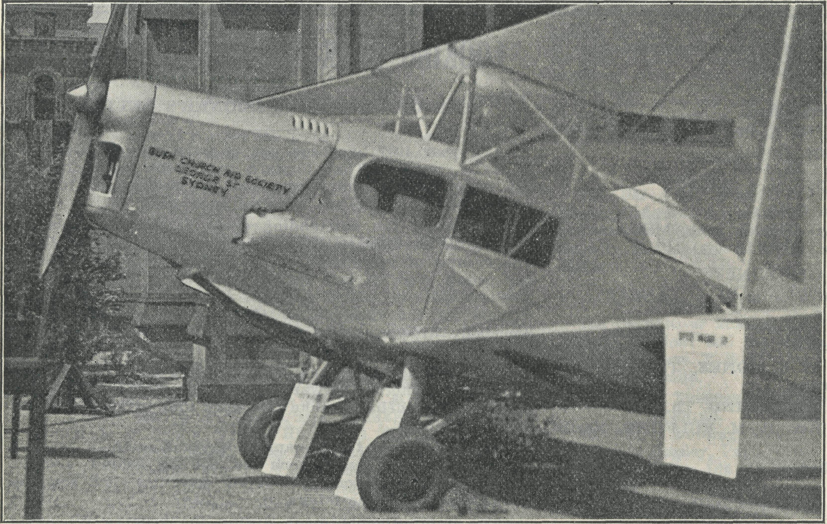

Dedicated by the Archbishop of Sydney, January 19th, 1938.

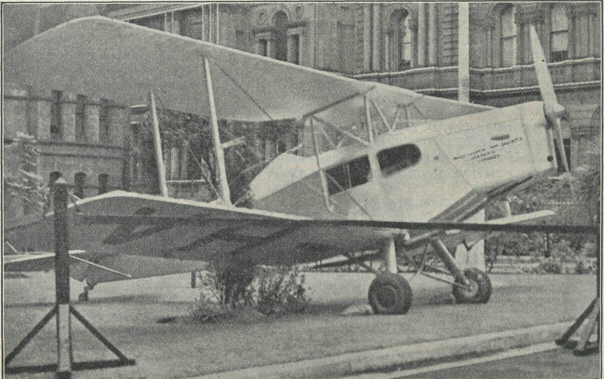

February 1, 1938. . THE REAL AUSTRALIAN.
And from Above
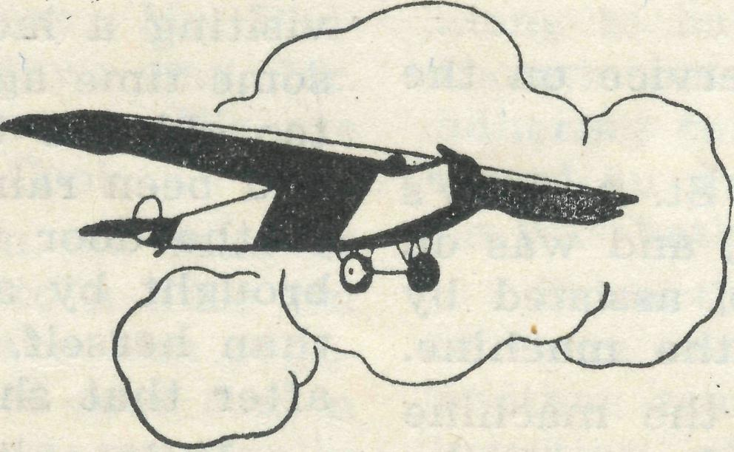
For every hour that the new B.C.A. Aeroplane is in flight, 35/' will be needed to cover the expenses. In one hour the 'plane will travel 100 miles.
If the Doctor is called to Cook from Ceduna, that will mean 500 miles of travel to take him there and back. Five hours means five 35/', but it may mean a saved life and will certainly mean relief from suffering.
The extension of B.C.A.'s work and the addition of the aeroplane service mean much in added responsibility and work to the Organising Missioner and his staff. This, of course, is gladly undertaken.
Maybe you cannot take the work off our shoulders, but YOU CAN help with the responsibilities. Why not decide right away to add to your responsibilities by under' taking to keep the aeroplane in flight for one hour, a half-hour, or a number of minutes ?
Somebody in a lonely place is given aid from above because you sent help to B.C.A. Fill in the form and return NOW—but remember, if it is going to be real help it must be additional to what you already give. It would not be fair to rob the Hostels or Missions of your support.
TO THE SECRETARY,
BUSH CHURCH AID SOCIETY.
I rejoice to send you the sum of £ in order to keep the Medical Aeroplane
in flight for—*One Hour. Signed
*Half an Hour. Address
* Minutes.
35/- per Hour ; 17/6 per Half-Hour ; 7d. per Minute. ^Strike out unappropriate clause.

THE REAL AUSTRALIAN.
February 1, 1938.

THE DEDICATION OF VH-AAA.
VH-AAA is the registered number of B.C.A.'s new Medical Aeroplane. The VH tells us that it is an Australian 'plane ; AAA means that it has been given the first number, and is therefore Australia's "number one" 'plane in the registration list.
We hope that it will give "number one" service on the West Coast !
The 'plane was brought into the grounds of St. Andrew's Cathedral, Sydney, on Wednesday, January 19th, and was on view for the day. At 11 a.m. the Archbishop, assisted by Archdeacons Langley and Charlton, dedicated the machine.
His Grace spoke of the great need which the machine would supply, and urged those gathered to help meet the £500 still required to meet the finance.
All day long large crowds assembled to view the machine, and a tremendous amount of interest was aroused. A plentiful supply of B.C.A. literature was available, and we are sure that the venture enabled a great many people to learn something of B.C.A. work for the first time.
The machine is very finely built, and has room for three passengers and a pilot. When the stretcher is in use, two passengers can be carried.
We are grateful to the de Haviland Company for the splendid workmanship of the 'plane, and for the manner in which they have finished every part of it.
Now we must do our part to enable the machine and pilot to answer every call made. Pray and give, that we may not fail.
LOYALTY.
Rev. H. Broadley.
The last two or three months have taught me to appreciate the faithfulness of at least one of the bush congregations. My car suddenly developed oil trouble. It first made itself known to me as I was hurrying from Smoky Bay to Nunjikompita one hot Sunday afternoon. The service was timed for 2.30 p.m., and I was running late. About five miles from my destination I had to stop. When you are forty miles from home on a lonely road, and know that nearby homes will be empty because the families await you some miles away at a hall, it is food for thought. Any moment a stray car may come along. Any moment someone grown tired of waiting may come homewards. By walking on you may find the people there, or miss them by but a few minutes. I waited !
The people had more patience than I expected. Not till 4.20 p.m. did a truck come homewards. We arrived home at Ceduna about a quarter to 8 o'clock, after a tow of forty very dusty miles.
Another time a touch of influenza prevented my arrival at the same centre. Telephones are in use, but only in certain hours. This makes it difficult to tell the outback people what you intend if plans have to be changed suddenly. The congregation turned up and waited about an hour before going home.
The third time, the car broke down nineteen miles out on my way to the same place. After a two mile walk I managed to borrow another car. I arrived five minutes after everybody had gone home, though they had waited over an hour.
Yet, when I arrived there in good order and condition last Sunday, about thirty people turned up to greet me with smiles and jokes. Thirty comprises the usual congregation, with every family (C. of E.) in the district represented. Would all congregations were as loyal and patient as they.
A chance remark, made in my hearing the other day, shows how people notice one's practice just as much as one's preaching. The speaker had returned to Ceduna on a short visit, after twelve months' absence. He said that
he would not be a clergyman for £5000 a year ! What especially beat him was, how, with all the disappointments he gets, a minister can keep cheerful. It would certainly be impossible at times if it were not for the inspiration of Christ.
Another illustration was given to me yesterday. I was visiting a lady who does not go out much. She said that some time ago she was telling her family that she is getting too old, too this, too that, to do very much these days. It had been raining rather heavily about that time. She went to the door to take in the milk, and saw that it had been brought by a hard working little woman, some years older than herself, who was wet up to the knees. She said that after that she couldn't grumble any more.
It is certain that the sermons we preach unconsciously are more effective than those spoken only by the lips.
Perhaps some who read these words will wonder why we cannot dig up thrilling tales to tell of work out here. One reason is, we are working amongst ordinary folk just like you. They have to put up with a bit more dust, more heat, more distance and other such inconveniences than perhaps fall to your lot. Underneath, they have the same needs and desires. The B.C.A., as I see it, exists to help you to share some of your privileges with them, not because you have to, but because you want to. The nurses and missioners are the instruments you use for this purpose.
CHRISTMAS AT PENONG.
Sister M. Meades.
Christmas was a very happy time at Penong. We had patients in Hospital who were too sick to be discharged, so we did not go down to Ceduna, but had our festivities with the Rev. E. and Mrs. Constable.
The weeks before were very busy ones, making preparations for the Sunday School Christmas Tree and Party, and sorting out the various gifts and prizes. The children had their Tree on the Wednesday afternoon before Christmas. The day was very hot, with a strong north wind blowing and clouds of dust, but fortunately the wind changed in time for the children to enjoy games outside. After games, the children gathered in the rather dim dining-room of the Rectory, where the Tree was, and, amid a hush of expectancy, Father Christmas arrived ! To be sure, some of the children thought he was rather slim after previous editions of Father Christmas they had seen, but others who had never seen him before were very thrilled and excited. The party was a great success, and we are very grateful to the Auxiliaries in Melbourne and Sydney for the toys sent out, and to Miss Mackenzie, of Adelaide, for the parcel she sent, which contained decorations for the Tree among other good things.
The staff celebrations were quieter, but very happy. Mr. Constable had to go up the road for services, so the day was spent in decorating the patients' rooms, setting up our Tree and preparing Christmas dinner for 6 p.m. In this case, too, many cooks did not spoil the broth, for the dinner was excellent. After dinner we sang carols, which patients, staff and visitors all enjoyed, and then at 9 p.m. we received our parcels from the Tree.
With hearts overflowing with thankfulness and praise, we knelt together at the end of the day to worship and give thanks to God for His unspeakable Gift, Who yearly becomes dearer to us as we experience more and more of the wonder of His love for us. May God give us grace to serve Him with a perfect heart and with a willing mind in the days to come.
# & # & #
Sister Hitchcock.
It is a typical West Coast afternoon, with a very hot sun and a strong north wind blowing, the temperature being llOo or over. It is Sunday, and fairly quiet, and in their efforts to get cool, Sister Meades and Mrs. Constable are

February 1, 1938.
THE REAL AUSTRALIAN.

sprawled in elegant positions flat on the floor, and Sydney James Cook (about whom Mr. Constable has written in another article) is raising his voice lustily in strong objection to the hot weather, as, being only ten weeks old, he has not learned to take a philosophic view of it. We are not envying anyone who is out on a long trip to hold services. Mr. Constable is out at Coorabie, 50 miles from here ; Mr. Pad-man, the Methodist minister, is 19 miles away ; and Mr. Broadley is probably about 45 miles from Ceduna. We are also wondering how Sister Todd is faring at Cook.
We are also not envying an ex-patient, an old man of 84, who left us last Sunday. He went home to a little tin shack of one room (although some friends have him regularly to meals since he has been ill). This old man had a friend, and they both lived alone in tin huts practically alongside each other. The old man had not seen his friend come out of his hut for about twenty-four hours, so thought he would call in and see how he was getting on. He saw him lying over the bed, so touched him on the shoulder and said, "Come on Alf., old chap," when, to his horror and amazement, he found he was dead. It was such a shock to the old man that he was taken ill himself, and brought into Hospital, and was not expected to recover. While he was in here we had opportunities of talking to him, and found out that he was an agnostic, and although he knew he had not many years to live he seemed not at all worried about his state. All efforts to persuade him of his need of a Saviour appeared useless, because he believed that God made man of His own Image, and therefore man did not need a Saviour. Contrary to everyone's expectations, he recovered, and left Hospital more fit than before, but still holding to his convictions. When anyone speaks to him, he listens patiently, but with an air of patient endurance which seems to say, "No one will ever convince me that I am wrong." However, the seed sown may, in God's good time, bring forth fruit. We should value your prayers for him.
Although there are some here who appreciate the Word of God, and are glad of opportunities of worshipping Him, there are, as in most places, many who seem utterly indifferent to the things of God. However, as in most things, there are the bright spots which help in their way those who are seeking to lead souls to Christ, and, as it says in Ecclesiastics : "In the morning sow thy seed, and in the evening withhold not thine hand ; for thou knowest not whether they shall prosper, either this or that, or whether they both shall be alike good."
AN OPPORTUNITY FOR CONSECRATED SERVICE.
The Society needs a consecrated Nurse who will undertake charge of a small hospital for aboriginals at Kooniba Mission, in the Far West Mission of South Australia. This is an urgent need, and the task, though difficult, will have many joys for one who will undertake it for Christ's sake. Apply to—
The Organising Missioner, Church House,
George Street, Sydney.
DUSTY TIMES ON THE NULLARBOR.
Sister D. Todd.
Since last writing, I have moved from the Dispensary at Cann River to the Hospital at Cook. What a difference there is in the natural beauties around us ! From the stateli-ness of giant trees, and the beauty of tree ferns, grass and wild flowers, to the dry, parched plain, where no tree grows of its own accord, and red dust seems to be in continual motion. Nevertheless we still have the same blue sky, and sun to shine on us, and our Heavenly Father to watch over us where we are. The needs of the people here, too, are the same. They all need care and attention when sick, but above all they need the Lord Jesus in their lives.
It is over two months now since I arrived here. Since the end of October we have had a continual stream of patients in the Hospital. We started off with a little newborn black baby being brought along to us to care for. It had been discarded by mother and father, and the blacks were going to kill him. One of the black men brought it along to us to save its life. The poor little mite looked as * though he had been rolled in the dirt, as he had gravel adhering to his skin all over his body, and was just wrapped round in an old dirty bag. What a transformation when he was bathed and dressed up in his baby clothes !
Since then we have had several children in here, some of them coming from up to 170 miles away. Then we had another man in with his head cut open, necessitating the insertion of eleven stitches. Septic hands, deep seated splinters from sleepers, and other cuts and injuries seem to keep up the list of out-patients coming along for treatment.
In November we had our first birth in the new Hospital, when a dear little son was born to a very proud mother here. He is the dearest little chap, and is being named after our Hospital here. We pray that he may grow up to be a man of God, as was Bishop Kirkby, in whose memory this building stands.
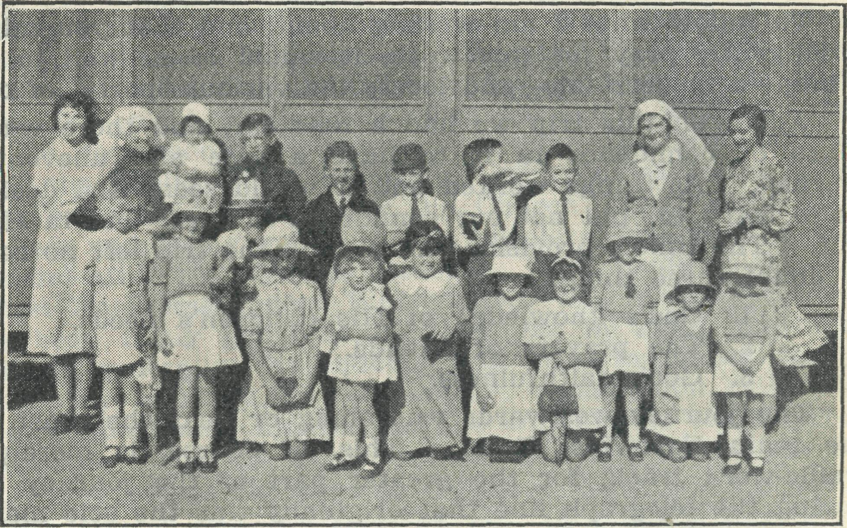
Sunday School at Cook.
Life at the Hospital goes blissfully on its dusty way these days. As I sit and write these words, the dust comes streaming in through the walls, doors and crevices that no one dreamed existed, but they were found by the dust. It is only with difficulty that one can breathe, as the air is so dense with red dust. Our Hospital building was reputed to be dust-proof, but what can possibly resist this red dust of the Nullarbor Plain when it is being whirled along with a strong wind at fifty miles an hour ! On Christmas Eve the people here were holding a Christmas Tree up in the hall for the children. The day had been delightful, and had been an encouragement to all the mothers to work hard for it. Most of the parents and little ones had gone along to the hall. Suddenly the wind commenced to blow, and on investigation we were greeted with clouds of dust. The storm kept up for a couple of hours, and several people were completely lost on their way home, as they could not see for dust. The dust storm was followed by rain, which made mud of the dust that had already fallen everywhere. The next morning we found our Hospital filled with dust, our wood heap had been almost concealed, and also ! for our garbage tin—it had taken up a new abode about half a mile out on the plain !
Two days before New Year's Day we had the worst dust storm of all. One could see it coming for some time before it actually reached us. It swept on and on in its wild course till the whole camp was enveloped in a dark cloud of dust. It drifted in through every ventilator, window, door, and even the floor. Gradually it became darker and darker, till we could not see outside the windows. By 5

THE REAL AUSTRALIAN.
February 1, 1938.

o'clock it was pitch dark, and we could not see anything inside. We switched on the electric light, but even then the air was so laden with dust that we could only dimly distinguish the outline of any object that was two paces away from one. When it at last ceased to blow we had to commence the cleaning. Brooms were useless till the worst of it had been removed with a spade, and carried out by the bucketful. We just had it cleaned up nicely again when another dust storm came along, and this has kept up continually now for the last five days. These people are certainly very brave to live here year in, year out, and contend with such trying weather conditions. They do need your consideration and help, and are very grateful for it; but, above all, they need your prayers on their behalf, that they may come to the knowledge and love of Christ and His saving power to clease from all sin.
'HE IS FAITHFUL."
Rev. E. Constable, Penong.
At the end of October we—that is to say, Mrs. Constable and myself—journeyed completely around this little parish. It was the first time I had done the "round trip," previously having cut across to the Line from one point or another.
To follow what I am writing about, and that you might intelligently pray for this work, it would be as well to get a map—a modern one—and locate the various "ports" of call.
Again on this trip we had a new car, and there was a sense of confidence in it to have a safe and uneventful journey. As things worked out, it would seem God desired us to learn to "put not our confidence in cars," but in Himself. The timely provisions all around the trip left no room to doubt three things :
- God's knowledge of His children's needs.
- The prayers of friends.
- God's faithfulness.
The journey westwards was along or near the coast, on the main East-West Road. This, of course, is merely a traffic-worn track, for the greater part of the journey following the telegraph line that originally was the sole means of communication of Western Australia with the Eastern States, Eucla being the "city" of two States, though ten miles within Western Australia.
On the outward journey, five homes only are the entire population after one leaves the 50-mile radius of the home district. In order, these are Colona Homestead (68 miles), White Wells (an outpost of Colona, 143 miles), Nullarbor (150 miles), Eucla Homestead (289 miles), and Mundrabilla (351 miles). Mileages are from Penong.
The first day brought us to Nullarbor, where we are always made most welcome by Mr. and Mrs. Brooks. After a Service of Holy Communion next morning, we set out for Eucla and Mundrabilla. The day was very hot, and not the sort of day one would choose to have to "get out and get under" ! At 70 miles out, in a quiet treeless spot, the off back tyre blew out, causing the car to do some gymnastics amongst the telegraph poles. The tyre and tube, both new, were completely ruined ; the canvas of the tyre had been fractured by stones, so weakening it, and finally causing the blow. We remarked, "If only our friends could see us !" as with much effort we sheltered from the sun beneath the lid of the boot of the car. Here we ate some lunch, and put on the spare tyre. To my disgust, I found the other back tyre was flat almost. By the use of a box and two jacks, I took the front wheel off and put it on the back, as it was in better condition. Later in the journey I had to exchange the other front wheel on to the rear also, and carefully watch the pressure in all four to avoid a further blow out, for if such occurred we would have been helpless. The tyres being brand new, one hardly reckoned on needing more than one spare. Now, however, we had to go implicitly trusting the Lord to undertake ; for we did all our part, and it would have been faithless to turn back.
We called in at Eucla for a while, and went on to within ten miles of Mundrabilla before camping for the night. Rather an eerie spot that—alone away out there, the road being locked in by the dark form of the Hampton Range : the limestone cliffs that are the edge of the Nullarbor Plain, and against which the waves once smashed themselves to foam. The car is our tent on such occasions, as the seats are convertible into beds ; so we live in comfort !
Next morning Mundrabilla proved a refuge from the heat, and Mr. and Mrs. Hogarth were kindness itself to us. Did we relish that cold bath ? We had only to go 80 miles across the Plain to Forrest that day, so we were in no hurry. At 9 o'clock that morning the station truck had set out for Forrest on its monthly trip for supplies. There it was perched in a most precarious angle half-way up the 200 ft. cliff. This "pass" over the cliff goes almost straight up, and at the top curved sharply to the left, where there is a sudden ledge. It was 1 o'clock before the truck finally got up.
We left about 2.30 p.m., and Mr. Hogarth said, "Change gear as you take the first bend ; whatever you do, don't let it stall on the rise." That last curve and rise was a sensation never to be forgotten. It reminded one of a dog with its front feet over a fence and pulling itself over with its back ones. So the car literally hauled itself over the top, and we looked back as from an aeroplane upon the homestead below. About half-way across the Plain we overtook the truck, and took over a passenger and her little boy, thinking we would be into Forrest before them. As things turned out, the truck beat us in by a few yards. No, it wasn't a race ; but 27 miles from Forrest our car stopped, and no coaxing would start it. The truck came along in a while and towed us in to the camp. We reasoned this way : What if the truck had not been going that day, of all days of the month ? What if it had not been delayed so long on the cliff ? Well, we would have had 27 miles to walk. But He knew !
Again, at Forrest is the aerodrome, and there the Airways mechanic spent a whole day finding and rectifying the trouble. I shall be taking too much space in "The Real Australian" if I tell the whole story ; but, both in material matters and spiritually in our contacts and services, the "good hand of the Lord was upon us," as it always is.
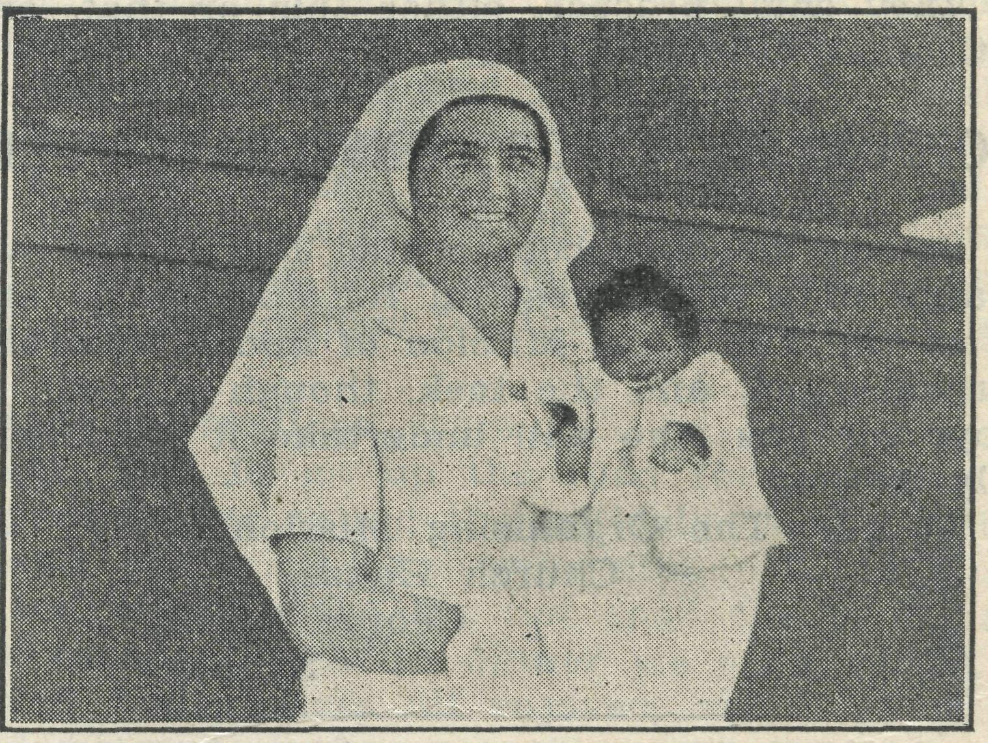
Sister Todd and Sydney James Cook.
To-day he is just two months old, and the loveliest, chubbiest little black picanniny you could desire. But that is just what love and care will do ! If you could have seen that little bit of humanity as he was brought to the Bishop Kirkby Hospital, in a sense you would have thought he was hardly worth the tea and sugar the native had asked in exchange for him. There he was, covered only with dirt, unattended from birth, carried in an old bag. Jabbering something about "white man devil-devil," the black man made clear, at any rate, that he wanted Sister to keep the unwanted little thing. After several lots of water and much

February 1, 1938.
THE REAL AUSTRALIAN.

delving for gravel and sticks from his mouth, throat, nose and ears, there he was clean and snug in some woolies. A shock of straight ebony black hair was his characteristic feature ; to-day it lies down beautifully. Before bringing him with us to Penong, under Sister Bossley's nursing, we claimed this little gift from God for Christ in Baptism. What more appropriate names could we give him than Sydney James, in memory of the one who set such an example of Christian love for such a one ? He possibly will be called Sydney James Cook. One understands he is to be adopted by B.C.A., and we pray that he will grow up to be a "man of God," bringing the message of Jesus to his own people. Pray for Sydney James !
MINISTERING TO THE ABORIGINALS.
Dr. Roy Gibson.
I have often been told by the Organising Missioner that I should "write something for 'The Real Australian.' " After putting off the evil day for some time, I have been finally brought to the point.
I thought that it might be of interest to the readers to hear something of the aboriginal inhabitants of this district. In the district, which will be served by the Far West Medical Scheme, there are between 250 and 300 people of aboriginal extraction, and, as is usual, those living nearest the settled centres show the largest proportion of mixed blood. The majority of these natives are de-tribalised, the only approach to a tribal community being at Ooldea, on the Trans-Australian Railway, and even these frequently treck down to the coast and are thus brought into contact with their more sophisticated brethren. The greatest concentration in any one place is at the Kooniba Mission Station, which is staffed by the Evangelical Lutheran Church, and there Pastor and Mrs. Traeger and their helpers are dong a wonderful work for their charges, and witnessing for Christ in a manner that it would be well for many of those thrown into contact with the aboriginal race to emulate. Nor is their task made lighter by the inadequacy of the arrangements made for the physical welfare of the natives. I have been medical officer to the aborigines in this district for four years, and during that time there has been no trained nurse on the Mission Station, thus throwing a great deal of anxiety on the Mission staff ; also there is no hospital equipment, and practically no medical and surgical supplies for the use of those natives who require hospital treatment. It would have been impossible for me to have done anything effectually to alleviate their physical disabilities but for the unfailing, ungrudging help, often under the most primitive of conditions for working, that has always been given me by the Sisters at the Ceduna Hospital. They have never hesitated to offer me their assistance at cases at the Mission at any time, night or day, though this means a drive of 50 miles and the difficulties of working in a native hut or "wurlie," as it Js in such places as these that we have frequently had to conduct surgical and obstetrical procedures.
When one is used to the apathy and neglect shown by the Government to the aboriginals, and the unthinking and un-Christian attitude, often merging into actual brutality, shown by individual white people—often incidentally they show no hesitation in exploiting the native—one is relieved to find that there are some who, voluntarily and without recompense, just because they are true Christians, will help the natives, treat them as human beings and God's children, and will willingly do the most distasteful tasks in their service when they are ill. "Inasmuch as ye do it to the least of these, ye do it unto Me."
It was with delight that we learned from Mr. Jones the
project of getting a B.C.A. Sister to take on the position of
Resident Nurse at Kooniba Mission. The work will be
hard, and there will be plenty of it, but whoever takes up
this work will know that it is a job worth while doing ; it
is a work of Christian charity in the highest and best sense
of the word. • •
WORK IN THE WEST.
Rev. C. Baker.
Since February, eighteen trips have been undertaken, including eight to Ivanhoe. The country people have been kept in touch as regularly as possible. Numerous services have been held in homesteads or railway sidings, and a number of services have been held specially for homestead children. A few have been linked up with the Mail-Bag Sunday School ; others are being prepared for Confirmation, both inside and outside the towns. Fairly keen interest is being shown in the classes.
Since I returned from Melbourne at the end of May, I have travelled 3300 miles in the Van. (The Van has covered 22,957 miles since it first went on the road, 14,600 odd since I took it over.) Special trips this year include the Melbourne trip, two to Wilcannia during Mr. Langshaw's illness, and a trip there for the Archbishop. Next month 1 shall take the Bishop of Riverina from Ivanhoe to Wilcannia, and then to Menindee for Confirmation.
The work in Menindee has been encouraging in many respects. The town Sunday School has increased in a few weeks to twice its usual numbers. Lately we have had nearly forty children on several occasions. The increase is partly due to special visiting with that purpose in view, and the numbers are being maintained. The Bend Sunday School is still well maintained. Services in Menindee are at times disappointing in numbers, but continue to be fair. Many Church of England families have left Menindee in the last few months, which has affected the attendances. I visit the public school regularly. The Ladies' Guild have had a beautiful cupboard for the Church Vestry built and installed, and thirty splendid new kneelers have been made by them, after the style of hassocks. The Guild celebrates its first Anniversary next Wednesday. The country people have been fairly generous in donations in some quarters. Speaking generally, the country folk have responded fairly well to my ministry in every way. Communion rails are to be installed next month, and the windows of the Church altered for more air in summer. The W.F.O. System is being tried out at the present moment.
The response to the services, etc., in Ivanhoe has been better in recent months. But there is nothing particularly outstanding to report about the work there. It is a time of sowing the seed. The B.C.A. ministry is much appreciated by some.
I visited Pooncane a fortnight ago. It is smaller in population than Ivanhoe (about two dozen homes), and there are 35 children in one public school. Fifteen persons attended my evening service, and six came to Holy Communion the next morning.' Most of the townspeople are Anglican. The constable and his wife showed great interest in our visit ; they are C. of E. The school teacher, a Methodist, is very keen about spiritual things. He holds a Sunday school every week. He co-operated with me on my visit. I feel that regular services in this town will be of value. I hope to go there on 26th December again, and then across country to Ivanhoe, on my Christmas trip. Between my previous boundary and the town of Pooncarie there are many homesteads on both sides of the river, amounting to about twenty in all. There is also a section of Outback country east of the river below the railway line which has not been in my area, but so far as I know is uncared for. It is a fair sized bit of country in area, containing perhaps nine to twelve homes. Will B.C.A. be asked to look after Pooncarie only until the Wentworth man gets a car ? Or will B.C.A. continue to look after Pooncarie definitely in the future ? This should be determined as soon as possible. If B.C.A. continues with this new area, definite boundaries should be decided upon for this southern portion. I may say that the permanent addition of this new area will tax the Menindee Missioner with a maximum of activity if a regular work is to be maintained. The present area has now a B.C.A. ministry which has developed into a full-time

8
THE REAL AUSTRALIAN.
February 1, 1938.

job. To keep up with the demands of the work needs all one's time and energy. For example, it is two or three months since I have found time for more than one or two complete days "off." Most times each day is occupied morning, afternoon and night in work. But it is all worthwhile, and I am of the opinion that B.C.A. acted very wisely in having two men instead of one in the Western portion of the State. The extra expense involved will be amply repaid in spiritual results eventually.
There is one requirement which I feel is now essential for the Van—new tyres for the rear wheels. Summer, and a hot one, is approaching, and good tyres will be needed. Only one of the present tyres has a distinct tread. Two of the other tyres have been vulcanised, the spare is getting weak, and all four, apart from the one with a tread, have small holes and cuts around the surface. The hot sun is starting cracks in the rubber. With two good tyres at the rear, and my best two of the present ones at the front, the Van will be well shod, and I shall have three spares which will be useful for a long time. The size of the tyres is 5.50 x 19, Goodyear Heavy Duty. Could these be supplied as soon as possible ?
[Note.—The foregoing is one of Mr. Baker's regular reports of his work to the Organising Missioner. It is printed here in order that our readers may obtain a really first hand idea of work entailed in B.C.A. Missions.—Editor.]
WAYFARING MEN.
Rev. C. Baker.
A rowdy group of six young men, dissolute, careless manner, unkempt in appearance, come lounging aimlessly along the dusty main street of Menindee ; their sandshoes, in a somewhat decayed condition, encase dirty feet that rise and fall languidly as they walk. Their clothing has obviously known better days. Presently they cease walking and hold solemn conclave in the middle of the street, after which they separate into pairs and move off in various directions. Two of them knock at the Rectory door. I open it, and behold two young men not yet twenty. My first and most lasting impression is that I could scarcely have believed such evil and villainous countenances possible in youths of their age, did I not behold them at that very moment. "Could y' let us 'ave some food, Dig?" is their immediate request. While this is being prepared I converse with the pair. They tell me the usual story of how they jumped a goods train, were arrested by the police at Menindee, and, after spending a week in the lock-up, have just been released. As soon as they can jump another train they will proceed to Broken Hill, doubtless to be arrested and locked up again. In the meantime food is their chief problem.
I now speak to them quite definitely about their souls and eternal welfare, pointing them to Jesus Christ as their only Saviour from-sin. But their hearts are hard and unimpressionable, and their perception is slow and vague. The food is ready in the end. Having received it, with some Christian literature, they depart. God help them ! God help these wasted and wasting lives, undeniably bad at heart, brutal, Satan possessed, lacking all the fine and noble qualities possible to men. To talk to them for even one minute is to feel hopeless with regard to them ever being better. Their way of existence, their type of mind, their outlook on things, apparently excludes the remotest possibility of any one of them becoming a Christian. But with God all things are possible ; let us never forget that fact. Neither let us underestimate the value of a B.C.A. Missioner being on the spot to be at least one person who speaks to these outcasts about Jesus Christ. They well know that nobody wants their undesirable presence. So to be told that Christ wants them, and died to lift them up, may have a special and compelling appeal for them.
These six young men are only a few among many. All
the year round young train jumpers, and older ones too, pass through Menindee, staying for a short while in the lock-up en route. They are on their way to Hell. Earnest prayer is needed that the Missioner may be used of God to lead them to Christ, so that they may journey on towards Heaven instead.
Many types of wayfaring men call at my Rectory door. Here is a man of over forty who tells me that he has never been so down and out before. Once he was an opal miner. Now he mends boots and does other odd jobs. He has come to Menindee to make a fresh start, and would like me to help him. The man seems genuine and worthy of one's assistance. For a few days all is well. Then one afternoon he staggers along the street, absolutely dead drunk, for the time being completely out of his mind, followed and angered by two little boys. He passes on from Menindee. We see him no more.
Here is a blind man, led about the country from a young lad, begging. His is a life of darkness in more senses than one.
There are two youths who are cycling to Broken Hill looking for work. They are decent fellows. They happen to camp in Menindee on a Sunday night, so they come to the service and are helped thereby.
Another night a travelling talkie show man attends the evening service, thankful for the spiritual ministrations of the Church, before he passes on his way.
All wayfaring men, all living souls, all precious to God. Some of them far off, however ; others are His by faith. Pray that God will use His servants to help them all in a real and lasting way.
WERRIMULL.
Rev. F. Bayly.
The work of the Church in this part is doing very well. Most of the centres show consistent attendance, and in some much improvement.
The Sunday School work in Pine Tank, Werrimull South and Werrimull is very good. The teachers are keenly interested in every method to improve themselves and children.
We hope to start a Sunday School at Meringur and Merinee,
Confirmation classes are being given to about nine candidates, and we expect a visit from the Bishop of St. Arnaud on February 20th.
Christmas Trees and tracts were given at several centres, and the gifts kindly sent by B.C.A. have been distributed to the children throughout the district.
A "wheat drive" has been launched, and up to date we have had very little encouragement, as to the results. We are still hoping for the best.
The weather has been extremely hot, with occasional heavy dust and thunderstorms.
We are receiving great help from the three Sisters at the Hospital, who are helping in all parts of Church life in Werrimull.
Sister Hamilton has taken charge of the Werrimull Sunday School, and we have nearly thirty children attending. Sunday School is in recess at present, and we feel it is not advisable to open again for a while, but the children are receiving their lessons and doing them at home.
A noteworthy example of churchmanship is exemplified in a long drive of 17 miles in a jinker by a lady, with a friend and two children, to attend an evening service at Werrimull, afterwards driving back the 17 miles home on roads far from good.
We give thanks for the blessings bestowed upon us, and ask for your prayers in our endeavours to teach and preach in the service of our Master^.

February 1, 1938.
THE REAL AUSTRALIAN.

THE VISITOR.
KATOOMBA RALLY.

The small blue car halted before the gate that must needs be opened before the last mile of her journey could be accomplished. The driver, relieved by the knowledge that this indeed was the last gate, descended from the car in thankfulness.
Twenty times during the space of two hours the same operation had been performed. Twenty gates had been opened, and those same twenty had been closed, for woe betide the man who fails to close the gates of the Australian sheep farmer. Some are good gates, some are bad gates, and some are just loose panels in a v/ire fence, which impose a great strain on the traveller's patience and vocabulary. Nevertheless they must all be securely fastened after he has passed through.
The task performed, the car continued on her journey toward the homestead, visible a mile ahead. Beyond the house the dry dust was rising in clouds from the sheep yards. The bleating of many frightened sheep, the barking of dogs and the yelling of men greeted our traveller as he passed the homestead and brought his car to a halt close to the sheep yards. From the back of the small two-seater he brought out and donned a grimy set of overalls, and, waving a greeting to the four men already engaged with the sheep, he took his place at one end of the long narrow trough filled with a sickly yellow liquid. The Australian merino, upon whose back grows the world's finest wool, must go through many unpleasant experiences in order to keep her fit and her wool up to the best standard. This morning the sheep on the "Avon" run were being "dipped" in the evil yellow fluid which, on penetrating the woollen coat, poisoned the small red mite that at certain seasons of the year finds a home on the back of the sheep.
The work is commenced as early in the day as is possible, so that the whole mob may be finished before the sun's rays have any great heat, otherwise sheep may suffer injury from scalding. At such a time visitors cannot expect to be entertained with the usual Australian outback hospitality. They must go and talk to the womenfolk or lend a hand at the trough, pushing in the protesting woollies or helping them out after their short swim is over.
Our traveller was well accustomed to, such occasions, and was soon as busy as the other four. Two of the men were already well known to him—Charlie Bird, the owner of 'Avon," and Bob, his jackeroo ; the others he supposed were the new owners of "Garton," some ten miles further on, come to lend a hand. It is one of the fine characteristics of the Australian farmer that he is always ready to lend a helping hand to his neighbour.
Two hours later the last sheep was through, and Bob was left to see that the sheep got back safely to the feed paddocks.
As the others walked over to the homestead our traveller was introduced to the two strangers, and learned that they were the new owners of the adjoining property, as he had supposed.
Our traveller was the last to finish in the bathroom, and when he appeared in the kitchen the inevitable cup of tea was being served. His appearance brought forth a smiling welcome from Mrs. Bird, but his "back-to-front" collar and black vest evoked from the surprised strangers the expressive remark : "Cripes, a parson !"
T. J.
On the evening of Monday, January 17th, some 450 people gathered in the lown Hall, Katoomba, to see and hear of the Society's work.
The Archbishop occupied the chair, and spoke most tellingly of the various activities seen by him on his recent tour of South Australia and the North-West of New South Wales.
Archdeacon Langley also spoke of the Society's needs, and urged those gathered to stand behind the B.C.A. in its great endeavour.
The Organising Missioner outlined the growth of B.C.A. during the past four years, and showed some coloured moving pictures of Wilcannia, Cook and Ceduna, taken during the Archbishop's trip.
We feel that the venture was well worth while, for at this time people are gathered at Katoomba for the Convention and holidays from many parts of the State. Such gatherings enable the circle of interest to be widened.
We are grateful to the Archbishop and Archdeacon Langley for making the trip up from Sydney in order to speak, and to the Rectors of Leura and Katoomba for their splendid co-operation.
URGENTLY NEEDED !
Consecrated men for training for outback ministries. Also three clergymen in priest's orders to undertake difficult outback ministries.
Apply to-
The Organising Missioner,
Bush Church Aid Society, Church House,
George Street,
Sydney.
THE REV. W. I. FLEMING.
We are happy to announce that the post of Victorian Secretary has been filled by the appointment of the Rev. W. I. Fleming, of Mitcham, Victoria.
Mr. Fleming came out from England in 1925 as a B.C.A. trainee, and for his first year he worked as the Society's first Missioner at Cann River while still a layman. From Cann River he proceeded to Ridley College for the Th.L. course, which he successfully negotiated, and was then appointed as Missioner in the North-West Mallee. Upon his return to the Melbourne Diocese, Mr. Fleming was appointed to the Parish of Mitcham, and continued to take a very real interest in the Society's work.
For some years Mr. Fleming has been a member of the Victorian Committee, Council member, and Honorary Clerical Secretary of B.C.A. in Victoria.
As Victorian Deputation Secretary, Mr. Fleming should be welcome in every B.C.A. parish, for he comes with a long first hand experience of * the Society's activities and a keen desire to see the B.C.A. progress in Victoria. We commend him to the prayers of all our people.

POSTAGE STAMPS.
NOTES.

Postage stamps of all kinds will be welcome at our Office in Sydney or Melbourne.
We extend to the Rev. and Mrs. H. Broadly, of Ceduna, our congratulations on the advent of a son, John Raymond.

10
THE REAL AUSTRALIAN.
February 1, 1938.

During March and April two more Sisters will be added to our staff; Miss Isabel Harris and Miss Symons will be proceeding to their stations. We welcome both Sisters to our staff, and assure them of our earnest prayers for a happy and blessed companionship in this work.
Jan. 24, 1938 : £1, Anonymous—Aeroplane (Sydney). Jan. 31, 1938 : 10/- for General Fund—"A.Y.Z."
. We thank Mrs. Howard Gill for the sum of £2/6/- collected from friends for the children's Christmas.

We extend our congratulations to the Rev. George Brown-Calderwood, a B.C.A. trainee and Curate at St. Matthew's, Prahran, Victoria, who has recently passed his priest's examination, and is to be ordained to the priesthood at the next Melbourne ordination.
"REAL AUSTRALIAN" SUBSCRIPTIONS.
Following are the subscriptions received since last issue. For want of space, we are only acknowledging the subscriptions where no receipt has been received :—Mrs. B. Binnie, Mrs. Broadfoot, Mrs. Jowsey, Mrs„ E. I. Lawford, Miss M. Kittson, Mrs. A. M. Nicholas, Miss E. Burrowes, Mrs. I. T. Bossley, Mrs. A. M. Shepherd, Mr. R. Henniker, Mr. A. F. Osborn, Mrs. M. Simmonds, Miss C. Spragg, Mrs. E. Frisken, Mrs. W. H. Watson, Miss R. S. Fishman, Mr. G. Hampel, Mrs. H. E. Day, Mrs. C. W. B^{ird}> Mrs. W. A. Clegg, Mrs. H. Gordon, Mrs. J. Watt, Miss M. Jamieson, Miss M. E. Cabrera, Miss D. L. McLeod, Miss C. Chaffer, Mrs. J. B. Bulley, Miss M. Oliey, Mrs. J. C. Rickard, Mrs. Frank Wheen, Mrs. P. Goodwin, Miss Pease, Mr. V. F. Windon, Miss B. McKnight, Mrs. Moore, Mrs. Dalton, Miss Marsh, Miss J. McClelland, Mrs. Mercer, Miss Gibbon, Mrs. Bennett, Miss C. M. Locke, Mrs. Coburn, Miss Carleton, Mrs. Hansen, Mrs. Russell, Mrs. Stevens, Miss Monckton, Miss Gibbon, Mrs. Macartney, Mrs. Dunbar, Mr. Gearing, Mrs. Dougherty, Mr. and Miss Jessop, Miss Dawkins, Mrs. and Miss C. Dennis, Capt. S. G. Hooper, Mrs. H. N. Butt, Mrs. and Miss Seedsman, Miss Weatherley, Mrs. McCrea, Miss N. Irwin, Miss R. Bartlemann, Miss M. King, Miss Aumann, Mrs. A. iNojle, Mrs. E. Evans, Miss E. A. Scott.
J£ %. %. %. %.
We wish to make grateful acknowledgment to the following donors of anonymous gifts :—
Nov. 27, 1937 : 10/- for Christmas Toy Fund from "A.Y.Z."
Dec. 1, 1937 : £1 note, Anonymous—X.A.
Dec. 8, 1937 : 10/-, Xmas A.—Anon., Edgecliff.
Dec. 20, 1937 : 5/-, Xmas. A.—Anon. (Milson's Point).
Dec. 23, 1937 : Postal note for £1—X.A., "A Friend."
THE PLACE OF PRAYER.
A PRAYER FOR USE WITH OUR PRAYER LIST.
O Lord God of our nation, Who has commanded men to subdue and replenish the earth : Look in Thy love upon all those who in the distant parts ol our land are striving against many difficulties, and are deprived the access of the means of grace. Strengthen and guide the Bush Church Aid Society and its Clergy, Nurses, Deaconesses, and Students. Cheer and encourage them in discouragements and loneliness, and bless their ministrations to the good of those they serve, and grant that the message of redeeming love may thus be rooted and grounded in our national life, to the glory of Thy Great Name, through Jesus Christ our Lord. Amen.
Sunday—Pray for the Missions.
Evening. The West Darling Mission at Wilcannia, Menindee, and the N.-W. Mallee; and the Missioners, the Kevs. R. Langshaw, C. Baker and F. Bayly.
Morning. The Far West Missions at Penong, Ceduna and Kyancutta; and the Missioners, Revs. L. Broadly, E. Constable and Wm. McLeod.
Monday.
Evening. The Denmark Settlement, the Kirton Point Mission; and the Missioners, the Revs. K. Luders and B. Lousada.
Morning. The Cann River Mission, the Bonang Mission; and the Mis-sioners, the Revs. T. R. Fleming and H. R. Smith.
Tuesday.—For the Hospital Work.
Morning. Evening.
For Sisters Dowling, Meades, For the Cann River Dispell-
Hitchcock, Bossley, Page, Prit- sary, Sister Hutchinson and
chard, and Miss Ida Andrews her patients,
at Ceduna.
Wednesday.—For the Hostels.
Evening. For Wilcannia and Mrs. Mann and Miss Taylor, that they may be blessed in their witness.
Morning. For the children at Mungindi and Matron Cheers as she seeks to win them into the Kingdom.
Thursday.
Evening. For the Organising Missioner, that he may be strengthened and guided in all his endeavours for the good of the work and in his relationships with his fellow-workers.
Morning. For the Sunday School by Post, with its Gospel message for the children. For the teachers and helpers, that they may find encouragement in their work.
Friday.
Morning. For the Bishop Kirkby Memorial Hospital and Sister Todd as she ministers to the people on the great Nullarbor Plain.
Evening.
For students and all in training for this work of God.
For the safety of Doctors and Pilot in the Flying Medical Service.
Saturday.
Morning. Evening.
For the President and Council For the Home Base Staffs,
of the Society, that they may Auxiliaries, and Parochial
be guided by His wisdom. Workers.
Give Thanks—
For progress made in the Field during the past year. For kindly givers who have helped us with their self-denials. For the completion of the Aeroplane. For the joy of service.
Wholly set up and printed in Australia by D. S. Ford, 44'50 Reservoir Street, Sydney, N.S.W.

