Registered at the G.P.O., Sydney, for transmission by post as a periodical.

Organ of the Bush Church Aid Society for Australia and Tasmania.

No. 73.
OCTOBER 31, 1939.
1/6 per annum (post free).

The Real Australian.
October 31, 1939.

The Bush Church Aid Society for Australia and Tasmania.

HEADQUARTERS OFFICE :
Diocesan Church House, St. Andrew's Cathedral, George Street, Sydney.
(Telephone : M3164.) Cable Address : "Chaplaincy, Sydney."
VICTORIAN OFFICE :
St. Paul's Cathedral Buildings, Flinders Lane, Melbourne.
(Telephone : F5675.)
President : The ARCHBISHOP OF SYDNEY.
Hon. Clerical Secretary : Ven. Archdeacon W. L. LANGLEY.
Hon. Treasurer : T. S. HOLT, Esq.
STAFF.
Organising Missioner : Rev. T. E. JONES, Th.L., Church
House, George Street. Sydney. Victorian Secretary : Rev. W. I. FLEMING, Th.L. South Australian Secretary : Rev. R. M. FULFORD, North
Terrace, Adelaide, S.A.

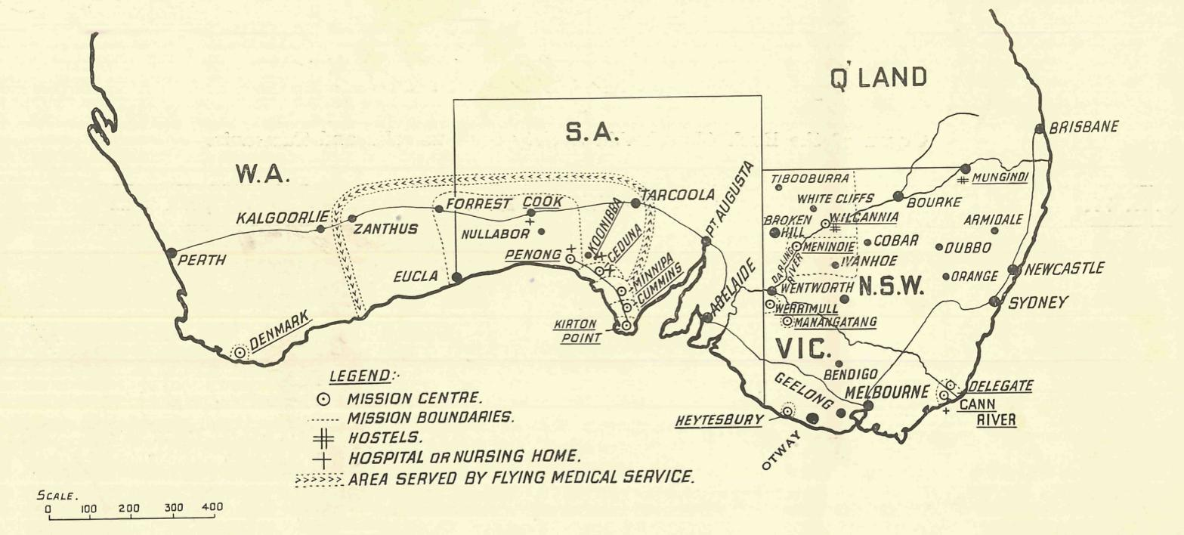

MISSIONS.

FAR WEST MISSIONS, S.A.
Ceduna—Rev. L. H. Broadley, Th.L., The Rectory, Ceduna, S.A. Penong—Rev. E. V. Constable, Th.L., The Rectory, Penong, S.A. Minnipa—Rev. W. A. McLeod, Th.L., Minnipa, S.A. Cummins—Rev. R. T. Hallahan, Th.L., Cummins, S.A. Kirton Point—Rev. K. Luders, Th.L., Port Lincoln, S.A.
VICTORIAN MISSIONS.
Croajingalong—Rev. N. Holdsworth, Th.L., Cann River, Vic. Delegate-Bonang—Rev. T. R. Fleming, Th.L., The Rectory,
Delegate, N.S.W. N.W. Mallee—Rev. F. Bayly, Clergy House, Werrimull, Vic. Heytesbury Mission—Rev. G. Beatty, Th.L., Timboon, Vic.
Otway Mission—Rev. T. H. Pickburn, Th.L., Beech Forest, Vic.
WEST DARLING MISSIONS.
Wilcannia—Rev. D. Livingstone, Th.L., Reid Street, Wilcannia, N.S.W.
Menindie—Rev. G. B. Calderwood, Th.L., Menindie, N.S.W.
WESTERN AUSTRALIA.
Denmark—Rev. B. Lousada, Denmark, W.A.
CHILDREN'S HOSTELS.
Mungindi—Miss E. Cheers, Mungindi, N.S.W. Wilcannia—Mrs. C. Mann, Wilcannia, N.S.W. Miss A. Taylor, Wilcannia, N.S.W.
MEDICAL SERVICES.
Gippsiand, Vic.—Sister I. Harris, The Dispensary, Cann River, Vic.
FLYING MEDICAL SERVICES.
Pilot : Mr. A. Chadwick, Ceduna, S.A. Dr. R. Gibson, Dr. F. Gibson.
CEDUNA HOSPITAL.
Matron : Sister F. Dowling.
Staff : Sisters B. Bossley, V. Page, L. Pritchard, L. Loane, Nurse J. Branford, Miss I. Andrews.
KOONIBBA ABORIGINAL HOSPITAL.
Sister G. Hitchcock, Koonibba, S.A. PENONG HOSPITAL.
Sister D. Goodwin, Penong, S.A. Sister J. Eglitsky, Penong, S.A. Miss M. Millar, Penong, S.A.
BISHOP KIRKBY MEMORIAL HOSPITAL.
Sister M. Symons, Cook, S.A. Miss D. Dykes, Cook, S.A.

October 31, 1939.
The Real Australian.

CLEAN HANDS
By the O.M.

On the outbreak of any war those nations concerned find it necessary to answer the question, "What are we fighting for ?" To-day we find that the same question is asked, and attempts at answers are given in conversation, press and pulpit.
If you were asked the question, what reply would you give ? Would you say, "We are at war in order that right and justice should prevail'¹ ? If you were then asked to get away from general terms and be a little more explicit, would you reply, "Well, I suppose we fight because we believe that all people have a right to live free and happy lives. They have alight to expect that their children shall be educated, properly fed and looked after when they are sick, even if they belong to a small nation too weak to defend itself from the dictates of strong and aggressive countries. Because we believe that the government of any land ought to be for the benefit of all—those who are small and financially weak as well as those who are strong and politically important¹¹ ? Would you insist that the misfortunes of men and women living thousands of miles away are your responsibility ; not just because if they go under you might find yourself in the same plight, but rather because you are Christian men and women with inescapable Chris-tian responsibilities as well as privileges ? Would you so reply ? I hope that you would.
I want to warn you about one great danger that exists in such a situation. While we exert all our power and might, nationally and individually, while we brace ourselves for the tremendous sacrifices we will willingly make, God keep us from becoming self-righteous. We may fight hard and long to remove the evils of Hitlerism cr any other power, but we need to re' member that the same things, maybe in a lesser degree, exist here in our midst.
When we think of minorities and their treatment, let us re member that a minority exists in Australia. They are not a small handful of people who have drifted in from a foreign country, but they are the original owners of this land. Almighty God put them here and gave them the means of a happy and contented livelihood. We have come and given them—what ? WE call them "blacks,¹¹ "niggers,¹¹ "abos.¹¹—God calls them His children.
The B.C.A., eighteen months ago, established a hospital for aboriginals at Koonibba, in South Australia. The day the building was opened a small girl was admitted suffering from T.B. of the spine. Doctor Gibson said that if she was kept in bed for two years, in steel splints and carefully nursed, she may walk again. Sister Hitchcock says in a recent letter that Iris—for that is her name—is now walking after only eighteen months¹ treatment.
Some time ago a young man, a full-blooded aboriginal, was admitted into hospital for treatment. It was then discovered that he was successfully managing a very large sheep-run in the most difficult country in South Australia, and had five white men working under him. Yet there are those who say that it is impossible to do very much with the aboriginal. He must be treated like a small child, to be fed on meagre rations and given only primitive tools to play around with. Almost anything will do for him to live in, and first-class equipment and decent buildings are so often net considered at all necessary. Missionary work in India, Africa, New Zealand and America has proved that the primitive races of those countries can be fitted to take their place in the world. Is the power of Cod any less effective in Australia ? Maybe it is that we are thrilled by the stories of souls won for God beyond the seas and fail to appreciate the responsibilities of people in our own backyard. Please remember that the work B.C.A. is doing for the aboriginals, though it may be only a very tiny bit, is as important and as efficient as any other of our work.
Then also in our land are children who live in an isolation that is very real. I know that a lot of humbug has, and is, being told of the hard lot of our inland people. One would think sometimes that they are all poverty-stricken, half'fed, living in rabbit warrens. Of course they are nothing of the sort. Rather are they splendid people, prepared to work hard and growl a little. Their homes, for the most part, may be rough and rude, but they are generally comfortable. Money may be scarce, but food is generally plentiful. Nevertheless, that is not everything. Look at a map of N.S.W. and find Wilcannia. Now trace down south until you come to> Menindie, and realise that it is 93 miles from Wilcannia to Menindie without a township in between. Now go along in an easterly direction, and you will find Ivanhoe, 130 miles away. Then 118 miles, north-west from Ivanhoe you come back to Wil-
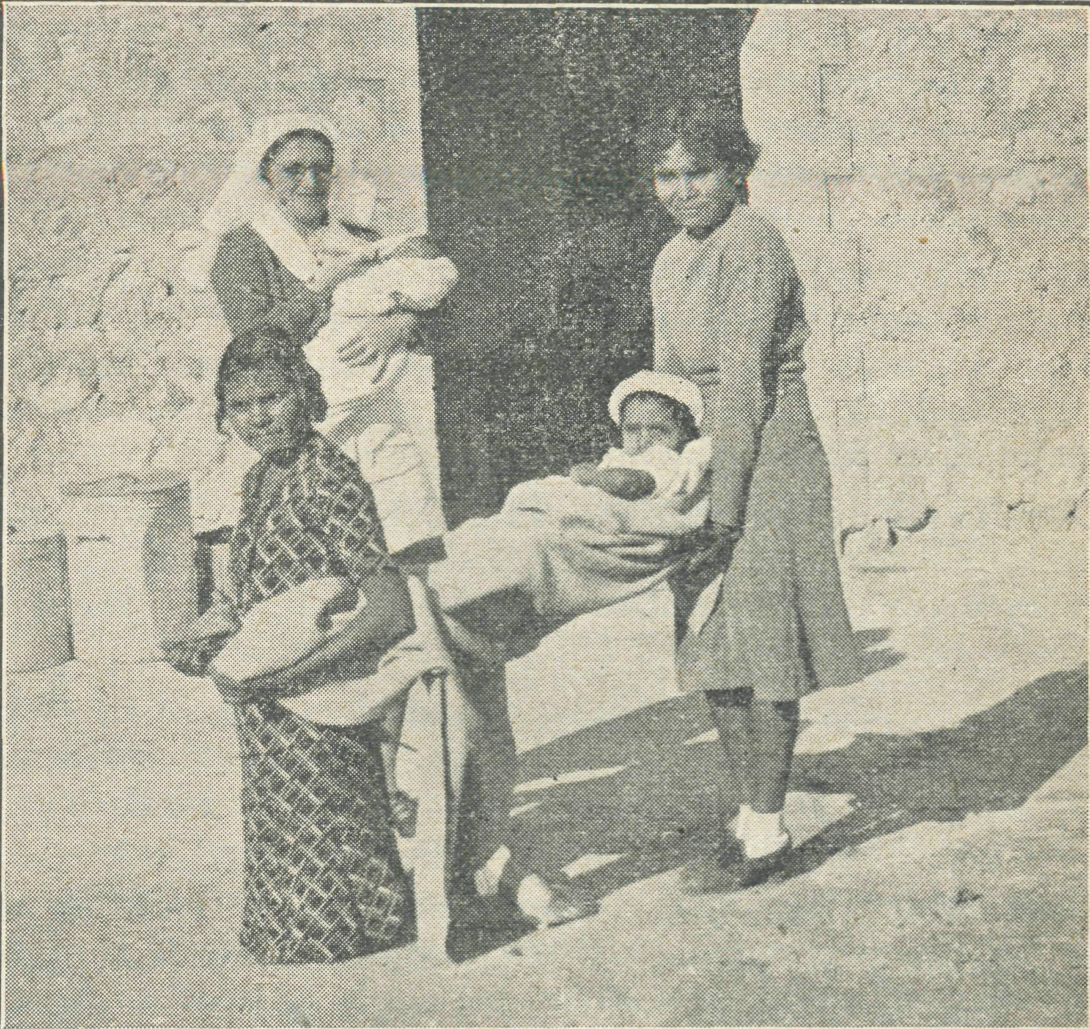
Iris being brought out into the sunshine—she can now walk.
cannia. You have now been over a triangular piece of country of approximately five thousand square miles in which many people live, and there are three small villages, or towns if you like, in that area. You may repeat the experiment with the country north of Wilcannia, and find that in a much larger area there are less towns. So you see the isolation of our settlers can be very real. This prevents the building of schools for the use of those children who live in such areas. Shall we be content by saying, "Well, there are correspondence lessons. Let them use them.¹¹ Lessons given at school are indeed important, but school brings companionship and fellowship with other children, and such are just as important in the building up of character and citizenship. Would you like to live in a place where for ten years you lived alone ? Nobody to talk to about the things that interest you. No social life, games, or fellowship ? Would it be much consolation to be told that you could write letters to your friends, however nice that would be ? Remember then that B.C.A. needs your support for its children's hostels, because they are very necessary for the full development of many of our children.
The other day the morning's newspaper informed us that the government has increased its order for Lockheed aeroplanes from fifty to one hundred, and that it will cost £1,500,000 to pay for them. I am sure that most of us felt that was wise spending

The Real Australian.
October 31, 1939.

under the present circumstances. £15,000 each for aeroplanes to give us security is not waste, as some would have us believe. In another column you will read that Mr. Chadwick needs a blind flying instrument costing £48 so that he can carry doctors, nurses and patients in greater safety when cloud formations are about ; and also you will read a letter of appreciation from relatives of a young girl whose life was undoubtedly saved by brave flying of Mr. Chadwick in dangerous circumstances. I venture to think that £48 spent on those instruments would be wise spending.
What can you do about it ?
Remember jthen, as the days go by and ycu along with all others are asked to make more and more sacrifices in order that peace and righteousness may prevail throughout the world, that this land of ours is not exempt from our efforts. We can more effectively work for the Kingdom of Christ to reign in the world if we see to it that Australia is won for Him. We can fight to right the wrongs which exist in other parts of the world with greater vigour if our own hands and hearts are clean.

THE HEALING MISSIONS

CEDUNA HOSPITAL.
Sister F. Dowling.
We are indeed fortunate in the number of visitors we have, even though we are so far cut of town. It is a decided break, and one which we appreciate, especially when it is a member of the great family to which we belong. Fellow-Christians don't need much introducing—there is the decided consciousness of the tie that binds us together. Very often these different folk who come out to gain knowledge of the work may not always realise what fresh inspiration is imparted to the workers also.
The recent visit of Rev. W. H. Stanger, of Sydney, made us realise what could be accomplished in a week by the aid of the aeroplane. Within that space of time he had come from Sydney, seen the work at Ceduna, Koonibba, Penong and even up to Cook, and then back to Sydney again.
Our friend of the Colonial and Continental Church Society, Miss Brooke-Anderson, spent several days with us, and the fellow ship enjoyed certainly helped to cheer us on our way. She is doing a big work for the Lord, and our prayers go with her.
The Rev. Creswell, of the "Australian Christian World," also paid us a short visit from Adelaide. This week we have had with us the Rev. and Mrs. Constable, senr., of Melbourne, and all were pleased to welcome them to our midst once again.
Since writing last time, Nurse Moody has received her call to resume her training at the Adelaide Hospital. She is hard at her work again and very happy to be back. It is good to hear of a band of young nurses there who are witnessing for the Lord.
Sister Pritchard is at present spending her leave in Adelaide. Miss Andrews also is spending her three months furlough in Sydney. Wc must not forget the Lord's solving of the cooking—one who is doing it as unto Him.
Sister Hitchcock has just spent a couple of weeks with us. Hers is a very constant job, and even though we experience some difficulty in dragging her away, she needs the break to help her carry on so big a task.
You may remember, in the previous "Real Australian,'¹ the story of a young girl brought down from a place called White Well, away up on the Nullarbor Plain. Her case was one of appendicitis, but an operation was inadvisable at the time. She was sent home for several weeks before coming down to have her appendix out. Before the time expired she was brought in again, and this time operated on, and spent another period with us. May be some of you have followed her up with prayer. She has gone home again without making any decision for Christ—back to that lonely home on the Nullarbor ; but, thank God, she is not alto-gether cut off from the ministrations of the Church. Will you remember the Rev. E. Constable, our B.C.A. missioner at Penong, as he dees the Nullarbor trip each quarter and calls at that home for a service. May he be given the joy of seeing the one we have prayed for born again into the Kingdom of Christ. There are four in the family—four souls for whom Christ died, and let us never forget it is His will that such as these should be brought to Him in order that they might have the mere abundant life.
That Nullarbor trip is a long, weary car-journey—many miles covered, much petrol used, very few people visited ; but, if we as Christians can only keep before us the vision of the worth of each individual soul in Christ's sight we will never question whether it is w6rth the expense, time and energy.
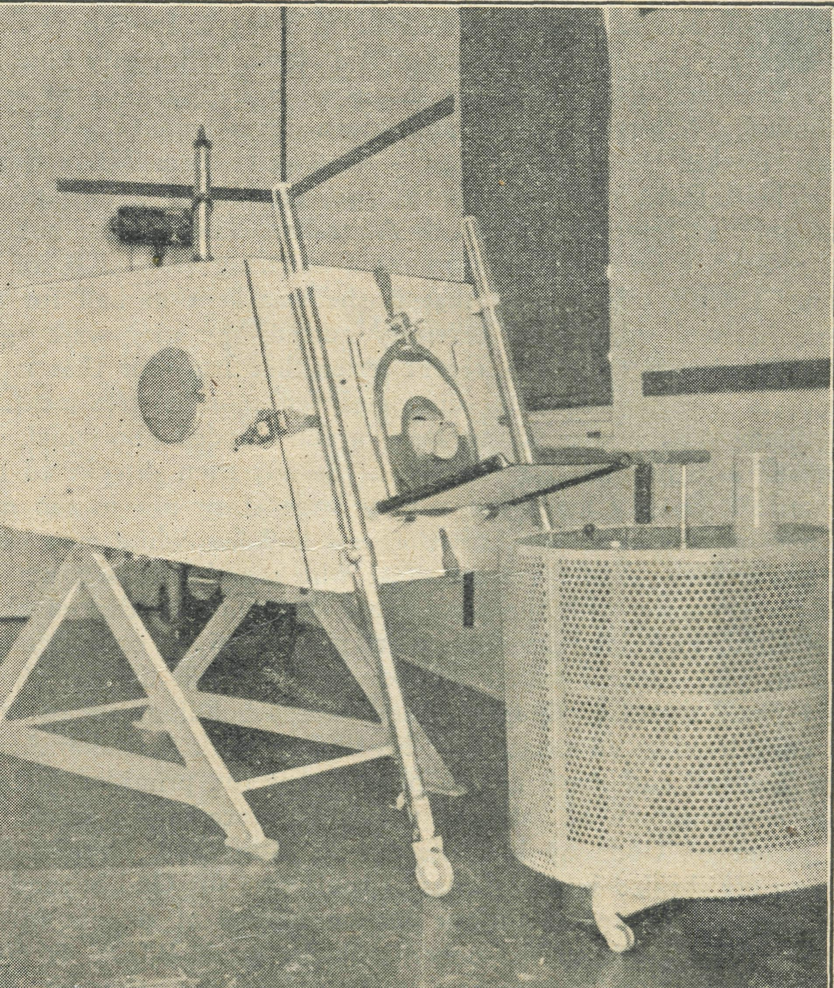
One of Lord Nuffield's "Iron Lungs" at Ceduna.
The other day a woman from an outback farm walked into the office and passed over a cheque to reduce some of her hospital debt. She had driven twentyseven miles in a jinker, a perilous-looking turnout pulled by two horses. Several years ago the same person used to drive about in a car, and she and her husband considered themselves quite comfortably settled on the farm. Hard times have come through bad seasons, low price of wheat, illness in the family, and so on. Her kiddies' clothes were ragged and hers were no better. One could not but help being struck by the earnest desire to be out of debt. A parcel of toys was given to the children, followed later by a parcel of clothes, mostly received in the boxes from Melbourne and Sydney. As the woman got in and drove off, we stood watching them go on their three hours' drive home. There is indeed something to greatly admire in these women. Their past life has been full of hardships, the present isn't much better ; but they always lock to the future for better times. This woman, since being in hospital, has had her kiddies connected up with the Sunday School in ^heir district.

October 3 L 1939.
The Real Australian.

Recently we had an urgent call to Gook one Saturday after' noon, and as the regular monthly trip was to be on the following Tuesday we decided to stay the week-end in order to save further expense by making another trip. Sunday was as good as a tonic. Perhaps there may be some former B.C.A. minister reading this, if so, I can see his eyebrows raised at the thought of a Sunday in Cook being a tonic to any Christian. They will remember their experiences up there of the Sabbath being regarded as anything of a holy day, but rather as a sports day. But there has been a change at Cook since their day. Certainly the sports continue, but the Lord has placed a definite witness for Himself up there.
During the afternoon, sitting out on the verandah, presently the chatter of children's voices was heard drawing closer until the children were seen coming up the verandah into the hospital. Yes, it was a thrill just to witness these little groups arriving. But what had they come for ? you ask. To hear about Jesus and His love. Presently the singing started—
""Wide, wide as the ocean High as the heavens above, Deep, deep as the deepest sea Is my Saviour's love."
Jesus Christ Himself once said, "Suffer the little children to come unto Me," and here these kiddies were being allowed to come and learn of that love which passeth all understanding. As a rule it isn't a pleasant thing to sit and listen to singing that is not in tune, but those kiddies, even though they only hit the right note here and there, sang lustily, and it was a joy to listen to them.
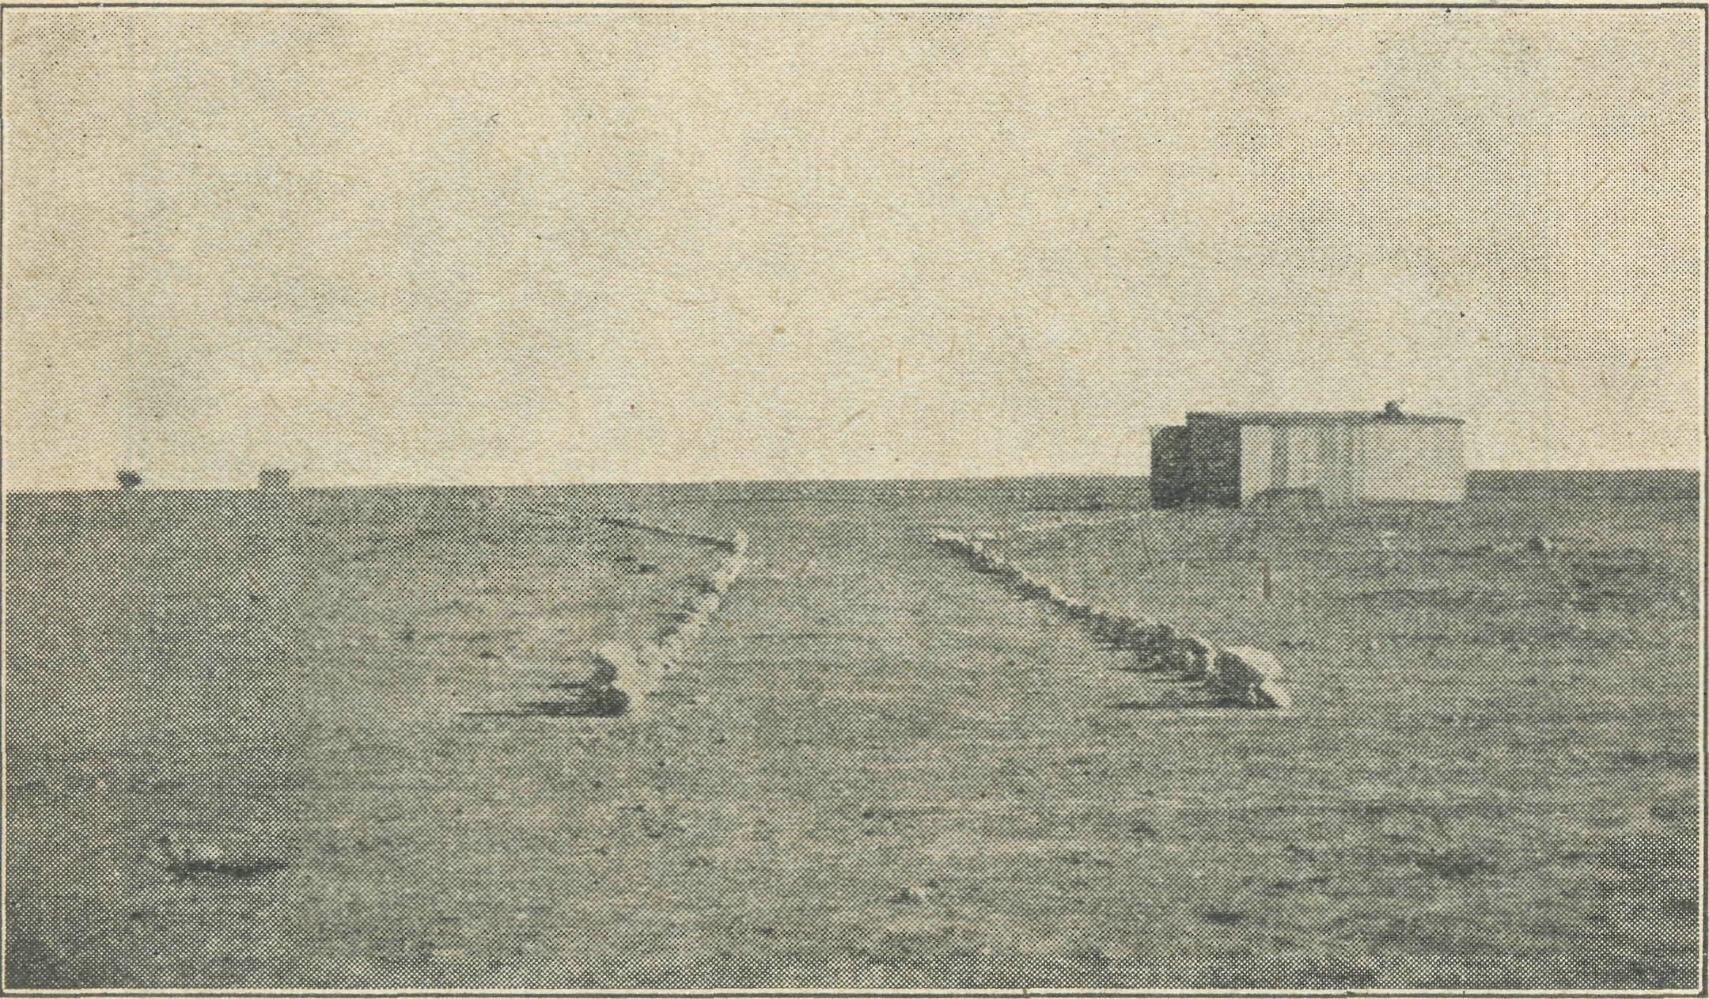
The approach to the Cook Hangar.
Evening came. Every Sunday evening the Sisters have a service at the hospital ; the numbers are growing, over thirty were present on this particular night, and the service was taken by Dr. Gibson. "Come ye yourselves apart and rest awhile.'¹ Can you picture the little gathering in that room, away up there on the lonely Nullabor Plain ? Yes, He was there, and we felt it, and praised Him for the marvellous answer to the prayer that He would establish a witness for Himself in Cook, in the healing of the sick and the preaching of the Gospel. Years ago a man of God dreamed of such a thing, and now tcday there stands a building erected in his memory—because he had faith, and when he prayed he be lieved God was able.
We are apt to forget at times just how much there is to praise God for. We are apt to forget also just how much has been accomplished in the work. Let us consider what great things the Lord hath done for us.
Next morning, after consultations and operations, we once more set off for home. "It was good to have you all up here for so long for fellowship," said Sister Symons. But, like the Apostle of old, one felt it was good for us to have been there, for the presence of Christ was as real as it was then.
And so, as the work continues en, we trust your interest will grow, and that you will be keen to interest others and seek their help by prayer, that during these difficult times His work may still go forward to His glory.
Sister L. Loane.
In Sydney recently an experiment was carried out in the treatment of whooping cough. It has been practised with good results in Europe during the last few years. Four small children were taken in a 'plane to a certain height, kept there a short time, and then taken back to hospital. Each child showed a marked improvement in condition after the flight, due to the fact that the lack of oxygen in the air at the great altitude kills the whooping ccugh organisms. It sounds a strange cure, but it proves effective.
A few weeks ago Dr. Gibson was called out to Thevenard to a baby, four months old, who had whooping cough. The child was very ill and did not respond to any of the usual treatment, and the coughing spasms continued frequent and severe. Doctor de-cided to follow the lead given by the Sydney physicians, and take the child up in the 'plane to ten thousand feet. "Wrap him up well," was the advice given, so the baby arrived out at the aerodrome tightly rolled in blankets, and his legs and arms bandaged to keep out any stray draughts. The stethoscope was strapped to his chest and he was handed into the 'plane, and away we went. It was a perfect day, and so as we flew out over the sea we had a won' derful view of the coastline in each direction, and of the many little islands that lie outside the bay. Flying in a sig-sag, we gradu' ally climbed higher and higher till, after almost an hour, we reached ten thousand feet. What a view we had from there ! The coast from Streaky Bay to Fowlers Bay was quite clear, and we could trace the roads running in every direction, and the channel through which the ships enter. We remained at ten thousand feet for twelve minutes, and then descended, circling again and again over the hospital till the people in Ceduna began to wonder whatever was happening, and if it was an enemy 'plane. The baby slept most of the time and had no coughing spasms. He was handed back to his mother and taken home, and all that night he slept peacefully. Since then his condition has rapidly improved and coughing almost ceased ; so the experiment proved successful and ■another use was found for the 'plane.
Near the Ceduna railway station is an old tin shack, and here an old man of eighty-three lives alone. There are few in the town who care much what becomes of him, and few who could help in time of need or illness. He loves his old shack and is happy to live there alone and look after himself, free from any obligation to anyone. Three times now he has been brought into the hos-pital, always against his will. He never fails to assure us that he will be dead within a week, and that he has ordered his coffin and plot in the cemetery. Three times he has got up and gone home again to his old shack. I think he is beginning to regard the hospital as his second home, and though he grumbles when here, he is more than ready to admit that it is net such a bad place after all. He has a special black silk beret with a many-coloured pom' pom on the top, and he sits up in bed wearing the beret at a most rakish angle and with a wicked twinkle in his eyes, and we always have the feeling that as soon as he is able he will be up and away. He enjoys the reading from the Word in the evenings, and continually interrupts to give his idea on the subject, and he can. quote verse after verse. He knows the way cf salvation, but does he believe in his heart ? He listens to the singing, he attends the service on Friday afternoons and listens to whatever is said to him, and yet he lacks that faith through which alone he can enter Eternal Life. "Hell is the grave and we are the devils," he says. How can we get past his philosophy ? Oh, do pray with us for him, that the barrier may be broken down and what is now only head knowledge may become real belief in the Lord Jesus and acceptance of Him as Saviour. Now he tells us that he has put his shack up for sale, and when he sells it he is going back to prospecting on the goldfields in the West. What will become of him then, we wonder?

The Real Australian.
October 51, 1939.

The days slip by much in the same way. The patients come in and go out again. They hear the Word of God, but do they receive it into their hearts and turn to the Lord. How we do need that faith to believe that He alone can bring forth the fruit in His own time, and to trust in the promise that His Word will not return to Him void.
Sister B. Bossley.
When one is told that she is going for three months' leave it sounds such a long time, and one immediately begins to think of all the things to be done—all those little things that have been left for months past "Until I go to Sydney." Then comes to mind a picture of the beautiful Sydney Harbour and the city itself, the thousands upon thousands of people, while just here and there is a home and family which have been in one's thoughts and prayers, but have not been visited for three years ; or maybe a friend at the office, or in one or other of our hospitals who will be waiting with a ready welcome, and to hear all about our doings on the West Coast. And how we long to hear all the news of eld friends ! How we will talk ! Then comes the thought of the trip over the mountains, with all their beauty, and of a little, quiet country town nestling among the hills, and a little river wending its way quietly by ; of a few old. friends and many memories, and—home.
At last the thoughts become realities—at least many of them— and I find that time is slipping past only too quickly. The first part of my holidays was a real lazy time, perhaps it would be better to say restful time—at least it sounds better, and was an absolute contrast to our constant active life at the hospital at Ceduna. However, after a period of three years on the West Coast, a quiet time with very little to do and all day to do it in, did not go amiss, and I certainly feel the better for it.
It was a privilege to be able to tell many of the people of my home town about the work of the B.G.A., more particularly of that on the West Coast, and to be able to show many photographs of interest. Many of them knew nothing about the work of the Society, or even that it existed. They were amazed to hear of the extent of the work, and many were keenly interested in the spiritual work that was being done. One young couple (old school friends), with whom I stayed for a week or two, right out in the bush, were particularly interested. Night by night as we would sit round the fire and talk, they would ask question after question about the work in all its spheres—the workers and the people and country—until I am sure they must have known it backwards ! They were not satisfied until I had written pages telling of the work and many incidents in our daily round of life, also the names of all the centres, missioners, sisters, etc., and had drawn numerous maps showing the location of each place, and the mileage from one to another, and told of the country and the travelling done, etc. (I had forgotten for the time that such a book as "These Twenty Years" existed ; I have since sent them a copy.)
My stay in. Sydney was comparatively short, and I did not see and do all I wanted to ; but it was great to be present at the Annual Rally and to meet many old friends there. It was also a privilege to see the work that is being done by those women who have the supervision of the Sunday School by Post. I hap' pened to visit them when they were busy sending out the lessons, so was able to see in some measure the tremendous task they have undertaken, but realise that the sending out of the lessons is only a very small task compared to the preparing and compiling of them. May God indeed bless them and those children to whom the lessons go.
On my return journey it was a great joy to meet and have fellowship with friends that have been, and are still, associated with the B.C.A. We do thank God for those who helped to build up this work in past years, and we do thank Him, too, for those who are still helping by their prayers, by their service, and by their gifts.
THE STORY OF LOUISA.
Sister Hitchcock.
Louisa is an educated half'caste native, and there is nothing exciting or especialy interesting about her life ; but there is so much of good in her that will never be known, so why not record it in our columns, for here is another "Real Australian."
Louisa is tall and almost painfully thin, and has pleasant brown eyes. She has a family of five girls, and a husband who, apart from being a diabetic under treatment, is even too lazy to chop wood for his wife.
Louisa keeps herself and five daughters by washing at the hospital for a small sum of money, out of which she pays one shilling a week rent for her little cottage. She is spotlessly clean, and produces clothes as white as any white woman could wash them. Sometimes the wash is huge, but after getting her children off to the Lutheran mission school, she comes quietly smiling to commence work, and continues, still smiling, until it is finished. If you were to visit Louisa's little tweroomed brick cottage you would find it always swept and clean, and would sometimes smell the odour of fresh bread which has just been removed from the little stove. (Louisa is more fortunate than some of her neigh' bours and boasts a brick cottage and a stove, while Margaret, next door, has a tin house and a little camp'oven.) You might also see a dear old man with grey hair and a cheery face, sitting by the fire. This is Uncle Sam, Louisa's father, who goes out to work for short periods and then comes home for a while.
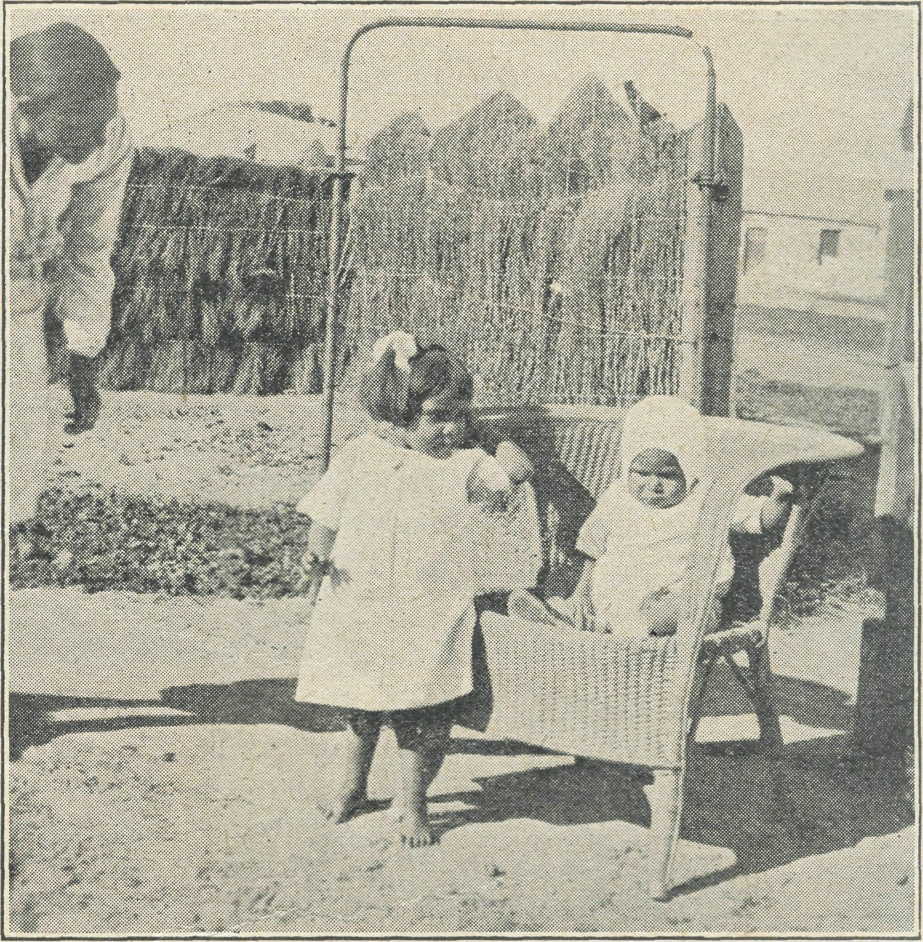
Louisa and two of her children.
The average native lives on bread and meat, and wild roots and berries, and, as rabbits abound in these parts, they make up a large part of their diet. Louisa is a very keen rabbiter ; natives, on the whole, do not possess guns, but find where the burrow is and dig the rabbits out of their holes with a crowbar, and then kill them with a waddy. Often as many as ten rabbits are found in the one hole. Louisa often goes rabbiting, and returns with about ten or twelve, and plenty of smiles. At the present time there is a new freezing works at Thevenard, and rabbits are in great demand. The rabbit'man (as they callhim) pays sixpence a pair for rabbits, and each day now every available man, woman and child is on the track of rabbits. If they are not sure of the time he will be calling, they bring home large bags of rabbits and keep them alive till he calls for them.

October 31, 1939.
The Real Australian.

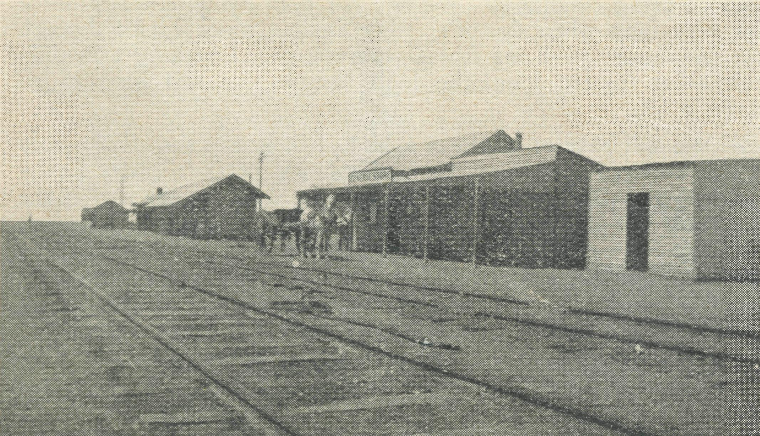
Louisa's eldest daughter, Nina, has just left school, and delights in helping her mother keep the house clean. She quite often bakes the bread and looks after the little ones. She is very quiet, like her mother, and has artistic tendencies, and can paint and draw beautifully. Unfortunately, a hobby like this needs money to buy crayons, paints, etc., so it is not often she can indulge this art.
Louisa's youngest daughter is a mischievous child of three, whose name is Desma. She has a delightful personality, and is really a charming little person. In fact each one of her children is most attractive and winning. Audrey has big brown eyes and serious, thoughtful face ; Lorraine can do nothing else but grin ; and Joyce has long legs and arms and plenty of energy. Fortunately for these children, their mother is a keen Christian, and can teach them the vital things of life, and they attend regularly at the little mission church each Sunday.
One of her chief characteristics is generosity. At the hospital one day there was a shortage of bread, and Louisa immediately offered a loaf of her hard-earned bread. At Christmas-time Louisa wanted to give a Christmas present to show her appreciation of what had been done for her ; not having anything to give in kind, she gave two shillings of her money.
All this may be an everyday, ordinary life, but it is lived in a quiet, unobtrusive way, and those who come into daily contact with Louisa cannot help but admire her.
SHOPPING.
Miss D. Dykes.
Shopping !—yes we have a shop in Cook, one of the all-sorts variety where you can buy anything, and if they have not what you require in stock then they will get it for you in the next few weeks. We get our bread three times a week, but other groceries, etc., are brought once a week. Thursday is my market day. Perhaps you would like to come with me !
There; is sure to be a wind blowing, anything up to fifty miles an hour, so you will need a coat and hat and dark glasses are advisable as it is rather glary. We must not forget a flour-bag for bread, and also money, which we take in a tin, especially after having witnessed a neighbour chasing wildly across the plain in pursuit of a ten-shilling note, but all to no avail—the wind won.
Cook's Shopping Centre.
Well, we had better be going, as we must be back in time to put the dinner on. It is rather rough going, but maybe when the hospital has been here a few more years we will have a path worn across. It really is amazing the amount of dust you collect on your shoes. We have not far to go, and the only sign of vege-tation is a row of eight peppercorn trees, which are quite a welcome break. We give our order and pay the week's bill, but leave most of the goods to be brought home on the town dray, and take
only the bread, butter, and maybe a vegetable for dinner. Our vegetables we order ten days ahead, likewise small goods, taking delivery once a week—on Thursday. If you are needing anything at the post office it is just a little further along, past the station, which is a pleasant little building complete with lamp and a Jarge signboard that announces to the train passengers that this is Cook. The post office is small, but has all requirements. We had better start for home now, and should a westerly wind be blowing it will be quite a battle, but we have the bag to anchor us now. So ends market day.
The only other bit of shopping we have to do is at the butcher's twice a week. The butcher's shop is an old converted guard's van which is stationed at the slaughteryard. We have not far to walk, and this time it is not quite so rocky as we go across the golf course and cricket pitch. It is very fortunate the van is pulled up at a ramp, but most times we have to scramble up as best we can. They don't go in for a platform at all on this line, so people get quite used to it. The getting up is not so bad, but the climbing down needs care as there are only two steps and rather a big drop to the ground.
And so we have our shopping days. It took a while to get used to, but we are quite old residents now.
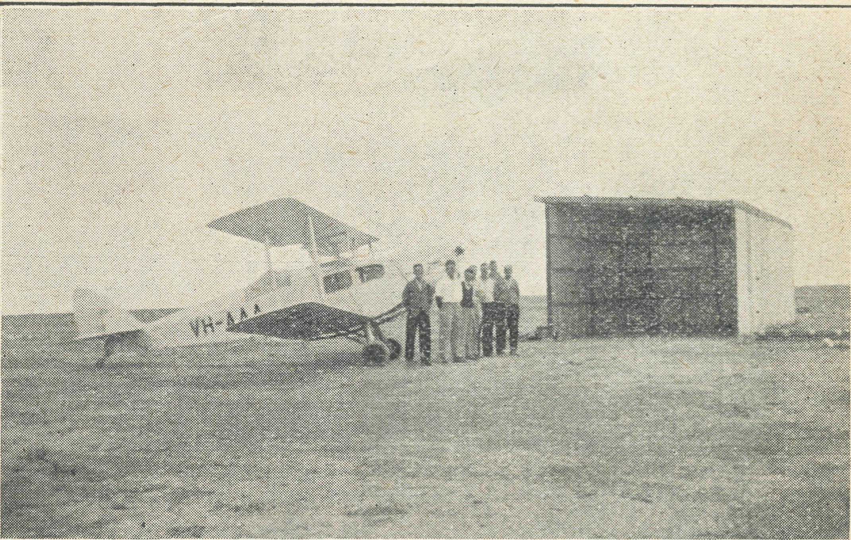
VH-AAA and some of the Cook menfolk.
IS THE B.C.A. FLYING MEDICAL SERVICE WORTH WHILE?
Sister Symons.
At 1.15 p.m. on September 30th the goods-train was shunting and getting ready to leave for the east, when an aboriginal named Tommy, who had been asking for food from a resident cf Cook, saw the train move and thought it was about to go without him. He dashed across to the train and attempted to jump on, but lest his grip and was thrown underneath. The wheel passed over his foot, crushing it badly and almost severing 'it. Within a few minutes he was admitted to the^ hospital.
Dr. Gibson was immediately communicated with by telephone, and at 5 p.m. we saw the welcome sight of the 'plane arriving almost at our back door. By 6.30 p.m. the operation was over and the patient back in the ward.
If the B.C.A. 'plane had not been available, doctor would have had to come 300 miles by car over very rough roads. Otherwise the patient would have had to be put on the first train and sent either to Port Augusta or Kalgoorlie, 500 miles either way, and he could not have had medical attention for at least another twenty-four hours. In a critical condition a lot can happen in twenty-four hours !

The Real Australian.
October 31, 1939.

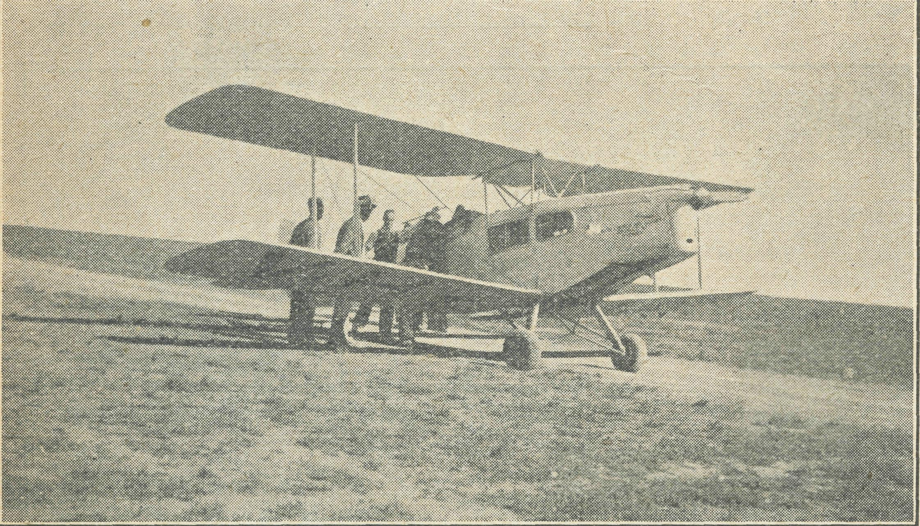
It was an added thrill to be able to put the 'plane in the hangar for the night. The men had been working on it for weeks, in the evenings after work and on Saturday afternoons, and were just putting the finishing touches to it when the 'plane arrived
The money for the hangar was raised by the people of Cook, who worked hard for many months A fete was held in July, when £61/15/' was made. There are, however, some difficulties" to be overcome.
There is a young mother at one of the small camps down the line. She has four young children, three of whom need medical attention. The twins, aged three, have not been well for some time, and the baby, aged four months, is not progressing as it should. Advice can be given by letter for the baby.
Although they are only thirty miles away, to see the doctor means catching the slow goods train to Cook on the Friday before doctor's visit, and staying until the following Tuesday. Such are some of the difficulties the mothers on the East'West line have to face.
VH-AAA lands at Tarcoola for a small patient.
THE FLYING MEDICAL SERVICE.
Pilot Chadwick.
The school is only about a mile and a half away, but the country is undulating and covered with that thicklygrowing blue' bush, the typical vegetation of the country bordering on the great Nullarbor Plain. Tracks from the railway siding to the old mining township wind here and there over the intervening distance. Gold was first discovered here back around 1900, and is still in active
production, and, following his usual custom, Mr. R was driving
the children from the mining town down to school. Here also is the large locomotive sheds where the engines are changed, cleaned and refuelled after completing one stage of drawing an exprss train across two< States.
Such is the picture I have tried to reconstruct of Tarcoola, on the transcontinental railway, about midway between Port Augusta and Cook, and a scene that may be enacted there almost every day. This morning, however, the happy chatter of the children was broken by a cry of intense pain, for little Dorothy, a child of about six years, had fallen off the truck and under its wheels, which passed over her chest.
Some time ago, when Lady Dugan paid a visit to Tarcoola, she became interested in the residents¹ desire to provide the district with a Nursing Home, and to this end gave very generous assis' tance. The building, called the Lady Dugan Hall, consists of three rooms—kitchen'dining room, Sister's bedroom, and ward' room. It was here that the child was brought, and Sister set about
stopping the bleeding from an injured lung, and treating the patient for shock.
Meanwhile the telephones were buzzing, and the secretary of the Hostel Committee got in touch with the doctor, giving him all information he could of the accident, and also spoke to me in regard to the whereabouts of a landing'place they set about to prepare.
Leaving Ceduha with a strong southwesterly wind blowing, we flew the first seventy miles through conditions of rain and low clouds. At this point we had to spend some time in circling up through a break in the clouds, for the Gawler Range lay ahead, and I could not fly below the clouds at that low altitude and clear the range. Not before the altimeter registered 6,000 feet could I turn the nose of the Fox on to. our course again, and fly north' ward towards the transcontinental railway, still climbing to top the cloud layer at a little over 7,000 feet.
Reaching the railway 180 miles out from Ceduna, we fly west' ward, and, checking off well, station and siding against my map, little difficulty is experienced in locating Tarcoola, where the small clearing with its marking line and smoke from a nearby fire guide us down to a landing.
There was a car waiting for doctor, and as soon as he stepped out of the cabin he was taken aboard and driven post' haste to the hostel. The driver of the car did not seem to pay much attention to tracks, and ignored the presence of blue bush, for he just drove straight over the lot, and as the car sped away in this manner, to the amazement of all who saw it, we realised that the vital needs of the moment were those of that little patient who may, or may not, have a slender chance of recovery.
Upon examination, doctor finds a long list of internal injuries that make it inadvisable to move the patient that day, so we decide to stay overnight. This gives me just the time I require to make a thorough check on the motor, and also to have a good look around for a site suitable for use as a permanent landing'ground. During the course of the afternoon's work I ask one of the men to measure the length of the landing strip they have cleared. He tells me it is about 260 yards long. That was all right to land on into a strong wind, but I do not consider it long enough for a takeoff, so after tea I went along and explained the position to the secretary. Without any hesitation he made arrangements for a party of men to clear another 150 yards next morning.
The photograph reproduced here was taken a few minutes before we left Tarcoola, and it gives you some idea of the nature of that country, together with the cleared strip from which we took off, and some of the men who put in such good work with spade and axe. Some day soon we hope to see a bigger and better landing'ground at Tarcoola, one capable of being used in all winds.
Well, with Dorothy made comfortable on a mattress, she and her mother parted in tears, and we begin the return journey. Approaching the lakes, those clouds of yesterday have formed again, and we climb above them to get the full advantage of smooth flying conditions. We had not been flying at that altitude for very long when doctor's rather anxious voice comes through the telephone to tell me that Dorothy is only breathing with dim' culty—her injured lung, the high altitude—we will have to go down a bit.
We will have to go down a bit ! I looked at the clouds, only a few hundred feet below us, and thought of the Gawler Range below them. Does it need very much imagination on the part of the reader to try and analyse my feelings under these circumstances ? Can you for a moment think of yourselves being in the position of having three human lives, and a lot of valuable equipment under your finger'tips, when a move in one of many directions would seemingly place all at a serious disadvantage ?
With a prayer in my heart I can only say that I will do my best, and then began a long and gradual descent to the cloud level. The top of a layer of cloud is very undulating, like hills and valleys, and by descending still lower into these valleys I wao able to reduce altitude by one thousand feet. Now, by following

October 31, 1959.
The Real Australian.

a winding course along these valleys I waited for the necessary time to elapse that would carry us past the range, and so enable me to descend still lower, where in the heavier air Dorothy would feel more comfortable.
Cloud scenery in the sunlight is a sight that cannot be described merely in words ; it is something rather that 1*3 impressed only on the minds of those who see it, making you wish to lean over and grasp a handful of its feathery whiteness ; it is a picture no artist could paint, and floating along with the banks of it rising hundreds of feet on each side of us, one is lost for a moment in the beauty .and wonder of it all.
By looking through the window in the instrument panel, I can see Dorothy asleep. She has been like that now for half an hour, and I feel a vague misgiving ; but she moved her head and I am reassured. The strong headwind we have encountered has made this a long journey, and I found it necessary to call in at one of our emergency landing'grcunds for extra petrol. Staying there only the few minutes required to fill up, we are in the air again and heading for Ceduna on the last leg.of our journey.
Back in the hospital, Dorothy is given all the care and skill that the staff can provide, and is nursed back along the road to recovery. Within a week—yes, I can hardly believe my eyes—she
is sitting up in bed and blowing up toy balloons to help along that injured lung.
In less than three weeks after her accident, Dorothy again goes aloft in the B.C.A. 'plane, this time for Cook, where she can be reached by members of her family, and, at. a suitable opportunity, go back home again by the train she is so familiar with. The day's work over at Cook, we pack our bags and cur' selves into the 'plane and leave for home again. Dorothy, who has come across to the aerodrome to watch our departure, stands close to Sister, still rather shy, and one wonders what pictures have been impressed on the mind of a child who had before never seen another township but her own, had never been in an aeroplane, and had never seen the seaside.
One day recently, when I walked into the hospital, Sister handed me a letter to read. It was from a member of Dorothy's family at Tarcoola, and the thoughts it conveyed were something like this : "We are indeed very grateful for the kindness shown to little Dorothy, and for the skillful attention given her after the serious accident she met with here a few weeks ago. Nor can we say in words the joy we feel at having her again within our threshold." Truly written from the bottom of a very grateful heart.

POSTS AND RAILS

Miss Ida Andrews, who has for the past three years capably attended to the domestic duties of Ceduna Hospital, is at present in Sydney enjoying her three months' furlough before returning to Ceduna for a second term of service.
Sister Pritchard is also on long furlough in Adelaide, and expects to return to Ceduna at the end of the year.
Sister Plumb, of the Australian Nurses' Christian Movement, Sydney, is spending her holidays with the B.C.A. nurses on the West Coast. Sister Plumb's counsel and help have been of great benefit to B.C.A., and many of our nurses came through her hands.
We offer our congratulations to Mr. and Mrs. McLeod on the birth of a daughter. Mrs. McLeod has been in Sydney for some time, and expects to be able to leave hospital in the course of the next few days.
The Ven. Archdeacon and Mrs. Langley returned from Eng' land early in September, and were welcomed at the Annual Rally. The Archdeacon was busily engaged telling B.C.A's. story in many parish churches and, considering the difficult days cf the past year, met with considerable success.
Mrs. Livingstone has again been a patient in Wilcania Hos' pital, but we are glad to report that she is now well again. Both Mrs. and Mrs. Livingstone have had a lot more than their share of ill-fortune since taking up residence at Wilcannia. We cannot but admire their pluck and steadfastness in their work.
The Editor commends an article by Miss Le Plastrier, our ener-getic Chatswood secretary. It is not often that any of our friends are able to visit one of the mission fields, and I am sure that cur readers will appreciate her impressions and experiences.
Miss M. Vaughan Jenkins passed to her rest recently. She was not known by all our friends, but for many years Miss Jenkins had been keenly interested in the work of the B.C.A. Some six years ago she visited the Nullarbor Plains, and for some time camped in a tent on the east-west line while she investigated the medical needs of the people of that area. When the appeal for funds was launched to build the Bishop Kirkby Memorial Hospital, Miss Jenkins' exhaustive report fur-nished the basis of that appeal. We mourn her passing while thanking God for her life and witness.
Our friends will be interested to learn that the Rev. Thomas Gee, who served this Society so well in the Victorian Mallee, has transferred his sphere from Dapto to Milson's Point. We wish Mr. and Mrs. Gee every blessing in their new sphere.
Miss Andrews, a keen supporter of B.C.A. and sister to Miss Ida Andrews, was recently married to the Rev. M. Payten, and will, with her husband, shortly take up residence at the Dapto Rectory, to which parish Mr. Payten has been appointed Rector. B.C.A. offers Mr. and Mrs. Payten every good wish for their married life and much blessing in their new ministry.
From time to time appeals have been made for £50 to build a hanger at Cook. The hangar is now an actual fact, and has been built by the people of Cook. The ladies undertok to raise the money and the men to build it. After many months of work the ladies held a fete, and from the twentythree families at Cook £61 was received. Isn't that a wonderful effort! The extra £11 goes on improvements at the hospital. Thank you, Cook !
A B.C.A. friend writes :—"In a copy of the 'Real Australian' you mentioned if one could not give a direct offering in money towards the children's Christmas gifts, one could send fancy work which could be disposed of and the money given towards same. I am sending by this mail a small box of work which I have done. I had it priced for me and it amounts to £1, so hope you will be able to realise that on it ; but of course that will be left in your hands." This is a splendid idea, and we would be happy for others to follow this example. The contents of the box referred to in this letter are a number of very finely worked d'oyleys. Would any friend like to purchase them for Christmas presents ?
Why not make a Christmas present of one year's subscription to the "Real Australian" to one or more of your friends ? Send name and address and postal note for 1/6 and we will be happy to do the rest.
When making your will, remember the B.C.A. Our correct designation is "The Bush Church Aid Society for Australia and Tasmania."
Hymn books and prayer books in good condition are needed in mission areas.
THE NEED FOR VH-AAA.
Mr. Chadwick still needs that blind flying instrument to enable him to be sure of his course in all weathers. Enquires have been made and we find that the instrument can be procured for £48 landed in Australia. Will you remember this real need in your prayers and giving ?

The Real Australian.
10
Octoher 31, 1939.

SPECIAL PRAYERS FOR YOUR USE.
For Church Life in Country Districts.
C\ LORD, Who art present when two or three are gathered together in Thy Name, bless, we beseech Thee, the little far-scattered groups of brethren who in our wide land meet together to worship Thee. Give them a perpetual freshness of spirit, and the power to inspire in each other holiness, helpfulness, and understanding of Thy help. Refresh with the joy of enthusiasm those who endure weary journeys to Thy trysting place. Grant that these little companies of Thy servants who, through differences of interpretation, are prevented from worshipping together, may yet be united in the spirit of Christian charity, awaiting in love the time when there shall be one fold and one Shepherd. Grant that the common life of all communities, isolated from each other by great distances, may be purified by this spirit of charity from all meanness, falsehood, malice, and idle gossip, and grant that they who share a common lot may draw strength from each other's virtues, and in their weakness help one another, through our one Lord, Jesus Christ.

For Country Doctors and Bush Nurses.
Q GOD, Who didst choose a beloved physican to set forth the life of Him Who went about doing good, grant that Thy strong tenderness and compassion may be manifest in the work of country doctors and bush nurses. Make them at all times alert to be faithful, as those whom Thou hast burdened and inspired with the honour of their calling. In lonely emergencies strengthen them with confidence that, having done all they can, they may with good conscience leave the issue to Thy power working within Thy law. Make them resourceful and of sound judgment, and hearten their labours with the energy of compassion and the firmness of duty that conquers weariness. Through Him Whose power is called forth by suffering, Jesus Christ our Lord.
For Drovers, Shearers, Stockmen, Dairy
Workers, and all whose work is the care
of animals.
Q GOD, Who called Thy Son Jesus to be the Good Shepherd, grant to all who are charged with the care of animals the spirit of understanding, care and compassion, and reverence for life. Preserve them from the unfeeling selfishness of "the hireling who fleeth because he is an hireling," and grant that they may do their work in the spirit of honourable responsibility, as those who will account to Thee for their stewardship of Thy creatures. Thou Who hast ordained that all living things shall minister to each other, grant that we may receive the service of Thy humbler creation with the skill of sympathy and conscience. Through Jesus Christ our Lord.

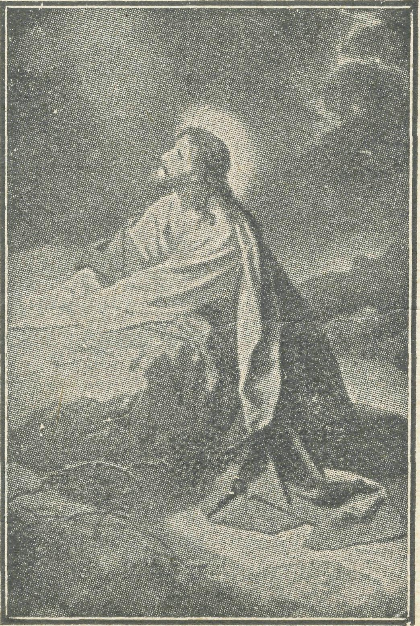

October 31, 1939.
11
The Real Australian.

THE PLACE OF PRAYER.
A Prayer for Use with Our Prayer List.
O Lord God of our nation, Who has commanded men to subdue and replenish the earth : Look in Thy love upon all those who in the distant parts of our land are striving against many difficulties, and are deprived the access of the means of grace. Strengthen and guide the Bush Church Aid Society and its Clergy, Nurses, Deaconesses and Students. Cheer and comfort them in discouragements and loneliness, and bless their ministrations to the good of those they serve, and grant that the message of redeeming love may thus be rooted and grounded in our national life, to the glory of Thy Great Name, through Jesus Christ our Lord. Amen.

SUNDAY.
THURSDAY.
MORNING.
The Far West Missions at Penong, Ceduna, Minnipa and Cummins ; the Missioners, Revs. E. V. Constable, L. H. Broadley, W. A. McLeod and R. T. Hallahan.
EVENING.
The West Darling Missions at Wilcannia and Menindie : the N.W. Mallee ; and the Missioners, Revs. D. G. L. Livingstone, G. B. Calder-wood and F. Bayly,
MORNING.
For the Mail-Bag Sunday School with its Gospel message for the children. For the teachers and helpers, that they may find encouragement in their work.
EVENING.
For
the Organising Missioned that he may be strengthened and guided in all his endeavours for the good of the work and in his relationships with his fellow-workers.

FRIDAY.
MORNING.
EVENING.
MORNING.
The Cann River Mission, the Bonang Mission ; and the Revs. N. Holdsworth and T. R. Fleming.
For the Bishop Kirkby For students and all
MONDAY.
EVENING.
The Denmark Settlement, the Kirton Point Missions and the Missioners, the Revs. B. Lousada and K. Luders.
TUESDAY.
Memorial Hospital and Sister Symons and Miss D. Dykes as they minister to the people on the great Nullarbor Plain.
training for this work of God. For Rev. G. Beatty and the Heytesbury Forest Mission. For Rev. T. H. Pickburn and the Otway Ranges Mission.

MORNING.
For Sisters Dowling, Boss-ley, Page, Pritchard, Loane, Nurse Branford and Miss Ida Andrews at Ceduna ; Sisters Goodwin and Eglitzky at Penong.
EVENING.
For the Cann River Dispensary and Koonibba Mission Hospital ; and Sisters I. Harris and G. Hitchcock.
SATURDAY.
EVENING.
MORNING.
For the President and For the Home Base Staffs,
Council of the Society, that Auxiliaries, and parochial
they may be guided by His workers,
wisdom.

WEDNESDAY.
EVENING.
MORNING.
For the children in the For the Flying Medical
Service, Mr. Chadwick, and Doctors R. and F. Gibson.
Mungindi and Wilcannia Hostels, and for the workers, Miss Cheers, Mrs. Mann and Miss Taylor.
Each day pray that the many needs of the work may be met.
Running expenses of 35/- per hour to keep the Medical 'Plane
in the air. Consecrated clergy missioners for urgent work in the field.
An increase of £2000 in the year's income to provide for the new works undertaken.

Give Thanks—
For the rich blessing and wonderful growth of the Society's work.
For all the kindly givers who have helped with their self-denials.
For the Flying Medical Service.
For the new hangar at Cook built by the local people.
For new workers in Hospitals and Missions.
For the joy of service.

The Real Australian.
12
October 31, 1939,

NEWS FROM THE MISSIONS

AFTER TWO YEARS ON THE COAST. Rev. W. McLeod.
It seems like breaking a long silence to write after two years or more. The O.M. has jogged me sometimes about the matter, and I have scratched my head and said, "What can I talk about ?"
You see, I have found the work just the formal functioning of a parish parson, only on a large scale. What can I tell you but of the plain yet very necessary and essential work of spiritual ministrations which it is the privilege of those to give who are everywhere ordained to the ministry of our Lord and His Gospel.
Yet, as I write, the thought comes that you who read the "Real Australian,¹¹ and who are deeply interested in every way in the work of the B.C.A., just really want to know what does happen in these places where the ministry is so dependent on the B.C.A. and your kindly support of it. So here goes !
Firstly, this Minnipa Mission District, which takes its name-from the town of Minnipa as being the exact centre of the district, is in between the Cummins and Ceduna districts, running along the Port Lincoln-Ceduna railway line. It is long and narrow, the district extending about 120-odd miles. Mostly it is along the line, with a few centres scattered to right and left. There are seventeen or eighteen centres where services are. held, seme occa-sionally, mest once a month, and Minnipa once a fortnight.
The largest congregation would total over forty, the smallest
We pass from home to home, making personal contact, visit' ing as constantly as possible, though not seeing each home each time. Conditions of time and distance won't allow this. People welcome us sincerely, and in the hospitality given we can enter into their daily life and discuss the problems very real to them. Their interests have become ours. In some places are children to link up with spiritual things. Some Sundays after service we have a small Sunday School. Of course, our ideal is the MaihBag Sunday School. We have a few young people on this now.
At certain times there is Confirmation instruction to be given, wherever opportunity occurs, maybe on Sundays or in our visita' tions. In our time here we have had visits from the Bishop twice for Confirmation in different centres.
Baptisms are very important and form a potentially effective ministry, more so than the city, because baptism forms an integral part of usual services and makes a splendid teaching basis.
about ten. It is necessary to have four services every Sunday, sometimes five, never less than four.
The West Coast along the railway line is remarkable for small towns to which the neighbouring farmers look for most of their affairs. This, of course, gives no town a greater importance than any other, and thus the church in this district, though called the Minnipa Mission District, is so only in name, though Minnipa is the largest with one other Church centre. Yet there is no centre of influence and cf necessity central conferences are hard to arrange.
The priest'in'charge, though residing in Minnipa, visits each group and community, as far as he is able, and as time allows, mostly the week preceding services in each centre and endeavours to keep Church'life vital in each place. There is not the same possibility of concentrating on each centre in connection with the parish as a radiating point as there is in town, say, with a parish church and its branch churches. In fact we have no Anglican Churches here ; our services are held in halls, schcohrooms and private houses. They are yet devotional and reverent and real. Though we think it would be fine to have a church or two of our own, especially at Minnipa and some other large centre, we hope and pray this may be possible in the near future.
Now come with us one Sunday and ycu will become familiar with these names : Minnipa, Chilpuddie, Kaldoonera, Karcultaby. Another day, along the line, staying at different homes, you will visit these places for Sunday services : Wirrulla, Pimbaacle, Yar-rama, Yantanabie, Poochera. Yet another Sunday down from here : Yaninee, Wudinna, Palabie, Wynella, then home to Minnipa for the night service,, and finally away down the line, Kyancutta, Warramboo, sometimes Kopi, then off the line, Cootra East and Koongawa.
What do we find ? Many, many splendid people, good and hospitable, who have passed the early pioneering stage of this comparatively young country. It has been hard, but they have battled with it, and won, despite dryness, rain at the wrong times, and many trying conditions. Wealthy ? No. But their real enemy is not conditions of the countryside but stupid economic conditions of society—man's deliberate ignorance and misuse of God's bounteous gifts of nature and life.
They struggle on against these odds, a fine, splendid and courageous people, hoping this year will be better than the last. Not that they are unhappy. They count themselves fortunate in many respects. The city has come close to the country with fairly frequent mails, radio, etc. They have their amusements in the various villages and form quite a good social
Too, amidst the light of daily toil come the sad shades of sorrow—not often, fortunately. Yet this district has seen sudden passing and cutting off of young, splendid lives by tragic means. These leave deep impressions on sympathetic hearts, and though there is no real hearse or coaches, these brave young bodies are carried reverently on cars or buckboards, and all come to see them laid to rest, shocked and grieved. Then one's heart lifts to feel the privilege of the ministry of Christ and to tell forth to all about the message of God's eternal love, of Christ's death and life, for us and ours, and them, and to pass to those in deep sorrow some comfort and consolation if they but turn to Him and lean on Him. So the ministry of the things of God are adequate in every way from birth to death.
Now what can I tell you ? Of individual people ? But there are so many individual types, mostly very splendid. Of hardships ? Not ours, because we never noticed many particularly. Certainly there are some inconveniences, but they are not hardships. We can't speak cf distances, because one completely disregards them after the first few weeks. We gather the perspective of the country people. Ten or twenty miles is next door. We travel miles with' out feeling any undue strain. God has made man to fit his envir-onment. For this we thank Him. There is only this, the more I see cars and use them the less I like them, though appreciating their essential value and use.
Undoubtedly the people have experienced some real hard' ships, but many of these have been overcome by hard work and courage. Before the days cf water conservation and when land was being opened up, hardships were very real. Even now there can be, and are at times, bad feeding shortages. But more feed is grown than⁻ used to be the case.
We have seen women living under trying conditions in the awful and deadly heat of summer—and it can be hot ! Dust and heat and flies are terrible things to humanity, but prevalent in most country places. We find a changing world when people are easing the position by modern conveniences and helps. Farmers, too, are turning more to the idea of mixed farming, driven so by econimic necessity. Sheep, cews and pigs are becoming common features and valuable aids to eke out a living.
Financial hardships are very real at present to them, and this year has seen many of them forced back to where they began. Some have gone, most by dint of endurance and effort remain to pick up what they have lost, with great faith and hope. Some say the farmer growls. If he does he has reason to. But our experi' ence is that deep down he does not, and he is a very patient fellow, far more patient and kindly disposed than he is given credit for.
life.
Working among them has been a real experience of tremendous value. The position is certainly such that the B.C.A. has been heavily leaned upon, much more than I like. But the work is infinitely worth while, to spread the truth of the Gospel to offer spiritual things to our people here.

October 51, 1939.
13
The Real Australian.

May I, in conclusion, say a few words of appreciation of the women of the West Coast—splendid, brave and enduring ; good, kind and hospitable, they are fitting equals to their menfolk.
Also for the missioned wife, who is not his curate, but by companionship and the boundless essentials and details, has made his lot a very pleasant one, and been one with him. In this regard let me quote one of our womenfolk who said to me when I came one day alone : "What did you come for ? I see enough men about the place. Where is your wife ?" I have no conceit left now.
May I finish this long epistle with these words, that all that is being done, and has been done, is "to the glory of God and the extension of His Kingdom."
VISITING IN THE WEST.
Rev. D. Livingstone.
On Friday, September 8th, we completed our moving opera' tions and entered the Rectory. It was an unpleasant task, but at a cost of much sweat and aching muscles we finally settled down. The next day the town was visited by a Salvation Army officer, who is a most friendly chap. That night he and I held an open' air meeting which was attended by a large and attentive crowd.
The following week was spent mainly in straightening out the Rectory. Unfortunately for us, the task is further ccmpii-cated by the fact that the house is built on the sand at the most unprotected corner of the town. A hedge and lawns are urgent needs to keep the sand down. In order to do this, tons of sand have to be carried in to build up the ground. The old truck has already carried in a great deal, but much is still needed. Some hedge is in and a little grass, but it is a slow job. Shovelling sand is about the hardest work anyone can tackle. You try it ! Two tons an afternoon is as much as I can do.
One day that week I had a rest and drove to Ivanhoe for Mrs. Mann and Sister Taylor, who returned from holidays. That time the car went splendidly. We came back to find my wife cooking tea for a number of children who had arrived early.
Then on Monday, September 18th, a knock sounded on the dcor at 8 a.m. It was the secretary of the Methodist Church. "Will you please take our visiting preacher to Cobar ?" There had been some hitch in their arrangements, so in the absence of the local Methody, I drove the gentleman in the Methodist car. However, after going one hundred miles of the 165, we met the Cobar Methody, who then took charge of the stray. On the way back I called on a parishioner. As we were drinking tea I could see that the dear lady had something on her mind, and at last, summoning all her courage with an obvious effort, she asked : "Mr. Livingstone, may I ask you a question ?" Greatly wondering, I said, "You may/¹ "Would you be offended if I gave you a shoulder of mutton?¹¹ Very relieved and not a little thankful, I hastened to assure her that it would take a great many shoulders of mutton to offend me. So, taking the mutton, all went well until 5 p.m., when the car broke down just twenty-five miles from Wilcannia. I worked on it till dark, and get it partly repaired, but it was a two-man job. Finally, the missing Methodist parson turned up at 11.30 p.m. looking for me. Eventually I crawled into bed in the wee sma¹ hours to sleep the peaceful sleep of one who has done a VERY good deed for the day.
I left Wilcannia on September 28th with three passengers, 70'lbs. of cake, many loaves of bread and dozens of scones ! A Gymkhana was being held in White Cliffs, and I had been asked to take all these out. On the way the car stopped four times with dirt in the petrol. That is a very common trouble out here, especially now that another dusty summer is upon us. That night was spent at the historic White Cliffs hotel. I spent the evening sitting on the floor of my room writing letters by candlelight with a drawer from a cupboard for my desk.
The next day was spent at the Gymkhana as a guest of a parishioner, and there I met many people of the district it had not been possible to call on.
The following day I continued the trip, and at lunch-time reached the Poverty-stricken home of a delightful Christian woman. After lunch I had the privilege of administering Holy Communion to her and an eighteen-year-old son. This son is a fine young fellow, whose chief delight is still his Mail-Bag Sunday School lessons. Last year this lady saw exactly three ether women ! As I left she said : "You have no idea how much brightness the visit of the minister brings in to the home. It lasts for weeks afterwards.¹¹ That is what you are doing when you help B.C.A.
Taking a regretful leave, a race commenced with a succession of severe storms. Fortunately the car did not get bogged, although once or twice it was a very near thing. The rain fell heavily at regular intervals of about five miles.
Just after dark I reached the next house in a terrific storm. The lightning split the heavens and the thunder the ear-drums. It was very severe while it lasted. I forgot to mention that during the afternoon I had a race with an emu and her baby. They both raced along by the side of the car for some distance, until the poor little baby gave up and crouched down in the sand. Although I was doing at least thirty miles per hour, the big emu shot ahead, her legs pounding the earth, and finally cut across me and disappeared into the bush.
The next morning, after a short service, I was conducted through a small but very beautiful garden—an unusual sight out here. To have a really decent garden out in the bush one must have tremendous patience and a very great love for flowers. They also had a tame kangaroo, which would even come and sit up at the table and eat off a plate ! Many birds, too, came quite close to us, absolutely unafraid. It was an oasis in the desert, and one I was sorry to leave.
That night was spent at a home sixty miles further on. No Anglican minister had ever called there before, although it was net the fault of the clergy. Each time any had tried to get there they had been prevented by rain. The only other minister to have been there was a Methodist, in 1928. It is a very lonely place. Very few people ever call there, so I was given a great welcome. Here I arranged to hold a service next time I go round that way. After giving me three fleeces of wool for the church, six gallons of petrol for the car, and a setting of eggs for some friends further up the road, I left for the next house twenty miles away.
It was, unfortunately, the home of a man who had gone pretty well native, and the place was really a black's camp, and a very dirty one at that. Still, over a cup of tea we had a talk, and, leaving some papers, found a family of three at the next place, just opening up a "block.¹¹ A "block¹¹ is briefly a sheep farm that is smaller than a station. The "house¹¹ was made of cane-grass, sacking, tin, and bits of a tent. In this a woman was trying to cook, fighting flies, mosquitoes and sand. The family spoke hopefully of the time when they would have a decent home and many sheep. To that end they cheerfully faced the future. Of such stuff are the outback people made.
By lunch-time I reached a place where the people had started in exactly the same way, and now had a "decent house¹¹ and "many sheep.¹¹ But just when the father and mother were preparing to enjoy the fruit of their many years¹ sacrifice and labour, the husband died—just four months ago. The heartbroken mother, with all her dreams smashed, is carrying on, but the blow- was a bitter one. The home is twenty miles south of the Queensland border, and is in a very lonely part. Delivering the eggs, I went on.
The next few places were Roman Catholics, and they were very disheartened, for many sheep were being lost through the fly. One man had lost a thousand. This place was remarkable for its 10,000 gallon rain-water tank, the largest I have yet seen. They told me that once there were three 1,200 gallon tanks, but such was the effect of evaporation that by the time one was used the other two were half-empty, and by the time the second was used the third was dry !
Leaving there, I passed many kangaroos and families of emus. It is a really charming sight to see stately father and mother emu surrounded by a group of frightened babies.
The next day I met the loneliest people yet. The young girl is a fine Christian, and we had a great talk for hours. She told

The Real Australian.
14
October 31, 1939.

me that some neighbours had called about the middle of last year ! That was the last time she had seen a woman ! That night was spent at another lonely place. As I pulled up at the house the husband came out and said, "Are you lost ?" "No. Why ?" "It's the first time I have seen any of you blokes out here. Thought you must have been lost." After tea we settled down to yarn, but were eventually driven outside by a plague of insects. The air was thick with them. We talked till 1^ a.m., were kept awake for some time by a bad storm, yet breakfast was over by 6.30 a.m. Tired out, I helped them load a shearing engine on the truck to deliver to a son in Wilcannia and went on my way. I would have loved to have camped on the road for a day or two's rest, but I dared not, owing to threatening weather. This day was made miserable by thousands of grasshoppers. They smashed on the windscreen, on my face with stinging blows, and were tangled in my hair.
Lunch was spent in a half'completed house which the owner was trying to build himself. The bushmen need to be good builders and first'dass mechanics, as well as many other things, in order to carry on efficiently. Picking up a maihbag to deliver in White Cliffs, I crashed over an atrocious road to a very nice home, where some Baptists dragged me into an argument on baptism. Still, we parted good friends and I left with some books to deliver in Wilcanina.
The next house was thirty miles away. Rain was threatening and darkness falling. It was a wonderful drive ! I had to feel my way round bogs in dense darkness, flounder through creeks, was startled again and again by the ghostily shapes of emus, kan' garoos and night birds dashing through the glare of the headlights, but finally reached the home of our friend the garden and bird' lover. As I left early the next day a dust-storm came up and I had a lovely time cruising through a thick fog Sf sand. At the next house I was given some letters to post and some mint to leave further down the road. Delivering the mint, I was requested to tell the next people to send up some packets of Epsom salts on the first car that passed ! The salts are a great boon out here, for they are used to clear the dirty water. Later en, I reached the hardest place of the lot. The people would not talk ! They seemed scared to death of the parson, and it was hard work to keep the conversation going. However, they were pleased to have a reading from the Bible and prayer, and gave me some things to sell at our bazaar.
That night I was at the house where my wife was burned some months ago. I left here next day loaded with vegetables for the hostel and wool for the Church. Reaching White Cliffs, I taught the five Anglican children in the school there. At night service was held in the church. Fourteen attended and six par' took of Holy Communion, and a solemn time it was. Two chih dren joined our Mail'Bag Sunday School, who, together with others who had joined, made seven children gained on the trip.
After a night at the hotel, I went over a frightful road, where I found an elderly couple in great fear of the war. I did my best to comfort them, and then travelled over fourteen miles of the worst road yet !-—and that's saying something. The last mile was done entirely in first gear with the car just moving I was quite dizzy at the finish, and every bone seemed to rattle. How the poor car stood it was a miracle. Judging by her groans, squeakes and rattles, she must have been pretty sore.
I eventually arrived home just in time for dinner. While eating, a man came in and said : "One of your tyres is going down." 589 miles had been covered in ten days, and that was all the trouble I had. Truly the Lord looks after His own.
THE PEDAGOGUE AMONG PIONEERS.
Rev. R. T. Hallahan.
It is to be sincerely hoped that when the annals of the Aus' tralian outback are compiled a worthy pen may be devoted to that section which records the labours of the men and women in the field of education. Prime mention would have to be made of the mother who, in addition to the multitudinous tasks that fall
to the lot of a farm or station housekeeper, has had to superintend the education of her family. Happily, in the Education Depart' ment of each State there has been not only a frank recognition of the contribution thus made, but also a readiness to bear the financial and administrative burden of providing small primary schools in the scattered outback, and of staffing such schools with the right type of junior "peds," who will set the feet of young Australia upon the paths of learning. It has been my privilege to have been associated with numbers of these young men and women during the years of my ministry in the back country of Victoria and South Australia, and in this article I should like to intrc duce some of them to the family of "Real Australian" readers.
In Victoria there is opportunity given for the ministers of all denominations to give religious instruction to the pupils of all State schools. In no case have I found one of these teachers to be antagonistic to such teaching, and in very many cases happy co'Operation has been given by them. $ There comes to mind a young Presbyterian teacher, gifted with a friendly disposition and a capacity for playing the violin. On each occasion of my fortnightly visit to his school of twenty scholars the violin would be brought into commission and the hymns and choruses taught by its aid. Permission to use the school building for a monthly Church service having been obtained, the violin would again be in evidence, leading the praises of the congregation. What that means to the bush parson as well as the people needs no telling. There were occasions when the friendly hospitality of the vicarage was partaken of, and it says much for this lad that he preferred that twenty'mile bicycle ride through sandy places to the very much easier relaxation of a motor jaunt to the nearest town for a week'end cricket match.
In South Australia there is not yet the privilege of entrance to State schools for religious instruction by ministers. We have, however, friendly teachers who encourage their children to come for lessons after school hours. I should be glad to make you known to one such. We will call him "Mac"—a young man of twentythree, born and bred in the neighbourhood of his school, and equipped thus with a knowledge of his own and his scholars' environment which is of immense value to him. A gifted teacher, I have witnessed with delight the friendly spirit and disciplined tone of the school. His example as a loyal churchman meant much to the parents as well as the scholars. He has been for three years in one of the most depressing environments, flat lime' stone mallee country, with heat and flies indescribable in summer and frost in winter ; his school a little stcne annexe to a galvanised iron hall, about fifteen scholars, some of whom have to ride five or six miles to school ; and he carried on cheerfully and corn' petently. Quite recently he was transferred to another school, and just a few days ago I learned he had volunteered for service with the Second A.I.F.
Twenty miles away from "Mac" I have another good friend. He is even more difficultly placed. A tiny school at a place called "The Mount" because of its proximity to a hill one hundred feet high, houses ten children of varied ages, offspring of four strug' gling farmers in the nearby district ; eight miles from the nearest railway siding and a vile road. This young man of twentysix has battled along for three years in this locality, though his birth and upbringing were in the city. His scholars are a credit to him, and, in addition to the work of teaching them, my frined has identified himself with the struggling community. He is the "crack" kangaroo shot, the captain of the local football and cricket teams, and also a fairly regular Church'goer and frank critic of the parson. His quarters are a room in the galvanised iron homestead of one of the poorest of the families. His erner' gence above his difficult environment is evidence of a grit to an unusual degree.
One more of my pedagogue pals deserves mention. A lass in her early twenties, suffering severe physical difficulties, has a school in the southwestern swamps, about twenty miles from my home. With satisfaction I discovered that she is the daughter of an old A.I.F. friend, and in her battle against the problems raised by isolation and physical disability, she has proved to be a worthy daughter. Her appreciation of the ministry of the Word

October 31, 1939.
15
The Real Australian.

and Sacraments is shown by a friendly help with the children, and giving that is really sacrificial to the financial support of the Church. Held in high esteem by the parents of her scholars, she is doing her bit to fulfil the hope of the "Real Australian¹¹ readers and win her part of "Australia for Christ.¹¹
A VISITOR'S IMPRESSIONS.
Miss Le Plastrier.
It was my privilege on two occasions during the past few years to visit Wilcannia, and there to witness, first-hand, something of the work being carried on through the agency of B.C.A.
First, a bit about the district itself. On my first visit the country was in the throes of a terrific drought, thousands of live' stock having perished through lack of water and feed—not a blade of green to be seen anywhere, most of the waterholes empty which at ordinary times are like lakes of varying si^es. But what a trans' formation when next I visited the town : carpets of green in all directions, acres upon acres of little blue and white flowers, and lakes full to overflowing—all the result of bounteous rains. The parish embraces an area of 60,000 square miles. In one direction it extends for over two hundred miles, and a trip along this route means the missioner is on the road for three weeks, visiting the various homes and holding services. On the last visit through this district he covered over 1,300 miles. It is impossible for us who are privileged to attend Divine Service every Sunday to visualise what it would be like to have a service only about twice a year, and yet that is all it is possible to arrange for these outlying districts. These visits of mine have convinced me more and more that we owe a great deal to our country folk, with whom disappointments, hard' ship and loneliness are ever present, and which at times are over' whelming ; and ours is the joy and responsibility of supporting a work which endeavours to bring to the knowledge of these people the message of God's love and His way of salvation. In very few instances does the missioner receive anything but a very warm welcome, and on leaving a hope is expressed that it will not be long before another visit is made.
Many are the travelling difficulties encountered, and the mis' sioner has to be prepared for all emergencies ; something goes wrong with the car, or it may become bogged, and at such times one cannot go to the nearest garage as we would here in the city, for there are none. Until one has been through the experience of being bogged out in these parts one cannot really understand the desperateness of it all, and I can now speak from experience, for on returning home recently we were bogged for sixteen hours in the maihcar, all through the night, and a wet winter's night at that. An experience, yes ; but not a thing one would like to encounter more than once, yet for the missioner it may happen any time, in fine or wet weather, for sand is just as much a prob' lem, if not more so, as mud. The missioner is usually on his own, and the extricating of the car is often a hard and tedious job, and there is sometimes a delay of two days before he is on the way again.
Important work is also being carried on in Wilcannia itself, where there are about fifty Church of England families. There is not only the ordinary parish visiting to be done, but also that of the District Hospital, and religious instruction in the State School. On the roll of the Sunday School the name of every available child is to be found ; and, with an average attendance of about seventyfive per cent., they have a record of which very few city parishes can boast. Tha greatest results will, I feel sure, be achieved through the work amongst the young life of the parish. The older folk, in most cases, have had set ideas for so long regarding certain matters, which are contrary to the principles of the B.C.A., that they are not prepared to try out other ways ; this fact alone makes the work there difficult, and at times so disappointing. Unfortunately no services can be held while the missioner is out of town, and this naturally does retard the work.
Just recently a rectory has been built. This was officially opened and dedicated by the Organising Missioner in August last ; and I am sure it will prove a blessing to many, and be the means
of drawing the rector nearer to his people and enable him to minister to them more effectually.
Another work of great importance being carried on is tha| of the Hostel, where boys and girls are able to come from the surrounding district in order to attend the State School. At present a family of twentyeight are in residence. A truly Christian influence at this time in their life should mean much to chese boys and girls, and help them in after years to overcome the problems and difficulties of life.
With the co'Operation of these two phases of the work much can and will be accomplished to the glory of God and the weh fare of His people in this corner of His vineyard. As outwardly there may seem very little result to show for this work, some may be tempted to ask, "Is it worth while ?'¹¹ Be it only one soul brought into the Kingdom of God such work is surely justified. Our part is to make known the "Good News,¹¹ and the rest can be left with God.
I am sure I can speak for those labouring in Wilcannia in asking for your prayers on their behalf that they may be given an abundance of His Grace to enable them to carry on.
FROM MENINDIE TO MELBOURNE.
Rev. G. B. Calderwood.
For months we had been preparing to take a group of boys from Menindie to Melbourne. Moneyboxes were full to over' flowing and excitement ran high as the time drew near for our departure.
At last the "big¹¹ day arrived, bright and sunny, fitting in very well with the general spirit of the party. Piling into "Old Buttercup,¹¹ thirteen boys, three girls, a friend and I took the track for Mjldura, 180 miles distant.
It would take too long to record in detail our trip down to Melbourne, but as we journeyed through Victoria's inland towns wonder and amazement spread over the faces of these out-back children who had never before ventured so far from their home town.
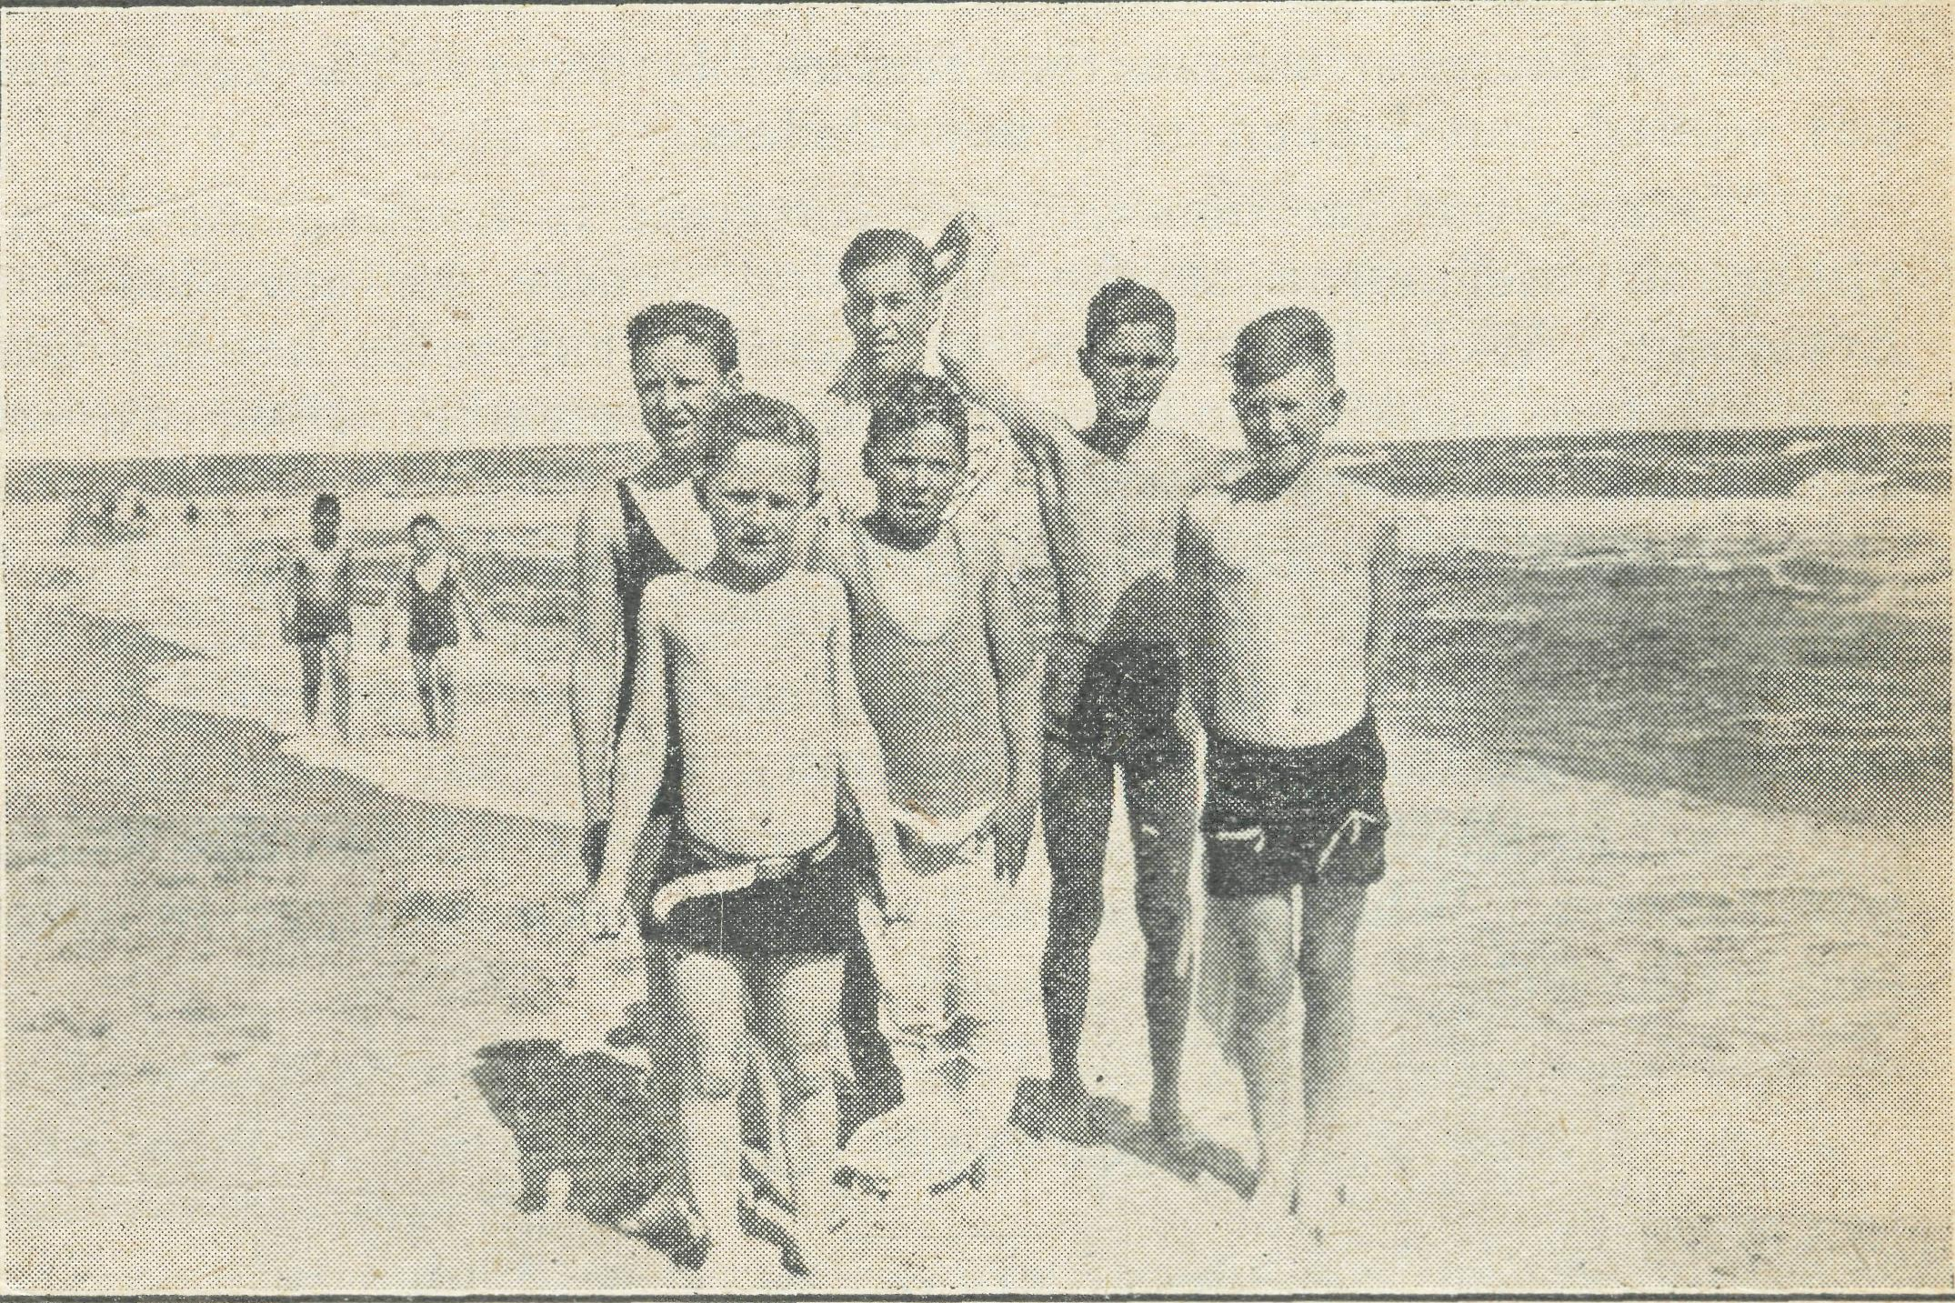
Some Menindie boys at Frankston.
The trip occupied three days—days during which I got to know my young flock in a way which ordinarily would have taken years. Arrangements had been made for our party to join mem' bers of the Melbourne Church of England Boys¹ Society at their permanent camp at Frankston.
Since our return, a member of the party, aged eight years, has written an essay on the trip, and I think he ought to be given space to continue this article. He writes :—
"At half'past nine on Thursday morning, August 31st, we all set off in Mr. Calderwood's van from Menindie for Pooncarie. Light patches of grass mingling with the gay colours of the wild

The Real Australian.
16
October 31, 1939.

bush flowers made a pretty picture. Sheep graced contentedly, while in the background the homesteads of the station'owners could be seen.
"At lunch'time we landed at Pooncarie and had lunch, after' wards strolling around for awhile ; but I am afraid there was very little to see in such a tiny town. Nevertheless, the old Darling River flows through there, and we musn't forget that !
"Once again the boys packed into the van and we started off for Wentworth, which is on the junction of the Murray and Darling Rivers. Crossing Wentworth bridge, I peered around at everything. By the end of a jolly and interesting day we rattled into Mildura, strolled around the streets, just taking in the newness of it all, and then we were ready for bed, feeling very tired but happy, too. Having had breakfast and viewing the grape plan' tations, we made tracks and eventually arrived at Sea Lake for an excellent lunch. Late that night we arrived in Bendigo, saw our first tram, tossed into bed, turned over and were fast asleep.
"From Mildura to Bendigo we had been passing through 'wheat' land,' but leaving Bendigo it was gracing country. We had lunch at Ascot Vale, and finally arrived at Frankston about six o'clock that evening. Now our good time blossoms out. My ! it was a lovely time, too. We went to the pictures in the city, and at interval feasted on ice'cream. Later we went to see 'The Argus' being printed, which was simply wonderful. We toured around in trams and sometimes electric trains, rambled on the beach at Frankston, and munched delicious Melbourne lollies ! Saturday we went to all the marvellous big shops and 'stickybeaked' until we were really satisfied.
"At the end of the Frankston camp we stayed at Hampton. I was living in a two'storied house ! I could see the sea and hear its peaceful lap as it swirled around the shore. At Hampton we had scooters. Gee! but we had good fun scrambling around the streets.
"Whilst we visited Melbourne we went to the Zoo and saw the enormous animals. The lions, tigers, and leopards lounged around, taking life quite easily, while the elephant marched around just simply loving the work of carting children for joy'rides. We saw huge birds, including the peacock with its lovely colours, while monkeys entertained us, too.
"At the Museum we saw that remarkable horse, Thar'Lap/ He was stuffed, but looked real, nevertheless.
"During our vacation we were fortunate in meeting the Arch' bishop of Melbourne at the Cathedral, where we attended for Evensong. Well, I regret to say that our enjoyable holiday was over all too quickly, and on Thursday, September 14th, we set off for our eld home town."
It was a great joy and privilege to conduct this trip. Since our return the boys are backing me up in a way which makes me feel confident for the future of the Church here, and I give grate' ful thanks for the splendid opportunity which was given me.
The enclosed snapshot shows some of the lads en the beach at Frankston. While they stood in bathers I was wrapped in over' coat and scarf.
ON THE JOB !
Rev. H. Broadley.
Visiting in the suburbs is a matter of going from door to door. The same applies in the bush, except that the doors are farther apart.
Recently I went down to Pimbaacla and' Nunjikompita to pay some calls. The first place was forty miles from home. Amongst the things talked over was the possibility of the district raising a fund by subscription which could be lent to a farmer to enable his wife to go to Adelaide for a necessary operation. Later it was found unnecessary to raise this fund.
The next call was made ten miles further on. Here I learnt that the Rev. W. McLeod was to be on his own in the next few months, as his wife had gone, or was going, to Sydney.
A visit was paid to a family near the Pimbaacla siding. They were preparing to visit a farmer who has recently been driven off his farm. Everyone in the district is thoroughly stirred up about the unfair treatment he has had from the Government. He is considered one of the best farmers and steadiest men in the district.
At another place I found a young mother snowed under w^{r}ith clothes, and anxiously waiting for the return of a car from Ceduna. About a week before a friend had come, with two children, to visit her. That day she had been taken by car to the doctor at Ceduna, as she strongly suspected that she had pneumonia. Her two children were left with her hostess, who found the additional burden of two children on top of her own, in rather small quarters, a bit of a trial for a day or so. A neighbour did come down and offer to take one, but she thought it might lead to fretting.
That night I stayed at a farm, and next morning set off again, this time round Nunjitkompita. Out of the events of that day two can be mentioned. At 4 p.m. an appointment with the local schoolmaster was kept. He is new to the district, but has soon made it plain that he is keen on his Church. He has earned the respect of the parents. The appointment was for a Confirmation lesson. After the lesson he asked if he owed anything for my travelling expenses in coming all that way to see him.
On leaving him, another ten or twelve miles brought me to Karkara, where we have a monthly cottage service. Tea came first. After washing'up we assembled round the table. Some visitors were present for tea, and they stayed for the service. There are many disadvantages in taking a service under such con' ditions, but it is well worthwhile. You can picture the one oil lamp by which to see, the heads bowed round the table with eyes on Prayer Books, the music from the folding organ being the air without the harmony. After the service a cup of hot coffee is provided—Jack Frost has been round lately—and then a ten' mile run and home at 10.30 p.m.
Fifteen visits, a Confirmation lesson, and a cottage service were the business of the trip.
When the services are held on Sundays practically every family turns up with most of its members. These people deserve the best we can give them.
In parishes such as we have on the West Coast, with many centres of church'life and potential church'life, each place has its own particular needs and problems. This has one good effect on the missioner ; it makes him become broader<-minded, because it is surprising to notice how each centre has its own separate mental atmosphere. A reference to two districts which are asso' ciated with Ceduna will give some idea of things as they are.
Nurka is a little centre about thirty miles north'east of Ceduna. Four years ago there were eight families there, all of them attached to the Church cf England. They had a one'teacher school to which nine or ten children went. If they wanted any social life they had eight to fifteen miles to go, according to where they lived ; this is still true. In December, 1936, services were begun in the school, once in four weeks. The attendance was very good. To'day there are four of those families left. The school has been closed, only two children of schoohgoing age being left in the district. Another district has applied for the school building, and will certainly get it very soon. The churclvgoers at Nurka say that when it goes they will go to Mudamuckla once a month for their services. For one it will mean a nincmile trip each way, for the other about eleven or twelve miles each way.
Denial Bay is west cf Ceduna, some eight miles by road. Unlike Nurka, which is well inland, Denial Bay is on the coast. It is a dying town. It once had a doctor and a hospital, two stores, and a hotel. The bank was opened for business once a week. The doctor has gone (Dr. Gibson, of Ceduna, locks after it now), the hospital is a private house, one store has closed down, the bank no longer opens, and in the last month the hotel has closed and been partly demolished.
Spiritually, the place is not very bright. The services are few and poorly attended. At the last service there were seven

October 31, 1939.
15
The Real Australian.

present—two women, who are almost completely deaf, one young woman who came with me from Ceduna, and four children. It is not easy to carry on a service under such conditions, especially when all except one were very hasy about the Prayer Book. In an attempt to help the children, I now go over once a month on a Saturday morning at 11 a.m. to give the youngsters some special teaching to try to improve matters. Sundays are fully taken up, so the visit has to be on a week-day, and Saturday is the only suitable one for them. If we had one local person who was a keen Christian I am sure the children would respond wonderfully. Here is something to pray for.
TENNIS FOR TEN.
Rev. E. Constable.
There were just ten of us who enjoyed a day of tennis in the quietness of distant Eucla homestead recently. Most people have heard of this spot on the western coast of the Great Australian Bight ; many still perhaps think of it as a township, whilst others know that some years ago Eucla ceased as such and now is a private home as the centre of a sheep-run. Neighbours ? Yes. One family 127 miles east, another 62 miles west, and the Trans-Continental Railway eighty miles north.
Leased for use, the government buildings, built of fine sandstone quarried nearby, stand as a memorial to the past activity in this place. Then a large staff of telegraphists belonging to Western Australia and South Australia handed to each other respectively interstate telegrams for re-transmission on their long journey. The clicking of telegraph keys has given place to the buzz; and bleat of shearing shed.
But what of the tennis ? Personally, it was my first game for over twelve months, so I was run off my feet. The folk had come the sixty-two miles from Mundrabilla, and we had gone 282 miles from Penong, so it was with keenness we had that day's recreation and social intercourse. But was that all to it ? Of course not. I like tennis, but I would not travel that far for a game alone. The previous evening we had gathered together for a service, and with the same readiness as displayed on the court, the hymns were joined in, Mrs. Constable playing the little organ.
Slides illustrating the address on the theme, "What think ye of Christ ?" helped to remind all of the fact that Christ Jesus entered all aspects of the life of His day, and calls for us all to allow Him so to enter with us to-day—i.e., a full salvation.
Sunday morning found us completing this visit by again having a reading from the Scriptures and prayer. Then off we went to the east-west line to pursue our fortnight's itineration.
WERRIMUL.
Rev. F. Bayly.
I am complying with a very urgent request from the editor of the "Real Australian¹¹ for something for next issue.
For the last few months we have been exceedingly busy preparing for Confirmation. But although busy, it has been a very great joy watching the spiritual growth of the candidates. Thirty-three out of thirty-six candidates were confirmed by the Bishop of St. Arnaud on the 29th October, at 7.30 p.m. The other three could not come owing to transport difficulty. Quite a number of the candidates travelled over thirty miles.
The church was packed, many had to be seated around the doors outside, and although unable to see, could hear and take part in the happy service. One hundred and thirty-six people were present, and all met the Bishop on the vicarage lawn after the service. It was a happy ending to a very happy day.
In preparation of the candidates there was considerable travelling needed, for only four of the thirty-three could get to the church for lessons. It was often after midnight before I reached home.
Travelling in the Mallee is much better this year because of the wild flowers and acres of white everlasting daisies in the pine country looked like snow scenes. The prospects of a good harvest this year are very promising. The bad season last year has delayed the lamb industry this year by about two months.
Through the secretary of the Bush and Prairie Visitors, Mr. Whithal, a link has been formed between the Mallee children and the Challech children of Wallington, England. We hope it will be a bond of fellowship for all time. Quite a number of adults are receiving letters and magazines from visitors in England.
The Ladies¹ Guild at Meringum has been very active and have bought a large Prayer Book for the desk and small ones for the use of the congregation.
A Ladies¹ Guild at Merinee is also doing very useful ..vork.
I had a wonderful experience a short time ago. After baptising eight children of one family, and preparing to finish the service, the mother came to me and asked if she might be baptized. On the 29th October the mother and six of the family were confirmed.
Please continue your prayers for all who have been confirmed, and also that Christ will claim all the Mallee fok for Himsef.
DENMARK, W.A.
Rev. B. Lousada.
Most of us are familiar with the characters of Steele Rudd, a mixture of "humour, truth and caricature of the real Australian. Some of his tragedies can only be solved by a sense of humour or a spell in hospital. A local supervisor allows him to buy chaff for his horses, after it is eaten the main office in the capital city disallows the advance. Wild heifers are given to another settler, about five in number. He signs for them, but is not able to take delivery. One breaks its neck in the bush, another is shot for venison, another defies the whole neighbourhood for six months, another disappears in the wide horizon, one is tamed. At £8 each the settler realises he has the most expensive cow in the district.
In ministering under such conditions the Church has to reprove, rebuke, exhort with all lcngsuffering. The local place of meeting consists of an iron hall with bag windows, with floor and seats around the walls. A block does for a Holy Table and services are held once a month. If the doors are not carefully propped open they will swing and creak with a vengeance. Some of the children like to make tea at the close of the service. A dog sniffs out the eatables. In the middle of the prayers he has to be driven out. Then a horse breaks loose and half the congregation go after it. So the service proceeds.
After two years comes a day when the Bishop visits the centre for the first time, and some of the children are presented for Confirmation. A retired English nurse, who plays the little harmonium, thinks it one of the most glorious services she has ever taken part in. So, we feel, do the angels and archangels and all the company of Heaven who join with us in the following Communion service. So the Church of Jesus grows under pioneering and stimulating conditions.
HERE AND THERE IN THE HEYTESBURY.
Rev. G. Beatty.
In previous letters I have tried to give you a connected story of the work in the Heytesbury, but this time I just want to say a word about things here and there.
Before coming here we were told it was wet in the winter, now we know. At one period this winter it rained on thirty consecutive days, then we had one day without rain, followed by seven more wet ones ; but everybody here accepts the fact as a natural course of events and dons gum boots and raincoat and carries on.
One Saturday afternoon, during the wet period, the telephone rang. The exchange is not usually open on Saturday afternoon, so we knew it must be an urgent call. I lifted the receiver and the voice of a distracted father came over the wire. His little girl, who was in hospital ill with pneumonia following measles, had taken a very bad turn and the parents were asked to come at once for she was likely to pass away at any moment. My offer to drive them to the hospital, which was twenty-five miles distant, was gratefully accepted. The rain fell down in torrents and the wind was blowing a hurricane, but on we went splashing through

The Real Australian.
18
October 31, 1939.

water, driving as fast as was compatible with safety, hoping and praying we would be in time. At last the hospital was reached and straight to her bedside we went. Yes, we were in time ; there she was, her big brown eyes wide open. It was pitiful to watch her fighting for breath ; one lung had collapsed and she was living on oxygen. After a while she seemed to rally, and then came another bad turn. About 7 p.m. there was a distinct,change for the better, so we went home, for at home there were five other children. It was still raining, and the road was flooded in many places. I shall not soon forget the drive home that night. Early on Sunday morning Jesus took her into His bosom.
The funeral was on Monday, when many friends and neigh' hours gathered, and the missioner had the opportunity of pointing the bereaved to the God of Comfort, and of reminding all of the life after death and of the need of preparation for that life.
I always admire the faithful women of the various B.C.A. Auxiliaries who work hard making clothes and many other useful articles to help the people in the bush, and I sometimes wonder whether they realise how much these articles are appreciated by the bush folk. The bereaved family mentioned above are not strangers to adversity, and more than once the mother has, with tears in her eyes, expressed her sincere gratitude to the missioner for the help he was able to give the family through the good offices of B.C.A's. Women's Auxiliaries.
Most people in the bush are hungry for reading matter, and the books and magazines sent in by various friends are very much appreciated. In one part of the mission we have instituted a lending library, and a settler's wife with a taste for literature is the enthusiastic librarian. As well as circulating reading matter of the lighter sort, she is striving to encourage the reading of good books. The people are most enthusiastic about their library and very grateful to those who have supplied the books and magazines.
During the winter services have been maintained and at two centres the attendance has increased.
When war was declared some of the people here said that they hoped it would net in any way affect the help the Society was giving them. I told them B.C.A. would not let them down.
The other day, when visiting some settlers who are having a big struggle and who live very isolated lives, both husband and wife said how much they appreciated the visits of the missioner, and then they told me something which made me realise once again the worthwhileness of the task B.C.A. has set itself. Yes, the task is worthwhile, so, keeping in mind the Society's motto, "Australia for Christ," let us keep on praying and paying until the task is accomplished.
In conclusion, let me say "thank you very much" to the Mail' Bag Sunday School Department for the gift of music copies of Hymns Ancient and Modern and the Sunday School Hymnary.

THE HOME BASE

"A HAPPY BIRTHDAY."
Birthdays are occasions when we can express to our loved ones and friends something of the regard and affection we have for them in a tangible way. We pick our gifts for them with the object of giving as much pleasure as our purse will allow, and when we present our gift our eyes watch the faces of our friends for those smiles of pleasure which betoken that we have achieved our object and given them happiness.
So it should be at Christmas'time—for is it not the Birthday
of our Lord ? Do we not wish to give Him also the greatest
pleasure. Would we not rejoice to know that His face also lit
up with happiness Shall we not make Christmas an oppor-
tunity of expressing our regard and affection for Him in some tangible form ?
Certainly we cannot see Him in material form and give Him our gifts in that way, but we can make Him a birthday gift through His work. In your Christmas giving will you spare some' thing for our Lord ? Will you give it as Llis birthday gift through B.C.A.?
The B.C.A. is doing so very much these days in the lonely places. The articles in this little paper speak of the real spiritual as well as the practical nature of that work. So much is needed to keep it going day by day. Above all other things, it is the work of our Lord and is done in His Name and for His sake. See to it that you do not forget to send to B.C.A. for the Christ' mas season some gift as a birthday present to your Lord.
THE N.S.W. ANNUAL RALLY.
The Rally was held on Saturday, September 9th, in St. Andrew's Chapter House. Saturday night was an innovation and proved quite successful, while many of our friends who are usually present at our family gathering were unable to attend, many new faces were observed in a full hall.
The "family tea party" at 5.45 was a very happy gathering, and about 250 friends were present.
His Grace the Archbishop presided at the meeting and weh corned the Ven. Archdeacon and Mrs. Langley back to Australia after their strenuous labours on behalf of B.C.A. in England.
The Archdeacon told us something of the interest he was able to arouse in England for B.C.A. work.
The Rev. C. Baker, who recently returned from the Menindie Mission after three years' service, gave us a graphic picture of the value of the Society's ministry there.
Perhaps the most impressive thought Mr. Baker left with us was provided not so much by the details of his ministry but rather by his own forthrightness and earnestness. We all felt that if all B.C.A's. missioners are like Mr. Baker it is indeed a joy to keep delving into our pockets in order to pay the bills to send them out to minister to people who certainly need to know some thing of the real value of Christian living.
The evening was brought to a close by the Organising Mis' sioner, who showed a new set of pictures of some of the Society's spheres of work.
The evening's thank-offering amounted to £120.
THE N.S.W. WOMEN'S AUXILIARY.
Annual Thanksgiving Service.
Early in the year our N.S.W. ladies, at the request of the Organising Missioner, undertook to raise the sum of £250 before the end of December in order that our premise to pay for the newlyconstructed dormitory at Wilcannia might be kept. This was no small undertaking, but our lady friends are nothing if not courageous. They have what Bishop Kirkby called "grace, grit and gumption."
At their Annual Meeting they gave the sum of £50 for this purpose, and then set about organising a "Thanksgiving Service" in the side chapel of St. Andrew's Cathedral for October 18th.
The day duly arrived and about one hundred friends gathered in the side chapel for the short service taken by His Grace the Archbishop. The Organising Missioner gave a short address stressing the need for keeping our work at full strength in these difficult days.
After the service afternoon tea was served in the lower Chapter House, and great was the excitement when it was learned that the thank'offering had amounted to £120. This,together with the £50 given previously, brings the total to £170, leaving £80 to be collected if our objective of £250 is to be attained.
Very real thanks are due to our women friends for the mag' nificent effort they make to meet all the calls made upon them. This is the spirit that keeps B.C.A. going.

