Registered at the G.P.O., Sydney, for trammission by post as a periodical-



Organ of the Bush Church Aid Society for Australia and Tasmania.

No. 74.
MARCH 1, 1940.
1/6 per annum (post free).

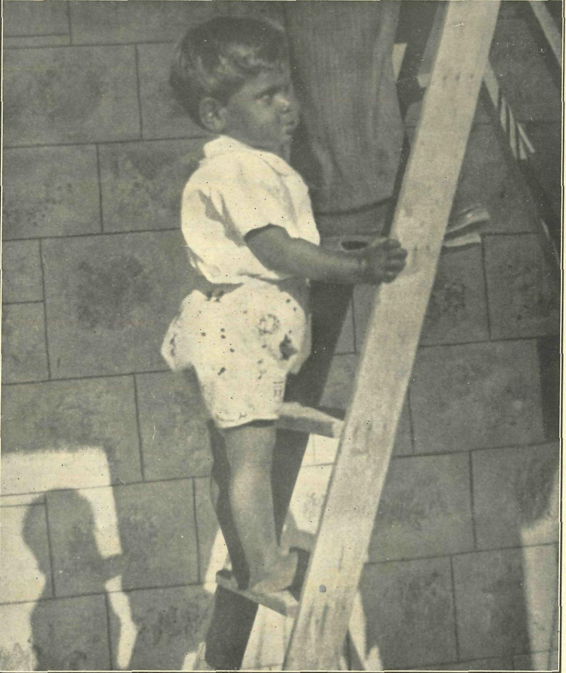
"Sydney James Cook is now two and a half years old. Pray earnestly for him as he climbs life's
ladder."

The Real Australian.
March t, 1940.

The Bush Church Aid Society for Australia and Tasmania.

HEADQUARTERS OFFICE :
Diocesan Church House, St. Andrew's Cathedral, George Street, Sydney.
(Telephone : M3164.) Cable Address : "Chaplaincy, Sydney."
VICTORIAN OFFICE : St. Paul's Cathedral Buildings, Flinders Lane, Melbourne.
(Telephone : F5675.)
President : The ARCHBISHOP OF SYDNEY.
Hon. Clerical Secretary : Ven. Archdeacon W. L. LANGLEY.
Hon. Treasurer : T. S. HOLT, Esq.
STAFF. Organising Missioner : Rev. T. E. JONES, Th.L., Church
House, George Street, Sydney. Victorian Secretary : Rev. W. I. FLEMING, Th.L. South Australian Secretary : Rev. R. M. FULFORD, North
Terrace, Adelaide, S.A.

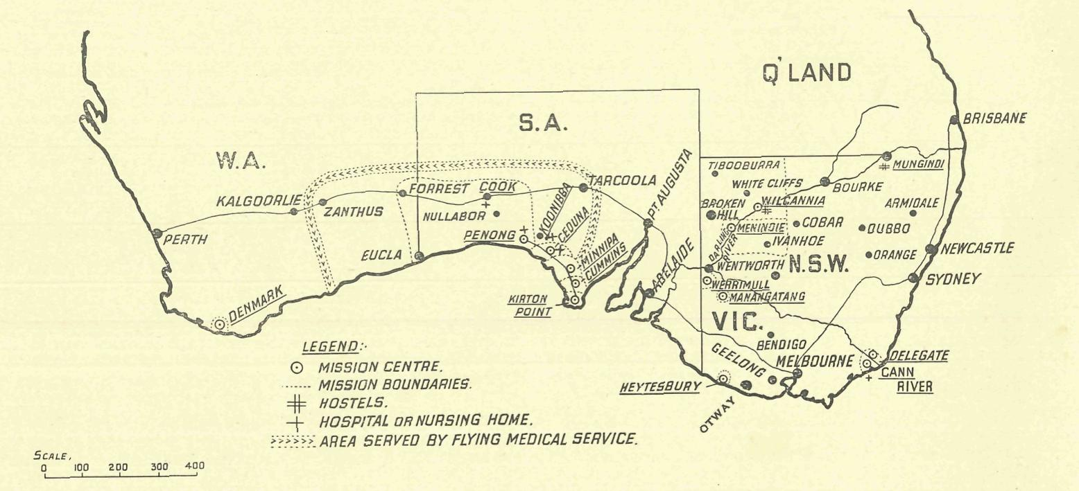

MISSIONS.

FAR WEST MISSIONS, S.A.
Ceduna—Rev. L. H. Broadley, Th.L., The Rectory, Ceduna, S.A. Penong—Rev. E. V. Constable, Th.L., The Rectory, Penong, S.A. Minnipa—Rev. K. Luders, Th.L., Minnipa, S.A. Cummins—Rev. T. R. Fleming, Th.L., Cummins, S A. Kirton Point—Rev. R. T. Hallahan, Th.L., Port Lincoln, S.A.
VICTORIAN MISSIONS.
Croajingalong—Rev. N. Holdsworth, Th.L., Cann River, Vic.
Delegate-Bonang—Rev. W. McLeod, Th.L., The Rectory,
Delegate, N.S.W. N.W. Mallee—Rev. F. Bayly, Clergy House, Werrimull, Vic. Heytesbury Mission—Rev. G. Beatty, Th.L., Timboon, Vic. Otway Mission—Rev. T. H. Pickburn, Th.L., Beech Forest, Vic.
WEST DARLING MISSIONS.
Wilcannia—Rev. D. Livingstone, Th.L., Reid Street, Wilcannia, N.S.W.
Menindie—Rev. G. B. Calderwood, Th.L., Menindie, N.S.W.
WESTERN AUSTRALIA.
Denmark—Rev. B. Lousada, Denmark, W.A.
CHILDREN'S HOSTELS.
Mungindi—Miss E. Cheers, Mungindi, N.S.W. Wilcannia—Mrs. C. Mann, Wilcannia, N.S.W. Miss A. Taylor, Wilcannia, N.S.W.
Wentworth Falls, "Coorah"—Sister A. Spence, Miss M. Boydell, Mr. I. Taylor.
MEDICAL SERVICES.
Gippsland, Vic.—Sister I. Harris, The Dispensary, Cann River, Vic.
FLYING MEDICAL SERVICES.
Pilot : Mr. A. Chadwick, Ceduna, S.A. Dr. R. Gibson, Dr. F. Gibson.
CEDUNA HOSPITAL.
Matron : Sister F. Dowling.
Staff : Sisters B. Bossley, V. Page, L. Pritchard, L. Loane, Nurse J. Branford.
KOONIBBA ABORIGINAL HOSPITAL.
Sister G. Hitchcock, Koonibba, S.A.
PENONG HOSPITAL.
Sister D. Goodwin, Penong, S.A. Sister J. Eglitzky, Penong, S.A. Miss M. Millar, Penong, S.A.
BISHOP KIRKBY MEMORIAL HOSPITAL.
Sister M. Symons, Cook, S.A. Miss D. Dykes, Cook, S.A.

March I, 1940.
The Real Australian.

THE SEED AND THE FIELD
(By the O.M.)
THE SEED IS THE WORD."

Mr. John Smith had lately taken up a virgin block of country and hoped one day to grow wheat. Mr. Smith had big ideas and liked to think of himself as a wealthy wheat-farmer, but unfortunately he was not fond of hard work. So Mr. Smith reasoned with himself : "Why bother ring-barking, grubbing out trees and uprooting strong bushes ? Fll put a match into it. Everything is dry and it will soon burn." In went the match. Oh, yes ! the scrub burned very well—and so did most of the bigger timber, to say nothing of Mr. Smith's neighbours¹ fences. However, the paddocks were fairly well cleared. Again Mr. ■ Smith reasoned with himself : "Why bother ploughing ? Fll just scratch the top and sow the seed, that ought to do.¹¹ What a mess those hidden roots made of the tynes of Mr. Smith's scarifier ! However, the seed was in and Mr. J.S. sat back waiting for "results. He got them alright. The wheat certainly grew, but so did the scrub and every imaginable weed. Stupid and unbelievable, you think ?
Mr. John Smith had a brother who was not a wheat-farmer, though he talked a great deal about "sowing the seed.¹¹ Robert Smith lived in the city and was considered to be a very respectable man—he was also a churchman. He attended all the Church services and prayer meetings. One evening at a Church service the rector read a request from a missionary organisation for the help of the parish in raising a large sum of money for the establishment of a new mission station amongst some hitherto untouched heathen tribes. "I don't believe in foreign missions,¹¹ said Robert Smith. "Let these savages alone, they are happy as they are.¹¹ At a later date Mr. Robert Smith found amongst his mail a letter from another organisation telling him of a proposal to establish a hospital in the remote interior of his own land to serve isolated settlers. "If these people go and live in these God-forsaken places, serve them right,¹¹ he said to his wife. Mr. Robert Smith was the proprietor of a large flour mill. One day a young lady called on him and explained that she was the secretary of a Children's Home. They found it difficult to< keep up the food supply. Could Mr. Smith help them by selling the Home a quantity of flour at a discount ? Mr. Smith was very sorry, but taxes were heavy and a war had started, he really could not do it.
The next Sunday was Harvest Festival at the church Mr. Smith attended. The first hymn was, "We plough the fields and scatter the good seed on the ground.¹¹ Mr. R.S. sang with great gusto.
* * * *
A young missioner was taking a service in a small tin hut away in the centre of one of Australia's great plains. He had been sent out by the Bush Church Aid Society to sow the seed of the Word of God in the hearts of these lonely people. For a number of years his work had
been greatly helped by means of a little hospital which had been established by that same Society for the use of these lonely people. Before the advent of the hospital the young missioner had found it very difficult to arouse anv interest in spiritual things amongst his flock. "What does the Church care for us ?" some said. "How can God be a God of Love when we have to go over 500 miles when we or our children are sick ?" others had asked him. He himself had felt the uselessness of sermons without some practical means of preparing the hearts of his hearers by ministering to their needs. You can imagine his joy when the day came for the opening of the little hospital. The people realised that it had cost many thousands of pounds to build in so remote a place. More important still, they knew that it had been built for their needs to save them pain any anxiety, and to prevent those unnecessary deaths which had so embittered their hearts.
The nurses were kindly, Christian women who served them as efficiently as those in the big hospitals of the large towns. Not content with the hospital alone, the B.C.A. had bought an aeroplane so that the doctor could come to them speedily and comfortably. It had made them feel secure and happier.
But on the night of our service the missioner was sad at heart. The little hospital at the end of the row of homes was still there—but deserted. The doors were locked and the verandahs covered in thick dust. The nurses had gone, and no longer did the aeroplane land gracefully on the nearby landing-ground. When they and their loved ones were ill the long 500-mile journey had now to be undertaken.
You see, a war had come and everybody had said, "We cannot give to the B.C.A. any more. Taxes are mounting higher and higher, and I am in all sorts of war -organisations, and I give to all sorts of war appeals. Something will have to go, and it must be the Church and its work.¹¹
Stupid and unbelievable ? I devoutly hope so. May the day never come when this fairy-story will come true-But remember, the B.C.A. is engaged in preparing the fields of men's hearts so- that they may be receptive to the seed of the Word of God. This necessary preparation is an expensive business. It costs B.C.A. over £10,000 per annum to keep going. The aeroplane alone absorbs £65 each month, and the insurance demand note which has just been sent us requires £195 to pay it. Hospitals, hostels and missions need to be maintained. Shall we shut down on the work of the extension of the Kingdom of God because there is a war oh ?
The seed is the Word, and the field is to be found in the hearts of men and women. We must not only sow the seed but, by the grace of Almighty God, prepare the field for its growth.

The Real Australian.
March I, 1940.

THE HEALIN
ISSIO NS

THE FRONT LINE.

Sister V. Page.
Early in December an opportunity was made for me to accorri' pany Mr. Constable on his quarterly trip to Cook, and with us went Sister Eglitsky.
Although I had been on the "coast" three years and had visited Cook twice, both trips were made by the B.C.A. 'plane, and I had a very keen desire to go by car and experience a little of what that trip means to Mr. Constable.
We left Penong at 8.30 a.m. with misty rain falling, which made travelling very pleasant. Roads, on the whole, were quite good. Scattered farms were seen till we got to Coorabbie, and then they gradually disappeared until as far as one could see only vast plains and mallee country were visible.
It was a lovely picture which met our eyes when we came to Colona Station at about 11 a.m. A green and white house with roses—yes, roses !—climbing over the verandah. A stone wall enclosed the front garden, where quite a vast number of flowers were blooming. Here travellers are usually regaled with cups of tea by Mrs. Reid. Unfortunately she and Mr. Reid were away on holiday. I was doubly disappointed as I had not met either of them.
We travelled on until at 12.30 p.m. we came to a tank. These tanks are placed at intervals along the roadside. Sometimes they are an erection about ten feet high, and others are close to the ground. They consist of an area, varying in size, of corru' gated iron which drains into either underground or surface tanks. Here one can procure water for personal use or for watering travel' ling stock. Being the erection type of tank, we ran the car under and partook of our lunch.
Our next halting'place was to> be White Wells, so we were soon on cur way. At White Wells a family is living miles from any other human being. Here we all joined in reading His Word, and had fellowship in prayer. There were two girls who had both, at different times, been patients in the hospital. They were very pleased to see us again, and one felt how much one would have liked to have stayed longer ; but time was passing and we still had many miles to go.
We reached Nullarbor in time for afternoon tea, and w^{r}ere welcomed by Mr. and Mrs. Brooks, who, as most people know, are very good friends to B.C.A. Here we joined together in par' taking of the Lord's Supper. After having a little time of "chatter," we had tea, and Mr. and Mrs. Brooks showed us one of the caves, of which there are many on the Nullarbor Plain. We had to go down a small opening in the ground, by rope, for a few feet, and then, with the aid of a petrol lamp, Mr. Brooks showed us the wonders. Although the opening was small, the cave was very large. We had to pick our way carefully over huge boulders and loose stones. We saw some beautiful stalagmites and stalactites in their natural state, and had to be very careful we didn't break any of them as we went by.
When we came up again it was dark, so we bade our friends good'bye and made for Cook. Rarely did we see a tree now, it was mostly blue-bush and salt'bush. We quite appreciated Mr. Constable's skill in picking out the track, as to the untrained eye it was barely visible.
At Cook we were greeted by Sisters Symons and Dykes, who ministered to us with a delightful hot bath and supper, and, after giving the "news," we each went to bed.
The next day was hot. Mr. Constable had some camps to visit, so I accompanied him. Here travelling was not so good. The track was strewn with stones, and in some places huge boulders
projected. Here again the experienced driver was able to cope with the difficulties. We called first at one camp, thirty miles from Cook, to tell them we would be back next day to have a service, and then proceeded to the next camp, Hughes, sixty miles from Cook. These "camps" consist of varying numbers of three'roomed houses, usually from three to seven. The men are engaged in keeping the railway line in repair, and the wives in keeping the men fit. One has to see the places to appreciate what those women are putting up with. In a few instances they have tried to grow a few hardy things such as geraniums, but otherwise the ground about the camp is as bare as a table, and the only thing to see for miles is scrub'covered plains—and the heat is enough to roast one. In spite of this, and the isolation, I was delighted to find some lovely little kiddies as spic and span as one could wish, all ready to meet daddy, who was due home just then. The folk were very kind to us, and we were given hospitality for the* night. Mr. Constable had the task of getting people to come to Church, which was held in the men's barracks.
Next morning we made back to the first camp, where we were given tea, and afterwards nearly everyone came to the service held in the house. For music we had a wheezy accordion, and could only have such hymns as the musician knew ; but everyone sang lustily and seemed to enjoy the service. After service we went on to Cook, where once again we were very thankful to have a bath. At the home in Hughes where I stayed, the lady of the house said : "Would you like a wash in your room, Sister ?" Not wishing to make work, I said : "No, thank ycu ; I can go to the bathroom." She looked very apologetic and said : "I'm sorry, I have no bathroom." So I did as they did—washed in a little corner just outside the kitchen.
At/ Cook, Mr. Constable took the service, which is usually part of the Sister's work. A fair number were present. On the Wednesday a thanksgiving service was held for the work which has been accomplished by the B.C.A. and the people of Cook. A hangar for the aeroplane has just been erected, and several other building operations were in progress, including a stone morgue. A very good attendance marked the occasion, and as it was the evening for the regular Cook trip, we were pleased to have with us Sister Dowling and Dr. Gibson. Two lads who were going through to. Perth selling Bibles for the British and Foreign Bible Society also happened to be with us, so the Lord's work was very well represented. In the morning Mr. Constable gave Holy Communion to those at the hospital, and it was good to be able thus to have fellowship together.
We left for Penong about 10 a.m., via Watson and Ooldea. At Watson we visited the stone'crushing works and also the man' ager's wife. She was living in a house of straw ! I can't go into details, but it is specially prepared for building purposes, and was very nice and cool. She was very pleased to see us, and regaled us with afternoon tea, even cutting her Christmas cake for our special benefit.
We reached Ooldea siding after an interesting trip. Salt'bush and blue'bush and stones were the chief items on the scenery pro' gramme, but in the distance we could see a wonderful stretch of water in which was mirrored numbers of trees ; but it was only a mirage. We were very interested to find a rabbit hanging in a bush. Evidently it had crawled up into the bush to get the leaves which couldn't be reached from the ground, and had slipped and got suspended and died.
At Ooldea we didn't wish to worry anyone, so Mr. Constable procured a kerosene tin of water and a tin dish from one of the cottages and left' Sister Eglitzky and I to remove the dust and stain of travel in the hall, where afterwards Church was to be held. This accomplished, we all had tea, and then prepared for

March 1, 1940.
The Real Australian.

service. Mr. Green, who is in charge of the Ooldea Mission to Aborigines, and his assistant, Mr. Matthews, arrived with a number of "boys" from the mission. A few of the folk from the siding also came along. Hurricane lamps were our only light ; a startled bird, which had its nest in the hall, flitted excitedly round our heads, and service began. Mr. Matthews has a very nice piano' accordion which he played for the service.
After service we drove for a few miles piloted by Mr. Green's truck. Then came a walk over the sandhills to the mission house. It wasi too dark to see much, but we did know that the sand only stopped at the door ! Mrs. Green and Mrs. Matthews wel' corned us with the inevitable cup of tea which means so much to travellers, and afterwards we were shown to our rooms. I was awakened in the morning by Mr. Constable hurling abuse at the crows which seemed to have gathered from far and near to hold ai consultation. It was not long afterwards that another sound greeted my ear—the aborigines. They were very interested in the visitors, and came peering through the wired'in verandah until Mr. Green told them in their own language to scram ! We visited their school, which was in recess, and saw them being given the rations. It's an ideal spot for the natives, but I think a very hot and tiring place for those who work there. However, they love the work and seemed very happy. There are two children in each of the Green and Matthews families.
We left Ooldea soon after breakfast, and made for Penong by a different road. We did not touch Nullarbcr Station, but did see Colona again. The track on this route was not so good as the rains had caused numerous washaways. At Colona we were agair! unfortunate in not meeting Mr. and Mrs. Reid, but Mr. Reid junr. dispensed afternoon tea. From there we went straight for the hospital at Penong.
One felt that the trip had been very worthwhile, and one could pray more intelligently for the work that is being done. In these days when war work is very much to the front, and people feel an extra call on their time and money, are we going to have our "Mannerheim Line¹¹ dented by lack of funds ?
Sister F. Dowling.
During the past three months we have had several changes on the staff. We learned with regret that Miss Andrews, who for the past three years has carried on with the cooking, had decided not to come back again. We look back with gratitude to her time of service here, realising that her job was anything but an easy one, but she was sent by the Lord and did it as unto Him. We wish her God's blessing for her future work. Will our friends please remember this need in prayer that He will raise someone of His own choice to carry on with this side of the work.
Sister Pritchard has returned from holidays, and Sister Page has gone to Melbourne for her long leave.
Before Christmas we had the pleasure and privilege of a visit from our friend and advisor, Sister Plumb of the Nurses' Christian Movement (Sydney), who was accompanied by her mother, whom we were all delighted to meet. Though the visit was not as long as we would have liked it to be, it was a great joy to have the fellowship even for a short time, and we feel that the know ledge and insight into the Work will be of great value in the future both to Sister and B.C.A., who seek their nurses from the N.C.M.
In December we were pleased to welcome the Kennedy brothers, of the British and Foreign Bible Society, who were motor' ing across to Perth in the Society's van, distributing the Scrip' tures to folk they came in contact with. May the Lord go with them and add His blessing to their work.
Christmas is over once again. We all had a happy day together here, particularly so because we were able to have with us the Penong staff and Rev. E. Constable, Sister Hitchcock from Koonibba, besides the Broadleys and Chadwicks. Our thoughts were with the others of the family in more isolated spots, who were not able to have such fellowship. We do offer our grateful thinks to the Adelaide, Melbourne, and Sydney Women's Auxiliaries and
friends for the contents of the boxes sent. All articles will be put to good use. The personal gifts from the Auxiliaries to the staff were much appreciated ; please accept our thanks.
The Balwyn branch of the Anglican Bible Class Union for' warded a donation to be given to some needy cases in the dis' trict. We won't have very far to go to find them !
Recently a letter was received from a brother in the Lord, pleading for much prayer. It wasn't very hard to understand his feelings which prompted that S.O.S. to us. He was about to tackle something big for his Lord, something for which he felt himself incapable of achieving in his own strength, and so he was anxious to get people praying for him and his work from the outset. It is at such times the only way we feel we can even start to accomplish something the Lord has set us to do ; the difficulties, we see ahead just make us cast ourselves upon Him for help. Without Him we can do nothing.
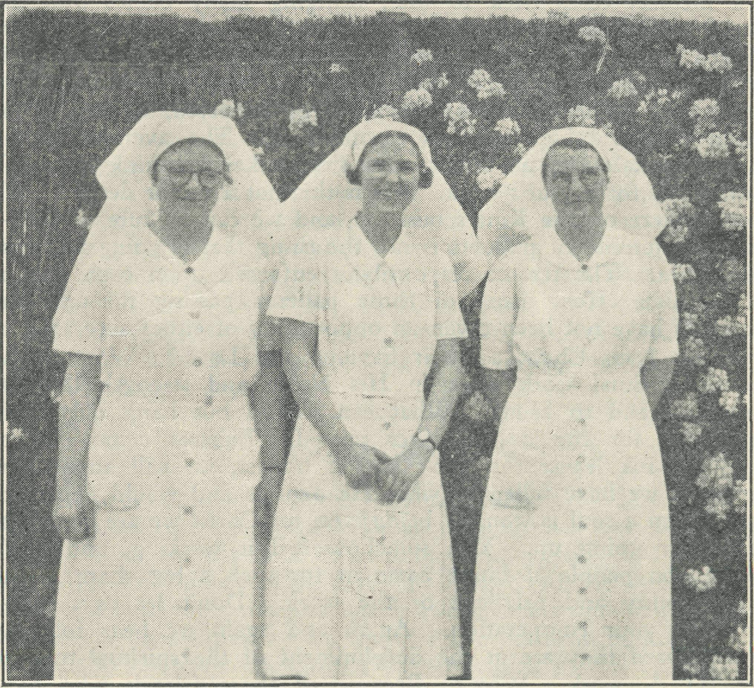
Sisters Dowling, Loane and Bossley, Ceduna Hospital, West Coast, S.A.
Only a week or so ago we had a major operation. A very difficult case which called forth all the skill of the surgeon. The climax came during that operation, when even though everything was apparently done right certain trouble persisted. When seconds count and the trouble must be stopped, the air becomes pretty tense and one can feel the desperateness of the occasion. Then we remembered the Great Physician standing by—"Lord, guide his hand to the trouble." And the Lord answered, and that which had been previously hidden from the touch was revealed, the obstacle was removed and the bleeding stopped. An accident ? No, the believer in prayer doesn't accept it at that. The amazing thing is that in the majority of our experiences we forget we have Him with us to help, even in the little difficulties as well as the big problems of our work. And so once again we ask for prayer, and we don't make any apologies for asking for it either. God knows we need it to keep in the line of His will, to do anything in the power of the Spirit, the only way that results can be expected—whether seen or not at the present time—for His glory. You who love the Lord and pray each day ""Thy Kingdom come," set to and take a real living part in this work. Think of the O.M. and the Council with their heavy responsibilities to God. Don't sit back on your chair and wait for them to make a false move, a wrong choice—get behind them in real prayer, beseeching God to guide every move and decision. "Bear ye one another's burdens and so fulfil the law of Christ.' ' Think of the missioners

The Real Australian.
March I; 1940.

outback. If ever a minister of the Gospel should find out whether he is en solid rock or a sandy foundation it is in such places. Summer months with those long, hot, dusty drives with a service at the end of each, the congregation a mere handful, sometimes only two or three. Back again in the evening for service abso-lutely dog-tired, and again the message of salvation is preached. Surely it is the God of all grace who helps such men to persevere at their work for Him.
We think of the Hostels where those numbers of kiddies are committed to the charge of His servants. What an oppor-tunity ! Surely they need our prayers. And for the work of the Mail-Bag Sunday School and the Women's Auxiliaries, all who play such a big part in having the gospel preached to the outback folk. And for our hospitals. We look at the list of cases typed out for the year's work. We think with satisfaction of taking out so many gallbladders ; relieving people of that general nuisance known as the appendix ; repairing hernias which can cause such discomfort and even death in babies and adults ; nursing the many sick medical cases back to life ; bringing many babies into the world under decent conditions and giving the mother a proper chance from the start ; endeavouring to help mothers rear their babes according to modern mothercraft teaching, and so on. The list is sent to headquarters. As is to be expected, Geduna is far ahead of the other hospitals in numbers. The average of the other hospitals may no doubt cause the workers to think it doesn't look much for a year's work. But is this not a minor detail ? We are out here on the King's business, and we can be sure of this— that the number of patients is not the thing that is going to count with Him. The terrific respcnsibiliy enforced upon each one of us is this : How many of those patients passing through our hospitals have not been given an oppo-rtunity of either accepting or rejecting Jesus Christ as their Saviour and Lord ? What is the list of spiritual work done in His Name and strength that we have to hand to Him ? What can we do but hang our heads in shame for the opportunities missed. Excuses come quicker than the ink leaves the pen ; but, if honest, we will admit how far short we have fallen of what He expects and would expect of us. When a soul is won, or being won for Christ we are conscious of prayer going up. You somehow feel it working, and that's where you people at home come in for such a big share in the responsibility and privilege of the work. Don't let us down— we need your co-operation. Again and again we hear folk say how pleased they are at the development of the spiritual tone of the B.G.A. work. Why ? Because of those friends who have laboured in prayer and prayed the Spirit into the work. Australia for what ? Not the Anglican Church—no, thank God we have a wider vision than that. The motto is "Australia for Christ," the Head of the Church. We must see that God has blessed the work in the past, and there is not a doubt that He is continuing to bless it as a whole—it is growing before our eyes. Are we going to be used by Him to spread the Gospel still further in bur own land ? Will each of us face up to the part he or she is called upon by Him to do in this work ?
If you are at a loss for something further to pray about, take a bird's-eye view of the O.M. in his office with £500 to be found at the end of each month for salaries ! And at the end of each quarter another £850 for grants and running expenses ! Phew ! What a lot of you say, "Where does it all come from ? No one is asking you to sit down and write a cheque or send a sub' scription. You may or may not be able to do that. But we do plead with you to get down to real prayer, making sure that you "Touch the Throne," and then things will begin to move. Those who have the money will find it mighty hard to hang on to it once they realise that "the silver and the gold are MINE." Instead of one or two in the office having to get headaches wondering when and where the money is coming from, let us all do our part. If you are undecided what to do, ask at headquarters—they will put you wise ; only don't go saying you "have always been very interested in B.C.A. work," "I'm very keen on B.C.A.," etc., etc., unless you are giving some practical and prayerful help. It will be good to know there are more heartaches than headaches—hearts that are burdened for the lost souls of our country and doing something to help bring them to know Him.
Sister L. Pritchard.
When one is told that three months' holiday is due to them it passes through one's mind : "What a long time away from work !" But when the time comes there are so many people and places to see, and so many things to be done, that at the end of the time one wishes for longer to do the things left undone.
The first five weeks of my holiday were spent at Penwortham, a delightful place for a rest, surrounded by hills—such a change from the flatness of the countryside where we live. As it was springtime when I arrived there, the fruit trees were one mass of blossom. I shall never forget the wonderful sight of the apple orchard, all pink and white, and the hawthorn hedges covered in white blossom. It reminded me of the first verse of psalm twenty-four : "The earth is the Lord's and the fullness thereof."
From there I went to Melbourne, and what a joy it was to meet from time to time those faithful ones who are standing behind us in prayer and giving up so much of their precious time in working for the needs of the B.C.A. It dees one's heart good to meet these good folk, and to know of the keen interest and the untiring energy of them all. One delightful afternoon was spent at the Botanic Gardens, where Mrs. Constable and I were entertained and met quite a few of these workers.
Another opportunity was made for us by a kind auxiliary worker to meet the Essendon branch. All were very interested in our work out here, and enjoyed seeing the snaps we had, especially those of young Sydney James Cook.
I can honestly say that Melbourne was reluctantly left behind, and as I journeyed back to Adelaide my thoughts were very much with those praying partners of ours. After a short stay in Adelaide, in which a happy Christmas was spent, I made my way to Cook, on the East-West Express. There is very little of interest as far as sight-seeing goes on that trip, and to see the small camps of men who work on the line one thinks, "What' a life !" and yet if these men did net live and work there we travellers would not have such a comfortable journey as we enjoy. These are the people whom the B.CA. are endeavouring to reach. Mr. Constable comes in contact with quite a few, but there are still many who have not as yet been reached.
The hospital at Cook is a boon to sick ones along the line. People who had to travel 600 miles by rail are now able to go to hospital with much less travelling, where there is spiritual healing as well as bodily healing. The work that Sister Symons and Miss Dykes accomplish in that place is an inspiration, especially the services that these two girls take in turn each Sunday. May God bless the Word spoken there, and may your prayers for the work in that place go on.
On the 10th January, doctor being due at Cook for consultations, afforded me an opportunity of another trip in our 'plane; so home, and once again back on the job.
Sister L. Loane.
fm HAPPY, Pm HAPPY,
Make Jesus King And then you'll sing Pm HAPPY.
For four or five weeks these words and others were to be heard all over the hospital at almost every hour of the day, sung in a shrill, tuneless voice by a little girl. She had been brought in with an infected eye, the result of an injury. At first it was hoped that the sight might be saved, but gradually all such hope was given up. She must be blind in one eye. She was a bright little child, and after the first week did not seem to worry about her eye at all; and once out of bed, life was full of interest for her. She soon found her way into the sitting-room, when we went to sing in the mornings and evenings, and her bitterest tears were when she thought that she would miss what she called "my singing." She learned many choruses, but never remembered the tunes ; but that did not matter to her, nor when she sang

March I, 1940.
The Real Australian.

"Two little eyes to look to God¹' did not occur to her that she only had one little eye.
At the same time we had in a lad of fourteen years, who had been out rabbiting with his father and had come in with typhoid. He was very ill for a few days, but as he improved we were able to talk to him and find out something of his life. He said that he had never heard of Jesus ; he did not know what Christmas Day meant ; he did not know even the best'known Bible stories. This we found afterwards was not quite right, but he only knew very little, and each story we told him seemed to be new and full of wonder to him. That was a great opportunity. We tried to begin at the beginning to tell him of Jesus and His love. We gave him a simple life of Christ to read, hoping he would read at least a little of it. He was thrilled with it all and seemed deeply impressed. Never had he had such a book. When he was almost well again, Jean (our little girl) used to sit at his door and teach him her choruses, singing them over and over again to him. He went home just before Christmas ; one week he came to Bible Class, but has not come since. We are told that he has gone out with his father again. What will become of him, we wonder ? Will all that he has learned in here be forgotten, or will he remember it and his interest grow till he, too, comes to know and love his Saviour. Pray for him.
Among little Jean's happiest moments were those spent in the nursery watching the babies. She loved to bring her baby along to be weighed and to be put to bed in one of the nursery cots. She liked to watch the older babies which were brought in from day to day to what might almost be called our clinic. The mothers bring their children in to be weighed and to ask advice on their many problems. The advice is always given, but not always foh lowed, and sometimes the tables are turned and the Sister finds that the mother has entirely different ideas which she in a most re' proachful voice expounds, and nothing will pursuade her that they are not best for baby. Those are the moments when the Sister is glad to have someone else at hand to change the subject. It is, however, very interesting to watch the progress of the various babies, and though ours is not a real clinic, it serves as such to those mothers who are keen and need help. Here, as in most small country towns, we see some very ancient motor-cars, but they are not naif as interesting as the ancient models in prams that arrive at the hospitals. Though there are never very many prams in our '"parking ground," there are some very strange ones. One in particular comes to mind : it is very old and well worn ; its wheels old bicycle wheels, its handles I am not sure what. Every day for a week or more two little girls would push it in, three miles along the rough, sandy roads, so that they might spend a few minutes with their mother, and then three miles back to the farm to carry on the work with which the mother was not there to help, the baby of nine months being one of their greatest re' sponsibilities.
We think of all this. We think of little Jean and the young lad : it is all full cf hope. Then we turn to one other—one who has lost her sons and now her husband ; one who has no belief in a God of Love, and apparently no desire to know or turn to Him Who alone can help her. She is in absolute despair. What can be done for her, and who can be used to do it ? She now remains unmoved by what she hears and sees, "but with God all things are possible." So may we be kept faithful in prayer, not only in the cases that seem full of possibilities, but for those that to us seem impossible.
HOW WE SPENT CHRISTMAS. Sister D. Goodwin.
It had been decided, some weeks before Christmas, that pro' viding we had no patients we would all spend Christmas Day at Ceduna. On Thursday our last patient was discharged, and how we hoped that everyone would keep well until after Christmas !
On Friday we gave the Sunday School children their Christmas tree and party, and all enjoyed it very much ; and, thanks to the senders of the B.C.A. boxes from Melbourne, we had ample toys
for all. We had the honour of decorating the House of God for our Lord's Birthday ; we had very little in the way of flowers, but had plenty of asparagus fern, which made it look very nice and Christmasie. We had orders from headquarters that all our parcels were to be ke$t back and taken to Ceduna to go on the Christmas tree. Mr. Constable took on this responsibility, so we wouldn't have the temptation of opening them.
Christmas morning and no patients—what a joy ! We put Sydney James down to sleep and all went to service. What a lovely little service it was ! One felt the presence of our Lord so near. Dashing back to hospital, we hurriedly dressed Sydney James, who was so excited at going "ta'ta" in the motorcar.
We left Penong at mid'day, and, picking up Sister Hitchcock at Koonibba, we arrived at Ceduna at 12.55 p.m., which speaks well for our driver (Mr. Constable) and his car on these rough roads. The Ceduna Hospital looked very gay with many coloured streamers, balloons, etc. The Christmas tree in the sitting'room looked very exciting. The dining'rcom was beautifully decorated in pale blue and lemon. The staff had worked very hard to have everything looking so nice. The table looked very tempting with gay decorations and hospitahgrown flowers ; and what a happy crowd we were as we gathered around the table.
After dinner we retired to the sitting'room, where Mr. Broad' ley, acting as Father Christmas, gave us our gifts from the Christmas tree. For a time there was nothing but rattling of paper and the "Ohs" and "Ahs" of happy satisfaction as each received some welcome gift. After commenting on gifts, etc., all who could spent a lasy afternoon ; except Sydney James, who didn't waste a minute enjoying his toys. We thank all kind friends who sent him gifts.
In the evening we all gathered on the verandah, and while watching a magnificent sunset we sang carols, and so ended a gloriously happy day.
Sister J. Eglitzky.
October 30th was Sydney James' birthday. Many of the "Real Australian" readers will be acquainted with our dusky little friend, so we do not need to introduce him again. We had been preparing for this eventful day, and invited all the Penong chil' dren to attend the party—to which twentyone responded. We all had a very happy time, so did the now two'years'cld Sydney James ; indeed, he somehow knew there was something in the air, and that it was meant for him ; and, being the centre of attraction, he com' menced by bullying all the little ones as they appeared and passed his way, just by way of letting them know that he was master of the occasion and that it was his party. He would get right into the centre of the circle when seme game was in full swing, and later insisted on running off with the peanuts when a peanut race was on. Still, the children, small and big, were very long'suffering and took it all in good part. You should have seen them all at the actual party "tucking in," and, being a warmish day, lemonade and water vanished like magic, until we began to feel quite alarmed for the wellbeing of the children (but no casualties occurred, so all is well). Sydney James had a cake made expressly for him' self with two candles on it, which he manfully blew out, or rather tried to—a little guest helping him out. We had crepe paper caps for the occasion, and Sydney James' was the tallest. He looked so birthdayish that we took a few snaps of him with his cake (before it had vanished !). Sydney James, being a cautious little person, tried the cake just to see what it was made cf, and found the icing pretty good, so just had another lick and yet another when he thought no one was looking ! Sydney James received numerous gifts from his admirers both around him and in the cities of Adelaide, Melbourne, and Sydney, so you see our little blackboy is well known throughout Australia. A kind friend pre' sented him with a beautifully bound copy of the Bible, so we shall hope and pray it may be a very real book to Sydney James in later years.
I should also like to tell you cf my little sojourn at Koonibba Mission Hospital, relieving Sister Hitchcock for a little while. It was a very different experience to any I had previously had, actually living amongst and nursing the "real Australians." At

The Real Australian.
8
March I, 1940.

first I found them all dull and uninteresting, only dealing with them as out-patients ; but soon found, on admitting and nursing them, that cne could grow really fond of them, and if one gets really interested in their mode of living and tries to understand their motive, etc., it is surprising how much is learnt in a comparatively short time. The "real Australian" lives in a world particularly his own : he has no ambitions and no cares beyond the cares of his family and how to procure the best meal. He is like a happy, carefree child who spends his time between eating and sleeping and hunting for food. Of course, the half-caste is different, trying to copy the white man with little success, and rather discontented with his lot, as well he might be, poor fellow. A little kindness goes a long way with them, though one finds them often trying to the point of exasperation, yet one's whole sympathy goes out to this poor, down-trodden race.
The children particularly are loveable, when they are clean and sweet, and make very "patient" little patients, and grateful, too, only they are very shy and have no way of expressing their gratitude as there is no word for "thank you" in the aboriginal language. Most of the mission children speak English, so it is easy to teach them nice manners. It is a joy to< gain their gradual confidence and smiles at the end of the day. We had an outbreak of influenza-pneumonia amongst the children, and had as many as eight and nine little patients in at once, when the hospital normally only accommodates six, and there were also numbers of not-so-sick ones in the native cottages and in the children's home, so that my time was well filled ; but I loved it all, and it was good to have everyone of them well again within a few days. I particularly rejoiced over a "full-blood" native girl of sixteen who had a severe attack of pneumonia and was desperately ill for two or three days, but fully recovered, and the Pastor later on informed me that she was the first "full-blood" known to him to have recovered from pneumonia, so I praised God for answered prayer in giving the doctors skill in using the necessary drugs and for wisdom in nursing, and also for praying friends without whom none of this work could be carried on.
Christmas has come and gone, and we all had a very happy time and praised God for all the joys He gives us. What a wonderful Saviour we have !
Sister G. Hitchcock.
Christmas time at Koonibba is a great attraction. Natives come from far and near, and the week before Christmas sees the arrival of many varied conveyances from motor-trucks and ordinary horse conveyances to camel buggies. The cottages (which are already full to overflowing) are overtaxed to a still greater extent, and it is amazing where everyone fits in. The camp on the hill also grows much larger, extra wurlies and open-air shelters being erected to allow of further accommodation. Everyone has an extra special "clean-up" at Christmas-time : houses are whitewashed inside and the more enterprising paint part of the walls green, put up new curtains, and hang pictures on the walls. Their decorative ideas were helped this year by receiving, as a great surprise, an assortment of pictures and calendars as a Christmas present from the children of the Mail-Bag Sunday School from all parts of Australia. I went to visit a sick child in one of these cottages recently, and the mother proudly showed me the pictures hanging on the walls.
The Lutheran people, who are very thoughtful for the natives and especially at Christmas-time, give very liberally towards Christmas cheer. Everyone from far and near who is likely to be present is catered for, and Mrs. Koehne (in charge of the home), Mrs. Troegar (the Pastor's wife), and Mr. and Mrs. Lange (the school teachers, who also have charge of the store), have their work cut out ordering dresses, socks, etc., and sorting everything out into the right parcels. It all means a great deal of work, but everyone works together in unity, and so everything eventually gets into apple-pie order.
The school children are taught Christmas carols for weeks beforehand, and the school teachers take much trouble in teaching them Bible portions, telling of the prophecies of the coming Messiah and the fulfilment of the prophecies.
Eventually Christmas Eve comes, and although natives are too stolid to show their excitement, one feels there is great expectation everywhere. The Church has a beautiful big Christmas tree decorated with candles and many ornaments (also donated by the Lutheran people). Then all the children are seated in rows in the church, and it is quite pathetic to see the different colours— some are full-bloods and very dark, some are half-castes, and some could be taken for white children.
Anyone listening who did not know the Christmas story should know it by the time the children had finished. They thoroughly enjoyed themselves, and so did their audience. As soon as the singing was finished, the lights were put out and the candles on the tree were lit ; then lights on again, and then began the giving of presents to camp natives, cottage people, and visitors. The Home children received theirs separately in the Home afterwards.
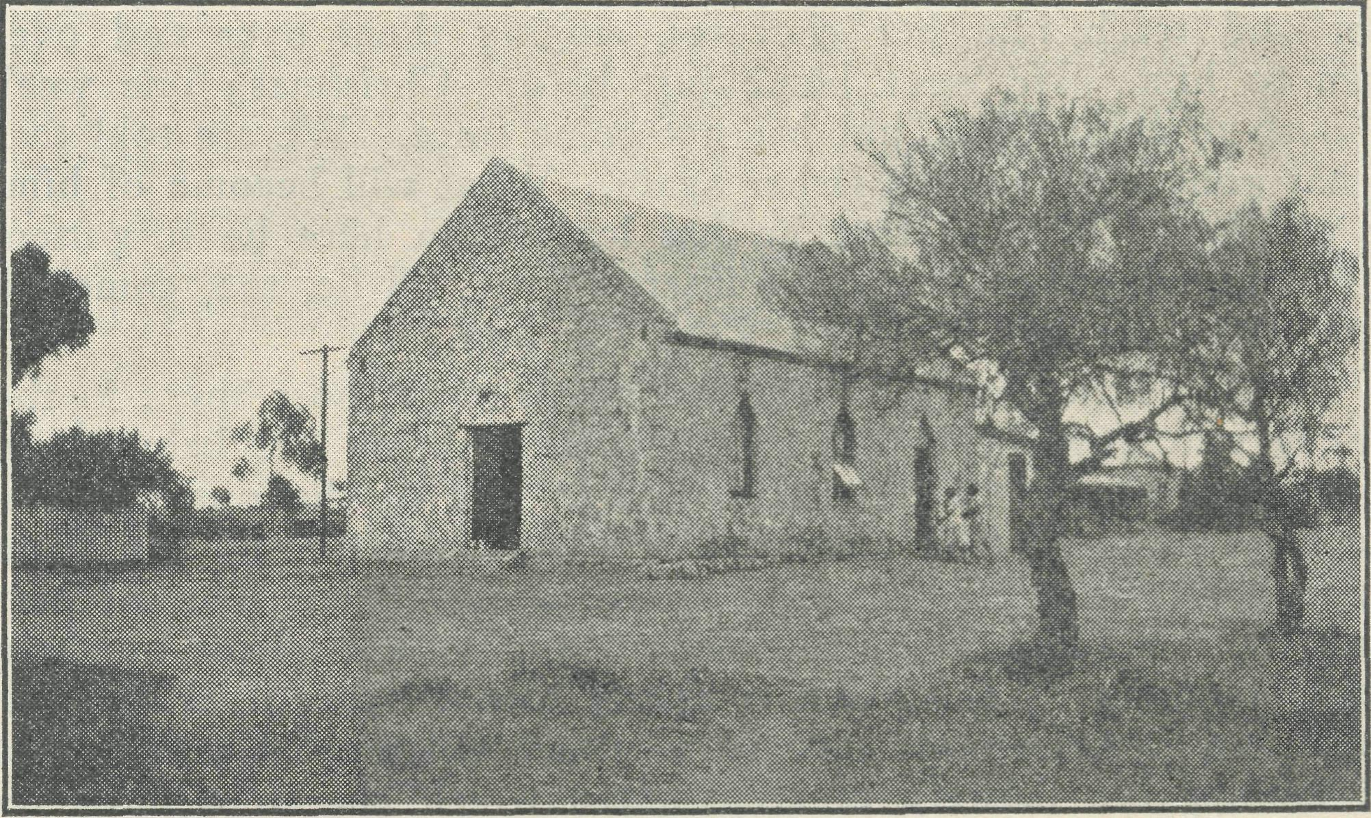
Schoolhouse at Koonibba Settlement, Lutheran Mission,
Almost immediately after the receiving of gifts, car and truck-loads of natives left for their homes ; some went to Wirrulla, some to Bookabie, and after the New Year the whole mission station was practically empty. Even the Children's Home was empty (all its occupants having gone to Denial Bay for a fortnight's holiday), and the only cottages occupied were the homes of the few faithful women who had stayed behind to milk the mission cows while the home people were away. As a reward for their labours they were) allowed to have all the milk produced by the cows, and before the parents were able to make the cream into butter it was devoured just as it was.
Apart from this side of things, Pastor Traegar has had much joy recently in the renewed interest taken in spiritual things, especially amongst the camp natives.
Firstly, there was a large Confirmation class to be taught, then a baptismal class of twelve, mostly camp natives. One of the most important of these was Yarry Tchura, and it was through his influence that all the old camp people desired to attend the classes to renew their knowledge of the Scriptures. I was attending to old Steve Hart's eye one day when a bell rang and Steve said what I though was "God bless you !" I was staring in utter amazement, because they never say anything like that, when I realised he had said "lesson," and he was off to his baptismal lesson. On the Sunday after the Confirmation and Baptism, Pastor held a Communion Service, and for the first time for years the camp people all attended, and it was most inspiring to see old "Lame Paddy" crawling up to the Communion rails on hands and knees. (He gets along everywhere in this manner, and although he had a wheel-chair at one stage, he has it no longer because he would persist in making it travel miles over rough roads.)
Yarry Tchuna is an interesting character. He was a native chief with much influence over the other natives. He still wearj his hair in the style of a chief (all plastered together and tied at the back). Over a year ago, Pastor tackled him about letting his two young grandsons come to the mission for Christian teaching. Yarry was so ferocious that the other natives had to protect Pastor against him. Then, not so very long ago, it was. with some

March 1, 1940.
The Real Australian.

astonishment that Pastor beheld a camel buggy arriving containing Yarry and family, for the children to be left in the Home. After depositing them, Yarry returned to his own way of living at Fow ler's Bay. Then a few months after, Yarry returned to the camp, this time to try and get some colleagues to take away from Chris' tianity back to his old heathen ideas. I remember, during a thunderstorm, hearing loud, yells from the camp on the hill, and was told that it was Yarry scaring away the thunder devil. How ever, the Holy Spirit works in most unexpected places, and it was not very long before, instead of getting converts to heathenism, the other Christian natives in the camp had begun to change Yarry's ideas. Then, again to the Pastor's amazement, he asked if he might be baptized. He was questioned and found to know what he was doing. After much careful instruction he was exam' ined by Pastor himself, as well as by two elders of the native con' gregation, and found ta believe absolutely in the saving power of Christ. Therefore it was with much rejoicing that he was received into the Church.
COOK.
Sister M. Symons.
This quarter we have many things to give thanks for. First, we must thank the women in Melbourne through whose efforts we were given an ether machine which makes the work out here so much more effective. It has already been used with great success.
Then the faithful band of men who built the hangar are still working. They have built a staff room on to the hospital and have now almost completed a morgue, which was badly needed, but which we trust will not often be used.
On December 6th we held a thanksgiving service in the hall of the hospital. We were very fortunate in having several of our Ceduna and Penong B.C.A. family with us for the event. As we had no patients at the time they were all able to stay at the hospital. There was quite a large gathering showing that the people of Cook are interested in the work of B.C.A.
Several new ones have come to our Sunday evening services recently.. If the numbers increase much more we will have to< have a chapel built. We know that there is a lot of prayer behind this service. Through the generosity of those who bought buttons we have been able to have ten blinds put up.
No doubt you have heard much about our lack of scenery over here, and it is all true as far as trees and vegetation are con' cerned, of which there is absolutely none. Yet we do have scenes of beauty which are not seen in the more hilly country.
A couple of weeks ago we were having a talk outside the hospital, when we saw approaching from the west a huge red wall, which was a magnificent sight with the setting sun behind it. It took us some time to realise that it was a dust'Storm coming. I was about fifty miles away when we first saw it, and it took about three'quarters of an hour to reach Cook. When it did arrive it struck with such force that it carried away two old tanks which we had hoped would catch the overflow from our other tanks, and with which we intended to water our garden(?). Alas ! poor garden. One tank is six miles and the other nine miles down the line—just a heap of galvanised iron. It took us two days to get the dust out of the hospital.
Another night we watched a storm which was a long distance from Cook. The lightning did not come in vivid flashes as I had been used to seeing it, but a continuous flutter which lasted over an hour.
Then again we do get some wonderful sunrises and sunsets, almost every day. So >you see we dwellers of the plains do not always deserve the sympathy we seem to get from our city friends.
Some amusing incidents do occur occasionally to break the monotony. This morning, as I was working in the kitchen, I heard some weird sounds coming from the ward. Only a few minutes before I had been in the ward and the patient was sound
asleep. Wondering what had gone wrong, I hastened to investi' gate, and found the patient gurgling with his thumb somewhere in the vicinity of his tonsils. After a few minutes he managed to tell me that he had swallowed his false teeth, and could neither get them up nor down. I stood for a few seconds wondering how I could get a six'foot man by his heels and shake the obstruction out of his throat, when I chanced to glance at the locker beside his bed, and there was the offending article. He had removed them before he went to sleep, and, waking up suddenly, he found his mouth empty and thought he had swallowed them. Total collapse of patient and staff.
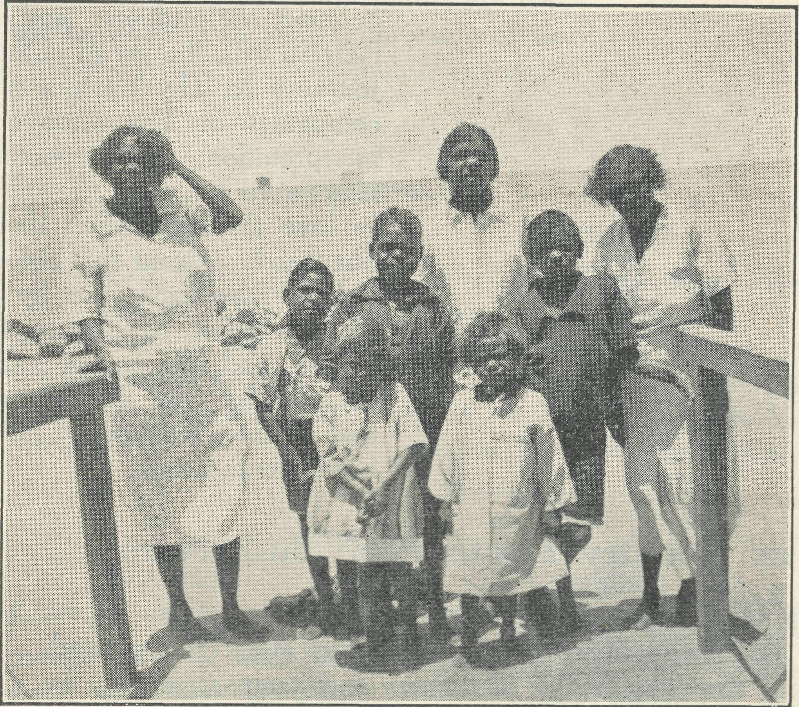
After a clean-up and an issue of new clothes from B.C.A. Hospital. AN INTERESTING HOLIDAY.
Sister Plumb.
Sister Plumb is the secretary of the Australian Nurses⁹ Christian Movement, and is vitally interested in the B.C.A. and its work. Most of the Society's nurses are obtained through her and the movement. For a long time we have been anxious for Miss Plumb to visit our hospitals, and at last she tvas prevailed upon to do so. It would not be out of place to pay a tribute here to Sister Plumb's interest in our work and to her very helpful advice in matters relating to our nursing work.
Perhaps many readers of the "Real Australian" have become familiar with the progress of the medical side of the B.C.A. Society's work on the West Coast, South Australia, during the past sixteen years, and will be glad to hear some impressions my mother and I received during our recent visit to this interesting part of the B.C.A. field. On October 21st we set out by boat from Sydney to Adelaide, where we spent a few days before leaving for Ceduna by the "Bungay," the Royal Mail 'plane which flies to Perth. It was our first experience of 'plane travelling, so we found it very interesting ; but we had a very hot and bumpy trip, and after two hours' travelling with head'winds, reached Ceduna. We were met at the aerodrome by Dr. Roy Gibson and Sister Dowling, and were taken by car through the straggling little town to the hospital overlooking Murat Bay, part of the Great Australian Bight.
The hospital we found was a beautiful building with wide
verandahs, and to our surprise there were green lawns and a
garden bright with flowers. So many of us can remember hearing
of the dearth of water other than for household purposes until
(Continued on page 1.2.)

The Real Australian. 10 March 1, 1940.
SPECIAL PRAYERS FOR YOUR USE.
For Church Life in Country Districts,
f\ LORD, Who art present when two or three are gathered together in Thy Name, bless, We beseech Thee, the little far-scattered groups of brethren who in our wide land meet together to worship Thee. Give them a perpetual freshness of spirit, and the power to inspire in each other holiness, helpfulness, and understanding of Thy help. Refresh with the joy of enthusiasm those who endure weary journeys to Thy trysting place. Grant that these little companies of Thy servants who, through differences of interpretation, are prevented from worshipping together, may yet be united in the spirit of Christian charity, awaiting in love the time when there shall be one fold and one Shepherd. Grant that the common life of all communities, isolated from each other by great distances, may be purified by this spirit of charity from all meanness, falsehood, malice, and idle gossip, and grant that they who share a common lot may draw strength from each other's virtues, and in their weakness help one another, through our one Lord, Jesus Christ.

For Country Doctors and Bush Nurses,
C) GOD, Who didst choose a beloved physican to set forth the life of Him Who went about doing good, grant that Thy strong tenderness and compassion may be manifest in the wz>rk of country doctors and bush nurses. Make them at all times alert to be faithful, as those whom Thou hast burdened and inspired with the honour of their calling. In lonely emergencies strengthen them with confidence that, having done all they can, they may with good conscience leave the issue to Thy power working within Thy law. Make them resourceful and of sound judgment, and hearten their labours with the energy of compassion and the firmness of duty that conquers weariness. Through Him Whose power is called forth by suffering, Jesus Christ our Lord.
For Drovers, Shearers, Stockmen, Dairy
Workers, and all whose work is the care
of animals.
Q GOD, Who called Thy Son Jesus to be the Good Shepherd, grant to all who are charged with the care of animals the spirit of understanding, care and compassion, and reverence for life. Preserve them from the unfeeling selfishness of "the hireling who fleeth because he is an hireling," and grant that they may do their work in the spirit of honourable responsibility, as those who will account to Thee for their stewardship of Thy creatures. Thou Who hast ordained that all living things shall minister to each other, grant that we may receive the service of Thy humbler creation with the skill of sympathy and conscience. Through Jesus Christ our Lord.

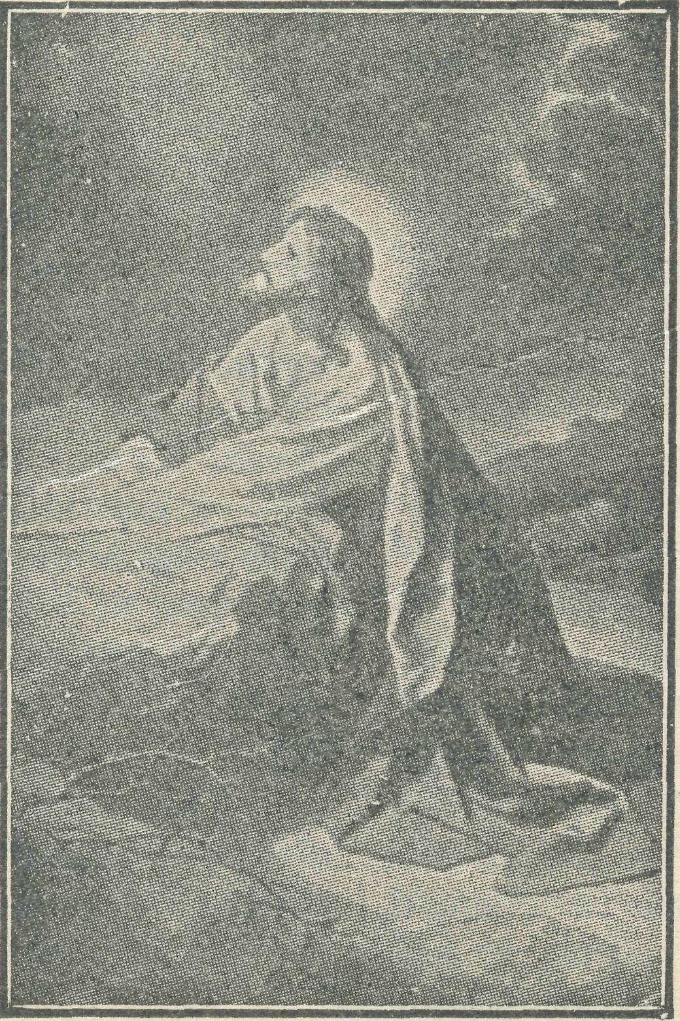

March t, 1940.
11
The Real Australian.

THE PLACE OF PRAYER.
A Prayer for Use with Our Prayer List.
O Lord God of our nation, Who has commanded men to subdue and replenish the earth : Look in Thy love upon all those who in the distant parts of our land are striving against many difficulties, and are deprived the access of the means of grace. Strengthen and guide the Bush Church Aid Society and its Clergy, Nurses, Deaconesses and Students. Cheer and comfort them in discouragements and loneliness, and bless their ministrations to the good of those they serve, and grant that the message of redeeming love may thus be rooted and grounded in our national life, to the glory of Thy Great Name, through Jesus Christ our Lord. Amen.

SUNDAY.
THURSDAY

MORNING.
EVENING.
MORNING.
EVENING.

The Far West Missions at The West Darling Missions Penong, Ceduna, Minnipa and at Wilcannia and Menindie :
Cummins ; the Missioners, Revs. E. V. Constable, L. H. Broadley, K. Luders and T. R. Fleming.
the N.W. Mallee ; and the Missioners, Revs. D. G. L. Livingstone, G. B. Calder-wood and F. Bayly.
For the Mail-Bag Sunday School with its Gospel message for the children. For the teachers and helpers, that they may find encouragement in their work.
For the Organising Missioner, that he may be strengthened and guided in all his endeavours for the good of the work and in his relationships with his fellow-workers.

FRIDAY.
MONDAY
EVENING. The Denmark Settlement,
MORNING.
The Cann River Mission,
the Bonang Mission ; and the the Kirton Point Missions and
Revs. N. Holdsworth and W. the Missioners, the Revs. B.
A. McLeod. Lousada and R. T. Hallahan.
TUESDAY.
MORNING.
For the Bishop Kirkby Memorial Hospital and Sister Symons and Miss D. Dykes as they minister to the people on the great Nullarbor Plain.
EVENING.
For students and all in training for this work of God. For Rev. G. Beatty and the Heytesbury Forest Mission. For Rev. T. H. Pickburn and the Otway Ranges Mission.

SATURDAY.
MORNING.
EVENING.
For Sisters Dowling, Boss- For the Cann River Dis-
ley, Page, Pritchard, Loane, pensary and Koonibba Mission
Nurse Branford at Ceduna ; Hospital ; and Sisters I.
Sisters Goodwin and Eglitzky Harris and G. Hitchcock,
at Penong.
WEDNESDAY.
EVENING.
MORNING.
For the children in the For the Flying Medical
Mungindi and Wilcannia Service, Mr. Chadwick, and
Hostels, and for the workers, Doctors R. and F. Gibson.
Miss Cheers, Mrs. Mann and For the wives and families
Miss Taylor. of the Missioner and Air
Pilot.

EVENING.
MORNING.
For the "Coorah" Hostel and its workers, Sister A. Spence, Miss M. Boydell and Mr. I. Taylor.
For the President and Council of the Society, that they may be guided by His wisdom.
For the Home Base Staffs, Auxiliaries, and parochial workers.
Each day pray that the many needs of the work may be met.
Running expenses of 35/- per hour to keep the Medical 'Plane in the air.
Consecrated clergy missioners for urgent work in the field.
That our work may continue to progress despite the difficulties of wartime.

Give Thanks—
For the rich blessing and wonderful growth of the Society's work. For all the kindly givers who have helped with their self-denials. For the Flying Medical Service. For the opening of the new Hostel at Wentworth Falls. For new workers in Hospitals and Missions. For the joy of service.

The Real Australian.
12
March I, 1940.

(Continued from page 9.)
the pipeline was laid down some years ago from Port Lincoln. Of course there are several tanks for drinking purposes as well.
It was a joy to be welcomed warmly by the hospital family, and to be taken on a tour cf inspection round the pleasant wards, the splendidly equipped operating theatre, obstetric wards, the X-ray and Iron Lung ; also the fine kitchen, and last, but not least, the pretty nursery. This modern hospital is naturally the pride of the whole district, and there seemed to be a constant stream of patients, some of whom came in for immediate operation in the middle of the night.
The staff consists of five A.N.CM. nurses (Sister Dowling being Matron), and all are intensely interested in their healing ministry and meet each morning after breakfast for a song-song, well-known hymns and choruses being chosen. The patients appre' date this, and also the daily Bible-reading and prayer in the wards. This is a mission hospital where they live and preach Christ in practical ways, and many have come to know and trust the Saviour while in hospital.
We were privileged to be present at the weekly Bible class at the hospital, which is open to all in the town who> desire fellow-ship, when the Rev. L. H. Broadley led us in Bible study and prayer—a very profitable time indeed. There was also the weekly ward service, when a message from God's Word was given. Each evening we had prayer and fellowship with the "family" ; • this was a real joy.
Of course, we were delighted to meet Doctors Roy and Freda Gibson, who render such wonderfully unselfish service to each of the B.C.A. hospitals < also Mr. Chadwick, the splendid pilot of the B.C.A. medical 'plane, and his wife. Mrs. Chadwick, we found, was the organist of the little church. The only Sunday we were in Ceduna we worshipped there. It was an evening service, pre ceded by a baptism and followed by Holy Communion. Myriads of insects were there to torment us, for it was a hot spell.
Having heard so much of the "rectory¹¹ (just one stone room until recently), we were glad to see that there was now quite a nice cottage in addition.
One afternoon the Rev. L. H. Broadley took us with him on a pastoral visit to Denial Bay, and then to Thevenard, a Greek settlement where there is a thriving fishing industry, and we realised the difficulties encountered by a B.C.A. padre in visiting his people. Another afternoon Dr. Gibson drove us to Koonibba, the Lutheran Aboriginal Mission, twenty-five miles away. What an exciting drive we had, for the road was under water almost all the way. The Dodge behaved splendidly, considering it was not a boat. We received a hearty welcome from Sister Hitchcock, who proudly showed us round her nice stone hospital.
Recently there had been an epidemic of influenza and pneumonia among the children, but all recovered, which proved to the Protector that with proper care and nursing there need not be a heavy mortality from such epidemics among the aborigines.
Pastor and Mrs. Traegar entertained us at afternoon tea and showed us round the settlement, and finally we visited the bush blacks in their "wurlies," all of whom are cared for by Sister when ill. Sister is beloved by her large family of about 200 dark people.
When the day came for the monthly visit to Cook, I had the opportunity of accompanying Dr. Roy Gibson and Sister Dowling in the VH-AAA Moth 'plane. We prepared for various kinds of weather and off we flew. What a thrill it was to be in the little medical 'plane, which is housed in its own hangar with its wings folded back like a bird, at the aerodrome at Ceduna. Mr. Chadwick is a perfect pilot, and we flew so easily it seemed, keeping the coastline in view for many miles until we turned inland to Nullarbor sheep station, where we landed and refuelled. While this was being done, Mrs. Brooks invited us into the homestead, where we found a lovely fire as well as hot scones and sausage rolls, and we were regaled with many cups of tea. Mr. and Mrs. Brooks are good friends of the B.C.A. family.
As we continued our journey, we flew above the clouds part of the time—a glorious sight, like a huge snowfield ; and then we saw pools of water shining in the sun all over the Nullarbor Plain as far as the eye could see. Before sunset we arrived at Cook, and landed in the "field" which had been carefully denuded of stones, and a hangar built by voluntary labour by the men of Cook, adjacent to the hospital. Sister Symons and Doreen Dykes were on the lookout and feeling somewhat anxious as we were later than they expected.
The Bishop Kirkby Memorial Hospital is a worthy monument to a great man. It is a modern, well-equipped hospital, not far from the railway station of the Transcontinental Line, and is at the end of the long row of houses where the railway people live. There is a post office and general store, and this is Cook.
One was impressed by the lofty ceilings in the hospital, the up-to-date operating theatre, the wide hall and verandah—the latter needing long canvas blinds for protection from the strong winds which constantly blow. (Some of the blinds have since been procured.) Linoleum now covers all the floors, which adds to its comfort. In the men's ward "King Tommy" was a happy patient, quite content to be in bed, though he felt at first to have had his foot amputated by Dr. Freda Gibson and then to be cared for by "two women" was the last straw ; but he had survived the ordeal. We saw many of his own people hovering around the hospital, so he was not lonely.
Many patients were seen during the evening, and so the doctor and sisters were kept busy.
Doreen Dykes is very proud of her white kitchen, so spic and span, with various cupboards right up to the ceiling. Late in the evening we were glad to gather round the fuel stove for warmth while we yarned, then followed a hallowed time of fellow' ship and prayer, and finally bed.
How it rained and blew all night ! Next morning Lake Seldom and many miniature lakes could be seen everywhere. Cook is so flat and gets frequent dust-storms, so the rain was a pleasant interlude.
Sister Symons is learning many things, such as taking her turn leading the Sunday evening service, to cultivate a garden in spite of the goats which wander everywhere, and to diagnose diseases and conditions of patients without a medical man. She and Doreen are enthusiastic gardeners, and in all they are doing are counting on constant prayer and help, for they are very isolated.
Our thirteen hours' visit was brief, yet we felt we had made the most of it. There was red mud everywhere as we took off very regretfully early next morning and headed for Colona Station to refuel. We were flying among the clouds when I looked earth' wards, and saw a car, looking like a tiny speck racing along a ribbon-like track. I discovered this was for our benefit—it was the petrol, and shortly we began to descend to the landing-ground. The homestead had received a telegram saying when we had left Cook, so were prepared. Ccorabie is also visited on this monthly trip and patients come in from the surrounding district to see doctor.
Soon we were in the air again, heading for Penong, which we reached in time for lunch. Sisters Goodwin and Eglitzky, with Sydney James Cook, came out to meet us. Having heard so much about Penong, I was interested to see the hospital situated amid rolling downs, so different from Cook. The hospital is built of stone with verandahs all round, and has a spacious hall, several small wards, operating theatre, a nice garden, and quite a conservatory on the back verandah. The people of the district erected the hospital twelve years ago. Doctor visits Penong weekly, which is quite a boon. I was delighted to see Sydney James—to see him is to love him. He is a bonny boy of two years, and well trained, and of course runs about everywhere and gets into every kind of mischief. He is slow of speech, but no doubt he will make up for it later on.
The Rev. and Mrs. E. Constable live near by, and the church is close at hand, but the parish extends for 300 miles, and includes Cook and beyond. Many of the folk are very isolated and appreciate the efforts being made to reach them with the Gospel message.

March I, 1940.
13
The Real Australian.

These folk need fellowship in these outback places, and B.C.A. seeks to meet this need. It was good to see what was being done at Penong.
We left for Ceduna as the sun was setting, though I had hoped to spend a day or so there. We had received word that seats were available on the 'plane going to Adelaide next day, so
mother and I packed up on the Friday and reluctantly bade farewell to the B.C.A. family at Ceduna. We felt sad as the 'plane rose in the air, and saw them waving farewell, for our six days¹ sojourn with them had been so happy in every way. We had seen God at work through His servants on the West Ccast, and had realised how dependent they were upon our prayers for them.

NEWS FROM THE
ISSIO.N

CEDUNA. Rev. H. Broadley.
An unusual combination of circumstances led recently to a famine of Church of England clergymen in the districts west of Port Lincoln. The railway line from Port Lincoln to Penong is about 330 miles long. All the B.C.A. mission centres are on this line. Two other parishes have their centres on the coast, namely Streaky Bay and Elliston. The Rev. E. Constable left early in January for his holidays, thus Penong was temporarily vacant. The Rev. W. McLeod left Minnipa to return to Sydney. The Rev. R. T. Hallahan was on holidays, too. Streaky Bay has been without a clergyman for some months. It thus came about that west from Ceduna the nearest Church of England clergyman was somewhere near Kalgoorlie in W.A., and east from Ceduna the nearest was at Elliston, nearly 200 miles away. This gives some idea of the areas served by B.C.A. missionaries. As I was in the centre of this great district I naturally hoped that nothing would happen which would require long trips up or down the coast. So far nothing has happened, and it has been straightforward going to do the work in and around Ceduna.
Straightforward going does not mean that the missioner is surrounded wherever he goes by keen people eager to know the Gospel, or to know more of it. There are some who are eager to learn all they can of the Christian Faith ; there are others who have allowed the difficulties of their life on the farms to crowd out a longing for heavenly things. The darker and lighter sides of work here are shown by the following :
In districts where there are hardly any C. of E. families, so that a service in a hall is not wise, the solution lies in a cottage service, which, of course, has to be on week-nights. In one such district I offered to come out to more than one family and give them a service about once a month. In each case the offer was turned down. Reasons are not given. A general unwillingness is all that appears on the surface. It is frankly disappointing, but it doesn't do to give up hope. The missioner still has a respon' sibility towards those people, and by prayer and thought, looks to God to show the way round the difficulty.
On the other hand, encouragement is given by such little confessions ""as was made the other night by a girl who is one of a number of children who attend the Bible class. She said, "Last week I went up to a lady's house to deliver the milk. It was about twenty-five past seven. She said to me, 'Aren't you going to Bible Glass to-night ?' I ran all the way home and got ready, and ran all the way down to the hospital, and then I found I wasn't late after all."
No doubt similar experiences are met with by city and suburban clergymen. That is to be expected, because human nature is the same wherever we go. It is more and more evident that men and women everywhere need the inspiring and cleansing power of the Gospel. The B.C.A. exists so that our own countrymen won't miss the opportunity of hearing and responding to the call of Jesus Christ.
THE OTWAY MISSION.
The following extract is taken from a newspaper published in Western Victoria, and tells of the opening of the new rectory at Beech Forest.
It is nearly twelve months since B.C.A. became responsible for the Church work in the Otway Ranges, and Mr. Pickburn and his wife are doing a very splendid job there.
The news extract is published here so that our friends will appreciate what value the local people put upon B.C.A. help, and also it serves to indicate that the diocese and the people them' selves are doing all in their power to cater for the spiritual needs of the district.
B.C.A. exists to help bush people to help themselves.
A SIGNIFICANT EVENT.
"The opening and dedication of the new vicarage was a very significant event in the history of the Otway. It was the begin-ning of a new era of life and hope, and the end of a long period of trials and setbacks. During that period of trial the flag of the Church had been kept flying by the devotion of the church-people throughout the district. If in one or two places the flag had been hauled down, it was only a temporary withdrawal—what might be termed a strategic retreat," said the vicar.
"It is our duty and privilege to lock forward with hope," said Mr. Pickburn. "A new era in the life of the Church was signified by the ceremony that day, in which the work of the Church in the Otway could be given the full attention of a resident priest. We are now in the happy position where the priest and the people can work together in the furtherance of the work of God.
Mr. Pickburn said that he was sorry that Mr. Fleming, the representative of the Bush Church Aid Society in Victoria was not able to attend, as it would have been his privilege, on behalf of the church-people of Otway, to extend to Mr. Fleming their appreciation of what the Society had done in the Otway. "The one way we can shew our gratitude is by our loyalty and love for the Church," concluded Mr. Pickburn.
A MISSIONER GOES TO PRISON.
Rev. G. Beatty.
Since the last issue of the "Real Australian" another avenue of service has opened up for the missioner in the Heytesbury. He has been officially appointed chaplain to the recently established Cooriemungle Prison Camp. This is the first prison camp to be established in Victoria, so B.C.A. has supplied the first chaplain of the first prison camp in this State.
The camp, which consists of a collection of permanent buildings for the housing of officers and prisoners, is situated on the edge of a virgin forest of some seventy thousand acres. The prisoners are drafted from Pentridge Gaol after having served a third of their sentence, and are good conduct men. They have much more freedom than they had at the gaol.
The first objective of the camp is to get a farm going, and to become more or less self-supporting, and then the prisoners are to clear the seventy thousand acres of forest and to make roads through and to prepare it for settlement ; but it will be many years before this is accomplished. At present the men are engaged in fencing the camp. T© do this they have to cut a line through the forest, the fencing posts being split from the trees that are knocked over.

The Real Australian.
14
March i, 1940.

The missioner visits the camp every week, and also holds ser' vice there once a fortnight, on a Sunday afternoon at 4.30. Officers and prisoners alike have given the missioner a great weh come, and the work at the camp presents unique opportunities.
Come with me and meet one or two of the chaps. Here is Frank ; he is thirty years of age, was a bank officer, but is now doing three years for embezzlement. What was his downfall 7 Gambling, lived above his means, fiddled the books to pay his debts. Listen to his story. He went to Sunday School, sang in a Church choir, belonged to Church clubs, left off going to Church, became an .outsider. But listen ! He is speaking : ''Honestly, padre, I am not telling you this simply because you are a padre, but because I mean it. I can definitely trace the beginning of my downfall to the time I went outside of the Church. But now I have come right back and will never be a backslider again. The only thing that has kept me sane in gaol is religion." He is a chap of good physique and above the average intelligence, and means what he has just said. Pray for him.
Meet George—a good chap with high ideals now. His money got mixed up with the funds of the firm he was working for, and he did not know which was which. He lived a high life, had a car he could not afford, "fiddled the books, fell in the soup,'" and is now "doing a stretch." No, he will never do it again. He has become an interested Bible student, and acts as verger for the services. Pray that he may make a complete surrender.
Let us move on. Here is Stan. "Hullo, Stan ! How are things tO'day ?" "Fine, thank you, sir, fine.'¹ The other day Stan came to me with a profession of conversion and he is certainly bubbling over. Pray that he may grow in grace and in the know ledge of our Lord and Saviour, Jesus Christ. Pray that his new' found faith may stand the test of the trials and temptations of life. He is soon to be released.
There are, of course, one or two who have lived on the game, and who will be at it again as soon as they are released, unless a radical change comes over them soon. There are others who present problems which are not easy of solution. Pray for them all. Pray for the missioner as he moves amongst them.
The services at the camp, which are held in the prisoners' recreation and mess rooms, are most hearty. The singing nearly lifts the ro'of at times, and there is always a solo or a duet from one or two of the men. Each chap takes a genuine interest in the services and listens intently whilst the gospel is preached and the vital truths of Christianity expounded.
WATCHNIGHT.
Rev. T. R. Fleming.
When so many are carelessly saying "gocd'bye" to the old year and "welcome to the new¹'' with never a thought for its opportunities and its responsibilities, it is good that the Church should make a call for a more careful attention to the solemnity of the moment.
But for the congregation in the little Church of St. Philip at Delegate the last Watchnight Service was something more, for it marked the end not only of another year but also of my ministry there. It was a heart'searching time for me. There was the consciousness of all the failures and of all the things not yet done that one would have liked to have done. But it was a time also of fulness of heart, of real thankfulness to God for what He had given me the strength to do. It was a sad moment of farewell to many dear friends.
Somehow a bush ministry, in spite of all its peculiar difficuh ties of working with small groups and scattered districts, does allow the missioner and his people to really get to know each other. Their sorrows are your sorrows and their joys your joys in a much closer relationship than is possible in the bustle of a city parish, and so the moment of parting brings up such clearer and vivid pictures of your people—the people you have learned to know and to love, the people who have become very truly your friends.
And so I looked over that congregation and in the beauty and strength cf our service of Holy Communion we felt our' selves one as the children of our Heavenly Father.
I can never adequately express my feelings, nor could I repeat those sacred little farewell words of each one at the door after' wards, but I do know that in every heart present was a deep thank' fulness to God for the B.G.A. that had made all that went before in those three years a possibility, and which made that service a beacon of light in the bush, calling the men and women of our great outback to the foot of the Cross of Jesus Christ.
CANN RIVER.
Rev. N. Holdsworth.
As some of our readers already knew, the mission district of Croajingolong consists of twelve centres grouped about Cann River as the logical centre. All of these receive regular attention, services being held, at the least, once a month, some fortnightly, and Cann River once a week. But there are many other smaller communities which so far it has been impossible to do any more than just visit occasionally.
The parish comprises about 6,000 square miles, and is filled to capacity with God's gifts of typically Australian fauna and flora, and each valley is rich in agricultural and horticultural products.
During winter months the greatest impression upon a" visitor would be that of loneliness—scarcely a soul is to be seen as one traverses the good but monotonouslycurved roads. But with the coming of spring the place just seems to teem with wild'life and the most glorious wild'flowers imaginable ; and to dispel the former impression come literally thousands of tourists and campers to visit such places as Mallacoota, Tamboon, or to fish in fresh waters of the Combienbar and Bemm.
Car'driving then becomes a nightmare, and every one of the thousands cf bends is a potential death'trap, due principally to the efforts of our inglorious legion of "mug'drivers"—those bright specimens who, having paid their registration fees, proceed to stake out their claim on both tracks of the road by travelling at ridiculou-speeds, usually upon their wrong side.
But far away from Prince's Highway are little valleys sparsely populated and their inhabitants almost completely cut off from all amenities of civilisation ; and it is here that the missioner is most welcome.
One visits a farmhouse containing say seven members of a family. After a long yarn and a good cup of tea, the missions suggests a season of prayer. With apparent delight the whole family kneel around the big table, and there we discover that He is in the midst of us, and we place our troubles, our hopes and aspirations in His tender keeping, and it is brought home to all that "underneath are the Everlasting Arms." The missioner pro' ceeds on his way, conscious that his ministry as the representative of the whole Church has been instrumental in lifting these lonely people up to the very throne of the Heavenly Grace.
But there is such a thing as "local temperament," which cotv sists mainly of prejudices against this and that and the other thing ; and when the missioner has the misfortune to run up against lr his lot will not be particularly happy, and there will be many dark days when his ministry will seem to be so ineffective that it is only his faith and love for people that prevents the despairing cry, "Oh ! what's the use ?"
At these times I would remind readers of the very real sense of prayer by others for him, and their actual help in the 'field, and other helps, enable the missioner to go on with his appointed task. Never cease to pray, my friends, not only for those to whom he ministers but for the missioner himself. And this I know to be true cf all the other fields of service and the men and women who work in them.
However, taken by and large, the district is quite a happy place, with occasional breaks from the tire of life by sports meetings, picnics, and trips to the beach, fourteen miles away.

March 1, 1940.
15
The Real Australian.

At Cann River we have both boys¹ and girls' clubs, which are the means of providing spiritual and social aids to our growing young Australians.
During a recent hike of the C.E.B.S., at which twelve beys wc^{ere} present, we walked seven miles and had a great time, and even the smallest (six and a half years old) insisted on coming home "under his own steam," and scorned the proffered help of a "pickaback." But the highlight of the trip was this. During a "spell-o" one lad was heard to remark, "Gee ! Laurie's sitting on a bull-ants' nest !" Laurie (eight years old, and usually slow, and a bit dull) laconically replied, "I was" ! !
"BUSH CHURCH AID SOCIETY."
jRsv. A M. Fulford.
How that word "bush¹¹ brings to the mind of the real Aus-tralian the glory of his own native land. It tells him of the huge forests and vast spaces of the "outback" in a way that no other word can even suggest. The bush to him includes all that large area of sparsely populated country including many fair-siz,ed towns in the hinterland, or just back from the coast of every State in the Commonwealth.
The "bush," as our nurses and missioners know it, is a place, where men and women live mainly in isolated districts, and a place where the ministrations of the Gospel of Christ are just as precious as they are to those whose dwelling-places are in the larger cities. It includes for them such places as the widely spread Nullarbor Plain of South Australia, the forests of Gippsland in Victoria, and the large areas of the Darling and Murrumbidgee in New South Wales. It is criss-crossed by some of the worst roads in the whole of Australia, and it means travelling under conditions of which city dwellers can have but the faintest idea, unless they themselves have been fortunate enough to do a trip out back. I say fortunate enough because, in spite of the hard going, much of the country has a beauty all its own, and in most instances they have come in contact with some of the finest characters in Australia.
The word "Church" is a very precious term to many. It speaks of fellowship, inspiration, service ; but if we interpret it in the light of what we learn from the story of its development it is a nobler, grander and even healthier term than that narrow parochial conception of it which seems to be the usual interpre-tation. What do we mean by "Church" ? Perhaps it means some splendid building with beautiful appointments and a service where there is a good choir and excellent music, many opportunities for fellowship with others who also love the Lord Jesus ; a place of inspiration and help for the workaday life ; a veritable spiritual home where love and faith and service vie with each other for first place. W⁷hen that word serves to describe the little groups of worshippers in the outback its all so different. It is the scattered portion of Christ's flock rather. Here and there is some lonely settler whose house is off the beaten track and miles—many, many miles sometimes—from other folk. This outback man is a believer in Christ Jesus ; his wife and children are with him in the same fellowship, and he feels the need of the means of grace most keenly. Or maybe we see a small group of people gathered into some home, school house or tiny church. Perhaps the music is not so £.^{r}.%nd and the service is of a very simple nature, yet it lacks nc^{tn}nng of reverence or sincerity, or even for that matter of inspnªtion and fellowship. The Church outback, consisting as it so ° ften does, of "two or three gathered together in His Name," is a vital part of the Body of Christ. It is to this Church that the Society endeavours to render all possible aid in order that it may grow stronger and holier, and then in its turn be a helper to those who dwell beyond the "outback."
The word "Aid" brings before us many pictures of which our society may be justly proud. One might stand at the door of some lonely homestead and wonder if the children have any oppor-tunity of knowing our Lord Jesus Christ. Presently that one is made conscious that the little ones are engrossed in the study of
the B.C.A. Mail-Bag Sunday School lesson, and the parents seem to be almost as keenly interested as the children. Or it may be one looks down the road. That cloud of dust just new on the horizon ? Iti is the missioner's car. One of his rare visits to this out-of-the-way place. Everyone in the house is now hurrying out to meet their friend who comes to them from the far-distant township. He is an ordained minister of the dear old Church, and finds time to visit those isolated members of his flock. Indeed, he counts it a happy service for them and his Divine Master. It has meant for him many hours on the road, but what matters that since their spiritual: needs can be met in this way only.
There is yet another picture. It is the sickroom. Home remedies haven't made much difference, the doctor is so far away, the patient seems to be getting worse, thoughts of possible death and the awful loneliness makes the anguish terrible. Then word is brought that the B.C.A. 'plane with the doctor and nurse is on its way. Time makes all the difference between life and death. Up there the reads are not so rough, and there is no delay through broken springs and punctured tyres. Soon the 'plane is on the ground. The doctor finds the case is very serious—-expert nursing and maybe an operation. The 'plane departs with a stretcher case. Left behind is some patient loved one, but there is lots of confidence and courage because of the knowledge that the aid rendered at the B.C.A. hospital is of the best.
And so one might go on telling the story of help given the out-back people of the Church. The hostel for children attending school so far away from home, hospitals, motor cars and 'plane, Churches cooperating with nurses, doctors, clergy and lay-workers —each fitted into the plan of helping the needy.
My story is complete when I remind my readers that the B.C.A. is a society or fellowship in which many friends unite in a service for their Master—some working at the home base and others performing their part of the scheme far afield—all part of the B.C.A. Society with its slogan "Australia for Christ."
"HERE AND THERE."
Rev. G. B. Calderwood.
A few days before Christmas I returned to Menindie after a very hot day in the out'back. Ambling up the main street at about 15-20 m.p.h. in our new Chev. I received quite a shock. A man jumped on to the running-board and stuck his head through the open window. I nearly jumped out of the seat ! One look at him and I could see he was desperate. "Mr. Calderwood, could you do me a favour ? My youngest boy is running a tempera' ture and is in agony. Sister thinks it is appendicitis. There is no one else who can help us. Will you run him into the Broken Hill hospital—please !"
The next train for Broken Hill wasn't due for two days, and two days is a long time for a boy in that condition. Swallowing a cup of tea, filling up with petrol, and dashing round to the boy's home, we were soon ticking off the seventy-five miles to hospital. It was rough travelling, particularly at night. The boy was very sick three or four times, causing delay, and every minute was precious. At 11 p.m. we drew up at the hospital, and a very grateful father¹ shook me by the hand. The lad was in time. Coming back to Menindie after a holiday, the first one to greet me in Sunday School was the smiling face of the boy who was the principal in that anxious drive through the night.
"The Police Sergeant would like to see you, Mr. Calderwood." What on earth had I done ? Calling in at the police station, I soon discovered. Two aborigines wished to embark on the sea of matrimony. It was a splendid wedding. The bride, decked out in veil and bouquet (supplied by the Australian Government), and carrying a New Testament ; the bridegroom in navy-blue suit, and the best man in white duck trousers, made a charming picture fit for any paper. They were married on the front lawn of the assistant manager's home at the aboriginal station, the lawn being suitably decorated for the occasion. The only thing absent was confetti. I was very conscious of dozens of black faces peering

The Real Australian.
16
March 1, 1940.

over the fence and gates, for only a privileged few were allowed to sit on the lawn.
Afterwards a reception ! I have attended many such functions, but never one like this one. The right spirit was present. The affair opened with prayer, followed by a well-known chorus, "Into my Heart." The Doxology was rendered, the happy couple wished "God'Speed," and a very hearty meal of tea and biscuits brought the evening to a close. How vastly superior to many of our fashionable weddings in Melbourne and Sydney. It was a privilege to be asked to perform such a sacred office when two hearts pondered the vows so seriously.
The time is 1 a.m., there is a knock at the door, a voice calls "Are you awake ?" A boy of some eighteen years was standing there. In a voice choked with tears, he informs me that his father has passed on into the unseen. Would I go down to his mother ? Of course. I had been speaking to the deceased
a short time before he collapsed. The shock of his death was severe. In the small hours of the morning, in a dimlylit room, we commended him to the Father. A brave little lady thanked God for the ministry of the Church.
The work goes on. There are countless difficulties to be over' come. But here and there we are able to render a service in the Name of the Master, and He is brought nearer to the people.
OUR NEXT ISSUE.
Our next issue will be published in June, and will be a special 21st Birthday issue.
Cost of printing and paper will net allow of waste copies.
If you desire any extra copies of our Birthday number, please send intimation to that effect to Melbourne or Sydney office. Extra copies will be 4d. each.

POSTS AND RAILS

During the past few months some changes have been effected in the location of a number of our missioners. In the ordinary course of events we should have had to announce that the Revs. T. R. Fleming and Wm. McLeod had concluded their terms of service, and we would have been faced with the very difficult problem of replacing them. It was, therefore, with much happiness that we learned that both of these workers were ready to serve another term in a new¹ sphere. Four changes have therefore taken place. They are as follows :—
The Rev. T. R. and Mrs. Fleming have transferred from Delegate to Cummins ; the Rev. Wm. and Mrs. McLeod have moved to Delegate ; the Rev. R. T. and Mrs. Hallahan are now located at Kirton Point ; and the Rev. K. Luders is in temporary charge at Minnipa.
Such transfers are a heavy drain upon finances for they involve a considerable sum in fares, freight and reconditioning of motor cars. The great benefit derived is that the Society is able to have the services of these workers for a longer period, and they bring to their new districts a rich experience. Pray for them and their work.
•£♦ •?♦ •$♦
We regret to report that the Rev. N. Holdsworth, of Cann River, recently suffered considerable injury as a result of a car accident. At the moment of writing he is making a good recovery in the Berwick (Vic.) hospital. It will be some weeks before Mr. Holdsworth is again fit for duty. Sister Isobel Harris, also of Cann River, has had to relinquish her work for health reasons. Our readers will, I am sure, specially remember both these workers in their prayers.
•$• •$» .♦$• ■
Sydney has had an influx of B.C.A. workers of late, for during the months of January and February we saw the faces of Rev. E. and Mrs. Lousada, Rev. E. and Mrs. Constable, Rev. Wm. and Mrs. McLeod, Rev. D. and Mrs. Livingstone, Rev. G. and Mrs. Beatty, Sister Page, Mrs. Mann, Miss Taylor, and Miss C. Roes. We hope that they all enjoyed their holidays and go back refreshed.
We offer our sympathy to Mrs. R. T. Hallahan on the death of her mother, Mrs. Boyce. Mrs. Boyce was a staunch friend of B.C.A. for many years, and since her daughter's marriage to Mr. Hallahan, spent a considerable time at Werrimull and Cummins.
<►?» •£» ♦$♦
In our last issue a request from Mr. Chadwick was published for a "blind flying" instrument. We are happy to be able to announce that funds were speedily given for this purpose, and the instrument is now on order and we await delivery from England. This will be a big boon to Mr. Chadwick as well as to those of us who have responsibility for the safety of workers.
Recent additions to the B.C.A. family are to be found in the following : To the Rev. and Mrs. T. Jones, a daughter ; to the Rev. and Mrs. K. Luders, a Son ; to the Rev. and Mrs. W. McLeod, a daughter ; to the Rev. and Mrs. T. R. Fleming, a son ; to the Rev. and Mrs. G. Beatty, a daughter ; to the Rev. and Mrs. G. Calderwood, a daughter. It would therefore seem that B.C.A. is assured of future missioners and nurses.
♦ ♦ ♦ ■
Miss Ida Andrews, who for some years has been in charge of the domestic arrangements at Ceduna Hospital, has resigned that position. Miss Andrews hopes that very soon she will be able to commence training at one of the Sydney Hospitals. We regret to lose her services, but rejoice that she is seeking to fit herself for further service. We wish her much blessing and success in her new sphere.
•$♦ *§♦ ♦$♦
Recently the O.M. was asked to be the special preacher at St.
Luke's, Mosman, on the occasion of that parish's Harvest Festival.
After the service the O.M's. car was loaded up with all manner of
groceries and tinned goods for the "Coorah" Hostel. These have
been a very great help, and we say a very real "thank you" to St.
Luke's and its rector, while commending the idea to other parishes.
•£♦ *§* *§*
While on the subject of groceries, may we say that with three hostels and four hospitals for which we are now responsible, B.C.A. will appreciate more than ever gifts of groceries and foodstuffs. Have you forgotten those neat little "Globite" cases called "Swags" ? Come to the office, pick up one, and help your friends to fill it with groceries. By all means "knit socks for soldiers," but don't forget to "Give groceries to B.C.A."
»£♦ <►£♦ »|*
Each year's end brings into the office an old and valued friend of B.C.A. in the person of Mrs. F. J. Marshall, of Bexley. Mrs. Marshall's visit is for the purpose of handing in a sum of money collected by her in the district in which she lives. Such a task as that of collecting is by no means a pleasant one, and calls for much in the way of devoted interest. Mrs. Marshall has been doing this work since 1923, and in that time has collected the very good sum of £292/19/'.
Many folk ask what they can do to help the Church in its work—here is one answer ready to hand. Seventeen years of constant and devoted labour by one who not only says that she thinks B C.A. work "very splendid," but is also moved to do some' thing for it. We offer our thanks not only to Mrs. Marshall, but to all those people who, over the years, have aided her by their kindly giving to render such signal aid to the B.C.A. We hope that such interest will continue into future years.

March 1, 1940.
Vi
The Real Australian.

On February 8th the A.N.A. airliner, "Bungana," made a forced landing at Dimboola, Victoria. It appears that a large eagle crashed into one of the engines and broke a petrol pipe, which caused the 'plane to catch fire. Some very wonderful handling on the part of the pilot enabled the big machine to be landed without injury to the passengers or crew.
Mr. Allan Chadwick, with his wife and small daughter, were passengers in the "Bungana" at the time. They were returning to Ceduna after holidaying in Melbourne. All our friends will rejoice with us to know that, apart from the shock inseparable from such an experience, the Chadwicks are quite well. We thank God for His gracious protection.
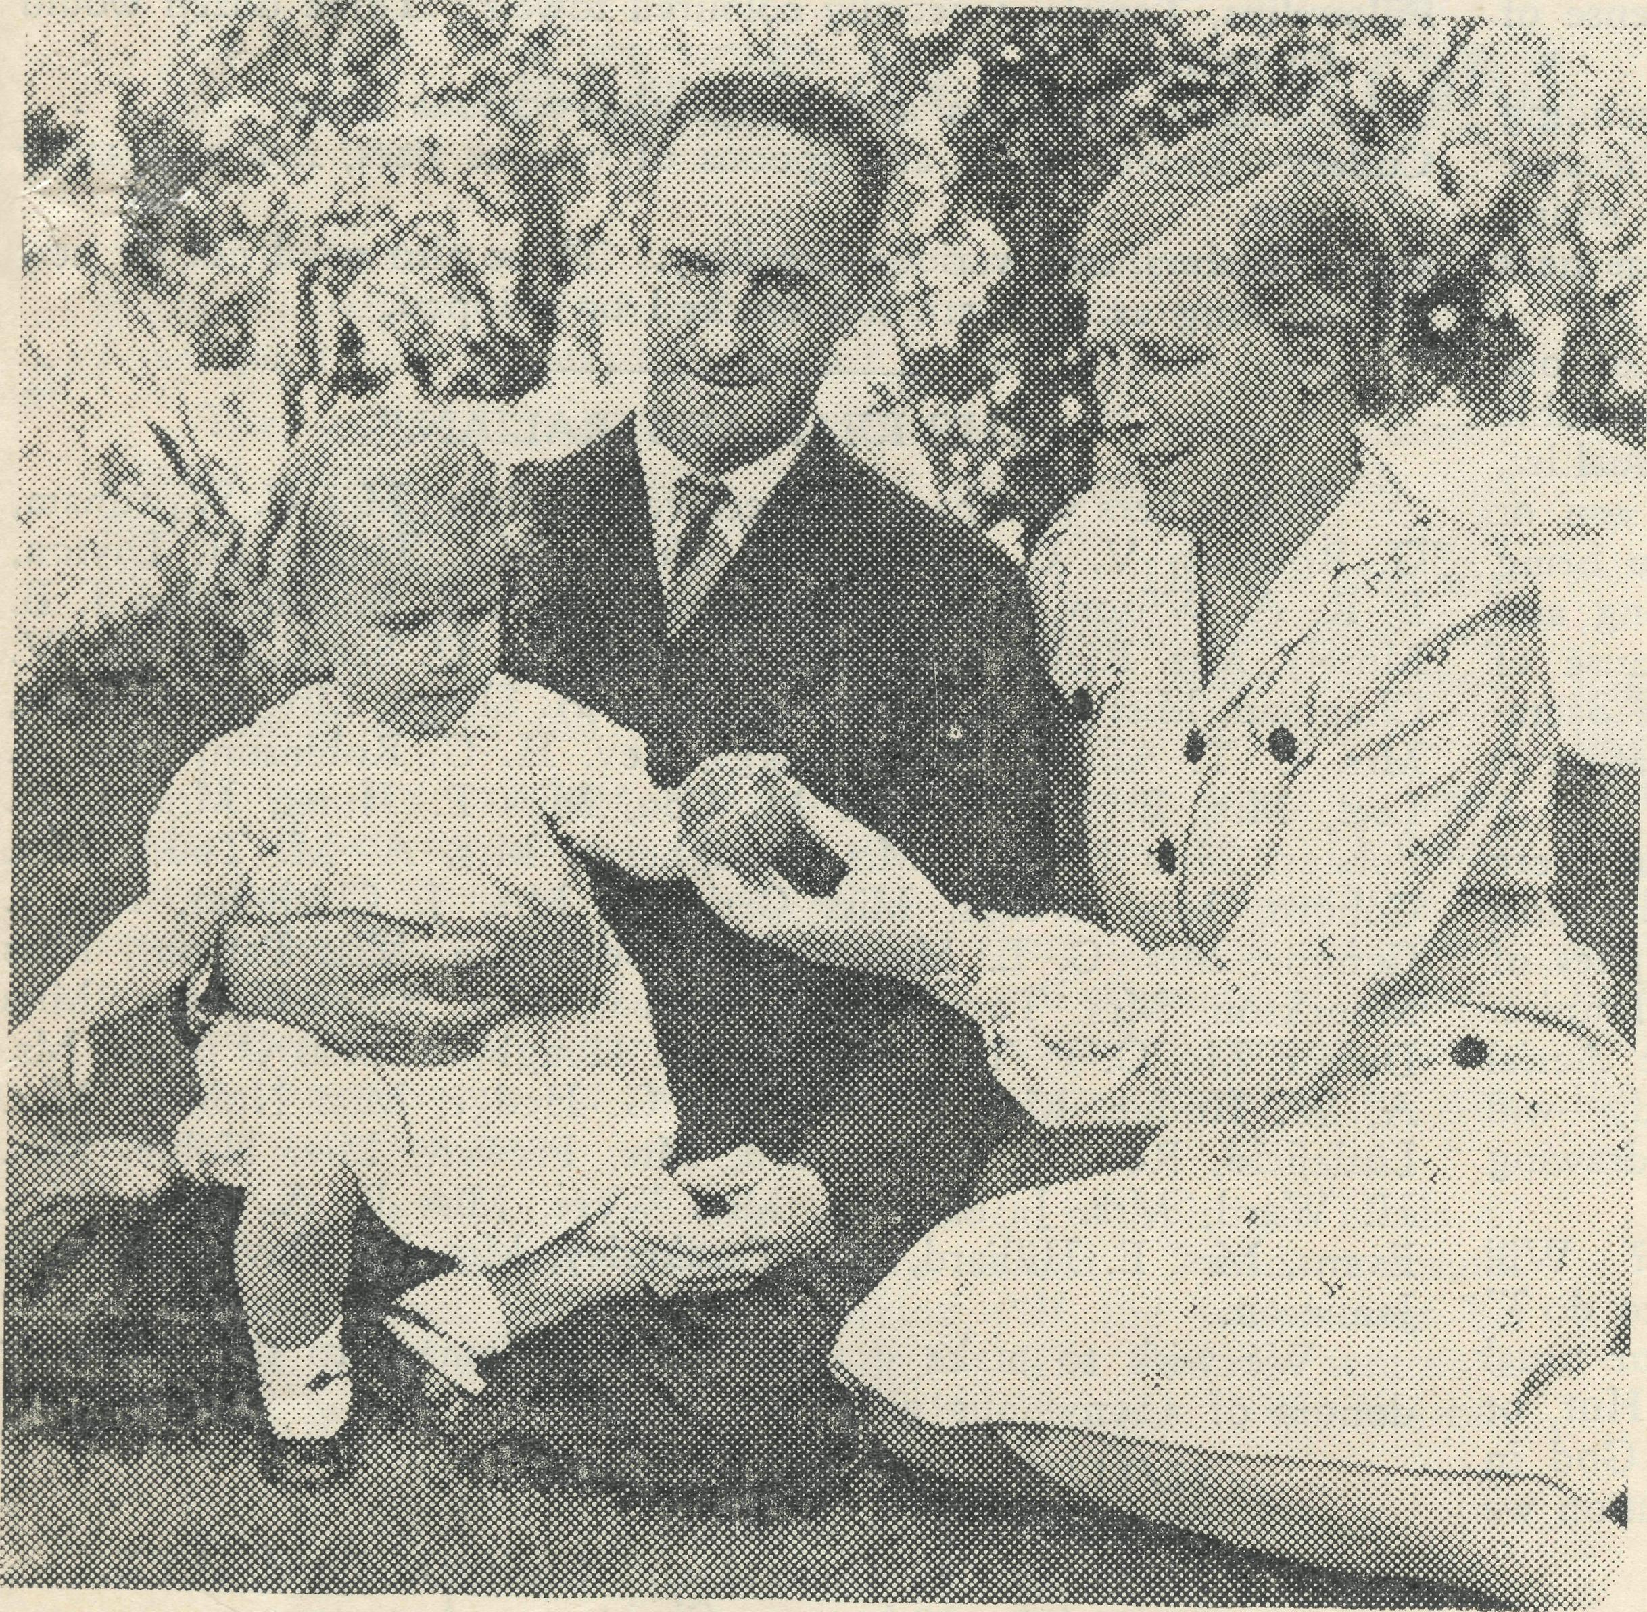
menced. As a result, most of the boys who were to come from beyond Milparinka and Tibooburra have been unable to make the journey. Seven have arrived, but we expect quite a number of others as soon as the transport difficulty has been solved. Some of the boys are to attend the Katoomba High School, and others the Wentworth Falls Public School. We would be glad to hear from any country parents to whom such an institution would be a boon.
The Society has been very fortunate indeed in secur' ing a staff for this new work, which will, I am sure, lay a solid foundation of service. The farm activities are in the capable hands of Mr. Ian Taylor, who has had a wide experience of farm work at Grafton and the Northern Territory.
Sister Audrey Spence, until recently second-in-com-mand at the Masonic Hospital, is Matron. Miss Spence, in earlier days, was at Cann River, so is no newcomer to B.C.A. Her qualification as a double certificated nurse and her administrative experience in so large an institution as the Masonic Hospital eminently fit her for her task.
Miss M. Boydell is known to many of our friends as a keen B.C.A. Mail-Bag Sunday School worker. For a considerable time she has been attending as a vclun-tary at the Mail'Bag office. Miss Boydell is now in charge of the domestic side at "Coorah."
As is to be expected, there are many things re' quired for "Coorah," and on another page you will find a list of them. If you can help, please do.
Mr. and Mrs. Chadwick and Barbara.
— (Block by courtesy of "The Leader," Melbourne.)
CAUSE FOR THANKSGIVING.
Many of our friends will no doubt have been disturbed by the various critical and in some cases abusive letters and articles appearing in the Sydney press of recent date concerning the felling of pine-trees on the mountains, and more particularly at "Coorah." A state' ment was sent to the morning and evening papers by the Organising Missioner, but so far as we could notice only the "Daily Telegraph'¹ published the statement. To publish letters and articles criticising the actions of persons or societies and to omit publication of any statement from the other side is a miserable attitude.
In justification of B.C.A. policy, I would say that it is not proposed to cut down all the pines, but only so many as from their condition demand it. Many of them will be replaced by young pines which will, I am sure, add to the beauty of the Mountains in the future days. B.C.A. is seeking to make "CoorarT not a hostel only, but a place of real beauty.
IT IS CORBAN!

THE NEW B.C.A. HOSTEL.
With the beginning of the school new year, the latest addition to the Society's Hostel activities was commenced at Wentworth Falls. The new hostel is known as "Coorah" and is situated on the Main Western Road, about a quarter of a mile outside of Wentworth Falls towards Katoomba.
The house itself is a fine, spacious, brick building of fifteen rooms. It is set in some fifty acres of very beautiful parklands. Efforts are being made to use a considerable portion of the land as a small farm for the production of vegetables, fruit, milk, butter and eggs. We have been able to do a good deal of improvement and to purchase a few fowls and horses, but much more is needed. Have any of our country friends any good milking cows they can spare? We will be happy to pay the necessary freight on them or any other useful farm animal. The more we can produce the less we will have to buy.
It was indeed unfortunate that the very week the children were to arrive, the railway strike at Ivanhoe and Broken Hill corn-
One of our keen Bark Hut secretaries has just been in with the results of her box-opening. She was very sad about the small' ness of the amount, due, she explained, to the fact that so many of her boxes l^ad been returned to her empty. The excuse offered was usually something like : *T am very keen on the Red Cross, or the Soldiers¹ Comforts, or seme other such war-time appeal, and I cannot take the Bark Hut again." She was so dispirited that she felt like giving up her work. Happily she went away again with a determination to still carry on.
As she was telling of her disappointments, my mind went back to the scene recorded in St. Matthew, chap. 15, where Jesus flailed the scribes and pharisees over their teaching and practice of Corban, whereby a man was enabled to evade his obligations to his parents and home by declaring that his money was now Corban—dedicated to some other purpose. Our Lord did not hesitate to describe this action as a complete denial of the law of God.
It is not difficult to earn a reputation for generosity if we make someone else pay for our generosity. Neither is it charity, for it is contrary to God's will and command. Many a man to-day

The Real Australian.
18
March I, 1940.

has a reputation for being a "good fellow"—but at the expense of of his wife and children.
How very different was the attitude of the man who in sending his donation wrote : "I am increasing my gift to B.C.A. because I know you will have difficulty in keeping up the income owing to the war. I cannot promise that I shall be able to do this next year, but I shall endeavour to keep it up."
The lonely people of the outback are more in need of our B.C.A. ministry than before the war. It is apparently inevitable that when our troops get into action there will be many casuallies, and lonely outback homes will be lonelier because a dear sen or brother or husband has found a grave in foreign soil. To bring comfort to the lonely bereaved homes will mean many long and weary journeys for our padres—and petrel is dearer because of the war. The ministry of the gbspel of consolation and the Sacra' ments of our Lord must not be curtailed in these days, rather it ought to be increased. But how ?
The medical work is more than ever necessary so that there may be no unnecessary casualties on the home front. For the most part, those among whom we labour are producing the supplies of food that are so vitally ejsential to this nation and the Empire. The staffing of the hospitals and the maintenance of the Aerial Ambulance—for which we receive no Government subsidy—will be increasingly difficult ; but we dare not contemplate withdrawing from these areas where no other medical help is available.
Reader ! will you pause to think over these things ? Will you humbly pray, "Lord, what wouldst THOU have ME to do ?" It may be that by some self-sacrifice you can increase your usual gifts—whether by means of subscription, donations, Bark Hut, or some other way. The establishment of the Kingdom of God in Australia—for which we pray daily—is the greatest contribution we can make to the coming of a just and lasting peace.
URGENT NEEDS.
For "Coorah" Hostel.
Linen—especially three-quarter bed sheets. These can often be made from worn fulhsized sheets by cutting in middle and joining at sides.
Pillowslips, Towels, especially coloured towels. Three dozen would
be useful. Table Cloths, Curtains and Tea-cloths—various sizes. Cutlery—Knives, forks and spoons of various sizes, not necessarily
new. Cups, Saucers, and various Crockery. These also need not be new
so long as they are not cracked or chipped.
"THE REAL AUSTRALIAN."
Subscribers who have not received receipts : Mrs. C. Wyndham, G. Robbins, V. C. Slade, Miss Clodes, Mrs. Tingle, H. Laytcn, E. R. A. Wilson, Mrs. E. Marchbank, Miss E. Burvill, Miss J. B. Mosely, Mrs. Richardson, Mrs. Bramish, W. D. Scott, Mrs. H. W. Chapman, Miss M. A. Brougham, Miss A. Slingo, Mrs. H. Chivers, Mrs. E. T. Alford, Miss Spraggs, Rev. H. G. Robinson, Miss A. Leet, Mrs. E. Smith, Miss M. Coo, Miss P. Hurst, Mrs. J. R. Forster, Miss Flattery, Mrs. Dougherty, Mrs. A. M. Todd, Mrs. Coburn, Mrs. Weeks, Miss Carleton, Mrs. J. Chisholm, Mr. J. Connor, Mrs. C. L. Mercer, Mrs. Seedsman, Miss Parsons, Miss Monckton, Mrs. Topgh, Mrs. Dunbar, Mrs. Brook-Hansen, Miss Dicker, Mr. G. P. Tait, Mrs. R. W. Haughton ,Miss CTBrian, Mr. A. W. Hodge, Mrs. B. Pell, Mr. G. Hedge, Miss Noblett, Mrs. Littlefield, Rev. A. J. Bamford, Mrs. Prewett, Mrs. Noble, Mrs. H. W^{r}ard, Mrs. J. McGrea, Miss Were, Miss E. A. Scott, Mrs. Evans, Mrs. E. Hilliard, Mrs. Fazakerley, Mrs. W. Davies, Miss E. Jamieson.
We wish to make grateful acknowledgment to the following donors of anonymous gifts :—
22/11/39 19/5 box openings.
27/11/39 12/- donation.
23/11/39 £2 General and Christmas Fund, AY2.
27/11/39 10/' note Christmas—Anonymous.
11/12/39 4A Christmas—Anonymous, Roseville.
12/12/39 5A Christmas—Anonymous, Albury.
2/1/40 5/' Donation—Anonymous.
2/1/40 5/- Donation—Anon.
12/1/40 10/- Donation—AYZ.
Victorian :
21/11/39 10/- Donation—M. S. Boyce.

/£=
21st Birthday Year of B.C.A.
THE VICTORIAN ANNUAL RALLY
will take place in the
Chapter House, St. Paul's Cathedral, Melbourne
on
Thursday, April 11th, 1940
at 7.45 p.m.
Make a special effort to be present at this our 21st Birthday Meeting, and bring a
friend with you.
A BIRTHDAY OFFERING WILL BE TAKEN.
Details as to speakers will be furnished later. We hope to have Sydney James Cook
present in the flesh.

