»
istered at the G.P'J., Sydney, for transmission by post as a periodical.

SPECIAL 21st ANNIVERSARY NUMBER.
&%its&va/U4s &v C&its£

Organ of the Bush Church Aid Society for Australia and Tasmania.

No. 75.
JULY 1, 1940.
1/6 per annum (post free).

"--------------,

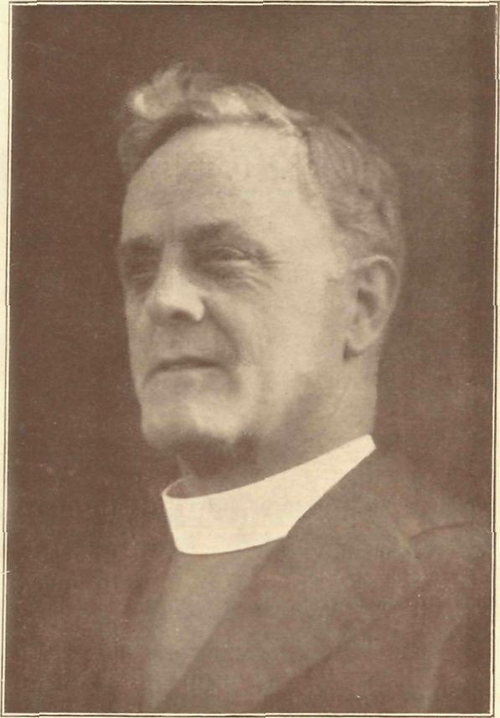



The late Rt. Rev. S. J. Kirkby, the first Organising Missioner of B.C.A., 1919-1932.

The Real Australian.
July /, 1940.

The Bush Church Aid Society for Australia and Tasmania.

HEADQUARTERS OFFICE :
Diocesan Church House, St. Andrew's Cathedral, George Street, Sydney. (Telephone : M3164.) Cable Address : "Chaplaincy, Sydney."
VICTORIAN OFFICE :
The Bible House, Flinders Lane, Melbourne.
(Telephone : F5675.)
President : The ARCHBISHOP OF SYDNEY.
Hon. Clerical Secretary : Ven. Archdeacon W. L. LANGLEY.
Hon. Treasurer : T. S. HOLT, Esq.
STAFF.
Organising Missioner : Rev. T. E. JONES, Th.L., Church
House, George Street, Sydney. Victorian Secretary : Rev. W. I. FLEMING, Th.L. South Australian Secretary : Rev. R. M. FULFORD, North
Terrace, Adelaide, S.A.

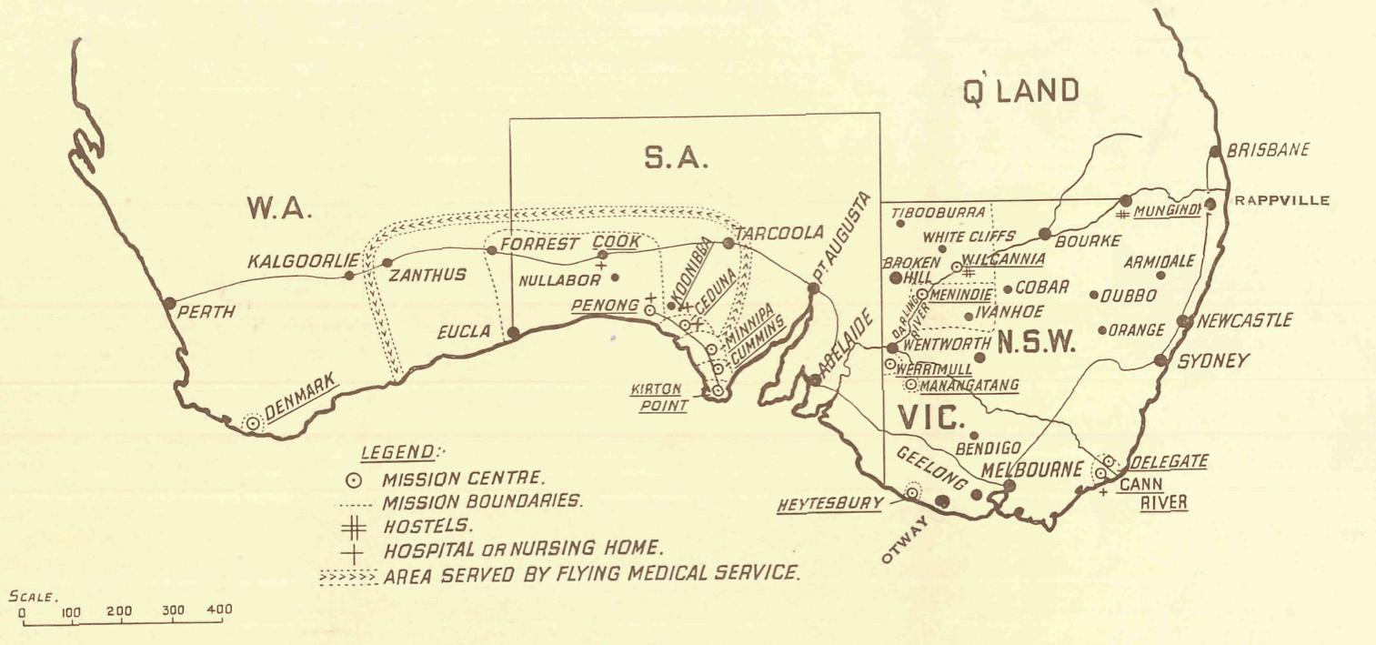

MISSIONS.

FAR WEST MISSIONS, S.A.
Ceduna—Rev. N. Chambers, Th.L., The Rectory, Ceduna, S.A. Penong—Rev. E. V. Constable, Th.L., The Rectory, Penong, S.A. Minnipa—Rev. L. Morris, Th.L., Minnipa, S.A. Cummins—Rev. T. R. Fleming, Th.L., Cummins, S.A. Kirton Point—Rev. R. T. Hallahan, Th.L., Port Lincoln, S.A.
VICTORIAN MISSIONS.
Croajingalong—Rev. N. Holdsworth, Th.L., Cann River, Vic. Delegate-Bonang—Rev. W. McLeod, Th.L., The Rectory,
Delegate, N.S.W. N.W. Mallee—Rev. F. Bayly, Clergy House, Werrimull, Vic. Heytesbury Mission—Rev. G. Beatty, Th.L., Timboon, Vic.
Otway Mission—Rev. T. H. Pickburn, Th.L., Beech Forest, Vic.
N.S.W. MISSIONS.
Wilcannia—Rev. D. Livingstone, Th.L., Reid Street, Wilcannia,
N.S.W. Menindie—Rev. G. B. Calderwood, Th.L., Menindie, N.S.W. Rappville—Rev. K. Luders, Th.L., The Rectory, Rappville,
N.S.W.
WESTERN AUSTRALIA.
Denmark—Rev. B. Lousada, Denmark, W.A.
CHILDREN'S HOSTELS.
Mungindi—Miss E. Cheers, Mungindi, N.S.W.
Wilcannia—Miss H. Gurrier Jones, Miss B. Gurrier Jones,
Wilcannia, N.S.W. Wentworth Falls, "Coorah"—Sister A. Spence, Miss M. Boydell,
Mr. I. Taylor.
MEDICAL SERVICES.
Gippsland, Vic.—Sister I. Gwynne, The Dispensary, Cann River, Vic.
FLYING MEDICAL SERVICES.
Pilot : Mr. A. Chadwick, Ceduna, S.A. Dr. R. Gibson, Dr. F. Gibson.
CEDUNA HOSPITAL.
Matron : Sister F. Dowling.
Staff : Sisters B. Bossley, V. Page, L. Pritchard, L. Loane, Nurse J. Branford.
KOONIBBA ABORIGINAL HOSPITAL.
Sister G. Hitchcock, Koonibba, S.A.
PENONG HOSPITAL.
Sister D. Goodwin, Penong, S.A. Sister J. Eglitzky, Penong, S.A. Miss M. Millar, Penong, S.A.
BISHOP KIRKBY MEMORIAL HOSPITAL.
Sister M. Symons, Cook, S.A. Miss D. Dykes, Cook, S.A.

July 1, 1940.
The Real Australian.

A MESSAGE FROM THE PRESIDENT

The Right Rev. S. J. Kirkby has been truly described as "a great Australian." He loved his land with an intense devotion. Love quickened his sensibilities, and he saw a great need.
The scattered people in the far'distant "out'back" country needed spiritual ministrations, and he set himself to supply that need. The Bush Church Aid Society was established largely through his enterprise and devoted labours. He was the first General Secretary, and piloted the Society through the early days of pioneering effort. The Society has grown apace, and now ministers to bodies and souls in many parts of the country.
It was my privilege some time ago to visit many of these centres of activity⁵ when I opened the hospital at Cook. I found everywhere a devoted body of humble Christians thankfully re' ceiving the Word of Life ministered to them through the agents of the Society. I found railway officials and servants of Govern' ment Departments, whose duties called them * to remote areas, warmly appreciative of the valuable services rendered by the efficient hospital staff.
These are days when the importance of spiritual ideals is pressed upon us in a new and startling manner. David represents the anxious ones in his day as asking, "If the foundations be destroyed, what can the righteous do ?" The Psalmist returns a confident answer, "The Lord is in His holy temple." We too can
rest in this confidence in these days of difficulty. But we cannot afford to be simply quiescent. We must use every power within our reach to establish truth and righteousness. The agency which God honours in the establishment of His Kingdom is the word of His truth, and the visible word of His Sacraments. It is at once our privilege and cur responsibility to see that in no part of Australia is there a famine of the word of God.
Only thus can the eternal principles be firmly implanted in the hearts of our people, and only thus can an effective resistance be offered to the insidious foes that seek to destroy the righteous in the earth. "The righteous Lord loveth righteousness." It is the aim of the Bush Church Aid Society—by its mission stations, its hospital ministrations, and its Mail'Bag Sunday School—to bring to the doors of the dwellers in "the out'back" the message of that eternal righteousness which guards these who trust in the Lord Jesus Christ. The favourite hymn of its first Secretary is the watchword of all its endeavours :
"Jesus, Thy Blood and righteousness My beauty are, my glorious dress ; 'Midst flaming worlds, in these arrayed, With joy shall I lift up my head."
HOWARD SYDNEY.

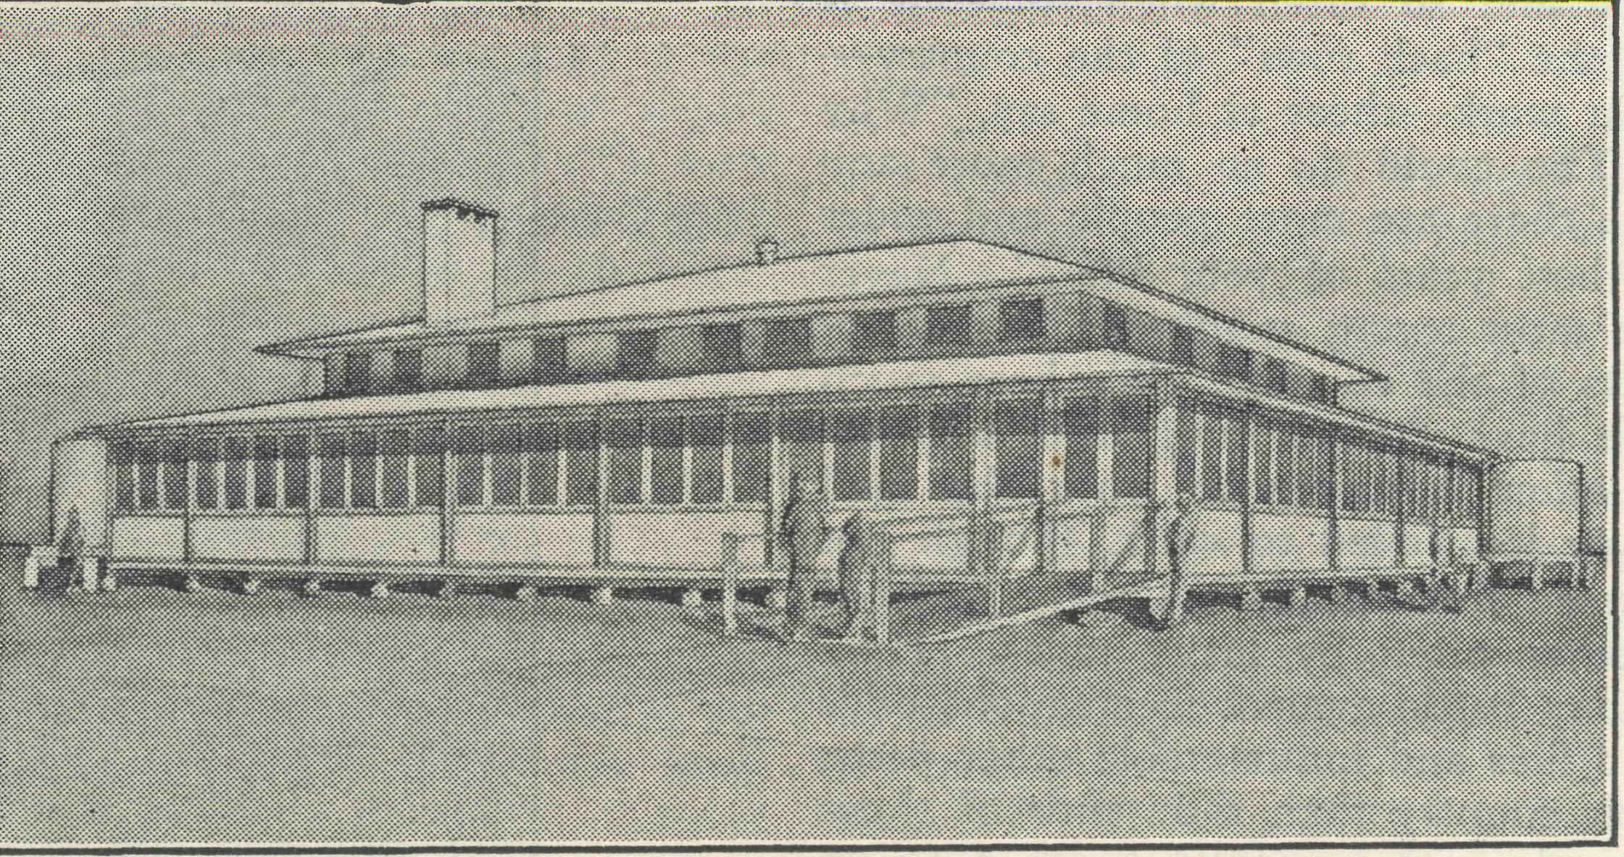

The Bishop Kirkby Memorial Hospital at Cook, South Australia. Opened 1937.
THE ORGANIZING MISSIONER'S LETTER

This issue of the "Real Australian" commemorates the 21st Birthday of the Bush Church Aid Society.
Twentyone years is not a long time, and there are many Missionary Societies of our Church considerably older than B.C.A. Nevertheless, those twentyone years are very important. B.C.A. began its work in 1919, just after the World War—it comment' orates its coming of age just as another great war comes upon us. The first years of the Society's life have been spent in an interval of peace, and its ministry has been one of building up in areas many of them opened as a result of soldier settlement.
In the days which lie immediately ahead, it will be our task to at least maintain the work we now do. We must see to it that
those who remain behind in the lonely areas shall still have the spiritual and medical services we now render.
To my mind, the most outstanding thing in B.C.A. is to be found in the men and women who serve in the various fields of the Society's activities. They are all so splendidly loyal, so des' perately in earnest, and so ready to make sacrifices that we feel the work must continue to be blessed of God.
I would suggest that you read very carefully every article in this issue. Having done that, ask yourself, "Are these people doing a worthwhile job?" "Can I let them down?" I venture to think that the reading of this issue will cause you to redouble your efforts.
TOM JONES.

The Real Australian.
July 1, 1940.

FROM THE. HEALING MISSION:

'THE BACK ROWS."
Sister L. Loane.
"Let us for a moment imagine what would have happened on the Galilean hillside, when our Lord fed the five thousand, if the Apostles had acted as some act now. The twelve would be going backwards, helping the first rank over and over again, and leaving the back rows unsupplied. Let us suppose one of them— say Andrew—ventures to say to his brother, Simon Peter, 'Ought we all tc be feeding the front row ? Ought we not to divide, and some of us go to the back rows?¹ Then suppose Peter replies, 'Oh, no ; don't you see these front people are so hungry ? They have not had half enough yet ; besides they are nearest to us, so we are more responsible for them ?' Then if Andrew resumes his appeal, suppose Peter goes on to say, 'Very well, you are quite right. You go and feed all those back rows, but I can't spare anyone else. I and the other ten of us have more than we can do here.'
"Once more, suppose Andrew persuades Philip to go with
him ; then perhaps Matthew will cry out and say, 'Why they are
all going to those farther rows ! Is no cne to be left to these
needy people in front T "
These words, spoken at the Shewsberry Church Congress might will be applied to our own country at this present day. It is so difficult to find the necessary workers for the out'back parishes, for the hospitals or the hostels, and so often when someone is willing to go out, as it were, to the "back rows" of the country— feels led of God to that particular work—those at home say, "Why go to that outlandish place ? You could do so much more and so much better here in the city ; there are more people and wider opportunities. Why waste the best years of your life ?" Never a thought for those who, under most trying conditions, are carry ing on in the distant lonely parts of the country. We hear much about populating Australia. We have various emigration schemes for bringing people out from other countries to work the land which the Australian has more or less failed to work, though not entirely. There are many scattered homesteads in lonely, isolated places, separated from one another often by many miles. Here Australians are carrying on. They battle against tremendous odds of heat and drought, of dust and flies and innumerable other pests, and are doing far more for their country than thousands of those city dwellers who are so often ready with words of harsh criticism rather than active help. Are these people not the "back rows" of that multitude of people whom we are bidden to feed ? Is it right that they should be left because the front rows of city and suburban dwellers are still hungry, and yet, despite their hunger, so often turn down the Bread of Life which is almost at their back doors. Is the need of the "back rows" not greater at this present time of war than ever it was before ? How can anyone withhold the men or money necessary to carry on the work that is being done to feed them, too ?
Nullarbor Station consists cf a homestead and several out' buildings, and many thousands of acres of flat, drylooking country on which sheep are run. There are just a few mallee trees to be seen, and saltbush, and here and there we are told is grass. What the sheep eat is a mystery. In one direction is the Nullarbor Plain, stretching away for miles in its same unending monotony. In another direction, and only about seventy miles away, lies the head of the Bight, a welcome break in the little'changing scenery. In the summer time it is hot, the winds are strong and almost con' tinuous, the dust is indescribable, the loneliness and isolation, to my mind, must be terrific. However, in spite of all this and much more, those people who are there now, and have, been there for seventeen years, are battling on against all odds, getting the best out of the country, helping to work and to populate the inland
where so many of the city dwellers would scorn to go. They are in the back rows ; there are not many of them—there should be more—but what right have we to neglect them ?
Doctor received a telephone * call from Koonibba. A small native child had come into the hospital with a broken arm, would • he come up and set it ? Twenty five miles is not very far, and the doctor was soon there ; but his arrival caused a great stir at the hospital, and in fact at the whole mission, for the patient, aged three years, had decided not to wait for him and had slipped off with her mother who was going rabbiting. A search was begun, and after about an hour the child was found and brought home in triumph by her father, the arm was set, and all was well. No one was very surprised at the event—it was exactly what might have been expected. All the natives go rabbiting, even the tiniest children, and the time of the day does not matter to them. What about these people ? Are they not part of the "back rows," and are we not bidden to feed them, too ? Or does our responsibility end with the white race ?
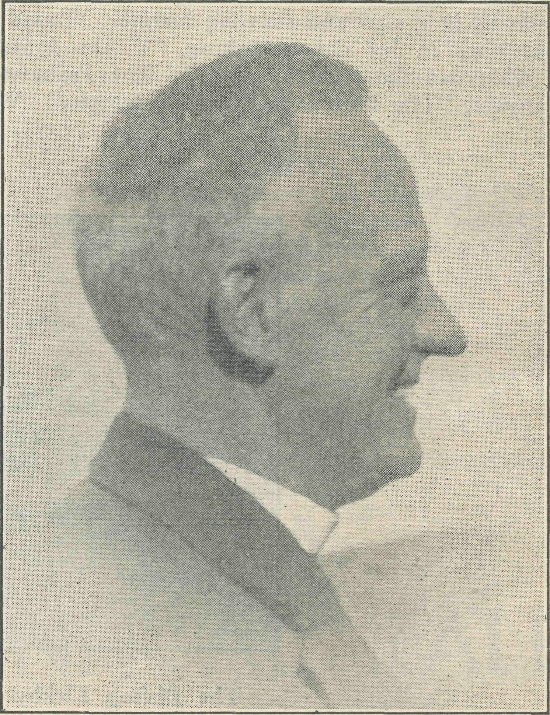
The late Rev.. T. Terry. Organising Missioner, 1933-4.
Every Tuesday evening a Bible Class is held at the Ceduna Hospital, and to it three or four children, between twelve and thirteen years of age, have been coming regularly for many weeks. They are very interested, they are ready to learn, and yet they, too, are in the "back rows." Are they worth teaching ? Is it worth maintaining anyone to teach them, to bring them—if it be His will—^to a living knowledge of a Crucified Saviour ? Are not three or four worth much in His eyes ?
Now, more than ever, we must be ready to build up and main' tain that work which is being carried on. Nothing should be allowed to slip. Everyone is being asked to make a special effort for his country, and that effort must be made for the outback, too, that the baskets of food may be sent to supply the "back rows."
Some months ago you were asked to pray for a young lad who was in hospital for several weeks with typhoid fever. Those prayers have been answered, because he is now working on a farm with Christian people. He is encouraged to read his Bible and

July 1, 1940.
The Real Australian.

is able to attend the services which are held in the district at regular intervals. He came up to see us a few days ago—quite a different lad, clean and neatly dressed, and looking very well. He is thrilled with his job and told us how he has three meals a day and a hot dinner every day, as well as morning and afternoon tea. Best of all, he has not lost interest in the things that count. He is reading his Bible and is eager to learn, though as yet he has not come to a living knowledge of Christ as his personal Saviour. Please continue to pray for him, that he, too, may be one. with us in Christ Jesus.
FIRST IMPRESSIONS.
Sister Gwynne.
In making a first contribution to the "Real Australian," I am doing so under the above heading, especially after being told that ^Cann River was a cold, wet place in winter, and the writer coming from Sunny Queensland. The journey from Brisbane was truly delightful, being enhanced by the wonderful "farewell" by friends and the bountiful gifts received to cheer and refresh one on the journey. A somewhat enforced delay in Sydney of one week, owing to prevailing circumstances, was cheered by the numep ous friends one met so unexpectedly, and also by the utmost kindness of all concerned.
Next came an uneventful but somewhat sleepless night-—the journey from Sydney to Bombala ; but intensely interesting after daybreak, as one viewed the country passed through—at that time suffering much from drought. In every direction there were miles and miles of barren, treeless, undulating country, destitute of grass or herbage of any kind, yet carrying hundreds and hundreds of sheep. One wondered how they kept alive.
After leaving the train and collecting bag and baggage, I was faced with a fifty-eight-mile trip by car. Ordinarily that would have been a thrilling and delightful journey : new country, new scenes, etc., and the prospect of at last arriving at my future lodging-place and seeing something of the district in which I was to labour. But alas ! sad to relate, that journey lost much of its joy and thrill owing to the fact that I became desperately car-sick. Fifty-eight miles of extremely windy, corrugated roads seemed just too much. Continuous "S" curves and hairpin bends—of which there were hundreds—tended to upset my equilibrium.
One of the first impressions was the immensity of the district, and the apparent density, and I felt "How long is it going to take me to know such a district and to know my way about, and to get to know the people ?" But I was not left to wonder for long. I had not time to unpack and get the least little bit like settled when the telephone rang asking if I could go out to a case. Cer-tainly, yes ! Where and how ? Place named and the "How ?" answered, "They will call for you." At 9 p.m. a car arrived. A few questions elicited' the nature of the case and gave one some idea of what to take. How far is it to the patient ? Fortyfive miles. Back over corrugated, windy roads. "And were you car' sick ?" Shame to have to confess it. Yes, frightfully so ; but fortunately alright and ready for almost anything upon getting out of the car. We arrived at 11.40 p.m. Fortunately the patient was then asleep. Having had a look at the patient—pulse good, and apparently a natural sleep—the motto of "Let sleeping patients sleep" was strictly adhered to. A cup of tea, which was very refreshing and welcome, and to bed shortly after midnight, brought me to the end of my first day. Returning next day, and with only two or three minor cases for a couple of days, gave me time to get more or less comfortably settled.
The next exciting experience came during that first week. A voice at the front door at 2.30 a.m. : "Are you there, Sister ?" "Yes, just a moment"—and one is out of bed. A few questions, and, gathering up what was required, off we set. Only one mile this time. But oh ! what a desperately sick woman. A hypodermic injection and a couple of hours' hard work got her quietened down sufficiently for us to get her into a car and take her to hospital.
Sixty miles over Corrugated, windy roads, up hill and down dale— the nurse once again car-sick, the patient adding to the difficulties by hemorrhaging from the nostrils—was not an experience that one would like repeated too often. With the patient safely landed in hospital, under skilled medical attention and careful nursing one felt there was every hope of her recovery, and praised God for the privilege and opportunity of helping such a sick woman in a remote corner of the country. Again we praise God also for the opportunity of bringing comfort and cheer to others in times of such difficulty, and to sad and despondent hearts.
On another occasion the telephone rang and I was asked if I could go out to such-and-such a place, as an elderly woman would like to see the Sister. Yes, very well. Friday morning by the butcher's cart—one of the means of transport, also of visiting. After lunch the Sister is brought back to the dispensary by car, to learn that there has been a message from a district forty-five miles away during my absence. After making inquiries, it was arranged to see that patient next day. Arrived back from the morning's visit just in time to light the fire and get ready for a Guild meeting at 3 p.m. The meeting started ... a knock at the front door ... a young man has had an accident with his motor-bike. An examination revealed a nasty cut on one leg which necessitated three stitches, also treatment for minor shock and various abrasions.
Upon making inquiries, it was learned that the one available means of transport to the case fortyfive mijes away next day was entirely out of the question ; so I was faced with the problem of how to get there. That evening a patient came who had been attending twice a day for treatment to a poisoned hand. Having presented the problem to him, and being of a very kindly and generous disposition, he readily agreed to take me to see the needy case. We left the dispensary at 9.30 a.m., after having first of all re-dressed the young man's hand. Upon arrival, I soon realised that it was really a case for the hospital. After much debate, the patient decided to go to a hospital about forty miles away, and would get his son to take him. But just as we were about to leave he decided to go to Orbost, if this young man would take him. Yes, he would gladly do that. So we got him ready and made him as comforatble and warm as possible in the back seat of the car, reclining as much as possible, and off we set—103 miles to Orbost. Having rung the doctor from Cann River, he was waiting for us when we reached the hospital at 8.15 p.m. Having safely delivered the patient, we felt like tea and supper. Having been thus refreshed, we returned to Cann River, encountering thick fog on the way, which meant slow travelling. Committing our way to Him Who watches over all and trusting in His promise, "As the mountains are round about Jerusalem, so the Lord is round about them that fear Him," we arrived at Cann River, again after an uneventful trip, at 11.30 p.m. Car sick? No, not the least bit, and that after a little over 200 miles for the day. Not a bad day's trip for a cne-handed driver, is it ?
CEDUNA.
Sister F. Dowling.
How many of our readers are being tempted to question how B.C.A. is going to keep going during these critical times we are passing through ? "How can we hope to get sufficient funds to keep the work from slipping back ?" Everything seems to be in such a turmoil in this time of the world's crisis. The demands are great upon everyone, and there is a very real temptation to think, "Who will now care to give towards the work for the extension of the Kingdom of God on earth ?" There is so much else of seemingly greater importance that little thought can be given to anything else but that which is occupying the mind of the whole world at the present time. This evening we gathered round the Word of God and thought about the peace of God that should be experienced by these who have made their peace with God

The Real Australian.
July 1, 1940.

through justification by faith in Christ Jesus. What a message there is to the hearts of the fearful : "Be anxious for nothing, but in everything, by prayer and supplication with thanksgiving, let your requests be made known unto God. And the peace of God, which passeth all understanding, shall keep your hearts and minds in Christ Jesus." The test is going to be, are we going to labour together in prayer and supplication ? If so, we will experience that peace promised ; if we fail in this, we are going to be mighty anxious about quite a lot of things. Don't let us forget this one great fact, that it is Him Whom we are to look to for our needs, and we must believe that no matter what the circumstances are, He can and will supply those needs. It is here we will come to learn the difference between our wants and our needs. How many of us really believe in an Omnipotent God ? If we say we do, then we must trust Him and believe that He can work miracles now as He has done all down the ages.
During a short stay in Melbourne, it was a pleasure tc meet many of the friends whose enthusiasm has not waned one bit.
We were pleased to welcome the O.M. to Ceduna last mon'h. There are many matters of importance to attend to, and his is a big responsibility, and these tours of inspection of the wcrk are anything but a holiday for him.
Nurse G. Moody was home for her annual leave. We praise God for answered prayer in her return to health and strength again. She tells us of the joy of spiritual fellowship amongst a group of the nurses who are keen for the Lord.
Sister Hitchcock has returned from a well-earned holiday in Melbourne, and is hard at work once again at Koonibba.
Nurse Branford, who has been on the staff for the past three years, will be leaving in August prior to commencing her training at the Adelaide Hospital. We pray she will be kept firm in her witness for Him in her new sphere of work. We thank Gcd for the Nurses' Christian Movement, which does so much to shepherd and strengthen the Christian nurses.
Have our praying friends remembered the need for someone to do the cooking out here ? Miss Linke, who came to relieve for two months, has been with us nine months. We are grateful for her services here. She leaves us in two weeks' time, and we do ask you to remember this need in prayer, that someone after His own heart may be called to the work.
Recently the wireless station at Forrest, over the Western Australian border, sent an S.O.S. to Ceduna for the doctor. An Air Force man with internal haemorrhage. We started off on our 350-mile trip, arriving in a little over four hours, stopping to refuel at Cook. On arrival at Forrest, we were met by an anxious group of Air Force officers. The patient was in the Civil Airways Hostel, in a shocked condition, after having had a severe haemorrhage from the stomach. He had come from Perth the previous day in an Air Force machine, being very sick on the way across. Looking a ghastly colour when he landed at a place to refuel half-way to Forrest, his mate asked if he felt alright ? Apparently it was not an unusual thing for him, when up in a 'plane, to be violently ill. However, on this trip there were signs of blood, which was not the usual thing. Assuring the others he was quite o.k., they continued the journey to Forrest, he having several haemorrhages on the way, and by the time they landed at Forrest he was looking and feeling very ill. He informed the other members of the crew that it wasn't the usual air-sickness, for there seemed to be a lot of bleeding. The amateurs decided it must be coming from the back of the nose and left it at that ! However, cracking hardy, the victim decided he would have some tea, thinking he might feel better with something to fill the aching void, and he actually sat down and ate corned beef, salads (including raw onion), followed by peaches and cream, etc. ! During the night he had a couple of haemorrhages, but did not call anyone. Next morning, on his way to the bath, he collapsed. His fellow-officers carried him back to bed, and there then followed a severe haemorrhage, which
scared everyone present, and the wireless was soon tapping out its S.O.S. for help.
Owing to the patient's condition, it was impossible to move him for forty-eight hours, and then, not chancing the air again, we put him aboard the East-West Express on a bed and took him to Cook hospital, 140 miles along the line. "Thank heaven we haven't got to go any further !" said the patient as we were drawing into Cook at midnight. If the B.C.A. Hospital wasn't at Cook he would have had tc go over 400 miles to Kalgoorlie. He was not far wrong in thanking Heaven for the fact that he didn't have to go any further than Cook, for surely it is only a prayer-answering God Who can make possible such a work as this to be carried on amongst the people of the isolated parts of our own land. We have prayed much for his soul, for surely he was brought amongst us for a definite purpose. May the Holy Spirit draw him to the Father.
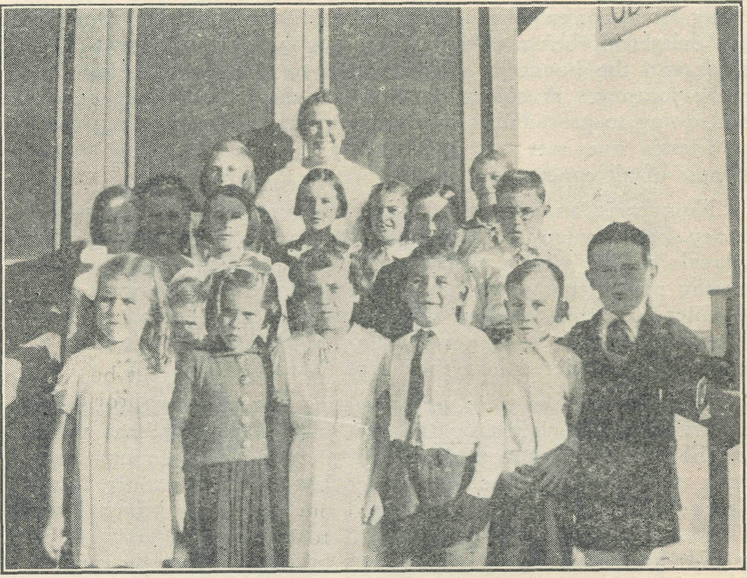
Sunday School at Cook.
COOK.
Sister M. Symons.
Newspaper reports all agree that the response to the appeal of our King for a day of prayer on May 26th was outstanding. To those who witnessed the great gatherings in the city, I would like to describe our little gathering at Cook.
Our church-people decided that they would like to have a special service for prayer at the same time that the service was being held in the city, besides having our usual service at night.
We met in the sitting-room of the hospital at 3.30 p.m. Just ft- little gathering of ten people, but we each believed Christ's promise that where two or three are gathered together in His Name He is in the midst. His Presence and the spirit of intercession was just as real to us as it must have been to those in the larger gatherings.
The service at night was better attended than the afternoon, twenty being present. How we long that all these people may come to know Christ in a very real way. One patient who attended the service said it brought back memories of his boyhood when he was in a choir in England. Another patient who recently left us accepted a New Testament, which he promised to read.
Just at present we have a patient who listens attentively while the Word is being read each evening, but she says it is all just a puwle to her. We try to explain facts to her, but we believe

July U 1940.
The Real Australian.

that only the Holy Spirit can reveal the truth to her, and that He will if she truly seeks.
We ask your prayers for these people, that the seed sown may fall on good ground. Each one necessitated a special call for doctor from Ceduna, and we feel that it was both a warning and another chance for these people to hear of God's gift to them.
A PICNIC AT COOK.
Miss D. Dykes.
The Sunday School meets each Sunday afternoon at the hos-pital, mostly in the sitting-room ; but if it is a nice day, on the verandah. The children are fairly regular and quite keen, love to sing, and are very fond of expression work. The Mail-Bag Sunday School lessons have proved a great help in this respect.
All children love a picnic, and the ones here are no excep' ticn. Although the surrounding country lacks secnery and places to explore, it is wonderful what can be found and appreciated even by the tinies. On several previous occasions the older girls had been out for an afternoon, but this time we decided to take all of them and go for lunch. So one day during the May holidays was fixed, the children tcld to be at the hospital at eleven o'clock, plus a chop, water, and other eats required. Everyone was well en time when the day arrived, which proved to be fine with just a few scattered clouds, and so we got off soon after eleven—twelve boys and girls, ages ranging from four to eleven years, each with their various bundles. We set off in a southerly direction, which took us across the aerodrome, so that walking was easy to start, but soon we-got on to the stony way and made walking interesting by watching out for little flowers, strange stcnes, and one little boy, aged four, kept a lookout for bunny-shelters under salt bushes where the rabbits made a little nest to shelter from the sun, prowling foxes and dogs.
The scenery did not change ; the highest bush we saw was only two feet, and the ground is so flat that after an hour's walk we could still see the houses of Cook, but we decided to call a halt here. Great was the curiosity as to how we should cook the chops. All gathered saltbush roots for fuel, and having found a suitable fireplace in a rabbit-warren, the young lads set to work and soon had a fire on the way. Great amusement was caused by disappearing knee-deep into rabbit holes. There are patches of these warrens every now and again where the soil is evidently a bit softer to burrow into.' Having got the fires gcing, we put two billies on, and soon had chops suspended on greenish saltbush sticks well on the way, 'midst many squeals as chops slid into the fire, sticks breaking, etc., and we ended by placing chops all in together on top of the fire. One lass nearly lost hers down a rabbit'hole, but it was rescued after much rooting. At last chops were ready, certainly some had very generous coats of mother earth, others were rather ashy, but they just tasted lovely when helped down with tomato sauce and tea.
After cleaning up the debris we played games. There was no nice green grass, or even a clear sandy patch, but all among small saltbushes and stones, and yet all enjoyed themselves as much as any batch of children in a lovely city park. We started on our homeward way fairly early, and gradually saw the houses getting plainer to view. It took much longer to get back as we kept side' tracking to explore rabbit-warrens, but we saw only one rabbit and he departed from us so quickly that it was just like a little cloud of dust bounding away at great speed.
And so we arrived home looking a bit the worse for Nullarbor dust, and rather weary, but very happy.
A PATIENT'S EXPERIENCE.
Early in May of this year, while travelling by air from Perth to Forrest, W.A., the writer was stricken by an internal haemorr' hage some time before arriving at his destination. Being in no
pain, and having no knowledge of the cause of the trouble, little attention was paid to it once Forrest was reached—at least, no*" until a rather good meal had been disposed of at tea'time. Some little time after this meal, considerable discomfort was experienced and the bleeding recommenced. Still in ignorance of the cause, but knowing all about the effect, bed was sought in the hope of this bringing relief. After a fairly comfortable night, on trying to reach the bathroom the trouble again showed up, following a collapse at the bathroom doer.
For a few hours after this my recollection is rather disjointed. Snatches of conversation came to me : "The Flying Doctor is at Cook tO'day." After a while, "He has changed his visiting day. We'll have to get him from Ceduna." Much ringing of telephones. "The 'phone is net very clear, try the wireless." "We must stop the Express and send him on to Cook." Eventually, the most welcome of all, "The Flying Doctor has left Ceduna and should be here in about four hours."
Some hours later—it seemed like days—the drone of a Moth 'plane is heard, and in a little while I am introduced to Dr. Gibson, who proceeds at once to the business in hand.
A short examination indicates gastric ulcers, which had bled, "Fortunately," said doctor, "without a perforation." A "perfora' tion" had to be explained before I agreed with the "fortunate." Removal was ordered by train to the nearest hospital, at Cook, 120-odd miles away. The Bishop Kirkby Memorial Hospital at Cook is the only hospital between Kalgoorlie and Port Augusta, about 1,100 miles.
More ringing of bells resulted in arrangements being made for the "Trans." Express to stop at Forrest on the following day. By this time it was evening, and how different from that of the pre vious day ! The haemorrhage had been arrested and treatment begun. Sister Dowling was left to supervise the train journey, while Dr. Gibson made the return trip to Cook in the Fox Moth early the following day.
For the train journey, the patient was first carried, still in bed, on an old Ford to the railway station, and on arrival of the train, placed in the brakevan. The reverse procedure was observed after a four-hour journey to Cook. Six husky "pall-bearers" (as someone called them) stumbled in the dark across the rcck-strewn road between Cook station and the hospital.
Enquiries by this time had revealed that the immediate treatment for ulcers was a strict diet for an initial period of three weeks, acccmpanied by innumerable doses of "bis.-mag." powder. By the end of the first week on a "milk only" diet, pronounced canna* bilistic tendencies were being displayed, but these were fortunately relieved when the diet was slightly relaxed for the second week. It was during the first week that an imaginary odour of grilled steak (which is strictly "taboo") proved extremely tantalising."
During these two weeks, while still confined to bed, the resource of Sister Symons was severely taxed to provide reading matter. A voracious literary appetite was satisfied with books such as Admiral Byrd's "Alone," Morton's "In Search of England" and "In the Steps of the Master," Daphne du Maurier's "Rebecca" and "Doctor Bradley Remembers" by Brett Young. Along with several others, this excellent reading whiled away the long hours in bed very pleasantly.
At the end of two weeks the patient was allowed out of bed, and, I think, surprised Sister by being able to walk quite well without assistance. Now, for the first time, it was possible to survey Cook. After a fortnight in the town, a little curiosity was perhaps permissible.
Statistics had already been collected from numerous visitors, and from these my first mental impression of Cook was amended. Cook has twenty-odd houses, railway station, general store, post office, public school (with about fifty pupils), public hall, about a dozen huts and tents ; and last, but not least, the Bishop Kirkby Memorial Hospital. Another surprise was to learn that water carried by train from Kalgoorlie, W.A., was laid on to most of the houses. The water supply at Cook must surely be unique, as it travels over 300 miles by pipe-line from Mundaring Weir, near

The Real Australian.
July I, 1940.

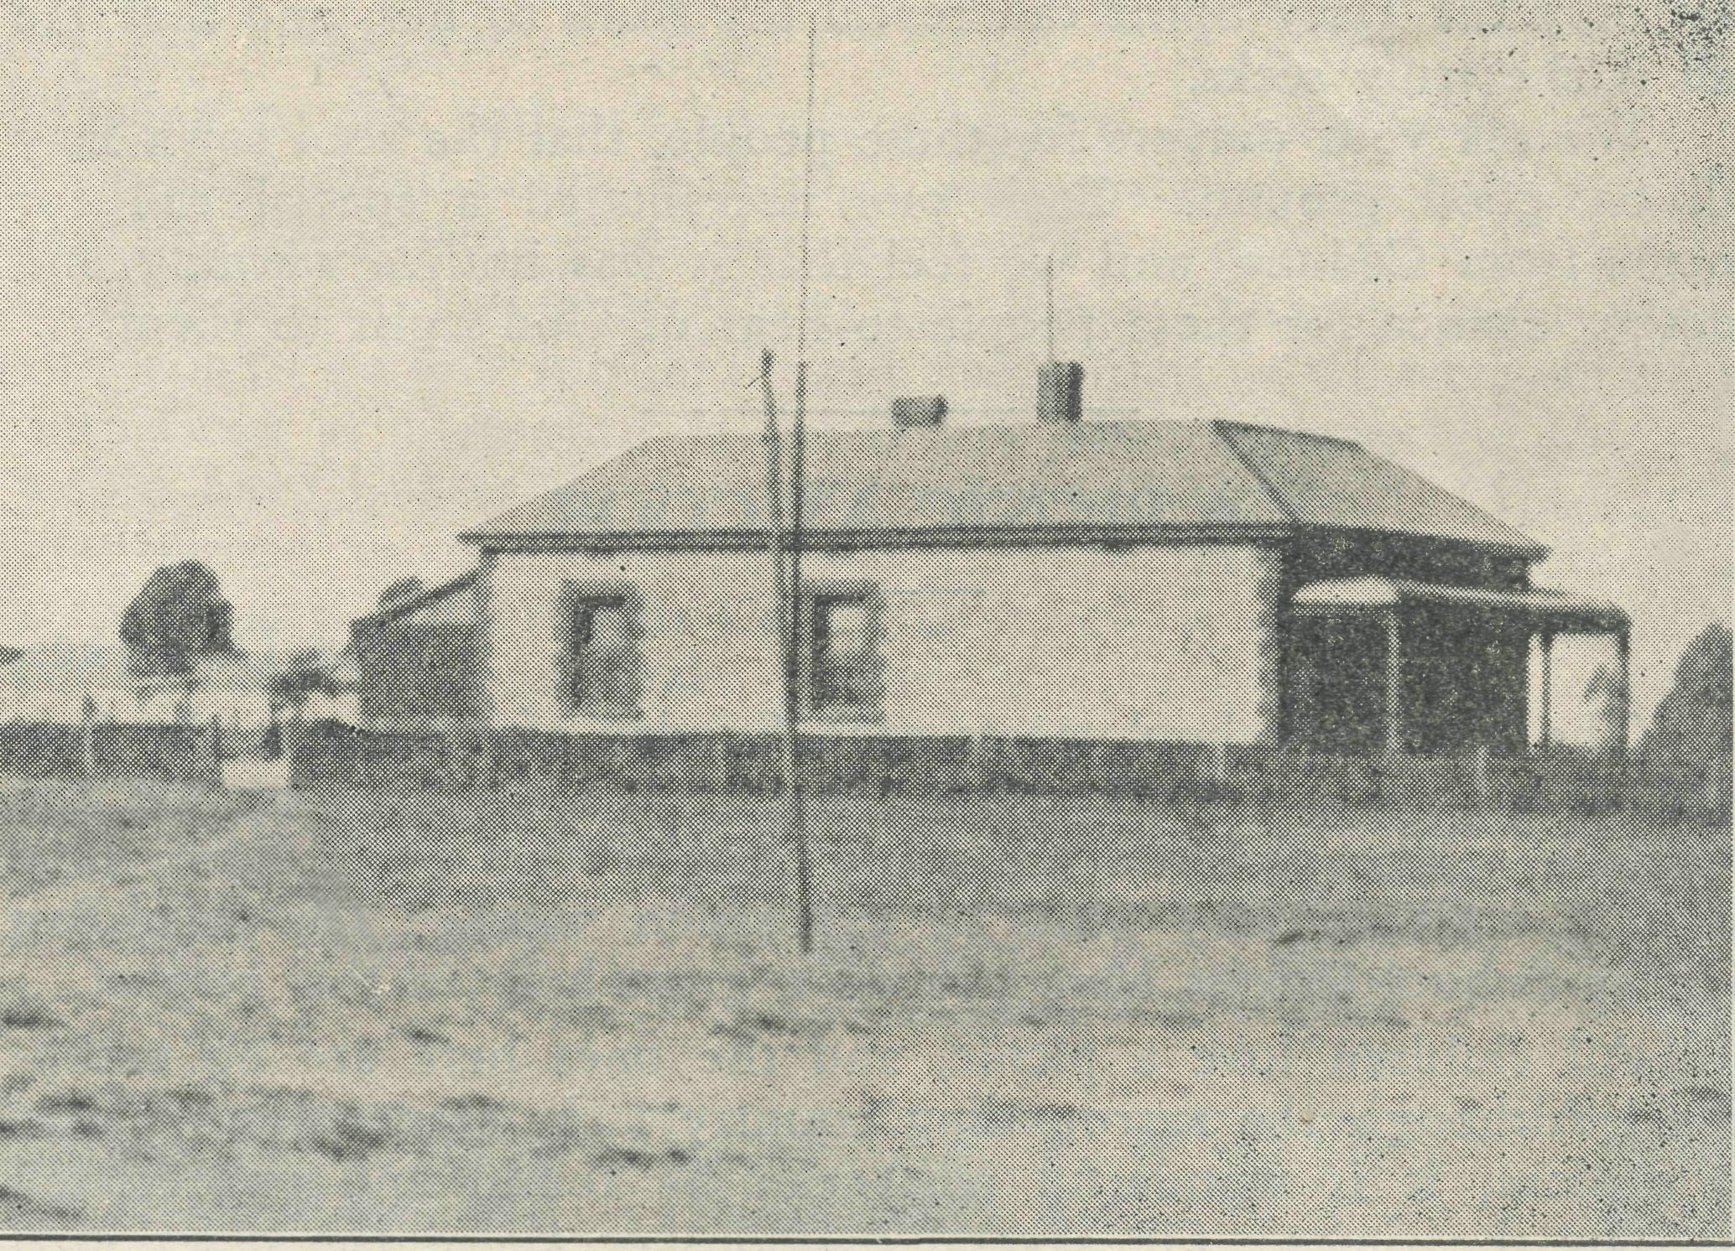
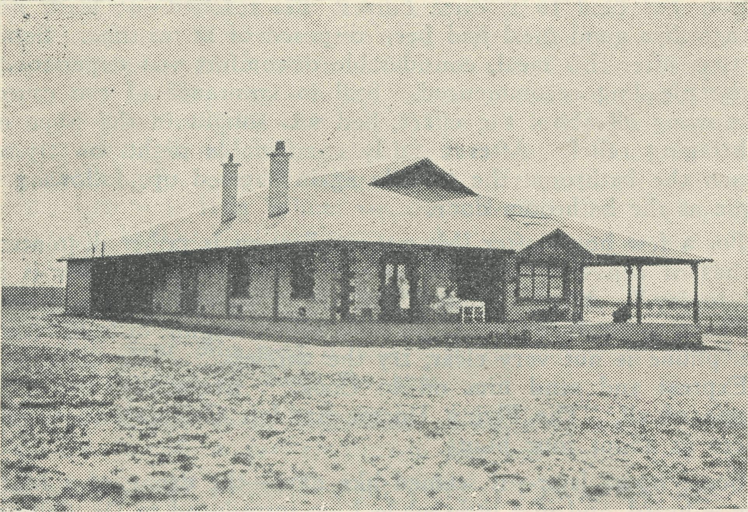
Penong Hospital, S.A.
Koonibba Aboriginal Hospital, S.A.

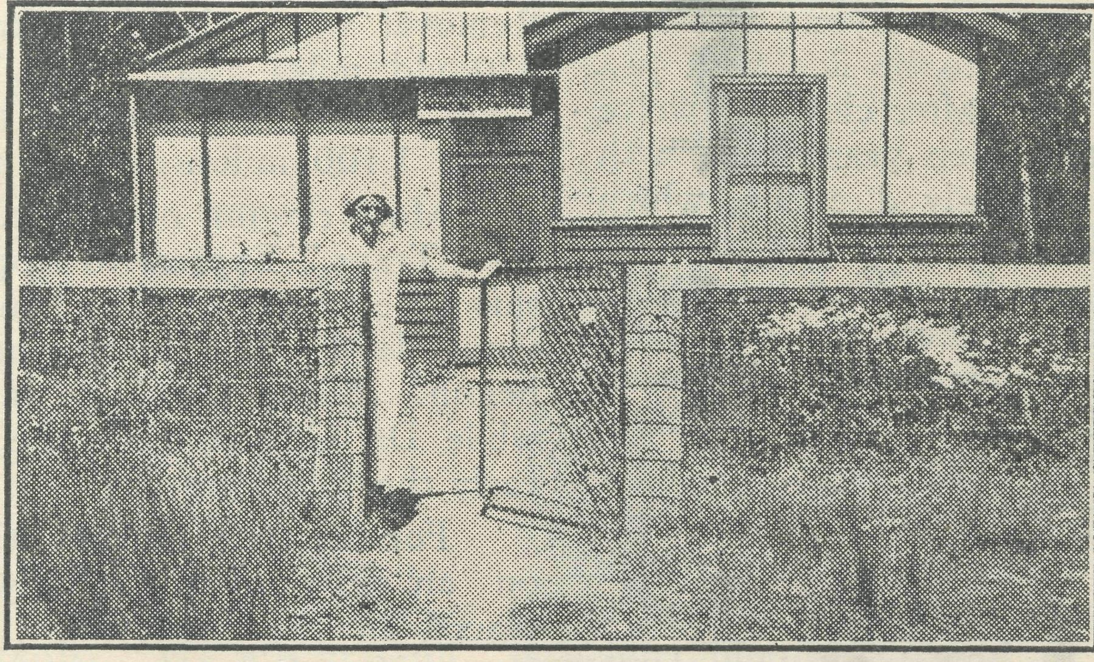

Cann River Nursing Home, Victoria.

Perth, before beginning the journey by train to Cook. The popu-lation of the town was estimated at about 150. In mentioning population, one must not forget the herd of goats, estimated at about seventy or eighty, which are a prominent feature, being the source of Cook's milk supply.
Thanks to the treatment of Sister Symons and Miss Dykes, excellent progress was made in regaining strength in the third and last week at Cook. During this week reading was somewhat neglected, but walks on the golf-links, etc., compensated for this. Yes, they play golf at Cook, almost everybody. A nine-hole course has been laid out on the salt pan, and amid the surrounding salt-bush. Bogey is 36. One small lad of six years was heard to remark to his dad : "I went round in 79 this morning. My first game for three years, too."
One morning at 3 a.m. the sound of an alarm-clock and a summons from Sister was the signal that the time for departure was nigh. At 4 a.m. the west-bound train bore me away from Cook, glad to be on my way home, but nevertheless glad that I had been able to learn a little more of life in out-of-the-way places and to become acquainted with the excellent work of the Bush Church Aid Society, the Flying Doctor, and hospital services.
RAIL FALLS ON WORKMAN'S ARM.
Serious Accident at 742 Miles Camp.
Once again the value of the medical service provided by the Bush Church Aid Society for the benefit of those residing in the distant parts was proved recently. While at work at the 742 Miles
Camp, Mr. George Jennings, a fettler of that localiU, was unfortunate to have several rails fall on his left arm, which was severely injured.
He was fortunate in a sense that the last freight train from Parkeston was somewhat behind schedule, and this allowed him to be brought to Cook with a minimum of delay. Had the train been running on time other arrangements would have had to be made, and medical attention may not have been available to him sooner than it actually was.
Cook was communicated with and the doctor at Ceduna was advised of the pending arrival of the injured man, and the estimated time of his arrival. Dr. Freda Gibson and Sister Dowling, of the Ceduna Hospital, left in the B.C.A. Society's /plane with Pilot Chadwick, and arrived in Cook not long after the patient, who had entered the hospital shortly after three o'clock.
The injury necessitated the amputation of the left arm below the elbow, and the operation was performed with the minimum of delay. The party left in the 'plane for Ceduna at 9.30 on Sunday, after having done another fine piece of work.
This is the second call answered by the Flying Doctor this month. Sergt. Lewis, of the R.A.A.F., who was the other patient to receive attention, is now able to leave his bed and will soon be leaving Cook.
Mr. Jennings' condition is reported to be satisfactory.
(The above is an extract from a Kalgoorlie newspaper, and the following is from the patient himself.)
♦£♦ !♦£♦ ♦£♦
^{l}T was a patient' in the Bishop Kirkby Memorial Hospital at Cook. I met with an accident on the East-West line, and after the

July 1, 1940.
The Real Australian.

operation, which was carried cut by Dr. Gibson, when I was settled down, I was given a book called 'These Twenty Years.' I read that book twice, and when I see what wonderful work this mis' eionary society has done for the people in Australia, we must thank God that there is such a society to do this good work for us. Every care and attention was given me by the Sister and others.
"I must say the 'plane service is a great help to the Nullarbor Plains, and one must give credit to Drs. Gibson for their won' derful service to the people of the Plains.
"In conclusion, we had a special service at Cook Hospital on Sunday, 26th May, at the little room which does for a church, and the service was carried cut by the matron, which I think was a success.¹'
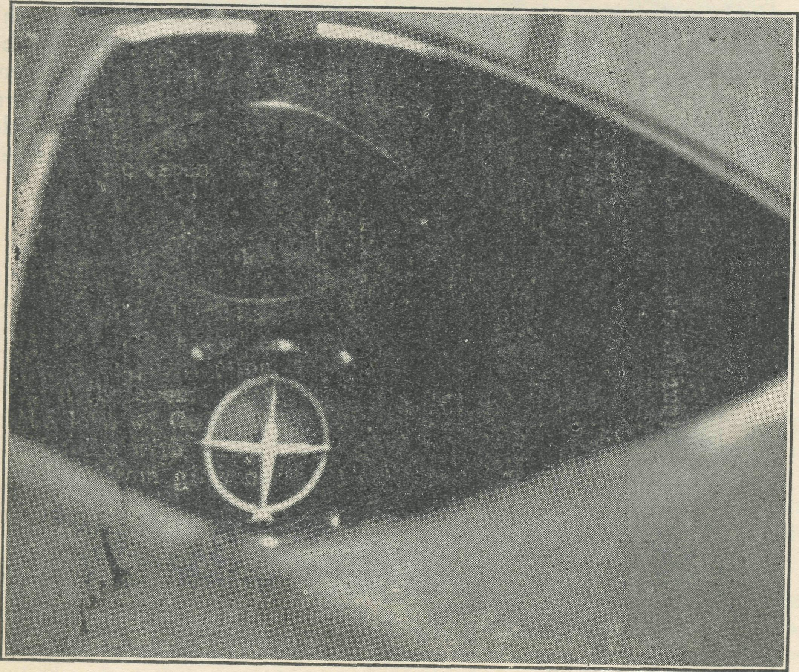
Blind Flying Instrument in cockpit of VH-AAA.
FLYING MEDICAL SERVICE.
"bank" indicators on the face of the instrument and trying to keep them both in their proper places. By the end of that trip I felt that I had become friendly enough with that instrument to rely on it to guide me and all that I was responsible for through a layer of cloud wherever and" whenever I met it.
The instrument really came into its own and proved its value beyond any doubt when en April 8th Sister Dowling and I left Ceduna after an early breakfast and flew to Melbourne to attend the 21st Birthday Rally of B.C.A. When my clock told me that we ought to be nearing our destination, I descended through the clouds into a world that was dull and drab under its blanket of cloud, and found myself within ten miles cf Essendon, straight ahead, where we landed at 6 p.m.—eleven hours after we had left Ceduna, eight and a half hours of which we had spent in the air, and had covered a distance of 750 miles.
The return journey, undertaken four days later, was made in two stages with an overnight stay in Adelaide, which, owing to a morning of heavy rain and no visibility, developed into a stay of two nights there. We left Parafield the following morning and, against a strong head-wind, climbed up through the broken cumulus clouds to 9,500 feet. Again the little blind-flying instrument came into its own, and by its indications I was able to guide the machine through each successsive layer almost as if no cloud was there.
Soon the clouds rose to over 10,000 feet, and as they showed no signs of breaking I descended through them to where I could see the ground, get my bearings, and land at Kyancutta for fuel, where we also had lunch.
For the final eighty miles into Ceduna it rained hard all the way, and even at an altitude as low as 1,000 feet the ground was quite often obscured by rain and cloud, so that it was a matter of flying on instruments all the way.
May I convey to the donor the sincere thanks and appreciation of all members of the staff for this very wonderful gift, and let you know that the trip to the Rally in Melbourne could not have been made at the time it was made without the aid of this blind-flying instrument.
It is net an "Alladin's magic lamp" whereby you just turn it on and sit back until the clouds roll by, for the human element is still a most important factor, and there are some types of weather that even a big commercial airliner with all its many aids to navigation will not tackle.
But it is a most useful and essential aid in negotiating most of the weather conditions met with in the course of normal flying, and I look forward to the future with faith and hope that we may be enabled to carry on this flying medical service to an even greater degree than before.

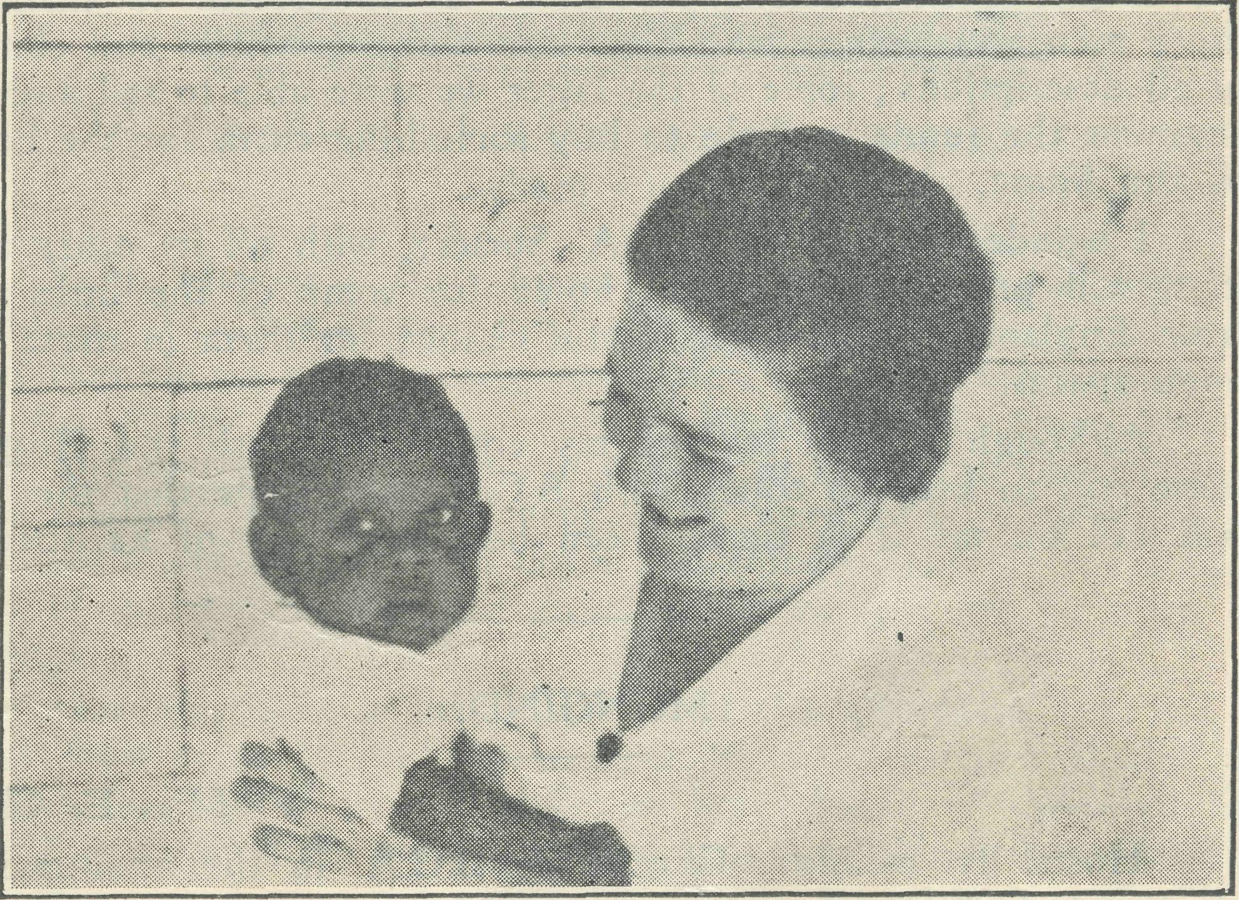
Mr. A. Chadwick.
Some time ago an appeal was made for the necessary finance to buy a blind flying instrument for our Fox Mcth, VH-AAA. I am very grateful to be able to tell you that last November the appeal was answered in full, and immediately our Sydney office placed an order with the Victorian agents. The instrument had to be shipped from England, and reached me at Ceduna here late m March of this year.
Fcr the next few days I was kept busy making a base-block and fittings for attaching the instrument to the machine, and looked forward eagerly to the time when all would he ready for a trial while VH-AAA was in flight.
That time came on the morning of April 3rd, when, having made the final connections a few minutes before, we took off from Ceduna for Ccok. After starting up the engine, we took our seats, and as we climbed up and headed westward across Murat Bay, I turned on the instrument control and settled down to the course.
It was a perfectly clear day, and as we flew along I allowed the machine a little turning movement left or right, and also "banked" left or right, and watched the-corresponding indications of the instrument and its reactions to correction by movements of the controls. This trip to Cook and return, flown in all-clear weather, gave me good practice in watching the "turn" and
Sister Dowling and Sydney James Cook at nine months
old. Sister Dowling has rendered outstanding service as
Matron-in-charge of our West Coast Medical Services,
Sister has been with us for nine years.

The Real Australian.
10
July 1, 1940.

FROM THE HOSTELS

AFTER SEVENTEEN YEARS.
Mrs. C. Mann.
For seventeen years I have managed to ignore all requests for an article for the "Real Australia," this time I was caught napping.
I have always contended that my work at the Hostel is just the same work that thousands of women are doing all over the world, with this difference, that they were not my own children ; and also, unlike very many mothers, I knew that if I could not make ends meet the O.M. and that band of wonderful workers, the "Ladies' Auxiliary," would get together and work and accom' plish what it was impossible to do at the Hostel with funds at our disposal.
My work has been most interesting, and besides being much attached to the children, some of the mothers will be my lifelong friends. I have left them all with a very sore heart, and I hope my successor will be as happy in her work as I have been.
My coworker and I at times felt the work very heavy, especially washing for twenty-six, with no hope of getting suitable help. We often wished for an electric washing machine ; at others, wondered if a washingmp machine would not have been more use' ful. Still, we were both happy in the work and thankful to God that He had given us both healthy bodies to carry en.
The children all had their duties to perform, down to the youngest, aged six. Hostel life teaches both boys and girls to be useful in the home, and are encouraged to help mother when on holidays.
Some cf the children have never come in contact with other children, except on rare occasions. What a change for a boy to find himself one of a dozen, all strangers ; to find himself sleeping in a dormitory with other lads, feeling lonely and home' sick for mother and dad, and other lads chattering around, and he lying there wondering if he will ever be able to laugh and chatter in the same way. A few days and he is one of them— with as much to say and making as much noise.
We folks at the Hostel have always tried to live up to the late Bishop Kirkby's idea for the Hostel to be a home, and not an institution : a home where children could be free and happy, and taught to love and fear God. Much has been done lately to make the Hostel more comfortable both for staff and children, and we have much to thank the O.M. for. His kindly interest in us, although we were so many miles away from headquarters, has always been much appreciated. I would like to thank all those men and women who have sent along groceries and clothing of all descriptions ; some of the latter we were able to sell and thus augment the funds, or help to buy something extra for the benefit of the home.
I wonder now if the B.C.A. Society, with all its other activities, will provide a Christian home for some of the little mites from England. What a wonderful chance for them in those wide open spaces.
Although I have severed my connection with the Hostel. I hope still to keep in touch with B.C.A., and hope that the O.M. will call, on, me if at times I can help with any of its activities.
MUNGINDI.
Miss E. Cheers. in the attainment of
Cheerio to B.C.A.
Hostel II. calling, its twentyfirst birthday.
For ten and a half years we have pursued the trail set before us, and already sixty children have benefited and had opportunities that otherwise they would have missed if it had not been for the thought of the B.C.A. and its generous supporters.
Provision had been made to accommodate twelve. Soon appli' cations came from all parts of the district and as far as eighty miles in Queensland. True, the dormitories somewhat resembled parking stations, nevertheless we were content to go on, feeling that each child must be received. Now, thanks again to B.C.A., a new and spacious dormitory has been added and we are no longer over-crowded.
During the year we were greatly cheered by visits from the Bishop of Armidale, the Organising Missioner, Miss Brooke' Anderson, and Deaconess Edith Lowenstein ; also by letters and greetings from other B.C.A. workers.
A word of thanks to the B.C.A. Women's Auxiliary. When goods arrive from them, done up in "Eveready" battery cases, the carriefs usually remark on them. It is a slogan that could be applied to the Women's Auxiliary—ever-ready to help ; linen (tea-towels always needed), replacing floor-covering that has been worn out by the tramp, tramp of so many little feet, clothing for little ones who come here and can afford so little ; above all, for their prayers. May they be greatly helped in their work.
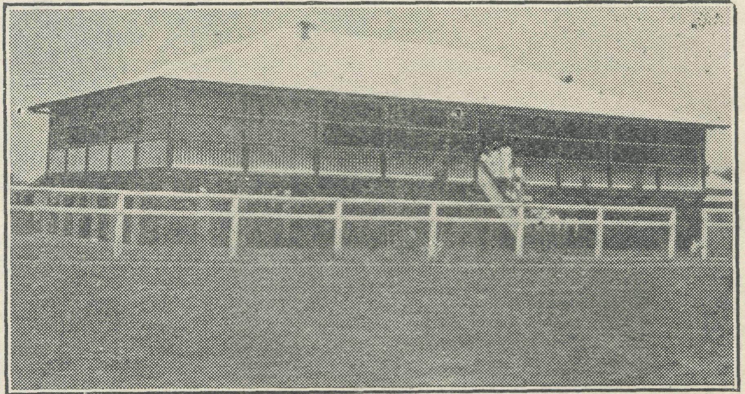
Mungindi Hostel, opened 1930.
When we read of the vast amounts given for war work we realise how little has been given for the extension of God's work in Australia.
In conclusion, a great privilege was afforded to be able to attend the opening of "Coorah." That "Goorah" will prove worthwhile is without a doubt, and many from this Hostel will in time find their way there, and so receive more of the blessings provided for them by the B.C.A.
'COORAH."
Sister A. Spence.
We are well into our second school term at "Coorah," and were able to face the second term with quite different feelings to those with which we began our work here in February.
Having lived together for four months, we had become as one family, and we were as pleased to welcome the boys "home" from holidays. That they arrived from their own homes with faces wreathed in smiles and protested that they were quite glad to be back, was compensation for much hard work and sleepless hours of planning and praying to establish "Coorah" as a B.C.A. Hostel for boys, in all that the name embodies.
Seven boys aged from eight to fourteen years, as different in temperament and character as seven boys cOuld be, have taken a good deal of knowing and careful understanding and handling so the best in them might be developed. There have been disturbing times when two difficult lads seemed to be going to overstep authority, and I almost wondered "if they do not do as I say now, what will I do ?" However, quickly came the thought

July i, 1940.
11
The Real Australian.

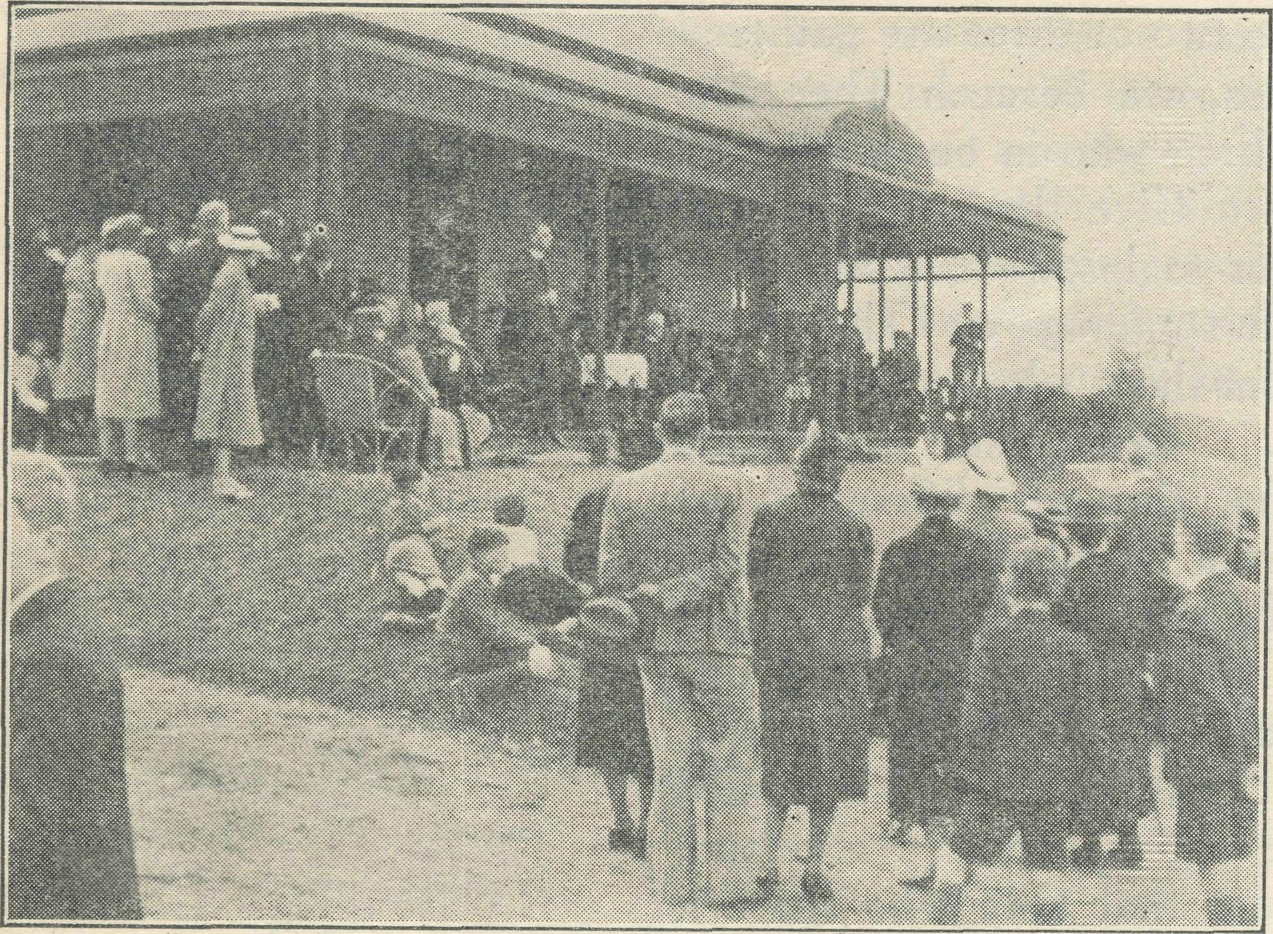
'Coorah" Official Opening.
and assurance that this is God's work and I a fellow-labourer with Him. He will undertake and it will be alright. Those boys are now as easily managed as any cf the others, and we thank God and take courage, being confident that He Who hath begun a good work in them will perform it until the day of Jesus Christ.
best thanks and appreciation, even as we say "Please keep on being generous." 'Tray for us and B.C.A. work until it hurts." And if we all give until it hurts then can we expect God to pour down upon us such a blessing that the work will advance in leaps and bounds.
•£♦ •$♦ ♦?♦
Miss M. Boydell.
"Coomb"—the new Bush Church Aid Hostel. To my mind there come two pictures : the first, December, 1939 ; and this place as I just saw it.
A magnificent eld home in the most wonderful setting of garden, trees and orchard, with so many possibilities. But the house had been empty for years, and though some rooms showed signs of having been lived in lately, dust, dirt and disorder reigned supreme. Some rooms were filled with furniture, others were almost bare, but all were covered with dust and needed much cleaning and a coat cf paint.
I had been sent up to carry on till Matron came, and have the.place ready for boys by the beginning of the February term.
The first days I felt almost overwhelmed. Where should I begin ? But I realised the urgency, and feeling sure God needed me here, and determined to do my best with the help of a very capable friend who had come up with me, we set to work at once, and each day brought some .pressing duty ; some days it was washing, others scrubbing or making jam, but all had to be done, and as quickly as possible.

One of the younger boys had never been to any kind of Church service or heard a prayer, and he seemed unable to learn quickly enough to satisfy himself. The elder boys were learning the "Books of the Bible," so Neville decided to do likewise. In the middle of lunch a shrill little voice would break forth : "Matthew, Mark, Luke, John, the Acts, the Romans, and what are the next two ?'" Then he would commence all over again until we were greatly relieved when he knew them all.
The mountain air has given them tremendous appetites, and they are growing and developing so quickly that already new clothes of February are outgrown. To those of you who have made this place possible, it is indeed worthwhile, even for the few boys we have had, and to you we say a big "thank you."
The Spirit of God is working in all their hearts in such a way that we who look on are amazed, and humbled at the smallness of our faith and the largeness of God's bounty and grace. So we thank Him for the privilege that has been ours, and commit the difficulties cf the days ahead to Him with confidence, sure that as we seek to win these young folk for Him, He will honour our endeavours, and the work and giving of us all will bear abundant fruit. These are the men of the near future, may we accept our responsibiity in helping to prepare them and train them in the ways of right thinking and right living.
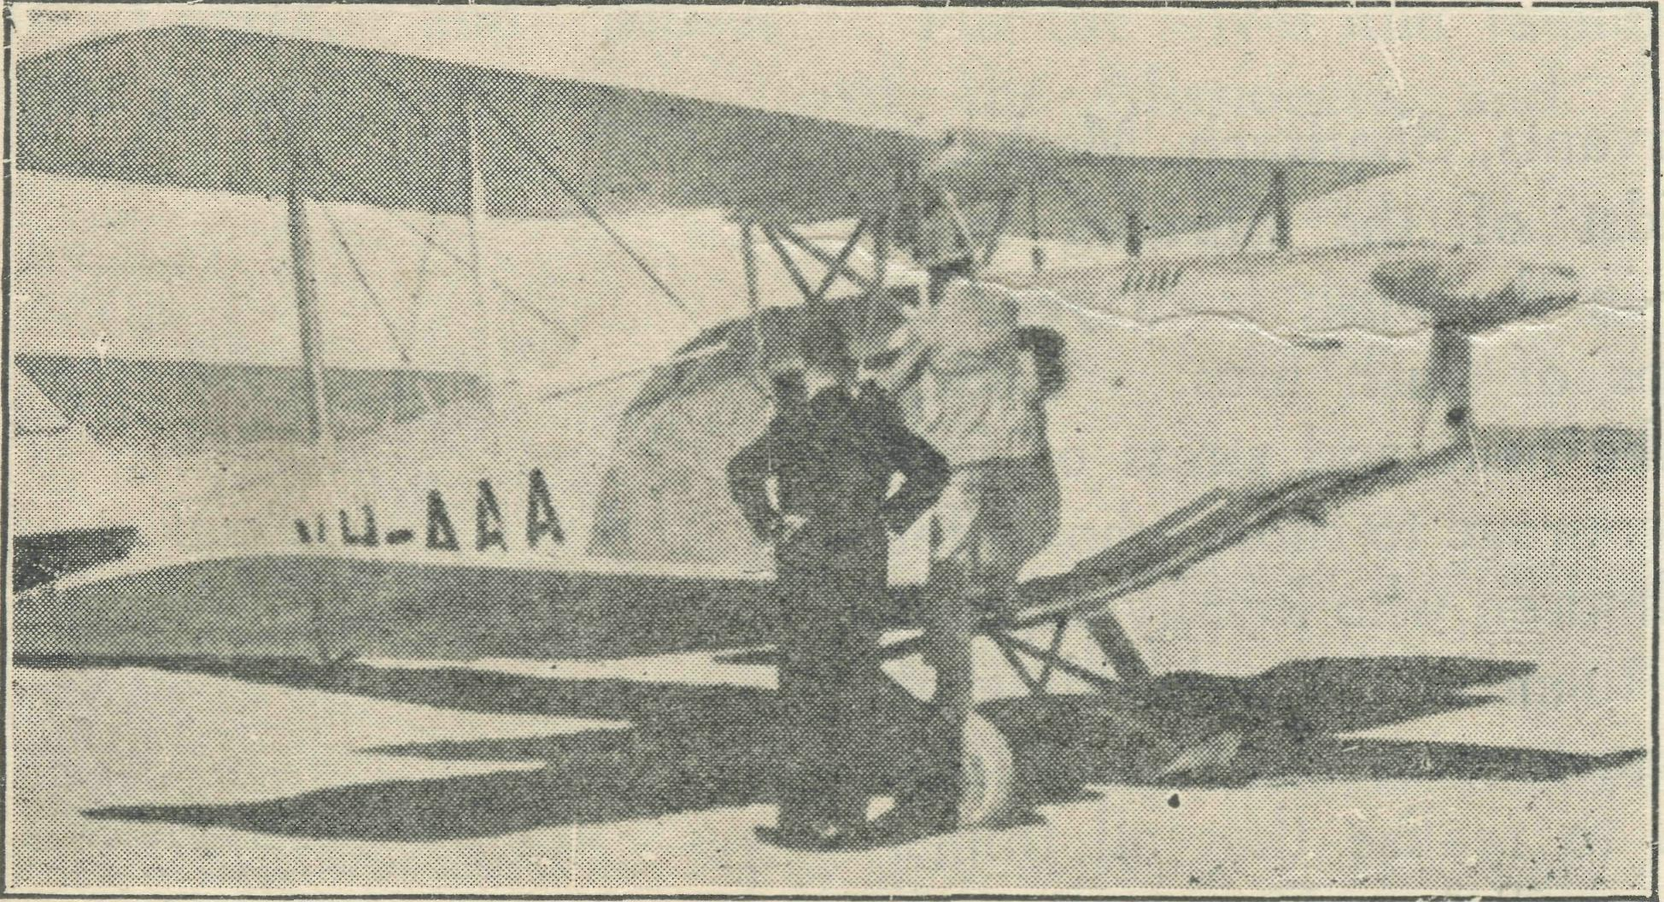
Preparing VH-AAA for a call.
B.C.A. friends have been so generous and have come to the rescue in so many ways, and we would have you accept, our
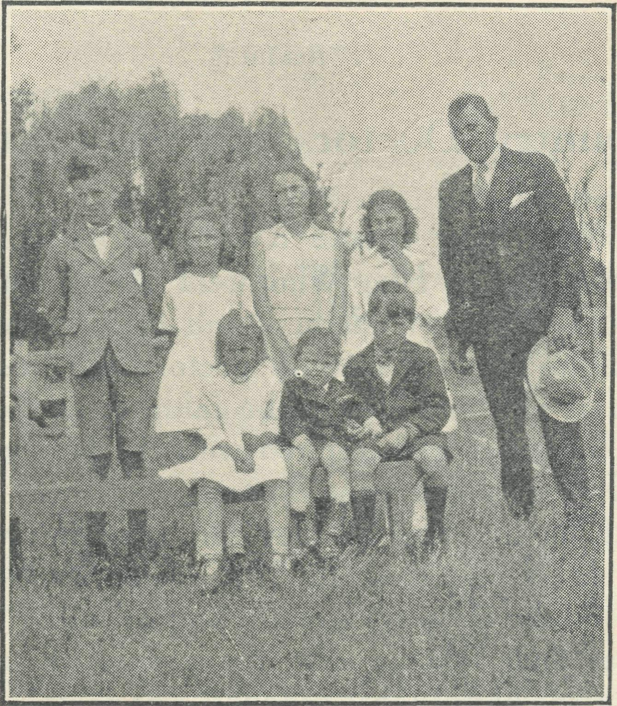
A family of B.C.A. Ma'IBag Sunday School scholars.
Then Matron (Sister Audrey Spence) arrived, and with her coming order began to reign. We still had much to do, but gradually things were getting into order, and April 6th brought my second picture—everything outside looking fresh after days cf rain, and inside, though we still needed so many things, "everything was changed. The dirty grey walls were now a deep cream, the floors and furniture all clean and shining, and all the inmates full of excitement, for the Archbishop was coming to open the Hostel.
Wentworth Falls people provided the afternoon tea, but we had quite a lot to do, for so great was the interest shown that over two hundred people gathered here that day. We felt God was indeed blessing our work, and pray that He will continue to do so.
It has all shown me, as never before, how He does indeed supply our needs, for always just as something becomes an asbo' lute necessity someone sends us that very thing ; and so we praise Him for His goodness and thank Him for the opportunity He has given us here.

The Real Australian. 12
SPECIAL PRAYERS FOR YOUR USE.
July I, 1940.

For Church Life in Country Districts.
{"\ LORD, Who art present when two or three are gathered together in Thy Name, bless, we beseech Thee, the little far-scattered groups of brethren who in our wide land meet together to worship Thee. Give them a perpetual freshness of spirit, and the power to inspire in each other holiness, helpfulness, and understanding of Thy help. Refresh with the joy of enthusiasm those who endure weary journeys to Thy trysting place. Grant that these little companies of Thy servants who, through differences of interpretation, are prevented from worshipping together, may yet be united in the spirit of Christian charity, awaiting in love the time when there shall be one fold and one Shepherd. Grant that the common life of all communities, isolated from each other by great distances, may be purified by this spirit of charity from all meanness, falsehood, malice, and idle gossip, and grant that they who share a common lot may draw strength from each other's virtues, and in their weakness help one another, through our one Lord, Jesus Christ.

For Country Doctors and Bush Nurses,
r\ GOD, Who didst choose a beloved physican to set forth the life of Him Who went about doing good, grant that Thy strong tenderness and compassion may be manifest in the wz>rk of country doctors and bush nurses. Make them at all times alert to be faithful, as those whom Thou hast burdened and inspired with the honour of their calling. In lonely emergencies strengthen them with confidence that, having done all they can, they may with good conscience leave the issue to Thy power working within Thy law. Make them resourceful and of sound judgment, and hearten their labours with the energy of compassion and the firmness of duty that conquers weariness. Through
-iim Whose power is called forth by suffering, Jesus Christ
Dur Lord.
For Drovers, Shearers, Stockmen, Dairy
Workers, and all whose work is the care
of animals.
r\ GOD, Who called Thy Son Jesus to be the Good Shepherd, grant to all who are charged with the care of animals the spirit of understanding, care and compassion, and reverence for life. Preserve them from the unfeeling selfishness of "the hireling who fleeth because he is an hireling," and grant that they may do their work in the spirit of honourable responsibility, as those who will account to Thee for their stewardship of Thy creatures. Thou Who hast ordained that all living things shall minister to each other, grant that we may receive the service of Thy humbler creation with the skill of sympathy and conscience. Through Jesus Christ our Lord.

Prayer in Times of Bush Fires.
O GOD, Who was with Thy servants, Shadrach, Meshach and Abednego, in the midst of the burning fiery furnace : Be with our brethren in the bush from year to year, in the perils and hardships of bush fires. Endue them with physical strength in the heat and stress of fire-fighting. Give consolation and courage to those who suffer loss, especially the women and children who loyally support and minister to them. Be with them in the re-building of farm and home, cleanse their hearts with the fire of Thy gracious Spirit ; and help them to realise that all things work together for good to them that love Thee ; through Jesus Christ our Lord. Amen.

July I, 1940.
13
The Real Australian;

THE PLACE OF PRAYER.
A Prayer for Use with Our Prayer List.
O Lord God of our nation, Who has commanded men to subdue and replenish the earth : Look in Thy love upon all those who in the distant parts of our land are striving against many difficulties, and are deprived the access of the means of grace. Strengthen and guide the Bush Church Aid Society and its Clergy, Nurses, Deaconesses and Students. Cheer and comfort them in discouragements and loneliness, and bless their ministrations to the good of those they serve, and grant that the message of redeeming love may thus be rooted and grounded in our national life, to the glory of Thy Great Name, through Jesus Christ our Lord. Amen.

SUNDAY.
THURSDAY.

MORNING.
EVENING.
MORNING.
EVENING.

The Far West Missions at The West Darling Missions
Penong, Ceduna, Minnipa and at Wilcannia and Menindie :
Cummins ; the Missioners, the N.W. Mallee ; and the
Revs. E. V. Constable, N. Missioners, Revs. D. G. L.
Chambers, T. R. Fleming and Livingstone, G. B. Calder-
L. Morris. wood and F. Bayly.
For the Mail-Bag Sunday For the Organising Mis-
School with its Gospel mes- sioner, that he may be
sage for the children. For strengthened and guided in
the teachers and helpers, that all his endeavours for the
they may find encouragement good of the work and in his
in their work. relationships with his fellow-
workers.

MONDAY.
EVENING.
The Denmark Settlement, the Kirton Point Missions and the Missioners, the Revs. B. Lousada and R.'T. Hallahan.
TUESDAY.
WEDNESDAY.
MORNING.
The Cann River Mission, the Bonang Mission ; and the Revs. N. Holdsworth and W. A. McLeod.
MORNING.
For Sisters Dowling, Boss-ley, Page, Pritchard, Loane, Nurse Branford at Ceduna ; Sisters Goodwin and Eglitzky at Penong.
MORNING.
For the children in the Mungindi and Wilcannia Hostels, and for the workers, Miss Cheers, and Misses Gurrier Jones.
EVENING.
For the Cann River Dispensary and Koonibba Mission Hospital ; and Sisters I. Gwynne and G. Hitchcock.
EVENING.
For the Flying Medical Service, Mr. Chadwick, and Doctors R. and F. Gibson.
For the wives and families of the Missioners and Air Pilot.
FRIDAY.
EVENING.
MORNING.
For the Bishop Kirkby For students and all in
Memorial Hospital and Sister training for this work of God. Symons and Miss D. Dykes For Rev. G. Beatty and the as they minister to the people Heytesbury Forest Mission, on the great Nullarbor Plain. For Rev. T. H. Pickburn and
the Otway Ranges Mission.
SATURDAY.
MORNING. EVENING.
For the President and For the "Coorah" Hostel
Council of the Society, that and its workers, Sister A.
they may be guided by His Spence, Miss M. Boydell and
wisdom. Mr. I. Taylor.
For the Home Base Staffs, For the Rappville Mission
Auxiliaries, and parochial and the Missioner, the Rev.
workers. K. Luders.
Each day pray that the many needs of the work may be met.
Running expenses of 35/- per hour to keep the Medical 'Plane in the air.
Consecrated clergy missioners for urgent work in the field.
That our work may continue to progress despite the difficulties of wartime.

Give Thanks-
For the rich blessing and wonderful growth of the Society's work.
For all the kindly givers who have helped with their self-denials.
For the Flying Medical Service.
For new workers in Hospitals and Missions.
For the joy of service.

The Real Australian.
14
July i, 1940.

NEWS FROM THE MISSIONS

FRESH FIELDS AND PASTURES NEW.
Rev. K. Luders.
I have just come in from chasing a red cow out of the back yard. It has happened before, and will happen again and again until such time as I can make the fence red-cow-prcof ; which leads me to think of the Vicarage fences, the gates and the Vicarage itself—all symblematic of the parish. The fence posts are askew, and the hinges only just "hinging." Every gate a nuisance to open and a trouble to shut. The Vicarage ? Well, by the strenuous efforts cf a faithful few it has been reduced, remodelled and made habitable. But at first glance it is not inviting. The ground is still scarred where there were foundations of four addi-tional rooms, now reduced to firewood by the efforts of white ants and a renovator-builder. Salvaged timber served for building a verandah and kitchen. Perhaps by this time next year a coat of paint will give uniformity of colouring, but at the moment the place looks like a camouflage artist's working model. But still, it 13 headquarters, and home, and fairly snug.
Look at the Church buildings. St. John's, Rappville, is almost imposing from a distance—though the smithy and the saleyards as a background do detract somewhat from the picture. A closer look reveals that one window-frame at least is fast approaching the falling'OUt stage, and others are not far behind. Evidently the paint required for the walls was underestimated, and the last coat finished in steps and stairs on the front gable. Come inside. The bulge in the boards ? Oh, white ants. The whiteish dust on the seats? Oh, borers in the ceiling. Yes, the curtains and hangings are faded and a little torn. What do they prove ? The many may be indifferent but the remnant are still true.
Now to St. Aidan's, Wyan. Wyan was once a flourishing district with comparatively numerous inhabitants^so many in fact that an extension was made to the church. Needing a bit of attention 7 Well, yes. Some of the guttering has gone, some boards are retting and a few windows are drooping. A pretty church, but neglected. What is that upon the ceiling ? Oh, a dead bat.
To St. Andrew's, Camira Creek, this time. Remember to bend your head forward as your bounce. The road is not quite the best in the world, and "Mona" (the old Dodge) is not gentle with her passengers. Fourteen miles and a bit, and here we are. Mind the bottom step, it is a bit "wonky" ; the ethers are firmer than they look. The dullness of the porch and vestry is due to the windows being boarded up when the glass fell out. With no lining to the building it does look bleak, but what could be done has been done. That thing like a flying carpet was once a reredos of sorts, and was hoisted up aloft " to make the place less barn' like.'" I was told. Yes, there is room for improvement, but there always is. Don't be misled by appearances. Some of the most devoted souls in the parish worship here.
Where next ? Let us go to St. George's at Ellangowan. By the direct track it would be a twenty-two-miles run, but it is best to go a long way round and cover twenty-four miles. In wet weather we would have to cover thirty-seven miles. This church is erected on land donated by a gentleman who erected the building on half'pay—voluntarily of, course. Here the torch has never gone out, though it may have become dimmed now and again. St. George's is well-appointed and well cared for. It is no one's fault that mice played havoc with the organ. In any case that damage has already been made good. They are good listeners here, too—glad of every Gospel crumb.
St. Agatha's, Yorklea, is rather a contrast. Yes, pretty ram-shackled ; rank grass right to the door, the door itself wedged shut with a chip of wood. That's rather a strong smell ? Birds.
They have rather made a mess of things, and the white ants have helped. Not very encouraging to worshippers. Perhaps that is why so few come. Last time one young woman turned up. The one loyal family was prevented by a case of sickness from attending.
There are other centres : Hogarth Range, Cherry Tree, Lee ville, Busby's Flat, and Coombell. The parish covers an area of somewhere about—well it is near enough to thirty miles long and twenty-six miles wide, so work it our for yourself.
The parishioners include dairy farmers, cattle graziers, timber cutters, railway workers, timber mills employees, brickworks em-ployees, haulage contractors, distillers of ti'tree oil, etc. I have just discovered forestry workers. Also there is a sprinkling of "tick" men, school teachers, and storekeepers. Perhaps I may tell you more about these people later. At the moment all I need say is that the majority have one thing in common—an ignorance of their need and a lack of enthusiasm for spiritual things.
Here I find that my ministry is welcomed not only by An-glicans, but also by Methodists, Baptists and Presbyterians. Ministers of each of these others touch certain limited localities, but seem to be without the resources to go far afield.
Reference to resources turns my mind to the matter of transport. At first it was proposed that the parish should be "worked" by means cf two horses, a sulky, and perhaps a saddle. The means of locomotion were to have been on the spot when I arrived. I am glad to say they were not. Excursions to various centres soon made it abundantly clear that horseflesh could not stand up to the job. One horse was brought here on trial. What fun ! She was guaranteed to be quiet, with a good action for sulky use. I clambered into the sulky, grasped the "ribbons" (I believe that is the correct "horsey" term), a,nd away we went. That mare won my heart. She was willing to work though lacking in beauty. With instructions to get used to her for a week before taking a trial run, I helped release her cf harness and sought to make friends. Next morning I learned by the system of trial and error that there is only one side on which to approach a horse—fussy animal—and a correct way to lay a hand upon her. Really, I had no idea horses were so finicky ! At the end of a week we were more friendly, though there was lacking that mutual, absolute trust so essential for true comradeship. Came the day of the sulky trial. With help from a third party, the mare was insinuated into the sulky harness. I washed my hands, put on a coat and hat*—yes, a hat too—^mounted . . . and stayed at home ! We smooged, to her, we remonstrated, and finally whacked her—but only once. Then we sent for the agent who was "pushing" the sale. He gave us a demonstration—and what a demonstration ! I was glad it was his sulky that was backed with such violence into a three-foot log that it (the sulky, of course) flew high into the air. It was a case of all hands to the rescue then. After he had "knocked the devil out of her" (not my expression), the mare set off. Feeling that repetitions of these performances before setting out on each run might become too arduous, I declined the deal.
Since then we have purchased a parish car, been presented with a motor-bike and given a horse. The car you know about ; the motor-bike won't "mote," but we hope to realise on it; the horse !—who said you should not look a gift horse in the mouth ? He was crazy. I was invited to look into this mare's mouth, so I did (trying to appear wise, too). There were gaps where there should have been teeth, but for all I knew this may have been due to a bout of temper, hunger, or absent-mindedness when the animal chewed barbed-wire. But still I have suspicions. You see, before we saw the horse it was nine years old by repute. Since it has become the parish property it has been identified as "the
mare that was on the mail-run in " and again as "the mare
the Canon used in the parish before the last war." We estimate that she must be over twenty-five years of age, and so have turned her out for a holiday.

July l_{t} 1940.
15
The Real Australian.

One of the most pleasing features of this new station is that, being in N.S.W., I may take Scripture classes. In every school all children other than Roman Catholics attend. Two Sunday Schools will be commenced in the near future. The young people of the parish present a fruitful field of opportunity.
DELEGATE.
Rev. Wm. McLeod.
Our first impression was one of contrast, of geography and climate. Instead of the undulating mallee-clad country of the West Coast, with farms here and there, we saw real gums, hills and pastoral grasslands.
Approaching Delegate, Mount Delegate stood out like a huge sentinel. Local people very casually call it a hill. On the West Coast we would certainly have called it a mountain.
The summer days were comparatively mild, and some nights cold enough for fires. But we certainly prefer the West Coast winter, with its warm, mild, spring-like days. Here we are becom-ing well-acquainted with icy winds, fogs, dull days and heavy frosts. We have had one slight fall of snow. Fires at night are regular friends of ours.
Though Delegate, our principal centre, is in N.S.W., all other centres, with one exception, are in Victoria. After the first strangeness and little complications of working in two States, one becomes accustomed to crossing borders.
It is interesting to feel oneself in the regions of the famous Snowy River, and to know that all rivers here are tributaries. As far as I can state, there is no record of the Delegate River ever running dry. What a wonderful record when we think of some of the larger rivers of Australia.
Though there is no great distance between homesteads, yet the very contours of the country make this distance, for every practical purpose, greater than it is. Good roads, nowadays", make it possible to travel in comparative comfort. What must it have been for the pioneer !
We have met very many fine people, who undoubtedly spring from hardy stock. We feel thankful that the B.C.A. has made it possible to carry on the work of the ministry here. It will take a long time to know them all, as the time taken for schools does net allow for as much visitation as we would like. The Victorian State schools can only be entered at certain periods of the day, and eight are in this district. Though not as large a district as Minnipa Mission, one feels often a greater sense of isolation because of hills and valley and bush, and learns to realise the pioneer work of some of these folk in the out-centres by the clearing of lands for pasture. While most of the roads are good, they twist and turn, with towering cliffs now above or deep gulleys a few feet away, and progress is slow.
There are eight service centres : Delegate and Craigie in N.S.W., Bonang, Bendoc, Lower Bendoc, North Bendoc, Goon-gerral and Tubbutt in Victoria.
Delegate has a very fine church in an attractive setting, which will be sixty years old this year. The district has the distinction of possessing the first church on the Monaro Tablelands. Over one hundred years ago, on the present site of the cemetery, and in Delegate station property, was a small building known and referred to by Bishop Broughton as the "Delegate Chapel." This building has long since disappeared. So you see the record of Christian worship is old here.
A very important side of my work is the conducting of religious instruction in the schools.' This takes up a lot of the time, but is well worthwhile. Eight schools are taken weekly, and two fortnightly. Much car travelling is required, but the work is too vital to leave undone. The young people are worthy of every attention, and are very responsive.
Our usual Sunday starts at Delegate at 8 a.m., then out to two country centres for services, except on one Sunday in the
month, when we have 11 a.m. also at Delegate, then on to Tubbutt, about forty miles away, through some of that grand Gippsland country of changing Varieties of beauty—tall, straight timbers, valleys, mountains and streams. Many good folk are to be found, their holdings among the valleys and hills, and bearing the evidence of much hard labour in clearing of timber that the grass may grow.
The only Church buildings are in Delegate and Craigie, N.S.W., and one Union Church at Bendoc, Victoria, where we alone now attend. All other services are in halls or schools, except at Tubbutt, where we use private dwellings. Worship in these is none the less real and worthwhile. Some attendances are necessarily small, because settlement is small, or distances and conditions of country are against scattered settlers. But, after all, this gives the sense of much of the ministry of B.C.A., which is often for such people, and worthwhile in every way.
Though I have to keep my mind on the wheel and eyes On the roads as they wind about, there is a tremendous compensation in the scenic magnificence and remarkable variety of it. Eyes on the road or not, one sees quite a lot of it. What we will feel like in the dead of winter may be another matter. Local people have prepared our minds for what it can be, and we have had a little taste.
But Delegate has a very fine rectory, made available by the splendid efforts of our people. We have no lack of wood, so will find much comfort in the warmth of fires.
Most of this country is essentially grazing, sheep and cattle, and certainly has a wonderful reputation. This does not mean that hard and careful work has not been done by its people. In fact there is abundant evidence of it everywhere.
Also things can happen to them to affect them severely. We never want to see again such a sweeping and disastrous grass fire as one we had some months ago. It. moved at a terrifying speed and did much damage. But I heard no growls, just thankfulness that it had not been as bad as it could have been. The way they fought this destroying power, and the wonderful recovery of the country are things worthy of note.
There is room for great work here in the matter of the Church and its ministry, in order that among so many fine people God's Kingdom and Christ's salvation may be established.
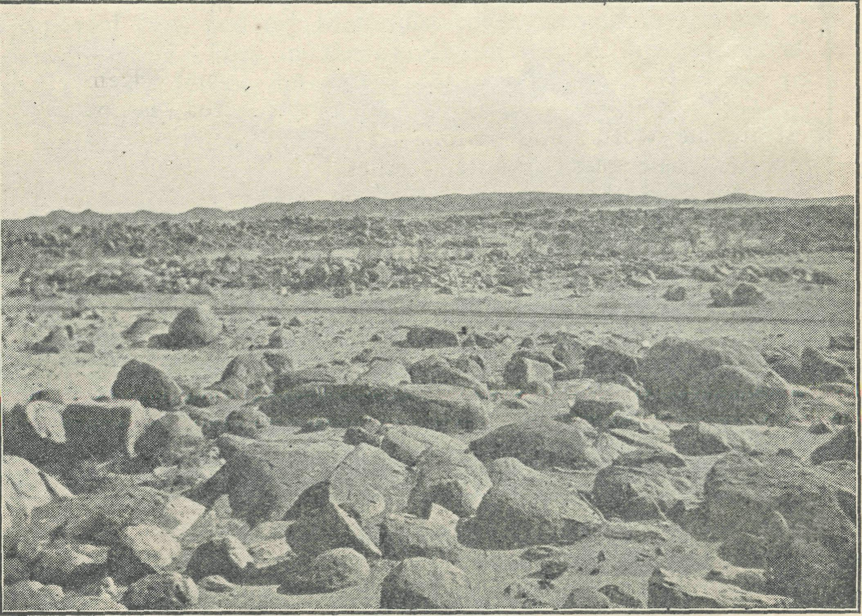
The road to Tibbooburra, Wilcannia Mission.
WILCANNIA.
Rev. D. Livingstone.
It was May 26th, 1940, the King's Day of Prayer. In the farthest town from Sydney in N.S.W., a B.C.A. missioner, a young miner and a drunken man were sweeping a dilapidated hall,

The Real Australian.
16
July 1, 1940.

repairing very old forms, and arranging a table covered with a torn sheet in preparation for the Evening Service. The piano sounded like nothing on earth, but we had to leave that and hope for the best:
At last all was ready. At 7.25 p.m. on a bitterly cold, pitch' dark night, the missioner, in cassock and surplice, stood outside the hall vigorously ringing an auctioneer's bell to summon the people to repentance and prayer. As the bell shattered the silence, lanterns and torches showed pin-points of light, and in a few minutes nearly sixty people—the largest number ever seen at any of the rare services—were balancing somewhat precariously on the swaying forms.
The piano and singing were by no means a delight to the ear, but earnestness and sincerity rang in every note. As the service went on the atmosphere became more and more solemn. Although the sermon was delivered to the accompaniment of a low running commentary by our drunken friend, the congregation drank in every word. During the special prayers that followed, and last" of all, during a period of silence which was broken only" by a few low sobs when we prayed for our relatives and friends actively engaged in warfare, His Presence was very near. Never have I been privileged to conduct such a solemn service.
So Tibcoburra played its part, and a very real part, in that Day of Prayer. Under God, that was due to the Bush Church Aid Society.
As the missioned long patrol of over 1,200 miles went on for three weeks, home after home had its own little service of prayer. Psalm 46 brought comfort to many a soul that was a little afraid. Mothers were strengthened as we prayed for their boys in Palestine or in camp, for a very high proportion of the young men of the outback are already serving with the Forces.
A friend who did this trip with me said on our return, "It is worthwhile.¹¹ And so it is, wonderfully worthwhile.
The outback needs B.C.A. as never before.
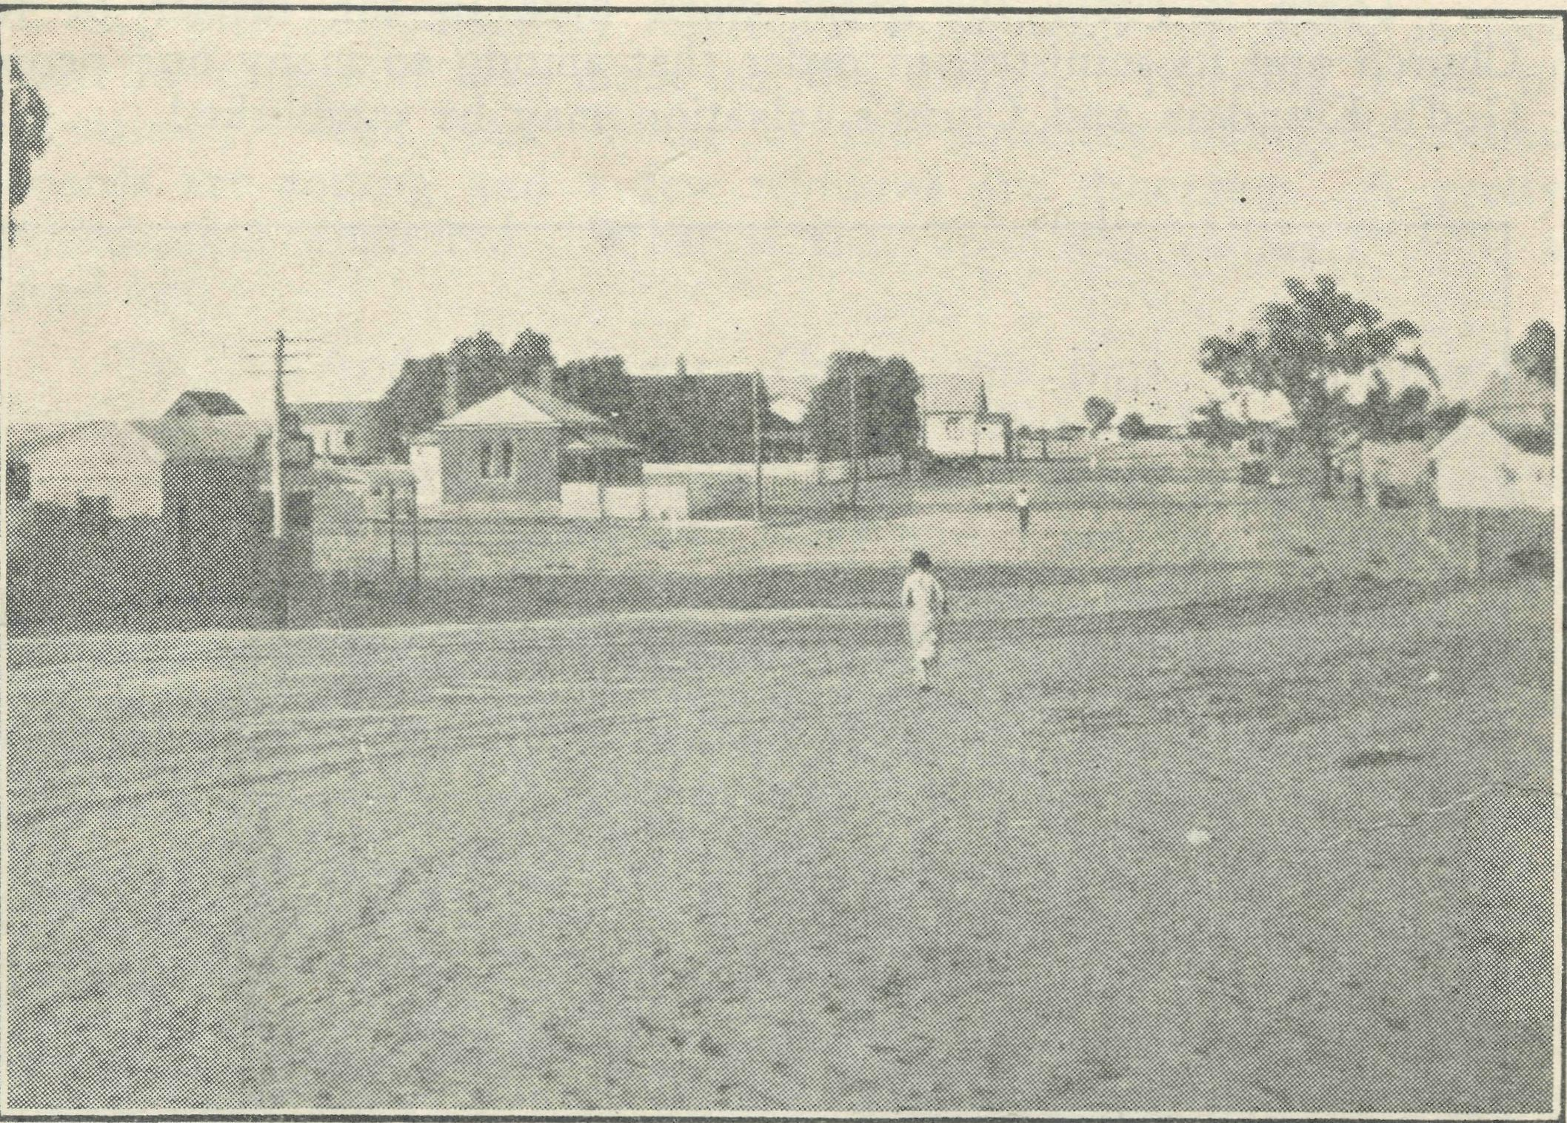
Menindie. MENINDIE,
For twenty-one-years B.C.A. has carried on its ministry. Shall we abandon this work now ? No ! a thousand times NO !
a dark, dreary night, in vision soared up to Heaven and saw spreading before them fields of opportunity for service in the outback. But while holding the vision, they set about dealing with actualities and endeavoured to focus the love and truth of God upon the common things of daily life in the bush.
Not the least in all their mighty work was the publication of the "Real Australian." To me this little? paper is as the front window where the work of the B.C.A. is displayed, with all its hopes and visions, its ventures and challenges, to the people of Australia, and is of invaluable service in promoting interest in the necessary task of bringing the Church to the people of the outback.
It is a publication different from others, in that each contribution is a personal letter from the man in the field to the friends of the B.C.A. in the cities. Through these letters the work is laid open and its demands clearly seen. Its demands are many, for it is no easy or small task which has been undertaken. But when one thinks of it as a partnership with God, then all His help and sharing ini the work can be confidently claimed and the demands are met. When that Divine partnership was sought by the B.C.A. founders God put into their hearts great powers of courage, faith, endurance and hope ; qualities which have developed in the storm and stress which followed the launching of such a project. It is a privilege to sail with God in these times of world upheaval, indeed it is a great privilege to live to-day and to enter the wealthy heritage from the past.
It has taken twenty-one years of hard struggle and striving to build up the Society to its present stage. To-day and to-morrow is the testing'time as to whether the stability of our thoughts, hopes and prayers will endure. The seed has been sown. What shall we reap ? Surely, with the faith shown in the past, we can gather in love, joy and goodwill. Behind the B.C.A. stands Gcd. The Society is young, and its hopes are in the future. The years stretch out before us—years of great opportunity for adventurous service. Our cause—-the spread of the Gospel of lesus Christ— is needed to-day in the country. Our hope is immortal and God is with us.
In Menindie Fm known as an optimist. As I look out on this section of the work I see great possibilities. The young people are building a church—not of wood and stone—which will reach the heights of God. We are standing together, conscious that in God this great adventure of faith known as the B.C.A. will be a power for good in the future, as in the past, and that men and women will be led upward and onward to the City of God*.
Now for a scrap of news. It was my privilege to be the first to welcome the Misses Gurrie lones to the West, and to take them on to Wilcannia. The story of their arrival in that town is not without excitement, but I don't wish to steal their thunder in relating what occucrred.
The youngsters of Holy Trinity have now a gymnasium. Two instructors, one for the girls and another for the boys, do the coaching. We hope to have a display shortly. I have performed many tasks of a strange nature since arriving in Menindie, but the strangest was when the local butcher called very late one Sunday night. "Mr. Calderwood," he began, "we have run out of meat at the shop. Could you possibly supply us with some sheep."
Next morning I rang a station homestead and was promised four sheep. When I collected them I discovered that eight had been put aside by way of good measure. The proceeds go to church funds. I don't know who was most pleased—the butcher or myself.

Rev. G. Calderwood.
It must be with great thankfulness to God that the Bush Church Aid Society celebrates its "coming-of-age." The road along which it has travelled has net been easy, but under the Divine guidance of God it has weathered many storms and is now one of His strongest instruments in the country.
At this time you can't help but let your thoughts go back to the beginnings of the work. A handful of men and women on
THE HEYTESBURY MISSION.
Rev. G. Beatty.
With this issue of "The Real Australian" we thank God for the twenty-one years of faithful service that B.C.A. has been able to render to Australia and to her people outback. With faith in God and with a love for the souls of men, for twenty-one years the workers of the Society have gone forth to remote areas of our

July 1, 1940.
Vi
The Real Australian.

land, taking the ministry of the Word and Sacraments, and in some cases the Ministry of Healing. What this ministry has meant, and means, to the people outback and in the forest areas cf our land can never be recorded on paper, for words are inadequate to express spiritual values. For twenty-one years this work has gone on day in and day out, and if only there could be recorded a- list of the souls won and the lives enriched through this ministry, during this period, what an inspiring catalogue it would be.
As this is a birthday number, I suppose some account of the progress of the work in the Heytesbury should be given. It is now ever eighteen months since B.C.A. set foot here. The missioned coming was heralded with joy by the people, for it meant that they now had a fully ordained man in their midst, and the Bishop of the Diocese expressed his appreciation to B.C.A. in no uncertain tones, as for him it meant the solution of a big problem.
When the missioner arrived everything was at bedrock, but gradually the work has grown, despite many problems and difficulties. At each of the service centres the congregations have increased in numbers, and at the moment there are four more centres seeking services. On every side there are signs of awakening interest. With the war new opportunities have come and new avenues of service have opened up, for in wartime the people in the bush need and value the comfort and strength of the Gospel more than ever.
The last time I wrote to you I mentioned the work at the Cooriemungle Prison Camp. This is proving to be most worthwhile. Stan, of whom I wrote in the aforementioned article, has now been a free man for two months, and his conversion is proving to be definite and real, and the gratitude of his wife (who is a true Christian) knows no bounds. Previously an inveterate gambler and a drunkard, and with no interest in his home, his wife, or his child, Stan is now a changed man and is influencing for good those with whom he is working. One of his workmates said to me a couple of weeks ago, when I met him in Melbourne, "Do you know, since Stan came back I have not had a drink.¹¹
After the Easter Communion Service at the camp one cf the men, as he went out of the mess-hut where the service was held, said to me in a rather broken voice, "Thank you, very much.¹¹ Then I noticed that as he walked away he buried his face in his hands. He was absolutely broken up. Afterwards he said, "My word, that service touched me this morning. It absolutely broke me up. To-day is the first time for thirty-three years that I have taken Communion, and it will not be the last. I am a prodigal come home.¹¹
So keep on praying, keep on giving, for the value of a soul in the sight of .God cannot be measured.
However, it's all over now, and here we are, well-settled on the West Coast in a very typical B.C.A. parish. The winter is now with us, things are beginning to look green ; the climate is glorious at this time of the year, and, having found my way all round the district, we are feeling quite at home.
In many of your minds there will still be present vivid memories of Empire Sunday and the King's call to prayer, so I thought I might tell you of that day here in this parish.
To cope with expected crowds, we had hymn-sheets printed at Port Lincoln, but delivery was the trouble. Finally the printer arranged for them to get to Yallunda Flat, ten miles from here, late on the Saturday night. So in the dark of 5.30 a.m. on the Sunday morning I ran out to get them, and came back to light fires, etc., so that we could have breakfast before 8 a.m. Holy Communion, as immediately afterwards I had to drive fifty miles over the worst road that I know of anywhere, to Lock for a combined service in the Institute Hall. Some 240 people— Lutherans, Roman Catholics, Methodists, and Anglicans^joined in that great service of prayer.
When that was finished, into the car with a sandwich lunch . as I drove along, for I was now due at Yellukka to look in at a Sunday School ; but when I got there the district was there to see . if I could squeeze in a service for them, as they were too far away from their nearest service. What could I say ? So we had a most informal but none- the less sincere time of prayer. Think of this, you who have only to go to the corner of the street !
Then on to Kapinnie. There two surprise's met me. First, this was advertised as our ordinary fortnightly service, but people of all creeds had gathered. The second, for some time, to try to create a better atmosphere as the service has to be held in the public hall, the men on the carpentry and the ladies sewing, had been making a temporary sanctuary that could be folded up after each service, and by a great spurt they had finished it and had it erected to meet my eyes as I entered the hall. • Another very moving service was held.
Back to Cummins, with just sufficient time for tea before going into church for Evensong at 7 p.m. And what a congregation! The churchwardens had to borrow seats from the hall. After this, a combined service of prayer in the public hall, and here the process was reversed, for our church seats had new to be borrowed, for there were 340 people there. Where had they all come from ? That is still a mystery. The street was lined with all types of cars, and my Methodist colleague and myself felt well repaid for our effort in that great service of intercession as a united people forgot differences of creed in their response to a Christian King.
But if B.C.A. had not stepped into the breach two years ago most of these services would not have been held.

CUMMINS,

Rev. T. R. Fleming.
There is always a thrill about proceeding to a new job, but coming to Cummins had rather more than its share. We travelled from Melbourne to Adelaide by boat, and we had no sooner passed "The Heads¹¹ than a roll began that continued for eighteen hours, to the undoing cf most of the passengers and many of the crew. So at breakfast-time next morning our cabin was a hospital, with my wife and both the children sick.
We were met at Port Adelaide by the Rev. K. Luders, who acted as a guide for the day. We had much shopping to do, and Mr. Luders stood it as only a well-trained husband can !
We were to go to the Hallahans at Port Lincoln, but when the boat docked there, the Rev. R. T. Hallahan met us with the news of whooping-cough in his family, so we had to put the time in on the beach, and get over our exchange of information whilst avoiding the meeting of the children/ Then we drove on to Cummins in a blistering heat, and with a family still suffering from a disturbed internal economy, who seemed to have lost all interest, in life in general and Cummins in particular.
LIFE BEGINS
Rev. L. Morris.
MINNIPA^so read the legend on the railway station, and no word in the English tongue could have been half so sweet to a travel-stained clergyman who had looked for that glorious name from Saturday evening until Tuesday afternoon. For the last time I gathered together my belongings, and with feelings of thankfulness that my journey was over and expectancy as at last I was to enter on my work as B.C.A. missioner, I climbed down out of that train and set foot en my district.
Soon I found myself duly installed as missioner in a community of farmers, and I -could scarcely tell wheat from barley, or a cultivator from a plough. Many a laugh have the locals had already from my amateur ideas and efforts about a farm, and I am astonished at the large number of mistakes I have managed to cram into so short a time. Still, the farmers are a helpful lot, and I have had quite a few'take pity on my poor, ignorant, helpless state, and am now in process of learning what happened to our

The Real Australian.
18
July 1, 1940.

bread before it became flour and our bacon before it saw a bacon factory, as well as a host of other interesting and useful things.
Came my first Sunday, and a very hopeful young man. set out to take services. ^{u} 'Arriet¹¹ (for such is the name of the car I'm to use) went well for a few miles, and then—calamity ! For no apparent reason she slackened speed and came to a halt by the roadside. Now my knowledge of motors and their engines is practically nil, and it was only a short while before my resources were exhausted, and I had reached the conclusion that the reason for the stoppage was some deep mystery known only to the initi' ated. Imagine my surprise and joy when a tentative push on the self-starter produced results, and " 'Arriet" was on the way again ! Before becoming a total wreck she reached a garage, where a wise man did some wonderful things to the carburettor, and be' hold ! she was all right once more. Eventually she brought me to the first meeting'place, where I found a congregation of two still patiently waiting. I am thus sharply reminded at the outset that my days among large congregations are no longer. A short time of fellowship in prayer and over the Word of God, during which we experience a very real sense of the fulfilment of His promise, "Where two or three are gathered together in My name, there am I in the midst," and I am off on the twenty miles or so for the next service.
I nearly miss the hall, a little stone building off the road, with no habitation visible anywhere around and no apparent reason for its existence. However, by and bye a few of the folk trickle along, but we find the door locked and no one with a key ! Frantic dashes about the countryside until that valuable article is produced and we are able to enter. While the key is coming someone has found a window open, and, clambering through, we find dust everywhere. Nothing for it but to organise a sweeping brigade, and after some vigorous work we are ready for service ; and glorious it is on that sunny Sunday morning to commune with the Sun of our souls and feel his nearness.
Onward we go until " 'Arriet" again mysteriously stops. In' vestigation shows that the petrel tank is empty, and I reflect that her previous misdemeanours have been a bigger drain than I in my innocence had thought possible. So I set off on a tramp across paddocks to a house which fortunately is only about half'a'inile away, and here I find myself warmly welcomed and discover that " 'Arriet," like a perfect lady, has chosen to stop just outside the farm where service is to be held. Within a short time petrol has been supplied and the car, with its occupant, has arrived safely. A quick wash and brush'up and service begins. There is some' thing beautiful and somehow reminding of Apostolic days about this gathering of "the church that is in Thine House" for the fellowship of the Breaking of Bread, and a deep peace pervades as we "feed on Him in our hearts by faith with thanksgiving."
Service concluded, we partake of the evening meal, and I set out on the twentysix miles' drive for the evening service. This time " 'Arriet" chooses to behave beautifully, but I find a new trouble as darkness descends, and I drive over a narrow, somewhat winding road, replete with unexpected bumps and patches of loose sand in my first experience of night'driving in the bush. How ever, in the end all is safely traversed and I find an enthusiastic gathering at the evening service. The number present totals 3 3, and the folk are very excited over the largest number ever present at service at this centre. Despite that I am used to city congrc gations, some of the atmosphere kindles my spirit and we join in our service in a mood bordering on exaltation. We think of God's benefits to us and our hearts go out in thanksgiving as we remember especially the Cross of Calvary and the salvation there wrought for us.
So my first Sunday comes to a close and I am praising God for His mercies and wondering in what new paths He will lead me in this bush ministry. I reflect on blessing received at these small gatherings of humble Christian folk, and as I contemplate similar gatherings at other B.C.A. stations, feel thankful that He has enabled me to see for the first time a little of what the Society means to small communities and isolated families in the outback.
CEDUNA.
Rev. N. Chambers.
B.CA. missioner at Ceduna. What does it feel like ? How do you like the place, the work, the climate, the people, etc. ? are the questions asked.
After a nine-year connection with the Society, as a student and on the waiting list, one is new on the staff. On returning from New Zealand there was a period of being a "spare part," so at Delegate and at Wentworth Falls an opportunity was given to renew old friendships, make new ones, and see something of the B.C.A. in action. "Coorah," at Wentworth Falls, is a delightful place, and has great possibilities in service to the out'back.
Allocation directions were for South Australia, there to re' lieve the Rev. K. Luders at Minnipa and carry on until the Rev. L. Morris could take over. Then proceed to Ceduna and assume charge of the Ceduna district in succession to the Rev. H. Broadley. These orders were received on the Wednesday, and en the Mon' day morning, Mrs. Chambers, Gavin and the writer took off by air for Ceduna. In contrast with surface transport, the actual travelling time from Sydney to Ceduna was under eight hours. In fact, even by staying overnight in Adelaide, we arrived in Ceduna before the staff knew we were due.
One's impressions of that trip are confined mainly to the heat. It was in the midst of a heat'wave. So hot was it in Adelaide that Gavin couldn't sleep—so his parents didn't either. There was a north wind and the mercury registering 108 degrees on arrival at Ceduna. Having recently come from a more temperate climate, and a place where wind meant salt spray, not dust, the contrast was impressive.
It was a pleasure to meet the nursing staff, the Chadwicks, and renew acquaintance of fellow'students in Messrs. Broadley and Constable.
The month in the Minnipa Mission district was a liberal edu' cation for West Coast service. All so new in outlook, mode of life, and local problems in civil and religious life. The history of the "Coast" as one has heard it is an inspiration, and the fortitude and faith of the pioneers are beyond words.
The work of the Church is very worthwhile in this area. In the Minnipa Mission great tribute is paid to the devotion of the Rev. W. McLeod. 1'he people loved him and keenly felt his going.
One of the difficulties of a locum tenens is his strangeness to the district and lack of knowledge of its Church life, routine, members, and all those details which make up the general working knowledge from the minister's point of view. Thus the thought-fulness of Mr. McLeod in leaving wonderfully complete directions, guides, maps, and parish information was greatly appreciated. Indeed, so complete -was the information and so clear the maps that it was rarely necessary to ask the local residents.
On going to Ceduna one found the parish information for this district all in order, and so arranged as to enable a stranger to find what was required. This is an indication of the> business-like methods of the B.CA., and one tenders grateful thanks to the Revs. Broadley and McLeod for this service.
Now, Ceduna. We like Ceduna. Its location on the coast is very favourable. There is much of abiding interest in the district, whether it be on the waterfront, the railway, the aerodrome, or the farms, to say nothing of the fauna, flora, and the beauty of the sea, sky and the changing seasons.
However, our main interest is in the people in relation to the Lord Jesus and His Church. There is a small but keen group of Christians whom it is a joy to know and a privilege to serve.
The Church buildings in most centres are beautifully kept by voluntary helpers, especially St. Michael's, Ceduna. The con' tribution made by the Church outside through the B.C.A. in the ministry of healing, together with the devotion and witness of the staff, is a great inspiration.

19
July t, 1940.
A big problem in a bush ministry is transport. To adequately cover the district would exhaust the slender resources of the travelling allowance long before the end of each quarter. Regular services must be maintained. With increased fuel prices and rationing looming ahead, .the possibility of substitute fuels has been explored. Thus a producer gas plant has been acquired and is in process of being fitted to the car. A major difficulty is the bulk of the charcoal fuel.
The district has suffered a visitation in the person of the O.M. The Ceduna churchfolk were given an unusual angle on themselves, viz., in a lantern lecture to see slides of their district and themselves. Also Mr. Jones was present and gave the special address at a most encouraging first anniversary of the Sunday School at Mudamuckla.
The Ceduna district owes a great deal to Mr. and Mrs. Broadley for the keenness and efficiency of the ministry exer-cised here during the last four years. They have done a good piece of work.
The shadow of war is on everything, and everyone here as elsewhere in our Empire. Patriotic efforts are most keenly supported. Over all is a new sense of the need of God and a showing of new interest in spiritual things. We pray for an effectual sowing of the seed of life in this newlyturned soil in the belief and hope of a great reaping in the time of harvest. The need for help for the Church in the bush is not less, but greater in these times when so many extra calls come on to not increased resources. We must maintain and expand the work.
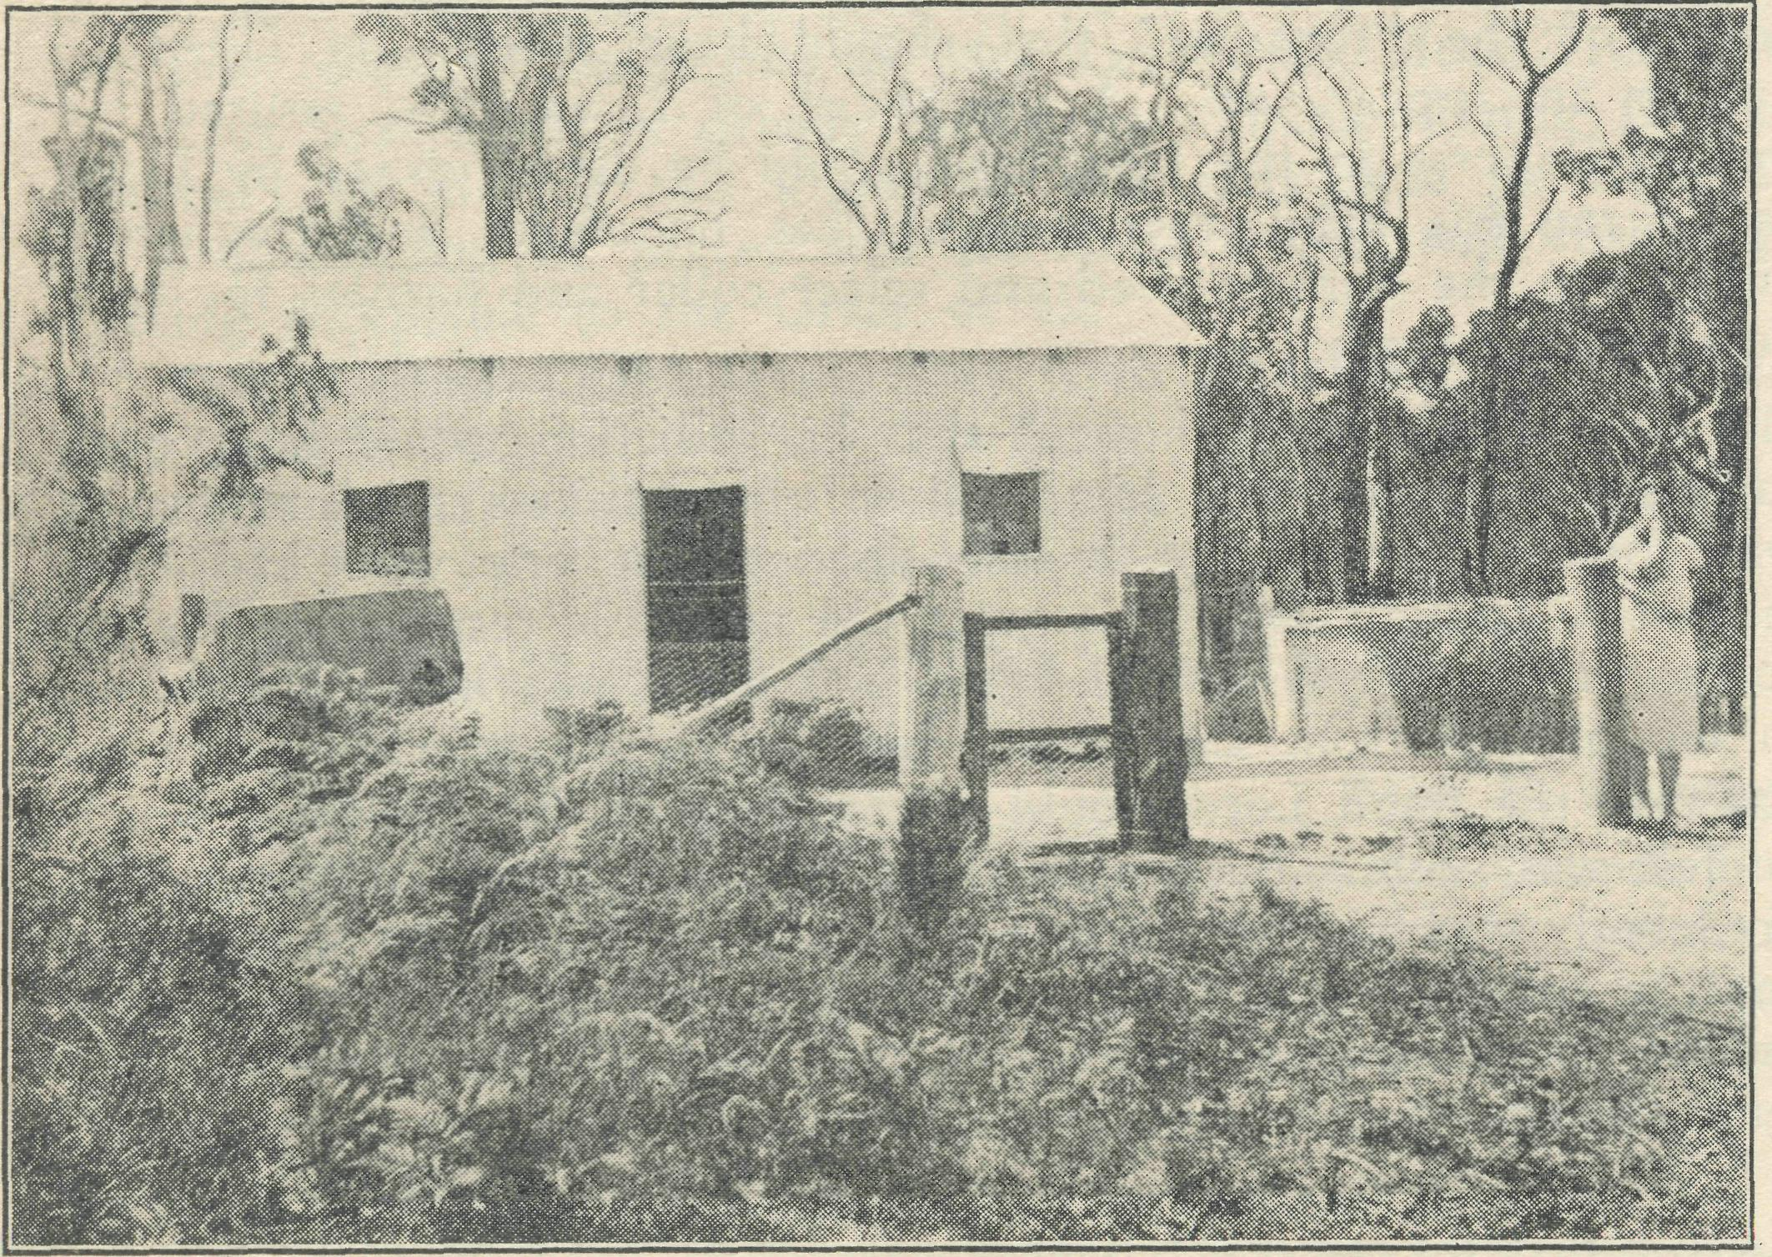
A settler's home in the Denmark Mission. FROM THE DENMARK MISSION, W.A.
Rev. B. Lousada.
The work continues steadily on with many signs of grace in the lives of those ministered to in Church, Sunday School, State schools and homes. There are the usual tales of endurance and quiet heroism of the bush. Particularly is this so with the ever-recurring bush fires. The Australian bush makes a more rapid growth than in any other country in the world. The eucalypts re-seed themselves in a marvellous manner, even when the ground is completely cleared. The dead trees still standing on most farms light up like candles and shower sparks on homes, sheds and haystacks. In some cases lately in this district it has meant as much as three weeks' fighting, almost day and night, for the farmer and those who are able to assist him. This means the fire comes from the four points of the compass in turn. The fire is beaten back from the cowshed, then it is discovered the pigsty is on fire. Hastily the beaters come across and put it out with water, bushes or bags. In the meantime the farmer decides to let the bull out
The Real Australian.
for fear he may be damaged in his yard. Fire-breaks are burnt not always with success, as it needs co-ordination to be carried through hurriedly in the face of an advancing wall of flame. Two recently-confirmed lads saved the mission house. It stands alone, surrounded by big dry trees. These were soon alight on top and showering sparks on the house and front verandah. One boy thought of his own haystack two miles away, and decided to commit it to the Lord's keeping while he helped around the mission house, and tried with the other lad to save a haystack belonging to his companion's father, a few hundred yards away. In this they were not successful as sparks cannot be arrested all around and about a stack at the same time. Fortunately, on re-, turning home he found the fire had missed his own stack. No doubt an answer to prayer.
THE OTWAY.
Rev. T. Pickburn
Last year we had eighty-eight inches of rain (it is measured in yards here !)—an all-time record. Some years agp the local schoolteacher wrote down to the Department and requested that they should supply him with a rain-gauge, and they sent him back one of the usual affairs that register up to one hundred points. The teacher sent it back requesting that a gauge be sent up that registered in feet instead ! Football here is usually played, in the rain and fog ; the Saturday before last the players at one end of the field could not see the players at the other end, the fog was so thick. On one historic occasion two inches of rain fell during a match, which was carried en as usual. They are a hardy breed in these parts. Judging by the way this year has behaved so far, it bids fair to create another record. If there is any place in this world where church-people can honestly at times plead inclement weather for non-attendance at worship it is here in the Otways. We are treated frequently to howling gales, driving rain, and sr.aking fogs. Unfortunately, for nine months of the year Sunday seems very often to be chosen as chief exhibit of the weather's bad manners. Sometimes trips to services are made in vain, and people simply cannot be blamed for not stirring out of doors. The O.M. will not forget in a hurry his experience of trying to speak to us here at Beech Forest with a howling gale on the rival platform !
However, that is sufficient about the weather, except to say that despite the severity of the winter (363 days of the year), the summer is delightful, and we love living here. It is a most healthy and bracing climate, and quite free from any of those ills usually associated with cold and wet regions.
Good news here ! At last, after many setbacks, and after overcoming many difficulties (chiefly the obtaining of teachers), the Sunday School will be opened next Sunday afternoon. We expect to have about thirty children altogether, and that number will include some Non-Conformists, because ours will be the only Sunday School in town. Keith Mackenzie and Mrs. Pickburn have volunteered for this work, leaving me free on certain Sunday afternoons - to open and carry on another small Sunday School in a nearby district.
Confirmation classes will be started soon on week-days here in Beech Forest, and the problem of the confirmees in outlying centres will, I hope, be solved by the B.C.A. correspondence course. All being well, Confirmation will be held at the end of the year.
The special services held last Sunday fortnight—the occasion of the King's call to prayer—were very well attended, and it is a good sign that many were disappointed that services could not be held in their districts. However, those districts will be given the preference on the next occasion.
Congregations in the various centres have all shown increased numbers during! the past six months, and it is hoped that further improvements will yet be made. Some day, perhaps, the vicar will have a car with more seating accommodation, and he will be able to pick up quite a number along the road in various places

The Real Australian.
20
July I, 1940.

and take them to the services. In districts such as this a charabanc would be very handy ! Is that a new thought ? There seem to be possibilities there !
The visit of the O.M. was very greatly appreciated here a few months ago by all who had the pleasure of hearing his addresses. Many have said how much they are in ignorance of the work of the Church Societies such as B.C.A., and it does much good to have the Church's good deeds brought into the light. We look forward to another visit in the not-too-far-distant future. Visiting priests are most welcome here in the Otways— such occasions are all too rare. We are well off the beaten track and we like to be reminded that we are sharing in the work of something far greater than just the "C. of E. in the Otways.¹¹
Concluding, may I extend, on behalf of all the church'people of this district, our sincere best wishes to B.C.A. on this birthday occasion. May the Society have birthdays unlimited and without end is our prayer.
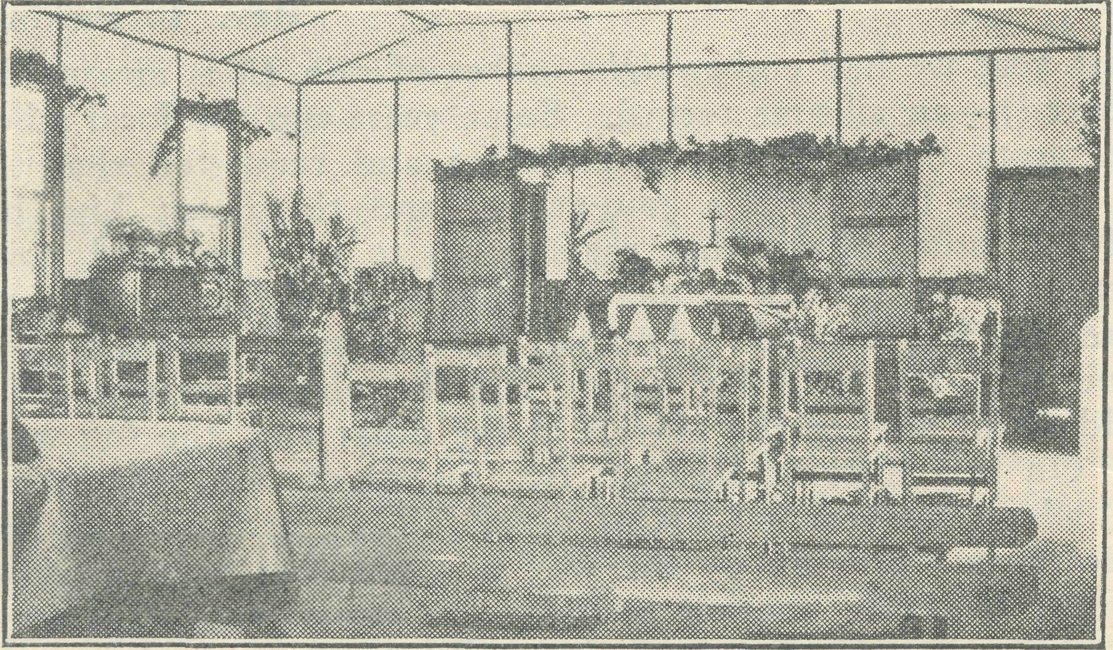
Interior of Mission Hall, Kirton Point, S.A. KIRTON POINT.
Rev. R. T. Hallahan.
Some months ago, on the completion of his period of five years' ministry here at Kirton Point and the attached sixty miles of coastal district, my friend, Karl Luders, left with his wife and family for duty in another B.C.A. area, leaving behind them a fine record of service well and faithfully rendered to the varied classes of people who comprise the population of the town and district. It has been my privilege to have entered into this rich heritage of ordered, happy parochial activities, and I trust I am truly grateful for the inspiring example that has so been set.
The change from the Cummins Mission District to Kirton Point is noticed when one thinks in terms of pioneers. There one was privileged to be among these sturdy sons of the soil, as they wrestled with the problems associated with the task of clear' ing, fencing, stocking and cropping the virgin mallee scrub, rearing their families under primitive conditions and generally doing their best to fulfil the scriptural injunction to subdue and replenish the earth. One's ministry was very largely that of encouragement under adverse conditions—one met the pioneers at work. Here one comes into contact more frequently with the pioneer who has completed his wrestling days and is either living in comfortable retirement, if success has attended him, or, as sometimes happens, is in more humble circumstances "living on the pension." One's ministry thus becomes consolatory, and the counsel frequently given is "Remember that your labour is not in vain in the Lord." The repetition of this sentence now reminds me that it has been used several times during the past month at the Burial Service when the bodies of these old pioneers have been laid to rest in the soil upon which their life's labours have been expended. I thought it would be of interest to "Real Australian" readers if I were to outline the lives of one or two of these men.
The first time I saw Lewis he was a patient in the Port Lincoln Hospital; having been brought down the sixty miles of Coast Road in the car of a relative. Patriarchal in appearance, he lay back on his pillows, with eyes closed, his long white beard covering a goodly portion of his chest, the personification of serene old age. At first I thought him asleep, but inquiring from the man in the next bed, I learned that through all the long eighty years of Lewis' life there had never been a lifting of those eyelids. Blind from birth, a son of one of the early pioneering families, he had shown how adversities could be met and surmounted.
When I made myself known there was an instant response of welcome on his part, and for the remaining weeks of his life one sensed the sincere warmth of his welcome. On each visit to his bedside some fresh glimpse was obtained of the cheerful, resourcefulness with which he had been endowed, and the faithfulness with which he had utilised these gifts. Quite early in life he had learned to feel his way around, and as is so frequently the case, when one sense is lost the remaining senses develop an acuteness truly re-markable.
Lewis, as he went through the bush could not only feel but also hear his way. Even when to all other observers there was a perfect calm, Lewis' ears could discern the rustling of the leaves in the tree-tops, and he could choose out his path almost unerringly thus. He learned to play the violin, and his services were in constant demand at those country dances which were then, and are also now, held on the evening of a wedding in the district. From another source I learned that Lewis undertook a ten-mile night ride to fulfil a promise he had made to play when the driver of the "turn-out" that should have taken him failed to put in an appearance. A neighbour of Lewis' also assured me that each horse in the farm team could be distinguished by Lewis as he ran his hand over it, and that he could, and frequently did, go to the harness shed and select collar and harness for each horse in the team.
One would have thought that his affliction would have been sufficient safeguard for him against unscrupulous persons, but it was common knowledge in the district that one who had been intimately friendly with this great old man was responsible for his comparative poverty in old age. . Yet there was never a murmur to me of this from Lewis, and his last conscious wish expressed was that the good Lord would release him of the weariness which he felt was such a burden to those who ministered to him. The tired body was laid to rest in a cemetery located in the spot called, appropriately enough, "Happy Valley," and the soul entered into the eternal realms of light and love where "His servants shall serve Him and they shall see His face."
Quite a different type was another to whom I was called at the hospital where the last few days of his adventurous life were passed. This Louis was of Norwegian birth, and had responded to the call of the sea in his early youth. His was a hard life, for it was lived on "windjammers" trading between Port Lincoln and Scandinavian Ports with cargoes of wheat and timber. Not much opportunity for cultivating the more tender graces of the Christian and-all-too-frequent chances for indulging in the semi-pagan pleasures that are so attractively thrust in the path of the sailor ashore by those who live in so-called Christian ports. Louis had settled in Port Lincoln when advancing years made it impossible to earn his living on the sea.
He became a waterside worker and a respected member of the community. My first contact with him was in the hospital, and there was given a brief chat and a prayer, though I had no idea that his passing was so imminent. Only a few days later he was laid to rest in the cemetery within sight and sound of the sea which had been so much a part of his life. One of the most touching incidents at his funeral was the arrival towards the close of the service at the grave of an old shipmate of his who had walked two miles from his hut in order to be present. One was thankful for this evidence of true mateship and for the opportunity to proclaim the Lord Jesus Christ as the Eternal Friend and Saviour of mankind.

July 1, 1940.
21
The Real Australian.

THE HOME BASE

B.C.A. WOMEN'S AUXILIARY.
Miss Ashe.
The B.C.A. Women's Auxiliary met at the Bible House on May 29th for their Annual Meeting, and, as usual, had a very happy gathering. The splendid attendance was cheering, as so many of the members are active war'workers.
The much'appreciated Organising Secretary was in the chair— he had just returned from a most strenuous trip to the outback stations, and, in his brief address, placed the needs before us, showing plainly how the work was combating the same evil that had plunged us into a world war, and urging us in that realisation to continue our efforts. The Rev. L. H. Broadley was the speaker from "the field." We all felt, from his address on his work at Geduna, how real was the self'sacrifice of those who minister in our B.C.A. "outback," and how wide the opportunities for service. He duly voiced the need of maintaining the medical work, and appealed for our aeroplane effort. The offering reached the sum of JE40/10A.
Mrs. Raymond Beatty (Miss Heather Kinnaird) delighted us once more with her singing, and we owe Mrs. Bolton (her able accompanist) grateful thanks for journeying from Hunter's Hill to do so. The report was read by Mrs. Bode, Hen. Secretary, and the treasurer's statements by Mrs. Lee Smith, Hon. Treasurer.
Our next effort is already facing us—Thank-offering Day in October ; by making this known at this early date we hope to lay a foundation of prayer and self-sacrifice that will ensure an offering acceptable to the Giver of all.
Our Annual Thanksgiving Day is to take place on Wednes' day, October 16th, at 3 p.m. We hope that all our friends will keep this date free and help to make the day a great success.
Primary Grade.
"Dear Teacher,—Will you get some mere Bible picture books for us, please ; the children love the pictures," writes one mother from the country. All children love pictures, but our Primary Grade children, who do not read or write easily learn a great deal from pictures. That is why they enjoy the illustrated lessons sent out, the Birthday picture cards—a different one for each year, with appropriate verses to learn—and the enrolment card with its picture.
The religious teaching of the very young child is often a problem to parents, and we seek to help them, not only with lessons, but with personal letters from the teachers. Great interest is shown when teachers find opportunity in their holidays, or travel to visit Mail'Bag Sunday School children in their homes, or meet them when they pay a visit to the city. Then when the teachers have their Quarterly Conference these adventures are related for our mutual benefit.
Many children show a very decided liking for an outdoor life of activity at an early age. "I can't get Reggie to do any colouring, or drawing, though he likes to hear the story ; he always wants to go out with his father and the horses," writes a mother. So we must find other ways of appealing to this lad. Possibly playing the lessen story will attract him, or building some scene from it in a sand'patch in the garden.
The teachers are expected to deal wisely with each child, giving all possible help and encouragement. Problems are dis' cussed at the Quarterly Conferehce and suggestions are given to enable each individual child's needs to be met.
So this section of the work goes forward, happy to be able to help even "one of these little ones."

MAIL-BAG SUNDAY SCHOOL.
Miss E. Huntley.
Acting on the theory that a missionaryhearted Church is a progressive Church, we have for some time thought to form, in connection with out Mail'Bag Sunday School, a Missionary Band through which the children would have the opportunity of putting into practice the interest in missionary work that we have always tried to encourage in them.
It has now been definitely decided that we form our Mail-Bag Missionary Band. Through this the children who become members will be able, by their pennies from time to time and in other ways, to help extend God's Kingdom amongst the abo' rigines of our own land.
It was most gratifying to receive, a few days ago, an order from Melbourne for fifty sets of our Confirmation lessons for Seymour Military Camp. So B.C.A. is, in this way, too, taking its share in the war work of cur country and nation.
In spite of the disturbing times, our Sunday School continues to grow in membership, necessitating an increased number of lesson papers this month. So, too, do encouraging letters from children, parents and teachers of small Sunday Schools continue to come. Recently one girl, who has for seven years been a pupil and sent in work regularly and is reluctantly discontinuing now that she is about eighteen, wrote : "The teachers, and in fact the whole Mail'Bag Sunday School, are wonderful—-absolutely won' derful, and I know there are thousands of others who agree with me ; and now that I am leaving,' as the saying goes, I want to wish it and each and every one of you all of the very, very best in all your wonderful work, and may it long continue to bring joy and brightness, and so much more than that, into the lives of lenely little bush kiddies, who have no chance of real Church or Sunday School, and of learning about God."
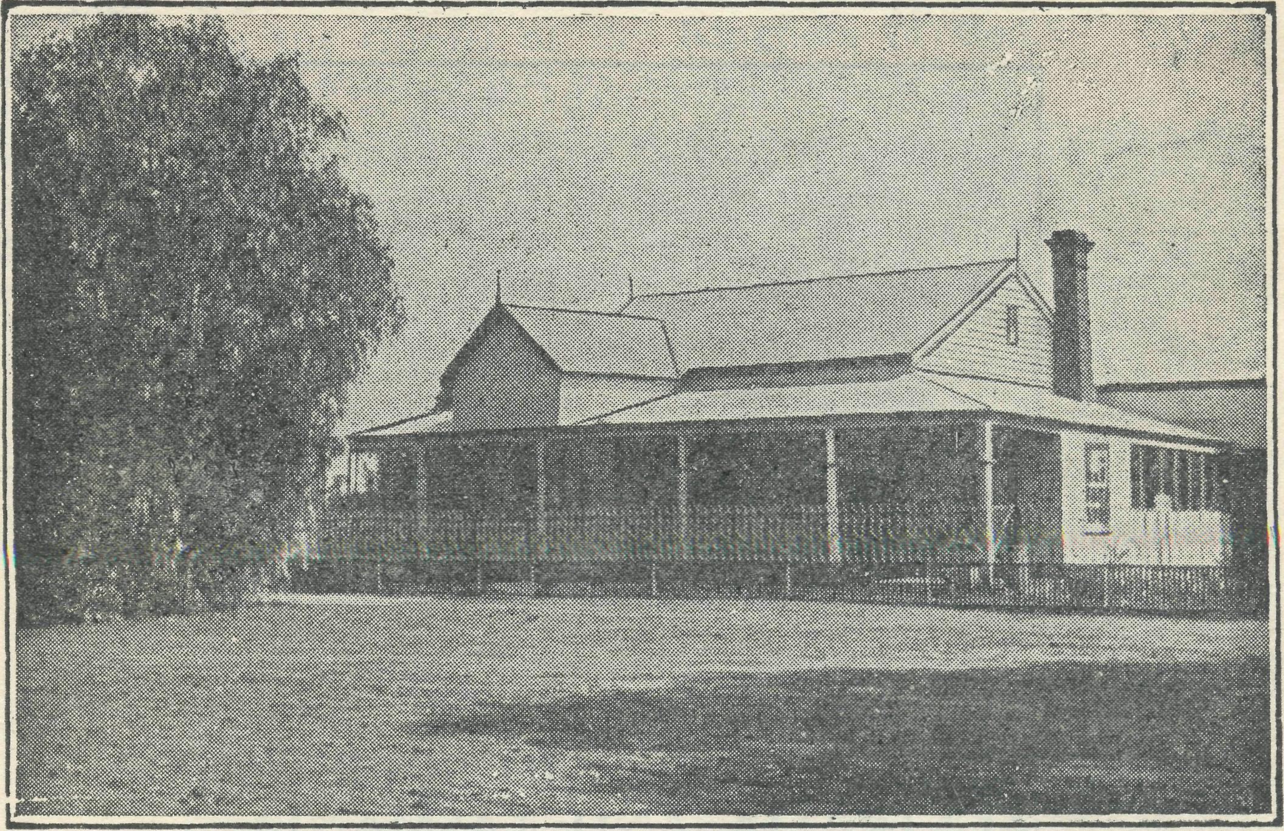
Wilcannia Hostel, established 1920.
MRS. C. MANN.
Describing the work of those who have served in B.C.A's. Hostel at Wilcannia, the late Bishop Kirkby wrote in "These Ten Years" :—
"Special mention must be made of the matrons and their helpers who have managed, contribed, and planned to make the Hostel so pleasant. The feeding of the large family, jhe care of the sick ones, the oversight of wardrobes, the harmonising of relations—what a task it has been ! Come a raging, blinding dust' storm in that hot summer climate ; come an epidemic of measles

The Real Australian.
22
July 1, 1940.

or scarlet fever ; come a period of shortage of needed elements (fresh vegetables) in the local food supplies ; come a drought with its discomforts, depresssion, and its disappearing water-supply . . . still the work of these Hostel Sisters goes on. These women may not belong to any order officially recognised by the Church ; upon them no dedicating hands have been laid ; but they belong to an order recognised by our Lord, and on them the Spirit of Jesus rests. They feed the hungry, they tend the weak, they give "the cup of cold water in His Name," and in so doing offer rich service unto Him. Their work may be sometimes drudgery— sweeping, washing, cooking, scrubbing, and sewing—but in their doing it they make it fine."
The work could not be described in more graphic terms, and they could not be better applied than to the long years of service given by Mrs. Mann as matron of the Wilcannia Hostel.
Mrs. Mann joined the hostel staff as a temporary help, she stayed for seventeen years. In those long years there have been good days, but there have also been days of very grave difficulty. There have been times when it seemed impossible to keep the Hostel going. Drought in the North-West and lack of finance at headquarters have, time and again, made it impossible to furnish even the bare necessities at Wilcannia. At such times it would have surprised nobody if Mrs. Mann had said that she could "not carry on ; but she did carry on. The writer feels that the continued existence of the Wilcannia Hostel has been due, time and again, to Mrs. Mann's tenacity, faith and readiness to bear burdens which would have overwhelmed so many. Never at any time has she grumbled at conditions, always has she made the best of them.
Mrs. Mann is known and loved throughout the North'West of N.S.W., and she could leave Wilcannia with no better thought than that in the seventeen years she has been at the Hostel she has been able to leave on the lives and character of many young people a great influence for good. Mrs. Mann leaves our work after the longest period of service given by any of our workers. We wish her well and pray that God will bless her abundantly in the years which lie ahead.
T.J.
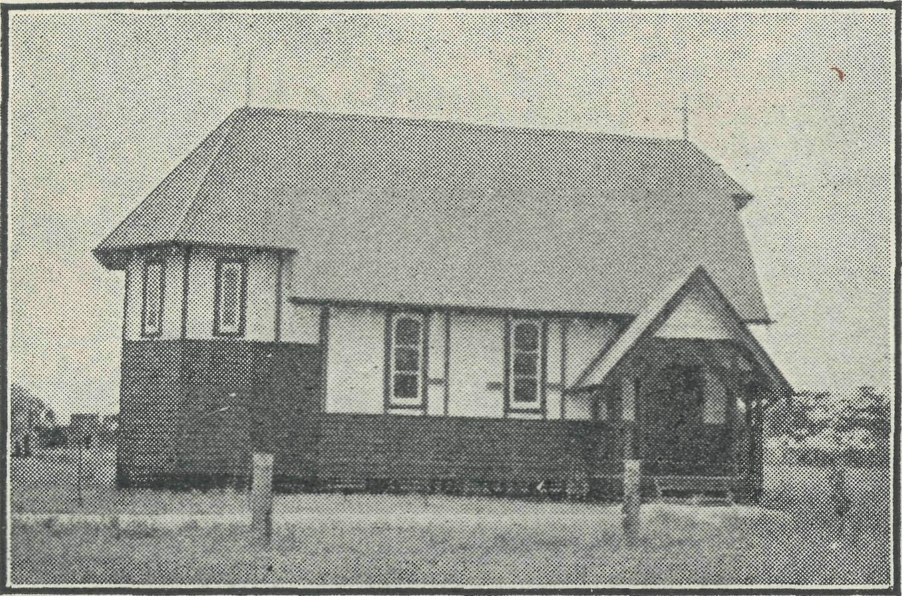
St. Nicholas' Church, Werrimull.
THE BUSH CHURCH AID SOCIETY FOR AUSTRALIA AND TASMANIA
(Victorian Branch.)
The 21st Birthday Rally of the Bush Church Aid Society was preceded by a tea in the Y.W.C.A. rooms, at which a twenty-first birthday cake, complete with candles and made by Sister Caroline Ross, was ceremoniously cut and then eaten.
Archdeacon W. L. Langley, one of the foundation members, presided at the Chapter House meeting, and the other speakers were the Rev. T. E. Jones, Organising Missioner ; Sister F. Dow ling, Matron of the hospitals in the Far West of South Australia ; Mr. A. E. Chadwick, the pilot of the B.C.A. Flying Doctor's 'plane.
The Rev. Dr. Law, in his welcome to the Archdeacon and Organising Missioner, spoke of the debt that New South Wales owed to Victoria for many of its good men.
The Archdeacon said B.CA. was one big family ; whether Sydney or Melbourne or elsewhere, they were all one. Inevitably on such an occasion, he was reminiscent in his remarks, and said they little thought twenty-one years ago that B.CA. would grow to such an extent as it had. This wonderful growth showed how God had blessed and used B.CA. Its primary aim was to make Christ known and an experience in every phase of the work. It was by sustained prayer and a sense of community and consecration, as well as the spirit of great courage to undertake the seemingly impossible. He concluded with a call to fresh endeavour in these difficult days and the years that lie ahead.
The Rev. T. E. Jones spoke of the disappointment due to little Sydney James contracting whooping cough and having to remain at Penong. He also passed on a tribute given by a pilot of one of the Douglas machines, who said that B.CA. had "the best civil pilot in Australia." In the two years of its service the 'plane had had no forced landings or other mishaps.
Mr. Jones said that mention of B.CA. made one automatically think of Sydney J. Kirkby, who faced such great difficulties in the early days in the way of securing men, and friends, and resources. He traced the development of the work from humble beginnings to the present time, and emphasized that the work called for the highest and the best of men and materials, and not cast-offs. The ministry of healing was the "hands of God" at work through the doctors and nurses.
The whole work was Gospel work of the most vital kind, and though much was humdrum, it was never mere humanitarianism. nearly twenty years at the Wilcannia Hostel. Under great handicaps she had ministered nobly.
He spoke of the impending retirement of Mrs. Mann after The Mail-Bag Sunday School continued to grow and the Confirmation lessons particularly were being very widely used.
The operating costs of the aeroplane were remarkably low— less than £800, and yet giving a regular and not only emergency service.
The hard times of war meant more and not less reason for giving. "We should be better Australians,¹¹ he concluded, "if we remember our obligations as citizens of the Kingdom of God.¹¹
Matron Dowling described the type of people to whom the hospitals ministered. Wheat and sheep men, railway men, and fishermen predominating beside the aborigines. The daily routine began at 5 a.m. and included "quiet time,¹¹ Bible-reading and prayers, besides weekly services in the wards. It is difficult to get the Gospel across to people who have been forty or fifty years away from its influence. Yet there was a deep appreciation of the nursing work as practical Christianity. She humorously told of the conversions of some "pretty tough nuts.¹¹ "You have no idea how hard some of those old 'cockies¹ are.¹¹ "The good old appendix¹¹ had brought more than one into hospital, and into vital contact with Jesus Christ, The building-up work was not neglected. "Many who are keen to win souls,¹¹ she added, "are not always so keen to build them up."
Instancing numerous cases when the hospitals had been used to "save life" in a double sense, she said the nurse aimed to make the "Far West Medical Mission" the "Far West Spiritual Mission.¹¹ Though the work was hard and results scanty, yet we must carry on as Christ did. It is His work and not ours.
The pilot of the aerial ambulance, Mr. A. E. Chadwick, told of the pioneering work which had been done in the way of securing sufficient—and suitable—landing-grounds, of which there were only four when they began the Flying Medical Service. Many hundreds of miles were traversed by car, and now there is a great chain of landing-grounds for⁵, regular use. The nurses were apprehensive as they had their first flights, but now it was a matter of course for them to take their turn at accompanying the doctors. 182 trips, aggregating 34,000 miles, had been underaken, and over 2,000 patients received attention in an area of 42,000 square miles. The melodious names of widely-separated places are just as familiar now as the names of Melbourne city streets were to Victorians.

