Registered at ihe G.P.O., Sydnev. lor transmission by post as a periodical
Organ of the Bush Church Aid Society for Australia and Tasmania.

No. 77.
FEBRUARY 24, 1941.
1/6 per annum (post tree)

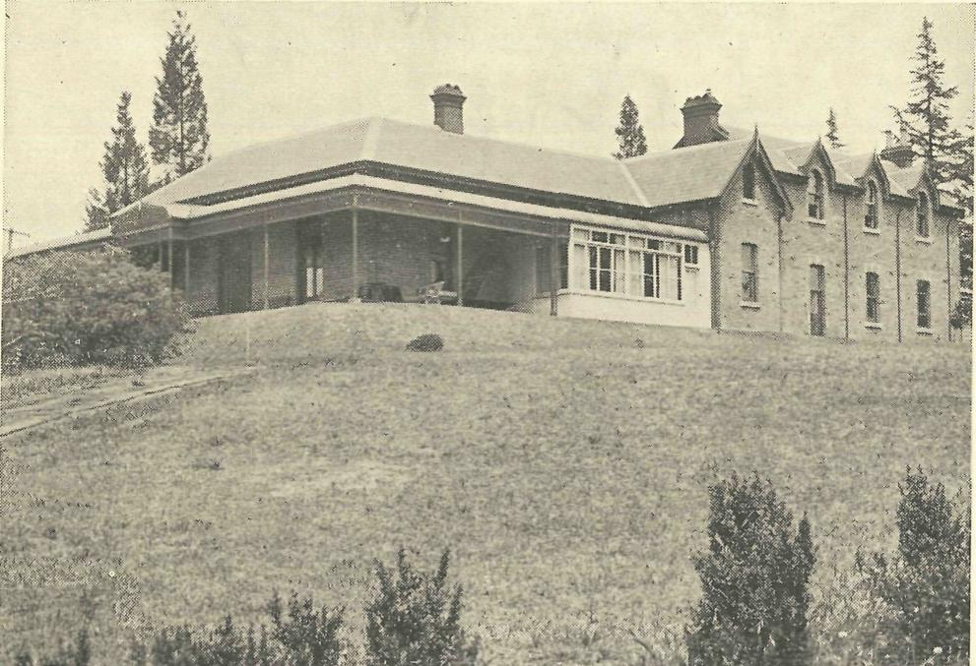
The "Coorah" Boys' Hostel, Wentworth Falls.

The Real Australian.
February 24, 1941.

The Bush Church Aid Society for Australia and Tasmania.

HEADQUARTERS OFFICE :
Diocesan Church House, St. Andrew's Cathedral, George Street, Sydney.
(Telephone : M3164.)
Cable Address : "Chaplaincy, Sydney."
VICTORIAN OFFICE :
The Bible House, Flinders Lane, Melbourne.
(Telephone : F5675.)
President: The ARCHBISHOP OF SYDNEY.
Hon. Clerical Secretary : Ven. Archdeacon W. L. LANGLEY.
Hon. Treasurer : T. S. HOLT, Esq.
STAFF.
Organising Missioner : Rev. T. E. JONES, Th.L., Church
House, George Street, Sydney. Victorian Secretary : Rev. E. D. SHAXTED. South Australian Secretary : Rev. R. M. FULFORD, North
Terrace, Adelaide, S.A.

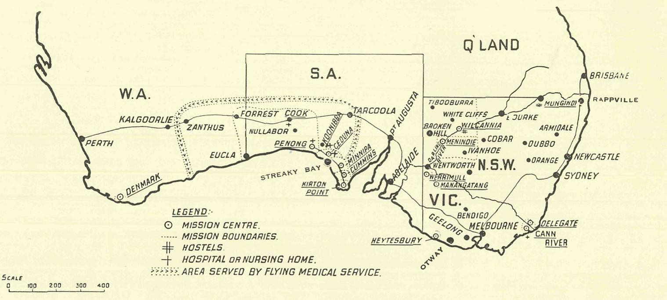

Keep the Flag Flying

By
purchasing War Savings Certificates.
donating War Savings Certificates to the Society.

Certificates can he -purchased for:
16s. for each £1 Certificate. £4 for each £5 Certificate. £8 for each £10 Certificate.
Buying them helps Australia in the World War. Donating them to B.C.A. helps the Kingdom of God in the fight against the evils which cause all wars.
The certificates will be used to build up a fund to assist in the purchase of a new medical plane when
that becomes necessary.

February 24, 1941.
The Real Australian.

"THANKS BE TO GOD!"

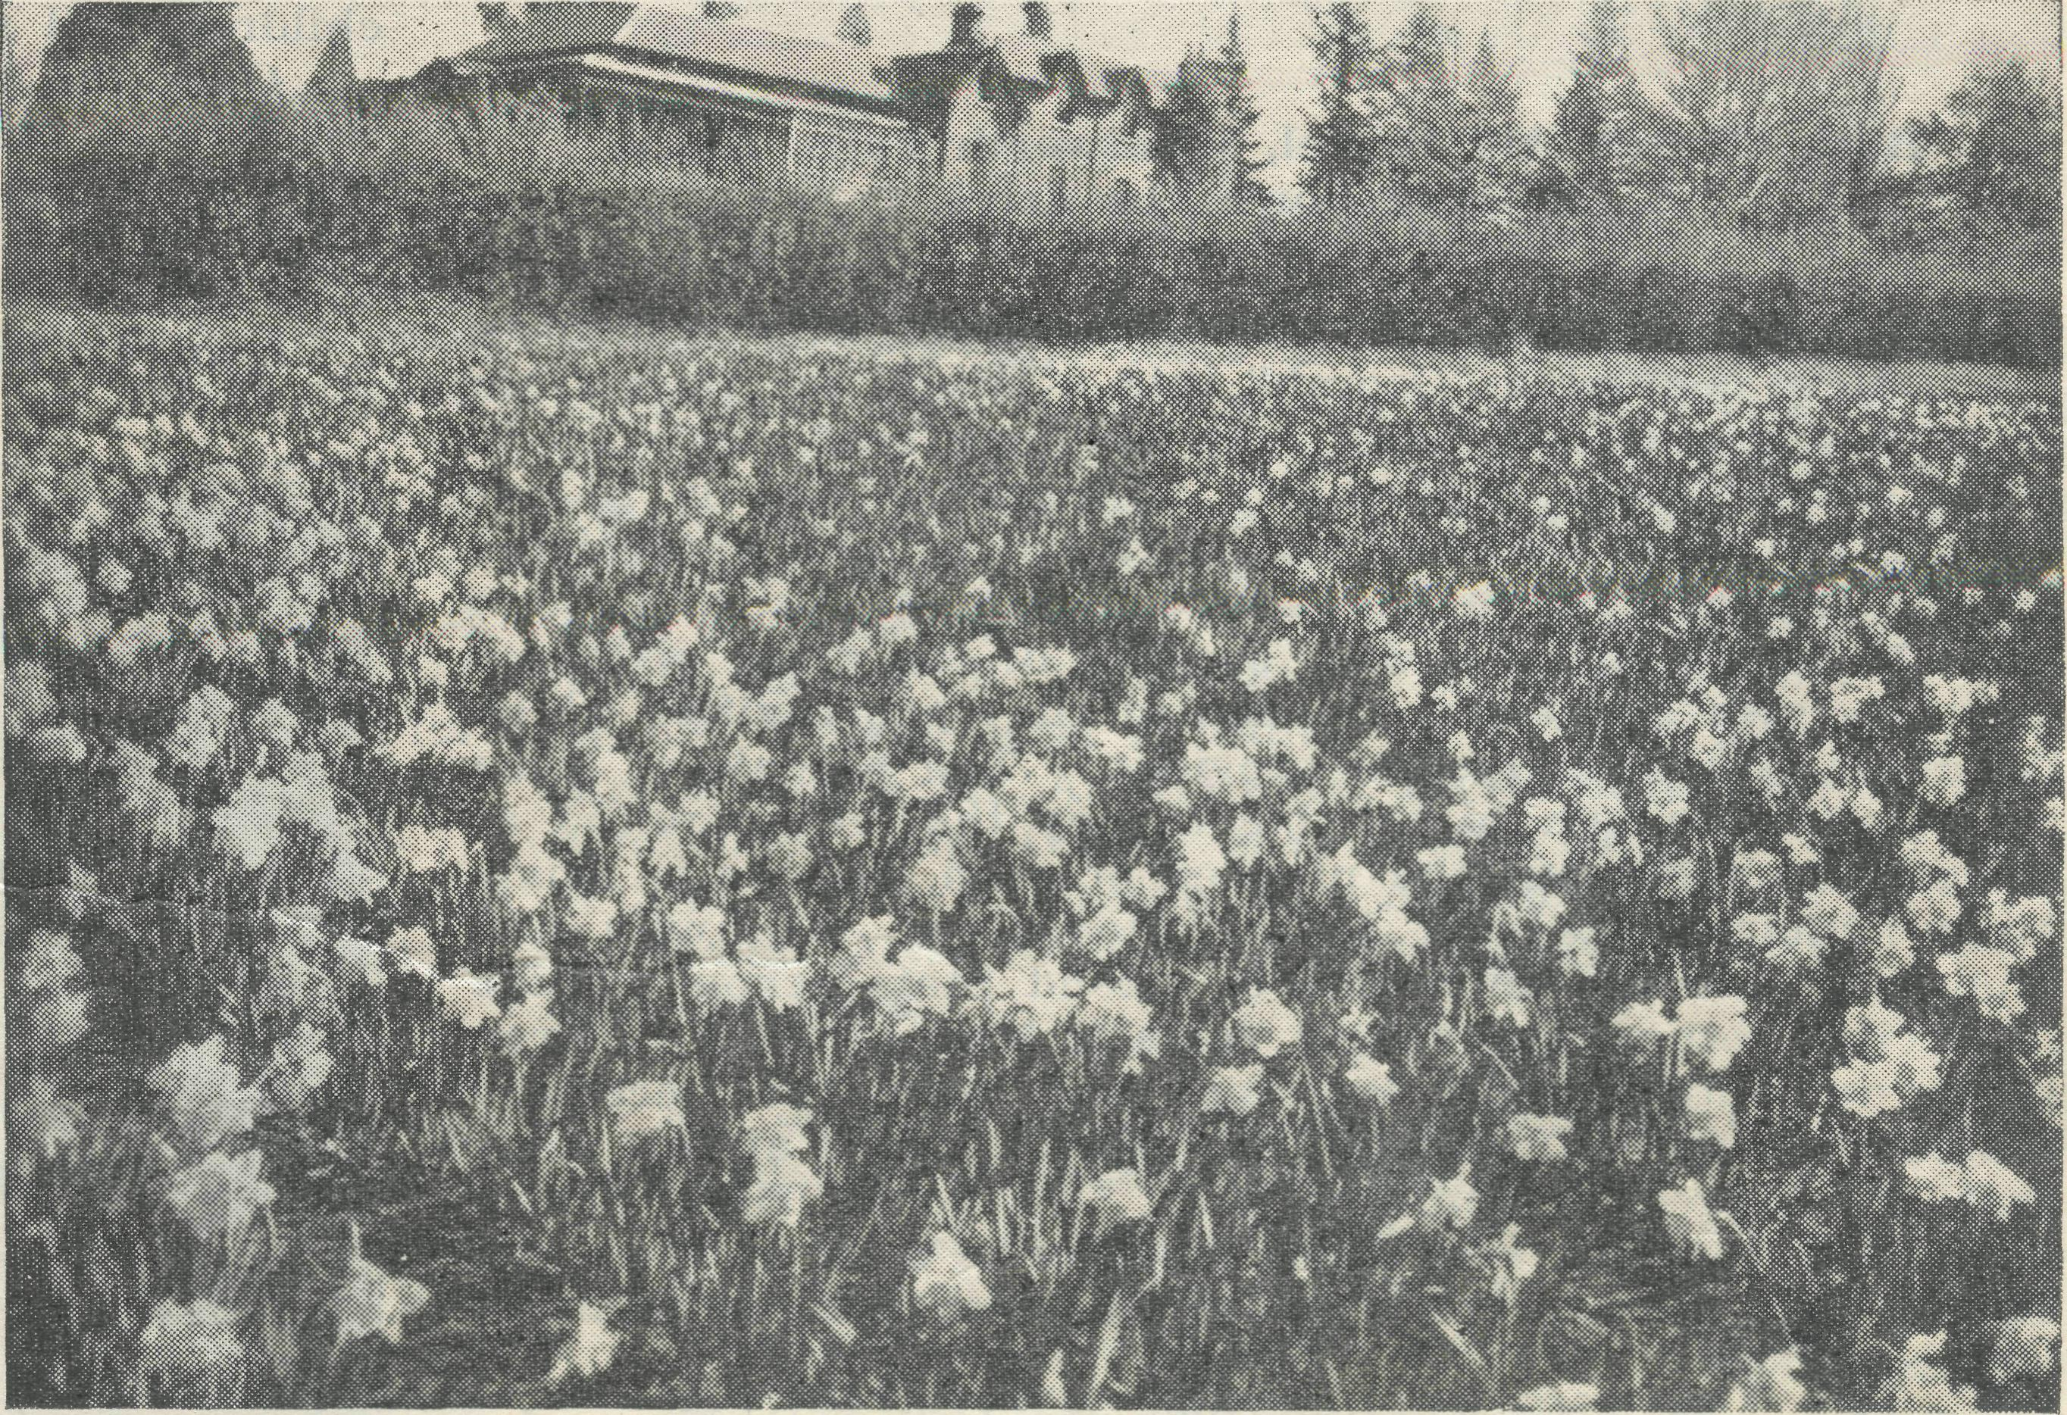
A field of daffodils in bloom. There are many thousands of these golden flowers on the property.
THE O.M.
Although it is not yet possible to give exact figures of the support given to B.C.A., it is clear that 1940 was a record year both as regards income received and work accomplished. When our accounts are audited, they will show that something over £ 11,000 was received into our General Income, plus £3,500 in securities, which has been placed to the assets of the Society. I am sure that our friends will rejoice to know that the interest in our work is so great as to cause the income of the Society to reach to so splendid a figure.
Looking back over the year, we in the Office remember with deep thankfulness some of the many proofs of our Father's gracious provision. Time and again the position looked hopeless. Month after month we wondered how it would be possible to pay the many hundreds of pounds that were necessary to pay stipends and grants. Then there were the occasions when this Missioner needed another car, or that one must have urgent repairs made. A Hostel required badly-needed extensions, another some new furnishings. The aeroplane must have a new part or stay on the ground, or perhaps we needed to pay for some hundreds of gallons of petrol at twice city prices.
So the needs arise day by day, and, thank God, B.C.A. has never yet said, "It cannot be done I" When the needs arise, the decision can only be made to meet them in the sure and certain hope that our Father will, in His goodness, send the wherewithal to pay for them. B.C.A. does not possess a large reserve fund to provide for these needs.
THE HOSTELS.
"COORAH" — WENTWORTH FALLS.
"Coorah," Wentworth Falls, in the Blue Mountains of New South Wales, has long been known as one of the beauty spots of the Mountains.
It is a very splendid property of some forty-five acres. Built by Mr. R. W. Pitt, of Pitt, Son & Badgery, it was for many years the home of this well-known family of N.S.W. In its five-acre garden were planted many valuable and beautiful trees and shrubs. In the Spring the many ornamental trees with their beautiful flowers make a dazzling display, while the Autumn brings the beautiful tints of the maple trees. Mr. Pitt was interested in the growth and breeding of daffodils, and accumulated a huge stock of bulbs, which to-day run into over a million. Mr. Pitt derived his income from the country and out-back through the firm with which he was connected, and as a result he had a great regard for the "man on the land." In order to give tangible expression to this regard, Mr. Pitt and his wife conceived the idea of giving as a free gift their beautiful home and grounds for the
's LETTER.
Each time the need has been met often in unexpected ways. One day we very, very badly needed £240 to pay stipends. One afternoon came a solitary letter in the afternoon mail, and in it a cheque for £240.
Another occasion found us needing well nigh a thousand pounds, and in due course came the intimation that a certain lady had left us a portion of her estate. We received £1,300 from that source.
Perhaps the greatest joy we in the Office get is from the hundreds of people who cannot send large amounts, but who regularly respond with smaller amounts to the many appeals they receive. These are they who, out of the little they have, give much.
Now what of the future ? These days which lie ahead are full of sacrifice and giving, that our Nation and Empire may survive. Are we going to fight tooth and nail with our hands, our prosperity, our money—yes, and our loved ones ? Yes, of course we are, and with the help of Almighty God we are going to win. But—and there is a "but"—are we, while pursuing this struggle, going to forget that which makes the survival worthwhile ? Pray God we are not. If our land, our Empire, survives without the Spirit of God being in it, will it be worthwhile ? I think not. Can we pray to the Father of all that He will grant us the victory while we forget His other children in the out-back and over the seas ?
Then let us see to it that, though it shall cost us great sacrificial giving to win the war and maintain God's work, we shall be found worthy of victory.
THE HOSTEL, WENTWORTH FALLS.

The Real Australian.
February 24, 1941.

use of country people. The result was that the property passed into the hands of the Country Women's Association, who had charge of it for three years, but at the end of that time the G.W.A. asked the Trustee Company to resume it. Representations were then made to the Union Trustee Company on behalf of B.C.A., and in 1939 it was given as an outright gift to the Society.
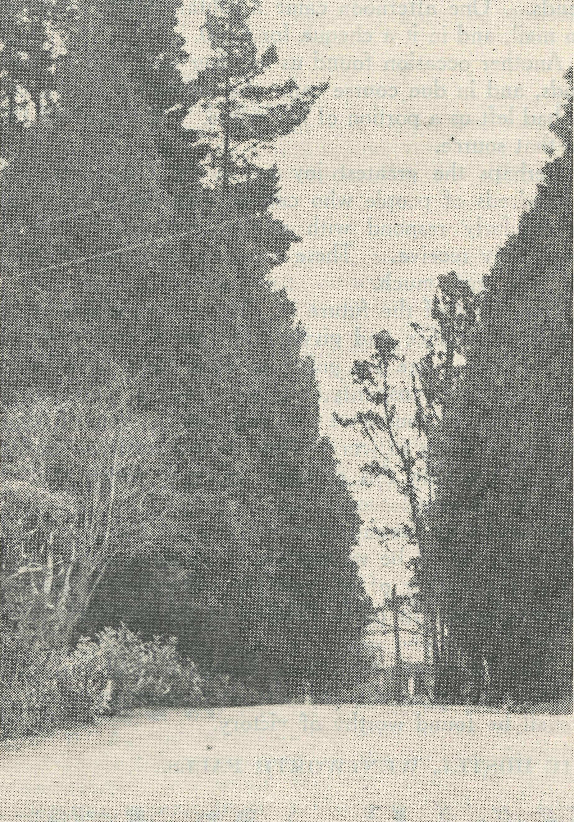
Bush Church Aid Hostel, Wentworth Falls, N.S.W. Looking down the drive.
In order to conform to the wishes of the original owners, the Society converted "Coorah" into a Hostel for Boys from country and out-back areas. It had long been our wish to make available the opportunity of higher education to our boys in the more remote areas. It can be well appreciated by our friends that in the inland places of our land there must be many children who, because of the great distances between town and town, are denied the opportunities which the State education system provides. The parents of some are wealthy enough to be able to pay the fees required at boarding schools, but the number of such parents is small. Many children are sent to our Hostels at Wilcannia and Mungindi, and are thus able to attend State school. Like their city brothers and sisters, some at least of these children show an aptitude for learning, and pass the necessary examination for entrance to High School. It is at this stage that the biggest difficulty arises. To go to High School means living within reasonable distance of a large town, and this involves considerable expense for parents in low financial circumstances.
Such a Hostel as "Coorah" solved the problem, for children may be sent for small fees well within the limits of most parents.
Perhaps the greatest advantage is that parents are assured that their children will be properly cared for under ideal conditions.
We are therefore hoping that the work at "Coorah" will grow each year until the building is full to capacity.
As the property covers forty-five acres of good farm land, efforts are being made to produce as much as possible. Already the Hostel is supplied with milk, butter, eggs, fruit and vegetables from the farm, and from time to time fruit and vegetables are sent to the Hostels at Mungindi and Wilcannia. By this method we hope that "Coorah" will help very materially in the maintenance of the whole of our Hostel work.
Boys are taken at "Coorah" for State school attendance as well as High School. We should be glad if any of our readers knowing families to whom this Hostel would be of use would advise them to write for prospectus, and we invite any of our friends who should from time to time be in the Blue Mountains district to call upon the Matron, who will be only too happy to show them over the house.
WILCANNIA HOSTEL.
The Hostel at Wilcannia came into being as a result of the desire of the Rev. F. Harvey and his wife to provide a home for the children of our huge mission district in the North-West while attending school. Mr. and Mrs. Harvey began by taking a small number of children into their own home. Within a short time, by the generosity of some of our friends, it became possible for B.C.A. to buy a suitable building in the township.
For twenty years now the Hostel has been serving the children of the North-West of New South Wales, and has eased the burden of the problem of education for many parents.
This venture has had its ups and downs, for so much depends upon seasons. When things have been really bad and it has appeared that it would be impossible to keep the doors open, our friends have again and again come to the rescue.
During the years much has been done to improve the Hostel building. Renovations have taken place inside and outside, and new and comfortable dormitories have been built. The Wilcannia Hostel accommodates twenty-four children, and at present has the full number in residence.
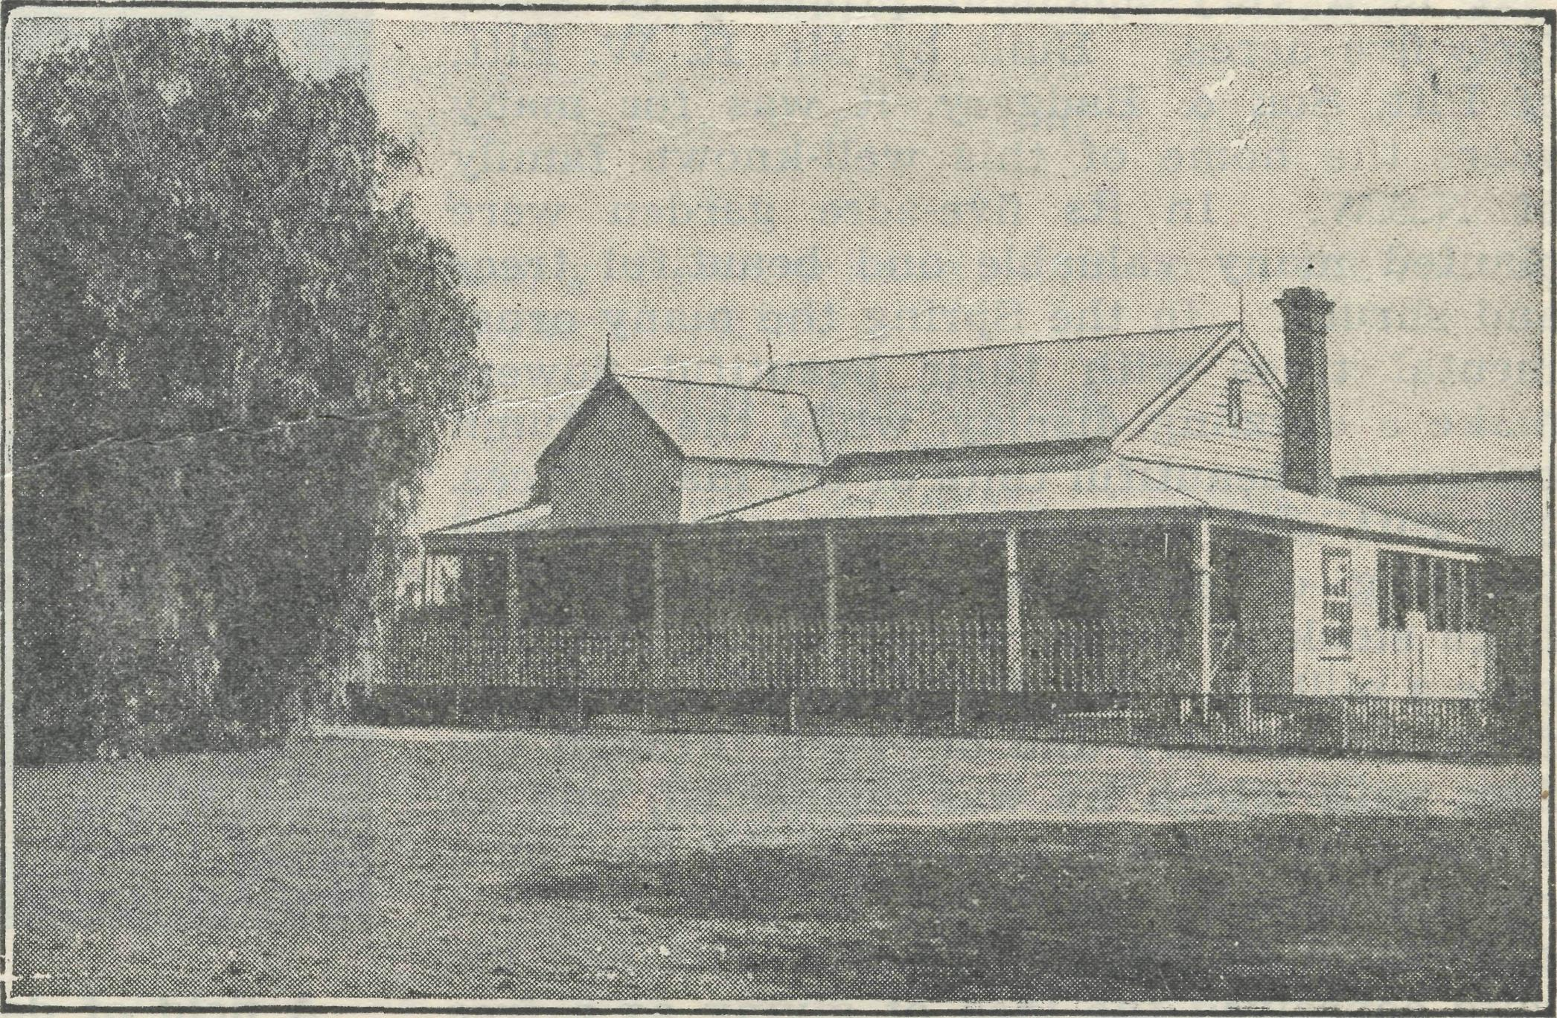
Wilcannia Hostel, established 1920.
Over the years the Society has been well served by its workers in this centre, and it is due to their devotion and hard work that this piece of service has developed so splendidly. It would not be possible for me to mention all those who have served at Wilcannia, but one must mention Mrs. C. Mann, for her name will always be inseparably linked with

February 24, 1941.
The Real Australian

Wilcannia and its Hostel. Joining the staff as a temporary worker, she remained for seventeen years, and for most of that time was Matron. Her problems and difficulties must have been legion in such a climate. Mrs. Mann resigned in 1940, and the present staff, the Misses Gi;rrier-Jones, took over the work.
We feel that this Hostel has been abundantly worthwhile, and as the days go by its influence for God in the North-West will continue to grow.
MUNGINDI HOSTEL.
As the Wilcannia Hostel grew out of the ministry of the Rev. F. Harvey as missioner, so the Mungindi Hostel came into being as a result of the ministry of the Rev. H. E. Felton at Mungindi.
Though Mr. Felton did not bring children to live in his home, he nevertheless was deeply concerned with the need
The Rev. I. Renshaw, Vicar of Worsley, draws attention to a matter which calls for careful consideration of our Church folk. Writing to his people, he says : "I fear we shall all be called upon to support many good causes in this national emergency. There is perhaps the temptation to very careful giving, because there comes to our mind the increased taxation and higher expenses and so on, but I think we need to give careful thought lest we fail to be generous. Do not let the old charities suffer. Remember they do their splendid work through all the years when there is no emergency. They still need your help, and need it badly. The Churches try to do their share in these trying days, so do not forget your Church and the Church's own societies. And please do your bit for every mother's boy in the country's service, who will not have too easy a time, especially these winter months—a few extras and comforts will make all the difference. I know it means giving and giving, but as that little poem says, 'Just give till the Lord stops giving to you.' "

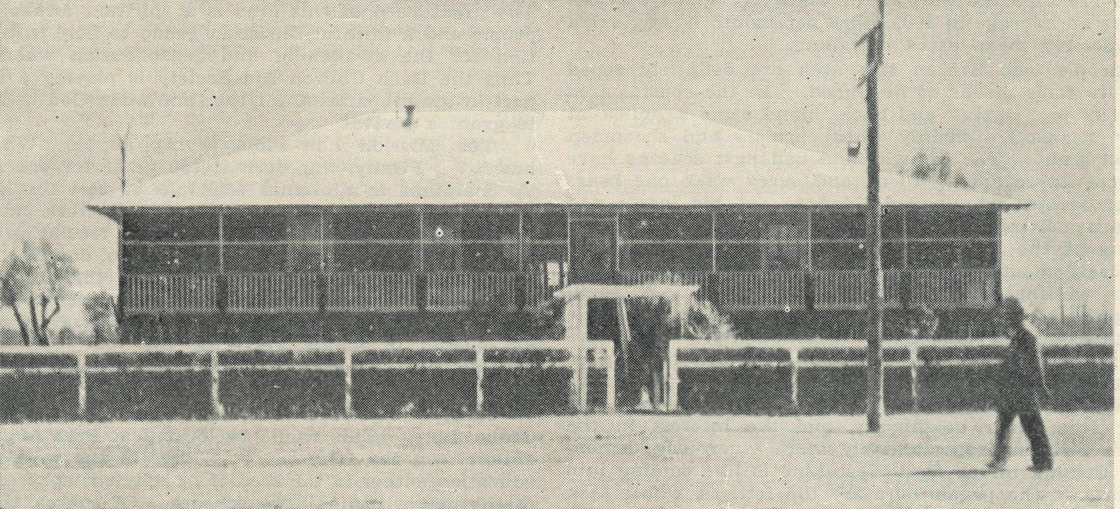

MUNGINDI HOSTEL, 1939.

of the children in the black-soil plains. The result was that the Society determined to build a Hostel at Mungindi, and in 1929 plans were put in hand. The necessary funds were given, and in 1930 the present Bishop of Armidale opened and dedicated the building.
The first Matron was Miss E. Cheers, and, as she is still in charge, she has now eleven years in hand towards exceeding Mrs. Mann's seventeen years' record. It would appear that the people of the Mungindi district are in better financial circumstances than those in the North-West, for many of the children after a period at the Hostel come down to Sydney and elsewhere to the Church boarding schools.
This means that we are able to lay real foundations in their young lives, which afterwards are capable of fuller development.
As Mungindi Hostel was specially built for the purpose, it has not required the same financial expenditure for alteration as at Wilcannia. Nevertheless, during 1940 additions were made to the building for better housing and the provision of extra room. Mungindi, like Wilcannia, has a splendid record and reputation in the black-soil plains, and many people in the district have told me that they owe their thanks to B.C.A. for two things—the provision of the Hostel, and sending of Miss Cheers to Mungindi.
'REAL AUSTRALIAN/
Subscribers who have not received receipts :—Mrs. M. Simmonds, Miss M. E. Cabrera, Miss M. Nicol, W. Richey, Mr. L. Smith, Miss T. Tremlett, Mrs. G. Hutchinson, Mrs. Tingle, Miss N. Starkey, Mrs. C. Lumb, Miss A. Bode, Miss J. Harris, Mrs. C. Wyndham, Mrs. W. Williams, Mr. Davis, Miss H. Wheeldon, Mrs. E. Hughes, Miss Jamieson, Mrs. R. Tually, Mr. F. L. Prime, Sister B. Bossley, Mrs. A. Taylor, Mr. E. Veness, Miss M. Milte, E. Hilliard, Mr. A. L. Short, Mrs. Fletcher, Mr. A. Wallwork, Mr. C. Mills, Mrs. R. Farrow, Mrs. Slack, Miss Gilpin, Miss Grieve, Miss H. Hocking, Mr. A. Smith, Mrs. F. Malone, Mrs. Ashton, Miss A. Penrose, Mrs. Seedsman, Mrs. R. Knight, Mrs. C. Myers, Mrs. J. Forster, Mrs. Paterson.
•J* +*£» *** *T* •X*
We wish to make grateful acknowledgment to the following donors of anonymous gifts :—
11/11/40 : £1 donation—"A Young Friend."
15/11/40 : 10/-, Christmas—A.Y.Z.
15/11/40 : £1 War Savings Certificate—"M. M."
22/11/40 : £1 War Savings Certificate.
27/11/40 : 5/-, Christmas—Leura.
15/1/41 : £5 donation—A. Y. Z.

The Real Australian.
February 24, 1941.

FROM THE MISSIONS.

THE WEST COAST OF SOUTH AUSTRALIA.
Rev. N. Chambers.
The Far West Mission has now been organised into a single Church group. Its headquarters are at Ceduna, and all the various units are linked together in their representative Councils and in the person of the Missioner.
This Mission covers a sizable slab of country. Starting at a place called Flagstaff Landing, some 40 miles east of Ceduna, the boundary line follows the coast past Fowlers Bay and along to the head of the Great Australian Bight, thence on over the Western Australia-South Australia State border to a station called Madura. Thence the boundary runs north (still in Western Australia) across the Nullarbor Plain to the Transcontinental Line at Forrest, following east along the Line until Ooldea Siding is reached, thence south to Flagstaff Landing on the coast. To adequately cover this area for the purpose of taking religious services only means an average of 1200 miles per morth. Any extra duties invariably mean extra travelling.
The people who live in this area are definitely zoned according to their means of livelihood. In the coastal area from Penong to Flagstaff and back inland some 30 miles, at places the people are mainly wheat-farmers and sheepmen on a small scale. The drought and bad past seasons have played great havoc among them, and every week one hears of another farmer who has decided to cut his losses and seek to earn a living on the labour market in the big industrial towns of the State. At various points on the coast one finds settlements of fishermen. The fish most usually caught is whiting, and less often schnapper. A small freezing plant at Ceduna is the medium of marketing the fish. The fishermen are mixed in nationality. There are many Greeks in the area. Further west are the bigger sheep stations, such as Yalata, Nullarbar, Eucla, Mundrabilla. The people on the stations are few in number ; they live far apart from their neighbours, and the interest in the Missioner's visit is proportionately more vigorously demon-started. Coming to the East-West Line is like coming into a new world. The people here are the fettlers, whose task is to keep the line in working order. Every twenty miles or so is a camp of three-roomed huts or canvas tents, where the men and their families live. Their whole life is bound up in the Line. All day long the men are out on it, in the heat, the dust, and the rarely absent wind. All the section of the Line in the Mission area is along the Great Straight— 320 miles of railway line without a bend. The problems and ways of life for the fettler families in this area are on their own.
It is in this area covered by the Far West Mission that the B.C.A. has its highly efficient Hospital System and Flying Medical Service. Ceduna, Penong and Cook are hospital centres, and recently a nursing centre at Tarcoola has been undertaken. Acting as the link with the back country and the hospital centres is the Ambulance 'Plane. Much has been written to tell of the efficiency and usefulness of this system. The sense of security it imparts to the out-back people to know that help can be quickly brought in times of need can only be understood in the light of the sufferings and privations endured by the pioneers who opened the country.
The fact that this is all done as a piece of service for the love of Christ is not without effect when the word of reconciliation is preached.
The Missioner has for his transport a Bedford Panel van. This van is equipped with a removable stretcher, and so serves the dual purpose of a caravan for the Missioner when he is on the "wallaby," and as an ambulance when surface transport is needed for stretcher cases. This van has to
be pretty well self-contained, because any trouble on the road has to be fixed with the resources on hand. Help is usually a long way off. The biggest hazards lie in the roads, or rather tracks, when one goes out West. Blow-outs, punctured fuel or water tanks, broken springs, or sand or mud bogging—all kinds of things can happen, and they often do.
Generally the people in the Mission area are not very interested in spiritual things, and their lack of interest is reflected in the attendances at organised services. There are some choice souls whom it is a pleasure to meet. There are those who help in every way they know. But the great majority are frankly pagan in effect, if not in profession. Thus the work of the Gospel in such an area must be to emphasise the need man has of God and the way of reconciliation through the Cross. To this end the work and faithful witness of the Nursing Sisters in the various hospitals is constantly directed. In the services and homes the vital question is ever present, "What think ye of Christ ?" The great need of this area is a spiritual awakening of the people and a faithful Christian group to help in the preparation for the awakening and consolidation when it comes. Thus the Bush Church Aid Society is playing a tremendous part in the preparation for the time when God will be pleased to grant a revival.
The Mission has some crying needs. What mission hasn't ? Firstly, the work i:, too great for one man to do. To maintain a minimum schedule of services is no mean work in itself. To do other pastoral work adequately is impossible. There is no need for a second priest in the area, but a lay worker is essential to do the "serving at tables" jobs which take up so much of the time and energy of the one who is in the Mission for the spiritual work. In view of the right of entry to schools now given to ministers of religion in South Australia, the need for help in the Mission is imperative. There are thirteen schools in the Mission area.
Also, a big need is for a School Hostel to serve the Trans. Line. This would be located at Port Augusta. For children on the Line there is little in the way of a future education, either in the secular or religious spheres. Certain of the bigger camps have schools. Of course, there are no facilities for secondary education. A B.C.A. Hostel at Port Augusta would mean that the children would have good educational facilities, and be under direct Christian influences at the most critical period of their lives. It is tragic to see the young children growing up without any adequate direction, little help in the forming of ideals and ambitions, and practically no leading into the paths of Christian experience and living.
Will you please remember this corner of the vineyard in your prayers ? Pray for the folk who have felt the call of the Christ, yet are resisting because of social pressure. Pray for the Word that is given to the worldly-minded, the careless and the indifferent. Remember the staff, that they may be upheld in their often loneliness and occasional understandable discouragement. Pray for the needs of the area a& you know them, especially remembering the professing Christians, because the need for strong, definite witness on the part of local converted people is very great.
ST. NICOLAS', KIRTON POINT.
Christmas Day.
Rev. R. T. Hallahan.
A Christmas joy that is very infrequently experienced by the Missioner of the B.C.A. is that of being with his wife and family throughout the day's festivities. Generally-^he task of travelling to each centre in the parish to administer

February 24, 1941.
The Real Australian.

the Holy Communion is one that takes all his available time and energy, and the roads are frequently of such a nature as to prohibit the plan to take the wife and children along.
Thanks mainly to the provision of a comfortable modern car, and a recent reconditioning of the West Road by the Main Roads Board, Christmas Day, 1940, was "one out of the box" for the family at Kirton Point.
The day began with an early Celebration (6.15 a.m.) at the main centre of worship in the parish, the Missions to Seamen Hall, Kirton Point. As several families living some miles away who are without means of transport have to be catered for, the parish car shared the work with other volunteers, which meant rising at 5 a.m. for the Missioner and his wife. Returning with the passengers to the Mission Hall, we passed a sturdily independent family who chose to walk the two and a half miles, and had almost completed the journey. Arriving at the Hall five minutes before the scheduled time of service, the discovery was made that three of the sailors whose ship lay out some miles away in the bay had chosen the kitchen table as their couch when the launch, going out to the ship on the previous night, had put off without them. They stayed to the service, but only had standing room, as the 90 other people present strained the Hall's seating capacity. Afterwards we were able to provide them with a breakfast before we set off for the "country" round of services.
The first of these services (approximately 30 miles away) was held at St. Matthias' Church, Lake Wangary, the only consecrated church in the parish. Built of stone some 40 years ago, it stands as a monument to the zeal of the then incumbent, Rev. Canon W. Howard, who is at present living in retirement at Adelaide. This service was timed for 9.30 a.m., and punctually at that hour 22 communicants were in their place, some of whom had been baptised and confirmed there. The Communion vessels used here were the gift of St. Matthias' Church, Port Melbourne, on the occasion of the Church's consecration in the year 1900. A living link with that Church was realised when Mrs. Hallahan recalled that twelve years ago she formed one of an evangelistic band which took open air services weekly in parts of that parish in Melbourne.
Not much was available, however, for reminiscences, with the next service timed for 11 a.m. ten miles away at Coultra. Once again, robe case and Communion vessels were stowed in the boot at the rear, and the family in the seats inside, and the intervening miles were covered at a speed which enabled us to reach the Hall, where the service is held "on time."
Here the externals were not so helpful, and drab walls of the Hall had been brightened with kalsomine, and the ceiling, as is very often the case, decorated with an array of streamers used on the occasion of a previous dance, and not very conducive to a reverent atmosphere. We are grateful, nevertheless, for the privilege of using this Hall, and for the efforts that our local Church folk have made to create an atmosphere of worship. We remember also with humble pride that several of the boys who have been regular communicants here are now in the fighting line, and we pray that the Presence they have sensed here in these peaceful surroundings may enfold them as they go about their duty there.
In the small out-back communities the gaps in the ranks of communicants are noticed acutely, and the spirit of the country folk is every whit as patriotic as that of the cities. Hence the gaps are frequent. Eighteen partook of the Communion here, and, after the service, our family, together with the Parish Treasurer, who accompanied us, were the guests of our faithful Churchwarden and his wife, who for many years have been outstanding in their generous and unostentatious service for the Church. The home is one which has developed as the result of half a century of family effort, and is marked by an atmosphere of real friendliness. Their house is only a few miles back from the main road,
so that within a short space of time after the service we were comfortably ensconced under the cool verandahs enjoying a real relaxation. It appeared to be no unusual thing for an extra five guests to be present at that table, and the hostess was overjoyed to learn that she had made it possible for us to enjoy our first family union at Christmas dinner since we engaged upon the ministry of the B.C.A.
We had only 30 miles to go to the next service, which was timed for 7.30 p.m. at Mount Hope Hall. There was full advantage taken of the offer to rest for a few hours before starting off, which event was not allowed to take place without the provision of a refreshing tea.
The journey in the cool of the evening through the Mallee country has an ever-increasing charm. Though to city dwellers there is nothing appealing in the succession of long miles of straight, flat road, flanked on either side by the ever-green mallee gum, there seems to emanate a refreshing influence from the sight and sound of these hardy eucalypts, so typical of the people who dwell among them.
We did not expect many at the evening service. There has been an established custom in this district of making Christmas Day a picnic day. We feel that the efforts of our esteemed predecessor to alter this custom by instituting the evening service are worthy of continuation. We waited until 8 p.m. before anyone came, and then two faithful families, numbering all told nine persons, were gathered together.
A short service of praise and prayer, with a five-minute talk on the value of setting aside the day, and a friendly chat after the service, brought us to 9 p.m. Under ordinary circumstances I should have accepted the hospitality of one or other of the families, stayed the night, and given Scripture lessons to the children after school on the following day. With the family, however, the plan was to return that night the 62 miles to Kirton Point. This was successfully accomplished before midnight, and a tired but happy family gave thanks to the Father in Heaven for His bountiful provision for us. We hope and believe that other families joined with us in giving thanks for His unspeakable gift of Jesus Christ His Son, our Lord, and we are thankful to all readers of "The Real Australian" who encourage us in the work by their prayers and gifts.
THE OTWAYS.
Rev. T. Plckbum.
As I have not sent in a report since we returned from our holiday in October last, I should like to mention this much-looked-for and greatly appreciated event, because B.C.A., in making the holiday possible for us, also brought to us another very great blessing, the value of which we feel very much and will continue to feel as time goes on. I will come to that point shortly. As it was so long since I had seen my parents, who live at Young, my wife and I decided that, as we could not make that long trip by train with the baby, we should have a fortnight in our respective homes ; so leaving my wife and Richard in Melbourne, I proceeded to Sydney for a few days to renew old acquaintances, and to visit relatives and a sister who is training as a, nurse at Wollongong. It was grand seeing Sydney again ; I had not been there since 1928, when the first steps were being taken in the building of the Bridge. A pleasant experience it was to meet the Organising Missioner and Mrs. Jones at B.C.A. Headquarters, and to drink a refreshing cup of tea on what was (to an Otway dweller !) a hot day. The stay in Sydney of a few days was all too short, and I had perforce to leave undone much that I had intended doing. My wife and I are both looking forward to the day when we can make a trip home and to Sydney together—one reason being that that is the only way in which I can ever hope to convince a loyal Victorian that all I say (as a loyal New South Welshman) of New South Wales and Sydney is quite true ! Naturally it was a great pleasure to visit Young

The Real Australian.
February 24, 1941.

once again and see my parents after a period of seven years' absence, and I spent a very happy week there, wishing, of course, that I could have had longer to stay. However, that visit home was, I hope, the forerunner of annual visits to come.
Now to come to a very interesting event which brought the great blessing mentioned previously. On the way from Sydney to Young I called in at Bungendore, where my brother has lately gone as Rector. I spent half a day and a night there before continuing my journey to Young. During conversation that evening, my brother happened to mention that his new parish provided him with a car, leaving him with his own car barely a year old and only having done 8,000 odd miles on his hands, and he had not been up to that time successful in selling it. Talking things over, we, to put the matter briefly, evolved a plan whereby I became the owner of the car—an almost new Ford Perfect Sedan. It was not a very difficult matter, nor a matter of much regret, to dispose of my former car ; and now the Missioner's work is made very much easier, more comfortable, and far less expensive in a car that is always a pleasure to drive. No more do the wind and the rain howl through the side-curtains as of yore ! There have been occasions here when it was as wet inside the old car as outside. But now we can laugh at the weather and all its vagaries and go from place to place dry and in great comfort. Very many thanks to the B.C.A. for that holiday—it has meant a great deal to us in many ways.
Since my last report the Sunday School has been opened, and is now very well established. We cannot but help feel proud of the results of this venture—results which have far exceeded our expectations. From the time we opened until Christmas time there was a 90 per cent, average attendance, the number of children on the roll being now 30. It is most encouraging, because we look to the Sunday School to provide the Church men and women of the future. The children have set a wonderful example of loyalty and devotion, some walking two miles to be present (wet or fine)—an example that could well be copied by the parents of many of them. On the Sunday night before Christmas there was held a special Evensong for the children—we called it the Christmas Tree Service. A pine tree was set up in the Church, beautifully decorated and lit with small festive candles. Evensong was sung, and the children delighted and amazed the members of the congregation by singing some unusual and very lovely old carols which had been taught them by my wife. At the end of the service gifts were distributed to each child—gifts of value, thanks to the generosity of one or two interested members of the congregation. The whole service was greatly appreciated by the children and the Church people present, and it conveyed a message that went home to the hearts of all. Many expressions of appreciation were afterwards offered, and promises were made that, if they are fulfilled, will put new life into the Church here in Beech Forest. Sunday School opened again last Sunday, and the coming year is looked forward to with confidence after the experiences of last year.
We have suffered some great losses here in Beech Forest. Five valued members of the congregation have gone Tiway during the last few months, and their places have not been taken. It was with especially great regret that we had to say good-bye to Mr. and Mrs. Atlee, who have been transferred to a school in another diocese. Mr. and Mrs. Atlee were of great assistance in all phases of Church life here, and we feel their absence very keenly. In the districts, too, we have lost a number of Church people, and, in common with all other parishes, the districts have given their quota of men to the fighting forces.
We have been experiencing an amazing Summer here— or, perhaps one should say, the lack of it. Fine days have been conspicuous by their absence, and wind, rain and fog have been the order of the day for months past. However, to-day gives promise of fine weather to come—the sky fully
blue and the sunshine brilliant. In this country one gets strong physical cravings for the feel of the sun's warmth, and every opportunity is taken to make the most of it in the garden or elsewhere when it does shine. Long and bitter have been the complaints of all since last week's terrific southerly gales. Gardens were ruined, both vegetable and flower. Fortunately we did not suffer as much at the Vicarage ; we had taken the precaution some weeks previously to erect an eight-feet high trellis between the house and the garage, forming an excellent windbreak, and also greatly improving the appearance of the house itself. After the gales, one look at some of the potatoes and peas in an unsheltered portion of the garden compelled me to sit down and order some more trellis for the western end of the house. This has now been erected, and we can now look forward to the garden growing in peace and quiet.
Last Thursday there was held at a little centre 22 miles from here, called Wangerrip, the Patronal Festival of King Charles the Martyr. Wangerrip is the smallest centre in the district, and overlooks the sea, which is about five miles from the Church. The Church, a little wooden building and originally the kitchen of a homestead no longer existent there, is three miles off the main road, and is reached by a very narrow and tortuous track—luckily the surface is now fairly good all the year round. The Church is fully appointed, even to the Bishop's Throne, and the whole in the result of much effort and devotion on the part of Mr. W. A. S. P. Gratton-Wilson, who is a farmer in that district. At present Mr. Gratton-Wilson is overseas with the A.I.F., but even so his thoughts have been very much at the little Church at Wangerrip, as shown by the fact that he has spent considerable time and much money in buying several new articles for the Church in Palestine and Egypt. Unfortunately all of these were lost, owing presumably to enemy action. The Church at Wangerrip is, I believe, the only one in Australia dedicated to King Charles the Martyr—but I am by no means certain of this. The average congregation has been, over the last few years, only three adults and three children, excluding the Missioner and family. After Mr. Gratton-Wilson enlisted, it was found necessary to close the service there for the duration of the war, as Mrs. Gratton-Wilson and family had no means of getting to the Church. However, a promise was made that a service would be held on each Patronal Festival, and last Thursday, in accordance with that promise, we went down to Wangerrip for 11 o'clock Mattins and Holy Communion. The congregation numbered a dozen, and after the service we adjourned for picnic lunch under the magnificent shade of some Boobiallas (that's open for correction !) growing around the Church. It was a most enjoyable experience for all who were there. In the afternoon we went down to Yuulong, eight miles from Wangerrip, to welcome the new school-teacher, an ardent Church woman, but unfortunately twelve miles from the nearest service, which is at Lavers Hill. However, to keep her in touch with Church matters, Miss Hjorth will spend one Sunday each month at the Vicarage in Beech Forest.
The Bishop has promised to come to the Otways for Confirmation on 13th July—an event to which we all look forward very keenly. It is very many years since the Rite of Confirmation was given in this district, and it is hoped that the occasion will be the means of a spiritual revival in all the centres where Confirmation will be held. There are many adult Church people throughout the Otways who have never been confirmed.
TAKING UP THE SLACK.
Rev. K. Luders.
In any haulage job, the first thing to be done towards "getting a move on" is to take up the slack and take the strain. It may seem that such a simile is not well-chosen ; but I am not so sure. Because of geographical, social and other factors in this district, the Church has to be to a far

February 24, 1941.
The Real Australian.

too great an extent a "one man show." Certainly there are good and faithful souls who "pull their weight," but their co-operation is diffused by distance. The Church had lost impetus here, and in "getting things going" one felt like a leg-weary "moke" trying to shift a six-horse furniture van. But, at any rate, now we have a toe-hold and the wheels are beginning to turn.
To-day the flood waters are down, but six months ago we were suffering a drought. Dairy farmers found their herds depleted. Parishioners who did not move their herds to the coast and pay heavily for agistment had to pay heavily for insufficient fodder and hand-feed their stock. I had corns on my hands from carrying buckets of well water. In those days many of our people had lost the habit of giving—in most instances having precious little to practise with. Finance was a worry. A watchful eye had to be kept on expenditure. Consulted regarding the purchasing of petrol to be used in visiting, the Treasurer advised against it. Money coming in was barely enough to pay car-running expenses. Prospects were bad. So I cooled my wheels at home.
That didn't mean loafing. On a second-hand car of ancient vintage there is always something to be done. This particular one is a battered old amazon with a brave appearance. There were gates, posts, fences, roofing, flooring, and tanks needing attention. Of course, the white ants, like the poor, are ever with us, and then there are the regular jobs of gardening and wood-chopping. It gives variety to read theology and then do concreting ! I have become (in my own opinion) something of an expert in repairing and maintaining petrol and kerosene lamps. At least none has blown up yet !
Which reminds me of an evening service held in Busby's Flat Hall. There, facing the collapsible Communion Table, the congregation strings itself along a seat improvised from three kerosene cases and a plank thirty odd feet long. On this night I depended on a local resident to supply petrol for
the electric light engine. He failed to appear, and because we had no means of "milking" Mona's petrol tank we did the best we could with a few dingy oil lamps. Kerosene supplies were so low that the lamp burnt out in about half an hour. The service was abbreviated considerably. Now, on the occasions of evening services at Busby's Flat, I take the precaution of carrying a rubber tube for "milking" and the petrol lamp as well. "Be prepared" must be the motto of the bush parson !
But there are bright spots. I have had the honour of meeting the grandson of the man who was in charge of the Merino sheep brought from Spain by McArthur in the early days. I learned that McArthur later set the grandfather up with bullocks. This enabled him to become one of the finest carriers on the Sydney-Bathurst track. This grandson, who styles himself an atheist, seems to tally up and take pride in the number of ministers he can affront or chase off his farm. Actually he is not so "tough" as he makes out, and last time I saw him was considering attending Church.
It was a privilege to be able to bring some consolation to a mother who had lost two young boys within twelve months, both rather tragically.
Since the last article was scribbled, a woman has been received into the Church from the Roman Church.
Getting back to finance. When things were rather bad there came an anonymous note : "Please find 10/- enclosed for a feed for 'Mona.' I trust that God will bless you abundantly in your work." A mystery, but a pleasant one. The Treasurer was pleased. His dry comment was : "We can stand a lot of these !"
The few Sunday Schools we have are getting into their stride once more. It is hoped to find some help for Mrs. Luders this year. Thirty children of ages from four to fourteen, plus a baby, is a couple of hands full. As you may judge from this, the youngsters are responding very well.

THE HEALING MISSIONS.

THE IMPORTANCE OF OUR WITNESS.
Sister F. Dowling.
During a holiday in Sydney recently, it was good to note the ever growing interest in B.C.A. work. There is still much to be done in our different parishes to awaken the people to the work being carried on by their own Church in Australia. One hears so often the criticism, "Why aren't the people told more about the work ?" We agree that it is a great deal through lack of knowledge that more support is not given. Well, what about it ? Let us ask ourselves the question, "Am I honestly doing my utmost in my own parish to stimulate the interest of the folk in the work Christ is doing through the B.C.A. ? Have I got as many people as possible to get 'The Real Australian,' so that they will have regular news about the work, will be able to pray intelligently, and give what support they can ?" We could well take a lesson from the enthusiasm and keenness with which the many war workers throughout the United Kingdom are throwing their weight and time and money into a mighty effort to support the cause for which our men are fighting for freedom. In comparison, what a weak and half-hearted effort is made by the majority of Christians in mission work.
Undoubtedly it is the personal touch of the workers with the people that stirs up the interest in the work, and many ask why more speakers are not sent round to the different parishes. Don't blame the Organising Missioner, for the poor man is jumped on if he gets the workers doing deputation work while they are on holidays. How can he possibly do all the deputation work that is necessary ? Have you
ever thought to pray definitely, and keep on praying till it becomes a fact, for someone to be appointed to help the Organising Missioner with the office work and deputation work ? What a difference it would make in more ways than one ! When one stops to think of the way the work has grown in recent years, does it seem right that the administrative staff remains the same ? Perhaps some have forgotten the time when we waited upon the Lord to send someone to direct the work. The prayer was answered. Now let us get to and pray for an assistant, that one may not be left to bear the burden of the ever increasing work.
It's a tonic to see the different branches of the work carrying on. Dropping in to the office of the Sunday School by Post, one found the ever faithful Miss Huntley with her workers preparing the lessons. This is a big task, and who can tell what the results will be from this branch of His work ?
One had the privilege of a short holiday at "Coorah," our Hostel at Wentworth Falls. Perhaps at times the work may seem humdrum amongst the boys, the endless stream of visitors to be entertained, and many other calls, but to one coming from outside it makes you feel it is good to be there, and you leave with the thought that it would be good to come again.
The women of our Auxiliaries are as keen as ever, and we were delighted that the Secretary of the Sydney Auxiliary paid us a visit. We have been trying for a long time to persuade some of the women to come across and see the work they have done so much to help forward.
Several boxes arrived from Sydney full of good things,

The Real Australian.
10
February 24, 1941.

which will be much appreciated by all.
The Melbourne women have done splendidly. In response to a request for a pair of diabetic scales, we were very soon in the possession of a very fine pair, which are a big help in weighing out the diets. Also the sheets, mattress, covers, etc., were greatly appreciated.
The Adelaide folk are working hard, and we have them to thank for most of our theatre linen. It is splendid to have all these things made to order !
The staff were delighted to have a visit from Miss Clarkson, Secretary of the Adelaide branch of the Nurses' Christian Movement. We are very interested in this branch of t£ie work, as we feel we had a share in praying it into existence. Few people realise the share the Nurses' Christian Movement has in our B.C.A. work. All our nurses come either from the Melbourne or the Sydney branches, and when on holiday the fellowship and help gained at the Rest Rooms is much valued by us all.
We also had the pleasure of welcoming Miss Mannet, of China, but her stay was far too short. However, she left us with hearts full of praise for what the Lord has accomplished and is accomplishing in China. We feel we can take a greater part in the work being done over there. The Chinese children have been told all about the B.C.A. 'Plane, the Hospitals, etc., in Australia.
Well, I suppose all our readers have heard the cry from Ceduna, "We want a cook"—the catch being, it must be a Christian one. For several months the Sisters have been carrying on in the kitchen, and, as the domestic staff has been reduced to save expense, the extra work entailed difficulties in many ways. It was disappointing to come back from Sydney without someone who had offered her services to the Lord for this work. We started off from the first praying with all confidence that the Lord would supply our need. Days, weeks and months passed, and still no cook ! Why was He not answering our prayers ? I think we have since realised the Lord had need to teach us many lessons while He was keeping us waiting. It's something like us as a nation—the Lord has a lot to teach us before He will give us the victory. Some little time ago someone offered for the work—one living in Ceduna for an indefinite period— and she has commenced work amongst us ; maybe she is His answer to our prayers. We were very grateful to the people over here who supplied us with cakes during the last few months to save extra work for the Sisters. Also our thanks are due to Mrs. Hatwell, of Adelaide, for sending us a case of jam, which came in very handy, though she didn't learn of our lack of help—but the Lord did.
We have even had a visit from the Vice-Regal party, which was thoroughly enjoyed by all. The Governor and his wife proved a charming pair, and won the hearts of the people. Both seemed very interested in hearing of our mission work.
Prayer is asked for a Young People's Bible Class commenced here, and held every Friday evening at 7.15 o'clock. It is a great opportunity to tell the young folk of the love of Christ.
Recently a patient was admitted to Hospital with a septic arm. Of course, every day the usual question was asked, "When can I go home ?" He was told that probably at the end of the week, and come back for dressings. But by that time he didn't want to go home. Typical ! He ended up by staying three weeks in Hospital, and during that time became interested in the spiritual side of things. He would come to nothing definite, but he is reading and we are praying. Please join us, that his eyes may be opened to the Truth as it is in Christ Jesus.
Some time ago prayer was asked for a mother who had lost her son, and was in the depths of despondency. Later her husband was taken. He was the patient who was in Hospital, went home and said to his wife, "Those girls up there certainly seem to have something in their lives we don't seem to have." They commenced reading the Word to find out what the something was. He was brought back
to Hospital again, this time too ill to take notice of anything said, and shortly afterwards passed away. At this time opportunity was given to witness to the wife of the love and saving power of Jesus Christ. Of course, all thought after the husband's death, "This will be the finish of her." However, some time has elapsed, and quite recently a patient admitted said in the course of conversation, "My word you
people have made a big difference to Mrs. ; she is
a different woman these days !"
RETROSPECT.
Sister L. Loane.
As we come to the beginning of a new year we pause for a minute and think over all that has happened during the past twelve months. We think of the patients, 400 odd, who have come to the Hospital for treatment and gone out again, of the few who have passed beyond our aid, and of the new lives begun here ; then there are the visitors and the tradesmen who come in day by day. All these people ! As we think we realise how many are outside of the Kingdom of God ; many certainly may not be far from the Kingdom and many secure in their own minds as to their own almost perfect state, and yet they are outside. Then as we realise all this we ask ourselves : How much have we done to bring them in ? How faithful have we been in the task committed to us ? Have we prayed sufficiently ? Have we spoken often enough ? Have we worked hard enough to bring them in ? Is the Hospital just a hospital, or is it a place of spiritual healing and blessing ? How many cases are there that we know have been definitely helped by what they have seen and heard here ?
There is that old man who came in with a septic arm ; he was quite disinterested at first in everything, did not seem to care much whether he was read to or not, and was generally suspicious and sceptical of the staff and all that was done for him. Gradually his attitude altered, and when he went home he seemed to be definitely seeking ; the Holy Spirit had begun to work in his heart, and the difficulties were being overcome. How far he has gone on we do not know ; maybe he has forgotten all about his spiritual needs now that he is physically well again, but maybe he has not. We should be faithful in prayer for him.
Then there is a young woman who lost her baby—a terrible disappointment ; she did want that baby so badly ! At first it was too much to be borne, but after a time she came to realise that God had taken His gift back in love, and she was claiming His promise of peace and His help and comfort. Little has been heard of her since she went out, but we believe she has accepted the Lord Jesus Christ and is no longer outside the Kingdom.
Just one more case : that of a young lad who was in about eighteen months ago, and whom we believed had come to a living knowledge of Christ as Lord and Saviour. He is in the Air Force now, and at Christmas time was home on leave. His witness seems definite, and, though he has never actually said that he belongs to the Lord, his life and witness make us sure he does. Pray that he may be kept by the power of God and used to His glory amongst the other R.A.A.F. trainees.
The children of the Bible Class are still keen, and though the numbers are small—never more than eight or nine—they come fairly regularly, one walking in each time from her home which is two miles out. Occasionally the butcher gives her a lift, but not often ; however, she does not mind the walk. How much they remember of the lesson and how much the spiritual application is understood are unanswered questions, but the Holy Spirit will work in their hearts if we are faithful in prayer for them.
What does all this, which is really so little, show? Is it not that we who are here should be more active in our witness to our Lord, more ready to speak for Him, and more eager to live for Him and not ourselves ? And you^vho are

February 24, 1941.
11
The Real Australian.

our prayer partners and supporters must be ready to play your part and do it all as unto Him Who has committed to you that important and ever-increasing part of the work. "Ye are not your own ; ye are bought with a price"—a text that has been in my mind again and again lately—is it not a fresh challenge to each one of us who are connected with the work of the Society in any way to redouble our efforts to make the work effective, and to fulfil His purpose in it ? What if the fruit of the work seems scarce ; it is all the more precious, and He alone knows just how great or small it is and will bless it;. "Not our own !" Oh, Father, keep us faithful ; may we not fail in one thing that has been entrusted to us !
NURSING FIGURES FOR CEDUNA AND PENONG FOR 1940.
CEDUNA HOSPITAL.
Number of in-patients 410
Number of out-patients 230
Mothercraft visits 336
X-Rays •. 56
Operations 149
Births 55
Deaths 8
Number of nursing days 2499
PENONG HOSPITAL.
Number of in-patients 125
Number of out-patients 750
Operations 35
Births 20
Deaths 1
Number of nursing days 874
FROM KOONIBBA.
Sister G. Hitchcock.
Blind Billy is an old native who has only become blind in recent years. He lives most of the time in the back-blocks with his young wife and friends, wears no clothes, and keeps to most of his old native laws and ways. Two or three months ago he fell into.the fire and burnt his arm and chest, and, according to custom, his friends applied remedies consisting of covering the burnt area with rabbit skins and emu feathers. This went on for some time, until the police discovered how ill he was, provided him with a pair of football shorts (the only garment available), and brought him down to Koonibba, a distance of over 100 miles. The first night he arrived Dr. Gibson saw him, and, as his condition seemed very low, he was given a sedative and treated for shock until the morning. In the morning he had more or less recovered, but we had to treat him with care for a few days. Unfortunately, as his condition began to improve so he began to exert his authority, and it was with great difficulty we managed to wash him and do his dressing. He saw no reason why he should be under our control, and being blind made him frightened, and he would struggle violently and try to bite, and misbehave whenever anyone would come near him. For a while the presence of one of his friends made him more manageable, but even this failed before long, and Billy flatly refused to stay in bed. At last it was decided to humour him and let them build a "wurlie" as close to the Hospital as the scrub allowed, and that I should dress his burn twice daily in the wurlie. It was doubtful as to how he would get on in (to say the least of it) not too clean conditions once he got out of Hospital, but he continued to improve, and his burn healed up remarkably well in a comparatively short time. He understood very little English, and was very amused at our efforts to talk to him in his own language. Pastor Traeger tried to get from him what his beliefs were, and managed, partly through his friends, to find out that he still hung on to his old heathen beliefs, and he apparently desired nothing better. Imagine
the sorrow of the heathen mind in utter darkness, knowing not the love of God, not only blind physically but blind spiritually. His face certainly showed the state of his mind ; there was distrust of his fellows, and jealousy because he could not always see just where his wife was, and wanted her to always stay by him. In cases like this, other Christian natives can do much to teach him about Jesus, and some of them make fine missionaries.
The day came for Billy's departure to his home at Karingabie, and his friends all came with a camel-buggy to take him away. It so happened that that very morning Mrs. Bode, from the B.C.A. Women's Auxiliary in Sydney, was visiting the Mission, accompanied by Sister Dowling and Rev. N. Chambers. It was decided that Mrs. Bode would be very interested to see him before he went away. The natives had decided to leave early in the morning, so it needed great strategy on my part to keep them till the visitors arrived. The order was given that Billy must not leave the Mission until the Sister had had a last look at his burn, and I delayed to go down to the camp as long as possible. When I did go, there was still no sign of the car from Ceduna, and the natives were getting restless ; so I told them to get into their buggy, thinking it would take them a long time. To my surprise, they were up in a twinkling and starting to drive off when, just at that moment, the car arrived, and they were persuaded to wait a few more minutes. I was glad Mrs. Bode was able to see something of the wilder type of native than the ones at the Mission. After Billy had departed, Pastor Traeger showed Mrs. Bode and all of us around the Mission Station. We saw the new school, and, although numbers were depleted on account of an outbreak of whooping cough, the few children who did remain in the school sang songs and hymns most lustily.
This article really ought to finish here, but I know you will rejoice to hear of another soul brought into the Kingdom by the grace of God. Over a year ago, "George" (mentioned in a previous "Real Australian") was seriously ill in Hospital —so ill that it seemed almost impossible for him to recover. Previous to his illness he had been living a life of sin, and he refused to give it up. For this reason he had been excommunicated from the Lutheran Church, which meant he could attend services if he desired, but was not allowed to be a communicant member of the Church. When it was thought that he would not recover, the question was put to him by the Pastor as to whether he would repent and turn from his sins and come to God for forgiveness. However, he remained stubborn and refused to listen. A miracle happened, and he recovered from that illness and went away quite well, but left the Mission altogether. About Christmas time he came back to the Mission for a short time, and, although he did not approach Pastor, in talking to one of the elders of the native congregation of the Church he expressed the desire to come back to the Church again. Only a few days ago he came into Hospital again in a serious condition, and it was obvious that he could not live more than about 24-36 hours. He was perfectly conscious practically to the last, so Pastor again approached him, and this time it was a very changed man who expressed his repentance and the desire to be received again into the Church. A service was held, with several members of the native congregation being present, and he was received again into the Church ; then he partook of Holy Communion, and in less than twenty-four hours he had gone to his rest. What a different burial took place from what would have been the case had he remained in his old state ! (The Lutherans do not believe in holding a Funeral Service for a non-Christian.) I was not able to be present at the service, but as it was held close by the Hospital I was able to catch some of it, and it was good to hear a portion of the Scripture read from the Parable of the Prodigal Son and to hear the words : "I will arise and go to my Father, and will say unto Him, 'Father, I have sinned against Heaven and before Thee, and

The Real Australian.
12
February 24, 1941.

am no more worthy to be called Thy son.' " One cannot help but praise God for His goodness and love for each individual soul, for surely "The Lord is longsuffering to us-ward, not willing that any should perish, but that all should come to repentance."
VISITING THE NULLARBOR.
Sister M. Meades.
I have been urged by several people to write for "The Real Australian" an account of my holiday (?) with the B.C.A. staff of the Far Western Mission, and also to tell something of the work of the B.C.A. Sewing Circles in Adelaide.
Recently I went with Miss Morris, who is an ex-B.C.A. worker, to the St. Peters Sewing Circle, and helped to pack up a parcel of linen for the Far West Mission Hospitals, the second to be sent out this year. This Circle, under the leadership of Mrs. Irwin and Mrs. Corney, and the Magill Circle under Miss Morris and Mrs. Newland, are very faithful in their work each year for the B.C.A. Hospitals. They take a very keen interest in the work of the Hospitals, and keep replenished the linen for the nursery which they furnished when the new Hospital was built at Ceduna.
Now to give you a glimpse of the Missioner's work on the Nullarbor Plain. I was stationed at Penong Hospital during a part of the ministries of the Rev. H. Smith and the Rev. E. V. Constable. From time to time I have seen these missioners start out hopefully on the Nullarbor trip each quarter, returning ten days or a fortnight later, travel-worn, weary and burdened spiritually with the great need of the people to whom they have tried to minister. I felt I wanted to see for myself this country and these people of whom I had heard so much. At last the chance came.
It seemed the most natural and right thing to be flying West again in response to invitations from Sister Dowling and Mr. and Mrs. Constable. After a few days renewing friendships we were off on the Nullarbor trip, the Rev. E. V. Constable, Mrs. Constable and I, hopefully praying that this trip, which we knew might be the last that Mr. Constable would make, might result in great blessing.
The first day out, Mr. Constable ministered to his usual congregation "up the road" ; then we pushed on to Nullarbor Station. From then on we touched only two homesteads in the next three days, and on the fourth evening out we reached Forrest, in Western Australia, well out in the Nullarbor Plain, and the most westerly point of the Penong Parish. The heaviest part of the trip now lay before us. I was in rather a unique position. Having been a member of B.C.A. staff, I felt at one with Mr. and Mrs. Constable in their work, and yet I could look on as an outsider.
The Nullarbor Plain has to be seen to be believed ! A vast, dreary stretch of country some 500 miles long by 200 miles wide, the only people living on it besides natives being the fettlers and gangers of the East-West Railway Line. Cook, which is about the middle, boasts a store, telegraph office and school, and is the biggest camp. The camps are very small, some with only four small cabins, and are 25 to 30 miles apart.
You have read in "The Real Australian" how the 'plane brings medical aid to these isolated people, but do you realise that the quarterly visit of the B.C.A. Missioner is the only spiritual help these people get ? Is it any wonder they become indifferent to the things of God ? How would you get on yourself without Church services, Bible class and fellowship with other Christian people ? The hearts of these people seem to be as stony as the plain on which they live. They are pleased to see the Missioner and to give hospitality. They will talk of any and everything under the sun except spiritual things. Day by day as we went along the Line the burden grew heavier. In one cabin as we talked, the woman was listening to the results of a race meeting on the wireless, as her husband would want to know
the winners when he came home. This is not the atmosphere in which to speak of spiritual things, but if you waited for the atmosphere to be right on the Nullarbar you would wait a long time. It was really thrilling to hear Mr. Constable preaching the Word in unmistakable language at the services, and one just prayed that the Word would not return void.
As the car turned towards Cook on the seventh evening out, we were filled with a wonderful sense of exhilaration which I shall never forget at the thought of fellowship with Sister Symons and Miss Dykes. They gave us a warm welcome, and it was great to be with them and to talk over Mission news and the happenings of the way.
We were sorry to leave Cook, but this time we felt we were on the last lap of the journey, as Cook is half-way stop on the "round" trip ; but we felt encouraged and strengthened, and had before us the prospect of fellowship with the U.A. Mission Staff at Ooldea, where we were to sleep that night. It is only possible to see the men in the camps at night, and this necessarily makes the trip a slow one. Accommodation for visitors is very difficult to provide, however willing the people might be, as the cabins are so small. At each camp Mr. Constable endeavoured to contact each man separately and ask them to come to the service, of which the camp had been notified by letter. Mrs. Constable in the meantime visits each home, and so invites the women and children. Services are held in all kinds of queer places and trying circumstances.
We returned to Penong a fortnight after leaving it, travel-worn, weary and burdened, having met in all those 1150 miles only two boys who professed to have any definite experience of Christ, always excepting the Mission staffs. Will you pray for these people, that God, Who commanded the light to shine out of darkness, may shine in their hearts, to give the light of the knowledge of the glory of God in the face of Jesus Christ.
FLYING MEDICAL SERVICE.
Pilot Allan Chadwick.
During these troubled days, when the thoughts of everyone are so much turned towards the overseas events which mean so much to us all, it may be perhaps refreshing to pause for a moment and see how our responsibilities on the home front are being discharged.
Situated as we are over here, far from the main centres of our organisation, we still have our job to do, in an ever-increasing field of service, and in this I am pleased to be able to tell you of a journey our Flying Ambulance recently made to another far distant point on the map.
The place in question was "Millers Creek," a large station taking its name from the creek which runs through the property, and situated just south of the Stuarts Range and north-east from Mount Eba, of which I have told you something at an earlier date.
From our Flying Medical Service point of view, the test was highly satisfactory, for by its aid the manager at Millers Creek was able to get his information through to Dr. Freda Gibson clearly, and without the "fading" encountered on the telephone when speaking over long distances ; and so once again the value of radio has proved itself in the out-back parts of our large continent.
The method of communication in this instance may be of interest, for both telephone and radio were employed— Millers Creek speaking to Mount Eba by telephone ; Mount Eba speaking to Ceduna by radio ; CedunV speaking to Dr. Gibson by telephone. When Doctor wishes to ask any question regarding the patient, the reverse process was gone through.
This exchange was carried on for half an hour, until Doctor had obtained what information she required, and finally decided that her presence at Millers Creek was needed.

February 24, 1941.
13
The Real Australian.

We therefore told them that the 'plane would leave Ceduna early next morning, and what time to expect us.
At the last minute they told me that there was a landing ground at Millers Creek, and that a 'plane had landed there a long time ago. My original intention being to land at Mount Eba and go on from there by car, I decided to land as planned and make further inquiries from the station manager there. His_{N} report on the Millers Creek ground was favourable, so we immediately took off again and flew on, to find the ground quite suitable and all he claimed it to be, landing there 2 hours 35 minutes after leaving Ceduna, a distance of 240 miles by air.
Doctor's examination of the patient, one of the station hands with a long term of service there, showed that he had contracted measles, an infection which was attacking both children and adults at that time over here, and this of course meant that he had to be isolated on the station there. He also had a complicated chest ailment, which they had taken to be pneumonia, and this called for further investigation and specialist treatment in Adelaide.
So, after leaving instructions for the patient's immediate care and treatment, we were given a cup of morning tea, after which, with the assistance of several other men, I refuelled the 'plane and we set off for Ceduna again, arriving home in mid-afternoon.

The Revs. R. M. Hudson, F. H. Watts and A. C. Miles
have joined our Victorian Council. We welcome them into this B.C.A. sphere, and feel sure that the contribution they will make will be towards further success in the Society's work.
vp ££• »J* •$* rf>
We welcome the Rev. E. D. Shaxted to the position of Victorian Secretary. Mr. Shaxted comes to us with a good deal of experience of deputation work, and we are looking forward to a happy and useful term of service from him. We feel sure that rectors will give to him the same happy welcome as they accorded previous secretaries.
%. # * * #
We have a very few copies left of B.C.A.'s book, "These Twenty Years." As it is very unlikely that it will be reprinted, we advise those of our friends without a copy to secure one without delay. The price is 2/-.

#
#
War Savings Certificates to the value of £191 are now deposited at the Bank on behalf of B.C.A. These are going to be a very valuable possession when our Medical 'Plane needs to be replaced. Have you sent yours along yet ? If not, why not go along to Bank or Post Office, buy one, and post it to us !
*
*
#
*
We are deeply grateful to our many friends who at Christmas time so nobly responded to our Christmas Appeal. I am sure they will rejoice to know that in New South Wales the sum of £383 was received, while Victoria received £261.
¥
#
Sister A. Spence, who during 1940 acted as Matron at "Coorah," has returned to her nursing work at the Masonic Hospital at Ashfield. We are deeply grateful to Sister for her work at "Coorah," and our prayers go with her as she resumes her nursing.

*
*
#
#
¥
#
#
#
*

#
#
#
*
Our thanks are due to St. Luke's, Mosman, and St. Augustine's, Neutral Bay, for gifts of groceries from their Harvest Festivals. These are a very real help, especially in the problem of feeding healthy children in Hostels, and, while thanking these parishes, we would ask for the remembrance of others on such festivals.
*
A limited number of mixed daffodil bulbs will be available for sale from "Coorah" shortly. The price will be 8/- per hundred, plus postage. If you would like some for planting in your own garden, please send in your order.

#
#
#
Mr. I. Taylor, who for two years cared for the farm at "Coorah," has gone to another position. To him also we say "Thank you," and wish him well.
#
Sister M. Symons, who has been in charge at Cook, had recently to return to Sydney for a serious operation. Sister is now recovered, and enjoying her three months' furlough. Meanwhile Sister Pritchard is in charge at Cook.

*
#
#
¥
*
STREAKY BAY.

The Rev. W. I. Fleming, our late Victorian Secretary, is
now serving with the A.I.F. overseas. The prayers of our
*
^
#
friends will be with him and his family during their
separation.
9t
*
The Society needs young men for training as missioners. We require men whom Bishop Kirkby described as "men of grit, grace and gumption." The first step is to see the Secretary in Melbourne or Sydney.
Again we would say a very real "Thank you" to Mrs. Marshall and her friends for the fine sum of £13. Mrs. Marshall has been a faithful collector for B.C.A. funds for very many years, and the gifts she has brought to the Office have been a very real help.
The important Parish of Streaky Bay, on the West Coast of South Australia, in the Diocese of Willochra, has been vacant for some months. The Bishop of Willochra has offered the nomination and administration of Streaky Bay to the B.C.A. As a result, the Rev. David Livingstone has been appointed, and will take up his duties as from 1st April.
Though Streaky Bay will require no financial aid from the Society, for it is well able to meet its own needs, its addition to our sphere of activity on the Coast will have beneficial results. Streaky Bay lies 80 miles south-east of Ceduna, and is second only to Port Lincoln on the West Coast. We ask the prayers of our friends for David Livingstone and his family, that as they go to this new sphere of service they will receive wisdom and strength and enjoy a happy ministry.

The Real Australian.
14
February 24, 1941.

WAR MEASURES.
As a result of war conditions, the Council of B.C.A. has thought it wise to economise on financial commitments where this can be done without closing down any of our missions.
As a result, the following missions have been amalgamated for the duration of the war : Penong and Ceduna, Cann River and Delegate, Wilcannia and Menindie. Though this shift will save certain expenses, it will call for much work on the part of those in charge and real sacrifice on the part of the wives of missioners.
Remember very specially the three men and their families who are called to do this additional work—the Rev. N. Chambers at Ceduna-Penong, the Rev. G. B. Calder-wood at Wilcannia-Menindie, and the Rev. Wm. McLeod at Delegate-Cann River.
A NEW VAN.
Some time ago a sum of £360 was received from the offices of the Colonial and Continental Church Society, England, by B.C.A. The money represented a gift from the Church people of Ireland for the purchase of a Van.
We have long felt that such a vehicle was very badly needed in the Minnipa Mission. The Van has been purchased, and the Rev. L. Morris has been able to return to Minnipa feeling that he is now better equipped to continue his ministry. At the request of the donors, the Van has been named "St. Patrick's Van." Mr. Morris has been doubly fortunate while in Sydney ; not only did he acquire a new vehicle, but he also obtained a wife ! Mrs. Morris is a fully trained nurse, and also possesses her Mothercraft certificate. We are hoping that she will find at Minnipa a very definite and useful sphere of service for her abilities. We assure Mr. and Mrs. Morris of our prayerful wishes for the days before them.
SYDNEY JAMES COMES TO TOWN.
Rev. E. Constable.
"Sydney James and 'plane arriving Parafleld 10 o'clock. Ring Control Office." So read the telegram that finalised the plan that Sydney James should come to us at Magill for a holiday.
It was a thrill to see VH-AAA skim to the ground once again as in days at Penong, and to again receive a hand wave from Mr. Chadwick, and on opening the cabin door to greet Mrs. Chadwick, Barbara and her "sweetheart," Sydney James.
It had been a four-hour journey, but generally pleasant, and the children had behaved well, so Mrs. Chadwick reported. All the 'planes about intrigued Sydney James, who ejaculated, " 'Planes—two 'planes !" It was interesting to hear how well he could speak.
Space would not permit a detailed diary of the outings and doings during the four weeks' of S.J.'s stay, but we shall tell of some of them.
Glenelg Beach was one of the first points of interest— though, of course, the beach is no novelty, yet ever a place of enjoyment to him. His multi-coloured modern ruffled bathers set off his "sun-tan" perfectly. He did not want for admirers nor playmates, and one felt that there, as on other occasions, his happy, healthy appearance was doing much to win sympathy and admiration for the cause of his race. Some amusing remarks were overheard. One small admirer questionably said, "But is he real ?" Yet another, observing the white palms of his hands and soles of his feet, knowingly declared, "He's got white blood in him !" The event of the day, however, was his ride on the merry-go-round, or as S.J. called it, "Gee-gees go round the corner !" At first he stood and stared at this bright, whirling musical box dumbfounded. At each attempt to get him to go on it he would put his hands safely behind his back and, in fear, say, "No ! No !" Not wanting to let him miss the opportunity of such a thrill, and knowing he would like it once
he was aboard, I finally picked him up and, amidst temporary screams, climbed on with him and got astride a dapple grey. The screams ceased and away we went, and, like every child, Sydney James thrilled with his ride, and at the end of the round the usual request for "More !" was his comment on "merry-go-rounds." The proprietor kindly offered him the freedom of the place, but it was tea time by now, and so Sydney James said, "Good-bye ! Gee-gee's going round the corner !"
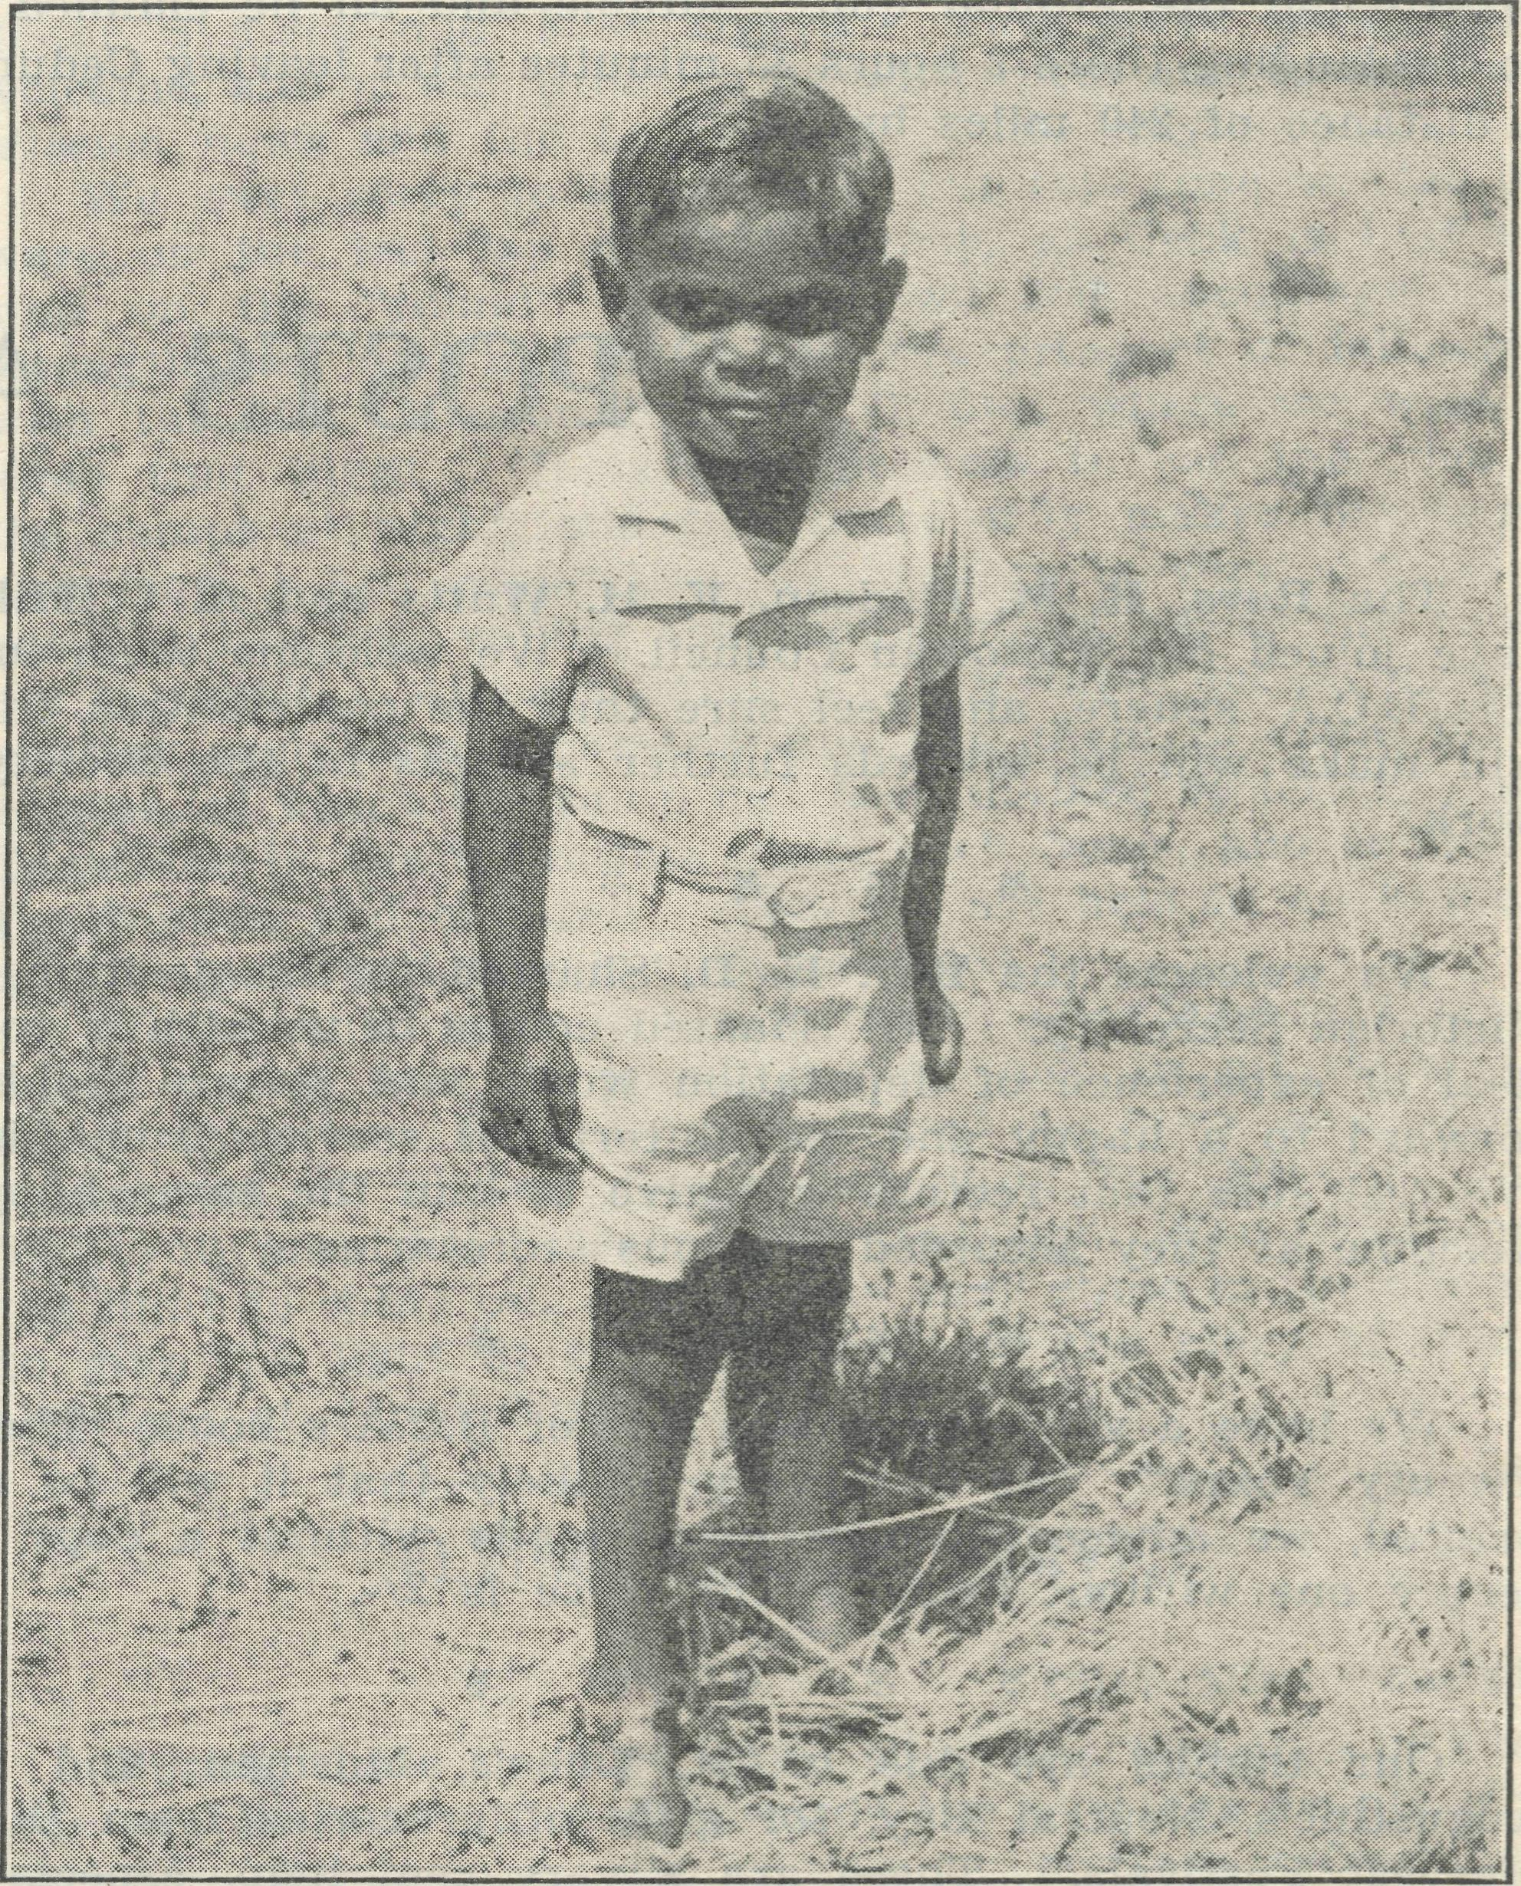
Sydney James Cook at 3 years and 4 months.
We rightly judged that the Zoo would be as amusing to him as his expressions there would be to us. Being a "real Australian," he was given the privilege of free access. To his joy he found "Blarbara," her Daddy and Mummy awaiting our arrival—only as visitors, of course. It was rather a warm day, and ice blocks were much enjoyed by all. (I might let you into a secret : ice blocks will be Sydney James' undoing in life !) Mr. Chadwick undertook to take the children on the "puff-puff"—a bit tame to him, no doubt, having to stick to mother earth—but how the children waved and beamed with delight as in and out of the tunnel and round the corner the "great express" raced !
A few days before the recent floods, we went to the Murray River at its nearest point at Mannum—a delightful spot, with its tree-lined wide sweep of the river. Sydney James, as he stood by this lovely stretch of water, made me conjure up thoughts of the days gone by when many a "black picanninie" played on those same river banks—happy days ! One and sixpence hired us a boat—not an oarsman amongst us—but what fun ! Sydney James tried in vain to drink the Murray dry, and in any case the boat always demanded its share.
Now he is back again at Penong—no Murray River there, no merry-go-rounds, no trams, no elephants (though once there was), but a "Sissie" and a "Moble" who love and care for him. And he is happy !

