Registered at the G.P.O.. bydney, tor transmission by post as a periodical.

Organ of the Bush Church Aid Society for Australia and Tasmania.

No. 81.
JULY 16, 1942.
1/6 per annum (post free).

'INASMUCH!'

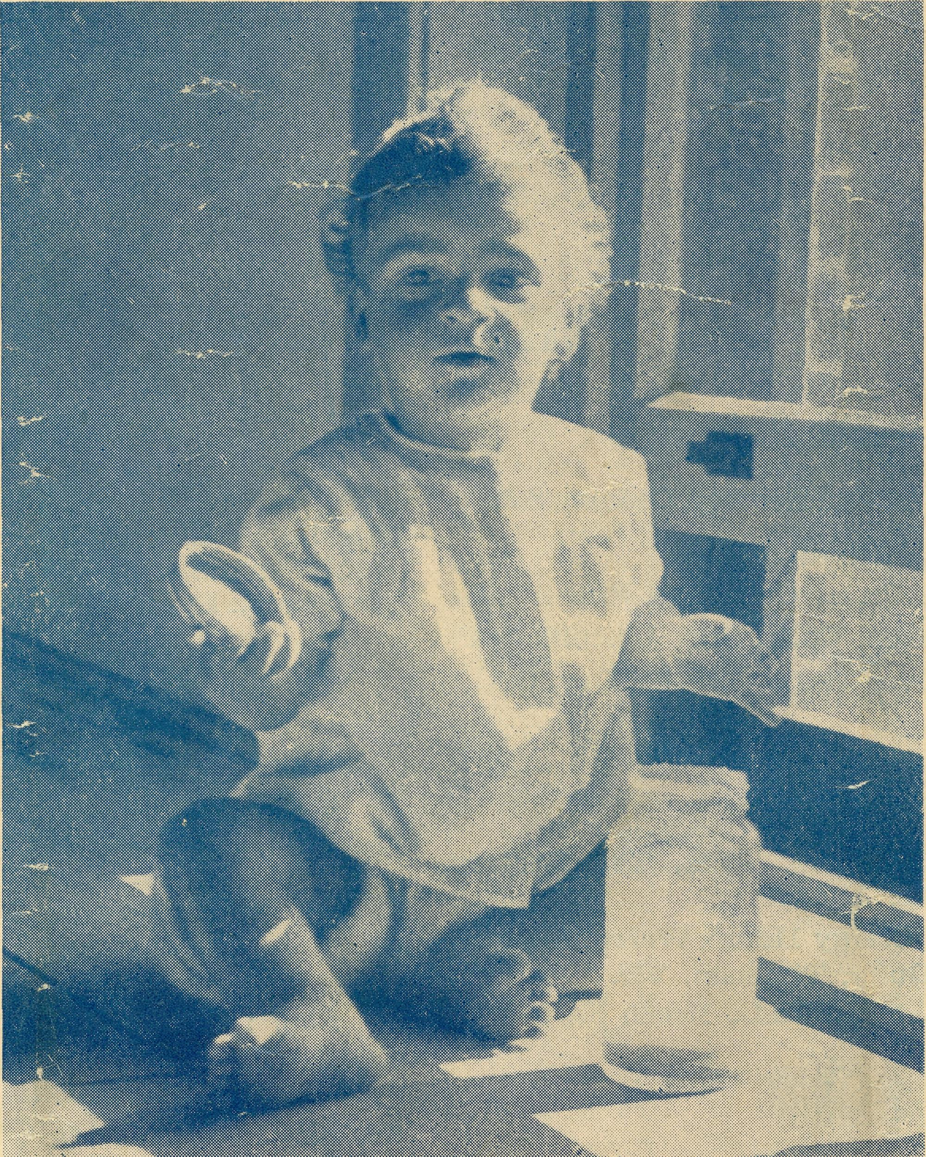
-

JOHN, A Ceduna Baby.

The Real Australian.
July 16, 1942.

The Bush Church Aid Society for Australia and Tasmania.

HEADQUARTERS OFFICE :
Diocesan Church House, St. Andrew's Cathedral, George Street, Sydney.
(Telephone : M3164.)
Cable Address : "Chaplaincy, Sydney."
VICTORIAN OFFICE :
The Bible House, Flinders Lane, Melbourne.
(Telephone : F5675.)
President : The ARCHBISHOP OF SYDNEY. Hon. Clerical Secretary : Ven. Archdeacon W. L. LANGLEY. Hon. Treasurer : T. S. HOLT, Esq.
STAFF. Organising Missioner : Rev. T. E. JONES, Th.L., Church
House. George Street, Sydney. Victorian Secretary : Rev. E. D. SHAXTED, Th.L., Bible House,
Flinders Lane, Melbourne. South Australian Secretary : Rev. R. M. FULFORD, North
Terrace, Adelaide, S.A.

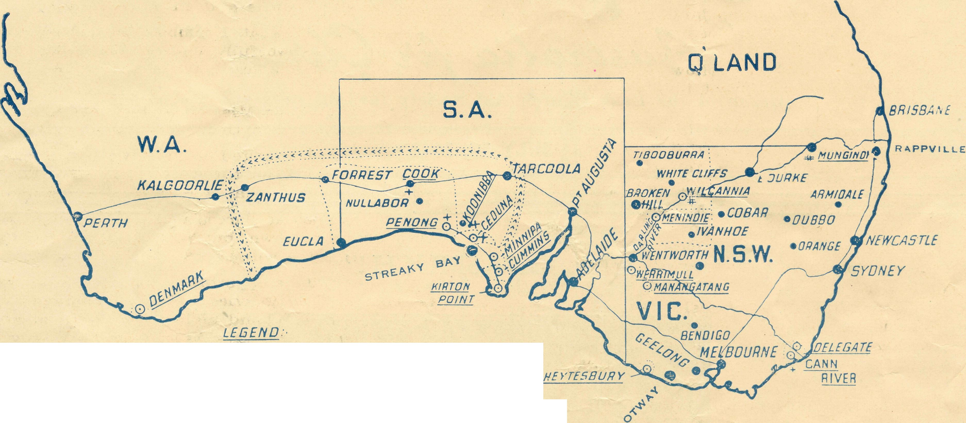
O MISSION CENTRE.
MISSION BOUNDARIES. =#= HOSTELS
HOSPITAL Of?NURSING HOME. ■ AREA SERVED BY FLYING MEDICAL SERVICE.

100 200 3C3 4-00
MISSIONS.

FAR WEST MISSIONS, S.A.
PenoiT \ ^{Rev}-^{H}* ^{Broadlev}> Th.L., The Rectory, Ceduna, S.A. Minnipa—Rev. L. Morris, Th.L., Minnipa, S.A. Cummins—Rev. T. R. Fleming, Th.L., Cummins, S.A. Kirton Point—Rev. R. T. Hallahan, Th.L., Port Lincoln, S.A. Streaky Bay—Rev. D. Livingstone, Th.L., Streaky Bay, S.A.
VICTORIAN MISSIONS.
Croajingalong } Rev. N. Chambers, Th.L., The Rectory,
Delegate-Bonang f Delegate, N.S.W.
N.W. Mallee— Rev. E. J. Dorrell, Clergy House, Werrimull, Vic. Heytesbury Mission—Rev. W. Duffy, Timboon, Vic. Otway Mission—Rev. T. H. Pickburn, Th.L., Beech Forest, Vic.
N.S.W. MISSIONS.
I Rev. K. Luders, Th.L., Menindie, N.S.W.
Wilcannia Menindie
Rappville—Rev. P. M. Connell, The Rectory, Rappville, N.S.W.
WESTERN AUSTRALIA.
Denmark—Rev. B. Lousada, Denmark, W.A.
CHILDREN'S HOSTELS.
Mungindi—Miss E. Cheers, Mungindi, N.S.W.
Wilcannia—Miss H. Gurrier Jones, Miss B. Gurrier Jones,
Wilcannia, N.S.W. Wentworth Falls, "Coorah"—Miss E. Hawkins.
MEDICAL SERVICES.
Gippsland, Vic.—Sister I. Gwynne, The Dispensary, Cann
River, Vic. FLYING MEDICAL SERVICES.
Pilot : Mr. A. Chadwick, Ceduna, S.A. Dr. R. Gibson, Dr. F. Gibson.
CEDUNA HOSPITAL.
Matron : Sister F. Dowling.
Staff : Sisters B. Bossley, V. Page, L. Loane, Branford. KOONIBBA ABORIGINAL HOSPITAL.
Sister G. Hitchcock. PENONG HOSPITAL.
Sister Firmin, Penong, SA.
Miss M. Millar, Penong, S.A.
BISHOP KIRKBY MEMORIAL HOSPITAL.
Sister L. Pritchard.
Miss D. Dykes, Cook, S.A.
TARCOOLA, SOUTH AUSTRALIA.
Sister M. Symons.

July W, 1942.
The Real Australian.

THE OJM's. LETTER.

I must first apologise for the extreme lateness of this issue of "The Real Australian." Much travelling since the middle of May has made it impossible for me to give the time and thought necessary to the publication of this issue.
The evening of Thursday, 14th May, saw me bound for Menindie to spend a few days with the Rev. Karl Luders. Arriving on Friday, I found that Mr. Luders had arranged for me to tell something of B.C.A.'s story to the locals. Quite a number gathered despite a very cold night, and much interest was shown in the lantern slides. Saturday saw us in Wilcannia discussing local church problems at a meeting called for that purpose. The lantern was again used at the evening service the following day, and we hope that, as a result, a more intelligent interest will be taken in the Society's wide activities.
It was a joy to spend a few days with Mr. and Mrs. Luders and family, and to realise that, despite a variety of offices in B.C.A., we are all one in fellowship and loyalty.
Wilcannia Mission is no easy task these days. The re-amalgamation of Wilcannia and Menindie calls for much labour and long periods from home. This makes big demands upon the womenfolk, and I cannot help but feel that the wives of missioners give much service and sacrifice.
It was a great joy to again visit the Hostel. The Misses Gurrier Jones are doing a great task. Thirty-one children were in residence, and many applications have to be refused for lack of room. The management and atmosphere of the Hostel is all that could be desired, and we thank God for such splendid workers.
I arrived back in Sydney via Ivanhoe for the annual meeting of our Ladies' Auxiliary on May 21st. The attendance was not up to the usual standard, but the enthusiasm and keenness was there, and an offering of £56 spoke volumes for the spirit which permeates our women friends.
A few days at home, and then off to Melbourne, where I arrived for the Rally on May 27th. The night was cold and very wet, and the brown-out almost a black-out. It was not possible to secure the Chapter House, so we had to go to the small Central Hall. Numbers were down, but a good meeting encouraged us. Archbishop Booth in the chair, and Bishop James of St. Arnaud, spoke highly of our work. Sister Caroline Ross told of her seven months at Koonibba, and the O.M. confined himself to a brief ten minutes. A little over £100 was given as a Rally offering, and we feel that in these days that is a definite encouragement.
It was a joy to be present at a meeting at St. Thomas', Moonee Ponds, by Miss Woods and other B.C.A. friends. The weather was awful, but thirty-five ladies came along, and that very good friend of B.C.A., Bishop Johnson of Ballarat, told them of the Society's activities in his diocese.
Some days were spent in Adelaide renewing many contacts and doing necessary business. Opportunities of preaching at St. Luke's, Whitmore Square, and Holy Trinity, Adelaide, kept me busy on Sunday, May 31st. It was good to see Mr. and Mrs. Gumbley at St. Luke's and to tell them the news of Sydney. The Rev. R. M. Pulford is a tower of strength to B.C.A., and effects a great amount of business inseparable from the West Coast work.
Arriving at Ceduna I was met by Mr. Broadley, and it was good to see him back again in his old surroundings. He and his wife and family were warmly welcomed by the people of the district on their return to commence a second term of service, and they are doing a great job.
The next few weeks were rpent in visits to Cook, Penong, Koonibba and Tarcoola. It would take too much space to describe each in detail. Sufficient to say that one came away
conscious of a service well done in each centre. There is no doubt that we owe a tremendous lot to our nursing staff. It is their devotion and unfailing witness that has largely contributed to the success and blessing of our work. For some time they have been short staffed, and domestic help has been very difficult to procure. Heavy wash days and all the hospital cooking at Ceduna has been done by the nurses for many months. The position is eased a little now by the arrival of Miss Fox to attend to the cooking, though laundry help is still an unfilled want.
Sister Hitchcock at Koonibba has a busy time, for the
whole mission is woefully understaffed owing to war calls.
At one stage during my stay Sister had fifty natives down
with influenza.
Sister Firmin and Miss Millar form our family at Penong, and both are happy in their work there.
Cook is much changed owing to war conditions, and much further work has been thrown on Sister Pritchard and Miss Dykes, but one feels that it is in capable hands.
Sister Symons at Tarcoola has the loneliest job. She is very much on her own, but here again one felt that efficient work and effective witness was being put forth.
While at Ceduna opportunity was provided to visit Streaky Bay and the Livingstones. It is encouraging to see the splendid work David and his wife are doing at Streaky. In the short time they have been there they have won their way into the hearts of a great many people, and their spiritual witness is very real.
Each Friday night at Ceduna Sister Loane has a Junior Bible Class. During my stay they had their second birthday party. It was a cold and wet night, yet eighteen boys and girls turned up. The following Friday was also cold and raining in sheets; the roads were inky black and very muddy, and there was no party. The attendance was eighteen on that night also, and many of the children had a mile and a half to walk. Pretty good, don't you think ?
On my return journey a few days were spent witn the Morris's at Minnipa, the Flemings at Cummins, and the Hallahans at Kirton Point. All are doing no easy task, for the depletion of population by call-ups and munition requirements have materially affected each district. It is our part to see that they are not spiritually depleted. At Minnipa keen interest was shown in the proposed new church, made possible by the gift of £400 from England. We hope that the next few weeks will see the commencement of building operations. Mr. Morris showed me some very fine Communion linen and kneelers sent by ladies of the Col. & Con. from England, and it was quite thrilling to handle a piece of very old stone which had been sent by the Provost of Coventry Cathedral for incorporation into the Minnipa church. Quite a lot of furnishings will still be needed if the building is to be a worthy one. Some can be provided by the locals; some will be too much for them. Would any friends of B.C.A. like to help in the provision of Pulpit, Lectern, and Holy Table ?
While at Minnipa I had first-hand witness to the work of Mrs. Morris, or "Sister" as she is known. A woman in the little town, having had all her teeth out, was bleeding badly, and "Sister" was called in to help. Doing all she could to stop the flow of blood, Sister then called the doctor twenty-eight miles away, who, after seeing the patient, ordered her into hospital. The problem then was how was the patient going to get there ? The solution was provided by Mr. Morris, who, at 11.30 p.m„ drove "Sister" and patient into Wudinna along roads made none too safe by heavy rains. "St. Patrick's Van," the gift of our friends in Ireland, has

The Real Australian.
July 16, 1942.

made possible a piece of service of tremendous value on the West Coast.
While with Mr. Fleming I was able to preach at Murdinga, Karkoo and Lock. It had been raining for weeks and the roads were under water in many places, yet at each centre we found a good attendance of worshippers—much better than I have seen in city parishes under the same weather conditions, yet at Karkoo and Lock service is held in a public hall, and at Murdinga in a small schoolroom. The atmosphere of a beautiful church was missing, but a real spirit of worship was to be found in the people.
Kirton Point brought the opportunity to renew old and valued friendships, for B.C.A. has a big share in the hearts of many people in that place. Mr. and Mrs. Hallahan have won their way into the love and esteem of their congregation, and one hopes that they will continue there for some time to come.
Journeying home, the thought uppermost in one's mind was, "Can we continue to maintain so extensive a ministry ?" For the work B.C.A. maintains to-day is not only large in area and varied in character, but also calls for considerable sums of money for upkeep. Wherever I went the calls of war were emphasised—loans, taxes, higher cost of living, calls for upkeep of Red Cross and kindred worthy works. Can our people be expected to meet all these demands and maintain such activities as those of B.C.A. ? Is that the right
way for Christian men to look at things to-day ? Always, always the maintenance of God's work is put last ! Can we maintain Christian work—can we give our time, money, effort and interest into missionary work when we must do so much for our nation's struggle for survival ? We haven't the time left, nor the cash.
If we lose the war, we won't have any church or religion, and righteousness will be no more. That's true enough, but—will we win simply by the manufacture of munitions and supply of men if righteousness disappears from our midst ?
The other day I read, and maybe you read, of a Czech town which was utterly wiped out by the Germans. Every man, woman and child was killed—brutally murdered— because they had been true to their ideals in the face of the invaders' threats. Did they say, "We will submit in order that we may live and one day in the distant future re-establish our ideals and loyalty" ? No ! they died. Did they fail ? Was defeat their portion, or were they, having lost all, including life itself, the victors ?
God grant us strength and courage to make all sacrifices for our native land and strain every nerve in its struggle to victory. God grant us, too, grace to rise high enough to place all on the altar of sacrifice in order that the ideals of love and righteousness for which we now fight may remain alive in the hearts of our people.

FROM THE MISSIONS,

MINNIPA.
The Rev. L. Morris.
In past articles for "The Real Australian," both my wife and I have sometimes mentioned the medical side of our work here as being a feature of things with some appeal to the folk, and with quite a lot of value. We were reminded of this rather forcibly last Tuesday—the day we reached home after our holiday over there in Sydney. Hadn't been home two hours before a badly cut finger came along for Sister's administrations. There was a lull after that, but about 12.30 a.m., when we were sleeping the sleep of the travel weary, we were roused by a knock at the door (at least my wife was—it takes more than that to wake me, even when I haven't been travelling for three consecutive nights). Outside I found an excited young man, who urged us to come with all speed to the aid of an old lady suddenly taken very ill, a heart attack being suspected. I assure you we wasted no time in assembling medical kit and getting away. Sister did what was possible on the spot, and then had a 'phone consultation with the nearest doctor, breathing a little prayer of thankfulness that Minnipa is one of the very few places where the 'phone can be used throughout the night. Doctor wanted the patient brought down to him, so we began to take thought. The old lady was in a state bordering on collapse, and getting her into the Van was a bit of a problem, until we remembered that the Red Cross had recently bought a stretcher. Nothing for it but to knock up the local baker, in whose custody it reposed, and borrow same, with the aid of which we were able to convey our patient into St. Patrick's Van, now masquerading as an ambulance. Away on our dash to the hospital at the highest speed the condition of the road and the condition of the patient will allow, while I reflect that I'd never previously realised just how bumpy and corrigated that particular piece of road was. Eventually we reach hospital without incident, and are mighty glad to leave our patient under doctor's care.
Returning home thankful that we have been able to be of service and praising God for the wonderful way he over-
rules, we realised that had the old lady's illness been the previous night things would have been very serious.
It reminds us, if reminder were needed, of the appalling difficulties which surround the folk out here in their efforts to win a grudging living from the fruits of the earth. Isolation is seen at its most dramatic stage in such cases of
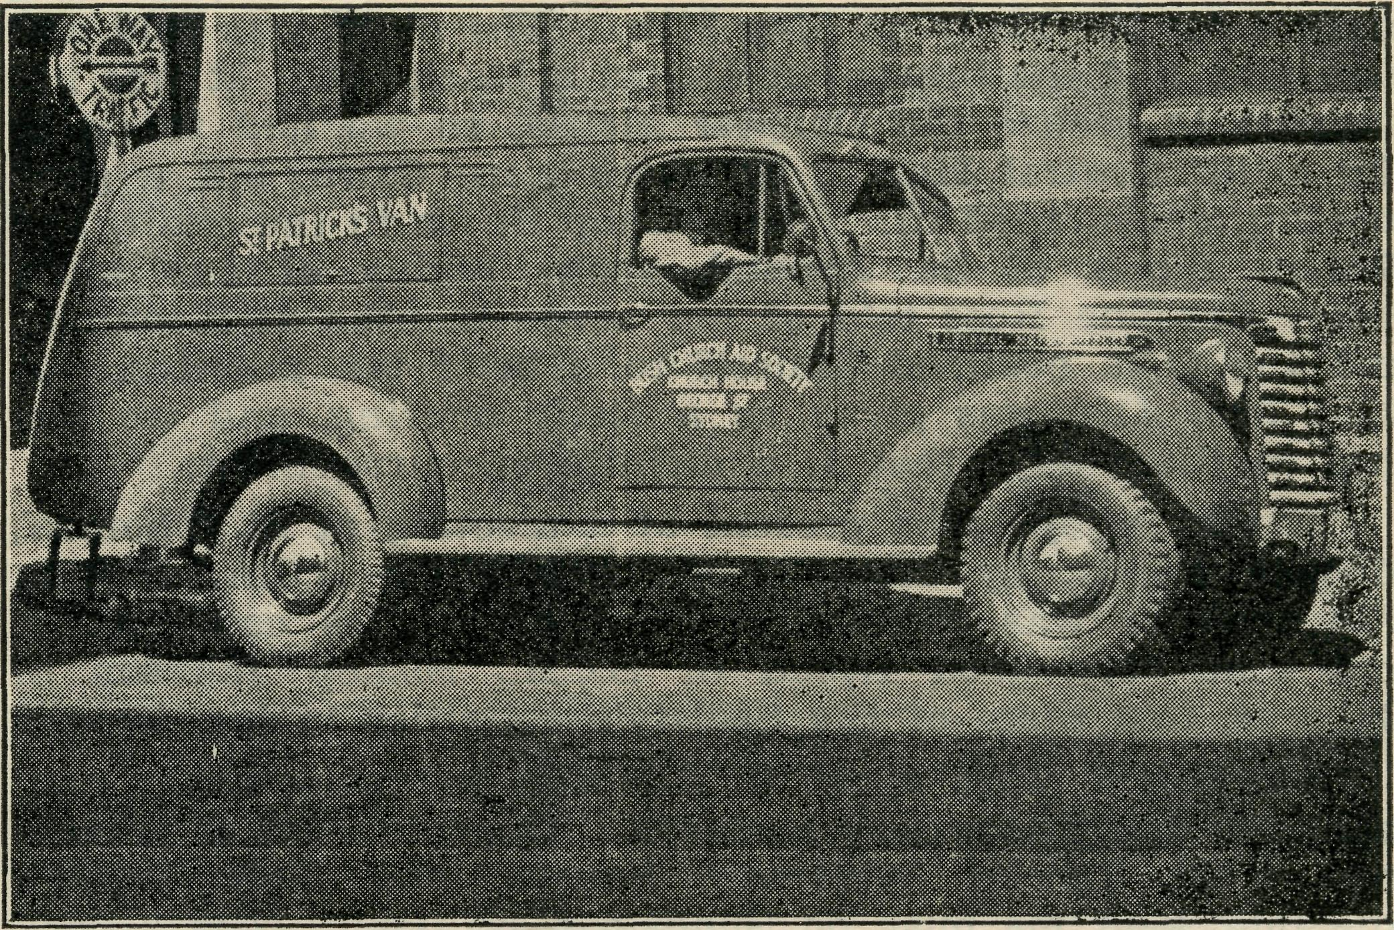
ST. PATRICK'S VAN.
sudden illness and hectic dashes for medical aid, but it affects all avenues of life. Kiddies especially are up against it— their playmates are few, their games of necessity limited, their education (both in the secular and religious) under a great handicap. While the Education Department does what it can, it still remains that children who are educated in a very small school are at a disadvantage, and that those who are to receive high school education must go and board hundreds of miles away from home. There is a great need for hostels to cater for just such people. So far as the

July 16, 1942.
The Real Australian.

Minnipa Mission is concerned, the isolation is increasing, as many continue to move out of the district. In no less than five small centres we have had to discontinue services and carry on as best we can, with occasional visits to the few who are left. This sort of thing means an increasing struggle to keep church life going, but it has one good aspect. I am now able to plan an occasional trip to districts hitherto entirely beyond my district. I had word only this week from one such place saying that there are a number of babies to be baptised, but that it is eight months since they last had a visit from a clergyman. The need of such places is obvious, and the facts speak more eloquently than any words of mine can.
A word about the church that is to be erected at Minnipa before I close. Readers will recall that some time ago mention was made of a gift of money from England for the building of a church at Minnipa. The gift, of course, kindled a great enthusiasm, and the people have since been working with a will to raise the additional amount necessary. We have been further heartened by the arrival of two parcels from England with gifts for the church. Outstanding in point of interest is a stone from the bombed Coventry Cathedral, which has been sent by the Provost with the following message : "This piece of stone was part of the Cathedral Church of St. Michael, Coventry, destroyed by enemy action, November 14th, 1940. It is given to the Church of St. John, Minnipa, South Australia, with the greetings of the Provost and people of Coventry Cathedral."
The stone, a small one, is of red sandstone, and looks ancient and venerable. We shall be glad to include it in the fabric of our church, and it will serve as a unique link between the stately cathedral that will surely be erected after the war and our humble village church. Also among the gifts were a beautiful little Communion set and some exquisite needlework. We are thankful to those who gave them, and the fact that they gave in such times of unparalleled stress is surely a testimony to the abiding value of spiritual things and an inspiration to all of us.
STREAKY BAY.
to set a good example by decorating the car and leading the procession to mark the beginning of the carnival. While puzzling over this mighty problem, someone suggested that it might be a good idea to decorate the car upon the theme, "The First Red Cross." The result was that the B.C.A. missioners' faithful old chariot led the procession dressed in the following manner : Across the radiator was a large blackboard drawing of the Cross of Christ bridging the gulf between God and man. Above the hood was a large banner bearing the sign, "Calvary for Victory," done in red, white and blue. Upon each side and at the back were large S.G.M. posters upon the same theme, and, of course, there were plenty of red, white and blue ribbons to give the patriotic touch. At the sports ground we parked the car in a prominent position where all could see and read, and much interest was aroused.
About the same time our Annual Fete was held, and this, too, was a spiritual as well as a financial victory. In accordance with B.C.A. principles, raffles and dances were not held, and while the parishioners most loyally co-operated many expressed doubt as to whether the usual £100 or so would be raised; but the Lord remembered us, and the £100 did come in, and, best of all, everyone concerned stated how much better the Fete was without the raffles and other etceteras. So we praised the Lord and took courage.
Just recently, two centres a little out from the town asked if they might have two services a month instead of one, and this has now been arranged and is proving very successful in every way. So although the year has been by no means an easy one, there has been much to encourage and to gladden the heart. One of our greatest difficulties is the continued removal of many from the parish to the city. This naturally is gradually affecting our congregations and work generally, but those who are left seem to make the extra effort necessary, and upon the whole both congregations and finances are maintained.
Our parishioners have been extremely kind and helpful in every way, and we trust that, upheld by the prayers of all readers of "The Real Australian," the coming years will be marked by ever increasing blessing throughout the Mission.

Rev. D. Livingstone
Just a year has passed since we came to Streaky Bay from Wilcannia, so it might be of a little interest to some of B.C.A. helpers if we review some of the highlights of that year.
Soon after we first came a Convention was held for the deepening of the spiritual life, and it was a great success. The meetings lasted all day, and there was a total attendance of something over 300. The speakers were the Rev. L. Morris, B.C.A. Missioner at Minnipa, who spoke upon the theme, "To me to live is Christ"; in the afternoon the Methodist Home Missioner at Streaky Bay, the Rev. R. C. Dalton, spoke of the work of the Holy Spirit; and the final meeting was conducted by the Rev. N. Chambers, who was then Missioner of the B.C.A., Far West Mission, who summed up the addresses of the two previous speakers and pointed out the necessity of the deepening of the spiritual life in these days. People came to this Convention from all over the district, even from as far as Ceduna, and many more would have come but were prevented by the petrol rationing. Such was the enthusiasm aroused that there are still requests being received for another Convention to be held, and we hope before very long to accede to the requests. It is evident that many were blessed on that day, for it was a day of real spiritual power which will not soon be forgotten.
Another highlight was the Red Cross Procession. It is not often these days that a Red Cross carnival can be used for the furtherance of the Gospel, but we were able to do that on this occasion. I happen to be the President of the local branch of the Red Cross, and, as such, was expected
CUMMINS.
Rev. T. R. Fleming.
The war has inevitably brought many changes, and in the smaller numbers of a bush mission these changes are perhaps a little more noticeable. The work of the Missioner has to be adjusted to meet these new conditions, and most of us are now settled into the new routine, but I thought that some mention of these problems would help our many fellow-helpers in the big cities to a better understanding of our needs.
The populations of our various small communities are always a little unreliable, but the changes are now so rapid that it is difficult to grasp how quickly a well established centre can be reduced to a place of uncertain services. Let me tell you of Karkoo, one of the better centres from the point of view of our church life, though financially the settlers were on a precarious basis. Here we had seven families, or rather six and a bachelor. From one family of two boys one joined the R.A.A.F. and the other was rejected, but, being unable to get labour, they had to seek a smaller farm and now have left the district. The next had two boys, and they are now in khaki, so they are reduced by half. Another had also two boys; one is in Air Force blue and the other in khaki, so they had to turn from farming to another source of income, as the father could not manage the farm by himself, and have now left the district. The next farm is a little better off : they have three sons, one under age and trying to grow up as quickly as possible so that he can join (Continued on page 7.)

The Real Australian.
6
July 16, 1942.

THE PLACE OF PRAYER.
A Prayer for Use with Our Prayer List.
O Lord God of our nation, Who has commanded men to subdue and replenish the earth : Look in Thy love upon all those who in the distant parts of our land are striving against many difficulties, and are deprived the access of the means of grace. Strengthen and guide the Bush Church Aid Society and its Clergy, Nurses, Doctors and Air Pilot, and Students. Cheer and comfort them in discouragements and loneliness, and bless their ministrations to the good of those they serve, and grant that the message of redeeming love may thus be rooted and grounded in our national life, to the glory of Thy Great Name, through Jesus Christ our Lord. Amen.

SUNDAY.
THURSDAY.
MORNING.
The Far West Missions at Penong, Ceduna, Minnipa and Cummins ; the Missioners, H. Broadley, T. R. Fleming and L. Morris.
EVENING.
The West Darling Missions at Wilcannia and Menindie : the N.W. Mallee ; and the Missioners, K. Luders and E. J. Dorrell.
MORNING.
For the Mail-Bag Sunday School with its Gospel message for the children. For the teachers and helpers, that they may find encouragement in their work.
EVENING.
For
the Organising Missioned that he may be strengthened and guided in all his endeavours for the good of the work and in his relationships with his fellow-workers.

MONDAY.
FRIDAY.

MORNING.
EVENING.
MORNING.
EVENING.

TUESDAY.
SATURDAY.
For Sisters Dowling, Boss- For the Cann River Dis-
ley, Page, Loane and Bran- pensary and Koonibba Mission
ford at Ceduna; Sister Firmin Hospital ; and Sisters I.
and Miss Millar at Penong. Gwynne and G. Hitchcock.
WEDNESDAY.
Each day pray that the many needs of the work may be met.
Running expenses of 40/- per hour to keep the Medical 'Plane in the air.
Consecrated clergy missioners for urgent work in the field.
That our work may continue to progress despite the difficulties of wartime.
The Cann River Mission, the Bonang Mission, Rev. N. Chambers, the Streaky Bay Missioners, and the Rev. D. Livingstone.
MORNING.
MORNING.
For the children in the Mungindi and Wilcannia Hostels, and for the workers, Miss Cheers, and Misses Gurrier Jones.
The Denmark Settlement, the Kirton Point Missions and the Missioners, the Revs. B. Lousada and R. T. Hallahan.
EVENING.
EVENING.
For the Flying Medical Service, Mr. Chadwick, and Doctors R. and F. Gibson.
For the wives and families of the Missioners and Air Pilot.
For the Bishop Kirkby Memorial Hospital and Sister Pritchard and Miss D. Dykes as they minister to the people on the great Nullarbor Plain. For Sister Symons and the Tarcoola Medical Hostel.
MORNING.
For the President and Council of the Society, that they may be guided by His wisdom.
For the Home Base Staffs, Auxiliaries, and parochial workers.
For students and all in training for this work of God. For Rev. W. Duffy and the Heytesbury Forest Mission. For Rev. T. H. Pickburn and the Otway Ranges Mission.
EVENING.
For the "Coorah" Hostel and its workers, Miss E. Hawkins.
For the Rappville Mission and the Missioner, the Rev. P. N. Connell.

Give Thanks—
For the rich blessing and wonderful growth of the Society's work. For all the kindly givers who have helped with their self-denials. For the Flying Medical Service. For new workers in Hospitals and Missions. For the joy of service.

July 16, 1942.
The Real Australian.

(Continued from page 5.) his brothers, one in the R.A.A.P. and the other in the A.I.F. In another there is only one son old enough to serve, and he is in the Navy. One family only is left undisturbed; they have an only daughter. Thus a former good congregation is reduced to three families, and two of those reduced in numbers. Petrol rationing makes it very difficult for one of those. We must reduce this centre to one service a month, but they have pledged themselves to keep this going, not only for themselves, but for when the boys come back.
At Murdinga we have always tried to keep a service going for four families—not a big number at the best of times. Now two of the farmers have enlisted and their families removed. We cannot close down here for the sake of the two that are left, but this will cut our income from this centre by half, as they are all poor and cannot afford to make it up. One could go on in this strain, but the above will be sufficient for you to understand the problem.
In our country districts the sorrow of one is the sorrow of all the district, and our casualty lists have a very big effect. When the supreme sacrifice has been made the Memorial Service is a call to all the district, and on these occasions we have great opportunities. Your prayers for us in this branch of our ministry means much.
Petrol and tyres are also very real problems, both through rationing, though we have been treated very favourably by the Government and price. Petrol is now costing us in this mission district just 50% more than it did two years ago, and we have smaller numbers from which that money can come. Wheat farming has not the margin of profit at present that gives big returns, and there are no munition works paying big wages. Calls on the purses are daily increasing, and to keep up what they gave before calls for big sacrifice, yet we thank God we have been able to pay our way, and the people have given most generously in a determined effort to preserve the church life pending the return of the boys when the days of peace are with us once again. They are doing their best, and relying on the good friends of B.C.A. to help them through. We cannot and must not let them down who have given so generously of their sons, husbands and fathers for us.
CEDUNA.
Rev. H. R. Broadley.
One of our friends (who has never been here !) usually refers to Ceduna as "that horrible place !" She, like many others, was a bit puzzled why anyone who had served a term in B.C.A. work should, after tasting the joys of suburbia, return not only to B.C.A. work, but also to the same place. The people we have met since coming back take it as a kind of compliment, and agree that Ceduna "isn't such a bad place after all."
Superficially, everything would appear much the same as in 1940. Yet in many ways there is a marked change. The war has spread its tentacles far and wide, and we find its effect not only in petrol rationing, black-outs and brown-outs, but in the number of people who have gone away either to the fighting services or to war work of some kind. Almost everyone who is left has some voluntary war job to do.
This means that, in addition to the usual difficulties of building up a strong Christian community, there are many additional obstacles to be faced. In this situation it is grand to have not only the fellowship and backing of the other members of the B.C.A. staff here, but also that of the many readers of "The Real Australian."
When we left in April, 1940, the Rev. Eric Constable was still at Penong. Now, that district, which includes the settlements along the Transcontinental Line from Forrest to OoldGa, comes under the Missioner at Ceduna, whose territory ranges for about 440 miles along the coast to 230 miles along
the Trans. Line. The Rev. N. Chambers also had an extra slice north of Ceduna, up to Tarcoola and beyond.
Once in three months, as before, the round trip is due, taking in Colona, Nullarbor, Eucla, Mundrabilla sheep stations, and the stretch from Forrest to Ooldea.
My first attempt at the end of March was rather a failure. All went well, though somewhat lonely, for the first half of the trip. Eucla was reached without much trouble. Forrest also, though the track was pretty violent at times, the little van leaping from point to point like a mountain goat, even at reasonable speed, gave the impression that the bottom might fall out any moment. Rain descended as I left Forrest to go to Reid, some nineteen miles away to the east. By the time Reid was reached it looked hopeless to go on. On entering the school to take a lesson, I asked the teacher if I could get a place to sleep anywhere. A loaded van is not suitable to sleep in if you can't put some of the things outside. She immediately offered a hut nearby. A bed and mattress was brought along by two boys. Meals were offered by one of the local residents where the teacher boards.
I stayed in the camp for two days, from Friday morning till Sunday morning, and then made an attempt to get to Cook—118 miles further on. Twenty-six miles along the track the car did something which prevented me from taking it any further. I finally decided to walk along the railway track, expecting to have nine or ten miles to go. It turned out to be 6-7 miles. On approaching Deakin I was mistaken for a "swaggy," and, suspecting what might be done, announced immediately on arrival that it was the "local" Church of England clergyman. Straightway board was offered in one house and bed in another. Next morning there was help to get the car out of the bog, but after driving it to Deakin it was too risky to take it further. I stayed there from Sunday night till Tuesday mid-day. From there it was possible, with help, to get to Cook, and thence (after being royally entertained by Sister Pritchard and Miss Dykes), through the ever-ready kind offices of Mr. and Mrs. Brook of Nullarbor Station, to get through to Penong and contact with the Medical Aeroplane on its usual weekly visit.
It would be wrong to stop here without saying a word of deep appreciation about the help and hospitality received at both Reid and Deakin. When it is possible to slip across the road to get extra things from the shop, an unexpected visitor is not so bad. The people on the Trans. Line depend on the "Tea and Sugar" train which comes once a week. In both centres they were beginning to get down in the food cupboard. They had to wait some days for the train to bring more things. Yet, in spite of that, there was no hint that I was a nuisance, but rather a ready reply to my apologies that "It will be all right—we'll manage !" Surely there is good ground here to sow the Gospel seed in. It makes me feel that I want to do everything possible to make the visits memorable to them. As it is, there is a risk that owing to inadequate ministrations—once in three months at most—they may lapse into "decent" pagans ! That isn't good enough. Amongst other things, I would like to have some lantern slides, for as we all remember pictures more easily than words, it is Glear that for an occasional visit the slides would be of incalculable value.
The Woollahra branch of the Auxiliary held its annual meeting earlier in the year. Due largely to the untiring efforts of Miss Bennett, it was very successful, and the gifts of money and kind show an increase on last year.
■*f* *^ »j* V *J* *V>
The Organising Missioner was able to be present at the Essendon Ladies' Auxiliary meeting recently. Though a wet afternoon, thirty-five members were present and were thrilled to hear of B.C.A. work in the Diocese of Ballarat from the Bishop himself. Bishop Johnson has proved a good friend to B.C.A., and we are very grateful to him for his kindly interest.

The Real Australian.
8
July 16, 1942.

FROM THE HEALING MISSIONS.

CEDUNA HOSPITAL.
Sister F. Bowling.
A ring came on the 'phone to say a patient was on his way to Hospital, having been badly burnt. One of the old pioneers of the district, over 80 years of age, was driving round his paddocks in a sulky when, placing his pipe in his hip pocket against a box of matches, the pipe apparently still alight, the matches caught fire and soon his clothes were alight. He struggled to get his boots off, but succeeded in removing only one, and had to let the other burn off his foot. His trousers were burnt, his legs and back receiving terrible burns. He got into his sulky and drove three miles to his home. His family hastily wrapped him in clean sheets, and then drove him eighteen miles to hospital. Anyone who has ever experienced burns will appreciate what that old chap went through. In a couple of days' time one leg became gangrenous, which resulted in him having to have his leg amputated. He stood the operation remarkably well, but two days later it became evident that he could not survive the infection. On the same evening as he passed away, after our prayer and Bible reading we were singing some hymns, and he sent out a request for several of the old favourites. He was a professing Christian, an elder of his church, and a regular attendant of God's House. The members of his family were very moved by watching him lie and listen with such feeling to the old hymns just before he passed to be with his Lord. When listening to stories of his experiences in his early days on the West Coast, one cannot but admire the remarkable courage and fortitude these folk had in facing their many difficulties and hardships while endeavouring to open up the country for farming. Thank God the Church followed them out here, and, even though after years of hard work and privations they don't seem any better off financially than when they began, they had the opportunity of learning of Him.
Another interesting case was of a farmer who, one evening, was unharnessing his horses, when they took fright and bolted, knocking him down and dragging the combine right over him. He was dragged some distance, and finally his leg was caught on a stump. He sustained a double compound fracture of the lower leg. As he lay on the ground he realised that it was only Wednesday and he stood little chance of anyone coming his way until the following Saturday, when his brother had arranged to meet him. He was living alone, and seldom was the occasion when anyone happened to call and visit him. He decided to do something about it, so he crawled two miles, having to get over a fence on the way, and, reaching the nearest road, lit a fire to try and attract someone's attention, which he succeeded in doing some time later. He was brought into Hospital, where he stayed for eight weeks.
It is difficult for city folk to realise the isolation ©f the country, and now that petrol is so restricted the farm people seem more isolated than ever. Put yourself in this young girl's place. Working shorthanded on the farm, she was doing more than her share of the heavy work. One morning she felt an acute pain in the right side, which gradually got worse. Feeling very off colour, she felt like going to bed, but, not wanting to leave the heavy jobs for her old mother to do, she kept going all day. Finally she had to give in and go to bed. She and her mother were alone on the farm. The father and son were working several miles away. There was no telephone and no means of conveyance. Most people know what to fear when they get a pain in the right side, and most people know it can be fatal to leave it too long. She just had to lie there and wait until the father came home with the truck the following day, when she was then brought thirty-three miles to Hospital. It was a very sick patient
we admitted with a ruptured appendix. However, after a stormy passage, much prayer and many tabs, she pulled through and was discharged from hospital, with orders to come back later for operation. Several weeks later she came back for her operation. She listened intently to the Word of God as it was read each evening, and the day before going home remarked to one of the other patients, "I'm going to miss being read to each night !" Next morning we gave her a Bible and some Scripture Union Notes, and she has promised to read a portion each day.
Dr. Freda is still carrying on this big district on her own. Although she looks remarkably well, we all realise what a big strain the responsibility must be to run such a practice. Please remember her in prayer, that she may ever be conscious that He is her strength and stay in all things.
We welcome Sister Hitchcock back again after her long leave. Many of her natives were at the station to meet her. We do pray that another worker may be found to assist her at Koonibba. Sister Ross returned to Melbourne after relieving Sister at Koonibba for seven months. We wish her God's blessing on her future work.
We were almost overwhelmed when both lots of boxes from Sydney and Melbourne arrived together last week. It is impossible to write letters to everyone, so please accept our thanks. The folk here more than ever will appreciate the gifts of clothing, etc. The gifts of tea, as can be well imagined, were especially acceptable.
Yet another link has been made with an isolated town on the Trans. Line by the Flying Medical Service. Our first trip to Tarcoola last month was a great thrill. Flying across-country, and then coming across a little township which seemed to be just in the middle of nowhere, made one realise the tremendous need of these places. Tarcoola is 250 miles from the nearest doctor and hospital. Imagine what it would mean to you, if you and your family were living there, to know that if an emergency arose you could get in touch with Ceduna by 'phone and have the doctor there in less than two hours, instead of having to wait a day or so to take you or yours to Port Augusta ! But greater still, the Church has enabled one to be placed there as His ambassador. There is no minister there, and Sister Symons has a big responsibility, and it is up to all of us to back her up with prayer, that not only the physical needs of the folk may be met, but also that the Bread of Life may be given to them.
PENONG.
Sister Firmin.
Less than a year ago, in the need for nursing staff for the hospitals in charge of the Bush Church Aid Society in South Australia, I recognised an opportunity of definite serviee for the Lord Jesus Christ.
In due course I arrived on the West Coast. After a few weeks' probation at Ceduna Hospital, I was transferred to Penong, meeting Sister Goodwin, and saying farewell almost in the next breath. With the patient and faithful guidance and assistance of Sister Bossley, the next week of initiation slipped by. My first patient arrived on Monday—a week after I arrived—then another, brought from Fowlers Bay on Christmas Eve. It has been a great source of comfort to remember that the Lord Jesus understood all manner of sickness and disease. He has never failed to help in time of perplexity.
Many and varied are the physical ills that one is asked to treat or to advise regarding treatment. It is sometimes a little difficult to suggest a treatment which, as well as being easy to obtain and use, will relieve and eventually cure

July 16, 1942.
9
The Real Australian.

the trouble, if possible. However, the work is full of interest. Thursday being Doctor's consulting day, the hours of 2 p.m. to 4.30 p.m. are usually fairly busy while Doctor is seeing patients. Sister Dowling or another Sister from Ceduna usually comes, with Doctor Freda Gibson and Mr. Chadwick making a pleasant interlude for us. During the last few weeks there have been two major operations, giving us a little surgical nursing—a change from the medical and obstetric, which has occupied us for the past six months. Small numerically, but not of least importance, are our babies. There have been five born here this year up to date.
Some of the mothers are within reach of the Hospital, and bring baby along for weekly weighing. Others whose homes are much further away do not come often, but ring or write to report baby's progress or be advised, if necessary.
The Outpatients' Department is never closed. A child arrives complaining of toothache. In most cases I have followed the instructions received from a dentist friend, and have been able to relieve the condition by a temporary filling. As the visiting dentist only does extractions, the inevitable result is that if a tooth begins to decay and gives trouble it just has to come out. A boy was rushed up here with a fish bone embedded in the back of his throat. I was thankful that it came out quite easily. Boils, cuts and minor injuries are attended to at the Hospital.
To the industry and enterprise of the Hospital Aid Committee—a committee of local ladies—we owe the addition of the lighting plant, which is a wonderful convenience and advantage in our work. They have been responsible for very good practical help in providing other useful equipment as well.
Sister L». Loane.
Penong ! I had been there quite often on short trips— had once even spent a week there. It was the middle of summer and very hot; we had two small children in with infected eyes, which needed constant treatment day and night. After that week I decided I did not like Penong much, and would never be particularly anxious to go there again.
So much for first impressions! Recently, however, I spent a fortnight there, and have now changed my mind. We were busy, but that was all to the good; it kept us from being lonely, especially as the patients were a very cheerful lot. The main worry was the outpatients : What type of cases would we get ? Would the advice be correct ? and so on. Well, on the first morning the 'phone rang. "It's about little Mary, Sister; she's not been so bright these last few days." When the anxious mother discovered it was only a relieving Sister speaking who did not even know little Mary, she decided to see Doctor next week when she was up that way. No advice needed—the first case easily treated ! Next a woman who had sore ribs. I examined her carefully and asked numerous questions, and finally was told that they were much better than they were yesterday; so I heaved a sigh of relief and advised returning home, as no treatment was necessary. Next came a man with stiffness round the ribs, and the same story that he was better to-day. I began to think it easy work when the patients only came for advice when they were cured !
The next, however, was a little different. It was at 2.45 a.m. We were all asleep, but were wakened by a loud and determined ring at the door bell. I almost fell out of bed and into dressing gown and slippers, and hurried to the door, wondering whatever it would be. Fortunately it was fairly moonlight, for there on the verandah was a native leaning casually against the post and another half sitting, half lying on the ground. The man standing pointed to the other and said, "Heye trouble !" After many questions, I gathered that the patient must have got a spark from the fire in his eye and burned it, so took him inside, expecting the worst. He had a very sore-looking eye, which I washed out, and out came a large piece of ash. "Him all right in the morning; you give medicine !" So I put on a bandage
and hoped for the best, fully expecting to have to send him to Koonibba in the morning. At 8 a.m. they came again— "Him all right; you give heye trop !" So I put a drop in the eye and off they went, quite happy and quite cured. It's a great life—when all goes well !
The two weeks at Penong were soon over, and I came home with Mr. Broadley after his service in the Church there. On the way we called at Bagster, where we had promised to take a service for Mr. Rayner, the Methodist clergyman, who has a parish nearly as large as the B.C.A. Missioner's. It was the first time a Church of England man had taken the service, there, and the welcome from the people was most cheering. Twenty-five people came, and it was great to see the spirit of co-operation between the two churches and the people so willing to work in with members of another church. We looked around at the varied means of conveyance that had brought the people to the little hall. There was one large fairly recent model sedan car; there were two very ancient trucks—one with no seat at all on the back and one with an ancient car seat (we presumed the children rode there). Then there was a very ancient-looking horse-drawn vehicle (perhaps it would be called a dray—I don't know), and not far from it was a buggy with an old horse waiting patiently to go home. How cold it must have been driving against a bleak easterly wind ! Then, last but not least, was the B.C.A. Missioner's Van. What a variety—a pity no one had a camera ! Everyone enjoyed the service, and did not fail to show their appreciation by joining in with the singing, etc. It's times like these that make us realise something of the value of the work out here, and, though we do not see very much result from, messages that are sent forth, yet we know that where the seed is sown in due course it must grow and bring forth fruit.
And now I must just say a little about the children and their Bible Class. They are as keen as ever, and for the past few months we have had an average attendance of sixteen or twenty each Friday evening. It is nearly two years since we started with four or five members, and gradually we have grown. Now several of the older girls are coming, and they are a real help with the class and an encouragement to the younger ones. How I long for one, even one, to come right out for the Lord ! The children often come early and amuse themselves while they are waiting by singing the choruses. The other evening we were surprised to hear the organ being played, and later on found that one of them had borrowed a music book and had learned some of the more familiar choruses and was then able to play for the others. And so will you continue to pray for them, for it is only through your prayer support that anything can be achieved. Pray, too, for their leader, that grace may be given sufficient for the task. Thank you for your past prayers, and thank you for those you will offer in the future. "The effectual fervent prayer of a righteous man availeth much." How much more that of many such people ?
COOK.
Miss D. Dykes.
Although we have not got much to remind us of harvest time out on the plain, our Mail-Bag Sunday School lessons keep us up to the seasons and special services, and so when we saw it was Harvest Festival time we decided to try a service in Cook.
We have a regular Sunday school and evening service each week, taken by both of us, one reading lessons and singing solos and the other taking the service and talk. Our extended sitting-room makes a very nice chapel, although we often wish we had a separate little building, especially when we have baby patients; and we are fortunate to have an organist to play our little organ, which does very good service, as people love singing and join in with a will. The

10
The Real Australian.
service takes the form of a shortened evening service from the Prayer Book, as most of the congregation are Church of England, and about every quarter we have a visit from the Missioner at Ceduna. Recently we had a wedding, held in our hall-way by request of the bride's mother, who said the atmosphere was more like a church than the local hall. As the Missioner from Ceduna was not available, they obtained the service of a Presbyterian minister from Port Augusta, who works in conjunction with the A.I.M., and was very interested to hear of work being done by B.C.A.
Our first thought of Harvest Festival was mainly for the children's service, but we decided to extend it to the evening, and opportunity was taken to speak on "Christ, the True Vine," and the quantity and quality of our fruit-bearing. Through kindness of an ex-patient and the aid of Sister Symons, we were able to get some grapes, vines and fern from Tarcoola, and there, supplemented with some bamboo and a lovely bunch of zinnias grown in Cook, we made the room look very festive. As quite a few of the children had never seen or heard of a Harvest Festival before, their faces were a picture when they entered the room and placed their gifts on the table. They were told that proceeds were for mission work in Africa, and one little three-year-old was heard to remark, "When are the mission children going t< eat the fruit ?" As a result of the day, we were able to send £2/10/- to C.M.S. for Tanganyika.
Last year there was a weekly meeting of the young girls to work for Aboriginal Missions. Working as a branch of the Mail-Bag Missionary Band, they send in their monthly pennies and have made quite a few nice scrap-books. At Christmas we were able to make up a little gift for each of the native children at Ooldea Mission, and received two lovely letters, one from a boy and another from a girl, to say "Thank you." When school began this year two of the younger Mission Band girls came and asked when we were starting meetings again, and they were told all depended on getting enough material to work with. So they decided to have a bazaar on their own, just asking children seven years and under to buy, and almost the first thing I knew was when they arrived at the back door to lend me 1/9 "to buy some things for the Missionary Band." Last year the Band had a stall at the Hospital Bazaar and raised £12, and this year are hoping to have a Fair of their own for mission work.
CANN RIVER.
Sister I. Gwynne.
In reviewing the past year, though more or less familiar with the work, and not taking particular notice at the time, one is rather amazed at the number and variety of cases that have been dealt with during the period under review.
One feels very humble and a real sense of inability, but nevertheless a realisation of appreciation, and therefore a certain sense of satisfaction, that one is thus enabled to help in a large country district, with the nearest doctor almost sixty miles away.
The number of calls during the year have been just over 1000, and the number of individual cases attended have been approximately between 260 and 270. That may seem a small number, but many have required attention for a week or more at a time, and often two and three times a day. There are elderly folk who need quite a lot of attention.
It is rather interesting to note the variety of cases attended. Quite a number of these have meant travelling over sixty miles to see a doctor, and then taken to hospital for treatment. Through petrol restrictions and the consequent depletion in motor traffic, there have not been the same number of accidents calling for attention. So we get quite a variety in our little sphere of labour.
As well as being the Nursing Sister, one endeavours to fill the role of Church Sister, and so is village organist and Sunday School teacher. Beside this there is district visiting
July 16, 1942.
when possible, various meetings, and State school religious instruction classes fairly frequently. The State school classes are more or less a real joy, though one shrinks from the ordeal, but it is a real field for sowing the seed. Then one is also called on occasionally to give a talk to the Christian Endeavourers of our sister Methodist Church. This is a fruitful field.
During nursing, and occasionally when visiting folk, one is able to have heart-to-heart talks with others of the things of God and our need of a Saviour, and here and there one does see some result of the seed sown and of answered prayer. So we—
"Labour on, spend and be spent, Our joy to do the Master's will."
THE FLYING MEDICAL SERVICE.
Pilot Chadwick.
The beginning of this year has seen still further evidence of the growing activities and need of the Flying Medical Services in the remote and scattered areas of our vast "outback." The latest centre to receive our ministrations in this respect is Tarcoola, on the Transcontinental Railway, situated half-way between Port Augusta and Cook, and about 250 miles from each.
Since September, 1941, Sister Symons has been stationed at the Nursing Hostel there, and since then efforts have been made by the Committee of the Medical Fund there to obtain suitable grading equipment in order to prepare a landing ground for the 'plane. In order that the aeroplane service could begin as soon as possible, the landing ground was constructed in a modified form. This has been sufficient to give us a start, but I hope that one day the area will be extended to conform to the normal layout of aerodromes.
We made our first scheduled flight to Tarcoola towards the end of March, and were warmly welcomed by Sister and local residents alike. Tarcoola as a town has a dual personality, for it is one of the many places from which Australia's gold is mined, and it is also refuelling and servicing station for engines on the East-West Line. The mining township is situated on a low range of hills just behind the railway section of the town, and its many mining shaft structures, forming a more or less irregular network, are visible as one approaches from almost any direction. As with all other places, Tarcoola and its surrounding district is feeling the acute shortage of man-power, due to the present national crisis. Notwithstanding this, however, the people there have worked hard to bring their district within the scope of our Flying Medical Service, and, having seen its beginnings, are still thinking in terms of progress. They have in mind now plans to build a hospital of their own, that they may receive skilled medical attention just where they are, and so avoid the long and tedious train journey of 250 miles now only available to them once each week. We hope to hear more about this project in the latter part of this year, when plans may be advanced considerably farther than they are at present.
As it is generally realised by everyone that the men of our defence forces are stationed everywhere throughout Australia, it only naturally follows that our work brings us in contact with them sometimes. We had occasion recently to answer a call for assistance made to Doctor Freda by a military doctor somewhere in our territory. While one of the transport drivers was backing his utility truck, a rifle fell over and caused the only cartridge, left in the barrel when the magazine was removed for safety, to be fired. The bullet entered the man's back above the shoulder blade, travelled up his back, and finally took a piece out of his ear before passing on to damage the top of the cabin and break the windscreen. After leaving the gun, the bullet had to pass through the framework of the truck before

11
July 16; 1942,
reaching its victim, and the doctors remarked that they recovered "a suit of clothes and a pound of ironmongery from the operation."
Every day is a busy day these days, for, in addition to our ordinary routine, so much extra work has been thrust upon many of us in sharing the responsibilities of home defence in one of its many branches. I am quite sure that only those who have to organise anything fully realise what a task lies ahead of us all. Our own A.R.P. organisation has been steadily brought into being, and several practice try-outs we have had have taught us many practical lessons, chief amongst which is that there is still much more to be done and learnt.
#
#
*
Ceduna's two mail and shopping days each week find Doctor simply surrounded by patients waiting to be seen in the surgery, and yesterday was just such a day. Therefore, when a 'phone call came from a farm ten miles out asking her to go out to a patient who was rather ill, she asked if I would go out and bring him into hospital. I called in at the hospital to see if any member of the staff was free to go, but they were all up to their eyes in work too, so needs be that I went out alone, and, making the patient comfortable in the car with pillow and blankets, successfully completed that little mission.
*
I made no reference in my letter to the Medical 'Plane and its Pilot, because I feel this work needs special emphasis.
It is four years and three months since VA-AAA and its Pilot commenced their work at Ceduna. I well remember the day I stepped out of the little 'plane on to the Ceduna aerodrome. How thrilled we all were ! How thankful that at last God had blessed our efforts and brought to fruition a dream which had cost much in anxiety and effort. It was the final necessary cog that would wield together all B.C.A. work on the West Coast, and would save much in strain and time. Those early days were full of thrills.
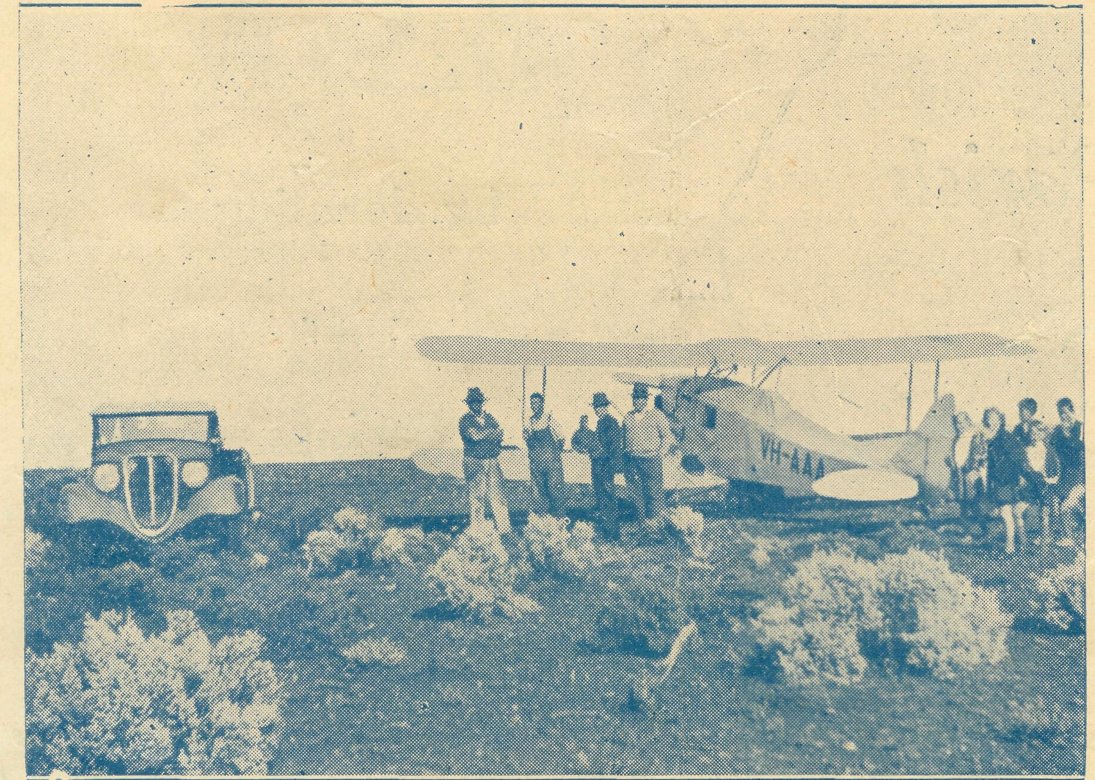
To-day, after four years, the thrills are still there, but Pilot and 'Plane have lost their newness and glamour. They are both part of the organisation. Four years' service without mishap or any single cause for anxiety is a splendid record on the part of the Pilot. Forty thousand miles and four thousand patients is an equally fine record on the medical side.
As a pilot and engineer Mr. Chadwick is second to none, and we were blessed by God in securing his services.
The little 'plane has done its work nobly and well, and has proved the wisdom of its selection for that type of work. Of course, costs of maintenance of such a service are not light, for, as most of you know, the insurance alone runs into nearly £200 per annum. In these days, with prices of
The Real Australian.
everything at such high levels, this piece of service is a constant drain upon financial resources; but I am sure you will feel with me that it is very worthwhile and must be kept going, for even one life saved is worth the cost—but we know it has saved many lives.
I want you specially to think of this little aeroplane, its pilot, and the doctor and nurses who travel in it. To-day we associate aeroplanes with bombs and destruction; this is one that brings mercy and healing in Christ's Name. Remember it in your prayers and, if possible, send a little gift to keep it flying to all those who, in sickness and anxiety, need the comfort and help it brings.
One day it must be replaced with a newer machine. Already about £600 has been given in War Savings Certificates for that purpose. Can we make it £1000 before Christmas ?
T. J.
VICTORIAN NOTES.
The annual collections for B.C.A. from the Parish of St. John, East Malvern, amounted to £17/10/-. Since 1929 St. John's has helped us in this way, but this year's total is easily a record amount. Well done, St. John's, and many thanks!
# # # # # *
An afternoon was held at Christ Church, South Yarra, last month, by the kindness of Canon and Mrs. Murray. Some money was received, and B.C.A. gained a few more friends.
# & # « # &
Miss Ivy Woods has resigned as Secretary of the Central Women's Auxiliary to devote her energies to the Essendon Auxiliary. Her capable services were much appreciated in the city, and she is greatly missed by all her friends there.
# # # « # V
Miss Clack, the efficient Treasurer of the Central Auxiliary, has been appointed as Secretary. We feel sure she will maintain the high standards set by her predecessor. ^ # # & & #
Mrs. Constable visited Melbourne and brought Sydney James with her. A number of the Auxiliary members had the pleasure of meeting him in the Botanic Gardens. Afternoon tea together, and the entertainment of Sydney James, provided a memorable and very happy time.
# # # # # *
As foster-father to Sydney James, the Victorian Secretary had an entertaining morning in the city. Probably Flinders Street Station was the greatest thrill for our young visitor, while he was a great attraction in Collins Street.
POST AND RAILS.
Sister Grace Hitchcock has returned to Koonibba after seven months' absence. Sister spent four months doing Infant Training Course in Melbourne, and has thus enlarged her sphere of useful service. Sister Caroline Ross, who took duty at Koonibba during Sister Hitchcock's absence, has returned to Melbourne, and will soon commence the Infant Welfare Course.
& & %, # & *
Sister D. Goodwin, known to our friends for her work at Penong, has recently been appointed Matron to Delegate District Hospital.- The local doctor is Dr. Langley, son of Archdeacon Langley, our Hon. Clerical Secretary, while the Rev. N. Chambers is B.C.A. Missioner at that centre.
r ^{r}'^>-' & ". %* ,■."*"• ^ nt ■
_{r} Our friends will be glad to know that Archdeacon Langley is making appreciable progress towards recovery, and we feel sure that a great many will have him and Mrs. Langley in constant remembrance and prayer.

The Real Australian.
12
July 16, 1942.

Our New South Wales Ladies' Auxiliary annual meeting was held in the Chapter House on May 21st. While not up to the usual numbers, it was good to know that real interest was being maintained in B.C.A. The balance sheet disclosed that approximately £350 had been raised by the Auxiliary during 1941. This is a very splendid result—£83 more than last year. The Rev. Gordon Beatty and Mrs. F. H. B. Dillon told of various spheres of the Society's activities, and the O.M. took the chair. £56 was received in the offering.
SUBSCRIBERS WHO HAVE NOT RECEIVED RECEIPTS.
Mrs. Mann, Miss Jamieson, Mrs. A. Starling, Mrs. Hunter, Miss E. Downey, Mrs. W. J. Williams, Miss K. Cadwallader, Miss V. Cox, Mrs. Baker, Mr. Aldridge, Mrs. H. J. Alsop, Miss L. Banks-Smith, Miss I. A. Dutton, Mrs. Cox, Mrs. Jowsey, Mrs. J. C. Spring, Mrs. Grant, Miss Tilley, Miss E. Neath, Miss F. Scott, Miss Goodshaw, Miss Walsh, Miss Mann, Mrs. Bishop, Mrs. Moore, Mrs. J. Rogers, Mrs. E. W. Noonan, Mrs. E. J. Hooper, Mrs. and Miss Webb, Mrs. Brooks,
Miss M. G. Thompson, Mrs. Cerini, Miss Shields, Mrs. Ash-worth, Mrs. Mercer, Miss Hansen, Mrs. T. Boddy, Mrs. C. Anderson, Miss Wheeldon, Miss Brady, Mrs. C. Uebergang, Mrs. Willett Bevan, Mr. F. Gaunson, Mrs. Muir, Mrs. Piper, Mr. Cadwallader, Mrs. M. Andrew, Miss Bigmore, Mrs. Stanesby, Mrs. C. Booth, Miss I. Brown, Mrs. Ross-Watt, Mrs. Holbrook, Rev. G. Stirling Home, Miss M. Williams, Miss Delaney, Mrs. M. Brown, Mrs. Tregear, Mrs. Delaney, Rev. H. C. Busby, Mr. Lack.
23/3/42, "A Sympathiser," 2/-; 31/3/42, Anonymous (Gloucester post mark), 6/-; 1/4/42, Anonymous, Dulwich Hill, 5/-; 7/4/42, "Interested," £1; 1/4/42, Anonymous, Balmain, £1; 2/4/42, Anonymous (Caorimal post mark), 2/-; 2/4/42, Anonymous (Wahroonga post mark), 2/-; 8/4/42, Anonymous, 2/-; 10/4/42, Anonymous, 6/-; 13/4/42, Anonymous (Penrith post mark), 3/-; 14/4/42, Anonymous (Cooerwull post mark), 10/-; 13/4/42, Anonymous, £1; 14/4/42, Anonymous, Willoughby, £1; Anonymous, 10/-; 22/4/42, Anonymous, £1; 27/4/42, Anonymous, 10/-; 7/5/42, "A.Y.2.," 10/-; 11/6/42, Anonymous (St. Luke's, Adelaide), 6/-; 18/6/42, Anonymous, 5/-; 2/7/42, Anonymous, 5/-; 13/7/42, "A.Y.Z.," 10/-.

The Bush Church Aid Society
SUGGESTS THAT YOU

purchasing War Savings Certificates.
by donating
War
Savings
Certificates.
to the Society.
Certificates can be purchased for :
16s. for each £1 Certificate. £4 for each £5 Certificate. £8 for each £10 Certificate.
Buying them helps Australia in the World War. Donating them to B.C.A. helps the Kingdom of God in the fight against the evils which cause all wars.
The certificates will be used to build up a fund to assist in the purchase of a new medical 'plane when
that becomes necessary.
VV'hollv set up ana printed in Australia by D. S. r/ord, 44'50 Reservoir St., Sydney.

