Registered at the G.P.O., Sidney, for transmission by post as a periodical..

Organ of the Bush Church Aid Society tor Australia and Tasmania.

No. 84.
JULY 1, 1943.
1/6 per annum (post free).

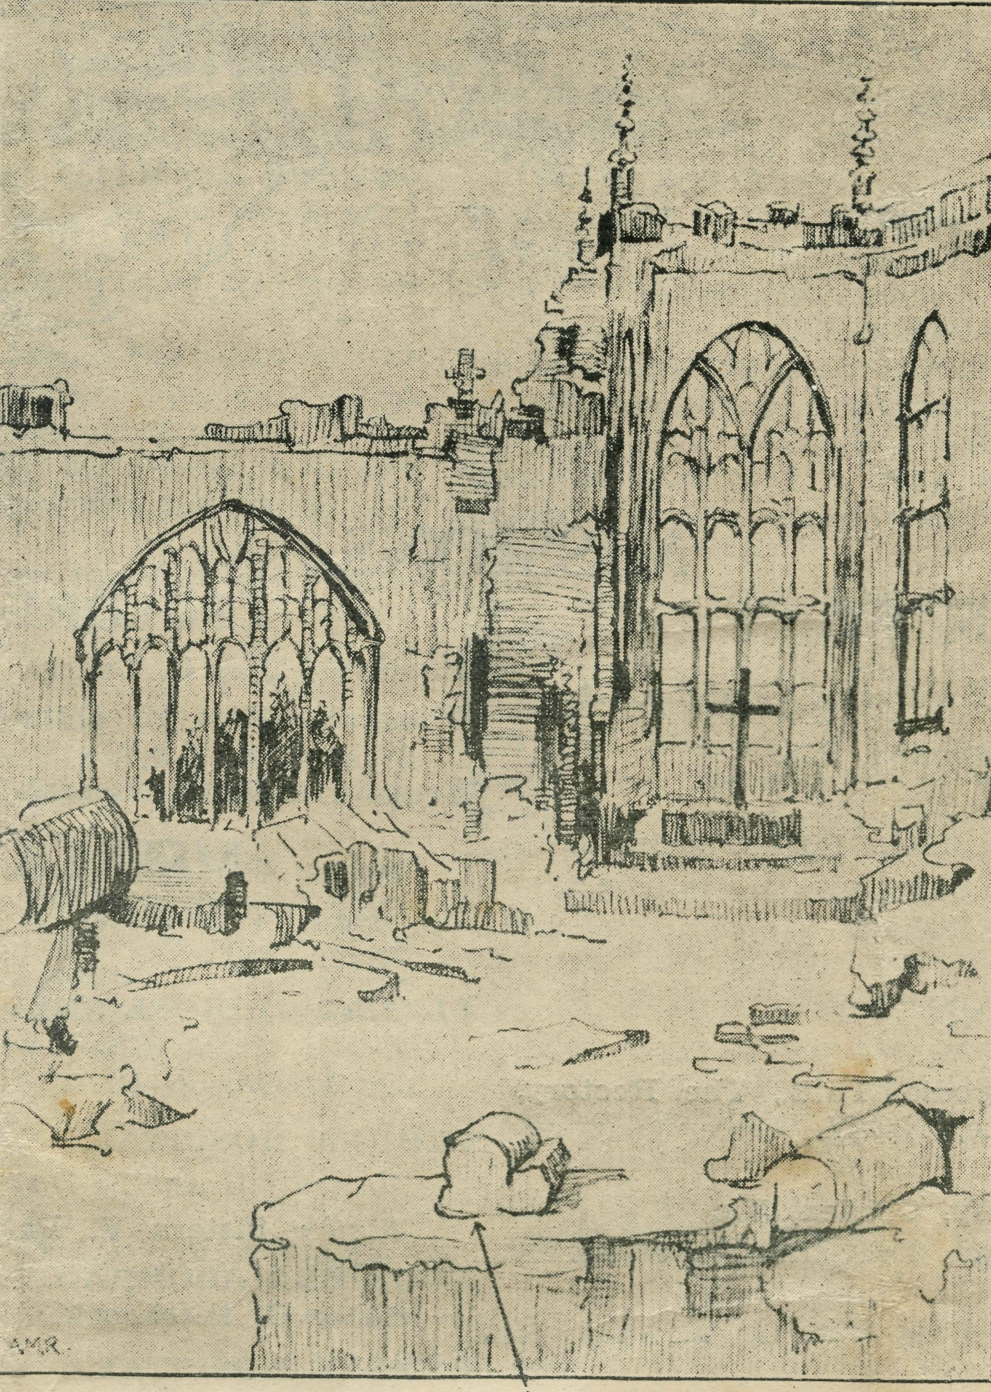
\
This piece of stone was part of the Cathedra/ Church of St Michael Coventry} cfestrot/ed be/ enemy act/on November /^
I $4-0
IT IS G/V£At TO THE CHURCH OF ST. JOHN, MirtH/PA. SOUTH Al/STRAUA WITH TH£ $#E£TIH4S OF THts PROVOST A/TO fFOFLE OF COY£trTRY CATHEDRAL.

The Real Australian. 2 July 1, 1945.
The Bush Church Aid Society for Australia and Tasmania.

HEADQUARTERS OFFICE :
Diocesan Church House, St. Andrew's Cathedral, George Street, Sydney.
(Telephone : M3164.) Cable Address : "Chaplaincy, Sydney."
VICTORIAN OFFICE :
The Bible House, Flinders Lane, Melbourne.
(Telephone : F5675.)
President : The ARCHBISHOP OF SYDNEY. Hon. Clerical Secretary : Ven. Archdeacon W. L. LANGLEY. Hon. Treasurer : T. S. HOLT, Esq.
STAFF. Organising Missioner : Rev. T. E. JONES, Th.L., Church
House, George Street, Sydney.
Victorian Secretary : — -,. Bible House, Flinders Lane,
Melbourne. South Australian Secretary : Rev. R. M. FULFORD, North
Terrace, Adelaide, S.A.

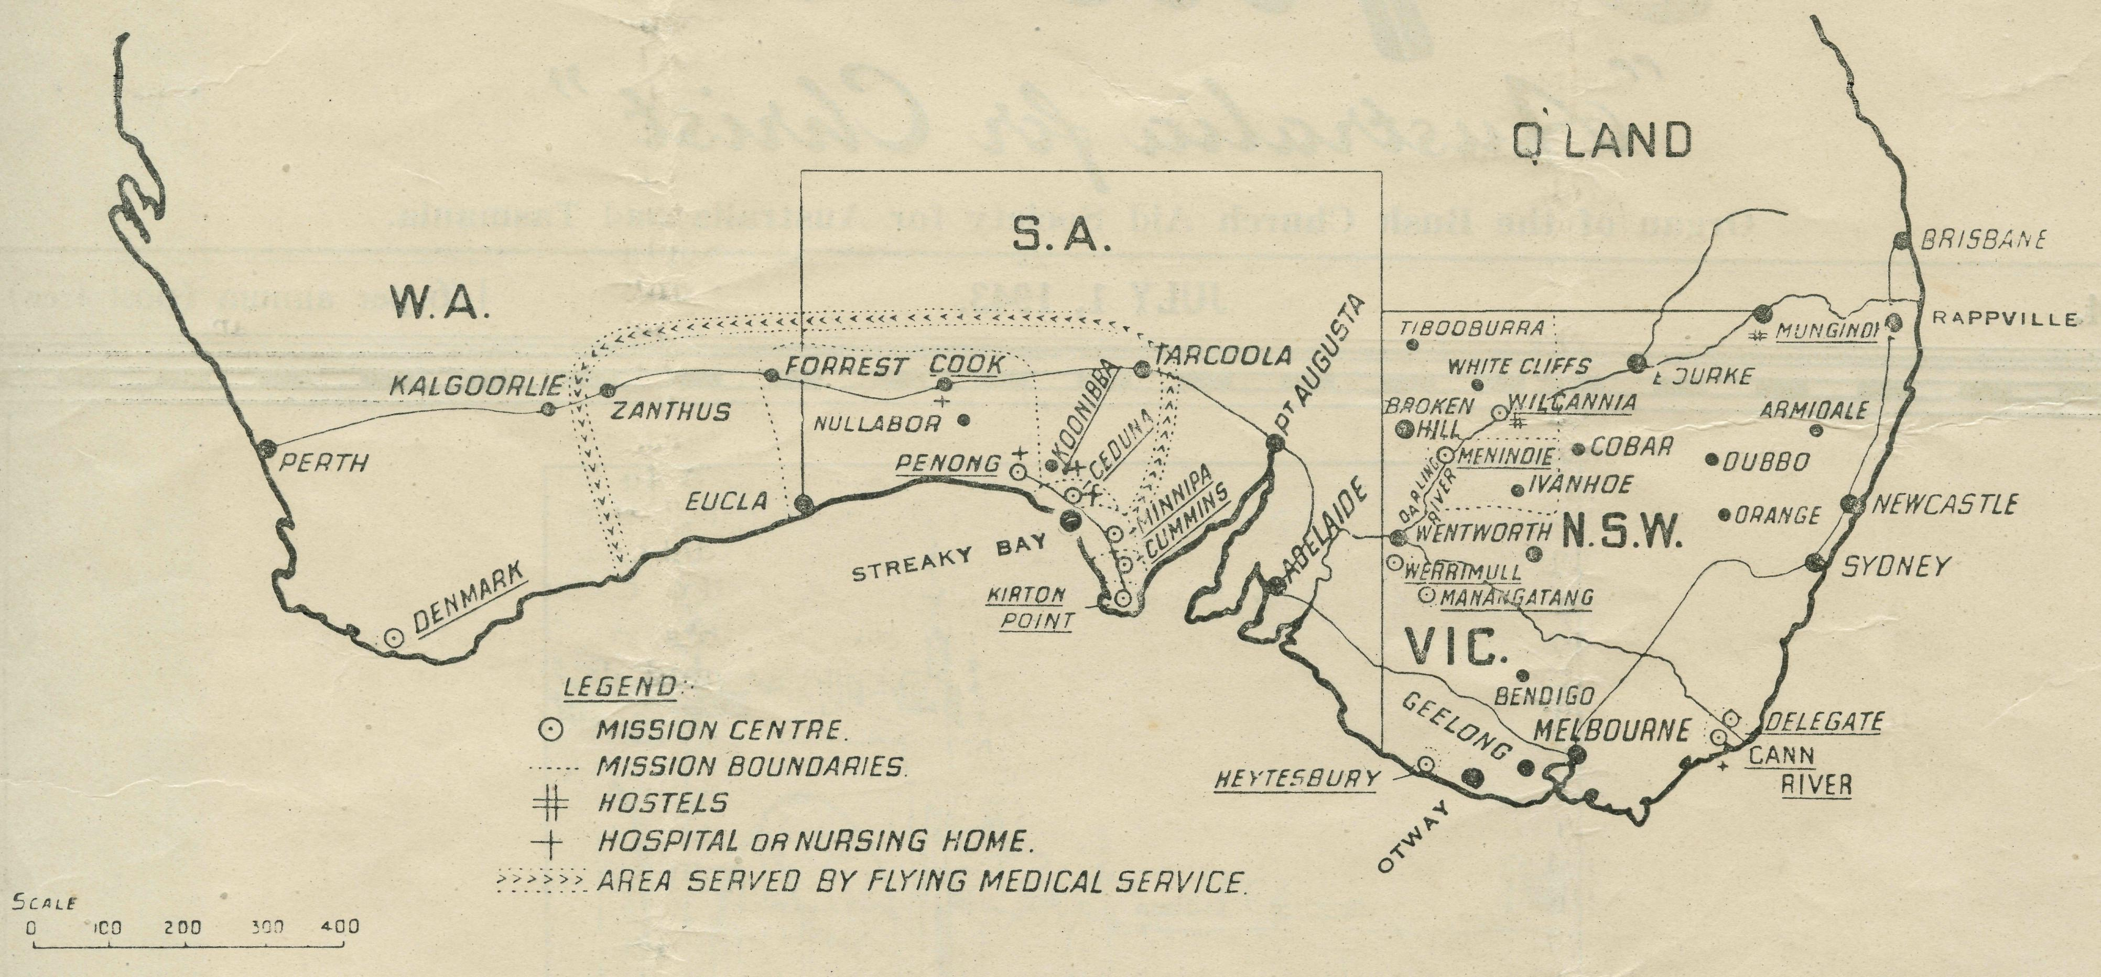

MISSIONS.
CHILDREN'S HOSTELS.
Mungindi—Miss E. Cheers, Mungindi, N.S.W.
Wilcannia—Miss H. Gurrier Jones, Miss Y. Gurrier Jones,
Wilcannia, N.S.W. Wentworth Falls, "Coorah"—Mrs. Mann, Miss F. Harding.
FAR WEST MISSIONS, S.A.
Penomr 1 ^{Rev}* ^{H#} ^{Broadle}y> Th.L., The Rectory, Ceduna, S.A.
Minnipa—Rev. L. Morris, Th.L., Minnipa, S.A.
Cummins—Cummins, S.A.
Kirton Point—Rev. R. T. Hallahan, Th.L., Port Lincoln, S.A.
Streaky Bay—Rev. D. Livingstone, Th.L., Streaky Bay, S.A.
VICTORIAN MISSIONS.
Croajingalong ) Rev. K. Brodie, Th.L., The Rectory,
Delegate-Bonang } Delegate, N.S.W.
N.W. Mallee—Werrimul, Vic.
Heytesbury Mission—Rev. W. Duffy, Cobden, Vic Otway Mission—Rev. T. H. Pickburn, Th.L., Beech Forest, Vic.
N.S.W. MISSIONS.
Wilcannia { _{Rev} _{K} _{Lude}rs, Th.L., Wilcannia, N.S.W. Menindie )
Rappville—Rev. P. M. Connell, The Rectory, Rappville, N.S.W.
WESTERN AUSTRALIA.
I>enmark—Rev. T. R. Fleming, Denmark, W.A.
MEDICAL SERVICES.
Gippsland, Vic.—Sister I. Gwynne, The Dispensary, Cann River, Vic.
FLYING MEDICAL SERVICES.
Pilot : Mr. A. Chadwick, Ceduna, S.A. Dr. R. Gibson, Dr. F. Gibson.
CEDUNA HOSPITAL,.
Matron : Sister F. Dowling.
Staff ■: Sisters V. Page, L. Loane, Edgar, B. Warner.
KOONIBBA ABORIGINAL HOSPITAL.
Sister G. Hitchcock.
PENONG HOSPITAL.
Sister Firmin, Penong, S.A. Miss M. Millar, Penong, S.A.
BISHOP KIRKBY MEMORIAL HOSPITAL.
Sister L. Pritchard.
Miss D. Dykes, Cook, S.A.
TARCOOLA, SOUTH AUSTRALIA
Sister B. Bossley.

July 1, 1945.
The Real Australian.

THE O.M.'s LETTER.

I DIPS ME LID !"
I was standing on the rear platform of the little petrol-driven train as I travelled down to Port Lincoln. On the narrow gauge the train rocked violently from side to side, and conversation was difficult in that clatter of wheels on the iron rails.
My companion was a little stocky chap, with twinkling eyes, a hooked nose, and a tongue that travelled over Australia much faster than the 40-mile-an-hour vehicle we were then on. He knew his out-back, and to him "the Alice" was a distant suburb of Adelaide ! He knew them all : Darwin, Katherine, Birdsville, Norseman, Nullarbor, Ceduna, where you will. Mention some little one-horse place in the interior and he would tell you the storekeeper's name and the number of his children, if any. He was a superviser of roads, and knew the places also where "no roads go by"
He talked of this and that; we swapped ideas about this part of the country and the other. We talked of men and women we had met in the homestead or on the track—and then we got on to Ceduna. "Know anything about the Ceduna Hospital ?" I asked. "Cripes ! I was a patient there not long ago. I'd been in bed a fortnight, and was about fed up lying there doing nothing. The doctor said I'd have to put up with it for a month. Me on me back for a month ! I argued with the Sisters to let me up, but, cripes, they had me trousers !" He grinned delightedly as he went on— "Those women, I dips me lid to them !" and he raised his hat solemnly in the air. "They're great women making the out-back worthwhile."
Well, he ought to know; he had roamed the whole extent of the interior, and he knew from bitter experience what loneliness and isolation mean in times of sickness. We parted later to go our separate ways, and there remained with me those words of his : "They are fine women; I dips me lid to them !"
I had arrived in a little township on the East-West Line, and was walking along the only street the place possessed with an entirely different type of man. Tall and big he was like the out-back itself. The manager of a sheep-run of some 3000 square miles, he had a big job. We were talking about the B.C.A. medical work when he turned to me and said : "That's a fine woman you have sent to us, and she is doing a fine job."
Another day I attended a gathering of people in a West Coast Mission Their first B.C.A. missioner came to them two years ago—long enough for them to have learned his faults and failings as well as his good points. I was biting into some fruit cake when a gentleman standing alongside said, "You sent us the best parson we ever had."
That's the judgment of the bush. "They are doing a fine job !"
We were at Nullarbor Homestead for the night. The old place isn't much to look at, and it has nothing much in the way of conveniences, but to us of B.C.A. it has been an oasis in the desert for twenty years because Mr. and Mrs. Roy Brooke live there. They have been great friends and helpers to every B.C.A. missioner who has gone to Ceduna or Penong, as well as to the nurses. On each side of Nullarbor lies 80 miles of uninhabited road and, by the time the old home is reached, we have always been glad to halt and enjoy the hospitality of these two friends of ours. That night as we talked round the fire, Mr. Brooke told us that this was the last time they could entertain us. They were going away from Nullarbor, convinced of the hopelessness of remaining on, after twenty years.
We were sad at the tragedy of it. Twenty years of Stirling endeavour, hoping, ever hoping, that things would be better, but seeing oaly the fading of their dreams. We will miss them. The jourmey will be longer and more tiresome without their friendship and hospitality. We told them so, but it was good to learn from them both that, in these past twenty years, the visits of the B.C.A. missioners have been a real help to them in their lonely life. "They have been good to us," they said. Although we know and appreciate that the debt is all on our side, it was good to know they saw it like that.
So it goes on, this ministry of nurse, missioner, hostel worker and others, aa£> day by day some are blessed and helped in daily living. Isn't that the best job of all—to help in daily living ?
This B.C.A. which you have so splendidly helped to build up is doing a fine job. Will you keep it at work ?
There are some, in these days, who think that the men who minister out-back should return to the city with its teeming thousands. They say the major job lies in the towns, and the small handful of people in the bush are almost negligible.
I like to think that our Lord's ministry was not spent in the large cities of H.s time. True, He went to Jerusalem from time to time, but His larger ministry of the word, healing and teaching was to the few in the country villages and open heaths. In these days of added population in our towns, and the increase of problems of morality and right living, let us not forget the wayside places. In the incessant calls upon your purse and time, forget not those who, having been sent out into the out-back of this great land, are doing a fine job. They make the out-back worthwhile, and those who see them at work and receive their ministry "dip their lids" to them in honour and appreciation.
You may be too far away to "dip your lid"; then dip your pocket, in order that the out-back may continue to be made worthwhile.

NEWS FROM THE FIELD.

HOT NEWS.
Rev. K. Lude^rs.
Seemingly, it is hot news that the O.M. wants, judging from the urgency of his demand. And it is easy to oblige. I'll tell you something of the last trip, on every day of which it was well up over the century. In fact, on one day, at a certain place, the thermometer registered 124 degrees ! But wait a while before you wilt—though there was nothing wrong with the thermometer, its position was not the coolest part of the house.
Maybe you have read in some papers that the Paroo River was flooding the back country to an extent that left
little hope of anyone or anything surviving. That the Dogger (oh, begging his pardon !)—I mean the Government Inspector of Vermin Pence—had to buy a boat in which to sail along and inspect 30 miles of fence. Well, water it down a bit ! True, the Paroo came down, one house being flooded to the depth of a refrigerator, and, worst of all, some lives were lost, but the damage has not been so extensive as reported. The Dogger dogged in a boat, but the longest stretch of water he had to cover was eight miles. I had planned to go north-east, then west across the Paroo, but these swamping report* scared me into going in the opposite direction.

The Real Australian.
July t, 1943.

Hamstrung by petrol rationing, it had not been possible to cover this ground before, and so it was a trip of "first contacts," with brief visits not always productive of any discernable results. These days, when fewer travellers are on the road, one is always assured of an extra warm welcome from tank-keepers who are dotted along the stock routes. Explanation ? Tanks are earth-embanked reservoirs. Government-owned, contents are used for watering travelling stock at prescribed rates. Invariably the keepers are old men, glad to receive any sort of reading matter. Have you any ?
The day provided matter for numerous articles, not all of them suitable for "The Real Australian." We had better let it go at that. It was a pleasure to pull in for the night at the homestead of one of the oldest and best respected families in this district. My host and hostess were the first couple married in Menindie Church.
Next day, the first call was at a place where the parents were contemplating sending their son to board at the Hostel, and so I was able to be of some assistance. Later, I did an extraordinary ordinary thing by pulling up outside the front door of a house. The only other time that a car had done such a thing was twenty years before. It seems that even yet I have not shaken off all "towny behaviourisms" !< But still it is reasonable to expect the front of the house to be the front. That is not so in the West. In almost all cases houses are built on the geometrically squarish plan —steps, long verandah and hall door at the front, structural afterthoughts at the back. Approach should be made via the afterthoughts! Very often one is repulsed from the frontal approach by a gateless six foot wire-netting fence.
"Man proposes . . ." This was a "pot-pouri" Sunday, if you will excuse the term. Having started out jauntily enough, pride was soon to have a fall. Two miles on the track and behold—a creek ! Dry, of course. Backing away and then dashing at it, the utility flew across three-quarters of the way, then burrowed. Letting down the tyres to give them more spread generally does the trick, but on this spot someone else had been sand-bogged and had shovelled in the loose sand. Toil was called for. It meant digging and jacking and corduroying. A gum tree cast a welcome shade, but even so, and though the day was young, it was hot in that sandy creek bed, the tools burning the hands. Out at last, the tyres pumped up again, and on. But there are always compensations. Soon there loomed into view the house shown on the mud map. An empty house, and a stool, and a small bath tub, and a plentiful supply of water. It was luxury ! Much better than bathing in a wash-up dish, which is not a unique experience in these days. Perhaps it was because of being exhilerated after the bath that I took the wrong turn. By devious ways and through a fence, the track led at last to a charcoal burners' camp, and the arrival was made in nice time for extra grilled chops to be cooked over the open fire. Only a skeleton staff was on the job, so that one woman, two men and a lad formed the "congregation" while we had a talk about the most important things. With a fresh set of directions to follow, I plugged along these extra miles and so arrived at the destination first decided upon. The place is rather off the beaten track, and that was one reason for persevering in efforts to get there. It was to discover that the family was R.C. It made little difference. The mother was always glad to welcome anyone willing to talk of spiritual matters.
It would be tedious to tell of each day's happenings in detail : the people visited, the boggings and toilings, the stoppages because of the engine running hot, the innumerable drinks from the water-bag. So let us jump ahead.
Here, as everywhere, there are striking contrasts. One morning I left a place that was an oasis of comfort, and stayed the night at another that was a model of utilitarianism. At the first the initiative of the owner had improved and made the best use of a large natural water-hole in a
creek overlooked by the dwelling. The house itself was equipped fully with electric domestic, appliances. At the second, the open stony plain swept up to the very doors. A minimum of tank water, and in the front (which, of course, was used as though it were the back), beyond a small vegetable plot, an earth tank holding drinking water for the stock and bath water for the family. The house, an unprepossessing structure of corrugated iron, stone battered and dented. But (and this is important) the spirit within was the same. A commentary on the comparison is that whereas in the first case one tends to remember the place, in the second it is the people who linger in mind. Here we talked long into the night. Next morning two infants were baptised.
The next day had its bright spot in a conversation with one who at first seemed most unpromising, but finished by accepting a New Testament. It had its other incidents, too, mostly to do with tail winds and a hot engine. The going was rough, over some extraordinary stone formations. Not being a geologist, it is not possible to expand the topic.
Another baptism and the winning of a Bible Reading Fellowship member were "the scanty triumphs" for this day; the rest was mostly idle talk, it now seems, thinking back.
Allow me to observe once more that "Man proposes . . ." —you know the rest. I set out on the trip with the fixed intention of avoiding a certain place where I considered a visit would be a waste of time. It was not to be. Getting bushed again when trying to cut across country, I had to make back to the beaten track and take the turn that led to the place to be avoided. Before getting there—long before as a matter of fact—another dry creek crossed the path on a track that is used only once in many months. Calamity ! Reversing in the creek bed to launch another attack at the opposite bank, something in the gear box went "whang." This entailed a greasy inspection. Satisfied that no damage would be done by continuing the journey, I coaxed the utility out on to the open road, re-packed, and poked along at the best speed possible. Just as daylight failed, and after negotiating yet another nasty creek, I pulled up at the front gate of the homestead. Here was a family of R.Cs., and most hospitable, most kind. Though anxious to get on with lamb shearing, two of the men-folk helped "take down" the gear-box and remove the damaged part. No small job when no garage equipment is available, this took all day. Next day, after doing the last minor assembling jobs, I was able to repay them with a very small service, but am still very much in debt. In the period spent there, we came to know each other fairly well, and talk swung quite naturally to things I never expected them to be prepared to discuss. This means some useful ground broken.
More goings and stoppings, and then Tibooburra. It was the second Saturday in the month, the day on which all meetings are held—Hospital Board, P.P. Board, W.C.L., The Patriotic League, etc. Everyone is out for good fellowship, and the day winds up with a dance that lasts into the morning. This is the day on which to meet the people, hence the timing of my visit. Next day we had a service, but it was only to be expected that in these days, when manpower is scarce and none can long be spared from the blocks, that the number attending should be small. Later I was reprimanded by people who would have come had they been notified of the service in time to make suitable arrangements. I shall try not to offend again, and hope the utility will run well enough for us to keep to programme.
Well now, we have got to Tibooburra, but I shall have to leave you there because there is no time to deal with the return trip. I hope you enjoy it, the rocks and the glare, the heat and the flies. Console yourself with the thought that it would be worse in New Guinea !
Desperate is the cry for help from the Hostel. Not that things are not successful. They are too successful. The better the Hostel becomes, the greater the number of demands for admission and the greater the strain on the staff. Now

July t, 1945.
The Real Australian.

that sounds good, "the staff," doesn't it ? A staff of two when there should be at least three—and a fourth would not come amiss. Matron was done to a frazzle at the end of last year, so much so that I doubted whether we would see her in Wilcannia again this term. But for the sake of the youngsters and what it means to them, she, with her sister, are here once more, game as ever. Is there no one in all Australia with the grit and grace to back up the Matron and lend a hand with one of the best branches of the B.C.A. activities ? The Organising Missioner will gladly give full information to inquirers.
MINNIPA.
Rev. L. Morris*
Last night I strolled along to the local hall to pay my little tribute of homage at the official farewell to one of the local lads home on leave from the R.A.A.F. In all, I think, of the little centres in these parts, it is an unvarying custom that every man of the district who joins the forces is tendered a complimentary social. Then all the district assembles from far and wide to honour him and wish him well. It is a good custom, and the memory of it must mean much to the boys.
But last night, in addition, we farewelled one of the citizens who is shortly to leave us. He and his family have been good church attenders, and thus our little Minnipa congregation has been further depleted. Ever since the war began families have been moving out; a bad season, low prices for farm products, high wages in munitions factories, the desire to live near relations when the man of the home has gone to war, debts and the impossibility of reducing them under present conditions, transfers of bank officials and school teachers—all sorts of reasons have contributed to the exodus, and as a result the rural population in this Mission, at any rate, has dwindled to less than half its former size. Lest you should say, "Well the Mission is no longer worth working!" I hasten to add that about 10,000 square miles of territory have been added to the Mission, so that there is still much to do. But I do want you good folk who support B.C.A. to see that more than ever, under wartime conditions, is your support necessary if out-back missions are to continue. Expenses have increased while population has diminished.
The job is still abundantly worthwhile, however. Take, for instance, the Easter services, which this year were a special joy. Over the Good Friday-Easter period I had services in eight different centres, and had to travel 251 miles to conduct them. The triumphant Easter message, with its note of victory over all the powers of evil through the power that is in the crucified and risen Lord, brought its never-failing inspiration and cheer into those tiny congregations as we thrilled in our devotion to Him Who died for us and rose again. It is perhaps worthy of note that, despite the poverty of our numbers after so many removals, despite petrol restrictions, despite a V.D.C. camp which took quite a number of men away for the week-end, there were more communicants over the Eastertide than is ever on record in the history of the Minnipa Mission. At one service we had four families of which two had to travel over ten miles to get there. Do you see what I mean when I say it is worthwhile ?
We have just received another gift from England—the last in connection with the church which is to be built at Minnipa as soon as the Government gives permission. This last gift is an original etching depicting part of the ruined Coventry Cathedral after its bombing, and with the identical stone which was given to be built into the proposed Minnipa church clearly indicated. The etching is to be hung in the porch of the church when it is built. It forms another link binding us to the Old Land, and it renders a little more vivid our sense of their loss, and of that nobility of spirit which, forgetful of its own distresses, thinks of the need of others.
FOWLER'S BAY.
Rev. H. R. Broadley.
Away up towards the head of the Australian Bight is a tiny settlement called Fowler's Bay. It has been my job, by arrangement with the Methodist minister at Ceduna, to pay a visit to this part of the world every six weeks, and by alternating our visits it has meant that the people had a chance of a service at three-weekly intervals.
Fowler's Bay is 42 miles beyond Penong, which means that it is almost 90 miles from Ceduna. That is not so far as we count distance out here, but sufficiently so at present with petrol restrictions. The approach is mostly through the usual mallee scrub, until a few miles from the settlement there are some miles of sandhills to pass. This white sand from the coast is gradually moving inland. The track is becoming drifted over in places, so much so that a new track has had to be cut further inland, but, as little rain has fallen, it is almost useless for traffic. At the final approaches there are salt sand flats, excellent in dry weather, but no good with rain upon them. Fowler's Bay is surrounded by sea, sandhills and sandflats. About ten families live in the "Bay," and one or two nearby.
The usual practice I follow is to arrive in the afternoon, and make a round of visits. This is partly to let people know I have arrived. Someone always assumes responsibility for providing tea. This gives an excellent chance to know the families. One family, that of Mr. and Mrs. Riddle, provides lodging for the night. At 8 p.m. we have the service. For some time we had it in the hall, but, as we felt it did not provide' quite the atmosphere for a service, Mrs. Riddle offered the use of a big room in her house. This has proved much better.
Readers of "The Real Australian" may remember that I appealed for slides some time ago. I am pleased to say that what Mr. Shaxted sent from Melbourne Office, together with some bought out of two gifts of £2 each, I have about 150. A selection of these was taken up to Fowler's Bay on the last trip. A six-volt battery was borrowed from a garage at Ceduna, and the result was that we were able to have a lantern service, to which about thirty came. The reverence in the services is most noticeable. The folk join in the prayers heartily, and some of the best singers are half caste children whose bright faces are always welcome.
Next morning I go to the school. About a dozen children are in the room for religious instruction. They are quite interested, but seem to know very little of the Bible or the Christian faith.
In view of the number of children in the small population, I suggested and urged, some time ago, that a Sunday School should be begun. Two ladies immediately said they would be ready to do what they could, although they had no experience.
After some skirmishing around, the "Sunday" school began. Eighteen scholars are on the roll, and most come. The lessons are provided by the B.C.A. Mail-Bag Sunday School. The school meets on Wednesday afternoons because of local conditions. On my last trip I was given enough money to buy 18 sets of O.H.S. stamps and albums to help encourage the children to keep on coming regularly. These have now been sent on.
After the lantern service, the teachers said how helpful the pictures had been. They were especially glad that some pictures of the Crucifixion were shown, as a recent lesson had been on that subject.
So once more the proclaiming of the Good News of Jesus Christ is advanced. Your prayerful interest in this small settlement will encourage those who have the opportunity, and therefore the responsibility, to make "His way known upon earth, His saving health among all nations," to go on building up the Kingdom of God in Fowler's Bay.

The Real Australian.
My /, 1943.

THE PLACE OF PRAYER.
A Prayer for Use with Our Prayer List.
O Lord God of our nation, Who has commanded men to subdue and replenish the earth : Look in Thy love upon all those who in the distant parts of our land are striving against many difficulties, and are deprived the access of the means of grace. Strengthen and guide the Bush Church Aid Society and its Clergy, Nurses, Doctors and Air Pilot, and Students. Cheer and comfort them in discouragements and loneliness, and bless their ministrations to the good of those they serve, and grant that the message of redeeming love may thus be rooted and grounded in our national life, to the glory of Thy Great Name, through Jesus Christ our Lord. Amen.

THURSDAY.
MORNING.
The Far West Missions at Penong, Ceduna, Minnipa and Cummins ; the Missioners, H. Broadley and L. Morris.
SUNDAY.
EVENING.
The West Darling Missions at Wilcannia and Menindie : the N.W. Mallee ; and the Missioners, K. Luders and E. J. Dorrell.
MORNING.
For the Mail-Bag Sunday School with its Gospel message for the children. For the teachers and helpers, that they may find encouragement in their work.
EVENING.
For
the Organising Missioner, that he may be strengthened and guided in all his endeavours for the good of the work and in his relationships with his fellow-workers.

MONDAY.
FRIDAY.

TUESDAY.
SATURDAY.
For the President and For the "Coorah" Hostel
WEDNESDAY.
Each day pray that the many needs of the work may be met.
Running expenses of 40/- per hour to keep the Medical 'Plane in the air.
Consecrated clergy missioners for urgent work in the field.
That our work may continue to progress despite the difficulties of wartime.
MORNING.
The Cann River Mission, the Bonang Mission, Rev. K. Brodie, the Streaky Bay Missioners, and the Rev. D. Livingstone.
MORNING.
For Sisters Dowling, Page, Loane, Edgar and Warner at Ceduna; Sister Firmin and Miss Millar at Penong.
MORNING. For the children in the Mungindi and Wilcannia Hostels, and for the workers, Miss Cheers, and Misses Gurrier Jones.
EVENING.
The Denmark Settlement, the Kirton Point Missions and Missioner, Revs. R. Hallahan and T. R. Fleming.
EVENING.
For the Cann River Dispensary and Koonibba Mission Hospital ; and Sisters I. Gwynne and G. Hitchcock.
EVENING.
For the Flying Medical Service, Mr. Chadwick, and Doctors R. and F. Gibson.
For the wives and families of the Missioners and Air Pilot.
MORNING.
For the Bishop Kirkby Memorial Hospital and Sister Pritchard and Miss D. Dykes as they minister to the people on the great Nullarbor Plain. For Sister Bossley and the Tarcoola Medical Hostel.
MORNING.
Council of the Society, that they may be guided by His wisdom.
For the Home Base Staffs, Auxiliaries, and parochial workers.
EVENING.
For students and all in training for this work of God. For Rev. W. Duffy and the Heytesbury Forest Mission. For Rev. T. H. Pickburn and the Otway Ranges Mission.
EVENING.
and its workers, Mrs. Mann and Miss Harding.
For the Rappville Mission and the Missioner, the Rev. P. N. Connell.

Give Thanks—
For the rich blessing and wonderful growth of the Society's work. For all the kindly givers who have helped with their self-denials. For the Flying Medical Service. For new workers in Hospitals and Missions. For the joy of service*

July I, 1943.
The Real Australian.

TARCOOLA NURSING HOME, S.A.

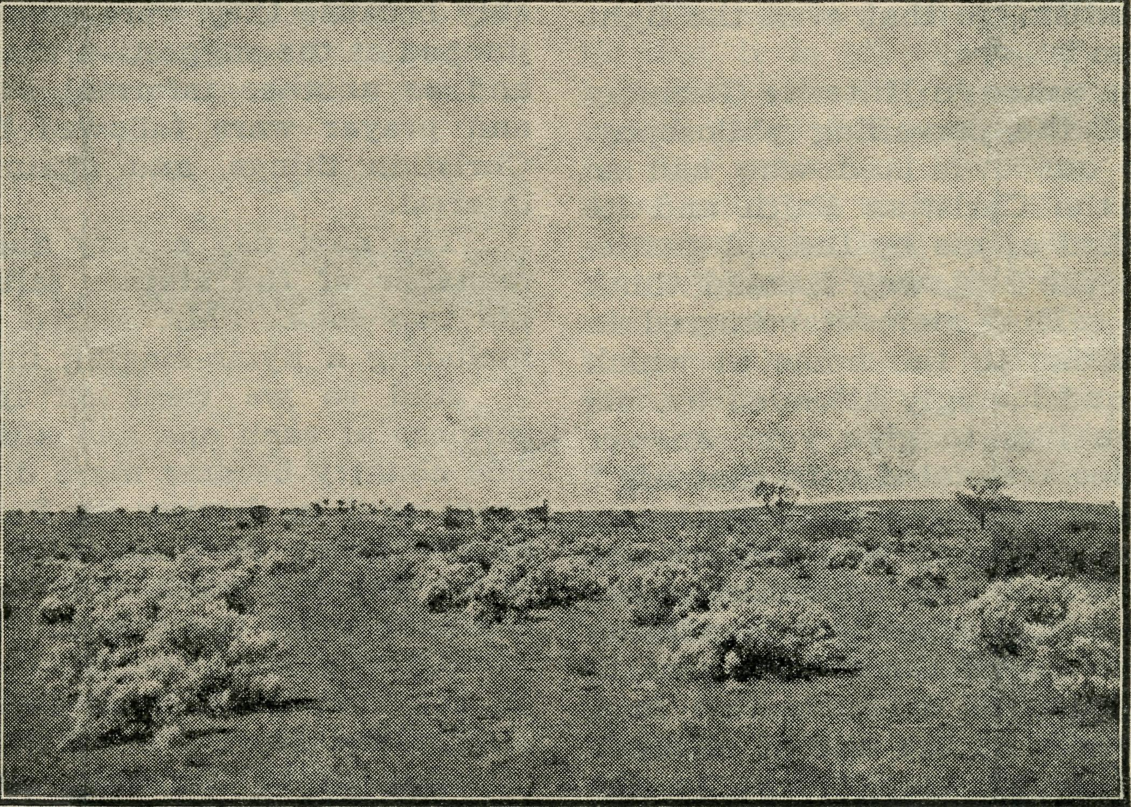
THE
LADY DUGAN
HOSTEL
MANAGED
BY
B.C.A.

A Distant View of the Township.

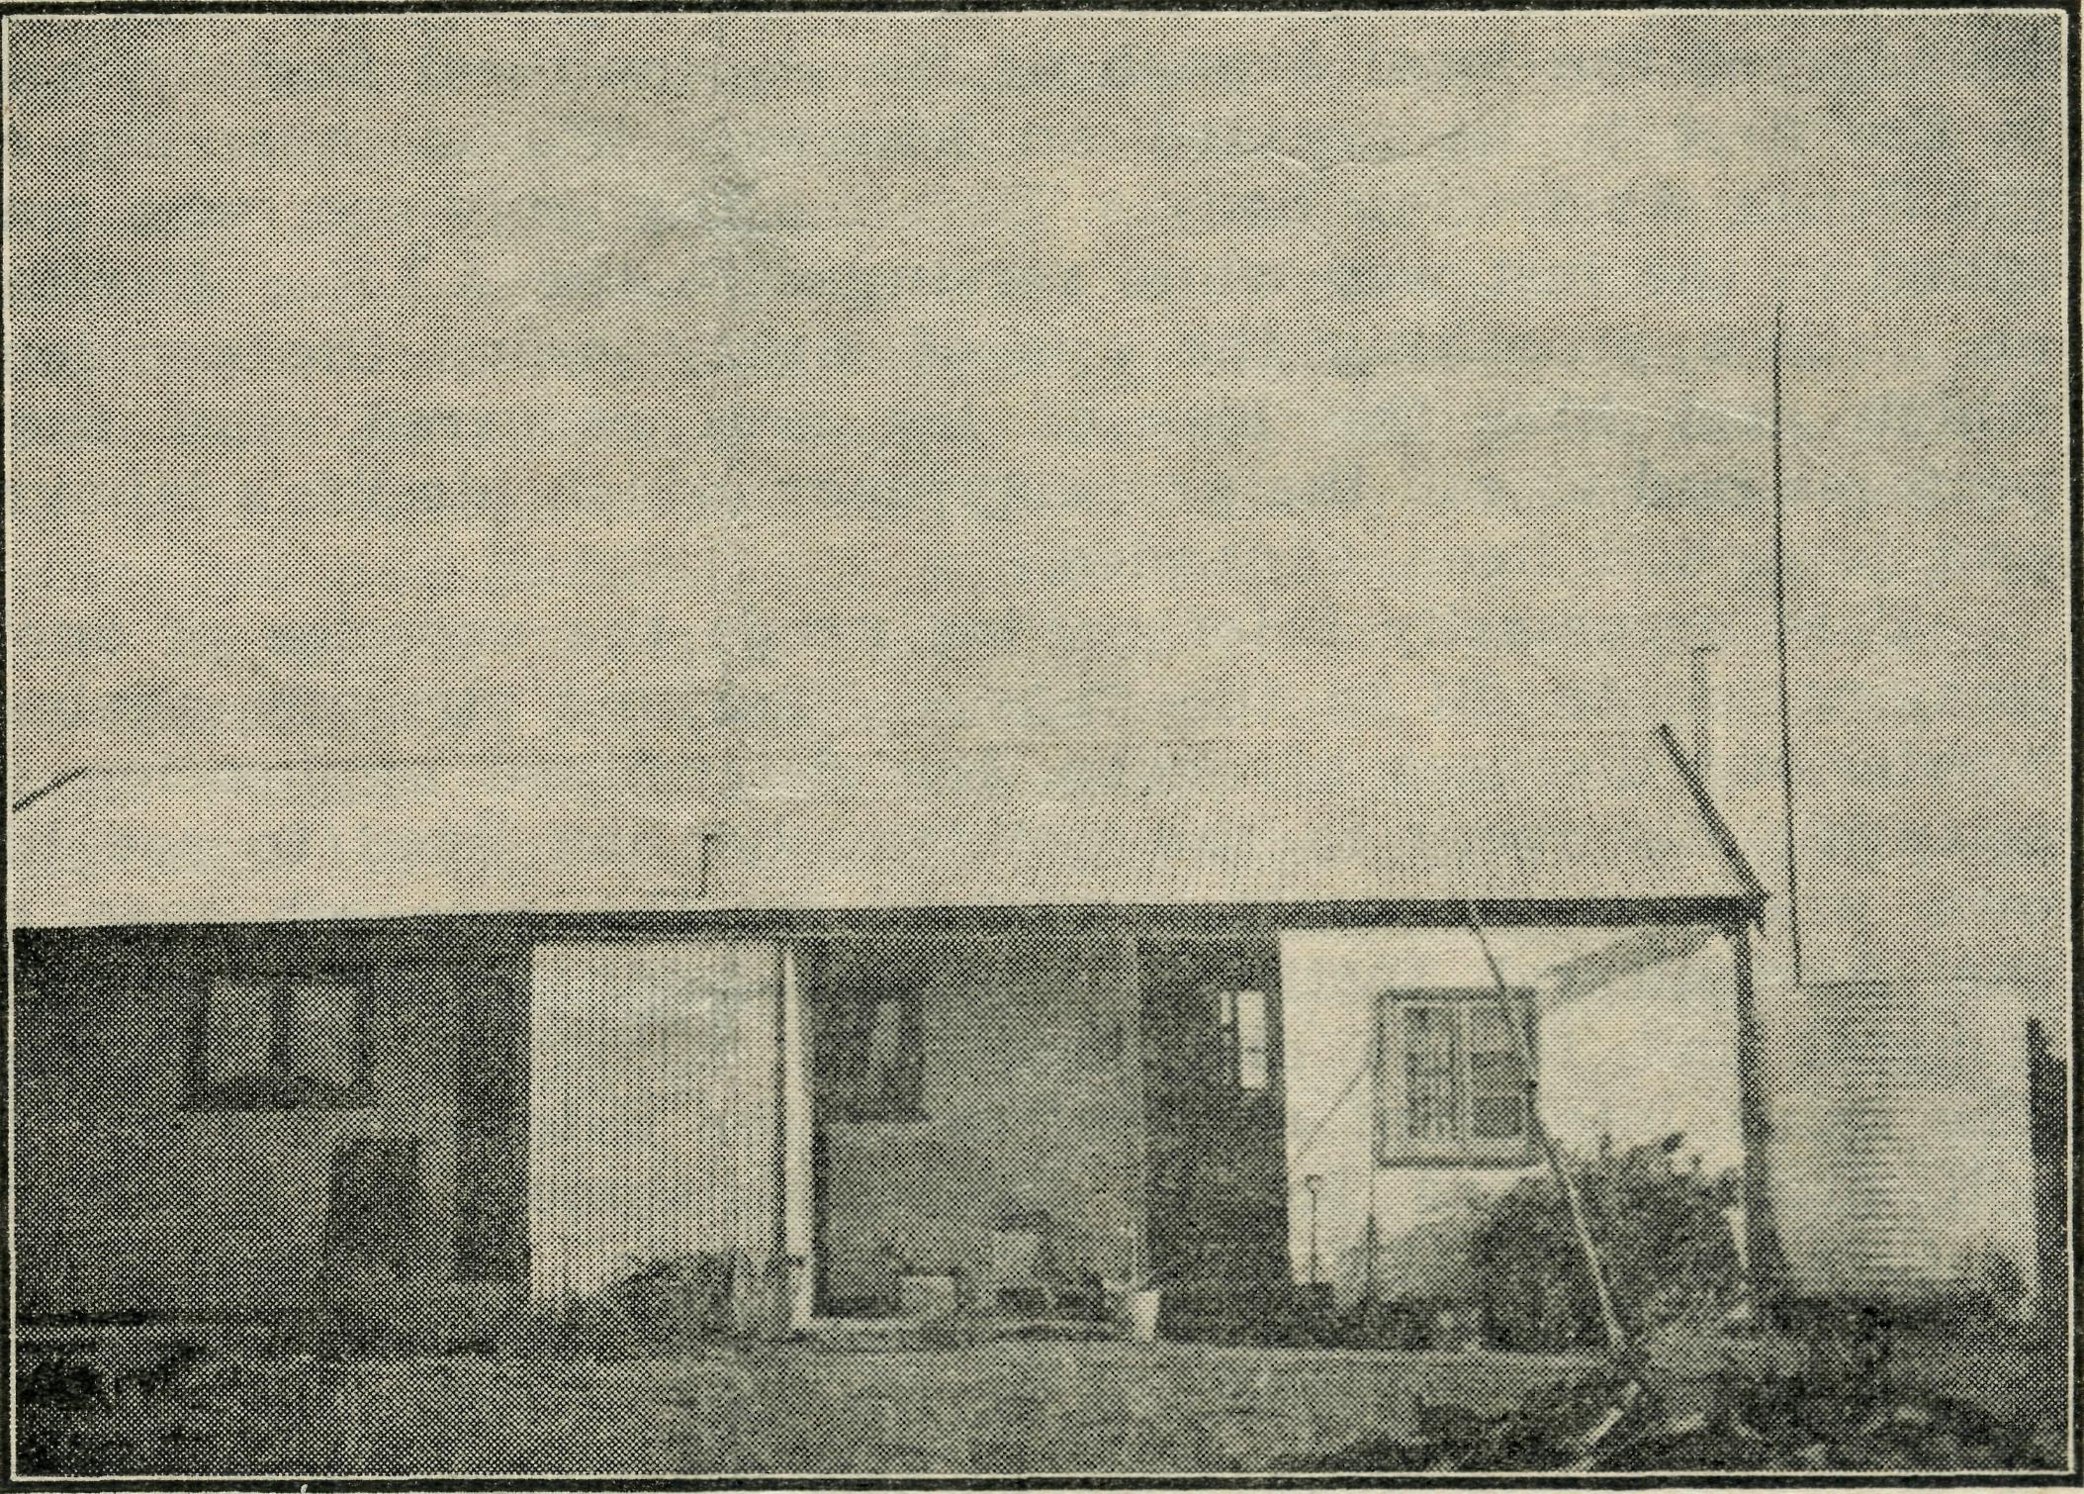
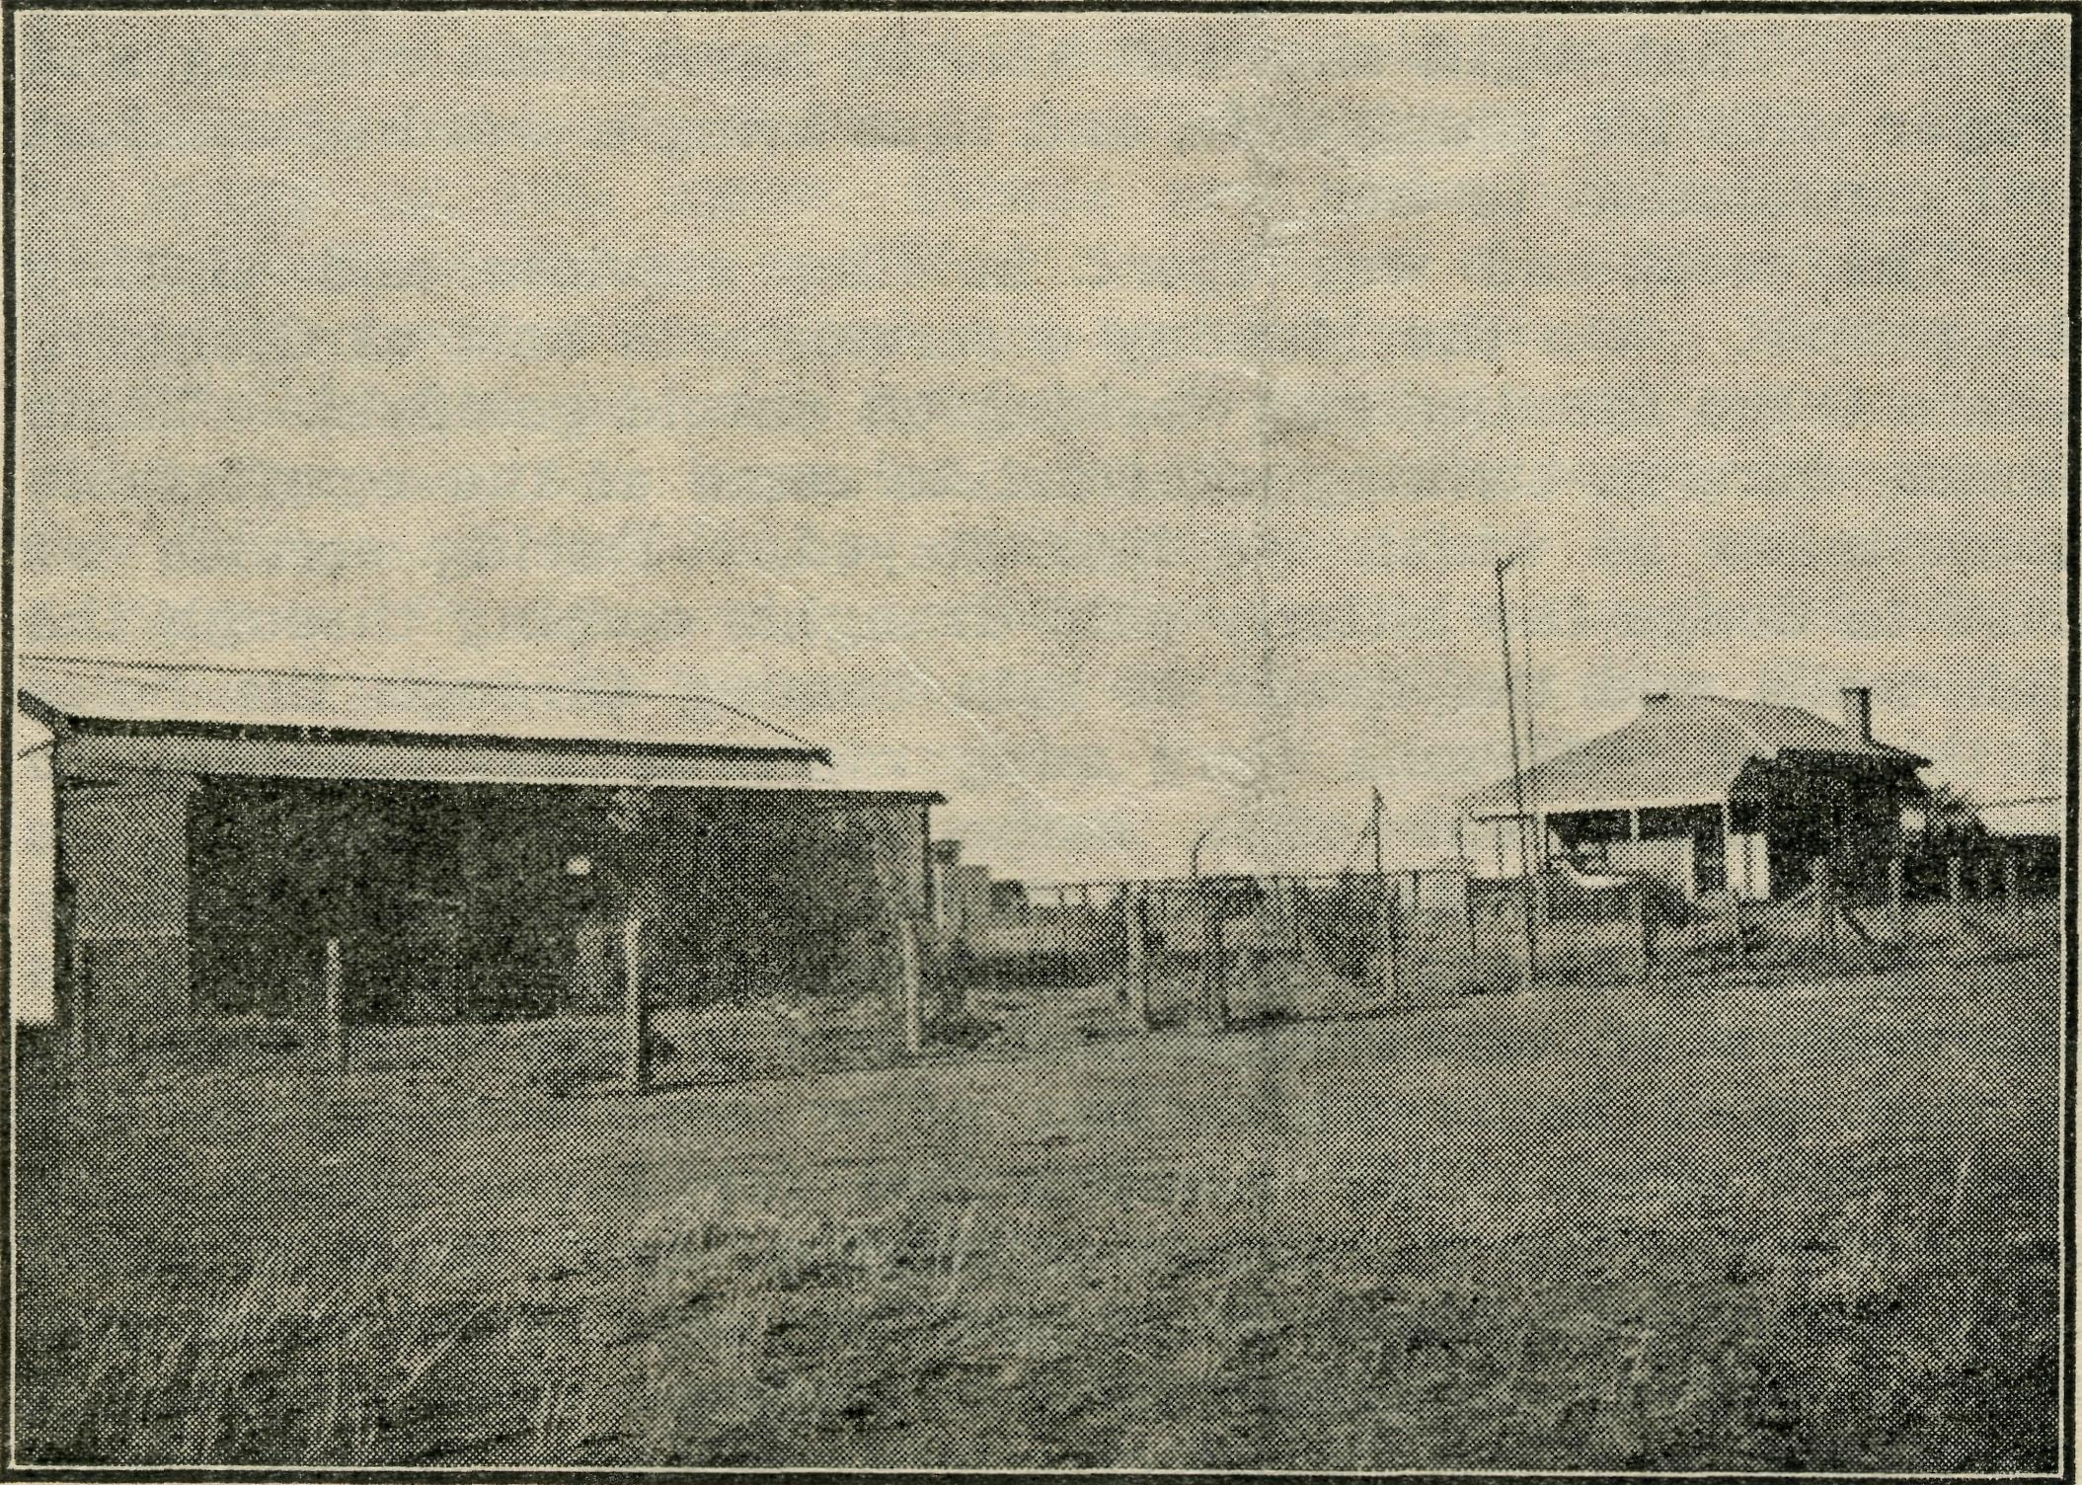

The Lady Dugan Hostel on the left.
Back View of Hostel.

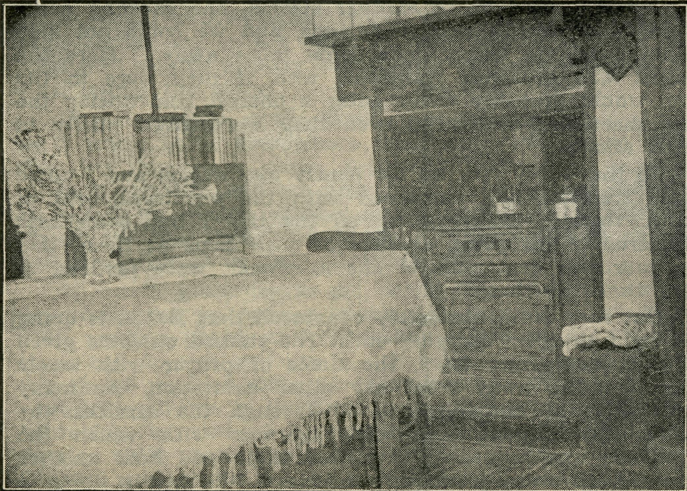
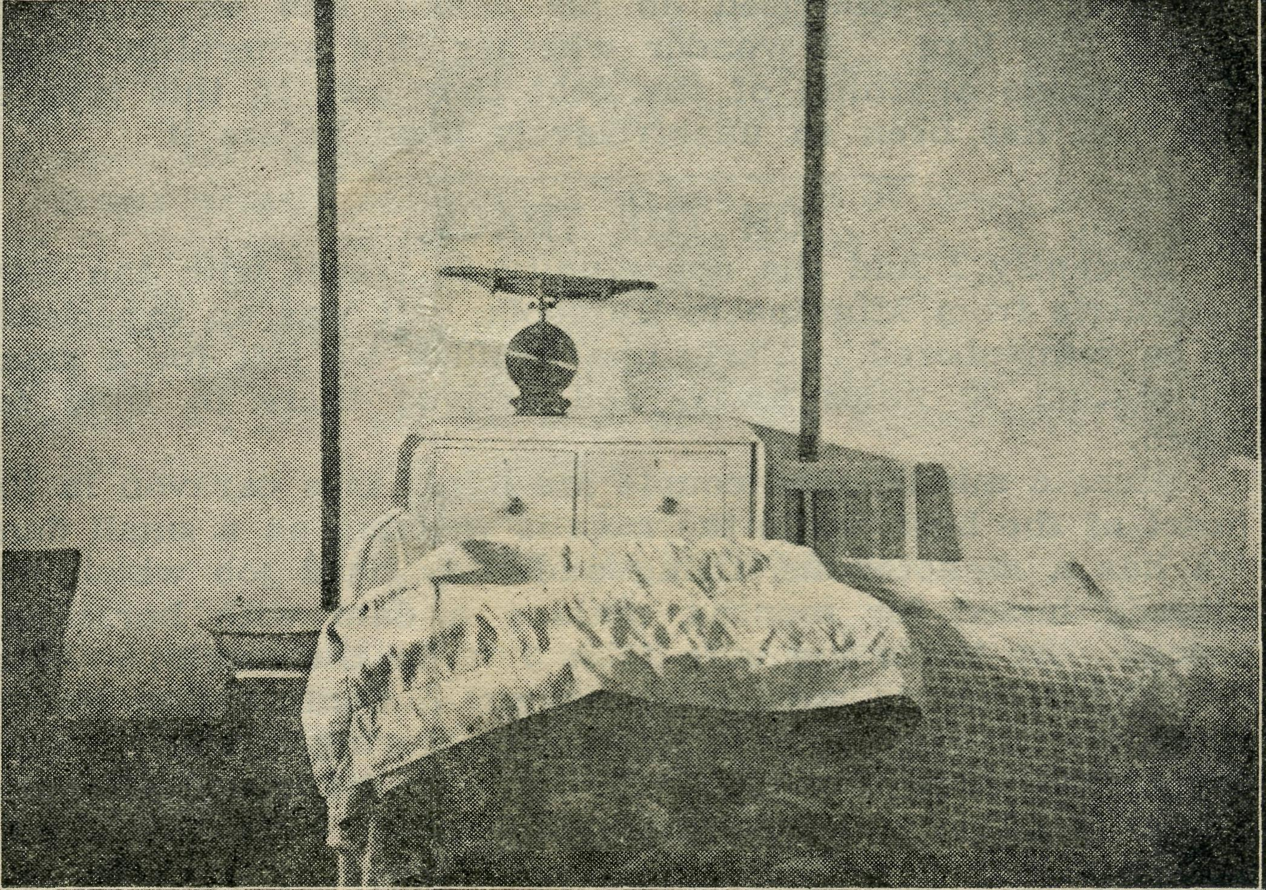

Sister's Kitchen.
A Corner of the Ward.

The Real Australian.
8
July t, 1943.

A PIONEER.
Rev. R. T. Hallahan.
"What is the use of an old man of eighty-three, short of an arm and bent with rheumatism, so that even the light work in a garden is beyond him ?"
This question could have been asked in Hilterite Germany and answered in the fashion of the prevailing philosophy. It could be asked by many in our own land who had so loosely the abiding realities of the Christian Faith and its valuation of all life. It was asked of me by the old gentleman himself, and I answered it the best way I could think of on the spur of the moment. That moment occurred in the course of my pastoral visitation to the home in which he now lives in company with, and lovingly attended by, his wife and daughter. Would you like to give your answer after hearing some of the activities associated with that life ?
Its beginnings. Born in Drake's country, glorious Devon, of a family which always numbered among its members one at least who followed in the wake of that adventurous sea rover. Educated at a grammar school of ancient foundation (he still remembers a passage in one of the reports sent to his parents, "Possessed of the spirit of determination in a degree approaching the dangerous"), at the age of eighteen he emigrated to Australia and found employment in the agricultural and pastoral areas. After marriage, he launched out in the endeavour to establish a home in the then virgin country of Eyre Peninsula, hung on in the face of adverse conditions, and finally succeeded in his object. He was the founder of the local branch of the Agricultural Society, and is the first to be granted an honorary life membership of the South Australian body. Bereft of his only son, who was killed in the last war while serving with the A.I.F. Carried on until approaching the age of eighty, when the accident which cost him the loss of his arm occurred, and then perforce had to sell the property upon which his life's labours and love had been expended.
This necessarily brief outline needs the exercise of one's imagination to fill in the gaps. The long struggle against mysterious diseases of sheep, the determined application of scientific discovery to the problem, he has lived to see his own practical diagnosis confirmed by the research men of the Agricultural Institute, and the addition of a certain mineral salt to the diet practically eliminate the disease. The same intelligent application of the determined spirit to soil problems has led to the establishment of luxuriant pasture, and fruitful fields and orchards. Through it all the patient, hopeful, loyal co-operation of wife and daughter, and now their ministrations in his day of infirmity.
I wonder if your answer to this old pioneer would have been the same as mine. I wonder if you think it worthwhile that the ministry of Christian assurance as to the reality and usefulness of a life beyond the grave should continue to be exercised on his behalf, and on behalf of others like him. I wonder whether this generation really understands anything of the debt they owe to this type of life that has been so unobtrusively lived before it.
ON THE TRACK.
Recently I had the opportunity to travel with the Rev. L. Morris from Minnipa to Tarcoola. It was an experience to be remembered. Early one Monday we left for a small out-station 80 miles away, and arrived there in time for lunch.
Here a middle-aged couple are living in a caravan in the heart of the bush while the man is working on a small dam. He has a monotonous, tiring and very hard job which has already lasted for months, making a dam with horse and scoop. At times his wife joins him in the work ! After lunch, Mr. Morris gave a young girl a Confirmation lesson. This was followed by a little service, during which we were joined by three Roman Catholics who happened to come along, and they all listened intently as the missioner clearly and faithfully preached the Gospel.
That night we reached a station many miles further on.
After tea we were talking of politics. One of the men happened to remark that some of the Allied leaders were very fine men. We were able to suggest that it was probably because they were men of prayer, and before long they jumped at the suggestion that we should follow their example, and so another informal service was held. Bible reading and prayer were followed by another excellent talk about Christian things, and again the family listened with deep interest.
The next day a very fine family was visited. Here the manager of the station faithfully holds Sunday School for his two sons. Mr. Morris again held a service, this time including a hymn-singing interlude around the piano.
And so we went on from station to station, holding services at each one and always receiving a hearty welcome. The country became more difficult, and the missioner showed great skill in driving St. Patrick's Van over very bad sandhills. Some of these hills stretch continuously for seven miles, and the track over them is very rough, making great demands upon the driver.
After a few days we reached Kingoonya, a small town on the Transcontinental Railway, where a complete Church of England service was held.
And so to Tarcoola, 30 miles further along the line. Here we met Sister Bossley, who is the B.C.A. nursing sister there. Sh© had just returned from attending to a man who had been fatally injured on the line. Although she was not able to save his life, she was able to make his passing easier. That night she was able to have Bible reading and prayer with his young wife, and thus bring a word of comfort and consolation to her.
The week-end was spent holding services and visiting the people. On the Monday a service was held at Glenloth, where three families are working on an old goldfleld. Their homes were in striking contrast to some of the comfortable homesteads at which we had stayed. During service we tried to dodge the bitterly cold draughts coming through the slab walls and the drops of rain coming through the holes in the roof. Hymns were sung more or less tunefully to the accompaniment of a series of extraordinary sounds coming from something that in the long ago had probably been quite a decent piano. But nevertheless there was an atmosphere of earnestness and sincerity and real devotion in that poor home which has never been excelled in any great cathedral. My heart ached for these people, and especially for the half-dozen children present; some of them were twelve, and yet could neither read nor write, and showed obvious signs of improper feeding. But they heard the Gospel of Jesus Christ clearly presented. But—at least three months must pass before the next service.
Taking a regretful leave,—regretful because we felt that we could easily spend several days teaching them the things of God—we went on to another station, one showing every evidence of wealth and refinement, and we could not help thinking of the other home some miles away. Here the Gospel was preached to people who, if they were in the city, would probably never enter a church, and during the long discussion which followed they were given plenty to think about.
So the work went on for nearly two weeks, and I came home tremendously impressed with the worthwhileness of B.C.A. work. Before going on the trip I had sometimes wondered if the great expense of such trips as these, and the sacrifices demanded of the missioner, were justified in such times as these.
But now I am absolutely convinced that B.C.A. is doing the right thing in carrying on. The sincere welcome given at each home and town, the times of prayer with lonely families miles away from any other habitation, the many expressions of blessing received through the services, the earnestness evident, and the eagerness with which the missioner was requested to "come again and hold another service"—all were profoundly stirring. B.C.A. is doing a grand job !

July 1, 1945.
The Real Australian.

ON THE PLAINS.
Sister B. Bossley.
Since returning at the beginning of the year from my
three months' leave, I have spent four months at Cook, where
I relieved, and the remainder of my time here at Tarcoola,
where I have taken over the work.
While at Cook we had a very busy time maintaining an average of a couple of children and three adults, and mostly a baby—as we had five while I was there—so the work wai constant; and we ended up with a case of diphtheria, fortunately just as Sister Pritchard returned, and I was able to take over the case. The child progressed quite well, and the isolation only lasted three weeks. However, it meant that Sister Symons had to wait an extra two week* here, until I was free to take over.
It was a joy to go back to Cook, and to enjoy the comforts, etc., that have been added from time to time. It is nearly six years since I first went to Cook—for three months, when the hospital was first opened—and the difference in the place now is most marked and encouraging. In those early days the building was just a bare hospital, comprising theatre and sterilising room, two wards, dining-room, one bedroom, kitchen, bathroom and laundry, with a verandah all round, and no break of any description for the winds. The floors were all bare boards, and the only heating apparatus was a kerosene stove in the kitchen; and those of you who know the Kullarbor will know how cold it gets, and how much a fire is needed and appreciated. Now, as many of you know, things are quite different. Two extra staff bedrooms and a nursery have ail been built, also the dining-room extended on to the verandah, forming a little alcove, which has been made into a sitting-room. A brick fireplace has been built in, there is a lovely carpet on the floor, and the lounge suite, upholstered in red leather, finishes it off. There is a new dual-wave wireless set, which has been given, as were all the other comforts, by the people of Cook. The floors, of course, have been covered now for some time, and a wood stove has been put in, also a refrigerator and canvas blinds round the verandah. Only those who have to live and work in a place like Cook can realise fully the advantage of these extra comforts, but which all tend to make the work easier, smoother running, and more proficient; and we do thank God that He has given the people of Cook sufficient interest in their hospital to give these extras, and we pray that we who have been, and are privileged to work there, may give of our best in service to them.
The spiritual side of the work at Cook has grown, too. The Sunday School is flourishing, and it is a joy to see the kiddies (the three and four-year-old ones, as well as the bigger ones) coming along week by week to hear of the Lord Jesus; and to see them in their homes, in their own little way playing Sunday School, singing their choruses, and even telling the story.
The attendance at the Sunday evening services is erratic, as it seems to be everywhere these days, but we do thank God for those who come, especially those lads from the military services, and we pray that He may lead them on to a full knowledge of the saving and keeping power of Christ, and that those who do know Him may be encouraged and strengthened in their Christian life.
It was a great joy to me, while there, to find six lads who delighted to come a couple of evenings a week for Bible reading, prayer and fellowship, sometimes by the hour, if we had no sick patients in. It was a help to us all, and though we were all different denominations, what mattered ? —we were all one in the Lord Jesus Christ. Such times of fellowship, as well as strengthening us individually, surely help to unite us in one body, of which Christ is the Head. I would ask you to remember Mis» Dykes especially as »he
carries on the work in school and Sunday School, and the services each Sunday.
So much for Cook—now for Tarcoola.
The work, as many of you know, is quite different here, in that it is all out-patients. We have a ward with one bed, but it is only used in extreme emergencies, as one is called away frequently, and there would be no one to care for the patient. However, one finds plenty of work to be done, and it is amazing the amount of sickness that has been prevalent the last few weeks, especially amongst children. I don't think there has been a time when I have not been visiting at least two kiddies a day, and just the last two or three weeks I have had several very sick ones, necessitating three and four visits a day.
I had a very sad accident case a few weeks ago. About
- p.m. one evening the Stationmaster came over and said there had been a bad accident down past Barton (about 130 miles down the line—West), and that one man was very ■eriousiy hurt. However, there was a military doctor going on leave on a train at Barton. They had taken him to the scene of the accident, and he was bringing the man on by train as quickly as possible and taking him to Port Augusta. The doctor wanted me to meet the train here about 1 a.m. with morphia and other stimulants. About
- p.m. the Stationmaster came over again to say the man's condition was critical, and there was another military train going down in about an hour's time, and would I go, and take the things with me, and meet doctor and patient half way. This I did. We transferred to the other train at 1 a.m. about 50 miles down. The man's condition was certainly very critical—in fact, far beyond the human aid that we were able to give. He died about 3 a.m. (half an hour before we reached Tarcoola). When we arrived here there were police enquiries, statements, etc., to be made; then the body was taken to the police station, and it was 6 a.m. before we had finished our work. A couple of hours' sleep, then up again, because there was other work to be done. We learned that the man was 38, and had only been married •even weeks. They took the body to Port Pirie, and the wife went through on another train that night. I went over to the train, and was able to see her for a time.
I would ask your prayers for the Sunday School and services each Sunday, The Sunday School has an average of 24 or 25 children, with 30 on the roll, and we do need more helpers in this vital work of bringing the little ones to Christ. The attendance at the services varies. Sometimes there are only about eight, and sometimes 14 or 16 present; but it is very encouraging to see four men there regularly, and to know that they can be counted on. There are also three of the older Sunday School girls who never miss. I only take the service each alternate Sunday, as one of the men of the town takes it the other Sunday. I do ask you to uphold us in the work of proclaiming the Gospel message, not only here in the services, but in our witness and ministry day by day amongst those with whom we meet and work.
I was greatly encouraged by the visit of Revs. L. Morris and D. Livingstone last month, and thank God for the time of blessing and fellowship we were able to have together.
We were glad to welcome the O.M., too, for a brief visit while he was over. Sister Hitchcock, from Koonibba, also accompanied him on the trip, and she appreciated having the opportunity to see Tarcoola.
OUB COVER PICTURE.
Our cover picture is a copy of an etching sent to Mr. Morris to hang in the new Minnipa Church when built. It depicts the shattered Coventry Cathedral and the piece of stone sent to be incorporated in the new Church at Minnipa. Copies of this picture are available for sale at 6d., and the proceeds will be devoted to the Minippa Church furnishings.

The Real Australian.
10
July 1, 1943.

POST AND RAILS.
Since our last issue certain changes have taken place in our field staffs.
The Rev. and Mrs. B. Lousada, after nearly seven years at Denmark, W.A., have returned to Victoria, where Mr. Lousada has been appointed locum tenens at Lakes Entrance, Dio. of Gippsland. They have done a splendid job at Denmark, and return now because Mrs. Lousada's health will not permit her to stay another winter at Denmark. We thank them for their long and loyal service, and wish them much blessing in their new sphere.
t^f» ♦ji %j* *^ •*£» Sfr
The Rev. T. R. Fleming succeeds Mr. Lousada at Denmark. Mr. and Mrs. Fleming have already been in B.C.A. service for eight years, having previously been at Cann River, Delegate, and Cummins. They journey to Denmark early in July, and we pray that they may receive guidance and blessing in this fresh sphere.
Sister M. Symons returns to Sydney after — years* service, of which the past eighteen months have been spent at Tarcoola. Sister has had a lonely and difficult job, which she has performed with much devotion. We trust that she will find happy and useful work after her holiday. Sister B. Bossley, who has been on our South Australian staff for seven years, has been transferred to Tarcoola.
*p *5p *r *p *& *&
Sister Branford is completing her obstetric course in Adelaide, after which she hopes to return to Ceduna, where a warm welcome awaits her.
•X* *x» *T "F *r V
Owing to the acute shortage of clergy, the Bishop of Ballarat has asked B.C.A. to agree to Mr. Duffy, of Timboon, taking over some part of the Cobden Parish. This we have been happy to agree to, and ask the prayers of our readers for Mr. Duffy in his extra work.
V V *P *f> *& *f>
The Rev. E. D. Shaxted, our Victorian Secretary, left ns at the end of June to become Vicar of All Saints', Northcote, Dio. of Melbourne. Mr. Shaxted has helped considerably to build up our cause in Victoria in the two years he has been with us and, while we regret his departure, we wish him every blessing at Northcote. We are sure he will keep the out-back needs before his people.
j£ s& %> & # ¥
Our very good friend, Miss I. Woods, of Moonee Ponds, was married recently to Mr. W. L. Woods, also of Moonee Ponds. We wish them both much joy and blessing in their life together.
Mrs. Gerrard, of Pennant Hills, who is our keen Secretary of our Ladies' Auxiliary in that parish, recently suffered a severe injury to her thigh, and is at present in Hornsby General Hospital. Mrs. Gerrard will be incapacitated for some time as a result, and we ask our friends' prayers on her behalf.
Dr. Dillon-Smith, widow of the late Rev. K. B. J. Smith, one time Victorian Secretary of B.C.A., recently passed to her rest. To Miss Dillon, of the Home Mission Society, and other members of her family, we offer our sympathy and prayers.
Recent additions to the B.C.A. family are a daughter to the Rev. and Mrs. D. Livingstone, of Streaky Bay, a son to the Rev. and Mrs. T. R. Fleming, and a son to the Rev. and Mrs. K. Luders. We are losing count of B.C.A.'s "grandchildren," but all are making lusty progress. # * # * # #
Our N.S.W. Headquarters Ladies' Auxiliary hope to make their "Market Day" on Friday, August 13th, a big success. It is their annual effort, and will be preceded by the annual
business meeting. In these days of rationing and coupons, such efforts are by no means easy, but the co-operation of as many of our friends as is possible will make this effort well worthwhile. Do come along on Friday, August 13th, at 2.30 p.m., to the Bible House in Bathurst Street.
We hope that very soon Sydney James Cook will be a boarding scholar at the King's College, Adelaide. This step is taken that he might have every opportunity for the best training to fit him for manhood. Listeners to B.C.A. Outback Session are being asked to help pay the £60 per anum required for his fees. Would you like to join this effort ? Send your gifts to the Office and mark them "Sydney James."
*P V *P *P *J» V
The wireless session from 2GB each Friday morning at 9.15 is proving very popular. You can help by inviting your friends to listen-in. We will supply little reminder cards for distribution if you will ask for them.
# m. * « * *
We regret that, in acknowledgments made in the last issue to amounts collected by Mrs. Marshall, the address was wrongly given as Hurstville. This should have read, "Mrs. Marshall of Rockdale."
The B.C.A. Wireless Session at 9.15 on Friday morning will probably be shortly extended to 3DB and 3LK, Victoria. Announcement will be made on 3DB Charity Session at 4.30 p.m. daily. Tune in, and have your friends listen also.
Our sympathy goes out to the Rev. W. V. Gurnett and his family at the sudden passing of Mrs. Gurnett. Since coming to Pennant Hills, Mr. and Mrs. Gurnett have proved themselves good friends to B.C.A., and we have appreciated their friendship. We pray that comfort and strength may be granted each member of the family.
* * # # # *
We also extend our prayerful sympathy to the family of Miss Sarah Gerdes on the death of her father. Miss Gerdes is a keen Mail-Bag worker, and she and her sister have been keen supporters of B.C.A. through the Drum-moyne Girls' Fellowship.
Has anybody a good portable gramophone ? The Wilcannia Hostel could use one, and we would be glad to forward it if you will send one into the office.
The Melbourne Rally of B.CA. was a good success. The Archbishop of Melbourne was our chairman, and assured the meeting that B.C.A. would always have his keenest support. Our President, the Archbishop of Sydney, inspired all present with his earnest appeal for continued support for B.C.A.'s worthwhile work in these war days. Sister Page impressed all with her sincerity and wholehearted devotion in her work. The Rally did much to stimulate the interest of all present. The offering amounted to £100.
MANPOWER.
Manpower ! This is probably the greatest problem facing those in charge of the nation to-day. It is also an acute problem in the Church. The ranks of the clergy have been so thinned by calls for military needs as to leave parishes perilously understaffed. Men and women must have the Gospel lived and preached amongst them in the services— and out of it. Men and women must learn to live righteously in the services and out of it.
Though the metropolitan sees have given the greatest number of men to the services and are all woefully understaffed, they are able, by their compactness, to adopt an expedient not practicable in the bush.
The temporary amalgamation of parishes throws a tremendous burden upon the rector left to carry on. He is only one person, and can be in one place only at one time.

July U 1943.
11
The Real Australian.

^Nevertheless with lay assistance he can give some ministry, though inadequate, in both parishes.
In the bush the huge areas involved almost precludes this method being used. A man who is already ministering in an area of anything from five to a hundred thousand square miles is totally unable to spread his ministry further afield. Then, of course, the problems of tyres and petrol become acute.
In the bush to-day there are opportunities for Christian witness as never before, but they cannot be grasped because there are not men enough to send out into the highways and byways.
If we cannot grasp the opportunities now, can we prepare to meet them at the earliest possible moment ?
The bush and plain need men—men of conviction and earnestness who will serve in the lonely places not simply from a sense of duty, but with a real consciousness of call to a special work; men who will see in the people who live out-back souls to be saved, of equal value as those who live in great cities.
Let us prepare now for the opportunities that will surely be ours. If war is to cease in all the world, that cessation must commence in the hearts of men. If we are to make any real impact for Christ in lands near to, or far from us, we must see to it that the Christian evangel is preached and lived among our own people.
We need, then, men and women to train as ministers and deaconesses for work out-back.
We need the necessary finance to provide that training, a,nd money received now for that purpose will be put into a Special Candidates' Training Fund.
Can you do one or the other of these things ? Will you ■do them, that the "order" which men seek in the world may be of God ?
SUBSCRIBERS WHO HAVE NOT RECEIVED RECEIPTS.
Mr. Wareham, Mrs. Alexander, Mrs. Bradshaw, Mrs. Bury, Mrs. Cochran, Mrs. Dalway, Miss Dennis, Mrs. Fletcher, Miss C. M. Hancock, Mrs. Monds, Miss Shaw, Miss Westmoreland, Miss G. Swann, Mrs. Boddy, Miss I. Lowe, Miss M. Stephens, Mrs. Bevan, Mrs. Chase, Miss J. Smith, Miss Lucey, Miss Knowling, Mrs. E. W. Noonon, Miss V. L. Sollas, Miss M. G. Thompson, Dr. C. E. Sundell, Frau Zundel, Deaconess Sundell, Miss Shields, Mrs. C. H. Nash, Mrs. Danbridge, Mr. and Miss Jessop, Mrs. Bicknell, Mrs. Muir, Mrs. Uebergang, Mrs. Piper, Miss E. Tilley, Sister H. Foster, Mrs. J. C. Taylor, Miss Hedderwick, Miss Bachelor, Miss Walch, Miss* E. Mann, Miss Stainsby, Mrs. L. Panelli, Mrs. E. D. Fethers, Miss Armfield, Miss I. Brown, Miss C. Kirby, Miss L. Slade, Mrs. J. L. Affleck, Mrs. Hughes, Miss E. Downey, Mr. H. T. Arnold, Mrs. Symons, Mrs. C. J. Cocks, Miss Hargreaves, Mrs. E. Marchbank, Mrs. Alsop, Mrs. H. Gordon, Miss Charles, Mr. W. Gearing, Mr. Watling, Miss Hicks, Mr. D. Crowhurst, Mr. W. Palmer, Miss D. Banks-Smith, Miss A. Hilliard, Miss M. Lambert, Mrs. A. Theobald, Mrs. J. Flatt, Mrs. C. Lumb, Rev. Griffith Cochrane, Mrs. A. Williams, Miss B. Date, Mr. Elyard, Mrs. Hutchinson, Mrs. Barker, Mr. N. Windle, Mrs. A. H. Starling, Miss I. Brady, Miss Blencoe, Miss A. J. Watts, Miss Bigmore, Mr. Chadwick, Miss J. Webber, Mrs. J. A. McElroy, Mrs. H. Layton, Miss Piatt, Mrs. Rose, Mrs. Israel, Mrs. Reeve, Miss M. Matthews.
29/3/43 : 10/-, Anonymous. 5/4/43 : 5/-, "City Sister;" £1/10/-, Anon.; 5/-, Anon. 13/4/43: fl, Anon. 14/4/43: 1/-, "A Friend." 19/4/43 : 10/-, Anon. 20/4/43 : fl, Anon. 21/4/43 : £10/10/-, Anon. 3/6/43 : 5/-, "Listener." 11/6/43 : 5/-, Anon. 16/6/43: £5, F.M.S., "A Friend." 18/6/43: 5/-, Anon. 21/6/43 : £1, "Widow's Mite"; 4/-, "A Sympathiser"; 4/-, "Listener"; 8/-, Anon. 22/6/43: 4/2, "In Memory of Edith." 23/6/43: 8/-, "Wellwisher," M.O.R. 24/6/43: B.C.A. Listener, 10/-. 25/6/43 : "Listener," 2/-; Anonymous, 4/-. 25/6/43 : "An Admirer," 4/-. 28/6/43 : "A Listener," 12/1. 24/5/43 : N. J., 10/-. 25/5/43 : "Well Wisher," £1/10/-. 9/7/43 : "Inasmuch," £1.

Are You a Regular Listener to - - -
B.C.A. OUTBACK SESSION
at 9.15 a.m. each Friday on
2GB.
• Widen the circle of our friends and ask your relatives and neighbours to listen-in also.

The Real Australian.
12
July i, 1945

If you are NOT superstitious, come along to
Our Ladies' Auxiliary
MARKET DAY
— AND —
ANNUAL MEETING
— IN —
THE BIBLE HOUSE, BATHURST STREET,
— ON —
Friday, August 13th,
at 2.30 p.m. BRING A GIFT OF GROCERIES OR OTHER SALEABLE ARTICLES, OR SEND IT INTO THE OFFICE BEFOREHAND. COME YOURSELF AND BRING A FRIEND I

by
purchasing
War
Savings
Certificates
The Bush Church Aid Society
SUGGESTS THAT YOU
by donating
War
Savings
Certificates.
to the Society.
Certificates can be purchased for
16s. for each £1 Certificate. £4 for each £5 Certificate. £8 for each £10 Certificate.

Buying them helps Australia in the World War. Donating them to B.C.A. helps the Kingdom of God in the fight against the evils which cause all wars.
The certificates will be used to build up a fund to assist in the purchase and maintenance of a new medical 'plane when that
becomes necessary.
Wholly set up and printed in Australia by D. S. Ford, 44'50 Reservoir St., Sydney.

