Registered at the G.P.O., Sydney, for transmission by post as a periodical.

Organ of the Bush Church Aid Society for Australia and Tasmania.

No. 86.
MARCH 15, 1944.
1/6 per annum (post free).

WILCANNIA MISSION.
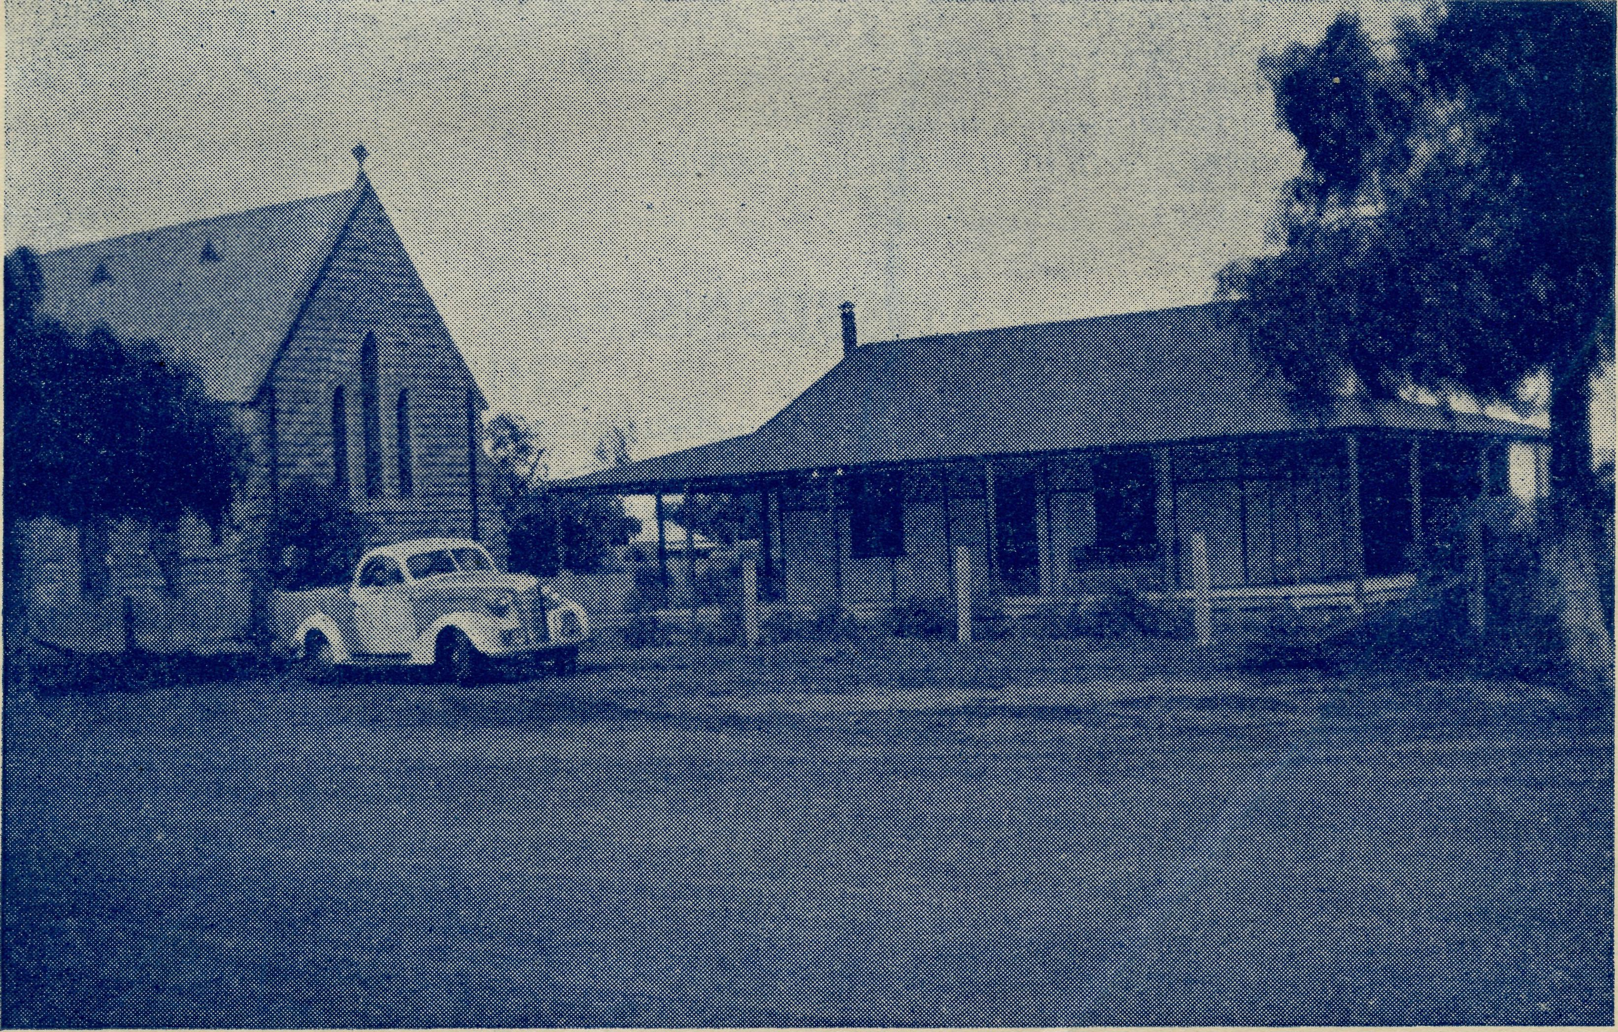
The Church and Vicarage, Wilcannia.

The Real Australian.
March 15, 1944.

The Bush Church Aid Society for Australia and Tasmania.

HEADQUARTERS OFFICE :
Diocesan Church House, St. Andrew's Cathedral, George Street, Sydney.
(Telephone : M3164.)
Cable Address : "Chaplaincy, Sydney."
VICTORIAN OFFICE :
The Bible House, Flinders Lane, Melbourne.
(Telephone : F5675.)
President : The ARCHBISHOP OF SYDNEY. Hon. Clerical Secretary : Rev. L. GABBOTT. Hon. Treasurer : T. S. HOLT, Esq.
STAFF. Organising Missioned: Rev. T. E. JONES, Th.L., Church
House, George Street, Sydney. Victorian Secretary : Rev. A. DONNELLY, Th.L., Bible House,
, Flinders Lane, Melbourne. South Australian Secretary : Rev. R. M. FULFORD, North Terrace, Adelaide, S.A.

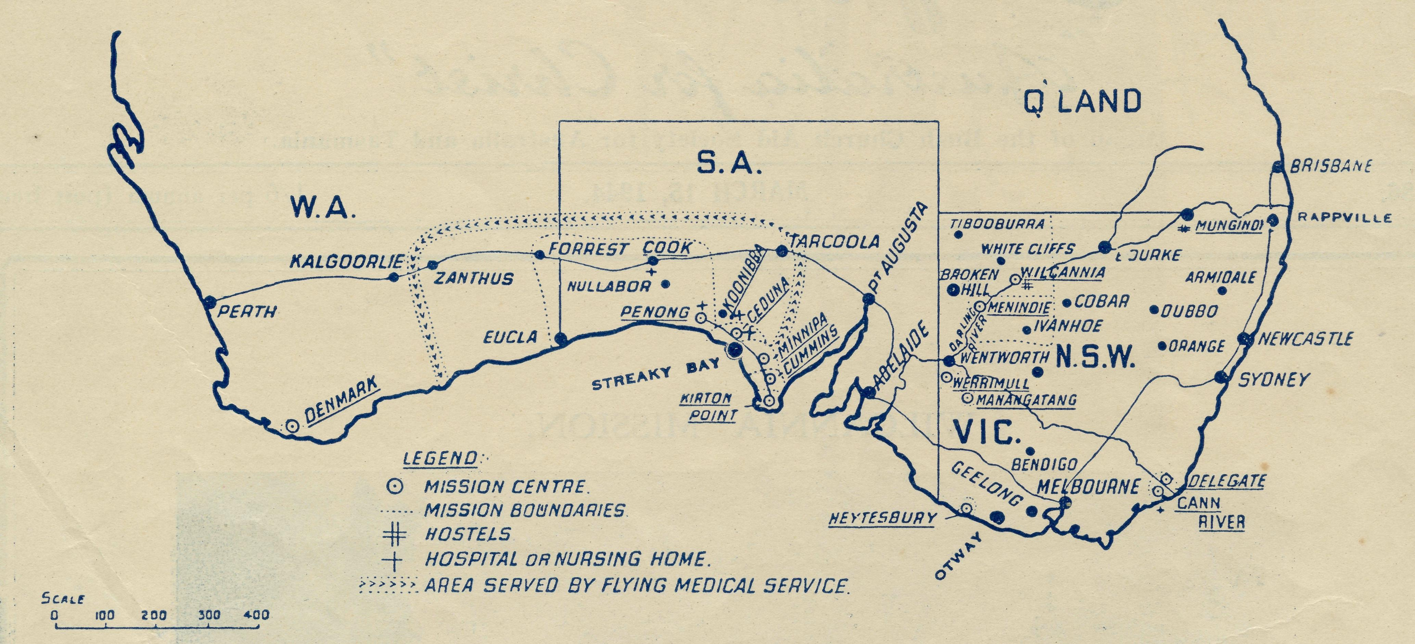

MISSIONS.
FAR WEST MISSIONS, S.A.
Penone 1 ^{Rev}* ^{H}* ^{Broadle}y> Th.L., The Rectory, Ceduna, S.A. Cummins—Rev. D. Pugh, Cummins, S.A.
Kirton Point—Rev. R. T. Hallahan, Th.L., Port Lincoln, S.A. Streaky Bay—Rev. D. Livingstone, Th.L., Streaky Bay, S.A. Minnipa—Rev. L. Morris, Th.L., B.D., Minnipa, S.A.
VICTORIAN MISSIONS.
Rev. K. Brodie, Th.L., The Rectory,
Delegate, N.S.W.
, Werrimul, Vic.
Croajingalong Delegate-Bonang N.W. Mallee—Rev. Heytesbury Mission—Rev. W. Duffy, Cobden, Vic Otway Mission—Rev. T. H. Pickburn, Th.L., Beech Forest, Vic.
N.S.W. MISSIONS.
Wilcannia ) _{Rev} _{K} _{Lu}ders, Th.L., Wilcannia, N.S.W. Menindie )
Rappville—Rev. P. M. Connell, The Rectory, Rappville, N.S.W.
WESTERN AUSTRALIA.
Denmark—Rev. T. R. Fleming, Denmark, W.A.
CHILDREN'S HOSTELS.
Mungindi—Miss E. Cheers, Mungindi, N.S.W.
Wilcannia—Miss H. Gurrier Jones, Miss Y. Gurrier Jones,
Wilcannia, N.S.W. Wentworth Falls, "Coorah"—Mrs. Mann, Miss F. Harding.
MEDICAL SERVICES.
The Dispensary,
Cann
Gippsland, Vic.—Sister I. Gwynne, River, Vic.
FLYING MEDICAL SERVICES.
Pilot : Mr. A. Chadwick, Ceduna, S.A. Dr. R. Gibson, Dr. F. Gibson.
CEDUNA HOSPITAL.
Matron : Sister F. Dowling.
Staff : Sisters V. Page, L. Loane, Branford, G. Moody.
KOONIBBA ABORIGINAL HOSPITAL,
Sister G. Hitchcock.
PENONG HOSPITAL.
Sister Firmin, Penong, SA. Miss M. Millar, Penong, S.A.
BISHOP KIRKBY MEMORIAL HOSPITAL.
Sister L. Pritchard.
Miss D. Dykes, Cook, S.A.
TARCOOLA, SOUTH AUSTRAIJA.
Sister B. Bossley.

March i5, 1944.
The Real Australian.

TWENTY-FIVE YEARS.

THE ORGANISING MISSIONER'S LETTER.
First a sincere expression of thanks to all our friends for their very generous response at Christmas time. The sum of £673 was given to our Christmas appeal, and during the month of December the total sum of £2684 was paid into B.C.A. funds in Sydney. Such wonderful • giving has greatly eased our financial position and enabled us to face up to necessary new work. Thank you all !
We have passed through difficult days in recent years, and it is a tremendous encouragement to know that our friends are ever ready to back all the efforts made by the Society.
Now about the days which lie immediately ahead. I have mentioned previously the need for a hostel at Port Lincoln. The need is an urgent and insistent one. Nearly every mail brings me reports of children denied the opportunity of a secondary education because of lack of suitable accommodation away from home. From time to time there is much talk of the necessity of giving all children in a democracy equal opportunities for higher education. It sounds very fine until you stop to think that all such schools are in larger towns and many children live in isolated places. To them such democratic theories are of no avail.
There is a High School at Port Lincoln and another at Kalgoorlie, but none in between. Kalgoorlie is 1000 miles from Port Lincoln, and a lot of children live in between.
We already have evidence that if B.C.A. opened a hostel at Port Lincoln to take fifty children it would be full immediately. Because of the difficulties of domestic staff, so large a start cannot be made, but we are going to open a hostel at Port Lincoln in May next. Until such a time as we can buy the necessary building, we will lease it at a weekly rental. Of course, we don't want to pay rent a moment longer than is necessary, but it will cost £2200 to buy the property we need.
Now what justification is there to launch upon you a
another appeal ? First there is the undoubted need itself, but there is another. This year, 1944, is the Silver Jubilee of the B.C.A. It will be 25 years ago on May 26th since that small handful of earnest people met together in St. Andrew's Chapter House to form B.C.A. They did this because they believed a need existed which they must meet. How well they did it ! Much has been done in those 25 years. Missions, hostels, hospitals, an aerial medical service, a Mail-Bag Sunday School have been founded and maintained at a splendid degree of efficiency.
B.C.A. has, in the short space of 25 years, grown from tiny beginnings to be the largest organisation of its kind in the Commonwealth. A splendid record, don't you think ? One for which we can thank Almighty God and take courage for the future.
Well, now, another need exists, urgent and insistent as I have already said. Can we mark our Jubilee Year by buying this property for our Jubilee Hostel ? We can, if all our friends will help. Can you give or collect 25 silver coins—or notes if you like ? One for each year of wonderful service by this Society.
The next issue of "The Real Australian" will be our Silver Jubilee Number, and will be published early in May next. It will contain details of the proposed hostel and meetings to be held to mark this occasion. Meanwhile keep the evening of Friday, May 26th, booked for a B.C.A. Tea at 6 p.m., and a special gathering to follow. All our friends must come that night. Twenty-six people were numbered in the first meeting that started B.C.A., but we must have a "full house" this year.
Collect your gifts and have them ready for May 26th, and help to make our Silver Jubilee year memorable.
To our Victorian friends I would say, book April 24th for the B.C.A. Rally in St. Paul's Chapter House. Make this year's Victorian Rally an outstanding success also. The platform will include speakers from Victorian fields, and His Grace the Archbishop of Melbourne will be in the chair.

NEWS FROM THE HOSPITALS.

CEDUNA.
Sister F. Bowling.
Another Christmas season has passed. May we take this opportunity of thanking the women for their gifts to the staff. We were fortunate in being able to get two boxes through from Melbourne with gifts of toys and clothing. The folk who went to the trouble of making so many different toys out of match boxes, little blocks of wood painted blue and white, picture puzzles, hand-made dolls and animals, etc., would certainly feel their labours were not in vain, if they could see the pleasure the children get out of them. One little girl, an accident case, in here for several weeks, used to play for hours with the little blue and white blocks.
Recently several pairs of sheets were given to the hospital by some Sydney women who had purchased them with their own coupons. We all know the value of coupons, and we thought this was a jolly fine gesture on their part.
A gift of a very fine set of instruments for examining ear, nose and throat came from the Melbourne women. This will be of great value in the work, and was appreciated very much.
The summer is here again, and we are all appreciating the refrigerators in the different hospitals, and really wonder how we ever managed without them. Still it is good to have been without them, for they are valued all the more.
In December we bade farewell to the two relievers on our staff—Sisters Warner and Edgar, of Adelaide. We appreciated their service and contribution to the Lord's work
here, and all join in wishing them God's blessing in their future sphere of service.
Sister Hitchcock is on holidays in Melbourne. We do pray that someone will soon offer to come over and help share the burden of the work; the continuous day and night duty is a great strain, and one cannot be expected to do it indefinitely.
All will be pleased to know that some weeks ago Dr. Freda has been able to have a spell from her heavy responsibilities of the practice, the Army having relieved Dr. Roy to take over the work while she has a holiday.
Sisters Moody and Branford have joined the staff. We were pleased to welcome Sister Branford to our midst again after an absence of twelve months, during which she completed her midwifery training. Sister Moody we have known for a long time, as she came to us as our first pro., and much prayer and interest has followed her through the years of her training. We trust she will be used to His glory in her service here.
Recently, in a service held in the ward for the patients, Mr. Broadley pointed out to those present the solemn responsibility of either accepting or rejecting the Gospel message of Salvation. He said that all who passed through the hospital heard in one way or another this message of Salvation, and it rested with them what they did about it. Many hundreds pass through, but there are few that show any interest in spiritual things. We read of a great awakening and many people turning to God, but there is not much evidence of that.

The Real Australian.
4
March 15, 1044.

As most of you know, we are still without anyone to do the cooking for us. Sister Page, who can ill be spared from the nursing side, has carried on as before in the kitchen.
Would our friends please make this a matter of earnest prayer that some child of His will hear the call and offer for the work.
KOONIBBA.
Sister G. Hitchcock.
Have you ever wondered what a Mission Station for Aborigines looks like ? If you are interested, come with me now to Koonibba and see for yourselves. No, we're not a long way inland like Alice Springs, and we don't all live in tents; in fact, we seem to be gradually getting many conveniences—nearly as many as people who live in the city. The hospital itself has been described before in "The Real Australian," but not the whole Lutheran Aboriginal Mission Station. On the map, we're down near the coast towards the Great Australian Bight. You'll see Ceduna, right on the beach, and Penong a little inland, and 50 miles further west—well, there's Koonibba, right between the two, and sometimes we can manage to see our friends at Ceduna, and sometimes those at Penong.
After we leave Ceduna we go along the main road to the west, and after going about 27 miles we come to a gate, and after going through it we go through three miles of timbered country—this is all Mission Station property to enable the natives to hunt rabbits, sleepy lizards, etc. After three miles we come to a gate, and are immediately welcomed by a host of starved kangaroo dogs and mongrels of every description. We will go to the hospital first, as this is in a central position; it's a nice cool biulding like an ordinary house made of stone, containing five rooms from the outside. In front, south and east of the hospital in a sort of semicircle, are about sixteen two-roomed cottages, twelve of which are made of stone and four of galvanised iron. These are the natives' cottages, and you'd be surprised how many natives manage to squeeze into these houses.
Now we'll go to the back of the hospital to the north. There, towards the east, is the farm-house and sheds, etc., belonging to the Station; next is a fairly large stone building which is the store, and quite a well-stocked one—groceries, drapery, hardware (we used even to be able to get saucepans), fruit and vegetables once a week. The post office is next to the store. Behind this building are more paddocks, with sheep in some, and wheat and oats, etc., in others, and a large rock-hole from which the name Koonibba was taken. Now we'll come back to the store; right alongside is another dwelling, being the store-farmer and wife's residence. Next comes the school teacher's residence, and next to this the nice new modern school for 80 or more pupils. That finishes the north. Now to the west of the hospital you can see a very large stone building, which is the home for children whose parents are wilder, and for others who do much "walk-about"; from there they attend the Mission day-school, as also do the children from the cottages.
Well, now, we've nearly finished. Not far from the Home is the boys' room where the Home schoolboys sleep at night, and in front of that is the old schoolroom used for a woodwork-room for teaching the schoolboys cupboard building, etc.
Now we must continue to the west of the hospital. Here is the last building; it is the pastor's residence, and there is the church just about next to it.
Will you come inside and have a cool drink, or would you prefer ice cream ? That sounds good, doesn't it ? It is good, and we appreciate being able to keep our milk, butter and meat, etc., in good condition.
The inmates in the hospital, as in all hospitals, are always changing; some get better quickly, whilst some have long, trying illnesses. We had a patient recently who was a big help spiritually to the other natives. She had an incurable
heart disease; at first she was very ill, but with treatment she improved rapidly and was looking forward to going home. However, unfortunately, complications developed, and she went downhill again rapidly; she knew she was dying, and she knew she was leaving a husband and a girl of ten and a boy of two, but she trusted them into her Heavenly Father's safe keeping and prepared to leave this earth and be with Him. For several hours before she died she spoke to her husband, who stayed with her all the time, and kept assuring him and her friends that she was going to the place that Jesus had promised to prepare for her, thinking of the verse : "In my Father's house are many mansions. I go to prepare a place for you; and if I go and prepare a place for you, I will come again and receive you unto myself, that where I am there ye may be also." At last she departed to be with Jesus, and everyone felt what a beautiful witness it was to her dark friends she had left for a while.
Since August the hospital .has been kept very busy, sometimes with patients who respond quickly to treatment and go out well and happy, and others who have illnesses such as cancer, etc., for which there has been no cure. All, however, need treatment, and it is good to have a place where both the sick may be cured and the dying cared for. More help, however, is needed in the hospital. Wouldn't you like to come and help to nurse these people for whom Christ died ? It's not such a bad place after all, do you think?
We certainly still only have water in tanks and have to pump and carry it, but any day now we hope to have a small tank laid on over the theatre, so that the water may be produced by just turning on a tap. And won't that be good !
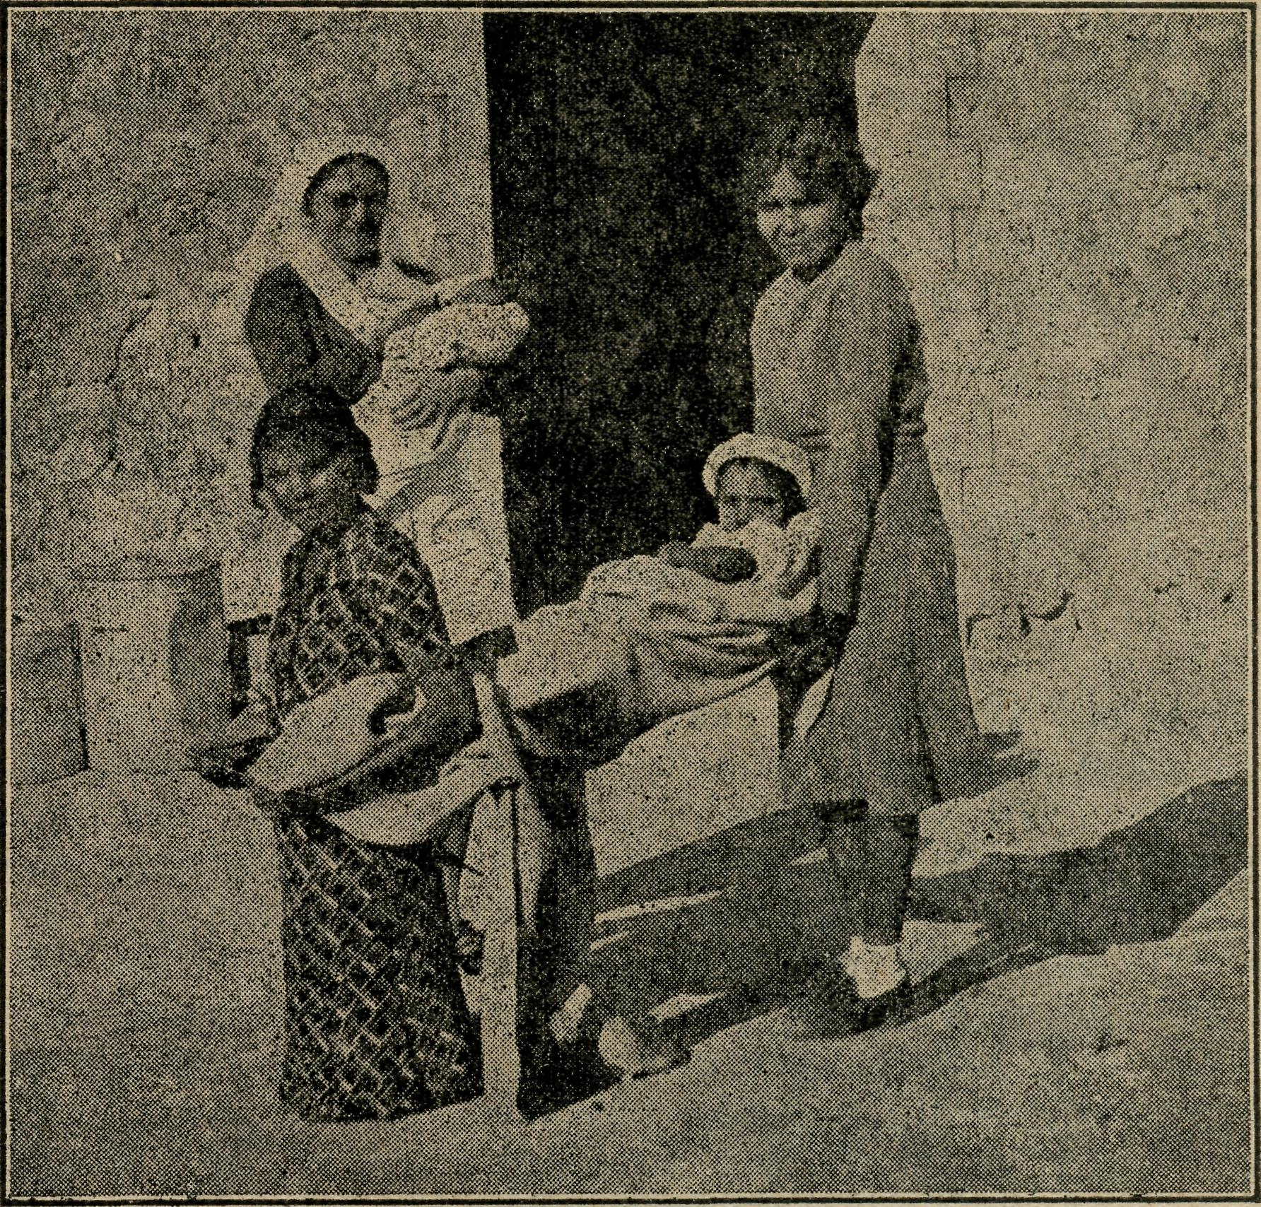
Sister Hitchcock and Patients.
Sister L. Loane.
To most of you who read "The Real Australian" regularly, the work at Koonibba will seem quite familiar, and I feel that there is little that I can tell that will help to make it any clearer to your minds; and yet as it is seen through different eyes, perhaps it will open up new interests to you and bring before you in a new light those of our countrymen who form this little colony here, and who, but for their dark skins and lack of opportunities, are in so many ways like ourselves.
A few weeks spent on the Mission is not nearly long enough to get to know many of the natives; in fact, I rather feel they treat the relieving Sister as a subject of curiosity, and yet it is plenty of time in which to get to know some

March 15, 1944,
The Real Australian.

of their ways. They all come, "both children and grown-ups too," up to the hospital with all their aches and pains, cuts and bruises, and the Sister is called upon to treat everything from a sore toe to a headache, except, of course, when Doctor's treatment is necessary. It is no use to say there is nothing wrong, or it's only a cold, or it will be better in the morning. Oh no ! they must be given some treatment, even if it is only half an inch of sticking plaster or an eye drop. An old chap came in one afternoon after a hot day and said he could not see out of his eye—too sore ! I washed the eye out; how was that—a little better ? But still there was something he wanted—a drop ! Yes, in went the drop, and the cure was wonderful—a bit too wonderful, I think, for I fancy the eye is blind ! However, he went away quite happy. His name is "Skinney Mick." No other name, they tell me !
There is one patient in hospital who is really very sick, and has been for months, but he gets a great deal of interest out of watching all the out-patients go in and out of the theatre. He has a word for nearly all, and generally ^a history, either of the family or case for the Sister. It's really very handy when just about all of the natives, and especially the children, will say is "Yus," etc.
One afternoon a mother came in with her small son. He had been very quiet, and not playing as he generally does. Why was this ? All I could find wrong with him was a bit of a cold, and told her so. That would not do. Something must be done to make him better—what about some "rubbing medicine" ? It was given, and all were satisfied. It seems to me that none of the natives have clocks or watches—or if they have, they don't go. They never know when to come for treatment and when to feed their babies; that is, of course, if they-are doing as Sister says and feeding at regular intervals. So the custom is for Sister to ring a large school bell at the various set times, and then they know to come. "What is that bell ?" "Oh, that's only Violet's bell !" It always raises a smile when these bells are rung, but it's not quite so funny when the one who is wanted thinks it's someone else's bell ! The trouble is there are various other bells on the Station—there is the meat bell, the store bell, the bell for devotions, etc.
From the spiritual point of view, the work is not easy. It is a Lutheran Mission Station, and the natives are all well grounded in the doctrines and beliefs of the Lutheran Church. Many of them are true Christians. It seems to me that it is more by the life than by any words that they can be helped by the Sister, and yet in this we are so often aware of utter failure. Just in passing, I would like to pay a small tribute to Sister Hitchcock, who has so faithfully served the people here for the last six years. It is a very consistent job, because there is no one to relieve, not even at nights, and after a while several calls during the night become very wearying, especially if there is a sick case in or a case in the theatre. Then there is no one with whom she can discuss the cases or the various other problems or episodes that arise in the course of the day's work, and that is a great disadvantage. Sometimes Ceduna rings up, which is a help, but there are limitations to a telephone conversation. The other whites on the station are all very good, but they too have more to do than they can manage, so one sees little of them. Altogether it is an isolated job and, but for the fact of being busy, would be very lonely. And so when you think of the work over here on the coast, will you especially think of and pray for Sister Hitchcock in her sphere at Koonibba ?
Just before closing, I would like to ask for very special prayer for the Children's Bible Class at Ceduna. I know how many of you are interested in it, and how you have through the past offered much prayer for it—and, thank God, it has been blessed. Last year we had the joy of watching one lass of 15 years old come to a living knowledge of the Lord, and now she is witnessing brightly for Him in her own home and surroundings. Her letters are a source of real encouragement, and we do praise the Lord that He has given
us this one soul. And yet the Bible Class was only one of several helps that led her to the Lord, and I feel that we have only been allowed to reap what another has sown. And oh ! I do pray that someone else will reap where we have sown. Just lately the class has been growing smaller and smaller, till at present numbers are very low and interest not great. Why is this ? Perhaps some have gone away to school! Yes, they have, but they are home on holidays now. Perhaps some have gone away for holidays ! Yes, but why don't they come during school time ? Perhaps some have grown up ! Yes, they have, but where are the younger ones ? Perhaps some have grown tired of hearing the message week by week ! Well, then, perhaps they need a new teacher and the Gospel message presented in another way. Will you please pray for them, and for us, that we might be guided as to what is the best step to take to regain their interest and enthusiasm, and to find new members to replace those who have gone away.
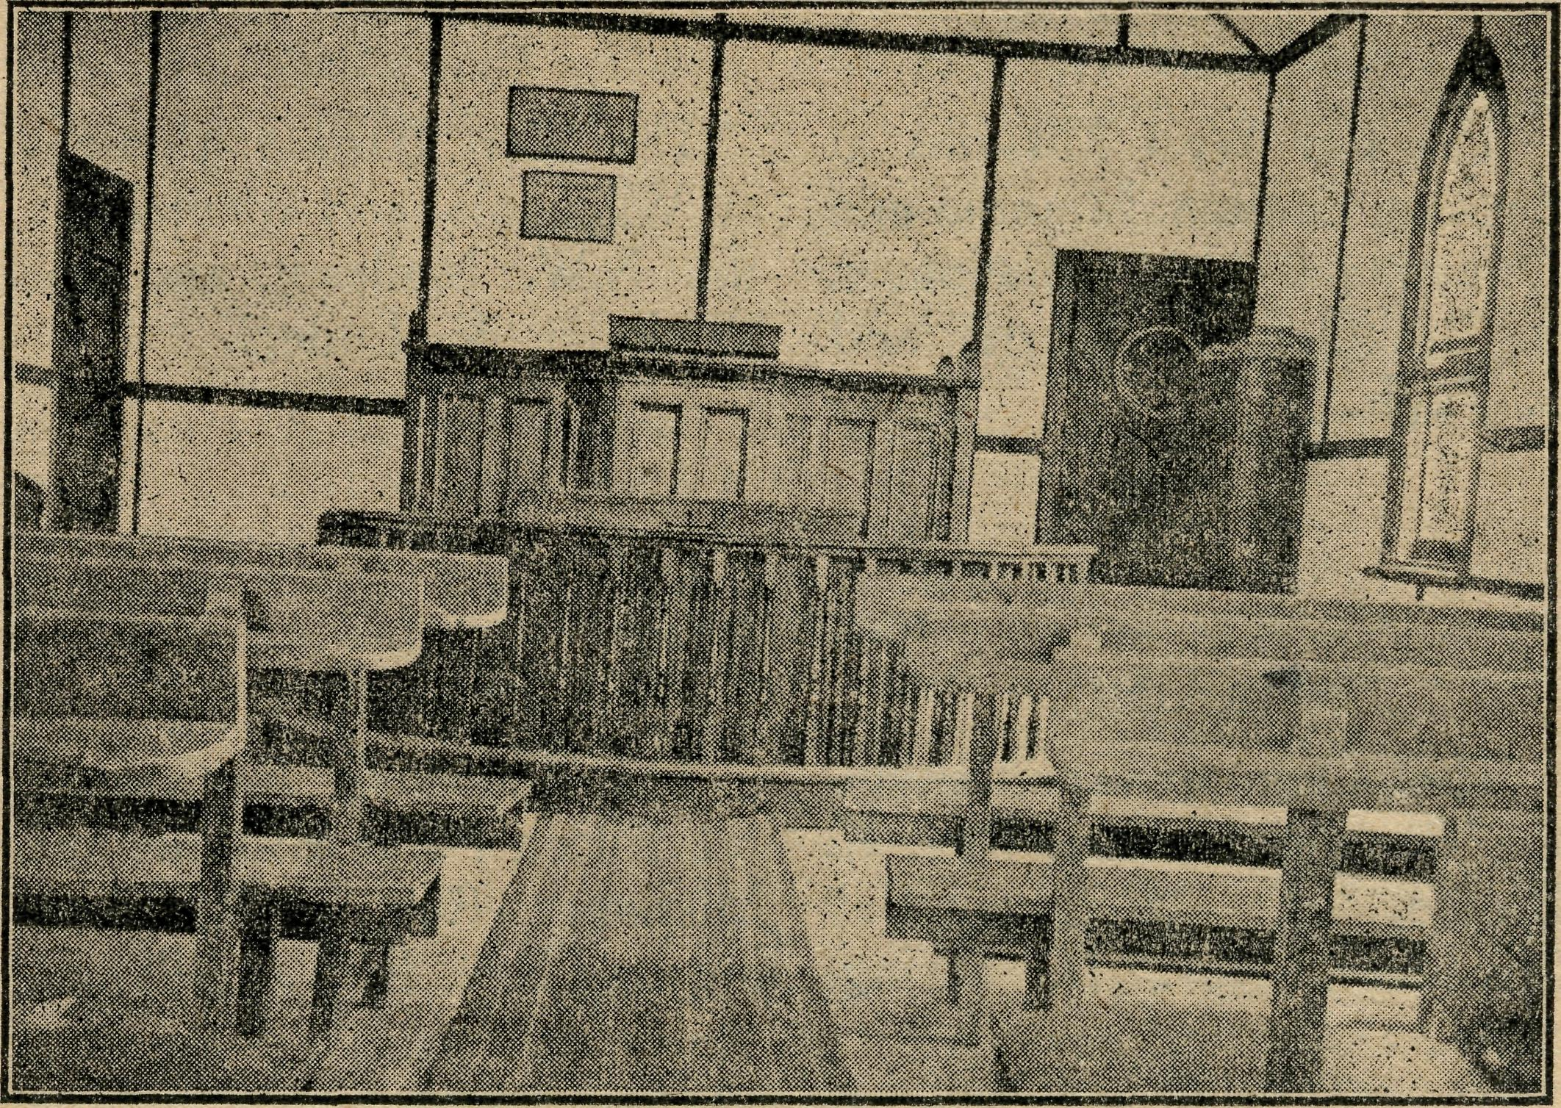
Interior of Tarcoola Church.
COOK'S OUT-PATIENTS.
Sister Pritchard.
Last year, the sixth of the hospital's existence, our outpatients exceeded all previous figures, the number being 1176. You may wonder how it is that we have so many in such a small place, but we get calls from near and far—over an area of 300 miles. This goes to show just how much the hospital is appreciated, and what a boon it is to people along this great East-West Line.
Here are a few of the cases dealt with in the past year. As I was busy at the line one day, a man came running as fast as he could, carrying a child of about six years. The child's face was covered in blood. On examination, I found that he had a nasty gash across his forehead about two inches long and exposing the bone. Several stitches had to be inserted. The wound healed wonderfully, but the child will carry the scar for life on his forehead.
Two days later a boy was brought in with his upper lip split right up, exposing his teeth. He and some lads had borrowed a boomerang from a native, and were trying to throw it. This lad received a nasty smack which temporarily stunned him. Once more needle and cotton set to work I This wound, too, has healed well. A one time seamstress stands me in good stead at these times !
The 'phone rings. A man at Hughes (60 miles west) has cut the top off his finger—could you advise what to do ? This man has been visiting here for some weeks now having his finger dressed.
One night as we were retiring, after a very hot day, the porter from the station called and asked if I could speak

The Real Australian.
March 15, 1944.

THE PLACE OF PRAYER.
A Prayer for Use with Our Prayer List.
O Lord God of our nation, Who has commanded men to subdue and replenish the earth : Look in Thy love upon all those who in the distant parts of our land are striving against many difficulties, and are deprived the access of the means of grace. Strengthen and guide the Bush Church Aid Society and its Clergy, Nurses, Doctors and Air Pilot, and Students. Cheer and comfort them in discouragements and loneliness, and bless their ministrations to the good of those they serve, and grant that the message of redeeming love may thus be rooted and grounded in our national life, to the glory of Thy Great Name, through Jesus Christ our Lord. Amen.

THURSDAY.
EVENING.
The West Darling Missions at Wilcannia and Menindie ; the N.W. Mallee ; and the Missioner, K. Luders,
SUNDAY.
MORNING.
The Far West Missions at Penong, Ceduna, Minnipa and Cummins ; the Missioners, H. Broadley, L. Morris and D. Pugh.
MORNING.
For the Mail-Bag Sunday School with its Gospel message for the children. For the teachers and helpers, that they may find encouragement in their work.
EVENING.
For the Organising Missioner, that he may be strengthened and guided in all his endeavours for the good of the work and in his relationships with his fellow-workers.

FRIDAY.
The Denmark Settlement, the Kirton Point Missions and Missioner, Rev. T. R. Fleming and Rev. R. T. Hallahan.
SATURDAY.
Each day pray that the many needs of the work may be met.
Running expenses of 40/- per hour to keep the Medical 'Plane in the air.
Consecrated clergy missioners for urgent work in the field.
That our work may continue to progress despite the difficulties of wartime.
EVENING.
MONDAY.
MORNING.
The Cann River Mission, the Bonang Mission, Rev. K. Brodie, the Streaky Bay Missioner, Rev. D. Livingstone.
TUESDAY.
MORNING EVENING.
For Sisters Dowling, Page, For the Cann River Dis-
Loane, Branford and Moody pensary and Koonibba Mission
at Ceduna; Sister Firmin and Hospital ; and Sisters I.
Miss Millar at Penong. Gwynne and G. Hitchcock.
WEDNESDAY.
MORNING. EVENING.
For the children in the For the Flying Medical
Mungindi and Wilcannia Service, Mr. Chadwick, and
Hostels, and for the workers, Doctors R. and F. Gibson.
Miss Cheers, and Misses For the wives and families
Gurrier Jones. of the Missioners and Air
Pilot.
MORNING.
For the Bishop Kirkby Memorial Hospital and Sister Pritchard and Miss D. Dykes as they minister to the people on the great Nullarbor Plain. For Sister Bossley and the Tarcoola Medical Hostel.
MORNING.
For the President and Council of the Society, that they may be guided by His wisdom.
For the Home Base Staffs, Auxiliaries, and parochial workers.
EVENING.
For students and all in training for this work of God. For Rev. W. Duffy and the Heytesbury Forest Mission. For Rev. T. H. Pickburn and the Otway Ranges Mission.
EVENING.
For the "Coorah" Hostel and its workers, Mrs. Mann and Miss Harding.
For the Rappville Mission and the' Missioner, the Rev. P. N. Connell.

Give Thanks—
For the rich blessing and wonderful growth of the Society's work. For all the kindly givers who have helped with their self-denials. For the Flying Medical Service. For the joy of service

March 15, 1944.
The Real Australian.

to a man at Reid (150) miles west) who was worried about his child. As we are not connected to the station by 'phone, I walked over and was put in touch with a very worried father. After asking a few questions, I decided that the child was suffering from an overdose of heat, the weather having been hot for six days. Advice was given accordingly, and the father told to bring the child on the first available train if he did not improve. We presume that he did improve, as he has not put in an appearance.
An urgent message from Barton : Could Sister extract a tooth ? I received this message after another scorching day at about 9.30 p.m. The butcher on the "Tea and Sugar" (our supply train) had been suffering from violent toothache. The train was due in at 10.45 p.m. It duly arrived at 11.15 p.m., and I was able to relieve the sufferer, who said he had been in agony with the toothache through the heat of the day. The heat is bad enough to put up with travelling on that train without having toothache.
A little girl of five, years who commences school tomorrow, came down to-day by herself and said, "Mummy said, would you pull three teeth out for me—they are loose, see !" waggling them with her tongue. She sat in the chair as good as gold and let me remove them without a murmur.
A child breaks an arm. Break is set and arm put in plaster, and the child is sent to Port Augusta to have it X-rayed.
Men with cinders in their eyes, a crushed finger, a sprained ankle and numerous other complaints are treated to the best of our ability.
We must not forget our Mothercraft Department. Seventeen babies were born here last year; the majority belong to the town, and, as each mother desires to have her baby weighed each week, it gives us an opportunity to give advice also. So one must be ever ready to help in all kinds of ways, and it is wonderful how we are helped ..and guided to do the correct thing time and again, and we know that we could not do this in our own strength. Pray that we may be guided day by day to help these people whom we contact, not only to heal their bodies, but to draw them closer to Him Who loves us.
CANN RIVER.
Sister I. Gwynne.
On calling at our B.C.A. Office in Sydney recently whilst returning from leave, one was reminded that the next issue of "The Real Australian" was due in March and contributions would be gladly welcomed.
Inspiration ? Yes ! a great word, and a great thing, but somehow it is lacking here just at the moment, especially as regards writing. But by way of inspiring our readers, one must conjure up a few lines.
First of all, it was most gratifying and inspiring to receive letters and papers for distribution, and a donation towards the work amongst children here, from some readers of "The Real Australian" after the last contribution— "Getting About."
Perhaps I could continue on that subject, if it is not wearying to you. A friend of mine intended going to Orbost for the day recently, and asked me if there was anything I wanted. "Oh, yes !" I said. "If you wouldn't mind taking a pair of shoes in to be mended." He very kindly called next morning en route*to Orbost, and I gave him two pairs of shoes to leave at the bootmaker for repairs. On leaving them, the bootmaker said to him, "She wears out a lot of shoes." There had been an epidemic of measles in the district. Only measles ! But measles can be very nasty and very vicious at times; and it proved so this particular time, for it was a very bad form of measles.
Whilst visiting two patients in the one house on the Monday, there was a knock at their back door. "Is Sister here ?" "Yes." Could I come and see baby, please ?—the wound he had has broken out again, and there is a frightful lot of discharge. I called there as soon as I could and
tended to cue wee babe, about five or six weeks old, who had had a very nasty abscess on one hip.
Monday night I was called out to see another case—a very sick man. Measles ! Next morning a car called for me at 5 o'clock and took me to see the case of the previous night—four miles away. Temp. 103 and over. (Here I must explain that that ^case was one of two bachelors who were "batching" on their own selection, and had no one to look after them.) Advised him to go home, where his mother could look after him, and would have been only too pleased to do so, or go to hospital. Both steadfastly refused. Couldn't do that. His father and mother had not had measles previously, and he didn't wish them to get it. However, after tending him and doing all I could, I walked home and saw another man in Cann River village who was pretty sick—but not measles this time. Only 'flu ! He was living alone, so I saw that he had some tea and toast. Then on to see the wee babe again, and dressed the wound; also tended to the mother, who had a swollen leg. Then on two miles in the opposite direction to tend the two other cases, both desperately ill—a child of two and a half years with whooping cough and measles, and grandpa with measles in a- very bad form, bordering also on pneumonia. (Both were later taken to hospital.)
By that time it was lunch hour. So, lunch over, I returned the two miles and saw two other patients who had the 'flu. Then home and just time to have a bath, and then start on the evening round ! Saw the babe again and sponged him and re-dressed the wound, and then tended the mother. Put a plastine on her leg and bandaged. Then walked four miles to tend again the first case of the day— sponge, etc., and see that he was alright for the night. Only twelve miles walk that day, apart from all the short distances to patients near my cottage ! But I was motored home about 9.30 p.m. Next day much the same routine.
Do you wonder that "she wears out a lot of shoes" ! Ah, yes ! but there is joy in ministering. He came not to be ministered unto, but to minister; and we endeavour to follow in His footsteps. And it often happens that one is "ministered unto" as well. I could tell you lots about one of those patients (and how he ministers to others), but perhaps I had better not—for he also gets "The Real Australian," and I would be severely called to task for "telling tales/' even though it would only mean giving honour where honour is due.
But now for something different in the way of travel. We had a very sick woman—an elderly woman—and there was no hope of recovery. Fortunately for all concerned, her last illness was brief; but it meant a lot of nursing and attention for ten days. It also meant a lot of night watching as well as day. Others helped—but Sister was responsible ! Consequently, at the end of that time one felt a little bit "played out"—for Sunday was Just as busy as Monday. As our minister was here from Delegate for the week-end, he was able to take the funeral service on Wednesday morning. It had been suggested that I should return to Delegate with him for a few days' respite. After a lot of thought, I decided to do so and so made hurried preparation. . We started off early in the afternoon. There had been a fair amount of rain during the week-end, and the roads were not the best. At one place we got bogged, but fortunately we were there only a few minutes when the local P.M.G. truck came along from the opposite direction and gave a helping hand and pulled us out.
Then on nearing Delegate we ran out of petrol. Fortunately we had got to the top of a rise, and the driver was able to coast downhill for a distance of about one and a half to two miles. By that time we had reached a house where we were able to get sufficient petrol to enable us to do the remaining two or three miles into Delegate. The "joys" of motoring ! I was treated to a most welcome and refreshing cup of tea and supper, and it was not long before I departed to bed for the night.
And now time hurries on, and I must close—or I shall miss the post.

The Real Australian.
March 15, 1944.

NEWS FROM THE Ml IONS.

SPRINGS AND BRAKES.
Rev. R. Halialian.
We B.C.A. missioners often visualise life in terms of motor cars. So many of our working hours are spent in or under the car that we can be pardoned if, in the course of our hours of reflecting thought, the car and its lessons play an active part.
For the past month "Ophelia" and I have lived apart ! She had to be overhauled, and I had a good rest, rendered all the more enjoyable in view of the anticipated trouble-free trips that were confidently anticipated as a result of the overhaul.
Alas and alack ! the first "country" round of services revealed two weaknesses the mechanics had failed to discover—a weak leaf in the spring, and a weak point in the hydraulic braking system.
We limped home, fortunately having fulfilled engagements, and while "Ophelia" has these attended to I did my best to philosophise.
Buoyance and control ! What a nightmare of a journey if these are lacking ! Every corrugation on the road is a source of irritation, and every down grade and curve a source of trepidation.
How often on the journey of life are we reminded of these twin needs of the spirit ? What a menace is a person lacking either, or both !
What painstaking thought have motor engineers and designers given to the provision of reliable springing and braking !
Can we doubt that the all-wise and loving Father of mankind would fail to provide the best sources of buoyancy and control ? How cheering it is to meet souls who can bear adequate witness to the truth of this provision.
Here are two whom I met "on this self same journey.
A young couple whom I married some years ago. The wife with an affliction that robs her of the full use of her right arm. Two children have been given them, and they are a credit to her.
She and her husband have battled to maintain a farm. The death of one brother and the enlistment of another is responsible for this. Just a few weeks ago, the mother, while inside the home, thought she heard the crackle of fire outside. She rushed out with the babe in arms to discover the weatherboard portion of the house on fire, the husband a mile away up the paddock. Putting the babe and the other child in a safe place, she battled with the flames alone until the arrival of her husband. Her nearest neighbour three miles away.
The major portion of the dwelling was saved, but all the clothes, which had been washed that day, went up in smoke. Sit down and moan ? Not she. She could put the brake on her disappointment and loss, and, after a day or two home with mother, went back to clear up the mess, buoyed up with the spirit of hope that had its source in the knowledge of God and His perfection. She is there at her post of duty, and, if any of the neighbours are unaware of the source of her buoyancy and control, the fault lies not with her, but with them.
It is a sacred privilege to be called to minister to folk like this young pioneering couple, and one just does not dare to give way to the grouching spirit wiien it assails.
STREAKY BAY.
The Rev. D. Livingstone.
Thirty miles from the town of Streaky Bay there is another small port on the shores of the bay called Port Haslam. Services are held there once a month.
When I first went there the services were held in a small school building. The congregation was small owing to the
out-of-the-way situation of the school, and also to the difficulty the adults had in squeezing themselves into the limited space behind the small dual desks. It is not easy to worship with legs stretched out into a narrow passage or bumpin/ against the chin !
After a time an elderly gentleman, Mr. W. G. Lewis, offered us the use of his home. There was an immediate increase in the congregation. The increase continued until the room became uncomfortably crowded; whereupon Mr. Lewis knocked down a dividing wall, and we now worship in a commodious and comfortable room. It is not often that people knock their homes about in order to make room for a church service. Although Mr. Lewis is 83, he still retains the enthusiasm and vigour of youth to a remarkable degree, and takes a keen interest in the welfare of the Church and its services.
Quite a lot of work is entailed in preparing and cleaning up the room, but all this is done very cheerfully. He also renders valuable assistance by playing the organ. He and Mrs. Lewis are an inspiration to both church people and missioner. B.C.A. counts it a privilege to minister to such people.
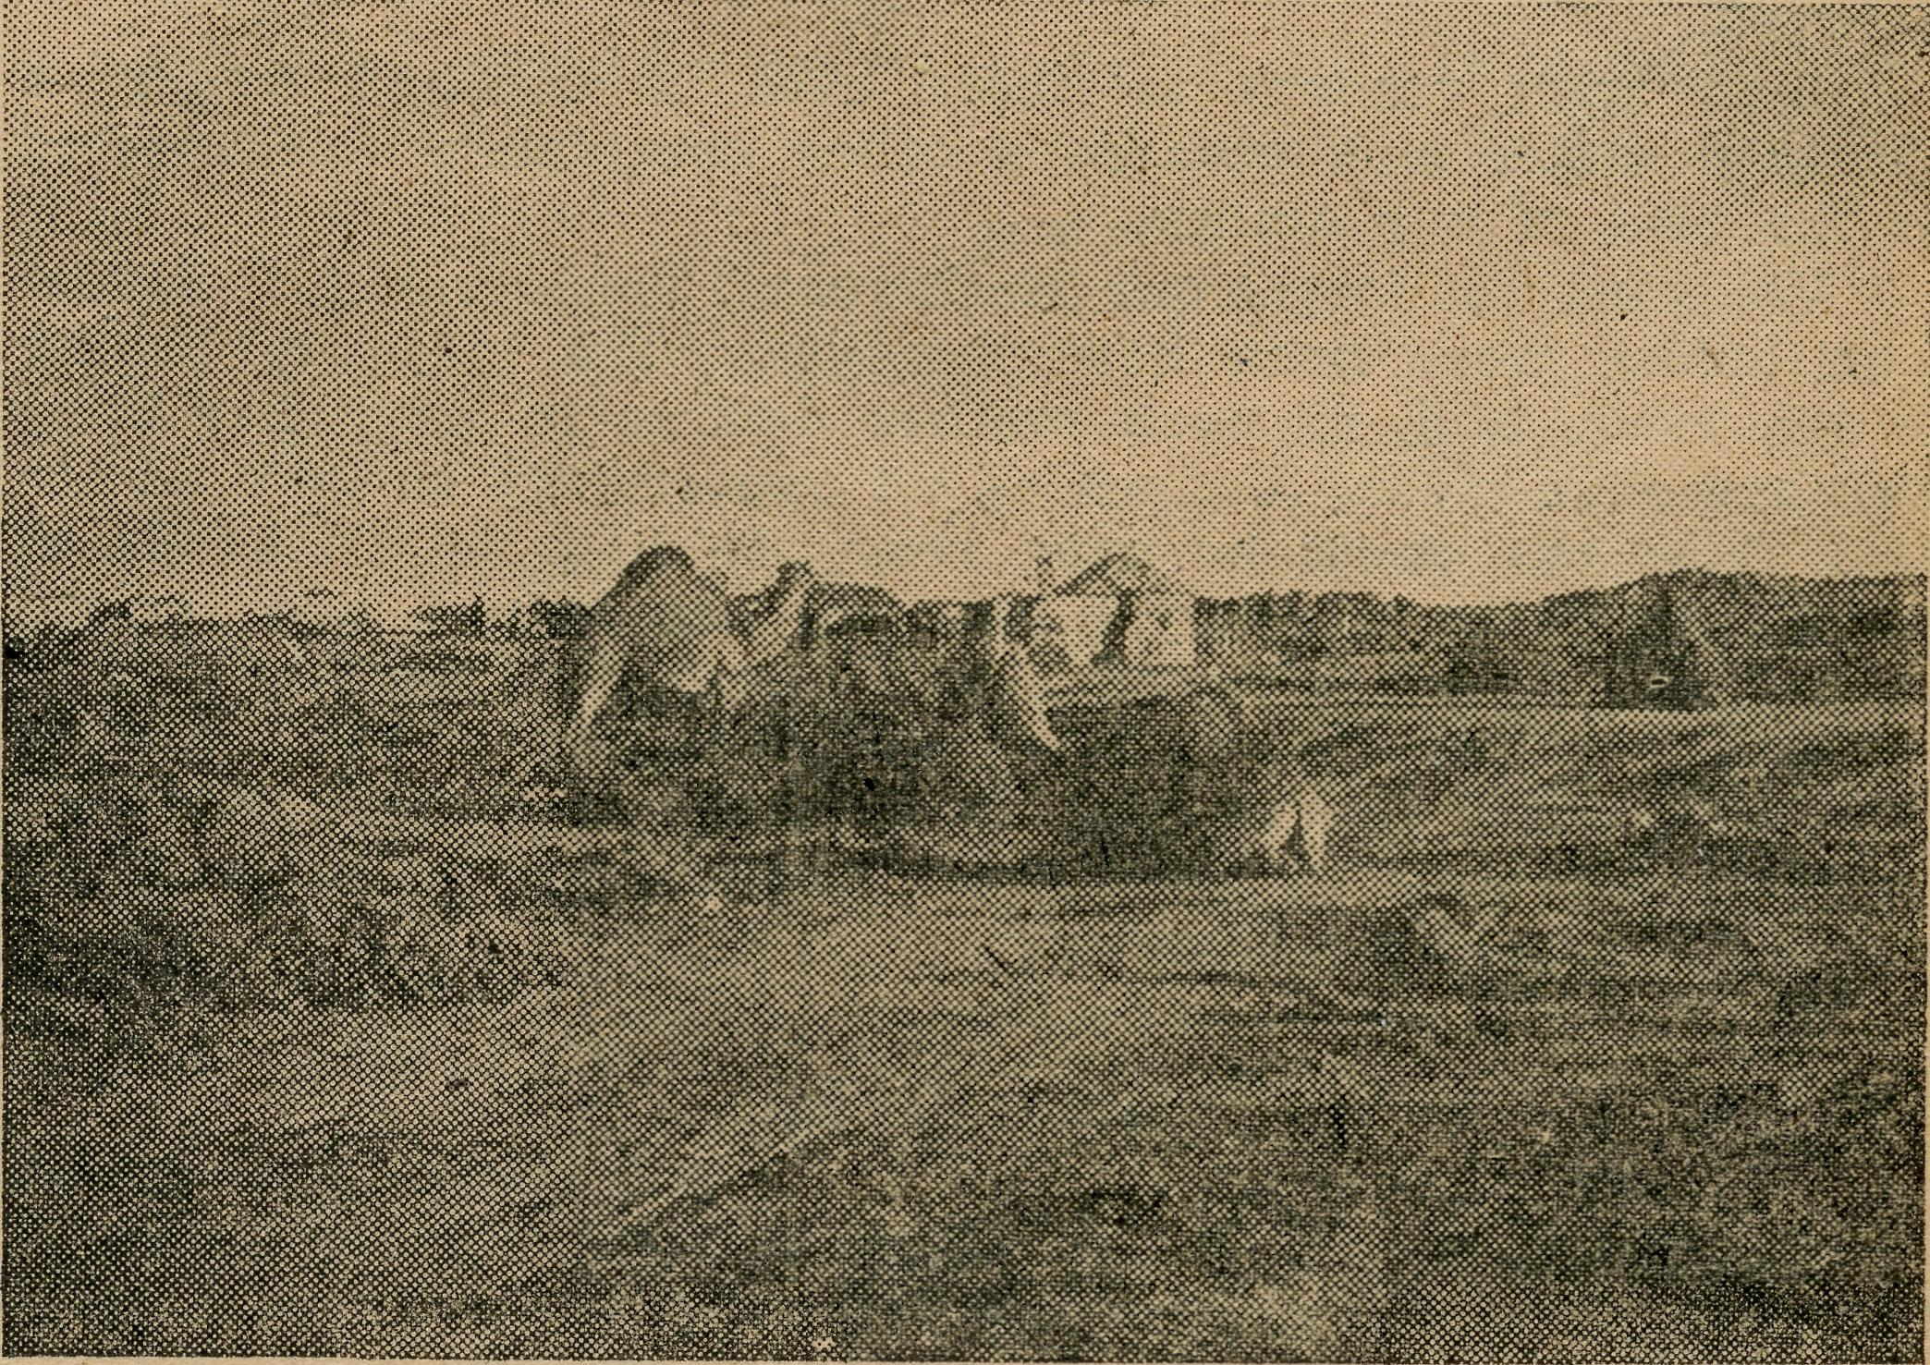
A North-Western Settlement.
BOUNCING A BISHOP IN THE BUSH.
Rev. K. Luders.
The title may not be elegant, but it is truly descriptive, as the present Archbishop of Brisbane can testify. Come to think of it, it has fallen to my lot to give a number of Bishops some rough bumpings. This last lot was, in its way, historic, for the trip round this "most remote corner" was the last to be made by Bishop Halse as Bishop of Riverina. It afforded him the opportunity of peeping in through the back door for a glimpse of his new Diocese of Brisbane. He confided to me that, at that particular part at any rate, his new diocese did not look much different from the old.
This jaunt had been planned three months before, and on the day before departure preparations were completed. Preparations are a bit of a bother these days. There was a time when almost every sheep station would see to it that the clerical visitor set off for the next place with a tank full of petrol. Not so these days. Petrol is available at only a limited number of places, and it is not wise to depend upon getting any considerable quantity at many of them. To buy fuel in bulk one has to obtain a permit from the local policeman—first locating that gentleman. With fuel, water,

March 15, 1944.
The Real Australian.

oil, tools, spares, bedding, tucker box, shovel, axe, lantern and slides, books and personal belongings stowed away, I skipped down to Ivanhoe to meet the Bishop. He alighted from the "Silver City Comet" dusty and train-weary, and showing signs of suffering from one of the worst colds he could remember having. We both wondered (without telling each other) how travelling "out back" would affect him.
After a service in the local Presbyterian Church building, with the congregation, we retired to the local cafe for supper. There the official farewell was held with a friendly and cheerful little gathering. Next morning, after an early Celebration, the tour really commenced. The programme was a full one. We started fairly early and kept going, making only one call on the way to Wilcannia—a shocking lack of economy with petrol and rubber in times like these. Still, it was unavoidable.
At Headquarters there was a Confirmation Service, at which two very promising lads were made full members of the Church. Later, a basket supper and farewell in the Rectory. (If there appears to be a too plentiful sprinkling of farewells, please remember that these centres are from 60 to 150 miles apart.)
Next morning, looking towards White Cliffs, whither we were bound, I saw heavy dark clouds lowering. Ominous rumblings were to be heard. A bad beginning, if not a bad trip, seemed indicated. It was all a false alarm. Nothing untoward happened on this leg of the journey. At "The Cliffs" certain arrangements had to be made, and some business transacted on behalf of a hospital inmate. After that, we pushed on to a station for lunch. The track led north, and as we travelled it a good number of cars passed. Most of the dwellers along this road were going into the "Opal Town" (it now has 17 buildings standing, and half of them used only occasionally) for a dance to be held that night and a gymkhana and dance the next day. As a consequence, there were only two places where the callers were welcomed.
One spectacular sight seen on the way to that night's camping place was a grand dust cloud. On the far horizon columns of dust were sweeping up into the air to feed a mighty billowing cloud. On our side the cloud appeared red—rusty red, the same as the dust hereabouts. But on the side furthest from the sun it was a glowing and splendid purple. How majestically it rolled along! And weren't we glad it missed us ! The worst we got was to be submerged by one of the tearing, swishing columns. At times the track was blotted out and the car had to be stopped. Dirt was in our eyes, ears and teeth, and up our nostrils. The driven sand stung the unprotected parts of the body hard enough to cause considerable discomfort. But it did not last long. Petrol line blockages and a washed ou^ stretch of track slowed us down, so that it was not till 9 p.m. that the homestead was reached. On the way we were treated to some brilliant displays of lightning.
How warmly we were welcomed, even at that inconvenient hour ! Our needs were amply provided for. It was luxury to have a shower before retiring—much later. This particular place is served by mail lorry, once a week when things are normal. Some time before, the family had been cut off from the rest of the world for six weeks. There is no 'phone connection and no pedal wireless. For medical services and such, the family goes, not to Tibooburra, nor to White Cliffs, but to Bourke. At the time of departure next morning, our hostess gladly accepted some literature and pictures for the growing family.
The next landmark was an out-station next to a small lake, made larger than usual by recent local downpours. Numerous wild fowl fled with clackerings and squawkings when the car suddenly appeared. We met and talked with an old boundary rider who was "home" doing his weekly "laundering."
Nine miles further on was a telegraph line and a well-beaten track. The trouble was to get to them over not-very-well-known country—a stretch that is notoriously bad. The very first attempts to circle a half-filled clay-pan brought
disaster. Dry sand, blown over the softened clay, hid the .danger, and before we knew it the car was axle deep. Winning free at last (easily said and read, but not so easily done), we tried the high ground, but that, too, was deep with sand. Nothing was left but to make a 20-mile detour, and then to press on for our destination. This meant at one stage traversing a road eroded into irregular, sharp, yard-deep valleys. The car squeaked and groaned. The seats seemed extraordinarily hard. The Bishop qualified to ride the worst of buckjumpers ! At another stage the track was the stoniest imaginable. Large and small, smooth and sharp, these stones rocked the 'bus and popped from the tyres with small explosions.
Arriving only ten minutes after the appointed time, we learned that the service at Tibooburra was to be postponed until later in the evening. This suited very well. It gave time for a wash and brush-up; we did not bother about feeding. And "bother" means bother. Here there is only one place to obtain meals—the hotel. When sittings are finished food is "off." Demanding food at odd hours puts an overworked staff to great inconvenience.
At the service there was a record congregation of 31 I A visit by a Bishop demanded special efforts. Some old church furniture had been resurrected and, if I remember rightly, a vase of flowers graced a table. What really mattered was that the spirit was right. Plans were to give a lantern show for the children in the Court House while their elders danced in the Hall. But as a Hospital meeting at the Court House was in session so long, the show was abandoned. Not having eaten for six hours, we were "peckish," until a Hospital Sister, learning of our plight, treated us to supper.
Next morning we had early Communion before setting out to visit two prospective confirmees who, everyone had hoped, would have been at the previous night's service and been confirmed. They were members of a family living in Queensland, in the Diocese of Brisbane. Due to the state of the track and the need to make calls en route, it was not possible for us to fulfil our mission, so, after popping in through the back door of the Brisbane Diocese, we returned to Tibooburra to give the promised lantern show and hold an informal service.
Skipping a great deal that, though useful, does not make interesting reading, let me say that the next evening we had tea at a place that, not so long ago, was locally famous for its splendid roses. Here there were some wonderful blooms to be seen. The manager at this place kindly rang a neighbour, who sent by pedal wireless ("transceiver" for short) a message to forewarn our intended hostess of our pending arrival. Daylight was fading and tracks were hard to follow. Shooting round a bush, the car came to a sudden stop. It was propped up on the "diff" housing, with both back wheels suspended over holes from which the wheels of a bogged lorry had been dug out. Approaching a creek, we picked out way like black trackers and arrived easily and safely on the other side, opposite a house. "Who showed you the way across ?" the menfolk demanded. "We followed your movements by watching the lights." When we said, "No one," they were incredulous.
At the next stop, where a sick man was visited, we were gravely warned about the difficulties of negotiating Turkey Creek. We resolved to be careful. Crossing a smaller creek, the driver was too careful and had to do a good deal of shovelling for his pains. Turkey Creek presented no difficulties whatever. The number of times I have been stuck where I should not, and have not been stuck where I should, is truly amazing.
At 11 p.m. our intended hostess decided that her neighbours had persuaded us not to try crossing the creek, and she and the household had gone to bed. (By the way, these creeks have in them, not water, but sand.) At midnight, when the dogs barked their welcome to us, the billy was set boiling again. Next morning we had a most delightful family service of Holy Communion. After breakfast the

The Real Australian.
10
March 15, 1944.

Bishop demonstrated the handling of a model "T" Ford as it was done "in the good old days" in Queensland.
Well, there were a couple more calls before we pulled into White Cliffs once more. The local Church members did not advise me that plans of any sort had been made, so during the service I said farewell to the Bishop on their behalf. An anti-climax came with the announcement made later that a community supper was prepared in one of the homes. And a happy supper party it was too ! After that we ran straight home to Wilcannia. After next morning's service, the Bishop said he was so much improved he had almost forgotten he had had a cold—he "believed it had been bumped out of him !■"
Most of the day was taken up overhauling the car and preparing for the last stage—the trip to Menindie. There, next evening, following a service, there was yet another farewell supper. The following morning, after a quiet service and a visit to the school, a very much "bounced" Bishop, for the last time, boarded the train at Menindie station.
And the next morning I "slept in" I
CHRISTMAS IN THE FOREST.
The Rev. W. Duffy.
I have just arrived back from Portland after having spent a fortnight at the Clergy Rest. On my return I found a letter from the O.M. asking for some news for #The Real Australian." As I wrote an article for last issue, I think I will content myself by writing an account of the Christmas services in this part of the Bush Church Aid field. Before doing that, I would like readers to know that up to the present we have not suffered like the rest of the Western district of Victoria as the result of fire. The suffering caused by the fires to human beings and animals is almost beyond comprehension. As copies of this paper find their way to other parts of the world, I would like to bring to their notice the extent of the damage done. Thousands of square miles of country have been swept, hundreds of homes burnt and 21 lives lost. When you add to this the loss of approximately 3,000,000 sheep, besides cattle, you can get some idea of the extent of the damage. All this took place a few miles from this Mission district, so we count ourselves very fortunate to have escaped. The next month may see the same things happening here, as the season has been an exceptional one, and manpower is very scarce.
Now for a run around the district for our Christmas services. As Christmas Day fell on Saturday, it made it easier to give all centres a service. Some had a service on Saturday, some on Sunday, and the rest on Monday. I was indebted to my neighbouring Vicar, who came over and held a Celebration in the Cobden Parish Church at 9.30 a.m. This allowed me to spend all my time in the Forest. I was awakened at 5.15 a.m. by the alarm clock, as my first service was at Peterborough (32 miles away) at 7.30 a.m. I left the Vicarage a few minutes after 6 o'clock, arriving at the little Presbyterian Church by the sea at 20 past 7 a.m. There I found twelve people waiting to malje their Communion. What a lovely service it was, too !—the roar of the Southern Ocean rising above the music of our lovely Christmas hymns. After a hurried breakfast at the hotel, I made ready for my next service. It was Curdie Vale, about ten miles away, where again the Presbyterian Church was used. As I went into the little church, I found a beautifully decorated Christmas Tree and a huge star there. I found that the Lutheran congregation, had used the same little church the evening before for their Christmas service. After this service, where most of the congregation had come at least three or four miles per horse, I made my way back to Cobden (30 miles away) for my Christmas dinner.
Next morning, Sunday, found me Celebrating in the Parish Church at Cobden at 8 a.m. At 9.30 a.m. I was at Port Campbell (25 miles away), and at 11 a.m. at the Methodist Church at Timboon (10 miles away). After lunch,
another 8 miles to Scott's Creek for 3 p.m., and then home »11 miles for 7.30 Evensong.
Monday morning found me at the Cooriemungle Prison Camp, 25 miles away, for service at 9 a.m. This was followed by a celebration of Holy Communion, when one warder and six prisoners received the Sacrament. It was inspiring to hear the prisoners singing those lovely hymns, and also to feel the sacred atmosphere in that mess-room. There was no doubt of their sincerity as they knelt on that har floor ! Another trip of 23 miles brought me to Princetown, where we had a Celebration in St. Luke's Church. This is our only Anglican Church in the whole district. After lunch at Princetown, another 23 miles back to the Prison Camp, where I had been invited to help judge the sports the prirsoners had arranged. After tea, I had the honour of presenting the prizes to the placed men. I had been given the task of buying these prizes, which consisted of i lb. butter and 1 lb. of cheese for each man. A little tobacco and a box or two of matches made up the rest of the prizes. After all this I set me for home, 25 miles away, arriving home very tired at 11 p.m.
Now why do I write in this way ? It has not been to show how many services I took, or how many miles I travelled. It is to let you,decide for yourself whether the work of the B.C.A. is worth while. I can safely say that, except for the B.C.A., not one of these services would have been held. On one side, we have 300 miles travelled; nine or ten services at small centres; about 130 persons contacted. I will tell you two stories of this trip.
The first about a prisoner aged 21. During the service before the Celebration, I told them of the birth of Christ and why the Christmas Communion meant more to Christians than Christmas dinner. This lad come to me before the Communion and said : "I am not confirmed, Mr. Duffy, but I want to be. Do you think I could come to Communion ? My mother would be so pleased !" He was allowed to come.
The other story comes from that early little service at Peterborough. This centre is a small holiday resort, and sometimes many visitors attend our services. One visitor asked me how many miles I had come at such an early hour. When I told her over 30 miles, she paused for a moment and said, "It's a long way"; but when I tell you something, I think you will say that it was worth it? She said : "My husband is in the Air Force abroad, and has been away for the last four Christmasses." She told me where he had made his Christmas Communion the previous years—always in battle areas. She told me that a few months ago she received a letter from him saying that this year, if everything went well, he would be making his Communion at Calcutta Cathedral. He said, "I will be very close to you in that Communion"; and she said to me, "I have been very close to him at this Celebration this morning." Thousands of miles apart, yet so close !
I know myself that to give her that great joy was well worth the little inconvenience I suffered.
Do you think it is worth while ?
MINNIPA.
Rev. L. Morris.
I sometimes think that the children are the ones who have most to put up with in the saprsely settled parts of our great continent. True it is that they don't seem to worry about it at all, but nevertheless they suffer many disadvantages in comparison with their city brethren. They often grow up without any companions of their own age; primary education is frequently attended by serious difficulties, such as travelling lengthy distances under the full blaze of a typical out-back sun, and then "stewing" all day in a box 15 feet square called, for want of a better name, a school. Secondary education is sometimes impossible, and, where possible, it means separation from home. These difficulties in the secular sphere are paralleled in the religious,

March 15, 1944.
11
The Real Australian.

for the education of the children in spiritual matters is one all too frequently neglected for want of opportunity.
I am allowed a half-hour each week in each school for religious instruction, but of course in such a scattered district I would need a helicopter plus an unlimited supply of petrol to do even a fair proportion of them in the time. It works out, under present circumstances, that I can do each school once a month, and then, of course, I must take all the classes in one. As I am the only clergyman to visit most of these schools, you will see that there is very little instruction given.
This is being partly overcome by the use of the B.C.A. Mail-Bag Sunday School lessons. When I go to school now I take with me the lessons for the various grades for a month. The children there and then do the first lesson, and I leave the rest with them. Next month when I call I have four lessons to collect and correct, and four more to set. This system is not ideal, but it is helping a great deal, and for the most part the children are quite keen. They like the lessons, and many have done good work. Quite a few of the parents have expressed their appreciation, and have spoken of the benefit their children have received.
There has been a certain bother in getting some of the necessary materials. I couldn't obtain plasticine or crayons for a time, and my thanks are due to many good B.C.A. supporters who sent along supplies. I take this opportunity of letting them know that I have no need of crayons or plasticine at present. I still lack Bibles, however, and I could find a good use for sixty more. So if you happen to have a Bible you can spare, I should be very glad to receive it.
Over the war years the population of these districts has tended to become smaller, and, although there has been little movement for some months, it seems to be starting up once more. Again good Church families are leaving the district, making it still more difficult for the witness of the Church to be maintained. Nevertheless, we are confident that as God has blessed us in the past He will continue to be with us in these present difficulties.
ST. THOMAS' WOMEN'S AUXILIARY, MOONEE PONDS, VICTORIA.
Summary of Activities During 1943.
Although we have not grown in numbers, the enthusiasm of members has been maintained and quickened.
Our special efforts during the year were an Australian Tea at the home of Mrs. Mark Brown in April; a Lantern Lecture in the School Hall in May, at which we had the pleasure of Rev. T. Jones' company; an Australian Tea in July at the home of Mrs. A. Rettick; a Sale of Work organised by Mrs. Tregea at her home in September; and our Thank-offering Service in the Church in November, followed by social intercourse at the home of Miss de Gruchy, At the Thank-offering Service we were pleased to have the Rev. A. C. Donnelly to give the address, and we wish him well in his new work. As a result of all these efforts we have been able to provide a Glyda chair and bedspreads for Sister Hitchcock at Koonibba; a diascopic set, two sets of enamel dishes, etc., and six teapots for Penong; £25 towards general funds, and £5 to the maintenance of our cot in Penong Hospital.

POST AND RAILS.

Congratulations to the Rev. and Mrs. Broadley, of Ceduna, on the birth of a daughter.
# * * # # * '
The Rev. John Greenwood, Curate of St. Clement's, Mosman, and a trainee of B.C.A., leaves Sydney towards the end of March for Ceduna. Mr. Broadley has had an almost impossible task seeking to minister to both the Ceduna and Penong areas, and Mr. Greenwood's advent will enable the work in the West Coast Mission to be more efficiently done. We welcome Mr. Greenwood, and wish him well in his new sphere.
•J* »ji ^f» «^> »j# ^^
Since our last issue we have said "Good-bye" to Sisters Edgar and Warner, both of whom came to us to relieve at a difficult time. We are grateful to both, and appreciated their work and fellowship.
# # & * 3; #
Sister Branford is back again at Ceduna, after completing her obstetric training. Sister G. Moody, who commenced as a probationer at Ceduna Hospital, is now on the staff. We welcome both, and pray they may be happy with us.
$ # ^ %• ^ #
Mrs. Marshall, of Rockdale-Bexley, came in as usual at Christmas time, bringing with her the sum of £18/10/6 which she had collected from her friends. We are grateful to Mrs. Marshall for her continued interest and enthusiasm for B.C.A., and to her friends who for so many years have supported her in her work for B.C.A.
# ^ s& # * *
We extend our congratulations to three of our missioners who have recently distinguished themselves in the academic field when carrying on their big jobs. The Rev. L, Morris recently secured his London B.D. with first class honours, while the Revs. H. R. Broadley and D. Livingstone passed the examination for Comparative Theology for Th.Schol.
•^ t^< »J* *£t *ji «J#
We regret that unavoidable understaffing was responsible for the Matron of Wilcannia Hostel spending the whole
vacation as a patient. Miss Gurrier-Jones was unable to get back to Wilcannia on time for the Hostel opening owing to the condition of her health.
Unfortunately, all our hostel workers, as well as nurses, find themselves in the same state of affairs. It is deplorable that in these days, when there is so much talk of a new order after the war, more of our people do not realise that the world can only be made better as we individually are found ready to serve in Christ's ministry here and now. Here in hostels and hospitals of B.C.A. is an opportunity to bring about God's order in the lives of our young people. It may be that the need of the "heathen" in far off fields has the more appeal, but our own people need God too. Let's talk a little less about a "New Order" and do a little more. Any volunteers ?
We welcome the Rev. D. A. Pugh and his wife to Cummins. They have taken the place of Mr. and Mrs. Fleming, and we wish them much blessing in their work.
We are grateful to Mrs. Richards, ,of Bellevue Hill, for the generous gift of £41 towards the cost of furnishing the new Hostel at Port Lincoln. Mrs. Richards collected this fine sum by the sale of her own work at Christmas time.
FOOLS!
It has been the fools who have really saved the world. The respective generations to which they belong misunderstood them, laughed at them. Their friends as well as their enemies stood up to condemn them, and somestimes to destroy them. But time always vindicated them, and later generations realised their worth.
Pools have been the salt of the earth, shaming us out of our worldly-wise but carnal policies and saving us from a selfish materialism. Not that they found us easy to teach or willing to respond. Frequently they were compelled to go down to the depths of foolishness—even to death—to convince us of our error. The pity of it is that we let them

The Real Australian.
12
March 15, 1944.

die and scoffed at them for exhibiting themselves as such fools while we still entertained our notions and hugged our delusions. But the world was saved. Truth was kept free, and love inviolate. The fools have rendered us that service.
Think of some of them ! At once there springs to our mind the Master, even the Lord Jesus. Contemporaries judged Him the greatest fool of all. Interpretated in terms of the wisdom of this world, His life was a failure, and His submission to death utter foolishness. Yet in that life, yea, pre-eminently in that death, there was the world's redemption. We had perished, morally, socially, spiritually, if He had not died. And He stands at the head of a wonderful succession, a succession of men and women who live in our affection and undying esteem because they hazarded everything and made themselves fools for His and (shall we say ?) for our sake. There is Paul, who abandoned the prospects and pleasures of this life and gave himself to arduous travel, unremitting toil, ceaseless ministry, and eventually to a malefactor's death. There is Francis of Assisi, Savonarola of Florence, the ever-glorious martyrs of the Reformation— Cranmer, Ridley and Latimer—who died at the stake, and noble souls like Livingstone and General Gordon. Judged by the standard of this world, they were fools, and doubtless were often stigmatised as such. Yet they live on in a rich and wondrous immortality of true fame, while others, their contemporaries, calculating and designing, are forgotten or despised.
And women also belong to this holy band of whom the world has not always been worthy. Two sisters of the New Testament story will always be remembered for their utter foolishness, and yet for their real value. One is the poor widow of Jerusalem, •who, in giving to the work of God, gave "all that she had, even all her living," sacrificing as it were not only her income, but even her capital. The other is Mary of Bethany, who incurred the censorious criticism of those of superior wisdom because she made sacrifice to her Lord and Master and counted not the cost. Of course these were fools ! They were all fools, but would to God that we had more like them in these present days.
For Australia stands in sore need of daring souls who are prepared to withstand popular opinion, to risk all that they have and all that they are, to sacrifice worldly prospects, even to be crucified. We need them in the special ministry for the distant bush. From the Church there has gone forth a succession of men who have left behind the comfort and fellowship of the city, the pleasant prospects of ministry in the eity dioceses of Australia, in order to give service in some of the most difficult and depressing areas of Australia. Perhaps some of their companions have called them fools, and perhaps such they are; but they are "fools for Christ's sake." I only hope that others will follow in their train, that men in the ministry in the capital cities will courageously face the issue and ask themselves, "Does God want us at the outposts and not at the citadel ?" I ask young men in training at our Universities and Theological Colleges to think the matter out. To give a few years to service in the Far West may mean a sacrifice, but it is worth it all.
The young women of the Church have a responsibility in this matter. Bush Nurses and Deaconesses have wonderful opportunities for expressing the love of Christ in terms of real and worthwhile service.
Surely if the mothers of men are prepared to go out into pioneering areas and suffer hardship and isolation, their sisters, who have been touched by the Spirit of Christ, will not hesitate to go out and minister to them. It means much, I know—madness some will call it—but it is always worth while being a "fool for Christ's sake." Moreover, it is only in that way that Australia will be rerdeemed. Pleasure, materialism, fripperies of modern life, the unreality of things curse us at the present. The only thjng that will save us is a spirituality that will count all things but loss, that will refuse to acknowledge the world's standards, that will keep the way of the Cross.
Therefore I would appeal to the youth in Australia for daring self-sacrificial service. In our own particular work
we want men who are not afraid to be unconventional in their ministry, men who can stand a scoffing laught as well as a cynical sneer, men who will put God and His ministry absolutely first and everything else last. We need women as nurses and hostel workers who will look upon this work as a channel of Christian service, not simply as a means of securing a salary. There is a tremendous amount to be .done even yet amongst our folk out-back. It can only be done by those ready to make real sacrifice. To sum up, we want men and women of vision, venturesomeness and vim; of vision as those who have seen the challenging Christ; of venturesomeness, as those who will hazard their prospects and their lives for His sake; of vim, as those who will rest not day or night to carry out His will. Of course, such will be fools; but what of that ?
LADY DUGAN HOSTEL, TARCOOLA.
Cases Treated from January 1, 1943, to December SI, 1943.
In-patients .... .... 6
Minor Operations (local anaesthetic) 16
Mothercraft Visits .... 126
Out-patients 860
MURAT BAY DISTRICT HOSPITAL.
Summary of Cases Treated from 1st January-31st December,
1943.
Surgical.... 179 Medical.... 101 Midwifery .... 43 Total.... 323
Operations, 102. General Anaesthetics, 49. Out-patients, 154.
X-Rays, 30. M- aercraft Visits, 303.
Total Number ^Nursing Days, 2198.
PENONG MEMORIAL HOSPITAL.
Summary of Cases Treated from 1st January-31st December,
1943.
Surgical.... 54 Medical.... 110 Midwifery .... 13 Total.... 177
Operations, 21. General Anaesthetics, 13. Out-patients, 166.
Mothercraft Visits, 33.
Number of Nursing Days, 705.
SUBSCRIBERS WHO HAVE NOT RECEIVED RECEIPTS.
"Real Australian."—Miss E. M. Hodges, Mrs. O. Leech, Mrs. Jack Mudge, Lady Stevens, Miss M. Parsons, Mr. R. H. Lack, Mrs. E. Hoad, Miss J. Flatt, Mrs. A. T. Percival, Mr. and Miss Were, Mrs. Finlay, Miss Goodshaw, Mrs. Todd, Mrs. Russell, Miss Miller, Mrs. J. de Frederick, Mrs. F. Malone, Miss Davies, Mrs. Forster, Mrs. C. Drury, Mrs. Dalton, Mr. A? M. Dreher, Mrs. Pollard, Miss I. Whelan, Mrs. Lethbridge, Miss M. Rhodes, Miss M. G. Thompson, Mr. G. J. Allen, Mrs. Dunbar, Mr. W. H. Best, Mrs. M. Walker, Mrs. Miller, Mrs. Rendle, Mrs. Dougherty, Miss D. Rogerson, Miss Bennett, Miss A. Lee, Rev. Canon Batten, Miss Monckton, Miss Audley, Mrs. Seedsman, Mrs. A. W. Noble, Mrs. W. Aumann, Miss Kinvig, Miss Carleton, Mrs. R. H. Green, Miss R. B. Hill, Mrs. J. McCrea, Mr. W. Gearing, Mr. H. Curtis, Rev. G. Stirling Home, Mrs. W. Johns, Miss Zeis, Deaconess Gibbon, Mrs. Laugher, Mrs. L. F. Poole, Mrs. Piper, Mrs. Muir, Mrs. Duke, Mr. E. G. De Breton, Mrs. Minns, Mrs. Rose, Mrs. J. C. Rogers, Miss Barrowclough, Mrs. E. Noonon, Miss A. F. Harris, Miss E. Longfield, Rev. J.* H. Willcoxson.
Anonymous.—7/10/43, 10/- Anon.; 8/10/43, £5 Anon.; 13/10/43, 2/- "An Interested Listener"; 3/11/43, 10/- Anon.; 5/11/43, 2/- Anon. Hurstville;, 1/6 "R. A," 3/6 Xmas Anon.; 26/11/43, fl Anon.;. 1/12/43, 5/- Anon.; 2/12/43, 2/- Xmas Anon.; 6/12/43, "Mrs. S.," Rockdale, 5/- Anon.; 8/12/43, 5/-Anon. Helensburgh, £1 Anon.; 10/12/43, "A.Y.Z.," 10/- Xmas; 14/12/43, 1/6 "R. A.," 3/- don. "Florence Brown"; 15/12/43,

March 15, 1944.
13
The Real Australian.

5/- Xmas, Anon. Dulwich Hill; 20/12/43, 10/- Anon. Narra-been; 20/12/43, £1 "M." Anon., 4/6 Xmas Anon.; 21/12/43, 10/-Anon.; 22/12/43, 10/- Xmas Anon.; 29/12/43, £2 "M.M.P.," Tasmania; 24/1/44, 6/- Anon.; 4/2/44, 10/- Anon., East Kew; 7/2/44, £2/10/- Anon. Ashfield, £1 "A Wellwisher"; 11/2/44, £1 Anon.; 17/2/44, £2 Anon.; 25/2/44, 5/- "L.M.," Neutral Bay; 28/2/44, Subscriber, 11 Little Street, Mosman, 10/-.
A NEW WORLD ?
The Rev. Tom Jones.
The other day I noticed an advertisement in one of the daily papers by a maker of household electrical appliances.
These days, with shortages of so many things and the impossibilities of buying others, it would appear useless to advertise such articles. But the makers realised that they would need to sell their goods after the war is finished. The advertisement therefore read, "Save to buy an all-electric kitchen after the war," and the illustration which accompanied this exhortation showed a happy housewife in the midst of her electric range, iron, jug, vacuum, washing machine and ironer. It appeared that, once she was able to buy all these things after the war, she could take each afternoon off and go to the beach. In another paper I noticed that it was stated that in the new homes to be built in Australia when peace comes, it is thought that most of these modern and labour-saving appliances will be built into new homes for as little as £70.
Well, now, that's going to be very nice—if it comes to pass ! I am sure those of you who are housewives will save hard to get that extra £70.
I suppose by this you are saying to yourself, "What has this sort of thing got to do with B.C.A. ?" My reply is, "A great deal."
All these things are going to help you live easier and happier lives. They will give you more leisure and better health—save you from unnecessary strain and give you a chance to enjoy life and your family.
To obtain these things two essentials are required—the money to buy them, and the convenience of electricity in your home.
The first essential is possible to most people if they save hard enough; the second is governed by the locality in which you live.
Now come with me to South Australia and the Nullarbor,. and visit some of the housewives who live at Cook, Tarcoola, Forrest, Deakin or Hughes. We will take some of these wonderful electric things with us—jugs, washing machines, refrigerators, etc. When we get there we will find that it is impossible to give them away, never mind sell them— because these people have no electricity to make them work. Yet they would like the same opportunities as you now or will possess to improve your health and happiness, and they merit it at least as much.
Let us suppose you lived at Hughes in one of the little three-roomed weatherboard homes to be found there. When you went visiting, you would find you had two neighbours in the immediate vicinity and a few more thirty miles away.
The scenery you would feast your eyes upon would consist of a seemingly endless plain on which grew stunted saltbush about five inches high, with a railway line about fifty yards from your front door.
You would do your shopping on Tuesdays when what is known as the "Tea and Sugar" train came along at 2 p.m. —or maybe 10 p.m. Over you would go to the train and buy your groceries; then you would move to the next truck and obtain your meat. The butcher has a truck or so of live sheep, and kills as he goes along. So your meat would be nice and fresh—for that day ! What it would be like
the following day, and the day after that, I don't know— for you would have no means of keeping it uncooked in that hot climate.
Now you can move to the next truck and buy your bread; but you must buy enough for a week, and the same quantity each week. Another truck sells greengroceries, so down you go to that. Maybe you want some lettuce—you can get them too. The only thing about them is they were put on the train at Kalgoorlie three days before, and Kalgoorlie gets all its vegetables, etc., from Perth, 300 miles away. So I won't guararntee their condition when you get them !
Milk ? Yes, you can buy it—in the tin, or keep goats !
Now let us suppose you have a young family of school age. You can get up bright and early to see they are properly dressed and washed behind the ears. You give them their school books, kiss them "Good-bye," and—send them into the front room to start their lessons, until you can come along and give them a hand. Failing that, they go uneducated unless you can get transferred to one of the few bigger places like Cook, which have a small school.
So it is going on day in and day out—and has been going on so for about twenty years in this part of Australia, and longer than that in many others.
What difference are all our wonderful ideas going to make to these folk, now or after the war ?
Will our plans include electrical schemes to cover the country, to include the isolated settler and railway worker, as well as you who dwell in the great cities ? Will our educational improvement include provision for schools and hostels for the children who live miles from nowhere ? It may come if we can find statesmen who place human value much higher than economic values.
What can and will we do—you and I—now ?
Well, B.C.A. cannot undertake great electrical schemes. But we can go to these folk and do, and say, "We appreciate the conditions under which you live, and we realise what a great contribution you are making to the welfare of Australia and ourselves. We are going to do what we can to make life more bearable for you."
We can do it by seeing to it that our hospitals and medical aeroplane remain in service. To this end, I need £198 to pay for the insurance on our 'plane. We need at least three double-certificated Christian nurses to add to the staff and a capable cook for Ceduna Hospital.
We can do it by keeping our out-back school hostels open and opening new ones. We need a cook for the Wilcannia Hostel, and £2200 to buy a new hostel at Port Lincoln.
We can do it by standing behind our missioners in their task of taking the ministry of comfort and cheer to those lonely folk.
But will we do it, or plead that we have so much more to do ?
The answer is up to th^se of you who are reading this. Do we want a new order ? Then let's begin at home—now !
Listen-In
— TO^-
B.CA.'s "OUT-BACK" SESSION.
2GB at 10 a.m. — 3DB at 9.15 a.m.
EVERY FRIDAY.

The Real Australian.
14
March 15, 1944.

The Bush Church Aid Society


Help Australia
by
purchasing
War
Savings
Certificates.
SUGGESTS THAT YOU
Certificates can be purchased for
16s. for each £1 Certificate.
£4 for each £5 Certificate.
£8 for each £10 Certificate.
Help B. C. A.
by donating
War
Savings
Certificates.
to the Society.

Buying them helps Australia in the World War. Donating them to B.C.A. helps the Kingdom of God in the fight against the evils which cause all wars.
The certificates will be used to build up a fund to assist in the purchase and maintenance of a new medical 'plane when that
becomes necessary.
YOU ARE INVITED TO ATTEND
THE VICTORIAN RALLY OF B.C.A.
— on —
Monday. April 24th, 1944,
at 7.45 p.m.
in-
St. Paul's Chapter House, Swanston Street, Melbourne.
Chairman : His Grace the Archbishop of Melbourne. Speakers : The Rt. Rev. THE BISHOP OF BALLARAT.
The Rev. TOM JONES. O.M.
The Rev. D. DUFFY, Missioner at Timboon.

TH ANK-OFFERIN G.
COME AND BRING A FRIEND !

D. S. Ford, Printers, 44'50 Reservoir St., Sydney.

