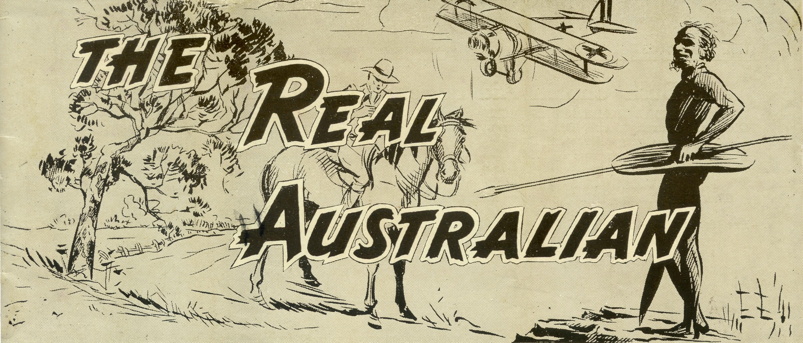

No. 87.
MAY 26, 1944.
1/6 per annum, post free

Silver Jubilee Number, 1919-1944

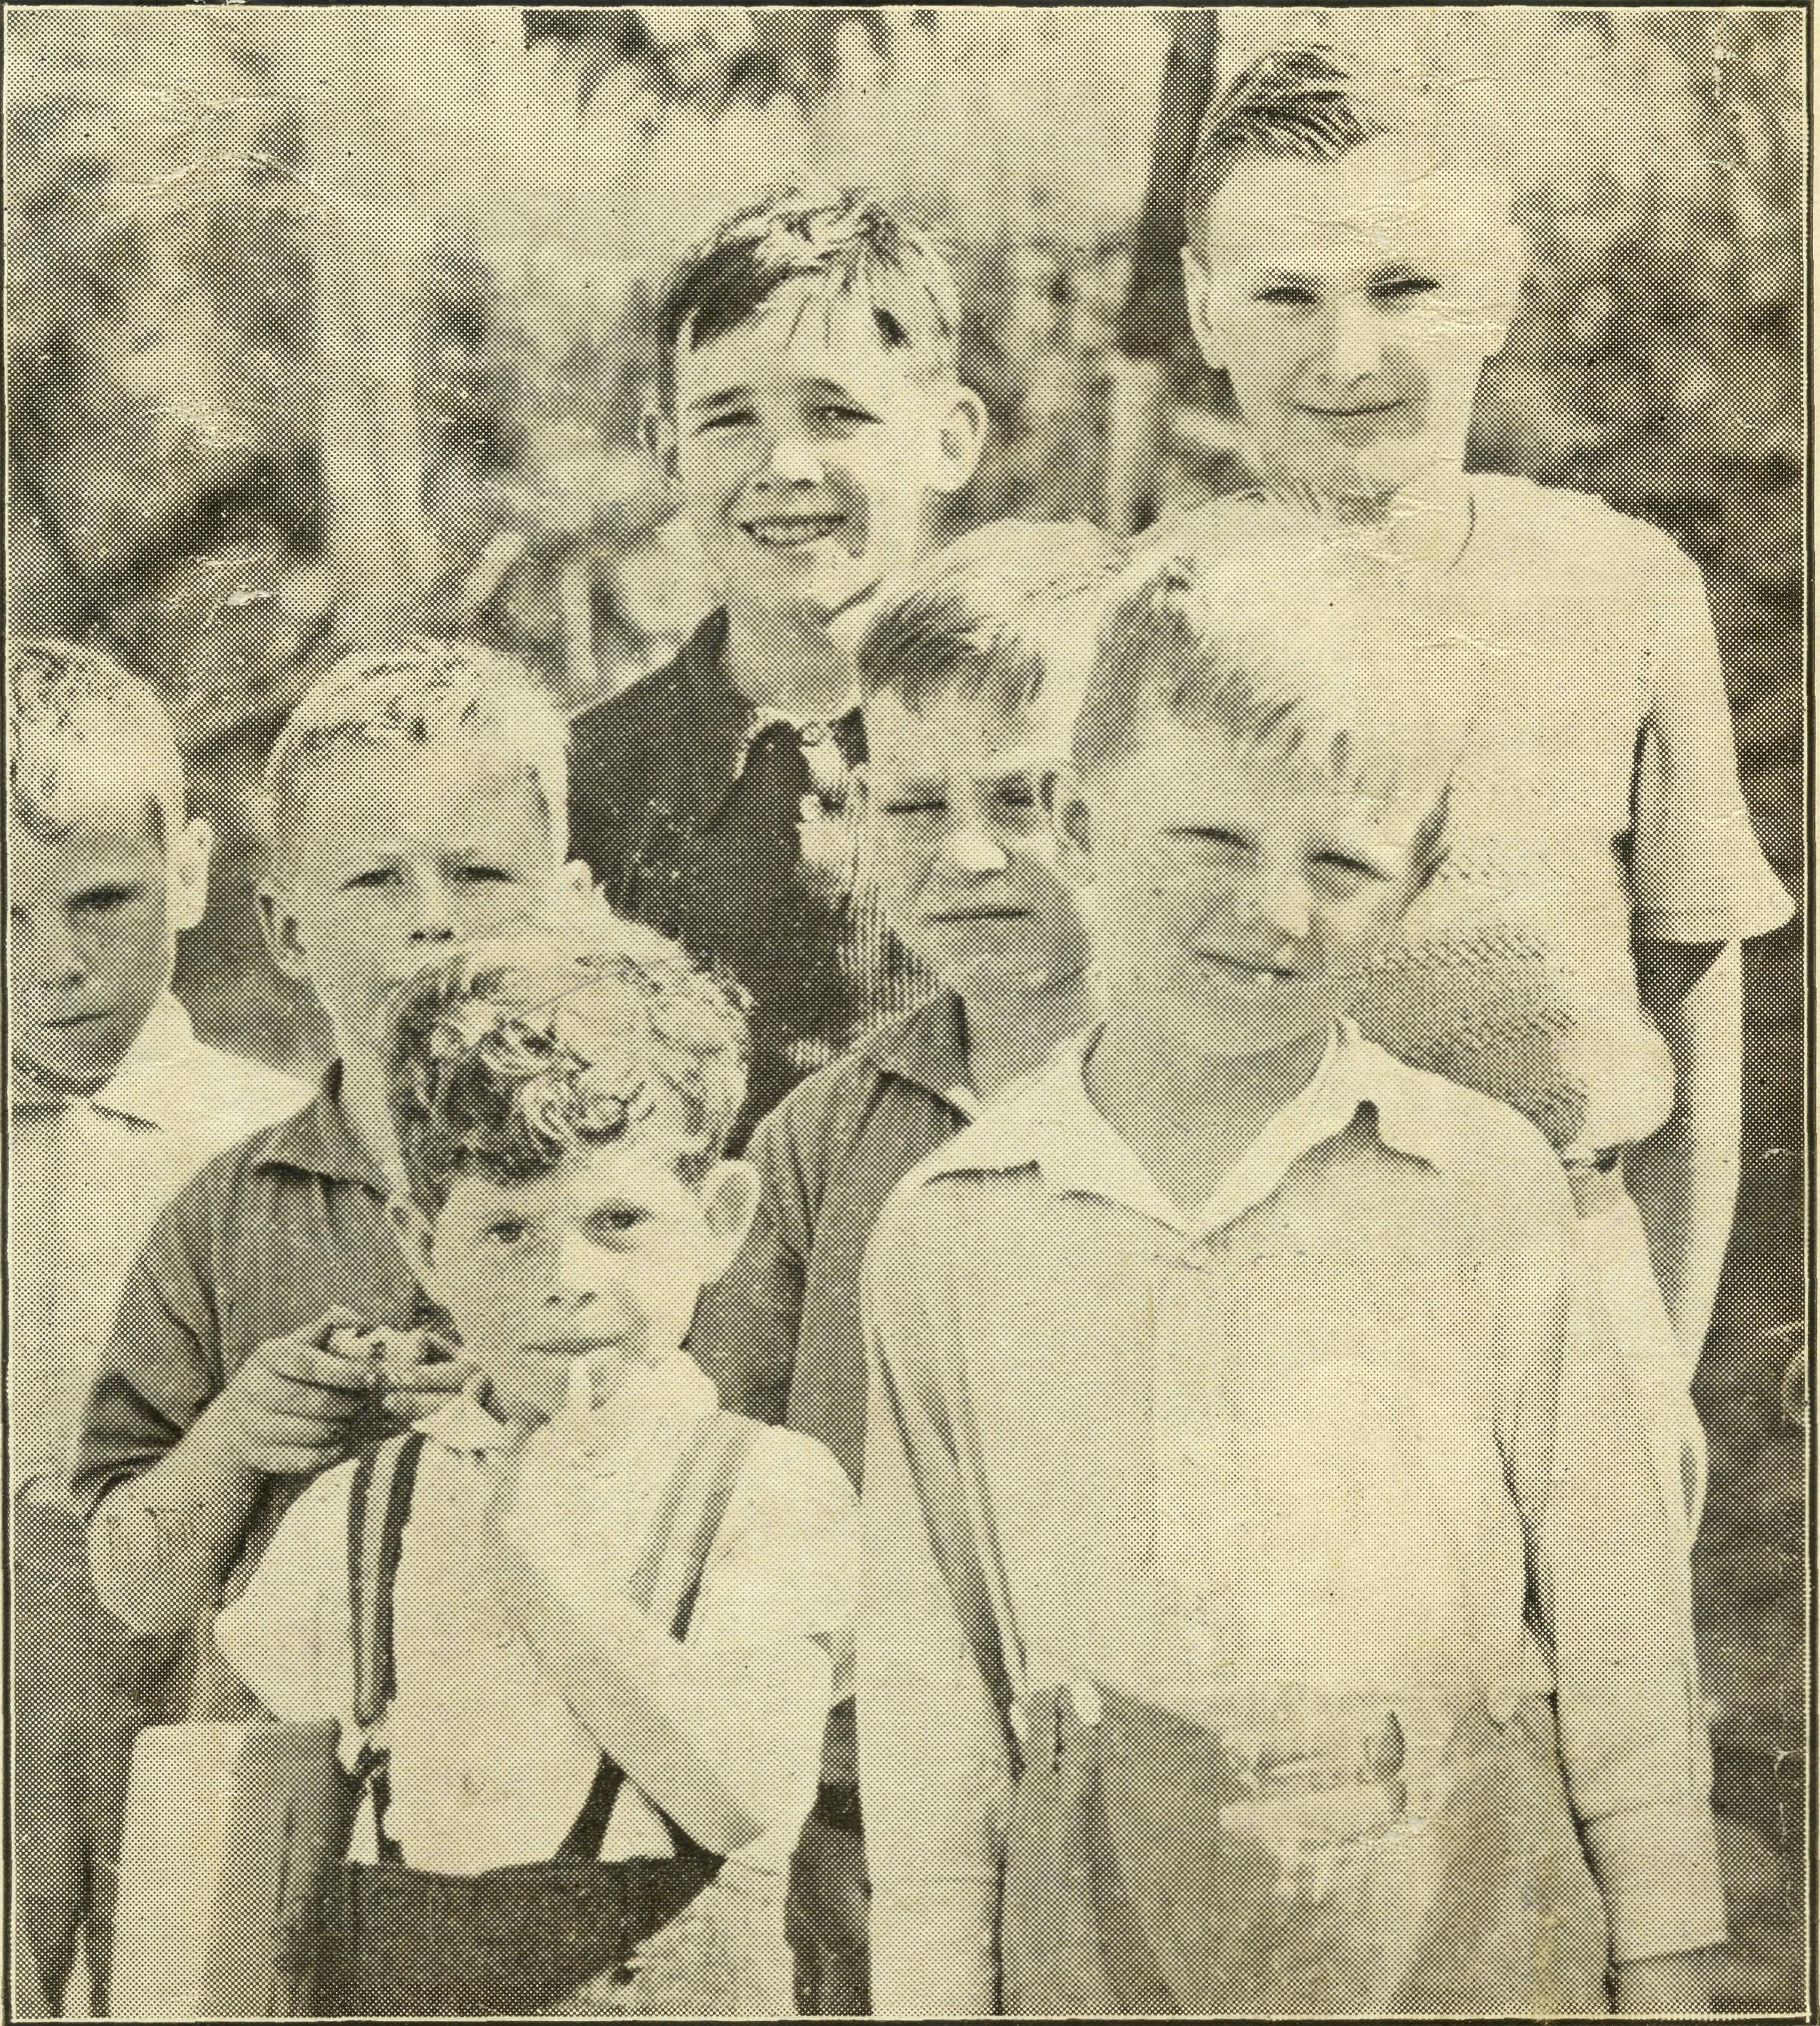

Registered at the G.P.O. Sydney, for transmission by post as a periodical.

THE REAL AUSTRALIAN
May 26, 1944

The Bush Church Aid Society for Australia and Tasmania
HEADQUARTERS OFFICE:
Diocesan Church House, St. Andrew's Cathedral, George Street, Sydney.
(Telephone: M3164)
Cable Address: "Chaplaincy, Sydney.¹¹
VICTORIAN OFFICE:
The Bible House, Flinders Lane, Melbourne.
(Telephone: F 5675)
President: The ARCHBISHOP OF SYDNEY.
Hon. Clerical Secretary: R_{ev}. L. GABBOTT. Hon. Treasurer: T. S. HOLT, Esq. STAFF.
Organising Missioner: Rev. T. E. JONES, Th.L., Church House, George Street, Sydney.
Victorian Secretary: R_{ev}. A. DONNELLY, Th.L., Bible House, Flinders Lane, Melbourne.
South Australian Secretary: Rev. R. M. FULFORD, North Terrace, Adelaide, S.A.

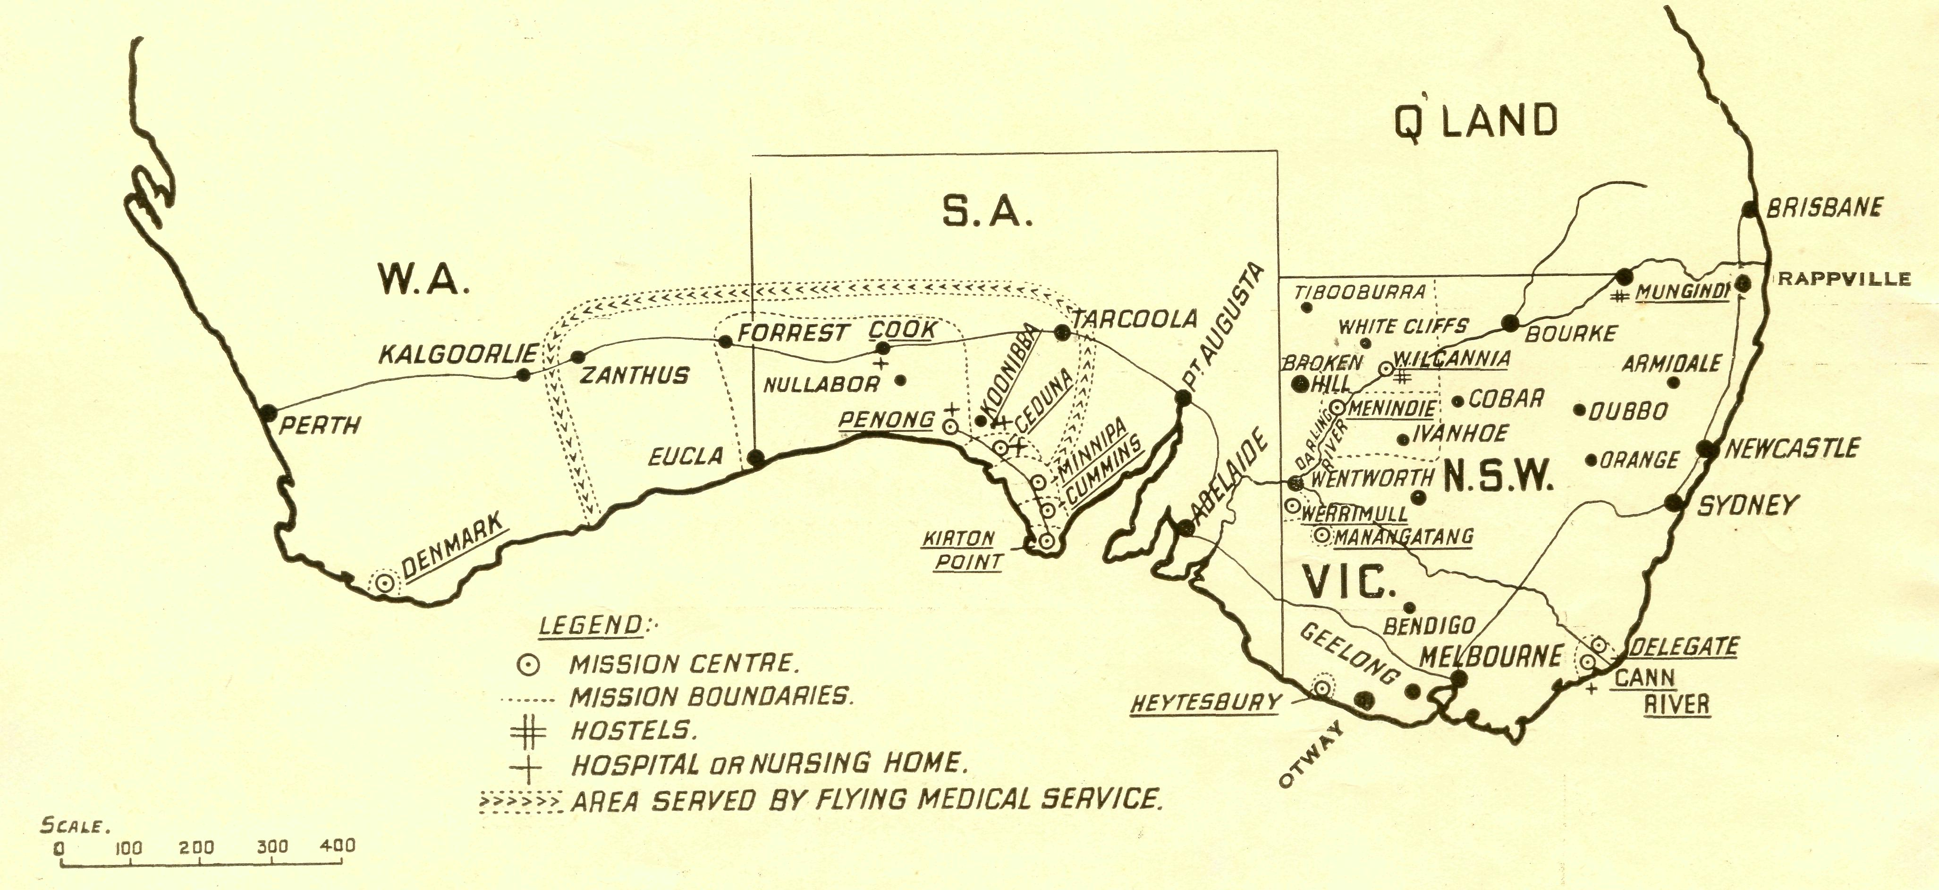

'Australia for Christ"

FAR WEST MISSIONS, S.A.
■p fRev. H. Broadley, Th.L., The Rectory,
renong , Ceduna, S.A.
Ceduna [ Rev. J. Greenwood, Th.L., Ceduna, S.A.
Curnrnins—Rev. D. Pugh, Cummins, S.A.
Kirton PoinU—Rev. R. T. Hallahan, Th.L., Port Lincoln,
S.A. Streaky Bay—R_{ev}. D. Livingstone, Th.L., Streaky Bay,
S.A. Minnipa—Rev. L. Morris, Th.L., B.D., Minnipa, S.A.
VICTORIAN MISSIONS.
Croajingalong J Rev. K. Brodie, Th.L., The Rec
Delegate-Bonang J tory, Delegate, N.S.W.
N.W. Mallee—Rev. , Werrimul, Vic.
Heytesbury Mission—Rev. W. Duffy, Th.L., Cobden,
Vic. Otway Mission—Rev. T. H. Pickburn, Th.L., Beech
Forest, Vic.
N.S.W. MISSIONS.
Wilcannia J Rev. K. Luders, Th.L., Wilcannia,
Menindee J N.S.W.
Rappville—Rev. P. M. Connell, Th.L., The Rectory,
Rappville, N.S.W.
WESTERN AUSTRALIA.
Denmark—Rev. T. R. Fleming, Th.L., Denmark, W.A.
CHILDREN'S HOSTELS.
Mungindi—Miss E. Cheers.
Wilcannia—Miss H. Gurrier Jones, Miss Y. Gurrier
Jones.
Wentworth Falls, "Conrad Mrs. Mann, Miss F.
Harding. Port Lincoln, S.A—Sister H. E. Sowter.
MEDICAL SERVICES.
Gippsland, Vic—Sister I. Gwynne, The Dispensary,
Cann River, Vic. FLYING MEDICAL SERVICES.
Pilot: Mr. A. Chadwick, Ceduna, S.A.
Dr. R. Gibson, Dr. F. Gibson. CEDUNA HOSPITAL.
Matron: Sister F. Dowling.
Staff: Sisters V. Page, L. Loane, Branford, G. Moody. KOONIBBA ABORIGINAL HOSPITAL.
Sister G. Hitchcock. PENONG HOSPITAL.
Sister Firmin, Penong, S.A.
Miss M. Millar, Penong, S.A. BISHOP KIRKBY MEMORIAL HOSPITAL.
Sister L. Pritchard.
Miss D. Dykes, Cook, S.A. TARCOOLA, SOUTH AUSTRALIA.
Sister B. Bossley.

May 26, 1944
THE REAL AUSTRALIAN

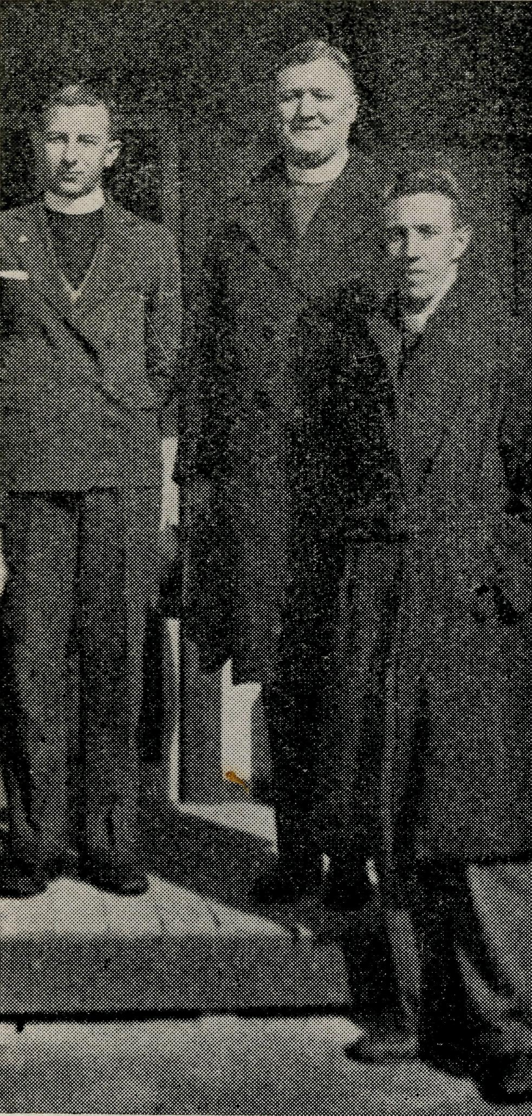
News from the Missioners

Rev. K. Luders, The Archbishop of Sydney, and Rev. H. Broadley.

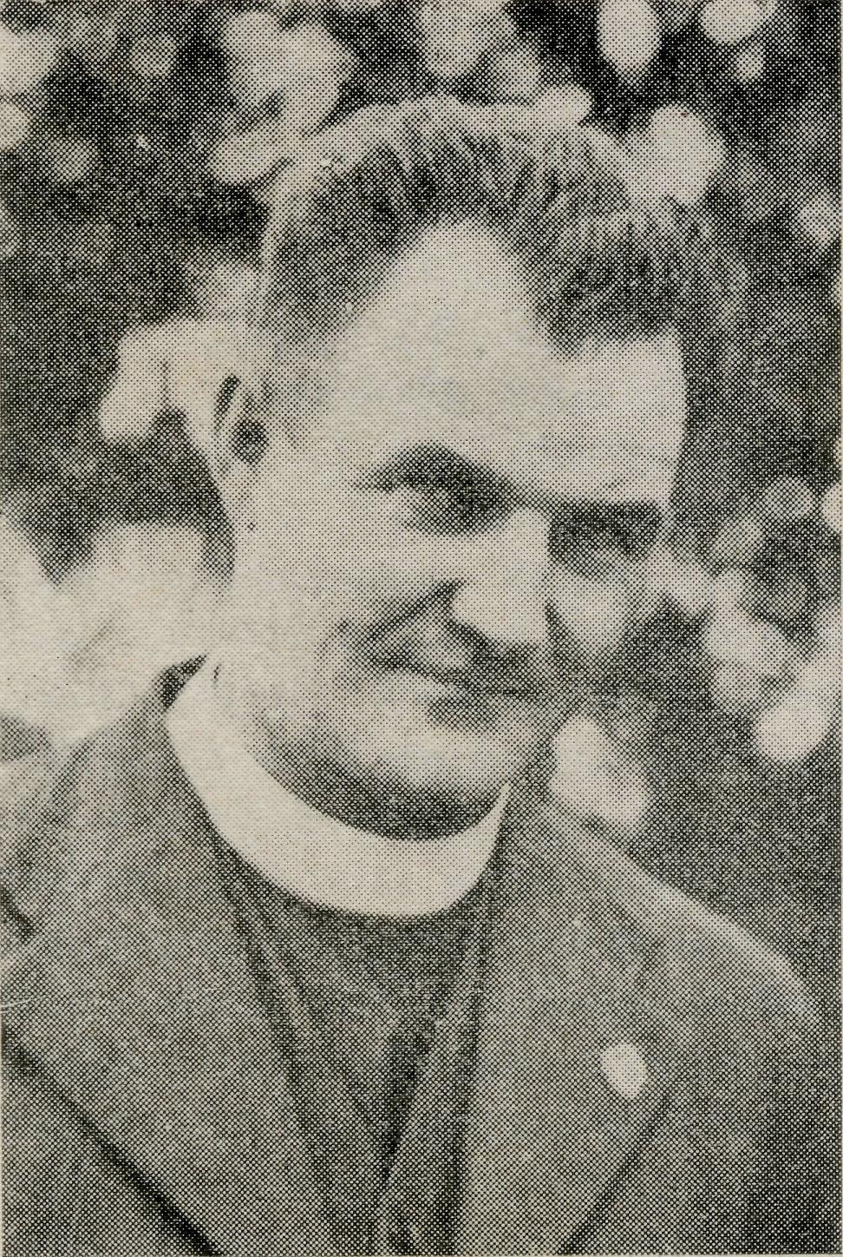
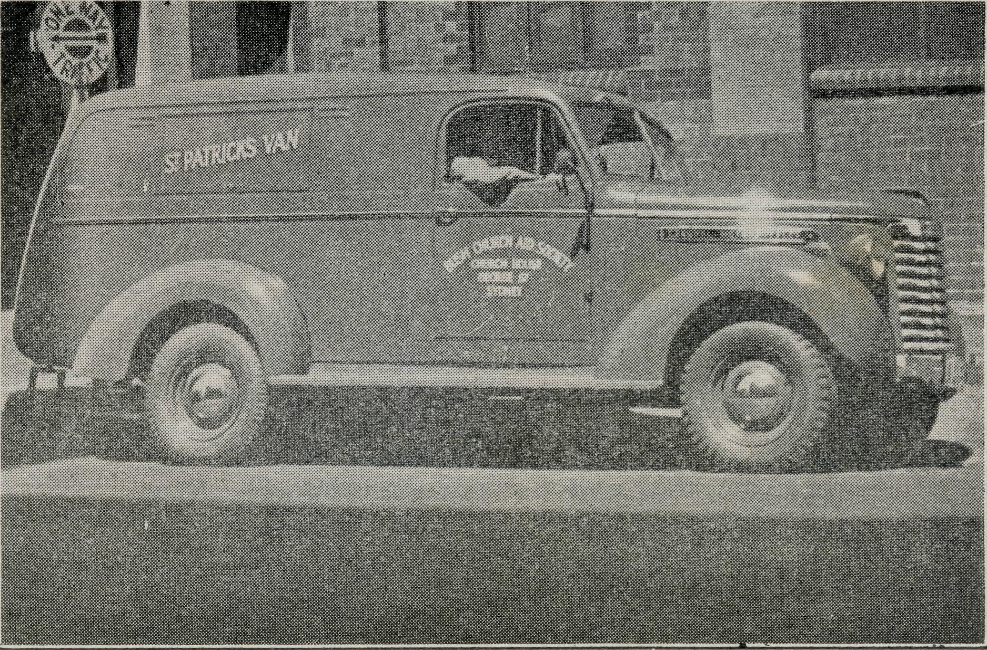
Rev. R. T. Hallahan.
Rev. Leon Morris and St. Patrick.

THE REAL AUSTRALIAN
May 26, 1944

In Which We Serve
Part of an Address given at the Melbourne Rally, 1944, by the Rev. W. DUFFY.

I remember about 12 years ago, when I was about to be ordained; there were six young fellows in the Lecture Room at Ballarat; cold fear was in the heart of the whole six, because Beech Forest had to be rilled. I remenv ber our dear old Principal saying, "Duffy, you are the strongest—you go to Beech Forest." I was the first one off the list, and away I went. Bishop Crick advanced me £30 to buy a car, and off I set sail with this car to the Ballarat Police Station to get a licence. The police' man said, "Back up there," and I attempted to do as he asked me, and I managed to knock half the police station down. He said, "Go away, son, and get some practice." I didn't have any time to go away and get any practice.
I remember going to Beech Forest straight from Cob lege—straight from a happy group of young fellows, down to the worst vicarage in Victoria, and I am saying something when I say that. The bathroom—well, you had only to stand in the bath and the water would come tumbling down through the ceiling, and there, for three and a half years, I was practically drowned. When I went there, the old pioneers used to come and tell me what it was like—the old story of the man who kicked a hat lying on the ground, and a voice said, "Fm under that hat, standing on a horse." Let me tell you some' thing of that work: The roads are dangerous; I syrm pathise with Mr. Pickburn in the travelling part of the work, because. there is no more dangerous travelling in Victoria, and it is a constant strain upon a man. I used to start off on Sunday and take services, and gradually work around Monday, Tuesday, Wednesday, Thursday, and get back on Friday, quite exhausted. You cannot go to bed at night before 2 o'clock down there, because the people are used to going to bed every night at about 7 o'clock, and they enjoy the company of someone coming in, and that means I used to sit up quite late, tired though I was.
And so we began the work at Beech Forest, and I think that the first six months was the most dreadful experience I have ever passed through: the loneliness of a single man cast down there. Of course, there were certain places where a man could go if he wished—a hotel, for instance—but I mean the scarcity of the right type of place.
Gradually, we overcame that, and the real appreciation of the people makes one feel very, very happy and very thrilled. The thing that struck me most of all was the fact that the people were a neglected, deserted people— neglected, I think, by the Church, not because the Church wants to neglect them, but because the Church did not have enough money to help them; neglected by the Gov rnment; deserted by everybody. Once I remember asking a dignatory of the Church to come down, and he said, "What is wrong." I said that there was nothing wrong, "but we have not seen you for two years."
I was young and inexperienced, and wondering how I was going to contact these people. A fellow came and said, "Can you help," and I asked him what was wrong, and he said, "My wife is going to hospital, to be confined, and the only truck we have is away. My wife is coming down through the scrub." I turned the car and went back
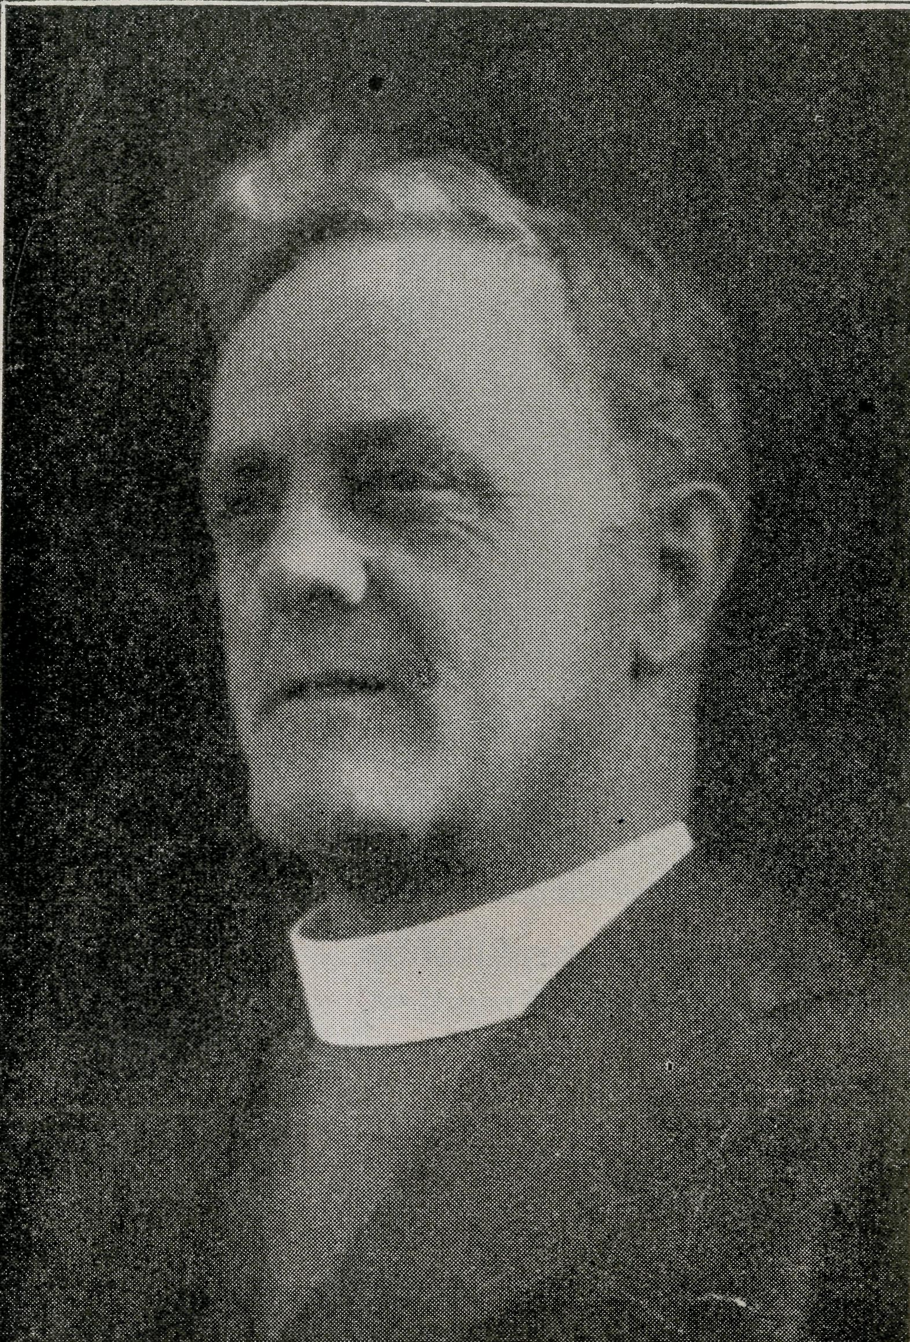
Rt. Rev. S. J. Kirkby, O.M. of B.C.A., 1919-32.
about half a mile, and I saw this woman. I was, as I have said, young and inexperienced, and single. I got the biggest fright of my life. I remember going around a corner so fast, that the husband said to me, "You had better go easy or we will never get there." We did get there, and shortly after, a little Australian was born. There was a lady there who was very keen on Christian Science, but suddenly her little boy took ill, and she wanted a doctor for him, about 2 a.m. She got in touch with the Bank Manager and dragged that poor fellow out of bed, and went 48 miles in the middle of winter because she thought her baby was dying. She came out and looked quite pleased, and when asked what was wrong, she said the doctor had told her the trouble was wind. Two weeks later there was a knock on my door, and a man said, "Will you come out and take my little girl into Colac as she is very ill; she is five years old. She might have diphtheria, pneumonia or it might be her heart," and he mentioned several other things it might be. I said I would, and I set off 48 miles. The little child was giving a little moan every now and then, and when we had gone 10 miles on that trip he said, "I think she has gone." We had hurried in 48 miles and she had died. There is the hardship; there was no one to give any help. The child had died of croup. At 6 o'clock she was playing with the other kiddies; no one knew

May 26, 1944
THE REAL AUSTRALIAN

anything about it, with the result that the little child, because she lived in the country, lost her life.
Not so very long after that, a young fellow, 17 years of age and 12 stone in weight, was working on his father's saw mill; his arm was cut and taken off at the shoulder. He was taken in to Colac and died the next day. He died of shcck, because there was no one to give him an injection. Do you not think there is wonderful scope here for the Bush Church Aid.
After three years of work, I left.
Seven years later, I felt I would like to accept a Mili-tary Chaplaincy. I was asked if I would go back to the Heytesbury. It was a case of going back or into the Army. I do not claim any kudos for going back. Back I went, and it was no sacrifice to me at all. We had got to the stage where our little home was getting comfort' able and we had just got the electric light. When I men' tioned the matter to my wife, she said, "Wherever you go, I go." I will say that the women make a lot of sacrifices, and, although they do not receive any medals, they are doing a lot for the Church.
It is a big area at Timboon, and the other day I asked the Shire Secretary what area I covered. He assured me it was 300 square miles, though sometimes it seems like 10,000 miles. Mr. Jones quotes, sometimes, some of the South Australian areas, but 300 square miles down there means a lot. It is so hilly. A man once said to me, regarding Beech Forest, that, when he was not up to his waist in mud, the snakes were chasing him around. He said, "If the good Lord had so much land to dispose of, why did He put it in such big heaps." Three hundred square miles takes a bit of travelling round. The work is interesting; it is wonderful work, but it does get you down, because you go day after day, and year after year, and we have not a little Church of our own—we have to make use of the Methodist and Presbyterian and other denominations. We make it as near an Anglican Church as we possibly can, but we do miss the atmosphere of our own Church. I am not going to say very much about that work. We do six schools every week; there are 10 centres. I do four schools in one day, and that means doing 85 miles to do the schools every Tuesday. That means you get over Sunday and into the schools again. We have five services every Sunday.
The prison chaplaincy to me is the same as if I had been appointed a chaplain in the Forces. I did have itchy feet for some time after the war, but now I am interested in that work, the itch has gone. When a prisoner's warrant comes, it often says "Religion—Nil." You have to talk to them about football and everything else. Thank God I played for 18 years. I have had to learn about horseTacing—I know all about that now. You have to take the men steadily—talk about football, cricket, horse'racing and gradually, perhaps after one month, two months or three months, you see them in at the service in the mess-room. When they get in, they stop, not because of any influence, but because of the atmosphere of that mess-room. It is a mess-room where they blaspheme and that sort of thing on ordinary days, but, when there is a Service, to them it is holy ground. I watched one man, because I was interested in him. During the singing, at first he laughed, and he looked around and found he was the only one grinning; during the singing of the second verse he made more noise than anyone. From that day on, that fellow was one of my best men. It is a lovely sight, a real thrill, to see them. We have our Communion, our Easter Communion, and our Christmas Communion. The second in command there is a very good Anglican, and he says that I am running a terrific
risk every time we have Communion. There are about 32 prisoners, and of those, about 20 are Protestants. Last Christmas we had our service, and those who were not remaining to Communion were to go out quietly during the singing of the hymn. Nine filed out and nine remained. It is a wonderful sight to see them kneeling there in their old moleskin trousers, and see someone showing someone else the place in the Prayer Book.
We have our disappointments, but we do have real thrills sometimes, because we receive letters from these fellows, saying how much they appreciate what we do. For doing that job, I receive £20 a year, and it costs me about £40. We have to keep in contact with those fellows in the outside world. While I am in Melbourne, I have to find four wives and patch up domestic quarrels.
One man said to me, "Will you come to my cell?" Which I did. He fossicked around and brought out a little brown paper parcel, and he said, "Will you take it home for your little girl." He added, "I appreciate your work so much; I got 15 peanuts for a prise, and there are eight for your little girl." That gave me a thrill, and a lump came into my throat, and I told him I had enough to buy peanuts for my child, but he said he would be disappointed if I did not take them. He showed his appreciation in that manner.
This work we do in the service of God. I thank the Bush Church Aid and Mr. Tom Jones for that wonderful co-operation and help, and for the friendship given. We do not feel that we are stuck out in the never-never, and that no one worries whether we live or die. Letters come from Sydney, and the Auxiliary send us little presents of toys for our children, and this means a lot.
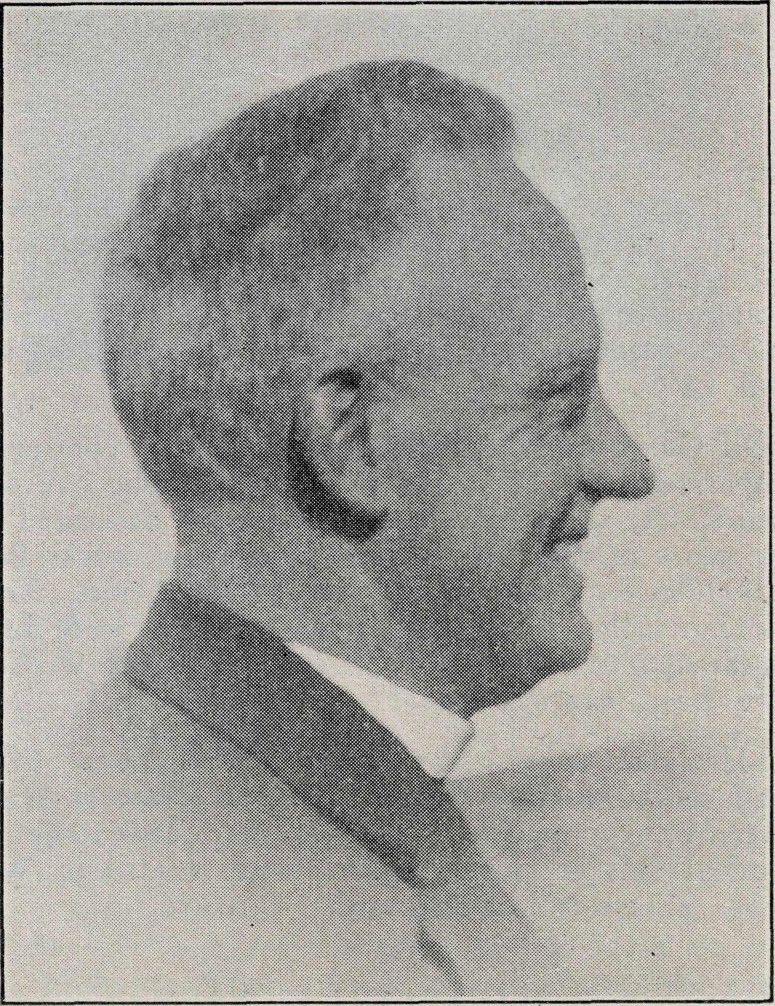
The Rev. Tom Terry, O.M. of R.C.A., 1933-4.
On behalf of the Missioner at Beech Forest, the Rev. and Mrs. Pickburn, I thank Mr. Tom Jones and all of you. There are times when we get very lonely, and when the time comes and we make an appeal to the Church, give us your help and give us your prayers.

THE REAL AUSTRALIAN
May 26, 1944

History in the Making
By the Rev. O. A. BAKER.

One hundred and nine years ago a surveyor made his way south along the great out-back river of N.S.W., the Darling. His name was Major (afterwards Sir) Thomas Mitchell. He selected a site for a settlement and called it Fort Bourke. Then he pressed on for a further 300 miles, passing places which later became the sites of Wilcannia and Louth. Trouble with aborigines turned him back when he was in the vicinity of what is now the town of Menindee.
Nine years later, another explorer passed that way, Cap' tain Charles Sturt, of the 39th Regiment. He was on his way to explore the centre of Australia. Very shortly afterwards hardy pioneering settlers began to take up their living in this part of the State, and Menindee came into existence as a supply depot.
In 1860 the Burke and Wills expedition to the Gulf of Carpentaria commenced, and the explorers' party made a brief stay at Menindee en route. Burke and Wills partook of the hospitality of, the Menindee Hotel, which is still in operation.
By the '70's and '80's the township had grown con' siderably. Huge four'wheeler bullock waggons and also stage coaches were familiar sights. Seventy miles to the west stood a broken-backed ridge. On September 5th, 1883, Charles Rasp, a boundary rider of the Mount Gipps Pastoral Company, discovered on this ridge a lode of lead' Zfincsilver. Immediately prospectors and miners were attracted and Broken Hill came into existence, known to local people more familiarly as "The Hill." The rise of the new town, now third city in N.S.W., doomed Menindee to a secondary place, though in the early days some of the claim'jumping cases were tried there in the Court House.
Menindee at first was in the diocese of Goulburn. In 1884 the new diocese of Riverina was formed, an area of 118,000 square miles, with headquarters at Hay. Men' indee was included. About 15 miles west of Broken Hill was a mining town called Silverton, and the Rector there had the spiritual oversight of Menindee. But as Broken Hill grew, Silverton shrank, and by 1895 the Church became a branch of the larger town. In 1892 Menindee was promoted to a full parish, and had resident ministers until 1899.
On Christmas Day, 1892, services were conducted in a temperature of 118 in the shade. A public hall was used until 1893, when the first church was dedicated. For a few years in the '90's a meat preserving works flourished five miles up the river. Sheep were put through a machine called a digester. The remains were known as "hashmagandi" to the locals. Even crows were said to have been canned there!
Menindee parish was unable to continue to finance itself as a separate district, and in 1899 it was incor' ported in the parish of Wilcannia. The town received regular visits from the rectors, who resided at Wilcannia itself, 92 miles further north up'river.
B.C.A.'s FIRST TASK.
On May 26th, 1919, the Bush Church Aid Society was
formed, with the Rev. S. J. Kirkby as its first Organising Missioner. "Early in 1920 an invitation to investigate the needs of the West Darling area (N.S.W.) came from the Archdeacon of Broken Hill, the Ven. Godfrey Smith, and the Organising Missioner at once proceeded on a journey to that far country. It was a time of paralysing drought. The whole countryside was dead and desolate and the townships dispirited. That mighty stream, the River Darling, dried up for miles in its length, was only a chain of water holes, small or large." (These Ten Years.)
Wilcannia had no Rector. B.C.A. provided one, and also the extra finance needed to supplement the con' tributions of the parish. Menindee benefited also. By 1926 the church building there had become unsafe through the ravages of white ants and climate, so a new and pleasing structure was erected in its place, made of large cement bricks, with an imitation stone facing. About this time the railway bridge across the river was completed, making it possible for a continuous rail con' nection between Sydney and Broken Hill, via Parkes, Condobolin and Ivanhoe.
In 1920 the B.C.A. had also opened a hostel for children in Wilcannia, to enable out'back kiddies to attend school in the town, while at the same time pre viding a Christian atmosphere for them. The first pupils came from a homestead in the Menindee district. From 1928 to 193 3 an aeroplane was used in the Wilcannia parish to facilitate the rector's ministry in the vast area which stretched from the north-west corner of the State down to Ivanhoe. This was a notable and unusual achievement at that time. The 'plane was a mere "baby" by present-day standards, weighing only 874 lbs. The cruising speed was 80 miles per hour.
In the early part of the last decade the world depression drove large numbers of people from Broken Hill to Menindee, where they were able to eke out an existence on the river banks. Their conditions were appalling, especially at Lunatic Bend. With the help of B.C.A., the ministry of the church continued, and a forward step was taken in 1936 when it was decided to make a separate "parish" of Menindee and Ivanhoe. I was asked to take up this work, and later on the town of Pooncarie was included. For the first time in 37 years a minister became resident in Menindee again, in the old court house mentioned above. Transport was provided by the B.C.A. caravan. A full ministry now became possible in the towns and on the land. Menindee church was considerably improved and the whole work built up. The caravan covered 22,000 miles in three years. The clergy that have laboured at Menindee in the century of its history have used the following means of locomotion: horse, sulky, buggy, bicycle, motor bicycle, car, caravan, aeroplane, steam train and diesel train, and river boat.
I returned to Sydney in 1939. When my successor left Menindee, the town once again reverted to the Wilcannia parish. The war conditions and shortage of clergy made this necessary in 1942. But the good work still goes on, thanks to B.C.A. and its many supporters. The traditions of the Society are splendid and strong, as is the courage of those to whom she ministers. That tra' dition must go on.

May 26, 1944
THE REAL AUSTRALIAN

Minnipa
Rev. Lu MORRIS.

As I sit writing this article it looks as though the rain has cleared away, and my wife has taken courage and started on the washing.
Over the last three days we have had 39 points; a little while back we managed half an inch, spread out over a few days, but we don't seem to get a good soak' ing rain, which is what the country greatly needs at this time of the year. This, unfortunately, isn't at all unusual, and most years round about now the farmers are turning a wistful eye cloudwards and indulging in a lot of wishful thinking. For our soil is good, and, given the rain, we could grow quite a lot. However, the rainfall is just not good enough and, therefore, this country remains a marginal area.
That explains a lot. It explains why the population must remain scattered, it explains why, from a parish point of view, financial stability is almost impossible. Expenses are great in comparison with the population to be served. It explains why B.C.A. has received such a ready welcome from those with the good of Christ's Kingdom at heart. Because of B.C.A., a regular ministry can be maintained, and if services aren't as frequent in any centre as we would like, everyone knows why and takes it with a good grace.
I am at present preparing eleven candidates for con' firmation. The number is not large, but the scattered population makes it quite a problem. One candidate is at Minnipa, and I can generally see her once a fort' night, so that isn't too bad. Most of the others are in districts I visit once a month, but as they don't live there, there is still quite a lot of travelling to be done. One lives in such a very inaccessible spot that it is two months since the last visit. I would greatly like to multiply personal contacts, but this is not possible, so we just plod along, putting our trust in the postal service and the B.C.A. Mail Bag Lessons. These lessons are excellent and represent the only means of giving adequate instruction to candidates in isolated areas.
Hand in hand with spiritual ministrations goes medical assistance, in this case rendered by my wife. During one of my trips away recently she had a very rough time with a number of patients quite seriously ill and no St. Patrick's van about, to convey them to hospital if need be. However, when a child in convulsions necessitated a
quick trip to the doctor, our policeman came to the rescue and drove Sister and patient down. Before they arrived back there was quite a stir when a midwifery case demanded attention, but the handy telephone came to the rescue until such time as Sister arrived in person on the scene of her labours.
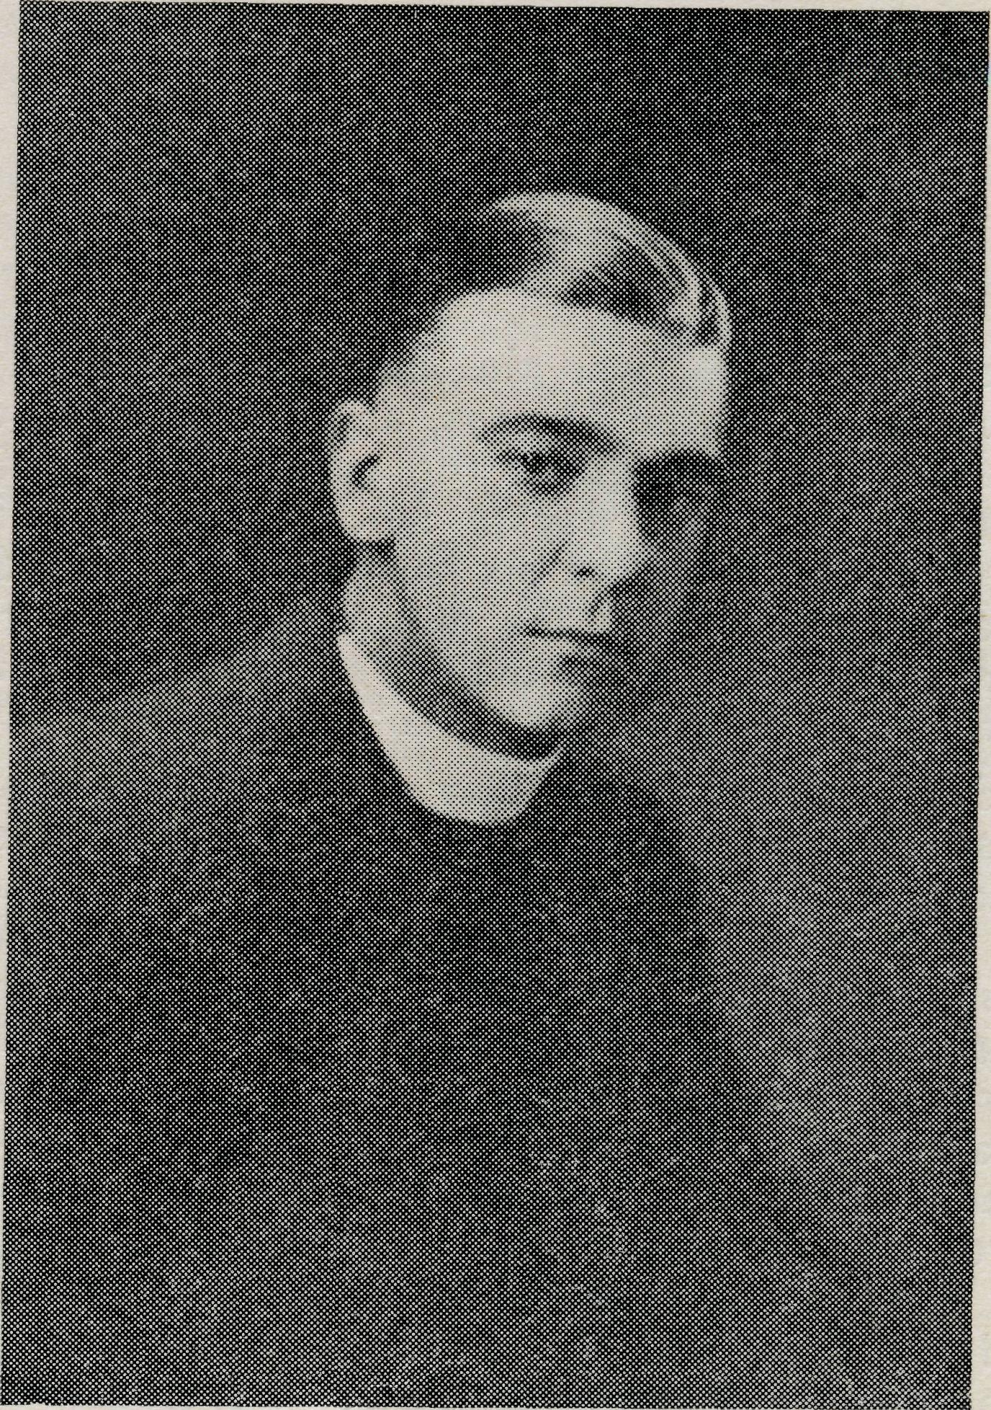
Rev. T. Jones. O.M. B.C.A. from 1934.
In the last issue of the "Real Australian" there was an appeal for Bibles for use in the schools. Many responded, and I want to say a hearty "Thank you" to all who assisted. Such was the response that our need has been more than met, so that I now have a few Bibles to spare. It is heartening to have the ready help thus offered and to know that so many are interested in the welfare of the children.

Heytesbury Forest Mission
Rev. W. DUFFY.

I have just returned from the Annual Rally at the Chapter House, Melbourne, and I find a letter from the O.M. asking for an article for the special Silver Jubilee Issue of the "Real Australian." As it is likely that this particular issue will be kept as a souvenir by many, and also that copies will find their way to different parts of the world, I feel it would be wise to give a picture of this part of the B.C.A. field.
It is situated in the South-West part of Victoria, and adjoins the Otway Mission. It is a large tract of country, approximately 300 square miles, that was looked upon as being too poor to worry about. The price of the land, 10/- per acre, was a true indication of its value. It did, however, have a very valuable asset—a reliable rainfall of about 30 inches per year. After a good deal of experimenting, it was found that this soil responded

THE REAL AUSTRALIAN
May 26, 1944

wonderfully to top dressing with artificial manure. The result has been, that what was once barren, hungry country is now, in many cases, like a Garden of Eden. The Forest is, of course, inhabited by settlers—many of them soldiers of the Great War—and it is to this type of folk that the B.C.A. missioner is sent. To-day there are good roads running to every part of this great parish, so work is not as difficult as formerly. Naturally, these settlers are poor, and scattered, and quite unable to keep a fully ordained man. The result has been that for years the work was carried on by a Deacon or a Reader, and a visit from the Priest of the neighbouring Parish to dispense the Sacraments. B.C.A., with its policy of caring for the country folk, took up this work almost six years ago, and ever since there has been a fully qualified Priest in charge. It is still hard and tiring work, but these people do appreciate the help that B.C.A. is giving. It is almost certain that, without the help of B.C.A., there would not even be a Deacon or Reader in the Forest at present. The district has a future—the once poverty stricken settler is finding his feet and making good. Before many months it is hoped that an area
school will be in operation at Timboon, and motor buses will transport over 300 children to the school. What of the church life? Already there are Presbyterian and Methodist churches scattered over the Forest, and still there is not one Anglican building, except the Vicarage, in the whole area. The other denominations are ever ready to lend their buildings, but Anglicans like to have a church of their own—fitted and furnished as an Anglican church should be. We have our hopes and ambitions, and we are looking forward to the day when we will be able to build a church costing from £800 to £1000. We have part of that amount now, and, for the time being, building is out of question, but when the war is over we want to get busy. We want to be on the spot and, as the district advances—as it certainly will—the church will advance with it. We appeal for your prayers and your help, without it we could not keep going. The Easter week-end services numbered ten, and two weddings, and involved 320 miles travelling. It is very tiring, but it is worthwhile, because we feel that, with your help, we are building a foundation for the Anglican faith in this area which will last for ever.

Easter in the Bush
Rev. T. PICKRURN.

Easter Day, 1944, was the happiest day ever spent by the missioner in the Otways, and the memory of the beautiful services throughout the parish will remain for a long time. It was a day of much travelling, with no time to spare between the six services held, but, despite that, the day ended with the missioner feeling refreshed, and more than thankful for the day's spiritual joys and for the privilege of ministering to so many people.
The day began at Apollo Bay at 7 a.m., where a good congregation was waiting. The Church had been beautifully decorated and the atmosphere of devotion was most marked at that early hour. It was an inspiring beginning to a long day and that same spirit of devotion was apparent at all the following services. From Apollo Bay we went to Beech Forest for the 9 a.m. Celebration, where another good congregation was waiting. The missioner's next call was at Laver's Hill, and from thence on to Devondale for the last of the morning services. At these centres, as in the others, all had gathered together, and the atmosphere of worship and devotion was most marked. After enjoying the hospitality of a Carlisle River family, we went to the hall for Evensong. Heavy rain had set in some hours previously, and was now falling very steadily. It seemed as though the service would be marred by the weather, but to the missioner's surprise, over 50 people were waiting in the hall for the service. That surprise must have shown on the missioner's face when he looked through the door, because the congregation gave way to their amusement in no uncertain way. The hall had been most tastefully decorated and the whole atmosphere of the service quiet and devout. It was a pleasure to bring the Easter message of encouragement to these faithful people, who, despite the weather, were determined not to miss the opportunity of worshipping on Easter Day. From Carlisle River, we left for Beech Forest, where a child was admitted to the Church in Baptism. After this, the car—and the missioner—had to be re-fuelled for the long journey back to Apollo Bay for Evensong. In spite of the wet night many came
to this service, during which another little boy was admitted to Christ's flock. Evensong was a fitting end to an inspiring day—a day on which almost 200 people paid homage to their Risen Lord and Master.
One often thinks how good it would be if members of town and city congregations could be present at some of the acts of worship in the little B.C.A. centres. In the small districts we have none of the beautiful churches or adjuncts of worship, but the spirit of humble devotion is very apparent in all of them. Services for the most part are in halls or in buildings of other denominations, and great pains are taken to give to these places a true atmosphere of worship. To see the missioner and his family setting off on a Sunday morning must present an interesting sight, because everything necessary to reverent worship must be taken on the trip. Vases, cloths, kneelers, books and flowers must all be stowed away in the little car and the trouble entailed in all the packing and unpacking is more than well worthwhile. When all set up and furnished, it is surprising how easily the mind can become oblivious to drab and dull surroundings. In one centre, it is sometimes necessary for the missioner, with a band of helpers, to clear away the remains of the previous night's dance, but, even so, the hall is soon made to look like a place of worship—in one corner, at least. Some day, it is hoped, when peace is again restored, we may in this particular centre be more mindful of "the things belonging to our peace" and erect to the glory of God a real House of Worship.
I must close these notes with an expression of very deep thankfulness to B.C.A. for its continued help in Christ's work in the Otways. This feeling is one that is shared by all our people in this district, and I am glad to say that, as a result of Mr. Donnelly's visit of some months ago, a good number has been added to the list of active friends of the Society. It is hoped that interest in the Society's work will grow and that the forthcoming Jubilee will be marked by an ever greater enthusiasm and response to the Call of God made through B.C.A,

May 26, 1944
THE REAL AUSTRALIAN

Some We Serve
Rev. R. T. HAULAHAN.

One of the great privileges that appertain to the office of the B.C.A. clergymen is that of being admitted into the family circle of those who have been the pioneers of the country in which his pastoral ministry is exercised. This was brought vividly home to me in the course of my most recent visitation, which included the observance of "Good Shepherd" Sunday. It was my good fortune to be the guest of one such family during an unusual reunion, and it seemed to me most fitting that the Jubilee number of the R.A. should contain an apprecia-tion of what this family, and others like it, have done and are doing for Australia in peace and in war.
Both father and mother are nearing the 70 mark, and each come of pioneering stock. Years ago, when they were "newly-weds," they battled to get the necessary capital for the purchase of a virgin block near the old home. How many back-breaking hours of contract shearing this meant for him, and how much pinching and scraping for her, can only be guessed, and before the guess is made, there must needs be a knowledge of the scanty wages then paid, and the soaring costs of household commodities in an area so isolated. Eventually, however, the day arrived when the move was possible, and with high hopes the young couple began to carve out of the scrub their dream home. Like so many other dreams this did not materialise. After years of hard work the venture proved unprofitable; disappointing yields from the crops and mysterious diseases in the sheep eventually compelling them to abandon the project. Consider what this meant when there were eight additional mouths to feed, and eight more backs to clothe, all on the very low scale of wages then obtaining.
Thanks very largely to the grit and managing capacity of the mother, the family was reared and schooled, and another much smaller property purchased. A small orchard planted, a few sheep, half a dosen cows, a small fowl run and a vegetable garden helped the exchequer, but, with one child a permanent invalid, it needed all the help.
Then along comes World War I, the enlistment of the eldest lad of 18, to be followed afterwards by his return with a shattered arm that took two years¹ hospital
treatment to restore it to its present state of half fitness. (In spite of this handicap, he took advantage of the Repatriation Scheme and launched out for himself on a wheat and sheep property that, thanks to his industry, has developed well.)
Meanwhile the rest of the family grow up and engage in various rural occupations until the advent of World War II. Three of the other boys are now "in it," two having come through campaigns with the A.I.F. in the Middle East and New Guinea, and the third is in the R.A.A.F.
Of the remaining two boys, one is engaged in the South Australian Shipbuilding Yards, and the other met with an untimely death as a result of a fishing accident. He was the only one missing from this family re-union mentioned. To make up for this, there were present the respective wives of the two A.I.F. men, who were home on leave. One of these girls is from a neighbouring home, but the other is a Melbourne lass, visiting for the first time the home of her husband, and the scene of his boyhood. It is my belief that she, together with those who read this, will feel, as I feel, that, while the back country of Australia is capable of producing families such as this, there need be no fear for the future.
Just one thing in conclusion. At the back of this family history is a long and faithful record of Church life and Christian witness. Stowed away in my car as tangible evidences of this were four separate consignments of produce from the old home. One being that regular contribution to the Rectory larder, and the other three to homes of young struggling settlers I should pass en route.
No woman in the district is held in higher esteem or greater affection than this one, whom I trust will forgive me if I reveal her identity, as it is known throughout the district as "Auntie Nell."
Among the children who will benefit from the establishment of the B.C.A. Hostel will be some who will call her Grannie, and it is hoped that, under the shepherding care of the Hostel Staff, they will appreciate the worth and emulate the example of their forbears.

The Rappville Mission
Rev. P. CONNELLr.

Let me begin with a short description of this place so that you can picture it.
Rappville parish is situated in the Richmond River district, almost within sight of the Queensland border. It is roughly about forty miles long by thirty miles broad. Much of the western portion of the parish is very mountainous, consisting of spurs or offshoots from the main Richmond range. Between each range of hills lies a valley with its creek, and it is along these creeks, on the rich flats that many farms are situated. The rest of the parish is fairly level, and the soil not very fertile. Over the whole extent of the parish are many State forests,
most of them of hardwood timbers, but some of softwood. In the southern portion of the parish there is a forest of mixed pines, 900 acres. The main industries right through the parish are cattle, butter, timber and—a very small but quite important one—ti-tree oil. This last is obtained by one-man stills situated through the country, and is the means of obtaining one of the newer and more effective antiseptics.
In the parish there are thirteen centres. Rappville—■ near which I live—is the largest of these. It contains four or five shops, a post office, hotel, school and public hall, besides about fifty homes. Many of the names of

THE REAL AUSTRALIAN
May 26, 1944

other centres are reminiscent of the blacks—Mongogarie, Banyabba, Bungawalbin, Whipone and Gibberagee, are some of them. I take service at each out-centre once a month, at Rappville more often. Many centres also have a school (though within my time here, five of these have had to close for lack of children), and at each of these I take Religious Instruction.
Transport is one of the big problems. This seems to be a B.C.A. difficulty. Distances are not as great here as in some other B.C.A. centres, but the roads are rather bad, in winter especially they are car traps. My petrol allowance will just allow me enough for runs to services, and the rest must be done on horseback. I have a good horse of my own, and the parish supplied me with a very nice saddle shortly after I came here. Most people in the bush are in a like position, what with tyres so hard to obtain and supplies of petrol very limited. Even farmers thirty and forty miles from Casino, our nearest big town, only receive four gallons per month for use in their cars. Many people are getting their old sulkies out of the barn, painting them up and using them again after twenty years.
I have several little Sunday Schools, quite apart from church services, run by faithful church people in various districts. Most people I meet seem more grateful for help given their children in this way than for anything else a minister does for them.
The people throughout this district are a fine type,
taken as a whole. The war has hit most of them very hard. Most of the younger men and many women, too, are in the services or away for other reasons arising from the war. Their going has left quite a number of farms to be run by the older people and the very young, which makes it very hard for them. Tve seen a girl of fourteen ploughing beside her father. Yet I can truthfully say Tve never met a more cheerful and hearty body of people. One often meets instances of wonderful faith and indomit-able courage in the face of loneliness in most unexpected places. An old couple come to my mind here. They live eleven miles from any railway or shop of any kind, on a farm in very poor and rough forest country. I often stay the night there when passing through that part. They are always glad of a little service of prayer and Bible reading, and just to talk to them for a while is a real inspiration to me. I think of another—a woman who came out from England as a girl years ago, and married a farmer in a district ten miles from here. She and her husband reared a large family on a small farm. Their home is just a small four-roomed cottage. The rooms have no ceiling, only the galvanised iron roofing separates one from the sky. Her husband died since I came, and now she is still battling with her two children—the rest are grown up. A more cheerful or faithful Christian would be hard to find. There are many such people scattered throughout the parish, and to me it is a privilege to be called to minister to them.

Serve in The Sandhills
Rev. H. BROADLEY.

The last trip we took up to Cook was one of unusual interest. Instead of goin^ via Nullarbor, I went via Ooldea. My companion was an old friend from Muda-muckla, a farmer named Mr. W. Remicke, whose family have been for years steady members of the Church. We stayed the first night at Colona sheep station, being enter' tained by Mr. and Mrs. Reid, whose son is a prisoner in Malaya. We had a short informal service and so to bed.
The next day was one of expectancy. We were to go nearly 100 miles before we could expect to find any living person. The track winds a bit, and is fairly rough, though not nearly so bad as the Nullarbor proper. At intervals of a few miles are shed tanks. These are tanks placed under or beside a kind of shed without walls. The roof is the catchment area. Although rain had not fallen for perhaps 12 months or more, there was plenty of erosion on the track, which meant careful driving. We had lunch at a shed tank and later came to Pidinga rock hole. This is a hole in the ground, which at this point happens to be rocky. A low wall of cement has been built round the lower edge of the sloping rock above the hole to direct the water below. Over the holes gab vanised iron has been placed to make a roof, and no doubt prevent evaporation. On the road map it is indicated that Pidinga contains 40,000 gallons of rain water. When we saw it there may have been 20 gallons. Some miles further on we crossed over a causeway built where two salt lakes meet. They were dry, as was to be expected.
At the 93-mile point, we came to the Ooldea Railway Camp, which consists of about five cottages and a porter's office. We pushed on across the railway line, having been shown the crossing by a black boy. As I had writ-
ten to Mr. Green of the Ooldea Mission, and told him of our plans, it seemed best to go the three or four extra miles to the Mission and report our arrival. In 1936, with the Rev. H. R. Smith, of Penong, I had gone by car for a mile and then walked for three miles over sandhills to reach the Mission. To-day it is possible to drive for over three miles along a bumpy, sandy track before getting out to walk the rest. We stuck on one rise, and Mr. Remicke got out and pushed, while I kept the engine on the job. We were hailed by some native boys who wanted a ride. They got on the running board, and the extra weight nearly stuck us again. We came to a shed. One boy yelled and I thought he said, "Tomato Shed." It sounded a bit unusual, but I did not think it mattered what he had said. A hundred yards further on we stopped well and truly. The sand was obstinate. We realised that it was "Motor Shed," not "Tomato Shed." Mr. Green does not bring his truck beyond the shed. However, as a boy said the Mission "was just over the hill," we set off to walk. I don't know which hill the boy meant, but it must have been the fifth. We were pleased we had not tried to drive on. At last over the rise appeared a wisp of blue smoke. We were almost there. We topped the rise, and there before us lay the Mission in a large sand saucer, surrounded by some hills, 100-150 feet high.
As we walked down the slope towards the house, black boys and girls ran excitedly down the sandhills from all directions, yelling a welcome. We felt like royalty arriving. Certainly Mr. and Mrs. Green, who are at present trying to run the Mission short-staffed, gave us a hearty reception. After tea we went back to the car accompanied by numbers of boys, both big and small.

May 26, 1944
THE REAL AUSTRALIAN

clearing sand away, cutting and laying bushes to corduroy the track. It was an unforgettable sight, and I was sorry I could take only one photograph. We then went in Mr. Green's truck to the siding.
Services are not all cut and dried when I am out on the Nullarbor, so it was a case of visit, find out the lay of the land, and hold a service or not according to cir-cumstances. I had prayers, Bible reading and a short talk with a man and his wife in their kitchen. One or two families were away. In another cottage the oppor-tunity was obviously not there, so I went on to the next cottage, rejoining Mr. Green and Mr. Remicke. There we had an informal service. It was encouraging to know that the lady of the house is a definite Christian, and her husband is favourably disposed. We left late, and on arrival back at the Mission were not in bed till the early hours. Next morning we planned to move on to Watson and Fisher. Before breakfast, I had an opportunity of speaking to the native children after their breakfast. They listened well, though it was an unusual situation for me. After breakfast, we saw the rations given out and the natives bringing branches for the wood'heap. Farewells were then said. We started from the "Motor Shed" and hoped for a good trip. All went well until about a mile or so from the Railway Siding. As we were
Under Mr. Green's direction, all worked with a will travelling parallel to the line, we ran over a stone which punctured the sump and let all the oil out. We were in a fix, for we did not have an entire refill of oil for the sump, even if we patched it. We walked back to the siding and called at the house of our good friend, where we had the service. She pointed out a native, who, in return for 6d. and a billy of tea, took a letter from me to Mr. Green explaining what had happened. Then we sat down to wait for him to tow us back to the siding, where it would be easier to do repairs. In the early after' noon he arrived. Work began, watched by quite a crowd of natives and hundreds of persistent flies. In the late afternoon, a lovely dust-storm came along, and we were glad to take shelter for about an hour. Then back to work we went. Fortunately, the ganger at Ooldea had spent five years in a garage, and, as Mr. Green had his duties at the Mission to attend to, he passed the main job to Mr. Opperman, who finished it, working for an hour or more by spotlight. It was too late to go on our way, so we accepted the hospitality of Mr. and Mrs. Dicks and stayed the night.
We left Ooldea feeling that the accident had given us the opportunity of realising the kindness of the folk there, which otherwise we might have missed.

The Pilot
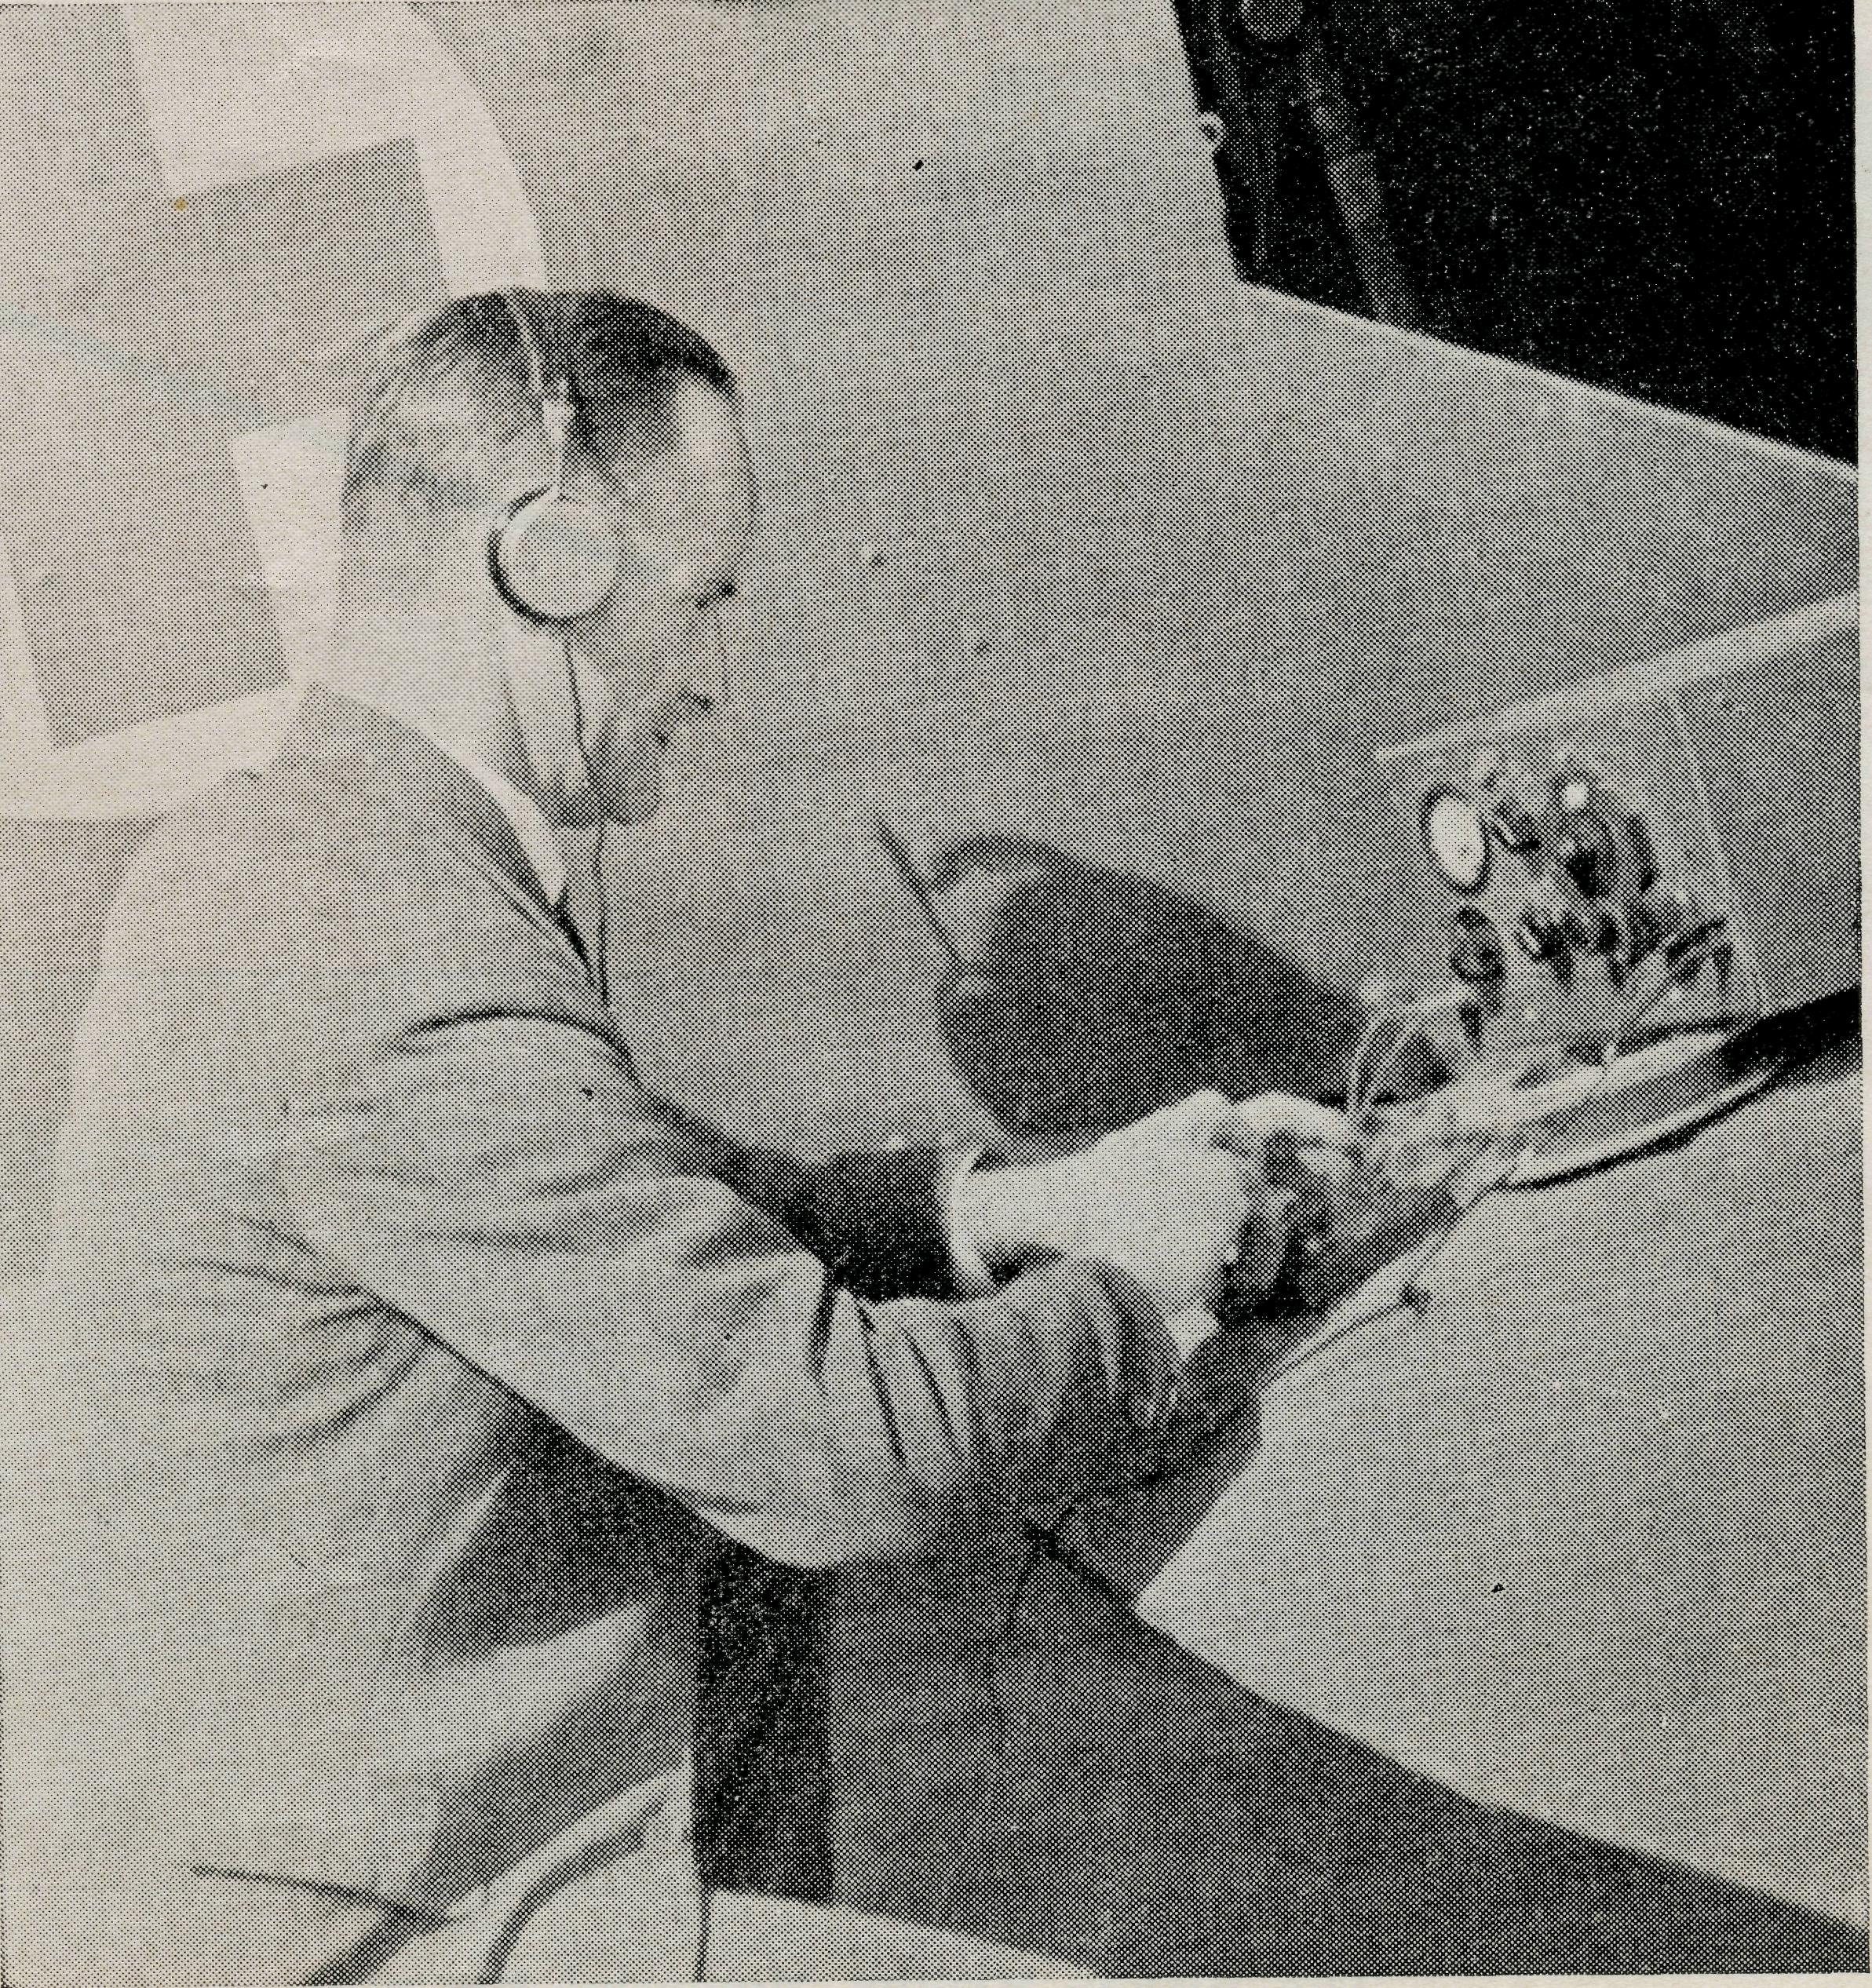
Mr. Allan Chadwick, who has piloted the medical 'plane for 6 years.

THE REAL AUSTRALIAN
10
May 26, 1944

The Medical
VH-
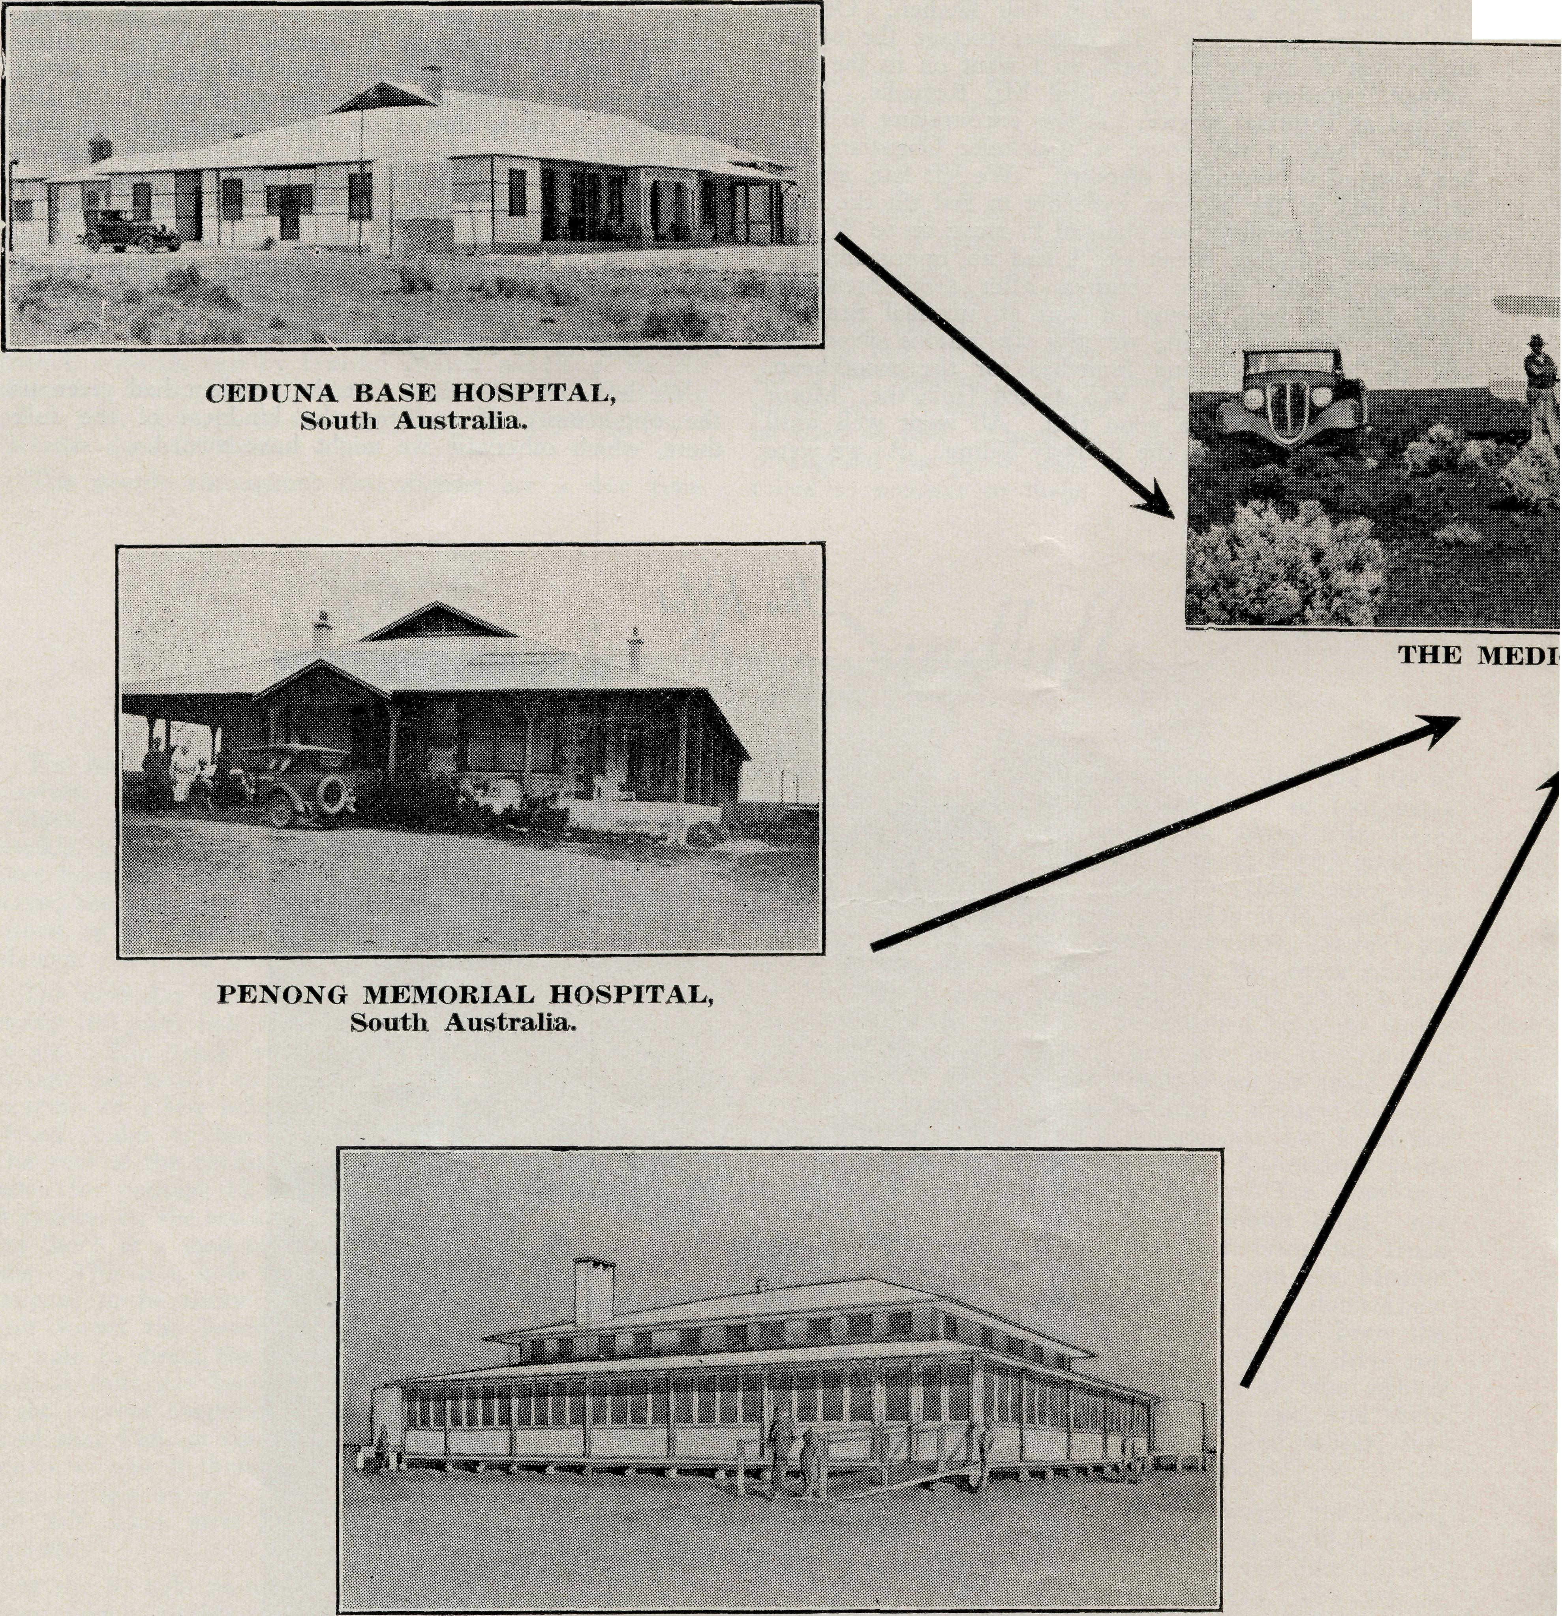
The Bishop Kirkhy Memorial Hospital, Cook, South Australia,

May 26, 1944
II
THE REAL AUSTRALIAN

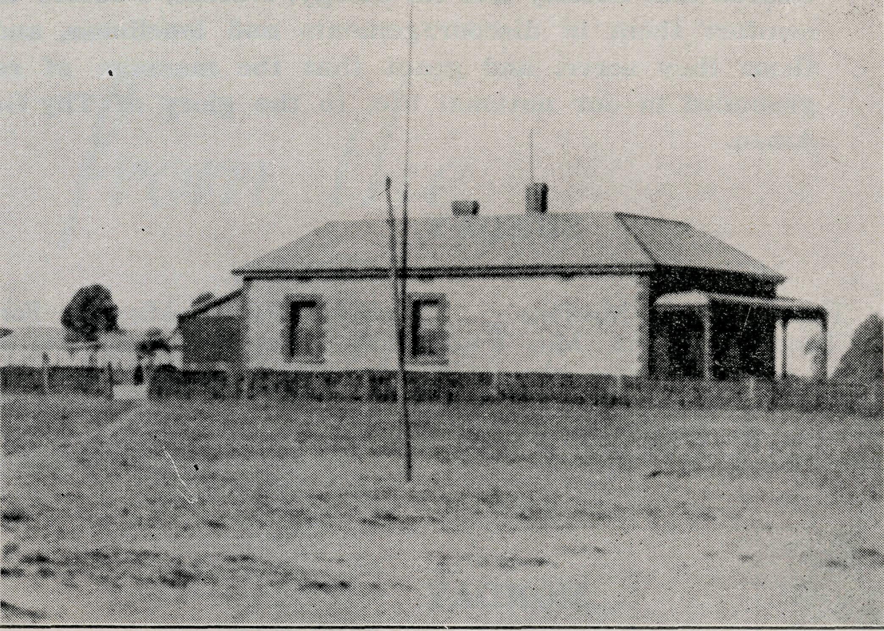
Services, 1944
VAA
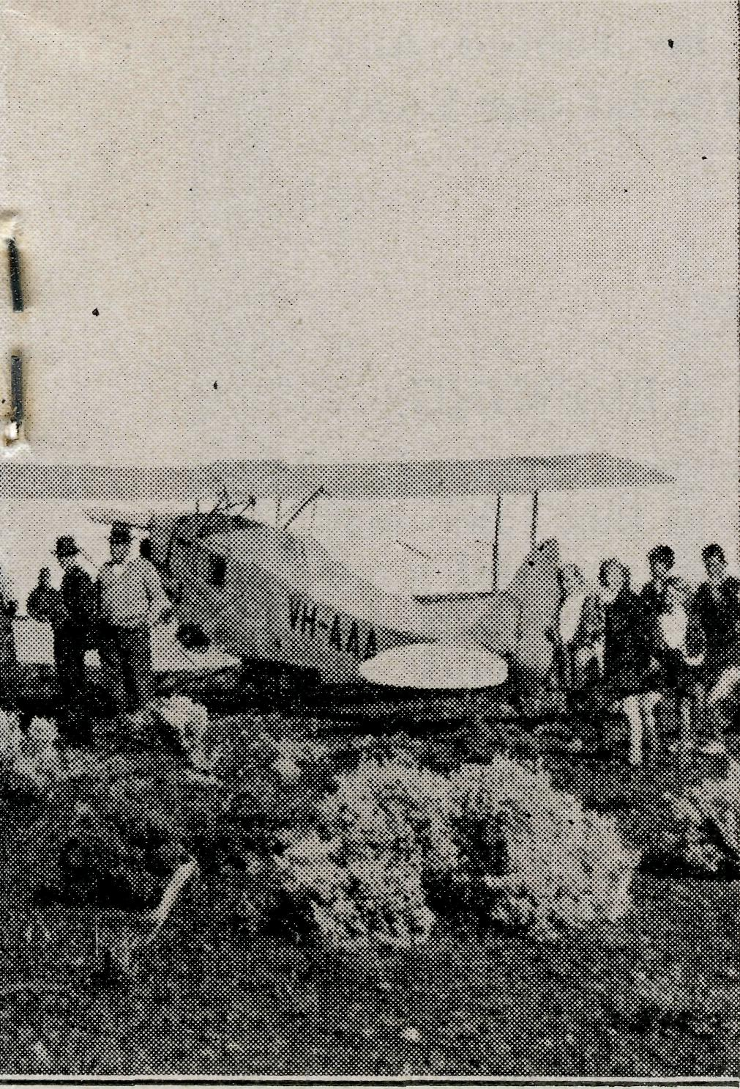
KOONIBBA HOSPITAL, South Australia.

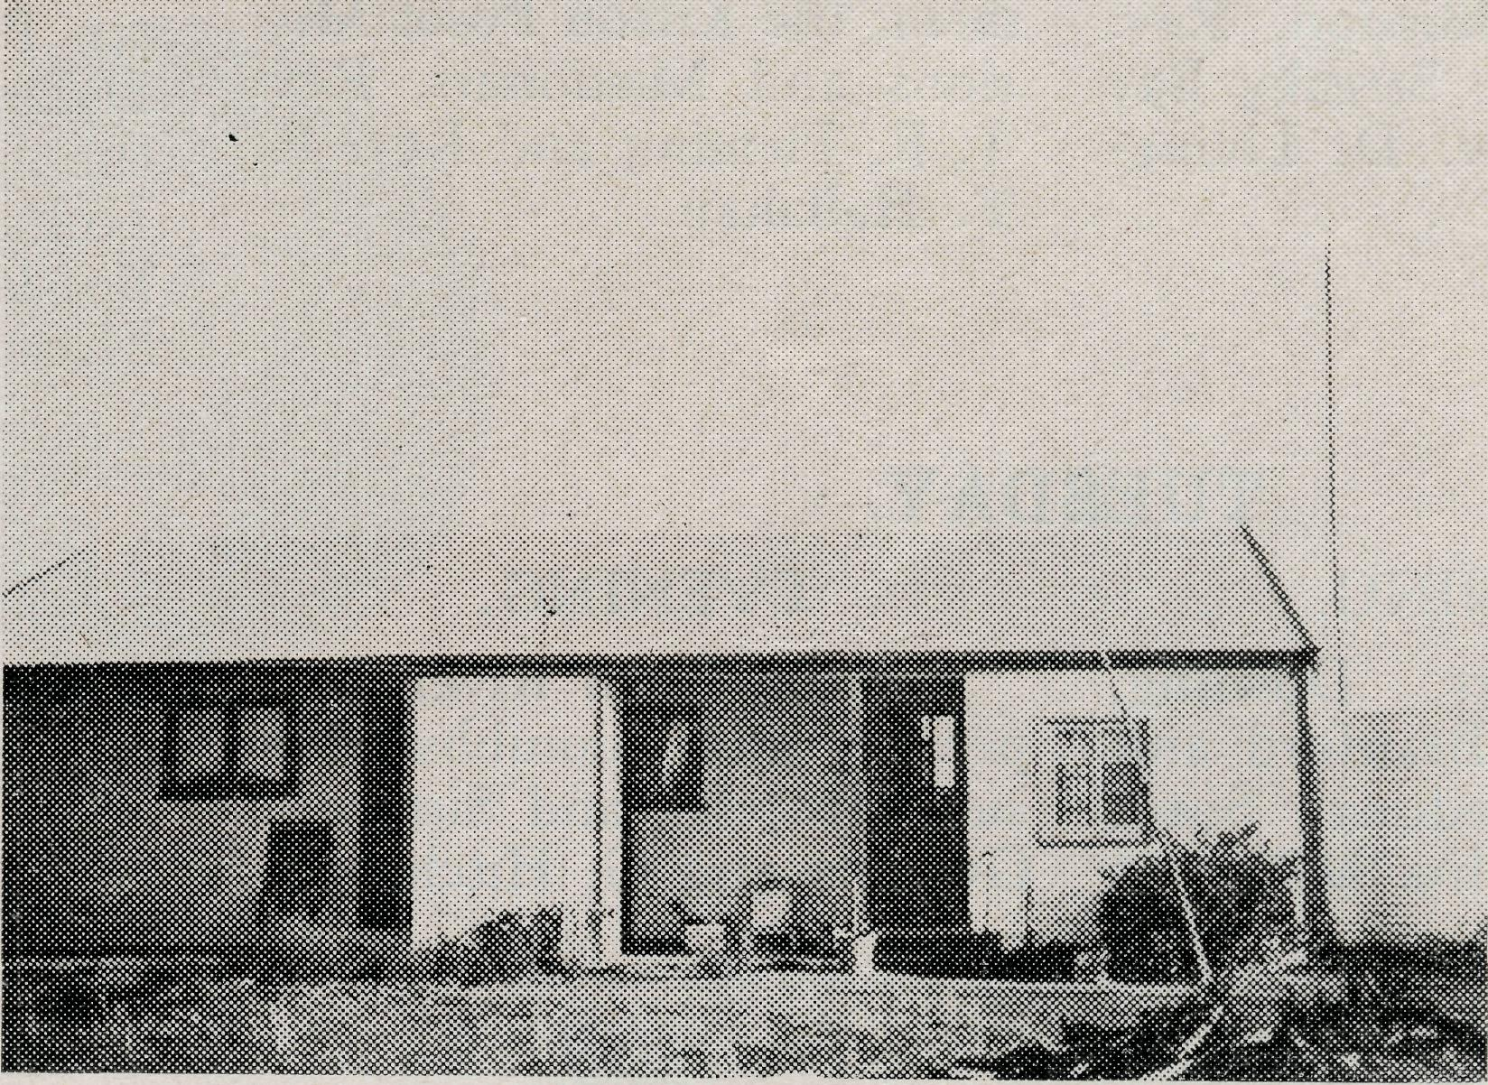
IL PLANE.
TARCOOLA MEDICAL HOSTEL,
South Australia.

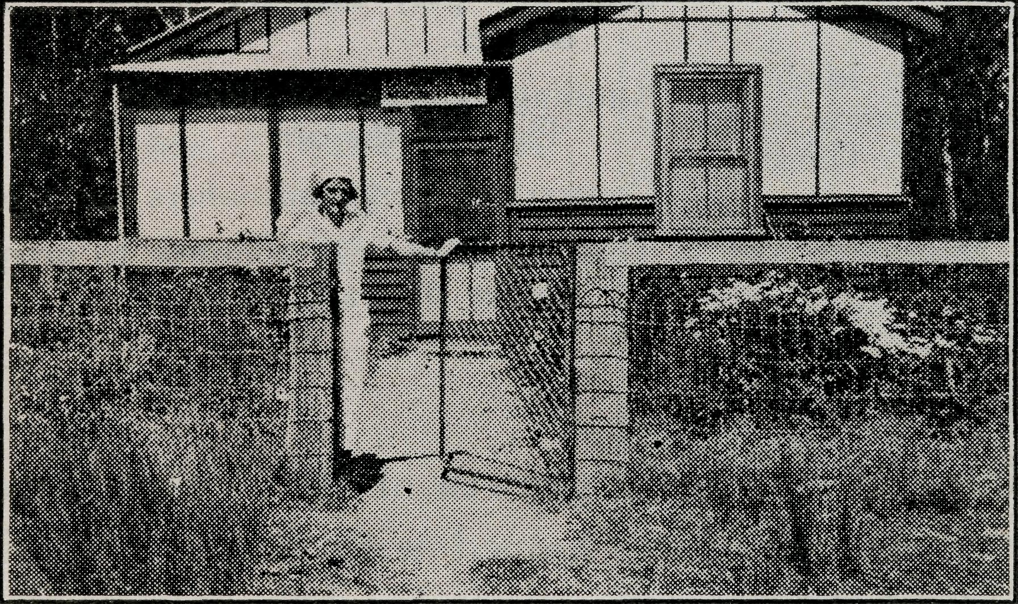
CANN RIVER DISPENSARY, Victoria.

THE REAL AUSTRALIAN
12
May 26, 1944

THE PLACE OF PRAYER
A Prayer for Use with Our Prayer List.
O Lord God of our nation, Who has commanded men to subdue and replenish the earth: Look in Thy love upon all those who in the distant parts of our land are striving against many difficulties, and are deprived the access of the means of grace. Strengthen and guide the Bush Church Aid Society and its Clergy, Nurses, Doctors and Air Pilot, and Students. Cheer and comfort them in discouragements and loneliness, and bless their ministrations to the good of those they serve, and grant that the message of redeeming love may thus be rooted and grounded in our national life, to the glory of Thy Great Name, through Jesus Christ our Lord. Amen.

MORNING.
SUNDAY.
EVENING.
THURSDAY.
MORNING. EVENING.

The Far West Missions at Penong, Ceduna, Min' nipa and Cummins; the Missioners, H. Broadley, L. Morris, D. Pugh and J. Greenwood.
The West Darling Missions at Wilcannia and Menindee; the N.W. Mal-lee, and the Missioner, K. Luders.
For the Mail-Bag Sunday School with its Gospel messages for the children. For the teachers and helpers, that they may find encouragement in their work.
For the Organising Missioner, that he may be strengthened and guided in all his endeavours for the good of the work and in his relationships with his fellow-workers.

FRIDAY.
MONDAY.
MORNING.
The Cann River Mission, the Bonang Mission, Rev. K. Brodie, the Streaky Bay Missioner, Rev. D. Livingstone.
EVENING.
The Denmark Settlement, the Kirton Point Missions and Missioners, Rev. T. R. Fleming and Rev. R. T. Hallahan.
MORNING.
For the Bishop Kirkby Memorial Hospital and Sister Pritchard and Miss D. Dykes, as they minister to the people on the great Nullarbor Plain. For Sister Bossley and the Tarcoola Medical Hostel.
EVENING.
For students and all in training for this work of God. For Rev. W. Duffy and the Heytesbury Forest Mission. For Rev. T. H. Pickburn and the Otway Ranges Mission.

SATURDAY.
TUESDAY.
MORNING. EVENING.
For Sisters Dowling, For the Cann River Dis-
Page, Loane, Branford and pensary and Koonibba Mis-
Moody at Ceduna; Sister sion Hospital, and Sisters I.
Firmin and Miss Millar at Gwynne and G. Hitchcock.
Penong.
MORNING.
For the President and Council of the Society, that they may be guided by His wisdom.
For the Home Base Staffs, Auxiliaries, and parochial workers.
EVENING.
For the "Coomb" Hostel and its workers, Mrs. Mann and Miss Harding.
For the Rappville Mission and the Missioner, the Rev. P. N. Connell.

WEDNESDAY.
MORNING.
For the children in the Mungindi, Wilcannia and Port Lincoln Hostels, and for the workers, Miss Cheers, the Misses Gurrier Jones and Sister Sowter.
EVENING.
For the Flying Medical Service, Mr. Chadwick, and Doctors R. and F. Gibson.
For the wives and families of the Missioners and Air Pilot.
Each day pray that the many needs of the work may be met.
Running expenses of 40/- per hour to keep the Medical 'Plane in the air.
Consecrated clergy missioners for urgent work in the field.
That our work may continue to progress despite the difficulties of wartime.

Give Thanks—
For the rich blessing and wonderful growth of the Society's work. For all the kindly givers who have helped with their self-denials. For the Flying Medical Service. For the joy of service.

May 26, 1944
13
THE REAL AUSTRALIAN

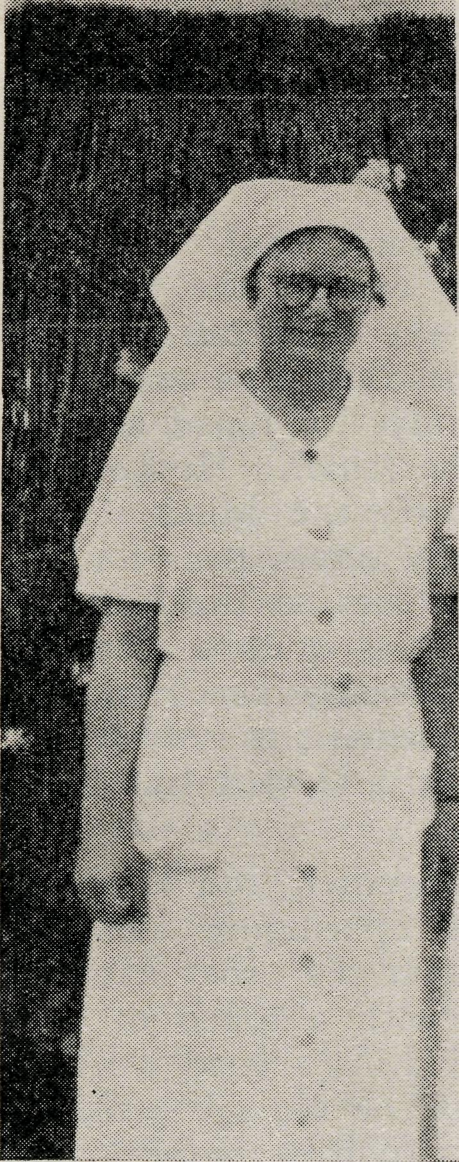
News from the Healing Missions

Sister F. Dowling,
Matron of Ceduna
since 1934.

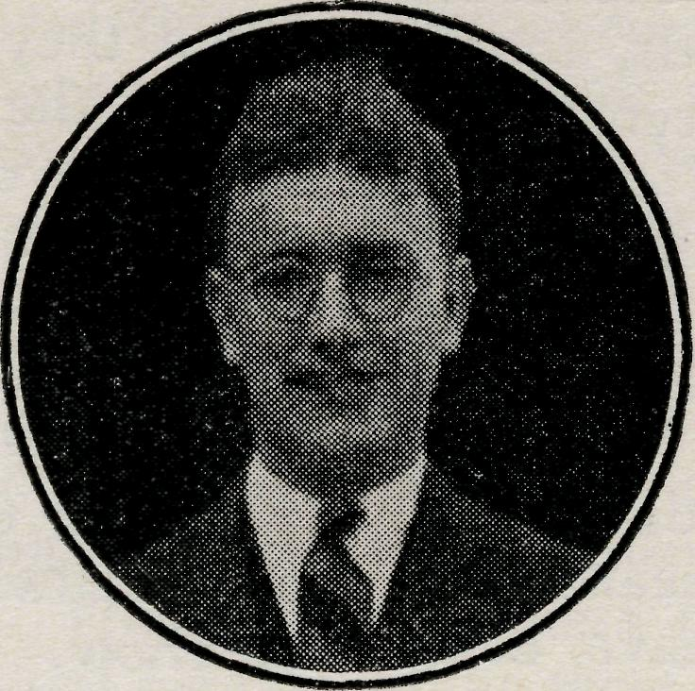

Dr. Roy Gibson.

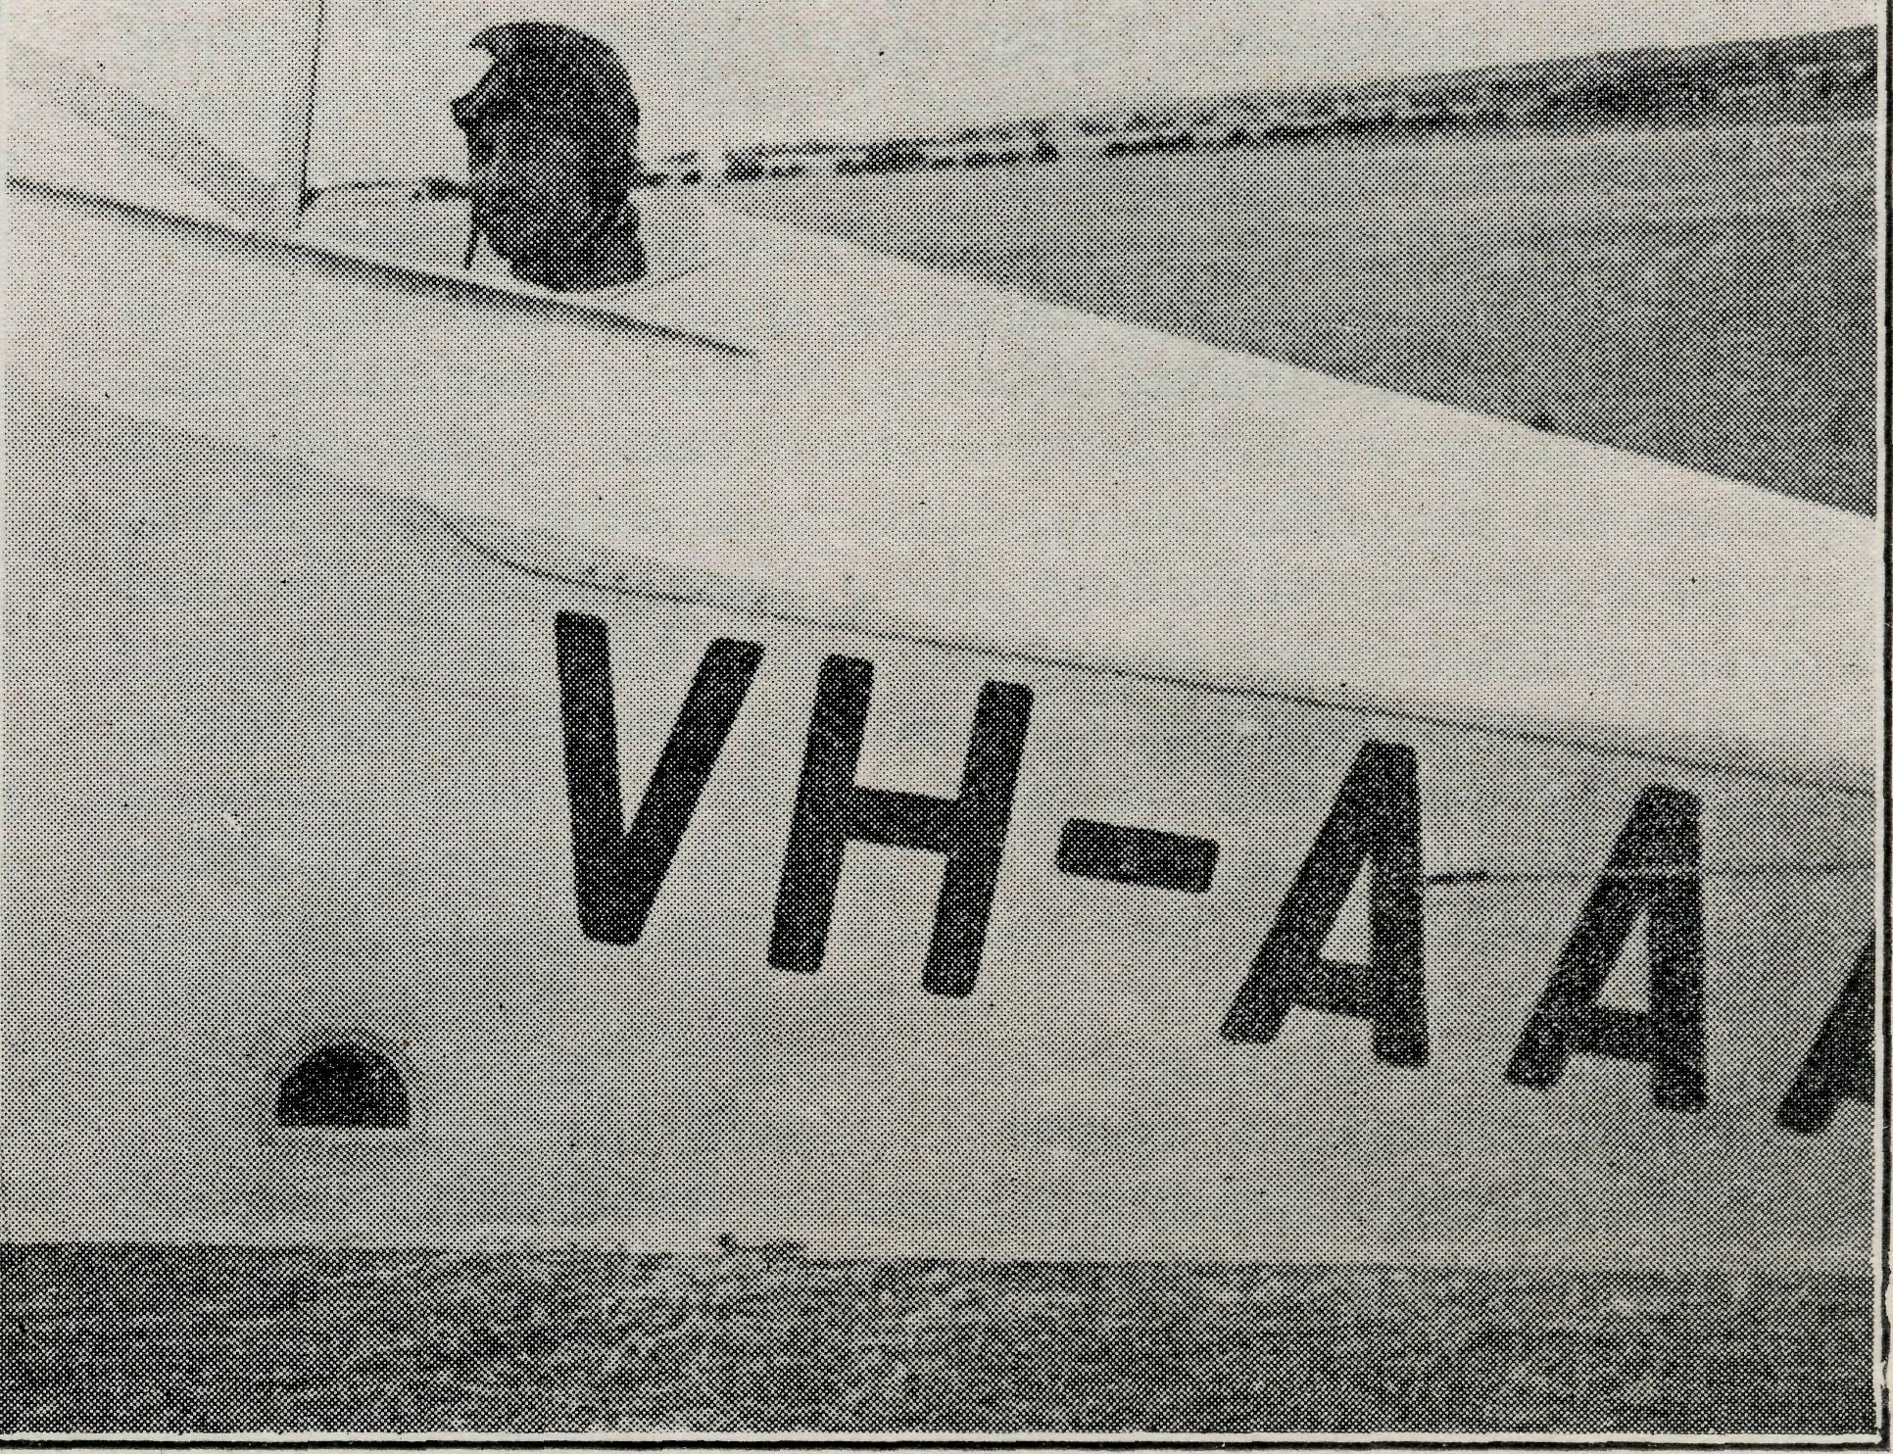
Mr. A. OHADWICK
and the Medical 'Plane.

THE REAL AUSTRALIAN
14
May 26, 1944

Koonibba Personalities
Sister G. HITCHCOCK.

There are some interesting characters among the aborigines at Koonibba, and this is just a brief sketch of some of them.
Firstly, here is someone you may have met before in the pages of the "Real Australian,¹¹ viz;., Paddy Mundy. However, if you want the other natives to know of whom you are speaking you must say "Lame Paddy,¹¹ the other is his registered name, but everyone here prefers his nickname. Paddy has a very strong muscular body and arms, but his legs and feet are wasted and powerless. Paddy is one of the most cheerful natives I have met and his life is not exactly a bed of roses. Instead of being able to walk like other people, having been lame from birth, he has to get along by pulling himself along the ground on his hands and buttocks, and pulling his feet after him, or lifting them over rough places with his hands. When he was a boy he used to scale up trees, and go rabbiting, digging them out of their burrows with a crowbar, and killing them with a waddy.
Many years ago someone presented him with a wheel chair, but it was a self-propelling one and it gave him big ideas, and Paddy used to travel long distances through the scrub and rough country, so that meant the eventual finish-up of that chair. Then there was a long period when Paddy had to return to his original mode of travel, and he found it paid him to stay on the Mission, where he could get food and had plenty of friends. He could manage to get around occasionally, on his hands, to see his friends, and could go to church. He is a keen Christian, and does not like to miss a service if he can help it. However, the continual strain on his hands and body from the rough stony tracks eventually had its effect on Paddy, and he had to spend quite a long time in hospital for treatment of several abscesses, which took a long time to heal. It was during this time that it was discovered that he was a diabetic, and that, of course, means that he should not leave the Mission, hut must have daily injections of Insulin to keep him in good health.
Then came a day when Lame Paddy got another chair. One was given him from the B.C.A. hospital at Ceduna, but this time it was the sort that should be pushed by someone else. For quite a while he got much pleasure out of this chair, and, being of an independent disposition, he soon managed to propel himself along by pushing on the wheels with his hands. However, much wear and tear on this poor chair soon reduced its usefulness, and towards its end it was a common sight to see Paddy on the ground with a piece of wire, hammer and nails, etc., trying to renovate his chair. There came a day when it got beyond the renovating stage, and once more Paddy had to return to travelling along the ground. He had a long patient wait this time, until Mr., Fulford (our B.C.A. secretary in Adelaide) kindly searched the whole city of Adelaide and at last discovered a chair costing £40. It is a 'beauty, with self-propelling levers, and the fact that Paddy is a diabetic will keep him here on the Mission, and thus ensure its longer life. Although someone advanced the money, the natives promised to collect it between them, and as natives would lose interest once the chair was in Paddy's possession he couldn't have it until it was paid for. Micky Free, of whom you will hear more later, made himself chief collector, and by sheer persistence in tackling the wives of men in the Labour Corps on pay day, Micky at last succeeded in
collecting £20 from the natives. Pastor could see that that was about their limit, so the rest of the amount was donated by the white staff on the Lutheran Mission Station, a small amount being donated from a charitable fund. So now, at last, Paddy Mundy, full-blood aboriginal, is the proud possessor of another chair. He goes to church regularly, visits his friends on the Mission and has an occasional trip into the nearby scrub, goes for his milk to the Children's Home and comes to the hospital in the morning for his injection. It is quite a treat to see his beaming smile, and he is already becoming an expert, and gets along at a great speed—it is only to be hoped he does not get too enthusiastic and start travelling to Alice Springs or Port Augusta.
Micky Free is a different type altogether, and is about a quarter-caste. He boasts of his upbringing amongst whites, and has quite an influence over the other natives; in fact, he is designated by some, with a touch of sarcasm, as "The King of Koonibba." He is a good worker, and although he's about 75 and gets the old-age pension, he still carts wood for other natives to earn money, and daily goes out trapping rabbits, and selling the skins. Micky is an elder of the church, and feels it his duty to help Pastor Traeger to manage to keep the natives in order. He reports cases of misbehaviour, and on Sundays goes round rounding up people to go to church. He is a great one on clearing the Mission Station of dogs when they begin to multiply to any extent, and it is told me by the other natives that Micky is so good at it that they can come to see him with their dogs following, and whilst eating his own dinner he can throw a piece of poison to their dog (all unsuspected by them, of course), and go On eating his dinner without being at all afraid of poisoning himself. So much for Micky Free.
Jimmy Gherkin, full-blood. It's pronounced like that, and I always spell it that way, but it might be Gurkin. Anyhow, "coming events cast their shadows before," so if ever you see an attractive little black and white puppy (at Koonibba, I mean) you may rest assured that Jimmie is just a few yards behind—they always travel together, and are practically inseparable. Jimmie is also a diabetic. It was discovered in the early years and treated for a while, but then, in true native fashion, Jim said, "I'm cured now—no more sugar," so had about ten years' untrammelled freedom, roaming all over the countryside wherever and whenever he desird.
Eventually, however, Jimmie got a sore foot, and as by this time there was a hospital at Koonibba, Jimmie was admitted and spent five months here with a gangrenous foot, and was very fortunate to get off without having an amputation. One fine day Jimmie was released from hospital, but was afraid to put his foot to the ground. In fact, for about a whole year, nothing would persuade him that he could do without crutches. At last he let them go, and discovered he could get on quite well without them. He was content to stay on the Mission for a while for treatment, then he decided he'd have a bit of a holiday in Ceduna, going round chopping wood, fishing, and earning a bit of money. After six months' freedom, the inevitable result—back to the Mission with a sore foot again. However, this time he could be treated as an out-patient, and his foot is quite healed again now, and we can only hope that he does not take another holiday for a while, at least.

May 26, 1944
15
THE REAL AUSTRALIAN

Finding God at Ceduna
Sister F. BOWLING.

Some ten years ago one of the old pioneers of the dis' trict was admitted to hospital in a diabetic coma. The said patient, in spite of her diabetic condition, had her own ideas of what she could eat, rather than what she should eat, and not being overTond of injections of insulin, the two omissions landed her in hospital in a comatose condition, from which it was not expected she would recover. But recover she did, and was soon on the mend again. She manifested an interest in the daily reading of the Bible, the singing of the hymns, etc. Her husband, who had battled through many years of adversity with her, was not a believer, and the old lady said, "He is not at all interested. I do wish he were. I keep on pray ing for him." "We will pray for him, too,¹¹ we told her, and we did for some years. Many opportunities were taken to speak to him—the passing on of books, which might help to turn his thoughts to the things that mat' ter in life. Most of you have heard the story of his admission to hospital a few years ago, and of his accept' ance of the Lord Jesus Christ. He recovered from his illness, and in the years that followed, sought to know the Lord better. In one of the cases sent out from Syd' ney or Melbourne, someone had given a Bible with very large print, divided into four books. He was delighted to read these and accept them as a gift. The hardest thing of all for him was to learn to pray. These things are not easy when we are young, and one can appreciate the difficulties in setting out to follow the Lord Jesus Christ when over 70 years of age. The years passed by, all the family had married and gone away, the old couple were left alone, both more or less invalids. One day last month the old chap called in for a talk and some prayer together. "Mum¹¹ would probably be going to live with one of their married daughters, but he felt he couldn't stand all the children around him. Then he asked what he had come to ask. "What about the hostel the B.C.A. are opening at Port Lincoln? Do you think I could live there?¹¹ On being told this was for High School children, his face fell. "Well, I don't know what is going to happen to me." He was assured that his Heavenly Father knew of his need, and He would provide a place for him, and provide a place His Father did, for within three days he was admitted to hospital, and died soon after. "In my Father's house there are many mansions. I go to prepare a place for you." The old lady, as she looked at her husband in bed for the last time, said, "He is going to be with Jesus—ever since he was a patient in here he has read his Bible and said his prayers every day, and always went to Church." God had answered her prayers and those of others.
How many of us, I wonder, fully appreciate the cour' ageous work being done by the men of the Merchant Navy? We think of the many wheat boats which have called in here to fill up with wheat to take to countries where the people are starving. Many of them, we fear, never reach their destination. One British boat on a similar mission, called in to Melbourne. The crew, no doubt, welcome the chance of having a good time in the great city. One of the lads "chanced" to walk in and see what was on in "Everyman's Hut." Mr. Alex. Gib christ spoke that night, and the spirit worked in the lad's heart, and he began to think. Back on board ship,
amongst the rowdy crew, the thoughts of God were crowded out. The ship sailed for an unknown destina' tion, travelling along the Australian coast, and finally called in at Ceduna for a cargo of wheat. What of the lad? Does he realise that at this far away spot, God is waiting to lead him still nearer to Himself? In the course of his work of loading he jumped from the deck on the wharf, fractured his leg and was admitted here, and here he stayed till the boat sailed some days later. He learnt this was a Mission hospital, began to read—of his own accord—the Bible on his locker. His interest grew each day, and finally, before leaving hospital, he signed a Mis' sion card. In spite of all the difficulties which he knew lay ahead re his witness, before the other members of the crew, he was going "to give it a damn good go," as he put it. We have had no further news of him. His home is in Wallesey, in Liverpool, England. Does a Christian mother await his homecoming?
A very ancient model Ford car has just driven up. The mother of a family has come in from a farm to collect her seven'year'old daughter. The previous week the little patient had been brought in with a gangrenous appendix and operated on successfully. Does the reader happen to be the person who at one time sent us out a big doll accompanied by a lot of doll's clothes, with a note asking that the doll be kept in the hospital and given to sick children while they were patients? Whoever sent it would be well rewarded if they knew all the pleasure the kiddies have had from their gift. This little lass cried bitterly when she was told in Doctor's Surgery that she was going into hospital. She finally became willing by the thought that she might get a lovely doll at the hospital like her little cousin got when she came in with burnt hands. The patient's first words on opening her eyes after the opera' tion were, "Where's my dolly-"
The folk from England have just sent a second parcel of hand'made dolls which are really lovely, so one was procured for her ladyship, and off she went to sleep again, quite happy with the doll in her arms. It was a grateful mother who collected the little girl to take her home again.
Recently an American transport plane landed here to reTuel and then found it could not continue the journey till the following morning. Could we take a patient in for the night? A young lad from the American Naval Air Force being invalided home to California. Two frac tured thighs, compound fracture of lower leg, fractured ankle, compound fracture of the humerus, and fractured collar bone, and he was still very much alive! He had been six months in Perth Hospital and was very thrilled at the thought of joining his wife and family. How we wished he was staying longer. He left at daybreak next morning.
A party of nine lads were asked down for supper after Church one Sunday evening. We don't know any of their names—all nine lads, somebody's husband, son or brother. We got them singing the good old hymns. On asking if they had any favourites, one of them replied, "The only hymn I know is 'Land of Hope and Glory.' "

THE REAL AUSTRALIAN
16
May 26, 1944

Notes from Penong

Miss MILLER.
Comes a request from Sydney for something for the R.A. So after a lot of thinking, one sits down and thinks —all the things one was minded to write of have taken wings. Somehow everything seems so commonplace and much too ordinary to write, until one realises that Jesus found in the everyday things much that He could use in teaching the people of the Love of God.
One morning, about two weeks back, we h*ad a visit from the local General Carrier, who unloaded a substantial-looking box on to our back verandah. The following afternoon we delved into its depths and great was our pleasure as we unearthed a number of children's books, and quite a few Bibles, most of which have since been dis-tributed. Some were kept to add to the Hospital reading matter. The rest of the box was packed tightly with food' stuffs, which were much appreciated and have added greatly to the appearance of the pantry. Our thanks are due to the Melbourne folk for the contents of the box.
Our Sunday School here at Penong is only small, but the kiddies who do attend are very regular, and one wishes that it were only possible to do more. It is not any easy matter to give a lesson each week that will hold the atten-tion of the little tots and yet meet the spiritual needs of the older children. The Mail Bag Sunday School lessons have been invaluable in helping to do this. We are for' tunate to have the services of a keen musician to play the organ for our Sunday School. Though small children are not very critical—at least, not in one's hearing—of one's vocal efforts to lead and teach, it makes the teaching of new hymns and choruses much easier.
We recently admitted to Hospital a half-caste woman who is married to a white man. Her home leaves much to be desired as regards modern conveniences and home comforts, most of the furniture consisting of packing cases, and she herself has to cart and carry all water for the household use. She has three little children, the eldest just school age. They are 15 miles from the nearest school, so she has undertaken the task of teaching him herself, although her own schooling was of the simplest. She also desired that the children should have some spiritual teaching, too. I was able to pass on to her a number of M.B.S.S. lessons, which she appreciated very much, and has promised to use.
This woman is only one of many such people scattered throughout our great land of Australia, and it is to you and I to whom they look for help.
Although it is not given to all to minister personally, there is one way all can help, and that is through prayer. Your prayers are asked for, that we ourselves may be given the grace to do His will.
Sister FIRMIN.
Four shorts—the telephone gave our call signal for after-office hours, and the time was something to twelve on Easter Monday night. It was the Fowler's Bay policeman ringing from Coorabie. There had been a fight, a native had been cut in the leg with a pocket knife, and
was being brought here for attention. They would be here in an hour, he said, but it was nearer two when they arrived. The car was a back number for speed. The wound was discovered, under a variety of improvised dressings saturated with blood, and still bleeding slightly. I could not help observing and taking pleasure in the kindliness of the white man who had brought the patient in—a native employed on his sheep station. The wound obviously required sutures. After a little hesitation I thought I had better do so. The only alternative was to contact Doctor, which I decided I ought not to do. The process could have been more aeseptic as far as skin preparation, and it must have hurt, but the job went off all right. They left here about 3 a.m. At 6.30 a.m. a woman arrived for confinement. Not all days are like that one. It seemed never ending. Last month was a comparatively quiet one in hospitial, however, as was March. January and February were fairly busy months. Tonsillectomy seemed to be the order of the day. There were six births.
Several extra conveniences have been added here during the last few months. To our Doctors and the Hospital Aid we owe our thanks for the shadowless light in the theatre. It has been used and pronounced very good. Some of our readers may know the position of our nursery—out in the paddock, someone said—a light on the verandah makes the final routine work of the day much easier, and incidentally safer. Also after long waiting we have a fly-proof wire door—a piece of real professional work. Actually the door took shape suddenly and came from an unexpected direction. Having had the urgency of the need emphasised to them, some of our friends moved in the matter. The gesture was much appreciated.
We were pleased to welcome Rev. J. and Mrs. Greenwood to Penong. Mrs. Greenwood remarked that the screen pictures do mot do full justice to the hospital, which certainly has a pleasing appearance, the colour of stone and red roof and brick finishings contributing greatly. A project to plant a double row of trees as a memorial avenue from the road to our gate has been discussed in Hospital Aid meetings. I hope the vision will materialise. It badly needs a few trees about. As all these women have plenty of work at home and little leisure, I think it marks their appreciation of this work when a few willing hands get to work on a stack of mending or anything else that we give them to do at the monthly meetings. It is good to have their support and co-operation. From the Auxiliaries in the Eastern States we have received surgical instruments and enamel ware for the theatre, also just recently a big box of groceries, etc. Thank you, all! The books and stuffed toys and dolls are very good. Therein is provided an object of interest while one attempts some necessary minor surgery such as suturing a small cut or even giving a hypodermic injection for a child. Afterwards it is mostly the anxious "parent or guardian" who requires treatment for collapse and not the patient. Very often the children, if left alone, react better than they are expected to do to hospital treatment. One mother who feared that her child would be "driving Sister mad," was agreeably surprised to find that we remained sane after several weeks of him as a patient. Dennis was quite lovable at times, at other times well, not quite so good.

May 26, 1944
17
THE REAL AUSTRALIAN

Our Silver Jubilee Objective

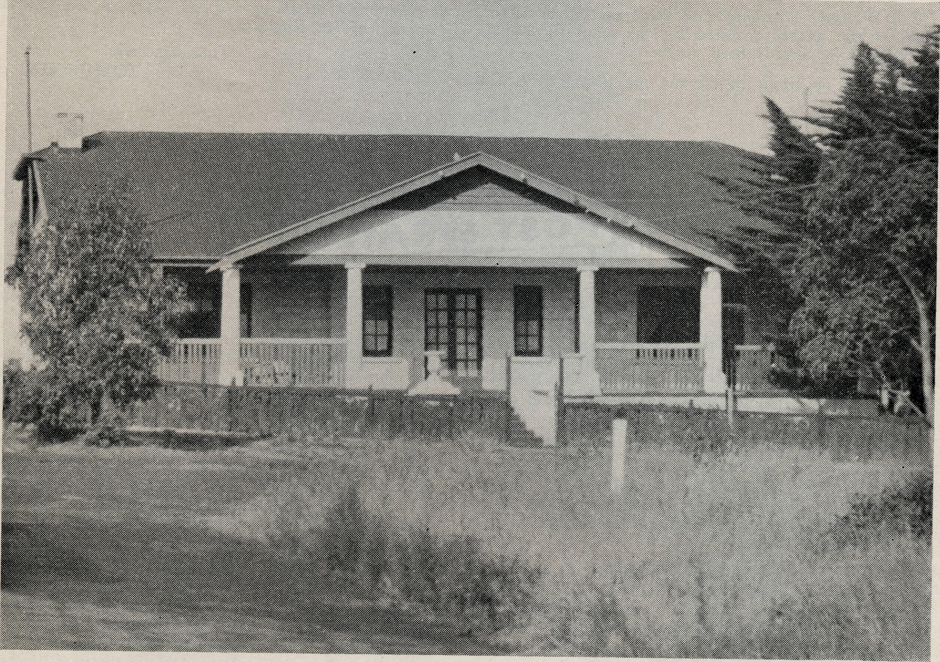

The Home at Port Lincoln, recently acquired by B.C.A. for use as a Children's Hostel, and for which we ask for gifts towards the £2150
for its purchase.
The Organising Missioner’s Letter

There seems so very much that one could write on such an occasion as our Silver Jubilee that it is hard to know what to leave out. Perhaps I had better confine myself to the new hostel and let the other articles which follow impress this work and its importance upon your mind and heart.
Recently I took a hurried trip to Port Lincoln for the purpose of finalising the purchase of the building to be used as our fourth Children's Hostel. As a result, I was able to arrange the purchase at ,£2,150, with four months to complete the payment.
On May 6th we took possession and the Matron com' menced her duties. Sister H. E. Sowter has been appointed Matron and she undertakes this work as no newcomer to B.C.A. Sister was in charge of Penong Hospital for some years, and was also our Sister at Cann River. Lately
she occupied an important and well-paid job m Sydney, and goes to Port Lincoln at some financial sacrifice. Pray for her.
The hostel building is a modern and well-built house, with accommodation at present for twenty children; later we hope to increase it. It is beautifully situated on the shores of Boston Bay, with a fine view of that harbour from the front door.
I have no doubt that this hostel will become the home of many outback children over the years, and that in it a piece of worthwhile service will be rendered.
When visiting Port Lincoln I received many expressions of real thankfulness from residents that B.C.A. was going to take this important step.
One man told me, "Mr. Jones, this is the finest thing that has happened to this district for many years."

THE REAL AUSTRALIAN
18
May 26, 1944

The people of the town are taking a real interest in the project, and already arrangements have been made to supply many of the things needed in kitchen and dor' mitories. Others are offering their services for weekly mending parties, etc.
Our Women's Auxiliary have made themselves respon' sible for the finance required for the main furnishings, and these have already been purchased.
Well, it's up to us to see the job through. Let us
do so with the same determination which actuated those few folk who began B.C.A.
We need £2,150 in approximately four months, and 1 am sure you will see it supplied.
You will also pray that the service rendered here and elsewhere will be always for the Glory of God and the extension of His Kingdom.
Yours sincerely,
TOM JONES.

Since our last issue, the Rev. John Greenwood and his wife have arrived at Geduna and commenced their min' istry. Their advent was a great relief to Mr. Broadley, and we pray that they will form a team which will render redoubtable service.
As with most institutions in city and country, our hostels and hospitals are suffering acutely for lack of domestic help. We have appealed times out of number for such workers, without result.
In consequence our nursing and hostel staffs are greatly overworked. It would be a sad day if hospitals or hostels had to close down for this cause, yet it is only because our present workers shoulder the extra burden that they have not already done so.
Surely there are two or three of our women friends who would undertake the duties of cooking or washing as Christian service. Can and will you face up to this need? Particulars from the O.M.
The Archbishop of Melbourne gave kindly commendation to the Society's work; the Bishop of Ballarat, who had journeyed down specially for the meeting, paid tribute to the work being done at Timboon and Beech Forest in no uncertain terms.
The Rev. W. Duffy was a tonic. He is vitally interested in his work, and had his listeners just as interested before he was finished. The Editor felt that much of his address was too good not to give it wider publicity and, therefore, some is reported in this issue.
The O.M. added an historical touch by recounting some B.C.A's. work over the past quarter of a century.
All went home feeling it had been a gathering worth attending. The collection to date, which was for the Silver Jubilee Fund, amounts to £281.
In order that all available space in this issue can be used for news and photographs, we are holding over the usual list of unacknowledged donations.

Our readers will note the change in the set-up of this journal. We think it is for the better, and hope that you do, also. The new sue is more handy and compact, and the-new front page attractive. After this issue we will, because of the necessity of Government regulation, revert to the newsprint for the inner pages, but they will be made as attractive as possible.
This issue will be kept for reference by our friends, and we hope you will send a copy to some friend or relative. ' If you require extra copies, they can be obtained at the office, but for this issue the price must be 6d. each for extra copies.
On the occasion of the Society's Silver Jubilee our thoughts and sympathy are very specially with Archdeacon and Mrs. W. L. Langley at their home in Gordon.
The Archdeacon, together with Mr. T. S. Holt, Mrs. E. Bragg and Miss Foulcher, are the only surviving foundation members of B.C.A. in Australia. Bishop G. A. Chambers, of Tangyanika, is the fifth.
We pray that the Archdeacon and his wife may both improve in health and enjoy a full measure of comfort in their retirement.

The Melbourne Rally, held on Monday, April 24th, was, without doubt, the best ever for Victoria.
It was a cold and wet day and night—the O.M. couldn't get warm, but a well-attended meeting listened with great interest to some really thrilling addresses.
A washing machine and a refrigerator would be very useful articles to have in our new hostel at Port Lincoln.
I wonder if somebody would like to do something about them?

May 26, 1944
19
THE REAL AUSTRALIAN

Sister I. GWYNNE.
". . . And behind the dim un\nown Standeth God within the shadows, Keeping watch above His own . . ."
—Lowell.

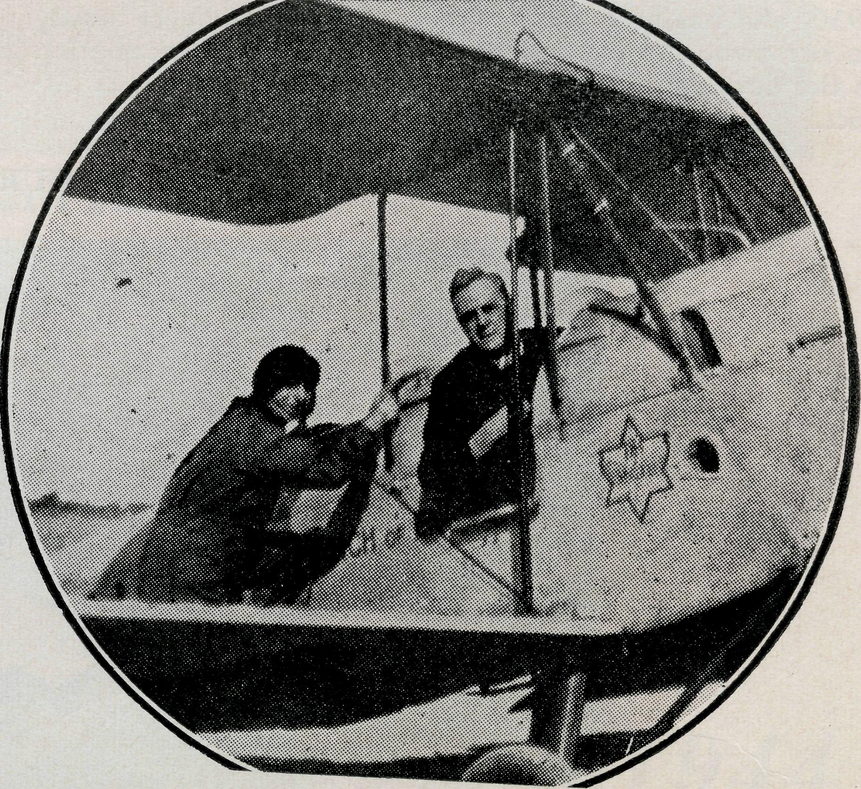
The truth and reality of the above words were most markedly demonstrated and brought to one's mind just recently. Just after 7 p.m. one evening, as I was think' ing, ""Well, what will I have for tea—what is there in the larder?"—the telephone rang. The voice at the other end revealed a most anxious mother with a very sick babe. This particular babe, now eleven months old, has had a nasty skin rash since he was three months old. Now he was very ill—listless, vomiting, stiff neck, excess pain on movement. Not being a medico, one could not very well determine what might be the real cause of the trouble, and so advise treatment. It could be anything from ear trouble to meningitis. There were also lumps under the ear. The mother would certainly like me to see him. Only thirtythree miles out, and their own car had a broken leaf in the front springs. So we sought the help of our local police officer. He assured me that the tyres of his car were not the best, and he had no spare tyre, but he wouldn't see me stuck. So I went back to my cottage, had tea, and looked in the kit'bag to see that I had what things might be necessary and useful in such a case. Two hours passed and the chauffeur had not called. I later learned that he had gone to two or three other folk to. try and get their assistance. None were at home. One of them had-gone to help a man whose truck had gone over an embankment. So the P.O. had no option. So off we set. About 22 or 23 miles out, the car seemed to skid on a particularly rough piece of gravel. There was a rocky, high embankment on one side and a drop of anything from 10 to 20 feet on the other side. The driver stopped, the worst had happened—-a blow-out. "Yes, and my best tyre, too. Well, Sister, you had better curl up on the back seat, and I'll see what can be done." It was a fairly cold night. So the P.O. set to work and, after a struggle, got the wheel off. He had no spare wheel, and simply cannot get tyres. Then, after more than half-an-hour's struggle, he had to give it best. We were a long way from our destination, and seemed to be miles away from anywhere. Help must be sought. So the Police Officer set off to walk. Would he go forward or backward to get to the nearest house? He decided, for more reasons than one, to come backwards. Had to walk about five miles, and came to a house. All in bed! I should think so. The time? Well, after 2 a.m. After waking some of the household, a young man came out and got in his car on learning of our difficulty, and brought the P.O. back to the scene. The said young man was none other than head mechanic at one of the leading garages in Bairnsdale—out on holiday for the long week-end. With his tools he set about to help, and after a great deal of trouble and sheer brute strength, he succeeded in getting things free and the tyre off the rim. Just after they arrived back, another car appeared from the opposite direction. The anxious mother had 'phoned and knew that we had passed a particular telephone office 15 miles from Cann River—at 11 p.m. As it was getting so late and we had not arrived, she surmised that something must
be wrong, and wakened her husband to come and look for us. When they got the tyre off and looked at the tube, it was a sight for sore eyes! Could it be repaired? It was riddled to ribbons almost right round. No spare tube, no spare wheel, and this one beyond repair. What could one do at such a place and such an hour. The second car to arrive had a spare tube—one inch larger, but it served the purpose and the situation was saved. Providence? "Standeth GOD within the shadows, keeping watch above His own."
The father of the sick child then took me on, whilst the other two men effected repairs, and then returned to the house for a sleep. I finally arrived to see the sick babe at 3.45 a.m. A nice, cosy fire and a cup of good hot tea and toast was most acceptable. An examination of the babe revealed that the case was not as serious as it might have been, and hot packs and teething powders would most likely have good effects. Then we went to bed for the remainder of the night. Next morning, or rather, later that morning, which happened to be Good Friday, the babe showed slight improvement, - and the mother was greatly relieved of her anxiety.
Having been brought back so far again on the return journey, the local P.O. was able to bring me home without further mishap.
B.C.A.'s First Aeroplane, used by Rev. L. Daniels at Wilcannia for five years, 1928-33.
VH—U.G.M.

THE REAL AUSTRALIAN
20
May 26, 1944

Another visit to an anxious mother, but this time of quite a different nature. This woman's husband had been working at the aerodrome-—some twenty or thirty miles away from home—and so was only home every other week-end or so. On this particular occasion she felt that there was an estrangement, a rather cold good-bye. She had told me previously that she had fears that another woman was claiming his attention. However, she was very upset over matters. So that night, before retiring, we had a read over the Word, and then we had prayer together, praying especially for the husband. A few weeks later I received a letter from her, and she said,
"Sister, I'm sure God must have answered your prayer, for X was quite different when he came home—just like his old self. He assured me it was I that he wanted and nobody else."
And only just a week ago, after suturing up a cut on a man's shin, one had the joy of telling him of the Saviour, Who alone can solve every problem, and in Whom alone we find peace and joy and satisfaction.
One could go on, but time and space do not permit.
So the dual ministry goes on, and we would value, prayer, that the seed sown will bear fruit unto life eternal.

Service with the Children

The work at our hostels ranks as one of the best things we have ever undertaken; though the maintenance of these "homes from home" is by no means easy or without responsibility.
The control, feeding and general care of a large family of, say, 20 or 30 children is no light task, and drought in the west and north-west makes the task immeasurably more arduous.
Dust and sandstorms occur with a frequency which would break the heart of all but the most devoted, making the task of keeping the home cleaned an almost whole-time job.
When one depends upon tanks for water, care must be exercised in the use of that precious fluid, and such an occurrence as the finding of holes, developed when away on holidays, is almost a tragedy. This, together with the destruction of the local power house, upon which the town depends for river water and electric light, recently happened at Wilcannia.
We have a proud record of devoted service from our Hostel workers. In front rank is Mrs. Mann, who, after 17 years at Wilcannia, is now in charge at Wentworth Falls; nearly 20 years is a long span.
Then Miss Cheers, who began the work at Mungindi in 1930, and has been there ever since. She manages mostly on her own, and has rendered an outstanding contribution to the development of the young life of the Mungindi district.
The Misses Gurrier-Jones, who are at Wilcannia, though their service has as yet not been as long in duration as that of Mrs. Mann and Miss Cheers, are doing a magni-firent job, as is also Miss Harding, who is Mrs. Mann's right hand.
To-day these workers are handicapped by the lack of domestic help. If you have a hostel with, say, 20 children, and the cook leaves, what are you going to do—resign?
That's what many would do. It isn't fair, really; surely amongst our many friends there are some who could undertake to help on the staffs of one or more of our hostels! We urgently need such assistance. Please think about it.
Sickness which often comes with dry, dusty seasons or excessive wet, does from time to time hit our hostels. A doz,en children down with scarlet fever, mumps, whooping cough or any other of the ailments which sometimes reach epidemic proportions, mean a tremendous lot of work to an already overworked staff. Please pray constantly for these workers, and ask God if you can do something about it.
If you can help, don't be content to pray someone else into the job—do it yourself.
Still, there are some compensations. Recently Mrs. Mann was thrilled to have a visit from a young man in the Air Force. He had been one of her many children at Wilcannia, years ago.
Yes—perhaps the finest job anybody can do is that which contributes something of the finest character to young lives.

THE HEART OF OUR MEDICAL SERVICE.
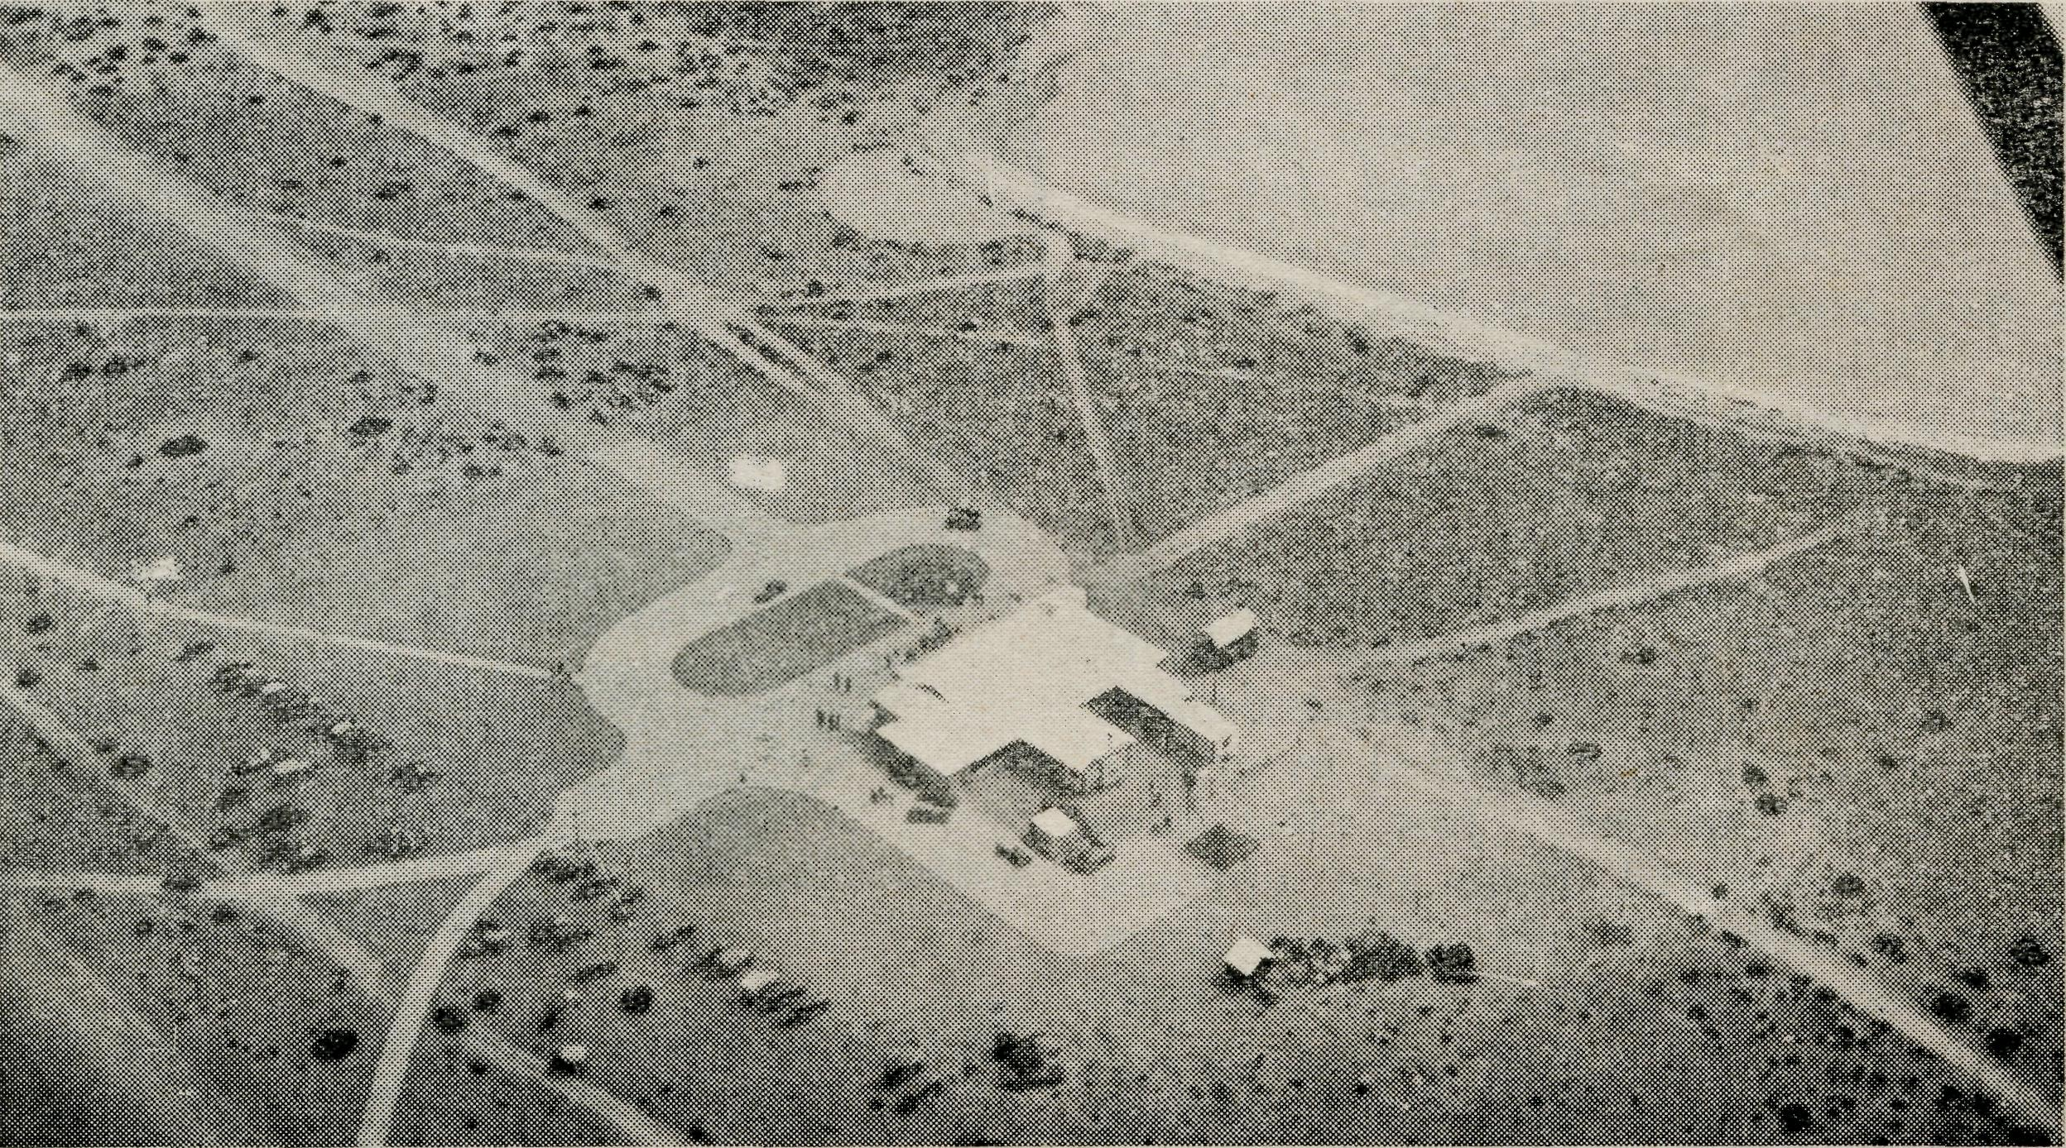
Oeduna Base Hospital from the air.

May 26, 1944
in.
THE REAL AUSTRALIAN

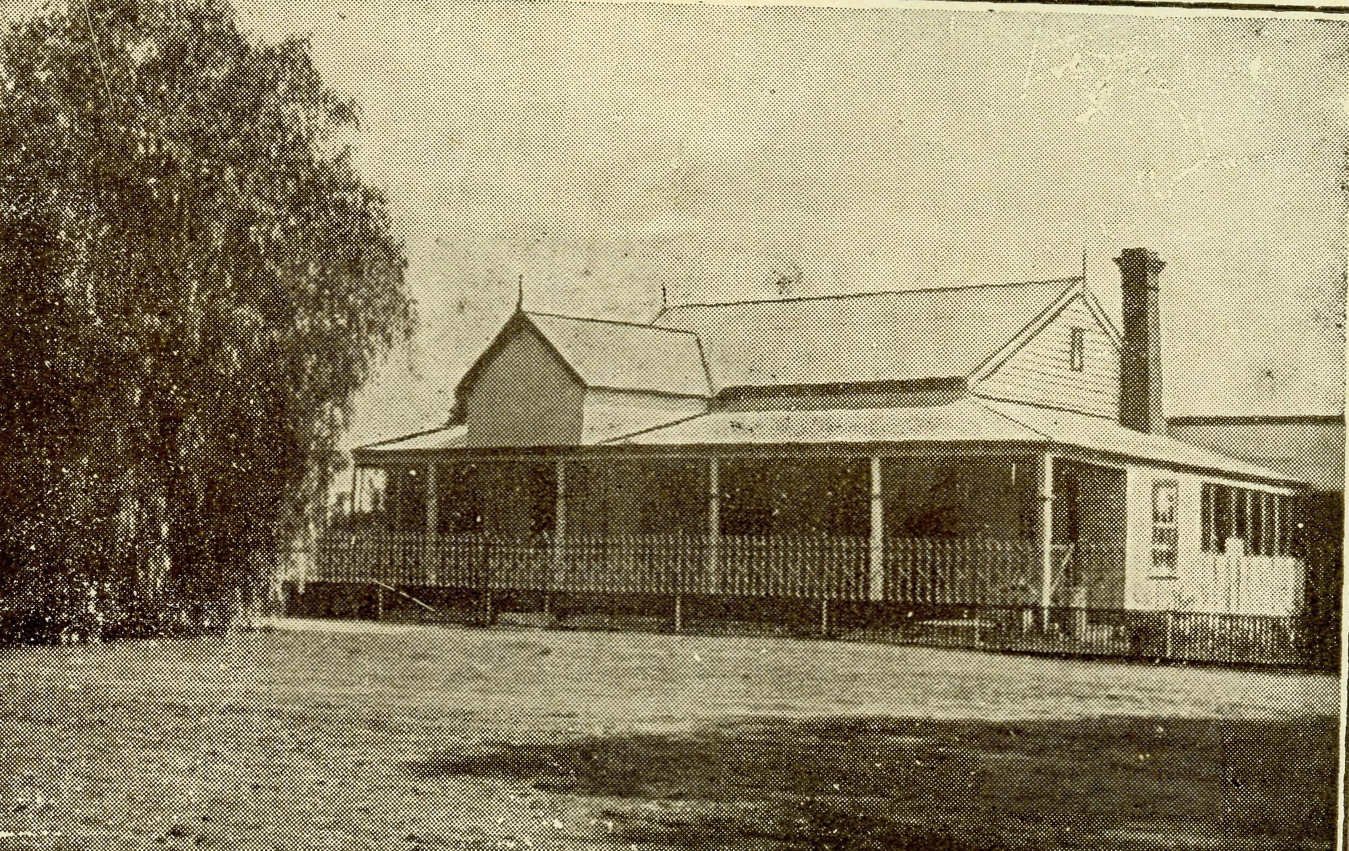
The Hostels of BCA

WILCANNIA HOSTEL, N.S.W.

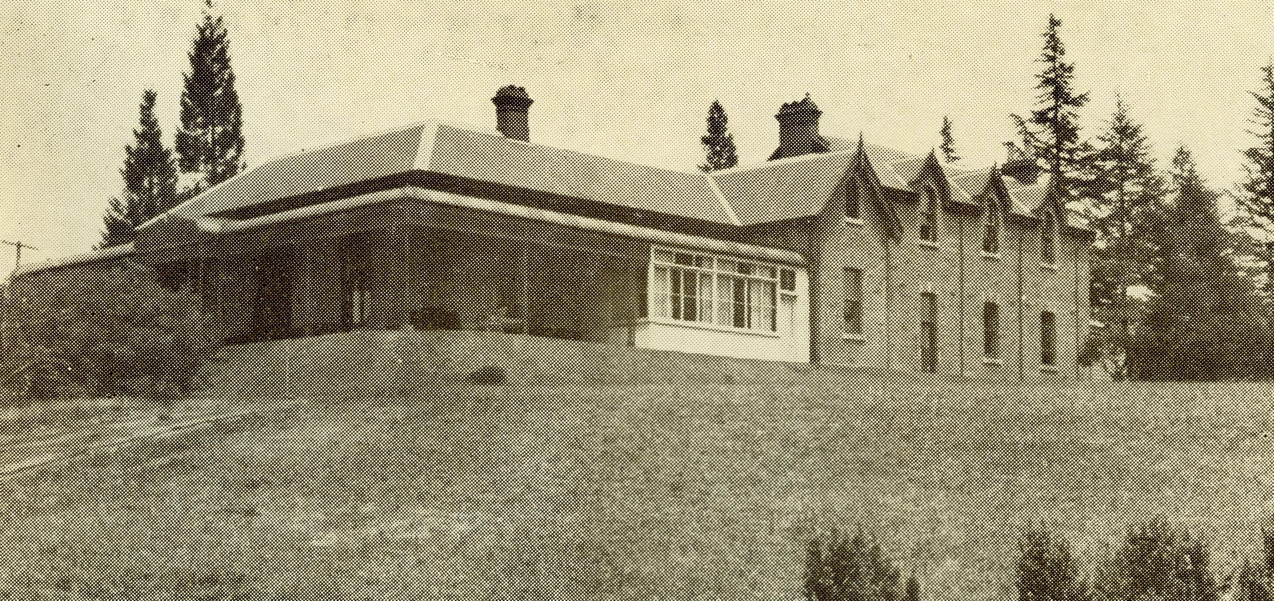

"COORAH," WENTWORTH FALLS, N.S.W.

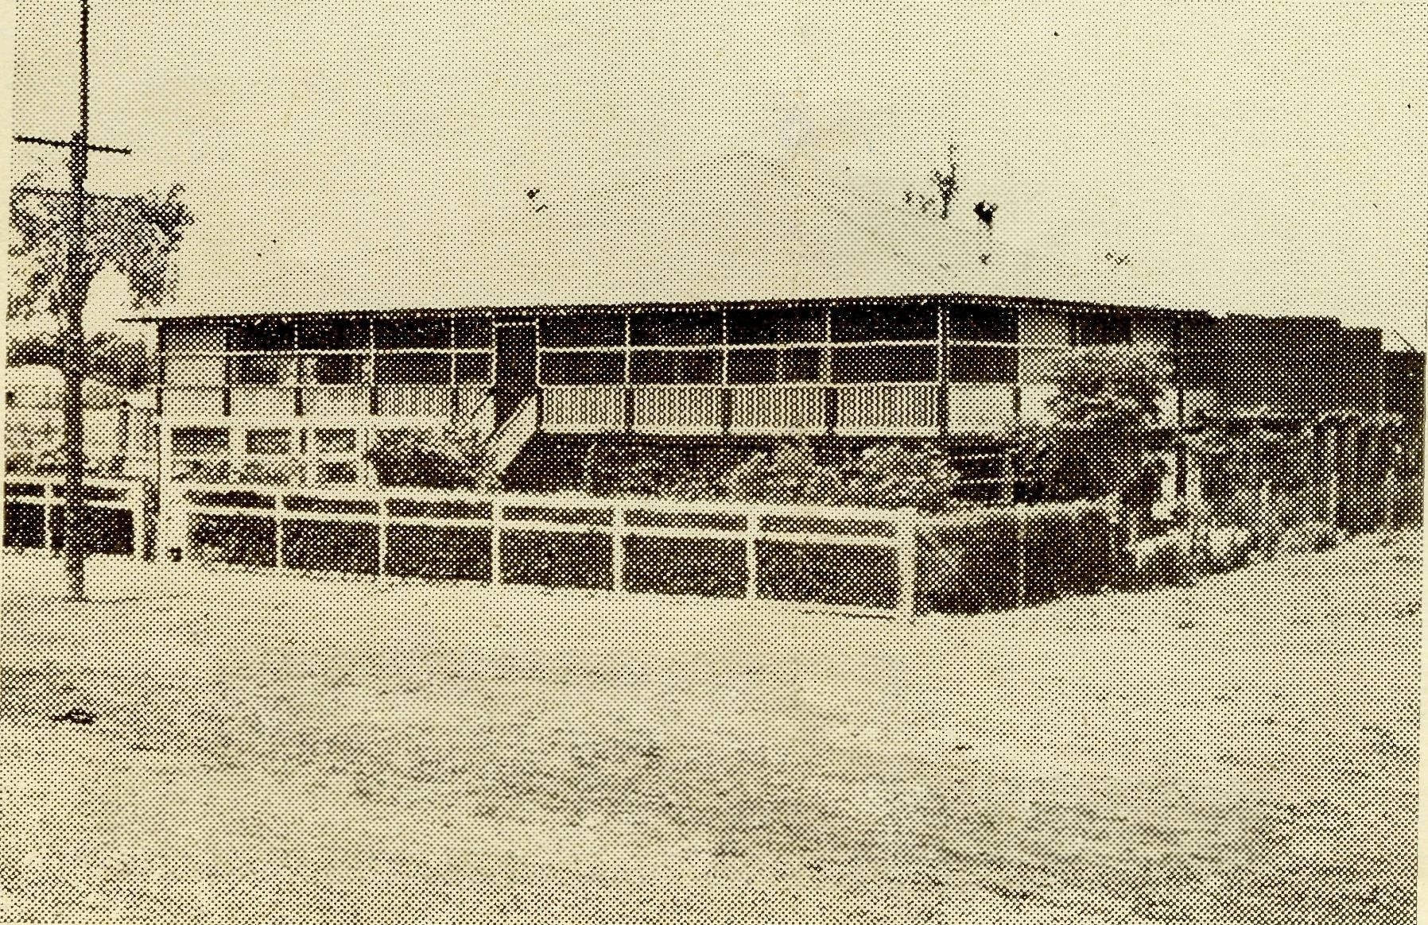
1920
1944

MUNGINDI HOSTEL, N.S.W.

THE REAL AUSTRALIAN
IV.
May 26, 1944

Don't Forget!
Tune in to:
2 G.B. Sydney, at 10 a.m. on Fridays
or
3 D.B. or 3 L.T. Victoria, at 9.15 a.m. Fridays.
or

5 M.U. 5 A.D. 5 P.I. 5 S.E.
South Australia on
Sundays, at 9 a.m.

And hear the interesting Story of B. C. A.
Week by Week.
Edgar Bragg & Sons, Printers, Sydney.

