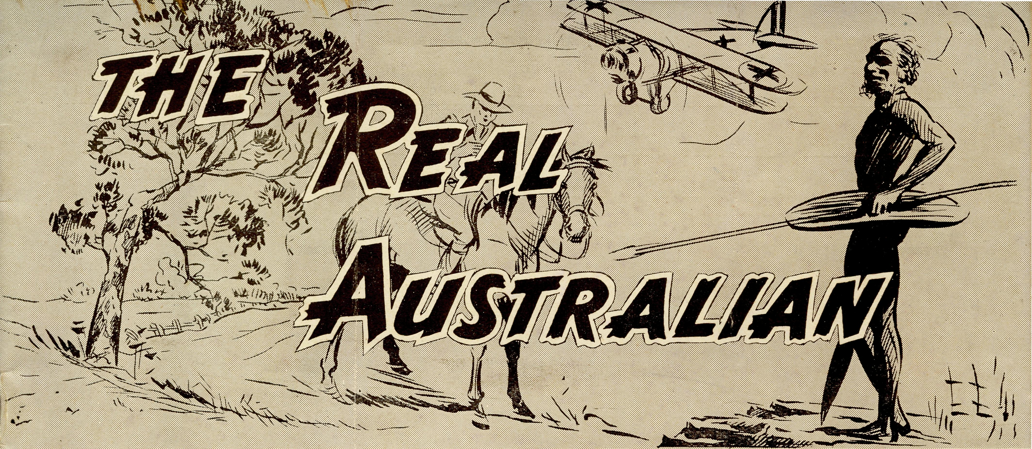

No. 88.
OCTOBER 26, 1944.
1/6 per annum, post free



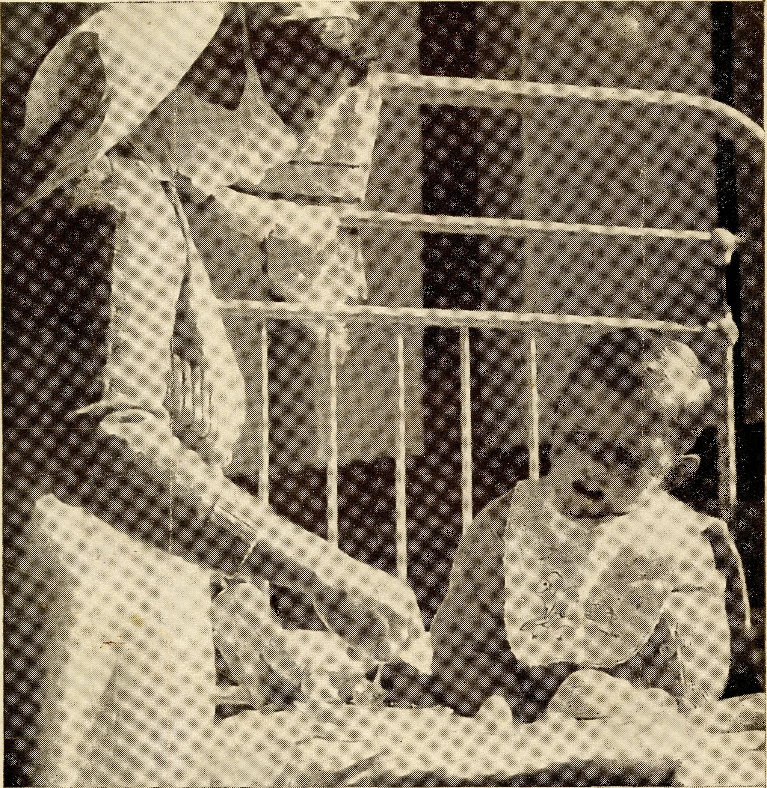
A small paralysis patient at Ceduna Hospital.
Registered at the G.P.O., Sydney, for transmission by post as a periodical.

THE REAL AUSTRALIAN
October 26. 1944

The Bush Church Aid Society for Australia and Tasmania
HEADQUARTERS OFFICE:
Diocesan Church House, St. Andrew's Cathedral, George Street, Sydney.
(Telephone: M3164)
Cable Address: "Chaplaincy, Sydney."
VICTORIAN OFFICE:
The Bible House, Flinders Lane, Melbourne.
(Telephone: F 5675)
President: The ARCHBISHOP OF SYDNEY.
Hon. Clerical Secretary: Rev. L. GABBOTT. Hon. Treasurer: T. S. HOLT, Esq. STAFF.
Organising Missloner: Rev. T. E. JONES, Th.L.,
Church House, George Street, Sydney. Victoiian Secretary: Rev. A. DONNELLY, Th.L.,
Bible House, Flinders Lane, Melbourne. South Australian Secretary: Rev. R. M. FULFORD,
North Terrace, Adelaide, S.A.

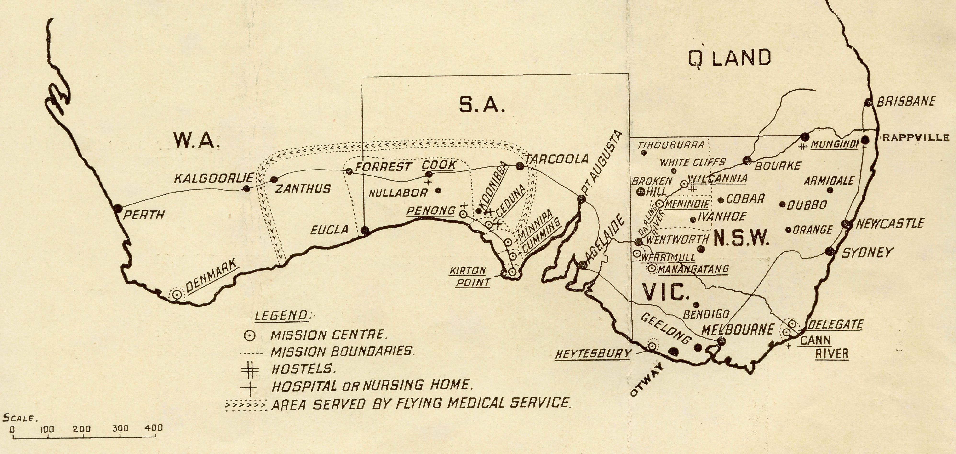

⁶⁶Australia for Christ'

FAR WEST MISSIONS, S.A.
_{n} fRev. H. Broadley, Th.L., The Rectory,
^{Penon}S J Ceduna, S.A.
Ceduna [ Rev. J. Greenwood, Th.L., Ceduna, S.A.
Curnrnins—-Rev. D. Pugh, Cummins, S.A.
Kirtoh PbinU-Rev. R. T. Hallahan, Th.L., Port Lincoln,
S.A. Streaky Bay—Rev. D. Livingstone, Th.L., Streaky Bay,
S.A. Minnipa—Rev. L. Morris, Th.L., B.D., Minnipa, S.A.
VICTORIAN MISSIONS.
Croajingalong | Rev. K. Brodie, Th.L., The Rec
Delegate-Bonang ) tory, Delegate, N.S.W.
N.W. Malice—Rev. , Werrimul, Vic.
Heytesbury Mission—Rev. W. Duffy, Th.L., Cobden,
Vic. Otwiay Mission—Rev. T. H. Pickburn, Th.L., Beech
Forest, Vic.
N.S.W. MISSIONS.
Wilcannia J Rev. K. Luders, Th.L., Wilcannia,
Menindee J N.S.W.
Rappville—Rev. P. M. Connell, Th.L., The Rectory,
Rappville, N.S.W.
WESTERN AUSTRALIA.
Denmark—Rev. T. R. Fleming, Th.L., Denmark, W.A.
CHILDREN'S HOSTELS.
Mungindi—Miss E. Cheers, Miss E. I. Cheers. Wilcannia—Miss H. Gurrier Jones, Miss Y. Gurrier
Jones. Wentworth Falls, "Coorah"—Mrs. Mann, Miss F.
Harding. Port Lincoln, S.A,,—Sister H. E. Sowter.
MEDICAL SERVICES.
Gippsland, Vic—Sister I. Gwynne, The Dispensary,
Cann River, Vic. FLYING MEDICAL SERVICES.
Pilot: Mr. A. Chadwick, Ceduna, S.A.
Dr. R. Gibson, Dr. F. Gibson. CEDUNA HOSPITAL.
Matron: Sister F. Dowling.
Staff: Sisters L. Loane, Branford, G. Moody, Maddern. KOONIBBA ABORIGINAL HOSPITAL.
Sister G. Hitchcock. PENONG HOSPITAL.
Sister Firmin, Penong, S.A.
Miss M. Millar, Penong, S.A. BISHOP KIRKBY MEMORIAL HOSPITAL.
Sister L. Pritchard.
Miss D. Dykes, Cook, S.A. TARCOOLA, SOUTH AUSTRALIA.
Sister V. Page.
On Leave: Sister B. Bossley.

October 26, 1944
THE REAL AUSTRALIAN

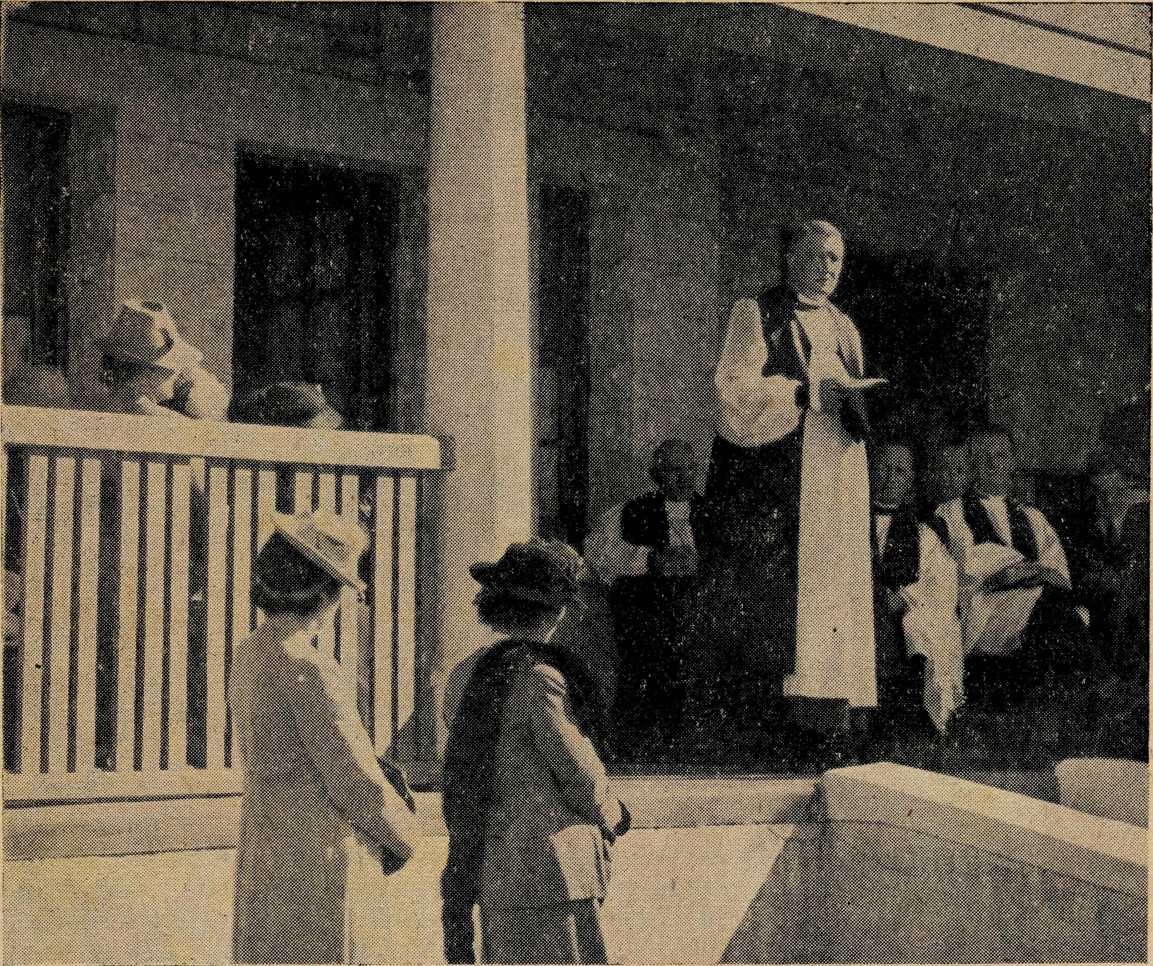

His Grace, tbe Arcbbislboip of Sydney, dedicates the Silver Jubilee Hostel.
The Organising Missioner’s Letter
Rev. TOM JONES.

First of all, I must say "Thank You" to you all for that really wonderful response to our Silver Jubilee Appeal. I think every friend of B.C.A. must have sent a gift towards it. As a result the whole amount was very soon in hand, and the new Hostel was speedily paid for. It's doing a great job and will in the days ahead be an import' ant part of this Society's service.
The opening day was a great success, and the President, the Archbishop of Sydney, who journeyed over, to S.A. for the function, accompanied by Canon R. B. Robinson, a member of our Council, was greatly impressed with the building and its situation. The people of the district were thrilled that the Archbishop had journeyed so far to be with them on that day. Our thanks are also due to Bishop Thomas, of Willochra, who also fitted the date into his programme and was present with us.
The Jubilee Tea was one of the most successful gather' ings ever held in Sydney's Chapter House. It was amaz,' ing how over 300 people got in and sat down to tea. Some of our ladies decorated the Hall, and really one wondered how they had turned the more or less drab Chapter House into the splendid colour picture it pre sented.
The Cathedral presented a grand sight from the pulpit and it seemed to the preacher that there could not be room for any more than we had present. The Communion service was simple and impressive, and many were the words of appreciation for a splendid and happy evening.
Three of those who attended the first B.C.A. meeting were present with us on May 26th. It must have given them a great deal of joy that night in the realisation that the small work they helped under God to start, had grown to so big a service.
Now we are off to even greater service, for if we were content to stand still we would be faithless to our trust.
There is much still to be done. Each Hostel requires extensions or improvements. I think especially of Wih cannia. Here the buildings are old and really do not merit renovation. Can we build a new Wilcannia Hostel with something in the way of modern appliances? Those who have served here have done so under by no means the best conditions, but it was upon their labours that all our hostel work has been built. We can honour their self'sacrificing service best by providing the best of facili' ties in which they may render it.
There is an urgent need for more workers—men and

THE REAL AUSTRALIAN
October 26, 1944

The Wilcannia Mission needs three men instead of one.
The Cann River-Delegate area needs another man.
Two districts in South Australia need additional staff.
There is a big scope for women workers, especially deaconesses.
These needs mean a greater income.
Vehicles, cars, trucks and vans need replacing. We would be in a pretty pickle but for the help of our friends in Ireland and the Colonial and Continental Church Society. Without good transport the workers are not
able to do their work efficiently. Again, these needs call for greater giving.
When the war is over, the greatest of all tasks will face Christian people—the making of new men and women by the grace of God.
Is it too much to ask for the same spirit of sacrifice, endeavour and service for that end as has been freely given to prosecute this war?
Can we show the same spirit of patriotism for the Kingdom of God as for this Kingdom of Australia?
I believe we can, and will.

A Vision Lost – and Regained
Rev. T. PIOKBURN.

Nearly forty years ago at Carlisle River, one of the centres in the Otway B.C.A. Mission District, the church-people of that day decided to build an Anglican Church. A block of land was given, and the timber for the framework of the building was also presented by a member of the congregation and actually placed upon the land. However, as there was also at that time an urgent need for a school building, it was decided to use this timber to build a hall which was to serve the purpose of both school and place for public gatherings. That hall still stands and, although no longer used as a school, is still in use for all public gatherings, including those for Christian worship. With the building of the hall a vision was lost for very many years, and Christian worship was conducted in an atmosphere that was never conducive to that reverence and awe that a House of God alone can really inspire.
A short time ago the Lost Vision was regained, and with real enthusiasm the churchpeople of Carlisle River determined to remove a reproach they felt had lain upon them for so long. After Evensong, about two months ago, a meeting was held and it was unanimously decided to build an Anglican Church in the district, and the St. John's Church Building Fund Committee was formed to raise money for the purpose. Subscriptions were accepted at the meeting, and £150 was given and promised by members of the congregation who were present. During the following week the fund grew to £200, and it was evident that the proposal to build a church had caught the imagination of not only Anglicans, but others as well. Members of other denominations expressed willingness to give to the building fund and to help in every possible way. This attitude on the part of those who are not members of the Church is very greatly appreciated by the Committee, and, together with the great enthusiasm of the
Anglicans, augurs well for the success of the appeal. Carlisle River churchpeople are really determined in their efforts to build a church, and are keen to work and find the necessary money as soon as possible.
A most comendable decision was made at the inaugural meeting—it was unanimously felt that the House of God in Carlisle River should be built with money freely given by the people and not with money extracted by dubious means such as raffles, chocolate wheels and the like. Although this decision will probably mean a longer period of work ahead, the people are not dismayed, and feel that the decision made was the right one.
The question is often longingly asked, "How long will it take to find the necessary money?" No definite answer can, of course, be given to that question, but people and Missioner are leaving no stone unturned in their search for ways and means of hastening the day when the Great Vision will be fully realised. A Church building at Carlisle River is urgently needed, not only for the present generation of Christians in the district, but for the generations yet to come. The coming generation must not be allowed to use the reproach that has often been levelled at those Christians of bygone years—"O that fhey had built us a Church." In the words of a member of the congregation used at the meeting, "Carlisle River must have a Shrine, a House for Divine Worship, that will act as an inspiration, not only to ourselves, but to our children, and it is our responsibility to see that it is provided." It is a big responsibility to be undertaken in such a small district, but one that will have God's blessing and the interest, it is hoped, of all friends and former residents of Carlisle River. It will be a great day indeed when, in its lovely bush setting, a House of God shall arise and be for the people a centre of inspiration and spiritual joy and strength.

October 26, 1944
THE REAL AUSTRALIAN

Next to Godliness
Rev. K. LUDERS.

It occurs to me that anyone who has been a consistent reader of the "R.A." and without any other course of information, might be excused for forming the opinion that for 25 years the B.C.A. has sent ordained men to outback places to occupy their time in digging cars out of bogs, and has sent nurses to remote parts to save souls rather than heal the sick. In the "R.A." articles, contributed by the B.C.A. personnel, incidentals feature prominently, sometimes so much so as to obscure the main purpose of their ministry. Let any with misgivings of the kind indicated above be reassured. The matter of caring for the sick is so well attended to by those working on the medical side that they have built up an enviable reputation; I can testify to that. Also, for the others of us, let me say that though more time than we wish is given to digging, etc., we are not unmindful of our high calling to preach the Word and administer the Sacraments. THAT goes on steadily as you have a right to expect it to go on. The incidentals loom large because of problems presented. Problems that are not beyond solving, but which can be tiresome.
One minor problem incidental to ensuring that things connected with the ministry be done "decently and in order" is that of keeping clean—a thing that is no difficulty to a town or city dweller. Just in case you should imagine that in the West we are reduced to imitating sparrows, and keep clean by having dust baths, let me hasten to say that things are not really so bad as that.
Perhaps this is the place to confess that it was the bogey of uncleanness that frightened me into hesitating to volunteer for the "back blocks." Long before the bright advertising lads began with high-pressure salesmanship to push the. sales of this or that soap, guaranteed to make one's presence acceptable in the company of even the most fastidious noses, I was almost intemperate in the matter of baths. Now, older and more experienced, I know the bogey was only a bogey, and that, though water be rationed, it is possible to keep respectably clean, anywhere.
Like milestones dotting the way, there emerge memories of baths enjoyed since beginning bush work. At Kirton Point, to which we were first posted, as a newly-wed couple we had half a house and a share of a bathroom. The bathroom was exactly according to name. The bath had been removed for repairs. Water had to be carried. The first bath (greatly needed after a day's unpacking) was managed in a wash-up dish and by the unaccustomed light of a kerosene lamp. It was in the same district that I was once mildly surprised to see a lizard careering round the bath as though it were a speedway. Not favouring it as a bathing companion, I chased it down the plug hole.
One can become accustomed to most things—given time. At Minnipa, relieving for some months, the stay was not long enough to enable me to get to the state of looking forward to a bath. Perhaps this was because of the first one "enjoyed" there . . . The water from the Todd River reservoir, piped to Ceduna, services Minnipa on the way. To reduce its corroding effect upon the pipes, this water is treated in a way which, whatever else it does, makes the stuff offensive to the nasal organ. The
water in the pipes at the Minnipa house had lain dormant for weeks. When the taps were turned on it sprang to life and delivered a gas attack. Leaving the water running, I retreated in disorder to the front gate while wisps of odour penetrated all the house. This was at midnight. What with hot weather, hard work and long hours, the day had been a gruelling one. That bath was necessary. At long last I screwed up courage, washed the dead flies down the drain, ran a bath, held my nose and hopped in. The ordeals became progressively milder as the days passed.
In fancy, I now see the Rappville bathroom; unlined, semi-private and draughty. The lower half of one wall had been painted. It was royal-blue and had a frieze of white fish. These fish were nose-diving and sky-rocketing alternately. How I envied them! Half the bottom fell out of the bath when it was removed to ascertain why the water would not stay in it longer. We bought one ourselves, and put it in—and hope it is still doing good service. In this area of abundant rain and insufficient tanks, it was common to draw well water for bathing. For a warm bath, kerosene tins of water had to be heated on the kitchen stove.
After this gentle breaking-in, we were ready for the West. It is true that the first encounters with Darling River water in the bathroom were in the nature of a shock, but yet the remark of a New Zealand visitor that "there was no need to go far for a mud pack," was in the nature of an over-statement. At Wilcannia the water supply is fairly good. That water-carting from the river had to be done recently was due to the burning down of the power-house.
Townships out from the river are under a disadvantage. At one there is an hotel having its bath-water supply conserved in a tank---a crater scooped in the earth. Round it are growing delightful gum trees. A windmill pumps water to an overhead tank, from which the bathroom is serviced. My first shower there had some mild surprises; first, the bathroom door would not shut—not that that mattered particularly at the time; next, I discovered that to avoid risk of breaking my neck, it was necessary to tread warily in that bath, which was balanced on three legs; finally, one had to watch one's equilibrium when on the bath-mat. This was the seat of a wrecked chair. The slats were curved and made a fascinating little see-saw,
Water was getting low on my last visit. The temperature was up and a shower was indicated. Forewarned, I avoided the men's bathroom (no water), and tried the ladies'. This was the other half of a corrugated iron shed and separated from the first by a partition extending halfway up the walls—the triangle above being effectively screened by spiders' webs. A spanking new green and cream enamel bath looked oddly out of place in such an unattractive setting, but it served to buoy up one's hopes. Under the shower in a jiffy and then—time for reflection. With the tap hard on, only a lazy and murky trickle crawled round the edge of the shower and dribbled down. Quicker to take a plunge! The tap over the bath gave no greater volume of water—water as dark as very strong tea. I pondered. Then light dawned. Leaves, twigs and bark from the gum-trees had discoloured the water. No matter—in fact, if my hide were tanned it might prove

THE REAL AUSTRALIAN
October 26, 1944

monwealth and overseas, recognise their responsibility that these people have a regular monthly visit by a B.C.A. missioner. It means 89 miles of travelling to reach the small congregation, and of necessity can only be under' taken once each month. I count it a privilege to carry the Christian message to these people.
The monotony of glaring sandhills and dull stunted scrub is forgotten as voices are raised in singing the old favourites. They still carry their evergreen fragrance of the love and power of God. In the hush of the evening hour the benediction is pronounced. There comes the dull murmur of the waves upon the adjacent shore, and with it the remembrance of One Who trod the shores of the Gali' . lean Lake, ministering to His companions, and pointing them to the life of service to mankind.
Those sandhills stand as a picturesque background to the rugged beauty of Australian coastline. But what of the lonely life of the inhabitants of the little group of houses nestling at their foot amongst the scrub? It is our responsibility to maintain a ministry amongst them. There are children to be helped, and who will deny them any opportunity granted to those in more settled districts?
Australia is not a land of separate communities, each an independent unit, but a family. Your support is required by the members of your family in prayer and gifts to maintain the work of the outback ministry.
There are needed 12 Alexander Hymn Books. Perhaps some reader may have spare copies lying idle, and would care to put them in the service of this Mission work.

The Children’s Need
Rev. H. BROADLEY.

The opening of the Hostel at Port Lincoln draws attention to the needs of children on the West Coast. The High School children are a representative group of quite a large number of children, some of whom live, as in Ceduna and Thevenard, up to lj miles from school; others have to get up early so as to be ready to go to school (8'9 miles away) in a small horse'drawn, car'wheeled "jinker." Still, others can't go to school at all. There used to be a school within a few miles of where they live, but through families leaving, children growing up, and the little ones being but babies, the teacher has been transferred, and the school closed. Since I first came over here, at least seven schools have closed. This means correspondence lessons at home, with mother as teacher, which is not fair to either mother or youngsters. It is against this back' ground that we approach them to take up Mail Bag Sun' day School Lessons. Their readiness to do so indicates a keenness to do their best for the children committed to their charge. I had an interesting visit the other day to a farm-home about 37 miles from Ceduna. Intending to visit the little school for religious instruction, I pulled up with a doubt or two owing to the quietness and the ab' sence of horse and jinker so often tethered nearby when school is in. "Sure enough the place was closed. This occasionally happens if the teacher becomes sick suddenly with "flu," etc.
On this occasion I went on to visit a family which up to four months ago lived at Ceduna. About a mile along a roughish, narrow, mallee-bordered track, I came to. .the gate. Outwitting a cow which appeared to meditate slipping out, I went on 200-X)0 yards to the house, which was roughly the shape of a B.C.A. Bark Hut, lower wall at the back. Two or three little boys were playing at the back, getting well dusted in the process. They looked up with cheerful grins and we made suitable re' marks. On enquiry, I found that mother would be a few minutes, as she was having a bath. A little later she appeared and welcomed me in. In the course of the following conversation, I found that a little while before, the teacher had gone away for a small operation^—I think to Adelaide, a mere 400 miles. She was not expected back till after the September holidays were over, and perhaps not then. In the meantime, the school was closed, the children were home and much of their learning was at a standstill. If the school should close permanently, the nearest one is at least seven miles away. When you
realise the children's ages, you feel that the risk of sending them on their own is too great. They are 4, 5, 7, 8, 9 years of age. Four year old would stay at home, of course. However, I spoke about them doing the Mail-Bag Sunday School, and the mother agreed. A great deal of help could be given by frequent visitation. At present that is not possible. I am, therefore, hoping to do something by letter, and also by sending little magazines like
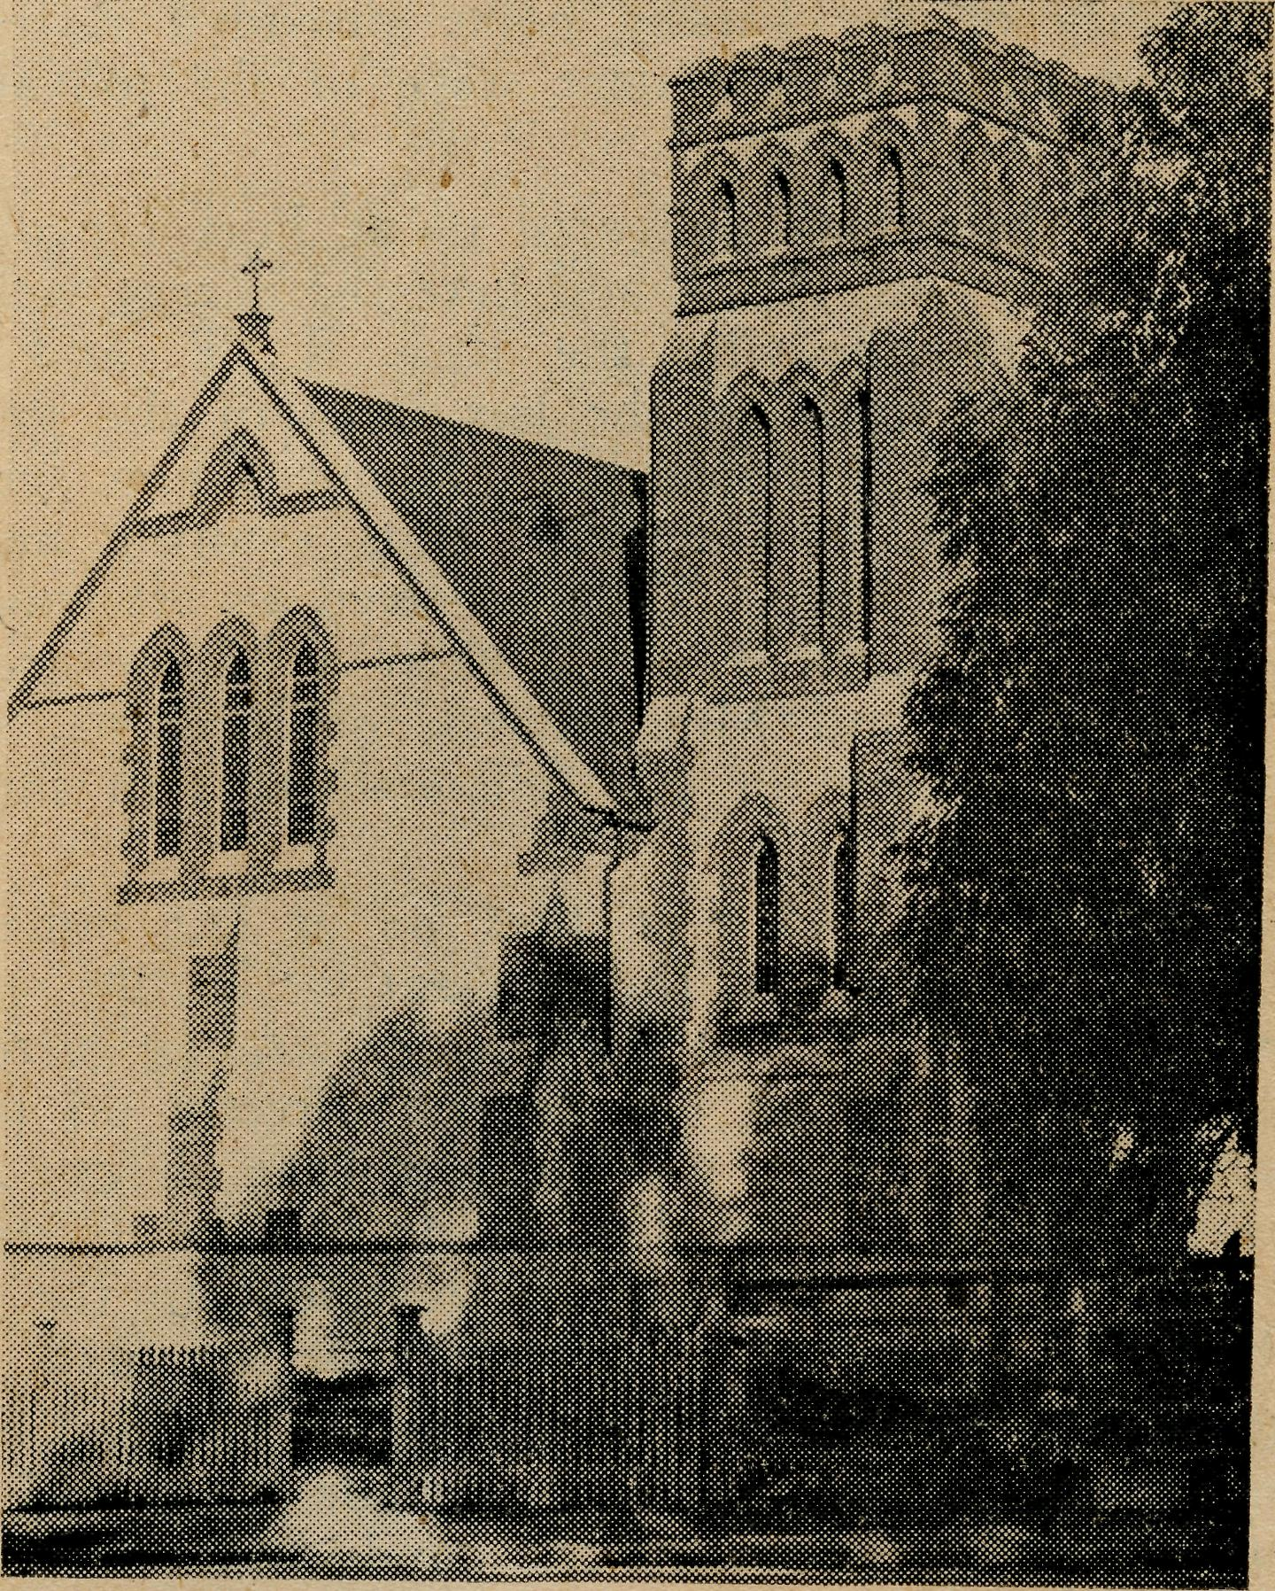
Churclh of St. Augustinie, Streaky i*ky.
the C.M.S. "Round the World" to give them encouragement. If anyone would like to help by sending me copies of such-like children's religious periodicals, I think good work can be done with them, especially in these days of enforced and special isolation for farm folk. Naturally, the latest issues would be best, old ones which are torn and grubby are embarrassing to pass out to others, and give them an unfortunate impression. The family referred to above is only one of many whom I hope to serve in this way.

October 26, 1944
THE REAL AUSTRALIAN

The Flying Medical Services
PILOT A. OHADWICK.

After snpell of eight months since a patient was flown from the outback to hospital in V.H.-A.A.A, the month of May this year began for Us a series of emergency flights which have followed closely on each other, and kept us all very busy.
The first of these emergency calls came from Tarcoola, up on the East-West Railway. A fettler, working on that section of the line, was suddenly taken ill with peritonitis, and brought into the Nursing Hostel there for Sister's attention. A ring on the 'phone from Sister brought Doctor and the 'plane over, and the diagnosis was confirmed. Then, with the help of two of his workmates to act as stretcher bearers, we soon had him comfortably settled aboard the 'plane and ready for the return trip to Ceduna, where the theatre was already being prepared for the case, and the operation was begun very soon after we landed back here. A week or two later, when this patient was out of bed again, and convalescent, it was a very different man who greeted me as I stayed to chat with him for a while; now free of the pain that had been with him for some considerable time while he had tried to carry on at work; he talked of his present marked improvement, his wife who had made the long journey from another State to be near him in his illness, his family of six children, and the prospect of him being able to return to the job again in clue course.
A few days later came the need for a trip to Adelaide with an elderly patient paralysed in the limbs on one side of the body, due to some obscure cerebral condition. After spending some time in hospital here, Doctor considered that further specialised investigation of the complaint was advisable, and so made the necessary arrangements in Adelaide for that purpose. The patient on this trip was accompanied by a young woman who had been her compainon in the home for many years, and in both cases this was their first experience of aerial travel. On arrival at Parafield, after a very good trip in clear weather, both ladies voted it an enjoyable flight, and said they would fly again when the opportunity offered. This was put into effect when, after undergoing treatment which resulted in restoring much of the patient's good health which she previously enjoyed, she was able to return to her home again, and secured a seat on the west-bound mail plane which always calls at Ceduna.
From the flight just mentioned I returned to Ceduna late on the following afternoon, and before breakfast next morning a call came from Cook, where Sister had a patient in hospital with a strangulated hernia. After a quick breakfast I went out to the aerodrome to perform the several small but necessary jobs requiring attention after a long flight, and everything was ready within a couple of hours, when we took off for Cook, flying into a steady head-wind. This was one of the occasions when minutes were precious, and so as most of the things were ready in the theatre for Doctor when she arrived, they went straight ahead with the operation, which promised to be a fairly big one. By four o'clock in the- afternoon it was a very hungry group of people who gathered around the late dinner table to do justice to a meal that we all regarded as being more than welcome. Again the operation was quite successful, and on our next trip to Cook the patient had been discharged, quite recovered.
For our next emergency trip we broke out into entirely new country altogether, flying by the direct route to Kingoonya, again up on the East-West Railway. We have landed at Kingoonya before, but not until now had we approached it by the direct route from Ceduna. From there we were taken five miles by car through lightly timbered country to one of the station homesteads of that district, where Doctor performed an operation on an infected finger, which had reached about twice its normal size. Lunch was provided for us there, and upon returning to Kingoonya we took off and flew the 50 miles westward to Tarcoola, where we landed and stayed for the night. Making an early start next morning, we continued on westward along the railway to Cook, 250 miles distant, to catch up with our regular scheduled trip which was listed for the previous day. We arrived* there in time for lunch, and after Doctor had seen all the patients, we left again and flew back to Koonibba, and finally home to Ceduna, covering a distance of 475 miles for the day, and 646 miles for the two days' round trip.
The scene is Tarcoola aga*in. This time there are a group of plumbers working high up on the roof of the large locomotive shed, repairing the iron sheets and replacing some of the badly rusted ones with new sheets. One of the men stood on a sheet of the iron, from which the nails had been removed, and it slid down the roof, carrying him with it, and when they reached the edge of the course, like the man on the flying trapeze, he flew through the air with the greatest of ease, seated on the sheet of iron, to the ground 30 feet below, and landed in a sitting position. Sister saw him within a tew minutes of the accident, and he was paralysed from the hips down, and could only move with somebody assisting him, and with great pain. Well, we offered him all the comfort we could for the trip, and flew him back here to Ceduna, where he could be X-rayed and operated on if necessary. Can you imagine the relief and joy of both patient and staff alike when X-ray showed that no fracture was present, and no evidence developed to suggest that there was any serious internal injury? He was suffering from severe shock, however, which* was only natural, and this took some time and careful nursing to overcome, but he readily responded to treatment, and in a remarkably short, space of time was able to leave his bed and begin to regain the use of his legs again with the aid of crutches.
Tarcoola has demanded much of our time during the past couple of months, and on one of the regular trips to that centre, a trunk line call came for Doctor from Kingoonya again. This time someone up there had managed to be standing in the way of a horse's hoof as he moved it quickly backwards, and the result was severe facial injuries and concussion. Being a regular trip to Tarcoola, I had a full passenger load for the trip, and was, therefore, unable to take anyone else on board at tfie time. So the patient was brought up- to the Hostel later on that afternoon, where Sister dressed his injuries, and Doctor and I went back next morning with the stretcher and brought him over to Ceduna, where he was in hospital for several weeks before being discharged and able to return to his home and work again.
Very recently our little 'plane figured in writing another chapter in B.C.A. history by landing for the first time at Streaky Bay. This emergency call came from the

THE REAL AUSTRALIAN
October 26, 1944

Doctor there, who was seeking speedy transport for one of his patients over to Adelaide, where he could receive special and urgent treatment with equipment not available elsewhere. The patient was a lad aged six years, who had undergone an operation on his throat, but it was found that in order to complete the operation successfully, special equipment was needed; hence the urgency of the call. In order to enable the 'plane to land there, a runway was cleared of stumps and stones in one of the large paddocks by several willing helpers, and a smoke fire lit to indicate the wind direction. I learnt later that as the 'plane ap' proached the town, the school children were taken out to watch as it went over and circled the paddock where the landing was to be made. Having made the lad comfort' able in the cabin with rugs and pillows, and then the Sis' ter, who was to care for the patient during the journey, we took off again for the remaining part of the journey to Parafield, which was nearly 300 miles away. There was an ambulance waiting on the tarmac for us when we landed, and the patient was taken straight into the Child' ren's Hospital where, we learnt from subsequent reports, he responded to treatment, and early hopes are held for his return home again. Perhaps a much clearer picture of this incident may be conveyed to you who read, if I quote extracts from a letter sent to Sister at the hospital here by the Doctor. He says: "I thought you might be interested in the patient sent over by plane last Tuesday. I had to do a tracheotomy last Saturday on account of the respiratory obstruction, but the condition extended down the trachea and was spreading to the bronchi, and it be came obvious that he needed bronchial aspiration and removal of crusts through a bronchoscope if his life was to be saved. He had a very good trip over in the 'plane, but just after arrival at the hospital he became very obstructed, and it was with some difficulty that they were able to clear it. He was given penicillin, and bronchial suction by vacuum pump, and had two or three less serious attacks of obstruction. The last I heard, last night, was that he had had a better day and seemed to be improving, so it is possible now that he is over the worst. I have very little doubt that he would not have survived if we had not been able to get him across, and in a case like his, a 'plane was the only way to take him. We are all, therefore, very thankful and grateful that the 'plane was available."
Sister F. DOWNING.
This is being written in the V.H.-A.A.A. on our way to Tarcoola. One's memory goes back to a few years ago ₄when a party of B.C.A. folk set out by car one morning for the same destination in order to make plans for the Flying Medical Service to be extended to the people on the Trans, line at Tarcoola and Kingoonya, and surrounding districts. That trip by car will not be forgotten in a hurry. Our blood pressures must have soared pretty high, as We struggled to get the car out of the sand in the heat of the day. In the early hours of the following morning we arrived at the hotel at Kingoonya, and were we glad to see it! After knocking, a voice shouted out the numbers of vacant rooms* and we just fell into bed and slept the sleep of the just. And here to-day, we were sailing through the clouds looking down at that same country which we laboured through that day, and we will arrive in Tarcoola a little over an hour from the time we left Ceduna! But we don't forget our brother, Leon Morris, who still does the trip by road in St. Patrick, ministering to the folk at the different sheep stations along the way, and we breathe a prayer for God's blessing on that ministry.
A young married man left his wife and little son at Kal-goorlie to go and do a job at Tarcoola. In the course of removing a roof from one of the sheds he slipped and went hurtling to the ground 30 feet below. The S.O.S. was sent to Ceduna and it was not long before Doctor had brought him back here for X-ray and treatment. When the wife was notified that her husband working at Tarcoola had had a serious accident and was now in Ceduna Hospital, she was in a bit of a whirl trying to work out how he got to Ceduna. She didn't know the Lord had opened up a Flying Doctor service between the two places, but she was to learn a lot about that later, as in a couple of days she arrived direct from Kalgoorlie by the mail plane and saw things for herself. What of the patient? A chap who had had opportunities in his youth of hearing the gospel, but as the years went by had gradually grown away from it all. The atmosphere of the hospital brought it all back to him.
As he listened to the message from the hymns and the reading from the Word of God that night, he began to consider his relationship with God. He told a visitor one day as they were talking together, it seemed that the day he was lifted into the B.C.A. plane and borne up into the air he felt he had been lifted from a low level of living to something higher, and that the Ghristian influence of the hospital was making him think deeply. When saying good-bye, these were his words: "Sister, I've thought a bit about this accident, all the pain I've suffered, what it's going to mean in loss of work and wages, but I can honestly say it's been well worth-while to have had that fall and a crack on the seat, to be brought in touch with this place and what it stands for." He was given a New Testament and promised to read it. Surely an awakening is going on in that young man's heart. He has gone back to Kalgoorlie. What about it? Are you interested, Now you folk who often express the wish that you could be out here taking an active part but because of age, illness, etc., etc., it is impossible for you to do so, here is an opportunity for you to do a big part in the work. You can do more by your prayers than you ever dream of, so we suggest you help in this way.
Our doctors had the unenviable experience of having to operate on their own son for an acute appendix, and we are pleased to be able to say he made a speedy recovery and was home again by the end of the week.
The arrival of a yardman from Adelaide has meant the lifting of many extra jobs from the staff. We are still without a cook, so please remember this need in prayer.
We wish to thank the folk of the Pennant Hills Auxiliary for their second parcel of bed socks for the patients. These were much appreciated.
The plane is beginning to bump, which means we are nearing our destination and are beginning to descend. Looking out of the window, one sees the little township of Tarcoola—a row of houses, a store, church, hall, station and sheds, and a hotel, of course—this little clump of buildings just dumped down in what looks to be an endless desert. Isolated—you couldn't imagine anything more so, and to this place the ministry of healing is brought to the people, no only to the body, but, above all, to the souls* of the folk. They are, and have been, terribly short of water for a long time; the water has to be carted by train over 250 miles. That is the Government's job to see they are supplied with sufficient for their needs. What about the Church of God? To all of us who joined together form the living Church, to us comes the challenge to bring the water of Life to these folk who know not of it.

October 26, 1944
THE REAL AUSTRALIAN

The Day of Prayer
Rev. L,. MORRIS.
Last Sunday was a day of Rational Prayer and Dedication. I have a little picture in my mind's eye of the sort of services most of you who read this article were able to attend. It includes a beautiful church, a large congregation, a robed choir, an organ and all the things that city churchgoers regard as normal. My experiences were a little different.
Early in the day the son of the home where I had camped gleefully pointed out a flat tyre. Normally this would have been bad enough, but with the present tyre position it was tragic. You see, St. Patrick has now done 42,500 miles on her original tyres, and they are beginning to show the effects. Only two days previously one of the tyres had developed a nasty bulge, and was listed unsafe. The tube in another was very old and inclined to leak a bit. All four tyres are worn down fairly fine, so I drive with caution.
Fortunately, I was able to walk to the first service and leave my flat tyre (no time to mend the puncture). Our service was in a hall, and a congregation of 20 had gathered. The number included one family from 11 miles out, so you see, although the attendance wasn't large, judged by city standards, it represented a fair amount of effort.
Service over, there was time for a meal before pumping up my flat tyre and setting out hopefully for the next centre—8 miles away. Here we again meet in a hall, a congregation of 18 this time. The people have done a good job in decorating the hall to look like a church. Unfortunately, there is no one to play the piano, so we just sing unaccompanied. I suppose the result would hardly please the fastidious, but at least the singing is hearty and one feels that the words of the well-known hymns mean much to the small congregation.
After service, the routine pumping is done, and I drive 16 miles to a little school where a congregation of 15 duly assembles, having travelled by car, truck or Shank's, as the case may be. Again, our worship is without musical accompaniment, again the surroundings are hardly conducive to worship, but I'm sure there are few congregations whose worship is more sincere.
And now we face the 56 miles journey to Minnipa for the evening service. If I make good time I'll get tea before service; if not, well, that has happened before. The first 30 miles are without incident, then the engine temperature rises and I am reminded that leaky radiator is no advantage. I fill the radiator from my water can and, while on the job, give the slack tyre a pump up. All is now well for 14 miles or so, and then the Van stops altogether with a petrol choke. I'm caught in the dark now, and it is quite a job grappling with a torch, spanner, petrol pipes, etc., all at once, but eventually that little matter rights itself and I start up once more. A glance at the watch shows that I'll be just on time provided nothing else goes wrong. But—two miles from home I puncture. This means pressing into service the spare tyre, already bulging. I make the change in haste, fervently trusting that the wretched tyre will do the distance. It does, and I arrive just a quarter of an hour late to find the congregation of 32 patiently waiting. Soon we unite with our brethren far and wide throughout the Empire in our service of prayer and dedication.
Kirton Point
Rev. R. T. HALLAHAN.
The B.C.A. Missioner at Kirton Point enjoys on each alternate Sunday the experience of conducting three services and a Sunday School in the one place of worship, the Missions to Seamen Hall.
If there happens to be a ship in port, as is often the case, he gets some variation by visiting it in his capacity of Hon. Chaplain of the Flying Angel Mission. Perhaps he may persuade a few of the men to come to the evening service, although as a general rule seamen fight shy of organised worship. This does not mean that they are irreligious, but that they feel rather keenly the curiosity sometimes shown in their uniform, and are averse to any suggestion of flaunting their religion.
Sometimes one or two will accompany me on my round of country services, and show keen interest in the life of the farmers who produce the meat and wheat that their ships transport to needier peoples.
I was. rather glad that none were with me on a recent country Sunday, the one on which the service of worship had to be postponed because of the following:
The Church of St. Matthias', at Lake Wangary, nestles in a grove of trees, pine and gum, a mile away from the lake, and about five miles from the rock-girt shores of Mt. Dutton Bay. The tiny hamlet, consisting of a school and half a dosen houses, adjoins the land on which the Church is built. In one of these houses lives an old invalid pensioner, a former teacher in the Sunday School.
Her son, discharged from the first A.I.F. at the close of World War 1, in an impaired mental condition, has been her constant and at times her only companion. Generally I pay a call there before the church service for a chat and a quiet word of prayer. This morning the service was timed for 11 a.m., and as the time was near, I decided to call after the service.
When two or three families from farther away had arrived by car, I discovered that the son had been missing from the home since some time early in the morning. He had gone clothed only in his night attire with no boots on. A search party was organised, and as it was generally thought that he would have made for his old fishing spot, on the shores of the Bay, the two most experienced bushmen set off on horseback to pick up his tracks.
Just about the time service was due to commence, a message was received that these had been found as expected a mile and a half along the road. By then another half doz,en men had arrived, who felt it their duty to join in the search, and would have set out on foot. I felt, however, that time would be saved if these could be taken to the spot in my car. There was a road just passable, they said, so we took it. It led through devious ways and over very rough limestone country. We eventually arrived at the fishing spot, and not long afterwards one of the party returned with the news that the body had been found floating in the water at the foot of the cliffs. Our return was. in silence, and one sensed the deep feelings of these men for the mother bereaved in such a tragic manner of her son. The breaking of the news to her was rendered easier as the recollection of her simple faith came to mind, and it was indeed remarkable how that faith lent her fortitude, and how the expressions of sympathy from the friends who had come to Church were assessed at their real value.

THE REAL AUSTRALIAN
10
October 26, 1944

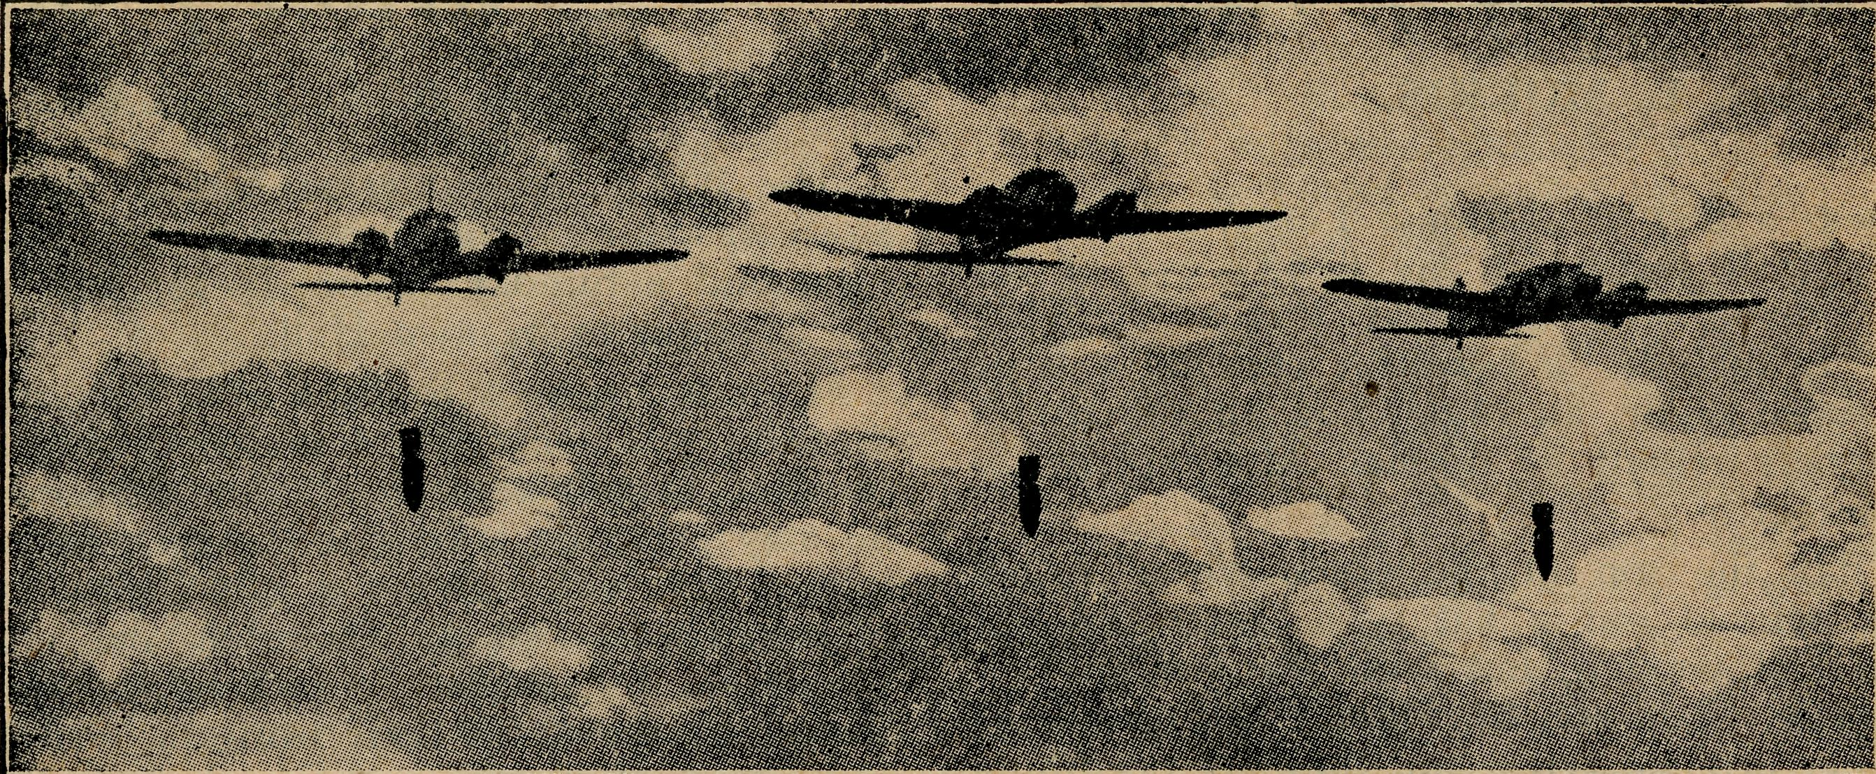

YOU MUST KEEP THESE GOING FOR DEFENCE.
Jogging Along at Rappville
Rev. P. CONNELL.

Last week I had one of my most memorable services when I baptised a family of six boys. The eldest was twelve and the youngest one year. They had not been baptised, the mother said, because no minister had been handy at the time they were born. As she lived in the bush some miles from church, they had waited all this time. I arrived one afternoon by train and found two of the boys at the station, having come to collect the battery of their wireless, and they took me home. The home was very small, only four rooms, and those not big. Yet I notice with large families in the bush, they can keep very quiet when strangers are about. But what must it be like when the visitors have gone? IT1 guess those parents need good nerves.
Soon after I arrived and had been introduced to every one, we fixed upon a time and place for the service that night. The boys were a bit frightened about being bap' tised, as some of the men about the place must have been telling them it was like having a tooth out. How ever, I trusted that all would be well and it was. After a short address, in which I told them as well as I could what baptism meant, I began the actual ceremony, start' ing with the youngest; and when the elder boys saw it was so simple, they lost all nervousness and came for' ward one by one. We had simple hymns and the old couple with whom I stayed the night expressed their gratitude at such a service in their home. Everyone else was thankful, too, and when I left we had arranged to have a permanent Sunday School, which one of the ladies had promised to teach. It is taking services like this one at this little place, Boylston, that makes me feel glad to be called to this ministry, to people outback. They are always so grateful in such places for what a minister does for them.
To'morrow I must do my work on the horse, and I am glad that she's been well fed lately. The first place is five miles away, and the second seven miles further. The reason I cannot use the car is that one of the four tyres
is nearly done, and I expect to have a blow-out soon if I cannot get another, so it is at such times as these that a horse comes in handy to me in this work.
At Wyan Church, five miles away, a window was broken some years ago, and the opening is at present covered by a bag. We've grown disgusted with the sight of the bag, and so have collected enough to buy a new window and effect some further repairs to this particular church.
SOME DAYS LATER.—I had my services as I mentioned above. My first was at Rappville early in the morning. The second was at Wyan (5 miles), but not until 2 p.m., so I had plenty of time to ride the distance through some beautiful belts of forest and a good deal of scrub. I got to a place for dinner, and then rode on in time for service at Wyan, where there were eighteen people. When the service was over, I went across to a parishioner's place to see them, and, of course, enjoy that inevitable cup of tea. My next service lay seven miles further on. A member of the congregation, who lives there and was going home in his sulky, gave me a lift, and with Ruby tied to the back of the cart by the halter I always carry, we jogged merrily on to Busby's Flat for the evening service. Here there is a timber mill, and nearly half the population lives around it. We have church here in the public hall. Sixteen were present, and it was a happy service. I was speaking about the King's Call to Prayer, and nearly all the children present went to sleep before it was over, which I hope wasn't my fault. At this place the congregation is nearly always largely composed of the members of one family who've pioneered in this district for the past fifty years. That night I slept at their home, and in the morning rode back to Rappville and got in about dinner time.
Well, there is no more news for the present, and I must get to preparing the issue of the next quarter's envelope system.

October 26. 1944
II
THE REAL AUSTRALIAN

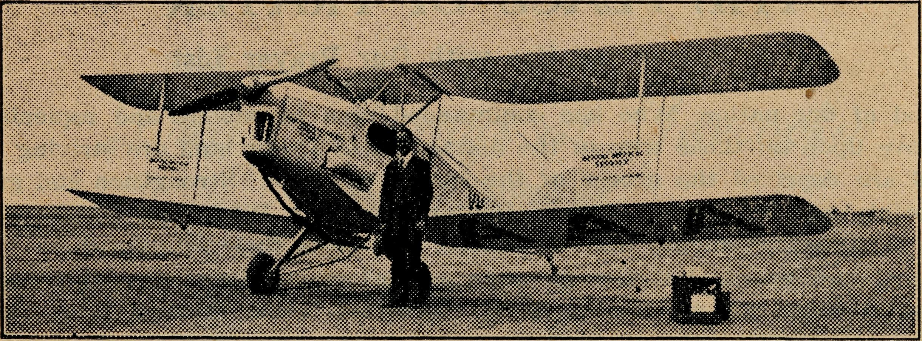

YOU CAN KEEP THIS FLYING FOR SALVATION.



Sister Grace Hitchcock, after seven years¹ service at Koonibba Mission Hospital for Aboriginals, will shortly return to Ceduna. Sister Hitchcock has placed the work at Koonibba on a firm basis, and we feel the time has come for the Lutheran Church, who manage the mission station, to supply one of their own nurses. Arrangements have been made for this to take place, and a nurse is on her way to take up Sister Hitchcock's duties.
We hope our friends will continue to take an interest m the Aboriginal work at Koonibba, which, despite the change of staff, will still remain a part of our Flying Doctor Service.
We are glad to announce yet another generous gift promised from our friends in the Homeland. Dr. Bate, of Col. e? Con. Church Society, informs us that friends in Ireland are gathering funds to purchase a second van for use by the Rev. K. Luders in the Wilcannia Mission. The van used by the Rev. L. Morris at Minnipa was also supplied by our Irish friends. We say a very real "Thank you¹¹ for the promise of this good gift.
The Rev. K. Luders is keen to have a little church built at Tibooburra. Already some funds are in hand and many of our friends are interested. Would you like to have a share in it? Send along a gift to the office.
The passing onward of Miss Norbury was a big shock to many in the Diocese of Sydney. As Head of Deaconess House, Miss Norbury made an outstanding contribution to the training of many women workers for the service of the Church. We were always grateful for her interest in and appreciation of B.C.A.'s ministries.
The Annual Rally in Sydney, held on Tuesday, 26th September, though not up to the usual standard in attendance, was one of the best we have had.
The Archbishop, just returned from the Dedication of the new Jubilee Hostel at Port Lincoln, had an interesting story to tell.
The Bishop of Riverina told us a great deal about the Wilcannia Mission from a new angle, that of Bishop of the Diocese. The Bishop spoke in high terms of the Rev. Karl Luders and his work. It was good to hear the Bishop and to know of his deep concern for those who live in the more lonely places within his vast diocese.
The Rev. W. Duffy kept us in good humour with his Irishman's account of work at Timboon.
We are grateful to each of our speakers for an interesting and informative meeting. The offering amounted to £200.

The Rev. David Livingstone writes that the Direct Giving Appeal for church maijitenance at Streaky Bay is now over £160.
When it is considered that this district is experiencing the worst drought on record, and the farmers will not even get seed wheat from their crops, this is a remarkable effort and speaks well for the ministry given at Streaky Bay, and the strength of church life in that centre.
The Annual Market Day held by our Sydney Women's Auxiliary was a happy and successful gathering, although the day was wet and cold. The various stalls were well stocked and found a ready sale for their commodities. The amount gained on the day was £130. As a result, the Auxiliary has been able to furnish a refrigerator for the Kirton Point Hostel.

Our friends will learn of the passing of Deacpness Currie with sorrow. Miss Currie was a great friend of B.C.A. and knew personally many of our workers.
She was a great intercessor and her prayers were con' stantly made for all missionary work wherever performed. We • shall miss her and her constant remembrances of our work.
We trust our friends are not forgetting those War Saving Certificates. We have received about 1500 to date, and, as you know, they are being reserved for the purchase of a new ambulance aeroplane.
We really need one now, and hope that as soon as a suitable machine is available we shall be able to purchase. Send along a Certificate before Christmas.

THE REAL AUSTRALIAN
12
October 26, 1944

THE PLACE OF PRAYER
A Prayer for Use with Our Prayer List.
O Lord God of our nation, Who has commanded men to subdue and replenish the earth: Look in Thy love upon all those who in the distant parts of our land are striving against many difficulties, and are deprived the access of the means of grace. Strengthen and guide the Bush Church Aid Society and its Clergy, Nurses, Doctors and Air Pilot, and Students. Cheer and comfort them in discouragements and loneliness, and bless their ministrations to the good of those they serve, and grant that the message of redeeming love may thus be rooted and grounded in our national life, to the glory of Thy Great Name, through Jesus Christ our Lord. Amen.

SUNDAY.
THURSDAY.

MORNING.
The Far West Missions at Penong, Ceduna, Min-nipa and Cummins; the Missioners, H. Broadley, L. Morris, D. Pugh and J. Greenwood.
EVENING.
The West Darling Missions at Wilcannia and Menindee; the N.W. Mal-lee, and the Missioner, K. Luders.
MORNING.
For the Mail-Bag Sunday School with its Gospel messages for the children. For the teachers and helpers, that they may find encouragement in their work.
EVENING.
For the Organising Missioner, that he may be strengthened and guided in all his endeavours for the good of the work and in his relationships with his fellow-workers.

FRIDAY.
MONDAY.
MORNING.
The Cann River Mission, the Bonang Mission, Rev. K. Brodie, the Streaky Bay Missioner, Rev. D. Livingstone.
EVENING.
The Denmark Settlement, the Kirton Point Missions and Missioners, Rev. T. R. Fleming and Rev. R. T. Hallahan.
MORNING.
For the Bishop Kirkby Memorial Hospital and Sister Pritchard and Miss D. Dykes, as they minister to the people on the great Nullarbor Plain. For Sister Bossley and the Tarcoola Medical Hostel.
EVENING.
For students and all in training for this work of God. For Rev. W. Duffy and the Heytesbury Forest Mission. For Rev. T. H. Pickburn and the Otway Ranges Mission.

TUESDAY.
MORNING. EVENING.
SATURDAY.
MORNING. EVENING.
For Sisters Dowling, Page, Loane, Branford and Moody at Ceduna; Sister Firmin and Miss Millar at Penong.
For the Cann River Dispensary and Koonibba Mission Hospital, and Sisters I. Gwynne and G. Hitchcock.
For the President and Council of the Society, that they may be guided by His wisdom.
For the Home Base Staffs, Auxiliaries, and parochial workers.
For the "CoorafT' Hostel and its workers, Mrs. Mann and Miss Harding.
For the Rappville Mission and the Missioner, the Rev. P. N. Connell.

WEDNESDAY.
MORNING.
For the children in the Mungindi, Wilcannia and Port Lincoln Hostels, and for the workers, the Misses Cheers, the Misses Gurrier Jones and Sister Sowter.
EVENING.
For the Flying Medical Service, Mr. Chadwick, and Doctors R. and F. Gibson.
For the wives and families of the Missioners and Air Pilot.
Each day pray that the many needs of the work may be met.
Running expenses of £5 per hour to keep the Medical 'Plane in the air. *
Consecrated clergy missioners for urgent work in the field.
That our work may continue to progress despite the difficulties of wartime.

Give Thanks—
For the rich blessing and wonderful growth of the Society's work. For all the kindly givers who have helped with their self-denials. For the Flying Medical Service. For the joy of service.

October 26, 1944
13
THE REAL AUSTRALIAN

Daily Dooings at Jarcoola
Sister B. BOSSLEY.

During the past few months the medical work at Tar' coola has been very erratic. This frequently seems to be the case in our work, but it is noticed more when one is here alone to cope with the busy periods, and also the slack times, which in a way prove more difficult, and are a greater problem as how best to use one's time to the Glory of God. But I expect it is really about the urgent cases, and the busy times that you wish to hear, for there is little to put into writing about the slack intervals, except to say that they frequently prove a time when one comes to know and understand more of the great Divine purpose and love of God, and when one is built up in the Faith, and refreshed and strengthened, so that when the busy days come and there is need for definite wisdom and guidance and help, one can simply trust Him, knowing that "He faileth not."
May, June and July were all busy months, but particu
larly July, when 140 patients were treated at the Hostel
and in their homes. Most of the patients were locals,
but quite a few were from outlying stations and farm
houses, necessitating many miles of travelling to visit
them. ,
One day while visiting at ^frequent intervals a diabetic who was far from well, a call came to go out to a station, about 35 miles distant, to a man who had ricked his back while starting up an engine, and was in very severe pain. I did not like leaving my diabetic patient here, but the man was in too much pain to be left, and could not bear to be moved, so the trip of 30 odd miles, over appallingly rough roads was impossible for him, so there was nothing for it but to prepare for the trip. Just as I was getting a few things together, a big lumbersome old truck, with all the upholstering gone, and the springs from the undercarriage I think completely missing, pulled up at the door, and a young woman* came in to ask me to come up to the old town (fortunately only two miles away) and see a young girl who was very sick—they thought it was an appendix. As I clambered into the truck, the woman said the men were all away shearing, and she hoped I didn't mind going with her, as she had never driven the truck before. Of course, I said, I didn't mind, but I was glad we only had two miles to go each way. After seeing the girl I decided it was not an appendix, for which I thanked God, but had to come back and ring up doctor, about some treatment for her, then back again to put the treatment into operation.
When I returned to the Hostel, the bus that was to take me out to the station had arrived and was waiting. This time a 1928 model Ford utility—minus hood, doors, running- board, and upholstery, while the bonnet was kept in position by straps. Fortunately the engine was good, and we averaged about 40 miles per hour over terrible roads. I really don't know how I arrived there, but I certainly had to hang on "by the skin of my teeth" for there wasn't anything else to hang on by, except the wind-screen.
By the time I gave my patient an injection of morphia, also a local anaesthetic injected into the injured part, strapped his back, and made him comfortable, leaving drugs and instructions, etc., it was quite late, but as is ever the case in the outback, could not leave without a cup of tea. By this time, the manager of the station had arrived in his modern utility, and brought me home, for which I was very thankful. I arrived about 9 p.m. to find my diabetic patient much improved.
Another afternoon, when half-way through a fairly big ironing, a call came to go out to a station about 40 miles away, where it was feared the husband had pneumonia, and the wife, who was a diabetic, had been getting up to him for the past couple of nights and had also caught a nasty chill, completely upsetting her diabetic condition, and she feared a diabetic coma. Again there was a hurried packing, and then the trip, stopping on the way at a station closer in for tea. Arrived about 8 p.m. to find both patients very sick—the husband with a temperature of 103 degrees, and all the signs and symptoms of pneumonia and pleurisy. The wife had a very heavy cold, and neuralgia of the face, and was on the verge of impending diabetic coma. Out came the M. and B. tablets for the husband, and insulin, etc., for his wife, and a busy time was experienced in that home for the next four days, before it was safe to leave them. It was a Christian home, and it was a joy to be able to minister to their spiritual needs as well as their physical.
I was unable to contact Doctor by 'phone; someone would have had to come in to Tarcoola with a message for the Post Office to ring through. But everything went well, and both patients have since gone to town for a holiday.
The plane has been called into commission, too, these past few months, for urgent and accident cases. Some months ago, an Italian employed by the National Works Council on the line about 60 miles west of here, came in on a water train in a critical condition with peritonitis, and needing immediate surgical treatment. Had he gone on by train to Port Augusta, he would not have been there under 20 hours. However, the plane and doctor were summoned, and the patient taken back to Ceduna, and operated on within five hours after arriving here.
While repairing the roof on the loco, shed here, one man had the misfortune to fall nearly 30 feet, sustaining slight spinal and pelvic injuries. He, too, was fortunate in being able to be taken to Ceduna Hospital within three or four hours of injury, instead of having a day's wait here, then a 12 hours' trip into Port Augusta.
Another man who received severe facial injuries and concussion, was taken to Ceduna for X-ray and repair work, and yet another received benefit when Doctor came up to attend an injured hand.
So the story goes on, and will continue to go on. Will you do your part to maintain this work of ministry and healing in these out-back centres? You can, by your gifts and by your prayer, and by the giving of yourself for God's work to these lonely people of the outback.

THE REAL AUSTRALIAN
14
October 26, 1944

The Teaching Service
Sister L, LOANE.

During the past month the need of the young people in this district has been deeply impressed on our minds, and in particular the need of those who are just growing up. The world has a certain number of attractions to offer them in the way of dances, socials, weekly picture shows and even a tap-dancing class. With these there always come the temptations that meet young people in any town or city no matter what its size. Is there any thing that we can offer them that will help to keep them on the right track and give them a definite object as they face the future? We have various opportunities of doing this through the classes that are held regularly here in the town, but to reach the children and young people who live in the country is quite a different matter.
Religious instruction is held in the school each week. There are several who teach, and every child, with the exception of the Roman Catholics, attends the lessons. Even the tiny ones, and the little Greek children who are just learning to understand English, have their Bible Story week by week. It is an opportunity that till re' cently was denied in South Australia, as religious instruc' tion in State Schools was for years barred by law. How far can we get by these school classes? Perhaps only as far as sowing the seed, but surely some of that seed must fall on good ground.
Then there are the Sunday Schools, one at Thevenard, and two, Anglican and Methodist, here in Ceduna. What are the opportunities they offer?
Quite recently Mr. Jenner, the Methodist Minister, has started a Bible Class for the older boys and girls of that denomination. His idea is to give those who feel they are too old for Sunday School, something definite to do on Sunday afternoon, and to encourage them to bring their questions and difficulties to be discussed and made clear. So far it is hard to judge just how the children will react to that scheme, but it is another way of approaching and helping them.
Then there is the Bible Class, held here every Friday evening. The numbers have been keeping up and more and more of the older boys and girls have been coming more or less regularly, so that now the. whole nature of
the class has changed from what it was originally. What is it that brings the children along? .Their reasons for coming no doubt are varied, and perhaps would surprise us if they were to tell us just why they come, but what' ever their reason, the door is opened to the message of Jesus and His love.
How can we make the most of all these opportunities?
With this thought in mind, a monthly meeting has been arranged for all those who are teaching children of any age. We, both Anglicans and Methodists, come to' gether and talk over our problems and difficulties, so that from each other's experience we may learn new lessons in how to teach the children in our own classes. It has proved a help and given a sense of unity in the work for the Master here.
What of the results of all these efforts? As far as we judge they are small, but there are three cases which come to my mind that point out the value of continued teaching, the one in contrast to the other two. She is a lass of 19 years. She would never come to Bible Class, but at one time there was a great influence for good in her life, and we hoped that it would lead on to a living know ledge of Christ as her Saviour, but that influence was removed, and steadily she has slipped right back. To'day she appears to have little time for those things that would lead her back to God. She needs much prayer. The other two are girls of about 16 years, both of whom have now left Ceduna, but who used to be most regular at Bible Class and who have both given their hearts to the Lord. One, brought up in a Christian home, tells in her letters of the help she found in the fellowship and lesions every Friday evening. The other, brought up under less favourable circumstances, is now bearing a faithful witness for her Master in her own home and district, and is seeking guidance for a life of service in the future. The knowledge that these two have been so definitely helped is a great joy and encouragement to go on and to count no effort as lost in seeking to win the children.
Once again I would ask you to continue in prayer for all these classes and in particular for the older boys and girls. Prevailing prayer to bring them into the Kingdom and to keep them from the evil one.

Don't Forget
Tune in to:
- G.B. Sydney, at 10 a.m. on Fridays
- D.B. Victoria, at 9.15 a.m. on Fridays

October 26, 1944
15
THE REAL AUSTRALIAN

The New l/l/ork
Sister SOWTER.

One is reminded very forcibly that one belongs to the B.C.A. staff when the old familiar notice comes to hand, "Please send something for the R.A."
Well, it really is a privilege to be serving in such a delightful spot as Port Lincoln, with its not less delightful people, and be connected with a work which aims at do-ing something for our girls and boys of the outback dis-tricts of this fair land. Having spent some time at Penong on the West Coast of this State, and knowing the isola' tion of many of the families where children have to re' ceive their education by correspondence (and we know that in many cases, this proves to be very good), still, these children miss the companionship of other children and the community life which gives confidence and bearing, and will be an asset as they grow up in helping them to take their place in the world; also are not the boys and girls of tO'day our men and women of to-morrow, and if given a right lead, what an asset to our nation many of them may be?
In the last issue of the R.A., our O.M. told you of the purchase of this splendid building and grounds (with a wonderful view of Boston Harbour), for the children of the outback districts attending the Port Lincoln High School, a place where they will come under proper super' vision out of school hours.
I came into residence in the beginning of May, and had a very busy time collecting bits and pieces in order to take students for the beginning of the second school term.
On the 17th of May I was welcomed to Lincoln by between 70 and 80 ladies, each of them bringing gifts for pantry and kitchen, and what a delightful lot of things—pots, pans, dishes, groceries, about 40 bottles of jam, honey, and donations. I would like to say, "Thank you¹' to friends of Sydney and Melbourne who sent linen, crockery and cutlery; many of these things we were unable to purchase.
Members of the High School Council have also done a big job in pruning and spraying fruit trees, and grape
vines, others washing walls and kalsomining rooms
The ladies of St. Nicholas' Guild purchased the material for bedspreads, had them hemstitched, and then mono-grammed them, which has a very pleasing effect, and does the ladies great credit.
The official opening and dedication of the hostel was a much looked forward to event. It was a great joy to web come the Archbishop of Sydney, O.M., and Canon R. B. Robinson, also of Sydney, who had arrived from Ade' laide the morning of the dedication, and to show them over the hostel and grounds prior to the opening, each of them expressing their appreciation of the location, the building and the grounds, which offer such splendid opportunity for extension.
The day was perfect for such an occasion; Boston Bay looked like a sheet of darling glass, the people commenced to arrive about 2 p.m., and by 2.30 between 350 and 400 were assembled to witness the opening of the hostel, which, for a number of years, had been so badly needed.
I do feel that a great responsibility rests upon the one called to be in charge in a place like this, that these children may not only realise the need for higher education, but. that they may truly realise their need for the things of God and in realising this, they may be led to accept Him as their Saviour and Friend, and so friends of the B.C.A., I ask your prayers for myself and those young lives who will come under my control, that there may be such a spirit of love and comradeship that in years to come, they shall have only the happiest memories of their time spent at the B.C.A. Hostel at Port Lincoln.
At the beginning of the year it is hoped there will be accommodation for thirty girls, but to make this possible there are necessary alterations of dormitories, extra shower and bath rooms to be built, and so we ask our readers to bear in mind the importance of this work, and help as far as possible with their contributions; also if any one has a piano standing idle, will they please remember the B.C.A. Hostel at Port Lincoln needs .oge badly.

5 M.U. 5 A.D. 5 P.I. 5 S.E.
Tune in to:
South Australia on
Sundays, at 9 a.m.

THE REAL AUSTRALIAN
16
October 26, 1944

Victorian Notes

We in Victoria are pleased to report a steady increase of interest in the Society's work.
The Silver Jubilee Hostel appeal met with a ready response, which the appeal deserved.
Through the agency of the radio our membership is steadily increasing, and we are grateful to these well' wishers for their gifts of cash and kind.
We take this opportunity of thanking our many anony mous donors.
CHRIST CHURCH AUXILIARY, SOUTH YARRA.
The Auxiliary started about three years ago. In the first year £16 was collected; the next year £42 was raised, and this year we are directing our attention to the Tibooburra Church appeal, to which £39 has been subscribed; huts and other donations are above average.
In August a successful meeting was held in Christ Church Parish Hall, when we had the pleasure of hear' ing from the Rev. T. Jones about the need for a Church in Tibooburra besides churches that are wanted in the Heytesbury Forest and Beech Forest Missions.
Many cards have been distributed telling of Mr. Jones' talk from Station 3DB, Melbourne, on Friday mornings, from 9.15 till 9.25, and several members listen regularly.
CENTRAL WOMEN'S AUXILIARY.
The Central Women's Auxiliary maintains a keen inter' est with regular monthly meetings.
At the June meeting the Rev. A. F. Thomas gave an interesting illustrated talk on Japan, and an Opportunity Stall was also well patronised.
We were pleased to welcome Miss Mabel Miller at our August meeting.
By kind permission of Dean Langley, we held our annual Temple Day in St. Paul's Cathedral on Tuesday, 17th October, at 2.30 p.m. The special preacher was the Rev. W. Duffy, B.C.A. Missionary of the Heytesbury Forest.
GIFTS FOR PORT LINCOLN HOSTEL.
From Miss Simcocks, 838 Drummond Street, North Carlton, N.4: 10 dessert spoons, 7 forks, 2 teaspoons, 2 table knives, 6 saucers, 15 plates.
From Mrs. Duncan, 205 Beaconsfield Parade, Middle Park, S.C.6: 6 knives.
From Mrs. Murtagh, 136 Dandenong Rd., Oakleigh, S.E.I2: 2 forks, 2 dessert spoons, 2 knives, 1 teaspoon, 1 jam spoon.
From Miss GreySmith, Mornington: 6 knives.
From Mrs. Geo. Cox and friends, Mornington: 3 quilts.
From Mrs. Francis, 20 Kelburn St., Caulfield, S.E.7: 7 saucers and donation.
From Mrs. N. Gower, 275 Kooyong Rd., Elsternwick, S.4: One dozen cups and saucers.
ST. THOMAS' WOMEN'S AUXILIARY, MOONEE PONDS.
We resumed our meetings in March and every alter' nate month in place of the usual business meeting we have had an Australian Tea at the home of one of our members. The hostesses at these afternoons have been Mrs. M. Brown, Mrs. O. Tregea, and Mrs. W. L. Woods. We also had a very interesting lantern lecture by the Rev. A. F. Thomas in April. By these several efforts we have raised £23.
We look forward to a Sale of Work arranged by Mrs. A. Rettick, and to be held at her home on 12th September; we know we shall reap quite a large amount by the sale of Mr. and Mrs. Rettick's handiwork. Our Thank Offering Service will be held (D.V.) on Wednesday, 8th November, and then we will join in a social evening afterwards at the home of Miss de Grouchy, who web comes us each year on this occasion.
We report with regret the passing on of Mrs. W. Clarke Hudson, a member of our Auxiliary, and always a keen supporter of B.C.A.

Mail Bag Sinday School

To tell of what our MaihBag Sunday School is doing is a big job. Any boy or girl, irrespective of how far away he or she lives or how old, may become a scholar and receive lesson papers. The school is divided into six grades, and so meets the needs of children of different ages. Suggestions for Bible readings, prayers, hymns and handwork help the children make the truths of the story part of their life. Those who wish send their answers and handwork back to the office. From there it is sent to their individual teachers, who try to be a real friend to each pupil. The youngest children, who are unable to write, have sketches of the story to colour, or maybe the words of a text to fill in. If they should have been asked to model or play the story, then Mother writes and tells the teacher about it. The understanding ccoperation of the parents is a necessity for the lessons to be of real value to the children, particularly the
younger ones; and, despite the extra work so many country mothers have to do these days, most of them still find time to help their children learn of the things of God. There is also a Missionary Band for the child' ren, and, for those who need them, special Confirma' tion preparation lessons are available. At present we are contacting hundreds of families and a number of Sunday Schools, but we believe there are many more who would like to join with us. We would be very pleased to have the prayers of all B.C.A. friends, and would also ask them to further assist in the work by making it known to as many as possible.
So, with my kindest regards, I am, Yours very sincerely,
Mrs. L.V.T.

October 26, 1944
THE REAL AUSTRALIAN

One Sunday Morning
Mrs. Wilson was getting ready for the service. She went every time the parson was able to get around their way. It wasn't very often; about four times a year, for he had such a very big district to travel.
Of course, they did not have a church to worship in, for there were only six families altogether in her district, and the next village was eighty miles further on.
A tiny, single-roomed, limestone building was used for services. During the week it was the local school for the ten children of the immediate district.
Of course, it would be a lot nicer and would help them to worship better if they had possessed a church, with all the beautiful appointments they had in the church where she had been brought up.
The maps of Australia and other places; the multiplica' tion tables chalked by the teacher on the blackboard built into the wall and the crayon drawings of the child ren were a bit out of place on Sunday. Still it was church to the handful of people who were only able to worship with a real parson once a quarter.
When all was ready, Dad packed the family into the jinker. When petrol became so scarce, the car had to be connected to one horsepower use. This was done by taking the engine out and fitting a pair of shafts to the chassis. It looked somewhat unusual, but a jinker with balloon tyres was much to be preferred to the old iron' tyred type. The four miles to the village school took a little over half an hour, and they found everybody else already assembled.
Dad gave the parson a hand to get out his baby organ, which he carried in the car, and soon all were more or less seated in the schoolroom.
It's a bit awkward trying to fit into school desks when you have grown up and put on more weight than you would care to boast about, but those who couldn't fit into them sat on the top.
The parson in his white surplice played the hymns as well as doing everything else. It was never possible to learn new hymns, so they persisted with the old ones they had known all their lives, "Abide With Me," "Sun of My Soul" and "Onward, Christian Soldiers." Some of them were a bit hazvy about even these welhknown tunes, but they did the best they could, and surely God would understand.
The sermon was short, for the parson understood that they would be better able to remember his message. He reminded them that, though they were a little community living away in the Never'Never, God saw them and cared about them, even if their brothers and sisters in the more populous places forgot they even existed. Mrs. Wilson felt that it helped her to put up with the loneliness of her existence.
When the service was over, some of the menfolk got the fire going while the women prepared the foodstuffs. Church was one of the few social gatherings they had, and they made the most of it.
While the parents were making these preparations, the children remained in the schoolroom with the parson. A
quarterly visit must be made the most of, and the bush parson crammed as much into his time as he could. Teach' ing the young is an important part of his job, so Sunday School was in session.
Lunch'time provided the padre with the opportunity of a chat with each of the folk present, and in these days of petrol restrictions saved a lot of travel in individual visits.
Much of his time was taken up with journeying on the roads, for his parishioners lived at considerable distances from each other. It was expensive this getting about, and the state of the so-called roads soon took the best out of his car.
Under normal circumstances, it would be quite impossible for him or any other parson to do it. The people of the district were good and as generous in their financial support of his work as their circumstances would allow. But—well, take just a normal Sunday's running— he had three or four services, which meant between 120 to 200 miles of travelling. Petrol was 3/6 a gallon — between £l and 35/- just for petrol. Then there was all the running about during the week for sick ones, schools and normal visits. He would be very fortunate if £150 a year paU his petrol bills. Added to this, there were car repairs, depreciation and, of course, he needed a little as salary to live on.
It was because he had been sent out by the Bush Church Aid Society that it was possible to give any ministry at all here. The Society sent the necessary extra money to him to meet the bills.
Of course, the B.C.A. did not have a private gold mine from which to draw. It was simply an association of many Christian people who were interested in the needs of their brothers and sisters who lived beyond the big cities. These people realised that it was part of their Christian duty to help their pioneer kinsfolk and they had said to our outback padre, "If you will go out into these lonely places and minister to these people, we will see to it that you are furnished with the things you will require to carry on."
He had come out three years ago and had never regretted leaving his city parish. These friends of B.C.A. had stuck by him. Never once had they let him down. Even when his old car had given up the ghost and it became obvious that a new one had to be found, they rallied round and £300 had been found to get him another.
On another occasion, he had wanted to help a little woman who lived in a rambling tin house without much furniture. She had four children and couldn't afford to send any of them to school. Because the friends of B.C.A. had established hostels for just such kiddies, he had been able to get the two eldest children into one of them. They were now going to school and their mother had been very grateful. When she had finished weeping with thank-fulnes, she had told him, "It makes a lot of difference to know that there are some who care about us."
So he was able to go on in the knowledge that he was not alone in this work. There were many hundreds of folk behind him and he was just their agent in God's work.
T.J.

THE REAL AUSTRALIAN
October 26, 1944

Subscribers who have not received Receipts

REAL AUSTRALIAN.
Mrs. Brennan, Rev. C. Adams, Mr. F. Madden, Mrs. C. Chapman, Mrs. F. B. Dann, Mrs. D. J. Davidson, Miss Elring-ton, Miss H. Jones, Mrs. C. H. Pearson, Mrs. H. Starling, Mrs. R. E. Williams, Mrs. A. Hunt, Mrs. A. Bachtold, Miss Wheen, Mrs. M. G. McDonald, Miss M. Sellars, Mrs. W. Scherferle, Mrs. Gillam, Rev. A. G. Reynolds, Mrs. Woodman, Miss Abrams, Mrs. F.' Handasyde, Mrs. G. W. Mason, Mrs. H. L. Falconer, Miss E. Kleinert, Miss Hall, Miss A. Westmoreland, Rev. K. G. Aubrey, Mrs. E. Boddy, Mrs. Llewelyn Bevan, Mrs. Bradshaw, Mrs. Bury, Mrs. Cochrane, Mrs. Dalway, Miss Dennis, Mrs. Fletcher, Miss C. M. Hancock, Mrs. Monds, Miss Shaw, Miss Craw' ford, Mrs. C. J. Kirkby (Vic), Mrs. Brook Hansen, Mrs. M. Chase, Miss C. Nellor, Mrs. Blake, Mrs. Tregea, Mrs. M. Brown, Mrs. J. Taylor, Miss M. G. Thompson, Mrs. C. Uebergang, Miss Melva Robinson, Miss M. Armfield, Miss E. A. Tilley, Mrs. Grant, Miss I. Lowe, Miss J. L. Smith, Miss Gearing, Mrs. Laugher, senr., Mrs. Manuell, Mrs. Nash, Miss Shields, the Misses Shields, Miss I. Brown, Miss I. Milburn, Miss Wright, Miss Coburn, Miss King, Mrs. Patmore, Mr. Brady, Miss Eccles, Mrs. H. Tresise, Mrs. B. Pell, Miss Walch, Miss Mann, Mrs. Colechin, Mrs. Curry, Mrs. S. Moore, Mrs. Bishop, Dea-coness Sundell, Mrs. Holbrooke, Miss Bigmore, Mrs. Beardmore, Mr. H. Hayes, Mr. R. C. Hutton, Mrs. Williams, Miss Hilda Sutton, Mr. C. Wigglesworth, Miss Shirley Matthews, Mrs. M. Andrew, Mrs. Murtagh, Rev. B. B. Lousada, Mrs. R. Ellis, Mrs. P. G. Thomson, Mrs. A. Rettick, Miss Hollick, Mr. W. Shelton, Mrs. Mills, Mr. G. Pym, Miss Wombach, Mr. Younger, Miss Williams, Miss Swann, Mr. Retallick, Miss Hadfield, Miss Dicker, Miss Willersdorf, Miss Peterson, Mrs. Doherty, Mrs. Delaney, Miss Thompson, Mrs. Pengilly, Mrs. Booth, Mrs. McDonald, Mr. Goldsworthy, Mr. Toms, Rev. T. Gair, Mrs. James, Mr. Alan Hester, Miss Wheeler, Mrs. Miller, Mrs. Rendle, Mrs. Stebbins, Mrs. Luders, Miss Hardwick, Mrs. Boissery, Mrs. Maddocks, Mrs. Edwards, Mrs. Vince.
ANONYMOUS.
6.3.44, 'TLB.," 5/- donation; 27.3.44, Anon., North-bridge, 5/-; 17.4.44, 10/-, Anon.; 24.4.44, Hurstville Anon., 2/-; Miss N. Von Stieglit2i, 26.4.44, "An Interested Listener,¹¹ Wahroonga, 10/-; 1.5.44, Anon., Homebush, 10/-; 15.5.44, Anon., 10/-, Jubilee; 19.5.44, Anan., 2/-, Jubilee; 26.5.44, Anon., Burwood, 6/-, Jubilee; 29.5.44, "A Sympathiser,¹¹ £l, Jubilee; Anon., Chatswood, 6/-, Jubilee; 31.5.44, "N.H.R.,¹¹ £2/10/-, Jubilee, Anon., 6/3, Jubilee; 1.6.44, Anon., 2/6, Jubilee; 5.6.44, Anon., Hurstville, 2/6, Jubilee; 8.6.44, Anon., St. Barnabas¹, Chats-wood, 4/-; 16.6.44; Anon., North Sydney, 5/-, Jubilee; 26.6.44, "A Worldly Christian,¹¹ £2 donation; 3.7.44, "R.E.J.,¹¹ Anon., £6; 4.8.44, "Anon.,¹¹ Chatswood, 5/-; 16.8.44, "Anon.,¹¹ Auburn, 4/- donation; 11.9.44, Anon., 2/6; 25.9.44, Anon., Hurstville, 2/-; Mrs. McMillan, 10/-; Mr. and Mrs. Lingard, 6/9, Jubilee.
ANONYMOUS (VICTORIA).
10.2.44, "A Friend,¹¹ 10/-; Anon., 5/-; 11.2.44, Anon., 3DB, 2/6; 21/2/44, Anon., 3DB, 10/-; 28.2.44, "F.E.J.,¹¹ 3DB, 10/-; 3.3.44, Anon., 3DB, £l; 9.3.44, 3DB, Anon., 2/-; 28.3.44, "A.C.,¹¹ Anon., 3DB, £l; 30.3.44, "A Listener to 3DB,¹¹ 2/6; 14.4.44, "K.A.,¹¹ Kew, one £l War Savings Certificate; 18.4.44, Anon., £5, Rally; 20.4.44, Anon., 10/-, Rally; 24.4.44, Anon., 4/-, Rally; Anon., £l, Rally; Anon., £1/5/-, Rally; 26.4.44, Anon., seven £l War Savings Certificates; 1.5.44, Anon., 2/- donation; 3.5.44, Anon., 2/6, Rally; 15.5.44, Anon, £5 donation; 18.5.44, Anon., 3DB, 6/-; 22.5.44, Anon., 3DB, 10/-; 24.5.44, Anon., 2/-, Rally; 26.5.44, Anon., 2/-; 30.5.44, Anon., £5 Rally; 13.6.44, "Two Friends,¹¹ 12/6, Jubilee; 22.6.44, "M.N., 3DB, 5/- donation; 26.6.44, Anon., 5/-donation; 1.7-44, Mrs. Berry, 6/-, donation; 12.7.44, "A Friend,¹¹ 3DB, 10/- donation; "L.,¹¹ North Carlton, 3DB, 3/- donation; 21.7.44, Anon., 2/- donation.


Help Australia
by
purchasing
War
Savings
Certificates.
Certificates can be purchased for:
16s. for each £1 Certificate.
£4 for each £5 Certificate.
£8 for each £10 Certificate.
Help B.C.A.
by donating
War
Savings
Certificates
to the Society.

Buying them helps Australia in the World War. Donating them to B.C.A. helps the Kingdom of God in the fight against the evils which cause all wars.
The certificates will be used to build up a fund to assist in the purchase of a new medical 'plane
when that becomes necessary.
Edgar Bragg A Sons, Printers, Sydney.

