

No. 89
MARCH 15, 1945
1/6 per annum, post free

ANOTHER NEW HOSTEL
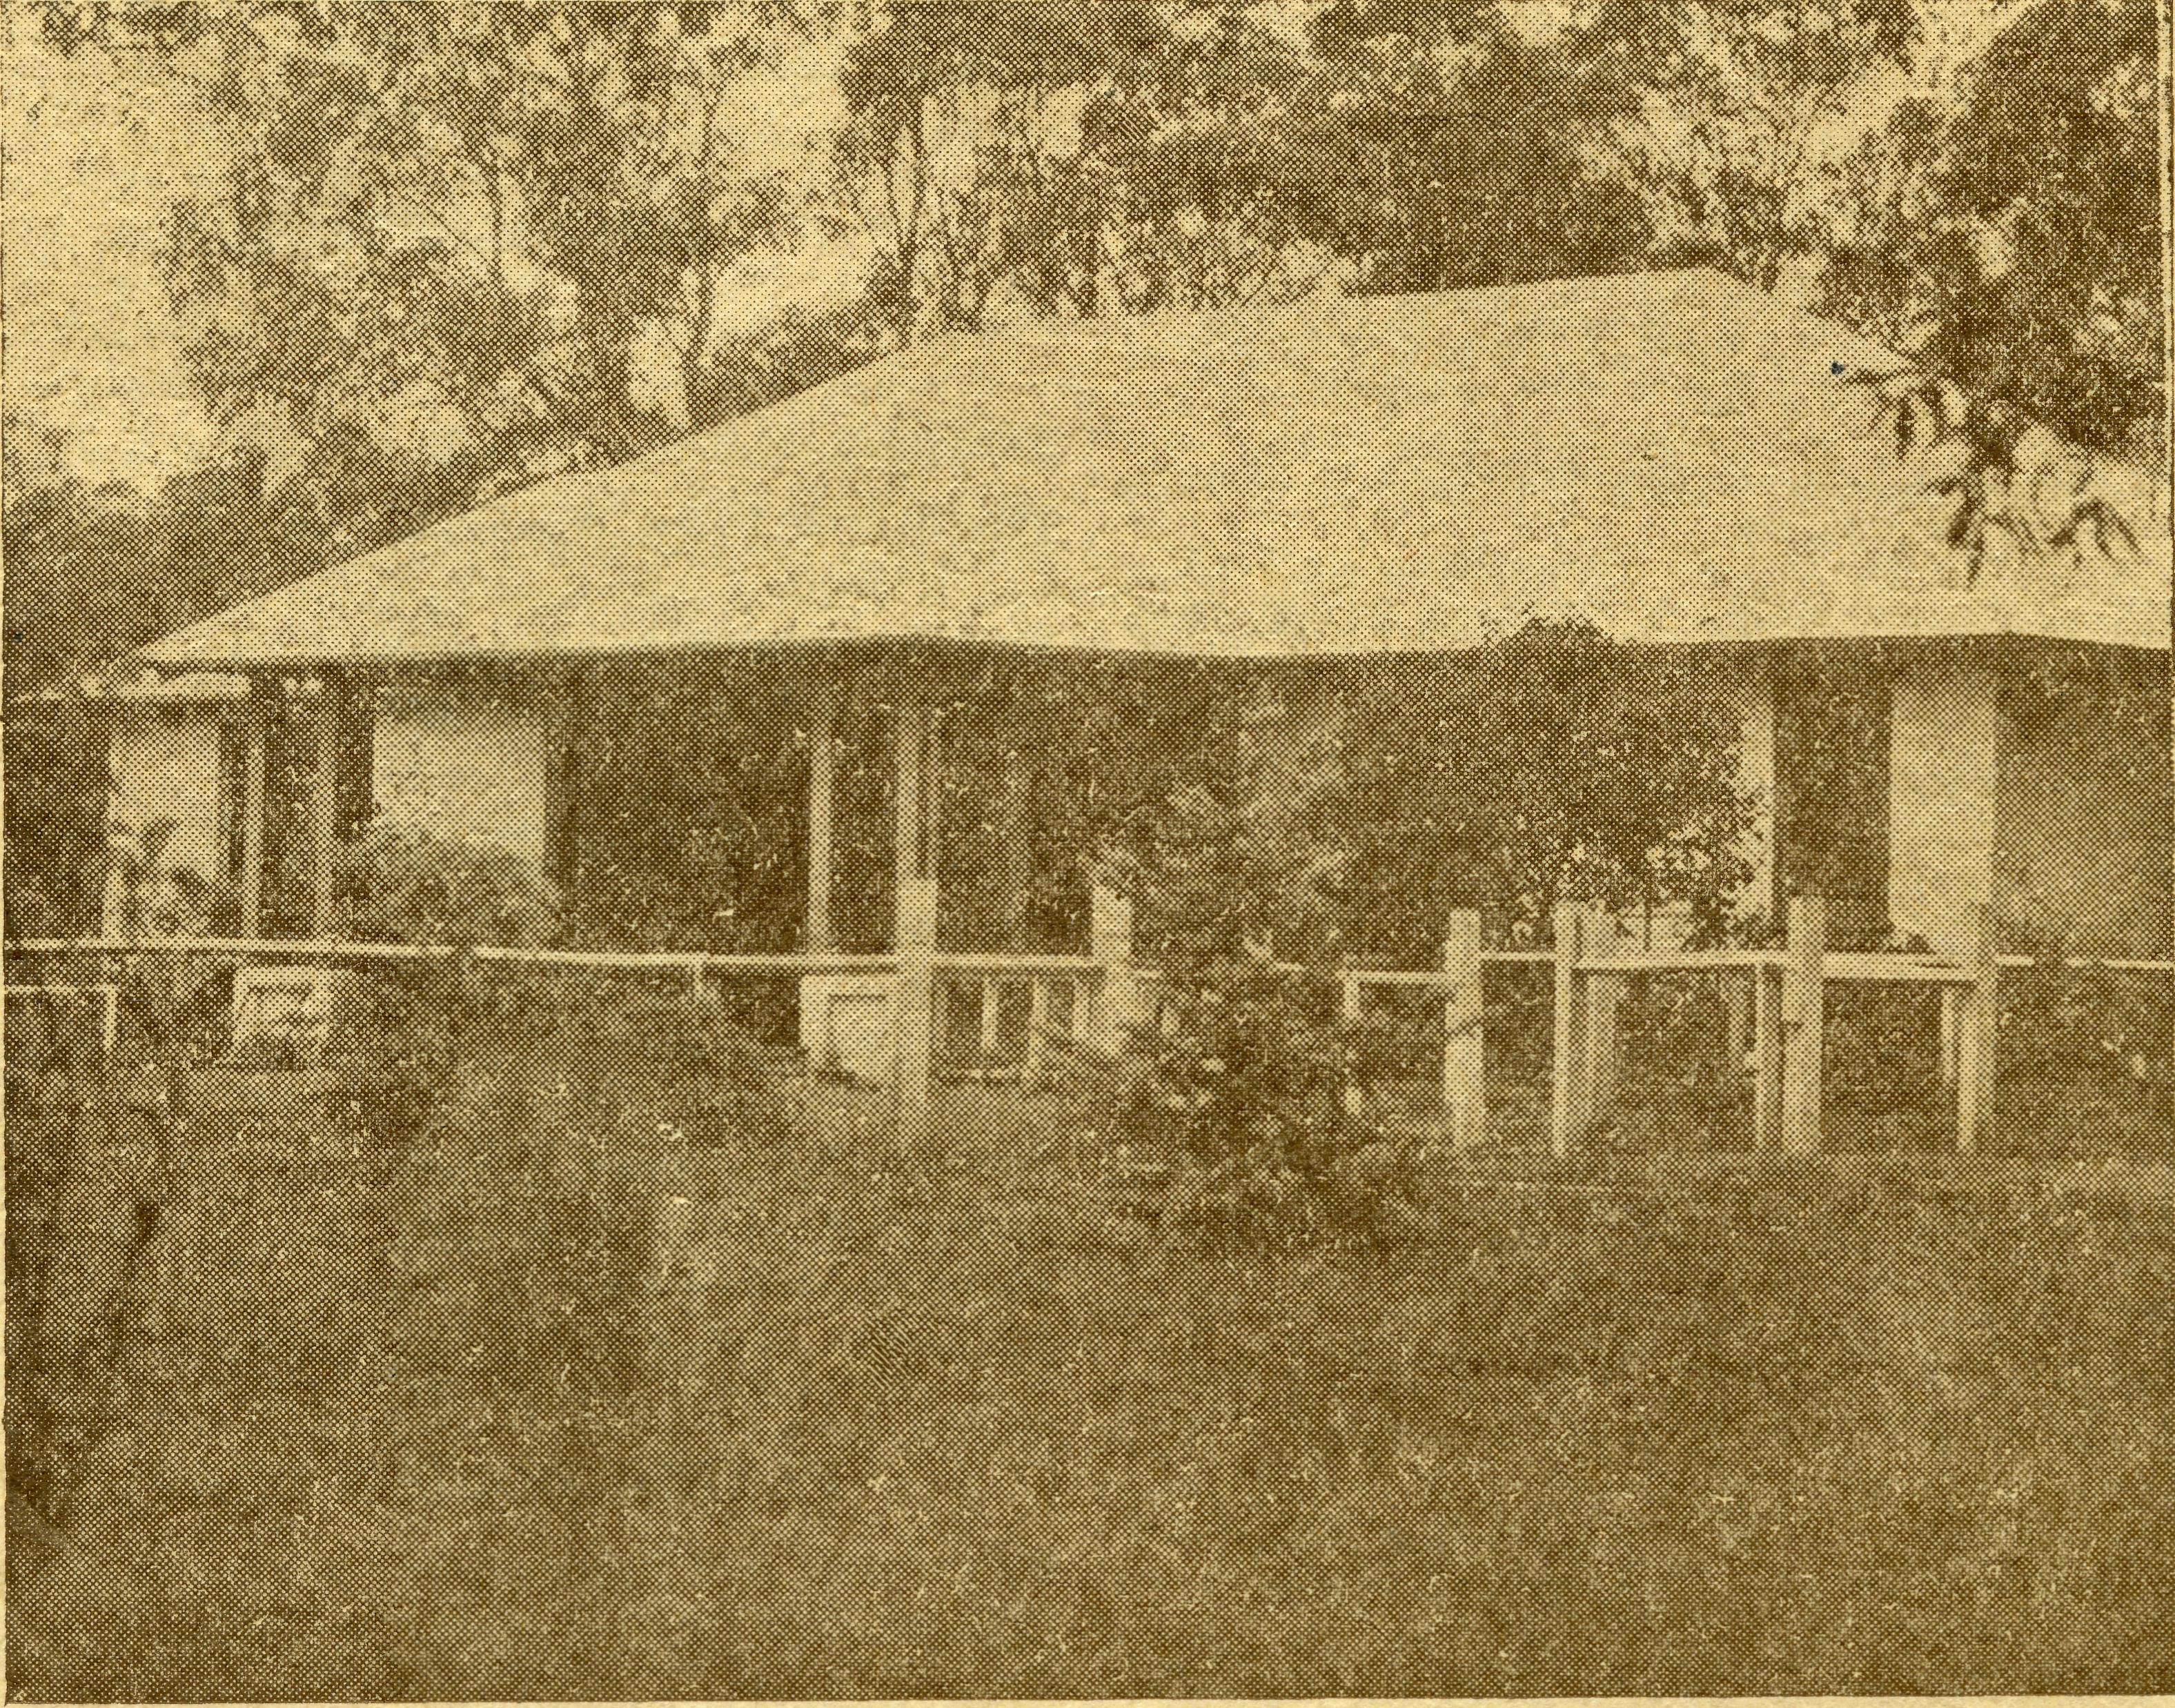
No. I Park Road, recently purchased by B.C.A. for use as a High School Hostel for Girls.
Registered at the G.P.O., Sydney, for transmission by post as a periodical.

THE REAL AUSTRALIAN
ii.
March 15, 1945

The Bush Church Aid Society for Australia and Tasmania

HEADQUARTERS OFFICE:
Diocesan Church House, St. Andrew's Cathedral, George Street, Sydney.
(Telephone: M3164) Gable Address: "Chaplaincy, Sydney."
VICTORIAN OFFICE:
The Bible House, Flinders Dane, Melbourne.
(Telephone: F 5675)
President: The ARCHBISHOP OF SYDNEY.
Hon. Clerical Secretary: Rev. L. GABBOTT. Hon. Treasurer: T. S. HOLT, Esq.
STAFF.
Organising Mission er: Rev. T. E. JONES, Th.L., Church House, George Street, Sydney.
Victorian Secretary: Rev. A. DONNELLY, Th.L., Bible House, Flinders Lane, Melbourne.
South Australian Secretary: Rev. R. M. FULFORD,
North Terrace, Adelaide, S.A.

B.C.A. Activities and Staff

MISSIONS.
Ceduna, S.A. ( Rev. H. R. Broadley, Th.L., Rev. J. Penong, S.A. J Greenwood, Th.L., Ceduna, S.A.
Cummins, S.A.—Rev. D. A. Richards'Pugh, Cummins, S.A.
ICirton Point, S.A—Rev. R. T. Hallahan, Th.L., Port Lincoln, S.A.
Streaky Bay, S.A—Rev. D. Livingstone, Th.L. Streaky Bay, S.A.
Minnipa, S.A—Rev. L. Morris, B.D., B.Sc, Th.L., Min-nipa, S.A.
Delegate-Bonang ( Rev. K. Brodie, Th.L.,
Croajingalong, Vic. J Delegate, N.S.W.
Heytesbury Mission.—Rev. W. Duffy, Th.L., Cobden,
Vic. !
Otway Mission, Vic. — Rev. T. H. Pickburn, Th.L., Beech Forest, Vic.
Wilcannia, N.S.W. ( Rev. K. Luders, Th.L.,
Menindee, N.S.W. J Wilcannia, N.S.W.
Rappville, N.S.W Rev. P. Connell, Th.L., Rappville,
N.S.W.
Denmark, W.A—Rev. T. R. Fleming, Th.L., Denmark. W.A.
-, Werrimull, Vic.
Werrunull, Vic.—Rev.
SCHOOL HOSTELS.
Wilcannia, N.S.W. — Miss H. Gurries Jones, Miss Y. Gurrier' Jones.
Mungindi, N.S.W—Miss E. Cheers, Miss E. I. Cheers.
Wentworth Falls, N.S.W. — Mrs. C. Mann, Miss F. Harding.
Port Lincoln, S.A.—Sister A. E. Sowter. Bowral, N.S.W.—Miss J. Bradley.
MEDICAL SERVICES.
Ceduna, S.A.—
"Matron: Sister F. Dowling.
Staff: Sisters P. Maddern, J. Lucas, M. Kay, G. Moody. Penong, S.A—Sister L. Loane. Cook, S.A—Sister B. Bossley, Miss D. Dykes.
Tarcoola, S.A Sister V. Page.
On Leave.—Sister G. Hitchcock, Sister L. Pritchard.
PLYING DOCTOR SERVICE.
Pilot—Mr. A. Chadwick.
Doctors—Dr. R. Gibson, Dr. F. Gibson.
MAIL BAG SUNDAY SCHOOL.
Superintendents.—
Senior: Miss Huntley. junior: Miss R. Campbell.

March 15, 1945
THE REAL AUSTRALIAN

Just Dust
Rev. J. GREENWOOD.

It was the first Wednesday in December, and according to the plan of services, the day of my trip to Fowler's Bay. The weather was clear and gave no hint of any cyclonic disturbance as I drove westward from Ceduna. There was indeed a spirit of joyful anticipation in the air, as though the atmosphere was desirous of giving a day of pleasure to the little settlement lying peacefully 89 miles away in its setting of brilliant sand'hills.
As the hot drowsy afternoon slowly passed away, my thoughts travelled ahead to the happy reception awaiting me. Somehow the heat was forgotten in anticipation of the smiles and laughter of children in party mood. In the back of the car were books and toys to be distributed at the small Sunday School's Christmas Party. I could not help but think of the pleasure it would give those who had helped to provide such an assortment, if they could be transported to the scene of this outback party: What a privilege it is to act on their behalf, bringing such joy to these isolated children.
The shimmering roof-tops of the settlement were at last discernible across the salt flats and soon the coolness of the stone house, where the children were assembled, helped one to forget that the outside temperature was soar' ing over the century mark. Here were 16 children, with all the keen anticipation of youth ready to do justice to a glorious array of food. But first they raised their voices in song and so choruses memorised for this special occasion were poured forth with full enthusiasm.
Children, whether in the quiet, isolated places or in the more closely populated areas, are all alike, where toys and books are concerned. Such treasures bring so much happiness, and so the chain of fellowship is supplied with another link. This small community may be isolated, but at least the Church has not forgotten the needs of these people.
The service at the close of the day was a fitting con' elusion to the occasion. The party spirit melted into the serene peace oP-worship as thanks to God were given and prayer was offered for the needs of body and soul.
The following day dawned red and boisterous; the north'westerly gale was early showing the heated frenzy later to be loosed upon the dry country. In the little weatherboard schoolroom, housing 16 children, there was an atmosphere not much unlike a heated oven. Despite the heat, the children sang lustily the choruses, introduc ing their monthly religious instruction. As I returned to the car I could see the crests of the sand'hills whipped into thick clouds. It certainly gave promise of a dirty day.
The shelter of the bay was soon left as I travelled tc wards Coorabie School, 12 miles north'west of Fowler's Bay, and the fury of the hot wind increased. Across the salt flats it roared with the breath of a furnace in its touch. Beyond the flats the wind tore at the stunted scrub as though it would tear it from the dry earth mothering its roots. In the distance fallow ground could be seen stirring into whirlpools of flying, stinging clouds torn up by the raging wind. Above all hung a sinister,
dark red cloud of flying dust which, although away on the far horizon, would soon lend its heat and sting to the present fury.
The dust swirled and eddied about the car as the wind and wheels churned up the surface. At last sane tuary came as I pulled up in the shelter of the little stone schoolroom. The teacher came out with a cheery welcome, but also with the gloomy news that the stormy day and sickness had kept his small number of pupils at home.
In the hall next door, Doctor was concluding his monthly consultations. Around the corner came Sister Dowling with the news that they could not possibly travel by the aeroplane to Penong. There was only one alter' native and that was supplied by my opportune arrival.
We ploughed along a heavy dusty road with the thick choking clouds making visibility very poor. And so for 10 miles we headed directly into this raging monster, ^pouring his fury upon a desolate, dry country. Turning on to the main highway brought the wind more to the rear as we headed southeast for Penong.
As we travelled along the highway, visibility improved. The wind had not commenced to stir up so much of the harder surface, while belts of scrub rendered a certain amount of shelter. - Here and there an exceptionally strong gust brought a billowing mass of dust about us, but for the main part of the journey the thick irritating dust clouds were spasmodic. The temperature, however, was not so kind, as it steadily climbed over the century.
At Penong Hospital, cool drinks served to settle the dusty throats after the 50 miles journey. Then the weary trip was forgotten as amidst jocial fellowship lunch was partaken.
However, the road must be faced once again, as evening service was scheduled to take place at Koorin' gabie, which meant retracing 48 of those miles only just completed. Then four miles more must be covered to reach the school which serves as a district hall, church or school, as required.
The first half of the journey was attended by moder' ately clear visibility, but against a roaring gale. It seemed as though it would take hold of the roof and tear it asunder. Suddenly a gust of wind seized a side curtain and, in a matter of seconds, tore it away from its fastenings and carried it some hundred yards along tne road.
This was scarcely retrieved and the journey continued when there was a sudden lull in the storm. It was, how ever, only a brief respite, as it changed direction and swept across wide spaces of cleared country.
The air was filled with choking dust and stinging gravel. The countryside was obliterated as clouds of red fury screamed through the air. For brief intervals a short stretch of road was visible and occasionally a glimpse given of some landmark. The afternoon dragged on, but yet the shifting dust poured along relentlessly, blocking vision and parching the throat.

THE REAL AUSTRALIAN
March 15, 1945

A sudden easing of this fury brought a brief glimpse of a windmill; what a sight, sanctuary until the evening should bring relief. The track into the farm, usually quite easily discerned, now had to be carefully located. At last it wavered into sight through the gloom and beyond the cloud of dust was a familiar home.
Inside the house the atmosphere was thick with the penetrating dust despite closed doors and windows. The view from all quarters was obliterated as the wind drove before it the surface of acres and acres of cleared ground. One felt that a thick blanket was settling down upon the the whole countryside, and it was hard to realise that there were other people moving about their duties beyond that pall of flying earth.
As the sun sloped towards the west, the gusts became more fitful and gradually, as though reluctant to rest, the wind abated. The flying cloud slowly subsided, although eastward thick clouds could be seen flying high. The last rays of the setting sun shone softly over the parched earth, now white in parts as though swept clean by a gigantic broom.
How symbolic of man in his tempestuous mood. He screams and raves while, above all, is the peaceful assur-ance of the One Who holds the secret of every phenomenon in His grasp. Amidst the holocaust of brutality a man cries out to God and finds above the storm, peace.
The last five miles to the little school for the evening service were completed in the serene peace of an atmosphere breathing the message of peace.
After service, a call at a nearby home furnished the reason for the absence of a family usually so regular in attendance. It had taken an hour after the men returned home to make the kitchen clean for the evening meal. At 9 p.m., with the washing-up just completed, the beds had to be cleared of dust before rest could be enjoyed.
To these people and many others such an event is one of numbers. Just another dust storm, but yet the number of these upheavals increases per week as the summer progresses. These stoic people are as human as any in more populated areas, and you depend upon them as much as they depend upon you. Your bread and meat is the source of their livelihood, and this calamitous drought brings upon them hardships not easily understood until experienced.
A dust storm strikes the city and causes a few hard words and thoughts. But think of those who are out in the places from whence that dust originated. That discomfort to you is the livelihood of your brothers and sisters.
Never was a bath more welcome than the one at Penong that night. The drive back had been through a night of beautiful serenity with a clear starry night to brighten the road. What a wonderful feeling of peace enveloped me as I stretched out under the cool sheets and allowed sleep to take possession of weary, heavy eyes.
Just dust, shifting and shifting; the golden heritage of the nation ever on the move.

Pioneering Work in the Diocese of Ballarat
By the BISHOP OF BAIXARAT (Bight Rev. W. H. JOHNSON).

It is a privilege to write for readers of The Real Australian an account of the Otway Ranges and the Heytes-bury Forest, the areas in our diocese for which the Bush Church Aid Society generously provides the stipends for two missioners.
When I became Bishop of the diocese, Archdeacon Bennett asked me to reserve, as soon as I could, a period for an extended tour in a corner of the diocese which presented a problem so far as the provision of a settled ministry was concerned. The area to which the Archdeacon took me was the Otway Peninsula, which, with the exception of Wilson's Promontory, is the most southern portion of Victoria. In this Peninsula are the Otway Ranges and to the west of them is the Heytesbury Forest. At once I saw that the task confronting the Church in these two areas was definitely of a pioneering nature. I found that we had not a single church building in the Heytesbury Forest, where many settlers were opening up the country, while in the Otway, in the area known as the Parochial District of Beech Forest, we had only one church, and that was in the town of Beech Forest itself. Further, I found that there was no resident clergyman in either of these large areas. The Rev. O. C. Marsh, who was then Vicar of Cobden, was taking an occasional service at Timboon in the heart of the Heytesbury in a little Methodist building, while at Beech Forest I found a
faithful layman, Mr. Ernest Coates, who is known and respected in many parts of the diocese, doing what he could to provide services in the Otway. He had no means of locomotion, not even a horse. I found him in a house with an umbrella open over his head. The reason for this was that the house was so dilapidated that it was only with the protection of an umbrella that Mr. Coates " could keep dry. The average yearly rainfall at Beech Forest is 89 inches!
Immediately on my return from that tour I made two appeals. One was to the Council of the Diocese to sanction the building of a vicarage at Timboon and another at Beech Forest. This sanction was promptly given, and at its last meeting the Council of the Diocese sanctioned a request that the Vicarage at Beech Forest should be enlarged.
The other request went to the organising secretary of the Bush Church Aid Society in Sydney, the Rev. Tom Jones. I asked that the B.C.A. should provide two missioners for the pioneering work in the Otway and in the Heytesbury Forest. A quick response came from the B.C.A. They undertook to provide the stipend of a Missioner for the Otway, and one of our own priests, the Rev. T. H. Pickburn, was appointed to the post, and has been there ever since. For the Heytesbury Forest the B.C.A. undertook to provide not only a Missioner, but

March 15, 1945
THE REAL AUSTRALIAN

his stipend, his motor car, and his travelling expenses. The Missioner they sent us was the Rev. G. R. Beatty, from the Diocese of Sydney, whose ministry was so faith' ful that he will ever be remembered with affection in the Heytesbury Forest. He was loaned to us by the Diocese of Sydney for one year, but he was so successful in the work that at my request his term of service was extended to three years. He is tO'day a Chaplain in the A.I.F. His place in the Heytesbury Forest was taken by one of our own priests, the Rev. Walter Duffy, who at my call readily stepped down from the position of Vicar of St. Paul's, Linton, to become B.C.A. Missioner in the Hey tesbury Forest.
THE OTWAY RANGES.
Now let me tell you of my recent visit to these parts. I wonder how many readers of this article know any thing of these parts. Take the Otway Ranges first.
These Ranges provide some of the steepest drives and the most spectacular scenery to be seen in Victoria. One must have a good nerve and be a proficient driver to negotiate the roads through the Otways. On the first occasion on which I drove from Warrnambool through Princetown to Laver's Hill and Beech Forest, and then through Turton's Pass and down Wild Dog Road to Apollo Bay, I had to call in at the garage in Apollo Bay to have a punctured tyre mended. While the man mended the tyre his wife entertained me by showing me a picture-album of snapshots of "people who didn't get through!" They were pictures of motor cars which had gone over the edge at different points on those precipit' ous roads. The good lady added: "There are some who get through, but haven't the nerve to drive back again. We frequently have to provide a driver to drive people back to Colac." That was in the days before the war, when motoring was prevalent. This is the country in which the Rev. T. H. Pickburn is working. He went there first nine years ago to Forrest, which is at the be' ginning of the Otways at the Birregurra end. After three years there he moved to Beech Forest to become Bush Church Aid Missioner in the Otways proper. That post he has filled for the last six years. It is not an easy job. To conduct the services he has to travel long dis' tances on roads which demand every ounce of concentra' tion from the driver. But the pastoral work involves much more travelling. For in the gullies and on the river flats in these Ranges there are settlers to whom the Church's ministry must be brought. How faithfully this work is being done is shown by the fact that on my recent visit Mr. Pickburn presented 36 candidates for confirma' tion. A striking proportion of these candidates were adults who previously had not had an opportunity to receive confirmation. One of them was a man of over 80 years of age. But alas, when we arrived for the service we found that he had become ill the night before and had to be taken hurriedly to the Colac Hospital. We were told that he was sadly disappointed to miss his con' firmation. So when I was leaving Beech Forest to go to the Parish of Terang, Mr. Pickburn came with me as far as the Colac Hospital, where I confirmed the dear old man.
On the Sunday we held Confirmation services at four different centres in the Otways—Devondale, Carlisle River, Gellibrand and Beech Forest. The last service was the only one held in a church, as Beech Forest is still the only centre in which we have a church in the Otways. However, the people at Carlisle River are making a deter' mined effort to build a church. Judging by the enthusi' asm I saw while I was there I do not think it will be long before their efforts are crowned with success.
THE HEYTESBURY FOREST.
The work in the Heytesbury is of a similar nature to that in the Otways. Services are held at various centres, not one of which possesses a Church of England building. There is a church at the old settlement of Princetown to which Mr. Duffy goes, but this is outside of the Forest area. Mr. Duffy showed real unselfishness by his readiness to leave the lovely church of St. Paul's, Linton, to go to a pioneering work in which he would have no conse' crated building in which to conduct worship. I could not help contrasting the surroundings in which the Confirma' tion was held at Timboon with those Mr. Duffy had been accustomed to at St. Paul's, Linton. St. Paul's, with its most artistic windows, given try the Lewers family, has a very beautiful atmosphere. At Timboon we held the Confirmation service in the Mechanics' Hall. Outside was the van which travels there each week to provide the weekly picture show. The seats in the hall are from some old theatre and hardly give the place the appear' ance of a "house of prayer." Certainly, devoted workers had done everything that was possible, particularly with flowers, to give the hall an air of beauty. But they could hot possibly produce the atmosphere of St. Paul's, Linton. My hope is that Mr. Duffy's work will be crowned by the building of a church in Timboon. The diocese re' cently gave a grant to the fund that has been started for that purpose. If any reader feels moved to send a dona' tion to that fund, I can assure him or her that it would be serving a really worthy cause.
During the trip we went to Peterborough for Con' firmation. It was the first time a Bishop had been to this little settlement for Confirmation. We had to hold the service in a building erected by the Presbyterian Home Mission Society. While in Peterborough I heard this story: The young wife of a soldier had to be in Peter' borough over Christmas. She and her husband had urn dertaken that during his absence in the forces, each of them, if they could possibly do so, would go to the Holy Communion on certain days, one of which was Christmas Day. Each year so far they had been able to fulfil this undertaking. Shortly before Christmas she received a cable from her husband saying: "Will be at Holy Com' munion in Calcutta Cathedral on Christmas Day, will be with you in spirit." The poor little wife was sad at heart, fearing that in such an isolated place as Peter' borough there would be no chance for her to make her communion. But great was her joy when at the boarding house she saw a notice to the effect that the Bush Church Aid Missioner would visit Peterborough and hold a Cele-bration of the Holy Communion on Christmas morning!
PRISON CAMP.
To one particular branch of Mr. Duffy's work I must give special attention. It is his work as Chaplain of the Corriemungle Prison Camp in the Heytesbury Forest. I was there on the day this camp was opened in 1938. It is an experiment in the handling of prisoners. The camp is run on lines that give the men every incentive to make good. The experiment has proved successful and the camp has become a permanent institution. It goes with' out saying that the work of the Chaplain is of the great' est importance, and, if he is the right man for the job, can be of very great influence. It was most fortunate that we had the Rev. G. R. Beatty in the Forest when the camp was⁴ inaugurated. I at once nominated him for the position of Chaplain, and the Inspector-General of Penal Institutions, Mr. Akroid, accepted the nomination. Mr. Beatty, who was given every facility by the officers, established an important place for the Chaplain in the working of the camp. He was succeeded in this position

THE REAL AUSTRALIAN
March 15, 1945

by Mr. Duffy who, like Mr. Beatty, seems to have a par' ticular aptitude for this kind of work. When I go there we always follow the same programme. First we have a tour of inspection: we see the men at work, we inspect the land that is being cleared, the horses, the poultry, the vegetable garden and other features of the property. Then follows the evening meal in the officers' mess, after which officers and prisoners assemble for a service at which I preach. The service is attended by all Non'Roman Catholics. Finally comes a concert given by the prisoners themselves. This function runs well into the night and always involves ''another address from the Bishop for the Irish, for whom it wasn't a good day because they could not be at the service." I could write at length about these gatherings—-they are so full of light and shade. But I will sum it all up by telling of an incident that happened many miles from the Prison Camp. I was having the midday meal in a restaurant on the Western Highway, which runs through the heart of the diocese and on into South Australia. There were four men at a table in the opposite corner to me. It was a hot day; they had no coats on, and their shirt sleeves were rolled up. They were obviously motordorry drivers. One of the men never took his eyes off me during the meal. When I came out he was waiting on the footpath. He was a man I had met on one occasion at the Prison Camp. He was a Roman Catholic. He said: "I waited to see you, be cause I wanted to give you a message for Padre Duffy. Tell him I've kept my word. I'm going good and I intend to' keep on going good. I have a splendid job driving one of these motor trucks you see here. I shall never forget what Mr. Duffy did for me." Can you wonder that one of the visits that I always enjoy in the course of my work is the visit with the Bush Church Aid Missioner to the Prison Camp at Corriemungle in the Heytesbury Forest?
Mininpa
I Rev. L. MORRIS.
Some months ago now two nurses approached me after service and said simply: "We'd like to be confirmed." They were just in good time to fit their preparation in before the next visit of the Bishop, but arranging for their instruction wasn't exactly straightforward. I visit their centre once a month, and in my day there must visit the parishioners and the inmates of the hospital, as well as any other incidentals which might crop up. More' over, nurses' hours don't always fit in easily with my visits, and to complicate matters, one of the candidates was on night duty and the other on day duty. However, the good Matron proved helpful in arranging a monthly period when both girls could be free together, so we were able to proceed. One lesson per month is obviously not good enough, but we were able to fall back on the excellent correspondence lessons produced by the Mail Bag Sunday School. These lessons provide a summary of the Church's teaching on each of the more important aspects of Christian faith and practice, each lesson being followed by a set of questions. The candidates took one lesson a week. Together they read through the notes and discussed the lesson. Then they wrote out the an' swers to the questions. At my next visit they produced their answers for my inspection. Generally I found that their spiritual keenness had led them to the right ideas on the subject, but here and there I was able to correct an error, or right a misapprehension. In this way, the course was covered, and I am persuaded that the two learned much.
Eventually came the day of the Bishop's visit. There is no Anglican church anywhere in this district, but the Methodist people are good enough to let us use their church. All the church people turned out in force for the occasion, the parents of the confirmees being in the congregation. One family lives 60 miles north, and the other 80 miles south of the confirmation centre, so you see it meant quite an effort in these days when travel is difficult, for them to be present at all. I like to think that even in these days there are people who will travel 160 miles altogether to be present at a church service.
The confirmation was a solemn culmination to the months of preparation. The centuries'old service, with its message of dedication and the gift of God's Holy Spirit, lived again. Thus entered two more of God's children into the wider fellowship of His Church.
Streaky Bay
Rev. D. LIVINGSTONE.
During the last week or two we have had an interest' ing example of the team work typical of B.C.A.
Recently I received a letter from Mrs. Daisy Bates, the welhknown woman worker among the Aborigines. In this letter Mrs. Bates stated that she was not well, and asked me to arrange for her transport to the Streaky Bay Hospital. It seems that she made this request be' cause she was under the impression that Streaky Bay was only 80 miles from Wynbring Siding. Of course, she was mistaken, because Wynbring Siding is 100 miles west of Tarcoola, on the Transcontinental Line. So Mrs. Bates was nearer 280 miles away than 80.
However, I rang Mr. Greenwood, at Ceduna, and asked him to do what he could, as he was so much nearer. He rang back later to say that it wa's impossible to reach Wynbring by car from Ceduna, and suggested that we get in touch with Sister Page, at Tarcoola. I had not done this previously, as Mrs. Bates had said that she wanted to come .to the coast for a rest, and a change.
So once again the telephone wires began to hum- over many hundreds of miles of the inland, and Sister Page went to see what she could do in the matter.
The next day she reported that Mrs. Bates, in her opinion, should leave Wynbring for medical attention, but that Mrs. Bates now preferred to stay until the Federal Government made arrangements for her transport.
Therefore, we wrote to the Federal member, Mr. E. Russell, who immediately appreciated the position and made the necessary arrangements. Unfortunately, Mrs. Bates' condition suddenly became much more serious, and it became necessary to send an ambulance from Port Augusta, 320 miles from Wynbring.
At the moment of writing, late in January, word has been received that the patient's condition is now critical. She is 40 miles from Tarcoola, so it looks as if B.C.A., through the medium of Sister Page, will be ministering to this picturesque old lady in the hour of her need.
If you will look at the map and find Streaky Bay— the town is named Flinders on most maps—and then look for Ceduna, Wynbring Siding and Tarcoola, you will get some idea of the area covered by the B.C.A. in ministering to just one person.
But it is all wonderfully worthwhile, and we count it a privilege to be on hand to help in such a case as this.

March 15, 1945
THE REAL AUSTRALIAN

Jottings from Rappville
Rev. P. CONNEIX.
Ceduna
Rev. H. BROADLEY.

I would like to tell you about my Christmas night service at Boyleston. This place has been mentioned before in news from Rappville, as it is my youngest centre in the parish, and that makes the fifteenth district I go to for services. I had promised them a service on Christmas Night, and so I ran down in the car from Rappville in the afternoon of Christmas Day, and arrived when Christmas tea was just about to begin. By the look of the welhloaded table when I got into the Frasers' house, I thought that nobody would feel like anything but bed that night. However, as soon as we had had tea, I was asked if I would like to go and have a rest somewhere while preparations were being made for the service. All was bustle and hurry for half an hour. Mr. Fraser then came and told me all was ready, and so the service began in the dining'room. Fifteen people were there, mostly from two families, as most members of the other two were away for Christ' mas. We sang the good old Christmas hymns, "O, Come all ye Faithful," "Hark, the Herald Angels Sing," and "While Shepherds Watched Their Flocks by Night," with great enthusiasm, though we had no organ. Then I preached on the Lord coming at Christmas to be among us as God, to live our human life with all its change and chance, as an ordinary man, and to save us in that last earthly act of love by dying on the cross for our sins. I stopped for a moment and noticed that some smaller boys were asleep and older boys were nodding, so I ended, and we sang, "Abide With Me." I unrobed, and packed my hymn books, and people were still yarn' ing twenty minutes afterwards, with not the slightest intention of going home, so we sat and talked for an' other quarter hour or so of various tbfings in the life of the little community, and finally we went to bed.
In the morning I got up and went round the farm to say good'bye to everyone. I tried to crack a bullock whip which I saw lying on a rail, but only got the lash coiled round my neck, to the vast amusement of the kids. These whips can make a report like a .303 if properly cracked, and take chunks out of a luckless bullock's hide if not laid on properly. Every one of the youngsters here receives a stockwhip as a present very early in life, and uses it as easily and effortlessly as you or I wield a knife and fork at mealtime.
At Rappville we had our annual Sunday School picnic in December, and everybody was surprised and pleased at the beautiful gift books B.C.A. had sent up for the children. Each child received a book, and the quality of those prizes will be long remembered by me and all those who were there. They ranged from little story books for kindergarteners and children too young to read, up to one relating Dr. Paul White's experience at Mvumi, Tanganyika, as a Jungle Doctor, and Dr. Wih fred Grenfell's narrative of his life as a missionary doctor to the people of Labrador. There must have been forty to fifty books in all, and I can take this opportunity of ex' pressing the parish's appreciation of B.C.A.'s thoughtful' ness in this matter.
When I left Rappville to come home and see the family in Tasmania, after three years away, I felt that a very,happy and fruitful year of the mission's work had closed. It makes one feel inspired to go on serving in this work. With all occasional difficulties and the fre' quent feeling that it is very inadequate spiritually to touch people only occasionally in such a large area, the joy of continuing in God's work here makes it well worth' while to me and them.
I have just returned from a holiday at Port Lincoln, where we had the opportunity of staying in the new Hostel for girls. As it is vacation time, of course we had a quiet spell, except for the noise our own family can make, which, on occasions, is considerable. Through the information we gained from conversations with the Matron, Sister Sowter, and from observation, it is clear that she is going to have a very busy time. There is a serious need for someone to assist, and in these days it is not easy to find people fitted for the job and willing to come. That has been evident from the long wait for a new cook at Ceduna Hospital. In addition to the per' sonnel need, there is required abundant supplies of equip' ment. All you have to do to realise this is to cast your eyes or your mind round your own home and notice just how much equipment you feel you need for quite a small family if they are to be comfortable. Then think of what is needed for a family of 30, and even if you aren't much good at arithmetic, I think you will get a good idea. Some things-the girls will bring for their own use such as blankets, sheets and personal clothing, but much will have to be there for them. Otherwise, I picture 30 young ladies arriving in the rig'OUt of swagmen, i.e., mugs, billies, frying pans, knife, fork, spoon, and so on, tied on in various places. Probably their parents would be willing for them to do that so that they might get a chance to go to High School, but it would not enhance the dignity of B.C.A., which, after all, holds some of the respect due to God in its keeping. Let us not give the impression that what is done for God is cheap or shoddy. Just to show how you need not be a million' aire to help, I may mention that just before we left to go to Port Lincoln, I was given three table knives, unused, to take down as a small gift. I appreciated being the bearer of such practical help, and so would you.
In the last issue of The Real Australian I asked for copies of magazines like the "Round World," to give out to the children over here; mentioning that it would be best if they were in good repair. The reply from readers of the "R.A." has been prompt. I have already sent out two monthly lots, and while we were away in Port Lincoln more continued to arrive. The magazines are mostly "Round Worlds," "Every Girl's Magazine," and* the "Boys' Magazine." Some have arrived with no name attached. Others have a note or letter. I am writ' ing to thank these folk personally. To those of you who have sent them without disclosing who you are, I say "Thank you." One or two folk have even gone into the office concerned and paid a subscription so that they can be sent for some months ahead. In whatever way they come, the magazines will be sent out to homes where the children have few chances of a wide and rich experi' ence of life.
Perhaps you would like to know how conditions are over in this area? On December 29th, when we went down in the rail car to Port Lincoln—a distance of about 270 miles—it began as a warm day even at 6.30 a.m. The train goes inland for about 16 miles, and stays in' land for the next ten hours until it reaches the sea again at Lincoln. By the time we were 40'50 miles down the track we were running through a hot fog of dust. With occasional relief, this lasted all through the length of Mr. Morris's parish of Minnipa, and the north end of Mr. Pugh's. The last 50'60 miles improved in clearness and coolness, so that except for the grime we had picked

THE REAL AUSTRALIAN
March 15, 1945

up, we were comfortable. On our return trip there was no dust, although plenty of heat. About every eight miles along the railway line is a siding. Some like Wir' rulla, Poochera, Minnipa, Wudinna and Cummins, are noticeable settlements. Others are just a wheat shed and a house or two. Out of sight are the farms, which look to these sidings as their source of supplies and outlet for wheat, sheep, etc. Loneliness is always obvious, but in these days the windswept paddocks give an impression of dreariness. It is not encouraging country to live in, and it is our job and privilege to do what we can to lead our neighbours to the only true Source of Inspiration. In the country, personal contacts are easier. There are not too many people about, neither are they always rush' ing off somewhere. The best ministry seems to be the result of concentration on friendship. We learn what our neighbours are really doing and thinking. It can
come as a shock sometimes when these sudden revela' tions are made, completely falsifying ideas which have been our stock in trade perhaps for years. Yet these things are necessary if our ministry is to be built on facts and not on fancies.
We may well ask for your prayers, that there may be developed in us the power of interpretation, to translate the message given in 16th Century English, through people who lived 2,000 or more years ago, to folk who live in isolated bush homes in this 20th Century. I know of no more humbling an experience than to try to exercise a sincere ministry in these days. "Trust in the Lord with all thine heart and lean not unto thine own understanding; in all thy ways acknowledge Him and He shall direct thy paths,¹¹ becomes an absolute necessity of experience.

THE RESULT OF MANY DUST-STORMS.

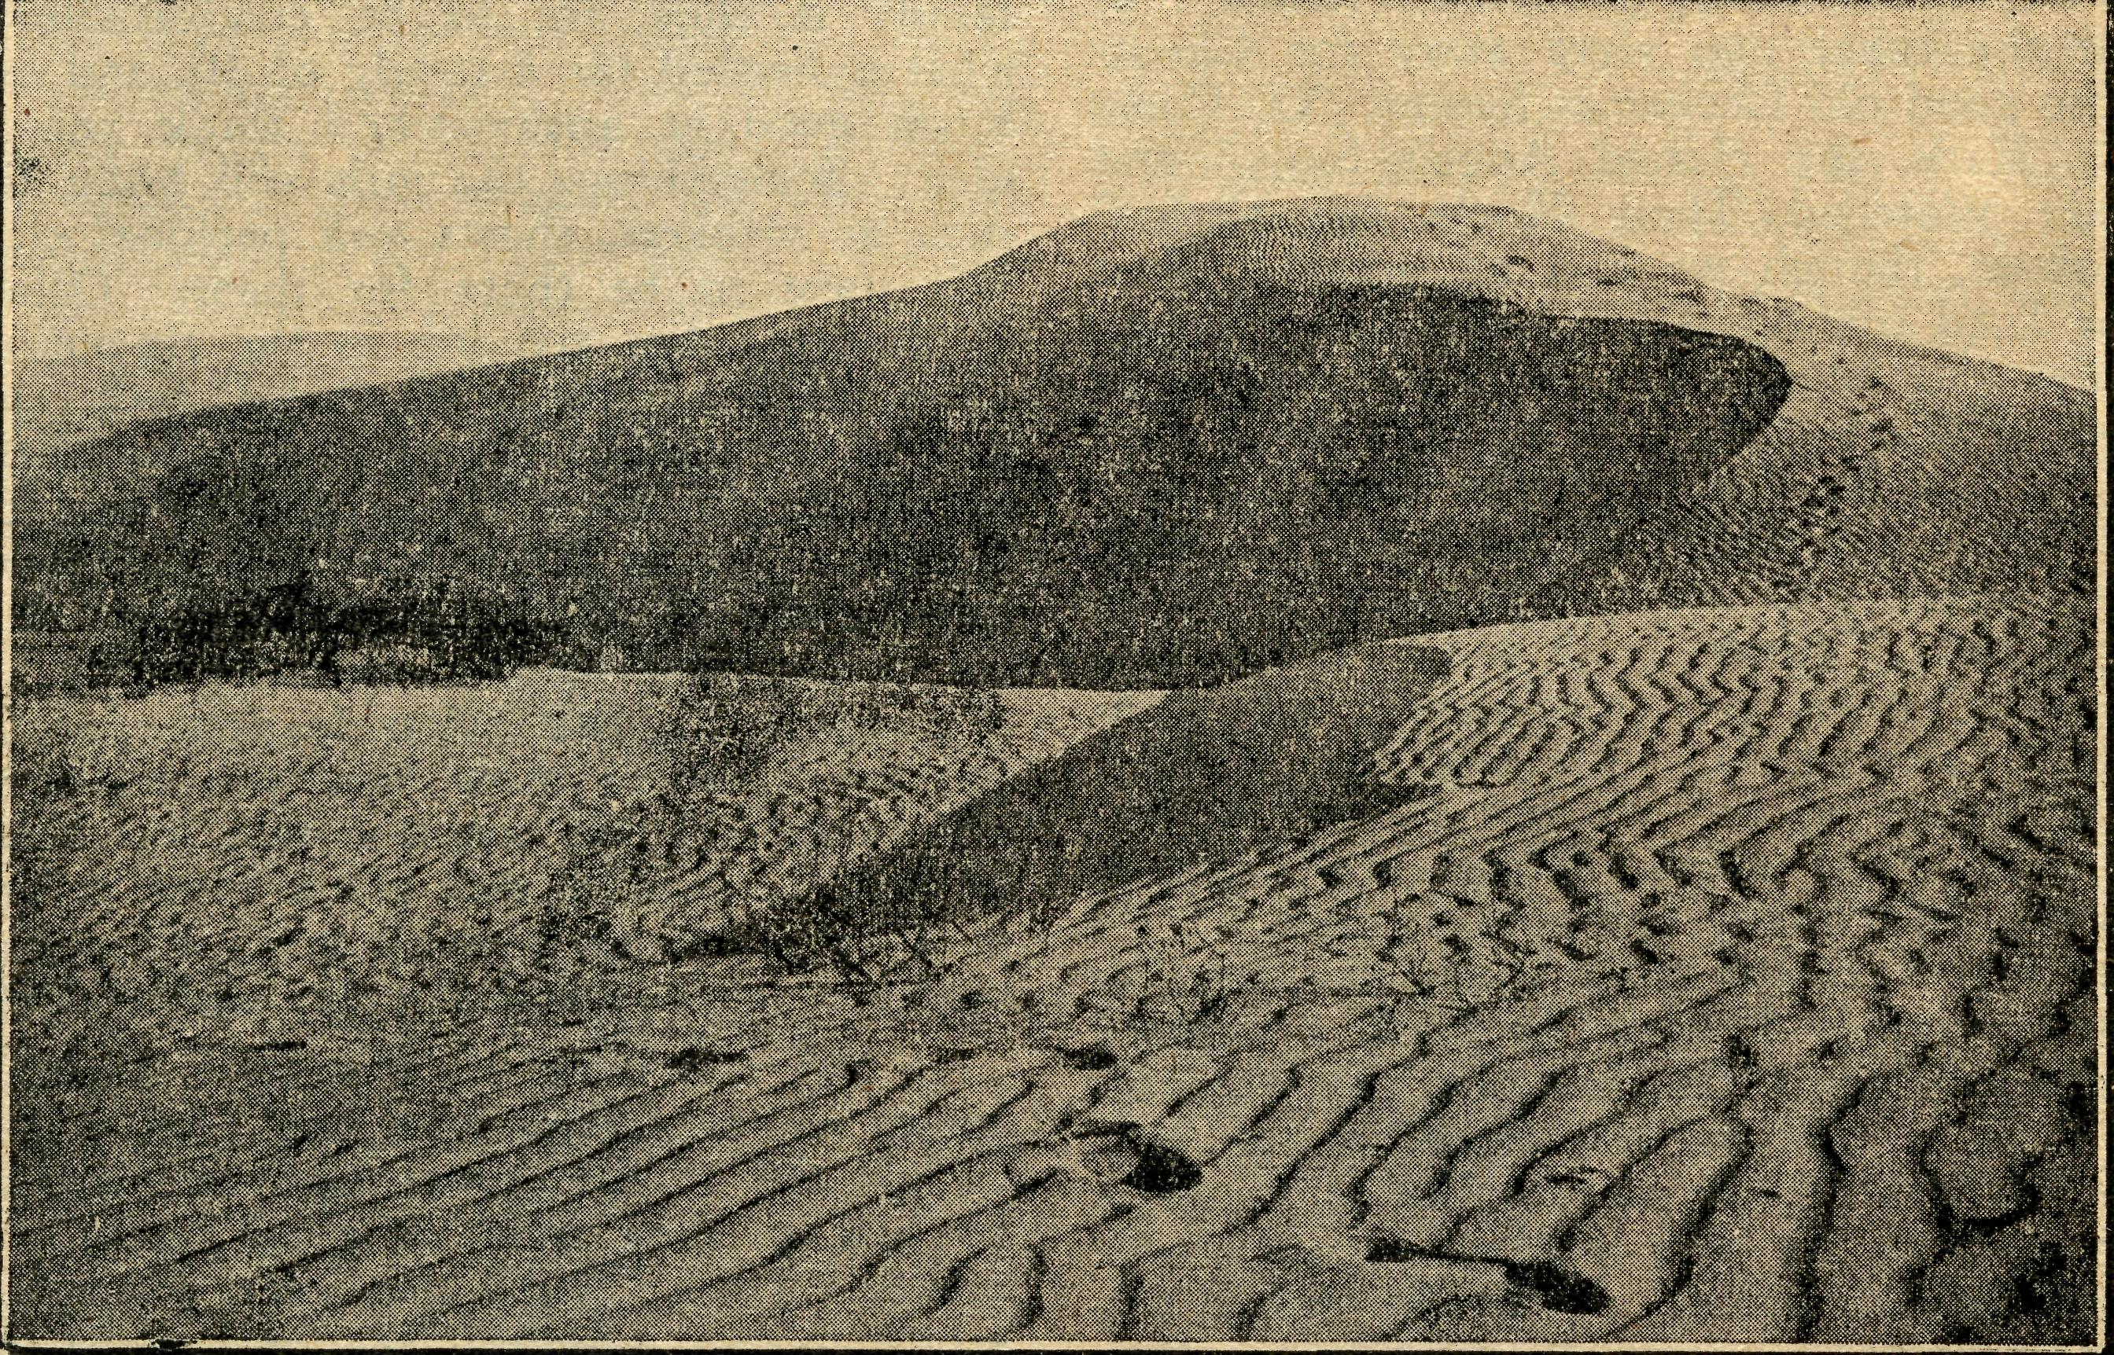

Sandhills in South Australia.
B.C.A. Family

In an office in the shadow of Sydney's Cathedral a prayer concluded the arrangements made to send me forth on my journey to join the B.C.A. workers on the West Coast, and Mr. Jones greeted me as a new mem' ber of "the family.¹¹
During the stages of the long journey, the fellowship of family unity was felt in warm greetings from members at Melbourne. I was welcomed by Mr. Donnelly, and spent a quiet afternoon in the gardens with Sister Hitchcock, who saw me aboard the "Overland,¹¹ bound for Adelaide—leaving a pleasant memory of the bond of B.C.A. workers with me. This bond was again evident in Adelaide and Port Lincoln, where cordial greetings
were extended to me by Sister Pritchard; and Mr. Broad' ley. A friendly voice called and I found Mr. Living' stone waiting to conduct me to the Ceduna Hospital, where a warm welcome awaited me from more of the B.C.A. family.
A glow of fellowship greets a newcomer, who is quickly put at ease and in work there is co'Operation and feb lowship, strengthened by times of spiritual refreshment, in morning and evening unity in prayer. In my first week here I was privileged to join in a communion ser' vice in the sitting'room—a simple Service serving to unite a family in the common bond of work for our Lord and Master.
Sister. J. LUCAS.

March 15, 1945
THE REAL AUSTRALIAN

The Organising Missioner’s Letter
Rev. TOM JONES.

First I must say "thank you" to the many friends who gave us so excellent a result as £470 for our Christmas Appeal in N.S.W. and over £370 in Victoria. The income for the month of December also reached the record total of £3,236 for N.S.W., and £1,284 for Victoria. So far as can now be ascertained, the total income in N.S.W. for the year eliding December 31st, 1944, was £17,979, an increase of £6,000 over the previous year.
While it is dangerous to lay the emphasis on finances, they certainly do indicate the love and interest shown by our many friends, and we feel that the interest in the work of B.C.A. is steadily growing and the service itself blessed by Almighty God.
1944 was our Jubilee year and it was but fitting that it should be the best financially.
In the early part of the year we were able to purchase a property in Port Lincoln, equip it and enable it to com' mence duty as a High School Hostel for Girls. All this cost £3,000, which you gave us. You will, I am sure, be happy to know that Sister Sowter has a "full house" of 30 girls for this year. Unfortunately, the demand greatly exceeds the accommodation, and many girls have to be refused. It looks as if we will have to go in for another one at Lincoln, doesn't it? In order to take the 30 girls we now have, building alterations had to be made and more furniture bought. We have done it, and the cost is £450. Keep this on your prayer list.
Wentworth Falls Hostel needed some renovations and the provision of extra facilities. As I write, these are being carried out, and on completion will add greatly to the comfort and easy working of the Hostel.
During the past two months yet another big step has been taken which needed a good deal of faith in the Providence of God that He would supply the means of its fulfilment: Representations were made to B.C.A., which had as their objective the provision of a Hostel for Girls attending the High School at Bowral. Investigation showed that many country children of that district were
travelling up to six hours to go to High School. For this and other reasons, B.C.A. decided to meet the need.
The only suitable home available was the home of the late Dr. Zielie, and the price, with furniture, was £5,300. We did not have the cash for the purpose, but as the need was undoubtedly there and we did feel it was God's will for us, the Society arranged to buy the property. In the short space of six weeks £2,000 has been paid off the amount without fuss or appeal. I am sure that within a reasonable time the balance of £3,300 will be forth com' ing. Now put this on your prayer list also.
The Bowral Hostel is going now in full swing. It is a lovely home with nearly 10 acres of beautiful parkland, and the High School is just over the road.
Now you will say that is a fair list of needs to pray for and help liquidate, but I am afraid I am not finished yet. One thing which always worries me, especially when NEW hostels are opened, is that at Wilcannia. Really, my friends, though it has done a good job, it is not good enough. In the early days, when we were just beginning, it was all right to "make shift," but not now.
The staff at Wilcannia have to put up with heat, flies and dust, which cannot be comprehended by city dwellers. I don't think they should also have to stand and work in an iron walled kitchen, with the heat of the day OUT' SIDE somewhere around 110 degrees. Do you? We simply must rebuild Wilcannia Hostel, and I think that, despite all the other things which MUST be done, we ought to get busy this year. Now, please put this on your prayer list and, maybe, you would like to send something towards the cost, which, at a very rough estimate, would be £3,000.
Wilcannia is where we started looking^ after other people's nippers in the name of God. It has been served by devoted workers in the most adverse conditions. Let's rebuild as a Thankoffering for all that Almighty God has allowed us to do for Him there and elsewhere.
I think that is enough for now.

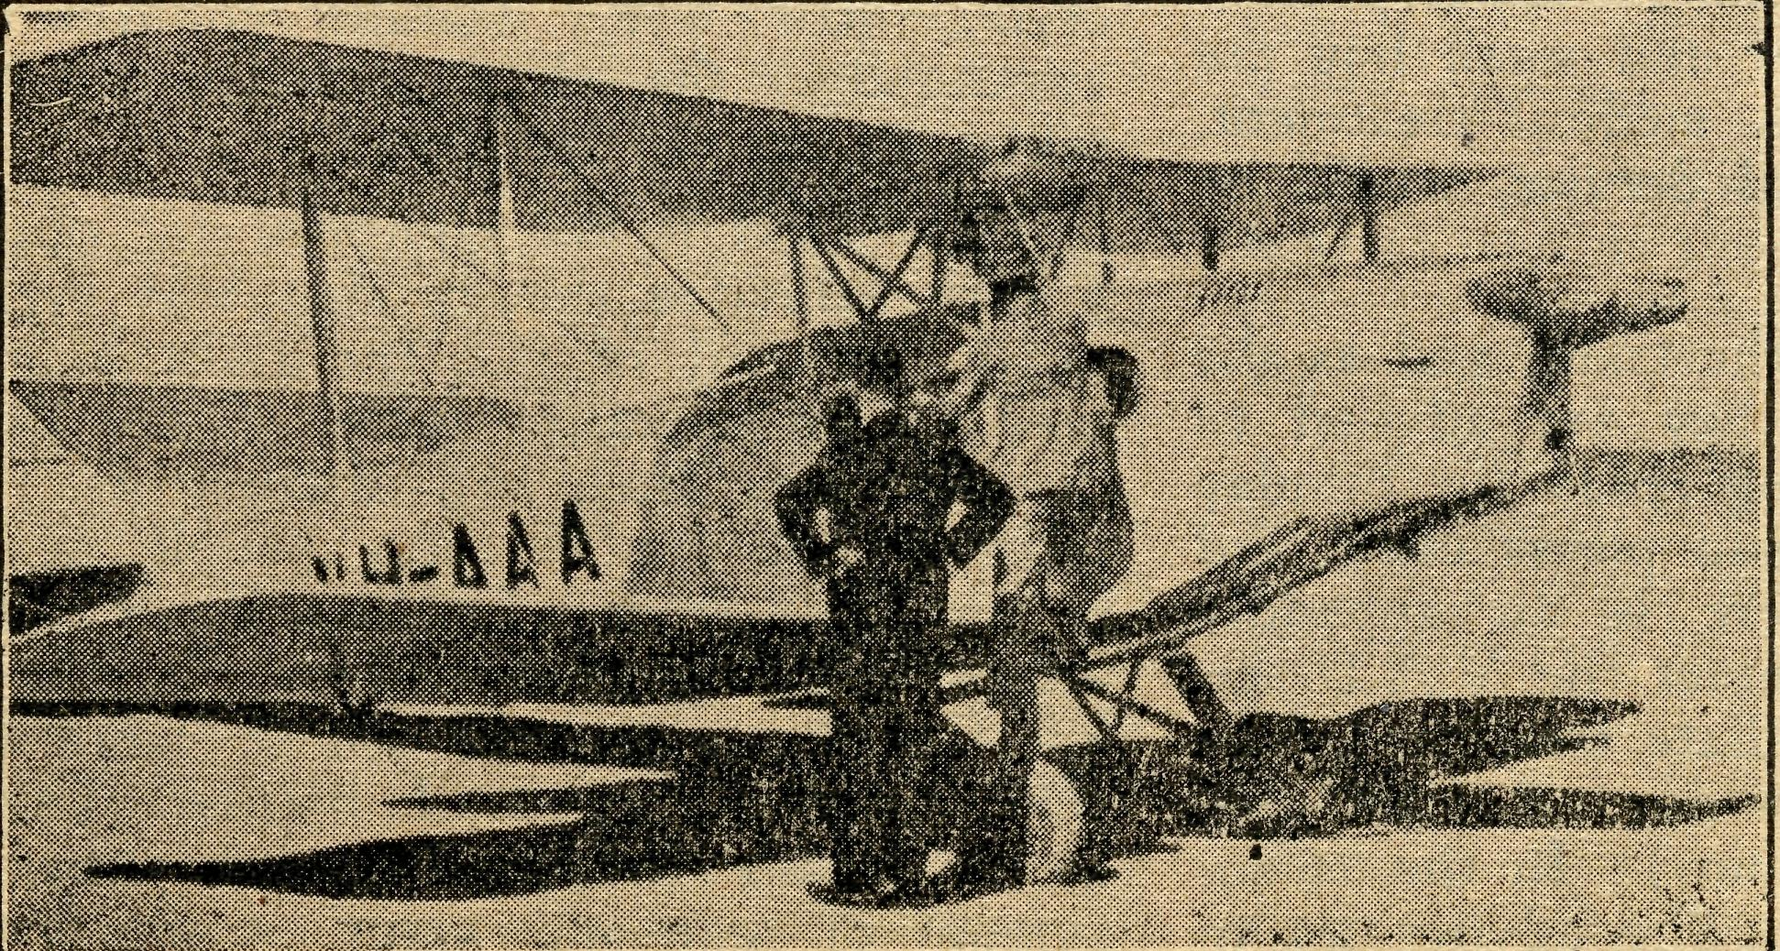
MAKING READY FOR ANOTHER CALL

THE REAL AUSTRALIAN
March 15, 1945

Jarcoola
Sister V. PAGE.

It was with very mixed feelings, just three months ago, that I saw Sister Bossley board the Adelaide-bound train for well-deserved holidays, after about 18 months' service in this lonely outpost of the Bush Church Aid Flying Medical Service. For some considerable time every footstep that came within hearing at night, I felt must be for me, and I would sit up in bed, which was on the verandah, and wonder just what the case would be, only to find that the footsteps passed by. I chuckle every time I think of one night when I was awakened by footsteps coming at terrific speed towards the hostel. I thought of all the most terrifying accidents that could possibly make anyone hurry in such a manner, and tried to cope with them as I thought of them. Nearer and nearer they came. I would soon know the worst—and then right past my gate galloped a horse, probably going for a drink at the railway station!
Soon after I arrived here I was introduced to one oi the worst dust-storms for years, according to local residents. If one realises the rainfall for 1943 was 316 points, and 1944, 355 points, one might get some idea, of the state of the surrounding country and the amount of loose ground surface that is just waiting to be transferred to the house and surroundings. Tarcoola has sand of the red variety, which in some places is feet deep. It is no uncommon sight to see the menfolk digging sand away from the gates after a dust storm, so that one can get in and out with reasonable ease. There is only a Cyclone fence round the hostel, which has its advantages as well as disadvantages. It lets the sand OUT as well as IN! Things lying on the ground are quickly covered or unearthed according to the "blow," and I am constantly digging the garden out from under. Garden, did I say? Well, where the garden was, and will be again when the winter comes, for this soil will grow almost anything under suitable weather conditions.
In between trying to find the lino and furniture under the dust, one attends to the numerous ailments of suffering humanity and wonders why B.C.A.'s must choose these lonely, dusty, hot places for their ministry. Why not the Dandenongs or the Blue Mountains (for the N.S.W. nurses).
And then suddenly the answer comes.
About 180 miles away in one of the little siding camps a small boy of 1\ years is taken ill. A military train coming east is stopped and the father and small boy are allowed to get on and travel towards medical treatment, which, if there was no Flying Medical Service, would be about 400 miles!
Fortunately, there is a V.A.D. on the train, and as she thinks it is a case of appendicitis, they are advised to contact Tarcoola. Just as I am getting ready for Sunday School a message is brought: "Will you please come and speak on the railway 'phone. There is an appendix case on the train." I am able to contact the V.A.D. on the 'phone to give advice as to immediate treatment. The time is 2.30 p.m., and the train not due till 9.15 p.m. (Put yourself in the place of the father.) In the meantime I get in touch with Dr. Gibson, who advises me to
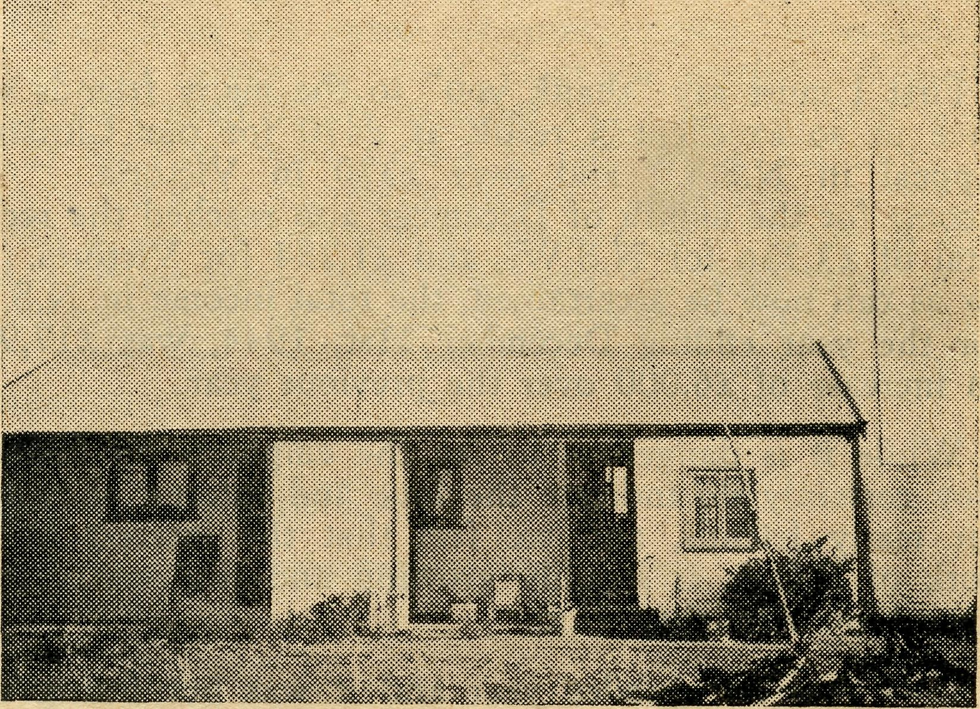
The Tarcoola Medical Hostel.
take the child off the train on arrival at Tarcoola if his condition does not justify the further 200 miles to Port Augusta. There are many things to consider—the train would be in Port Augusta about 8.30 a.m. next morning, sooner than Doctor could get to Tarcoola. The weather conditions might be such as to prevent the plane from coming.
However, there is the assurance that "as thy days so shall thy strength be," and I know guidance will be given when the time comes, so I proceed to Sunday School and give the children their lesson.
Can you imagine my relief when, later, above the evening noises is felt, rather than heard, the throb of a 'plane engine, and soon to our straining eyes is revealed that messenger of life, the B.C.A. 'plane.
Doctor has decided to come and meet the child on arrival of the train, bringing Sister Dowling with him. Tea is the first item on the programme, and we have scarcely finished when the train is seen approaching, some 1-J hours before schedule. It appears that army men volunteered to help stoke, and all the men decided to wait till they got to Tarcoola for their tea, thus avoiding a delay by the wayside and enabling the train to be "pushed" ahead of time. On arrival at the train, we found an anxious father, a worried V.A.D., and a very miserable, crying little boy. Having confirmed the diagnosis of appendicitis, the child, accompanied by his father, was taken by car to the hostel.
This hostel is not equipped for operations, and it was a very primitive theatre that was eventually set up. A small cupboard of just the right height and length was used for an operating table. Sister Dowling had brought the necessary linen and instruments. Dr. Gibson is fortunately not one of those people who expect rabbits to be produced from a hat and made things much easier by accepting things as they were. It was amusing to see him kneeling down to scrub up, as chairs were the only available stands for the wash basins! The scrubbing up was by no means hampered by the position, judging by the amount of soap and water on the floor.

March 15, 1945
THE REAL AUSTRALIAN

It is not long before our little patient is "under¹'' and the operation in progress. Fortunately, the appendix is in good operable condition, so no complications are ex' pected. A message is sent by Doctor to the train (which had a long wait, due to early arrival), to let the men who have been so interested know that all is well.
It is late before we finish the cleaning and have a chin wag, and then to bed. Doctor consults next day, which is a day before the scheduled four weekly trip, and then they are away again to Ceduna, and I am once more on my own.
My little patient, Terry by name, goes ahead nicely and is great company. Almost the first thing he says is "Terry wants a cup of tea,¹¹ and he says it about 100 times a day.
In five days he is allowed up and sits in the big chair in the kitchen, and advises me when the kettle boils for Terry's cup of tea! He has his meals at the table now and points excitedly to Terry's plate and Terry's chair.
On the seventh day his parents come to take him to a friend's place nearby, where they are staying prior to going home. Terry is outside when they arrive. Speak' ing to them, he says, "Mummy is inside!" However, he soon knows which is Mummy when it comes to going home.
Have you ever wondered why B.C.A. extends its work to these out of the way places? Have you ever wondered if it is worth while? Surely here is the answer. Will you give your support?

A Glance at Wilcannia Hostel
Mis® H. GURRIER-JONES.

A busy day? Yes, all days are busy as we try to make a home "away from home" for our children—they nuni' ber from 22 to 30. All mothers of such large families will tell you it is not just the washing, ironing, cooking or cleaning, that makes one sink rather wearily into a chair at the end of the day, murmuring "Quiet at last—• they are all in bed." Nor is it just these things that make a home. No! It is the things that come between— the sympathy, help and patience, that all children de' mand and should receive, especially these children whose homes are perhaps in Tibooburra or somewhere along the border fence; they have their parents' help only for a few weeks in each year.
I am preparing the dinner, watching the clock, and working to plan as I must fit the work in; all seems going well this morning and I am hoping to finish that job in the laundry before dinner. But listen! A sound of voices and footsteps—who is this coming? Through the window I see two of the bigger lads carrying Noel, aged 10, one of the brightest little boys imaginable. He has surely met with an accident. What can it be?
Here they are at the kitchen door and eager voices tell the tale of woe. "Matron, Noel has cut his leg open right to the bone, and Mr. Behl said to take him home to you. It will have to have some stitches, he is sure. Noel was playing cricket at school and fell on a piece of tin." (I try not to look worried.) "Take him carefully into the little room next to mine, and I will .come and see what it is. Don't go back to school, boys, I may need you." I glance at the stove, take off my apron, and wash my hands, then following the patient, I proceed to take off the temporary bandages. Yes, it is an ugly wound, but not quite to the bone, I think, and I have dealt with worse. "Run off to school, boys, the Doctor is not at the hospital now. Tomight perhaps you will have to be the ambulance." The leg is duly bandaged and the patient made comfortable. But he is not so happy. I notice the bright little eyes are filled with tears. "Why, what is the matter, Noel? Is it hurting you?" "No, it is not hurting, so much now, Matron. But Lachlan's cut was worse than this, and Ron's finger, and they didn't have stitches. Matron, you can always fix
our things, must I go to the hospital?" "You can ah ways fix our things." What a joy it is to do this for them, and how many and varied their difficulties are.
I hurry back to the kitchen, the clock ticks on. In just half an hour the rest of the family come tumbling in to dinner, such a chattering, happy crowd, each one stopping at the kitchen door to say "Good afternoon, Matron," perhaps adding, "That smells nice," or "May I have a big serve, please?" Five minutes and the bell will ring— they scatter off to wash hands and brush hairs.
So the day goes on. Noel has been made ready for his visit to the Doctor, and is back again in the little hospital room.
Seven o'clock; the hour we all love! The chairs are arranged in the sitting room, the bell rings—games cease, and the family gathers happily for our session of prayer and praise. "Matron, Noel says may he have the door open, he wants to sing, too." The door is opened, and Sister goes to the piano. Someone is sure to ask for Number 6, "Jesus Stand Among Us," "Tell Me the Old, Old Story," and many others, until we have to say "No more." "Well, just one last one for Noel: 614, "Jesus is Calling the Children." A lad reads the Scripture portion and the S.U. notes—a short prayer, and good' nights are said. But this is not quite the end. A com' pany of little people wait in my bathroom for dress' ings—a thorn, tooth'ache, a sore eye, and so on, any thing is better than nothing if it only means a dab of iodine. At last even Bonnie, our baby is satisfied, and lights are out.
There are anxious times and times of stress and wearfi ness as well as the joys which we share with the children, but in these we have proved that "our help cometh from the Lord."
We, who are in touch with these outback people know
what a great and long'felt need is being met by B.C.A.
in the Hostels, and we know, too, how gratefully it is
acknowledged by many parents living in these isolated
places. ."
Sister and I do feel it a privilege to have a small share in this work, so helping to fulfil the injunction spoken to the Disciple of old—"Feed My lambs."

THE REAL AUSTRALIAN
10
March 15, 1945

Otway News
Kdv. T. H. PICKBURN.

Since last writing for the "R.A." I was able to pay a brief visit to N.S.W. for the purpose of seeing my par' ents and renewing old friendships in various parts of the State. A few days were spent in Sydney, and it was a pleasure to call and have a short talk with the O.M. at his office. It was most heartening to learn of the in' creased support being given to B.C.A. throughout Aus' tralia—may it ever be so—there is much work to be done for Christ, and the B.C.A. is in a splendid strategy cal position to tackle and solve problems which would otherwise present too many difficulties for ordinary church organisations. It was good to hear tO'day on the 3DB B.C.A. Session of the moves being made to provide Hostels for children, enabling them to further their edu' cation by attending higher grade schools. Hostels .are an urgent need in all parts of the country. This year especially, I have been besieged with requests in this Mis' sion district "to find board for boys and girls in Colac to enable them to attend the High School there. Unfor' tunately, nothing can be done by the missioner in this regard—all enquiries have proved fruitless. What a grand opportunity it is for the church to provide a Christian Home for these boys and girls. Let us hope that the day will soon come when the Church will take a strong lead in this matter and endeavour to establish these homes where they are most needed. Children in this Mission district, as no doubt in others, are handi' capped by reason of their isolation, and it is only the favoured few who can be sent to boarding schools or for whom suitable board can be found in the larger towns.
While at Young on holidays, the Rector asked me if I would care to address the members of the C.E.M.S. at their quarterly tea. The Rector's invitation was accepted and I was able to talk to the men about the work of B.C.A. The story of B.C.A- came as a complete surprise to the great majority of the men present. Here is an extract from the Young Parish News in the "Southern Churchman":—
"In between the meal and Evensong, the Rev. T. Pick' burn gave a most encouraging and thrilling account of the work of the B.C.A. I for one, confess that I was ignorant, of the fact that the Church has Flying Doctor Services and Inland Hospitals second to none in the Commonwealth." Those words prove how much in need of complete overhaul is the propaganda department of our Church!
On return from holidays, the work of preparing men and women, boys and girls, for Confirmation re'coni' menced. This is a period which presents many problems and difficulties in a scattered district like this. Classes could only be held in two centres, and many were in' structed either individually or by correspondence. Thanks to the B.C.A. Confirmation Lessons, instruction by cor' respondence was found to be very satisfactory, and ap' preciative references have been made to the instructive and interesting lessons. On the 19th November the Bishop visited the district and at four centres confirmed a total of 36 men and women, boys and girls. On the Tuesday fob lowing the Bishop confirmed Mr. Samuel Hargreaves, aged 79. Illness prevented Mr. Hargreaves from being present at
the service at Carlisle River on the Sunday, and learn' ing of his disappointment, the Bishop offered to confirm him in Hospital at Colac, where he had been taken. Mr. Hargreaves's fellowpatient was also a good Anglican, and for the four of us who took part in it, the ceremony was a very moving and at the same time happy one that will not easily be forgotten.
A short time ago, the Missioner was asked to preach on the occasion of the Temple Day for the Essendon Ladies' B.C.A. Auxiliary. This was a very happy occa' sion, and it was a privilege to be able to tell these splem did B.C.A. helpers something of the Otway Ranges and the Church's work in the district.
After the service a very pleasant and informal evening was spent at the home of one of the Auxiliary members, and the missioner and his wife will remember with much pleasure the kindness and hospitality shown. This Aux' iliary has taken a great interest in the work the Car' lisle River people are doing towards providing funds for a church in that district, and very generously has of' fered to give the Cross and vases for the new church. This action is much appreciated by the Carlisle River people and their efforts have been stimulated by this evidence of "outside" interest.
Mention of Carlisle River reminds me of another valu' able offer made recently by Miss V. Teague, of Mt. Eliza. On hearing of the proposed Church at Carlisle River, Miss Teague very kindly offered to paint a picture of "The Flight into Egypt," to serve as a frontal in the new church. The interest evinced and the offer made by Miss Teague are sincerely appreciated, and I have written to her accepting her most generous offer. The interior of the new church will be much beautified as the result of Miss Teague's labours.
At Beech Forest, it is hoped that, the church building will be removed from its present site and rejected close to the vicarage. The building is in fairly good condition, but is gradually deteriorating under the many buffetings received from our frequent gales. The vicarage site is the more sheltered of the two, and if moved, the church c^n be thoroughly reconditioned so that it will serve its purpose for many years to come. It was hoped to do this work by local labour, but there were so many difficulties in the way of this that it has been decided to engage' a firm of house removers to undertake the work. Church and vicarage should never be separated, especially in a climate such as we experience here, and the day is much looked forward to when the Church can be used and cared for as it should.
The Bishop has promised an extra room and verandah for the small vicarage at Beech Forest. Plans have been drawn up and a competent builder has undertaken to do the work—"some day.". The additions to the vicarage are urgently needed, and will be greatly welcomed. It is to be hoped that the difficulties in the way of early building will be overcome sooner than anticipated. It would be good to have the extra room and verandah before the winter sets in again.

March 15, 1945
II
THE REAL AUSTRALIAN

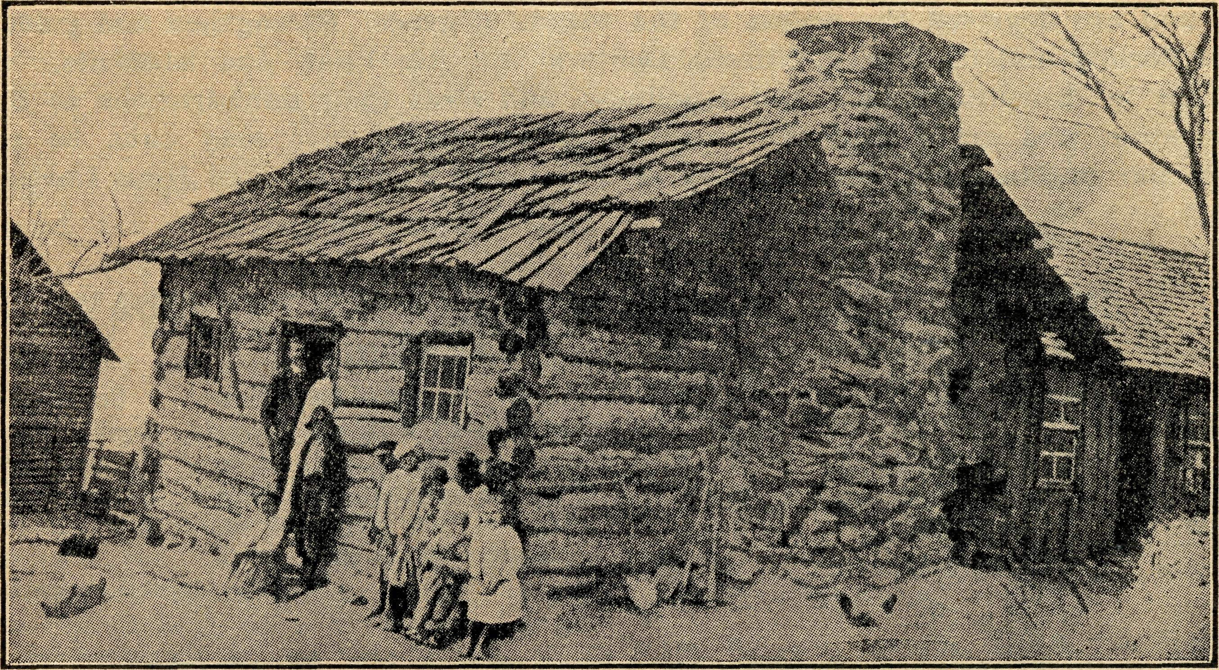

A home in the North-west of New South Wales.



It is good to be able to report that since our last issue two new volunteers have come forward for our nursing staff.
During the past few months it became necessary for Sister G. Hitchcock and Sister L. Pritchard to go off duty for extended terms owing to breakdown in health. Both these Sisters have done a magnificent job at Koon' ibba and Cook respectively, but hard work and staff shortage have undermined their health. Both are now away resting. The advent of Sister Kay, of Melbourne, and Sister Lucas, of Sydney, was indeed an answer to the prayers of many. Both new Sisters have gone to Ceduna, where they are busy settling in, and we are sure they will both be splendid members of our West Coast family.
Mrs. C. Manning (Sister Branford) became the very proud mother of a charming daughter at Ceduna Hospir tal during the month of December. We pray for God's blessing upon them both, and father, who is in the forces.
David Livingstone, of Streaky Bay, again gets our congratulations for a very good pass in New Testament in the examination for Th. Sch.
We need more and more nurses and workers for hos* tels. It would be splendid if our young women would realise that such avenues of service as are presented by B.C.A., are very real channels of Christian vocation. Why leave it all to the Roman Catholic Church?
Will our good friends note that for purposes of mak' ing legacies, the correct designation of this Society is "The Bush Church Aid Society for Australia and Tas' mania.'"
The Rev. A. Donnelly, who has been doing splendid work as our Victorian Secretary, has tendered his resig' nation as from Easter. We are sorry to lose him, for he has been a keen advocate of B.C.A. and done much to increase the interest and income in Victoria. We do wish him well in whatever sphere he goes.
Will our friends please note that Sydney James Cook is no longer a responsibility of B.C.A. He has been leg' ally adopted by Dr. and Mrs. C. Duguid, of Adelaide. This took place without any reference to this Society, who had been responsible for his upbringing since birth.
We are sure that Sydney James will be well looked after, and pray he may grow into a Godly man.

THE REAL AUSTRALIAN
12
March 15, 1945

THE PLACE OF PRAYER
A Prayer for Use with Our Prayer List.
O Lord God of our nation, Who has oonimanded men to subdue and replenish the earth: Look in Thy love upon all those who in the distant parts of our land are striving against many difficulties, and are deprived the access of the means of grace. Strengthen and guide the Bush Church Aid Society and its Clergy, Nurses, Doctors and Air Pilot, and Students. Cheer and comfort them in discouragements and loneliness, and bless their ministrations to the good of those they serve, and grant that the message of redeeming love may thus be rooted and grounded in our national life, to the glory of Thy Great Name, through Jesus Christ our Lord. Amen.

MORNING.
SUNDAY.
EVENING.
THURSDAY.
MORNING. EVENING.

The Far West Missions at Penong, Ceduna, Min-nipa and Cummins; the Missioners, H. Broadley, L. Morris, D. Pugh and J. Greenwood.
The West Darling Missions at Wilcannia and Menindee; tjae N.W. Mal-lee, and the" Missioner, K. Luders.
For the Mail-Bag Sunday School with its Gospel messages for the children. For the teachers and helpers, that they may find encouragement in their work.
For the Organising Missioner, that he may be strengthened and guided in all his endeavours for the good of the work and in his relationships with his fellow-workers.

FRIDAY.
EVENING.
The Denmark Settlement, the Kirton Point Missions and Missioners, Rev. T. R. Fleming and Rev. R. T. Hallahan.
MONDAY.
MORNING.
The Gann River Mission, the Bonang Mission, Rev. K. Brodie, the Streaky Bay Missioner, Rev. D. Livingstone.
MORNING.
For the Bishop Kirkby Memorial Hospital and Sister Bossley and Miss D. Dykes, as they minister to the people on the great Nullarbor Plain. For Sister Page and the Tarcoola Medical Hostel.
EVENING.
For students and all in training for this work of God. For Rev. W. Duffy and the Heytesbury Forest Mission. For Rev. T. H. Pickburn and the Otway Ranges Mission.

SATURDAY.
MORNING. EVENING.
EVENING.
For the Cann River Dispensary, and Sister Firmin, and Koonibba Mission Hospital, and Sisters I. Gwynne and G. Hitchcock.
TUESDAY.
MORNING.
For Sisters Dowling, Branford, Maddern, Kay, Lucas and L. Loane at Penong.
For the Bowral Hostel, staff and students.
For the President and Council of the Society, that they may be guided by His wisdom.
For the Home Base Staffs, Auxiliaries, and parochial workers.
For the "Coorah" Hostel and its workers, Mrs. Mann and Miss Harding.
For the Rappville Mission and the Missioner, the Rev. P. N. Connell.

WEDNESDAY.
MORNING.
For the children in the Mungindi, Wilcannia and Port Lincoln Hostels, and for the workers, the Misses Cheers, the Misses Gurrier Jones and Sister Sowter.
EVENING.
For the Flying Medical Service, Mr. Chadwick, and Doctors R. and F. Gibson.
For the wives and families of the Missioners and Air Pilot.
Each day pray that the many needs of the work may be met.
Running expenses of £5 per hour to keep the Medical 'Plane in the air.
Consecrated clergy missioners for urgent work in the field.
That our work may continue to progress despite the difficulties of wartime.

Give Thanks—
For the rich blessing and wonderful growth of the Society's work. For all the kindly givers who have helped with their self-denials. For the Flying Medical Service. For the joy of service.

March 15, 1945
13
THE REAL AUSTRALIAN

Cann River

Sister I. GWYNNE.

There is an old saying that "Delay is dangerous"— but it has been unavoidable to some extent in responding to a request for some news from Cann River.
It is not. always easy to write for the public-—vastly different to writing a letter to a friend, and so the thought goes round and round in one's mind, "What shall I write?"
This time one feels constrained just to write "a few scraps" from here and there, more or less trivial, but still incidents that may call forth earnest prayer and thanksgiving.
(a) Away in one of the outer districts of Cann River,
about 3 5 or 36 miles out, and 5 miles from any other
habitation, lives a family. The husband and father is
a sleeper-cutter. (The RAILWAY LINES are constantly
needing SLEEPERS—by the way). There are three or
four children, and as it is too far to send them to school,
the mother is nobly teaching them by correspondence.
Their home is spotlessly clean, and with a nice little
garden, etc. Our Sunday School organiser visited her
with the local school teacher, and in course of conversa
tion she discovered that the mother was very desirous of
some form of teaching for Sunday. Having found out
that they belonged to the Salvation Army, she promised
to get in touch with them and have lessons sent by post.
The mother was most grateful, and the Bairnsdale Salva
tion Army officer visited her recently during his annual
tour of our district. Weeks and weeks often pass before
they see any other men, wbmen or children. The previ
ous school teacher used to visit her occasionally and take
some other children out, and thus cheer them along life's
way.
Oh, the grit and stamina of these country folk and what brave hearts the women folk have to stand by their husbands, and to care for them in these lonely outback places. May God richly bless their endeavours to give their children the best they can through correspondence.
(b) A young man called at "The Cottage" one night,
and after talking a little while he said, "Sister, how
much do I owe you?" I said, "YOU don't owe any
thing, you've paid your annual subscription." (He
always pays doyble). However, he asked again later,
and also a third* time, so more or less jokingly, I said,
"What would you say if I said you owed a Tver'?"—
thinking I was making it big enough that he would know
I was only joking. However, on leaving later, he handed
me £l, saying he had not any more at present, but
would that be acceptable to the funds. Acceptable? I
should think so! Next morning there was a knock at the front door—fairly early—and on answering, I found the same young man there and he handed me another £4, saying, "We must keep the place goings—we can't lose you or let the place close down. We can't do without the Dispensary." So, you see, the Nursing Centre is appreciated and fills a very real need in the district.
(c) Two school children were having an argument one day—as children often do (and adults also)—and apparently the topic turned to religion. One child was overheard to say to the other—after a rather serious discussion, "You're X religion, aren't you?" said the girl. The boy replied, "I'm the religion Sister teaches us in school." (One might well ask, "And what is that?" Just the simpSle story of Jesus and His love. That God is a living, bright reality, that HE KNOWS all about us, HE LOVES us, and HE CARES for us, and HE wants us to love Him, too).
Is the work of the B.C.A. worth-while? Shall you answer that question?
A VISITOR'S IMPRESSIONS OF CANN RIVER.
When I visited the Nursing Centre at Cann River it was not as a stranger to the work of the B.C.A., for I had been interested in this for several years. Yet a knowledge from afar is quite different from a close-up view. One needs to live for a while in the midst to be able to appreciate the difficulties under which our Sisters work, and the tremendous service which they are rendering.
Although there are those who have a prior claim upon the services of the Sister-in-charge, she is yet ready to go at a moment's notice to anyone who may need her, whether the call be near or far. With the nearest doctor sixty miles away, a great deal of responsibility naturally rests upon the Sister. Hers is no eight hours a day duty, for a call may come at any time in the 24 hours, and in the Spirit of the Master, at Whose call she is there, she goes out to serve those in need.
Nor is nursing the only thing that claims her attention. In two State Schools and a Sunday School there are little children to be taught about the Friend of little children, and once a month there is a service to be taken in the little church at Cann River.
We who live in the cities owe it to this noble band of B.C.A. workers to stand/ behind them in praying and giving, that their labours be not in vain.

When Making Your Will Remember the B.C.A.

THE REAL AUSTRALIAN
14
March 15, 1945

Locomotion
Rev. R. T. HAIXAHAN.

So much of the generous contribution made to the work of the B.C.A. by readers of The Real Australian is expended on the purchase, upkeep and running of the motor cars used by the Missioners that it seems right to me to render an account of some of the uses to which the car is put in the service of the Master.
Its first and main job is to convey the Missioner to the various scattered centres of worship, in order that the people in these sparsely populated areas may be regularly reminded of His redeeming love, and its claim upon their lives. Even if a large percentage seem to be unmindful of their need of redemption, and unwilling to yield to the claims of Christ, it is still our job to present a wit' ness to them, as well as to carry a ministry of encouragement and consolation to the responsive ones.
Added to this primary use of the car, and arising from it, there comes that of serving these people in the manifold avenues that present themselves in the course of the regular "round."
For something over ten years there has been maintained in this district a regular schedule of country services. The people naturally bank on the missioner coming at a certain time, and have learned that he is willing to back up his witness of the Gospel by everyday means of service. To their credit let it be said that surprisingly few impose upon this privilege, and very many are ready to overlook shortcomings in the discharge of these "wayside¹¹ duties.
As a recent Sunday in January was fairly typical of all this, I shall attempt to recall its events.
It so happened that by making an early start it would be possible to get through the services and reach home before midnight. On these comparatively rare occasions my wife and three year old boy come with me.
We planned to leave at 9 a.m., but half an hour before that time, a large overseas ship berthed at the jetty. So few of the men from these ships get an opportunity to see our back country, that in my capacity of Hon. Chaplain to the Missions to Seamen, I boarded the ship and gave an invitation for any two of them to come up with me on the day's round of services. Two wireless operators were ready within the prescribed 10 minutes, and we then set off. Another aged parishioner, whose home was 30 miles away, accompanied us, and as she had lived
a life-time in the district, the sailor boys were treated to a running commentary of the places we passed en route. After the first service 30 miles away we boiled the "billy¹¹ and had a picnic lunch. Ants and flies did their best, or worst, to mar the joy of the occasion, but the meal passed off very happily.
Our next stop was 30 miles farther on, where service was timed for 3 p.m. It is one of the punctual centres, and we were able to spare half an hour for a chat with the folk at its conclusion. The seafarers were delighted to meet an old couple who had left their part of England more than 25 years ago. The conversation concluded, we sat down to tea in the kitchen at the back of the hall in which service had been held. No ants or flies this time, and no "billy¹¹ to boil, thanks to the kindness of the old couple who lived next door, and provided the boiling water for the tea. Six p.m. came with a rush, and away we set off for the next and last service, 20 miles distant, on the homeward track.
Arriving at the hall, our sailor friends were put on to the job of pumping up the pressure in the petrol lighting system. Fortunately, there were no blocks or leaks in the pipe, so the lights were satisfactory.
The service, late in starting, concluded at 8 p.m., and we commenced the last stage of the journey home. Now, however, we were more fully laden. A laddie of 10, badly in need of a holiday, was to come with us on the first stage of his travels. A young man who had met with an accident and had to get to the Port Lincoln doctor without delay also joined us.
We were to have picked up another passenger, a girl returning to work at the hospital, but on arriving at her home no lights were visible, and I concluded she had found another way down. (It was not until later that I discovered the reason for her failure to be on time—the old family car had broken down eight miles away.) Thus considerably relieved, we journeyed on to pick up our aged lady friend and arrived with passengers and parcels intact at about 11.30 p.m.
Thanks to the provision of, a roomy and reliable car, one was able to accomplish this with a minimum of strain, and it is trusted that the recounting of this will have done something to enlighten the donors of gifts as to the manner in which they are being expended.

Don't Forget
Tune in to:
- G.B. Sydney, at 10 a.m. on Fridays
- D.B. Victoria, at 9.15 a.m. on Fridays

March 15, 1945
15
THE REAL AUSTRALIAN

A Week-end Diary
Rev. K. BRODIE.

To avoid heat, left Delegate, N.S.W., for 77 mile trip to Cann River, Victoria, at 4 p.m. on Friday, February 9th. Going up over Craigie Range, near Delegate, met a violent thunderstorm, which lasted half an hour. De' layed during the storm to give shelter to a horseman. Storm ceased. Went merrily on the way. In the cool of the evening, car going perfectly. Hoped to reach Cann River in time for tea. Thirty miles from Bombala, back spring shackle bolt broke, leaving spring ploughing roadway. Impossible to repair. Walked two miles to nearest farm. Stayed the night. Next morning rode ten miles to nearest 'phone to call breakdown truck from Bombala, and cancel Saturday trip to Cape Everard. Car repaired by 2 p.m. on Saturday. One gets used to break' downs and walking and riding through the bush. Now decided to visit some people on way down to Cann. Ar' rived Cann in time for tea, but a day late. After tea, visited and met Sister Firmin, who is relieving Sister Gwynne for six months.
Sunday, H.C. service at Cann, 10 a.m. service poorly attended, most people having gone to Genoa for gym' khana on Saturday. One'third of proceeds of gym' khana to Cann River B.C.A. Nursing Centre. The work is very much appreciated by the people of the district, and the House Committee does a good job in return, by making the Sister as comfortable as possible. Left Cann at 1.30 p.m. for service at Genoa, 31 miles along Princes Highway, at 3 p.m. On the way met a crowd of lads and lasses returning from Genoa with large string of fine horses and ponies—a goodly sight of quality horseflesh and splendid healthy young Australians, all keen and efficient riders. Service at Genoa again poorly attended,
most people recovering from day before or cleaning up after it. 7.30 p.m. service at Mallacoota, 15 miles from Genoa. Service well attended by locals and R.A.A.F. personel from Mallacoota Aerodrome. After service had supper and long talk with several young R.A.A.F. offi' cers, who gave thrilling and unaffected accounts of their experiences abroad. Went to bed very late. Hotel room' mate snored abominably. A poor night's rest.
Monday. Felt fairly well under the circ. Attended Mallacoota School at 9.15 a.m., and watched usual ceremony of flag'saluting and profession of allegiance. Might well be copied by other States. Spent profitable half hour with children. After school paid a few calls and went on for unprofitabe trip to Gipsy Point, to meet a man to ferry me over Genoa River to baptise three children. Nobody to meet me. Apparently my mes' sage had not been received. Visited a few people back along the road to Genoa. Delegate being singularly devoid of fruit and vegetables on account of late frosts, dry weather and grasshoppers, took the opportunity to garner a few pears and apples. Lunch at Genoa. School at 1.15 p.m. Went on 15 miles into the mountains at Wangrabelle for short visit for school and service. Back at Genoa at 5 p.m. Picked a few blackberries. Long winding trip back to Cann over beautiful Drummer Mountain. Scenery reminiscent of Blue Mountains. Ar' rived at Cann for tea. Spent the evening in profitable discussion with this one and that in the kitchen of Cann River Hotel. Marvellous traditional hospitality of Gipps' land people much to the fore. Cann River Flotel people are particularly good to the clergy. Goodness knows how we would get along without the splendid hospital' ity. So to bed, in the "Prophet's Chamber," Room 25.
{Continued on page 16)

Tune in to:

5 M.U. 5 A.D. 5 P.I. 5 S.E.
South Australia on
Sundays, at 9 a.m.

THE REAL AUSTRALIAN
16
March 15, 1945

Port Lincoln Hostel
Sister H. SOWTEB.
In the last issue of The Real Australian I told you something of a new work which the B.C.A. had undertaken in the establishment of a school hostel at Port Lincoln for children of the out-back district wanting to attend High School; also gave you a short account of the official opening and dedication in August, an occasion which will stand out in the minds of many Lincoln people whose responsibility it was to find suitable accommodation in private homes for as many as 83 children.
For the remainder of the year we carried on with a comparatively small number of boarders.
Hostel life was something very new to the girls, and many of them were very shy of entering the hostel, being afraid of they hardly knew what. However, I rejoice to say that without exception they have been very happy, and I overheard a remark by one of the students to the effect that "This was just home away from home."
In the latter part of last year there were so many applications for accommodation for the beginning of school term this year, it was decided to have some alterations and extensions to the hostel in order that accommodation could be provided for thirty students; this, of course, necessitated a further expenditure of some £3 50. To do this work, especially at the present time, is a very costly business, for, of course, the necessary furnishings and equipment have to be provided as well.
BUT THINK! Wars may come and wars may go, but these children have only one life to live, and these are precious years of that life which will NOT come again. Sincerely I ask your prayers for God's guidance in this work, that many of these girls be brought to a very definite knowledge of Christ and accept Him as their Saviour.
Many parents have written expressing their appreciation of the fact that their daughters will be under the supervision and Christian influence of the hostel.
This vacation—excepting for ten days I had at Port Kenny—has been spent getting things in readiness to receive the thirty students. It is still very difficult trying to obtain necessary equipment, especially large cooking utensils, and I am still looking for a large kettle— new or second-hand.
In the latter part of December, a social afternoon was held at the hostel when each lady was asked to bring a preserving jar. Thus I had quite a nice number of jars to preserve some of the lovely fruit Port Lincoln can produce.
To date I have made up eighty pounds of apricots into jam, and preserved fifty bottles of apricots, and about twenty of peaches. The fruit was given, and I
was assisted in this work by one of our outstanding friends of Port Lincoln. There are still figs, grapes, pears and quinces to come.
I am most grateful indeed to the Ladies Auxiliary in Sydney for their gift of a lovely Kelvinator, which arrived in excellent order. This is a great asset, and words fail to express my gratitude for same. For all other gifts in money and kind I am more than grateful.
May I remind our readers we are still looking for a piano or an organ.
When I tell you that thirty lunches will have to be cut daily, would you say we needed a breadcutter. I think so. But it is something we will have to do without unless our friends provide it for us.
A WEEK-END DIARY
{Continued from page 15)
Tuesday. Cann River School at 9.15 a.m., after which ready to depart for Delegate. Went to take leave of hostess, who gave me a case of tomatoes, two large marrows, an outsize pumpkin, and a bag of potatoes. Cann River is so fertile and productive'that it can afford to feed the clergy at home and abroad. A glorious day, driving through beautiful tall timber of Gippsland and mountain scenery began to make way back to Delegate, visiting and doing schools on way. Arrived Delegate in time for tea, after covering great distance and variety of scenery and climate. Delegate on Lower Monaro, rolling downs, very cold, splendid sheep country, 2,500 ft. high, plenty of snow in winter. Down to Cann through beautiful mountain forests with some of the largest and tallest timber in the world. River and fern. Bird and beast. Cann Valley, miles of it, rich agricultural and pastoral flats. Grow anything here. Only trouble is remoteness and lack of higher educational and medical facilities. Cann being on sea level and hemmed by high mountains is warm after the Monaro. Timber mills all through this country and plenty of gold if you can find it—reef or alluvial. Have not yet got gold fever, but do go after the elusive trout when time permits. There are some fine trout streams on the Monaro. Mallacoota right on the S.E. corner of Australia with Cape Howe and Gabo Island. This work covers some of the most romantic and beautiful country in the Commonwealth. Usually one sees on the road, lyre birds, goannas, foxes, snakes, dingoes, porcupines, wallabies, kangaroos, wombats, etc. Strange to say, on this trip I saw but one porcupine (echidna) and but one kangaroo, nothing else. Most unusual. There is always a good variety of animal and bird life to break the monotony of winding, tedious and narrow and dangerous roads. This trip has covered about one-third of parish. More later. Don't mind the diary form. I'm too busy to be literary.
This trip covered 300 miles.

March 15, 1945 iii. THE REAL AUSTRALIAN
MAINTENANCE
The Annual Cost of maintenance of all the varied activities of the Bush Church Aid Society is £12,000* The whole income is derived from the free gifts of
Christian people.
♦
You can help by:
- A donation to our Funds.
- Keeping a B.C.A. collecting box in your home.
- Subscribing to our Quarterly paper, "The Real Australian".
- Donating a War Saving Certificate.
- Daily remembrance in your prayers of the work and workers.
- Including the Society when making your will.
Our Address is:
BUSH CHURCH AID SOCIETY, Church House, George Street, Sydney, N.S.W. Or Bible House, Flinders Lane, Melbourne, Vic.
Our Telephone Numbers are:—Victoria, FM 5675. N.S.W., M3I64.
We will be happy to supply any other information
you require.

THE REAL AUSTRALIAN
IV.
March 15, 1945

Subscribers who nave not received rseceipts

ANONYMOUS.
13.10.44, Anonymous, 10A; 23.10.44, E.A.W., Ramsgate, £5; "A Widow's Mite," 10A; 8.11.44, Anonymous, Vic, 10A; 14.11.44, Anonymous, Wyong, £1; 17.11.44, Anonymous, 2GB, 10/'; 20.11.44, Anoy-mous, 10A; Mrs. Brown, £1/1/7; 24.11.44, Anony mous, 6A; 28.11.44, Anonymous, 2/-; 1.12.44, "Inas' much," 10A, books; 8.12.44, Anonymous, 2A; 11.12.44, "Listener," £1; 11.12.44, Mrs. Berckelman, 5 A, Xmas; 12.12.44, Mrs. B. Campbell, 10/-, Xmas; 13.12.44, "Anonymous," 12/6; 14.12.44, Anonymous, £5; 18.12.44, J. Beamwell, 5A, Xmas; "A Widow," 5A, Xmas; B. Grahame, 10/', Xmas; J. Beamwell, 5/', Xmas; Anonymous, Cammeray, 5A, Xmas; Mrs. Mc Millan, 10A, Xmas; Miss G. Cook, 10A, Xmas; 19.12.44,
Miss Ashe, £1, Xmas; Miss Bennett, £1, Xmas; 20.12.44, Anonymous, Croydon, £5, Xmas; 21.12.44, Anonymous, Dulwich Hill, 5/', Xmas; "A Widow," 5A, Xmas; Miss B. Grahame, 10/', Xmas; B. Lourier, £1, Xmas; 29.12.44, Anonymous, 10A, Xmas;- Miss McKern, 2A, Xmas; Mrs. Vincent, £1/1/', Xmas; 2.1.45, Anonymous, Chatswood, 5A, Xmas; G. Ans* dell, 10A, Willoughby; 11.1.45, "A.Y.Z.," 10A; 22.1.45, Anonymous, 13/'; 22.2.45, Anonymous, Hurstville, 2/'.
REAL AUSTRALIAN.
Miss Leech, Miss M. Simmonds, Mr. L. J. Hurst, Mrs. D. M. Watson, Mrs. S. Brady, Miss H. S. Jacobs.


Help Australia
by
purchasing
War
Savings
Certificates.
Certificates can be purchased for:
16s. for each £1 Certificate.
£4 for each £5 Certificate.
£8 for each £10 Certificate.
Help B.C.A.
by donating
War
Savings
Certificates
to the Society.

Buying them helps Australia in the World War. Donating them to B.C.A. helps the Kingdom of Sod in the fight against the evils which cause all wars.
The certificates will be used to build up a fund to assist in the purchase of a new medical 'plane
when that becomes necessary.
Edgar Bragg & Sons, Printers, Sydney.

