No. 93
JULY 15, 1946.
1/6 per annum, post free

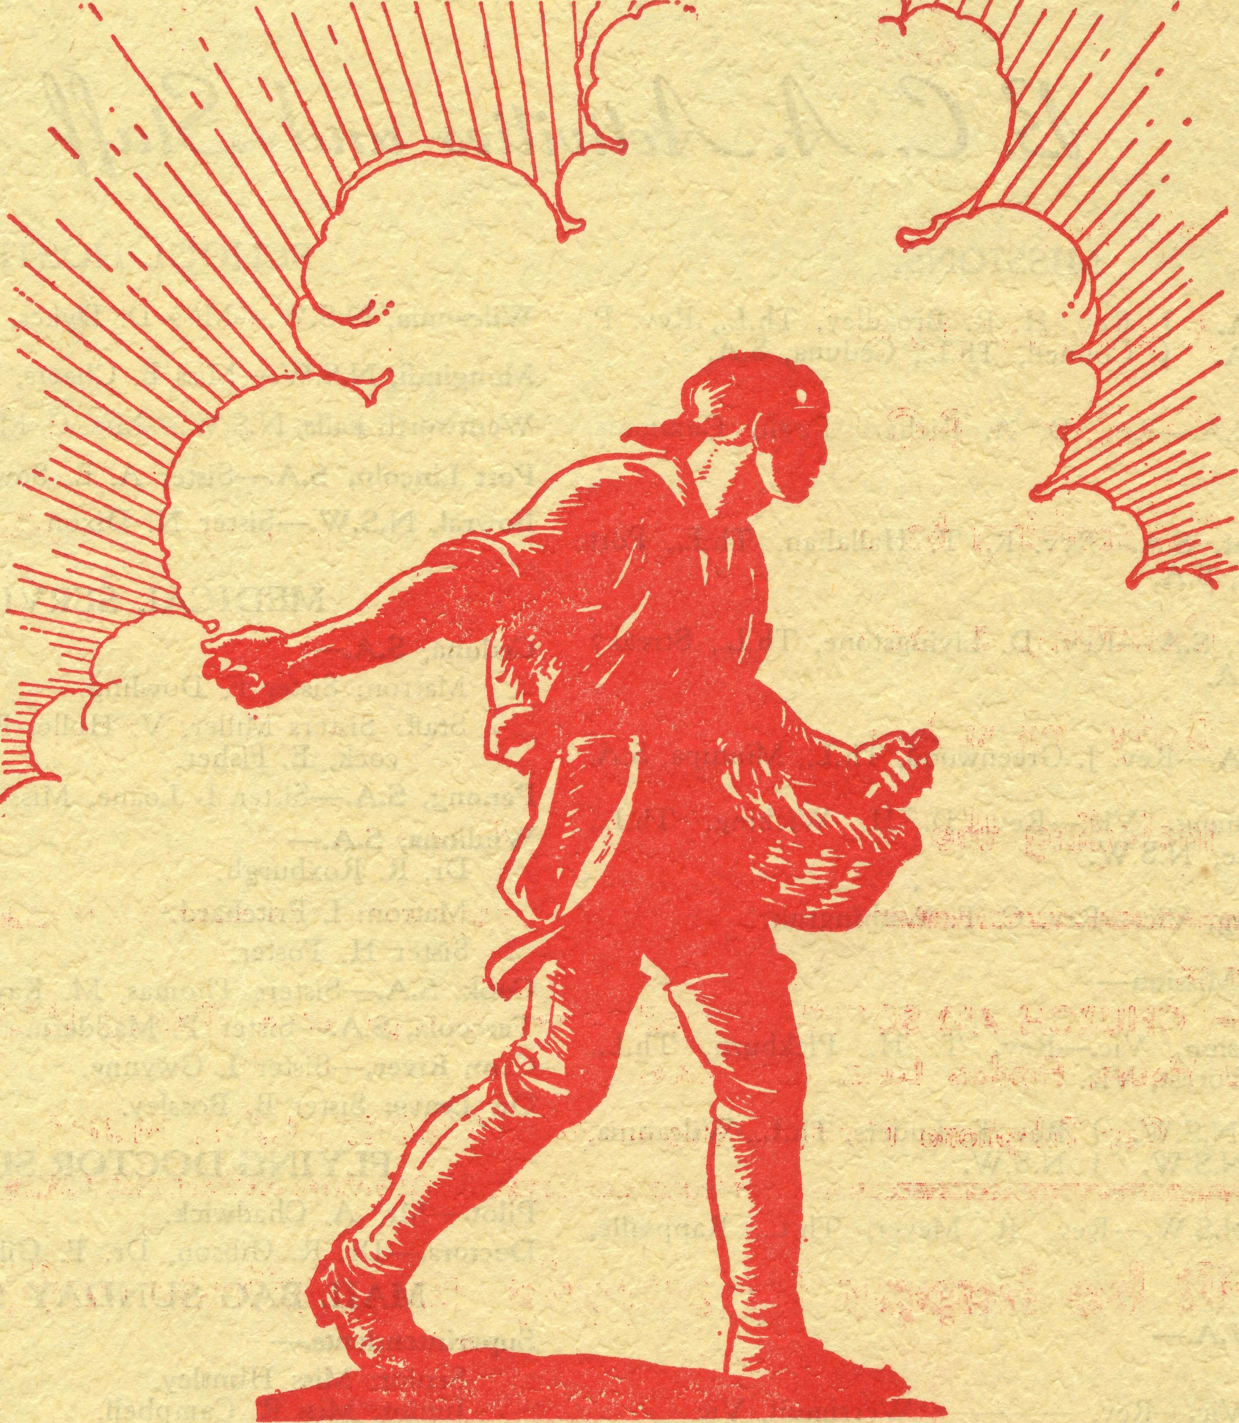
Registered at the Q.P.O., Sydney* for transmission by post as a periodical.

THE REAL AUSTRALIAN
July 15, 1946.

The Bush Church Aid Society for Australia and Tasmania

HEADQUARTERS OFFICE:
Diocesan Church House, St. Andrew's Cathedral, iGeorge Street, Sydney.
(Telephone: M 3164) Cable Address: "Chaplaincy, Sydney."
VICTORIAN OFFICE: The Bible House, Flinders Lane, Melbourne.
(Telephone: FJ 5675)
President: The ARCHBISHOP OF SYDNEY.
Hon. Clerical Secretary: Rev. L. GABBOTT. Hon. Treasurer: T. S. HOLT, Esq
STAFF:
Organising Missioner: Rev T. E. JONES, Th.L. Church House, George Street, Sydney.
Victorian Secretary: Rev. L. G. BALL, M.A., Th.L. Bible House, Flinders Lane, Melbourne
South Australian Secretary: Rev. F. H. B. DILLON, Th.L.

B.C.A Activities and Staff

MISSIONS.
Ceduna, S.A. 7 Rev. H. R. Broadley, Th.L., Rev. P, Penong, S.A. ) Connell, Th.L., Ceduna, S.A.
Cummins, S.A.—Rev. D. A. Richards'Pugh, Cummins, S.A.
Kirton Point, S.A.—Rev. R. T. Hallahan, Th.L., Port Lincoln, S.A.
Streaky Bay, S.A.—Rev. D. Livingstone, Th.L., Streaky Bay, S.A.
Minnipa, S.A.—Rev. J. Greenwood, Th.L,, Minnipa, S.A.
Delegate-Bonang, Vic.—Rev. D. H. Wicking, Th.L., Delegate, N.S.W.
Croajingalong, Vic.—Rev. C. F. Withington.
Heytesbury Mission—
i Otway Mission, Vic.—Rev. T. H. Pickburn, Th.L., Beech Forest, Vic.
Wilcannia, N.S.W. 7 Rev. K. Luders, Th.L., Wilcannia, Menindee, N.S.W. \ N.S.W.
Rappville, N.S.W.—Rev. R. Meyer, Th.L,, Rappville, N.S.W.
Denmark, W.A.— Werrimull, Vic.—Rev.
-, Werrimull, Vic.
SCHOOL HOSTELS.
Wilcannia, N.S.W.—Miss D. Dykes, Miss Farr. Mungindi, N.S.W.—Miss E. Cheers, Miss E. I. Cheers. Wentworth Falls, N.S.W.—Mrs. C. Mann, Miss N. Stokes. Port Lincoln, S.A.—Sister A. E. Sowter. Bowral, N.S.W.—Sister N. Dixon
MEDICAL SERVICES. Ceduna, S.A.—
Matron: Sister F. Dowling.
Staff: Sisters Miller, V. Holle, R. Gillan, G. Hitchcock, E. Fisher. Penong, S.A.—Sister L Loane, Miss E. M. Simpson.
Wudinna, S.A.—
Dr. R. Roxburgh.
Matron: L Pritchard.
Sister H. Foster. Cook, S.A.—Sisters Thomas, M. Kay Tarcoola, S.A.—Sister P. Maddern. Cann River.—Sister I. Gwynne. On Leave: Sister B. Bossley.
FLYING DOCTOR SERVICE.
Pilot.—Mr. A. Chadwick.
Doctors.—Dr. R. Gibson, Dr. F. Gibson.
MAIL BAG SUNDAY SCHOOL.
Superintendents.—
Senior: Miss Huntley. Junior: Miss R. Campbell.

July 15, 1946.
THE REAL AUSTRALIAN

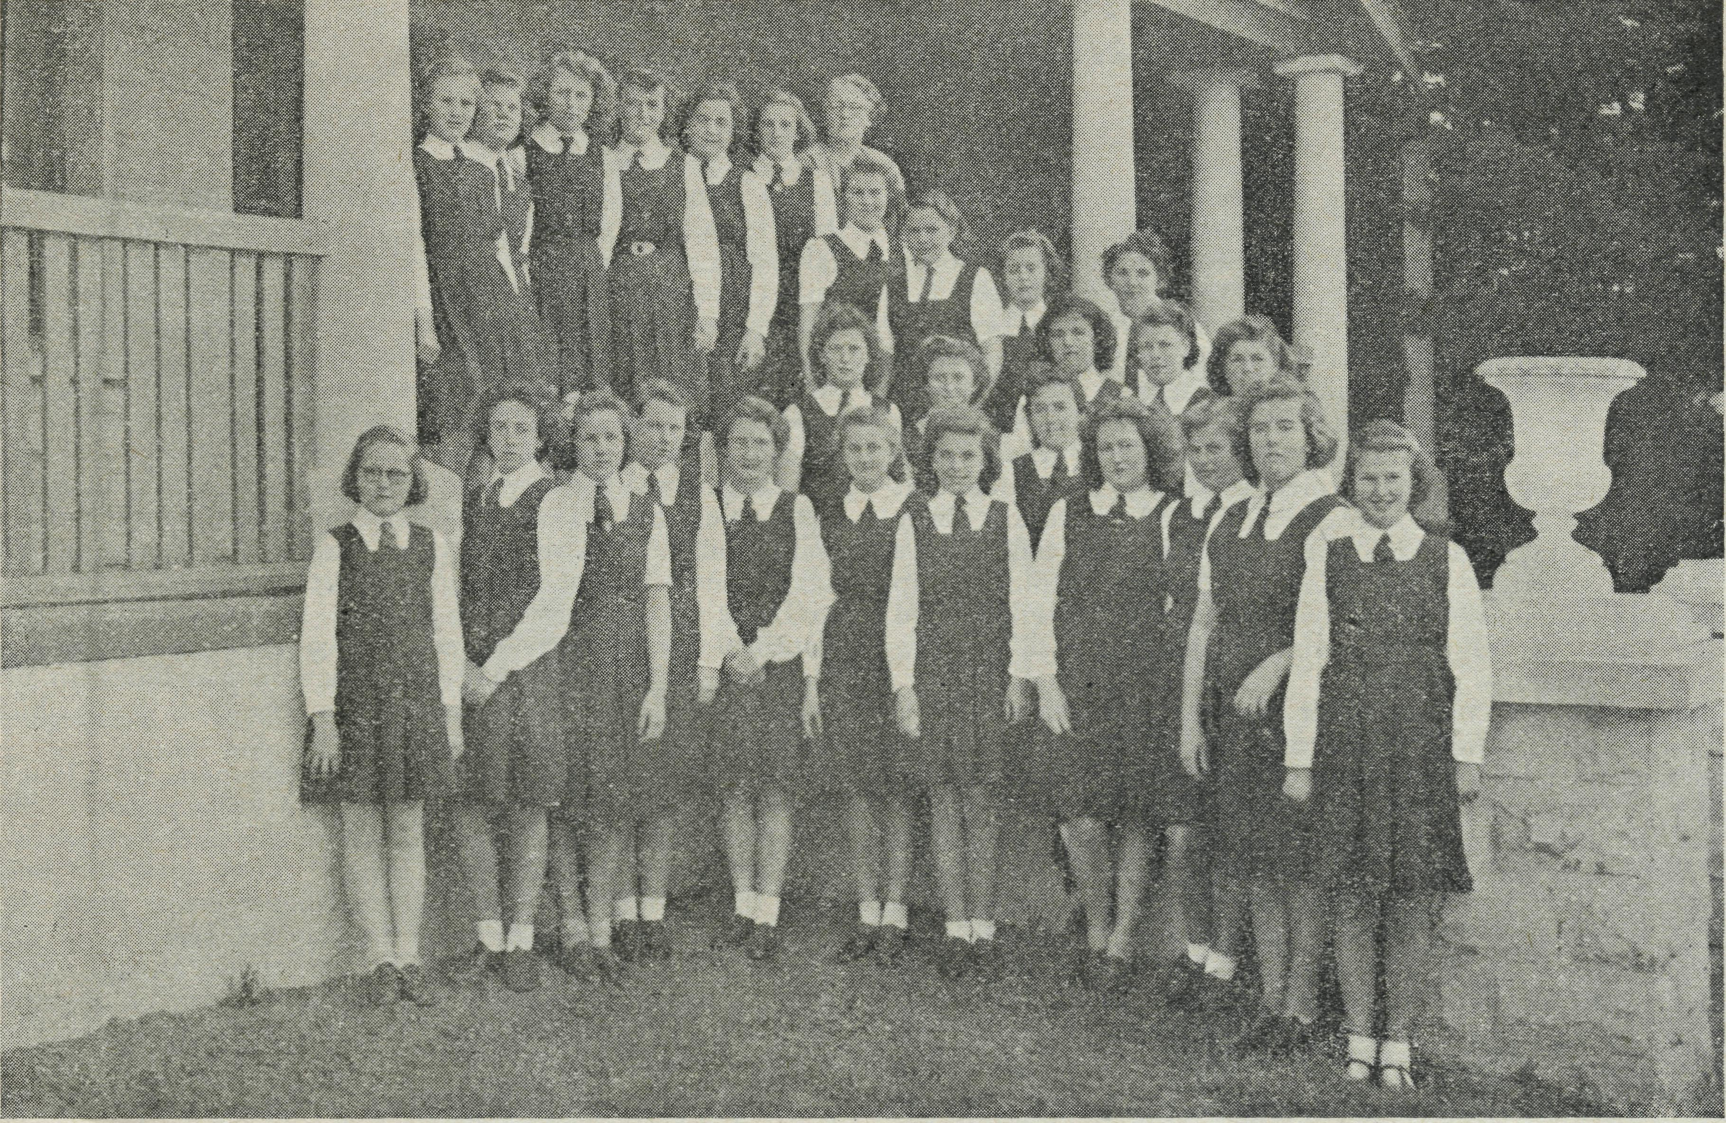

From A Hostel Girl’s Diary
(This article was written by Pat Gibb, an Intermediate Student at the Port Lincoln Hostel.)

May has passed, carrying the second anniversary of the unofficial opening of the Hostel with it, and many happy memories of the days passed by the girls living within its walls.
Well do I remember the first few weeks at the Hostel. Being an only child, the sight of so many girls some' what bewildered me, and to me everything seemed strange and slightly hostile. When I settled down and made friends, I began to look upon the Hostel as a large family and not a group of girls from all over Eyre's Peninsula.
As the weeks passed, we all had our quarrels and jokes, happiness and despondency, and several good times were had after lights out in each of the dormitories. On birthdays we had midnight feasts and for all the noise we made, it is a wonder to me that Matron never heard us.
During the year we had several little concerts between ourselves and each time every girl who attended the gathering had to be in fancy dress costume. Matron has always been rather proud of our impromptu dressing abilities as we have no ready made costumes. Blazers are suddenly transformed into trousers of bearded old men, sheets become the voluminous robes of graceful Egyptian girls, dorm, curtains become the flowering veils of blushing brides, white pyjamas become trousers and shirt of handsome grooms and best men, and occasionally dusty cases are dislodged from the top of the wardrobe, and Matron's nursing uniforms are fumbled for and later donned. Even the grape vine is robbed of its foliage.
At the end of the year, we had a break'iip party and the guests present were the headmaster of the Port Lincoln High School and his wife, Mr. and Mrs. Hallahan, Mr. and Mrs. Bishop and Mrs. Pughe. Beforehand, each of the girls were given a sheet of paper and we were able to do what we liked with it, and when everyone had finished, Mr. Johnson gave us a black leather gold inscribed cover, and after we had placed our pages in it, we kept it until break'Up night and then presented it to Matron.
When the results of the exams were finalised, the results of the Hostel girls were very pleasing. Our Leaving and Intermediate students both received their certificates, and all the other girls did well, including one top of the class, one second, one third, and one fourth, and various other positions, and seven first prises were gained.
This year we have had two impromptu concerts and we have had many goods times though not as many as last year, as we have nine girls sitting for their intermediate, and we have to settle down and work hard.
I think all the girls should be extremely grateful to Matron for all she has done for us. She has been like a second mother to us all, and has been kind and considerate when we have been ill, and I write these things because I am sure all the girls heartily agree with me.
The girls also entertain gratitude towards the members of the Bush Church Aid Society, who have provided us with an opportunity to continue our education further by attending the Port Lincoln High School.

THE REAL AUSTRALIAN
July 15, 1946.

Sitting on the Fence
REV. R. S. MEYER.

Sitting on the top of a two-rail fence, one has an excellent view of the cattle at a cattle sale and also gets, of course, the full blast of the auctioneer's cracked voice. Of more interest still to the B.C.A. Missioner is the full view of so many faces, all of them quite well known, but revealed this day in another aspect. It is a secret joy to watch their nods, winks, grimaces or subtle move' ments of stock'whips as they bid for this lot of prime baldy steers or that one'horned, ancient Durham cow, which goes with the auctioneer's jaunty assurance that "she'll make a good house cow." Indeed, there are many things to attract the Missioner to a sale, especially if it's a selling'out sale. Then there's a chance of picking up some old corrugated iron to build a much-needed shed around the Vicarage, or perhaps some pig'wire to cow proof the vicarage garden.
There are, of course, other reasons still why a sale is so important. There one meets half the parish at once and a number of long trips might be saved. Local matters can be talked over with members of the Parish Council. One can meet those men who are tucked away up lonely creeks or in far'distant places who can only be visited infrequently. No doubt you would care to meet some of these men. They are mostly open, hard-working, simple-living men. The pleasures of this part of the North Coast are the simple ones, and the pioneering work is still being done. That is why there has been a drift away from this part of the country up to the "Big Scrub" farther north. It is largely an ungenerous soil and money may only be made by sheer hard work. Those that remain are those with the stout hearts and the far'ahead look. Here's a youngish man with his foot on the lower-rail appraising the value of a line of dairy heifers, which, to those who know, are too "pricey" for his means. His skin is tanned by the outdoor life he has lived since his discharge, hewing out a place for himself in the hills. He is clothed in a Digger's hat, khaki shorts, military boots—that's all. He is power' fully built, a man who obviously delights in toil. His home lies at the foot of the range, miles from any com' munication, store or neighbour. He has no truck, de' pending solely upon his horse and sulky to cart his cream and pick up stores, etc., at the faraway railhead. His young wife was a schoolteacher, used to all the comforts of towns. Now she, too, with the spirit of our forefathers, had made a home and rears a young family without many of those amenities which townspeople regard as essential. The first time I found my way along a murderous track to this place, though a stranger, I received the warmest of welcomes and the inevitable cup of tea. Visitors practically never come here. The B.C.A. Missioner is always a friend. How they loved that time of prayer around the kitchen table before departure. I remember their last request as I left. It was to bring them a pound or two of sausages from Rappville! They daren't order sausages to go to the railhead where they pick up, because they would not last the long journey. Even the freshest meat has a struggle at times to get home eatable. Unfortunately for their request, I have been unable to oblige, because sausages are but rarely obtainable at Rappville. Sausages, you see, are a luxury in the bush!
Here is a queer customer. A thin, rakish-looking individual with a "pork-pie" hat on the side of his head. His face is deeply lined, his eyes betray his alcoholic habits. He tries to be jaunty with everyone, assuming a carefree manner. But he is too well-known. Men
know him as a man who has gone through his money. His farm is not the place it used to be. He does not take the same care of his cattle. His children have all either married or left him. His wife could put up with him no longer and left him, too. Now he lives on his own in the bush. I befriended him one day in his untidy kitchen. I have not got him to church yet, but he does carry his New Testament with him everywhere he goes and has promised to read it daily. He also tells me that he reads every line of my parish paper and agrees with everything I say — even my temperance articles! Will you pray with me that this man will not merely agree mentally, but will come to accept Christ as Saviour?
There's a young woman present at this sale, too. Her youthful freshness is in strange contrast to the motley, masculine assembly. A broad-brimmed hat hides an unruly mop of fair hair. She has merry blue eyes, which have in them a look which betrays a feminine lack of confidence in herself among these cattle-men. She laughingly bids for half a dosen scraggy brindle poddies. She lost her father some time ago and she and her mother are carrying on their place alone. They love the bush and the comfortable home they have made for themselves. They do not want to leave. The towns and the cities have no attractions for them, though their life is a hard and difficult one. So they carry on together with an ever-growing trust in Him Who is able to do exceeding abundantly.
These three are quite typical. There are others here, too, who have struggled and lost; some who have toiled for long years and have won; some whose lives are in a sorry mess, gamblers, wasters, drunkards, immoral. But all have the one need of Christ as Lord and Saviour. Even so, it is the Missioner's privilege to bring them the gospel of redeeming love. He counts all of them as his friends for Christ's sake, and, although large numbers are not converted, there are those who have come to accept Christ as Saviour.
My first twelve months with B.C.A. has taught me many lessons, not the least of which is that what counts in the ministry is not the preaching or the filling of churches, but the personal seeking out of men and women in their homes and the commending of Christ to them in a personal and individual way. When I was rector of Abbotsford, in Sydney, too many things prevented one from fulfilling a pastoral ministry. Not so in the bush. Here the ministry is entirely pastoral, and one sees the results and the blessings. It is a privilege and a joy to serve the Lord and these people in this way.
Apart from the systematic visiting of the district, I am enabled to keep in touch with every home by means of my small printed monthly, entitled "Church Review." It is posted out freely to every home, and if any B.C.A. friends would care to receive it regularly, I would gladly post it to them. It has been a tremendous help in this mission, and I find that the people look forward to its monthly message, news, evangelical teaching, etc.
TUNE-IN TO
2GB FRIDAYS AT
9.50 a.m.

July 15, 1946.
THE REAL AUSTRALIAN

At Jarcoola
Sister P. MADDERN.
Since I took over the post at Tarcoola at the beginning of December, there have been no spectacular cases needing the immediate attention of the "Flying Doctor" but nevertheless the constant medical service supplied by B.C.A. to the isolated people of the Far West has been quietly going on over the months. The fact that Sister lives near by and can be called upon for advice and treatment is one of the things which help them to carry on in spite of being so far away from the conveniences and privileges available to city and "net so distant" country people. And there are others besides these living here who benefit from the service. Many people travelling on the East-West Express, who find themselves in difficulties on the long journey, have availed themselves of the help of the B.C.A. Sister. This was particularly evident at the time of the floods, when the Express was held up here for a week and and the stranded passengers, especially those with children, found themselves needing first-aid treatment usually available in every home.
But the first and foremost aim of B.C.A. is to take the gospel of the Lord Jesus Christ to the people of the outback, and this work has also been carried on week by week. At the end of December the Missioner, supplied from Adelaide by the East-West Mission, resigned, and up till now another has not been appointed. In the meantime the regular Sunday evening services and Sunday School have been carried on, and so the spiritual needs of the people have not been neglectd.
Working amongst these children is absolutely a thrill! We have up to twenty-eight, between the age of three and thirteen, attending each week. These kiddies, who are deprived of so much that others living in larger towns have, enjoy every minute of their meeting, and are so appreciative and keen about all that is done for them. The order of service is much less formal than in larger places because of the variety of ages and the difference in conditions, but it is nonetheless enjoyable. During the summer months when the temperature was so often well over the century mark, the conditions became rather trying in the little iron building, so a departure from the conventional was made and the scholars and teachers lined up half-way through for a cool drink from Sister's water-bag before continuing with lusty singing. Heat and dust were forgotten as they sang the well-known children's hymns and C.S.S.M. choruses and listened to the stories of Jesus, told as simply as possible so that the youngest as well as the oldest could understand. To see the expression of keen interest on their faces as they listen has made me feel that the work, although done under "not so easy" circumstances, is so very worthwhile.
The privilege of sharing the life of the people in these parts and of being able to pass on to them something of my own spiritual experience has brought into my life a rich and lasting blessing.
Moving a Church
REV. T. H. PICKBURN.
Reading through the Otway news in the last issue of the "R.A.," one cannot help detecting the note of despair that crept into the mention of the removing of St. An-slem's Church at Beech Forest and the enlarging of the vicarage. Since those notes were written, however, all things have worked together for good, and St. Anslem's Church now stands alongside the enlarged vicarage. It is nearly three years since steps were first taken to have the Church removed, but many difficulties and disappointments had to be overcome before the work was actually commenced by a Colac contractor in the first week of February last. The work of removing the building and setting it in its new position took one week, and the contractors were blessed with ideal weather for the full time. It was a most interesting undertaking and attracted very much attention from the townspeople. Some even came to wag their heads and say, "It can't be done. They'll never shift it out of there. It's far too steep. It will fall to pieces as soon as they begin to move it." And so on. There was much conjecturing after that fashion. However, the. critics were confounded—the contractor was an expert in his work and the Church rose majestically from its old position to the new, none the worse for the experience. After the contractors and carpenters had finished, there came a hectic period of four weeks preparing the church for the Bishop's visit for the purpose of re-hallowing the building for use as a place of worship. Much work had to be done to the interior of the church —painting, renewing of glass in windows, staining and polishing furniture, laying felt on the sanctuary floor and hanging curtains. The Missioner and his wife, with a small band of helpers, completed all this work by 2.30 a.m. on the day, of the Bishop's arrival! We were extremely fortunate, when one considers the difficult times, to be able to acquire all that was needed for beautifying the interior of the church, but we were well compensated for the time and trouble taken in this regard.
On the 27th March, at Evensong, in the presence of a large congregation, the Bishop re-hallowed the church for use and congratulated the church people on the good work carried out. It was a most inspiring service and one that will not be forgotten for a long time. The Bishop and Mrs. Johnson were afterwards welcomed by the Churchpeople at supper in the local Shire Hall. This was a most happy occasion—a marked spirit of friendliness and warmth was apparent—and the evening was enjoyed to the full by all who were present.
The newly-formed Ladies' Guild provided supper for the large gathering, and their efforts are deserving of much praise. This was their first work for the church, and judging by this initial effort the future for the Guild and the church in Beech Forest looks very bright indeed. The members are very enthusiastic and are keen to work and pay off the debt that now lies on the church and to play their part in the welfare of the parish. The formation of the Guild is a decided step forward in the

When Making your Will
Remember the B.C.A.

THE REAL AUSTRALIAN
July 15, 1946.

life of the church here, and membership increases at each meeting. A properly constituted Church Committee is also being formed, and it is hoped that the same keen' ness and sense of responsibility will be shown by the men of the church. I remember saying more than three years ago that proper interest in the church would be restored with its removal and beautifying. It is with considerable pride that I record at last the fulfilment of that prophecy. It is a most pleasing sight after all these years to see members of the Guild caring for the interior of the church, and already members of the Church Committee taking an interest in the exterior of the building and the grounds. Much work yet remains to be done— we need a sanctuary and a vestry on the church—the vestry could not be put back on the building as the timber in it has deteriorated to too great an extent— but with cO'Operation and keenness on the part of all the churchpeople these additions will be made as soon as possible.
The Vicarage.—With the addition of a good wide verandah and an extra room on the northern side of the house we now have a comfortable and roomy home. The carpenters were at work for almost two months at
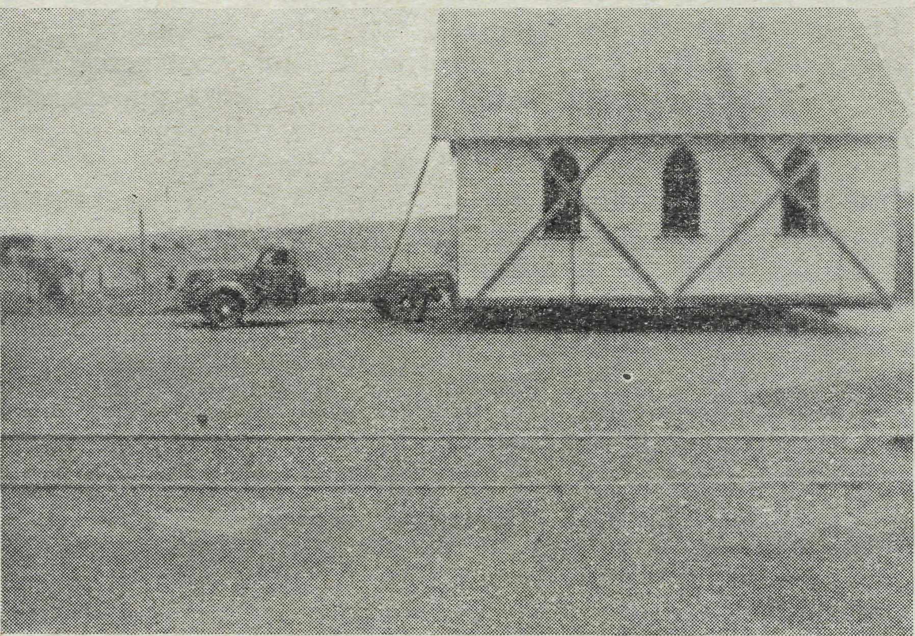
Beech Forest Church en route.
the vicarage and had to face many difficulties—the weather for the whole of their stay was appallingly bad and there were many delays in obtaining materials and sup' plies of various kinds. The Missioner and his wife had a busy time making life a little more comfortable for the carpenters, who came from Apollo Bay to do the work, and in trying to get everything needed by the men to complete the additions. Much work was also done in rectifying faults which had developed in the building, and we hope that now the vicarage will be as weatherproof as it is possible to be in this climate. The wide verandah is a great boon to the children, who have somewhere to play on wet days, and to the Missioner s wife, who is able to hang washing outside of instead of inside the house during the prolonged wet weather. The carpenters also thoughtfully provided us with a modern clothes lines, which can be pulled up to a good height. This is the envy of all the local residents!
It is with a feeling of great relief that the completion of these two works is recorded and of great satisfaction in the knowledge that the next Missioner who comes to Beech Forest will find a comfortable house with a well-cared for church alongside. The present Missioner and his wife hope that they will be forgiven if they express. the wish to enjoy for a period the fruits of much labour and worry!
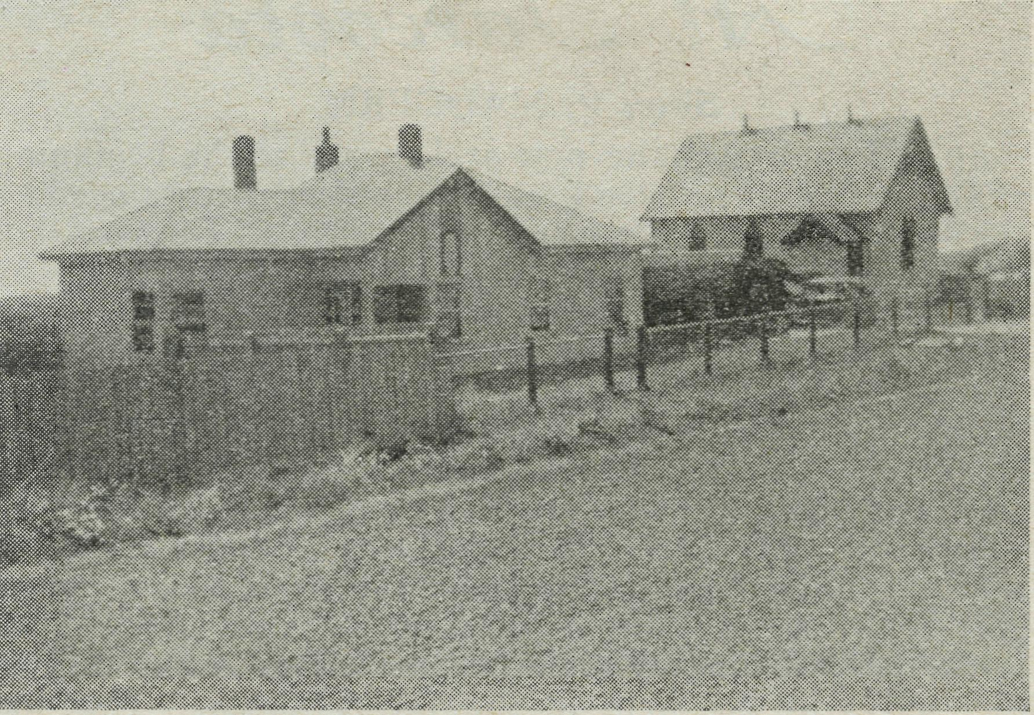
The Vicarage, with the Church at the new site beside it.
The year has been an extraordinary one in many ways. The weather seems to have become completly out of hand and alrady more than 38in. of rain have fallen. Disastrous flooding occurred on the flats, potatoes being ruined, and many farmers were compelled to take their cattle out to the plain country. Serious landslides occurred on many roads, some of which are still not open for use. Long detours are necessary to reach certain parts of the district. A short time ago, the missioner had to make a round trip of 220 miles to collect two boys who lived 25 miles from Beech Forest, and take them to St. Cuth-bert's Boys' Home in Colac. The boys had to wade through water for nearly half a mile to reach the car.
An epidemic of scarlet fever had added to the general discomfort of the times. Owing to the closing of the isolation ward at the Colac Hospital, because of shortage of nurses, the fever soon became widespread. Two small patients are now slowly recovering at the vicarage.
Services for the last two months have been adversely affected by the weather and sickness, but with the gradual improvement being shown in both, we can at last look forward to a return to more normal times.
Carlisle River Churchpeople are working steadily towards their goal—a new church—and now Gellibrand River people have taken up the challenge. After a meeting held about two months ago, it was decided to start work and raise money for a church building, and already a sum of about £130 is in hand for this purpose. At Gellibrand the Methodist Church has been used for Anglican worship, but, as we cannot get the use of this building for extra services when we require it, the decision was made to work for our own building. The church-people of Gellibrand River are to be congratulated upon their decision, and although years of work lie ahead of them, the achievement of their goal will bring them much happiness.
HAVE YOU A B.C.A. BARK HUT BOX?
If not,
SEND FOR ONE TO-DAY,
And use it for Your Gifts to the
Society.

July 15, 1946.
THE REAL AUSTRALIAN

The acting Organising Missioner’s Letter
The Rev. C. A. BAKER.

For a considerable time past, our Organising Mis-sioner, the Rev. Tom Jones, has been feeling the burden and strain of his onerous duties as director of the Society's wide and varied ministry. He has not spared himself in this great task, with the result that he has become very much rundown in health. Medical advice indicated that Mr. Jones must have a complee rest, so in April he was granted leave of absence for a period, during which it is hoped that he will be much refreshed and strengthened. Our sincere good wishes are extended to him ior a speedy recovery.
Efforts are being made to secure an air passage to England for Mr. Jones, so that he can visit the Old Country on behalf of the Society. Opportunities there for speaking of the work of B.C.A. are many, and several informed people have urged that the time is appropriate for such a visit to be made. Piayer is asked that guidance may be given in all the arrangements.
The present position of the B.C.A. finances is causing some concern. The cost of the work in the first half
of this year has been very heavy, particularly on account of expansion in our activities. Simultaneously, our in' come has been less than usual, causing a somewhat strait' ened position. Several thousand pounds are needed im-mediately. Our readers are invited to offer earnest prayer for the full provision of our needs.
Another matter that has caused concern is the absence of volunteers for service as B.C.A. missioners. Several vacancies on the field are about to occur, and ordained men are urgently needed to fill them. I want to appeal specially to my younger brethren of the clergy to con' sider this matter. The work calls for keen and vigorous Christian ministry in the out-back by those who are pre' pared to make some sacrifices for the sake of carrying the Gospel into the lonely and difficult places of our land.
This ministry constitutes a challenge to missionary service. Who will take up the challenge? Some of our missioners have given very long service, which has been a great strain upon them. Who will come forward to follow in their steps?

An Outback Easter Day
Rev. H. R. BROADLEY.

Easter Day, 1946, was a busy day for services which covered most of the district around Ceduna. The first was at 6 a.m. at the Hospital where two or three of the patients joined in with the staff. At 7 a.m. we had our Communion at St. Michael's. It was small in numbers, but remarkable for the fact that two members of the congregation, a mother and her son (Confirmed last year), drove in 17 miles to attend it. We have no services in their district, and so they set off so early in order to join in where they could. The next service was at 9.30 a.m. 25 miles south-east at Smoky^ Bay, over a dusty, scenic railway kind of track I mentioned in the last "R.A."
After service a warm invitation to a cup of tea was reluctantly declined as Mudamuckla, 20 miles north, must be reached by 11 a.m. The first few miles of this road .are sandy and winding, making progress rather slow for the Bedford. After Mudamuckla was lunch, and then on 22 miles to Nunjikompita for 2 p.m. There it was a pleasure to meet a family up for a day or two from Elliston way who had come along as they used to do regularly when living in our parish. Another farmer, recently returned after being in other parts for quite a long time was there, too, plus a couple of folk not previously attending, but inspired to do so after contact at the Ceduna Hospital. Then more miles was needed to arrive at Carawa for 4 p.m. There I saw that a farmer and his eight-year-old daughter had arrived, after travelling in a "jinker" for about an hour. News was passed on of a car being out of order, probably preventing another family from coming. After a short delay, one of our regular families came along in their small buck-board. They had had trouble with their differential, and had only just patched the 'bus up temporarily by 3 p.m. or so, and then had to clean up and come the five miles to the Hall. That reminds me that part of one family at Mudamuckla had just got to church because their utility had been "fixed" a very short time before 11 a.m.
Father had to be left at home to get himself clean from the grease and dirt.
From Carawa Hall to Ceduna is 43 miles or so. Good time was made on the return trip, so that after tea, there was just time for the 7.15 p.m. service at Ceduna. Here again there was extra interest because we had present four members of the Rocket Experimental Party and their pilot. You will remember that they have designs on the Nulla-bor as a safe place over which to fire rockets. Seven services and 120 miles of travel made a full and tiring day, but a pleasurable and interesting one.
I again thank those who continue to send papers suitable for sending out to the families in the out-centres. Not only do I receive "Round Worlds" and other children's papers, but a fair number useful for adults. They all appear to be appreciated very much. From time to time a parcel of suitable papers comes from England, where it is evident, that, despite their own troubles, they take a lively interest in making what fellowship they can with us.
WOMEN'S AUXILIARY VICTORY THANKSGIVING DAY
Friday, November 1st,
BIBLE HOUSE
OBJECTIVE:
To help build a Church at Hogarth Range, Mission District of Rappville.
TREASURE CHEST FOR GIFTS.
Further details will be announced later.

THE REAL AUSTRALIAN
July 15, 1946.

When it Rains
Rev. J. R. GREENWOOD.

The temperamental weather of the West Coast swings so easily between long dry spells and then sudden tor' rential downpours that one can expect at some time or another to be "caught." On a recent Saturday morn' ing I left Minnipa amidst a cloud of dust and howling, burning wind. I had sixty-five miles to cover before tea' time, and having been delayed two days by a fatality in the family of local Church people, there was some visiting to be brought up to date. As the day wore on so the visiting list grew less, until at last by 6 p.m. the last call was made. Here I was to camp for the night, and, after conducting a Harvest Festival Service in the farm kitchen the next morning, to continue the Sunday's duties with another three services spread over a distance of some 50 miles.
However, as I was preparing St. Patrick's Van for the night's rest, rain commenced, and heavy, ominous clouds rolled up with increasing number. Fortunately, there was room in a shed, and the van was soon under additional protection, allowing me to sleep with open windows and a dry bed. It was good that evening to sit around the cheery fire in that farm kitchen and hear the steady rain pattering on the galvanised'iron walls. The kitchen, entirely innocent of any wall lining became a sanctuary of fellowship, with the soft light of the kerosene lamp dispelling the heavy shadows.
This family is of true pioneering stock, as father and mother took up the block upon which they now live nearly 30 years ago. The family has been brought up in the galvanised'iron house, and educated at the little school a mile away at the corner of the paddock. The nearest town is 45 miles away, and the telephone about 12 miles by the nearest road. These things seem to be of little concern to people who have grown used to such distances.
We talked of many things that night, but then in those parts; a visitor for the evening is not a regular affair. A quiet assurance and faith in God was revealed as the soft glow of the firelight brought forth reminiscences of former days. The inevitable cup of tea brought with it thoughts of bed, after a tiring day.
The steady downpour of rain and the heavy night as I ventured forth to the van gave promise of a sticky road for the next day's journey. I went to sleep that night with the steady drumming of rain as my slumber song.
At breakfast time came news of extremely heavy rain about Tarcoola, and along the Transcontinental Railway to Port Augusta. Water lay in large pools about the farm and still it continued to pour. It was quite evident that the only ones to be a service would be those where I was camped. We held our Thanksgiving Service in the kitchen. One had to be careful of the position taken, as the heavy rain was now finding its way through the roof. The overlapping galvanised'iron in places allowed drips to fall with unerring aim upon the luckless person in the line of its fall. However, despite the damp con' ditions, five of us joined together in our worship to the accompaniment of the roaring rain and the splutter of the stove as drips found their mark. At 1 p.m., when I should have left for the next service, the rain re' doubled its efforts and made quite certain the fact that I was not to get away that day. And so it continued until the early hours of Monday morning, having registered 467 points in a little over 24 hours.
The news from other parts of the State brought advice that 7in. to 9in. had fallen in parts where the average for he year is usually 3in. to 4in.
Although the rain had ceased, yet large lakes gave ample proof of the flood. St. Patrick proved a problem when the time to leave arrived. First it was thought a good push might help to start the engine. But the slippery ground soon ended that attempt. Then a tow with my host's car was suggested only to find that the engine would not start. There was nothing more for it but to try the patient old draught horse. And so St. Patrick, with his 29i horsepower useless, was linked up to one horse. However, he was not to be persuaded; there was only one alternative, I was compelled to set to work and wipe the distributor, wires, and check over the spark plugs. This was done with, every now and again, a scudding shower threatening to undo my good work. At last the job was completed, and one press of the self-starter brought the engine into life.
After carefully skirting the treacherous edge of a dam, the main road was reached. I am afraid that it could hardly be called a road; it was nothing more than a creek bed, as every few yards, water rushed across what was once a nicely graded surface.
Five miles along the road was my first call; a little weatherboard school with six pupils. The monthly religious instruction was given, and the lessons for the next three weeks left with a teacher who co-operates in giving the instruction between my visits.
I resolved to keep to the main highway after such heavy rain, and splashed on my way, hoping to get to the next school by a detour of some 25 miles. Another eight miles were accomplished, when, down in, a hollow, I could see a shining lake of water. The closer it came the worse it looked. Stopping the car a few yards back, I reconnoitred the position, and felt increasing alarm as the depth of water seemed so hard to gauge.
Fortunately, another car pulled up behind me, and the
driver, too, was a little sceptical about crossing. As we
discussed the matter, a car approached from the other
side. Without any hesitation it plunged into the water;
twice the engine coughed, and soon the car was taking
a sig-sag course as the wheels skidded on the treacherous
road surface beneath the water. However it gradually
drew out of the lake and at last stood on dry land
beside us. ■ ₍
The driver was not very optimistic, as he told us that there were four more lakes each worse than the one in front of us only about three miles along the road. One was quite impassable and the detour through the scrub very treacherous.
My new companion and I decided against the lakes, and decided to attempt a cross-country road. This, however, was soon found to be worse, as the clay composition of the road gave no grip for the tyres.
I turned back knowing that I could camp at a farm a short distance along the road. Everything went well, and I was just feeling that safety was assured when in the gateway of the farm St. Patrick's back wheels stuck in a large-si2ie bog.
A short walk brought four stalwart young men to the rescue, and soon the van was once again under shelter. The hospitality of the bush people can rise to any occasion, and so it was I was made welcome for the night.
It was hopeless to try and get a message to anyone, as the next telephone was 10 miles away, and the road a treacherous, greasy mass. I just had to hope no one was anxious for my immediate welfare.

July 15, 1946.
THE REAL AUSTRALIAN

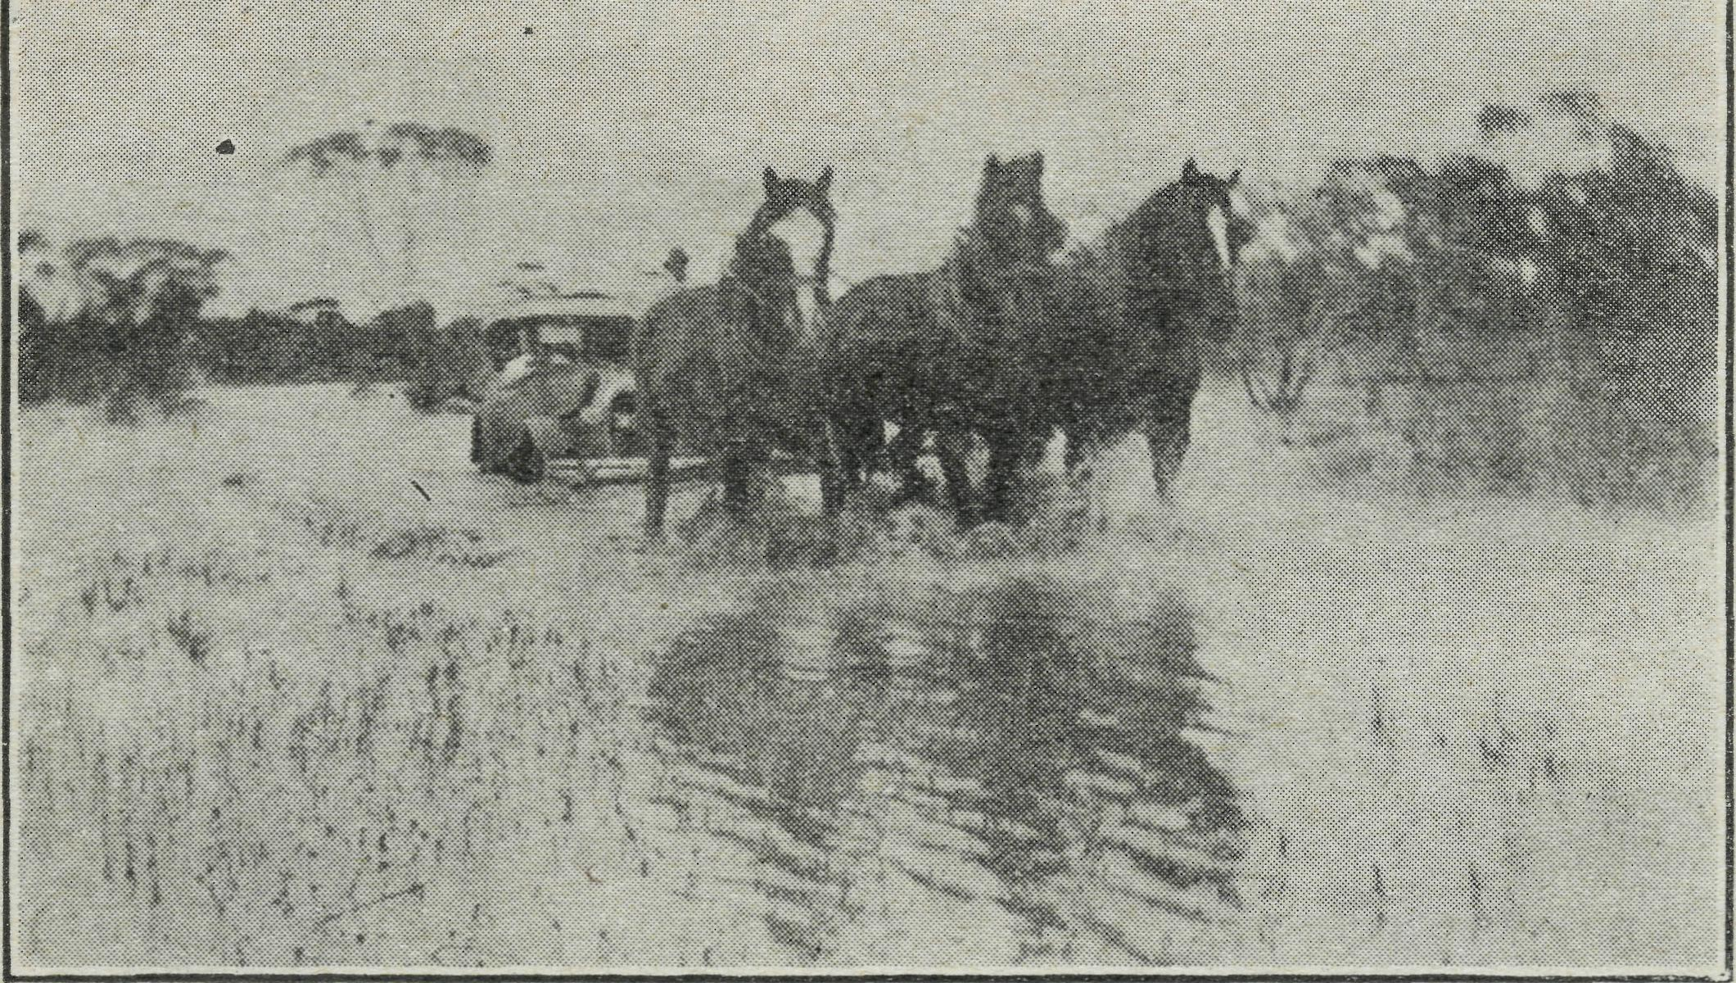

This is one way out.

The following afternoon brought steady sunshine and a drying wind. With the farm car going ahead once again, an attempt was made to get nearer home. The lakes of water were still impassable, but, with extra help, detours were soon accomplished. St. Patrick faithfully ploughed through the scrub in the wake of the other car. I parted company with my friends six miles along the road, and I thanked God for such bush hospitality and assistance.
There were other lakes on the road, but none too deep to prevent St. Patrick coming through safely.
Such rain is, fortunately, only experienced occasionally, yet nevertheless no matter what the weather conditions
the work of the outback ministry goes on week by week.
It seems hard to realise that country soaked by 3in. to 4in. of rain within a week should be inundated with a raging dust storm. The drought has been so severe that only many good, soaking rains without a following wind can restore the country to a productive state.
Loneliness and privation of many of the amenities of the age are the lot of people who labour to maintain the primary industries of our country.
They look to you for the provision of a coherent and efficient ministry to their spiritual as well as their material life.

Nullarbor Jottings
Sister M. KAY.

It has been far from monotonous or dull at Cook, as many people seem to think when travelling through. "What do you do?¹¹ they say. Well, one day one might be cooking cakes which do not come out as they should, and the next on a train going to see a patient miles away—not in a carriage either; one such trip was made in a guard's van which is known as "Black Maria," and I really think it had square wheels. It was quite an experience, rattling along the line, the night was very hot, so it was better than sitting down at the hospital The train arrived back in Cook in the early hours of the a.m. The next day—"Business as usual"—the many household tasks that are ever waiting to be done.
FROM THE CHILDREN'S POINT OF VIEW. Cook in the kitchen as usual, endeavouring to make cakes—three or four children race in. "What a funny cake, Sister! Mum's don't look like that!" The cook strives to look disinterested, but it is too much for her, and so all laugh together. Incidentally, the same children had this cake at a picnic a couple of days later, and they reversed their opinion, and said that it was a nice one—apparently they didn't see the sodden streak across the centre,
Another day a young boy of seven came into the kitchen, and asked me if I had any jobs for him, so I sent him off to pull up a few carrots. When I was scraping them, he said, "Why are you scraping them, Sister?" to whcih I replied, "Because they are dirty and would make you the same inside your body." He thought for a while, then said, "God makes our hearts clean, doesn't He?"
Then, just a few days ago, I was taking the Scripture lesson at the day school. The lesson was "The Creator." The children were just back from holidays, and the school inspector was there. They were very restless and apparently inattentive. The lesson seemed to be a failure, so I went away far from satisfied. The next day I asked that some encouragement be given in the work.
Some hours later, one of the school children arrived at the hospital and said, "Ever since you told us the story yesterday, I have been thinking how God made the birds." This may seem trivial, but it was very important to me, as I felt that no matter how adverse conditions were, God's Will would be done, and that it we trusted in Him our feeble work would be greatly magnified and used to the glory of the Father.

THE REAL AUSTRALIAN
July 15, 1946,

The First B.C..A. Medical Plane
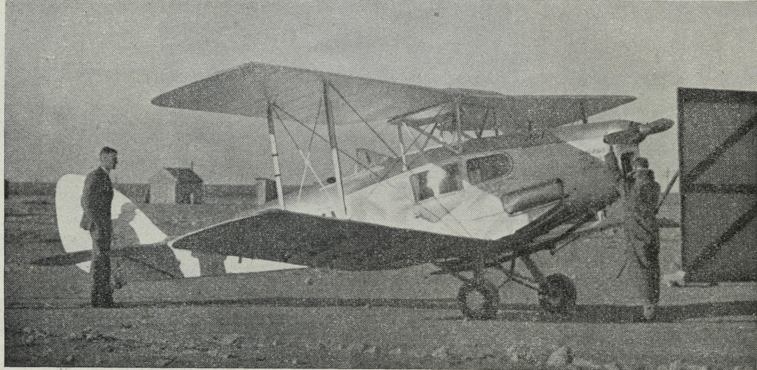
VH. A.A.A. Inaugurated B.C.A, Flying Doctor Service, April, 1938.
Here are some interesting facts about the plane illustrated above. In its eight years of service it has:—
Made 680 flights. Flown for 1,656 hours. Flown a distance of 125,220 miles (equal to five times around the earth at the equator.) Brought treatment to 7,844 patients. Carried 50 stretcher cases.
In this aircraft the pilot sits in an open cockpit behind the cabin, which holds three sitting passengers or a stretcher case and attendant.
This plane will soon be based at Wudinna Hospital, in Eyre Peninsula, S.A., and will be flown by Dr. Roxburgh himself.

July 15, 1946. 9 THE REAL AUSTRALIAN
The New Medical Aeroplane

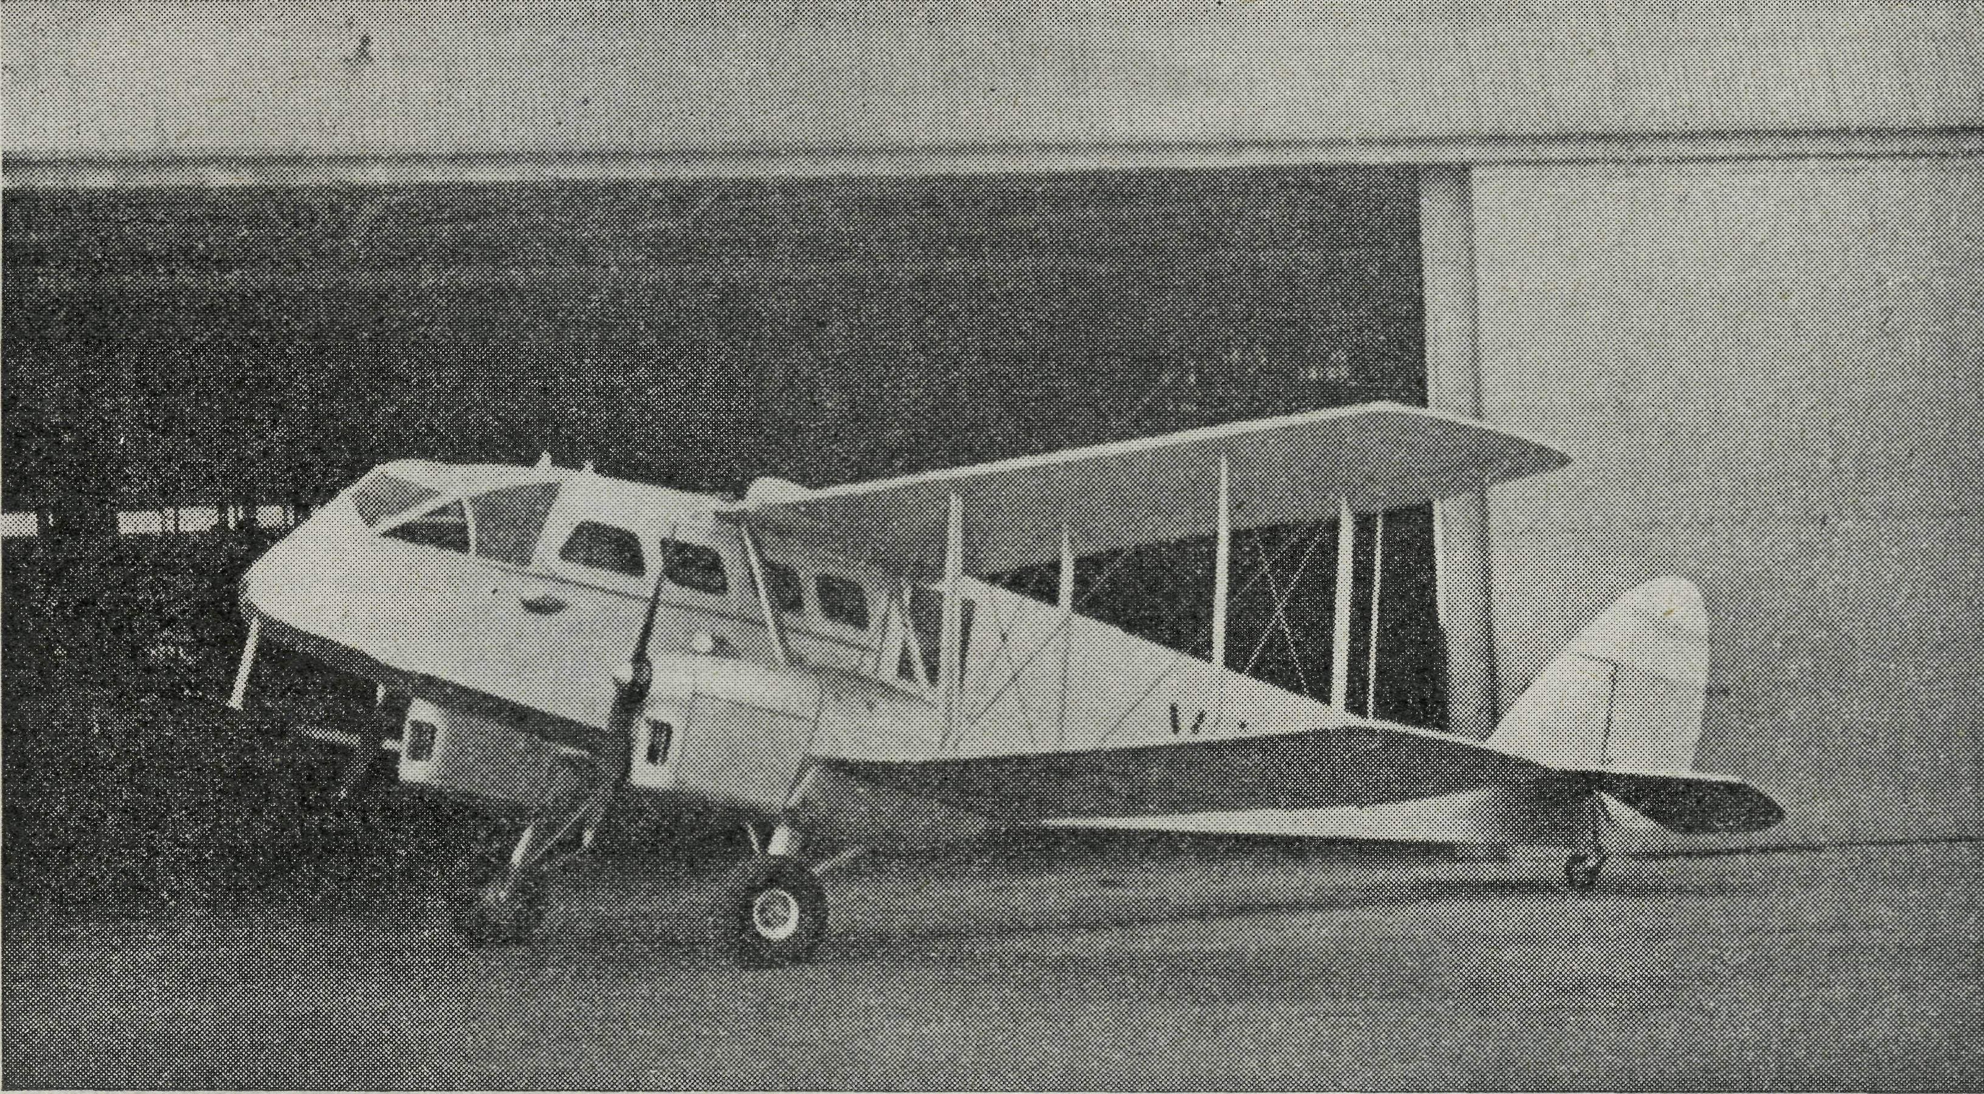

VH-AGI, shown above, is a much larger plane than the other, and has twin engines. The pilot will sit in the nose of the plane, while behind him in the cabin, there is seating for four persons, and permanent fittings for two stretcher cases, one above the other.
This aircraft will shortly be stationed at Ceduna, S.A., and will be flown by the B.C.A. pilot. The two planes will in future provide a more efficient and a more extensive niedical ministry than was possible with one.
Air services are costly to operate, but we look with confidence to B.C.A. friends and supporters to give of their substance according to their ability, for the purpose of maintaining the flying medical work. Every shilling given helps to save a life, relieve a sufferer, remove anxiety, or lead a precious soul into the Kingdom of God,

THE REAL AUSTRALIAN
10
July 15, 1946,

The Mail Bag Sunday School
MISS E. HUNTLEY.

Someone asked the other day, "How many children would you say you have in the Mail Bag Sunday School?"
As a matter of fact, this is a question we are frequently asked, and one we are more and more reluctant to answer, as we receive more and more evidences of the often unsuspected ways by which children are reached by our Lesson papers. Only a few days ago we received a most interesting letter from a clergyman in Queensland, who received from us every month six copies of our lesson paper. He writes:—
"Very many thanks for your letter and information concerning this very valuable Society (this was a circular letter which has been sent recently to all the clergy in Australia, enclosing a copy of our lesson sheets and Confirmation Notes).
"At present most of the monthly lessons which you so kindly send me are used by Sunday School teachers who collect a few children every Sunday. These WOMEN—no men, so far—are doing a great work.
"I would like to extend these benefits to many of the older children in the State Schools who meet for lessons for preparation for Confirmation after the usual lesson in the State Schools. Many have been using the lessons both for themselves and for their younger brothers and sisters. At present I have no car, and must do something to keep the Church in touch with the young people.
"The half-hour in the State School fortnightly or monthly is all too little.
"I would greatly appreciate the addition of 12 lessons to those which I am getting. With your kind permission I prefer to correct the lessons, as it keeps me in touch with the children.
"I have failed to discover any reference to the financial side of your Society's effort, but if you would let me know just about the yearly cost of the lessons, I could get my Parochial Council to budget for the cost —and I am sure they would gladly do so.
"Perhaps an experience of mine in the teaching in the State Schools may interest you. Country children generally do not sing. I carry with me a number of copies of the "Church and School Hymnal." It is English and so not all of the hymns are suitable, but many are. Often the whole lesson time is spent in
r #s#>#N*s#s*^<rvr<s#
TUNE-IN TO
3 DB
THURSDAYS AT
4.45 p.m.
learning, singing, and getting to know the meaning of the hymn or hymns selected. The teachers say that there is only one day in the week or fortnight when there are no absentees.
"The children will never forget the words and tunes of these hymns. Some one may object because there is no time for Bible stories, but the best of the hymns are full of teaching, and the half-hour is all too short."
In addition to the individual families to which we send lessons month by month there are forty lots of lessons, of varying numbers, sent to those who use them for small Sunday Schools which they conduct, or who distribute them to children in their district. Recently we have learned that one girl, who has been one of our Mail Bag Scholars for some years, is now the teacher of a subsidized school, and she tells her old teacher that having children of various denominations in her school presented difficulties in giving religious instruction, but she finds that by using our Mail Bag lessons this difficulty disappears.
We could add to these instances, others, which show the far-reaching ramifications of the Mail Bag Sunday School influence, when one set of lesson papers is used to teach numbers of children, often quite unknown to us.
With home-life becoming more normal, now that the war is over, we are making a special drive to bring our Sunday School before a greater number of families. One way by which we are hoping to do this is through the medium of the local country newspapers. We hope the day is not far distant when we shall have that other very valuable medium—our own Mail Bag Sunday School Van. We have had this imaginary "Mail Bag Wagon" hitched to the star of hope for a number of years, and we feel that this star is growing brighter as the idea "catches on."
Miss Campbell, of our Primary Department, is making a three months' tour of our Mission Centres, helping where she can in the training of teachers for country Sunday Schools, and making personal visits to the Mail Bag families she can reach, and enrolling additional children as • scholars.
We suppose none of our readers fail, to bring our Mail Bag Sunday School before the notice of friends or relatives with families in the country? Or before any who might be encouraged to start a small Sunday School in districts where there is not one? We will be happy to supply all particulars if you send us the name and address to which to post them.
As I am writing this, a letter has come from one of our old Mail Bag scholars, who, after having served in the Forces, is now acting as governess to two children in the country, for whom she is receiving our Mail Bag lessons. To quote from her letter, she says, "I wonder if you ever think what a really wonderful thing you are doing for country children. The Blackfriars is world-renowned for their work, but so few people seem to know of your little band of spiritual helpers. I almost wish I was young enough to do these little lessons myself. I am anxiously awaiting the arrival' of their classes and teachers —for Royce and Netta, I mean."
This is yet another urge to do something to make our M,B,S.S. better known-—to get that Van!

juty 15, 1946.
11
THE REAL AUSTRALIAN

Jottings from Penong
REV. P.M. CONNELL.

During the past month we have had a visit from two "special" people—Miss Campbell and Sister Nunn.
Miss Campbell joined us at Coorabie one day and came on with me to Kooringabie, where I was to take a service at night. During the afternoon we visited around in the homes of the people. It seemed to take their breath away when we three—Miss Campbell, Gladys and myself —walked up to the door. Well, we had tea in a farm' house, after Miss Campbell had taken snaps of a team of plough horses and the farmer had explained to us all the ins and outs of seeding with the particular machine we were watching in action. Then we went along to the little school-house for the evening service. Sixteen people came and very much enjoyed the slides shown by the projector with which Miss Campbell illustrated an address on Easter. Then back to Penong. Here we had another lantern lecture, given in the little church at this centre. Though I had only had a day in which to advise the townsfolk of the lecture, we had a church full, and they very much appreciated the service. Penong has an area school. Two buses journey to the town from opposite directions, each coming about 25 miles twice a day, to bring about ten children each to school, so when I told the school children, many went home to distant farms to tell their parents of Miss Campbell's lecture. Miss Campbell, whose home and office is in Sydney, is in charge of the Junior Mail Bag Sunday School run by the Bush Church Aid Society for outback children who cannot get to a Sunday School. After staying at Penong four or five days, Miss Campbell left by plane for Forrest and continued her visit to places along the trans, line, where more of her mail bag scholars are situated.
Our second "special" visitor this month was Sister Ethel Nunn, of the Women's Hospital, Old Cairo. She was brought by Rev. Broadley half way to Penong from Ceduna, I having come down half way to pick her up. She was scheduled to come straight through to Fowler's Bay for a lantern lecture. At Penong, on the way to Fowler's Bay after the visitors (Sister Page accompanied Sister Nunn) had had dinner in our rectory, the car was considerate enough to break down within walking distance from the township. And it was a complete breakdown.
There was nothing for it but to borrow a car. The
Methodist minister, Mr. Pengilly, came to the rescue and lent me his car. So we reached Fowler's Bay only half an hour late, and we were rewarded by a very interested audience of twenty people. Sister Nunn told us about Egypt .and its wonders, the work being done for the Lord Jesus among a very difficult set of conditions and promising to become harder now that Britain has agreed to quit Egypt.
From Fowler's Bay we drove back to Penong. After the visitors and ourselves had had tea, we set out for the evening lecture to be held in the Penong Hall at 7.30 Fifty people came from as far as twenty miles away and were very appreciative afterwards of what they had seen and heard.
My next three months are going to be a little more exacting, as the Rev. Broadley has had to take an extended vacation owing to his condition of health, and I am doing some of his more important centres. See if you can say their names: Mudamuckla, Nunjikompita, Carawa, and Puntabie. They are a round trip of 200 miles from Penong, and we will use the Ceduna rectory on nights when it is not convenient to come right home here to Penong. Gladys and I were married just about four months ago. She is enjoying the work and settling down to live in a very different countryside from that which she left in Rappville. Would the many kind friends in B.G.A. who have wished us well please accept our thanks for their kind wishes. We are very happy and both well.
The salt works, some nine miles from Penong, are working and employing about twenty men. Soon, if persistent rumours are true, the Gypsum works will start also.
These are about ten miles from Penong and could employ up to about 200 men. So the future of Penong is quite bright. On the agricultural side very good rain has fallen to give a fine start to the wheat and oats just sown, and farmers everywhere have hopes of a good season. It is a wonderful thing to see the hand of God falling in blessing upon our district, though it is a pity that more folk do not join us in thanking Him for His provision.
I would like to thank all those who remember our work in their daily prayers.

Uunc in lo--
5 M.U.
5 A.D. 5 P.I. 5 S.E.
on Sundays, at 9 a.m.

THE REAL AUSTRALIAN
12
July 15, 1946.

Out of the Mail Bag

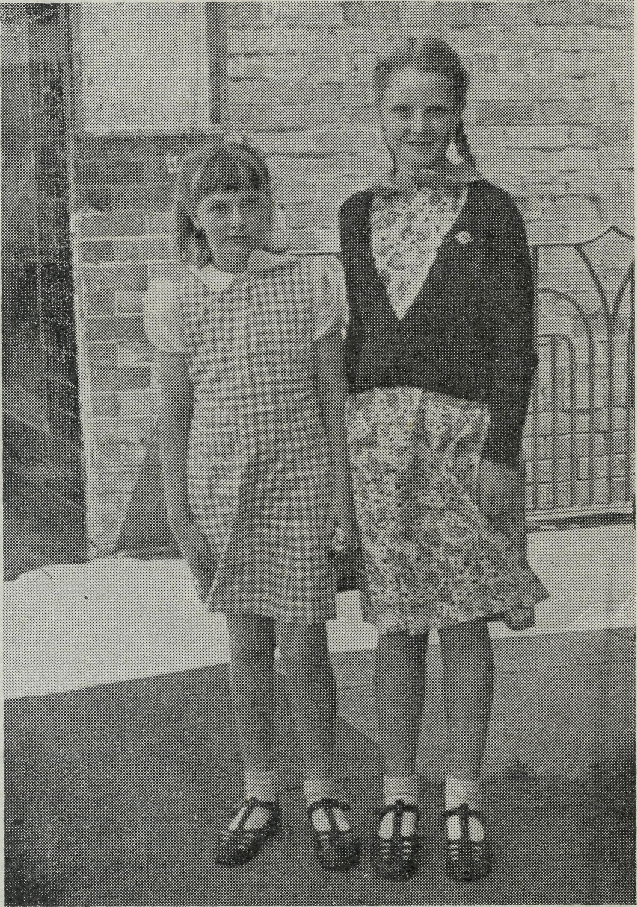
Our Mail Bag Sunday School teachers receive many interesting letters from their pupils and their parents.
One isolated mother writes to say that her daughter has now been able to go to a Church of England Grammar School, which will enable her to have a full association with church worship and Christian instruction. The mother expresses her gratitude for all that the B.C.A. postal lessons have meant to her child up till now, pointing out that they have given her her whole Chris-tion foundation. /T could not have taught her in the same way wihout the help of her B.C.A. Sunday School teacher." The child has seldom had the opportunity of entering a church.
Another mother writes, "Will you enrol my three boys in your Sunday School. I was a member of your Sunday School before my marriage. We live fourteen miles from the nearest school or church." Thus we teach the second generation.
Yet another mother says she has been ill for many months, unable to look after her children. They have been looked after separately by various aunts in different places. This has interfered with the Mail Bag lessons, but now that the woman is well again,, the family has been re-assembled and the lessons are being used regularly once more. This family lives in North Queensland, which the mother proudly calls "God's own country".
A woman away over in Western Australia, on the Trans. Railway Line sends a letter of thanks for coloured plasticine and hymn books. These have brought great delight to the children. They recently greatly enjoyed a visit from Miss Campbell, and have talked about it ever since. The nearest medical aid to this place is 260 miles away.
The accompanying photograph shows Margaret and Mary Linton, mail bag scholars. Mary recently won a High School Scholarship from a small school.
Mail Bag Scholars.

Subscribers Who Have Not Received Receipts

DONATIONS.
4/3/46: Anon. Don. 2/-. 4/3/46: Anon. Don. 3/-. 5/3/46: Anon. Don. 10/-. 18/3/46: Anon. F.M.S. £1/10/-. 1/4/46: "H.G." Don. 2/6. 2/4/46: Anon. Don. 10/-. 29/4/46: Anon. Don. 6/-. 3/5/46: Miss Allnutt, Easter 4/-. Anon., Concord, Easter £2/10/-; Tibooburra £2/10/-. 8/5/46: Anon., Moss Vale, Easter 10/-. 10/5/46: Miss M.L.H., Easter 5/-. 21/5/46: "A.Y.Z.", Easter 10/-. 22/5/46: A. Prehening, Easter £4. 22/5/46: "A Sympathiser", Easter £1. 23/5/46: "A Friend", Mentone, Easter 3/-. 29/5/46: Anon., Woodford Don. 4/-. 3/6/46: Anon., Sth. Hurstville, Don. 2/-. 4/6/46: "M.H.", Easter 10/-. 26/6/46: Anon., Kogarah, Don. 10/-. 26/6/46: E.R. £10.
REAL AUSTRALIAN,
Miss Heuston, Mrs. Hatton, Mrs. Carlill, Mrs. Fischer, Miss S. Dixon, Miss I. Harris, Mrs. Jennings, Miss Myers, Mrs. H. S. Cotton, Rev. J. Vaughan, Mrs. Binnie, Mrs. Warnes, Miss D. Close, Mr. Body, Mrs. Kaufline, Mrs. M. Harris, Mrs. L. Hodgson, Mr. Toland, Alan Rahn, Mr. J. S. Milne, Mr. E. R. Smith, Mrs. O. Green, Mrs. F. Box, Mr. Olde, Miss L. Lord, Mrs. A. Baker, Mrs. L. Willison, Miss L. Smyth, Mrs. J. Cook, Mrs. F. Campbell, Mrs. F. Furness, Mrs. L. Beck, Mr. R. Patmore.

THE REAL AUSTRALIAN
13
July 15, 1946.

THE PLACE OF PRAYER
A Prayer for Use with Our Prayer List.
O Lord God of our |natoin, Who has commanded men to subdue and replenish the earth: Look in Thy love upon all who in the distant parts of our land are striving against many difficulties, and are deprived the access of the means of grace. Strengthen and guide the Bush Church Aid Society and its Clergy, Nurses, Doctors, and Air Pilot, and Students. Cheer and comfort them in discouragements and loneliness, and bless their ministrations to the good of those they serve, land grant that the message of redeeming love may thus be rooted and grounded in our national life, to the glory of Thy Great Name, through Jesus Christ our Lord. Amen.

SUNDAY.
THURSDAY.

MORNING
The Far West Missions at Penong, Ceduna, Min-nipa and Cummins; the Missioners H. Broadley, D. Pugh, J. Greenwood, and P. Gonnell.
EVENING
The West Darling Missions at Wilcannia and Menindee; the N.W. Mal-lee, and the Missioner, K. Luders.
MORNING
For the Mail Bag Sunday School with its Gospei messages for the children. For the teachers and helpers, that they may find en' couragement in their work.
EVENING
For the Organising Missioner, that he may be strengthened and guided in all his endeavours for the good of the work and in his relationships with his fellow-workers.

MONDAY.
FRIDAY.

MORNING
The Cann River Mission, the Bonang Mission, the Streaky Bay Mission; the Missioners C. F. Withing-ton, D. H. Wicking, and D. Livingstone.
EVENING
The Denmark Settle
ment, the Kirton Point
Missions, and Missioners,
Rev. and
Rev. R. T. Hallahan.
MORNING
For the Bishop Kirkby Memorial Hospital and Sisters Bossley and Kay, as they minister to the people on the great Nulla-bor Plain. For Sister Maddern and the Tarcoola Medical Hostel.
EVENING
For students and all in training for this work of Go. For the Heytesbury Forest Mission. For Rev. T. H. Pickburn and the Otway Ranges Mission.

TUESDAY.

MORNING
EVENING
SATURDAY.

WEDNESDAY.
MORNING EVENING
Each day pray that the many needs of the • work may be met.
Running expenses of £5 per hour to keep the Medical 'Plane in the air.
Consecrated clergy missioners for urgent work in the field.
That our work may continue to progress despite the difficulties of wartime.
For Sisters Dowling, Miller, Gillan, Thomas, Hitchcock, Holle, L. Loane, and E. Fisher.
For the Bowral Hostel, Sister N. Dixon, and Students.
For the children in" the Mungindi, Wilcannia and Port Lincoln Hostels, and for the workers, the Misses Cheers, Miss Dykes, Miss Farr, and Sister Sowter.
For the Cann River Dispensary, and Sister Gwynne and Koonibba Mission Hospital, and Sisters L. Pritchard and H. Foster, and the Wudinna Staff.
For the Flying Medical Service, Mr. Chadwick, and Doctors R. and F. Gibson, Dr. R. Roxburgh.
For the wives and families of the Missioners and Air Pilot.
MORNING
For the President and Council _ of the Society, that they may be guided by His wisdom.
For the Home Base Staffs, Auxiliaries, and parochial workers.
For the Victorian and South Australian Secretaries.
EVENING
For the ^{U}C o o r a h. ' Hostel and its workers, Mrs. Mann and Mrs. I. Mann, and Miss Stokes.
For the Rappville Mission and the Missioner, the Rev. R. Meyer.

Give Thanks—
For the rich blessing and wonderful growth of the Society's work. For all the kindly givers who have helped with their self-denials. For the Flying Medical Service. For the joy of service.

THE REAL AUSTRALIAN
14
July 15, 1946.

N.S.W. Women’s Auxiliary

The annual meeting, held on April 12th, took place in the Bible House, and was well attended. The Archbishop of Sydney presided, and addresses were given by Sister L. Loane and Pilot Chadwick. An appeal was made for funds to provide a refrigerator for the Rev. and Mrs. P. ConnelPs very small rectory at Penong. The full amount was raised, and the refrigerator has been despatched. It will be a great boon. During the after' noon, vocal items were rendered through the kindness of Madam Ada Baker. The successful gathering concluded with an enjoyable afternoon tea.
It is with much regret that the Auxiliary members have said farewell to Mrs. F. H. B. Dillon, on the occasion of her departure for Adelaide, where her husband has been appointed as Rector of the parish of Holy Trinity. Mrs. Dillon was sometime Matron at our Ceduna Hospital, and rendered splendid service as President of the Auxiliary, and in many other ways.
Mrs. Lee Smith, who is a foundation member of the Auxiliary, has accepted the Presidency in succession to Mrs. Dillon. She has the full confidence of the mem' bers, and has always been a keen Auxiliary worker.
A welcome has been extended to several new members, namely Mrs. Loane, Mrs. Colvin, and Mrs. Kershaw.
On learning of most urgent needs at Wudinna Hos' pital, the Auxiliary was able to purchase from funds a large supply of sheets and mattress cases, which were des' patched forthwith to the Matron, Sister L. Pritchard.
During May, at an afternoon tea gathering, the Auxiliary members welcomed back to Sydney the three Misses Gurrier-Jones, who have done such good work at Wilcannia Hostel. At the same function, Sister L. Loane and Miss E. M. Simpson were farewelled prior to pro' ceeding to Penong.
The Annual Thanksgiving Day will be held in Novem-ber. Details of this will be found elsewhere.

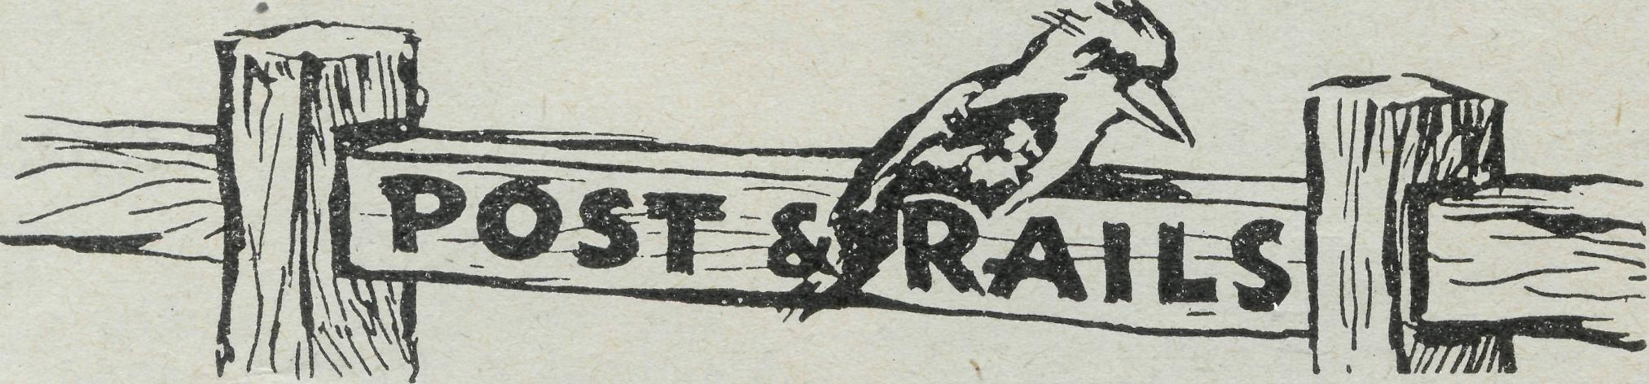

The Rev. D. H. Wicking, Th.L., has been appointed to the Delegate-Bonang Mission, and has taken up his duties there. We welcome him into the B.C.A. family and pray that his ministry may be very fruitful.
The Rev. W. Duffy, Th.L., after five years of service with the Society, has concluded his ministry at the Heytesbury Mission, and has been inducted to the parish of Murtoa, in Victoria. He has given outstanding service, and our good wishes go with him to his new parish.
We deeply sympathise with Mr. Duffy in the loss of a brother, a clergyman of the Diocese of Ballarat, who was much beloved, and who passed away only a few. weeks after his marriage.
A welcome is extended to Sister Foster, who has joined the staff at Wudinna, and to Sister Fisher, who is about to take up her duties at Ceduna. Their help at each hospital is much needed and will be greatly appreciated. ■
Deaconness N. Dixon is matron of the hostel for girls at Bowral, in succession to Mrs. Hastie. Sister Dixon entered on her duties at the beginning of the second school term, and we extend her our good wishes in her new responsibilities.
Miss E. M. Simpson, of the parish of Hunter's Hill, Sydney, has gone to Penong Hospital, to take care of the cooking and housekeeping, a need which has been acute for some time past. Her services will be much appreciated.
Miss N. Stokes, of Campsie parish, Sydney, has joined the staff of ^{l}Coorah," Wentworth Falls, where she will take the place of Miss Farr as sub-matron. We wish her God's rich blessing in her ministry there, and offer her our sympathy in the recent loss of her father.
The Misses H. and Y. Gurrier-Jones have returned to Sydney after completing a term of service in charge of the Wilcannia Hostel, and we are grateful to them for all they have accomplished while there. Miss D. Dykes and Miss M. Farr have taken up their duties at the Hostel, and we extend to them our good wishes in their work among the children.
The Rev. F. H. B. Dillon, one of our earliest mis-sioners, and for years a member of the B.C.A. Council in Sydney, has accepted nomination to the parish of Holy Trinity, Adelaide. He has agreed to act as our South Australian Secretary there. We wish him and his wife, both of whom have done so much for B.C.A., great blessing in their Christian Ministry in Adelaide.
Mrs. F. J. Marshall, of Rockdale, passed away recently. She collected funds for the Society for many years past, setting a splendid example. We shall miss her great personal interest in the work, and thank God for the memory of her enthusiasm. We are glad to know that Mrs. V. J. Middleton, of Bexley, a friend of B.C.A., has kindly taken over her work.
We gratefully acknowledge the receipt of a legacy contained in the will of the late Mrs Ada West.
The Rev. T. R. Fleming has completed his ministry at Denmark, W.A., and is now in charge of the parish of Mt. Barker in the same vicinity. Mr. Fleming has given long service under the B.C.A., having joined the staff of the Society in 1935. He has been Missioner at Cann River, Delegate, Cummins, and Denmark—a splendid record. We wish him God's blessing in his new ministry.
There has been urgent need for someone to assist Sister Dixon at the Bowral Hostel for High School girls. At the time of going to press the need has not been met. Would anyone who is able to undertake this work please contact the Acting Organising Missioner.
We are glad to report that Miss A. Brooke-Anderson, Secretary of the Ladies' Association, of the Colonial and Continental Church Society, has informed B.C.A. that the Association has given the sum of £200 Sterling, £100 each to the districts of Carlisle River in the Otways, and Timboon in the Heytesbury Forest, as contributions towards the erection of their churches. This gift is much appreciated.

July 15, 1946.
15
THE REAL AUSTRALIAN

Victorian Secretary
The Rev. L. G. Ball, M.A., Th.L., has been appointed Victorian Secretary, and we extend to him a cordial web come as he takes up his duties. It is gratifying to be able to announce his appointment, as the office of Vic torian Secretary has been vacant for some time. It is hoped that Melbourne friends of the Society will soon have the opportunity of meeting Mr. Ball.
Victorian Notes
(The following notes were omitted from the March is
sue, and although some months old now, are published
here on account of their interest.)
CENTRAL WOMEN'S AUXILIARY.
We regret that Mrs. Pettingill, who has been our valuable Secretary, has been obliged to resign owing to ill health. We are grateful for her splendid work for B.C.A.
On Tuesday, 29th September, Miss Langley, of St. Catherine's, Toorak, invited the Central Women's Auxiliary to hold a Gift Afternoon at the school. This was very successful. Mrs. Morris, formerly of Minnipa, spoke about her work there, and some interesting glimpses of other sides of B.C.A. activities were given by Sister Pritchard and Miss Dykes.
In October, Mrs. Watts, of Bentleigh, was a very gracious hostess at an Australian Tea, which she gave for the month of the Auxiliary. The Rev. T. H. Watts presided, and everyone was interested in an address from the Rev. E. L. Panelli, about the work of B.C.A.
On 20th November, the annual Temple Day of the Auxiliary was held at St. Paul's Cathedral. The Rev. A. C. Miles conducted the service; the Rev. Leon Morris gave a very stirring address, and Mrs. Wenzel presided at the organ. The offering amounted to £56. At tea after the service a warm welcome was given to Padre W. I. Fleming, returned P.O.W., and to the Rev. Leon Morris.
Donations from the Central Women's Auxiliary in 1945 to the general funds of the Bush Church Aid Society amounted to £85.
CHRIST CHURCH AUXILIARY, SOUTH YARRA.
Our young Auxiliary is growing slowly, and, let us hope, surely. Three satisfactory meetings have been held —April, the Annual Meeting. In August, we had a Gift Day, and, as a result of this, £17 was divided between Timboon and Carlisle River towards the building of a church in either place. Later, a half-sovereign (25/-) was given to each. In December a further £5/6/8 was donated between Timboon and Carlisle River Church building funds. Mrs. Morris—formerly of Minnipa, giving the address to an interested gathering.
During the year three new Bark Huts have been taken, and also we have obtained new subscribers to the "Real Australian."
ST. THOMAS' AUXILIARY, MOONEE PONDS.
We have had a very successful year, the total receipts
being £127/5/2. The four efforts for the year were:—
An Australian Tea, on 10th July £21/8/0
A Musical Evening, wtih an opportunity Stall,
on 19th September - - £56/3/6
An Afternoon at the home of Mr. and Mrs.
Rettick, when the sale of their handiwork
realized - £21/5/6
Our Thank-offering Service, on 14th Novem
ber, the offertory being £12/0/0
We have allocated the following amounts:—£75 to the fund for the new aeroplane; £5 to our cot in Penong Hospital; and we purchased eighteen yards of curtain material for Cook Hospital; one cane lounge, two office tables, and two office chairs for Qeduna and Cook Hospitals.
Coupons Wanted
The Girls' Secondary School Club and parish groups of Sydney have kindly offered to provide linen requirements for our hospitals, if coupons can be supplied. "Real Australian" readers who could give one or more clothing coupons for this purpose are invited to send them to the B.C.A. Sydney Office.

YOU ARE INVITED TO ATTEND
THE VICTORIAN RALLY OF B.C.A.
on
TUESDAY, SEPTEMBER 17th, 1946
AT 8 P.M. IN ST. PAUL'S CHAPTER HOUSE, SWANSTON STREET, MELBOURNE
Thank-Offering* Come and Bring a Friend.
DETAILS OF SPEAKERS WILL BE ANNOUNCED LATER.

THE REAL AUSTRALIAN
16
July 15, 1946.

Cann River
SISTER I. GWYNNE.

What shall I write? First of all, it must be a note— or rather many notes—of praise. Praise to God for ail His Goodness and for the wonderful and marvellous way in which prayer was answered and all obstacles removed step by step all the way, during six months¹ leave of absence—for further training and furlough. He is able to defeat all the devices of Man-power, etc. During that time one found endless opportunity for proving God's faithfulness, and that He is a very present help. "He is our refuge and our strength.¹¹ Since returning, too, one finds countless times when one is unable to express all one's gratitude—and can only very humbly praise God. It was delightful to have the opportunity of seeing one's family again, and enjoying the home ties.
It was a delightful privilege also to meet many friends in Brisbane and renew friendship with tried and trusted friends. Another privilege was that of meeting with a company of about twenty-seven or more nurses, and to have the opportunity of giving a message to them from God's word and tell them of His love and testify to His faithfulness. It was a joy to see the keen interest of these young trainees. Sunny Queensland can be.—and is at times-—just as cold or colder than Cann River. Having developed a nasty cough whilst in Brisbane—which lasted many, many weeks, the Doctor thought it most unwise for me to return south. But six months' leave was up, and believing it to be God's will that I should return, the return trip was made. What a joyous few days were spent in Sydney with very dear friends. Friends, I say;
but ah, do they still think so when letters are so few and far between? I trust they understand and that their friendship is not so easily broken.
Holidays are excellent, but somehow one is always more or less glad to get back into harness again. And now ten months are gone, and one still asks "What shall I write?"
The life of a Bush Nurse is by no means monotonous, and one never knows just what is going to happen next. This, of course, gives spice to life. Some weeks ago one had quite a little divergence from the ordinary. There are days when it is just the trivial round and the common task, but this was one of the extra days, or nights rather. It started off with the ordinary everyday affairs of getting breakfast, etc., and then attending to one who was very ill—one whom I had staying with me—one of those rare and precious souls, a radiant child of God. She had developed ear trouble, as well as other troubles, and had been a victim of rheumatoid arthritis for many years. It seemed imperative to take her to Hospital, so after interviewing her son—our Vicar—all arrangements were made and the morning quickly passed as the necessary preparations were made and lunch partaken of. Soon after a car arrived to take us the 58 miles to Orbost to see the Doctor, and then to the hospial.
A little shopping was done, afternoon tea and the return journey to Cann River was made, arriving somewhere round about 7 p.m. The fire was lit up and tea ready, but we had not finished tea when another (ex-

Help Australia
by
purchasing
Savings Certificates.
Certificates can be purchased for:
16s. for each £1 Certificate.
£4 for each £5 Certificate.
£8 for each £10 Certificate.
Help B.C.A.
by donating
Savings
Certificates
to the Society.

Buying them helps Australia in the World War. Donating them to B.C.A. helps the Kingdom of God in the fight against the evils which cause all wars.

July 15, 1946.
in
THE REAL AUSTRALIAN

pected) patient arrived to have a poisoned hand attended to. He was brought by two friends, our chauffeur of the afternoon, and his wife. This case was not so desperately urgent that he could not wait for me to finish my tea, so I calmly continued to do so. But the meal was scarcely finished when I head the familiar click of the gate after a motor had pulled up—and then a knock at the door. On answering it, I was confronted by a group of people, four or five who had brought a sick man 31 miles for attention. He appeared to be a heart case. They left him to my tender (?) mercies and made their return journey home. The man was a stranger in the district. Profession etiquette—"tend to the worst case first" was put into practice; so the last was first on this occasion, as he seemed a very sick man.
After giving all the treatment I could, including a cup of tea to warm him up, we had to make enquiries about accommodation for him. So the chauffeur took us to the Hotel where enquiries were made. A room was provided, he was put to bed, an injection given to ensure a good night's rest, and we saw him comfortably settled. I returned home. The first arrival had been attended to in between times. By this time it was getting late, and I felt like a refresher, so a cup of coffee was made, but we were not allowed to have that in peace and quietness.
A knock at my front door. My neighbour came across the road to say the Hotel rang him, asking him to tell me that the patient had a bad turn. My friend took me to the Hotel again (after we finished our coffee). Two gentlemen were nobly doing their best to help him, and were watching the patient till I arrived a few minutes later. After seeing him, I decided I had better stay on duty, and if permitted snatch what sleep I could. The Hotel proprietress kindly placed a bed at my disposal,
just across the passage from the patient. First of all, I returned to my cottage, only a few hundred yards, to collect a few things I required, and also a further injection.
On arriving back at the Hotel I found the patient, who was propped up with umpteen pillows, making sketches in a note book. He had his attendant, Ven. Archdeacon
, sitting on the end of his bed whilst he, the
patient, made a few deft strokes with his pencil, and produced a very real sketch of the Archdeacon. Then I had to sit on the end of the bed whilst a sketch was made of me—so the Archdeacon now has my portrait.
With one or two other symptoms (???), notably the fact that the patient wanted me to sit and hold his hand (he was frightened), and also that a nasty cough seemed rather forced—my suspicions were being aroused as to the seriousness and severity of the case.
Another heart turn—holding of breath (pulse fairly good)—another severe spasm of coughing—then I re' sorted to firm talking, saying it was far too cold for me to sit there in a cold room, it being past 3 a.m. The patient finally settled down, and yours truly was able to snatch an hour's sleep. I had to be on the job early as the other patient of that night was to arrive at 6 a.m. to have his hand redressed, before going on the service car to Orbost. At 7.15 a.m. the heart case was up, dressed, and apparently O.K., ready to go on the 'bus to Orbost. So we get a little of everything and plenty of variety, even if people do try to "put it over" one, and it gives spice to life.
I could ramble on telling of many and varied experi' ences, but this must suffice for this time—as time and space are limited. I can only conclude by saying, "Brethren, pray for us," that there may be blessing as we contact these various lives.

WATCH FOR DETAILS OF
THE ANNUAL RALLY
IN SYDNEY
To be held in the Chapter House on TUESDAY, OCTOBER 1st.

THE REAL AUSTRALIAN jv July 15, 1946.
MAD INHUMANCIE
The Annual Cost of maintenance of all the varied activities of the Bush Church Aid Society is £20,000. The whole income is derived from the free gifts of
Christian people.
♦
Yon can help by:
- A donation to our Funds.
- Keeping a B.C.A. collecting box in your home.
- Subscribing to our Quarterly paper, "The Real Australian".
- Donating a Saving Certificate.
- Daily remembrance in your prayers of the work and workers.
- Including the Society when making your will.
Our Address is:
BUSH CHURCH AID SOCIETY, Church House, George Street, Sydney, N.S.W. Or Bible House, Flinders Lane, Melbourne, Vic.
Our Telephone Numbers are:—-Victoria, FJ5675. N.S.W., M3I64.
We will be happy to supply any other information
you require.
Edgar Bragg k Sons, Printers, Sydney.

