

No. 95.
APRIL, 1947.
1/6 per annum, post free.

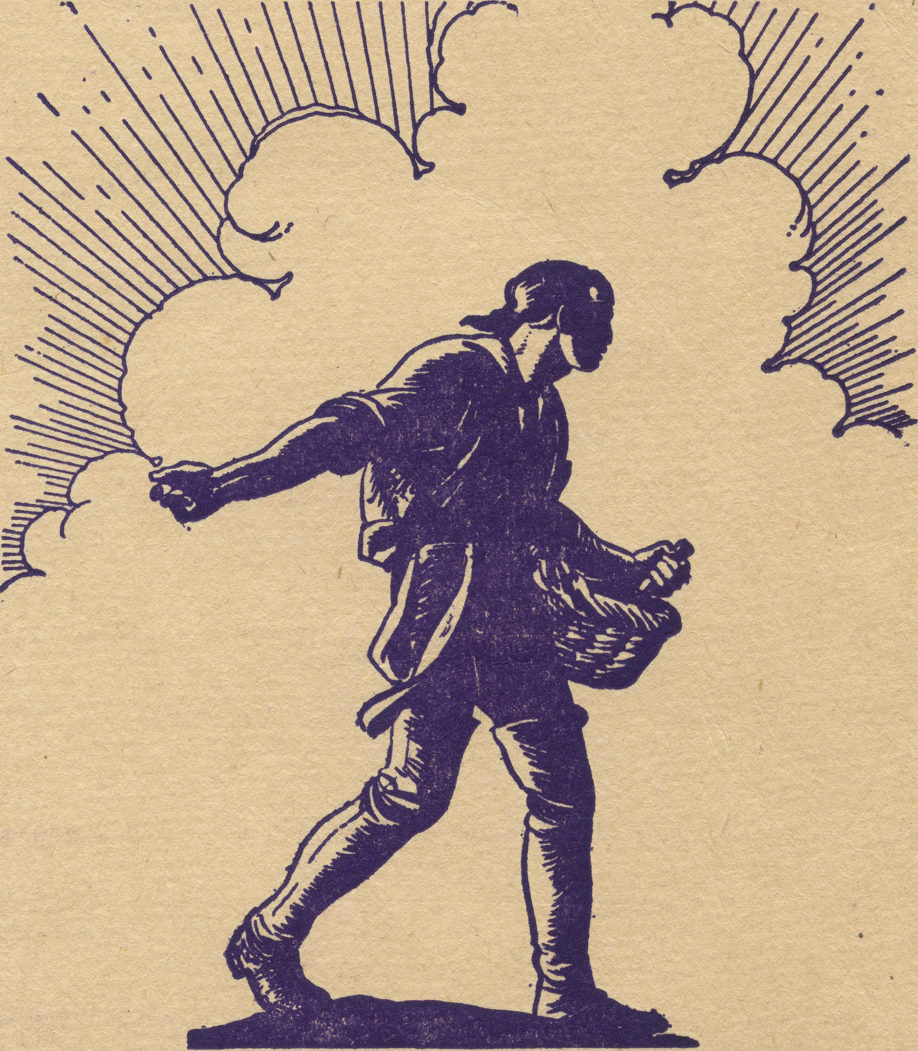
Registered at the Q.P.O., Sydnev. fa* transmission by peat as a period leal.

THE REAL AUSTRALIAN
11
April, 1947

The Bush Church Aid Society for Australia and Tasmania

HEADQUARTERS OFFICE:
Diocesan Church House, St. Andrew's Cathedral, George Street, Sydney.
(Telephone: M 3164) Cable Address: "Chaplaincy, Sydney."
VICTORIAN OFFICE:
The Bible House, Flinders Lane, Melbourne.
(Telephone: FJ 5675)
President: The ARCHBISHOP OF SYDNEY.
Hon. Clerical Secretary:, Rev. L. GABBOTT.
Hon. Treasurer: T. S. HOLT, Esq
STAFF:
Organising Missioner: Rev T. E. JONES, Th.L. N.S.W. Secretary: Rev. D. G. LIVINGSTONE, Th.Schol. Church House, George Street, Sydney.
Victorian Secretary: Rev. L. G. BALL, M.A., Th.L. Bible House, Flinders Lane, Melbourne
South Australian Secretary: Rev. F. H. B. DILLON, Th.L.

B.C.A. Activities and Staff

MISSIONS,
Ceduna, SA. h _{R} _{p} _{Conne}n _{ThX}„ Ceduna, S.A. Penong, SA. )
Cummins, S.A.—Rev. D. A. Richards-Pugh, Cummins, S.A.
IGrton Point, S.A.—Rev. R. T. Hallahan, Th.L., Port Lincoln, S.A.
Streaky Bay, SA.—Rev. T. J. Hayman, Th.L.
Minnipa, S.A.—Rev. J. Greenwood, Th.L,, Minnipa, S.A.
Delegate-Bonang, Vic.—Rev. D. H. Wicking, Th.L., Delegate, N.S.W.
Croajingalong, Vic.—Rev. C. F. Withington.
Heytesbury Mission, Vic—Rev. G. MUTTEN.
Otway Mission, Vic*—Rev. T. H. Pickburn, Th.L., Beech Forest, Vic,
Wilcannia, N.S.W. 7 Menindee, N.S.W. J
Rappville, N.S.W.—Rev. R. Meyer, Th.L., Rappville, N.S.W.
Denmark, W.A.—Rev. C. H. Sherlock, Th.L.
Werrimull, Vic.—§.ev. , Werrimull, Vic
SCHOOL HOSTELS.
Wilcannia, N.S.W.—Miss L. Knox, Miss Farr. Mungindi, N.S.W.—Miss E. Cheers, Miss E. I. Cheers. Wentworth Falls, N.S.W.—Mrs. C. Mann, Miss N. Stokes. Port Lincoln, S.A.—Sister H. E. Sowter. Bowral, N.S.W.—Deaconess N. Dixon.
MEDICAL SERVICES.
Ceduna, SA.—
Matron: Sister F. Dowling.
Staff: Sisters Miller, V. Holle, R. Gillan, G. Hitchcock, E. Fisher. Penong, S.A.—Sister L. Loane, Sister Woodings.
Wudinna, SA.—
Dr. R. Roxburgh.
Matron: L Pritchard.
Sister H. Foster. Cook, S.A.—Sisters Thomas, J. Coleman. Tarcoola, S.A.—Sister V. Page. Cann River.—Sister I. Gwynne. On Sick Leave—Sister B. Bossley, Miss D. Dykes.
FLYING DOCTOR SERVICE.
Pilot.—-Mr. A. Chadwick.
Doctors.—Dr. R. Gibson, Dr. F. Gibson.
MAIL BAG SUNDAY SCHOOL.
Director.—Miss R. Campbell

April, 1947
THE REAL AUSTRALIAN

"We Will Get By”
A Letter from the Rev. Tom Jones, O.M.

Liverpool, ENGLAND.
March 16th, 1947. My Friends of B.C.A.,
Mr. Livingstone has asked me to write a letter for the "Real Australian." It is quite a new experience to be on the receiving end of such a request.
I have had the very wonderful experience of meeting many friends and relatives, after 22 years' absence from my homeland, and it is one I am never likely to forget.
There is a very great interest here in Australia and B.C.A., and I have been able to make many new friends for our work.
The severe winter has placed a very heavy burden upon Britain and her people. Transport has been chaotic, and is still working under very great difficulties, for it is still snowing as I write. This condition has affected the mining and transport of coal, and, as a result, coal, gas, and electricity have had to be severely rationed. Many people have found it impossible to provide sufficient warmth in their homes in this, the worst winter for 50 years.
Rationing extends to most commodities. Bread, meat, all tinned foods, butter, milk, and indeed all staple foods. Even sweets are on the ration list, each person, old or young, is allowed but 2oz,. of sweets per week. Coupons, of course, have also to be surrendered for clothing, but I wonder do Australians realise that in England, even now, it is not possible to buy a pair of bed sheets unless one is newly-married.
Certain fruits, which to us in Australia are common and cheap, are luxuries here. Pineapples are anything from 15/- to 30/- each. Yesterday I paid 10£d. for two Jaffa oranges, and, during Christmas week, mandarines were 5/- lb.
Of course, everything is not as bad as this, vegetables are but little dearer than in Australia. The main drawbacks are lack of fats, and the monotony of diet. A tin of beef dripping is a very welcome gift in England.
This, you will feel, is a very dismal picture of Britain, but I am glad to say there is another side which gives great encouragement. Life may be far from easy here, but there is a spirit to be found in this people which makes me more than proud that I came from this stock.
The people freely admit that life is more difficult now than in the war years, save the bombs. Yet they will say, "We will get by," or "Well, we have much to be thankful for. There are others worse off than us." I stand in silent admiration of them, and I am glad that I am here for some little time at least to share in the difficulties of daily living, and, I pray, to absorb some of the wonderful spirit of these most remarkable people. I can understand why Hitler lost the war, no war machine could beat these people, unless God Himself be dead. I am understanding more than ever what Winston Churchill meant, under God, to the world. Many folk have said to me, "When we listened to him, he gave us courage when there was nothing else to give."
My travels up and down the country have enabled me to see something of the awful price the people paid in the war. Towns are black and drab, because it is still impossible even to obtain paint to brighten them up.
Each city had its heaps of ruins of churches, schools, factories, shops, and homes, or their bomb sites, as they are called, cleared areas upon which once stood some buildings. While walking around the district where I was born and grew to manhood, I came to a block of four streets, where many of my friends had lived. Today they are lines of pre-fabricated emergency homes. Why? You see, two land mines fell at the same time on those four streets, and there was not a house left after the explosion. The people who lived in those houses were in one big shelter for safety, and a direct hit killed them all.
My friends tell me that when they went through their worst period, when Hitler did his best to wipe out Liverpool, many of them did not take off their clothes for six weeks. Nights spent in shelters, fire fighting without water, looking for friends and relatives who had been bombed out and trying to live day by day at the same time—these are the stories of the war years. These are the people who can still say, even now, "We will get by."
I find a great gratitude here for the help Australia has given. These people are tremendously grateful, and very proud that Australia and the rest of the Empire stood by them during the war. They are grateful also for the food parcels which are constantly coming. I was in a home the other day and noticed from the window the postman walking up the path to the front door. My hostess said to me, "Here is a little bit of Australia coming to me." It was a food parcel. I was a little ashamed as I saw the look of pleasure and happiness on her face as she opened the parcel. Why should I be ashamed? Let me put it this way. A few weeks ago, I was addressing a large meeting in the North. The Chairman in his remarks asked me if I would convey to Australians their very real thanks for their gifts and help to British people, and especially for the wonderful food parcels. The meeting loudly applauded his words. I felt a little overcome, for, as I told them, their gallant stand alone in 1940 gave us in Ausralia life itself. We indeed have great reason to thank them. Food parcels in no matter how great a number cannot measure up our debt to them.
However, this is one real and practical way of expressing our thanks, so I hope that as many of you as possible, will send over a gift parcel to somebody in England. Mr. Livingstone will be glad to supply you with names and addresses.
I am glad to hear from Mr. Livingstone that B.C.A. is continuing to go ahead. There is still a very big task before us. More hospitals and hostels need to be opened and we are already pledged to considerable extensions in our medical work. The two aeroplanes are a very big expense. The insurance and overhaul of both machines will amount to £1,000 per annum.
There is an urgent need for more and more workers in our missions. This means men, women, and money. Have we in Australia; reached the limit of our giving, or can we give more? It seems to me that B.C.A. is in need of an extra £4,000 to £5,000 for 1947. Many people in Britain have assured me that they will help us.
It is a humbling experience to go around Britain and see the tremendous devastation all over the country, and

THE REAL AUSTRALIAN
April, 1947

to realise' the tremendous job ahead of these people for many years to come, in rehabilitating cities and homes— and then to hear them say that they must help US.
We, in B.C.A., have a big but wonderful job to do for our people. In the name of God, WE MUST NOT FAIL NOW.
Now, my friends, will you, when you have finished reading this letter of mine, sit down and forward to
B.C.A. in Melbourne or Sydney, a very special gift towards that extra we will need this year, so that in this work which we have undertaken for God and our people, we also, like the splendid folk in this Island, 'Will get by:,
Yours very sincerely,
TOM JONES.

First Impressions of Streaky Bay
Rev. T. Hayman

The difference is the journey from city life to country life. Impressions gained here in many particulars would not be so marked coming from a country place to Streaky Bay, Being used to city life, there are many adjustments which we have had to make.
Our journey of over fifteen hundred miles has taught us two things. We are almost entirely dependent on our own means of transport—the car, and only a small Morris tourer, at that. So much could go wrong and in awkward places miles from anywhere. The second we learnt was that, we were in God's hands utterly and entirely. We give Him thanks for so wonderfully preserving the car without even a puncture. The only mishap we had was that petrol was leaking for a few miles due to a loose nut. We smelt the petrol fumes and were able to tighten the nut.
We are now in the B.C.A. family, feeling its warmth in the two large cities en route, and at Wudinna Hospital. Here we found keen Christian fellowship with those who enjoyed prayer and Bible study intermingled with good solid work.
As we came into the district of which Streaky Bay is the centre of the semi-circle, we were very interested to see what sort of country it was. Certainly it was not as barren and flat as I had imagined. Quite a number of trees lined the road, and there are gently undulating hills. But where are the people? We did see one man with his team of eight horses working on the fields. (I was going to say plowing; but that is only one of many operations!) The huge fields with the farmer's house just out of sight over the hill, gave us a tremendous feeling of space—miles and miles without seeing one house.
Twice we were escorted part of the way in. Over fifty pink and white parrots flew with us for a while. Later two or three bright green parrots accompanied us. We were within two or three miles of our destination, and thought that every hill-top would bring us a view of the sea in the distance ahead of us. Suddenly we came to the shore, running quite close to us on our right. We followed the line of the bay and were soon in the delightful little town of "Streaky Bay."
A town of about eight hundred inhabitants, Streaky Bay was the largest group of houses we had seen on our route for two hundred and fifty miles. It boasts of a number of varied stores and garages. It has its own power plant and water supply. Three churches have been built here—a Methodist, Roman Catholic, and Church of England.
We soon spotted the Church of England and its large Rectory. There, working in the backyard, was one of
the oldest and most faithful members of the Church. His first words were, "Come to tea with us!" The invitation was repeated in the next five minutes by another member. While one came to the back door, a third friend arrived at the front to see that all was well.
Our belongings will not be here for three weeks. We are tired of saying we have such-and-such—but it's in the crate! Neighbours have come to our rescue, and we have articles from four homes, with many more willing to lend us things.
We have had our first Sunday here. Services were restricted to the township itself, as it was too late to let other places know of our arrival and proposed meetings. However it only needed two notices in the town and almost everybody knew what had been planned News spreads here! Qur worship was sincere and simple amongst people who are frank, honest, and wholehearted.
To gain an impression of what we have seen of the work here, think of the wood that has to be collected and chopped, the fires to be lit and kept going; the water, part of which supply must be hand pumped from an underground tank to a small overhead one (after fixing the pump), the dust and dirt over all, to be constantly swept out or washed from the hands, the twenty-five miles to-morrow to be traversed to teach Scripture in a small school, and visit in the district, and then think of warm-hearted country people who are always willing to talk or help in any way they can.
My wife and I are very grateful for fine work done in the Rectory for us. We look forward to a happy term of service, and pray for God's strength to keep us faithful. May souls be won and lives strengthened to His glory.
N.S.W. LISTENERS !
tune in to
2GB
for the B.C.A. Session NOTE THE ALTERATION
Now on
TUESDAYS AT 11.20 A.M.

April, 1947
THE REAL AUSTRALIAN

No Flowers – By Request
By a Visitor to the B.C.A. Field.

''What! Me go to the outback? Fair go, mate. You don't think I am going to bury myself out there, do you?" and the young man laughed it off.
Was he right to even try to dismiss the work of the Kingdom of God in the outback with but a smile and a gesture of amused incredulity? Perhaps it has been rightly said that the locality that receives the least of our evangelising seal is that which is at our very doors. That may be due to our own ignorance or misconcep-tions of what constitutes the outback and its demands.
So it was, with a few vague imaginative pictures in my mind, I set off late in January 1947 to view for myself the reality of the "West Coast", "Eyre's Peninsula" and "the B.C.A." A bus service which must surely be unique, operates from Adelaide to Streaky Bay, a distance of 484 miles. It is operated, and driven by a woman, who has been doing it for many years—and her scheduled time of journey is 15 h hours—but that is "just by the way".
Wudinna is on this route, 380 miles from Adelaide, and there I saw my first evidence of B.C.A.—in the form of the Central Eyre Peninsula Hospital, staffed and maintained by the Society. It is quite a large L-shaped stone building with spacious verandahs, and spotlessly clean— possibly its cleanliness was most striking because one of those "vague" pictures mentioned above, was of a small institution' coated with a fine film of neighbouring farms. But no, there are trees at Wudinna and gardens and
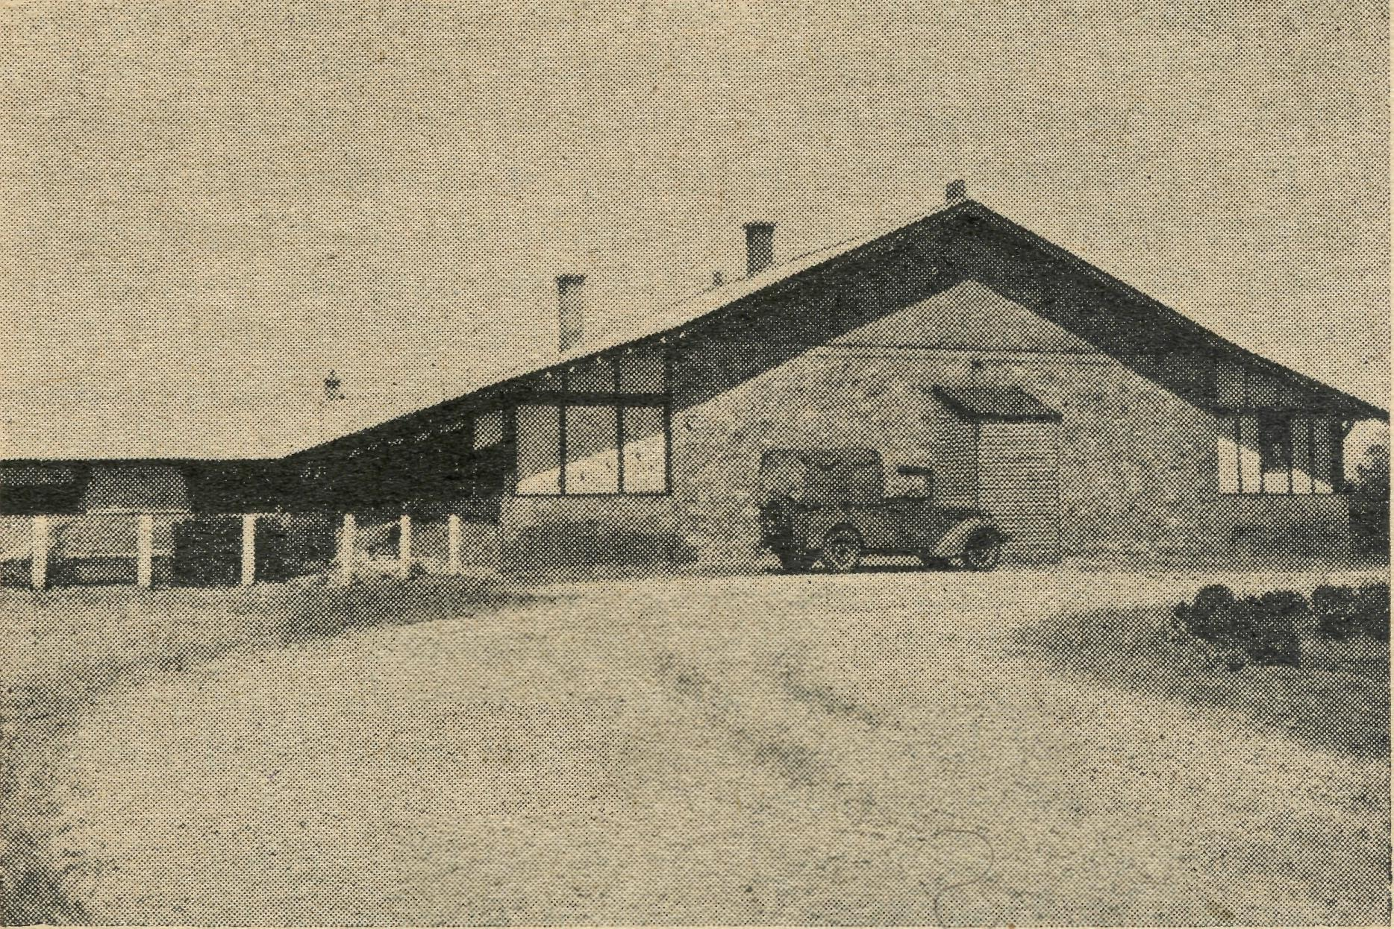
Wudinna Hospital.
grass and water laid on. So my course of disillusionment commenced. The Medical service is supplied by a doctor and his wife (also a doctor) and by the hospital staff, who with ancillary aids such as X-ray and pathology equipment and the operating theatre, pass on to the men and women over a wide area, the benefits of modern medical science.
At Minnipa, 25 miles away is the local B.C.A. Mis-sioner, and it was in company with him and the doctor that I was introduced to the Murat Bay District Hospital at Ceduna, a further 110 miles westward. The introduction was somewhat clouded in dust, but after a trial of the white porcelain bath and the gleaming h. and c.
taps, the outlook was not nearly so murky. It was then that I realised the proximity to the sea—what appalling ignorance!—but somehow that section of geography had always been covered by the words "Great Australian Bight" and left at that. Here again was a well-built structure, housing 14 patients without bulging! When the packing commences, there are untold possibilities in the verandahs. The operating theatre and X-ray equipment complete the picture of the modern hospital—or do they? What about the staff? Here again the staff has been supplied by the B.C.A. or rather should it be said that God has called certain persons to serve Him as workers under the auspices of the BCA. Probably one of the strongest impressions made on me was the devotion df the workers not only to their Society, but more especially to their Master. And that devotion is being carried into their daily life be it in the wards or the kitchen or in contacts in the town. The ultimate and inevitable result is that men and women are not only regaining their physical strength, but many are finding for the first time the possibilities of a spiritual re-birth. Are there many? No, but there are some which indicates that the hospital is fulfilling its primary purpose which is more than that of a philanthropic organisation—it is an agency for the spreading of the good news of our Saviour and Lord to the people who have not the benefits of regular worship, as the city folk. Here again the medical side is conducted by a team of husband and wife who operate the Flying Medical Service as well as maintaining the practice in their own town.
From Ceduna a trip was arranged to fly to Cook, which is on the Trans-Continental Railway Line about 220 miles in a roughly (very) north-of-westerly direction. The initial stages of the journey were interesting to one who had never before left terra firma more than momentarily, but when the pilot remarked that on the final 80 miles of Nullarbor Plain there was nothing to see, his passengers having realised the accuracy" of his words, succumbed to Morpheus and went to sleep. Which reminds me that the B.C.A. owns its own plane and this plane requires regular maintenance and piloting. These duties are carried out by a man for whom I developed the highest regard during my ten days in Ceduna and my 11.00 miles as his passenger. To maintain such a machine is difficult enough but to fly it for years without mishap is a record, giving great credit to himself and considerable comfort to his passengers.
And so to Cook! My picture, if I had ever tried to imagine such a place, was a dry flat plain. It was certainly flat but far from dry on our second visit. It was then that I was entertained by one of those rare treats when things don't run to schedule. With one wheel of the undercarriage stuck firmly in the mud, our three travellers left the machine and pottered back to the hospital through the biasing heat. The townsfolk, with the aid of "Cocoa", the town's horse, and many cheering kiddies, pulled the machine from the mud and towed it ignominously tail first back to its hangar. This meant a delay of a further 18 hours and illustrated the possibilities of the unexpected and the protective Hand of God. It is good sometimes to see a new place when things don't go quite according to plan. A week prior to my appearance a strong wind had hit the little wood and iron church at Smoky Bay. When I first saw it, its

THE REAL AUSTRALIAN
April, 1947

roof had jumped a nearly fence and was spread in a narrow strip for a hundred yards up the next hill. This meant work, volunteer labour, to collect the bits and stack them together. All that remains now to be done is to rebuild the church! and until then some makeshift must be instituted.
The hospital at Penong was also visited, both by plane and car, being only 46 miles from Ceduna. Here again we have a theatre, but no X-ray equipment due to the lack of suitable electric power service.
The Lady Dugan Hostel at Tarcoola was the crowning experience of a most eventful journey. This institution consists of three rooms with a front and back verandah, and one of these rooms is the hospital ward, dispensary, casualty or labour ward, just depending on circumstances. The town is situated on the Trans-Continental Railway Line and is about 100 miles from Ceduna, the course being set over sand dunes which stretch to the limits of vision in all directions. These dunes run approximately East and West, and are covered by low timber, which of course would make any forced landing a calamity. Dotted here and there is a salt lake, which, but for odd periods of the year, would be quite dry. Tarcoola forced home upon me an impression which had been gaining in intensity—viz., the utter loneliness of some of these posts; yet the nursing staff will volunteer to go to such a place and go alone, without human companionship. Why? It cannot be just love of nursing or humanitarian principles, for they would not stand it more than a comparatively short period. The only explanation I can see, and they would tell you too, is a call of God to a converted life to spend at least portion of it as a witness to His Saving and Keeping Grace in this far corner of His vineyard.
To return to our young man who spoke so quickly and glibly at the introduction, this work is in need of men who will listen for a call, and heed it once they hear it. Any glamour in it will evaporate under the bleaching sun, but the knowledge that a man or woman is in the place of God's Will will compensate for those things that we feel we have left behind. In this work there lies a wealth of experience—how would our spiritual lives stand up to the strain of being for weeks on end without Christian fellowship? No squashes, no rallies, no church services even, except the ones we organise ourselves, no prayer meetings but our own—it is under such conditions that the mouse-like Christian develops into the man-like Christian. The experience gained and the increase in spiritual stature would stand any man or woman in good stead were they called upon at a later date to leave this particular sphere of service. "Consecrate me now to Thy service, Lord, By the power of grace divine; Let my soul look up with a steadfast hope, And my will be lost in Thine."
P.S.—Three weeks later—the N.S.W. Secretary: "I want four men for here and three deaconesses. I could do with a couple of nurses there and there. Why, if six men came into the office now I could have every one on his way to a job by this evening." The work is awaiting the response of real Australians and consecrated Christians.
Minnipa Mission
(Rev. J. R. Greenwood.) SERVICES OUTBACK
The person who has spent all or most of his time in and around the more settled districts of this vast Commonwealth finds it hard perhaps to visualise the conditions of the outback both in church matters and in communal life.
There are those who are more or less familiar with the orderly services conducted in the very helpful atmosphere of churches built according to the best ecclesiastical architecture. Others not quite so conversant with the interior of those buildings are nevertheless familiar with the external beauty of such places. If you are one of those people who are accustomed to worshipping God in the midst of beauty and having His House to remind you of His eternal presence, then think of your brother and sister who meet from time to time to worship in an atmosphere far different from that of a city Church.
In the large area of Minnipa Mission there are, at present, no Church buildings. Here- at Minnipa the people have worked faithfully and patiently for some years to accumulate a fund to build a Church. Their efforts have been materially assisted by a generous donation from a friend in England. The only bar to the progress of the building is Government permission to proceed, plus, of course, the extreme shortage of materials. The Church of St. John exists only on paper and in the dreams of the local people. However, that will finally be overcome, and the hope will eventually materialise. The people of Minnipa, like so many of the bush dwellers, make use of the local hall for services.
It is a tribute to the ingenuity of the members of this congregation that once a fortnight the hall becomes in many ways a Church. All the externals are present so that at least those present have no doubt in their minds that church service is to be conducted. The previous night may have been picture night, or a dance may have been held. After these functions, with the hour somewhat late, often a few of the faithful members will set to work and erect their very portable Church. If, on the other hand, they have not attended the particular function, it behoves the missioner to collect help at an early hour and have the arrangements completed for the conduct of Divine service.
When the hall is used for all secular functions, it is necessary to have some equipment to remind the assembly of the particular reason for meeting. Fortunately the Minnipa people possess a particularly good hall, and so, apart from the inconvenience of arranging and then storing away the church furniture, the lack of a Church building is not quite so acute. At the same time, it does place a very heavy burden upon those who have borne so long such inconvenience.

When Making your Will Remember the B.C.A.

April, 1947
THE REAL AUSTRALIAN

Besides the township of Minnipa there are 20 other places to receive the ministrations of the missioner. The Word of God goes forth to an area of some 40,000 square miles, which includes large tracts of territory in the sheep station country stretching from here to the country North'west of Tarcoola. Amongst the farming country of the West Coast there are about 17,000 square miles of territory where isolated homes are scattered in some of the most inaccessible places. In these remote homes are souls to be reached with the glorious message of redeeming love through Jesus Christ Our Lord. Their opportunities are not so prolific as their brothers in more populated areas. But can we deny them the knowledge which means so much to every believing Christian? In the hospitals are opportunities to witness for Our Lord in a ministry both to body and soul. The hostels for children present a unique opportunity to present the Christian form of life to those at the most impression' able stage of life. To the missioner there come oppor' tunities in the most unexpected places to point men to the Saviour of mankind. It must not be thought that every person in the outback is sitting waiting to receive the Christian message. There are many disappointments and setbacks for the labourer in God's service outback just as much as there are for his brother in the city. But whereas the city ministry is in a more concentrated form, the bush ministry, so itinerating in operation, must find the servant ready to adapt himself to many and varied conditions.
The services, whilst upholding the evangelical tradition of the Church, nevertheless are presented in surround' ings which to the average person may seem peculiar.
The sun beating down on an unlined galvanised iron hall soon sends the shade temperature over the century so that missioner and congregation entering during the afternoon have rather a warm reception. It is not a very pretentious building, yet to the assembled people it is Church. There is no orderly, neatly robed choir to lead the singing nor yet even an organist to direct the music. The missioner arranges the furnishings which are transported from service to service per medium of the stalwart St. Patrick's Van. This mobile Church unit provides a valuable contribution to the ministry of Word and Sacraments in the outback places. The vestry is the rear portion of the hall commonly called the Supper Room. The service proceeds with the missioner adding to his duties that of organist as he supplies the accompaniment to the hymns on the piano of rather doubtful age, and more or less in tune. Around the hall there hang the drapings and decorations of various dances tattered and torn in the passage of time. The flies soon realise that here is a happy hunting ground and add their drone to the heavy atmosphere. The whole place is not very conducive to worship, but yet is the place where the eternal message of God is proclaimed and therefore a hallowed place for that time.
Later that afternoon another congregation assembles, this time in a little weatherboard school twenty feet square. It is a time of special note, as a young baby is to receive the sacrament of Holy Baptism. The view from the windows is hardly an uplifting nor yet inspiring sight. The neighbouring paddock has not responded to the rains after devastating drought so that a stretch of sand drift greets the eyes of the congregation. The burning sun adds to the glare and makes the weather' board building resemble the interior of an oven prepared to greet the weekend roast. Here once again the secular surroundings are to a certain degree put into the back' ground as the portable Church is arranged. The con' gregation squeezes into the. small desks which in many
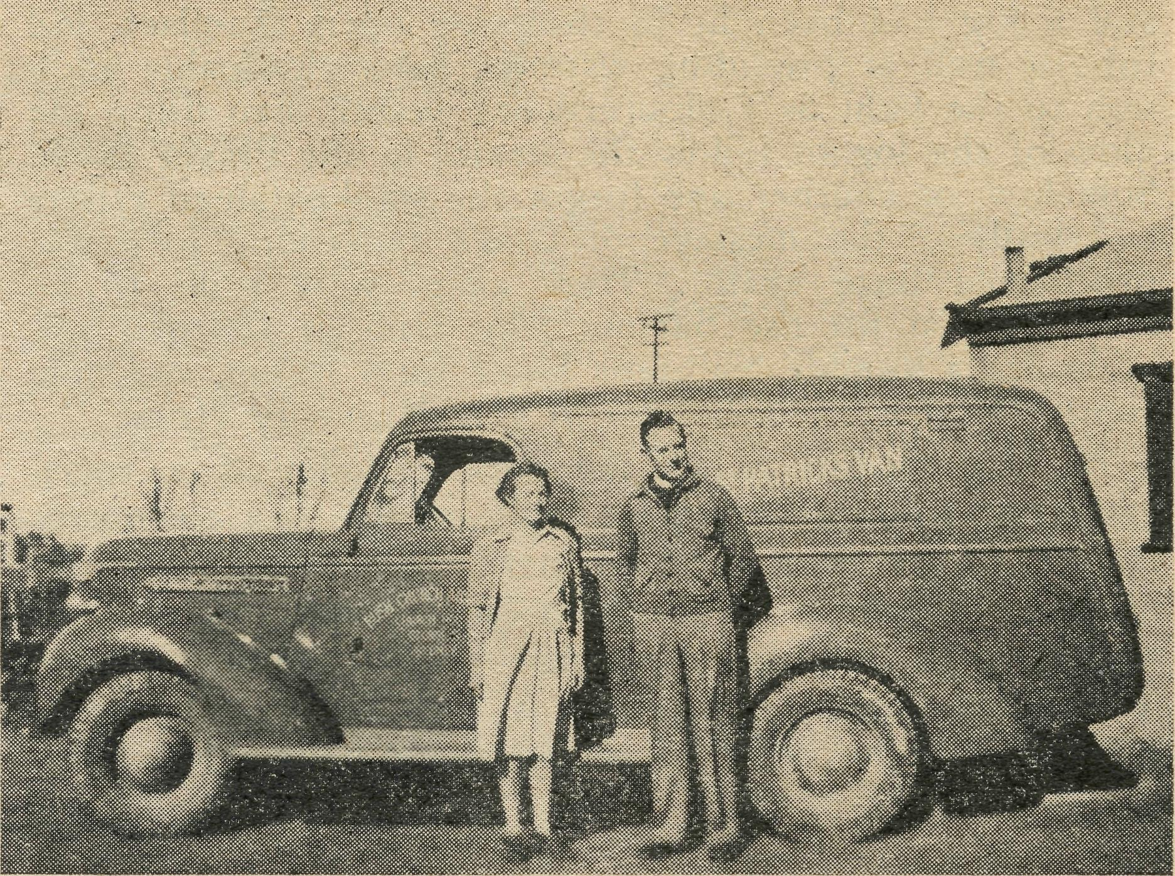
The Rev. and Mrs. J. Greenwood abou! to set
out in their caravan on a 1000-mile patrol of
the Parish.
cases were outgrown quite a few years ago. And so amidst the instruments peculiar to an ordinary day school worship is offered to Almighty God. The blackboards, maps, charts, pictures and even the smell of chalk cannot let us forget the usual function of that building, but here for a brief portion of its life that place becomes a hah lowed place. The singing may be a little discordant, but what is that to Him who judges the heart and not the outward form. Until recently a very ancient fold' ing organ served to provide the background for the hymns, but unfortunately age has waged a decisive war, and after totally collapsing the instrument has reluctantly been retired from service. Until something in the way of a folding organ is procured the services where no piano is available will have to be unaccompanied.
The public hall and the school each make their con' tribution to the bush Church. But there is yet another place which makes a very valuable contribution to this work, and that is the home. In some parts of this dis' trict there are no halls or schools available, so the people arrange to have the service in their homes. Once a month about twenty people assemble in one house or another, each taking their turn on a roster system. For the most part, the homes are not very pretentious places, consisting mainly of galvanised iron lined, if at all, usually with hessian or thin boards. In one such home recently a service was conducted which was attended by twenty two people. Out in the farm yard were assembled a collection of trucks and cars of ancient vintage, which had carried the congregation to the monthly service. The house was a simple structure with no claims upon architectural beauty, the whole place being constructed of galvanised iron and entirely unlined in the interior.
However, the full ccoperation of the mother of the home was given, and soon the livingnoom was made to resemble Church. This stalwart mother of ten chih dreri carries out a tremendous task with calmness and assurance and would not let anything prevent her joining in the worship and fellowship of her Church.
The flickering kerosene lamps revealed a collection of sincere bush folk gathered to worship God, no matter what the surroundings may be. In the dim light they peered at the hymn books as the words of welhknown hymns were supported by the piano which occasionally caused a discord with a flat note. It was a cool night

THE REAL AUSTRALIAN
April, 1947

and a log had been lit in the large open fireplace and this, as well as providing warmth, gave a valuable addi-tion to the light as I observed one young man using the glow of the log to follow the service in the Prayer Book. Somehow or another one forgot the smoke-stained rafters and walls as the message of God's redeeming love was proclaimed once again. Here again were souls to be fed and won for the Saviour who Himself adorned and beautified a humble Nazarene home for a season, and now awaits His faithful followers in His Heavenly Home.
At the conclusion of the service followed a social gathering around the supper table, as this is a customary feature of evening services in the bush. The warm' hearted fellowship of such people proves helpful in setting forth a ministry peculiar to the country places. The outer curtain of reserve is torn aside and one is given the opportunity of seeing these people in a new
light which in the ordinary way would perhaps be denied.
So it is that day by day the people outback are reminded of God's love and are called upon to give Him their life. This constitutes a challenge to those who profess and call themselves Christians. Jesus Christ died for all men and not just for one particular section of the community. We cannot afford to let this work lag and become ineffective, as there are other powers always anxious and ready to assail the hearts and minds of the outback. The need of men and women willing to sink self is ever great, and becomes more and more pressing as the days pass. But for the fact that God is able to supply every need the task would seem too stupendous to be performed by man; because of this we can thank Him for the many blessings vouchsafed.
N.B.—An organ has been given as a result of a broadcast over Station 2GB. (Editor.)

N.S.W. Secretary’s Letter

Since the last issue of the "Real Australian" we have been given much cause for thankfulness to Almighty God. The Christmas Appeal reached a total of £462, which enabled us to meet many special commitments, and above all, to send out over 1500 books, Bible pictures and other gifts to the children in our outback homes and Sunday Schools.
The Rev. Theo and Mrs. Hayman volunteered to serve with B.C.A. and are now at Streaky Bay in South Australia, where they are settling down to what I feel sure will be a ministry of real blessing to them and their people.
Miss L. Knox volunteered for service in our hostel work and she is now Matron of Wilcannia Hostel, where she and Miss Farr are doing a splendid work. We are grateful to Mr. Farr, too, for he went out for some weeks to help in that Hostel.
Sister Dorothy Robinson, of Sydney, has gone to Ceduna for several months to relieve our sorely pressed nurses there, who are desperately in need of their already far too long overdue holidays.
Financially too, we have cause for thankfulness. Although we ended 1946 several thousands of pounds short of our commitments, since then we have received some gifts which encourage us to believe' that eventually this debt will be removed. We extend our sincere thanks to the anonymous donors of gifts of £70 and £500 in recent weeks, and to other anonymous people who have sent smaller but just as much appreciated amounts.
The deputation work has met with a warm welcome wherever the speakers have gone. Many Young People's Fellowships, Sunday Schools, day schools, churches and other organisations have been addressed, and on every occasion there has been a most friendly and helpful atmosphere. B.C.A. certainly has a very large number of enthusiastic and faithful friends.
I extend to the Rectors, Churchwardens and Box Secretaries and all others who have helped in so many ways, the sincere thanks of B.C.A.
The weekly broadcasts, too, have proved a worthwhile means of spreading the story of B.C.A., and again it is the same story of friendly encouraging response.
But having said that with a deep sense of sincere gratitude to God and to our friends, I must add that there is another side to the picture.
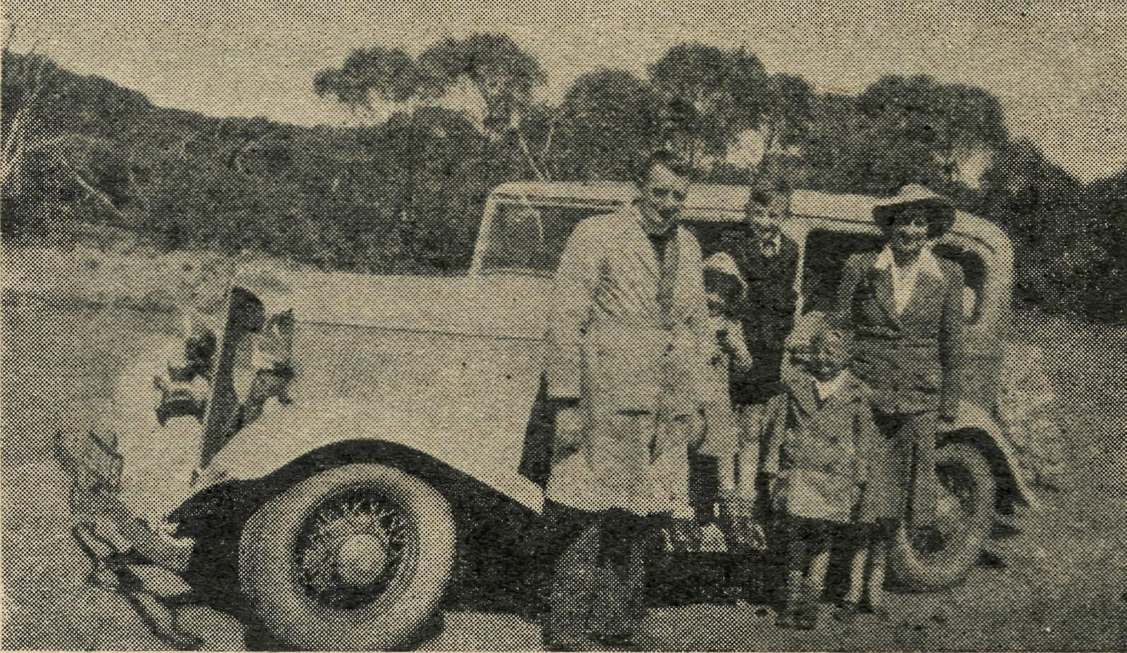
The Rev. David Livingstone with his wife and family.
B.C.A. is in really desperate need of workers. We simply must have at least four more nurses and four more missioners if our work is to be maintained, let alone extended. B.C.A. has done, and is doing, a really great work for the Kingdom of God and this nation, but in many ways we have only touched the fringe of the work. Very much remains to be done. Our missions, hospitals, hostels and Mail Bag Sunday School all must be extended if Australia is to be won for Christ.
B.C.A. commenced in a spirit of sacrifice, devotion and endurance. It has continued in that spirit. It must go on in that same spirit.
Therefore, I call upon all who have the Kingdom of God and the welfare of our people at heart to pray and work and give so that we shall be enabled to fulfil the task committed to us.
Pray that clergy will offer to work as missioners, pray that trained and consecrated Christian nurses will offer to go out to minister to the people of the outback in their need. And give as you are able, so that the expense of this ministry will be met as each need arises.
Then you and we together shall be one in the greatest need of our nation and our time, the winning of Australia for Christ,

April, 1947
THE REAL AUSTRALIAN

Port Lincoln Hostel
Sister H. E. SOWTER

Here at the beginning of another school year, I am reminded by our N.S.W. Secretary that the friends of the Bush Church Aid Society far and wide want to know something of what is going on and the work that is being accomplished at their Girls' Hostel in Port Lincoln. I say their hostel for I am not unmindful of the fact that it was their contributions which make possible this work.
First of all I would like to give you some account oi the happenings of last year.
We were unfortunate in the 2nd term in having an epidemic of Chicken-pox which meant weeks away from school for a number of students. In the 3rd term we were more unfortunate still, there being an epidemic of measles in a very bad form, and again it meant that all the girls who had not previously had the complaint had to stay away at least two weeks from school, just prior to examinations.
Fortunately the Hostel consists of two separate buildings and so I was able to isolate those who had not previously had measles, and also make a ward for the sick ones. However, I am sure our readers will be pleased to learn that all but one of our Intermediate students were successful, most of them obtaining six or seven subjects, some with credits. We are also very proud of one of our 2nd year students who gained highest number of marks in the State for "Home Science".
At the end of the year we were sorry to say good-bye to a number of the old students, some to continue in Adelaide, others to go into positions elsewhere.
At a break-up party, at the end of the year, we were glad to be able to have with us the parents of several of the students who were spending a few days in Port Lincoln.
The Hostel's second Birthday was celebrated by a launch picnic to "Boston Island." This very lovely spot has an area of some 4,000 acres and is situated in Boston Bay. Much to the delight of some of the girls who had not previously been on a boat, this trip necessitated about four miles in the launch to the landing. All spent a very lovely day and in the evening were privileged to see a most wonderful sunset when water and sky alike were turned to a dazzling, shimmering gold. ■
1947. Here we commence our school year with a full hostel—-twenty-nine students. A number of the
students arrived on the Friday prior to the school openings on the Tuesday, as the rail bus only runs from the far west coast once a week. Monday the 10th was all hurry and bustle, that being the day most of the students arrived. Old girls, fourteen in number, all showed excitement to be back and meeting old pals again; new ones, shy, wondering what hostel life would be like, nervous of commencing High School and meeting new teachers, etc. However, it does not take long to make new friends and for every one to fall into line, and for old and new alike soon to feel quite at home, and, I think, happy.
Mr. Johnson, Headmaster of the High School, whom we are always pleased to have with us, came along in the evening to make the acquaintance of his new pupils by joining hands with them on the back lawn, and then entering his name in the visitors book, followed by all the Hostel students enrolled for 1947, and thus we begin a new school year. Those in charge of the work ask for God's guidance and the prayers of our B.C.A. friends, that this work be done according to His Holy Will.
The following few lines of verse are a hurried attempt by B. Dansie, one of the girls.
HOSTEL PERSONALITIES
Matron Sowter is in charge,
Of girls both old and new. The Hoppings,—Colleen, Thelma and Marg.,
Are most of the Tumby Bay crew.
Studious Yvonne tops the list,
Of the Prefects at the school. She's sweet sixteen and never been kiss'd,
And her's is a very firm rule.
Next on the list is Doris A,
A girl both witty and wise. Then Betty and Shirley have their say,
As well as the girls with four eyes.
But let's not forget our Melva,
The eldest one of us all, Who beat the best in D.A.
She "showed them"; short, fat and tall. There are many more of us, too,
In the B.C.A. Hostel this year, But I can't introduce all to you
Because this poem's too short, I fear.
Beryl Dansie.

A Headmaster Speaks
(The following letter has been received by the Society)

Perhaps you would be interested in the impressions 1 have formed of the work of the Girls' Hostel at Port Lincoln, sponsored and administered by your B.C.A. Society. I am Head Master of the school here where these girls attend, and thus am perhaps qualified to speak on the matter, after two full years here.
I have been honored as a visitor on several occasions, I see the girls at school daily, and I believe I have the confidence of the Matron. At the outset, I can assure you that the Hostel does fill a real need, and has become no longer a luxury, but a necessity, invaluable and indis-
pensable. In a tourist holiday resort, accommodation is always at a premium, and the great majority, if not all, of the 25-30 girls at the Hostel would, in its absence, be denied the opportunity to attend here, as other board and lodging is quite literally almost unobtainable.
The reasonable charge made to the parents places this advantage within the reach of many, who, being farmers in difficult areas, could not rrreef heavy boarding-school fees for their daughters. This makes the whole proposition a very practical, while still idealistic, service to the people in the area: It is this community service, a prac-

THE REAL AUSTRALIAN
April, 1947

tical meeting of an obvious need, with no stress on the necessity to budget for financial gain, which is the crux of the matter, and which has made the strongest impression on me.
Matron Sowter puts into everyday practice her Chris-tion ideal, is solicitous for the welfare of her wards, while insisting on discipline and order, and she has earned and retained the respect and the affection of the girls under her care.
At the school, my staff concur in my own opinion, that the group of girls from the Hostel can be recognised by their happy dispositions, their freedom from school disciplinary troubles, and their general deportment and conduct. Many of our prefects and house leaders are drawn from the senior girls at the Hostel.
My Senior Mistress reports—"I think the Hostel has done a grand job, and is doing magnificently in moulding of characters. The whole thing is worthy of the utmost praise. Some weaker sisters sometimes resent a little discipline, but this does not retract from the splendid over-all picture."
In effect, Sir, the success of the enterprise has only thrown into stronger relief the urgency of the need of a similar institution for boys. All the contributing factors in the present scheme are just as vital in the case for boys.
The Rev. Mr. Jones, of your organisation, has gone so far as to say that he is so impressed with this need that he would be prepared to recommend the immediate purchase of a property for this purpose, if we could find a suitable property. We have not thus far been able to find such a property, as while there are several possibili-ties, the owners are not at the moment prepared to sell.
We have so much admired the results of the establishment and work of the Girls' Hostel that we are most anxious for its continuance, and for the opening of a similar home for boys.
Visitors
MISS R. CAMPBELL
When we city folk wish people to visit us, we invite them on a certain day and time, and forthwith make preparations to receive them. Not so in the "outback"; visitors often arrive unannounced and uninvited, yet rapidly fit into the daily routine and become "one of the family". There is one thing in common to visiting at either place—-the welcome.
Suppose yourself to be a housewife out on the Nullabor Plain, S.A. A wire comes from further along the Trans Australian Railway line, asking for "shake down" hospitality for a night for someone of whose existence you are unaware. Yet there is one vital point of contact— the Bush Church Aid Society. This name assures a traveller of many open doors in the "outback". A city person might ask "Isn't there a hotel or boarding house?" Such luxuries are hundreds of miles away, there is not even the shop down the street for extra provisions; the only accommodation available is in the Railway homes. The Nullabor housewife thinks to herself, "Even a 'shake down' bed is impossible in my crowded household, with six children, but I could provide the meals, if someone 'would offer a bed." The woman next door says she will top and tail two of her children in one bed to give hospitality for the night. "But both ask "Why would anyone want to visit out here?" Certainly it would not be the local sights. They are the same anywhere within
hundreds of miles. Perhaps the answer is to be found hidden in the meaning and purpose of the Bush Church Aid Society.
In the "piccaninny dawn" the fast goods stopped and a sleepy visitor climbed down on to the permanent wav and was taken over through the dimness to a house and a welcome bed. After a refreshing sleep and breakfast, the visitor was left to sit on the verandah and view the scenery.
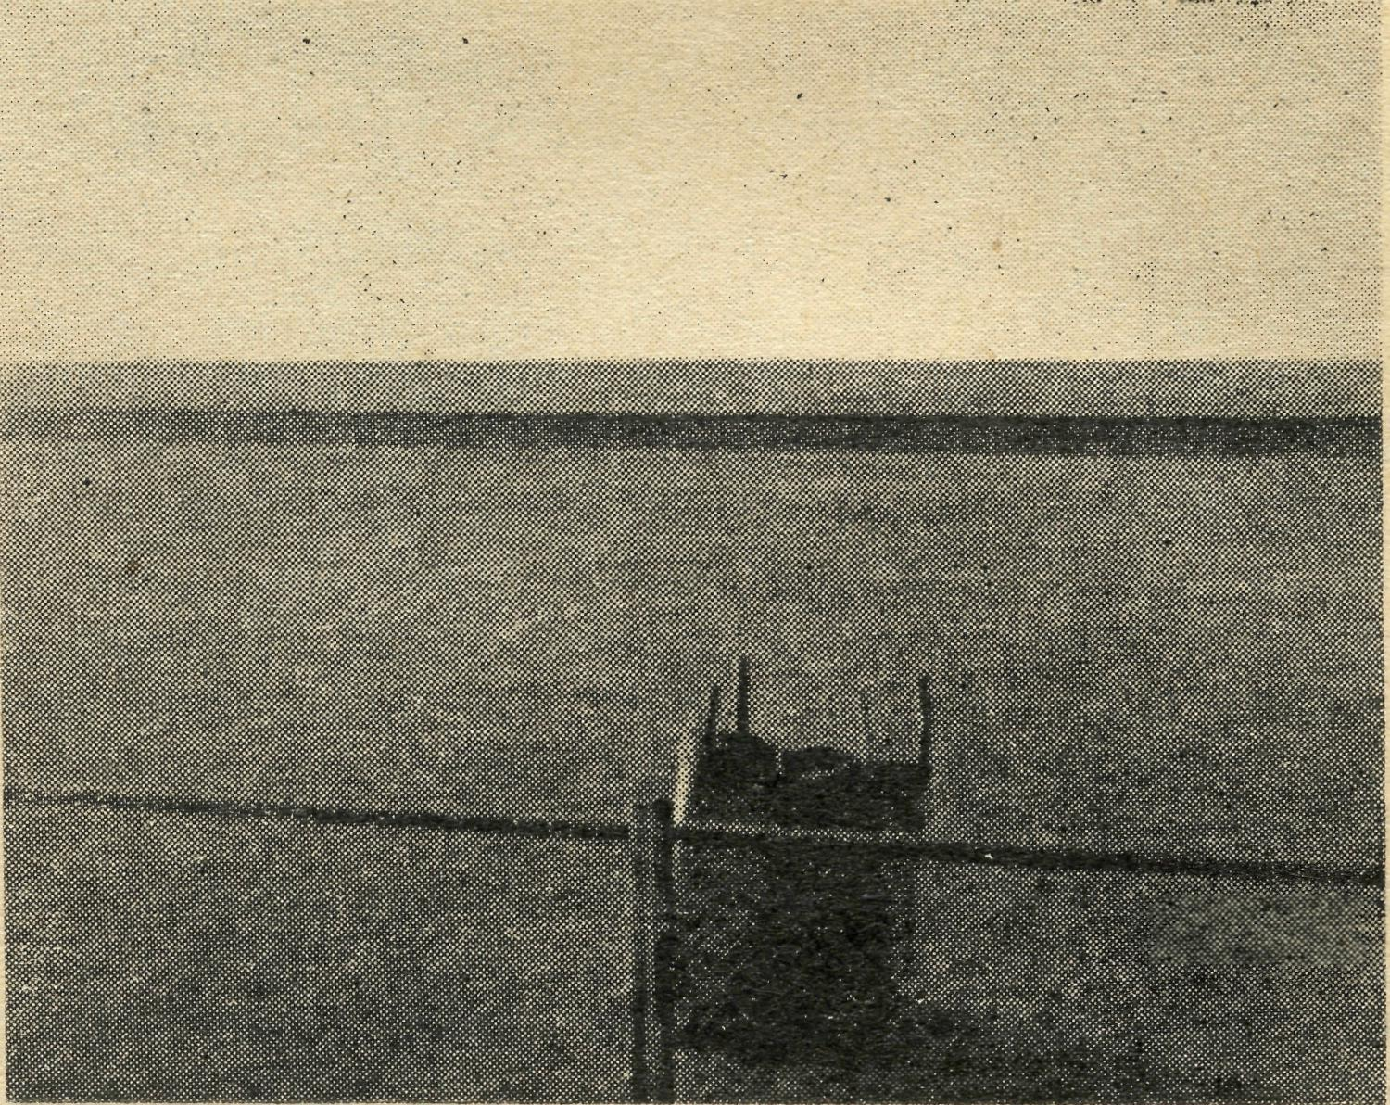
The View!
It took but little time to do so. Front and back the same wind-swept plain stretched out to meet the distant horizon. What a fascination it held! . Hours could be spent contemplating its vast emptiness. The truth of the Psalmist's words "The Heavens declare the glory of God", must surely have been inspired by splendour of colour and cloud formation such as one sees at dawn or sunset on that bare, treeless plain. The effect is awe-inspiring, leading naturally to worship.
Each of the dozen or so homes in the camp are of interest (not the houses, of course, for they are built to the. same design all along the line); it is the people who provide the interest. Every home is visited and friendly contact made. Mothers are told of Sunday Schools, also of a film service to be held. Most of the children and babies in the camp first saw the light of day at the Bishop Kirkby Memorial Hospital at Cook. Mothers express appreciation of the help and guidance of the Sisters there, and send them messages about the progress of their children.
The children in these camps receive Religious Instruction once in three months, when our Missioner goes along the line, otherwise their Religious Education is carried on by means of our Mail Bay Sunday School. Lessons are sent from Sydney to Cook, S.A., and distributed from there to the various families interested. The Sisters cannot leave their work at Cook to follow up these lessons and discuss difficulties with the parents, so when a Sunday School visitor comes many problems are ironed out.
Life holds little colour, variety or excitement for the children of the Nullabor, so real Sunday School is an event not to be missed despite religious views held by parents, or on what day in the week it may happen to be. Along the children come to the little one-roomed school house, well washed, complete with best clothes, and a penny! The children are friendly, and once the first shyness has worn off they are very responsive; rarely does anyone come especially to see them, so there was no half measure about their welcome, or the joy with which

April, 1947
THE REAL AUSTRALIAN

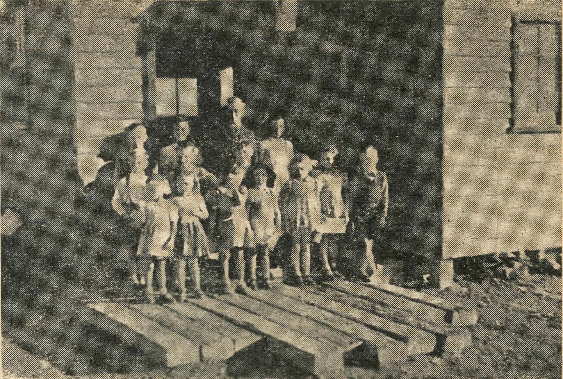
they looked at, or read, the Bible story books before the lesson period began. Their ages ranged from 18 months to 14 years, for there are no children on the line above school age as there is no opportunity for higher education or employment. The singing was hearty though limited in variety, from lack of regular teaching; attention at prayer time was always quiet and reverent, while interest in the Bible story and expression work was all any teacher could wish for. Each child took away some token of his artistic etforts, and reminder of the lesson in the form of a text or coloured outline picture. Finally, faces were wreathed in smiles when a camera was produced.
Some visitors can make rather extraordinary requests, such as, for a 6 volt battery to be taken from the .wireless at home to the school room for a film service. Some' times this request would arouse no enthusiasm at all among the male population, so the indirect method was used effectively—the children were told they would be shown pictures if they could find a battery!
In the evening almost the entire camp would turn out to see the films, we sang hymns unaccompanied, short films of other parts of Australia were shown, then those of a religious nature, to remind parents and children of the care of God the Heavenly Father, and the friendliness of the Lord Jesus Christ.
On the way home from the service people readily discussed the subject of the films and expressed their appreciation of the Bush Church Aid Society's efforts to help them.
A Saturday afternoon "Sunday School'' on the Nullabor Plain.
Later, in the stillness of the night one of the railway men would rattle on the door and say ^{u}She will be here in about twenty minutes!'¹ While hastily dressing, one could see away in the distance the headlight of the train which was to take the visitor on to the next camp.

The N.S.W. Secretary Visits Rappville

At the beginning of this year I paid a visit to the mission at Rappville in northern N.S.W. in order to see the work of the mission and to give lantern lectures and talks about the history and work of B.C.A.
After a twenty hour journey by train, I was met at the station by our missioner, the Rev. R. Meyer, and was soon enjoying a most welcome cold shower.
Rappville itself is a small village set in beautiful forest country. The green paddocks and tall spreading trees were a revelation to me after the endless, dry, treeless plains of the Far West. Although the village itself is small, it is only 20 miles from the excellent town of Casino, so shopping and other activities do not present the difficulties so familiar to many of our other missions. However, there was plenty of evidence of the recent drought. The cattle looked poor and thin, and as I travelled through the parish, I heard many stories of severe losses, stones only too common throughout B.C.A. missions.
Rappville is the most fortunate of all our missions in that it possesses a number of churches. As I went from church to church I could not help thinking of a mission like Minnipa, which has 20 centres and not a single church building.. At Rappville itcelf the church is a small wooden building suffering badly from the inroads of white ants. At York Lea, another of the 14 centres, the church is almost a total wreck from the same pest. Ellangowan Church, on the other hand, is a good, welb cared for little building. This centre was a particular interest, because it was the home of Mrs. Connell, and it was a pleasure to meet her relatives and friends.
Hogarth Range is beautifully situated but there the people have to worship in an open weather shed, The
congregation here is most grateful for the gift which has supplied the means to erect a church of their own.
At Mongogarie, another beautiful district, I saw the small cottage which has been purchased to provide a centre of worship. When the necessary alterations are made it should be very suitable for this purpose.
During my visit, very heavy rain fell, again in marked contrast to other missions. At Boylestpn, a storm burst while we were waiting to commence a lantern lecture. The rain was so heavy that it burst into the hall from every direction! It was impossible to get proper shelter. Some children hid behind the piano and gained a little protection. For half an hour we felt that we were in a sinking ship as streams of water drove through the roof, windows and other apertures. I have never seen any thing like it.
Heavy rain and storms also caused damage to the Rectory when the roof leaked on several occasions, and Mrs. Meyer did not find housekeeping easy. Living in B.C.A. missions is always harder for the wives than for the missioners, for every woman likes to be able to keep her home as presentable as possible. In this case, it was rain that upset the home. In most other missions the ever present dust makes housekeeping difficult, and I find it hard to decide which is worse.
It was most gratifying to hear the parishioners' expres-sions of satisfaction with the work of the missioners and I gladly conveyed a measure to that effect to the Council of B.C.A.
It was a real pleasure to hear of the blessing received by many souls in the mission, and I left with the impression that yet another needy corner of Australia is being Won for Christ through the ministry of B.C.A.

THE REAL AUSTRALIAN
10
April, 1947



Together with others we are glad to know that our President The Archbishop of Sydney has completely recovered from his recent severe illness, and extend to him our good wishes for the future.
. # # * #
The Rev. Tom Jones, our Organising Missioner, continues to have a successful ministry in his visit to the Old Country. He has visited many parts of England, where he has addressed many gatherings and made numerous contacts. Recently he was in Belfast and Dublin in Ireland, where he preached at the Cathedrals, and he has also been to the Isle of Man.
# # #' *
Hearty congratulations are extended to our N.S.W. Secretary on his success in obtaining the Australian College of Theology diploma of Th.Schol., and to the Rev. Leon Morris, BSc, B.D., Th.L., Vice-Principal of Ridley College, Melbourne, formerly a B.C.A. Missioner, on his attainment of the degree of Master of Theology of London University.
# # # *
Friends of the Society will be interested to learn that the Dragon, the second medical aeroplane which was purchased last year, will go into service soon, as the hangar in which it will be housed at Ceduna is almost completed. The Fox Moth will then be stationed at Wudinna.
# * # *
Both Sister B. Bossley and Miss D. Dykes have undergone major operations recently, also the Rev. D. H. Wicking, all members of our field staff. We extend to them our good wishes for complete recovery.
# # * * '
A Prayer Meeting for the work of the Society is held in St. Andrew's Cathedral, Sydney, in the Chapel on the first and third Monday of each month at 1.20 p.m. All friends are invited to attend.
# # # #
In January the Rev. K. Luders completed his ministry at Wilcannia, where he has rendered yeoman service. He has been a Missioner of the Society since 1936, serving at Kirton Pt. (S.A.), Rappville (N.S.W.), and Wilcannia. His work under the Society has been of a high order, and we wish him and Mrs. Luders God's rich blessing as they leave the B.C.A. ministry to begin their new work in the parish of Culcairn-Henty in the Diocese of Riverina. They will long be remembered for their fine Christian witness, and devotion to their task.
# # # #
We have learned with regret of the death of Mrs. A. A. Bragg, who was so well known in Christian circles, and who gave such a splendid life of service to her Master. Mrs. Bragg was one of the two women present at the inaugural meeting of the Bush Church Aid Society in the Chapter House on 26th May, 1919. She was also a keen member of the Women's Auxiliary, and was ever interested in the work of the Society. Our sympathy is expressed to the members of her family in their great loss,
Various aspects of the Mail Bag Sunday School department have been reorganised recently, and further
improvements are being planned.
# # # #
We offer our congratulations and good wishes to the Rev. L. H. A. Broadley on his appointment to the charge
of St. John's, E. Willoughby, Sydney.
# # . # #
Miss E. M. Simpson, who has been cook and housekeeper at Penong Hospital, has now relinquished this work, and her place has been taken by Sister Woodings,
whom we welcome into the B.C.A. family.
# # # #
Recently Miss A. Toye passed away at an advanced age. She will always be remembered as the first person to be Matron of the Wilcannia Hostel in succession to
the Rev. and Mrs. F. W. Harvey.
# * * *
Deputation Visits. Our N.S.W. Secretary, the Rev. David Livingstone, has visited the following parishes on deputation work in recent months:—Burwood East, Chats-wood (St. Paul's), Campsie, Coogee, Cremorne, Dul-wich Hill, Earlwood, Greenwich, Kiama, Kensington, Kogarah, Longueville, Waverley (St. Barnabas'), Mosman (St. Clement's and St. Luke's), Neutral Bay (St. Augustine's), Narrabeen, Pennant Hills, Rockdale, Roseville, Roselle, Ryde, Summer Hill, Sydney (St. Michael's), Wahroonga (St. Paul's), Port Kembla, Langlea, Concord North, Auburn.
# # # #
We are grateful to those who have responded to our Appeals for Gifts for the work. Recent gifts have been a folding organ, hospital equipment, a sewing machine, and a wireless set. A Sewing Machine is also needed for Wilcannia Hostel. Enquiries have indicated that one may be obtained at Broken Hill. Some of the friends of the Society who are especially interested in the Hostels may care to send donations towards the purchase of this. Also,
the Bowral Hostel is in need of a Dining Room Clock.
# # # #
Hymn Records are needed by the Rev. J. Greenwood
for his work in Minnipa parish.
# # * #
The Matron of Coorah Hostel at Wentworth Falls is grateful for the Harvest Festival gifts that were sent to the hostel by the church at Blackheath.
Hogarth Range. The amount that was appealed for to enable a church to be built at Hogarth Range has been exceeded in the splendid response that has followed. In addition to the money raised by the Women's
Auxiliary, gifts were received from England.
# # # #
Gifts are still needed to enable the people of Tibooburra to reach the total objective required to build their church. Also, in the parish of Minnipa there is great need for places of worship. There are twenty-one centres without a single church building! The town of Minnipa has money in hand to build a church when circumstances permit, but there is no provision for the other centres.

April, 1947
11
THE REAL AUSTRALIAN

The New Year at Bowral
Deaconess N. DIXON.

Another year has begun at the Hostel. Our family totals 16 High School girls so far this year, six of whom are new. Several weeks having passed, the girls have settled into the routine of both school and Hostel, and are happy.
A new girl came to me the other night for something, and said, "Oh, Sister, I am so happy here¹'—quite a spontaneous remark which was good to hear. Ping Pong, etc., has been popular in between duties and home work to help some over homesick periods, when there are no letters and so on.
Four of the girls have taken their stand fox Christ, one last term, and three this year, which means God is wonderfully answering prayers.
The Hostel grounds and vegetables are looking well, thanks to having help now. We do thank God for the recent rains which were a real blessing.
While we have now obtained some of the things we have needed so very long, we still have some things to get. Should some one be able to spare a sewing machine for here, I should be grateful. At present the girls and myself have to visit neighbours to do any sewing. I should also like a wireless for the pleasure of the girls, at week-ends particularly.
Books of course, are a great source of pleasure, and I thank book donors for those we received, and ask for more, when possible.
Will you all continue to pray for the B.C.A. family in Bowral, that much blessing will result for the Kingdom of God?
N.B.— Since the above was written, a sewing machine has been given, and a wireless set has been promised. Ed.

Highlights from Cook
Sister E. THOMAS

The activities for 1947 commenced at Cook with a New Year Service as the old year passed into history, eighteen people being present at this service.
Unexpected things often happen, even on the Nuh larbor Plain, and during January a call came from about 300 miles away to say that a woman was rather ill at this small camp and could I possibly leave Cook, and, travelling on the express, which had already arrived here, accompany the patient to Kalgoorlie. Immediate action was necessary and after making a few hurried prepara-tions, I found myself on the train and after travelling about nine* hours reached the small camp where the patient was waiting. Arriving at our destination about 11 a.m. the next day, the patient was soon in hospital and surgi-cal treatment was necessary at once, the patient making good recovery. The next day I spent in Kalgoorlie before catching the next East-bound express on the 550-mile trip back to Cook. This is just one of the many jobs one is called upon to do, and it is a privilege to be able to serve in such a manner.
We, on the dry Plain, have had a good share of rain lately, more than our share to be exact, for at times the same dry Plain has been one large expanse of water, even to the extent of delaying trains for about 24 hours when a stretch of the line was under water. Rain water tanks are full, and the gardens benefited greatly and no damage was done. Even the Medical Plane from Ceduna
was delayed on the last trip, having to wait here an extra day till the weather became fine enough and dry enough to take off.
A fortnight ago, a Harvest Festival Service was arranged, and Mr. Collins of the Tarcoola Mission conducted the service. There was a good display of gifts, which were sold next day, the proceeds being for B.C.A. funds. We were reminded once again that the harvest shall never fail and that the Lord will provide.
Recently the ladies of the town, at their own suggestion, formed a Hospital Auxiliary and are keen to help in any way possible, offering to help in any emergency, and it is good to know that there are people whom we can call on for aid should the need arise.
The Women's World Day of Prayer service was held on February 21st, when we combined with many others in worship and adoration to a loving Heavenly Father, and we pray that much may be accomplished as a result.
The work here goes steadily on, the attendance at Sunday School and services have not been quite so good of late, due to the numbers on holidays, but the interest is good. The young folks are keen on coming to Bible Class and are keen too on their half hour a week in the day school. Please continue in prayer that the seed sown will one day bring forth fruit in the hearts and lives of these people among whom we work, and so, we confidently press forward, "looking unto Jesus .

SOUTH AUSTRALIAN LISTENERS !
Uunc in to--
5 M.U. 5 A.D. 5 P.I. 5 S.E.
on Sundays, at 9 a.m.

THE REAL AUSTRALIAN
12
April, 1947

The Parish of Denmark, W.A.
Mrs. C. H. SHERLOCK

"As you know our parish is a hundred miles long with 18 centres, so there is plenty to do, but being young it is all such an adventure. We are very happy and somehow the work grows on us. Denmark itself is quite a big town and here alone we could find plenty of Christian work, as there is a great need for spiritual things, but naturally each centre must be attended to. We have started a Young People's Fellowship and last meeting we had 30 (it being the third meeting) so we were encouraged. My chief work has been in the Sunday School, as I've taken over the complete school above Kindergarten age. A capable and enthusiastic lass of 20 has this section and really does a good job. I've given some assistance in teaching, having done a lot of Kindergarten work in Sydney, and she is keen to learn. We've added a girl of about 16 to assist with the practical work and meantime my husband and I have given her extra training in how to teach, so that with reading books on the subject, she'll be able to start teaching in a few months' time.
I love my youngsters—boys and girls of varying ages— I have 20-25 each Sunday and they seem to love their Sunday School. We have note books and stars for good work, as well as learning the catechism, so it all helps to retain their interest.
Each month we spend 5-6 days out at Walpole Mission, as this is at one end of the parish. During this time we visit and hold Church services in the different centres. The women do seem to love seeing me, as they do live quiet, simple lives, often very lonely. Our little son, though only 15 months, little realises the happiness he brings, as he readily goes to people and does help our work without knowing it. So God uses even our little child in all his innocence. Some people live in very primitive conditions, such as I never believed possible. Brave women seem to live and bring up families, and as well, assist on the farm. It makes my heart bleed to see it. The tragedy of it all is too, the nearest hospital is Denmark, 5 ^{s}) miles away, and no doctor, except a retired one at Nornalup—one village nurse, a married woman with her own family to attend to—so really they have very little medical aid. My husband is one of three voluntary ambulance drivers and in doing this very necessary work sees just how hard the lot of some people is. We both feel that if only B.C.A. could
send a sister to open a hospital at Nornalup, what a real godsend it would be. The people would feel the Church really cared and by such a practical help I am sure would more readily listen to Christian things. We both feel very strongly about this, and would be absolutely thrilled and thankful to B.C.A, and God for such a woman to come and minister to these people in their sore need. At Kronkup, about 25 miles from Denmark, there is a very enthusiastic body of church people, but like most centres, they are poor. However, their spirit and their willingness to give of what they have is outstanding. It took 7 years to raise £34 towards the re-erecting of a small church from Albany. Since our arrival, we've had the church removed and at present it is waiting re-erection on the land itself. Denmark Church Committee are lending £50 and our Women's Guild £20. However, they need another £50 to see the project through and there will be great rejoicings when the little church is paid for and used as a place of worship instead of the old tin shed at present used. The spirit of the women is wonderful. Though they have little they do what they can. We've had two American Teas and every woman made cakes and brought vegetables to sell, and we sold everything.
Our Denmark Women's Guild packed into our car and another car and brought their gifts. So it all helped. We have a Girl's Guild, which does handicraft, sewing, etc., at the home of the secretary of our guild, and they send a parcel of toys, bibs, pot holders, aprons, etc., all beautifully made and with the profits of which the American Tea was helped. So you see the people are keen, and though poor, do give of what they have and God blesses it all. I do find the Women's work very interesting. I was trained in our Sydney Teacher's college as a Home Science teacher, and little did I realise how God was preparing me for this missionary venture. The women love to talk about home and cookery, sewing, etc., so having it at one's fingertips and with modern ways, does help. Also I find a big work among young mothers and babies, as naturally they have little assistance from clinic when in the outer districts (though Denmark has a good clinic sister). Here too, I can help as I did the Truby King pre-natal and ante-natal course in Sydney, and also have the famous "Our Babies" book, so useful to us in training our little boy."

"AUSTRALIA FOR CHRIST"
BUSH CHURCH AID SOCIETY
THE N.S.W. SECRETARY OF THE B.C.A. REV. D. G. LIVINGSTONE
is available to address week night and week day meetings and to give lantern lectures on
behalf of the Society.
Phone: M 3164. Address—
REV. D. G. LIVINGSTONE, Bush Church Aid Society,
Church House, George St., Sydney.

April, 1947
13
THE REAL AUSTRALIAN

THE PLACE OF PRAYER
A Prayer for Use with Our Prayer List.
O Lord God of our nation, Who has commanded men to subdue and replenish the earth: Look in Thy love upon all who in the distant parts of our land are striving against many difficulties, and are deprived the access of the means of grace. Strengthen and guide the Bush Church Aid Society and its Clergy, Nurses, Doctors, and Air Pilot, and Students. Cheer and comfort them in discouragements and loneliness, and bless their ministrations to the good of those they serve, and grant that the message of redeeming love may thus be rooted and grounded in our national life, to the glory of Thy Great Name, through Jesus Christ our Lord. Amen.

SUNDAY.
THURSDAY.

MONDAY.
FRIDAY.
TUESDAY.
SATURDAY.
WEDNESDAY.
MORNING EVENING
Each day pray that the many needs of the work may
be met. Running expenses of £7 per hour to keep the Medical
Tlanes in the air. Consecrated clergy missioners and other workers for
urgent work in the field. That our work may continue to progress despite the difficulties of the post-war period.
MORNING
The Far West Missions at Penong, Ceduna, Min-nipa and Cummins; the Missioners, D. Pugh, J. Greenwood and P. Connell.
MORNING
The Cann River Mission, the Bonang Mission, the Streaky Bay Mission; the Missioners C. F. Withing' ton, D. H. Wicking, and T. J. Hayman.
MORNING
For Sisters Dowling, Miler, Gillan, Hitchcock, Holle, L. Loane, E. Fisher, and Woodings.
For the Bowral Hostel, Deaconess N. Dixon. For Theological Students of the Society in training.
For the children in" the Mungindi, Wilcannia and Port Lincoln Hostels, and for the workers, the Misses Cheers, L. Knox, Miss Farr, and Sister Sowter.
EVENING
The West Darling Missions at Wilcannia and Menindee; the N.W. Mai-lee, and the Missioner.
EVENING
The Denmark Settle ment, the Kirton Point Missions, and Missioners, Rev. C. N. Sherlock and Rev. R. T. Hallahan.
EVENING
For the Cann River Dispensary, and Sister Gwynne and Koonibba Mission Hospital, and Sisters L. Pritchard and H. Foster, and the Wudinna Staff.
For the Flying Medical Service, Mr. Chadwick, and Doctors R. and F. Gib' son, Dr. R. Roxburgh.
For the wives and families of the Missioners and Air Pilot.
MORNING
For the Mail Bag Sunday School with its Gos'pe messages for the children. For the Director, Miss R. Campbell, the teachers and helpers, that they may find encouragement * in their work.
MORNING
For the Bishop Kirkby Memorial Hospital and Sisters Thomas and Coleman, as they minister to the people on the great Nulla-bor Plain. For Sister Page and the Tarcoola Medical Hostel.
MORNING
For the President and Council of the Society, that they may be guided by His wisdom.
For the Home Base Staffs, Auxiliaries, and parochial workers.
For the N.S.W., Victorian and South Australian Secretaries.
EVENING
For the Organising Missioner, that he may be strengthened and guided in all his endeavours for the good of the work and in his relationships with his fellow-workers.
EVENING
For students and all in training for this work of God. For the Heytesbury Forest Mission, and the Otway Ranges Mission, and the Missioners, G. Mutten and T. H. Pickburn.
EVENING
For the "C oorah" Hostel and its workers, Mrs. Mann and Miss Stokes.
For the Rappville Mission and the Missioner, the Rev. R. Meyer.

Give Thanks—
For the rich blessing and wonderful growth of the Society's work. For all the kindly givers who have helped with their self-denials. For the Flying Medical Service. For the joy of service.

THE REAL AUSTRALIAN
14
April, 1947

Holidays and Work Days
Rev. P. CONNELL.

Yesterday, I received Mr. Livingstone's letter asking for an article for the "Real Australian¹'. There is really quite a lot to talk about as so many things have happened and are happening lately.
We, Mrs. Gonnell and I, have just finished our annual holiday. The first few days of it were spent in Port Lincoln. We mainly went there to have our teeth filled, as the travelling dentist who comes through here at intervals draws teeth and makes dentures, but doesn't fill. Well, he fixed our teeth and we were very glad of it. While at Port Lincoln we were the guests of the Church of England's Girls' Hostel at Kirton Point, a suburb of Port Lincoln. When we first arrived after a sweltering hot train journey, no girls had arrived and the hostel was empty as the High School did not start till the day before we left. However, Mrs. Hallahan arrived in the evening after tea with some girls who arrived early, so we slept at the hostel that night. We enjoyed Lincoln very much. It is a beautiful place and the harbour is, I believe, the third best in the Commonwealth, wide, deep, and almost land-locked. We found the Institute library a very good one. I looked for books on the Boer War, my favourite historical period. There seems to be a dearth of works on the subject.
We were only a day or two in Lincoln when the girls were everywhere, in every room and passage way. They began to arrive in numbers. There will be thirty residents at the hostel this year. They come from places hundreds of miles up the coast. The at' mosphere of the hostel is a very happy one. We had prayers on the last evening of our stay and felt that no anxious, loving parents need be worried about their children when living in the hostel. It was a very happy place. We are grateful to Sister Sowter for making it possible for us to be there. The Rev. Bob Hallahan, a very busy man, went out of his way to make us feel at home. He ran our baggage down to the train, as it was too heavy to carry from the hostel to the station. I found myself wishing we had been able to come to Lincoln a fortnight earlier. We couldn't stay any longer as we were due to stay in a holiday shack on a beach near Ceduna.
We arrived at the beach of Smoky Bay and took up residence in the shack which a kind friend had loaned to us for a fortnight. This is a very quiet beach at Smoky Bay, though several fishermen, their wives and children live in shacks like the one we were in, which makes quite a little settlement along the shore. This community suffered a tragedy lately. A cyclone blowing at 91 miles an hour, blew away our little church there. It was a Union Church in effect, because although owned by the Methodists, it was used by any religious body. Most of the local residents are now Church of England and we have been using the church for regular monthly services for years past. So a Working Bee—called here a "Busy Bee"—composed of all the interested people in the district—collected all the pieces of tin, rafters, doors, matchboard lining, etc., spread over several acres of bush.
We reckon on having enough materials to rebuild a slightly smaller church. It will be situated this time on the beach near the biggest centre of population, viz,., the fishermen's homes. These folk have a number of growing children who need a Sunday School and the fishing community here seems likely to be a permanent one. A store
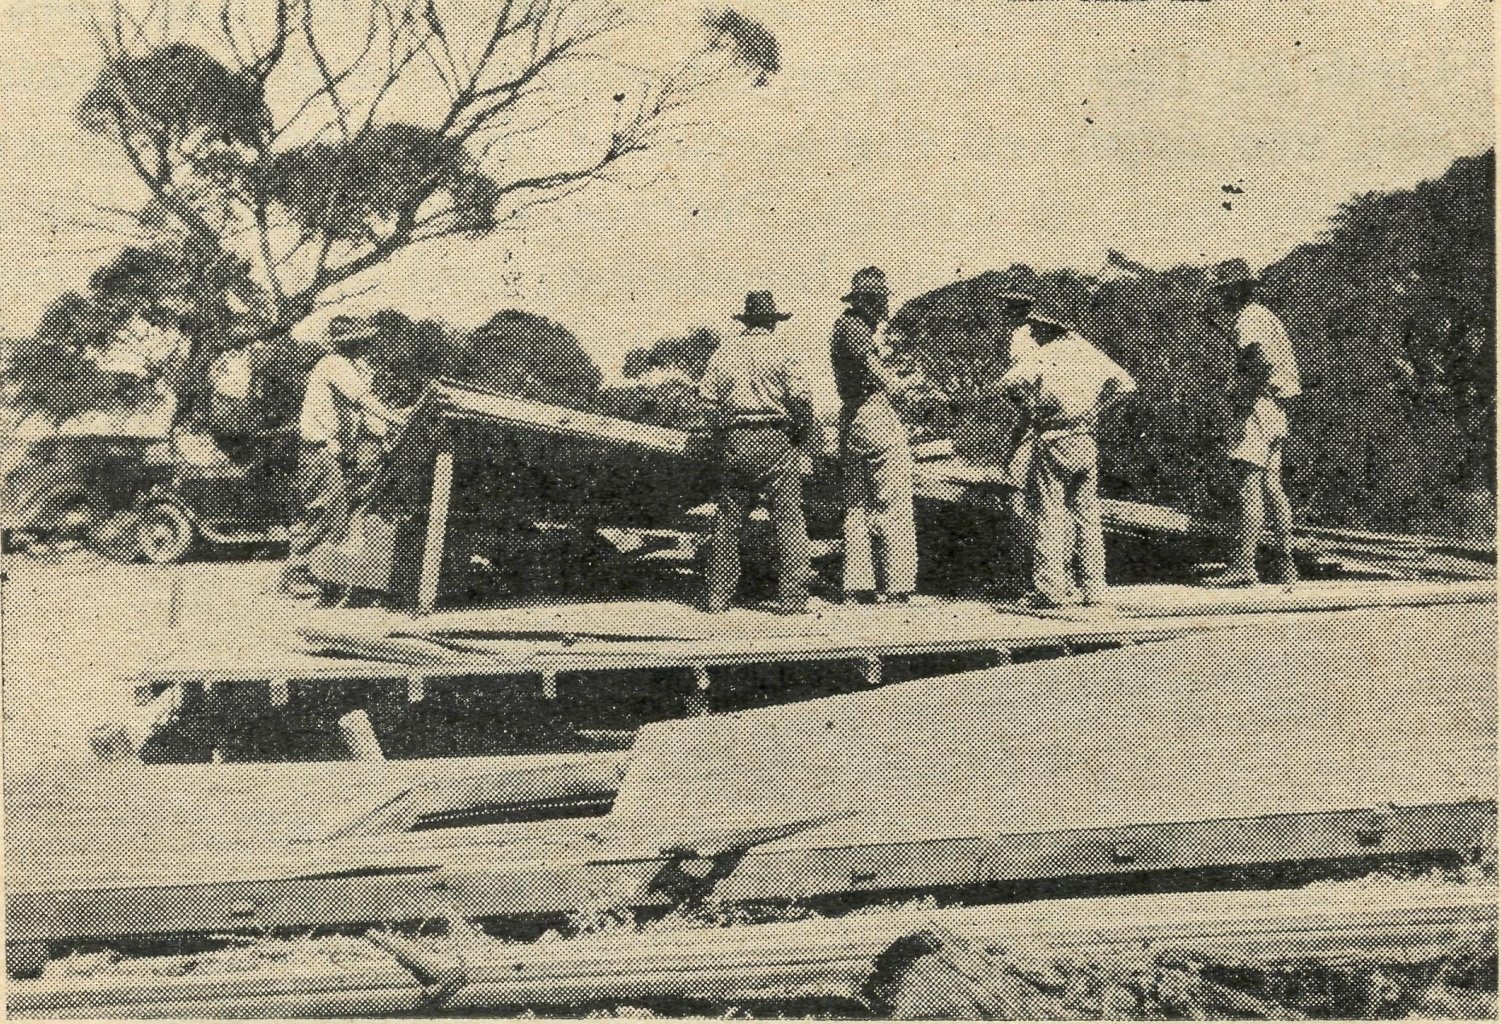
The Church that was blown away.
will soon be erected on the beach by Mr. Salmon of Mudamuckla, a neighbouring township.
Well, I broke off talking about our holiday to describe the loss of the church. I should also say in that connection that the people are going to subscribe to the payment of extra material to complete the new church and pay for its erection. They are in a very poor district and it will be a bit of a struggle for them to do this, as with the present cost of materials and difficulty in obtaining them, the sum needed may be upwards of £50. Any small donation towards this cause will be gratefully received by me. I can assure you that the seal these people have shown in endeavouring to have their own place of worship in order again, well merits your c^iii^athetic interest.
To get back to the holiday. It was enjoyable, but not long enough; however, all good holidays are that way. We caught fish, swam, read, got badly sunburnt, and on one occasion had our dinghy left high and dry by receding tide. The result, we had to walk home round the shore and come back next day to rescue our boat.
Tonight is an important night. The Rev. Leo Ball, Victorian Secretary of B.C.A., arrives by train from Minnipa and tomorrow begins his visit to the Far West Mission. Here is his itinerary in outline. Tomorrow we will set out for Fowler's Bay (100 miles) calling at Penong for dinner, and visit a school for Religious Instruction on the way. At Fowler's Bay in the evening we will have a service and sleep at that town afterwards. On the following day we expect to travel another forty miles, taking one school and visiting about a dosen places before nightfall, when we will have another service at Kooringabie before returning to Penong. Here we will sleep the night. In the morning on our way back to Ceduna we will visit the Koonibba Lutheran Mission for Aborigines. The rest of Friday and Saturday will be spent in local visiting, writing sermons and preparing for the Harvest Festival which takes place in Ceduna and district on Sunday next. Mr. Ball is to accompany me on my round that day. One of the churches we will visit will be Smoky Bay, afore-mentioned, which will hold its

April, 1947
15
THE REAL AUSTRALIAN

Harvest Festival Service in the big goods shed at the end of the jetty.
On Monday, Mr. Ball, Gladys and I will set of! in the Buick for Cook (288 miles). We hope to leave at about seven o'clock, arriving at Colona station homestead for lunch and refuelling. We will go on to Nullar-bor homestead, another 88 miles, and then do the last lap, much of which hasn't a fence, a tree, a house, a human, a hill or anything else, but is just a vast expanse of flat country all around, that reminds one of being far out at sea, on a calm day. Oh, I forgot the rabbits!
Mr. Ball and I together will visit one of the smallest line-camps for a service, so that he can see what the work on the line is like. Unfortunately, he cannot be with me at Cook for long as he has to return in a few days to accompany the Rev. John Greenwood on his rnonthdong trip to Tarcoola, and the wild country between there and the opal fields at Goober Pedy in the north.
Well, my work goes on. I will be remaining at Cook some weeks after Mr. Ball leaves me, as it takes a good while to complete a visiting of all the line-camps between Barton and Coonana (80 miles short of Kalgoor-lie, W.A.) which is my beat. This is done every three months. It is work that takes it out of one, but it gives a wonderful return. It is a ministry that always seems to me so intensely worthwhile. You feel the importance of your spiritual responsibility and the corresponding need for daily grace to rise to the occasions that crowd upon a minister here. And let me say it, I think the people of the outback are the salt of the earth. Their open-heartedness, friendly hospitality and ungrudging selflessness are not equalled anywhere else in our land. I feel we owe them a very great debt of gratitude for the lonely but important job they are doing, on the big sheep runs, lonely telegraph stations, railway centres and isolated farms of our back country.
We have been praying lately here that more men would volunteer for the work as there are vacancies for both missioners and nurses. If any young man should read these lines and would like to offer his youth to the service of the outback it would be a thing he would never regret and such men are urgently needed.
In saying good night now, I would just like to thank many anonymous donors of papers and books for my work. Your gifts are very welcome. Magazines, especially those of a pictorial character, such as Pix and National Geographic, are very welcome to outlying folk along the line.
Mr E. Huntley
After more than 20 years of service in the Mail Bag Sunday School, of which she was the Superintendent of the Upper Grade, Miss E. Huntley has retired from office. It is the desire of the Council of the Society to place on record its appreciation of the great contribution that she has made to the advancement of Christian teaching among the children of the out-back and of the bush by her unstinting service in this capacity. She has given of her time and' ability in a voluntary manner, and many owe her a debt of gratitude for this Christian work which she has so willingly undertaken.
The teachers and helpers of the Mail Bay Sunday School entertained Miss Huntley at an afternoon tea party on January 18th at the home of Mrs. W. V. Toms, and presented her with a Bible, an illuminated address, and a standard lamp as a token of their good wishes and esteem. Miss Huntley's association with the Mail Bag Dept. will not be entirely severed, as she has expressed her willingness to continue the distribution of the Confirmation Notes.
Scholars of the Upper Grade of the Mail Bag Sunday School frequently need a Prayer book to use with their lessons. Often there is not one in the home, and at the present time they are expensive to buy.
There may be people interested in our work who have Prayer Books for which they have no immediate use. If they are complete, and in fair condition, we would be glad to have them to pass on to "outback" children who need them.
WOMEN'S AUXILIARY, SYDNEY.
The Auxiliary started the year in February with a service of Holy Communion in St. Andrew's Cathedral, and is looking forward to another year's work.
The Annual Meeting is to be on May 2nd in the Bible House at 2.30 p.m.
The Auxiliary is hoping to raise enough money to supply Wilcannia Hostel with a sewing machine, which is very badly needed by the workers there.
During the Christmas recess, several workers From the field have been in Sydney. A small afternoon tea was arranged in the G.F.S. rooms to welcome back the Rev. and Mrs. K. Luders, and to say farewell to the Rev. and Mrs. T. J. Hayman. Mrs. Mann and Miss Stokes from Wentworth Falls, and Deaconness Dixon from Bowral were also present.

VICTORIAN LISTENERS!
TUNE-IN TO
3 DB
THURSDAYS AT 4.45 p.m.
THE WOMEN'S AUXILIARY
INVITE YOU AND YOUR FRIENDS TO BE PRESENT
on
FRIDAY, MAY 2nd, 1947
at their Annual Meeting in the
Bible House, Bathurst Street, Sydney
at 2.30 p.m.
CHAIRMAN: THE ARCHBISHOP OF SYDNEY. SPEAKER: THE REV. H. BROADLEY.

THE REAL AUSTRALIAN
16
April, 1947

Victorian News
Rev. L. BALL

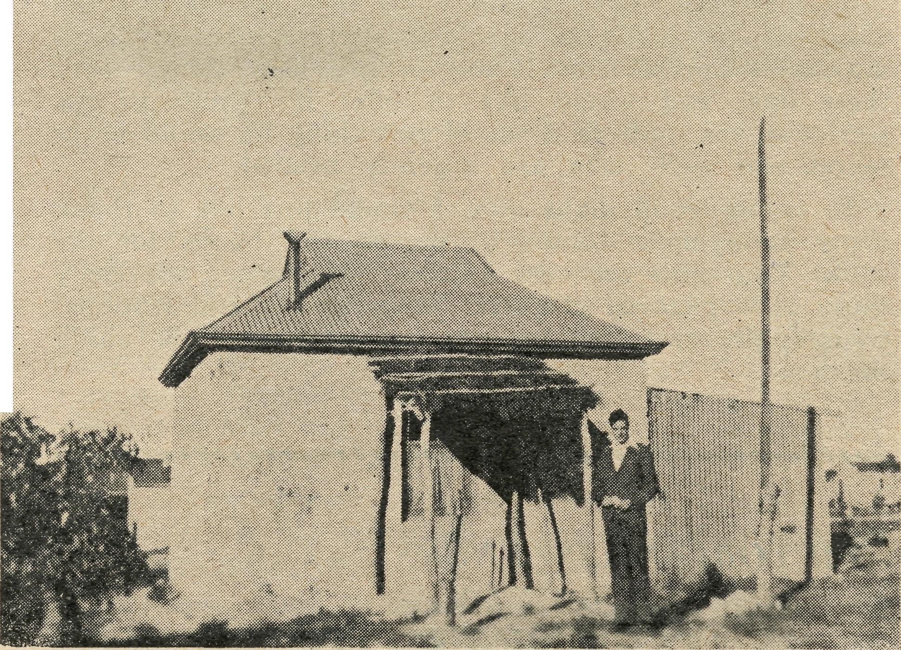
VICTORIAN SECRETARY VISITS THE FIELD
The journey from Melbourne to Port Lincoln, at the Southern extremity of the Eyre Peninsula in South Australia, proved uneventful save for the warm welcome and cordial hospitality accorded me by the Reverend F. Dillon and his wife in Adelaide, both early workers in B.C.A.' Mrs. Dillon was our first nursing sister at Ceduna over 20 years ago. What changes have taken place since then.
At Port Lincoln the same gracious reception awaited me, the Rev. R. Hallahan meeting the boat, taking me home for breakfast, showing me over the Seamen's Mission, of which he is Superintendent, and around the town. Sister Sowter, who is in charge of our Girls¹ Hostel there, is doing a magnificent job, looking after the material and spiritual needs of 28 girls in residence. Matron Sowter, with one helper, does every thing, housekeeping, cooking, washing, ironing, etc., for the family. You, our devoted friends, have supplied her with a washing machine and other labour-saving devices, but there are still three urgentlyneeded improvements in the Hostel. First the addition of a room for dressing—the girls at present being scarcely able to move in their three congested dormitories; secondly, a larger cooking stove, the present one being the size used for an ordinary family. Imagine cooking every day for 30 people on your size stove! Thirdly, the sink and draining board are both too small and too old. If you can help supply any of these most necessary inv provements, please let us know.
Port Lincoln is a town of some considerable size and importance now. Its 4000 people are chiefly engaged in one or other of its three main industries, the manufacture of superphosphate, its freezing works which exports 100,000 lamb carcases, besides considerable quantities of frozen pork, to England each year, or the small but rapidly growing fishing industry, chiefly whiting and shark. During the war when Norwegian cod liver oil was unobtainable, it was found that certain species of sharks'¹ liver was even richer in vitamin content. After three hours at Port Lincoln, the journey continued by train 150 miles up the Eyre Peninsula to Minnipa. The Rev. Alun Pugh of Cummins, 40 miles up, warmly greeted me and took me around the town and to the . Church and Rectory during the 20 minutes¹ stay at that station.
MINNIPA.
The next four days, Saturday to Tuesday, were spent with the Rev. John Greenwood at Minnipa, picking up the threads of his work in that large mission area of 17,000 square miles, a district with 21 service centres, and not a Church or Church Hall in it, all services being held in public halls, schools or homes. On Sunday we had five services and 80 miles travelling, and on Monday another service in the evening at Mt. Damper. Tuesday we went to Wudinna to meet Dr. Roxburgh and his wife, who is also a medical practitioner, and to see the hospital there, which, as you know, we are now staffing and running. Tuesday evening I left Minnipa by train for Ceduna, a 4 hours' run, and had the privilege of staying at the hospital and meeting our splendid staff there. To live in this Hospital, if only for a few days, and share in the morning and evening prayers, hymns and Bible reading of the Sisters, and to watch the quiet and efficient way in which the hospital is run is in itself a benediction.
The next day the Rev. P. Connell and I set out on the Fowler's Bay—Coorabie-Kooringabie trip, a round journey of some 200 miles. Fowler's Bay lies 100 miles west of Ceduna, and is one of the earliest settlements in South Australia with a most interesting history. To-day it has a population of only 16 adults and some 30 children. Originally it was a whaling station, then the port of dispatch for a lively and most lucrative kangaroo skin trade, followed by wool and wheat. One year Fowler's Bay despatched 100,000 bags of wheat and 12,000 bales of wool. To-day the figures are 4,000 bags of wheat and 8-900 bales of wool. Fowler's Bay is much more isolated than its situation should suggest. It has only a weekly mail and a coastal boat, calling every four to six weeks with provisions. Mr. Connell conducts a service here once a month and takes Religious instruction in the State School. We had a service the night we were there and the following day pushed on to Coorabie for state school instruction, and on to Koorin-gabie for visiting and a service at night, after which we returned to Penong hospital, about 50 miles distant, for the night. The following day, on our way back to Ceduna we visited the Lutheran aboriginal station at Koonibba and had lunch with the Pastor. This Mission, comprising 10,000 acres and founded in 1908, consists of Church, school with 72 children and two teachers, four staff dwellings, store house, workshop, aborigine cottages and the natives' camp area. It is in touch with some 450 aborigines, approximately half of whom live more or less permanently on the mission. Sunday, February 2nd, was spent in the Ceduna district, Ceduna, 8 a.m. Smoky Bay, 30 miles out, 11 a.m., Mudamuckla at 3 p.m., and Ceduna at 7 p.m.
The one-room Rectory at Penong.
TO COOK BY CAR.
The next day we commenced the long trip to Cook. Sharp at 6.30 Monday morning Mr. Connell pulled the "Old Warrior", a 21-year-old Buick tourer, up at the hospital ready for the journey. And the "Warrior" looked it! With 38 gallons of petrol aboard, 14 in the tank and the 24 in three 8-gallon drums in the back— the seat having been removed for the purpose—with a

April, 1947
17
THE REAL AUSTRALIAN

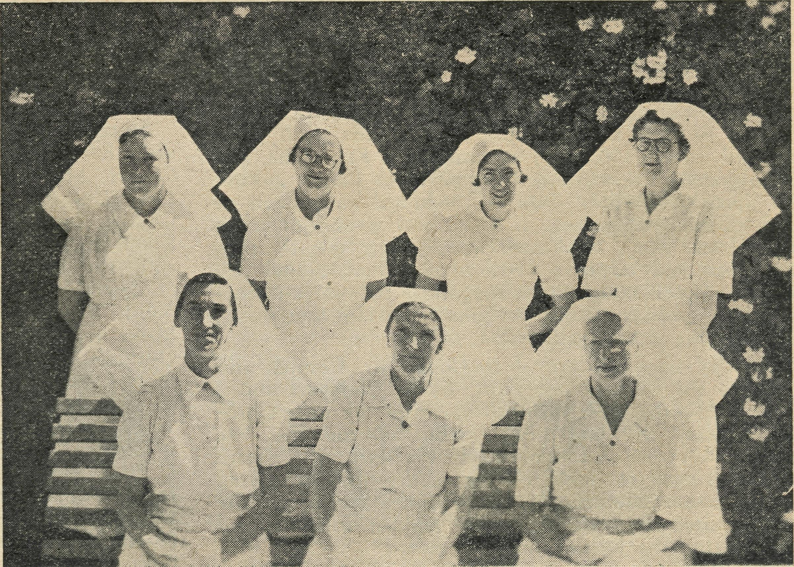
CEDUNA NURSING STAFF.
Front Row (left to right): Sisters R. Gillan. G. Hitchcock, V. Holle. Back Row: Sister E. Fisher, Matron F. Dowling and Sisters L. Loane and J. Miller.

spare spring bolted on one running board and a shovel on the other, with portable organ, service books, and books, papers and magazines for distribution, with bedding, suit-cases, spare water tins and sundry other requisites bulging out, the old Buick was a picture. A last farewell from the hospital staff and off we set for Penong, our first stop, where we were expected by Sister Holle and Sister Woodings for breakfast. By 8.30 we were on the road again, heading for Colona Homestead, the largest sheep-run in S.A., 1,400 square miles. It has 120 miles of dog fence to maintain—a costly business— besides 60 miles of water piping for stock purposes. After lunch and taking on a few gallons of petrol, for there is no petrol to be obtained after Colona until one returns there, nearly a 400-mile round trip, we struck westward again for the next place, Nullarbor Station, 88 miles away.
Being delayed with some oiling trouble it was 4.30 in the afternoon before we reached Nullabor, where the traditional outback welcome awaited us. The hour there was all too short, but with another 65 miles ahead of us and fairly slow going, we had to push along, so with regret we bid our friends farewell and turned towards the last dog-fence in S.A., 25 miles from the Homestead. At the fence we made a brief halt to leave a bundle of reading matter with the lonely dog-fence rider and his wife, and to say that we would be back to-morrow and stay longer, we pushed westward to our destination for the night, Koonalda Station, the last settlers going west in S.A. Here Mr. and Mrs. Roy Gurney live, 60 miles from their nearest neighbour, 75 miles from the nearest store, and 257 miles from the nearest doctor. All five of their children, ranging from 7 years to 4 months, were born in B.C.A. hospitals, one at Ceduna, three at Penong, and one at Cook. Situated on their land are the Koonalda caves, the largest yet discovered on the Nullabor, and it was the presence of water in these caves that induced Mr. Gurney to take up this 240 sq. miles of pastoral lease from the Government. There is, of course, no surface water anywhere on the Nullabor. Even much of the bore water to be found is unsuitable for stock. There is, however, an abundance of feed,
for sheep will thrive on the bluebush and saltbush with which mihe plain abounds. The only problem is water. Mr. Gurney performed an almost incredible feat. With the aid of a lad of 17 he got an old car engine, foot by foot, in places inch by inch, over the most preci-pitious and tortuous rocks to near the water's level in the caves. Then he took down a pumping plant and over 1000 feet of piping, and now has an abundant supply of good water available at the surface.
We spent that night and the following morning at Koonalda, after which we returned to Wugina Gate on the dog fence, and struck northward in a straight line for Cook. Before reaching the fence we visited one of the rabbit "chillers" or refrigerators on the Nullabor. Periodically, rabbit trapping on the plain is a most profitable and lively industry. Every few years there is a plague of rabbits, and if prices are good hundreds of trappers are engaged. Firms establish large refrigerators and transport waggons on the Nullabor, collect the rabbits from the trappers, "chill" them on the spot, and despatch them almost daily to Adelaide. Here they are skinned, packed and exported to England. One firm alone chills and dispatches up to 10,000 pairs of rabbits a week. Cook Station dispatched 82 tons of rabbits last season. So it is a fairly important industry. One refrigerator we visited had been on the Nullabor for nine months, and expected to remain there for another two to six months.
COOK.
Cook was reached by 8 o'clock that evening, and a warm welcome given us by Sister Thomas and Sister Coleman. Like all the "camps", as they are called along the east-west line, Cook is solely a railway employees' settlement. It consists of Station buildings, loco sheds, school, hall, 33 houses, our B.C.A. Hospital, and a few other buildings, slaughter yards and railway refrigerators. There are just over 100 adults in Cook and approximately 40 children at the State school. Its isolation is greatly accentuated by the fact that beyond the small cluster of buildings "there is absolutely nowhere to go." Walk north, south, east or west from Cook and

THE REAL AUSTRALIAN
18
April, 1947

you are simply walking towards the horizon with not a house or tree or even a mound to break the monotony. "You can't even go for a walk," one said. A while later, I thought I would try, but sure enough, within 10 minutes I was glad to turn back. An occasional dance and an equally occasional cricket match with a team from Reed or Rawlina constitute the social events. All water for Cook comes 530 miles by train from Kalgoorlie, and all Kalgoorlie water comes by pipe from Perth, another 380 miles. So every drop of domestic water used in Cook travels 910 miles! It takes two weeks for it to travel from Perth to Kalgoorlie through the 30 inch water pipe laid down in 1903 at an overall capital cost of about £8,000,000. From Kalgoorlie the water is con' veyed in "gins" to Cook, 5 "gins" working continually, each carrying 8,000 gallons.
The day after our arrival in Cook, Mr. Connell and I caught the West-bound train, he to Coonama and I on to Kalgoorlie. Mr. Connell exercises the only Christian ministry the 600 people who live on the line between Koonana and Cook have. He starts at Coonana and works back to Cook, visiting each settlement, giving instruction to State schools, conducting a service for the adults, distributing tracts, books and magazines, and administering the Sacraments as required.
DENMARK.
Although the work at Denmark, 43 miles west of Albany, is maintained financially by the Colonial and Continental Church Society of England, we have the privilege of providing the Missioner and exercising a general oversight of the work. Denmark was opened up first by timber milling interests 50 years ago. When milling ceased, about 1914, a few Australian settlers took up land, but not until the early 1920's, when the Government inaugurated the Group Settlement scheme for English immigrants, were there any considerable number of people there. During the 1930 depression the W.A. Government opened more country and settled a number of families of unemployed men in the vicinity, mainly at Walpole. It is to these English and Australians that the Reverend C. Sherlock ministers. The Parish is 500 to 600 square miles in extent, with 16 service centres, Denmark having a weekly service, 12 centres a monthly service, and 3 centres a quarterly service. Mr. Sherlock is the only resident minister of religion in Denmark. There are 225 children at the State School, and Mr. Sherlock alone gives religious instruction there. He takes the whole school in four grades half an nour weekly. There is also a most important School of Agriculture just built in Denmark with 40 resident students who must attend their place of worship weekly. There being no Presbyterian Church and only an occasional Methodist service, Mr. Sherlock has most of the boys at Church, 23 of them Anglicans. The principal is an Anglican, and Mr. Sherlock goes to the school one evening a week to talk to the boys, besides having a confirmation class there, 18 being Confirmed last year. So Mr. Sherlock has a great sphere of service and is doing a fine job.
The Sunday I was at Denmark I had the privilege of being present at the Ordination to the Priesthood of the Reverend B. Wrighton at St. John's Church, Albany. Mr. Wrightson, the son of an English settler at Denmark, is Curate-in-Charge of St. Peter's, East Coburg, Melbourne, where at Ridley College he has taken his Th.L., and is now doing 2nd year Arts. After completing his degrees in Melbourne he intends to return to his home Diocese of Bunbury.
VICTORIAN NEWS (Continued)
The Rev. L. G. Ball, Victorian Secretary of B.C.A., left Melbourne on 19th February, to visit missions and hospitals in South Australia in order to obtain personal knowledge of the work.
Since the last issue of the Real Australian, deputation visits have been made to the following parishes:—Christ Church, Mitcham; the Parish of Hastings and centres; St. Luke's, North Fitzroy; St. Columb's, Hawthorne; Christ Church, Essendon; St. Saviour's, Collingwood; All Saints', Kooyong; Christ Church, Hawthorne; All Saints', North-cote; the Parish of Warburton and centres; the Parish of Emerald and centres; St. Hilary's, Kew; Christ Church, South Yarra; Holy Trinity, Hampton; St. John's, East Malvern; All Saints', Clayton; St. John's, Footscray; St. Oswald's, Glen Iris; the Parish of Greensborough and centres: All Saints', West Footscray; and St. Stephen's, Gardenvale. In November last, Mr. Ball visited the Rev. T. FI. Pickburn at Beech Forest, and the Rev. G. Mutten at Cobden. On this trip contact was made with the Rev. J. Hall, vicar of Colac, and Mr. Ball preached at St. John's, Colac, at 11 a.m. and 7.30 p.m., on Sunday, 17th November; on the same day he preached at Nalangil (parish of Swan Marsh) at 2.30 p.m. and at St. Cuthbert's Boys' Home (parish of Colac) at 4.30 p.m. The 11 a.m. service at St. John's, Colac, was broadcast by the Colac wireless station.
B.C.A. Auxiliary, St. John's, Heidelberg. Activities During 1946,
Having money in hand from a function held in 1945, the purchase of a pair of baby scales was completed and these were forwarded to the B.C.A. hospital at Cook, South Australia. Later in the year a function in the parish hall was held and was responsible for the raising of £8/7/-. At this function the Victorian Secretary of B.C.A.—the Reg. L. G. Ball—gave a Lantern Lecture. Mrs. L. L. Morris (formerly of Minnipa, S.A.) and Sister Hitchcock also spoke of the work of the B.C.A. A recitation was given by Miss Boreham.
At the meeting the allocation of this money was discussed at length and as several of the members had met the Sister-in-charge of the hospital at Cook, they thought it would be nice to help her with some babies' clothing and blankets which she needed for the hospital. Mes-dames O'Mara, Moore and Brightwell were asked to see to this and were able to purchase .four large towels in addition to go with the parcel. It was also decided to send Sister Thomas a Christmas gift of reading matter and this was arranged with a book-store in Melbourne.
With the lifting of the particularly heavy burden of wai* we are hoping for this branch of St. John's organisations to go forward in the work of our Lord more energetically and prayerfully..
HAVE YOU A B.C.A. BARK HUT BOX?
If not,
SEND FOR ONE TO-DAY,
And use it for Your Gifts to the
Society.

April, 1947
19
THE REAL AUSTRALIAN

A Gift Afternoon was held at the home of Mrs. Ware, 1226 Malvern Road, Malvern, Vic., in November, 1946, and the sum of £3/10/' was given to the B.C.A. We are grateful to Mrs. Ware and her helpers.
COPY OF LETTER RECEIVED FROM A 3DB LISTENER
30th January, 1947.
Dear Sir,—I have just listened to your talk on the radio about the work of the Bush Church Aid Society and I heard you talk about the girl who came to one of your hostels last year and there became a Christian but will be unable to return this year unless she can get enough money.
I am a school-girl in Melbourne and I am also a Chris-tian. I would like to do the best I can as a Christian and so I enclose a little gift towards the education of that girl. Please send it for her as I was particularly touched with her story. I'm sorry the gift is so small but it is sent for the Lord's work.
May God bless you richly in your work for the Bush children. I prefer to remain anonymous.
Yours in Christ, A FRIEND.
A Matron Meditates
Miss L. KNOX.
Emerson says that simplicity is the most valuable asset that the world has, and that the world derives most of its benefits from simple things, i.e., the tilling of soil, etc. We give much consideration here to the children committed to our charge and we endeavour to teach them the value and meaning of the simple things of life, and the simple truths of God.
Our work is not without its problems, but the fact that boys and girls are not perfect does not prevent them from endeavouring to become better than they are.
Every child is precious; some become precious stones, while others remain just ordinary stones. But who knows! We may find here in this outpost of the B.C.A. some of whom it may be said, "That gem of purest ray serene."
To change the metaphor, I see each child as a ship upon life's ocean, and I want each small ship to sail eventually into the harbour of usefulness and happiness; some may sail on sunny seas where soft winds blow, others on stormy seas all alone, yet I pray that each may be a hardy craft, never to sink, no matter what the weather, so it can, as it were, sail over many seas, touch many lands and grow rich with experience.
One unfailing point of contact with the children is flowers. You cannot imagine how these children of the far West love them. And all we have are a few dwarfed sunflowers. So we are going to get a garden going. We shall speak to the earth and it shall teach us.
We see everything here as belonging to God. The world, His great workplace, and life His time for doing work, and we His workpeople.
We have the loyal cooperation of Mr. and Miss Farr. Mr. Farr is our carpenter, mechanic, upholsterer, cobbler and in brief, general factotum. No job is too big, none too* insignificant for him. Miss Farr presides over the kitchen with such efficiency that her good cooking touches the children's hearts and soothes their tempers delightfully, for small people are like big people and like nothing better than an appetising meal.
I wish to enlist the sympathy and prayers of all those who are interested in the work that we are doing.
A Missioner Relaxes
Rev. R. T. HALLAHAN
One of the problems that confront the B.C.A. Mis-sioner on this West Coast is that of providing a holiday for oneself and family.
In the years previous to the war it was possible to plan so that a house could be rented for a few weeks at seaside or hills in Adelaide, and a considerable saving of boat fares could be effected by putting the family in the car and driving round by road, a distance of 430 miles.
During the war petrol restrictions prohibited the road journey, and since the war housing is the bugbear.
This year, thanks to an old friend of B.C.A. who is now Rector of an Adelaide parish, it was arranged for an exchange of duties during most of the month of January, and as the petrol position was easier we decided to do the journey by road.
A blowout at the end of the first hundred miles occured right in the main street of a township, where it was possible to purchase a new tyre and tube, thus lessening the inconvenience though increasing the cost.
Apart from this there was no other incident to mar the journey, the first 200 miles of which was through dusty saltbush and malle plains. After leaving Port Augusta the contrast became marked, lofty hills and luscious fields and later on vineyards, provided a welcome change for the eyes.
We arrived at the Rectory in Adelaide on the evening of the second day, and were thankful to get a good night's rest. Country hotels are not always the quietest.
It so happened that the Fourth Test match was about to be played in Adelaide, and this provided a real thrill for the boys.
It also had its adverse side because of the rush of motorists for service at the City garages, and some much needed attention for "Ophelia's" knees was unable to be secured.^ "Ophelia" is the ten-year-old Chev. car fitted with "knee'action" independent front wheel springing of the hydraulic type, one which calls for expert reconditioning and imported parts from the U.S.A.
We were fortunate in that the gas workers' strike concluded after our first week in Adelaide, and my wife was able to enjoy the luxury of cooking with gas.
An unexpected surprise came my way when I was asked to give a talk to the members of the Australian Nurses Christian Movement. It was a real joy to meet several nurses who had been on the staff of one or other of our B.C.A. Hospitals out here, and to interest others who are contemplating such work when through their training course. As my own life in the Gospel and health in body are largely due to the B.C.A. nursing staff, I felt quite justified in advancing the claims of B.C.A. for workers.
It was good to renew fellowship with my old friends from Ceduna days, the Rev. and Mrs. F. H. B. Dillon, who are now at Holy Trinity.
These breaks in work are heightened in value by such contacts. All too soon came the day when we had to return, and we chose the two hottest days of the year for it!
However, apart from an obscure ignition trouble which necessitated our being towed for five miles, we had^ an uneventful journey home, and in the old soldier's words, "here we are again."

THE REAL AUSTRALIAN
20
April, 1947

Otway Mission Notes
Rev. T. H. PICKBURN

This is a tract of country that can certainly spring some surprises. When I last wrote an article for the R.A. we were experiencing the wettest and coldest winter ever recorded and over 90 inches of rain fell during the year. It was a year of many floods, much sickness throughout the parish, and blocked and damaged roads necessitating considerable extra travel in connection with the parish matters. Work is still going on repairing damage done to the roads almost a year ago and it will be some time yet before the work is completed.
The present summer is the warmest and driest ever recorded! It is an amazing contrast, and after longing for sunshine, as we did last year, we are now being treated to it in large and most acceptable doses. Water has become very scarce and householders are already carting supplies. At the Vicarage we have been compelled to exercise extreme care and, unless rain falls within the next two weeks, we too will have to seek for supplies. This is an unheard-of state of affairs for Beech Forest, but the sheer enjoyment of the glorious weather precludes worry about the water shortage. Advantage was taken of the favourable weather to paint the Vicarage walls and roof and the house now looks most attractive in its new coat of cream and red. Next year all efforts will be concentrated on painting the church walls and roof and it is to be hoped that by that time the necessary paint will be available. The whole Church property will then present a most pleasing and well-cared-for appearance. We are hoping that the work of re-building the damaged northern wall of the Church will be undertaken shortly. It is most urgent that the work be done before the winter arrives. This wall received the battering of 35 years of gales on the old site and has been greatly weakened. There are now two vacant blocks in the main street of the town—the old Methodist Church was recently dismantled and taken away to another parish.
The missioner and his family had a most enjoyable holiday this year at Portland. We were very fortunate in being able to have the use of the Clergy Rest Home and thoroughly enjoyed our fortnight by the sea. This was the first holiday we had had together as a family for
six years and we are hoping that another six years will not elapse before the next one! Portland is a delightful place and the Clergy Rest a comfortable house with plenty of room for the three children to play. We returned to the parish feeling greatly refreshed—a feeling that has been enhanced by the unusually pleasant summer we have experienced ever since.
An enjoyable occasion took place a short time ago. Prevented in previous years by transport problems from doing so, this year we undertook a parish picnic at Apollo Bay. All transport was provided by members of the congregation and adults and children had a very pleasant outing. The day was so successful in every way that it has been decided to make it "An Important Annual Fixture!"—as one member of the congregation described it. Originally it was intended to hold a Sunday School Picnic only, but is was soon found that adults love a picnic as much as children!
The irreplaceable loss of two valued Sunday School teachers has caused the revision of the Service Plan to enable the missioner and his wife to take over this important work. When the present epidemic of measles has passed we expect to have thirty scholars on the roll. We are working under great difficulties as both senior and junior classes must be held in the church together. Some day we hope to build a large vestry and meeting-room which will be of great advantage to the Sunday School.
Towards the end of last year we welcomed the Victorian Secretary, Mr. Ball, to the parish. Mr. Ball preached at Devondale and Beech Forest and also spoke to the children at the latter centre. We hope to have another visit from Mr. Ball later on and to take him to other centres in the district.
These notes do not, I know, record anything of spectacular interest. Work, however, goes on steadily and quietly and results are encouraging. The missioner and his wife look forward to another year of fellowship in the large B.C.A family and pray that it will be a year of successful endeavour for our Lord Jesus Christ in all things.

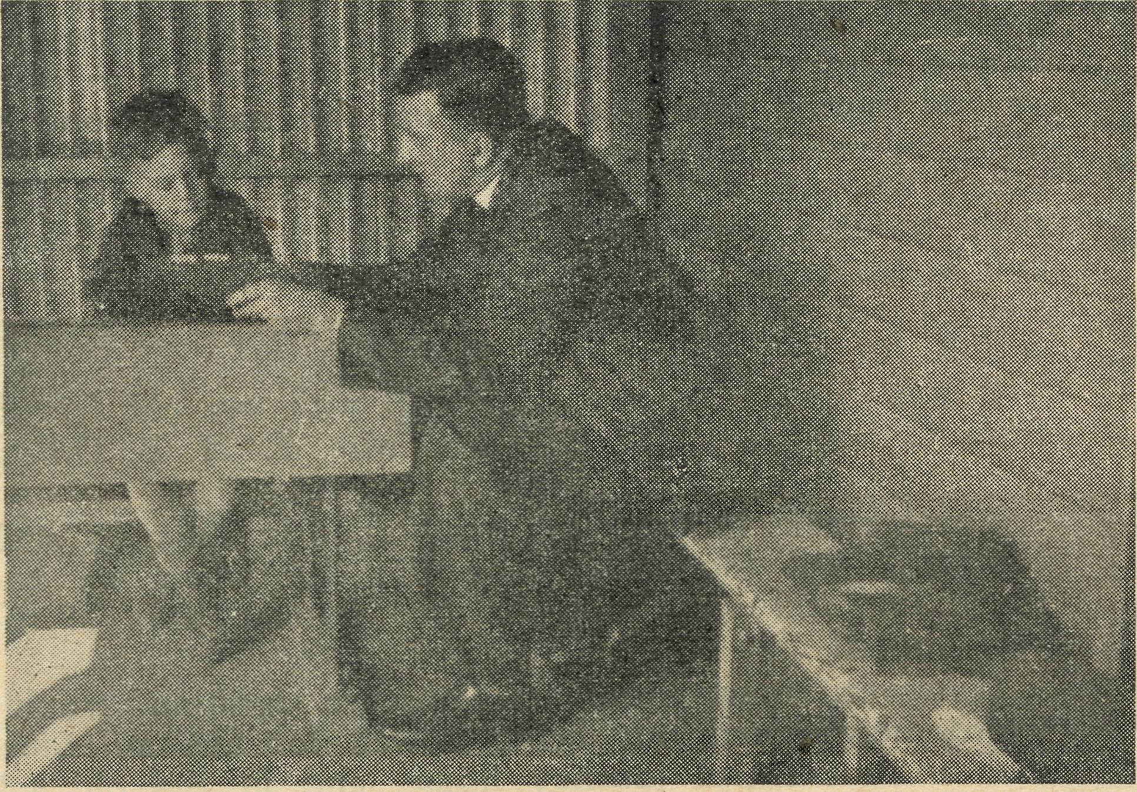
WORTHWHILE, EVEN FOR ONE.
The Missioner travels an extra 40 miles to give
this boy the message of the Lord Jesus Christ.
It is the essence of the B.C.A. ministry to go
out of the way to reach every soul.

April, 1947
THE REAL AUSTRALIAN

Cook Bible Classes
Sister J. COLEMAN
Re the Bible Class. Three boys from 12'16, and two girls of 14 came last night. We had some singing. They did not know many hymns and chose very young children's hymns, so we hope to teach them some.
I had a short Bible reading and we read a verse each, as I wanted them to get used to reading. The older lad giggled and shuffled, and finally got through it. His ignorance surprises me, he did not seem to have any idea of which end of the Bible to find the New Testa' ment! I got over this by giving them the number of the page I wished them to find. I daresay he was very nervous, and self'conscious, so I am hoping he, and the others, too, improve as time goes on. It will need to be a very "elementary" Bible Class for some time, I am afraid, but I trust that incapable as I feel to do the task, in some way these young people may be taught something of the love of God, and learn to read and appreciate His Word.
REAL AUSTRALIAN RECEIPTS.
Mrs. F. Caldwell, Miss Gallan, Mrs. Gilford, Miss Fetherstone, Mrs. Tingle, Rev. H. Robinson, Mrs. Win' grove, Mrs. Hoad, Mrs. N. Humphreys, Miss C. Comini, Sister Lundie, Mrs. Vallance, Miss V. Pocknall, Miss E. Osborne, Miss N. von Steiglitz, Mrs. Spittle, Mrs. O'Don-
nell, Miss James, Mrs. Vince, Mrs. G. Williams, Miss Hollow, Miss Cooper, Miss Hilliard, Mrs. Williams, Miss Banks-Smith, Mrs. A. Saunders, Miss Snodgrass, Miss Fisher, Miss Murray.
Subscribers Who Have Not Received Receipts
11/11/46.—An Interested Listener, 2/' Xmas. 18/11/46.—Anon, 12/- Xmas. "20/11/46.—N. Oliver, 5/- Xmas. 26/11/46.—Anon., £1/1/- Xmas. 2/12/46. —Anon., 2/- don. 2/12/46.—"A small helper", 2/6 Xmas. 4/12/46.—Mrs. Brown, 14/5 Box Opening. 5/12/46.—"Wellwisher", 10/- Xmas. 4/12/46.—Anon., £1 don. 6/12/46.—Anon., 2/6 don. 9/12/46.—Anon., £1 don. 10/12/46.—Anon.. 10/- Xmas. 16/12/46.— Anon., 10/- Xmas; Miss McCulloch, 10/- Xmas. 17/12/46.—Mrs. Ramshaw, 10/- Xmas. 18/12/46.— Anon., Caringbah, 10/-' Xmas; Anon., B.M.S.S., £1 Xmas; A. Pickering, £1 Xmas. 19/12/46.—Anon., £5 Xmas; Dulwich Hill, 5/- Xmas; Anon., 10/- Xmas. 20/12/46.—Mrs. Rowe, £1 Xmas; Anon., 10/- Xmas. 23/12/46.—Mrs. Lowick, £1 don. 24/12/46.—Anon., 6/- Xmas. 31/12/46.—Anon., 10/- Xmas; Mrs. Hobday, £1 Xmas. 15/1/47.—Anon., 5/- Xmas. 24/1/47.—"A Christian Friend", 10/- don. 28/1/47,.—Anon., 107-don. 10/2/47.—Anon., 10/- Xmas. 12/2/77.—Anon., £70 don. 21/2/47.—Anon., 2/- don.; K.C.G., 10/-M.B.S.S. 24/2/47.—Anon., £1 don. 26/2/47.—Anon., 15/- don. 28/2/47.—Anon., 5/- don. 13/3/47.— Anon., 6/- don. 17/3/47.—Anon., £1 don.; J. Wallace, 2/6 don.


Help Australia
by
purchasing
Savings Certificates.
Certificates can be purchased for: 16s. for each £1 Certificate. £4 for each £5 Certificate. £8 for each £10 Certificate.
Help B.C.A.
by donating
Savings
Certificates
to the Society.

Buying them helps Australia's Rehabilitation. Donating them to B.C.A. helps the Kingdom of God in the fight against the evils which cause all wars.

THE REAL AUSTRALIAN iv April, 1947
MAINTENANCE
The Annual Cost of maintenance of all the varied activities of the Bush Church Aid Society is £20,000. The whole income is derived from the free gifts of
Christian people.
♦
You can help by:
- A donation to our Funds.
- Keeping a B.C.A. collecting box in your home.
- Subscribing to our Quarterly paper, "The Real Australian".
- Donating a Saving Certificate.
- Daily remembrance in your prayers of the work and workers.
- Including the Society when making your will.
Our Address is:
BUSH CHURCH AID SOCIETY, Church House, George Street, Sydney. N.S.W. Or Bible House, Hinders Lane, Melbourne, Vic.
Our Telephone Numbers ere:—Victoria, FJ5675. N.S.W., M3I64.
We will be happy to supply any other information
you require.
t£4&&r Bragg Jr Set**, Pitniere, $y#»*ir

