

No. 96.
AUGUST, 1947.
1/6 per annum, post free.

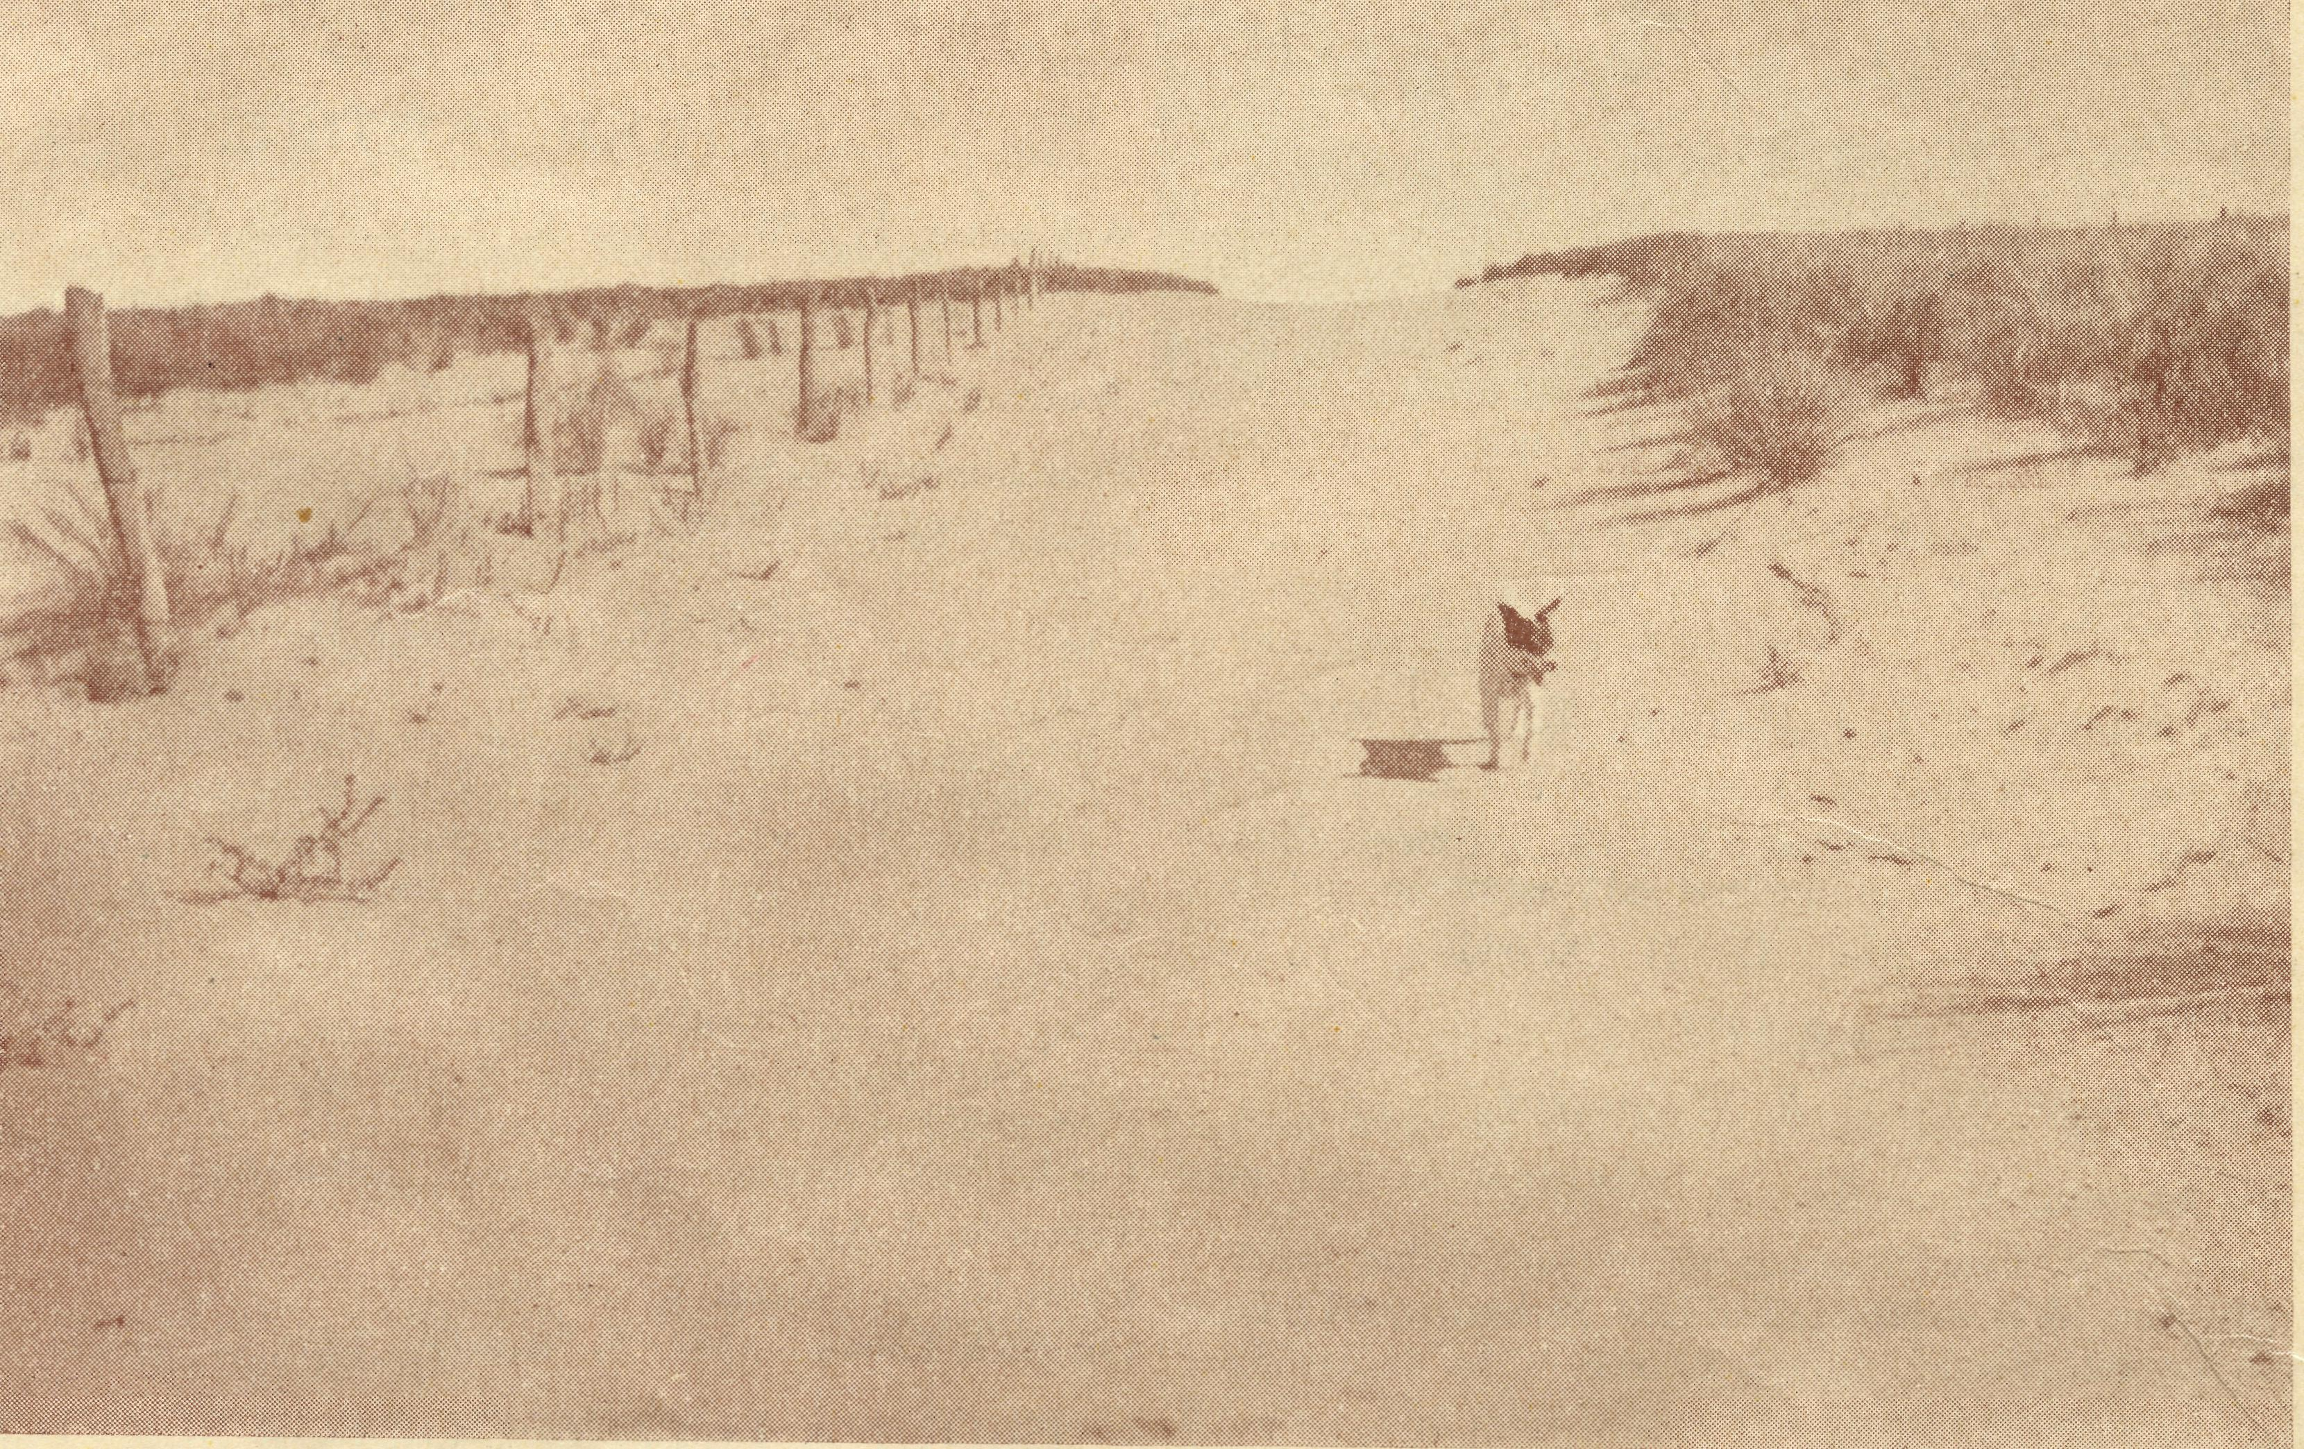
THE OUTBACK
Registered at the G.P.O., Svdnew *~r> transmission by post as a periodical.

THE REAL AUSTRALIAN
August, 1947

The Bush Church Aid Society for Australia and Tasmania

HEADQUARTERS OFFICE:
Diocesan Church House, St. Andrew's Cathedral, George Street, Sydney.
(Telephone: M 3164) Cable Address: "Chaplaincy, Sydney."
VICTORIAN OFFICE: The Bible House, Flinders Lane, Melbourne.
(Telephone: FJ 5675)
President: The ARCHBISHOP OF SYDNEY.
Hon. Clerical Secretary: Rev. L. GABBOTT.
Hon. Treasurer: T. S. HOLT, Esq
STAFF:
Organising Misdcner: Rev T. E. JONES, Th.L. N.S.W. Secretary: Rev. D. G. LIVINGSTONE, Th.SchoL Church House, George Street, Sydney.
Victorian Secretary: Rev. L. G. BALL, M.A., Th.L. Bible House, Flinders Lane, Melbourne
South Australian Secretary: Rev. F. H. B. DILLON, Th.L.

B.C.A. Activities and Staff

MISSIONS.
Ceduna, S.A. 1: _{Rey} p _{Connel}i_{f} _{Th}.L., Ceduna, S.A. Penong, S.A. )
Curnrnins, S.A.—Rev. D. A. Richards-Pugh, Cummins, S.A.
Kirtcn Point, S.A.—
Streaky Bay, SA.—Rev. T. J. Hayman, Th.L.
Minnipa, S.A.—Rev. J. Greenwood, Th.L,, Minnipa, S.A.
Delegate-Bonang, Vic.—Rev. D. H. Wicking, Th.L., Delegate, N.S.W.
Croajingalong, Vic.—Rev. C. F. Withington.
Heytesbury Mission, Vic.—Rev. A. L. Mills.
Otway Mission, Vic.—Rev. T. H. Pickburn, Th.L., Beech Forest, Vic.
Wilcannia, N.S.W. ) Menindee, N.S.W. J"
Rappviiie, N.S.W.—Rev. R. Meyer, Th.L., Rappville, N.S.W.
Denmark, W.A.—Rev. C. H. Sherlock, Th.L.
Werrimull, Vic.—Rev. , Werrimull. Vic.
SCHOOL HOSTELS.
Wilcannia, N.S.W.—Miss L. Knox, Miss Farr. Mungindi, N.S.W.—Miss E. Cheers, Miss E. I. Cheers. Wentworth Falls, N.S.W.—Mrs. C. Mann, Miss N. Stokes. Port Lincoln, S.A.—Sister H. E. Sowter. Bowral, N.S.W.—Deaconess N. Dixon.
MEDICAL SERVICES.
Ceduna, S.A.—
Matron: Sister F. Dowling.
Staff: Sisters Miller, V. Holle, R. Gillan, G. Hitch-cock, E. Fisher, M. Crouch. Penong, S.A.—Sister L. Loane, Sister Woodings. Wudinna, S.A.—
Dr. R. Roxburgh.
Matron: L Pritchard.
Sister H. Foster.
Cook, S.A.—Sisters Thomas, J. Coleman.
Tarcoola, S.A.—Sister V. Page.
Cann River.—Sister I. Gwynne.
On Sick Leave—Sister B. Bossley, Miss D. Dykes.
CEDUNA FLYING DOCTOR SERVICE.
Pilot.—Mr. A. Chadwick.
Doctors.—Dr. R. Gibson, Dr. F. Gibson.
WUDINNA FLYING DOCTOR SERVICE.
Doctor-Pilot.—Dr. R. Roxburgh.
MAIL BAG SUNDAY SCHOOL.
Director.—Miss R. Campbell

August, 194?
THE REAL AUSTRALIAN

VH-AGI

Those letters are of great significance to B.C.A., and to all its friends and workers. For they represent the registration number of the new Dragon aircraft which is now in commission with our Flying Medical Service at Geduna. The B.C.A. Flying Medical Service commenced on January 19th, 1938. If you had been near St. Andrew's Cathedral, Sydney, on that day, you would have seen a group of clergy and a crowd of people gathered round a small plane in the Cathedral grounds. They were there to share in the dedication of the Fox Moth, VH.'AAA, to the work of the Flying Medical Service of B.C.A. It was dedicated so that medical aid could be speedily given in time of need to the people of the outback in the name of the Lord Jesus Christ.
Shortly afterwards the pilot, Mr. A. E. Chadwick, flew that plane to the Far West of South Australia, where it was based at Ceduna on the shores of the Great Aus' tralian Bight. So commenced the Flying Medical Service of the B.C.A., and all through the years since then the plane has done splendid work. Year after year it has flown across the Inland without accident or mishap, landing on, and taking off from inadequate, and at times, dangerous, landing grounds and clearings, and always flying over country where a forced landing would almost certainly result in disaster. Those nine accident-free years are not only an assurance of the loving, protecting hand of God, but are also a striking tribute to the care and skill of our pilot. During those years the plane carried doctors, nurses and patients for nearly 150,000 miles. It has enabled over 8000 patients to be treated, who otherwise would have been treated only with difficulty, and in some cases, not at all; and it has been the means of saving many lives and alleviating much suffering.
As the years have gone by more and more demands were made on VH-AAA until it proved inadequate for the task.
So we came to another great day in the history of B.C.A., March 29th, 1947. If you had been in a large hangar at Kingsford Smith Aerodrome, Sydney, on that Saturday morning, you would have seen something unique. Grouped round a twin-engined, six passenger aircraft were some clergy in their robes, and a number of friends of B.C.A. Around them in that huge hangar workmen were busy at all sorts of noisy jobs on other aeroplanes, but this group stood quietly, with reverently bowed heads, as one of the clergy said: "In the Name of the Father, and of the Son, and of the Holy Ghost, I dedicate this plane to the work of the Flying Medical Service of the Bush Church Aid Society.¹'*
The hearts of all present were stirred as they read on the fusilage the inscription.
Church of England,
Bush Church Aid Society,
George Street, Sydney.
"Australia for Christ¹¹
And so VH'AGI, a twin-engine Dragon Aerial Ambulance, joined our staff. Shortly after the conclusion of the service, Mr. Chadwick, who has so ably piloted the smaller plane for so long, took his seat at the controls of his new charge, and flew into the West.
A LIFE-SAVING FLIGHT
Soon after VH'AGI arrived at Ceduna, an urgent summons was received. A railway guard on the Perth' bound Transcontinental Express became suddenly ill at Rawlinna, 300 miles west of Cook. He was hastily trans' ferred to the East'bound train, which travelled at high speed to Cook, where the patient was placed in hospital. In the meantime a call had been sent to Ceduna, and soon VH'AGI was making her first emergency flight. With doctor and nurses on board, it roared through the sky. Upon arrival at Cook an operation was performed, and as a result VH'AGI was the means of saving the life of the guard.
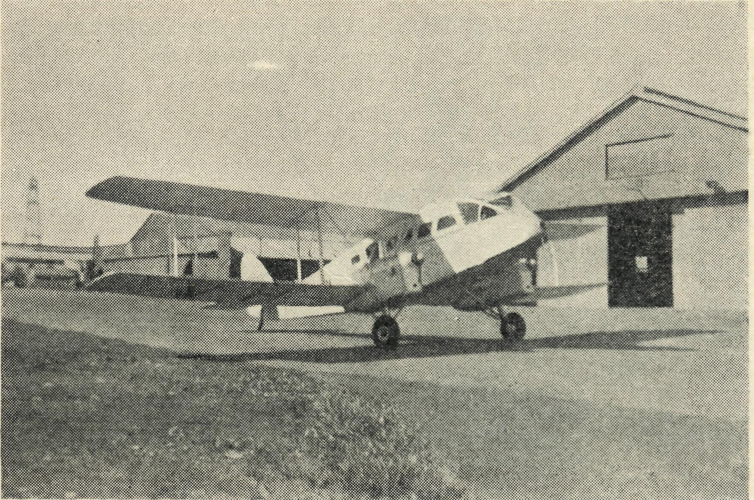
Shortly after the return to Ceduna another urgent call was received, and this time the new plane flew to Tarcoola to save the life of a small boy.
So VH'AGI continues in the great tradition established by VH'AAA. Let us see to it that the means are con' tinually supplied to keep it flying in the Name of the Lord, to continue His healing ministry.
VH-AAA
And what of the other plane which has flown for so long and so faithfully?
After being thoroughly reconditioned, it has resumed its career, this time at Wudinna, where it is now laying the foundations of a second Flying Medical Service of the B.C.A. The pilot is now the Doctor himself—Dr. Russell Roxburgh. The demands upon VH'AAA as yet have not been so heavy as at Ceduna, but when the service is fully established, the indications are that its life will be as full as ever. Our prayers go with Doctor, the Sisters and the plane as they build up this new venture of B.C.A.
Much will be demanded of them all. Much will be demanded of us, but let us see to it that our prayers, our sympathetic interest and our gifts will KEEP THEM FLYING.

THE REAL AUSTRALIAN
August, 1947

One Day at Streaky Bay
Rev. T. J. HAYMAN.

As the bell finishes ringing, we find a number of Streaky Bay worshippers gathered together for their morn-ing service at eight o'clock. In the quietness and solemnity of the Church they meet around the Lord's Table, re' membering afresh the Sacrifice of their Saviour and Master, "until His coming again."
When breakfast is over, preparations are made for the day's journey, for no time must be lost after Sunday School. To'day there is a board, a case for "flannel' graph" pictures, a box of Prayer Books and Hymn Books, and another case for the Missioner's usual service requisites, including some Scripture Union daily notes to encourage the daily reading of God's word.
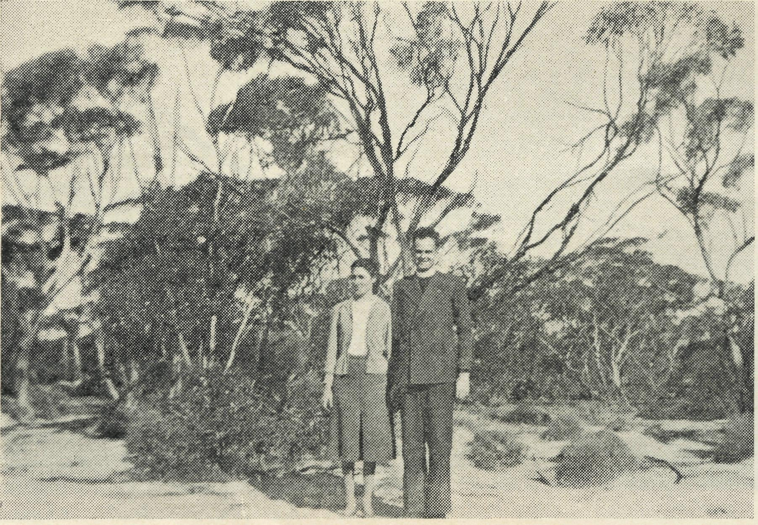
Rev. T. J. and Mrs. Hayman.
Knock, Knock! Some children want to come into the Church early for Sunday School. One little fellow asks if. he may ring the bell. He can't quite reach it, so must climb the tower ladder, stretch out for the rope and swing himself up and down on it! Soon the meeting is in progress. The little ones are in a room in the rectory under the care of Mrs. Hayman. We have determined to take a photo one day of these delightful tinies. One feature of tO'day's programme for the bigger children is interesting. Just before the united learning of the texts from the Bible, we have the birthday time, and there was the box, a missionary box, put close by as a reminder, for it is one of the lad's birthday, and the leader mustn't forget to allow him the opportunity of putting in one coin for every year of his age!
Eleven'thirty, and all too soon Sunday School is over. Now into the car and off we go as soon as possible down the Port Kenny Road. It is the best road around these parts, but there are thirtyeight miles to do before lunch, so we must keep up the pace. Each Sunday of the month we visit different centres. Out from Streaky Bay we only see one or two houses all the way. To'day we dine, not as usual with the Baptist Sisters (for they are going to Inkster), but with one of the kind families close by. Port Kenny is a small place, housing many of the fishermen of Venus Bay. For the service in the hall at 2 p.m. a number of the farmers and their families come in
too. There is quite a large gathering (for these parts) with a number of children, for with the aid of the ''flannel-graph" there is depicted the story of the palsied man borne by four, to be laid, through the roof, at the feet of Jesus. We were all reminded of the great importance and cost of the forgiveness of our sins by Jesus. The service closes, we pack up, and with the children standing around the car, we move off along the road again.
The next stretch is only ten miles, but it is crossed just in time for the service at Colley. We have been grateful to receive a good inch of rain during the past week. The farmers have put in the wheat seeds, and the rain at this stage is a big help to a good harvest in December. Praise God for His providence, for this is the best opening •rain for years. With the heavy rain, however, the road becomes the watercourse, and "Look out! Just missed a big pot'hole full of water!" Here we wind in and out, mostly in second gear, finding the best spots where to advance. Sometimes there will be three tracks all leading the same way, and we have to take our pick. It pays to follow the tracks of a car, whose driver lives in these parts and so knows the road.
At Colley the wind is blowing strongly through the open windows in the hall. They couldn't be shut, be' cause the white ants had eaten away the frames. The only thing to do is to carry the table and chairs down to the other end for a little shelter. Here the numbers are few. Nevertheless, we enjoy our meeting with these kindly folk in the service of the Lord's Supper.
It is five o'clock and we wave good'bye to drive home into the setting sun. What a beautiful sight! The rich and ever'changing hues in the clouds provide a wonderful setting above the long, straight road, lined by the small trees of the scrub. Darkness sets in and by the lights of the car we see the rabbits crossing the road. They seem to see how close they can come to the wheels without fatal injuries. Sometimes there is evidence of those who were unsuccessful. Occasionally a fox will saunter across, in no great hurry, yet at a safe distance.
We arrive back in Streaky Bay at six'thirty at the house of some friends who have kindly invited us for tea. We regret our brief visit, for the bell again rings at seven, and we prepare for the evening service. It is cold, and there are not as many as usual, but we can still praise God for His goodness, and tell of His wondrous love. God hears and answers our prayer.
N.S.W. LISTENERS !
tune in to
2 GB
for the B.C.A, "Outback" Session Now on
TUESDAYS AT 11.20 A.M.

August, 1947
THE REAL AUSTRALIAN

Denmark Doings
Rev. C. SHERLOCK.

In a letter written some months ago for the "Real Australian¹' I mentioned the urgent need of providing a Church for the centres of Kronkup and Torbay within this Mission area, and now that this need has been met feel that an account of the building and opening of the Church of St. Oswald may be of interest to readers.
Firstly, I would express appreciation of the prayerful interest of so many in the project and extend sincere thanks to those who sent monetary gifts. Readers will recall from the earlier number that the neighbouring Parish of Albany had made available to us at a very nominal sum a Church which had served for many years one of their out-centres, and which was disused at that time because of changes in population and the improvement of transport services. Our job was to find a builder who could dismantle, remove and re-erect the building for us, and also to find the finance for new materials where required, as well as furnishings for the Church. Not an easy task in these days of labour shortages and in a community where family coffers are not large, but a happy and blessed one, with the co-operation of so many willing settlers and in the strength of Him who was the Carpenter of Nazareth.
Our initial difficulty was to secure a builder to undertake the work by contract. The difficulty of assessing the amount of new material required before demolishing the Church on its original site proved an obstacle that we could not overcome, so that finally we accepted a contract of £90 for the labour only of the work, our Committee to find all new materials as well. To our great joy the building was demolished about a month after the letting of the contract, and our hopes ran high for the early arrival on our site of the materials and then its erection. However, materials'arrived for jobs which had been commenced by our contractors before undertaking our work, so that they had to go to fulfil these obligations. Meanwhile, we had our block surveyed, and the transfer of it to the Diocesan authorities completed. The land was given by one of our parishioners and is a corner block on the Albany-Kronkup Road, conveniently situated for folk from both Torbay and Kronkup. By this time the quantities of new materials required was known, and commenced a search for them. Weatherboards, guttering, paint, putty, glass, sash cord, galvanised iron, hinges, door, locks and numerous other items all were to be found, and in an area where supplies are always scarce and at present even scarcer. Here again we found many answers to prayer, for in the least expected ways things kept just turning up; so much so that I am sure I have gained at least a little of the outlook of Dicken's Mr. Micawber! After two months' delay the work of building commenced amidst much excitement on the part of the resident population, and week by week the Church drew nearer completion. The two most difficult items to obtain proved to be glass and galvanised iron, and finally we solved the problem by substituting four smaller panes in each window for one large pane, as small sheets of glass could be bought, and by using for part of the roof the o]d iron with slieves of new sheets on the joints.
As soon as the contractors had completed their work (and a splendid job it was) the men of the district set about painting the Church. Several working bees were organised in quick succession, and to the last of these
before the Dedication service the Victorian Secretary for B.C.A., who arrived in the parish that day, was pressed into service. (I might add that he did not take much pressing!) Meanwhile, inside the Church the ladies were hard at work polishing windows and putting a new appearance on the articles of furniture which had so wonderfully come from many sources. Our most urgent need had been pews, and these we were fortunate to obtain from the Parish of Katanning, a centre some 100 miles from Kronkup, where the parishioners had just obtained new pews for their Church in keeping with their other furniture. We purchased ten of these at a total cost of £30, and this provides us with a seating capacity of 80-90. The pews are strongly constructed, in excellent order, and are most comfortable. When placed across the Church they allow a 4ft. 6in. centre aisle and an aisle of 1ft. at each wall. One of the parishioners generously donated a matting runner for the aisle, whilst from funds in hand we purchased curtain materials to drape across the Eastern end of the Church in lieu of a reredos. Several parishioners gave the price of a pew, whilst the Albany Parish assisted with many items. The Font which was used in the Church in its earlier location in the Albany Parish was given and was repolished by one of our young men. It now looks as good as new. The contractors built the Holy Table for us, and the Frontal and super frontal for same were given by the Albany people. A beautiful set of communion linen sent some years ago by the Ladies' Auxiliary of the Col. and Con. Church Society in England has provided that need, and the care of the same has been undertaken by the members of the Ladies' Guild at Kronkup-Torbay. A beautifully toned organ was given by our good friends at Albany at the cost to us of only £3/3/-for minor repairs and tuning. The Lectern came from the same source, whilst the Prayer Desk was given by the Denmark Church. A former B.C.A. Missioner here, the Rev. B. B. Lousada, presented the Bible for the Lectern, and numerous parishioners gave many smaller though equally essential gifts.
With our Church thus completed there drew near the great day of dedication. The Bishop had arranged to come to Albany to ordain to the Priesthood a former parishioner of Denmark, Bertram Wrightson, who, having received his first call to the Ministry whilst living at Denmark during the early days of B.C.A. work here, had followed that call for a number of years, first whilst working in the goldfields area in several capacities, later in the ranks of the Church Army, both as Parish Evangelist and Military Welfare Officer, and eventually in parish work in Melbourne Diocese whilst a student at Ridley College. With this engagement in the morning (which in itself was a great landmark in the life of our Parish), the Bishop kindly agreed to come to Kronkup in the afternoon for the service of dedication. Accordingly, we arranged for a 'bus to convey 24 of our parishioners to Albany for the Ordination service in the morning, returning via Kronkup in the afternoon. The Choir of St. John's, Albany, also hired a 'bus and came to lead the singing at the Dedication service. Despite rather inclement weather a crowd of just 200 assembled in the Church for the service. Every available seat was borrowed from the local Hall, as well as chairs from nearby farms, to assist with seating accommodation. Even so, many had to stand in odd places, but everyone seemed to fit in somewhere!

THE REAL AUSTRALIAN
August, 1947

The service itself was an inspiration. The Bishop was met at the Western door by myself and representatives of the laity, and invited formally to dedicate the Church. This the Bishop agreed to do, and after knocking on the door with his Pastoral Staff, the procession of Choir and visiting clergy moved up the aisle to their appointed places, reciting the 24th Psalm. Then followed appropriate versicles and responses, together with prayers, after which the Bishop and his attendants went in turn to the Font, Prayer Desk, Lectern, Chancel step, Communion Rails and Holy Table. At each, portions of Scripture were read and prayer offered. The reading of the lesson followed, after which the sentence of Dedication was read and delivered. Then came the words of solemn dedication, followed by an inspiring sermon from the Bishop. At the conclusion of the service all present were entertained to afternoon-tea in the local hall by the members of the St. Oswald's Kronkup-Torbay Ladies' Guild.
A few weeks afterwards our local Committee met to assess the financial position, when it was found that all costs were able to be met from monies received as gifts or raised through the work of the womenfolk. The local Committee of Kronkup owes £50 to the Denmark Church Committee, but this amount was raised by the Denmark folk and lent free of interest to Kronkup centre, so that from a Mission point of view the whole of the cost, approximately £200, has been paid. For this we thank God, as we do for the generosity of members of the Albany Parish, whose help has made the work possible. The building and contents are now insured for £500, the difference, of course, in the cost to us resulting from the merely nominal purchase figure paid to the Albany Parish for the building. When one remembers that for nearly 40 years this area has been in the course of settlement, one can appreciate how much the settlers love having a real Church. How different now the atmosphere of the services! At long last the children can be taught by sight as well as by word just what a Font and pews, etc., are.
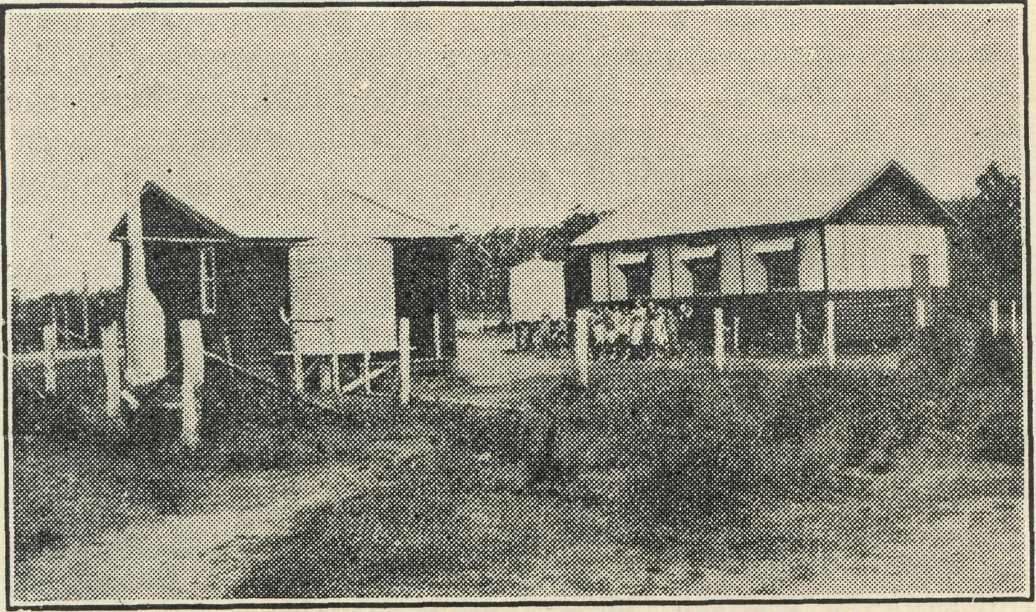
A Group School in Denmark Mission.
In this large district, with its ever-growing population, where there are yet only two licensed Churches, the Parish Church in Denmark, and St. Oswald's at Kronkup, at Walpole we have a Mission House where two rooms are turned into a Chapel and the other rooms used as living quarters by my wife and self on our monthly visits there; but in all the other 19 centres we have to use either private residences, schools or halls. Not all of these as yet have population enough to justify the erection of a Church, but many have. When our present urgent need for a new Parish car is met, we hope to start activities for building in at least one of these, But more of this in future days.
CROAJINGALONG
Rev. C. F. Withington.
The Church of England is now the only religious body working in Croajingalong, and the life of a vicar in these parts is therefore full and interesting indeed.
Since our last record in the "Real Australian" there has been progress made and also ground lost.
With contacts through Baptism and normal visitations, numbers of worshippers in the centre of Genoa and Malla-coota have been increased, and at the last named centre several candidates are offering for confirmation this year.
In the second place, ground has been lost by my decision to sell my car. This was made imperative due to rising costs of running and repairs, to rapid depreciation on bad roads, and to insufficient allowance for travelling. The allowance paid by the parish amounts to £100 per year, which just covers cost of petrol and oil and few minor repairs. The parish does well to find this amount, and with quotas to the Diocese to be met could hardly find more.
Our need is for a car, and we pray that such may be found for this all-important and growing work.
I wish those who read this could join with us in services by lamplight in the little school room at Mallacoota, and could enjoy with me the hospitality of remote bush homes or the many other varied activities of Church life amid these forest fastnesses of Eastern Victoria.
But of course there are many of you who do share this grand adventure. Believe me, there is real gratitude in the hearts of the faithful that a ministry is made possible through B.C.A.
We have other plans for the near future. A small church at Genoa to serve the growing needs of a most responsive community, and a Young People's Fellowship at Cann River to foster the growth of body, mind and soul in our young people.
Thank you, kind friends, for prayers and gifts; may God bless all our endeavours.
(Editor's Note.—We have since been able to supplv Mr. Withington with a small car—but it is old, and not altogether suitable.)
DELEGATE—BONANG
Rev. D. Wicking.
Since the last report the work has been done quietly and without anything spectacular.
In December the Lord Bishop of Gippsland confirmed 16 adults, one of whom had been baptized in the "little new brick church" at Delegate, more than 65 years ago.
It is not often that a person is baptized and confirmed in the same church after so many years.
The B.C.A. Mail Bag Sunday School lessons are used by nearly every school child in the parish.
The girls, under the leadership of the Rector's wife, have formed themselves into a branch of the Young Anglicans.

August, 1947
THE REAL AUSTRALIAN

News from The Far West Mission

Rev. P. M. Connell.
It is time for an "R.A." article again, so I must recollect some of the many things that have occupied me this last quarter.
First, I would like to thank the people in the large cities who are beginning to take a personal interest in the needs of this mission. Three people just recently have written to me—one from Sydney, one from Melbourne and one from Perth. The one from Sydney sent a Postal Note for 10/' for "the church that was blown down." The remains of this church, by the way, are still waiting to be re'erected. It will be done by voluntary local labour of church people. Two things are holding the work back— lack of building materials and lack of money. We need £50 at least, to re'erect the building, as some parts of the timbering will need to be replaced. I should also add a third factor holding things back until now has been that the farmers have been busy seeding. The much needed rain has come at last in good measure, and the men on the land expect a good harvest if all goes well. My second letter came from Melbourne, and it contained a 5/' Postal Note. I would like to say here how grateful I am for such help; though small, it is very welcome, as the farmers may be able to collect a few pounds among themselves, and such small amounts all mount up. I am trusting that in some way the needed money will come from some' where, and Fve not been disappointed yet. In these matters, God will surely provide as our needs arise. The second letter I referred to just now also assured me of something I value very much, and that is, constant prayer for the work out here. The writer said she had prayed for me and my work before my marriage, and was praying for us both now. I am very grateful for this, and for all the prayers that readers of the "R.A." may offer up for us. We need it.
The third letter came last night. As I said before, it was from Perth, from someone I had never heard of. The writer is an invalid and has been bed-ridden for years, often in great pain. She subscribes to the "R.A." and is sending me some small children's playthings which she makes herself, for distribution to families in the out' back. She says, *T have a notebook in which there are things to pray for. Now I am putting the names of the different missioners with a space, there I enter the different things they want us to pray for, the individual things for themselves.¹¹ I am very grateful to her for this. The thing I will ask her to put first is, that I may be filled with the Holy Spirit, so that I may be guided by God's Grace in His work that I am trying to do. The lady who wrote says also, "I pray that more and more men and women may offer for service in the B.C.A. especially priests as missioners," and I might also add, "women as nurses." If any of you would join with this lady in her prayers you will be giving a very valuable and indeed, an essential ministry to further Christ's cause out here.
I thought you might like to hear a little bit about actual phases of the work. So here are some views of the Cook trip.
The place is the little siding of Coonana, about 80 miles from Kalgoorlie in W.A. Coonana is what is called a "married camp"—about 12 families. The camp consists of their homes, twelve houses in a row along the side of the railway track. Each house is built exactly like the rest, to simplify construction requirements, I suppose.
As I stand on the verandah of one of the homes and look at the other houses on either side of me, it is like looking down the perspective of some cathedral aisle, as each verandah is built exactly like the last. This camp has a school of about twenty children. The school is at the end of the houses. All around is heavy scrub, and the country is uniformly dry, though much of the timber is big. I am taking Evening Prayer in the schoolroom and this is the scene. The congregation—2 adults, a man and a woman, about half a dozen children. The lights were not a great success, we had two hurricane lamps and a carbide lamp. However, each of us sat in the little desks with our hymn or prayer book held close up to the nearest lamp. There after hymns and prayers, I tried to give the message we all know, and trust that it may be blessed to some of them.
Here is another scene, this time on a different part of the line in Sth. Aust. near Cook. It is just after 5 a.m. I am on the early water train outward bound for Reid,
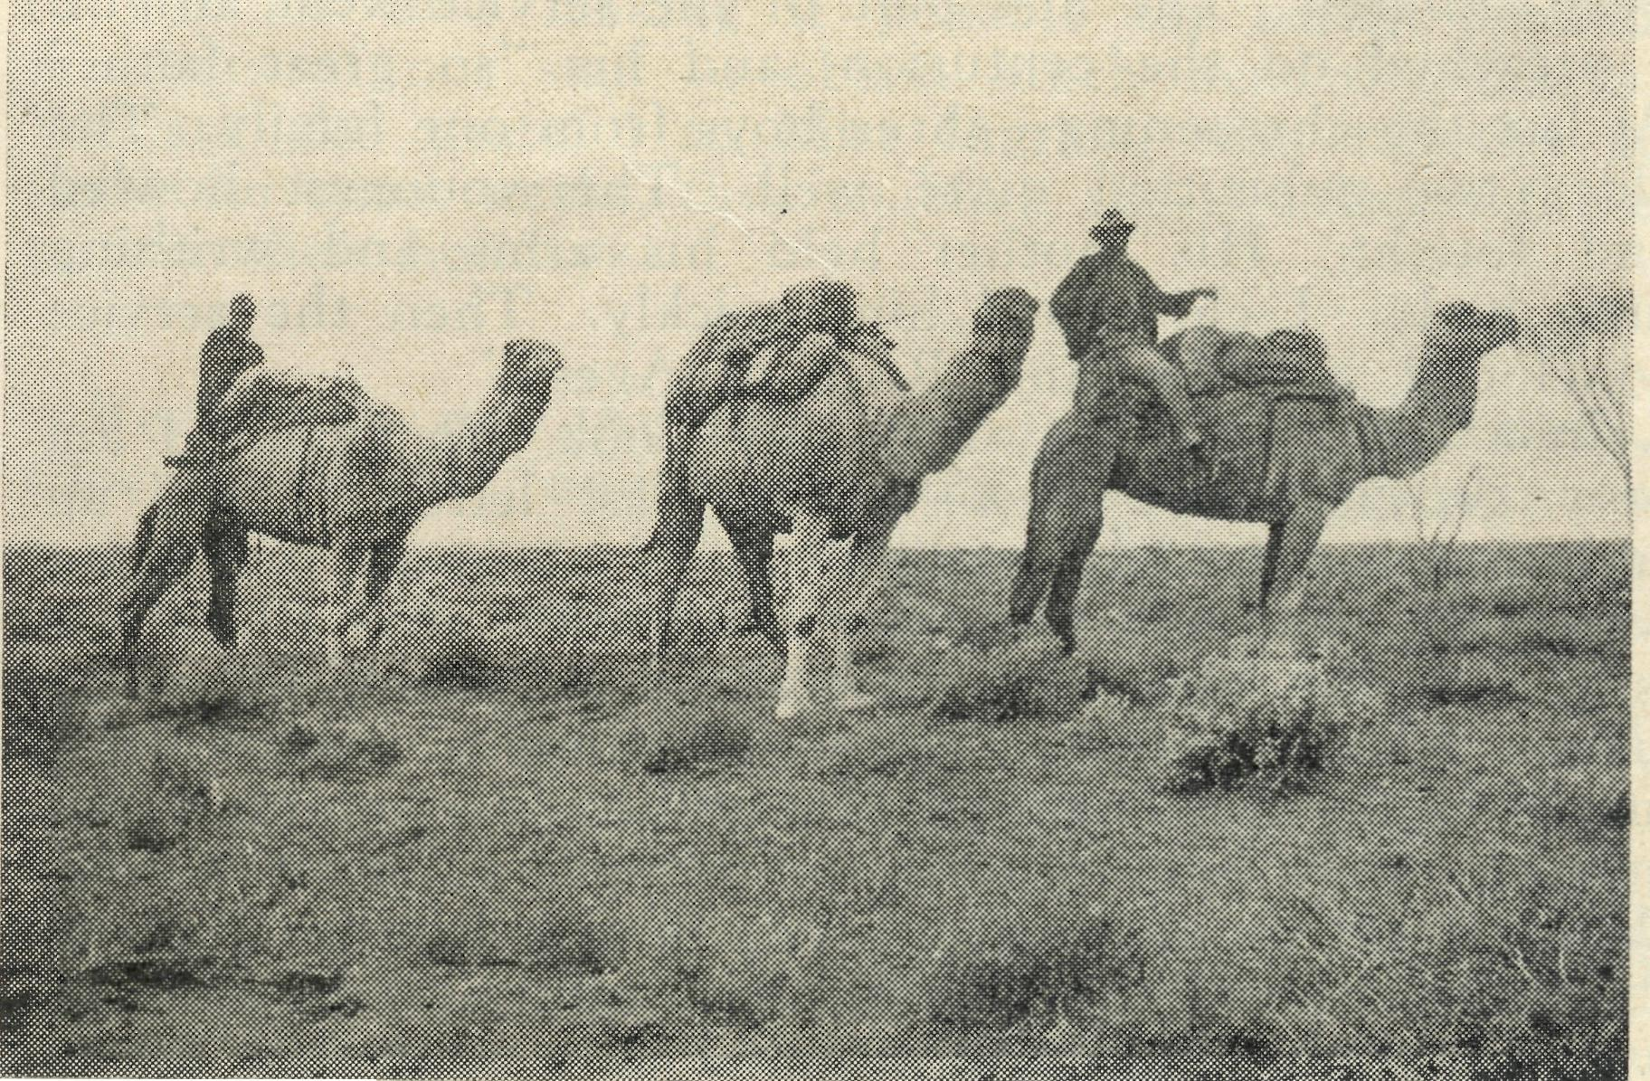
Some other travellers in the Far West.
W.A. The roofs of Cook are just dots on the eastern skyline. I sit in the van with the guard who is reading a Pix. The sky is mauve-coloured all round the horizon and the guard prophesies a "sticky day ahead."
This is not the usual guard's van. It is a thing that looks like a house on wheels. It is very sooty and black on the outside and inside it is rather bare and dirty. On the table here is the guard's tucker box, his kit bag and an empty set of forms labelled, "Train Waybills." In the corner is a stove. It has no fire in it. Around the floor are a kettle and a teapot, a heap of thin stringy chips, the sort for a quick fire, and some long big pieces of split sleeper. Over near the door is a big water drum propping the door open. On the door handle hangs a coat. Against one of the grimy windows hangs another coat. The sun is shining in through the open back door of the van and we are doing about 20 m.p.h., not much of a speed and pretty noisy, still it's only a water-train! Weary stretches of flat plain with patches of salt bush all over it, stretch around the train. Through the open back door, you can see it, through the four grimy windows you see it,—it's everywhere. The sun is up now.

THE REAL AUSTRALIAN
August, 194?

This last scene is from my diary and just shows the type of work. My task that morning I felt was to try in some way to make personal contact with thz guard's thoughts, and find out by conversation, or in some other way, how to "speak just a word for Jesus.'" I failed that morning. I fail often. Sometimes I succeed in broaching the one great subject that leads to a man's honest expression of his feelings and human needs and perhaps his spiritual yearnings. Can you see why I need your prayers?
Just one more snapshot. It is perhaps rather ordinary, but at has in it a true picture of my work, its hopes and some of its difficulties. It is from my diary, 11th November, 1946. "To-night had a typical service, such as I usually have in these camps. It was at Reid on the Trans. Line, about 3 3 miles west of the border between S.A. and W.A. At 7.30 the congregation began to roll up; mostly children this night. I could also hear the squeak of a pram coming along the cinder-track as there was to be a christening at the end of the service. It was a hot night. We threw open all the windows of the little school room where the service was to be held. Three long forms at one end of the room were for the congregation. Nearly one half of the rest of the space was occupied by the piled school desks. The service began. As soon as we began I could see that the service^ would have to be simplified and fairly short as most of the congregation were children. The first part of the service went alright. I preached on the centurion, and his "so great faith." At last the christening—three boys from one family. The elder two submitted quite well. The youngest howled and fought. His mother held his arms and writhing little body. I christened him quickly. Then the service concluded, and we sang 'Rock of Ages'."
In a few days I set off on my Cook trip again. I am busy getting ready now—writing last letters, fixing up addresses for the Lay readers while I am away, arranging with people on my route for hospitality, etc. (This last is all done by wire some days ahead.) Packing up magazines, handy gospels, New Testaments, tracts and literature for handing out. Everything is important, and may so easily be forgotten, as there is so much to do. When I arrive at Cook it will be too late to discover then that this and that should have been packed. The trip will last three weeks and more. Please remember me in your private prayers.
Any magazines and general reading you can send will be welcome.
(Editor's Note.—Head office has received over £10 in donations towards the re-erection of "the Church that was" blown away." We will gladly pass on further donations.)
SOUTH AUSTRALIAN LISTENERS !
Tune in to - -
5 M.U. 1
5 A.D. ^{on} Sundays,
5 P.I. | at 9 a.m.
5 S.E. 1
Cummins Mission
(This article is submitted by an Adelaide University student, who was staying at Cummins recently.)
It was a most welcome experience for me, a University student who has been all his life a town-dweller, to spend some time in a Country Mission measuring over 160 miles in extent.
I was not long in the Cummins Mission before I saw what grave disabilities prevailed; handicapped by which the Church finds it so difficult to function. The townships are scattered in remote places; and the areas between are thinly populated. The roads, although fairly safe in dry weather, become bumpy and treacherous after a fall of rain. When a Missioner visits the remote parts of his district he must spend a great part of his time on the road; and too often when he reaches his destination he can only do a fraction of the pastoral work necessary, because he must soon leave for other parts of the Mission. Contact, therefore, between Missioner and his people is difficult—the spiritual needs and problems of Church-people cannot be adequately ministered to under these circumstances. Indeed, largely because the Church has not been able to provide sufficient ministry in the past, the spiritual life of many country districts is at a low ebb.
On June 24th I set out with the Cummins Missioner on a 350 miles tour over some of the Mission to conduct services and administer to the church-people of the Cowell-Cleve and Kimba end of the Mission. On Sunday services were conducted at Cleve and Cockabindnee in the morning, Mangalo in-the afternoon, and Cowell at night. Monday morning was spent in administering sick Communions at the Hospital and the homes of various parishioners, and during the afternoon the monthly meeting of the Mothers' Union was held.
Early Tuesday morning a start was made for Kimba, 60 miles north of Cowell; and on the way up homes were called upon, prayers said and literature distributed. Evening prayer was said in the evening; and on the following morning Communion was administered to the townspeople. It was apparent wherever we went that the church-people were most grateful for the services of the Church in churches, Mission halls or school-house and private dwelling, and an atmosphere of reverence and devotion prevailed. People came from as far as 20 miles (over bad roads and in cold weather) to a service held in a draughty school-room; and enjoyed their opportunity of joining in corporate worship, although they worshipped under such difficulties. Not only do the church people show great love for Our Lord, but they have great regard for the Church and her priests, alms, travelling expenses, and money for the upkeep of the Church are offered generously. The Clergy are gladly welcomed and entertained in the homes of their congregation, where a bed, or a meal, or just a "Cupper" awaits them.
This particular mission is like many other country districts in Australia awaiting the ministrations of the Church. At present the clergy, although working overtime and under many difficulties, are struggling to keep their end up; and consequently the Church cannot evangelise as she should. For many years to come the thinly populated areas of the country are purely Mission areas, because money for their existence and the manpower must come from without. The field is waiting and the ground is being slowly but surely prepared. Who will sow the seed from which the harvest will be reaped?

August, 1947
THE REAL AUSTRALIAN



Sister B. Bossley and Miss D. Dykes are still on extended leave following serious illness.
# # * *
The Prayer Meeting for the work of B.C.A. is now
held in St. Andrew's Cathedral Chapel, Sydney, on the first and third Mondays of each month at 1 p.m. All friends are invited to attend.
Sister M. Crouch of Adelaide has joined our nursing staff at Ceduna.
Arrangements are now being made for our Annual Rally. Do come and make this meeting an outstanding success. It will be held on Tuesday, September 30th, and it is hoped that the speakers will be the Rev. R. T. Hallahan, who will tell of something of his 14 years¹ experience as a missioner of the Society, and the N.S.W. Secretary, the Rev. D. Livingstone, who will illustrate his talk with new pictures of the work of B.C.A. The Chairman will be the Rt. Rev. W. G. Hilliard, Bishop-Coadjutor of Sydney.

We congratulate the Rev. C. and Mrs. Sherlock upon the arrival of a daughter, and the Rev. J. and Mrs. Greenwood upon the arrival of a son. Mr. and Mrs. Greenwood and David were in Sydney in July, enjoying a well-earned holiday after 31 years' service in South Australia. They are now back at Minnipa.
# # # #
We are grateful to those who responded to our appeal for gifts. The Ladies' Auxiliary was able to purchase a new sewing machine for Wilcannia Hostel through the splendid response to a broadcast appeal, and other donations. A dining room clock was given for Bowral Hostel. Another refrigerator is needed for Ceduna Hospital. Some money has already been given for this purpose, but more is needed.
We are also grateful to all those people who have given cash for food parcels and parcels themselves, in answer to the appeal by the Rev. Tom Jones in the last
issue. The response was splendid.
# # # *
We welcome Mr. Harold Bragg to the Council of the B.C.A.
# # # #
Many thanks to those who sent in donations towards the cost of rebuilding the church that was blown away at Smoky Bay.
* * #
Sister Dowling of Ceduna is enjoying long leave, the first for four years.
The Rev. R. T. and Mrs. Hallahan, after serving B.C.A. for a total period of 14 years, have completed their ministry at Kirton Point, S.A., where they did most faithful work. They also worked at Cummins, S.A., and in the Melbourne office. Their work under the Society has been of a high order, and we wish them and their family God's richest blessing as they leave the B.C.A. ministry to begin their new work at Windsor, N.S.W. They will be long remembered for their fine Christian witness and devotion to their task.
# # # #
The Rev. Tom Jones, our Organising Missioner, continues to have a successful ministry in his visit to the Old Country. Since our last issue, he has visited Scotland and the north of England, as well as other parts. He was also the preacher at the Empire Day Service at Liverpool Cathedral, and one of the speakers at the annual meeting of the Colonial and Continental Church Society,
Our thanks are due to Miss Osborne and Mrs. Livingstone, who arranged a Cooking Demonstration at St. George County Council, Kogarah, N.S.W., which resulted in a substantial addition to our funds.
Sister D. Robinson has returned to Sydney after relieving at Ceduna for three months. We are grateful to her for thus making it possible for sorely pressed members of our staff to obtain much needed holidays. We are also grateful to Miss Ingram, who relieved at Cook for some weeks, thus enabling the two sisters there to take their holidays.
* # # #
Recently a new Auxiliary was formed at St. Luke's,
Clovelly, N.S.W., and its committee has already planned a year's programme of activities, which should prove interesting and attractive to people who wish to know more of the lives and needs of our outback folk.
* # # #
Some of our missioners urgently need small Communion sets for use in homes on their bush patrols. Gifts of money for this purpose or gifts of Communion sets will be gratefully received.
* # # #
We have learned with regret of the death of Mrs. E. L. Langley, the wife of Archdeacon Langley. Mrs. Langley was deeply interested in the work of the Society. We express our sincere sympathy with the Archdeacon and his family in their bereavement.
* * #
The Col. and Con. Church Society has sent Denmark Mission £200 towards a much-needed new car. More money is needed for this purpose, and we will gladly send on donations.
PRAYER BOOK AND BIBLES
In a recent issue of this magazine we asked for Prayer Books for the use of our Mail Bag Sunday School children, and we wish to thank those who responded to our appeal.
To those who have not sent in but may wish to do so, we would suggest that they see that either Bibles or Prayer Books are in GOOD ORDER, and COMPLETE

THE REAL AUSTRALIAN
August, 1947

*#s*#Nr-#,#^#\#sr.#^»\r*\*#,r,r^*.#N**

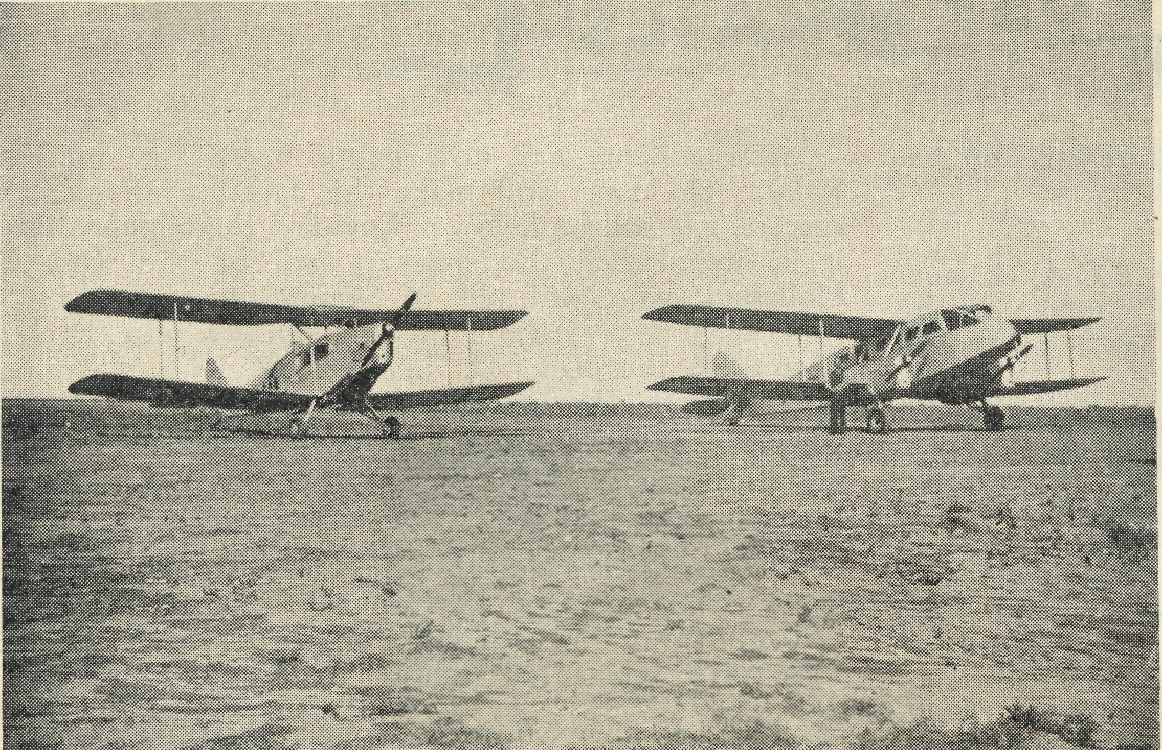
The Flying Medical Services of the Bush Church Aid Society

VH-AGI Flying Costs £7 per hour

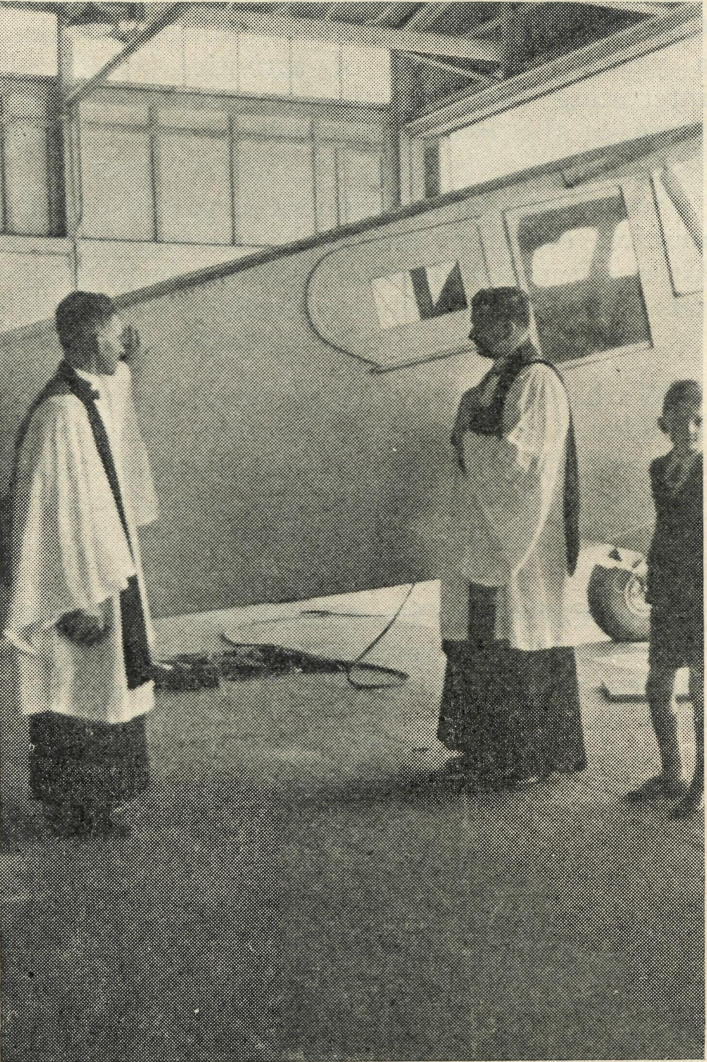
Three Flying Doctors, accompanied by the \ Bases at Ceduna, S.A., and Wudinna, S.A.
and make many emergency flights to station

Dedication of VH-AGI. March, 1947. KEEP THEM

August, 1947
THE REAL AUSTRALIAN

Nr^\r^^#^#v#srsrs#viNrv#^v#\ryrvr^vr^rv#^^

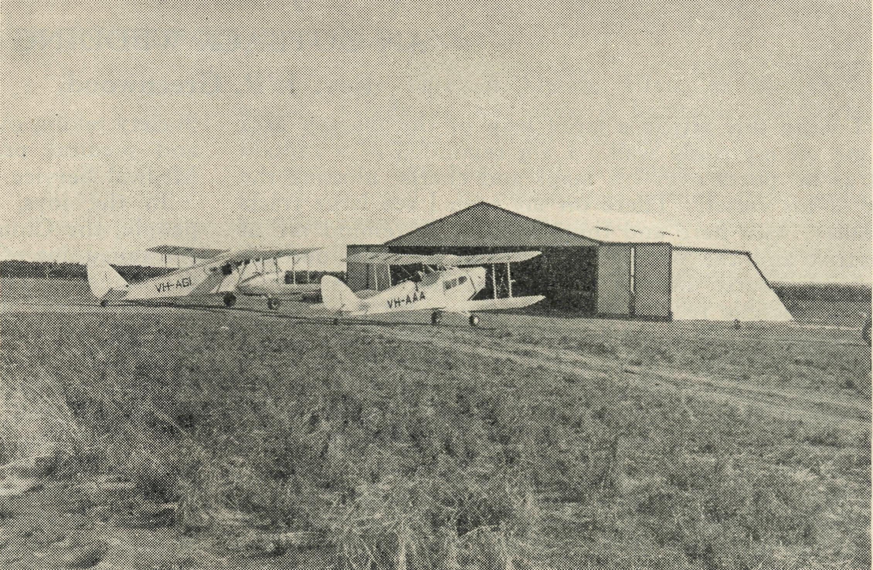

Planes outside B.C.A. Hangar at Ceduna.
VH-AAA Flying Costs £5 per hour

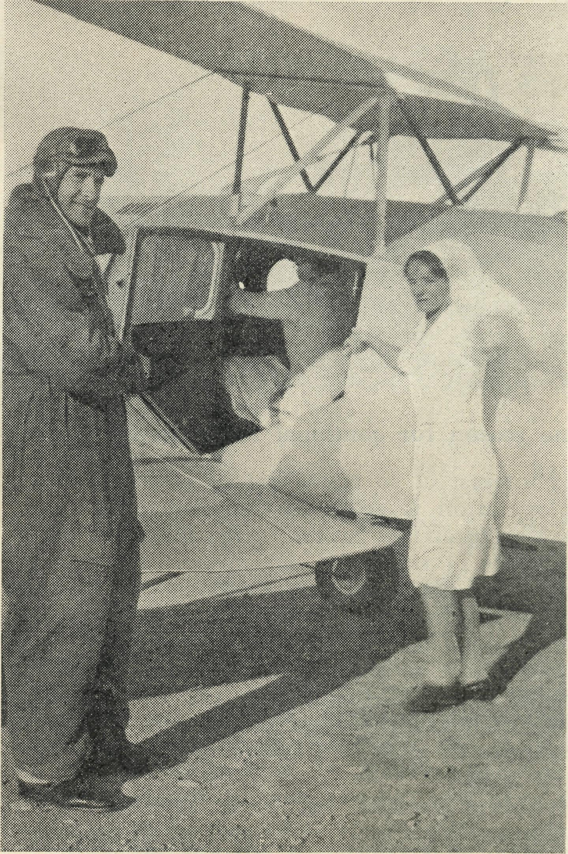
flying sisters of B.C.A. fly regularly from the
to

^Jarcoota
homesteads and lonely outback settlements.

FLYING
Doctor and Pilot prepare to take off.

#<#*s#sr#N*#*v#vr#N#*#srsr#>#v#s#sr#s#N#'*

THE REAL AUSTRALIAN
10
August, 1947

Minnipa Mission
AN OUTBACK WEDDING Rev. J. R. Greenwood.

As I write this article a large map of the mission area faces me on my study wall. I am reminded of a captain ' at sea as he pores over his maps and charts, plotting the course of his vessel. There on my map I see large tracts of country, with here and there a name to remind me of the district and the people who inhabit our vast outback places. A course has to be plotted so that as many people as possible receive regularly the ministry of Word and Sacrament. One has to take into consideration the expense of running the Van and to remember the time occupied in reaching out as far as possible to each section of the area. There are schools to receive religious instruction, services to be conducted and homes to be visited, as well as the occasional calls of a special nature.
The trips vary in duration from 5 or 6 days to 3 weeks, and with the continual travelling consideration must be given to the servicing of St. Patrick's Van. With a life of some 74,000 miles the Van must be continually inspected and attended to, as so much depends upon this valuable means of transport. Taking it all in all, there is much to occupy the precious hours, and the weeks seem too short to accomplish as much as one would like.
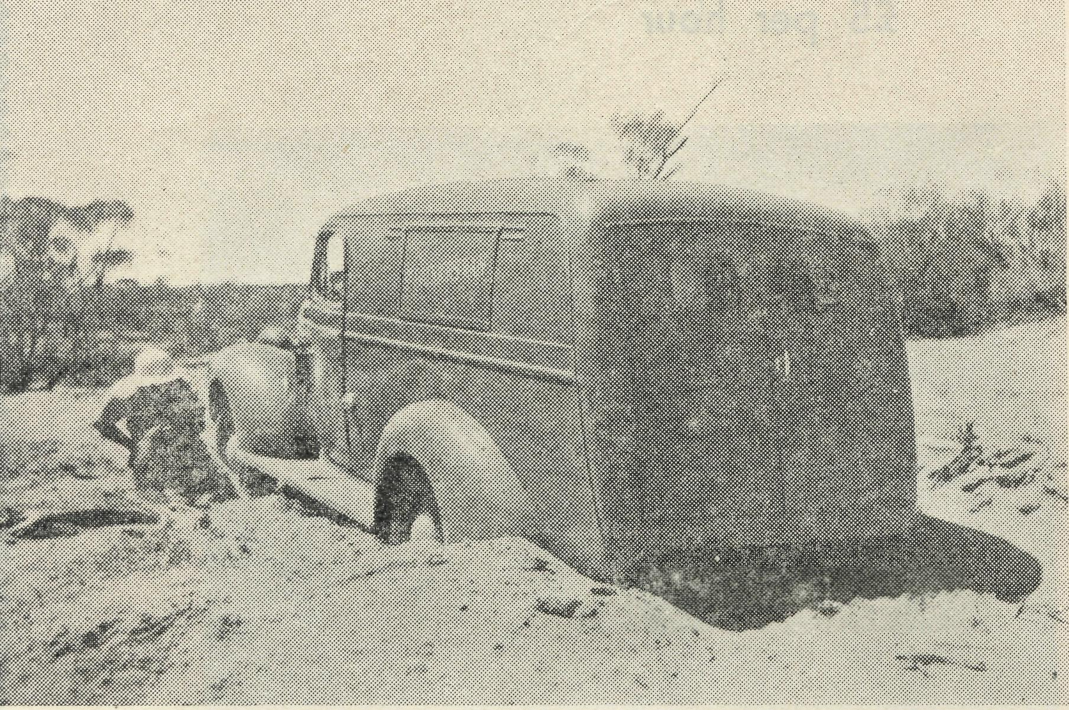
One reason for continual inspections.
The kindly interest of so many friends is deeply appreciated, as co-operation is given to this outback ministry. I am continually receiving papers, magazines and books, as well as supplies of tracts for distribution amongst the lonely settlers. To add to this indebtedness the Minnipa Church recently received news of a gift of £210 from a friend in England. This will materially help in the erection of a noble edifice in the town to remind the people of their duty to God. Unfortunately, the official permit to build the Church cannot as yet be granted, but nevertheless we continue to pray and labour for the day when our Church is built.
Another building venture has been launched in the town of Wudinna, which is 25 miles east of Minnipa and about the same siz,e, having a population in town and district of some 400 people. Two blocks of land have been acquired in the centre of the township, and it is hoped by gifts and special functions to raise the money to build a Church in the near future. Special interest in Wudinna has been caused by the Bush Church Aid
Society taking over the administration of the local hospital and medical practice, which includes a Flying Doctor Medical Service.
In the joys, as well as the sorrows of the outback people, the Church has her part to play, and it is by the continued interest of many friends that this ministry is maintained. There is, however, a tremendous challenge to the youth of our Church to answer the call of the outback by serving in the mission work, hospitals and children's hostels. We need to extend the sphere of the effective ministery, but without the manpower enterprise is restricted and may even be crippled.
A short time ago I was privileged to conduct the marriage of the daughter of a father and mother who have spent many long years in the Australian bush.
Lest you should thing that it was a typical wedding, set in the inspiring atmosphere of a beautiful Church, I hasten to assure you that such was not the case. When your nearest Church is over 100 miles away, then you are forced to do all the improvising you can possibly conjure up so that people may be reminded of the presence of the Church in their midst.
In a little stone hall, bereft of any semblance of ecclesiastical art, two people were joined together as man and wife. The hall stands in a clump of pines some considerable distance from the nearest house. However, the ingenuity of the local people was not to be frustrated, and so a great deal of work was undertaken in a spirit of fellowship so typical of those who live so far away from the more settled areas of our vast country.
The walls were soon bedecked with flowers—yes, they do grow in these parts—and many yards of white streamers disguised the drab roof timbers. It was my job to provide the necessary cloths to drape an old kitchen table and prepare it as a Holy Table. As there was no supper room to act as a vestry, the piano must be placed at an angle to provide a screen while the bridal party signed the register.
It was unfortunate for the bridegroom that the bride decided to be a half-an-hour late. But there again no notice was taken of this happening in country where all sorts of things conspire to delay even a wedding. There was no need to send out invitations as the whole district co-operated in this great event.
At last, however, the bride arrived to allay the anxiety of her bridegroom, who, as you can well imagine, had been subjected to many quips from the guests. The solemn service was conducted amidst the homely surroundings so familiar to all, and yet on this occasion transformed into a place of sacred and hallowed memories.
The service concluded, the bridal party left on a trip along the road until the hall-turned-Church became once again a hall for the wedding reception. Many willing hands and strong arms soon had the trestle tables erected, and after much running backward and forward to cars, trucks and buggies, the tables were duly prepared with food.
By this time the bridal party had completed their tour of the district—if they did go on a tour, which I much doubt—and the clergyman now turned to the task of being toast-master.
Such experiences are a reminder of the need for continued interest in the work of God amongst the outback people.

August, 1947
11
THE REAL AUSTRALIAN

A Doctor Reports

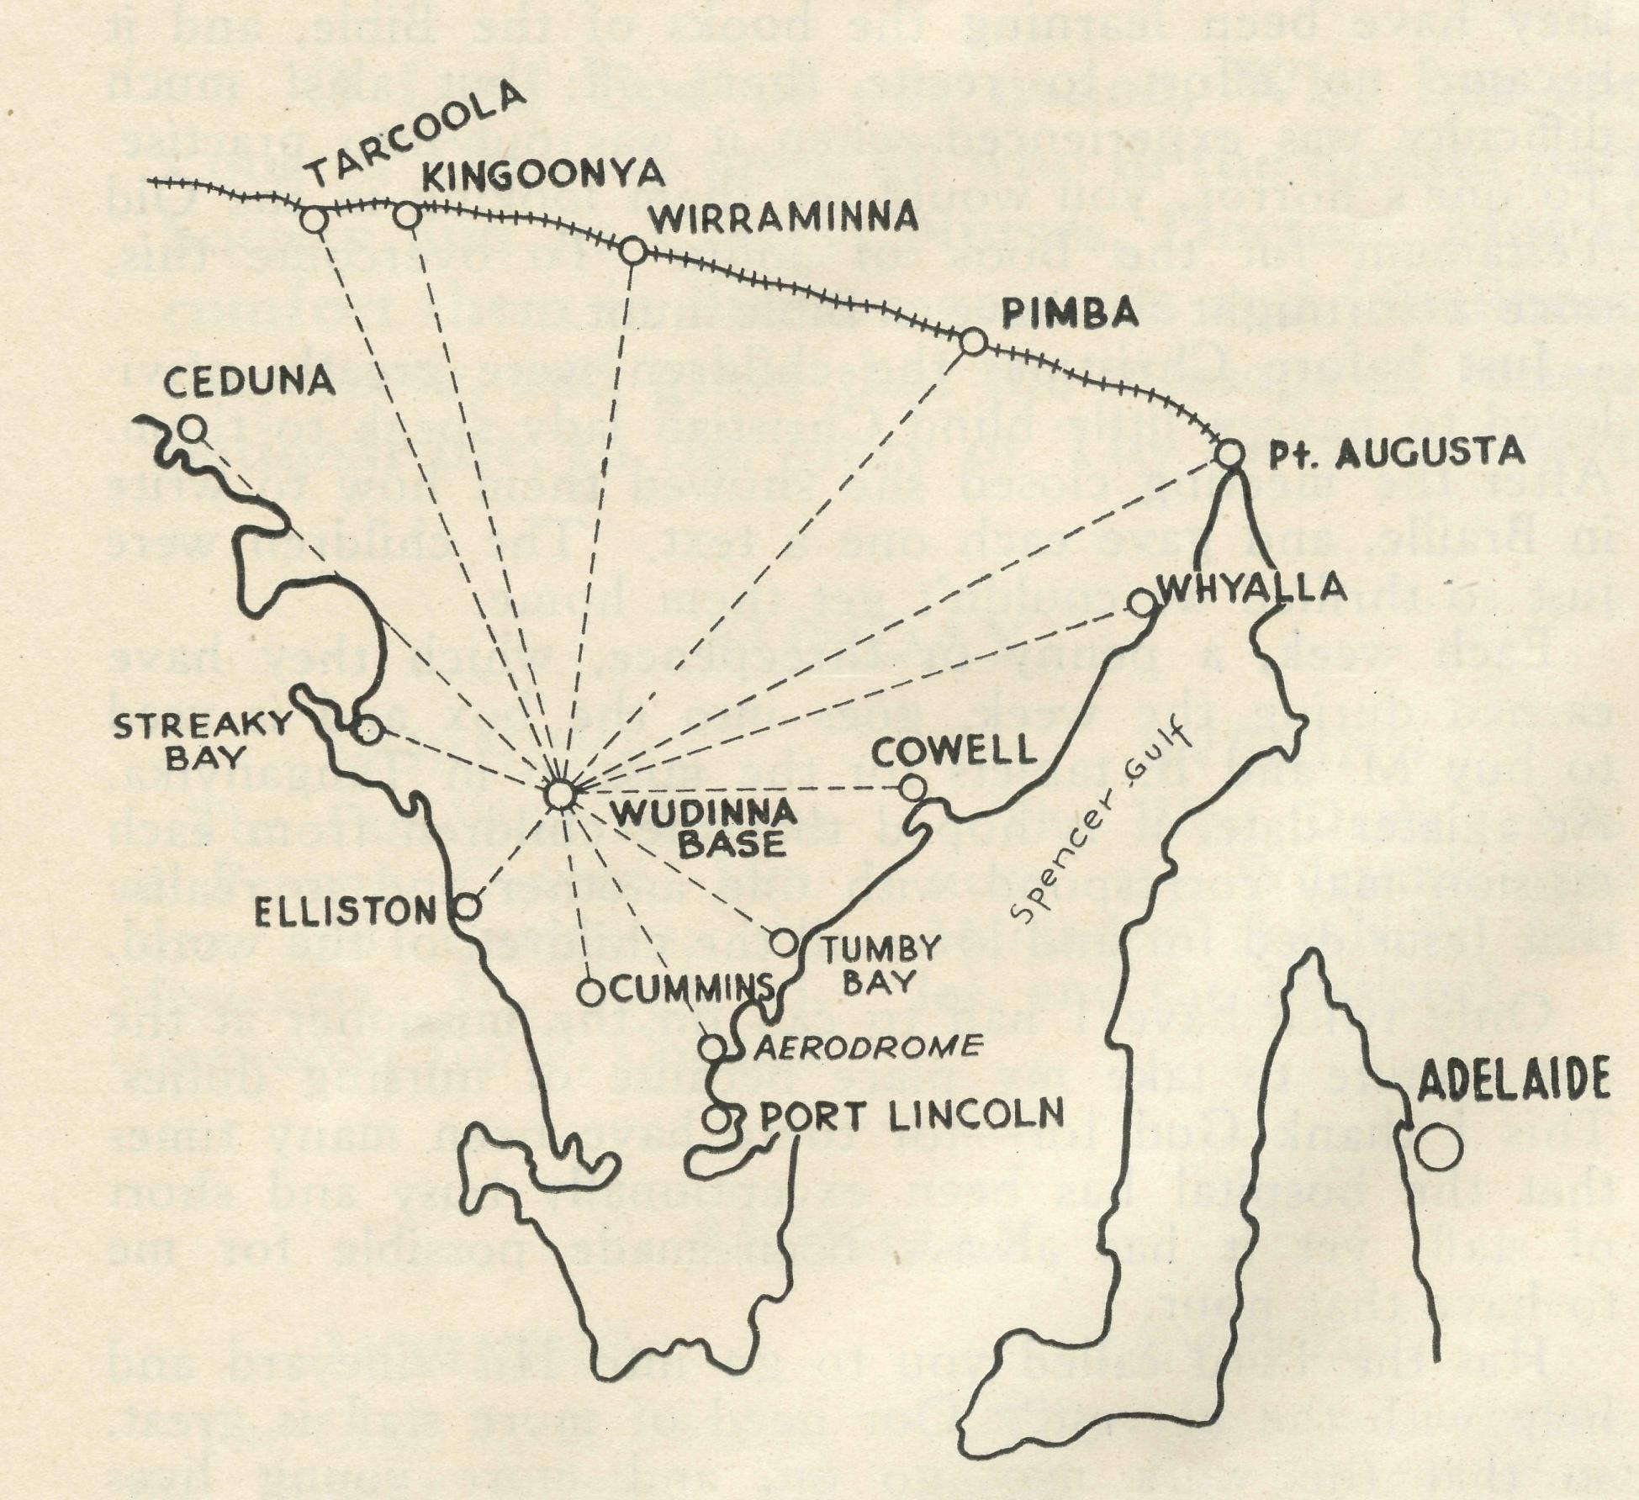
Dr. R. ROXBURGH, B.A., MB., B.S.
Wudinna, West Coast, South Australia, is the centre where meets the Council of Le Hunte, a district sixteen hundred miles square. It is the site of the Central Eyre Peninsula Hospital, built to meet the needs of Le Hunte. Owing to staffing difficulties, and the local reputation of the B.C.A. Hospital at Ceduna, in 1946, it was handed over by the Council for management as a private hospital by the Bush Church Aid Society.
War had absorbed potential country medical practitioners, and the practice of Le Hunte had fallen into the hands of its council, who again were faced with staffing difficulties. They decided to transfer their worries to B.C.A.
Medical officers were about to be discharged from the services, and Principal Medical Officers were advertising practices for sale and jobs available. Thus the Society acquired a M.O. qualified to fly a light aircraft for a projected aerial medical service in the Eyre Peninsula. He, the Society, and the people of Le Hunte, were fortunate in his possession of a very charming and accomplished wife.
VICTORIAN LISTENERS!
TUNE-IN TO
3 DB
THURSDAYS AT 4.45 p.m.
We came here in March, 1946, to the shell of a house. Gradually we made it habitable and sorted out workable consulting rooms and dispensary.
Sister L. Pritchard had preceded us to take charge » of the Hospital. Its possibilities seemed great, and fifteen months have seen equipment acquired and improvements made. From Adelaide come essential new theatre equipment. The Society's friends throughout Australia have presented more. Local country women, football association, and the District Council of Le Hunte have worked to increase hospital amenities. Staff has been added and staff lost. In the initial transfer period Sister loan Mildren helped us greatly, came back on one occasion to relieve, and remains among the nurses one is glad to have known. bister Bossley's illness not only lost us a capable sister, but deprived the staff and patients of a sincere and cheerful friend. Recently in Miss M. Earle we have lost a valuable staff member who showed quiet capability in any work she undertook.
The Ceduna District Hospital is a credit to the Bush Church Aid Society, and the hospitality it offers needs experience for appreciation. It has provided a tradition for Wudinna and given us help on many occasions. Very great also has been the pleasure and help coming from the knowledge of Drs. R. and F. Gibson to whom this practise and ourselves owe much. With the acquirement of his new De Haviland Dragon, Allan Chadwick, pilot since February, 1938, of VH-AAA, the Fox Moth, has tutored me most carefully and kindly in the flying of this latter aircraft, and has worked for her establishment here. Now hangared at Kyancutta aerodrome she links us closer with Ceduna.
Medical practise here is widespread. At Warramboo, sixteen miles away, one consults on Tuesdays at Berts' store, enjoying the hospitality of Mr. and Mrs. G. T. P. Thomas, the latter a trained sister, on whom the townsfolk and myself depend greatly. At Minnipa, in the other direction, Mrs. W. O. M. Wilcourt, of the hotel, comes into the same category, and saves the doctor many a twenty-four mile trip. Here also the missioner, Rev. J. R. Greenwood, and his wife provide for us a home away from home. At Yaninee one consults in the house of Mr. and Mrs. J. W. Craigie, and at Kyancutta in that of Mr. and Mrs. A. I. Cook, and finds a welcome in both bomes. Short of an aerodrome here, we have to thank the Bedford family for aerodrome facilities at Kyancutta and in particular Mr. W. R. Bedford for his maintenance work upon and general help with VH-AAA.
Work is constant and varied, bringing us into contact with people who appreciate our endeavours in the arts of medicine, surgery and pharmacy. To us New South Welshmen Adelaide consultants have been most considerate and kind, and we have found good friends in our neighbours, Drs. M. A. Trudinger of Elliston, J. R. Coates of Kimba, D. A. Keenwick and A. J. Clarkson of * Port Lincoln. Also in A. M. Bickford and Sons, Adelaide, and C. L. Thomas, Port Lincoln, we have found good friends.
Though the fires be sometimes slow in kindling in the morning, and sometimes the Tod water runs brown, I am thankful to my wife for putting up with these things, thankful to the hospital staff for coping with the trials that beset them, and we are glad that the Bush Church Aid Society gave us the opportunity to be here.

THE REAL AUSTRALIAN
12
August, 1947

With the Children at Ceduna Hospital
Sister A. J. Miller

May I introduce you to my Bible Class? And what a class! Fifteen young energetic children, ranging from nine to fourteen years, who are as keen as mustard. Every Friday night, at 7 p.m. you hear sounds of whistling, • chattering and laughter as they come along in their various groups. Our average of eleven has been well maintained, except, of course, over the vacation when so many were absent. Being held at the hospital creates a great interest, and is a novelty.
One night, a quarter of an hour after we had started, a little girl came in very rumpled and streaked with grease. I was a bit amazed, as usually the children are spotless. However, after the class was over, she came along and apologised for her untidiness. She and her family had spent the day out, and coming home a puncture was their lot. Knowing the little lass, I can well imagine her completely under the car. Had she gone home to change, she would have been too late! Another little lass, spending the day on the beach, the temperature being over 112°, packed up her things at 6 p.m. and announced to her mother that she was going home to get ready for Bible Class. All the persuasions from the mother that Bible Class would be off because of the heat were of no avail. She was in her place at 7 p.m. These are only two instances of their keenness, and we thank God for it, and pray that the seed may be sown faithfully in their youth and bring forth fruit to His honour and glory.
We begin with choruses which the children thoroughly enjoy and the nursing staff assist us—thank you! Recently
they have been learning the books of the Bible, and it became no effort to recite them off; but alas! much difficulty was experienced when it was put into practise. To one's horror, you would see them looking in the Old Testament for the Book of John. To overcome this, once a fortnight we have a Bible hunt.
Just before Christmas the children were greatly privileged to have a little blind Christian lady speak to them. After the meeting closed she showed them how to write in Braille, and gave each one a text. The children were just so thrilled we couldn't get them home.
Each week, a penny or threepence, which they have earned during the week, goes into the box and is used to buy M. and B. tablets for the mission in Tanganyika. At a later date, it is hoped that the children from each mission may correspond with one another and so realise that Jesus died for and loves all the children of the world.
Only twice have I had to call on the missioner at the last minute to take my place because of nursing duties. This I thank God for—for there have been many times that the hospital has been exceptionally busy and short of staff, yet it has always been made possible for me to have that hour.
Has the Lord called you to go into His vineyard and help with the harvest? Our need of more staff is great, so that the work may go on, and more young lives touched with the Gospel message. Is He to call in vain?
(Editor's Note.—This article from Sister Miller clearly reveals the Christian nature of our hospitals. We need more nurses for this Christian Missionary service.)

Mail Bag Sunday School
SCHOLAR—TEACHER Mrs. S. James.

In the past it has been a joy to us to welcome several of our Mail Bag Sunday School Scholars to our work as teachers, some taking charge of a country Sunday School, or helping in one conducted by their parents, while others have become teachers in our Mail Bag Sunday School itself.
Here is a brief outline of the career of the latest of these helpers to offer, trusting that it will inspire others to do likewise.
Living on her father's sheep station outback, she joined the Mail Bag Sunday School early in 1937, doing outstanding work and showing great interest. After passing through several grades of our school and completing the course of Confirmation Lessons, she left home for High School, where she was able to attend a Sunday School.
From High School she became a Science Student at Sydney University, residing at one of the Church of England Hostels for students. While at the Hostel she taught in Sunday School each Sunday, and throughout these years kept in touch with her former Mail Bag Sunday School teacher.
On 31st May, 1947, she received the degree of Bachelor of Science in the presence of her parents, friends and teachers. We congratulate her on this distinction and
also on the position which she holds at the Sydney University.
Finding that she would be living in Sydney she has offered her services for B.C.A. work as a Mail-Bag Sunday School teacher.
Having lived in the country for so many years she would naturally have an intimate knowledge of the bush child's needs, so we were very pleased to accept her offer.
As we thank God for this new helper we pray that the children she contacts will receive great blessing, and that many others will follow in her footsteps.
STAMPS. STAMPS. STAMPS.
We need postage stamps! Used stamps! Any issue of Australian stamps! Foreign stamps! All are of use to us!
Just cut out the stamp, leaving a quarter-inch margin— we'll do the rest! Send them to our Sydney or Melbourne office.
Ask your friends to save them, particularly those working in large offices or Mail Order departments. Ask children to save them, too. By these simple means you can help us to help the people of the outback.

August, 1947
13
THE REAL AUSTRALIAN

THE PLACE OF PRAYER
A Prayer for Use with Our Prayer List.
O Lord God of our nation, Who has commanded men to subdue and replenish the earth: Look in Thy love upon all who in the distant parts of our land are striving against many difficulties, Society and its Clergy, Nurses, Doctors, Hostel Workers, and Air Pilot, and Students. Cheer and comfort them in discouragements and loneliness, and bless their ministrations to the good of those they serve, and grant that the message of redeeming love may thus be rooted and grounded in our national life, to the glory of Thy Great Name through Jesus Christ our Lord. Amen.

SUNDAY.
THURSDAY.

EVENING
The West Darling Missions at Wilcannia and Menindee; the N.W. Mal-lee, and the Missioner.
FRIDAY.
EVENING
The Denmark Settlement, the Kirton Point Missions, and Missioners, and Rev. C. N. Sherlock.
SATURDAY.
EVENING
For the Cann River Dispensary, and Sister Gwynne and Koonibba Mission Hospital, and Sisters L. Pritchard and H. Foster, and the Wudinna Staff.
MORNING
The Far West Missions at Penong, Ceduna, Min-nipa and Cummins; the Missioners, D. Pugh, J. Greenwood and P. Connell.
MONDAY.
MORNING
The Cann River Mission, the Bonang Mission, the Streaky Bay Mission; the Missioners C. F. Withing-ton, D. H. Wicking, and T. J. Hayman.
TUESDAY.
MORNING
For Sisters Dowling, Miller, Gillan, Hitchcock, Holle, L. Loane, E. Fisher, Woodings and M. Crouch.
For the Bowral Hostel, Deaconess N. Dixon. For Theological Students of the Society in training.
WEDNESDAY.
MORNING
For the Mail Bag Sunday School with its Gos'pei messages for the children. For the Director, Miss R. Campbell, the teachers and helpers, that they may find encouragement in their work.
MORNING
For the Bishop Kirkby Memorial Hospital and Sisters Thomas and Coleman, as they minister to the people on the great Nulla-bor Plain. For Sister Page and the Tarcoola Medical Hostel.
MORNING
For the President and Council of the Society, that they may be guided by His wisdom.
For the Home Base Staffs, Auxiliaries, and parochial workers.
For the N.S.W., Victorian and South Australian Secretaries.
EVENING
For the Organising Missioner, that he may be strengthened and guided in all his endeavours for the good of the work and in his relationships with his fellow-workers.
EVENING
For students and all in training for this work of God. For the Heytesbury Forest Mission, and the Otway Ranges Mission, and the Missioners, Rev. A. L. Mills and Rev. T. H. Pick-burn.
EVENING
For the "C oorak' Hostel and its workers, Mrs. Mann and Miss Stokes.
For the Rappville Mission and the Missioner, the Rev. R. Meyer.

MORNING
For the children in* the Mungindi, Wilcannia and Port Lincoln Hostels, and for the workers, the Misses Cheers, L. Knox, Miss Farr, and Sister Sowter.
EVENING
For the Flying Medical Services, Mr. Chadwick, and Doctors R. and F. Gibson, Dr. R. Roxburgh.
For the wives and families of the Missioners and Air Pilot.
Each day pray that the many needs of the work may
be met. Running expenses of £7 per hour to keep the Medical
'Planes in the air. Consecrated clergy missioners and other workers for
urgent work in the field. That our work may continue to progress despite the difficulties of the post-war period.

Give Thanks—
For the rich blessing and wonderful growth of the Society's work. For all the kindly givers who have helped with their self-denials. For the Flying Medical Services, For the joy of service,

THE REAL AUSTRALIAN
14
August, 1947

Penong Memorial Hospital
The people of Penong recently purchased a new operat-ing table for the Hospital there. It is a memorial to five men who gave their lives during the War. Sister L. Loane, the Sister in Charge at the Hospital, has written the following account of the arrival and dedication of this fine piece of modern equipment.
"We had our service to-day, and everything went off very nicely. The table arrived about two weeks ago, but we did not unpack it till this morning. Three lads came over and helped remove miles of rope and string, paper and that waterproof paper stuff. Everything
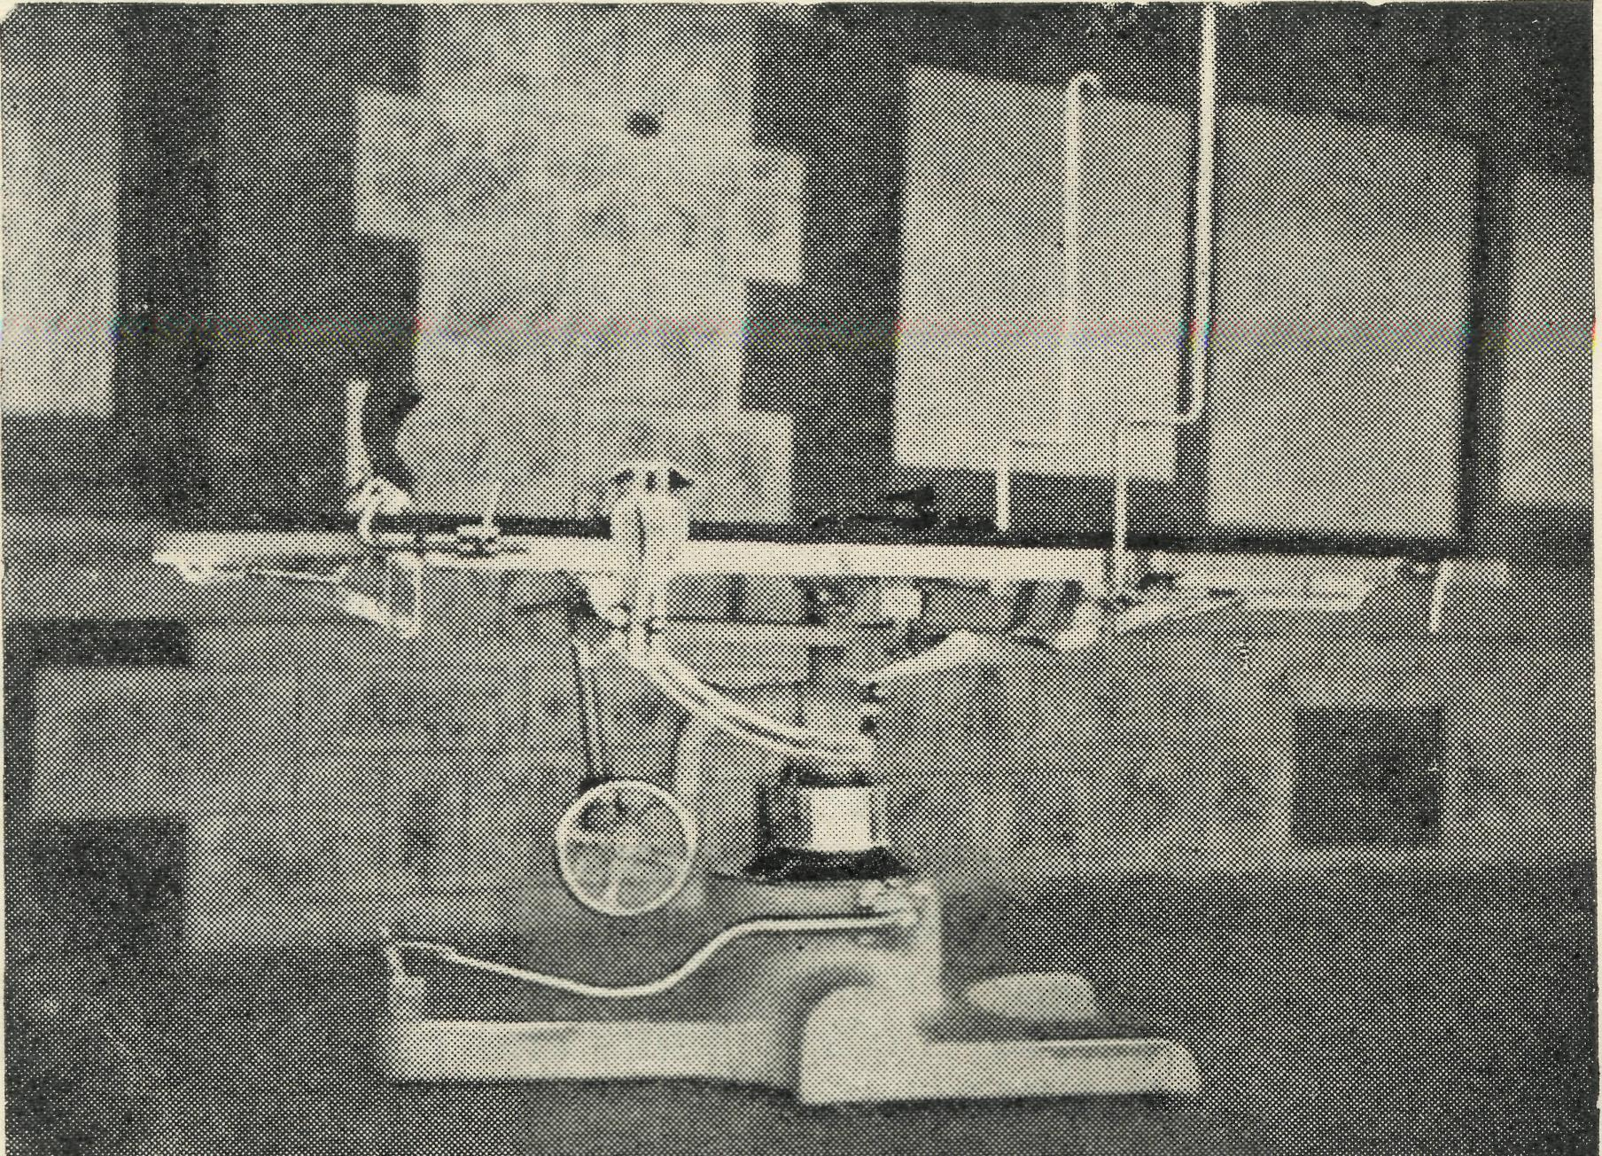
The New Operating Table.
was complete, and the only damage was that the pedal that works the opening to fix the table on the floor had been forced up and torn back its steel casing. The table is the gift of Penong and district—as far up the coast as Nullarbor and some miles down towards Ceduna, and it was presented to the Trustees of the hospital as a memorial to the five boys who fell in this war and those in the last. Mr. Connell took the service and the reading, and Mr. Pengille, the Methodist minister, gave the address, which was really good, on the subject of 'memorials¹, bringing in the memorial of the Communion Service, etc. Then Mrs. Cyril Murray unveiled the table by removing a flag and saying she had much pleasure in so doing. We had the service on the east verandah, the full length of which was crowded, and a fair number of men and boys standing in the garden. We only had our little portable organ, so the volume of sound was not great, and the hymns seemed to have unfamiliar tunes, so singing was weak. The people in the garden were generally a line or so behind those in the front. However, it all passed off happily and it was great to see so many there. Let's hope at least one heart was lifted a little nearer the Throne. The table is now in the theatre and looks 'just it.'
"The hydraulic lever and brake won't work, but the men say that is because of lack of oil, and they have decided to put some in, so let's hope that will fix it. It is much lower than Ceduna's, and rather different in several ways, but should satisfy the surgeon's wishes.
"I took various snaps, but the day was heavily overcast and the light poor on the verandah, so they may not turn out so well."
Thanksgiving from Wilcannia Hostel
Miss M. Farr
I have been given the task to write our contribution for the "R.A." We have been so blessed over the last months that it can only be a story of thankfulness.
First, we give thanks for the visit of the Rev. L. Ball, the Victorian Secretary of B.C.A., at Easter-time. Mr. Ball stayed at the Hostel, and was a very welcome visitor. After having our Church shut for so many months, it can be imagined how good it was to have two services each on Good Friday and Easter Day.
For some time our sewing machine has been useless. With what joy did we see a big package put on our verandah from the Singer Co. It was not long before there was some mending ready to try it out, and what a difference it makes. We are indeed thankful to the Sydney Ladies' Auxiliary for their lovely gift.
Only a few days later another package arrived, this time a kerosene heater sent by our friends in the Mail Bag Sunday School Office. Just the thing to take the chill from the dining room these frosty mornings, and we find many other uses for it too.
Again the doorbell rings, and it is the parents of some of the children with meat, milk and oranges for the Hostel, or a gentleman from one of the stations nearby with a case of mandarins and oranges. Sometimes, too, the mailman brings us fruit sent from our friends nearer Sydney. So our kiddies are able to go off to school with an orange, mandarin or apple for their morning lunch to help them keep their rosy cheeks and sparkling eyes.
For some months we have been waiting for a carpenter to do several jobs for us. Twice men had promised to come but had not arrived. Now another man came to look at the work and the next morning there he was, actually starting it. Within a couple of days it was finished. Now we can take the meals from the kitchen to the dining-room without them, or us, getting blown away or, occasionally, getting wet.
Then, too, we are eating vegetables from our own garden and have promise of many more. The rain early this year made this possible, but Miss Knox has green fingers, and has put in a lot of work to get such good results. Now we have some more rain just when things were getting dry and dusty.
These are the big things and there are many small things for which we are very grateful. We do give humble and hearty thanks to God for all His goodness to us.
HAVE YOU A B.C.A. BARK HUT BOX?
If not,
SEND FOR ONE TO-DAY,
And use it for Your Gifts to the Society.

August, 1947
15
THE REAL AUSTRALIAN

The B.C.A. Medical Plane Dedicated
By Courtesy of "The Church Record"

Saturday, March 29th, 1947, was an eventful day in the history of the Bush Church Aid Society.
Some time ago, B.C.A. purchased a twin-engined, six-passenger plane in order to extend its flying medical ser-vice, based at Ceduna, in South Australia.
On March 29th the plane had completed its tests and was ready to fly to its new base. That morning in the large hangar, at Kingsford Smith Airport, Sydney, it was dedicated for service by the Acting Organising Missioned the Rev. C. A. Baker, in the presence of the pilot, Mr. A. E. Chadwick, the N.S.W. Secretary, the Rev. D. Livingstone, Canon R. B. Robinson, and a number of other members and friends of the Society. Owing to unavoidable circumstances it had not been possible to make a public announcement of the dedication, otherwise the attendance would have been much larger.
The N.S.W. Secretary commenced the service by reading the story of the healing of the Nobleman's Son. Mr. Baker then outlined the history of the Flying Medical Service during the past nine years. Basing his address on the portion of Scripture he drew attention to the fact that the Lord miraculously overcame the problems of distance to heal this particular case. He went on to show how the B.C.A., by the use of its aerial service, had been able to overcome the problems of distance in the outback by bringing doctors and nurses to the sick in the shortest possible time. Mr. Baker stated that the plane would be used not only to heal the bodies of many
people outback but would also be used, as the other plane had been, as a means of taking the Gospel of the Lord Jesus Christ to far distant places. He emphasised that B.C.A.'s motto is "Australia for Christ" and that all the work of the Society was based on that great ideal.
Mr. A. E. Chadwick, the pilot of the Flying Medical Service, ever since its inception nine years ago, then told how the new plane would enable a more effective work to be done than had been possible with the older and smaller machine which would not pass out of service but would be used to continue its splendid work at another Flying Medical Base of the B.C.A. at Wudinna in South Australia where it is to be flown by Dr. Roxburgh, one of the Society's doctors.
Mr. Baker then dedicated the new . plane with the words:—
"In the Name of the Father, and of the Son, and of the Holy Ghost, I dedicate this plane to the work of the Flying Medical Service of the B.C.A.", and concluded the dedication with prayer.
Canon R. B. Robinson offered further prayer and a solemn service concluded with the Benediction.
The plane is inscribed with the words: The Church of England, Bush Church Aid Society, "Australia for Christ," and it goes out with the earnect prayer that it will play an important part in winning this country for the Kingdom of God.

This Happened at Wudinna

BY ONE OF
One afternoon Doctor came to the hospital to ask if Matron would accompany him to an adjoining village for the purpose of persuading two old women to come into hospital for treatment and care. They had lived a very secluded life for many years ever since Miss F. had retired from active nursing along the West Coast. Her certificate was obtained in Dublin. The two sisters were sent for from Ulster at a very early age by a brother. And so Miss F. (88 years) and Miss E. (92 years) put themselves behind barricades in their tiny little cottage, depending on their storekeeper for food supplies. Early this year, two men under the influence of liquor, broke into the house, brutally assaulted both women, smashing up all crockery and sundries. Miss F. spent the rest of the night stumbling around the countryside looking for help. After a few days Miss F. succumbed, leaving Miss E. in our care for about 6 weeks. You can imagine how solitary she felt. We at last managed to convince her that she would be able to get about again; but then came a reaction. She realised that she could walk, but was to be kept a "prisoner" in "this prison". Of course it was impossible for her to return to her home alone, but this was her ambition, so each morning she took a stick and went on long walks about the grounds. With the idea of "escaping" one day, probably.
Now we began to be amazed at Miss E's "coming out." The rest of the patients looked forward to her visits with the wit and humour which came so easily to her. She could recite lots of poetry learned as a child, and one would go into her room at night to hear her going through the Evening Prayer. She received Holy Com-
THE STAFF.
munion at the hands of the Missioner while in bed. She roamed all through the building at odd hours, and if passing the sitting room where we were having evening Bible Class, would accept an invitation to attend and would astound us all with her knowledge of the Bible. We were holding her money for her, and when she was given her account asked how much was over. She was told "£12". "Give me £5 and keep the rest," she said. When we expostulated she said, "No, I'll have the pension, and I suppose I have been a nuisance." We assured her she had been a tonic. This from one who, with her sister, had been very prejudiced against hospitals and doctors. She came to appreciate the doctor eventually.
She needed clothes, and patients rallied round putting up a record, I'm sure, in knitting a neat black cardigan in three days. One gave a warm overcoat, but was forced to take £1 from our proud old patient; and other things were added until all was ready. Doctor drove us to the station in the same "covered wagon" (jeep) which brought the two sisters into hospital, and Miss E. was helped aboard the train and placed with friends. We heard from her niece eventually that she had arrived safely at her destination and was very grateful to all for the help that B.C.A. Hospital had given her. Our answer is "to God be all the Glory"!
The staff of the Wudinna Hospital are rejoicing with its trainee on her spontaneous conversion of Saturday last (20th June). She is exceedingly happy, as are we all. So what must the Joy in Heaven be "over one sinner that repenteth"? To God be all the Glory."

THE REAL AUSTRALIAN
16
August, 1947

Bowral Celebrations
SISTER N. DIXON.

The Hostel has just had its second birthday, and we celebrated it in the proper style with a supper party and a cake with two candles. We were happy to have with us Rev. L. A. Pearce and Mrs. Pearce. The cake cutting and candle lighting was performed by Mrs. Pearce. We closed the evening with the Doxology as a means of expressing our gratitude to God for His blessing, and thanking Him for answered prayers.
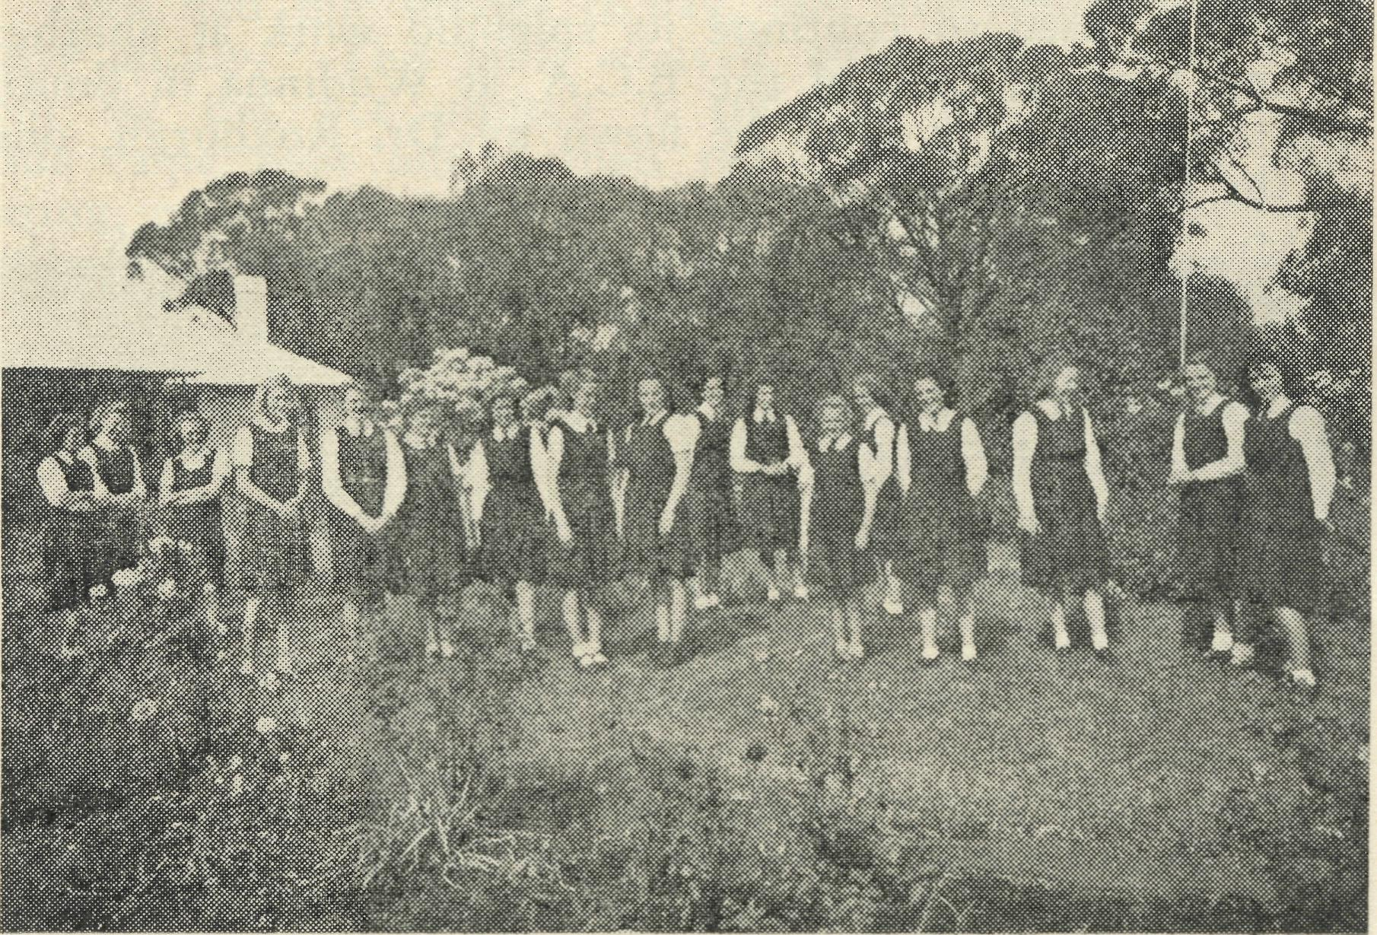
The Girls of Bowral Hostel.
We also had a very happy time over the King's Birthday week-end. We had our first Old Girls' Week-end Reunion, and everyone had great fun. The lack of trains through the cuts in the services was rather a trial, and interfered somewhat and prevented some from coming.
On Friday night the girls arrived, and there was much
excitement and laughter and comparing of notes on
various topics. Meals were full of phrases such
as "Do you remember the day we ?" "Remem
ber when we did such and such?" "Have you
seen so and so?" It was a very happy thought
that prompted the Rector, Mr. Pearce, to invite the girls
to take their old places in the choir. It gave just the
right spirit to the day to be in their places in St. Jude's
again. We had Bible Study and prayers just as we always
did. Monday was very bleak and cold. The girls did
intend taking lunch out, but finally decided to have
their picnic in a sheltered corner of our own back
paddocks. They had chips and sausages, and thoroughly
enjoyed themselves. Such happy gatherings of the
"Clan" keep the girls in touch with us who remain here
and make possible more vital prayer on both sides.
We are to have a tennis court here at last. It is an urgent need as we have a number of teen-age girls who should have their leisure used up in a practical healthy way. Also few of them are able to go home at weekends, and it will fill a long-desired want.
We have the loan for an indefinite period of a good portable gramophone, and we are appealing for some records for the use of same. Records of good music will be very much appreciated and much enjoyed. We have the loan of some for a while, and often one or other of the girls will say—"Please, Sister, will you play that record of Chopin? We like it so much that we would like to hear it before we start our work." If any of our B.C.A. friends have good records they can spare for use here we would be very grateful.
We wish to thank all those good folk who have been so generous in helping our Bowral Hostel, and making it such a lovely Christian home for High School girls.

“Life is a Grand Adventure” at Cann River
Sister I. Gwynne

Some words that were read to me recently made a tremendous appeal to me, and there is an old saying, "The best way to keep a good thing is to pass it on"; so I'm passing on these words.
"Life is a grand adventure—even when it goes against you. (It is a grander adventure where God, in the Person of our Lord and Saviour, Jesus Christ, through the Power of the Holy Spirit, is our daily Companion and Guide.)-It isn't life that matters, it is the spirit that we bring into it that counts, and makes life worthwhile.
If one can think of oneself in relation to life, instead of thinking of life in relation to oneself, we will get somewhere and be happy. Happiness is mental adjustment to whatever circumstances surround one."
And life is a grand adventure in some of the B.C.A. outposts. One never knows what is going to happen next—or when! I realised just recently that there has only been one, or two at the most, uninterrupted washing mornings for many months.
Perhaps you would like to do the round with me, would you?
To start off, Sunday night, after an unusually busy Sunday, we went to Church in the evening, and though asked to have a cup of tea after the service, begged to be excused on the plea that we. had to be early astir next morning to be ready for the 'bus at 6.15 a.m.— only to find that there were visitors at home to have supper with us and say "Farewell" to my guest. That meant a late retirement to bed. Early astir—well before 5 a.m.—as there was another person to dress and get ready as well as myself, get breakfast and have it, and all the last minute things to be packed into suitcases and strap them up, and be ready for the 'bus at 6.15 a.m. An early start for the day, yes; but soon after 7 a.m. someone calls for Sister: "Could you come down presently and see our little girl?"—giving some of the symptoms. (He allowed me time to have breakfast, little knowing that it was a past meal). So I went about an hour later to see a child of seven years, who had apparently injured some ribs when she fell off a chair. The necessary treatment was given and then a further attempt to finish the washing, knowing that another call had to be made.

August, 1947
in
THE REAL AUSTRALIAN

Telephone messages, and then a visit to another patient, a boy. He had been ill with gastric trouble the previous week, and recovered, but now felt very sick. I could not detect any definite symptoms as to the cause of the trouble, and the temperature was far too high for my liking; so after consultation with the parents, we decided to take him to the doctor right away. The necessary arrangements were made, a hurried lunch, and we took the child to the doctor and the hospital, a distance of 58 miles. After doing a little shopping whilst there, we made the return trip (a delightful trip, and a delightful spiritual chat with the driver).
Hoping to have tea and an early night to rest, lo, the telephone rings again, and another call is made. This time a local patient again, and he is attended to and the necessary advice given, as far as one can give it for the prevailing 'flu.
^{u}So we come to the end of a perfect day"? The scene changes: A reasonably quiet and peaceful Sunday. Services morning and evening, and Sunday School at 10.30 a.m. It has been a delightful day after a very heavy frost, everything beautifully peaceful and quiet. The Evening Service is over and one has a quiet read at the fire and then to bed. Did I say everything was peaceful? Ah, not everywhere.
I And the wind was beginning to howl, too. But at the Dispensary at least everything was quiet. To bed in the vicinity of 10 p.m., and I frequently pray for the listening ear in case I am needed through the night.
A little later a car is heard, and then it stops. Then the familiar click of the gate and footsteps on the path and verandah. I get out of bed, and enquire who is there. Mr. X. (our local Police Officer). Aha, whatever can be
want at this hour on a Sunday night. Having thrown on a dressing gown and lit a lamp (torch battery is flat), I meet the visitors at the front door. An elderly man had passed away very suddenly (just fell down outside after dark—or about dark, and it took some time to find him), and there was no one to attend to him, would I be so good as to go with them to do the last offices. Certainly; so I gathered up the necessary materials, etc., and went with them. Home again to bed some little time after midnight. The adventures—the unexpected—■ but ah, the joy of service!
Again the scene changes. This time a vastly different scene. My distant friends always ask: "Is it cold in Cann River? How do you manage for fuel? etc., etc." We are in the Gippsland forest area here, and fortunately fuel (wood) is not a problem, and it is not rationed, except as one rations oneself as the supply gets low.
Saturday afternoon-—and there are the multiple little jobs to be done before dark and the week-end supply of wood and kindling to have ready; then to get tea ready for a visitor at 6 p.m. A truck is seen to be pulling in to the Dispensary gate. What is it this time—and I naturally expect a patient. On arrival at the front door, I see a truck-load of wood. "Where shall we put it, lady?
With compliments from Committee." Many, many
thanks!
Adventures? The unexpected? Yes, and we praise God for them all and especially for the many kind hearts. We take courage, look up, and keep on with the job, looking unto Jesus, Whose we are and Whom we serve. Please pray for us and with us that our service may not be so faulty, but that we may be found faithful in that which is least.

REAL AUSTRALIAN RECEIPTS
Mrs. Bowman, Miss Marks, Miss Rowe, Mrs. Taylor, Mrs. Starling, Miss Beckwith, Mrs. L. Neville, Rev. R. Horsley, Mr. Buchanan, Mr. J. Hosa, Miss Foy, Mr. Stevenson, Mrs. C. Bromwich, Mrs. Whiteman, Mrs. A. Beatty.
Subscribers Who Have Not Received Receipts
19/3/M7: Anon., £5 don.; Anon., £4 don. 24/3/,47: "A Listener", 5/- don. 25/3/'47: C.L.D., 5/- don. 27/3/M7: Miss Chapman, 12/6 box. 11/4/M7: Anon., £1/1/- don. 15/4/M7: "A Helper", 15/9 box. 23/4/Y7: Miss F. Boyle, £1 don. 23/4/'47: Mrs. Bradley, 2/- don. 29/4/M7: "A Wellwisher", 5/- machine. 13/4/M7: "A Friend", £1/1/- don. l7/6/'47: Miss Webster, 14/- box. 18/6/'47: Mrs. Tout, 5/-, Smoky Bay Church. 19/6/,47: "A Humble Listener", Smoky Bay Church. 27/6/'47: "One of Your Listeners", £1, Smoky Bay Church. 7/7/'47: "Anon.", 10/- don. 11/7/M7: "Anon. W.H.", £1 don. ll/7/,47: "Anon.", 2/- don.
VICTORIAN NOTES
During the last quarter the Victorian Secretary has visited the following parishes, for whose help we are grateful.
St. Stephen's, Richmond; St. Chad's, Chelsea; St. George's and St. John's, Bentleigh; All Souls', Sandring-ham; St. John's, Croydon; Holy Advent, Malvern; St. Jude's, Carlton; St. Paul's, Canterbury; St. Clement's,
Elsternwick; St. Faith's and St. Stephen's, Parish of Burwood; St. Paul's, East Kew; Parish of Mount Dande-nong; St. John's, Lilydale; St. Thomas', Essendon; Christ Church, Hawthorn; St. Barnabas', Balwyn; Holy Trinity, Kew; Parish of Belgrave; St. Mark's and St. Cecilia's, West Preston; St. Silas', Albert Park; St. John's, Heidelberg; Parish of Kallista; Parish of Ferntree Gully; Church of Emmanuel and St. Gabriel's, Oakleigh; St. Mary's, East Preston and St. George's, Reservoir; Parish of Romsey.
Our grateful thanks to the many friends who have given papers, magazines, books, etc., for distribution outback, and to the lady, whose name we failed to get, for the reading lamp for Wilcannia.
DEPUTATION VISITS
Our N.S.W. Secretary, the Rev. D. G. Livingstone, has visited the following parishes, schools and associations on deputation work in recent months.
Chatswood School; Sefton; Deaconess House; Narra-been; Moore College; Campsie; Sth. Canterbury; Canterbury; Ashfield; Corrimal (all churches), Cronulla, Car-ingbah, Clovelly, St. Mary's (branch churches), Earlwood, Fort Street Girls' High School, Guildford, St. Paul's (Chatswood), Manly, Summer Hill, Wenona School (North Sydney), North Sydney Girls' High School, North Sydney Boys' High School, Watson's Bay, Kensington, North Sydney (St. Thomas), Carlton, Drummoyne, Wentworthville, Protestant Welfare Association of Main Road Board; Surry Hills, Bankstown, Neutral Bay,; (St. Peter's); A.N.C.M. Prince Henry Hospital; Annan-dale, Merrylands, Bexley Nth. He has also visited the South Australian missions and Mungindi Hostel, and has conferred with the Victorian Committee.

THE REAL AUSTRALIAN iv August, 1947
A Date to Remember
ANNUAL RALLY OF B.C.A.
IN CHAPTER HOUSE,
ST. ANDREW'S CATHEDRAL, GEORGE STREET, SYDNEY,
TUESDAY, SEPTEMBER 30th, AT 8 P.M.
A Great Meeting A Great Story Great Pictures
ALL PEOPLE ARE CORDIALLY INVITED
Vacancies Which Must Be Filled
MISSIONS
- Two clergy are needed for the Far West Mission of N.S.W. based on Wilcannia.
- Two clergy are needed for vacancies in South Australia.
- Clergy for other missions which B.C.A. has been invited to administer.
HOSPITALS
- Trained Nursing Sisters for Wudinna Hospital in South Australia.
- Housekeeper for Cook Hospital, who can also help with nursing and children's work.
- Trained nurse or housekeeper for Penong Hospital.
HOSTELS
1. An assistant Matron for Port Lincoln Hostel.
Edgar Bragg & Sons, Printers, Sydney.

