

No. 98.
MARCH, 1948.
1/6 per annum, post free.

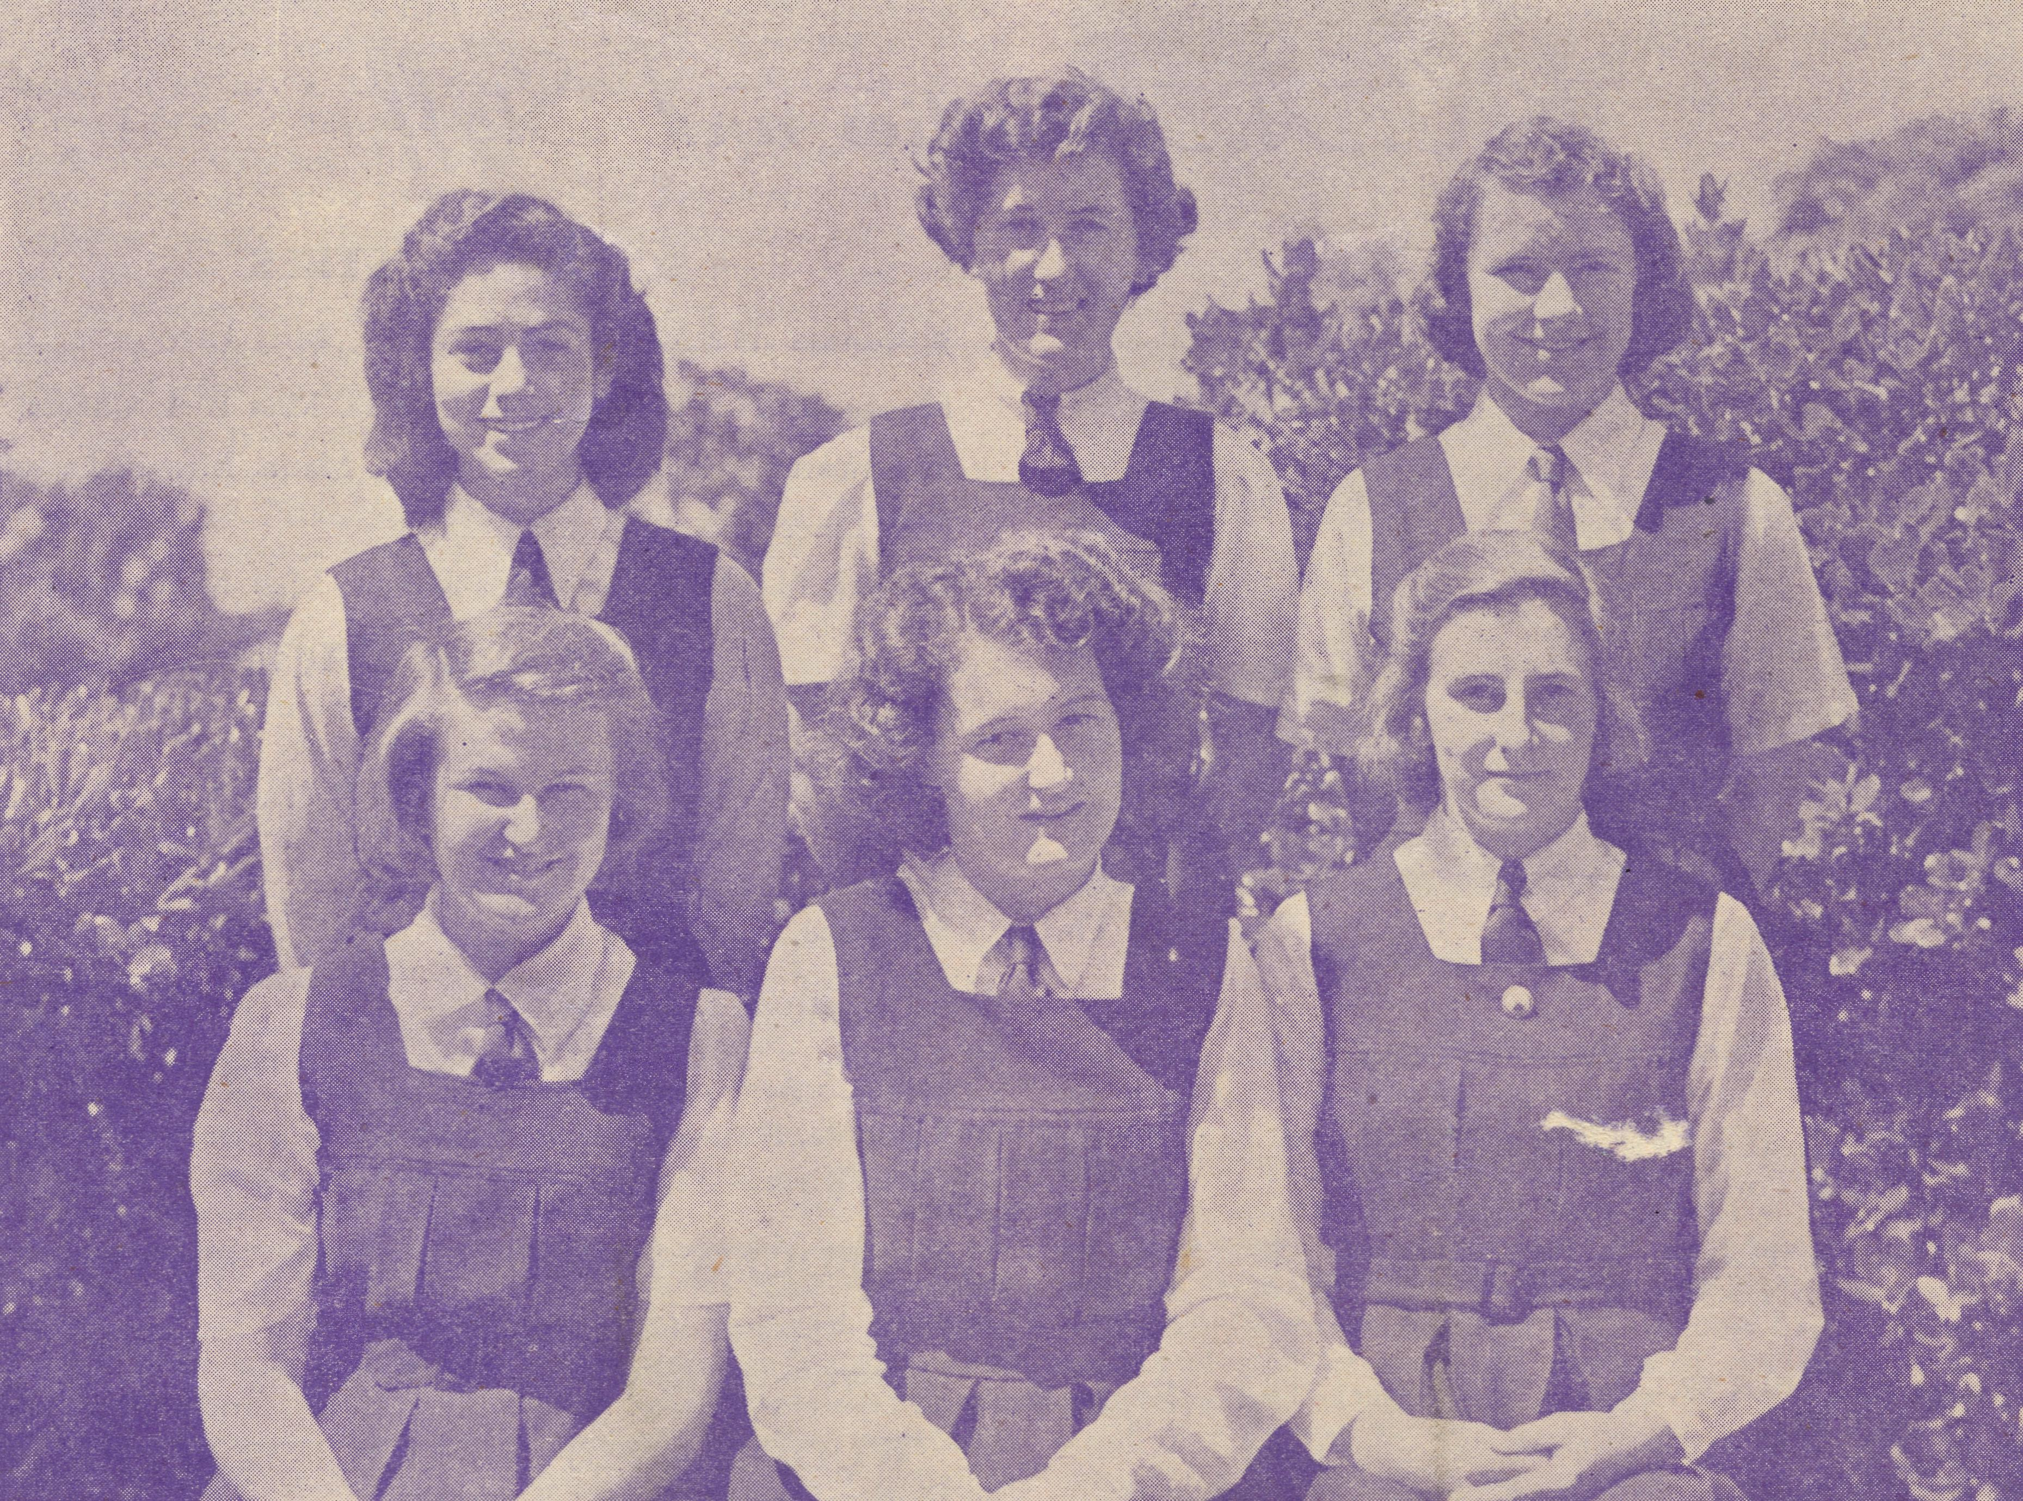
Senior Girls of the B.C.A. Hostel at Pt. Lincoln, S.A.

THE REAL AUSTRALIAN
March, 1948.

The Bush Church Aid Society for Australia and Tasmania

HEADQUARTERS OFFICE:
Diocesan Church House, St. Andrew's Cathedral,
George Street, Sydney.
(Telephone: M 3164)
Cable Address: "Chaplaincy, Sydney."
VICTORIAN OFFICE: The Bible House, Flinders Lane, Melbourne.
(Telephone: FJ 5675)
President: The ARCHBISHOP OF SYDNEY.
Hon. Clerical Secretary: Rev. L. GABBOTT.
Hon. Treasurer: T. S. HOLT, Esq
STAFF:
Organising Missioner: Rev T. E. JONES, Th.L. N.S.W. Secretary: Rev. D. G. LIVINGSTONE, Th.Schol. Church House, George Street, Sydney.
Victorian Secretary: Rev. L. G. BALL, M.A., Th.L. Bible House, Flinders Lane, Melbourne
South Australian Secretary: Rev. F. H. B. DILLON, Th.L.

B.C.A. Activities and Staff

MISSIONS.
Ceduna, SA. \ _{Rey} _{p} Connell, Th.L., Ceduna, S.A. Penong, S.A. J
Cummins, S.A.—Rev. D. A. Richards'Pugh, Cummins, S.A.
Kirton Point, S.A.—
Streaky Bay, SA.—Rev. T. J. Hayman, Th.L.
Croajingalong, Vic.—Rev. G. Pearson.
Delegate-Bonang, Vic.—Rev. D. H. Wicking, Th.L., Delegate, N.S.W.
Heytesbury Mission, Vic.—Rev. A. L. Mills.
Otway Mission, Vic.—Rev. T. H. Pickburn, Th.L., Beech Forest, Vic.
Mr. W. Davison.
Wilcannia, N.S.W. ) Menindee, N.S.W. f
Rappville, N.S.W.—Rev. R. Meyer, Th.L., Rappville, N.S.W.
Denmark, W.A.—Rev. C. H. Sherlock, Th.L.
Werrimull, Vic.—Rev. , WerrimulL Vic.
SCHOOL HOSTELS.
Wilcannia, N.S.W.—Miss L. Knox, Miss Farr. Mungindi, N.S.W.—Miss E. Cheers, Miss E. I. Cheers. Wentworth Falls, N.S.W.—Mrs. C. Mann, Miss F. Lawtey. Port Lincoln, S.A.—Miss I. Beck. Bowral, N.S.W.—Deaconess Dixon, Miss Michael.
MEDICAL SERVICES.
Ceduna, S.A.—
Matron: Sister F. Dowling.
Staff: Sisters Miller, V. Holle, J. Eatch, D. Osborne, G. Hitchcock, B. Tierney, L. Sinclair. Penong, S.A.—Sister L. Loane, Sister Woodings.
Wudinna* S.A.—
Dr. R. Roxburgh.
Matron: L Pritchard.
Sister J. Coleman, G. Honey. Cook, S.A.—Sisters Thomas, R. Gillan. Tarcoola, S.A.—Sister E. Fisher. Cann River.—Sister I. Gwynne.
CEDUNA FLYING DOCTOR SERVICE.
Pilot.—Mr. A. Chadwick.
Doctors.—Dr. R. Gibson, Dr. F. Gibson.
WUDINNA FLYING DOCTOR SERVICE.
Doctor-Pilot.—Dr. R. Roxburgh.
MAIL BAG SUNDAY SCHOOL.
Director.—Miss R. Campbell

March, 1948.
THE REAL AUSTRALIAN

The Organising Missioner’s Letter

I must first of all thank you for the very wonderful response to B.C.A. Christmas appeal. The total amount for N.S.W. was £548, and in Victoria £381. Each year our friends continue to give us more than on the previous occasion, and 1947 was no exception to this. These figures set a record which will be very hard to beat.
In Post and Rails you will read reference to Sister Page's illness. I feel I cannot refrain from also mentioning it. Sister Page has been with us for many years and has served in various centres. She has been at Tarcoola for some years now, and as our friends know Tarcoola is not the easiest place in B.C.A. work. Infantile paralysis has been acute in South Australia and is of course no respecter of persons. Nurses as well as others are liable to go down with it. We are happy indeed to be able to say that Sister is well on the road to good health, and will soon be able to take an extended holiday, which we all hope will see her in perfect health. The prayers of our friends have been greatly valued in Sister's sickness, for her recovery has been so remarkable as to convince us that the prayers of many availed much.
Quite a number of new workers have come on to our staff, and these additions will be noted elsewhere in this issue. They bring sorely needed reinforcements to a hard-pressed band of nurses and hostel workers, who for years now have enabled this work to go on simply because they were willing to overwork. Our big need now is for ordained clergy. There are many opportunities for a very real service in out-of-the-way places. Such work calls for men who will put service before every other consideration. We hope that very soon there will be found those who will offer for this work.
You will remember that our Irish friends gave us the money for three vans. St. Patrick has become almost an institution at Minnipa, and now goes to the Wilcannia area. The second van, St. Columba, has now been purchased, and when you read this will be carrying the Rev. John Greenwood somewhere north of the. Transcontinental Line. While in Ireland, I met some of our good Irish friends and their enthusiastic Secretary, Mr. Adcock. They are very interested in Australia, and particularly in B.C.A., and generously support our work. They will, I am sure, be glad to learn that St. Columba is on the road.
I write this on the eve of an extended tour to West Australia and the West Coast work. While away I am to investigate several new challenges that have been placed before us. The maintenance of a new hospital to be built at Cummins, another at Locke, the possibility of taking over the hospital at Cowell, all in South Australia; a nursing home at Rawlinna in W. Australia; and a hospital now being built at Tarcoola to replace the present nursing home. Later I hope to visit Broken Hill to investigate the possibilities of obtaining a suitable building to replace that at Wilcannia. These are big and important ventures and will greatly increase the scope of our service. They will also add in a very great measure to our financial responsibility. I sometimes hear a great deal about "Faith Missions", and sometimes get a little impatient when I feel that I am being told that B.C.A. is not one of them, because it places its needs before its friends. If the responsibility and maintenance of a work so big in its scope as B.C.A. is to-day is not a venture of faith, I don't know one.
Very often the Society undertakes work and great responsibility in complete dependence upon Almighty God for the wherewithal to see it through. I am glad to say the Almighty has never let us down yet and I refuse to believe He will start now.
Recently we had the opportunity of supplying a need that has been with us for years. Mungindi Hostel is far too small and we have been turning children away for years. Would we buy a property which came into the market late last year and which was just over the road
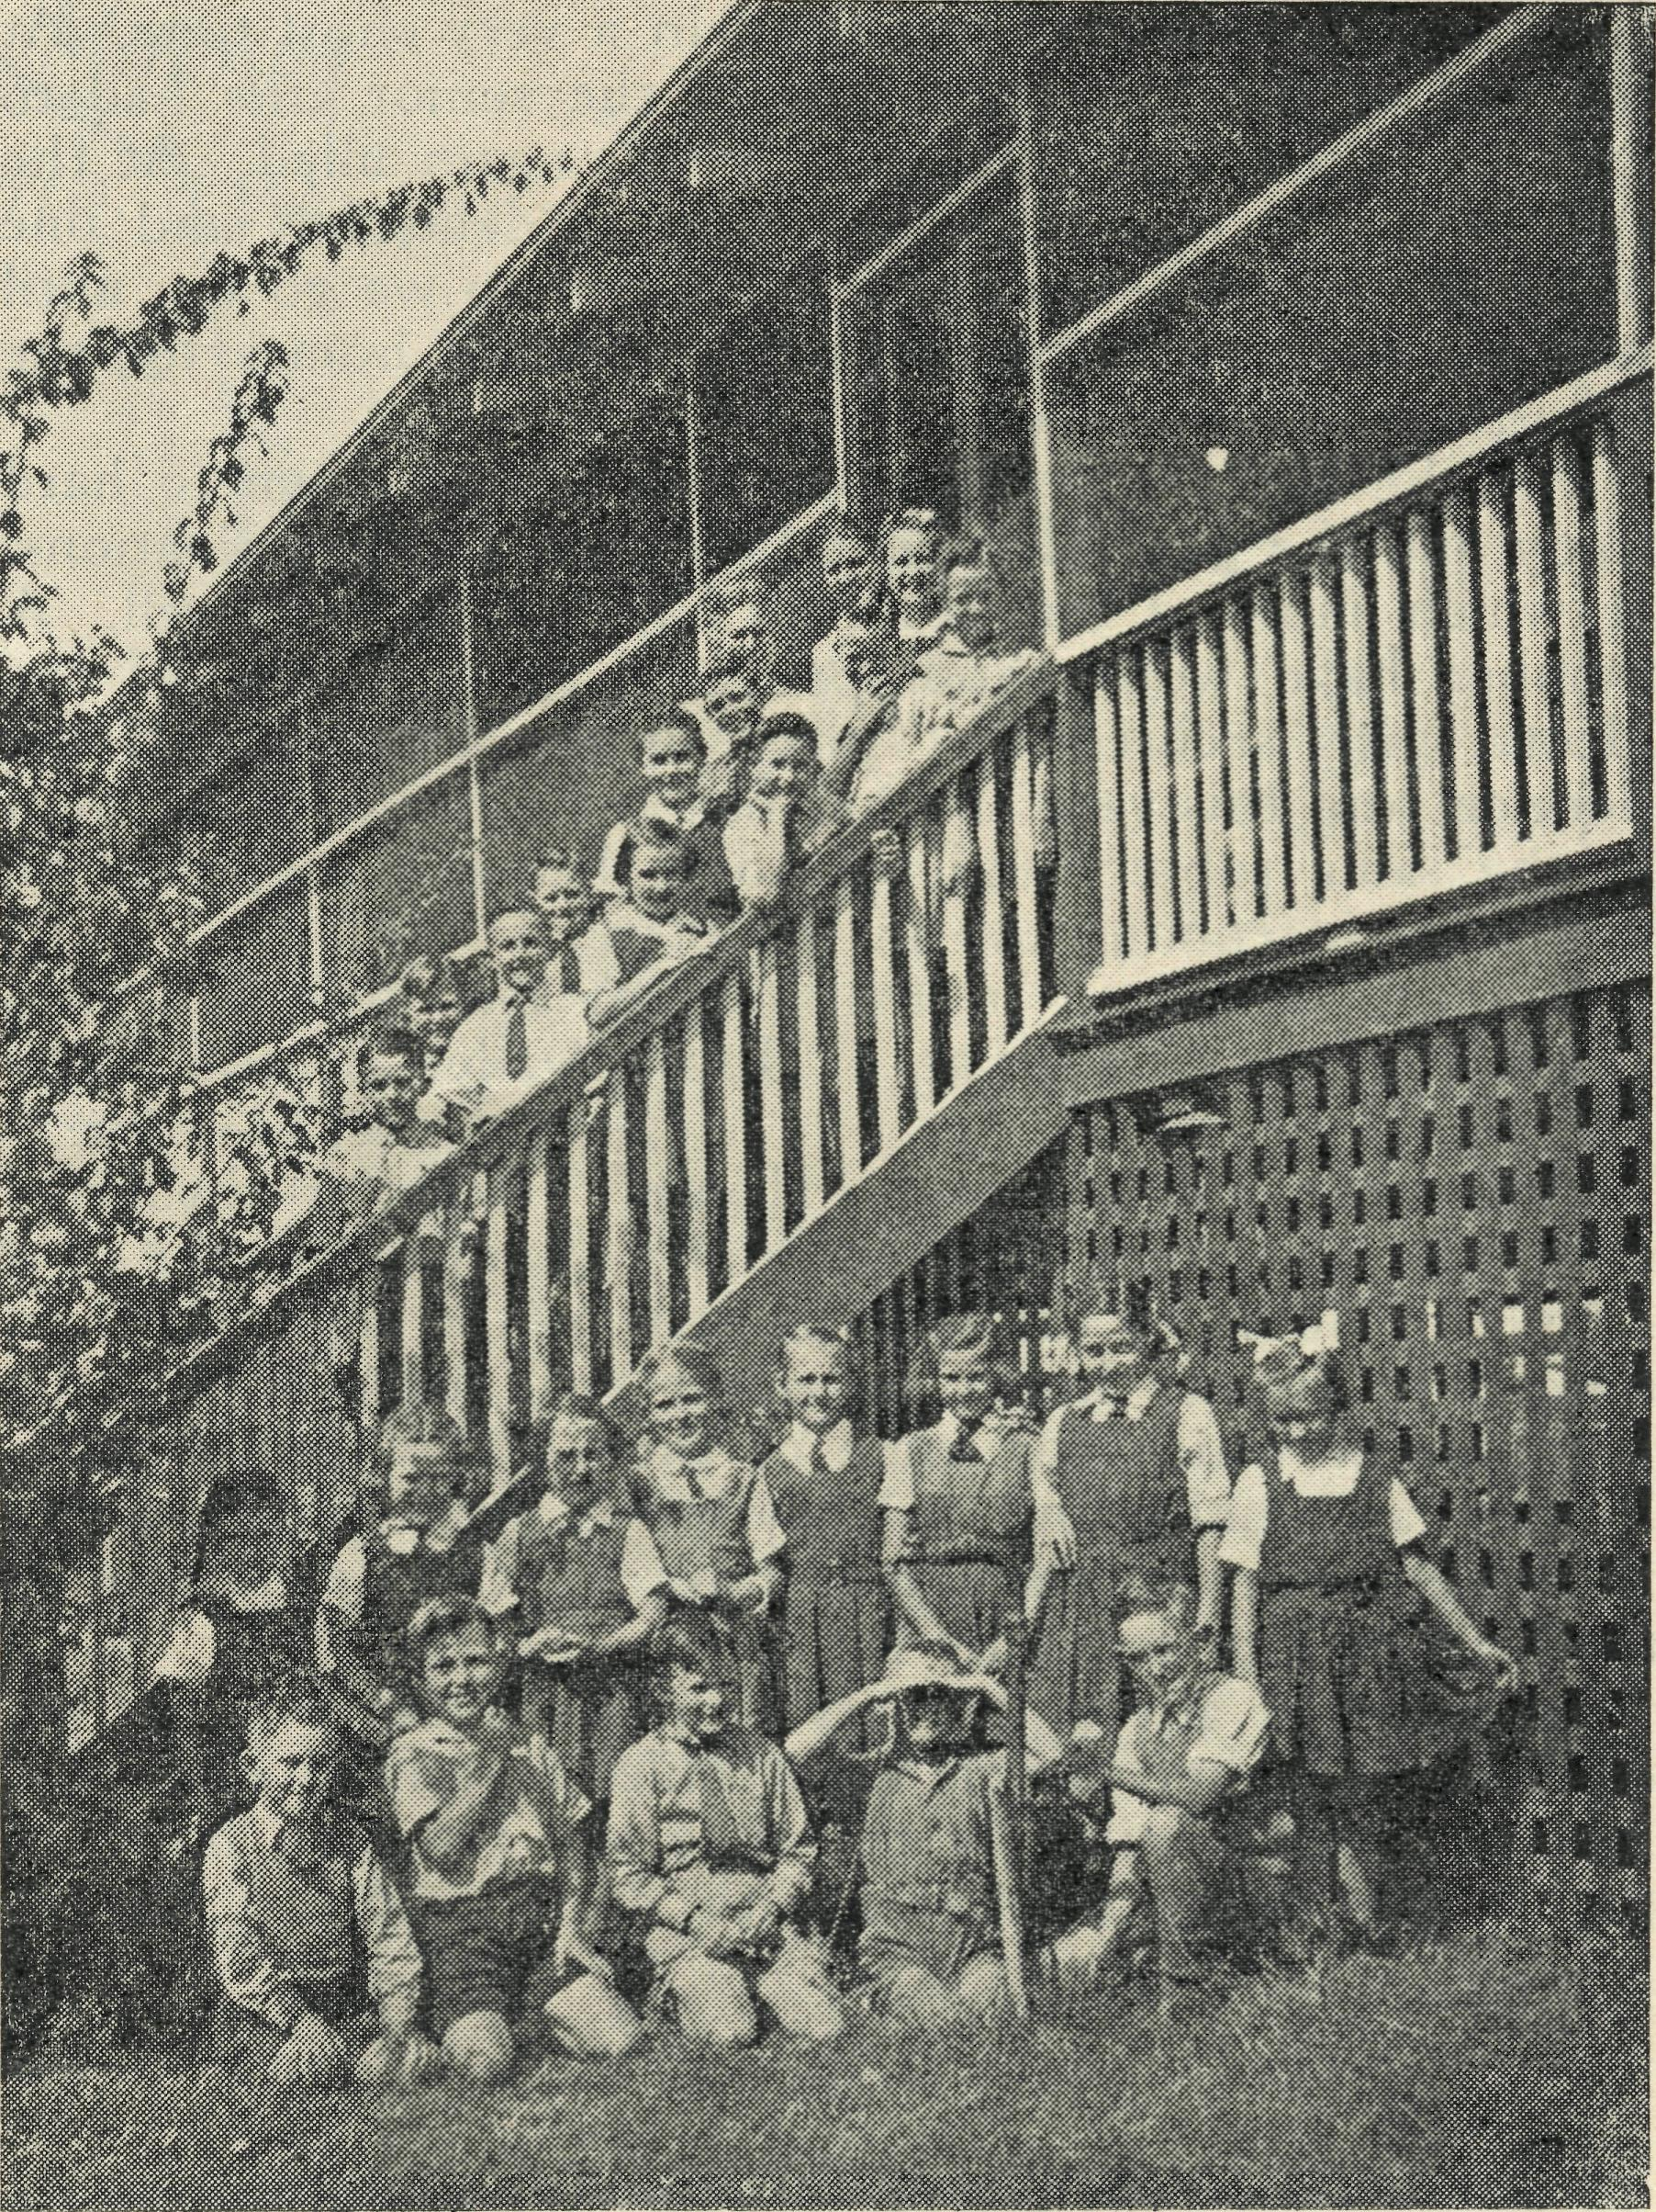
Mungindi Hostel Children.
from the present hostel? The cost was to be £1,000, and we had not the money, only a deep conviction that we should buy it. Of course, you can't buy property with convictions, though people sometimes get convictions for buying properties for which they cannot pay. Up to now we have only the right type of convictions. You can save us from the other if you believe we acted in faith. Will you therefore forebear with us this Easter when we send you a short' note and the usual envelope? I know you have lots of calls, and Income Tax is heavy, but we need that £1,000 for the extra children who will, by its means, be able to go to school while living in a Christian family in our new hostel.
Well, I think I have put enough before you for this issue, haven'tT?
THE O.M.

THE REAL AUSTRALIAN
March, 1943.

Port Lincoln Hostel
Sister SOWTER

As we come to the end of another school year we thank God that we can feel that it has been a year of usefulness and service.
The Hostel opened with a full enrolment of 29 stu-dents. Two were only temporary, waiting for a school bus to be put into commission in their district. Before they left, there were two more girls waiting to take their place. Then the parents of another child moved to Lin-coin, and this vacancy was filled in a very short time. At the end of the first term, one of the senior girls had to give up school and this vacancy was again filled. At the end of the second term two more students left and one of these vacancies was again filled, and so we go on, until now all have returned to their respective homes for the Christmas vacation.
For the last couple of months all settled down to hard study and the general topic was lessons and examinations, at which most of our students have done very well. A number have won school prizes. Last year one of the Hostel girls secured first place in the State for Home Service, and this year another has come top of the school in the same subject and we hope that she, too, may be successful in coming top in the State.
We are honoured in that one of our girls has been Head Prefect as well as a House leader of the High School.
And now holidays and "Home". What a thrill for them all. For some of them home is only a matter of a couple of hours by car—to others it means anything from sixteen to twenty hours in either road or rail bus, the last part of which for some of them is by freight train, loading and unloading as they go along. After leaving the train, many of them may have to travel anything up to forty or fifty miles by car.
In order to attend primary school, one of our present students rode her bicycle eight miles to school each day, making sixteen miles by the time she returned home at night, and riding a bicycle with dust, heat and flies to
contend with is no small thing. This girl had no opportunity for attending any kind of religious worship. I was very pleased when she expressed a wish to be baptized, and she is now a member of our church, and we can feel assured that she will make a very worthy member.
Many of the students had their first trip on the water when, for our second Anniversary, we went to Boston Island, some four or five miles across Boston Bay for a picnic which all enjoyed very much. This is a beautiful island of some four thousand acres situated at the mouth of Boston Bay. It was here that we saw "The Sunset turn the Ocean Blue to Gold". Many of our readers may be very surprised to know that Boston Bay is bigger than Sydney Harbour. It has sufficient depth to take six ships of the Queen Mary type.
This year we said goodbye to four of our older and much-loved students, three of them having done their leaving, and one the intermediate examination. Two of them have given very faithful service as teachers in our Sunday School. One, who had correspondence lessons until coming to the Hostel two years ago, and another will commence teaching in the New Year, and yet another hopes to train for nursing. We do pray that, as the girls go out into the world, they will be an inspiration for good to those with whom they come into contact.
From time to time letters of appreciation are received from parents for the care and supervision of their daughters. Were it not for the Hostel, quite half of these girls would be unable to have any secondary education, as board is almost impossible.
Already we are booked out for 1948 and have a few-bookings for 1949. There is a very great need here in Pt. Lincoln for a boys' hostel. It was a day of great rejoicing this year when Miss Beck was able to join our staff as sub-Matron. And now, last but not least, we say "Thank You" to those who have helped in this great cause by their gifts and prayers.

A Headmistress Pays Tribute

Some time ago we published a letter from a headmaster telling of his impressions of the work being done at Port Lincoln Hostel. We now have pleasure in publishing another letter, this time from the Senior Mistress.
"There is no doubt that the establishment of the Bush Church Aid Hostel at Port Lincoln is and has been a great success.
"I have come in contact a great deal with the girls who live there, and I have the greatest admiration for those in charge of it, and for those who administer its working.
"The girls are a group of wholesome, courteous young folk growing into womanhood with the highest principles,
and their influence must be felt when they return to take up life in the various country towns from which they come. They work so harmoniously together, one helps the other, and the many offers to assist in little or big duties round the school and in the class room, show a spirit of unselfishness and service. But I really can't speak too highly of the girls from the Hostel—and especially those I teach—they seem to have something, and its that intangible "something" that is so noticeable. Such an atmosphere in any class or school makes for happiness, and I personally feel that these girls are having a very good influence on the rest of the school which they attend."
Senior Mistress.

March, 1948.
THE REAL AUSTRALIAN

THE LINES ON THE MAP INDICATE THE DISTANCES TRAVELLED BY STUDENTS OF THE HOSTEL.

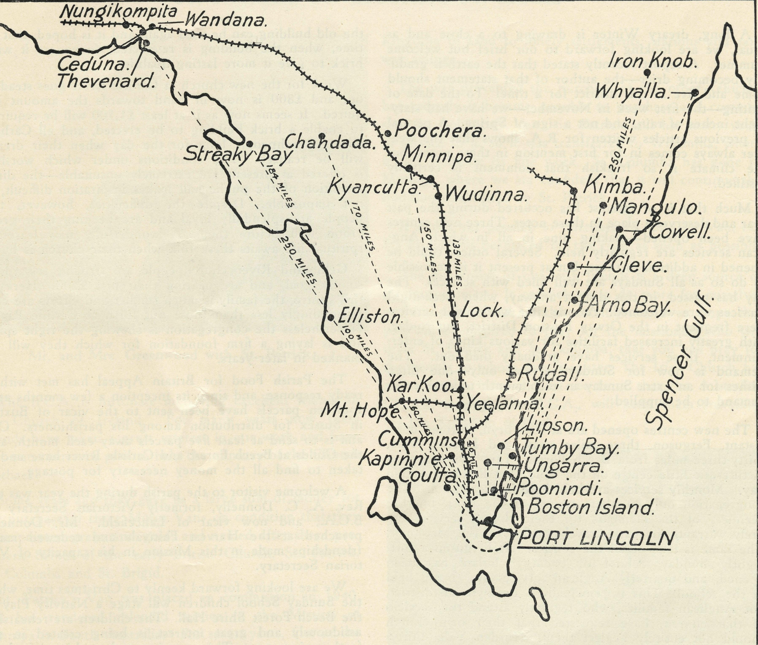

All roads lead to the B.C.A. Hostel at Pt. Lincoln, S.A.

N.S.W. LISTENERS !
tune in to
2GB
for the B.C.A. "Outback" Session Now on
TUESDAYS AT 11.15 A.M.
VICTORIAN LISTENERS!
TUNE-IN TO
3 DB
THURSDAYS AT 4.45 p.m.

THE REAL AUSTRALIAN
March, 1948.

Otway Mission Notes
Rev. T. PICKBURN

A long, dreary Winter is drawing to a close and as usual, we are looking forward to our brief but welcome Summer. A report recently stated that the earth is gradually becoming drier—the author of that statement should come and live in this district for a time! To the date of writing—the first week in November—we have had sixty-eight inches of rain, and not a sign of Spring. A perusal of previous articles written for R.A. shows that the weather always comes in for first mention in these notes, but the climate is so freakish that comment is certainly justified.
Much that is of interest has occurred during the past year and deserves a place in these notes. Three new centres have been opened—making nine in all in which Anglican services are regularly held. Several others could be opened in addition to these, but at present it is impossible to do so as all Sundays are well filled with services. The day has passed, in this district anyway, when week-night services were welcomed. At one time week-night services were frequent in the Otway Mission District, but to-day, with greatly increased facilities for various kinds of entertainment, these services have gradually died out. The demand is now for Sunday services only—one often wishes for an extra Sunday in each month to enable the demand to be supplied.
The new centres opened are at Tanybryn, thirteen miles distant, Ferguson, three miles away, and Horden Vale, thirty-three miles from Beech Forest. Tanybryn is a most picturesque little centre on the Wild Dog Road to Apollo Bay. Monthly services are held here in the school. The congregation only numbers twenty at the most, but the keenness of the members for their church services entirely warrants the extra travel entailed by the Missioner. The same is true of all the centres. At Ferguson a fortnightly Sunday School of twenty scholars has been opened, and quarterly Anglican services are being held in the school. This is principally a Presbyterian district, but Anglican families, who regularly attend the services of that church, have requested that their own church should not entirely neglect them. Horden Vale, thirty-three miles away, is the longest trip that the Missioner has to undertake in this district. The venture is very well worthwhile, and Evensong in this centre is distinguished by the very hearty and able singing, the men's voices being predominant. The only "disadvantage" in holding this service lies in the fact that the hospitality shewn after the service results in the missioner and his wife returning home at 1.30 a.m. on Monday! It wouldn't do for this to he a weekly event.
A most unfortunate happening occurred at Lavers Hill during the early part of this year. The Presbyterian church building, which had been used by Anglicans for many years as a place of worship, blew down in a violent storm and became a total loss. This was a big blow to the congregation at the Hill, and services are ' now carried on in the unsuitable atmosphere of the public hall. This is a state of affairs which pleases nobody, so Anglicans and Presbyterians have combined to raise the money necessary to rebuild the church, Much of the timber from
the old building can be used again and it is hoped, that in time, when the building is re-erected, to veneer it with brick to give it more lasting qualities.
Work for the new church at Carlisle River goes steadily on, and £800 is now in hand towards the amount required. It seems now as if at least £1,500 will be required to enable a brick building to be erected, and all Carlisle River churchpeople long for the day when their dream will be realised. The conditions under which worship is offered at present are extremely unsuitable—the dirty condition of the public hall makes inspiration difficult, if not impossible. Despite the difficulties, however, the people are splendidly loyal and are keeping their great vision well before them. A wonderfully new lease of spiritual life awaits these folk when their church is built.
Gellibrand River churchpeople are striving towards a similar goal, and are nearing their first £200. Here in this centre, the family is much smaller and efforts are correspondingly less than those put forth at Carlisle River. Nevertheless the congregation is shewing the right spirit and is laying a firm foundation for which they will be thanked in later years.
The Parish Food for Britain Appeal has met with a ready response, and since its inception a few months ago, fourteen parcels have been sent to the vicar of Buxted in Sussex for distribution among his parishioners. Our aim is to send at least five parcels away each month, and the Guilds at Beech Forest and Carlisle River have undertaken to find all the money necessary for postage.
A welcome visitor to the parish during the year was the Rev. A. C. Donnelly, formerly Victorian Secretary of B.C.A., and now vicar of Lancefield. Mr. Donnelly preached at the Harvest Festivals and renewed many friendships made in this Mission in his capacity of Victorian Secretary.
We are looking forward keenly to Christmas time, when the Sunday School children will stage a Nativity Play in the Beech Forest Shire Hall. The children are rehearsing assiduously and great interest is being created in the forthcoming event. This promises to be a big night both for the children and adults and many from distant parishes have stated their intention of being present. We hope to be able to report a wonderful night in the next issue of R.A.!
The missioner now possesses a more suitable car for the work in this district. An application for a large 32 H.P. Ford was successful, and it is a joy to be able, after all these years, to take the hills in top gear. Crawling about the countryside in second gear we found to be too tiring and a waste of time, especially on Sundays, and we were not son— to say farewell to the small car. Another advantage in having a big car lies in the fact that we are now. able to pick up and take passengers to the various services. Last Sunday we arrived at Devjndale with ten souls on board. Our next step will be to invest in a small charabanc!
P.S. Since I began writing these notes five days ago
the rainfall has increased by another six inches!

March, 1948.
THE REAL AUSTRALIAN

Gifts from Ireland
ST. PATRICK, ST. COLUMBA, ST. BRIGID

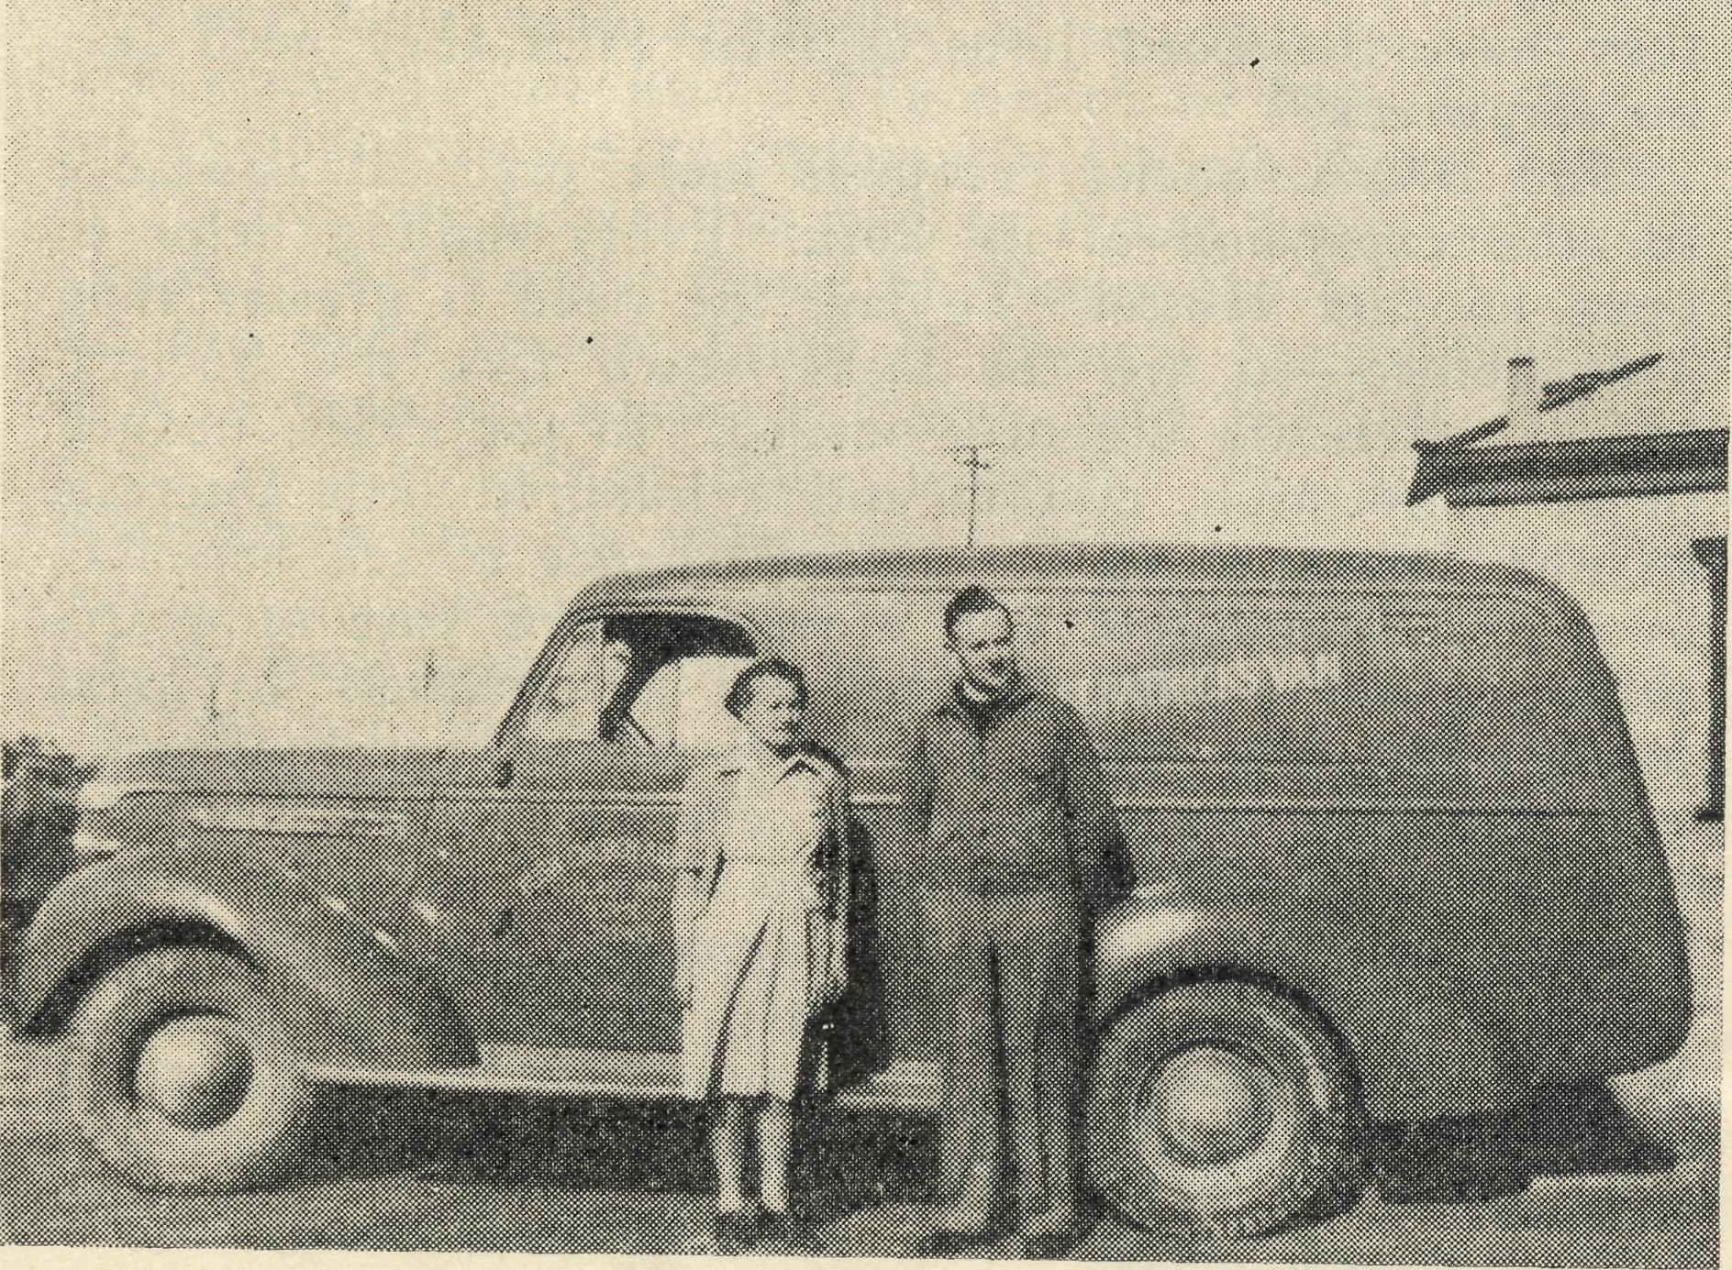
Mr. and Mrs. Greenwood with St. Patrick.
The B.C.A. is fortunate in having excellent friends in the Church of Ireland. For many years now these friends have taken a great interest in our work and have sent out numerous gifts to help the ministry of the Church Outback.
Some years ago they gave us a large sum of money for the purchase of three Motor Vans on condition that they were painted green and gold, and named after three prominent Saints of the early British Church, St. Patrick, St. Columba and St. Brigid.
St. Patrick's Van was placed in commission m 1940, and has rendered splendid service in the Mission of Minnipa in South Australia. For seven years, first in the hands of the Rev. L. Morris, and later the Rev. J. Greenwood, St. Patrick has travelled over some of the most difficult country in Australia, taking the message of the
Kingdom of God to lonely settlements, stations and railway sidings.
The war prevented the purchase of the other vehicles, but recently it became possible to purchase and commission St. Columba's Van. St. Patrick still has many years of service in it, so it was transferred to Wilcannia, where it will continue its fine work. St. Columba has gone to Minnipa, where we are confident that it will continue the tradition established by St. Patrick.
It is not yet pcssible to purchase St. Brigidhs Van, but St. Brigid will be placed on the road as soon as possible.
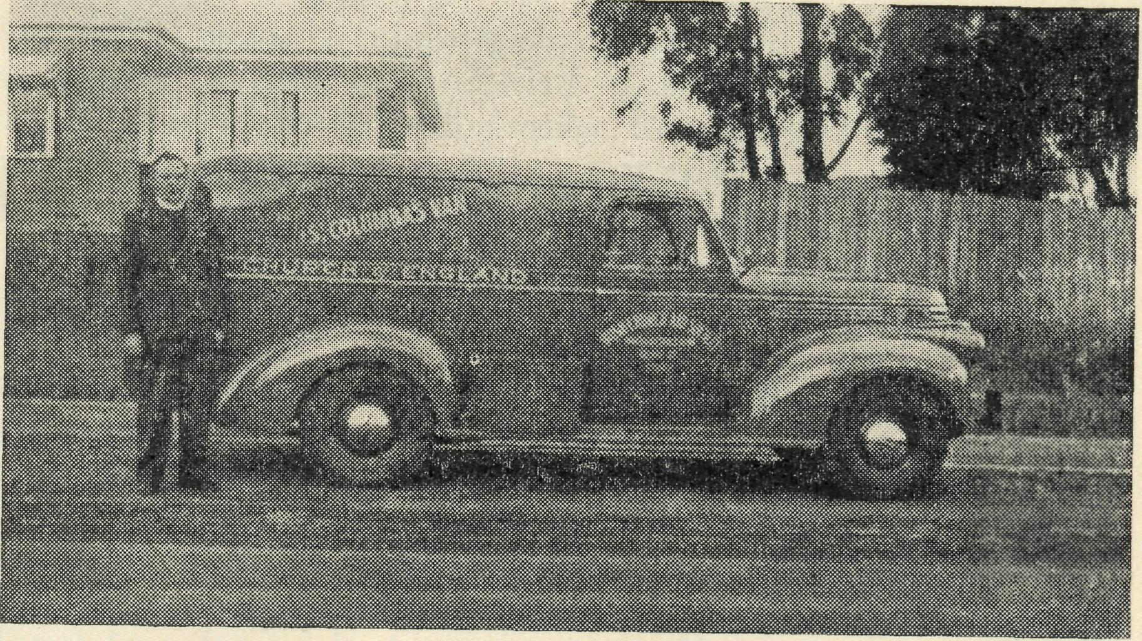
Rev. J. Greenwood leaving Sydney with St. Columba.
The generosity of our Irish friends is a deep source of inspiration to us. It compels us to do more for ourselves and for the outback of this country. And we hope that you will be inspired to pray for the missioners who will drive St. Patrick and St. Columba, that you will pray for the people to whom they minister. The Irish Church has given us the vans. Let us see to it that the Australian Church, through the B.C.A., will keep them travelling for the Kingdom of God.

>*^+*^*sr**r^*^4^^h+*^*^+*^*^s*sf^*^*s4
When Making your Will Remember the B.C.A.

THE REAL AUSTRALIAN
March, 1948.

A Matron Drea,s and Pleads
Miss L. H. KNOX

"By the old hearthstone the Spirits dwell,
The children of bygone years, They lieth hid, the stones amid,
And liveth on smiles and tears." Where are they now? Some are married and with children of their own; while others—Scattered! Yes! But many remember still their old associations with the B.C.A. Hostel which sheltered and trained them while they were being educated in order to fight the battle of life.
And tonight these spirit children are going round on tiptoe, scanning each new face to see who has taken his place. One goes to the corner chair, that used to be his own favourite place, to see who is sitting there now. Another gently walks to the fire-place, where he is soon joined by others, and points with shadowy fingers to the much'loved picture face of the beloved founder—the late Rev. F. W. Harvey—and then all group near the piano and in imagination we hear them sing "The King of Love my Shepherd is". Then, as night draws on, they pass into the pleasant twilight and finally, and obviously regretfully, return to their hiding place, murmuring, "We, too, are sailing on life's wild stream, and although our boat be frail, our Pilot is so sure, and His arm so strong
that the rage of the waves and the wind cannot harm us. Soon more boats with other boys and girls will leave this haven to sail on other seas, and as we wish them 'Godspeed', we want them always to remember that while they have the Lord Jesus as their Pilot they need fear no shipwreck."
The B.C.A. Society requires more practical assistance for the expansion of its work. Every shilling helps to open another Hostel. To-day, the need is greater than ever before—so are the tasks which face the Society. More hostels are urgently needed. In the cities, hedged in by convention, custom and a hundred little interests of our daily life, we have small chance to see ourselves as we really are, but out West, stripped bare of every thing in the world save self, in a loneliness so great sometimes as the grave, face to face with new conditions, new demands, we have ample chance to take our own measurement. And I assure you that the result obtained is not calculated to make one conceited.
Someone once wrote "Variety is the spice of Life". Well, if any young men and women are seeking variety, come out West and they will find variety enough and to spare.
God bless you all.

Farewell to Croajingalong
Rev. C. F. WITHINGTON

As I write, a characteristic Gippsland shower is falling, refreshing the forest and bringing to life a thousand frogs in the lagoons and waterholes by the river. As a shower of rain enlivens the countryside, so the Christian Message brings joy and peace, the Divine Melody, to the toiler of the bush.
Such has been my experience for the past two years, such has been the reward for services and ministry carried through Bush Church Aid to every settlement of this vast area.
On the Sunday evening before Christmas I wish you could have joined us in the lovely little Church of St. John the Evangelist at Cann River, as we sang the age-old carols by candlelight, and prepared ourselves for the Christmas Festival. Here we sensed the real and vital Presence of our Master, Who, I believe, enjoyed our worship as He did the benediction of the Angels in the stable of an inn long years ago. This form of worship we repeated at Genoa and Mallacoota during the following week, in a public hall and a little schoolroom. Time and place seemed insignificant as we sang and prayed and talked together in fellowship.
On December 6th, the Bishop of Gippsland dedicated a lovely Memorial Lych Gate at Cann River, and the opening ceremony was performed by His Excellency the Rt. Hon. W. J. McKell, Governor-General of Australia, who was accompanied on the trip by Mrs. McKell and their two daughters.
It was a real honour and privilege to have the King's own representative with us on this memorable occasion. Over 300 people gathered to pay tribute to the three Pioneer Evangelists to whose memory the gates were
erected. It was a wonderful day, and of great significance to the future of the work in Croajingalong. We remembered in particular Robert Martin—sea captain-evangelist-clergyman—who, with rare courage, faith and conviction, carried his message from Orbost to the back country in the early eighties; John Sackfield, lay reader of Bendoc, who lost his life attempting to reach Cann River across the hills; and Edith Reece, English gentlewoman, by birth as well as by nature, who worked at Cann River from 1925-32, ministering in a multitude of ways to the spiritual and material needs of all with whom she made contact. To crown her ministry, she had built in 1928 the Church of St. John the Evangelist, which stands to-day as testimony to a life of selfless service and sanctity.
In general we remembered all pioneers who, midst the adversity and loneliness of the bush kept alive the Faith of their Fathers by the family hearth, awaiting the day when the Church could supply a ministry for their every need.
At the conclusion of our day's services, with all outstanding accounts met, we find that we have in hand a sum of £25 to be used as the basis of a fund for building a small church at Genoa. We are hoping that this building will be commenced during 1948.
As my wife and I leave Cann River in February for fresh fields of service, may we take this opportunity to thank all supporters of B.C.A. for the prayers which have encouraged and strengthened us during our stay here. It has been both a privilege and pleasure to work within the B.C.A. family.

March, 1948.
THE REAL AUSTRALIAN



There have been a number of resignations from our staff since the last issue. The health of Miss D. Dykes would not allow her to continue at Coorah; Sister Sowter of Pt. Lincoln Hostel has had to return home owing to illness in her family; Sister H. Foster has left Wudinna for the same reason; Sister B. Crouch has fulfilled her term of promised service at Ceduna and Tarcoola and has gone to the Sydney Bible Institute. The Rev. C. F. Withington and his wife have concluded their term of service at Croajingalong. These former members of B.C.A. have done sterling work in their various spheres and we are indebted to them. Our best wishes and prayers go with them all.
# • *
Sister Woodings of Penong has also been compelled to resign owing to the state of her health, but she has consented to stay on for a time to allow others to obtain their much-needed holidays. We are grateful to her. She is doing a splendid job.
# # #
Miss L. H. Knox has resigned from Wilcannia Hostel but has kindly offered to stay on for the first term of this year while we endeavour to replace her. Miss Knox has also earned our admiration and gratitude for her excellent work.
# # #
The rather formidable list of resignations has been balanced by a number of additions to our staff. Sisters J. Eatch and D. Osborne have gone to Ceduna to relieve for several months. Sisters L. Sinclair, G. Honey and B. Tierney have joined our hospital staff in South Australia.
# # #
Miss F. Lawtey of Melbourne has replaced Miss Dykes at Coorah.
# # *
The Rev. G. Pearson, who has been curate at Bairns-dale, Victoria, is the new missioner in Croajingalong. We offer all these new workers a sincere welcome and pray that God will bless them abundantly.
# * #
Sister V. Page of Tarcoola has been a victim of the infantile paralysis epidemic in South Australia. We are thankful to say that Sister is making a miraculous recovery at Ceduna. She has asked us to extend her thaimb and ours to all those friends who have been praying for her.
# • *
Sister B. Fisher has replaced Sister Page at Tarcoola.
# # *
Sister R. Gillan has joined Sister Thomas at Cook.
# # #
Miss N. Stokes has transferred from Cook to Ceduna.
# * #
Sister I. Gwynne of Cann River is on her long leave. An old friend of B.C.A., Sister Firmin, is relieving her.
There was quite a B.C.A. invasion of Sydney during the holiday period. The Sherlocks of Denmark, the Rox-burghs of Wudinna, Sister Loane of Penong, Miss Cheers, Miss Beck, Sister Sowter, Miss Knox, Miss Farr, Deaconess Dixon, the Meyers of Rappville, have all been to see us. Mrs. Mann of Coorah spent her holidays up
Wilcannia way.
# # *
Small folding organs are still an urgent need of our missioners. They are a vital part of the equipment needed for cottage, station and open-air services.
# # #
Miss Isabel Beck is now Matron of Pt. Lincoln Hostel. An assistant is needed to help her with the work of
the Hostel.
# * #
The N.S.W. and Victorian Secretaries have heavy bookings of deputation meetings, but they will always be glad of more opportunities to tell the B.C.A. story in churches, drawing rooms and halls.
# • •
Miss Michael has been appointed to assist Sister Dixon at Bowrai Hostel.
# # #
Bowrai Hostel needs pieces of cutlery, knives, forks
and spoons. Can someone meet the need?
# ■#'■»
The Rev. T. Hayman has been given a concertina for the work amongst the children at Streaky Bay. Thank
you!
# * *
Our box holders contributed £2,000 last year through the Bark Huts, an all-time record. Our grateful thanks to you all. This splendid result indicates the value of
our boxes. If you haven't a box_{f} send for one to-day.
# # #
Our good friends from the Parish of Kembla recently sent the amount of £10/11/-, which were proceeds of box openings.
# # •
Just as we go to press an anonymous friend has sent us £500 towards the cost of the new hostel at Mungindi. Thank you.
SOUTH AUSTRALIAN LISTENERS!
June in to--
5 M.U. I
5 A.D. ^{on} Sundays,
5 P.I. _{a}t 9 _{a}.m.
5 S.E.

THE REAL AUSTRALIAN
March, 1948.

Jarcoola Outpost
Rev. J. R. GREENWOOD

The Perth-bound train slides into a small siding 250 miles west of Port Augusta in the early hours of the morning. Passengers sleepily look out on a string of railway buildings set in the foreground of a row of three dozen houses. Wondering why his journey should be thus prolonged by a halt of one hour, the passenger settles himself comfortably in his bed and sleep silences his questions. But without that railway settlement the passenger would not be able to accomplish his journey, nor would he go very far without the help of those same people whose work necessitates living in the remote parts of our vast Commonwealth. Some live in larger camps, such as Tar-coola or Cook, where there are schools for their children and more opportunity for social life. Others live in camps of perhaps three or five homes where the great event of the day is the passing of the passenger or goods train. Once a week, the all-important "Tea and Sugar Train" arrives with the groceries and the meat, and most important, the latest news of the events occurring in other similar camps.
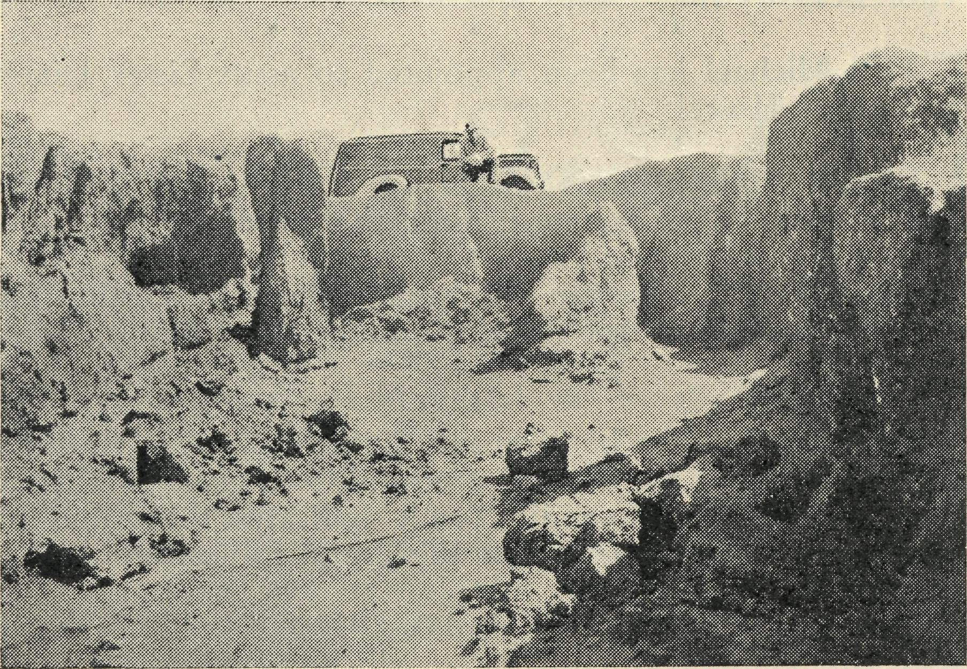
An eroded Road on the way to Tarcoola.
Alive to the opportunities and realizing the challenge presented, the B.C.A. operates a ministry to the railway people of our outback. At Tarcoola is a small three room timber and iron hostel where a nursing sister braves the extremes of weather and propagates the Gospel of our Lord Jesus Christ by service to the community in which she labours. The small rooms of her abode become a stifling oven in the midst of summer, with the temperature hovering so often around the century. Then comes the opposite extreme in the very brief winter, when white frost lies around the yard and the cool chilly wind blows in through the door and window cracks.
The small township of Tarcoola, which seems so unimportant to the train traveller is a vital outpost in the conduct of Christian work. To this isolated community comes the Doctor from Ceduna each month. This is made possible by the interest of so many friends in the city and overseas whose gifts have provided the medical aeroplane and keep it flying on the errands of mercy.
Three times each year the missioner at Minnipa bounces his way over the rough bush tracks, visiting sheep stations on the way, but with the ultimate aim of ministering to the people at Tarcoola. The road twists and turns through sand hills eight miles north-west of Tarcoola, and then about four miles from the railway siding a plain is crossed and the last gate is reached on this trip marked by so many similar halts. As the van is picking up speed from the gate, one can see in the distance a number of whitewashed buildings scattered over the side of the opposite hill. Here and there a poppet head rears above the ground, representing the remains of the labours of some gold miner. Or it may be the site of some gold miner's present toil, as there are still some who are endeavouring to win the elusive gold from the earth.
This is the old town of Tarcoola, which before the railway track came creeping into the outback was the scene of much labour and sorrow. The population is now very small and is likely to remain so unless much more capital can be persuaded to the field. However, there are people here to whom the ministry of the Church cannot be denied. Tucked away in the fold of the hills is a little galvanized iron house with its interior lined with hessian and carefully whitewashed. Everything inside is scrupulously clean and tidy, and one is not at all surprised when the inmate gives a warm welcome to the visitor.
Some thirty years ago this lady come to the Tarcoola gold field with her husband, seeking to win a livelihood in this remote area. Now a widow, she remains alone with her treasured memories to pass the hours of loneliness. Her tales of the old days are numerous and enlightening as she makes those times come nearer with her anecdotes. The first trip to this place took her nearly a month from Port Augusta, 250 miles to the East. Unsettled weather made the journey a much more arduous one, and with the slow means of transport a very lengthy adventure. Even this, however, did not daunt the early settlers as they struggled by camel team through the vast open spaces of outback country. The great cry was ever for water, and this in dry seasons became a costly item when large storage tanks were so scarce. It seems hard to imagine the old town of Tarcoola with a population in the vicinity of 500, with stores and two hotels when to-day all that remains are a few people and the ruins of gold mine workings. Here and there a miner is winning a living from the earth, but the continual activity of a gold rush is left to the memory of those who experienced such excitement.
Some time ago this old widow had the agonizing experience of seeing her treasured little home being consumed by fire. A few glowing embers fell out of her stove while she was hanging out her washing, and in a few minutes the hessian and timber was ablaze. Ignoring the flames, she attempted to save some of her belongings, and then tried to quell the flames with buckets of water. Fortunately for her, the B.C.A. sister was being taken to a miner's home further away when the fire was noticed. Her burns were attended to, but the efforts of the men only served to save the shell of the building. Even this could not persuade her to leave the place, and so a

March, 1948.
THE REAL AUSTRALIAN

working bee of the men was organized to rebuild the little home.
It is a joy to minister to such a brave and fearless lady who shows a very appreciative interest in the ministry given to her. It is nearly two miles from her home to the present township of Tarcoola, and so it is a pleasure to her to have the missioner call three times per year and drive her to service on Sunday so that she might partake of Holy Communion in fellowship with others. The road is only a rough, stony track, and so a lady who is far from young must depend upon such opportunities to attend services.
And so we come into the new town of Tarcoola over the hill from the old town. The B.C.A. Medical Hostel is a haven for the traveller who, at the end of two weeks bouncing over bush tracks, finds it quite a relief to re' main settled in one place for three days; Sister gives the details of the various families in the camp; who is away on leave; who are the newcomers; who is sick; who has been inquiring about Holy Baptism and any other useful information concerning the life of the community. Each week Sunday School is conducted by Sister and the children encouraged to love the Lord Jesus Christ.
An opportunity to advertise the forthcoming services is given when a visit is made to the local school to give religious instruction. Then a children's service is organized and the felt'graph brought into commission with good effect. All the homes are visited and literature distributed to be read after the visitor has departed. The projector proves an asset in this itinerating ministry, but
unfortunately a limited number of slides prevents its being used as often as one would like.
Each day of the visit Christian fellowship is enjoyed with the Sister, and around the throne of grace the needs of this and all the work of God are presented to Him who is always ready to receive the prayers of His
servants.
There is a small number of young people being prepared for Confirmation at Tarcoola, but without the help of Sister this would be a tremendous task. Here help is given in taking the candidates through the Church Catechism and the lessons prepared by B.C.A. Mailbag Sunday School are supervised. With Sister to preside at the organ on Sunday the services are presented with bright singing to warm the hearts of the worshippers. The cooperation of the wife of a railway employee, who is also an organist, also helps in creating a spirit of worship on these occasions.
The week-end over, the van is once again turned on to the track, and the homeward trip commences. But there are still 250 miles to be traversed and a week of travelling before Minnipa is once again in view.
Tarcoola may be an outpost of the Minnipa Mission, but it is nevertheless an important unit in the work of the Church. It is to be regretted that so infrequently can trips to that place be undertaken, but with the demands of twenty-one service centres, time is all too short. The need of the outback for more men and women becomes more and more insistent.

The Children at Cook
Sister E. THOMAS

It is Sunday evening at Cook, and the congregation, mostly children, have just gone home. Tonight we talked about Jesus calling Matthew and we can only hope and pray that these young people will hear His "Follow Me" and will go forth to love and serve Him.
Opportunity has been taken to get the Bible Class children to come along and form a choir and render a special item, and we trust that interest may be aroused and others may gather for worship in His house.
There is nothing spectacular to report from this outpost—the work has just been going on steadily. The weather has indeed been very hot the last few days, several times registering the highest in the State. To-day has been very oppressive and even now there is not a breath of air, but we have one consolation, which is that we get a cool change some hours before those living in the settled areas.
In spite of excessive heat, the children come along to Sunday School in good numbers and those of about seven years of age have class in the front hall, and to do their expression work they prefer to lie flat on the floor and just carry on in spite of the fact that their crayons begin to bend and go into many queer shapes, but it does add variety.
The Bible Class children are very regular in attendance and enjoy it very much—these and the older Sunday School children are all proud of the Bibles given them by B.C.A. at the end of the year.
The ladies of the Hospital Auxiliary have been quietly working for the last twelve months and have raised a considerable amount of money and are now providing more needed equipment.
There have been a number of outpatients as usual, many of them coming long distances for advice and treatment and for consultations with Doctor. Some come several hundreds of miles along the line. One family comes per motor lorry ninety miles across the Nullarbor when necessary, and there are five young children in the family. One cannot help admiring the grit of this mother.
I should like to pass on my thanks to all those who show their practical interest in the work here and who send many and varied articles, to those also who remembered us at the Christmas season, but most of all to those of you. and I know there are many, who daily remember us at the throne of grace—please pray on.

THE REAL AUSTRALIAN
10
March, 1948.

From Cook to Wudinna
Sister J. COLEMAN

It was with mixed feelings that I boarded the Transcontinental Express at Cook in October en route for Wudinna by way of Tarcoola and Ceduna. The children and the work among them in School and Sunday School, and particularly the older children's Bible Class, had become very dear to me.
The Lord had been very gracious to us in the past year and mercifully supplied all our needs far beyond our deserving. Would He not again in a new sphere? He might well have said, "Wherefore didst thou doubt?" On our train I met a Christian woman, who was interested in the work of B.C.A., and who later very graciously sent me a lovely box of The Lily of the Valley to Ceduna. That evening at Ceduna we joined in singing that lovely hymn, the chorus of which goes "He's the Lily of the Valley, the Bright and Morning Star, He's the fairest of ten thousand to my soul."
At Tarcoola I was privileged to arrive in time for most of the evening service conducted by the Rev. J. Greenwood, and next day to join in their Sunday School picnic, which, though ending in a tropical storm, proved a happy day for children and adults.
Tuesday brought Doctor's visit, and the return trip to Ceduna in the Dragon.
Some weeks were spent at Ceduna during which the happy fellowship was greatly enjoyed. Particularly enjoyable was a week in which we were happy to have Miss Beath of the Dohnavur Fellowship as our guest, as she was en route for her trip to India. The stories she was able to tell us of God's mercy and blessing and answer to prayer and the slides which she showed of the work in that part of India were indeed an inspiration.
Then came the journey by railcar to Wudinna. Towards the end of the trip, which was becoming increasingly warmer, I was very glad to see the Rev. and Mrs. Greenwood, who welcomed me at Minnipa with bright greetings and cool lemonade.
Wudinna, I was pleasantly surprised to find, is in quite good farming country, with a good deal of natural fresh
green mallee scrub still standing, and particularly round the Hospital grounds, which considerably adds to its attractiveness and helps keep out the dust — I hope!
We had a very happy time of fellowship at Christmas, and I felt it was good to be here.
We have had rather an acute time of staff shortage, being really reduced to a bare minimum. The last straw was the sudden departure of our native laundress just before Christmas. However, "in sorrow He's our comfort, in trouble He's our stay, and we've learned our every care on Him to Roll." The washing has just got itself out on the line somehow, mostly before sunrise—ask the Matron and our two loyal nurses, who, regardless of the forty hour week, rose to the occasion.
We have an excellent gardener, who besides doing all the outside jobs and helping in many ways, keeps us in vegetables and tends the trim lawns, hedges, and flower garden. "There shall be showers of blessing" the hymn says, and I believe there shall—"Mercy drops round us are falling" right now. A relieving sister came back to us last week, which has improved the situation, and to-day a native girl commenced duty as housemaid, who should prove very efficient.
We have had several native patients in hospital recently-as a number of them are camped, or are working and living in and about Ceduna. One has just lately gone home with her newly-arrived baby son. A full-blooded native, but just a lovely, dusky-pink, fat little fellow he was for the first two weeks. They listen quietly to the Word as it is read to them each evening in the ward, and sometimes read a little for themselves. How far it penetrates their quiet reserve it is hard to say—but it is written "My word shall not return unto me void."
In Wudinna there is quite a large Sunday School, requiring a teacher and Superintendent and there are other avenues of service which would be open to us if we had an adequate staff. Will you offer your services to the Master in this corner of His vineyard that an effective work and witness may go on among these people?

News from the Far West Mission
Rev. P. CONNELL

At present I am at Fowler's Bay, where for a few days we are living in two rooms, which are all that are left of the ruins of an old hotel. We had intended to bring the Penong Cubs here for a few days, but owing to the infantile paralysis scare only two turned up. It was rather a washout as far as the Cubs were concerned. However, we came on with the two boys and we are all having an enjoyable few days. I will conduct a service tomorrow night, and then the following day will be spent visiting farms and homesteads. The Cubs are eager to come too. They will not only enjoy themselves, but will see something of the B.C.A. at work outback. Perhaps one of them might become a B.C.A, missioner, who knows?—it has happened before.
To-day we took the boys to see a deserted station homestead. It's an immense stone place of about twenty rooms, complete with ballroom and conservatory. But it is gradually falling into ruins—just another ruined homestead of the outback.
Tomorrow I hope to visit Coorabie with the Cubs. As it is the Doctor's day there, I will see many of the folk of the district. It will mean that a lot of petrol will be saved, but I prefer to visit them in their own homes. However, we have to study the petrol situation.
Yesterday I received a telegram. "Please hurry up with the R.A. article", or words to that effect. So you can see that even in this remote corner of Australia, a hundred miles from Ceduna, we cannot escape the world.

March, 1948.
11
THE REAL AUSTRALIAN

Fowler's Bay itself is a very sleepy little place on the shores of the Great Australian Bight. It consists of a Post Office, the unused and ruined hotel mentioned earlier, an empty house and the police station. Mr. Copley, the police' man, serves many hundreds of miles of scrub and station country; is responsible for the local agency of the Bank; is local harbourmaster; issues rations and blankets to the wandering natives and much more as well. For instance, in the middle of the night, a parishioner took her son to him with a raging toothache. Out it came there and then!
Next to the Police Station are the wheat store sheds and the jetty goods shed. At present this is inhabited by four men of the South Australian Harbours Board, who have had a lonely job for some months repairing the jetty. The wheat shed has over five thousand bags in it and four thousand more have yet to come. It is interesting to watch the wheat coming in from farms up country in motor trucks or horse-drawn lorries. The district has a good harvest, the first for four years!
Alongside the wheat shed is another house owned by the possessor of the only boat in Fowler's Bay. Next door to him is the local store. For some unknown reason the front door is always closed so the customers enter by the back door!
Then come two more residences, the local hall, two more houses and the school complete the town of Fow' ler's Bay!
This school must be almost unique, for it is within twenty yards of the beach and no more than forty from the sea. It is very small and will find it hard to keep open this year, for eight children are leaving.
On one side of Fowler's Bay rise some picturesque sandhills. They are very high and extend for miles.
There is not much more I can say about this little town, but I thought I should like to give a bird's eye
view of it to show what some of my outback centres are like. It is my third largest township, the others being Ceduna and Penong, in that order.
It is now the day after I commenced this article, and I am getting ready for the service to be held in the Hall tomight. Tomorrow I set off to visit homesteads in the back country twenty miles in from the sea. I hope to visit a number of places and take a service in the evening.
Just here I wish to thank the people in the cities who have so kindly helped me lately. Some have sent cash donations, others have sent books and magazines for, distribution outback. The gifts, but particularly the prayers of all you good folk are a great encouragement to us.
Another matter I want to speak of is the willingness of the people here to receive spiritual help. They welcome the ministry of the Church. Their thanks and feelings are often inarticulate, but I know from small occasional remarks and incidents that they value the work of any sincere minister of religion. Knowing that one's work amongst these people is helping at least some of them gives one heart to go forward in the face of seeming apathy.
Though this is only the beginning of February, I am beginning to think of the Cook trip, that long, long journey along the Transcontinental Railway and over the Nullarbor Plain. It will commence in March, if all goes well.
Letters to the Chief Traffic Manager at Port Augusta must be sent off soon so that my ticket for travel along the Line for a month will be at Cook by the time I arrive there.
Please pray for the work in these small townships and the work along the Trans. Line, for the prayers of all friends of B.C.A. are essential for the spiritual welfare of this ministry.

Report from Melbourne Office

As this is the first Real Australian for 1948, we would like to say to our band of wonderful friends and supporters in Victoria, "Thank you, one and all, for tbe truly remarkable way in which you have worked and given so faithfully throughout 1947". We know figures are not everything, but we have surely ample reason for thanksgiving and encouragement. Our Box holders have done magnificently, and our Rally Offering in 1947 broke all records except Jubilee year Special Appeal. It was £226, a really splendid response. There has been a big increase in the number of Bark Hut holders, 300 new boxes having been taken in 1947 in addition to 46 new R.A. subscribers and 25 new annual subscribers.
Our four Ladies' Auxiliaries have rendered outstanding service throughout the past year, and to each of them, and particularly to the Office-bearers, we tender our grateful thanks. Some of the older members have given years of devoted service to our work outback for which no words can adequately express our thanks. Part of their reward is to see the way the work has, with God's blessing, prospered. Just a word about our Women's Auxiliaries. We have only four in the whole of Melbourne! Obviously it is an absurdly small number. It should be nearer forty. Now this is where some of our devoted members in parishes where there is no Auxiliary can help. Our four existing Auxiliaries are in the parishes
of St. Thomas', Moonee Ponds; Christ Church, South Yarra; St. John's, Heidelberg; and the Central Women's Auxiliary, which meets in the city. Would you see if you can secure the interest of even a small group of ladies to meet regularly—two existing Auxiliaries meet only three times a year—and form a working Auxiliary? If so, the Victorian Secretary will gladly come and explain ways and means by which such a group can help.
There is one group of workers whose consistent and unobtrusive service is in danger of being forgotten. We refer to the clerical members of the Victorian Committee. Here are the names so that you may not only know them but remember them in prayer. The Rev. Canon L. L. Wensel (Chairman), the Reverends C. H. Raymond, E. L. Panelli, H. C. Busby, T. H. Watts, W. T. C. Storrs, Dr. A. Law, T. Wilkinson, R. M. Hudson, A. C. Miles, W. I. Fleming and L. L. Morris. Every month these clergy give of their time and devotion with such consistency and unity of spirit as makes it a privilege to serve with them. In the name of you all we offer our thanks to them. Last, but by no means least, we wish to express our indebtedness to our untiring and utterly devoted worker in the office, Miss Jean Baldwin. Few know how much we owe to her, but He knows, and what more matters.

THE REAL AUSTRALIAN
12
March, 1948.

Fire !!
Rev. T. PICKBURN

On the 24th January last at a place in the western portion of the Mission, there broke out a serious bush fire, which had disastrous potentialities for the whole of the Otway Ranges. A few weeks of exceptionally (and unusually) dry weather had turned the undergrowth into tinder and extreme vigilance was being exercised by forestry officers and landowners alike. Despite all pre' cautions, however, a fire, which was later proved to have been deliberately lit, started in unoccupied Crown lands and raced away on a two mile front. This fire caused very grave concern, as it was fanned by a strong nor' therly wind, and for some time it was feared that it would become uncontrollable and threaten the destruction of valuable timber and dairy lands further south. Aerial reconnaissance showed beyond all doubt that a fire bug had been at work, because a line of fires appeared over a distance of two miles. These fires soon met and formed one huge wall of flame, racing before the strong wind.
Unfortunately, the perpetrator of this crime has not yet been apprehended despite all the efforts of police, detectives and forestry officers. It is a tragic commentary on the perversity and criminal selfishness of some human nature that a fire such as Kennedy's Creek fire could be lit, with its terrible possibilities, simply for the sake of obtaining new grass for cattle. It is very difficult to imagine a human mind so lacking in a sense of proportion —^and it is this unpredictable human factor which causes the gravest concern to forestry officers and landowners each summer.
The fire burned for nine days, during which time it appeared certain that the small township would be wiped out. It was due solely to the superhuman efforts of fores' try men and firefighters that the township 'was saved and that damage to property, was reduced to a minimum. No less than fifty men were continuously employed in the en' deavour to bring the flames under control. Some of the men had been brought from Melbourne and beyond, as there was not sufficient local labour available to undertake the work. The most modern and up'to'date machinery and equipment were brought in and used to fight the fire, and it is due to this fact that the fire never became completely out of control. Modern methods of firefighting are greatly in advance of those used even ten years ago, and the country owes a great debt to those who risk their lives to save the forests and properties endangered by fire,
HAVE YOU A B.C.A. BARK HUT BOX?
If not, SEND FOR ONE TO-DAY
And use it for Your Gifts to the Society.
*^S#N*S#N#N*S***#*N#t#S***S*#S***#V#S*#S«S*#S#vrv#^^
The following incident will show the absolute necessity of having available all the latest methods to assist in fighting fires. On one occasion during the Kennedy's Creek fire eleven men were trapped between two racing tongues of flame. Hope of saving the men was almost abandoned, the men themselves being on the verge of panic, and spraying themselves with their knapsack pumps in a last desperate effort to beat off the flames. It was owing to the quick thinking and coobheaded action of the driver of a bulldozer that the men were eventually saved. Scraping a pit in the ground with his machine, the driver ordered the men to lie down in it. As they did so the flames raced and roared over their heads, and they came through unharmed. Thus miraculously eleven lives were saved by the coolness and efficiency oi a man and his machine.
The fire was eventually brought under control on the 1st of February, after burning about 12,000 acres of timbered land. Fortunately, no valuable forest country was destroyed by this fire, but had the hot northerly wind continued to blow, the fire would have raced away, completely out of control, ruining very many thousands of acres of valuable forest, including the 5,000 acres pine plantation at Beech Forest. The destruction to properties and stock would have been incalculably great. It does not do even to think of the possible loss of valuable human lives that would have followed if the Kennedy's Creek fire had not been subdued when it was.
So once again, one man's action, cold-blooded in its selfishness, has led to great cost in labour, time, money and mental anguish—a beautiful countryside has been laid waste, a blackened ruin, set back for at least ten years until once more Nature lays her healing hands upon the wounds.
These recurring fires in the Otway Ranges serve to act as a grim warning to churchpeople in the district to build their new churches in brick. Many churches built of wood have gone down before the arch-enemy, fire, in the Otway Ranges in the past thirty years, and although far more costly, the brick church is the safest and most enduring building.
Subscribers Who Have Not Received Receipts
12.11.47—Mr. James, 1/6. 17.11.47—Anon. 3/- don. 5.12.47—Anon. 10/- don. 9.12.47—Anon. 10/- Xmas. 12.12.47—Listener, 5/- Xmas. 15.12.47—Mrs. Lowick, £1 Xmas. 15.12.47—Anon. 1/10. 16.12.47—Anon. £1 Xmas. 18.12.48—Anon. £1 Xmas. Mrs. Ivers, 10/-Xmas. 22.12.47—Anon. 5/- Xmas. 23.12.47—A Sympathiser, £1 Xmas. 31.12.47—"Widow's Mite", 10/- Xmas. 7.1.48—Anon. £1/7/- Xmas. 9.1.48—Mrs. Lindsay, 5/-Xmas. 9.1.48—Mr. Gelding, 10/- Xmas. 12.1.48—Miss Horton, 2/6 R.A. 20.1.48—"A Friend in Balgowlah", £5 don. 22.1.48—Miss Hetherington, 2/- R.A. 3.2.48— AYZ, 10/- don. 5.2.48—Inasmuch, 10/- don. 8.2.48— Anon. 8/- don. 16.2.48—Anon. 5/- don. 23.2.48— Anon. 2/-.

March, 1948.
13
THE REAL AUSTRALIAN

THE PLACE OF PRAYER
A Prayer for Use with Our Prayer List.

O Lord God of our nation, Who has commanded men to subdue and replenish the earth: Look in Thy love upon all who in the distant parts of our land are striving against many difficulties, and are deprived the access of the means of grace. Strengthen and guide the Bush Church Aid Society and its Clergy. Nurses, Doctors, Hostel Workers, Air Pilot, and Students. Cheer and comfort them in discouragements and loneliness, and bless their ministrations to the good of those they serve, and grant that the message of redeeming love may thus be rooted and grounded in our national life, to the glory of Thy Great Name through Jesus Christ our Lord. Amen
i.

SUNDAY.
THURSDAY.

MONDAY.
FRIDAY.
TUESDAY.
SATURDAY.
WEDNESDAY.
MORNING EVENING
Each day pray that the many needs of the work may be met.
Running expenses of £7 per hour to keep the Medical 'Planes in the air.
Consecrated clergy missioners and other workers for urgent work in the field.
That our work may continue to progress despite tire-difficulties of the post-war period.
MORNING The Far West Missions at Penong, Ceduna, Min-nipa and Cummins; the Missioners, D. Pugh, J. Greenwood and P. Connell.
MORNING
The Cann River Mission, the Bonang Mission, the Streaky Bay Mission; the Missioners G. Pearson, D. H. Wicking, and T. J. Hayman.
MORNING
For . Sisters Dowling, Miller, Hitchcock, Holle, L. Loane, Woodings, Eatch, Osborne, Sinclair, Tierney.
For the Bowral Hostel, Deaconess N. Dixon. For Theological Students of the Society in training.
For the children irf the Mungindi, Wilcannia and Port Lincoln Hostels, and for the workers, the Misses Cheers, L. Knox, Miss Farr, and Miss I. Beck.
EVENING The West Darling Missions at Wilcannia and Menindee; the N.W. Mal-lee, and the Missioner, Mr. W. Davison.
EVENING
The Denmark Settlement, the Kirton Point Missions, and Missioners, and Rev. C. N. Sherlock.
EVENING
For the Cann River Dispensary, and Sister Gwynne and Koonibba Mission Hospital, and Sisters L. Pritchard and J. Coleman, G. Honey and the Wudinna Staff.
For the Flying Medical Services, Mr. Chadwick, and Doctors R. and F. Gibson, Dr. R. Roxburgh.
For the wives and families of the Missioners and Air Pilot.
MORNING For the Mail Bag Sunday School with its Gospel messages for the children. For the Director, Miss R. Campbell, the teachers and helpers, that they may find encouragement in their work.
MORNING
For the Bishop Kirkby Memorial Hospital and
Sisters Thomas and Gillan as they minister to the people on the great Nullar-bor Plain. For Sister Fisher and the Tarcoola Medical Hostel.
MORNING
For the President and Council of the Society, that they may be guided by His wisdom.
For the Home Base Staffs, Auxiliaries, and parochial workers.
For the N.S.W., Victorian and South Australian Secretaries.
EVENING
For the Organising Mis sioner, that he may be strengthened and guided in all his endeavours for the good of the work and in his relationships with his fellow-workers.
EVENING
For students and all in training for this work of God. For the Heytesbury Forest Mission, and the Otway Ranges Mission, and the Missioners, Rev. A. L. Mills and Rev. T. H. Pick-burn.
EVENING
For the "C o o r a h" Hostel and its workers, Mrs. Mann and Miss Lawtey.
For the Rappville Mission and the Missioner, the Rev. R. Meyer.

Give Thanks—
For the rich blessing and wonderful growth of the Society's work. For all the kindly givers who have helped with their self-denials. For the Flying Medical Services. For the joy of service.

THE REAL AUSTRALIAN
14
March, 1948.

Look at this, Sister!
Sister L. LOANE

Thursday is usually a busy day at Penong because it is Doctor's weekly visiting day at the hospital. We never know just what it will bring forth. Sometimes there are only one or two people to be seen, sometimes many more; sometimes there is an operation to be done, or other special treatment, and generally inpatients to be seen. As a rule things go smoothly, but there are times when the routine is upset. I think in particular of one Thursday some weeks ago. All was going well, till suddenly the door bell rang loudly. "It's urgent, Sister," was the explanation, and the next minute a father appeared with a small child wrapped in a sheet. She had been very severely burned when the forge had fallen on her, and they had brought her in the six miles as quickly as possible. As soon as Doctor saw the child, an anaesthetic was given and the burns treated, but her condition was so serious that it was very doubtful whether we would be able to help her. Many a prayer was offered that evening, and indeed, throughout the following days when the little life was in the balance. However, the Lord was very gracious, and gradually her condition improved, and in about six weeks all the burns were healed and the child was ready for home. I cannot help feeling that the healing was a direct answer to prayer because that little life seemed to be quite out of our power in those first few hours and days. Gradually, as the little girl improved and her interest in toys and books and surroundings returned, we were able to have stories together and she was never ready for bed till she had had a story from the "Jesus book". One day we heard how a little girl at Ceduna was asking Jesus to make her burn better and it was healing, so our little girl prayed that night for healing for her own wounds. Next day the dressings were all intact when I looked at them during the morning, but when I came into the ward later on, the dressings were off her legs and the child was looking at them with keen interest. "Look at this, Sister!" she said with much pride. Yes, it certainly was unbelievable how much they had improved in so short a time. From then on we prayed
every night, and I think the little patient was as sure as we were that Jesus had made her better.
This story brings to my mind the need at Penong Hospital for a book of Bible Stories suitable for children between four and seven years, preferably with pictures. Perhaps there is someone whose family has outgrown these simplest books and could let us have them to use as bedtime stories for our little ones.
I think of another evening when were were just settling down for a quiet read by the fire when the door bell rang again. This time it was the policeman from Fowler's Bay. He said there had been an accident up there and he had the patient outside. It seems that men had been working on the jetty when the king pin had come out of the crane, which then fell over. One of the workers, seeing it coming in his direction and having no other way of escape, jumped into the sea, followed by the crane, which caught him on his side. He could not swim, but was eventually pulled out of the water and brought down here, feeling very miserable, with a broken arm and ribs. Doctor did not come up till next morning, and when he had seen the patient, he decided to take him to Ceduna for X-ray and treatment. Mr. Chadwick then went over to the plane and brought the stretcher. Having enlisted the help of two men and their utility, they drove the patient across the paddock to the plane and without further delay took off for Ceduna, where the patient made a rapid and satisfactory recovery. This proved the value of the larger plane in the service, because two stretchers are always carried, whereas a stretcher was only carried in the Fox Moth when the need was known.
In writing these two stories I have tried to give some small idea of the value of the gifts of those who support us, gifts not only of money, but the many little things that help to cheer those who come to us, and of the use to which these gifts are placed. We do value your love and generosity, and above all your prayer, and our thanks go out to you all, and above all to Him Who has called us to His service and has made possible this way of bringing the Gospel message to many.

For the Children’s Sake – Streaky Bay
Rev T. HAYMAN

It is certainly worth doing all we can in the bush, even if it is only for the children's sake.
Some of our readers may have given towards the Christmas books presented to as many children as possible in the outback areas. These are Christian books designed to supplement the slender teaching possible when separated by such wide distances. Here is the story of one boy. After receiving his book, every night before going to sleep he read one of the stories. He became very interested in the stories for they were just suitable to his age. One day he told his mother that the next time he saw the Missioner he was going to tell him how much he
enjoyed the book! When the time came he was too shy, so mother acted for him.
Another day it was hot, dry and dusty. The temperature read about 100 degrees. Armed with a lantern, a special battery globe, and slides on Mission work in India, the Missioner set out for a country school about forty miles away. A few miles out from Streaky Bay, there was a rattle. Stopping the car, the Missioner jumped out and looked under his little Morris to find the tie rod swinging freely behind the wheel! Immediately he realized the protection of God, for it meant that the car could have swerved to either side, having

Marcfi, i94&
15
THE ftEAL AtJSfRAL1AN

no control over one wheel. Another motorist later said he "ran up a tree" when a similar accident occurred. Now to fix it!
Fortunately, near-by there was a loose piece of fencing wire—a friend in need. With the wire, much grunting, and lying in the dust, the tie rod was wired into position. Should the Missioner go back and have the steering mechanism secured? Certainly there was nothing inviting in the trip ahead on a day when perspiration poured out and with the likelihood of trouble. There were to be two meetings that day. One in the school in the morning, and the other some miles away in the hall. To go back would mean the school class would be impossible.
So on he went! The going had to be steady, for there was still only secure steering with one wheel and the other kept somewhere in position. Along the main road all went well. But the last seven miles were across a track that had*some nasty parts. Once he just missed a bush when travelling over large stones and the wheels were pushed apart. Out he got again and straightened the wheels. At last, over half an hour late, he arrived. The teacher had readjusted his programme and all was
Well. ;! ,»j j
Soon, with curtains over the windows, the eight boys and girls of Colley school saw beautiful pictures of India, and heard of the work of God among the outcastes cf that land. The complete attention and interest of the children and their teacher made the talk amply worth while.
The journey had to be continued through dust in parts about six inches deep. Here the wheels had to be straightened many times. Finally, Port Kenny was reached, where the local garage mechanic kindly made the joint stronger with additional wire, which made the
Where regular tuition and help can be given through Sunday School and school classes to children, wonderful progress in things spiritual has been shown. When we see the children who are taught regularly responding so well,
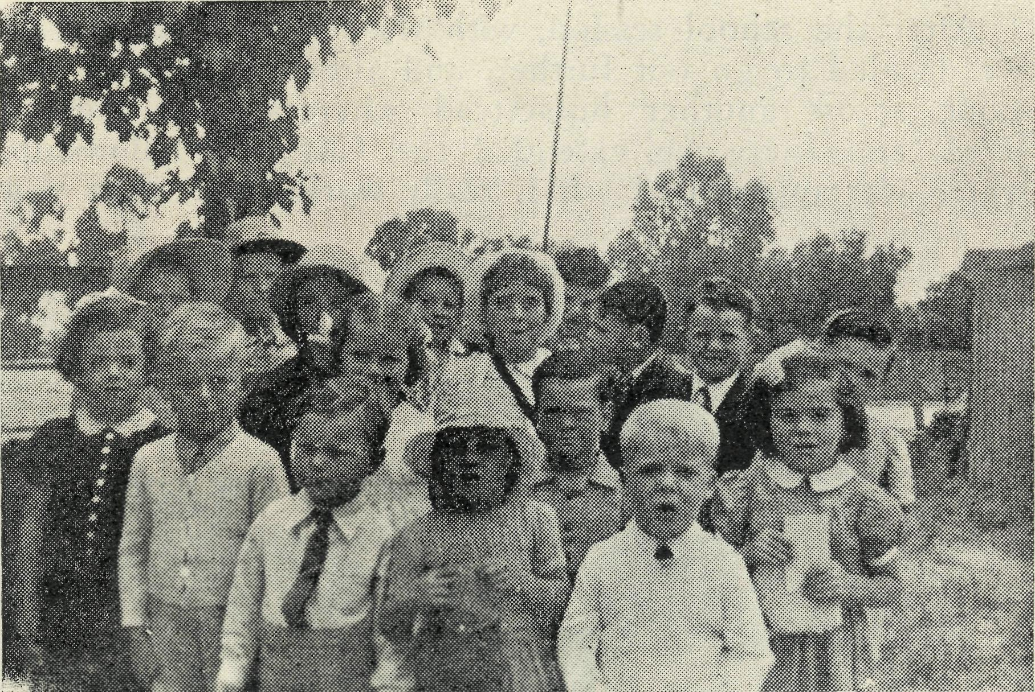
Streaky Bay Kindergarten.
it makes our hearts ache for those who would respond if they could receive similar teaching. But with only occasional recruits at long intervals, little can be done. However, the Mailbag Sunday School is very valuable and helps to fill up the gaps between personal visits, steering firm. That evening, about forty adults and children came from the near-by houses of fishermen and from distant farms.
Recently a Church Missionary Society member was passing through on deputation work. He taught the children about the Aborigines on Groote Eylandt. Among other pictures shown was one of the native children receiving small gifts. After the class, one of the lads said he was going to give some of his marbles to be sent up to Groote Eylandt in a parcel. This inspired others, and quite a quantity of marbles, pretty cotton bags and pencils were sent away.

Rain in the West Darling Mission!
Mr. W. DAVISON
It is strange, but true, that it is not all heat, dust and drought m the Far West of N.S.W., as we have found in the few short months we have been privileged to work for our Saviour here. It can rain here as well as anywhere else. It has been a real blessing, and praise can be given to Him who supplies all blessings, yet it can hamper operations, staying the advancement of the Gospel as the roads become impassable.
We think of a lonely little town in our area which has not had any fellowship or service for a number of months. When the day dawned for us to visit this town, the rain prevented our trip, thus causing disappointment.
Another day was chosen, and arrangements were made
by phone early in the morning. The day was one of
God's masterpieces of beauty, for the sun shone brilliantly
with not a single cloud in the sky. A light breeze
cooled off any excessive heat, making the day very comfort
able and pleasant. The car was quickly prepared, and with
a word of prayer concerning the trip and work ahead,
we began our tour towards this lonely, almost deserted
town. , i '
Only a few homes nestled at lengthy distances along the road and, where possible, Christian Fellowship was given and appreciated.
Appreciated! Yes! with a capital "Y"! We recall one family of three whose nearest neighbour on one side was
ten miles, and on the other thirty miles. They were longing for fellowship. The mother had endured many hardships on the land, but through it all her faith remained unshattered. This is one of the many of the outback folk who appreciate what the Bush Church Aid Society is endeavouring to do in giving them fellowship and spiritual guidance. Will you join us in praying for these folk?
Eventually we arrived at our destination—once a famous town, noted for its supply of opal, but now ranking among the many Ghost Towns of the West. It consists of four homes, hotel, post office, general store and a school—once it had a population of over four thousand people!
Being 2.30 p.m., it was time for us to visit the school and give a Scripture lesson. On entering, we see about seventeen children gating shyly at us, and after a few promptings from the teacher (who also enjoyed the fellowship we were able to give) we received a very weak "Good Afternoon". However, a few cheery words, a word of prayer followed by a few choruses and a Bible quiz soon helped them to overcome their shyness. Finally, story time arrived, with the children listening eagerly, as God's way of salvation through His Loving Son, was explained to them.

THE REAL AUSTRALIAN
16
March, 1948.

After the school session, with the townspeople visited, we decided to go out further, and after a nine mile trip came across another homestead where a few families lived, and tnere we^ extended the Christian fellowship, which was appreciated. It is really worthwhile when you
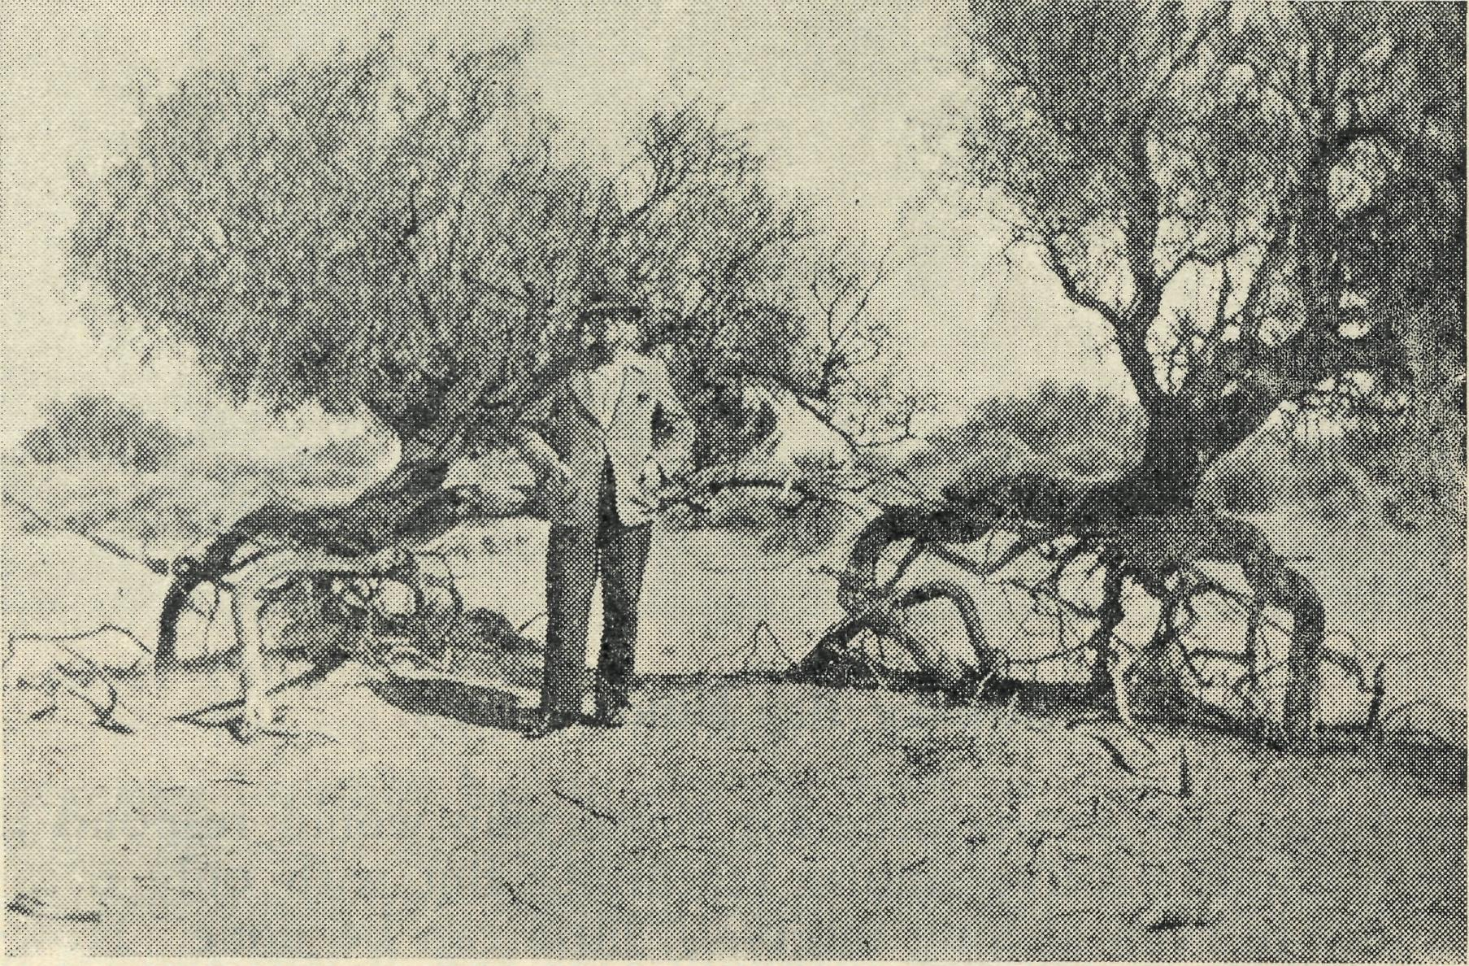
The Rain Might Cure This.
hear the people say, "Do come again soon, we did enjoy your visit".
Stopping on the way back to town, we had a wayside tea, enjoying the quiet and the fellowship of our Master,
before we once, again were busy, keeping the banner of the gospel flying.
With about forty minutes to spare, we arrived at the little old stone church at the rear of the town. At 7 p.m. we rang the first bell, then at 7.30 we rang the second, but there was no one yet in sight. Being used to country folk, we waited, and ere long our patience was rewarded, for ten minutes later the whole congregation appeared over the hill in a body.
The conditions of the service were very trying, as the beams from the kerosene lamps were not of sufficient strength to allow all to join in. However, we could definitely feel God's presence with us all the time.
The service over, it was a deep joy and thrill to know that each one, old and young, was singularly blessed, and greater still the joy when one dear old soul said, "Thank you for a very lovely service". •
After a very happy time of fellowship in one of the humble homes following the service, we set out for our home base. A little after midnight found us pulling up outside the Rectory, tired, yet rejoicing at the many blessings He had bestowed on us throughout the day.
As we meditate over all this, does it seem really worth while—long distances—running costs—few people, humble and poor. Is it really worth while? Once again, YES, with a capital "Y". Are they not the souls for whom our Saviour died and lives, that they too might have "Life and have it more abundantly"? These are the works of the B.C.A. amongst the outback folk, for our Lord and Master. Please pray that He will help us to be real channels of blessings to these people.

Christmas at Wudinna
Sister L. E. PRITCHARD

There were great preparations for days ahead, but all felt rather limp because of the heat, and wondered why Australians still hold to the old tradition of the hot feast of goose and plum pudding, but we were pleasantly surprised when the day dawned fine and cool and our energy returned. There was much tying on of parcels to the Christmas tree and last minutes touches to the place to make it look Christmas before we retired to bed. During that time we.had a visit from Father Christmas, who presented each patient with a gift. One little girl was over-awed at his presence, but thawed enough to answer a few questions and to tell him what she would like. After attending to our patients we had breakfast, then met round the throne of grace for a short while. Then we prepared a place for our Christmas communion, for which Mr. Greenwood arrived at nine to administer the same to us. We numbered fourteen, and a happy holy time was spent round the Lord's Table.
Preparations were continued for the feast, then fourteen sat down including David Greenwood, who I verily believe enjoyed his bone as much as we enjoyed our luscious meal.
After the everlasting dishes were disposed of, we then gathered around the Christmas tree, which Santa, with the help of a few agents, had laden till the boughs were slightly bending.
Santa did a good job, and we all enjoyed opening our parcels, the contents of which had intrigued a Yew of
the staff for quite a number of days, but at last their curiosity was satisfied.
After routine duties were completed for the afternoon, those who could were invited to tea at the Roxburghs, where a feast of good things again awaited us. Mrs. Roxburgh had kindly arranged to send teas down to the hospital for the patients and staff left behind, to lighten the burden of the cook, who had had a fairly heavy day. She was thus able to enjoy Christmas tea with her family.
After tea a very happy time was spent sitting around a fire (yes, a fire on Christmas night) singing carols at Doctor's suggestion by torch and auriscope light, a very fit and appropriate ending to a very happy Christmas Day.
CHRIST CHURCH, WOMEN'S AUXILIARY, SOUTH YARRA, 1947.
The usual meetings were held during the year on the dates for receiving the contents of Bark Huts, the total amount from the Huts being £11-8-0, and donations amounting to £6-3-4. In April the first meeting for the year was held at the Vicarage when the Vicar, the Rev. J. A. Housden, gave an address. In August, the Annual meeting and Gifts Day was held, when an address was given by the Rev. L. L. Morris. The final meeting for the year has been arranged for 11th December, when the Rev. E. L. Panelli will give an address.
E. M. GILL, Box Secretary.

March, 1948.
111
THE REAL AUSTRALIAN

URGENT!
Christian women with a knowledge of housekeeping and a great love for children are urgently needed as House Mothers and Assistants in our Hostels. "Write to the Organizing Missioner for further information.
LEARN MORE OF B.C.A.
We have splendid up-to-date Lantern Slides, which give an excellent idea of all B.C.A. activities.
The N.S.W. Secretary will be glad to give Lantern Lectures in Churches, Halls and Drawing Rooms.
Make arrangements with him to-day.
Ring up M3164 or Write N.S.W. Secretary.
BUSH CHURCH AID SOCIETY.
DIOCESAN CHURCH HOUSE, GEORGE STREET, SYDNEY.

THE REAL AUSTRALIAN iv March, 1948.
''Australia for Christ"
WHAT THE CHURCH IS DOING
in
THE OUTBACK
through the
BUSH CHURCH AID SOCIETY
PASTORAL..
• Maintains 14 OUTBACK CLERGY
Situated at Ceduna, Penong, Minnipa, Streaky Bay, Cummins, Kirton Point, Wilcannia, Menindie, Rappville, Delegate, Croajingalong,Werrimul, Beech Forest, Heytesbury, Denmark.
EDUCATIONAL.,.
• Maintains 6 SCHOOL HOSTELS
Situated at Wilcannia, Mungindi, Port Lincoln, Bowral, Wentworth Falls.
• Maintains MAILBAG SUNDAY SCHOOL
Teaching Outback Children.
MEDICAL...
• Maintains 4 fully equipped HOSPITALS
1 Medical Hostel, 1 Medical Dispensary, 2 Medical Aeroplanes, 3 Flying Doctors, 17 Nursing Sisters, 1 Pilot.
MAINTENANCE
The Annual Cost of maintenance of all the varied activities of the Bush Church Aid Society is £25,000. The whole income is derived from the free gifts of
Christian people. You can help by:
- A donation to our Funds.
- Keeping a B.C.A. Collecting box in your home.
- Subscribing to our Quarterly paper, "The Real Australian".
- Donating a Saving Certificate.
- Daily remembrance in your prayers of the work and workers.
- Including the Society when making your will.
Our Address is—
BUSH CHURCH AID SOCIETY,
Church House, Bible House,
George Street, Sydney, N.S.W. or F.hnders Lane, Melbourne, Vic.
Phone: M 3164. Phone: FJ 5675.
E. BRAGG & SONS, PRINTERS, 4 BARKER STREET, SYDNEY

