No. 103.
June, 1949.
1/6 per annum, post free.

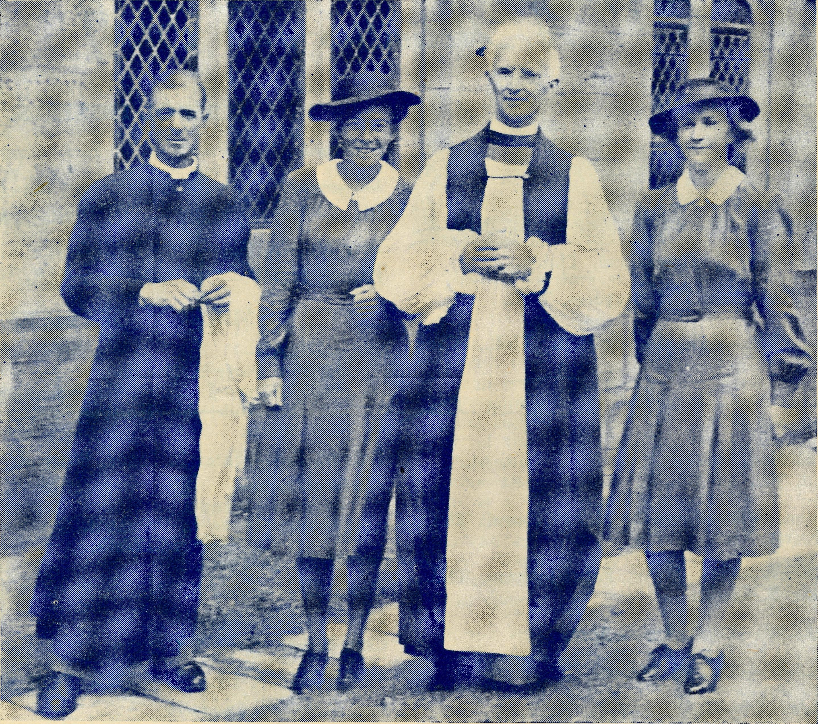
Rev. T. Jones, Deaconess B. Clarke, Bishop Hilliard and Deaconess P. Spry at St. Andrew's Cathedral after the Service of Commendation on February 23rd, 1949.
Registered at the G.P.O., Sydney, for transmission by post as a periodical.

THE REAL AUSTRALIAN
June, 1949.

The Bush Church Aid Society for Australia and Tasmania
President: The ARCHBISHOP OF SYDNEY.

HEADQUARTERS OFFICE.
Diocesan Church House, St. Andrews' Cathedral.
George Street, Sydney. Telephone: M 3164,
Cable Address: "Chaplaincy Sydney." Hon. Treasurer: Mr. T. S. Holt.
STAFF.
Organising Missioner: Rev. T. E. Jones, Th.L.
Assistant Organising Missioner and N.S.W. Deputation Secretary: Rev. D. G. Livingstone, Th.Schol.
VICTORIAN OFFICE.
Bible House,
Flinders Lane, Melbourne, Vic.
Telephone: FJ 5675.
Victorian Secretary: Rev. L. Ball, M.A.
South Australian Honorary Secretary:
Rev. F. H. B. Dillon, Th.L.,
Holy Trinity Rectory, North Terrace, Adelaide, S.A. Phone: C.1134.

B.C.A. Activities and Staff

MISSIONS.
Ceduna, S.A. \ _{Rcv} p _{C}onnell, Th.L., Ceduna, S.A. Penoiig, S.A. \
Cowell, S.A.—Rev. D. A. Richards-Pugh, A.L.C.D., Minnipa, S.A.—Rev. J. Greenwood, Th.L. Streaky Bay, S.A.—Rev. T. J. Hayman, Th.L.
Croajingalong, Vic.—Rev. G. Pearson, Th.L., Cann River, Vic.
Delegate-Bonang, Vic.—Rev. D. H. Wicking, Th.L., Delegate, N.S.W.
Heytesbury Mission, Vic.—Rev. E. G. Beavan, M.A. Timboon, Vic.
Otway Mission, Vic.—Rev. T. H. Pickburn, Th.L., Beech Forest, Vic
Wilcannia,, N.S.W.—Rev. E. W. Fisher-Johnson, Th.L., Deaconess B. Clarke.
Menindee, N.S.W.-—Deaconess P. Spry.
Rappville, N.S.W.—Rev. R. Meyer, Th.L.
Denmark, W.A.—Rev. C. H. Sherlock, Th.L.
Werrimull, Vic.—Grant-in aid.
MAIL BAG SUNDAY SCHOOL.
Director.—Miss R. Campbell
SCHOOL HOSTELS.
Wilcannia, N.S.W.—Miss M. Farr.
Mungindi, N.S.W.—Miss E. Cheers, Miss E. I. Cheers.
Wentworth Falls, N.S.W.—Mrs. C. Mann, Miss F. Lawtey.
Port Lincoln, S.A.—Miss I. Beck.
Bowral, N.S.W.—Deaconess Dixon, Miss Michael.
MEDICAL SERVICES.
Ceduna, S.A.—
Matron: Sister F. Dowling.
Stall: Sisters J. Miller, G. Hitchcock, B. Tierney, V. Holle, M. Horsburgh, O. Morgan, Miss Stokes.
Penong, S.A.—Sister L. Loane, Sister R. Portch.
Wudinna, S.A.—
Dr. R. Roxburgh. Matron: Sister L. Pritchard. Sisters E. Fisher, M. Wells. Nurse D. Barry.
Cook, S.A.—Sisters E. Thomas, R. Gillan.
Tarcoola, S.A.—Sister V. Page.
Cann River.—Sister I. Gwynne.
CEDUNA FLYING DOCTOR SERVICE.
Pilot.—Mr. A. Chadwick. Doctor.—Dr. F. Gibson, O.B.E. Pharmacist.—Miss E. M. Page.
WUDINNA FLYING DOCTOR SERVICE.
Doctor-Pilot.—Dr. R. Roxburgh.

June, 1949.
THE REAL AUSTRALIAN

Assistant Organising Missioner’s Letter

On behalf of the O.M. I wish to express our appreciation of the many messages received in the office concerning his ill-health. The sympathetic concern of such a number of friends has been a very real uplift to Mr. Jones as he rests from the responsibilities of the work during these few months.
The deaconesses are settling in at Wilcannia and Men-indee. They are meeting many difficulties and things are not at all easy. But they are overcoming the obstacles one by one and are doing splendid work.
Recently, I was able to visit some of the missions and hospitals in Western and South Australia and it was good to see such excellent work being done in those parts by our splendid team of workers.
I left Sydney in pouring rain, but how different it was at Ceduna the next day! The summer had been a very dry one and the whole country had a burned-up, blistered look, while the all-pervading dust was much in evidence. It was a great pleasure to talk for a few minutes with Mr. Connell, Mr. and Mrs. Chadwick and some of the other workers but it was over all too soon, and shortly afterwards I was looking down on the Nullarbor Plain in its bare, immense awfulness. As I flew on in comfort, I thought sympathetically of Mr. Connell who would be soon travelling over that plain on his regular patrol in his very old and unreliable car, and longed for the day when we could supply him with a new vehicle. Fortunately, that day is not far off. A new van is being built and all being well, it will be ready next month. But it has to be paid ior, and the cost will be at least £950. In 1940, St. Patrick's Van cost £450. These increased costs are a most heavy burden that the Society has to bear but the work must go on no matter what the cost. The Ladies' Auxiliaries are helping with the raising of this sum but we shall be most grateful for any contributions for this purpose. Speaking of this reminds me that the Deaconesses who are doing such good work under serious difficulties should also have a vehicle. More cars or vans will be needed next year. Please pray that all these needs will be supplied. They are absolutely necessary if the Gospel is to be taken to the Outback.
To resume, that night I was met at the Perth Airport by Charles Sherlock, the missioner at Denmark, 300 miles south of Perth. The next day we drove down to the mission and then commenced a strenuous but most inspiring series of services, meetings and visits to schools during which we travelled something like 1000 miles in six days.
It would take far too long to describe the work being done in Denmark in detail so I will endeavour to give just a glimpse or two of what is being done.
At one period the missioner was deeply concerned about Sunday sport in that area. He arranged a special service and invited the members of the sporting bodies to hear the Church's views on such things. As a result, a fine young fellow was converted and became a Sunday School teacher. To make a long story short, that voung man now drives a motor bus through the bush on Sundays and teaches numbers of young children who
otherwise would have no opportunity of attending Sunday School. Both children and parents deeply appreciate what is being done and are arranging little functions in order to help with the expense.
At one centre I met a young married woman who with her three children walks 2^ miles along a narrow forest track in order to attend the services in her centre. She does this at night as well as in daylight. In another place Mr. Sherlock pointed out the home of another man who walks 5 miles in to Church. It was good to see the keenness of these people. The mis-sioner's work as an official ambulance driver, his chaplaincy at the Government school for boys being trained as farmers, the building of the church at Kronkup and many other things are all interesting and long stories in themselves. I left Denmark convinced that a fine
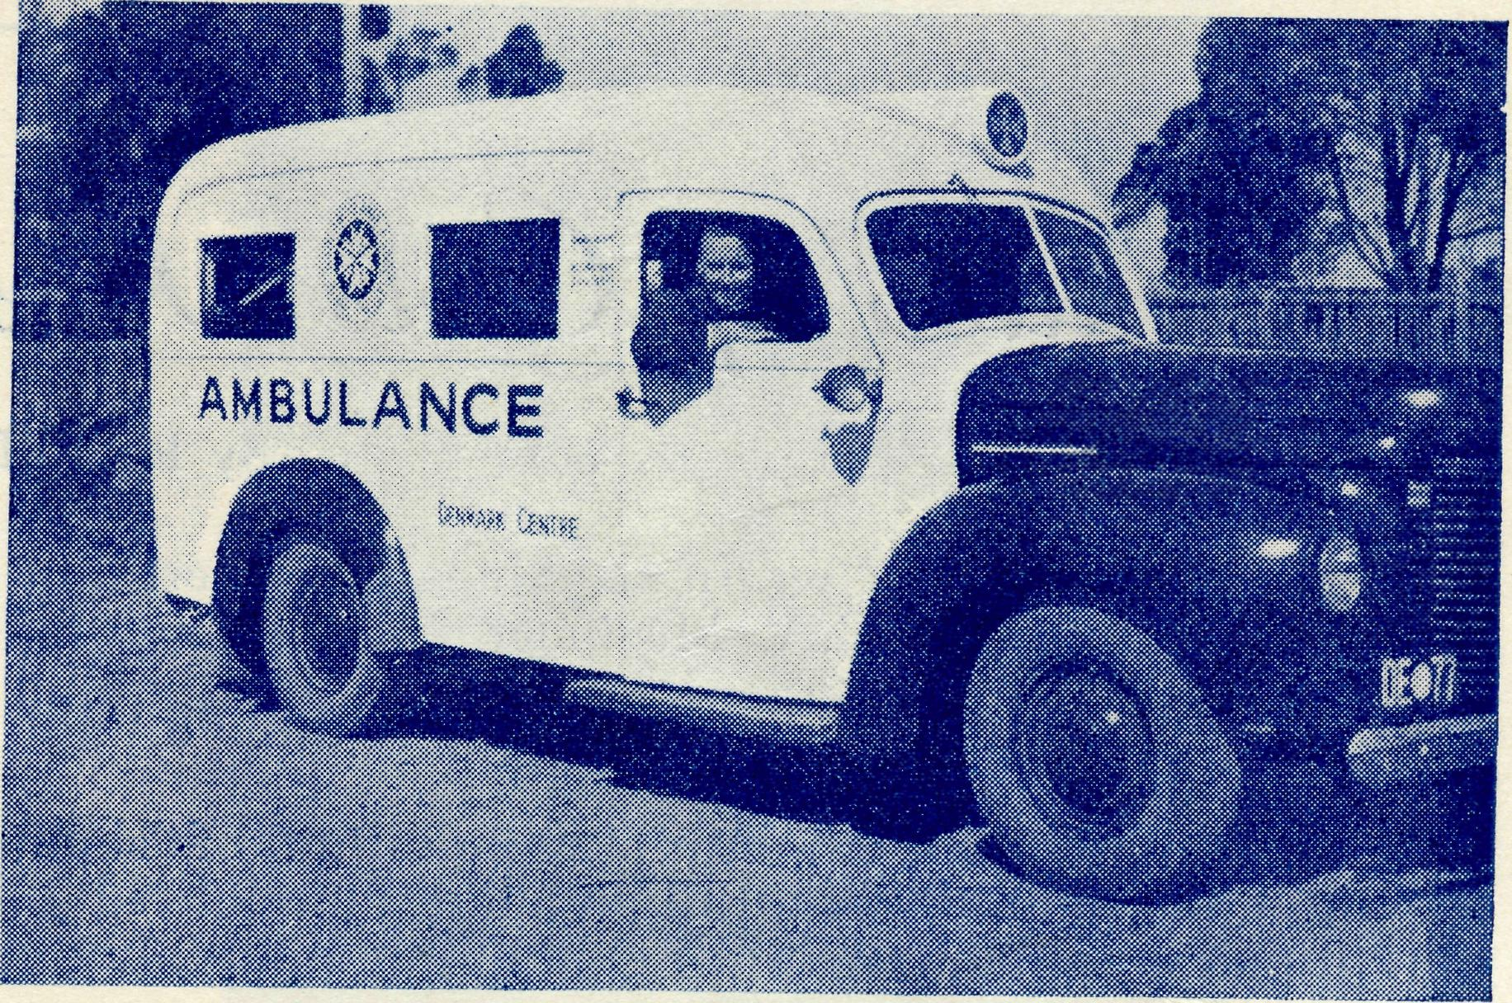
Rev. C. Sherlock at the wheel of the Ambulance.
work is being done but convinced also that another man is needed to share the task there. It is impossible for one man adequately to meet the need. But that is the need everywhere in B.C.A. In South Australia it is obvious that missioners there are seriously feeling the strain of travelling over their huge areas. They must have more assistance. We have recently received more requests from several bishops for B.C.A. missioners. There is a wonderful opportunity for us in these days. Surely there must be devoted clergy somewhere who will heed the call to serve God in the Outback through B.C.A. We need TWELVE MODERN APOSTLES to the Outback. Please pray that suitable men will heed the call to volunteer.
It was another inspiration to see the excellent work that Miss Beck is doing as Matron of the Girls' Hostel at Port Lincoln. The behaviour and deportment of the girls was a credit to the influence of life in the Hostel, and one could well believe the words of the Headmaster who said that the girls from the Hostel are a sweetening influence in the whole school. But the matron urgently needs an assistant. It is neither easy nor fair for one woman to have the responsibility of caring for 33 girls without assistance. Will someone offer to help her in that most important work?

THE REAL AUSTRALIAN
June, 1949.

I returned home impressed more than ever with the worthwhileness of the task which B.C.A. is attempting to do; impressed with the devoted spirit and sacrifice of the B.C.A. family of missioners and other workers; impressed with the need for more clergy, hostel workers and nurses.
Financially, too, our needs are great and very urgent. Several thousand pounds would be very handy at the moment, not for the joy of handling it but to spend for vital work in the Kingdom of God. We have been encouraged by the gift of £750 sterling from the Colonial 6? Continental Church Society in England. The help given by the Motherland when the difficulties are so great over there is a continual source of inspiration, but it is a challenge to us to do more ourselves to evangelise our own Outback. It is unthinkable that His work should be hampered merely for the lack of money. Let us never forget that money means the preaching of the Gospel, teaching children the things of God, the saving of life and of souls through the ministry of B.C.A. nurses, doctors, planes, pilot and chemist.
It was on May 26th, 1919 that the inaugural meeting of B.C.A. was held in 'Sydney. We have come a long way during these thirty years. Our thirtieth birthday will be celebrated on Friday, September 2nd, in the Chapter House, Sydney. One speaker will be the Rev. John Greenwood, who has done great work in South Australia for the past five years. He has an inspiring story to tell. The other will be Miss Rose Campbell of the Mail-Bag Sunday School. Under Miss Campbell's leadership the Mailbag is going ahead in a truly wonderful manner. She will show still films of this most interesting work. I hope that everyone of us will do all in our power to make this Rally worthy of the thirty years' splendid history of B.C.A.
God has blessed B.C.A. wonderfully during these thirty years. He has led us into a mighty work. I believe that He has even greater work for us to do in the years that are to come. But He needs our prayers, our gifts and our service.
Asst. O.M.

Dedication of Girl’s Hostel at Mungindi, N.S.W.
By Rev. H. E. FELTON

It was a great joy to return to Mungindi where one had been Vicar and B.C.A. Missioner 20 years ago, to represent the Society at the Dedication of the second B.C.A. Hostel in that far-off border town.
At 3.30 p.m. on 26th April a gathering of about 100 people, including the Hostel children, assembled in and around that new Hostel.
The Right Reverend, J. S. Moyes, M.A., D.D., Bishop of Armidale, accompanied by the Rural Dean of Moree, the Rev. R. A. Marshall, the Vicar of Mungindi, the Rev. J. M. Rattray, and myself took part in the act of Dedication. The Bishop had arranged a service similar to that used for the Dedication of a vicarage.
After the opening hymn, I spoke briefly of the building of the first hostel through the efforts of the late Rev. S. J. (later Bishop) Kirkby with the support of friends of B.C.A. and local gifts, and told of progress and of the dire need of more accommodation. I spoke, too, of the generosity of the B.C.A. family which made possible the purchase of the new property for £800, which was about to be dedicated. I then, on behalf of the B.C.A. requested the Bishop to dedicate the Hostel. This he did in solemn and fitting manner and then spoke to the congregation.
After congratulating the Society he said he wanted to pay tribute to two people. Firstly to Bishop Kirkby, whose foresight led to the building of the Boys' Hostel, as it now is, and for whose life and ministry we must ever praise God, and secondly to Matron Cheers, who for 19J years has done a splendid piece of work for God and His Church and for the children of the district of Mungindi. He then asked all present to support the work of B.C.A. whenever they could and to remember that what is done in Mungindi is only a small part of a great work done in many lonely parts of Australia.
During the singing of another hymn an offering of £29 was made to the funds of B.C.A. and we were dismissed with the Bishop's blessing.
The Boys' Hostel at present is crowded with 28 boys. These are cared for by Matron E. M. Cheers. There are 16 girls in the new Hostel. These are in charge of Miss ]. Cheers, affectionately known as Matron Jo. These two matrons desperately need help.
The 44 children are happily housed in their respective hostels. All attend the Mungindi Central School. I visited the School and found the headmaster was loud in his praises of the training of the children from the Hostels. The "hostellers" comprise l/3rd of the total enrolment of the school. Some 250 children have stayed at the old Hostel during its 19 years of real service to children of the border districts round Mungindi.
I came away in the little motor-train, thanking God for what He had done through B.C.A. for children of the outback.
N.S.W. LISTENERS !
tune in to
2GB
for the B.C.A. "Outback" Session
Now on
FRIDAYS AT 11.15 A.M.

June, 1949.
THE REAL AUSTRALIAN

Flying Doctors in Remote South Australia
By E. J. STRETTON
{Reprinted by courtesy of "Walkabout")

Perhaps it is not welbknown that the far west of South Australia possesses one of the best Flying Doctor Services in Australia, and as modern as conditions will allow. Although it does not serve such a vast territory as the Broken Hill and Charleville Services, it neverthe' less covers an area of over 80,000 square miles. Its home base is at Ceduna, on the shores of Murat Bay, and is about 220 miles nortlvwest of Port Lincoln.
The Bush Church Aid Society, after working for several years in small cottage hospitals, was forced to seek larger hospital accommodation. Increasing population and in' dustrial expansion demanded it. A fine modern hospital, less than half a mile from the centre of the township between the main east'west road and the beach was therefore built, staffed and fully equipped.
During the war years, like all hospitals in Australia, the staff was often very hard pressed. There was a shortage of nurses and a heavy intake of patients, but the staff kept going cheerfully in the characteristic way of B.C.A. sisters.
The Society also conducts a cottage hospital at Penong, forty odd miles to the west of Ceduna on the overland road. This hospital, under the supervision of a sister, meets the needs of short period patients. The Society maintains another small hospital at Cook, on the east'west line, also under the control of a sister. It caters for railway workers and their wives and families.
In 1945 the B.C.A. took over the Wudinna hospital. This is quite a modern institution on the Ceduna'Port Lincoln railway line, 130 miles to the south'west of Ceduna. There, a supervising sister has a small staff to help her. The hospital is an auxiliary base for the Ceduna Flying Doctor Service. It is provided with a DH. 83 Fox Moth 'plane which is piloted by Dr. Rox' burgh, the local medical practitioner.
Dr. Freda Gibson succeeded Dr. Roy Gibson, who died last year. The latter had been flying doctor to the service ever since its inception. During the war he served as M.O. to the forces in the far north. In his absence his wife, who is also a Doctor, carried on alone. Her skill and endurance probably saved the lives of many patients in the lonely outback.
In the past year or two, if Dr. Roy Gibson for any reason could not attend an urgent call from the outback, Dr. Freda, as she is popularly known, would immediately set out in the D.H. 84 Dragon plane for a journey of anything up to 230 miles. For her work she was awarded the O.B.E. Dr. Freda married Dr. Roy in 1933, and practised with him up to the time of his death. As far as is known she is the only official lady flying doctor in Australia.
Several patients have been brought in by the B.C.A. plane in a serious condition following an urgent call by pedal wireless, relayed by land line to the doctor at Ceduna. Calls such as these have set pilots the problem of choosing the nearest landing ground to the case in' volved. But they have always made safe landings and take'offs.
Pilot Chadwick has been in charge of the plane since the service was started in April, 1938. With the doctor, he has flown over some of the most difficult country in Australia, notably between Ceduna and Tarcoola, which consists mostly of sandhills and spinifex with
occasional dry but treacherous swamps. The Nullarbor Plains section to Cook is also covered by dense, low bush and very rough gibber country that is hazardous to land on. The plane has a cabin capacity of three seats and two stretchers, a cruising speed of 90 miles an hour and a flying range of 5J hours.
Flying without the aid of wireless equipment, Pilot Chadwick, even before the war, made 970 trips in 2,415 flying hours and flew 185,380 miles to attend
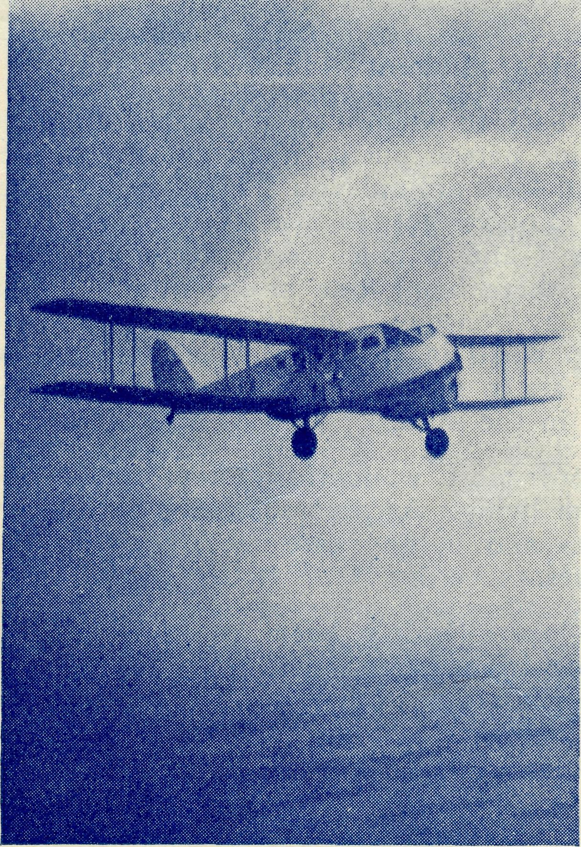
Dr. Freda flying to the rescue.
11,100 patients. He has now had eleven years of troublcfree service.
During the last few months, the Society has opened a pharmacy and dispensary in Ceduna, so that the community can get the prescriptions made up inv mediately.
Nearly 4,000 people, scattered over a wide area, are served by the Ceduna service. The actual figures are; Ceduna and district, 2,600; Penong and district, 560; Fowler's Bay and district, 150; Cook, 230; Tarcoola and district, 300.
The writer is a pioneer of over half a century and is thoroughly conversant with most of the country covered by the service and the conditions under which the people live and endure. The relief with which the doctor is welcomed as he or she steps from the 'plane is often very poignant. The high tribute paid to the Flying Doctor Service by those in outback homesteads, and especially by those gallant women who share the hardships and loneliness of the far interior with their husbands and children without seeing another white man or woman for weeks and often months will never fade in its sincerity.

THE REAL AUSTRALIAN
June, 1949.

News from The Deaconesses

By. Deaconess P. SPRY.
It happened! A letter did come from H.Q. asking for an article for the "R.A." and where to start Fm somewhat pulled.
Menindee is on the Darling River, 71 miles east of Broken Hill and about 627 miles from Sydney. I arrived here in St. Patrick's Van with Rev. and Mrs. Fisher-Johnson at 5 p.m. on 18th March. I'd spent a happy time in Wilcannia from 2nd March with Deaconess Clarke at the B.C.A. Hostel, Miss Farr being in charge. A hostel really is a home from home and it was a joy to witness how Christ inspires a woman to spend long hours seven days a week in difficult conditions looking after other people's children.
To get back to Menindee, it's a difficult place to describe; as one person put it, when you get to the Railway Station and look around you think "where's Menindee?" Scattered! You've got to see it to believe it. Homes extend for 5 and 6 miles respectively on both sides of the River, there being one bridge at the far end. My bicycle is my constant companion, though we do break partnership when in sand, which is quite frequent! It's a work of art to ride down the main street without skidding over in the sand.
The Lord most wonderfully kept a flat for me in which I am living. Accommodation i$ as difficult here as other parts and in any case most people live in very small homes.
Because there hadn't been anyone here for several years it has been necessary to start work from scratch. Young people are anxious for something to do with their time and of course lack spiritual training because there's been no one to tell them of the Saviour; it has been necessary to teach the children hymns at Sunday School. There are ample opportunities and more work to be done than one person can cope with. The town itself could fully occupy one's time, but the people further afield want to hear the Gospel, too.
So far I have only been able to make one trip to a home 75 miles from here by train. I was met at a little siding in the middle of nowhere and taken to the home where I was made very welcome. That night a neighbour and his wife came over and we held an informal service in the kitchen. The lady of the house was so glad to see me and talked the whole time. Their nearest town is 75 miles away and neighbours are. none too close as all stations are 50,000 acres at least. One of the lads from that home, aged 12 years, is this year attending Sunday School and church for the first time in his life. He is able to do this through the B.C.A. hostel. When I asked him how he liked attending school he replied, "It's good, so easy to what it is at home and I never want to go back to correspondence." These boys and girls haven't any companionship at all, they spend their lives completely cut off from anyone their own age.
You might wonder whether it was worthwhile travelling 150 miles and being away for 30 hours just to take a short service; but when you consider they hadn't had anyone to lead them in the worship of God for years, and if you'd witnessed the welcome I received you
wouldn't have had a doubt as to whether it was worthwhile.
There are many homes I cannot contact because I haven't a vehicle. Please join with me in praying God will supply a means of transport so all homes can be visited and the good news that a Saviour has been born, can be taken to them as well.
My welcome has been a warm one on the whole but the work is difficult and so are the conditions. There is need for more labourers; Satan has a terrific grip due to the lack of spiritual training over the last few years.
Do pray for the Y.P.F., G.F.S., and Y.P.U. which have been commenced, and praise God for the interest which has been shown. These meetings are held every second week. Each Sunday morning there is a good roll up of children for Sunday School and a service is held in the Church every Sunday night. Rev. E. W. Fisher-Johnson comes down from Wilcannia once a month to take a Communion Service. It's good to see and talk to another Christian! There are great opportunities at the school, too. I hope we'll be able to start a Guild next week.
It is such a worth while work and there are great opportunities. Do uphold us in prayer, for we need your help.
Deaconess B. CLARKE.
Our trip to Wilcannia was very pleasant and the climax of months of waiting and happy preparation for our new sphere of work. Hour after hour passed by as the train jogged along, and as sightseeing was impossible during the night, we made good use of sleepers. The train from Parkes was air-conditioned and beautifully cool, but the contrast when we stepped onto the platform at Ivanhoe was really hard to take for the first half-hour or so. We were met by a doctor from Wilcannia who in the absence of Mr. Fisher-Johnson drove us in St. Patrick's Van to our destination. This 114 miles stretch in the heat, over a rough dusty road, was the most tiring part of the journey. The monotony was broken by glimpses of "real Australians" in the form of kangaroos, emus, galahs and sheep, a real treat for one born and bred in the city.
Miss Farr greeted and welcomed us in heartwarming B.C.A. style. The Hostel proved a home from home for us, and we appreciated the atmosphere and comfort of the place, particularly during those first few really hot days when the thirst we had acquired on the way out just refused to be quenched, and the dragging weariness, also a result of our trip and the hectic days preceding it, refused to go. The fourth day was cooler and on the Sunday rain was falling—delightful, invigorating, refreshing rain. We revelled in it, and trudged to Sunday School and Church wondering if rain had ever been quite so welcome at home.
In visiting the homes of the people during the days that followed we were struck by the indifference generally to spiritual things. We were warmly welcomed by the friendly folk, but there was no Christian fellowship excepting between ourselves. We are praying that

June, 1949,
THE REAL AUSTRALIAN

there will be a great turning to the Lord here before very long.
Miss Spry left for Menindee when the roads were passable again and car travel was not a gamble. We miss her and are thankful for the help she gave whilst in Wilcannia. It's good to know that she has things well in hand and the people of Menindee are having regular services and care once again.
We are grateful for your prayerful and practical interest in us. My thanks to the Ladies' Auxiliary for so thoughtfully providing mats for my room. They have made a big difference and I do appreciate having them.
At the moment I am writing from Ivanhoe and intend staying here for a few weeks before returning to Wih cannia. The actual country or station visiting seems almost impossible without a car or van or some means of transport. With bicycles a certain amount can be done but when some of the homes are 20 miles or more off the road, and those on the road are also miles apart, cycling isn't all that it could be.
There is a great work to be done and though its magnitude almost overwhelms us, we have trust and confidence in a great Saviour. He has called us—He has sent us forth, and we are thankful for opportunities of service for Him.
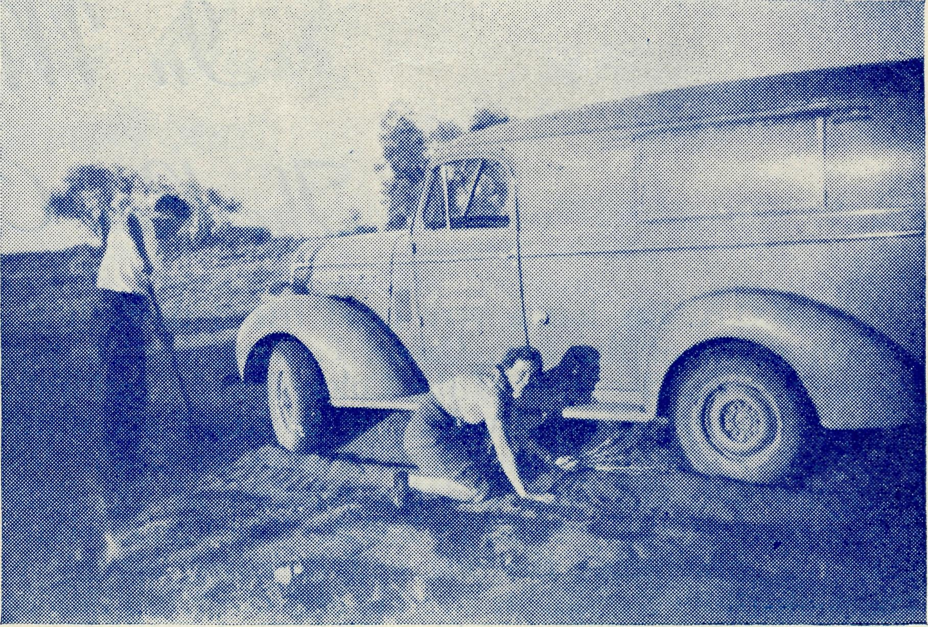
Deaconess Spry strikes trouble.
Greetings to you one and all. May the Lord bless us abundantly, as we labour together for the extension of His Kingdom.

Wilcannia Hostel
Miss M. J. FARR

Wednesday, the 2nd of March, was a reddetter day for us at the Hostel, for we welcomed the Misses Clarke and Spry into our midst. Before they came, there were questions from the boys, such as "What is a Deaconess?" "What did they do?" and so on; but once they were here, the boys soon transferred their questions to the ladies themselves. The Deaconesses joined with us right from the start and were soon enticed into a game of ping-pong. After a walk to the sandhills on a lovely moonlight evening, a picnic was arranged and the boys had a lovely time tumbling their visitors in the sand.
While they have been here, we have had hot and cold weather, rain and sunshine, nice days and dusty days, water and electricity, and no water and electricity; so they have had a taste of what can happen.
While Miss Spry waited for the road to Menindee to dry up after the rain, she varnished some of the fur' niture and our sitting room looks much better for her help. She also, with the aid of one of the boys, re planted one side of our front lawn and tidied up the front garden.
It has been a joy to have their friendly fellowship and to share in their enthusiasm for their new tasks. Now Miss Spry has gone on to Menindee and Miss Clarke has settled down to jog along with us but I am sure the road will be brighter and easier because our Lord has made our paths to meet. May God help them to keep their hands to the plough until His Will has been done.

ASSISTANT MATRONS
are urgently needed for the
GIRLS' HIGH SCHOOL HOSTEL
at Port Lincoln, South Australia, and at Mungindi, N.S.W.
Write to the Organising Missioner for details.
IS THIS YOUR CALL TO CHRISTIAN SERVICE?

THE REAL AUSTRALIAN
June, 1949.

In Memoriam
The Rev. Canon F. Bate

The B.C.A. has lost a very good friend through the sudden death of the Rev. Canon F. Bate, until a year or two ago the Secretary of the Colonial and Continental Church Society, the great English Society from which B.C.A. has grown and to which it owes so much. We offer the Col. and Con. and the relatives of Dr. Bates the sincere sympathy of all in B.C.A. The Canon visited Australia just before the war and endeared himself to many on that occasion. It was his and our hope that he would have been able to visit us again in the near future and B.C.A. would have appreciated the opportunity to honour one to whom the Society owes so much. Canon Bate had another link with Australia in the person of his brother, who lives in Melbourne.
We gratefully join in the tribute to Dr. Bate's life and work reprinted below. The account is taken from the April issue of "The Greater Britain Messenger", the magazine of the Colonial and Continental Church Society.
"Our readers will have learned with deep regret of the sudden death of Canon Bate, whose life for more than thirtyfour years was identified with that of the Society. While grieving that he has gone from our midst, we thank God for his life and the splendid contribution he made to the cause which is so dear to all our hearts.
The Rev. Canon Frank Bate, M.A., B.Litt., D.D., was a man of outstanding gifts. Always a keen student, he obtained a first in history at Liverpool University in 1904 and a B.Litt. from Balliol College, Oxford, three years later. Throughout his life he interested himself in the study of languages and he was able to read the New Testament in most European tongues, being familiar with the characteristics of different translations and editions.
"He was ordained in 1907 and, after serving in several curacies, he became rector of Pimperne, a country parish in Dorset, in 1911. He remained in this living until he joined the staff of the Society in 1915 as Assistant Secretary. He served as Chaplain to the Forces during the
first World War, being granted leave of absence by the Society while he was away.
Following his return he was appointed Secretary for Overseas Work and later General Secretary, occupying the latter position for more than twenty years. During this time he acquired a knowledge of our Church throughout the world rivalled by very few men. This knowledge and his talent for administration were devoted without stint to the service of the Society.
"Canon Bate had the gift of clarity of expression, and so was a forceful speaker. Many will recall his sermons and addresses, especially those delivered to gatherings of young people. He was also an able writer, his articles appearing regularly in "The Record" and other periodicals.
"The contribution he made to the work of the Church in Canada was recognised by numerous honours bestowed upon him. Emmanuel College, Saskatoon, Wycliffe College. Toronto, and the University of Western Ontario each conferred upon him the degree of Doctor of Divinity honoris causa. In 1938 he was appointed an honorary Canon of the Diocese of Saskatoon.
"One of the great interests of Canon Bate's life was in education, and he served on the Boards of Governors of a number of educational institutions, including Allied Schools, Clifton College, and the London College of Divinity. Many tributes to the contribution he made in this field have been received.
"Even after his resignation as Secretary, Canon Bate maintained his interest in the Society which he had served so well. His successor will always remember with gratitude the courtesy, help and sage advice which have been available during the months which have passed since he undertook his difficult task. We are deeply conscious that a wise counsellor and friend has departed from us. We thank God that whether here or in the world beyond we are united in a glorious fellowship in Christ's service."

SOUTH AUSTRALIAN LISTENERS !
Listen to the B.C.A. story through
5KA and 5AV every THURSDAY at 11.45 a.m.
TELL YOUR FRIENDS OF THIS INTERESTING
BROADCAST

June, 1949.
THE REAL AUSTRALIAN

Books in the Bush
By Rev. J. R. GREENWOOD.

The members of the Church in the Minnipa Mission are most grateful to all the kind friends, who, at Christmas time remember the children in the bush. The weeks of December are a time of great rejoicing as the missioner distributes all the books provided for the children. Just prior to last Christmas I set off on a typical trip to the schools and homes in the bush. After almost six hours had been spent by my wife and I sorting and arranging the books according to the ages of the children, I set out one Friday morning with a box loaded with these expressions of goodwill.
At the first school, 3 5 miles away, there were only four young people to receive Religious Instruction. The Felt'Graph had been prepared with the story of the visit of the Wise Men to the infant Jesus and this was used to remind them of the true significance of Christ' mas. After the lesson came the distribution of the books.
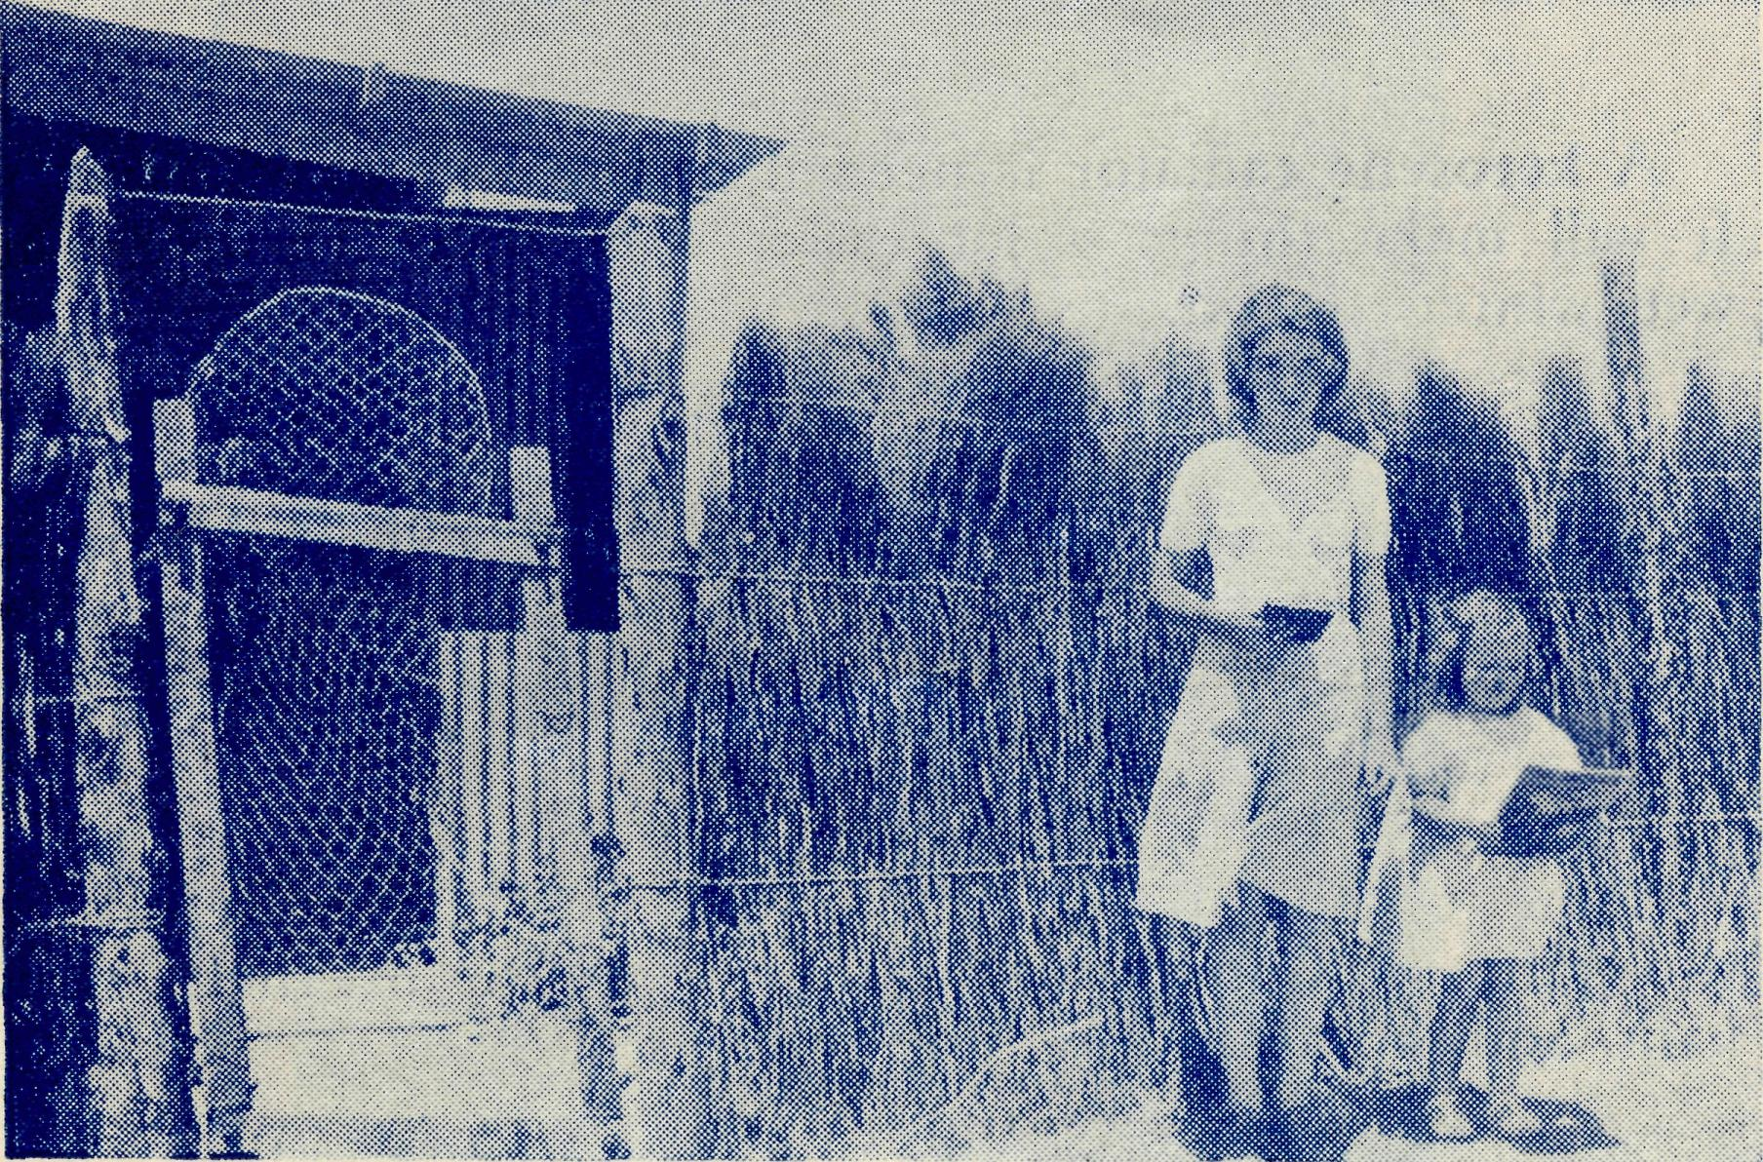
'Wherever children were found books were given them."
Then I travelled another 8 miles to a school of eight children where the same scene was again to be witnessed. But there was no time to spare for there were two more little schools to be visited. Twelve miles north'West there were five children awaiting the missioner's visit and then back 14 miles south'west a larger school was visited where over 20 children heard the Christmas story. So ended the day as far as school instruction was concerned, but not the end of the day for the missioner.
It was only 4 p.m. and with almost 4 hours of light to be used there were farms to be visited. Wherever children were found, books were given to them. I wish that those people who had given the money for these books could have seen the delight of the children and the appreciation of the parents as they received these excellent books provided by B.C.A. Believe me, the distribution of these attractive books is a wonderfully worth-while way of spreading the Gospel.
After the proverbial cup of tea at one of these homes the family was gathered around the kitchen table while the Word of God was read and prayer offered. Then all joined in the fellowship of the Lord's Prayer and somehow that place became a hallowed sanctuary for the worship of Almighty God.
By 8 p.m. I had reached a camp of migrants, mainly Baits, who were busy putting m a new water pipe line. The people cooking for them are friends of some years' standing, and soon the missioner was enjoying a good, if somewhat belated, tea. After the inner man had been well satisfied, here again three people were gathered with the missioner at an informal service. The next morning gave an opportunity to meet the migrant workers, who through their interpreter were given an invitation to join in the service to be held on the Sunday. Since that visit three men have been most regular in their attendance at church.
Leaving the hospitable friends, a circuitous route was taken to the home I intended to make as a camping place that night. Wending my way along the main highway I arrived during the afternoon at the side track which was to be my road for the remainder of the day. Along 16 miles of road four families were visited and once again the box provided valuable material to pass on to the children.
Towards evening even the bush track had to be left for a six miles drive through the scrub and open paddocks to reach a home tucked away from the regular travelling public. That night camp was made on top of a hill providing little shelter, but plenty of opportunity to receive the effects of a gusty wind. Here lives a family who are also members of the family of God, and who, despite their remoteness, receive a ministry similar to that given in more populated areas.
So the days went on, including the Sunday with four services and about 60 miles of travelling. By the Tuesday night, Minnipa was once again in sight with over 200 miles travelled since the previous Friday morning.
But that was only one part of the mission visited. Even then many could not be reached because of lack of time and the distances to be covered. The same thing was to be carried out in the other 4 weeks of the month.
This work would not be possible but for the prayers and gifts of those interested in the extension of Christ's Kingdom. It is not possible for all to view the work being done, but these short references help you to realise that much is being done with the support you give.
The missioner is always conscious of his position of dependence upon God as he moves about as an ambassador, knowing that with him is the interest of those moved by God to support the bush work. There is much that could be done but more workers are needed to extend this ministry outback. Who will respond to the challenge?

THE REAL AUSTRALIAN
March, 1949.

Sisters M. Horsburgh of Tullamore N.S.W. and O. Morgan of Manjimup, W. Aust. have joined our nursing staff and are now at Ceduna, Sth. Aust. We extend a warm welcome to them with our prayers for a long and happy ministry with the B.C.A. family.
We are grateful to Mr. Birch of Boronia who has given £25 towards the cost of a still film projector for being used by Miss Spry. It is a great help to the work. The balance of the cost has been guaranteed by Boronia Young People's Fellowship.

Sister A. Howlett has resigned from Wudinna Hospital to become Matron of St. Margaret's School, Brisbane. We offer Sister our very best wishes.
The B.C.A. Outback Session broadcast through 2GB is now heard on every Friday at 11.15 a.m. This ses-sion is now in its seventh year, and still wins many friends for the Society.

Miss H. Baylis, who has done very good work as Assistant Matron of Port Lincoln Hostel, was married recently. We offer her and Sister Hautot, formerly of Wudinna, who is also to be married, our very best wishes for their future hanpiness.
South Australian broadcasts have now been resumed. The B.C.A. story may be heard every Thursday at 11.45 a.m. through 5KA, Adelaide and 5AU Port Augusta. Ask your friends to listen in.

Recent visitors to Sydney were Sister L. Loane and Sister B. Tierney, who both had an enjoyable annual leave. The Rev. A. Pugh, of Cowell, also came over to get another car to replace his worn-out vehicle. Owing to lack of finance it was possible only to supply him with a second'hand car.
The Rev. R. Meyer and his family also came to Sydney for their annual holidays.
A kerosene radiator is needed in the Denmark mission. It will make things a lot easier over there in the cold, wet winter season.
Many thanks to "Elizabeth Ann" of Geelong, Victoria, for the gift of £50 in War Saving Certificates sent in to the Victorian office.

Good portable gramophones are needed by several of our missioners. These instruments are a great help in bush visiting and services. We shall be pleased to forward to the field any sent into either Head Office or the Victorian office. Also, good records are always a need.
Some of the B.C.A. missioners will be grateful for the gift of Communion Linen for use in their bush halls and homes.
The Rev. John Greenwood of Minnipa needs a portable font for use on his long inland patrol. Such a font would add to the solemnity of the Baptismal Service in many a lonely home and rough camp.

Sister B. Bockleburg, who comes from the Minnipa Mission, has temporarily joined our nursing staff. We hope to welcome Sister as a permanent member of our family when her training is completed.
The Wilcannia mission could use to advantage 16 millimetre movie films of good entertainment and religious programmes.

Wilcannia Hostel needs a small bookcase or bookshelves for the use of the children. We will arrange transport if anyone has such a bookcase to spare.
Congratulations to the Rev. P. and Mrs. Connell upon the birth of a son last February.

Has your Bark Hut Collecting Box been emptied lately? If not, we shall be grateful if you will kindly send in the contents as soon as possible.
A portable wireless will be a great boon to the deaconesses. They are living in lonely quarters. Who would like to help them in this way?

Wudinna Hospital is still in urgent need of a Christian cook. Is there some devoted Christian woman prepared to work for God in this way?
Remember the Rally. Our 30th Birthday will be commemorated on Friday, September 2nd, in the Chapter House, Sydney.

June, 1949.
THE REAL AUSTRALIAN

Harvest Festival in the Haytesbury
Rev. E. G. BEAVEN.

The coat'oharms of my University consists of the open Book across which are the words "Dominus illuminatio mea", meaning "The Lord is my Light". Few, if any, other heraldic signs are more obvous or so full of meaning, and I remembered it with a greater understanding on Sunday, March 20th, 1949. I have now had some 40 Sundays in this Mission, and none have given me more hope and encouragement, or a fuller realisation of the comfort and joy which we may obtain from public worship in these outlying parts.
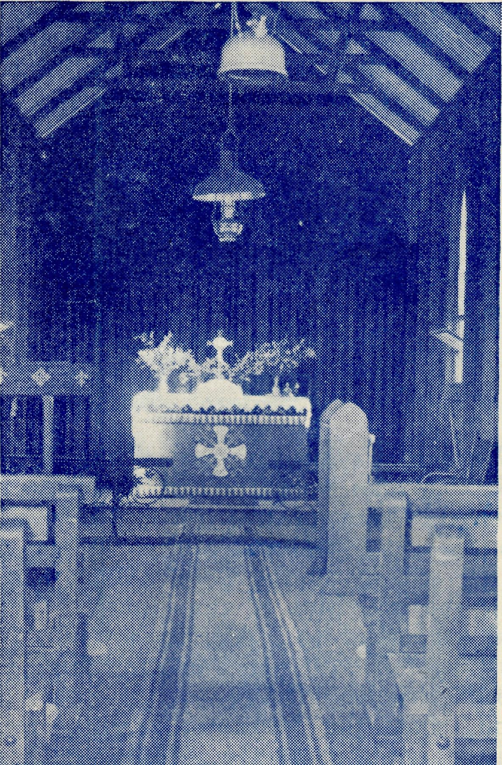
A Church in another Forest Mission, Kronkup, in Denmark, W.A.
This Sunday in the middle of Lent was set aside here in Timboon for our Harvest Festival. For those of you in England who read this magazine it may seem a strange date for such a Festival, but our seasons here are the reverse of yours and while you sow, we reap.
The Methodist Church, where we hold service, was decorated with masses of flowers and with offerings from the congregation. When the service started it was com' fortably full, but by the time the first hymn ended a dozen more had crowded in, and we had the best attendance there since the Institution last June. Besides those who comprise our normal congregation, representatives came from Curdie Vale, Curdie's River and Ayrford. It was an inspiring service in the best evangelical tradition and nowhere have I known a more devout and thankful congregation, and it was doubly invigorating when one realised that the worshippers were nearly all from farming families, who work so hard to enable God's
people throughout the world to pray with certainty and confidence. "Give us this day our daily bread".
Having public worship week by week in various small centres where a couple of dozen people comprise an exceedingly large congregation, it is essential that we should endeavour to meet all together three or four times a year to demonstrate our unity, and to take renewed strength and courage from our cohesion in the One Body of Christ. This was one of those rare but invaluable occasions, and although most of the other Mission* under B.C.A. probably find it impracticable to do this, we who have the opportunity are determined to take advantage of it whenever possible.
Then in the afternoon I went to Curdie Vale, some 11 miles away, which is a scattered community along the banks of the Curdies River about seven miles from its mouth. There are not many Church of England families here, but once every four weeks we meet in prayer and praise. The Service was, as usual, simple but satisfying, and we were pleased to have with us for the first time since I came.a pioneer family from Durham, England, who have carved their home out of the virgin bush in the last 21 years. Lack of transport and illness have prevented their attendance for a long while, but now better health and another second-hand engine in an older truck enabled them to come along.
After that, the journey was continued to Peterborough, a place well-known to holiday-makers from Melbourne and other parts of Victoria. This small village lies at the mouth of the Curdies River and comprises about two dozen houses whch, together with two or three Guest Houses, caters for the numbers of people who come year by year to enjoy the sands and the sea and river fishing.
The resident Church of England families are only half a dozen all told, but they meet in happy fellowship ^or service during the winter months, and are joined by numerous visitors in the season. I thoroughly enjoy my visits to Peterborough, and for everyone's benefit I have increased the number of services from one every four weeks to one every fortnight, and it has been well worthwhile.
After a meal I looked through the growing dusk to the little Presbyterian Church we use and seeing a light in the window walked over to prepare for the service. Just as I got to the door our Committee member, who was lighting the lamps, rushed out into his car and away he went. This was rather mystifying, and when I entered I found his mother, our organiste, wandering round with a candle which cast at best a very dim religious ligbt. Apparently the main lamp, a most imperfect one by any standard was out of Shellite and the search was on. Finally, fuel was found and it was lighted. As this was being done, the kerosene lamp which is supposed to provide the minister with illumination burned lower and lower, and my afternoon's hostess rushed out for more kerosene. She reappeared carrying it in a teapot—I can but hope that it is not normally used for tea—and finally we started about 15 minutes late. While all this confusion raged the congregation, chiefly visitors, entered and tried as successfully as possible to find their seats.

THE REAL AUSTRALIAN
10
June, 1949.

Again we had an extraordinary and spiritually uplifting service, though during it I was surprised to receive a beam of light direct into my left eye. My first impression was that the Shellite lamp had gone up in flames, a con' tingency I have expected for some months past, but it was only an elderly lady using a pocket torch to try to follow the service in the Prayer Book. When we all went home the night was pitch'black with intermittent rain and a high wind, and this, coupled with a shockingly corrugated road, made the 13 miles back to the Vicarage rather difficult
Physically and mentally it was a trying and tiring day. but though the lights of this world were dim and troublesome, the Light of God was with us and weary souls, some with physical ailments, others overworked, some despondent and others at times a little forgetful of the spiritual realities, went to their evening's rest re freshed in spirit and comforted beyond anything that the world can give
The distractions which cast a certain shadow upon that Sunday, e.g., decorating the Church at Timboon before the service and then taking everything away immediately
afterwards, also our lighting problems at Peterborough, were entirely due to the fact that we have to borrow or hire buildings belonging to other denominations. The neglect of the years is rising up to mock and hinder us. But hearts are afire and the faith within them will move mountains, including the building problems of the pre sent day. I have nothing concrete after nine months to justify this Christian optimism, but it is going to happen and all the wiles of the Evil One will certainly fail.
We ask for nothing we could do ourselves, but outnumbers are few, our resources scanty, and surely we may ask for a little more encouragement, a lot more prayer and some practical help in these Mission areas scattered about Australia where the battle between God and Devil is also being waged. Also, let us remember that it is in these farming areas throughout the world that the fate of man is being determined, and now that all other solutions have proved both fantastic and useless, dare we neglect any more to turn to Him Who comes as a light into a darkening world?
P.S. In future there will be adequate lighting of the Church at Peterborough.

Croajingalong
Rev. G. PEARSON.

Since my last article appeared in the "R.A.", the Church in this district has been going through a rather hard time. The main reason for this is that three of our centres have lost good church people, who have moved to towns outside the district. In any one of the tiny centres the loss of even one family from a congrega' tion means that perhaps half of the regular congregation is gone. Where more than one family moves away the loss is severe. Recently I was surprised to learn that Club Terrace, one of our centres of some twelve homes, was once a thriving gold mining town.. At present, the only apparent sign of gold mining is an ancient ore stamper, recently renovated to test an occasional sample of ore brought in by some persistent and hopeful digger. In Club Terrace the State School was recently closed, because there were less than six pupils attending. This means that the children no longer receive religious instruction at the school.
At Wangrabelle also the State School has been closed; the children do their school work by means of the correspondence system. In the meantime, both Church of England and Presbyterian services alternate, month about, at the school building. Wangrabelle, like Club Terrace, has seen better days, and now what was years ago good farm land has gone back to bush and scrub. What will become of this land is a matter for future generations to decide; no doubt in years to come, when Australia carries millions more people, it will be put to good use. Now wallabies and kangaroos, foxes, dingoes and rabbits are in possession, along with others of their bushland brethren.
At Cann River, the centre of Church work in the Croajingalong district, an eight day mission is being planned. This will be held during March, iSunday 13th, to Sunday 20th, and will be conducted by the Rev. W. J. B. Clayden, one of the Gippsland's most experienced
priests. We are praying, as one of the Notes on the Mission Service plan puts it, "that the Mission may be a means whereby our spiritual life is deepened, and ourselves brought closer to God". Perhaps the printer responsible for setting up the Service Plan had a cynical outlook on the activities of the Church, for his effort was, "You are asked to PAY, each day . . ."! That meant a steady job with pen and ink, altering the word to the more Christian PRAY.
At Cann, since the missioner recently married, the Vicarage is assuming again the air of a real home. Since it was put in order by the Rev. F. Withington, who found it in a very dilapidated state at the beginning of his ministry here a few years ago, the Vicarage and its grounds have been going through a series of improvements, in which the Church building also has had a share. While the present missioner was away on his annual vacation in October, Sister Gwynne of the Nursing Centre, and others of the local Church people, scrubbed and painted to good effect. Then lino, and more paint and curtains, plus more "elbow grease" arrived—and more is still to come.
The success of the little Sunday School, opened at Genoa some months ago, has been very encouraging. Despite the fact that several of the scholars have left the town, the Sunday School will carry on. Awards were won during 1948 in the Gippsland Examinations and prizes are ready for distribution at a special service.
Work among the young people is an important aspect of activities here in the bush, as, of course, it is in any place, for the young people must receive the Christian message if they are to live Christian lives.
If it were not for the fact that the B.C.A. helps «,o provide the ministry in this mission many of these children would not hear the Gospel of our Lord Jesus Christ.

June, 1949.
11
THE REAL AUSTRALIAN

Franklin Harbour Mission
Rev. D. A. RICHARDS-PUGH.

The Franklin Harbour Mission, which is the latest acquisition of the B.C.A. needs some introducton to readers of the "R.A." Situated mid-east of the Eyre Peninsula it comprises the District Councils of Cowell, Cleve and Kimba, and stretches south to north, 115 miles, and in the other direction, 77 miles. The majority of the inhabitants are engaged in agricultural pursuits, and in a low rainfall area their existence is precarious.
The mission is one of the oldest, having existed from 1880. In those days services were infrequently held in the Jetty woolshed—-the Missioner making the difficult crossing in an open sail-boat from Wallaroo on the mainland. Soon afterwards in a suitable room adjoining the Hotel, and then before the erection of a church, in 1908, and dedicated to St. Hugh of Lincoln—in the local institute. In the intervening years churches were erected at Cleve and Kimba, 27 miles and 60 miles respectively from Cowell. From these main centres and Cowell, other country centres have been established, some were forced to close through drift of population, others have stood the test of time until to-day. There are 14 centres which are visited monthly, and ministrations maintained. In these out-centres, services are held in halls, school rooms and private homes. Often it is necessary, in very little time, to change the hall or school room in readiness for Divine Worship—but with the co-operation of willing hands, a transformation quickly takes place. Although lacking the grandeur of Cathedral or Parish Church, an atmosphere is created, the old familiar hymns are sung, perhaps often too fre' quently and without the accompaniment of an organ or piano, but they are enjoyed by young and old.
In such a scattered area as this, Religious Instruction in the schools has to be maintained. Fortunately, in these parts of South Australia the country schools are becoming consolidated—and with the opening of an Area School at Cleve the problem of Religious Instruction is becoming solved. It may be necessary to give a brief outline of this new type of school. The primary function is to give the children a liberal education and instruct them for their future life upon the land; consequently, adjacent schools are brought into the one centre which enables the Missioner to have practically all the children under the one roof for Religious Instruction. The time saved and petrol conserved is of immense value to the other important work of the mission.
The Mission, which was without the services of a resident Missioner for 5 years, is gradually being re-
organised and the continued support from the people is encouraging. Just at present 20 young people are receiving instruction from the B.C.A. Confirmation lessons, some receiving it per correspondence while others more favourably situated are able to join classes. In one instance, a young lad of 15 rides upon horse-back to join with another family for their instruction. Will you think and pray for these candidates as they prepare for their confirmation?
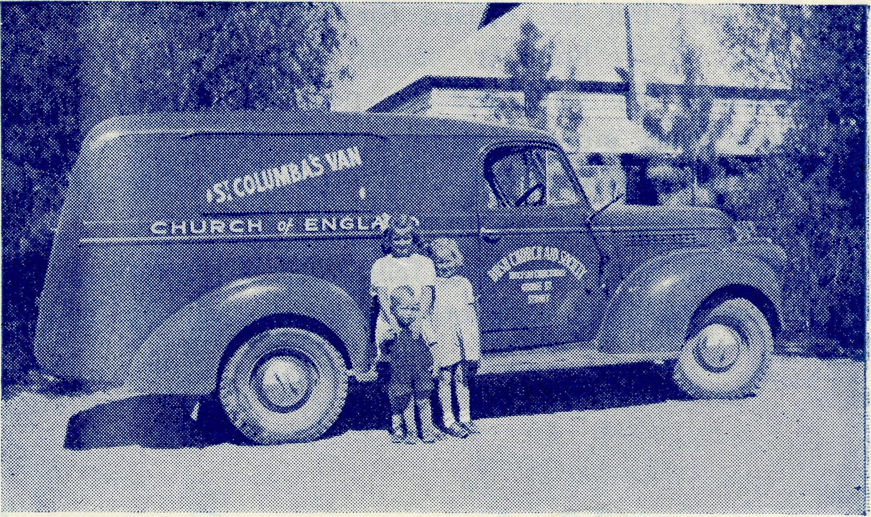
A small family which receives religious instruction in a lonely home.
In the course of visiting some of the more lonely-homesteads the opportunity for leisure hour reading is apparent, and the Missioner takes this opportunity of thanking those many friends of B.C.A., known and unknown, who frequently send books and magazines for these lonely folk. Their action is deeply appreciated,, and at the same time some Christian teaching is assimilated by what is read.
Just at present Harvest Thanksgiving Services are-being held throughout the Mission. Despite an indifferent season, where in some cases our farmers have not: reaped the grain they sowed, there are still many grateful hearts who can show forth their praise to God for His innumerable gifts. In a locality such as this we are daily reminded of our utter dependence of one upon another. We are told in the Book of Genesis "That God sent forth Adam to till the Earth", and our farmers have-been doing it ever since, so this occasion is to us not only one of thankfulness but a repeated call upon God to continue His goodness during the coming season.

THE REAL AUSTRALIAN
12
June, 1949.

Streaks from Streaky Bay
Rev. T. HAYMAN

We live in a scattered area. As far as the farming people are concerned, we will be even more scattered, for a number of families have left the district and others intend leaving, owing to the bad seasons, and very, very few are taking their place. Other farmers are enlarging their borders. In one centre there are now very few to attend the monthly service. But the needs of the few must still be met. On the whole, praise is certainly due to God for the great loyalty of the people.
The school work has been extended. Another school at Chilpenunda is regularly visited and correspondence students are reached monthly where possible. The dry year, however, has not only meant water restrictions in Streaky Bay, but has caused the roads to be powdery with dust. Large holes are caused through wind erosion. These holes, the sand and the powdery dust all make travelling even more unpleasant than usual. But, bad as it is here, it is even worse in other parts where severe losses are being suffered through the drought.
In Streaky Bay, refreshing fellowship has been enjoyed from time to time with other members of the B.C.A.
family, and with the C.M.S. missionary, Rev. L. Bake well. The folk have benefited by their visits to the services. The call of God has been heard to go to the mission field. At least one young person has determined to train for that sphere of God's work.
A children's mission was again held on the beach in Streaky Bay during the summer holidays. With the help of friends from Adelaide, the missioner earned out a programme of sport and meetings. Not only were the children interested, but also many adults attended regularly on the beach and were an active help in judging competitions and in decorating. The value of this work has been evident in the interest aroused in Christian things by both children and adults. A number of children professed to accept Jesus as their Saviour and Lord. Attendances have grown noticeably at the family service in Streaky Bay. Some of these have been the largest services on record. In these days of apparent spiritual decline in the world generally, it is good to see how these country people do value and attend the House of God. To Him be the glory.

Melbourne Central Women’s Auxilary

The Annual Meeting of the Central Women's Auxiliary was held on 15th March. Mrs. L. G. Ball occupied the chair and the following Office Bearers were elected. President: Mrs. W. L. Woods. Vice-Presidents: Mes-dames Ball, C. Patterson and Sergeant. Secretary: Mrs. L. Morris. Treasurer: Mrs. L. G. Ball with Mrs. Dews-bury, assistant. Sister L. Loane, on furlough from Penong, spoke to the gathering and her address was very much enjoyed.
Since the Annual Meeting, the Auxiliary's President for the past two years, Mrs. W. L. Woods has undergone a major operation and therefore is unable to carry on this year. The ladies are indeed very sorry that she is unable to continue as their President and her able leadership will be sorely missed. All wish her a speedy return to full health and strength.
Mrs. J. H. Pettingill, one of the Auxiliary's Vice-Presidents, has been granted extended leave, and with her husband will leave for England on the 7th May. As both Mr. and Mrs. Pettingill have been far from well, it is felt that the long sea trip will be most beneficial. The Auxiliary wishes them God's blessing on their journey.
There passed to rest on the 12th April one of our most devoted and best loved members in the person of Miss W. Ambler. The Auxiliary has sustained a great loss, for Miss Ambler has been for many years a prayerful and most reliable helper. She has been faithful to her Lord and He has now called her to Himself. To all sorrowing relatives the Auxiliary extends sincere sympathy.

When Making your Will Remember the B.C.A.

June, 1949.
THE REAL AUSTRALIAN

THE PLACE OF PRAYER
A Prayer for Use with Our Prayer List.
O Lord God of our nation, Who has commanded men to subdue and replenish the earth: Look in Thy love upon all who in distant parts of our land are striving against many difficulties, and are deprived the access of the means of grace. Strengthen and guide the Bush Church Aid Society and its Clergy, Nurses, Doctors, Pharmacist, Hostel Workers, Air Pilot, Deaconesses, and Students. Cheer and comfort them in discouragement and loneliness, bless their ministrations to the good of those they serve, and grant that the message of redeeming love may thus be rooted and grounded in our national life, to the glory of Thy Great Name through Jesus Christ our Lord. Amen.

THURSDAY.
MORNING EVENING
For the Mail Bag Sun- For the Organising Mis-
at Penong, Ceduna, Min-nipa and Cowell; the Mis-sioners, Revs. D. Pugh, J. Greenwood and P. Connell.
SUNDAY.
EVENING
MORNING
The Far West Missions The West Darling Mis-
sions at Wilcannia and Menindee: the N.W. Mal-lee; the Missioner, Rev. E. W. Fisher < Johnson and Deaconesses P. Spry and B. Clarke.
day School with its Gospel messages for the children. For the Director, Miss R. Campbell, the teachers and helpers, that they may find encouragement in their work.
sioner, that he may be strengthened and guided in all his endeavours for the good of the work and in his relationship with his fellow-workers.

MONDAY.
FRIDAY.

MORNING
EVENING
MORNING
EVENING

TUESDAY.
The Cann River Mission. the Bonang Mission, the Streaky Bay Mission; the Missioners, Revs. G. Pear' son, D. H. Wicking, and T. J. Hayman.
The Denmark Settlement, the Kirton Point Mission, the Missioner, Rev. C. N. Sherlock, For the Pharmacist, Miss E. M. Page.
For the Bishop Kirkby Memorial Hosoital and Sisters Thomas and Gillan as they minister to the people on the great Nullar-bor Plain. For Sister Page and the Tarcoola Medical Hostel.
For students and all in training for this work of God. For the Heytesbury Forest Mission, and the Otway Ranges Mission, and the Missioners, Rev. E. G. Beavan and Rev. T. H. Pickburn.

EVENING
For the "C o o r a h" Hostel and its workers, Mrs. Mann and Miss Lawtey.
For the Rappville Mission and the Missioner, the Rev. R. Meyer.
MORNING
For Bisters Dowling, Miller, Hitchcock, Holle, L. Loane, Tierney, R. Portch, O. Morgan and Miss 'Stokes.
For the Bowral Hostel, Deaconess N. Dixon and Miss Michael. For Theological Students of the Society in training.
EVENING
For the Cann River Dispensary, and Sister
Gwynne and Wudinna Hospital, and Sisters L. Pritchard, E. Fisher, M. Wells, Nurse Barry and Staff.
SATURDAY.
MORNING
For the President and Council of the Society, that they may be guided by His wisdom.
For the Home Base Starrs, Auxiliaries, and parochial workers.
For the N.S.W., Victorian and South Australian Secretaries.

WEDNESDAY.

MORNING
For the children in the Mungindi, Wilcannia and Port Lincoln Hostels, and for the workers, the Misses Cheers, M. Farr and I. Beck.
EVENING
For the Flying Medical Services, Mr. Chadwick, and Doctor F. Gibson, Dr. R. Roxburgh.
For the wives and families of the Missioners and Air Pilot.
Each day pray that the many needs of the work may be met.
Running expenses of £7 per hour to keep the Medical 'Planes in the air.
Consecrated clergy missioners and other workers for urgent work in the field.
That our work may continue to progress despite the difficulties of the post-war period.

Give Thanks—
For the rich blessing and wonderful growth of the Society's work. For all the kindly givers who have helped with their self-denials. For the Flying Medical Services. For the joy of service.

THE REAL AUSTRALIAN iv June, 1949.
THE 30th ANNUAL RALLY
OF THE BUSH CHURCH AID SOCIETY
Will be held in the
CHAPTER HOUSE
of St. Andrew's Cathedral, Sydney, on
FRIDAY, SEPTEMBER 2nd, 1949
at 7.45 p.m.
CHAIRMAN ... Mr. H. Bragg.
SPEAKERS .... Rev. John Greenwood, Th.L., of Minnipa, S.A.
Miss R. Campbell, Director Mail Bag Sunday School.
STILL FILMS BRIGHT SINGING
Make this Rally worthy of the Thirty Fears' splendid history of B.C.A.
TWELVE MODERN APOSTLES
To the Outback Are Urgently Needed
THEY MUST BE CLERGY OF GRACE, GRIT AND
GUMPTION
Many places in Australia which earnestly desire the preaching
of the Gospel and the ministrations of the Church are being
denied them because sufficient Clergy are not available.
"Go ye into All the World" includes Outback Australia
WILL YOU GO?
Full particulars will be supplied upon application to the Organising Missioner.
EDGAR BRAGG t CONS PTY. LIMITED, PRINTERS. 4 BARKER STREET, SYDNEY

