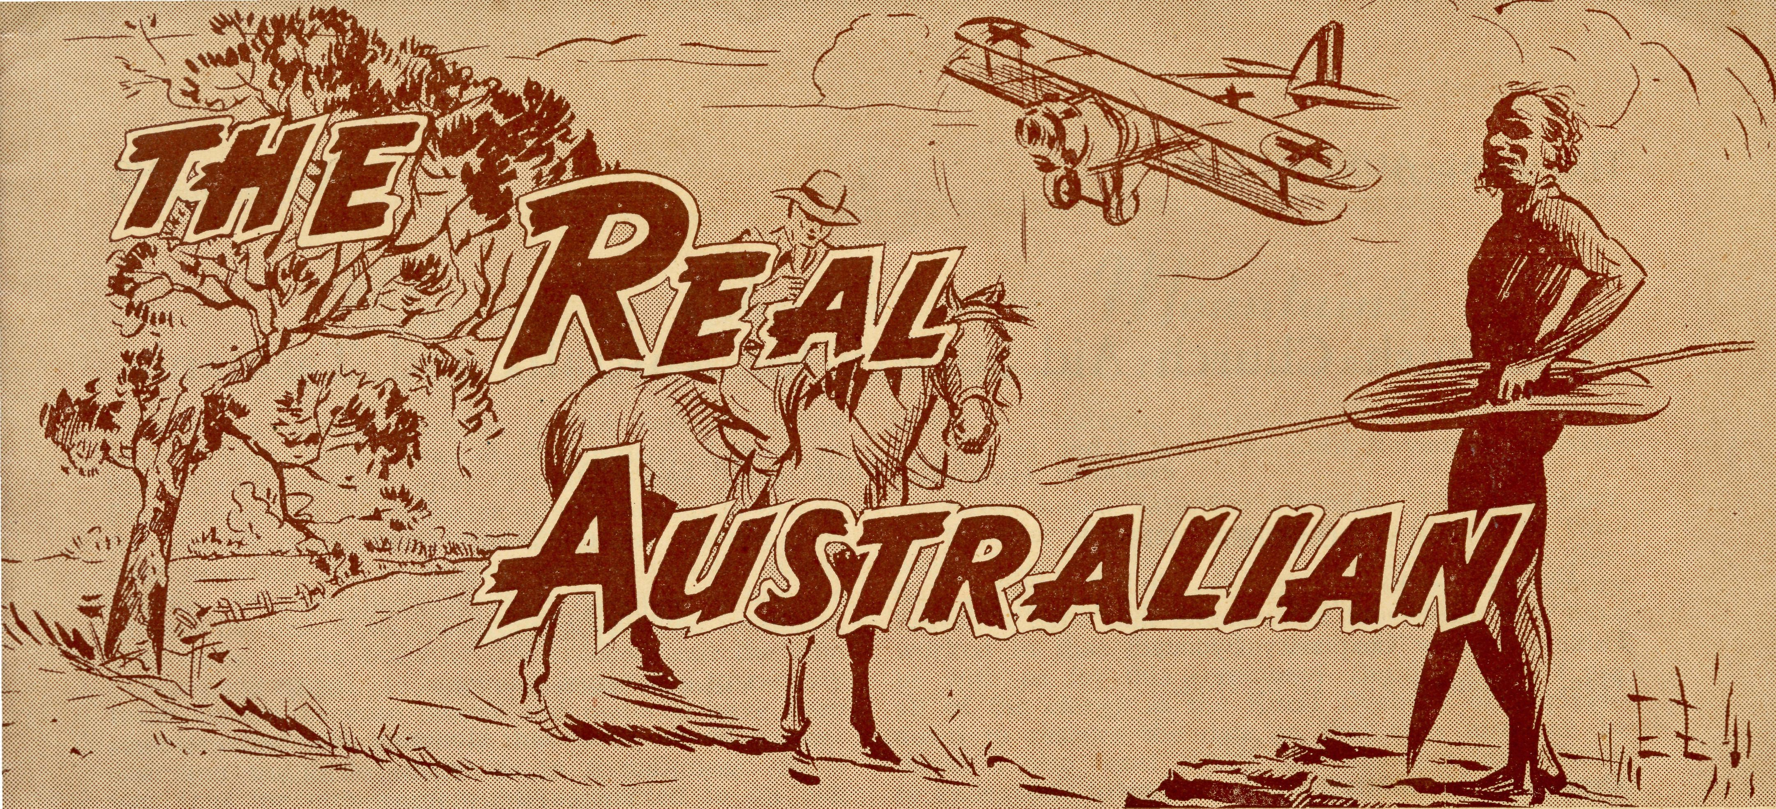

No. 105.
December, 1949
1/6 per annum, post free.

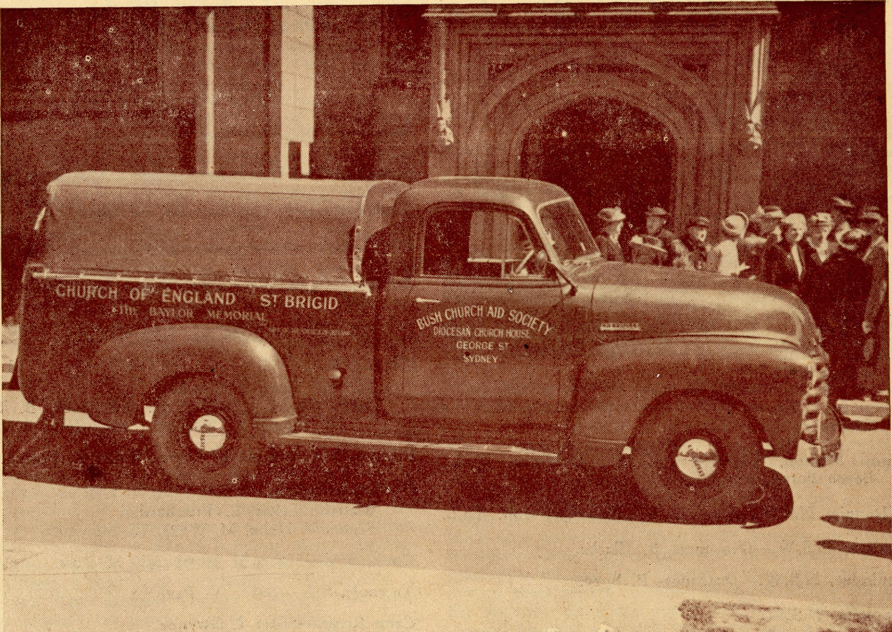
ST. BRIGID'S VAN DEDICATED AT ST. ANDREW'S CATHEDRAL, 21-9-1949.
Registered at the G.P.O., Sydney, for transmission by post as a periodical

THE REAL AUSTRALIAN
December, 1949

The Bush Church Aid Society for Australia and Tasmania
President: The ARCHBISHOP OF SYDNEY.

HEADQUARTERS OFFICE.
Diocesan Church House, St. Andrews Cathedral.
George Street, Sydney. Telephone: M3164.
Cable Address: "Chaplaincy Sydney."
Hon. Treasurer: Mr. T. S. Holt.
STAFF.
Organising Missioner: Rev. T. E. Jones, Th.L.
Assistant Organising Missioner and N.S.W. Deputation Secretary: Rev. D. G. Livingstone, Th.Schol.
VICTORIAN OFFICE.
Bible House,
Flinders Lane, Melbourne, Vic.
Telephone: FJ 567 5.
Victorian Secretary: Rev. L. Ball, M.A.
South Australian Honorary Secretary:
Rev. F. H. B. Dillon, Th.L.,
Holy. Trinity Rectory, North Terrace, Adelaide, S.A. Phone: C.1'134.

B.C.A. Activities and Staff

MISSIONS.
Ceduna, S.A. \ _{Rcy} _{p} Qonnell, Th.L., Ceduna, S.A. Penong, S.A. )
Cowell, S.A.—Rev. D. A. Richards-Pugh, A.L.C.D.,
Minnipa, S.A.—Rev. J. Greenwood, Th.L.
Streaky Bay, S.A.—Rev. T. J. Hayman, Th.L.
Croajingalong, Vic.—Rev. G. Pearson, Th.L., Cann River, Vic.
Delegate-Bonang, Vic.—Rev. D. H Wicking, Th.L., Delegate, N.S.W.
Heytesbury Mission, Vic—Rev. E. G. Beavan, M.A. Timboon, Vic.
Otway Mission, Vic.—Rev. T. H. Pickburn, Th.L., Beech Forest, Vic
Wilcannia, N.S.W.—Rev. E. W. Fisher-Johnson, Th.L.
Ivanhoe, N.S.W.—Deaconess B. Clarke.
Menindee, N.S.W.—Deaconess P. Spry.
Rappville, N.S.W.—
Donnimtrk, W.A.—
Werrimulb Vic.—Grant-in aid.
MAIL BAG SUNDAY SCHOOL.
Director.—Miss R. Campbell
SCHOOL HOSTELS.
Wilcannia, N.S.W.—Miss M. Farr.
Mungindi, N.S.W.—Miss E. Cheers, Miss E. I. Cheers.
Wentworth Falls, N.S.W.—Mrs. C. Mann, Miss F. Lawtey.
Port Lincoln, S.A.—Miss I. Beck.
Bowral, N.S.W.—Deaconess Dixon, Miss Michael
MEDICAL SERVICES.
Ceduna, S.A.—
Matron: Sister F. Dowling.
Staff: Sisters J. Miller, G. Hitchcock, B. Tierney, E. Thomas, O. Morgan, J. Armstrong, Miss Stokes.
Penong, S.A.—Sister L. Loane, Sister R. Portch.
Wudinna, S.A.—
Matron: Sister L. Pritchard.
Sisters V. Holle, M. Wells, W. Mansell.
Cook, S.A.—Sisters M. Horsburgh, M. Ross.
Tarcoola, S.A.—Sister V. Page.
Cann River.—Sister I. Gwynne.
FLYING MEDICAL SERVICE
Pilot.—Mr. A. Chadwick, Mr. W. Bedford. Doctor.—Dr. P. Gibson, O.B.E. Pharmacist.—Miss E. M. Page.

December, 1949
THE REAL AUSTRALIAN

Moving a Church over Mountains
Reprinted from the "Church Chronicle' by kind permission of The Bishop of Ballarat.

Here is a striking contrast: On the Second Sunday after Trinity, 1948, I was at Westminster Abbey; on the Second Sunday after Trinity, 1949, I was at Prince town! At Westminster Abbey, which is one of the world's most historic buildings, the worship was most dignified, the ceremonial artistic, and the music superb. At Princetown we were not able to use the Church because of its dreadfully dilapidated condition. The walls of the building are cracked and the iron of the roof rusted. It has been impossible to remedy these defects because labour and material have been unobtainable. The result is that birds are in possession and the little church is in a sad mess. So it was that for our worship we assembled in an old, totally unbeautiful wooden hall. When we had chosen the hymns, the Vicar, Rev. E. G. Beavan, sat down to play them on a decrepit piano. There was a small organ, but it was unusable because mice had taken the felt out of it to make their nests! Many of the notes on the piano were dumb and others were tone-deaf. I was beginning to wonder whether we could sing without an instrument when we heard a motor truck groaning up the hill. We looked out and found that on the truck was an organ. Faithful men had determined that we would have better music than could be produced from the piano that was usually employed.
With all hands helping the organ was soon in position and the service started. I took the service and preached while the Vicar acted as organist. Believe it or not, it was a very helpful service! Everybody joined in, taking their parts in the psalms, the responses, and above all in the singing, and this is more than could be said for the congregation in Westminster Abbey where most of the people remained dumb, leaving everything to the choir.
The other services we had on this day in the Heytesbury Forest were held in a wood and tin building which acts as a picture hall. This hall was used because we have no church building in the Heytesbury area, except the Princetown church which, as I have explained, is unusable. During the day the Rev. E. G. Beavan showed me a picture of the very lovely church in which he once served in the Diocese of Hereford, a church which used to have a congregation of 900. In this country we owe a great deal to priests who come from Great Britain to undertake pioneering work such as Mr. Beavan is doing. Mr. Beavan would feel rewarded could he have heard the expressions of appreciation made to me by the people as they spoke of his ministry amongst them. I said that we have no church building in the Heytesbury Forest. I am glad to be able to add that we hope to have a church at Timboon by the middle of November. The disused Garvoc Church has been put on wheels and moved on to the block of land next to the Timboon Vicarage. The story of its removal is quite a romance, owing to the difficulties encountered in conveying a cumbersome building down steep inclines, around hairpin bends, over narrow bridges, and along roads with forest trees abutting on either side. However, the task was completed, and the Church now stands on the church
block in Timboon. Extensive renovations have to be affected and it will take until November to complete them.
I have chosen Saturday afternoon, 17th December, for the date of the dedication of this Church in Timboon. This will be a day of rejoicing for the Rev. E. G. Beavan and the churchpeople of the Heytesbury Forest. I hope that members of the clergy who have worked in that district in the past will be able to be with us for this ceremony. Besides them, I ask all of the clergy in the Rural Deanery of Camper-down to reserve the date so that they also can be there. I also want clergy and diocesan lay officials to endeavour to journey from Ballarat for the event, and I ask that parties of lay people in neighbouring parishes should plan to go to Timboon on that day. People who have beautiful churches to worship in, such as those at Colac, Mortlake, Camperdown and Warrnambool, and churchpeople from smaller centres too, should regard it as a privilege and a duty to join with their fellow churchpeople at Timboon in their rejoicing on the day in which the building, which will be to them the House of God, will be dedicated. Remember! 17th December.
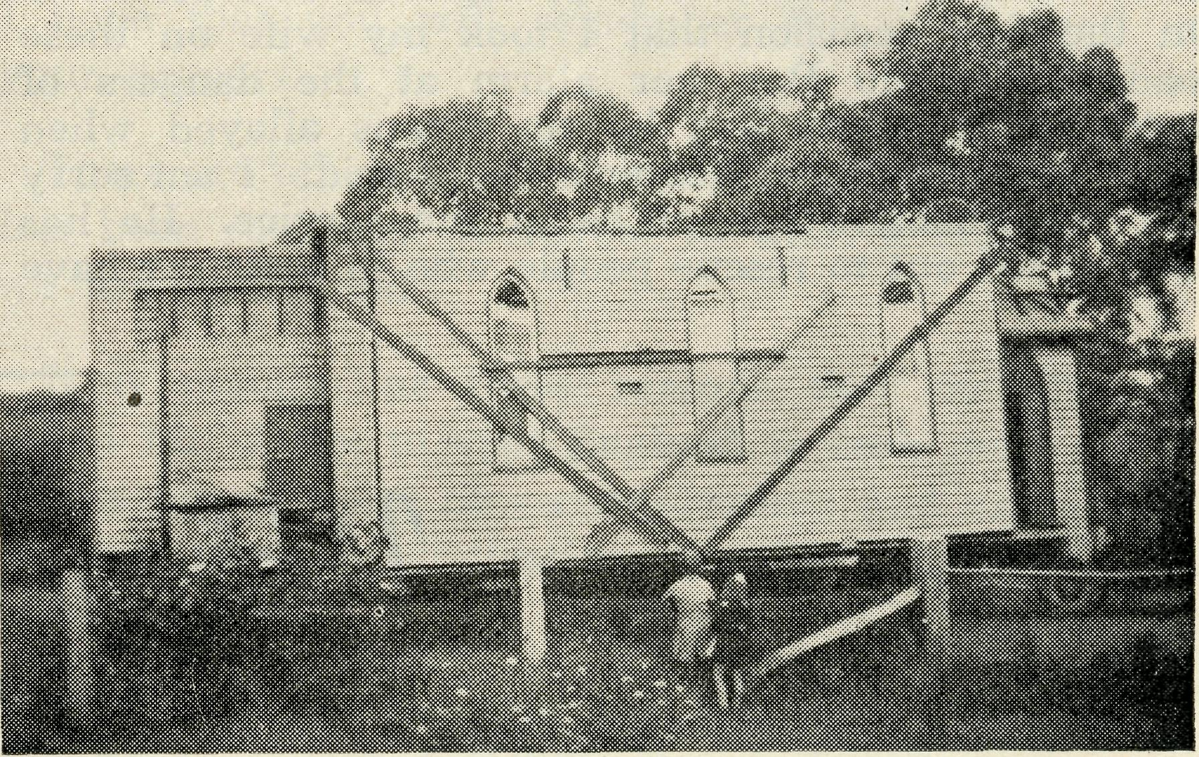
Two interested spectators of the moving operations.
It is obvious that if this call is answered in the way I hope it will be, there will be a concourse of clergy and people too big for the Timboon churchpeople to supply with provisions. I suggest, therefore, that the Timboon folk be asked to provide only hot water for tea-making, and that all the rest bring their own provisions. Then, good weather permitting, we could have a great picnic of churchpeople on the block behind the new church before the visitors set out on their return journey on the Saturday evening. My journey after the event will be to Panmure for a confirmation, a parish luncheon and a service for the dedication of some memorials on the Sunday.
Before I leave Mr. Beavan and his work, I want you to know that plans are in hand for undertaking the renovation of the Church at Princetown as soon as labour and material are available. This is indeed gratifying, and speaks well for Mr. Beavan's initiative.

THE REAL AUSTRALIAN
December, i949

THE OTWAY
During the week prior to my visit to the Heytes-bury I was at Colac, Alvie, Beeac and in the Otway. The weather was at its coldest, but in spite of this we had good attendances at all services, excepting at Beeac. This was understandable as my visit there fell on the worst night we have had this winter.
These visits brought me into contact with many whose work for the Church I appreciate very sincerely indeed. There is only room for me to speak of two of them here. The first is Mr. George Wright, a devoted churchman whom I first met in Terang through the Rev. Arthur Bennett. Mr. Wright was a journalist and editor who in his retirement accepted my invitation to become Reader-in-Charge of Apollo Bay at a time when the war had seriously depleted the staff of the diocese. Together with Mrs. Wright, he moved into the Vicarage at Apollo Bay, and there he and his wife have done and are still doing a very faithful work. The sacramental ministry at Apollo Bay is supplied by the Rev. T. H. Pickburn from Beech Forest, and he is the other of whom I wish to speak in warm appreciation.
The conditions and the nature of the travelling in the Otway make Mr. Pickburn's work the most arduous work in the diocese. Mr. and Mrs. Pickburn live at the highest point of the Otway Mountains in what is the most severe climate in Victoria. Besides this Mr. Pickburn has constantly to travel on roads that are notoriously precipitous and tortuous. On the first occasion that I took my wife on these roads to Apollo Bay her alarm at the dangers of motoring on them was by no means allayed when the Secretary of the Women's Guild said: "I am sorry that my husband cannot be at the service. He has been called out to rescue people who in their car have
gone over a 300 feet precipice." This was on Skeines Creek Road. On this occasion Mr. Pickburn warned me not to attempt the journey on that road as it was impassable. The continuous wet had caused serious landslides and at one spot a motor lorry had been bogged for three days. So I travelled by the road that is very appropriately called Wild Dog Road. The country was white with hail stones which were still there when I returned a couple of days later. In my car I twice met heavily-laden motor tractors hurtling along with their loads of enormous trunks of giants of the forest. Fortunately I was each time on the right side of the narrow road and travelled slowly. A man with whom I breakfasted that morning entertained me by relating how on one occasion he had saved a head-on collision with one of these tractors only by crashing his car sideways along the side of the cliff. The drivers of these tractors have my sympathy. If they jam the brake on suddenly they run the risk of bringing fifteen tons of tree trunk sliding onto them!
Well, these are the roads on which the Rev. T. H. Pickburn has been motoring for the last thirteen years! He and his splendid wife are to be commended for the way they have "stuck it". When I spoke to him about it the other day his reply was: "I stick it because I like the country and I like the people of the Otway. We're putting up with nothing more than our splendid churchpeople whose farms and homes are in these mountains."
I want it to be known throughout the diocese that it is possible for this pioneering work to be undertaken by the Church in the Otway Mountains and in the Heytesbury Forest through the generosity of The Bush Church Aid Society which provided the stipends of each of the Vicars.

Wilcannia Hostel
Miss M. FARR

As one looks back over the past few months in an endeavour to find what will interest our friends, one sees at every turn how God has blessed us.
Last term there was a good deal of sickness, one boy being seriously ill, but when the time came to go home for holidays, at the end of August, all were well. The one who had been so ill saw another doctor on his way home who confirmed our doctor's report that he was now quite well.
During the first week of the holidays I was privi-ledged to be able to go to Hay to the Diocesan Women's Conference. This was a very inspiring and friendly gathering and one came back spiritually refreshed to carry on in the new term. Quite a lot of gardening was done in the next week and a good fall of rain at the end of the week has made the garden nourish.
Then there are the good friends who have helped us with such things as meat, cake, eggs, fruit, honey, and jam. The parents of two of the boys brought half
a sheep and a large carton of eggs when returning their boys. This afternoon we had two visitors, the first brought a basket of jam bottles and some seedlings and stayed to help darn the boys' socks. The other brought a big armful of silver beet.
Another happy event was the arrival of a letter
from Miss D. Dykes, a former Matron, who has been
very ill. It is good to know that the prayers of her
many friends have been answered and that she is
making steady progress. v
Now the boys are all back and as I write are having a happy evening, some reading or drawing, others playing draughts or checkers. The two youngest are sitting like little old men, very serious over their game. Another is giving me a running commentary on the game of draughts.
We do thank our Heavenly Father, that through His grace, B.C.A. is able to give these and many other children, a Christian home and educational facilities they would otherwise not be able to have.

December, 1949
THE REAL AUSTRALIAN

Advance!

Advance! has been a keynote of B.C.A. ever since the Society commenced in 1919. As we look back over this past year it is clear that this keynote has been well in evidence. Two Deaconesses commenced new ministries at Menindee and Ivanhoe, arrangements have been made to open a new medical hostel on the East-West Railway at Rawlinna in Western Australia, and big developments have taken place in the Mail Bag Sunday School, for one large country diocese has requested us to supply the lessons for the bush Sunday Schools and lonely homes within its boundaries in addition to all the other work of the Mailbag. In some of the well established missions there have been other advances which have been most encouraging.
Then, as we look ahead to next year, it is quite evident that there will be more and very big advances. An entirely new work will be that of establishing at Broken Hill a hostel for boys. The Council of B.C.A. has made a big venture of faith in purchasing a large building with extensive grounds in an ideal part of that city as a cost of some £5,000. Although the money is not in hand it was felt that this was an opportunity which should not be missed because for many years now it has been quite clear that a hostel is most necessary for boys of the Far West who desire to study the special courses of training available in Broken Hill schools. There is much local interest and support but we will need help from every friend of B.C.A. if this new hostel is to be established on sound lines. So I earnestly ask you for your prayers and gifts. A Christian married couple is urgently needed to manage the Hostel. This should be a most satisfying task for the right people. I shall be glad to hear without delay from those who would be interested in such a position.
Another advance is being made at Menindee. Deaconess Spry has done splendid work there and it is now time for a missioner to be appointed. The huge Water Conservation scheme and other developments mean that this area will be a vital one in the life of the Church. I am pleased to say that Mr. William Mitchell, a Student of Ridley College, will be ordained in Broken Hill in March and will become deacon in charge of the area. He has had experience of working in distant country areas and is an ideal man for the post. Please pray for him and his wife as they commence what will be a task full of difficulty and challenge.
Then the developments in the Mail Bag Sunday School mean that a Van will have to be supplied for this work. This is referred to on another page but I hope that everyone will remember this need in their prayers.
Also the Medical side will, we hope, make further advances. Dr. Freda Gibson is doing truly magnificent work but it must be obvious to everyone that she cannot continue working on the present lines for an indefinite period. Therefore, we hope that during the coming year we will be able to obtain the services of a young doctor to relieve Doctor Freda of the flying duties. This doctor will be in addition to the one still required at Wudinna.
In reference to that need no doctor has yet been found to replace Dr. Roxburgh. This has been a great disappointment for we thought that such work would have made an immediate appeal to Christian doctors. Unfortunately, none appear to be interested. I hope that you will remember this vital need in your prayers.
There are other advances looming ahead but enough has been said now to reveal to what a mighty task we are committed.
It is mainly for these reasons that the Council asked Mr. Jones to visit England to seek more manpower for all these new commitments and extensions. Already there are indications that he is meeting with some success.
Also for these reasons, the Rev. John Greenwood has been appointed N.S.W. Deputation Secretary. It is obvious that the administration of what is now a very large and extremely varied Society is a heavy responsibility which makes the appointment of a deputationist absolutely essential. Mr. Greenwood will come to Sydney some time next March and will be available for speaking engagements from April 1st.
Thirty years of remarkable growth are now behind us. Many advances are about to be made. The quality of the work to be done will depend upon the prayers, service and giving of us all. Let us then press on in faith, encouraged by God's faithfulness in the past and His promises for the future, advancing with ever increasing strength to take our share in winning Australia for Christ and His Church.
ASST, O.M,

THE REAL AUSTRALIAN
December, 1949

He dreamed Many a Dream

On September 21st an impressive service of Holy Communion was held at St. Andrew's Cathedral, Sydney, so that friends of the Organising Missioner could pray for God's blessing upon Mr. Jones as he left for England. It will be recalled that the Council of B.C.A. had requested the O.M. to visit Great Britain again in order to follow up his earlier very successful visit. The preacher at the service was the Rev. E. Cameron, a member of the Council, who has kindly given permission for his sermon to be printed in this "Real Australian".
THE SERMON
Preached in St. Andrew's Cathedral, Sydney, at the
Valedictory Communion to the Rev. T. E. Jones, O.M.,
on Wednesday, September 21st, 1949, by
The Rev. Ernest Cameron, Rector of St. Lukes,
Mosman.
Genesis 37:19. This dreamer.
Hebrews 11:8. By faith, Abraham . . . went out, not knowing whither he went.
It may be a straining of the context, but I am sure I will be forgiven, for I believe that these two texts sum up the ministry of our O.M. He dreamed many a dream—but not being content with dreaming—he set his mind and hand to make those dreams come true. Like Abraham, by faith he went out, not knowing whither he went. As a young man in Liverpool, who gave up all his home and prospects (though of hard work) in response to an Inner Voice which called upon him to go out and tell others the Good News, he went forth in faith. There came the call for men for the Church beyond the Sunset in Australia, and he walked eighty miles, the last twenty he walked all night, to keep an appointment for an interview with the Rev. (now Bishop) G. A. Chambers. As a result, he was accepted and came to Australia to be trained for the Sacred Ministry. It was while I was in charge of the Provisional District of Northbridge on his first Sunday in Sydney that he preached there, and a bond of friendship has been maintained across the years.
In his early days of organising for our Society he dreamed dreams, which have become realities and are a commonplace to us now: the need of a healing ministry to the body as well as the soul of the men, women and children in the hinterland of our vast continent. Unceasingly, without thought of his own health and strength, he gave himself to the work of the Master whom he served. And to-day we know how much his work has meant, or do we? When Canon Bate returned to England after his visit to Australia on behalf of the Colonial and Continental Church Society, in an interview with one of the
leading Evangelical weeklies of England, he said:— "I have spoken of the expansion of the work of the Bush Church Aid Society under the guidance of the Rev. Tom Jones, and to him and his predecessor, Bishop Kirkby, the B.C.A.S. owes more than could be told." The work of the B.C.A.S. continually reminds me of that saying of Donald Hankey that "true religion is betting one's life that there is a God." Betting one's life means letting go some of the things which seem extremely desirable because there is a bigger thing upon which the heart and hopes are set.
It means turning aside from the things which attract and charm and giving all one's energy and power to the things which you esteem greater, better and more wonderful. It was this that Abraham did
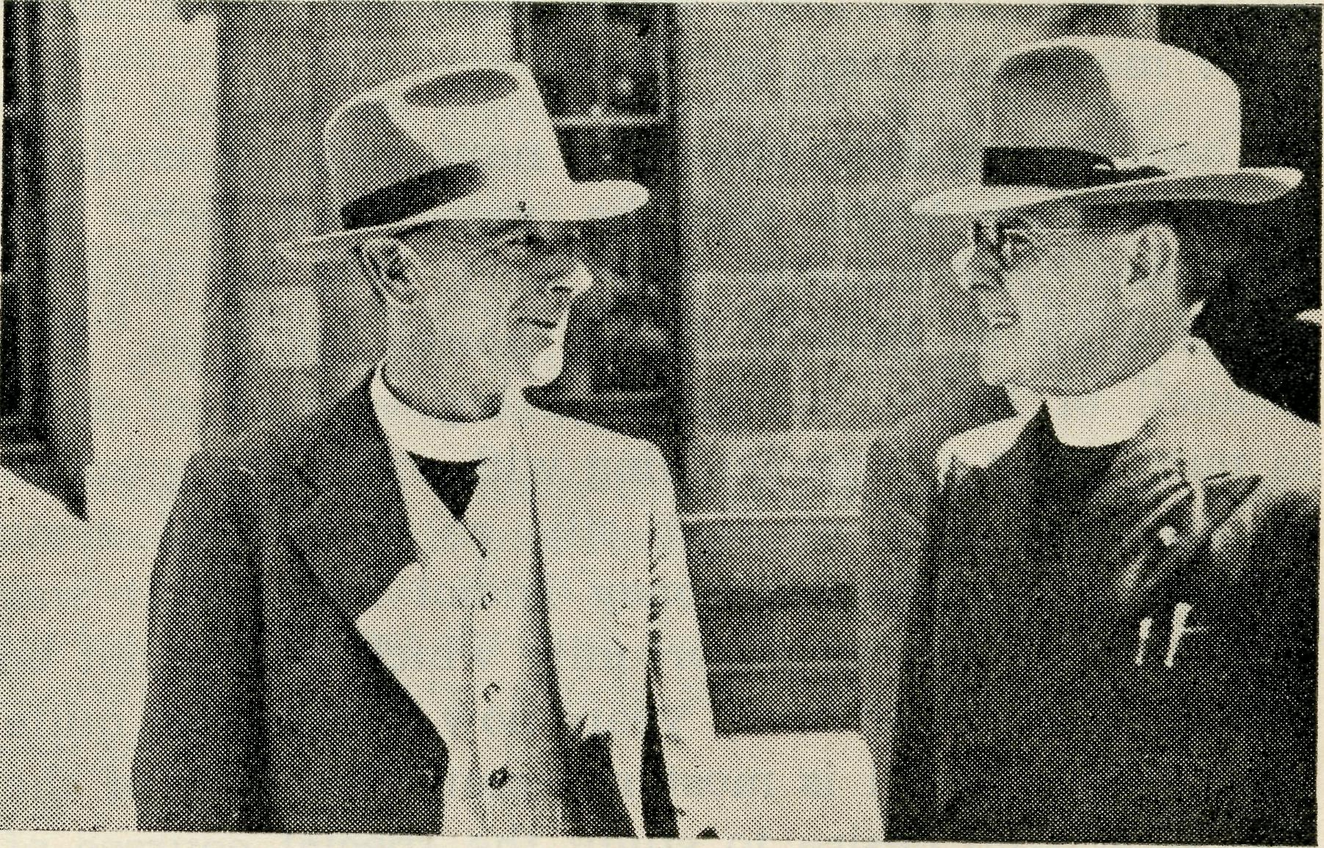
The O.M. chats with Canon Cameron at the cathedral.
when he left Ur and ventured forth on his great missionary effort into the land of Canaan. It was this that St. Paul did when he gave up the brilliant career that was open to him as a leader among the Pharisees and embarked upon his apparently hopeless crusade of convincing the world that the message of the Gospel was the only thing to save the world. It was this than sent forth S. J. Kirkby to found the Bush Church Aid Society. It was this that sent forth Tom Jones on his evangelistic work in England which was to find its full fruition throughout Australia. For Faith is a great adventure and faith is a man's job: it is a big adventure involving risk, but a risk well worth while.
The policy of "safety first" has never found a place in the councils of B.C.A. for to lose the spirit of adventure would have meant that the B.C.A.S. would have ceased to live. There have been dark and anxious days in its history; days of discouragement, but always there has been the call to venture on again, believing that our God in Christ was calling for this or that work to be done and in faith it was accepted, the challenge met and paid for; so there have been days of great encouragement too.

December, 1949
THE REAL AUSTRALIAN

Our Master went forth, not knowing whither He went, and His path led Him to Calvary's hill. He died there in hope, a hope that maketh not ashamed, for the Cross has become His Throne and by it He wields a mighty power in the world redeeming man from the degradation of sin, raising from despair to hope, and through Him hope rises unconquerable in the human heart. It is this message of salvation which we are pledged to proclaim as members of His Church. Let it never be forgotten that our work in B.C.A. must be an ever expanding work. Our Organising Missioner is about to leave for England; the way is planned for him, he goes in faith to plead the cause of "the outback" in England. There are those who would say "Why should not Australia support its own work?" but let it be said quite definitely that there are people over there who delight to give of their substance for such a work as this; the van,
dedicated to St. Brigid, which stands outside this Cathedral this morning is "a tangible evidence of that.
He goes forth in FAITH, depending upon what God has already wrought, in the sure knowledge that God will guide and bless him in His work.
So in this glad Communion hour, as we thank God for the ministry which our O.M. has been privileged to exercise we also pray that God will be with him in his going out and his coming in, in his down sitting and his uprising and to him personally we say "God bless you with a loving sense of His near presence, to guide you, to strengthen you and to give you His peace".
Mr. Jones has arrived in London and is already engaged in telling the B.C.A. story at many meetings. The O.M. keenly appreciates all the messages of goodwill he received before and since his departure from Sydney.

Another Gift from the Church of Ireland
St. Brigid’s Van

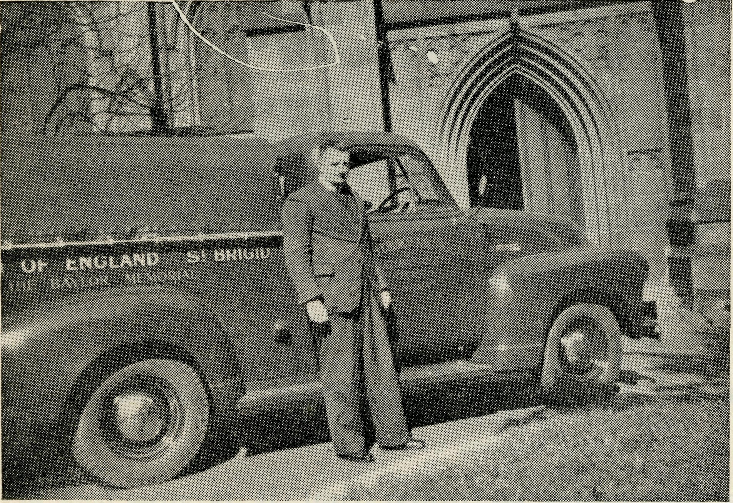
The names of St. Patrick and St. Columba will be familiar to readers of the "Real Australian" through the descriptions of the excellent work done by the two Vans used by the Society at Wilcannia and Minnipa. These Vans were purchased through the really wonderful generosity of our friends of the Church of Ireland who have sent out large sums of money for the purpose. There appears to be no limit to their interest and desire to give, for now once again we are indebted to them for yet a third Van, this time at their request, dedicated in honour of St. Brigid. We are most grateful to the Colonial and Continental Society, the Irish Secretary, the Rev. W. H. Adcock and all those who have given so marvellously to help build up the Church in this Country. The Ladies' Auxiliaries of N.S.W. and Victoria have also helped with the expense of fitting
out the Van and sending it out to Ceduna. The Society sincerely appreciates this assistance given by the Auxiliaries. From Ceduna the Van will travel along the shores of the Great Australian Bight and across the Nullarbor Plain enabling the missioner to do more effective work.
Like St. Patrick and St. Columba, St. Brigid was a saint of the early British Church. She was born in Ireland about 453 A.D. and later established communities of Christian women. She travelled so extensively for this purpose that it is said that "her name is written across the length and breadth of Ireland." St. Brigid founded the famous Kildare Abbey and her name will always be linked with that ancient centre. She died in 523 and was made the Patron Saint of County Kildare.
This year is the Jubilee of the Irish Auxiliary of the Col. and Con. and to commemorate this important event these good friends have made this remarkable gift for which B.C.A. thanks them most sincerely, with the prayer and hope that this fine example of Christian giving will inspire our own people to supply the means to keep the Vans and the mis-sioners travelling outback with the Gospel of our Lord Jesus Christ.
St. Brigid's Van was dedicated in the grounds of St. Andrew's Cathedral, Sydney, by His Grace, the Primate of Australia, on Wednesday, September 21st, 1949, immediately after the valedictory service of Holy Communion to bid farewell to Rev. Tom Jones before his departure for Great Britain.

THE REAL AUSTRALIAN
December, 1949

Mail Bag

The Royal Mail arrives!
Since .6 a.m. the Mail car has been speeding along country roads making brief stops to pick up mails, passengers, a variety of produce, strange shaped packages and cream cans.
Heavy mail bags from official Post Offices are secured on the roof, those from smaller wayside offices are carried inside the car. "Private Bags" are skilfully snatched up by the driver as he swings the Mail car in to the side of the road, and without stopping, pulls them out of mail boxes and off large spikes on posts, or tree trunks; these he hangs on a hook on the outside of the car.
Whilst sitting in the mail car for almost ten hours one falls to wondering about the contents of those mail bags. So often our Mail Bag Sunday School lessons are addressed "Private Bag". Perhaps these bags hold children's replies coming back to teachers in far off Sydney.
Probably mail men never think about the contents of those bags, for to them they are just a job to be done; but when some of the letters find their way to the Mail Bag Sunday School Office, the teachers take a very different view of them.
You know the exclamations of joy, delight and satisfaction which follow children's hasty tearing wrappers off birthday and Christmas gifts? Mail Bag teachers become like children for when their mail comes in, they comment upon it admiring with pride and interest any piece of work "their" children have done. Similarly, they are disappointed when no response comes to their repeated letters and lessons. They have to exercise a good deal of imagination to picture the causes behind the silence.
Experienced teachers who have sympathy, and understand outback conditions, know that silence does not necessarily mean indifference but may be caused by sickness, extra cooking for seasonal workers, or just an over-worked mother who cannot get the mail away.
So much depends upon Mother in a country home. She must often fill the various roles of house-keeper, cook, nurse, school teacher, and, on her day of rest-Sunday School teacher.
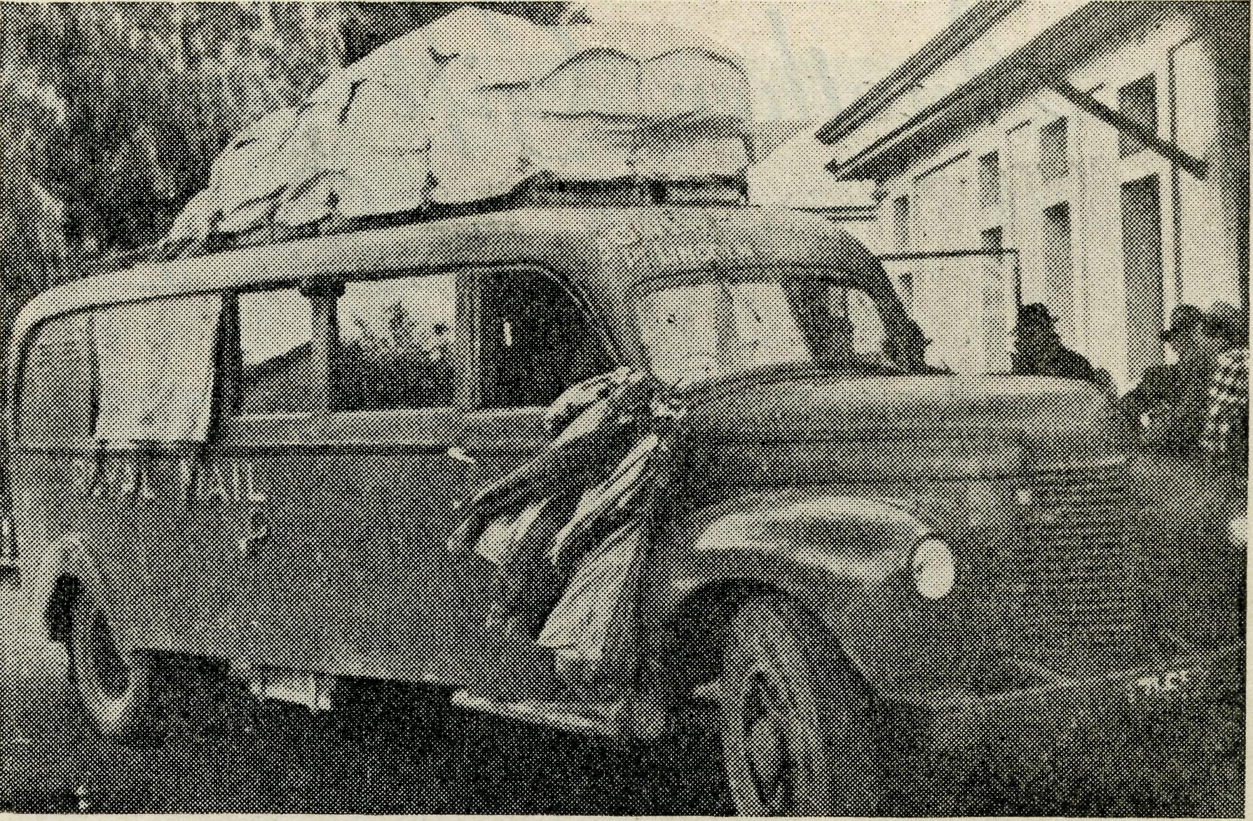
A South Australian Mail Truck.
Without the interest of the mothers, our work would be less effective; so we offer prayers of thankfulness for those mothers who are helping us to lead their children along the Way of Life.

A Challenge to Young People
The Mailbag Sunday School has developed so much that it is now necessary to supply a Special Van for this work. What a fine thing it would be if the Young People of the cities made a gift of this Van for the welfare of the Young People of the Bush! Already one Fellowship has guaranteed £50. Others have promised to help. The fund is now open for the £1200 which will be needed. We feel confident that the Young People of the cities will be glad of this opportunity to help others who are not as fortunate as themselves. Get your Fellowship, Sunday School and Youth Organisations interested and the money will soon be supplied. B.C.A. will support your efforts with speakers and information.

December, 1949
THE REAL AUSTRALIAN

Dr. Roy Gibson Memorial
It is just one year since Dr. Roy Gibson passed to his rest. During the year many tributes have been paid to the memory of Dr. Roy and to the great work which he did at Ceduna and through the inland country beyond. The Council of B.C.A. is of the opinion that many of our friends would like to pay practical tribute to Doctor's work by supplying some permanent memorial. It has been decided, therefore, to launch an appeal for the furnishing and beautifying of the Church at Ceduna where doctor worshipped and served for so long as Churchwarden and lay-reader. The memorial will he a Communion Table, Sanctuary rails and reredos, and it is hoped that sufficient money will he given to make this memorial worthy of the first flying doctor of the Church of England. Contributions should be sent to the Head office of B.C.A. at St. Andrew's Cathedral, Sydney.
There is Something in this Christianity
By F. GIBSON

During my 16 years' association with the Bush Church Aid Society nursing sisters, I have many times been impressed by one thing—the fact that the only way the Christian Faith will be impressed on the majority of people is by example. All the teaching in the world is not likely to make much permanent impression, if it lacks worthwhile example.
Through the years many types of patients have been treated in our hospitals and I think that I can say without exception that they have all gone away with the idea that "there must be something in this Christianity business", if it produces such types as our nurses. It is not easy to build up such a reputation through long years of arduous work, and to keep it. Their reputation is built up in a similar fashion to that of our Royal Family. The influence of the Crown on the life of the nation is very great. But it is only maintained by the selfless lives of the members, of the Royal Family, their obvious devotion to their subjects, and their willingness to give their lives in their service. In return for this, their people hold them in a special niche in their hearts, and regard the Monarchy as the greatest thing in the Constitution of the British Empire to-day.
Hence, although in Parliamentary Governments, Royalty takes no part, when it is consulted for an opinion, in moments of national crisis, this opinion carries very great weight.
It is the same with our B.C.A. Sisters. The only way in which they can permanently impress the people with the superior results of practical Christianity is unflaggingly to maintain their high standard, to be always cheerful and hard working, suppressing any personal feelings of tiredness and discomfort, and to be always ready to put out a helping hand to the other person. Of course, they do all this gladly because they are not dependent on human gratitude for their happiness. Nevertheless, at times the road they travel must seem hard and tiring and sometimes lonely.
A few months ago, we had an overseas ship in port to load grain. The crew of this ship were a rough crowd, one of the toughest being a very Irish chap of 21 years. He had the reputation of being a "bad egg", as he always finished in the lock-up in ports through being in the centre of all the brawls. He was admitted to our hospital with a head injury contracted in a brawl. For several days he would not answer anyone civilly, and was always on the defensive, but gradually the kindliness and goodwill which obviously radiated from the sister in attendance on him, thawed him out, and he became quite human. Sister Dowling lent him a book about the sea,. He became quite absorbed in it, but could not finish it before his discharge from hospital, so Sister Dowling said to him, "Well! take the book with you, and the other boys may care to read it." The young boy could not believe his ears. "Do you mean," he said, "that you would give this book to me?" One could see that he had come up against kindness too rarely in his short life. The next morning he was discharged, caught the train to Lincoln and rejoined his ship. When he was left in hospital at Ceduna, everyone on the ship prophesied that he would abscond, as he vowed that he would never return to his ship. However, he reported for duty and a few days later the agent for the ship said to me: "Whatever have you people done to Pat? He is a changed man—so quiet and polite, that no one recognises him!" I tell this story as proof that the strongest force in this world to-day is still Christ. If Christ working through the B.C.A. Sisters could effect such a change in so short a time, what could he not do to this lad, if he had stayed with us a few months longer?
And so the tale goes on through the years, one person here, another there, just a few amongst untold millions, but each one saved for the Kingdom of God,

THE REAL AUSTRALIAN
December, 1949

•*\^»tr:. j-a-l j*a*-; j»a*l -Ta«l j»a*i ?•/

B
<

Brings Chr
. . through

* MISSIONS
* DEACONESSES
* MAIL BAG SUNDAY SCHOOL
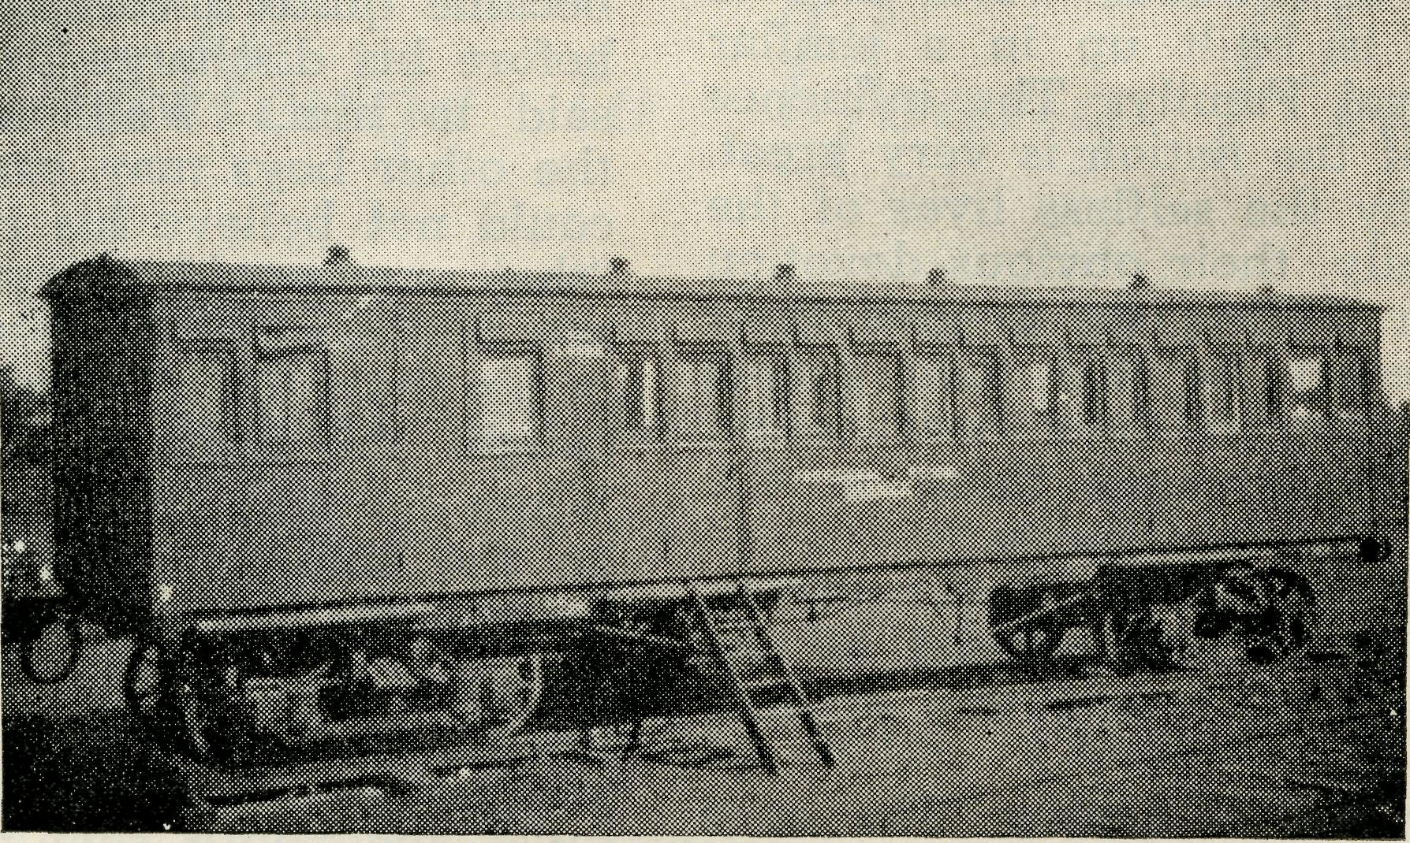
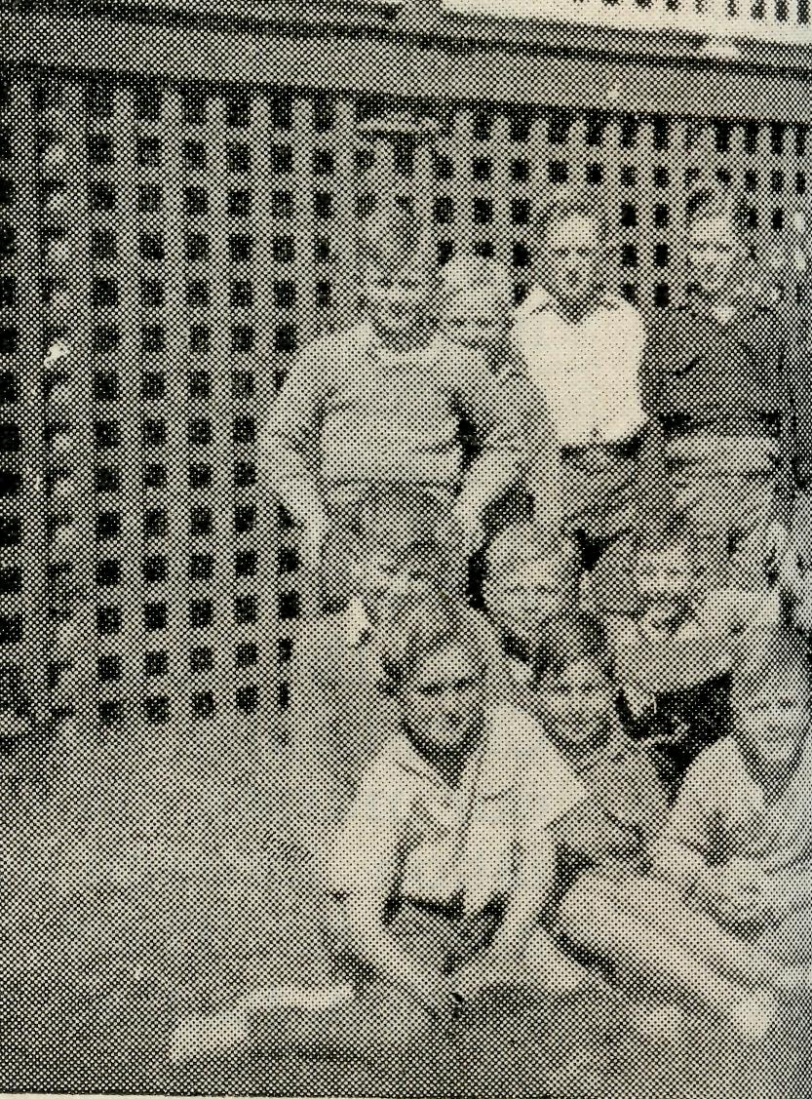
The boys of
Remem

Darnick Public School, visited by the Deaconesses.
THIS EXTENSIVE WORK FOR G(

December, 1949
THE REAL AUSTRALIAN

A

ist to All
ough . .

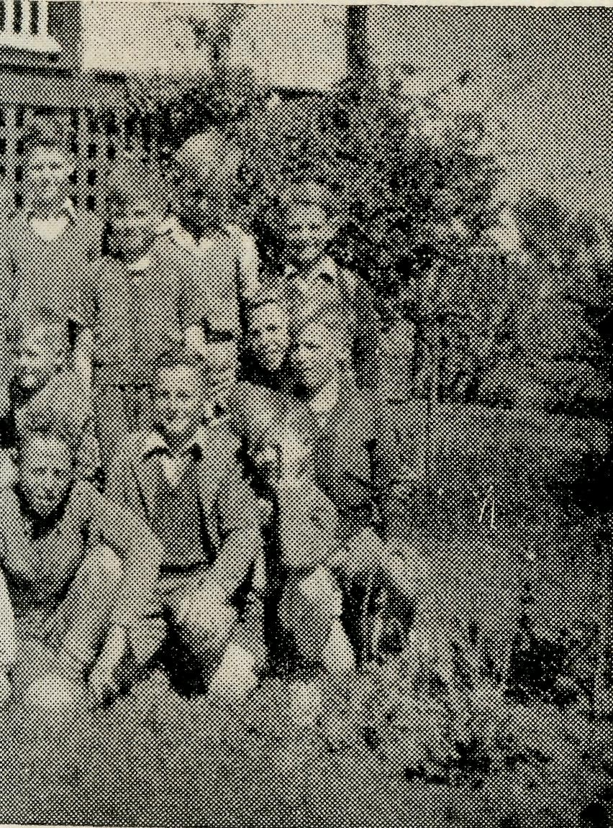
lungindi Hostel.
ber. . .
HOSTELS *
HOSPITALS *
FLYING MEDICAL SERVICES *
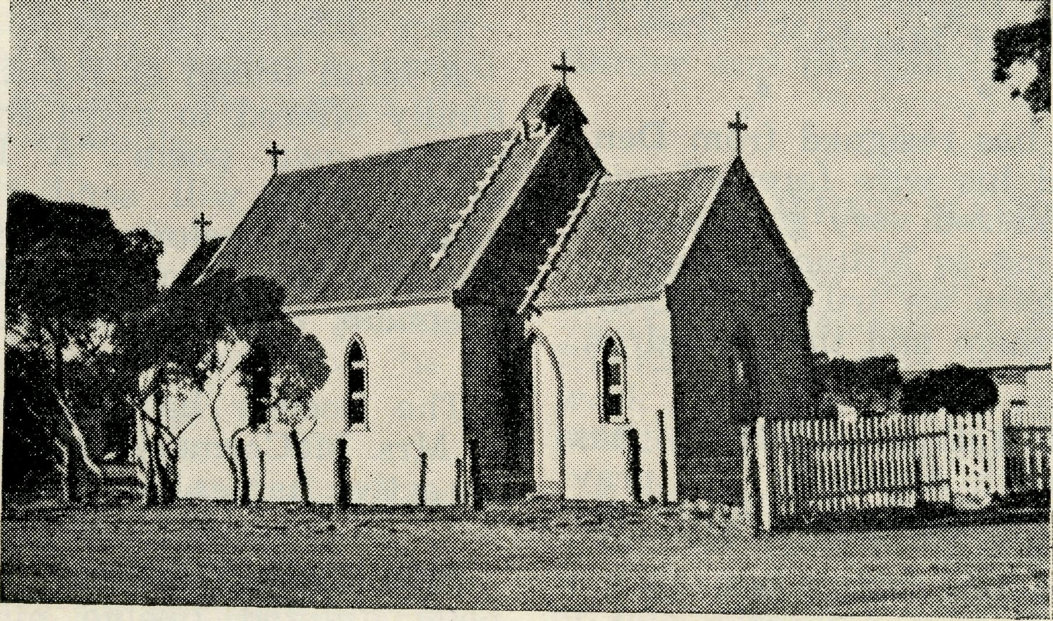

The Church on the edge of the Nullarbor.
D IN YOUR CHRISTMAS GIVING

THE REAL AUSTRALIAN
10
December, 1949

Sickness has taken severe toll of some of the B.C.A. staff in recent months. John Greenwood, of Minnipa, was off duty for two months and Philip Connell is still on long sick leave following a severe operation. They have the best wishes of all our friends for complete recovery.
* * * *
The Rev. John Greenwood who has been a missioner, first at Penong and then for some years at Minnipa, where he did extremely good work, has been appointed N.S.W. Deputation Secretary. The Council has made this appointment so that the deputation work will not suffer during the absence of the Organising Missioner in Great Britain. Mr. Greenwood brings to his new office a keen desire to serve the Church through B.C.A. and a wide and thorough first hand knowledge of the Society's
activities.
* * * #
The Society is grateful to members of the Broken Hill G.F.S. and the Young People of Guildford and
St. Luke's, Mosman, N.S.W.-, for gifts of portable radio sets for workers in the field.
* * * *
A Jumble Sale, organised by Mrs. L. R. Livingstone and friends, of St. Paul's, Kogarah, N.S.W., realised £10. This is a useful example which other friends may care to follow.
The Rev. George Fuhrmeister has been appointed missioner at Minnipa in the place of Mr. Greenwood. Mr. and Mrs. Fuhrmeister are assured of the best wishes and prayers of many friends as they commence their important task next March.
* * , * *
The Rei Charles Sherlock has resigned from Denmark, W.A. "^{r}e bid him and his wife farewell with deep regret fox °y have rendered very good service in this mission. . ^{T} are going to Milton, a country parish in Sydney Diocese, where we trust that God's richest blessing will be with them and their children.
* * * *
Sister Wilma Mansell, of Lithgow, N.S.W., has joined the nursing staff in South Australia. We pray that she will spend many happy years with the
Society.
* * * *
Will you please remember to empty your Bark Hut this
month and hand it to your local Church secretary? It will be a real help to the funds if all the contents of the boxes are sent to either the Victorian or Head Office before the end of the financial year, December 31st next. Some Bark Huts have been handed in without the name and address of the owners. If your Bark Hut has not been returned to you will you please communicate with Head Office? Box holders may send the contents of the Bark Huts direct to the office if they so desire.
Deaconess Clarke will be grateful for the gift of good books for her mission library at Ivanhoe, N.S.W.
* * * *
Good gramophone records are always acceptable
for use by the missioners in halls and homestead
services.
* * ~* *
The Society is grateful to two laymen who generously provided the cost of an excellent dinner for the students of Moore College in order to interest them in the work of the Church Outback. The students were evidently deeply impressed by the speeches made by the Rev. J. Greenwood, the Organising Missioner, Mr. H. M. Bragg, and Mr. T. Holt. Reports indicate that the dinner succeeded admirably in its object.
•* * * *
The Society sends Christmas Greetings to all its
friends with the prayer that the New Year will be one of true happiness in worthwhile Christian service.
* * # &
We are grateful to the ladies of Bowral and Eastwood, N.S.W., who recently held most successful Garden Fetes. They resulted in £65 and £17 being added to the funds.
* * * *
Nurse Barry who went from Eurwood East, N.S.W., to do her preliminary training at Wudinna, has now gone to the Royal Adelaide Hospital to complete her training. We hope that it will not be long before we welcome her back as Sister Barry.
A blind friend of B.C.A. now in his 83rd year has kindly offered to assist the funds by sending a copy of his own poem "A Blind Brother's Comment" to all who will send threepence and a stamped addressed envelope to him at his address. He is Mr. William Henry Walkom, of 8 Austin Street, Clapham, South Australia.
The Society has regretfully learned of the death of Mrs. McCormack, of Heidelberg, Victoria, who was an active helper for.many years.
* ■".■■'#. * *
Miss Beck, Matron of Port Lincoln Hostel, has been granted twelve month's leave of absense to enable her to visit Great Britain. She has the good wishes of us all for a pleasant and instructive journey.
* * * *
Our friends have noted the passing of Canon Pearce, of Bowral, N.S.W., with sorrow. The Canon was a member of Council for some years until he moved to Bowral. It was partly through his keenness that the Girls' Hostel there was established. We offer our sincere sympathy to Mrs. Pearce and her family.

December, 1949
11
THE REAL AUSTRALIAN

We have been notified of several legacies for B.C.A. and for the work of the Colonial & Continental Church Society in Australia. They include £1000 from the estate of Miss M. E. Duncan, of England, £600 from the late Mrs. Wilkinson, of Queensland, and a smaller sum from Miss Horton, of N.S.W. We are grateful for the thoughtfulness and interest which inspired these gifts.
* * * *
An electric sewing machine is an urgent need at Wudinna Hospital. Such a machine will make the work of patching linen a lot easier for the nurses.
An Ancient and Modern Hymn Book with tunes will be a boon to Minnipa Mission.
* * * . *
A doctor is still needed at Wudinna Hospital. Despite extensive advertising and many appeals and despite the fact that a large area with many settlements and homes is left without the services of a medical man, no doctor has offered his services. Please pray that some qualified man will answer this
vital call.
* * * *
A font is needed for the Church, the removal of which the Bishop of Ballarat describes in this issue. The price required is £17/10/-. Would some one care to donate this sum to help the people who moved a Church over mountains?
H» * * *
Congratulations to the Rev. R. Hudson, a Victorian member of Council, who was elected Canon at the recent Melbourne Synod.
* * * *
We also congratulate the Rev. Ernest Cameron, a Sydney member who has been appointed an Honorary Canon of St. Andrew's Cathedral, Sydney.
* * * *
Sister Daphne Yorke, of Adelaide, and Sister June
Armstrong, of Orange, N.S.W., have been accepted for services with our medical staff and will shortly commence duty in South Australia. We extend a cordial welcome to these new workers with the prayer that many more will follow their example.
...* '.*.. . ''.._.* c... "...'.*
Dr. R. Roxburgh, of Rochester Street, Homebush, N.S.W., has kindly accepted appointment as medical adviser to the Society in Sydney. Doctor's practical experience and knowledge of our work will be a great asset to our workers.
* * * *
Messrs. F. Ingoldsby, I. Booth and J. Stockdale,
students of Moore College, Sydney, have been accepted for training as future missioners of the Society. This now means that there are six students in training. It is good to know that future manpower requirements are being assured in this way.
* * * *
T;HE BISHOP OF GRAFTON writes: "Let me thank B.C.A. very much indeed for the splendid cheque of £91/10/3 received from you for Kempsey through the Archbishop, who generously made it up to £100. I would be glad if you will say that I am sure they will be touched and delighted at this very solid sign of your generous sympathy."
Many thanks indeed to all good friends who have given childrens' books, gramophones, crockery, a set of carvers, magazines and other goods. This very real help is sincerely appreciated.
* * * '*
The total offertories, which include gifts sent in by friends unable to attend the meetings, received at the Melbourne and Sydney Rallies, were £174 and £320 respectively. Many thanks to all who gave so generously.
* * * *
The Members of the Sydney Women's Auxiliary held their annual Thanksgiving Day on Friday, October 21, in the Bible House. Over a hundred people were present and the meeting was a most enjoyable one. The Rev. David Livingstone introduced Deaconess P. Spry, the special speaker, who came down from Menindee to give the address. She spoke of the scattered families visited in that area, the warm welcome always given her, especially by the women and children, and the very great need of some form of transport, to enable her to cover more ground.
The Rev. H. Broadley, in proposing a hearty vote of thanks to Miss Spry, made some pertinent remarks, bringing out various points in the address, and asked if any one would like to ask questions.
Miss Young seconded the vote of thanks, and during the singing of the closing hymn, the thankoffering was presented.
Afternoon tea followed, and most of the goods on the stalls were sold; the remainder were sent to Minnipa, to help the Strawberry Fete, held annually by the Church there.
The financial result of the afternoon amounted to about £80, the bulk of which will help to defray the cost of the new St. Brigid's Van at Ceduna.
* * * *
We have learned of the death of Canon Barder,
of Sydney, with sincere regret. The Canon was one of those who helped the Mailbag Sunday School in its early days. We offer our sympathy to Mrs. Barder and her family.
WHEN MAKING YOUR WILL
Legacies for small sums, as well as large, are thankfully received by the Society and we ask our friends, while they still with us, to remember the work of B.C.A. when considering the ultimate disposition of their property.
It is usually wiser to consult a solicitor in an important matter of this kind. A Will must be in writing, and signed at the foot or end in the presence of two witnesses, who must be present at the same time, and must sign the Will as witnesses in the presence of the person who is making it.
The following form has been drawn up and is printed here for the convenience of those who are interested:—
I give unto the Treasurer for the time being of
the Bush Church Aid Society of Australia and Tas
mania the sum of pounds
(words, not figures), and I direct that the receipt of such Treasurer shall be a sufficient discharge.

THE REAL AUSTRALIAN
12
December* 1949

A Dragon to the Rescue
Sister V. PAGE

In our childhood days the Dragon was the villian of the piece and knights in armour hurried to slay the beast and so rid the community of an evil.
To-day's story is very different. Here we have the dragon hurrying to the rescue not only of fair damsels, but of young and old alike for our dragon is no respecter of persons and is in reality a Dragon Rapide aerial ambulance, which has brought to many communities a sense of security in time of illness.
It was in the late evening that two long rings on the telephone (my code ring after post office hours) disturbed the quiet of the hostel. On answering I was told that an elderly man, some 85 miles away, was very sick, and his wife, quite naturally, was worried. Armed with pencil and paper, I gathered details of his illness, and after giving some temporary advice, reassured the anxious wife that I would get in touch with Dr. Gibson at Ceduna and see what could be done. The next day, Tuesday, was to be the usual monthly visit from doctor, so she said that she would call to see the patient before landing at Tarcoola. However, Tuesday was a dreadful day with the wind blowing at the rate of many knots, so the trip was postponed. Doctor gave me instructions to pass on to the sick man until he could be seen, and meanwhile I kept in touch with his wife in regard to his condition. Wednesday dawned and with it the need for an immediate appendix operation at Ceduna, which meant that Doctor could not get away. It was decided to send the plane up and transfer the patient to Ceduna. As staff was short there I was detailed to accompany the patient to Ceduna. As he lived 25 miles away from the station homestead where the plane was landing, I got in touch with the manager and asked that the patient be brought in to the homestead to save precious time.
Mr. Chadwick, our pilot, although not in shining armour, brought the Dragon to a standstill at Tarcoola just in time for dinner, after which we flew to our destination in a north-westerly direction (I think I'm right) 60 miles away. It was an excellent trip and the isolation of such places was forcibly revealed. Not another house was seen, and the country flown over was very barren and dry except for the usual mulga and bluebush. On our arrival we were given a cup of tea. The weather report wa3 not promising but after giving the patient an injection and getting in touch with Ceduna it was decided we could just make it. Our patient was comfortably strapped on the stretcher and placed in the plane and we were soon on our way to medical aid. The sick man had a very good trip and was most interested in the country over which we were flying. The accompanying nurse was pleased when the aeroplane touched down! It was not long before the patient was comfortably settled in bed and the very thought of being where he could be well cared for had made him feel much better, although his condition was serious. So once again, our Dragon aeroplane had been to the rescue.
Can you imagine what it would be like with no plane to make the journey quickly and reasonably comfortably? It is no use saying, "why live there?" Someone has to live in these parts if the rest of the country is to have meat and wool. Someone has to keep the trains rolling between east and west. But someone doesn't have to supply medical aid, nursing facilities or a Flying Doctor service. This is done purely because "the Love of Christ constraineth us". Will you help us to help the people of the outback by your prayers, by gifts and by your own personal service?

SOUTH AUSTRALIAN LISTENERS !
Listen to the B.C.A. story through
5KA and 5 AH every THURSDAY at 11.45 a.m.
TELL YOUR FRIENDS OF THIS INTERESTING
BROADCAST

December, 1949
13
THE REAL AUSTRALIAN

A trip to Tibooburra
Rev. E. W. FISHER-JOHNSON

At daylight one morning early in July, I set out for Tibooburra, my most remote centre. My intention was to travel via Broken Hill, which is 120 miles from Wilcannia. This road is the best of all roads leading out from the town despite the fact that after moderately heavy rain, motor vehicles are unable to traverse it for one or two weeks. However, on this occasion, the weather being dry, the road was in fair condition although it was corrugated in parts. I decided to go by mail truck which runs twice a week and eventually left Broken Hill at 1.30 in the afternoon.
Broken Hill has a population of over 28,000 people, so it was not surprising to find that it takes some miles to leave the city. Along the various routes near the city one often finds a hotel by itself or even a little suburb of Broken Hill. Such is the case on the Tibooburra road. After passing Broken Hill's broadcasting station we soon found ourselves at Stephens Creek, which is a little village 10 miles from the city. Some five miles further on we came to a solitary wayside hotel which marks the last link with the outer fringe of Broken Hill. We now proceeded properly on our way. The road is of gravel, slightly corrugated. The country is undulating, and I am glad to say, is at the moment, looking very fertile with its abundant green grass due to splendid rain some months back. It is hard to believe that more often than not this area is a barren waste of nothing but sand and stones. We were not many miles on our way before passing the ruins of Mount Gipps—this was the first place in the Broken Hill area that suggested the possibility of tin mining.
The sun was by now losing much of its warmth, but despite the cold that was beginning to make itself definitely felt we could not help admiring the picturesque hills in the gathering dusk. Our next stop was at a road repair gang camp (80 miles from Broken Hill), here we had a cup of tea and fellowship. Then we went on to a grazier's home for tea where I received a cordial welcome, the parents feeling that they already had an interest in B.C.A. activities since two of their sons are in residence in the B.C.A. Hostel at Wilcannia. These folk are about 100 miles from Broken Hill but the nearest Hostel to which they can send their children is the B.C.A. Hostel in Wilcannia, about 250 miles from their home. What a boon it would be if B.C.A. had a Hostel in Broken Hill! How happy were the parents to receive the message I gave them from their sons 250 miles away.
At about 9 p.m. we set off from this hospitable home into the extremely cold night — there just wasn't a window in my side of the driving cabin so one just had to allow the icicles to triumph—one could almost be forgiven for doubting the truth of the poet's words about man's ingratitude.
We called at several more homesteads where the occupants and I enjoyed a brief time of real fellowship. At one home I found a young family of three children all of whom require to be baptised on my next visit.
We were making good time so our driver thought we would try to make Milparinka in the early hours of the morning where we could have a few hours' sleep, but alas! just when all seemed to be going well, the lights failed and refused to be rekindled, with the result that we were obliged to spend the rest of that bitterly cold night on the road. By daylight we wondered if we possessed hands or feet.
One advantage of travelling by daylight next morning was that I was able to view two most imposing lakes—Lake Cobham and the Salt Lake. Cobham Lake, I am told, always has a little water in it, but, at the moment, is several miles in extent. Actually, the usual mail route is across portion of the country which now forms part of the lake. Similarly the Salt Lake is very different from its usual appearance. At the present time it is 5 miles long! Truly it can be said that the dead heart is beating again. Everywhere in this area there is a veritable carpet of wild flowers, particularly white and yellow ones, easily a foot high. All this abundant vegetation is due to the most wonderful rain early in the year. There were some pathetic cases of hardship during the rains, but generally speaking, they were a marvellous blessing. One case of hardship I recall is that of a family whose home was covered with flood waters and even now only the roof is showing. One is very tempted in these parts, seeing the seasons are so often dry and hot and dusty, to choose the shadiest and coolest-looking spot on which to build one's house, but apart from the fact that it is always wise to note the geographical contour of the land, and choose a highish spot, it is also very wise never to choose a building spot where there are box-trees. Box-trees in this type of country spell "water".
Eventually at about 9.30 in .the morning we reached Milparinka. This is the oldest township on the Albert Goldfield, near Mt. Browne, in the Grey Ranges. This remote outpost, set amongst hills, consists of a hotel, a post office and a store (all directed by the same family) and some old ruins from the gold digging days. The hopes of the majority of the gold-miners, even when persisted in unto the end of life, were frustrated, and so it is with all hope that is not built upon a Sure Foundation and is not in touch with Reality.
In Milparinka I was happy to make the acquaintance of one of our former B.C.A. Hostel girls. On nearly every trip in these parts one meets at least some one who has, or has had, a child staying at a B.C.A. Hostel. The Hostel work done by B.C.A. is a very real contribution to the mental, physical and spiritual well-being of the children of the outback.
Milparinka, despite its smallness, is quite an important mail centre. On this particular trip a very considerable amount of mail was taken off there for the homesteads further out. After the mail arrangements were finalised and we had had breakfast, we set off for Tibooburra which is 25 miles north of Milparinka and arrived there about mid-day.

THE REAL AUSTRALIAN
14
December, 1949

Tibooburra presents a unique sight in that it is set in the midst of a stony hollow. The population is about 80 and the town's buildings could easily be counted. There is a store, a school, a court house, two hotels, several dwellings and a well-staffed and up-to-date hospital (equipped with a radio transceiver so essential in these parts). When I visited the school, I found 25 children on the roll.
After an afternoon's visiting, we had our evening service in the court house and there were 22 present. I preached from the Bench—not the Dock. Speaking generally, the townspeople were glad to see a clergyman and one wished that they could have more frequent visitations.
Tibooburra too, was once a gold-mining town. Even to-day, after rain, it is reported that it is a common sight to see people closely investigating the good earth for any evidence of that precious metal and now and again nuggets are discovered.
On this trip, all the reminders of the former gold days, persistently recalled to one's mind man's constant seeking after earthly treasure, which in the end avails nothing, whereas the seeking of heavenly treasure yields the everlasting benefit of Eternal Life.
May we all be faithful in taking this message to the Outback.

The Melbourne Annual Rally

On Wednesday, September 21, the Annual Melbourne Rally was held in St. Paul's Cathedral Chapter House. There was a slightly smaller attendance than last year, probably owing to the polio epidemic which has affected most gatherings in Melbourne in recent weeks. Nevertheless, with characteristic B.C.A. generosity the Rally Offering, instead of being less, was greater, £174 this year as against £160 last year. Those good friends who were unable to be present sent their gifts and many were remembering the meeting in prayer.
The evening meeting was again preceded by the popular Rally Tea at 6 p.m., when nearly 200 friends of B.C.A. joined in a happy meal, the success of which was due, in large measure, to the excellent catering of our good friends, Mr. and Mrs. V. Page. We were honoured at tea with the presence of two Bishops, the Bishop of St. Arnaud, who later spoke at the evening meeting, and our old friend, Bishop Baker, Principal of Ridley College.
While the Chapter House was being cleared after tea in preparation for the meeting to follow, interesting slides of the Society's work were shown, each being introduced with a caption. Emphasis was laid upon the national importance of the Society's work in helping to stem the drift of our people to the cities. A further fact stressed was the acute shortage of clergy in some of our outback dioceses. In Victoria, for instance, with an area of 88,000 square miles there are 6 dioceses and nearly 400 clergy, whereas in the diocese of Willochra with an area 360,000 square miles or 4 times the size of Victoria, there are twelve clergy; in the diocese of Kalgoorlie with 310,000 square miles, 5 clergy; and in the diocese of the North West 600,000 square miles, 8 clergy.
Canon Wenzel briefly welcomed the visiting speakers, after which the Archbishop called upon the Bishop of St. Arnaud to address the gathering. Bishop James paid a great tribute to the work of the Society in his diocese affirming that, but for such help as the Society had been able to give, it would have been impossible to minister to some of the remoter parts of the Mallee. He referred to the fine work done by former B.C.A. missioners, particularly that of the Rev. W. T. Fleming, who is now a member of the Victorian Committee.
The Archbishop then called upon the Rev. John Greenwood to speak. Mr. Greenwood began by describing the mission in which he works, an area of 40,000 square miles, based on the small township of Minnipa, 250 miles west of Port Augusta. For some 40 or 50 miles around Minnipa there is farmland beyond which lies the station country. The stations range for a few thousand to many thousand acres each. Wilgena, for instance, in the Minnipa Mission, is 2 million acres, or 3,000 square miles. Mr. Greenwood told of his normal Sunday's work around Minnipa, and of his quarterly patrol through the station country. Mention was made of the Medical Hostel at Tarcoola and the new hospital being built there; also of his ministry at the remote opal fields at Coobar Bay.
Mr. Greenwood particularly stressed the need for more clergy in the outback, and appealed to young men to consider the challenge of our own inland areas.
During the hymn that followed, the offertory was received, after which the Rev. E. G. Beavan spoke. Mr. Beavan said that after listening to Mr. Greenwood he felt that he, Mr. Beavan, lived within a stone's throw of Melbourne. Even so, though comparatively near, his area had its difficulties. Before speaking of these, however, Mr. Beavan conveyed a message of greeting from the Parent Society in England, the Colonial and Continental Church Society, on the staff of which he himself had worked for some years before coming to Australia 18 months ago.
He then told the epic story of how the little township of Timboon in the Heytesbury Forest is getting a Church. It is too long to relate here, but we agreed with one who afterwards said, "That story should be put into print," and we hope it will be.
Mr. Beavan told of the difficulties of settling into a place like Timboon, which has been so long without a resident Minister, without Church buildings, with an unreliable means of transport and with bad roads. Yet there was no pessimism. With a little help and a faithful ministry these people would overcome their difficulties. Mr. Beavan appealed to the friends of B.C.A. to extend that helping hand.
The singing of "Lord Speak to Me" and the blessing by the Archbishop brought a memorable evening to a close.

December, 1949
15
THE REAL AUSTRALIAN

This Varied Work
Rev. T. HAYMAN

A very worried looking man came to me one afternoon and said, "I am very concerned about my wife and I believe you share my concern too!" His wife was very ill. Could we get her off to Adelaide where there would be expert medical care for her? The case was not urgent enough to call our B.C.A. plane. After enquiry it was ascertained that the best way would be to catch the plane 200 miles away and thence to Adelaide. But how would we reach the plane in time? Certainly not by ordinary public transport as there was nothing available anywhere that day. So I offered to make the trip.
A friend very kindly came to look after our child, while my wife, a trained nurse, and I started off with our patient and her husband at 2 o'clock the next morning. Country roads may not be the best under any circumstances, but when there is rain, the roads are muddy and slippery. For the whole trip, we had to drive through rain, or parts where it had just been raining. Many stretches of road had to be covered with great care, especially with a sick patient in the back, lest the car should suddenly swerve and go off the road.
I knew also that some of the tyres had worn well but they were well worn, and I wondered whether I would have a puncture or a blow-out. Either would make all the difference between catching and missing the plane. None of the party had had very much sleep the night before, and those in the car took the opportunity of a nod, but the driver could not allow himself to drop off to sleep. However, there was not much fear of that with the concentration on the road and the responsibility of the very sick passenger.
Finally the destination was reached two minutes before time, the patient and her husband safely placed on the plane and before long the hospital was reached nine hours after commencing the 450 miles journey. Prayer offered in the silence of the night trip was abundantly answered. My wife and I were then made very welcome by Miss I. Beck, the Matron of the B.C.A. hostel. On the return trip that same day we had not gone ten miles before I found myself dropping off to sleep! But a two hours nap refreshed me. Five miles further, bang! went a tyre and the car wobbled to a standstill. The spare tyre was also found to have a slow puncture. It had to be kept up with a leaky pump which pumped three pounds pressure every hundred pumps! The next 150 miles were uneventful, but coming down a steep hill, the car skidded and turned around in the mud. We were both very thankful that all three mishaps were on the way back and not on the outward part of the 400 miles drive.
When, due to the strain of the work, one's neighbouring missioner is ill and has to go on extensive sick leave, it is the duty of the remaining missioner
to do what he can to fill the need. Shortage of men means that almost the impossible has to be attempted in doing parts of two mission districts in one.
It was quite a pleasant day when I and my wife started one Sunday's task. The first service was the solemn early morning service of remembrance and rededication around the Lord's Table at Holy Communion. Here is the purpose of the whole; He died for us, He rose from the dead, and is coming again.
When all the things were packed into the car the family set off from Streaky Bay on a forty-five miles trip out to the "line" (the railway) to Wirrulla for a service in Minnipa Mission district. The number present does not begin to compare with city churches, yet it is a good percentage of those possible. At the conclusion of the service we were asked to stay to dinner with almost the entire congregation. They realised there was not very much time to spare between the eleven o'clock service there and the next one many miles further on at two o'clock, so they brought their lunch with them and boiled the billy before the service in the supper room of the hall. It was a very kind and pleasant gesture.
Chandada, the first service in the afternoon, was back again over the district border into Streaky Bay parish but in the general direction of the day's itinerary. Then onto Minnipa where it was good to see those who had come in the face of the counter attraction of a Golf Gala day. The folk at the B.C.A. hospital at Wudinna very kindly provided tea for the travellers. It is always good to have fellowship with these folk. My wife and baby daughter remained here, the baby being put to bed, while I was able to take some of the staff further on to Warramboo, again in Minnipa Mission, for the evening service. A number of young folk in their late teens or early twenties made this service all the more important and enjoyable. The people throughout spoke of the good work of Mr. J. Greenwood, their own missioner and hoped he would speedily recover.
Back to Wudinna after the service, the party was met with the news of the serious illness of a very old man in Streaky Bay, and I had been sent for. We packed everything into the car again and returned to Streaky Bay after travelling 250 miles in the one day with five services. The aged man, 91 years old, passed on a few days later after regaining consciousness sufficiently to appreciate prayer offered at the bedside.
So this work is wonderfully varied. We never know what is going to happen next or where we shall be next, at home or hundreds of miles away. But through it all the ministry of our Lord and His Church is available to these people, and being available, helps to build up the Kingdom of God.

THE REAL AUSTRALIAN
16
December, 1949

All This for a Confirmation Lesson!
REV. J. R. GREENWOOD

When one wishes to be confirmed it is generally only a matter of mutual arrangement if ordinary classes cannot be attended at the time suitable to the clergyman of the parish. However, when the person lives in the outback area the matter is a much more involved affair.
It so happened that some time ago two young men asked to be prepared for confirmation. The problem which arose was how could classes be arranged to suit both them and the missioner. One lives 60 miles from Minnipa and the other is 10 miles away from his friends. The lessons arranged by the Mail Bag Sunday School were procured for both the candidates but there was still the problem of personal interviews from time to time. It was arranged that they should meet alternatively at each home and so it was that I made my way over a rough bush track one evening to hold the first class.
On top of a hill, with little shelter to break the force of the cyclonic wind which sweeps so often through this country, was a small home where real bush hospitality was awaiting me. The outer walls, partly rough stone and partly galvanised iron, looked weather beaten and worn. The heavy sand piled up in heaps around the fences gave mute evidence of the ravages of successive dry seasons. St. Columba's Van was made ready for the night and soon I was inside the house enjoying their genuine hospitality and friendship.
In the middle of the table was the kerosene lamp which threw fitful shadows on the hessian-lined walls and an occasional gust of wind came through the cracks in the walls to stir the flame into a smoky whisp. About ten miles away was the other candidate who was expected at 8 p.m., but who had advised he might be late as this was a track he had never used and the lights of the old car were not as good as they should be. The tea out of the way we sat back waiting for the sound of the car engine. Slowly the time passed and it became obvious that the visitor was going to be very late if he came at all.
We walked out along the scrub track trying to see headlamps glowing in the distance or hear the engine of an approaching car. All we could see was the mallee scrub rolling into the distance under the light of a fitful moon; no noise save the moaning wind in the trees greeted us. Reluctantly we returned to the house and I gave a confirmation lesson to the one candidate. Before we retired the rest of the family were joined together in prayer and worship as Bible Reading and prayers were shared.
But what of the other candidate? The next day, being Sunday, the usual round of services brought me to the little schoolroom near the young man's home. The experience he had undergone the previous night was something which so often befalls those who live in remote places.
He had set out armed with directions as to tracks and gates and driving an old car which at times could prove most temperamental. All went well for over four miles but just as the main track was being left
and as close watch had to be kept for the first gate, the headlights flickered and then went out. Fortunately there was a moon to give a little light but clouds often blotted it out for some time.
After considerable effort to gain some light from the lamps the task was given up and a search made for the gate. At last it was located and so the old car was driven into the paddock and a slow journey continued. The track was not familiar to the driver and often the moon was hidden behind a bank of cloud. A bush looming up suddenly gave warning that the track had been left; here and there other faint tracks crossed the correct one and then sudden bends left the driver groping for his bearings. The moon gives a very good light at times and no doubt is much appreciated under favourable circumstances but on this occasion it often caused much confusion. On coming into a clear patch of country the track seemed to disappear entirely and so an attempt was made to strike out in the direction which should lead to the destination sought. But what was that in front? The car's brakes were not the best but this time they did stop the vehicle with a jolt. An investigation soon revealed the fact that what had helped to stop the car was a fence post now almost out of the ground. Obviously this was not the track.
After walking around for some time the moon decided to shine more continuously and so a faint track was found leading back to one better defined. Along this faster time was made until coming on to sandy ground the track once again disappeared, covered by drifting sand stirred up during the windy day. The car ploughed on towards a shadow ahead when to the driver's consternation he found himself driving straight into a belt of scrub.
A survey was made of the surrounding country and to his amazement a very clear track was not far from him and what was more it was the continuation of the one he had left. The decision was made to retrace his tracks as by now the sky was quite clear and the bright moon was shedding a steady light. Slowly the trees were avoided, bushes safely passed and the track, now clear and then faint, kept in sight.
Ahead appeared a gate and to the great comfort of the traveller on the other side he found a clearly marked familiar track leading to his home. At midnight, after four hours of driving around the bush and walking as he searched for tracks, the weary traveller made his way to bed. All this to get to a confirmation lesson!
After service that night in the little schoolroom I made my way to the candidate's home and for the second time that week-end gave a lesson to one person.
If it were not for the interest and support of the many friends of B.C.A. such a ministry would not be possible. What a joy it is to minister to people who can overcome the trials and difficulties of isolation. There is a tremendous need for more workers to maintain a more coherent ministry and to go about preaching and teaching in the Name of Jesus Christ.

December, 1949
111
THE REAL AUSTRALIAN

THE PLACE OF PRAYER
A Prayer for Use with Our Prayer List.
O Lord God of our nation, Who has commanded men to subdue and replenish the earth: Look in Thy love upon all who in distant parts of our land are striving against many difficulties, and are deprived the access of the means of grace. Strengthen and guide the Bush Church Aid Society and all members of the staff. Cheer and comfort them in discouragement and loneliness, bless their ministrations to the good of those they serve, and grant that the message of redeeming love may thus be rooted and grounded in our national life, to the glory of Thy Great Name through Jesus Christ our Lord. Amen.

SUNDAY.
THURSDAY.

MORNING
The Far West Missions at Penong, Ceduna, Min-nipa and Cowell; the Mis-sioners, Revs. D. Pugh, J. Greenwood and P. ConnelL
EVENING
The West Darling Missions at Wilcannia and Menindee: the N.W. Mai-lee; the Missioner, Rev. E. W. Fisher - Johnson and Deaconesses P. Spry and B. Clarke.
MONDAY.
MORNING
For the Mail Bag Sunday School with its Gospel messages for the children. For the Director, Miss R. Campbell, the teachers and helpers, that they may find encouragement in their work.
EVENING
For the Organising Missioner, and Asst. Organising Missioner, that they may be strengthened and guided in all their endeavours for the good of the work and in their relationships with their fellow-workers.

FRIDAY.
EVENING
The Denmark Settlement; for the Pharmacist, Miss E M. Page.
EVENING
MORNING
The Cann River Mission, the Bonang Mission, the Streaky Bay Mission; the Missioners, Revs. G. Pearson, D. H. Wicking, and T. J. Hayman.
TUESDAY.
MORNING
MORNING
For the Bishop Kirkby Memorial Hospital and Sisters Horsborch and Ross as they minister to the people on the great Nullar-bor Plain. For Sister Page and the Tarcoola Medical Hostel.
EVENING
For students and all in training for this work of God. For the Heytesbury Forest Mission, and the Otway Ranges Mission, and the Missioners, Rev. E. G. Beavan and Rev. T. H. Pickburn.

SATURDAY.
WEDNESDAY.
MORNING EVENING
Each day pray that the many needs of the work may be met.
Running expenses of £7 per hour to keep the Medical 'Planes in the air.
Consecrated clergy missioners and other workers for urgent work in the field.
That our work may continue to progress despite the difficulties of the post-war period.
For Sisters Dowling, Miller, Hitchcock, Holle, L. Loane, B. Tierney, R. Portch, O. Morgan, E. Thomas, J. Armstrong and Miss Stokes.
For the Bowral Hostel, Deaconess N. Dixon and Miss Michael. For Theological Students of the Society in training.
For the children in the Mungindi, Wilcannia and Port Lincoln Hostels, and for the workers, the Misses Cheers, M. Farr and I. Beck.
For the Cann River Dispensary, and Sister
Gwynne and Wudinna Hospital, and Sisters L. Pritchard, M. Wells, V. Holle, W. Mansell and Staff.
For the Flying Medical Services, Mr. Chadwick,
Mr. Bedford and Doctor F. Gibson.
For the wives and families of the Missioners and Air Pilot.
MORNING
For the President and Council of the Society, that they may be guided by His wisdom.
For the Home Base Staffs, Auxiliaries, and parochial workers.
For the N.S.W., Victorian and South Australian Secretaries.
EVENING
For the "Coora h" Hostel and its workers, Mrs. Mann and Miss Lawtey.
For the Rappville Mission.

Give Thanks—
For the rich blessing and wonderful growth of the Society's work. For all the kindly givers who have helped with their self-denials. For the Flying Medical Services. Tor the joy of service.

THE REAL AUSTRALIAN iv December, 1949
Another Opportunity!
Big Developments at Menindee, N.S.W.
Many of our friends have been impressed with the huge water conservation scheme at Menindee and the obvious need for development in our work there. Deaconess Spry has worked gallantly without a vehicle, but one must be supplied. A special fund is now open for this purpose. A missioner will soon be there to minister to the area and the men working on the new project. This is a vital, strategic opportunity. A motor truck has been ordered in the faith that God and His people will supply the money. Send your donation as soon as you can to the office or representative in N.S.W., Victoria, and South Australia.
Urgent Staff Needs Are
- CLERGY MISSIONERS
- QUALIFIED NURSES
- HOSTEL WORKERS
CAN YOU STAY HOME IN COMFORT WHILE VITAL WORK FOR GOD REMAINS TO BE DONE?
Arrange for an Interview Today
EDGAR BRAGG 4 CONS PTY. LIMITED. PRINTERS. 4 BARKER STREET. SYDNEY

