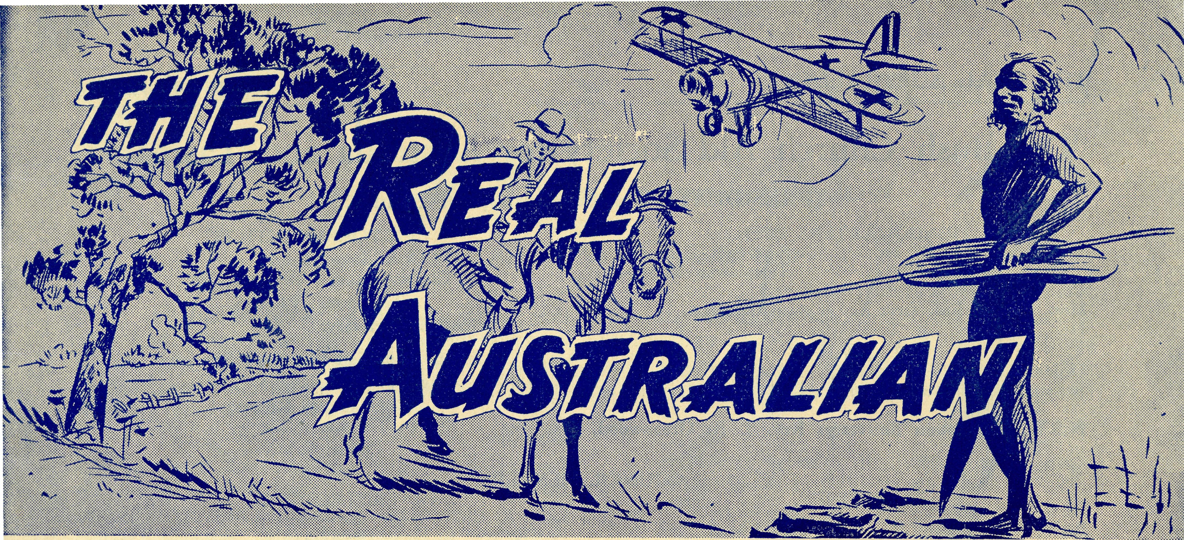

No. 112.
September, 1951.
2/6 per annum, post free.

Jne iVledical d5ade
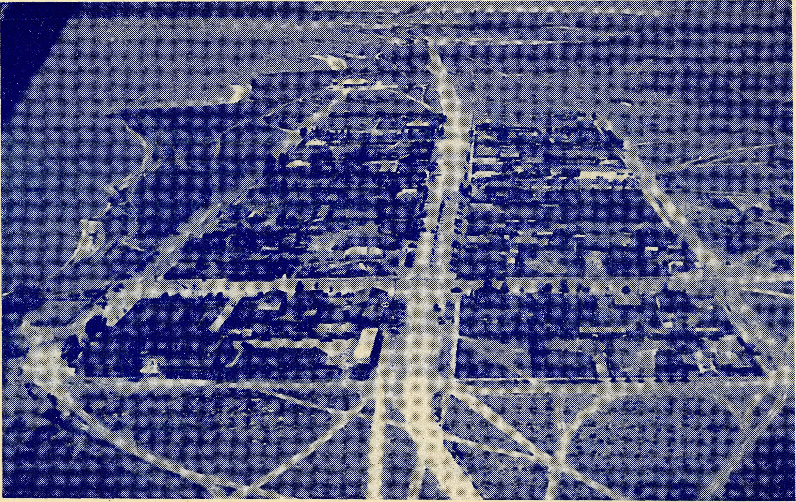
The Township of Ceduna from the Air.
Registered at the G.P.O., Sydney, for transmissiof by post as a periodical.

THE REAL AUSTRALIAN
September, 1951.

The Bush Church Aid Society for Australia and Tasmania
PRESIDENT: The Archbishop of Sydney.

HEADQUARTERS OFFICE.
Diocesan Church House, St. Andrew's Cathedral,
George Street, Sydney. Telephone: M 3164.
Cable Address: "Chaplaincy Sydney.¹'' Hon. Clerical Secretary: Rev. Canon Cameron. Hon. Treasurer: Mr. T. S. Holt. STAFF. Organising Missioner: Rev. T. E. Jones, Th.L. Assistant Organising Missioner: Rev. D. G. Livingstone,
Th.Schol. N.S.W. Deputation Secretary: Rev. J. R. Greenwood, Th.L.
VICTORIAN OFFICE.
Bible House, Flinders Lane, Melbourne, Vic. Telephone: FJ 5675. Victorian Secretary:
South Australian Honorary Secretary:
Rev. F. H. B. Dillon, Th.L.,
Holy Trinity Rectory,
North Terrace, Adelaide, S.A.
Phone: C.1134.

Right Rev. Rev. H. E.
SYDNEY.
Bishop W. G. Hilliard, Felton, Th.Schol.
Rev. C. A. Baker, Th.L.
Rev. L. H. Broadley. Th.L
Mr. H. M. Bragg.
Rev. A. Gerlach. Th.L. Rev. F. Ingoldsby, Th.L. Rev. I. Booth. Mr. A. Williams.
COUNCIL MEMBERS.
MELBOURNE.
M.A.
Archdeacon C. H. Raymond, Th.L.
Canon L. Wensjel, Th.L.
Canon R. Hudson, B.A., Th.L.
-J Rev. E. R. Panelli, Th.L.
Rev. A. C. Miles, Th.L. Rev. H. C. Busby, Th.L.
STUDENTS IN TRAINING
Rev. J. Stockdale, Th.L. Mr. T. Morgan. Mr. D. Percival. Mr. C. Burgess. Mr. B. Schofield.

B.C.A. Activities and Staff

MISSIONS.
Ceduna, S.A. ) _{Rey} _{T} j _{R} _{Th} _{L} _{Ceduna?} _{S}.A
Penong, S.A. J
Cowell, S.A.—Rev. D. A. Richards-Pugh, A.L.C.D.
Minnipa, S.A.—Rev. G. Fuhrmeister, Th.L.
Streaky Bay, S.A.—Rev. P. Connell, Th.L.
Croajingalong, Vic.—Rev. J. Shilton, Th.L., Cann River,
Vic. Delegate-Bonang, Vic.—Rev. D. H. Wicking, Th.L.,
Delegate, N.S.W. Heytesbury Mission, Vic.—Rev. E. G. Beavan, M.A.,
Timboon, Vic. Otway Mission, Vic.—Rev. K. Seymour, Th.L., Beech Forest, Vic.
WEST DARLING MISSION:
Wilcannia, N.S.W.—Deaconess B. Clarke, Deaconess P. Spry.
Menindee, N.S.W.—Rev. W. Mitchell, Th.L. Rappville, N.S.W.—
Denmark, W.A.—Rev. J. Johnston, Th.L. Wertimull, Vic.—Grant-in aid.
MAIL BAG SUNDAY SCHOOL.
Director-—Miss R. Campbell.
SCHOOL HOSTELS.
Broken Hill, N.S.W.—Mr. and Mrs. A. McLaughlin.
•Mr. and Mrs. Hustler. Miss M. Farr.
Mungindi Boys' Hostel, N.S.W. Mungindi Girls' Hostel, N.S.W.-
Bowral, N.S.W.—Miss E. Cheers. Port Lincoln, S.A.—Miss I. Beck
MEDICAL SERVICES.
Ceduna, S.A.—
Matron: Sister F. Dowling.
Staff: Sisters J. Miller, G. Hitchcock, B. Tierney, R. Metcalfe, J. Armstrong, L. Langtree. Penong, S.A.—Sister L. Loane, Miss F. Lawtey. Wudinna, S.A.—
Matron: Sister R. Portch.
Sisters: V. Holle, B. Barber, V. Brealey. Cook, S.A.—Sisters M. Horsburgh, M. Ross. Tarcoola, S.A.—Sister V. Page. Cann River, Vic.—Sister I. Gwynne, Rawlinna, W.A.—Sister E. Thomas
FLYING MEDICAL SERVICE.
Pilot.—Mr. A. Chadwick, Mr. W. Bedford Doctor.—Dr. F. Gibson, O.B.E., Dr. M. Mueller. Pharmacist.—Mt^s E. M. Page.

September, 1951.
THE REAL AUSTRALIAN

Come out of your own backyard
The O.M.'s Address at the Annual Rally

On the inside cover of this magazine you will find printed a list of field workers of B.C.A. You will remember that some of those names have been appearing there for periods ranging from ten to twenty years.
There are two reasons why I point out this long service list. It surely means that there must be something satisfying in this B.C.A. service. Here are women, qualified nurses, and remember, we take only the best; each of them could be earning very much more than they can hope for in B.C.A. and in much better surroundings. They could be on a forty-hour week instead of from daylight to dark. Yet they feel that God wants them just where they are and that this service for Him is better than a so-called 'good job'. They feel that as Christians they must do a job that only Christians can do.
The Air Pilot has been on the job for fourteen years now, for the very same reasons. Make no mistake about it, Allan Chadwick is not merely a good pilot and engineer, he is the best there is for this type of flying. His years of trouble-free service and the utter confidence shown in him by all members of the staff testify to that. The mere fact that he has stayed in B.C.A. so long proves that he isn't serving for financial gain.
The Missioners, what about them? I suppose that after four or five years in the outback, with small congregations and a very great deal of travelling under not the best of conditions, a man may be pardoned for looking for a city or suburban parish. But these men have come to feel that the work B.C.A. does is worthy of all their powers, and that the sacrifice of convenience and additional income is part of that service.
The same can be said of those who, for a great many years as voluntary helpers and teachers have carried on the Mail Bag Sunday School and built it up into the very
fine organisation that it is to-day. Unstint-ingly, they have given of their time, abilities and substance, with little publicity. We would say, 'thank you' to them here and now.
I sometimes wonder if those who manage our hostels have not the most exacting task. It is difficult to get Christians to-day to realise that washing floors, cooking meals and doing all the humdrum and arduous jobs of domestic life, rank as important in the estimation of God as the mighty sermons of great revivalists or the surgical miracles of medical missionaries. It's the motive that matters, and it will be a poor look-out for some of us if the Almighty ever starts to grade our service by any other standard. I am of the opinion that, caring for twenty or thirty children, and teaching them the Christian life by daily example, will not rank, by any means, as the lowest form of Christian service.
Can we wonder at the blessings which have been sent in so great abundance upon the work of this Society? Can we marvel at the great things it has undertaken by the grace of God? This B.C.A. has been blessed largely because of the unstinting devotion of its workers; it has grown to its present dimensions because of their zeal and enthusiasm.
Then there are those whose names are not known by many. That great army of friends who, over the years, have also proved their stickability.
Let us pause here for a moment and run our minds back over the great things that have been undertaken in, say, the past fifteen years.
Soon after the death of our beloved Bishop Kirkby, we built a hospital as his memorial at Cook on the great Nullarbor. This was no mean feat, and I think that you will agree I should be a good judge of that. The very

THE REAL AUSTRALIAN
September, 1951.

location of the building, in the centre of one of the largest desert plains in the world, made it a hefty task. It cost £5,000 to build and equip—and that was a very large sum to B.C.A. friends fourteen years ago. Indeed, it was the biggest task our supporters had been asked to face, up to that date. They took it in their stride.
Within a year of the completion of that hospital, yet another big task confronted us. No less than the establishment of a Flying Medical Service—entirely financed and staffed by the Church. It called for the purchase of an aeroplane, suitably fitted, the erection of a hangar to house it, the addition of a pilot to staff it, and an efficient ground organisation so that it would do its work effectively. It added thousands of pounds to our annual commitments for maintenance, overhaul and insurance. Over the years it has grown into what we have very good reason to believe is an organisation of its kind second to none, and by the addition of a second 'plane and pilot, it has grown to three times its original size and scope. By the grace of God, the enthusiasm of all our medical and nursing
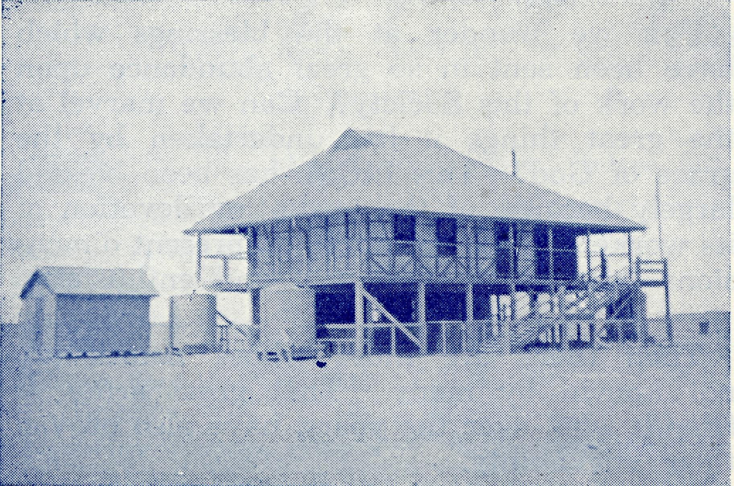
The School at Cook, S.A.
staff, the faith and material support of our supporters, this great venture was begun and has been maintained over the years.
In our Jubilee year we decided to mark the event by the establishment of a Girls' Hostel at Port Lincoln. It required the sum
of £3,500 and the money came in in a few weeks. It now houses twenty-eight girls who attend the Port Lincoln High School.
Later came the Bowral venture, yet another hostel. That ran into £6,000, and I always get a thrill when I remember it took only five weeks for our friends to find that amount. In 1947, we needed more room at Mungindi, and when a suitable house became available, you very quickly found the £1,400 needed for its purchase.
The latest venture has been the new Boys' Hostel at Broken Hill. That is about half paid for and I am expecting that the £3,000 now outstanding will be greatly reduced after this meeting.
There have been many other additions to our work in that time. Chief amongst them was the taking over of the Hospital at Wudinna and the addition of the Ceduna pharmacy. The friends of the B.C.A. have, by the grace of God, done a truly magnificent job, because they believe in it and its mission. It surely means that they also find in it a satisfying service.
Now I come to my second reason for talking of long and devoted service in the field and behind the scenes. What about the future? We cannot expect the present staff to go on for ever. We cannot hope to maintain the work without a continuous stream of fresh and devoted men and women coming into it; even the O.M. must go one of these days. I am concerned at the shortage of Christian workers in all fields, and more particularly in this one, because it is nearest my heart and has had so much of my life.
I am appalled at the demands made, especially on our nurses. They work sometimes around the clock. It's no good saying Terrible!' or 'they should not be permitted to do it.' The cold, sober fact is that if they did not we would be compelled to close down a very large part of our work. Hostel workers are likewise placed. Are you busy at home looking after three or four children and a house? I am sure you are. How would you go on looking after say, twenty-eight children in a hostel?

September, 1951.
THE REAL AUSTRALIAN

Now I know that Christians can give service anywhere and that one has not to go to Tibet, Peru or Penong to be a missionary, but may I say this very earnestly; there are certain jobs that Christians alone can do, and they ought to be the first call on the life of a Christian. There are too many who call themselves by Christ's name, yet find all sorts of reasons for never venturing out beyond their own circle of friends and life. There are too many Christians who spend a great deal of time praying the Lord to send a revival and labourers into His vineyard—when they ought to- be facing up to the challenge themselves.
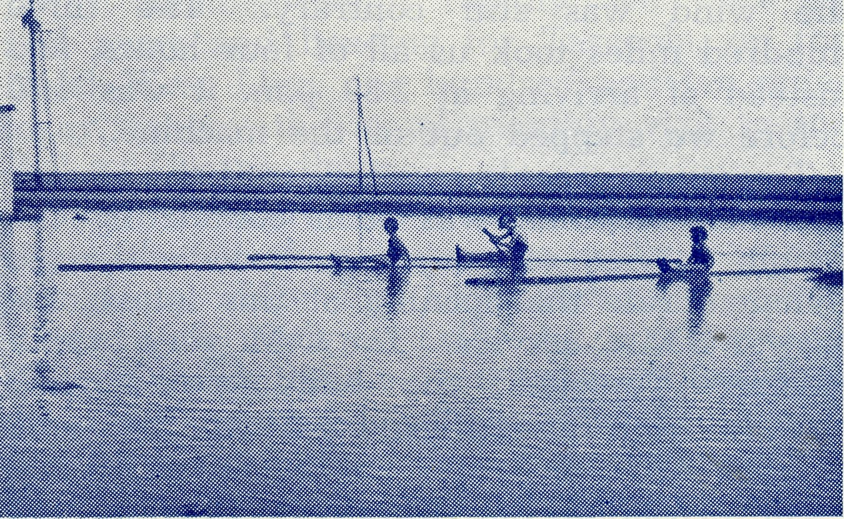
Boating at Cook!
The demands of Christ are hard—for Christians. You cannot get away from them by telling yourself and others that YOU couldn't put up with the lack of social life or even that your relatives need you. The demands of the Kingdom of God must come first. If this were so with all those who call themselves Christians in this diocese alone, I am sure that the flow of missionaries and other workers going out from it would stagger the imagination, and B.C.A. needs would be well met. I am quite sure that it would not leave the work in this diocese any the poorer. Missionary zeal has never hurt the Church anywhere, so far as I know, when it has been fanned to white heat.
Now what about the future at the home base? Here, too, we cannot expect our present faithful ones to live for ever—not where we can use them, at any rate. Those
in our Auxiliaries have done a truly magnificent job all these long years, but they need augmenting. Are you so busy that you cannot find time to add one more society to the things that you are interested in? So are they. Have you so many missionary collecting boxes at home that it is quite impossible to add another to the number? So have they. Do you already give to so many charities, mission and church, that you simply cannot afford to do a scrap more? So do they. Are you so very busy with life and the cares of the world to-day, that you could not possibly spare the time to interest some of your friends, or hold 'an afternoon' in your home for the B.C.A.? So are they. Are you so devoted to Christ's cause—are you so thankful for what He has done for you that no sacrifice, no demand or offering is too great for you to meet? So are they, and they will welcome you into their fellowship, now.
You younger folk, what will you do about it? We need your prayers, your interest and your help. Are you already in everything, so that your time is fully occupied in parish, home and other interests? You are the very people we are looking for. Come in and help us. We need an Auxiliary of Young People who will make even more widely known the work and services of the B.C.A., and who will become a reservoir of inexhaus-table supply of Missioners, Nurses and other workers. Write into the office. We will then tell you what we want of you.
Are you a young man facing up to what to do with your life? Why not come and have a talk about the possibilities of training for a bush ministry, and then find out for yourself what God wants you to do for Him? Are you a nurse or deaconess, or one thinking of training? Why not ask if you should go 'bush' for Him. Can you do domestic work for the Kingdom of God? Why not think of a B.C.A. hostel or hospital?
The aim and purpose of the B.C.A. is contained in its motto,. 'Australia for Christ'. It is an end and purpose for which we need the service and devotion of many more. It cannot be attained if Christians are content to stay forever in 'their own backyard'.

THE REAL AUSTRALIAN
September, 1951.

Rawlinna

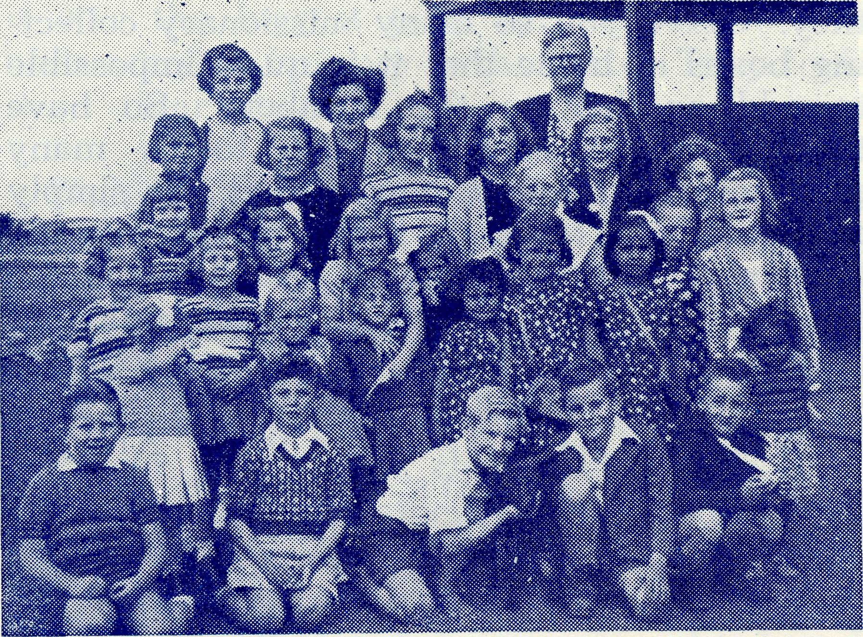
Sister Thomas and Rawlinna S.S.
Rawlinna is a very small speck on any map. If you look very carefully you will find it at the western end of the Trans-Continental Railway line about two-hundred miles from Kalgoorlie. Though it is just off the Nullarbor Plains the country is little different from the flat emptiness of the Plain proper. The township, railway siding, camp or whatever else you may call it, consists of twenty houses in which live the railway workers and their families, a small school and a few odd buildings. North, south and east lies the station country where distances are measured in hundreds of miles.
Rawlinna became of importance to B.C.A. friends at the beginning of this year, when Sister Thomas left Ceduna to take up the work at this far distant spot. It is now six years ago since the O.M. received a request from the people of this Western Australian railway camp for the services of a B.C.A. Nursing Sister, and a promise that they themselves would secure from the Railway Commissioner a suitable building. At that time it was not possible for B.C.A. to do more than bear the request in mind, but in February of this year the project had become a reality.
A strong wind was blowing from the west on the morning of July 3rd as six of us piled into the Dragon. Besides the pilot, Sister Dowling, Dr. Mueller, Mr. Hayman found themselves seats, while the O.M. made him-
self comfortable on the top stretcher. Sister Coleman, on her way to Tibet, occupied the lower berth.
We were off to Rawlinna via Cook, for as the six hundred mile journey is just outside the range of the Dragon's fuel tanks, we must needs refuel at Cook. The headwind made the journey slow and tedious, causing us to arrive at Cook an hour later than we anticipated. However, Miss Ross had dinner awaiting us and we did full Justice to her very excellent cooking. No time was wasted in getting a move on to our destination for the wind was still contrary. The three hundred miles took us all of four hours, and instead of arriving at 2.30 p.m. it was 4.30 before we stepped out of the machine.
Twenty-six people awaited us at the Hostel, and Mr. Hayman was soon conducting the simple service of prayer and dedication to commemorate the opening of this latest outpost of B.C.A. service. The O.M. very briefly officially "opened" the building that had already been giving good service for some months.
On inspection, the Hostel proved to be two railway cottages suitably joined together, and well furnished by the local people. The whole gave the impression of being a comfortable home for the nurse and an efficient centre of nursing service. Sister Thomas has a job ahead of her and we hope that she will be able to lay solid foundations in the B.C.A. tradition.
The same evening, Mr. Hayman conducted evening service in the small hall which does duty as 'church' whenever the Missioner can get around that way. Rawlinna is within the area served by Mr. Hayman and forms part of his Nullarbor trip. To minister to these small railway camps involves him in a round trip of well over 1,000 miles in a little more than a fortnight. Normally, travel for him is over poor roads or in all sorts of trains; to travel to Rawlinna by air was much more comfortable, in Mr. Hayman's opinion.
We ask all our friends to remember very specially these two B.C.A. workers, nurse and missioner, as they minister to the folk in this far distant outpost of our work.

September, 1951.
THE REAL AUSTRALIAN

Fly Away with the B.C.A.
SISTER WORTH OF ADELAIDE

A grey, dull morning with heavy clouds overhead—but that made no difference to the keen anticipation I felt as with Doctor, Sister and the Pilot I boarded the twin-engined 'plane of the B.C.A. at Ceduna.
We taxied across the aerodrome and then turned to face the wind. A final check over the instruments, and then with throttles opened and engines roaring, the "Dragon" sped across the field with great determination. Gaining height rapidly, we were up and away and heading for Tarcoola, on the North-West Line, one hundred and ten miles away, to pay the usual monthly visit to the B.C.A. Centre there.
Soon we were out into brilliant sunshine above the clouds, which were no longer grey, but snowy-white, like an unending snowfield. Later, with unerring skill, the pilot took us down through the clouds once more, and then we could see Tarcoola in the distance, just a few houses on either side of the railway-line. Here, in isolation yet with undaunted courage, the B.C.A. Sister lives and labours, bringing nursing care and comfort to the sick in this outback place, and Christian fellowship as well. The regular visits of the Doctor must do a great deal towards dispelling fear and apprehension amongst those who live in such far-away places.
Whilst Doctor consulted, I was taken to see the township and it was interesting to see the strip of ground where the first emergency landing was made to bring help to someone in need before the regular visits were inaugurated. It was interesting, too, to see the new Hospital next door to the present Centre. Only half-built, one longed to see it completed so that the work could be extended. Built of stone, it will be moderately cool in summer in comparison to the existing weatherboard building, but that is not saying very much, for heat has a way of penetrating. When the hospital is completed, another nurse will be needed and what a joy it will be for the present lone worker to have a companion.
Fortified by a good meal cooked by Sister, we took off in the"early afternoon for Mul-
gathing Station, fifty miles to the North-West, where the B.C.A. has extended its Flying Medical Service to include those who work on some of the outback stations and who would otherwise be hundreds of miles from the nearest doctor. "Doctor's Day" at Mulgath-ing has become one of the highlights of the month and many come from far and near with those who need medical attention. An old farmhouse has been converted into a surgery where Doctor consults, extracts teeth, performs other minor operations and advises on the care of baby, with the B.C.A. Sister as her untiring helper.
The last patient seen, we took off once more with the "Dragon" headed for home, one hundred and thirty miles away. It was dark by the time we reached Ceduna, but the "blessed lights of home" were on, to guide our pilot and, making a perfect landing, we were soon back in the warmth and fellowship of the Hospital.
Two days later we were up and away again, after an early dinner, this time with Penong, forty-three miles away, as our destination. Imagine my delight when I discovered we were to "drop down" at Koorxibba, the Lutheran Aboriginal Station, which lies halfway between Ceduna and Penong. My sympathies were with the sick ones, but it was grand to have the opportunity to see the work being done there.
Back in the 'plane, we were on our way once more to Penong there to meet and see something of the valiant work done by the two B.C.A. workers. No "forty-hour week" has caught up with any B.C.A. worker. A cheerful day and night shift, as the need arises is the order of the day—or night!
Home again, and then a few days later I left for Wudinna, this time in the small single-engined 'plane, the "Moth". I shall always remember the helpless feeling I experienced when, with one passenger already in the 'plane, I put my head inside the door, only to feel immediately that the rest of me would never

THE REAL AUSTRALIAN
September, 1951.

fit! My amazement was still greater when I learnt that the "Moth" had actually carried three passengers.
Once again we were to prove that "His faithfulness reacheth unto the clouds"—for on this trip we flew into stormy weather. Upon landing we were told that a 90-mile an hour wind was blowing. We could quite believe it, as a few minutes later we watched the 'plane take off sideways, or so it seemed, on its way to Kyancutta. Half an hour later Wudinna was enveloped in the worst dust storm it had known for years, but His faithfulness reached beyond the clouds of dust, for by this time the "Moth" was safely in the hangar.
Finally, I had the opportunity of visiting Cook, the railway town on the main North-West line, two hundred and eighty miles from Ceduna. Here it was a joy to find that the Hospital is a spiritual as well as a medical centre, for Sunday School and the weekly Sunday service are held and conducted by the two Sisters in charge. Situated as it is in the centre of the Nullarbor plain, with hundreds of miles of barren country on either side, the Hospital is a real "oasis" in more ways than one. In spite of the isolation and barrenness the workers gave the impression that they would not change places with anyone.
Time would fail to tell of the faithful work being done by the B.C.A. Hostel workers, of which I heard; of the splendid work of the
B.C.A. missioners and their wives, whose parishes extend for hundreds of miles and include isolated railway towns and sidings, lonely stations and farm houses. No inspiration of large gatherings for them—just small groups of faithful worshippers, or groups of people who have not yet learned to worship, but in whose lives is a great need. Once again the impression was gained that no other work in their opinion would pay such large dividends in spiritual satisfaction as that in which they were engaged.
Time would fail, too, to tell of the many stories heard of emergency calls answered, when the Flying Doctor and Flying Sister or Sisters, had taken "the wings of the morning" to take medical aid to someone in the outback.
Then, too, the fellowship and hospitality enjoyed in each B.C.A. Hospital and Centre was something to be remembered with thanksgiving. It was a joy, too, to think of the faithfulness and care of the B.C.A. pilots, so that one travelled in the 'planes without fear of accident, knowing that every detail had been attended to beforehand.
Behind all this vast field of service I saw the multitudes who support it by prayer and sacrificial giving; the leaders who direct it and the love of Christ Who constrains those who share in the work.
For inspiration and blessing I can thoroughly recommend a holiday with the Bush Church Aid Society.

The Timboon Mission

Just a day after I posted my last article to Sydney the bush fires, mentioned in a footnote by the Editor, broke out about two miles away. Within forty-eight hours they had spread alarmingly and were threatening Tim-boon from three sides. It was intensely hot, but luckily the wind was neither strong nor steady. However, by the Tuesday evening the fire was less than 400 yards away on three sides of the Church and Vicarage, and another fire was rapidly approaching the centre of Timboon down the main road from Port Campbell, The lack of water was hindering
all efforts to keep the fires in check and by 10.0 p.m. it seemed as if nothing could save the township, and we had things all ready to leave by the only road left open. A sudden change in the wind then drove the fire almost back on itself and by midnight we were able to go to bed with the glare of fires and the crashing of falling trees all around us.
On the. next day I drove my family and some others to Peterborough, and returned determined to do my best to save the Church property, but with little hope of succeeding.

September, 1951.
THE REAL AUSTRALIAN

It was a still, heavy day with the sky completely obscured by clouds of smoke, and every hour I made a tour round the district to see how things were going. Fortunately there was no wind all day, and by evening the peril was passed.
In spite of the large area burnt out, and the almost simultaneous commencement of fires in at least half a dozen different places, no serious damage was done. Houses completely surrounded by flames emerged unscathed, and altogether we were wonderfully preserved from a major disaster. Finally, the long, drought came to an end with nearly eight inches of rain.
Miss Campbell paid us her promised visit. We re-opened the three Ladies' Guilds during her stay so that she could speak to them about the work of the Society and in particular the Sunday School Section of it. Also she was able to speak to our two regular weekly Sunday Schools and to address the members of two of our congregations. It was a most successful and interesting week for us and was, I trust, the same for Miss Campbell herself. What with these talks and personal visits to Mail Bag scholars, she had quite a busy time, but I understand that Beech Forest really showed what rushing around can be.
These visits from Headquarters are most valuable to us all, and I notice that the results of this visit are appearing in many and various directions. Also, I learned of some of the practical difficulties which face the Mail Bag Sunday School Department, and I do hope that all friends of the Society in Sydney will rally round to try and overcome them. The only hope for the future rests with the effective Christian education of the children, and in these B.C.A. Missions we could do little were it not for the M.B.S.S. Neglect, indifference and plain unadulterated ignorance make our adult Christian community small in numbers and ineffective in witness, and we are liable to leave but a miserable inheritance in worldly things to our children, so let us adventure a little more to see that they secure something more valuable and less perishable.
I was compelled to spend some days in hospital with a most painful sinus infection, I
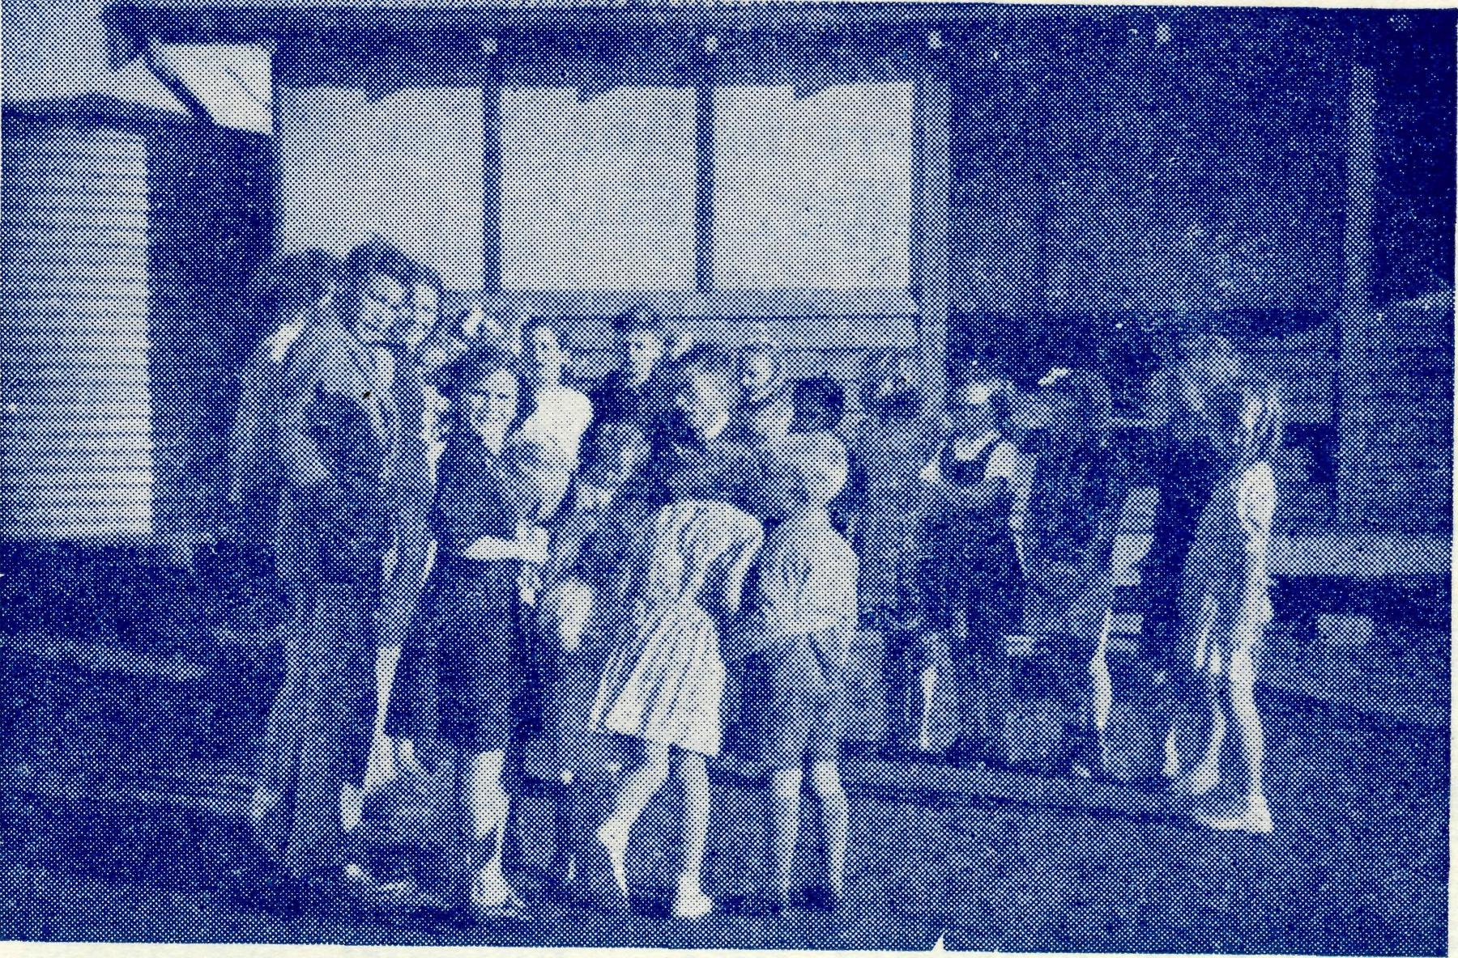
had suffered with it from Christmas, but at last it became so bad and such a hindrance to my duties that I had to seek medical help from that outstanding Christian, Dr. Ian Holt, the son of B.C.A.'s Treasurer. He has finally set me to rights again.
In the past few months, much hostility has been experienced in regard to our use of a hired hall in one centre, and a church loaned by another denomination in another. It seemed for a while that we should be forced to seek other accommodation, but by the help of others more friendly to us, we have been able to retain the use of the buildings, temporarily at any rate. Such unfortunate episodes must happen while things are in their present condition, and the only cheerful aspect is that this opposition indicates a slight crack in the wall of indifference which has handicapped the work of the Church ever since the Society began down here. With the slow, but most encouraging, increase in Church members at Peterborough, especially during the six summer months, I feel that 'ere long it will be essential to have our own church there. So I am opening a Church Building Fund for Peterborough and any gifts towards it will be most thankfully received and acknowledged. Many of our supporters in and around Melbourne particularly are accustomed to spend their holidays in Peterborough and I am sure that they with others will be pleased to help our resident congregation in this way.

THE REAL AUSTRALIAN
September, 1951.

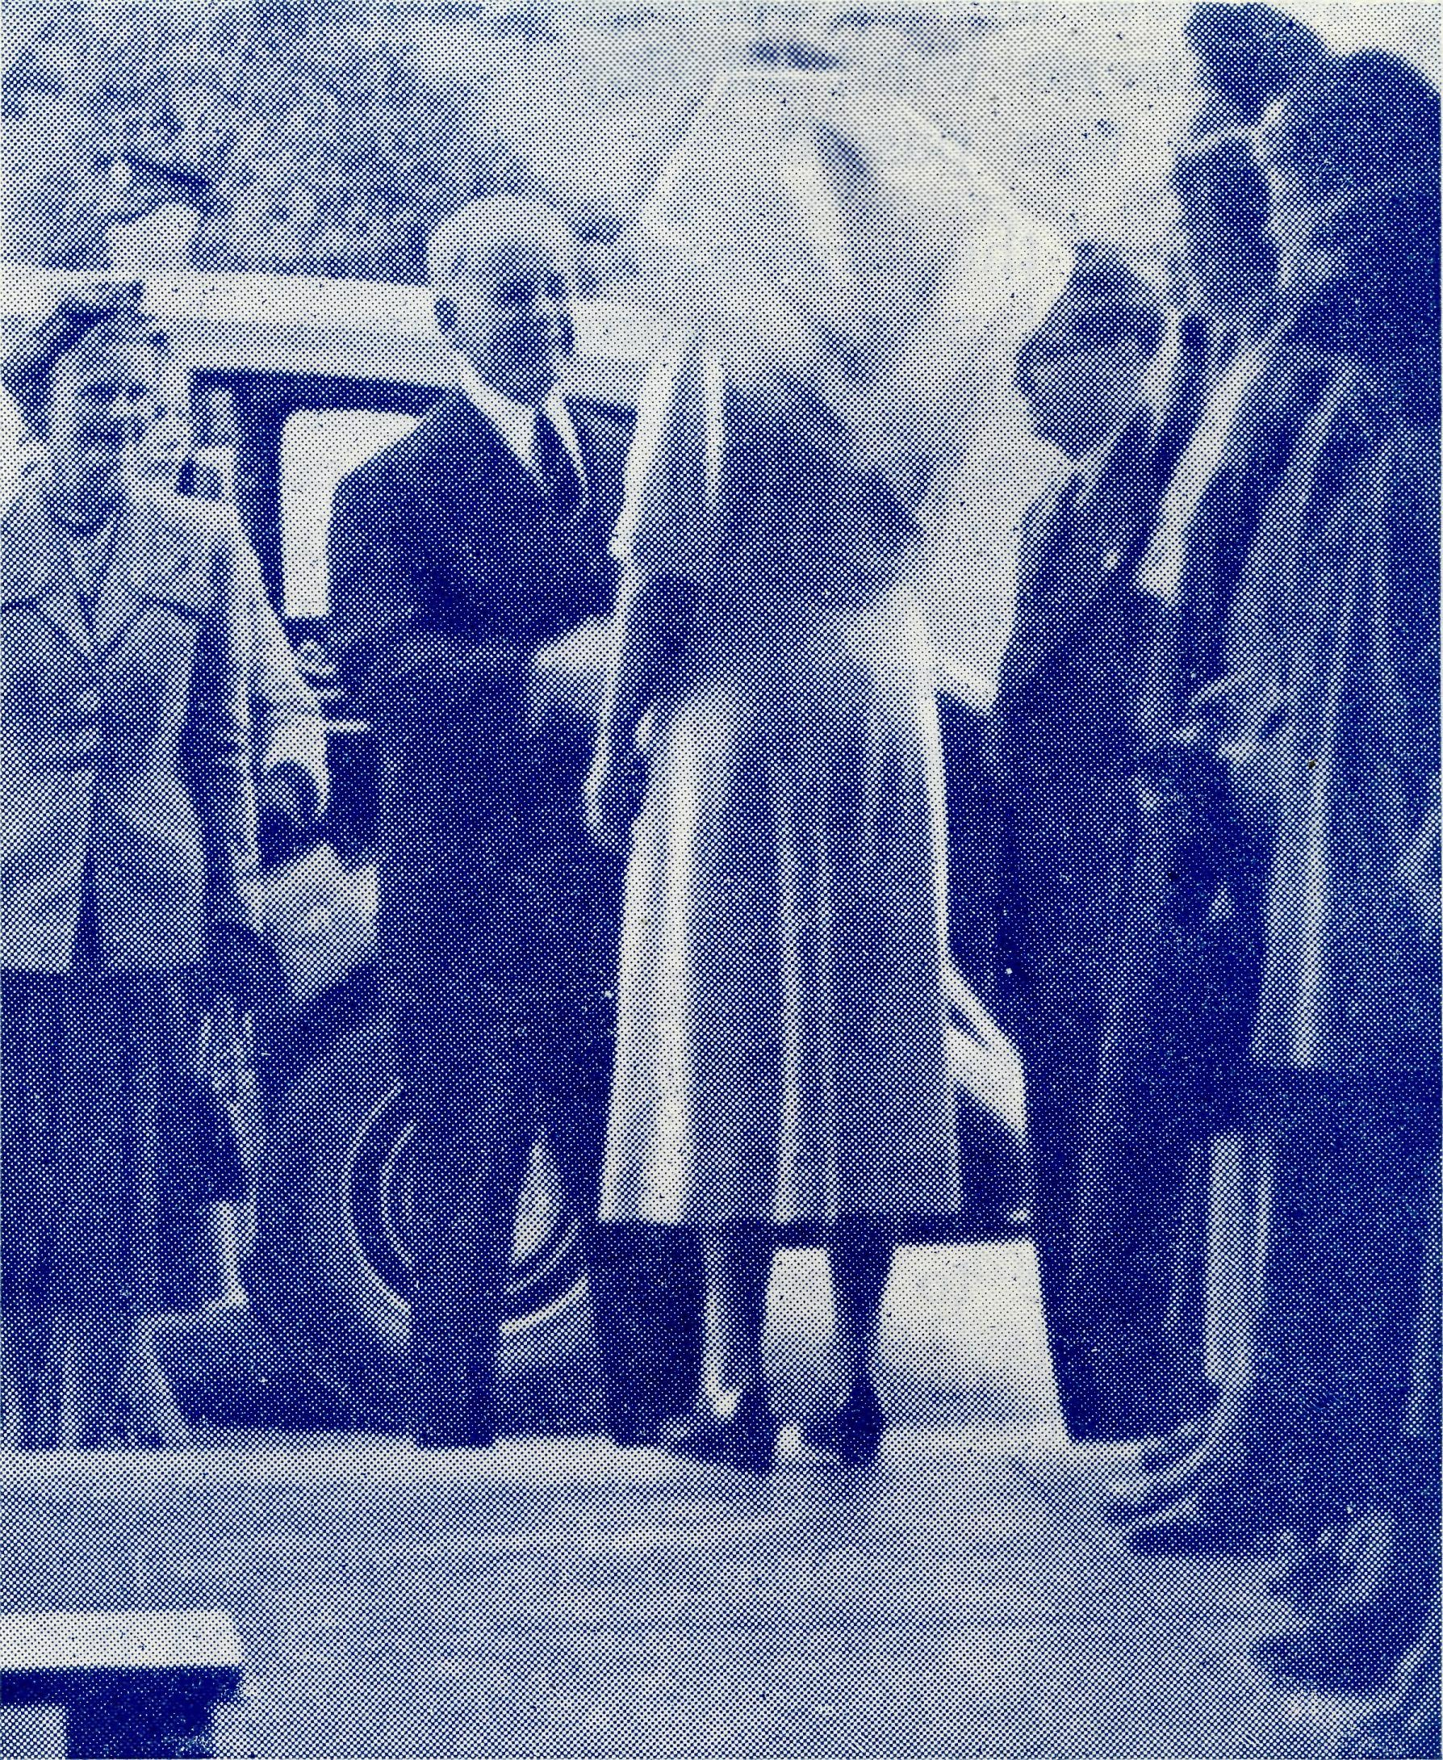
ST. LUKES, CLOVELLY, AUXILIARY TO THE BUSH CHURCH AID SOCIETY
Financial Report for the Year Ending May, 1951.
At the close of this, our fourth year of activity, we have quite a creditable amount of money to be forwarded to the Bush Church Aid Society—here is our Balance Sheet.
Our total funds amount to £87/10/10— the amount collected from Bark Huts is £8/18/4, which leaves a total of £78/12/6 representing our effort for the year.
I think you'll be interested to hear briefly again, just what has been done by this Auxiliary during the past four years. In the first year, 1947-1948, £45 went towards the purchase of Linoleum for "Coorah" Hostel; in the second year, £52 towards the purchase of St. Brigid's Van; last year, £60 for the purchase of medical supplies for B.C.A. Hospitals, and now this year, we have £78/12/6 which I feel sure Mr. Livingstone will help us to dispose of, so altogether we have raised the sum of £235/12/6, plus £42/13/3 from Bark Hut collecting boxes.
I should like here, to thank Mr. Arnold for his kindness in auditing our books each year.
The Governor of South Australia visHs Ceduna Hospital.

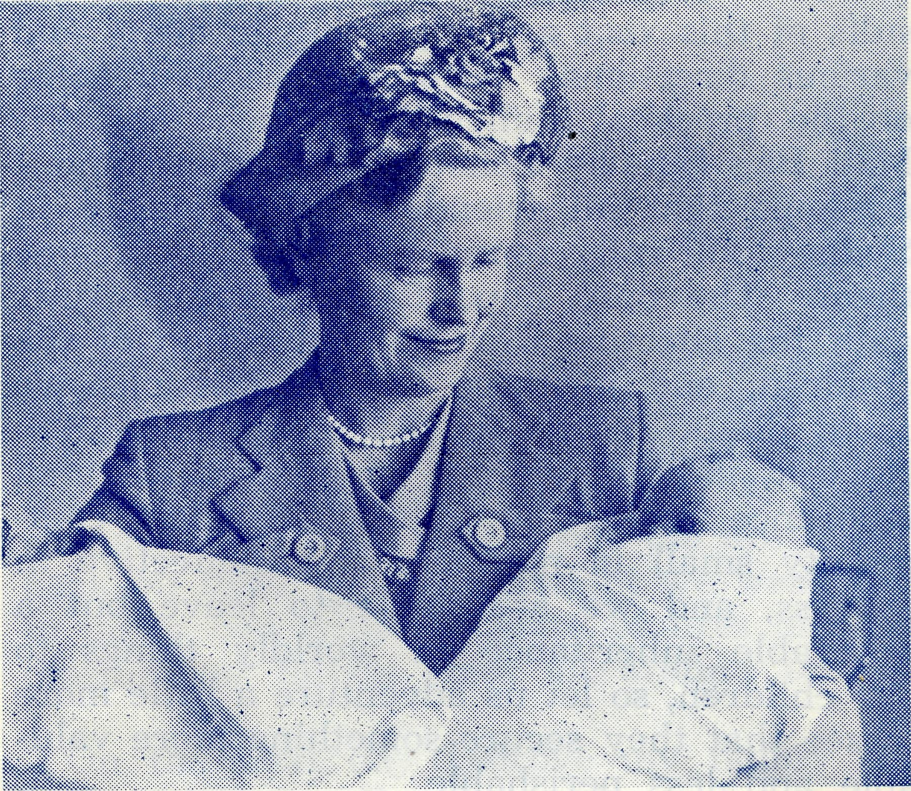
BURWOOD EAST AUXILIARY
This branch has had a very excellent year and we are grateful to them for their continuing interest in B.C.A. activities.
Mrs. Kershaw has supplied us with a statement that shows an income of £38/1/3 and we understand that since the end of their financial year they have raised a further £26/15/- by means of a luncheon.
Thank you Burwood East.
WOOLLAHRA AUXILIARY
This branch again held their Annual Effort in the Rectory and raised the splendid sum of £54/10/3. This parish has always shown keen interest in B.C.A. and the Annual Meeting is always a time of friendliness and inspiration.
This year a large quantity of beautifully made woollen articles were made by a member of All Saints who has passed her eighteenth year.
Thank you Woollahra,
Sister Dowling greets Sir Willoughby Norrie.
Lady Norrie nurses the twins born in Ceduna Hospital,

September, 1951.
THE REAL AUSTRALIAN

From the Bush Padre’s Radio Talks

It was the padre's day off—at least, that is what he had told himself as he settled down to catch up with some of his reading. He got as far as the second page, when that destroyer of days off, the telephone, rang derisively.
Reluctantly, the padre picked up the telephone to hear the voice of the air-pilot of the Ceduna Flying Medical Base. While making his daily inspection of the aeroplane, the pilot, who is his own engineer, had found that one of the main bolts in the undercarriage had broken and he was due to take Doctor on her clinic visit to Cook on the Nullarbor, three hundred miles away, that afternoon. A spare bolt would have to be secured from Parafield, four hundred miles away, and would take time. Could the padre take the pilot down to Kyancutta, one hundred and twenty miles down the road, to enable him to pick up the second and smaller 'plane in which to take Doctor on her mission? The padre put away his book regretfully, attended to petrol, oil and water needs of his vehicle for a two hundred and forty mile trip, and then set out for the aerodrome two miles distant to pick up the pilot.
Four hours later the small "Fox Moth" headed into the wind towards Ceduna to pick up Doctor, leaving the padre enviously gazing at the small speck in the sky and thinking of his slower and dusty trip back to his reading.
The flight to Cook and back proved uneventful and to one who has done the journey many scores of times, the dry, brown plains spreading for hundreds of miles, with an isolated home here and there, was without interest. Doctor was satisfied to catch up on her sleep quota. The clinic patients provided her with nothing unusual or professionally exciting: expectant and nursing mothers to be helped and advised, children's eyes to be examined, a tooth to be extracted, made up routine work for the day.
The day following the return from Cook, doctor decided that a patient in the Ceduna Hospital needed treatment in Adelaide, and when the patient had been comfortably strapped in the bunk, the little 'plane set off
on her four hundred miles to the metropolis of South Australia. The day was clear and bright and the warm winter's sun made flying conditions ideal.
It was on the return trip the following day that trouble came. Half the journey had been completed as the tiny single-engined machine approached the township of Port Pirie on Spencer's Gulf. A few warning splutters and the propeller stopped its hitherto seemingly ceaseless turning. The magneto had failed and, deprived of its vital spark, the engine cut out. Fortunately, the pilot had enough height to make a forced landing on Port Pirie's excellent aerodrome, and a telephone message to Parafield brought a spare magneto in forty-five minutes, by the big "Douglas" passenger 'plane. After an overnight stay at Port Pirie, the small "Fox" was away again early next morning and landed safely at Kyancutta to find that the much wanted bolt for the larger "Dragon" had not yet arrived.
However, to keep the pilot from unduly brooding, Doctor informed him that an old lady of eighty years had broken her femur, and another trip to Adelaide would be necessary. Bad weather had come up and it was necessary to fly just above the tree tops until, an hour later, the "Fox" flew into a clear sky. On arrival at Parafield the old lady was carefully transferred to the waiting ambulance and the pilot bedded down his machine for her second night at Parafield in that week.
Back again at Kyancutta the next morning, and this time Port Pirie was passed uneventfully, but that blessed bolt had not yet arrived. However, Doctor again had some interesting news for him: this time two patients to go up to Ceduna, one a haemorrhage case. The two were duly flown the one hundred and twenty miles and soon recovered. The pilot was satisfied to know he could sleep in his own bed for a few nights—unless Doctor found a few more 'Long distance' patients.
Another day passed, and a bolt was duly found at Broken Hill, and arrived at Ceduna by service car. It was speedily fitted into
(Continued on page 12)

THE REAL AUSTRALIAN
10
September, 1951.

The Flying Medical Services

Calling at Mulgathing on our regular trip one day, Doctor found one of the patients to have a poisoned hand, swollen up like a football, and needing urgent surgical treatment to reduce it. As time was considered an important (factor in this case, we flew straight back to Ceduna where the operation could be performed, and the patient treated in hospital until ready for discharge. Being on temporary employment only at the station, he then returned to his home in Adelaide by surface transport. Having flown this man direct back to Ceduna, we had by-passed Tarcoola, which normally would have been our next port of call, and all the outback station folk from that area were still there waiting to see Doctor. So late that afternoon, Doctor and I flew back to Tarcoola, and after tea, carried on with the consultations until late in the evening, and stayed the night there, returning to Ceduna next morning.
Three days later came the next call, to a man who had been thrown from his horse while mustering, and was found unconscious with severe head injuries, after his horse had come home riderless. When we arrived at the Station, he had begun to come round, but was still very dazed. He remembered practically nothing of his flight down to Ceduna. X-rays showed a fracture of the skull, where he had been kicked by the horse as he fell, and when convalescent, the scar on his head showed very clearly the outline of the horse's hoof. However, a month in hospital put matters right again, and he returned with us on our next regular trip as far as Tarcoola, together with the little girl with burns on her shoulder, of whom I wrote in my last letter. She also had recovered by this time, and was ready to be returned to her home again, and great was her excitement when she sighted Tarcoola through the cabin window. We had by-passed Mulgathing, for we had another very sick child with rheumatic fever to transport back to hospital here, and she had a rather extended stay of three months.
Our third call was to an Adelaide business man who, while travelling through the northwest station country, was taken seriously ill
with an internal haemorrhage. We flew him back to hospital at Ceduna, where he remained for several weeks before he was well enough to return to Adelaide and continue with treatment at the Daws Road Military Hospital, he being a returned soldier and P.O.W. from World War II.
Fracture cases need to be X-rayed whenever possible as the picture provides Doctor with invaluable information when it comes to setting the broken bones. As there is no X-ray plant at Penong, we flew up there one day to transport a fractured leg case down here for an X-ray and appropriate treatment.
Interspersed between all our flying, there are, at various times, numbers of calls that have to be answered by car. We have been called to Streaky Bay for a consultation with the Doctor there, where as yet there is no landing ground at all suitable for the "Dragon". Calls come from Penong and Koonibba Mission Station for Aborigines, frequently at night, when the car is used, as it is when the weather conditions do not permit us to fly in the daytime on our regular trips. I well remember one night call to Penong, when Doctor watched the patient's condition through the night until 3 a.m., when I was called out of bed to go down into the township and bring up an ex-nursing Sister to assist the hospital staff with a major operation. An electrical storm was raging at the time, and the lightning flashes near and vivid enough to render driving possible without the car headlights, while they lasted. With the assistant brought back to the hospital, and the electric lighting plant running to cater for the extra power drawn by the shadowless lamp in the theatre, I was able to retire for a couple of hours until it was time to get up for breakfast.
Then there was a car trip one night down to Wudinna, where there are no night landing facilities. Dr. Rogers rang on Thursday afternoon while we were up at Penong on our usual weekly trip to ask Dr. Freda's opinion about a certain case, and it was arranged that he should ring again later in the afternoon and give a further report. He did
(Continued on page 12)

September, 1951.
11
THE REAL AUSTRALIAN

The Society has been notified of bequests from the estate of Miss M. Symington, Mr. R. L. Brain and Mrs. A. Weatherly and Miss H. Darke.
The Sisters in charge of Cook Hospital will be glad to receive copies of Alexander Hymn Books.
Many thanks to Miss M. E. Puddiphatt for the gift of a portable glass baptismal font for use by the Deaconesses, which will be most useful on their bush patrols. It is given in memory of her two brothers, Thomas and Frederick, who gave their lives in World War I.
Congratulations to the Ken Seymours of Beech Forest upon the birth of a daughter and to the Phil Connells of Streaky Bay on the birth of a son.
Your bark hut should be opened next December and the contents given to your local secretary or State office. Try to break last year's record of £3,307 by the prompt opening of your Bark Hut.
The Society urgently, even desperately, needs qualified nurses for its hospitals and assistants for its hostels. Accept your share in taking the Gospel to the Outback by applying now for these essential posts.
The Society will appreciate opportunities to tell the B.C.A. story and to give lantern talks at mid-week gatherings, meetings, fellowships and similar groups. Arrange a meeting now and leave the rest to us!
Children's Hymn Books in good condition are needed for some of the Hostel children. Any donations either of books or money to purchase these will be deeply appreciated.
Miss Lorna Stuart who assisted B.C.A. in the Head Office for twelve months left recently to commence training for a nursing career. We offer her our best wishes and look forward to her returning to the Society when her training is complete.
Miss Stuart has been replaced by Miss Edith Lawrence whom we warmly welcome to the B.C.A. family.
We have received through the post £5 from a bark hut opening with £1 for the Rally offertory, post marked Narrabri. We are most grateful for this help, but would appreciate the name and address of the donor.
Mrs. E. Reed, of Collaroy, has generously given a portable Organ to the Society. This most useful gift will be a very real help to the outback ministry.
Mr. R. Brooks, of Kensington, N.S.W., has been accepted as a B.C.A. Student at Ridley College, Melbourne. The Society now has ten students in training.
The N.S.W. Secretary was able through the co-operation of the Rector, the Rev. M. Williams, to visit the Parish of East Maitland and neighbouring parishes during the month of August. A visit was made to the East Maitland schools to give instruction to the Church of England classes, and combined groups of all denominations were addressed at the Maitland Girls' and Boys' High Schools and the Largs Public School. At the invitation of the headmaster, the boys of the Church of England Grammar School, Morpeth, were given a talk on the activities of the Church in the outback.
The Warden of St. John's College, Morpeth, gave the opportunity to address the men doing their theological course and as the guest of the Vice-Warden a profitable time of discussion was shared with the men in training.

THE REAL AUSTRALIAN
12
September, 1951.

On Sunday, 5th August, an address about the work of the Society was given at each of the five Church services. Visits were paid to St. Mary's, Maitland (Rev. M. Redman), St. Peter's, East Maitland, Largs and Tenam-bit (Rev. M. Williams), and St. Luke's, Telarah (Rev. C. Jessop). The women at East Maitland and Maitland showed a deep interest in the work of the Church outback, at their respective meetings.
The fellowship and assistance provided by the Rev. M. Williams and the Rev. M. Thomas
(Curate East Maitland) made an extended trip possible and the Society is under a great debt of gratitude to them.
WANTED.—A Small flat by two ex B.C.A.
Hostel Workers. If you can help ring M 3164.
All young people interested in proposed
"Young People's Auxiliary" of B.C.A., are
asked to contact the office in Sydney as soon as possible. Telephone number as above.
Over £700 is now in hand for the Mail Bag Sunday School Van. This money has been given by the young people of the Church in order to help the young people of the Bush. Another £700 is still required and B.C.A. will be grateful if other Young People's organisations can supply the balance. Why not arrange a meeting of your group and invite a B.C.A. speaker to tell you all about this scheme?

From the Bush Padre’s Radio Talks (Continued)

the "Dragon's" undercarriage. The next day was doctor's clinic at the Tarcoola Medical Hostel of the Bush Church Aid Society. Everybody was happy that the large machine was back in operation, for the Tarcoola trip involved taking a nurse as well as doctor and and also provided the opportunity of taking the Sister-in-Charge at this small township on the East-West Line, some much-needed stores and medical supplies. The country between Ceduna and Tarcoola provides one hundred and twenty miles of sandhills, and although a patch of dry salt lakes en route provide possible forced landing grounds, the staff are always happier in the double-engined "Dragon" on this trip. On the return journey from Tarcoola, news awaited doctor of a patient at Cook who needed her attention and the "Dragon" was soon again
in the air, but this time it must needs turn back. Less than an hour's journey out of Ceduna, the pilot saw a severe electrical storm far too extensive to fly around, and much too dangerous to fly through. Sister at Cook was advised by 'phone of the treatment for the patient. All concerned were relieved to learn the following day that the patient had so responded as to make doctor's presence unnecessary.
To keep this aeroplane flying costs £7/10/-per hour. Will you help? Do send for one of my small collecting boxes or 'phone M3164. The address is the Bush Padre, B.C.A., Church House, George Street, Sydney.
Tune in to "The Bush Padre" on 2GB at 11.15 a.m. every Friday and 2CH at 6 p.m. every second Sunday.

The Flying Medical Services (Continued)

this while we were at Koonibba Mission Station where we had called on our way home from Penong, and it was decided that Dr. Freda should go down to Wudinna for a consultation. As it was, our departure from Koonibba was after sunset, and it meant a night landing on the flare path at Ceduna, and putting the Dragon away in the hangar by
the aid of car lights and torches, as has frequently happened of late. While I was doing this with the aid of the aerodrome groundsman on duty, Dr. took the Sisters travelling with us, and the freight, in to the hospital, picked up what other medical equipment she needed, and collected me at the aerodrome gate. We then made the one hundred and

September, 1951.
13
THE REAL AUSTRALIAN

A Memorial
"Presented November, 1950, to the Church at Ceduna by the
Bournemouth Auxiliary of the Colonial and Continental Church
Society of England, in grateful memory of Charles Augustus
Phillips, Priest, Hon. Treasurer, 1922-50."
This is the inscription on a beautiful silver Holy Communion set just received from England. The people of Ceduna are very grateful for this gift, forming a valuable link between our Society and the parent English Society, and between this wee part of Australia and the Mother Country.

thirty miles to Wudinna in three hours, and as a result of the doctors' combined diagnosis, a course of treatment was followed which resulted in a very happy event for someone during the following afternoon.
Late one afternoon at Penong after an already busy day, a 'phone message came through to say that a patient was being brought into Penong from some fifty miles out with symptoms which sounded like appendicitis. On arrival at the hospital, Doctor's diagnosis confirmed this, and the theatre was set up for the operation. Realising that it would be dark before they were able to finish, I set about arranging for lights of some sort to assist me with the take-off. At the appointed time, about eight cars arrived at the landing ground and, lined up at intervals of about one hundred yards, shone their headlights across the ground. This gave me the required guide, and we took off across their beams. A few minutes out from Penong, the rotating beacon at Ceduna became visible, and the rest of the flight was made using the beacon as navigational aid.
At Tarcoola one day, Sister Horsburgh called Doctor on the 'phone from Cook to say that she had a patient in hospital with severe abdominal pains which came on him quite suddenly while working on one of the railway locomotives that morning. We flew along the transcontinental railway for about two hundred and fifty miles to Cook, and Doctor diagnosed the case as appendicitis, and things were got ready to operate. While this was going on, I found that I had some diagnosing to do on my own account. After
refuelling the Dragon, and wishing to taxi back to the hospital (I can bring the 'plane to within about fifty yards of the hospital at Cook), one of the motors simply refused to start. After applying the usual tests for trouble of this sort, I finally located the cause to an electrical fault in one of the magnetos, which necessitated a replacement magneto being obtained from Adelaide. Unable to ring through that night, I booked the call as soon as the Post Office opened next morning, and by the willing co-operation of the aircraft servicing organisation at Parafield, a magneto left Adelaide on the west bound passenger train at midday. Contact was also made with Mr. Bedford at Kyancutta, who flew up to Cook in the Fox Moth that afternoon, and left again next morning with Doctor Freda and Sister Metcalf for Penong, where Doctor was able to carry on with the usual weekly consultations. For my part, I saw that the 'plane was made ready for the return flight when the serviceable magneto had been fitted, and generally occupied myself with several odd jobs that needed doing around the hospital. Some little time after lunch a train whistle was heard, but being nearly two hours before the passenger train was due, nobody took much notice of it, until the train drew into the station, and it proved to be the passenger train running that much early. Well, here was luck and the chance of getting home than night, if the magneto proved docile enough to be synchronised without too much trouble. Recruiting the assistance of one of the local residents, the job went ahead briskly, and was completed within the time limit I set myself.

THE REAL AUSTRALIAN
14
September, 1951.

THE PLACE OF PRAYER
A Prayer for Use with Our Prayer List.
O Lord God of our nation, Who has commanded men to subdue and replenish the earth: Look in Thy love upon all who in distant parts of our land are striving against many difficulties, and are deprived the access of the means of grace. Strengthen and guide the Bush Church Aid Society and all members of the staff. Cheer and comfort them in discouragement and loneliness, bless their ministrations to the good of those they serve, and grant that the message of redeeming love may thus be rooted and grounded in our national life, to the glory of Thy Great Name through Jesus Christ our Lord. Amen.

SUNDAY.
THURSDAY.

MONDAY.
FRIDAY.
TUESDAY.
SATURDAY.
MORNING EVENING
MORNING
The Far West Missions it Penong, Ceduna, Min-nipa and Cowell; the Mis-sioners, Revs. D. Pugh, G. Fuhrmeister and T. Hay-
MORNING
The Cann River Mission, the Bonang Mission, the Streaky Bay Mission; the
Missioners, Revs. J. Shil-ton, D. H Wicking, and P. Connell.
MORNING
For Sisters F. Dowling, J. Miller, Hitchcock, L. Loane, B. Tierney, R. Metcalfe, V. Brealey, L. Lang-tree, and Miss F. Lawtey.
For the Bowral Hostel, Miss E. Cheers. For Theological Students of the Society in training.
EVENING
The West Darling Mis
sions at Wilcannia and
Menindee: the N.W. Mai-
lee; the Missioner, Rev.
W. Mitchell, and Dea
conesses P. Spry and B.
Clarke.
EVENING
The Denmark Settlement; and the missioner Rev. J. Johnston; for the Pharmacist, Miss E. M. Page.
EVENING
For the Cann River Dispensary, and S i 8 t e r
Gwynne and Wudinna Hospital, and Sisters R. Portch. V. Holle, B. Barber, and Staff.
For the Rawlinna Medical Hostel and Sister E. Thomas.
MORNING Fur the Mail Bag Sunday School with its Gospel messages tor „ne tTudicn. For the Director, Mils R. Campbell, the teachers and helpers, that they may find encouragement in their work.
MORNING
For the Bishop Kirkhy Memorial Hospital and Sisters Horsburgh and Ross as they minister to the people on the great Nullar-bor Plain. For Sister Page and the Tarcoola Medical Hostel.
For the President and Council of the Society, that they may be guided by His wisdom.
For the Home Base Staffs, Auxiliaries, and parochial workers.
EVENING
For the Organising Mu
sioner, and Asst Organising Missioner, that they may be strengthened and guided in all their endeavours for the good of the work and in their relation-
^ships- with their fellow
^■workers.
EVENING
For students and all in training for this work of God. For the Heytesbury Forest Mission, and the Otway Ranges Mission, and the Missioners, Rev E. G. Beavan and Rev K. Seymour.
For the Rappville Mis
For the N.S.W., Victorian and South Australian Secretaries.

WEDNESDAY.

MORNING
For the children in the
Mungindi, Broken Hill and Port Lincoln Hostels, and
for the workers, Mr. and Mrs. Hustler, Misses I. Beck, M. Farr, Mr. and Mrs. McLaughlin.
EVENING
For the Flying Medical Services, Mr. Chadwick,
Mr. Bedford, Doctor F. Gibson, and Doctor M. Mueller.
For the wives and families of the Missioners and Air Pilot.
Each day pray that the many needs of the work may
be met. Running expenses of £7 per hour to keep the Medical
'Planes in the air.
Consecrated clergy missioners and other workers foi urgent work in the field.
That our work may continue to progress despite the difficulties of the post-war period.

Give Thanks—
For the rich blessing and wonderful growth of the Society's work. For all the kindly givers who have helped with their self-denials. For the Flying Medical Services. For the joy of service.

September, 1951.
15
THE REAL AUSTRALIAN

An Unusual Prison

One of my friends is the padre in charge of the B.C.A. mission at Txinboon in the Diocese of Ballarat, Victoria. Within the boundaries of his district is the Corriemungle Prison Farm, established by the Victorian Government as its first venture in prison camps. My friend and his predecessors have been chaplains to this unusual type of prison since the inception of the experiment.
The camp consists of a number of wooden buildings for administration, recreational and domestic purposes, the men occupying small separate rooms at night. It is only at night that the men are locked up, and, of course, the place is reserved for good conduct men only.
The first object of this camp is to establish a more or less self-supporting farm from the virgin forest, and then to clear the whole seventy thousand acres of forest and scrub, make roads through it and generally prepare the whole area for settlement.
The padre visits the camp at least once per week, and after having lunch strolls over to and talks with each of the thirty men wherever they are working — in the bush, garden, workshop or cookhouse. If you were to saunter up to one of the groups working in the scrub, you would find it hard to realise that these men are in gaol or that one of their number is a warder, for he would probably have his coat off and be working with them.
Many of these men have matrimonial or domestic worries and find the padre a very good friend and help to them in such matters. A letter written to a wife, or a visit paid to a home, perhaps in Melbourne nearly two hundred miles away can make a very great difference.
The men are of varying types and are "in" for a variety of offences. Let's meet one or two of them. First here is Frank. He is thirty years of age and had a good job as a bank teller, but gambling fascinated him and he fiddled the books to pay his debts. He tells us that from his earliest days he attended Sunday School, sang in the Church choir and belonged to the Church clubs, then left it all and began to play the horses and live far beyond his modest means. Eventually he found himself clearing scrub in the prison camp, with plenty of opportunity for meditation on the stupidity
of it all. He then goes on, to the padre, "Honestly, sir, I am not telling you all this just because you are a padre, but because I now know that when I lost interest in God, I began to get into trouble." We hope he means it, and to give him a chance to prove it, the padre will do all he can to help him while he is in prison and when he comes out. Much can be done to help these men by finding them jobs after a quiet talk with the right kind of employer.
The next in the gang is George, who professes himself full of high ideals now, after six months in prison. Somehow or other his money got mixed up with that of the manufacturing firm he was working for, and George simply could not decide which was his and which was not; now he has three long years to work out that bit of arithmetic. He is firm in his declaration that "he will never do it again" and once in prison is more than enough for him. The padre hopes that George's good intentions will last through the years of freedom, and that the interest he now professes in the thing of God will endure. Meanwhile, he is there to do the best he can for him.
As we move on we meet Stan. There is no doubt about the reality of his change of heart. He never really had a chance in life. Born in a slum of parents who completely neglected him, he had to fend for himself from the earliest times he could remember. He got into the wrong set, went to the worst places and learned the most evil things. Now he undoubtedly is full of a quiet confidence and to him the padre is a special friend who has helped him to realise that life is a splendid thing when you find out the Will and Purpose of God. Stan will need the help and guiding hand of his friend the padre for a long time yet, but my friend is sure that he will grow in grace and stature as a man.
There are, of course, some who have lived on the game and who will be at it again as soon as they are out, and there are others who present problems that are not easy of solution, like the man "in" for marrying six different women. The Padre can but offer his ministry and hope and pray that He Who sees the hearts of all will use his efforts to His own ends.

THE REAL AUSTRALIAN
16
September, 1951.

The camp services are held in the prisoner's recreation room. They are hearty affairs and the singing nearly Kfts the roof at times. Nearly always there is to be found a good organist at the camp, and Frank is never the only one who can sing. A solo or duet is always part of each service and each man shows a genuine interest and listens quietly to the
words of the padre. You will, I am sure, realise that this is no easy ministry. Many are the disappointments and heartbreaks. Yet sometimes my friend while walking down a Melbourne street is greeted with an outstretched hand and smiling face of one who made good, and he then feels it all worthwhile.

Ceduna Works Covers 80,000 sq. miles
By Garth Rawlins

To Ceduna, on South Australia's West Coast, in September, 1926, went a party of medical missionaries of the Church of England's Bush Church Aid Society. The work since has spread to an area of some 80,000 square miles of the vast outback.
In a small stone cottage near the Great Australian Bight 25 years ago began a unique service of Christian healing which some of the world's most isolated people have come to look upon as indeed their "flying angel".
B.C.A. arrived at Ceduna with six years' experience of caring for the needs of bush folk in N.S.W. and Victoria. Its missionary activities so impressed the outback residents that the society was asked to start medical work among the scattered population.
So the cottage was converted into a 10-bed hospital in charge of a pioneer nurse—Sister Doris Percival (now the wife of the Rev. F. Dillon, of Adelaide's Holy Trinity Church), when Ceduna was a one-store-and-hotel town.
In those days it was nothing for Mrs. Dillon to assist at operations by lamp-light amid a raging dust-storm, telephone nursing instructions to a homestead 60 miles away, or receive a patient brought 90 miles strapped to a barn door over the back of a motor car.
Now a flourishing town with a population of 600, Ceduna has the most up-to-date hospital for its size in the Commonwealth, and a flying medical service rivalled only by the Australian Flying Doctor Service.
One of Six Hospitals.
Built by the District Council of Murat Bay in 1937 at a cost of less than £5,000, the
Ceduna Hospital is one of six on the West Coast staffed by B.C.A. personnel. The latest is at Rawlinna, on the W.A. side of the border.
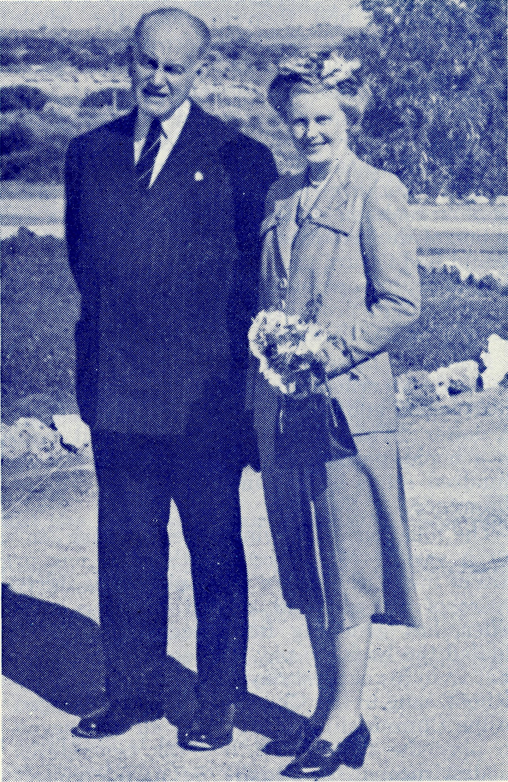
The Governor and Lady Norrie outside Ceduna Hospital.

September, 1951.
in
THE REAL AUSTRALIAN

They are all in charge of efficient Ceduna Hospital matron Sister F. Dowling. She came from Sydney 19 years ago for B.C.A. medical work in S.A.
She is one of five sisters at the hospital. Her four assistants all hold certificates in general nursing, midwifery, and mothercraft. Even the cook is a double-certificated sister.
Their qualifications would enable them to earn high salaries in city hospitals, but they prefer to give their services for appreciably less in return for the satisfaction of "serving God and the outback".
Women form the backbone of the B.C.A. medical organisation. It has its own pharmacist at Ceduna. Miss E. M. Page, of Sydney, services the area's medical needs from her modern chemist shop.
Liked Job and Went Back.
One of two women doctors who devote their time and energy to B.C.A. is famed flying doctor Dr. Freda Gibson, O.B.E., M.B., B.S., a mother of two children.
She has flown thousands of miles tending outback sickness since she succeeded her husband, Dr. Roy Gibson, three years ago. He had been B.C.A. flying doctor for 15 years before he died.
Dr. Gibson's assistant is Dr. M. Mueller. The daughter of a former superintendent of nearby Koonibba Lutheran Native Mission Station, Dr. Mueller performed locum tenens work for Dr. Gibson last year, but liked the work so much that she returned permanently early this year.
Two aircraft, a 90-m.p.h. Dragon and a Fox Moth, capable of cruising at 85 m.p.h., are used by the doctors and nursing sisters. The planes are in charge of slight, friendly pilot Mr. Arthur Chadwick.
The Fox Moth, believed to be the first aircraft wholly built in Australia, at a cost of £1,660, is based at Kyancutta, 130 miles away.
Mr. Chadwick's interest in a Victorian aero club brought him to South Australia to start
the B.C.A. flying service in 1938. Since then he has:
0 Made 957 trips (92 in the past year) ;
• Covered 229,806 miles (18,173);
© Spent 2,934 hours in the air (220);
• Visited 13,418 patients (1,076).
He has a relief pilot, Mr. W. R. Bedford, a motor engineer at Kyancutta. A slight stammer prevented him from joining the R.A.A.F. for air-crew service in World War II, but it hasn't stopped him from flying hundreds of miles for B.C.A.
Regular flights are made to Koonibba, Penong, Coorabie, Cook, Tarcoola, Wudinna, and Rawlinna (W.A.). Trips are also made to such faraway places as Port Lincoln (240 miles from Ceduna), Miller Creek (200), Coober Pedy (270), and Parafield (390).
1 met Mr. Chadwick on what he considered
an ideal day for flying. With Dr. Mueller,
Sister Dowling, and B.C.A. organising mis-
sioner (the Rev. T. E. Jones), he had flown
at 5,000 ft. on the Tarcoola run from Ceduna.
Caught in Dust Storm.
But weather conditions are not always suited to flying. Mr. Chadwick has often been caught in a whirling dust storm, and has had to hover low over the transcontinental railway line for his Nullarbor navigational aid.
Some outback sheep stations have provided their own air strips for B.C.A. planes. One such station is at Mulgathing, 130 miles north of Ceduna. On its 2,000 square miles some 60 people are served by B.C.A.
If it had not been for the flying service, a case of toothache would have cost an elderly station hand a 620-mile return train trip to Port Augusta, via Cook, for treatment.
Hundreds of lives have been saved in the past 13 years.
Mr. Jones, who inaugurated the flying medical service, has been attached to B.C.A.'s Sydney headquarters for 17 years. He's proud of his "baby" and has cause to be.

THE REAL AUSTRALIAN
IV
September, 1951.

B.C.A. provides its own hospitals, staff, as well as doctors throughout the West Coast.
Mr. Jones quietly conducted me round Ceduna Hospital one day recently. As he pointed to a new terrazzo floor, recently installed at a cost of £ 300 in the operating theatre in memory of "Dr. Roy", he said significantly: "We're very proud of those who have sacrificed so much for God's work out here."
Among B.C.A. statistics he gave me, I learnt that it costs about £5,000 a year to maintain the S.A. flying medical service; the annual plane overhaul alone costs £1,000.
B.C.A. still manages to charge some patients rates lower than an Adelaide taxi fare.
That is made possible by contributions by Church of England adherents mainly in New South Wales and Victoria, where large-scale B.C.A. activities include missions, hostels for outback school children, and a mailbag Sunday school.
These services also benefit South Australia, and the society's flying medical service operates in no other State. But South Australia pays little towards its upkeep.
Surely this is a good case for a Government grant.

Donations by Church Folk.
Petrol costs 3/11 a gallon at Ceduna; in some outback parts the charge is 8/-. Yet
An interesting article which appeared in the Adelaide News on llth September, 1951.

“The whole multitude were Praying”

In all our endeavours for the salvation of men, do we lay all before God?
Do we tell Him each detail—intimately?
Do we ask Him for all He will give— confidently?
When there is work to do for Him in far away places, when we possess servants of His who will undertake it, do we get "cold feet" and ask for a balance in the bank before we bestir ourselves, or do we tell Him all about it and then go and buy the railway or steamship tickets?
We organise societies, we appoint committees for this and that. We have the finest speakers and get the best publicity we can. We collect money and are filled with the best intentions for its administration.
We do it all for God's own Kingdom and desire nothing for ourselves, be it either fame or a good salary.
But the spiritual results will be exactly in proportion to the power of the Spirit of God that is found in it—and the degree of that power will again be in proportion to the sincerity of the prayers we offer around it.

"ACCORDING TO YOUR FAITH BE IT UNTO YOU"
EDGAR BRAGG ft SONS PTY. LTD.. PRINTERS 4-« BARKER STREET, SYDNEY

