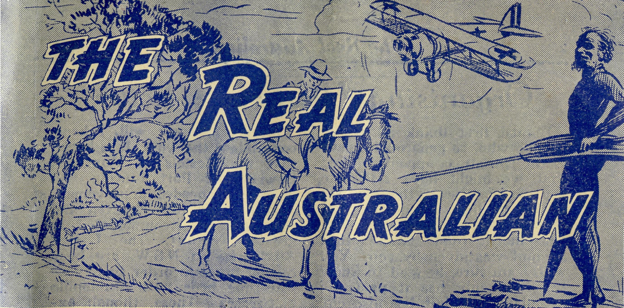
No. 1 (New Series). MARCH, 1952 2/6 per annum, post free.
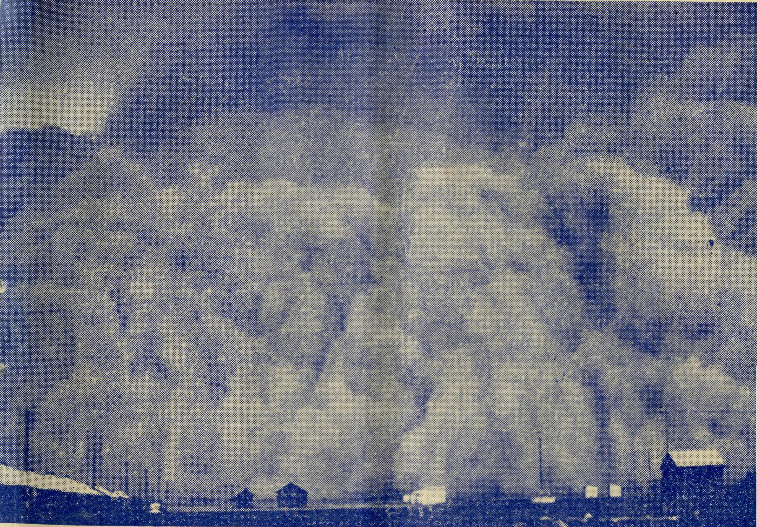
A dust storm at REID, South Australia. Registered at the G.P.O., Sydney, for transmission by post as a periodical.
The Official Organ of THE BUSH CHURCH AID SOCIETY
Church House, George Street, Sydney, N.S.W.

The Real Australian
March, 1952.

Organising Missioneds Letter

I must first thank all B.C.A. friends who, so generously, gave to the Christmas appeal. I asked that we might have £1300 to pay the expenses of the overhaul of the medical aeroplane. That seemed asking a very great deal, yet more than twice that amount was given by you. You will, I am sure, be glad to know that not only has it paid the aeroplane bill, but has also enabled us to finish the year with a goodly credit balance. Thank you, alj. It has given us great cheer and sets us off smilingly for the present year.
The high production costs of the "Real Australian" and the scarcity of good quality paper have made it imperative for economies to be made. To have increased the price would not have solved our problem, for as our printer holds limited stocks of certain paper which we use, and fresh supplies are not coming to hand, we should have had to cease publication during the next twelve months, or use alternatives.
With this issue, therefore, the size of the pages of the "Real Australian" has been reduced by half, but it contains almost the same amount of reading material as before. This has been effected by using a slightly smaller type. I am sure that our readers will understand and bear with us in this matter.
During 1952 we will, I hope, consolidate the work. It is hoped that the Hostels at Mungindi, Bowral and Port Lincoln will have much needed improvement made so that the children and staff will be accommodated in greater comfort. The Ladies' Auxiliaries in N.S.W. are busy raising funds in order to replace war-time beds with Dunlopillo mattresses. These, though expensive, will solve the bed problem once and for all. Maybe, you would like to help them. We need also to complete the payment of the Broken Hill Hostel and there is sure to be many odds and ends coming along.
We are glad that, at last, it has been found possible to staff the Mission at Rappville and we are sure that Mr. and Mrs. Ger lach will do an excellent work there.
It is cheering also, to be able to announce that we have three new additions to our men in training, Messrs. Warburton and Brookes to Ridley College and Mr. Tom Jones jnr. to Moore College. They will be helped by your prayers for them.
Thank you for all your prayers and help that have enabled B.C.A to do so fine a job. Let us see that it so continues in the days ahead.
—The O.M.

I Saw Cook
By A Visitor
I had decided to spend my took my seat in the Trans-con-
holidays visiting the B.C.A. tinental train, and set out on
Hospital at Cook, so one bright. _{h} the long journey to the centre
sunny day in September last, I of the Nullarbor.

March, 1952.
The Real Australian

The country about Adelaide was looking very green and fertile after the recent rains, but I was soon to learn that all the world was not like that. The next morning, we were in the Mallee scrub country, and before that day was out we had left all vegetation behind and were on the flat, arid Nullarbor. The transition seems to come quite suddenly. One moment there is the scanty Mallee, the next—nothing.
Many of the little camps are named after the early Prime Ministers, some are simply designated by the number of miles they are from Port Augusta. They are quite small places. Just a handful of homes, together with accommodation for men away from their home while on shift work.
These are the little settlements for which the B.C.A. cares. The heat, dust and flies of the summer, and the cold, biting winds of the winter, the isolation and the great distances from friends are the conditions under which the hospital staff and the missioners work.
A few hours before the train reached Cook I received my initiation into the local colour. A first-class dust-storm met us head-on. It swept through every crack and cranny, and in spite of the hurried closing of windows and doors, we were soon covered in a thick coating of red dust. Of course, it became oppressively hot in the closed train, and when the conductor brought afternoon tea, it was very welcome.
Later, the train attendants swept un the dust and opened the windows and we were able to appreciate the cooler air. By
the time Cook was reached it was much pleasanter. Sister Horsburgh was waiting to meet me and soon had me over in the very lovely Hospital. Sister Ross had a cup of tea ready, and when I had refreshed myself, both of the girls proudly showed me around the building.
All the rooms have high ceilings, very necessary in that climate, and there is a fine verandah running round the four sides of the building. The wards and other rooms run off both sides of the wide hall that divides the hospital, and it was amazing to see the high gloss of the floor.
There are two main wards, one for women, the other for the male patients. A truly lovely nursery, a well equipped operating theatre, sterilizing room, dispensary, the staff's comfortable quarters and the usual kitchen and domestic arrangements.
There is nearly always a baby in the Cook hospital, and that calls for very early rising for the sister on duty; babies have their breakfasts very early, and on my first morning I was spoilt with breakfast in bed.
The B.C.A. 'plane arrived on my first day, so I had the opportunity of meeting some of the members of the staff from Ceduna, together with Dr. Freda Gibson. It was the first and smallest of the two 'planes, and seemed so very tiny after the large passenger 'planes I had seen. However, it does a verv big and important fob.
The B.C.A. is blessed in having such fine workers in its ranks, and it is to be hoped that many more will offer for the fine service the society renders to the people in these lonely places.

The Real Australian
March, 1952.

Timboon
Rev. E. Beavan

Our Temple Day Services were held at Timboon on Sunday, Nov. 11th, so we combined them with Remembrance Services. The Rural Dean came down from Camperdown to be our special preacher. We were happy to have him with us for the first time since our church was opened. There are still many things which we must do to improve our church building, and the collection, which was slightly more than that of last year, will go a considerable way in providing the necessary finance.
Early in December the O.M. came to us for a week and was able to see most of the mission, including the Prison Farm. I am sorry to say that he did not see very many worshippers at the three services at which he preached, for it was a particularly wet week-end. I hope, however, that he found his visit as useful in gauging the position here, as we were pleased to have him.
The Christmas Season started off with the annual Christmas Concert at the Corriemungle Prison Farm. A party of good friends from Cobden came down, as in previous vears, to entertain the men. We had hoped to stage the concert on the green lawn in the front of the administration buildings, but as the day turned out to be one of our usual wet ones, we had to go indoors. However, everybody enjoyed themselves immensely.
Then we had our Sunday School Prize Giving and Christ-
mas Tree in the Timboon Hall. Nearly all the 52 scholars attended together with 40 adults. It was a very noisy affair, but a happy one.
We have made some alterations to the planning of our Sunday School, and have decided to hold it at the same time as Morning Service. The scholars assemble in the church with the congregation, sing a hymn, join in corporate prayer and then go off to their classes in the vicarage and the vestry. This arrangement has led to a very big improvement in numbers and efficiency. Some of the children come up to eleven miles in order to attend.
The Sunday before Christmas Day I baptised six children, quite a large number for a country district for one day. In the evening of the same day we had our Carol Service at Timboon, using a film strip to project the words on to a screen, and then to show a picture-story entitled "The First Christmas," with which we concluded our service.
The Christmas Day weather-was perfect and I do not recall ever seeing the sea at Peterborough so calm and blue as it was when I arrived for service. We had congregations well above the average at Peterborough, Port Campbell and Timboon and it was very moving to realise that we were joining with tens of thousands of others throughout the world on the same day, and in the same

March, 1952.
The Real Australian

words to commemorate the birth of Our Lord, in remembrance of the salvation He brings to us.
A happy day ended with a Carol Service at Port Campbell,
this being a joint effort by the Ministers' Fraternal, and I now look back on the most impressive Christmas Season since I came to Timboon.

Coming To Sydney
Deaconess Spry

Last Saturday I arrived home from Sydney, where I had been for a week, having taken seven of the young girls from the Parish to the seaside for a holiday, and seeing the temperature has been over the century every day since our return, we have been wishing ourselves back by the sea!
This was a new venture by the Society—our aim being, not only to give the girls a holiday, which they had—a good one at that, but to instruct them in spiritual things. A very keen interest was shown.
On Wednesday, 9th January, I was due to leave here at 9 a.m. with 4 girls from Wilcannia, aged between 10-12 yrs, one girl's home being on a station some 50 miles out. However, at 8.15 a.m. there was a phone call from the hospital informing me of a death, which meant a 6 hr. delay, for I had to take the funeral!
Eventually we were on the road, the kiddies were beside themselves with excitement, having been packed for over 24 hours and ready waiting to leave for 6 hrs. We had travelled only about 30 miles when the engine of the van caught fire! You can imagine the panic and heart turns. Fortunately it was quickly smothered and without very much delay we were on the way again. The nerves were feeling a bit shattered although I was
full of praise to God for "keeping" us.
We had some 70 miles to go to Menindee yet, and time was quickly passing. We were due at Menindee for 7.30 p.m. service as Mr. Mitchell is on holiday and it gives the folk an opportunity to worship. The road was anything but good; however, we arrived only half an hour late and a good number were in the church singing favourite hymns, awaiting my arrival. Although it had been a very tiring and exhausting day, I felt that the Evening Service was of great blessing and was worthwhile.
The five of us were comfortably accommodated at Menindee, some at the Methodist Nursing Service and some with the mother of one of the Menindee Sunday School children who joined our holiday expedition.
Thursday at noon our train pulled out. Two of the number hadn't been in a train before— they all were too excited for words! Two more girls joined us at different stops along the line, making us a party of eight. Some of the girls were strangers —but not for long.
We sat in the Silver City Comet, commonly known as the Diesel, for 7 hours; a terribly hot day and the air-conditioning wasn't working and of course, we couldn't put the windows up! It was most un-

The Real Australian
March, 1952.

comfortable and trying, but as the train pulled up at Parkes and we prepared to change, I heard one of the party say to the other, "Well, I thoroughly enjoyed that!" Words failed me!
After a hurried tea at Parkes the girls anxiously boarded the steam train; although it was stifling in the compartment they couldn't be persuaded to stay on the platform—"No, the train might go!"
It was almost an impossible task to get them to sleep—"No, I'm not going to sleep until I see the Blue Mountains", and "I'm not going to sleep until we go through a tunnel!"—I wish I could have made a recording of all the questions that were asked, and for hours before the train arrived in Sydney I was asked, "Miss Spry, is this Sydney?" The train was an hour late, and we all were ready many, many miles back—but we passed the time playing guessing games, which were interrupted with multitudes of questions!
At last we were at Central! The girls were very quiet, but nevertheless didn't miss a thing. As we were travelling from Central out to Doll's Point (where Mr. and Mrs. Freeman very kindly loaned us their home. We shall always be indebted to them.) one of the girls seeing the tramlines, said, "Look! The train lines go along the streets!" Mr. Greenwood was asked, "Where is the Church?" He hastened to explain tha^{f} there are many churches in a city.
All hands were hungry and tired, so after breakfast the girls had a rest until dinner time; then we had our first swim. Some had been in the sea before, but two of them hadn't
previously seen it. They weren't impressed! It was salty and what's more, there were jelly fish there which were frightening! But it was cool. None of them wanted to go in again. However, the next afternoon as we were preparing to go down, I suggested they put their togs on under their frocks, just in case—After a little persuasion they all came in and I had a job in getting them out. That P.M. some of the B.C.A. Staff and friends joined us and we had games and a picnic tea. As I walked home with the girls the smallest member of the party said, "Well, that was better than I expected it to be. I didn't think it would be much of a picnic but it was good!" This remark was unanimously agreed upon by all the party. It was good to hear, but still better was the following request, "Miss Spry, can we have longer at Prayers to-night for there's something I want to ask you?" All desired the same, so I arranged, after we'd showered and got into pyjamas, to have a Question Time, followed, after supper, by Prayers. The keen interest really did my heart good. There was a portion of Scripture, read the night before, which they hadn't understood, though the morning Bible Study was clear in their minds.
Can you imagine what it's like never to have used a Bible before, or to have had any Christian association or teaching, never to have joined in singing with others? That was the case with some of our party and, as we learnt our Camp Chorus and to sing Grace, it was verv obvious that some of the girls who have lived on stations and received correspondence school

March, 1952.
The Real Australian

lessons, just hadn't any idea of tune. Bravely though, they fought on and toward the end of the time were making some headway.
Each day was packed full; we were always up early. We were very well fed by Miss Farr, of the Mungindi Hostel, who very willingly gave up part of her holiday to look after us. After breakfast we had our Bible Study then off we went. We attended the Cathedral for 11 a.m. service on Sunday. We in spected Deaconess House, all signed the visitors' book, wondering if perhaps some day some of the number may return as students. We saw also Moore College, the University buildings and the Prince Alfred Hospital, had our lunch in the University Park—as we were eating, someone, on seeing a double tram, exclaimed, "Look at the double decker car!" "That's not a car," came a scornful reply, quickly followed by "Say! What is it anyway?"
After getting home, resting and having tea, we attended the local church. I might say the girls were very impressed by the "most beautiful big church" (the Cathedral) and requested that they might inspect it later.
We didn't have to suggest writing home, for that was done Friday and Saturday. There was much to tell about the train trip, arrival, first swim and quick shopping expedition.
On Monday we went over "the Bridge" by train and walked back, had dinner at Coles' Cafeteria which was a great treat and then went from one big store to another, where there was much excitement buying, not for themselves, but something to take home. "Dad"
proved a difficult one to shop for, and the cause of much consideration and concern, but finally something suitable was found. There was nothing selfish in their shopping. Tuesday we visited the Zoo, travelling of course, by ferry. There is no need to say who was exhausted first.
Wednesday we were taken by Mrs. Livingstone snr. and her friends to the open beach at Cronulla, by car. To swim ir-(and taste of) the Pacific, to be knocked over by breakers, build sand castles, walk along the beach, climb sandhills and gather shells, swim in the baths, climb on the rocks and lie in the sun. for it was a cool day, and eat lovely meals was a tremendous thrill from beginning to end, our treat being concluded by going home "on the punt". We loved every minute of it. I wish you could have seen the joy on the kiddies' faces.
Thursday brought forth another thrill, the inevitable trip to Manly, Mrs. Livingstone kindly taking the girls while Miss Farr and I attended the Farewell Communion Service for the Rev. Alf and Mrs. Gerlach who are going to our mission at Rappville. After having lunch at C.M.S. we made our way home. I wish you could have seen one of the girls while we were on the underground railway. She kept a handkerchief over her nose and mouth because of the terrible smell! She is so used to the good clear fresh air, she couldn't bear the other. The same lass wanted to know why the sky was always such a dirtv colour, "not nice and blue like it is at home."
The escalators caused much amusement, too! Fear possessed

The Real Australian
March, 1952.

them prior to getting on—but before long they just loved them, especially at Wynyard, where we had to do it twice.
In spite of all the excitement and adventure, never did they lose their enthusiasm over Bible Study and Prayers. It was all part of the day and was as important as the rest. How vital it is that this truth should be impressed on their young lives and that Christ become a real, true, living Companion to each of them. Opportunity to teach this is given when the church takes the children into its care and gives them such a holiday. But it must be followed up by others, by a reunion during this year; do pray concerning this.
Each girl joined the Scripture Union—pray that they may faithfully read their Bibles day by day. It's not easy when away on your own. Some of these girls are 100 and more miles from Wilcannia and are not getting regular visits. Do pray especially for them.
The last day we were in Sydney, in spite of being up early to Manly and back, a long trio, "a last swim" had to be had. So off we went—and it proved to be "the best swim of all". The tide was in and the enclosure proved quite rough. Some learnt to do "the dead man's float", others learnt to swim a stroke or two, the rest just thoroughly enjoying it all. Believe me, we found it hard to get out and go home, knowing the long, hot, dry time ahead.
The excitement about "going home" was every bit as great as "going to Sydney". Each wanted to go home and "tell Mum and
the others all about it". We left on the 8.50 p.m. train so saw something of the city lights before departing, which proved to be a great thrill.
I can't let this "screed" go without mentioning the wonderful behaviour of the children. There wasn't the slightest trouble with any of them; they were most wonderfully behaved and it's a pretty tiring business travelling 1336 miles in 10 days.
As we neared Menindee on the Friday after spending 21 hours in the trains, and knowing I was conducting a service in Menindee that evening, one of the girls looking very weary and hot, turned to me and said in a very old-fashioned way, "I don't think I could register a service to-night, Miss Spry." I knew only too well how weary she was. Each had the option of going to bed or church, knowing they would be up early in the morning for the 100 miles trip uo river to Wilcannia in St. Margaret, but all decided to go to church, AND kept awake all the time, afterwards quite proudly saying, "How were we in church, Miss Spry?" knowing full well all I could do was to tell them how wonderful they were.
It was 1 p.m., Saturday 19th, when we arrived home, very hot. 114 deg., but we had had a lovely time. Of course, that morning we had been thinking ouite a bit about Deaconess Clarke who was being married in Sydney. We wished amongst all other good wishes, that she might have it cool!

March, 1952.
The Real Australian

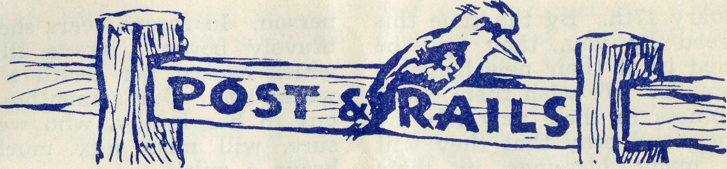

REV. DAVID LIVINGSTONE
It is with regret that we announce that Mr. Livingstone leaving us, having resigned as from March 31st. He joined the staff of the society in January 1939, being first, missioner at Wilcannia and five years later transferred to Streaky Bay. Towards the end of 1946. Mr. Livingstone came to Sydney and joined the administrative staff. During his long service, he has won, both for himself and the society, a great many friends-and has been a welcome depu-tationist wherever he has been. Our good wishes go with him and his family as he takes up his new duties at Auburn.
Remember the work of B.C.A. in your will.
REV. JOHN GREENWOOD.
We are glad to announce that Mr. Greenwood has been invited by the Colonial and Continental Church Society to visit England for a deputation tour. He will leave on April 1st by the "Oronsay", and will arrive in England on May 3rd, in time for the C. & CCS. Annual Meeting. We are confident that Mr Greenwood will do much to commend the work of the B.C.A to our friends at home.

REV. F. H. B. DILLON
The Dillons have been a tower of strength to the B.C.A. cause during their six years at Holy Trinity Adelaide. Many of the staff are much in their debt for the friendliness and generous hospitality received from them. They will certainly be missed in Adelaide and it is St. Clement's, Mosman, good fortune to have them in the Rectory very soon. We pray that Fred and Doris will find rich blessing in their new task.
* * *
Remember to listen-in to the "Bush Padre's" wireless sessions at 11.15 a.m. every Friday from Station 2GB and at 6 p.m. on alternate Sundays from 2CH.
DR. J. UPSDELL.
Dr. Upsdell, together with his wife and family arrived in Adelaide on January 8th by the "Orontes". The doctor's mother who accompanied them, was unfortunately ill on arrival, and had to be transferred to hospital. We understand that she is now recovered. The Doctor joins our staff at Wudinna, and we hope that he and his family will be happy in our work and family, when thav settle down to the new conditions.
REV. A. GERLACH
Mr. and Mrs. Gerlach were farewelled by some of our Sydney friends at a service of Holy Communion held in St. Andrew's Cathedral on Thursday,

10
The Real Australian
March, 1952.

January 17th. By the time this is read by you, they will be settled in at their new home in Rappville. We wish them every happiness in their new life together, and pray that they will find many blessings in their work.
person. In recent years she had bravely borne a grave illness, which caused her death a few weeks ago. Our sympathy goes out to her family, who we are sure, will miss very much so brave a spirit.

MRS. BODE.
Our friends will be glad to know that Mrs. Bode is making good progress. She is now out of hospital and hopes that very soon she will be able to walk a little. Her address is 24 Robert St., Strathfield.
MISS D. DYKES.
Miss Dykes was for many years housekeeper-nurse at the Bishop Kirkby Memorial Hospital on the Nullarbor. She also did a faithful work amongst the children at that place, especially in the small school to be found there. Later, she did service at the Wentworth Falls and Wil-cannia hostels. She was known as a very cheerful and happy
SECOND-HAND ARTICLES.
Will our friends please note that we must ask that no more second-hand articles be sent to us at the office, unless they are specifically asked for. Our office space is so limited that the efficiency of the work is often impaired by the goods that must find a temporary home there. We also find that many things sent in are useless to us, especially in these days of heavy freight charges. The following goods we do require, and would be glad to purchase them at reasonable cost.
Two lounge suites and some chairs in good condition.
A piano suitable for teaching.
These are needed for one of our hostels.

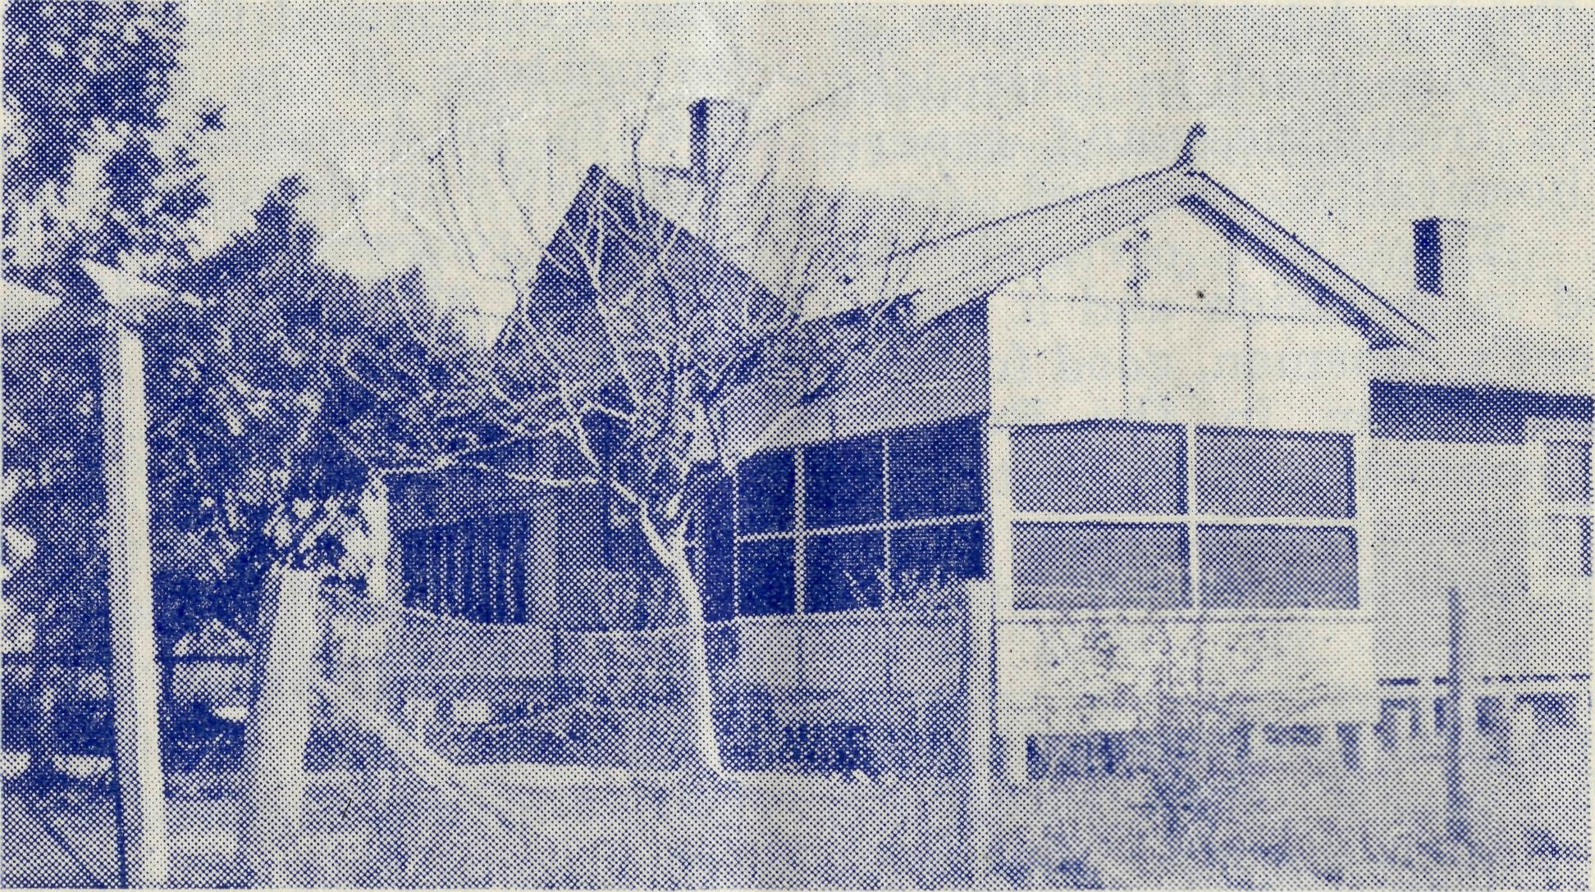
Girl's Hostel, Mungindi

March, 1952.
The. Real Australian
11

The Bush Padre s Radio Session

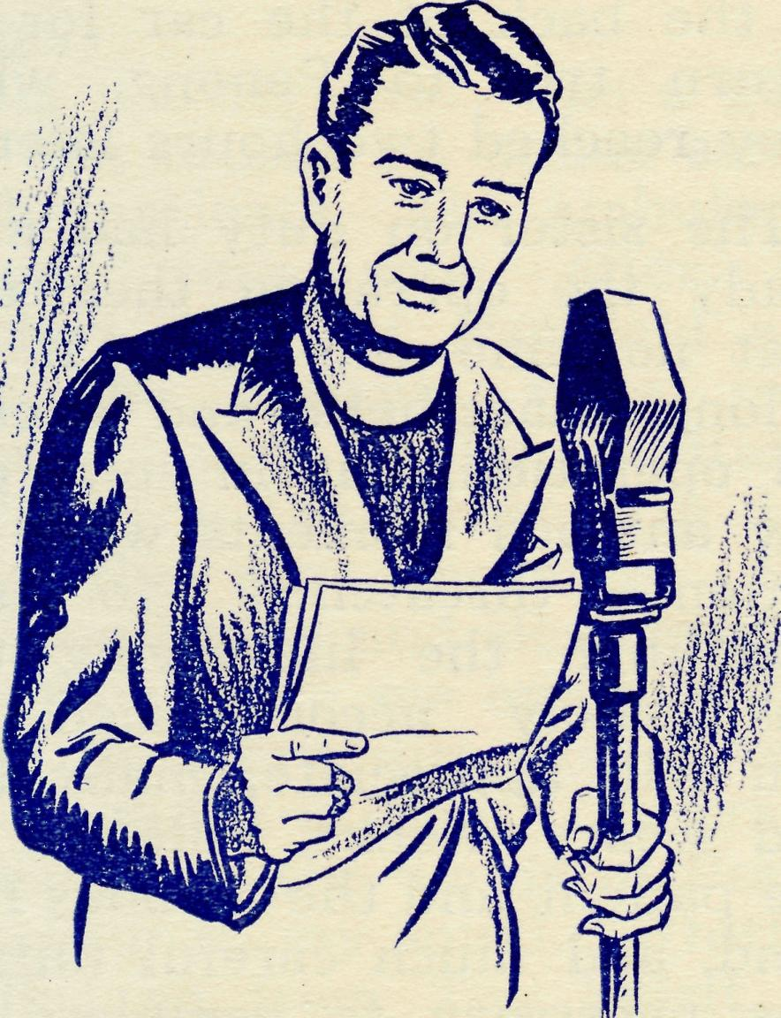
If I were to offer you the chance of saving somebody's life, would you take it? If that person was an utter stranger to you, would it make any difference? If it was quite impossible for you to meet that person either before or after you had done your deed of mercy, would you refuse to help?
Why do I ask you all these seemingly foolish questions? The simple answer is that the lives of many people depend upon us; the happiness of many people depends upon us; the comfort of many people also depends upon us.
We of the Bush Church Aid Society, by our hospitals, flying doctor services and nursing homes, most certainly make many of the people who live in the Outback more comfortable in their daily living; we help them towards happiness, and, when the occasion arises, save their lives.
You might say, "That may be true, but what has it got to do with me?" To which I must re-
ply, "A very great deal." You see, without you and your interest and help, we could do nothing. The agents of the B.C.A.—padres, nurses, doctors, air-pilots and those who look after the children in our hostels—can do nothing unless you stand behind them. They are encouraged and strengthened by your prayers, and they are provided with the very necessary tools, equipment and buildings so imperative for their work, by the gifts that you make to the funds of the B.C.A. from time to time.
I do want you all to feel that this is really your work and service. Not only something in which you can have a part, but something which is part of you. Can you see it like that? Will you try and interest others— your friends and neighbours— in this very practical and worthwhile piece of Christian service? I want to give you an example of what your help and interest does in the lonely places, and show you that you really can help to save somebody's life.
It was a cold morning when, at 2.30 a.m. the telephone bell rang in the little hospital at the small village of Penong on the edge of the great plains of western South Australia. The call was from the base at Ce-duna fifty miles away. The speaker was the B.C.A. flving doctor, and she had received an urgent call from a lonely homestead one hundred and ten miles west of Ceduna. She would call in at Penong to pick up one of the Sisters, for it was

12
The Real Australian
March, 1952.

almost certain that the patient would have to be brought into Penong Hospital.
An hour later the sister on call stepped into doctor's car and rugged herself up for the sixty chilly miles ahead. In the silvery moonlight even the dusty plains looked like fairyland, and the grey salt-bush seemed to catch and play with the bright moonbeams. The only other occupants of the road at that early hour were the timorous rabbits scuttling speedily across the track, a fox here and there, looking for an early breakfast, and a rare wombat returning to his burrow.
The house was a lonely homestead some thirty-five miles from its nearest neighbours, and in the earlv morning light appeared to the two travellers as if it were set on the very edge of Australia. An anxious husband who had been scanning the horizon for the past hour to gain a glimpse of doctor's headlights, met them at the door. His wife was desperately ill and in great pain. Doctor was soon convinced that there was an internal obstruction that would need to be removed as soon as the patient could be transported to hospital, or death would be
the inevitable result. Doctor and sister did all that was possible to make the patient comfortable in the back of the car for the return trip to Penong, which they reached two hours later.
The sister on duty had made ready the operating theatre so that no time was lost. It was a long anaesthetic and a critical operation, but in spite of a few anxious moments when the patient threatened to stop breathing, the life-saving task was safely accomplished. As you will appreciate, many long and weary weeks followed for the patient and the anxious husband, and much careful nursing was necessary to complete the task that doctor had begun. But the patient recovered, and is now home again and happy.
That is typical of many such stories that I could tell you. You will agree that these doctors and nursing sisters are doing a great job, but they depend upon you. Without motor cars, hospitals, petrol, aeroplanes, drugs, dressings and, of course, something for their own small needs, this splendid work could not go on. You can save a life by standing behind these women. Will you do it, and do it now?

Mrs. P. Connell

My wife had been ill for a fortnight when the doctor informed me that she must be regarded as a polio suspect, and that I must take the necessary steps to get her into the Northfield Infectious Diseases Hospital at Adelaide. I found that the B.C.A. 'plane was to take another polio case to
Adelaide from Wudinna, and I would have to connect with the 'plane at mid-day. As Wudinna is 85 miles away from Streaky Bay, it was necessary to hurry to get there in time.
However, we made it and my wife was soon lying comfortably on one of the stretchers. The father of the second patient and

March, 1952.
The Real Australian
13

myself were invited to make the journey also, and we were very glad of this thoughtful provision.
The journey over, was a good one and caused no undue strain to the patients. The ambulance arrived very soon after we touched down at Parafield and both the patients were soon whisked away to the hospital.
We made the return trip first thing the next morning. The day was sunny and clear enough to enable us to see one hundred miles in every direction. As I saw so much of South Australia beneath me, the words of Psalm 139 came to my mind. "Whither shall I go from Thy Spirit, or whither shall I flee from Thy Presence? If I ascend up into the heaven, Thou art there .... If I take the wings of the morning and dwell in the uttermost parts of the sea, even there shall Thy Hand lead me." It was a comforting thought. We arrived safely back at Wudinna.
The Sisters at Wudinna have taken charge of my babv, three months old, and he seems very happy with them. It was hard to come back, with my other two boys to an empty hou^e. An old lady, very trembly and
too kind to consider the possibility of infection, insisted on coming each day to cook dinner for us. The remaining week of quarantine should pass easily enough, then I am to send the boys to the farm of a friend while my wife gets better.
We have good cause to be very grateful to God for His mercies, and to those whom He uses to pass on His blessings. I am very grateful to the many friends who helped me to get my wife to Adelaide and especially to my B.C.A. fellow workers for their selfless service.
—Phil. Connell.
Since Mr. Connell wrote the above it has been confirmed that Mrs. Connell is definitely a polio case. There is every hope that she will make a good recovery, but it will be a long time, and many weary months in hospital must first pass. Paying a visit to Northfield we were encouraged to see Mrs. Connell brave and cheerful. She is making satisfactory progress. We are sure that all our friends will remember the whole Connell family in their prayers each dav. as they go through this difficult time.— Editor.

THE CHILDREN'S MISSIONS ON THE COAST
Mr. Brown of the Children's Special Service Mission recently visited the B.C.A. areas of the West Coast of South Australia. In a letter to his friends he has something to say of his experiences there, and we reprint the relevant portion.
"Another highlight was my visit to the West Coast and the Far West of S.A. at the invita-
tion of the Bush Church Aid, and arranged by my old friend, Rev. Theo. Hayman whose Headquarters are at Ceduna and whose Parish is only 80,000 square miles. A well worked out programme enabled me to spend a week in the Minnipa district, in Rev. Geo. Fuhrmeister's 40,000 square miles, a week each at Cook (in the Far West), Ceduna and Penong; six days at Tarcoola (also in the Far West), five days

14
The Real Australian
March, 1952.

at Streaky Bay with Rev. Phil. Connell, two days at Port Kenny (with the Baptist Mission Sisters Hogan and Roger-son), and two days at the B.C.A. Hostel at Port Lincoln where Matron Beck is doing a magnificent job with 28 girls who are attending the High School.
While at Port Lincoln I was delighted to be motored through and back to Cummins (40 miles each way) for a meeting one night. There are six or seven keen Christian people on the Staff of the High School there, besides a band of other keen young Christians, so you can realise that the devil doesn't know whether he is Cummin or goin'!
I travelled by Mission van, mail bus, 'plane, car and train. Part of the distance between Cook and Tarcoola is on that part of the railway line where there is not the hairsbreadth of a bend for 320 miles. When the children at Cook saw me off on the Transcontinental, my arm was quite sore by the time I finished waving as I had to keep on doing so in case some child was still looking. But there was no bend in the railway! The hospitality I received at the B.C.A. hospitals at Ceduna, Pe^-nong, Wudinna and Cook and at the Hostel at Tarcoola would keep me going for hours if I got started so perhaps I had better desist.

On The Railway
Rev. T. Hayman

At half-past two on a Friday morning I lay on a bed for the first good sleep since the previous Sunday night. For five nights I had been catching trains at odd hours and arriving at the various railway camps at even odder hours. I had to sleep just whenever I could squeeze it in. I have learned that it is unsafe to sleep much before a train is due, for they arrive at unpredictable hours and if I miss one, I may have twenty-four hours to wait for the next.
These new diesels can be as much as five hours early. Last Tuesday evening I was at an "unattended" camp, that is one at which there is no appointed station-master. Nobody had offered a place in which to hold the service, because, I think, the owners were self-conscious about
their furniture, or the lack of it. However, it was quite pleasan^ to have the service outside, until a stiff south wind blew up. We were just on the point of finishing the service when, looking round, I saw the headlights of the oncoming train that was not due until midnight —and it was now only eight o'clock. As you can guess, I scrambled my things together in order not to be left behind.
At one of the camps at which I held a service, one of the women told me that the regular church services, to which she had been used, were the things that she missed the most since coming to live on the east-west railway line. They have no other opportunities for corporate worship, except when I get around three or four times a year. Even the wireless ser-

March, 1952.
The Real Australian
15

vices cannot be heard by them because of the excessive static that characterises that area.
After the service, I was asked to supper. Sometimes I live in my tucker-box. At others I am asked to a meal. Supper over, others went to bed, but that I dare not do, so I wrote letters. The train was due at midnight, but long before that time mv writing was getting very erratic, for I was really too tired to concentrate. Yet I dare not go to sleep. The train stops for a very few minutes, and I could be left behind. It was 1 a.m. when she arrived, and a very sleepy parson bedded down in the luggage van.
Rawlinna is my central base for this section of the line. I need to study the timetable very carefully when making out my
itinerary. My first journey this week was to a camp 80 miles east of Rawlinna. Then I doubled back 200 miles west, followed by a trip of 170 miles east again. Now I am 50 miles further east, and to-morrow I return to Rawlinna. The factor that governs all this rushing about is that I must travel by a train that gets me to a camp in the morning, and allows me to leave by another train after 10 p.m. the same night.
I wrote to the folks at one of the camps suggesting that I arrive on one of the "fast goods" and depart by the "tea and sugar". They replied suggesting other arrangements because, as they told me, I would not be there long enough. Well, it's nice to know that they like to see me.

A Holiday Camp

This year we made an experiment, and it proved a good success. Deaconess Spry was anxious to bring down for a holiday at the sea-side some of the children of the North-west. We tried very hard to obtain a suitable cottage for the purpose, but without success. Rather than call the project off, we decided that we would go to Bowral instead, and arrangements were made to do this.
Then it happened! One of the Bush Padre's wireless friends very generously offered her home. She and her husband and family were going to Blackheath for their holidays, and told us that they would like somebody to have the use of their home
while they were away.
It was the very thing needed, for the house is at Doll's Point. What could be better for a seaside holiday? We moved in and the children had the time of their lives. Some had not seen the sea before, and none had been to Sydney. They voted Sydney as being a degree or two bigger than Broken Hill.
The big shops, the Pfarbour Bridge, Manly, Cronulla, the Zoo, St. Andrew's Cathedral, the University and above all, the Pacific Ocean, made the week a memorable one. It was a very tired party but a very happy one that we packed into the Broken Hill train on the night of January 18th.

16
The Real Australian
March, 1952„

We owe Mr. and Mrs. Freeman a very big "Thank you" for the use of their home. It was, indeed, a kind and generous thing to do. We say "Thank you" also to those of the Bush Padre's wireless friends who sent in donations that made it possible to pay all expenses, Mrs. Livingstone, snr., for the party and outing she gave to the children. Miss M. Farr gave up a week of her leave to assist Miss Spry manage the party. Thank You to both.
Messrs. Edgar Bragg and Sons loaned us their truck, so that we could get the necessary bedding down from Bowral, and one of
their compositors Mr. Cart-wright gave up one of his Saturdays to drive it. So, you see, it was a very real co-oporative effort.
Some of us would like to do it again next year. We would like to have three parties. One from Mungindi, one from Broken Hill and another from Wilcannia-Menindee. To do this, we will need some house mothers, one hundred pounds in cash and above all, a suitable cottage at the sea-side. We do not want to leave the arrangements to the last minute, so if you can help provide any of these needs, let the Organising Missioner know. Wouldn't it be great if we OWNED a house at the seaside?

Christmas at Ceduna
Sister Millar

Christmas means decorations, so to the big box we went, only to discover that the streamers had been put away in a hurry and were thoroughly mixed up. However, we had enough patients sitting-up to solve that problem and in quick time the bright and cheerful colours were ready for hanging.
We were kept very busy and it was not until the morning of Christmas Eve that we were able to get around to the iob of decorating. Of course, there was the usual number of interruptions, including a call from Cook informing us that they were sending us a small boy of six years who needed the removal of his appendix, if he was to enjoy Christmas.
He proved to be a brave little fellow, and chatted away to all who would listen. He informed us that when he had been a patient in the Port Augusta hospital, he had only liked one of the many nurses who had attended to him. We decided that we must be on our best behaviour. We managed to have everything ready by 8 p.m. when the Carol Singers arrived in buses and cars, and a hapny evening was provided for the patients and staff.
Christmas Day was begun with Holy Communion for staff and patients, ioined by some of the townspeonle who were unable to attend the service at the church. For the first time in history our service was interrupted. Somebody's Christmas

March, 1952.
The Real Australian
17

present arrived right in the middle of the service—a lovely baby girl weighing 7J lbs.!
Christmas dinner was really good, thanks to Sister Hitchcock who excelled herself on a very hot day. After dinner, every bell in the place began to* ring—the telephone bell, the door-bell and all the patients' bells . joined m. and Father Christmas, bent almost double with his heavy load, appeared.
One small girl, who had never seen Father Christmas at such close quarters before, was a first terrified at his huge bulk,
but soon got over it. When all the gifts had been distributed and Father Christmas sent on his way, we all gathered for tea —one of the few times in the year when as many of the B.C.A. staff in the vicinity as is possible get together. Twenty-two of us sat down to tea, and at its conclusion Mr. Hayman read to us the Christmas Story from the Gospel, and led us in prayers of thankfulness for the greatest of Christmas Gifts.
When all was quiet, and the washing-up done, we were able to open our own parcels, and so concluded a happy day.

An extract from the report of
the Headmaster of
PORT LINCOLN HIGH
SCHOOL. GIRLS' B.C.A. HOSTEL
This is so much an essential part of the school life and work that it is difficult to realise that it is, in fact, a separate institution. Close co-operation has afways been maintained between the staff and the invaluable matron, Miss Beck, who has another year of devotion to duty in her record. The whole group
of our "Hostel girls" give unmistakable evidence of well-being and development, physical, mental and spiritual. Within a few months of their arrival, these girls, some from far-distant centres, develop poise and personality and become very much alive to the necessity for maintaining the Hostel's fine record. The influence of the Hostel and its staff and the boarders is one of the factors that have a sweetening effect in the school life, which is valued very highly. —E. Johnson. 18/12/1951.

The Doctor becomes a Patient

I have recently reversed my role and am now a patient in the Ceduna Hospital. One gets quite a different view of the nursing work when lying in bed
instead of walking through the wards.
When I am the medical officer and have the care of the patients, I may do my daily round

18
The Real Australian
March, 1952.

at any hour, for I must fit it in with my family jobs, such as getting my small daughter ready for school. I try to see my patients early in the day, but no matter at what hour I call, the Sister in charge is always ready for me. She has the latest information regarding the condition of each patient.
To be a patient in the hospital shows me the other side of the picture. As I am a very poor sleeper, I often lie awake for hours, and so can hear the night sister going about her many activities. I am quite convinced that she would never be able to sit down long enough to run the risk of falling off to sleep.
With the first streak of dawn and in the winter, long before the dawn, the busy day commences. All are busy with
brooms, dust-pans and dusters, and this is besides the care of the patients. People continually drop in, some come for a purpose, others because having been patients in the hospital at some time, they wish to renew friendships made with the staff. All are given welcome and never made to feel that they are in the way.
Christmas and New Year did not mean extra time off for anybody in our hospital. The preparations to make everybody happy took up any spare time that may have come along. It was indeed a happy time for all patients and staff, and culminated in a large gathering of B.C.A. staff from other centres who sat down to a meal in the preparation of which Sister Hitchcock had excelled herself.

Mungindi Hostel Girls
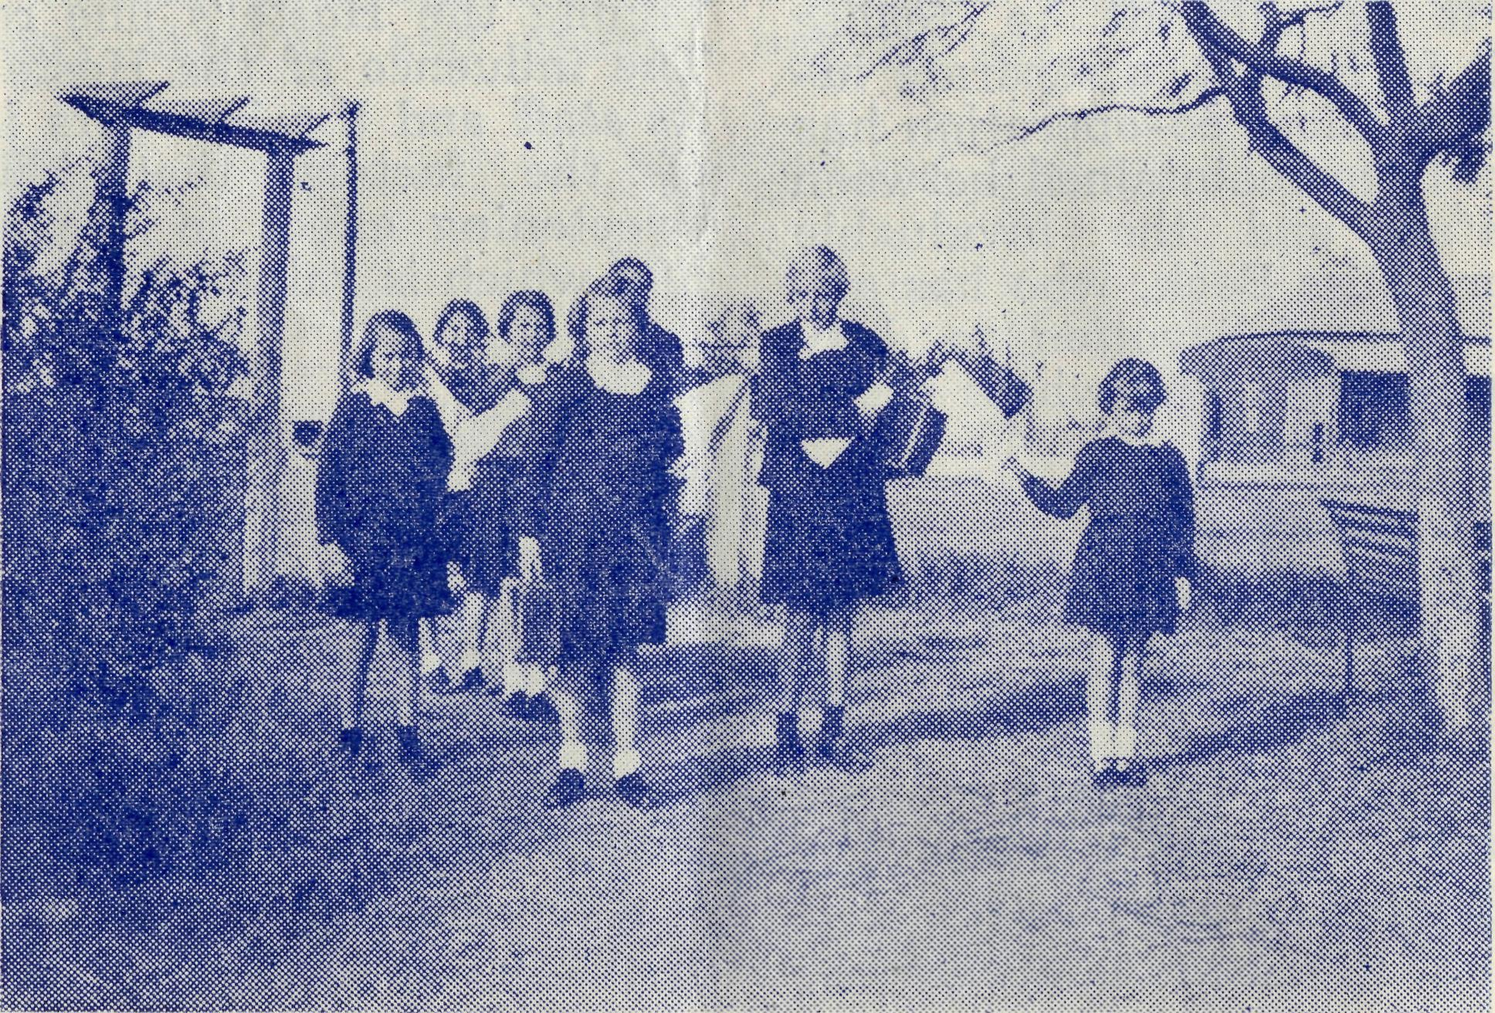

March, 1952.
The Real Australian
19

ST. JOHN'S AUXILIARY, HEIDELBERG.
Our first gathering together for 1951 was at a garden party held in the beautiful grounds of Mrs. TatchelPs home on April 3rd. Despite a showery day between 70 and 80 people were present to enjoy walking around and hearing Rev. E. Beavan tell us something of his work in the Timboon area. A very nice afternoon tea was served by a team of six of the members and two others had a busy time on the stall. This function revived memories for many of other garden parties held for B.CA. before the war.
On August 2nd, our second meeting was again combined with the monthly meeting of the Mothers' Union.
The annual meeting was held at Mrs. Moore's home on Nov. 2nd. We look forward to this meeting as we enjov her hospitality very much. This time we also had several knitted garments for babies and scrap-books to display. These were later divided into two parcels
with used linen, soaps, powders and sweets and sent to Tar-coola and Ceduna.
We had a successful year, but naturally we look for the increase in membership. Our box-holders for 1950-51 numbered 16, the three collections from boxes amounted to £16/5/11. The total amount raised during the year was £45/13/7. We sent £25 to Sydney for general medical supplies and £10 to Tarcoola for soft furnishings. About 141bs. of used linen was sent on for hospital use. We were happy to be able to assist Miss Moore of H.O. by dressing dollies for Christmas boxes and also with addressing wrappers and envelopes.
We again look to God for His grace and guiding in 1952.
Office-bearers were elected as follows:—President. Mrs. A. Craig; Vice-Presidents, Mes-dames Moore and O'Mara; Hon. Secretary and Treasurer, Mrs. Brightwell; Assisting with Box-openings, Mrs. Finn.
—A. G. Brightwell,
Hon. Secretary.

B.C.A. Personalities
Miss E. M. Cheers

Miss Cheers has the longest record of service with the Society, excepting that of the O.M. She came to us in 1928 for service on the Sisters' Mission Van. In 1930 the Society established the hostel at Mungindi and the late Bishop Kirkby could think of no person who would make a better matron for it than Miss Cheers,
The Bishop's choice was a wise one, for Miss Cheers proved the very person for this new work.
In the twenty years to 1950, Miss Cheers became mother to many children of the north-east corner of N.S.W. and set a very high standard of life and work in the hostel.
At the end of 1950 Miss Cheers transferred to the Bow-ral Hostel of which she is the present Matron. We hope that she will be able to continue with the Society for many years to

20
The Real Australian
March, 1952.

Topics for
Prayer and Praise

For the Society
O Lord God of our nation, Who has commanded men to subdue and replenish the earth: Look in Thy love upon all who in distant parts of our land are striving against many difficulties, and are deprived the access of the means of grace. Strengthen and guide the Bush Church Aid Society and all members of the staff. Cheer and comfort them in discouragement and loneliness, bless their ministrations to the good of those they serve, and grant that the message of redeeming love may thus be rooted and grounded in our national life, to the glory of Thy Great Name through Jesus Christ our Lord. Amen.
For Nurses and Doctors
O God, Who didst choose a beloved physician to set forth the life of Him Who went about doing good, grant that Thy strong tenderness and compassion may be manifest in the work of country doctors and bush nurses. Make them at all times alert to be faithful, as those whom Thou hast burdened and inspired with the honour of their calling. In lonely emergencies strengthen them with confidence that, having done all they can, they may with good conscience leave the issue to Thy power working within Thy law. Make them resourceful and of sound judgment, and hearten their labours with the nergy of compassion and the firmness of duty that conquers weariness. Through Him Whose power is called forth by suffering, Jesus Christ our Lord.
For those who Minister to Children
O Lord, Who art present when two or three are gathered together in Thy Name, bless, we beseech Thee, the little far-scattered groups of brethren who in our wide land meet together to worship Thee. Give them a perpetual freshness of spirit, and the power to inspire in each other holiness, helpfulness, and understanding of Thy help. Refresh with the j of enthusiasm those who endure weary journeys to Thy trysting place. Grant th it these little companies of Thy servants may be united in the spirit of Christian charity, awaiting in love the time when there shall be one fold and one Shepherd. Grant that the common life of all communities may be purified by this spirit of charity from all meanness, falsehood, malice and idle gossip, and grant that they who share a common lot may draw strength from each other's virtues, and in their weakness help one another, through our one Lord, Jesus Christ.
Praise
For the Blessings vouchsafed to the Society, for all kindly givers, for the joy of service.
SUNDAY
For all Mis-sioners and Deaconesses of the Society and their people and for all students in training. MONDAY
For all Doctors and Nurses serving in the outback, and for the spiritual and physical health of the patients unue-their care. TUESDAY
For all workers in Hostels, the children under their care and the teachers who instruct them. WEDNESDAY
For the Director of the Mail Bag Sunday School, the pupils of the School and all teachers and voluntary workers.
THURSDAY
For the Fly-i n g Medical Service and the safety of the pilots and all who travel with them.
FRIDAY
For the Council of the Society, the Home Base staffs, Auxiliaries and Parochial workers.
SATURDAY
For all neces-s a r y finance needed for the maintenance of so large a ministry and for guidance in its right application.

Edgar Bragg & Sons Pty. Ltd. 4 Barker Street, Sydney.

