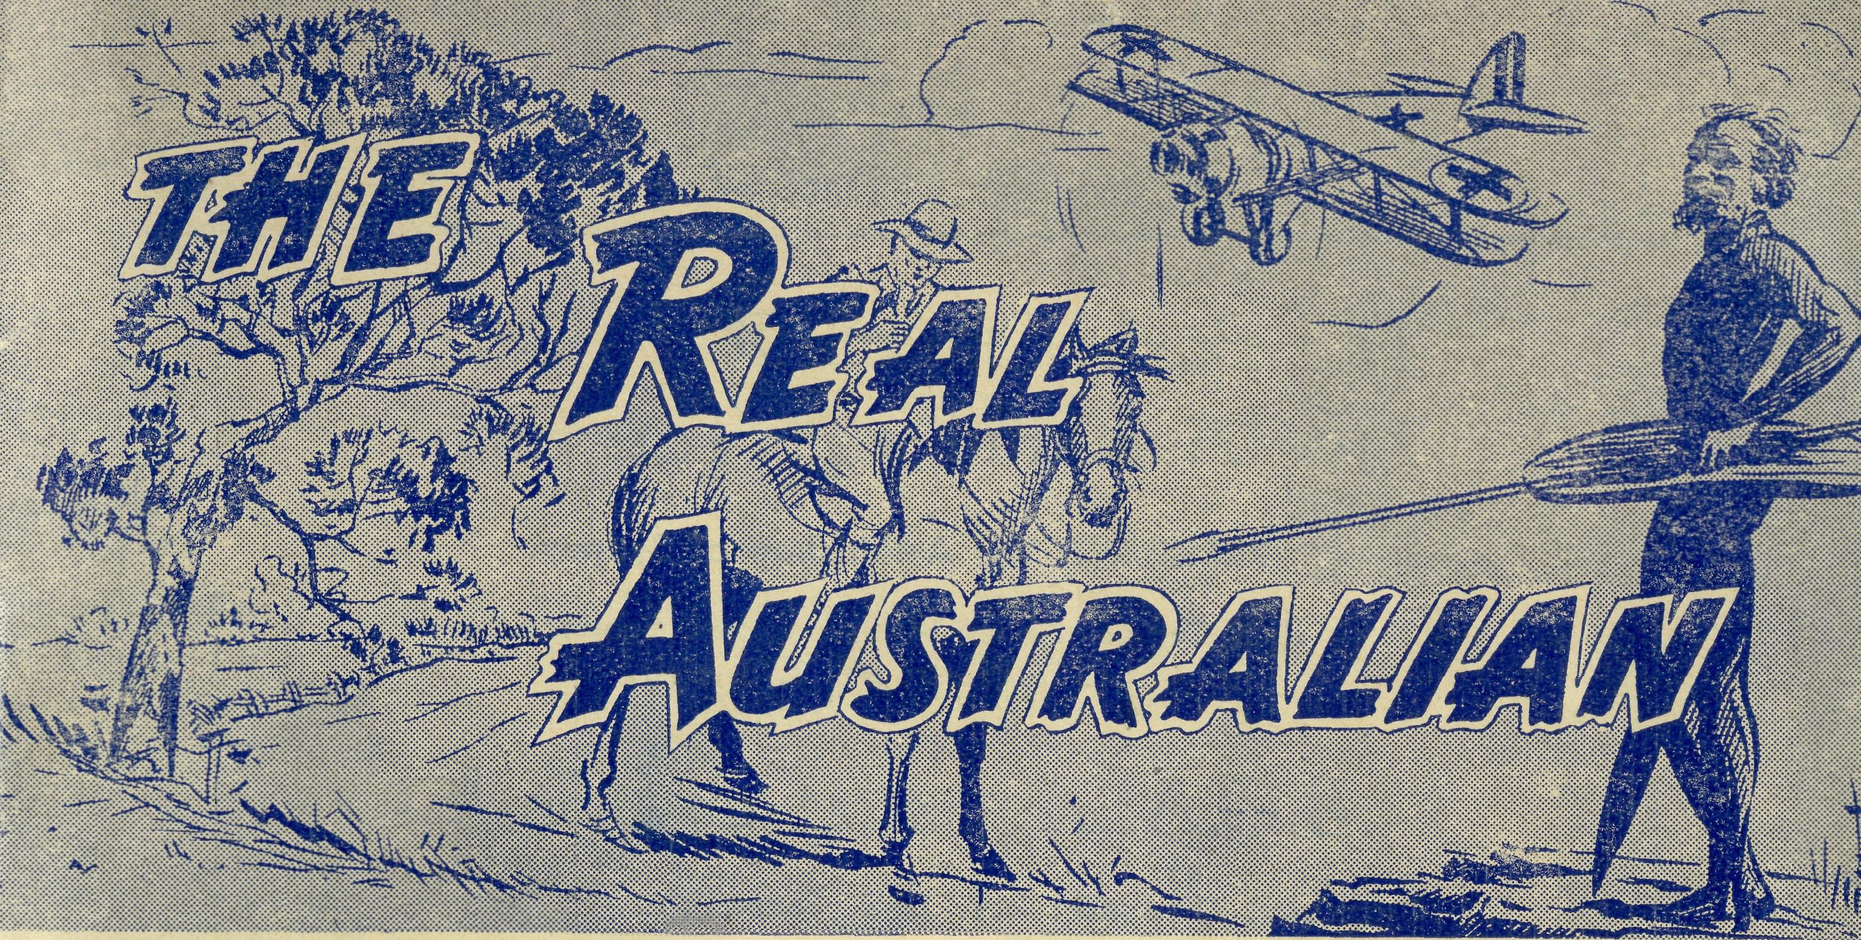
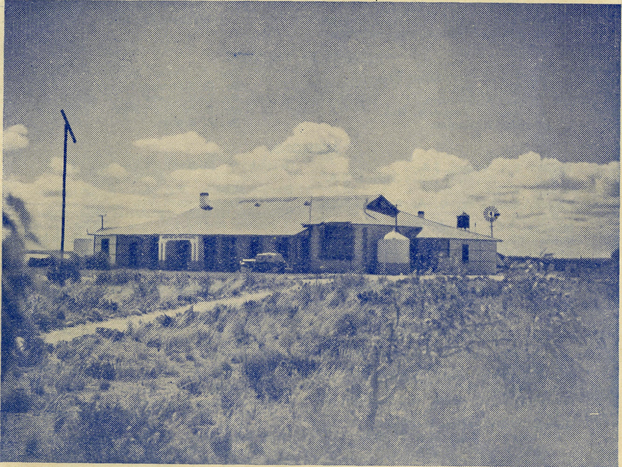
October, 1952.
SUNDAY For all Mis-sioners and Deaconesses of the Society and their people and for all students in training. MONDAY
For all Doctors and Nurses serving in the outback, and for the spiritual and physical health of the patients uncle-their care. TUESDAY
For all workers in Hostels, the children under their care and the teachers who instruct them. WEDNESDAY
For the Director of the Mail Bag Sunday School, the pupils of the School and all teachers and voluntary workers.
THURSDAY
For the Fly-i n g Medical Service and the safety of the pilots and all who travel with them.
FRIDAY
For the Council of the Society, the Home Base staffs, Auxiliaries and Parochial workers.
SATURDAY
For all neces-s a r y finance needed for the maintenance of so large a ministry and for guidance in its right application.
No. 3 (New Series).
20
The Real Australian
Topics for
Prayer & Praise
For the Society
O Lord God of our nation, Who has commanded men to subdue and replenish the earth: Look in Thy love upon all who in distant parts of our land are striving- against many difficulties, and are deprived the access of the means of grace. Strengthen and guide the Bush Church Aid Society and all members of the staff. Cheer and comfort them in discouragement and loneliness, bless their ministrations to the good of those they serve, and grant that the message of redeeming love may thus be rooted and grounded in our national life, to the glory of Thy Great Name through Jesus Christ our Lord. Amen.
For Nurses and Doctors
O God, Who didst choose a beloved physician to set forth the life of Him Who went about doing gcod, grant that Thy strong tenderness and compassion may be manifest in the work of country uoctors and bush nurses. Make them at all times a' rt to be faithful, as those whom Thou hast bu dened and inspired with the honour of their cal ing. In lonely emergencies strengthen them with confidence that, having done all they can, they may will good conscience leave the issue to Thy power workiig within Thy law. Make them resourceful and c? sound judgment, and hearten their labours with the energy of compassion and the firmness of duty that conquers weariness. Through Him Whose power is called forth by suffering, Jesus Christ our Lord.
For Church Life in Country Districts.
O Lord, Who art present when two or three are gathered together in Thy Name, bless, we beseech Thee, the little far-scattered groups of brethren who in our wide land meet together to worship Thee. Give them a perpetual freshness of spirit, and the power to inspire in each other holiness, helpfulness, and understanding of Thy help. Refresh with the jo\ of enthusiasm those who endure weary journeys to Thy tryst ing place. Grant that these little companies of Thy servants may be united in the spirit of Christian charity, awaiting in love the time when there shall be one fold and one Shepherd. Grant that the common life of all communities may be purified by this spirit of charity from all meanness, falsehood, malice and idle gossip, and grant that they who share a common lot may draw strength from each other's virtues, and in their weakness help one another, through our one Lord, Jesus Christ. i
Praise
For the Blessings vouchsafed to the Society, for all kindly givers, for the joy of service.
Edgar Bragg & Sons Pty. Lid. 4 Barker Street, Sydney.
OCTOBER, 1952. 2/6 per annum, post free
THE CEDTJNA BASE HOSPITAL Registered at the G.P.O., Sydney, for transmission by post as a periodical.
The Official Organ of THE BUSH CHURCH AID SOCIETY
Church House, George Street, Sydney, N.S.W.

The Real Australian
October, 1952.
October, 1952.
The Real Australian

The Bush Church Aid Society for Australia and Tasmania
PRESIDENT: The Archbishop of Sydney.
Hon. Clerical Secretary: Rev. Canon Cameron. Hon. Treasurer: Mr. T. S. Holt.
B.C.A. Activities and Staff
Organising Missioner: Rev. T. E. Jones, Th.L. N.S.W. Deputation Secretary: Rev. J. R. Greenwood, Th.L. Victorian Secretary: Rev. L. Morris, Ph.D., M.Th., B.Sc.
VICTORIAN OFFICE:
Bible House,
Flinders Lane, Melbourne, Victoria.
Telephone: FJ 5675.
HEADQUARTERS OFFICE:
Diocesan Church House,
St. Andrew's Cathedral,
George Street, Sydney. Telephone: M 3164.
Cable Address: "Chaplaincy, Sydney".
STUDENTS IN TRAINING.
Rev. F. Ingoldsby, Rev. I. Booth. Mr. A. Williams. Rev. J. Stockdale, Th.L Mr. T. Morgan.
Th.L. Rev. A. Cooke, Th.L.
Mr. C. Burgess. Mr. T. V. Jones. Mr. D. W. Warburton. Mr. R. Brooks.
MISSIONS.
Ceduna, S.A.-Penong, S.A.—
Rev. T. J. Hayman, Th.L., Ceduna, S.A. Rev. D. W. Diaper, Th.L. Cowell, S.A.—Rev. D. A. Richards-Pugh,
A.L.C.D. Minnipa, S.A.—Rev. G. Fuhrmeister, Th.L. Streaky Bay, S.A.—Rev. P. Connell, Th.L. Croajingafong, Vic.—Rev. G. Garner, Th.L.,
Cann River, Vic.
MAIL BAG SUNDAY SCHOOL.
Director—Miss R. Campbell.
SCHOOL HOSTELS.
Broken Hill, N.S.W.—Mr. and Mrs. A.
McLachlan. Mungindi Boys' Hostel, N.S.W.—Mr. and
Mrs. Hustler. Mungindi Girls' Hostel, N.S.W.—Miss M.
Farr. Bowral, N.S.W.—Miss E. Cheers. Port Lincoln, S.A.—Miss I. Beck.
Heytesbury Mission, Vic.—Rev. E. G.
Beavan, M.A., Timboon, Vic. Otway Mission, Vic.—Rev. K. Seymour,
Th.L., Beech Forest, Vic. Wilcannia, N.S.W.—Deaconess M. I. Spry.
and A. Howiand. Menindee, N.S.W.—Rev. W. Mitchell, Th.L. Rappville, N.S.W.—Rev. A. Gerlach, Th.L. Denmark, W.A.—Rev. J. Johnston, Th.L.
MEDICAL SERVICES.
Ceduna, S.A.—
Matron: Sister F. Dowling. Staff: Sisters J. Miller, G. Hitchcock, B. Tierney, J. Payne, P. Shipway, Miss F. Lawtey. Penong, S.A.—Sisters L. Loane, L. Lang-tree. Wudinna, S.A.—
Matron: Sister R. Portch. Sisters: V. Hoile, B. Barber, V. Brealey. F. Ellis. Cook, S.A.—Sisters M. Horsburgh, M. Ross. Tarcoola, S.A.—Sister V. Page. Cann River, Vic.—Sister I. Gwynne. Rawlinna, W.A.—Sister E. Thomas.
FLYING MEDICAL SERVICE.
Pilot—Mr. A. Chadwick, Mr. W. Bedford. Doctor—Dr. F. Gibson, O.B.E., Dr. M.
Mueller, Dr. J. Upsdell. Pharmacist—Miss E. AA. Page.
The O.M.'s Letter
I have recently returned from a very hurried trip to South Australia. Perhaps you may find it interesting if I tell you something of where I went and what I saw.
My first port of call was Adelaide in order to meet a nurse who had come out from England for the B.C.A. Service. I first met her in 1950 during my last visit to the Old Country. She offered to me for service in the outback, and came out as a migrant on the 'Orontes\ After seeing sister through the customs and other necessary formalities for a nurse coming to a new country, I saw her off to Wudinna where she is to serve, then I caught the plane for Port Lincoln.
Port Lincoln is a really delightful spot, set at the mouth of Spencer's Gulf. It can aptly be described as the capital city of the west of South Australia, as Broken Hill is for the N.W. of New South Wales. It is a port and rail terminal, and acts as the receiving and despatching centre for the goods and produce of all that huge tract of country that lies west of the Gulf. It has a population of about four thousand people, and the town.hip fringes Boston Bay, probably the best deep water harbour in the world.
As many of you are aware, the B.C.A. has a hostel for girls at Port Lincoln. The children come from far and wide, some travelling three or four hundred miles from their homes to the hostel. They are thus enabled to complete their education to the Leaving Standard, for the town has a splendid High School. When you leave Port Lincoln, going west, you find that the next High School is at Kalgoorlie, over one thousand miles away. Recently a mother went. to see the Headmaster of the High School in order to make arrange-'ments for her daughter to attend the school. One of the first questions the Head asked, was whether she had been able to arrange accommodation for the girl. The mother replied that she had been able to get her child in at the B.C.A. Hostel. "All your troubles are over then. You need not worry about her any more", the Headmaster told her. It is good to know that those who are responsible for the school can feel that way about the management of the B.C.A. Hostel after eight years of such service.
I really wish that I could take you to meet the girls at that place, and Miss Beck who looks after them, for I am very sure that you would come away, as I do, feeling that it is a piece of work of which we can be really proud, and also thankful that some at least of the children who live in the difficult places of the land have so gracious a provision made for them. There are thirty-two girls in

The Real Australian
October, 1952.
October, 1952.
The Real Australian

the hostel. Their ages range from eleven years to sixteen. All are smartly dressed in school uniforms. They are robust, happy and full of fun, and it is very evident, even to a casual visitor, that they all have a very great affection for Miss Beck. I was only able to stay there one night, for I had to go on in the old rail bus to Wudinna the next morning. However, I was able to enjoy what I think is the highl'ght of the daily life of the hostel, the evening devotions. After dinner, when the dishes are all washed and put away, thirty-two beaming faces are gathered in the dining room. Some sit at the table, the rest crowd around the piano or anywhere else that they can get. You should hear them sing. I am quite sure that if I could bring them to Sydney as the choir and put them on a platform at a meeting they would bring the house down. They really enjoy it. Then we have prayers, a Bible reading and a short talk. They listen very attentively, and I am sure that they are learning something that will most certainly help them in later life as wives and mothers. Day by day, they have the example of Miss Beck's quiet ministry to them. She herself was brought up on a farm on the West Coast of South Australia, and knows what the difficult days can mean to one so placed. She is a quiet person, but is very much devoted to her girls, and I am sure that her witness must leave its impression on the lives of those who come and spend some of their formative years in her company. I am very anxious that we shall be able to build a new dormitory at this hostel at the end of the year. It will give more elbow room for the girls, and is a necessity if the work there is going to progress. The next morning I stood at the gate and watched thirty-two girls depart for school. It certainly looked like a hoard of locusts on their way to some green field. Then I caught the rail bus and sat in it for five hours while my bones shook to pieces.
The rail bus is a quaint affair, but very sensible. It looks exactly like a single deck road transport bus, except that it has iron wheels and runs on rails. It also pulls along two goods carriages. There is a story that it ran as a bus on the Adelaide streets until it wore put, and then they fitted iron wheels to it and used it as a train, but I think that that is a fairy story.
The railway line, 3ft. 6in. wide, runs from Port Lincoln to Penong, and is about 300 miles in length. Trains do not run every day. Once a week you can go all the way to Ceduna and Penong. " Every Tuesday, to be exact, and every Friday you can come down on the return journey. On Thursday and Friday another bus goes up as far as Minnipa, which is half the distance to Penong. I went up on a Thursday and got off at Wudinna, twenty-eight miles before Minnipa. On a typical South Australian summer's day it is quite a feat of physical endurance to travel in that train for three hundred miles, but I was very thankful that it was winter for me. Leaving Port Lincoln at 10.30 a.m. I arrived at Wudinna at five in the afternoon, and was very soon at the hospital drinking a welcome cup of tea.
The hospital has the high sounding name of The Central Eyre Peninsular District General Hospital, but we call it simply the Wudinna Hospital. About six years ago it seemed certain that the hospital would have to be closed. The district, through its Shire Council, found itself no longer able to maintain it or obtain the necessary staff. The B.C.A. was then asked if they could take the hospital over and incorporate it into the existing medical services of the Society in South Australia. After examination we decided to do so. The hospital buildings are quite modern, and it is licensed as a twenty-bed hospital, though long and wide verandahs enable many more than twenty patients to be taken when necessary. Up-to-date theatre equipment enables all but the most complicated operations to be performed. The staff consists of six double certificated nurses. The doctor is an Englishman who came out specially for our service, and he, like the nursing staff, is there because he wishes to give consecrated service to the Kingdom of God.
Wudinna is also our second Flying Medical Base. The Society has an aeroplane at Kyancutta, nine miles from Wudinna. This is because there is no suitable landing ground nearer than that. In any case, it is no handicap, for the time that is occupied by doctor travelling by car those nine miles allows the pilot to wheel out his plane and get her warmed up. The whole staff—doctor, sisters, domestic staff and air pilot—work as a team and provide an excellent example of practical Christian service.
While staying at the hospital I walked into one of the wards one day to talk to a patient. She was an old lady of 82, and had been very ill in Adelaide for many months. There was no reason, from a medical point of view, why she should not have stayed in Adelaide. But she was one of the old pioneers of the west, and her sons and daughters were still there. She was unhappy and wanted to be back in the country that she had known and loved so well. Her son came into the Wudinna Hospital one day and told the story, and added that Mum would be happier in the local hospital amongst her own people. She had not long to live, and it was not really an urgent medical case, but could the plane go over to Adelaide and bring her back? Of course, we said that it could, and said a wee prayer that an urgent call would not come from somewhere else while the plane was away. So to-day she is happy, awaiting the call that must come to us all sooner or later—to-day just an old age pensioner of 82, but one of those who, by her courage and sacrifice, helped to lay the foundations of this nation and to open up much of the country to fuller development. We can but serve them in their need of to-day and take courage and inspiration from their example.

The Real Australian
October, 1952.
October, 1952.
The Real Australian

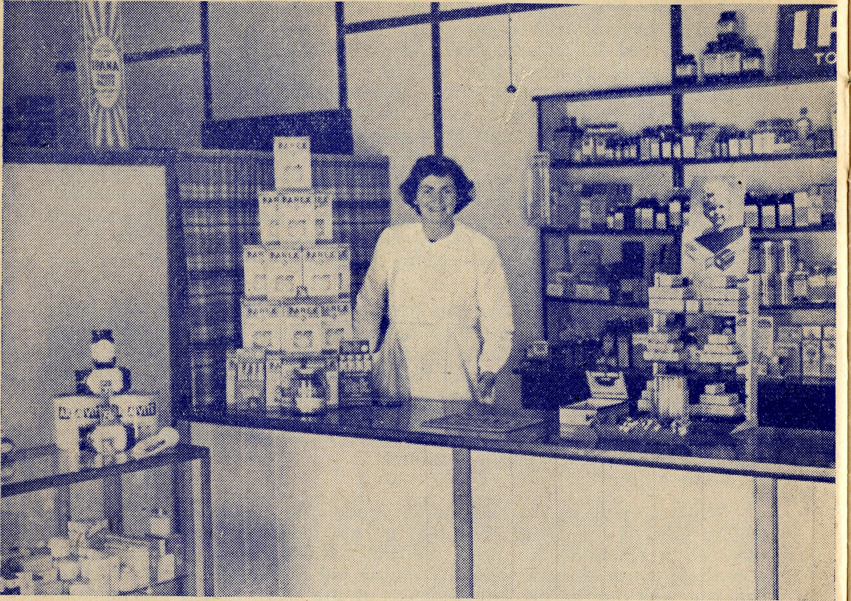
The Pharmacy
The Chemist's Shop, as it is more often called, was established at Ceduna in June, 1948. For many years before this date there had been no such facilities in that district. No qualified pharmacist thought it worth-while to open such a business in the township. As a result, the Medical Officers were required to do their own dispensing, if the patients were to obtain the medicines prescribed. This added very considerably to the demands made upon the doctors and was a tedious business for them.
B.C.A. had often thought that a pharmacy, together with a fully equipped chemist's shop would provide a very valuable service to the people of the Ceduna district. The difficulty was to obtain a suitable person with the necessary qualifications. Miss Esme Page provided the solution, when, in 1948, she offered for the work of the Society.
The shop is situated on the main street of the township, and is divided into two sections. The curtain to be seen in the illustration divides the dispensary from the sales department. It is a bright and attractive shop in which most of the goods you are able to buy at the suburban chemist's, are to be found, and Miss Page has
them displayed very attractively. When one enters her shop one feels that it is impossible to go out without making a purchase. Everything looks so nice and tempting.
Miss page attends to the dispensing for Penong and the Koonibba Mission, as well as for the area in the immediate vicinity of Ceduna. If you were travelling west, you would have to go all the way to Kalgoorlie to meet the next pharmacist.
In this place, a worthwhile piece of service is being rendered by a Christian woman. It is sometimes hard for us to really feel that we are doing valuable service for the Kingdom of God by simply following our vocation in an out of the way place, but we are glad that Miss Page is able to feel that she is doing just this.
The Wudinna Staff
From left to right:
Sis. R. Portch
Sis. V. Holle
Sis. V. Brealey
Sis. F. Ellis
Sis. B. Barber.

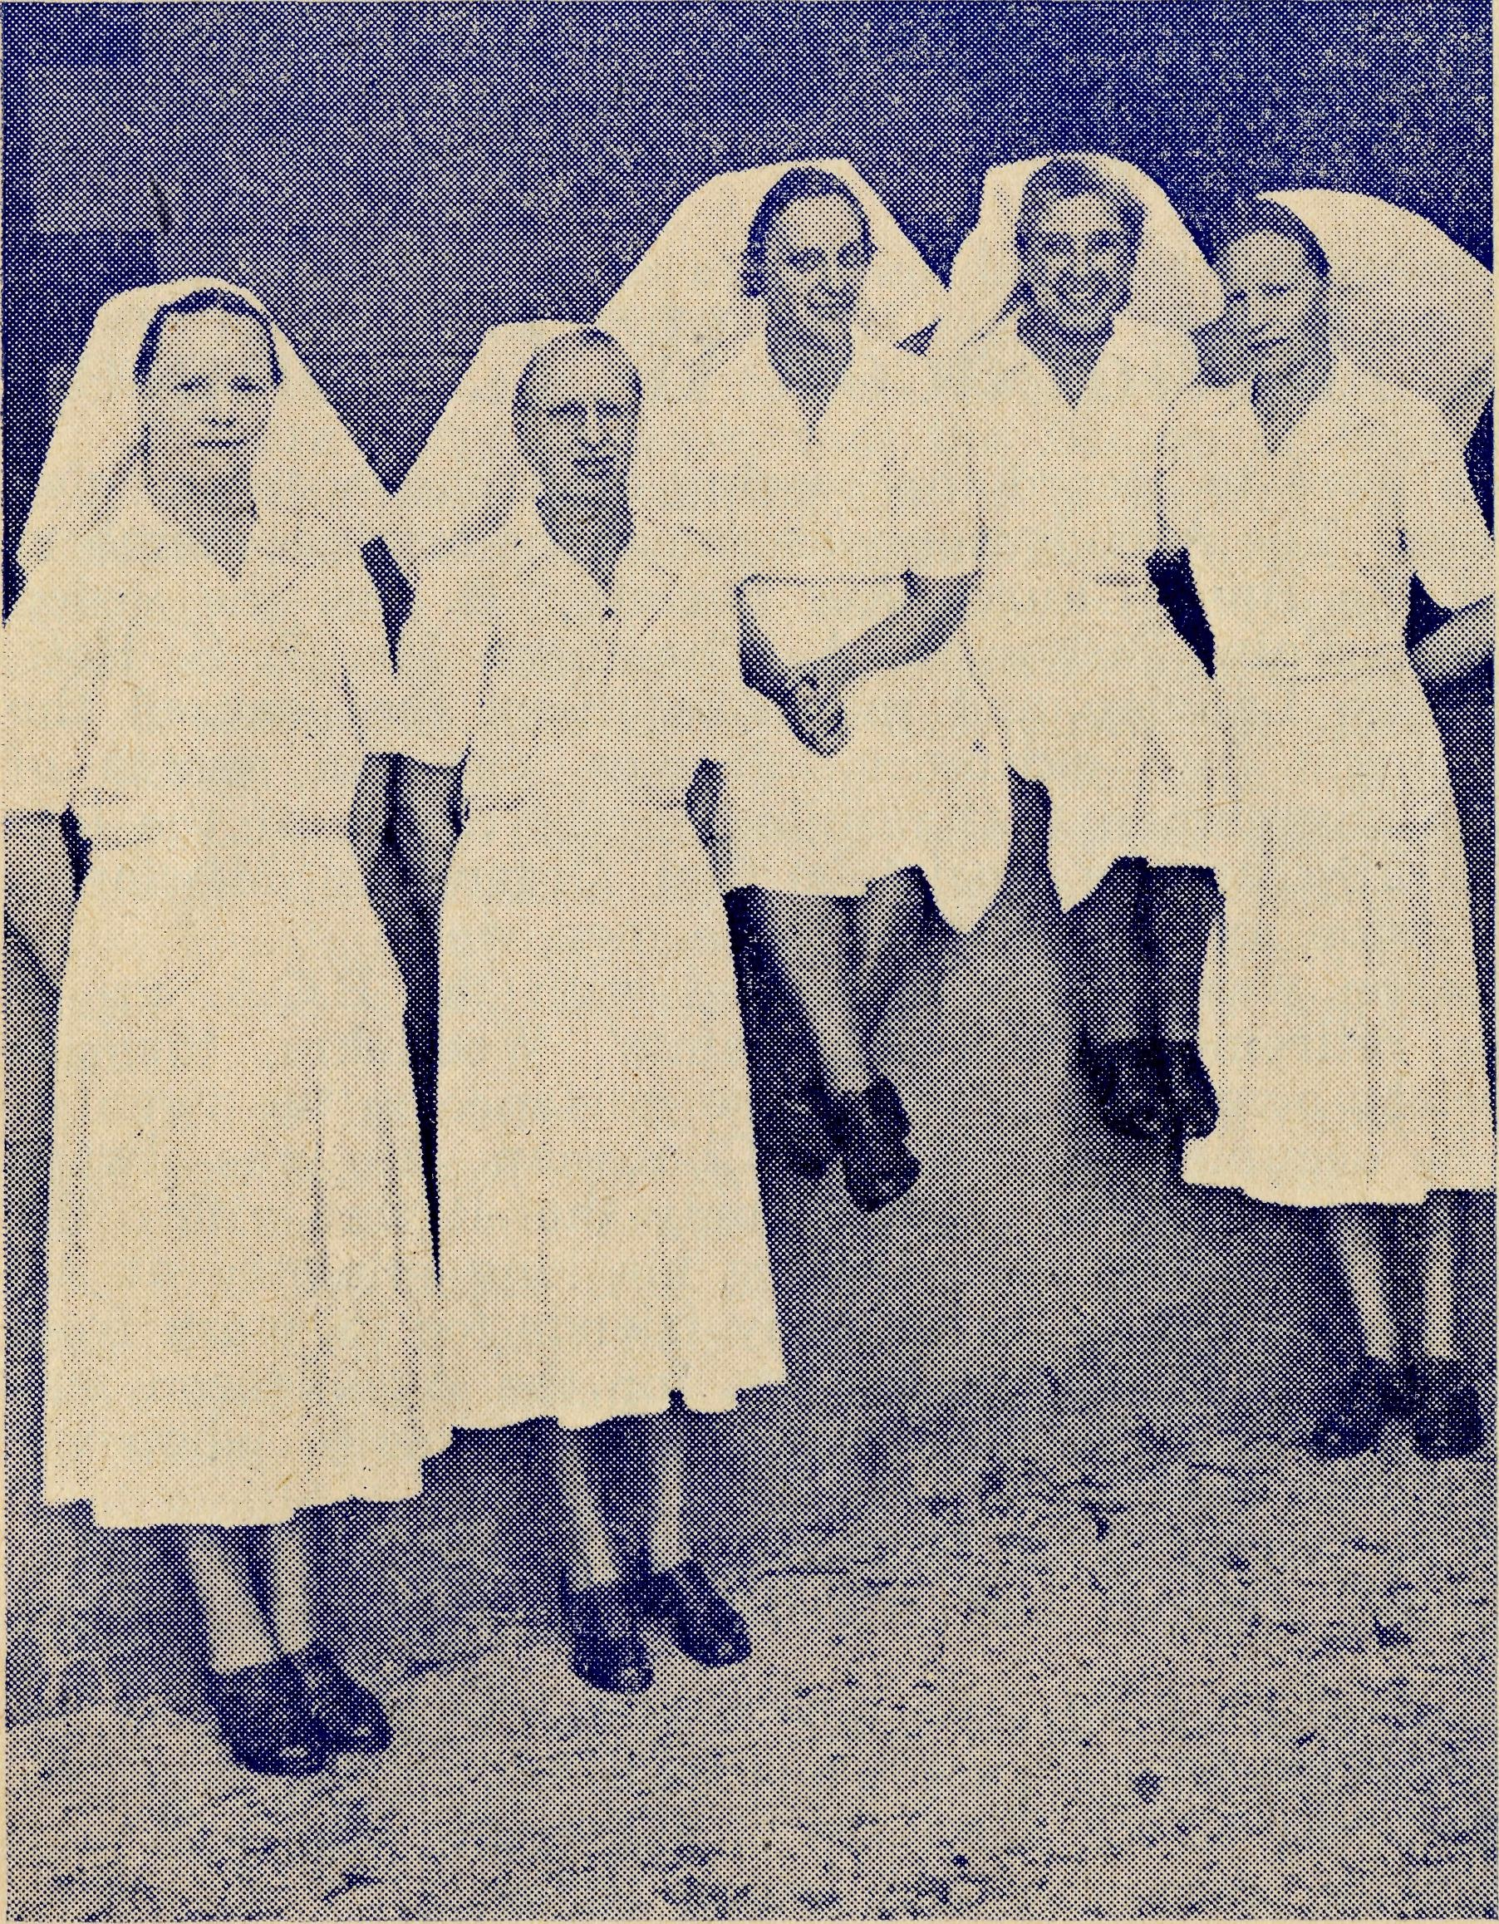

The Real Australian
October, 1952.
October, 1952.
The Real Australian

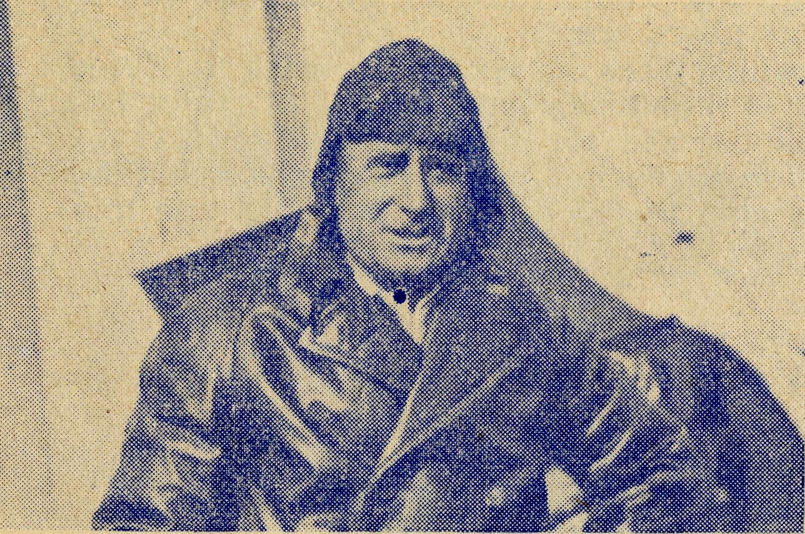
B.C.A. Personalities
Rev. L. Daniels
The Rev. L. Daniels was the second B.C.A. Missioner at Wilcannia. He served from 1922 to 1932. In 1927 he visited England as Deputa-tionist for the Society, and came back with a Moth Aeroplane. For 5 years he served his huge district as the first clergyman to pilot his own plane. Mr. Daniels is now the Rector of the parish of Kurrajong in the Diocese of Sydney.
The Yen. Archdeacon W. L. hangley
We regret to have to record the passing of Archdeacon Langley since our last issue. The Archdeacon was one of the original members and founders of the Bush Church Aid Society. It was the vision of the late Bishop Pain, Bishop G. A. Chambers, Mr. T. S. Holt, the late Archdeacon Langley and men like them, that caused the B.C.A. to be brought into existence. It was also the genius of these outstanding churchmen that resulted in the choice of the late Bishop S. J. Kirkby as the Society's first Organising Missioner. What giants of vision and inspiration these men were!
The Archdeacon was closely associated with the B.C.A. up to the time of his retirement from All Saints', Woollahra, through illness. The Society owes much to his wise guidance in the twenty-two years that he occupied the office of Chairman. He was always ready to back a venture of faith, asking only that it was within the scope of,the Society's objectives. During his long ministry at All Saints', B.C.A. was enabled to make many friends for jts work from among the members of that congregation, for the Archdeacon was always ready to further the interests of the Society whenever opportunity presented itself.
During 1939 he visited Great Britain as Deputationist for B.C.A. and gathered much support and friendship for the work in the outback.
We who follow him, can draw much from the example of vision and courage that the Archdeacon set before us in his life and ministry. We offer our sympathy to the members of the family who will miss one who was a wise counsellor and loving father.
We welcome to our staff Sister F. Ellis, who comes to us from England. The Organising Missioner met her during his recent visit to the Homeland and accepted her offer of service with the B.C.A. Sister has joined the staff at Wudinna, and we hope that she will find it a useful and happy sphere of christian service.
Sister A. Butler, a Westralian has joined the staff at Ceduna. Her contact with the B.C.A. was made during her training in Melbourne. We are glad to welcome her into our family and wish her also, every blessing.
The Rev. D. Draper has joined the staff in the Ceduna Mission, and his presence will be a big help to Mr. Hayman, who has been under a heavy strain for some years with all the physical and spiritual demands of an immense district. At the moment of writing Mr. Draper is getting his first taste of life and work on the Nullarbor. We are sure that he will find much to thank God for in his new ministry.
Sister Horsburgh is at present home at Orange after an operation. She is now in good fettle and is eagerly looking forward to returning to Cook, where she and Sister Ross have done such a good job.
We are sorry to learn that the Bishop of Willochra is seriously ill. At the time of writing, he is a patient in Calvary Hospital, Adelaide, awaiting a major operation. We are sure that the many friends of the B.C.A. will remember the Bishop in their prayers, that he may be fully restored to health and strength.
Deaconness Ada Howland has joined our staff, and is at present working with Deaconess Spry at Wilcannia. Miss Howland comes from Liverpool, England, and offered for service with the B.C.A. through the Colonial and Continental Church Society. We assure Miss Howland of our prayers and good wishes, that she may find a happy and useful sphere of service in this work to which she has come.
In our last issue we wrote: if you are a subscriber to this paper
and you have not sent in your 2/6 for this year, will you please do
so? Those who are boxholders or give an annual donation to B.C.A.
are sent the paper free of any extra cost, but if they wish also to
pay the 2/6, it will help our printing costs. Many of our friends
have sent in the amount of the subscription and we are very grateful
to them. The announcement is repeated in case there are others
that would do likewise. ^H
BOXHOLDERS
Will those who make their gifts through Bark Hut boxes please note, that if they have not already opened them for the September period, we would be glad if they would do so and send the contents into the office.

10
The Real Australian October, 1952.
October, 1952. The Real Australian 11

Bush Padres' Session
THE DOCTOR ROY GIBSON MEMORIAL
Following upon the reminder in our last issue, many of our friends have sent in their donations to this fund. It is good to see the amount steadily rising, and we hope that ALL friends of the B.C.A. will associate themselves with this memorial to Dr. Roy's work. If you have allowed it to slip your memory, send your gift in right away. Do not worry if you can manage only a small amount. As we said before, if every reader of this journal sent one shilling, it would snowball into £450.
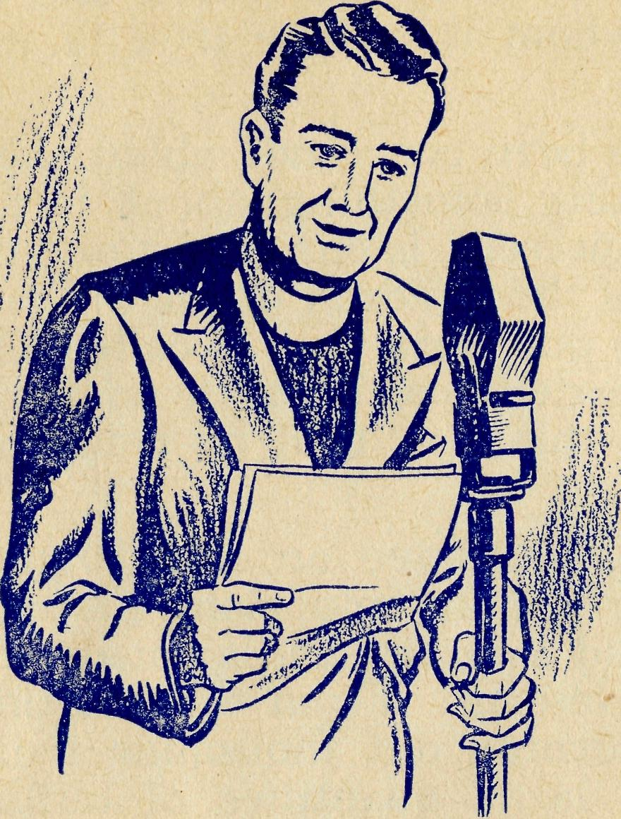
ORCHID SHOW
Do not forget to book a date between October 10th and 18th. During this time the Orchid Show will be held at David Jones Ltd. in the interests of the B.C.A. Flying Medical Service. Mrs. Bolton of Strathfield has undertaken this bold venture which ealls for much organising and hard work. Let us all support her with our interest and presence. His Grace The Archbishop of Sydney is to officially open the Show on the afternoon of the tenth. If you can make some of your purchases at the store during that week, it will help very considerably. We are hoping that David Jones Ltd. will co-operate again next year.
YOUNG PEOPLE'S ORGANISATION
This, the youngest branch of the Society's activities, continues to make progress. During recent months, we have had the good fortune to have had talks on the B.C.A. spheres of work, by the Rev. T. Hayman, who has charge of the Ceduna Mission, and Miss E. Page, our Pharmacist who is also at Ceduna. Such visits to us by those who are 'on the job' enable us to obtain the widest possible grasp of the extent and effectiveness of the work in which we are interested.
In 1953 we hope to be able to enlarge our groups, so that others can be trained to know not only what the Society is doing, but also how best to present the story in order to interest others. To this end, we would welcome others who are interested enough to join one of the new groups in the coming year. The Organising Missioner would be glad to hear from them in good time, so that the necessary preparations can be made.
The B.C.A. joins with the many other friends of the Bishop of Ballarat in wishing him a speedy and complete recovery from his recent illness and operation. The Bishop has always been a good friend of this Society and never lets an opportunity slip of saying a good word for B.C.A. We have had many years of happy association together in the work at Beech Forest and Timboon, which are both in the Diocese of Ballarat. We pray that it may so continue for as long as our help is needed.
The Editor would like to remind all our friends that donations to any branch of our medical work are rebateable for income tax purposes but the donor must specify such purpose when making the gift.

Do you recognise the words "Thy Kingdom Come"? Oh, yes, you are smiling a little at me and saying "Of course, I do. They come from the oldest prayer in Christendom and were taught us by the Lord Himself". How often do you say them? Once a week? Now and again at Easter or Christmastide perhaps. Or every day of your life? They should most certainly be on our lips and rise from our hearts in these pressing days, for there is so much around us that distresses and disturbs. The gods of gold and iron and clay own great sway in our midst. Yet the Christian must remain an optimist. Above all the noise of striving to reach unworthy ends, he must be able to believe the assurance, "Thy God reigneth".
But it is not sufficient to say the words with our lips. We must believe in our hearts that this Kingdom of God can come. If we believe in our hearts, we must show it forth in our lives. There are possibilities in this land of Australia. They are great possibilities if this prayer of the Christian can be brought to pass. It can only be brought to pass if Christians within the borders of this land will, by God's help, do something about it.
It is easy to make sweeping assertions, but I am certain that I am right in saying that there are thousands of children living in this country to-day who have the scantiest knowledge of God, if any at all. Some of them, perhaps most of them, live in the great cities of the land where many opportunities exist to give them this knowledge —Sunday Schools, Church Kindergartens and Religious Teaching in the Day Schools.
There are others who are so placed that these facilities are not within their reach. They live in areas of Australia far removed from Day or Sunday Schools. Some are taught in secular subjects by the Correspondence Method, but Christian Teaching is not on the curriculum. The few Bush Padres spread over great areas find it impossible to visit homes or tiny outback schools often enough to enable them to give anything like regular and systematic instruction. They do the best they can whenever the opportunity presents itself, but they often despair at the hopelessness of what can be done in four or five visits a year.
It is a serious state of affairs, for much as we deplore the decline of moral and spiritual values in the Old World, when we are able to visit it, we are conscious of a great tradition that has become an

12
The Real Australian
October, 1952.
October, 1952.
The Real Australian
13

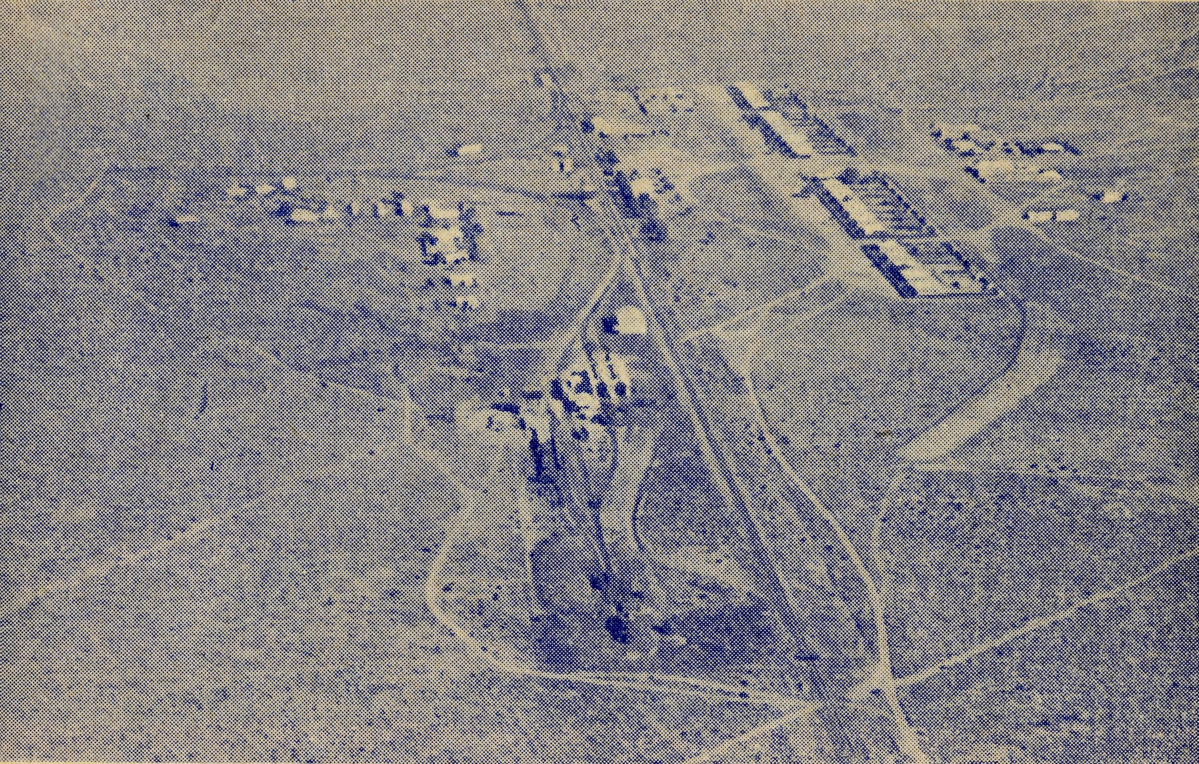
TARCOOLA No. 1.
ingrained part of the national character, and rises to the surface in times of great stress and trouble. We in Australia are too young to have many traditions like that, but unless we do something, and do it soon, a generation will grow up of whom it will be true to say, "They know not God".
There are some in the land who have been concerned about these things, and are actively engaged in doing something about it all. The Bush Church Aid Society, which I represent, is one of the organisations that is seeking to meet the need of the children in the outback and the bush. We have a department of our work that is called The Mail-Bag Sunday School. As the name denotes, it exists to teach these lonelier children something of the things of God by using the post or mailman as its agent.
In a building in Pitt Street, Sydney, is located an office that is far from pretentious, but it is the heart of an important piece of work. If you were to visit it, you would find the walls lined with shelves containing thousands of printed lessons. From time to time you would see an electric duplicator turning out thousands more, for the smaller children, together with large quantities of outline drawings and handwork sheets. At appointed times each month a small group of earnest people are very busy there making up the necessary sets of lessons, putting them in envelopes and addressing them to thousands of children in the Commonwealth and beyond it, for the lessons go as far afield as New Zealand, Pakistan and Thailand.
Each day brings the large brown envelopes that are supplied to each scholar for the return of the lesson work. They are addressed to individuals, care of the Mail-Bag Office. There are sixty teachers, each of whom has a Sunday School Class, the members of which may never see each other and who live, in some cases, many hundreds of miles apart. Each teacher keeps in constant touch with each of the scholars for whom he or she is responsible, and many friendships are formed that endure over the years.
To-day we have, from time to time, requests from parents who have themselves been scholars in their younger days, that their children may receive the lessons also. This, I think, is the best indication of the worth of this service.
To-day, with the cost of printing, stationery and postage at such high rates, the cost of this ministry is very great The cost of the lessons only for each child is ten shillings per year. We ask that the parents pay this. Many do, but some do not. But we do not allow the child to go without its lessons if the parents do not pay. On top of these costs are those of administration and equipment, for although the teachers do their work on a voluntary basis, there must be some guiding hand giving whole time to the direction of the organisation, as well as the things that are necessary for the efficient execution of the job. I, therefore, suggest to you that if you are really concerned that your prayer "Thy Kingdom Come" shall really come to pass, here is an opportunity of doing something about it. Will you pray for this Mail-Bag Sunday School of B.C.A.? Will you send a gift towards its maintenance?
Tarcoola is one of the three largest of the railway 'camps' on the East-West Line. The homes of the railway families are seen on the right of our photo. In the centre foreground are the Loco Sheds, which, with the advent of the new fast Diesel trains, will be no longer required. In the centre left are the Police Station, Hotel, Church, Nursing Home and sundry small buildings. The Nursing Home was built in the same year B.C.A. established the Bishop Kirkby Memorial Hospital at Cook, 250 miles to the west of Tarcoola. This Society became responsible for the nursing service at Tarcoola and has staffed it ever since. Sister V. Page, who has been with us since 1937, has ministered at Tarcoola since 1944.
2KA.
You can hear THE BUSH PADRE from "The Voice of the Mountains" on ALTERNATE FRIDAYS at 4.15 p.m.

14 The Real Australian October, 1952.
October, 1952.
The Real Australian
15

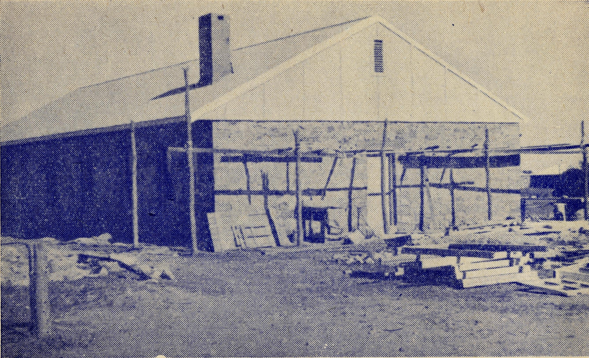
TARCOOLA No. 2.
This is the new Hospital now being built at Tarcoola by the local people and those that live in the surrounding 'station' country. The Government of South Australia has given generous assistance on a £1 for £1 basis. It will replace the present iron Nursing Home and will provide up-to-date facilities for nursing as well as better conditions for the staff.
Mrs. P. Connell
We are happy to be able to tell you that by the time you read this, Mrs. Conneil will be out of Hospital. She has been able to walk a little each day, and her doctors feel that she is now on the road to complete recovery. She will be staying with some Adelaide friends for a few weeks, after which we hope that she will be able to go to her people who live in the Lismore District. Arrangements are being made to enable Mr. Connell to join his wife and their children. It will be a very happy family reunion after so long a separation.
The Central Women's Auxiliary
Melbourne
We resumed our meetings with an Annual Dedication Service in the Lady Chapel, and later, spent the afternoon together in the Fitzroy Gardens. Our meetings have been well attended, though we have missed some familiar faces, absent through illness.
We regret the passing of two of our most faithful members, Mrs. L. A. Clarke and Miss N. Rowe. They were always quick to respond to any need of the work we all have at heart. We shall miss the happy fellowship that we had with them.
Our first function of the year was an 'Australian' Tea, at the home of Cr. Marie Dalley, O.B.E., of Kew. Colour slides on Japan and a talk by Major A. Peachey provided us with a most interesting afternoon. We are very grateful to our many friends who helped us raise funds for our hospital, and especially we would like to acknowledge the sum of £10 from D.R.D.
On May 20th, we were glad to welcome home Dr. and Mrs. Morris, and enjoyed hearing from them something of the experiences they had while visiting England.
Our Temple Day was held on June 17th in the Lady Chapel of St. Paul's Cathedral. Dean Roscoe Wilson gave us his usual helpful address. We are now looking forward to an afternoon at the home of our good friend Mrs. Sergeant of Moorabin.
Our energetic secretary, Mrs. H. Goodwin, is leaving on her trip abroad sometime in September. We wish Mr. and Mrs. Goodwin a very happy and interesting holiday.
We regret that Mrs. L. G. Ball has had to relinquish the position of Treasurer, and thank her very much for the valuable help that she has given to us over a long period of years. We are grateful to Mrs. S. L. Budds for accepting the vacant office and she has already given us plenty of evidence that she will fill it capably.
During the year we have been able to supply: Four Space Heaters, One Preserving Outfit, Two and a half dozen Tray Covers and Duchess Sets, One dozen Tea Towels, One dozen Pillow-slips.
These have gone to our hospitals in South Australia, and we are glad to say that we have also been able to make a gift to the Dr. Roy Gibson Memorial Fund. Our aim now is to supply a new type of sterilizer for the Ceduna Hospital, and for this we will need the help of all our friends.
To all those who support us so faithfully in the cause of B.C.A., we would say, 'Thank you'.
I. A. W.

16
The Real Australian
October, 1952.
October, 1952.
The Real Australian
17

The Qreat Need
In these days of wireless, telephone and motor cars it may seem hard to believe that people can be lonely. Yet it is true to say that some of these things that are marks of progress have had a very retrograde effect on the lives of some of our people.
In the old days life was more leisurely because we moved more slowly. In the outback the folk travelled by horse and buggy. This made a journey of a hundred miles to town quite a business. So much was done in a day, and each night the traveller would stay at one of the homes or hotels on the track. By this means even the person living in the most remote spot in a district, from time to time saw and talked with his fellows. There was a friendliness and fellowship that was part of life's round, even if most of the days were spent in loneliness and isolation. With the coming of the motor car much of that is changed. A trip of a hundred miles means but a few hours on the road and can be done between meals. Having devised a means of quick travel, man does not want to add to the time by calling in here and there. Whereas, in the old days, the neighbours popped in, to-day they whiz by in a cloud of dust. Perhaps I'm a bit of a cynic, but somehow I feel that with all our boasted progress, life is too fast for man's fullest development.
Fellowship is the great need of the folk who live in the lonely places. Spiritual fellowship is their greatest need, though sometimes they are not fully aware of it, but in that respect they do not differ much from their kindred in the^ great cities. There is a family I know in which there are four children. The eldest is of school age, but because of the isolation of their home, he is unable to attend a school, and so misses the companionship of others of his own age. Mother teaches him by means of the Correspondence Lessons. She does her best and really makes quite a good job of it. But you can well imagine that with the cares and distractions of three small children and the usual household duties it is no small task that she carries out. The child is getting the best education possible under the circumstances, but it is a very great pity he cannot have the benefit of living and playing with others like himself. I wish that we in the B.C.A. had an inexhaustible goldmine so that we could have enough School Hostels to cater for all these children who live under such circumstances.

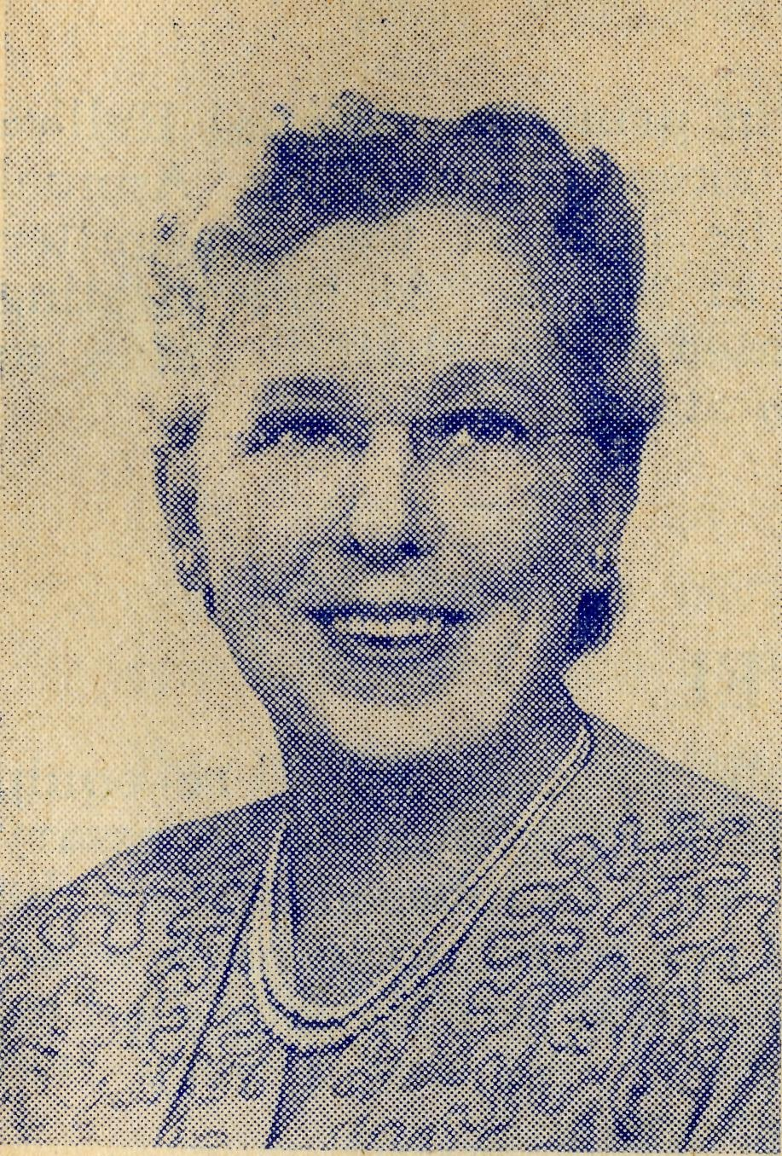
Miss E. M. Cheers
Miss Cheers this year completes twenty-five years' service with B.C.A. Her first two years were spent on the original Ladies' Van. At the opening of the Mungindi Hostel she became its first Matron and remained there until the beginning of 1951 when she transferred to the Bowral Hostel for Girls. We hope that Miss Cheers will be able to continue with us for many years yet.
WHY NOT BE A NURSE IN THE OUTBACK?
The B.C.A. offers a splendid sphere of service to our own people. The chief requirements are General and Obstetric Certificates. Mothercraft Training is not a 'must', but is a very useful addition for those who are to minister far from Baby Clinics.
A real sense of Christian vocation is essential, for B.CA. is definitely a Christian Mission.
The Organising Missioner will be glad to answer any further enquiries. Why not think and pray about it?
BROKEN HILL HOSTEL.
Our thanks are due to Mr. and Mrs. Parker of Tor Downs Station in the Menindie District for their generous gift of an 'Agar' stove to the Broken Hill Hostel. Such a gift is of inestimable value to the efficient running of the Hostel, and we deeply appreciate the thought and kindness of these good friends.

2CH —
THE BUSH PADRE broadcasts from this station on ALTERNATE SUNDAYS at 6 p.m.
MUNGINDI GIRLS' HOSTEL.
In our last issue we asked for some furniture for this Hostel. Miss Suttor, who for many years has been a worker in our Mail-Bag Sunday School has responded by giving a table, day-bed and a cupboard. The last being for the Mail-Bag office. Thank you, Miss Suttor.

18
The Real Australian
October, 1952.
October, 1952.
The Real Australian
19

ANNUAL MEETING.
By the time that this issue appears in print the Annual Rallies in Melbourne and Sydney will have taken place. The Annual Business Meeting of the Society is to be held in the Committee Room of Church House on October 3rd at 3 p.m. At this meeting the Balance Sheet and Report is presented. We shall be glad to see any members present who are able to attend.
PORT LINCOLN GIRLS' HOSTEL.
During the year we have been able to completely re-equip the hostel beds with Dunlopillo Mattresses. This was made necessary because all the furnishings at this Hostel were purchased during the war and the quality of the bed fittings did not stand up to hard wear. The amount involved has been about £370 and our Sydney Ladies' Auxiliaries have raised most of the money. We say a very real "Thank you" to them for this splendid effort.
AEROPLANE EQUIPMENT.
We desire to fit the Dragon with wireless. This will mean a wireless set and certain modifications to the plane. It is not necessary to stress the value of such equipment for medical work in the outback. The set will cost £180. The modifications will come out of General Funds, but would anybody like to give the Wireless Set?
ANNUAL THANKSGIVING MEETING.
The Central Women's Auxiliary of N.S.W. are to hold their Annual Thanksgiving Meeting in the Bible House, Bathurst street, Sydney, on Friday, October 31, at 2.30 p.m. This is the annual special effort of our ladies, and we are particularly anxious that it shall be well supported. It is a great encouragement to our friends to see a well filled room at such efforts, so do come if it is at all possible. We promise that you will have an interesting afternoon.
Remember to listen every FRIDAY at 11.15 a.m. to THE BUSH PADRE on station 2GB
THE MAIL-BAG SUNDAY SCHOOL OF THE B.C.A.
Serves many thousands of children in
THE COMMONWEALTH OF AUSTRALIA. THE ISLANDS
OF THE PACIFIC. NEW ZEALAND. THAILAND.
PAKISTAN.
Each year many of our outback and country children are prepared for confirmation by means of the B.C.A. confirmation instruction course, issued in book form.
The printing of the lessons costs 10/- per year for each child. Would you like to pay the costs for one child?
NEW NURSES' BLOCK AT CEDUNA
A new Nurses' Block is in course of erection at Ceduna Hospital to replace the old wooden building that has done duty for so many years. The new building is of stone and in keeping with the main hospital building. It will add much to the comfort of the staff, especially to those who while on night duty have to try and sleep in the daytime. The old rooms were very hot in the summer months and made sleep almost an impossibility during the daytime. The local people have done a great job in raising over £3,500 towards the cost. The South Australian Government has made a grant of £3,500 towards the total cost of £7,000 which is the cost of the building alone. The local residents have enough in hand to cover the purchase of all the necessary furnishings.
Sister F. Dowiing has been asked to lay the foundation stone on September 3rd, and the inscription on the stone will commemorate Sisters twenty-one years' continuous service at Ceduna. This is a splendid thought on the part of the people of Ceduna, and we are happy to know that such splendid service is to be permanently recorded. It is hoped that the new quarters will be ready for opening early in the coming year.
MAIL BAG SUNDAY SCHOOL VAN
Recent contributions sent in without an address attached have been paid into the above fund and we wish to acknowledge our grateful thanks to the donors. On July 25th, 10/-. July 28th from Mr. Jellicoe, £1/10/-.
In addition to the above, other folk, as well as Sunday Schools, still have our need of a Van in mind, and from time to time send us contributions which are helping our fund to grow toward our objective —a Van especially set aside to work among children of the outback.

