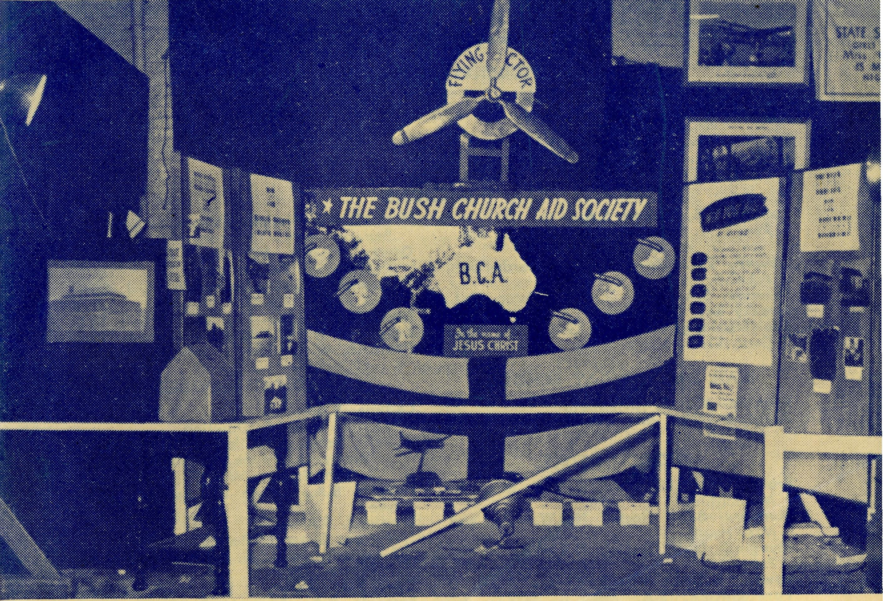
SUNDAY
For all Mis-sioners and Deaconesses of the Society and their people and for all students in training. MONDAY For all Doctors and Nurses serving in the outback, and for the spiritual and physical health of the patients una*; thekr care. TUESDAY For all workers in Hostels, the children under their care and the teachers who instruct them. WEDNESDAY For the Director of the Mail Bag Sunday School, the pupils of the School and all teachers and voluntary workers. THURSDAY For the Fly-i n g Medical Service and the safety of the pilots and all who travel with them.
FRIDAY For the Council of the Society, the Home Base staffs, Auxiliaries and Parochial workers.
SATURDAY For all neces-s a r y finance needed for the maintenance of so large a ministry and for guidance in its right application.
2/6 per annum, post free.
DECEMBER, 1952
No. 4 (New Series).
20
The Real Australian December, 1952.
Topics for
Prayer and Praise
For the Society
O Lord God of our nation, Who has commanded men to subdue and replenish the earth: Look in Thy love upon all who in distant parts of our land are striving against many difficulties, and are deprived the access of the means of grace. Strengthen and guide the Bush Church Aid Society and all members of the staff. Cheer and comfort them in discouragement and loneliness, bless their ministrations to "the good of those they serve, and grant that the message of redeeming love may thus be rooted and grounded in our national life, to the glory of Thy Great Name through Jesus Christ our Lord. Amen.
For Nurses and Doctors
O God, Who didst choose a beloved physician to set forth the life of Him Who went about doing good, grant that Thy strong tenderness and compassion may be manifest in the work of country doctors and bush nurses. Make them at all times alert to be faithful, as those whom Thou hast burdened and inspired with the honour of their cal ing. In lonely emergencies strengthen them with confidence that, having done all they can, they may with good conscience leave the issue to Thy power working within Thy law. Make them resourceful and of sound judgment, and hearten tneir labours with the energy of compassion and the firmness of duty that conquers weariness. Through Him Whose power is called forth by suffering, Jesus Christ our Lord.
For Church Life in Country Districts.
O Lord, Who art present when two or three are gathered together in Thy Name, bless, we beseech Thee, the little far-scattered groups of brethren who in our wide land meet together to worship Thee. Give them a perpetual freshness of spirit, and the power to inspire in each other holiness, helpfulness, and understanding of Thy help. Refresh with the joy of enthusiasm those who endure weary journeys to Thy trysting place. Grant that these little companies of Thy servants may be united in the spirit of Christian charity, awaiting in love the time when there shall be one fold and one Shepherd. Grant that the common life of all communities may be purified by this spirit of charity from all meanness, falsehood, malice and idle gossip, and grant that they who share a common lot may draw strength from each other's virtues, and in their weakness help one another, through our one Lord, Jesus Christ.
Praise
For the Blessings vouchsafed to the Society, for all kindly givers, for the joy of service.
Edgar Bragg & Sons Pty. Ltd. 4 Barker Street, Sydney.
The B.C.A. stall at the Melbourne Hobbies Exhibition. Registered at the G.P.O., Sydney, for transmission by post as a periodical.
The Official Organ of THE BUSH CHURCH AH) SOCIETY
Church House, George Street, Sydney, N.S.W.

The Real Australian December, 1952
December, 1952. The Real Australian

The Bush Church Aid Society for Australia and Tasmania
PRESIDENT: The Archbishop of Sydney.
Hon. Clerical Secretary: Rev. Canon Cameron. Hon. Treasurer: Mr. T. S. Holt.
B.C.A. Activities and Staff
Organising Missioner: Rev. T. E. Jones, Th.L. N.S.W. Deputation Secretary: Rev. J. R. Greenwood, Th.L. Victorian Secretary: Rev. L. Morris, Ph.D., M.Th., B.Sc.
VICTORIAN OFFICE:
Bible House,
Flinders Lane, Melbourne, Victoria.
Telephone: FJ 5675.
HEADQUARTERS OFFICE:
Diocesan Church House,
St. Andrew's Cathedral,
George Street, Sydney. Telephone: M 3164.
Cable Address: "Chaplaincy, Sydney".
STUDENTS IN TRAINING.
Rev. F. Ingoldsby, Th.L. . Rev. A. Cooke, Th.L.
Rev. I. Booth, Th.L. Mr. C. Burgess.
Mr. A. Williams. Mr. T. V. Jones.
Rev. J. Stockdale, Th.L. Mr. D. W. Warburton.
Mr. T. Morgan. Mr. R. Brooks.
MISSIONS.
Ceduna, S.A.-Penong, S.A.—
Rev. T. J. Hayman, Th.L., Ceduna, S.A. Rev. D. W. Draper, Th.L. Cowell, S.A.—Rev. D. A. Richards-Pugh,
A.L.C.D. Minnipa, S.A.—Rev. G. Fuhrmeister, Th.L. Streaky Bay, S.A.—Rev. P. Connell, Th.L. Croajingalong, Vic.—Rev. G. Garner, Th.L.,
Cann River, Vic.
MAIL BAG SUNDAY SCHOOL. Director—Miss R. Campbell. Assistant—Miss M. Patterson.
SCHOOL HOSTELS.
Broken Hill, N.S.W.—Mr. and Mrs. A.
McLaughlin. Mungindi Boysr* Hostel, N.S.W.—Mr. and
Mrs. Hustler. Mungindi Girls' Hostel, N.S.W.—Miss M.
Bowra'l, N.S.W.—Miss E. Cheers. Port Lincoln, S.A.—Miss I. Beck.
Heytesbury Mission, Vic.—Rev. E. G.
Beavan, M.A., Timboon, Vic. Otway Mission, Vie.—Rev. K. Seymour,
Th.L., Beech Forest, Vic. Wilcannia, N.S.W.—Deaconess M. I. Spry.
and A. Howland. Menindee, N.S.W.—Rev. W. Mitchell, Th.L. Rappville, N.S.W.—Rev. A. Gerlach, Th.L. Denmark, W.A.—Rev. J. Johnston, Th.L.
MEDICAL SERVICES. Ceduna, S.A.—
Matron: Sister F. Dowling. Staff: Sisters J. Miller, G. Hitchcock, B. Tierney, J. Payne, P. Shipway, J. Armstrong, Miss F. Lawtey. Penong, S.A.—Sisters L. Loane, L. Lang-tree. Wudinna, S.A.—
Matron: Sister R. Portch. Sisters: V. Holle, B. Barber, V. Brealey. F. Filis. Cook, S.A.—Sisters M. Horsburgh, M. Ross. Tarcoola, S.A.—Sister V. Page. Cann River, Vic.—Sister I. Gwynne. Rawlinna, W.A.—Sister E. Thomas.
FLYING MEDICAL SERVICE.
Pilot—Mr. A. Chadwick, Mr. W. Bedford. Doctor—Dr. F. Gibson, O.B.E., Dr. M.
Mueller, Dr. J. Upsdell. Pharmacist—Miss E. M. Page.
The O.M.'s Letter
It is only 28 years ago that the first of the B.C.A. Hospitals was opened in an old hou e at Ceduna in Souih Australia with a single nurse. From that tiny beginning the years have seen, not only great improvements at Ceduna itself, until we can today boast of what is admitted to be the best country ho p tal in South Au:tralia, but also the establishment of further hospitals at Penong, Cook, and Tarcoola, together with a Nursing Home at Rawlmna in West Australia, and the management of the modern district ho pital at Wudinna. All this has developed to serve the people in a huge area of country in the most difficult and some of the most sparsely settled country in the state of South Australia, and gives medical cover for 900 miles.
Fifteen years ago the efficiency of the service was improved by the establishment of a Flying Doctor Service. The Bush Church Aid Society bought its own aeroplane, added a pilot to the staff, built the necessary hangars and arranged for the important ground organisation. The doctors were thus able to work Irom their base at Ceduna to the out-centres as far away as Cook, 300 miles away on the great Nullarbor. To visit such places as Tarcoola, Cook, Penong and many other small centres in settlements or homesteads became a matter of weekly routine. When Wudinna was added to our responsibilities a second plane was bought and another pilot engaged.
We have been proud of the splendid manner in which this service has functioned and the efficient way in which the staff in all departments have worked together lo make it the very great success that it is today. We are also proud, and thankful to Almighty God, that in all the years these services have been running they have been entirely financed by Christian people, who have given generou ly to the Bush Church Aid Society for their maintenance. These services are a contribution of the Church to the needs and problems of the outback people, and are a constant witness to the fact that Christ through His Church does care for the people of the land.
Now I want to tell you of the latest development, in which I hope you will be very interested and will want to have a share. No doubt, you heard on the news sessions 1he announcement that a radio station is to be established at Ceduna by ihe B.C.A., as a communications centre for the Flying Medical Service. Up to date we have used the telephon'c communications of the P.M.G.'s Department for communication between hospitals and patients. Many years ago we went into the matter of a radio base, but decided at that time to continue with the telephone. Now the decision has been made to alter that policy and establish the radio network. The P.M.G.'s Department have been very helpful and have already approved the plans and equipment and allocated the wavelengths to be used.
The next step is the erection of the necessary buildings. A house is required in which the operator and his family can live, and another building must be erected for the equipment to be

The Real Australian December, 1952,
December, 1952.
The Real Australian

installed in the radio base. This matter has already been put in hand, and we expect that before many months have elapsed the station will be operating for the further improvement of the medical services. You will be glad to know that we have a goodly sum in hand for the necessary expenses of establishment of the radio base, but there will be other needs. Each hospital will need a transceiver set in order that the staff may have access to this quick and important channel of communication with the doctors and the Base. Many hundreds of pounds will be required to install them. Will you help to supply some of these transceivers?
As you can well realise, though this venture is a large one and will require much organisation and finance, it will be very worthwhile. By this means isolated homesteads will be in immediate touch with the doctor or nurse. Just a flick of the switch, and the miles will be eaten up. Patients will be able to obtain necessary advice or call the doctor just as speedily as you can in your suburban home by picking up the telephone. Isn't that a worthy object? It will also aid the sisters in isolated hospitals and nursing homes. Instead of having to take all the responsibility for calling doctor to urgent cases, the nurses will be able to talk freely and at any time about every aspect of their cases, and so leave doctor free to make this decision. Therefore we hope that you who have shown so great an interest in the advancing work of the Bush Church Aid Society will be keen about this latest step.
A Picnic on the Nullarbor
SISTER THOMAS.
The school children from the five schools between Kalgoorlie and the South Australian border had been looking forward for some time to the Inter-school sports to be held at Zanthus. When the great day came, sixteen children, a number of the mothers and myself boarded the "Tea and Sugar" at Rawlinna and made ourselves comfortable in the extra carriage that had been put on to be our home for the next three days. Other children joined us at the sidings of Reid and Haig. Most of the rest of the day was spent in story-telling and singing, and it was not until the children were all asleep in their bunks that comparative quietness reigned.
At the very first streak of dawn whispers were heard and then much excited chatter, we had arrived at Zanthus. The first task was a visit to the bathroom in the rest house that had been made available for our use. Here we had our meals and social functions each evening.
The Bishop of Kalgoorlie, together with Mr. Cunningham, the local Member of Parliament, were our distinguished visitors. They seemed to enjoy themselves and formed a high opinion of the children who live on the East-West Railway Line.
Throughout the three days of sports, Zanthus and Rawlinna ran neck and neck, and it was only in the final events that Rawlinna managed to get its head in front and win the sh;eld.
The Bishop of Kalgoorlie gave us Communion on Sunday at 7.30 and at 10.30 a.m. He conducted a very well attended service of Morning Prayer, at which the children made a very excellent choir. A hike, in the afternoon, to the low-lying scrub was enjoyed by young and old alike, especially the ice-cream and cold drinks that were served when we got there. Monday saw the prizes and trophies awarded, and how proud we were to receive the Shield. Then back to the "Tea and Sugar'' for our trip home to Rawlinna, where we arrived tired but happy at 3.30 a.m. on Tuesday.
The gathering of children and parents on such an occasion provides an opportunity to talk to them about spiritual th ngs, as well as to entertain them and provide good fun. The Bishop was very helpful by carefully explaining to them the meaning and purpose of the Communion Service. Pray for these people, that they may learn to know Him who is the Way, the Truth and the Light.
Rappville Revives
REV. A. GERLACH.
Most of the readers of the "Real Australian" will be aware that the Rappville Mission is the "baby" of the B.C.A. Mission Districts, because it is much smaller than the others, being only a mere 1,200 square miles.
On our arrival, in February of this year, we found a parish, that had been vacant for two-and-a-half years! The Rector of Casino had done his best to provide for the needs of the northern end of the district, but the south had not had a serv'ce of any description since Christmas, 1950. Of the twelve schools in the parish, none had received any religious instruction classes during the vacancy. Sunday Schools had ceased to exist, though a handful of the children had been receiving the lessons of the Mail Bag Sunday School.
My main task in the first few months was to re-establish some sort of ordered plan of services and visitations. For the first six weeks, we were dependent upon the local people for transport, but at the beginning of April, B.C.A. made a car available. This enabled me to push ahead with the organisation of the district.
The Mission could be more aptly styled a circuit, rather than a parish, for it takes a month to cover all the thirteen centres that go to make it up. We have five churches; in four localities worsh'p is conducted in public halls, and in the remain'ng centres, gatherings are held in private homes. Three Sunday Schools are now functioning, and we hope that soon we shall be able to start two more.
From the po'nt of view of numbers, Rappville's revival has been very encouraging, but our main task, here as elsewhere, is to win men and women to personal allegiance to the Lord Jesus. It is never an easy task, but here we are encouraged by some hopeful signs. A few weeks ago, the Archdeacon visited us, and at the conclusion of his stay, remarked that he felt that there is a definite stirring of awakened interest in the things of God. People, who previously were not interested, are turning again to the things of God.

The Real Australian December, 1952
December, 1952. The Real Australian

THE BISHOP'S VISIT
It had been planned that the Bishop of Grafton should visit us lor two days in late October for Confirmation, which had not been held in this district for three years.
In the city, this would have presented no great problem, but in the bush it is a very different matter. The 28 candidates were distributed throughout seven different centres. Five of them lived at Rappvxlle; the others lived from eight to 27 miles away. We hoped that we could have two, if not three Confirmation Services at convenient centres.
When the time drew near, the Bkhop found that he could spare but one day. The Confirmees must, therefore, be assembled in one place, and Rappville was selected as being most centrally placed. The two lads who had the greatest distance to come, found themselves m trouble. At the last minute the family Chev of 1928 vintage refused to move, so Mrs. Gerlach took the parish car and brought them in. The Bishop undertook to take them home on his return to Grafton, but even bishops get into trouble, and when the service was over, we found the bishop's car with a flat tyre. However, that was soon remedied, and the boys drove home in the episcopal car this time.
St. John's, Rappville, was built to seat about 80 persons in reasonable comfort; a 100 CAN be squeezed in, if it is really necessary. On Wednesday, 29th October, it overflowed with a record congregation.
Under the glare and hiss of the kerosene pressure lamps, twelve girls and sixteen boys took upon themselves the vows made on their behalf at their baptism, and were received into full membership of the Churoh of God. The Bishop spoke to them of the need of loyalty to God and His Church.
Afterwards, a happy family of people gathered together for the inevitable cup of tea. The blessings of that night will not readily be forgotten by those who were present.
THE SOCIETY'S FIRST MEDICAL PLANE
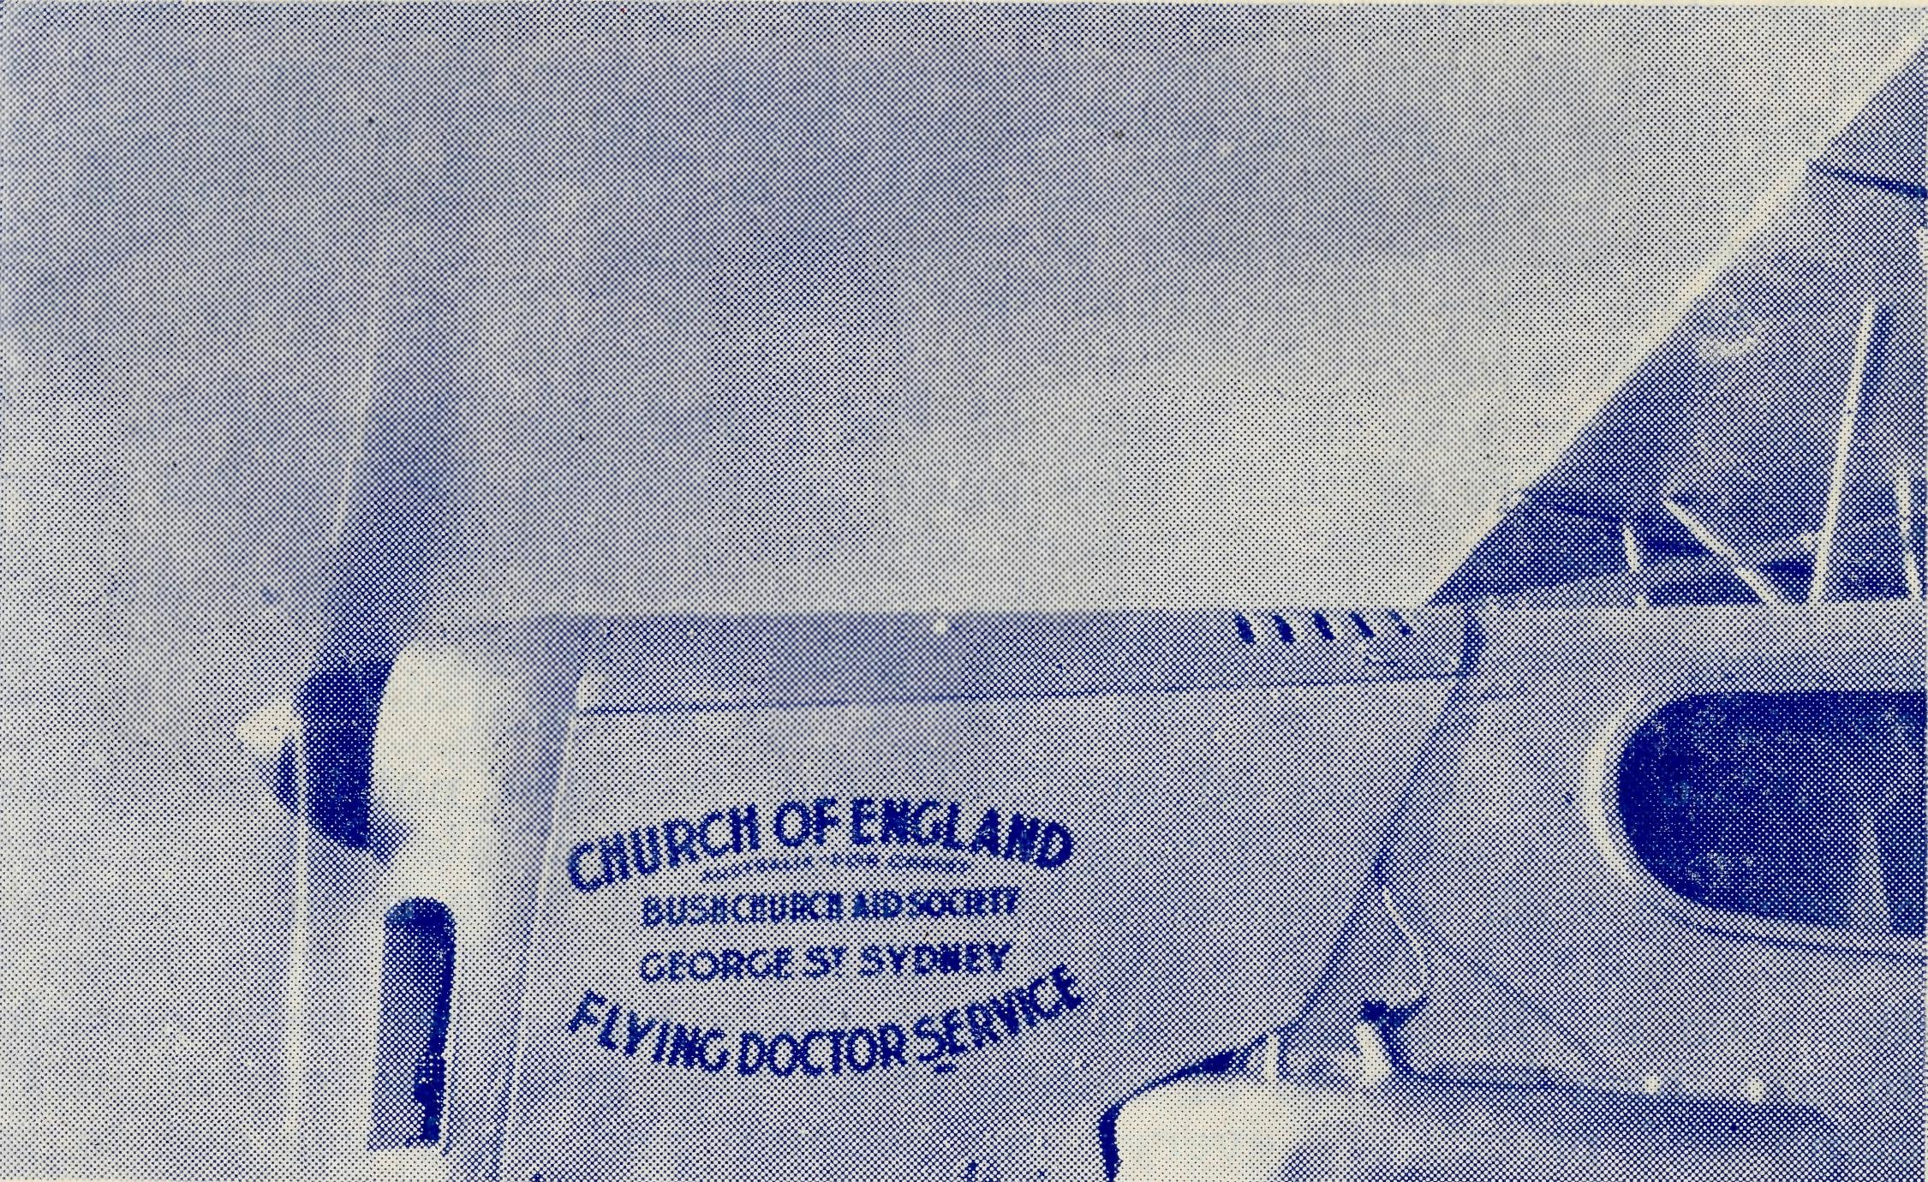
Bought in 1937, this 'Fox', made by De Havillands at Sydney, has
flown over one-quarter of a million miles in its errands of mercy.
The new radio base will add the last link towards the maximum
of efficiency for this service.
Back to Cook

THE MAIL-BAG SUNDAY SCHOOL OF THE B.C.A.
Serves many thousands of children in
THE COMMONWEALTH OF AUSTRALIA. THE ISLANDS
OF THE PACIFIC. NEW ZEALAND. THAILAND.
PAKISTAN.
Each year many of our outback and country children are prepared for confirmation by means of the B.C.A. confirmation instruction course, issued in book form.
The printing of the lessons costs 10/- per year for each child. Would you like to pay the costs for one child?
It was good to be going back after an absence of three months. I suppose it is good for nurses to see the profession from the patients' angle occasionally but I am very glad and thankful that I am at last back on the giving instead of the receiving end.
On my return journey it was necessary for me to come via Ceduna, owing to the difficulty of obtaining a berth on the East-West express. This meant a night in Adelaide and it was a real thrill to be met unexpectedly by an old Ceduna resident who, with his wife, is now living in Adelaide. They were always out to do all they could for the staff at Ceduna and now their home is open to all to stay there when passing through Adelaide.
After picking up Sister Teirney from Hospital where she had been an inmate following an argument with a carving knife, our friend took us out to his home to dinner, after which we enjoyed a sing-song around the piano.

The Real Australian
December, 1952.
December, 1952. The Real Australian

Next morning we set off for Ceduna together with Mr. Williams, a B.C.A. student and his fiancee who were going out to get firsthand knowledge of the work. The trip proved to be exceptionally rough. Our visitors had never flown before and Sister Teirney and I decided that if they weathered this trip they would be fit for anything the Dragon had to offer. They did. The weather greeted us in true Ceduna style, a gale force wind and clouds of dust but a very real welcome awaited us from the staff. It was great to see them again after three years and somehow I felt as though I had never been away.
Next day was the laying of the foundation stone of the new nurses' quarters so there was much preparation for the big event. The highlight of the afternoon was the presentation of a wristlet watch to Sister Dowling by the people of Ceduna after she had performed the ceremony. It was good to see this token of their appreciation of all that Sister has meant to them.
About 4.30 we set off for Cook. This trip was not to be without its excitement either. Having a full load and a late start, darkness caught up with us. For some two years there have been emergency landing rlares kept here and Mr. Chadwick had instructed some of the men in the laying of them but there had never been occasion to use them before so of course there was great excitement in the camp and practically every man, woman and child was out to see the sight. It was quite a welcome home.
It was Doctor's consulting day so there was no time to get settled in and unpacked before starting work.
The following Saturday we were without patients so we decided to take the children for a picnic to the "Ruined Castle"! A ruined castle in the middle of the Nullarbor, it does sound exciting, doesn't it? One does learn to use imagination out here and it is wonderful what it can do. In reality our castle is the remains of a few railway sleepers which had apparently been used as a rifle target at some time. They have been burned and only a few pieces remain. We set off in the usual way for a Nullarbor picnic, carrying our wood and water and armed with grillers, sausages, etc.; also a piano accordian owned by a lad employed in the store, who is our right hand in all our youth work. We soon arrived at our destination, it is only about three-quarters of a mile from the hospital and that was quite far enough carrying all the gear. There were no buses running that day.
Games were the first item on the programme. Have you ever tried a three-legged race with someone about a third your height? It is quite handy; if you are being left behind, it is a simple matter to lift your partner off the ground and run for it, not orthodox but fun all the same.
Soon everyone was anxious for the real business of the day, So grillers, potatoes and sausages appeared from everywhere and in no time all were enjoying their own version of baked potatoes and grilled sausages plus plenty of grit for good measure.
After lunch a walk was suggested. Where would we walk? It did not really matter. If we went east there was nothing, if we went west there was nothing and south and north are the same,
so we just walked. At times we were walking through National Park at others through the Botanical Gardens and, believe it or not, we did find lots of white everlasting daisies, much to the delight of the children who soon presented Sister Shipway and myself with armfuls of them.
When the novelty of walking wore off, everyone gathered round for a story and for some choruses, accompanied by the accordian. Our surroundings may not have been very inspiring, sitting there in the middle of nowhere, but everyone enjoyed that little time of worship. The Lord has indeed given us a great privilege in bringing the gospel to these boys and girls.
We have been very encouraged lately at the numbers coming to the Monday night bible-class, especially older ones. Do pray that they may come to really accept Christ as their Lord and Saviour. The home influence, in most cases, is anything but encouraging for them to take that step. Only a real work of Grace can do it.
Have you ever lived 250 miles from your baker? We do. He is not a first class baker either and as the bread only comes twice a week now instead of four times and stands outside the store overnight in more or less open boxes you may be able to imagine what it is like. Maybe you won't. However, after putting up with it for a week or so we decided to try the art of bread-making, reckoning that no matter how terrible the results it could,be no worse than what we were buying. We were delighted when the first batch even looked^like bread and since then we have enjoyed fresh bread every other day.
Do I hear some nurses saying they want experience? Then why not think and pray about B.C.A. — nowhere could you get more experience of every description: nursing, housekeeping, sewing, plumbing, cooking, painting, gardening, Sunday School teaching and conducting church services. Is there anything else you require?
The joy of this job is though, that it is the Lord's work and whatever you are called upon to do, no matter how big the task or how small, it can be done to His glory, and one finds how true are His words: "My Grace is sufficient".
First Sunday in Advent—1922
It is thirty years ago this Advent, since our Mail Bag Sunday School became a reality.
B.C.A. pioneer workers, especially Rev. F. W. Harvey (West Darling Mission) and Deaconess Shoobridge (Croajingalong) soon felt the need for some means of teaching the children whom they visited in isolated places.
The Organising Missioner, Rev. S. J. Kirkby, whose experience had also shown him trfis need, arranged with Rev. A. J. H. Priest to prepare suitable lesson papers, which were then duplicated for sending to isolated children in various States. This was called "The Sunday School in the Mail Bag". Later, as the scheme developed, it became known as "The Mail Bag Sunday School". Within a few months the demand for lessons had so increased as to warrant the papers being printed instead of duplicated.

10
The Real Australian
December, 1952,
December, 1952.
The Real Australian
11

The Bush Padre's Session
The act of faith in launching this scheme was soon justified in the response from rectors, parents and children; also support came from the Church in the cities when financial help and workers were asked for.
Among those associated with the Mail Bag in the early days were Rev. J. V. Patton, Rev. A. J. H. Priest, Rev. H. W. A. Barder, Rev. J. R. Le'Huray, Mr. T. N. Griffin, and Miss Cox of Leichhardt.
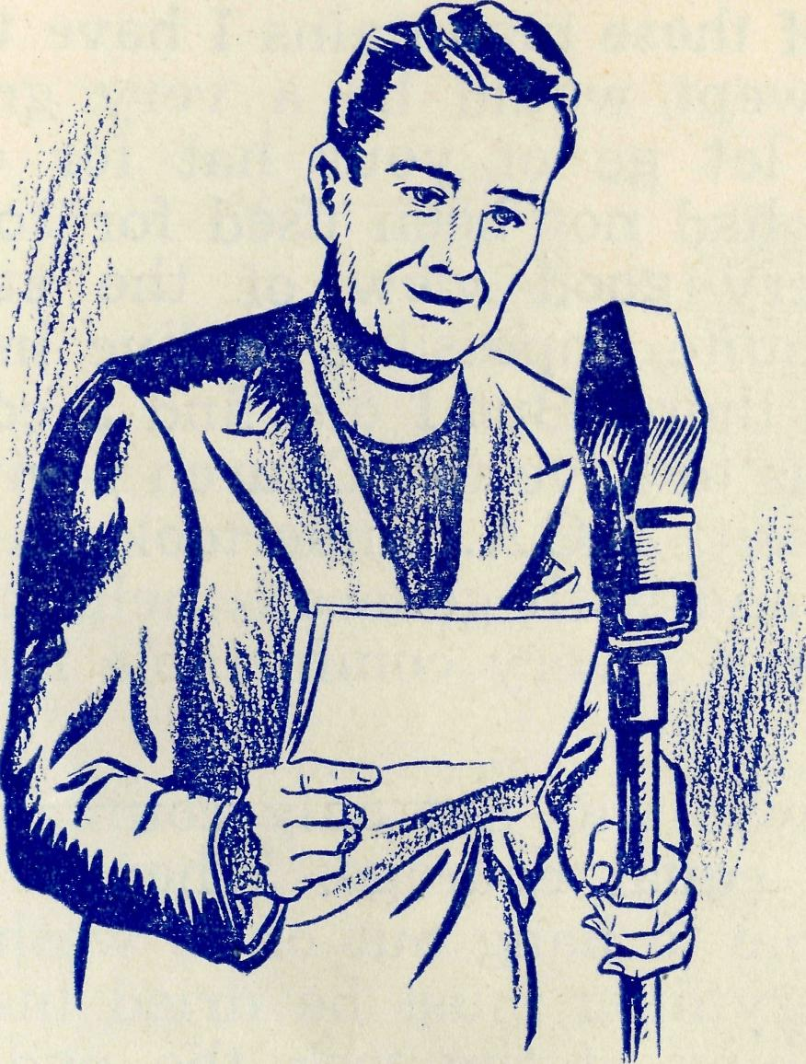
This work continued to expand and as we read in the "Real Australian", February, 1926, "Miss Huntley has taken over the work hitherto carried on by Rev. A. J. H. Priest.. We are hopeful of developments in this important branch of religious work." Miss Huntley was ably assisted by other voluntary workers, especially Miss E. Schofield.
The next development was a set of lessons for the younger children — many of whom were now seeking enrolment. This led in 1931 to the formation of a Primary Department, with its own Leader — Miss R. Campbell.
The value of the personal touch has always been stressed in this work, and many experienced teachers had been recruited to correct children's work and keep in direct contact with them.
These groups of voluntary workers. felt the need to meet and discuss problems arising from their work. From 1934, regular quarterly Conferences of both Upper and Primary Grades have been held and some of the original teachers are still giving faithful and valuable service.
In order to give children of the outback the best possible Christian education the syllabus of lessons has gradually been expanded to eleven grades, thus supplying the child from pre-school age, to adolescence with a course of lessons suited to his needs.
Any isolated child seeking full membership of the Church is able to prepare for Confirmation by studying the Confirmation lessons published by the Mail Bag Sunday School.
The supply of lessons to children throughout the Commonwealth, New Zealand, as well as Pacific Islands, has necessitated a great expansion in organisation and clerical work. The staff now consists of a full time Director and Assistant. These are ably supported by many part time voluntary workers as well as teachers.
Surely this record, showing how the foundations of the Mail Bag Sunday School were laid, is a challenge to us to carry the work forward and we will meet it in the spirit of Nehemiah's words — "therefore we his servants will arise and build."
D. FOSTER
2CH —
THE BUSH PADRE broadcasts from this station on ALTERNATE SUNDAYS at 6 p.m.

I have told you on other occasions of some of the Mission work in what is called the Heytesbury Forest area, located in the diocese of Ballarat. It is to be found in that part of Victoria about Cape Otway. You might think, after examining the map, that an area so near to a big city like Melbourne would have no need of a special type of ministry such as the B.C.A. provides. Perhaps I had better tell you how it is that we work in a diocese like Ballarat.
You see, many of the country dioceses of the Church of England have within their boundaries certain problem areas. This is because many of them have some country that is still in its developmental stage. In greater or less degree this is so with the Heytesbury District. The whole area is very mountainous, and most of it is densely covered with trees. It has a very high annual rainfall, which in some places is as much as 88 inches per year. Everything grows most prolifically, including the undergrowth and trees. Some years ago, I do not know how many, the Victorian Government of the day decided to open up this country for settlement. Great gangs of men were sent in with axes to hew the timber down or to ring-bark the trees, and so kill them. This was a disastrous operation. All the trees on whole mountainsides were ring-barked, and in some cases one can see them standing to-day; even though they are dead they are very beautiful in their forms against the sky. This method of clearing came to a sudden end, though not before many "graveyards" as they are called had been created.
Instead, settlers were encouraged to go in and clear land for farms while not entirely destroying all the timber. As time went on small communities were created with their stores, halls and hotels to serve the settlers in the surrounding districts.
The Ballarat Diocese is an area of small towns, with the exception of the town of Ballarat and one or two others. The resources of the Church there were very much taxed to cope with the growing needs of the diocese as a whole, and very little could be done for this area of which I have told you. From time to time the bishop was able to send a clergyman to minister to the folk who lived in the Heytesbury area, but it proved to be an intermittent ministry. About fifteen years ago the Bishop approached the Bush Church Aid Society and asked if we could help him solve the problem.

12 The Real Australian December, 1952.
December, 1952. The Real Australian 13

RAWLINNA, W.A.
.IN THE OUTBACK?
In response to the Bishop's request, I went to have a look at an area called Beech Forest. When I got there I found that the centre of what has since become the B.C.A. mission there, was a little township standing right on the top of one of these mountains I have told you about. To say that it was windswept would be a very great understatement. You simply dare not let gc of your hat for one second. I found a wooden Church that had not been used for some years, and a rectory that gave a very good view of the stars without having to go outside. It was quite impossible to live in it. It seemed that it never ceased to rain there. But I did find a community of people who were very anxious to have the Church revived in their midst. As a result of my visit, B.C.A. undertook to be responsible for the Beech Forest area, and with generous help from the diocese the people were able to have a very comfortable house built for the padre and his wife.
To face such a job needed a man who was not only courageous himself, but who also had a wife of equal courage. When I tell you that sometimes it is quite impossible to hang out one's washing for as long as six weeks, and that everything must be dried inside the house, you will understand something of the task the padre's wife has to face. I found the right man, with the right wife, and what a great job they both did. They stayed there for ten years, and I have always considered that one of the mo t outstanding pieces of service given by any Bush Padre I have had anything to do with. Congregations were built up. Sunday Schools established in every village and settlement within the area. Every Day-school was regularly visited week by week for the instruction of the children. Since that time other padres have followed and it has been possible to keep up a continuous ministry, whereas before it was so intermittent.
I was visiting Beech Forest not very long ago, and was asked if I would go along to the Sunday School concert and prize-giving on the Saturday night. For the whole day it simply poured with rain, and the wind blew the water in great gusts. I assure you, it was far from inviting, and I think it would be true to say that if I had not had to attend I would probably have decided to stay at home be^{c}ide that nice log fire. I was quite sure 1hat the whole affair would be a frost and that nobody would turn up in such awful weather. But I did not know my Beech Forest people. They came from every out-district, and the children had a great time of it. The next day was, of course, Sunday, and the rain continued without a break. We had three services arranged at three different centres. Again, I was sure that there would be few, if any, in our congregations. Again I was wrong, and that day I was told that, in that part of the world, the harder it rained the more went to Church because the rain did not allow them to do anything else.
WHY NOT BE A NURSE
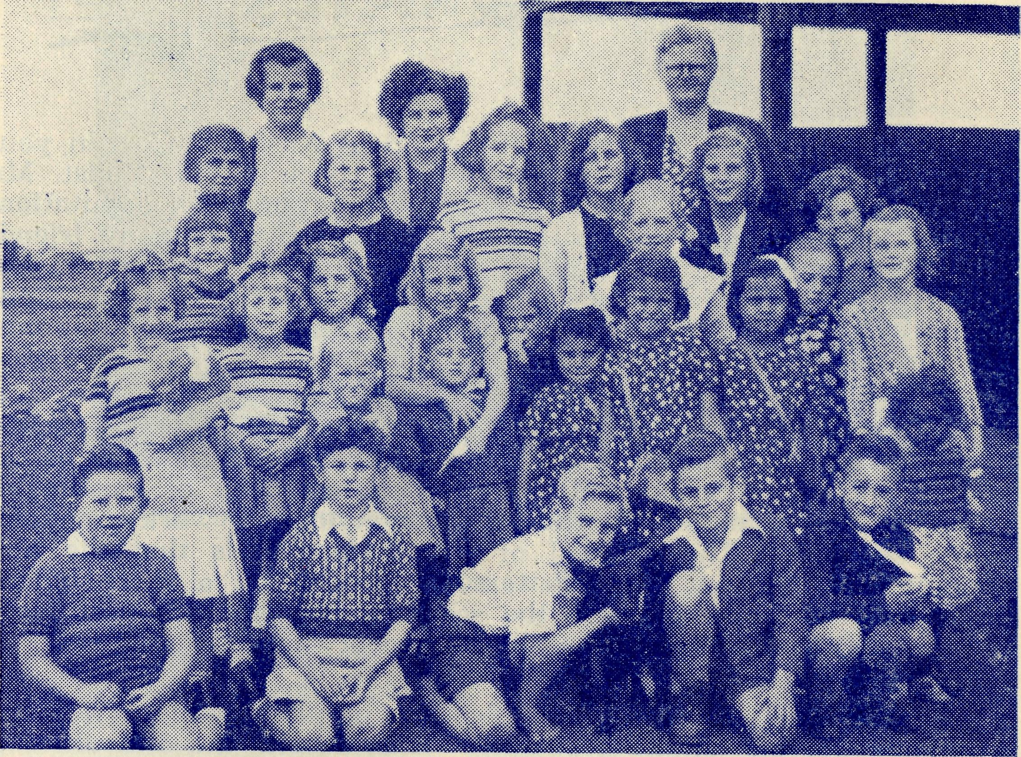
Rawlinna is a tiny place on the plains in Western Australia. Here you see most, if not all of the children who live there. Sister Thomas (back row) cares for their spiritual needs as well as looking after their bodily health. Take a good look at them—then ask yourself if the RCA. spends your money in a good cause.
2KA.—
You can hear THE BUSH PADRE from "The Voice of the Mountains" on ALTERNATE FRIDAYS at 4.15 p.m.

14 The Real Australian December, 1952
December, 1952.
The Real Australian
15

By the time that this issue of the "Real Australian" is in your hands, the Rev. John Greenwood will be back in our midst. Mr. Greenwood has carried out a very heavy programme of deputations for the B.C.A. during his visit to the Homeland, and many friends have been added to the circle of those who are interested in the Society's work. We are greatly indebted to the Colonial and Continental Church Society for receiving Mr. Greenwood as deputationist and for the excellent programme they prepared for him.
Our friends will be interested to learn that Miss Myra Patterson has now been appointed to the office of Assistant Director of the Mail-Bag Sunday School. Miss Patterson has been of inestimable value to Miss Campbell in that department of our work, for some years, as clerk. The Council of the Society feels that the new appointment will put Miss Patterson's service on a more official basis, and, we hope, increase the scope of her effective usefulness. We are glad that she has been able to accept the position.
The Annual Thanksgiving Meeting of the Sydney Women's Auxiliary was one of the best ever. This, despite the difficulties of traffic caused by the State funeral of the late Mr. Hughes, was very pleasing.
The two speakers, Sister Dowling and Deaconess Howland, made
it abundantly worthwhile being present, and we appreciated very
much the presence of Mrs. Mowll in the chair, on a day when many
other duties called her. The stalls and offertory amounted to £80.
* * *
We are glad that Sister J. Armstrong has rejoined the staff at Ceduna. Sister returned to Sydney over a year ago in order to complete her Mothercraft training. Sister has gained her certificate, and this training will widen her sphere of useful service.
It has been good to welcome Sister Dowling, Sister Shipway and Dr. Mueller to Sydney while on holidays. We hope that they have found much refreshment and renewed vigour.
Victorian friends of the Society are invited to be present at a Farewell Communion Service for the Revs. A. Cooke and John Stockdale before they leave Melbourne to take up their respective posts with B.C.A. Trie Service is to be held at St. Jude's, Carlton, on Monday, December 15th, at 10 a.m.
Morning tea will be served after the service, and there will thus be an opportunity for friends to meet these new Missioners.
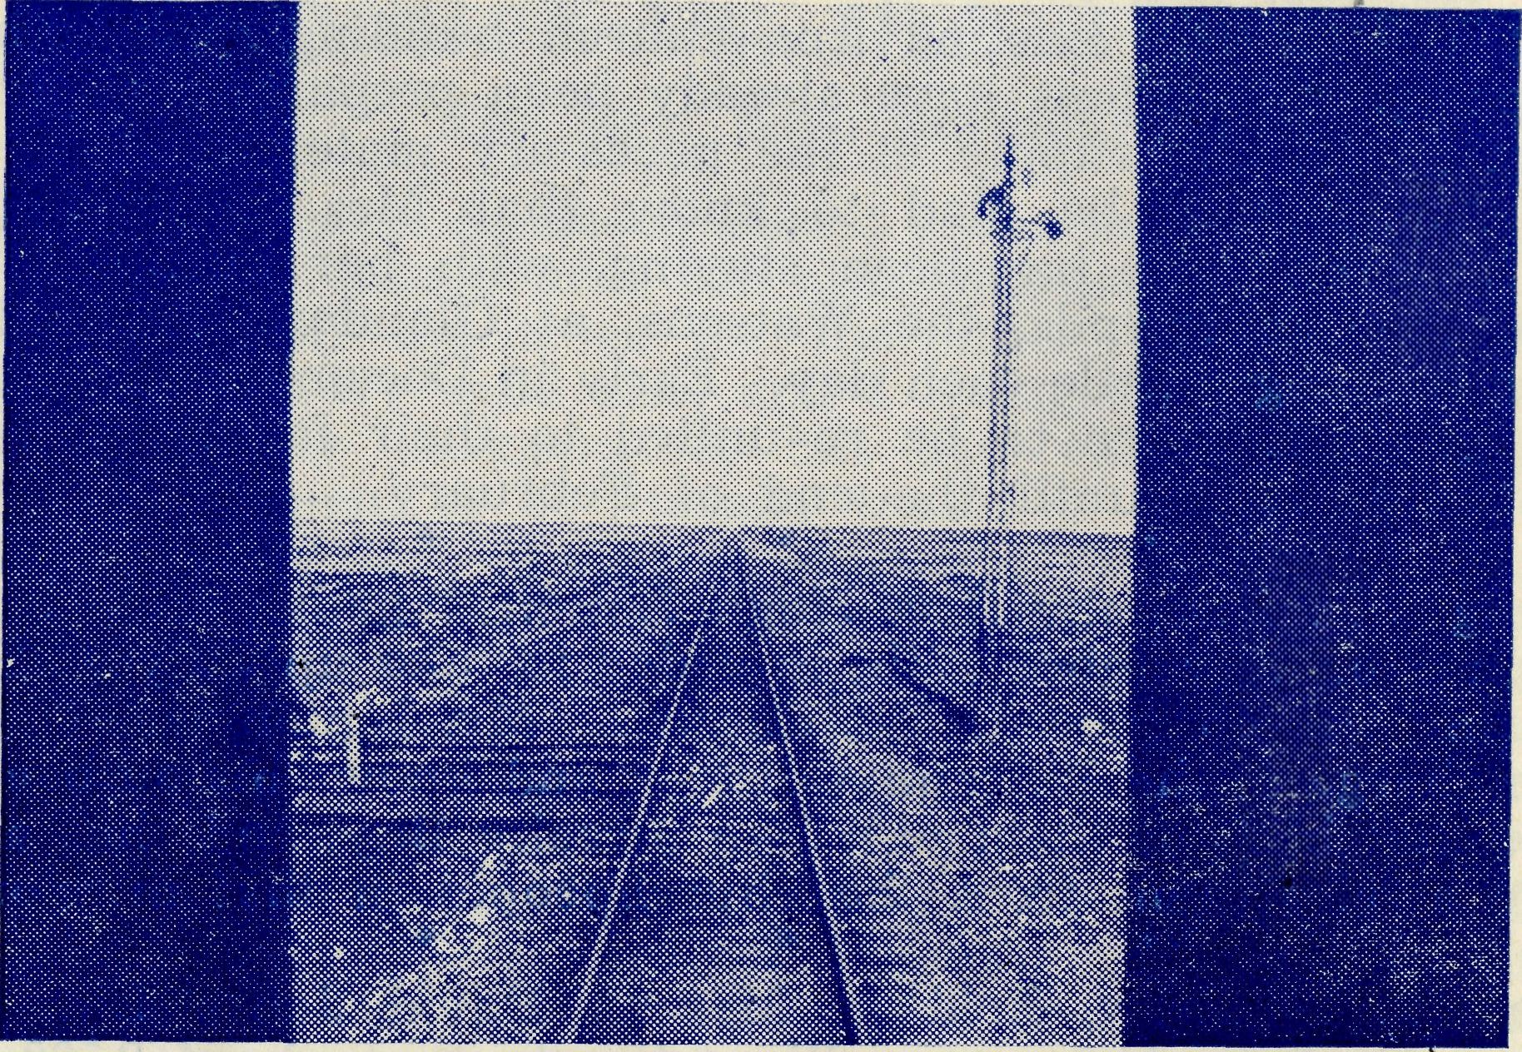
The Nullarbor from the rear of the Transcontinental Train.
Our Victorian readers will be interested to learn that the Rev. E. G. Beavan has been appointed to the office of Victorian Secretary. Mr. Beavan brings to this task a wide experience gained in England, Newfoundland and the B.C.A. Mission at Timboon in the Diocese of Ballarat. Before coming to Australia in 1948, Mr. Beavan was Organising Secretary for the Col. and Con. in the North-West area of England. The Organising Missioner remembers the many well-organised meetings Mr. Beavan arranged for him in 1946-7. We feel sure that a good success awaits Mr. Beavan's labours in his new office. He will take up his duties towards the end of January.
We owe a very great deal to the Rev. Dr. Morris for the splendid work he has done in Victoria for the Society, while acting as Victorian Secretary, since his return from England. His display at the recent Hobbies Exhibition was outstanding. Thank you, Dr. Morris.
* * #
Mr. Beavan's successor at Timboon will be the Rev. A. Cooke, who is at present curate at Heidelberg, Victoria. We pray that Mr. Cooke and his wife will have a happy and useful field of labour in that centre.
It is hoped that Hogarth Range in the Rappville Mission will soon be able to make a start on the church building that it has dreamed of for so long. The war and shortage of materials has held up this project and the money so kindly given by friends of B.C.A. in England and Australia has been gathering interest. Moves are now being made to make an early start on the building.

16
The Real Australian December, 1952
December, 1952.
The Real Australian
17

Mr. Hayman and his people at Ceduna are also busy in their effort to replace the exist ng iron church building with something; more appropriate. Plans have already been prepared and arrangements made for the supply of the necessary materials.
All friends will be glad to know that Mrs. Connell is now out of hospital. She has been staying, with her husband,- in the home of our old friends, the Watsons, at Glandore, Adelaide, and has been walking a little each day. Early in December Mr. and Mrs-Connell go to Lirmore to be re-united to their family. They will
stay there at lead until the end of February.
* * *
Our good friend, the Rev. Hugh Linton, together with his wife, left Sydney on November 17th, in order to take up duty at Streaky Bay during the absence of Mr. Connell. Mr. Linton was for many years in charge of the Wilcannia district and knows his outback. We are sure that both of them will like Streaky Bay, and that a warm welcome awaits them from the churchpeople in that mission.
* * *
The Orchid Show, held at Messrs. David Jones Ltd. during October, was a good success. We estimate that about 2,500 people attended during the week. Some thousands of informative pamphlets were distributed and much interest in the work of B.C.A. was kindled.
We are greatly indebted to Mrs. Bolton for the immense amount of hard work that she put into the organising; to the growers who kindly loaned such an excellent display of orchids, and to Messrs. David Jones Ltd. for making the store available.
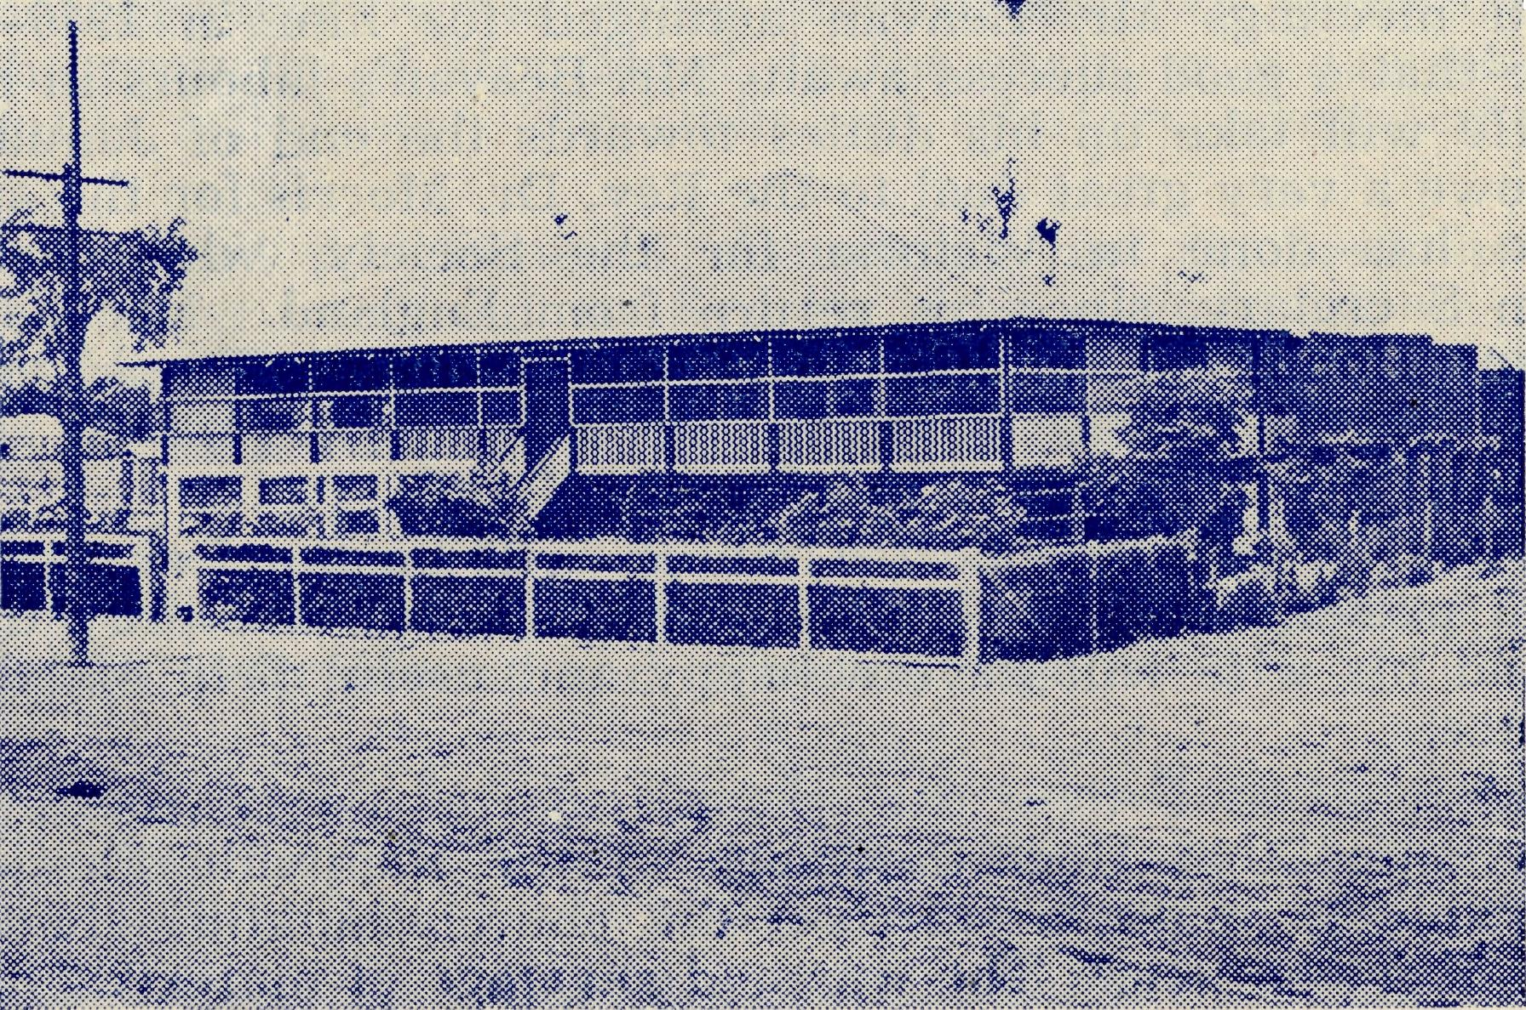
This hostel, built by B.C.A. in 1930, is still going strongly. In the twenty-two years somewhere about 350-400 children have lived here.
MUNGINDI
Water by the Yard
The Rev. Ken. Seymour
When I first came to Beech Forest I was told by those who knew the place that it rained here for nine months in the year and the water dripped off the trees for the other three! My first year proved to be a very mild one, and I thought that conditions here had been greatly exaggerated, but my experiences since have proved the comment to be literally true.
Last year we had 95 inches of ran. Many days it rained all day long, some gave us thunderstorms and drizzle, nearly all the rest it just drizzled. Oh yes, sometimes it snowed and at others we had a thick impenetrable mist when visibility was reduced to nil. When the snow thaws, one has to tread warily or a certain part of one's anatomy may get uncomfortably wet.
This year we have already recorded 85 inches, so it looks as if we shall beat last year's record with ease. The wet season began in March and has continued almost unbroken until November. We have seen the sun about a dozen times during that period, for when it has not been rain ng or drizzling, it has been blowing with gale force with an overcast sky. Needless to say, everyone's temper is becoming frayed, even to that of the missioner and his wife.
The farmers have had a bad year. Most of them were unavoidably late getting their potatoes in, and the ground was so wet that digging them out became a well-nigh hopeless task. Many of the paddocks, .especially in the lower areas, were almost impossible of approach, so acres of potatoes were left to rot. Many of those that were harvested were found to be rotten inside and, therefore, unfit to market.
The saw-millers have done a marvellous job. It is simply amazing what they can do with a bull-dozer when they require to get logs out of the forests, over steep, rough country which becomes nothing less than a rea of mud.
Although these conditions have made church work very difficult, it is pleasing to know that attendances at services have kept up very well. In none of the centres has there been any falling off in the numbers. I feel that this is an indication of the appreciat:on by our people of the ministry being given to them. Throughout the whole year it has been necessary to cancel only four services owing to the impos ibility of getting to the centre.
Johanna is our newest centre. It is twenty-four miles from Beech Forest and is approached by one of the worst roads in the Otways. The road is narrow and winds around the sides of the precipitous hills. Going down is not ro bad, but coming up with a car-load of parishioners to be dropped at the gates of their various farms, is a very different business. The Austin takes most of the journey in second and th'rd gear, and who can blame her?
There are eight Anglican families in the Johanna district, and whenever we have service, there is at least one representative of each in attendance. Normally we have 18 present, and that is a very good average from eight families. We have a monthly service at this centre in the home of one of the parishioners. The front

is The Real Australian December, 1952.
December, 1952. The Real Australian 19

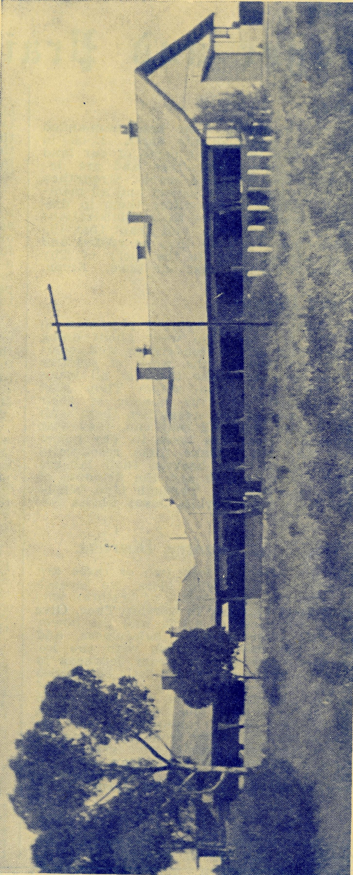
room is made to look like a church, perhaps it would be better to say, feel like a church, for we have little church furniture. After service, we all have supper together: this is one of the advantages of NOT having a church building.
Located at Wudinna, South Australia, this hospital was tken over by the B.C.A. for maintenance and administration in 1946 and is now the second base hospital of the society’s flying medical services.
THE CENTRAL EYRE PENINSULA DISTRICT HOSPITAL
A little over a year ago, we started a Youth Fellowship, at Beech Forest, and it was a joy to find that half the available number of young people in the village came along to the first meeting. Every one of these foundation members has remained faithful, and we have gained one or two more. The majority have become regular attenders at church and their enthusiasm has given new life to many of the older and faithful members of our congregation. We have a devotional time together, and then of late, we have followed this with a careful study of the service of Evensong, so that all can have an intelligent understanding of the form of worship they are using. We have had debates, play readings and talks by local people on a variety of subjects. We play games with the aid of muscle, enthusiasm and wind power. I have been told that on still nights we can be heard for many miles over the settlement. We are trying to make our Fellowship an exercise in the spiritual, the intellectual and the muscular.
The Mail-Bag Sunday School of the B.'C.A. is quite a feature in this mission. Both parents and children have come to appreciate its usefulness. At Kawarren a lady is teaching her own two boys, with the aid of these valuable lessons, and also three of her neighbours' children.
I think this is enough news for now. I will save the rest for next time.
MISS MAUDE ASHE
Since our la^{c}t issue, Miss Ashe has passed to her rest. In a very full life she had a hand in the creation of many useful activities in connection with the Church's work in the Diocese of Sydney.
The Home of Peace which has proved so great a boon to many during the last few days of their earthly life, owes much to her vision and organising ability in its establishment. From 1901 to 1912 Miss Ashe was Head Deaconess in the Sydney Diocese. At the invitation of the late Bishop Kirkby she, together with Mrs. W. L. Langley, formed the Women's Auxiliary of the Bush Church Aid Society which has meant so much in the life and development of our outback work.
We remember with gratitude so much devoted service, and offer our sympathies to Miss Bennett, who for so many years devoted herself to caring for Miss Ashe in her long illness.

