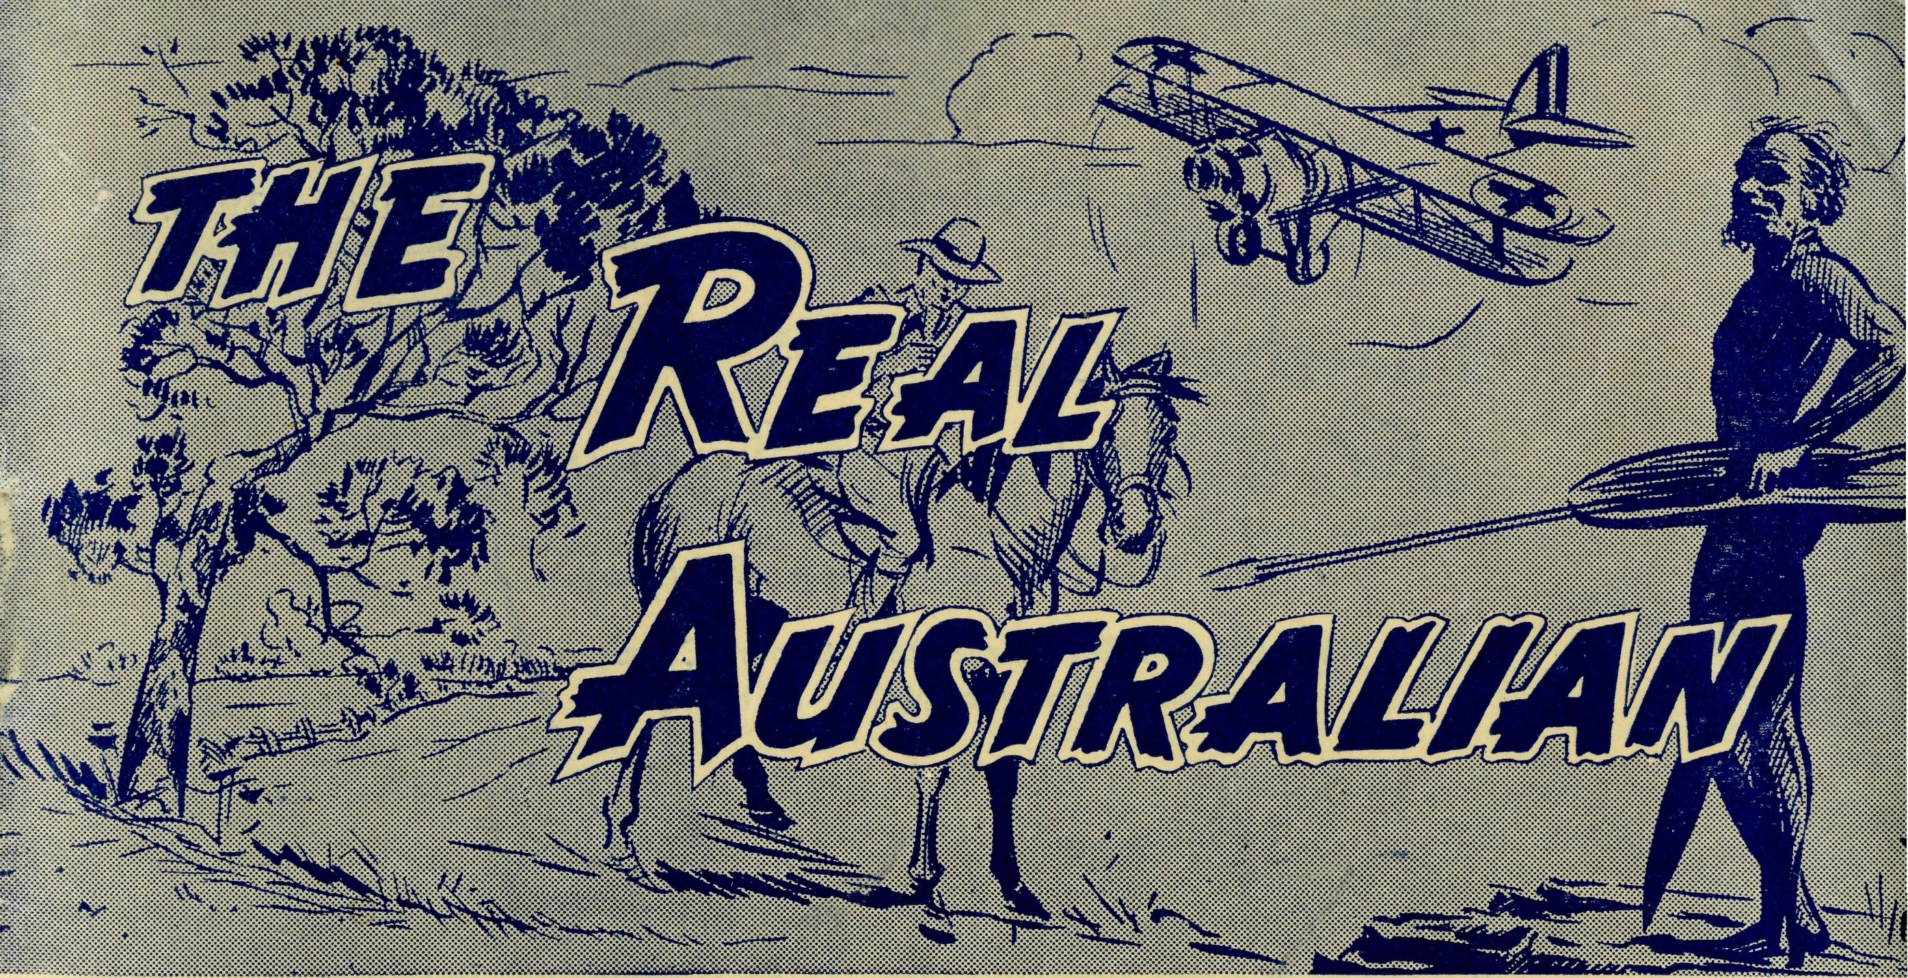
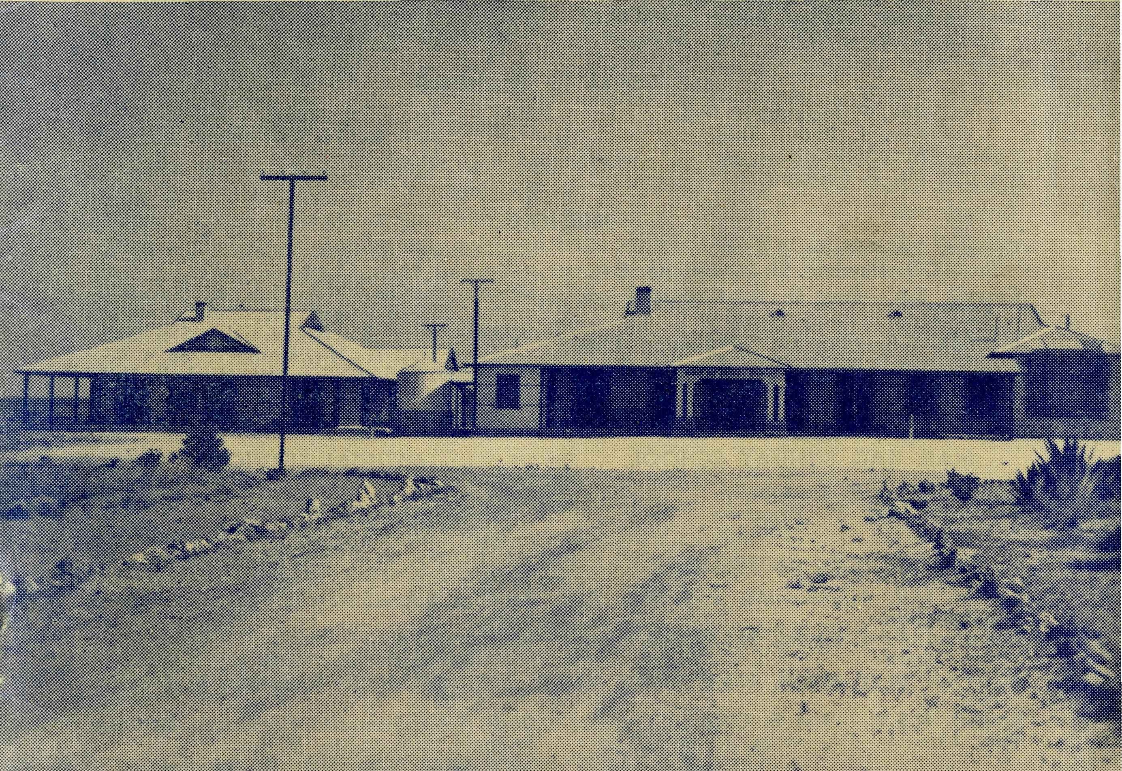
March, 1953,
SUNDAY
For all Mis-sioners and Deaconesses of the Society and their people and for all students in training. MONDAY
For all Doctors and Nurses serving in the outback, and for the spiritual and physical health of the patients undtf; their care. TUESDAY
For all workers in Hostels, the children under their care and the teachers who instruct them. WEDNESDAY
For the Director of the Mail Bag Sunday School, the pupils of the School and all teachers and voluntary workers.
THURSDAY
For the Fly-i n g Medical Service and the safety of the pilots and all who travel with them.
FRIDAY
For the Council of the Society, the Home Base staffs, Auxiliaries and Parochial workers.
SATURDAY
For all neoes-s a r y finance needed for the maintenance of so large a ministry and for guidance in its right application.
MARCH, 1953.
2/6 per annum, post free.
No. 5 (New Series).
20
The Real Australian
Topics for
Prayer and Praise
For the Society
O Lord God of our nation, Who has commanded men to subdue and replenish the earth: Look in Thy love upon all who in distant parts of our land are striving against many difficulties, and are deprived the access of the means of grace. Strengthen and guide the Bush Church Aid Society and all members of the staff. Cheer and comfort them in discouragement and loneliness, bless their ministrations to the good of those they serve, and grant that the message of redeeming love may thus be rooted and grounded in our national life, to the glory of Thy Great Name through Jesus Christ our Lord. Amen.
For Nurses and Doctors
O God, Who didst choose a beloved physician to set forth the life of Him Who went about doing good, grant that Thy strong tenderness and compassion may be manifest in the work of country doctors and bush nurses. Make them at all times alert to be faithful, as those whom Thou hast burdened and inspired with the honour of their caking. In lonely emergencies strengthen them with confidence that, having done all they can, they may with good conscience leave the issue to Thy power working within Thy law. Make them resourceful and of sound judgment, and hearten their labours with the energy of compassion and the firmness of duty that conquers weariness. Through Him Whose power is called forth by suffering, Jesus Christ our Lord.
For Church Life in Country Districts.
O Lord, Who art present when two or three are gathered together in Thy Name, bless, we beseech Thee, the little far-scattered groups of brethren who in our wide land meet together to worship Thee. Give them a perpetual freshness of spirit, and the power to inspire in each other holiness, helpfulness, and understanding of Thy help. Refresh with the joy of enthusiasm those who endure weary journeys to Thy trysting place. Grant that these little companies of Thy servants may be united in the spirit of Christian charity, awaiting in love the time when there shall be one fold and one Shepherd. Grant that the common life of all communities may be purified by this spirit of charity from all meanness, falsehood, malice and idle gossip, and grant that they who share a common lot may draw strength from each other's virtues, and in their weakness help one another, through our one Lord, Jesus Christ.
Praise
For the Blessings vouchsafed to the Society, for all kindly givers, for the joy of service.
Edgar Bragg & Sons Pty. Ltd. 4 Barker Street, Sydney.
Ceduna Hospital and new nurses' block. Registered at the G.P.O., Sydney, for transmission by post as a periodical.
The Official Organ of THE BUSH CHURCH AID SOCIETY
Church House, George Street, Sydney, N.S.W.

The Real Australian
March, 1953.
March, 1953.
The Real Australian

The Bush Church Aid Society for Australia and Tasmania
PRESIDENT: The Archbishop of Sydney.
Hon. Clerical Secretary: Rev. Canon Cameron. Hon. Treasurer: Mr. T. S. Holt.
B.C.A. Activities and Staff
Organising Missioner: Rev. T. E. Jones, Th.L. N.S.W. Deputation Secretary: Rev. J. R. Greenwood, Th.L. Victorian Secretary: Rev. E. G. Beavan, M.A.
VICTORIAN OFFICE:
Bible House,
Flinders Lane, Melbourne, Victoria.
Telephone: MF 3552
HEADQUARTERS OFFICE:
Diocesan Church House,
St. Andrew's Cathedral,
George Street, Sydney. Telephone: M3164.
Cable Address: "Chaplaincy, Sydney".
STUDENTS IN TRAINING.
Rev. F. Ingoldsby, Th.L. Mr. T. V. Jones.
Rev. I. Booth, Th.L. Rev. D. W. Warburton.
Mr. A. Williams. Mr. R. Brooks.
Mr. T. Morgan. Mr. J. Smith.
MISSIONS.
P. R.
Ceduna, S.A.-Penong, S.A.—
Rev. T. J. Hayman, Th.L., Ceduna, S.A. Cowell, S.A.—Rev. D. A. Richards-Pugh,
A.L.C.D. Minnipa, S.A.—Rev. G. Fuhrmeister, Th.L. Streaky Bay, S.A.—Rev. P. Connell, Th.L. Croajingalong, Vic.—Rev. G. Garner, Th.L.,
Cann River, Vic.
MAIL BAG SUNDAY SCHOOL.
Director—Miss R. Campbell. Assistant—Miss M. Patterson.
SCHOOL HOSTELS.
Broken Hill, N.S.W.—Mr. and Mrs. A.
McLaughlin. Mungindi Boys' Hostel, N.S.W.—Mr. and
Mrs. Hustler. Mungindi Girls' Hostel, N.S.W.—Miss M.
Farr. Bowral, N.S.W.—Miss E. Cheers. Port Lincoln, S.A.—Miss I. Beck.
Heytesbury Mission, Vic.—Rev.
Cooke, Th.L., Timboon, Vic. Otway Mission, Vic.—Rev. K. Seymour,
Th.L., Beech Forest, Vic. Wilcannia, N.S.W.—Rev. J. Stockdale,
Th.L., and A. Howland. Menindee, N.S.W.—Rev. W. Mitchell, Th.L Rappville, N.S.W.—Rev. A. Gerlach, Th.L. Denmark, W.A.—Rev. J. Johnston, Th.L.
MEDICAL SERVICES.
Ceduna, S.A.—
Matron: Sister P. Dowling. Staff: Sisters J. Miller, G. Hitchcock, B. Tierney, J. Payne, P. Shipway, J. Armstrong, Miss F. Lawtey. Penong, S.A.—Sisters L. Loane, L. Lang-tree. Wudinna, S.A.—
Matron: Sister R. Portch. Sisters: V. Holle, B. Barber, V. Brealey. F. Ellis. Cook, S.A.—Sisters M. Horsburgh, M. Ross. Tarcoola, S.A.—Sister V. Page. Cann River, Vic.—Sister I. Gwynne. Rawlinna, W.A.—Sister E. Thomas.
FLYING MEDICAL SERVICE.
Pilot—Mr. A. Chadwick, Mr. W. Bedford. Doctor—Dr. F. Gibson, O.B.E., Dr. M.
Mueller, Dr. J. Upsdell. Pharmacist—Miss E. M. Page.
The O.M.'s Letter
I write this letter while at Ceduna. One of the reasons for my visit was to attend the function arranged by the Shire Council for the official opening of the new Nurses' Quarters.
Unfortunately, the day, January 26, turned out to be exceedingly hot, though that did not prevent a goodly number attending. The Chief Secretary of South Australia performed the ceremony and, on behalf of the residents, handed over the building to the B.C.A.
The new quarters are a vast improvement on the old weatherboard building that has been "temporary" for the best part of twenty years. Six well-appointed bedrooms, a very lovely sitting-room and the necessary bathing conveniences provide the staff with a home of their own, though three members of the staff have their rooms in the hospital building itself.
The new home is built of limestone and brick to match the main hospital building, giving to both an attractiveness and unity very much to be desired in such institutions.
Every effort has been made to give the staff comfort and convenience, and to this end the local ladies have done a great job in the furnishing of the new home.
As we go to and from the aerodrome we pass the little building that was the first B.C.A. hospital at Ceduna. We have gone a long way in the twenty-nine years that have elapsed since we began with one nurse and many makeshifts. Undoubtedly God has blessed the devoted work given by those who have come to this place in His Name and served Him and His people so well.
Just now there are a number of things being done that will add to the effectiveness of the work B.C.A. is doing; they will also add to our responsibilities. The residents at Penong are adding to the Hospital; Tarcoola has almost completed its new building; a new dormitory is going up at the Girls' Hostel at Port Lincoln, and arrangements, have been put in hand for the erection of the necessary buildings at Ceduna for the Wireless Base.
We need your prayers and support very much at this time so that all the needs may be met and the services rendered in the most effective manner.
May I suggest that our friends remember this work at Easter time by making a small offering for these projects?
THE BUSH PADRE IS ON THE AIR.
2GB EVERY FRIDAY AT 11.15 a.m.
2CH ALTERNATE SUNDAYS AT 6 p.m.

The Real Australian
March, 1953.
March, 1953.
The Real Australian

On ‘The Line’
Mrs. Hayman
My daughter, Rosemary, was full of excitement as we left Ceduna for Cook on our first flight in the B.C.A. plane. My husband had left a week earlier in St. Brigid's Van to do a month's visiting along the East-West railway line. We were to meet him at Cook and visit some of the camps on the great plain.
The day was perfect for flying and I found it very interesting to see the long ribbon of road that is the Western Highway, and the many side-tracks that wriggle their way over the scrub and sand to the solitary homes that dot the outback. We followed the coastline for a hundred miles and then turned north to cross the flat, treeless and, until we should get to the railway line, empty Nullarbor Plain.
After two-and-a-half hours' flying we arrived at Cook and found Sisters Horsbourgh and Ross awaiting us with their usual warm welcome, and the patients filling the long form on the back verandah of the hospital, for it was "Doctor's Day." They kept Dr. Mueller busy until late that night.
The Men's Ward was empty of patients, but soon became full of the Hayman family for it was to be our sleeping quarters. After breakfast early on the following morning we said good-bye to Sister Dowling, Dr. Mueller and Mr. Chadwick and watched them go off into the vast blue sky to a busy day at Coorabie and Penong before returning to Ceduna.
A few nights later Sister Horsbourgh was called out of bed to answer a 'phone call from a camp over a hundred miles away down the track. Soon afterwards the ambulance rail-car was off on its long trip to pick up the patient, and by the early morning he was comfortably settled in the little hospital. Meanwhile, arrangements had been made with Ceduna and it seemed that hardly any time had elapsed before Mr. Chadwick was landing the plane in his usual easy manner almost at the hospital doorstep. As the day was Sunday, one of the local young men and I were able to relieve the sisters of the Sunday School and by the time the evening service was due to begin the plane was on its way back to Ceduna, taking the patient to Doctor.
The women of the little township of Cook take a real interest in ihe hospital and have formed themselves into a hospital auxiliary. On the Tuesday following the emergency plane trip, they came along to decorate the sisters' sitting-room and to generally prepare for their annual fete, They very soon turned the sitting-room into a very excellent concert hall, and we all enjoyed the splendid programme they put on later.
On Wednesday the children and I were off on the fast-goods train to Rawlinna, two hundred and fifty miles nearer Perth in the west. It was a cool day and made for comfortable travelling, and the appetising things that Sister Ross had packed for us helped to make it a picnic for us. At each siding we passed we were greeted by the people when they came along for their bread and the mail. Many of these sidings have but three to six houses and thirty miles of desert on each side. We noticed that many of the door-posts of the small
homes had been gaily decorated, and were interested to learn that this had been done by the German migrants working on the line as a sign of welcome to their wives and families who had come out to join them in their new life in Australia.
We had left Cook at noon, and as the goods train had to stop at every siding it was 6 o'clock before we arrived at Loongana where my husband was waiting to join us. Three hours later, we reached Rawlinna to find Sister Thomas ready to greet us. My husband left again soon afterwards in order to visit other camps further on.
When he returned on Saturday evening, we had a concert given by twenty of the Rawlinna girls who had been trained for the event by Sister Thomas. This was followed by the illustrated story of "The Littlest Camel" and then by the Sunday School Prize-giving. Everybody had a very happy night, including the many children who had but latelv come from Europe and to whom Christmas in the hot desert places was entirely a new experience.
On the following Monday Sister had her washing completed early because the thermometer said that it was 103 degrees, when a message came through telling of a sick child at a siding fifty miles away. Sister then got busy calling the doctor at Kalgoorlie two hundred and fifty miles west of her. Switching on her wireless, she called "9ED calling, 9ED calling" until the station at the other end answered her and put her through to the doctor. When she had received his instructions, she was off on the first train in order to give the small patient the required treatment. A few days later we were off again for Cook for the Christmas celebrations at that place.
When the "Tea and Sugar" pulled into Cook, there were scenes of great excitement as cases of fruit, vegetables, live poultry and pine trees were unloaded. On the treeless Nullarbor, Christmas Trees have to be brought a long way and are carefully treasured.
We had a Bible Class in the evening and although it was still well over the century, the young folks went around the camp singing Christmas Carols, which, in the still night of the plains, echoed far into the night.
It was still very hot at 4.30 a.m. when my alarm rang. We must needs make an early start for we had three hundred miles to go that day in order to reach home. The bath and tea we found awaiting us at the hospital in Ceduna were very welcome and fortified me for the task of facing the removal of the accumulated dust I found when I got home.
This was my second trip to the Nullarbor and served to impress upon me how worthwhile it is to spread the "Good News" to lonely people.
Cann River
Sister I. Gwynne
It was nine-thirty on Monday night when I received a phone call asking if I could accompany a patient to Orbost, sixty miles away. After leaving the patient in the doctor's hands I had a cup of tea before making the return trip and arriving home again at two-thirty on Tuesday morning.

The Real Australian
March, 1953.
March, 1953.
The Real Australian

Tuesday was full of the ordinary tasks and in the evening we had our Young People's Fellowship. It is not necessary for me to attend, but I feel that it is a splendid opportunity to contact our young folk, even though it means another late night.
Wednesday morning a man called for me soon after six o'clock to take me to see his wife. It was a confinement case so there was no time io dawdle; as it was, the baby arrived very shortly after I got there. I spent some considerable time with the mother and baby and, as I was somewhat concerned about the mother, I was glad that the home was not very far away from my cottage. I had no difficulty in visiting her a number of times each day. The dentist and doctor attend Cann River on alternate Wednesdays, with the exception of the fifth Wednesday. I was glad that the birth happened on a free Wednesday so that I could give my undivided attention to mother and babe.
On Sunday morning up again at six so that I could attend the mother and babe early in order that I might go to eight o'clock service. My plans were defeated, for at seven another man arrived to escort me to his wife. After examination, I decided that the woman had better see the doctor, so that meant another trip to Orbost and back. I had returned by four o'clock and, after seeing the mother and child again and having some tea, I was able to attend the evening service. Then another visit to my two patients and then to bed.
Monday morning and again on deck early and while attending my patients another call comes to a man who lives a short distance up the highway. Off I go and then back home again for medical supplies and a mixture for him, then off to see the babe and mother.
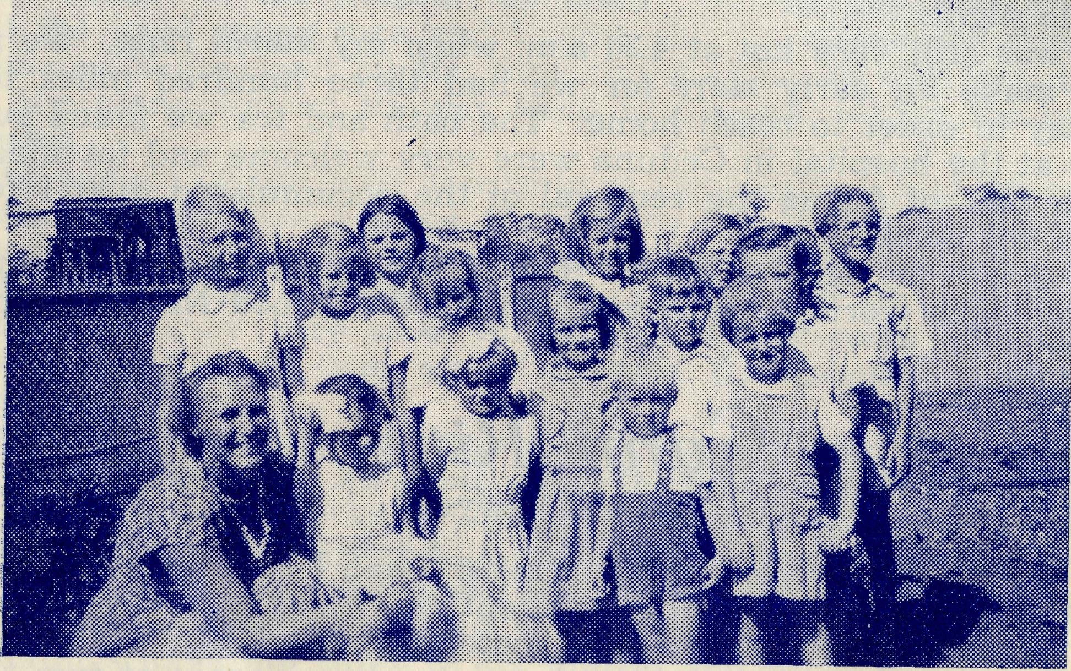
These are typical children of B.C.A. Missions.
AN OUTBACK SUNDAY SCHOOL
The Flying Medical Service
This letter is very largely a review of the past year's work that has been carried out from our main base at Ceduna here, and as I write with the cloze of the year 1952 in sight, I am prompted to do. so in this way because this has been our busiest year on record, and the statistical figures which I will set down below appear reasonably certain of being achieved, and may even be exceeded.
Miles Flown: 22,000
Stage Flights: 220
Hours Flown: 264
Patients Seen: 1,180
Patients Carried: 27
Thinking firstly of our regular flights, Penong calls for our attention once every week, on a Thursday afternoon, and as a rule we will average 40 odd flights up there during the year. This is accounted for by the fact that there is a gap in the flying schedule while the Dragon is undergoing its annual overhaul in Adelaide each year, and the few occasions we are unable to fly owing to adverse weather-conditions. To this can be added the occasions on which we are called up there to emergency cases, to give the average figure for the year.. We are scheduled for Cook once each month, usually on the first Wednesday, and during the year 15 flights have been made. These included one for an appendix operation on a boy of about 9 years of age, and on two occasions complicated obstetric cases were flown back to Ceduna hospital where they could be under the close watch of Doctor, who could be summoned in a matter of minutes instead of hours. At a later date, we had the pleasure of these two latter patients travelling back to Cook with us on scheduled flights, convalescent, and on the road to good health again.
Coorabie is a consultation centre situated some 12 miles northwest of Fowler's Bay, and a landing is made there each month on the way back from Cook. The residents of the district there come under the Penong Medical Scheme, and when necessary, will come down to Penong on a Thursday, in addition to their regular day,, even though the distance involved is about 45 miles. It is noteworthy that no emergency calls have come from Coorabie during the year.
Hospital work at the Koonibba Mission Station is also undertaken by Doctor, and the arrangement is that the Sister in charge there will call Doctor whenever she is wanted. During the year, we have made 10 landings there, either going to, or returning from Penong on a Thursday. Any calls made at other times are done by car, as the distance of 25 miles does not warrant the use of the aircraft for such a short journey. Doctor does answer many more calls from Koonibba; as a matter of fact, she has been called there twice during the past week.
Tarcoola, which is situated on the Transcontinental Railway in the north-eastern sector of our territory, is, like Cook in the northwestern sector, scheduled for one call each month, and during the year a total of 17 flights has been made there. We have transported five patients back to hospital at Ceduna during the year, one of whom we took on board during a regular visit, and four in answer to

8
The Real Australian
March, 1953.
March, 1953.
The Real Australian
9

special calls. On two of these latter occasions Sister Page has been the unfortunate victim, when she suffered from a poisoned finger, and at a later date from an attack of pneumonia. Also two appendix cases have been flown down for operation. In one instance while we were flying down to Penong en route from Cook, a call was received at Ceduna concerning one of these cases, and we received word of it on landing at Penong. As I carry an emergency supply of fuel at Penong, I was able to refuel there, and leaving Doctor and Sister to carry on with the usual consultations and return to Ceduna by car transport kindly supplied by the local residents, I flew across to Tarcoola, picked up the patient, and flew back to Ceduna where the patient was operated on that evening.
A call is made at Mulgathing Station, situated some 50 miles by air north-west of Tarcoola, on the same day, while we can usually expect a number of emergency calls from here, only one such has been received this year.
Turning now to the places to which we have made special calls other than those on our regular list, Wudinna, Parafield, and Coober Pedy come in for special mention. Five visits have been made to Wudinna, either to pick up patients who had to be taken over to Adelaide, or to fly Dr. Upsdell to other centres, thinking especially of his recent trip to Cook and Coorabie while Dr. Mueller was away on holidays. On one occasion in the interim between the departure of Dr. Rogers and the arrival of Dr. Upsdell, Doctor Mueller went down there for a day's consultation, seeing the patients in hospital and also outpatients who came along when they knew a Doctor was in attendance that day.
Eight flights have been made to Parafield this year, and a brief account of two of them may be of special interest to our readers. As you know, there is a factory established at Thevenard to process the Gypsum obtained from the fields situated near Lake McDonald, on the coast south of Penong. Recently, while the bags of Gypsum were being stacked in the shed prior to shipment, portion of one of the stacks collapsed and fell on one of the workmen. He was extricated as speedily as possible and taken to the Ceduna hospital, where it was found that he had suffered a severe fracture of the left arm, and^a spinal injury. The opinion of those who witnessed the accident was that he was fortunate to be alive at all, as a stack built up high enough to fall on a man would contain at least a ton of Gypsum, probably more. He was obviously a case for the Royal Adelaide Hospital, so with his wife and small daughter travelling over with him, and Sister Payne to attend him during the flight, we left Ceduna about the middle of the afternoon, and flew the last hour into Parafield after sunset, the patient being transferred from the Dragon into the waiting ambulance in the light shining from the illuminated hangar where the Dragon was to be housed for the night. The fractured arm was succesfully treated whilst the patient spent the best part of three months flat on his back on a wooden frame. Eventually he was allowed up and about again wearing a surgical support for his back, and he returned home convalescent, only to be admitted into hospital here again for an operation for a hernia which had been in evidence for quite some time and suddenly became a matter of some urgency. However, in due course he recovered from
that, and although unable to return to his former employment, he is now working on his own account at a job which keeps him fairly well occupied, and does not call for any heavy lifting.
The second case to which I refer was that of a footballer who fell during a match being played about 25 miles further down the coast, and suffered a depressed fracture of the skull. He was brought into Ceduna late in the afternoon, and I received word from Doctor that she wanted him taken to Adelaide only a few minutes after my landing back from the flight just previously mentioned. Unfavourable weather conditions and the fact that it would have meant a night flight all the way to Parafield, made it necessary to postpone our departure until early next morning. I had planned for a 5.30 a.m. take-off, but early morning fog held us up for a short while until just after 6 a.m., which was still 1 hour 15 minutes before daylight, and we were over Minnipa when the first rays of dawn showed us the town below. With Sister Shannon and the patient's wife and brother-in-law, we flew an uneventful journey to Parafield in clearing weather, and after Sister had seen the patient safely into hospital, we returned home the same afternoon. This patient has also fully recovered and is again working on his farm as usual.
Coober Pedy, situated in the extreme north of our territory, calls for a flight of some 280 miles to reach there, with a stop at Mt. Eba for refuelling in order that the return flight to Ceduna may be made non-stop and direct. Two flights have been made there during the year, both less than a fortnight apart, and in both cases the patients were Natives suffering from pneumonia and pleurisy who had to be brought down to the Koonibba Mission Station to the hospital for Natives there.
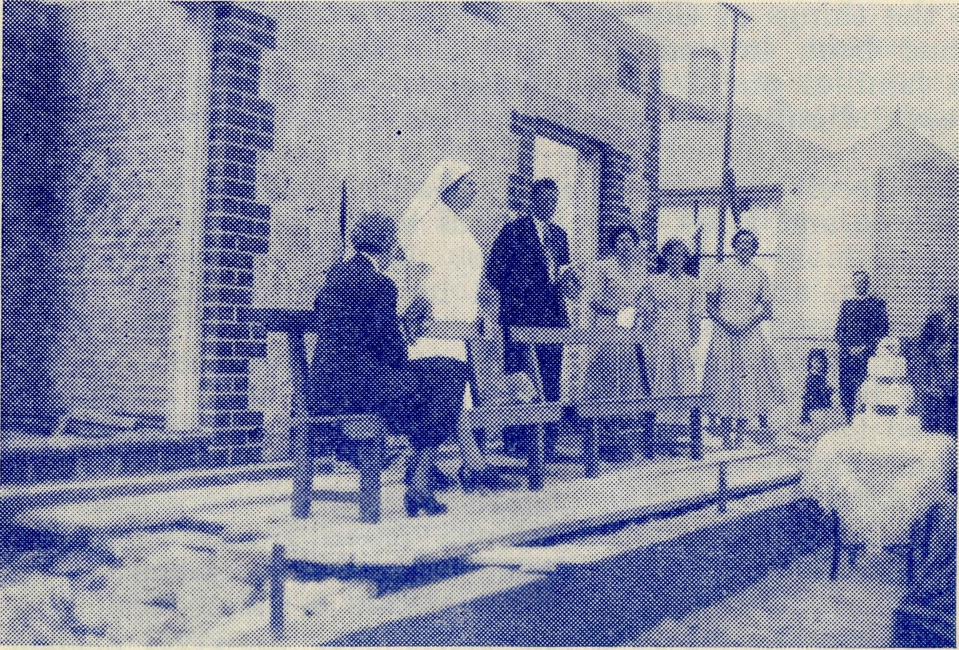
Sister Bowling performs the Unveiling of the Commemoration Stone in the New Nurses' Quarters.
CEDUNA, STH. AUSTRALIA

10
The Real Australian
March, 1953.
March, 1953.
The Real Australian
11

In Another Land
Deaconess A. Howland
There were seven of us in St. Aiden's truck with Mr. Mitchell driving. Two were in the front with the driver and the rest of us filled the back. Thus we left for White Cliffs at seven o'clock on a very hot and dusty morning.
Our first port of call was a station homestead at which the good lady of the house set us off on what proved to be for me a record day's drinking—soft drinks only, of course.
We arrived at White Cliffs at ten-thirty to find that the plans for a Communion service had gone awry. The people to whom the letter informing them of our visit had been sent were away from home and another family who could have come were out of touch because the telephone wires were down. We rang the church bell and waited.
The church building at White Cliffs is now unusable and we had arranged to hold the service in the school. This proved more in keeping with the congregation, for six children only turned up. We altered our plans on the spot and instead of Communion service had Sunday School.
After a sandwich lunch in the school we paid a visit to one of the old opal miners who still fossick about in the diggings and gain something of a living. We were presented with some opal chippings before we left on our trip back along the dusty track. We called in at the various homesteads on the road, so at least we got some visiting done. We wondered if it had been worthwhile. That is not an easy question to answer when you have travelled one hundred and twenty miles on a hot dusty day in order to jrive Sunday School lessons to six children, but somehow I felt that it was worthwhile to have had that short time with the children who get so little instruction in the things of God.
I had been invited to spend Christmas Day with one of the Station families and I was looking forward to the visit. There was one great difficulty for me—if possible, I had to drive myself to the homestead.
I had received a few driving lessons, but to that date had not driven alone and I felt very nervous at the prospect. I stood in the garage and looked at the car. How big and powerful it looked to me just then, and how weak and incompetent I felt; yet I had to drive it thirty miles.
Surveying the car grimly, I knew that it was now or never. If I didn't try it now, I felt that I never would, so I climbed into the driver's seat. Then I found that the seat was too far back and try as I might I could not alter it and had to use two cushions to rectify matters. After starting the engine, I breathed more easily as I saw the wall slowly receding from me. Then I had another anxious moment wondering if I could get safely out of the gate which just then didn't seem very wide to me. What a blessed relief it was to find myself out on the road and safely over the river bridge. Now I was out of "occupied territory" and on the open road. I found myself humming the tune of "Guide me, O Thou Great Jehovah", and never were those words more appropriate for me.
I had been told to look for the turn-off at the sandhill by the five-mile peg. I was quite sure that I had travelled more than five miles and had not seen any sandhill. There was something in the distance that looked as if it may be it, but it seemed a long way off. Then ahead of me there loomed a narrow bridge, just as I became conscious that another car was behind me. I slowed down to let him pass and then drove slowly over the bridge.
Now I was level with the nine-mile signpost and discovered a sandhill alongside of it, but where was my track? I had travelled four miles too far and must turn around and negotiate that bridge a second time. Goodness, I could never turn round when learning, could I do it now? Thank heavens, there wasn't a soul in sight. By some miracle I was facing the right way round a few moments later and set off to return over that four miles.
There was still no sign of that elusive sandhill. Where could it have got to? I got out of the car but found only a faint car-track almost hidden in a clay-pan. I was lost in the bush on a boiling hot day, and Christmas day at that. Ahead of me the road went back to town. Behind me it stretched away into the outback. All around me was space, plenty of it, with the cloudless blue sky overhead.
I wasn't worried, because I knew that my station hosts would come looking for me, but it was 107 degrees, very dusty and it was lunchtime and I was hungry and thirsty. Each time a bush moved in the breeze or a "willy" raised some dust I thought that it was my rescuers coming for me. I began to understand a little how people who are really lost must feel. I could get back to town, but how awful for any who could go neither forward nor backward with. assurance.
Eventually my rescuers arrived and we set off for the station home. A mile or two and the other car had a broken spring—that meant we crawled for the next sixteen miles. Eventually we arrived to be greeted by the anxious family.
"Would you like a cold shower?" asked my hostess. A cold shower on Christmas Day! I felt that she ought to have been asking me if I would like to sit by the fire. It was then that I realised how far away I was from my own family and friends, but I also realised how fortunate I was to be able to spend Christmas Day with a family when I could quite easily have been all alone in Wilcannia. "Goodwill to men" was being shown to me in a practical manner.
Dinner was awaiting me and it was of the variety called "cold". Much the best for a Christmas Day in weather over the hundred mark. Everything else was just like home. Gaily decorated table, a huge Christmas Tree in the lounge room that covered almost the entire length of the room, brightly coloured packets tied on the branches. Soon the floor was littered with paper of many colours and three small children made themselves happy as gifts circulated with loud expressions of surprise and delight.
We had tea on the lawn. I looked at the children in their sun-suits, my host in shorts and myself in a short-sleeved dress. How great a contrast from the Christmas of the year before in England when I had been warmly clad before a blazing fire. But the same spirit was present here in the Australian bush as I had known in my homeland twelve thousand miles away.

12
The Real Australian
March, 1953.
March, 1953.
The Real Australian
13

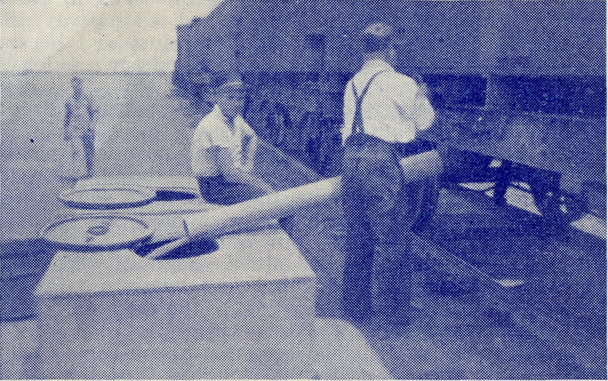
NULLARBOR PLAIN No. 1.
Unloading water from the train.
The Water of Life
The Rev. T. Hayman
We had some rain here a few days ago. It did not last for very long, and less than an inch fell on the parched ground. Our children watched the drops fall, with whoops of excitement, for falling rain is one of the rarer sights in this part of the world.
However, we are comparatively fortunate as far as the supply of water is concerned. Here at Ceduna we are on the end of the pipeline that brings water all the way from Port Lincoln—a distance of about two hundred and eighty miles. It is known as the Todd River Scheme and is interesting for the fact that there is no river. The water is caught in a very large catchment area and runs into a reservoir, which in recent years has been augmented by bores sunk to tap a large underground supply.
The water is pumped to the top of a hi^h hill near the township of Port Lincoln from which it flows to Ceduna in the pipes that seem to wrigggle their way along the ground. Each little siding is served from the line as it passes through.
The water has an appreciable amount of mineral salts dissolved in it, making it difficult to obtain a lather for washing purposes, but it is excellent for watering stock and the garden.
Leaving Ceduna, there is no other pipe-line for eight hundred miles. The next one is that which brings water to Kalgoorlie from Perth. Some of the farmers and the station people have bores which bring the underground water to the surface. Others rely entirely on artificial rain catchments. When their own supply fails, they must go many miles to the large Government Tanks that are kept for
that purpose. These also rely on rain catchment from large expanses of corrugated iron roofing placed over the tanks.
There is nothing so deadly as the task of carting water in droughty times. Day after day the men must go along the dry and dusty roads for ten, twenty or thirty miles, fill the tank carried on the truck, and return to water their stock. There is time for nothing else when that job has to be done, and nothing to show for it, except that the sheep are enabled to hang on to life and await the coming of the rain. If the rain takes too long to come, all the work goes for nothing, for the sheep die of slow starvation.
In the old days, many a man tried to walk through this waterless country and many times found the tanks dry. Lonely graves that still dot the track testify to the hopelessness of their task.
On the Nullarbor Plains proper, there are no bores. The men and their families who live and work on the line rely almost entirely on the water brought to them once per week by a special train. A water "gin" is allotted to each section, and the water is emptied into square tanks alongside the railway track. .The residents of each camp or siding must then come daily and collect enough water from the tanks for each day's supply. When the week's supply runs out, there is no more left, unless there is some in the house tanks containing the water gathered from the roof—but four inches of rain a year does not allow of a very large reserve.
When the square tanks go dry, one must defer one's bath until the water train comes again. The fresh water in the house tanks is far too precious to be used for anything but drinking. On the hot dusty days of the long surnmers when it feels as if the Evil One has left the doors of his own private apartments wide open, a cool stream in the desert would be a treasure beyond price.
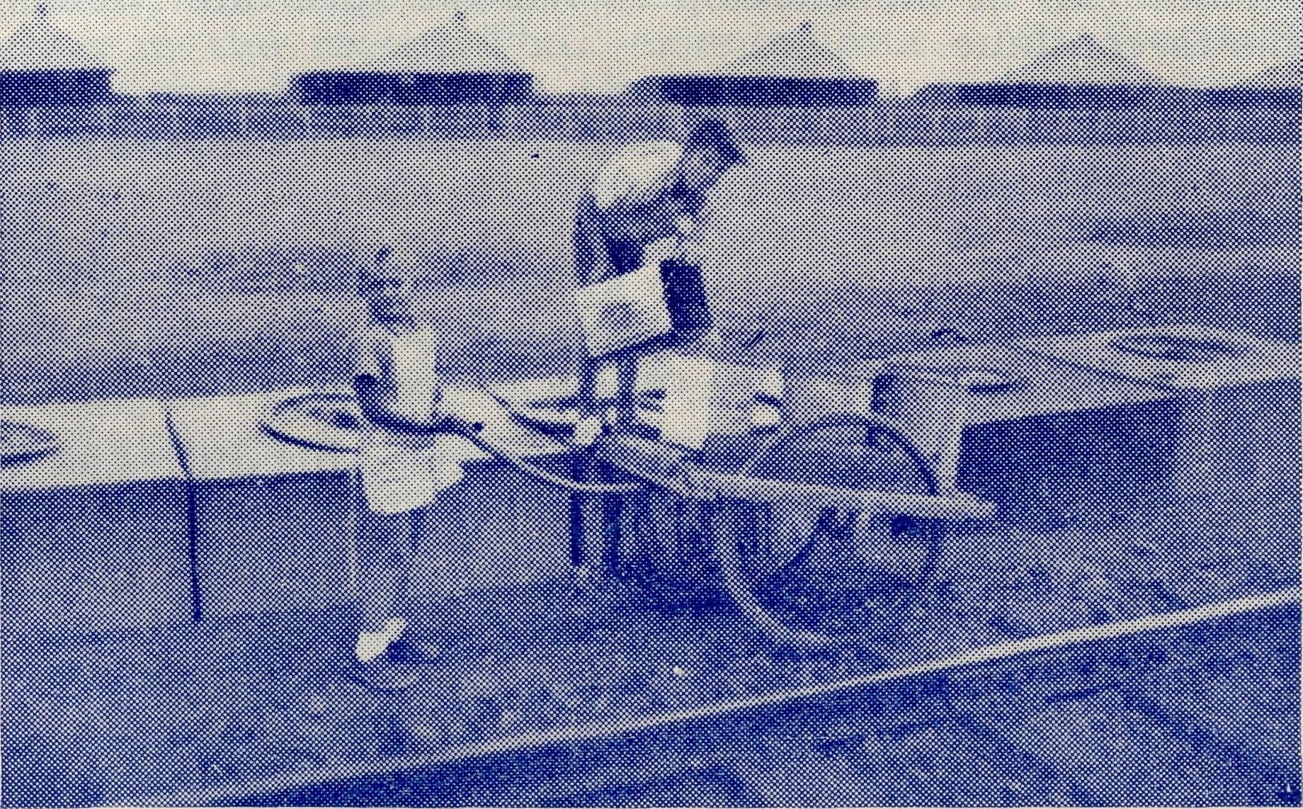
Taking the water home to mother.
NULLARBOR PLAIN No. 2.

14
The Real Australian
March, 1953.
March, 1953.
The Real Australian
15

Our friends will be glad to learn that Deaconess Spry has undergone successfully her operation at St. Ives Hospital, Melbourne, and is now at home with her parents. We pray that she will soon be completely fit again.
The Rev. J. and Mrs. Stockdale are now in residence at Wilcannia and the Rev. P. R. Cooke and his wife are settling in at Timboon. We pray that they will enjoy their respective spheres of service.
Since our last issue Miss Lawtey and Sisters Payne, Shipway, Loane, Holle and Brealey have been on leave. Sister Miller is also about to go back to Ceduna after annual holidays.
The people of the Penong district have been able to arrange for the addition of an Obstetric ward and a Private ward to the present hospital building. These additions, especially the Obstetric ward, will provide much welcome facilities for patients and staff. These additions are the Penong people's tribute to the splendid services rendered to them by the late Dr. Roy Gibson.
We ask our friends to note that coins must not be posted to us in the mail. We have been receiving a number of letters containing coins. When this is done, the Postal Department registers the letter and charges us twice the amount of the postal and registration fees. As a result, we are receiving letters for which we have to pay more than is contained in the envelope. We are sure our friends do not want this to continue.
Congratulations to the Rev. P. M. Connell of Streaky Bay, who has gained his Th.Schol.
Our friends will be pleased to know that Mrs. Connell continues to make good progress and it is expected that she will soon be well enough to enable the family to return to South Australia.
The Rev. E. G. Beavan has now commenced his duties as Victorian Secretary and will welcome any opportunity to tell of the B.C.A. work. We are looking forward to a very real impetus for B.C.A. interests from Mr. Bea van's presence in Melbourne.
The friends of B.C.A. extend sympathy to the Rev. H. E. and Mrs. Felton whose son passed away in January. Sympathy is also given to Mrs. B. O'Connor of Killara whose husband, the Hon. B. O'Connor, passed away early this year. We pray that God may give His consolation and comfort.
Sister P. Shipway has been on the sick list and is to see a specialist. We pray that a speedy return to health and strength may be given.
The Rev. H. G. and Mrs. Fuhrmeister of Minnipa and the Rev. A. and Mrs. Gerlach of Rappville are all rejoicing in the birth of their respective sons.
Mr. J. Smith of N.S.W. has been accepted as a student-trainee and will commence studies this year at Ridley College, Melbourne. Supporters are asked to remember him and the other trainees in their prayers as they take up their studies for 1953.
Mrs. Gerrard of Pennant Hills, an ardent and helpful supporter of B.C.A. for many years, has been compelled to relinquish her duties as Secretary of her B.CA.i Group.
During the 15 years she has been Secretary, Mrs. Gerrard has gained a large number of friends for the work. At the December meeting in her home a present of a walking stick was made by the members of her group.
We are deeply grateful for the enthusiasm and interest which have been fostered by Mrs. Gerrard and her willing band of helpers.
The newly-appointed officers of this group are Mrs. Edwards, President, and Mrs. Norfor, Secretary. We welcome these ladies and assure them of a warm-heartd appreciation of their services.
A Drawing-room Meeting can be a big help to gain new supporters and friends. Will you try one? Ring or write to the office; we will welcome your offer and give you all the help you need.
We offer our congratulations to the Rev. D. W. Warburton on his success in the recent Th.L. examinations. Mr. Warburton was ordained to the diaconate in December by Bishop Baker, for the Bishop of Tasmania. Mr. Warburton is the first B.C.A. candidate to serve in the Diocese of Tasmania and after his ordination to the priesthood will work as a B.C.A. missioner in that Diocese.
Y.P.A.—A band of younger friends formed some months ago is now planning to extend the interest of our youth in B.C.A. The Young People's Auxiliary is preparing itself for team work at Fellowship Teas and to act as Stewards at Missionary Exhibitions. Y.P.A. meetings are held on the 2nd Friday each month, at 7 p.m., in the St. Andrew's Cathedral Choir School. Membership is open to all young people over the age of 16 years who have an interest in the work of B.C.A.
POSTER WORK.—Are you a poster artist and desire to help the work of B.C.A.? If so, we need you urgently. Can anyone spare time to do this very practical piece of service? There are several pressing needs for immediate attention.

16
The Real Australian
March, 1953.
March, 1953.
The Real Australian
17

ST. JOHNS AUXILIARY, HEIDELBERG
Activities for 1952 began on a note of enthusiasm at the first meeting, held in April at the Vicarage in a very happy atmosphere. A lot of sewing and knitting was! taken in hand and plans made for a sewing bee to follow, which same grew into two and a few smaller unofficial ones. From these efforts quite a few parcels were sent away—containing all sorts of things, including two dozen tea towels,. two large patchwork rugs, four bunny rugs and baby clothes chiefly. Mrs. O'Mara undertook the making of a patchwork bed cover, which was displayed and much admired at the rally.
The second meeting was combined with the September meeting, of the Mothers' Union, when Policewoman Palmer of the Victorian Police Force told an enlightening and, at times, moving story of the people who come to the attention of policewomen.
Mrs. Moore's hospitality was again enjoyed at the annual meeting; held in her home, when, unfortunately, several members could not be present. It was decided to give £15 towards the upkeep of the vans. The history of the Auxiliary, since its inception in 1925 until it was constituted in its present form in 1944, was read. Office-bearers were re-elected as follows:—President, Mrs. A. Craig; Vice-Presidents,. Mesdames Moore and O'Mara; Hon. Secretary and Treasurer, Mrs.. Brightwell.
In August Dr. Morris gave the address at a service at St. John's on B.C.A. in South Australia particularly and gave a fillip to the interest of the several members present. Eight new box-holders, put their names on the list. In October a film night was held, by courtesy of Vacuum Oil Co., but heavy rain marred the attendance Nevertheless, over 50 people came to see a good programme.
All meetings were well attended. The number of box-holders has increased to 29 and the amount collected from the three openings was £21/8/-; total amount raised, £45/15/5. Several thousands of used stamps were taken into Melbourne office for sale to help funds.
We closed the year on a sad note with the passing of a very popular and faithful member, Mrs. E. Fawkes, who will be greatly missed.
To all the folk who have taken such an interest in the Auxiliary and have supported it so cheerfully and generously in many different ways, a sincere "Thank You."
—(Mrs.) A. Brightwell, Hon. Sec.
2KA.—
You can hear THE BUSH PADRE from "The Voice of the Mountains" on ALTERNATE FRIDAYS at 4.30 p.m.
Making Links
J. R. Greenwood
It was a privilege to meet in England many friends of the B.C.A. Our family is growing almost world-wide and many new friends are learning what is being done by the Church in our outback places.
This interest in England is fostered by the Colonial and Continental Church Society who provided a full programme of meetings and missionary exhibitions.
The 130 years of Col. and Con. history have seen many ventures in the cause of Christ's Kingdom. In keeping with these deeds are the sacrificial acts of service by B.C.A. workers and supporters. Through Col. and Con. new friends have been gained and B.C.A. is deeply indebted to the mother society.
But our work in Australia is a growing responsibility as all growing children are and while much more can be done by the growing child, nevertheless the help of the parent is an ever-present necessity.
The majestic Cathedrals and Abbeys, the lovely parish churches which have stood for so many centuries are reminders of the goodly heritage which is ours. As one stood in the pulpit of a church which has witnessed to the things of God for 900 to 1,000 years or more, the insignificance of man became apparent.
The ages have passed, the surroundings changed with the expansion of towns and industries but the Church of God has stood steadfast. The turmoil of wars has claimed her people and lives have been sacrificed, but in season and out of season the Gospel of God's love has been proclaimed.
Throughout the journey up and down the country there was evidence of the Christian Faith and its effect upon the community. The villages and hamlets clustered around an old stone church are a direct contrast to similar collections of houses in our inland places.
I could not but compare in my mind the gently undulating pleasant fields with the vast spaces of our outback. There was a sense of responsibility and urgency as one realised that in the lovely village church were hearts to be touched with the nessage of the Gospel in action through our B.C.A.
I can well remember one evening in >evon preaching in a lovely church surrounded by rolling green hills. It had been a pleasant early summer's day and the twilight dispensed with the need of electricity. A mellow light stole through the stained glass as I addressed a well-attended service.
It seemed a far cry from Devon to the outback of Australia. I thought of the same service conducted so many times in a galvanised iron shed or small schoolroom. But the beauty of it all was that whether in the village church or the bush shed, the same message was proclaimed. The people in the church that night had relations or friends who, though now separated by some 12,000 miles, nevertheless, are being drawn together by the ministry of the Christian Church through B.C.A.
I went for a short walk after the service and turned down a country lane with a hedge of hawthorn on either side. Two women were talking at a cottage gate and as I drew level gave me a warm

18
The Real Australian
March, 1953.
March, 1953.
The Real Australian
19

greeting. One had been to Church and was telling her friend about the work being done by B.C.A. I was drawn into the conversation and before long found the opportunity to give an informal deputation talk. "I am sure I could never do it; they must be brave," said one of my listeners when she had heard about the B.C.A. staff. The idea of distances and vast open spaces; the remoteness and isolation; the heat and dust storms; the sacrifice and difficulties seemed so foreign in the pleasant Devon village.
These women were thrilled to know that the Church was doing so much for those in lonely parts. The old grey building with its tower just discernible over the hedgerow was symbolic of something more to these women when they heard about B.C.A.
There was now an appreciation of a living active band of people carrying out the command of Our Lord "to preach the Gospel and to heal the sick".
Throughout the months in England many opportunities were given to propagate the great work of our Society. In Cathedrals, Abbeys, town and country churches the challenge of service and the plea for prayers and gifts were placed before congregations, in most instances, of good numbers.
A number of Rotary Clubs gave opportunities to open new spheres of interest. The members showed a deep interest in the B.C.A. work and were particularly sympathetic towards the Flying Medical Services. Such a field of interest was profitable to the building of fellowship and gave members a new insight into the work of the Christian Church.
During my travels there were those who asked, "Why does not the Australian Church give all the support to the B.C.A. work? Why ask the church in England to help?"
When people realised the peculiar difficulties we face; the great distances; the rough tracks; the isolation and heat, their sympathy in a number of instances was kindled. There were those who, learning the nature of our B.C.A. work for the first time, and hearing of the sacrificial support of Australian friends, changed from critics into supporters.
Some recalled that their own relations and friends were settling or had settled in places where the regular ministry, such as they knew it, was not available. Their sympathy was gained but one could not but be impressed by the need for more people to realise just what an increase in support is required.
Having driven St. Patrick's Van and St. Columba's Van for a number of years, it was an added thrill to meet those who made the Vans possible. The meetings in Dublin and Belfast were well attended. It was inspirational to meet people who represent a small percentage of the population and yet who are so warmhearted and liberal with gifts for the work in Australia.
The Irish friends are anxious to keep St. Patrick to the forefront and before long St. Patrick's Van Number 2 will be added to the B C.A. vehicles.
In these days of increased costs, to purchase a van such as we require in B.C.A. work is' no mean effort. Our Irish friends surely set
us an example^ of sacrificial giving. In 1939 St. Patrick's Van No. 1 cost £500; a similar van to-day will cost in the vicinity of £1,600. Surely Ireland gives a courageous lead to devotion in the missionary cause as the scriptural hand of fellowship is extended.
Such sacrificial giving will cause all of us to increase our share in the work.
It was encouraging to find in England, where many parish churches are labouring to maintain ancient fabric and restore ruined buildings, a keen desire to support work in other parts. Real financial strain is being felt, yet there is a keenness to help with work in remote places for the building of Christ's Kingdom.
There is an encouraging sign of the appreciation that living agents must be maintained to propagate the Gospel. With all the burdens of her home responsibilities; rising costs; shortage of staff; decreased sources of income; it was humbling to find a zeal for missionary endeavour.
The trip to England did much to maintain the goodwill of many friends of B.C.A. New friends have been gained which means increasing prayer, the most effective worker for any Christian organisation.
Lamps
Rev. H. G. Fuhrmeister
Have you ever noticed how temperamental lamps can be
Recently I had eight miles to go for an evening service and as it was very cold and very dark I wondered what sort of an attendance we would have in the little hall. When I arrived I found three ladies and a girl trying to get the petrol-gas lights to burn but as all attempts met with failure we had to resort to the Tilly lamp.
As no others had arrived when it was time to begin, the four of us started off with the first hymn during which another lady arrived. Then the lamp started to go out and I had to stop in order to pump it, but with only temporary success. One of the ladies then had a try while her daughter went fossicking in the back of the hall for a small kerosene lamp.
The Tilly decided to behave itself, so the daughter put the small lamp on the table for future emergencies, and I proceeded with the service. When we came to the Collect "Lighten our darkness, we beseech Thee, O Lord," the Tilly began to act in a most un-Christian manner and I was rather glad to notice that my small congregation saw no humour in the situation.
Finally, Tilly went out and I turned the fuel off and used the small lamp with which to conclude the service, but as its light was so feeble we had to omit the last hymn. I was the only one able to see with the light and after all the distractions and interruptions I did not feel equal to singing a solo. The Bush Parson has many such trials, but thank goodness, there are many joys and blessings.

