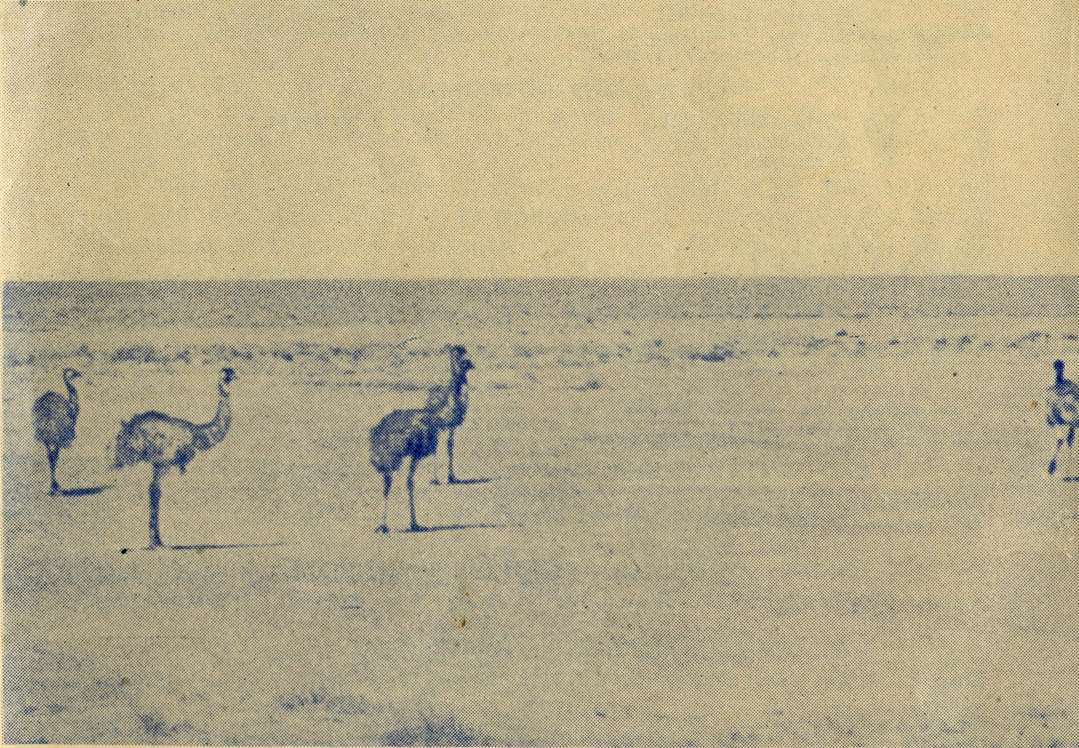
June, 1953.
SUNDAY
For all Mis-sioners and Deaconesses of the Society and their people and for all students in training. MONDAY
For all Doctors and Nurses serving in the outback, and for the spiritual and physical health of the patients und*-their care. TUESDAY
For all workers in Hostels, the children under their care and the teachers who instruct them. WEDNESDAY
For the Director of the Mail Bag Sunday School, the pupils of the School and aU teachers and voluntary workers.
THURSDAY
For the Fly-i n g Medical Seirvice and the safety of the pilots and all who travel with them.
FRIDAY
For the Council of the Society, the Home Base staffs, Auxiliaries and Parochial workers.
SATURDAY
For all neoes-s a r y finance needed for the maintenance of so large a ministry and for guidance in its right application.
JUNE, 1953.
No. 6 (New Series).
2/6 per annum, post free.
20
The Real Australian
Topics for
Prayer and Praise
For the Society
O Lord God of our nation, Who has commanded men to subdue and replenish the earth: Look in Thy love upon all who in distant parts of our land are striving against many difficulties, and are deprived the access of the means of grace. Strengthen and guide the Bush Church Aid Society and all members of the staff. Cheer and comfort them in discouragement and loneliness, bless their ministrations to the good of those they serve, and grant that the message of redeeming love may thus be rooted and grounded in our national life, to the glory of Thy Great Name through Jesus Christ our Lord. Amen.
For Nurses and Doctors
O God, Who didst choose a beloved physician to set forth the life of Him Who went about doing good, grant that Thy strong tenderness and compassion may be manifest in the work of country doctors and bush nurses. Make them at all times alert to be faithful, as those whom Thou hast burdened and inspired with 'he honour of their caking. In lonely emergencies ^rengthen them with confidence that, having done all they can, they may with good conscience leave the issue to Thy power, working within Thy law. Make them resourceful and of sound judgment, and hearten tneir labours with the energy of compassion and the firmness of duty that conquers weariness. Through Him Whose power is called forth by suffering, Jesus Christ our Lord.
For Church Life in Country Districts.
O Lord, Who art present when two or three are gathered together in Thy Name, bless, we beseech Thee, the little far-scattered groups of brethren who in our wide land meet together to worship Thee. Give them a perpetual freshness of spirit, and the power to inspire in each other holiness, helpfulness, and understanding of Thy help. Refresh with the joy of enthusiasm those who endure weary journeys to Thy trysting place. Grant that these little companies of Thy servants may be united in the spirit of Christian charity, awaiting in love the time when there shall be one fold and one Shepherd. Grant that the common life of all communities may be purified by this spirit of charity from all meanness, falsehood, malice and idle gossip, and grant that they who share a common lot may draw strength from each other's virtues, and in their weakness help one another, through our one Lord, Jesus Christ.
Praise
For the Blessings vouchsafed to the Society, for all kindly givers, for the joy of service.
Edgar Bragg & Sons Pty. Ltd. 4 Barker Street, Sydney.
EMUS AND FAR HORIZONS Registered at the G.P.O., Sydney, for transmission by post as a periodical.
The Official Organ of THE BUSH CHURCH AID SOCIETY
Church House, George Street, Sydney, N.S.W.

The Real Australian
June, 1953.
June, 1953.
The Real Australian

The Bush Church Aid Society for Australia and Tasmania
PRESIDENT: The Archbishop of Sydney.
Hon. Clerical Secretary: Rev. Canon E. Cameron. Hon. Treasurer: Mr. T. S. Holt.
B.C.A. Activities and Staff
Organising Missioner: Rev. T. E. Jones, Th.L. N.S.W. Deputation Secretary: Rev. J. R. Greenwood, Th.L. Victorian Secretary: Rev. E. G. Beavan, M.A.
HEADQUARTERS OFFICE: VICTORIAN OFFICE:
Diocesan Church House, Bible House,
St. Andrew's Cathedral, Flinders Lane, Melbourne, Victoria.
George Street, Sydney. Telephone: M 3164. Telephone: MF 3552
Cable Address: "Chaplaincy, Sydney".
STUDENTS IN TRAINING.
Rev. F. Ingoldsby, Th.L. Mr. T. V. Jones.
Mr. A. Williams. Rev. D. W. Warburton.
Mr. T. Morgan. Mr. R. Brooks.
Mr. J. Smith.
MISSIONS.
Ceduna, S.A.-Penong, S.A.—
Rev. T. J. Hayman, Th.L., Ceduna, S.A.
Rev. I. Booth, Th.L. Cowell, S.A.—Rev. D. A. Richards-Pugh,
A.L.C.D. Minnipa, S.A.—Rev. G. Fuhrmeister, Th.L. Streaky Bay, S.A.—Rev. P. Connell,
Th.Schol. Croajingalong, Vic.—Rev. G. Game, Th.L.,
Cann River, Vic.
MAIL BAG SUNDAY SCHOOL.
Director—Miss R. Campbell. Assistant—Miss M. Patterson.
Heytesbury Mission, Vic.—Rev. P. R.
Cooke, Th.L., Timboon, Vic. Otway Mission, Vic.—Rev. K. Seymour,
Th.L., Beech Forest, Vic. Wilcannia, N.S.W—Rev. J. Stockdale,
Th.L. Menindee, N.S.W.—Rev. W. Mitchell, Th.L.,
and Deaconess A. Howland. Rappville, N.S.W.—Rev. A. Gerlach, Th.L. Denmark, W.A.—Rev. J. Johnston, Th.L.
MEDICAL SERVICES.
Ceduna, S.A.—
SCHOOL HOSTELS.
Broken Hill, N.S.W.—Mr. and Mrs. A.
McLaughlin. Mungindi Boys' Hostel, N.S.W.—Mr. and
Mrs. Hustler. Mungindi Girls' Hostel, N.S.W.—Miss M.
Farr. Bowral, N.S.W.—Miss E. Cheers. Port Lincoln, S.A.—Miss I. Beck.
Matron: Sister P. Dowling. Staff: Sisters J. Miller, G. Hitchcock, B. Tierney, J. Payne, P. Shipway, A. Butler, J. Armstrong, Miss F. Lawtey. Penong, S.A.—Sisters L. Loane, L. Lang-tree. Wudinna, S.A.—
Matron: Sister R. Portch. Sisters: V. Holle, B. Barber, V. Brealey. F. Ellis, Mrs. E. Babbage. Cook, S.A.—Sisters M. Horsburgh, M. Ross. Tarcoola, S.A.—Sister V. Page. Cann River, Vie.—Sister I. Gwynne. Rawlinna, W.A.—Sister E. Thomas.
FLYING MEDICAL SERVICE.
Pilot—Mr. A. Chadwick,
Doctor—Dr. F. Gibson,
Mueller, Dr. J. Upsdel
Pharmacist—Miss E. M.
Mr. W. Bedford. O.B.E., Dr. M.
Page.
The O.M.'s Letter
Very soon after this issue of the ''Real Australian" is in print, the society's Wireless Communications Base will be an actual fact.
In order to bring this into being much hard work had to be done and a good deal of courage and faith was required by the Council of the society and all who have been associated with the undertaking.
Land had to be acquired, the necessary frequencies obtained from, the P.M.G.'s Dept., a lot of valuable equipment purchased and assembled and the required buildings erected.
The Wireless Base consists of two buildings; one is the residence of the operator and his family, the other, housing the wireless equipment, will be the operating centre. The buildings are not pretentious but they are solid and attractive. We have considered that the most important part was to put in the best possible equipment and be satisfied that the buildings be plain but good.
We have been very fortunate to secure Mr. George Cameron as our operator. Mr. Cameron is not only the holder of all the necessary technical qualifications for this work, but he also approaches it with the highest motives of Christian service. We are thus able to welcome them as further additions to our family of Christian workers.
You will, I hope, realise that this new addition adds tremendously to our responsibilities. Some would have us believe that we are taking on too much. But the truth is that, in Christian work, if you go back, you die; if you stand still, you stagnate. It is only by going forward when the challenge comes, that the lamp of faith burns more brightly, and courage and vision are kept strong and virile.
We realise how big the task is nowadays that faces the B.C.A. and we are only too well aware that without the; love, interest and very generous giving of those of you who read this, we will certainly not be able to meet the commitments that we have undertaken.
We can only assure you that in this important step that has been taken we have been impelled by its necessity and are convinced that it has the blessing of Almighty God upon it. We, therefore, ask for your prayers for it and your gifts for its maintenance.

The Real Australian
June, 1953.
June, 1953.
The Real Australian

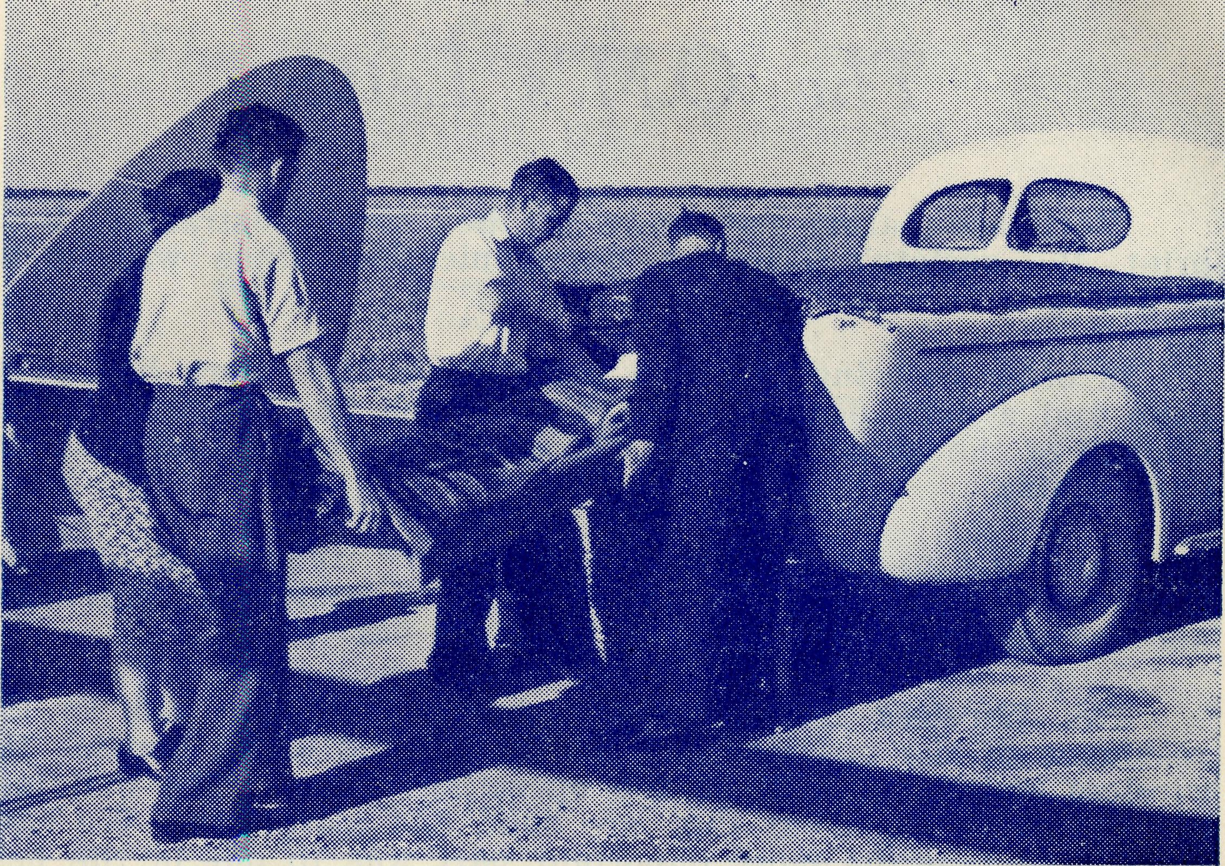
B.CA/s Flying Medical Services bring help outback. The Wireless Base at Ceduna will link up our services.
NOTICE FROM VICTORIA FOR R.A.
During the week-end May lst-4th the mail-box lock at the office in Bible House was broken, and evidence points to the fact that mail was stolen.
If any Box-holder or Subscriber sent money during the last ten days of April and has not received a receipt, will he or she please communicate with the Secretary?
Two postal notes from the country, correctly made out to the Society, were found lying in a city street some miles away and forwarded to the office. This points to the wisdom of complying exactly with the requirements of the Postal Department: that neither notes nor coins be enclosed in ordinary envelopes, and that all postal notes and money orders be properly made out, and the numbers noted.
Building a Church
Rev. T. Hay man
Our little Church at Ceduna was 'built in 1909 of wood and iron. In recent years it has had to be stayed with strong iron stays, to prevent the gales that blow from the Bight; from taking it inland. Last year, by the help of voluntary labour we were able to brighten the exterior of the building with a coat of paint, though somebody had suggested that the time had come to erect a new Church.
Over recent months that little snowball has been rolling around and getting bigger until today we are actually committed to the project. The women opened up the way with valiant efforts over the last three years, working, sewing and selling many things. The men have been putting their backs into it also, by coming to many 'working bees'.
We navel now purchased a block of land situated next to our Church Hall, drawn up the necessary plans, and we have enough money in hand to enable us to buy the required materials. As soon as the new block is cleared, the foundations will go down and the cement bricks will be made by volunteers. Our faith is that enough money will come in to enable us to complete the work.
Our church people are showing a determination that the new Church will be built with the minimum of expense and yet be as strong and beautiful as our resources will allow. In order to do this we are using as much of the material in the old Church as possible.
To B.C.A. friends the most interesting part of the new Church will be the porch-tower, which is to be a thanksgiving token to the work of the staff of the B.C.A Flying Medical Services, including past and present members. It will thus be a mark of the gratitude of the people of Ceduna for the hospital service given to them.
Much hard work still lies ahead for our small band of people, but we are hoping that our dream will be a reality by Easter of next year.
In the meantime I am writing this far from Ceduna, for I am in one of the far spots of this 'parish', which, I think, must be one of the largest parishes in the world. I am visiting as many of the twenty-five railway camps along the Trans-continental Railway Line as I can. Many of the fettlers today are new settlers from Europe, who, because of the desert conditions, do not stay long. There is, in consequence, a continual coming and going in the little camps. I feel that our responsibility is all the greater because of the very few times in which we can make contact with them.
The first camp I visited on this trip was Haig and, in the evening of my arrival, most of the folk from the twelve homes that make up the camp gathered for service and strip-film pictures.

The Real Australian
June, 1953.
June, 1953.
The Real Australian

After the service, I went to camp in the roadmaster's hut. My train was due at 4 a.m., so I borrowed an alarm clock and set it for 3 a.m. In due time the alarm rang most violently and I bustled to get my blankets packed. Then I looked at the clock, only to find that it was 1 a.m.! Not to be outwitted, I put the alarm on for 5 a.m. and went back to sleep to be awakened at 3 a.m.
At 5.30 I arrived at Loongana, where I spent a happy day. One of the most pleasant moments was a session with the four children of the camp — all girls. They sat on the floor and gently swayed to and fro as they sang ''Jesus loves me", and then they listened very attentively to the lesson that was given to them. In the evening we used an empty house in which to hold our service and everybody brought their own chair.
My report told me that the 'Tea and Sugar* would be on time, so our service would be nicely over by then and I could board her in comfort, but a loud 'toot' brought things to a hasty conclusion, for the train arrived twenty-five minutes early!
Things being as they are on the Tine', I must needs travel eighty miles east to Reid where I catch the mighty new Diesel, and then go one hundred and eighty miles west, in order to reach Rawlinna which is only one hundred miles away from restarting point.
At Rawlinna, Sister Thomas always has a warm welcome awaiting me. She is one of the most isolated members of the B.C.A. staff, and for that reason I was mildly reproved for not spending more time in that place.
One of the New Australians told me, "Church is not the same here. At home we go into a building that is used for worship only. It is a beautiful church. Here we can worship only in a place where dances, pictures and parties are all held." They are realising the penalty of having to live in such small communities. We must pray that the Church of the Living God will be so real to them that it will be truly enshrined in their hearts.
THE BUSH PADRE IS ON THE AIR.
2GB EVERY FRIDAY AT 11.15 a.m.
2CH ALTERNATE SUNDAYS AT 6 p.m.
2KA.—
You can hear THE BUSH PADRE from "The Voice of the Mountains" on ALTERNATE FRIDAYS at 4.30 p.m.
Easter Gifts of Love
Rev. P. Connell, Th.Schol.
It was Easter Eve and I was just getting into bed when I heard a loud thud on the front verandah. With my wife urging me on, I grabbed a dressing gown to investigate so strange a noise at that hour of the night. As I opened the front door I was just in time to see two local citizens hurrying out of sight through the vicarage gate. When I accosted them they returned evasive answers and made themselves scarce without giving me any satisfactory explanation for their presence. Very mystified, I returned to enter my front door and beheld a very large wooden crate that had not been there earlier in the evening. My visitors had evidently not come to help themselves, but to leave me something.
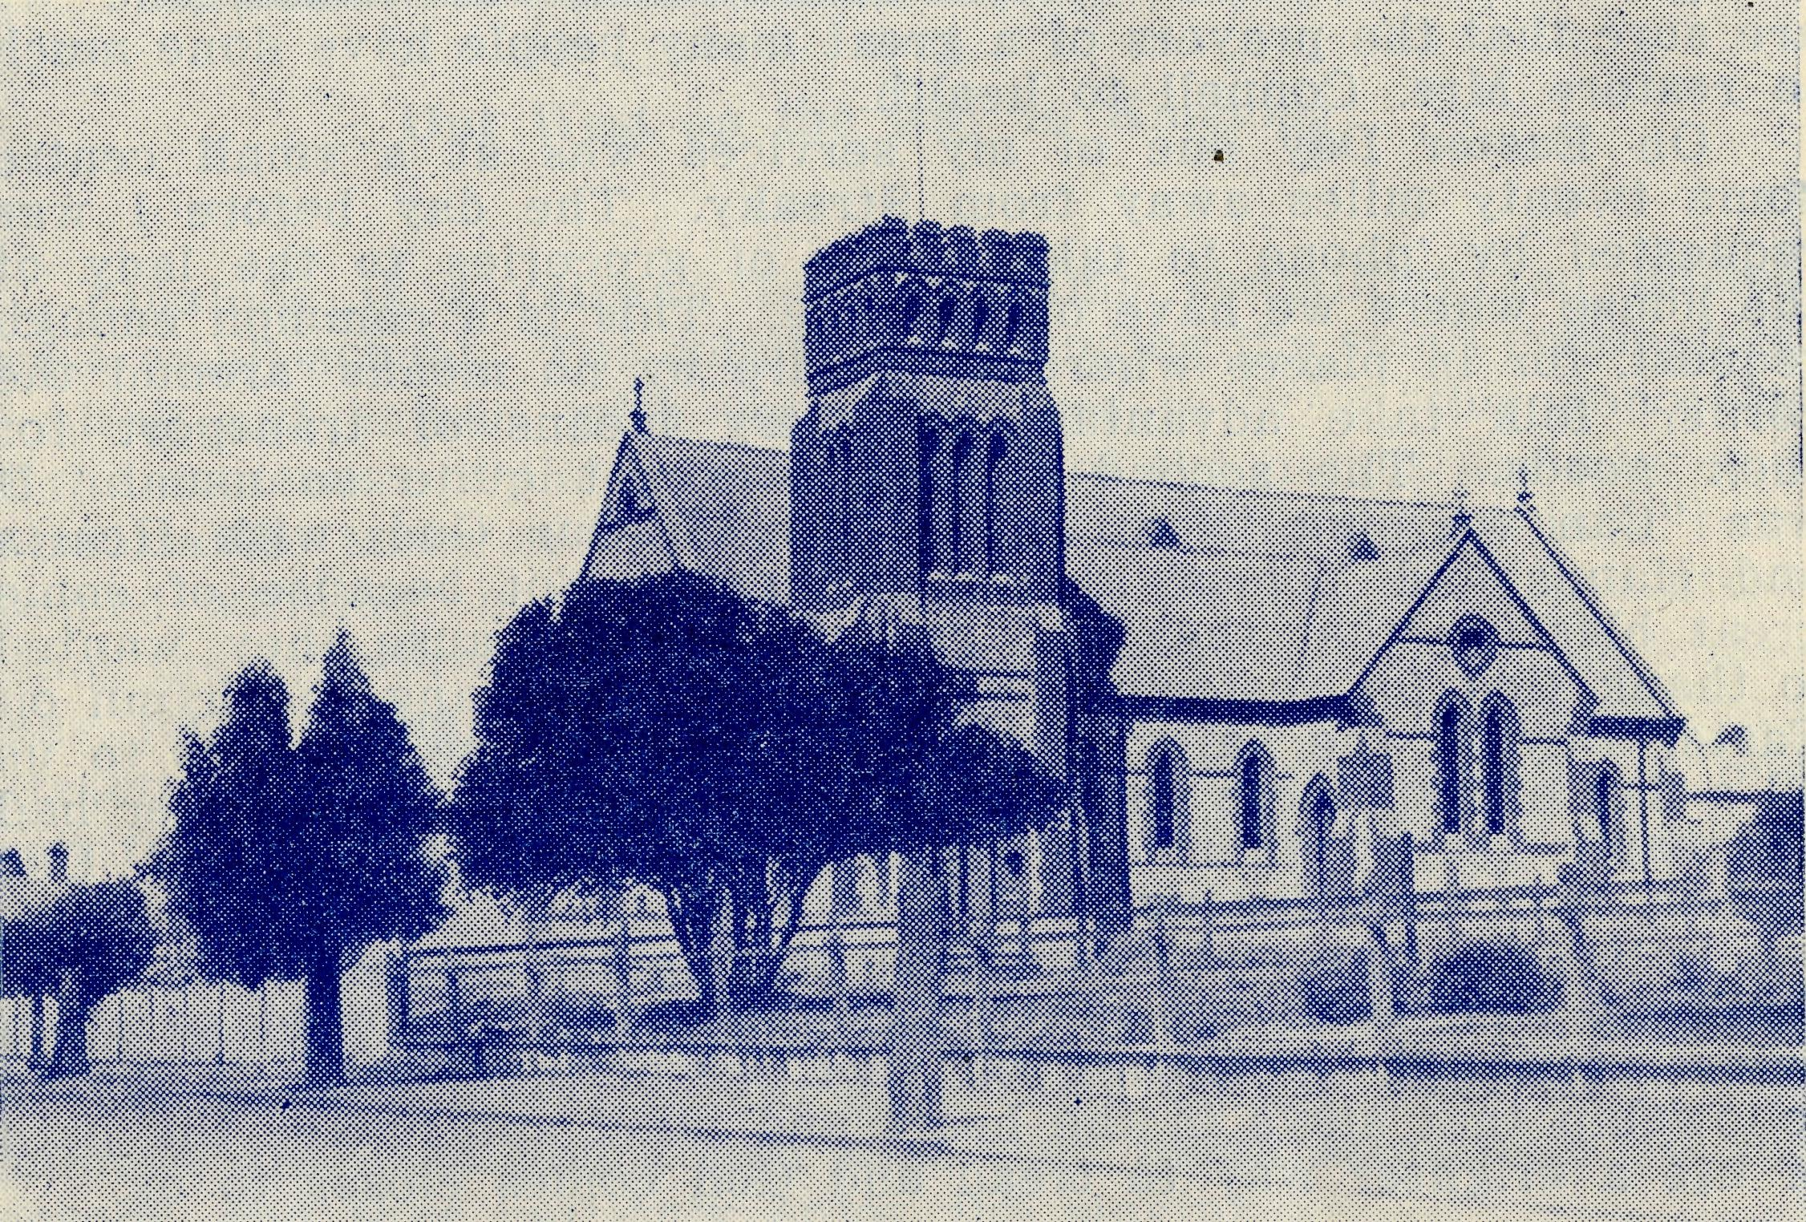
St. Augustine's Church, Streaky Bay.
Inside the crate, we discovered later, was an electric washing machine — an Easter Gift to my wife from ALL the people of Streaky Bay town and district.
A week later another gift arrived. This time it was a Technico floor polisher from the same source. They came, not simply from the members of my own congregation but from everybody — Methodists, Roman Catholics, Anglicans and others of the district.

The Real Australian
June, 1953.
June, 1953.
The Real Australian

A few weeks before, Mrs. Connell had returned to Streaky Bay after more than twelve months' absence. As all our friends know, she suffered a long illness caused by poliomyelitis and has been left with a difficult deformity. It seems that the people of this district had determined to ease the burden of her housework, and these handsome gifts were the result of their kindly thought of her.
We have since tried to say "Thank you", but it doesn't seem enough for so much kindness. All the years we shall remember this lovely thoughtfulness and giving, and we can only hope that in the days that we shall continue at Streaky Bay we will be able to show some little of our appreciation by offering our friendship to all who dwell in the town and district. I should also like to add here that in all the long months since Mrs. Connell first contracted this illness, we have greatly appreciated the many kindly marks of love and friendship that have been shown to us, not only in Streaky Bay, but by people living as far away as Victoria and New South Wales, and we are sure that the prayers of a great many people have done much to restore Mrs. Connell to health.
On Easter Day one of my services was at a small centre some twenty miles away from Streaky. The day before I was requested by 'phone to take a box of groceries to the lady of the house where we have our service. This is a common enough request, for in places where shops are by no means Around the corner' folk take advantage of every means of transport for their goods. The second request was not quite so usual. It was "Can we sing 'Now Thank We All Our Cod, with Hearts and Hands and Voices' at the service?" Not because of some great blessing; that they had received, but because they wanted to thank God for restoring Mrs. Connell. We sang the hymn on Easter Day in the hallway of that country home. It was to us all a day of happiness and great joy. The message of Easter had a greater reality than ever before, because of what God, Our Father, had done for us.
Later, we sat and drank tea and talked so very much. I think we said the same old things that have been said so often before, but the memories of such gatherings leave a sweet fellowship that stays in the heart and mind and makes the path of life a brighter way to tread and God comes closer to us.
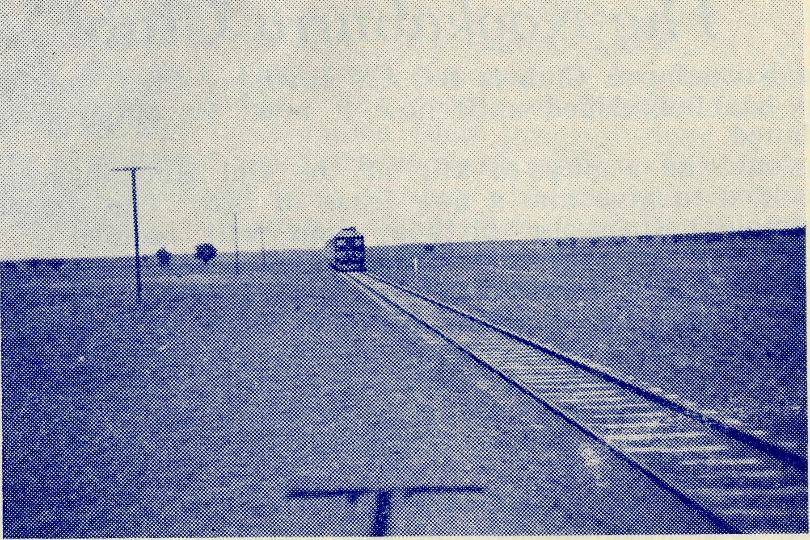
Out West on the way to Kinalong.
Kinalong is a railway fettlers' camp containing ten homes and a small school. The country surrounding the small community is bleak and barren, with very few trees to break the monotony of the sameness of the scenery. Some of the homes are new and comfortable, some are old and primitive. The school is a two-roomed building; one room in which the teacher lives, the other being the schoolroom in which he teaches twenty children whose ages range from seven to fourteen years. On the walls are attractive poster pictures of Britain and Malaya, and from one wall the Royal Family smiles down on the pupils.
It may sound a bit odd to have Sunday School in the middle of the week, but there are not enough Sundays to enable me to get around all the centres to have them on the right day. The children are keen and I find that they listen attentively to the lessons, and they certainly enjoy the singing.

Kinalong
Rev. W. Mitchell
We wondered what sort of a day it was going to be as we set off in St. Aidan for Kinalong, forty miles away. The great summer heat had, at long last, given way to a cooler temperature which made travelling much less strenuous. We hoped that it would stay that way.
After school we visit each of the homes and invite the folk along to Evening Prayer, which also takes place in the school. On this occasion the sermon is illustrated with a film-strip on the events of Holy Week. Then forty miles in the cool of the late evening and we arrive home at midnight.
It means many miles of travel in this country to reach a handful of people, but unless the Church sends her living agents to teach these scattered people, they can know little of God.

10
The Real Australian
June, 1953.
June, 1953.
The Real Australian
11

The Kookaburra Club
The Kookaburra Club is B.C.A.'s Birthday Club, but for some years it has languished until now it must be either revived or discontinued.
It would be a pity to kill off the Old Kookaburra, so we have decided to give him a new lease of life. The procedure is quite simple. On your birthday you will receive a cheery Birthday Card from the Old Kookaburra—and YOU will send to the Merry Old Gentleman the sum of Two Shillings and Sixpence so that he can pay his just dues to the B.C.A. for helping folk to stay in the bush and listen to his cackle.
Will you enrol yourself and your children in B.C.A.'s Birthday Band? It will help to keep your own interest in the society alive, and will also serve to introduce the work to the younger generation.
Please send name, address, date of birth, on the enclosed form, together with the sum of two shillings and sixpence. If you wish to enrol more than one member of your family, please use a separate slip of paper for each entry.
On Friday, May 29th, in the side-chapel of St. Andrew's Cathedral, a small band of friends of B.C.A. gathered to wish Godspeed to the Rev. I. and Mrs. Booth as they leave for Ceduna, and on the morning of June 3rd in the church of St. Luke, Mosman, representatives of the B.C.A. and of St. Luke's parish gathered at Holy Communion to say farewell to Mr. and Mrs. George Cameron. Our prayers go with these new workers to their several tasks asking that He will bless them and their labours for His Kingdom.
We welcome to our field staff the Rev. I. and Mrs. Booth. They took up their new work in the Far West Mission of South Australia early in June and are located at Ceduna. We pray that they will find much blessing as they minister in the far places.
After five years of service with the Society, Sister Rose Portch sailed from Adelaide by the "Maloja*' for Great Britain. Sister has been granted the necessary leave-of-absence in order to pay her family a visit, and she expects to be back again at Wudinna towards the end of the year. We wish her a happy journey and much joy in being with her family once again.
It has been a very great joy to welcome back the Rev. Phil and Mrs. Connell to the field. Mrs. Connell has made a remarkable recovery, due in a very large measure to her own sturdy faith and abounding courage. The people of Streaky Bay district of all denominations have shown their love for them by the giving of some very useful aids towards making housework easier. These will be a very great boon to one who can yet walk only with great difficulty. We pray God to bless them both.
• * •
All the friends of B.C.A. were sad at the passing of Mrs. Cranswick, the mother of the Bishop of Tasmania and Bishop G. H. Cranswick. Mrs. Cranswick was a very active supporter of all missionary work almost to the end of her long life, and her delightful personality and warm friendship made it a very great joy to be numbered amongst her friends. We extend to her family our sympathy in their bereavement.
• • •
Although it is now some months since the Rev. Barton Babbage left Sydney to take up his new work as Principal of Ridley College, it is the first opportunity we have had of wishing him well. Great reports are already going the rounds as to the excellent effects of his advent at Ridley, and we pray that he may go on from strength to strength so that Ridley may always be worthy of the very great name she bears. We remember with affection the kindness and interest always shown to B.C.A. by Bishop Baker and his wife, and, while wishing for them much joy in a less exacting life, look forward to the same happy relationship with the new Principal and his family.
• • *
It is encouraging to note the growing interest in the Society's work that is being shown in the Rural Deanery of Wollongong. This is greatly due to the enthusiasm of the Ven. Archdeacon H. G. S. Begbie, who receives us in his parish hall for an Annual Rally of our South Coast friends, which is growing in interest and numbers year iby year. This year's Rally held on March 16th was very well attended, and both the Rev. Hugh Linton and the N.S.W. Secretary found an attentive and interested audience awaiting them. We would ask all the South Coast clergy to accept our thanks for the help they gave in making the gathering the success it was.
• • •
The Headquarters Branch of the Women's Auxiliary held their
Annual Effort in the Bible House on Friday, May 15th. It proved
to be a good success and we were glad to observe many new-
faces. The afternoon yielded the sum of £100, which is to go
towards the flying medical work. We are grateful to all those
who helped to make the event so successful.
k k •
We regret to say that Sister Shipway is away on sick leave. Sister underwent a serious operation in Adelaide, but we are glad to know that she is now well on the way to complete recovery and expects to resume duty some time in August.

12
The Real Australian
June, 1953.
June, 1953.
The Real Australian
13

Apollo Bay
Rev. K. Seymour
Apollo Bay is a little town in the Otway Parish that has grown very much since the end of the war. It now numbers about 800 people, and houses are still springing up almost daily. A big boost has been given to it by the construction of a new breakwater, which has enclosed a large area of the bay to form a safe harbour for the fishing fleet. As a result the fishing fleet has grown considerably, bringing new wealth to the district.
The township is surrounded by high and rugged hills that rise to 1700 feet, but on them are situated many dairy farms from which a proportion of Victoria's butter is produced.
The roads are narrow and winding and one needs good nerves to travel over them. One of the greatest attractions of this country, the breath-taking views, are also a source of danger when travelling, for the temptation is to admire the view when one's eyes should be glued to the road. I have found it best to stop the car whenever I want to admire the scenery. Otherwise the hairpin bends and steep descents are liable to give one another sort of breath-taking experience.
The Church at Apollo Bay is named after St. Aidan and, though built of wood, is of goodly proportions, seating about one hundred and twenty persons. I am sorry to say that it is not very often that we have it anything like full. I am able to have three services each month at this centre; two Evensongs and one Communion Service. We get our best congregations in the summer because Apollo Bay is a favourite holiday resort of many Victorians.
Unfortunately, St. Aiden's has not been looked after as well as it might have been, probably owing to the fact that it is many years since the town possessed a resident rector. However, recently the people got busy, and today the Church looks very attractive after extensive repairs and a few coats of paint. The Ladies' Guild of fourteen members also did a good job. They decided that a new carpet was needed and even the price of £200 did not frighten them, and for good measure they added a very lovely blue curtain for the rear of the Holy Table.
Under the old carpet we found a note which read: "Amidst the worries of this church, we place this paper on the fifth day of January, 1906. Parson Dewhurst and Secretary Billings. Foundation Stone laid on the 1st August, 1905, by the Rev. J. H. Dewhurst. The church was dedicated on 7th January, 1906." When our Bishop came to dedicate the new work and furnishings he was mightily amused with the note and read it for all the congregation to appreciate.
The Church Hall has also been repaired and re-painted, and concrete paths have been laid around the building and to the street. You will therefore realise that the folk at Apollo Bay are showing their interest in and appreciation for the Church, and I feel that it is a joy to minister to them.
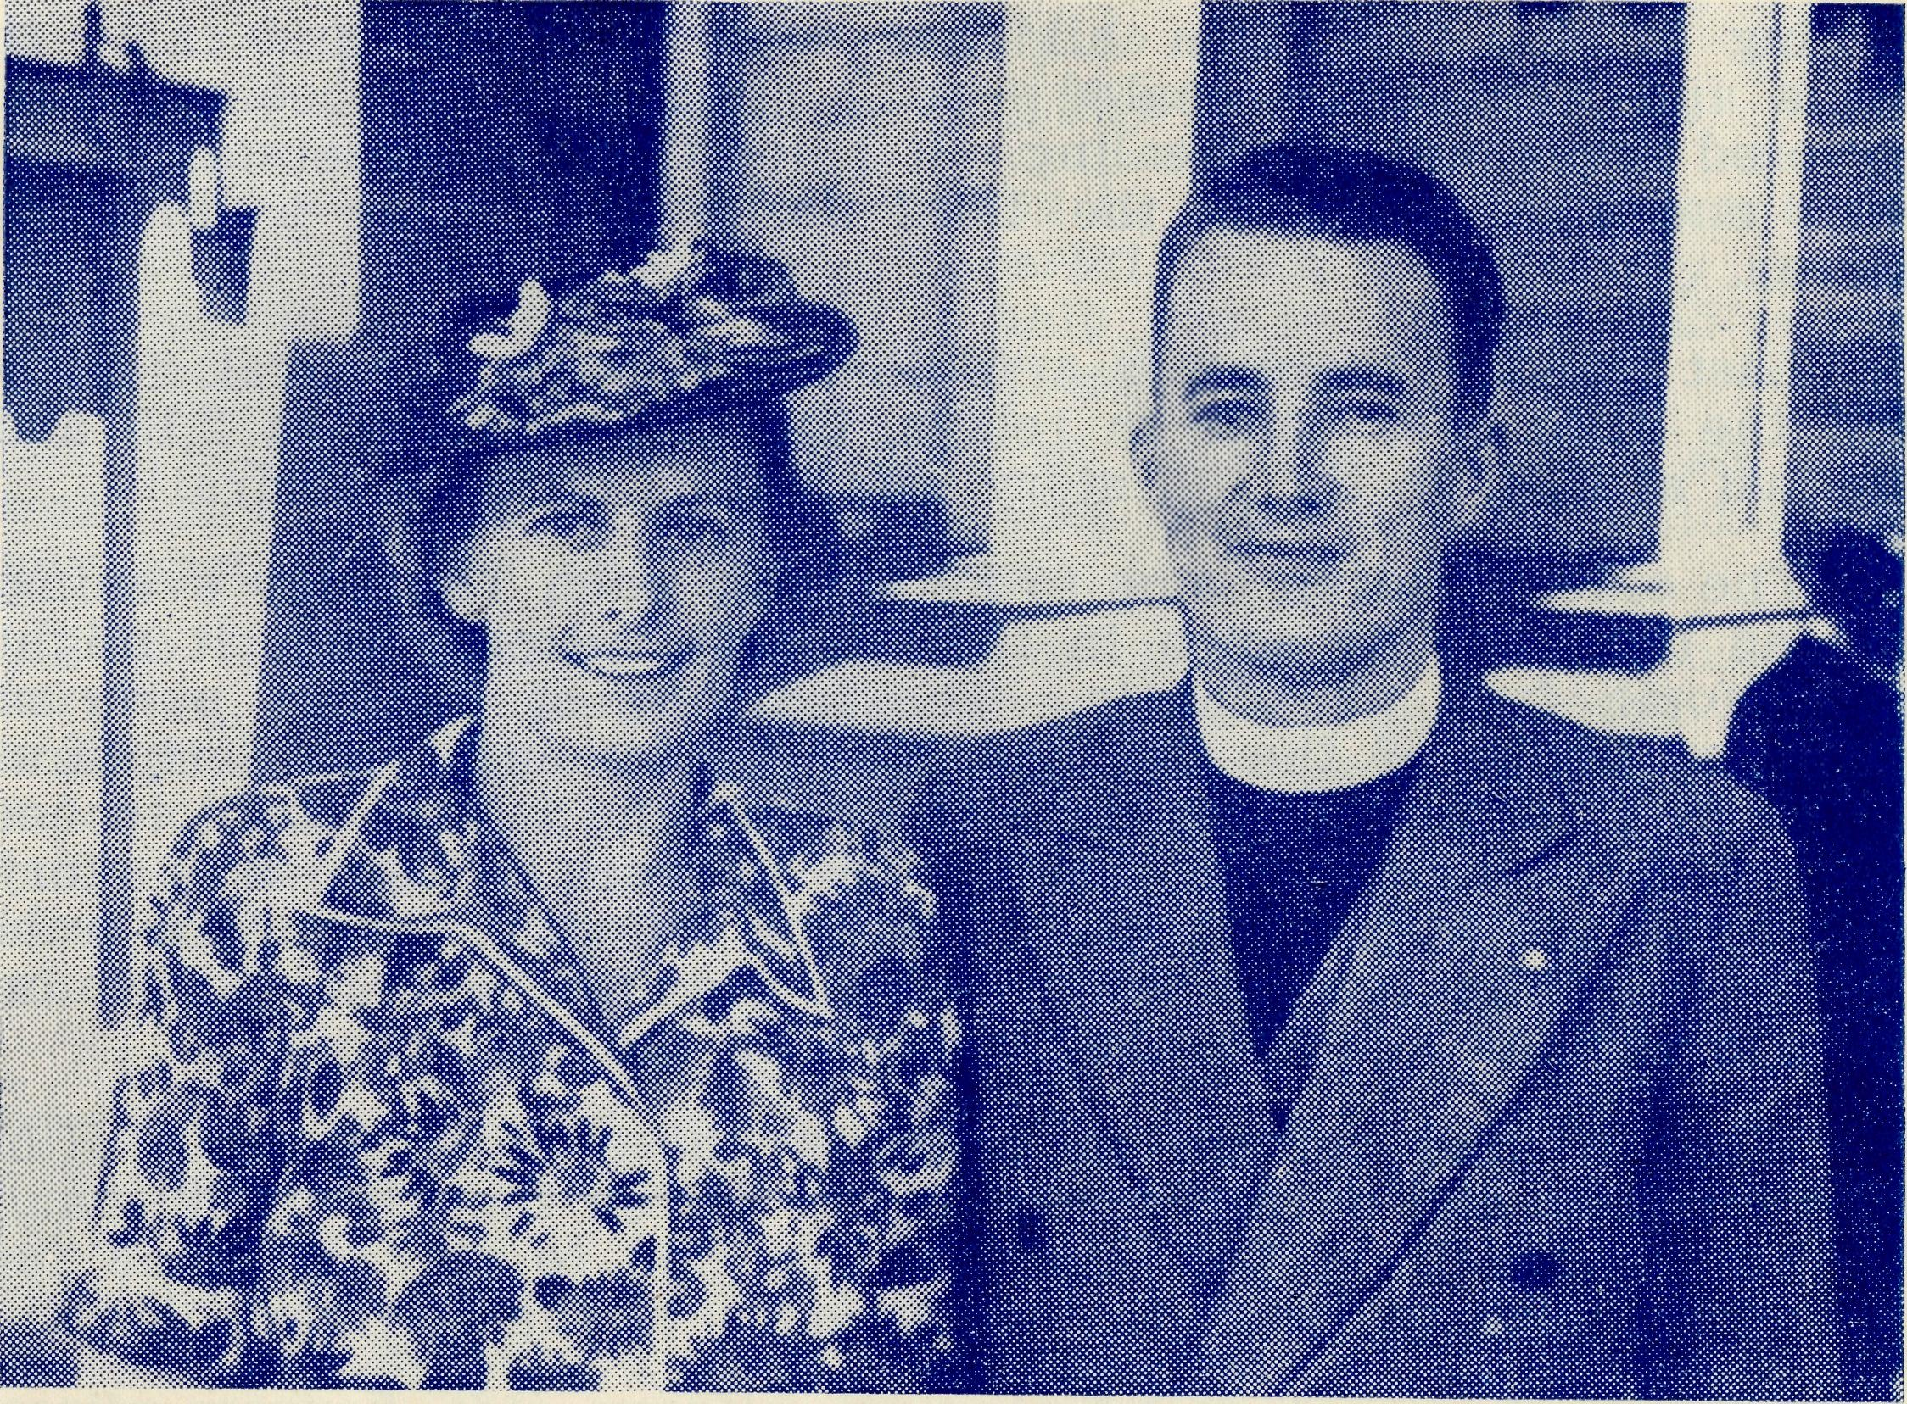
Rev. H. G. and Mrs. Fuhrmeister, Minnipa Mission.
Bringing the Children to Him
Mrs. Fuhrmeister
Whilst a new Rectory is being built in Minnipa for the Missioner, we are sharing a railway cottage. This house, as you may imagine, is built just some yards back from the railway line and the trains prove a constant joy and interest to Roger, our three-year-old. Only this morning when I was endeavouring to get the last mouthful of breakfast fin', Roger's mouth, which had been wide open, suddenly shut to say "trucks", for the train was getting ready to go and he wanted to see. His ears are more alert to train noises, however far distant, than anything at hand. There is a box left permanently at the front gate (this latter being well chained) on which he can stand when the trains come and go — a real grandstand view!
This year, even though a little cramped in house space, I have continued with Kindergarten Sunday School in the afternoons at three; our baby Ian goes to sleep and Roger joins in the class too, for he loves having boys and girls here. There has been an average of fourteen children and they do love to come. One Sunday, after hearing of Jesus healing all the sick who came to him "when the sun was setting"— or as one child told me — when the sun was going to bed, we acted the scene of their

14
The Real Australian
March, 1953.
June, 1953.
The Real Australian
15

coming to Him and each child had some 'sickness' and came to Jesus and went away healed —with straight back, seeing eyes, restored limbs and like healing. It helps them to understand that each one who comes to the Lord Jesus goes away a different person.
Last Sunday there was a football match on the oval nearby and the little ones came in relays, the first arriving at 2.15 and the last at 3.30, so the full story was varied on each arrival!
The older children come to Fellowship each Thursday evening, and as the 'seed' is sown in their hearts we pray that it might bring forth fruit abundantly. The learning of Psalms, parts of chapters, Books of the Old and New Testaments and Scriptural A.B.C. is a foundation for days to come; and it is a thrill to see how much is remembered from week to week. There is a story each time, and at present we are having different characters from the Bible. The fun we enjoy when playing several games on these occasions adds to the fullness of the fellowship.
What a glad service in pointing these children unto Him Who loved us and gave Himself for us. Even though my husband is away so much on the Sundays, I'm glad to stay at home for the opportunity to teach the young ones of the Saviour's love.
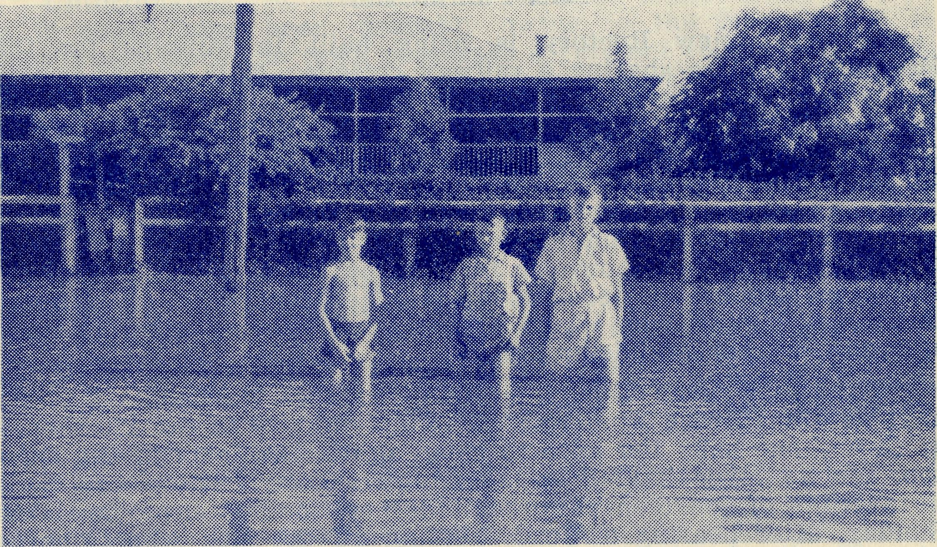
Mungindi Boys' Hostel in flood time.
B.C.A. Hostels serve the children outback.
The Bush Padres Session
Have you a nice church building in your parish with an organ and choir? Is it bright and cheerful, with a sanctuary graced with colourful flowers? Does it help you to worship and realise the Presence of God when you attend it?
I rather think that with most of you this would be so, but I want you to come with me to places where church buildings of any sort are few and far between.
In many of our mission areas public halls are used for services, and tiny bush schools serve as useful substitutes. Where neither is available the home of one of the people is used, and in more or less settled districts a roster is observed and each family takes it in turn to have service in their house. It is an excellent idea and certainly helps to create friendliness between the people who live in the district.
In many of our missions, homes must not be thought of in terms of the type of buildings we are used to in the cities and suburbs. Freight charges make if necessary to use the materials that come nearest to hand or which carry most easily. For these reasons most of the homes are built of corrugated iron or wood. In some places, where there is suitable natural stone of a variety easily worked, this supplies a material that provides a cool and more imposing building, but it is not very often that these conditions are to be found.
The house, to which I want you to come with me now, is built mainly of galvanised iron and is situated on the northwestern plains of N.S.W. It has been lined with strong hessian, and many coats of whitewash have given to the interior the appearance of plaster walls. The large dining-living room, in which about twenty people have gathered, is plainly furnished, but has a cosy atmosphere.
At one end of the room, a small table has been covered with mother's best afternoon tea cloth and the padre's small travelling Communion vessels gleam in the rays of the kerosene lamp that provides the illumination. You will realise that it is not possible for the padre to give Communion to all his people in the early hours, so it is necessary that some of these services take place in the evening.
The mother of the house has four children. Hers is a mighty task looking after such a family and attending to the many tasks that fall to the lot of the wife of a pioneer grazier. She is known in the district for her friendliness, and is looked upon as a friend in times of need whenever her neighbours are in difficulty. It is a remarkable fact that the more some people have toi do, the more ready they are to help others.
In the not-so-good light the members of the congregation have to concentrate very hard on reading the not-so-very-large print of the hymn books. There is a piano, but one would be very hard put to it to even guess when it was last tuned. Despite these draw-

16
The Real Australian
June, 1953.
June, 1953.
The Real Australian
17

hacks, everybody does the best they can to sing the well-known hymns. I don't think that the Lord worries over much about our tunefulness when we sing His praises; it's the spirit in the heart that He sees and appreciates.
When the time came for the act of Communion, all knelt on the floor in the place at which they had been sitting and the padre quietly stepped from one to the other, softly repeating the familiar words, "The body of our Lord Jesus Christ which was given for you . . . Take and eat this in remembrance that Christ died for thee, and be thankful." As he went from one to the other first with the bread, then with the wine, he was conscious that he was ministering to a small unit of the family of God, who, living in the more remote places of the land, needed to be reminded of the constant presence of their Father.
Victorian Notes
THE RALLY
The Annual Rally will be held in the Chapter House, St. Paul's Cathedral, on Wednesday, September 16th. Tea as usual will be at 6.0 p.m., and the main meeting at 8.0 p.m.
Speakers will include the O.M., and the Archbishop will be in the chair.
THE SECRETARY'S HOUSE
With the purchase of a house for the Victorian Secretary a heavy strain has been thrown upon the Society's finances, but we are glad to report that only £700 remains to be paid. Under the conditions of the loan we can repay this at the end of July, thus saving interest and also relieving us of a heavy debt. So may we appeal for liberal assistance in the next few weeks that this burden may be removed?
BOX SECRETARIES' MEETING
A meeting of Box Secretaries and Clergy was held, by the kindness of the Vicar, at St. Jude's, Carlton, on Friday, May 8th. In spite of an epidemic of colds and the difficulty of getting busy people together quite a number were able to attend, and a most useful time was had. Two films were shown, and we all decided that the second one, "The School in the Mail-Box", with a suitable introduction, could be used for background information at Society meetings. Also, several people were most interested in the other film, "Australia To-Day", with its early seascape scenes photographed in the Timboon Mission. Statistics given informed us that we now have 1414 Box-holders in Victoria, and 92 Box Secretaries, so we have a present objective of 2,000 Box-holders and then our finances will be getting to a more adequate level.
A discussion concluded the meeting, and several useful ideas were submitted. As far as possible they will be included in the future operations of the boxes.
It was also decided that we will from now on hold annual meetings of this nature with a service, followed by tea and general discussion.
R.A. SUBSCRIPTIONS
It is particularly requested that all Victorians sending subscriptions for the R.A. remit them to the Melbourne office, and not to Sydney. If they go to Sydney they have to be returned to Melbourne, which entails waste of time and money.
Farewell to Timboon
Rev. E. G. Beavan
It is twelve months since I wrote my last article from Timboon, and this will be the final one as I have already started a new phase of my association with the Society at the Melbourne office.
We were not allowed to forget the reputation owned by this corner of Victoria during our last winter, and all that had gone before was but a foretaste of what we experienced then. Fifty-eight inches of rain fell during the year, giving us about 125 rainless days out of the 366, and being just twenty-three points short of an all-time record. Strangely enough we had no serious flooding, but the result was considerable illness among the old and the very young, and also some disruption to our normal services and meetings. However, the solid nucleus of Christian folk here, as qlsewhere, do not let such trivial things affect them unduly, and we struggled through successfully, even if at times somewhat grimly.
My car inevitably suffered in the process, and I have a shrewd idea that the old horse and buggy days had their good points, and I do know that a motor boat in summer and my own feet in winter during my four years in Newfoundland were far cheaper.
In spite of all difficulties it was possible to make my last financial year at Timboon come closer to requirements than hitherto, and total receipts for all aspects of parochial work were just nine times what they were the year I arrived. The debt on the Mission has now been reduced to £125, and by the end of 1953 should be about wiped off. It will not be independent of the Society for the maintenance of its ministry for a long-while yet, but when the burden of the debt is removed there will be some chance of more speedy development.
After a short period when our people seemed settled in the parish the old customary movement out to other centres re-commenced, and we lost some of our most useful church people and helpers. Being so few in numbers it was a grievous blow, but there is comfort in the knowledge that they have all taken up active work in the parishes to which they have gone, and the ministry of B.C.A. through the years is now bearing fruit in places far removed from its present fields.

18
The Real Australian
June, 1953.
June, 1953.
The Real Australian
19

The attempt made by many of our dairymen to change over to sheep has not proved an unqualified success, especially as wool dropped so much in price by the time they had their first clip. Several have gone back completely to cows, others are now running both cows and sheep, and possibly in time this will become normal farming practice in the Heytesbury.
Whatever does happen it is quite obvious that the relative prosperity the average farmer now enjoys in these areas is bringing in its wake new dangers, and emphasises the absolute necessity of maintaining a Christian witness at all costs until a stable and well-grounded congregation has been built up which can manage its own temporal affairs.
The environment for Christians, especially the younger ones who are most likely to be affected, cannot be considered satisfactory. It was only twice that I found it absolutely essential at public meetings to denounce some evil which was being camouflaged under big-sounding names so that the unwary thought there was nothing vicious in it, but I found when the time was drawing near to leave that all the honest folk had found much help in this and my very presence in their midst. Indeed I was very surprised at some who told me this, never dreaming that I had had such influence with them, but the point which emerges is that this task of building the Temple of God in their hearts is a lengthy one, and we must recognise that as things stand it is only our Society which can do this. Indeed a burden is laid on us, but we must regard this burden in its true light; it is a most glorious privilege. We alone can do it, so let us see if through to the end.
The Bishop was due to visit Timboon and Peterborough on August 3rd, but five days earlier had to enter hospital for an urgent operation, so all I could do was to leave things as arranged, preach myself at Timboon, and give the missionary talk at Peterborough. They were both excellent services but rather subdued by reason of the Bishop's absence. It is with heartfelt gratitude to God that we are able to report his speedy recovery to health.
Early in December the Archdeacon came once again to our Temple Day, and this service was made specially noteworthy by the attendance of about half the members of the Choir of St. Matthew's Church, Geelong. Although the Archdeacon claimed that the large number of robed clergy who attended the opening of the Church three years previously constituted the first choir in Timboon's history, we may fairly claim that it was on Temple Day, 1952, that we had our first organised and trained choir to lead the singing and also to render an anthem. It was a fine gesture entailing a round trip of 190 miles, and it will be remembered.
Over the years we have been endeavouring to make the Annual Carol Service something different to the usual Christmas singing of half-a-dozen hymns which have become so well known that no one now heeds the words, and with the co-operation of
the Young People's Club we had over the course of three years learned five of the most beautiful carols in our own Australian "Book of Common Praise". Therefore by last Christmas we were in a position to make something really impressive and worthy of the occasion we were commemorating, and, with a full church, we held a service the like of which I have not known for many years. It was unfortunate for us that one of our greatest losses in membership during the year had been our organist, and so I had to play as well as take the service. But everything had been arranged and rehearsed to minimise the inevitable interruptions, and though I had to concentrate on carrying it all through according to schedule, I sensed that the atmosphere was such that the hope had become reality. We had unity with the angelic paean of triumph at the coming of our Lord and Saviour.
On this high note we sustained our whole Christmas worship, and the discordant notes of dingy, unkempt buildings we have to borrow in some out centres could not stifle it. Whatever may happen can never take away the firm conviction that this nucleus of Christians can be the foundation upon which may be built up a stable and influential Christian body.
After Christmas came the preparations for moving to Melbourne. Time went quickly and there seemed no end to the packing, but after a final twenty-four-hour rush we got on our way and within a few days were firmly installed in our new quarters. As I write this my Successor, the Rev. P. R. Cooke, is about to be instituted by the Bishop, and with the opportunities and difficulties he will encounter at Timboon very much in my mind I can but ask all our friends to remember him in their prayers. May God grant him blessing in all his labours.
DATES TO BOOK IN YOUR DIARY
September 22nd, 23rd, 24th, 25th:
ORCHID SHOW — CHAPTER HOUSE, SYDNEY. For Flying Medical Services.
September 16th:
MELBOURNE RALLY -CHAPTER HOUSE
September 25th, 7.45 p.m.: SYDNEY RALLY — CHAPTER HOUSE
October 30th, 2.15 p.m.:
Women's Auxiliary Bathurst Street.
THANKSGIVING DAY — Bible House, NOTE THE DATES AND BRING YOUR FRIENDS

