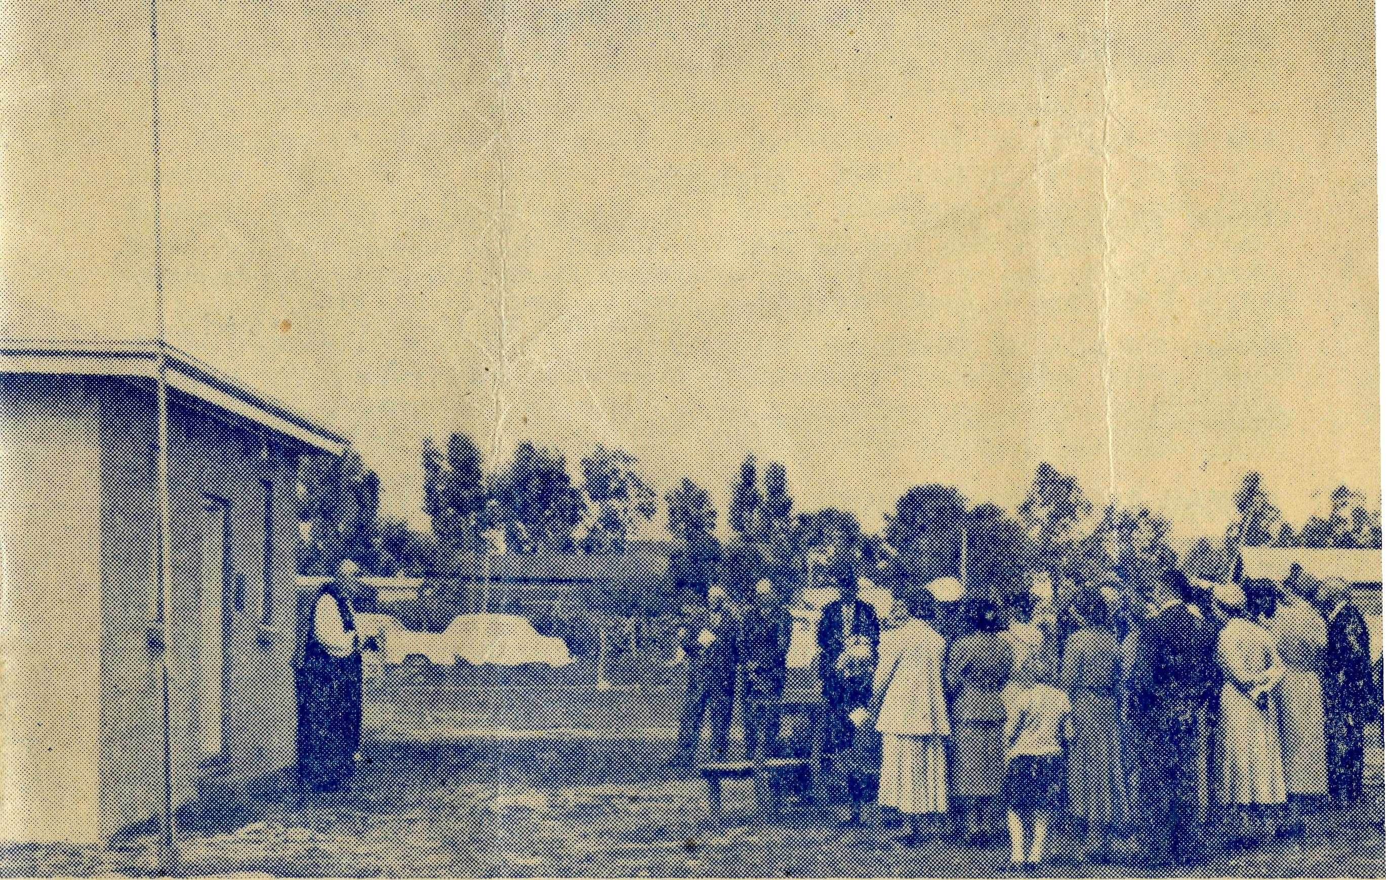
2/6 per annum, post free.
SEPTEMBER, 1953.
No. 7 (New Series).
20 The Real Australian September, 1953.
Topics for
Prayer and Praise
SUNDAY
For all Mis-sioners and Deaconesses of the Society and their people and for all students in training. MONDAY
For all Doctors and Nurses serving in' the outback, and for the spiritual and physical health of the patients under their care. TUESDAY
For all Workers in Hostels, the children under their care and the teachers who instruct them. WEDNESDAY
For the Director of the Mail Bag Sunday School, the pupils of the School and all teachers and voluntary workers.
THURSDAY
For the F'ly-i n g Medical Service and the safety of the pilots and all who travel with them.
FRIDAY
For the Council of the Society, the Home Base staffs, Auxiliaries and Parochial workers.
SATURDAY
For all neces-s a r y finance needed for the maintenance of so large a ministry and for guidance in its right application.
For the Society.
O Lord God of our nation, Who has commanded men to subdue and replenish the earth: Look in Thy love upon all who in distant parts of our land are striving- against many difficulties, and are deprived the access of the means of grace. Strengthen and guide the Bush Church Aid Society and all members of the staff. Cheer and comfort them in discouragement and loneliness, bless their ministrations to the good of those they serve, and grant that the message of redeeming love may thus be rooted and grounded in our national life, to the glory of Thy Great Name through Jesus Christ our Lord. Amen.
For Nurses and Doctors.
O God, Who didst choose a beloved physician to set forth the life of Him Who went about doing-good, grant that Thy strong tenderness and compassion may be manifest in the work of country doctors and bush nurses. Make them at all times alert to be faithful, as those whom Thou hast burdened and inspired with the honour of their calling. In lonely emergencies strengthen them with confidence that, having done all they can, they may with good conscience leave the issue to Thy power working within Thy law. Make them resourceful and of sound judgment, and hearten their labours with the energv of compassion and the firmness of duty that conquers weariness. Through Him Whose power is called forth by suffering. Jesus Christ our Lord.
For Church Life in Country Districts.
O Lord, Who art present when two or three are gathered together in Ttr^{T} Name, bless, we beseech Thee, the little far-scattered groups of brethren who in our wide land meet together to worship Thee. Give them a perpetual freshness of spirit, and the power to inspire in each other holiness, helpfulness, and understanding of Thy help. Refresh with the joy of enthusiasm those who endure weary journeys to Thy trysting place. Grant that these little companies of Thy servants may be united in the spirit of Christian charity, awaiting in love the time when there shall be one fold and one Shepherd. Grant that the common life of all communities may be purified by this spirit of charity from all meanness, falsehood, malice and idle gossip, and grant thot they who share a common lot may draw strength from each other's virtues, and in their weakness help one another, through our one Lord, Jesus Christ.
Praise.
for
For the Blessings vouchsafed to the Society, all kindly givers, for the joy of service.
Edgar Bragg & Sons Pty. Ltd. 4 Barker Street, Sydney.
The Primate dedicates the Wireless Base. Registered at the G.P.O., Sydney, for transmission by post as a periodical.
The Official Organ of THE BUSH CHURCH AID SOCIETY
Church House, George Street, Sydney, N.S.W.

The Real Australian September, 1953.
The Bush Church Aid Society for Australia and Tasmania
PRESIDENT: The Archbishop of Sydney.
Hon Clerical Secretary: Rev. Canon E. Cameron. Hon. Treasurer: Mr. T. S. Holt.
B.C.A. Activities and Staff
Organising Missioner: Rev. T. E. Jones, Th.L.
N.S.W. Deputation Secretary: Rev. J. R. Greenwood, Th.L.
Victorian Secretary: Rev. E. G. Beavan, M.A.
VICTORIAN OFFICE:
Bible House,
Flinders Lane, Melbourne, Victoria.
Telephone: MF 3552
HEADQUARTERS OFFICE:
Diocesan Church House,
St. Andrew's Cathedral,
George Street, S/dney. Telephone: M 3164
Cable Address: "Chaplaincy, Sydney".
STUDENTS IN TRAINING.
Rev. F. Ingoldsby, Th.L. Mr. A. Williams. Mr. T. Morgan.
Mr. T. V. Jones. Rev. D. W. Warburton. Mr. R. Brooks. Mr. J. Smith.
MISSIONS.
Ceduna, S.A.-Penong, S.A.— Heytesbury Mission, Vic.—Rev. P. R.
Rev. T. J. Hayman, Th.L., Ceduna, S.A. Cooke, Th.L., Timboon, Vic.
Rev. I. Booth, Th.L. Otway Mission, Vic.—Rev. K. Seymour,
Cowell, S.A.—Rev. D. A. Richards-Pugh, Th.L., Beach Forest, Vic.
A.L.C.D. Wiicannia, N.S.W.—Rev. J. Stockdale,
Minnipa, S.A.—Rev. G. Fuhrmeister, Th.L. Th.L.
Streaky Bay, S.A.—Rev. P. Connell, Mendindee, N.S.W.—Rev. W. Mitchell,
Th.Schol. Th.L., and Deaconess A. Howland.
Croajingalong, Vic.—Rev. G. Garner, Rappville, N.S.W.—Rev. A. Gerlach, Th.L.
Th.L., Cann River, Vic.
MAIL BAG SUNDAY SCHOOL.
Director—Miss R. Campbell. Assistant—Miss M. Patterson.
MEDICAL SERVICES.
Ceduna, S.A.—
SCHOOL HOSTELS.
Broken Hill, N.S.W.—Mr. and Mrs. A.
McLaughlin. Mungindi Boys' Hostel, N.S.W.—Mr. and
Mrs. Hustler. Mungindi Girls' Hostel, N.S.W.—Miss M.
Farr. Bowral, N.S.W.—Miss E. Cheers. Port Lincoln, S.A.—Miss I. Beck.
Matron: Sister F. Dowling. Staff Sisters J. Miller, G. Hitchcock, B. Tierney, J. Payne, P. Shipway, A. Butler, J. Armstrong, Miss F. Lawtey.
Penong, S.A.—Sisters L. Loane, L. Lang-tree.
Wudinna, S.A.—
Matron: Sister R. Portch. Sisters: A. L. Haywood, B. Barber, V. Brealey, F. Ellis, Mrs. E. Babbage.
Cook, S.A.—Sisters M. Horsburgh, M. Ross.
Tarcoola, S.A.—Sister V. Holle.
Cann River, Vic.—Sister I. Gwynne.
Rawlinna, W.A.—Sister E. Thomas.
FLYING MEDICAL SERVICE.
Pilots—Mr. A. Chadwick,
ford. Doctors—Dr. F. Gibson, O.B.E., Dr
Mueller, Dr. J. Upsdell.
Mr. W. Bed- Wireless Control Station
M.
Control Officer—Mr. G. Cameron. Pharmacist—Miss E. M. Page.
September, 1953. The Real Australian
The O.M.'s Letter
It is good to be able to report to you that the Wireless Control Station at Ceduna is now an actual fact and is 'on the air'.
It. is already proving a very great help to the nursing staff, especially at the more isolated points such as Cook and Tarcoola. Transceivers have been installed at both these points on the Trans-line and the sisters are able to make daily contact with the doctor at Ceduna and so obtain all the help and advice that they require about their patients.
Cook has been especially busy of late and many of their patients have been serious cases that have necessitated almost constant sessions with the doctor. This means that the sisters are freed from some of the serious responsibility that has been theirs for so long and doctor is helped in the task of deciding whether long trips ought to be made to patients on the great plains.
We can quite definitely say that the establishment of the Wireless Control Base has already proved to be a wise move— but it is only the beginning.
Such pieces of work are spectacular and appealing in their establishment, but they must be maintained day by day. This is the need that I now put before you.
Owing to the very generous provision of a friend of the Society, Mr. S W. Jones, of Toorak, Melbourne, who left the sum of £5,000 in his Will, it has been possible to establish this new work without making any appeal to our many friends. The establishment of the buildings that constitute the Control Station is but a part of the whole. Transceivers costing £95 each have to be supplied to outstations; the electricity bill for the operation of the transmitters will run into many hundreds of pounds annually; salaries have to be found and much valuable equipment purchased from time to time. These will be part of the task that we must look to you to undertake.
We will be able from time to time to keep you informed of the work that is done through this new venture, and I hope that you will always feel a thrill in having a part in it.
The B.C.A. has come a long way since that cold, wet night in May, 1919, when twenty-six men and women gathered in the Chapter House of St. Andrew's Cathedral, Sydney, and brought the Society into existence. If they could come and see to what extent the work has grown in that short time, I am sure that they would rejoice in it and be thankful that they had the courage to found the Society.
They handed the work on to us, and those that have followed them in it have not proved any less courageous for the things of the Kingdom of God than they.
Let us, then, who are here to-day, see to it that our hearts be filled with courage and faith that will enable us to 'show forth in our lives—the things that we believe in our hearts'. The Kingdom of God can be furthered only by constant prayer, devoted service, generous giving.

The Real Australian September, 1953.
September, 1953. The Real Australian

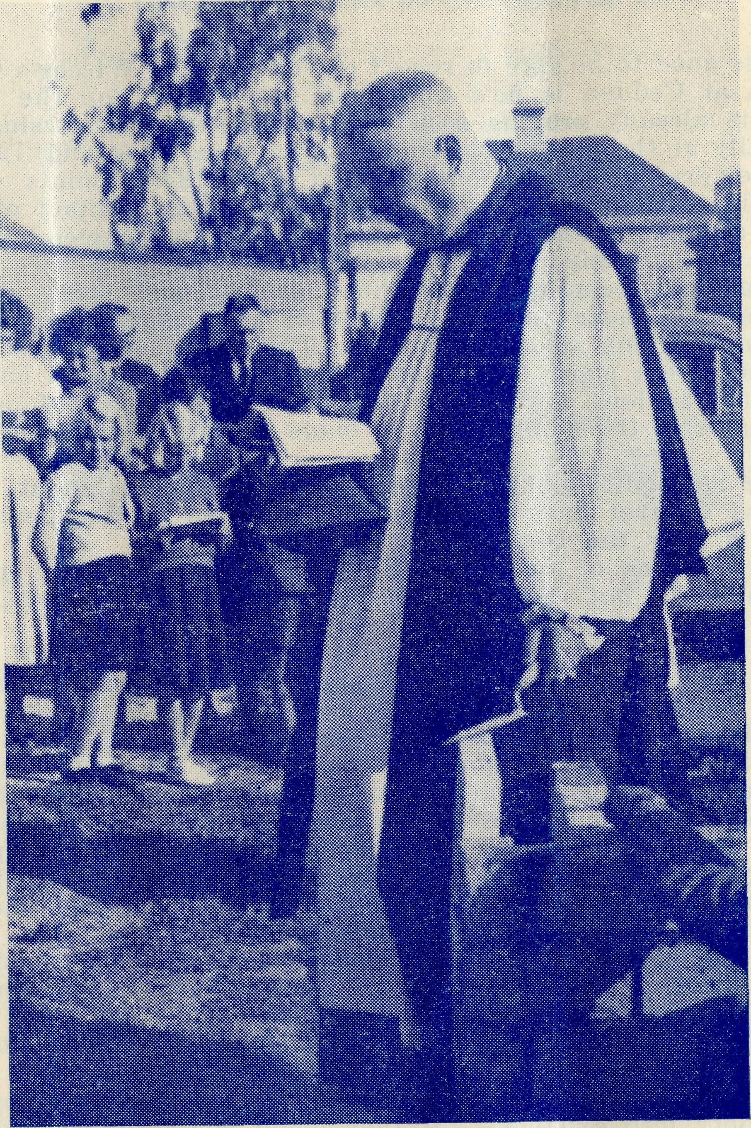
The Primate lays the Foundation Stone of Ceduna's new Church.
2KA —
You can hear THE BUSH PADRE from "The Voice of the Mountains" on ALTERNATE FRIDAYS at 4.30 p.m.
The Mail Bag Sunday School would welcome used copies of A. & M. Hymn Books, Prayer Books and Bibles, providing that they are in good condition. Some outback homes lack such books which are a necessity if our older children are to use the lessons effectively.
• • •
We are grateful to our Wollongong friends for the splendid support they gave to the evening held at the home of Mrs. D. Winton from which the excellent sum of £31 was obtained.
• • •
Mixmasters have been supplied to the Hostels at Bowral and Broken Hill by the kindness of St. Barnabas', Chatswood, and the Clovelly Ladies' Auxiliary. These machines are a very great boon to the staffs and help to lighten the burden of the daily-round. Thank you!
• • •
We are grateful to the members of St. Luke's, Clovelly Branch, for the sum of £85 (including the cost of the Mixmaster) which they remitted to Head Office as their effort for the year. Such sustained interest enables the Society to undertake with confidence the many tasks that are presented to it.
• • •
The Bush Padre wishes to acknowledge the many anonymous gifts that are sent to him for the Society's work by listeners. It is very encouraging to know that these broadcasts have an increasing circle of interested listeners and we would ask all our friends to make them as widely known as possible.
• • •
Our sympathy is extended to the Rev. E. Felton, rector of St. Chad's, Cremorne, and a member of the B.C.A. Council, on the occasion of the death of his father.
• * *
We acknowledge with thanks the anonymous gift of £250 handed to us by the Rev. F. H. B. Dillon, of St. Clement's, Mosman The amount has been paid into the Flying Medical Services as requested. Thank you!
• • •
We are indebted to the members of the East Burwood Auxiliary, who. through their very energetic secretary, Mrs. Kershaw, have paid into the society's funds the amount of £59. The help and interest of these parochial auxiliaries sustains the B.C.A. in its work and widens the circle of our friends. May we commend the idea to you?

The Real Australian September, 1953.
September, 1953. The Real Australian

The Young People's Auxiliary has now two trained teams ready and anxious to interest the young people of our parishes in the work of B.C.A. A request to the Sydney Office will bring them to your parish. Why not set a night apart to hear what they have to say? New members are needed for such training and we would welcome enquiries from any of our younger friends who are anxious to further the interests of B.C.A.
• • •
We tender our thanks to Mrs. Bolton, of Strathfield, for the very excellent display of Orchids she arranged in the Chapter House of St. Andrew's Cathedral from September 22nd to 25th. The Chapter House was a blaze of brilliant colour and many of the finest Orchids were on display. Such an exhibition entailed a very great deal of hard work on the part of Mrs. Bolton and we are glad to know that it attracted so very much interest and admiration. The members of the Women's Auxiliary supplied Devonshire Teas for the four days and this was a convenience of which many availed themselves. The ladies of the St. Luke's Sewing Circle (Mosman), organised a Work Stall in order to add to the financial results. The proceeds of the effort were for the Plying Medical Service and amounted to £115.
• • •
It has been good to see Sisters Ross and Horsburgh in Sydney on holiday. They have been experiencing some very anxious cases of late months and the change afforded by a holiday with their families has done them much good. It is a joy to see them go back to the job so happily. They have both spoken enthusiastically of the very great help the daily contact with doctor, provided by their transceiver, is to them.
• • •
Since our last issue, Sisters Butler, Hitchcock, Langtree and Payne have been away on holidays and we trust that they had a happy time. We really need two spare sisters so that all holidays can take place whenever due, for it is too big a strain to go over the twelve months without a break. Sister V. Holle has taken over the work at Tarcoola caused by the resignation of Sister V. Page. At present she is in charge of the Nursing Home, but by the end of this year it is expected that the new and modern hospital building will be ready for use, whereupon sister will transfer from the old home. Another nurse will then be required to assist Sister Holle, but no appointment has yet been made. Your earnest prayers are asked for sister in her neiv and more lonely task.
• • •
You are asked to note that a special dramatised broadcast of the work of B.C.A. is scheduled to take place on Sunday, November 15th, at 9.30 a.m., from stations 2FC, 3AR, 4QC, 5CL, and Short-wave station V.L.H. This programme, which will last half an hour, has been specially prepared by the A.B.C. in consultation with the Organising missioner, and will, it is hoped, do much to make the work of the B.C.A. more widely known.
It is possible that the programme may be put over the air by the B.B.C. on their English programme sometime early next year.
The Annual Rallies of the B.C.A. took place during the month of September in Melbourne and Sydney. Both were attended by 'packed houses'. The Rev. Theo. Hayman, in Melbourne and Sydney, Deaconess Howland in Melbourne, spoke simply but interestingly of the work in their respective spheres. At the Sydney Rally, His Grace The Archbishop of Sydney told of his recent visit to the B.C.A. centres on the West Coast of South Australia, and more especially of the Wireless Base. The Organising Missioner also had something of interest to tell. These Rallies are always times of happy fellowship of B.C.A. friends and we are glad to say that this year they were both up to the usual B.C.A. standard. Offertories were: Melbourne £480; Sydney £675.
SISTER V. PAGE, who has been Sister-in-charge at Tarcoola for the past eight years and before going to Tarcoola was at Ceduna for four years, has resigned from B.C.A. service to return home to Victoria.
Sister's service with the Society has been outstanding and has been carried out at some very real self-sacrifice to herself. Our friends will remember that she returned to Tarcoola after recovering from an attack of Poliomyelitis and since that time she has felt that in the interests of her health she ought to leave Tarcoola. We owe Sister Page a big debt of gratitude for carrying on for some years under health difficulties until such a time as it was possible to replace her. We pray that she will find a happy sphere and much blessing in Victoria.
DEACONESS SPRY. Our friends will learn with regret that, owing to health reasons, Deaconess Spry has been compelled to relinquish her work with the Society. After a long convalescence following upon an operation to her spine, Miss Spry has been advised by her doctor that she must not engage further in outback work. At the moment her future is unsettled but our prayers go with her for a happy sphere in the future.
The Victorian Secretary would be grateful to hear from anyone in Melbourne who could supply him with wooden packing cases, approximately 2 ft. by 2 ft. by 2 ft., in order to pack and send gifts to the B.C.A. Hospitals.
Eight are required annually, but even one or two would be of the utmost help.

The Real Australian September, 1953.
September, 1953. The Real Australian

Flying Medical Service
The end of July flying saw our mileage figures reach another new all-time record of 4,522 miles flown.
The normal Cook trip was scheduled for July 1st, but was postponed owing to the Doctors having to watch very closely a haemorrhage case operated on that morning.
We arranged to do Coorabie and Penong next morning, but the patient's condition still would not permit Doctor leaving, so the morning trip to Coorabie was put off, and an air force 'plane from Mallala brought over some blood from the Red Cross supply. When the blood transfusion had been given, Doctor was able to make the Penong trip in the afternoon, and we arranged to go to Cook on the Friday.
At 6.15 a.m. that morning, Doctor rang to say that an emergency stop at Penong would be necessary en route for Cook. This case kept us at Penong until late in the morning, so it was a late lunch that we sat down to on arrival at Cook. With a busy afternoon for Doctor, it was just on sunset when we took off, and flew home in the dark.
The next day another call came from Cook during the afternoon. As the weather was fine and cloudless, we were -able to fly home again that night when the operation was finished, so the flare path was laid for the purpose, and we took off at 7.50 p.m. and arrived home at about 10 p.m.
On the 9th July we made our first scheduled trip to Oodnadatta. Leaving Ceduna about 1 p.m. we flew through cloud and rain for the first 120 miles, and as ice was encountered at 5,500 feet, where I had hoped to be able to fly, I had to descend to 3,500 feet. However, the winds were favourable, and we made the journey of 340 miles in 3 hours 10 minutes. All Friday was spent at Oodnadatta, and the return trip made on Saturday, via Coober Pedy, where we landed for the first time on the new landing ground they have prepared for us there. Here we picked up a burns case—a Native who stood too close to a fire and had his trousers burnt off him, suffering an extremely bad burn from the hip to the toes. We brought him down to Ceduna hospital, where he has been for a month, and still far from being recovered; he will have to be moved to Adelaide for further treatment as soon as that can be arranged.
I had not finished refuelling after arriving back from Coober Pedy when we were called up to Cook again to another appendix case. A fettler had been brought in from a siding about 140 miles along the line, and was pretty sick. This meant a night take-off from Ceduna, flying all the way in the dark. Upon operating, Doctor found that his appendix could not be removed. He remained a very sick man for several weeks, but with constant penicillin treatment he was then able to leave hospital, and will ■ return in three months to have it removed when it will normally have settled down again.
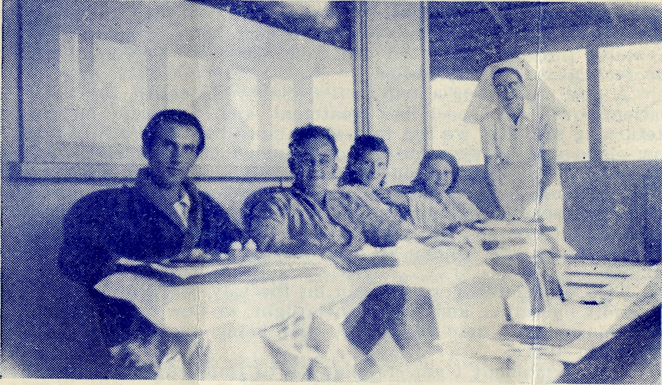
Sister Horsburgh and some of her patients at Cook.
. Arriving home the next morning, the day had not progressed very far when still another call came from Cook to another appendix; this time a boy, who had been brought in. He was being watched for several hours, but eventually it was thought advisable to go. up to him, by which time it was late in the afternoon again, calling for another night flight. Coming home the next morning, with the help of strong following winds, a record for the trip was established with the time of 1 hour 40 minutes.
Next day was the scheduled Tarcoola trip. The morning dawned fine and clear and we had a good trip up to Tarcoola. However, during the morning, the wind increased in strength to above 40 m.p.h., raising the dust and making it necessary to move the aircraft and securely chock the wheels. By about 2 p.m. the dust had subsided so I checked with Mulgathing as to the weather conditions up there, and the direction of the wind relative to the runways. Receiving a favourable report, we left Tarcoola and had covered about one quarter of the distance to Mulgathing when we met up with a dust storm, brought in from the edge of the Nullarbor Plain by the strong N.W. winds, and reducing visibility to only a few hundred yards. Flying then at an altitude of only a few hundred feet to keep the ground in view, we flew on until the road and telegraph line into Mulgathing was sighted, which proved to be about two miles south of the Homestead. Circling the aerodrome, the runway suddenly appeared out of the dust, and here again it was necessary to securely chock the wheels and tie the aircraft down, this time for the night, as the weather conditions were well below the minimum required for a night flight home.

September, 1953. The Real Australian
11

At 6.30 a.m. next morning when I rang the Post Office to get the weather report. Sister Page was waiting to speak to Doctor. During the night, a patient had been brought in with a badly infected hand, so we flew back to Tarcoola, where Doctor opened the infection.
A few days later a trip to Parafield was called for to fly a patient over for specialist treatment and a major operation. Returning next day we ran into some more bad weather, this time low cloud and heavy rain. At one stage I had to turn back and fly out of and around one stormy patch, and on three other occasions had to alter course to fly around patches of low cloud producing severe turbulance and heavy rain. However, we duly cleared the rough weather about 70 miles from home, an\d arrived for a late dinner after a very tiring trip of 5 hours 10 minutes.
Two days later saw us again on the way to Cook for another appendix operation, and staying overnight, we flew down to Penong next morning in time for lunch, that being our regular visiting afternoon there.
At the moment I am standing by to transport a very serious burning accident case to Parafield, which is in no fit condition to be moved as yet; I have had two rings from the hospital this morning concerning it. Yesterday afternoon when Sister rang and told me of the case, I worked to complete some maintenance work left over from Saturday; conducted the first half of the Evening Service until Mr. Hayman returned from Thevenard, afterwards taking the stretcher down to the hospital, and driving Miss Page up to the shop for morphia, etc.; arranged for a blood sample to be taken to Streaky Bay by a relative of the patient, in time to catch Birdseye's bus leaving at 7 a.m. to-day; and arrived home finally at 11 p.m.
The Primate’s Speech
The Archbishop said that he felt the establishment of the wireless control base by the Bush Church Aid Society to be of such outstanding importance as to justify him, as Primate of Australia, journeying from Sydney to dedicate the buildings. The new base, he considered, was a remarkable achievement by the Church of England through the Bush Church Aid Society. It had required much faith and courage as well as hard work on the part of the Society and its Organising Missioner (Rev. T. Jones), in the purchase and assembling of much valuable equipment and the erection of the necessary buildings. The control station was the coping stone in the development of the medical services provided by the Bush Church Aid Society which began in Ceduna in 1924, in a small cottage hospital. To-day, the organisation served an area of South Australia, west of Spencer's Gulf to Oodnadatta in the North, and as far west as Rawlinna in Western Australia. It has modern hospitals at Ceduna, Wudinna, Penong, Cook and Tarcoola, and a nursing home at Rawlinna.
Regular consultative visits were paid . also to Oodnadatta, Coober Pedy and Mulgathing. The medical staff contained 22 nursing sisters, and the services of three doctors were available. The Society owned a fleet of three aeroplanes, two of which were based at Ceduna and one at Kyancutta. It employed a pilot-engineer and retained the services of another pilot, as required.
The Flying Medical Service of the Bush Church Aid Society was the only such service at present located in South Australia. Other members of the staff were the wireless control officer and a qualified pharmacist.
The B.C.A. also provided a hostel for high school girls at
Port Lincoln, in vchich there were at present 31 girls, and to
which extensive additions had lately been made at a cost of
£2,000.
"Now we dedicate this control station and anticipate that in two or three weeks' time it will be officially 'on the air'. To date, twelve outposts have applied to the P.M.G.'s Department for approval to install transceiver sets to be connected to this control station; four others are about to apply, and it is confidently anticipated that others will become interested as the service develops and its facilities become more widely known and appreciated. The range and efficiency of the station is of the same high standard as those of similar organisations, and the telegraphic and medical services will be equally efficient.
"The wireless control station consists of two buildings, one being the residence of the operator and his family, and the other containing the wireless equipment is the operating centre. We are fortunate in having Mr. George Cameron as the wireless operator, for he has all the necessary technical qualifications, and approaches his task with the highest motives of Christian service.
"The cost of erection has been provided by funds left in the Will of the late Sydney William Jones of Toorak, Melbourne, who, in 1936, became ill while travelling on the Transcontinental train. He thus became aware of the need for increased medical facilities for people in remote areas, and when he died he left the sum of £5,000 to help provide such facilities. He expressed the wish that any building erected with the money should be a memorial to his wife. The B.C.A. have, therefore, decided to call this wireless control station 'The Anna Mason Jones Memorial', and so conform to Mr. Jones' wish.
"Such an addition to an already extensive work adds greatly to the financial responsibilities of the B.C.A.. which confidently look forward to the increasing support of generously-minded people."

12
The Real Australian September, 1953.
September, 1953. The Real Australian
IS

9. Roger Obo. Cook
M. Horsburgh.
A few weeks ago we had the privilege of seeing a miracle wrought before our eyes. Late one Saturday afternoon a patient came to us via the Tea and Sugar train. On the Friday evening he had developed a pain in his side which persisted through the night, but next morning he insisted on carrying out his normal duties, which included a thirty mile trip by fetler's 'trike' to the next camp with his ganger, examining the line as they went. By the time they had returned the Tea and Sugar had gone and the man was now obviously ill. The ganger's wife, who is a trained nurse, was asked to see him and she advised that he should come to hospital immediately; so once again on the fetler's 'trike' they set off in pursuit of the train. The Tea and Sugar is the provision train from which all the folk along the line get their supplies twice a week. Its stops at each camp are rather lengthy, so they were able to catch it at the next station.
After examining the patient I immediately rang Doctor and the plane was on its way and the emergency flares laid down here for the landing. Within four and a half hours of contacting Doctor, the patient was in the theatre. Alas! We were soon to find that he had delayed too long in coming to us and humanly speaking there was nothing that could be done for him by operation. He was only a young man and we were all rather stunned by the seeming tragedy of it, but we lifted up our hearts to God on his behalf and those words came to us again, "More things are wrought by prayer than this world ever dreamed of", and how true they are. Each day, instead of bringing the symptoms we dreaded, brought improvement and within three weeks our patient was ready for home. We do not know how the recovery came to pass, but we do know why. Our Lord has said, "Whatsoever ye shall ask in My name I will do it that the Father may be glorified in the Son. If ye ask anything in My name I will do it". Surely we can all prove that promise again and again in our daily lives and yet we are so slow to act upon it.
About the time of the above incident we seemed to have an epidemic of appendicitis, if such a thing were possible. Anyway, we managed to keep Doctor and Mr. Chadwick quite busy. They had said good-bye to Sister Ross who was going on holidays before the next scheduled trip, but they saw her six times after that before she went. Everyone was wondering if they would be next and the postmaster, who had charge of the emergency flares, complained that he no sooner got the kink out of his back from laying one lot than he had to start all over again. He is very happy that we have the flares, and all these people realise and appreciate just how much B.C.A. means to them.
Now we have our transmitter and we praise God for it. It is great to know that we will be able to contact Doctor any time without having to go and put the postmaster out of bed and also have the certainty that we will be able to get through.
Some time ago we had a small patient admitted who was haemorrhaging after a tonsil operation. When I tried to contact Doctor at 4.30 a.m. all the lines were down and it seemed that we were completely cut off, but eventually, after a delay of nearly an hour, we made contact but it was valuable time lost and a time of great anxiety to the Mother and to us. If you could listen in each evening you would hear something like this: "V.K.B. Victor-King-Baker — Ceduna calling 9.R.O. Cook. Hullo! 9.R.O., 9.R.O. 9.Roger Obo. Do you receive me, Sister? Over, 9.R.O." "9.Roger Obo to V.K.B. Good afternoon, Mr Cameron"
I was asked in a recent letter from a relative whom I had told about the broadcasts, if we alwavs dropped our H's when speaking on the transmitter!
This is 9.R.O. closing down to re-open at some later date.
The Rev. E. L. R. Panelli
It is with profound regret that we report the sudden death on July 31st of the Rev. E. L. R. Panelli, Vicar of South Melbourne, a Councillor of the Society and a member of the Victorian Committee for many years. The Funeral Service in the Church and at the graveside was conducted by His Grace the Archbishop of Melbourne, who paid a glowing tribute to his sterling character and work. The packed Church was eloquent testimony to the esteem in which "Pan" was held by his fellow clergy and the people among whom he had ministered in various parishes.
In training for the ministry in Gippsland when the 1914-18 war broke out, he enlisted in the A.I.F. and rose to the rank of sergeant. After his return he entered Ridley College and was ordained Deacon and Priest in 1922 by Archbishop Harrington C. Lees. After serving as curate at St. Stephens, Richmond, he became the first Van missioner of B.C.A. in the West Darling area and then the first Victorian Deputation Secretary for B.C.A. His re-entry into parochial work was made in the Mt. Dandenong parish, from which he went to Barrabool and Modewarre; Diamond Creek; then to Berwick before his appointment to South Melbourne in 1943.
At the August meeting of the Victorian Committee, Archdeacon Raymond spoke of his long association with and regard for him. Members stood in silence to complete a fine tribute to his memory.
Mr. Panelli was a man of strong principles, quite fearless in expressing them; intensely devoted to his Lord and Saviour and to His Church; and a faithful pastor at all times. His work as B.C.A. Councillor had a high place in his progress and life. He is sadly missed and his work for B.C.A. will not soon be forgotten. Af we thank God for having known him we express our sympathy with his bereaved wife and relatives.

14
The Real Australian September, 1953
September, 1953. The Real Australian
15

Cast Your Bread Upon The Waters . . ."
"I would like you to send me Sunday School lessons for my seven children. As an old pupil I can truthfully say the lessons are both interesting and helpful."
So wrote one mother, and how letters like this encourage, as well as help us to realise that country folk value the teaching our Society has been giving for over thirty years. This particular mother referred in affectionate and appreciative words to her own M B.S.S. teachers.
One might think that with seven small children to care for she would have little time, or energy, to supervise the children's Sunday School lessons; but as the eldest girl helps the younger ones, work for every Sunday in the month comes back to us regularly from the four children who are of school age. When children respond in this way the teacher is soon able to establish a happy relationship.
It is possibly no exaggeration to say that the effectiveness of our lessons depend not only upon the children but also the influence of their homes and parents—particularly their mothers. With young children, of course, mother must read and help throughout the whole of the lesson; while even older ones have to be supervised to some extent. Then it is generally mother who sees that the work is packed up and sent to the teacher.
So often in country homes out-door jobs must be carried out the same on Sundays as week days, and when one lives far from town or neighbours, what is there to make Sundays any different from other days? Church services over the air help, and some of our children listen to hymn sessions, as well as those especially for children. Some mothers realise the value of making the day different. Sometimes their methods are simple, but none the less effective. Different china on the tea table on Sunday night, changing clothes and "getting tidy" before starting the Sunday School lessons, etc., help to create an atmosphere which oft repeated must be of value to the children.
The title used for this article is, of course, well known; the truth of the words has been proved time and again by the workers in the various branches of our Society. Each part of the work is so often interwoven. For example—one of our sisters, in the course of conversation with a patient, learns that the mother is concerned that her childrren have had little Christian teaching, and and now they are to receive our lessons. Again, a missioner asked for lessons to be sent to a family living out of town, and both parents and children appreciated the lessons which were sent for some months. When tragedy overtook this family, the mother wrote of the help the lessons had been—"it is only over the past few weeks through the wonderful help given me by the doctors, hospital staff, and the missioner that I have realised the really big job the B.C.A. is doing".
Cooriemungle
"Right-o, Chaps, watch your language; it's Thursday night, remember. Hey, Bill, stop yer swearing, here's Mr. Cooke." Such is my usual welcome to the men's mess each Thursday evening when I go out to see 'me mates' at the Corriemungle Prison Farm.
I usually try to arrive out at the farm about 5 p.m., that gives me a chance to speak to some of the thirty or forty men and their officers as they come in from their various jobs at the dairy, ploughing, digging post holes, fencing, clearing the scrub or from the saw mill. After tea I usually walk around the men's huts or cubicles to chat with those who are going to bed early and then back into the men's mess, where I can either sit and chat to more of the men or watch them playing chess, draughts, bridge, five hundred or whatever card game has fancy at the moment. Stakes for the games are usually pretty high, a match (one single match) or a packet of cigarette papers being the usual medium for their betting transactions!
The prison farm idea is something relatively new in prison reform. The primary purpose of the farm is clearing land for new settlers. All the men sent there are volunteers, and are picked men from Pentridge. They are all on the honour system, and they receive ninepence a day together with a weekly three ounce cigarette-tobacco ration and also a box of matches for their labours. The primary aim of the farm is to release prisoners without anti-social complex and to a very high degree this is being successful. To me the farm is more like a military establishment than a prison. The atmosphere is excellent, and the men on the whole are an exceptionally healthy crowd, working in the open air all day long, and having their own huts or cubicles to return to at night time. The meals are quite good and, apart from the lack of freedom, the men are well catered and cared for.
My main task seems to be be to try and win the confidence of the men so that they can impart to me any of their troubles, domestic or otherwise, that may be worrying them at the moment. Already I have been able to help one or two who have had genuine worries at home. Prisoners are allowed to receive one letter a week and can write three letters a month, which are usually written on Saturdays. All mail is censored and only letters and parcels from family or close friends are allowed. (Parcels can include comforts of any kind, such as slippers, towels, pyjamas, safety razors, tobacco and up to forty cigarettes each week, but sweets and foodstuffs of any kind are prohibited.) Again, unlike most gaols, the men are not allowed visitors, and as they have nothing to do over the week-ends I have endeavoured to arrange some cricket and football matches for them with some of the local teams. These have proved most successful. This year also, two concert parties have visited the farm and we are hoping for a third before Christmas. Again, although the men are allowed to receive papers and have their

16 The Real Australian September, 1956.
September, 1953. The Real Australian
17

wireless in the mess, I am usually the only person they ever see, apart from the warders, and so they often rely on me to bring them news from outside.
Once a fortnight we have a service in the mess. This service is now entirely voluntary as against the usual compulsory system in gaols, and we usually get a ninety to one hundred per cent, attendance from the Protestant denominations. Normally those who are absent from the service one week will come along next time and apologise saying they were perhaps sick, tired or else went to bed early, not realising that it was a service night. I believe they are genuine and sincere. For all who go to the service, it is a "late night". In the winter, we have the service at 7 p.m., the time they are usually locked up for the night. Those who come to the service then remain till the end, usually about 7.45 p.m. In the summer the times are advanced by an hour. Those who come enjoy their singing of the hymns. Unfortunately at the moment we have no organist, and when you get about twenty men with powerful but untrained and at times not so musical voices, singing some of the more well-known hymns suddenly following the leader, getting off the key and then singing the rest of the verse to an unheard-of tune, which would probably make the original composer weep, the effect is most amusing and at times most amazing. Of those who come to the service, some are coming to Church perhaps for the first time, and many of them when they leave I fear will not go inside a Church again. Others have been most regular in their worship but perhaps drifted, got into wrong company and hence their present condition. It is my responsibility to preach to them the Gospel in its fulness, showing them the love and the grace of God; to offer them a helping hand, trying to be simple, yet not reducing the content of the message I have to tell. Flannelgraph, films and straightout talks are being used with discretion. I can borrow a 35 mil. projector from the local Consolidated S hool at any time I like, and I can get a battery from the local garage free of charge to show the films, but I still have to pay the cost or the hire of religious films!
I find the men most appreciative of my visits, talks and the interest shown in them. One man said not so very long ago, "It's good to see you each week, Padre. At least there is one night of the week we try to rise above the usual low level in our speech." Another asked quietly, "Mr. Cooke, are these services we have here the same as in other Anglican Churches?—That's good. My wife is always at me to go to Church with her and the kids. Through some of your talks I have been doing some thinking about God, Christ and the Church. Would it be all right when I get out to go to Communion and to other services with her?—Somehow now Church is different and I'd like to go." Again another chap when he came to Cooriemungle was quiet, sullen, surly and very unhappy. While he was there he became a changed man, happy, smiling, laughing, and a good influence in the place, keen to read the Bible and any Sunday School stories about Bible teachings.
Will you please remember us in your prayers?
It Never Rains But It Pours
Sister M. Horsburgh.
With the advent of the new diesel-electric trains the drivers, guards and firemen have been transferred to Port Augusta and twelve houses and some twenty single men's huts have been moved. With our population thus decreased we imagined we would be ladies of leisure!
We were soon to find out our mistake. Early one Monday morning a little girl was brought to us with a "sore tummy", which looked suspiciously like an appendix. After watching her for a couple of hours I decided to ring Doctor, who thought it advisable to come up. In the meantime I had admitted a man with a badly infected arm which needed very frequent treatment, so with that, plus the washing, two other patients, and getting the theatre as near ready as possible in case Doctor thought an operation was necessary for the little girl, things were beginning to get a bit hectic.
About half an hour before the plane was due to arrive the Station Master rang to say that a fettler's 'trike' was on its way from the next camp bringing a man with a badly injured hand. A steel rail had fallen on it. How thankful we were that Doctor was already on her way. The theatre was used, not for the appendix but to amputate part of one of the man's fingers, while our little patient was taken to Ceduna for further observation. It was rather pathetic to see the poor little mite, only two, being taken from her parents, and by a plane of all things. However, she soon settled down, and from all accounts became the pet of the staff at Ceduna.
Still patients continued to arrive until one day it was necessary to send one home to make room for another. Then came Doctor's day, which is always very busy, but this one proved even more so. Sister Page rang from Tarcoola to tell us of an accident on one of the stations near, there. A detonator had exploded during fencing operations causing extensive injuries to the arm and eyes of one of the men. It was decided that Sister should bring him down here, a distance of two hundred and fifty miles. The train was due to arrive at five-thirty a.m., so everyone was early astir. It was necessary to take the patient to the theatre to attend his injuries and he proved to be a very irate patient as both his eyes were bandaged and he was very fearful for his sight. He was a Lithuanian and we had many laughs at the accident victim of the previous week, who was a Dutchman, "telling him off in German.
Things began to quieten down, although we still had four patients and a very sick baby in, when next night, just before

18
The Real Australian September, 1953.
September, 1953. The Real Australian
19

the train was due here, we received a call to a maternity case at Ooldea, eighty miles away. Very hastily packing the necessary equipment Sister Ross ran for the train. Her first trip in the new train. It was not altogether appreciated as it meant a sleepless night and a return trip early next morning with the mother and babe. Next evening came a call from the other direction. They were bringing a child down from Reid with a severe dog-bite. They had a hundred and twenty miles to travel, so they did not arrive till eleven-thirty. The child was brought half way on a fetler's 'Hike' by his father and then transferred to the rail car, which had gone from here to meet them. As the father had to return home, to be ready for duty next morning, and the mother had to remain at home with the other children, the poor little fellow, aged six, had to come on his own. For a while he was so bewildered and frightened that we could not persuade him even to tell us his name. It seemed brutal to have to put thirteen stitches in his leg, knowing just how frightened he was. It is hard for those of you who have medical facilities at hand to realise what hardships these lonely people have to face. It is grand to be here and able to help them through B.C.A. Due to these new trains it is now very difficult for arrangements to be made for the children along the line to receive immunisation, so it was decided that we would travel as far as Reid giving the necessary injections. A fortnight ago I boarded the "Sugar" for the first trip and it was indeed an experience. The train stops at all the camps and at each there were ex-patients to greet me and at two of them I left behind a small group of children who looked as though they were really glad to see me back on the train, but each proudly clutching an attractive little card, made from used Christmas cards by a very good friend of B.C.A. in Sydney.
At one stop the Pay-master came along and invited me to afternoon tea, so I left my carriage, of which I was the sole occupant, and climbed up into his apartment. I was most intrigued by his little kitchen. Besides a built-in cupboard, folding sink, table, chair and wireless he had a little fuel stove with two kettles, spluttering and spitting every time the train lunched. During my visit he began preparing his dinner by placing a roast in the oven. I am still wondering how much fat stayed in the dish and how much trickled out the oven door. I am sure I would prefer to cook in a stationary abode.
We were late arriving at Reid. I had gone in hopes of having time, after the injections were given, to have some choruses and a story for the children as they have so little opportunity to hear of our Lord Jesus Christ, but somehow, after giving thirty-four injections and advising several other patients, my hour and twenty minutes was gone, so I had to leave them with a copy of St. Luke's gospel and a card and a prayer in my heart that that portion of God's word would be read and received and will bring forth fruit.
Getting Things Done
Rev. A. Gerlach.
It has been said that if there is anything worse than dry rot in the pulput. it is white ants in the pews. Well here in Rappvillle, we were not troubled by white ants in the pews, but we were considerably troubled with white ants in the Vicarage. They WERE in possession. They were getting into the house in at least half a dozen different places, and were making short work of much of the structure.
The Parochial Council decided that the cost of the pest exterminator was too great, so a few of the men set to work to see what they could do. Weapon number one was some arsenic. Wherever the insects were seen their track was liberally dosed and after a period their work was brought to a halt.
This is not the end of the story by any means. The damage had to be repaired and these days building repairs are a costly business.
The bathroom and laundry had been thoroughly riddled. Part of the floor had become dangerous and that portion of the house was considered to be beyond repair.
The wooden blocks which form the foundation of the house had suffered rather badly, too, and some had begun to sink.
Something had to be done.
Everyone agreed that a fire might be a blessing in disguise. A new house would be the best way out, but then there was the cost to be considered. Even a modest cottage would cost about £2000 if a builder were to be engaged. But if voluntary labour were to be available, and the co-operation of the local timber mills could be obtained, we reckoned that about £160 would suffice to renovate thoroughly the existing Vicarage, and so the work has commenced.
The local storekeeper is also a builder. He prepared the plans which were duly accepted and also offered his technical advice.
Replacing wooden blocks under an existing structure is no easy matter, but we thought that bricks would be both easier and more permanent. We have a sizeable brickworks in the parish, so the manager was approached. He gave us about 1,300 bricks for the job. One of the timber mills has given us a quantity of timber, and more has been promised from other sources. Another man donated a cast iron copper stand and copper, and a new kitchen sink was given. In addition to this, various parishioners have given beasts for sale and others have given of their means for the work so that now, considerable progress has been made.
More than half of the reblocking has been done, the new laundry and bathroom are complete but for the finishing touches. The kitchen has been shifted, a new stove and a new watertank have been installed.
When the renovation is completed, everyone is confident that the parish will own a far better looking and more convenient vicarage.

