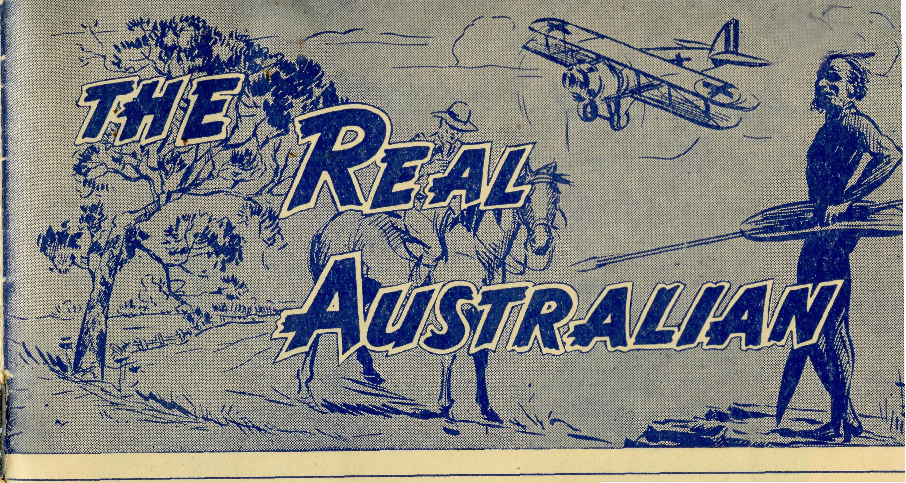
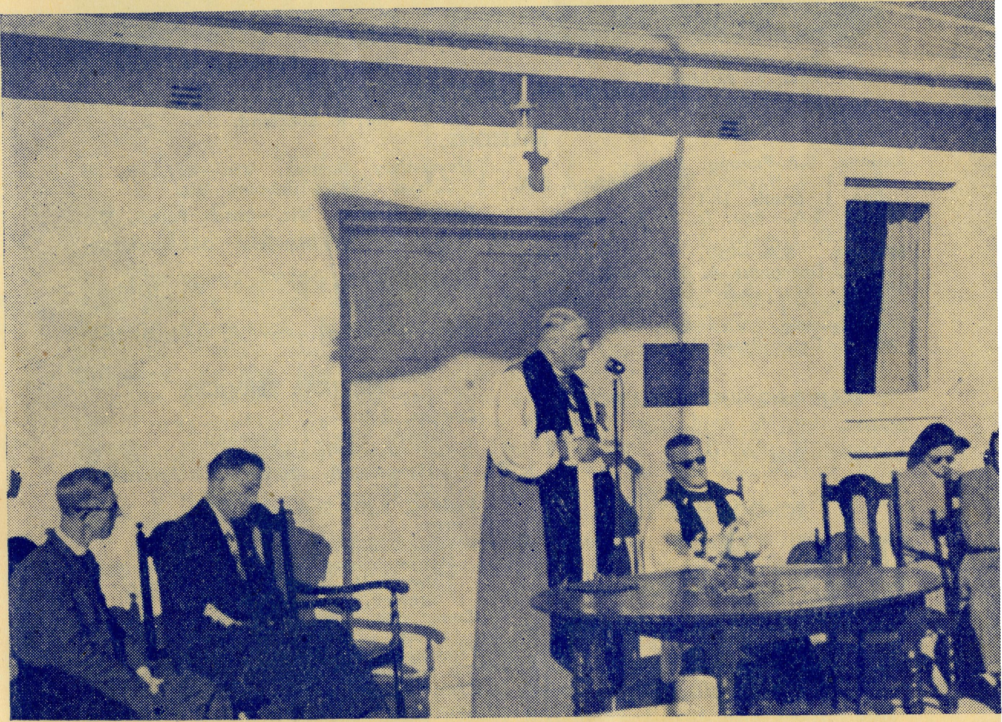
July, 1954.
The Real Australian
SUNDAY
For all Mis-sioners and Deaconesses of the Society and their people and for all students in training. MONDAY For all Doctors and Nurses serving in the outback, and for the spiritual and physical health of the patients under their care. TUESDAY For all Workers in Hostels, the children under their care and the teachers who instruct them. WEDNESDAY For the Director of the Mail Bag Sunday School, the pupils of the School and all teachers and voluntary workers. THURSDAY For the Fly-i n g Medical Service and the safety of the pilots and all who travel with them.
FRIDAY For the Council of the Society, the Home Base staffs, Auxiliaries and Parochial workers.
SATURDAY For all neces-s a r y finance needed for the maintenance of so large a ministry and for guidance in its right application.
2/6 per annum, post free.
JULY, 1954.
No. 9 (New Series).
24

Topics for
Prayer and Praise
For the Society.
O Lord God of our nation, Who has commanded men to subdue and replenish the earth: Look in Thy love upon all who in distant parts of our land are striving against many difficultits, and are deprived the access of the means of grace. Strengthen and guide the Bush Church Aid Society and all members of the staff. Cheer and comfort them in discouragement and loneliness, bless their ministrations to the good of those they serve, and grant that the message of redeeming love may thus be rooted and grounded in our national life, to the glory of Thy Great Name through Jesus Christ our Lord. Amen.
For Nurses and Doctors.
O God, Who didst choose a beloved physician to set forth the life of Him Who went about doing good, grant that Thy strong tenderness and compassion may be manifest in the work of country doctors and bush nurses. Make them at all times alert to be faithful, as those whom Thou hast burdened and inspired with the honour of their calling. In lonely emergencies strengthen them with confidence that, having done all they can, they may with good conscience leave the issue to Thy power working within Thy law. Make them resourceful and of sound judgment, and hearten their labours with the energy of compassion and the firmness of duty that conquers weariness. Through Him Whose power is called forth by suffering. Jesus Christ our Lord.
For Church Life in Country Districts.
O Lord, Who art present when two or three are gathered together in Th^ Name, bless, we beseech Thee, the little far-scattered groups of brethren who in our wide land meet together to worship Thee. Give them a perpetual freshness of spirit, and the power to inspire in each other holiness, helpfulness, and understanding of Thy help. Refresh with the joy of enthusiasm those who endure weary journeys to Thy trysting place. Grant that these little companies of Thy servants may be united in the spirit of Christian charity, awaiting in love the time when there shall be one fold and one Shepherd. Grant that the common life of all communities may be purified by this spirit of charity from all meanness, falsehood, malice and idle gossip, and grant that they who share a common lot may draw strength from each other's virtues, and in their weakness help one another, through our one Lord, Jesus Christ.
Praise.
for
For the Blessings vouchsafed to the Society, all kindly givers, for the joy of service.
Edgar Bragg & Sons Pty. Ltd. 4 Barker Street, Sydney.
The Primate opens the Radio Control.
Registered at the G.P.O., Sydney, for transmission by post as a periodical.
The Official Organ of
THE BUSH CHURCH AID SOCIETY
Church House, George Street, Sydney, N.S.W.

The Real Australian
July, 1954.
July, 1954.
The Real Australian

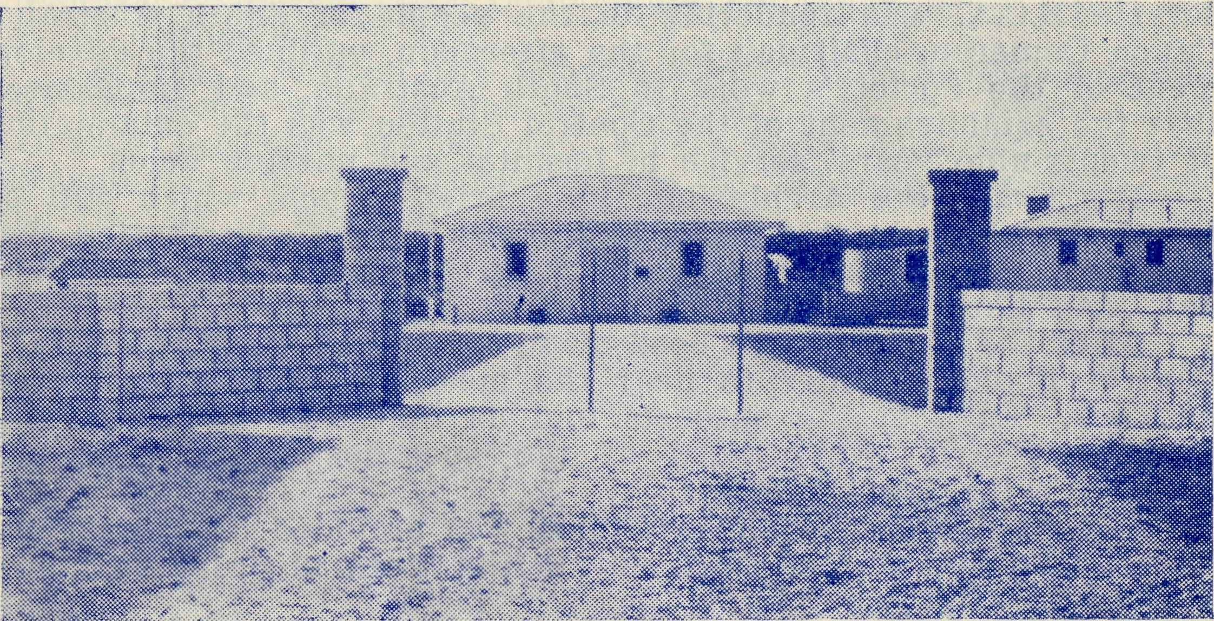
VICTORIAN OFFICE:
Bible House,
Flinders Lane, Melbourne, Victoria
Telephone: MF 3552
The Bush Church Aid Society for Australia and Tasmania
PRESIDENT: The Archbishop of Sydney.
Hon Clerical Secretary: Rev. Canon E. Cameron. Hon. Treasurer: Mr. T. S. Holt.
B.C.A. Activities and Staff
Organising Missioner: Rev. T. E. Jones, Th.L.
N.S.W. Deputation Secretary: Rev. J. R. Greenwood, Th.L.
Victorian Secretary: Rev. E. G. Beavan, M.A.
HEADQUARTERS OFFICE:
Diocesan Church House,
St. Andrew's Cathedral,
George Street, Sydney. Telephone: M 3164.
Cable Address: "Chaplaincy, Sydney".
STUDENTS IN TRAINING.
RADIO CONTROL STATION 1

MISSIONS.
FLYING MEDICAL SERVICE.
Bed- Pharmacist—Miss E. M. Page.
Wireless Control Station Control Officer—Mr. G. Cameron.
Rev. A. Williams. Rev. T. Morgan. Mr. T. V. Jones.
Ceduna, S.A.-Penong, S.A.—
Rev. T. J. Hayman, Th.L., Ceduna, S.A.
Rev. I. Booth, Th.L. Cowell, S.A.—Rev. D. A. Richards-Pugh,
A.L.C.D. Minnipa, S.A.—Rev. G. Furmeister,
Th.L., Deaconess A. Howland. Streaky Bay, S.A.—Rev. P. Connell,
Th.Schol. Croajingalong, Vic.—Rev. G. Garner,
Th.L., Cann River, Vic.
MAIL BAG SUNDAY SCHOOL. Director—Miss R. Campbell. Assistant—Miss M. Heesh.
SCHOOL HOSTELS.
Broken Hill, N.S.W.—Mr. and Mrs. A.
McLaughlin. Mungindi Bovs' Hostel, N.S.W.—Mr. and
Mrs. W. Hustler. Mung<ndi Girls' Hostel, N.S.W.—Miss M.
Farr. Bowral, N.S.W.—Miss E. Cheers. Port Lincoln, S.A.—Miss I. Beck.
Pilots—Mr. A. Chadwick, Mr. W.
ford, Mr. G. Job. Doctors—Dr. F. Gibson, O.B.E., Dr. M.
Mueller, Dr. J. Upsdell.
Rev. D. W. Warburton. Mr. R. Brooks. Mr. J. Smith. Mr. B. Buckland.
Heytesbury Mission, Vic.—Rev. P. R. Cooke, Th.L., Timboon, Vic.
Otway Mission, Vic.—Beech Forest, Vic.
Wilcannia, N.S.W.—Rev. J. Stockdale, Th.L.
Mendindee Th.L.
N.S.W.—Rev. W. Mitchell, Rappville, N.S.W.—Rev. A. Gerlach, Th.L.
MEDICAL SERVICES.
Ceduna, S.A.—
Matron: Sister F. Dowling. Staff Sisters J. Miller, G. Hitchcock, B. Tierney, A. Butler, J. Armstrong, M. Tarr. Penong, S.A.—Sisters L. Loane, L. Lang-tree. Wudinna, S.A.—
Matron: Sister R. Portch. Sisters: M. Denniss, B. Barber, V. Brealey, F. Ellis, T. Pole. Cook, S.A.—Sisters M. Horsburgh, M.
Ross. Tarcoola, S.A.—Sisters V. Holle and P.
Shipway. Cann River, Vic.—Sister I. Gwynne. Rawlinna, W.A.—Sister E. Thomas.
View from Front Entrance.
The O.M.'s Letter
The Official Opening of the Radio Control.
The week before the twenty-second had been cold and windy with grey overcast skies, and it seemed anything but promising for the week-end. However, we took off for Cook on the afternoon of Friday, the twenty-first, hoping that the weather would improve for the big day on the morrow.
We arrived in time for tea and later in the evening met the Trans-continental bringing the Primate and Mrs. Mowll from Perth. They had been visiting the Dioceses of Perth, Bunbury, Kalgoorlie and the North-west. We went to bed somewhat late after arranging for an eight o'clock take-off for the following morning.
>. After saying "Good-bye" to Sisters Horsburgh, Ross and Shipway, we were on our way to Ceduna on what turned out to be the most perfect of days, and arrived at Ceduna Hospital in time for an early lunch.
The official opening of the Radio Control Station was timed for 3 p.m., and the grounds presented a picturesque sight. The large number of motor cars of all colours; Girl Guides, Brownies and Boy Scouts in blue and khaki uniforms lining the long shell-covered path leading from the main gateway to the Control Building, and the Archbishop in white and red robes walking between the two lines of the guard of honour, presented an impressive picture that will be remembered by all the four hundred people who were present.

The Real Australian
July, 1954.
July, 1954.
The Real Australian

The Chairman of the Murat Bay District Council, Mr. P. Morrison, welcomed our visitors, including Mr. Riches, M.P., and Mr. Christian, M.P.
Both the Members of Parliament spoke of the very great service B.C.A. was rendering to the people of South Australia. Canon Cameron, chairman for the afternoon, outlined the development of the Society's work in South Australia, and emphasised that the establishment of the Control Station was the culmination of twenty-nine years' service in hospital and nursing fields.
His Grace the Archbishop, in a brief speech, which will be found elsewhere in this issue, laid stress on the contribution that had been made by many people to make the Radio Station possible, and then declared the building open.
After the speeches had been made the official party enteredThe Control Room in order to hear the messages received over the network. Each of the outposts told us that they had been able to hear clearly every word of the speeches which they had followed with great interest.
The final event of the afternoon was provided by the Ceduna ladies, who had worked hard during the week in order to supply a splendid afternoon tea.
We were glad that Mr. G. Scott, of the Wireless Branch of the P.M.G.'s Dept., was able to be present, together with the Regional Inspector. They were greatly interested in the technical equipment of the Control Station, and highly praised Mr. George Cameron for his work as a constructional wireless engineer and operator.
The presence of both Mr. Riches and Mr. Christian was deeply appreciated by B.C.A. friends, for both these gentlemen have been untiring in their efforts over many years to secure government recognition of the B.C.A. Flying Medical Service. It was cheering to learn from Mr. Christian that before he had left Adelaide for Ceduna he had learned from the Premier that the Government of South Australia had now decided that this recognition would be given to our service and that the sum of £500 would be placed on the current estimates for payment to B.C.A.
Mr. J. Morley, of Mulgathing Station, arrived in a friend's aeroplane, and Mr. and Mrs. Williams, of Lake Everard, made the long journey by car. It was good to see them both present.
Canon and Mrs. Cameron, Mr. and Mrs. Bragg and the Rev. L. H. Broadley represented the N.S.W. members of the B.C.A. Council, and the Rev. W. I. Fleming was present on behalf of the Victorian members.
The weather was as perfect as it could be for such an occasion—no wind and just sufficient warmth in the sunshine to make things very comfortable. Everybody seemed to have a very happy day and many were the expressions of satisfaction that B.C.A. had been able to bring to a successful conclusion this large enterprise.
In the evening some of our visitors came to the hospital for supper with the staff, and by the amount of chattering that went on I can well believe that "a good time was had by all", as some of our country papers have it.
On Sunday we filled the little hall that is being used for services while the new church is being built, and the Rev. W. I. Fleming celebrated Holy Communion and gave us a quiet talk full of inspiration.
For the afternoon the visitors spread themselves about the district. Some went to Penong with Mr. Hayman, where Canon Cameron preached the sermon, others went with Mr. Booth to Mudamuckla and Smoky Bay, where Mr. Broadley preached, and had the joy of meeting many old friends.
In the evening, the Archbishop held a service of Confirmation at Ceduna and confirmed three candidates. The hall was crowded and we came away feeling that we had been truly blessed.
On Monday morning the Archbishop and Mrs. Mowll left us to journey to Cowell and then on to Gladstone and Sydney. The Rev. W. I. Fleming and Mr. and Mrs. Bragg went with them; Mr. Fleming to catch the train at Port Augusta and Mr. and Mrs. Bragg to stay the night in the Minnipa Mission with the Fuhrmeisters.
On Tuesday we loaded the last of our visitors into the Skymaster and Ceduna became quiet and normal once again. So ended one of the most memorable and happy occasions in B.C.A. history which will live long in the memory of all those who were fortunate enough to be present.
The presence of Mr. Alban Kirkby throughout the week-end was especially pleasing to all of us. The Society owes much to the work and courage of the first Organising Missioner, the late Bishop S. J. Kirkby. He it was who began the great adventure for the Kingdom of God in Ceduna. It was fitting that his son should be present on this day which laid the coping stone on the work that has been built up from the foundations laid in that little hospital which is now a residence on the Ceduna road, close by the aerodrome.
Now what of the future? This is but the beginning; much remains to be done in work and prayer. Let us pray and work harder than ever before.
BOOK THE DATES NOW.
The Annual Rallies of the B.C.A. Friends
are to be held on the following dates —
SYDNEY - - - - FRIDAY, OCTOBER 1st, at 7.45 p.m.
in the CHAPTER HOUSE OF ST. ANDREWS CATHEDRAL.
MELBOURNE - - - WEDNESDAY, SEPT. 15th, at 7.45 p.m.
in the CHAPTER HOUSE OF ST. PAUL'S CATHEDRAL.
Informative Speakers . . . Excellent Colour Slides . . . Friendly Gathering . . . Come . . . and bring a friend.

The Real Australian
July, 1954.
July, 1954.
The Real Australian

RADIO CONTROL STATION 2
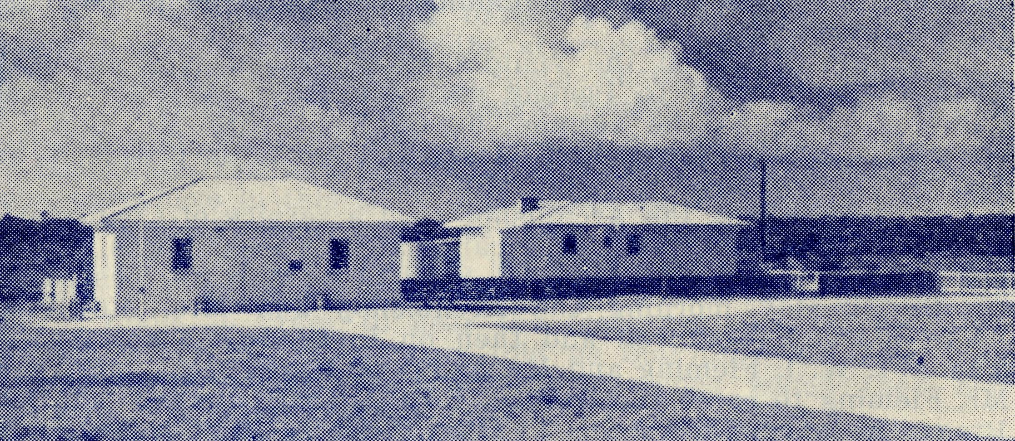
Control Room on left with Operator's Home on right.
Official Opening of Ceduna’s B.C.A. Wireless Control Base
Ceremony Performed by Primate of Australia.
The official opening of the wireless control station of the Bush Church Aid Society's Flying Medical Service at Ceduna was performed by the Primate of Australia, the Most Rev. H. W. K. Mowll, C.M.G. There was a large gathering present.
In the official party were Mr. Christian, M.P.; Mr. Riches, M.P.; the chairman of the B.C.A. Council, Sydney (Canon Cameron), Mr. Harold Bragg (member B.C.A. Council), Rev. H. A. Broadley, Sydney; Rev. W. Fleming, Melbourne; Mr. Kirkby (a son of the late Bishop Kirkby, who was a former B.C.A. organising missioner), the chairman of the District Council of Murat Bay (Mr. P. S. Morrison), Rev. T. Jones (Organising Missioner), Dr. F. E. Gibson, Dr. M. Mueller, Sister Dowling. Rev. P. H. Connell, and Rev. T. Hayman. The Scouts, Cubs, Guides and Brownies formed a guard of honour for His Grace, Dr. Mowll.
Thanks People.
After the singing of the National Anthem, Rev. T. Jones welcomed and thanked the people present for the interest they had shown, and the ladies for providing the afternoon tea. He also read several telegrams from people who regretted they were unable to attend.
CanJon Cameron, who presided, invited Mr. Morrison to welcome the visitors. On behalf of the people of the district, Mr. Morrison extended a sincere welcome to the Bishop and all present.
He said that the people of this country were proud to be associated with the B.C.A., not only at Ceduna, but everywhere, and were deeply indebted to the flying doctors and the nursing sisters. "We feel there is no service equal to theirs in Australia and that their work will be blessed with future success."
Replying for the visitors, Mr. Christian said he had given up all hope of getting to Ceduna in time as he was on the delayed "Minnipa".
However, the B.C.A. had promptly come to the rescue and arranged with Mr. Bedford, Kyancutta, to fly from the Wudinna base and pick him up. Mr. Christian referred to the service as being "out of the box".
He was particularly pleased to be present because he fully appreciated the great work of the B.C.A. He thanked Mr. Riches for his help in the battle for financial aid from the Government for the hospitals at Ceduna and Wudinna, and the radio station.
Supporting Mr. Christian, Mr. Riches said he had been thrilled when he received an invitation to attend the ceremony. He was glad of the opportunity to say a word of thanks on behalf of the receivers in his constituency, and to mention how grateful the miners at Coober Pedy were to Dr. Mueller for her regular visits.
Congratulates Organisers.
Mr. Riches congratulated the organisation and added that Ceduna had one up on Port Augusta in that it had a landing field and a flying medical service. Mr. Jones, he said, was a most efficient organiser, but he would have to be more than good to organise a similar service at Port Augusta, where there was no landing ground, aeroplane or flying doctor. Mr. Riches paid a tribute to Mr. Christian who, he said, had done a great deal towards getting Government aid for the project.
Mr. Harold Bragg congratulated the district on its new service, and thanked all for their help and co-operation. "We deem it a pleasure in the name of the Lord to labour for the B.C.A., and the pleasure we receive when we hear of the work you have done here is indeed great. We cannot say how much we appreciate the work of Rev. T. Jones, as organising missioner. and the Council is always strongly behind him."
Canon Cameron said that the opening of the radio control station marked the climax of much thought, prayer and work.
"Some seven years ago it was unanimously decided that Ceduna was the natural centre for a radio control station for the wide open spaces of South Australia. Arrangements were made and certain actions taken. Those arrangements, however, broke down, and the B.C.A. Council decided to go ahead with the building of its own station at Ceduna with funds provided under the will of the late Sydney William Jones. The station is a memorial to his wife, Anna.
Only Complete Service. "We of the Bush Church Aid Society are justly proud of the fact that we have the only complete flying medical service in

The Real Australian
July, 1954.
July, 1954.
The Real Australian

Australia, with our own hospitals, doctors, nurses, aeroplanes, pilots and radio control stations and officers.
"It is a ministry which we exercise under God to the whole of man, for the F.M.S. works side by side with the spiritual work carried out by our missioners.
"So many have contributed in so many ways to make this opening possible.
"We are pleased to have with us the Parliamentary representatives and the president of the shire, who in no small way has been of great assistance in this project.
"As chairman of the B.C.A. Council, I want to express our sincere thanks to the doctors, nursing staffs and pilots who are doing such noble work for this community in the name of the Church. I count it a special privilege, with my wife, to be with you for this occasion, more especially as our second son is the radio control officer here."
The Opening.
Declaring open the radio control station, the Primate said it was nine months since he came to dedicate the building.
"During those months additions and improvements have been made so that to-day we have these attractive buildings in a pleasant setting. They are, I am sure, a dignified addition to the township and a credit to the Bush Church Aid Society.
"They are not here simply as an addition to the township, but are primarily a centre of usefulness to the people, many of whom live hundreds of miles away. During the months that have elapsed since I dedicated these buildings, the radio control under Mr. Cameron has been operating successfully.
"At first only the out hospitals of the B.C.A. at Cook and Tarcoola were in contact, but month by month outposts in homesteads and small communities have linked up, until to-day there are 18 outposts that have been granted licences to operate transceivers to this station. This was the number set as a minimum by B.C.A. to justify the establishment of this venture, and the employment of a full-time operator.
"This is an entirely new area for a control station of this type. Many of the people who live in the wide district it serves were ignorant of its full usefulness, and it has taken time for them to appreciate how valuable a thing it is to have transceivers in their homes, so that they can make contact with the doctors every day if they so need.
"Some of the centres which have been granted licences are so remotely situated that the installation of the transceivers has been a slow business. Because of this we felt it would be wise to delay this opening function for some time.
"I am, therefore, able to be present with you to-day at the opening of a going concern which I confidently anticipate will continue to grow in scope and usefulness.
"Although this is a venture of the Bush Church Aid Society, its realisation has been made possible only by the practical help and cOHoperation of many people and organisations.
"The Murat Bay District Council, under the able leadership of
Mr. Morrison, has been unstinting in the support it has given the Society, and the practical assistance it has given Mr. Jones in the erection of the buildings.
"We are glad to have with us to-day representatives from other district councils of the West Coast, for we have had many evidences of their appreciation of these flying medical services.
RADIO CONTROL STATION 3
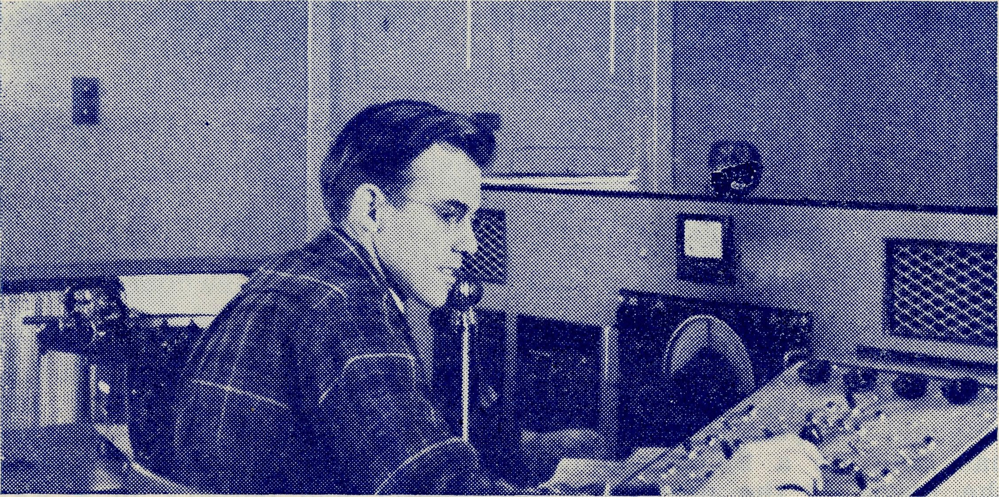
Mr. G. Cameron at controls during a Medical Session.
"Especially are we glad that both Mr. Christian and Mr. Riches have been able to come to-day. They are representatives of opposing parties in the South Australian Parliament, but they are one in their constant and unwavering advocacy of the importance and usefulness of this service to the many people who live outside the towns and villages of this part of South Australia.
"Mr. Scott, who is chief administrative officer of the wireless branch of the P.M.G.'s Department, has made the journey especially to be present to-day. Mr. Jones assures me that Mr. Scott has dealt with all the difficult questions that have arisen in connection with the wireless department in a fair-minded manner, and so enabled the organising to go forward without undue waste of time. Six members of the Council of the B.C.A. are also with us to-day.
"There have been many individuals who have helped to make these buildings possible. I do not want to single some out above others, but rather point cut that it has been a combined effort by B.C.A. and the people of the district it serves.

10
The Real Australian
July, 1954.
July, 1954.
The Real Australian
li

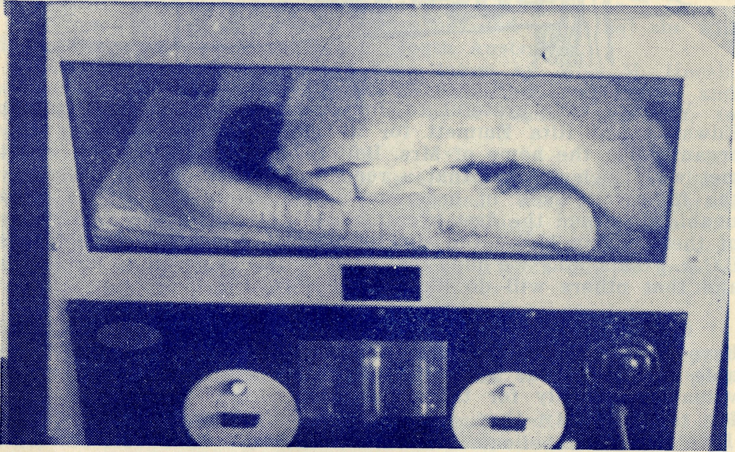
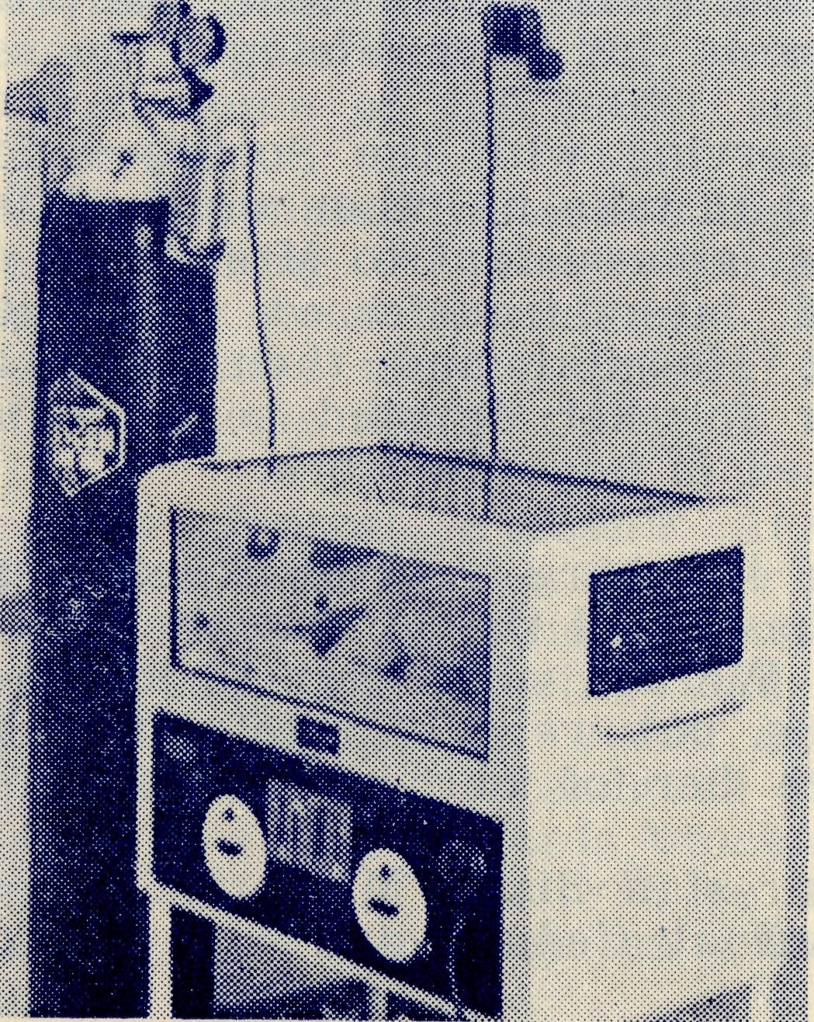
Tribute to Doctors, Sisters.
"It will be well appreciated that a radio control station would be of little use unless it was backed by efficient medical and nursing services. The name and work of Dr. Freda Gibson are so well-known in Australia as to require no emphasis on my part, and Dr. Mueller has, in the past three years, rendered great service to the people of the outback. Without the unfailing devotion and skill of the doctors, such a service as exists in this place to-day would have been impossible. We hope that they will long continue to be associated with us.
"To-day, with the doctors, there are the nursing sisters of the B.C.A. hospitals at Ceduna, Cook, Tarcoola, Penong and Wudinna, and the nursing home at Rawlinna. We are proud to know that our sisters have set a standard of nursing that cannot be surpassed anywhere in Australia.
Capable Pilots.
"Mr. Chadwick, who is also a member of the B.C.A., has been flying the Society's aeroplanes for 16 years. He is known as one of the most capable pilots in the Commonwealth, and with Mr. Bedford at Kyancutta and Mr. Job, who has lately come to Ceduna, we have a staff of efficient pilots in whom all our friends have the greatest confidence.
"Miss Page, as our pharmacist, completes the flying medical staff, and renders a most useful service. We feel, therefore, that the Church through the agency of the B.C.A. and the splendid co-operation of those whom I have already mentioned, has built up a flying medical and nursing service which meets the needs of the people of the country and outback in a way of which we can be justly proud.
"It is my very good pleasure to declare officially open this radio control station, with the prayer that it will be much used to the well-being of many people."
The official party and the public then inspected the building.
The ceremony was broadcast over the network by the officer-in-charge, and the outstations reported back that the reception was excellent, and that the medical and radio services were greatly appreciated.
Stations as far apart as Eucla in the west, and Coober Pedy and Evelyn Downs, near Oodnadatta, were clearly heard by the official party.
A transceiver as used on the outstations was on view, as was a new light-weight transceiver* for use in vehicles and fishing boats.
Afternoon tea was served by the Church of England Ladies' Guild.
During the evening some of the visitors were entertained at supper at the hospital.
SEND A DONATION TO B.C.A. — NOW !!
WUDINNA'S "PREfvP BABY
Baby Matthews was born at Wudinna much earlier than expected and weighed a little less than 2 lb.
Our pictures show him in a "Humidor" Cot given to the hospital by the people of Sth. Australia to mark the Queen's Coronation.

12
The Real Australian
July, 1954.
July, 1954.
The Real Australian
11

We are very grateful to Judy and Marie Bolton, Elizabeth Edwards and Rita Emmett for a very successful evening they organised at the home of Mrs. Bolton of Strathfield. Their effort met with such success that a repeat performance was necessary the following week in order to accommodate those who were unable ito attend the first evening. As a result of the enthusiasm of these young ladies the sum of £16/0/6 has been given to the B.C.A. Funds. May we hope that such enthusiasm will be infectious and that others will do likewise?
Our friends in the St. Alban's Five Dock Women's Guild
have also been busy and by means of a Street Stall have been
able to donate the sum of £9/3/- to B.C.A. Such efforts are
valuable not only for the financial help they provide but also
for the publicity they give to the B.C.A. work. Thank you,
Five Dock. * * *
Our best wishes and prayers for a speedy recovery go to our friends Mrs. Bolton of Strathfield and Mrs. Farram of Woollahra who have recently undergone serious operations.
# # #
We extend our good wishes to Sister Payne who, after four years' service, has returned to Sydney to be married. We shall miss her in the hospital work at Ceduna and she will also be missed by the Brownies of the district, to whom, with Miss Page and Sister Tierney, she gave her Saturday afternoons. We pray that she will find much happiness in her new life.
# # #
Miss Lawtey, who has been serving with the Society since the beginning of 1948, has resigned to take up other work. Miss Lawtey began her work with B.C.A. as assistant to Mrs. Mann at "Coorah", Wentworth Falls, and later transferred to South Australia, being first at Penong Hospital and then later at Ceduna. We are grateful to her for her devoted service and pray that she will be greatly blessed in her new work.
# # #
Mrs. Babbage, who has been in charge of the kitchen at
Wuddina, has also resigned. She has found that the strain of this
work is too much for her health. We are very sorry to lose her
for she will not be easy to replace, but we are grateful for the
service she has given and, assure her of our best wishes for
the future. '* * *
We are glad to welcome to our staff Sister Marjorie Tarr of Guyra. Sister has joined the staff at Ceduna and has already settled-in very happily.
Miss Myra Patterson resigned from the post of Assistant Director of the Mail Bag Sunday School and is now working in Adelaide. Myra was with the M.B.S.S. for five and a half years and in that time did sterling work and proved of very great assistance to Miss Campbell.
We are very sorry indeed to lose her and hope that she will find a happy sphere of service in South Australia.
Miss Patterson's place has been taken by Miss M. Heesh, who comes to the work with much enthusiasm and ability and who has already proved herself to be a capable successor to Miss Patterson.
The new hospital at Tarcoola is almost finished and we hope that it won't be long now before it is opened. With the completion of the building comes the need for furnishing. This is a very big and costly task that will tax the resources of the local people to the limit. Would some of our friends like to help?
Amongst the needs are:
Theatre linen. Six nursery cots. Baby Scales. Refrigerator. Polishing machine. Electric irons.
If any of our friends would like to help towards the supply of these necessary articles, we shall be glad to hear from them.
# # #
We regret to state that owing to continued ill-health of his wife, the Rev. Ken Seymour has been compelled to resign from the Mission of Beech Forest and has accepted a parish in the Diocese of Melbourne. Ken's departure from B.C.A. is a very real loss and we will undoubtedly miss him. We wish him every blessing in his new work and pray that his wife's health will speedily improve.
# # #
The Wollongong Rally of the B.C.A. was held in St. Michael's Hall on Monday, June 7th. Mr. Harold Bragg, who had just returned from his visit to Ceduna, was the speaker and Archdeacon Begbie chaired the gathering. The Rev. John Greenwood showed some of the latest colour slides of the B.C.A. spheres of service.
Unfortunately, the evening was very wet with severe gales blowing along the coast and these conditions militated against the usual good attendance. However, it was good to see a representative number present and to learn that the interest in B.C.A. on the South Coast is steadily being built up.
The Central Women's Auxiliary of N.S.W. is holding an Afternoon Sale in the Chapter House of St. Andrew's Cathedral. George Street, on Friday, August 6th, at 2.30 p.m. This is a very special effort being made by the ladies in order to help meet the increasing costs of B.C.A. maintenance. We look forward to a good attendance of our friends on that day. If you can send a gift towards stocking one of the stalls we shall be very grateful. There will be a Work Stall, Sweets, Cakes and Produce, and afternoon tea will be served. Please book the date and do come along.

14
The Real Australian
July, 1954.
July, 1954.
The Real Australian
15

We regret to announce the resignation of Miss F. Moore from the Victorian Office. Miss Moore has given the Society very useful service, especially when the Victorian Office has been without a secretary, and we are sorry at her going, but wish her every blessing in her new work.
RADIO CONTROL STATION 4
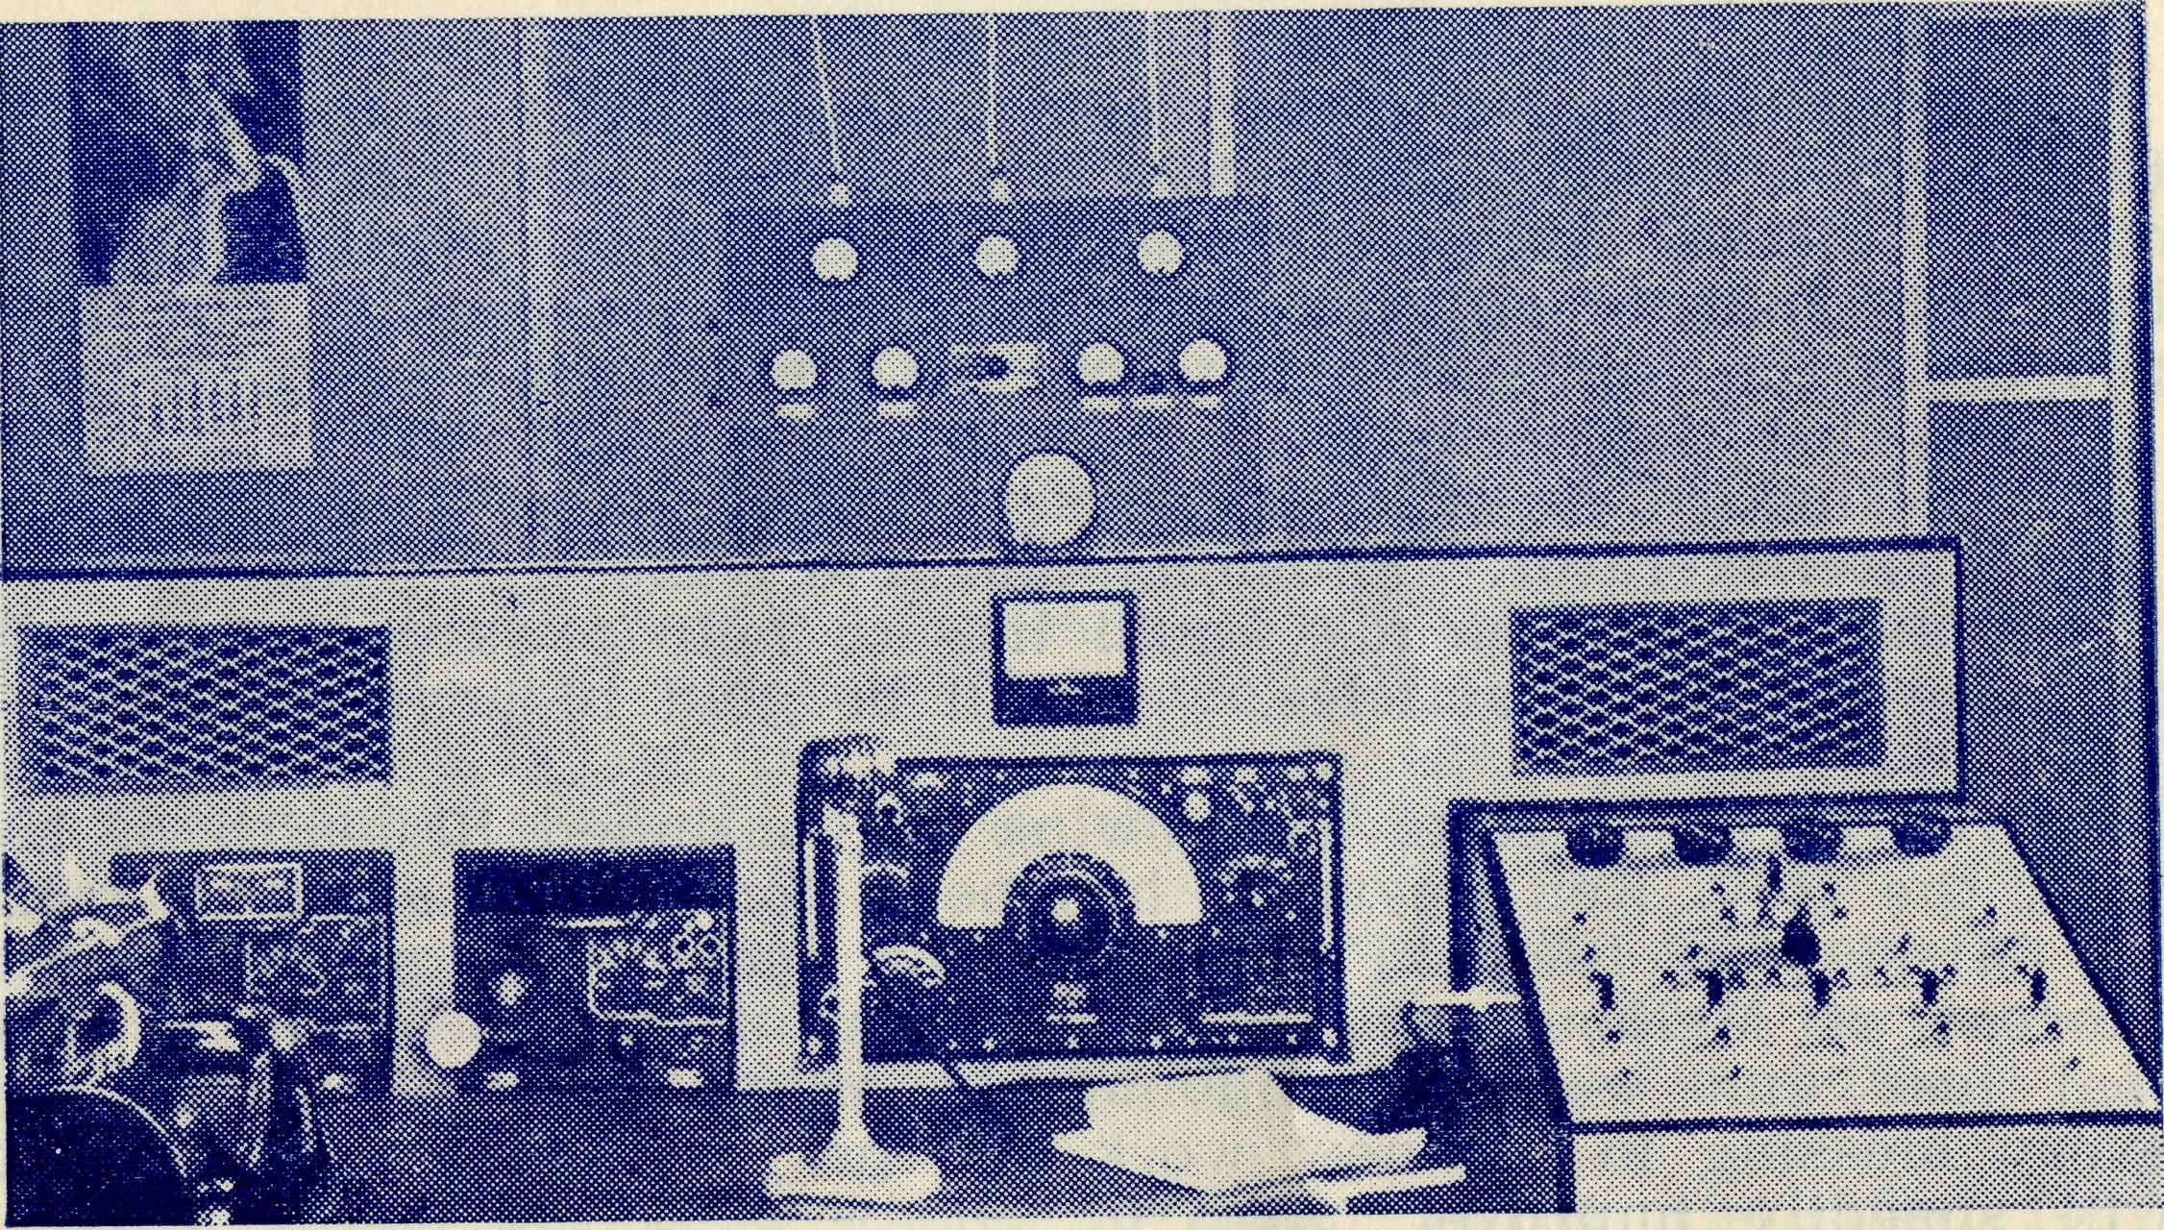
A full view of Control Panel and Speakers.
Along the Line
Rev. I. Booth.
At Forrest in Western Australia on the Trans-Australia Railway I had spent a very profitable as well as enjoyable day and a half. I was due to leave by fast goods train at 5.30 a.m. next morning for a small camp 204 miles east in South Australia.
The camps along the line are at an average of 30 miles apart, but much longer distances must be travelled to fit in with train timetables and stopping places.
Before retiring I was informed that the folks at the Aerodrome Hostel would be rising at 4.15 a.m. to prepare for a plane that was due in shortly after that time. I asked them to wake me at that time. As it happened, the plane was late and at 5.50 a.m. there was an excited knock at the door and I awoke to the call of "ten to six". The train should have left 20 minutes before!
The next few minutes were crammed with activity. While 1 dressed and finished my packing my host tried desperately to raise the station on the phone. He was told that the train was due in at any minute. I then hurriedly consumed a plate of porridge and some poached eggs while my friend kept watch at the door for the first glimpse of the train. The warning shout came as a cloud of dust appeared on the horizon and I was half way Through a cup of tea. It was still possible to finish my cup of tea, for the train can be seen approaching miles away across the plain!
My belongings loaded on a utility truck, I was taken to the station by a member of the Aerodrome staff, arriving just as the train pulled in, and a minute later it was moving out again into the expanse of the plain.
At Cook, where the train stops for nearly an hour, dinner was ready at the B.C.A. Bishop Kirkby Memorial Hospital. Sisters Horsburgh and Ross, as well as Sister Thomas at Rawlinna, never fail in their efforts to make the Missioner's time "on the Line" a little easier. After this brief stay at the hospital I returned to the train just as the carriage containing my goods and chattels was about to be shunted off. I dived in and rescued them just in time!
Having reinstated myself in the remaining carriage, the next stage of the trip was commenced. At my destination I was met by the Ganger's wife, who presented me with a wheelbarrow which she directed to be used for transporting my bags from the train to the hut where I would spend the night.
Each of the six houses in the camp was visited and an invitation given to attend a service and pictures that evening. There was a 100% roll up, representing many nations . . . one German family, two German men whose wives were on their way to Australia, an Italian in similar circumstances, a Yugoslav with an Italian wife and the Welsh Ganger with his Australian wife!
Four o'clock next mornng saw me endeavouring to push my wheelbarrow, full of bags, through a thick fog to the station. I could not see my destination — in fact I could not see an inch in front of me as it was impossible to hold a torch in one hand or the other sufficiently well to pick out the lumps of limestone which were spread every few inches across the area to be traversed. The barrow stopped, started, leaped, lurched and tipped!
With everything ready for the train I then had to grope around in the fog to find the wheelbarrow, which was then placed where the owner could repossess it later in the morning.
Similar happenings to these take place all along the line, providing anxious moments for the Missioner and often entertainment for those who may be looking on. With all these experiences comes the joy of being able to minister to these lonely folk in spiritual things, thus forging a link between them and the Church which would be missing but for the quarterly trips along the Line.

16
The Real Australian
July, 1954.
July, 1954.
The Real Australian
17

A Trip to Oodnadatta
EDITOR'S NOTE: At the request of the Organising Missioner the Rev. George Fuhrmeister recently patrolled all the area north of the Transcontinental Railway Line and visited many homesteads that have not seen an Anglican Minister for many years. He travelled 1,562 miles in 30 days, visited 35 stations where he took either a service or family prayers, gave lessons in three schools and distributed magazines, books and scripture portions. The farthermost home at which he called is 550 miles from Mr. Fuhrmeister's headquarters at Minnipa. This patrol,, together with the ministry on the East-West Railway Line, is of a special character and for which B.C.A. is seeking a clergyman who will undertake this arduous and exacting task. The following is a report to the O.M. from Mr. Fuhrmeister which I am sure the readers of the R.A. will find interesting.
Oodnadatta Trip, March, 1954.
As it is usually very hot in these parts during February I decided to make the extended 'Station trip' to Oodnadatta in March, but February turned out an exceptionally mild month this year and March opened up with some very hot days. I also djhose this time of the year because in winter the road is sometimes impassable, but again I missed out for although there were no rains, the grader had been along the newly made road and it meant driving in a cloud of dust all the time; and not only was the inside of the van heavily covered with dust but also the driver.
On heading north from Kingoonya this time I found some of the stations busy shearing and, at Ingomer, as I was staying overnight I suggested a lantern service, and was told that the men would welcome such if it was held outside, for it was so hot indoors. To this I readily agreed and we had our service out under God's heaven, with some on forms, others on their bunks and the manager and a couple of his men sat in a jeep on the outskirts. At the end a vote of thanks was spontaneously given and a collection which had been gathered before I arrived was handed me.
The next morning I set off for Coober Pedy, some fifty miles on, and along one straight section of the road I saw in the distance what looked like a whirlwind, but shortly I discovered it to be a car travelling at a fast speed towards me. On my arrival at Coober Pedy I saw there had been built an additional store, with accommodation and meals provided as well. During the afternoon I visited two of the old 'pensioners' who have been on the field many years, and with one of them, a member of our Church, I had tea and spent the evening. Next day I visited other 'dug-outs' (most of the people live underground at Coober Pedy), and made arrangements for an open-air service in front of one of the stores, where I was kindly given tea, supper and a bed for the night. The mail bus being due in that night there was a large number of people in to meet it, so we
had 30 to 40 at the service — two-thirds of which were aborigines. During that same afternoon I had a surprise meeting with two truck loads of aborigines from Ernabella Mission who, with their Missioner, the Rev. Ron Trudinger, and his wife, were travelling down to see the Queen — the fellowship enjoyed with them was 'short but sweet'.
From Coober Pedy I travelled 30 miles further north and spent a night at Mabel Creek Station. Around this area they had recently received over four inches of rain, and so they had an abundance of feed and their waterholes along the creek had several feet of water in them — an unusual sight for that time of the year.
The next morning I had to spend some time in minor repairs .and so did not get away until after lunch, but as their neighbour at Mt. Clarence was only ten miles away I arrived early enough to go out with the boss and bring in a mob of rams for crutching, and also help in yarding operations. After the evening meal we chatted for a time but as all were rather tired we closed the day with a scripture reading and prayer.
In the morning I set off rather early for Mt. Willoughby, which was 75 miles north, with no dwellings en route, and the graded road having ceased, it was more strenuous driving and very rough in the dried-up creek beds or where others had previously dug themselves out of bogs.
The nearer I got to Mt. Willoughby, the more the countryside showed signs of the well-nigh drought conditions they were experiencing, and along this same route, when returning, I overtook a herd of cattle being driven south and they had been without water for two days and with very little feed. I arrived at Mt. Willoughby looking as though I, too, had not seen water for days—but a bath and change of clothing soon altered that, and as it was a hot night I chatted with the manager and his wife out on the verandah.
Next morning I set off for Evelyn Downs with a hot north wdnd blowing, and when I saw the homestead, which is built on flat, open country, I wondered how it would survive the blast. Here the owner was away carting water for his sheep, which were being driven into Oodnadatta for trucking. While there a telegram was received and another sent by the manager's wife on the transceiver, which is certainly a real boon to these outback people. Here, also, I met a governess who had come out from England only recently, yet she was entering into this distinctly different life with real zeal.
The track from Mt. Willoughby to Evelyn Downs and on to Mt. Barry has some very stony sections and reminds one of cobblestone roads. On the last stretch of the road into Oodnadatta I met the men droving the sheep and at their invitation had a real 'on-the-track' lunch, which consisted of a hunk of meat on a slice of bread and (oily) butter, with sauce to flavour.
On arrival at Oodnadatta I contacted the A.I.M. medical sister and received very gracious hospitality at the hostel during my stay over the week-end. As I had been travelling for a fortnight I took the opportunity of using a washing machine and

18
The Real Australian
July, 1954.
July, 1954.
The Real Australian
19

MULGATHING HOMESTEAD
electric iron while there, and gave my van a clean up too. In visiting around the town I was able to do a little sowing of the Seed. On the Saturday night I had a very happy time with the Aborigine children at the U.A.M. Home, and on Sunday morning I spoke also at their little service. I assisted the sister at Sunday School conducted at the Hostel and at night a service was held on the verandah.
Although there are only one or two Anglican families in Oodnadatta and the numbers were not many at any of the gatherings held yet each presented a very real need for a regular ministry to them.
I returned to Mt. Willoughby via Arckaringa Station and words would fail to convey the wonder experienced in travelling through this unusual scenic (country. The road winds in and around the peculiar flat-topped hills and along valleys where several times I saw numbers of kangaroos and emus and at other times I viewed with awe the bronze-topped hills with their lovely pink valleys and longed for a colour film to capture something of this beauty. However much I may have been elated by these beauties I soon came down to earth again when I got back into the parched and stony country and on to the dusty road again!
I would like to say, though, that I received an unusually warm welcome on this trip at most places, due, I believe, to the medical work being done by the B.C.A. Flying Medical Service and the service rendered by the transceiver link-up.
As I came down south again I realized more forcibly that a Missioner was needed to be stationed at Tarcoola, not only to relieve the strain on the man at Minnipa but to give a regular ministry to these folk more often. Do pray that God will prepare and call out a man for that area.
REMEMBER THE B.C.A. BUSH PADRE BROADCASTS —
2GB EVERY FRIDAY at 11 a.m.
2CH ALTERNATE SUNDAYS at 6 p.m.
2KA ALTERNATE WEDNESDAYS at 4.30 p.m.
AFTERNOON SALE
ST. ANDREW'S CHAPTER HOUSE, GEORGE STREET,
FRIDAY, AUGUST 6th, at 2.30 p.m.
Work Stall ■ . . Sweet Stall . . . Produce Stall
. . . Cake Stall . . . Afternoon Tea.
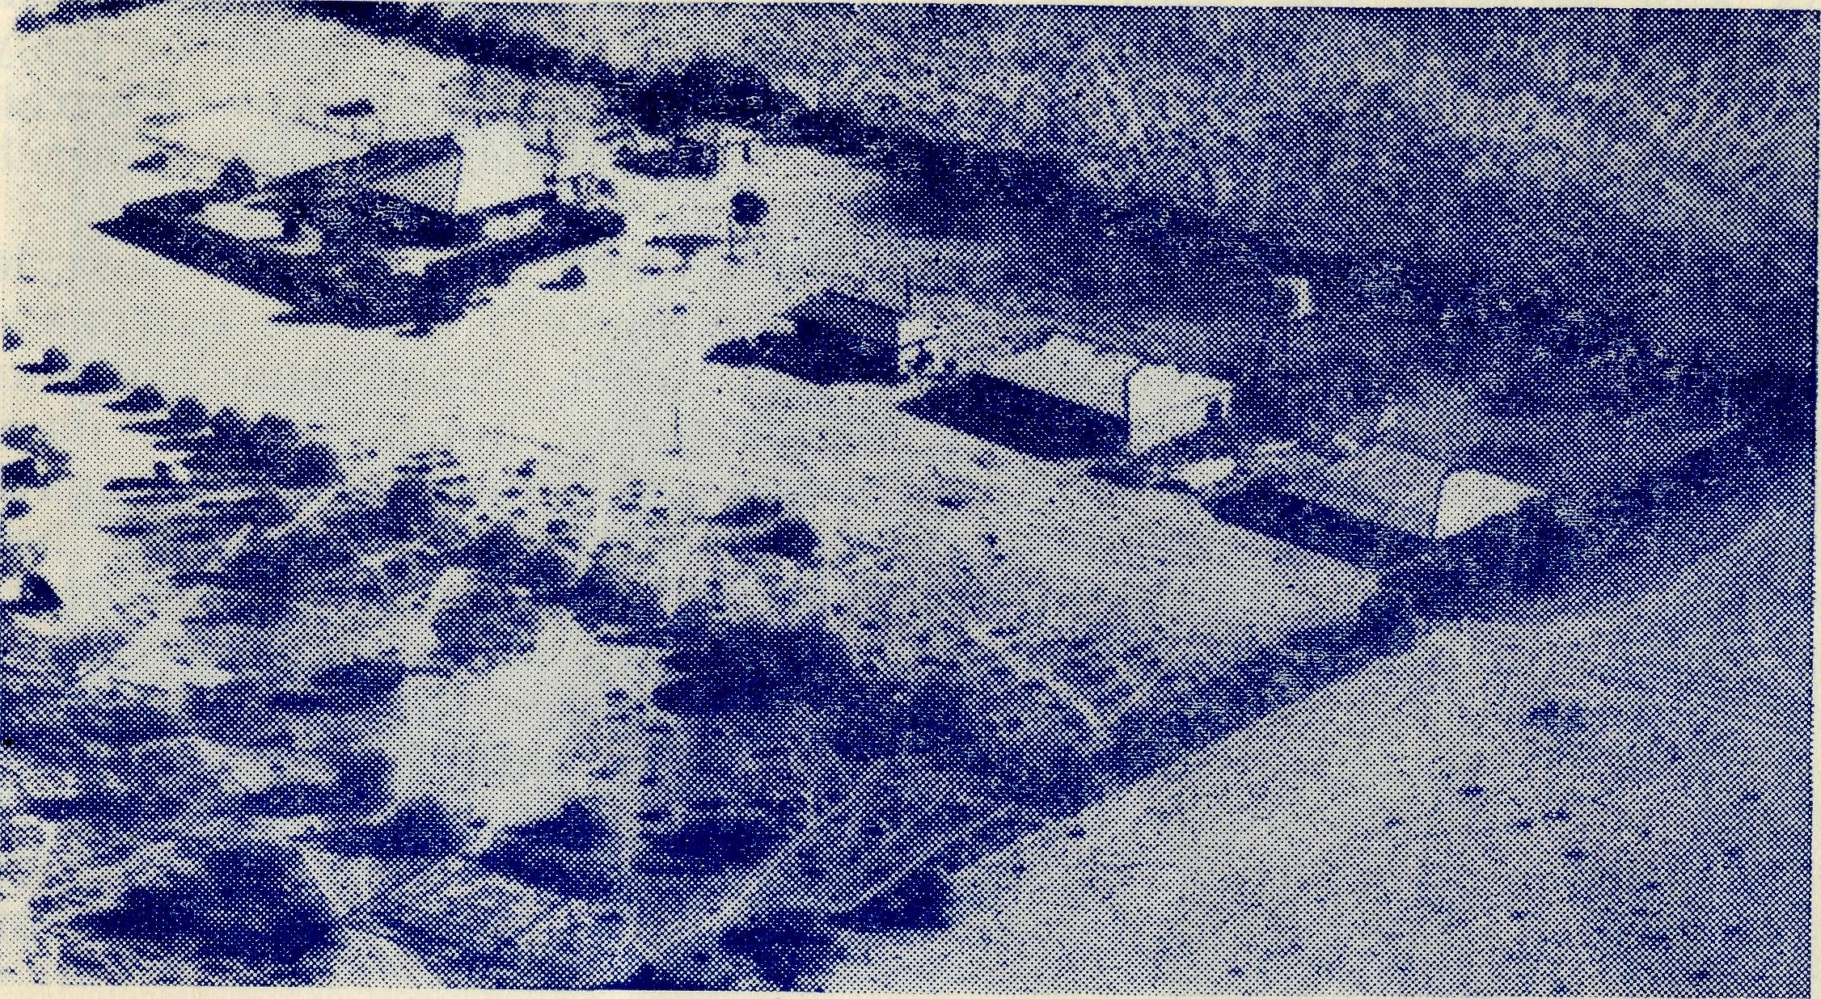
The Headquarters of a million acre property, equipped with a transceiver, it is one of Doctor's Clinic Centres.
“Ceduna"
Mrs. T. J. Hayman.
It is April and uncomfortably hot for this time of the year. Only 1/10" of rain has fallen this year so far, so most tanks are very low. Many farmers are buying drinking water and have been carting Todd River water for their stock for months.
To-day is washing day for most housewives, with a very hot north wind blowing the thick dust in all directions. Yet we still wash — tomorrow might be just the same, and the clothes will be dry in no time. We have enough water to wash the clothes, but the rinsing must be done in Todd water. This water is not for drinking and is so hard no lather can be made, but how thankful we are for this extra supply. It is pumped from Port Lincoln, which is 260 miles from here. The surrounding farming areas are gradually having the pipes laid for this water supply too.
Rosemary is aged 6 and was home from school later than usual to-day. She had to walk home with her bicycle the 1J miles from school, as the strong, hot winds were too hard to "push against. Her little face was red, but the heat was soon forgotten when a cool drink was produced.
John is 3, and the night the 10 points of rain fell he woke and was so surprised he began to make inquiries whether any members of the family were getting wet. He then asked "Who turned on the rain?" From little beginnings we are able to teach the things of God.

20
The Real Australian
July, 1954.
July, 1954.
The Real Australian
21

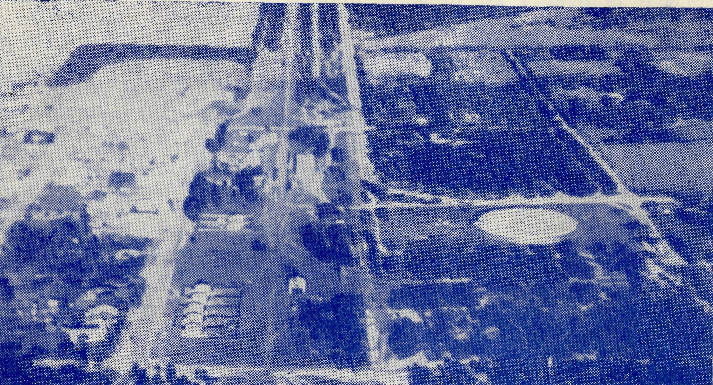
MINNIPA TOWNSHIP
The newly acquired Rectory in Ceduna is a great asset to the Church here. The new Church is being built directly behind us and adjoins the Hall where our S.S. meets week by week and Ladies' Guild monthly. We have a fine little band of busy mothers, who are keen and working hard for their new Church Building Fund. The Hall is now being used for all Church Services.
The Rectory is not a new building, but is a bungalow-style cement cottage and ideal for this hot climate. We are fortunate in having a beach, just down a cliff walk, right opposite our front gate. Here the children spend many hours on hot days and the mothers, armed with mending and darning, congregate under the brush shelter shed to find some relief from the hot sun. On these hot dusty days, we of Ceduna can always comfort ourselves in knowing that the inland places are always a couple of degrees hotter and the dust a little thicker than here.
Since moving to this Rectory, even the children have formed the habit of feasting on the beauty of the sunsets, as the sun sinks down over the Bay and forms beautiful reflections on the water. This reminds us of the chorus — 'Let the beauty of Jesus be seen in me'.
With all the activity and growing work in this corner of God's field we are looking for more men and women, boys and girls, to take their places on the Christian road.
Since writing about the dry, almost drought conditions, God has mercifully sent the rain. It is good to hear the steady trickle of water running into the tank. The rain to-day has saved me the daily task of watering the garden. It is hard work here, but the flowers are all the more appreciated.
The vast areas all around us parched and thick with dust for months past will be a completely changed scene soon after this rain has gone. A few days of our warm sunshine, and there will be a carpet of green everywhere.
The Elliston Trip
Rev. P. Connell.
For some years now the neighbouring parish of Elliston, 80 miles from Streaky Bay, has had no resident minister of any denomination. It is quite a fair-sized town, as they go on the West Coast, and it is the centre of a parish about 60 miles by 40, with six service centres 12-25 miles apart. By agreement with the Streaky Bay parish, the minister from that town takes services in Elliston parish on one Sunday in each month, and I would like to describe to you Avhat that monthly visitation is like.
I always begin by telling the Streaky Bay Cub Packs that there will be no "cubs" on Saturday afternoon as I am going to Elliston. After an early lunch, and the usual job of looking over the car's needs before starting, I set off. By tea time I arrive at Mt. Wedge, where the early morning service on Sunday is to be held. Mt. Wedge is in beautiful pastoral country, and I love to climb it because there is a fine view from the top.
Headquarters of Mr. Fuhrmeister's Mission.
Five parishes can be seen — which is saying a good deal out here where these are so large. The parishes are Streaky Bay, Minnipa Mission — Rev. G. Fuhrmeister, Elliston, Port Lincoln and the western corner of the Rev. Alun Pugh's parish of Cowell and Cleve. I will stay the night in a farm house which is at the foot of the mountain. I always enjoy staying here with the old couple who have the Post Office and Telephone Exchange for the district. In the morning one must be up bright and early for the first service which is held at 8 a.m., three miles away in the public hall. This hall is very interesting as it is typical of what such a place can be in a large pastoral district. It is about 70-80 feet long and about 40 wide, and built of wood and iron. It serves as a school during the week. When I arrive on Sunday morning the seats, long forms—not desks—will have to be rearranged for the service. The little table which serves as a Holy Table has first to be cleared of pens, chalk, a globe of the world and other school etceteras. As the piano is away up on the stage I never use it — it is too far away for the pianist to hear if the congregation are singing. They don't sing very well and so I stay among them for the hymns, which we sing extempore. The congregations at these little services are a very happy, friendly group of people with a very good showing of whole families among the worshippers, mother, father and children worshipping together. Then by 9 o'clock I leave for the next service, at Sheringa, 51 miles away. Here the service is in a very beautiful Church with a most unusual font, presented evidently by some society from the diocese of Wells in England. At this place, in fact at all of them except Elliston, there are

22
The Real Australian
July, 1954.
July, 1954.
The Real Australian
23

only kerosene hanging lamps for lights, but, as long as I can see, I like them better than any other. When the Sheringa service is over I go to a farmhouse for dinner. The country around Sheringa is very stony. To a stranger it looks like a wilderness, even the fences in many places are built of stones piled neatly. In the distance such a stone fence reminds one of a panoramic view of North China with the Great Wall flung across the landscape. At the place where I have dinner, the people have a lovely boat in a bottle which I'd love my boys to see. It is a very comfortable and cosy little cottage though perhaps in town we might not think so. The doors are low in many of these homes. I nearly always have to bob my head going out at the back door. As I leave this house the lady will almost certainly, if they are plentiful at all, say, "Mr. Connell, would you like some eggs to take with you?" I always ask to say a prayer at these homes and I feel they appreciate it. Then on to Elliston for the next service. Elliston has a Church, St. Andrew's, high on a hill, and a back-breaking lot of steps to the front door. Its congregation on a good day would be about 20. Then into the oar and on 12 miles to St. Luke's, Colton, another lovely stone Church standing on a small hill among trees. The congregation come from six or seven miles around and are very proud of their little Church.
Then on to Tafia, 12 miles further towards home. Here we have a very small congregation and we worship in the public hall. I always enjoy the warmth of worship at these small places. They're not good singers but such a happy crowd. I stopped in the Communion service the other day because I heard a sound out in the supper room, where the afternoon tea was ready for when the service ended. I said, "Mrs. Johnson, was that the fire falling out?" She said, 'No," and we went on with the service. There is an informality and silent understanding which only comes after years in the same locality. I have been almost ten years on this coast now, and I would like ten years more.
Then after the service is over I will sleep at another farmhouse. In the morning I will have breakfast and go home the remaining 56 miles to Streaky Bay and probably pick up a "boot" full of sticks on the way, or she-oak if I've remembered my axe.
The "needs" of this area are very many, but what remains in one's mind after such a trip as I have described are not the needs but subjects for continual thanksgiving — the unrestrained beauty of a West Coast coastline, the friendliness and sincerity of many a farmer, far distant from regular and normal means of worship for his wife and children, and the wonderful hospitality of outback Christians.
We are grateful to Canon Cameron for the pictures on pages 1, 6, 9, 14 and the lower picture on page 11.
Building a Church
Rev. T. Hayman.
"It's going to be nice when it is finished" is the saying that we are hearing quite often. The comment concerns the little Church being built at Ceduna. For many months the men have helped in working bees to make bricks. So many bricks were stacked around the foundation that many wondered what we were going to do with what we had left over! But it does not take a very large building to eat up twenty-eight thousand bricks. Even so we will have about two thousand more to make in the next few days.
At the moment the walls are creeping up past the windows. I say creeping, because we see the building every day. But many who do not come this way during the week remark on the fast progress that is being made.
Set right by our hall, the Church will be some forty feet back from the road frontage. Already we have a cement path to the front door, on either side of which we will have a small avenue of trees. This cement path, however, is six feet wide, for we have been using it as a smooth bed on which to make our bricks. A square tower will be in front of the Church, and the tower one day will be surmounted by a small spire. The nave or main body of the Church is 22 feet by 39 feet, which will be large enough to hold a hundred when occasion requires it, but with normal seating for fifty. It has always been the desire of some of our members to have pews. This hope will now be realised, and of the ten pews which we have ordered part of the cost of one has been donated.
Following on from the nave is the sanctuary, with a vestry on either side, maintaining the same slope of roof in order to economise. One of our vestries will be used in the normal way, but in the other we hope to store our chairs from the old Church. The windows and doors from the old Church are also used in these vestries.
It would seem appropriate before our dedication of the Church to have new furnishings for the sanctuary. Our colour scheme has yet to be decided. If funds permit, we would like a new Communion rail and Communion table. I don't know if we dare to think about the reredos behind the Communion table. One would certainly be greatly appreciated. The ladies fancy covering the sanctuary floor with squares in a pattern made, I believe, of hard rubber.
It is well known, I think, that quite a proportion of the B.C.A. work is in this state, and some of its members live in Ceduna. In appreciation of this, the tower of the Church is a thanksgiving token by the people for the medical services past and present. We pray that the building will be the scene of much blessing in the days to come.
Editor's note.—The O.M. will be pleased to hear from any of our B.C.A. friends.who wou!d_{Lj}care to help in the cost of furnishing this new Church.

