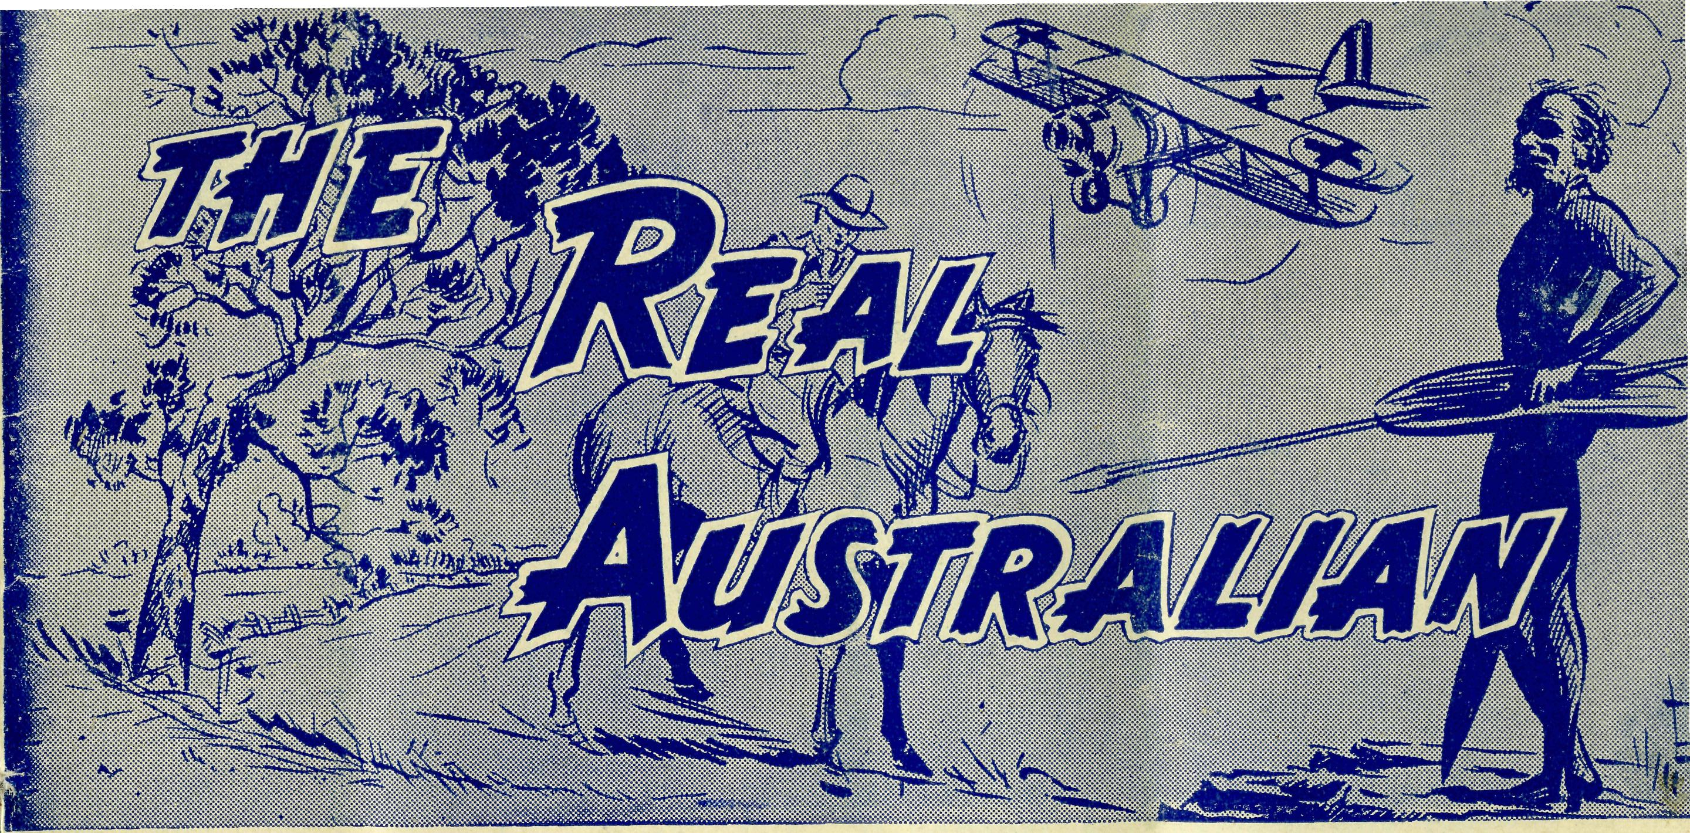
20
The Real Australian December, 1954.
Topics for
Prayer and Praise
SUNDAY
For all Mis-sioners and Deaconesses of the Society and their people and for all students in training. MONDAY
For all Doctors and Nurses serving in the outback, and for the spiritual and physical health of the patients under their care. TUESDAY
For all Workers in Hostels, the children under their care and the teachers who instruct them. WEDNESDAY
For the Director of the Mail Bag Sunday School, the pupils of the School and all teachers and voluntary workers.
THURSDAY
For the Fly-i n g Medical Service and the safety of the pilots and all who travel with them.
FRIDAY
For the Council of the Society, the Home Base staffs, Auxiliaries and Parochial workers.
SATURDAY
For all neces-s a r y finance needed for the maintenance of so large a ministry and for guidance in its right application.
For the Society.
O Lord God of our nation, Who has commanded men to subdue and replenish the earth: Look in Thy love upon all who in distant parts of our land are striving- against many dimcultits, and are deprived the access of the means of grace. Strengthen and guide the Bush Church Aid Society and all members of the staff. Cheer and comfort them in discouragement and loneliness, bless their ministrations to the good of those they serve, and grant that the message of redeeming love may thus be rooted and grounded in our national life, to the glory of Thy Great Name through Jesus Christ our Lord. Amen.
For Nurses and Doctors.
O God, Who didst choose a beloved physician to set forth the life of Him Who went about doing-good, grant that Thy strong tenderness and compassion may be manifest in the work of country doctors and bush nurses. Make them at all times alert to be faithful, as those whom Thou hast burdened and inspired with the honour of their calling. In lonely emergencies strengthen them with confidence that, having done all they can, they may with good conscience leave the issue to Thy power working within Thy law. Make them resourceful and of sound judgment, and hearten their labours with the energv of compassion and the firmness of duty that conquers weariness. Through Him Whose power is called forth by suffering. Jesus Christ our Lord.
For Church Life in Country Districts.
O Lord, Who art present when two or three are gathered together in Th^ Name, bless, we beseech Thee, the little far-scattered groups of brethren who in our wide land meet together to worship Thee. Give them a perpetual freshness of spirit, and the power to inspire in each other holiness, helpfulness, and understanding of Thy help. Refresh with the joy of enthusiasm those who endure weary journeys to Thy trysting place. Grant that these little companies of Thy servants may be united in the spirit of Christian charity, awaiting in love the time when there shall be one fold and one Shepherd. Grant that the common life of all communities may be purified by this spirit of charity from all meanness, falsehood, malice and idle gossip, and grant that they who share a common lot may draw strength from each other's virtues, and in their weakness help one another, through our one Lord, Jesus Christ.
Praise.
for
For the Blessings vouchsafed to the Society, all kindly givers, for the joy of service.
Edgar Bragg & Sons Pty. Ltd. 4 Barker Street, Sydney.
No. 11 (New Series). DECEMBER, 1954. 2/6 per annum, post free.
AN ISOLATED MEDICAL CENTRE
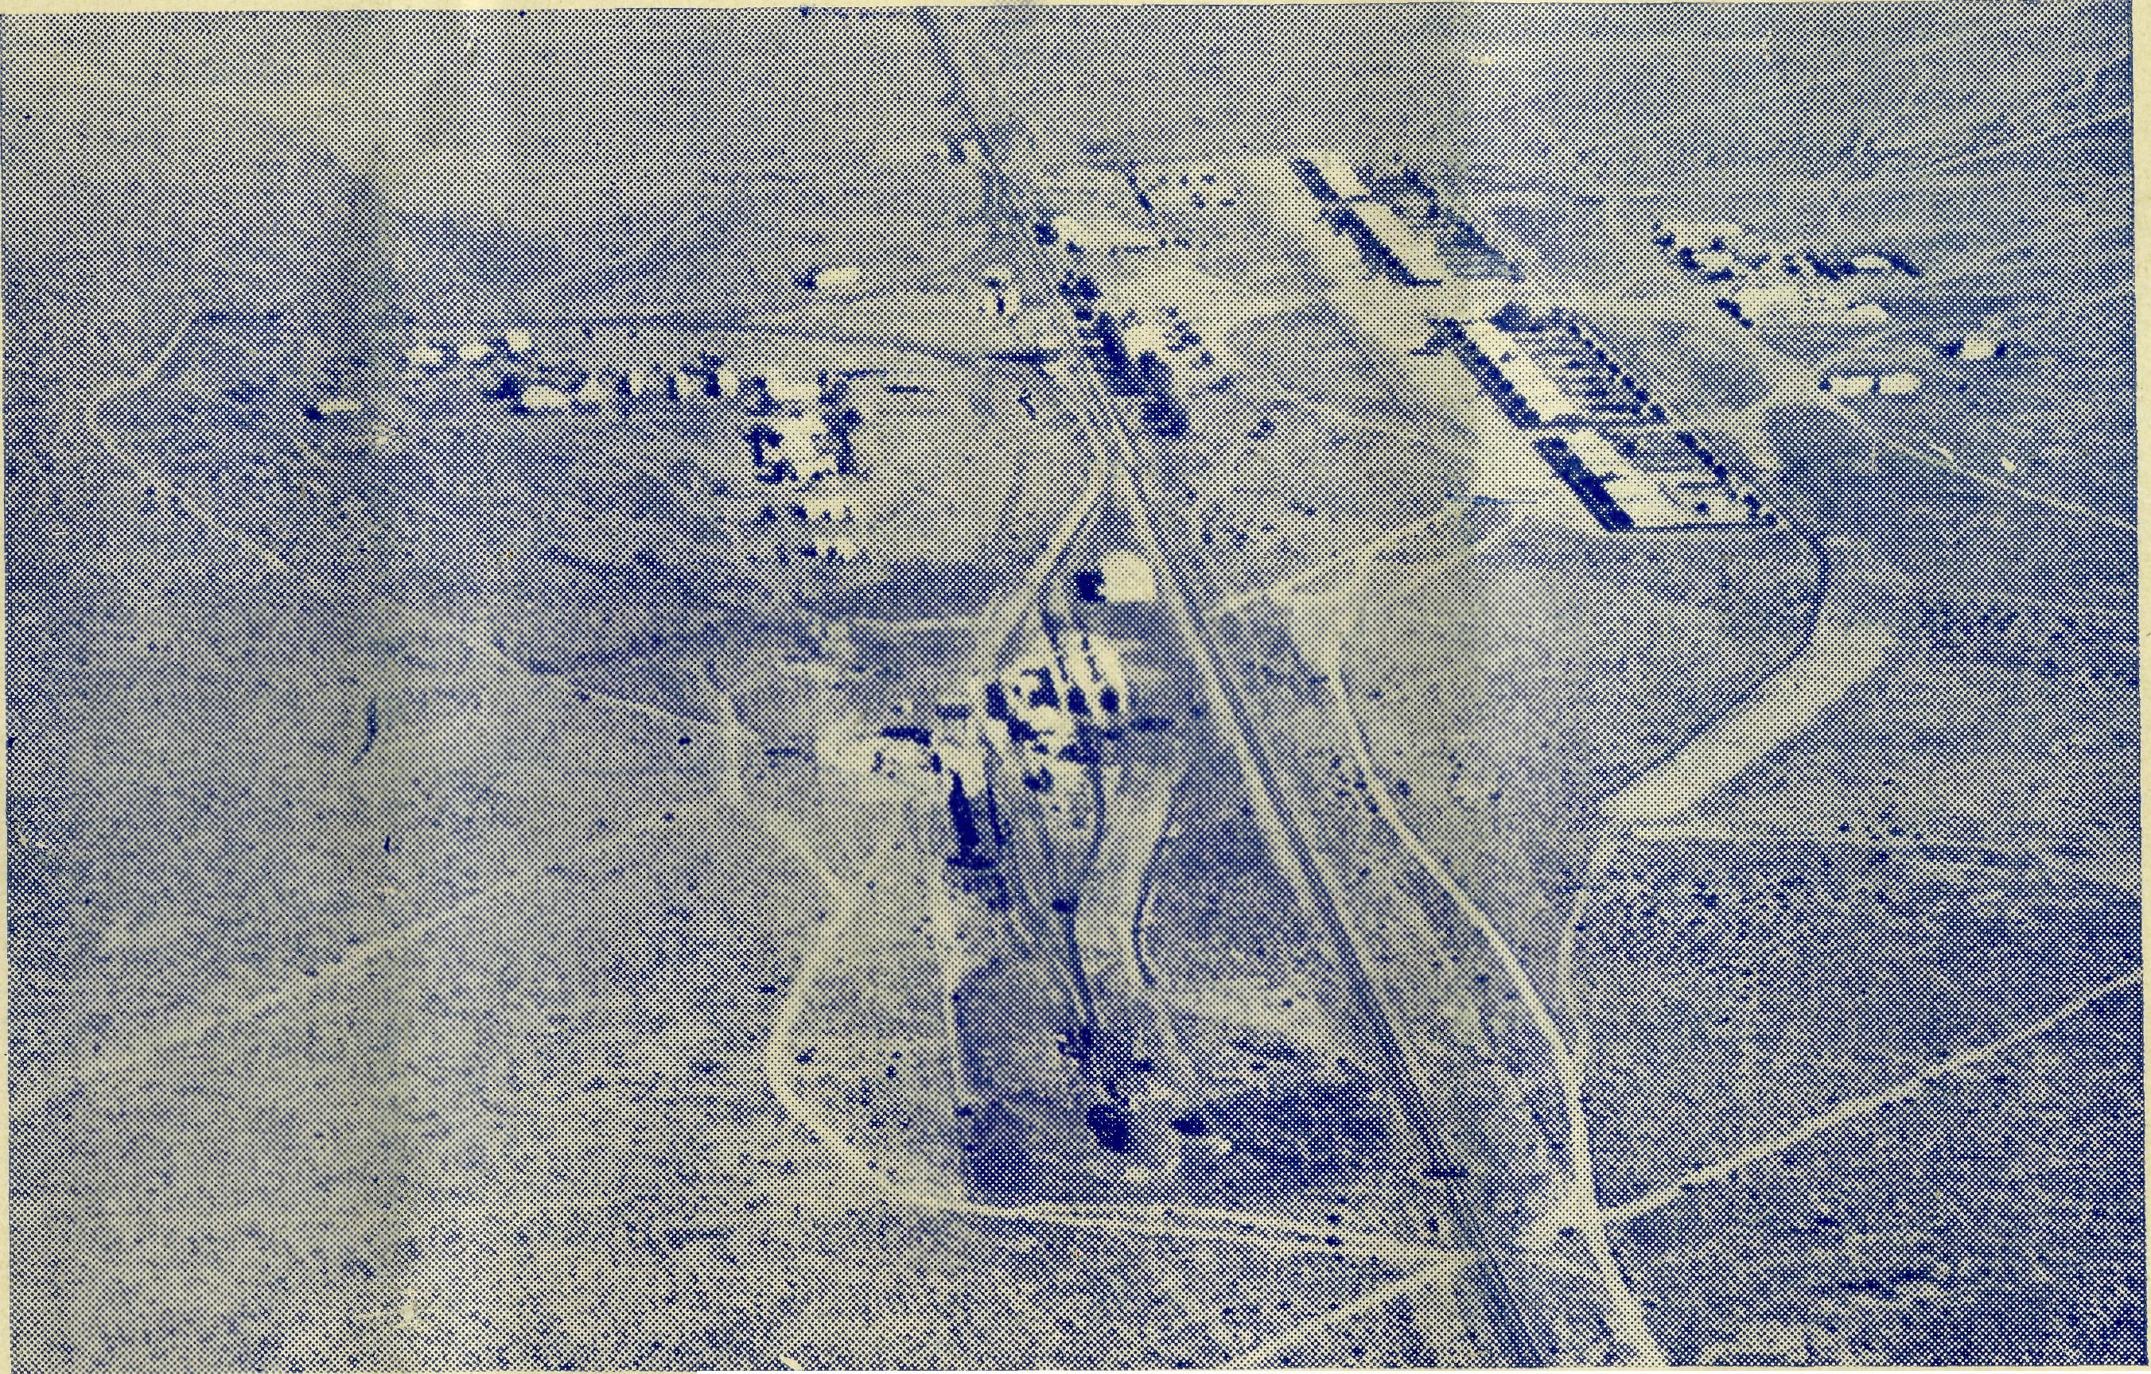
Registered at the G.P.O., Sydney, for transmission by post as a periodical.
The Official Organ of THE BUSH CHURCH AID SOCIETY
Church House, George Street, Sydney, N.S.W.

2 The Real Australian December, 1954.
The Bush Church Aid Society for Australia and Tasmania
PRESIDENT: The Archbishop of Sydney.
Hon Clerical Secretary: Rev. Canon E. Cameron.
Hon. Treasurer: Mr. T. S. Holt.
B.C.A. Activities and Staff
Organising Missioner: Rev. T. E. Jones, Th.L.
N.S.W. Deputation Secretary: Rev. J. R. Greenwood, Th.L.
Victorian Secretary: Rev. E. G. Beavan, M.A.
VICTORIAN OFFICE:
Bible House,
Flinders Lane, Melbourne, Victoria.
Telephone: MF 3552
HEADQUARTERS OFFICE:
Diocesan Church House,
St. Andrew's Cathedral,
George Street, Sydney. 'Phone: BM 3164.
Cable Address: "Chaplaincy, Sydney".
STUDENTS IN TRAINING.
Rev. D. W. Warburton. Mr. R. Brooks. Mr. J. Smith. Mr. B. Buckland.
Rev. A. Williams. Rev. T. Morgan. Mr. T. V. Jones. Mr. F. D. Buchanan.
Heytesbury Mission, Vie.—Rev. P. R.
Cooke, Th.L., Timboon, Vic. Otway Mission, Vic.—Beech Forest, Vic.
Wilcannia, N.S.W.—Rev. J. Stockdale, Th.L.
MISSIONS. Ceduna, S.A.-Penong, S.A.—
Rev. T. J. Hayman, Th.L., Ceduna, S.A. Rev. I. Booth, Th.L. Cowell, S.A.—Rev. D. A. Richards-Pugh,
A.L.C.D. Minnipa, S.A.—Rev. G. Fuhrmeister,
W. Mitchell, Rappville, N.S.W.—Rev. A. Gerlach, Th.L.
Men in dee, N.S.W.—Rev.
Th.L
Th.L., Deaconess A. Howland. Streaky Bay, S.A.—Rev. P. Connell,
Th.Schol. Croajingalong, Vic.—Rev. L. Luck.
MAIL BAG SUNDAY SCHOOL. Director—Miss R. Campbell. Assistant—Miss M. Heesh.
MEDICAL SERVICES. Ceduna, S.A.—
SCHOOL HOSTELS.
Broken Hill, N.S.W.—Mr. and Mrs. A.
McLaughlin. Mungindi Boys' Hostel, N.S.W.—Mr. and
Mrs. W. Hustler. Mungindi Girls' Hostel, N.S.W.—Miss M.
Farr. Bowral, N.S.W.—Miss E. Cheers. Port Lincoln, S.A.—Miss I. Beck.
Matron: Sister F. Dowling. Staff Sisters J. Miller, G. Hitchcock, B. Tierney, A. Butler, J. Armstrong, M. Tarr. Penong, S.A.—Sisters L. Loane, L. Lang-tree. Wudinna, S.A.—
Matron: Sister R. Portch. Sisters: M. Denniss, B. Barber, V. Brealey, F. Ellis. Cook, S.A.—Sisters M. Horsburgh, M.
Ross. Tarcoola, S.A.—Sisters V. Holle and P.
Shipway. Cann River, Vic.—Sister I. Gwynne. Rawlinna, W.A.—Sister E. Thomas.
FLYING MEDICAL SERVICE.
Pilots—Mr. A. Chadwick, Mr. W. Bed- Pharmacist—Miss E. M. Page, ford, Mr. G. Job.
Wireless Control Station Doctors— Dr. M. Mueller, Dr. J. Upsdell Control Officer—Mr. G. Cameron.
December, 1954. The Real Australian
The O.M.’s Letter
In the mission Church in which I was brought up there hung in a large frame the motto of the mission. The words were, 'Expect great things from God: attempt great things for God'.
It is in the spirit of these words that the Bush Church Aid Society has gone forward ever since its inception thirty-five years ago. It started with nothing more than a great hope and a wide vision. Those who were responsible for the Society's creation saw a great need in the outback places and pledged themselves to do something about it. They realised that they must expect God to do great things in order to bring the vision they had to pass, but they also pledged themselves to attempt great things on His behalf. Ever since those early days the history of the Society has been one long series of expectation and attempt at great and important ventures.
The first things that were attempted were the staffing and finance of two considerable missions: one in the forests of East Gippsland, the other in the north-west of New South Wales with headquarters at Wilcannia. One was an immense area of 80,000 square miles, of which most was open plains and subject to more than its share of droughts. The other was much smaller in area, but densely wooded country in which many people were carving themselves homes and farms from the virgin scrub. These were no small undertakings for a baby organisation, but they proved to be the beginnings of an extensive series of missions which to-day extend into the far west of Western Australia.
When the Society was born the only work visualised was that of the missions, but very soon the need of the children became apparent. In order to meet this need a hostel was started at Wilcannia in the spirit of faith and hope. It immediately proved a success and for over thirty years enabled a great many outback children to receive an education that may have otherwise been denied them. This hostel was sold when the Society purchased another building at Broken Hill to replace it. In 1930 the Mungindi Hostel was built and in 1947 a second home in the same town was established to meet the growing needs of the children of the district. To celebrate the Jubilee year of the B.C.A. the Port Lincoln Hostel was purchased and later another was established at Bowral in N.S.W. These have been considerable undertakings that required courage in the expectation that God through His people would make them possible of success.
In the year 1925 the B.C.A. was challenged to establish medical services in the west of South Australia for people who had no such amenities. Such a service was never thought of by those who were responsible for B.C.A.'s beginning. However, the problem was examined and the decision made. As a result a house was taken over and converted into a tiny hospital. It has been simply amazing how from that tiny beginning the medical organisation of the B.C.A, has grown. Hospital after hospital has come into existence

The Real Australian December, 1954.
December, 1954. The Real Australian

until to-day the whole of the western division of .the State of South Australia is splendidly served by six hospitals or nursing homes.
It was in 1937 that the boldest of ventures was made. As the hospital and medical work spread over greater distances it became obvious that some method must be devised so that the medical staff could cope with so large a work. It did not justify placing doctors, even if they could be found, in many little centres. Therefore, speedy and comfortable transport had to be provided to enable the doctors in the base hospitals to service the smaller centres and the people in the lonely homesteads. These were the reasons for the Society's purchase of an aeroplane, engagement of a pilot and bringing into existence of all the organisation necessary for the establishment of a Flying Medical Service. Eighteen years of such a service have proved it abundantly worthwhile, so much so that to-day there are three aeroplanes to cater for the needs.
Then in 1953 came the establishment of the Radio Control Base with its many outposts in far scattered hospitals and homesteads in the outback of South Australia.
Now comes the final task towards the completion of the whole service — the purchase by the Society of the Ceduna medical practice from Dr. Freda Gibson as she goes to Adelaide. Financially, it is one of the biggest tasks we have ever faced, and is made all the greater by the fact that it must be done at a time when the growing work of B.C.A. requires a large income for its normal maintenance.
The year 1955 will also see the establishment of mission work by B.C.A. in Tasmania of which you will read on another page.
Sometimes, one is appalled by the enormity of the task facing us and the very large income required month by month to meet the needs.
There have been many other things that have been attempted and accomplished over the years, the detailed telling of which will not fit into this letter. What I have told you is sufficient illustration that those who are responsible for the direction of the Bush Church Aid Sociey are prepared to attempt to meet the great needs facing many of our people in the lonely areas of this land, in the' full expectation that Almighty God through His people will make the attempt successful.
REMEMBER THE B.C.A. BUSH PADRE BROADCASTS —
2GB EVERY FRIDAY at 11 a.m.
2CH ALTERNATE SUNDAYS at 6 p.m.
2KA ALTERNATE WEDNESDAYS at 4.30 p.m.
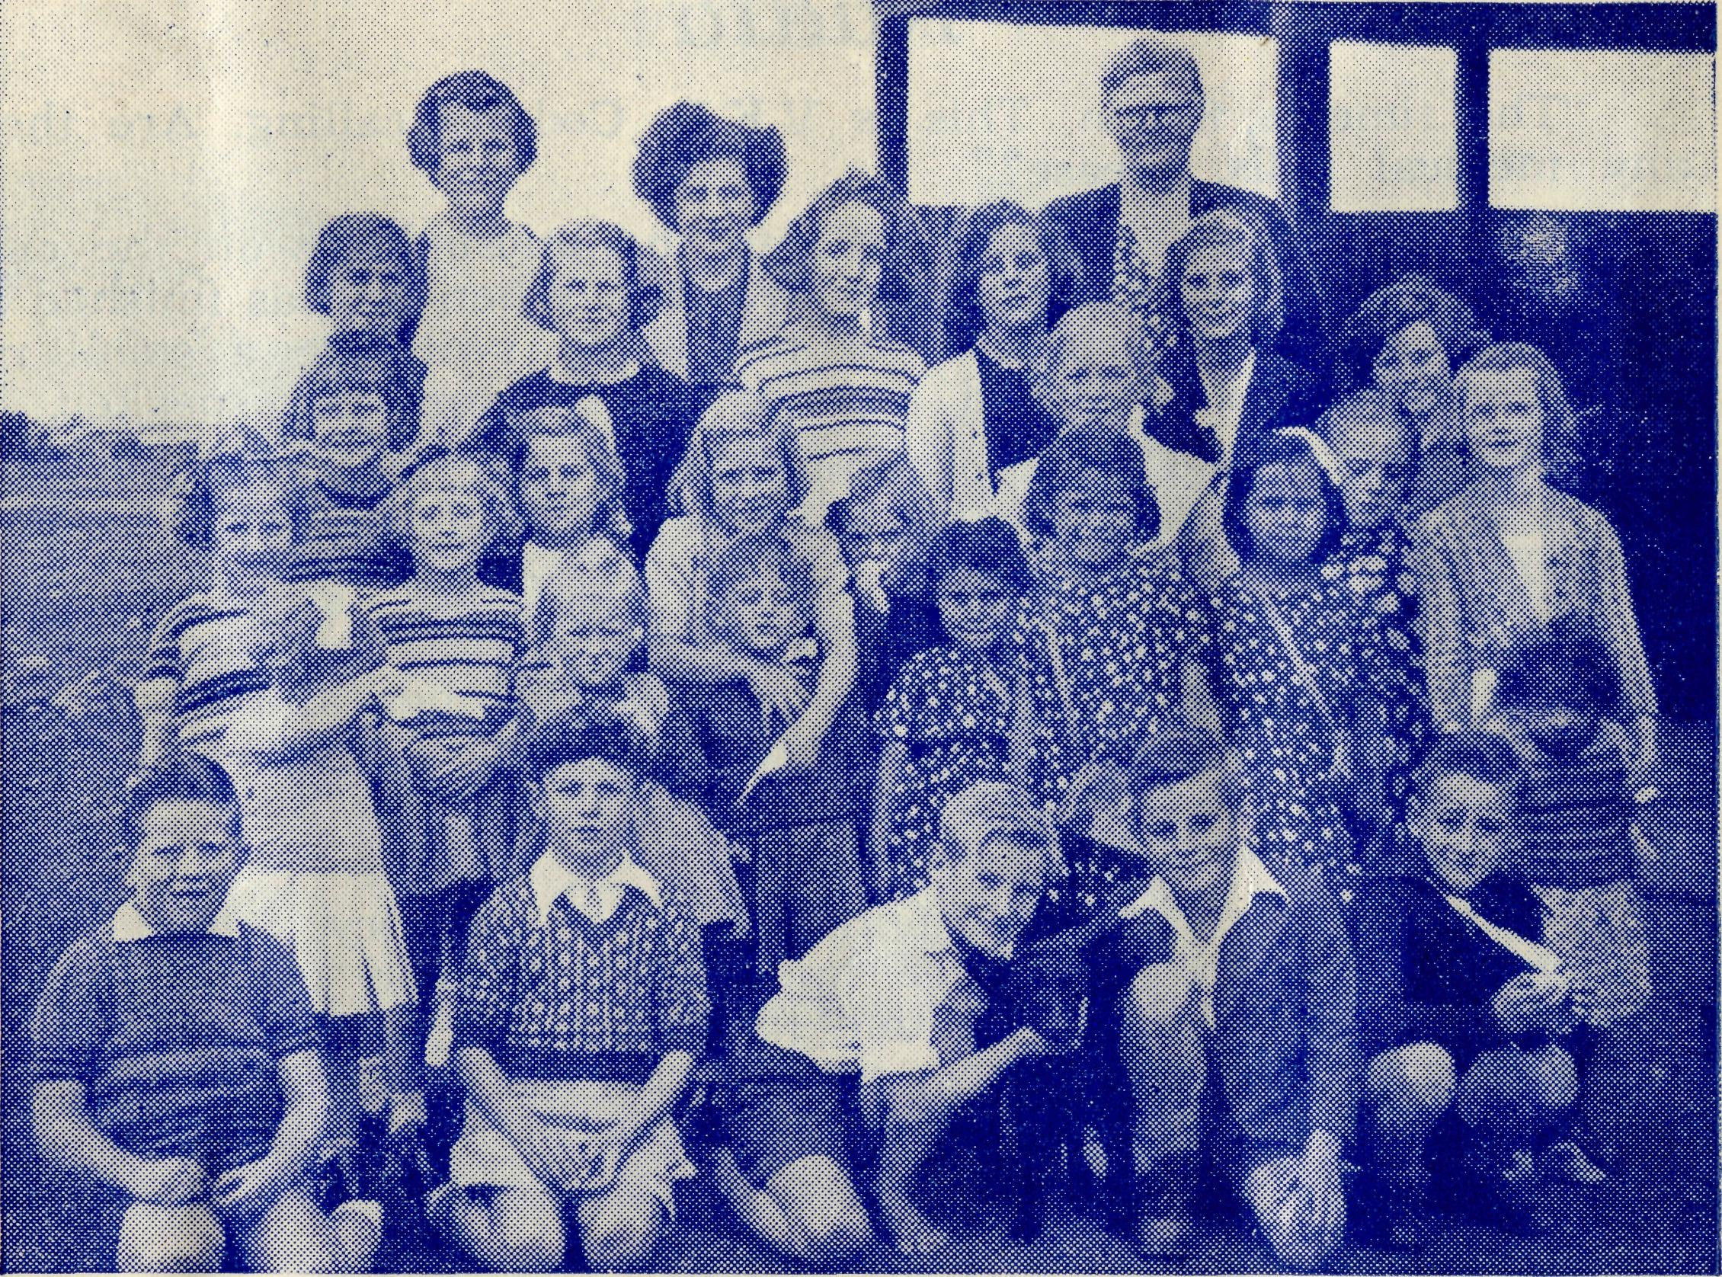
Sister Thomas and Rawlinna Sunday School.
‘and Tasmania’
The above words have always formed part of the title of the Society, yet we have never undertaken any work in that island diocese. This state of affairs is soon to be remedied.
The Bishop of Tasmania suggested to the B.C.A. that the extensive Hydro-Electric Construction Camps located in the Central Highlands would be a very suitable field for B.C.A. operations. As a result the O.M. has recently paid a visit to the camps at Tarraleah, Wyatinah, Butler's Gorge and Bronte Park.
In these camps on top of the mountains in rugged and beautiful country are some 4,000 people who have up to now not been able to receive the ministry that so large a number deserve.
As a result of the O.M's visit the Society will become responsible for the work of the church in these camps, as from March, 1955, and will also take over another area known as the Castra Mission if suitable arrangements can be made.
We will be able to tell our friends more details of this new avenue of service in our next issue. Meanwhile, we ask for the prayers and support of all our friends as the bounds of service grow wider.

The Real Australian December, 1954.
December, 1954. The Real Australian

Radio
F.M.S. No. 1.

"The lime is 8 a.m. This is V.K.B. Ceduna calling. Are there any medical calls, please?"
The young man is speaking into the microphone on the desk in front of a variety of dials and switches. When he has finished he leans forward and turns one of the many switches: a small red light glows before him and a voice comes from the speaker.
"This is 9.R.O. Cook, speaking. Nine Roger Obo, 9.R.O. calling V.K.B. Ceduna. Good morning, George; I would like to speak to doctor."
"Right, Sister, stand by and I'll get doctor for you." The young man pulls another of his switches and then picks up a telephone. In a house a quarter of a mile down the street a bell rings and doctor hears the young man say, "Sister at Cook would like to speak to you."
Doctor then gives her attention to sister's story, which comes to her over the air for three hundred miles and is then linked to her telephone line. She is told that a man, while climbing some scaffolding, slipped and fell to the ground and has suffered serious injuries. Sister has made him comfortable in her little hospital on the great Nullarbor, but he needs doctor's attention. "Can doctor come immediately?"
"I'll pass word to the pilot. We'll leave as soon as this medical session is over," doctor tells sister. She then stands by while others waiting for her help are switched through.
A sister at the Tarcoola hospital asks for advice in the treatment of a baby that has gone off its food; a mother in a lonely home in the north nearly three hundred and fifty miles away is anxious about her husband who, she thinks, has influenza but she is afraid he may have diphtheria after all; another is a sheepman in the west who requests that doctor will bring her dental forceps when she makes her mopthly visit next week as he has an aching tooth he'd like out. So the routine goes on until the young man announces: "There are no more medical calls. I am now ready to receive traffic." He then busily thumps the keys of his typewriter as each outpost asks him to send its daily quota of telegrams for this and that.
Some desire spare parts for cars or trucks to be sent from distant Adelaide; others are sending prices for sheep sales, orders for groceries or birthday greetings to a member of the family away from home, for in all these cases the transceiver is the only communication the folk have with the outside world.
The building from which the young man speaks to the many people scattered over the distant areas of the more remote parts of South Australia, is a plain, simple through attractive building some thirty feet by twenty. It is divided into two rooms. The larger room is the Operating Room, for here are the transmitters and receivers with their bewildering array of control switches and dials. The other, the Workroom, is filled with all manner of
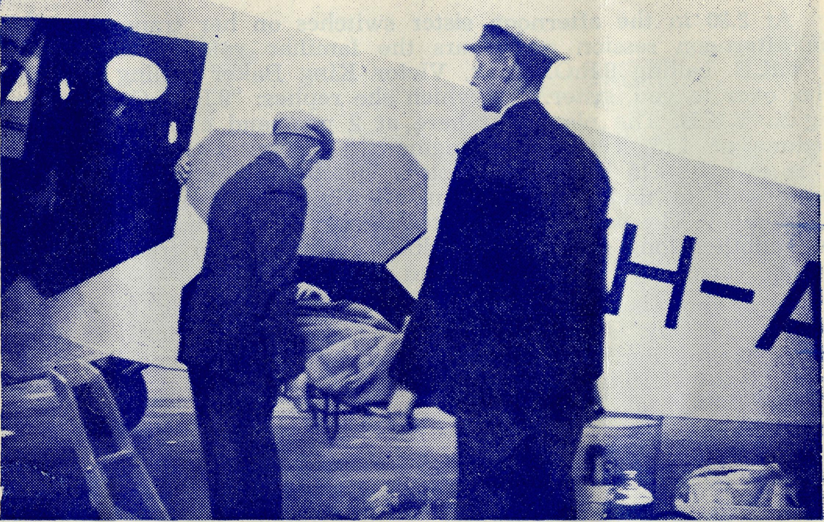
A patient transported 300 miles to Adelaide is taken from the plane.
radio and electrical equipment. Next to the Radio Building is the attractive home in which live the young man and his wife and small daughter. Dotted about the acre and a half of ground are wireless masts from which are strung so many yards of wire as to make one wonder why they ever called it 'wireless'.
While the young man is taking his telegrams, two other young men are pushing an aeroplane from its hangar in a nearby airfield, and a motor car is streaking down the road, leaving a long trail of dust behind it. The car soon arrives and is parked in the hangar, and doctor and sister make themselves comfortable in the aeroplane. A few minutes later the plane is zooming over the little township and heads towards the Great Australian Bight and the treeless Nullarbor.
The plane flies over mile upon mile of empty land. Here is Colona Homestead; eighty miles further on a few sheets of corrugated iron catching the sun's rays indicates that White Well has been reached. The plane is now on its last stretch, sixty more miles over a plain that except for scattered patches of stunted salt bush is devoid of vegetation, an odd rabbit the only life on the plain until Cook is reached.
The glistening rails to the east and west and the twenty homes standing like a straight line of soldiers on parade greet the travellers with dazzling brilliance as the hot sun is reflected from the roofs.

The Real Australian December, 1954.
December, 1954. The Real Australian

F.M.S. No. 2.
Within ten minutes of landing doctor is examining her patient and comes to the conclusion that he must be taken* back with her to the base hospital.
At 2.30 in the afternoon sister switches on her transceiver for the afternoon session and hears the familiar voice calling: "This is V.K.B. calling 9.R.O. Cook. Victor King Baker calling 9 Roger Obo, over to you, sister." To which she replies: "9.R.O. Cook replying to V.K.B. The plane left here at 2 p.m. and expects to arrive Ceduna at 4.15. They are bringing the patient back with them." It is exactly 4.15 p.m. as the plane touches down on the Ceduna aerodrome to find a green van awaiting them with the parson standing by. The patient on the stretcher is transferred to the vehicle and another long cloud of red dust is churned up from the road as the car speeds with its patient to the hospital.
It is just before seven the next morning. It is winter and though the sky is clear, it is bitterly cold as doctor and sister climb aboard the plane and wrap themselves snugly in layers of grey blankets. It is the last Friday in the month and that means 'Doctor's Day' at Evelyn Downs and Oodnadatta. 'Doctor's Day' means that on that day doctor will visit for clinical advice and treatment. Such visits are an important part of the B.C.A. Flying Medical Service at many outback townships and homesteads.
The flight to Evelyn Downs of three hundred and ten miles is made without any intervening stop and about 10.30 the plane touches down on the excellent landing ground the owner of the station has put down for that purpose.
In the homestead doctor finds three patients: one a member of the household, the two others from outstations. Two of the patients are given advice and medicine and the third, after a thorough examination is advised to go to Adelaide within the next month for specialist treatment. Then after lunch doctor's party is off again on the last leg to Oodnadatta.
It is a little after three when doctor and sister walk into the Australian Inland Mission Nursing Home at Oodnadatta which the A.I.M. kindly makes available for doctor on her visits.
During the afternoon and evening twenty-eight patients come to see doctor. They consist of the many varieties of patients as are to be found attending the consulting rooms of any suburban doctor day by day. Expectant mothers, festering hands or legs that need to be opened under local anaesthetic, injections for whooping cough, diphtheria and tetanus, coughs, colds and mysterious pains that worry an anxious patient.
There are patients from the township, black picaninnies from the nearby Aboriginal Hostel, men, women and children from the great cattle runs, and they are all glad to know that the B.C.A. brings the doctor to them every month. It is after 8 p.m. before the last patient is seen, then follows supper and bed, for doctor and sister must be away early on the morrow.
It is 6.30 the following morning when the bags are loaded into a car for the trip to the aerodrome, and by the time the pilot has

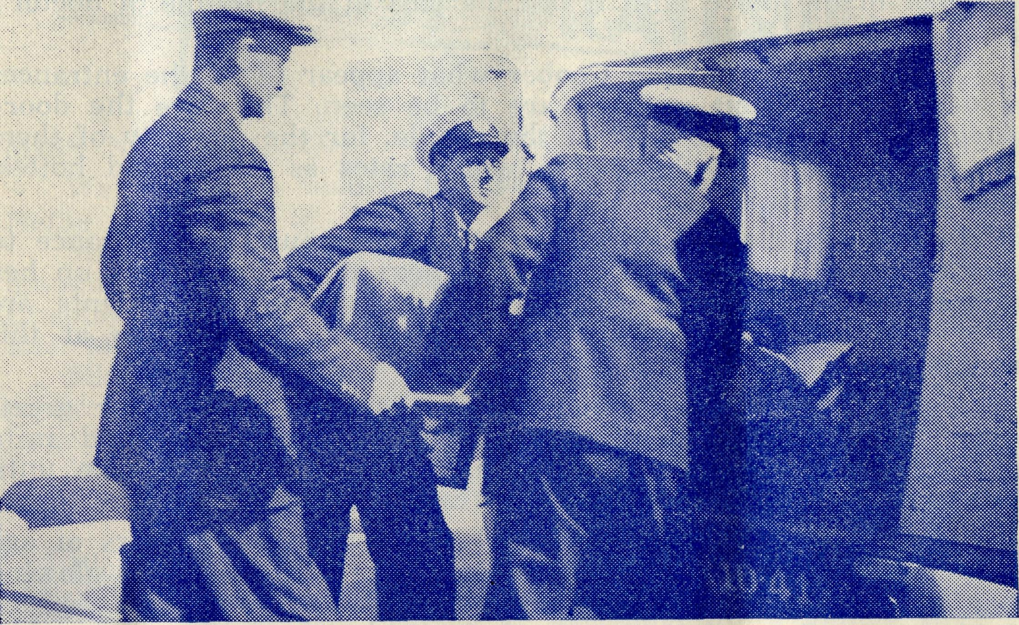
The patient being placed in ambulance. Pilot Chadwick at left.
made the necessary preparations and secured his weather report it is seven o'clock before they are in the air bound for Coober Pedy, one hundred and ten miles away.
The country is dry and uninteresting. The small hills break the flatness of the landscape which is scored by hundreds of dry watercourses tracing their way to the dry Lake Eyre, once an inland sea, towards the heart of the continent.
The journey is remarkable for the fact that no homesteads lie on the long route and it is not until the plane is directly above Coober Pedy that any sign of habitation can be seen. Coober Pedy is known for its opals, the only reason for its existence. As the plane approaches, what appear to be giant worm casts are seen covering many acres of ground. These are old workings, the rings of whitish earth being formed by the soil cast up from the diggings. Without these landmarks it would be very easy to pass Coober Pedy, unless a careful lookout is kept for the three iron roofs of the only buildings above ground. By now, the pilot knows just where to look for them and there is little fear of him missing his way.
Landing on the aerodrome some two miles out, eyes are strained for the first glimpse of the cloud of dust on the horizon that will tell of the truck coming out to fetch the party in. Soon the truck is alongside the plane and doctor's bags are loaded into it together with forty pounds of frozen fish, or more correctly,

10
The Real Australian December, 1954.
December, 1954. The Real Australian
11

fish that was frozen the day before at the Quick Freeze factory at Ceduna. This is one of the ways by which the Flying Medical Service makes life a little brighter at Coober. Fresh fish was unheard of in the place until it became part of the routine of doctor's day at Coober Pedy.
As the parties go into Coober what appear to be the entrances to very large rabbit warrens are to be seen. They are the doorways to the homes of most of the people, for the majority of them live underground in this place, which rates as the second hottest spot in the continent.
Patients, black and white, are clustered round the entrance to the Wilson's Store, and in the home next door doctor sets up her equipment in the front room and one by one the patients are called to see her. As many as eighteen are attended to at this remote and desolate spot.
One of the patients is an old pensioner, whom doctor greets with: "Well, you're looking much better these days," and in a shy voice he answers: "Yes, I am, thanks to you, because until you came to look after us, nobody cared for us."
Another patient is a native girl about twenty-six years of age who stands shyly at the table in a bright print dress and a glowing face, but who finds that no matter how hard she tries, speech won't come. Some few months before, she came for advice and help on one of these clinic days. Then she was quite blind. Doctor arranged for her to go to Adelaide and see a specialist friend. This was the first time doctor had been to Coober since the girl had returned from Adelaide . . . and her excitement was due to the fact that she was able to see her doctor friend . . . for the first time.
It is after mid-day before the last patient is seen and while the party is drinking a hurried cup of tea Mrs. Wilson hands sister a list of drugs required to replace those used from the medicine chest. These will be left with the B.C.A. chemist at her shop in Ceduna and brought up on the next trip to Coober Pedy.
A head wind makes the two hundred-mile trip back to Ceduna longer than usual and it is three o'clock before a tired but contented trio get back home with the feeling of a job well done.
"CHRIST'S HANDS”
Christ hath no hands but our hands to do His work to-day; He hath no feet but our feet to lead men in His way; He hath no tongue but our tongue to tell man how He died; He hath no help but our help to bring them to His side.
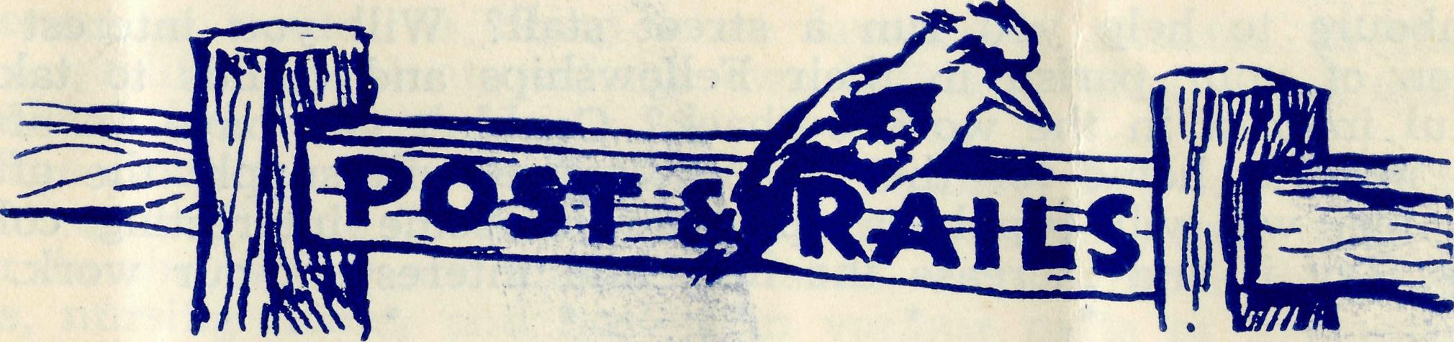
MISS N. FOULCHER,
We regret to record the passing, on October 27th, of Miss Nellie Foulcher, of Ryde.
Miss Foulcher was one of the only two women present at the inaugural meeting of the Bush Church Aid Society in St. Andrew's Chapter House, Sydney, on May 19th. 1919. The other being the late Mrs. E. Bragg.
Miss Foulcher never lost her keen interest in the Society and rejoiced to see B.C.A. grow from its tiny beginnings to its present large sphere of service.
We remember her with affection and extend to her family our sympathy as they miss her in their daily life. #'#.■#'••'-**
We wish to say 'Thank you' to Mrs. Thomas of Cronulla for the gift of some very useful crockery to the Girls' Hostel at Mungindi, and to Mrs. Taylor of Eastwood for a lounge suite for the Boys' Hostel, Mungindi. Both these gifts are excellent additions to the comfort of the staff and children at the hostels.
We are grateful to Mrs. Bohle of Eastwood who has done a good job in making a quantity of new surgical gowns for our medical staff. It was an urgent need and Mrs. Bohle must have put in many hours of labour. Thank you, Mrs. Bohle.
The Editor, while tendering the thanks of B.C.A. to Mrs. John Greenwood for a very magnificent effort that has resulted in a considerable sum of money being raised for the Society, would also like to suggest to other friends of the Society that they do likewise.
At the recent Sale conducted by the Women's Auxiliary, Mrs. Greenwood took charge of a stall for the sale of pottery. These goods were so strongly in demand that she has made five trips to the manufacturers for additional supplies with the result that there is now a constant stream of friends, neighbours and even the teachers of the local school coming to her home to make purchases. To date Mrs. Greenwood has sold over £200 worth of pottery, the profits of which are for the Society.
The tremendous increase in the B.C.A's commitments require a very large increase in our income and to this end we are hoping that many of our good friends will make additional efforts to increase support.
If you are thinking that there is nothing much you can do other than give a donation now and again, please take inspiration Ertifiri Mrs. Greenwood's effort. Can you get your friends and

12
The Real Australian December, 1954.
December, 1954. The Real Australian
13

neighbours to help you run a street stall? Will you interest the women of your parish in their Fellowships and Guilds to take a helpful interest in the work outback? Couldn't you have an afternoon in your home for the B.C.A.?' If you will supply the afternoon tea, we will supply a speaker and some interesting colour
slides. Try it and increase the help and interest in our work.
# # # # #
We are still looking for gifts towards the furnishing of the new hospital at Tarcoola. Since our last issue we have been able to send to the Tarcoola folks over £400 for this purpose. This help has greatly cheered them. We have ordered fifty pounds worth of linen in the belief that some of our women friends would like to meet the cost.
Are you a member of our Kookaburra Birthday Band? Send us your name and address and a postal note for 2/6 together with your date of birth. Each year we will send you an attractive birthday card which, while wishing you a 'Happy Birthday' will also remind you to send B.C.A. a birthday gift of 2/6. Enrol your
children now and start their interest in B.C.A.
# # # # #
We extend our sympathy to Mr. Harold Bragg on the death of his brother, Mr. Alex. Bragg of Epping. Though Mr. Alex. Bragg had been unwell for some time, his sudden passing was a
shock to his friends and family.
# # # # #
We are glad to announce that the Bishop of Gippsland has been able to find a man to fill the vacancy in the Cann River Mission, and we welcome the Rev. L. Luck as he takes up this new work, wishing him a ministry of blessing to himself and the
folk he will serve.
# * * # #
Congratulations to the Mitchells of Menindee on the birth of a
daughter. They now have a 'pigeon pair'.
# * # # *
We were sorry to lose the services of Sister Pole from Wudinna. Sister has returned home to Melbourne after helping us out for awhile. We hope that she may be able to come back again in the not too far distant future.
Busman's Holiday
(J. Burston)
We often hear the term 'Busman's Holiday', but have you ever heard it applied to pharmacy? Ever heard of a 'Chemist's Holiday'? I have just come back from one, which was so enjoyable that I wished that it had been longer.
It all started when a chance remark led the Organising Mis-sioner of the B.C.A. Society of the Church of England to write to me on behalf of their pharmacist at Ceduna, S.A. Her leave was twelve months overdue, and she needed the break but was unable
to secure a locum, so being more favourably situated in that I had a qualified assistant, and my own holidays being due, I decided to relieve her myself.
The Society, with headquarters in Sydney, had for years been operating a Flying Medical Service said to be better than any other in the world, and had established, among other things, hospitals, nursing homes and hostels in various parts of the outback, some of them many hundreds of miles from the nearest doctor. Then about five and a half years ago Miss Esma Page left the comforts of the city to go out and manage a pharmacy for them at Ceduna.
Ceduna is a small town of some 1,150 inhabitants on the west coast, about the top of the Bight. The east-west line passes a hundred miles to the north, but the main road passes through the town, and overland travellers often stay the night, and add to the life of the place. One of them called in the other day to buy some witch hazel, and she said she was travelling alone from N.S.W. to Kalgoorlie; the car was over the road being serviced. She'd be well on in her fifties, and was driving a Capital model Chev.!
Because of its central position, Ceduna is the focal point of a large proportion of B.C.A. activity and has a well equipped twenty-bed district hospital, two doctors, pharmacy, radio station, and two aeroplanes. The actual range at present is about 350 miles (as far as Oodnadatta and the opal mines of Coober Pedy) but they hope to bring in more stations very soon. Perhaps the most spectacular of this work is done along the east-west line. Running through the famous Nullarbor Plain, the only inhabitants are railway men and their families, living in camps of six to twenty houses at odd intervals along the line.
Smaller hospitals at Rawlinna, Cook and Tarcoola admit minor or emergency cases, and symptoms are sent by radio to the doctor at Ceduna, who gives directions for treatment, or if necessary, flies over to operate. Some cases are even flown over to Ceduna or on to Adelaide for treatment.
From a chemist's point of view, the pharmacy is rather interesting; absence of competition makes duplication of over-the-counter lines unnecessary, but conversely, remoteness necessitates a rather comprehensive stock of drugs and ethicals. Unlike most dispensaries I have seen, this one has a window which makes it very bright, and the electric water-heater, stainless steel sink and bright bottles give it quite a modern appearance. Added to this, the "family" atmosphere which permeates the various branches of the medical fraternity makes the life most enjoyable.
Material reward means nothing to Miss Page and her co-workers, otherwise they would have found more lucrative employment elsewhere. Their concern is to bring succour to the people of the never-never, and the appreciation of the people affords all the encouragement one could desire.
I hadn't much opportunity in three weeks to see much of the aborigines, who have always interested me greatly, but the few who live near (mostly mixed bloods) are evidence of a great social problem. They live in very poor circumstances, and their treat-

14
The Real Australian December, 1954.
December, 1954. The Real Australian 15

ment by the white population, to say the least, reflects little credit on our civilisation. The Lutheran mission at Koonibba Station is doing a very commendable job for them, and one regret is that I was not able to get out there, but a few native weapons which I was able to obtain will be valued mementoes of a most interesting experience.
Dr. Freda Gibson
Dr. Freda Gibson is relinquishing her work at Ceduna and taking up practice in Adelaide.
Dr. Freda came to Ceduna twenty-two years ago with her husband the late Dr. Roy Gibson. Since the death of Dr. Roy in 1948, Dr. Freda has carried on the work at Ceduna, and for the last four years has had the able assistance of Dr. M. Mueller.
The development of the B.C.A. Medical Services owes much to the help and co-operation of Drs. Roy and Freda Gibson, and without their ready co-operation much of the service would have been impossible.
As Dr. Freda goes to her new work in an Adelaide suburb, we wish her to know that we fully appreciate all that she has done to assist the development of the Flying Medical Service, and pray that she may have much success in her new practice.
Though Dr. Freda gave much service in the Flying Medical Service, the town and immediate district of Ceduna was her own private practice. It is essential that the doctor in the Ceduna practice shall be one who is in sympathy with the aims and objects of the work of the B.C.A. We are, therefore, grateful to Dr. Freda for offering the Society the option of purchase of her practice so that the B.C.A. can ensure that the right sort of person shall occupy the position.
In order to exercise this option the sum of £8,000 must be found for the purchase of residence, practice and motor cars and other incidentals. This is a very large sum of money and will take time to obtain. The Council of the Society has, therefore, arranged for a bank advance for that amount so that Dr. Freda may be paid in a reasonable time.
It will be necessary to liquidate this indebtedness as soon as possible and to this end we appeal to all our friends to be as generous as possible in their giving to the Society, especially during the next few months.
Such a development also adds to the Society's staff and monthly expenses. Dr. Peter Palmer at present on the staff at the Newcastle Hospital has offered and been accepted for work with the B.C.A. and will commence his service in February, 1955. Dr. M. Mueller, who is at present Dr. Freda's assistant, comes on to the B.C.A. staff and will remain at Ceduna in the Flying Medical Service.
To Nurses and Otbers
There seems to be a famine of Christian nurses for Christian work. Other church societies as well as B.C.A. are experiencing great difficulty in obtaining sufficient workers to maintain their work. The result is that a very great burden is being carried by devoted staffs who have laboured for many years.
There are certain tasks that only Christians can do, and service in a Christian hospital outback is one of the most important. These Christian hospitals cannot be maintained by those who are simply nurses, however good they may be. Christian service demands consecrated lives.
On the other hand those who call themselves Christians ought not to be satisfied by doing the second best or easier task, for while they are so content the Kingdom of God stands in jeopardy.
The B.C.A. needs consecrated nursing sisters — now. The work is hard and the salaries are small, but the need is great and urgent.
A matron who is not afraid of hard work is also required for a Hostel for Girls and a Cook-Housekeeper is an urgent need for one of our hospitals.
Are there Christians who will come forward now and do these essential tasks?
Nullarbor Crash Victims Recovering
The six victims of the head-on car crash which occurred on the Nullarbor Plain, ten miles west of Nullarbor Station, recently, are reported to be progressing satisfactorily. They were admitted to the Ceduna Hospital on the following day, after being conveyed from Nullarbor Station homestead by Ceduna's two B.C.A. ambulance planes.
A special landing strip was prepared at Nullarbor in order to obviate the necessity of moving the severely injured by road.
The east-bound car was carrying four people from West Australia, and the utility, travelling west, had three occupants from New South Wales.
Both vehicles were wrecked in the accident, which is alleged to have occurred when the vision of the drivers was obscured by a cloud of dust, caused by a car and caravan which had just passed.
The victims were an elderly man and woman, whose condition was announced as critical, a young women in a serious condition and two men and a woman with deep cuts and bruises.
Constable Pengilly, of Fowler's Bay. said that it was a miracle no one was killed. The crashed vehicles, which were completely wrecked, were thought to be travelling at about 50 m.p.h. when they met. The drivers did not see each other until the instant they crashed.
A message received by Ceduna B.C.A. Flying Medical Service

16
The Real Australian December, 1654
December, 1954. The Real Australian
17

soon after the accident, indicated that six people had been injured — one seriously.
Word was also sent to Constable Pengilly, who hastened to the scene of the accident by icar, and the B.CA's two ambulance aircraft set off from Ceduna for Colona, the nearest landing ground to the disaster. Dr. Freda Gibson travelled in the faster Proctor machine, piloted by Mr. A. E. Chadwick. The Dragon, which accommodates more stretchers, followed, piloted by Mr. G. Job.
Immediately following their arrival at Colona, Dr. Gibson and Mr. Chadwick were taken on to Nullarbor Station by truck. Constable Pengilly and helpers had already brought the injured to the station.
After administering treatment, Dr. Gibson decided it would be necessary to bring the planes to Nullarbor to move the victims. Mr. Chadwick then surveyed an area suitable for an emergency landing, after which he returned by car to Colona to bring forward the two planes.
Constable Pengilly and all available men cleared the emergency strip of bushes and stumps and filled in rabbit holes to make it safe.
The injured people were cared for through the night by Dr. Freda, who was assisted by Mrs. Cook, wife of an employee of the station, and the manager, Mr. Attick, who placed the homestead and its facilities at their disposal.
On the Sunday morning the landing area was ready and the two planes came on and landed safely. They left again later in the day, carrying three stretcher cases and the three other victims for hospital treatment.
Asleep, Uninjured.
The other person in the accident was asleep in the back of the utility at the time, and was uninjured. He remained at the station.
The patients were admitted to the Ceduna Hospital, after being met at the 'drome by two ambulances and other vehicles.
"COUNTRY FOLK"
We who are horn
In country places, Away from the cities
And shifting faces; We have a birthright
No man can sell, And a secret joy
No man can tell..
Pride of trees,
Swiftness of streams, Magic of frost
Have shaped our dreams No brighter vision
Their spirit fills Who walk by right
On the naked hills.
For we are bidden
To worldly things; The wild duck's flight
And the white owl's wings, To pike and salmon,
To bull and horse, To curlew's cry
And the smell of gorse.

From the Bush Padre’s Radio Session
Mile after mile of mallee scrub rolled around me and the horizon was blotted out by thin trunks and boughs. Then there was a break and a small building could be seen. It was no architectural beauty but at least it provided a place for outback youngsters to receive their education. The weatherboard building was about 25 feet square with a little porch stuck on the side.
To-day it would not see the dozen or so children arriving in buckboards and buggies for school because it was Sunday. Those same vehicles would be used to bring father and mother with them for their service.
The B.C.A. Van bounced me along the rough track and a great cloud of dust marked my progress. As the vehicle passed, the dust hung in the air until a fitful hot breeze carried it into the scrub. The drab mallee became more burnt looking with an additional layer of dust.
Limestone outcrops thrust their rough surface through the dusty track and sent a shudder through the Van and the driver. Springs and shock absorbers were called upon to do their appointed task. Many a squeak came from those protesting members despite the regular greasing they received. The corrugated stretches between the limetone rocks made everything in the Van rattle and bump. But steadily the miles were eaten up by the wheels and at last came a rest for the vehicle.
It was not a time of rest for the driver because his work was really just beginning. The drive over the rough track was only a preliminary to the work for the next hour or so.
The key for the little school was found in the usual hiding place and soon great activity took place. The hot air resounded to the sound of windows opening and chairs being pushed about. A duster was used to great effect and then I made a number of trips backwards and forwards to the Van. These labours brought into the school a collection of boxes and a long case with a number of leather straps. The boxes contained the hymn books and prayer books and drapings for the school teacher's table. Then came the task of undoing the long wooden case. It had to be done carefully, because the organ it housed was in the evening of its life. It did not look too secure propped against a desk but at least it would give some background to the singing. I resolved that I must take time before the next patrol to do some repairs to the instrument. But there were always so many jobs to be done in such a large mission district.

18
The Real Australian December, 1954.
December, 1954. The Real Australian
19

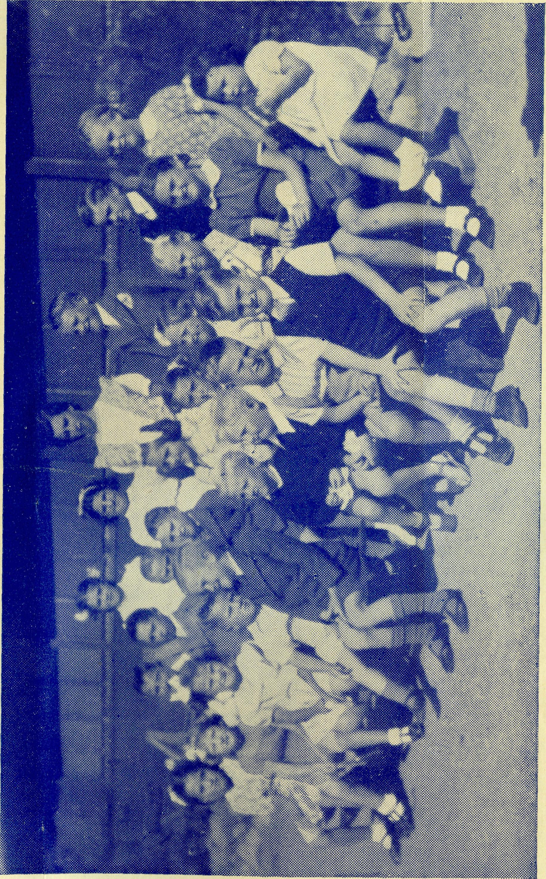
Everything looked just right — all I needed was the congregation. Well I must be patient —the people would come but time alone would tell whether the waiting was in vain.
I gazed out of the window and beyond the belt of mallee scrub caught a glimpse of a dry paddock. The sun was making its presence felt inside the little school building. The roof creaked as the iron expanded and timbers sent up their groans of protest upon the hot air.
The Sunday School at Cook S.A.
CHILDREN OF THE OUTBACK
Then over the noise of thousands of blowflies I heard the throb of a motor car engine — then came the noise of a chaff cutter —at least that is what it sounded like, but it was a truck of very ancient vintage. The dust of these vehicles was still in the air when a drooping horse slowly dragged a farm cart into the school grounds. Here was the congregation shouting greetings to each other and stamping the dust from their clothes as they came into the porch.
Now we were ready to start the service.
Around us were the blackboards — the maps — the charts and pictures used in the school. There was even the smell of chalk and plasticene to remind us of the usual function of the building. The congregation had the biggest problem because the desks were all right when they left school. But the years in between had increased the stature of the men and women who had been the boys and girls. It was a bit of a squeeze, so some settled for sitting on top of the desks. At the last moment a woman remembered the few sun scorched geraniums she had brought to decorate the school.
There was a scurry and at last someone found a pickle bottle which did justice for a vase. Now we were all ready and I announced the hymn and pumped the organ with my feet to give the music for the singing. The harmony was not exactly like that of a Cathedral Choir and the squeak from the organ bellows did not improve things but we managed to get along.
I am sure that our worship that day was received by God Himself, Who looks not upon the outward form but the inward heart.
In the outback the B.C.A. Bush Padres do their work in difficult places because they believe in the power of the Christian Faith. They know that men and women in lonely places need the ministry of God just as much as people in the city.
J.R.G.
PLEASE NOTE!
OUR NEW TELEPHONE NUMBER IS
BM 3164

