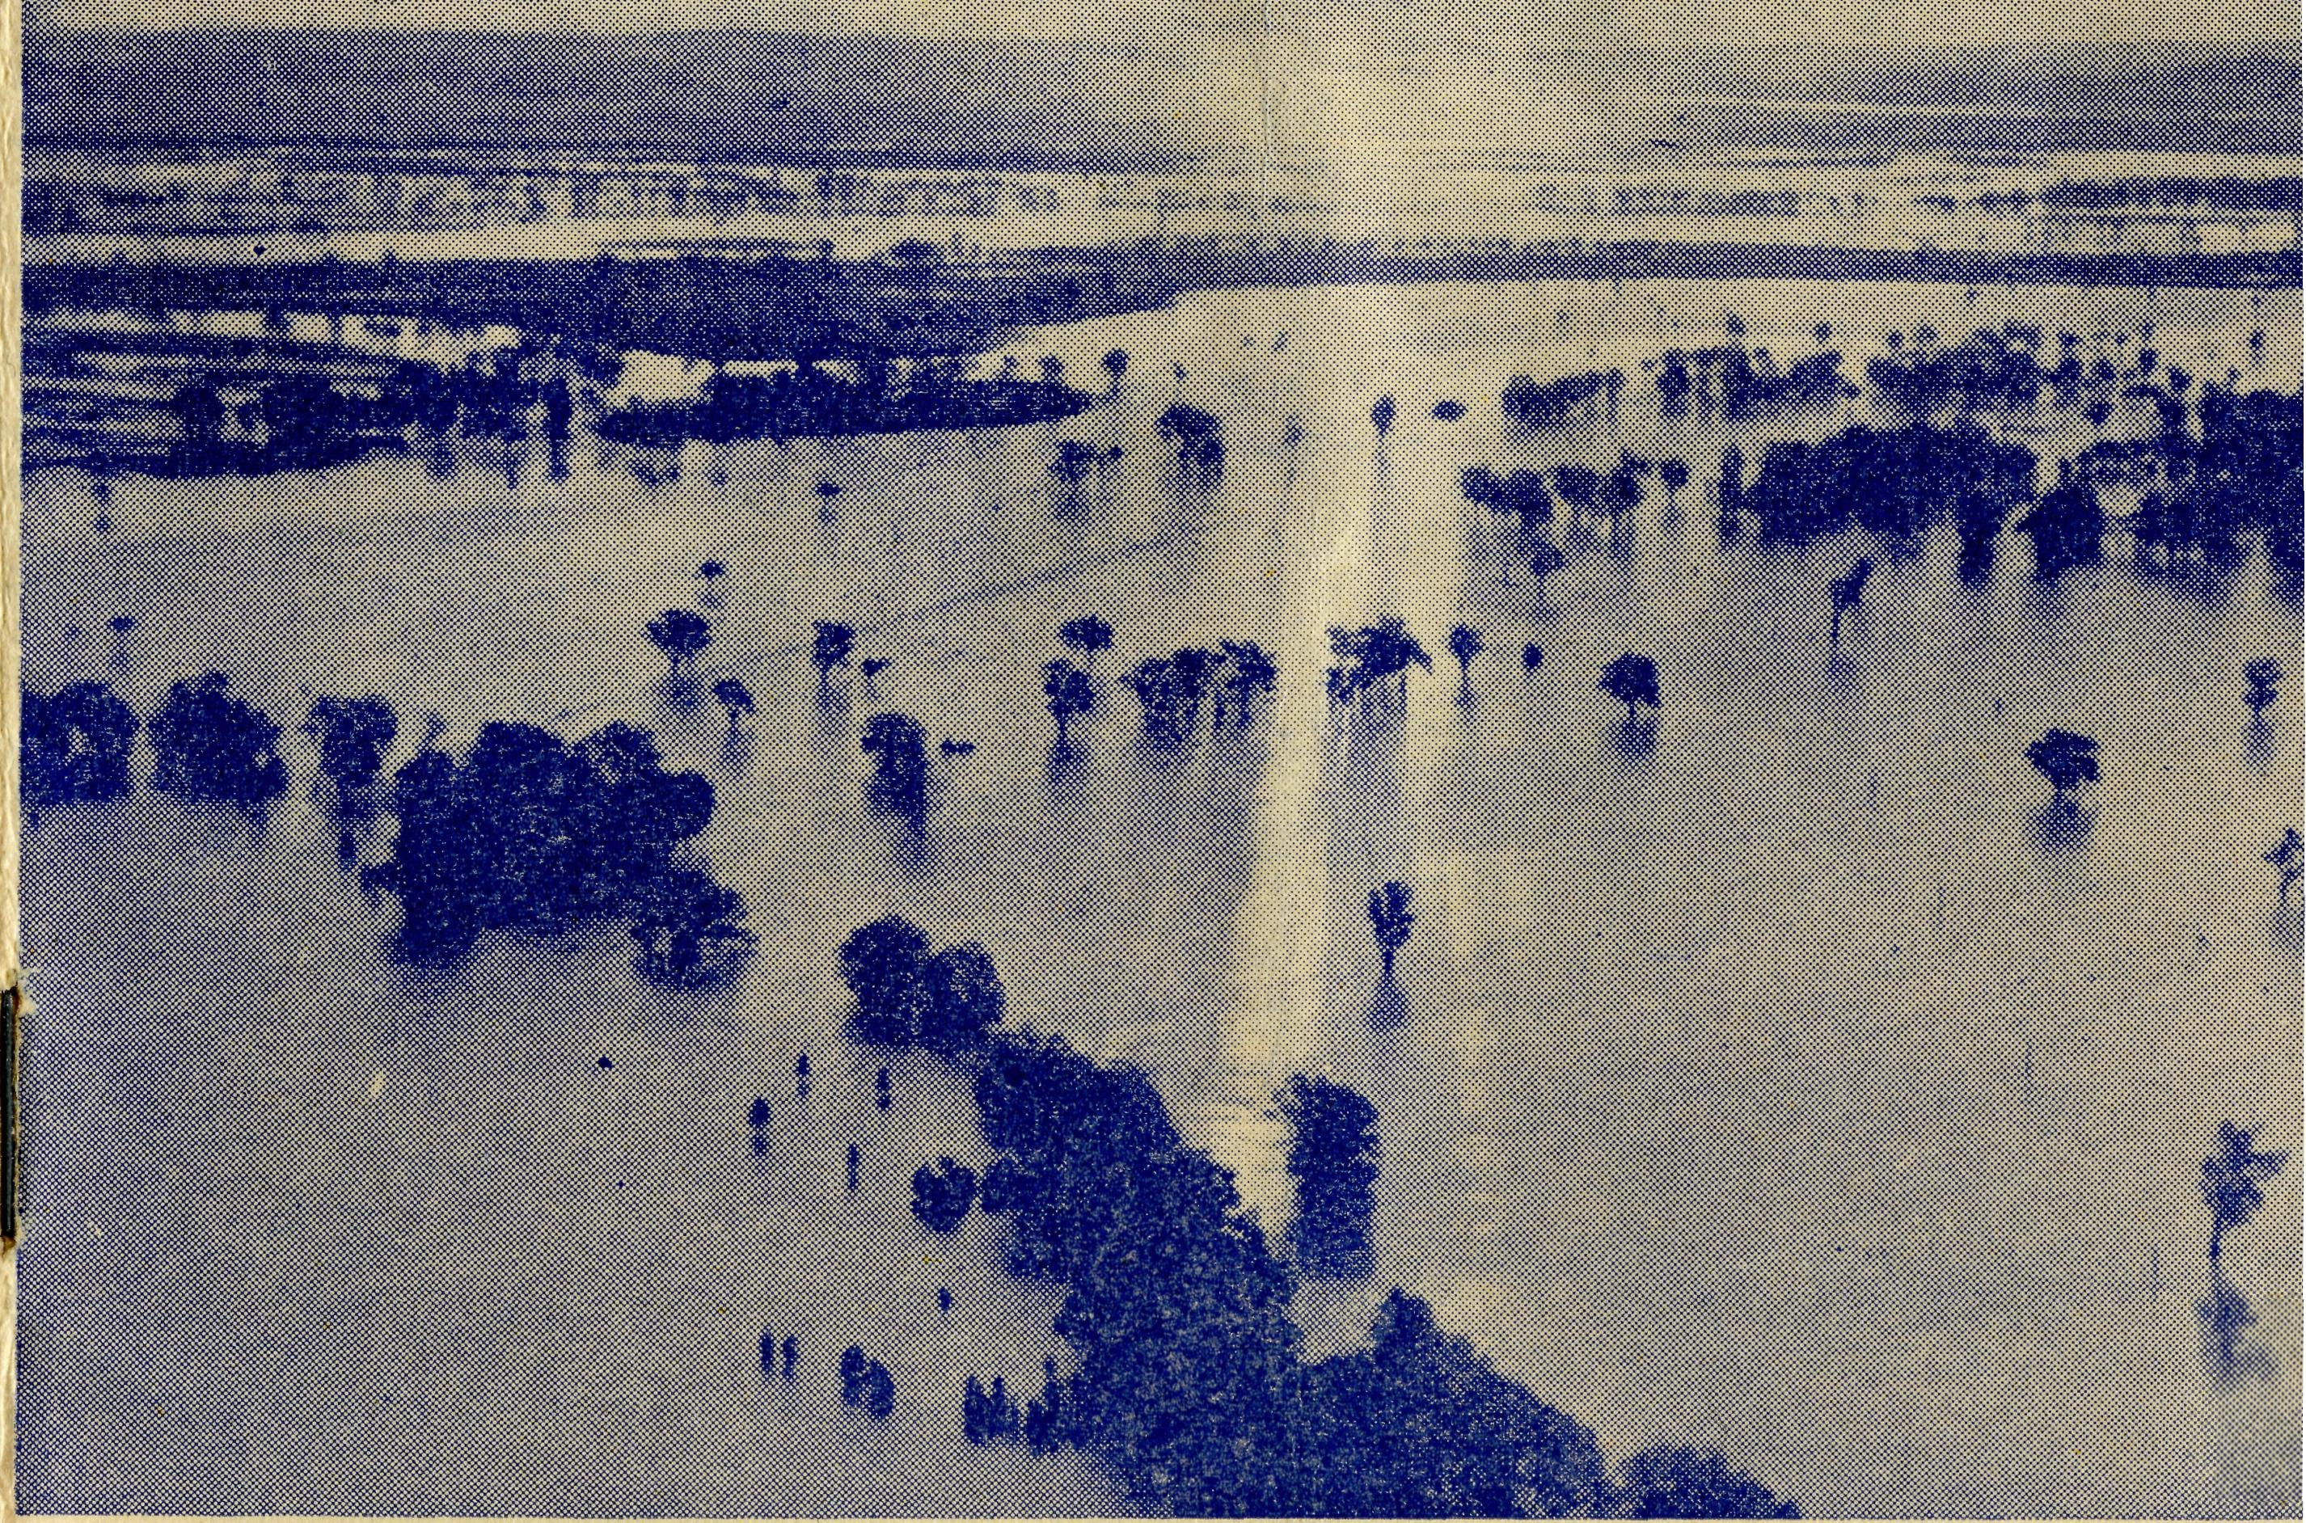
March, 1955.
SUNDAY
For all Mis-sioners and Deaconesses of the Society and their people and for all students in training. MONDAY
For all Doctors and Nurses serving in the outback, and for the spiritual and physical health of the patients under their care. TUESDAY
For all Workers in Hostels, the children under their care and the teachers who instruct them. WEDNESDAY
For the Director of the Mail Bag Sunday School, the pupils of the School and all teachers and voluntary workers.
THURSDAY
For the Fly-i n g Medical Service and the safety of the pilots and all who travel with them.
FRIDAY
For the Council of the Society, the Home Base staffs, Auxiliaries and Parochial workers.
SATURDAY
For all neces-s a r y finance needed for the maintenance of so large a ministry and for guidance in its right application.
No. 12 (New Series).
2/6 per annum, post free.
MARCH, 1955.
Topics for
Prayer and Praise
For the Society.
O Lord God of our nation, Who has commanded men to subdue and replenish the earth: Look in Thy love upon all who in distant parts of our land are striving against many difflcultits, and are deprived the access of the means of grace. Strengthen and guide the Bush Church Aid Society and all members of the staff. Cheer and comfort them in discouragement and loneliness, bless their ministrations to the good of those they serve, and grant that the message of redeeming love may thus be rooted and
g
rounded in our national life, to the glory of Thy reat Name through Jesus Christ our Lord. Amen.
For Nurses and Doctors.
O God, Who didst choose a beloved physician to set forth the life of Him Who went about doing good, grant that Thy strong tenderness and com-
S
assion may be manifest in the work of country octors and bush nurses. Make them at all times alert to be faithful, as those whom Thou hast burdened and inspired with the honour of their calling. In lonely emergencies strengthen them with confidence that, having done all they can, they may with good conscience leave the issue to Thy power working within Thy law. Make them resourceful and of sound judgment, and hearten their labours with the energy of compassion and the firmness of duty that conquers weariness. Through Him Whose power is called forth by suffering. Jesus Christ our Lord.
For Church Life in Country Districts.
O Lord, WTio art present when two or three are gathered together in Thw Name, bless, we beseech Thee, the little far-scattered groups of brethren who in our wide land meet together to worship Thee. Give them a perpetual freshness of spirit, and the power to inspire in each other holiness, helpfulness, and understanding of Thy help. Refresh with the joy of enthusiasm those who endure w^{T}eary journeys to Thy trysting place. Grant that these little companies of Thy servants may be united in the spirit of Christian charity, awaiting in love the time when there ahall be one fold and one Shepherd. Grant that the common life of all communities may be purified by this spirit of charity from all meanness, falsehood, malice and idle gossip, and grant that they who share a common lot may draw strength from each other's virtues, and in their weakness help one another, through our one Lord, Jesus Christ.
Praise.
for
For the Blessings vouchsafed to the Society, all kindly givers, for the joy of service.
Edgar Bragg & Sons Pry. Ltd. 4 Barker Street, Sydney.
By kind permission "Daily Telegraph"
Registered at the G.P.O., Sydney, for transmission by post as a periodical.
The Official Organ of
THE RUSH CHURCH AID SOCIETY
Church House, George Street, Sydney, N.S.W.

The Real Australian
March, 1955.
March, 1955.
The Real Australian

VICTORIAN OFFICE:
Bible House,
Flinders Lane, Melbourne, Victoria.
Telephone: MF 3552
Heytesbury Mission, Vic.—Rev. P. R. Cooke, Th.L., Timboon, Vic.
Otway Mission, Vic.—Beech Forest, Vic. Rev. T. Morgan.
Wilcannia, N.S.W.—Rev. J. Stockdale, Th.L.
Menindee, N.S.W.—
Rappville, N.S.W.—Rev. A. Gerlach, Th.L.
MEDICAL SERVICES.
Ceduna, S.A.—
Matron: Sister F. Dowling.
Staff Sisters J. Miller, G. Hitchcock. B. Tierney, A. Butler, M. Tarr, J. Kendall.
Penong, S.A.—Sisters L. Loane, L. Lang-tree.
Wudinna, S.A.—
Matron: Sister R. Portch.
Sisters: M. Denniss. B. Barber, V.
Brealey, F. Ellis, J. Johnson, Miss C.
Derbyshire.
Cook, S.A.—Sisters M. Horsburgh, M. Ross.
Tarcoola, S.A.—Sisters V. Holle and P. Shipway.
Cann River, Vic.—Sister I. Gwynne. Rawlinna, W.A.—Sister E. Thomas.
The Bush Church Aid Society for Australia and Tasmania
PRESIDENT: The Archbishop of Sydney.
Hon Clerical Secretary: Rev. Canon E. Cameron.
Hon. Treasurer: Mr. T. S. Holt.
B.C.A. Activities and Staff
Organising Missioner: Rev. T. E. Jones, Th.L.
N.S.W. Deputation Secretary: Rev. J. R. Greenwood, Th.L.
Victorian Secretary: Rev. E. G. Beavan, M.A.
HEADQUARTERS OFFICE:
Diocesan Church House,
St. Andrew's Cathedral,
George Street, Sydney. 'Phone: BM3164.
Cable Address: "Chaplaincy, Sydney".
STUDENTS IN TRAINING.
Mr. J. Smith. . Mr. B. Buckland. Rev. R. Brooks
Rev. A. Williams. Mr. F. D. Buchanan.
Rev. T. V. Jones
MISSIONS.
Ceduna, S.A.-Penong, S.A.—
Rev. T. J. Hayman, Th.L., Ceduna, S.A.
Rev. I. Booth, Th.L. Cowell, S.A.—Rev. D. A. Richards-Pugh,
A.L.C.D. Minnipa, S.A.—Rev. G. Fuhrmeister,
Th.L., Deaconess A. Howland. Streaky Bay, S.A.—Rev. P. Connell,
Th.Scho!. Croajingalong, Vic.—Rev. L. Luck.
Tarraleah, Tas.—Rev. W. Warburton.
MAIL BAG SUNDAY SCHOOL. Director—Miss R. Campbell.
SCHOOL HOSTELS.
Broken Hill, N.S.W.—Mr. and Mrs. A.
McLaughlin. Mungindi Boys' Hostel, N.S.W.—Mr. and
Mrs. W. Hustler. Mungindi Girls' Hostel, N.S.W.—Miss M.
Farr. Bowral, N.S.W.—Miss E. Cheers. Port Lincoln, S.A.—Miss V. Dodd, Miss
D. Duver.
ford, Mr. G. Job. Doctor*— Dr. M. Mueller, Dr. J. Upsdell
FLYING MEDICAL SERVICE. Pilots—Mr. A. Chadwick, Mr. W. Bed- Pharmacist—Mrs. G. M. Job.
Wireless Control Station Control Officer—Mr. G. Cameron
The O.M.'s Letter
The B.C.A. is faced to-day with the biggest problem it has met in its short thirty-six years of life, and this frank statement is written in the hope that you will give it your earnest consideration and support for the efforts that are to be made to solve the problem.
For Thirty-six years the society has been growing in its many spheres of activity. Some departments have grown more rapidly than others because of their very nature and the increasing demands made upon them. Others have developed more slowly because of the lack of sufficient staff, the great sums involved in capital costs or the increasing costs of maintaining them.
In its mission work, the society has not extended its work as much as it ought to have done, in view of the fact that this is the primary function.
This has not been due to any lack of opportunity, bishops are constantly placing the needs of the outback before us. The basic problem has always been lack of sufficient men offering for this work. The spiritual needs of the teeming thousands in the great cities of the continent is ever before the bishops of the Sees in which they are located, and are also ever present in the minds and hearts of the men who take Orders. This is as it should be, but to the writer it seems that such needs ought not to have so completely overshadowed the spiritual needs of our brethren in the lonely places.
The B.C.A. is constantly seeking the right type of young man for this work, and will continue to do so.
The five hostels of the Society are doing a splendid job catering for children, many of whom would otherwise be unable to obtain a secondary education, but five hostels in this big land are little more than a token gesture in the face of a great need.
That we have no more than five hostels is due to the capital costs involved in the purchase or erection of suitable buildings and the difficulty in obtaining sufficient staff to look after the children.
The Mail-Bag Sunday School could extend further its very important work, but to do so would mean greatly increased costs to finance.
The Medical Services of the B.C.A. started in a very small way. To-day they form the only complete Flying Medical Service in the world.
Over the years this side of the work has grown in a very spectacular manner. An increasing number of hospitals have been built or taken over, aeroplanes have been bought and maintained, a pharmacy came into existence, and, finally, a complete radio organisation has been created.
This has meant that the Society's financial responsibility has grown considerably and staff has been increased. The result has been that we have been dragging about £3,000 annually on ordinary income against costs.
There are those who advise the Society not to undertake any more work than existing income will pay for. Such advice if it had been followed in the past would have meant that there would have been no B.C.A. hostels and no Flying Medical Services.

The Real Australian
March, 1955.
March, 1955.
The Real Australian

In the type of work in which we are engaged growth is inevitable. It is not possible to stop at a certain point and say, "Thus far and no further". This is especially true in the field of our medical services.
If we had not been prepared to develop them to the highest efficiency the only other alternative would be to get out of this sphere altogether. Such things as aeroplanes and radio facilities simply had to be done. As Christian people we must see'that the work we are engaged in is done in the most efficient manner, or we must never start it at all.
Believing that our friends will appreciate this point of view, the council of the society has made plans to make a special drive for new friends and additional finance during the present year.
The method to be used is that of the sale of "buttons". We are seeking the co-operation of all rectors of parishes, Sunday Schools and Fellowships. For this purpose a small "button" has been prepared and will be available for sale in parishes.
Though they must not be sold house to house or on the streets, they can be sold to friends and in the parish gatherings.
If so small an amount as £20 can be raised as an average in each parish in the diocese of Sydney alone, a sum of £5000 would result. This would solve the whole problem for B.C.A.
Will you, therefore, give this scheme your full support, Take
a few "buttons" and sell them to your friends. Listen for announce
ment in your parish.
A Black Mother
Sister MILLER.
So much of our work is just the daily round that it is not easy to find something of interest to tell; but as one case has impressed me very much—that of a Mother's Love—I will tell it to you.
A few weeks ago there was an urgent call to Coober Pedy to bring down a child, a full-blooded native whose general condition was deteriorating rapidly. Just before the plane arrived there, Doctor received a wireless message that the mother was also sick, so Doctor advised her to come too. On arrival at the hospital the woman looked anything but sick, and it was very soon discovered she didn't want the child to come alone. However, we were truly grateful for her presence, as the child could only speak in their native tongue, which made our work difficult. We put both beds together on the verandah—and there squatted the little mother watching over the child. The minute the little one stirred the comforting hand would be there to soothe or move the pillow. Often in the night she would be seen bending over the child just making sure all was well.
As we watch the love and devotion that this camp native gives to her child we are reminded, afresh, of our Heavenly Father's great love for them and how He is watching and longing to help them.
Can you help them? Maybe you are not a preacher, teacher or a nurse, but God has bestowed upon us all some gifts to be used in His service. Are you using yours just where He wants you?;
Along the Trans-Line
Rev. IAN E. A. BOOTH.
Living in an outback town with its one store cum post office and a few scattered houses is often lonely, but living in a small railway camp of six houses and no store or post office can be extremely lonely. This loneliness and isolation is sometimes accentuated by the fact that all the neighbours might Le very New Australians who have not yet come to grips with the English language.
It is into such camps that my visits along 590 miles of the Trans-Australian Railway take me. To new and old Australians alike these visits, once in every three months, have become part of life on the line, and there is always a welcome for the Padre at most camps when he steps off the train.
Each house is visited, irrespective of denominational association, as, apart from occasional visits of the Roman Catholic priest, the Anglican Church is the only Church carrying on a regular ministry to these folk. In their isolation most folk appreciate the spiritual help given by the service and a chat with the Missioner.
The most difficult aspect of the work is the contact with New Australians. Most of these folk have come from the cities of Europe to the arid openness of the Nullarbor. They have not only the natural difficulties of language and life in a new country, but also those of outback isolation. A patient ear and a sympathetic understanding, involving the spending of a good deal of time, are necessary, but from this a mutual confidence arises which forms a good foundation for the work of the Ministry. Time must be spent to explain about Church life in Australia, especially helping them to understand the prayers in the services.
Last night I visited the home of a Greek family who had been in Australia only a few months. Greek folk have great difficulty in learning the English language, and these knew only the words necessary to buy their food from the Tea and Sugar train, and to understand the ganger when he gave them instructions to do their work.
I was able to give to this family a booklet of extracts from the New Testament in Greek. For over half an hour the man of the house read aloud to his family and they discussed it together while I sat with them. Many of the modern Greek words are similar in spelling to those of New Testament Greek, but how the pronunciation differs from college days!
However, every now and then I was able to discuss words with them, telling the English meaning by means of actions. They could not understand why I was not Greek Orthodox, but were quite pleased that an interest had been taken in them. At first they had thought I was a "big boss" from the Commonwealth Railways, but I departed a friend.
At another camp a German family is visited. They have now been in Australia for over two years working under contract to the Railways. The Australian way of life and the isolation of the Line are no longer a difficulty to them. However, it has been a hard two years, bringing stringent financial obligations in order to set up

The Real Australian
March, 1955.
March, 1955.
The Real Australian

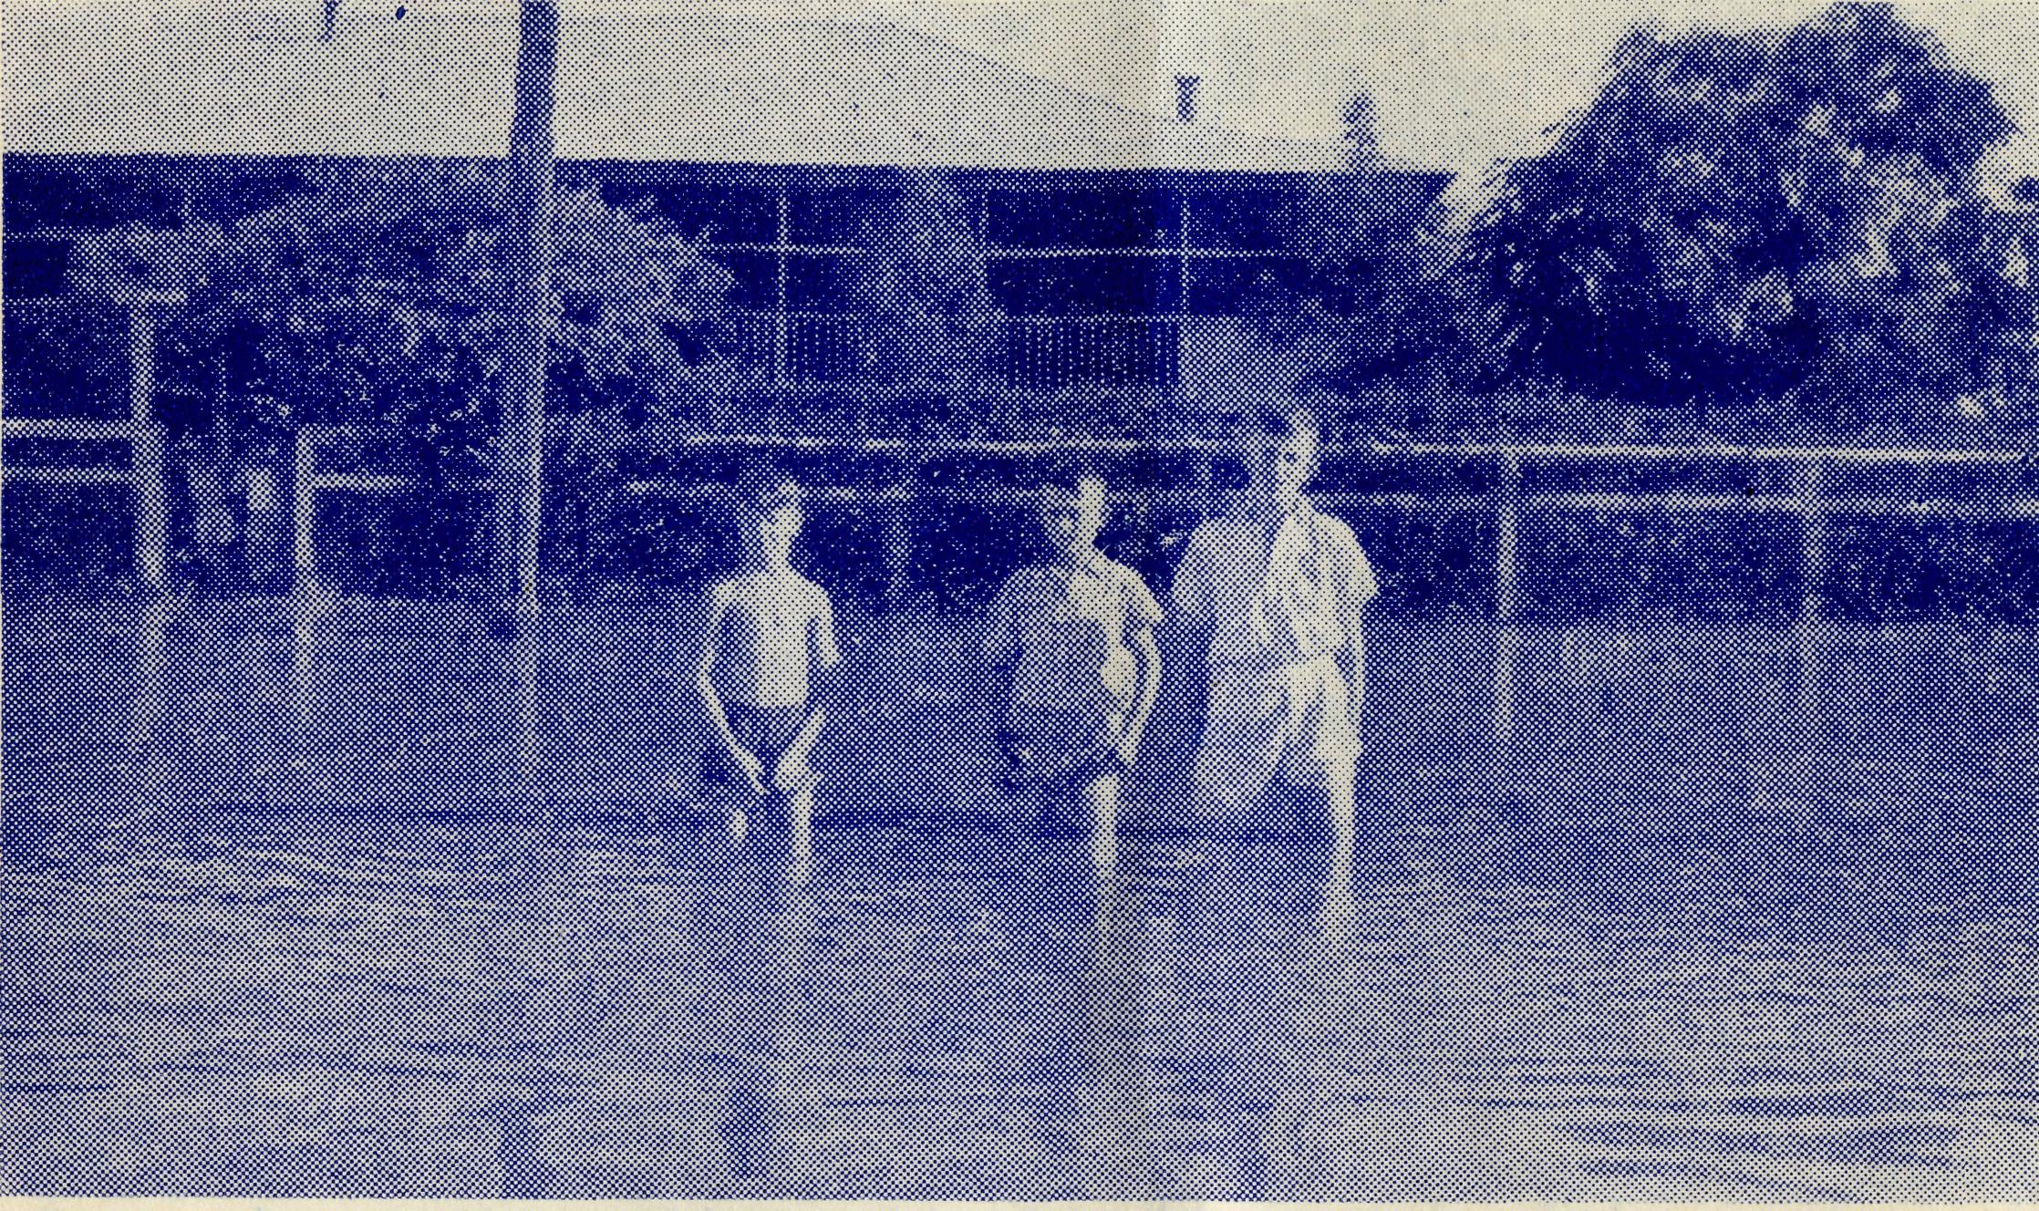
MUNGINDI HOSTEL
a new home in a new country. Their second baby had been born during this time, and he, they claimed, was a "real Australian", and so was given English Christian names, as they knew this would assist their son to be a full citizen of Australia. I was asked to baptize the baby, and after an hour or so of instruction and explanation relating to the service of Holy Baptism, was glad to be able to do so.
The Padre unofficially has become an information bureau, bringing to these new people an idea of life in Australia as a whole. Most of them have had only a short glimpse at the cities or more picturesque parts of our land. With this comes the opportunity of speaking of the Gospel, which is not for Australians only, but for the whole world.
Thus in a small way the witness of the Church can be wide in scope, even though seemingly limited by the geographical isolation of the outback.
Getting About
Rev. G. FUHRMEISTER
I had been listening on my portable transceiver to reports regarding a delayed trip to Oodnadatta and Coober Pedy by our Flying Doctor, and as weather conditions were still "not the best", I sought to furnish a report to the wireless base, for I was not far off the track the plane would take.
However, my signal, "9TG Portable—calling V.K.B.", skipped the base, but was picked up some 200 miles N.W. of Ceduna and relayed to the operator.
Eventually the two planes came as far as Coober Pedy—one to go on to Oodnadatta that afternoon with Doctor, and the other to Adelaide the next morning with a patient. During the night it rained heavily but cleared a little in the morning, and, as I was making my way to another station home the Adelaide-bound plane flew overhead and got through safely. Once again it rained at night, and on the Trans, next morning I learned that the Oodnadatta contingent had been "grounded" for a day and did not get away until later on that morning.
At the station where I stayed overnight they received over an inch of rain and brought their rainfall for the past 12 months up to about 3J inches. I went out after breakfast with the station manager in his jeep to inspect two of his dams, and although I was sprayed with mud while driving out, and had to wade through slush to get to the dam, it was well worth it to see and hear the expressions of delight at the rain caught. When a further report was received of 125 points at the east boundary, with another dam filled, the manager's face was like a full moon.
On further inspection I was told the road to my next destination was nigh impassable, and so I, too, was grounded for the day, and had to miss out visiting two homes.
The next few days of travelling were rather precarious, and along the way I came across the mail-man who had been bogged for 24 hours about ten miles out from a homestead. I was able to return him to the station I had left, and after making telephone
Some of the Hostel boys wading in the street during a previous
flooding.
communications and satisfying the inner man, I took him a further ten miles towards his destination, where we met a substitute mailman who was bringing the perishable goods out for the stations nearby.
The mail-man himself had helped out two men in a utility which had broken down while crossing a creek, and when I came upon them sitting waiting for the mail-man to return in four or five days' time with a new part, they were glad of some fresh tank water and some literature to read.
One morning while listening in to the news I heard a brief report of an outbreak of "polio" in the Minnipa district—one lad had died and a young woman was taken to Adelaide. I listened for further information on each news session, but heard nothing. So on the next transceiver session I enquired the names of those concerned, and learned that the boy was in my Religious Instruction class at school. Although it was a shock to me, I was grateful that I had been able to obtain this information and so pass on a word of comfort to the parents—even though I was nearly 300 miles from home at an outstation homestead.
Being so far away from home at such a time tends to make me somewhat anxious, were it not for the assurance of God's blessing and protection over my loved ones.
On another of my trips I found a woman with her two young children camping out with her husband and brother while they were making a fence across some very sandy country several miles out from the station homestead.

The Real Australian
March, 1955.
March, 1955.
The Real Australian

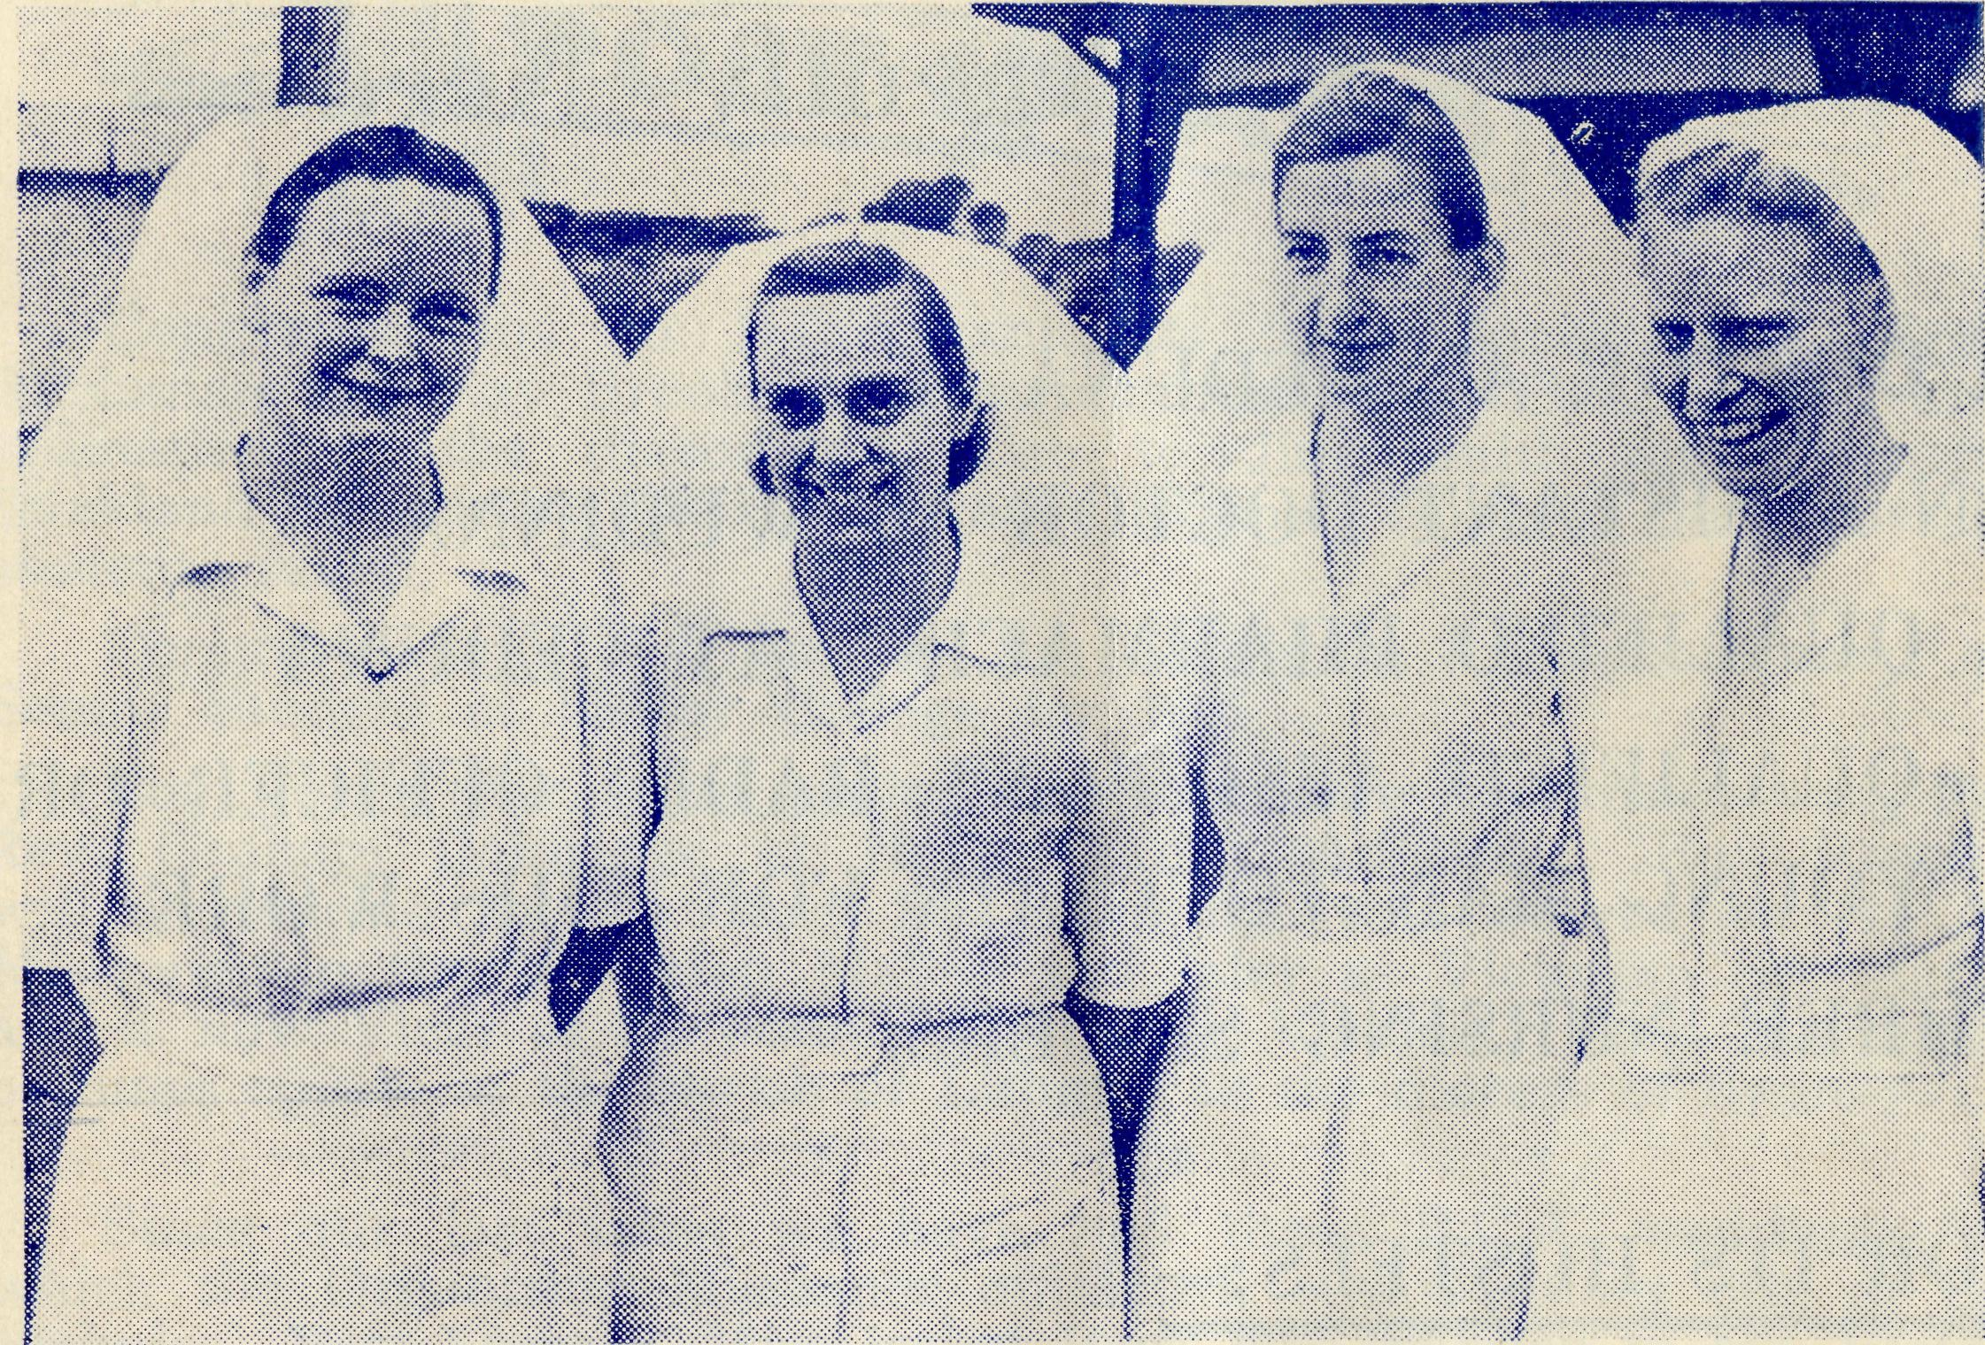
WUDINNA, S.A.
They invited my wife, two boys and me, to spend a night with them when returning from our Tarcoola trip. On arriving at the homestead we were met by the brother, who had so arranged his trip in to get supplies,, as to be there and pilot us out to the camp. The first part of the way was known to us, but after passing through a gate we were told to follow our guide through the scrub, and the camp was about two miles in. The track was so rough and winding, with overhanging branches and sandhills to be negotiated, that travelling was slow, and the way never-ending. My wife suggested that perhaps our guide couldn't count above "two". (On our return journey we checked the speedo and found him to be right!) However, we arrived safely at our destination and received a warm welcome.
Their tents were pitched in between two sandhills, but strange as it may seem the sandhills were covered with wildflowers at the time.
As there was only one table, the four children used that for their tea, while the five adults stood, using a trailer-top instead. After tea the children played, while chores were done, and were then washed and tucked into bed. One of ours was put in the front seat of the van and the other on a stretcher under a lean-to at the side. The evening was then spent sitting around the camp fire and yarning, and the day was closed with a Bible reading and prayer.
Before going to bed our hostess put on a leg of mutton to cook in a camp oven, for us to eat "on the track", and it proved to be as sweet as any we've eaten.
Next morning after breakfast the children thoroughly enjoyed the sand and picking wildflowers, and we were sorry to have to push on after morning tea. As we left we were glad to have spent a night in the sandhills, for it had been a blessing to us all.
A Hot Sunday
Rev. P. COOKE.
The missioner was in the vestry packing his books to take with him for the afternoon service. Through the door he glimpsed the flowers on the Communion Table: they too were wilting in the heat wave. The hot spell had lasted a week now, and showed no signs of abating: it was really a miracle that his wife had been able to find any flowers at all.
He thought of Bill Mitchell at Menindee and John Stockdale at Wilcannia: the heat was bad enough here in the ranges, but it would be terrific away on the open plains. He thanked his stars that the service this afternoon vv^as at Port Campbell, maybe it would be cooler by the water, though it would be a hot climb up to the church on the hill at Port Campbell.
The beach would be crowded: he could visualise the crowds lazing on the sands or swimming in the cool waters of Bass Strait. Port Campbell was full of campers at this time of the year; but
Sisters R. Portch, V. Brierly, M. Denniss and B. Barber at Wudinna.
would they come to church while on holiday? He didn't think so, on a day like this.
The books were packed, together with cassock, surplice and cloth for the table, not forgetting a kneeling mat, for the floor of the church gets hard long before the service is finished.
He walked over the lawn to the garage: the grass was dry and almost dead: it crackled as he walked on it. He looked at the tall grass growing at the back of the house. It was bright green a week ago: too green to burn off. Now it was a golden brown, blowing about in the burning wind.
He glanced sadly at his vegetable patch. Only yesterday morning he'd been proud of his lettuce, peas, beans and carrots. Now they'd "had it" and were beyond recovery. He'd have to start all over again when the rains came, if they ever did.
It was hot at Port Campbell, and nobody turned up for the service. Twenty-six miles in this heat for nothing. He went down and had a look at the beach, even the crowds on the sands looked exhausted.
Coming back along the street, he was stopped by one of his parishioners, who with some surprise asked him:
"What on earth are you doing by the beach on a Sunday— shouldn't you be taking service somewhere?" The emphasis was on the word "you"!

10
The Real Australian
March, 1955.
March, 1955.
The Real Australian

The Flying Medical Service of the B.C.A. Urgently Needs:—
A DOCTOR AT CEDUNA
AN ASSISTANT DOCTOR AT WUDINNA
A QUALIFIED PHARMACIST AT CEDUNA
A QUALIFIED ASSISTANT RADIO OFFICER OR A YOUNG MAN TO TRAIN FOR THIS WORK
THREE NURSING SISTERS. FOR ITS HOSTELS:—
A MATRON OR SUITABLE MARRIED COUPLE.
FOR ITS MISSIONS:—
TWO MISSIONERS FOR OUTBACK "PARISHES"
ARE YOU QUALIFIED TO FACE UP TO THIS URGENT CHALLENGE?
WILL YOU PRAY EARNESTLY THAT SUITABLE WORKERS WILL COME FORWARD?
REMEMBER THAT THE SOCIETY ALSO NEEDS
INCREASED SUPPORT IN ORDER TO MAINTAIN
ALL ITS VARIED ACTIVITIES.
Congratulations to B.C.A. students Tom Jones, Jnr., Fred Buchanan and Ray Brooks on passing their Final Th.L. exams, and ordination to the diaconate. Also to Jim Smith and Bernard Buckland on passing their first year's exams. None of the Society's students failed.
Congratulations also due to Jim Smith on his appointment as Senior Student at Ridley College for 1955.
Tom Jones, Jnr., after ordination, will serve his curacy with the Rev. Graham Deldridge at Holy Trinity, Adelaide. Ray Brooks will be curate to the Rev. Bill Fleming, who served as B.C.A. Missioner in the Victorian Mallee and later as Victorian Secretary, and is now Vicar of St. John's, Bentleigh, Victoria. Fred Buchanan becomes curate in the parish of Lithgow in the diocese of Sydney.
* * * * *
Since our last issue we have had three B.C.A. weddings, at which the Organising Missioner officiated. On January 6th, at St. Nicholas', Port Lincoln, Miss Isobel Beck was married to Mr. Victor Dodd. Mr. Tom Jones, Jnr., and Miss Judith Proctor were married at St. John's, Beecroft, on January 29th, and Mr. G. M. Job and Miss Esma Page completed the trio at St. Oswald's, Haberfield, on the evening of February 25th. With our congratulations go our very best wishes and earnest prayers for many blessings on them in their new life.
Our congratulations also go to the Rev. Phil Connell for securing a Second Class Honour in the examination for Th.Schol. This is no mean achievement for a man who works hard in an extensive
mission area.
* # * *
The Burwood East Auxiliary, of which the enthusiastic Mrs. Kershaw is the Secretary, raised the splendid amount of £86/14/8 during the year 1954.
Each year this circle of friends has gone on increasing its
support, and we are very grateful for their splendid help.
* * * *
We tender our thanks to the anonymous donor of a standard lamp for the use of the sister at Tarcoola. Friends of the B.C.A. have helped very considerably in the furnishings for this new hospital, and have, in this way, given great encouragement to the
local people in their big task.
* * * *
We regret to record the death of the Rev. B. B. Lousada. Ben Lousada was a pioneer of the Church in the outback, and served at Cummins in the early days, after which he went to Tanganyika with Bishop Chambers.

12
The Real Australian
March, 1955.
March, 1955.
The Real Australian
13

On his return to Australia, Ben became Missioner at Denmark, in the diocese of Bunbury, and later returned to his "mother" diocese of Gippsland.
We remember him with affection, for Ben was a lovable man.
* He * *
We welcome Sister J. Kendall to our staff. Sister found herself with four months to spare between finishing her general training and beginning her Obstetric course, and could think of nothing better to do with the time than to help ease the problem of shortage of nursing staff in B.C.A. We hope that she will enjoy her time with us.
* * * *
Since the last issue of this paper a goodly crop of brand-new Australians have arrived. Our congratulations go to: The Rev. and Mrs. Arthur Williams on the birth of a son, the Rev. and Mrs. A. Gerlach, who have a daughter, and the Rev. and Mrs. T. Hayman, who have a second son.
We much appreciate the effort made by the Normanhurst Women's Guild, who, despite an afternoon of torrential rain, rallied round and had a special afternoon for the funds of the society. We hope that their next attempt will be blessed with better weather.
* * * *
We regret to record the serious illness of the Rev. F. H. B. Dillon, and ask all our friends to remember him in their prayers, that God may lay His healing hand on him.
Sister J. Armstrong resigned from the Ceduna staff as from January last, and has entered a Sydney Bible Training College for a two-years' course. Our prayers go with her as she enters this new sphere.
* * * *
We are glad to be able to announce that the vacancy at Beech Forest has now been filled by the appointment of the Rev. Tom Morgan as missioner. Mr. Morgan brings much initiative and keenness to this work, and we are sure he will do much to build up the work of the Kingdom of God in the Beech Forest Mission. .
The Rev. Bill Warburton has begun his new work in the Hydroelectric camps in the centre of Tasmania. He will be living at Tarraleah, which will be central for this work. As this is the first B.C.A. mission in Tasmania, we shall follow Mr. Warburton's work with special interest and uphold him with our prayers.
The Rev. W. Mitchell and his family, after completing five years' service at Menindee, have entered upon their new work at Balmoral in the diocese of Ballarat. We have been grateful for the ministry that Mr. Mitchell has given at Menindee, and wish him every blessing in the parish of Balmoral. We regret that, to date, it has
not been possible to find a successor at Menindee.
* * * *
Our thanks are due to Dr. Margaret Taylor for undertaking locum duties at Ceduna while we seek a doctor for appointment to
our Flying Medical Service. Dr. Taylor is the youngest daughter of the late Rev. Stephen and Mrs. Taylor, and her family has had many associations with B.C.A. in the past. Miss Elizabeth Taylor was one of the earliest nurses of the society at Ceduna, and another sister, Miss A. Taylor, now Mrs. I. C. Mann, served on the staff of the Wilcannia hostel.
Thank you to Mrs. King, of Crescent Street, Hunters Hill, for the use of her home. A delightful afternoon was enjoyed by a good number of friends in the grounds of Mrs. King's home. The help of Mrs. D. Colvin, Rev. H. Linton and Rev. C. W. J. Gumbley contributed to the success of the Garden Party. The offering of £34 was an encouraging response to the presentation of work.
* * * *
We welcome Miss J. Bewley to the staff of the society. Miss Bewley has taken the place of Miss M. Heesh as stenographer in the Mail-Bag Office. We hope that she will be happy in this work
and find it a useful sphere of service.
* * * *
Miss Dorothy Duver, of Melbourne, has joined the staff and is now assisting Mrs. Dodd at the Girls' Hostel at Port Lincoln. Miss C. Derbyshire, also from Melbourne, has filled the long-felt need of cook-housekeeper at Wudinna. Sister J. Johnston, of Sydney, has joined the nursing staff at Wudinna and we hope that by the time this paper is in your hands Sister Jean Roberts will be serving at Ceduna.
These are very welcome additions to the Society's staff and we hope that each of them will find happiness in our work. Unfortunately they are insufficient to make up the losses of the past few months and we do need at least four more nurses and a competent married couple for hostel management.
Sister B. Barber of the Wudinna staff is at present on leave-of-
absence. She has gone off for a visit to England and we are hoping
that she will come back refreshed to a further period of service in
B.C.A. * * # *
The Wollongong Rally was a great encouragement and the good response indicative of increased interest. It was the fifth Rally and easily the best attended of all such gatherings.
The offertory of £30 was augmented by additional gifts from a number who could not attend. The grand total was almost £40. Archdeacon H. G. S. Begbie was Chairman and introduced the O.M. and the N.S.W. Secretary. The special feature, "Parish Without Gates", was presented with the B.C.A. pictures to illustrate the recorded play.
Our many friends on the South Coast are to be commended for
their interest in the Annual Wollongong Rally.
* * * *
The wireless broadcasts of the B.C.A. have been further extended, arrangements having been made for Bush Padre talks on station 2MG Mudgee on alternate Sundays at 4.45 p.m. The whole State of N.S.W. is now fully covered and we are glad to know that increasing interest is being shown in these sessions.

14
The Real Australian
March, 1955.
March, 1955.
The Real Australian
15

Streaky Bay
FLYING MEDICAL SERVICE

This year we again had a visit from a Children's Special Service Mission team. It consisted of five men and five women, the leader being the Director of C.S.S.M. in South Australia—Mr. H. A. Brown. They were here a week, and a very full week it was—and always is. I had been praying much with the children beforehand. I did want the mission to have real results.
The group arrived on Monday, 24th January, after a very busy mission at Ceduna. Monday was spent as a day of rest, and no meetings were held that day. Some kind children, about five of them, had banded together and worked hard with their crab nets on the jetty, to give the team enough crabs for their tea. And they succeeded. With the exception of one of the men—Mr. Percy Cox—everyone partook of crabs, some of them for the first time, with no ill-effects.
Work began in earnest on the Tuesday About 40-50 children gathered under the old pepper tree beside our rectory for Keenite study. They sang choruses to excellent accompaniment on the harmonium by Miss Joan Langdon, one of the members of the team. Then they dispersed each to their separate classes until Keenites were over. Afterwards swimming was the order of the day. This was the case all the week, as it was too hot for the usual games.
Then after dinner each day everybody adjourned to the beach. Mr. Brown gave the address and the attendances of children were increasingly good each afternoon The attempt of a band of bloodthirsty pirates to steal and carry off the C.S.S.M. Birthday Cake was happily thwarted, and a great deal of amusement and fun resulted from the efforts of the pirates to capture the cake.
The addresses given at the meetings were simple, straightforward gospel messages, accompanied by illustration. Many children heard the message. Many adults passing by also stopped to listen.
The co-operation of local people was a very notable feature of the mission. From the ice man who donated five blocks of ice per day for our two "fridges", to the ladies who came each morning to help Mrs. Connell prepare the dinner, everyone in any way interested in the Church's work here did something towards making things run smoothly till the mission ended on the 30th January.
During the last week-end I have travelled 220 miles to take four services. They were Harvest Tranksgiving services, but the amount of fruit and produce was small, as the year has been very dry. Grapes and figs, e.g., were very small and dried up. However, we joined in thanking God despite a very ordinary year, from a farmer's point of view, He has supplied us with sustenance for our daily physical needs, and most of all, grace and spiritual provision for our souls.
During the trip above described, the heat was terrific. The nights were hot and still, and the days were very humid. The temperature on Sunday night was 112 degrees in the kitchen of the station homestead where I stayed the night. All my parish is coastal, and as I went sweltering along I couldn't help wondering what sort of Sunday weather the other missioners at Ceduna,
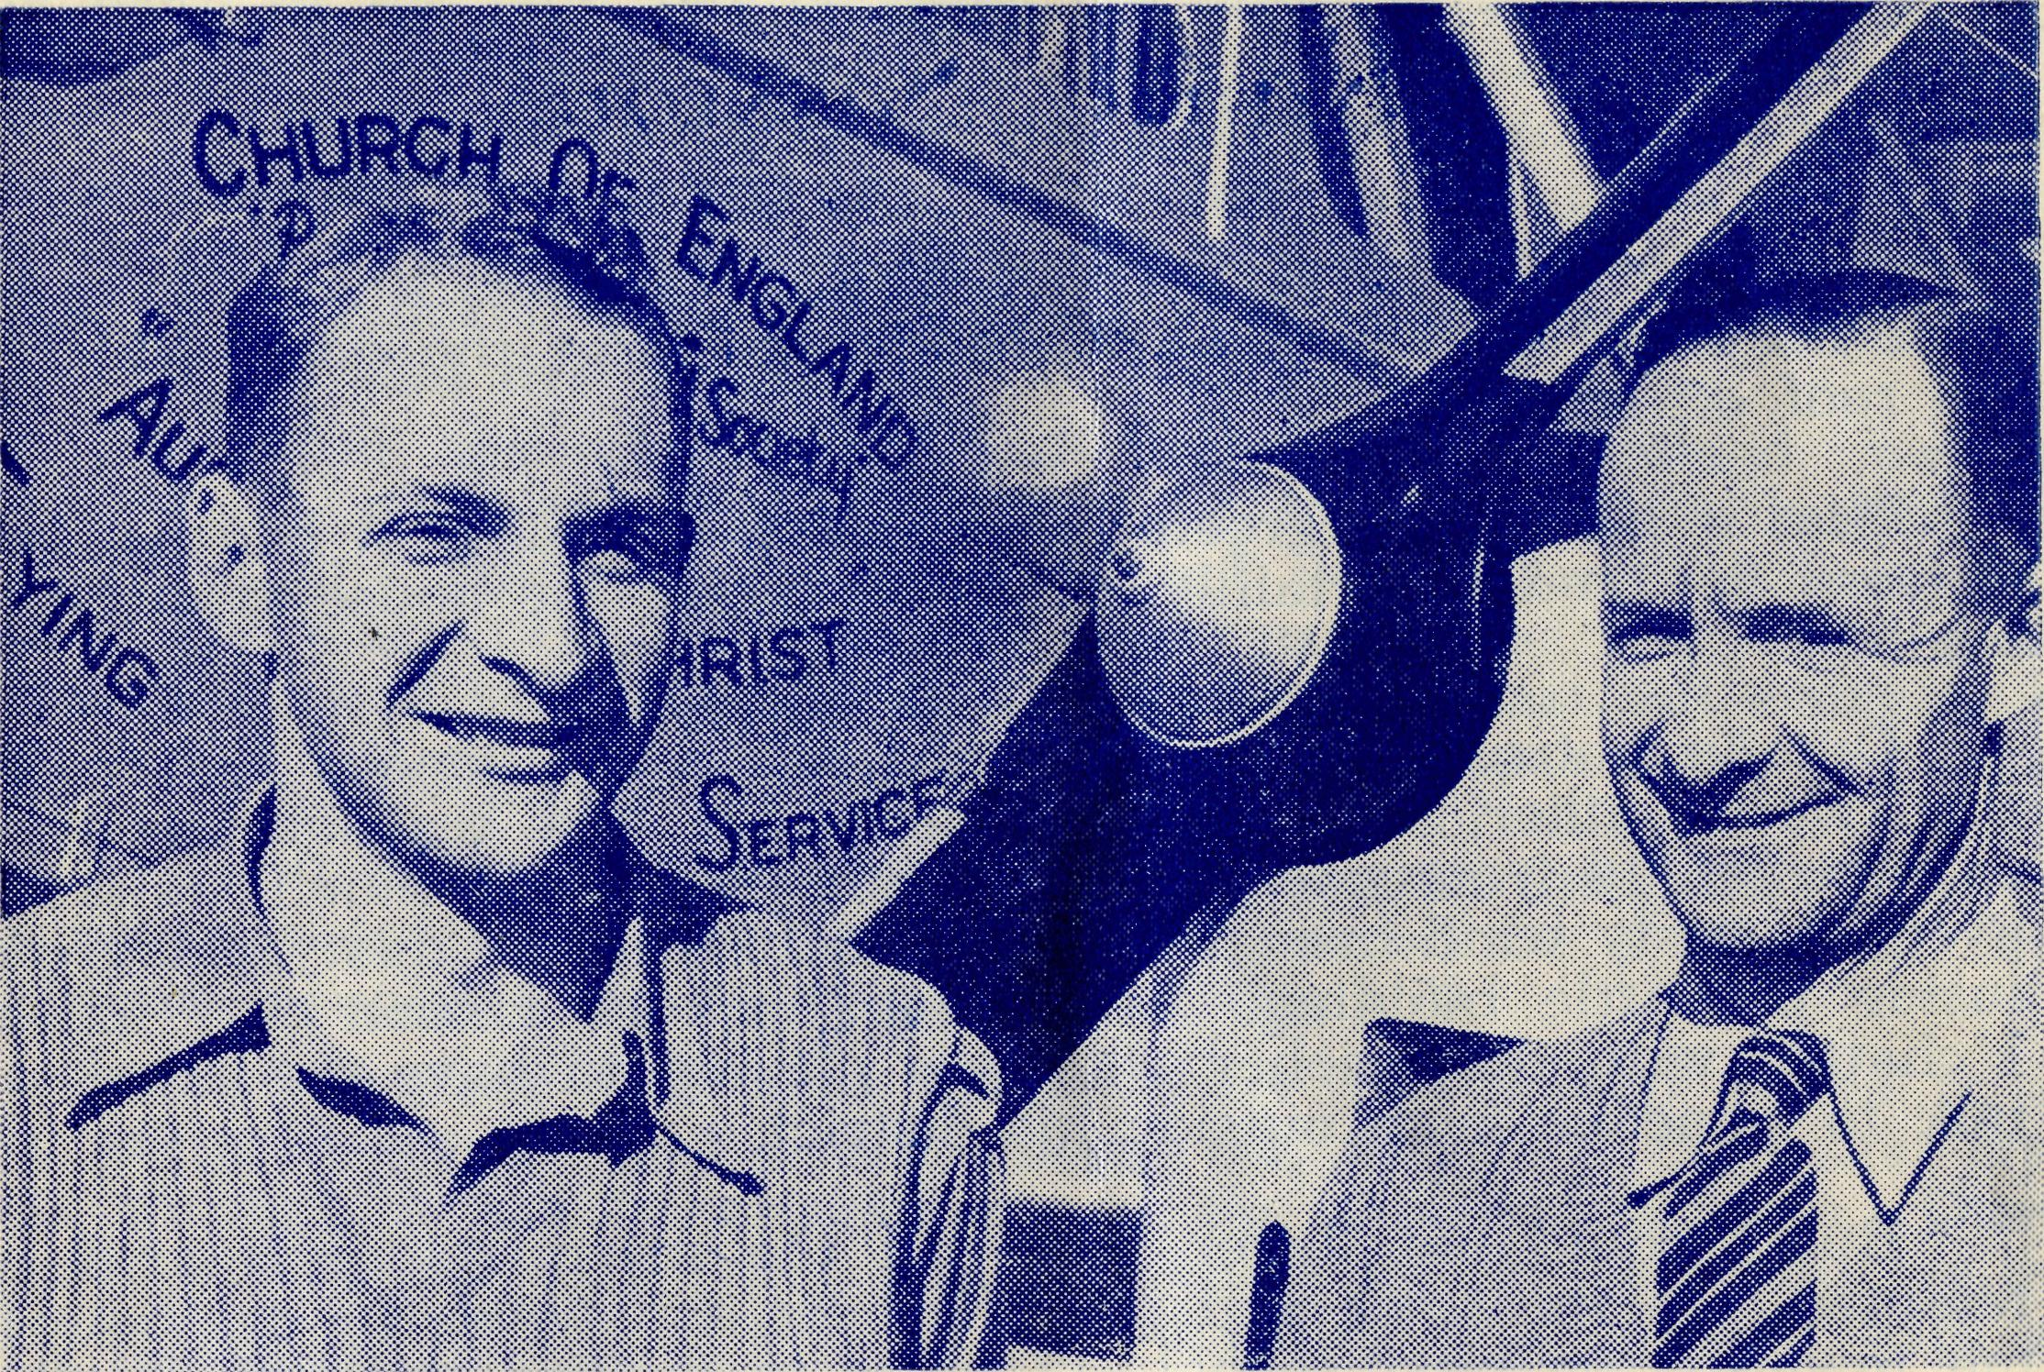
Mac. Job and Allan Chadwick, the Society's pilots at Ceduna.
Cowell and Minnipa were having for their services—equally hot or hotter, I'm sure. I arrived home on Monday at midday to find that Gladys and the children had had an equally hot day at home, and one of the children was ill. However, after a visit to the doctor he is better to-day.
God has been very good to us here, and it is a comfort to think of the certainty of the continuance of His comfort and strength for the daily performance of the work He has given us.
REMEMBER THE B.C.A. BUSH PADRE BROADCASTS-
2GB EVERY FRIDAY at 11 a.m.
2CH ALTERNATIVE SUNDAYS at 6 p.m.
2KA ALTERNATIVE WEDNESDAYS at 4.30 p.m.
2MG ALTERNATE SUNDAYS at 4.45 p.m.

16
The Real Australian
March, 1955.
March, 1955.
The Real Australian
IT

From the Bush Padre's Radio Session
"Are you there Mum—it's the parson—at least it looks like him underneath all the dust. Come inside and shut the door—it'll blow the roof off soon."
That is how I was greeted one day in the bush. It had not been an easy day and it certainly was good to see the house amongst the scrub.
Out on patrol in a .part of Australia more famous for drought than wet weather, I came to a little school. The teacher was trying to instruct 16 youngsters in an atmosphere not much unlike an oven. A gusty wind brought large quantities of the dusty playground inside the little building. After the Scripture Lesson was finished I chatted with the teacher who was pleased to have the break and talk to someone from outside his district.
But I could not linger there all the morning, much as I was tempted. Up the track and into the heat and wind the car bounced me towards the next school—12 miles to go and a rough track to make things worse.
The wind roared across the salt flats and burned everything in its track. Fallow ground was whipped into whirlwinds of dust and the flying gravel was hurled against anyone out on such a day. The dust swirled about the car as the wheels churned up the loose surface of the track.
But at last I pulled up in the shade of a stone schoolroom. The teacher came out with a cheery welcome but with the news that sickness and the stormy day had kept his school empty.
Next door in the district hall Doctor was just finishing the usual monthly clinic. Sister came over to me and I had a feeling I was about to get another job.
Above the howling of the gale came Sister's voice, "The aeroplane can't possibly take off—the storm's getting worse and we've got to get down to Penong. Can you help us?"
Well, there was nothing more for it—when people need the Doctor you have just got to get there somehow or other.
The car was turned about for a 50 mile trip with the hope that I might be able to catch up with the patrol later. We ploughed along with heavy dust making visibility very poor. The temperature went up and soon the century was passed. That, of course, did not improve things and travelling conditions became far from pleasant. The 50 miles seemed like 500 but at last there was the hospital and before we got to the door, we could feel that cool water running down our parched throats.
That was one part of the journey done but there now came the return trip to catch up with my patrol. The car was turned into the teeth of the gale and at times the gusts of wind threatened to turn over the vehicle. The air was filled with choking dust and stinging gravel. The countryside disappeared as clouds of red fury screamed through the air. For brief intervals a short stretch of road was visible and occasionally a glimpse given of some landmark. Vision was blocked for the most part of the journey and red dust covered car and driver.
The wind shifted slightly and there, straight ahead, was a clearing. A windmill was going around so fast that it looked as though at any moment it would take off in some record breaking flight. The track near the windmill could usually be seen quite well but today I had to search for it. There it was at last but every now and then the drifting sand blocked out the track and it meant another search. I had just about had enough of this when over a slight rise I could see the outline of a house in the haze. I drove straight up to the front door and that was where I received the welcome mentioned at the beginning of this talk.
"Shut the door and come inside—there'll be a cup of tea in a few minutes—you'll need it after being out there." I then saw my host through a murky atmosphere of the dust-laden room. Dust poured inside through every gap and chink in the roof and walls. There was no ceiling to stop it so everything was covered with a thick red mantle of dust.
A long-suffering farmer's wife brought in a cup of tea which certainly helped to wash away the parched feeling. She tried to apologise for the state of the house but it was obvious that nothing could be done until the storm passed away.
I thought of the women back in the cities and the many conveniences to make house work easier. Out in the bush there were no electric cleaners to suck away the dirt nor mechanical polishers to brighten up those dull floors. Just sheer hard work and much elbow grease would be the way to get the dirt out of that place.
The sun disappeared and the flying clouds of dust became thinner. A strange quietness claimed the countryside which for a. whole day had been a screaming inferno. The moon took possession of the darkness and the bare countryside looked as though it had been swept with a gigantic broom.
That night a little school nearby was the scene for our service. It was an inspiration to have a handful of people gathered to-worship and offer prayers together. Despite the terrible day they had managed to get to their monthly gathering. The sincerity of worship could not be doubted despite the atmosphere of a dusty schoolroom and the complete absence of any aids usually associated with a service in a suburban or city church,
J.R.G.
We are sorry to know that Sister Horseburgh's knee has not fully recovered from the operation she recently underwent and Sister has to return to Sydney for further treatment. We hope very much that the new treatment will prove satisfactory and that she will be able to again take charge at Cook.

L8
The Real Australian
March, 1955-
March, 1955.
The Real Australian
19

Disaster
ANNUAL REPORT

Disaster great and terrible has come to the country and outback districts. Flood waters greatly exceeding anything before known in the history of Australia have covered one fifth of the area of the State of N.S.W.
Imagine the whole of England and Wales covered with a great flood and you will have some idea of the enormity of the catastrophe that has descended on our people.
Many have lost everything they had, some even their lives.
Hundreds of thousand of sheep are dead and great numbers of cattle. Their carcases are now rotting in the hot sun that has followed the phenomenal rains. This, together with contaminated water supplies, brings the threat of disease, if not carefully guarded against.
The great merino studs which have taken over a hundred years to build up and which have been the foundation of Australia's wool industry have been decimated. It will take decades to make up the loss.
Farms which, by great courage of our pioneers, were won from the wilderness of the Australian bush have been obliterated and are now in danger of going back to the wilderness.
The waters have reached in some places as high as the tops of telegraph poles, and have spread out to places as far apart as Maitland on the coast to towns 400 to 500 miles inland, like Menindee, Bourke, Mungindi, Moree and Nyngan—and it all happened in a week!
The atom bomb could not have done more damage.
The people of Australia who live in areas unaffected by this •enormous disaster have responded in a remarkable way in generous giving to help relieve the sufferings of thousands of people.
Radio programmes have been stopped to appeal for support that has brought in a veritable flood of money. Newspapers, Churches and charitable organisations are using all their powers to cope with the rush of money, clothing and foodstuffs. But the task is so enormous that it will take years to rehabilitate all those who have lost so much.
B.C.A. friends will be anxious about the children and hostels at Mungindi. To time of writing we have learned that Mungindi is awaiting the coming of flood waters but does not expect them to be very great. However, much will depend upon whether further rain falls.
This year is the Silver Jubilee of the first hostel at Mungindi. We had hoped to celebrate the event on 24th April with special functions at Mungindi. We were also going to ask all the people in the district to help us financially.
Whether we can do this now remains to be seen, for many of the people from whom we were expecting support will have been seriously affected by the flood waters.
Please pray for all those in the stricken areas.
CENTRAL WOMEN'S AUXILIARY, MELBOURNE
Temple Day was held on 18th May in the Lady Chapel, St. Paul's Cathedral. Rev. E. G. Beavan gave, the address. Fifteen members were present. Offertory, £15/10/-. A Social Hour was spent later in the Fellowship Room, C.M.S. Arrangements were made for our work for the year.
An Australian Tea was held at the home of Mrs. Bent, Francis Street, Brunswick, on May 23. Musical items were rendered and proceeds were £7/10/6.
A Picture Night was held at Holy Trinity, Kew, on June 29, at 8 p.m. Proceeds were divided between Broughton Hall and the B.C.A. Auxiliary. Dr. Thomas, a well-known Rosian, showed pictures of gardens taken on his world tour. Our share of the proceeds was £9/12/6.
Over sixty people were present at an Australian Tea held at Christ Church, South Yarra, on the 11th August. This was the first time our Auxiliary had paid a visit to this parish. Proceeds, £28.
Our Annual Visit to St. Catherine's, Heyington Place, Toorak, was held on Saturday, 30th October. The Rev. E. G. Beavan opened the Australian Tea and Sister Page gave the address on her work at Tarcoola an Ceduna. Sister Page served B.C.A. for 19 years. Proceeds, £38/10/-.
An afternoon was held at the home of Mrs. Mundy, 8 Lyndhurst Crescent, Auburn. The proceeds were divided between the Radiant Health Club and B.C.A. and Mrs. Mundy donated the Afternoon Tea. Our share of the proceeds was £8/15/-.
The Annual Corporate Communion was held on Tuesday, 15th February, 1955. The Rev. E. G. Beavan gave the address. Offertory, £11/12/-.
An Afternoon was held on Saturday, 26th February, at the home of Miss Peterson, Essendon. This was a combined effort of the Moonee Ponds and B.C.A. Auxiliaries. Proceeds, £34. Our share, £17. The Rev. H. Raymond was in the Chair and Rev. E. G. Beavan gave the address.
We were able to send £146 to Port Lincoln for the refrigerator and we thank the Rev. E. G. Beavan for his co-operation with us in this matter.
Although we would like some new members for our Auxiliary God does supply our needs and the committee takes heart and looks forward to its work this year.
L. GOODWIN, Hon. Secretary.

