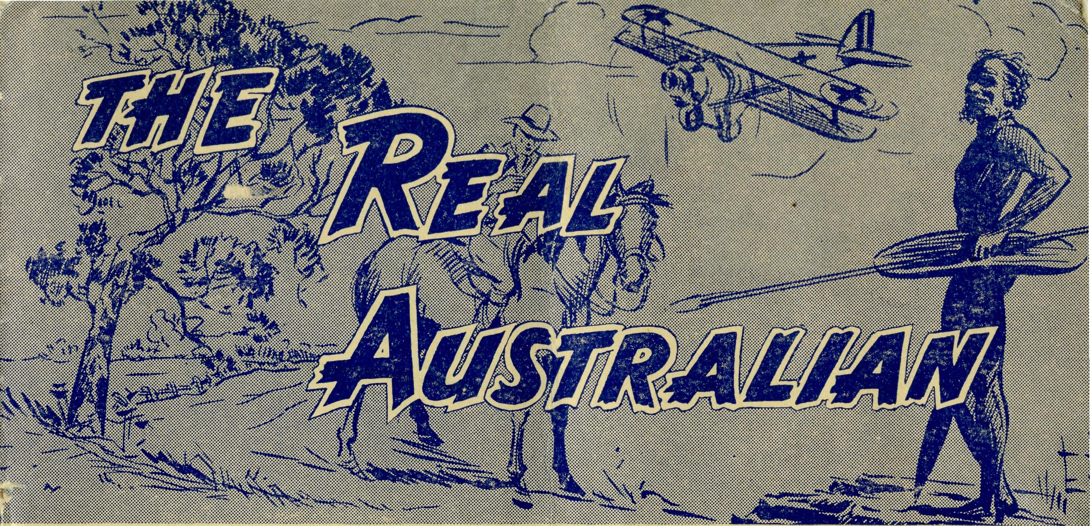
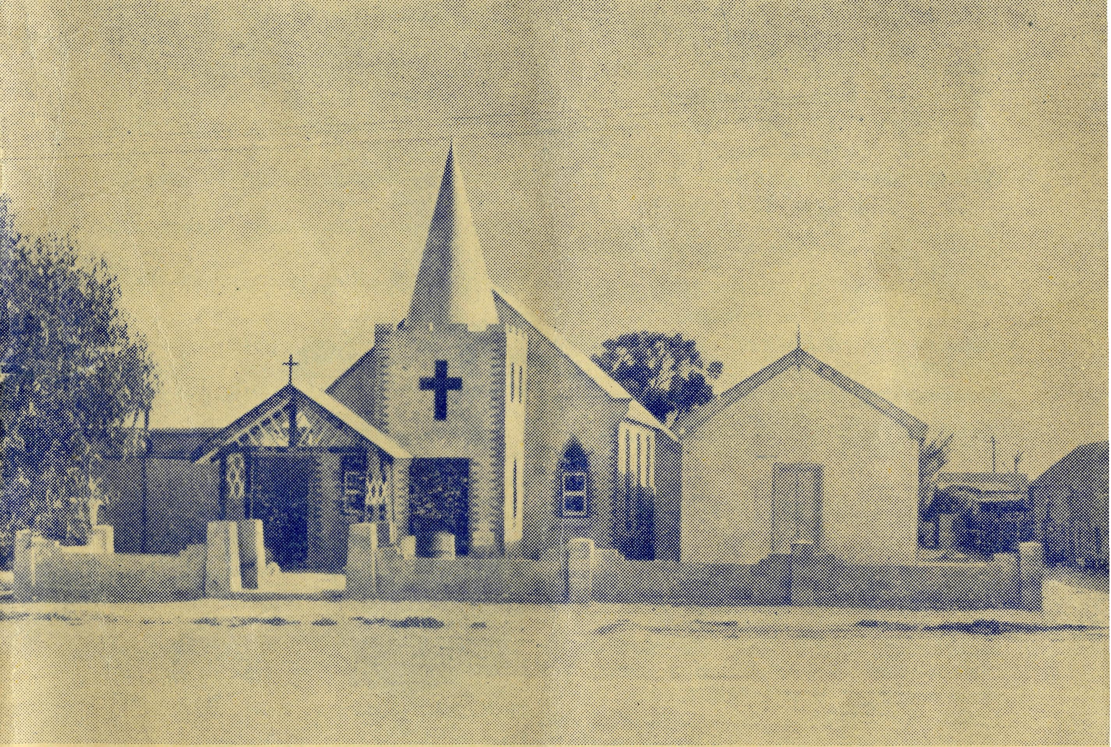
SUNDAY
For all Mis-si oners and Deaconesses of the Society and their people and for all students in training. MONDAY
For all Doctors and Nurses serving in the outback, and for the spiritual and physical health of the patients under their care. TUESDAY
For all Workers in Hostels, the children under their care and the teachers who instruct them. WEDNESDAY
For the Director of the Mail Bag Sunday School, the pupils of the School and all teachers and voluntary workers.
THURSDAY
For the Fly-ing Medical Service and the safety of the pilots and all who travel with them.
FRIDAY
For the Conn cil of the Society, the Home Base staffs. Auxiliaries and Parochial workers.
SATURDAY
For all neces-s a r y finance needed for the maintenance of so large a ministry and for guidance in its right application.
20
The Real Australian August, 1955.
Topics for
Prayer and Praise
For the Society.
O Lord God of our nation, Who has commanded men to subdue and replenish the earth: Look in Thy love upon all who in distant parts of our land are striving against many dimcultits, and are deprived the access of the means of grace. Strengthen and guide the Bush Church Aid Society and all members of the staff. Cheer and comfort them in discouragement and loneliness, bless their ministrations to the good of those they serve, and grant that the message of redeeming love may thus be rooted and
g
rounded in our national life, to the glory of Thy reat Name through Jesus Christ our Lord. Amen.
For Nurses and Doctors.
O God, Who didst choose a beloved physician to set forth the life of Him Who went about doing good, grant that Thy strong tenderness and compassion may be manifest in the work of country doctors and bush nuraes. Make them at all times alert to be faithful, as those whom Thou hast burdened and inspired with the honour of their calling. In lonely emergencies strengthen them with confidence that, having done all they can, they may with good conscience leave the issue to Thy power working within Thy law. Make them resourceful and of sound judgment, and hearten their labours with the energv of compassion and the firmness of i duty that conquers weariness. Through Him Whose power is called forth by suffering. Jesus Christ our Lord.
For Church Life in Country Districts.
O Lord, Who art present when two or three are gathered together in Th^{Tr} Name, bless, we beseech Thee, the little far-scattered groups of brethren who in our wide land meet together to worship Thee. Give them a perpetual freshness of spirit, and the power to inspire in each other holiness, helpfulness, and understanding of Thy help. Refresh with the joy of enthusiasm those who endure weary journeys to Thy trysting place. Grant that these little companies of Thy servants may be united in the spirit of Christian charity, awaiting in love the time when there shall be one fold and one Shepherd. Grant that the common life of all communities may be purified by this spirit of charity from all meanness, falsehood, malice and idle gossip, and grant that they who share a common lot may draw strength from each other's virtues, and in their weakness help one another, through our one Lord, Jesus Christ.
Praise.
For the Blessings vouchsafed to the Society, for all kindly givers, for the joy of service.
Edgar Bragg & Sons Pty. Ltd. 4 Barker Street, Sydney.
No. 13 (New Series). AUGUST, 1955. 2/6 per annum, post free
CEDUNA'S NEW CHURCH
Registered at the G.P.O., Sydney, for transmission by post as a Periodical.
The Official Organ of THE BUSH CHURCH AID SOX ETY
Church House, George Street, Sydney, N.S.W.

The Real Austjalian
August, 1955.
August, 1955.
The Real Australian

VICTORIAN OFFICE:
Bible House,
Flinders Lane, Melbourne, Victor!.
Telephone: MF 3552
P. R.
Heytesbury Mission, Vic.—Rev. Cooke, Th.L., Timboon, Vic.
Otway Mission, Vic.—Beech Forest, Vic.
Rev. T. Morgan, Th.L.
J. Stockdale,
Menindee, N.S.W.—
Rappville, N.S.W.—Rev. A. Gerlach, Th.L. Orroroo, S.A.—Rev. I. Booth, Th.L.
MEDICAL SERVICES.
Ceduna, S.A.—
Matron: Sister F. Dowling.
Staff Siste-s J Miller. G Hitchcock, B.
Tierney, A. Butler, M. Tarr, J. Roberts.
Penong, S.A.—Sisters L. Loane, L. Lang-tree.
Wudinna, S.A.—
Matron: Sister R. Portch.
Sisters: M. Denniss, V. Brealey, JF. Ellis, J. Johnson, Miss C. Derbyshire. Cook, S.A.—Sisters V. Holle, M. Ross. Tarcoola, S.A.—Sister P. Shipway.
Cann River, Vic.—Sister I. Gwynne. Rawlinna, W.A-- Sister E- Thomas. On Leave—Sisters B. Barber, M. Hors-burgh.
The Bash Church Aid Society for Australia and Tasmania
PRESIDENT: The Archbishop of Sydney.
Hon Clerical Secretary: Rev. Canon E. Cameron. Hon. Treasurer: Mr. T. S. Holt.
B.C.A. Activities and Staff
Organising Missioner: Rev. T. E. Jones, Th.L
N.S.W. Deputation Secretary: Rev. J. R. Greenwood, Th.L.
Victorian Secretary: Rev. E. G. Beavan, M.A.
HEADQUARTERS OFFICE:
Diocesan Church House,
St. Andrew's Cathedral,
George Street, Sydney. 'Phone: BM 3164.
Cable Address: "Chaplaincy, Sydney".
STUDENTS IN TRAINING.
Mr. J. Smith. Mr. B. Buckland. Rev. R. Brooks
Rev. A. Williams. Mr. F. D. Buchanan.
MISSIONS.
Ceduna, S.A.-Penong, S.A.—
Rev. T. J. Hayman, Th.L., Ceduna, S.A.
Wilcannia, N.S.W.—Rev.
Th.L.
Cowell, S.A.—Rev. D. A. Richards-Pugh, A.L.C.D.
Minnipa, S.A.—Rev. G. Fuhrmeister, Th.L., Deaconess A. Howland.
Streaky Bay
Th.Schol.
S.A.—Rev. P. Connell,
Croajingalong, Vic.—Rev. L. Luck. Tarraleah, Tas.—Rev. W. Warburton, Th.L.
MAIL BAG SUNDAY SCHOOL. Director—Miss R. Campbell.
SCHOOL HOSTELS.
Broken Hill, N.S.W.—Mr. and Mrs. A.
McLaughlin. Mungindi Boys' Hostel, N.S.W.—Mr. and
Mrs. S. Colefax. Mungindi Girls' Hostel, N.S.W.—Miss M.
Farr. Bowral, N.S.W.—Miss E. Cheers. Port Lincoln, S.A.—Miss V. Dodd, Miss
D. Duver.
FLYING MEDICAL SERVICE. Pilots—Mr. A. Chadwick, Mr. W. Bed- Pharmacist—Mrs. G. M. Job.
ford, Mr. G. Job. Wireless Control Station
Doctors— Dr. M. Mueller, Dr. J. Upsdell Control Officer—Mr. G. Cameron
The O.M's Letter
My first word must be of thanks to those readers of this magazine who so very readily responded to the statement of the society's position made in. this letter in our last issue.
The monetary gifts sent to the Head Office have helped very appreciatively to ease our position and relieve our anxiety.
Efforts are now being made in both New South Wales and South Australia to consolidate the B.C.A. work by special appeals.
In the Diocese of Sydney 116 parishes have signified their willingness to raise additional financial support by means of a "button" appeal. Attractive "buttons" have been made and supplied to the parishes, together with special literature.
The effort began in N.S.W. on Sunday, July 3, and many parishes have already sold their quota of "buttons", but we hope that this will be but a start and that there will be a generous response by direct giving from many of our church-people. Our aim is to raise an extra £3000 in this way, in New South Wales.
From remarks that have been made to the O.M. it would appear that there are an appreciable number of church-people who have the idea that B.C.A. is one of those very rare organisations that have no financial worries, and that somewhere there is tucked away a gold mine into which we can dip whenever the circumstances warrant so doing.
It is true that apart from such appeals as that for the memorial to the late Bishop Kirkby, B.C.A. has never launched an appeal for funds saying that it must have a certain amount on or by a certain date. But, the society is in very truth, a venture of faith.
The only gold mine we possess is that to be found for all Christian people in the providence of Almighty God, and the love and goodwill of His people. The society lives day by day in a very real sense. Each month there is almost £2000 to be found for salaries of the various staffs and travelling and other grants to missions.
The expenses of the Flying Medical Services go on day in and day out and must be found out of day to day revenue or there is a debit balance at the bank.
For those who are interested in the relation of overhead costs to money spent in field work, I would like to say that the overhead in B.C.A. administration so far as it is possible to fairly apportion it, is 12J per cent, of income. This is, as I am sure you will agree, very low.
We are also making our first State-wide appeal in South Australia. The Organising Missioner has been able to secure the splendid co-operation of the editors of four South Australian newspapers. They are the Adelaide Weekly Mail, the Port Lincoln Times, the West Coast Sentinel and the Cowell Tribune. -';.':
During the month of July these newspapers have featured the work of the B.C.A. Flying Medical Services and have appealed to the people of their State to give it special support. Five District

The Real Australian
August, 1955,
August, 1955.
The Real Australian

Councils have granted permission for "Button" Days in their areas and have started off the appeal in their districts with a special donation.
As a result "Button" Days have been held in Ceduna, Penong, Minnipa, Wudinna, Kyancutta, Streaky Bay, Cowell, Cleve, Kimba and Port Lincoln, and other efforts, such as street stalls have been arranged. It will take some little time to finalise the result, but in the first few days of the South Australian appeal over £1400 is in hand.
To those of us to whom falls the task of organising this effort, the greatest joy has come from many expressions of goodwill that have accompanied the gifts. Undoubtedly, the work that B.C.A. has done in South Australia has found a special place in the hearts of many people. We are glad to know that the society stands so high in their affections.
Almighty God has been good' to us all through the years. He has blessed the works of our hands, and has met all the needs. We know He will not fail now.
I write this sitting before a fire in the sister's sitting-room at Ceduna hospital. It was my joy this afternoon to meet the parents of a girl of fifteen who for six weeks had been a patient in this hospital. They had come over a hundred miles to take the daughter back home, but a few weeks ago they came here because they thought that she had not long to live, for she was gravely ill.
Today, they went home a happy, united family, and as they went, Sister said, "It's a miracle." In thirty-two years there have been many miracles in this place. Almighty God has wrought them by the hands of His servants. You and I can, if we will, continue to make them possible, by our prayers, by our work and by our giving. God grant we may never fail.
Women s Auxiliary Annual Report, 1955
Another year has been completed in the life of the Women's Auxiliary of the Bush Church Aid Society and all the members feel it has been a happy and successful time. We have been fortunate in securing several new members and we are glad to welcome them to the Auxiliary. Each month the meetings have been held and on different occasions we have had Mrs. Booth, the wife of one of the Padres of Ceduna, to tell of her life in the work of the B.C.A. and also Sister Loane giving a first-hand account of hospital work. One of our members, Mrs. Bragg, was able to go to Ceduna for the opening of the Radio Base, and on her return gave us a most interesting account, not only of the Radio work, but of all the different B.C.A. centres she visited.
Our biggest effort of the year was the fete held in August, and so gratifying was the result that this year we are going to make a greater effort. We are most grateful to all those who helped
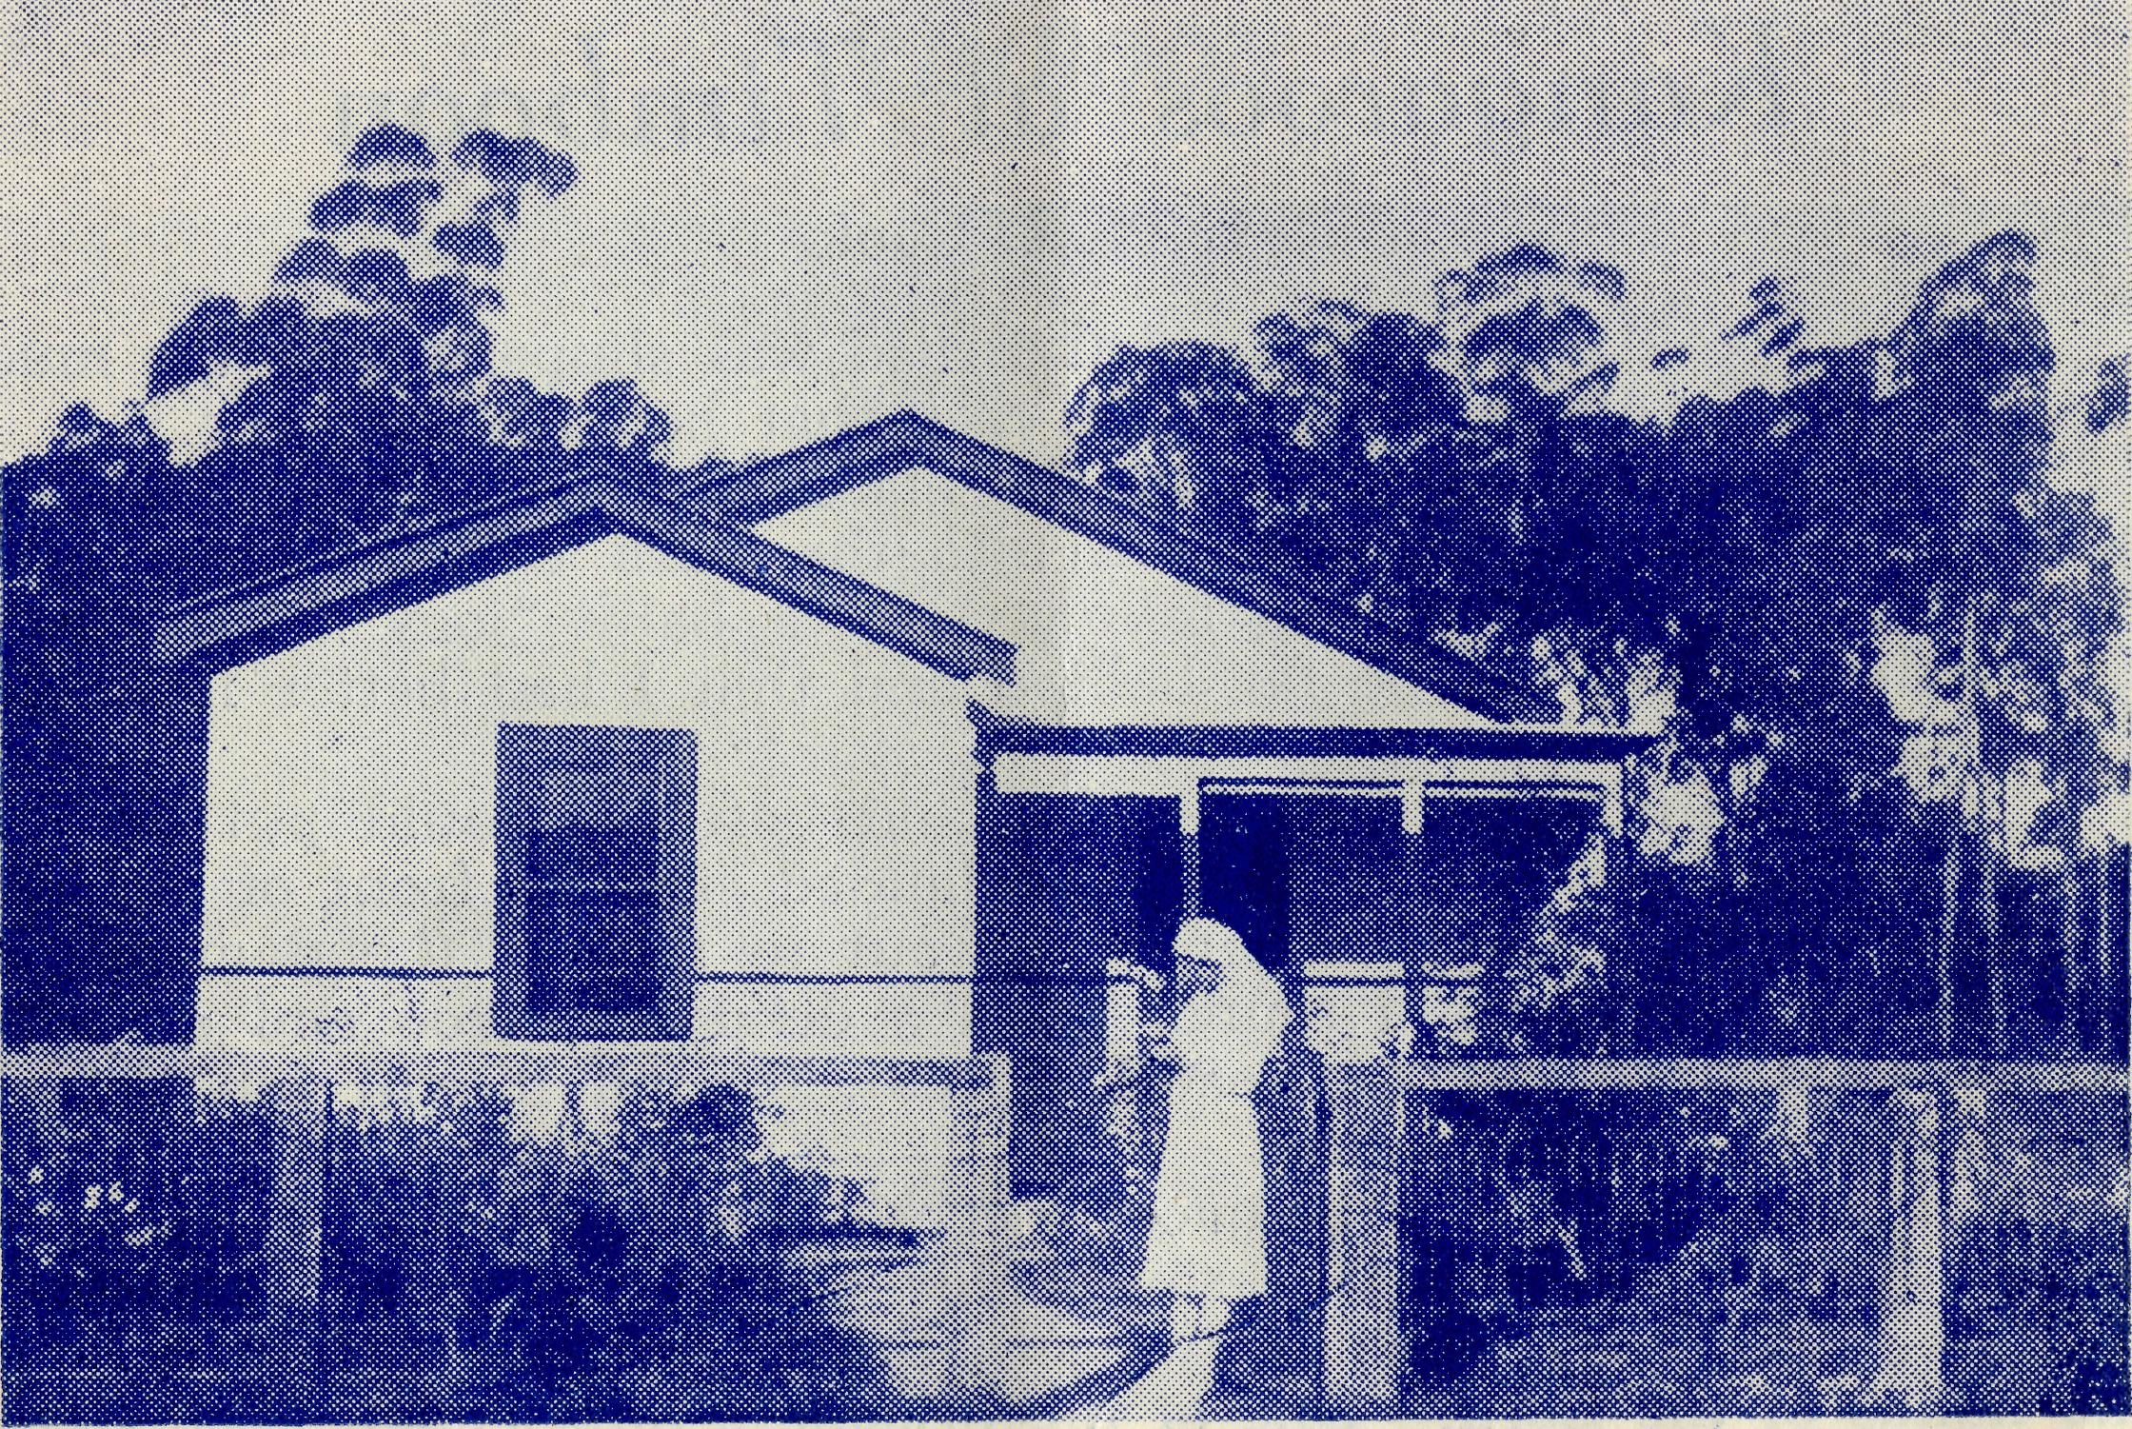
Sister Gwynne and the Dispensary, Cann River.
and especially the different parishes and guilds who sent gifts for sale.
Our president, Mrs. A. Colvin, and the Rev. Hugh Linton were able to arrange a very happy Garden Party at Hunter's Hill, thus helping to interest another parish in the work of the B.C.A..
During the year we were able to purchase necessary equipment for the Hostel at Bowral; bedspreads for Mungundi Hostel; operating gowns and steel bowls for hospital work, as well as pass in to Head Office financial aid to help with the Flying Medical Service and other B.C.A. work.
Mrs. Greenwood's ability to sell pottery during the year has been of great help to us and we thank her for her constant work.
The Auxiliary of Burwood East, and Guilds of Eastwood, Cremorne and Harris Park have continued to give us much financial support and we give them our most sincere thanks.
A feature of our meetings each month has been the talk by either Mr. Jones or Mr. Greenwood to give us up-to-date news of the work of the Society and we are most grateful to them for the time given to us.
To all those others who have helped us with prayers and gifts we say a sincere "thank you".
SEND YOUR GIFT TOWARDS THE EXTRA £3000

The Real Australian
August, 1955.
August, 1955. The Real Australian 7

TIMBOON
Kangaroos at Timboon
Rev. P. R. Cooke
It was a cold, wet night and the road was slippery with the mud churned up by the wheels of the cars that had passed over it.
A big kangaroo, attracted by the glare of my headlights, jumped across the road and disappeared into the bush on the other side. A few seconds later it was followed by a baby "joey". I realised that father would not be far behind and that I had better look out for him.
The thought had come too late and before I could put on my brakes an enormous "Old Man" 'roo landed right in front of me and I stopped with a thud. When I got out to inspect the damage, as the rain poured down, I found I had a dead kangaroo and a badly dented mudguard, plus a headlight that, though it still functioned, was badly out of alignment.
Kangaroos can be a menace in many ways. At the prison-farm In my district recently, they sowed down a crop of oats. The officer told me, "We have finished the job, thank goodness. Now it is in the hands of the Lord." One of the prisoners interjected, "Too right, and when it comes up, it will be in the hands of the kangaroos."
I heard a really delightful story about kangaroos. You probably know that in country districts mail is sorted at the post office and placed in canvas bags with a lock on them.
The mailman takes them out and as he passes the front gate of each homestead, he throws them out to be picked up by the folk at their convenience. On his return journey he collects them at the gate with any letters to be posted locked inside of them.
On one occasion the mailman was duly throwing out the bags here and there, when a bored passenger from the city asked him what the idea was, and who would collect them.
The mailman replied, "It's the folks' mail; they have trained the kangaroos to collect the bags and take them to the house." This was a bit too impossible even for the city slicker, but just at that moment a small kangaroo hopped out of the bush and stood staring at the mailcar, while standing on the mail-bag.
The mailman waved his hand and called out, "Nothing else today, mate", and drove on. Heaven alone knows what stories that city man told his friends.
People are much the same everywhere, it is only the conditions that are different. Whereas people live almost on top of one another in the cities, here they are miles apart.
Recently, one of my families went for swim in the lake in the
cool of the evening. It was Christmas Day, and as so often happens
in Australia, it had been a very hot day. .
The whole family of mum and dad and the four children had attended Communion at 7.30 and then had spent a happy day together, doing the minimum of chores and enjoying family companionship. In the late afternoon they finished the evening milking, for they are dairy farmers.
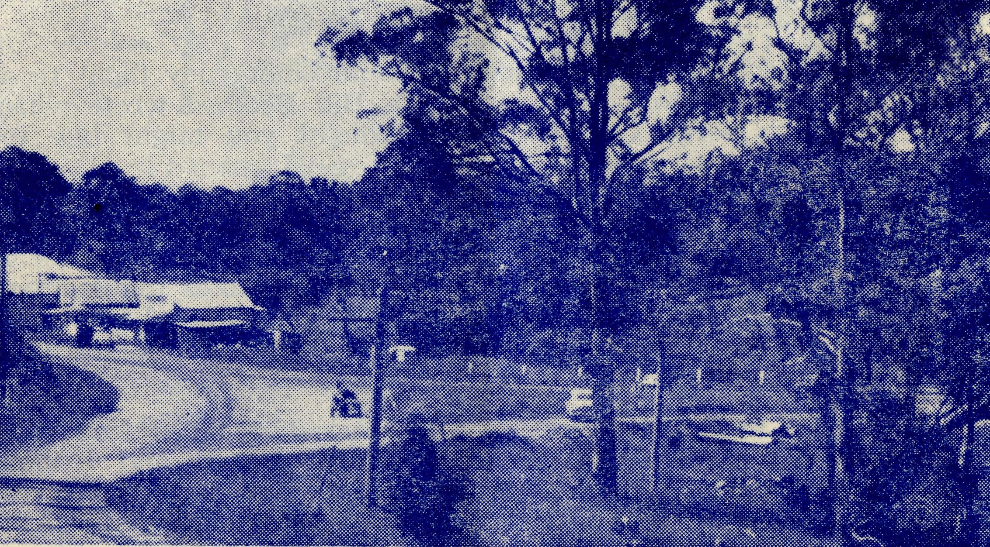
This is the road winding down from the Vicarage into the little village of Timboon.
Dad decided on a cooling swim and dived into the water. The seconds passed and he did not come up. Mum began to get alarmed. There were not many people in the vicinity, but what there were came in answer to the alarmed cries of the family.
One or two of the men tried to revive dad but all their efforts proved to be fruitless, and on Christmas Day sorrow enveloped that little family and mum was left to care for four small children and manage a bush block that still needs many improvements. Her eldest child is seven years, and mum has decided not to give up, but to try and continue with the block and milk thirty cows herself twice every day, until she can find some suitable lad to help her.
These tragedies happen all the world over, but somehow they seem nearer to us in the bush. Perhaps it is because we live nearer to our people and get to know them more intimately. On the other hand, this very intimacy enables us to help them much more than would be possible if they were simply one of many thousands in a crowded city.
Pray for them, and pray for us to whom is given so splendid a ministry that we be found ready at all times to be a comforter to our people and a guide to Him who understands all their needs.
AN EXTRA £3000 BEFORE CHRISTMAS

The Real Australian
August, 1955.
August, 1955.
The Real Australian

The Story Behind a Flight
EDITOR'S NOTE:
Sometimes the pilot's preparations for an emergency flight to a lonely homestead is very interesting. Mr. Bill Bedford wrote what follows to Mr. George Cameron, who thought you might like to read it.
# # #
On Tuesday morning Dr. Upsdell rang me up and asked me what I thought about a flight to Scrubby Peak. I told him that I didn't like the idea of landing on one of the salt lakes unless they had dried up sufficiently for a car to run over. However, I went out and circled the lake and received a signal from the ground warning me not to land.
I managed to find a convenient paddock two miles from the homestead, and put the Auster down safely. Doctor and I then marked out a single strip the required length and he ran his car up and down it a number of times so that I could find it the next day.
The next morning doctor told me that the trip would be required to move the patient to Adelaide and when I landed on the strip, I found that Mr. Staley and some of his men had improved the surface by filling in the rabbit warrens and many of the depressions. They had also lit a number of fires in order to keep the smoke signals going in order to give me the wind direction.
I made the landing in almost "no wind" conditions and with full flap, was able to land at about 40 miles an hour. The patient was duly "loaded" and with Sister Ellis we set off for the non-stop trip to Adelaide.
The emergency strip was hardly wider than the wing-span of Auster and we taxied between the stumps and the rabbit warrens but got away safely with a few yards to spare.
There was a good deal of turbulance and we bumped about a bit in the air, but did the trip quite safely and found the ambulance waiting for us at Adelaide.
A "cuppa" and a sandwich and we were soon on our way back to Wudinna where I deposited Sister Ellis and then came on to Kyancutta and home. I had asked for the lightest sister because of the shortness of the hastily prepared air-strip at Scrubby Peak and as Sister Ellis qualifies for that, she had been selected for the journey.
SEND A DONATION TO B.C.A. — NOW !!
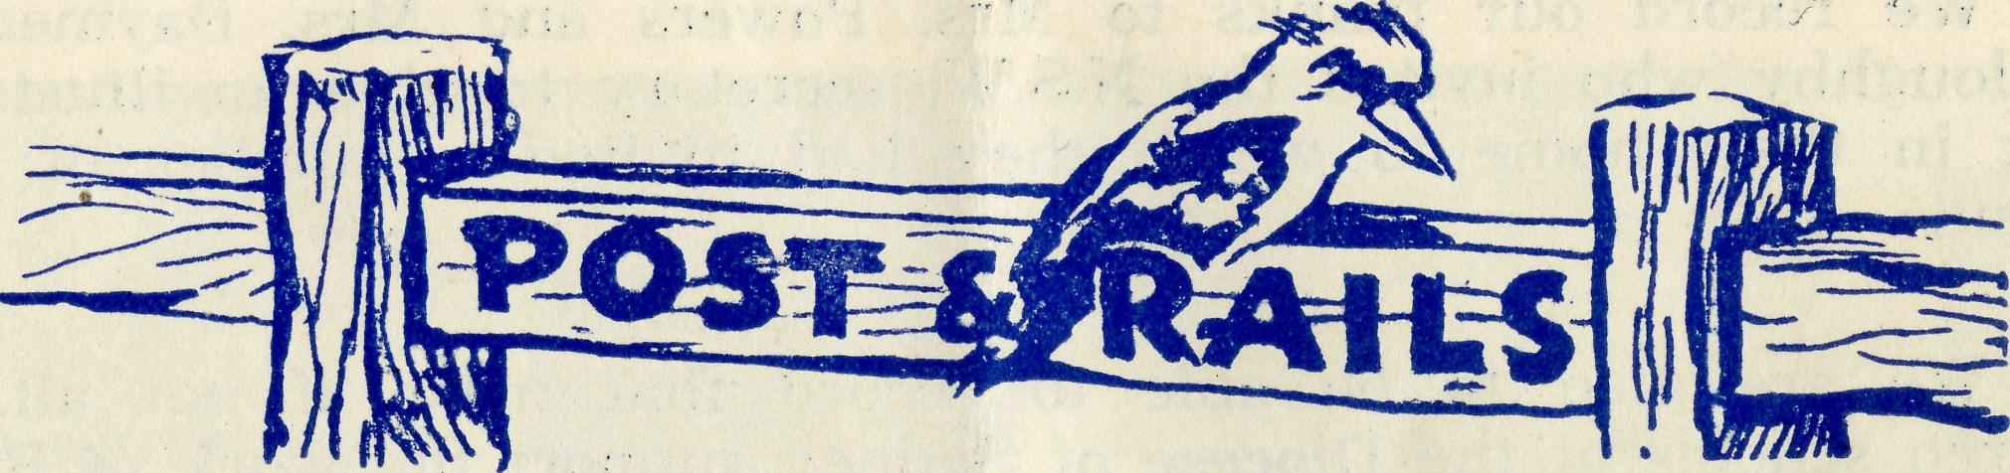
The Pennant Hills Auxiliary continues its valued support of the Society's work, under the leadership of Mrs. Edwards. We regret that Mrs. Norfor has been compelled to relinquish the position of secretary and we are grateful to Miss Williams for taking her place.
This auxiliary donated, during the past year, £40 towards the overhaul of the aeroplanes, £14 for a new wardrobe for the Boys' Hostel at Mungindi, and £24 for the cost of the new canvas blinds for the same centre. Thank you, Pennant Hills.
# # #
The St. Luke's, Clovelly, auxiliary has had another excellent year and recently forwarded a cheque for £140 to headquarters.
The Women's Guild at Normanhurst raised £10/10/0 by means
of a Children's Fancy Dress Party, and Mrs. R. C. Pike of Under-
cliffe forwarded £13 as the proceeds of the Garden Party she had in
her home. .
To all these friends we say "Thank you" and hope that their number will increase during the year.
# # . *
Congratulations to the Rev. and Mrs. George Furhmeister on
the birth of a son. They now have three musketeers and Mrs.
Furhmeister is grateful for the large verandahs that surround the
new rectory at Minnipa.
# # #
Mr. and Mrs. W. Hustler, after five years' service with the society, have left the Mungindi Hostel for other work. We thank them for their ministry to the boys who came under their care and wish them well in their new work.
We welcome to the staff Mr. and Mrs. S. Colefax of Campsie, N.S.W., who have undertaken the work at the Mungindi Boys' Hostel. They will be grateful for your prayers for help and guidance in their task of caring for 21 boys and two children of their own.
The N.S.W. secretary gave the address at a service of farewell
held in St. John's Church, Campsie, on May 14.
# # #
B.C.A. is grateful for the interest of the Bishop of Armidale and his Diocesan Council who made it possible for the N.S.W. secretary to address the Armidale Synod on the work of the society.

10
The Real Australian
August, 1955.
August, 1955.
The Real Australian
H

We record our thanks to Mrs. Powers and Mrs. Rayment of Willoughby who invited the N.S.W. secretary to give an illustrated talk in their home to which they had invited a number of their friends.
We are glad to be able to record that most, if not all, the church schools of the Diocese of Sydney support the work of B.C.A.
During the past year the following schools have sent donations to the office following upon the N.S.W. secretary's deputations.
Ascham, The Armidale School, Central Technical School, Belmore, Redlands, Kambala, Frensham, The King's School, Clare-mont, Trinity Grammar School, S.C.E.G.G.S., Shore, North Sydney, Fort Street Girls' High, St. Catherine's, Abbotsleigh.
We are grateful for the support the schools have given our work and appreciate the opportunity of stimulating the interest of the scholars in the work of the church in the outback.
* # #
Sister Ellis who has served a term of three ^ears at our hospital at Wudinna, has resigned and is returning to England. Sister offered for service when the Organising Missioner was in England during 1950. We are grateful for her faithful service and wish her every blessing when she returns home.
* # #
, Sister Barber has arrived in England and is at present enjoying a sight-seeing tour. Sister expects to return to Wudinna in April of next year.
* # #
We are deeply grateful to all those of our friends who helped
to make the two Jumble Sales organised by Mr. Greenwood and the Women's Auxiliary such a splendid success. The sum of £80 was a hard won amount from the two efforts. We commend the idea to other of our friends.
After flying a seriously ill child to Adelaide recently, Mr. Chadwick became himself a patient in the Adelaide Hospital. At the time of writing Mr. Chadwick's illness has not been fully diagnosed and he is remaining in Adelaide for further examination.
We are grateful to our friends the Rev. and Mrs. Graham Delbridge for the kindness and hospitality that they have shown to Mr. Chadwick while he awaits further treatment.
Our good wishes go to the new Bishop of Gippslnd, The Rt. Rev. E. J. Davidson and we look forward to a happy association with him as he seeks to further the work of the Kingdom of God in Gippsland.
The Rev. I. and Mrs. Booth are now settled in at Oiroroo in the diocese of Willochra. They have been warmly welcomed by the people of that district and are looking forward to a happy ministry there.
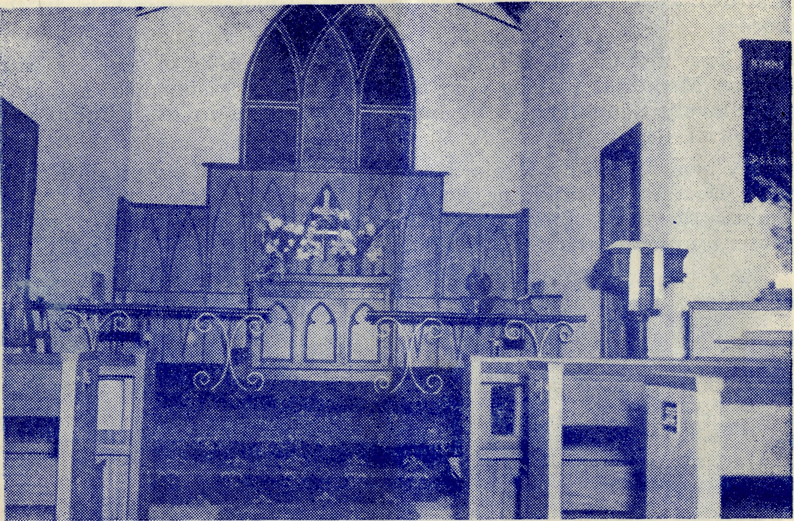
Interior of new Church of St. Michael and All Angels, Ceduna.
A Church is Built
Ceduna's old iron church was built in 1904, and for long years it was impossible to replace it by some more worthy building, because of recurring droughts and poor prices for wool and wheat.
When seasons improved and prices began to stabilise, the missioner, the Rev. Theo. Hayman, determined that the time had come to make a start on a new church building.
It has taken two years to build, and in that time Mr. Hayman, Mr. Booth and some of their laymen set to work to make the enormous total of 28,000 concrete bricks. Though such work as the laying of the bricks, plastering the walls and other such tasks, best done by an expert, have been contracted out, much of the labouring has been done by the missioners.
It was, therefore, a very great day when, on May 13 last, the Bishop of Willochra arrived at Ceduna to dedicate and officially open the new church of St. Michael and All Angels.
Over four hundred people attended the function and many of them had journeyed from as far away as 120 miles to be present. During the afternoon Mr. Hayman announced that the sum of £450 remained to be found in order to complete the amount of £3,600 which had been expended on the building.
You can imagine the joy of all when Mr. Hayman was able to announce that the splendid sum of £630 had been given that afternoon, and that the chureh had been opened free of all debt.

12
The Real Australian
August, 1955.
August, 1955.
The Real Australian
13

The Bishop told me later that both the attendance and the offertory were the largest of any similar function ever held in the diocese.
Those friends of B.C.A. who gave over £600 to the Dr. Roy Gibson Memorial will be glad to know that this sum has enabled a very lovely Sanctuary to be built and panelled in this church as a memorial to Dr. Roy.
A beautiful Holy Table is the gift from B.C.A. hospital staffs to their Doctor Roy, and the Porch Tower is the gift of the people of Ceduna to mark their appreciation of the work of the past and present nursing staffs of the B.C.A.
All the windows and pews are also memorials by the people of Ceduna to friends and loved ones.
We are glad that after all the work of a long line of B.CA. missioners in this area overWifncult years, it has now been found possible to erect a beautiful and permanent building for worship.
It was good to hear the many tributes that were paid that day to the zeal and unflagging labours of Mr. Hayman. He was, undoubtedly, the driving force and inspiration that made it possible.
A Trip to Ceduna
Mrs. C. E. Mann
EDITOR'S NOTE:
Our friends will remember Mrs. Mann and her faithful work as
matron of the Wilcannia Hostel for seventeen years and later at
Wentworth Falls for a further five years. She is now living at
Torrensville, a suburb of Adelaide, and is caring for her two grand
children so that they may go to school in the city. So she is still
managing a children's hostel in miniature. We were all very glad
when, early this year, it became possible for Mrs. Mann to pay a
visit to Ceduna and see something more of the work of the society
which she, by years of self-sacrificing labour, helped to build up.
* * *
I have always felt in my bones that I would very much like to see the hospitals, meet the staff and see something of the great expanse of thinly populated country. But never did I think that the way would open up for me to go so easily and in such great comfort.
In February last the medical plane was in Adelaide having an annual overhaul and my son, who was down from the Wilcannia district where he manages a large sheep station, got in touch with Mr. Chadwick and was able to arrange for me to go back in the "Dragon".
We left Parafield Aerodrome on a Saturday and returned the following Monday with Mr. Job and Miss Page, who were going to Sydney to be married. Never have I crowded so much travelling and sightseeing into so short a time.
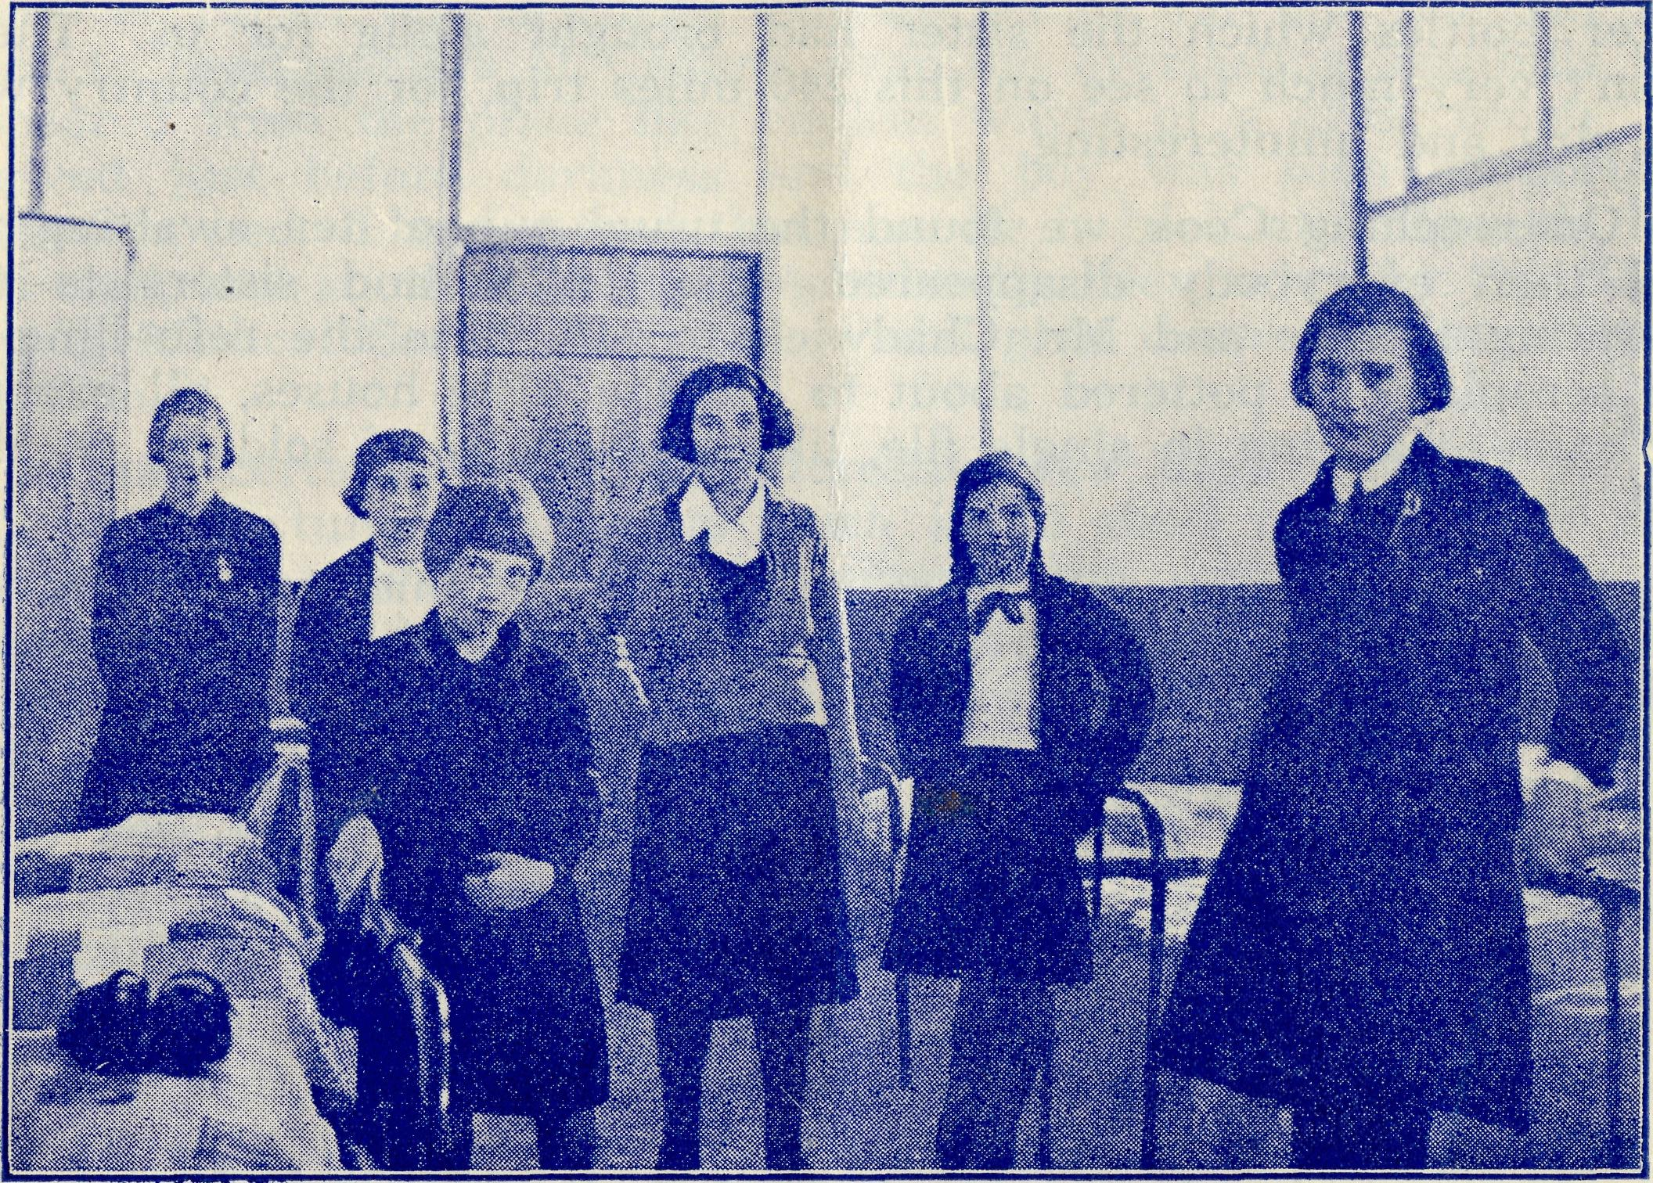
Some of the girls "Mothered" hy Mrs. Mann at Wilcannia.
In our flight to Ceduna we passed over great distances of bare country, or so it seemed at that height, for we were so high that I found it impossible to see any of the homesteads on the ground, but they were probably so few and far between that it was easy to miss them. I could quite easily appreciate the loneHness in which the people lived.
We reached Ceduna at six o'clock in the evening to receive a very warm welcome from Sister Dowling and her staff and the two doctors, Dr. M. Mueller and Dr. M. Taylor, the latter whom I know wery well.
We spent the evening very happily around a roaring fire in the sitting room of the beautiful new nurses' quarters. The event of the evening was a presentation to the two members of the staff who were soon to be married to each other.
On Sunday morning I was brought breakfast in bed and was then about to settle down for an enjoyable reading of an interesting book, when Sister Miller came into my room to tell me that they had just had an emergency call to Cook for an urgent appendix operation, and if I would like to make the trip, I had twenty minutes to get ready. I was ready on time for I have always wanted to see the memorial hospital the B.CA. built in memory of my old friend, the late Bishop Kirkby.
On the ground it was a very hot day, but I soon found that in

14
The Real Australian
August, 1955.
August, 1955.
The Real Australian
15

the aeroplane thousands of feet up in the air, I was glad of the hot water bottles which the sister had brought along for us. There wasn't very much to see on this 240 miles trip, for the country was flat, dry and uninteresting.
On reaching Cook we found the usual cup of tea awaiting us, and then everybody disappeared — the doctor and sisters to the operating theatre and Mr. Chadwick to attend to the refuelling of the aeroplane. I pottered about to see the little houses, all exactly the same, standing in single file, like a company of soldiers on this, vast plain.
At lunch time everybody re-appeared after making a small boy more comfortable by removing his appendix, and we sat down to-enjoy one of Sister Ross' excellent meals.
The hospital building erected in the centre of this seeming desert, is indeed a worthy memorial to a great and lovable man, and the service given so very willingly in it must be a very great boon to these people dwelling in these lonely outposts of Australia.
I stood for a few moments on the verandah looking out into the west and over part of that long line of railway track that stretches in a straight line over 350 miles of sand, dust and limestone without a single tree to break the monotony of it all. As I looked to the far-horizon, I wondered if ever these great spaces would be thickly populated, would there ever be houses and flower gardens, trees and picket fences. But, of course, I realised that water in abundance must be found before ever that could take place in an area where the annual rainfall is only four and a half inches.
We were just about to leave for our trip back to Ceduna, when Sister received a message on the transceiver from Ceduna, telling us that a young man had been badly injured at Bulgunnia station and was being rushed to Tarcoola hospital, would doctor go on there and attend to him?
So instead of going to Ceduna we flew 250 miles along the straight railway track and I glimpsed the tiny groups of four or five houses at every thirty miles along the line, with the great expanse of desert lying in between them.
When we got to Tarcoola we found that the boy had almost bled to death and the loss of blood was so great that the only way to* save him was by giving him a transfusion. Very fortunately Dr. Mueller had sensed what might be required and had decided to get the other plane at Ceduna to take her and the materials required for the transfusion to Tarcoola. She arrived a few minutes "after we landed, and soon the boy was having the life-giving fluid flowing: into his body.
I couldn't help but feel that the B.C.A. sister at Tarcoola must have a very great love for God's children and a deep faith in Christ, for I am sure that these are the only things that would keep a person living and working in such a lonely place, when she could so easily choose other more congenial places to work in.
When the boy had been attended to, he was loaded into the plane or rather one of them, and we set off for our 125 mile trip back to headquarters at Ceduna over the everlasting sandhills that appeared from the plane like endless waves of a great ocean. We arrived just before darkness and the boy was soon comfortably settled in bed. I understand that now he is back at Bulgunnia hale and well, and another life has undoubtedly been saved by the B.C.A. Flying Medical Service and those who give themselves so unstint-ingly to it.
I had certainly spent an interesting few days with B.C.A. and was very fortunate to see so much in so short a time. The most impressive part was to note how emergencies were handled so very efficiently and without fuss. There was no hectic running around. Everything and everybody was ready at a moment's notice, and preparations proceeded quietly and smoothly.
I wish it were possible for all the other fellow workers in B.C.A. to be as fortunate as I was, and to have a similar experience, especially those who helped to build the work up and were in it when the hospital services were in the process of building up. What a very great happiness they would have in knowing that they had helped in the building of so strong and enduring a foundation for a work that must surely be unique in the church.
I could not but feel thankful that I had my share in the early days of B.C.A. activities and was indeed thankful to have this glimpse of the medical service.
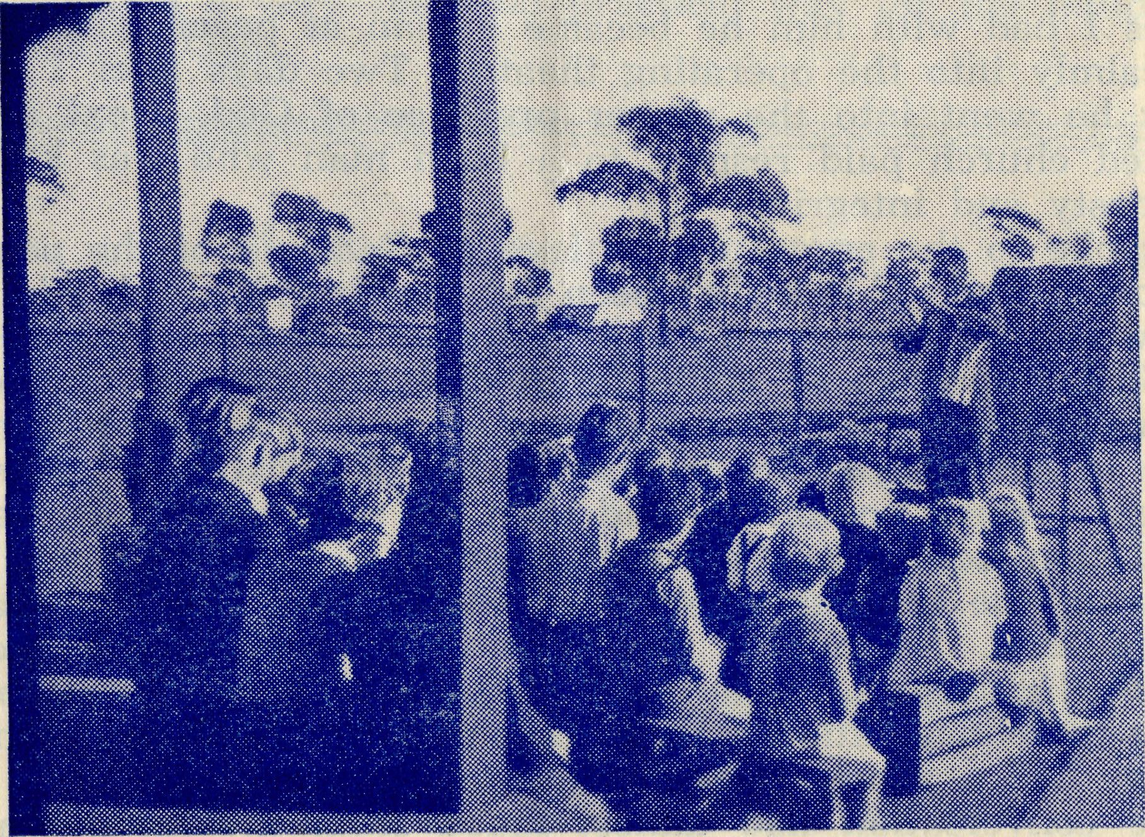
B.C.A. Missioner gives religous instruction in an outback school.
A BUSH SCHOOL

16
The Real Australian
August, 1955.
August, 1955.
The Real Australian
17

From the Bush Padre’s Radio Session
"I feel sorry for you fellows out in the bush. What do you do out there? It must be pretty tough at times. I couldn't stand it even if I were paid a fortune and I don't suppose you fellows get a fortune — so I don't know how you can stick it."
The speaker was a man from the city who, like a lot of people, cannot fully appreciate why Bush Padres go into lonely places to serve God. But the men who do the work, know just what it means to the outback people to have the Bush Church Aid Society.
The; Bush Padre's friend seemed sorry but there came a reminder of St. Paul's great declaration. "I am made all things to all men that I might by all means save some." This sums up very well what is the task of the Bush Padre.
About 5 o'clock one evening a woman came to the house and asked to see the Bush Padre. Without any preamble an obviously worried woman exclaimed, "I'm in trouble and I want help — my husband's desperately ill and wants to see you."
In the middle of my sympathy I couldn't help but be thankful she had turned to the Padre in time of distress. A question revealed that the man was in hospital. He was to undergo an operation which, in any case, would be hopeless. He hadn't made a will and wanted to put his affairs straight. There was no solicitor in the town so the local Bank Manager and myself went along to give help. Between us we were able to do what was necessary and then I had a few minutes with the man before his operation. He had never lived any nearer than 26 miles to a Church. But in the few minutes I had with him he became a man at peace with God. He went calmly into the operating theatre. Two days later I stood by him as he went into the nearer presence of God. Next afternoon a packed church paid respect to a bush man who was known for his honesty and integrity.
I spoke to the crowd of the love of God and of the peace men and women find. If it hadn't been for the Bush Church Aid Society there would have been no Bush Padre to help these fine people.
Some time ago an epidemic of diphtheria struck our town. It came to light that very little had been done in the way of immunisation as in our district we had no B.C.A. Medical Staff. I was able to collect a small committee and then we persuaded the local Shire Council that action was needed urgently.
During the time spent on this work I was able to speak to a young woman. She was a mother with a young family and being well off the beaten track didn't see other people very often. I brought the conversation around to spiritual matters and then before I left we had a short service in the lonely home.
The conversation had almost faded from my mind when one Saturday afternoon there was a knock at the front door. When I saw my caller I remembered the conversation in her bush home.
While my wife made her a cup of tea she asked could I get Sunday School Lessons for her children. Of course that was not hard with our Mail Bag Sunday School ready to answer the call. Then she promised to get to church whenever it was held in their district. As she was eleven miles along a rough track from the nearest hall where service was held, it showed her determination.
On another occasion I was able to help a young couple who were newcomers to the bush. They promised they would get to the nearest hall for a church service. On the next Sunday it was a terrible day and I did not expect to see many in the little bush hall. We were a bit late starting and just as I was about to announce the first hymn I noticed a man and woman walking along the bush track towards the hall. The man was carrying a baby in his arms and I immediately wondered what had gone wrong. ,
I walked over to the door as the young couple came closer and asked what had happened. "Oh, nothing much," replied the man, "But you know we promised we'd get here today. The old truck gave trouble at the last moment — so we've just walked. Hope we haven't made you too late waiting for us." I thanked God for their faithfulness because I knew they had walked four miles along a rough track. The weather was so bad they could have easily persuaded themselves to stay at home.
The little bush hall became a very hallowed place that afternoon. Thanks to the friends of the Bush Church Aid Society it was possible for a Bush Padre to be with the bush people that day.
So the Kingdom of God grows in the out-of-the-way places.
The friendly criticism of the man who couldn't imagine himself
working in such a place is just put aside. In many ways Bush
Padres are able to help people in the outback to a realisation of
the love of God. Such work is a demonstration of the Christian
faith at work in a very real and practical way for the building of
the Kingdom of God. J.R.G.
If you live in Victoria,
REMEMBER THE B.C.A. ANNUAL RALLY
IN THE
CHAPTER HOUSE OF ST. PAUL'S CATHEDRAL
ON
TUESDAY, SEPTEMBER 13, at 7.45 p.m.

August, 1955. The Real Australian
¹⁸ The Real Australian August, 1955.
The Flying Medical Service of the B.C.A. Urgently Needs:—
A DOCTOR AT CEDUNA
AN ASSISTANT DOCTOR AT WUDINNA
A QUALIFIED PHARMACIST AT CEDUNA
THREE NURSING SISTERS. A COOK-HOUSEKEEPER.
FOR ITS HOSTELS:—
A MATRON OR SUITABLE MARRIED COUPLE.
FOR ITS MISSIONS:
TWO MISSIONERS FOR OUTBACK "PARISHES"
ARE YOU QUALIFIED TO FACE UP TO THIS URGENT CHALLENGE?
If you live in New South Wales,
REMEMBER THE ANNUAL RALLY
IN THE
CHAPTER HOUSE OF ST. ANDREW'S CATHEDRA!
ON
FRIDAY, SEPTEMBER 23, at 7.45 p.m.
COME! AND BRING A FRIEND
19
WINGS OF MERCY
Each year the planes and doctors fly an average of 36,000 miles. It costs £4,000 per year to keep the plane flying, and about £10,000 for maintenance of hospitals, nurses and radio base.
Although most of these expenses are recovered in fees, B.C.A. urgently needs £3,000 extra income if this splendid service is to be maintained as a Christian witness.
Will you give
£1 to maintain the plane for 6 minutes 10/- to maintain the plane for 3 minutes 5/- to maintain the plane for 1| minutes?
REMEMBER THE B.C.A. BUSH PADRE BROADCASTS —
2GB EVERY FRIDAY at 11 a.m.
2CH ALTERNATIVE SUNDAYS at 6 p.m.
2KA ALTERNATIVE WEDNESDAYS at 4.30 p.m.
2MG ALTERNATE SUNDAYS at 4.45 p.m.

