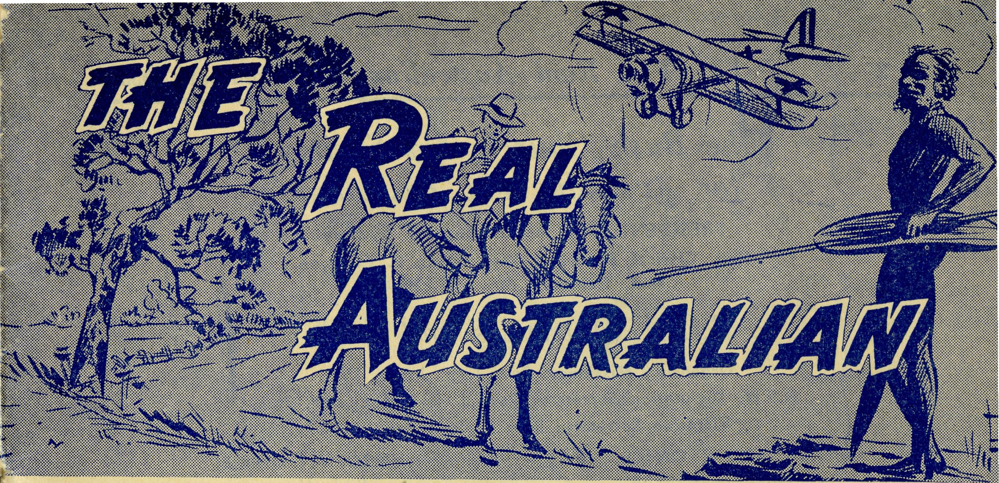
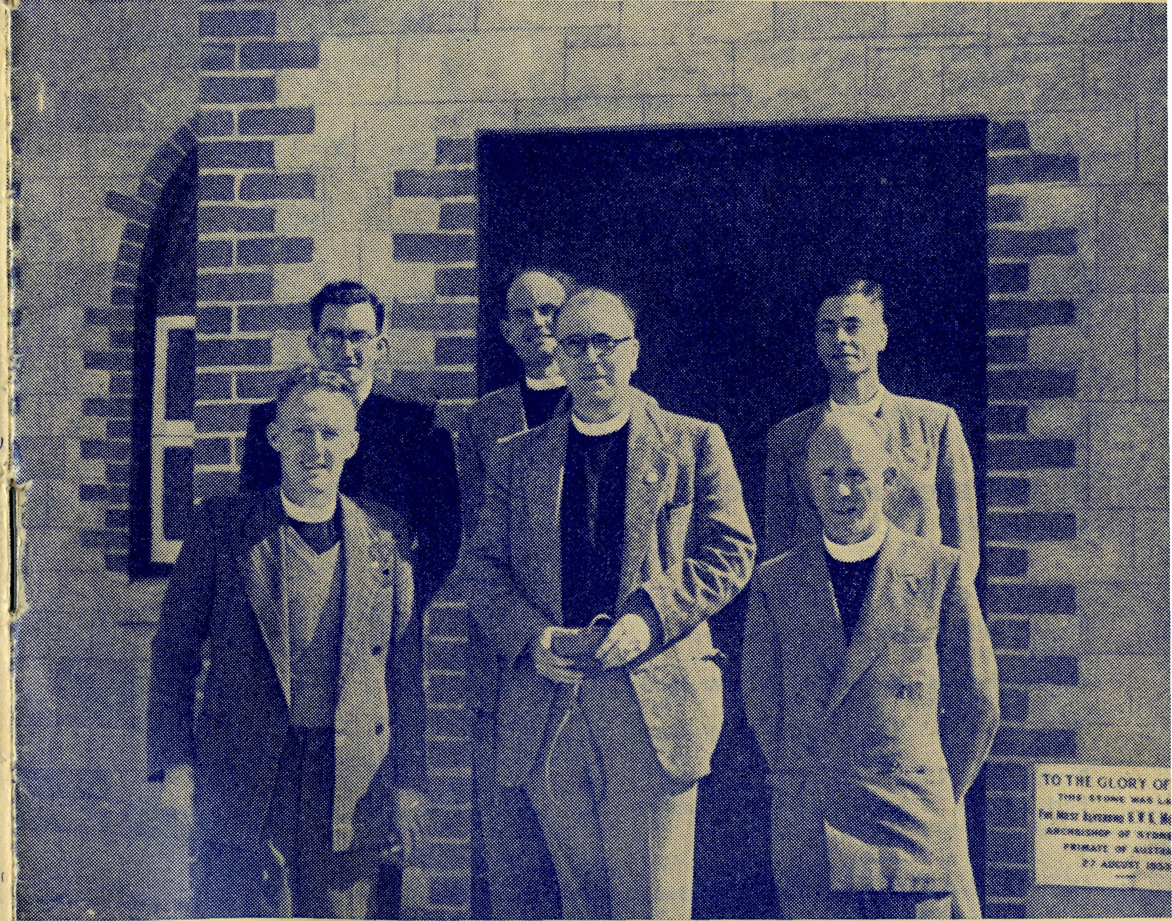
Topics for
Prayer and Praise
SUNDAY
For all M i s -s i o n e r s and Deaconesses of the Society and their people and for all students in training.
MONDAY
For all Doctors and Nurses serving in the outback, and for the spiritual and physical health of the patients under their care.
TUESDAY
For all Workers in Hostels, the children under their care and the teachers who instruct them.
WEDNESDAY
For the Director of the Mail Bag Sunday School, the pupils of the School and all teachers and voluntary workers.
THURSDAY
For the Flying Medical Service and the safety of the pilots and all who travel with them.
FRIDAY
For the Council of the Society, the Home Base staffs, Auxiliaries and Parochial workers.
SATURDAY
For all necessary finance needed for the maintenance of so large a ministry and for guidance in its right application.
For the Society,
O Lord God of our nation, Who hast commanded men to subdue and replenish the earth: Look in Thy love upon all who in distant parts of our land are striving against many difficulties, and are deprived the access of the means of grace. Strengthen and guide the Bush Church Aid Society and all members of the staff. Cheer and comfort them in discouragement and loneliness, bless their ministrations to the good of those they serve, and grant that the message of redeeming love may thus be rooted and grounded in our national life, to the glory of ■Thy Great Name through Jesus Christ our Lord. Amen.
For Nurses and Doctors.
O God, Who didst choose a beloved physician to set forth the life of Him Who went about doing good, grant that Thy strong tenderness and compassion may be manifest in the work of country doctors and bush nurses. Make them at all times alert to be faithful, as those whom Thou hast burdened and inspired with the honour of their calling. In lonely emergencies strengthen them with confidence that, having done all they can, they may with good conscience leave the issue to Thy power working within Thy law. Make them resourceful and of sound judgment, and hearten their labours with the energy of compassion and the firmness of duty that conquers weariness. Through Him Whose power is called forth by suffering. Jesus Christ our Lord.
For Church Life in Country Districts.
O Lord, Who art present when two or three are gathered together in Thy Name, bless, we beseech Thee, the little far-scattered groups of brethren who in our wide land meet together to worship Thee. Give them a perpetual freshness of spirit, and the power to inspire in each other holiness, helpfulness, and understanding of Thy help. Refresh with the joy of enthusiasm those who endure weary journeys to Thy trysting place. Grant that these little companies of Thy servants may be united in the spirit of Christian charity, awaiting in love the time when there shall be one fold and one Shepherd. Grant that the common life of all communities may be purified by this spirit of charity from all meanness, falsehood, malice and idle gossip, and grant that they who share a common lot may draw strength from each other's virtues, and in their weakness help one another, through our one Lord, Jesus Christ.
Praise.
For the Blessings vouchsafed to the Society, for all kindly givers, for the joy of service.
No. 14 (New Series). NOVEMBER, 1955. 2/6 per annum, post free.

Edgar Bragg & Sons Pty. Ltd., 4 Barker Street, Sydney.
SEE PAGE 16 Registered at the G.P.O., Sydney, for transmission by post as a periodical.

2 The Real Australian November, 1955.
The Bush Church Aid Society for Australia and Tasmania
PRESIDENT: The Archbishop of Sydney.
Hon. Clerical Secretary: Rev. Canon E. Cameron.
Hon. Treasurer: Mr. T. S. Holt.
B.C.A, Activities and Staff
Organsing Missioner: Rev. T. E. Jones, Th.L.
N.S.W. Deputation Secretary: Rev. J. R. Greenwood, Th.L.
Victorian Secretary: Rev. E. G. Beavan, M.A.
HEADQUARTERS OFFICE: VICTORIAN OFFICE:
Diocesan Church House, . * Bible House,
St. Andrew's Cathedral, Flinders Lane, Melbourne, Victoria.
George Street, Sydney. 'Phone: BM 3164. Telephone: MF 3552.
Cable Address: "Chaplaincy, Sydney".
STUDENTS IN TRAINING.
Mr. J. Smith. Mr. B. Buckland. Rev. R. Brooks.
Rev. A. Williams.
Mr. B. Viney.
Mr. F. D. Buchanan.
MISSIONS.
Heytesbury Mission, Vic.—Rev. Cooke, Th.L., Timboon, Vic.
P. R.
Morgan, c.
N.S.W.—Rev. J. Stockdale,
Ceduna, S.A.-Penong, S.A.—
Rev. T. J. Hayman, Th.L., Ceduna, S.A.
-Rev. D. A. Richards-Pugh,
Cowell, S.A.-
A.L.C.D.
Otway Mission, Vic.—Rev. T, Th.L., Beech Forest, Vic.
Wilcannia,
Minnipa, S.A.—Rev. G. Fuhrmeister, Th.L., Deaconess A. Howland.
Streaky Bay, S.A.—Rev. P. Connell, Th.Schol.
Croajingalong, Vic.—Rev. L. Luck. Tarraleah, Tas.—Rev. W. Warburton, Th.L.
Th.L.
Menindee, N.S.W.—
Rappville, N.S.W.—Rev. A. Gerlach, Th.L.
Orroroo, S.A.—Rev. I. Booth, Th.L.
MEDICAL SERVICES.
Ceduna, S.A.—
MAIL BAG SUNDAY SCHOOL. Director—Miss R. Campbell.
Matron: Sister F. Dowling.
Staff Sisters J. Miller, G. Hitchcock, B.
Tierney, A. Butler, J. Roberts, M. Bell.
Penong, S.A.—Sister L. Loane.
SCHOOL HOSTELS.
Broken Hill, N.S.W.—Mr. and Mrs. A.
McLaughlin. Mungindi Boys' Hostel, N.S.W.—Mr. and
Mrs. S. Colefax. Mungindi Girls' Hostel, N.S.W.—Miss M.
Farr. Bowral, N.S.W.—Miss E. Cheers. Port Lincoln, S.A.—Deaconess G. Banks,
Miss D. Duver.
Wudinna, S.A.—
Matron: Sister R. Portch.
Sisters: M. Denniss, V. Brealey, M.
Dean, J. Johnston, Miss C. Derbyshire.
Cook, S.A.—Sisters M. Ross, M. Tarr.
Tarcoola, S.A.—Sister V. Holle, Miss M.
Thomas. Cann River, Vic.—Sister I. Gwynne.
Rawlinna, W.A.—Sister E. Thomas. On Leave.—Sisters B. Barber, M. Hors-burgh, L. Langtree.
FLYING MEDICAL SERVICE. Pilots—Mr. A. Chadwick, Mr. W. Bed- Pharmacist—Mrs. G. M. Job. ford, Mr. G. Job.
Doctors—Dr. M. Mueller, Dr. J. Upsdell.
Wireless Control Station Control Officer—Mr. G. Cameron.
November, 1955. The Real Australian
The Organising Missioner’s Letter
On October 1st an important change took place in what is known as the Eyre Peninsula. It is that area of South Australia which extends from the western shores of Spencer's Gulf to the Western Australian border, and from the coast of the Bight to the 30th parallel.
This area was placed under the supervision of the Bishop of Willochra, at the time of the formation of the diocese of Willochra, although it remained part of the diocese of Adelaide, but the Bishop of Adelaide retained the right to resume jurisdiction of the Eyre Peninsula by giving one year's notice of his intention to do so.
The Bishop of Adelaide gave notice twelve months ago of his intention to take back this area, and on October 1st this came into effect. The Peninsula, therefore, is now directly administered by Adelaide and is no longer subject to the Bishop of Willochra.
There is considerable difference of opinion as to the merits of making this change, for it poses certain difficult problems, especially for the Bishop and Diocese of Willochra. But it would not be proper for the B.C.A. or this paper to enter into a discussion of them.
From B.C.A. point of view, the main thing that emerges is that from now on the Missions at Ceduna, Minnipa, Streaky Bay and Cowell will be part of the Diocese of Adelaide, being directly administered by its bishop, and the B.C.A. men will be licenced in that diocese.
There is no reason to suppose that the relations with the Bishop and Diocese of Adelaide will be any less happy than those we have had for over thirty years with the Bishops and Diocese of Willochra.
The Rev. Ian Booth will remain as B.C.A.'s sole missioner in the Diocese of Willochra, for Orroroo is outside the Peninsula. We hope that it will be possible to help the Bishop of Willochra in his difficult task of staffing so many outback areas. For this we need men with courage and vision.
This is the place to put on record our appreciation of the long and happy association we have had with the present Bishop of Willochra. He has always been helpful and understanding with the Society and its men, and we are glad that this association is to continue.
The recent rallies in Melbourne and Sydney were full of encouragement. Such large gatherings with their happy spirit testify to the virility of the Society and to the warm, place it has in the hearts of many of our church people. To those of us whose task it is to see to the day to day work of the Society such meetings give new zeal and enthusiasm.
The presentation of two useful and handsome travelling bags to mark the twenty-first anniversary of my becoming the Organising Missioner of the B.C.A. took me completely by surprise. The gift of a brooch to my wife found her in the same state. It was very nice and we both appreciated the kind thought behind both the gifts.
Will you remember that we are striving to obtain an additional £3000 of income before Christmas? If you haven't sent in your gift towards it, please do so now.

The Real Australian November, 1955.
November, 1955. The Real Australian

"Scouts"
"Aw, gee, it.was beaut." "Hey, Butch, when are we going camping again?" Some very excited and happy "1st Timboon" scouts were sitting in the back of my car coming home from their first camp at Easter. They were happy, excited, a little tired after four days in the open. They had had a happy time.
Altogether there were eighteen out of the twenty-one scouts in our troop in camp at Easter. One or two had been camping before, the majority hadn't. For almost four days we had lived together as three patrols, all under canvas enjoying this great experience of camping out, by ourselves.
We arrived at the camp site on the Thursday afternoon after school, when the boys set about unloading the truck carrying all the gear and supplies, putting up their tents and then getting on with cooking their tea. This first meal consisted of fried sausages, vegetables, apples and custard. After tea and washing up had been finished and other necessary chores done, the boys got into bed — no inner spring mattresses, simply sleeping on a groundsheet on the ground. The boys being very excited at their first night out, although asked on several occasions to go to sleep, talked till well after midnight and were awake early next morning.
The days went all too quickly. The three patrols, each consisting of six boys, worked as three separate units, and the boys in each patrol took their turn in cooking meals, doing necessary chores around the camp and making "gadgets" to help make the place more habitable. Without using a nail the lads made eating tables, knife, spoon and fork racks, a stand for cups, billies, cooking utensils, etc., all by using twigs and sticks from the trees and lashed together with square and diagonal lashings. Blankets were hung out to air each day, and inspections of sleeping tent and kitchens were made each morning. The standard was maintained at a very high level.
Some of the boys found in camp they could eat vegetables and other things they could not eat at home. They found, too, that they could help each other and that the matter of cooking was not so easy as Mum seemed to make it. The Scoutmaster and his assistants, of course, were always invited out to meals and they took their turns in going to each patrol for a meal. Every morning porridge was made; stew, corned beef, smoked fish, together with potatoes and green vegetables were the main dinner dishes, followed usually by stewed apple or quinces, with rice, sago or custard. Tea usually consisted of eggs, pancakes, macaroni cheese, damper or twist.
Sunday afternoon was visitors' days when many of the parents came to have a look and see how "little Johnnie" was faring. All visitors and friends were very happy and pleased with the layout and the set-up of the camp. The boys were in excellent spirits and so all were very happy indeed. The weather most of the time was excellent and this, of course, made things much more pleasant.
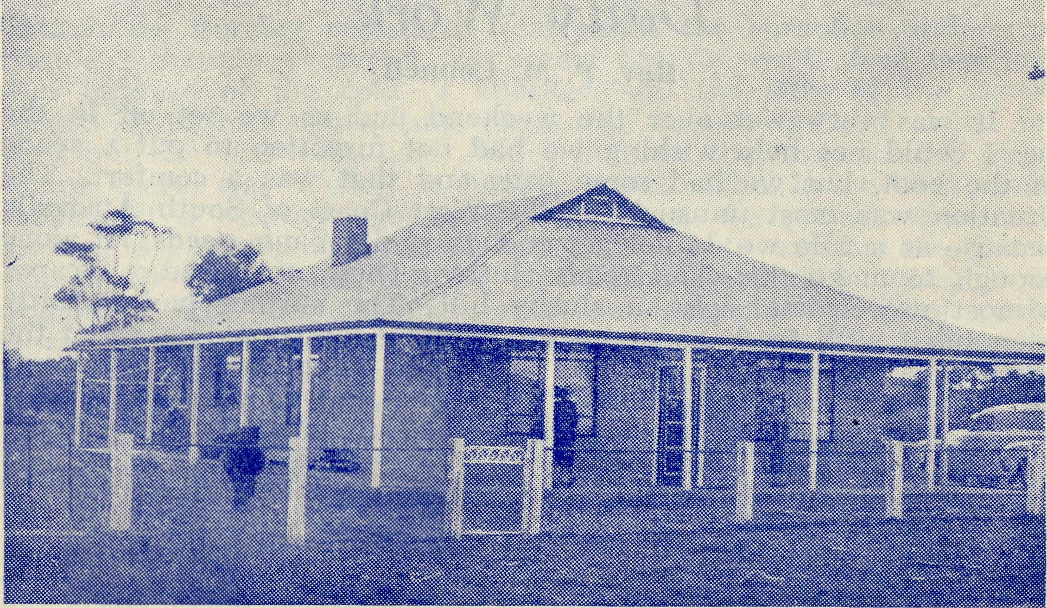
The new vicarage at Minnipa. This is the first church building erected in the mission.
Before I came to Timboon I had had nothing at all to do with scouting. On my arrival here I found we had no parish hall and also very few children around the town to commence a branch of any of the recognised Church youth clubs. I found there was a guide and brownie company, and a cub pack but no scouts. The people were waiting on someone to come into the town and start a scout troop. We started the troop in March, 1954, and have advanced slowly ever since. I have never regretted it and although I have a C.E.F. and a youth club for younger boys and girls under fifteen at Timboon, and another youth club at Curdies River, I am convinced in my own mind that Scouting has far more to offer the boy than any Church youth club. Others, of course, disagree. I have found I can get boys to scouts who would never think of coming to a Church youth club and who, in fact, will not come. Ours is an open troop, which means boys of all denominations and faiths can join. The only folk not allowed to join scouts are atheists and communists. These could not comply with the scout promise made by all scouts — "On my honour I promise to do my best, to do my duty to God and the Queen, to help other people at all times and to obey the scout law."
SEND YOUR GIFT TOWARDS THE EXTRA £3,000

The Real Australian November, 1955.
November, 1955. The Real Australian

Daily Work
Rev. P. M. Connell
It was very wet over the weekend and as we set off in the car I could not help wishing we had not forgotten to put a spade in the boot, but we had some bags and that was a comfort. The situation was most unusual for the West Coast of South Australia because as a rule we do not get enough rain for our needs, let alone enough to make the main roads slushy. Then, up ahead, appeared a most unwelcome sight, a. slushy hill. The surface had recently been piled with fresh earth by the council, for spreading when the conditions were damp enough. Now the conditions had become far damper than we have had for years, and as soon as I came within 100 yards I could see that we had an impossible job before us. Fortunately two men appeared, both farmers that I knew, and they stopped to tell me the road was impossible and couldn't be used. I must use the detour. I did. But this proved just as bad and one of them kindly came with his truck, ploughing through the undergrowth, double wheels churning up the mud, to our assistance. He had to lie on the muddy earth to tie his tow rope under my Holden's front axle. When it was all over he wouldn't take a penny, though he had used time, patience and petrol to quite a degree to help me on my way to a reunion of Christian friends in Minnipa parish. Imagine how thankful I was for the help of my farmer friend. They are nearly all very generous in any matter which concerns the forwarding of a minister's work. So I was able to arrive at Minnipa and be privileged, with Mrs. Connell and our family, to be present at the dedication of the rectory, and also the dedication of the new van. The roads from Streaky Bay were very bad, owing to the late rains, and we were twice pulled out of bogs by a friendly farmer along the road. It was a pleasure to be at such a happy gathering and to see the Reverend Mr. Fuhrmeister presiding at the little service of thanksgiving before the Bishop of Willochra dedicated rectory and van with appropriate prayers, going from room to room. It was also a joy to meet so many of the B.C.A. family there. Matron F. Dowling, Mr. A. Chadwick (the pilot from Ceduna), the Rev. T. E. Jones (the Organising Missioner), Mrs. Upsdell, Sisters Brealey and Ellis (from Wudinna) and Deaconess Howland were all present. It was great, too, to see the way in which about a hundred people of the Minnipa parish attended, and one could sense a very friendly, thankful atmosphere as those parishioners prayed together and listened to the Bishop's address, conscious that now their missioner and his wife have a commodious and convenient residence. May it not be long before they see the Church they hope to build erected.
At three o'clock I set off in the car for a confirmation lesson. The confirmee was confirmed some time ago and has been to Communion twice, but through illness just before the confirmation service she was not able to complete her course of preparation and she is completing it now. I drove up the hill to the farm. It was very cold and blowy and I had all the car windows up. Everything in the paddock was green through the late rains. As

I drove into the house yard, I noticed a new face, that of a young fellow from town, working on the farm, whom I had seen ar Church the Sunday before. I went inside the verandah and for a minute I thought everyone was away, but the back door was just shut because of the cold. I knocked and the lady of the house opened it to me, apologising for being rugged up and shawl on head but she was very cold. We went into the large sitting room where there was a fire of mallee roots. The house was built about half a century ago by the father of the present owner. I began the confirmation lesson, and went on to explain the Communion Service which can be so terribly confusing unless it is explained. The new communicant confessed having been quite at sea at her last Communion when she came in the service to the Collect, Epistle and Gospel. Then after a prayer I gave her some written work to do and the lesson was over.
Then my pupil asked me if I would like a cup of tea. I said yes very feelingly and we went out into the kitchen. She made the tea and then went and rang the big bell — just one stroke was enough — the bell that is on most farms to call the men to meals. Three "hands" came in and we talked about weather and crops as we ate and drank. Just before it was time to go my hostess said, "Could your wife use some pumpkin " I said "Yes"; and she began to cut through the tough pumpkin. Then she asked, "Would you like to take back some eggs?". I said "Yes" again, because, through the late cold weather we are having an egg-famine in Streaky Bay. So, loaded with pumpkin and a box of eggs, I said good-bye. My confirmation lessons or visits pastoral are often rewarded with gifts like this. The folk are most generous.
I drove up to the farm. It was thirty miles from home; the day was cold and we were just in time for dinner. What huge dinners you get served up to you on farms! But this time we even asked for second helpings. The dining room ceiling, made of hessian, was very low and sagged though it was once drawn tight and high, but now through years of changing conditions it was within touch of us as we had dinner. On the walls were many photos and also home-done crayon landscapes. My heart went out to them because my own efforts at landscape drawing are quite similar, lacking artistic perfection, but warm with the suggestion of real affection for some loved scene of home. The couch on which we sat was stuffed inside with straw and rattled when we moved. After justice had been done to the roast fowl and vegetables, with pudding and a cup of tea to follow, we talked for a while of old times and the lonely life of those people. Certainly, they were on the telephone but the nearest neighbour was some miles further on. We got up from the meal and went out through the kitchen. On the bench by the wall was a fur cap. The hostess told me it was made of water rats' fur. The animals had been caught in the creek below the house. I was struck by the genuine interest in spiritual things and concern for the needs of others which these people showed in conversation.
At present it is raining. In fact it has been raining on and off for weeks. It puts water into our little over-head tank and

The Real Australian November, 1955.
November, 1955. The Real Australian

saves pumping it up by hand from the big underground cement tank. Another result of the rain is that visiting round and about is not so possible nor so easy. Mud is everywhere. Householders don't like it tramped into their kitchens and the older ones all have colds.
This morning I visited an old lady of our Church here. On the way to see her I picked up another old communicant of 94 years who loves to come with me on this trip. When we arrived I left the two old ladies talking and went in to see the old man, infirm and unable to move about at all. He was very glad of my visit and said so. I had a reading from St. Luke, about taking no thought for the things of the body but to seek first the things of the kingdom of God. Then we had prayer and afterwards I went back to rejoin the old ladies whom I had left alone knowing they would have so much to talk about.
I want to ask for your prayerful rememberance of Mrs. Connell and myself and all engaged in Christian work in this mission. Though not nearly as big as the Far West Mission of the Rev. T. Hayman or the Minnipa Mission with Rev. G. Fuhrmeister in charge, it is nevertheless long and scattered. "Long" describes it. It is a long thin strip of coast comprising two parishes. Actually it is 150 miles of Eyre Peninsular coast line by about 40 miles deep, and has altogether about 15 centres. So please pray and remember us here with our varied needs of spiritual and material things and physical strength for the work. I remember St. Paul told one of his Churches that he hoped to fulfil his engagements through the fellowship of his loved Philippians, whom he reminds that both "in the defence and confirmation of the gospel, ye all are partakers of my grace". So it is with you who read this and who uphold us in prayer daily. May He give the grace of continuance in this work.
Bowral Hostel
The property now used by B.C.A. for a Girls' Hostel at Bowral was purchased from the Trustees of the estate of the late Dr. Ziele.
Since the purchase by the Society the trustees have returned the full amount of the purchase price to the Society on the condition that the hostel be known as the "Dr. W. Stewart Ziele Hostel".
A large framed portrait of Dr. Ziele has been placed in the entrance room of the hostel, and a name-plate is to be erected on the main gate.
We are very grateful for this splendid gift, which proves such a boon to many country children.
SEND A DONATION TO B.C.A. — NOW !!
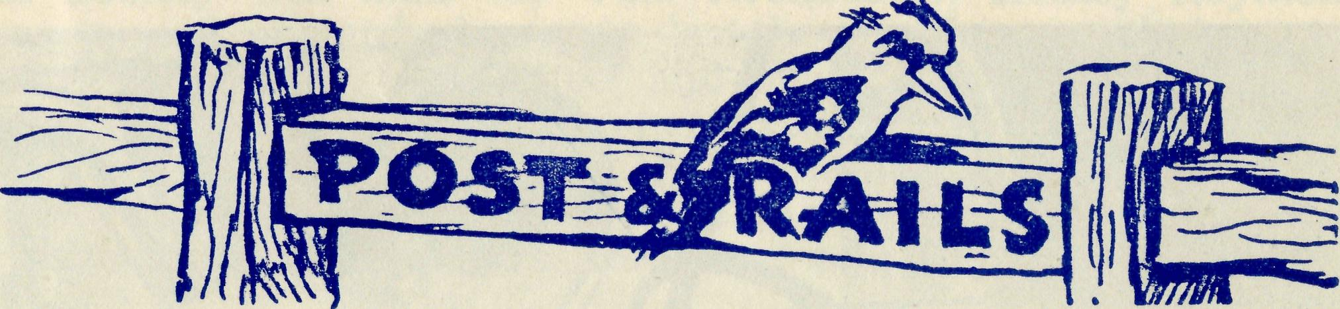
STAFF CHANGES
Quite a number of changes have taken place in the staff since the last edition of this paper. We welcome Miss Gwen Banks, who has been appointed to take the place of Mrs. Dodd at Port Lincoln Hostel. Miss Banks comes from Sydney and the best that we can wish for her is that she will be as happy in this important piece of service as Mrs. Dodd has been for over eight years.
Miss Margaret Thomas comes to us from the Parish of Carling-ford, and will spend some time at Ceduna before she goes to the new hospital at Tarcoola to help with the domestic side of the work. We are sure that she will find joy in her service.
Sister Margaret Dean, also of Sydney, goes to Wudinna, to help make up for recent losses. Sister will find a warm welcome awaiting her and we pray that she also will be happy as a member of our family.
Sister M. Bell comes to us from the Cohuna Hospital, Victoria, and she is joining the staff at Ceduna. By the time this is read by you she and the others named above will be busy with their daily tasks in their new spheres. We look forward to a long and happy association with them all.
Though this is one of the longest lists of new workers at one time for some years, the problem of staff is by no means solved, for we say "good-bye" to Sister Ellis, who, after three years at Wudinna, left B.C.A. service at the end of September, and Sister Shipway, who joined the ranks of "Godly Matrons" on October 29th. We wish them both much blessing and happiness in their new spheres. Sister Langtree leaves Penong for a while in order to do her Mothercraft Training, and will be coming back to us later on with this added qualification.
We are glad to announce that Dr. Charles Blower, who is at present on the staff of the Royal Prince Alfred Hospital, has accepted the position of Medical Officer at Ceduna. It is expected that Dr. Blower will join Dr. M. Mueller at this centre early in February. The prayers of our friends are asked for two more medical officers who are urgently needed for the B.C.A. services.
It is to be regretted that pharmicists seeking to do Christian service appear to be almost negligible. Pray also for this important need of the Society.

10
The Real Australian November, 1955
November, 1955. The Real Australian
11

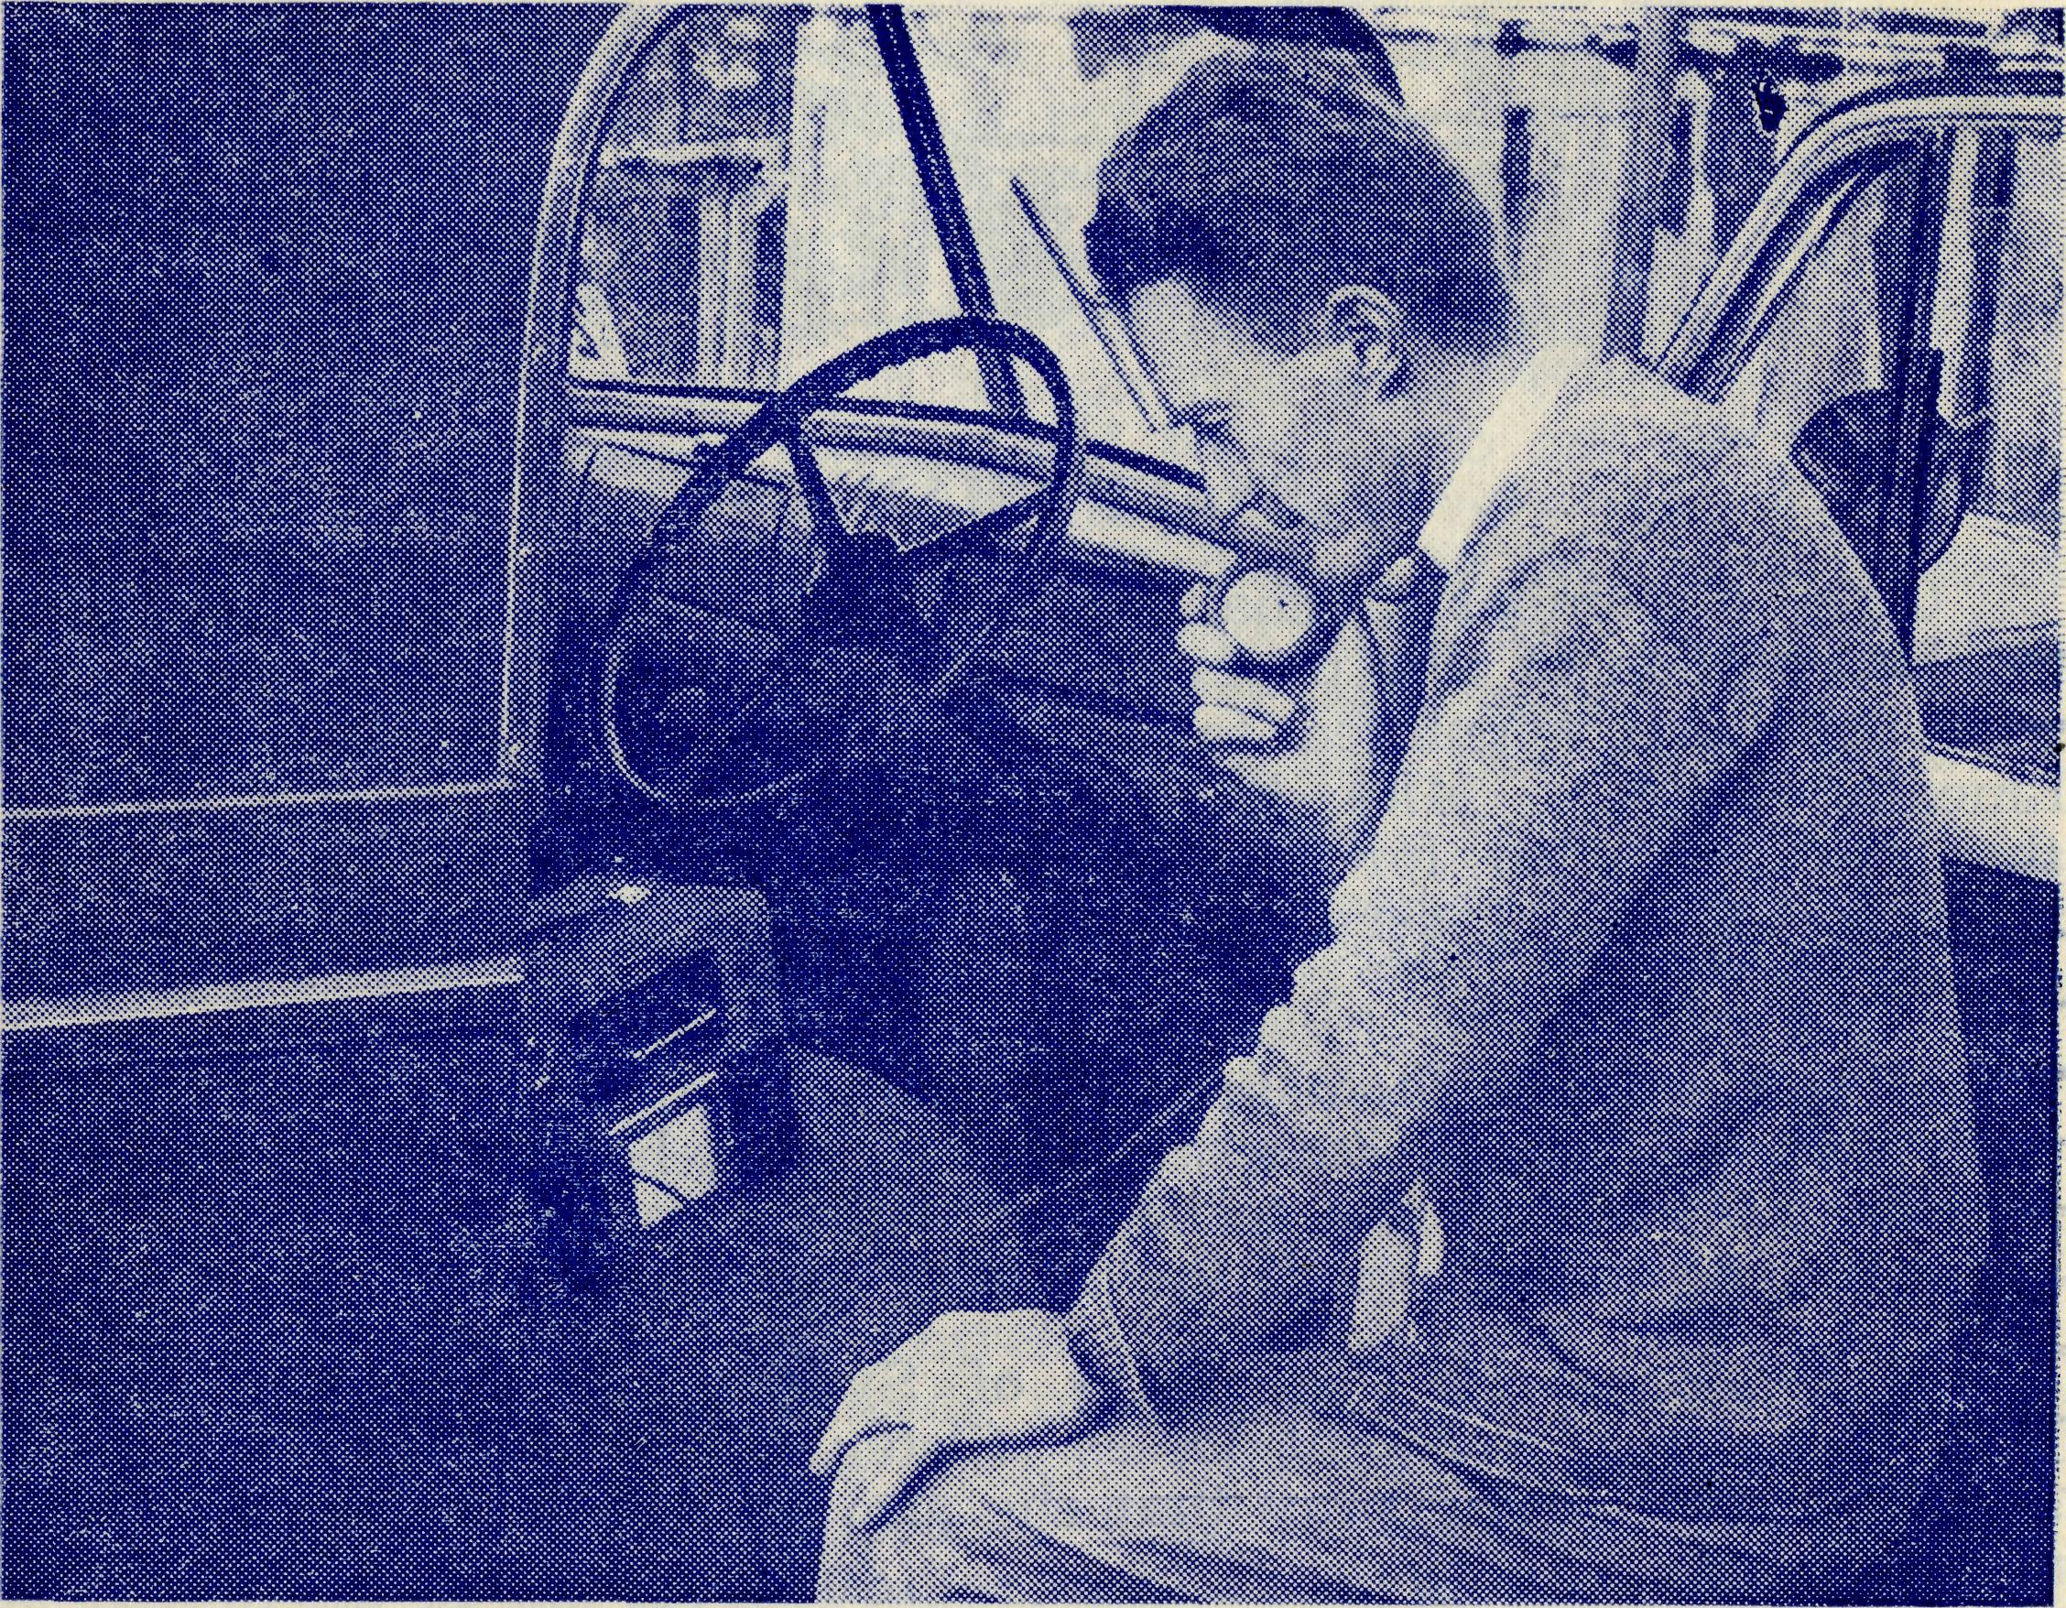
The Society will miss the Ven. Archdeacon Hedley Raymond_{r} who has passed onward since our last issue. He was chairman of the B.C.A. Victorian Committee and gave it wise and friendly guidance. The Organising Missioner remembers him with warm affection for his kindness and help while serving as his curate, when the Archdeacon was Vicar of St. Augustine's, Moreland. Our deepest sympathy goes to Mrs. Raymond and the family.
Our thanks go to Mr. and Mrs. Shain who opened their home and garden for the afternoon, and to the members of the Pennant Hills Auxiliary who made good use of the occasion. About sixty people had an enjoyable time and a good afternoon tea, and the funds benefited by £41. We commend the idea to others.
Mrs. K. Loane, who seems to spend most of her time sponsoring some effort for a good cause, also raised the sum of £20 for B.C.A. by a special effort in her home. Thank you, Mrs. Loane.
We are very grateful to the Bishop of Newcastle and his Diocesan Council for inviting the N.S.W. Secretary to address the Newcastle Synod on the B.C.A. and its activities. We are glad to see the growing interest in B.C.A. that is being shown in this and other dioceses of the N.S.W. province.

The Rev. G. Fuhrmeister using his portable transceiver to speak to the operator at the Ceduna base.
The second of what we hope will be an annual Women's Fair (held in the Chapter House of St. Andrew's Cathedral, on Friday, August 12) proved a good success. The well-stocked stalls were attractively set out by the members of the Central Women's Auxiliary and their helpers, and increased interest was shown by the women of the parishes. The effort resulted in a sum of £340 and we feel sure that each succeeding year will see the Fair grow into one of the biggest and best efforts to help the funds and foster the interest of the B.C.A. To all those who worked so strenuously and to such good purpose, we offer our thanks.
The Annual Rally in the Chapter House of St. Paul's Cathedral. Melbourne, was the success that it always is. About 250 friends of the Society sat down to a tea provided by Mr. Viney's women parishioners, and another hundred or so joined them later for the meeting.
The Archbishop of Melbourne was our usual friendly chairman, and the Rev. Theo Hayman and the O.M. were the speakers. The offertory amounted to £400.
The Organising Missioner extends his thanks to all those who have sent him congratulations on his thirty-one years' service with B.C.A. and his twenty-first as Organising Missioner.
We are glad to say that Allan Chadwick is now back on the job after his recent illness. Allan sends his thanks to all those of our friends who so kindly asked after him and wished him a speedy recovery.
The Rev. O. Cooper, rector of St. Stephen's, Bellevue Hill, has joined the council of the Society. Mr. Cooper has been one of our keenest supporters in the ranks of the clergy, and as a result of his efforts, his parish has one of the most formidable lists of B.C.A. boxholders in the diocese of Sydney. He will bring wise council and keen support to the Council of B.C.A.
Congratulations to the Rev. I. and Mrs. Booth, of Orroroo, on the birth of a son. The list of future B.C.A. missioners is now somewhat formidable. We need a few nurses now!

12
The Real Australian November, 1955.
November, 1955. The Real Australian
12

Into the North-East
of South Australia
The Rev. I. Booth.
A new place name has quietly appeared in the work of B.C.A.
Orroroo is a small township in the north of South Australia, approximately 160 miles north of Adelaide and roughly level with the top of Spencer's Gulf. To the north and east of Orroroo lies a great expanse of outback country given over primarily to sheep and cattle grazing. However, the industrial revolution is changing the face of this country in several places. Leigh Creek, one of the centres in this new B.C.A. mission, has grown up to supply a portion of South Australia's increasing coal needs. Even more spectacular in this atomic age is the growth of Radium Hill for the mining of uranium ore. In other remote places also there are signs of future industrial activity.
So far our Church has been a step behind in ministering to the needs of our people in these centres largely through lack of clergy and finance. The populations of both Leigh Creek and Radium Hill are fast approaching and surpassing those of many other South Australian country centres. Both boast a larger population than Orroroo, which has become the base for reaching out to them.
Why, then, was the base not established at one of these towns if they are larger? Orroroo had a Church with vacant Rectory. At Leigh Creek and Radium Hill there is nothing. Orroroo also is almost equi-distant from each place.
This new challenge to B.C.A. is a tremendous one. With accommodation at both these places and two men available to be based there the whole N.E. of South Australia could be adequately covered for its present needs. If these are not forthcoming the Church will fail to meet this challenge and will fall further behind in the advance of this Industrial Age.
My first visit to Radium Hill was for a wedding; the first to take place in the history of the town. As there is no church building the local Recreation Hall was set up to look as much like one as possible. A frontal covered an old packing case and was surmounted with a cross to serve as a Holy Table, white kneelers were borowed from Orroroo for the bride and groom, with a hospital screen loaned by the sisters of the Australian Inland Mission providing a vestry for the signing of the Register. A big crowd gathered to witness this historic ceremony which had added interest because it was a New Australian one. The bride was a young English migrant and the bridegroom was from Austria.
Just over two months ago I received a telephone call at 6.30 a.m.
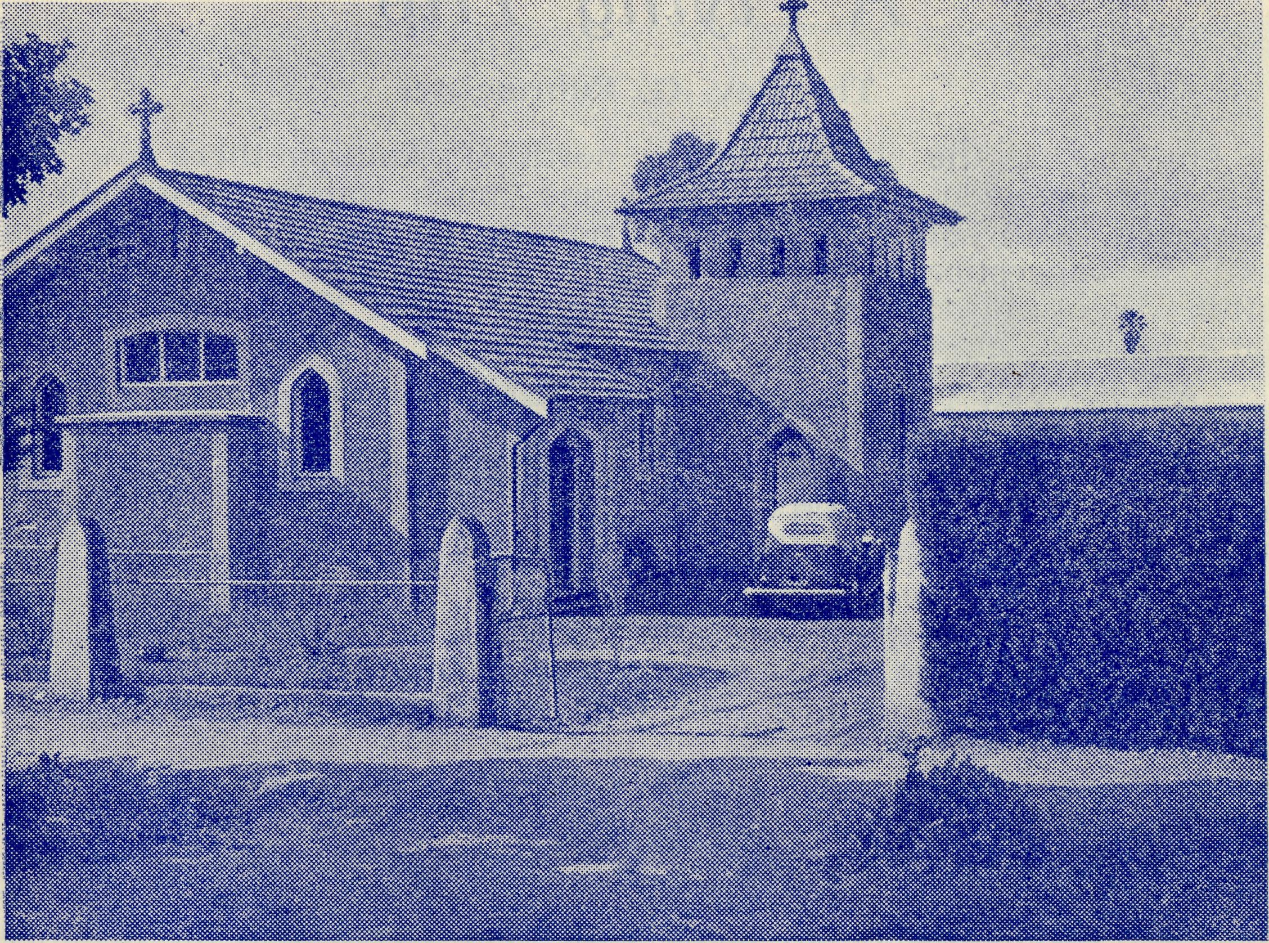
The pretty church at Orroroo in the Diocese of Willochra. This is the headquarters of a mission that extends to Leigh Creek in the north and Radium Hill in the East. The Rev. I. Booth is the
Missioner.
telling of the death of a Church member at Leigh Creek. W^{T}ould I come quickly as his wife was bewildered and wanted to talk to me? I packed my van immediately and after a quick breakfast set off, covering the 170 miles of road before lunch. When I arrived I found that there was very little provision in the town for funerals and this family were all the more confused as a result. With the aid of a friend of the family I had to act as undertaker. A coffin was purchased from the local store. It was far too big but we had to manage. A road gang was engaged to blast out a grave in the rocky soil of the Copley cemetery six miles from Leigh Creek. For a hearse we hired the ambulance and by the following afternoon we were able to hold the Burial Service. Such conditions add to sorrow but had I not been at home when the telephone call came the sorrow may have been even more intense.
Thus even in the first few months of this new venture of B.C.A. the need for a Missioner in this part of the outback has proved itself in many ways. We are looking forward to the time when, under God, we can fully meet this need.

U The Reed Australian November, 1955.
November, 1955. The Real Australian
15

“A Flying Trip”
The Rev. G. Fuhrmeister
In visiting the sheep stations north of Minnipa there are long; distances between the homesteads and much rough country to be traversed, with some of the roads nothing more than wheel-tracks; and the suggestion of doing the trip by aeroplane or helicopter is often discussed. I never dreamt, though, that this would be my lot — at least, for one occasion.
As the Van I was driving at the time had done nearly 100,000 miles, and another to replace it was nowhere in sight, I decided that rather than take the risk with St. Columba or eliminate the scheduled trip, I would "hitch-hike" with the Flying Medical Service from Ceduna.
The 110 miles west along the highway was covered before 7 a.m. breakfast at the hospital, and after morning devotions with the staff we left for Tarcoola about 8 a.m. Doctor and Sister had been "on duty" the night before and they enjoyed the trip by making up for lost sleep, but for me it was far too interesting and when my eyes weren't gazing intently over the side, my mouth and hands kept Mr. Chadwick busy v/ith questions.
Although on this part of the journey I did not fly over country I travel through, there were the miles of rolling sandhills, the dried-up claypans and salt lakes, with Lake Everard in the distance, and the conspicuous Mt. Finke; all of which were of tremendous interest to me. Having a tailwind most of the way, we arrived at Tarcoola in quick time, and were met at the 'drome by the Sister escorted by the policeman — not for safety but as means of transport!
Doctor and Sister Dowling were taken into the town, while "Chaddy" did his usual round of "checking up", and then the policeman returned for us. Doctor and Sister were kept busy inside until early afternoon, while Chaddy chatted outside to others he had met previously — one, a young man who had been flown to Ceduna two months before in a serious condition, now well and fit for work again. When all was finished, the team hurried off to fit in a visit to Mulgathing Station and then got back to Ceduna before dark — while I stayed on.
After the rush was over, Sister and I exchanged family news and discussed a plan of operation for the time I would be at Tarcoola. The next day I visited the School and homes, and had Communion with an old lady of 84 at Old Tarcoola, and a lantern service in the Church. That night Sister had to put a patient on the train for Pt. Augusta and as I was to go down the line to Kingoonya on the same train, which left about 1.30 a.m. next morning, we only had a short nap before wending our way to the station. I arrived at Kingoonya at 2.30 a.m. and was able to get a bed for the remainder of the night in a railway men's quarters. While at Kingoonya for two days I endeavoured to reach young and old with the message of the Word. On the second afternoon I got a lift out to a station about 40 miles away, where I spent the night. Next morning, when the mail man came through, I con-
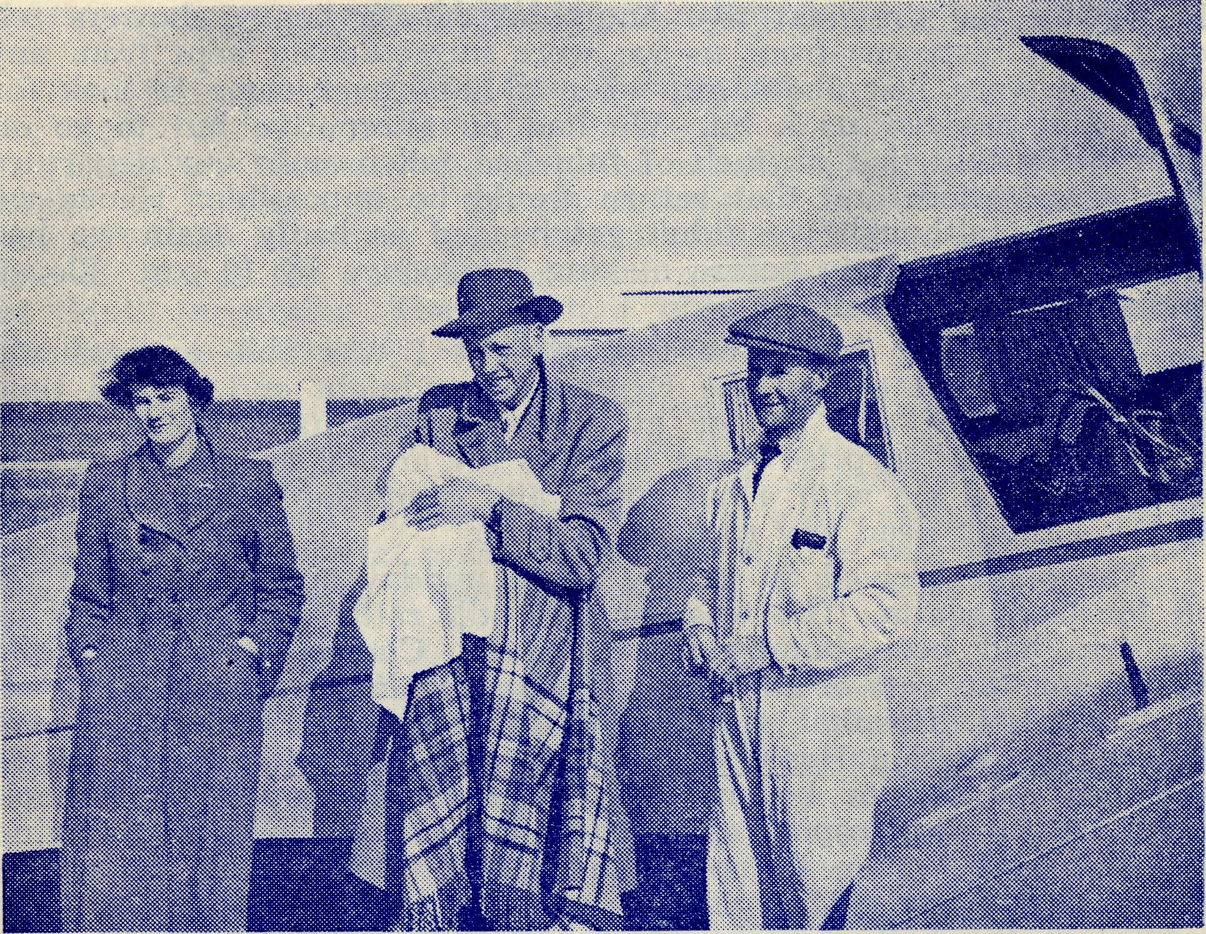
Baby Johnson, with his parents, before he was flown to Adelaide by Allan Chadwick for an urgent abdominal operation that saved
his life.
tinued my way with him to another station 20 odd miles further •on. There the Manager was away so I stayed with the Overseer and his family and, the next day being Sunday, they were able to take me on a visit to two other stations. At the latter we had a Baptismal service and in all it was a profitable trip. On the way home at night it looked as though we were in for more rain, and during the night and following day it poured down, and as a result all roads were well-nigh impassable — the mail man's truck was caught in a creek higher up and had to be abandoned. This meant, of course, I too was stranded but I managed to fill in my time easily with contacts around the station and odd jobs at the overseer's house.
I was to meet the medical plane on the following Friday at Coober Pedy, where monthly consultations are held, but as it was out of the question to get there it was suggested on the Wednesday that if I got into Kingoonya I could go back by train to Tarcoola and the plane might pick me up there. At 11-a.m. the overseer and I set off in a jeep on what proved a real adventure, for the road was slippery and water around in abundance. We managed to get through some bad patches and were feeling somewhat confident

16
The Real Australian November, 1955,
November, 1955. The Real Australian
17

when suddenly the jeep felt like a lift and down we went — thereto remain for the next five hours. Although heavy showers fell only short distances from us we were miraculously kept from any rain and were just about out when a Landrover came to look for us and it assisted us a bit. We had no alternative but to go on after being told that an inch of rain had fallen since our departure from the station, and that return would be impossible. Hence we set off and although we didn't get bogged as badly again we had a nightmare of a trip before making Kingoonya by 10 p.m. Eleven hours to do 60 miles!
The Bud Car had gone through but I was able to persuade "Controls" to let me on the Express at midnight and so had time to have a bath and supper at a Good Samaritan's home before leaving. To my surprise Sister awaited my arrival at about 1.30 a.m. and welcomed me with a hot cuppa and comfortable bed — needless to say I didn't need any rocking to sleep.
The plane arrived on Friday about midday and after lunch set off for Oodnadatta. The weather was still rather uncertain and as the trip had been bumpy from Ceduna, Chaddy flew above the clouds for the rest of the trip. While consultations were going on at the A.I.M. Hospital, I went off to conduct a wedding at the Aborigines' Mission Hostel — the bride and groom were full bloods and had wanted to be married white fellah way. The mission Sister was in the Hospital as a patient and a fine Christian aborigine lass was carrying on the work in a most capable way, caring for about 15 children. Most of the older ones came with her to a service in the hall at night. A young man remained behind after the service to talk over some of his problems.
Next morning we left at 7 a.m. with the weather still rather uncertain and shortly after taking off we ran into rain which continued until about ten miles from Coober Pedy and then suddenly it cleared and we were able to land safely — much to the pleasure of the folk there for we had emergency supplies on board for them. The road north and south had been impassable for about a week and there were several car loads of people stranded there.
Contact was made with Ceduna on the transceiver and after morning tea, while Doctor was consulting, I was able to speak to those waiting about. I have always found the work of the Flying Medical Service most appreciated by all and this helps to make it easier to speak of the Great Physician of the soul.
By 10.30 we were saying good-bye once again and soon were heading for Ceduna, with those on board showing the same interests (!) in the journey as when we had left Ceduna 12 days before — it seemed to me nearly that number of weeks!!
COVER PICTURE
The photograph was taken on the occasion of the opening of the new church at Ceduna. From left to right, back row: Rev. I. Booth of Orroroo, Rev. T. Hayman of Ceduna, Rev. P. Connell of Streaky Bay; Front row: Rev. G. Fuhrmeister of Minnipa, Rev. G. Beavan> B.C.A. Victorian Secretary, Rev. A. Richards-Pugh of Cowell.
Fowler’s Bay
The Rev. T. Hayman.
Early on Thursday morning the missioner prepares to go "out back" to Fowler's Bay, though nobody of course considers they are out-back as others are still further on. Fowler's Bay was the site of one of the earliest important settlements on the west coast of South Australia. These distant places must be visited during the week in a monthly schedule if possible.
In addition to Bible and toothbrush, the missioner before he-leaves must make provision for petrol, books, piano accordion, bedding, projector and, of course, his razor, so easily forgotten in the rush to see to many duties and try to get away early. Then, before departure, the hospital must be the last port of call, to see if there are any medicines or a mundane egg box to be taken to our sisters at Penong.
With a sigh of relief that he is at last on the way, the missioner then faces the long drive to Fowler's Bay. While there are many homes on the way that could be visited, they must be passed by at this time; Penong Hospital and two country schools are the only stops. A few farms are visited at Coorabie in preparation for a service to be held the following week and the small school of half a dozen children is visited for a religious instruction class. One or another of the farms always urges an invitation for dinner, even though the missioner may say he has food with him. Somehow around the table, with the whole family, even if there is not a definite act of family worship (and there very often is), there is a closeness of friendship that makes it easy to speak of Divine things..
A casual visitor would be amazed at the number of cars outside the Coorabie hall that night, for there would only be two houses; in sight, but the folk have been previously invited to come, by letter.
In one or other of the homes the missioner stays the night,, though he has his bedding in the van. On this occasion he stays at a home where there are two boys, six and eight years of age, who are doing their school work by correspondence. The mother's; task is a very difficult one indeed. Younger twins take up a great deal of time and attention. As her husband has no help on the farm, there are certain jobs in which he is glad of her help. One cannot help admiring the courage of that mother in trying to keep the boys to their school work. Others in the same district have taken the other course and have left for the city. In most cases this means a loss of population, for generally the farm is bought by a neighbour to increase his area. We are very glad to> know that B.C.A. is to make an attempt to solve this problem.. With the co-operation of the Department of Education and the P.M.G.'s Department, B.C.A, will establish a "correspondence school of the air" — the first of its kind to have a separate correspondent school teacher.

18
The Real Australian November, 1955.
November, 1955 The Real Australian
19

On the Friday, the important work of visitation must be finished in time to visit the one school in the Fowler's Bay area. The "township" is isolated in a peculiar way. Approaching it from Coorabie, we must cross quite a long stretch of swamps through which the road is "built up". These swamps are not as unhealthy as their name suggests. They are dry for most of the year. On the two remaining sides of Fowler's Bay (the sea is in front) there are sand hills. Already a house, a road and several windmills have been covered by drifting sand.
Fowler's Bay owes its first prominence to its importance as a repeater station for the post office. A number of large sheep stations were established early in its history and the trapping of kangaroos attracted a number. The township boasted a large hotel, post office, police station, one or two shops or stores, a large goods shed at the end of the jetty, and a school. Naturally with these there was quite a village of houses.
Much of this remains in skeleton form. Some of my friends are amused that I sometimes sleep in the only remaining room of the Globe Hotel, and that is the "temperance bar". All that is left of many of the wood and iron houses is the chimney standing like .a monument in memory of better days.
The people of this present township are certainly not to be judged by their surroundings. There is a pride of place and a spirit of comradeship as high here as anywhere. The timidity of the school children is well matched by the hospitality. We met that night in the large hall, still decorated with streamers from the last function. The arrangement of the planks on boxes and the simple tables covered by the green felt gave a devotional atmosphere which was very much enhanced by the sincerity of worship. The final prayer for peace and blessing is just as real here as in the largest cathedral. Did not the Master say, "Where there are two or three . . ."?
WINGS OF MERCY
Each year the planes and doctors fly an average of 36,000 miles. It costs £4,000 per year to keep the plane flying, and about £10,000 for maintenance of hospitals, nurses and radio base.
Although most of these expenses are recovered in fees, B.C.A. urgently needs £3,000 extra income if this splendid service is to be maintained as a Christian witness.
Will you give
£1 to maintain the plane for 6 minutes 10/- to maintain the plane for 3 minutes 5/- to maintain the plane for 1^ minutes?

IF YOU ARE A CHRISTIAN NURSE
YOU ARE URGENTLY NEEDED IN THE OUTBACK
REMEMBER THE B.C.A. BUSH PADRE BROADCASTS —
2GB EVERY FRIDAY at 11 a.m.
2CH ALTERNATE SUNDAYS at 6 p.m.
2KA ALTERNATE THURSDAYS at 4.20 p.m.

ENQUIRE OF B.C.A. NOW
The Official Organ of
THE BUSH CHURCH AID SOCIETY
Church House, George Street, Sydney, N.S.W.

