March, 1956
SUNDAY
For all M i s -s i o n e r s and Deaconesses of the Society and their people and for all students in training.
MONDAY
For all Doctors and Nurses serving in the outback, and for the spiritual and physical health of the patients under their care.
TUESDAY
For all Workers in Hostels, the children under their care and the teachers who instruct them.
WEDNESDAY
For the Director of the Mail Bag Sunday School, the pupils of the School and all teachers and voluntary workers.
THURSDAY
For the Flying Medical Service and the safety of the pilots and all who travel with them.
FRIDAY
For the Council of the Society, the Home Base staffs, Auxiliaries and Parochial workers.
SATURDAY
For all necessary finance needed for the maintenance of so large a ministry and for guidance in its right application.
No. 15 (New Series).
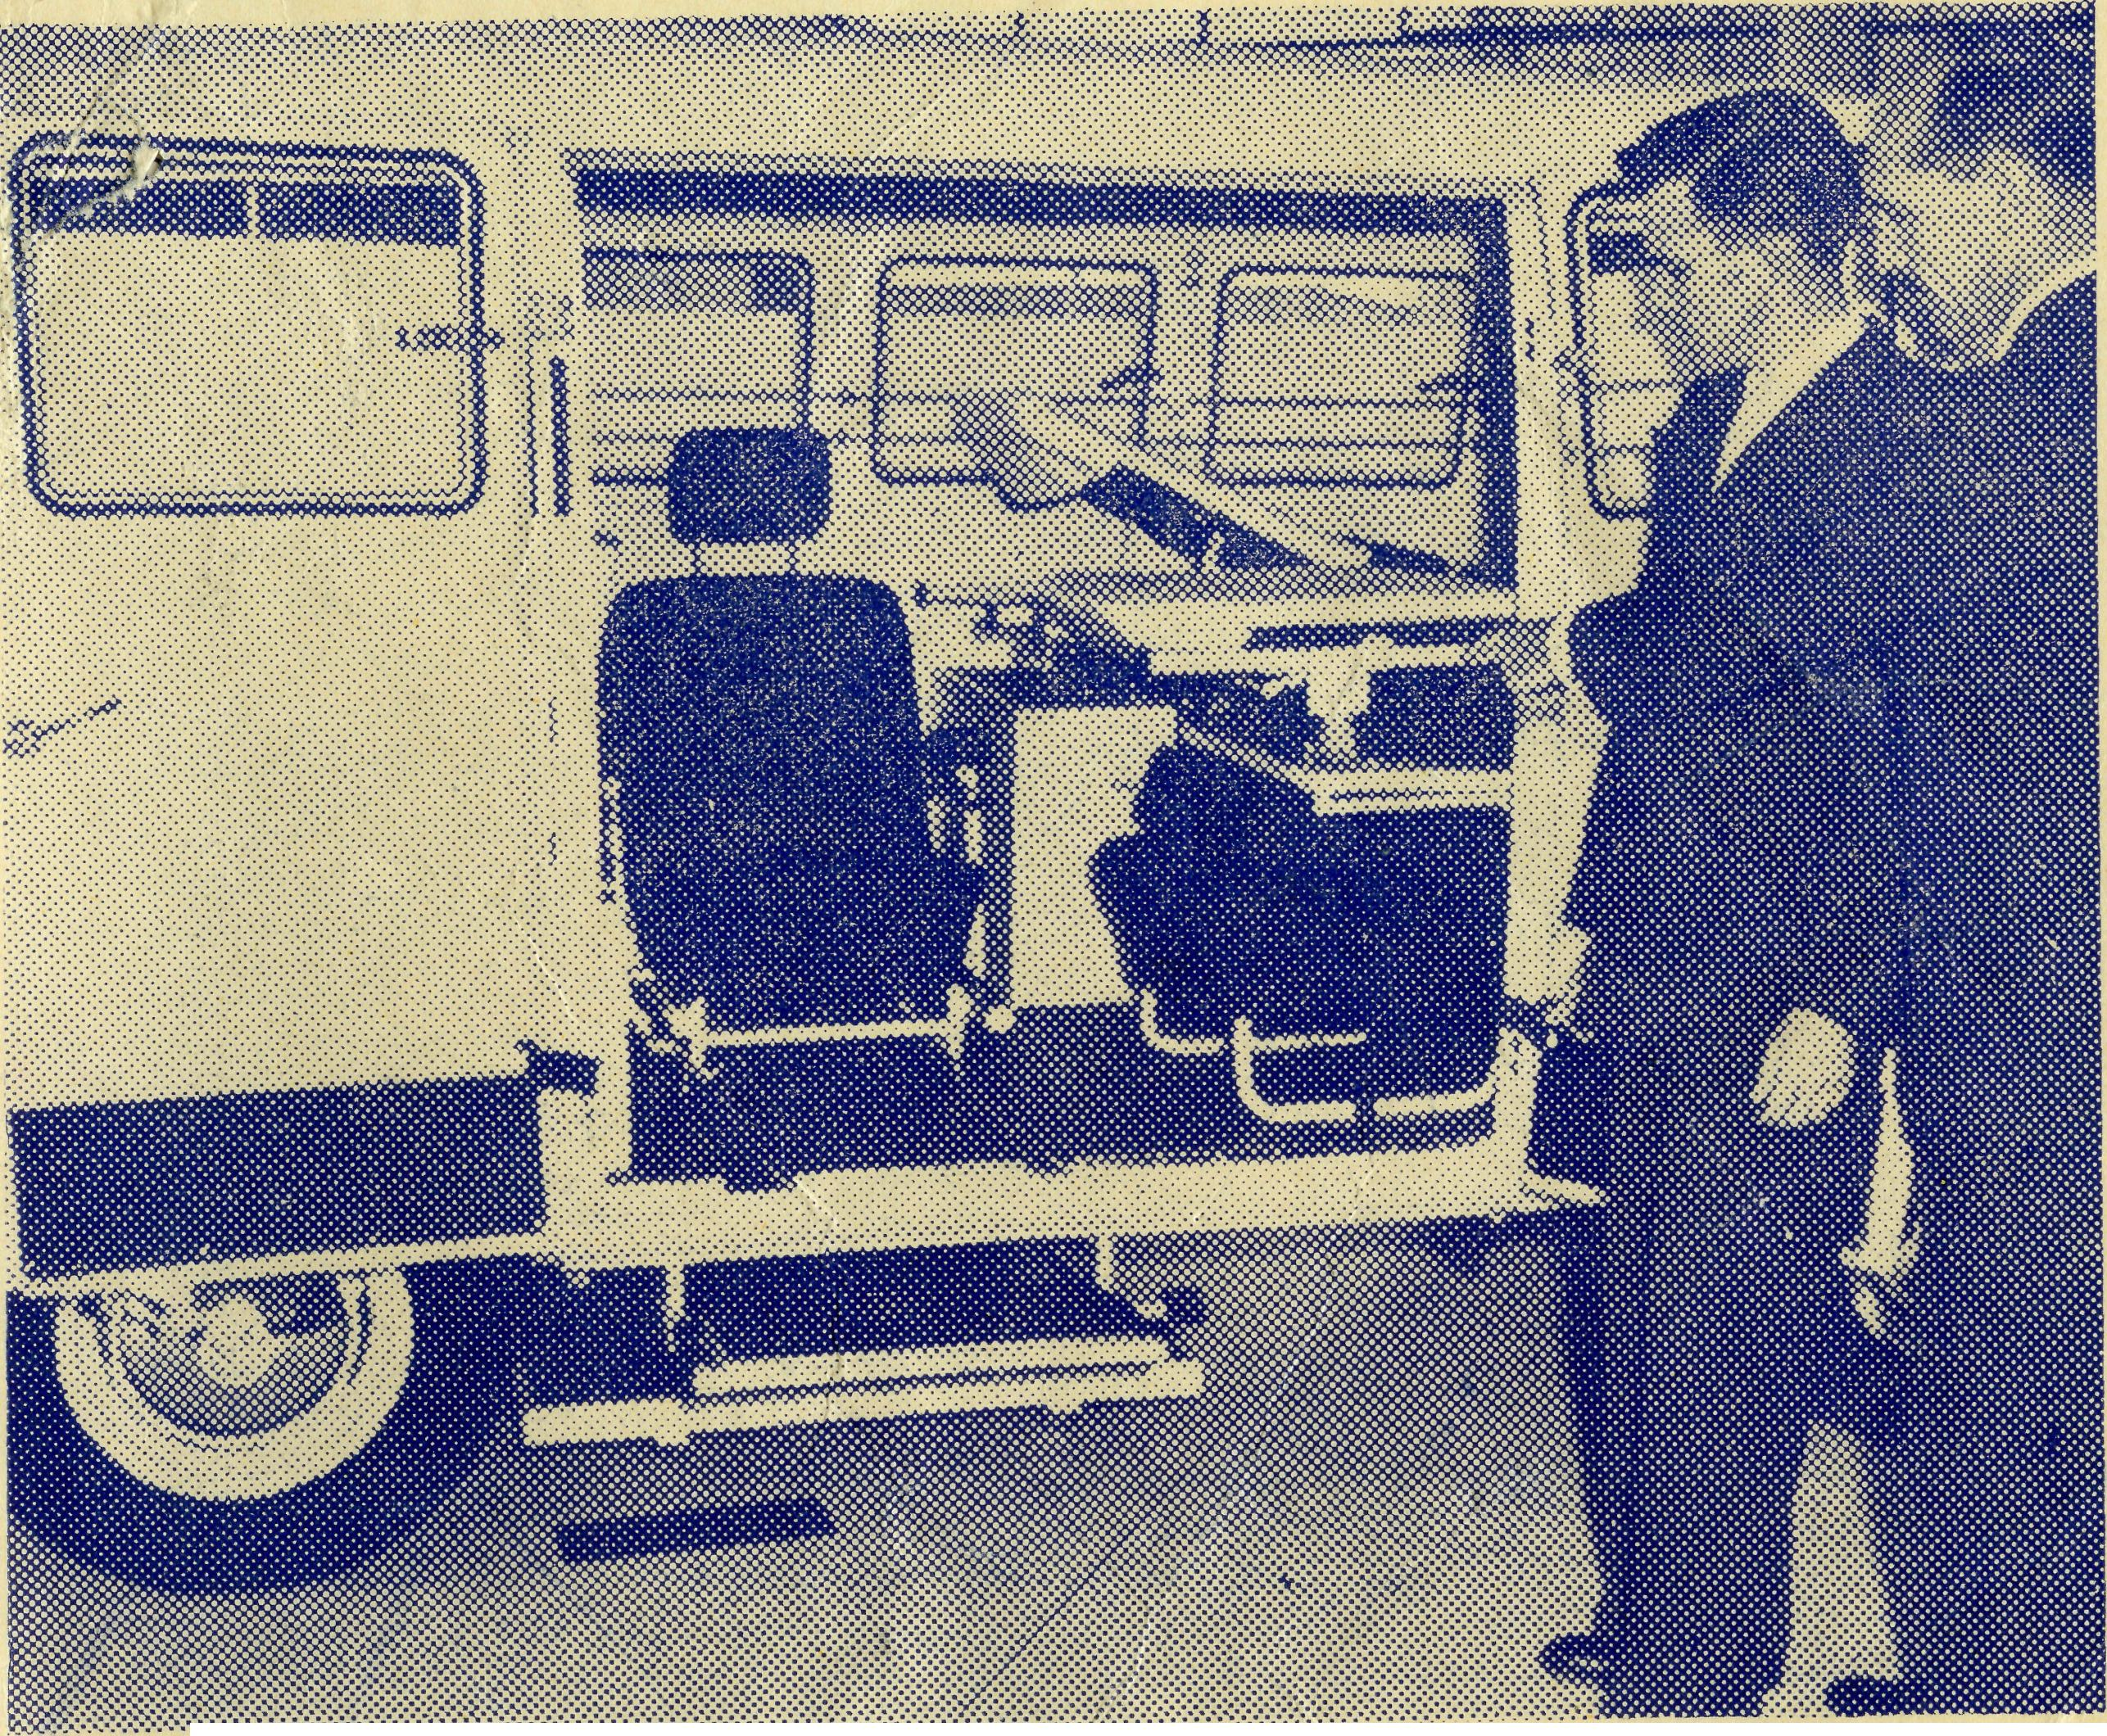
20
The Real Australian
Topics for
Prayer and Praise
For the Society.
O Lord God of our nation, Who hast commanded men to subdue and replenish the earth: Look in Thy love upon all who in distant parts of our land are striving against many difficulties, and are deprived the access of the means of grace. Strengthen and guide the Bush Church Aid Society and all members of the staff. Cheer and comfort them in discouragement and loneliness, bless their ministrations to the good of those they serve, and grant that the message of redeeming love may thus be rooted and grounded in our national life, to the glory of Thy Great Name through Jesus Christ our Lord. Amen.
For Nurses and Doctors.
O God, Who didst choose a beloved physician to set forth the life of Him Who went about doing good, grant that Thy strong tenderness and compassion may be manifest in the work of country doctors and bush nurses. Make them at all times alert to be faithful, as those whom Thou hast burdened and inspired with the honour of their calling. In lonely emergencies strengthen them with confidence that, having done all they can, they may with good conscience leave the issue to Thy power working within Thy law. Make them resourceful and of sound judgment, and hearten their labours with the energy of compassion and the firmness of duty that conquers weariness. Through Him Whose power is called forth by suffering. Jesus Christ our Lord.
For Church Life in Country Districts.
O Lord, Who art present when two or three are gathered together in Thy Name, bless, we beseech Thee, the little far-scattered groups of brethren who in our wide land meet together to worship Thee. Give them a perpetual freshness of spirit, and the power to inspire in each other holiness, helpfulness, and understanding of Thy help. Refresh with the joy of enthusiasm those who endure weary journeys to Thy try sting place. Grant that these little companies of Thy servants may be united in the spirit of Christian charity, awaiting in love the time when there shall be one fold and one Shepherd. Grant that the common life of all communities may be purified by this spirit of charity from all meanness, falsehood, malice and idle gossip, and grant that they who share a common lot may draw strength from each other's virtues, and in their weakness help one another, through our one Lord, Jesus Christ.
Praise.
For the Blessings vouchsafed to the Society, for all kindly givers, for the joy of service.
Edgar Bragg & Sons Pty. Ltd., 4 Barker Street, Sydney.
MARCH, 1956. 2/6 per annum, post free.
Mr. George Cameron takes delivery of the new Ambulance.
The Official Organ of THE BUSH CHURCH AID SOCIETY Church House, George Street, Sydney, N.S.W. Registered at the G.P.O., Sydney, for transmission by post as a periodical.

The Real Australian
March, 1956
March, 1956
The Real Australian

The Bush Church Aid Society for Australia and Tasmania
PRESIDENT: The Archbishop of Sydney.
Hon. Clerical Secretary: Rev. Canon E. Cameron.
Hon. Treasurer: Mr. T. S. Holt.
B.C.A. Activities and Staff
Organsing Missioner: Rev. T. E. Jones, Th.L.
N.S.W. Deputation Secretary: Rev. J. R. Greenwood, Th.L.
Victorian Secretary: Rev. E. G. Beavan, M.A.
HEADQUARTERS OFFICE: VICTORIAN OFFICE:
Diocesan Church House, Bible House,
St. Andrew's Cathedral, Flinders Lane, Melbourne, Victoria.
George Street, Sydney. 'Phone: BM 3164. Telephone: MF 3552.
Cable Address: "Chaplaincy, Sydney".
STUDENTS IN TRAINING.
Rev. A. Williams. Mr. J. Smith.
Mr. B. Viney. ^{Mr}- ^{B}_{D} Buckland.
Rev. R. Brooks.
Rev. F. D. Buchanan. Mr. R. D. Neve.
MISSIONS.
Ceduna, S.A.-Penong, S.A.— Heytesbury Mission, Vic.—Rev. P. R.
Rev. T. J. Hayman, Th.L., Ceduna, S.A. ^{Cooke}' ^{Th}'^{L}' ^{T}'mboon, Vic.
Otway Mission, Vic.—Rev. T. Morgan,
Cowell, S.A.—Rev. D. A. Richards-Pugh, Th.L., Beech Forest, Vic.
^{A}'^{LCEX} Wilcannia, N.S.W.—Rev. J. Stockdale,
Minnipa, S.A.—Rev. G. Fuhrmeister, Th.L.
^{Th}'^{L} Menindee, N.S.W.—
Streaky Bay, S.A.—Rev. P. Connell, p_{a}„„„:iu m c \a# d a r* . i_ tl .
Th.Schol. Rappville, N.S.W.—Rev. A. Gerlach, Th.L.
Croajingalong, Vic—Rev. L. Luck. Orroroo, S.A.-Rev. I. Booth, Th.L.
Tarraleah, Tas.—Rev. W. Warburton, Th.L. MEDICAL SERVICES.
Ceduna, S.A.—
MAIL BAG SUNDAY SCHOOL. ciª«°c:- .^{Sister}, ^P™""-⁹' ... , ,
Staff Sisters J. Miller, G. Hitchcock, B.
Director—Miss R. Campbell. Tierney, A. Butler, M. Bell.
Penong, S.A.—Sisters L. Loane and J.
SCHOOL HOSTELS. Roberts.
Broken Hill, N.S.W.—Mr. and Mrs. W. L. Wudinna, S.A.—
Calder. Matron: Sister R. Portch.
Mungindi Boys' Hostel, N.S.W.—Mr. and ^{S}i^{SterS}\,^{V}\,^{Brealey}'»»^{M}- S^{ear}k V ^{J},^{ohn}-
Mrs. S. Colefax. ^{ston}' ^{N}- ^{Verit}y- ^{M|SS} ^{c}- Derbyshire.
Mungindi Girls' Hostel, N.S.W.—Miss M. Cook, S.A.—Sisters M. Ross, M. Tarr.
^{Farr}- Tarcoola, S.A.—Sister V. Holle.
Bowral, N.S.W.—Mr. and Mrs. A. Cann River, Vic.—Sister I. Gwynne.
^{McLaughlin}' Rawlinna, W.A.—Sister E. Thomas.
Port Lincoln, S.A.—Miss G. Banks, On Leave.—Sisters B. Barber, M. Hors-
Miss D. Duver. burgh, L. Langtree.
FLYING MEDICAL SERVICE. Pilots—Mr. A. Chadwick, Mr. W. Bed- Pharmacist—Mrs. G. M. Job.
ford, Mr. G. Job.
Doctors—Dr. M. Mueller, Dr. C. Blower, Wireless Control Station
Dr. D. Allsop. Control Officer—Mr. G. Cameron.
The O.M.'s Letter
My first word must be one of appreciation to all those friends of B.C.A. who gave so very generously to our Christmas Appeal both in N.S.W. and Victoria. The amount for N.S.W. reached the total of £1,711 and, although I have not the total for Victoria, I understand that it was a very generous one
The appeals to our friends at Rally time and Christmas constitute one of the main sources of income for the maintenance of our work and the increasing giving at these times not only help us materially but also are of very great encouragement to those of us who have the task of the day to day management of the Society's affairs.
The past year has been one full of progress and consolidation, though it has also had its anxieties. The greatest problem has been the maintenance of staff. It is, therefore, good to know that the nursing staff is almost at full strength, but we do need two more nursing sisters to complete the job.
Dr. M. Mueller has had a very arduous and exacting task all the year in maintaining the Flying Service while having also to look after the Ceduna practice, except for two periods when she has had the assistance of Dr. Margaret Taylor, to whom we are very grateful for helping out. The Society is greatly indebted to Dr. Mueller for her work and the fact that she has done it without complaint.
Towards the end of the year Dr. Charles Blower accepted the post at Ceduna and, together with his wife, will be working with Dr. Mueller when you are reading this.
Dr. Jack Upsdell, who came to us from England four years ago, has expressed his desire to leave Wudinna for other work and we have been fortunate to be able to secure Dr. Allsop, who also comes to us from England. Dr. Upsdell has done much to build up a reputation both for himself and B.C.A. for outstanding medical work and he will be greatly missed in the district. The best that we can say for Dr. Allsop is that he will fit into the work and family of B.C.A. equally as well and as happily as Dr. Upsdell and his wife have done.
The one great problem that seems to be always with us is that of clergy. Proud as we all are in B.C.A. of the Medical, Hostel and various other activities of the Society, we cannot but remember that the primary work of B.C.A. is that of supplying living witnesses in the persons of ordained clergy of our church to the people who live in the outback of this great continent.
That there should be so many areas of this country utterly devoid of clergy is a great shame to us of the Church of England, and no amount of excuse can justify it. During General Synod week it was revealed to B.C.A. that in the west of Australia there is an area over ten times bigger than Britain in which not one clergyman of our church is to be found. It is not unpopulated for there are a number of important country towns in the area and a vast stretch of station properties. Much development is taking place within the area and it seems that the only sphere that lags behind is that of Christian witness.

The Real Australian
March, 1956
March, 1956
The Real Australian

It is the same in other places. Country towns with a population of four to ten thousand people which are the church's strategic centres for many country areas, are without a ministry.
Whenever this need is mentioned one is told that the need in the great metropolitan areas is so great as to consume all the available men and the clergy who could go seem to be unable to see past the multitudes in the cities. But must missionary work stop because of the growing populations in our 'home? cities?
I use the word missionary deliberately, for I am not one who believes that the only missionary work of the Church of God lies in foreign lands and other people. Many of our own people, especially the children, are as ignorant of God and the message of His Son as any heathen savage. Yet in their need for the Bread of Life there are few to offer them anything but the stones of indifference.
According to the last census returns our church has lost ground everywhere in Australia. I venture to say that it has lost the greatest ground in the country and outback areas and that this is because our outback dioceses which comprise over one-third of the country's area are denuded of clergy.
What shall we do? Can we continue to be indifferent? Must we say it can't be helped? The early disciples had the whole world to minister to and there were only a handful of them. Did Paul or Peter or Barnabas stay in Corinth or Rome or even Jerusalem and say, "There are too many people here. I cannot go on elsewhere"? Certainly not or else the Church of God would have been a small sect that would have quickly died. They built up a nucleus of lay Christians and then left them to spread the gospel to the rest*
Have we got so intensely organised to-day that we Cannot do just that, at least for a while? Must there be clergy in every parish all the time? Couldn't the lay people maintain the work and life of an established parish for one year or even two? Could not the rector of the parish next door give oversight, especially if his own lay people took on some of the work he would have to leave undone?
Is this a hairbrained idea? I don't think so, because we do something like this when a state of national emergency which we call a war comes along. We find the men from existing parishes to go to minister to our men in the forces. The deplorable state of the spiritual health of Australia in the country and outback is surely a state of national emergency.
Most of you who read this will hot be clergy, therefore you
may think this has no application to you. It has. You can pray
about it,and it needs Urgent, desperate and continued prayer. Then
and then only we may get somewhere along the road of winning
Australia for Christ and His Kingdom. Hitherto we have only
played with the idea.
— The O.M.
A Church for Leigh Creek
South Australia has commenced in recent years a great industrial expansion. Industry needs power and this need is being met by new power stations all over the State.
One such power station has been established at Port Augusta and has been equipped to use Leigh Creek coal. This with other demands for coal has led to the growth of the Leigh Creek coalfields in the far north of South Australia. Over the past few years the population of this town has been steadily growing and now stands at 1,000. Other denominations have established church buildings and provided resident clergy but as yet the Church of England has not been able to do so. B.C.A. has undertaken to meet this need if at all possible and we hope you will help us to do so.
A few miles down the North-South Railway is an old church building used in years gone by to provide services for a small railway town. As far as can be ascertained there has not been a service held in it for at least 28 years. The furnishings have disappeared and the windows smashed by children using the building as a playground. The only items of furniture left in the building are a marble font in reasonable condition and various parts of an organ strewn over the floor. Birds, wind and rain have all combined to make the scene one of desolation.
Closer examination reveals that the timber and corrugated iron which form the shell of the building are in quite reasonable condition despite the neglect of years. Permission has been given by the Bishop of Willochra and the handful of churchfolk still living in the town for the building to be removed to Leigh Creek to form the nucleus of a church building there. However, a shell without windows and furnishings is not all that is needed so it is hoped that our small band of helpers will be busy this year working towards the renovation and furnishing of the building.
Recently, on a visit to Leigh Creek, I received a phone call from the wife of the manager of one of the nearby sheep stations. Nearby? Well, only 75 miles out. Could they bring their babe in to be baptised? In circumstances like these B.C.A. Missioners usually make a visit to the station concerned and hold the baptism in the homestead, but these people had heard of the difficulties of this new Mission and decided that they would make the journey into town to save me a day's journey out to them. After the service, in the course of conversation, I learnt that their first babe had been baptised by the Rev. George Fuhrmeister on one of his visits to them while they were managing a station near Tarcoola in the Minnipa Mission. This gesture helped me to realise the real fellowship that exists in the B.C.A. missions.
In the future, when it is possible to have a Missioner based at Leigh Creek, all the stations in this vast area of the State will be visited regularly. At the moment we must be satisfied with a token ministry, but dare we be satisfied with this? This largely depends on the number of young men coming forward to serve God in the ranks of B.C.A.

The Real Australian
March, 1956
March, 1956
The Real Australian

To conclude I would ask if there are any readers of the R.A.
who would like to help provide a strip-film projector for use in
-this new area. At the moment the most has to be made of the
flannelgraph board but this is naturally limited in its appeal to
children and adults alike. Such a projector would be a great asset
in the work here.
* * * *
The First Twenty-five Years
A hefty young man over six feet with broad shoulders and sandy hair, grinned at me and said, "Remember me, sir?" I looked up at him and told him firmly, "Yes, of course, I do, and many's the time when you were at Wentworth Falls Hostel I wanted to dust the seat of your pants." The grin broadened, "Yes, and I would have deserved it."
The young man came of a family of nine, all of whom went at some time of their lives to the B.C.A. Hostel at Mungindi and attended the school in that town. Some of them, like this boy, had later gone on to the Katoomba High School when B.C.A. had the hostel at Wentworth Falls.
It was later in the afternoon when I met the father of this family who, as he gripped my hand, told me, "B.C.A. brought my family up and they are better men for having been in the hostels."
The occasion was the gathering that had been arranged to mark the Silver Jubilee of the first hostel at Mungindi. Quite a number •of the old 'scholars' attended as did the parents of past and present inmates. We were very glad that our good friend Bishop Moyes had been able to come along for the occasion to take the service and give the address.
Miss Cheers, who was the first matron of the Mungindi Hostel, was also able to be there and many tributes were paid to the care and training that she had given to a long line of boys and girls; over the years.
Today the B.C.A. has separate hostels for boys and girls. Miss M. Farr looks after the girls and Mr. and Mrs. Colefax are in charge of the boys.
We are grateful for the monetary gifts that were given for necessary improvements that are to be made to the Boys' Hostel, and we are specially grateful to Mr. A. Waugh for his help and interest shown in tangible form by the gift of a block of land for use as a playground and a memorial to the work of Miss Cheers.
IF YOU ARE A CHRISTIAN NURSE
YOU ARE URGENTLY NEEDED IN THE OUTBACK
ENQUIRE OF B.C.A. NOW
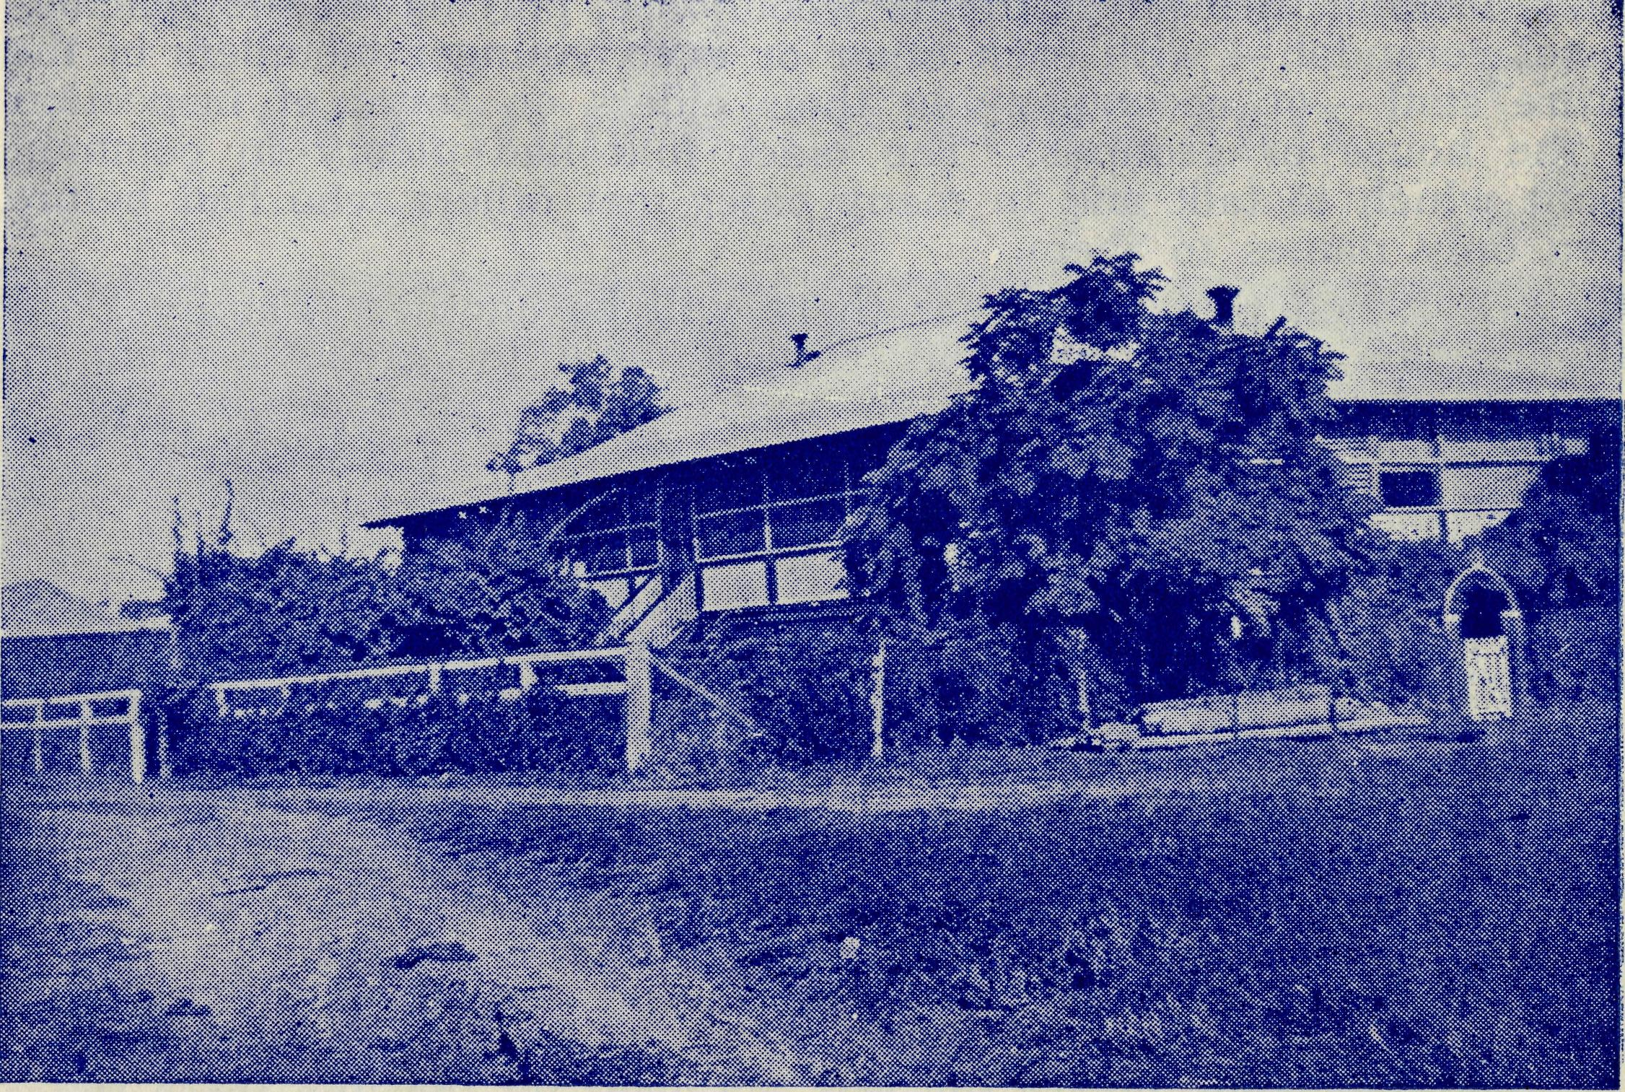
The Hostel at Mungindi, now used exclusively for boys. Dedicated!
on February 13th, 1930, by Bishop Moyes, who was present at the
Jubilee gathering on November 5th, 1955.
“Family Day”
January 14 this year was "Family Day" for members of the B.C.A, Council and Staff — past, present and future.
Several members of the present field staff were in Sydney for their holidays and it was decided that all who could would take a picnic lunch to the Girls' Hostel at Bowral, where Mr. and Mrs. McLaughlin are now in charge.
The day dawned bright and sunny and no fewer than eight vehicles took the road for Bowral, gradually converging at the Hostel some time between 10.30 a.m. and 1 p.m. The attendance included twelve children and reached the grand total of 41!
When everyone decided lunch was the next order of the day rugs were spread on the grass in the shade of trees, quite near the hostel building, and after the Rev. R. Hallahan had asked for blessing all proceeded to ease the pangs of hunger induced by an early start and a long trip.

The Real Australian
March, 1956
March, 1956
The Real Australian

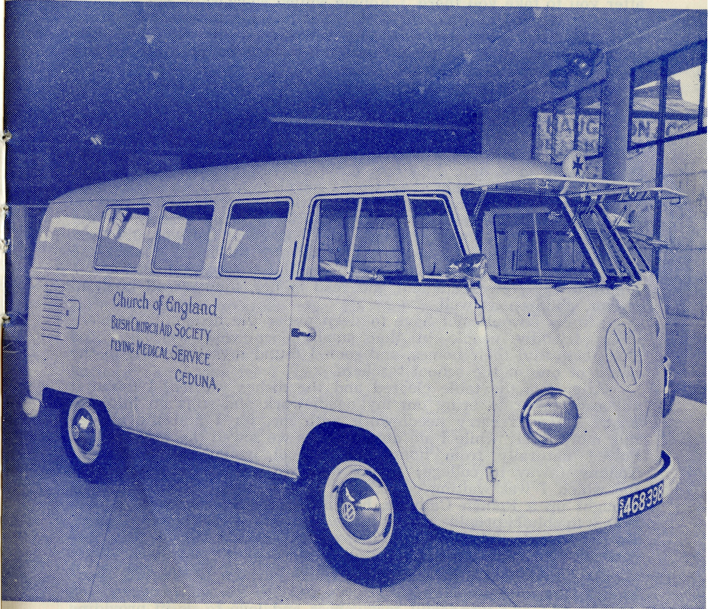
During the day the future missioners and nurses enjoyed riding bikes, locking themselves in the woodhouse, playing on the spacious hostel verandah — with each other or even younger members of the future staff — or accompanying their elders on tours of inspection of the house or grounds. The older folk had plenty in common about which to talk and in many cases met others who had before been only names to them.
It is hoped that next year there will be another "Family Day" when even more of the staff will be able to attend a common meeting place and get to know a greater number of the B.C.A. Family.
Woman s Work
By Deaconess A. Howland.
It was a hot, dusty day as I made my way to the railway station. I was early, and sat on the station looking around and thinking how different was this little place from some of the larger stations that I had known. Sydney, Adelaide, Melbourne, London and others: how far away they seemed, and how different with their teeming millions, their rush and bustle and noise, from this quiet little country town, where the rail car went up the line three times a week, and back again on the other three days. A freight train went through nearly every day, going either up or down, carrying with it the stores, groceries, vegetables, hardware and everything else necessary to make life possible out in the country, to say nothing of the mail so eagerly looked for, especially by those away from home and friends.
The rail car approached with a toot of its horn, which told all the countryside of its arrival. George, the driver, is a kind, friendly man. "Where to this time?" he asked. "Oh, the usual place," I told him. George had his "cuppa" at the refreshment rooms, the out-going mail and freight were loaded, and with a screeching toot we started off.
It was not a long journey, only forty miles, and in an hour and a half I was getting off again, dragging my two little bags with me. I dumped them on the railway station, and left them there while I went into the town. Where would I stay for the week-end? I had deliberately not made any arrangements, for I often found it a good thing just to wait and see what turned up.
I wandered round the little town with its dozen or so houses, its two shops, cafe, school, post office and hotel. It was very hot, and the sun seemed to be stronger than ever, and the glare of the roads harsher than ever on one's eyes. I turned to the school, so that I could inform the headmaster I would be there on Monday morning. Then I went into the office of a garage where I knew I would find the proprietor's wife keeping lonely vigil as secretary to her husband.
While I was there an old man came in, took a look at me, and would have fled but I called out —"It is all right, Robbie. Don't run away from me." He was an old reprobate, hardly ever sober,
ANOTHER STEP FORWARD
This is the modern ambulance that has been purchased for the B.C.A. Flying Medical Service at Ceduna from the proceeds of the South Australian Appeal made last year by the Adelaide Sunday Mail. It has two stretchers, detachable patients' chairs and is air conditioned.

10
The Real Australian
March, 1956
March, 1956
The Real Australian
11

but sober enough at this time to be scared stiff of anyone from the Church. "Now don't you start telling me I ought to go to Church," he quavered indignantly.
"Robbie, I wouldn't waste my breath talking to you like that," I answered him. "You know where the Church is, and when the services are held, and if you don't intend to come I am not running after you to take you there." Robbie smiled sheepishly, but changed his smile when I said to him—"It is not possible to run away from God, and there may come a time when you will wish that you knew where to find God," Poor old Robbie couldn't stand any more. He went.
I went, also, soon after, to visit another family. They had not long been in the district, and I try to visit them as often as possible for I feel a real concern for this family. The father and mother had both been heavy drinkers, and through carelessness while they were both drunk the youngest child had met with an accident which for a long time kept him barely alive. He did recover, and both parents vowed that they would never touch drink again.
That was before they came to this little town with its temptations of isolation and loneliness, the social life centring mainly in the hotel, and plenty of money to spend. I looked at the woman's face, ravaged by dissolution, and felt a great pity for her. I knew the hotel had caught her husband again and I felt very helpless, but I produced my New Testament and read to her, then we all knelt in prayer, children as well.
I knew I would not have to sleep under the hedge: there were many friendly people in that small place who welcomed the Deaconess into their homes, and soon I found myself invited to the house of one of the school teachers.
After tea, the table cleared and the dishes washed, I found it an easy matter to bring out my needlework and start an informal chat. I always carry needlework with me, for I find the women talk more freely while I am doing it. As we sewed the conversation flowed naturally from housework, school, young Johnny, older Tommy (away in college) to my own work, and the opportunity for which I was waiting came. My hostess told me she had been brought up a Roman Catholic, had married a Presbyterian, and in order to bluff people occasionally attended a Methodist service. But she confessed herself to be quite ignorant about God, and couldn't understand religion at all.
So I told her, quite simply, of God's purpose in creating mankind, of sin and rebellion which created the barrier between God and us, of God's wonderful forgiveness and love to us in providing the means of reconciliation, and of the love of Christ which led Him to die for us. She listened, and asked many questions, and as she was an intellectual woman I proved my answers from the Bible. She was greatly impressed, but when it came to midnight I knew I could go no further with her, and I could only commend her into our Father's keeping.
The next day I visited another house in the town, and was asked to spend the night there. I accepted gladly, for the more houses I could get in contact with the better. The husband went out after lunch. He did not come in for tea, nor supper, nor at
bedtime. Again I brought out my needlework, and my hostess brought out her knitting, but this time we were silent.
The husband had not returned, and I knew the anxiety that was eating into her heart. We both knew why he had not returned, but we did not know where he was, and in the heart of the woman sitting by me was the numbing fear that her drunken husband had met with an accident. So we sat together.
Eventually I brought out my Bible and read a few lines to her, then suggested that we seek God's help, so we both knelt down and prayed. The sadness welled up into tears as we finished, and the woman said to me: "I wonder if God really does hear our prayers. Does He really care?" I assured her that He did, that at this very moment He was watching over her, and sharing with her the burden of her sorrow. We talked until very late, then just quietly sat together and waited, and it seemed that the comforting presence of our Lord Himself shared that lonely vigil with us. It was almost 2 a.m. when through sheer exhaustion I had to leave her and go to bed.
The next day was Sunday, and as I took the service I was very saddened by the look of strain and worry on that woman's face as she joined in the service.
It was while we were in the little Church that the husband returned, found the house empty and got straight into bed with dirty boots and overalls on. He had been drinking out in the paddock all night. I stayed in that house on the Sunday night, and as I left to go to school on Monday morning the wife came up to me and said: "I am so glad you were here this week-end. I feel sure God sent you, for I couldn't have borne it alone."
I decided to return by the freight train which left late that evening — it would get me to my base in the early hours of the morning. I was usually the only passenger who travelled this monotonous journey so I always had plenty of time for meditation before I finally arrived home. I had plenty of time to offer my work to God, as the train crawled on, that He might take my loaves and fishes, and bless them as He might.
These may seem only trifling experiences to relate, but that is just the sort of thing that happens in our small country towns where souls are precious to God, and where He sends His servants to go and labour for Him.
It is a lonely and difficult task, and we rely very much on your prayers. Do not fail us.
MINNIPA
The Rev. and Mrs. George Fuhrmeister are leaving Minnipa and, at the invitation of the Bishop of Willochra, are going to Quorn. They have served five years in the B.C.A. at Minnipa, and will, we feel, do much useful work in and around Quorn which has a population of over four thousand people.
The Rev. and Mrs. Arthur Williams are to fill the vacancy at Minnipa.

12
The Real A ustralian
March, 1956
March, 1956
The Real Australian
13

We are glad to be able to report that Sister M. Horsburgh has been able to resume duty at Cook. Sister has had a long period of medical attention and has undergone two operations during the past year, but it now seems that she is again fully fit. She was warmly welcomed back to the Nullarbor.
# # # #
Our old friend and worker, Mrs. C. Mann, is again restored to health after a period of sickness. Mrs. Mann keeps her very keen interest in B.C.A. and its workers and it is always a joy to see her when in Adelaide.
# # # #
Congratulations to the Rev. and Mrs. T. V. Jones on the birth of their daughter, Jennifer Anne, on January 2nd. Our congratulations also go to Mr. Jones on his ordination to the priesthood in St. Peter's Cathedral, Adelaide, on St. Thomas's Day last.
# # # #
We welcome to our staff Miss N. Verity of Victoria. Sister joined the nursing staff at Wudinna early in January. We pray that she will find this service a happy and satisfying sphere.
# # # #
It is expected that by the time this paper is in your hands we will have welcomed Dr. and Mrs. Allsop to Australia. Dr. Allsop and his wife come from Britain to take up the post of Medical Officer at Wudinna. Dr. J. Upsdell, after four years with B.C.A. at Wudinna, leaves us for other work. We shall miss him and his wife and family for we have all grown to have a real affection for them. We hope that they will be happy in the new work they are contemplating.
# # # #
Our good wishes go to Miss Barbara Chadwick, the eldest daughter of Mr. and Mrs. Allan Chadwick of Ceduna, who is to be married in the Church of St. Michael and All Angels, Ceduna, on May 25th. Barbara was only a few months old when her parents came to Ceduna, when Allan took up his post as pilot to B.C.A. Flying Medical Service. We wish her every happiness and blessing in her new life.
# # # #
Miss Cheers, who has served the Society for twenty-eight years, has been granted twelve months' leave and sailed for England on the Orontes on 25th January. Miss Cheers was first one of our earliest Mission van workers before she became matron of the Mungindi Hostel in 1930, and later in 1950 matron of the Bowral Hostel for Girls. For some time now Miss Cheer's health has not been of the best and we trust that the trip home will do her a great deal of good and give her an enjoyable time.
Deaconess Ada Howland, who came to us from England in 1952
and has served at Menindee and Wudinna, leaves our work to
enter into another sphere of service in Victoria. We hope that she
will always feel herself a member of B.C.A.'s family and our
prayers follow her, that she may be happy in her new service.
# # # #

Mrs. Gerrard of The Priory, Pennant Hills, passed to her rest on December 5th, 1955. She had been a very keen worker for the Bush Church Aid Society and had a special interest in the Mail-Bag Sunday School of which she was a teacher for many years. Mrs. Gerrard founded the Pennant Hills Auxiliary and it was largely due to her keenness that this auxiliary has done so much for the Society.
We extend our best wishes to Sister Margaret Denniss who now that she is married is Mrs. Simpson. The wedding took place in Sydney on January 21 and in due course the newly-weds will return to the Wudinna district where this ex-B.C.A. nursing sister will practise as a farmer's wife.
# # # #
Mr. and Mrs. W. Calder are now in charge at Broken Hill Hostel, having taken over from Mr. and Mrs. McLaughlin, who have gone to the Bowral Hostel. We are looking forward to a happy, if strenuous, witness amongst the children from both these teams of workers, and our prayers are with them for the guidance and strength that they will need.
# # # #
B.C.A. is very grateful for the help and interest that the Rector of Mungindi, the Rev. K. Patfield, has shown in the work of both the hostels in that town. Especially would we thank him for the work he did in the preparations for the Silver Jubilee
Commemoration.
# # # #
Our congratulations go to Jim Smith, Senior Student of Ridley College and a trainee of B.C.A., on his splendid Second Class Honours in the recent Th.L. examination. Jim is to be ordained a deacon in St. Andrew's Cathedral, Sydney, for the Diocese of Adelaide, at the February ordinations.
He will then proceed to Ceduna to be assistant to the Rev.
Theo. Hayman in the Far West Mission.
# # # #
We regret to learn of the death of Mr. John Waugh of 'Daymar', Queensland, on February 5th. Mr. Waugh's son was the first boy to enter the B.C.A. Hostel at Mungindi and he has always taken a very keen interest in our hostels. We extend to Mrs. Waugh and
the family our deepest sympathy in their very great loss.
# # # #
Congratulations to Mr. and Mrs. Victor Dodd on the birth of Peter Charles in December last. Peter's mother, who used to be known to B.C.A. friends as Isobel Beck, should have no difficulty in managing so small a family, after eight years as matron to the girls at the Port Lincoln Hostel. The O.M. had the joy of baptising Peter in the old church of St. Thomas at Port Lincoln.

14
The Real Australian
March, 1956
March, 1956
The Real Australian
15

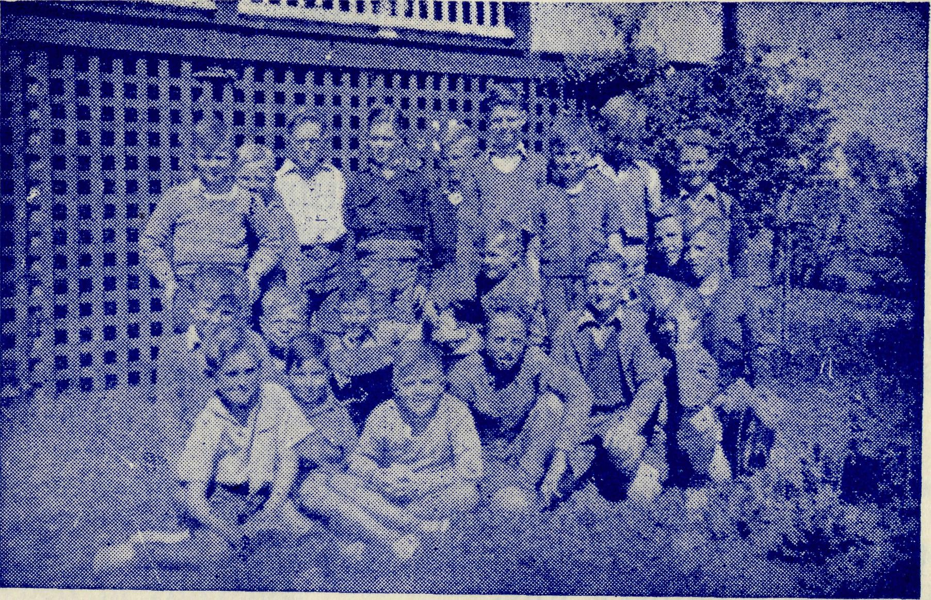
Some of the children who have been 'brought up' at B.CA.'s Hostel
at Mungindi.
A Teaching Ministry
By the Rev. H. G. Fuhrmeister.
The manager of one of the sheep stations I visit is a member of our Church and his wife is a Roman Catholic. They are most hospitable and friendly and do not oppose any move to make the most of my visits, yet they never take the initiative to help in this direction, or open up any conversation on religious matters.
Their son, about seven years of age, is doing his schooling by correspondence and usually has a governess to supervise his lessons, but sometimes his mother must do the supervision. I felt the need to approach warily the subject of his spiritual teaching.
On the previous visit to them I decided to take a run out to a small family living on an outstation some twelve miles away, and the boy asked if he could go with me for the drive — to which we both agreed. During the journey I thought to use the time in telling him Bible stories, and to these he listened eagerly and kept asking for more. By the time of my next visit I had almost forgotten the incident. When I spoke of going out to visit another outstation some 25 miles out, once again the boy asked to accompany me.
His mother then told me that after my last visit the lad had told her of the stories, and had been asking her questions ever since..
He went along with me and we didn't get far before he was asking me to tell him 'more stories about God'—and he kept it up for almost the whole of the way out and back.
At dinner I was asked by the parents and the j ackeroos several questions of a religious nature, which gave an excellent opportunity to help them, and before I left the mother questioned me about the correspondence lessons for her son. I very gladly linked him up with the Mail Bag Sunday School and we pray that he will become an earnest little Christian.
Christmas
Rev. P. R. Cooke.
Over the past few days I have been wondering how the readers of "The Real Australian" spent and enjoyed their Christmas. I expect that with each reader the answer would be different; some would have spent Christmas at home with the old folk, "we'll be home for Christmas"—funny the first Christmas was not a homecoming but an outgoing for all, for Jesus, Joseph, Mary, the shepherds and even the wise men. Others would have spent it away on holidays, at the beach, up in the hills, everywhere and anywhere; according to our own varying tastes and wishes. It is fair too to presume that most, if not all, my readers would have gone to Church on Christmas Day and taken their Holy Communion. Many can probably recall large congregations, lovely glorious music, carols, and of course a most inspiring and wonderful service. Later perhaps there was a family Christmas tree, the giving of presents or even a visit to someone in hospital.
Have you ever thought of the "bush Parson" and how he spends his Christmas? Mine, compared to some, is a relatively easy day. Others have more services and often greater distances to travel.
My alarm goes off about six and my first service is at Peterborough at 7.30. As I travel over the road the eleven miles seem all too short on such a happy morning. I pass little homesteads along the road and in some places Mum and Dad are out on the road watching "little Johnnie" or "Annie" riding the new bike that Santa Claus has brought; from other homes, smoke is coming up from behind the cowsheds, milking is in full swing and Christmas means little more than any other day. The cows have to be milked.
The service at Peterborough is a most delightful one, perhaps the nicest service in the parish for the whole year. A full Church — no, about twenty folk. Some are parishioners who have not been to Church since last Easter, some are regular worshippers and some are folk here on holidays. As we sing "O come all ye faithful" we realise that probably millions of others are singing exactly the same hymn that morning; we are not alone. We have no polished communion rails, no holy table, for we are using a Presbyterian Church and appreciate the kindness of the local trust for allowing us the use of their building week after week.
After the service, breakfast is had at the local hotel, the wife of the licensee is a very good church woman and her brother this year has gone out to work as a labourer on the Australian Board of Missions station at Forrest River.

16
The Real Australian
March, 1956
March, 1956
The Real Australian
17

Breakfast is over and I then motor to Port Campbell for the next service at 9.30 a.m. As I drive along what is the best piece of road I shall be on all day I get to guessing how many will turn up this year. There were six there last year. The rough, rugged cliffs along the great Ocean Road are a delight to see, and I am very fortunate to be traversing such a route on a day like this.
Coming into Port Campbell the campers, almost fifty of them, were astir, but there was little activity if any along the street. The Presbyterian Church was still shut, but it did not take long to open it and set it up for the service. A car was heard pulling up outside. We were to have someone, at least, for the service. When we commenced it there were three in the Church, later five others arrived: no singing but just a plain Holy Communion Service with a short address. A little depressing perhaps, especially as I could name a few families who were missing and still at home. However, I know it was appreciated by those who did come.
As I arrive back at Timboon there is one car outside the Church, and only ten minutes to go before we commence the service. A hasty cup of tea is poured out and drunk, the Communion Table set up again (the one communion set does the parish), and the organist is ready. A swift glance round the congregation shows we have about twelve worshippers in Church. By the time the first hymn is over and the service well under way, a few more cars have arrived and the numbers have swollen to about forty, just over double the congregations for the last two Christmas services at Timboon.
After the service, some as usual stay to chat, others get away to their families and to their dinners. Three services over, two to go. It is getting warmer. Thirty odd miles travelled, over sixty yet to come before the day is over, probably over some of the worst roads in the parish.
The afternoon finds us on our way to Princetown. At times this twenty-six mile journey can be the most boring and monotonous trip in the parish, and at other times according to the colouring and sunshine it can be the most delightful. Sometimes the colouring effects defy description. The road to-day is far from good, being well worn with the heavy holiday traffic.
The roads throughout most of the district are made of gravel They have heavy timber trucks over them most of the year, also the big school buses and the milk lorries. If the grader has recently been over them they are good to travel over and it is easy to keep the speed of the car up around the 40-50 miles per hour. At other times travelling faster than 20-25 miles per hour I am likely to break a shock absorber or spring or both.
To-day as I travel 30-40 miles per hour I soon pass the Sherbrook River, a delightful little spot for swimming and fishing. Then on past the Lochhardt Gorge — books have been written about the shipwrecks there and along the rugged coast line. Then on past the "Twelve Apostles" and finally into Princetown.
The township of Princetown consists of a Post Office, a store, ond "sweets and ice cream" shop, a hall, tennis court and a few other houses and sportsgrounds scattered around the countryside There was a stone Church built years ago on the side of a hill, but
like the house in the Bible story it was built with sandy foundations. A road was cut into the hill lower down and the foundations slipped and the Church had to be pulled down. The folk at Princetown now have about £300-£400 for their new building. As I drive up to the hall, a few cows graze contentedly beside the road, and apart from a car and a dog outside the tennis courts, beside the hall, the place is deserted. A game of tennis is in full swing on the courts and we know from past experience that unless they stop during the service, we can expect that the screams and yells from the fun associated with their friendly game will disturb our thoughts during our Christmas Communion Service.
The hall itself must be described. Streamers are still hanging across the ceiling, a few left-overs from the decorations from dances a month or so ago, probably some dead leaves and flowers still tacked up against the wall for decorations. Originally there were five windows in the hall, but as each pane of glass is broken so the window is roughly boarded up with wood from packing cases. It is generally quite gloomy inside even if bright and sunny outside. Princetown can get very windy at times and on these occasions, with the doors and windows shut in the hall, it is almost impossible to leave papers lying on the table or they will soon be blown away. The extra ventilation is most appreciated in summer but not so on a cold winter's day.
To-day, however, the hall has been swept out and even the matting from the old Church has been run down the aisle, the seats are soon swung around for the service and the table set up.
As the service proceeds it is; apparent we will have no more than eleven worshippers. Although invited, none of the tennis players outside will come and join us; what a pity for them, not knowing the love of God; what a pity for us too, disturbing our thoughts by their play and calling outside.
The final service for the day is at Curdies River at 7.30 p.m.
Every family is usually well represented at each service. It is
seldom there are less than a dozen at a service, usually in the
twenties or thirties with the Anglican population no greater than at
other centres. Once again the service is in a hall but with a
difference. The place is clean, the backless forms are in position,
lamps are lit, the carpet is down the aisle and across the
front, the hymn board with numbers is up on the wall* the
lectern and prayer desk are set in position, a white cloth
covers the table and flowers adorn the top of it. Once again
we attempt the hymns without music, lovely carols are sung, and the
faithful at Curdies receive their Christmas Communion at this
evening service. i
An hour or so finds me on my way home again, the day's services over. Other centres will have their Christmas celebrations during the next few weeks to fit in with the normal roster of services.
; Christmas Day is over. I am taking scouts camping for the next ten days, it's their "Christmas Camp".

18
The Real Australian
March, 1956
March, 1956
The Real Australian
19

THE CHILDREN'S CAMP
Twenty-four boys and girls from places as far away as Cook, Tarcoola, Kingoonya, Radium Hill and Leigh Creek spent a happy holiday at the B.C.A. Hostel at Port Lincoln. The O.M. was able to arrange the 'camp', and with the help of the Rev. and Mrs. Graham Delbridge, the Rev. and Mrs. Alun Pugh, the Rev. and Graham Delbridge, the Rev. and Mrs. Alan Pugh, the Rev. and Mrs. Ian Booth and Miss Margaret Warner together with Miss Gwen Banks it went swimmingly. Indeed, swimming was one of the chief delights for children who came from the far, hot inland.
The Rotary Club and many of the people of Port Lincoln helped very materially to make the children's holiday one that will live in -their memory a long time.
It was a very sun-tanned and happy mob that trooped into the bus for the beginning of the long homeward trip.
Our thanks are tendered to those mentioned above who did so much to give the children a good time. We hope to do it again at some future date, when the workers have recovered from the strain.
A NEED
B.C.A. requires the services, either in a temporary or
permanent capacity, of a young man holding 1st Class
Commercial Radio Operator's Certificate or the ability to
•obtain one or
a Broadcast or 2nd Class Certificate with a view to obtaining a First Class Certificate.
Apply to The Organising Missioner
or Victorian Secretary of B.C.A.
WINGS OF MERCY
Each year the planes and doctors fly an average of 36,000 miles. It costs £4,000 per year to keep the plane flying, and about £10,000 for maintenance of hospitals, nurses and radio base.
Although most of these expenses are recovered in fees, B.C.A. urgently needs £3,000 extra income if this splendid service is to be maintained as a Christian witness.
Will you give
£1 to maintain the plane for 6 minutes 10/- to maintain the plane for 3 minutes 5/- to maintain the plane for 1| minutes?
REMEMBER THE B.C.A. BUSH PADRE BROADCASTS —
2GB EVERY FRIDAY at 11 a.m.
2CH ALTERNATE SUNDAYS at 6 p.m.
2KA ALTERNATE THURSDAYS at 4.20 p.m.

