20
The Real Australian December, 1956
THE BUSH CHURCH AID MAIL-BAG SUNDAY SCHOOL
Director: Miss R. CAMPBELL.
Office: 242 Pitt Street, Sydney, N.S.W. Telephone: BM 3780

2/6 per annum, post free.
THE SCHOOL HOSTELS FOR OUTBACK AND COUNTRY CHILDREN
Broken Hill, N.S.W.—Mr. and Mrs. W. L. Calder.
Mungindi Boys' Hostel, N.S.W.—Mr. and Mrs. S. Colefax.
Mungindi Girls'* Hostel, N.S.W.—Miss M. Farr.
Dr. W. Stewart Ziele Memorial Hostel, Bowral, N.S.W.—Mr. and Mrs. A. McLaughlin.
Silver Jubilee Hostel, Port Lincoln, S.A.—Miss G. Banks, Miss D. Duver.
The Official Organ of THE BUSH CHURCH AID SOCIETY
Church House, George Street, Sydney, N.S.W.
Edgar Bragg & Sons Pty. Ltd., 4 Barker Street, Sydney.
No. 18 (New Series) DECEMBER, 1956.
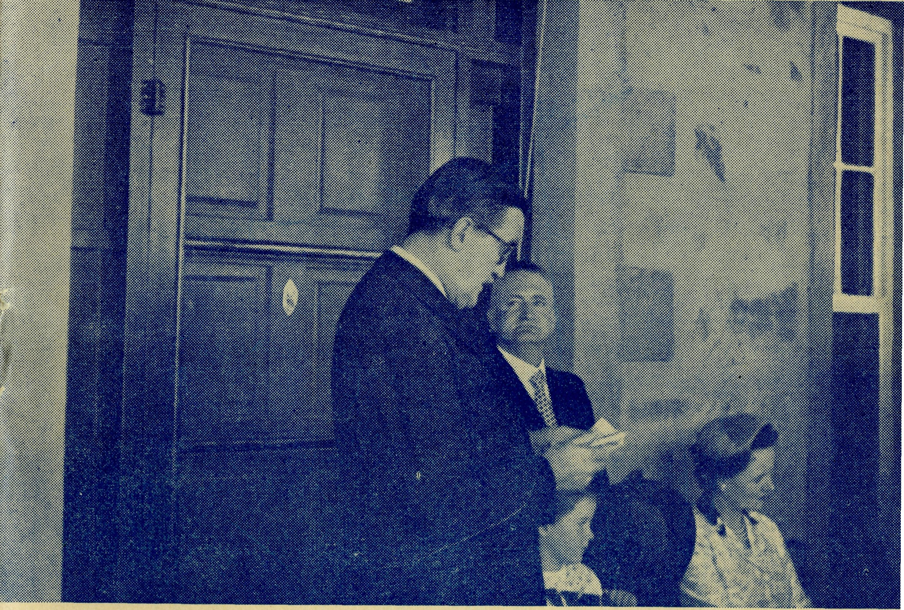
The Governor of South Australia opens the New Tarcoola Hospital.
The Official Organ of THE BUSH CHURCH AID SOCIETY
Church House, George Street, Sydney, N.S.W.
Registered at the G.P.O., Sydney, for transmission by post as a periodical

2 The Real Australian December, 1956
The Bush Church Aid Society
for Australia and Tasmania
PRESIDENT: The Archbishop of Sydney.
Hon. Clerical Secretary: Rev. Canon E. Cameron
Hon. Treasurer: Mr. T. S. Holt.
Organising Missioner: Rev. Canon T. E. Jones, M.B.E., Th.L.
N.S.W. Deputation Secretary: Rev. J. R. Greenwood, Th.L.
Victorian Secretary: Rev. E. G. Beavan, M.A.
HEADQUARTERS OFFICE: VICTORIAN OFFICE:
Diocesan Church House,
St. Andrew's Cathedral, Bible House,
George Street, Sydney.
'Phone: BM 3164. Flinders Lane, Melbourne, Victoria.
Telegraphic Address:
"Chaplaincy, Sydney". Telephone: MF 3552.
STUDENTS IN TRAINING:
Rev. F. D. Buchanan, Th.L., Rev. R. Brooks, Th.L., Rev. B. Buckland, Rev. T. V. Jones, Th.L., Mr. B. Viney, Mr. R. D. Neve.
FIELD STAFF: DIOCESE OF ADELAIDE, S.A.
Ceduna, Penong, S.A.—Rev. T. J. Minnipa, S.A.—Rev. A. Williams,
Hayman, Th.L., Rev. j. Smith, Th.L.
Th.L.
Cowell, S.A.—Rev. D.A. Richards- Streaky Bay, S.A.—Rev P
Pugh, A.L.C.D. Connell, Th.Schol.
DIOCESE OF WILLOCHRA, S.A.
Orroroo, S.A.—Rev. I. Booth, Quorn, S.A.—Rev. G. Fuhrmeister,
Th.L. Th.L.
DIOCESE OF BALLARAT, VIC.
Heytesbury Mission, Vic.—Rev. Otway Mission, Vic.—Rev. T.
P. R. Cooke, Th.L., Timboon, Morgan, Th.L., Beech Forest
Vic. Vic.
DIOCESE OF RIVERINA, DIOCESE OF GRAFTON,
N.S.W. N.S.W.
Wilcannia, N.S.W. — Rev. J. Rappville, N.S.W. — Rev A
Stockdale, Th.L. Gerlach, Th.L.
DIOCESE OF GIPPSLAND, DIOCESE OF TASMANIA.
^{VIC#} Tarraieah, Tas.—Rev. W. War-
Croajingalong, Vic,—Rev. L. Luck, burton, Th.L.
Th.L.
December, 1956 The Real Australian
The Organising Missioners Letter
At last the Tarcoola Hospital is opened and a very lovely building it is.
The Governor of South Australia and Lady George very kindly came to be with us on the great day. Both of them expressed very great pleasure at being present and their graciousness made everybody feel at ease with them.
At the ceremony on November 7th Mr. John Morley, the manager of Mulgathing Station, welcomed the distinguished visitors, expressed the appreciation of the people of the district for the excellent service of the B.C.A:, and outlined the history of the hospital.
Mr. Morley has been an indefatigable worker for the new building, and it is very true to say that without him and his great enthusiasm it would never have been built.
Our friends will be glad to know that Tarcoola now has one of the finest eight-bed hospitals in the State of South Australia. The visitors were surprised at the well-equipped wards, painted in pastel shade and furnished with bright flowers.
The operating theatre came in for special commendation. The equipment is first-class, and this is largely due to our very good Sydney friend, Miss Fairiie-Cuninghame, who gave the considerable sum for the purchase of the operating table as a memorial to her mother.
The bright nursery with rabbits on the curtains was furnished by Miss Young of Summer Hill as a memorial to her sister. It was in this section that the only patient in the hospital on opening day was found; a small black piccaninny of nine weeks.
Mr. Cashman of Sydney has also given one of the beds as a thankoffering, and other gifts of friends have gone towards the furnishings.
Sisters Holle and Tarr have put a lot of labour into getting the hospital into tip-top condition, and both of them looked very pleased with their efforts.
It was good to see Sister Page present. She had come from Melbourne for the occasion, and she must have found a very great pleasure in seeing the completed building opened after the eight years full of hope and much labour in the little iron nursing home.
The friends of B.C.A. know that during August I toured the Diocese of the North-West with a view to finding out what could be done to assist the bishop in his almost impossible task.
As a result we have promised to do all in our power to re-build

4 The Real Australian December, 1956
the church in this vast area of nearly half-a-million square miles, and this task will be one of the greatest challenges we have faced.
For many years the bishop has been working alone, doing his best to minister to the people living on the Murchison Goldnelds, Wittenoom Gorge, Roebourne, Port Hedland, Marble Bar, Broome, Derby and Wyndham. Spread over such a great area, his ministry at each place could, of necessity, be given only at long intervals.
B.C.A. has already received offers of service from two clergy, who though already in what are termed "good parishes", are ready to resign from them and to go to the North-West. We have accepted their offers of service.
Although it is hoped that financial support will come from the people of the districts to which these clergy will be going, it will be necessary for them to go and take up their new work and do all they can to re-organise before such assistance can be assessed.
There are two primary requirements that must be faced immediately. Houses must be built for them and their families to live in and vehicles must be provided for their travel about the large districts they will have. To do this will cost somewhere about £12,000, and the need is desperately urgent.
I have asked the two clergy and their wives to agree for the man to go first to his new sphere for a period of some months, and for the wives to stay behind while their husbands are laying the ground work of organisation. This is no small sacrifice to ask married people with small children. They have agreed to do this. We all must surely back them with our prayers and the utmost of our giving so that the new homes will soon be built.
B.C.A. has never refused to assist wherever it has been asked, so long as the need has been consistent with its work and purpose. It is also true to say that the friends of the society have never failed to see to it that B.C.A. shall carry out succssfully every challenge it has faced.
This is a great and urgent task and there is no time to lose. It is of great encouragement to know that young, virile clergy are, with their courageous wives, ready to go out into the toughest task the church has at the moment. Now it is up to us all to make sacrifices equal to theirs in order to ensure that the church in the Diocese of the North-West shall be re-habilitated in order to minister to the spiritual neeeds of our people who reside there.
Pray day by day for this great project and do your utmost to give something specially for the finances needed.
PRAY FOR B.C.A.
SERVE IN B.C.A.
GIVE TO B.C.A.

December, 1956
The Real Australian
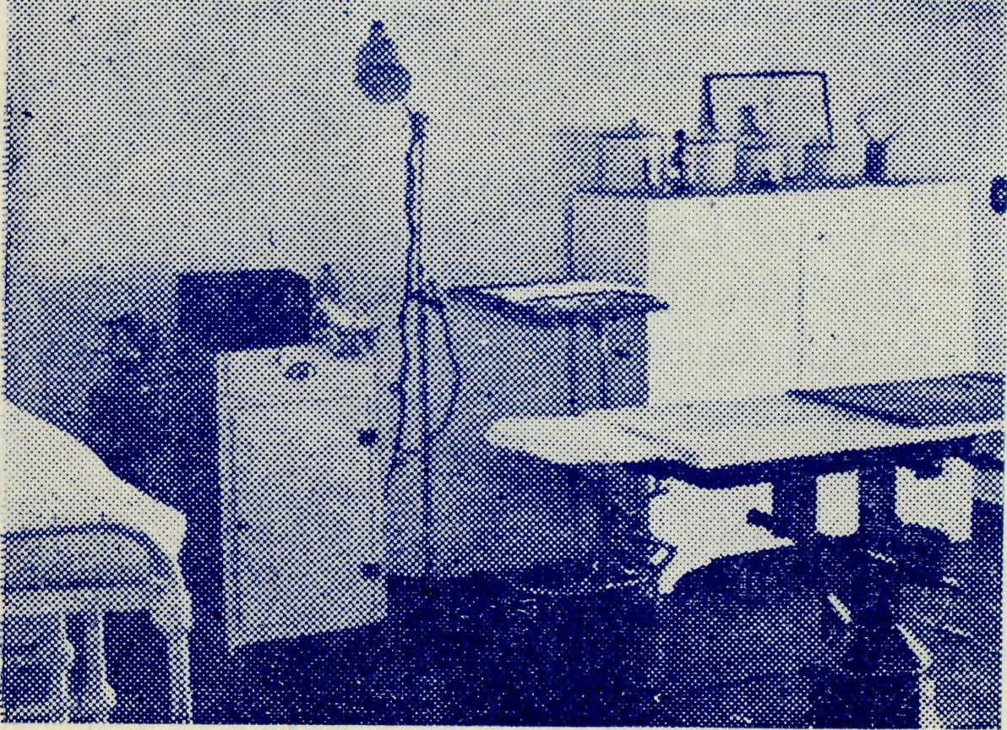
TARCOOLA 1.
A Corner of the Operating Theatre.

Glamour - Gloom - Glory!
Rev. J. SMITH
Some time ago I attended a missionary rally at which one of the returned missionaries spoke of the work under the following headings: "The glamour, the gloom, the glory of missionary work." What an excellent heading for an article for the "Real Autralian"!
Just before my wife, son and self left Sydney for Ceduna, we had the privilege (through the kindness of a friend) of going to one of Sydney's lovely beaches for a week's holiday. There was an air of excitement as we eagerly packed our cases in anticipation of a very enjoyable time on the beach. That was the Glamour of the Holiday.
The next day, on arriving at our destination in pouring rain, and with somewhat dampened clothes, we were informed that large numbers of holiday makers had given up and returned home. In a nearby shop, whilst drinking a hot "cuppa" to try and warm our cold and shivering bodies, we were asked the question, "Have you come to the seaside for a lovely holiday?"; to which we rather optimistically replied: "Yes, we have." By the time we arrived at the holiday quarters we were looking like three wet birds. That was the Gloom.
However, we stayed, the weather cleared overnight, and for the rest of the week we enjoyed ourselves immensely, basking in the warm sunshine and frollicking in the surf. That was the Glory.
It has been said that "History repeats itself".
For some time prior to coming to Ceduna we had been given glowing accounts of the work, and were anxiously looking forward to the day when we would be on our way out. With the prospects of going to Ceduna our expectations were raised to a high pitch, as Ceduna, we were told, was the centre of much B.C.A. activity, what with the Flying Medical Service and its planes, radio station, hospital staffed by B.C.A. and an ambulance, as well as a vast area along the coast and Trans-line to be covered by the missioner in

The Real Australian
December, 1958
December, 1956
The Real Australian

carrying the glorious message of the Cross of Christ to these people living in remote places. Such was the Glamour of the work to us.
In March of this year we arrived at Ceduna, with the weather hot and dusty, and with the whole of the countryside looking as barren as a board. With every gust of wind clouds of dust were sent whirling through the home, only to leave behind a thin layer of grit and dust over everything. Besides this, the home we were to occupy was only a temporary arrangement; we would have to find somewhere else to live, and no houses were, or are, available. That was the Gloom.
However, through* it all we have been able to catch a glimpse of the brighter side of the work and already are sharing in some of the joys of B.C.A. work. The following incidents will serve to illustrate what is meant.
It was a wet Sunday; rain had been falling throughout the previous week. The dirt roads, to say the least, were in a shocking condition and I had to take a service some 50 miles from here: was it worth going? Though it was raining incessantly at the time, I went, and in travelling, or rather I should say in slipping and sliding, the 50 miles, the Holden Van went through every conceivable antic of Holden gymnastics, except turning over, though one must confess that at one stage when the van suddenly slid from the road on to a nearby bank it was just about to do so. But it remained upright, and I was able to continue on my way. Imagine my joy on arriving at the small country hall, to find about 15 people inside, patiently awaiting the arrival of the missioner. They too had weathered the weather. We could well have sung a line of a well-known hymn, "Shine through the gloom, and point me to the skies".
In May it was our privilege to visit the people in their homes along the Trans-Continental Railway. We had the use of the Welfare Carriage provided by the Commonwealth Railways, in which we were able not only to sleep and have meals as we travelled from siding to siding, but also to hold services. At each of the sidings visited we were able to hold a service in the van, to which most of the camp residents came. Most of the people living along the line are workers for the Commonwealth Railways, and in the main consist of new Australians. At Zanthus, where we spent three days, we were able to visit the aboriginal mission and show our slides'. In the evenings the folk at Zanthus attended the service in the van and sang hymns in their own language (German), and as some of the natives were there, they joined in in their own tongues. Such a service makes one realise more than ever that the message of the Cross is unto all, and to as many as receive it there is the joy of singing the praises of Him Who loved us and gave Himself for us. That is the Glory.
LISTEN TO THE BUSH PADRE-
2GB Every Friday at 11 a.m. 2NX-2NM Every Sunday at 4.30 pm. 2CH Alternate Sundays at 6 p.m. 2KA Alternate Thursdays at 4.20 p.m.

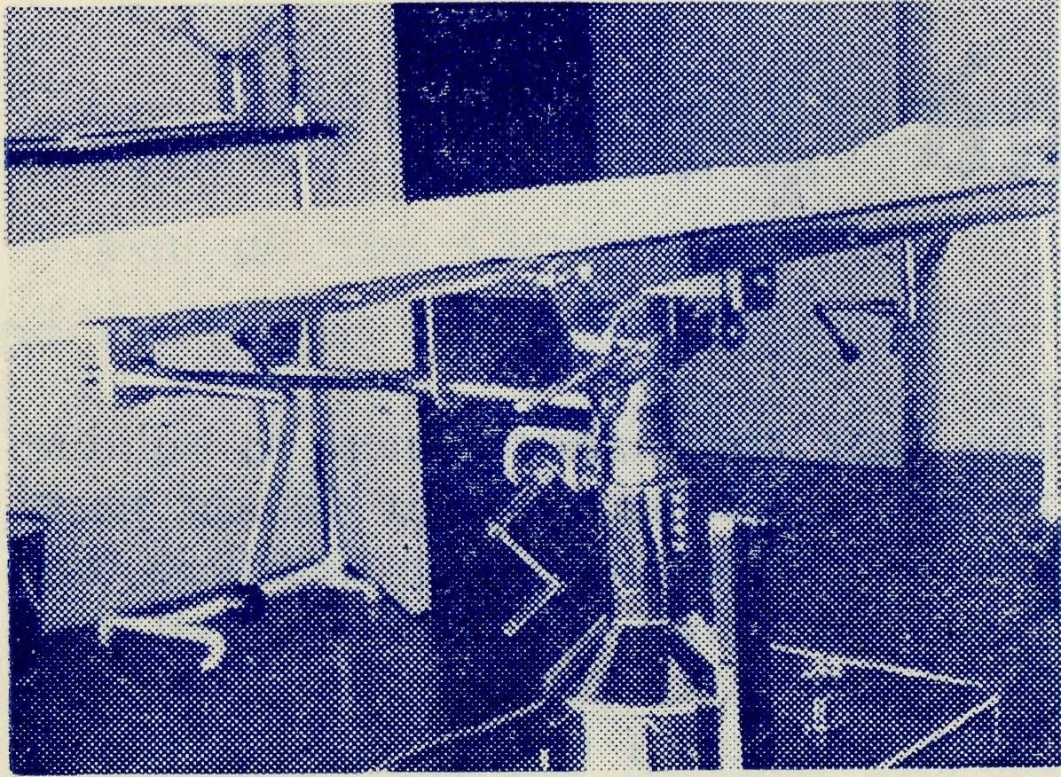
TARCOOLA 2.
The Operating Table, the gift
of Miss Fairlie Cuninghame,
of Sydney
‘and Tasmania’
MARGARET WARBURTON
Take the Lyell Highway from Hobart; travel for eighty miles through suburbs, orchards, hop-fields, farm lands, and then thick Tasmanian timber; round the final bend and Tarraleah suddenly appears.
Tarraleah is 2,000 feet up in the heart of Tasmania, the most mountainous country in the world. It is the hub of Tasmania's vast Hydro-electric schemes, which produce one-fifth of the worlds water power. It is also the centre of the Mission which justifies the concluding phrase of the official title of B.C.A.
We came to Tarraleah in February, 1955. Previously, Anglican services had been held monthly, for the most part in emergency buildings — the Library reading room at Wayatinah, the rat-mfested, tumble-down hall at Tarraleah, but in a neat, bright little Union Church at Bronte Park. At the Institution Service m the Tarraleah hall, several brave ladies sat at the back where supper was laid out, to keep the rats away from the food.
To-day we have an Anglican Chapel at Wayatinah—St. Luke's. It is very simple in design, but furnished with attractive pieces made by a Tarraleah Churchwarden. It has been carpeted throughout m a warm red Westminster by the congregation. At Tarraleah, the Hydro-electric Commission has built a beautiful Union Church in contemporary design. This Church — St. Barnabas'— and St Pauls, Bronte Park, are controlled by the World Council of Churches. In dealing with construction camp people we are confronted with problems peculiar to these areas. The most difficult of these questions concerns the floating population.
It would be safe to say at Tarraleah and Bronte Park 75 per

The Real Australian December, 1956
December, 1956
The Real Australian

Topics for
Prayer and Praise
For the Society.
O Lord God of our nation, Who hast commanded men to subdue and replenish the earth: Look in Thy love upon all who in distant parts of our land are striving against many difficulties, and are deprived the access of the means of grace. Strengthen and guide the Bush Church Aid Society and all members of the staff. Cheer and comfort them in discouragement and loneliness, bless their ministrations to the good of those they serve, and grant that the message of redeeming love may thus be rooted and grounded in our national life, to the glory of Thy Great Name through Jesus Christ our Lord. Amen.
For Nurses and Doctors.
O God, Who didst choose a beloved physician to set forth the life of Him Who went about doing good, grant that Thy strong tenderness and compassion may be manifest in the work of country doctors and bush nurses. Make them at all times alert to be faithful, as those whom Thou hast burdened and inspired with the honour of their calling. In lonely emergencies strengthen them with confidence that, having done all they can, they may with good conscience leave the issue to Thy power working within Thy law. Make them resourceful and of sound judgment, and hearten their labours with the energy of compassion and the firmness of duty that conquers weariness. Through Him Whose power is called forth by suffering. Jesus Christ our Lord.
For Church Life in Country Districts.
O Lord, Who art present when two or three are gathered together in Thy Name, bless, we beseech Thee, the little far-scattered groups of brethren who in our wide land meet together to worship Thee. Give them a perpetual freshness of spirit, and the power to inspire in each other holiness, helpfulness, and understanding of Thy help. Refresh with the joy of enthusiasm those who endure weary journeys to Thy trysting place. Grant that these little companies of Thy servants may be united in the spirit of Christian charity, awaiting in love the time when there vdiall be one fold and one Shepherd. Grant that the common life of all communities may be purified by this spirit of charity from all meanness, falsehood, malice and idle gossip, and grant that they who share a common lot may draw strength from each other's virtues, and in their weakness help one another, through our one Lord, Jesus Christ.
Praise.
For the Blessings vouchsafed to the Society, for all kindly givers, for the joy of service.
YOUR DAILY REMEMBRANCE
SUNDAY
. For all the Clergy-missioners of B.C.A., their wives and children, and the people to whom they take the Gospel of Christ. For all students of the Society in training for this special ministry.
MONDAY
For the Doctors at Ceduna and Wudinna, the Nursing Sisters in our hospitals. For the spiritual and physical needs of patients who come under their care.
TUESDAY
For the staffs at the Children's School Hostels at Broken Hill, Bowral, Mungindi and Port Lincoln, the children who come under their care and the teachers who instruct these children.
WEDNESDAY
For the Mail-Bag Sunday School as it reaches out into far-distant homes to touch young lives with the challenge of Christ. For the Director, her assistant and staff of voluntary teachers, and the parents of the scholars.
THURSDAY
For the Flying Medical Service pilots and all staff and patients who travel with them. For the Radio Base and its Control Officer. For the Pharmacist at Ceduna.
FRIDAY
For the Administration of the Society—the Council—the Home Base Staffs and Auxiliaries and all Parochial Workers.
SATURDAY
For generous givers, that all necessary finance needed for so large a ministry may be forthcoming. For guidance in the right application of all such gifts.

10
The Real Australian
December, 1956
December, 1956
The Real Australian
11

cent, of the congregations which attended my husband's first services have moved on. This means great fluctuations in Church attendances, and it also means that house occupants are changing daily, which makes routine visiting all the more important and difficult.
People who do this type of work have usually moved from project to project for many years, are not expecting to be in any one place for long, and so are lacking in a sense of permanence which expresses itself in a certain civic and social responsibility. Thus, too, we find that many who grew up with strong Church ties have become indifferent to and disinterested in the things of God.
However, we are now on the eve of our second Confirmation, when some 14 children and ten adults will be presented. Last year, of the 39 candidates, eight were adults and each one of these has continued in faithful Church attendance, although the majority have moved from the Highlands.
Youth work is a very important sphere of our parish life. We have a junior C.E.F. at Bronte Park, and a C.E.B.S. and G.F.S. at Tarraleah. Next year we hope to introduce a Young Wives' Group of the Mothers' Union at Tarraleah.
We both feel that it is a great privilege to be carving a parish out of what was virtually a non-existent Church interest, even as the H.E.C. is transforming virgin bush into a wonderful power scheme involving the building of huge dams, power stations, and oanals.
Concerning ourselves, I should like to say that we both praise God for the incalculable blessings of the past two years. Our little •daughter, Elisabeth, was born a fortnight before last Christmas, and is now ten months old. Lindsay, aged two and a bit, is growing into a sturdy, independent young man. Here I should like to offer an apology to those friends and workers of B.C.A. who sent us their unacknowledged greetings last Christmas. I returned from hospital with Elisabeth on Christmas Eve, and as a result of coping with two babies, and battling against unreliable health for several weeks, I just didn't get their letters answered. They may rest assured that we appreciate deeply their thoughts and good wishes, working as we are in this outpost of the B.C.A. service.
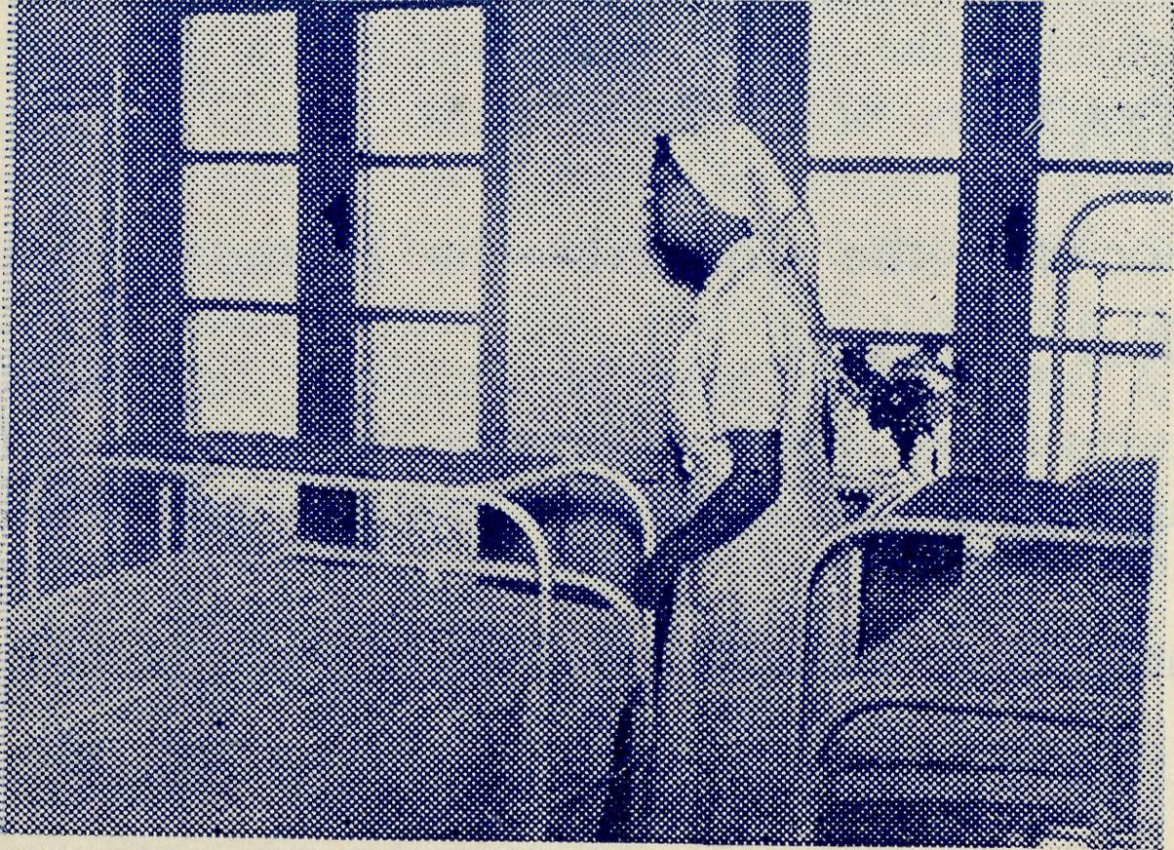
TARCOOLA 3.
One of the Wards, each equipped with three beds.

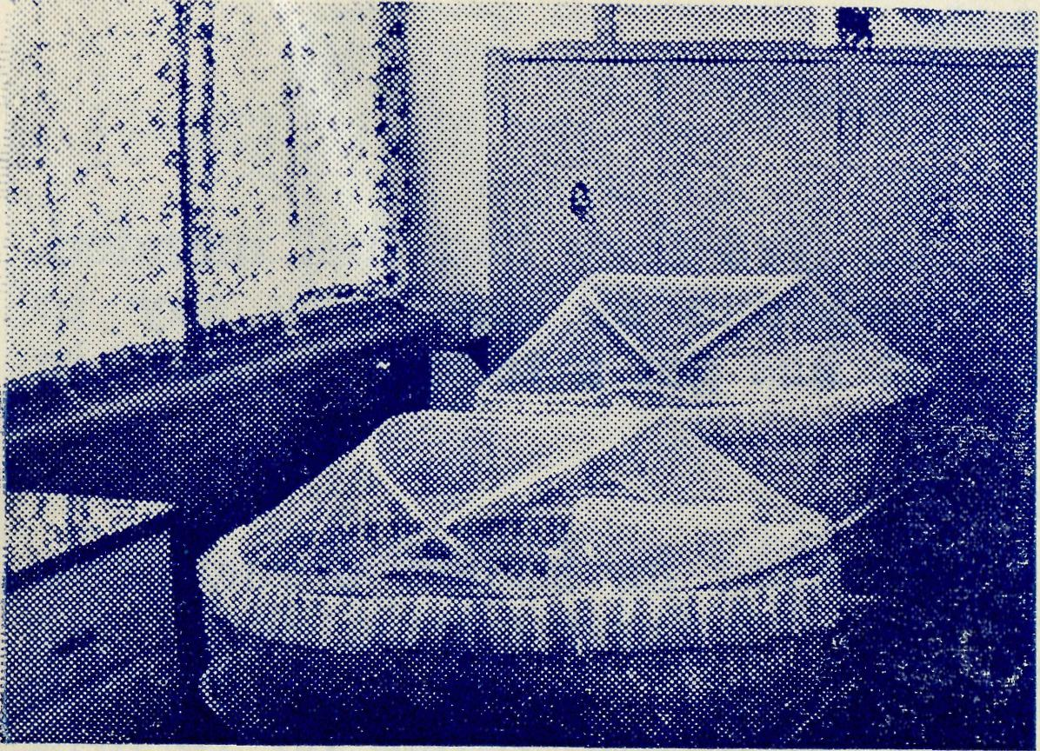
TARCOOLA 4.
Corner of the Nursery furnished by Miss Young, of Summer Hill, Sydney.

The Dry Land Appeared
Rev T. HAYMAN
Suddenly, I came to the edge of the cliff where the road is so steep that, to avoid the danger of the rolling stones, there is surprisingly enough, half a mile of bitumen. From this cliff can be seen the Samphire Plain, where long centuries ago the sea used to roll in and roar against the cliffs.
The cliffs now go inland. Turning away from the ocean a few miles out of Eucla they curve in and out of the empty bays for 200 miles. The sea now spends itself on the low-lying edge of the plain.
At the top of the cliffs the Nullarbor Plain furnishes mute evidence in the millions of shells and fossils of marine life that at a date earlier still the sea also covered its flat expanse.
The road before me lay like a long spear, in a straight line for 60 miles. The heat mirages danced on the open plain.
Many travellers call the scenery monotonous and vow that they will never do the east to west trip again. The constant repetition of sandy-coloured soil; dry grass now brown, now burnt black; dusty blue bush and salt bush, give no change of scenery for hundreds of miles. But travellers on this road must look up, for there one has the beauty of the ever-changing sky, which dresses in mantles of blue and green and red as the hours pass away.
Mundrabilla Homestead, nestling under the cliffs, is, unlike Madura and Eucla, off the beaten track. Half the property is below and half on top of the Nullarbor.
My hosts at Mundrabilla, who were expecting me, looked exhausted as they bade me sit down to tea with them. Theirs was a sorry story. They had just come in from almost 24 hours of fighting a grass fire. The fire, destroying hundreds of acres of valuable feed, they had learnt, was started the previous afternoon by criminal foolishness.

12
The Real Australian December, 1956
December, 1956
The Real Australian
13

A motorist observed a car pulled up by the side of the road. He stopped and enquired if he could help.
"Please!" they said, "have you a pump?"
"Yes, certainly I have."
He stayed to pump up a punctured tyre they had just mended. Whilst he was thus engaged, he heard one of the party say to another: "This grass wouldn't burn. It has got a touch of green in it yet."
"It certainly would," said his mate.
"No! I bet you it wouldn't." With that he struck a match to prove it. A steady breeze blowing at the time caught the blaze and with a tremendous crackle, it was away. The kindly motorist, for the safety of his own vehicle, jumped in and drove off reporting what had happened.
The fire gathered momentum, jumping roads, burning fence posts and racing for miles. There was no fear of the homestead burning as that had been protected by early precautionary burning of the grass. The owners, advanced in age, rushed out to see what they could do. Two Air Force men had been grounded whilst going through on a holiday with a vehicle lacking in certain parts. They joined the owners, and later, with the neighbours from sixty miles away, fought the blaze.
No sooner was one part controlled, when another would flare up and race ahead. Even "burning back" failed to achieve its purpose, but only brought confusion worse confounded. Finally a change of wind saved the day.
This story, told in vivid fragments, was the timely topic at the evening meal. Naturally, there was nothing to be done other than wash up and go to bed. I wondered what good I had done by coming. Perhaps they should have stopped me at the last sheep station. The next day had a full programme of many miles travelling and other stations to visit.
Pleasingly, at the request of my hosts, we had a service after breakfast the next morning. My visit was not to be in vain, although the bush padre must be prepared to take it "as it comes".
The service was held in the sitting room. A table, with a wooden cross on a rough cloth, was placed against one wall. My hosts, the two Air Force men and a neighbour's wife sat in a semi-circle on an assortment of chairs. Atmosphere may not be everything, yet there was a wonderful presence about that quiet bush service. The fervent "Amens" showed the unity of prayer and greatly assisted the padre in his message described by the lady of the house as "something to think about". One of the men acknowledged that he had not been to a service for years.
Without time for a cup of tea, I had to pack up and be gone. I went with a cheerful heart, being glad to be of service.
DO YOU PRAY FOR B.C.A.?
More B.C.A. babies continue to arrive and we can only hope that this augurs well for the staff problems somewhere about 1980.
Congratulations to The Rev. A. and Mrs. Gerlach on the arrival of Michael Walter and to the Rev. A. and Mrs. Williams at the advent of Peter John.
* # #
We also send our congratulations to Mrs. Simpson, better known to B.C.A. friends as Sister Denniss, who has also added a son to her family.
* * *
The Garden Party at the home of Mrs. Shain was a jolly fine effort and resulted in £45 and a happy afternoon for those who attended. Thank you, Mrs. Shain. We would like you to do it again next year.
* * *
Our good friend, Mrs. Kershaw, of Burwood East, and those stalwarts who help her, had yet another of those bumper Annual Luncheons in the Parish Hall. The hall, as usual, was packed to capacity and Mrs. Campbell of the C.W.A. came along and spoke of the work and needs of country women.
* * #
The Rev. John Greenwood, who looks after the deputation work of the society in N.S.W. would like to hear of lots more who will arrange to have a Garden Party, Luncheon or Drawing Room Meeting in their home or Parish Hall.
These are splendid ways of increasing the circle of interest and also adding considerably to the funds of the B.C.A.
Phone him at BM3164 or write into the office and he will gladly arrange to show his pictures. The Victorian Secretary will also rejoice to have the same sort of enquiries addressed to him. His phone number is MF3552.
The Annual Rallies of B.C.A. in Melbourne and Sydney were outstandingly good. In both cases the hall was well filled
It was pleasing and encouraging to note the presence at both gatherings of many young people. The criticism of past years has been that young people show so little interest in church gatherings and organisations and it is cheering to note that a change for the better is taking place.

14
The Real Australian December, 1956
The Archbishop of Melbourne was chairman at both gatherings and in Melbourne the Organising Missioner had the pleasure of presenting a reading lamp to His Grace, as a small token of our affection for him and to mark his coming retirement.
Sister F. Dowling gave a stirring account of the work at Ceduna where she has served for twenty-four years. Since the rallies we have had a number of indications that Sister's challenge will not go unanswered.
* * *
Our friends will be glad to know that Sister Thomas continues to make good progress and hopes to be back at Rawlinna very soon. Sister has had a long period of convalescence and has much appreciated the prayers and thought of many of our friends.
* # #
We are grateful to Mrs. Bolton for the wonderful display of flowers she produced for the Sydney Rally. They made the hall bright and gay and so helped much towards the spirit of the
meeting.
* * *
We extend our sympathy to the family of the late Mrs. Unwin, who passed away recently. Her daughter, Miss Unwin, of Croydon gives very valuable help in the Mail-bag Sunday School.
* * *
We say a fond goodbye to the Rev. and Mrs. Phil Connell and the boys at the end of the year. Phil has been with us since 1942, at Rappville, Ceduna and Streaky Bay. Both he and his wife have won the love and esteem of many people in the missions in which they have lived and worked. Mrs, Connell's great fight and constant cheerfulness after being stricken with polio has been a great inspiration to those on the staff and all others who have known her.
They go to the parish of Strathalbyn in the Diocese of Adelaide. This will be a happy sphere for them and we wish them much blessing.
Such an appointment gives great pleasure to B.C.A. for it is encouraging to know that clergy, while always being loyal to the traditions of this society, set such a good standard in their ministry as to be asked to fill so important a parish in Adelaide.
* # #
Consequent upon Mr. Connell's going to Strathalbyn certain other staff changes have been planned. Those that are definite at the moment are: The Rev. T. Hayman to Streaky Bay and the Rev. T. V. Jones to Ceduna.
CAN YOU SERVE IN B.C.A.?
December, 1956 The Real Australian 15
Mr. Hayman has done a magnificent job at Ceduna and leaves behind a beautiful new church that stands to his zeal and foresight. He has been at Streaky Bay before, having served there for two years before going to Ceduna.
The Rev. T. V. Jones has been for the past two years curate to our very good friend the Rev. Graham Delbridge at Holy Trinity, Adelaide.
The experience he has gained under Mr. Delbridge will prove invaluable to him in his new work. We extend to both of these missioners our best wishes for fruitful ministries.
* * *
The Rev. P. R. Cooke leaves Timboon at the end of the year to take up an appointment in the Diocese of Melbourne. Mr. Cooke has spent three years at Timboon and we have been grateful for his ministry. Our prayers go with him as he leaves us, that God may bless him and his family in their future service. At the-moment it is not known what provision can be made for Timboon.
* * '■*■ i, Y *
Since our last issue Sisters Mclntyre and Bradbrook have-joined our staff for a period and Sister Barbour expects to leave Sydney early in December for the Flying Medical Service of the Society.
It is indeed cheering to find that nurses are now offering for this work after a long period of famine. We welcome these new nurses and hope that others will be forthcoming as the need arises.
ON THE MAKING OF WILLS
Will any of our friends who have or intend to leave something; in their Will to B.C.A. please note that it is essential that the correct, name of the society be stated in their Will.
From time to time confusion has arisen in this regard and on at least one occasion an estate has gone elsewhere, which friends of the donor have assured us was meant for B.C.A.
The correct and only legal designation of the society is; THE' BUSH CHURCH AID SOCIETY FOR AUSTRALIA AND* TASMANIA.
Sometimes our friends want to leave something to our medical. and flying work. Here again trouble can arise by the incorrect use of titles that belong to other organisations. When making provision for legacies to this side of our work, we ask our friends to* make them to THE BUSH CHURCH AID SOCIETY FOR AUSTRALIA AND TASMANIA FLYING MEDICAL SERVICE. Will you especially note the term Flying MEDICAL Service as this is-peculiar to B.C.A. to differentiate it from similar organisations.
We are always happy to help by giving full information to our friends when they are making such provision or to their solicitors. Thank you.

16
The Real Australian December, 1956
December, 1956 The Real Australian
17

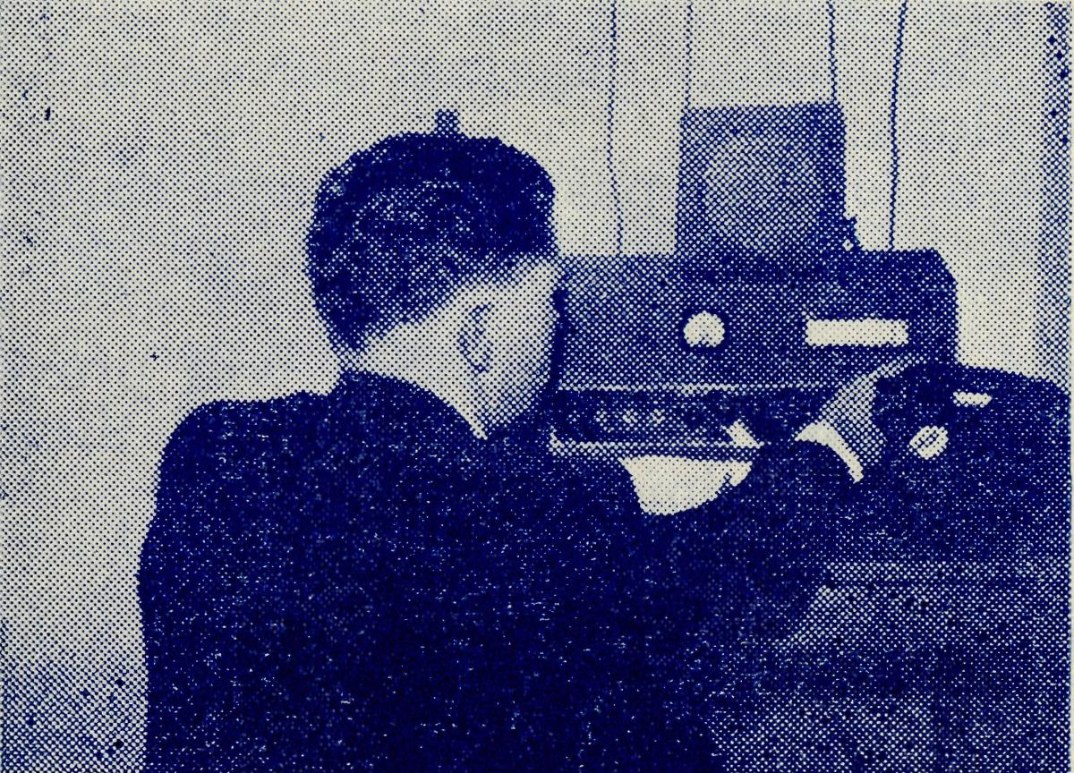
TARCOOLA 5.
Dr. Blower uses the Tarcoola
transceiver to speak to
Ceduna.

Going Away
P. M. CONNELL, Streaky Bay.
A few days ago I received a brief note from our Organising Missioner asking me to write a parting letter for the "R.A." and so I am sitting down to the task with a certain amount of regret to think that this will probably be the last time that I will be asked to write for our now long-established magazine.
Some years ago I found, while on some business with him, that that indefatigable man and pilot, Mr. Chadwick, had a store of the R.A. magazines from the first issue until now. It was a thrill to me to look at some of my own early contributions to it from Rappville days as long ago as 1943 and 1944. Being rather sentimental I felt as if I had been able to look into the past and mow, as I write this and look for a minute back upon the years gone by, I feel somewhat the same as I did when looking into those old issues.
I "joined up" in March, 1942, and was sent to Rappville, and have been "in the force" ever since. I have never regretted my step of those days and only regret that I am leaving now. Just recently, Canon Jones sent me a parting letter in which he says, '"You will always be a member of the B.C.A. family" and I like to regard myself as such, and hope that the days to come will find me able to continue to do something useful for the Society.
I have had a lot of fun in working with the Society that I .am sure I would never have had if I stayed in ordinary parish life. The fellowship, the happiness and the sense of being in an adventurous job with others like-minded was always an inspiration. Just to give a little example: sometimes I have felt what a long way I was from the life and activities that students who "went -through" college with me were living, and then I have thought of such persons as Sister V. Page for many years at Tarcoola, alone and away from her old home; of Sister G. Hitchcock at Ceduna who was here long before I came to the coast, and many others
whose lives have been an inspiration to me at times when I. thought that I was missing much that one might enjoy back in "civilization". The quiet devotion of these people has taught me that the fullest life can be lived in the "outback" as long as one has caught the gleam of service for God alone.
And now we have the job of "packing up"—and when I have a think about it it daunts me. Long ago an old vicar of mine said to a friend who asked why he had not taken an offer of preferment when it came, "well, when I looked at all my books and thought of the terrible job of packing them, I decided to refuse". No doubt it was only said in fun, but, believe me, it is enough to daunt anyone to think of setting about packing four to five hundred books as I must do or Cooks, the furniture removalists, will be on my doorstep and nothing will be ready for them.
We go to a place called Strathalbyn, thirty-five miles from Adelaide. It is much smaller than my present job though I think there will be many more people. The rectory is just as big as this one, and the boys are rejoiced to hear that there is plenty of ground in the rectory property to play football in. Daniel wanted to know if Cooks, who will remove our furniture in one of their special vans, would consider including his pet white billy goat among the rest of the furniture but as I thought they would not, he has resigned himself to the thought of giving it away to people who live on a farm.
The people of the bush with whom I have worked for so long are the ones I will remember most, and also the sense of timelessness that one finds only in the "outback". These things cannot be kept for ever but I will always carry the memory of them wherever I go.
As I look over what I have written, it seems to me how little I have managed to express all that I feel at this time. Yet that is the way with all farewells. One wants to say what the past has meant and yets ends up with very prosaic and ordinary sentiments. One cannot manage to say all that is in one's mind by the use of mere words. So it is with me now.
I want to thank all who have continually prayed for me and about my work. These persons must be many. Now and then 1 realized what a number of people were prayer partners with me in this work. And to you, who have given me such support, I toffer my heartfelt thanks. Please continue in prayer.
To the Society, most especially in the person of Canon Jones, Mrs. Connell and I will always owe grateful remembrance. In all sort of situations in times of "straight sailing", in sickness and in health—and we have had our share of both—the Society has stood by us in the most real sense. I rejoice that we have had fellowship in the work of the Gospel outback.
May God's blessing rest most fruitfully upon all the members rof the Society, past and present. We have had a different task, and a different sphere of labour, each of us, wherever we served, yet all were one in Christ Jesus, and His name be the glory.

18
The Real Australian
December, 1956*
December, 1956
The Real Australian
19

Growing Interest in B.C.A.
As far back as 1919, when the . Society's first meeting was; held, there was special emphasis placed upon challenging people in more settled places to remember the needs of the Church out-back.
The resolution read—"The time has more than arrived when, the conscience of the city concerning the needs of the country should be educated".
But to reach out meant staff and time to concentrate upon, gaining help. While there is still a tremendous amount yet to be done in this field, nevertheless it can be said that a great deal of encouragement has been given by an increasing number of: friends.
During 1956, city and nearer country parishes have continued. their support and given opportunities for the story of the work, to be presented in sermons and by pictures.
Then further north a great deal of encouragement has been. given in parishes in the Diocese of Newcastle.
In October, the N.S.W. Secretary was given most helpful cooperation by the Rectors of East Maitland, Maitland, West Maitland,, Telarah, Morpeth and Scone. Others have already made plans to have a visit from B.C.A. during the next year.
It has meant much has been added to the funds of the Society by new friends hearing about the work done by the Christian Church outback. Many Church of England people have learned,, for the first time, that their Church is doing a magnificent piece of service in some of our really difficult outback country.
Their prayers and material assistance will mean a great deal-to the extension of the Kingdom of God.
The Society is deeply grateful for the helpful support of Rectors-and parishioners who gave the N.S.W. Secretary such an encouraging reception. The meetings and Rotary Clubs addressed, as well as the services and special picture nights, all served to bring' the challenge of the work before appreciative supporters.
To help forward this new interest the Bush Padre has been able to secure time on Radio Station 2NX. The session will be* heard every Sunday afternoon at 4.30 p.m. It will be a big help if our readers note the time and listen regularly and persuade their friends and relations to do likewise.

THE BUSH CHURCH AID SOCIETY'S FLYING MEDICAL SERVICES

HOSPITAL CENTRES. Matron: Sister F. DOWLING.
CEDUNA. Staff Sisters: J. MILLER, G.
The Murat Bay District Hostpital. HITCHCOCK, B. TIERNEY, A.
BUTLER, M.BELL, N. VERITY, R.
McINTYRE, P.BRADBROOK.

PENONG.
The Penong Memorial Sisters L. LOANE and J.
Hospital. ROBERTS.
COOK.
The Bishop Kirkby Sisters M. HORSBURGH and
Memorial Hospital. M. ROSS.
TARCOOLA.
_, _ , tx . , Sisters V. HOLLE and M. TARR.
Ine larcoola Hospital.
RAWLINNA, W.A.
~_{k} _{XT} . _{u} . Sister E. THOMAS.
The Nursing Hostel.
WUDINNA. Matron: Sister R. PORTCH.
The Central Eyre Peninsula Sisters: B. BARBER, V. BREA-
District Hospital. LEY, M. DEAN, J. JOHN
STON, Miss C. DERBY
SHIRE.
MEDICAL OFFICERS.
Dr. C. BLOWER, Dr. M. MUELLER, Dr. D. ALLSOP.
AIRCRAFT. PILOTS.
"Percival Proctor". Mr. ALLAN CHADWICK.
de Havilland "Dragon" Mr. G. JOB.
Auster. Mr. W. BEDFORD.
PHARMACIST.
Mr. B. RICHARDS.
WIRELESS COMMUNICATIONS BASE.
Ceduna Base Operator: Mr. GEORGE CAMERON.
CROAJINGALONG NURSING SERVICE, VIC.
Sister I. GWYNNE.

