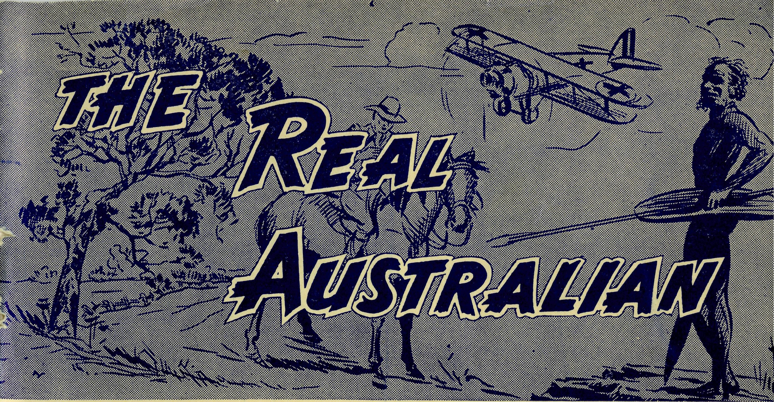
20
The Real Australian
THE BUSH CHURCH AID MAIL-BAG SUNDAY SCHOOL
Director: Miss R. CAMPBELL.
Office: 242 Pitt Street, Sydney, N.S.W. Telephone: BM 3780
March, 1957

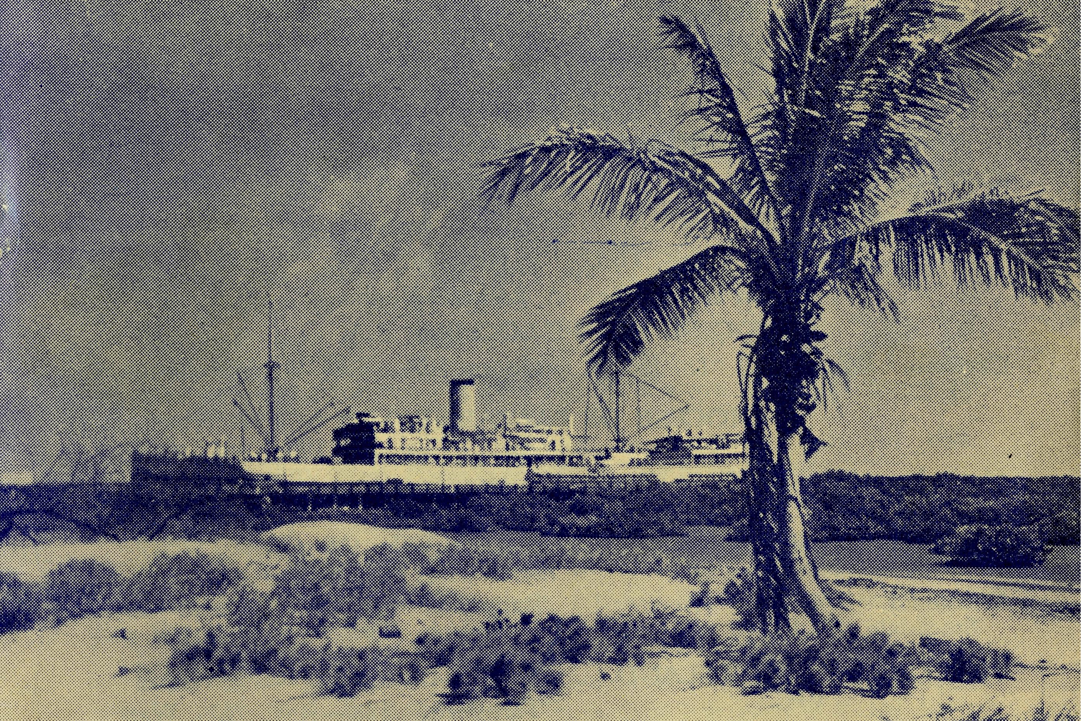
THE SCHOOL HOSTELS FOR OUTBACK AND COUNTRY CHILDREN
Broken Hill, N.S.W.—Mr. and Mrs. W. L. Calder.
Mungindi Boys' Hostel, N.S.W.—Mr. and Mrs. S. Colefax.
Mungindi Girls' Hostel, N.S.W.—Miss M. Farr.
Dr. W. Stewart Ziele Memorial Hostel, Bowral, N.S.W.—Mr. and Mrs. A. McLaughlin.
Silver Jubilee Hostel, Port Lincoln, S.A.—Miss G. Banks, Miss D. Duver
No. 19 (New Series)
MARCH, 1957.
2/6 per annum, post free

The Official Organ of
THE BUSH CHURCH AID SOCIETY
Church House, George Street, Sydney, N.S.W.
Edgar Bragg & Sons Pty. Ltd., 4 Barker Street, Sydney.
A State Steamer at Port Hedland
The Official Organ of THE BUSH CHURCH AID SOCIETY
Church House, George Street, Sydney, N.S.W.
Registered at the G.P.O., Sydney, for transmission by post as a periodical

The Real Australian
March, 1957
March, 1957
The Real Australian

The Bush Church Aid Society
for Australia and Tasmania
PRESIDENT: The Archbishop of Sydney.
Hon. Clerical Secretary: Rev. Canon E, Cameron
Hon. Treasurer: Mr. T. S. Holt.
Organising Missioner: Rev. Canon T. E. Jones, M.B.E., Th.L.
N.S.W. Deputation Secretary: Rev. J. R. Greenwood, Th.L.
Victorian Secretary: Rev. E. G. Beavan, M.A.
HEADQUARTERS OFFICE: VICTORIAN OFFICE:
Diocesan Church House,
St. Andrew's Cathedral, Bible House,
George Street, Sydney.
'Phone: BM 3164. Flinders Lane, Melbourne, Victoria.
Telegraphic Address:
"Chaplaincy, Sydney". Telephone: MF 3 552.
FIELD STAFF: DIOCESE OF ADELAIDE, S.A.
Ceduna, Penong, S.A.—Rev. T. V. Minnipa, S.A.—Rev. A. Williams,
Jones, Th.L., Rev. R. Brooks, Th.L.
Th.L. Streaky Bay, S.A.—Rev. T. J.
Cowell, S.A.—Rev. J. Smith, Th.L. Hayman, Th.L.
On Leave—Rev. A. Richards'Pugh.
DIOCESE OF WILLOCHRA, S.A.
Orroroo, S.A.—Rev. I. Booth, Quorn, S.A.—Rev. G. Fuhrmeister
Th.L. Th.L.
DIOCESE OF BALLARAT, VIC.
Otway Mission, Vic.—Rev. T.
Heytesbury Mission, Vic.—Vacant. Morgan, Th.L., Beech Forest,
Vic.
DIOCESE OF RIVERINA, DIOCESE OF GRAFTON,
N.S.W. N.S.W.
Wilcannia, N.S.W. — Rev. J. Rappville, N.S.W. — Rev A
Stockdale, Th.L. Gerlach, Th.L.
DIOCESE OF GIPPSLAND, DIOCESE OF TASMANIA.
^{VIC}' Tarraleah, Tas.—Rev. W. War-
Croajingalong, Vic.—Rev. L. Luck, burton, Th.L.
Th.L., Cann River, Vic.
DIOCESE OF THE NORTH-WEST
Murchison Mission Port Hedland Mission.
Rev. C. W. Rich, Th.L., Mount Rev. D. M. Douglass, Th.L.,
Magnet, W.A. Port Hedland, W.A.

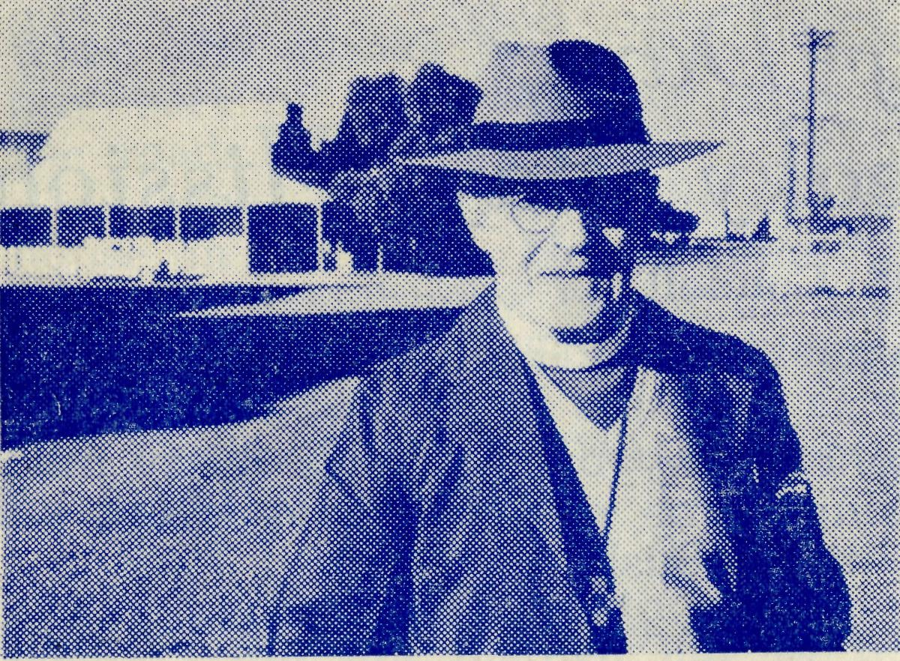
Bishop Frewer of the North-West

The Organising Missioner’s Letter
And now the North-West.
The Rev. C. W, Rich and the Rev. D. M. Douglass were fare-welled at a service in St. Andrew's Cathedral on Thursday evening, March 7th, and sailed for Perth en route to their stations in the Diocese of the North-West by the "Kanimbla" on March 9th. Thus we have taken our first step towards the rehabilitation of our church in an area of 500,000 square miles of this continent.
The wives of these two men have agreed that they will remain behind until such time as suitable homes can be built for them. We have promised that this time of separation shall not be long.
The men have entered upon this new work with courage and very real sacrifice. Their wives, and families have identified themselves with this sacrifice and with the same courage.
WE MUST NOT FAIL THEM.
The task now is a big one. No less than £12,000 must be raised IMMEDIATELY. Then we can build them homes and supply the cars necessary for the job. On top of this, we must also keep all the other work of the B.C.A. going.
You are urgently asked to send in a special gift for this project. Will you do it NOW? There is no time to lose.
Mr. Rich goes to Mount Magnet in the Murchison and Mr. Douglass to Port Hedland in the far north-west.
They will be far away from friends and it will be so easy to get downhearted. If we back them up by making sacrifices equal to theirs, they will feel that their friends are not far away and that they are not alone.
I am asking all our friends to make a special gift for this work at Easter-tide, but you need not wait to get the letter that will be sent you. You can do it now.
This great area of half-a-million square miles of Australia has NOT ONE Anglican clergyman, other than the bishop. We are given the opportunity to change that.
The clergymen have offered. The laity of our church must stand behind them.
Remember, send a gift now, and make it as large as possible.

The Real Australian
March, 1957
March, 1957
The Real Australian

An Encouraging Day
Streaky Bay Mission
Rev. P. Connell
Yesterday was an encouraging day for me so I would like to tell you about it.
I set out about 10 a.m. for one of my bush schools thirty miles away. It was a beautiful morning — one of those days when one feels glad to be alive, especially in the bush.
Arriving at my destination a little early I filled in the time by going over to visit a parishioner who lived near the school. The grass seeds clung to my socks as I walked through the long grass. A magpie and its rather green-looking fledgling were sitting on the fence.
The house was one of those built by the pioneers, of mud, in the early eighties of last century. Unfortunately, the owner was away, working on the roads I learned later, so I had just time to get to the school for my Religious Instruction class at 12 o'clock.
The school's name is Chandada and there are about thirty children there. About half of them are Protestants and I am in the habit of making no distinction as regards denomination, so I had all of them — Methodists, Lutherans and Anglicans. It was the story of the Cleansing of the Temple by our Lord. Then we had a few hymns. How glad they are to sing them. Of course, their repertoire is limited but they love to sing and it was a really happy half hour that I spent with them. Finally we had a talk and I announced that Church service would be held on the following Sunday afternoon.
Afterwards a little boy approached me. He lives ten or twelve miles from the hall where I hold service and his parents are not much interested in things of that nature so are never at Church, but the boy said he would ride in on his bike.
It was a very little thing and I am wondering if he will be able to do as he said, but it is such little things that give a missioner courage to go on: the consciousness that a seed is being sown even though sometimes the ground seem to be hard.
After the lesson I had another bit of encouragement in the fact that the schoolteacher said he would like to take Religious Instruction on the weeks that I am unable to come out to the school. This is very good news as I am the only Protestant minister visiting this school now, so I agreed to send the schoolteacher a book of Bible stories and if possible a regular supply of B.C.A. Mail Bag Scripture lessons. ■
Then on to dinner — and by this time I was feeling very anxious for some inner fortifications for my energies. I was also looking forward to the meal for the reason that it was to be at a home I love to visit: the people are so glad to see the minister. There is an old man there who loves to talk of the "old times" on the coast
when the blacks were thick and it was nothing but horses for any sort of work on the farm and any sort of transport along the roads.
I arrived and found the old man sitting out at the side of the house in the sun. He is almost blind and was very glad to see me and straightway began on the weather, which has been very changeable of late. This he blamed on the "Bomb", of course, and went on to tell me of the blast of same which he, along with others, had clearly heard. When I mentioned that I had come for lunch he said that was good.
Next I went out to the sound of an electric washing machine at the back of the dwelling where the lady of the house was very busy. I did not disturb her as it was quite evident that I could not do anything to help and bye and bye she called to us that dinner was ready.
We talked of many things which I suppose would be those talked of in any Australian home to-day: the Suez crisis; the "bomb" and its costliness, etc. Afterwards we had a Bible reading and prayer. As I often read my favourite portion of the Bible I have sometimes been reminded that I read the same verses the last time. Later in the afternoon I was going on with a reading of scripture while the old man was absent, but the farmer's wife asked me to wait as he would not miss it for anything.
In all, that day I visited seven places — a school, a shearing shed and farm houses. I don't suppose it seems a very great deal of visiting for one day, but the distances were such that I was quite satisfied.
In most homes we have prayer together and I read a portion of Scripture. If I ask, the people often reply, "Yes, please", or "We'd be very glad of it, Mr. Connell" in such a grateful way that I feel that in general the practice is appreciated.
Sister Rose Portch
We regret to record that Sister Portch has returned to Britain at short notice.
Sister's mother has been very ill for some time and is in need of careful nursing attention. Sister, therefore, felt it her duty to return and care for her mother.
It was during the Organising Missioner's visit to Britain in 1947 that Sister Portch offered for service in B.C.A. hospital work. A year later she arrived in Australia and served at Penong Hospital. Later she transferred to Wudinna and became its matron.
Sister has given outstanding and devoted service to the people of the Wudinna district and this was demonstrated in a remarkable manner at her going.
With only two days' notice the sum of £300 was donated as a gift to her and on the evening before she left a very large gathering met in the town to bid her farewell.
We are grateful for the splendid service Sister Portch gave, and hope that in the not too far distant future it will be possible for her to return to us.

The Real Australian
March, 1957
March. 1957
The Real Australian

A Lot of Water
Rev. J. Stockdale
Much has been printed in newspapers and a lot has been said over the radio about the floods on the Darling from the Darling Downs in Queensland to where the river joins the Murray at Went worth.
The Flood, for that is what it is called, has been with us now for seven months. One could not fully describe it, but here in Wilcannia it is nine miles wide and has been for that time, and at the time of writing we shall have it for another month.
It is very inconvenient to say the least. It has disrupted communications with the people on the eastern side of the river with consequent disruptions of parish visiting by patrols and virtual discontinuance of Church Services in Ivanhoe.
Recently a young man rang me from Ivanhoe and asked me if I would come down and marry him. Ivanhoe is 120 miles by road and in a south-east direction from here. In normal times it is quite easily reached in about three hours. However, the Flood was with us. He was not very keen on being married by the local policeman and I was the only Minister who could reach him, and that with difficulty.
I could fly, but then no one else would have been visited. So I rang a parishioner 65 miles out on the Cobar Road and asked him if I could borrow a jeep for a couple of days. He said "Yes" and I thanked him very much. I rang the young chap in Ivanhoe and said I could go but that we would have to make the wedding on another day. He was quite happy about that and after a bit more discussion we came to an agreement. It was to be in. the morning, on a Tuesday, so that the couple could catch the Silver City Comet for Sydney on the same day.
The day arrived for our departure, as my wife decided she would also go. A friend very kindly flew us the nine miles of water in an Auster and we boarded the jeep for Ivanhoe. We soon found out that it did not have any brakes. We were not left in any doubt either that they are very rough to travel in over long distances.
We had lunch at a station about twelve miles from the starting point. The folk had not been to town for some time so much talk went on. As we had had very considerable rain over the past six months the road was terrible, to say the least. We were very glad of the four wheel drive. We made one other call before reaching Ivanhoe. We wanted to reach there before it was really dark, for we were to have a service that night, and also to complete arrangements for the wedding on the morrow.
We arrived at Mrs. Whitchurch's right on dark. She was out, so we sat in the jeep for a few minutes until someone came and asked if I could pull a car out of a bog, right in the middle of the town. Ivanhoe was just one big quagmire we found, and I repeated the pulling out twice in the next couple of hours.
However, our hostess arrived and we made ready for Church after tea. The mud was not at all likely to let many people venture out after dark and we found only a handful of people there. We were all glad of the opportunity to gather and worship God and give thanks for the bountiful season which we were now enjoying. The Church is small, but always there is a sense of fellowship when we sing and pray together.
Later that evening arrangements were completed for the wedding and many friends of the young couple worked late into the night to get the Church ready.
Next morning we awoke to bright sunshine. The Church was crowded with relatives and friends. Everyone was* literally crammed in, like a peak hour tram in Sydney. The young couple were glad that we came, as I was also, and they started their marriage with the blessing of God.
The jeep was made ready and our last job of pulling a truck out of a bog in the main street was performed. Then we set off to catch the "Steamship" for Wilcannia.
We made three calls on the way home and they were short ones because of the time limit. We were welcomed most graciously by all, and after talk, the inevitable*cup of tea and prayer before leaving, we were on our way.
Sometimes we wondered if we had any springs. We arrived at the water's edge to find the boat waiting, and after loading up we were on our way. A twenty-minute ride in a motor boat and we were ready for the next part: a six-mile ride on the back of an Army Blitz.
The mail, pictures, suitcases, odds and ends and even rabbits were loaded on to the back and we were off. What a ride! We jolted, tossed and bumped and almost suffocated with fumes and one hour later we were at our front gate.
Now we knew what a wonderful job two men were doing under great difficulties to get the mails through. The way they can follow the road mile after mile under water when one slip would spell disaster is truly a miracle.
We were glad that we were able to go to Ivanhoe to share with some of the people the things that belong to God and to tell of the Gospel of Christ. We were also glad of the experience of what some people have to do to help others, and in that way get to know their problems and so reach into their hearts.

The Real Australian
March, 1957
March, 1957
The Real Australian

From City to Bush
Rev. Arthur Williams
In moving from a small parish in the heart of Australia's largest city to a large parish in the heart of Australia, is an experience which certainly provides many contrasts. For two years buses emptied thousands of people outside our door. Trains and trams rumbled beneath our home. Cars in a never ending stream sped past us day and night as they crossed the Sydney Harbour Bridge, and now after eight months in Minnipa Mission we have forgotten the terror of city streets.
Minnipa is a small town on the Eyre Highway, 400 miles by road from Adelaide on the way to Perth. A motor coach comes through from Adelaide and returns twice each week. We are also connected by rail to Port Lincoln, with trains arriving and departing every few days. A DC3 airliner calls twice each week. We have four general stores, a baker, butcher, hotel, local hall, post office and garage, as well as a school and police station.
About 50 families live in the town, the remainder of the population are farmers growing crops of wheat, barley, oats, as well as raising a few sheep. The district is not what we would call a rich farming area, although the last few years have been good ones with sufficient rain falling just at the right time, allowing most of the farmers to slightly improve their homes and machinery.
The town of Minnipa is the centre of the Minnipa Mission which extends for some 60 miles east and west through similar farming districts. In this 120-mile stretch Church services are held at 10 centres but without the benefit of a single church building. Here we find one of our greatest contrasts. It is hoped, however, that a church will be built at Minnipa in the very near future.
Northwards from Minnipa the mission stretches through the large sheep station country for a distance of about 400 miles. From the air, this northern country looks dry and barren with nothing but saltbush, scrub, and sandhill, but from the ground we find that it is "good" sheep country, if enough water can be caught in dams or bores and that a number of square miles can be reckoned for each sheep.
The huge area of the mission provides us with yet another contrast, but it is surprising how quickly one learns that 50 miles is not very far, and that such a drive is in many cases only a drive next door. Yet it is well worthwhile to visit these station homesteads, for the missioner realises that to spend an evening with a family or even just to have a meal with his people is the best and fastest way to get to know them.
To be welcomed into every home and not to be left standing on the door step as happens in some city homes; to set up "church'* in a station lounge-room or to baptise the children of these outback people is a thrill to be experienced, for these children and their parents could never come to church, but they do appreciate the church coming to them.
SNOW IN A B.CA. MISSION !
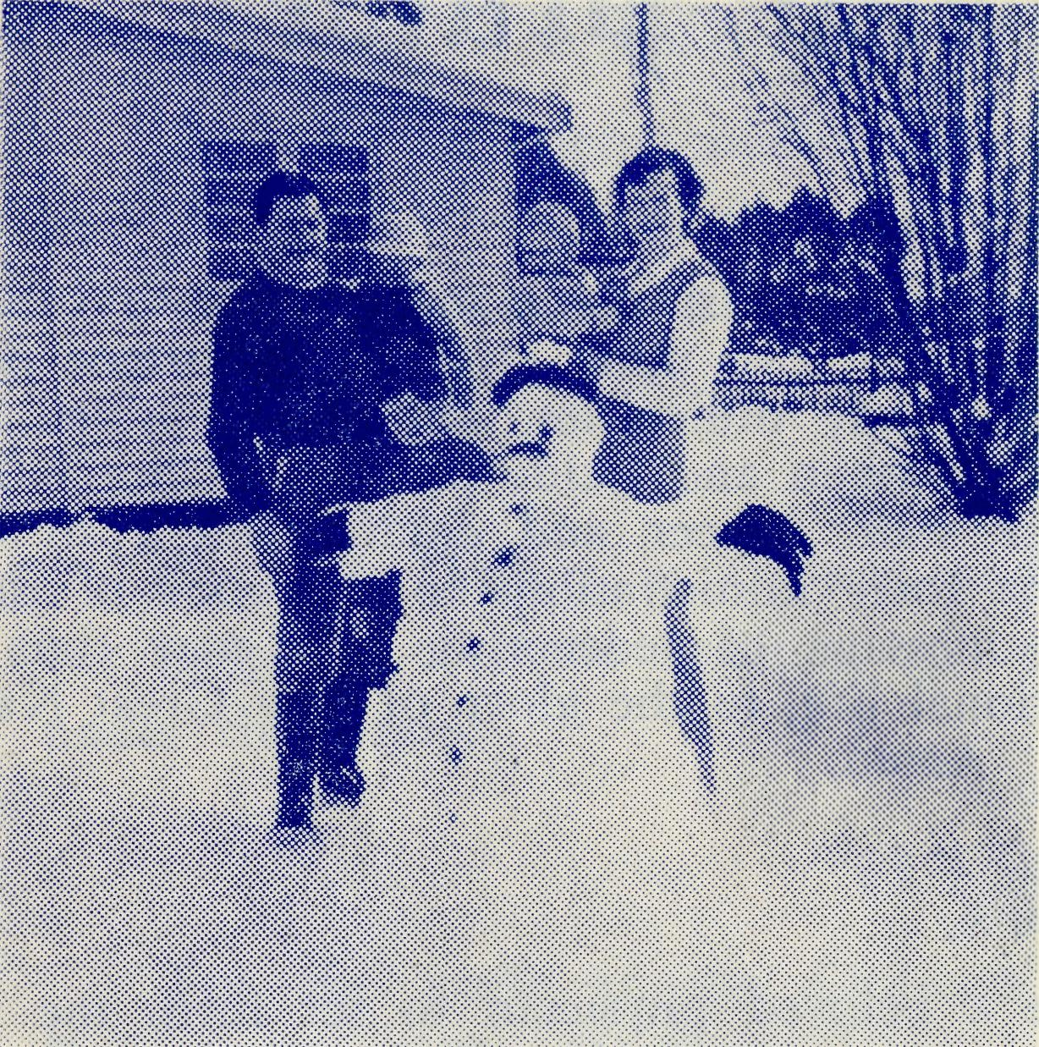
The Rev. W. and Mrs.
Warburton
outside their home at
Tarraleah, Tasmania.
Unfortunately, these visits to the station country, which also includes the townships of Tarcoola, Kingoonya, and Goober Pedy, can be made only three or four times each year.
Since coming to Minnipa the weather has been kind to us and we have yet to experience the hot, dry, dusty conditions for which the outback is noted. Like most other places, this year has been the wettest for 30 years and as far as travelling is concerned has provided us with yet another contrast.
I will always remember a journey home from Wudinna one evening at the beginning of winter. I had spent the day in and around the town and, although it had rained steadily for most of the day, the roads seemed to be quite good. After Bible study and hymn singing at the hospital I set out on the 24-mile return trip.
I had only travelled a mile or so when I felt St. Patrick's van beginning to slip and slide. Splashing mud soon covered the headlights and windscreen, making it practically impossible to see. Large pools of water lay across the road, the earth highway had become a quagmire,
A few miles further on, I saw the headlights of what was a large semi-trailer coming in the opposite direction. As we approached the truck suddenly slid across the road. I tried instinctively to swerve out of the way but although the wheels turned the van kept on in the same direction.
Then as suddenly as the truck had swung in my direction it slid back and we had passed one another with yards to spare. An hour and an half later I arrived home very thankful the traffic out here is nowhere as heavy as city traffic.

March, 1957
^0
March, 1957
The Real Australian
Topics for
Prayer and Praise
For the Society.
O Lord God of our nation, Who hast commanded men to subdue and replenish the earth: Look in Thy love upon all who in distant parts of our land are striving against many difficulties, and are deprived the access of the means of grace. Strengthen and guide the Bush Church Aid Society and all members of the staff. Cheer and comfort them in discouragement and loneliness, bless their ministrations to the good of those they serve, and grant that the message of redeeming love may thus be rooted and grounded in our national life, to the glory of Thy Great Name through Jesus Christ our Lord. Amen.
For Nurses and Doctors.
O God, Who didst choose a beloved physician to set forth the life of Him Who went about doing good, grant that Thy strong tenderness and compassion may be manifest in the work of country doctors and bush nurses. Make them at all times alert to be faithful, as those whom Thou hast burdened and inspired with the honour of their calling. In lonely •emergencies strengthen them with confidence that, having done all they can, they may with good conscience leave the issue to Thy power working within Thy law. Make them resourceful and of sound judgment, and hearten their labours with the energy of compassion and the firmness of •duty that conquers weariness. Through Him Whose power is called forth by suffering. Jesus Christ our Lord.
For Church Life in Country Districts.
O Lord, Who art present when two or three are gathered together in Thy Name, bless, we beseech Thee, the little far-scattered groups of brethren who in our wide land meet together to worship Thee. Give them a perpetual freshness of spirit, and the power to inspire in each other holiness, helpfulness, and understanding of Thy help. Refresh with the joy of enthusiasm those who endure weary journeys to Thy trysting place. Grant that these little companies of Thy servants may be united in the spirit of Christian charity, awaiting in love the time when there %hall be one fold and one Shepherd. Grant that the common life of all communities may be purified by this spirit of charity from all meanness, falsehood, malice and idle gossip, and grant that they who share a common lot may draw strength from each other's virtues, and in their weakness help one another, through our one Lord, Jesus Christ.
Praise.
For the Blessings vouchsafed to the Society, for all kindly givers, for the joy of service.

H
The Real Australian
YOUR DAILY REMEMBRANCE
SUNDAY
For all the Clergy-missioners of B.C.A., their wives and children, and the people to whom they take the Gospel of Christ. For all students of the Society in training for this special ministry.
MONDAY
For the Doctors at Ceduna and Wudinna, the Nursing Sisters in our hospitals. For the spiritual and physical needs of patients who come under their care.
TUESDAY
For the staffs at the Children's School Hostels at Broken Hill, Bowral, Mungindi and Port Lincoln, the children who come under their care and the teachers who instruct these children.
WEDNESDAY
For the Mail-Bag Sunday School as it reaches out into far-distant homes to touch young lives with the challenge of Christ. For the Director, her assistant and staff of voluntary teachers, and the parents of the scholars.
THURSDAY
For the Flying Medical Service pilots and all staff and patients who travel with them. For the Radio Base and its Control Officer. For the Pharmacist at Ceduna.
FRIDAY
For the Administration of the Society—the Council—the Home Base Staffs and Auxiliaries and all Parochial Workers.
SATURDAY
For generous givers, that all necessary finance needed for so large a ministry may be forthcoming. For guidance in the right application of all such ^ihs.

The Real Australian
March, 1957
March, 1957
The Real Australian
iar

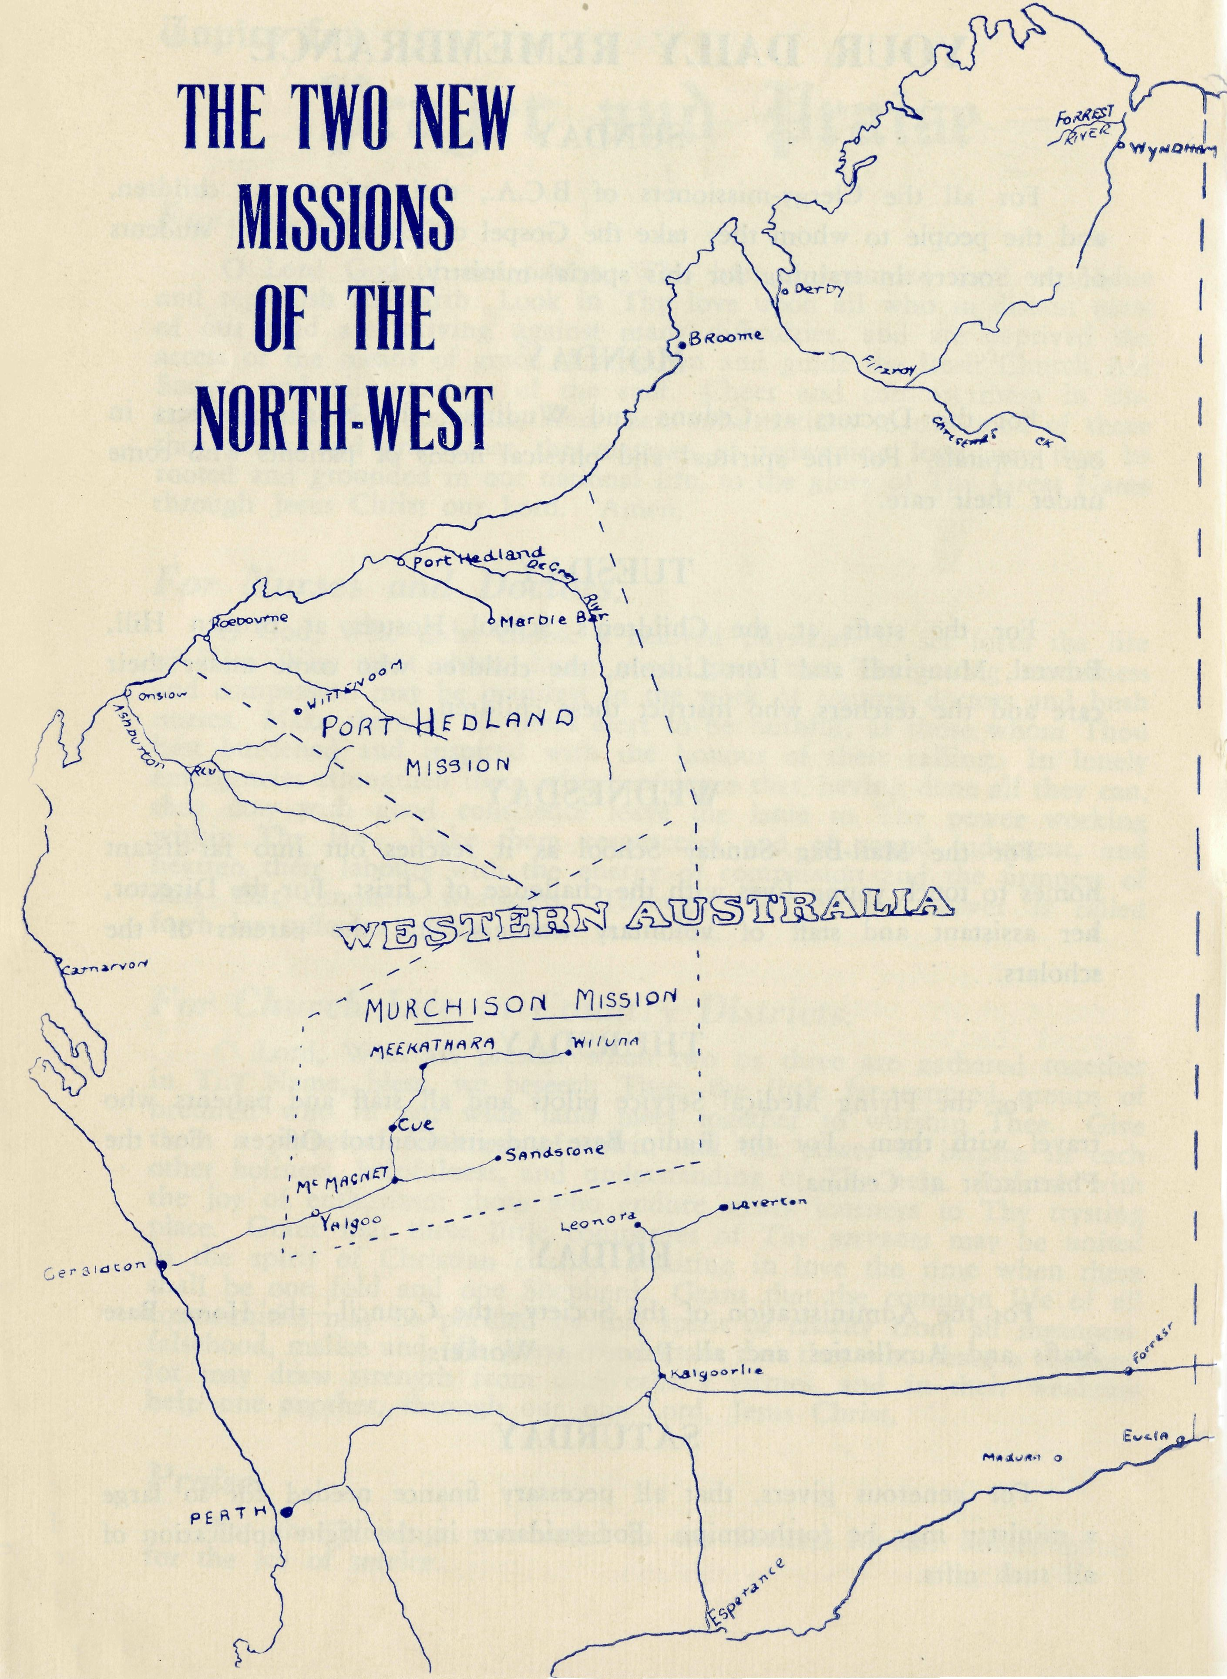
It is encouraging to find that many of our friends are taking a keen interest in the big project for the North-West.
St. Mary's, Caulfield, Victoria, has already raised £100 for the new work. This is in addition to the normal annual amount sent in by the church and its organisations.
Our thanks are due to the rector, the Rev. Canon E. F. Cooper_{r} and his congregation for this splendid effort.
St. Luke's, Mosman, is also well behind the effort being made and the Organising Missioner had a very successful day in that parish on March 3rd.
We hope that many more parishes will make a special effort in order that this urgent work shall be successfully accomplished.
# # #' # *
The Pennant Hills Auxiliary were able to pay for the cost of some renovations to the kitchen of the Mungindi Boys' Hostel, for which we are very grateful, and recently they received a legacy of £100 from the estate of one of their members, Miss Bellamy.
The interest and help of this group has been a great encouragement over many years.
We congratulate our friend the Rev. Graham Delbridge on his appointment as Archdeacon of North Sydney.
Mr. and Mrs. Delbridge have been a tower of strength to our cause in Adelaide and a great many of our workers owe them much for the ever-ready hospitality that has been given to them at the Rectory over the past five years. We are going to miss them a
very great deal.
*****
During February the Rev. Alun Pugh sailed on the "Fairsea" for England. He has received an appointment as chaplain to one of the ships bringing British immigrants to Australia.
Alun has been in Australia for fourteen years and we are all glad that this opportunity has come to him to visit his homeland and to see his parents again after so many years. He will return in May.
Meanwhile, the Rev. Jim Smith will minister at Co well.
* # * * #
Our congratulations go to the Rev. Jim Smith for heading the Second-class Honours List for Th.L. in the Australian College of Theology. There were no First-class Honours, so Jim topped Australia for the whole examination. Well done, Jim!

14
The Real Australian
March, 1957
March, 1957
The Real Australian

After obtaining his Th.SchoL, the Rev. Phil Connell decided to keep his hand in by attempting the London University's B.D. He has recently been notified that he has passed the first part of the examination, and he hopes to complete the job in the not too far
distant future. Very excellent, Phil.
# # # * #
The Rev. F. Buchanan, Mr. Brian Viney and Mr. Ray Neve made it a clean sweep for B.C.A. students by all passing their examinations. Our congratulations go to them also. It is encouraging
that none of our men failed.
# # # * #
Dr. Allsop has relinquished the work at Wudinna and is now in practice in Adelaide. We hope to make a new appointment shortly.
Since our last issue Sister Betty Brown has joined the staff at Ceduna. We are glad to have her and to know that she has settled into the work there happily.- Sister Maclntyre, who came to help us out for a time, has now returned to town to begin a Bible training course. We wish her well and hope that she will find a happy and useful sphere of service in the days to come.
# # # # #
Our friends will be glad to know that Sister Thomas continues to make improvement and she expects that very soon she will be
able to return to Rawlinna and pick up the threads again.
# # # * *
Soon after Christmas Anthony Blower arrived safe and sound. Dr. and Mrs. Blower are now enjoying their Christmas present.
Congratulations to them both.
# # * * • #
The Ladies' Auxiliary of Burwood East had another successful year during 1956. Mrs. Kershaw, their indefatigable secretary, reports that £103 was raised during the year, and that they have gained a number of new members. Many thanks for the hard work
put into the year's effort, Burwood East.
# # # # #
We ask our friends NOT to enclose coins in letters to us. We frequently receive cash donations in envelopes on which we are compelled to pay a considerable surcharge, because such transmission is against the P.M.G. regulations. Will you, please, use Money Orders or Postal Notes.
To Bill and Mrs. Bedford, a grand-daughter. We now have flying grandparents in the B.C.A., and if rumour is not a lying jade there are some more in the offing.
Congratulations to the proud grandparents. We expect you'll teach her to fly, Bill.
PRAY FOR B.C.A.
SERVE IN B.C.A
GIVE TO B.C.A.

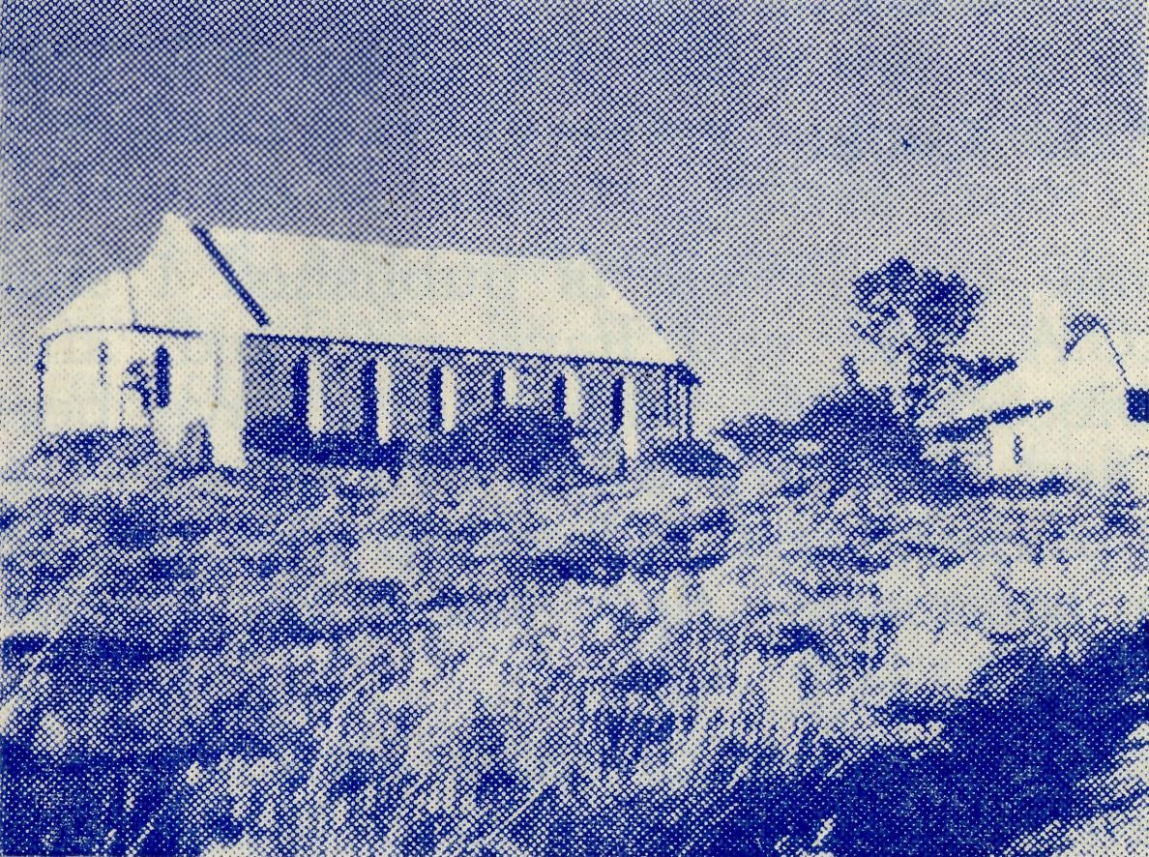
The Church on the Hill
at Roebourne in the
Port Hedland Mission.

The New and the Old
It is very easy to allow the new to overshadow the old.
While we rejoice in the new responsibilities of the North-West, we must remember the maintenance of the fields for which we are already responsible.
We need a Missioner for Timboon to take the place of the Rev. P. Cooke, who has lately returned to the Diocese of Melbourne. Timboon is a green and pleasant land and an important sphere of work. We hope that one of our clergy will come forward to fill the vacancy.
Towards the end of the year we will need a Missioner for Menindee, part of one of the oldest of B.C.A. fields and situated on the plains of the north-west of New South Wales. To one who cannot undertake to go so far afield as Western Australia, Menindee is a challenging sphere of service.
There are other of B.C.A. fields that will soon need replacements We shall be glad to hear from any of our clergy who may be interested.
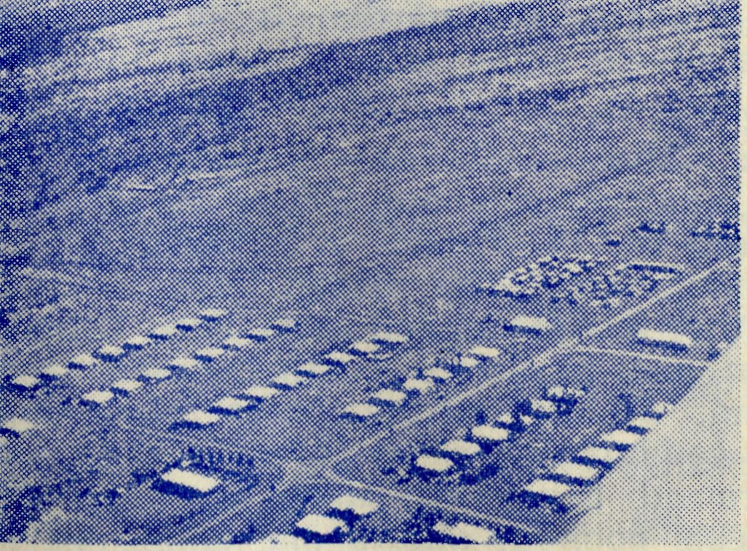
The C.S.R Town
of Wittenoom
in the
Hammersley Ranges.

16
The Real Australian
March, 1957
March, 1957
The Real Australian
17

Timboon
Rev. P. R. Cooke
In all probability, by the time this article is published I shall nave left Timboon and also B.C.A. and will have returned, after four years, to the Melbourne Diocese. My wife and I have been very happy indeed at Timboon and in many ways will be sorry to leave. We thank you for your prayers and fellowship and ask for your continued prayers as we commence new work in another sphere.
The mission at Timboon includes Cooriemungle Prison Farm, Curdies River, Kennedy's Creek, Lower Heytesbury, Nullawarre, Peterborough, Port Campbell and Princetown. There are also other small centres within the parish where parishioners live but where no services are held. Such places include Ayrford, Brucknell, Cowley's Creek, Curdies Vale, Newfield. At some of these centres other denominations hold services, at some of them we also used to hold services, but with such a moving population as we have here, many of our folk have moved out and those of other denominations have moved in. The furthest centre is approximately 28 miles from Timboon.
Some of the most useful and fascinating work is done at the Cooriemungle Prison Farm. Originally in 1939 when this excellent scheme began the "Farm" consisted of 16,000 acres of land in the Heytesbury Forest area, but this has been recently modified somewhat by the Soldier Settlement Scheme. There are seven officers at the farm and, at the moment, forty men.
Since its inception just under 1,000 prisoners have passed through the farm and there have been 13 escapes, less than one a year. "The Farm" is more like a military establishment than a prison.
There are no bars, the camp itself is in a most picturesque part and is surrounded by high hedges. From the office in the centre of the main block of buildings, the O.I.C. can see all the huts and the activities of the men when they are in camp. The men have hot and cold showers, a library and their own lighting plant. Beautifully kept lawns, hedges and gardens give anything but a prison appearance to the place.
The men work at clearing the land of timber, sowing down pastures, and putting up fences. This is all done by hand. When a block of 140 acres of timber country or about 200 acres of grass tree country has been cleared and the road made it is then sold by selection through the Lands Department. The prison farm also has its own sawmill and supplies other penal departments with timber. Gangs of prisoners at the farm are employed cutting down trees and scrub, clearing the ground, others cutting fence posts and putting up fences, others are sowing down pastures. Some are doing the necessary chores around the camp itself to keep the camp running smoothly and meals cooked, others are employed at
the "farm" where they run about 400 sheep, 30 odd head of cattle and six or so horses.
The men are often out during the day, out in the open, often without any supervision but there is little or no attempt to escape. Occasional concert parties from surrounding towns, and occasional cricket and football matches, also from folk from the surrounding towns, help to make their life a little more bearable and less monotonous. I visit the farm each week and once a fortnight we have an informal service in the mess room.
# # # # #
A Bush Baptism
Rev. Arthur Williams
The next station homestead to be visited was only 22 miles away, but as the road was still very wet and boggy from recent rains I wondered many times whether I would be able to make it without a long walk .being involved. St. Patrick's wheels spun and slipped several times but on each occasion managed to keep going. A Baptismal service had been planned at the homestead for that evening, a baby girl and her four-year-old brother were to be admitted members of Christ's Church.
When I arrived in the late afternoon I was for some time the object of inspection from the four-year-old. His mother had thought it best to warn her son of the minister's visit and to prepare him for his baptism. The little boy, however, was not so sure, for I learnt afterwards that his father had been asked "Couldn't Joe do it in the horse trough?" (Joe, being the station handyman, could do nearly everything.) His slightly older brother also had the wrong idea for after the evening meal I was asked when I was going to give his brother "the needle".
Having heard many stories and poems of "Bush Christenings", I decided that I ought to do a little explaining to the young candidate. As I set my portable font in position, with a little water in the bowl, I carefully explained what would happen, adding that I would baptise the baby first so that all could see how it was done.
As the service proceeded I noticed a small boy quietly and unconcernedly stroll towards the door, only to be retrieved by his father's hand. At last came the crucial moment, and as I took him by the hand a little voice turned to his mother and said "See, I'm not scared, Mum".
LISTEN TO THE BUSH PADRE
2GB Every Friday at IT a.m. 2NX-2NM Every Sunday at 4.30 p.m. 2CH Alternate Sundays at 6 p.m. 2KA Alternate Thursdays at 4.20 p.m.

18
The Real Australian
March, 1957
March, 1957
The Real Australian
19

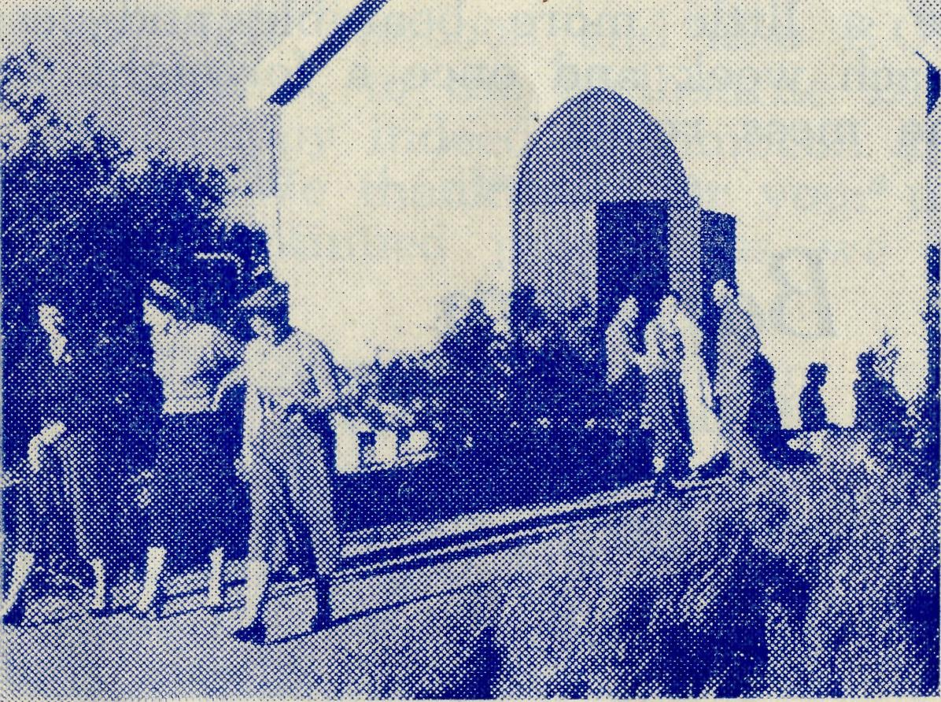
IN THE FAR NORTH-WEST
Some of the congregation
leaving after a service
at Port Hedland.
THE BUSH CHURCH AID SOCIETY'S FLYING MEDICAL SERVICES
HOSPITAL CENTRES. | Matron: Sister F. DOWLING.
CEDUNA.  The Murat Bay District Hospital.  PENONG. | Staff Sisters: J. MILLER, G. HITCHCOCK, B. TIERNEY, M, BELL, P. BRADBROOK, B. BROWN, M. BARBOUR.
The Penong Memorial Hospital. | Sisters L. LOANE and J. ROBERTS.
COOK.
The Bishop Kirkby Memorial Hospital. | Sisters M. HORSBURGH and M. ROSS.

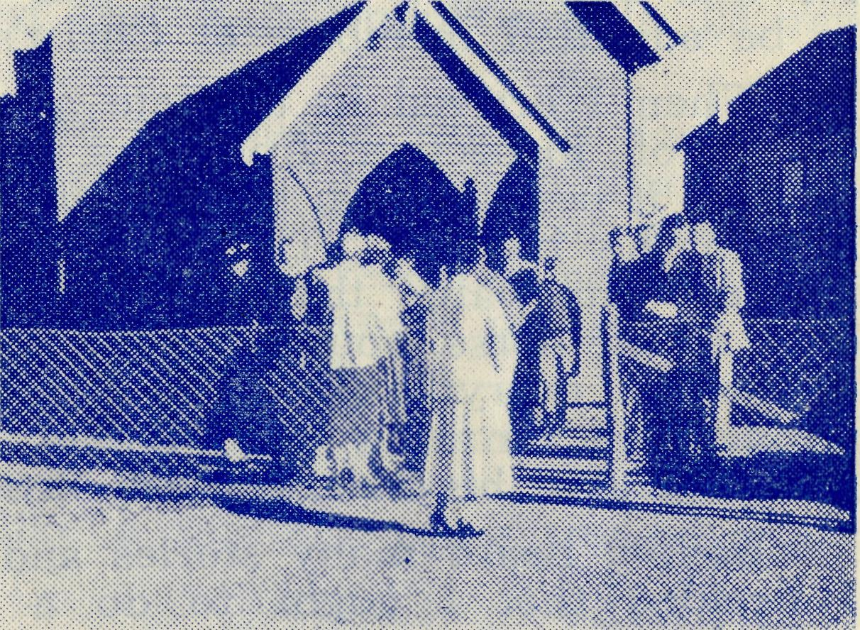
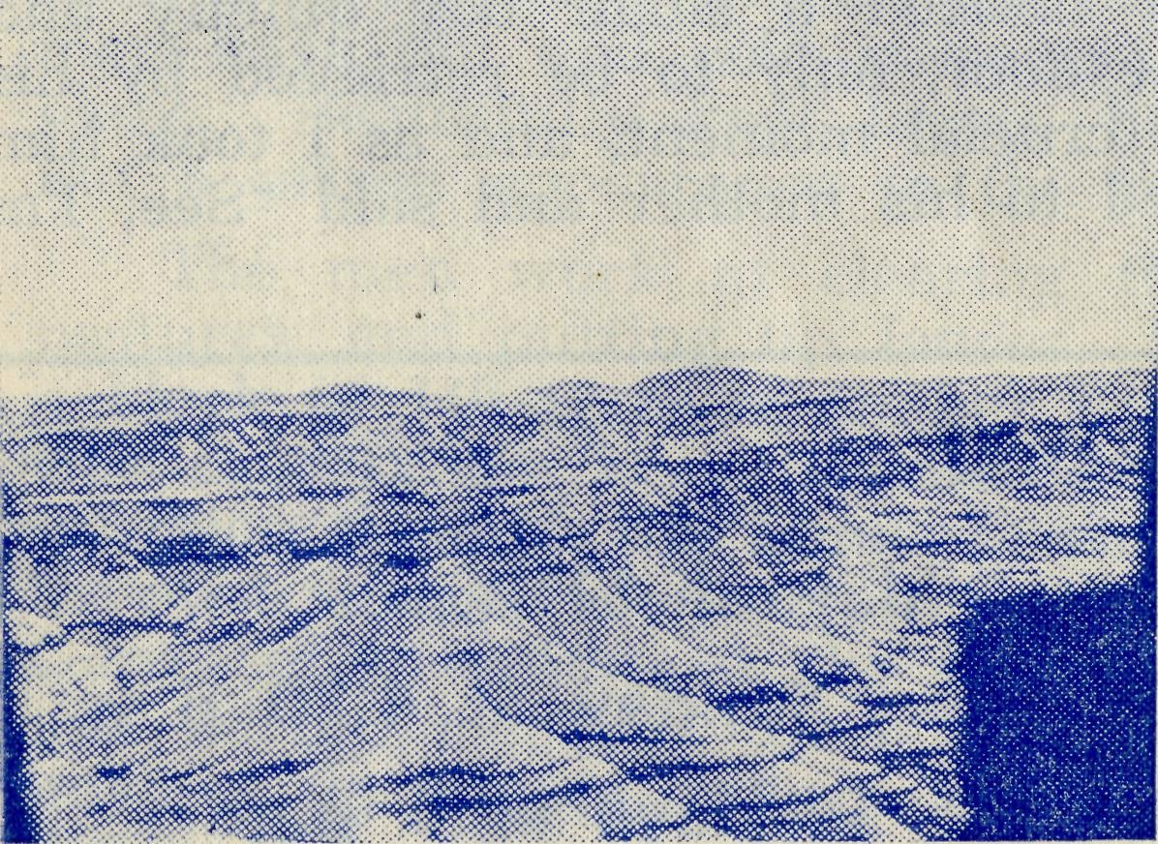
Sisters V. HOLLE and M TARR.
Sister E. THOMAS
Matron: Sister B BARBER Sisters: V. BREALEY, M. DEAN, J. JOHNSTON, N. VERITY.
At the Church Door, Mount Magnet.
Aerial View of Hammersley Ranges.
TARCOOLA.
The Tarcoola Hospital.
RAWLINNA, W.A.
The Nursing Hostel.
WUDINNA.
The Central Eyre Peninsula District Hospital.
On Leave: Sister A. BUTLER.
MEDICAL OFFICERS.
Dr. C. BLOWER, Dr. M. MUELLER.
AIRCRAFT. PILOTS.
"Percival Proctor". Mr. ALLAN CHADWICK.
de Havilland "Dragon" Mr. G. JOB.
Auster. Mr. W. BEDFORD.
PHARMACIST.
Mr. B. RICHARDS.
WIRELESS COMMUNICATIONS BASE.
Ceduna Base Operator: Mr. GEORGE CAMERON. Assistant: Mr. J WARD
CROAJINGALONG NURSING SERVICE, VIC.
Sister I. GWYNNE.

