20
The Real Australian September, 1957.
THE BUSH CHURCH AID SOCIETY'S FLYING MEDICAL SERVICES
HOSPITAL CENTRES. Matron: Sister F. DOWLING.
CEDUNA. Staff Sisters: J. MILLER, G
The Murat Bay District HITCHCOCK, B. TIERNEY,
Hospital M. BELL, P. BRADBROOK,
M. BARBOUR.
PENONG.
The Penong Memorial Sisters: L. LOANE and J.
Hospital ROBERTS.
COOK.
The Bishop Kirkby Sisters: M. HORSBURGH and
Memorial Hospital. jvl ROSS
TADPAAT A
on. -r ' 1 xx -1 ^{Sisters:} ^{V}- HOLLE and M. TARR
I he iarcoola Hospital.
RAWLINNA, W.A.
The Nursing Hostel. ^{Slster} E. THOMAS.
WUDINNA. Matron: Sister B. BARBER.
The Central Eyre Peninsula Sisters: V. BREALEY, M. DEAN,
District Hospital. D. CLEMENTS, N. VERITY.
MEDICAL OFFICERS.
Dr. C. BLOWER, Dr. M. MUELLER, Dr. D. ALLSOP.
AIRCRAFT. PILOTS.
"Percival Proctor". Mr. ALLAN CHADWICK.
de Havilland "Dragon" Mr. G. JOB.
Auster. Mr. W. BEDFORD.
PHARMACIST.
Mr. B. RICHARDS.
WIRELESS COMMUNICATIONS BASE.
Ceduna Base Operator: Mr. GEORGE CAMERON. Assistant: Mr. J. WARD.
CROAJINGALONG NURSING SERVICE, VIC.
Sister I. GWYNNE.
Edgar Bragg & Sons Pty. Ltd., 4 Barker Street, Sydney.
No. 21 (New Series) SEPTEMBER, 1957 2/6 per annum, post free.
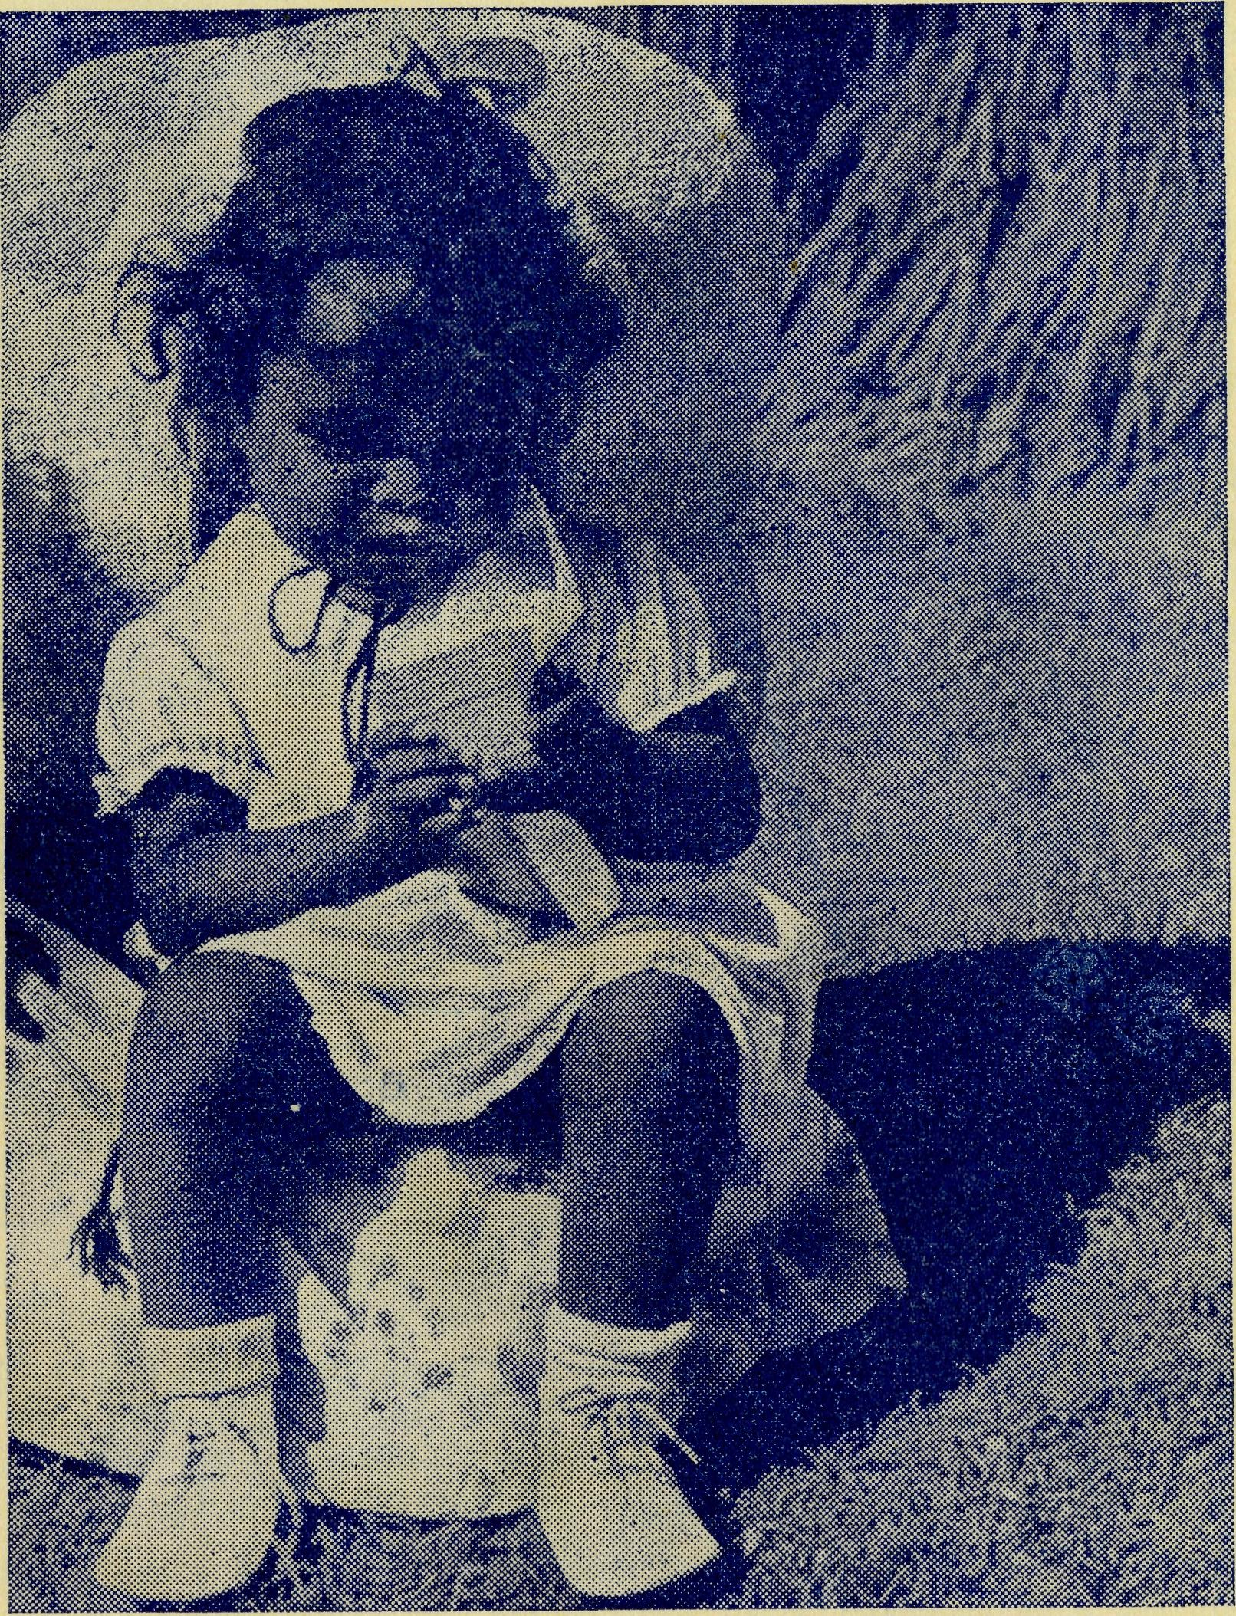
Ice-cream is good in any language.

Registered at the G.P.O., Sydney, for transmission by post as a periodical

2 The Real Australian September, 1957.
The Bush Church Aid Society
for Australia and Tasmania
PRESIDENT: The Archbishop of Sydney.
Hon. Clerical Secretary: Rev. Canon E. Cameron
Hon. Treasurer: Mr. T. S. Holt.
Organising Missioner: Rev. Canon T. E. Jones, M.B.E., Th.L.
N.S.W. Deputation Secretary: Rev. J. R. Greenwood, Th.L.
Victorian Secretary: Rev. E. G. Beavan, M.A.
HEADQUARTERS OFFICE: VICTORIAN OFFICE:
Diocesan Church House,
St. Andrew's Cathedral, Bible House,
George Street, Sydney.
'Phone: BM 3164. Flinders Lane, Melbourne, Victoria.
Telegraphic Address:
"Chaplaincy, Sydnev". Telephone: MF 3552.
FIELD STAFF: DIOCESE OF ADELAIDE, S.A.
Ceduna, Penong, S.A.—Rev. T. V. Jones, Th.L., Rev. R. Brooks, Th.L.
Cowell, S.A.—Rev. D. A. Rich- Minnipa, S.A.—Rev. A. Williams,
ards-Pugh, A.L.C.D. Th.L.
DIOCESE OF WILLOCHRA, S.A.
Orroroo, S.A.—Rev. I. Booth, Quorn, S.A.—Rev. G. Fuhrmeister,
Th.L. Th.L.
DIOCESE OF BALLARAT, VIC.
Otway Mission, Vic.—Rev. T.
Heytesbury Mission, Vic.—Vacant. Morgan, Th.L., Beech Forest,
Vic.
DIOCESE OF RIVERINA, DIOCESE OF GRAFTON,
N.S.W. N.S.W.
Wilcannia, N.S.W. — Rev. J. Rappville, N.S.W. — Rev. A.
Stockdale, Th.L. Gerlach, Th.L.
DIOCESE OF GIPPSLAND, DIOCESE OF TASMANIA.
^{VIC}- Tarraleah, Tas.—Rev. W. War-
Croajingalong, Vic.—Rev. L. Luck, burton, Th.L.
Th.L., Cann River, Vic.
DIOCESE OF THE NORTH-WEST
Murchison Mission Port Hedland Mission.
Rev. C. W. Rich, Th.L., Mount Rev. D. M. Douglass, Th.L.,
Magnet, W.A. Port Hedland, W.A.
September, 1957. The Real Australian 3
The Bush Church Aid Society For Australia and Tasmania
ORGANISING MISSIONER'S REPORT FOR THE YEAR 1956.
I present to you the thirty-eighth report of the Bush Church Aid Society.
The most notable feature of the year was the definite evidence of the increasing importance of this Society and its work in the life and development of the Church in Australia.
For the first time in the history of the Society the bishops as a whole called upon the Society to undertake the responsibility for thei future development of the Church in the vast area of the Diocese of the North-west and, with the Brotherhood of the Good Shepherd, to endeavour to awaken the whole Church in Australia to its responsibilities to the outback areas as a missionary enterprise.
The bishops also pledged that both organisations should have a free entry into their dioceses for the purpose of seeking men and finance for this new project.
This is a great step forward both in the concept of the problem of outback dioceses and in the work and function of the Bush Church Aid Society and promises a greater measure of success for the solution of this difficult problem than has been possible hitherto.
During the year the Organising Missioner, at the request of the Bishops' Special Committee for the Work in the Interior, toured the Diocese of the North-west from Geraldton to Wyndham, and the Northern Territory from Darwin to Alice Springs in order to investigate and report on the conditions of church life and its problems in these areas. These journeys were followed by a visit to Thursday Island to confer with the Bishop of Carpentaria as to the special problems of his diocese.
As a result of these enquiries the Organising Missioner presented a plan for the formation of a single Missionary Diocese to be the responsibility of the whole Church in Australia.
The result has been that, while agreeing in principle with the concept of a single Missionary Diocese, the bishops deferred implementing it until a later date and as an interim measure have asked the Bush Church Aid Society to be responsible for most of the Diocese of the North-west and the Brotherhood of the Good Shepherd to staff the area between Alice Springs and Darwin.
By the end of the year under review, we had received and accepted offers of service from the Revs. C. W. Rich and D. M. Douglass and had agreed to assume responsibility for the sum of £12,000 for the purchase of vehicles and homes for these men and their wives. Mr. Douglass had accepted appointment to Port Hed-land and Mr. Rich to Mount Magnet.
In other fields of the Society's missions the work was fairly maintained, though it is to be regretted that no man was available

The Real Australian September, 1957.
September, 1957. The Real Australian

to' replace the Rev. P. Cooke, who resigned from the Timboon Mission at the end of the year.
In the Rappville Mission and at Streaky Bay efforts were begun to ensure that both these missions would become financially self-supporting. It is confidently anticipated that this result will be achieved in the ensuing year.
At the end of the year the Rev. P. Connell was offered and accepted the Parish of Strathalbyn in the Diocese of Adelaide. Mr. Connell had served with the B.C.A. for twelve years, having been located at Rappville, Ceduna and Streaky Bay in that time. Jle rendered capable and devoted service and was much beloved by the people in each centre in which he served. We rejoice to know that he has been appointed to such an important living in the Diocese of Adelaide, where he will further the interest of the Society among his people.
At the beginning of the year the Rev. Jim Smith joined the staff and became assistant priest at Ceduna. Mr. Smith obtained excellent results in his Theological examinations and was the Senior Student at Ridley College during his final year. Hostels.
Mr. and Mrs. McLaughlin took over the charge of the Bowral Hostel at the beginning of the year and have been able to do much to improve the property. Mr. McLaughlin added twenty-seven feet to the new dormitory and thus enabled the available rooms in the main house to be used to greater efficiency.
Miss Cheers began her long service leave previous to her retirement after twenty-seven years with the Society. The Council arranged for her to pay a visit! to England in order to mark her long and valuable service.
Mr. and Mrs. L. Calder replaced Mr. and Mrs. McLaughlin at Broken Hill and besides doing much to improve the property have already made a deep spiritual impact on the boys.
At each of the hostels definite Christian witness is being given by the staff, and many of the parents from time to time speak appreciatively of the influence hostel life has on the character of their children.
Mail-bag Sunday School.
The work of the Mail-bag Sunday School has been maintained in all branches. The number of children returning work has increased so that we now have 46 teachers in our Primary and Upper Grades, with the possibility of more joining our school.
Much is owed to Miss Campbell and her workers for the far-reaching influence of this side of the Society's activities. From time to time Miss Campbell is able to make journeys to country dioceses. This enables her to meet the clergy of country parishes, address teachers and Sunday Schools, meet some of the children who are members of our Mail-bag Sunday School and to enroll new scholars.
It is to be hoped that in the near future it will be possible to find suitable staff for the proposed Mail-bag Van. This will enable this department to keep in closer touch with those whom it serves.
The Confirmation Studies are continuing to be widely used all over the Commonwealth and New Zealand. They continue to evoke
much appreciation from the many clergy who are using them. They have undoubtedly become the most popular means of giving Confirmation instruction.
Medical Services.
This side of the work continues its growth in scope and efficiency. Its main problem is the maintenance of nursing staff. Nevertheless,, when the great difficulty of many country hospitals in maintaining even a skeleton staff is remembered, we have great cause for thankfulness in that all our hospital work has been maintained with a reasonable number on the staff at each centre.
Kingoonya has been added as a centre for regular clinical visits. The people have installed a B.C.A. transceiver in contact with Ceduna and the doctor now visits this centre each month. This makes four B.C.A. medical centres on the Trans-Continental Railway Line.
The scope of the Radio Base contact continues to increase as the services become more and more appreciated. We now have 79 outposts of which fifteen are fishing boats.
During the year there were 870 consulations on the air. One hundred and eighty flights were made by the planes of which 44 were emergencies. Forty-three thousand miles were flown and 4,060 telegrams were handled. One thousand eight hundred and sixty-four patients were seen by doctor.
Radio School.
This venture is becoming increasingly important in the educational system of South Australia. As the evidences of the value of this personal link between teacher and pupil are becoming more widely appreciated by patients, it is adding to its sphere of operation.
We now have 20 sets in homes exclusively for educational purpose and many of the medical sets are also used for this service.
During the year Mrs. B. Jones resigned from the position as teacher and the Education Department of South Australia accepted the nomination of Miss Jean Coulter, of Melbourne, who was engaged to commence her new work as from the beginning of the new school year.
I feel confident that this service will grow even wider and will eventually be the accepted method of teaching outback children through the Correspondence Course.
Deputations and Propaganda.
The growing interest in the work of the Society in such dioceses as Newcastle, Armidale and Goulburn has brought the deputation work to more than saturation point for the present staff.
The Rev. J. Greenwood does a heavy programme and it is largely through his efforts that the demand for deputations has; grown in dioceses outside Sydney. The growing volume of field Work makes it impossible for the Organising Missioner to do very much deputation work.
The time has undoubtedly come when we must seek the services of at least one other suitable deputationist if we are to maintain the interest and finance necessary for our work.

September, 1957. The Real Australian

The Real Australian September, 1957.
Auxiliaries.
The various Women's Auxiliaries continue to grow in strength and to raise increasing sums for the funds of the Society. Apart from raising money the many functions *they arrange stimulate interest in the Society by bringing together many old and new friends. It needs ever to be borne in mind that societies such as ours have little opportunity to build up the personal interest and relationship so necessary for future development, except by such functions as the Women's Auxiliaries are able to arrange.
We are, therefore, grateful to the Women in Melbourne and Sydney who, while engaged in many other activities, give so much to B.C.A. Staff.
This organisation, like many of a similar nature, owes most of its success to the unfailing devotion of its field and office staffs. We are particularly fortunate to have in both spheres many who have given long years of unflagging service.
The administrative staffs, both in Sydney and Melbourne, work under confined conditions which in the case of Sydney we are glad to know will soon be corrected. We are grateful to the staff for the splendid work they have done. Finance.
The total income for the year was £45,823, as against £36,408 for the previous year.
The Organising Missioner's Letter
My first reference must be to the Women's Auxiliary Fair held in the Chapter House of St. Andrew's Cathedral on July 26th.
The women did a splendid job. The Chapter House was made to look very attractive and the goods displayed for sale were of high standard and just the things that everyone wanted to buy.
The result in cash was the splendid sum of £540, but the result in interest and fellowship was much beyond that. It is only at such functions that our friends can meet and learn more of the Society's activities. Mr. Greenwood's 'theatrette' was a very popular part of the day's interest and many new friends saw his pictures of the outback.
Interest in and help for the new work in the North-west continues. We are now approaching the £7,000 mark. That means we have another £5,000 to go; so we are by no means finished yet.
At the time of writing the new house at Mount Magnet is about to start growing and that alone will cost over £4,000. So keep on keeping on, but don't let your interest in the older established work languish.
We had hoped to be in our new¹ premises by this time, but it seems that we were too optimistic. The wheels of officialdom grind very slowly. However, we are now expecting that we will transfer 'before Christmas'.
On another page you will find most of the interesting part of the Annual Report. Read it carefully and you will rejoice with us at the very great progress that has been made in the development and conception of the B.C.A. work.
We welcome Philip Ian Booth, who arrived at the Orroroo Vicarage on June 8th last. Congratulations to the Rev. I. and Mrs.
Booth on the arrival of this, their second son.
* * *
We tender our sympathy to the Rev. B, and Mrs. Buckland on the death of one of the twins recently born to them. We are happy to know that Russell Victor makes good progress.
* # *
A recent letter from England tells of the passing of the mother of Sister Rose Portch. Our sympathy goes to Sister and her family
at the loss of a much-loved mother and friend.
* * *
The Organising Missioner has been able to tell the story of the North-west in the Cathedrals of Melbourne, Sydney and Armidale in recent weeks. These have greatly stimulated the interest in this venture and we are grateful for the many gifts that have been
sent to us as a result.
* * *
A friend whispers in our ears that Green Coupons are worth £1 per thousand and suggests to us that our friends may like to collect them for us. We make the suggestion and say that we shall
be glad to cash any number that may be sent in to us.
* * *
The Wollongong Rally was held on one of the coldest nights in the year but those who attended were warmed by the story they heard from Mr. Greenwood of the work of the B.C.A. We hope that next year we will be more fortunate in the night we pick and
so have a bumper night.
* * *
We regret to announce the resignation of Miss Gwen Banks as Matron of the Port Lincoln Girls' Hostel. Miss Banks found the strain of the work too great for her health and hopes to be able to engage in some other sphere of service. We are grateful to Mr. and Mrs. Dodd for taking charge at the hostel until another replacement can be found.
* * *
Our thanks go to Mr. L. Fowler, of Croydon, N.S.W., for the gift of a new filmstrip projector for the Boys' Hostel at Broken Hill. It is greatly appreciated by the boys and the staff.
By the way, a 16 m.m. projector would be a very useful addition to the equipment of the Ceduna Mission. Would any reader care
to fill this need?
* * *
We are glad to know that Mrs. Loane, of Chatswood, is making progress after her recent illness. We hope that she will be as active as ever before long.

The Real Australian September, 1957.
September, 1957. The Real Australian

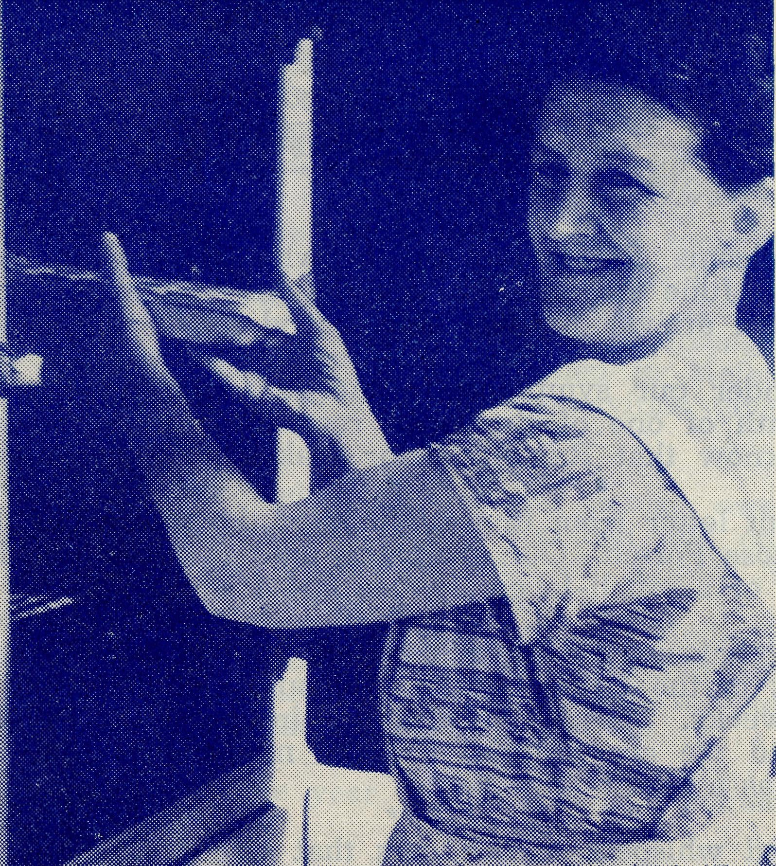
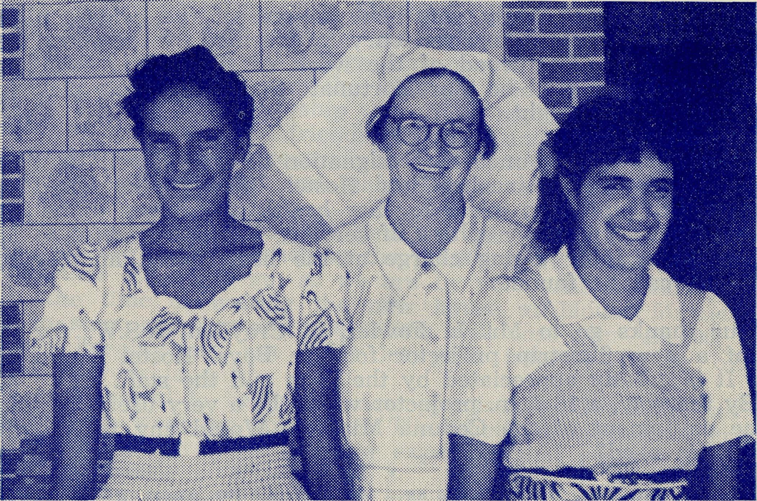
Sister G. Hitchcock.
Sister F. Dowling and two of Ceduna's Staff.
Long Service
The Bush Church Aid Society owes much of its effectiveness and growth to the long service of many of its workers.
Mrs. Mann, now in retirement in Adelaide, served with B.C.A. for twenty-four years in hostels at Wilcannia and Wentworth Falls.
Miss E. M. Cheers served first on the Women's Mission Van and then later as Matron at the Hostels at Mungindi and Bowral. Her period of service totalled twenty-eight years before her retirement at the end of last year.
On the opposite page are pictured two of the stalwarts of the Society's Medical Services.
The top pieture is that of Sister Grace Hitchcock, who joined B.C.A. as a nursing sister as long ago as 1934. Sister served at Ceduna for some years before starting the hospital for aborigines at the Lutheran Mission at Koonibba some twenty-five miles from Ceduna.
Sister's service with our native people took heavy toll of her health and she felt that she was no longer able to continue nursing. However, being very much a B.C.A. worker, she volunteered to take over the housekeeping duties at Ceduna, and for many years now she has ably looked after this side of the work.
Sister Florence Dowling joined the staff at Ceduna in January, 1932, and thus has completed her first twenty-five years.
Sister began her work in the old weatherboard building at Ceduna, which has become the second building used as a hospital at Ceduna by B.C.A. Soon afterwards the hospital services were transferred to the present modern buildings on the outskirts of the Ceduna township, and Sister has been Matron since that date.
During their years of service both these workers have seen great developments take place in the medical services. Extensions of the medical centres to Cook, Tarcoola and Rawlina, and the taking over by the Society of the Wudinna Hospital. The addition of the Flying Medical Service, Radio Base and Pharmacy have all come in their time, and much of it has been made possible by their co-operation and devotion.
We offer our best wishes to both these servants of the Kingdom of God for many more years of such service and our thanks for their devotion and loyalty to this work and service.

iq The Real Australian September, 1957.
September, 1957. The Real Australian
11

YOUR DAILY REMEMBRANCE
- The Rev. J. and Mrs. Stockdale and the Wilcannia Mission, N.S.W.
- The Rev. W. and Mrs. Warburton and the Tarraleah Mission, Tasmania.
- Mr. L. and Mrs. Calder and the boys of the Broken Hill Hostel, N.S.W.
Sister I. Gwynne and the work of the Dispensary at Cann River, Victoria.
- The Rev. T. and Mrs. Morgan and the Beech Forest Mission, Victoria.
- The Rev. L. Luck and the Croajingalong Mission, Victoria.
- The Rev. G. and Mrs. Fuhrmeister and the Quorn Mission, S.A.
- The Rev. I. and Mrs. Booth and the Orroroo Mission, S.A.
- Mrs. V. Dodd, Miss D. Duver and the girls in Port Lincoln Hostel, S.A.
- Miss R. Campbell and all her helpers and scholars in the M.B.S.S.
0. The Rev. A. and Mrs. Pugh and the Franklin Harbour Mission, S.A.
- Mr. Bill Bedford and the patients he carries by air. The Staff and patients in the Wudinna Hospital, S.A.
- The Rev. A. and Mrs. Williams and the Minnipa Mission, S.A.
- The Rev. J. and Mrs. Smith and the parish of Streaky Bay, S.A.
- Mr. Brian Richards and the work at the Ceduna Pharmacy, S.A. Miss Jean Coulter and the Radio Schoolchildren.
- Mr. A. and Mrs. McLaughlin and the girls at Bowral Hostel, N.S.W.
- Miss M. Farr and the girls at Mungindi Hostel, N.S.W.
jl7. Mr. G. and Mrs. Cameron and the staff at the Radio Base, Ceduna, S.A.
18. Mr. A. and Mrs. Chadwick, Mr. M. and Mrs. Job, and the Flying Medical Services, S.A.

- The Matron and Staff at Ceduna Hospital, S.A.
- Dr. C. and Mrs. Blower, Dr. M. Mueller and all medical services and patients.
- The Staff and Hospital Services at Cook, S.A.
- The Rawlinna Nursing Home and Sister-in-Charge, W.A.
- Mr. S. and Mrs. Colefax and the boys at the Mungindi Hostel, N.S.W.
- The Rev. C. and Mrs. Rich and the Murchison Mission, W.A.
- The Rev. D. and Mrs. Douglass and the Port Hedland Mission, W.A.
- The Staff and Hospital Services at Penong, S.A.
- The Rev. T. V. and Mrs. Jones, the Rev. R. Brooks and the Ceduna Mission, S.A.
- The Rev. A. and Mrs. Gerlach and the Rappville Mission, N.S.W.
- All students in training for outback ministries.
The Rev. E. Beavan, the Victorian Committee and office staff.
30. Canon T. Jones, the Rev. J. Greenwood, the office staff at
Headquarters and the Council of the Society.
Thanksgiving:—
For the continued growth of the work of the Society.
For the increase in support through prayer and giving.
For the devotion and service of those who work in the many activities of B.C.A.
For the work of Auxiliaries.
For opportunities of service in new and old fields.
PRAY FOR B.C.A.
SERVE IN B.C.A.
GIVE TO B.C.A.

12 The Real Australian September, 1957.
September, 1957. The Real Australian
13

Prayer and Praise
Two Years in the Orroroo Mission
By Rev. I. BOOTH.

For the Society.
O Lord God of our nation, Who hast commanded men to subdue and replenish the earth: Look in Thy love upon all who in distant parts of our land are striving against many difficulties, and are deprived the access of the means of grace. Strengthen and guide the Bush Church Aid Society and all members of the staff. Cheer and comfort them in discouragement and loneliness, bless their ministrations to the good of those they serve, and grant that the message of redeeming love may thus be rooted and grounded in our national life, to the glory of Thy Great Name through Jesus Christ our Lord. Amen.
For Nurses and Doctors.
O God, Who didst choose a beloved physician to set forth the life of Him Who went about doing good, grant that Thy strong tenderness and compassion may be manifest in the work of country doctors and bush nurses. Make them at all times alert to be faithful, as those whom Thou hast burdened and inspired with the honour of their calling. In lonely emergencies strengthen them with confidence that, having done all they can, they may with good conscience leave the issue to Thy power working within Thy law. Make them resourceful and of sound judgment, and hearten their labours with the energy of compassion and the firmness of duty that conquers weariness. Through Him Whose power is called forth by suffering. Jesus Christ our Lord.
For Church Life in Country Districts.
O Lord, Who art present when two or three are gathered together in Thy Name, bless, we beseech Thee, the little far-scattered groups of brethren who in our wide land meet together to worship Thee. Give them a perpetual freshness of spirit, and the power to inspire in each other holiness, helpfulness, and understanding of Thy help. Refresh with the joy of enthusiasm those who endure weary journeys to Thy trysting place. Grant that these little companies of Thy servants may be united in the spirit of Christian charity, awaiting in love the time when there shall be one fold and one Shepherd. Grant that the common life of all communities may be purified by this spirit of charity from all meanness, falsehood, malice and idle gossip, and grant that they who share a common lot may draw strength from each other's virtues, and in their weakness help one another, through our one Lord, Jesus Christ.
Praise.
For the Blessings vouchsafed to the Society, for all kindly givers, for the joy of service.
Two years have passed since our work began here at Orroroo in the north of South Australia. Co-ordination of all the duties necessary in this scattered area has not been easy and until recently little progress was apparent. However, in the past few months, we have been able to achieve some of the things we had hoped for.
It must be remembered that this Mission consists of three separate areas each of which has no geographical continuity with the other. In the Orroroo section we have a group of three Churches: St. Paul's, Orroroo; St. Aidan's, Tarcowie; and All Saints', Carrie-ton. These three districts had not worked together before but had formed three independent congregations and as time and convenience dictated had been attached to various parishes at different times.
In the far north, 175 miles from Orroroo, is the now famous township of Leigh Creek, which has rapidly sprung up to provide housing for the men employed in the open-cut coalfields. The population of Leigh Creek is now just over 1,000, of which at least 50 families are members of the Church of England. This forms the second unit of the Mission.
The third unit has as its main centre the uranium mining township of Radium Hill, 165 miles east of Orroroo. This is another modern and rapidly growing industrial area with a population of nearly 1,000. When visiting Radium Hill services are also held at Yunta, Manna Hill and Olary, tiny towns on the Port Pirie-Broken Hill Railway. To reach this part of the Mission I must travel through 80 miles of the Peterborough Parish.
To provide a ministry to this widespread area necessitates spending nearly five months of the year away from home. Fortunately, this is made up of trips taking five days one fortnight and six days the next. Life sometimes seems to be made up of packing and unpacking a panel van!
Perhaps the most interesting activity in the Mission at the moment is the provision of a church building for Leigh Creek. Some time ago it was recorded in the 'R.A.' that it was intended to pull down an old building at the little town of Copley, 6 miles south of Leigh Creek. A great deal of hindrance was met in the achieving of this plan but in recent months good progress has been made. The building has been pulled down and many repairs executed to ihe timber of the wall frames and roof. Working bees have been busy every week-end and without much professional advice have re-erected the shell of the building. A few modifications have been made to the external appearance and it is hoped that a brick porch will be added to beautify the front section. As there was no lining on the walls and most of the furnishings have 'disappeared' in the 30 years in which the building has not been in use, a great deal of finance will be required to prepare the Church for use. The congregation has raised over £100 and distributed 50 sets of envelopes for weekly contributions to the building fund as well as donating many of the materials and equipment for the job.

14
The Real Australian September, 1957.

This small congregation is doing a large job. They are nearly all married people with young families, which means that their effort to provide this building is one of great personal sacrifice but it is a sacrifice willingly given as they realise the necessity of providing for the spiritual care of their children and themselves.
Most of them will only be resident in the town for a few years as the population is largely a moving one. Therefore, the greatest value of their sacrifice will be for those who move in to take their places, they themselves having taken their place in some other parish.
Will you help them to complete their plans for this Church? Donations sent to the Offices of the Bush Church Aid Society will be directed to Leigh Creek for this purpose.
Speaking of your help to the work in this Mission I must thank many B.C.A. friends for their timely assistance in providing some of our needs. These gifts have facilitated the work and provided a little comfort in the Rectory. The Melbourne Ladies' Auxiliary worked hard to equip the kitchen with a refrigerator, a most necessary item in this country. Other gifts enabled us to purchase a filmstrip projector which has been used to great advantage. A small portable wooden Cross was made by one friend. It can be assembled quickly for use in halls and homes where services are held from time to time. These and other gifts are very greatly appreciated.
From the Rectory, Port Hedland
Dear Everyone,
Being a typical mother I shall start my letter by telling you about the family. I will begin with the youngest. Our twelve chickens (now 9 weeks old), are doing very well. They eat a great deal and are growing fast. I shall report on their egg-laying capacity in about three months time.
Judith Margaret is as wonderful as ever. She was one year old on Tuesday, but, as Don is away, the birthday will be clebrated next week. Ian gave her a Teddy Bear which she loves—she says 'Teddy' very clearly and roars with laughter when it groans. I cut the hair that flopped over her eyes and she now has a fringe—it makes her look like a real little girl. She stands up alone and has (accidentally) taken two or three steps alone-she is very confident when there is one finger to hold on to. We have a constant battle about the pot plants on the verandah, the soil tastes so good.
Port Hedland winter (?) climate suits Judith—she eats wonderfully now and has fat rosy cheeks. Now Ian—well I could write a book about the mischief he gets into, but he is very happy here in spite of his toy still "Coming on the ship". We bought him a tricycle with a carrier so I now don't have parcels to carry. There are plenty of children here for him to play with—he is 'growing up' very fast. He really looks after me while Don is away and both children are great company.
Don and I are very fit too. We are beginning to get to know

15
September, 1957. The Real Australian
folk here, and needless to say, Don is very busy. When he gets time he is going to write you all an account of his trips. He has been to Roebourne and Wittenoom three times now and to Marble Bar once (all in 6 weeks). On each trip he has spent several days visiting station properties (about 16 so far), and has found it all most interesting and worthwhile. The Services in the other towns (monthly), are much appreciated by the people and he teaches in the schools each trip. We hope to have Sunday Schools going in each town this month and children on station properties are being asked to join the Mail Bag Section. I will do that part.
When Don is away, I teach Scripture here (a class with the Convent children and one or two with the State School). I really enjoy this — Mrs. Dempster or Mrs. Smith-Ryan look after the children for me.
In Port Hedland, our Sunday School is growing slowly. Don takes the over eight-year-olds (about 12 to 15 of them), and I take the kinders, (about 9). Next Wednesday, the children are coming here for an afternoon tea party — we asked the older ones to bring a Bible Object for a competition. Last Sunday, I sent notices out, announcing our first Family Service.
I have not yet tried to form any Women's Group — mainly because our things still haven't arrived from Sydney, and we are still semi-camping. Mrs. Smith-Ryan had, however, arranged a fete for 9th July, and the ladies are working very hard for this. I have not been able to "Get into" this much, as it was all planned and settled before we came, but after the 9th, I will invite folk here and try to begin some regular meeting. I am anxious that it should be more than a "money raising" group and feel I would prefer to gradually introduce Mother's Union or Young Wives. It is difficult to know what approach to make. Will you pray that what is started will be really worthwhile for the work of God here?
Quite a lot has been happening here this last month. (I am not quite the lady of leisure I was!) Firstly, we had the visit of our Organising Missioner — Canon Torn Jones. He was only in Hedland for one and a half days, but it was great seeing him. He and Don went to the other centres. Next the Bishop came for four days on his way south from Broome. We were really thrilled at his being honoured with the C.B.E. in the Birthday Honours. He is a wonderful old man and a most gracious visitor in the home. He certainly knows the people of the North-west. Until yesterday, we thought the Primate was coming here this month. We feel very sad he is unable to, but we are really a very long way from Perth, and he has a big programme in the West. He will be seeing the Riches at Mt. Magnet.
Last week I had my first visit to a station. Don looked after the children and I joined a group of twelve ladies on a trip to Mundabullangasa — a wonderful station about 50 miles south. We arrived at the homestead at about 11 a.m. After looking around a little, we lunched (crumbed cutlets, ham, cold lamb and salad and scrumimy sweets, home made rolls, etc.) on the lawns. The property was all I imagined stations to be, but I was amazed at

16
The Real Australian September, 1957.
September, 1957. The Real Australian
17

how completely self-contained it was — the store shed was a shop for the 30 or so residents,
Mrs. Lucas — the manager's wife, who entertained us—showed us the quarters for the whites and half-castes. (Incidentally, one of the Lucas daughters is being married in our little Church in three weeks, four bride's maids. I am desperately trying to learn the wedding marches. No one else here seems to play at all.) After lunch we drove 20 odd miles to the shearing sheds. It was most interesting, and for a city person like me, most fascinating. More big buildings— sleeping quarters, cook, etc.
Our port here is quite busy — loading wool and manganese. All our supplies come by ship. During the winter there are quite a number of tourists on their way to Darwin. How about coming next winter — we have heaps of room for any number of visitors — the beauty of big verandahs. The trouble is, I can't get anyone to say they will come. You ought to, it's well worth it.
I must stop this lengthy meander, but first let me tell you. I have caught three bream and one flathead from outside our back fence. I would not like to tell you how many hours this involved. Also I am quite enthusiastic about gardening — we have lettuces, beans, tomatoes and cabbage growing. I cook on a fuel stove and like it very much.
Must away — we do love getting letters from you all. Thank you so much and most of all, we appreciate your wonderful support in prayer.
Love to you all from us all,
MARGARET DOUGLASS.
P.S. I forgot to tell you that last Sunday night, as Don was away, we had five folk here to an informal Service of Worship, conducted by me. This was quite encouraging, as we thought no one might come when we announced it.
Mount Magnet, Western Australia
10th May, 1957. Dear Folks,
It is so difficult to know where to start. So much has happened in such a short time, and it is so difficult for us to imagine that we are on the other side of Australia — that is till we stop and think, and then it all catches up with us.
I think most of you know of my dash to Sydney to get Joan so after a few details about my stay here on my own, I will start at that. life in a vestry can be fun — so they tell me, but I must confess I found it had very serious limitations. All I need say about it is that I was so fortunate to have been in Sydney last week, because part of the ceiling decided to give up the struggle and fall in — it landed on my bed!
Our trip over was a very happy affair — Mark has been playing "Hostesses" ever since — and apart from being rather tired on arrival, we found ourselves in reasonable shape. We are living
for the time being, in the C.W.A. Rooms, which we are managing to make adequate, if not quite like the Rectory at Canterbury. We have three real rooms — the fourth is the "bathroom" — it stores all manner of things, including a bath and is breezy to say the least. The fifth room is the laundry, and that is 200 yards up the street in the home of the Postmaster. Very handy — we can collect the mail and do a spot of washing at the same time. In spite of all this we are more than thankful to be together again, and are very conscious of the good hand of God in so many things.
As expected, there is a vast amount of territory to cover in the Parish. The five towns with which I am concerned run to three sides of a square and from one extremity to the other is 391 miles. Added to this there are 71 stations within reasonable range of my various centres, so there is plenty to keep me busy. I have arranged a schedule of services to cover the main centres and it will mean driving 1,500 miles a month to maintain them. Magnet and Meekatharra are the two main centres, each with about 1,000 people living in them. Cue, Wiluna and Sandstone are progressively smaller and so with the stations included, there are well over 2,500 people in all. Although the Bishop of the North-west had maintained a very faithful ministry in his area his visits have been spasmodic and as you can imagine, not always publicised or regular, with the result that folk often did not know he had been to town till some time after. One of the most pleasing features of the scheme is the genuine pleasure being expressed at our being here. At Sandstone, I conducted the first Protestant Service for seven years, and the whole town turned out. It was a very moving experience. Coming from an organised set-up of Church life, it is quite a frightening experience to be responsible for everything to do with Church services from ringing the bell — if there is one — to remembering to post notices in the towns. As yet, there has been no attempt at any organisations, though I have plans under way for a youth group here in Magnet, and it seems odd not to be tied down to meetings during the week. That of course is offset by the fact that Services other than at Magnet and Meekatharra must be held on week nights. There are schools in each town, hospitals in two of them and of course many homes to visit. As the routine settles down, I intend to make reasonably short (3 or 4 day) tours through the station country as I move from centre to centre.
When possible, Joan intends to come with me. We have tried it once and tomorrow are off again. We have a Vanguard Van,, and so with a mattress for Mark, a Tomato Sauce box for Pete (lined with a sheet of course), odds and ends of suitcases, 4 gallon drum of petrol, water, food, etc., etc., we present a formidable sight on the road. Needless to say, Mark wants to go> "camping" every day, but we manage to side track him with the promise of "to-morrow perhaps".
Even allowing for the red dust, which is a real menace and makes life rather miserable— particularly on washing days —this is a fascinating country. Oddly enough, it is a land of colour and variety, and never ceases to amaze. It is also a land of contrast..

18
The Real Australian September, 1957.
September, 1957. The Real Australian
19

Homes are the most deceptive things. Many places from the outside look like junk-heaps of whitewashed corrugated iron, yet inside present the picture of a modern home. With the exception of Sandstone, each town has D.C. electricity and whilst this limits some things, and the cost per unit prohibits others, it does allow for most of the conveniences within the home. Again each town has a reliable water supply — not always tasting the best! — but also allowing us to be independent of rain water — a good thing when rain is such a rare event.
One of the most depressing features of life here — and at that we are not as badly treated as the folk further north — is the very high cost of living. With the exception of meat (which is a little cheaper than Sydney), everything else has to come from Perth to the shops here and the cost of transportation is met by the customer of course. We were rather horrified to find that a week-end grocery order for such a small family as ourselves amounted to just over £4. Large tins of fruit are all over 4/-, .milk 1/8 a pint and Fruit Cordial (almost a necessity to disguise the taste of the water!) the size of a Mynor bottle — 5/3.
Thats sounds a dismal note to finish. However, as you may have been able to gather, we are very happy and well. Peter is getting fatter as each day goes past, Mark is getting filthier as he finds new ways to play in red dirt, and their Mother and Father fit and looking forward to a very real ministry, where we believe it is most needed.
Yours in Him,
JOAN and BILL RICH.
Appreciation
Below are extracts from two letters. The first is from the Rev. C. W. Rich to the Organising Missioner. The second from a letter to the Rev. D. M. Douglass from a parishioner at Roebourne. They speak for themselves.
On my first visit in Wiluna, 241 miles by road from here, I found the Church to be in a deplorable condition. It had not been used for a Service for about nine years, and I was told it would be unuseable. I had arranged to borrow the Methodist Church till such times as we could do something to the building as I had also made arrangements to baptize a baby on my next trip. I was very interested to receive the following letter, a few days before going again, from one of the womenfolk there.
"The father of the child to be christened has been helping, me get the Church in order — we have cleaned it thoroughly and oiled the floors and to-day, he is to do some carpentering at my expense, and later will do some at his own. I have polished the brass and mended the binding of the Bible to the best of my ability. Mrs. Heron is washing and ironing all linen and a surplice we found in the wardrobe. Mr. Bremner has found enough fibrolite to mend the ceiling and Mr. Heron is to get, if possible, a friend to help him get it up to the ceiling today — we will have flowers, etc., there by Monday. Some pews are mended and others to be quickly renovated today — windows will be glazed at a
later date, before the next Service. Mr. Heron did temporary repairs to the organ and it will play— will do more later."
Joan and I arrived to find accommodation had been arranged for us and I was naturally curious to see the Church. It was amazing. What had been a heap of broken pews, sagging fibrolite and dust really inches thick, had become a very presentable Church. Built in the days of Wiluna's prosperity, it certainly is the best of the Churches we now have for Worship, and I was hard pressed not to wish we had it here in Magnet. Later that evening, about 35 folk came together for the Service and the warmth of their appreciation was in very real contrast with the coldness of the night. You may not think 35 very many, or worth nearly 500 miles travelling, but as the town now only has about 80 folk — and I'm not sure that doesn't mean counting everything with legs — it represented very real interest.
Just another incident which demonstrates folk's real appreciation of our coming and which makes it all seem so worthwhile for
us. -
ROEBOURNE, WEDNESDAY. Dear Mr. Douglass,
Thank you very much for your pleasant and inspiring service on Sunday last.
The fact that you have been here, and will be here again seems to have filled in a void in the communtiy and is a great help, I am sure, to others besides myself.
Streaky Bay Mission
The Mission at Streaky Bay has now become a self-supporting district within the Diocese of Adelaide, and as such will no longer be found listed as a mission area of the B.C.A.
However, that does not mean that we will not continue to be interested in its welfare and be ready to assist the Rev. J. Smith whenever possible.
We are glad to know that the Bishop of Adelaide wholeheartedly welcomed the nomination of Mr. Smith, by the Organising Missioner, as priest-in-charge of this district.
Our good wishes go to Mr. and Mrs. Smith and we assure them of our prayers at all times.
LISTEN TO THE BUSH PADRE-
2GB Every Friday at 11 a.m. 2NX-NM Every Sunday at 4.30 p.m. 2CH Alternate Sundays at 6 p.m. 2KA 4.30 p.m. on 1st and 3rd Fridays of each month.

