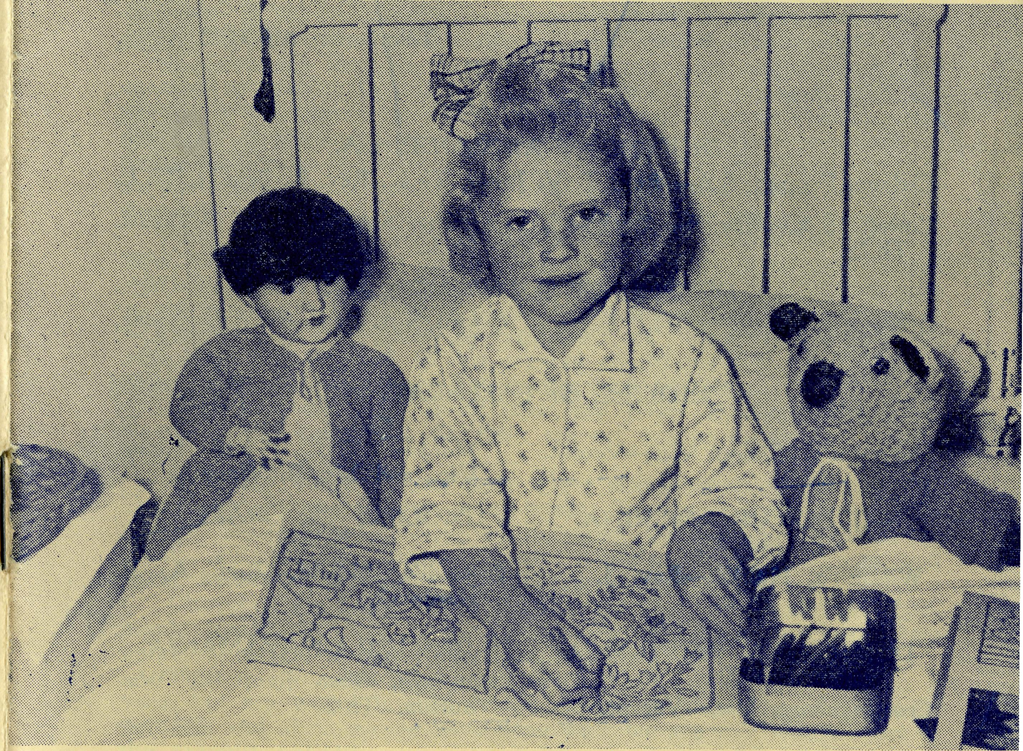
20 The Real Australian March, 1958.
THE BUSH CHURCH AID SOCIETY'S FLYING MEDICAL SERVICES
HOSPITAL CENTRES. Matron: Sister F. DOWLING.
CEDUNA. Staff Sisters: J. MILLER, G.
The Murat Bay District SIKSSKV ^S* ^{M}*
Hospital. BARBOUR, M. TROUP.
PENONG.
The Penong Memorial Sisters: L. LOANE and J.
Hospital ROBERTS.
COOK.
The Bishop Kirkby Sisters: M. TARR and M. ROSS.
Memorial Hospital.
^_{AT}^~~T * Sisters: V. HOLLE and D. CLEM
TARCOOLA. ENTS.
The Tarcoola Hospital.
RAWLINNA, W.A. Sister E. THOMAS.
The Nursing Hostel.
Matron: Sister B. BARBER.
WUDINNA. Sisters: V. BREALEY, M. DEAN,
The Central Eyre Peninsula N. VERITY, A. HAY-
District Hospital. WOOD.
MEDICAL OFFICERS.
Dr. M. MUELLER,
AIRCRAFT. PILOTS.
"Perceval Proctor". _{Mr} ALLAN CHADWICK.
de Havilland Dragon
Auster. ^{Mr}- ^{G}- J°^{B}-
Lockheed 12. Mr. W. BEDFORD.
PHARMACIST.
Mr. B. RICHARDS. WIRELESS COMMUNICATIONS BASE.
Ceduna Base Operator: Mr. GEORGE CAMERON. Assistant: Mr. J. WARD.
CROAJINGALONG NURSING SERVICE, VIC.
Sister I. GWYNNE.
LISTEN TO THE BUSH PADRE:
2GB Every Saturday 11.15 a.m.
2NX Every Sunday 4.45 pjn.
2CH Alternate Sundays 5.45 p.m.
2KA 1st and 3rd Fridays each month 4.30 pjn.
Edgar Bragg & Sons Pty. Ltd., 4 Barker Street, Sydney.
No. 23 (New Series)
MARCH, 1958
2/6 per annum, post free.

Registered at the G.P.O., Sydney, for transmission by post as a periodical

2
The Real Australian
March, 1958.
March, 1958.
The Real Australian

The Bush Church Aid Society
for Australia and Tasmania
PRESIDENT: The Archbishop of Sydney.
Hon, Clerical Secretary: Rev. Canon E. Cameron
Hon. Treasurer: Mr. T. S. Holt.
Organising Missioner: Rev. Canon T. E. Jones, M.B.E., Th.L.
N.S.W. Deputation Secretary: Rev. J. R. Greenwood, Th.L.
Victorian Secretary: Rev. E. G. Beavan, M.A.
HEADQUARTERS OFFICE:
Diocesan Church House.
St.. Andrew's Cathedral,
George Street, Sydnev.
'Phone: BM 3164.
Telegraphic Address:
"Chaplaincy, Sydnev".
VICTORIAN OFFICE:
Bible House,
Flinders Lane, Melbourne, Victoria
Telephone: MF 3552.
FIELD STAFF: DIOCESE OF ADELAIDE, S.A.
Ceduna, Penong, S.A.—Rev. T. V. Jones, Th.L., Rev. R. Brooks, Th.L.
Cowell, S.A.—Rev. B. Buckland, Minnipa, S.A.—Rev. A. Williams,
Th.L. Th.L.
DIOCESE OF WILLOCHRA, S.A.
Orroroo, S.A.-—Rev. I. Booth, Quorn, S.A.—Rev. G. Fuhrmeister,
Th.L. Th.L.
DIOCESE OF BALLARAT, VIC.
Otway Mission, Vic.— Rev. T.
Heytesbury Mission, Vic.—Vacant. Morgan, Th L.. Beech Forest,
Vic, and Mr. B. Viney.
DIOCESE OF RIVERINA,
N.S.W.
Wilcannia, N.S.W.—Rev. J. btockdale, Th.L.
DIOCESE OF GRAFTON,
N.S.W.
Rappville, N.S.W.—Rev. A. R. Hardwick,,
DIOCESE OF GIPPSLAND, DIOCESE OF TASMANIA.
Tarraleah, Tas.—Rev. W. War' burton, Th.L.
VIC
Croajingalong, Vic.—Vacant.
DIOCESE OF THE NORTH-WEST
Murchison Mission Port Hedland Mission.
Rev. C. W. Rich, Th.L., Mount Rev. D. M. Douglass, Th.L.,
Magnet, W.A. Port Hedland, W.A.
The Organising Missioner s Letter
I must first thank all those of our friends who so generously responded to our Christmas Appeal. The response overwhelmed us and the office staff was hard put to it to keep up with the task of opening the huge number of letters, writing out receipts and then sending out the acknowledgements, in addition to attending to the great number of people who made personal calls at the office.
The Melbourne office were also very gratified with the response they received to their appeal. Thank you very much.
As I told you in my letter in the last issue of this paper, we were able to face up to a very great task last year, but this does not mean that we have completed the various projects we then began.
The new aeroplane is already proving to us and the staff who have to travel long distances in it, the wisdom of having purchased it, but it is more expensive to maintain.
Our aim is to make arrangements so that as much as possible of the necessary maintenance can be done by our own staff at Ceduna. If we can do this it will mean that we will be saved very heavy labour costs at high rates.
This means that we must establish our own engineering shop in close proximity to our hangar at Ceduna and equip it with the necessary equipment for the work. We expect that in the long run such an arrangement will enable us to operate our aeroplanes as economically as is possible, but it will call for additional expense in the immediate future, for we must go right ahead now and erect the new workshop. Will our friends please bear this in mind?
Our new home in Bathurst Street is in the hands of the builders, who expect to have it finished early in April. It is unfortunate that city building renovations are not looked upon as attractive jobs in the building trade, and in consequence the cost of the renovations is going to be more than we bargained on. However, those of us who have had to work in our present conditions will think we are close to heaven when we get in the new premises.
The most worrying thing from my point of view is that we have not yet completed the task we set out to do in the North-West.
Certainly, the boys and their wives and families are on the job. They have got the Church going again; Sunday Schools, Instruction in the State Schools, Regular Services, systematic Visitation in towns, villages and station homes. Guilds, Mothers' Unions and Girls' Friendly Societies have all come into being.
Churches are being repaired and in at least two cases arrangements are being made to erect new ones. We have purchased two vehicles, bought a house for a rectory and built another one.
That is no mean accomplishment in the space of less than a year, but my worry is that we undertook to finance it at a cost of £12,000, and although we have done well, we are still £3000 short of the amount needed.
If I send you one of my letters at Easter tide, will you bear kindly with it? Let us get the job done.
T.J.

The Real Australian
March, 1958.
March, 1958.
The Real Australian

Church Enterprise with B.C.A.
GEORGE CAMERON
Ceduna, on the Great Australian Bight, is the centre of one of Australia's largest schools. It is a school without classrooms, desks, playgrounds or fences. Instead it has two-way radio, salt lakes, mallee and mulga scrub, and lots and lots of square miles.
The Radio School is run by the Bush Church Aid Society's Flying Medical Service, which you know is an organisation of our Church working in the inland, with assistance from the Education Department of South Australia. Lessons, broadcast daily, cover the work in the current set of lessons supplied by the Correspondence School of the Department.
Let us listen to a lesson for grades 4 and 5. Each child is called to answer the roll. First a girl from the opal mining centre of Coober Pedy, 230 miles north, answers her name. Then, swiftly changing to the more fertile southern tip of Eyre Peninsula, another child 200 miles S.E. answers. And so answers come from places like Flinders Island out of Elliston, Lake Everard in the salt lakes district, Wilpena near Leigh Creek, or a cattle station 200 miles N.E. at Billa Kalina.
One boy wants to know what a turnpike is. The teacher gives an answer and promises to have more information on the subject by the next lesson. Then for the day's lesson.
Today it is arithmetic—vulgar fractions, or money sums, are explained, and then quickly shooting questions at each child in turn a mental test is conducted. "Billy, if I have two shillings and buy five apples at 3Jd. each, how much is left? Over." There is a pause with faint crackles and static, and then Billy switches on his transmitter and says, "6Jd., Miss Coulter. Over." And then a question for the next boy.
So it goes on day by day—history, reading, poetry, geography, arithmetic, answering the endless questions, helping with difficult work, explaining new work as it comes out in the printed sets from the Correspondence School.
Because many mothers find it difficult to assist their children with the lessons, either through lack of knowledge or time, the Radio School is of great assistance to them.
Many children work better when the teacher watches over their work—they start on time and are encouraged to keep up with the correct work and not lag behind.
At present the teacher, who is on the staff of the Education Department, broadcasts for only 1| hours a day—before long it is hoped to extend this to enable more time for each grade. Lessons are given to all primary grades from one through to seven.
The transceivers used by the children are rented from the Flying Medical Service of the Bush Church Aid Society at a small yearly charge. They are so simple to operate that a child in grade one has no difficulty operating without assistance.
The future for this enterprise of the Church is very bright. School lessons are a beginning—education and instructional needs and other fields are even now crying out for attention.

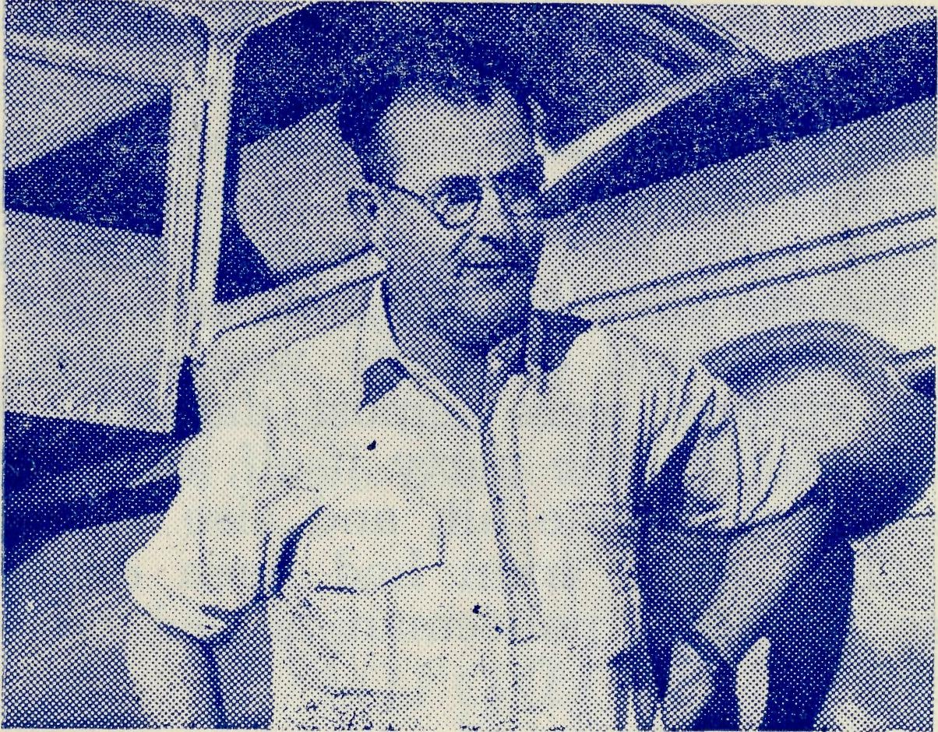
A GOOD COBBER
Harry Russell of Bul-
gunnia, a good friend
of ours.

The New Van Visits Oodnadatta
ARTHUR WILLIAMS
I was indeed very thrilled when I saw the new Minnipa Mission Van parked in the Cathedral grounds in Sydney, and I was thrilled again on hearing of the gift of a broadcast receiver for the van. But now let me tell of the van's first big station trip.
The weather was beginning to warm up as I checked the engine and tyres and commenced to pack for a long 1,500 mile trip to the outback stations. During the next three weeks the van would take me to over 30 cattle and sheep stations, as well as to the townships of Kingoonya, Tarcoola, Coober Pedy and Oodnadatta.
Fortunately there is plenty of room which makes packing so much easier. At last came the final check: petrol, oil, water, tools, shovel, food, hymn and prayer books, Communion vessels, font, projector and daylight screen, magazines and literature to be given out, my own bag—and all was ready. Early the following morning the journey began and as I headed north I could feel that it would be a very hot day and the road a very dusty one.
Several homesteads were visited, but as I had planned to revisit these people on the way back the visits were short. In the late afternoon of that day I came to a very sandy spot in the road where a truck was bogged in the soft sand at the side of the track. I stopped to see if I could give a hand, but as no one appeared to be about proceeded on my way. Later I learned that the truck had been stolen and that the young man concerned was armed "to the teeth" and likely to be dangerous. The trip I thought looked like being eventful.
During the next five days the temperature rose well over the century mark. The wind always from the north was hot and scorching, and frequently sent the red dust whirling up into the sky. Several times I was on the point of feeling sorry for myself, when I heard a news broadcast from Western Australia: "The tempera-

The Real Australian
March, 1958.
March, 1958.
The Real Australian

ture at Marble Bar has been over the century for the twentieth day in succession . . .", and I thought of Don Douglass and Bill Rich in the North-west.
It was late on Saturday afternoon when I arrived at Oodnadatta. I had planned to arrive much earlier in the day and to spend some time visiting, so that the Sunday services would be well attended. My first visit, to the home of the storekeeper, brought the news of a barbecue party that evening, to which everyone was going, so my hopes of a good evening's visiting were almost dashed. My second visit brought me an invitation to the party itself, so I made good the opportunity to see everyone in one hit, and also to enjoy goat chops at the barbecue. (The goods train had been derailed causing a shortage of meat, so the local policeman helped out by killing one of his goats.)
The morning and evening services and Sunday School were well attended, and my visits about the town on the Sunday afternoon gave me a real lift. Before leaving on the Monday morning a religious instruction lesson was taken at the school, and then a final visit to the store to fill up with petrol for the journey out. Here I found several messages for me: "Would you bring the mail and some apples?"; "Could you bring some potatoes?"; "Would you bring 12 lb. butter, the mail man will not be out for another week?". Eventually I left, with mail and newspapers for six stations, as well as apples, potatoes, butter and several other odds and ends. The new van looked like the Oodnadatta Mail itself.
It was late that afternoon when I pulled up at an iron-walled homestead which, despite the heat, was remarkably cool inside, being well insulated.
"Hello, Padre. Thanks for bringing the mail. How about a drink? I guess you could do with one. By the way, we have another job for you this evening—we'd like two of the youngsters baptised." Before I left I had baptised two children and enrolled three others in the Mail Bag Sunday School.
Fifteen miles away at an outstation a mother was finding the religious instruction of her children a little much for her. "Do you have a correspondence Sunday School?" she asked; and so another small boy was also enrolled.
The next week also proved to be very profitable as services were held in station homesteads, and as I had the opportunity to gather children together I made good use of my projector and daylight screen.
The following Sunday morning found me headed into Tarcoola, there to find Sisters Holle and Tarr beginning to wonder where I was, and a little anxious that perhaps the Missioner would not turn up on time for the services and Sunday School Anniversary to be held the following day. That afternoon a request came from the organisers of a children's Fancy Dress Parade to be held in the local hall that evening: "Would Sister Holle and yourself, together with one of the school teachers, be judges?" So for the first time in my life I became a Judge.
The Sunday School Anniversary, and tea which followed, was a great delight and a tribute to our Sisters for the way in which they are influencing the young people of Tarcoola. The little church building which is used at Tarcoola was well filled that evening for the evening service, and we ended the day feeling that God's Hand had been upon us.
Almost another week had passed before I drove up to our front gates here at Minnipa, but I couldn't help feeling that the new van's first trip was well worth while. It did its job well and helped me to do mine as well as I am able.
Margaret Writes Again
Dear Everyone,
Don said the other night—"I think you'd better call up all your powers of description and tell the folk at home all about our last trip . . . 'There we were—nothing but spinifex for miles—out in the blazing heat when . . .'" I'm afraid my tale isn't able to develop into an exciting thriller quite, but is just the story of a very frying journey in the outback.
Don left for Roebourne last Friday week in a car without a door and with a threatened thunderstorm. We had had a little rain, but not worth worrying about, Don assured me, earlier in the morning. We now know that even when it smells like rain we should enquire about the roads. Don's trip was not very pleasant. About 60 miles from Hedland the road was closed ahead and behind him, and he spent quite a few hours digging himself out of bogs before he finally arrived at Roebourne—the trip took 8 hours! The services on the Sunday were quite well attended, in spite of a ship being in at Point Sampson. The children and I flew to Roebourne on Monday morning, and we set out for Witte-noom in the late afternoon, after visiting a few people and snatching a wonderful swim at Sampson. With temperatures around the 105 mark we decided to do all our travelling by night—thus we arrived at Wittenoom Gorge at about 1.30 a.m.
Our week there was quite a busy one. Harry Smith and his son Gilbert let us have free run of their home—it really was marvellous of them. Don taught schools and visited in the mornings while I did the chores, then in the afternoons we went out visiting together. I must confess that by night time we were tired out—we did have a few visitors, but mostly went to bed early. It was very hot all night, so Ian and Judith slept out under the stars. On Sunday there were three services—the 7 a.m. Holy Communion was not very well attended, but there was a nice little group at Wittenoom's first Family Service. The two ladies who are running the Sunday School are doing a great job—one may be leaving—do pray for someone else to help. At the Evening Service there were about 15. At a very short meeting afterwards they decided to launch a Church Building Fund. The Bishop has secured some crown land in an excellent position, and Mr. Smith has drawn up some plans.

The Real Australian
March, 1958.
March, 1958.
The Real Australian

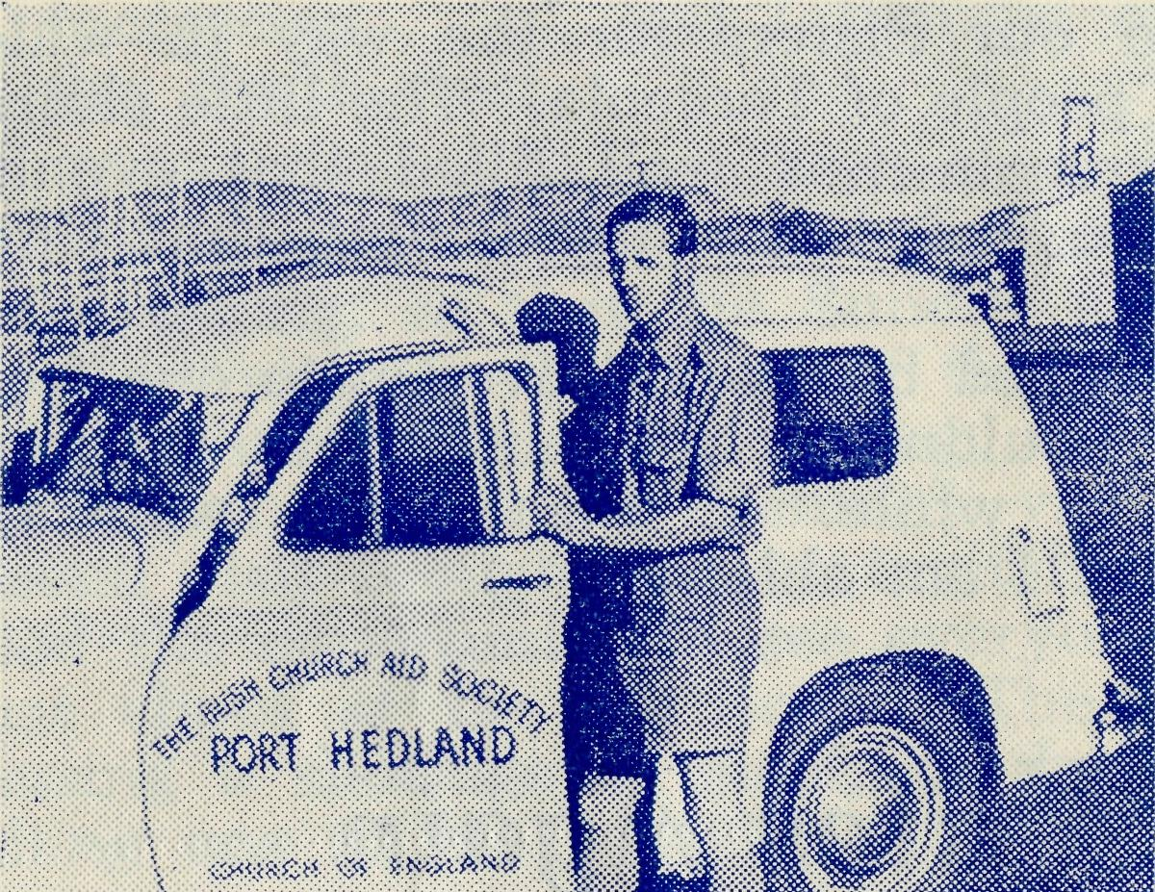
Don Douglass at Witte-noom with his van.
Starting from scratch they have a big task ahead, but a very well-worth-while one. Like so many mining towns, the population is a moving one, and there tends to be a temporary attitude to everything. As there is no other Protestant Church in the town, we feel that this is a very vital project.
As we left the Gorge on Monday at about 8 p.m. to drive the 300 miles home in the night, our host handed me a document with the maximum and minimum temperatures for every day of our stay. All eight days were well over the century and the report ended with "Av. min. 76 degrees; av. max. 103 degrees—one glorious week at Wittenoom Gorge." It is warming up. The drive in the moonlight was really beautiful until about 10.30 when we landed behind a big asbestos truck. As we could not hope to pass him we stopped for about 1J hours' sleep, then set out again much refreshed, passing the sleeping truck about five miles further on. We hit a huge pile of stones in the middle of the road at about 2 a.m., but thought there was no damage done. When I took over the wheel at about 3 a.m. I commented to Don how much better this night travelling was—we would be home for breakfast and there would be none of those horrible roadside meals in the red dust with the flies and heat annoying us. Oh, fateful words! At about 4 a.m. the car swerved madly to the right as our main back spring collapsed to the ground. When it was light enough to see, Don found the U bolts had shorn off. We had our picnic breakfast and Don worked on the van. At about 8 a.m. a car came at last and took me and the children to a nearby station. This good Samaritan returned with some spares and the spring was patched up. We were on the road again by 11.30 with only 110 miles to go. It was a slow trip now—barely averaging 25 m.p.h. The patched-up spring lasted to within 40 miles of home when, right in the middle of the Yuil River where no-one could possibly pass us until we were mobile, it hit the ground again. Yes, another picnic! This time four hours of it. The children and I were reasonably comfy under a small tree we found, but poor Don worked in the blazing sun all the afternoon. It was about 4.30
before another car arrived and they had to help Don get ours going before they could get through. Finally they succeeded, and then they took Judith and Ian and me home while Don struggled on in the Van. He finally arrived here at about 10 p.m., but not in our car! That was still out amongst the spinifex waiting for us to come the next day with the proper spares. Fortunately the Roman Catholic Priest was coming home late that evening and brought Don in. You can imagine how we enjoyed our "picnic" again the next day—I had to go with Don to drive one of the cars home. The children didn't really mind the delay very much—we always travel with plenty of water and emergency rations—and the empty river was a good sand pit. Ian has his doubts about our car now, and each time we've been out this week he said, "Will the spring break this time?" We sincerely hope the fixing is permanent now.
No rest for the wicked—Don is off again to-morrow for his regular Marble Bar trip—four days. The December travelling programme will be pretty heavy with special Christmas Services, then the regular trips will be cancelled for a couple of months—for the car's sake as well as Don's.
I don't think there is any more news of interest, so once again—cheerioh! and much love from all the family, from
MARGARET.
We regret that by an oversight no mention was made in the "Real Australian" of the departure of the Rev. Theo. Hayman from B.C.A. service.
Theo. Hayman joined the B.C.A. staff early in 1948 and was posted to Streaky Bay. He later transferred to Ceduna where he will always be remembered for the very great personal effort he put into the erection of the beautiful new Church of St. Michael and All Angels.
He then returned to Streaky Bay for a short period before his recent appointment to the important parish of Kensington in the Diocese of Adelaide.
Our good wishes go to both Mr. and Mrs. Hayman in their new sphere though, as with many others who have served with us before entering other spheres of work, we will always consider them members of the B.C.A. family.

10
The Real Australian
March, 1958.
March, 1958.
The Real Australian
11

YOUR DAILY REMEMBRANCE
1. The Rev. J. and Mrs. Stockdale and the Wilcannia Mission,
N.S.W.
- The Rev. W. and Mrs. Warburton and the Tarraleah Mission, Tasmania.
- Mr. L. and Mrs. Calder and the boys of the Broken Hill Hostel, N.S.W.
- The Rev. T. and Mrs. Morgan, Mr. R. Viney, and the Beech Forest Mission, Victoria.
- The Rev. L. Luck and the Croajingalong Mission, Victoria.
- The Rev. G. and Mrs. Fuhrmeister and the Quorn Mission, S.A.
- The Rev. I. and Mrs. Booth and the Orroroo Mission, S.A.

- Mr. and Mrs. S. Hummerston, Miss D, Duver and the girls in Port Lincoln Hostel, S.A.
- Miss R. Campbell and all her helpers and scholars in the M.B.S.S.
10. The Rev. B. and Mrs. Buckland and the Franklin Harbour
Mission, S.A.
LI. Mr. Bill Bedford and the patients he carries by air. The Staff and patients in the Wudinna Hospital, S.A.
- The Rev. A. and Mrs. Williams and the Minnipa Mission, S.A.
- The Rev. J. and Mrs. Smith and the parish of Streaky Bay, S.A.
- Mr. Brian Richards and the work at the Ceduna Pharmacy, S.A. Miss Jean Coulter and the Radio Schoolchildren.
- Mr. A. and Mrs. McLaughlin and the girls at Bowral Hostel, N.S.W.
- Miss M. Farr and the girls at Mungindi Hostel, N.S.W.
i7. Mr. G. and Mrs. Cameron and the staff at the Radio Base, Ceduna, S.A.
18. Mr. A. and Mrs. Chadwick, Mr. M. and Mrs. Job, and the Flying Medical Services, S.A.

- The Matron and Staff at Ceduna Hospital, S.A.
- Dr. M. Mueller and all medical services and patients.
- The Staff and Hospital Services at Cook and Tarcoola, S.A,
- The Rawlinna Nursing Home and Sister-in-Charge, W.A.
- Sister I. Gwynne and the work of the Dispensary at Cann River, Victoria.
- The Rev. C. and Mrs. Rich and the Murchison Mission, W.A.
- The Rev. D. and Mrs. Douglass and the Port Hedland Mission, W.A.
- The Staff and Hospital Services at Penong, S.A.
- The Rev. T. V. and Mrs. Jones, the Rev. R. Brooks and the Ceduna Mission, S.A.
- The Rev. A. R. and Mrs. Hardwick and the Rappville Mission, N.S.W.
- All students in training for outback ministries.
The Rev. E. Beavan, the Victorian Committee and office staff.
38. Canon T. Jones, the Rev. J. Greenwood, the office staff at Headquarters and the Council of the Society.
Thanksgiving:—
For the continued growth of the work of the Society.
For the increase in support through prayer and giving.
For the devotion and service of those who work in the many activities of B.C.A.
For the work of Auxiliaries.
For opportunities of service in new and old fields.
PRAY FOR B.C.A.
SERVE IN B.C.A.
GIVE TO B.C.A.

12
The Real Australian
March, 1958.
March, 1958.
The Real Australian
13

POST AND RAILS
Since our last issue we have said "Goodbye" to the Rev. Alun Pugh and his family. Alun joined B.C.A. in March, 1944, and served at Cummins on the West Coast of South Australia when that area was a B.C.A. Mission. Later he and his family transferred to the Franklin Harbour Mission, with headquarters at Cowell on Spencer's Gulf.
Though loth to leave B.C.A. service, Mr. and Mrs. Pugh were faced with the problem of the education of their two sons who are now of High School age. For this reason Alun accepted the parish of Edwardstown, in the Diocese of Adelaide. The Pughs are the third B.C.A. family to enter parochial work in the Diocese of Adelaide in the past year. All our good wishes go with them for the future.
The Rev. Alf. Gerlach and his family have also left us. Alf finished his term of service with us and has been appointed to the Parish of Bellingen in the Diocese of Grafton.
As a result of Alfs efforts it is expected that by the end of 1958 the District of Rappville will be financially self-supporting, and as is recorded elsewhere in this issue, the spiritual life of the Mission has received a very great impetus from the recent successful Mission that was conducted there. All good wishes for the future
to the Gerlach family.
# * *
We regret to record the departure of Sister M. Horsburgh
from the Cook Hospital, where she has done very sterling service
over a period of nine years. Sister felt compelled to leave B.C.A.
in order to undertake service in another field, and although we
regret her departure, we pray that she may be greatly blessed in
her new sphere. * * *
Our thanks are tendered to Mr. and Mrs. Victor Dodd for coming to the rescue at the Girls' Hostel at Port Lincoln. Mrs. Dodd, who is better known to B.C.A. friends as Isobel Beck, moved into the Hostel with her family and looked after the girls until we were able to find new staff.
We are glad to say that Mr. and Mrs. S. Hummerston of Wollongong joined our staff at the end of 1957 and are now in residence at the hostel. Reports indicate that they are happy in their their new work and have fallen in love with the beauties of Port Lincoln. We mean the town, not the girls. Pray for these new workers that they may be blessed.
* * *
B.C.A. babies continue to arrive. We tender our congratulations to Mr. and Mrs. Job of Ceduna on the arrival of Peter George on the 13/12/57.
To Mr. and Mrs. Stan Colefax, whose daughter arrived on 2/1/58.
Mr. and Mrs. Macintosh, nee Myra Patterson, whose son came along early in February.
Mr. and Mrs. Simpson, nee Margaret Denniss, of Wudinna, for scooping the pool with a ten-pound daughter in February.
Miss Farr, of the Girls' Hostel at Mungindi, has at long last been able to purchase the piano she has needed for the use of the girls who are learning music. We hope that it will help her to produce
a few more in the Gertrude Lawrence line.
* * *
The Rev. Bernard Buckland, at present curate in the Parish of Lithgow, in the Sydney Diocese, and a trainee of B.C.A., has been nominated to the Bishop of Adelaide as B.C.A. Missioner for the Franklin Harbour Mission to replace the Rev. Alun Pugh.
Mr. and Mrs. Buckland will live at Cleve, where a new rectory was recently completed. Our friends are asked to remember them in
their prayers as they undertake this important service.
* # *
On another page appears an announcement as to the future of the Mungindi Boys' Hostel. Here we would like to offer our good wishes to Mr. Stan Colefax in his new job as Deputationist for the British and Foreign Bible Society and to record our appreciation of the services of himself and his wife during the time they had charge at Mungindi.
* # #
We welcome three new workers to our staff since our last issue.
The Rev. A. R. Hardwick and his wife, who have taken the places of the Rev. A. Gerlach and his wife at Rappville;
Sister M. Troup, who has gone from Sydney to join the nursing staff at Ceduna;
Mrs. E. Douglas, who has joined the staff at Wudinna hospital and is looking after the housekeeping.
* * *
Sister Bradbrook has left Ceduna in order to commence training for work overseas. We regret losing her, but wish her every blessing as she prepares for a new sphere of Christian service.
The Mungindi Boys' Hostel
It has been regretfully decided to close the Boys' Hostel at Mungindi.
This decision has been made because in recent years the numbers attending the hostel have been steadily declining and the building requires extensive improvements that are not justified by the small number attending.
We, therefore, intend to improve and modernise the building during the present year and then to transfer the girls from their present home and then to sell the present building used by the girls.
We feel that there would be more scope for a hostel for boys in Moree, which is eighty miles away from Mungindi. Moree is one of the larger towns in the north-east corner of N.S.W., and has facilities for secondary schooling which we feel would be of considerable advantage.
The O.M. expects shortly to be visiting Moree and Mungindi in order to make the arrangements necessary for carrying out this plan.

14
The Real Australian
March, 1958.
March, 1958.
The Real Australian
15

APPRECIATION
We are very grateful to Dr. G, Middleton of Culcairn who, at his own expense journeyed to Ceduna in order to give Dr. Mueller some much-needed relief.
Though the time Dr. Middleton had available was short, it did enable Dr. Mueller to have a brief time away. Dr. Middleton has indicated that he hopes to be of further service and for longer periods in the future.
The dearth of Christian doctors prepared to get out of the cities and do a job in the country and outback makes one wonder what has happened either to the spirit of service that should be paramount in the medical profession, or to the outlook of doctors who are reputed to be also Christians.
A Letter from the Murchison
Dear Folks,
The very first thing that I must do is to say "Thank you" to those of you who have written since our last circular. We have tried to answer your letters, but I am afraid that it is just impossible to keep up with you all; so if you haven't heard before this then we do hope you will understand.
Like most folk who find themselves in new surroundings we notice from questions asked in letters that there are many features of our life here which we haven't mentioned, so I will start by trying to give you an overall picture.
Although not as large as some of the B.C.A. parishes ours is no "pocket handkerchief". There are five centres—Magnet, Cue, Meeka-tharra, Wiluna and Sandstone. Three of these towns are in a line running north—Sandstone is to the east of Magnet and Wiluna to the east of Meekatharra. Imagine Sydney as Magnet, then Gosford (that's Cue), and then Raymond Terrace (that's Meekatharra) would be the northern extent of the towns. Then, but in an easterly direction and not westerly, Mt. Victoria would be Sandstone, and if there is a town 116 miles west of Raymond Terrace, that would be Wiluna! Is all that sensible?
I manage to visit each place once a month. I hold three services a month in Magnet, two a month in Meekatharra and one a month in each of the other places. The longest week-end trip I do is the one to Wiluna, and as there is no road direct I must go through Meekatharra. That makes the round trip 482 miles. The shortest trip is to Cue, and that is only 50 miles each way. The roads between these towns do not quite compare with Parramatta Road, either for its traffic or for its surface. There is no bitumen, but for all that the gravel is not too bad—that is, unless it rains, and then it becomes impossible.
One simply has to travel at a reasonable speed, otherwise the corrugations (at say 30 m.p.h.) make it most unpleasant and are likely to jar your teeth out—not to mention shaking loose odd and sometimes important bolts and nuts. We are 352 miles by road
from Perth, which means for most folk an eight-hour drive if you don't eat (that takes time!). From here to Wubin (190 miles) the road is gravel, but steadily improves. The last 160 miles are bitumen, and never has bitumen felt so smooth. The only civilisation between here and Wubin is at Payne's Find, about half way, and Payne's Find consists of a pub and nothing else!!
Traffic between towns is not very heavy, and the worst traffic hazard is the kangaroos which insist on crossing the road at most inconvenient moments. They are just a little more dangerous than emus which are almost as plentiful and, of course, just to vary the situation, there are always sheep to be watched. The roads to Sandstone and from Meeka to Wiluna are so rarely used that they keep a good surface and are quite pleasant. It is also most wise to ring each of these places before setting out as a lift might be a week coming along, should you break down.
The countryside is incredibly flat. Mulga and a varied assortment of rather stunted and miserable-looking trees make up the vegetation. The ground varies from red clay to red iron-stone and granite, which at times looks very pretty but is also very persistent in its supply of talc-like red dust. At the moment, because of a few showers a little while ago, there is quite a bit of green grass under the trees, but with the heat that goes. Wild flowers are incredibly beautiful, and it is amazing that anything so lovely could come from such unlovely surroundings.
Sheep provide the stable occupation of many, apart from the towns, and stations range from one and a quarter million acres down. Magnet has Hill 50 Gold Mine to support quite a few workers, but is the only big mine in working order. The other places exist as rail centres and shops for the surrounding stations.
Magnet itself has a population of about 800, and there is a fair sprinkling of native folk and New Australians amongst that number. We have quite adequate shopping facilities—anything they haven't got they'll get ... at a price—and are much more fortunate than the Douglasses at Port Hedland, for instance, in that we can get both fresh meat and milk. There are two passenger trains a week and four planes a week. All the usual activities are evident in town, including the S.P. shop and our three pubs. Liquor hours extend till 11 each night, and it is even considered necessary to have two "sessions" on Sundays.
Much of this appeared in the last letter, didn't it? and I guess for those of you who have heard Canon Jones it is all familiar, but it now clears the way for us to write and talk about places and situations, knowing that they are fairly well established in your minds.
From the work point of view now. Things still move very slowly, and we are convinced that things will ever only be that way. Our services are slowly building in numbers, as too are our Sunday Schools, except for Meekatharra, where we have lost the invaluable services of our only Sunday School Teacher. We are making out there with a few folk who can take turn about, but that is no real solution. Here in Magnet I have two girls to help in the S.S. but they are not able to carry on when I am not here. We are

16
The Real Australian
March, 1958.
March, 1958.
The Real Australian
IT

going to have Sunday School every week here though, because Joan feels that she should be able to carry on. It means Pete will have to sit in the back in his pram, but provided he co-operates then it should be a good scheme. We are confident that children will come in better numbers when it is regularly held.
We are still recovering from one of the most wonderful weekends we have experienced. The Archbishop and Mrs. Mowll spent a week-end with us, and it was most uplifting. We had arranged special services and they were well attended. We trust that the added interest surrounding their visit will be reflected in the general attitude of the town. Of course, it is still very early, but there is little or no response on the part of the majority of folks. The "faithful few" are a joy, but pitifully few. We are consistently reminded of the phrase from Scripture—"There is no fear of God before their eyes", as it is truly the situation in these places. Much of it has come from the lack of opportunity, of course, but there are those who, having drifted so far from the things of God, are not any too anxious to find their way back. Still, with your prayers, much can be achieved.
A little family news and I must close. Joan is very well and happy and busy planning what she will do with furniture, curtains, etc., and when I see her with a far-away look in her eyes I know better than to comment, for it will be sure to cost either me or the Society money.
Mark is growing fast. He is quite a deal taller than when we came and has settled down well. He now has his pup, and if the poor thing ever lives through his tender treatment then I'm sure they will grow into real friends. Pete is now scaling 21 lb. and looks a picture. He is quite fair and still blue-eyed. He has reached the bub-bub, dad-dad, mum-mum stage and carries on the most amazing conversations with his feet.
All our best wishes for now—God Bless!
Yours in Him,
JOAN AND BILL RICH.
A Mission at Rappville
Rev. A. GERLACH
It is now nearly 18 years since B.C.A. took over the parochial district of Wyan-Rappville, which has been known by all friends of the Society as the Rappville Mission. This area is situated on the far north coast of N.S.W., between Grafton and Casino, 480 miles north of Sydney, and takes up about 1,200 square miles. We are attempting to work a dozen centres for worship, and to give religious instruction in twelve schools too. I give this information as a background to the events of which I want to tell you.
For quite a while now, a number of us have felt the need for an evangelistic mission in our area, and eventually the Rev. Roy
Gray, Rector of St. Mark's, West Wollongong, consented to conduct one for us. We were surprised, however, when Mr. Gray asked if he could bring a team of laymen and women with him. We had to arrange billeting around the parish for that, and everybody was filled with curiosity as to what so many people would do.
The tenth of August was "D" Day and the invasion began. The Reverend R. and Mrs. Gray had travelled the distance by car, and by devious means sixteen other people came too. These were mostly students from the Balmain Teachers' College.
The plan of action was quite simple. Each morning, members of the team gathered at the vicarage for prayer and briefing, and the company divided up into four smaller teams for visitation, school instruction, and meetings in district centres in the evenings. In the course of the meetings, in addition to the address, members of the team gave testimony as to what the Lord Jesus Christ meant to them. In centres where power was available, use was made of films and film strip. Coupled with all these things the lives of team members and fellowship within the team made a tremendous impact on our congregations.
Many folk saw for the first time in their lives the meaning of Christian fellowship.
By the time of the conclusion of the mission, congregations (members of which had travelled for as much as 25 miles to be present) had swelled to the extent that there were twice as many as the Church would hold. We had to engage the public hall to have any hope of seating everyone!
The real success of this venture was not in the size of the congregations, though that was very considerable and would easily have been the largest in twenty years. The important thing was that a goodly number of people found Christ and received Him as Saviour and Lord.
Already we have been able to begin two week-night meetings, one at Rappville and the other twenty miles away at Whiporie for prayer and Bible study. The Young People's Fellowship has been revitalised and a Women's Fellowship formed.
In all, we have seen a complete transformation not only in Church life on the organisational level, but in the lives of many of our people. We have seen before our eyes the fulfilment of the Word of God which says, "If any man be in Christ he is a new creature." For myself, I feel that of recent months we have been living with the events of Acts Chapter II going on all around us.
Earlier this week Mr. Gray paid us a return visit for three days in order mainly to strengthen those who had found the Saviour during or since the mission. This work was brought to a wonderful conclusion when the Bishop of Grafton, the Right Reverend K. J. Clements, visited the parish for Confirmation.
There is no doubt at all that there has been a fresh outpouring of the Spirit of God here in this place, and already blessings received are splashing over into other places. We do covet your prayers, therefore, that the power of Evil may be bound and that the Word of God may continue to be proclaimed and accepted freely.

18
The Real Australian
March, 1958.
March, 1958.
The Real Australian
19

The Rev. R. T. Hallahan
It is with deep regret that we record the passing to higher service of our good friend Bob Hallahan.
Bob was the first "product" of B.C.A. ministry, for he came to know Jesus Christ at Ceduna through the ministry of the B.C.A.'s first Matron of Ceduna Hospital, Sister Percival, and the Missioner who became her husband, the Rev. F. H. B. Dillon.
Bob then offered himself to the Society for training for the ministry and entered Moore Theological College.
He became Missioner at Werrimul in the Diocese of St. Arnaud in the days when the Victorian Mallee was truly a place of Sand, Sorrow and Sore Eyes, as Bishop Kirkby so aptly used to put it. Bob did a great job there and was loved and esteemed by all the folk irrespective of their affiliations or lack of them.
Later he went to South Australia and served at Cummins and Kir ton Point where his witness is still remembered by a great many.
Nell Boyce, who became Mrs. Hallahan, was for some years secretary to the Organising Missioner when he was the Melbourne Secretary of the B.C.A., and has, therefore, long association with the Society.
Bob's courage during his long and painful illness was an inspiration to many of his friends and his quiet confidence in the future was humbling to all who witnessed it.
Our love and prayers are with Mrs. Hallahan and the boys.
Wedding Bells
From the Bush Padre's Radio Session.
You all know the excitement in the home when a wedding is about to take place. There is a great deal of rush and bustle and a lot of excitement.
At last the guests and relations are all together in the Church. The organ peals forth its glorious music and in the quietness of some noble building a man and woman promise to be faithful to God and each other.
The bridal party moves to the friends outside and they are sent away with the good wishes of those who know them so well.
But there are others who cannot have their wedding in such a lovely place. Because they live so far from the more settled parts they depend upon the time the Bush Padre can be in their district.
I left home on a patrol and that night talked to a young couple in a lonely farm home. Beneath the flickering light of the kerosene lantern they signed the papers I had brought. I asked God's blessing upon their marriage and then made my way to the scrub along the track. That night I slept in the caravan in the quietness of the bush. Next morning there would be much to do making the local hall ready for the wedding and the reception to follow, and all to be held in the same building. I hoped we might have a cool day, but the morning would give us some idea of what to expect.
The day dawned red and fiery and gave promise of being more than warm. I was pleased the bridal party had decided to have the wedding in the morning. After breakfast a breeze sprang up and I gave thanks for it. We might at least have some relief from what could be a scorcher. Fortunately the breeze persisted, and did reduce the heat of the atmosphere.
In the local hall much activity was soon in evidence. The little stone hall has no architectural beauty, but we did the best we could. There was no ceiling, so we disguised as many of the roof timbers as we could reach with crepe paper. Strings of cobwebs decorated the rest of the roof.
The piano was pushed across the corner to provide a screen for the signing of the register. An old table was disguised with the cloth I had in my travelling Church Kit.
Then we waited for the arrival of friends and the bridal party. It was unfortunate for the bridegroom that his bride decided to be half an hour late. The comments of his friends were not exactly the sort of things to put him in a peaceful state of mind.
At last a cloud of dust came down the track and there was the bride. The old piano was played by the bride's mother and then it was that I found the lost chord. Possibly the piano was in tune once—but it must have been thirty or forty years before the wedding. However, somehow or other I recognised the Wedding March.
In the quietness of the bush a young woman was married in the only place which could be used for all public functions. It was a real district affair, because there was no need to send out invitations. Everybody for miles around : just came.
With the service concluded the bridal party left on a trip along the track. While they were away we quickly turned the Church into a hall again. Many willing hands and strong arms soon had the trestle tables in place. Then followed much running backwards and forwards to cars and trucks and buggies with the food for the wedding breakfast.
By this time the bridal party had completed their tour of the district. Now the Bush Padre turned into the Master of Ceremonies, and in the same place which had been the Church the wedding festivities continued.
When you are out in the bush you learn to use just whatever is available for any function. But such experiences are a reminder of the need for regular help with the work of B.C.A.
The Bush Padres need the continued prayerful support of our friends. They each perform a sacred duty for the Kingdom of God, and as they share the joys and sorrows of outback people so they give evidence of the Church at work.
CHANGE OF ADDRESS.
Will our Victorian friends please note that as from the first of April the address of the Victorian Office will be: Allen's Building, 276-278 Collins Street (7th Floor), Melbourne.

