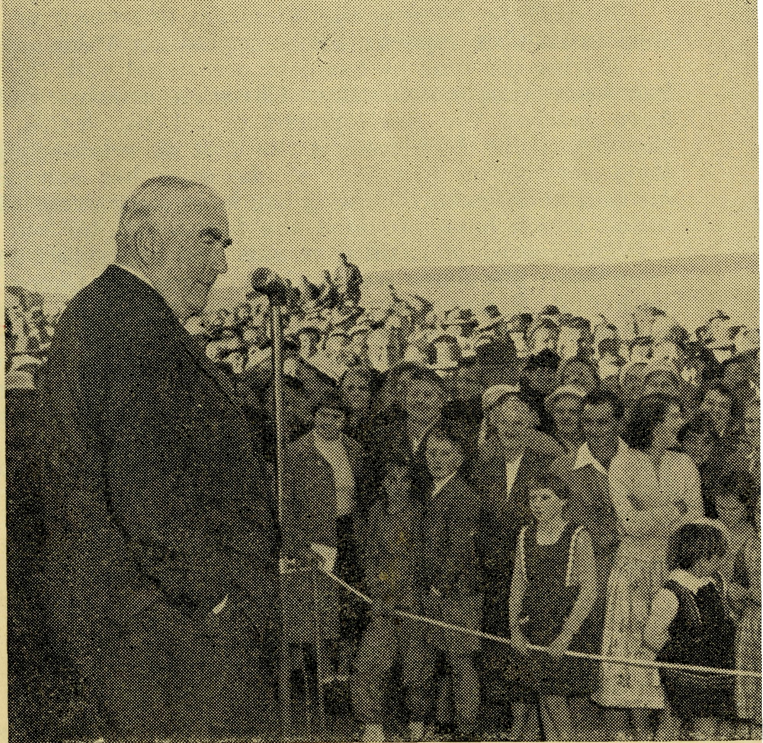
L
No. 25 (New Series) SEPTEMBER, 1958
2/6 per annum, Post free
Registered at the G.P.O., Sydney, for transmission by post as a periodical.
September, 1958
20
The Real Australian
FLYING MEDICAL SERVICES
HOSPITAL CENTRES.
Matron: Sister F. DOWLING.
Sisters: J. MILLER, G. HITCHCOCK, M. BELL, M. BARBOUR, M. TROUP.
CEDUNA.
The Murat Bay District Hospital.
PENONG.
Sisters:
L. LOANE and ROBERTS.
The Penong Memorial Hospital
COOK.
Sisters: M. TARR and M. ROSS.
Sisters: V. HOLLE
and D. CLEMENTS.
Sister E. THOMAS.
Matron: Sister B. BARBER. Sisters: V. BREALEY, M. DEAN,
N. VERITY, A. HAY-
WOOD.
The Bishop Kirkby Memorial Hospital.
TARCOOLA
The Tarcoola Hospital.
RAWLINNA, W.A.
The Nursing Hostel.
WUDINNA.
The Central Eyre Peninsula District Hospital.
MEDICAL OFFICERS.
Dr. M. MUELLER, Dr. K. THOMPSON.
AIRCRAFT. PILOTS.
"Percival Proctor". ^ _{Mr} ALLAN CHADWICK.
de Havilland "Dragon _{n} -
Auster. ^{Mr}- ^{G}' J°^{B}-
Lockheed 12. Mr. W. BEDFORD.
PHARMACIST.
Miss M. SCHULER.
WIRELESS COMMUNICATIONS BASE.
Ceduna Base Operator: Mr. GEORGE CAMERON.
Assistant: Mr. J. WARD.
CROAJINGALONG NURSING SERVICE, VIC.
Sister I. GWYNNE.
MAIL-BAG SUNDAY SCHOOL
Director: Miss R. CAMPBELL.
HOSTELS FOR SCHOOL CHILDREN
PORT LINCOLN.
Mr. 6? Mrs. HUMMER-STON and Miss D. DUVER. MUNGINDI.
Miss M. FARR.
BOWRAL.
Mr. & m^. Mclaughlin.
BROKEN HILL.
Mr. 6? Mrs. CALDER and Miss 1. STARLING.
Edgar Bragg It Sons Pty. Ltd.

The Real Australian
September, 1958
September, 1958
The Real Australian

Canon T. E. Jones, M.B.E., Th.L.
Organising Missioner since 1934 Bishop Elect of the Diocese of Willochra
The appointment of our Organising Missioner as the Bishop of Willochra, South Australia, was announced by the Primate, His Grace the Archbishop of Sydney, at the B.C.A. Rally on 26th September, 1958.
It was a happy coincidence that the speaker from the field was the Reverend T. V. Jones, son of the Organising Missioner.
The Bishop Elect has been associated with the Society since 1924, when he arrived in Australia from Liverpool, England, as a trainee. It was while Bishop G. A. Chambers was in England that the future organising Missioner offered his services. After completing his theological course at Ridley College, Melbourne, and serving a Curacy at St. Augustine's, Moreland, he was appointed Missioner at Boggabilla in the Diocese of Armidale.
In 1932 he became the Victorian Secretary of the Society and then in 1934 his appointment as Organising Missioner was announced.
During the time he has been associated with the work, expansion has been most noteworthy. Christian courage and deep devotion have marked the development of all the B.C.A. services. While the Organising Missioner is the first to acknowledge the fact that loyal service by members of the staff has commended the work far and wide, nevertheless it has been very often his own faith and vision which have provided the foundation for our many ventures.
The record of faithful service was recognised in 1956 when the Organising Missioner was made an Honorary Canon of St. Andrew's Cathedral, Sydney, and in the same year was honoured by being named a Member of the Most Excellent Order of the British Empire.
The B.C.A. Council and Staff are pleased that in its comparatively short history of 39 years two Organising Missioners have become Bishops, the first being the late Bishop S, J. Kirkby.
The O.M., as he is so well known in B.C.A., and Mrs. Jones can rest assured that they will be upheld by the prayers of many friends as he undertakes the arduous work of a Bishop in the Church of God.
The Consecration will take place on Tuesday morning, 28th October, in St. Andrew's Cathedral, Sydney.
Front cover picture is of the Rt. Hon. R. G. Menzies at the opening of the Old Folks' Home, Port Lincoln. We hope you like the new cover.
BISHOPSCOURT EDGECLIFF,
NEW SOUTH WALES. 10th October, 1958.
Dear Friends of B.C.A.,
A; Testimonial Fund has been opened to show our gratitude to Canon Tom Jones for his 24 years as our Organising Missioner and to help him and, Mrs. Jones to meet some of the very heavy expenses involved for them as he becomes Bishop of Willochra. It is planned that this gift will be presented to him at a farewell gathering to be held in the Chapter House on Thursday, November 20, at 8 p.m. Those who wish to join in this tribute of gratitude, affectiion and esteem may send their gifts to the Archbishop's Secretary, Bishopscourt, Edgecliff, and a receipt will be sent to them.
Believe me,
PRESIDENT OF B.C.A. AND PRIMATE OF AUSTRALIA.
Yours sincerely,

4 The Real Australian September, 1958
September, 1958
The Real Australian

The Organising Missioner’s Letter
The Annual Fair of the Sydney Women's Auxiliary was a very great success. The weather was kind and the Chapter House looked very colourful and attractive.
Lady Woodward proved a charming and capable "opener" and impressed us all by her evident interest in B.C.A. services. The result of the day in cash was £520 but the friendship and interest aroused was of much greater value.
We are now in our new home at 135 Bathurst Street and find ourselves working in much better conditions than we ever dreamed of in the past. If you have not already made an inspection, please come in and see us. You will find us between Pitt and Castlereagh Streets just opposite Bennett and Wood's side entrance.
The front is an attractive gift shop and we hope that Church people will form the habit of coming to see what we have for sale when they want something suitable for birthdays, "shower" teas, weddings, Christmas and any other gift occasions. We can promise you competitive prices and a good range of attractive articles.
If our friends patronise us, the shop will be of great help in meeting our financial needs.
In this issue you will find financial statements of much of the Society's activity, which will help you to appreciate something of the growing work and wide ramifications of B.C.A.
You will rejoice with me to know that with the help of our English friends—we have received another £1,250 from the C. & CCS.—we have attained the first objective for the North-West. The £12,000 we undertook to raise has been met. Please keep your interest in this work for we will need funds to help both Don Douglass and Bill Rich to meet the needs of their work.
The people at Menindee, N.S.W., are to build a rectory so that they can have a resident clergyman again. The Diocese of Riverina is helping them with a grant of £500 towards the cost and we of B.C.A. have promised another £500. If any of our friends would like to help in this we shall be glad.
In the last issue of the R.A. the Reverend T. V. Jones wrote of the need for a 16 m.m. projector for his work in remote places. Miss Helen Caterer, of the Adelaide "Mail", also spoke of this need when addressing a gathering at the Central Methodist Mission in Adelaide. The response has been overwhelming and we are now able to buy the projector, films and necessary electrical equipment to make it possible to use the machine under all conditions and voltages found in the outback. Thank you.
At Broken Hill
Mr. L. Calder
As we look back we can once again rejoice, for God has been with us and has enabled us to carry on the work with little or no difficulties. We had no outbreak of sickness, apart from several minor cases of influenza and tonsilitis, etc., and are very grateful for this.
The builders and painters have been busy again, and two dormitories, the staff room and the hall have been fully restored, repaired and then painted in modern attractive colours. This means that the entire interior of the building has been completely painted and it is very pleasing for boys and staff alike to live and work in clean and fresh surroundings. We hope that it will be possible before long to proceed with extensions and improvements to the boys' bathroom. Meanwhile I am pushing on with the exterior repairing and painting, and at time of writing would be approximately half-way round the Hostel. Time permitting, I hope to have it finished at the end of this year. It's a matter of "keep on keeping on", to use Berger's motto.
We have made good use of the projector for spiritual and other meetings. By purchasing just one or two films each month, we are slowly building up a stock of films, and will, I hope, be able to exchange these with other people as time goes on. Some of the boys have lent me some slides of their stations, points of interest in the surrounding district, views, etc., and these have provided some very interesting evenings. We would be very grateful for any gifts of 35 m.m. strip films or slides of interest.
We have had several gifts of books for the library, including a box from the C. of E., Oatley, and one from St. Paul's, Carling-ford. We appreciate these very much, as do the boys, for we are now getting quite a good collection on a variety of subjects. During the term Mrs. Calder found a novel method of disposing of countless numbers of unclaimed items, such as small toys, penknives, pens, etc., etc. About once a month these items are sold to the boys by auction, just after pocket-money distribution on Saturday morning, and the profits purchase books for the library.
The Hostel has entered a team in the local junior tennis competition under the name of "Country Juniors". The matches are played on a Saturday morning, so it is an excellent week-end interest for the boys. A tennis court of our own would be a wonderful asset, as the majority of boys are interested.
We hope during the second term to organize and run a type of fellowship meeting for the boys and some of their school friends. This will give the boys an opportunity to invite someone to their "home" as any normal boy would do. We also plan to re-start hobby classes which have not been operating for quite a long time.
The spiritual side of the work goes on and we endeavour to bring the boys to a full knowledge of the love of God, for we

The Real Australian September, 1958
September, 1958
The Real Australian

realize that after leaving the Hostel at the end of their schooling some of the boys will lose contact with the Church.
Once again, we thank all our friends for their interest and support, and ask for their continued prayers for our work.
From Port Hedland
Mrs. Douglass
Dear Everyone,
I know it is not very long since I last wrote, but such a lot has been happening here that I'd like to tell you about that I feel I must write even if you haven't time to read it straight away.
Our biggest activity this month has been our first Parish Tea. We invited all Anglicans to this function and were amazed at the number in such a small town. The prospect of catering for the eighty expected seemed at first tremendous, as food, etc., is not just Fought here—but when the members of the Young Wives' Group got together the plan all worked out wonderfully.
Salad and fruit salad ingredients had to be air-freighted specially but between us we donated the rest and the menu was pretty good. I made a special fruitcup, which we began with and continued to drink all the evening, and we had hot curry and rice, spaghetti bolognaise and fish savoury and cold mutton, silverside and fish with the salads. The sweets of fruit salad, lemon meringue pie, jelly whips, etc., were delicious, and we ended with tea and savoury scones. What a meal!
The best part of all this was the fact that it was served on tressels on our lawn, surrounded by shrubs and at the sea shore. The lawn was lighted and we borrowed sufficient chairs for all so when the Church Secretary, the Treasurer and Don spoke the people listened very well.
Mr. Dempster and Peter told of B.CA.'s sending Don here and of the parish's job of keeping him on the road and gradually taking over the full responsibility of their Minister, and Don told of the work in Sunday Schools, day schools and other towns. It really was an excellent evening and we made some very valuable contacts. Most of the station folk sent apologies because of mustering, but three families did come in, two of them travelling more than 100 miles especially for the tea.
Don is at Marble Bar now—he has his Service there to-night. Last Sunday he was at Roebourne and came home very happy— he said there were 25 at Church and he really felt God's presence and power working. One man was there for the second time— last month he came along dressed quite extraordinarily—shirt and tie, shorts, and sandshoes all looking rather the worse for wear and he himself had been drinking quite a lot. He told Don he hadn't taken much, but this time he was quite "on the ball" and told how much he appreciated the message and Service.
On Anzac Day the R.S.L. had its first march and Service (conducted by Don). The march was a credit to the men—36 of
them. Two days after this a man phoned here most anxious to attend Church—he said he would be there next Sunday night—he described himself on the phone to me as "the chap wandering along in the march on Friday". It is a thrill when God uses these occasions, isn't it?
When Don was in Roebourne I had the usual cottage Service here. Very few come but it is worth it for last week, just as Mrs. Chequer and I were about to start, two men from the manganese ship and an air hostess arrived. They had met outside the Church looking for a Service and came here to inquire. The little Service was great and one chap from the ship came to the Bible Study and Prayer Group on Tuesday night. He is a fine chap and really enjoyed the Christian fellowship, and so did we.
I feel this letter is full of how good things are—well that is how I feel at present. There were seven of us studying James on Tuesday night—another new person in the district came—and it was really good. It is wonderful how this group has come about.
Last year Don and I both felt that a week night Bible Study and Prayer Group was essential for Spiritual growth in the Parish, so we announced it and for several weeks we two studied together; twice then Mrs. Smith-Ryan joined (she has now left), then gradually we found first the Eldrids and then Mrs. Chequer, who joined her husband up here in February—she is a great person and teaches in the Sunday School. Coral, the lass who works at the Native Hospital and looks after the Kindergarten Sunday School, comes now, and Mrs. Match, another newcomer to the town. We all get a lot out of the studies and discussions.
Incidentally, please pray for Christians in lonely parts. Don had a letter from a young chap in Broome—where there is no Ministry, except when the Bishop is there—asking him some questions that were worrying him. Eric, the chap from the manganese ship in port, also spoke of the difficulties in the Navy. It is so marvellous to have fellowship—but we often take it for granted.
I've joined the Adult Education Library and am really enjoying the variety of reading matter I get. My latest book is entitled, "How to Become a Writer"! Expect great things in the future! The chief requirement of the author, apart from ability, is to have lots of time alone to practice. He must be unsociable and refuse to be interrupted no matter how worthy or needy the caller is. This lets me out—and all other clergy and their wives, I imagine, for our house is always full of people. My last visitor to-day left at 9 o'clock to-night. Still, it is a really enlightening book to read. It has strangled my hopes of making my fortune and retiring from washing and ironing by a best seller. I'll have to think of something else.
I must go to bed now. All the family join me in prayerful and loving greetings.
Margaret.

September, 1958
8 The Real Australian September, 1958
The Murchison
Rev. W. Rich
Dear Folks,
Yes— at last! Like most folks who do this sort of thing, all our good intentions fall by the wayside and it would appear that one letter in six months is about the limit. Once again many thanks to those of you who have written regularly and in particular to those of you who have remembered us in your prayers.
It is now over a year since we have been here and it seems in many ways very hard to realise. Oftentimes we get rather concerned about the general situation here but on reflection we can see so many signs of development and a certain measure of achievement for which we are most conscious of the need to consistently thank God for His goodness to us. As a whole the Parish has become quite stable and in most centres there are plans ahead for future development. We have managed to keep the Van on the road ail a cost of nearly £300 and two centres have credit balances of £200 odd and the other three over £300. From a financial point of view things are moving well—I only wish that they were so in other directions. Church attendance is, in the main, still most depressing. Sunday schools function in three places—Meekatharra, Cue and Mt. Magnet—and there is a possibility of one starting in Wiluna. Sandstone only has five Protestant children and they all come to Church when their parents come. We have three Guilds all doing their best with street stalls, children's frolics, Church cleaning, etc. At long last we have moved our building purchased from the Big Bell Hospital (another chap and I pulled it down) into Cue and soon we hope to have a little Church Building. We have sold the shambles of the Church building at Wiluna and are constructing a small chapel in the Rectory there. We must do something with the Church building at Magnet — Vestry ceiling fell in last weekend and the Church itself could loose al lits plaster board the same way. We have tried to borrow the £1,500 a new place will cost, but have been knocked back by Bank, Insurance Co. and Diocese. All the Magnet energies are to be directed to a Building Fund and the hope and prayer that the building stays intact.
Life in the west sometimes reads like a book and certainly has its moments. This last fortnight serves as a good example and I must add covers a few situations not anticipated in College lectures. It started with a trip to Cue and me being silly enough to come home none too well on the Monday. By Tuesday night I was in the grip of the wog and so stayed in bed till Friday morning. Being unsure of myself, I cancelled the Sandstone -Wiluna trip which should have started that day and decided to wait till Sunday before going to Meekatharra.
The Real Australian
On Saturday afternoon we were distressed to learn of the sudden death of our Churchwarden/Secretary/Treasurer from Sandstone. His good wife allows me to stay with them each time I am in Sandstone and so after ringing her in Perth to see the situation I found myself on the road going South at 3.30 p.m. Eleven and a half hours later I went to bed completely cured of the wog but a little weary. It was a joy to spend Sunday in Perth and to worship in the Cathedral—I had almost forgotten that they sing canticles and psalms in the Church of England! The funeral was on Monday afternoon and I came home on Tuesday. The trip on the road plus the running around in Perth knocked up 750 miles, but the expressions of gratitude from the family made it all so worthwhile. On Wednesday night I was in fine shape for a couple of hours cornerball, tunnell ball, duster hockey, etc., with the Youth Club. Thursday saw Religious instruction in the State Council, Hospital visit in the afternoon and our Vestry meeting at night. The Vestry meeting brought nine people along. Not many did you say?— considering it was our third attempt to hold one, two being at the first and three at the second, it seemed like a crowd. Needless to say all nine very smartly found themselves on the Church Committee for the year.
By Friday I was looking forward to a bit of a spell when the phone rang at 1.30 p.m. The local doctor had a maternity case that he thought should get to Geraldton as soon as possible and the other Ambulance drivers were at work. At 2 p.m. we were on the road and I was able to have the lady in Hospital at 6.45 p.m. They offered to feed us at the Hospital, but the nurse said she couldn't cook so yours truly set to with an outsize pan and consumed a feed which, as it turned out, was just as well it was a big one. The Geraldton Police contacted me whilst there and asked if I would wait till 10 p.m. to take back the constable from Meekatharra. Almost without exception W.A. trains are late and this one was no express. It was 11.15 before the train arrived and 11.30 before we were on the road again. We arrived in Magnet at 4.30 a.m.—total distance of 440 miles. Mark was very thrilled next morning—not only did Daddy drive an Ambulance but a "real live policeman" was asleep in the study. Our Guild had their first Street Stall on Saturday morning and I must admit I collected cakes, eggs, etc., in a bit of a daze.
Some of you will know that Joan has been in strife over the past three months. She has become allergic to something and is putting in some bad moments with hives. She has been on tablets for about 10 weeks and things are no better. Whilst in Perth for the funeral I had a chat to the Diocesan Registrar with the result that we were able to get some accommodation at a place called Mandurah on the South Coast. We will be boarding there so it will be a real break for Joan. We are leaving next Wednesday 21st after I come back from Meekatharra and she has her first appointment with the specialist for Thursday.
We are well settled into the Rectory—we even have some fowls and chickens and a boarder! School is a problem for the
continued on page 18

10
The Real Australian
September, 1958
September, 1958
The Real Australian
li

THE BUSH CHURCH AID SOCIETY FOR AUSTRALIA AND TASMANIA — FLYING MEDICAL SERVICE

RECEIPTS
£ £
Rally ..: 645
Christmas Appeal 806
General Donations 3,204
Commonwealth Railways 550
Government of South Australia 750
Penong and Far West Medical Committee .. 1,003
Tarcoola Medical Fund 413
Wudinna 625
Ceduna 1,475
Cann River 177
Victorian Office Transfers 2,080
Transfers from General Funds 3,719
15,447
£15,447
PAYMENTS
£ £
Balance overdrawn at Bank, 1/1/57 260
Salaries 10,350
Plane Maintenance , 1,724
Plane Petrol 1,372
Plane Insurance 1,051
Hangar Rent , 16
Travelling .:.. .. ' 484
Sundries and Exchange 70
15,067
Bank Balance at 31/12/57 120
£15,447

THE BUSH CHURCH AID SOCIETY FOR AUSTRALIA AND TASMANIA — GENERAL ACCOUNT

RECEIPTS
£ £
Donations 5,191
Christmas Appeals 923
Real Australian 69
Offertories 5,196
Boxes 5,443
Mail Bag Sunday School 1,024
Stipend Contributions , 849
Rallies 556
Col. & Con. Grant 403
Legacies 2,079
Sundries 95
Refunds 205
Transfers from other accounts 3,285
25,318
Balance overdrawn at Bank, 31/12/57 2,365
£27,683
PAYMENTS
£ £
Balance overdrawn at Bank, 1/1/57 1,041
Grants 11,784
Salaries (Office) ; 3,058
Mail Bag Sunday School 1,966
Motor Vehicle Expenses 321
Broadcasting 477
Advertising 367
Insurance 737
Stamps and Telephones 738
Printing and Stationery 1,311
Rents 102
Petty Cash 93
Students' Fees 492
Sundries , 277
Transfers to other accounts 4,681
Bank Charges and Exchange 70
Deputation Equipment 168
26,642
£27,683

Income
OTHER ACCOUNTS
CEDUNA No. 2 ACCOUNT
Expenditure £10,221
£627
NORTH WEST ACCOUNT

Income £9,594
Debit Balance
Expenditure £8,576
£324
Income £8,900
Credit Balance
Credit Balance
Income
GENERAL PURCHASE ACCOUNT
Expenditure
Credit Balance, 31/12/57
£308 £253
£561 £561
PROPERTY ACCOUNT
Balance, 1/1/57 £ 4,381
Income £20,949
Expenditure £23,655
£561
Credit Balance £ 1,675
£25,330
£25,330
CEDUNA PRACTICE ACCOUNT
Income .. £6,064 Debit Balance, 1/1/57 £1,652
RESERVE ACCOUNT
£7,793 Expenditure
Credit Balance £7,121
Expenditure £2,457
Credit Balance, 31/12/57 .. £1,955
£672
£6,064
£6,064

12
The Real Australian
September, 1958
September, 1958
The Real Australian
13

Summary of the O.M’s Annual Report
Income from deputations remained at the same level as the previous year. While there has been an increase of £2,626 in amounts received from parishes, donations have fallen by £2,739. This I attribute to the fact that under our new Promotion System some of our friends who gave to us directly are now directing their gifts through parish channels. Though this makes little difference to the end result it does mean that Promotion, though boosting "parish" giving, has not created overall new money and as we receive it as a parish donation, we lose the personal contact with individual donors, who are thus removed from our lists.
This means that in fact giving becomes less because we are unable to make our appeals at Rally and Christmas time to these friends. I, therefore, am of the opinion that in 1957 Promotion acted to the detriment of our overall income and it will be of great moment to see what 1958 brings in this regard.
The total income of the accounts before you was £84,818. After deducting transfers the details are:— Total Income:
General 22,523
No. 2 7,552
F.M.S 11,961
General Purchase 253
Property 20,949
Reserve 7,793
Practice 6,064
77,095
Add North-West 7,723
£84,818
It must be borne in mind that from these funds the following was expended in capital costs which have added to our assets and are non-recurrring:— Capital Expenditure:
Five Dock House 300
Broken Hill Hostel 300
Bathurst Street 15,508
add from Reserve 672
Ceduna House, 1 3,432
Ceduna House, 2 4,358
24,570
Less Sale of House at Ceduna 1,000
£23,570
To me the most disappointing aspect of finances is what seems to be the lack of a realistic share in the greater giving of parochial life. On the other hand, the fine response to the North-West was full of encouragement indicating that our people will respond to a wide national appeal if they are given full details of the problems to be faced.
MISSIONS. The outstanding event in our Mission Services was the commencement of B.C.A. association with the Diocese of the North-West.
For the first time since the inception of the Society an invitation was extended by the Bishops of the Church in Australia to the Society to assist in the larger problems of Church Development in the more remote areas of Australia.
It is opportune here to wish the Brotherhood of the Good Shepherd every blessing upon their work in the Northern Territory which they undertook at the same time that B.C.A. assumed responsibility for the North-West.-
From time to time we have been hard-pressed for nursing staff. This has seriously interfered with the arrangements for holidays for a hard-working staff. We have been grateful to some who have given short periods of service in order to allow holidays to be taken by some staff members.
A much larger number of Christian nurses is urgently needed by this and kindred Christian work if it is to be maintained as effectively as such service ought to be.
The statistics for our combined hospital ministry are:— Operations (all types): 237; In-patients: 911; Out-patients: 7,248; Mothercraft Visits: 973; Births: 190.
THE FLYING SERVICE. We were able to make an outstanding advance during the year. By the sympathetic co-operation of the Board of Directors of the Zinc Corporation we were able to purchase a splendid Lockheed "12" aeroplane, estimated to be worth £54,000, for the sum of £8,000, and for an extra £1,500 to acquire nearly £4,000 worth of spares.
Statistics for the year are:—Miles flown: 51,703; Patients seen by doctors: 4,245; Emergency flights: 25.
RADIO STATION. This sphere of our service has proved its worth and its establishment is abundantly justified.
Four hundred telegrams are handled each month and 1,000 consultations per year, but the comfort it has been to lonely homes and the greater margin of efficient working and safety it has given to our staff when flying cannot be calculated.

14
The Real Australian
September, 1958
September, 1958 The Real Australian
15

RADIO SCHOOL. We can well be proud of this service. Though there were "Schools of the Air" in existence before we entered the field, there were no facilities that would enable any country or outback child to receive the help of a teacher day by day while doing school lessons.
The Society pioneered the movement to put the Correspondence School on the air. This we did in co-operation with both the Education Department of S.A. and the P.M.G. Department.
It is a great joy to know that this innovation is now extending to other networks and that Education Departments in states other than South Australia are showing great interest.
MAIL BAG SUNDAY SCHOOL. From time to time throughout the past year the work which the children in our Mail Bag Sunday School return to us and their brief comments show how wholeheartedly they enjoy the lessons; this appreciation is further emphasised by the frequent comments in parents' letters. Our teachers endeavour to help their scholars by encouraging comments on the work as well as by their letters;*they also make every effort to see them when opportunity offers.
GENERAL. For almost forty years the growing services of B.C.A. have been directed and organised from two small rooms in Church House, Sydney, and the Victorian Deputation Secretary has been likewise housed in a small and inadequate room.
During 1957 steps were taken to provide an adequate and permanent headquarters building in Sydney by the acquisition of Nos. 131-135 Bathurst Street and by the leasing in Victoria of excellent accommodation in the new Allan's Building in Collins Street, Melbourne. Both these moves give facilities for greater efficiency and a happier atmosphere for our staffs and those who visit us.
C. & C. C. S. We appreciate the new interest and help of our English friends. They have taken up, the cause of the North-West with enthusiasm, given it much publicity, and to the end of the year provided us with £1,000 stg. towards our objective.
STAFFS. B.C.A. has always been fortunate in the people who have formed its small office staffs. They have always been much more than employees and have made the work of the Society part of their lives. Their service given during the year has been up to its usual standard and we offer them our appreciation.
To all who have assisted in the furtherance of this work we extend our thanks and pray for almighty God's continued blessing in the days ahead.
Signed—TOM JONES,
Organising Missioner.
DOES YOUR PARISH HALL NEED
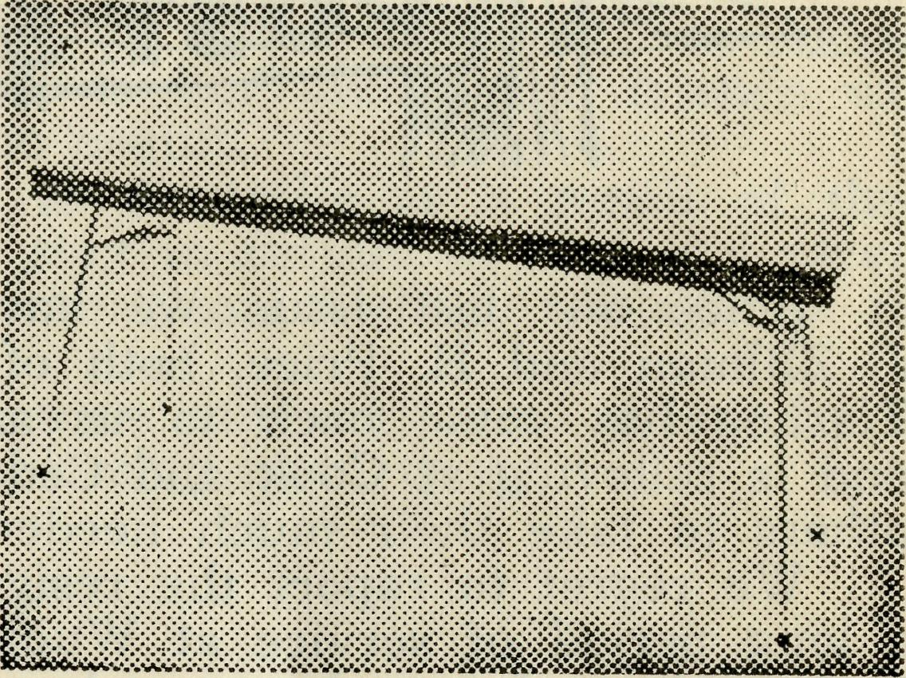
CHAIRS
OR TABLES?
B.C.A.
CAN HELP
YOU. FOLDING OR RIGID TABLES
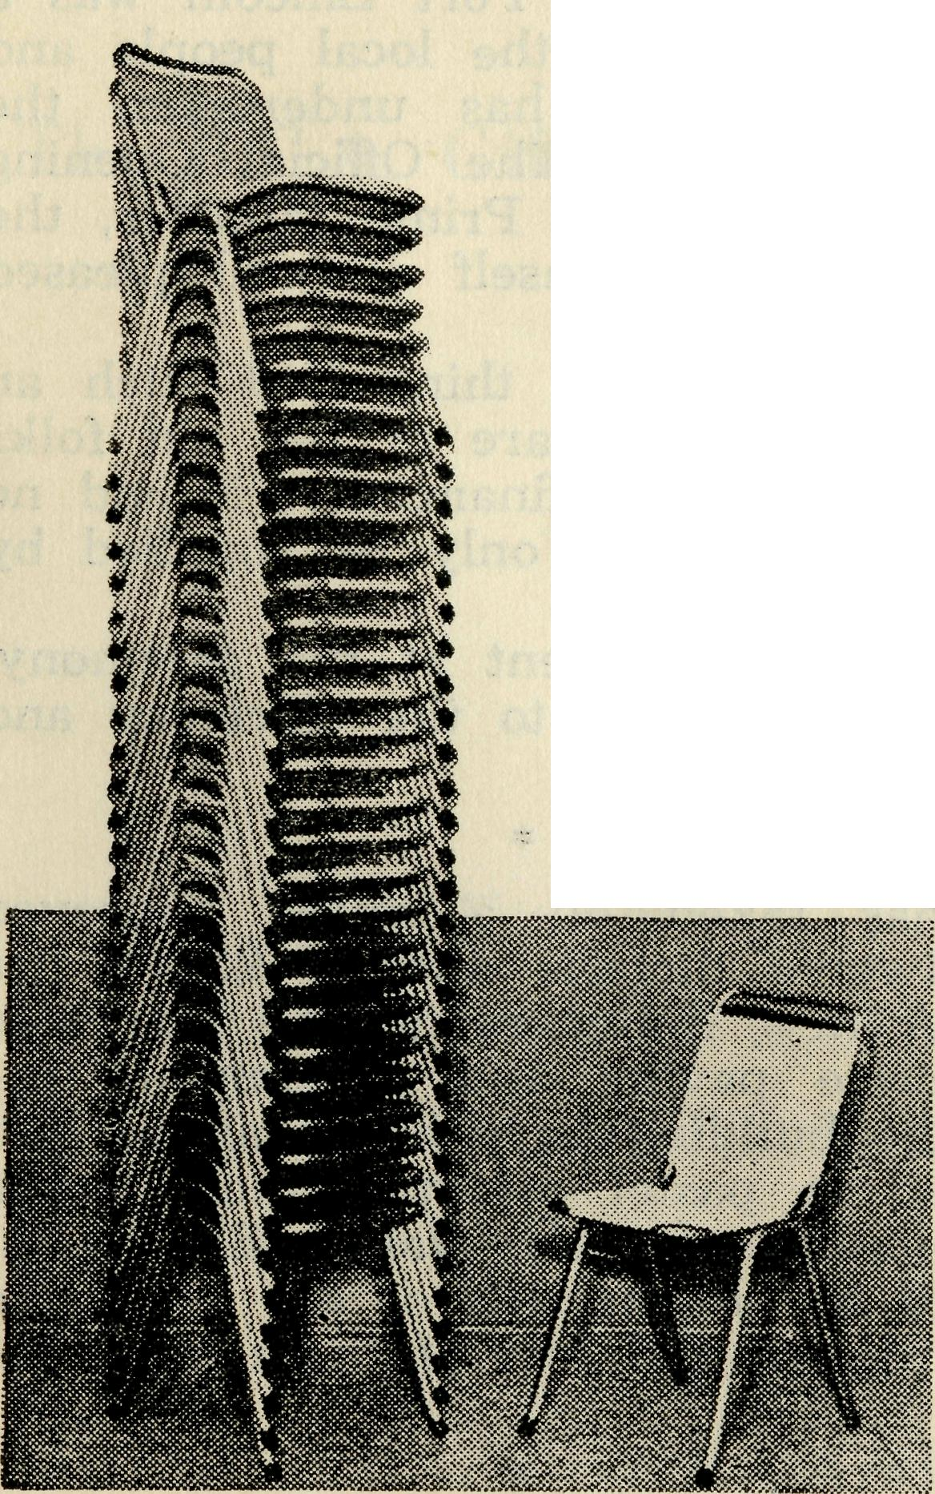
YOU CAN HELP B.C.A. BY MAKING YOUR
PURCHASE THROUGH US.
WRITE OR PHONE
BUSH CHURCH AID STY.
135 BATHURST STREET
SYDNEY, N.S.W.
STACKING CHAIRS BM3164

16
The Real Australian
September, 1958
September, 1958
The Real Australian
n

Since our last issue we have welcomed to our staff Sisters J. Zillman and H. Price, both of whom are at Ceduna. Sister B. Tierney has come back to us after a period of further training and is relieving at Cook and Ceduna and so making it possible for others to take their much needed holidays.
We regret to report the resignation of Sister Val Brealey after
a long period of service at Wudinna. Sister has had to return to
Sydney in order to be near her mother. We are grateful for all
the loyal and faithful service she has given over the years and
wish her well as she takes up other work nearer home.
* * *
The opening of the Old Folk's Home at Port Lincoln was a very pleasing success. This is a venture of the local people and at the invitation of the Trustees, B.C.A. has undertaken the responsibility of staffing and management. The Official Opening of the new £60,000 home was made by the Prime Minister, the Rt. Hon. R. G. Menzies, who expressed himself as well pleased with the building and equipment.
He also added that it was a very good thing that such an organisation as B.C.A. had undertaken the care of the old folks because, though the government could help financially, it had no Department of Human Kindness. This could only be supplied by Christian people.
The Organising Missioner, who was present at the ceremony,, was pleased to hear the many tributes paid to the efficiency and kindness of Mr. and Mrs. Vizor and staff.
The Broken Hill Hostel has taken on a much improved appearance. During the past twelve months almost £3,000 has. been spent on improvements. A new dining-room and playroom have been erected. More concrete paving and a complete reconditioning of every room in the building have been carried out, and the whole has been painted in pastel colours which give a very attractive air to the surroundings for the staff and boys.
We have been greatly helped by the parents of the boys who-have subscribed a considerable part of the cost of these improvements.
Our best wishes go to Mrs. W. Botting, better known to B.C.A. friends as Sister Linda Pfitchard, on her marriage recently to Mr. W. Botting in St. Andrew's Church, Summer Hill.
Mrs. E. G. Beavan
It is with deep regret that we record the death of the wife of our Victorian Secretary,
Mrs, Beavan had been unwell for some time, but her sudden passing was an unexpected shock to her family and friencs who had hoped for her full recovery to nealth.
Mr. and Mrs. Beavan came to Australia as a result of their contact with the O.M. during his stay in Britain in 1947 and served in the Timboon Mission for some years before taking up the Victorian post.
We extend to husband and sons our very real sympathy in their sorrow and pray for God's blessing upon them.
THE BUSH CHURCH AID SOCIETY
invites you to inspect The B.C.A. Gift Shop
on
the Ground Floor of the new B.C.A. House 135 Bathurst Street Sydney
WE STOCK AN INTERESTING VARIETY OF ATTRACTIVE ARTICLES SUITABLE FOR GIFTS FOR ALL OCCASIONS, AND THE PRICES WILL PLEASE YOU.
Pay us a visit at:
B.C.A. HOUSE
135 BATHURST STREET
SYDNEY

18
The Real Australian September, 1958
September, 1958 The Real Australian
19

station folk and we have a little boy of five staying with us from Monday to Friday. He goes home week-ends and whilst I think he thinks we are not too bad, the joy in his face when the utility turns up on Friday afternoons is a joy to behold.
Mark and Peter are very well. Mark has become a real "Sand-Groper" now. His recollections of Sydney are quite vague, though he remembers names well. He no longer has his pup—we sent it back out to the station because it was much safer for him to chase sheep than motor cars. Peter is all man now. His real problem in life is what we call "double g's"—a large prickle with wicked spikes which sting. Peter picks them up very readily but yells blue murder till someone comes and removes them. We are hoping that he will learn to leave them alone, but so far he seems clueless on that score.
So till next time,
Best wishes to you all—God Bless,
Joan and Bill Rich.
The Bush Church Aid Society
for Australia and Tasmania
PRESIDENT: The Archbishop of Sydney.
Hon. Clerical Secretary: Rev. Canon E. Cameron
Hon. Treasurer: Mr. T. S. Holt.
Organising Missioner: Rev. Canon T. E. Jones, M.B.E., Th.L.
N.S.W. Deputation Secretary: Rev. J. R. Greenwood, Th.L.
Victorian Secretary: Rev. E. G. Beavan, M.A.
HEADQUARTERS OFFICE: VICTORIAN OFFICE:
135 Bathurst Street, Allan's Buildings,
Thonef^{n}BM3164. ²⁷⁶'²⁷⁸ ^{Collins} ^{Street}>
_ Melbourne.
^Telegraphic Address:
"Chaplaincy, Sydney". Telephone: MF 8962.

AT THE FAIR
FIELD STAFF: DIOCESE OF ADELAIDE, S.A.
Ceduna, Penong, S.A.—Rev. T. V. /ones, Th.L., Rev. R. Brooks, Th.L.

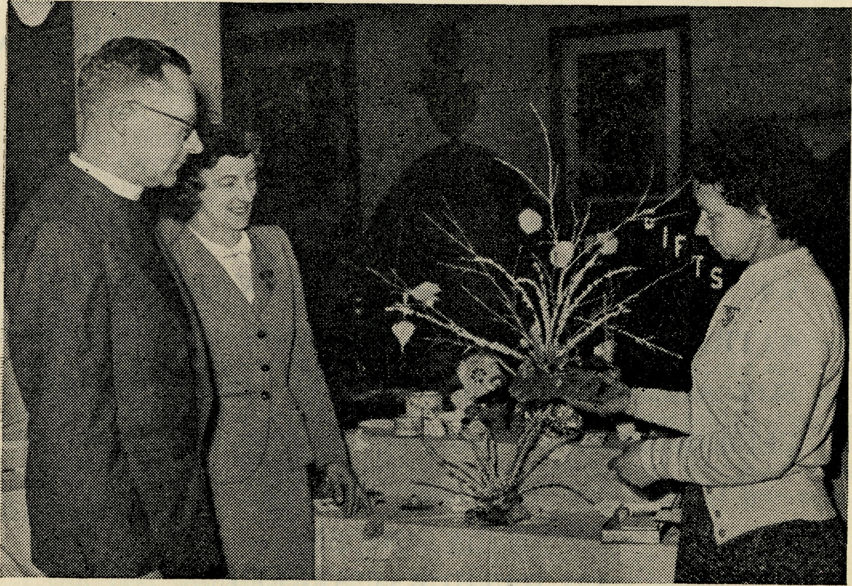
The Rev. John Greenwood inspects his wife's Stall.

Cowell, S.A. Th.L.
-Rev. B. Buckland,
Minnipa, S.A.—Rev. A. Williams, Th.L.
DIOCESE OF WILLOCHRA, S.A.
Orroroo, S.A.—Rev. I. Booth, Quorn, S.A.—Rev. G. Fuhrmeister,
Th.L. Th.L.
DIOCESE OF BALLARAT, VIC.
Heytesbury Mission, Vic.—Vacant
Otway Mission, Vic.—Rev. T. Morgan, Th.L., Beech Forest, Vic, and Mr. B. Viney.
DIOCESE OF RIVERINA,
N.S.W.
Wilcannia, N.S.W.—Rev. J. Stockdale, Th.L.
DIOCESE OF GIPPSLAND, VIC.
Croajingalong, Vic.—Vacant.
DIOCESE OF GRAFTON,
N.S.W.
Rappville, N.S.W.—Rev. A. R. Hardwick,.
DIOCESE OF TASMANIA. Tarraleah, Tas.—Rev. W. War-burton, Th.L.
DIOCESE OF THE NORTH-WEST
Murchison Mission Port Hedland Mission.
Rev. C. W. Rich, Th.L., Rev. D. M. Douglass, Th.L.
Mount Magnet, W.A. Port Hedland, WA

