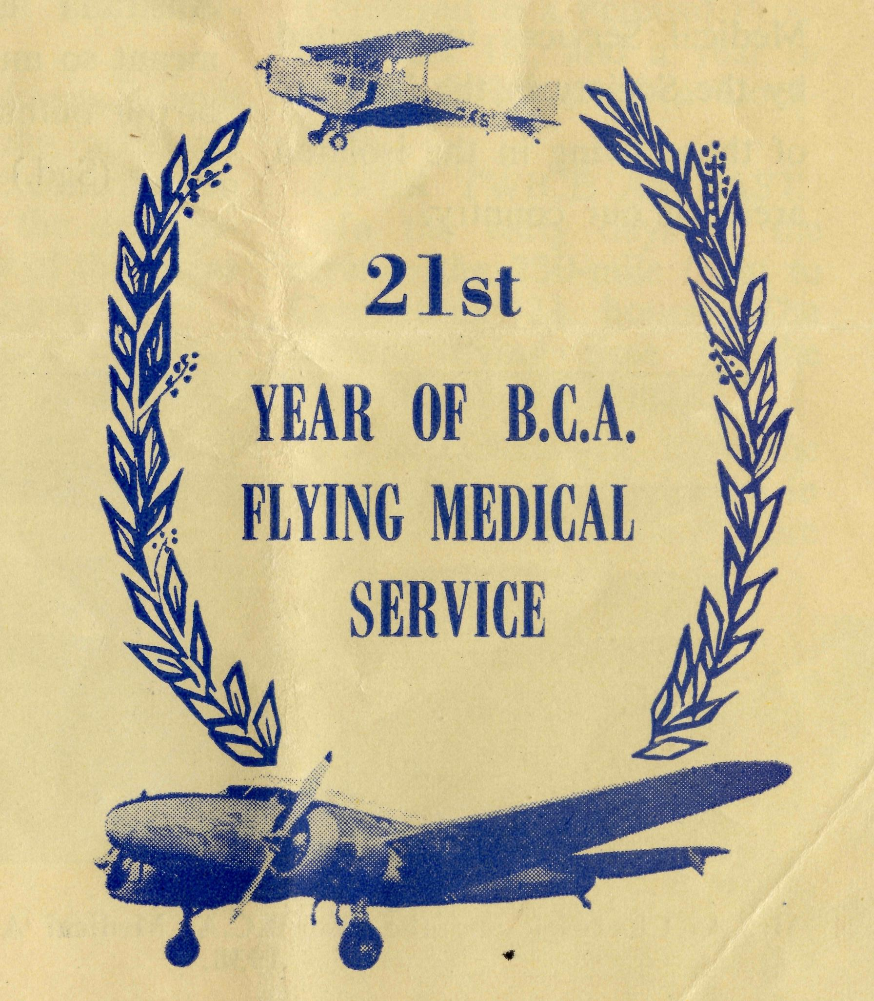
No. 28 (New Series), JUNE, 1959. 2/6 per annum. Post free.
Registered at the G.P.O., Sydney, for transmission by Post as a periodical,
The Real Australian
June, 1959.
24
FLYING MEDICAL SERVICES HOSPITAL CENTRES:
Matron: Sister F. DOWL1NG.
Sisters: J. MILLER, G. HITCHCOCK, M. BELL, M. TROUP, B. TIERNEY. A. BAKEWELL.
Sisters: L. LOANE and J. ROBERTS.
Sisters: M. TARR and M. ROSS.
CEDUNA, S.A.
The Murat Bay District Hospital.
PENONG, S.A.
The Penong Memorial
Hospital. COOK, S.A.
The Bishop Kirkby
Sisters: V. HOLLE and M. BARBOUR Sister E. THOMAS.
Matron: Sister B. BARBER. Sisters: M. DEAN, E. SIMMOND. H. WATT
Memorial Hospital. TARCOOLA, S.A.
The Tarcoola Hospital. RAWLINNA, W.A.
The Nursing Hostel. WUDINNA, S.A.
The Central Eyre Peninsula
District Hospital.
MEDICAL OFFICER:
Dr. M. MUELLER.
AIRCRAFT:
Auster. Lockheed 12.
PHARMACIST:
Miss M. SCHULER.
PILOTS:
Mr. ALLAN CHAD WICK, Mr.
GORDON TAYLOR, Mr. W.
BEDFORD.
DENTIST:
Mr. L. JAUNCEY
WIRELESS COMMUNICATIONS BASE:
Ceduna Base Operator: Mr. GEORGE CAMERON. Assistant: Mr. J. WARD.
CROAJINGALONG NURSING SERVICE, VIC:
Sister I. GWYNNE.
HOSTELS FOR SCHOOL CHILDREN
PORT LINCOLN, S.A.
Mr. & Mrs. S. HUMMERSTON and Miss D. DUVER. MUNGINDI, N.S.W. Miss M. FARR.
BOWRAL, N.S.W.
Mr, & Mrs. A. McLAUGHLIN and Mrs. PARKINSON. BROKEN HILL, N.S.W.
Mr. & Mrs. W. L. CALDER and Miss H. CHEW.
OLD FOLK'S HOME (Port Lincoln, S.A.). Mr. & Mrs. R. AVERY.
EDGAR BRAGG & SONS PTY. LTD.. PRINTERS. ISO BOTANY STREET. WATERLOO

The Real Australian
June, 1959.
June, 1959.
The Real Australian

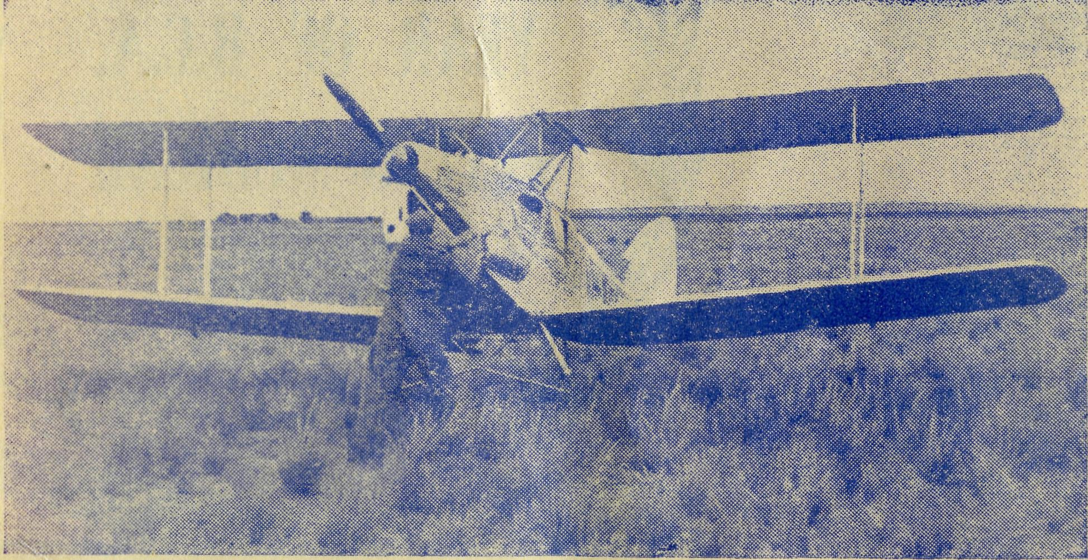
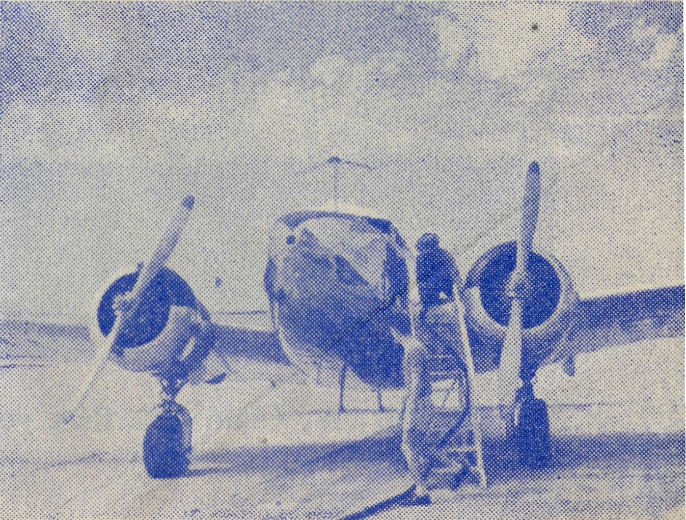
Tribute From South Australian Newspaper
WEST COAST SENTINEL. 1st April, 1959.
B.C.A.'S CEDUNA FLYING
MEDICAL SERVICE
COMES OF AGE
Message From The Premier of South Australia
The Honourable Sir Thomas Playford, G.C.M.G., M.P.
Mr. A. Chadwick and the first B.C.A. Medical Aeroplane, VH-AAA,
1938.
I congratulate the Bush Church Aid Society on the occasion of the twenty-first anniversary of the Flying Medical Services inaugurated by the Society in the interests of those living in the isolated areas of our country.
Your Society has made a contribution to the wonderful Air Medical Services which now cover the whole of inland Australia and which have meant so much to the welfare of our outback settlers.
(Sgd.) T. PLAYFORD,
Premier.
Twenty-one years ago, Pilot Alan Chadwick landed the Society's De Havilland Fox Moth at Ceduna.
Although the B.C.A. has seen fit to replace its aircraft at times during the period since, it has retained the services of its loyal and trustworthy pilot.
Alan Chadwick can be well proud of his long accident-free span and the contribution he has made to the development and success of this great and widespread service.
When he made his first mercy flight on April 4, 1938, the service had three landing fields in the whole of the area it then covered.
Today, Modern Lockheed 12A.
It now possesses 30 landing grounds distributed over the 200,000 square miles it serves, an area almost as big as New South Wales.
In 1947 the Society replaced the Fox Moth with a De Havilland Dragon. Later it changed to a Percival Proctor Mark III, and a year or so ago it procured a Lockheed. OVER TWICE AS FAST
In the early days of the service, the 230-mile flight to Cook took 3i hours. The present flying time in the Lockheed is H hours.
When Chadwick took the flying doctor to Tarcoola in the initial stages there were

The Real Australian
June, 1959.
June, 1959.
The Real Australian

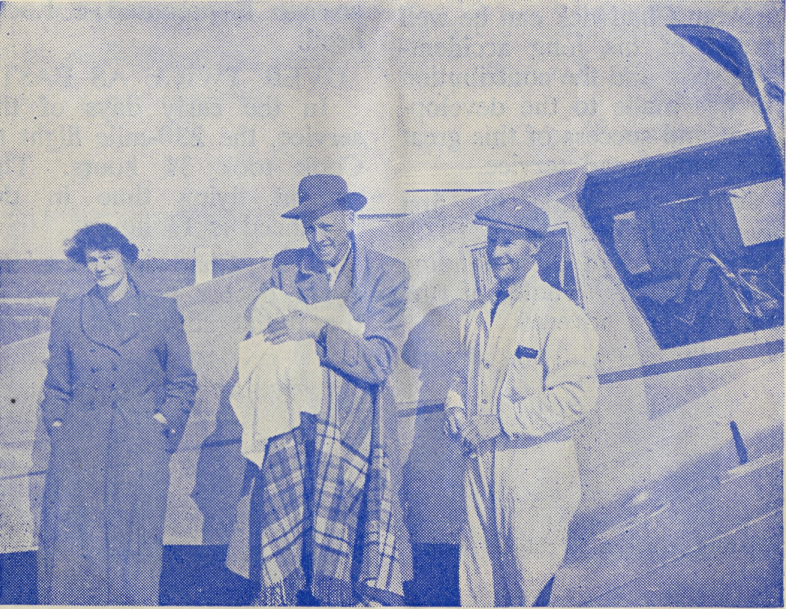
no aeronautical maps of the area, and he had to fly north to pin-point his progress on the lakes of Everard.
Now he knows the whole of the area like the palm of his hand, and needs no map to make a direct flight to any part of the immense territory.
In the beginning, the area serviced extended only as far west as Cook and north to the trans-continental railway line. Now it stretches north to Oodnadatta, west to Forrest,
21 Years' Service.
This issue of the "Real Australian" has special reference to the Society's Flying Medical Services. I am sure supporters will join in thanksgiving to Almighty God for the record of service established by Pilots, Doctors, Nurses, and Radio Officers.
On 30th March, 1938, Mr. Allan Chadwick landed at Ceduna Aerodrome in the B.C.A. Fox Moth Aircraft VH-AAA. This commenced a service which has steadily maintained a witness for Jesus Christ amongst people scattered far and wide over some of the really remote parts of Australia's outback places.
From Ceduna, near the Great Australian Bight, and into the inland parts of northwestern South Australia, reaches the message of Jesus Christ through the work and witness of His servants.
The vast mysterious Nulla-bor Plain broods silently for many long, hot months. Often the silence is shattered by the roar of aeroplane engines. The B.C.A. staff members are being carried unerringly by Mr. Allan Chadwick on an errand of mercy.
Someone in a lonely home watches anxiously as the hard blue sky gives no relief from
Mr. A. Chad wick flies young Patient to Specialist.
and south to the lighthouses near Kangaroo Island.
DEVELOPMENT
In its first year in 1938 the service did 71 flights over .13,318 miles in 180 flying hours; 1017 patients were seen on the flights, and six were conveyed to hospital in the aircraft. Last year the aircraft carried out 200 flights, covering 45,600 miles. In 466 hours; 2,500 patients were seen and 40 were conveyed in the aircraft.
The Organising Missioned Letter
the burning sun. Out of that breathless heat will come help in time of need.
After 21 years the Church of England's Flying Medical Service has shown in no uncertain way what can be done by the grace of God. The long years have seen growth in the development of amenities to make the service more effective.
Five modern hospitals provide places where the sick and victims of accidents may have skilled Christian women attending to their needs, bodily and spiritually. A modern Pharmacy provides cooperation in that important field of service. Radio has been called into service and breaks through the barrier of vast distances. Tribute to whom tribute is due.
Someone had to visualise the possibility of this Flying Medical Service. The First Organising Missioner, the Rev. S. J. Kirkby, before he resigned to become a Bishop, prayed that one day the Church would take medical and spiritual aid to isolated parts of the Nullabor Plain.
Then came long years of determined faith of fulfilling this through the labours of the Rev. T. E. Jones, now Bishop

The Real Australian
June, 1959.
June, 1959.
The Real Australian

FLYING MEDICAL SERVICES
21 years - 1938-1959
Would you like to join us in a Thank Offering to Almighty God?
21 years — 21/-One Shilling for each Year.
"To God be the glory, Great things He hath done."
Can you send £1/1/
to the Bush Church Aid Society?
Errands of Mercy
(Sister F. Dowling)
of Willochra. Obstacles there were in great numbers, but "T.J.", as he is remembered by many, knew that God was in this work.
The late Dr. Roy Gibson gave his co-operation to provide impetus to the venture. Then for a number of years his widow, Dr. Freda Gibson, added her medical training to the developing work. For some years now Dr. Merna Mueller has borne the tremendous burden of the medical practice.
On too many occasions this Christian woman has been left the full responsibility of an area covering about 200,000 square miles. In addition, the strain of the Ceduna Medical Practice itself would overtax the energy of any person other than one convinced of the indwelling power of Jesus Christ.
It makes one wonder what happens to Christian doctors, or where they are employed.
Twenty - one years ago Sister F. Dowling was amongst those who awaited the arrival of the Fox Moth aeroplane. With her today in the service are two others, Sister G. Hitchcock, now Ceduna Hospital's cook, and Sister L. Loane, of Penong Hospital, who remember the day Mr. Chadwick landed at Ceduna on that memorable occasion in March, 1938.
Growing Up.
B.C.A. has graduated from the Fox Moth to the Dragon, the Proctor, and now the modern, speedy Lockheed. In addition, Mr. Bill Bedford supplies his Auster Aircraft and flies from Kyancutta when needed.
It is most fitting that there should be a special issue of the "Real Australian" to mark the stage of B.C.A. history when the Flying Medical Services reach their "Coming of Age".
The Psalmist gives a timely reminder—"Praise the Lord with me, and let us magnify His Name together." The Future.
We cannot rest upon laurels won, as more opportunities open their challenge. This all means continual, believing prayer, and sacrificial offering of lives and gifts.
The word "decision" is very much in the air at present. I venture to say that we also need some "action". There are many agencies through which you may serve our Lord, and B.C.A. can offer you a valuable means of employing your talent and ability. Needs.
Nurses with a desire for Christian service are urgently needed. Young men to train as Bush Padres are sought; workers in Children's Hostels
can be given a great privilege of moulding young lives in the things of God.
Many will never hear the Word of God, nor have the opportunity of receiving Christian training, because you are not prepared to go outback. The Call.
Pray for B.C.A. workers, and that you may have faith to respond to His Call to serve.
"Commit thy way unto the Lord and put thy trust in Him, and He shall bring it to pass."
Perhaps a few recent cases may be interesting in connection with this special issue for the Flying Medical Service in the "Real Australian".
A call came from a railway siding on the Transcontinental
I know that many of you remember this work quite regularly with your gifts. They are very much appreciated, and encourage all the B.C.A. workers. However, as the 21 years of the Flying Medical Services are being remembered, would you like to make a special offering of £1/1/-, representing one shilling for each year?
"Unto Thee, O God, we do give thanks; yea, unto Thee do we give thanks."
JOHN GREENWOOD.
Railway Line in Western Australia, at a placed called Forrest. There is an aerodrome at Forrest which in the early days was used quite considerably by the mail 'planes going to and from

8
The Real Australian
June, 1959.
June, 1959.
The Real Australian

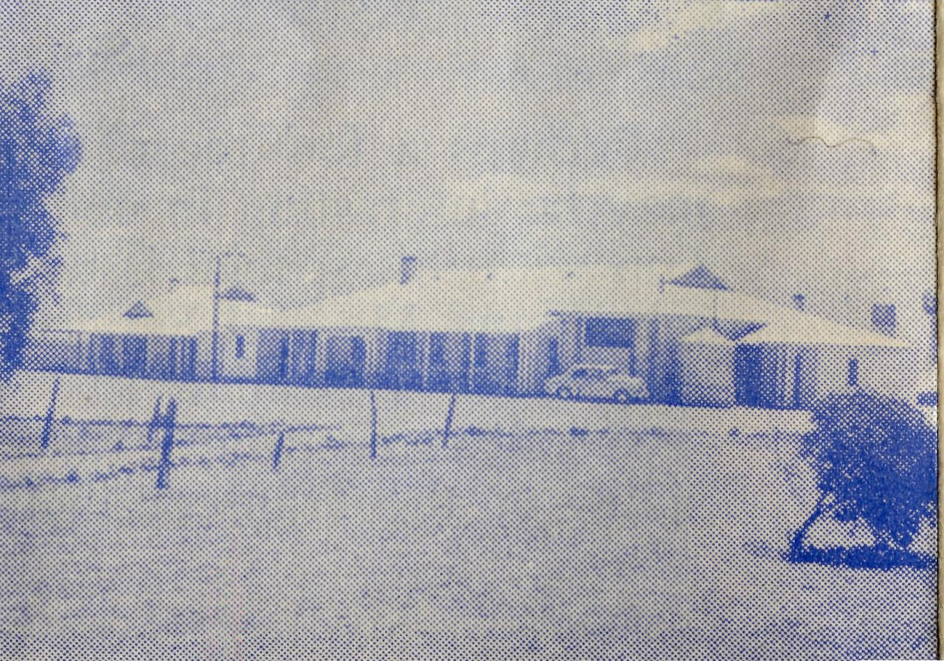
Perth. Though not used so much these days the Dept. of Civil Aviation still has a staff there, and also a large Hostel. At this Hostel the Dept. was installing a new gas stove. The latter was sent from Kal-goorlie, accompanied by a tradesman to instal it. The man was a New Australian, who apparently was horrified at the isolation of the place, and his one aim was to get the stove installed as soon as possible and then make tracks for the city. One of the D.C.A. men was helping him unload the stove from a truck, when somehow the language barrier caused a misunderstanding (nothing new— just ask Doctor!) and the stove landed on the D.C.A. man's leg, penetrating skin, muscle, tendons, and the bone itself.
The New Australian panicked and took to his heels, saying wildly, "I go for doctor." Then he stopped ■and hesitated — which way would he turn? The poor unfortunate victim, with the stove on his leg, revealed the fact that his sense of humour was still intact, by saying, "You'd better be smart and make up your mind, mate, which way you are going, it'll
Ceduna, S.A., Base Hospital.
be a long, long way whichever one you take. The nearest doctor is at Ceduna, about 375 miles away!"
The patient then took things in hand and had a message sent over the radio to Ceduna for help. After much scurrying and hurrying, getting the 'plane ready, weather reports, provisions for changed plans, and cutting lunches for four people, the Lockheed was zooming over the hospital on its way to Forrest with Doctor and Sister.
The patient was seen within three hours, and the injury being so serious, he was transferred to Cook Hospital, and an operation performed without further delay.
It was a sweltering hot day, and the theatre could have done with some air-conditioning to make things more pleasant. The work took longer than at first anticipated, owing to the extensive injury, and when finished, the daylight was too far gone to return to Ceduna. That meant an overnight stay.
As this had not been anticipated, all the patients who had come to see Doctor at Ceduna, and who had waited patiently all day for her return, had to be told the disappointing news. This is not always an easy thing to do, especially as it had been so hot, and some had a trip of 100 miles by road. Why at such times is it necessary to disappoint them? Because of this fact; there is just one young doctor trying to cope with the almost impossible task of trying to run a Flying Medical Service as well as the big Ceduna practice. And it is not as if we can see young Christian doctors streaming out to other mission fields either; one wonders just where they do go.
Might I say here just how grateful we were to Dr. Middleton and Dr. Chambers of N.S.W., who both spent their annual holidays here, giving Dr. Mueller a helping hand. It was what we all claimed as "a bit good". We are very thankful to know that Dr. Chambers and his wife and family are joining the staff here at the end of the year. We look forward to fellowship and service together.
A husband, wife, and three children recently made their
way from Victoria to the Opal Fields at Coober Pedy. They had not long been settled when the mother developed a pain in the right side. She didn't need to be told what the diagnosis was, as she had suffered a former attack of appendicitis. The doctor had told her that in the event of another attack she must have an operation immediately. On the strength of that advice, they still went to the isolated spot of Coober Pedy! The Radio Base there is the only contact with the outside world. And so the call came through at midday, and soon the 'plane with Sister on board went to collect the patient, a return trip of 440 miles. The patient was brought to hospital and operated on before dark. Complying with her request to "keep it for her", she took back to Coober Pedy a really super gangrenous appendix— change from opals, I suppose. Apart from the F.M.S., I wonder how the story would have ended! The following week was our round trip, and it was good to take her with us and see the delight of the family as they welcomed her home again. She had heard the Gospel many times, and her children have been connected with the

10
The Real Australian
June, 1959.
June, 1959.
The Real Australian
11

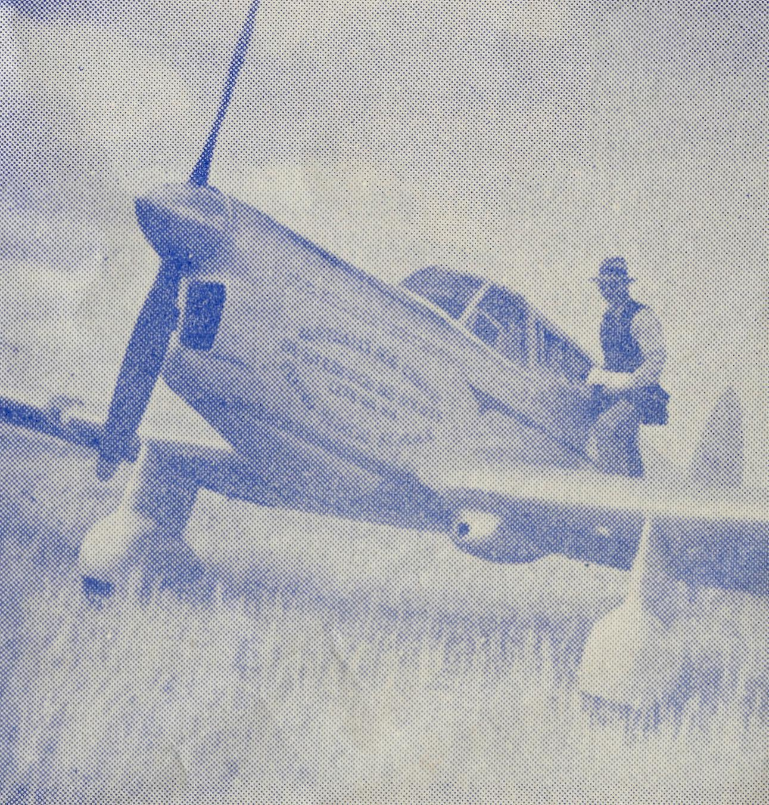
The Flying Medical Service
THESE 21 YEARS —1938-1959. (A. E. CHADWICK.)
Sunday School by post, belonging to their particular denomination. Surely all this, as in other cases, is not for nought in the Kingdom of God! His promise is that His Word will not return unto Him void.
And now we have been reminded that this work has reached its 21st birthday. Somehow it doesn't seem as long as that since a group of us waited at the aerodrome for the arrival of Mr. Chad-wick in the Fox Moth. I well remember standing alongside our O.M. (now the Right Reverend Tom Jones), our feelings were stirred, for our hearts were full. We were very conscious of the fact that in the arrival of the little aeroplane, many, many prayers had been answered, and much vision and faith on the part of those responsible was being honoured by Almighty God. Years previously, had not that man of God, S. J. Kirkby, dreamed and prayed that one day the Church would be able to bring medical as well as spiritual assistance to the folk in the isolated parts of the Nullabor and the Trans. Line. The impossible had been prayed for, and we were witnessing the answer to the prayer of faith. And our hearts were full—full of praise to Him for what He had done
and for the privilege of being fellow-labourers together with Him.
I have always felt that one of the great values of the F.M.S. work is that through it God has placed a witness for Himself in a very real way at Cook, Tarcoola and Rawlinna —places where the Missioner is only able to visit once a quarter, and not always that often. Those places are not just medical centres, but places where the Gospel is taught and preached. It has been said "The job of the missionary is not so much to TEACH as to SHOW the people Jesus Christ." Our sisters stationed in those places are doing both. I trust you realise your responsibility to them in prayer.
And what of the days to come? We read of the spiritual awakening in Melbourne, Sydney and other places. We plod along here praying for the same thing to happen in the hearts of the men, women and boys and girls whom we long to see brought to the Saviour. We thank and praise Him for those who have come to know Him, and ask for grace and faith to believe He is working, as He has promised to do, in the hearts and lives of those who are ministering, and those who are receiving the ministry.
This year marks the 21st Anniversary of the commencement of the Flying Medical Services by the Bush Church Aid Society, and the assistance of those of us directly connected with this part of the work has been sought, to enable the "Real Australian" to suitably mark this epoch in the history of the Society.
When B.C.A. established its Flying Medical Services, Ceduna was chosen because of its approximate central position in the area it was intended to cover. Here was the largest Hospital, and the Doctors, pharmacy, shipping port, aerodrome and refuelling facilities, and later the weather reporting station. Established communications with Adelaide were by road, boat and rail, via Port Lincoln, boat via coastal ports from Adelaide, and by air, Ceduna being a refuelling point for the air service to Perth. Communications with the inland were through the telephone network, and at times through the Aeradio network of the Department of Civil Aviation.
From the year 1925 onwards, when B.C.A. under-
The Mark Proctor.
took to staff its first mission hospital in response to a request from the residents of Ceduna and district, the medical work grew apace. In 1927 our second hospital was opened at Penong, in 1937 our third at Cook, and in 1938 a fourth at Koonibba. It was, however, the establishment of our own Bishop Kirkby Memorial Hospital at Cook in late 1937 which really outmoded the motor car as a means of speedy transport for medical staff to our new distant outpost. By this time, a medical service had been established which covered the whole of the far western area of South Australia, and to become effective, some comfortable and speedy means of transport had to be

12
The Real Australian
June, 1959.
June, 1959.
The Real Australian
13

provided. Thus, the Flying Medical Service was born when the first aircraft was purchased late in 1937, and arrived in Ceduna on March 30, 1938.
I well remember the first delivery and ferry flight of our little Fox Moth VH-AAA, which held the honour of being the aircraft listed first in the Australian Register of civil aircraft. The flight commenced from Mascot aerodrome, still only a grassed field and bounded by Cook's River. Leaving these in the early afternoon, the route took me via Goulburn to Coota-mundra, where an overnight stay was made. Next day, the flight was to Melbourne, and a quick glance at the map brings to mind again such place names as Wagga Wagga, Henty, Corowa, Wahgunyah, Violet Town, and Seymour, used as checking points as the aircraft passed over or abeam them.
The Fox Moth remained at Melbourne for several weeks, during which time many of the Victorian supporters of B.C.A. were given the opportunity to see it. The flight to Adelaide was then made in two stages via Nhill, and the Organising Missioner travelled in the aircraft. He was the Flying Medical Services' first passenger, although on arrival at Nhill, I am afraid that he
felt more like a patient, for it was a hot and uncomfortable trip.
A week in Adelaide, and then on to Ceduna, via Why-alla, solo this time, for the O.M. had gone ahead to attend to business and advise me when the small hangar would be ready to house the aircraft. Out from Whyalla the nose of the aircraft was pointed westward, and we climbed up into the clear air of that Wednesday afternoon. Below was the salt-bush coastal plain, a replica of a sight that was to become so familiar to me in the years that followed, over the Nulla-bor Plain.
Then came the Middleback Range with Iron Knob and Iron Barron separting this from the apparent unending expanse of timber ahead with Lake Gilles set in its midst. On the right was the Gawler Range with its series of salt lakes nestling in the valleys, and on the left beyond the timber line the farming areas of the West Coast, which stretch from Port Lincoln to beyond Fowlers Bay.
Nearing the coast again, reference to my watch and map told me I should be nearing journey's end. Noting the layout of a town in front, I hoped to be able to identfy it by the position of the hospital and the aerodrome. North of
the town and on the sea front a building set in grounds covered with white sea shell corresponded to the hospital as I remembered it from a photograph. Now for the aerodrome, south-east, somewhere under the port wing. First the familiar sight of the wind indicator, then the field proper, and down there on the tarmac was an aeroplane, the Douglas DC2 Bungana, refuelling en route from Perth to Adelaide. Yes, this was Ceduna.
Circling the hospital and town, I flew back and landed, and was soon greeted by my wife and every member of the staff that could be spared to leave the hospital for the time being. Wednesday, March 30, 1938, Ceduna, 1270 miles at 85 m.p.h. in an open cockpit, by the aid of a motorist's road
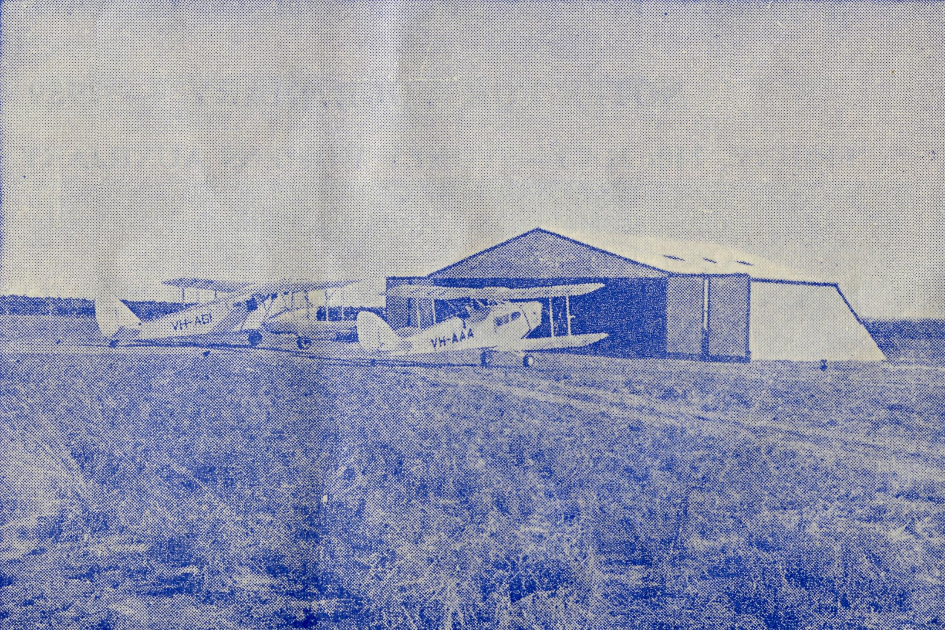
The Dragon
and
the
Fox Moth.
map, but we were here, and the service was ready to begin.
As with most new ventures our beginnings were quite humble. There were three outside consultation centres, three landing grounds, and in the first year we flew 18,000 miles.
Today there are nine outside consultation centres, over thirty landing grounds available, and we fly about 35,000 miles each year.
The Fox Moth was a single-engine bi-plane, which seated four people, and cruised at 85 m.p.h. One stretcher could be fitted in an emergency.
Then came the Dragon, which was a twin-engined bi-plane carrying six people, and cruising at 90 m.p.h. Two stretchers were standard cabin equipment.

14
The Real Australian
June, 1959.
June, 1959.
The Real Australian
15

Radio and F.M.S. "VKB Ceduna"
(Mr. G. Cameron)
NOTES FOR YOUR DIARY
The Proctor joined the fleet, and was a single-engine low wing monoplane carrying four people, and cruising at 130 m.p.h. One stretcher could be fitted in an emergency.
Now, of course, our pride and joy is the Lockheed 12A, purchased 18 months ago. A twin-engine low wing monoplane of all metal construction, it carries six people, cruises at 175 m.p.h., and a stretcher can be fitted for emergency use. In addition, the four cabin seats can be readily converted into two improvised stretchers should the need arise. With a retractable undercarriage and trailing edge wing flaps, electrically operated, and constant speed propellers driven by supercharged engines, this aircraft is much in advance of anything ever dreamed of before we had the opportunity of acquiring it-
Very efficient high power radio receivers and transmitters are installed in the Lockheed, and that of course enables us to keep in touch with every aeradio station in the area in which we are flying.
The communications of our early days, carried on through the medium of the telephone, have now given way to the radio, and often during a flight medical consultations are carried on with the out-stations or we may be diverted to another point on the network where some emergency has arisen.
I feel sure that the period under review has been a very fruitful 21 years, and I count it a joy and privilege having a part to play in this important and responsible task.
1959
"VKB, this is BHH. Receiving?"
"BHH; VKB: Go ahead."
"VKB; BHH. Our estimated time of arrival Cook is 1100 hours as advised previously. Landing in ten minutes. Have you anything for us?
"BHH, this is VKB. I have nothing for you. Hear you from 9RO on the twelve o'clock session. Over."
"Okay, BHH."
Today, the first of April, 1959, the ABC regional station announced to all who cared to listen in the north and west of the State that the Flying Medical Services Doctor would be visiting Cook Hospital for consultations. On Thursday the second there would be consulting at Cor-rabie and Penong.
As I sat in the new studio at the Control Station, and
heard the full-throated roar of the twin engines in the Society's Lockheed passing overhead, I glanced at the clock. It was 0930, which meant, given normal conditions, the plane and its occupants would arrive at Cook, 230 miles to the north-west, li hours later. Several minutes later, I heard the aircraft VH-BHH advising that the estimated time of arrival at their destination would be 1100 hours. Immediately afterwards, Cook outpost radio came on and advised they had heard the information and passed local weather reports to the control station. This was passed to the aircraft, which then signed off, and normal telegraphic traffic was handled from a number of other outposts.
How easy it was to accept this routine as a matter of

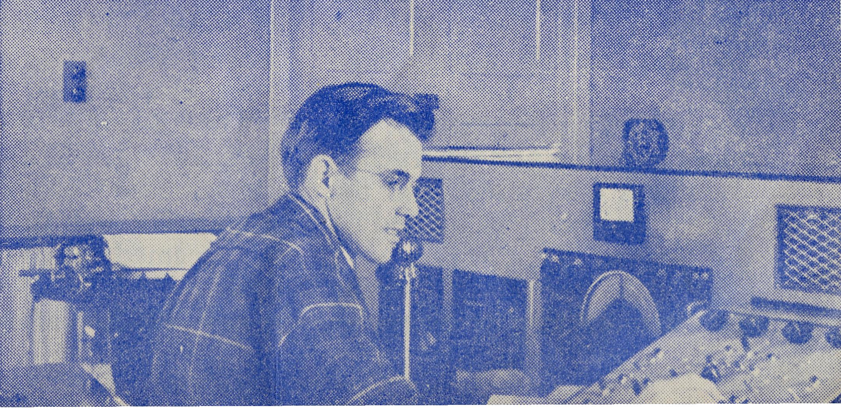
FRIDAY, 24th JULY—SYDNEY WOMENS AUXILIARY ANNUAL FAIR.
Chapter House, St. Andrew's Cathedral. Opened 11 a.m. WEDNESDAY, 9th SEPTEMBER—MELBOURNE RALLY.
6 p.m.: Tea. 7.45 p.m.: Rally. Chapter House, St. Paul's Cathedral. Chairman: THE BISHOP OF BALLARAT. FRIDAY, 9th OCTOBER—SYDNEY RALLY.
7.45 p.m.
Chapter House, St. Andrew's Cathedral.
Chairman: THE ARCHBISHOP OF SYDNEY.
Mr. G.
Cameron
in
Radio
Control
Room.

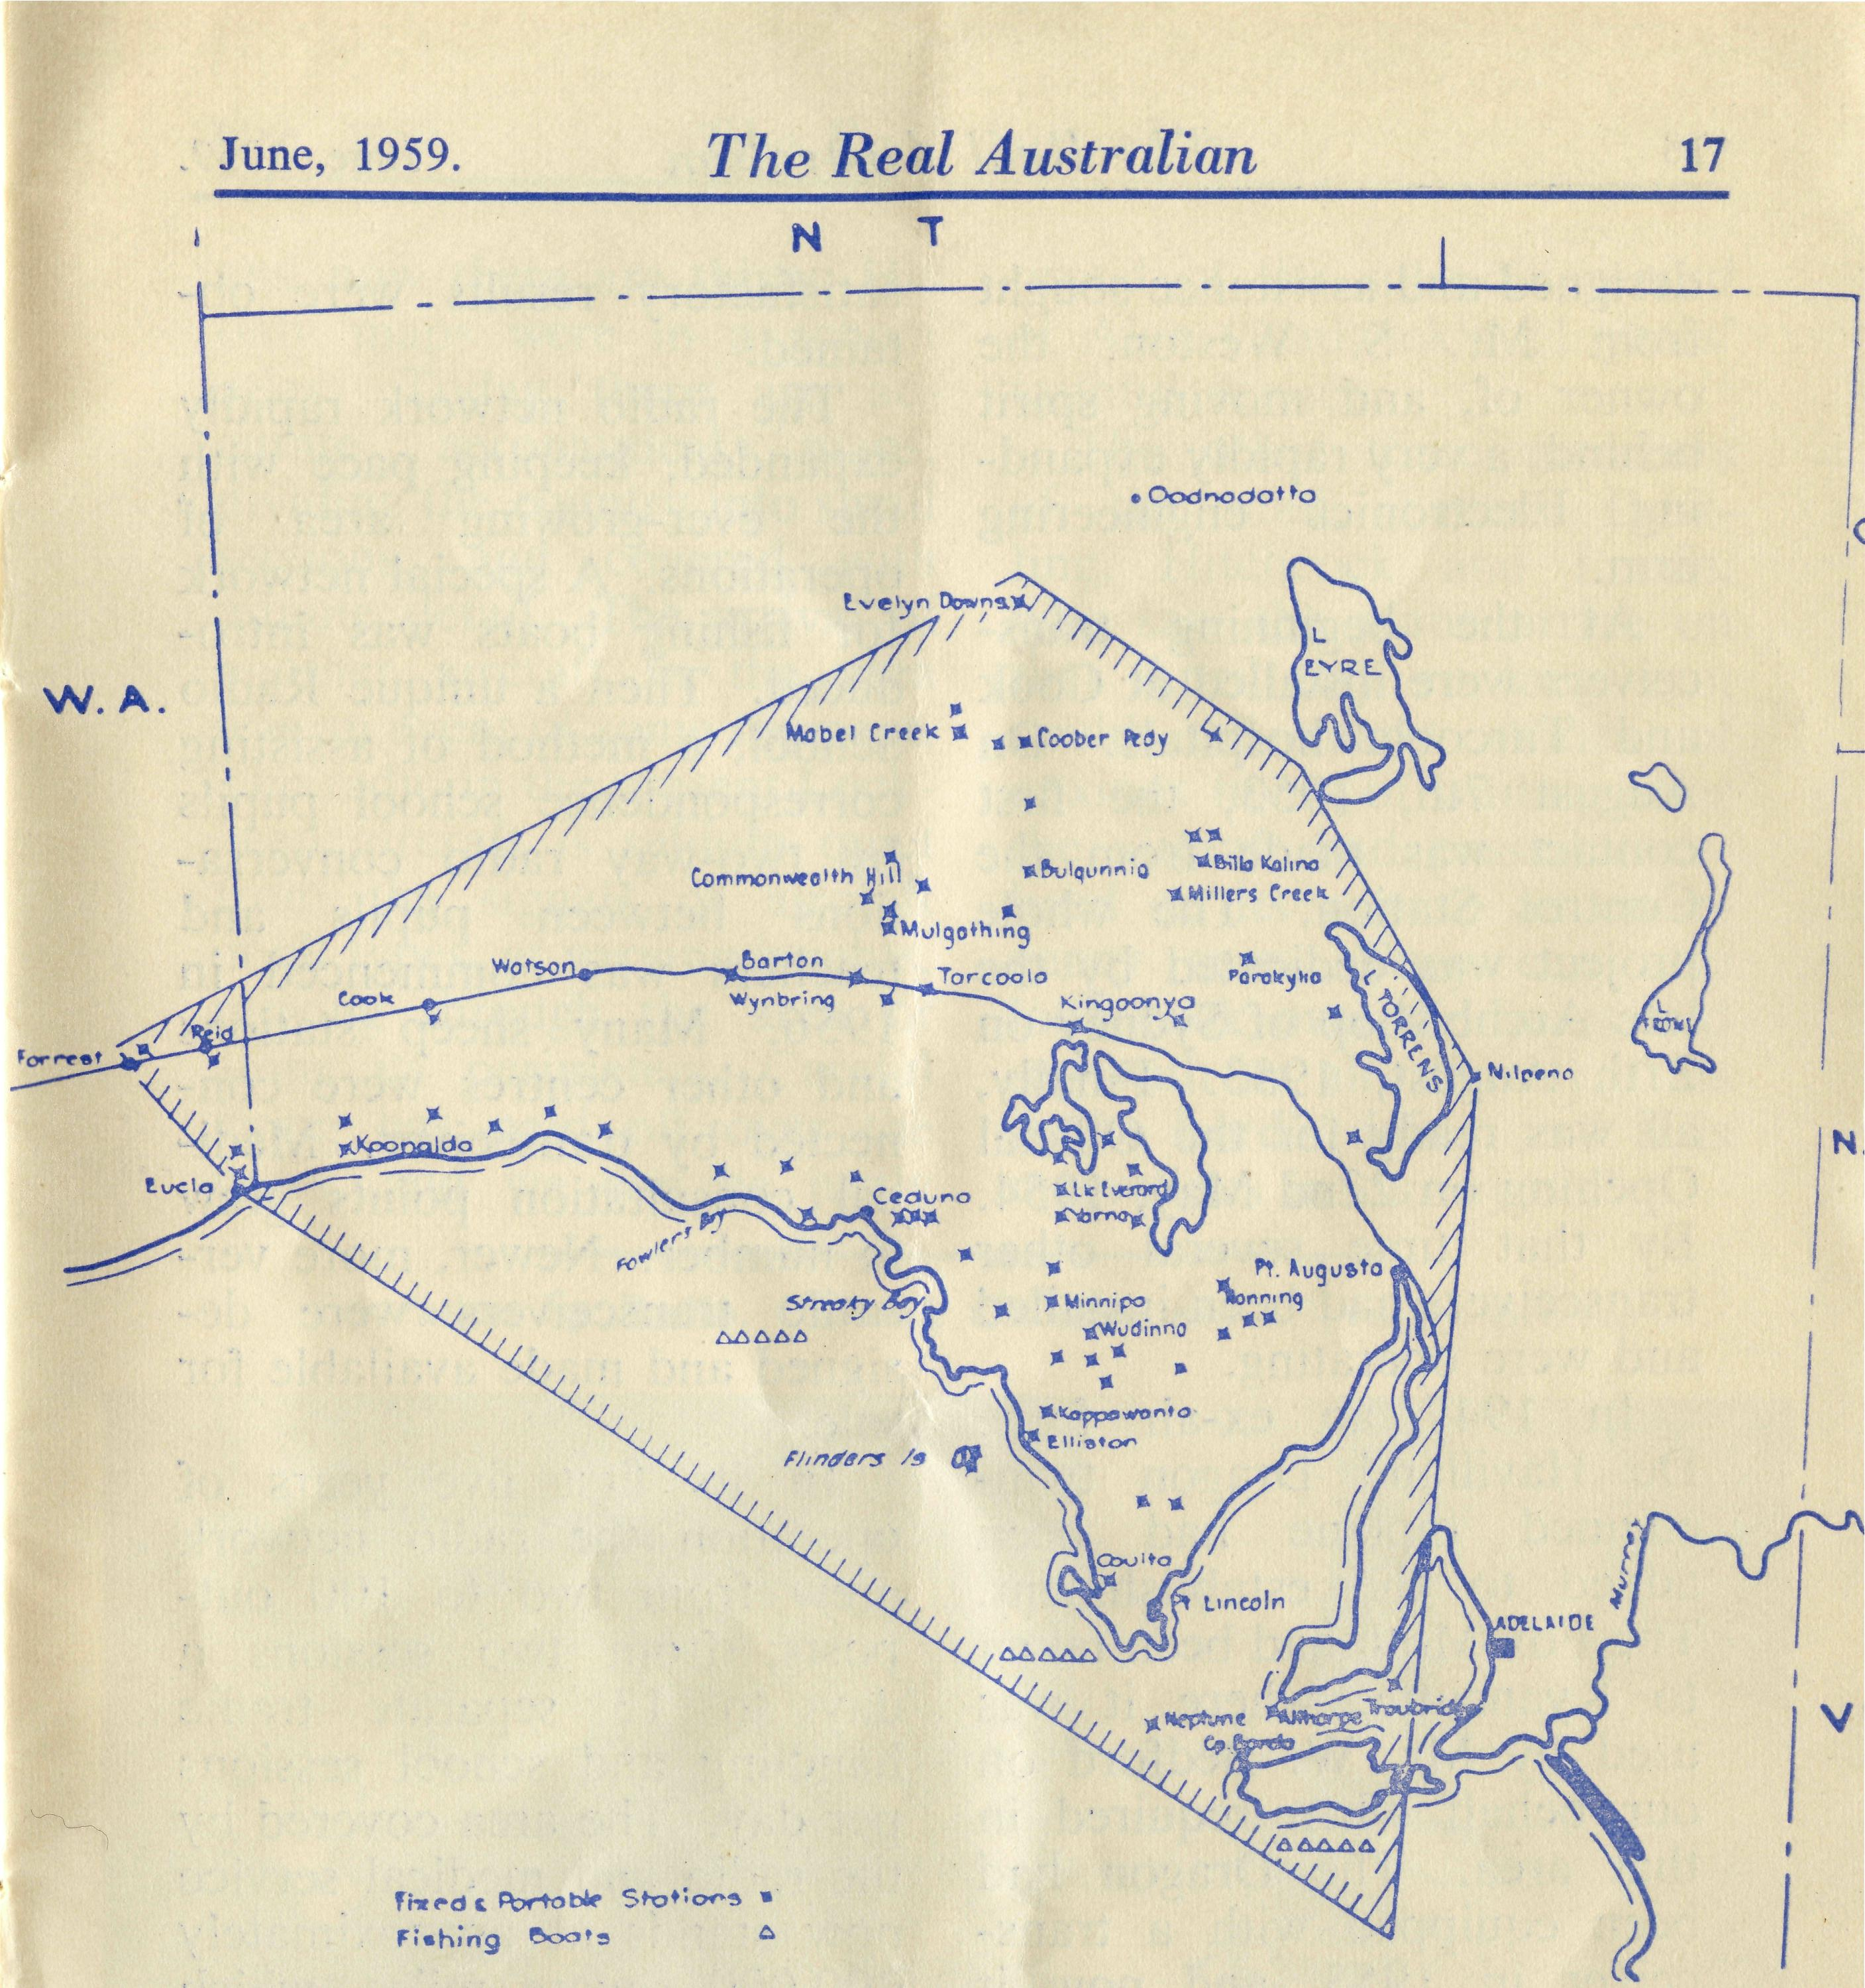
June, 1959.
'phone call from Cook put them at their ease, at least until it was time for the plane to make the return trip. Then the anxiety began all over again.
So it continued for many years. Gradually "Chaddy" learned the lessons of the lakes and sandhills, the inlets and the cliffs. Slowly they became familiar to him as he flew thousands of miles in that little aircraft, sitting in an open cockpit, with his passengers in an enclosed cabin below his feet. The twin silver ribbons of the Transcontinental Railway were excellent navigational aids. But still there was that silence between take-off and landing. Still, the medical service was available only to those who had a reliable telephone line, or after a long horse or car ride to a telephone. Even so, the Service was on call to people scattered over a large area. From Cook, in the west, to Tarcoola and Kingoonya, in the north, and the nearby stations, the Fox Moth with its unique registration numbers of VH-AAA, was a welcome and familiar sight.
The Second World War dragged on. The need for some method of speedy communication was fully realised, but seemed an unattainable goal.
In 1952, after careful
circumstances, to design and build transceivers suitable for use at the proposed outpost radio stations. A Control Room was erected on a suitable site on the outskirts of the town, and a residence for the operator built alongside. (A word of advice-:—don't live on the job!) A transceiver was
16
The Real Australian
fact! How commonplace! AH recorded by a few notations in the station logbook.
Let us step back in time to April 4th, 1938. A lot of us were still at school then. Hawker Demons and West-land Wapitis, Swordfish Amphibians, and Douglas DC2 aircraft were still things to be gazed at in awe. Some of them could fly at over 200 miles an hour!
At Ceduna, a stopping place for the DC2 airliners on their expensive way to Perth, the newly born Flying Medical Service was meeting its first test. Alan Chadwick, the pilot who had arrived a few days previously, on 30th March, was getting the brand new De Havilland Fox Moth out of its shed. A telephone call had been received from the Sister in charge of the Bishop Kirkby Memorial Hospital at the little railway centre of Cook, requesting the attendance of a doctor. Without reliable maps, the party set out, the doctor, who knew the ' road well, guiding where necessary, for the road was the only certain navigational aid . . . even the coastline was an unknown quantity. 3i hours later the first emergency flight was completed, and the patient was being examined by the doctor. That was a very long three and a half hours for those waiting at home. A
Area in South Australia served by B.C.A. Radio.
investigations and much prayer, it was decided that we should go ahead and build our own radio station, which at the start would serve only about eight centres. Much had to be done. Not only was it necessary to design and build the Control Station equipment, but through pressure of

18
The Real Australian
June, 1959.
June, 1959.
The Real Australian
19

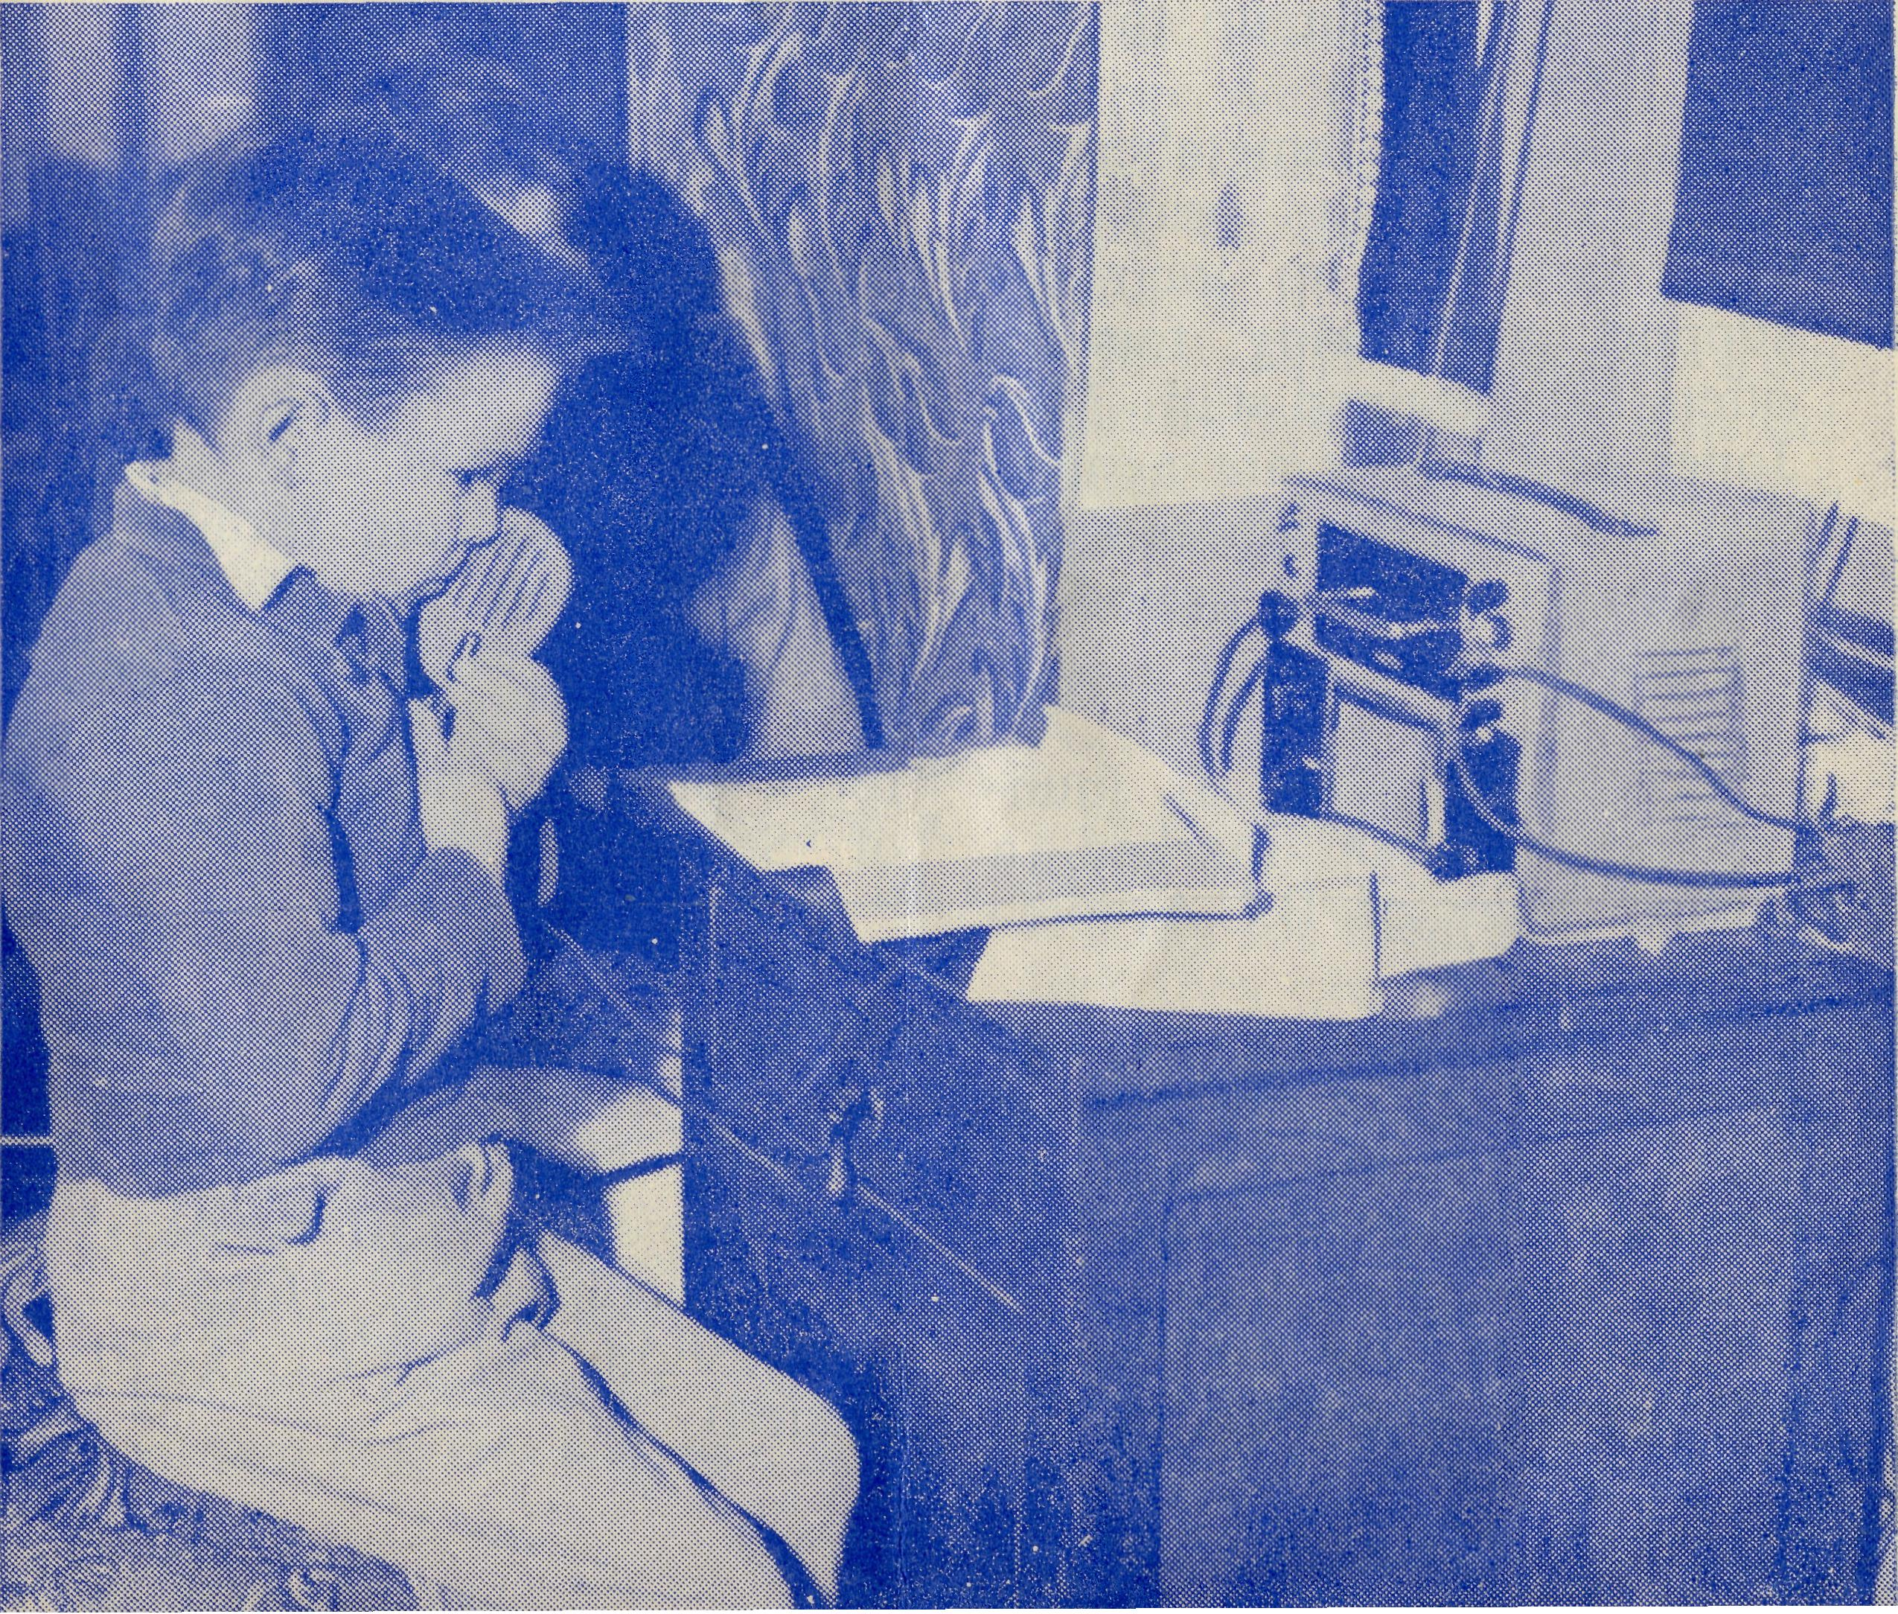
and now there are thirty. His only maps were in a school atlas. Today there are accurate aeronautical maps, dividing the country into small sections, and covered with minute detail. The arrival of another aircraft in the area was an event of some moment. The radio in the present Lockheed aircraft is seldom quiet from the signals of aircraft of all types, at varying heights, moving through the area or along its perimeters. Careful flying has paid off over the years, and we can be justly
designed and assistance sought from Mr. S. Weston, the owner of, and moving spirit behind, a very rapidly expanding Electronics engineering firm.
At the beginning transceivers were installed at Cook and Tarcoola hospitals. On August 7th, 1953, the first contact was made from the Control Station. The whole project was dedicated by the late Archbishop of Sydney on 27th August, 1953. Finally, all was ready for the Official Opening on 22nd May, 1954. By that time several other transceivers had been installed and were operating.
In 1947 an ex-air force De Havilland Dragon twin-engined biplane had been added to the establishment. The Fox Moth had been taken to Kyancutta, where it was used by Mr. W. Bedford on our behalf when required in that area. The Dragon had been equipped with a transceiver in 1953, and now it was possible to have occasional two-way contact with the aircraft. As there were no battery charging facilities on board, it was necessary to severely limit the power of the transmitter, and this, combined with the unavoidably inefficient aircraft aerials, made reliable communications difficult. Various modifications were carried out, and more
satisfactory results were obtained.
The radio network rapidly expanded, keeping pace with the ever-growing area of operations. A special network for fishing boats was introduced. Then a unique Radio School, a method of assisting correspondence school pupils by two-way radio conversations between pupils and teachers was commenced in 1956. Many sheep stations and other centres were connected by transceiver. Medical consultation points grew in number. Newer, more versatile transceivers were designed and made available for sale.
In its first five years of operation the radio network grew from two to 100 outposts; from two sessions a day to 13 separate traffic handling and school sessions per day. The area covered by the radio and medical service now stands at approximately 200,000 square miles, which is an area about the size of New South Wales. There are now 112 stations on the communications network, of which 23 are fishing boats.
Those early hazardous days are still fresh in the minds of the four remaining staff members who were serving in the area at that time. Mr. Chad-wick remembers that there were only three landing strips,
proud of the splendid record of Alan Chadwick's 21 years' faithful service.
The other three members of the staff, Sisters Dow-ling, Hitchcock and Loane, who saw the plane arrive on that April day so long ago, could tell many stories of anxious hours of waiting after the aircraft had passed overhead on its way to an emergency case. They can also look back over the years and say with us all, "Surely, 'this is the Lord's doing, and it is marvellous in our eyes'."
Education by Radio. Outback Children are helped by B.C.A.

20
The Real Australian
June, 1959.
June, 1959.
The Real Australian
21

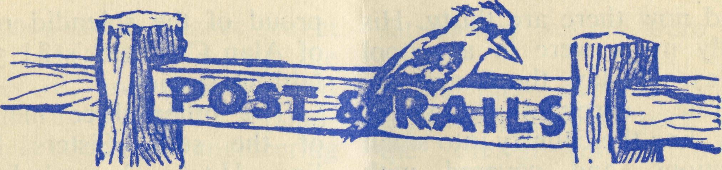
News from the Right Reverend T. E. Jones, Bishop of Willochra, tells of a busy time in America. Bishop Jones had been invited in 1958 to tell the Episcopal Church in the U.S.A. about the challenging work of B.C.A.
An extremely busy time was planned for our former O.M. by the American Church. After a brief visit to Canada, he is now in England, where contacts from previous visits are being brought up to date with B.C.A. news
Readers will remember the
Deputationist, and pray that
God may stir up increased
support and bring forward
offers from trained staff. Mrs.
Jones and family are assured
that B.C.A. remembers them
during yet another period of
separation.
* * *
The arrival of Mr. L. Jauncey at Ceduna marked a further stage of B.C.A. progress.
We now have a "flying" dentist—he earns the title as being part of the Church of England Flying Medical Services, based at Ceduna.
Later this year the dentist will occupy a section of the
B.C.A. Centre. By the time this is being read a builder will be commencing to erect our own Pharmacy, Doctor's Surgery, and Dental Surgery, in the main street of Ceduna. In the meantime the B.C.A. Dentist has opened in temporary premises. Much praise has been received for the efficient way in which Mr. Jauncey has arranged his rooms.
"To God be the glory, great things He hath done."
Port Lincoln Rotary Club has given a great encouragement to Mr. and Mrs. Stan Hummerston. After hearing a talk by the O.M. the Club gave new linoleum to cover the front room of the Girls' Hostel, and a radio set for the girls. Thank you, Rotarians, for a practical demonstration of "Service above Self".
There are several needs— can any reader help? Cleve, Franklin Harbour Mission— slide projector (£30 needed). Port Lincoln Girls' Hostel— combustion stove (£450 needed).
Wedding bells rang out for Miss Edith Lawrence on the 4th- April. Miss Lawrence came to B.C.A. Headquarters eight years ago, and now, as Mrs. C. Bunting, she takes over home duties. Friends of B.C.A. extend congratulations to Mr. and Mrs. Bunting and
pray God may bless them.
♦ * *
The previous news item brought a change amongst our office staff. Welcome Mrs. O'Neill, of Kensington, who now looks after the B.C.A. Gift Shop.
Incidentally, when it's gifts you need, remember this B,GA. Shop, at 135 Bathurst Street, Sydney. You will find a good selection of china, crystal, pottery, mulga wood, a host of gift items, and even koala bears. Your friends will be delighted, and you will be pleased at the reasonable prices.
And still another change caused by increased work. Miss R. Close has borne a great burden of labour for a number of years. Miss M. Podmore, of North Sydney, has now become our bookkeeper. For a while Miss Close will take holidays, long overdue, and then return as B.C.A. Office Secretary.
Records of service are only possible because of the conviction that this is God's work.
Pray for ail the office staff— without them administration of outback services would be extremely difficult.
B.C.A. assures the newly enthroned Archbishop of Sydney, the Most Reverend H. R. Gough, together with the Honourable Mrs. Gough, and Miss Gough, of a deep interest in their work and witness.
His Grace will be Chairman of the B.C.A. Rally on Friday, 9th October, at 7.45 p.m., in the Chapter House, Sydney.
^ :!< 5fc
Mr. Gordon Taylor, together with Mrs. Taylor and their three children, now occupy the 2nd Pilot's House at Ceduna.
Mr. Taylor resigned from Qantas flying staff to join the B.C.A.'s Flying Medical Services. His training and experience over a number of years' flying large aircraft from Australia to overseas places will be applied to outback flying with Mr. A. Chadwick.
Pray for them and the vital link they provide in Christian work amongst scattered people living a long way from medical facilities.
♦ * *
Twelve months ago the Old Folk's Home at Port Lincoln, S.A., was opened by the Prime

22
The Real Australian
June, 1959.
June, 1959.
The Real Australian
23

DIOCESE OF GIPPSLAND, VIC.
Croajingalong, Vic.—(Grant).
Minister. Mr. and Mrs. Vizor accepted the challenge to Christian service as Warden and Matron. Unfortunately a heart condition compelled Mr. Vizor to resign, and so his wife has accompanied him to their home country, England. Their Christian witness and devoted service have meant a lot during this first year of the Old Folk's Home. Thank you, Mr. and Mrs. Vizor, and may God bless you as you seek His will for your life and witness.
* * ♦
What about the Old Folk's Home? God answers the prayer of faith. For some time Mr. and Mrs. Roy Avery, of Cessnock, had prayed that they may be guided into Christian work.
They now serve Him as Warden and Matron at Port Lincoln. Readers will pray for them and their young son, Anthony.
* * *
Can you cook? Many people think that missionaries must be clergymen, deaconesses, teachers, or medical
workers. Those needs are certainly great, but the Church of God needs other people in various walks of life.
B.C.A. needs a woman who will be Cook at the Old Folk's Home—if you want Christian service, this may be your opportunity to serve.
* * *
Broken Hill Hostel is another place where you may serve.
Mr. and Mrs. Calder have three children, plus another 23 boys—will you think of this challenge? God looks to you, and if you are really desiring to win others for Jesus Christ you cannot hide.
Write to B.C.A. office or ring for an appointment to discuss the matter. A woman is needed who will help with the boys' work. Thank you.
$ $ $
The Sydney Women's Auxiliary Fair will be at 11 a.m. on Friday, 24th July, in the Chapter House. The workers will appreciate gifts of cakes, produce, and hand-work.
The Rev. C. W. Rich will show pictures of the Northwest of Western Australia.
The Bush Church Aid Society
for Australia and Tasmania
PRESIDENT: Hon. Clerical Secretary: Rev. Canon E. Cameron. Hon. Treasurer: Mr. T. S. Holt. Organising Missioner: Rev. J. R. Greenwood, Th.L. Deputationist (N.S.W.): Rev. C. W. Rich, Th.L. Victorian Secretary: Rev. E. G. Beavan, M.A.
VICTORIAN OFFICE:
Allan's Buildings, 276-278 Collins Street,
Melbourne. Telephone: MF 8962.
HEADQUARTERS OFFICE:
135 Bathurst Street, Sydney. Phones: BM3164, BM 3780. Telegraphic Address: ^Chaplaincy, Sydney."
FIELD STAFF:
DIOCESE OF ADELAIDE, S.A. Ceduna, Penong, S.A.—Rev. T. V. Jones, Th.L., Rev. R. Neve, Th.L.
Cleve, S.A.—Rev. B. Buckland, Minnipa, S.A.—Rev. A. Williams,
Th.L. Th.L.
DIOCESE OF WILLOCHRA, S.A.
Orroroo, S.A.—Rev. J. Winter, Quorn, S.A.—Rev. G. Fuhrmeister,
B.A., Th.L. Th.L.
Peterborough, S.A.—Rev. I. Booth. Th.L. (Grant in aid).
DIOCESE OF BALLARAT, VIC.
Heytesbury Mission, Vic.—Rev. B. Otway Mission, Vic.—Rev. T.
Viney, Th.L., Timboon, Vic. Morgan. Th.L., Beech Forest,
Vic.
DIOCESE OF RIVERINA, N.S.W. Wiicannia, N.S.W.—Rev. J. Stock- Menindee—Rev. R. Brooks, Th.L. dale, Th.L.
DIOCESE OF TASMANIA.
Tarraleah, Tas.—Rev. W. War-burton, Th.L. Poatina, Tas.—(Grant in aid).

WANTED
DIOCESE OF THE NORTH-WEST Port Hedland Mission.—Rev. D. M. Douglass, Th.L., Port Hedland, W.A.

Three men in Priests’ Order — need is Urgent. Enquiries to Bush Church Aid Society
MAIL-BAG SUNDAY SCHOOL
Director: Miss R. CAMPBELL

