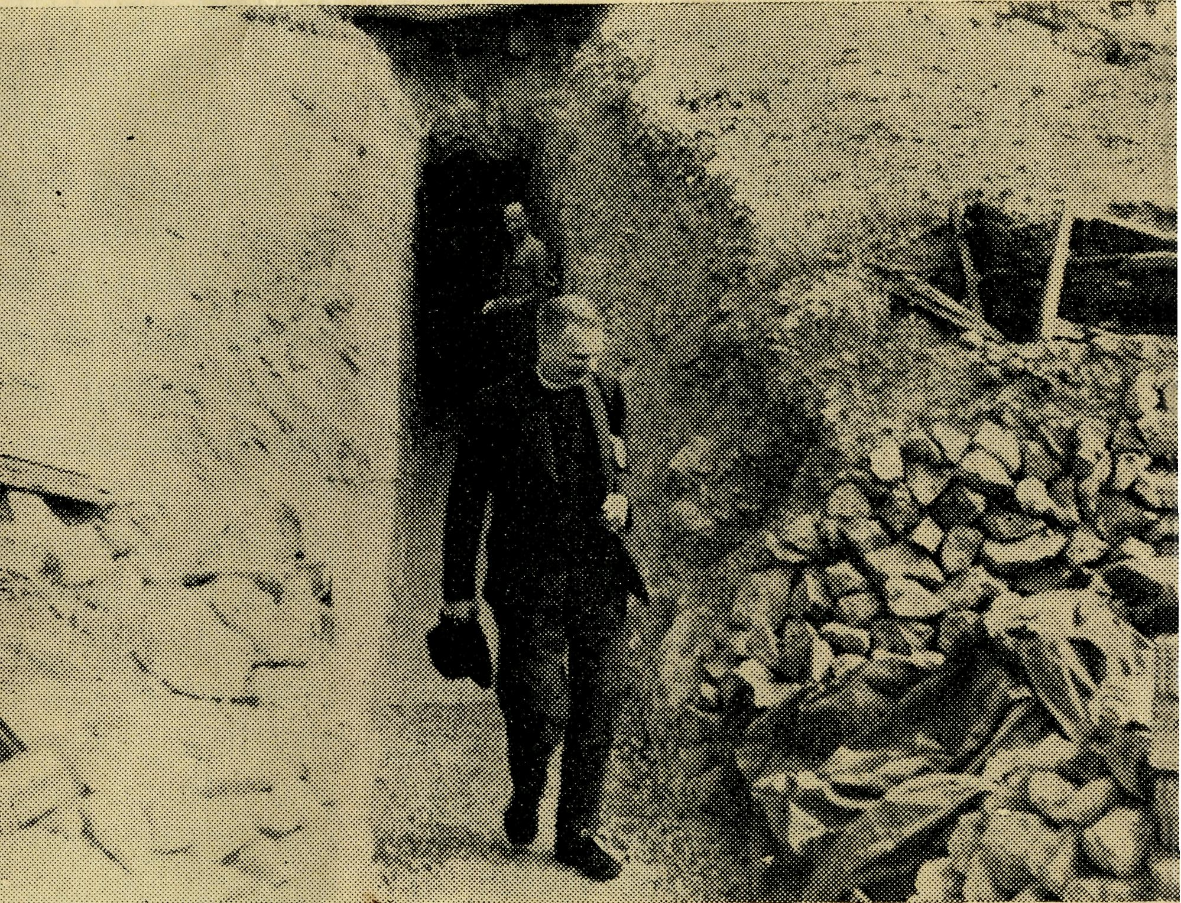
No. 30 (New Series), DECEMBER, 1959. 2/6 per annum, Post free.
The Archbishop of Melbourne visits Coober Pedy Opal Field
Registered at the G.P.O., Sydney, for transmission by Post as a periodical.
December, 1959
24
The Real Australian
FLYING MEDICAL SERVICES HOSPITAL CENTRES:
CEDUNA, S.A.
The Murat Bay District Hospital.
Matron: Sister F. DOWLING.
PENONG, S.A.
The Penong Memorial
Hospital. COOK, S.A.
The Bishop Kirkby
Memorial Hospital. TARCOOLA, S.A.
The Tarcoola Hospital. RAWLINNA, W.A.
The Nursing Hostel. WUDINNA, S.A.
The Central Eyre Peninsula
District Hospital.
Sisters: J. MILLER, G. HITCHCOCK, M. BELL, M. TROUP, B. TIERNEY, A. BAKEWELL and C. ENNEVER,
Sisters: L. LOANE and J. ROBERTS.
Sisters: M. TARR and M. ROSS.
Sisters: V. HOLLE and M. BARBOUR. Sister E. THOMAS.
Matron: Sister B. BARBER. Sisters: M. DEAN, E. SIMMOND, A. HAYWOOD.
MEDICAL OFFICERS:
Dr. M. MUELLER. Dr. R. CHAMBERS.
Dr. C. L. ROBERTSON.
AIRCRAFT:
Auster. Lockheed 12.
PILOTS:
Mr. ALLAN CHADWICK,
Mr. GORDON TAYLOR,
Mr. W. BEDFORD.
PHARMACIST: DENTIST:
Mr. J. ARGALL. Mr. L. JAUNCEY.
WIRELESS COMMUNICATIONS BASE:
Ceduna Base Operator: Mr. GEORGE CAMERON. Assistant: Mr. J. WARD.
CROAJINGALONG NURSING SERVICE, VIC:
Sister I. GWYNNE.
HOSTELS FOR SCHOOL CHILDREN
PORT LINCOLN, S.A.
Mr. & Mrs. S. HUMMERSTON and Miss D. DUVER. MUNGINDI, N.S.W.
Miss M. FARR.
BOWRAL, N.S.W.
Mr. & Mrs. A. McLAUGHLIN and Mrs. PARKINSON. BROKEN HILL, N.S.W.
Mr. & Mrs. W. L. CALDER and Miss H. CHEW.
OLD FOLK'S HOME (Port Lincoln, S.A.).
Mr. and Mrs. R. AVERY, Miss H. AVIS.
EDGAR BRAGG & SONS PTY. LTD., 130 BOTANY STREET, WATERLOO.

The Real Australian
December, 1959
December, 1959
The Real Australian

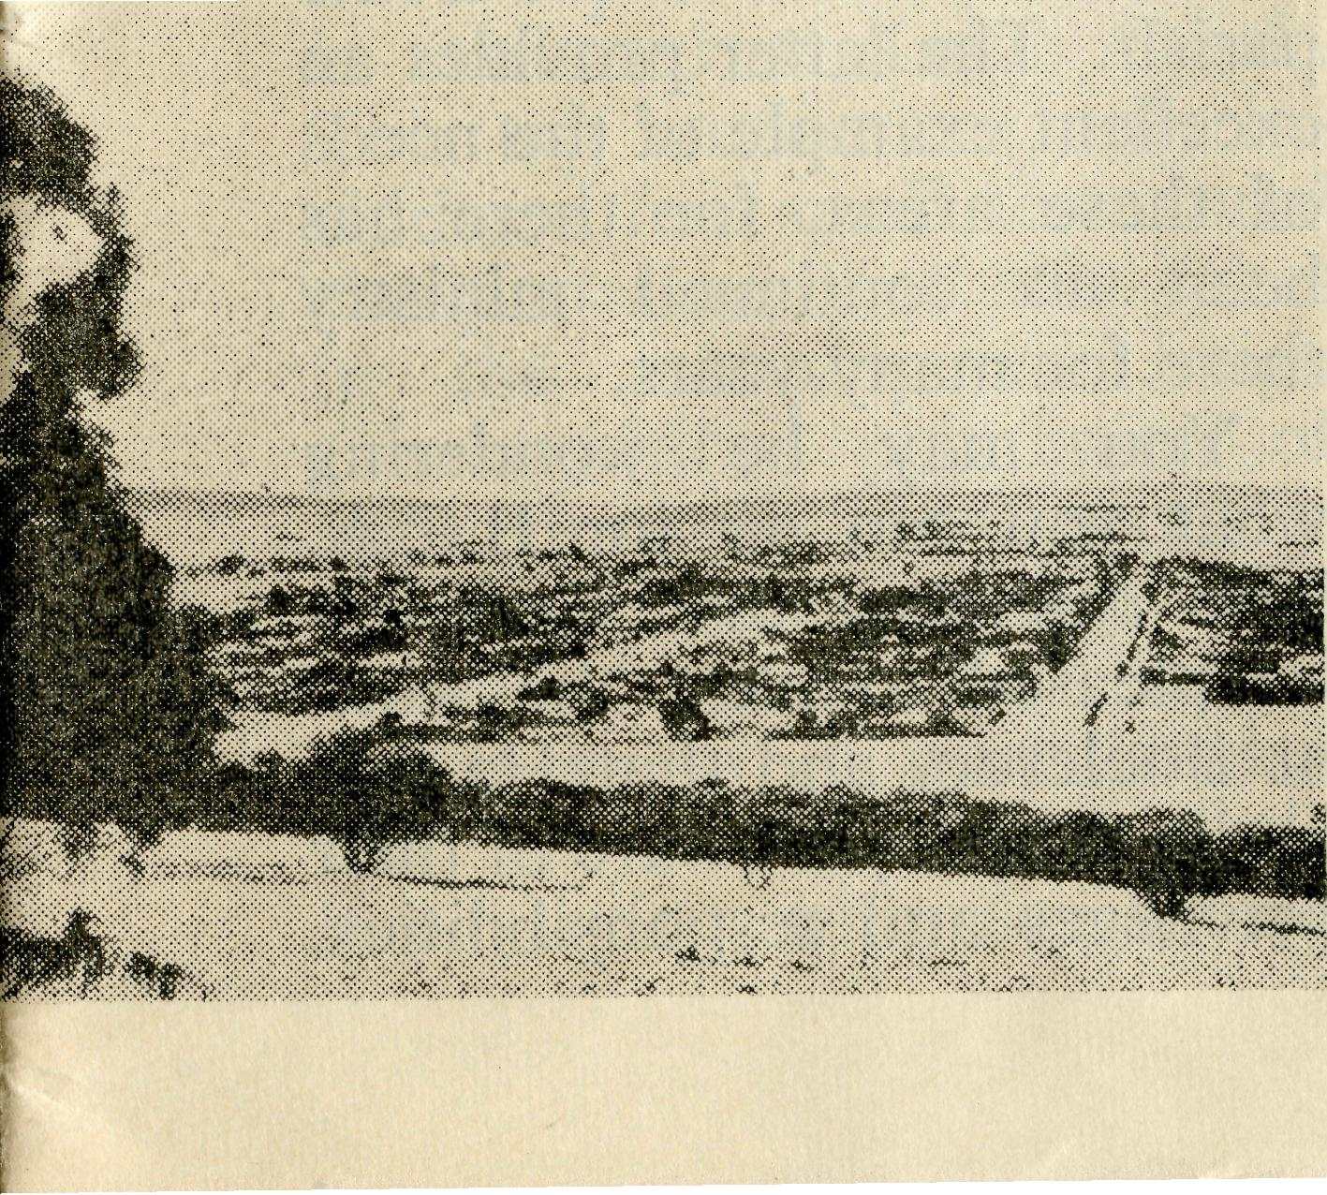
The Organising Mission’s Letter
Orroroo Incorporated
(Rev. J. Winter)
Thank You.
As with St. Paul ""I. thank my God upon every remembrance of you always in every prayer of mine for you all, making request with joy for your fellowship in the Gospel from the first day until now".
Thanksgiving is often overlooked with many problems arising, and I am always encouraged when in Church Services I join with congregations in the General Thanksgiving.
The year 1959 has seen changes and to all who have supported B.C.A. with prayers, service and gifts a word of appreciation is due. There are opportunities and challenges before us and all in B.C.A. plead for your continual prayer and support. The Challenge
The more I travel through the fields of service so much, the more I pray for increased staff in our hospitals. Loyal women give to the point of breaking strain of their time and energy. A few more devoted, dedicated Christian nurses could make all the difference. B.C.A. Staff members add to their nursing duties much of the domestic work. It is not that they begrudge doing this, but only because they are truly Christian it is done. B.C.A.
services are kept operating by nurses making sacrifices for the sake of Jesus Christ and the work of His Church.
There is also the service required from clergymen. I ask young men to heed the call from the outback. A most satisfying piece of work awaits you and yet in so many places the contribution of the Church of England is very small. It is not the fault of those doing their best with limited means and staff. The fact that people live in scattered areas is a challenge to those who benefit from the Church's ministry in closely settled places.
Give the men and the support and the Church of England will rise to heights never thought possible.
In many places \ve: have but one ordained man striving to the utmost to miriister id people scattered over thousands of square miles. An increasing number of young men in Priest's Orders giving say five years to B.C.A. could provide an effective means of extending the work of the Church of England for our Lord and Saviour. He gave His life for people outback but—"How can they hear without a preacher."
All B.C.A. services need help with staff and we can thank God that so many walks of life remain open for Christian workers. Within B.C.A.'s enterprise doctors, nurses, domestic workers, radio officers, aeroplane pilots, pharmacist, dentist and hostel workers are given the opportunity to show what real
When I left the Diocese of Melbourne for service with B.C.A., I was the unwilling victim of a multitude of terrifying thoughts. Would I like the new work to which I was going? Would I get an inferiority complex in a place where there were more sheep than people? I kept reminding myself that during my days in college, I was just an ordinary theolog., and not one
Christian devotion can mean. Over to You.
In many places B.C.A. is the one means of bringing men and women into the fellowship of the Christian Family.
Your service, prayers and gifts can help us to win "Australia for Christ".
JOHN GREENWOOD.
of those exalted beings in training for service with B.C.A. And yet here I was, on my way to Orroroo.
"Where?" my friends in Melbourne said, and I would launch into a recital of the data I had gathered in the Public Library. And so I came.
After six months in the work, I now feel that I could give the church at large in Australia a score of good
Orroroo at the foothills of the Flinders Ranges, S.A.

The Real Australian
December, 1959
December, 1959
The Real Australian

reasons why it must be interested in the outback areas of our country. The work is widespread, and distance is a constant factor in one's ministry. The congregations are often small by city standards, but the New Testament says nothing about the size of its churches. The country is lonely and desolate in many places at first sight, but it has a natural beauty of its own which soon becomes evident to the sympathetic observer. I made the mistake of trying to judge the nature of the country by means of a map, but such things are only an aid to direction and distance. The road to Broken Hill shows a place called Outalpa, which I failed to locate on my first journey. I have since found it—a tin shed about 8ft. x 10ft.
There are problems which are non-existent in a city ministry, but there is a peculiar spiritual reward to be had in the realisation that the witness of the Christian Church in Australia need not be limited in any way, but that all men may know the challenge of the Redeemer. It's a strange thing, that one may know, as I did for years, that an organisation called the Bush Church Aid Society is constantly appealing for men and materials to continue and enlarge its
work. But the significance of the task has to be seen to be believed. It may well be that many of the readers of this article are city-dwellers whose information about B.C.A. is derived solely from articles of this kind. As a city-dweller, I tended to under-estimate the importance of the work being done. Certainly, the need did not impress itself as strongly on me as I now know it should have done. Let me beg you, good people, as Paul says, in the bowels of Jesus Christ, to place as high an estimate as possible on your responsibility to the work of B.C.A. It must not only be continued, it must be enlarged.
Now a word about the work here. Since the change-over of missioners, the work has been re-arranged somewhat. The Leigh Creek trip is now done from Quorn, and the small town of Booleroo Centre has been added to the home parish. The latter provides an excellent example of the needs of these areas, for there has been no continued ministry there for many years.
You may be wondering what you can do for B.C.A. You can pray that God will be pleased to bless the work at Booleroo, and that He will make the people aware of their privileges and responsibilities.
The work at the mining town of Radium Hill is of first importance, and the congregation contains many whose spiritual needs are a constant challenge. The town itself is located in very dry, open country, on a uranium site. It's a most intriguing discovery to find this place tucked away in the wilderness,
Quorn and Beyond
(Rev. H. G. Fuhrmeister)
The normal district served from Quorn includes Hawker, Blinman and Parachilna, which covers approximately 5,000 square miles, but for some time Wilmington and Terka (25 and 28 miles south) have been served from Quorn too; and at the beginning of the year the area further North was added. This must be the position until a man is stationed at Leigh Creek. This top section not only includes a few small towns and sheep stations but also takes in the township of Leigh Creek with a population of approximately 2,000 people.
One of my monthly trips coincided with the school holidays, so it was decided that my family, and a little boy staying with us, should
and the thankfulness of the people for the ministry provided by B.C.A. is both evident and heartwarming. There is much to be done, but through it all one can hear the words of the Lord, "Lovest thou me?" The work is here. Will the people of Australia see that it is done?

accompany me. That meant five boys and Mum and Dad were packed into a Vauxhall Utility with a canopy over the back! We planned at the beginning to have two days in the Flinders Ranges "camping" in the shearers' quarters of a Parishioner near the holiday resort of Wilpena Pound Chalet which is 75 miles from home.
After breakfast we set off— as early as a family can get away, but the boys had been ready to start hours before we left. It turned out rather warm and the boys in the back of the van were very pleased when at last we pulled up at the bungalow type of house used for the shearers. There was much running here and there and investigation

The Real Australian
December, 1959
December, 1959
The Real Australian

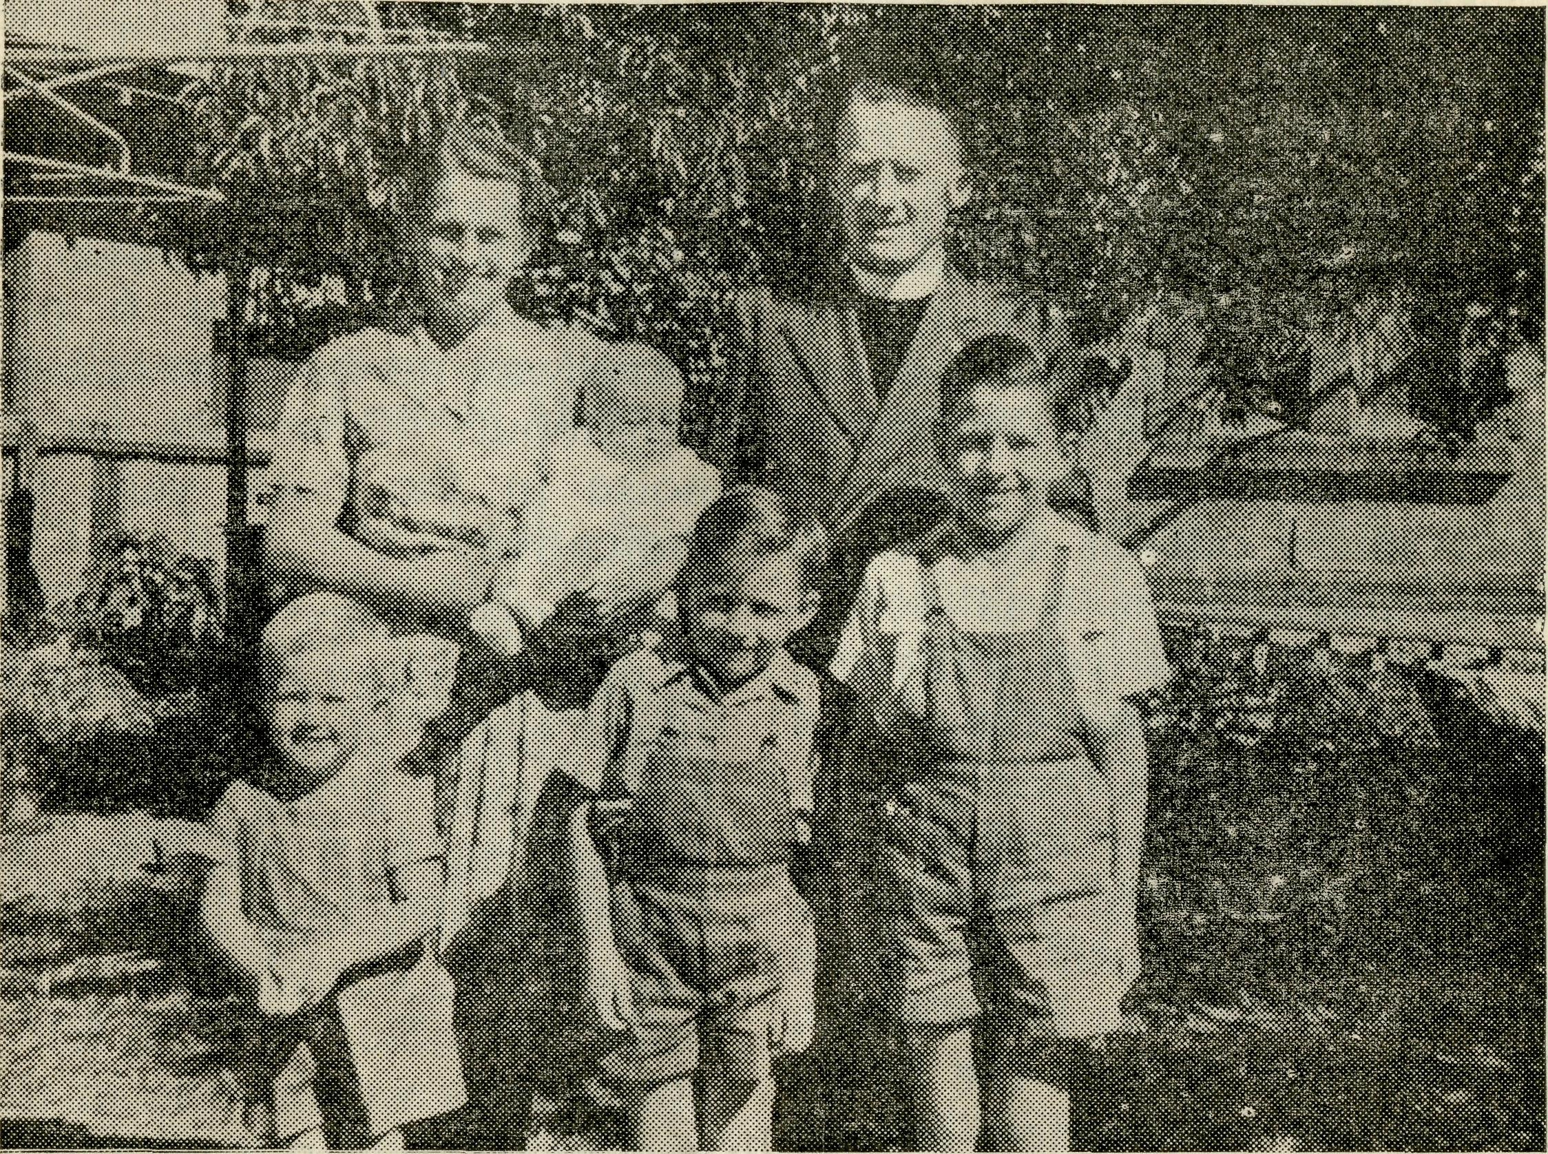
Leigh Creek but only three were represented at that Service. Later a Communion was given at the Hospital, a young couple interviewed and visits made. The Youth Fellowship Tea was more encouraging and by way of change my wife spoke to them. In the evening the numbers were again small and one couldn't help feeling sad that apathy and love of sport held so many in its deadly grip. What a challenge to prayer and need for a more regular ministry among these folk living in a "man-made" community.
made while the unloading was carried out and lunch prepared. The owner of the station was drafting sheep next morning and the boys were allowed to give a hand, much to their delight and advancement of their education. Our hosts were particularly kind to us, and on the day we left we had morning tea with them which turned out to be a sumptuous spread of everything little boys like at parties—cream puff, sponges and all the trimmings.
After lunch we packed up and journeyed some 45 miles further north to Blinman, where we were to have a Service at night—and camp in another shearers' quarters! On the way we came to several cars stopped by the roadside where one of their number had overturned shortly before, but fortunately no one had been hurt. It was most pleasing in the evening so see the occupants of the car at the Service to give thanks for their deliverance.
As the Organist for the Church was away, my wife played for the Service, but I can't say our children "played the game", for mother had to be in and out during the service to the three who were supposed to be sleeping in the van beside the Church.
A further distraction was the noise of restless opossums and birds in the ceiling of the old Church, which is propped up with posts on the outside and white ants eating the inside. The people are planning for a new one with the hope that this will be done before the wind blows the old one over as happened to the Methodist Church. It is always a joy to meet these folk who have a Service only once a month and some of them live up to 25 miles away.
Next morning after breakfast we set out for Leigh Creek, about 80 miles away by road and only 50 miles as the crow flies. The first 20 miles were through the Ranges with delightful scenery in contrast to the track along the north line, which is very flat and rough in parts. We stopped for lunch in a dry creek bed under some lovely gum trees, but because of the flies and ants were glad to get on the way again as soon as we had finished eating.
On arrival at Leigh Creek, our host, whose young son was with us, welcomed us with a cup of tea and told us that his wife was in hospital again. As there was a wedding service at 4 p.m., I soon had to be on the job. That night everybody was
Rev. H. G. and Mrs. Fuhrmeister and family.
pleased to "hit the hay" and slept soundly.
On Sunday morning we had Holy Communion, which was held in the Inter-Church building, as our own is still in the process of construction. (This Church was transferred from Copley, about six miles away, some two years ago. Voluntary helpers erected it at Leigh Creek but it is most difficult to get a tradesman to finish the inside. Join with us in prayer that this building may be completed.) There are about 30 Anglican families in

The Real Australian
December, 1959
December, 1959
The Real Australian

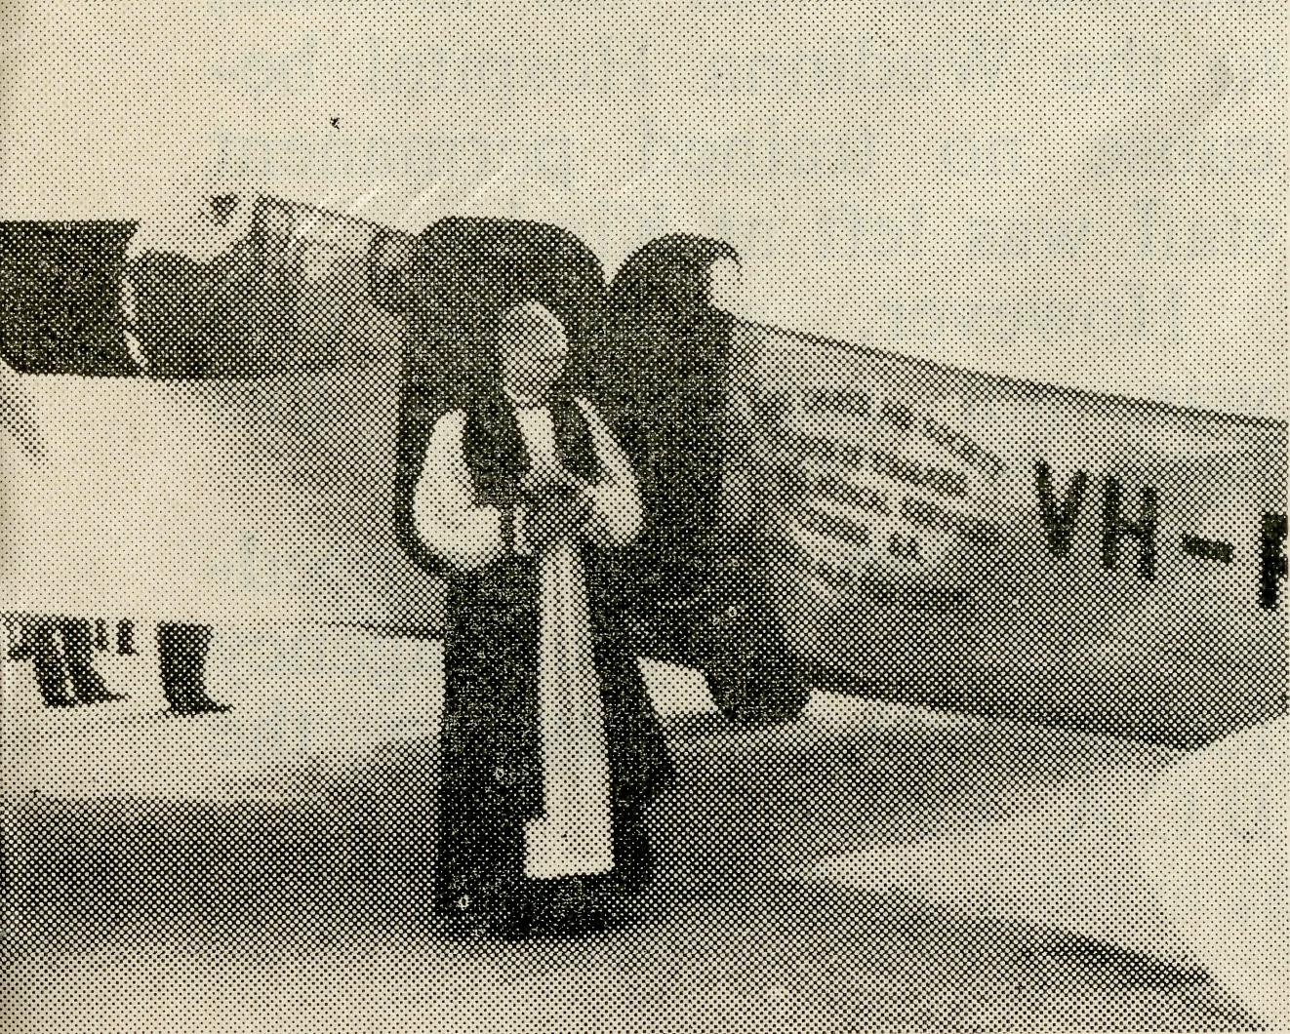
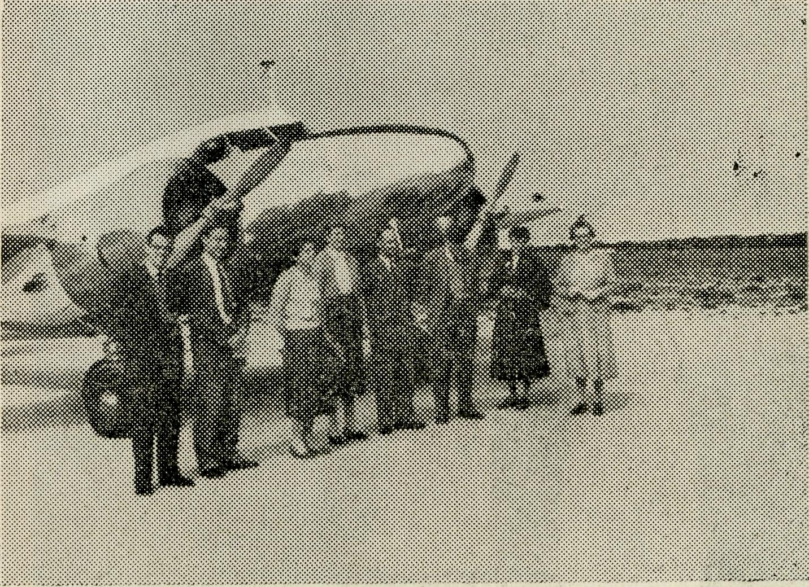
Archbishop of Melbourne Visits B.C.A. Flying Medical Services
(This extract is from the letter of the Archbishop in the "Church of England Messenger", September, 1959.)
Monday morning showed signs of the weather changing and by the time we had breakfast and packed, a strong northerly was blowing and clouds of dust were rolling across the countryside. However, as scheduled, we made an inspection of the coalfield (six miles out of the town) and although it was somewhat unpleasant, yet was none the less fascinating. On arrival back at Leigh Creek we refuelled the larder and started on our southward journey of 160 miles to Quorn. En route we visited Aroona Dam which is the water supply for Leigh Creek. It is situated among some hills in rather an intriguing setting and like an oasis in the desert. We had lunch while there in the back of the van and in between the gusts of wind and dust enjoyed our sandwiches and cool drink.
The rest of the journey home was hot and dusty and although the road runs parallel to a range of hills on the eastern side, we were not able to
enjoy the scenery because they were hidden in clouds of dust. A puncture about half way provided an outlet for the exuberant boys, and when we arrived home about 6 p.m. there was no need to tell our neighbours of the fact, for the noise in the back yard was indicative.
On these trips I endeavour to visit as many homes as possible both along the main route and along the back tracks, as well as give Religious Instruction in schools, but on this occasion is wasn't often possible. Yet I felt it abundantly worthwhile in that it gave some of our people the opportunity not only to meet the family, but also enabled my wife to understand better the peculiar difficulties of that area and thus pray more intelligently for those people committed to our care—and I hope it will help those who read these lines to do likewise.
We need most of all your prayerful support.
"On my way back from Perth (where, by the way, I saw the spring flowers in all their glory) I was privileged to be taken on a tour in their own aeroplane of the Bush Church Aid Society Centres and Hospitals in South Australia. Besides giving me a
Ceduna—Flying Medical Services Staff: Mr. G. Cameron, Dr. C. Robertson, Dr. M. Mueller, Sister J. Miller, Mr. A. Chadwick, Mr. J. Argall, Sister M. Bell, Sister F. Dowling.
sight of that astonishing thousand miles of near-desert country, it filled me with a great admiration for the people who live in it and for the devotion of clergy, doctors and nurses who serve them. The staff of B.C.A. combine in themselves deep Christian piety and a very high degree of technical skill. This is true not only of the medical staff but also of the radio and aircraft engineers. It made me proud to think that their work is part of the mission of the Church of England."
The Archbishop of Melbourne
blesses B.C.A. Lockheed—
"S. J, Kirby".

10
The Real Australian
December, 1959
December, 1959 The Real Australian
11

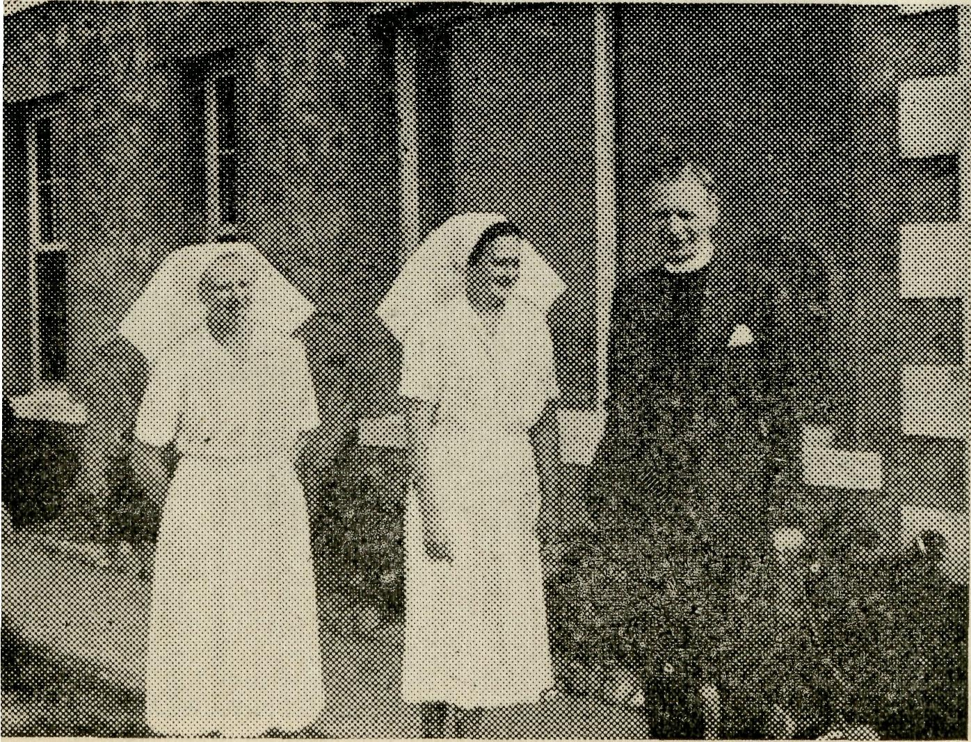
C. Duffie) said last night that the power change would be made in part of the town today.
It was hoped that this would allow a better supply
If this failed, a special alternating current line would be erected to serve all other hospital needs.
Another premature baby, born at the Kimba Hospital several days ago, had been transferred with his mother, to the Wudinna Hospital because no trained permanent staff was left at Kimba.
However, a humid crib was not required for this baby.
(Christian nurses are needed—B.C.A. is your agency for service. Apply to the B.C.A. Office.)
Sisters M. Holle, B. Tierney with
the Archbishop of Melbourne at
Tarcoola.
Christian Nurses at Work
(From a recent South Australian Newspaper Report) HOT WATER BOTTLE AID
Bush Church Aid Society nursing sisters at the Wudinna District Hospital used hot-water bottles to boost temperatures in a humid crib containing a premature baby born on September 11.
The birth of the baby to Mrs. J. G. Usher has delayed the District Council of Le Hunte's plan to change the Wudinna township's power supply from direct to alternating current.
Because one of the direct current generators failed yesterday morning and reduced the crib's temperature to below that required for the safety of the baby, nurses packed the crib with hot-water bottles to maintain the correct temperature.
The District Clerk (Mr. J.
Christmas Greetings
from
The Bush Church Aid Society
"And the angel said, Fear not for behold I bring you good tidings of great joy, which shall be to all people. "For unto you is born this day in the city of David, a Saviour, which is Christ the Lord"
(Luke 2, v. 10-11)

12
The Real Australian
December, 1959
December, 1959
The Real Australian
13

remove the debt.
A generous response with your Christmas Offering will see the year 1959 close with the General Fund in credit. I know you will help, and I thank God for your encouraging response to B.C.A. needs.
May God grant you all a Holy and Happy Christmas. Your prayers and interest will help to forward the aim of the Society to win "Australia for Christ".
Yours sincerely,
JOHN GREENWOOD,
Organising Missioner.
Christmas, 1959. Dear Supporters,
This year Christmas Greetings come to you with the "Real Australian" instead of a separate letter. By doing it this way, less money will be spent on postage, which means more of your gifts will be available for the maintenance of our work.
At the end of this letter you will find a perforated slip; please complete it with your name and address, and attach it to your Christmas Gift for the work of the Society.
It has been a year of much activity, for which we thank God and take courage for the year 1960. Essential buildings have been erected at Ceduna for the better working of the Flying Medical Services. A house has been erected to accommodate the Dentist, Pharmacist and Assistant Radio Officer. The Pharmacy, Doctors' and Dentist's Rooms will soon be completed. This property at Ceduna, S.A., is not just a material advantage, but enables the work of B.C.A. for Jesus Christ to be more effectively propagated. Already supporters have promised gifts of memorials, and have asked for equipment and parts of
the building to be marked in appreciation of relations and friends.
A loan of £12,000 for the Ceduna B.C.A. Centre has paid the cost, but now we must see that it is repaid. Another matter you might consider with your Christmas Gift is transport for our Padres. It grieves me when men have to add thousands of miles to vehicles which should be traded on new vans. The outback clergyman is absoluately dependent upon his vehicle. After some years on rough tracks even the sturdiest van becomes a financial strain. This seriously affects the all-important reason the clergy are in the field. They must be able to reach their complete mission districts as widely as it is humanly possible.
To win "Australia for Christ" is our motto. How can outback people be won except when men can reach them? How can they reach them without a reliable vehicle?
Two new vans (estate car type) are needed immediately, and a third will be required in a few months.
Early in 1960 the Lockheed aircraft will need the second engine replaced, and together with the annual overhaul for the Certificate of Airworthiness, an amount of approximately £1,750 will have to be found.
All these claims make heavy demands and are additional to the finance needed for regular commitments such as staff salaries and other running expenses. We have concluded the first complete year in our own building at 135 Bathurst Street, Sydney, but there still remains £17,000 to
CHRISTMAS OFFERING
Herewith my Christmas Gift of £ / /
To the
BUSH C H U R CH AID SOCIETY
B.C.A. House, Allan's Buildings,
135 Bathurst Street, OR 276 Collins Street,
Sydney. Melbourne.
Rev. Mr.
Mrs
Miss
Address
For (a) General Funds.
(b) Flying Medical Service. Gifts to Flying Medical Service are rebates of Income Tax.

14
The Real Australian December, 1959
December, 1959
The Real Australian
15

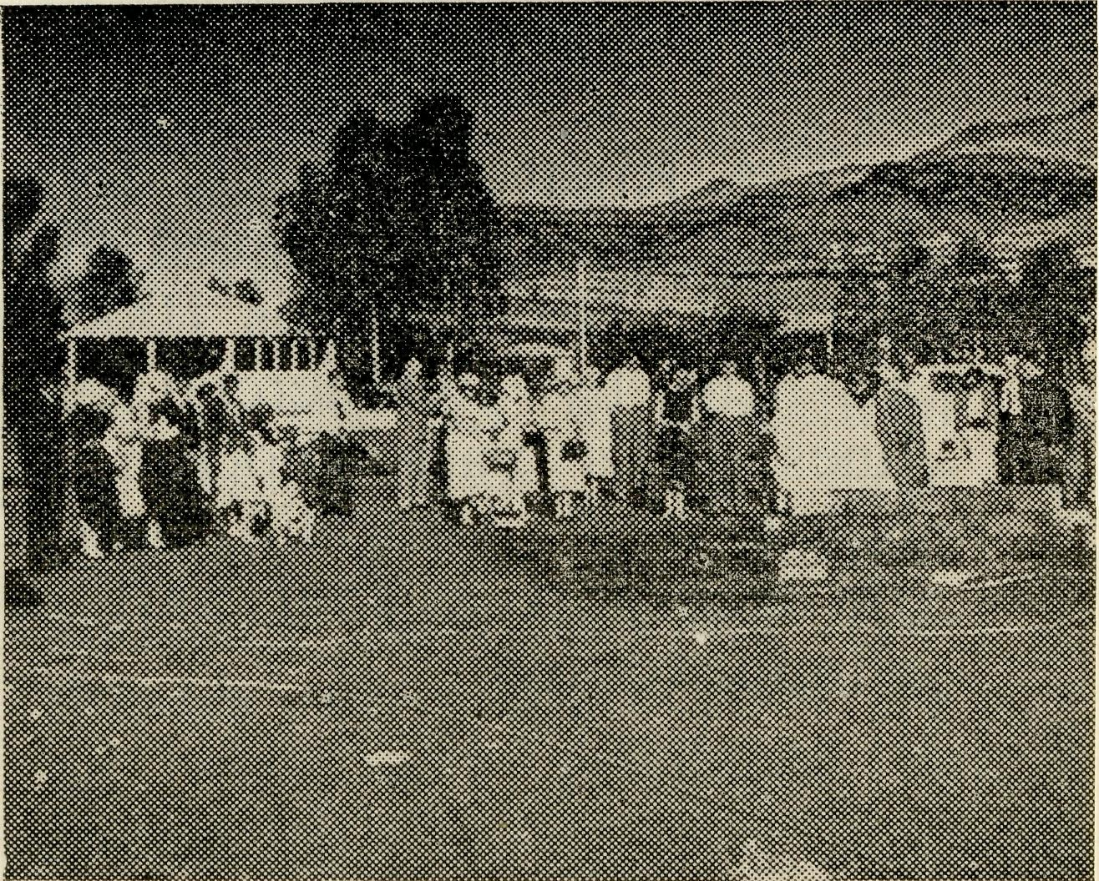
A Church Is Built
("St. Mark's, Wittenoom Gorge") By Rev. D. Douglass.
HAVE
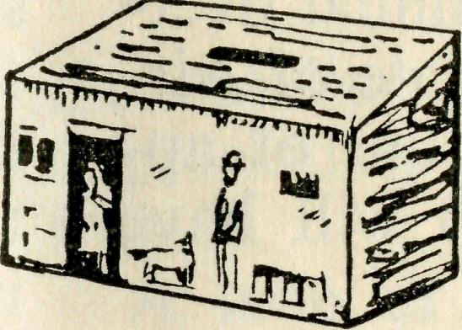
You a
Bark Hut?
If it has not been opened this year, will you please do it now?
(1) Send the contents (by cheque, postal note or money
order) to B.C.A. Office
or
(2) Bring your Bark Hut to be opened at B.C.A. Office
or
(3) Give it to your Church Bark Hut Secretary.
THANK YOU.
PRAY
GIVE
SERVE
Sunday, 19th July, 1959, at 3 p.m., the Foundation stone, made on the spot, of blue asbestos fibre and cement, was placed in position. The small crowd stood quietly and reverently to listen to the Bishop's closing words of blessing . . . "In the name of the Father, the Son and the Holy Ghost. . . ." On the one side towered the erosion - scarred Hammersley Ranges, the deep red changing to blue in the afternoon sun. Away in front, beyond the rows of white miners' houses, was the vast tableland—empty as far as the eye could see. Already, in faith, one could visualize those few feet of foundations growing into a Church, as the Spirit of God moved the people to build and give. So commenced the building of St. Mark's Church, Wittenoom Gorge.
It is fifteen years since the Bishop commenced his visits to the town of Wittenoom Gorge—then only a small cluster of buildings. It is now
Bishop of the North West sets
Foundation Stone of St. Mark's
Church, Wittenoom Gorge.
just over two years since the Bush Church Aid Society was invited to assist and I have come every month for Services from either Roebourne, Marble Bar or Port Hedland. Two hundred miles over these roads is a big distance and the summer heat does not make the travelling easy. Faced with much solid indifference, I was often tempted to give away the regular trips as a waste of money and energy.
Then, when things seemed most discouraging, small things began to happen which made all the difference. First, out of the blue, came a letter from a retired Victorian Priest. He explained that he could not longer preach but he could pray! This he did every second day for my wife

16
The Real Australian
December, 1959
December, 1959
The Real Australian
17

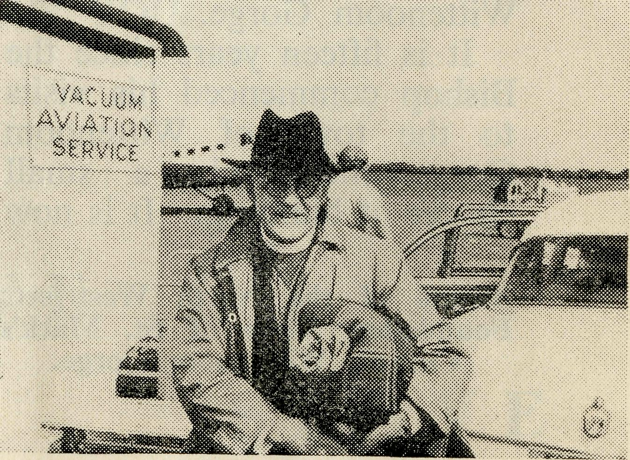
and myself, and especially for the Church at Wittenoom. Since prayer means action, he enclosed a cheque for £2. The Junior Christian Endeavour Group from the Parish of Moss Vale sent a gift. A lady aged 86 from Devon, England, said she prayed too and gave. Then in Wittenoom there were those who really did care. The boys and girls who listened so well at school; the Secretary of the Church dedicated his skill and wide experience as a designing draftsman to plan a Church. A structure which could be built by the local folk and which would fulfill the strict conditions imposed by isolation and climate had to be kept in mind. A building for one purpose—God's Glory.
The next morning, after a busy day of Services, the
The Right Reverend John Frewer recently achieved distinction. He made his 1000th air trip by commercial airlines. His vast Diocese of North-West Australia makes air transport a vital part of administration.
Bishop asked me to drive him to Port Hedland. The first twenty miles the road skirts the foot of the mountains. The deep bays and headlands gave the effect of a steep coastline.
To add to the illusion, the van plunged and vibrated on the waves of corrugation and dust plumed back like red spray. There was too much noise for conversation as we began our five or six hour homeward journey and I was in a thoughtful mood.
I thanked God for the start made, for the gifts and above all the prayers of so many; and my own prayer was, that as that Cross is raised over the homes at Wittenoom, many may discover in their lives its meaning and joy and peace which the Living Saviour alone can give.
Dr. Ross Chambers, his wife and family now occupy the Medical Officer's home at Ceduna. They are missed by Cessnock friends, but most welcome to B.C.A. work.
Dr. Chambers' arrival relieves Dr. Merna Mueller of some of the strain. All B.C.A. friends owe Dr. Mueller a great deal of appreciation. Without her sacrificial service the Flying Medical Services would have been in a much poorer condition.
* * *
Thank you, Dr. Chris. Robertson (Adelaide), for your timely assistance at Ceduna while the staff awaited the arrival of Dr. Chambers.
* * *
Sister Colleen Ennever (Wollongong) is now with the B.C.A. nursing staff. Sister is assured of a warm welcome to the family and will be remembered in the prayers of supporters.
* * ♦
Wudinna staff has said farewell to Sister Watt (Adelaide) and that means more trained nursing staff must be found.
Sister Gwen Brunt (Victoria) joins the staff early in 1960. Her arrival will give relief to the nursing staff.
What staff does B.C.A. need? Here are some opportunities:—
- Double Certificate Nursing Staff.
- Cook for Old Folk's Home.
- Domestic helpers (cooking experience helpful).
- Clergy (Priests Orders) and trainees.
His Grace the Archbishop of Melbourne was a welcome visitor to B.C.A. work in South Australia. It was a flying visit both in time and transport. His Grace flew 1,180 miles in three days and was in the B.C.A. Lockheed for eight hours. He gave willingly of time and thought and the Services and Addresses were appreciated by all who were privileged to attend.

18
The Real Australian
December, 1959
December, 1959
The Real Australian
19

CHRISTMAS GIFTS
REMEMBER - B.C.A. GIFT SHOP
Chinaware — AAulga Wood — Crystal — Pottery — Fur Koala Bears and Kangaroos — Cutlery — Text Plaques — Novelties —
Souvenirs.
GIFTS FOR ALL OCCASIONS
You help the Bush Church Aid Society when you shop at
B.C.A. GIFT SHOP
135 Bathurst Street,
SYDNEY.
Mrs. Ray Brooks (Menin-dee) and the members of her family are assured of Christian sympathy upon the sudden death of her father, Mr. Coulter (Victoria).
* * ♦
Miss R. Close is on duty again in the Sydney Office. Her service will be a big help with the ever-increasing office work.
* * *
The Port Lincoln Hostel has another addition to the family. Welcome to Beth Hummerston, and all good wishes to Mr. Stan and Mrs. Hummerston.
* ♦ ♦
Broken Hill Boys' Hostel will be under the care of Mr. A. and Mrs. Dean (Seven Hills, N.S.W.) in 1960. Supporters will remember them in prayer.
* * *
Mr. and Mrs. Calder found it an increasing strain to look after Broken Hill Hostel. B.C.A. Council passed a motion of deep appreciation for the service given. Mr. Calder is not leaving B.C.A. as he now becomes a Head Office Staff Worker.
* * ♦
The Women's Auxiliaries have been active throughout the year. Thank you for the interest aroused by the hard-
working women in both Sydney and Melbourne. The financial results have helped to relieve the cost of B.C.A.'s growing enterprises. We would like to have more groups of women formed into auxiliaries.
* * ♦
The three Rallies stimulated interest in B.C.A. and encouraged all who attended. Melbourne had a good collection of Episcopal visitors with His Grace the Archbishop of Melbourne giving a report of his experiences with B.C.A. Flying Medical Staff. The Bishop of Ballarat was Chairman and the Bishop of Willochra told the assembly about his American trip and the work in his vast diocese. It was pleasing to have the Bishop of Gippsland and the former Bishop of Nelson (N.Z.) on the platform.
Wollongong was the second Rally with Archdeacon H. G. Begbie as Chairman. Sydney followed with His Grace the Archbishop of Sydney as Chairman and the Rev. C. W. Rich to present the "North-West Challenge"!
All Rallies returned record offerings and gave much inspiration.
# ♦ #
All supporters must feel great concern at the increased cost of postage. This issue
endeavours to incorporate some things which have been separate letters in the past. Every penny saved means that much more for the work. The Christmas Letter, thanks and reminders to Box-holders are in this issue. You will appreciate the attempts to keep postal expenses to the minimum level.
♦ * ♦
Copies of "Far West", by the Rev. L. Daniels (the Flying Padre of Wilcannia), are available at 10/6 , postage 6d., at the B.C.A. Gift
Shop.
* * *
Garden Parties at Pennant Hills (Mrs. Shain) and Hunter's Hill (Church); Luncheons at Burwood East (Mrs. Ker-
shaw), Meadowbank (Mrs. Coleman); the Annual Gathering at Clovelly have all helped to extend B.C.A. interest during the year.
He * *
Clerical work and bookkeeping have become an increasing task for Sister Dow-ling and the Doctor. The position will be relieved with Mr. Frank Burner of Ceduna taking this responsibility. Mr. Burner is given a warm welcome to B.C.A.
* * *
B.C.A. staff and supporters assure the President, the Most Reverend H. R. Gough, of their prayers as he undertakes the additional duties entailed as President of the Church in Australia.

20
The Real Australian
December, 1959
December, 1959
The Real Australian
21

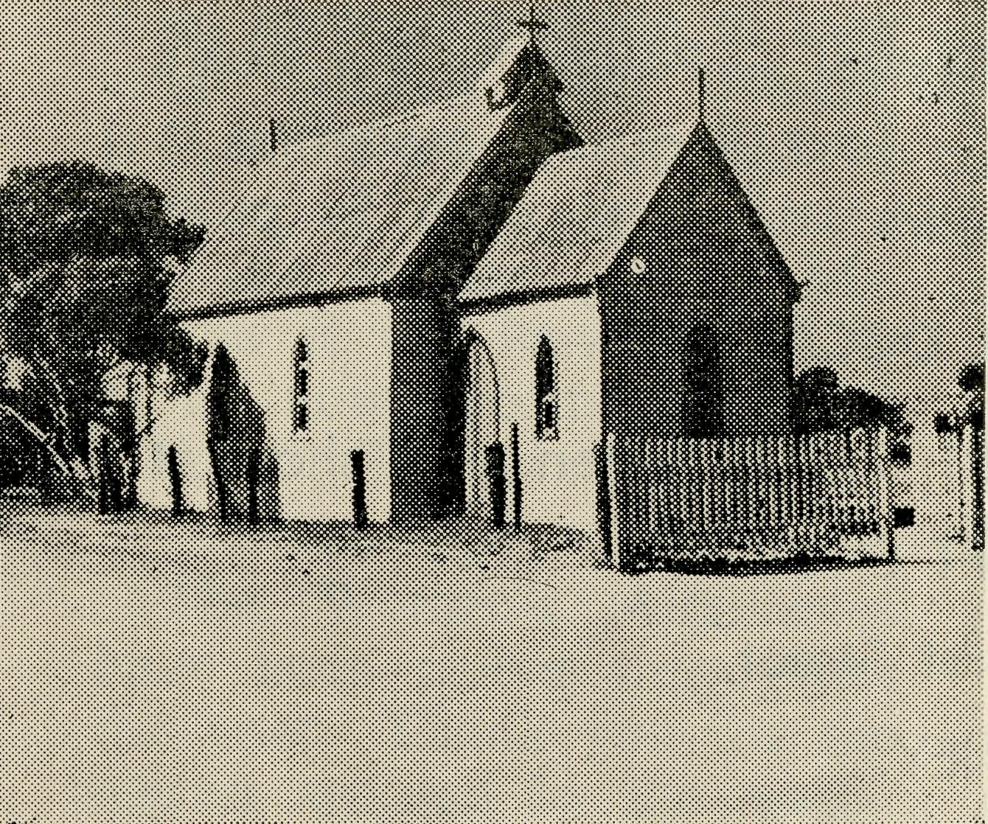
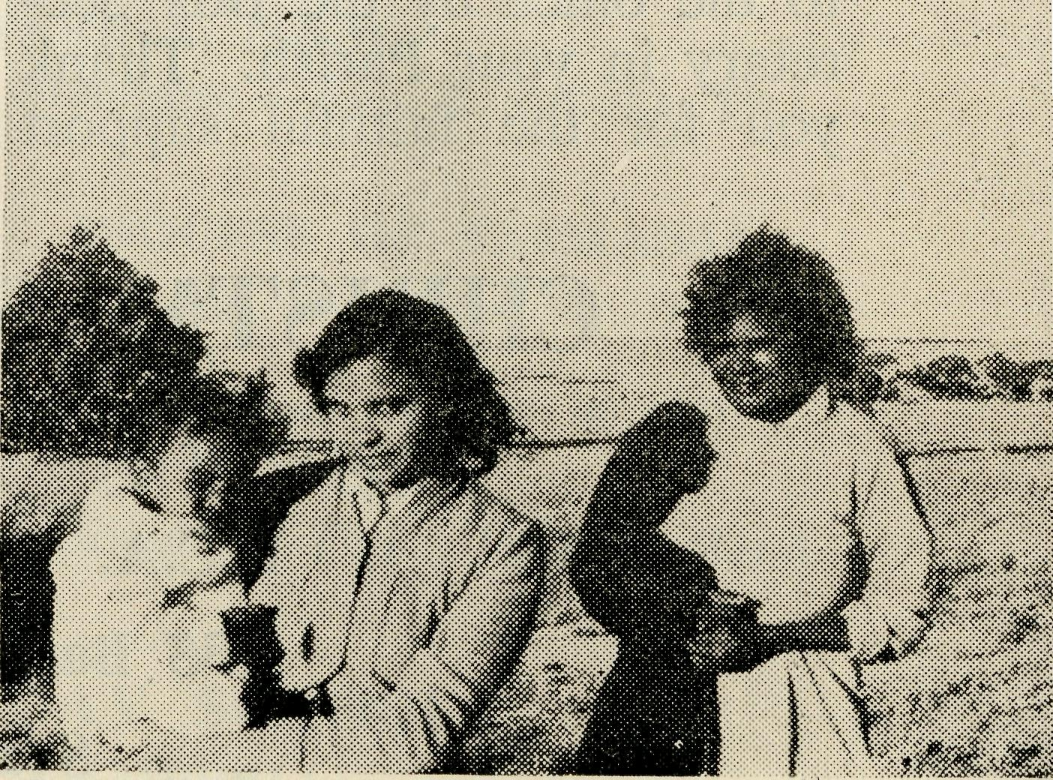
AN UNUSUAL MISSION
(Archdeacon G. R. Delbridge)
It all began with a letter from the Rev. Tom Jones asking if I would take a mission at Penong and Coorabie and district. In due course I replied to his letter by a telegram which he received whilst he was on patrol along the Transcontinental Railway Line. At Adelaide Airport on the Tuesday morning I watched the plane being loaded with human cargo, a patient on a stretcher, and it was not until I found myself as a guest at the Penong Hospital with Sisters Loane and Roberts that I realised the patient on the plane was going, as she described it, "home" to be in the hands of the fine Christian women at the B.C.A. Hospital. There I realised that the mission
which I had been asked to conduct was only part of the whole of the Church's Christian witness of day by day Christian service. The Mission was not the kind of mission that I envisaged, not by any means, and it had the two definite characteristics of visiting plus services and meetings. The mission began at Penong in the old Church which is held in place by strong railway lines forced into the ground. There is no light in the Church save kerosene lamps, but the Rev. Tom Jones, in his resourceful way, had rigged up a generating plant which he used during the mission not only for light but to operate the 16 mm. sound projector.
The next day we began our visiting campaign. Miles and miles over sandy tracks or dusty roads, from homestead to homestead, and always there was a great welcome to their familiar friend, the
St. Alphege's Church, Penong.
Rev. Tom Jones, and his visitor. At Coorabie, as a result of the visiting campaign we had almost 100 per cent, attendance of Anglicans on both nights that the mission meeting was held. Although I must say that the second night when the film was screened, there was a greater attendance with others from the district added.
The men, who are quite hard to get to Church, turned up. At Penong and Coorabie the mission consisted of two main meetings, but at Penong one of the hightlights was the women's meeting on the Friday afternoon when question after question about Christian life, about the Christian home, about bringing children up in situations which were different from those in the city, were brought forward. The visiting proved to be most valuable from the point of view of breaking down barriers, creating confidences and letting people see that an Archdeacon also is an ordinary human being. There was something sacred about a meal, for it brought us closer to the people to whom we were to minister
Penong—some of Doctor's patients.
in our talks and services. Literature proved to be a great boon during the whole time. In each of the meetings Bibles, Testaments, and Bible Reading helps, and other helpful, wholesome literature sold at a tremendous rate, and if nothing else was done, Christian literature went into the homes of people who find that ordinarily the only thing available is the weekly magazine and the comic.
Fowler's Bay caused me to think—that beautiful place, and yet a place that fills one's heart with sadness because of the encroaching sand gradually covering the town and because of the population move. There is in Fowler's Bay just one teenage boy, and when we arrived at his home it was the responsibility of Mr. Jones to "fix up" his school transceiver. When lunch was over Mr. Jones made contact with

22
The Real Australian
December, 1959
December, 1959
The Real Australian
23

Mr. George Cameron at Ceduna and talked with him about the special school coaching session that was to take place in a few afternoons' time especially for this lad.
As I came home from the mission I wondered what I had really done as a missioner and I realised that the mission of God's church goes on all the time. The mission of the
clergy, the doctors, the sisters, the radio staff, the pilots and the people who live in this part of the world who endeavour to witness and live for Christ, and it seemed to me that it was my job to learn from them and to appreciate their contribution in their daily mission of witnessing for Christ.
The Bush Church Aid Society
for Australia and Tasmania
PRESIDENT: The Most Reverend H. R. Gough, O.B.E., D.D.
Hon. Clerical Secretary: Rev. Canon E. Cameron.
Hon. Treasurer: Mr. T. S. Holt.
Organising Missioner: Rev. J. R. Greenwood, Th.L.
Deputationist (N.S.W.): Rev. C. W. Rich, Th.L.
Victorian Secretary: Rev. E. G. Beavan, M.A.
HEADQUARTERS OFFICE: VICTORIAN OFFICE:
135 Bathurst Street, Sydney. Allan's Buildings,
'Phones: BM3164, BM 3780. 276-278 Collins Street,
Telegraphic Address: Melbourne.
"Chaplaincy, Sydney." Telephone: MF 8962.

LISTEN TO THE BUSH PADRE
2GB Every Saturday 11.15 a.m.
2NX Every Sunday 4.45 p.m.
2CH Alternate Sundays 8.30 p.m.
2KA 1st and 3rd Fridays each month 4.30 p.m.
2LT 2nd and 4th Mondays each month 1.45 p.m.
Dear Supporter,
Many of you assist the work of B.C.A. with regular gifts in your Bark Hut Money Box.
Your name appears in the list of Boxholders forwarded to the office by the Box Secretary in your Parish. Thank you for the faithful support
and consistent interest which provide valuable assistance with finance to maintain the many services of the Society. May God bless you.
Yours sincerely,
JOHN GREENWOOD,
Organising Missioner.
FIELD STAFF:
DIOCESE OF ADELAIDE, S.A. Ceduna, Penong, S.A.—Rev. T. V. Jones, Th.L., Rev. R. Neve, Th.L.
Cleve, S.A.—Rev. B. Buckland, Minnipa, S.A.—Rev. A. Williams,
Th.L. Th.L.
DIOCESE OF WILLOCHRA, S.A.
Orroroo, S.A.—Rev. J. Winter, Quorn, S.A.—Rev. G. Fuhrmeister,
B.A., Th.L. Th.L.
Peterborough, S.A.—Rev. I. Booth,
Th.L. (Grant in aid).
DIOCESE OF BALLARAT, VIC.
Heytesbury Mission, Vic.—Rev. B. Otway Mission, Vic.—Rev. T.
Viney, Th.L., Timboon, Vic. Morgan, Th.L., Beech Forest,
Vic; Rev. B. J. O'Grady, Apollo Bay, Vic.
DIOCESE OF RIVERINA, N.S.W. Wilcannia, N.S.W.—Rev. J. Stock- Menindee.—Rev. R. Brooks, Th.L. dale, Th.L.

CHRISTMAS SHOPPING
Remember
B.C.A. GIFT SHOP
135 Bathurst Street,
Sydney.

DIOCESE OF GIPPSLAND, VIC.
Croajingalong, Vic.—(Grant).
DIOCESE OF TASMANIA.
Tarraleah, Tas.~Rev. W. War-burton, Th.L. Poatina, Tas.—(Grant in aid).
DIOCESE OF THE NORTH-WEST
Port Hedland Mission.—Rev. D. M. Douglass, Th.L., Port Hedland, W.A.
MAIL-BAG SUNDAY SCHOOL
Director: Miss R. CAMPBELL.

