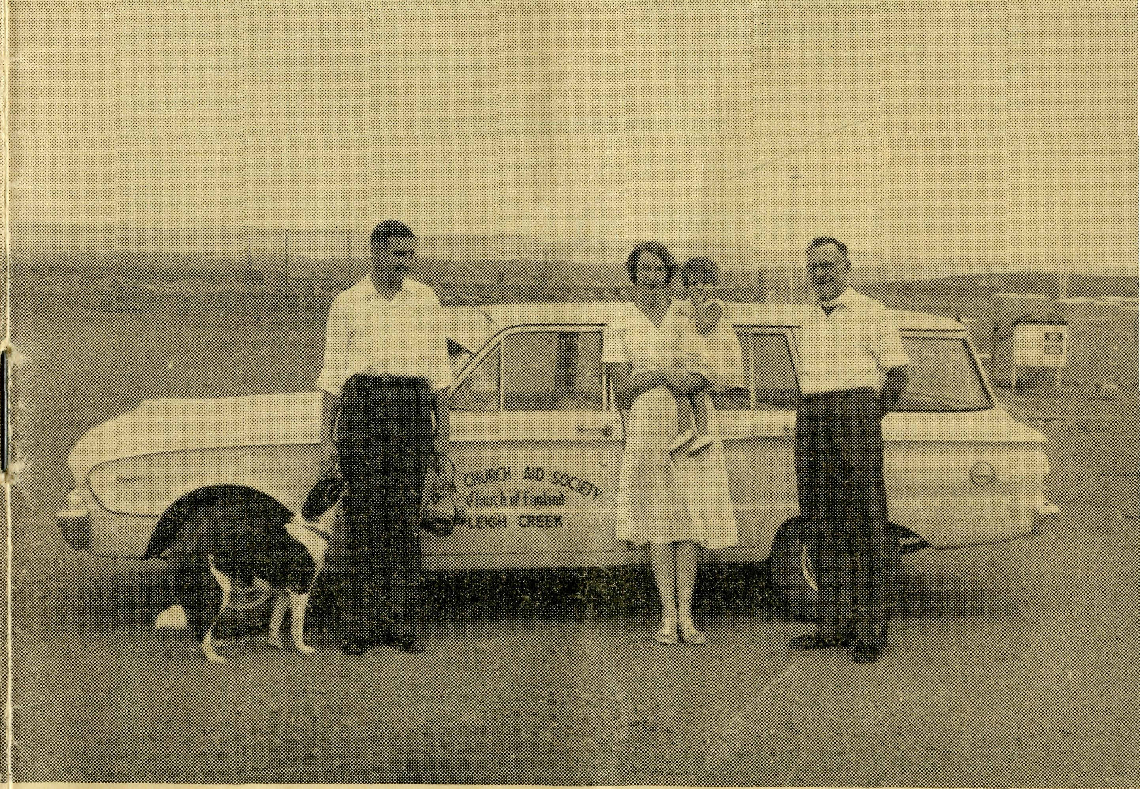
24
CEDUNA, S.A.
The Murat Bay District Hospital.
PENONG, S.A.
The Penong Memorial Hospital.
COOK, S.A.
The Bishop Kirkby Memorial Hospital.
TARCOOLA, S.A.
The Tarcoola Hospital.
RAWLINNA, W.A.
The Nursing Hostel.
WUDINNA, S.A.
The Central Eyre Peninsula District Hospital.
BOWRAL, N.S.W.
(Charlton Boys' Home).
BROKEN HILL, N.S.W. Mr. A. & Mrs. DEAN.
June, 1961
The Real Australian
FLYING MEDICAL SERVICES
HOSPITAL CENTRES:
Matron: Sister F. DOWLING.
Sisters: J. MILLER, G. HITCHCOCK, B. TIERNEY, M. BELL, R. TURNER, M. ROBEY.
Sisters: J. ROBERTS and V. COCHRANE.
Sisters: M. TARR and M. ROSS, G. BRUNT (Relief).
Sisters: V. HOLLE, M. HOPE and V. BROWNINGS (Relief).
Sister: E. THOMAS.
Matron: Sister M. DEAN. Sisters: A. HAYWOOD, J. ZILL-
MAN, N. WILKINS, Miss W.
IKIN.
DENTIST:
Mr. L. JAUNCEY.
PHARMACIST:
Mr. J. ARGALL.
MEDICAL OFFICERS:
Dr. R. CHAMBERS. Dr. M. MUELLER.
PILOTS:
Mr. ALLAN CHADWICK, Mr. W. BEDFORD.
AIRCRAFT:
Cessna 210. Auster.
WIRELESS COMMUNICATIONS BASE:
Ceduna Base Operator: Mr. GEORGE CAMERON. (Asst.): Mr. P. DAVISON.
FLYING MEDICAL SERVICES CENTRE, CEDUNA, S.A.
Mr. F. BURNER (Clerical Officer).
CROAJINGALONG NURSING SERVICE, VIC:
Sister I. GWYNNE.
HOSTELS FOR SCHOOL CHILDREN
PORT LINCOLN, S.A.
Mr. S. & Mrs. HUMMERSTON and Miss D. DUVER.
MUNGINDI, N.S.W. Mr. N. and Mrs. MELLOR.
EDGAR BRAGG & SONS PTY. LTD., 130 BOTANY STREET, WATERLOO
No. 36 (New Series), JUNE, 1961
3/- per annum, Post free.
Registered at the G.P.O., Sydney, for transmission by
Post as a periodical.

Rev. Jim and Mrs. Winter of Leigh Creek, and the Organising Missioner.

The Real Australian
June, 1961
June, 1961
The Real Australian

The Organising Missioner’s Letter
The Bush Church Aid Society
for Australia and Tasmania
PRESIDENT: The Most Reverend H. R. Gough, O.B.E., D.D. Vice-President: The Most Reverend F. Woods, M.A., D.D. Hon. Clerical Secretary: Rev. Canon E. Cameron. Hon. Treasurer: Mr. T. S. Holt. Organising Missioner: Rev. J. R. Greenwood, Th.L. Deputationist (N.S.W.): Rev. C W. Rich, Th.L. Victorian Secretary: Rev. J. Stockdale, Th.L.
VICTORIAN OFFICE:
Allan's Building,
276 Collins Street,
Melbourne.
Telephone: MF 8962.
HEADQUARTERS OFFICE:
135 Bathurst Street, Sydney.
Thones: BM 3164, BM 3780. Telegraphic Address: "Chaplaincy, Sydney."
Mr. A. Kirkby, 7 Ruthven Avenue,
Glandore. Telephone: LF3268.
SOUTH AUSTRALIA:
Rev. T. J. Hayman, Th.L. St. Matthew's Rectory,
Marryatville. Telephone: FA 1022.
URGENT STAFF NEEDS
Children's Hostels—Two Assistant Matrons.
Broken Hill—Boys, Mungindi—Girls and Boys. Two Ordained Men. Medical Staff—Doctor, Nurses.
B.C.A.
BRINGING CHRIST TO AUSTRALIA
Dear B.C.A. Supporters,
Do you care more for what people think about you than what God thinks of you?
He cares so much for each of us that He gives to the point of Divine Sacrifice. It is His Call which comes to all professing Christians.
But what happens when someone lets it be known that he feels his training is needed in missionary enterprise? Many face unnatural criticism and hard-to-bear persuasion.
Time and time again the challenge to serve in places far removed from cities has been sounded. Just as many times men and women have found excuses.
"When you go bush you'll be forgotten. Think of what will happen when a large Church wants a Rector. You'll be out of the running."
These things are said too often when clergymen show interest in outback work.
A young women finishes her nursing training. To go bush seems the last resort of stupidity and a waste of training. Or is it that she may miss a great opportunity to settle into suburban life nearer home?
"COME YE AFTER ME"
Our Lord knows that His followers will have to make decisions. Did He not Himself "steadfastly set His face to go to Jerusalem". There was suffering for Him but there was the glory of His Resurrection and the assurance of ours. As followers, we must be prepared to lose ourselves and allow Him to take control. His promise is true for all of us: "Whosoever will lose His life for My sake the same will save it".
We are called to give and not count the cost and thus we will prove that, "if any man serve Me, him will My Father honour".
WHAT CAN I DO?
I can prove His power and readiness to provide me with all the means needed to serve and win others.
He depends upon people with specific training to put their experience into service. Doctors and nursing staff have the opportunity to serve in country medical work. While you remain outside such service, many Australians will be without vital necessities in time of anxiety. Some will bear untold suffering of mind and body because trained

The Real Australian
June, 1961
June, 1961
The Real Australian

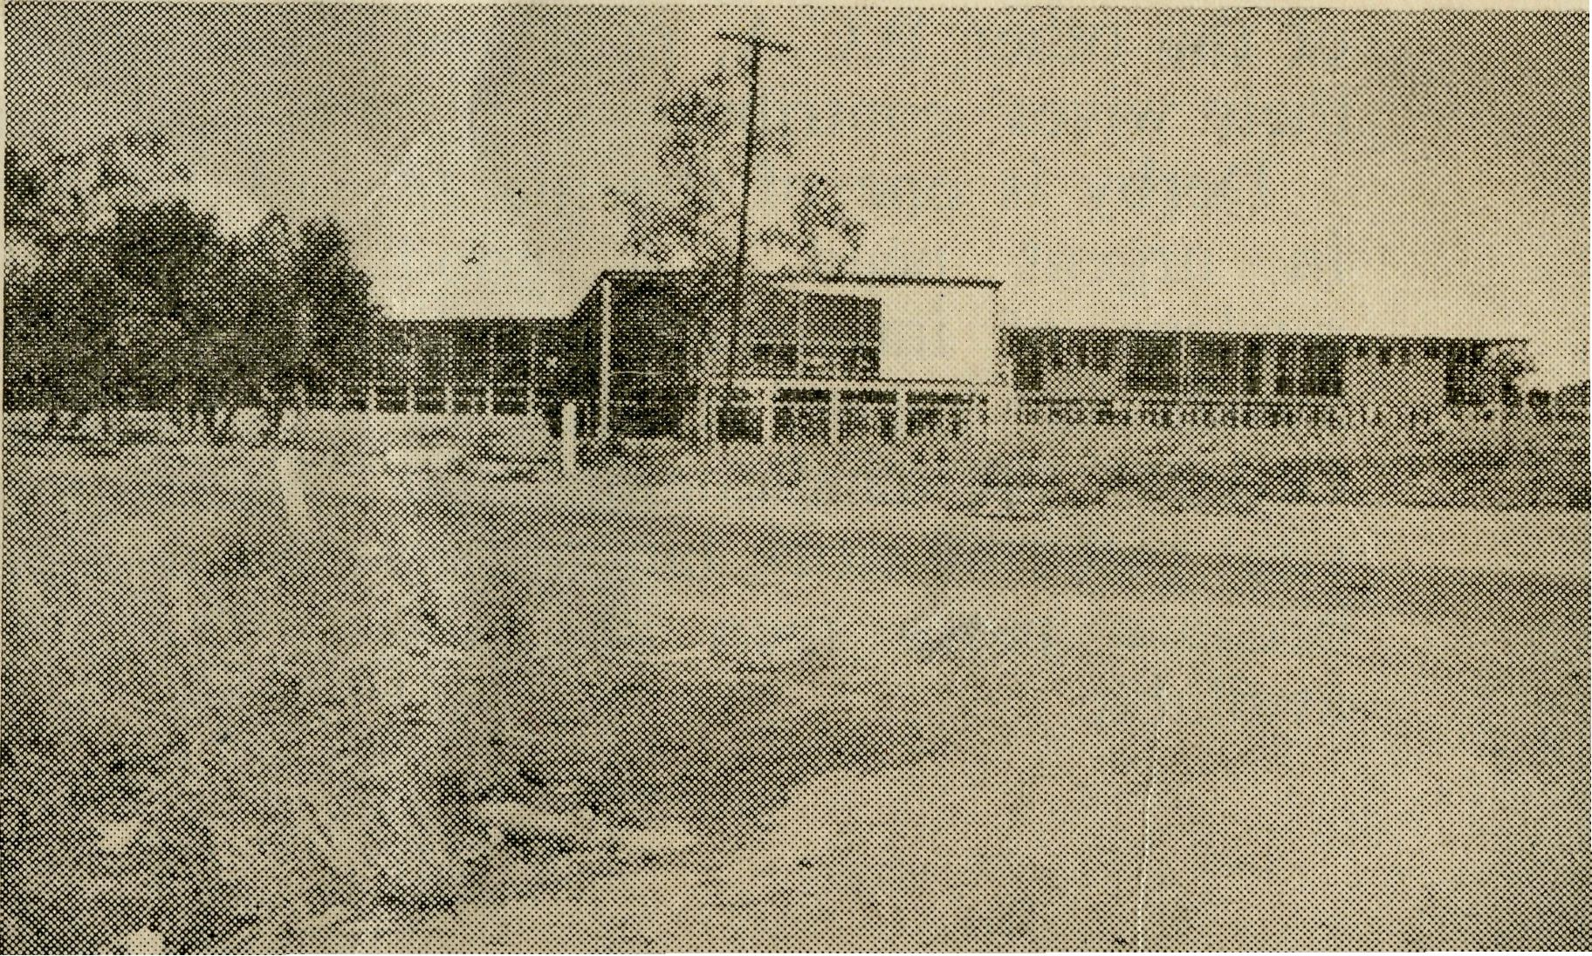
Christian people will only think of large cities and the amenities they offer.
MEDICAL SERVICES
B.C.A. hospitals and medical outposts are fitted with equipment equal to any city medical centre. The recurring problem is to find people capable of putting the equipment into Christian service.
Doctors and nurses are called to put their faith into practice.
HOSTELS
A privilege is given to some who realise the tremendous potential lying dormant in children from isolated places. Modern transport and communication shrink distances, but they cannot provide personal fellowship with others.
The Hostels of B.C.A. bring together large families of children from the early days of school life to the Leaving Certificate standard.
It has been possible to maintain the Hostels with Wardens and Matrons giving life and energy to the point of exasperation. How much more will be done to teach the Christian Way of life with assistance is known only too well by those who bear the burden of such work.
It is possible to combine domestic work with Christian service. Broken Hill needs
an assistant to minister to the boys and Mungindi appeals for help with the girls and boys.
Before many more months have passed the Darwin Hostel will require two women to assist the Warden and Matron.
By the time you read this I hope the contract for the Darwin project will be placed. Tenders have closed and prices are now being considered.
You will, I know, be praying for this great expansion and for final relief of the £60,000 debt.
B.C.A. AND CLERGY
What does Our Lord say to my brethren. "Feed my lambs. Feed my sheep." There are many who will never know the joy of receiving the ministry of the Gospel and Sacraments. They are not so very far removed and are an essential part of this great nation. Australia needs men and women in country areas if primary production is to reinforce secondary industry.
Technicians, engineers, and heavy industry workers, are certainly needed to supply equipment. Basically, however, we all depend upon each other.
Reduce the primary output, remove the people who main-
tain our railways, roads and telephones and the country shrinks. We cannot have everybody in the cities.
In the closely settled areas we have our organised Church life from whence spring men inspired to "Go and preach the Gospel to every creature". That there are sixteen men in the Society field work and twelve young men training is cause for thanksgiving.
It is not cause to sit back and think all the needs are supplied. Each man will tell you that he adds to his district places which have no hope of a regular ministry. The intermittent visitation is better than nothing.
Then there are places where the Church of England needs to establish a resident ministry but cannot do so because clergymen will not go bush in greater numbers.
A number of Dioceses, with their whole area or the larger part in country districts, plead for ordained men.
Hospital at Derby.
CHURCH AND STATE
Huge sums of money are either being spent or sought for development of many country places. Such public works will take people into small settlements or increase the population of existing towns.
Many will find that the Church in the large town becomes a memory of past days. Some will endeavour to do their utmost to preserve the training received. Others will swell the numbers of people who, having been left to their own resources for so long, give up the idea that the Church has a living message.
We must develop our gifts and utilise the bountiful natural resources in this wonderfully blessed country. By thus progressing we all benefit from increased production of primary products and the supply of raw materials for our industrial expansion. Improved roads and means of communication

The Real Australian
June, 1961
June, 1961
The Real Australian

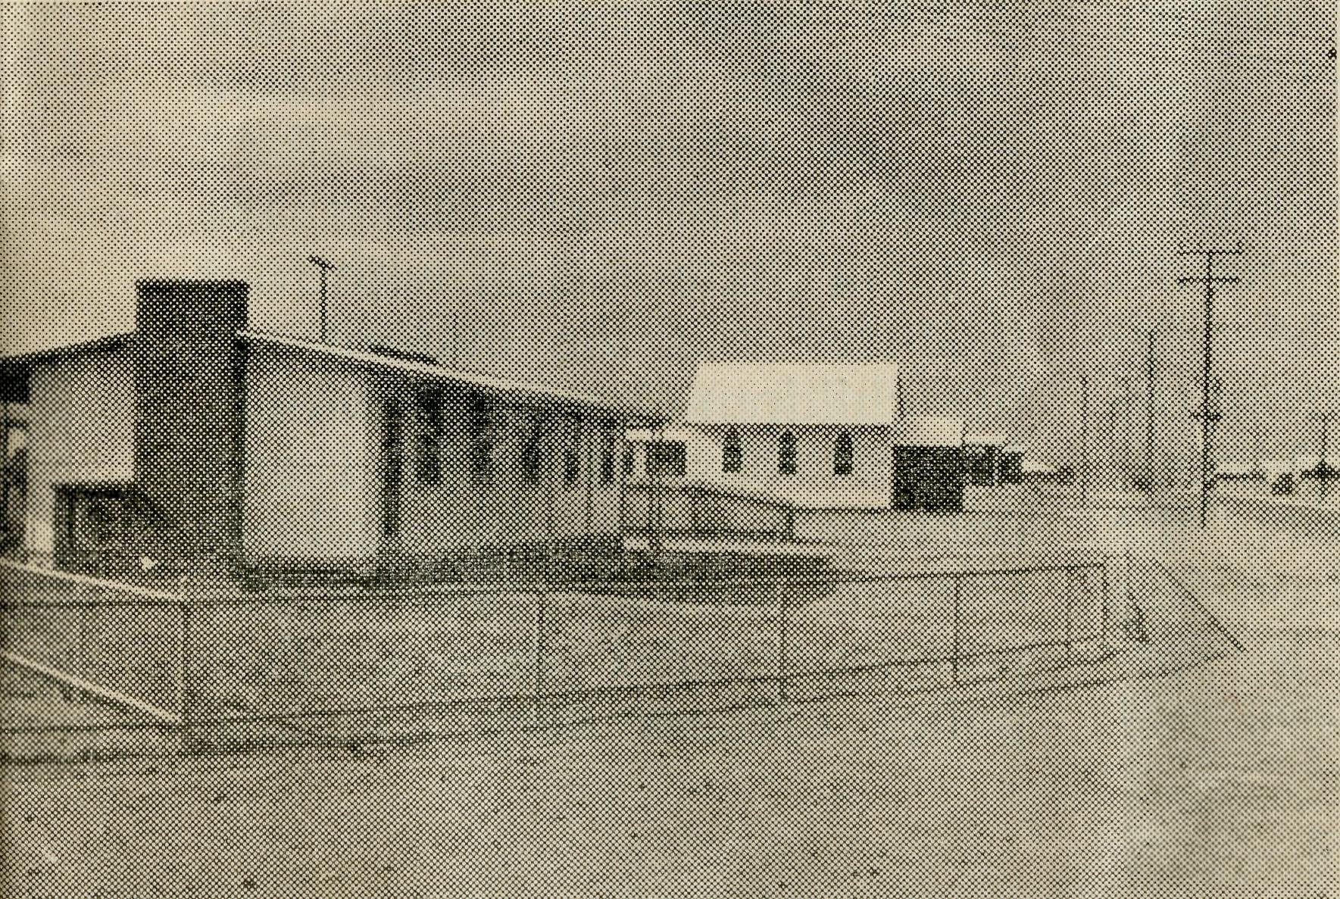
PRAY FOR B.C.A.
SERVE WITH B.C.A.
GIVE TO B.C.A.
bring benefit to the whole population, but someone has to go and live a long way from cities to give us the improved national developments.
ORDAINED MEN WANTED
A period of service in an outback area can give a man most valuable experience. He will often find himself getting to know people and their basic needs more deeply than in a place where humanity in the mass poses the problem of knowing thousands.
He may find small numbers in a number of country Church buildings. By the end of a day, however, he can often number more people than his city brother in one Church.
In the event of a man being married, let his wife read an article in this issue by Mrs. Bernard Buckland. (p. 19). The Reverend Bernard and Mrs. Buckland have shown devotion of the highest order to their country work. What they are doing is typical of the other B.C.A. men and their wives' contribution.
Derby is one of the places in urgent need. A good nucleus of interested people awaits a man in Priests' Orders. A challenging and vital piece of work languishes because more men are not available.
Similarly in other country areas the need is pressing and the answer of ordained men is awaited.
"Pray ye therefore the Lord of the harvest that He will send forth labourers into His harvest."
TRAINING
There are twelve men being trained in theological colleges for work sponsored by the Society. It is indeed encouraging to have such a number.
The financial part of such training increases our need for support from our friends. The general funds can be eased considerably if scholarships are available. There may be some who will adopt a trainee and so provide the expense of theological college fees.
WELCOME TO NEW WORK
There was a good representation of B.C.A. staff at Leigh Creek when the Rev. J. Winter was instituted by the Bishop of Willochra. Allan Chadwick flew me from Port Lincoln to Leigh Creek in the Cessna and showed the ability of the aircraft to fill our needs.
Mr. and Mrs. Winter have undertaken an arduous ministry, and depend upon all the support we can give them by our prayers and gifts.
The Rev. S. Thome was later instituted at Orroroo
and he and his wife and family given a warm welcome to their new work.
At Port Hedland, the Rev. O. Weaver has taken up duty to assist in the Diocese of North West Australia. The Bishop needs our help if the Church of England is to give an effective ministry in the vast Diocese. The challenge remains for a man in Priests' Orders to offer for further expansion at Derby.
B.C.A. VISION
Great things have been done by faith and ahead lies a field of service with opportunities to do great things for God. It calls for men and women of faith and courage. There are clergymen, doctors, nurses and children's hostel
workers needed to serve Jesus Christ and His scattered people.
As the field workers reach out they depend upon many who will pray and give to meet the expenses. The aim of the Society is to win "Australia for Christ" and to do so means equipping and maintaining those who go forth by faith. I know you will feel it is worthwhile to have a share in this campaign. God calls us to great things in His service and the response to increasing challenge rests upon the measure of your support by prayers and gifts.
Leigh Creek, S.A.
Rectory and
Church.
Yours in His Service, JOHN GREENWOOD.

The Real Australian
June, 1961
June, 1961
The Real Australian

The Parish of the Murchison
(Rev. Arthur Williams)
As I sat down in my study of our home at Mount Magnet, my eye first hit upon the name on the letterheads in my drawers, "The Parish of the Murchison". Sounds impressive doesn't it. Behind the door a map shows all the details in a glance. Five towns underlined in red stand out, and around these towns on every side another eighty names mark the sheep stations of the parish. All this in an area of roughly 30,000 square miles.
In a cupboard an older map, headed "The Murchison Goldfields", shows an additional six or seven towns. Places like Lennonville, once with a population of 1,500, now and old railway siding; Day Dawn and Big Bell, once with many thousands, now a few old buildings; Youanmi, once with its airfield and streets and recreation grounds and Churches, now only a few stones on the ground. Gold had made the Murchison boom, now apart from the two mines in Mount Magnet and a few prospectors, the Parish of the Murchison has settled down to what it, perhaps, will always be.
As I move about I am constantly being reminded by the older folk of the once great and thriving mining towns, of the thousands of people here and there, of the six and seven hotels of this place or that place. I hear of the former clergy and of the several parishes and all I can see is one large and struggling district, seeking help outside. There is a past, but what of the future? Are we wasting our time? So few seem to be concerned even in the slightest way with things Eternal.
BUT let us look again. Let us forget the glories of the past. There is a present and there is a future for the "Parish of the Murchison".
Here at Mount Magnet, with a population of about 1,000 and rising as new houses are being built, there are two schools, one a R.C. convent with three sisters, the other a State school with four teachers and the majority of the children Anglican. Mount Magnet has its hospital and doctor, two banks, railway station, airfield, post office, plus stores and garages. Two police officers keep law and
order. Four hotel keepers and an S.P. betting shop are supported, yet apart from the R.C. Priest no other denomination had a man resident here until B.C.A. came to reestablish the work.
At Cue, fifty miles away, there is a two teacher school, police officer, post office, stores, two hotels and a betting shop and no resident minister of any Church.
Meekatharra, 120 miles away, is bigger than Cue. It has a very big hospital, a doctor, airfield, post office, two police officers, three teacher school, four hotels and a betting shop.
Wiluna, 240 miles away, and Sandstone, 100 miles from here, each have their schools, policemen, hotels.
In all the parish, there are enough people to support 15 hotels and three betting shops; enough children at the State schools to keep 12 teachers occupied. The Police Department see fit to have seven police officers in the district. Three hospitals and two doctors are kept busy. A big proportion of the people are nominally Church of England, yet, for almost ten years before B.C.A. took up the work,
there was no resident Anglican clergyman. Is it any wonder that people seem so neglectful of the things of God. "... and how shall they believe in Him of Whom they have not heard? and how shall they hear without a preacher."
The Bishop visited each town as often as he could, and I would dare say that had it not been for these visits the Church may have disappeared altogether.
Like many other places throughout this land of ours, the parish of the Murchison suffered when it ceased to be as compact as a parish in the city or suburbs. The parish will no doubt always remain a scattered outback parish. We pray that it will never again remain neglected for so long.
After three years, life is returning. In two years a Church and Chapel were built. In 1960 another Church was completed and another chapel commenced. The Parishioners have contributed almost half of the cost of a new vehicle for use in the parish. Spiritually, things are still hard; however, with the prayer of God's people for the Parish of the Murchison, the Church in this place will live.

10
The Real Australian
June, 1961
June, 1961
The Real Australian
li

Mr. P. Davison has joined the staff at the Radio Control Station to give Mr. George Cameron welcome assistance.
Thanks to Dr. Margaret Taylor, the Wudinna district has been given medical assistance for a period when the local Council was left without a doctor.
An urgent plea has been made for B.C.A. to supply a doctor for as long as possible. Here is a wonderful opportunity for Christian witness, with a modern hospital and capable staff, to make the service effective.
Christian doctors are challenged and are needed for country service.
Sister Sladden has given welcome relief at Rawlinna whilst Sister Thomas had a holiday, and Sister Brownings has joined the nursing staff for a period of relief duty. It means accumulated holidays for hard-worked nurses can be given. Thank
you for such timely assistance.
^ ♦ ^
Welcome to Sister M. Bell, and congratulations upon the successful completion of her Infant Welfare Certificate. Sister Bell has returned to Ceduna where her service is
most appreciated.
* * *
We will miss Mrs. Lowe (Senior) at the Fair this year. Friends will remember her as she visits members of her
family in America.
* * *
Nursing staff with deep Christian conviction can have valuable opportunities to serve Jesus Christ in B.C.A. hospitals. Double Certificate nurses are urgently needed, and the plea goes out for trained staff for Christian hospital work. Who will come over and help?
* ♦ *
Miss Judith McMahon is now assisting Miss Campbell in the Mail Bag Sunday School. It is good to have people ready to serve when the need arises.
BUSH CHURCH AID SOCIETY
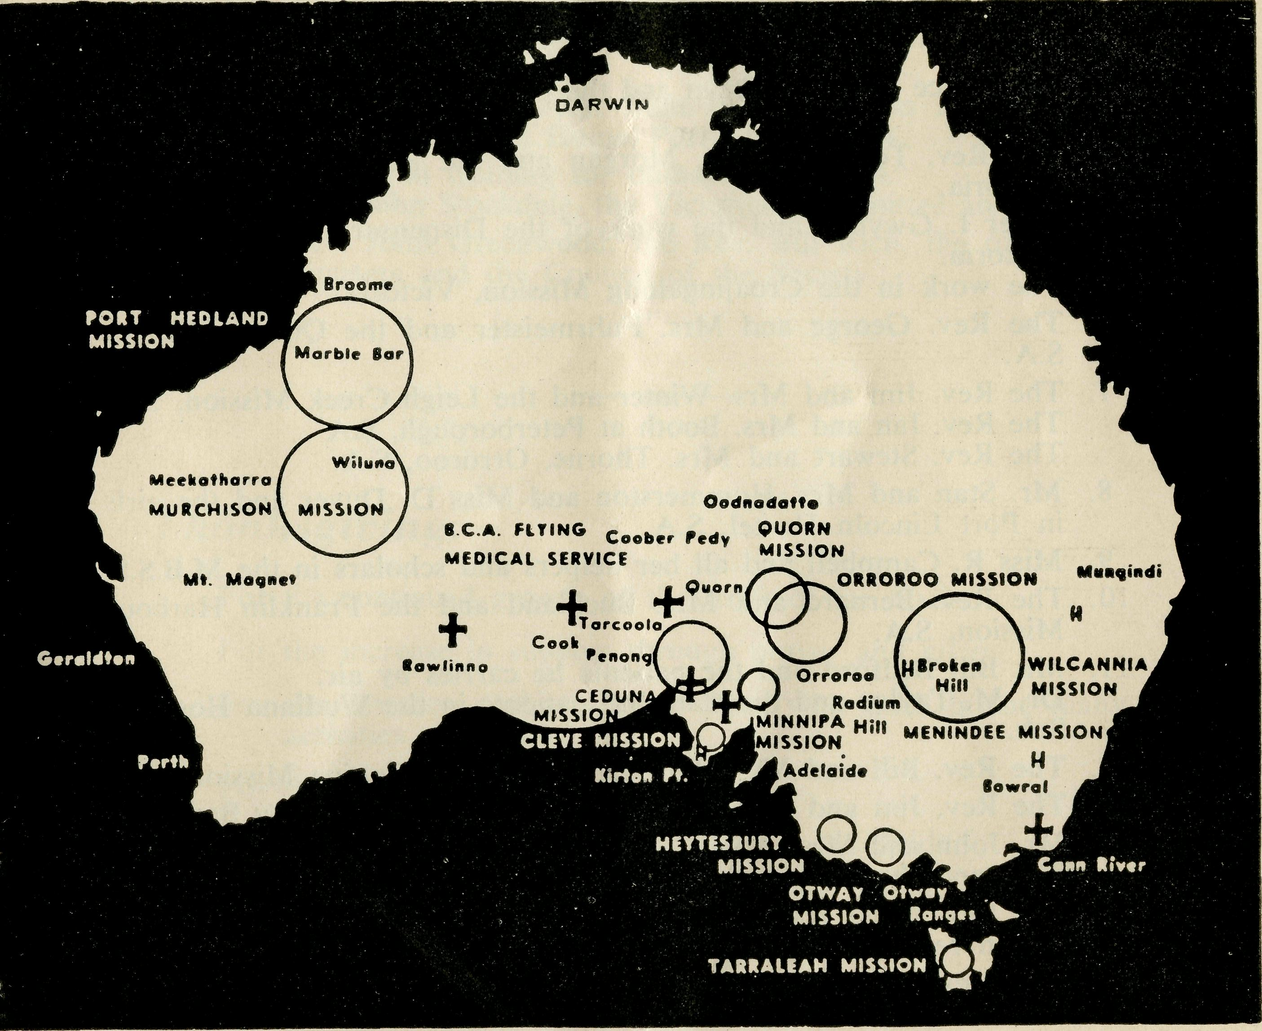
Map of B.C.A. work.
Topics for
Prayer and Praise

12
The Real Australian
June, 1961
June, 1961
The Real Australian
13

BUSH CHURCH AID SOCIETY
— Your Daily Remembrance —
- The Rev. Ray and Mrs. Neve and the Wilcannia Mission, N.S.W. The Rev. Ray and Mrs. Brooks and the Menindee Mission, N.S.W.
- The Rev. Brian and Mrs. Viney and the Tarraleah Mission, Tasmania.
- Mr. Bruce and Mrs. Dean and the boys of the Broken Hill Hostel, N.S.W.
- The Rev. Tom and Mrs. Morgan and the Beech Forest Mission, Victoria.
- Sister I. Gwynne and the work of the Dispensary at Cann River, Victoria.
The work in the Croajingalong Mission, Victoria.
- The Rev. George and Mrs. Fuhrmeister and the Quorn Mission, S.A.
- The Rev. Jim and Mrs. Winter and the Leigh Creek Mission, S.A. The Rev. Ian and Mrs. Booth at Peterborough, S.A
The Rev. Stewart and Mrs. Thorne, Orroroo, S.A.
- Mr. Stan and Mrs. Hummerston and Miss D. Duver and the girls in Port Lincoln Hostel, S.A.
- Miss R. Campbell and all her helpers and scholars in the M.B.S.S.

- The Rev. Bernard and Mrs. Buckland and the Franklin Harbour Mission, S.A.
- Mr. Bill Bedford and the patients he carries by air.
Dr. M. Taylor and the staff and patients in the Wudinna Hospital. S.A.
- The Rev. Bill and Mrs. Warburton and the Minnipa Mission, S.A.
- The Rev. Jim and Mrs. Smith and the parish of Streaky Bay, S.A.
- Mr. John and Mrs. Argall and the work at the Ceduna Pharmacy, S.A., and the Radio school teacher and children.
- The Rev. Theo Hayman and Mr. Alban Kirkby and South Australian representation.
- Mr. Neville and Mrs. Mellor, the girls and boys at Mungindi Hostel, N.S.W.
- Mr. George and Mrs. Cameron and Mr. Peter Davison at the Radio Base, Ceduna, S.A.
Mr. Frank and Mrs. Burner and the office work done in the B.C.A. Centre at Ceduna, S.A.
- Mr. Allan and Mrs. Chad wick and the Flying Medical Services, S.A.
- The Matron and Staff at Ceduna Hospital, S.A.
- Dr. Ross and Mrs. Chambers, Dr. M. Mueller and all medical services and patients. Mr. Lin Jauncey and the dental service.

- The Staff and Hospital Services at Cook and Tarcoola, S.A.
- The Rawlinna Nursing Home and Sister-in-Charge, W.A.
- The Rev. Ernest and Mrs. Withington at Timboon, Victoria, and the work in the Heytesbury Forest Mission.
- The Rev. Arthur and Mrs. Williams and the Murchison Mission, W.A.
- The Rev. Owen Weaver and the Port Hedland Mission, W.A.
- The Staff and Hospital Services at Penong, S.A.
- The Rev. Tom and Mrs. Jones, the Rev. Brian O'Grady, the Ceduna Mission, S.A.
- Mr. Roy and Mrs. Avery, Miss M. Farr, Miss H. Avis and the staff at the Old Folk's Home, Port Lincoln, S.A.
- All students in training for outback ministries.
The Rev. John Stockdale, the Victorian Committee and office staff.
30. The Rev. John Greenwood, the Rev. Bill Rich, the office staff at
Headquarters and the Council of the Society.
Thanksgiving:—
For the continued growth of the work of the Society.
For the increase in support through prayer and giving.
For the devotion and service of those who work in the many activities of B.C.A.
For the work of Auxiliaries.
For opportunities of service in new and old fields.
Special Remembrance
Pray for:
- Ordained Man needed for Derby (Diocese of North-West Australia).
- Nurses needed for B.C.A. Hospitals.
- Assistants needed at Broken Hill and Mungindi Hostels.

14
The Real Australian
June, 1961
June, 1961
The Real Australian
15

POST AND RAILS (Continued)
Prayer and Praise
For the Society.
O Lord God of our nation, Who hast commanded men to subdue and replenish the earth: Look in Thy love upon all who in distant parts of our land are striving against many difficulties, and are deprived the access of the means of grace. Strengthen and guide the Bush Church Aid Society and all members of the staff. Cheer and comfort them in discouragement and loneliness, bless their ministrations to the good of those they serve, and grant that the message of redeeming love may thus be rooted and grounded in our national life, to the glory of Thy Great Name through Jesus Christ our Lord. Amen.
For Nurses and Doctors.
O God, Who didst choose a beloved physician to set forth the life of Him Who went about doing good, grant that Thy strong tenderness and compassion may be manifest in the work of country doctors and bush nurses. Make them at all times alert to be faithful, as those whom Thou hast burdened and inspired with the honour of their calling. In lonely emergencies strengthen them with confidence that, having done all they can, they may with good conscience leave the issue to Thy power working within Thy law. Make them resourceful and of sound judgment, and hearten their labours with the energy of compassion and the firmness of duty that conquers weariness. Through Him Whose power is called forth by suffering, Jesus Christ our Lord. Amen.
For Church Life in Country Districts.
O Lord, who art present when two or three are gathered together in Thy Name, bless, we beseech Thee, the little far-scattered groups of brethren who in our wide land meet together to worship Thee. Give them a perpetual freshness of spirit, and the power to inspire in each other holiness, helpfulness, and understanding of Thy help. Refresh with the joy of enthusiasm those who endure weary journeys to Thy trysting place. Grant that these little companies of Thy servants may be united in the spirit of Christian charity, awaiting in love the time when there shall be one fold and one Shepherd. Grant that the common life of all communities may be purified by this spirit of charity from all meanness, falsehood, malice and idle gossip, and grant that they who share a common lot may draw strength from each other's virtues, and in their weakness help one another, through our one Lord, Jesus Christ. Amen.
Praise.
For the Blessings vouchsafed to the Society, for all kindly givers, and for the joy of service.
Miss M. Farr has been giving help at the Old Folk's
Home, Port Lincoln, S.A.
% % %
Domestic workers can find a place in B.C.A. work. In hospitals their service can be a valuable adjunct to the nursing staff.
Hostels for children provide privileges to train young Australians in Christian life and service. Broken Hill Boys' Hostel requires an assistant and Mungindi Girls' and Boys' are looking for help. Both positions offer a valuable opportunity for Christian women.
The needs are urgent, with both Wardens and Matrons becoming acutely pressed by the heavy strain of maintaining the Hostels without sufficient assistance. Can you answer the call?
♦ ♦ *
Thank you to the B.C.A. Women's Auxiliary at Moonee Ponds (Vic.) for a profitable year of fellowship and help. The Annual Report revealed a healthy interest in the Society's work.
* * ♦
The Rev. Tom Jones, at Ceduna, has a 16mm. movie projector, but needs an additional lens and film reel. The machine is proving a valuable asset, particularly for the
camps for children from the vast Nullarbor Plain. The cost of the lens and reel will be £39. Are there readers
who would like to help?
♦ * *
Sydney Women's Auxiliary Fair will be on Friday, 28th July, at 11 a.m., in the Chapter House, alongside St. Andrew's Cathedral.
The 1960 Fair passed the £600 mark and brought many favourable comments. Expanding work and the maintenance of established commitments call for all the help you can give.
A Fair needs cakes, sweets, groceries and handwork. Will our friends please stir up interest and help stock the Stalls?
Leave your gifts at B.C.A. House, or ring us and let us know what you can do, or bring your gifts to the Chapter
House on the 28th July.
♦ ♦ ♦
The Rev. H. E. and Mrs.
Felton, of the B.C.A. Council
and Women's Auxiliary res
pectively, will be absent
overseas for a few months.
% % %
Melbourne Women's Auxiliary held a successful Fair last year in the Chapter House. This year they will launch out in faith with their Fair on the 25th September

16
The Real Australian
June, 1961
June, 1961
The Real Australian
17

The Changing Scene
(Rev. Ray Neve)
in the Lower Town Hall from 10.30 a.m. to 4 p.m.
Gifts and offers of help may be directed to the Melbourne Office.
* * *
Mrs. J. Mason has done a great piece of work as Hon. Secretary of the Sydney Women's Auxiliary. Her work as the wife of the Rector of Northbridge has made it necessary to relinquish the Secretary's position. The Report presented at the Annual Meeting displayed a lively interest in B.C.A.
B.C.A. WOMEN'S
AUXILIARY ANNUAL
REPORT, 1960
"In presenting the 1960 Report I must first thank the President and all Women's Auxiliary members for their help and co-operation. Our appreciation of the way in which the Organising Mis-sioner and the Rev. W. Rich have guided our meetings and made them interesting and profitable must also be recorded.
An average of nineteen members have attended the monthly meetings, and in May we welcomed twenty-three visitors to discuss the Fair. We were pleased, too, that Mrs. Hynard and Mrs. Parry were able to join the auxiliary.
"The Fair was once again a very happy, busy day and we were glad to have the Hon. Mrs. H. R. Gough to open it. Funds were also augmented by individuals and various parishes, street stalls, toys made by Mrs. Richards and films shown by Qantas.
"Members were pleased to provide hospitality for the Rev. W. and Mrs. Warburton early in the year, and to have the opportunity of meeting Mr. Chadwick just after he had been awarded the Oswald Watt Medal for Flying. Many were present, too, when the new Cessna Aircraft was dedicated by the Archbishop.
"At the close of the year cards and gifts were again distributed to field members and staff of the Bush Church Aid Society.
"We are indeed grateful for all the help and co-operation given to the Auxiliary and pray that all our efforts may be blessed so that the work of the Society may be further extended.
"The Auxiliary's efforts for the year resulted in £896 being raised to help B.C.A. work."
Mrs. G. Hynard accepted nomination as Hon. Secretary and, as a future Missioner's wife, her service will be beneficial and appreciated.
My two years at Ceduna were ones of contrast. In 1959 the district had its worst drought on record, many farmers only reaped sufficient grain for seed, and sheep were sold for as low as one shilling each at the local market. In 1960 the farmers enjoyed record grain harvest, bringing with it an increase of business to the town.
The town has been transformed with the bituminiza-tion of the main roads and a nature strip down the middle. Several new business houses have been built and, of particular interest to B.C.A. supporters, the new Medical Centre. With the Cessna 210 it enables the medical work to be carried out more quickly and efficiently.
The work of the Mission to the Seamen has been developed and the men have appreciated this service. We use social activities, e.g., Saturday afternoon car trips, as a means of introducing them to Jesus Christ. Most of them respond by attending the Sunday service followed by supper at the Hospital and the opportunity of listening to the Billy Graham radio programme. This has aroused
lively discussion at times. This aspect of the work can be summed up in the words of an officer from a U.K. ship when he said, "This is the first time I have been to Church for three years, and I realise that I should go more often, please, may I have a talk with you on board ship this week".
Paul, speaking of the Gospel, says "for it is the power of God unto salvation to every one that believeth." This has been the experience of the rabbit trappers on the Nullarbor Plain, among the fettlers along the East-West Trans. Line and the truck drivers travelling on the goods trains. A truck driver from Geelong, Victoria, asked, "How can I became a Christian".
At a service held in the home of an Austrian family, the remainder of the congregation consisted of two Germans, two Danes, two Australians, an Italian, Greek, and an Englishman.
Another member of the B.C.A. staff met a young man in a local cafe who was hitchhiking to Western Australia. After some conversation he asked for Christian literature.

18
The Real Australian
June, 1961
June, 1961
The Real Australian
19

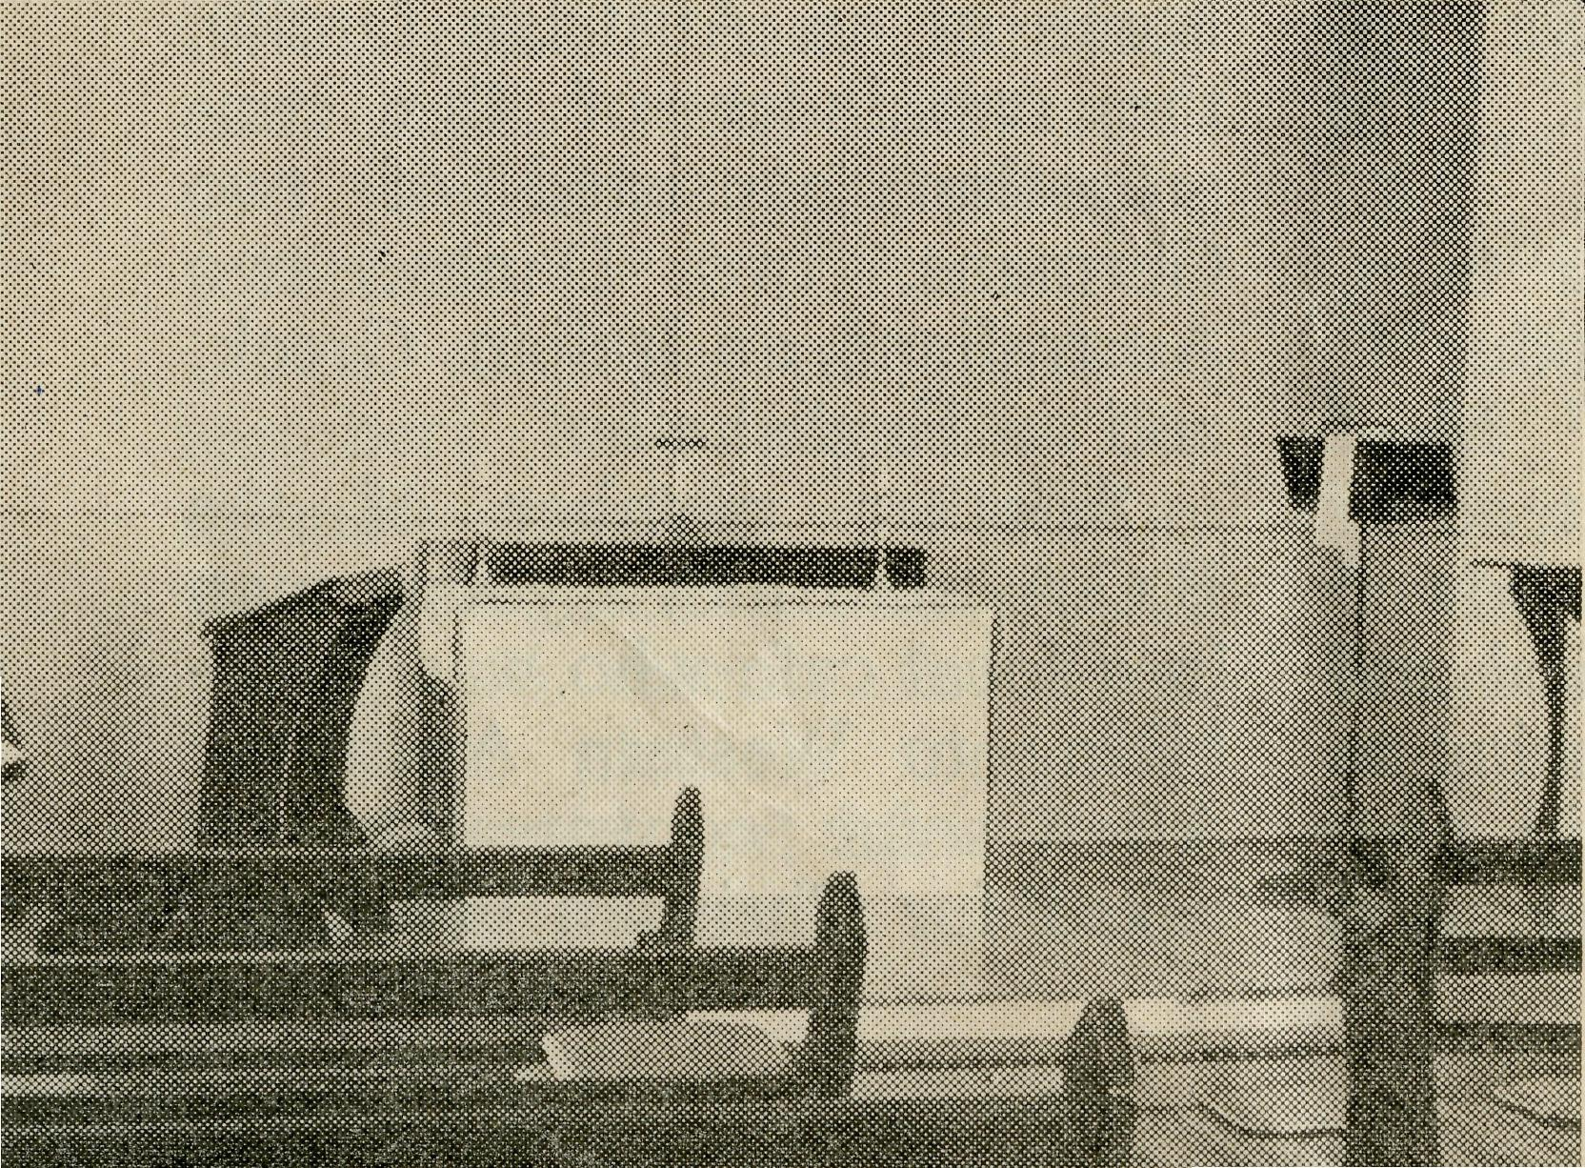
Wife of a "Country Parson'
(Mrs. B. Buckland—-Cleve)
DATES FOR YOUR DIARY
Friday, 28th July—Sydney Women's Auxiliary Fair, 11 a.m., St. Andrew's Cathedral, Chapter House.
Tuesday, 19th September—Melbourne Rally, St. Paul's Cathedral, Chapter House. Tea, 6 p.m. Rally, 7.45 p.m.
Friday, 6th October—Sydney Rally, Chapter House, 7.45 p.m.
Monday, 25th September—Melbourne Women's Auxiliary Fair, 10.30 a.m., Lower Town Hall.
Wollongong Rally, 6th November—St. Michael's Hall, Wollongong, 7.45 p.m.
He stayed the night and, as he was short of money, we got him some local work, and this gave us the opportunity of telling him about the Saviour Who died for Him.
Pray that the missioners will be kept close to Jesus Christ, and that the Holy Spirit will continue its work
of convicting the people "of sin, and of righteousness, and of judgment" in the Australian outback.
"Brethren, pray for us."
(Note from O.M.—The Rev. Ray Neve, formerly at Ceduna, is now at Wil-cannia.)
Leigh Creek, S.A.
Interior of
Church.
I do not quite remember just what I expected life as a Missioner's wife to be like before we came here, as life in a small country town was a complete mystery to me. However, I do remember that I visualised having to bake my own bread—what a relief it was to find nothing of the sort was necessary.
From a woman's point of view, Cleve is a very pleasant place in which to live. Our home is next door to the Church, and almost literally, "five minutes from everything"—school, post office, shops, airfield, sports grounds, hospital. There is electricity and "all mod. cons." Pictures are shown once a week in the Institute, the town's main hall, and regular visits to the town are made by dentists, occulists and a Mothers' and Babies' Health Association Nurse. There are two doctors in residence and the hospital is modern and kept up-to-date, while the school, to which children from up to thirty miles away are brought by school bus, takes pupils to Intermediate standards. There are about twelve shops, including butcher, baker and chemist, and one can buy almost anything, except furniture, right here in the town.
Fresh vegetables and fruit come by road, twice weekly, from Adelaide. So, as housewife and mother, I find the town meets all needs.
As a Missioner's wife the picture is rosy, too. As our Mission pistrict is only 10,000 sq. miles, I do not have the long separation from my husband that other Missioners' wives face, when their husbands are away for weeks at a time visiting outlying stations, or line camps. At the most, it would be two or three nights, while Bernard, staying at Kimba, visits farms and homes, school and hospital in that area, saving himself and the parish car the 90 mile round trip each day. For these short periods the three children are plenty of company.
Each town, Cleve, Cowell and Kimba, has its Ladies' Guild, and until the birth of Jane, last year, I attended all of them. Since then I have not attended Kimba Guild, as this would entail leaving with Bernard around 9 a.m., amusing the little ones while he takes Religious Instruction at Darke Peak School, lunch probably with a parishioner or a picnic meal, then another period of waiting while Religious In-

20
The Real Australian
June, 1961
June, 1961
The Real Australian
2)

Summer Camp for the Line Children
Smoky Bay, 1961
(Rev. T. V. Jones)
struction is taken at Kimba ings have to be held at the
School, before the actual Rectory, as we have no Parish
meeting. Much as I would Hall, and our lounge room is
enjoy the meeting, I shudder then called into service. Some-
to think of the children's be- times this means a last minute
haviour after being cooped up clean-up for me, as the
in the car all day. Cleve children think this room a
Guild is held here at the perfect play place.
Rectory, where mothers can All in all, my life and work
attend the meeting while their here are much the same as
children have the run of the those of any city Rector's
sandpit, swing and toy box, wife, apart from the fact that
leaving us in comparative the doorbell and 'phone,
peace for our discussions. On though well-used, are perhaps
Cowell's meeting day we all not so insistent. The people
go with Bernard after lunch in each town in the area are
and while he is, again, at kind, hospitable, thoughtful
school, I wait at the home of and friendly, but in many
a Guild member until meet- cases not mindful of their
ing time. spiritual need, and this ap-
Sunday School here at plies a good deal to the
Cleve is at 10 a.m., so I must women.
organise the morning sleeps Will you pray that here the
of Helen and Jane to coincide, "Rectory family" may cling so
so Russell and I, respectively, closely to Christ that His
learn and teach without dis- Friendship might be coveted
traction. We have four by those with whom we come
teachers at Cleve, but Cowell in contact in the everyday
only one, with two teenage things of life?
helpers, although Cowell (Note by O.M.—I am often
Sunday School has twice the told that a woman cannot be
number of scholars that Cleve expected to live in an outback
has. Kimba, as yet, has no area. Thank you Mrs. Buck-
Sunday School. land for giving such a clear
Most of the parochial meet- reply to help clergy wives.)
BUSH PADRE BROADCASTS
2CH Alternate Sundays 8.30 p.m.
2NX Alternate Sundays 4.45 p.m.
2KA 1st and 3rd Fridays 4.30 p.m.
2GN 2nd and 4th Sundays 9.45 a.m.
2GB Daily Announcements.
Thirty children came to the Camp this year from Tar-coola, Cook, Rawlinna, Haig and Zanthus. Fourteen of these children were New Australians, two of them Aborigines, and the others were Aussies, in the usual sense of the term. Their train travel was in excessive heat, and greatly delayed because of a fire in the Overland Express going the other way. Also, their trip down from Kingoonya to Smoky Bay in the bus, a distance of 200 miles, was rather uncomfortable because of the weather. They arrived in the middle of the heat-wave, and naturally we were concerned about their welfare because of the heat and fatigue, but, as ever, the children soon overcame that.
The Camp programme was such as to include opportunity to understand how to apply the Christian faith to their daily lives. Just before breakfast, they were divided into small groups and studied in a very simple way, a passage of Scripture applicable to them on that day. Quite
naturally, a lot of original thinking was done here, and some startling thoughts were expressed, but these youngsters were seeking to know more. In the mid-morning, we had a meeting at which we were taught some of the fundamentals of the faith. After tea, there was the opportunity of further teaching in a readily acceptable way, usually through the medium of films.
There were eight adults at this Camp: Sister Thomas, in residence on the Line, who was responsible for them as they travelled; a Czech, businessman who, since coming to Australia, has become an active member of the Anglican Church (he was cook, assisted by a young lady doing her Leaving Honours). The fourth was a medical student, then there was a primary school teacher, a stenographer, the Reverend Ray Neve and the local Priest-in-Charve. These formed the group, whose job it was to be with the children in all their activities. Fourteen of the children returned home able

22
The Real Australian
June, 1961
June, 1961
The Real Australian
23

B.C.A. GIFT SHOP
For Presentations and all Occasions.
CHINAWARE — MULGA WOOD — POTTERY CUTLERY — NOVELTIES — SOUVENIRS
B.C.A. GIFT SHOP
B.C.A. House, 135 Bathurst Street, Sydney
to swim, and will be displaying their Beginners' Certificate to their parents.
All of them, without exception, will be going home full of the experience of being able to attend a Church service. I have never seen a group of youngsters so quiet in Church before; the reason was, of course, they were so over-awed. Transport to the service was made available
by parishioners from the country coming for the service themselves.
We feel that these Camps mean a tremendous amount in the ministry of the Priest-in-Charge on the Trans. Line. He sees the children so infrequently and, for such a brief space of time, that such a Camp is the only thing to breach the gulf.
The Bush Church Aid Society
for Australia and Tasmania
FIELD STAFF:
DIOCESE OF ADELAIDE, S.A.
Ceduna-Penong, S.A.—Rev. T. V. Jones, Th.L., Rev. B. J. O'Grady,
Th.L.
Cleve, SwA.—Rev. B. Buckland, Minnipa, S.A.—Rev. D. W. War-
Th.L. burton, Th.L.
DIOCESE OF WILLOCHRA, S.A.
Leigh Creek, S.A. — Rev. J. Quorn, S.A.—Rev. G. Fuhrmeister,
Winter, B.A., Th.L. Th.L.
Orroroo, S.A. — Rev. G. S. Peterborough, S.A.—Rev. I. Booth,
Thorne, B.E. Th.L. (Grant in aid).
Gladstone, S.A.—(Grant in aid).
DIOCESE OF BALLARAT, VIC.
Heytesbury Mission, Vic.—Rev. E. Otway Mission, Vic.—Rev. T.
Withington, B.A., Th.L., Tim- Morgan, Th.L., Beech Forest,
boon, Vic. Vic.
DIOCESE OF RIVERINA, N.S.W.
Wilcannia, N.S.W.—Rev. R. Neve, Menindee.—Rev. R. Brooks, Th.L. Th.L.

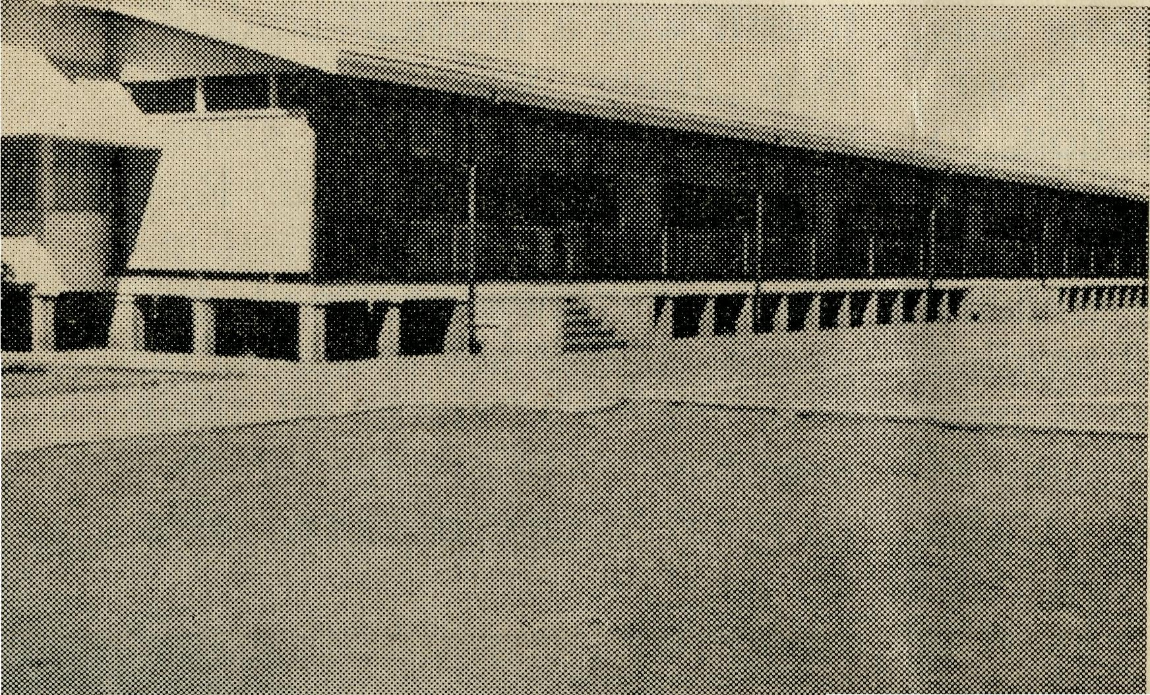
DIOCESE OF GIPPSLAND,
VIC.
Croajingalong, Vic.—(Grant).
NORTH WEST AUSTRALIA CALLS
DERBY NEEDS AN ORDAINED MAN
School at Derby.
DIOCESE OF TASMANIA
Tarraleah, Tas.—Rev. B. Viney, Th.L.
DIOCESE OF NORTH-WEST AUSTRALIA
Port Hedland Mission.—Rev. O. Weaver, M.P.S., Ph.C, Th.L., Port
Hedland, W.A Murchison Mission.—Rev. A. Williams, Th.L., Mount Magnet, W.A.
MAIL BAG SUNDAY SCHOOL
Director: Miss R. CAMPBELL.
OLD FOLK'S HOME (Port Lincoln, S.A.)
Mr. R. and Mrs. AVERY, Miss M. FARR, Miss H. AVIS, Mrs. F. WARD.

