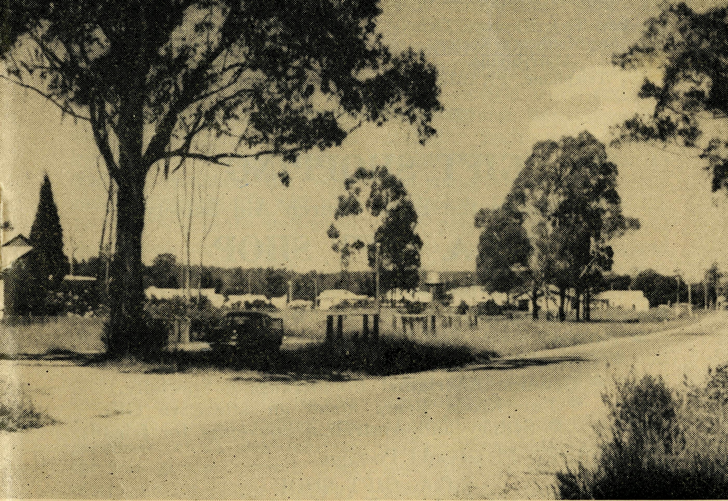
24
CEDUNA, S.A.
The Murat Bay District Hospital.
PENONG, S.A.
The Penong Memorial Hospital.
COOK, S.A.
The Bishop Kirkby Memorial Hospital.
TARCOOLA, S.A.
The Tarcoola Hospital. RAWLINNA, W.A.
The Nursing Hostel.
WUDINNA, S.A.
The Central Eyre Peninsula District Hospital.
BOWRAL, N.S.W.
(Charlton Boys' Home).
BROKEN HILL, N.S.W. Mr. A. & Mrs. DEAN. Mrs. M. SMITH.
June, 1962
The Real Australian
FLYING MEDICAL SERVICES HOSPITAL CENTRES:
Matron: Sister F. DOWLING.
Sisters: J. MILLER, G. HITCHCOCK, B. TIERNEY, M. BELL, E. HAWKEN, I. Mc-CREDIE, M. ROBEY, L. J. AINSWORTH.
Sisters: V. HOLLE and Miss M. FARR.
Sisters: M. TARR and M. ROSS.
Sisters: ' M. HOPE and V.
COCHRANE. Sisters: E. THOMAS, C. A.
McPHIE.
Matron: Sister M. DEAN.
Sisters: J. ZILLMAN, N. WELKINS, M. DICKSON, C. EMMETT, Miss W. IKIN, Miss M. SMEE.
DENTIST:
Mr. L. JAUNCEY.
PHARMACIST:
Mr. J. ARGALL.
MEDICAL OFFICERS:
Dr. M. MUELLER. Dr. V. PIPPETT.
PILOTS:
Mr. ALLAN CHADWICK,
Mr. JOHN LINDRIDGE
Mr. W. BEDFORD.
AIRCRAFT:
Cessna 210 VH-AEC „ VH-FMS Auster.
WIRELESS COMMUNICATIONS BASE:
Ceduna Base Operator: Mr. GEORGE CAMERON.
FLYING MEDICAL SERVICES CENTRE, CEDUNA, S.A. Mr. F. BURNER (Clerical Officer).
CROAJINGALONG NURSING SERVICE, VIC:
Sister J. ROBERTS.
HOSTELS FOR SCHOOL CHILDREN
PORT LINCOLN, S.A.
Mr. S. & Mrs. HUMMERSTON and Miss D. DUVER.
MUNGINDI, N.S.W.
Mr. N. and Mrs. MELLOR.
EDGAR BRAGG & SONS PTY. LTD., 130 BOTANY STREET, WATERLOO
No. 40 (New Series), JUNE, 1962
3/- per annum, Post free.
Registered at the G.P.O., Sydney, for transmission by
Post as a periodical.

Cann River Township. Nursing Centre — left.

The Real Australian
June, 1962
June, 1962
The Real Australian

The Organising Missioner’s Letter
The Bush Church Aid Society
for Australia and Tasmania
PRESIDENT: The Most Reverend H. R. Gough, O.B.E., D.D.
Vice-President: The Most Reverend F. Woods, M.A., D.D. Hon. Clerical Secretary: Rev. Canon E. Cameron. Hon. Treasurer: Mr. R. Stokes. Organising Missioner: Rev. J. R. Greenwood, Th.L. Deputationist (N.S.W.): Rev. C W. Rich, Th.L. Victorian Secretary: Rev. J. Stockdale, Th.L.
VICTORIAN OFFICE:
Allan's Building, 276 Collins Street,
Melbourne. Telephone: 63-8962.
HEADQUARTERS OFFICE:
135 Bathurst Street, Sydney.
'Phones: 26-3164, 26-3780. Telegraphic Address: "Chaplaincy, Sydney."
SOUTH AUSTRALIA:
Mr. A. Kirkby, 7 Ruthven Avenue,
Glandore. Telephone: LF 3268.
Rev. T. J. Hayman, Th.L. St. Matthew's Rectory,
Marryatville. Telephone: FA 1022.
GIFT SHOPPING
Remember the Bush Church Aid Society
B.C.A. GIFT SHOP
Gifts for any occasion.
• Cups and Saucers O Mulga Wood
• Pottery ® Novelties
• Crystal • Souvenirs
• Genuine Aboriginal Boomerangs a Specialty. • Fur Koala Bears make an attractive Gift. • Sydney and Australian Souvenirs for friends. Mail Orders — Please add Postage.
B.C.A. GIFT SHOP 135 Bathurst Street, Sydney.
Dear B.C.A. Supporters,
In another part of this issue you will see a notice concerning the central functions which give you an opportunity to gather with your friends.
The Sydney and Melbourne Rallies in September and the Women's Auxiliary Fairs enable us to meet and gain inspiration for the work of the Society. Melbourne this year will not have a pre-Rally Tea which will enable those who have missed the Rally in past years because of the clearing to be done, to be with us in the Chapter House.
ADVANCEMENT
By the time you read this it is hoped the Second Aircraft will be in service. This will enable the Flying Medical Staff to maintain the work more efficiently. It will also be a big help to the staff when movements are necessary.
In the Radio work, Mr. George Cameron has been busy for some months on the installation and re-arranging of equipment. It has not been done without some difficulties but we can thank God for the technical skill and patient application which has marked the transitionary period. The establishment of the two-way radio service has been well
justified and the figures for 1961 reveal the busy life which marks this aspect of our work. Last year 6,977 telegrams were transmitted in addition to 1,400 medicrl consultations conducted by radio. Added to this is the service to fishing vessels and the radio school.
Port Lincoln Hostel has been improved with the installation of sewerage equipment now that this facility has reached our property.
The town of Mungindi has been connected with the North West County Council Electricity Supply. This has brought benefit to the Hostel as an electric stove and hot water service have been installed. Such aids greatly assist those who minister to our young Australians.
Broken Hill Hostel is the next place to have improvements made. The kitchen and laundry areas need renovations and alterations to improve working conditions for the staff. Such improvements will need at least £1,500 and could mean more when plans are completed.
Derby, in North West Australia, claims attention with devoted efforts put forward by the Church Committee to secure a house for a clergy-

The Real Australian
June, 1962
June, 1962
The Real Australian

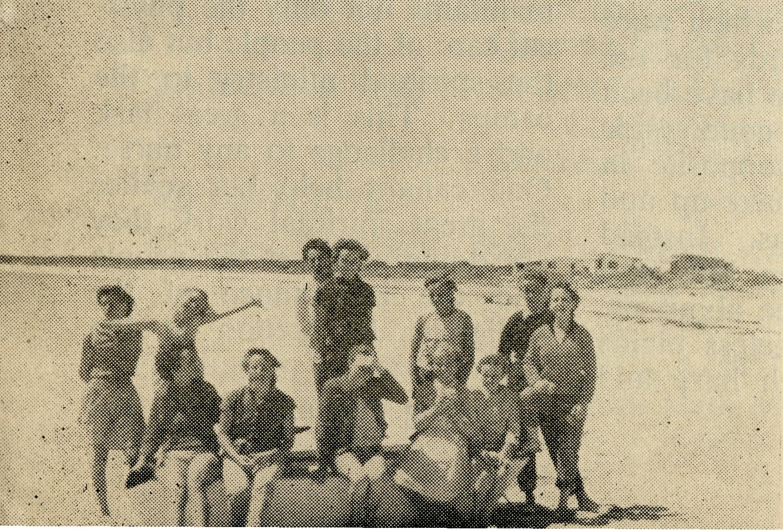
A Land of Contrasts⁵
(Rev. B. J. O'Grady)
man waiting for the word to go. The Society has promised financial aid but Perth is a long way from Derby. The city is the source for building materials which have a long sea voyage to Derby. STAFF NEEDS.
Dentist. After three years at Ceduna Mr. L. Jauncey is leaving the Ceduna Dental Service. His work has done much to commend this important service of the Society. A Dentist is now needed to continue this Christian work and I shall be pleased to hear from someone with the necessary qualifications. The need is urgent and an opportunity awaits a Dentist to share in the B.C.A. campaign to win "Australia for Christ".
Nurses. It has been encouraging recently to have new nursing staff offer for our work. In some cases the service is for a limited period so that the ever pressing problem is to secure Double Certificate staff for indefinite periods of work.
Old Folk's Home. Are there women who wish they could find a place for missionary service but are not trained nurses? The Old Folk's Home at Port Lincoln could well be the place for you. A partially trained nurse or any woman willing to do domestic work for the glory of God is needed.
Boys' Hostel—Warden and Matron. Supporters will be sorry to know that Mrs. Dean is not enjoying the best of health. Mr. and Mrs. Dean have proved very good workers and they will be a loss to our Hostel work.
A married couple will be needed as Warden and Matron of the Boys' Hostel at Broken Hill. I shall be pleased to hear from those who are interested in this form of Christian service. Doctor — Ceduna
Doctor V. and Mrs. Pippett and their two daughters are expected at Ceduna early in June.
Their son will be separated from them for a while at Geelong Grammar School.
After arriving from England three years ago Dr. Pippett was in practice at Myrtleford, Victoria.
Their contribution to the Christian witness will be a valuable asset.
Please remember Doctor and Mrs. Pippett and their family in your prayers.
It is cause for thanks to God that He raises up those with special training to serve Him through the Society's work.
May God bless you all in B.C.A. fellowship.
Yours in His Service, JOHN GREENWOOD
"From Greenland's Icy Mountains to India's Coral Strand." These words of a famous missionary hymn remind me of a contrast between two mission districts in which I have worked.
Before the parish became self-supporting, I worked in the Beech Forest and Apollo Bay Districts in Victoria. Tall thick trees reach to the sky and are surrounded by lush undergrowth and ferns, in amongst which are scattered many farms. The mission covered nearly 600 square miles of hills and dales rising to a height of 2,000 feet where the clear pure air at times is extremely cold. Fog was my constant companion on these hilly ridges, as I made many trips through the beautiful pass of Turton's Track with
its five miles of winding road and over 109 twists and turns in this short but lovely drive. At night one could see, on stopping the car, tiny glowworms on the bank of this Pass, looking like jewels studded in a plush mossy cushion. In the winter time many of the roads linking the various centres were blocked because of land slides and trees across the road. Often I could hear the cracking of trees and branches and the strain of bending timber under the tension of the elements of nature.
At the foot of these hills lies the beautiful seaside resort of Apollo Bay nestling snugly into the foothills of the Otway Ranges. This seaside resort is well known for its surf and holiday facilities and so each
Young Inlanders
enjoy Smoky Bay
Camp.

The Real Australian
June, 1962
June, 1962
The Real Australian

DATES FOR YOUR DIARY
WOMEN'S AUXILIARY FAIR.
Chapter House, Sydney, 11 a.m. Opening by the Lord Mayor of Sydney.
SYDNEY RALLY.
Chapter House, 7.45 p.m. Chairman: The Archbishop of Sydney.
MELBOURNE RALLY.
Chapter House, 7.45 p.m. Chairman: The Archbishop of Melbourne
WOMEN'S AUXILIARY FAIR. Town Hall, Melbourne, 11 a.m.
year we had a great influx of holiday-makers.
The Rev. Tom Morgan, the Mission Chaplain, and I had nine centres to attend, and each of these centres had at least one service a month. Because of the isolation of many of the centres owing to bad roads, the local priest is the only regular visitor to many of the people. During my time at Apollo Bay we were privileged to hear the Rev. Ken Perry of Borneo, a C.M.S. Missionary, and no doubt he felt after taking four hours to travel 25 miles and helping to move nearly 20 trees from the winding road, this Mission District had much in common with the conditions of Borneo.
After 20 months at this beautiful seaside resort, I was transferred to the Far West Mission of Ceduna, South Australia. It seems that now I have left the foggy nights behind and the dangerous curves and gullies which were some of the hazards for the motorist, and these have been changed for a countryside which is entirely opposite in its geographical make-up and climatic conditions. Instead of the steep green hills and tall trees I now see about me large sweeping treeless plains often clouded with haze and dust.
The Mission District of Ceduna covers 80,000 square miles, with seven centres scattered up to 100 miles from the main centre. The surrounding district of Ceduna is studded with wheat and sheep farms while Ceduna itself is a business centre for the farmers: while at Thevenard, two miles from Ceduna, a fishing industry is carried out employing 30 boats. Four times a year the missioner travels into the outback through sheep station country to the Trans. Line.
While I was there in November, 1961, the camps of Raw-linna and Cook had their Sunday School Anniversary. Both of these camps are small compared to towns, numbering only 12 houses, a railway station, Post Office, school and a hospital at Cook, and a Medical Hostel at Rawlinna. During the absence of the Missioner, the nursing staff of the Bush Church Aid Society maintains not only the physical care of the people but also the spiritual ministry to the camps. This is a great task and a challenge to any nurse. One cannot help but realise the great spiritual work they are doing amongst the people and the importance of the Religious Instruction at the schools.
During January, 1962, the
Rev. Tom Jones, Rev. Bill Warburton of Minnipa and I held a camp for the children whose fathers are employed by the Commonwealth Railway and whose residences are situated on the Trans. Line. The children were collected from the train and taken by bus 250 miles to our camp-shack at Smoky Bay. It was indeed a new thing for some of those children as many of them had never seen the sea. The camp was a great opportunity to bring the teaching of the Gospel of Jesus Christ to the young people. Their stay at Smoky Bay included all the activities of a holiday with fun and games for all, but stress was laid upon the deeper things of life, and through the opportunity of
SYDNEY
Friday, 27th July
Friday, 21st Sept.
MELBOURNE
Tuesday, 18th Sept.
Thursday, 1st Nov.
being able to live together, those of us who know the truth could by our example and words reflect the vision which we would wish them to have in their own life.
Australia is a land of contrasts and it is a huge place, but no matter where we go we meet people in our ministry who although scattered and living in certain isolation, respond to the deeper things of life. It is the supporters of B.C.A. who make it possible for men and women to work for God and many of the people are extremely grateful. We sometimes do not see the fruit of our work, but if it is done in the right spirit, it bears fruit, for it is God's battle and not ours; we are His servants and stewards.

The Real Australian
June, 1962
June, 1962
The Real Australian

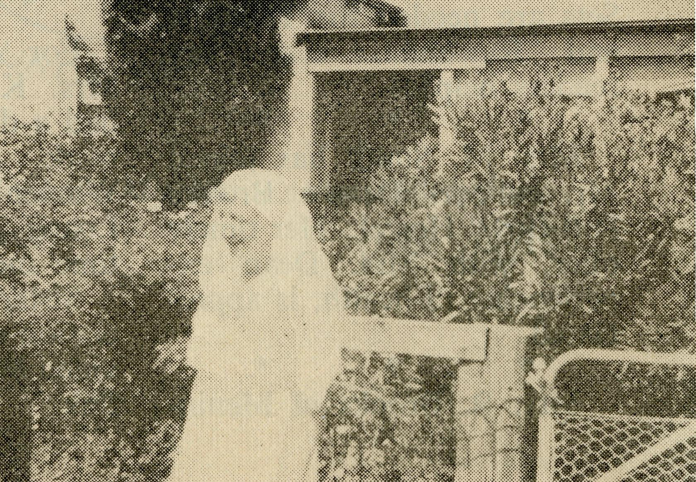
Second Church Building in Vast Mission Area
(Rev. D. W. Warburton)
A large crowd overflowed the small building on Saturday, February 10th, when the Bishop of Adelaide dedicated the Mission Hall of St. Timothy at Wudinna, S.A.
This day was the climax to the effort made by a small but willing team of men and women. Local builders, Messrs. Gordon and Donald Rashleigh, contracted to do the concrete work and brick laying. The rest of the building was erected by voluntary labour.
Building Committee Chairman Mr. Roy Knight, and Churchwarden Mr. John Chewings, gave the lead and certainly set the pace and standard of work.
The building is of concrete brick, supported by a "Grant Engineering" steel frame. The roof is of new contour asbestos. The large steel framed windows allow for adequate light and ventilation. It is divided into two sections: a Chapel (24ft. x 18ft.) and a meeting room (16ft. x 18ft.).
The Ladies' Guild, under
the chairmanship of Mrs. M. Heath, worked to provide the Communion Rails, Holy Table, Prayer Desk, Lectern and other fittings. The Rev. Bernard Buckland and the Churchwardens of Cleve (Franklin Harbour Mission) gave the old pews and organ from St. Michael and All Angels' Church, Cleve.
The Sunday School teachers, under the leadership of Sister M. Dean, have provided cupboards and chairs for the Sunday School meeting room.
This Mission Hall has made a vast difference to the atmosphere for our Services and Sunday School at Wudinna, and all feel that the effort was worthwhile.
It is of interest to all supporters of the Bush Church Aid Society that the first marriage solemnized in this building was that of Miss Anne Bedford. Anne is the daughter of Mr. Bill Bedford of Kyancutta who has flown for B.C. A. in a relieving capacity for many years.
In March, 1940, Sister I. Gwynne accepted the position of Sister-in-Charge of the Croajingalong Nursing Centre at Cann River, Vic. Such service is worthy of note and cause for thanksgiving to God for the 22 years of devoted Christian service. Sister Gwynne has been a diligent nurse and, above all, a faithful servant of Jesus Christ.
Friends of B.C.A. will remember her as she relinquishes her Cann River duties and enjoys long service leave. Sister Gwynne is not one who can remain idle. After some months for recuperation she
Sister I. Gwynne,
Cann River —
Croajingalong,
1940-1962.
plans to share in some form of active service.
Sister J. Roberts is now in charge of the Croajingalong Nursing Service maintaining this important part of B.C.A. work.
* * *
The Foundation Stone of the new Cathedral at Gerald-ton for the Diocese of North West Australia, will be set by His Excellency the Governor of Western Australia at 3 p.m. on Sunday, July 22nd.
Any friends who would like to make a donation to the project may forward their gift to B.C.A. office. Gifts will

10
The Real Australian
June, 1962
June, 1962
The Real Australian
11

be forwarded to the Appeal Organiser for the appropriate receipt. Those over £1 are permissible tax deductions.
* * *
Head Office welcomes Mrs. D. Sisman, Dulwich Hill, as bookkeeper to replace Miss E. Thomas who leaves us to undertake a course of study.
* ♦ *
Additions to B.C.A. family have been Elizabeth Argall and Philip Viney. Good wishes to parents and children.
* ♦ *
Congratulations to Archdeacon G. R. Delbridge, a B.C.A. Councillor, elected as a Canon of St. Andrew's
Cathedral, Sydney.
* * *
Rawlinna needs flannel-graph materials. The equipment will help the efficiency of the Church work along the Trans. Line and will be appreciated by Sister C. McPhie.
* * *
Small portable Communion Sets are needed for Tarcoola and Rawlinna. Can any
readers help?
* * *
Mrs. M. Smith has joined Mr. and Mrs. Dean at Broken Hill Boys' Hostel. Her timely offer, with Mrs. Dean experiencing ill-health, is appreciated.
* * *
Mrs. R. Brooks of Menin-
dee had a quick trip to hospital and is now home after losing her appendix.
The Rev. Brian O'Grady has been absent from Ceduna on extended sick leave.
The Hall at Sandstone was destroyed by fire earlier in the year. The Rev. Arthur Williams reports the loss of hymn and prayer books as well as Church equipment.
The Old Rectory is to be renovated and made into a Chapel. Gifts to help with costs will be gratefully received.
Sympathy is extended to the family of the late Mr. Williams of Belmore. The Rev. Arthur Williams (Mt. Magnet) and his mother and family will be remembered in our prayers.
♦ * *
For many years the late Mrs. K. Loane, Chatswood, had a deep interest in B.C.A. work. As a member of the Women's Auxiliary, Mrs. Loane gave willingly of her time and energy.
Sister L. Loane's long association with B.C.A. work provided Mrs. Loane with a close link.
BUSH CHURCH AID SOCIETY
The Place of Prayer
'Praying always with all prayer and supplication in the Spirit"
(Ephes. 6vl8).
'Whatsoever ye shall ask in My Name, that will I do"
(John 14vl3).

12
The Real Australian
June, 1962
June, 1962
The Real A ustralian
13

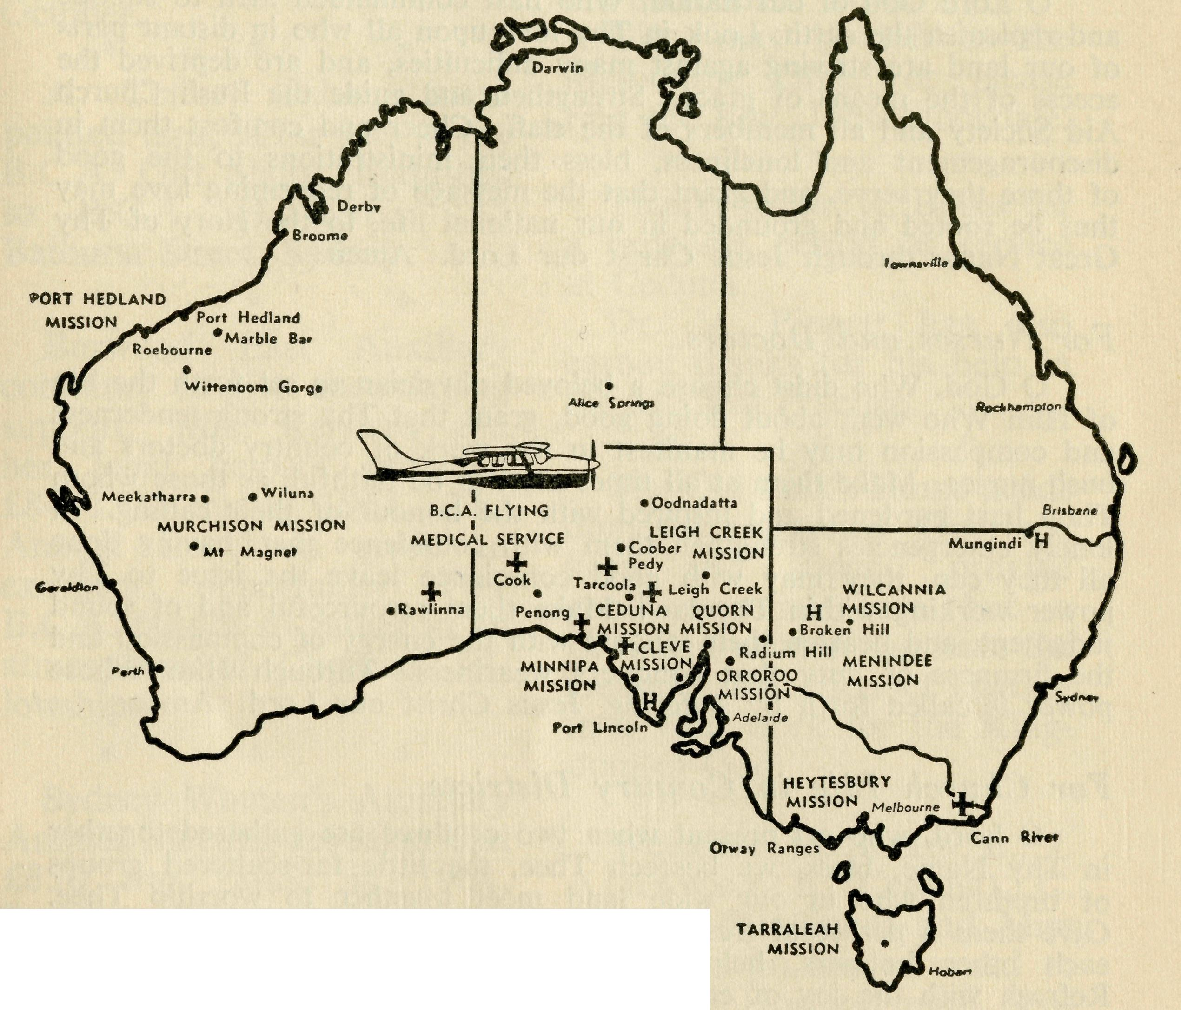
BUSH CHURCH AID SOCIETY four laily Sfawmbranrj
- The Rev. Ray and Mrs. Neve and the Wilcannia Mission, N.S.W.
- The Rev. Ray and Mrs. Brooks and the Menindee Mission, N.S.W.
- The Rev. Brian and Mrs. Viney and the Tarraleah Mission, Tasmania.
- Mr. Bruce and Mrs. Dean, Mrs. M. Smith and the boys of the Broken Hill Hostel, N.S.W.
- Sister J. Roberts and the work of the Dispensary at Cann River, Victoria,
The work in the Croajingalong Mission, Victoria.
- The Rev. George and Mrs. Fuhrmeister and the Quorn Mission, S.A.
- The Rev. Jim and Mrs. Winter and the Leigh Creek Mission, S.A. The Rev. Stewart and Mrs. Thorne, Orroroo, S.A.
- Mr. Stan and Mrs. Hummerston and Miss D. Duver and the girls in Port Lincoln Hostel, S.A.
- Miss R. Campbell and all her helpers and scholars in the M.B.S.S.

- Pilot: Mr. Allan and Mrs. Chadwick and the Flying Medical Services, S.A.
- Mr. Bill Bedford and the patients he carries by air. The staff and patients in the Wudinna Hospital, S.A.
- The Rev. Bill and Mrs. War burton and the Minnipa Mission, S.A.
- The Rev. Jim and Mrs. Smith and the parish of Streaky Bay, S.A.
- Mr. John and Mrs. Argall and the work at the Ceduna Pharmacy, S.A.
- The Rev. Theo Hayman and Mr. Alban Kirkby and South Australian representation.
- Mr. Neville and Mrs. Mellor, the girls and boys at Mungindi Hostel, N.S.W.
- Mr. George and Mrs. Cameron at the Radio Base, Ceduna, S.A., the Radio School teacher and children.
Mr. Frank and Mrs. Burner and the office work at the B.C.A. Centre, Ceduna, S.A.
- Pilot: Mr. John and Mrs. Lindridge and their work with the Flying Medical Service.
- The Matron and Staff at Ceduna Hospital, S.A.
- Dr. V. and Mrs. Pippett and family, Dr. M. Mueller, all medical services, dental service and patients.
- The Staff and Hospital Services at Cook and Tarcoola, S.A.
- The Rawlinna Nursing Home, W.A., and Sisters E. Thomas and C. McPhie.
- The Rev. Ernest and Mrs. Withington at Timboon, Victoria, and the work in the Heytesbury Forest Mission.
- The Rev. Arthur and Mrs. Williams and the Murchison Mission, W.A.
- The Rev. Bruce and Mrs. Woolcott and the Port Hedland Mission, W.A.
- The Staff and Hospital Services at Penong, S.A.

- The Rev. Bernard and Mrs. Buckland, and the Rev. Brian O'Grady, the Ceduna Mission, S.A.
- Mr. Roy and Mrs. Avery, Mrs. M. McLeod and the staff at the Old Folk's Home, Port Lincoln, S.A.
- All students in training for outback ministries.
The Rev. John Stockdale, the Victorian Committee and office staff.
30. The Rev. John Greenwood, the Rev. Bill Rich, the office staff at
Headquarters and the Council of the Society.
Special Remembrance
Pray for:
- Clergy to maintain outback ministries.
- Nurses to serve in B.C.A. Hospitals.
- Domestic assistants for Hospitals and Old Folk's Home.
Thanksgiving :—
Thanksgiving:—
For the continued growth of the work of the Society.
For the increase in support through prayer and giving.
For the devotion and service of those who work in the many
activities of B.C.A. For the work of Auxiliaries. For opportunities of service in new and old fields.

14
The Real Australian
June, 1962
June, 1962
The Real Australian
15

Prayer and Praise
For the Society.
O Lord God of our nation, Who hast commanded men to subdue and replenish the earth: Look in Thy love upon all who in distant parts of our land are striving against many difficulties, and are deprived the access of the means of grace. Strengthen and guide the Bush Church Aid Society and all members of the staff. Cheer and comfort them in discouragement and loneliness, bless their ministrations to the good of those they serve, and grant that the message of redeeming love may thus be rooted and grounded in our national life, to the glory of Thy Great Name through Jesus Christ our Lord. Amen.
For Nurses and Doctors.
O God, Who didst choose a beloved physician to set forth the life of Him Who went about doing good, grant that Thy strong tenderness and compassion may be manifest in the work of country doctors and bush nurses. Make them at all times alert to be faithful, as those whom Thou hast burdened and inspired with the honour of their calling. In lonely emergencies strengthen them with confidence that, having done all they can, they may with good conscience leave the issue to Thy power working within Thy law. Make them resourceful and of sound judgment, and hearten their labours with the energy of compassion and the firmness of duty that conquers weariness. Through Him Whose power is called forth by suffering, Jesus Christ our Lord. Amen.
For Church Life in Country Districts.
O Lord, who art present when two or three are gathered together in Thy Name, bless, we beseech Thee, the little far-scattered groups of brethren who in our wide land meet together to worship Thee. GivQ them a perpetual freshness of spirit, and the power to inspire in each other holiness, helpfulness, and understanding of Thy help. Refresh with the joy of enthusiasm those who endure weary journeys to Thy trysting place. Grant that these little companies of Thy servants may be united in the spirit of Christian charity, awaiting in love the time when there shall be one fold and one Shepherd. Grant that the common life of all communities may be purified by this spirit of charity from all meanness, falsehood, malice and idle gossip, and grant that they who share a common lot may draw strength from each other's virtues, and in their weakness help one another, through our one Lord, Jesus Christ. Amen.
Praise.
For the Blessings vouchsafed to the Society, for all kindly givers, and for the joy of service.
POST AND RAILS (contd.)
Tasmanian supporters will be pleased to know that a B.C.A. Rally will be held in St. John's Hall, Launceston, at 8 p.m. on Friday, 19th October.
A Coffee Table, hand painted tiles, is for sale at the B.C.A. Gift Shop. Enquiries to B.C.A. House, 135 Bathurst Street, Sydney.
♦ * *
Burwood East Auxiliary continues to give encouraging support. Mrs. Kershaw and her loyal helpers provided £84/15/3 during 1961. The Annual Luncheon gives an excellent opportunity for B.C.A. friends to gather in an atmosphere of Christian fellowship.
♦ * *
Sydney Women's Auxiliary Annual Meeting revealed that £850 was raised in 1961. Support by an increasing number of parishes is having a marked effect on extending interest in B.C.A.
♦ * *
The Lord Mayor of Sydney will open the Women's Auxiliary Fair in St. Andrew's Chapter House, on Friday, 27th July, at 11 a.m.
Gifts of cakes, sweets, fruit, produce will be welcomed by the Women's Auxiliary. They
may be left at B.C.A. House
before the date.
* * *
The Victorian Women's Auxiliary Fair will be held on Thursday, 1st November, in the Melbourne Town Hall.
Gifts may be left at the Melbourne Office or please ring the Rev. John Stockdale.
* * ♦
Thanks to Dr. R. Boger for a welcome period of service at Ceduna.
Dr. V. Pippett has also earned thanks for his help in the Medical Practice.
♦ * #
The Old Folk's Home needs domestic assistance. Quarters, keep and stipend provide good material care but a Christian woman can have the greater satisfaction of sharing in a vital work for the Kingdom of God.
* * *
Welcome to Sisters L. J. Ainsworth (Ceduna), C. Emmett (Wudinna) and Miss W. Ikin who has returned to Wudinna Hospital until September when she undertakes
nursing training.
♦ * *
Sister I. McCredie's relief duty has provided welcome assistance at Ceduna Hospital.
♦ * *
Early in the year congratulations were extended to Mr. R. and Mrs. Walker. Mrs.

16
The Real Australian
June, 1962
June, 1962
The Real Australian
17

THE WEST COAST SENTINEL
Wednesday, March 14, 1962.
To The Editor
TRIBUTE TO CEDUNA DOCTOR
It is with grateful thanks we remember the late Miss Janie Smith who for over ten years gave a day each week to the preparing of used postage stamps for sale. In this way she gave valuable help to the Mail Bag Sunday School. The funeral service on 14th May was taken by the Rev. Alan McMahon who is a B.C.A. Student.
Walker, formerly Miss J. Mc-Mahon, continues to give valuable assistance in the Mail Bag
Sunday School.
# * *
B.C.A. friends will be interested to know that the Bishop of Willochra is helping to keep open the hospital at Gladstone, S.A. He has secured two sisters for the initial stage of assistance.

PRAY FOR B.C.A.
 | SERVE IN | B.C.A.
 |  | GIVE | TO | B.C.A.
BUSH PADRE BROADCASTS
2CH | Alternate Sundays |  |  | 8.30 p.m.
2NX | Alternate Sundays |  |  | 9.30 p.m.
2KA | 1st and 3rd Fridays |  |  | 4.30 p.m.
2GN | 2nd and 4th Sundays |  |  | 9.45 a.m.
2GB | Daily Announcements.
STAFF NEEDS
Nursing Assistants and Cook — for Old Folk's Home and
Hospitals.
Dentist -— for Ceduna.
Nurses — Double Certificate.
WILL YOU OFFER FOR SERVICE ?
Sir,—-I would be very grateful if you would kindly publish the following tribute to Dr. R. Chambers, of Ceduna.
Widespread and genuine regret followed the news that Dr. Chambers would soon be leaving the district to take up residence in N.S.W., in order to undergo further specialist treatment for a spinal condition.
Since his arrival in Ceduna during 1959, the doctor has earned the esteem and affection of young and old, and all will be deeply sorry to see him go.
His personal interest and compassionate consideration for each individual won him the sincere gratitude of all.
Although the father of four young children, whom he scarcely ever had time to see, he was ever ready, day or night, to answer an S.O.S. from a patient.
His return to Ceduna to conclude his affairs was all too short, and did not permit any tangible expression of appreciation by the public.
We are indeed fortunate that we still have our Dr. Merna Mueller as medical officer for this vast area. She is carrying a tremendous burden alone at present. We need three doctors to cope, and to save continual over-work and exhaustion.
We were indeed fortunate that in Dr. Chambers we had a man, who, in spite of his own disability, dedicated his life to the service of others. Neither Dr. Chambers nor Dr. Mueller have ever observed standard consultation and meal hours, etc. Whenever there was a patient waiting, attention has been promptly and generously given.
Our sincere hope is that Dr. Chambers will soon be restored to complete health. His departure means a big loss to the district, and one which will not be easily replaced. Memories of his kindness will long be remembered by those who experienced his medical care.
In grateful appreciation, "EX-PATIENT",
Ceduna.

18
The Real Australian
June, 1962
June, 1962
The Real Australian
19

On Patrol
(Rev. R. Neve)
The Mission utility was well loaded as I left Wilcannia at 6.30 one evening with the temperature still over the century after a hot and oppressive day. My destination that night was a sheep station 72 miles from Wilcannia. On the way I stopped at White Cliffs and talked with parents who were watching their children celebrate Guy Fawkes night in the traditional manner.
This was the beginning of a patrol which was to last for two weeks, covering a thousand miles, going into the Far North Western corner of N.S.W. and travelling many miles along the borders of S.A. and Queensland. With a wide variation in both weather and country, from heat and dust storms to heavy rain and
floods; from stony hills to the sandhills of the border country.
This trip began in excessive heat-wave conditions with heavy dust storms adding to the discomfort of travelling and countless stops to open and close gates. The countryside was suffering from a severe drought, there was very little feed and the sheep were being moved out of the district by the thousands and cattle were being hand fed with the hope that the drought would soon break. As we prayed for rain in our Services it emphasised a real and crying need of the grazier.
By the end of the second day ominous black clouds could be seen on the northern horizon. I had now arrived at Wonnaminta Station where
I was to stay the night. On both sides of the Homestead there are creeks which are normally dry but when there are rains further north, they run bankers and one can be marooned for several days. After the evening meal the dust storm had increased in violence and it looked as if it might rain. After some discussion it was decided that I should go to the next Station, so they were contacted over the transceiver and an estimated time of arrival arranged. In the midst of this the spiritual ministry was not forgotten; several Christian books, including a copy of the New English Bible, were taken and after a Scripture reading and prayer I prepared to depart.
I found out later that the creeks came down two and a half hours after I left and nobody was able to get in or
out of the Station for four days. God does guide in mysterious ways.
The next 21 miles were slow going in the face of the dust storm with stops for gates and keeping a sharp lookout for kangaroos and sheep. The track was a twisting one with loose sand from 12 to 18 inches deep for much of the way. The lights of the Homestead were a welcome sight and after supper and sharing a shower with a large green frog, bed was a welcome place.
Next morning I showed a Christian film strip to the children, the parents watching as well and more books were sold. As the boy was going to the B.C. A. Hostel in Broken Hill later there was an opportunity to inform both parents and boy about life in the Hostel. One of the big sacrifices parents in the out-

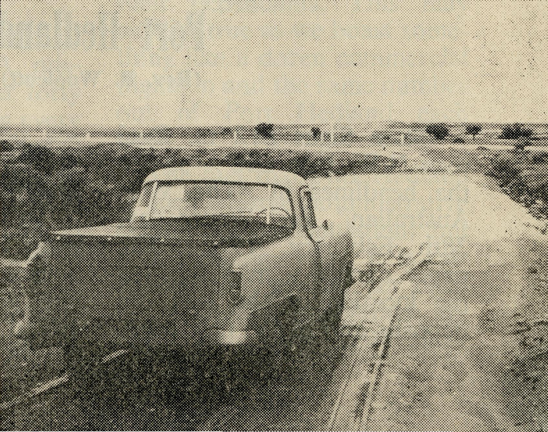
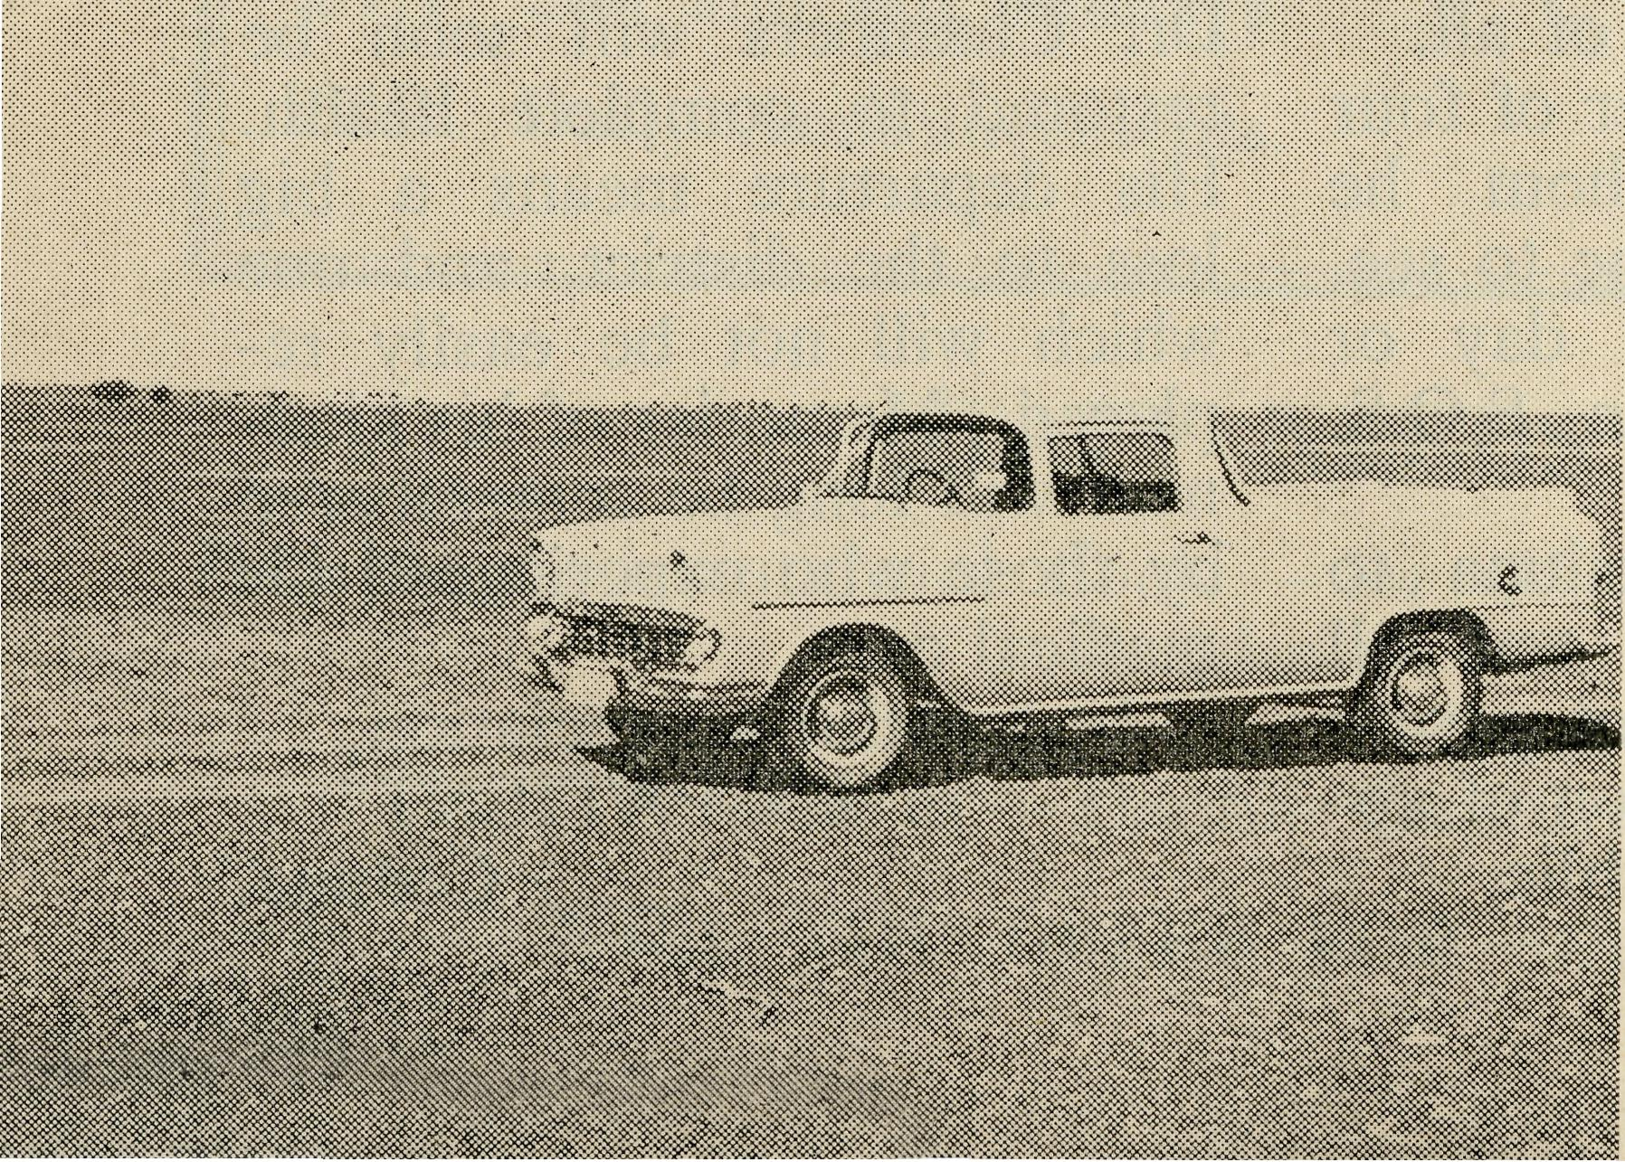
Beyond Wilcannia,
N.S.W.—after dry
weather.
Beyond Wilcannia -after rain.

20
The Real Australian
June, 1962
June, 1962
The Real Australian
21

Port Hedland
(Rev. B. Woolcott)
back have to make is to send their children away for higher education, thereby hastening the process of growing away from each other. Here B.C.A. provides not just a Hostel but a home run by dedicated staff seeking under God to lead those in their charge to a personal experience of Jesus Christ.
As I set out on the track again the weather was cooler and the sky overcast with light rain falling and the track over the claypan country was slippery.
I arrived in Tibooburra for the week-end and found the population increased by many visitors for the opening of a Children's Hostel. The opening was preceded by a Remembrance Day observance in which I took part. Appreciation was expressed by
"State Signs £12 m. Deal over N.W. Iron Ore"—so ran the headlines in "The West Australian" on Wednesday, 28th February, 1962. The paper carried a map showing the location of the iron ore deposits and of the new deep-
several leading citizens of Broken Hill that the Church was represented and had shown a concern for the spiritual welfare of the people.
Plans were changed as heavy rain had set in, the road was a quagmire and after 200 miles of this and crossing flooded creeks, I arrived at the B.C.A. Hostel in Broken Hill. Several hours after I got through one creek, four men were swept away and nearly drowned. The Wilcannia Road was closed because of flooding but the delay which appeared a waste of time proved to be in the purpose and providence of God.
I managed to reach Wilcannia by 6 p.m. on the Sunday and the Church bell ringing half an hour before Service, was a signal to the people that there would be a Service of worship that night.
sea port to be built for exporting the ore. (The map centred around Port Hedland.) To the west about 60 miles away is Mt. Goldsworthy, the source of the iron ore. To the east south-east lies Depuch Island where a new deep-sea
port is to be built—this is also about 60 miles away. From Mt. Goldsworthy to Depuch Island a railway and motor road is to be constructed— 125 miles in length. Two townships will be constructed, "complete with schools, water supplies, electricity, streets and other requirements . . ." The two townships will have a population of about 500 people.
The Western Australian Government early in April, 1962, gave permission for a group of three companies to make preparatory examination of further iron ore deposits south of Roebourne, between Roebourne, Witte-noom and Onslow. The group of companies include Kaiser Steel of U.S.A., Rio Tinto of England, and Consolidated Zinc of Australia. The claim is made that the iron ore in this region equals all the deposits at present being worked in Australia.
At present the pastoral properties in this B.C.A. mission area number about forty active stations. Counting every one living on these stations— fullblood aborigines, mixed bloods and whites—it would be hard to find four hundred people. The lack of rainfall and years of drought have forced many off the properties. Mining is becoming the
industry of the Pilbara district. As yet Wittenoom, the second largest town in the area, has a population of 1,000—all these folk are connected with the Blue Asbestos mine or with supplying the essential services needed for the mining community.
Next to mining, the second largest industry, if one can call it an industry, is government and commercial administration. Port Hedland, Roebourne and Marble Bar are essentially government and commercial centres, and rather heavily weighted on the Government side. All three are headquarters of Shire Councils, all three have aerodromes, post offices, etc. Port Hedland, with a population of over 1,500, is supposed to have no less than forty men connected with the Department of Civil Aviation. That means at least 100 to 150 of the population are D.C.A. and their dependants. This may well be true as we boast something like a dozen commercial flights in and the same number out of Port Hedland each week.
The fact that Port Hedland is such a large administrative centre brings population, but it is a moving one. It is calculated that seventy per cent, of Hedland's population are only temporary residents—

22
The Real Australian
June, 1962
June, 1962
The Real Australian
23

DIOCESE OF GIPPSLAND, VIC.
Croajingalong, Vic.—(Grant).
two-year or three-year terms —then off south to a better climate, their tropical service completed. A new population and a new congregation every two or three years. This is where the problem lies—on one hand a very small and very scattered station population who are permanent residents—and on the other hand a large temporary population, many whose true loyalties, especially in Church matters, lie further south in or near the cities.
It is truly amazing that so much has been possible in this area. Faithful workers, both clergy and laity, plus the prayers of our many supporters, have through the Holy Spirit's guidance made any progress possible. The car is now fully the responsibility of the local Church. This may sound a small effort; but at the estimated cost of 1/6 a mile then 1,000 miles or more a month is quite a large sum. Rough roads, heat, sea breezes —the cost of petrol, oils and replacements make transport expensive.
The temporary nature of the congregation makes work difficult. Folk take time to settle into a town—the new climatic conditions—especially the extreme heat of summer, these make progress slow.
Despite the problem of a moving population our Sunday School began in April this year with five teachers and forty pupils. One of our local doctors is our Sunday School Superintendent and he is assisted by two married women and two teenagers. Do pray for the work amongst the children of the town and those who are teaching them. Half our children meet in the Church and the others in a galvanised iron building which we proudly call our hall. It is not painted but is lined; however, when and if money permits, we hope to paint the inside and fit some proper windows. At the present we do not run to windows. Most of the kindergarten children sit on upturned boxes as we have not chairs yet. Do not imagine this deters the children from coming Sunday by Sunday.
You see we have lots yet to do. Much has been done. Last year the Church at Hed-land was painted and looks worthy of God's House. Also this year the parish bought a "Kleen-heat" gas stove for the Rectory, a vast improvement on a fuel one in temperatures of over one hundred. In a real sense I am here as chaplain to families away from their homes—in a strange land for two or three years.
The Bush Church Aid Society
for Australia and Tasmania
FIELD STAFF:
DIOCESE OF ADELAIDE, S.A. Ceduna-Penong, S.A.—Rev. B. Buckland, Th.L., Rev. B. J. O'Grady, Minnipa, S.A.—Rev. D. W. Warburton, Th.L.
DIOCESE OF WILLOCHRA, S.A.
Leigh Creek, S.A. — Rev. J. Quorn, S.A.—Rev. G. Fuhrmeister,
Winter, B.A., Th.L. Th.L.
Orroroo, S.A. — Rev. G. S. Gladstone, S.A. (Grant in Aid). Thorne, B.E.
DIOCESE OF BALLARAT, VIC.
Heytesbury Mission, Vic.—Rev. E. Withington, B.A., Th.L., Timboon, Vic.
DIOCESE OF RIVERINA, N.S.W.
Wiicannia, N.S.W.—Rev. R. Neve, Menindee.—Rev. R. Brooks, Th.L. Th.L.
DIOCESE OF TASMANIA
Tarraleah, Tas.—Rev. B. Viney, Th.L.
DIOCESE OF NORTH-WEST AUSTRALIA
Port Hedland Mission.—Rev. B. Woolcott, Th.L., Port Hedland. Murchison Mission.—Rev. A. Williams, Th.L., Mount Magnet, W.A.
MAIL BAG SUNDAY SCHOOL
Director: Miss R. CAMPBELL.
OLD FOLK'S HOME (Port Lincoln, S.A.)
Mr. R. and Mrs. AVERY. Mrs. M. L. McLeod.

