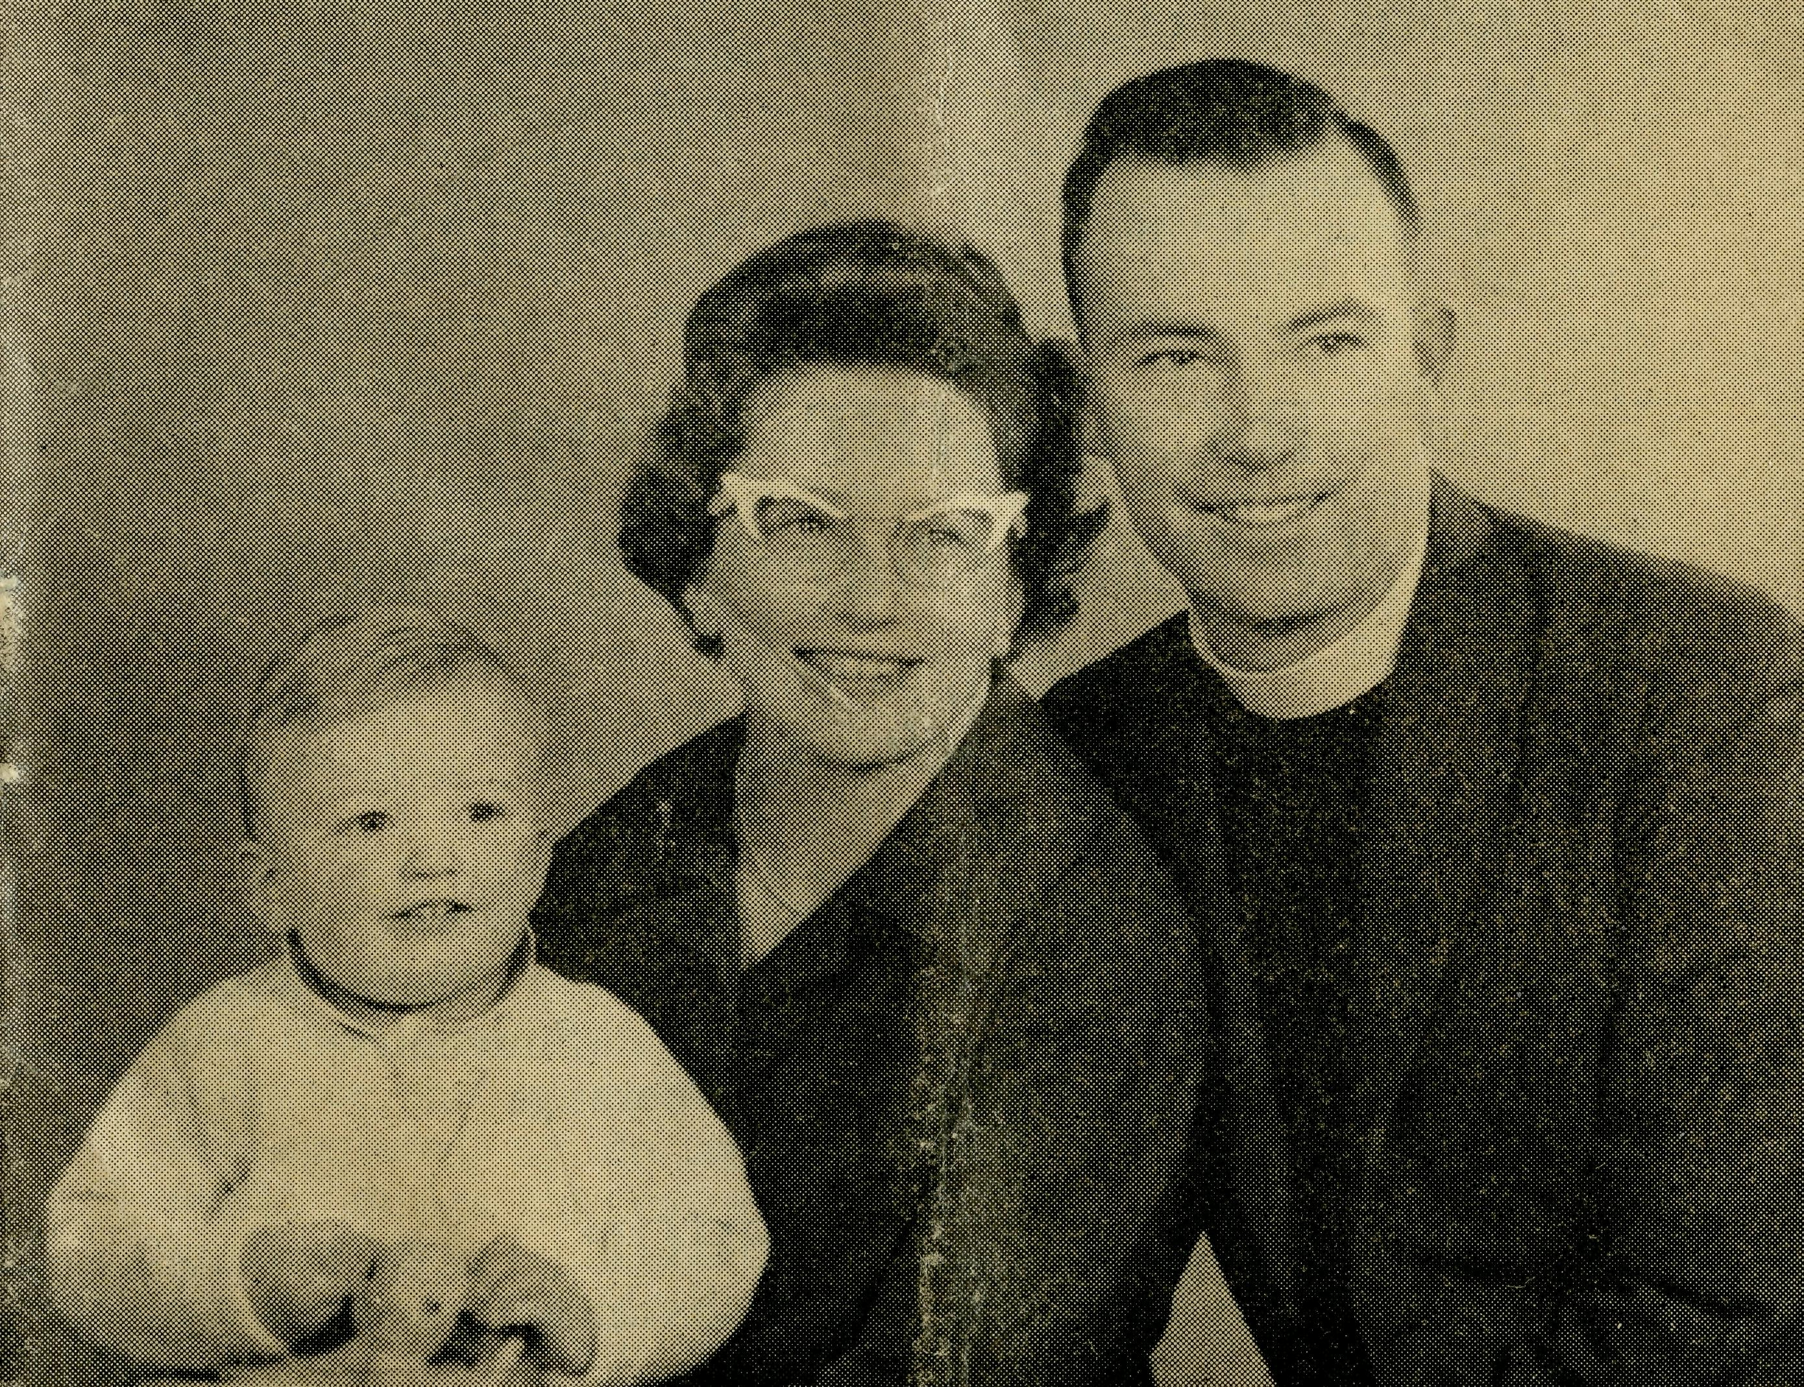
24
CEDUNA, S.A.
The Murat Bay District Hospital.
PENONG, S.A.
The Penong Memorial Hospital.
COOK, S.A.
The Bishop Kirkby Memorial Hospital.
TARCOOLA, S.A.
The Tarcoola Hospital. RAWLINNA, W.A.
The Nursing Hostel.
WUDINNA, S.A.
The Central Eyre Peninsula District Hospital.
BOWRAL, N.S.W.
(Charlton Boys' Home).
BROKEN HILL, N.S.W. Mr. A. & Mrs. DEAN. Mrs. M. SMITH.
September, 1962
The Real Australian
FLYING MEDICAL SERVICES
HOSPITAL CENTRES:
Matron: Sister F. DOWLING.
Sisters: J. MILLER, G. HITCHCOCK, B. TIERNEY, M. BELL, E. HAWKEN, M. ROBEY, L. J. AINSWORTH.
Sisters: V. HOLLE and Miss M. FARR.
Sisters: M. TARR and M. ROSS.
Sisters: M. HOPE and V. COCHRANE.
Sisters: E. THOMAS.
Matron: Sister M. DEAN.
Sisters: J. ZILLMAN, N. WIL-KINS, M. DICKSON, C. EMMETT, M. DAWSON, Miss W. IKIN, Miss M. SMEE.
PHARMACIST:
Mr. I. ARGALL.
DENTIST:
MEDICAL OFFICERS:
PILOTS:
Mr. ALLAN CHADWICK, Mr. JOHN LINDRIDGE Mr. W. BEDFORD.
Dr. M. MUELLER. Dr. V. PIPPETT.
AIRCRAFT:
Cessna 210 VH-AEC „ VH-FMS Auster.
WIRELESS COMMUNICATIONS BASE:
Ceduna Base Operator: Mr. GEORGE CAMERON.
FLYING MEDICAL SERVICES CENTRE, CEDUNA, S.A. Mr. F. BURNER (Clerical Officer).
CROAJINGALONG NURSING SERVICE, VIC:
Sister J. ROBERTS.
HOSTELS FOR SCHOOL CHILDREN
PORT LINCOLN, S.A.
Mr. S. & Mrs. HUMMERSTON and Miss D. DUVER.
MUNGINDI, N.S.W.
Mr. N. and Mrs. MELLOR.
EDGAR BRAGG & SONS PTY. LTD., 130 BOTANY STREET, WATERLOO
No. 41 (New Series), SEPTEMBER, 1962
3/- per annum, Post free.
Registered at the G.P.O., Sydney, for transmission by
Post as a periodical.

Rev. N. E. and Mrs. Hart with Stephen — Derby, W.A.

The Real Australian
September, 1962
September, 1962
The Real Australian

The Organising Missioner's Letter
The Bush Church Aid Society
for Australia and Tasmania
PRESIDENT: The Most Reverend H. R. Gough, O.B.E., D.D.
Vice-President: The Most Reverend F. Woods, M.A., D.D. Hon. Clerical Secretary: Rev. Canon E. Cameron. Hon. Treasurer: Mr. R. Stokes. Organising Missioner: Rev. J. R. Greenwood, Th.L. Deputationist (N.S.W.): Rev. C W. Rich, Th.L. Victorian Secretary: Rev. J. Stockdale, Th.L.
VICTORIAN OFFICE:
Allan's Building, 276 Collins Street,
Melbourne. Telephone: 63-8962.
HEADQUARTERS OFFICE:
135 Bathurst Street, Sydney.
'Phones: 26-3164, 26-3780. Telegraphic Address: "Chaplaincy, Sydney."
SOUTH AUSTRALIA:
Mr. A. Kirkby, 7 Ruthven Avenue,
Glandore. Telephone: LF3268.
Rev. T. J. Hayman, Th.L.
St. Matthew's Rectory,
Marryatville.
Telephone: FA 1022.
B.C.A. GIFT SHOP
Helps the Bush Church Aid Society
It helps you When shopping for Gifts
See B.C.A. GIFT SHOP's
wide range of Gifts for any occasion.
Chinaware Mulga Wood
Pottery Souvenirs
Genuine Aboriginal Boomerangs
Fur Koala Bears.
B.CA. GIFT SHOP
135 Bathurst Street, Sydney
Dear B.C.A. Supporters,
At the Sydney and Melbourne Rallies you will see a colour film, "Nullarbor Interlude". It is being shown by courtesy of the Commonwealth Railways and was made by Cinesound, Sydney.
The Bishop Kirkby Memorial Hospital, the B.C.A. aircraft and Flying Medical Service are all depicted as the staff co-operated for the scenes taken in the middle of the Nullarbor Plain. Both rallies are advertised in this issue and you will be given a warm welcome.
While our outback country gives a colourful background for photography it nevertheless presents a challenge to us. The Society is concerned with the spiritual and bodily needs of people. It is not only a matter of maintaining social services but it is our concern to use all means that some may be won for the Christian Faith.
To win others for Jesus Christ it follows we must have staff with special training that their service may provide influence and example. Some are required to do medical work, others to carry out nursing services, while there are those needed to look after
young people in Hostels or attend to the needs of guests in the Old Folk's Home.
In like manner others are needed to enable the particular skill of some to be carried out more efficiently. This means we must have people who will do the domestic work and cook meals. Each has their part to play in the Society's campaign to win "Australia for Christ".
As the Church upon earth, we are a living witness to the fellowship of the Body of Christ. There are many members to that Body and each has a function. If one is removed or does not function adequately, the whole Body suffers. In 1 Corinthians 12 you will find St. Paul's reminder to us as members of the Christian Church, "that the members should have the same care one for another" (v. 25).
God has a place for you and if you are faithful in prayer He will show it to you. It may mean giving up your present position but you can rest assured that He who calls also enables, by His Power, each of us to serve Him. B.C.A. is one avenue through which you may serve and there are many channels in

The Real Australian
September, 1962
September, 1962
The Real Australian

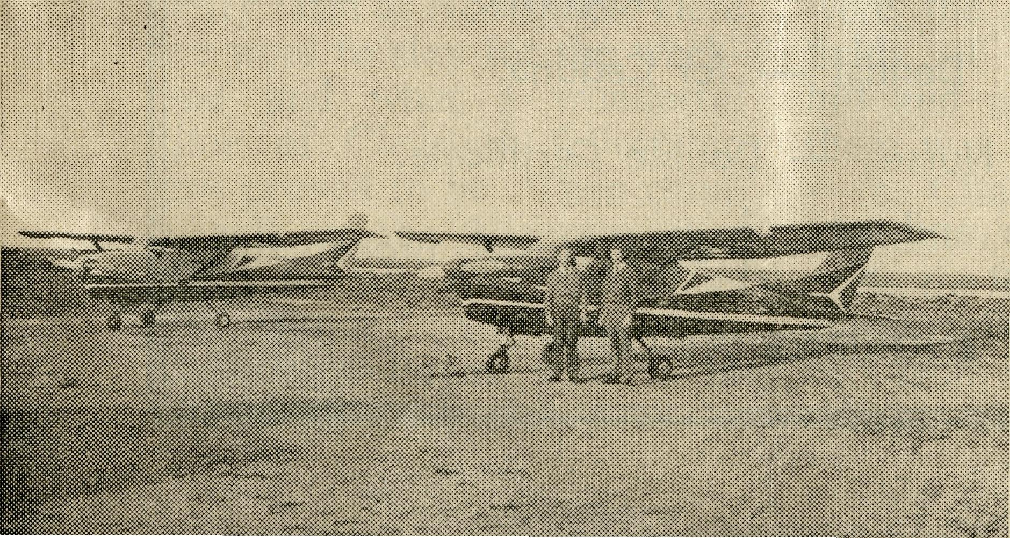
our work requiring your response.
The Body must also be sustained and in this category all may take their share. Spiritual work requires spiritual support by faithful prayers and sacrificial gifts.
If the Church is to give capable service then equipment must be available to enable the worker in the front line to give the best of his ability. To make do or improvise can often be a hindrance when but for the sake of a little more home help, the active witness of the Church might be more effective.
We need to each find our place whether it be support or field.
DEVELOPMENT
Derby, in the Diocese of North West Australia, now lays claim to direct action. The Rev. Noel Hart and his wife are in Western Australia with Mrs. Hart remaining in Perth. Until a house is ready, there is separation for them.
It is a big step in faith both by the new staff members as well as the Society's Council. A Rectory awaiting them would have been admirable, but with no resident Church of England for many years this was not possible. While Mr. Hart is there to establish a regular ministry in Derby
and amongst the iron ore workers on Koolan and Cockatoo Islands, his presence will enable the Rectory building to become established.
The local committee has been actively engaged in preparing the way with the hope of securing a clergyman. A new incentive is now given with a man in the place.
Until Mr. Hart is established it is not easy to ascertain the amount of local help available to meet the cost of Rectory, vehicle, travelling expenses and stipend.
The Society's Council decided to underwrite the venture which will mean a considerable withdrawal of funds. A house in Derby costs a lot more than in Perth and this, with furniture, car and removal expenses, can quite well be in the vicinity of £9,000.
But we are one Body and not all members have the same function. Some members will bear the responsibility of the ministry and others will provide the financial aid.
I know we can count upon B.C.A. friends to be with us in this new project. The need is urgent as there are many years of work to be brought up to date. There are people going to work in the North West who need to have the
ministry received in the southern cities ready to receive them into fellowship. In too many places people are being lost because the Church is not ready to receive them.
Please remember this need by sending your gifts and remember the Rev. Noel and Mrs. Hart and their baby son in your prayers.
Equipment needed includes a car, film-strip projector and duplicator as well as household items such as refrigerator and electric fans to relieve the humid summer heat.
All the foregoing follows closely upon the commendable assistance so many provided to supply our second aircraft.
VH-AEC
These letters are the registration of the Second Cessna 210 Aircraft now based at Ceduna with the Church of England Flying Medical Ser-
^{T}ice. The registration represents a tribute to Mr. Allan Edward Chadwick who has been the Society's pilot since 1938.
The Bishop of Willochra, the Right Reverend T. E. Jones, Organising Missioner at the time of the Flying Medical Service inauguration in 1938, gave permission to name the aircraft "Torn Jones" by which name he was so well known.
Ceremonies in Sydney, Melbourne, Adelaide and Ceduna provided opportunities for friends to gather and give thanks to God for the noble work of pilots and medical staff of the Society.
Our two Cessna 210 aircraft are proving of inestimable benefit and the Service shows what Christian people can do with their talents. Already VH-FMS and VH-AEC have shown their value.
Flying Medical
Service
VH-AEC
VH-FMS
Mr. A. Chadwick
(left)
Mr. J. Lindridge
(right)

The Real Australian
September, 1962
September, 1962
The Real Australian

Trainee's Wanderings
(Rev. J. Wyndham)
STAFF NEEDED-
Nursing Assistants and Cook —
for Old Folk's Home and Hospitals.
Dentist — for Ceduna.
Nurses — Double Certificate.
Married Couple and an Assistant } Boys’ Hostel, Broken Hill
ENQUIRIES WELCOME
DENTIST
It was a great shock to B.C.A. staff and the people for whom he had cared, when the death of Mr. J. L. Jauncey occurred in July. Since early in 1959 when he opened the Service at Ceduna, Mr. Jauncey applied himself diligently to the Dental Practice. His contribution as a Christian worker and high standard of skill won praise from his patients. He was keen to put his Christian faith into practice. B.C.A. friends are asked to remember Mr. Jauncey's parents in their prayers.
Mr. Stephen Wei of Adelaide has given three weeks' assistance to relieve the situation. It is all the more appreciated when realised that it has meant giving up his holidays to provide the help.
A dentist is needed to take
the practice and all enquiries will be gratefully received. COMMITMENT
The Society's activities call for men and women who have committed themselves to Jesus Christ. If you are concerned about the impact of the Christian Church on our country's life, then pray for God's guidance as you might well be the one He requires in some part of the B.C.A. services.
There are many members in the Body each with their particular function. It remains for us to allow God to have the direction so that we may be active members.
May the Holy Spirit guide you and fill you with His power.
Yours in Christian Fellowship,
JOHN GREENWOOD.
It was dusk on Saturday, 2nd June, as we crossed the Victorian border and the tall gums through which the Prince's Highway passes made it seem later still. Suddenly the trees disappeared and we entered the small settlement of Genoa and there was a signpost pointing to Mallacoota. What magic names these sounded—and then the truth dawned—we were passing through the area known as the Croajingalong Mission. Was it possible? Was I really in B.C.A. country? And then, some forty miles from the border we entered Cann River township. This was our destination, for you see, my friend and I were on holidays and arrangements had been made for me to assist in the parish on Sunday.
Our first call was at the Nursing Centre where Sister Jean Roberts directed us to Mr. and Mrs. Armstrong's dairy farm at Noorinbee. Here we were to stay for the weekend and what a wonderful time of Christian fellowship this proved to be. Then came a call to the Vicarage that night to talk over the plans for Sunday services with Deaconess Payne who is in charge of the parish.
The first service was 11 a.m. Holy Communion at St. John's — a delightful little stained weatherboard building in very well kept grounds— a credit to the parishioners. We had a wonderful time of fellowship here as we met around the Lord's Table. Lunch was a bit rushed for there was another Celebration at Combienbar, 30 miles away, at 2 p.m.
Combienbar nestles in another valley and was a good hour's drive from Cann River because the last twenty miles is along a narrow winding mountain track with deep gullies all around. It didn't seem like traditional B.C.A. territory as we twisted along the road, with the noise of waterfalls and bell-birds in our ears. The road was quite slippery despite the dry weather, for the sun rarely penetrates the jungle. Suddenly the forest ended and there before us were the rich emerald green fields of the valley. Up a hill and around a bend, and there was Combienbar school —the Church building for the afternoon.
As the Table was being prepared folk were arriving in cars from various parts of the valley. About 20 people were

8
The Real Australian
September, 1962
September, 1962
The Real Australian

present as the service commenced. There was no stained glass here i— indeed the "reredos" was a school blackboard with all last week's lessons on it in coloured chalk, while hanging from the roof were paper dragons, etc. Strange decorations for a Church service, you say. Yes, I guess so, but the Lord was present as always when two or three are gathered together in His Name.
Combienbar! I'd never heard of it before—Cann River was only a dot on the map where our Society supported a nurse. But mention these names now and one immediately thinks of the people who live there.
There is so much one could write about, including times of prayer with our friends in these places—Christians meeting and talking of the Lord
Whom we love. Will you pray for the people, for Sister Roberts and Deaconess Payne as they travel many miles on dangerous lonely tracks seeking to bring Jesus Christ into the lives of the people committed to them.
You know, we in the city who can kneel before the Lord's Table every week take our privileges for granted. Cann River has a Communion but once a month, while the folk at Combienbar had not been able to partake of the Lord's Supper for some months. Can you then realise what a joy it was to minister to these "Real Australians" in the Name of the Master. Editor's Note.
The Rev. J. Wyndham, a B.C.A. Candidate, made a holiday trip recently through Gippsland and the far west of
N.S.W.
NOTICE BOARD
MELBOURNE RALLY
Tuesday, 18th September
Chapter House, 7.45 p.m.
Chairman: The Archbishop of Melbourne.
Speaker: The Rev. C. W. Rich.
Film: "Nullarbor Interlude".
SYDNEY RALLY
Friday, 21st September
Chapter House, 7.45 p.m.
Chairman: The Archbishop of Sydney.
Speaker: Rev. J. Winter, Leigh Creek.
Film: "Nullarbor Interlude".
WOLLONGONG RALLY
Friday, 12th October
St. Michael's Hall, 8 p.m.
Chairman: Rev. B. H. Williams, Rural Dean.
Speaker: Mr. J. Argall, Ceduna Pharmacy.
LAUNCESTON RALLY
Friday, 19th October
St. John's Hall, 8 p.m.
Speakers: Rev. J. Stockdale, Rev. C. W. Rich.
MELBOURNE FAIR
Thursday, 1st November Melbourne Town Hall, 11 a.m.

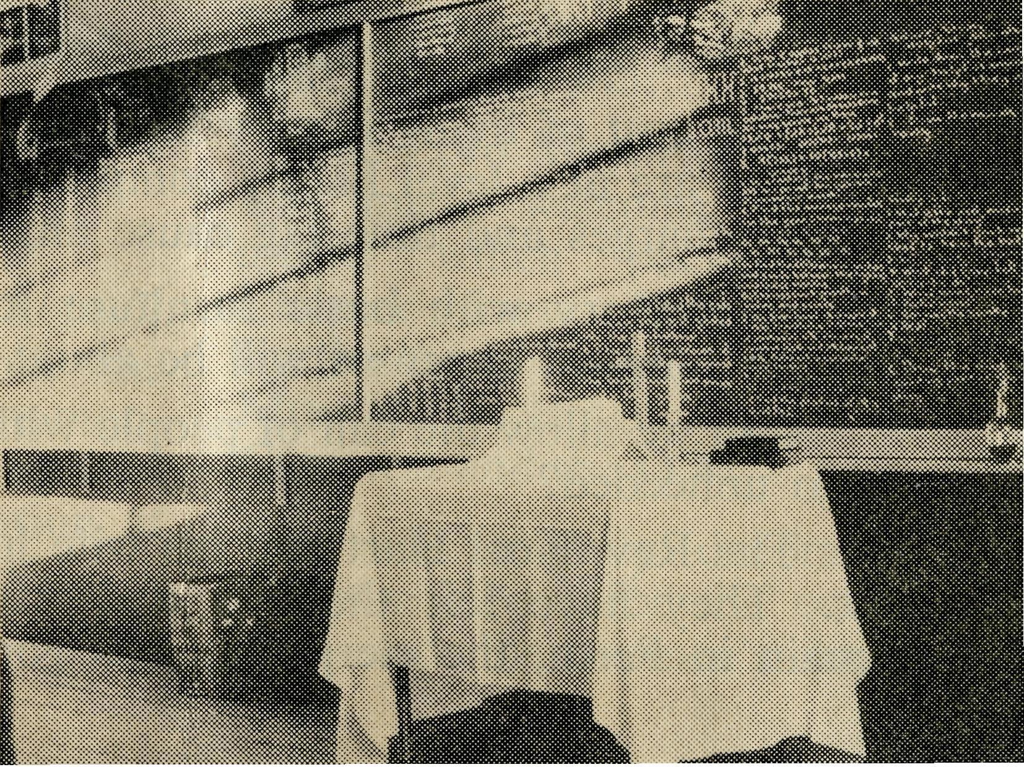
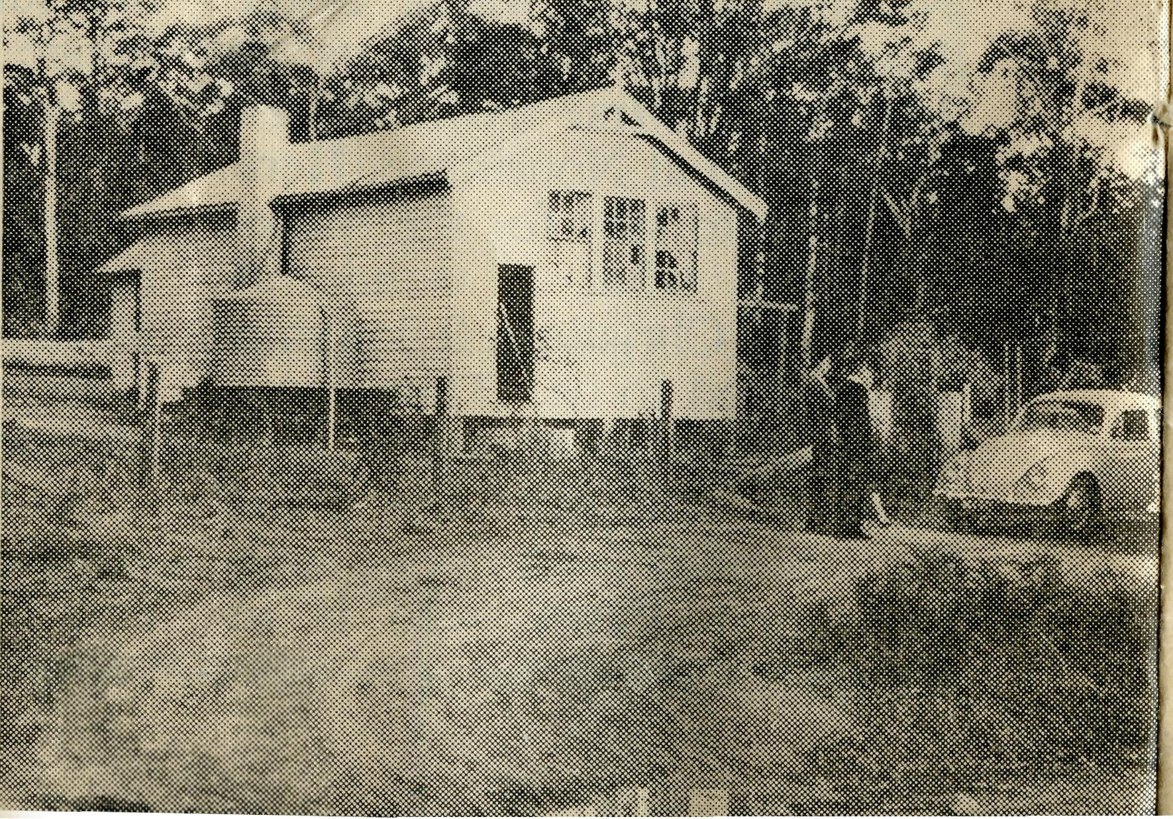
Combienbar School.
Combienbar School ready for Church Service.

10
The Real Australian
September, 1962
September, 1962
The Real Australian
11

NEW PROJECT DERBY
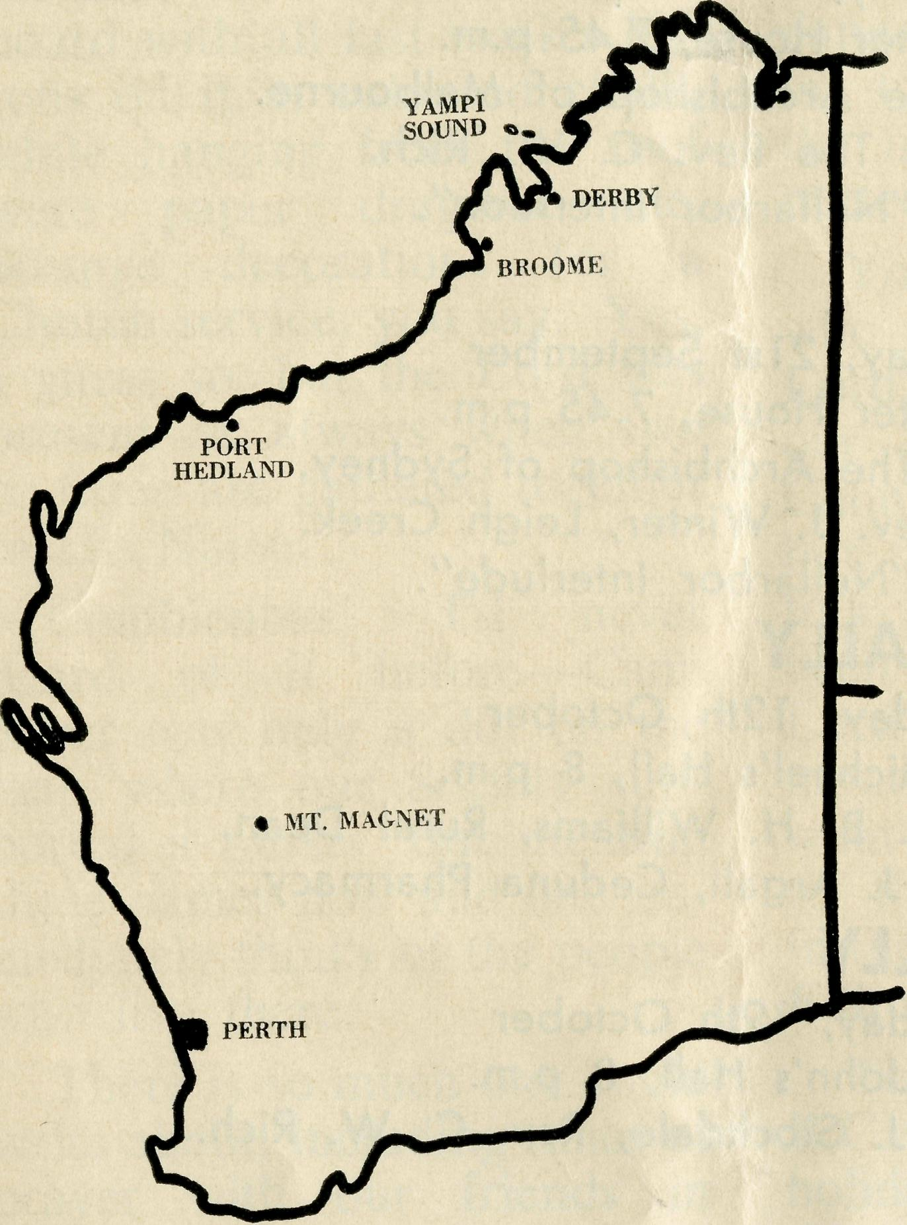
Derby will be the base for the third clergyman nominated by the Society to the Bishop of North West Australia.
He will minister to the iron ore workers on Yampi Sound, as well as organise the Church work in Derby.
In the country behind Derby are cattle stations as well as workers on the Ord River Irrigation Scheme.
It is a big task needing faith, courage and vision.
The cost of living is very high and consequently building expenses are at a level hardly comprehensible to city dwellers. Freight charges and time lag cause anxieties.
A Rectory with basic furniture for tropical conditions, car and removal expenses will be about £9,000.
Can we allow the call of people without a regular ministry to go unheeded?
The Rev. Noel Hart and his wife have put the call to the test. They have left the city and while his wife and son remain in Perth, the clergyman has gone to Derby.
B.C.A. family grew recently with the arrival of Simon William Warburton (Minnipa) and Suzanne Margaret Burner (Ceduna). May God bless them and the proud parents.
* ♦ ♦
Sister M. Dawson has joined the Wudinna Hospital staff for six months. The offer is appreciated and her service will be helpful.
* * #
Double Certificate Nurses with a desire to serve as Christian Missionaries can be assured of a warm welcome. Enquiries will be appreciated.
* ♦ ♦
Dr. V. and Mrs. Pippett and family have been given a welcome at Ceduna. The offer to serve for a few months was a relief for the staff.
* * *
An amount of £437/16/7 for B.C.A. work from the Australian Bush Commonwealth Fund has been received as a result of a resolution at the 1962 General Synod.
Leigh Creek Mission could quite well use a Duplicator. It will greatly assist the Rev. Jim Winter if someone can provide one.
♦ * *
Clovelly Auxiliary achieved such good results that £239 was received from the efforts. Boxes supplied £75 and £164 was the amount received from special functions. It is encouraging to have the help of Women's Auxiliaries.
* * ♦
The Sydney Women's Auxiliary Fair provided valuable assistance for the Society. The day's proceeds of £600 will be lifted to a new high level with proceeds of functions held after the Fair.
The Lord Mayor of Sydney was made welcome by the crowd which packed the Chapter House. He was met by the Archbishop of Sydney, Mrs. H. M. Bragg, Canon E. Cameron and the O.M.
It was a gaily decorated Chapter House for the occasion and the women's hard

12
The Real Australian
September, 1962
September, 1962
The Real Australian
13

You learn a Lot
(Rev. R. Brooks)
work was crowned with success.
* ♦ *
Mrs. D. Colvin (President, Sydney Women's Auxiliary) and Mrs. W. Lowe were missed from the Sydney Fair due to illness. Supporters will remember them in their prayers.
* * *
The late the Most Reverend Reginald Charles Halse, Archbishop of Brisbane and Metropolitan of Queensland, 1943-1962, always showed keen interest in B.C.A. work. He was appreciative of assistance given by the Society during his years as Bishop of Riverina. The Society thanks God for the memory of good fellowship.
* ♦ ♦
The legacy from the late Miss J. E. Warde enables us to look for a property in Melbourne to establish the Victorian Office more securely. For many years office space has been rented. We now look for a B.C.A. House in Melbourne.
The late Miss Warde had a deep interest in B.C.A. and for a number of years was a member of the Melbourne Women's Auxiliary.
* * *
Wilcannia needs a Church Hall and local efforts have provided £1,065. Another
£700 will secure a building.
* * ^
Ivanhoe (Menindee Mission) has £1,283 in hand for a Church. Perhaps some B.C.A. friends might like to help increase the funds or provide a memorial.
A woman to help in the Old Folk's Home would be welcomed by the Warden and Matron. It would be good to have someone who can take the cooking work. What about being a cook? Enquiries to the O.M.
* * *
Thank you, Northcote (Vic.) Fellowship, for the portable communion set for Tarcoola. Thanks also go to Mrs. E. Campbell of Hurl-stone Park for a communion set for Rawlinna. It is a memorial to her mother, Mrs.
J. Smith.
* * *
The Rev. B. Buckland needs a small brass cross for his travelling Church equipment.
* * *
The Victorian Women's Auxiliary Fair will be held on Thursday, 1st November, at 11 a.m., in the Melbourne Town Hall.
Gifts may be left at the Melbourne Office or collected if you will please ring the Rev. J. Stockdale.
"You're a long way from Menindee, Padre, just how far does your territory extend?" Such is frequently the question the Missioner is asked by a "parishioner".
The answer usually is, "Well, up to date—seventy miles north towards Wilcannia where the Rev. Neve takes up work, eighty miles south to Pooncarie, seventy miles west to Broken Hill and one hundred and fifty miles east to Ivanhoe—but, that is only as far as I have gone up to date! On all sides there are people who have not yet been visited."
The Missioner drives many hundreds of miles in his work of visitation. The area of Menindee Mission so far covered, that is, visited with some degree of regularity, is forty thousand square miles. There is more country to cover, and there are people who have not seen a Church of England Minister for many years.
"Well, Padre, you're a city bred man they tell me; do you like the outback?".
The Padre has to say yes, for he finds that in spite of heat, dust, sand and flies, the vast and silent plains have
somehow captured his heart, and somehow altered him. The plains and their people, the spiritual isolation, the "dust and tears and sweat" (in plenty) have put him in touch with life; have, in some mysterious way, made of him a better man.
The first thing the city bred person discovers is the informality of "the bush". The Padre meets his people man to man, in fact he has to be a man or he just doesn't reach them. He who stands on his dignity discovers that he stands alone. For instance, imagine one Bush Missioner: he has been bogged in black mud. It has taken him two and a half hours to walk (better say slither) six miles, in a howling thunderstorm, and that at night. He arrives at the homestead with his trousers rolled up above the knee, boots and socks covered with black mud, his clothes drenched and dripping. At his knock the occupant, dressed in pyjamas and dressing gown, meets him with a wide grin, "So you didn't make it, mate," he says. "Come in."
No, the Padre can't stand on his dignity, he accepts his people as he finds them, but,

14
The Real Australian
September, 1962
September, 1962
The Real Australian
15

LISTEN TO THE BUSH | PADRE
2CH Alternate Sundays |  | 8.30 p.m.
2NX Alternate Sundays |  | 9.30 p.m.
2KA 1st and 3rd Fridays |  | 4.30 p.m.
2GN 2nd and 4th Sundays |  | 9.45 a.m.
2GB Daily Announcements.
From The Annual Report-Year Ended 31st December, 1961
PRAY FOR B.C.A.
SERVE IN B.C.A.
GIVE TO B.C.A.
please God, he often leaves them somewhat more thoughtful than he found them.
Yes, informality is just part of life among the bush people. And there are always surprises. I had followed a Holden alongside the railway line for several miles. We reached a gate. A tall, tough looking fellow in khaki shirt, open at the neck, got out of the Holden and opened the gate. I put my head out the Zephyr window and shouted, "You go on, mister, I'll close the gate." He paused, saw my clerical collar and sauntered over. Then, holding out his hand, "Martin is the name, I'm the travelling Catholic Priest—how do you like the bush?"
A very pleasant hour fol-
lowed. We discussed the theology of authority, liturgy, celibacy, catholicity and Calvin; we discussed life in general and the bush in particular. Darkness was closing in and we had to part.
I asked curiously, "What, in your opinion, Brother, is the ultimate characteristic for which a priest should strive?"
He sat thoughtfully silent for a few seconds and then answered, "That he should be Christlike!"
We shook hands and the Holden drew away. "Hmm," I reflected as I swung the gate shut, "surely that's the ultimate for any man, be he priest, bushman, or whatever he will."
Yes, you learn a lot in the bush.
I present to you the Forty-Second Annual Report of the Bush Church Aid Society with a deep sense of thankfulness to Almighty God.
TRIBUTE is paid to all who have served with talent and training that the Christian missionary cause in Australia may be extended. The prayers and gifts of our increasing circle of friends have enabled the field staff to maintain a high standard of effective witness. Indeed, many can vouch for the encouragement given in times of strain by the faithful prayers of supporters.
To enable you to assess the value of the services maintained I direct your attention to the list of staff members. This will enable you to appreciate the importance of the Society's work.
A large percentage of workers have given long periods of service. To each an appreciative commendation is given for faithful witness to the power of Jesus Christ in their work.
CLERGY working in large areas with thousands of dusty miles to travel, have maintained services in many out-of-the-way places. Their min-
istry has meant much in encouraging local efforts to preserve Christian witness.
In March, 1961, the Rev. J. Winter was instituted as Priest in Charge of the Leigh Creek Mission in the Diocese of Willochra. The Society's help provides stipend, vehicle and travelling expenses.
The Rev. B. J. O'Grady replaced the Rev. R. Neve as Assistant at Ceduna, whilst the latter transferred to Wilcan-nia. This move enabled the Rev. J. Stockdale to accept appointment as Victorian Secretary.
The Rev. T. V. Jones encouraged his congregation to build a new Church at Penong. This replaced an old iron and wood building no longer serviceable. The small population undertook the venture in great faith as a considerable amount of money had to be borrowed.
Vehicles for the clergy are an important item of equipment. During the year the Assistant at Ceduna was supplied with a panel van, and new cars were placed at Min-nipa and Orroroo.
The Church owes a great deal to clergymen working in

16
The Real Australian
September, 1962
September, 1962
The Real Australian
17

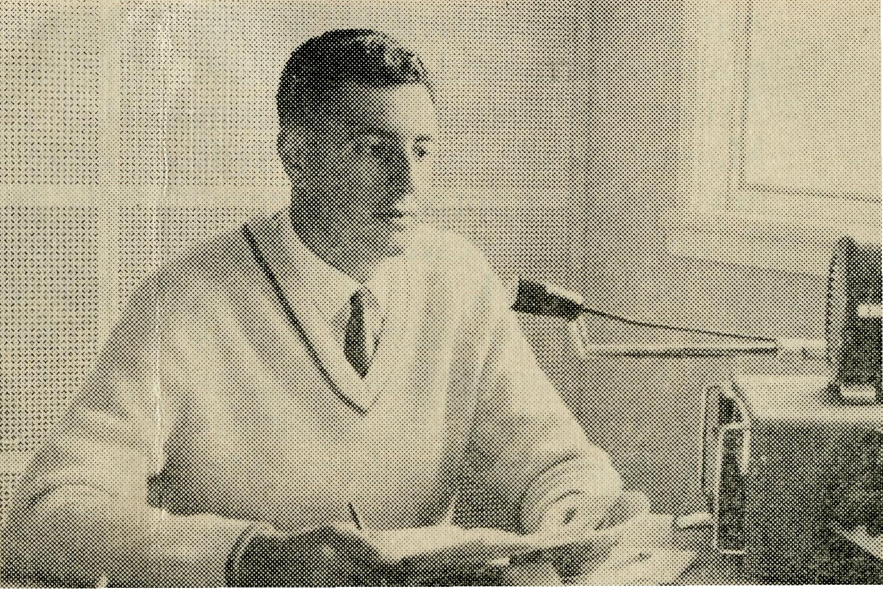
outback areas. Each one knows how much more effective a regular ministry could be if additional staff were available.
Assistance supplied over a number of years enabled the Franklin Harbour Mission (Diocese of Adelaide) and the Otway Ranges Mission (Diocese of Ballarat) to become self-supporting.
Towards the end of the year the offer of the Rev. N. E. Hart to undertake work at Derby in the Diocese of North West Australia gave encouragement to plan this move in 1962.
TRAINEES are the hope for filling future commitments. B.C. A. supporters can encourage young men by making available scholarships to assist in payment of fees.
EDUCATION of young country Australians is greatly assisted by the Hostel staff. The people who care for the students have an opportunity to give Christian training to young people at an impressionable stage of life.
During the year the development of the Darwin project was moved a stage nearer fulfilment. Co-operation sought by the Bishop of Carpentaria was given to enable the Diocese to develop a Church School. The Lease of Land and the Loan for the building
were transferred to allow the Carpentaria "Junior Residential College" to be planned.
THE MAIL BAG SUNDAY SCHOOL was maintained with zeal by the office staff and a large band of voluntary teachers and helpers. Children isolated from Sunday School by distance or health continued to be instructed; while small country Sunday Schools found our presentation of Bible stories helpful in their particular circumstances.
MEDICAL work was maintained in the far west of South Australia and in East Gipps-land.
It was a shock to all when it was known that Dr. R. Chambers' health would cause his withdrawal from Ceduna. Tribute is paid to Dr. and Mrs. Chambers for the faithful Christian witness maintained. Their fellowship was deeply appreciated by the staff.
All who are associated with the work can thank God for the service of Dr. M. Mueller who has for a long period of years taken a vital share of the medical practice.
Pharmacist, Dentist, Clerical Officer and Nurses made their valuable contribution to this part of B.C.A. activities. Each occupation shows the avenue open to people with special training to be used in
the service of Jesus Christ.
A challenge lies before people who profess to be members of Christ's Church. In hospital work there is the constant need for fully trained nurses. There are also opportunities for others who are partially trained to be engaged as cooks, or in general duties.
FLYING MEDICAL SERVICE staff provided vital assistance with the transport of patients and staff. Mr. Allan Chadwick was given assistance with the appointment of Mr. John Lindridge as the second pilot.
It was decided that a special drive be commenced to secure a second Cessna 210 aircraft. By the end of the year the financial support was so encouraging that negotiations were commenced with the Cessna agent.
RADIO CONTROL STATION operations were main-
Radio School
Teacher
(Mr. J.
Pemberthy),
Ceduna.
(Sth. Aust.
Education Dept.)
— the question is asked.
(Photo: Courtesy The Chronicle, Adelaide).
tained by Mr. George Cameron and development of improved equipment progressed under his direction.
It has proved a useful means of helping children with their education. In this regard the Radio School continued to provide valuable assistance through 24 school outposts.
OLD FOLK'S HOME staff members provided a valuable Christian home life for the guests. Here again is another avenue of service for women willing to provide assistance with cooking and home duties.
OFFICE WORK constitutes an important part of the Society's administration. The loyal support of the Sydney and Victorian office staff enables the field work to be maintained.
B.C.A. GIFT SHOP has provided an attractive approach to the Sydney office. The profit of £539 for 1961

18
The Real Australian
September, 1962
September, 1962 The Real Australian 19

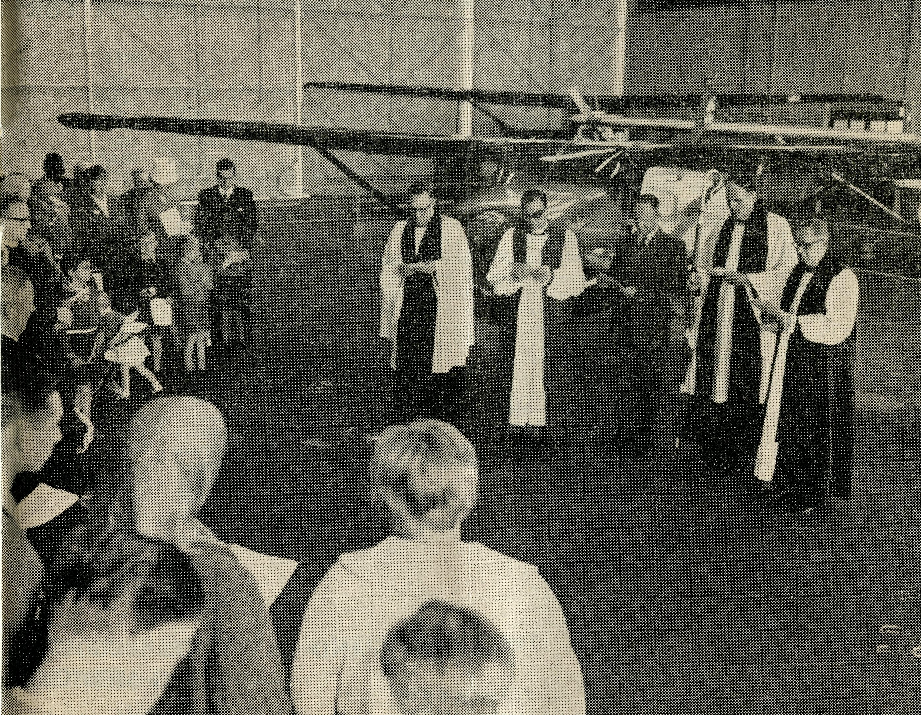
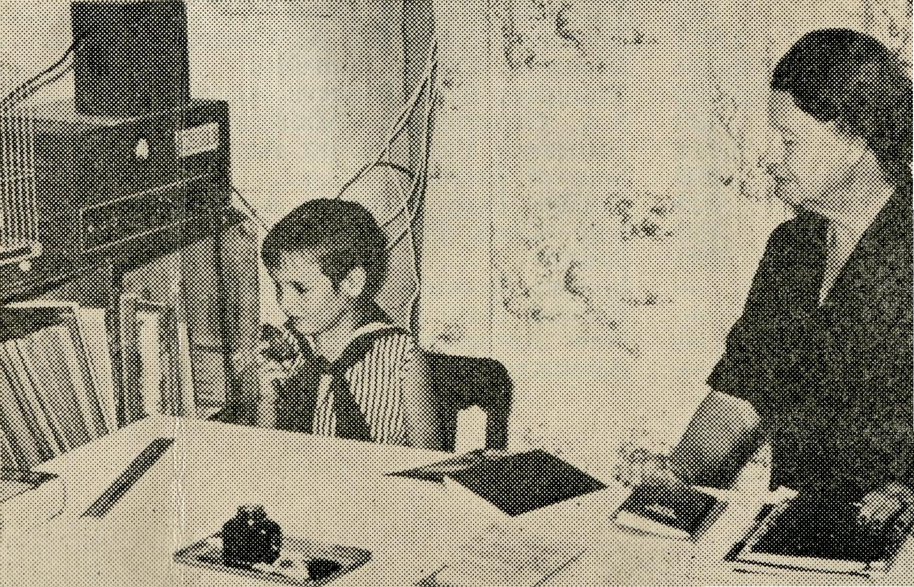
was lower than anticipated reflecting a recession in trade during 1961. Shop staff also gives office assistance which in turn saves expenditure on additional clerical staff.
Supporters can help by remembering to purchase their gift requirements at the Society's shop.
AUXILIARIES provide valuable opportunities to make known the Society's work. The Sydney and Melbourne Fairs both provided encouraging support. The Branch Auxiliaries gave helpful support to the Central functions as well as procuring local assistance to gain help for the Society.
DEPUTATION WORK is
the lifeline of the Society. The Rev. C. W. Rich has achieved great distinction in this field of endeavour. The growth in numbers of supporters in N.S.W. has given ample proof of the enthusiasm applied to the Society's interests.
Deputation work in N.S.W. was greatly assisted by a programme arranged for the Rev. Arthur Williams of Mount Magnet, while he was in Sydney. Many appreciative comments were received as a result of his work.
In order to accept invitations from the increasing number of Churches and organisations requiring speakers, Mr.
L. Calder, Miss R. Campbell and Sister L. Loane all gave valuable assistance.
Although the Rev. John Stockdale was not able to commence duty in Victoria until April, he was very soon heavily booked. By the end of the year the good results gave evidence of the manner in which he gained the response of Victorian friends.
In like manner the Rev. T. J. Hayman and Mr. A. Kirkby were able, in the midst of their own occupations, to gain supporters in South Australia.
C. & CCS. maintained interest and articles and pictures supplied by B.C.A. kept our work before English supporters. The link was strengthened with a visit to Ceduna by Mrs. J. Sherwood-Smith of the Commonwealth and Continental Church Society's Ladies' Association.
MEETING THE NEEDS
requires our devoted and faithful service. Together we can do much to extend Christian influence. We can be assured that He Who calls also gives power to fulfil our service. His "Follow Me" is answered by the assurance that "Ye shall receive power".
Thanks be to God for the privilege of serving Him.
JOHN GREENWOOD, Organising Missioner.
VH-AEC received into Flying
Medical Service.
Adelaide Ceremony.
(Photo: Courtesy of the Sunday
Mail, Adelaide.)
Radio School —
the answer is given.
R. to L.:
The Bishop of Adelaide Rev. T. J. Hayman Mr. A. Chad wick The Bishop of Willochra The Organising Missioner.

20
The Real Australian
September, 1962

September, 1962
The Real Australian
21

RECEIPTS AND PAYMENTS ACCOUNT FOR
RECEIPTS
I960 £  4,287 | Balance at Bank 1/1/61  Donations | £ ...... '. 3,542 | £ 1,636
28 | 1960 Christmas Appeal | 91
914 | 1961 Christmas Appeal | 738
74 | Real Australian | 66
7,273 | Church Offertories | 7,926
6,441 | Boxes | 7,011
6 | Kookaburra Club | 6
1,037 | Mail Bag Sunday School | 798
609 | Stipend Contributions | 500
1,046 | Rally | 695
1,091 | Easter Appeal | 40
873 | C. & CCS. Grant | 2,629
29 | Far West Books | 7
70 | Bush Padre
102 | Sundries | 117
384 | Allocated Donations | 542
1,978 | Willochra Appeal
1,190 | Commonwealth Bonds—Matured
4,650 | Transfers from Other Accounts:  Wudinna | £3,000  1,300  4,300
 | Reserve Account
 | Women's Auxiliary Donation
 | Debit Balance at Bank 31/12/61 |  | 29,840 404
£32,082 |  |  | £31,880
TWELVE MONTHS ENDED 31st DECEMBER, 1961
PAYMENTS
1960 £
951
10,133
722
974
5,635
2,295
659
624
236
961
991
936
1,251
144
270
388
529
450
196
28
1,740
37
201
95
1,636
£32,082
£ £
Debit Balance at Bank 1/1/60
Grants 10,845
Grants for travelling 626
Travelling 782
Stipends 5,994
Mail Bag Sunday School 2,030
Motor Vehicle Expenses 926
Broadcasting 525
Advertising 251
Insurance 1,152
P.M.G. Department—Stamps and 'Phone 835
Printing and Stationery 936
Real Australian 1,771
Petty Cash 91
Students' Fees 344
Sundries 198
Purchase of Motor Vehicles 1,650
Transfers:
Broken Hill House Account 224
General Purchase Account 950
Deputation and Office Equipment 151
Bank Charges and Exchange 37
North West Stipends and Expenses 1,171
Far West Books —
Removal Expenses 330
Sundry Allocated Sums 61
Credit Balance at Bank, 31/12/60 31,880
31,880 £31,880

1960
£
1,341
751
321
3,307
6,371
650
1,750
1,000
100
1,942
1,229
5,000
400
6,611
600
325
150
290
£32,138
RECEIPTS AND PAYMENTS ACCOUNT — FLYING MEDICAL
RECEIPTS
£ £
Bank Balance 1/1/61 1,778
Boxes 740
Com. and Con. Grants —
Appeals and Rally 4,531
General Donations 6,879
Commonwealth Railways 693
Government of South Australia 1,000
Penong and Far West Medical Committee 1,000
Tarcoola Medical Fund 905
Transfers from B.C.A. Centres 235
Victorian Office Transfers 3,584
Transfers from Reserve Account —
S.A. Government—Aborigines' Department 325
Insurance Payment on Aeroplane —
Sale of Engines —
Coober Pedy Progress Association 50
Sale—Cook Property „ —
Sundry 125
Sundry Receipts for Services 495
Refund Duty on Cessna 590
New Aeroplane Appeal 2,532
Allocated Donations 183
■ 23,867
£25,645
FOR YEAR ENDED 31st DECEMBER, 1961
SERVICE —
PAYMENTS 1960
£ £ £
12,477 Salaries 14,054
2,266 Plane Maintenance 634
2,910 Plane Petrol 1,090
116 Insurance 1,134
336 Travelling 509
186 Sundries and Exchange 273
12,069 Cessna Aeroplane 1,127
- Air Cooling Units 340
- Printing 135
- Removal Expenses 64
- Washing Machine 50
19,410
1.778 Bank Balance 31/12/61 6,235
(New Aircraft, £5,702) (Working Account, £533)
£32,138
£25,645

22
The Real Australian September, 1962

September, 1962
The Real Australian
23

Prayer and Praise
For the Society.
O Lord God of our nation, Who hast commanded men to subdue and replenish the earth: Look in Thy love upon all who in distant parts of our land are striving against many difficulties, and are deprived the access of the means of grace. Strengthen and guide the Bush Church Aid Society and all members of the staff. Cheer and comfort them in discouragement and loneliness, bless their ministrations to the good of those they serve, and grant that the message of redeeming love may thus be rooted and grounded in our national life, to the glory of Thy Great Name through Jesus Christ our Lord. Amen.
For Nurses and Doctors.
O God, Who didst choose a beloved physician to set forth the life of Him Who went about doing good, grant that Thy strong tenderness and compassion may be manifest in the work of country doctors and bush nurses. Make them at all times alert to be faithful, as those whom Thou hast burdened and inspired with the honour of their calling. In lonely emergencies strengthen them with confidence that, having done all they can, they may with good conscience leave the issue to Thy power working within Thy law. Make them resourceful and of sound judgment, and hearten their labours with the energy of compassion and the firmness of duty that conquers weariness. Through Him Whose power is called forth by suffering, Jesus Christ our Lord. Amen.
For Church Life in Country Districts.
O Lord, who art present when two or three are gathered together in Thy Name, bless, we beseech Thee, the little far-scattered groups of brethren who in our wide land meet together to worship Thee. Give them a perpetual freshness of spirit, and the power to inspire in each other holiness, helpfulness, and understanding of Thy help. Refresh with the joy of enthusiasm those who endure weary journeys to Thy trysting place. Grant that these little companies of Thy servants may be united in the spirit of Christian charity, awaiting in love the time when there shall be one fold and one Shepherd. Grant that the common life of all communities may be purified by this spirit of charity from all meanness, falsehood, malice and idle gossip, and grant that they who share a common lot may draw strength from each other's virtues, and in their weakness help one another, through our one Lord, Jesus Christ. Amen.
Praise.
For the Blessings vouchsafed to the Society, for all kindly givers, and for the joy of service.
The Bush Church Aid Society
for Australia and Tasmania
FIELD STAFF:
DIOCESE OF ADELAIDE, S.A. Ceduna-Penong, S.A.—Rev. B. Buckland, Th.L., Rev. B. J. O'Grady, Minnipa, S.A.—Rev. D. W. Warburton, Th.L.
DIOCESE OF WILLOCHRA, S.A. Leigh Creek, S.A. — Rev. J. Quorn, S.A.—Rev. G. Fuhrmeister,
Winter, B.A., Th.L. Th.L.
Orroroo, S.A. — Rev. G. S. Gladstone, S.A. (Grant in Aid).
Thorne, B.E.
DIOCESE OF BALLARAT, VIC.
Heytesbury Mission, Vic.—Rev. E. Withington, B.A., Th.L., Timboon, Vic.
DIOCESE OF RIVERINA, N.S.W.
Wilcannia, N.S.W.—Rev. R. Neve, Menindee.—Rev. R. Brooks, Th.L.. Th.L.
DIOCESE OF GIPPSLAND, DIOCESE OF TASMANIA
VIC' Tarraleah, Tas.—Rev. B. Viney,
Croajingalong, Vic.—(Grant). Th.L.
DIOCESE OF NORTH-WEST AUSTRALIA
Derby Mission.—Rev. N. E. Hart, Th.L., Derby, W.A.
Port Hedland Mission.—Rev. B. Woolcott, Th.L., Port Hedland, W.A.
Murchison Mission.—Rev. A. Williams, Th.L., Mount Magnet, W.A.
MAIL BAG SUNDAY SCHOOL
Director: Miss R. CAMPBELL.
OLD FOLK'S HOME (Port Lincoln, S.A.)
Mr. R. and Mrs. AVERY. Mrs. M. L. McLeod.

