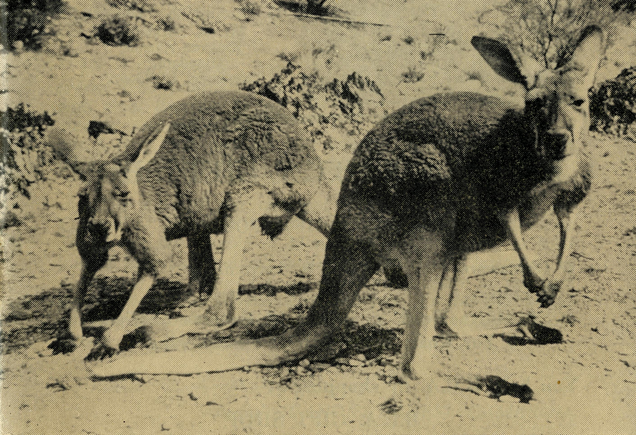
December, 1962
24
The Real Australian
FLYING MEDICAL SERVICES
HOSPITAL CENTRES:
CEDUNA, S.A. Matron: Sister F. DOWLING.
The Murat Bay District Sisters: J. MILLER, G. HITCH-
Hospital. COCK, B. TIERNEY, M.
BELL, M. ROBEY.
PENONG, S.A. Sisters: V. HOLLE and Miss M.
The Penong Memorial Hospital. FARR.
COOK, S.A.
The Bishop Kirkby Memorial Sisters: M. TARR and M. ROSS. Hospital.
TARCOOLA, S.A. Sisters: M. HOPE and V.
The Tarcoola Hospital. COCHRANE.
R^LINNA, WA _{sisters}. _{E} THOMAS.
The Nursing Hostel.
WUDINNA, S.A. Matron: Sister M. DEAN.
The Central Eyre Peninsula Sisters: J. ZILLMAN, N. WIL-
District Hospital. KINS, C. EMMETT, M. DAW-
SON, Miss M. SMEE, Miss M. CHAD WICK.
MEDICAL OFFICERS: DENTIST: PHARMACIST:
Dr. M. MUELLER. Mr. J. ARGALL.
AIRCRAFT: PILOTS:
Cessna 210 VH-AEC Mr. ALLAN CHADWICK,
„ VH-FMS Mr. JOHN LINDRIDGE
Austen Mr. W. BEDFORD.
WIRELESS COMMUNICATIONS BASE:
Ceduna Base Operator: Mr. GEORGE CAMERON.
FLYING MEDICAL SERVICES CENTRE, CEDUNA, S.A. Mr. F. BURNER (Clerical Officer).
CANN RIVER NURSING SERVICE, VIC:
Sister J. ROBERTS.
HOSTELS FOR SCHOOL CHILDREN
BOWRAL, N.S.W. PORT LINCOLN, S.A.
(Charlton Boys' Home). Mr. S. & Mrs. HUMMERSTON
and Miss D. DUVER.
BROKEN HILL, N S.W MUNGINDI, N.S.W.
¥/' ™ &o^^{S}Lr^{DEAN}- Mr. N. and Mrs. MELLOR.
Mrs. M. SMITH.
EDGAR BRAGG & SONS PTY. LTD., 130 BOTANY STREET, WATERLOO
No. 42 (New Series), DECEMBER, 1962
3/- per annum, Post free.
Registered at the G.P.O., Sydney, for transmission by
Post as a periodical.
Two Real Australians.

The Real Australian December, 1962
December, 1962
The Real Australian

The Bush Church Aid Society
for Australia and Tasmania
PRESIDENT: The Most Revereriu H. R. Gough, O.B.E., D.D. Vice-President: The Most Reverend F. Woods, M.A., D.D. Hon. Clerical Secretary: Rev. Canon E. Cameron. Hon. Treasurer: Mr. R. Stokes. Organising Missioner: Rev. J. R. Greenwood, Th.L. Deputationist (N.S.W.): Rev. C W. Rich, Th.L. Victorian Secretary: Rev. J. Stockdale, Th.L.
REMEMBER B.C.A. GIFT SHOP
ACCEPTABLE GIFTS FOR ALL
HEADQUARTERS OFFICE:
135 Bathurst Street, Sydney.
'Phones: 26-3164, 26-3780. Telegraphic Address: "Chaplaincy, Sydney."
SOUTH AUSTRALIA:
Rev. T. J. Hayman, Th.L. St. Matthew's Rectory,
Marryatville. Telephone: FA 1022.
¹ Chinaware • Pottery
• Mulga Wood
• Fur Koala Bears
VICTORIAN OFFICE:
Allan's Building, 276 Collins Street,
Melbourne. Telephone: 63-8962.
Mr. A. Kirkby, 7 Ruthven Avenue,
Glandore. Telephone: LF 3268.
Souvenirs • Cutlery
• Genuine Aborigine Boomerangs
Dear Friends of B.C.A.,
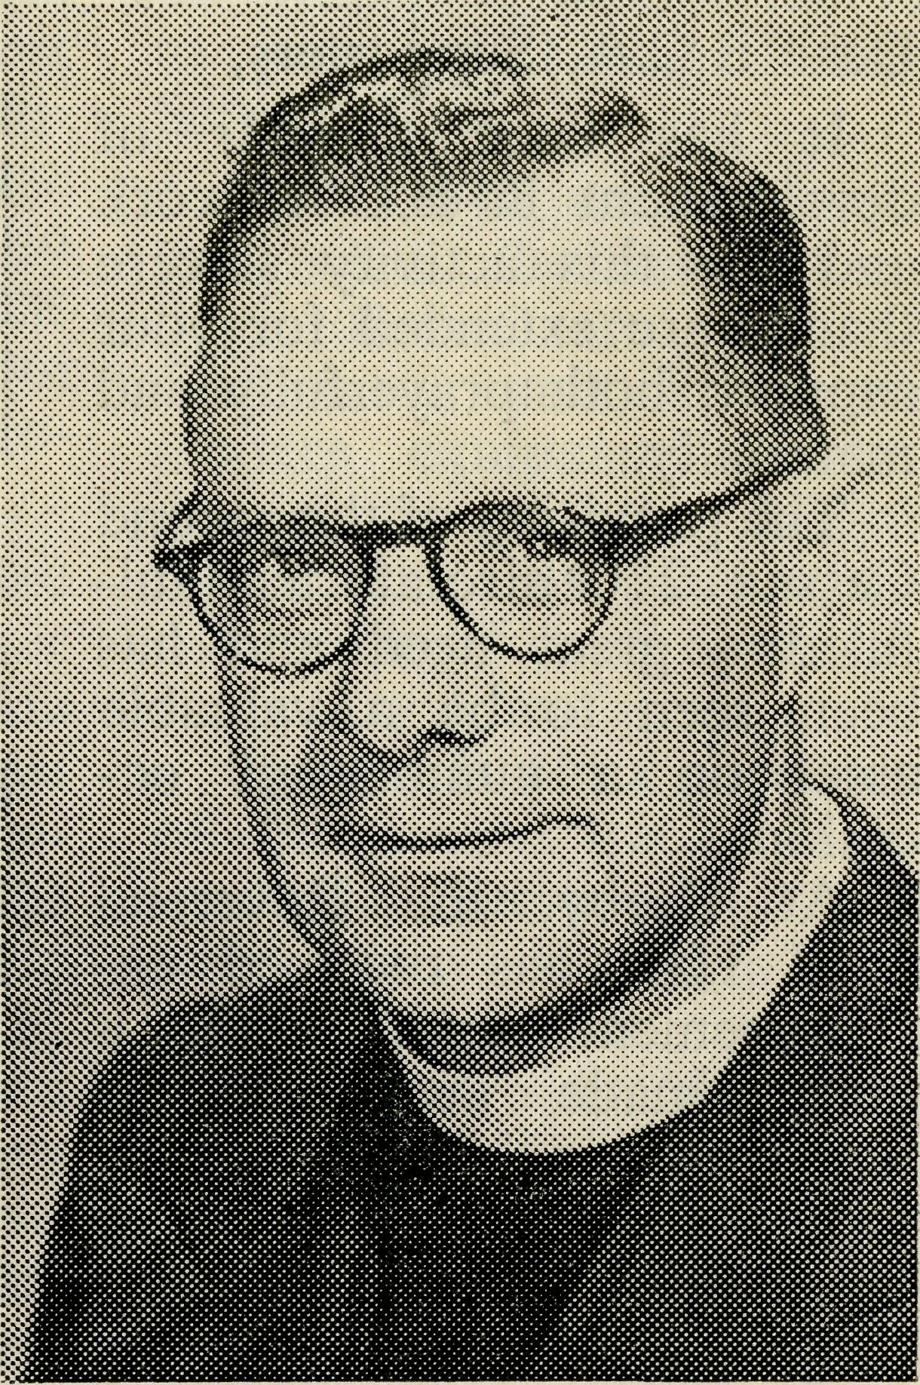
No doubt many of you will have already learnt that our Organising Missioner, the Reverend John Greenwood, has accepted the Parish of St. Stephen's, Coorparoo, in the Diocese of Brisbane.
Mr. Greenwood has served with the Society since 1944 at Ceduna and Minnipa. From 1950 to 1959 he occupied the post of Deputation Secretary for New South Wales. For the last four years he has been Organising Missioner of the Society.
Mr. Greenwood has served God faithfully and with great devotion in his various responsibilities in our Society. He and his wife will be greatly missed by us all and we wish them God's blessing in their Parish.
The Council has arranged a farewell evening in the C.E.N.E.F. Memorial Auditorium, cnr. Kent and Bathurst Streets, on the evening of Monday, 17th December, at 8.00 p.m. I hope that you will take this as a personal invitation to be present and many I know will care to share in practical appreciation of Mr. Greenwood's ministry. To this end, would you care to send any donation to me as Chairman, C/- B.C.A. House, 135 Bathurst Street, Sydney.

You help B.C.A. by shopping at
B.C.A. GIFT SHOP 135 Bathurst Street, Sydney.
Yours sincerely, Signed: (CANON) ERNEST CAMERON,
Chairman.

I¹ he Real Australian
December, 1962
December, 1962
The Real Australian

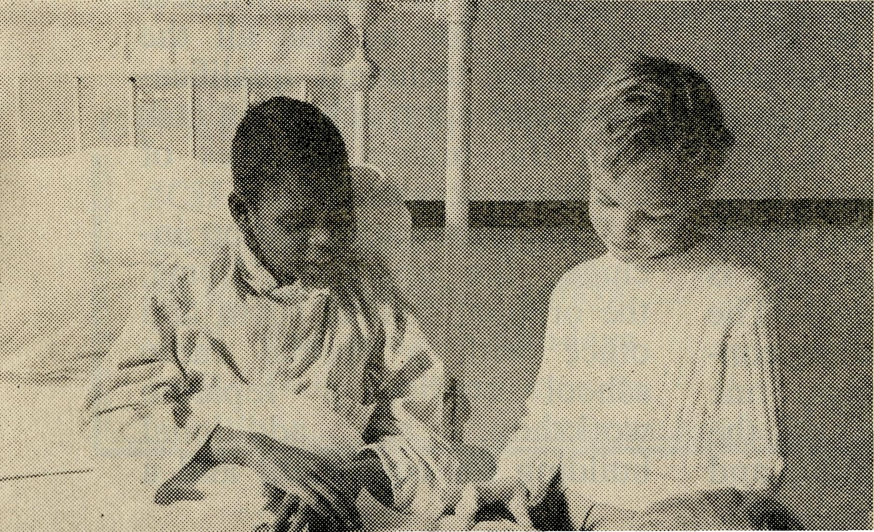
The Organising Missioner’s Letter
Dear B.C.A. Supporters,
It has been a year of development in B.C.A. work and for this activity sincere thanks are extended for your support, both prayerfully and materially.
The provision of the second Cessna 210 aircraft has fulfilled a great need and has been seen to be a valuable asset on a number of occasions.
At Derby, the Reverend Noel Hart has received encouragement and, with a house made available, his wife and son have been able to join him. Their new Rectory should be showing shape by the time this leaves the printer.
The Reverend Jim Winter and his wife and family are well settled in the new Rectory at Leigh Creek. A large debt has been incurred, but Mr. and Mrs. Winter have given faithful encouragement to the parishioners who nobly bear the responsibility. The Diocese of Willochra is to be commended for standing behind the loan.
A new Church Hall at Wudinna has enabled the Reverend Bill Warburton to organise his work more effectively.
At Wilcannia the Reverend Ray Neve is seeing a Parish Hall become an established fact. Another B.C.A. man, the Reverend Stewart Thorne, has the advantage of a Parish Hall recently completed.
The new Church of St. Alphege, Penong, has been most useful for the Reverend Bernard Buckland and the people of the district.
Extensions provided by the local Board at the Old Folk's Home, Port Lincoln, will enable Mr. Roy and Mrs. Avery and the staff to care for an additional four men.
Our three hostels have all been subject to alterations and improvements so that the work may be more effectively maintained.
The Bowral property being no longer required as a hostel is to be purchased for use as a Charlton Boys' Home. This will, in due course, enable B.C.A. to give attention to the need for a hostel in another area. At this stage certain properties are being investigated and details will be given at a later date.
WELL DONE, good and faithful clergy, who with their respective wives have given faithful bush service.
Early in 1963 field staff will
undergo certain changes. The vacancies left by men moving into more closely settled areas will be filled, for the most part, by men who are completing their training. Those replacing the members who have served their bush areas so faithfully will benefit from the hard work of their predecessors.
COMMENDATION is due
to Dr. Merna Mueller for her devoted service to Ceduna people and those in the vast area beyond the farming community. For six months the medical work has been covered by two doctors. Dr. V. Pippett has now concluded his period of service. Very timely help has been forthcoming from Dr. D. S. Tindal who has another commitment in January. It is also helpful having Dr. G. Middleton able to help in February. Both are thanked for the relief thus given.
The great need is for a
doctor to accept this challenge of Christian service and be willing to accept the call to join the Flying Medical Service Staff.
DENTISTS are not easy to find when the suburbs and large towns are left. At Ceduna a unit fitted with modern equipment needs a dentist to put the facilities into service. Is there a dentist looking for an opening in a country town?
Ceduna is not a ghost-town off the beaten track. It is a modern, progressive place with many facilities. The attractive stretch of blue water comprising Murat Bay, the tidy sealed main street and medial grass strips, with modern bank buildings, business premises and town facilities have pleasantly surprised many recent travellers.
APPRECIATION is expressed for the many messages and tokens of goodwill consequent upon my acceptance
Healing the Sick, Colour no Barrier.

The Real Australian
December, 1962
December, 1962
The Real Australian

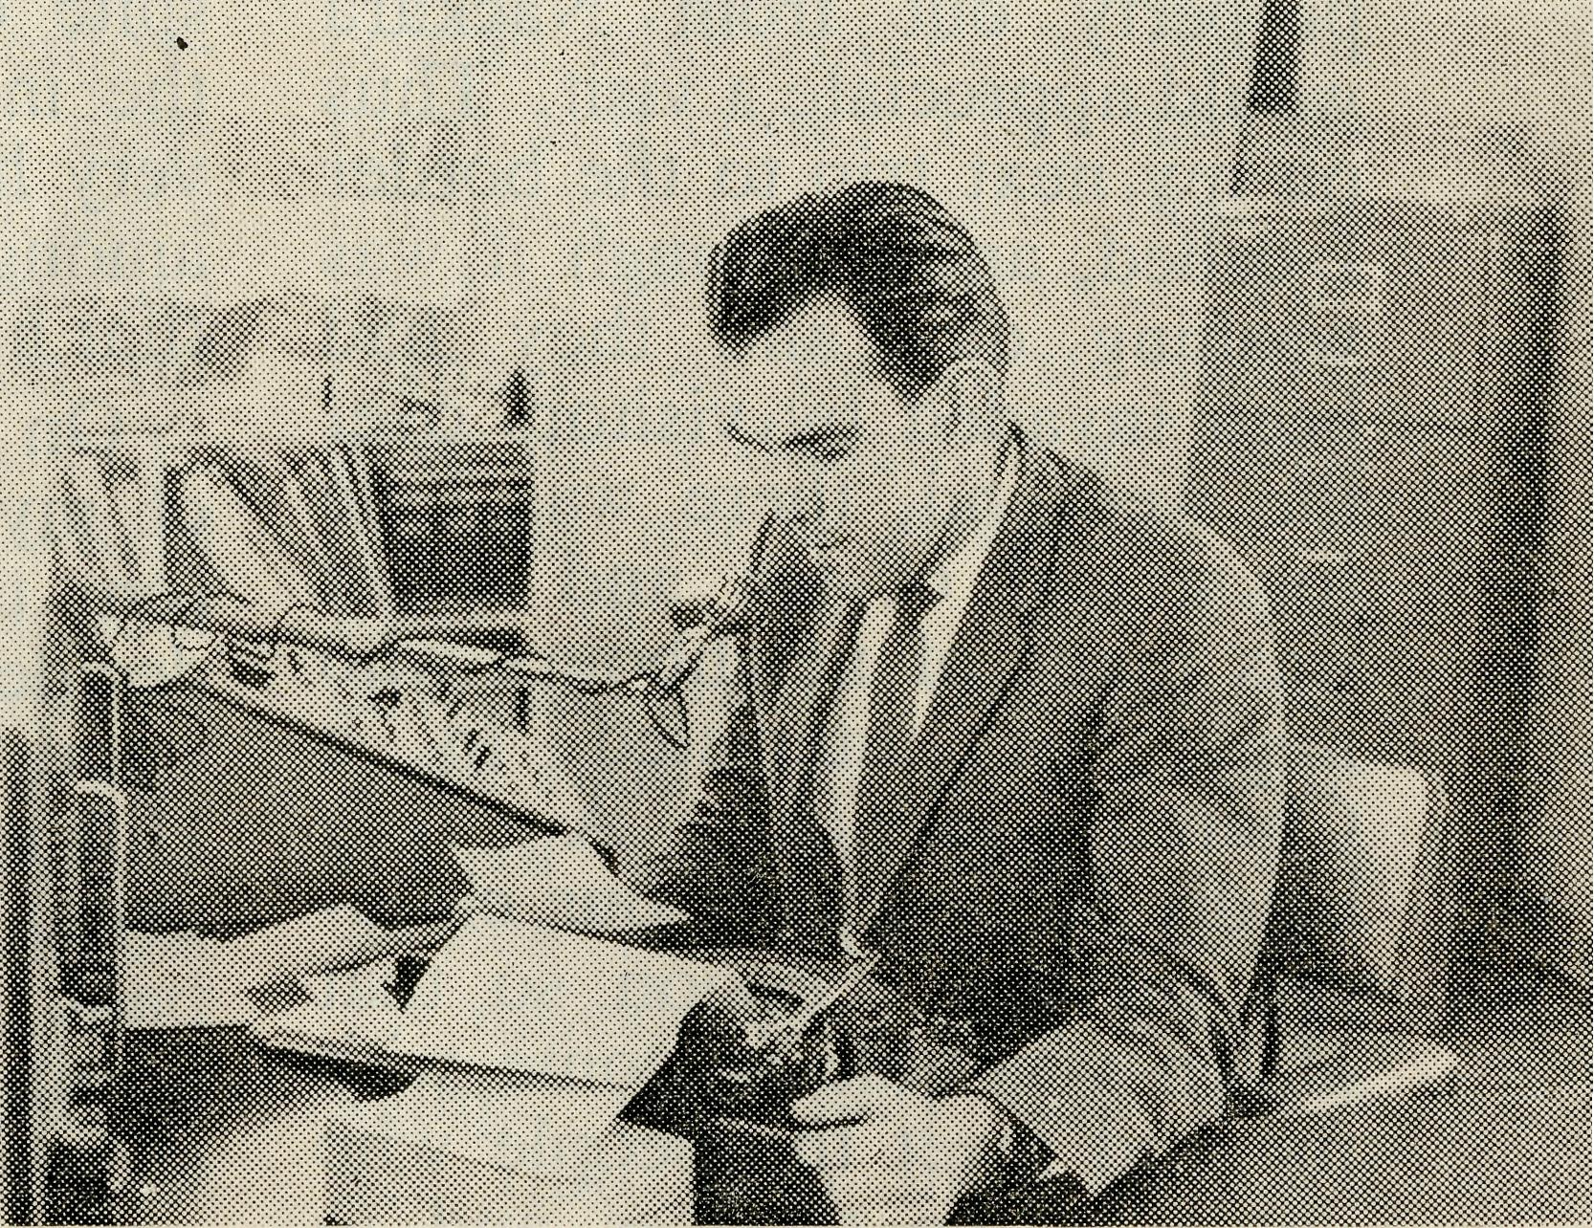
CHRISTMAS GREETINGS
TO ALL B.C.A. SUPPORTERS
¹¹ Unto you is born this day in the city of David a Saviour, which is Christ the Lord."
(Luke 2 v. 11)
Radio Control Station, Ceduna
of nomination as Rector of St. Stephen's, Coorparoo, Diocese of Brisbane. My wife and I have always been conscious of a strong bond of fellowship with the praying supporters of the Society's work.
Early in 1963, together with our two boys, we shall enter our new sphere of ser-
At the end of the year Mr. George Cameron concludes his service at Ceduna as Radio Operator. In 1953 the late Archbishop of Sydney (the Most Reverend H. W. K. Mowll) felt that the establishment of the radio work justified him, as Primate of Australia, in journeying from Sydney to dedicate the buildings. In his address he is reported as saying:—"The Wireless Control Station consists of two buildings, one being the residence of the operator and his family, and
vice for our Lord and His Church. The B.C.A. work and the aim to win "Australia for Christ" will always have an important place in our life.
May God grant to all of us a Holy and Happy Christmas.
Yours in Christian Fellowship,
JOHN GREENWOOD.
the other containing the wireless equipment in the operating centre. We are fortunate in having Mr. George Cameron as the wireless operator, for he has all the necessary technical qualifications and approaches his task with the highest motives of Christian service."
BUSH  2CH | PADRE BROADCASTS-  Alternate Sundays | ... 8.30 p.m.
2NX | Alternate Sundays | ... 9.30 p.m.
2KA | 1st and 3rd Fridays | ... 4.30 p.m.
2GN | 2nd and 4th Sundays | ... 9.45 a.m.
2GB | Daily announcements.
Today the radio station includes the operator's home, the original control room and office with a special radio school studio, a separate workshop, an additional building for equipment and a
large garage and storeroom which also provides accommodation for the ambulance.
The last complete yearly figures (1961) revealed that 137 outstations were based on Ceduna and included fixed and portable outposts, school sets and fishing vessels. During that year 1,400 medical consultations were conducted and 6,977 telegrams were handled at the Control Station.
It adds up to an impressive
Mr. G. Cameron
at Radio Control
Station, Ceduna.
total of dedication and devoted service on the part of Mr. Cameron.
A great deal of this could not have been achieved without the assistance of Mrs. Cameron. I am sure all concerned will appreciate the value of the service rendered by Mr. George and Mrs. Cameron and will pray for God's blessing upon them. Together with their four daughters they will establish their home in Adelaide.

The Real Australian
December, 1962
December, 1962
The Real Australian

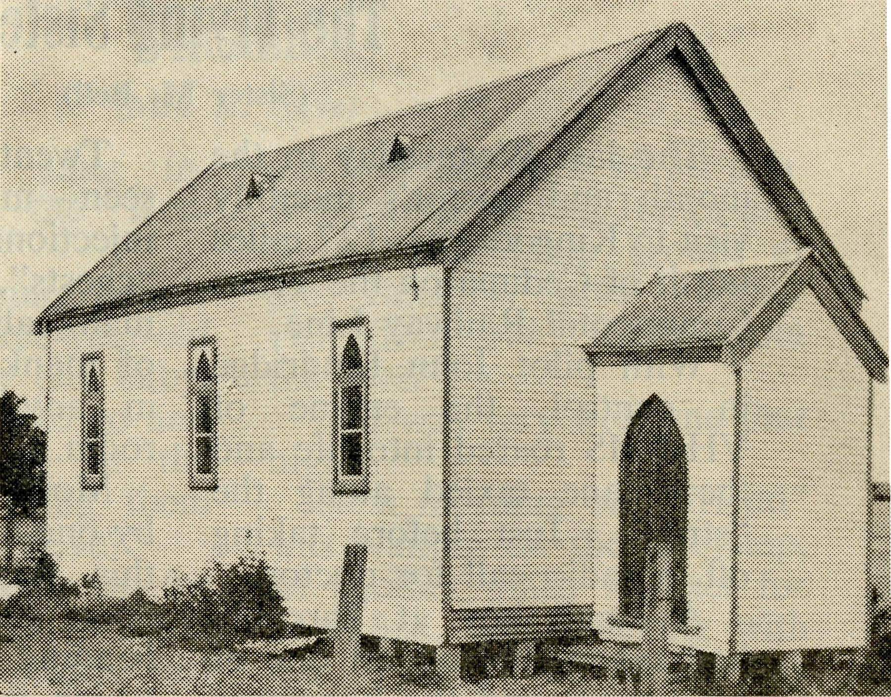
Pushing Back The Boundaries
(Rev. G. S. Thome)
"Lengthen thy cords and strengthen thy stakes" was the text given to me at my confirmation. This has been the case in the Mission District of Orroroo this year due to the enabling power of the Holy Spirit. A few months ago while visiting the Booleroo District Hospital a patient mentioned that some Church of England people on a station property out from Nackara would appreciate a visit. Thus on my next trip to the border I called, and, although it was washing day and they had been invaded by visitors over the weekend, there was time for a cup of tea and a list was made of neighbours who might be interested in a Church service. A lady kindly looked after our children on this occasion so that Helen was able to come with me and meet the people who come to the services and to see some of the homesteads I visit.
A fortnight later, a day was spent visiting this area calling at the homesteads. This resulted in quite an amount of interest being created and a few weeks later the first Church of England service was held in Nackara.
The service was held in the local hall, which was new and quite attractive, but the wind was bitterly cold. The lighting plant mounted on a trailer had to be pulled out of the hall, pushed round the back of the hall and connected up and started. There were no pianist or singers, so we said the verse of a hymn and then said Evening Prayer. In spite of these difficulties and the intense cold, there was a very happy time of fellowship amongst the ten who came that night.
On the homeward stretch of my last visit to Cockburn (on the N.S.W. border), I decided to visit some homesteads north of the Broken Hill road. I left Cockburn at about 9 a.m. and travelled back 15 miles then headed north. The first homestead sighted was 15 miles further on and here I met an Anglican lady who, besides teaching her two children, cooked for seven people and did her own housework. Another 15 miles and I came to another Anglican family. The mother was away in Adelaide await-ting the birth of her second child. Although this was a bachelor's camp for the time
St. Paul's Church, Cockburn, 1962. (N.S.W. Border)
being, lunch was most enjoyable and a very lively conversation on the husband's views of religion was carried on while we ate. Then off again another 10 miles N.E. to another homestead where there were two pre-school children and an invitation was extended to hold a service there on my next visit to them and to stay overnight. Another seven miles west I passed another homestead, but the family was away in Broken Hill servicing their aeroplane. Continuing for 16 miles S.W. a cuppa and prayer was shared with a young Anglican mother. Her children were aged four years and six weeks and there was no telephone or radio. What a challenge to city dwellers. At the next place I was introduced to a young married
couple who worked as station hand and cook. They had no transport so would find it hard to get to a service. The manager of the next station gave me a donation although he was not a Anglican. A total of 108 miles was covered before reaching the main road and quite a number of contacts made. The service at Nackara (another 17 miles) was most encouraging. One lady had made her third trip into Nackara that day, bringing her daughter to and from school and then back again at night—a total of 78 miles being covered by the time she returned from the service.
With the assistance of your prayers more visits will be made to these isolated folk and the cords will be lengthened.

10
The Real Australian
December, 1962
December, 1962
The Real Australian
11

The Flying Sister
(Sister M. Bell)
Wilcannia
(Mrs. R. Neve)

The last Wednesday in the month and doctor's monthly visit to Kingoonya—127 miles north of Ceduna on the Trans Continental Railway Line.
With pilot John Lindridge in control, the engine of VH-FMS roared into life and the 'plane taxied along the "strip". Just before taking off, a radio call for doctor.
A small boy at Tarcoola had taken the top off one of his fingers and the bone was protruding. Message returned to- Sister—"Yes, we would continue to Kingoonya as scheduled and call at Tarcoola as soon as consulting was completed."
Some minutes later we were looking down on the patch work of cultivated lands, and it was so nice to see the green again! The crops were coming on well. Then over the sand hills and dry salt lakes to Kingoonya. No green patches to be seen here, how dry and barren it looked from the air. Yet people lived here and there was work to be done on the railway line.
Consulting takes place in a specially equipped consulting room in the public hall, whilst the waiting room is the hall itself.
Twenty-seven patients were seen—mid cases, babies for injections, children with "chests", a sore hand, an old man—all sorts and conditions of mankind, as may be seen in any Doctor's consulting room.
Morning tea was provided by one of the local ladies, and this was a welcome break. Soon after mid-day we were heading west for Tarcoola, which is 50 miles away; this time to a modern and well-equipped hospital staffed by two nursing sisters. The finger was patched up and an inmate of the hospital and five outpatients were seen (it does not take long for callers to arrive once doctor's 'plane is heard).
Another welcome "cuppa" then in the air again, heading south over salt lakes, sand hills, cultivated land and homesteads—at last the sea and we were at Ceduna by 3 p.m. with dinner waiting for us. Is it worthwhile? I should think the folk of the outback would be unanimous in saying, "Most certainly!"
But to us it is worthwhile — B.C.A. — Because Christ Asks.
The telephone rang insistently—"Hello, the Rectory."
"We have a young couple here with a three-year-old and a six months old baby. They have nowhere to go and have been sleeping in the open. Can we bring them round to see Mr. Neve?"
As I put the kettle on for the expected family, I could not help but wonder just where one was expected to produce accommodation for these people. For to find such in Wilcannia is like finding a needle in a haystack.
Before they had arrived another visitor arrived, a woman hitch-hiking. After quite a long conversation we were still none the wiser why she had called. Over a cup of coffee we discovered she wanted a lift and money. This was the first time we'd had a woman of this nature call, although there is never any shortage of men. We cut her some sandwiches and declining the offer of a bed she returned to her camp on the road.
Not long after she had gone our "Family" arrived. After much trouble we got one of the local hotels to accommodate them overnight, but
this was not until 10.30 p.m. In between we had Junior and Senior Fellowship groups at the Rectory, plus another visit from our "friend from the road".
Bed was very welcome that night.
Next morning our "friend" was waiting on the doorstep, so another place was set for breakfast. On checking with our "Family" we found they had not slept at the hotel, for all our trouble, due to a domestic upset.
Finally we paid our "friend's" way out of town on the "mail" truck and Ray settled the father with his new employee. A caravan was provided with the job if the father liked to bring it 100 miles up the river. All this was settled in due course and later Ray baptized the father and two children. The little girl attended Sunday School while the family was in town.
But our weekend was not yet over. One more young chap arrived with a very long story and spent the night in our garage. He was able to get a job locally the next day.
No, this is not the normal Rectory life. The Lord provides quieter periods in between.

12
The Real Australian
December, 1962
December, 1962 The Real Australian
13

PRAY | FOR B.C.A.
 | SERVE | IN | B.C.A.
 |  |  | GIVE | TO | B.C.A.
Winter and Spring are lovely months here in Wil-cannia. The fruit trees hardly lose their leaves before they are in bud again. One evening, not so very long ago, Andrew—our two-year-old— called me out to the back door. "Pretties, Marmee," he said, as he pointed to our nectarine tree. Yes, it certainly was pretty. It was massed with delicate pink blossoms and, as the evening sun dipped behind the cedar trees, the whole tree seemed enveloped in glorious colours of the setting sun. The whole evening breathed peace, bringing one very close to one's Maker. Even as the last sun rays left us, there was not a movement, and sitting on the step with Andrew I could not help but think how wonderful it must have been when God walked with Adam and Eve in the Garden of Eden.
These peaceful evenings can also be long, lonely evenings, if one allows them to be so, when sitting waiting for a husband to return from a trip. The hours creep on—9, 10, 10.30, 11 p.m. He did say he would be home for tea even though a little late. Once
knowing his last port of call I 'phoned.
"Yes, dearie, he's just left. Take about I of an hour. Road a bit rough luv."
As I put down the receiver, his usual home-coming toot greeted me. What he did with I hour is still a mystery.
"Fair" time approached once again and all spare time was spent at the sewing machine, then, closer to the date, cooking. We were very thrilled to have the Rev. Ray and Mrs. Brooks from Menindee travel just on 100 miles to open our evening. How good it was to see them, although it was after midnight before we could sit down over a cup of coffee and enjoy a time of fellowship.
Not two weeks later our Bishop arrived to spend a week with us.
During his visit the Ladies' Guild provided our Parish Tea, catering for 86. How grateful I was to those faithful few women who turned up to help.
So life, even in a Rectory out bush, has its moments, but is it not a privilege to be able to serve Him, our God and Saviour, wherever it might be.
Supporters will be sorry to know that the young daughter of the Reverend Jim and Mrs. Winter suffered an accident in Adelaide recently. The latest reports are that she is making a steady recovery.
* $ ♦
Melbourne, Sydney and Wollongong Rallies were well-attended gatherings. The evidence of increased support was an encouraging factor of the 1962 Rallies. A total of £2,789 is an indication of your devoted support (Melbourne £665 and Sydney £2,124). Thank you and may this interest continue to grow.
* * #
The visit of the Primate in October to part of B.C.A. work was appreciated by the staff and the people who were privileged to meet him. Leigh Creek provided a dust storm, Tarcoola an emergency patient (not the Primate) and Wudinna a flat tyre on the aircraft. His Grace left behind the impression of friendly
concern for the spiritual and bodily welfare of our fellow Australians.
A call at Kokatha sheep station gave a glimpse of life away from the city. Ceduna provided the inside story of the vital nerve centre of Flying Medical Service activity.
* * *
Latest news from Western Australia is that the Reverend Bruce Woolcott is making a steady recovery from his surgical treatment. Supporters will remember Mr. and Mrs. Woolcott in their prayers.
J]S i{J ^s
Provincial Synod in Perth was visited by the O.M. in September. It was helpful in extending interest in B.C.A. work and provided opportunity to discuss North West Australia's activity with the Bishop and the Reverend Arthur Williams of Mount Magnet.'
* ^ *
News from Wyndham, through the agency of a good friend, Mr. Tom Herzfeld,

14
The Real Australian
December, 1962
December, 1962
The Real Australian
15

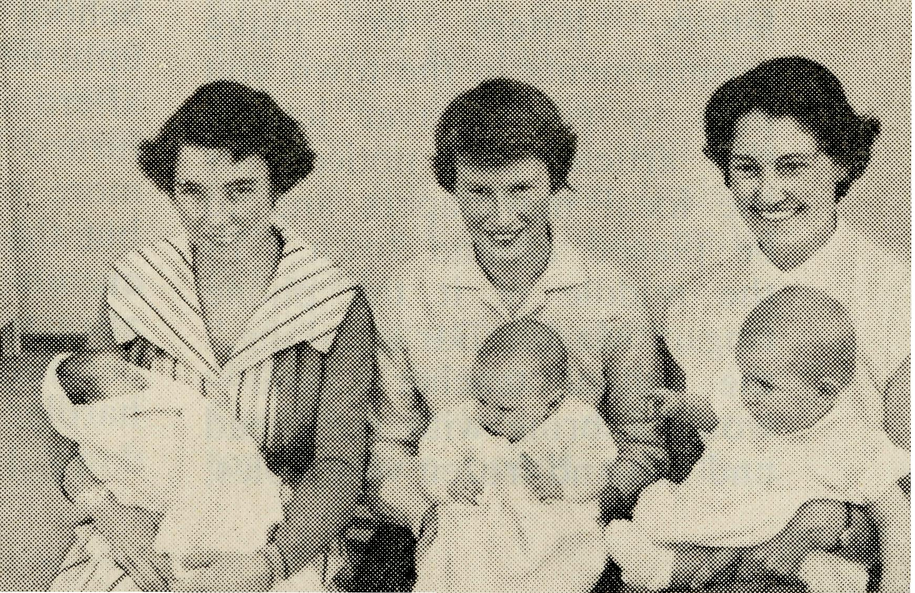
tells of an increased population. His information on the need for a regular ministry and development of the area might well be remembered in our prayers.
* # #
Miss W. Ikin, formerly of Wudinna Hospital, is assured of B.C.A. remembrance as she undertakes nursing training at Marrickville District Hospital.
* * *
Sister E. Hawken has returned to Perth for a third certificate. Ceduna Hospital Staff will miss her Christian service.
* * *
Thank you Sister I. Mc-Credie for the period of relief duty in our hospital work. It is helpful having trained nurses willing to give some of their time for such relief work.
* * #
Sister E. Thomas, of Raw-linna, has been at her Nullar-bor Plain post for eleven years. Is there a trained nurse looking for Christian service who will offer to accept this challenge? Sister Thomas would like a change, but waits to have someone offer.
* * *
Hospital work is helped by trained women who offer for a limited time. It still means problems arise as they conclude such periods of service.
Trained staff and partially trained Christian women are constantly needed for hospital work.
* * ♦
Box Secretaries are a valuable asset as they maintain support in their parishes. Some have been caring for B.C.A. interest for many years. Miss A. Leplastrier became Box Secretary at St. Paul's Chatswood, in 1935. After 27 years, Miss Leplastrier has relinquished her office, having earned high praise for devoted service. Thank you for a job well done, Miss Leplastrier. It is fitting that the new Secretary should be a B.C.A. worker and daughter of a late Women's Auxiliary Member. Sister L. Loane takes over the B.C.A. boxes in Chats-wood.
* # *
It is noted that the Darwin Hostel, now the Carpentaria Junior Residential College, will open early in 1963. B.C.A. part in the inauguration of the project will be remembered as furniture and equipment for the Principal's quarters have been supplied. The College Committee will have an inscribed plate installed signifying B.C.A. help.
* * *
Mr. T. Mayne and his wife and family will occupy
the Radio Control Operator's home early in January, 1963. Mr. Mayne brings his specialised radio skill into service for the Christian missionary cause. It is a great help having people with special skill willing to make sacrifices for the work of God.
Dr. V. Pippett concluded his period at Ceduna at the end of November. His help was a relief for Dr. Mueller and provided Christian fellowship for all the staff. Thank you, Dr. and Mrs. Pippett, for the valuable help provided.
Dr. D. Tindal can help for December, but has a previously arranged commitment early in January. Dr. G. Middelton will be able to provide relief for February. Thanks to both kind friends
Three B.C.A.
Wives and
Families.
Left to Right: Mrs. F. Burner
(Clerical Officer) Mrs. J. Argall
(Pharmacy) Mrs. J. Lindridge
(Pilot)
for such timely Christian service.
* * #
Is there a Doctor with faith so keen that he will offer for work with the Flying Medical Staff? All the material needs can be supplied, so there are no problems in that field.
WANTED. A DOCTOR. All information from the Organising Missioner.
* * ♦
A duplicator is needed by the Reverend Noel Hart for Derby. A piano in good condition is needed by the Reverend Ray Neve for Wil-cannia. Any offers?
* % %
Derby Rectory needs a radio set with a short wave band. Without short wave, reception is not possible. Perhaps some reader may be willing to respond.

16
The Real Australian
December, 1962
December, 1962
The Real Australian
17

Port Hedland
(Rev. B. Wookott)
What would a typical month be for you?
I guess many like to ask this question. Firstly, no matter what job you have there never seems to be a typical month — there is always the unexpected or the extra job coming your way.
The fourth Sunday of the month is over and that's my weekend at home. Monday has come, so in goes PH 27, the car, for greasing and regular check-up, for it will be into the outback again in a couple of days. One relaxes a bit after Sunday Services. Tuesday comes and preparation for School Scripture classes and Bible Study for Wednesday, letters must also be written—quite a big job when you are so far from the city and headquarters in Sydney and friends—business letters, letters to make arrangements in the town you plan to visit, prayer letters, this article, also notices for the local newspapers and to be placed around town. In the middle of it the phone rings, "Marble Bar speaking," the school teacher's wife— would I bring with me bread and fish and frozen vegetables,
and also go to the chemist— Yes, I'm only too happy, the least I can do. That means I must get these on Wednesday some time and also those other things someone else wrote about. I usually call at the chemist to see if he has any medicines for the outback folk. Tuesday this week must also be Sermon preparation as next Thursday I will be on the track.
Then comes Wednesday— five school classes at Port Hedland—then on the first Wednesday of the month is Mothers' Union, and every Wednesday evening Bible Study at the Rectory.
Mothers' Union is about six strong, not many, but worthwhile. My wife speaks at Mothers' Union, but I take the service. We meet after the service in our "Sunday School"—the ladies sit on upturned boxes and eat their afternoon tea from an upturned door supported on more boxes—a bit primitive, but the spirit is there. In the evening the Bible Study attracts only one other couple besides ourselves—once more hardly dramatic.
Thursday comes—my wife
has been washing and ironing as well as typing letters early in the week, so clothes are ready for the five to six days. This must be an early rise in order to be away about 7 o'clock—in summer the earlier the better, for even at 9 a.m. the temperature may have reached the century and it is unpleasant on the road when the temperature is around the 100. Clothes, a cool box of fruit, some homemade biscuits, gallons of water—not to mention robes, and spare petrol and oil, etc. —all have to be packed, plus a few magazines, if available —bush folk appreciate reading matter. At last off on the 125 miles trip to Marble Bar. Provided there are no blowouts or other car trouble I should be there in 3 hours.
I arrive at "the Bar", distribute the goods I have brought and remind them of the Church service to be held that evening, then call on the school teacher and arrange to come for Scripture after lunch. By this time it is lunch-time and so the Church Secretary and I discuss matters over lunch.
School, then hospital visiting—sometimes there is no one, but sometimes there is. After these regular calls, a little visiting in the town. 1 go up to look at the Church
—some ladies have cleaned it out; and after tea we have service. Sometimes six, sometimes a dozen attend. After Church we boil the billy for a cup of tea and a yarn. I bed down for the night and then off next morning.
Friday I leave for Nulla-gine, 73 miles from Marble Bar. "Don't forget to call in for a cup of tea in the morning," was the parting remark of a station woman on Thursday night, so I call in for a cuppa on my way and arrive at Nullagine at lunch-time.
Nullagine boasts of only fifteen white adults, a large Native Welfare Hostel for children, plus a small native camp. The school has two teachers, so after lunch I spend an hour at the school, then off visiting. After tea a Church service in the local hall.
Saturday morning finds me on the track again, 178 miles through Roy Hill to Witte-noom. This is a long trip which takes up to six hours and a stop for lunch is necessary on the way. The scenery is beautiful, but the road is not and one finds it hard to average forty miles per hour.
Arriving at Wittenoom, one checks arrangements for Sunday services, reads the town notice board and then

The Real Australian
December, 1962
December, 1962
The Real Australian
19

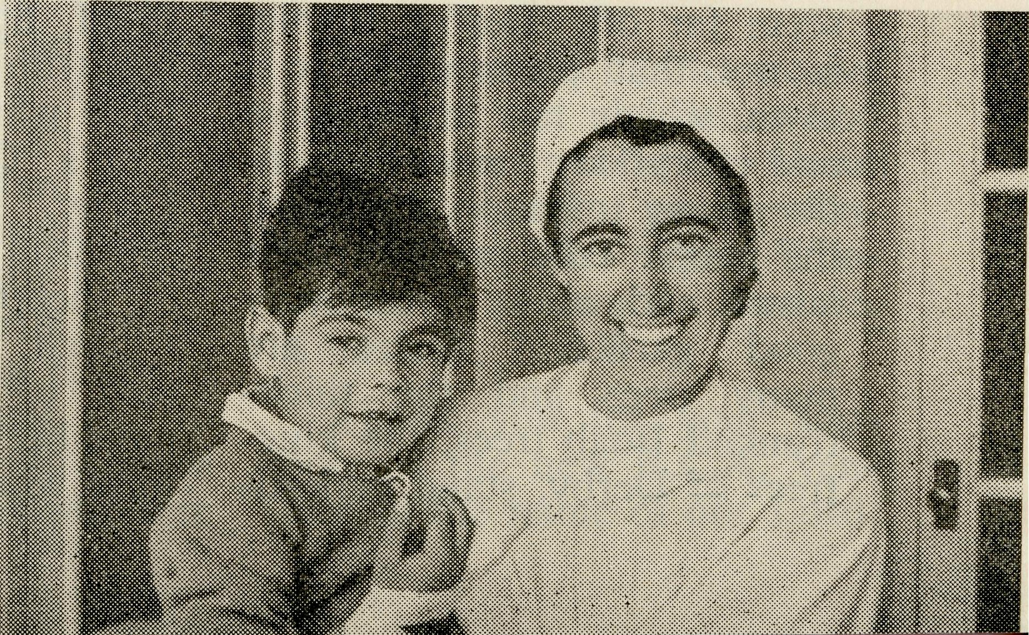
goes off for a wash and clean up. Saturday night is spent visiting folk who want baptism or to be married or some special reason for a visit. Sunday we have Holy Communion at 7.30 a.m. and Sunday School at 10 o'clock and Evening Prayer at 7.30 p.m. Sunday also affords a chance to visit as many folk as are at home. Monday comes, so do school classes—at least for an hour, then off to the hospital to visit. There is always someone in Wittenoom District Hospital with a town of a thousand folk. Sometimes I leave on Monday afternoon for home, sometimes I stay for Women's Guild on Monday evening and return home on Tuesday. To make things a little busier, we fit a Church Committee meeting in over the weekend.
Tuesday's trip is a mere 180 miles home to Hedland over a good road, and it can be comfortably covered in four hours or so. It has been six days since I collected my mail or even had a chance to read the newspaper. So what joy is in store! Home in time for tea and just enough time to get ready for Wednesday's school classes at Port Hedland. I attend this school weekly.
Wednesday school classes and Bible Study.
This week Thursday is Sermon preparation, Friday is used for catching up on mail and other things.
Saturday—well the garden does look as though I've been away and the car is filthy— even a day off might be in order.
The second Sunday I am here in Hedland. Holy Communion 7.30 a.m. and Evening Prayer 7.30 p.m. I usually drop in to the Sunday School as well. Monday comes and off the car goes to the garage. It's done over 600 miles since it last saw grease and oil. Most of that day is spent preparing for the Church Vestry Meeting, which is held monthly on the second Monday. That night our Vestry meets and we get to bed about midnight. The following day is spent writing letters — usually business — and getting ready for Wednesday — schools and Bible Study.
The third Thursday is Women's Guild — so while I prepare Sermons my wife prepares for Guild and packs my case ready for the trip to Roe-bourne.
Off to Roebourne on Friday morning, 125 miles each way. At Roebourne, on the Friday, school classes in the afternoon, then visiting in the town. Saturday I visit the
hospital, which usually has a few patients. Then a few calls at Point Sampson, a township 14 miles away.
Sunday follows the normal pattern. Holy Communion, Sunday School and Evening Prayer. Monday I spend some time arranging Church matters and then home after lunch; but don't forget to visit the folk at Whim Creek settlement and call on the Survey team and road work gangs. Home again for tea Monday.
Four days mail!—Tuesday will be busy—or it is my day off? I forget, anyway there are letters to be written and preparation for Wednesday's work. Wednesday, then Thursday and Sermon preparation and hospital visiting, also preparation for the fourth Sunday—my weekend home
Sister M. Hope
and little patient,
Tarcoola.
in Port Hedland. Friday and Saturday are usually quiet and the garden, car and other odd jobs can be done.
The fourth Sunday alters a little, as instead of Sunday School we have Family Service on Sunday Morning. The next morning, Monday, brings the round again—in goes the car for servicing to prepare it for the trip to Wittenoom.
Of course 1 have not accounted for Sunday School picnics, fetes, special visits such as Anzac Day and other such things-—I do not know where they fit in, but they do somehow.
Some say it is a quiet, lazy life in the North-West. It may be for them, but not for B.C.A. padres.
(Editor's Note: Written before Mr. Woolcott's illness.)

20
The Real Australian
December, 1962
December, 1962
The Real Australian
21

News from Derby
(Rev. N. E. Hart)
Three luggers lay motionless with their flat bottoms resting in the mud, a large turtle shell was also there half buried, a little black girl ran up and down with mud almost up to her knees. Two young, well-dressed natives sat on the jetty fence talking while the muddy water just lapped the foot of the pylons.
Not a very pretty picture perhaps, but this was the jetty at Derby, world-renowned for its tremendous tides. For what seemed miles on every side there was swamp land, and I knew that at certain times during the year all would be covered with water when the big tides came in.
But this is not the real picture of Derby. Far from it. When you first drive into Derby you would not notice the jetty or the mud, and even the swamp land would seem far off. Derby, to me, is not that picture. It is a town which has come alive and everybody knows it. Unlike many towns in the West, the people take pride in their lawns and many grow very good gardens. There are many trees and the thick-trunked Boab trees, the king-trees: ai Derby, stand majesti-
cally at various points around the town as though keeping a fatherly eye on all that is happening.
The roads of Derby are sealed and despite the flourishing home building programme there are quite a number of sealed bitumen roads just waiting for the homes to be built.
Cockatoos are numerous in Derby and many of the local people will tell of large man-eating crocodiles and pythons up to 19 feet long. This just adds to the charm of the place. From a purely human point of view I like Derby. However, it is the best time) of the year now and the heat, with its accompanying swarms of flies and other insects, still to come.
If you drive along the main street of Derby, on the left-hand side, you will see a small, light blue, iron building with white doors and a large white cross. This is St. Paul's Church of England, Derby. It speaks of the enthusiasm of a small nucleus of people who love their Church. It has a lovely fresh coat of paint, the grounds have been cleared, shrubs and trees wisely planted for shade
and a lawn is forcing its way through the shady ground.
They are a wonderful group of people, who gave a lot of publicity to my coming to Derby. On Tuesday, 4th September, there was a welcome planned in the home of Mr. and Mrs. Thorton where I was staying and who have kindly invited my wife and baby to come from Perth and stay, too. There were about 25 people at my welcome. The next night was my induction. The little Church was filled (that only means 40, but I was thrilled). Then on the following Sunday we had two services with a congregation of 17 at each, making a total Sunday attendance of 34.
These people, most of whom have been here only one or two years and probably will only be here another year or so, have eagerly awaited my arrival. They want a lead in the things of God. They want to worship Him in their little Church and they want to be active for Him. I believe the Church here will grow quickly. But there is a lot of hard work. Some of the most enthusiastic members have already booked their passage to Perth for the heat and are getting ready to go. To miss the heat and to see the Commonwealth Games are temptations irressistible to
those who have the opportunity to go.
Your prayers are needed that people may continually come forward to fill the gaps which will become more obvious as we try to organise the Church into action. On Sunday, 16th September, we start our Sunday School. It will no doubt have been going some weeks by the time you read this, but at the moment I have only one experienced teacher. Publicity is a big problem. There is no printer, of course, and there is no local paper. We badly need a good duplicator of some description. It would be used almost daily.
My wife, Robin, has been very busy in Perth searching for furniture which will be needed for our house when completed. She and baby Stephen will be joining me here during the next week. We are thankful to God for His wonderful provision for us.
If you would like to receive a copy of our newsletter and prayerletter published about every six weeks, please contact me or Miss Anne Wile-smith, 1 Edward Avenue, Kingsford, N.S.W.
Thank you for your support of the new B.C.A. venture in the name of our Lord.

22
The Real Australian December, 1962
December, 1962
The Real Australian
23

DIOCESE OF GIPPSLAND, VIC.
Croajingalong, Vic.—(Grant).
Prayer and Praise
For the Society,
O Lord God of our nation, Who hast commanded men to subdue and replenish the earth: Look in Thy love upon all who in distant parts of our land are striving against many difficulties, and are deprived the access of the means of grace. Strengthen and guide the Bush Church Aid Society and all members of the staff. Cheer and comfort them in discouragement and loneliness, bless their ministrations to the good of those they serve, and grant that the message of redeeming love may thus be rooted and grounded in our national life, to the glory of Thy Great Name through Jesus Christ our Lord. Amen.
For Nurses and Doctors.
O God, Who didst choose a beloved physician to set forth the life of Him Who went about doing good, grant that Thy strong tenderness and compassion may be manifest in the work of country doctors and bush nurses. Make them at all times alert to be faithful, as those whom Thou hast burdened and inspired with the honour of their calling. In lonely emergencies strengthen them with confidence that, having done all they can, they may with good conscience leave the issue to Thy power working within Thy law. Make them resourceful and of sound judgment, and hearten their labours with the energy of compassion and the firmness of duty that conquers weariness. Through Him Whose power is called forth by suffering, Jesus Christ our Lord. Amen.
For Church Life in Country Districts.
O Lord, who art present when two or three are gathered together in Thy Name, bless, we beseech Thee, the little far-scattered groups of brethren who in our wide land meet together to worship Thee. Give them a perpetual freshness of spirit, and the power to inspire in each other holiness, helpfulness, and understanding of Thy help. Refresh with the joy of enthusiasm those who endure weary journeys to Thy trysting place. Grant that these little companies of Thy servants may be united in the spirit of Christian charity, awaiting in love the time when there shall be one fold and one Shepherd. Grant that the common life of all communities may be purified by this spirit of charity from all meanness, falsehood, malice and idle gossip, and grant that they who share a common lot may draw strength from each other's virtues, and in their weakness help one another, through our one Lord, Jesus Christ. Amen.
The Bush Church Aid Society
for Australia and Tasmania
FIELD STAFF:
DIOCESE OF ADELAIDE, S.A. Ceduna-Penong, S.A.—Rev. B. Buckland, Th.L., Rev. B. J. O'Grady, Minnipa, S.A.—Rev. D. W. Warburton, Th.L.
DIOCESE OF WILLOCHRA, S.A.
Leigh Creek, S.A. — Rev. J. Quorn, S.A.—Rev. G. Fuhrmeister,
Winter, B.A., Th.L. Th.L.
Orroroo, S.A. — Rev. G. S. Gladstone, S.A. (Grant in Aid).
Thorne, B.E.
DIOCESE OF BALLARAT, VIC.
Heytesbury Mission, Vic.—Rev. E. Withington, B.A., Th.L., Timboon, Vic.
DIOCESE OF RIVERINA, N.S.W.
Wilcannia, N.S.W.—Rev. R. Neve, Menindee.—Rev. R. Brooks, Th.L. Th.L.
DIOCESE OF TASMANIA
Tarraleah, Tas.—Rev. B. Viney, Th.L.
DIOCESE OF NORTH-WEST AUSTRALIA Derby Mission.—Rev. N. E. Hart, Th.L., Derby, W.A. Port Hedland Mission.—Rev. B. Woolcott, Th.L., Port Hedland, W.A. Murchison Mission.—Rev. A. Williams, Th.L., Mount Magnet, W.A.
MAIL BAG SUNDAY SCHOOL
Director: Miss R. CAMPBELL.

Praise.
For the Blessings vouchsafed to the Society, for all kindly givers, and for the joy of service.
OLD FOLK'S HOME (Port Lincoln, S.A.)
Mr. R. and Mrs. AVERY. Mrs. M. L. McLeod.

