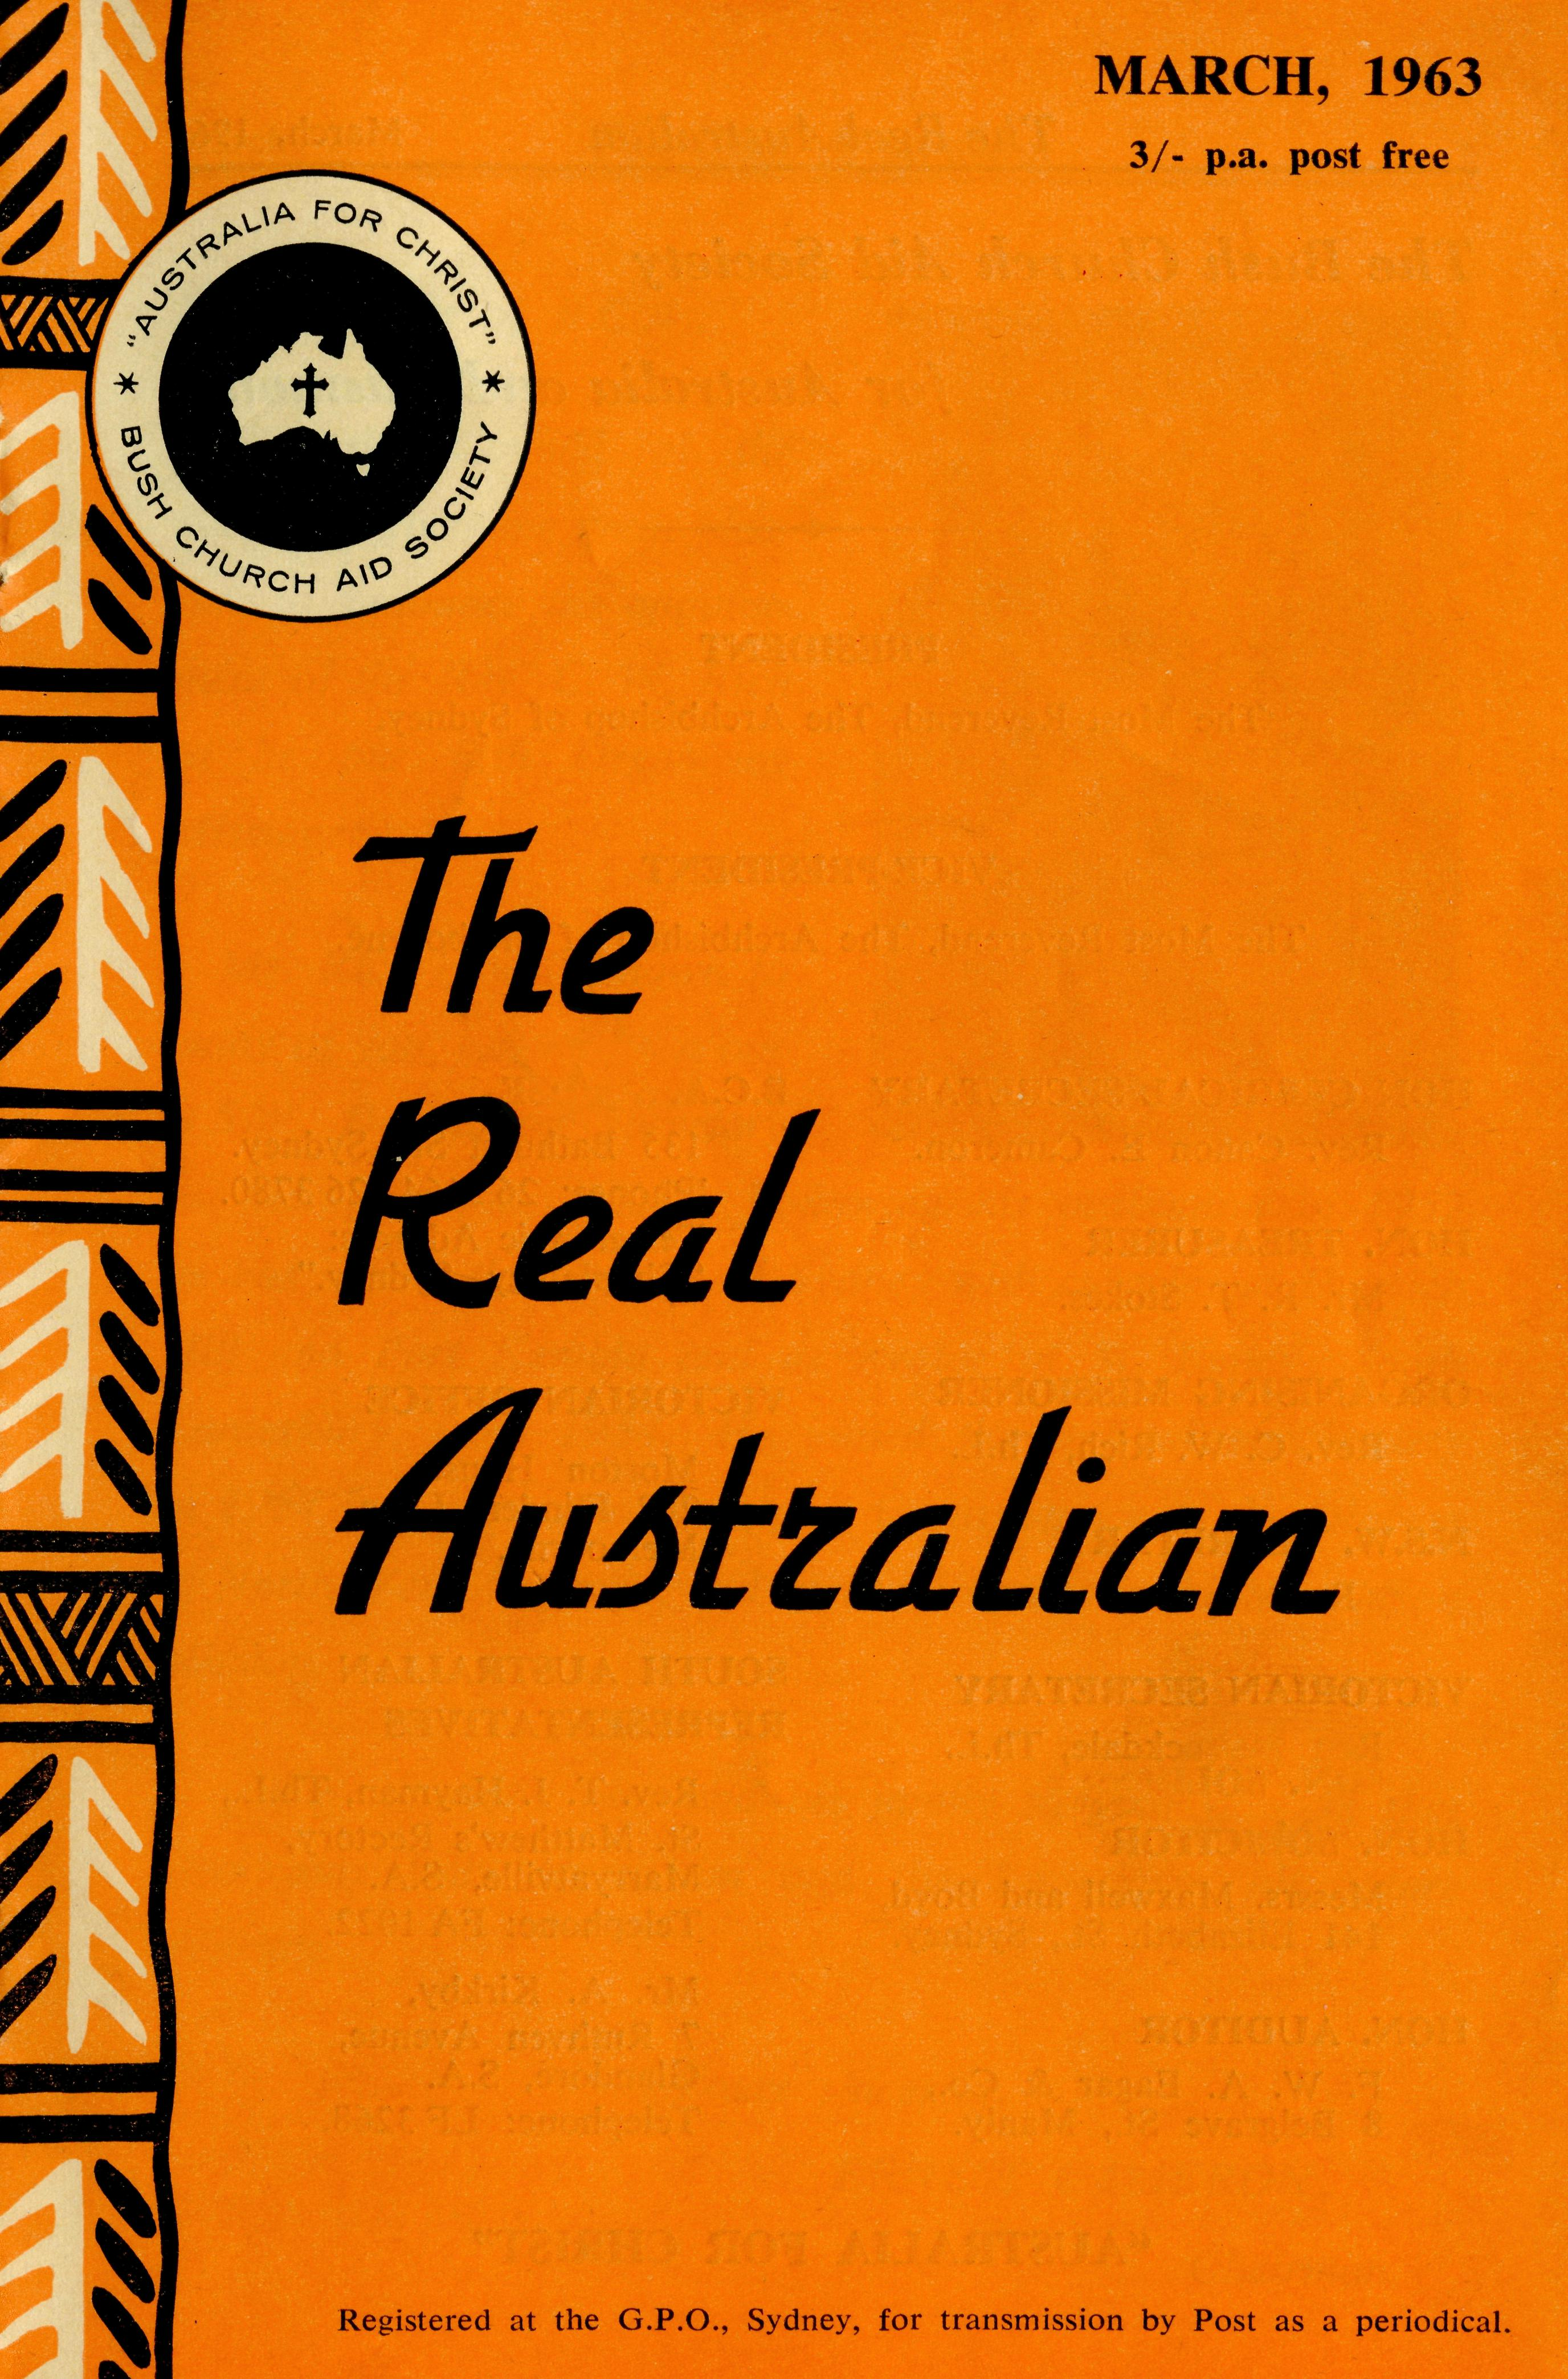
March, 1963
22
The Real Australian
FLYING MEDICAL SERVICES HOSPITAL CENTRES:
Sisters: J. MILLER, G. HITCHCOCK, B. TIERNEY, M. BELL, M. ROBEY, H. HEAVER, M. LEARY, J. GEE.
Sisters: V. HOLLE and Miss M. FARR.
CEDUNA, S.A.
The Murat Bay District
Hospital. Matron: Sister F. DOWLING.
PENONG, S.A.
The Penong Memorial Hospital.
COOK, S.A.
Sisters: M. TARR and M. ROSS.
Sisters: M. HOPE and V. COCHRANE.
Sister: E. THOMAS.
Matron: Sister J. ZILLMAN.
Sisters: N. WILKINS, C. EM-METT, M. DAWSON, Misses M. SMEE, M. CHADWICK.
The Bishop Kirkby Memorial Hospital.
TARCOOLA, S.A.
The Tarcoola Hospital.
RAWLINNA, W.A.
The Nursing Hostel.
WUDINNA, S.A.
The Central Eyre Peninsula District Hospital.
DENTIST:
PHARMACIST:
Mr. J. ARGALL.
MEDICAL OFFICERS:
Dr. M. MUELLER.
PILOTS:
Mr. ALLAN CHADWICK, Mr. JOHN LINDRIDGE Mr. W. BEDFORD.
AIRCRAFT:
Cessna 210 VH-AEC „ VH-FMS
Auster.
WIRELESS COMMUNICATIONS BASE:
Ceduna Base Operator: Mr. TOM MAYNE.
FLYING MEDICAL SERVICES CENTRE, CEDUNA, S.A. Mr. F. BURNER (Clerical Officer).
CANN RIVER NURSING SERVICE, VIC:
Sister J. ROBERTS.
HOSTELS FOR SCHOOL CHILDREN
BOWRAL, N.S.W.
(Charlton Boys' Home).
BROKEN HILL, N.S.W.
Mr. and Mrs. N. MELLOR. Mrs. M. SMITH.
PORT LINCOLN, S.A.
Mr. & Mrs. S. HUMMERSTON and Miss D. DUVER.
MUNGINDI, N.S.W.
Mr. and Mrs. S. BENNETTS.
EDGAR BRAGG 8t SONS PTY. LTD., 13Q BOTANY STREET, WATERLOO

The Real Australian
March, 1963
March, 1963
The Real Australian

The Bush Church Aid Society
for Australia and Tasmania
PRESIDENT
The Most Reverend, The Archbishop of Sydney.
VICE-PRESIDENT The Most Reverend, The Archbishop of Melbourne.
"AUSTRALIA FOR CHRIST"
HON CLERICAL SECRETARY
Rev. Canon E. Cameron.
HON. TREASURER
Mr. R. T. Stokes.
ORGANISING MISSIONER
Rev. C. W. Rich, Th.L.
N.S.W. SECRETARY Rev.
VICTORIAN SECRETARY
Rev. J. Stockdale, Th.L.
HON. SOLICITOR
Messrs. Maxwell and Boyd, 141 Elizabeth St., Sydney.
HON. AUDITOR
F. W. A. Eagar & Co., 8 Belgrave St., Manly.
B.C.A. HOUSE
135 Bathurst St., Sydney. 'Phones: 26 3164, 26 3780. Telegraphic Address: "Chaplaincy, Sydney."
VICTORIAN OFFICE
Morton House, 262 Flinders Lane, Melbourne.
SOUTH AUSTRALIAN REPRESENTATIVES
Rev. T. J. Hayman, Th.L., St. Matthew's Rectory, Marryatville, S.A. Telephone: FA 1022.
Mr. A. Kirkby, 7 Ruthven Avenue, Glandore, S.A. Telephone: LF 3268.

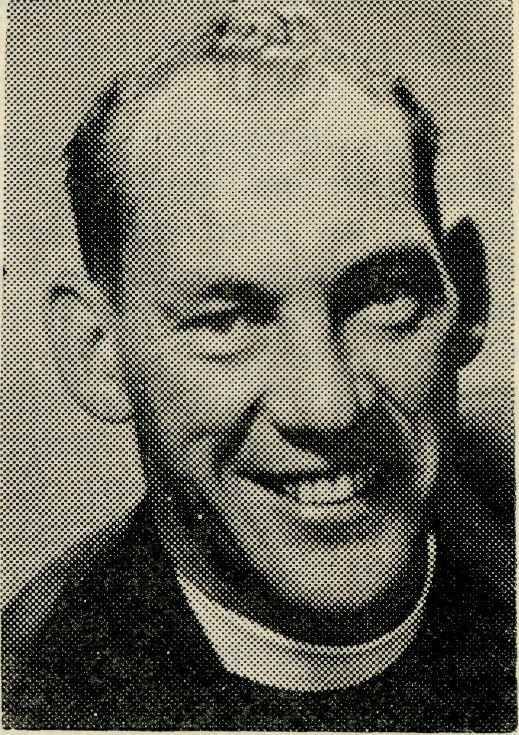
Dear Friends of B.CA.,
For the Council of the Society it gives me great pleasure to announce the appointment of the Rev. C. W. Rich to be our fifth Organising Missioner.
Mr. Rich is well known to many of you, having been our N.S.W. Deputation Secretary for the past four years. Following his ordination in 1952 he has served the Diocese of Sydney with curacies at Dulwich Hill and Port Kembla and as Rector of St. James, South Canterbury, from 1954. He joined the staff of our Society in 1957 in response to an appeal for assistance to the Diocese of North West Australia, and spent two years in the Murchison Mission.
We commend him and his family to your prayers that God may fully bless him and the Society in his future ministry.
Yours sincerely,
ERNEST CAMERON.
Chairman.

The Real Australian
March, 1963
March, 1963
The Real Australian

From The Organising Missioner
It was with a very real sense of my own inadequacy uppermost in my mind that I faced the offer from the Council to be your Organising Missioner. Confident, however, of His enabling grace I have accepted and am most grateful to those of you who, knowing this, have sent prayerful good wishes to me and my family. I have tried to acknowledge each in turn, but may have missed some. If so, please accept this as a personal "Thank you." Do continue to pray for us.
Elsewhere in this issue you will find an account of the extraordinary number of field staff movements which have greeted me and provided some real difficulties. Whilst I am continually grateful to God for the depth of devotion of those who come to us I am constantly saddened by the lack of available staff. Any unexpected movement of existing staff provides a crisis and thoughts of expansion are handicapped at the outset. There have been, and no doubt will be again, circumstances prevail which deny a continuity of ministry. To have to tell a Bishop that we
cannot supply a Priest or to receive a letter from a Hospital Matron saying her hard-pressed staff are well overdue for leave, underlines this fact.
Were this a B.C.A. problem alone, it would give us cause to take stock of our own attitude, but as it appears to confront every venture in Christian Service one may be forgiven for wondering how real and deep is the piety so often expressed by so many. Would to God there was a "waiting list" of folk ready, on call to service.
To turn this to a positive emphasis I would, at the outset of my ministry as O.M., challenge each reader to look to his or her vocation. To quote the well-known phrase of our first Organising Missioner, Bishop S. J. Kirkby, we need men and women of "grace, grit and gumption". I trust that you will be faithful in prayer for those of our staff who so serve God in the field. I trust too that none of us will take refuge in their unselfish expenditure of themselves and avoid our own responsibility.

with prayers and gifts do our supporters stand behind them, but that at the local level there exists a ready supply of men and women prepared to match their sense of personal service.
I hope, in the very near future, to visit each of the spheres of our service within Australia. What a tremendous thought to be able to encourage our brethren with the knowledge that not only
St. Stephen's Rectory, COORPAROO, BRISBANE.
Dear B.C.A. Friends,
Thank you for the many messages of goodwill received after you heard of my acceptance of the Parish of St. Stephen, Coorparoo, in the Diocese of Brisbane. My wife and our two boys are grateful for the assurance of your prayers.
It has been most encouraging to have your generous assistance, and the fellowship which has accrued augurs well for the development of B.C.A. work.
The Society's services have been maintained effectively because there are so many of you offering faithful prayers and giving your support in a sacrificial way.
My wife and the boys join me in thanking you for the presentation made to us. We shall always have a warm place in our hearts for B.C.A. work.
I commend to you the Rev. C. W, Rich, who now becomes the Organising Missioner. He will, I am sure, have your loyal support in the Society's activities.
May God bless the ever-increasing services seeking to win Australia for Christ.
Yours in fellowship,
JOHN GREENWOOD.

The Real Australian
March, 1963
March, 1963
The Real Australian

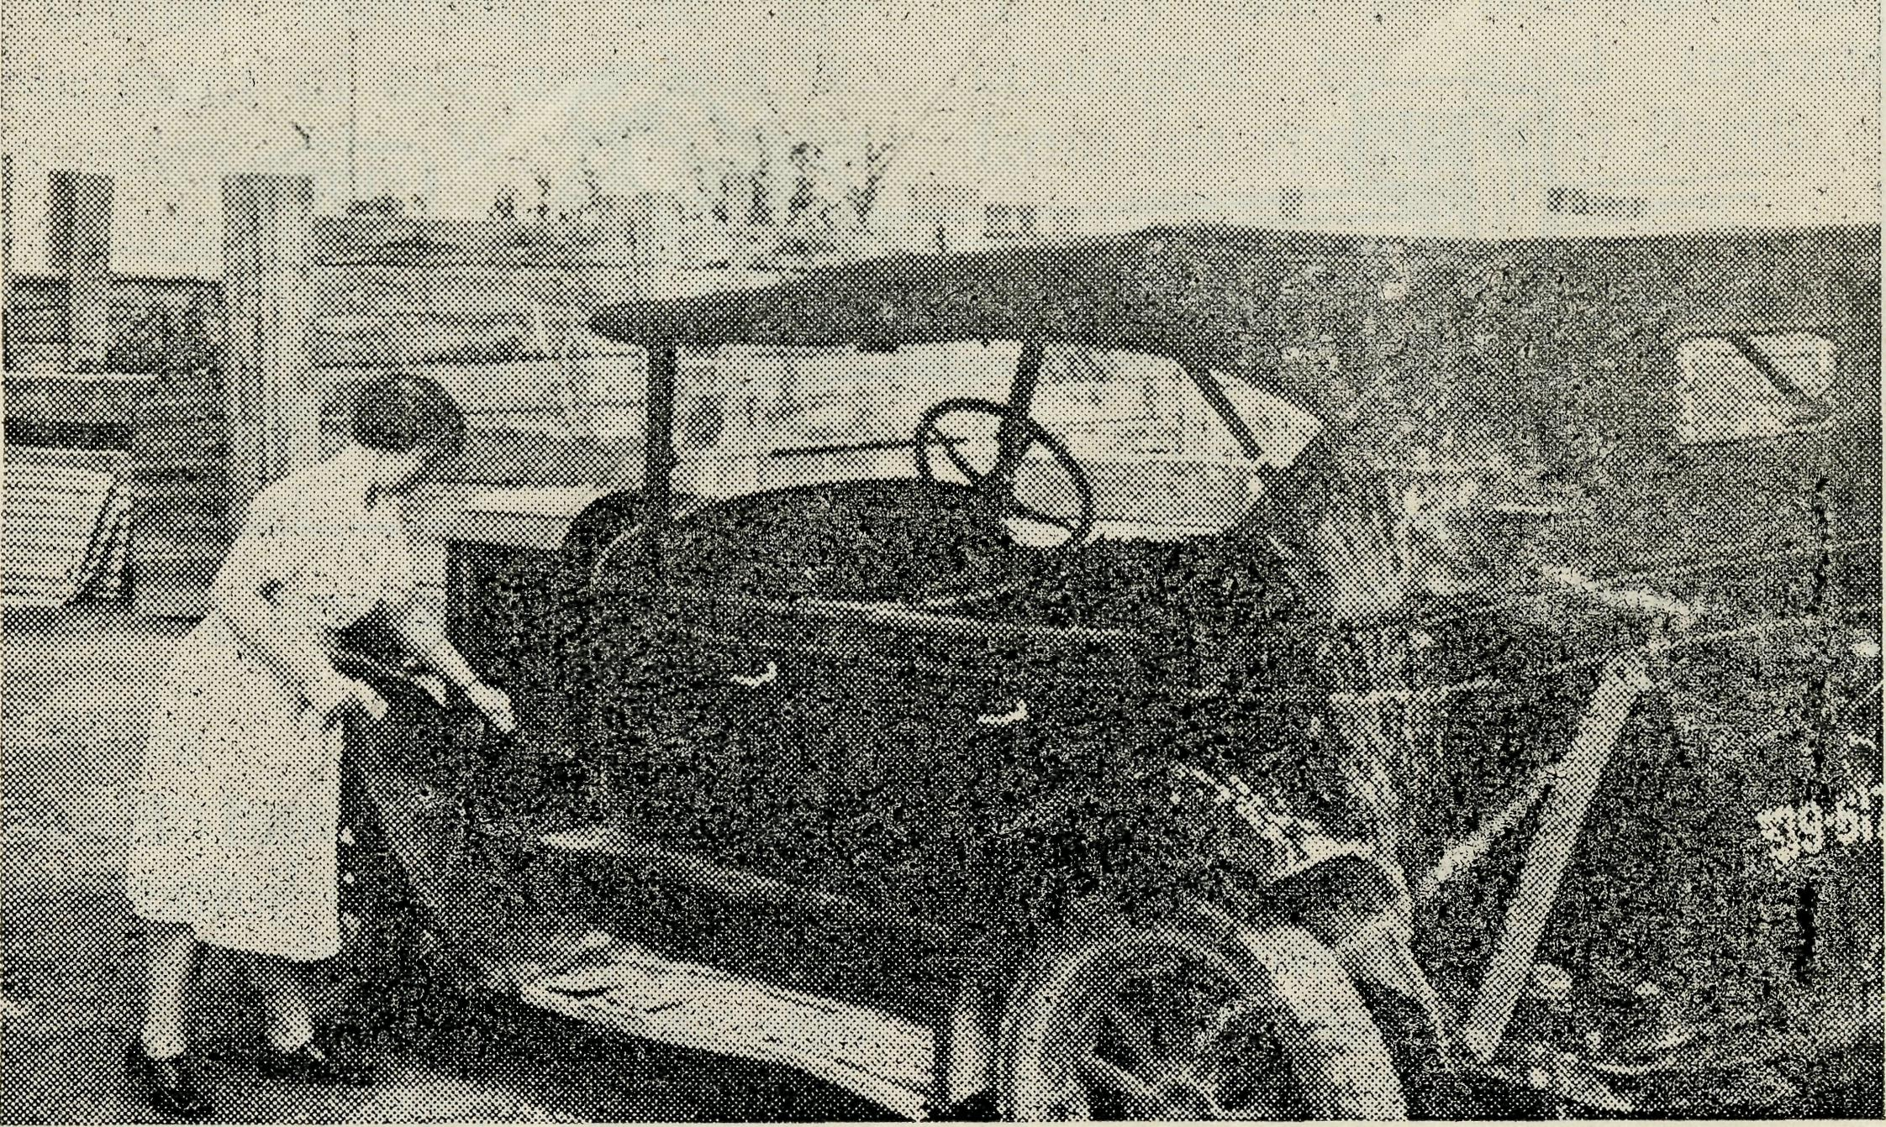
Nullarbor Interlude
(Sister M. Tarr)
Sister Tarr and another Patient!
Many people know of the sudden severe storms which long ago cut down the ravines into the Sea of Galilee. Such a storm hit Cook and surrounding areas some weeks ago — not sweeping down deep ravines but across a treeless plain called the Nullarbor, not bringing needed rain but just one big dark cloud of dust thrust along by a 50 miles an hour wind storm.
We had been sweltering in typical over-the-century temperatures for days and looking to see if the wind would be kind and come to us from the south. If this happened we would receive a cold change from the ocean rightly called the "Doctor". Not until 6 p.m., when we were having our evening meals, did this terrible dust storm come with a vengeance, not helping the heat to diminish very much but causing just one awful mess inside the hospital, as the dust filtered in through minute cracks under doors, etc. Fortunately this gale was soon over, but the dust it left in its wake was still to be dealt with. Finally, with much sweeping and dusting, we had the hospital looking a little
like it had been before the storm, and feeling justified in having a rest we relaxed, hoping that we wouldn't see one of those storms again for many a long time.
But this was a day of trials as, while sitting down, we heard a car drive up and then a knock came to our door.
Going to see who was there I met the Surveyor in charge of a mapping party who had been surveying the district around Cook for some weeks. "Sorry, Sister, but I have brought you one of our lads who has had an accident.
"During the gust of dust which hit Cook and district about 6 p.m., two of our men were on top of a 30 foot tower surveying. It hit so suddenly that they didn't have a chance to scramble down. One lad escaped without hurt, but the one we brought in tried to save an expensive instrument we were using and fell with the tower.
"He was knocked unconscious by some bars which fell on him and he is badly knocked about."
This was 9 p.m. They had brought the lad on a stretcher in the back of a Jeep, 48 miles over rough country. He had
lost a fair amount of blood and he was covered in one big coat of dust.
We transferred him into our theatre and examined his injuries. His head had had a bad knock, and there were two long gashes needing to be sutured. His foot was painful and swollen and looked as if a bone had been broken there. A large wound was seen under his right arm, but above all this his condition was good and he was taking it very well.
After cutting away the clothes from the injured areas we set to and sponged as much dust off as possible. Then we were able to do something about the wounds. By 1 a.m. the next morning the lad was in bed feeling a
little happier and a lot cleaner than some hours before. All the men ragged him about the clean sheets he was sleeping in, but I'm sure they wouldn't have changed places with him for all the clean sheets to be had.
In a week this man was transferred to his home in Melbourne, and sent for further investigation by a doctor whom we had contacted by radio about the case.
It is at such times as these that one knows the joy of helping someone in deep need and also one knows the helping hand of our Heavenly Father Who is very near. We are nothing without Christ, but we can do all thinqs through Christ Who strengthens us.

The Real Australian
March, 1963
March, 1963
The Real Australian

Valuable help is to be given to Dr. Mueller as Dr. L. O'Brien of Manly, N.S.W., has offered her services till July. We are most grateful to her. Her experience with the work of the Royal Flying Doctor Service in Western Australia will stand her in good stead. I wish that this could be an announcement of a permanent position—is there no Doctor willing to face this task as a challenge from God to full-time service?
Our congratulations to Sister Julie Zillman who, following Sister Dean's resignation, is to be Matron of the Central Eyre Peninsula Hospital, Wudinna. We trust she will enjoy the sense of prayerful support from us all as she undertakes this added responsibility.
©
Speaking of congratulations brings to mind Sister Jean Roberts of Cann River who has recently announced her engagement. We extend to her nd her fiance our sincere
congratulations and prayerful good wishes.
©
Sisters Leary and Heaver have temporarily joined the Ceduna Hospital Staff to provide holiday relief for our permanent sisters. Both will leave to enter Deaconess House, Sydney, to further their training. We thank them and wish them well in the Lord.
©
Sister J. Gee, from Melbourne, has come to us to provide a relieving Sister to allow breaks for our more remote Sisters within the Flying Medical Service. Her six months should prove invaluable. ®
In spite of fewer folk from the field with us, our Family Day in January was enjoyed by all. The chief concern of the day was the mysterious disappearance of the former O.M. (he said he was only parking the car!) and Mrs. Greenwood's obvious worry that he had given up and goiiQ to Brisbane without her!
Whilst awaiting the appointment of our new N.S.W. Secretary, Mr. W. L. Calder is proving, once again, his tremendous versatility by taking on, as well as his many other duties, a fair measure of Deputation work.
More "B.C. A. Babies" have arrived, and we welcome Bronwyn Jane O'Grady, Neil William Hummerston and Philip Alexander Mellor—we bid them welcome to our family and extend our congratulations to their parents.
The Rev. Bruce Woolcott and his wife have returned to Port Hedland after a five-month absence through ill-health. Mr. Woolcott writes
FOR VICTORIAN SUPPORTERS
PLEASE NOTE RE-LOCATION OF MELBOURNE OFFICE
MORTON HOUSE,
262 Flinders Lane,
Melbourne.

to say that he has been encouraged by good reports from his specialist in Perth.
We are indebted to Mrs. M. Shields of Mungindi for her devoted efforts at the Hostel during the latter part of last term and the opening of School this year. As she is to move to another part of the State we shall miss her valuable help and we pray that God will bless her, and her family, in their new surroundings.
Canon E. Cameron, our Hon. Clerical Secretary, and the Rev. E. Constable, a Melbourne Councillor, are to spend time overseas during the early months of this year. Our good wishes go with them. Both are to speak at various gatherings arranged by The Commonwealth and Continental Church Society. In this regard the Rev. David Livingstone, well known to many as a former Assistant O.M., has recently returned to Sydney, from England, bringing with him many reports of enthusiastic interest. We are indeed grateful to our many friends overseas for their prayerful and practical support.

The Real Australian
March, 1963
March, 1963
The Real Australian

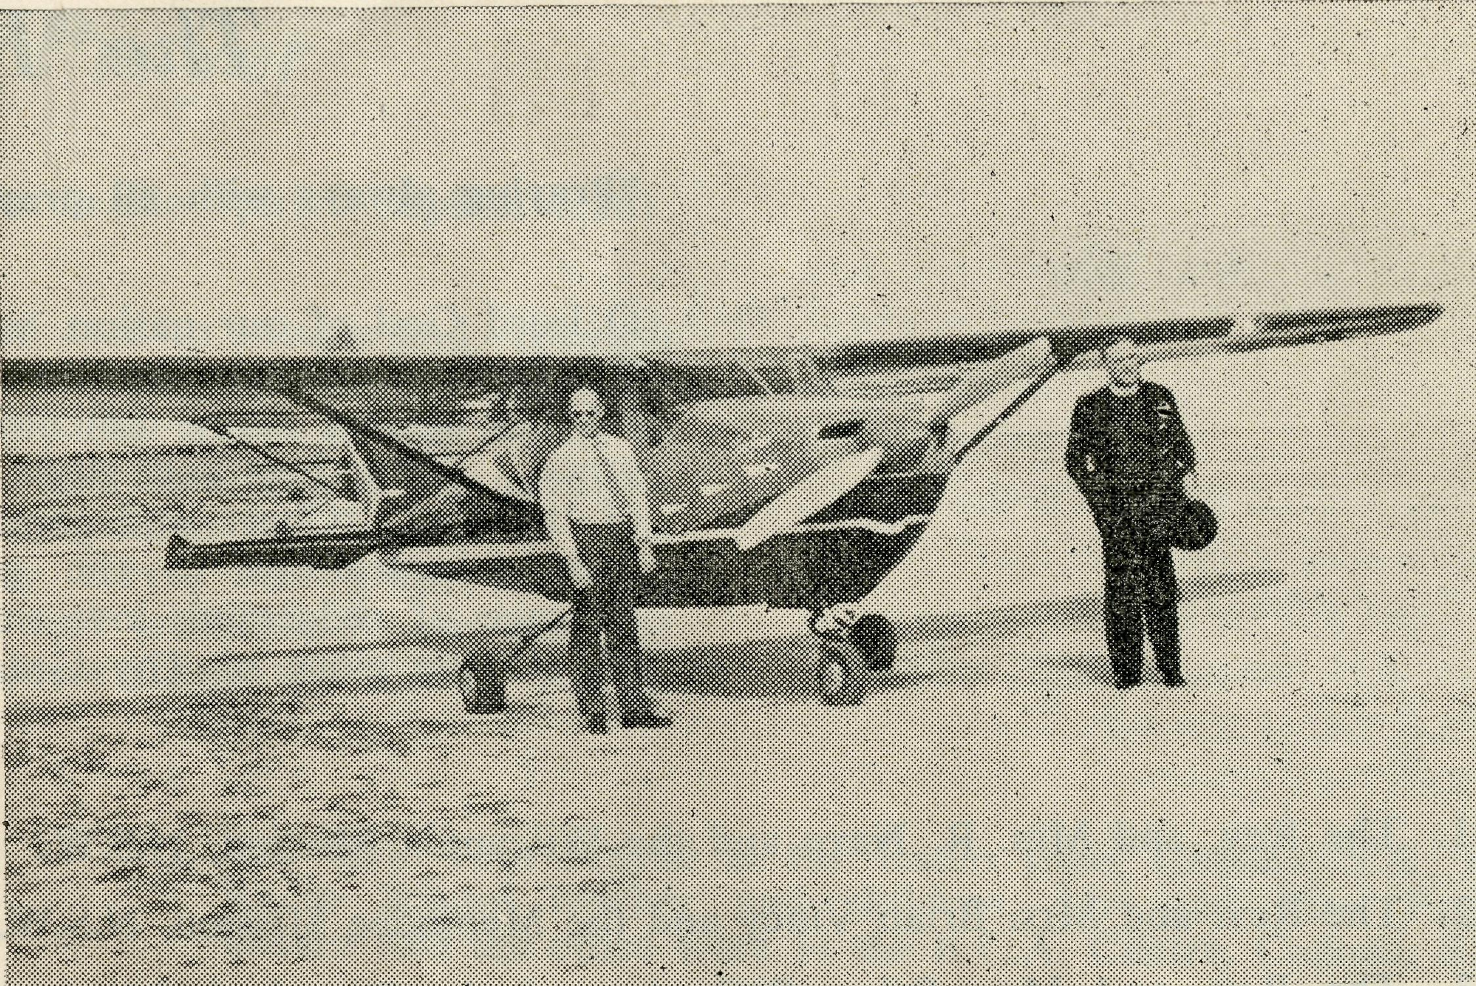
We in the more "isolated spots" of the State sometimes consider we are left out in visits by prominent figures, but recently we, in the north of South Australia felt very much in on it, when our Primate visited this State and particularly the Diocese of Willochra.
Though his visit was short, yet the Services held on the Sunday and Monday made it possible for a large percentage of Parishioners to meet and hear His Grace.
On the Sunday evening a number of cars went down from Quorn to Pert Augusta for Evensong and as may be expected the Church was filled to capacity. In this Service His Grace gave a clear, simple and challenging message from St. Mathew 11, vv. 28, 29, which was a most helpful word following a recent mission conducted there by Bishop Moyes.
The next morning, the Bishop drove His Grace up from Melrose to Quorn where
was able to get some shots of the dam and wild hops. On the way out from the dam, we came across two kangaroos, and the large red buck gave us a splendid display of hopping for quite a distance and then jumped over a fence without faltering.
At Leigh Creek His Grace preached at Holy Communion and later was given a public welcome in the Civic Hall.
The B.C.A. plane flew in that afternoon to take the Archbishop on to Ceduna, but their departure next morn-
Visit of the Primate
(Rev. H. G. Fuhrmeister)
a number of Parishioners met with them for morning tea— and as well the Anglican children from the Primary School next door came in to meet the Primate.
On the journey from Quorn to Leigh Creek, I was privileged to act as chauffer, and en-route a sumptuous luncheon was provided by the Parishioners at the Hawker Civic Hall. As it was of buffet style His Grace was able to chat with most of those present, and was especially delighted and, surprised to meet Mr, Ken Sweet, the Churchwarden, with whom he had been in battle in Africa during the last war, though this was only discovered when chatting together.
A bout halfway from Hawker to Leigh Creek we called in at the Parachilna School to meet the teacher and his 15 scholars.
Before going into Leigh Creek we visited Aroona Dam, which is the water supply of Leigh Creek Township, and where His Grace
During the Primate's Visit.
ing was delayed for about an hour, owing to a dust storm, which seemed to come up in no time and cleared almost as quickly.
The visit of such a gracious and humble man of God has been a stimulus to us all, and not only enlightened the Primate as to the potential of Church life in this far-flung Diocese, but also made us realise afresh the link we have with those who make up the body of Christ, and left us with the challenge to remember the others in our prayers, especially such who hold high positions within the Church.

10
The Real Australian
March, 1963
March, 1963
The Real Australian
11

The Place of Prayer
"Praying always with all prayer and supplication in the Spirit" (Ephes. 6:18).
O Lord God of our nation, who hast commanded men to subdue and replenish the earth: Look in Thy love upon all who in distant parts of our land are striving against many difficulties, and are deprived the access of the means of grace. Strengthen and guide the Bush Church Aid Society and all members of the staff. Cheer and comfort them in discouragement and loneliness, bless their ministrations to the good of those they serve, and grant that the message of redeeming love may thus be rooted and grounded in our national life, to the glory of Thy Great Name through Jesus Christ our Lord. Amen.

- The Rev. and Mrs. R. Neve and the Wilcannia Mission, N.S.W.
- The Rev. and Mrs. Brian Viney and the Menindee Mission, N.S.W.
- The Rev. and Mrs. Brian O'Grady and the Tarraleah Mission,
Tasmania.
4. Mr. and Mrs. Neville Mellor, Mrs. M. Smith and the boys of the
Broken Hill Hostel, N.S.W.
5. Sister J. Roberts and the work of the Dispensary at Cann River,
Victoria.
- The Rev. Alan McMahon and the Quorn Mission, S.A.
- The Rev. and Mrs. Ron Keynes and the Leigh Creek Mission, S.A.
- Mr. and Mrs. Stan Hummerston, Miss D. Duver and the girls in
Port Lincoln Hostel, S.A.
9. Miss R. Campbell and all her helpers and scholars in the M.B.S.S.
10. Mr. and Mrs. Allan Chadwick and the Flying Medical Services,
S.A.
- Mr. Bill Bedford and the patients he carries by air.
- The Rev. and Mrs. Bill Warburton and the Minnipa Mission, S.A.
- The Rev. and Mrs. Jim Smith and the parish of Streaky Bay, S.A.
- Mr. and Mrs. John Argall and the work at the Ceduna Pharmacy,
S.A.
15. The Rev. Theo Hayman and Mr. Alban Kirkby and South
Australian Representation.
16. Mr. and Mrs, Sid Bennetts and the girls and boys at Mungindi
Hostel, N.S.W.
17. Mr. and Mrs. Tom Mayne at the Radio Base, Ceduna, S.A., the
Radio School teacher and children, Mr. and Mrs. Frank-Burner and the office work at the B.C.A. Centre, Ceduna, S.A,
18. Mr. and Mrs. John Lindridge and their work with the Flying
Medical Service.
- The Matron and Staff at Ceduna Hospital, S.A.
- Dr. M. Mueller, all medical services, dental service and patients.
- The Staff and Hospital Services at Cook and Tarcoola, S.A.
- The Rawlinna Nursing Home, W.A., and Sister E. Thomas.
- The Rev. and Mrs. Ernest Withington at Timboon, Victoria, and
the work in the Heytesbury Forest Mission.
24. The Rev. and Mrs. Arthur Williams and the Murchison Mission,
W.A.
25. The Rev. and Mrs. Bruce Woolcott and the Port Hedland Mission,,
W.A.
- The Staff and Hospital Services at Penong, S.A.
- The Rev. and Mrs. Bernard Buckland, the Rev. John Wyndhami
and the Ceduna Mission, S.A.
28. Mr. and Mrs. Roy Avery, Mrs. Eastwood and the Staff at the Old
Folk's Home, Port Lincoln, S.A.
29. All students in training for outback ministries. The Rev. John
Stockdale, the Victorian Committee and Office Staff.
30. The Rev. Bill Rich, the Office Staff at Headquarters and the
Council of the Society.

12
The Real Australian
March, 1963
March, 1963
The Real Australian
13

Derby, W.A.
(Rev. Noel Hart)
The weather! What an easy topic for conversation. Particularly up here. The Wet has begun, the rivers are in flood, the insects are invading the town, and all roads out of Derby are out.
Last Friday, Derby experienced its worst cyclone for a number of years ... or was it a hurricane, gale or tornado? Names don't matter, but the aerodrome registered winds of up to 86 m.p.h. I was at Koolan at the time, Robin and Stephen were in the house alone. Hundreds of trees were snapped, iron electric light poles were bent, roofs flew off, cars took off down the street, others were damaged by sand, windows were broken, and there was a lot of general damage. Fortunately no damage occurred to the new Rectory, and very little to the Church. It had its humorous side. One man looked out the back door and saw fowls shooting past at roof height, being blown around like paper. Another tried to close his shutters, but the wind got behind them, and pulled him right out of the window. Stephen slept through it all and left his mother to see it out alone,
chewing all her fingernails right down! On Koolan Island the wind was less severe. Besides this, the whole township is built for cyclones, even to the extent of filling up the iron electric light poles, each with a ton of concrete. Cockatoo and Koolan still present a great challenge to the Christian ministry, and I feel I must spend more time there. At the moment I go once a fortnight. I leave Derby on the 8.00 a.m. plane and arrive at Cockatoo about 9.00 a.m. After a long wait at the airstrip for the unloading of cargo, I am taken down to the Guests' quarters by Land Rover. The quarters are very comfortable. I try to fit in a few visits before lunch at 11.30 a.m. The programme after lunch entails teaching at school (when in term), visiting, and setting up the hall for the service which I hold at 7.30 p.m. Invariably something else has been planned in the town at the same time, but we go ahead nevertheless. Friday morning is always a wasted morning. There is no plane across to Koolan on Fridays, and so I have to wait around for whatever boat transport is available. Last
Friday I was five hours travelling from one island to the other. All this travelling is like hitch-hiking, but I do get a good look at what is going on, and I eventually get to Koolan. The same journey by plane takes 10 minutes. Oh, if only I had an aeroplane! Ditto for my work in the Kimberleys. By the time I arrive at Koolan, there is only part of the afternoon left. I again take school Scripture if time permits, visit, arrange hymns (there is a pianist at Koolan), and set up the school for a service. We usually have a Bible Study and supper afterwards, and generally it is 11.00 p.m. before I see bed. Usually by 10.00 a.m. Saturday, I am home again. I feel at the moment that it is all too rushed. Transport is the big problem.
In Derby the Sunday School Prize - giving and Christmas Party were both very successful. The weather was very good and we had good attendances at the prize-giving on Sunday morning. God willing, the Sunday School should progress this year. The Christmas Services in Derby were a little disappointing. We had only 40 in all, in Church. There were only three or four children. I had expected much larger congregations (we had two ser-
vices), but of course many have already made their way South. The last two weeks have been very slack as far as services are concerned, half the congregation having gone to Perth for a month or two. They will all arrive back about rmd-February.
Wc have moved into our Rectory and are finding it extremely comfortable. During the heat of the day, the large ceiling fans which we have installed in four rooms, keep the air circulating and make things much more pleasant. We are very thankful that our personal luggage, crockery, etc., arrived safely. It has travelled across Australia by van, train and boat, and not one piece has been broken. The furniture for the house, purchased in Perth, also arrived O.K. with the exception of the dressing table mirror, which was smashed to pieces.
Robin and I need your prayers as we make plans for this coming year. At the end of the month we are holding a "get together" for some of the men folk of our Parish. The object is to see if some sort of men's organisation can be formed, which can introduce the men into our Church. When the climate is more favourable, we will probably have a night

14
The Real Australian
March, 1963
March, 1963
The Real Australian
15

Staff Movements
FROM THE GIFT SHOP
Supporters will be glad to know that we now have available teaspoons, key-rings, cake forks, etc., with a B.C.A. Motif. Sale of these attractive items will mean added support of the work of our Society.
for all the parish to "meet the Rector". Pray that a census of the district may be obtained easily. To continually visit every home is very trying in the heat, whereas much more could be accomplished if we knew who our Anglican families were. We are hoping to organise our ladies into some sort of team to take a census of the district.
I am planning an evangelistic mission for Easter for here and the Islands. It will be hectic and difficult, but there is such a great need for our Church people to be challenged with the gospel. Few of our ardent Church workers have a full assurance of salvation.
After the "Wet" is over, my work in the outback starts
once more. There are many Stations still not visited. Every year the roads are almost washed away, and travelling long distances in a short time is impossible.
There is also room for young people's work in the parish and we will have to face up to this problem this coming year. We trust that you will remember all these plans in your prayers.
We do thank all who have sent us cards and thoughts for Christmas and the New Year. It is not possible for us to reply to you individually, but we do wish you every blessing in the coming year, and trust that we may continue to unite our efforts together, to proclaim "the unsearchable riches of Christ" in North-West Australia.
An inevitable feature of the beginning of another year is the change it brings—this is particularly so this year as a large number of changes in staff have come about. They are listed below, with comment, that readers may, the more effectively, follow them with their prayers.
Rev. J. R. Greenwood.
In spite of the proximity of the Christmas Season and the many parochial functions a goodly gathering of B.C.A. friends met in the C.E.N.E.F. Auditorium to farewell Mr. and Mrs. Greenwood. Words of goodwill were spoken by Melbourne and Sydney representatives and presentations were made from the Women's Auxiliary and the whole B.C.A. family. Our prayerful interest will follow them in their ministry at Coorparoo, within the Diocese of Brisbane.
Sister I. Gwynne.
After several months' leave Sister Gwynne has now resigned and is resident at Too-woomba, Queensland. Her 22 years of devoted service at Cann River will always be remembered with thankfulness.
Rev. H. G. Fuhrmeister.
After 12 valuable years of service to the work of the Church within South Australia, Mr. and Mrs. Fuhrmeister leave Quorn to take up parochial work at Lang Lang in the Diocese of Gippsland.
Mr. G. Cameron.
Readers of the last issue of the "R.A." will realise that from its inception the Radio Control Base at Ceduna has owed a tremendous amount to Mr. and Mrs. Cameron. After 10 years they now leave us to take residence in Adelaide.
Sister M. Dean.
As Matron at C.E.P. Hospital, Wudinna, since 1960, and with eight years' service in all, Sister Dean leaves to return to Sydney.
Rev. R, Brooks.
Six years of Bush Ministry, two at Ceduna and four at Menindee, come to an end as Mr. and Mrs. Brooks leave to seek another sphere of service.
Rev. J. Winter.
Mr. and Mrs. Winter return to Melbourne after two years at Orroroo and two at Leigh Creek. Mr. Winter is to be

16
The Real Australian
March, 1963
March, 1963
The Real Australian
17

"Where were you Confirmed?'
(Rev. Arthur Williams)
Chaplain to Mentone Grammar School and will retain his association with B.C.A. through deputation work within Victoria.
Rev. A. McrVfahon.
Quorn, South Australia, is to be the sphere of Mr. Mc-Mahon's ministry as he leaves the Parish of St. Clement, Marrickville, Sydney.
Rev. J. Wyndham.
Mr. Wyndham's appointment is to Ceduna, to assist Ceduna and Minnipa Missions. He goes from the Parish of St. Michael, Flinders Street, Sydney.
Mr. T. Mayne.
The Radio Control Base, Ceduna, will give scope for Mr. Mayne's specialised ability. He and his family come to us from the Parish of St. Mark, Ermington.
Mrs. E. Eastwood.
Mrs. Eastwood has come to us from the Parish of St. Paul, Redfern, and will assist at the Old Folk's Home, Port Lincoln, S.A.
Mr. anil Mrs. L. S. Bennetts.
The Parish of St. Paul, Canley Vale, has given us Mr. and Mrs. Bennetts to be the Warden and Matron of the Hostel for Girls and Boys at Mungindi, N.S.W.
Mr. and Mrs. B. Dean.
Broken Hill Hostel has been served nobly by Mr. and Mrs. Dean for the past three years. Mr. Dean is to manage the Diocesan property at Gilbulla.
Mrs. M. L. McLeod.
For the past 12 months Mrs. McLeod has rendered most valuable help at the Old Folk's Home, Port Lincoln. She returns to her home in Sydney.
Sister M. Dickson.
At the end of last year Sister Dickson left Wudinna Hospital after 12 months' helpful service also to return to her home in Sydney.
Mr. and Mrs. N. Mellon
From Mungindi Boys and Girls' Hostel to Broken Hill Boys' Hostel will bring Mr. and Mrs. Mellor a sudden increase in family—nine to 28!
Rev. B. Viney.
After three years at Tarra-leah, Tasmania, Mr. and Mrs. Viney are to minister at Menindee, N.S.W.
Rev. B. 0⁵Gra:Jy.
Mr. and Mrs. O'Grady are to transfer from Ceduna to Tarraleah. They, like Mr. and Mrs. Viney will notice a drastic change of scenery.
Rev. R. Keynes.
From the Parish of St. Augustine, Bulli (Diocese of Sydney), Mr. and Mrs. Keynes will undertake the responsibility of the Mission District of Leigh Creek, South Australia.
Words of gratitude to those who leave seem, in a sense, so inadequate. The Church of God owes them a great debt as they have been prepared, each in their own way, to
"Oh, I was confirmed in St. Paul's Cathedral, London. It was really a very beautiful service and there were so many confirmed that year. They have a wonderful choir there, you know, and I used to go . . . But where were you confirmed?"
"Oh, I was confirmed in our Parish Church back home. The Church is not there now, they pulled it down to build a bigger and better one, but I remember that the Church was packed. In fact they had to bring in extra seats. The service was held one Sunday afternoon and one of the
contribute to her welfare. From the people of remote Australia to whom they ministered, and from the many to whom they have been but names on a prayer list, we wish them well and pray for God's richest blessings to follow them in their various locations.
To those who come to us we extend a welcome to the "family of B.C.A." and assure them of our continued prayerful support of their varied ministries.
Bishops Coadjutor came to the parish. I remember even now the Confirmation text for that year, 1 Timothy 6:12: Fight the good fight of Faith. There were about twenty-five of us confirmed that year. I well remember . . ."
Where were you confirmed?—well you will know. Perhaps it was in a great Cathedral with bells ringing, and the choir singing and the great organ filling the building with wonderful music, and the Archbishop in all his robes. Or perhaps you were confirmed in your own Parish Church with the organ and

18
The Real Australian
March, 1963
March, 1963
The Real Australian
19

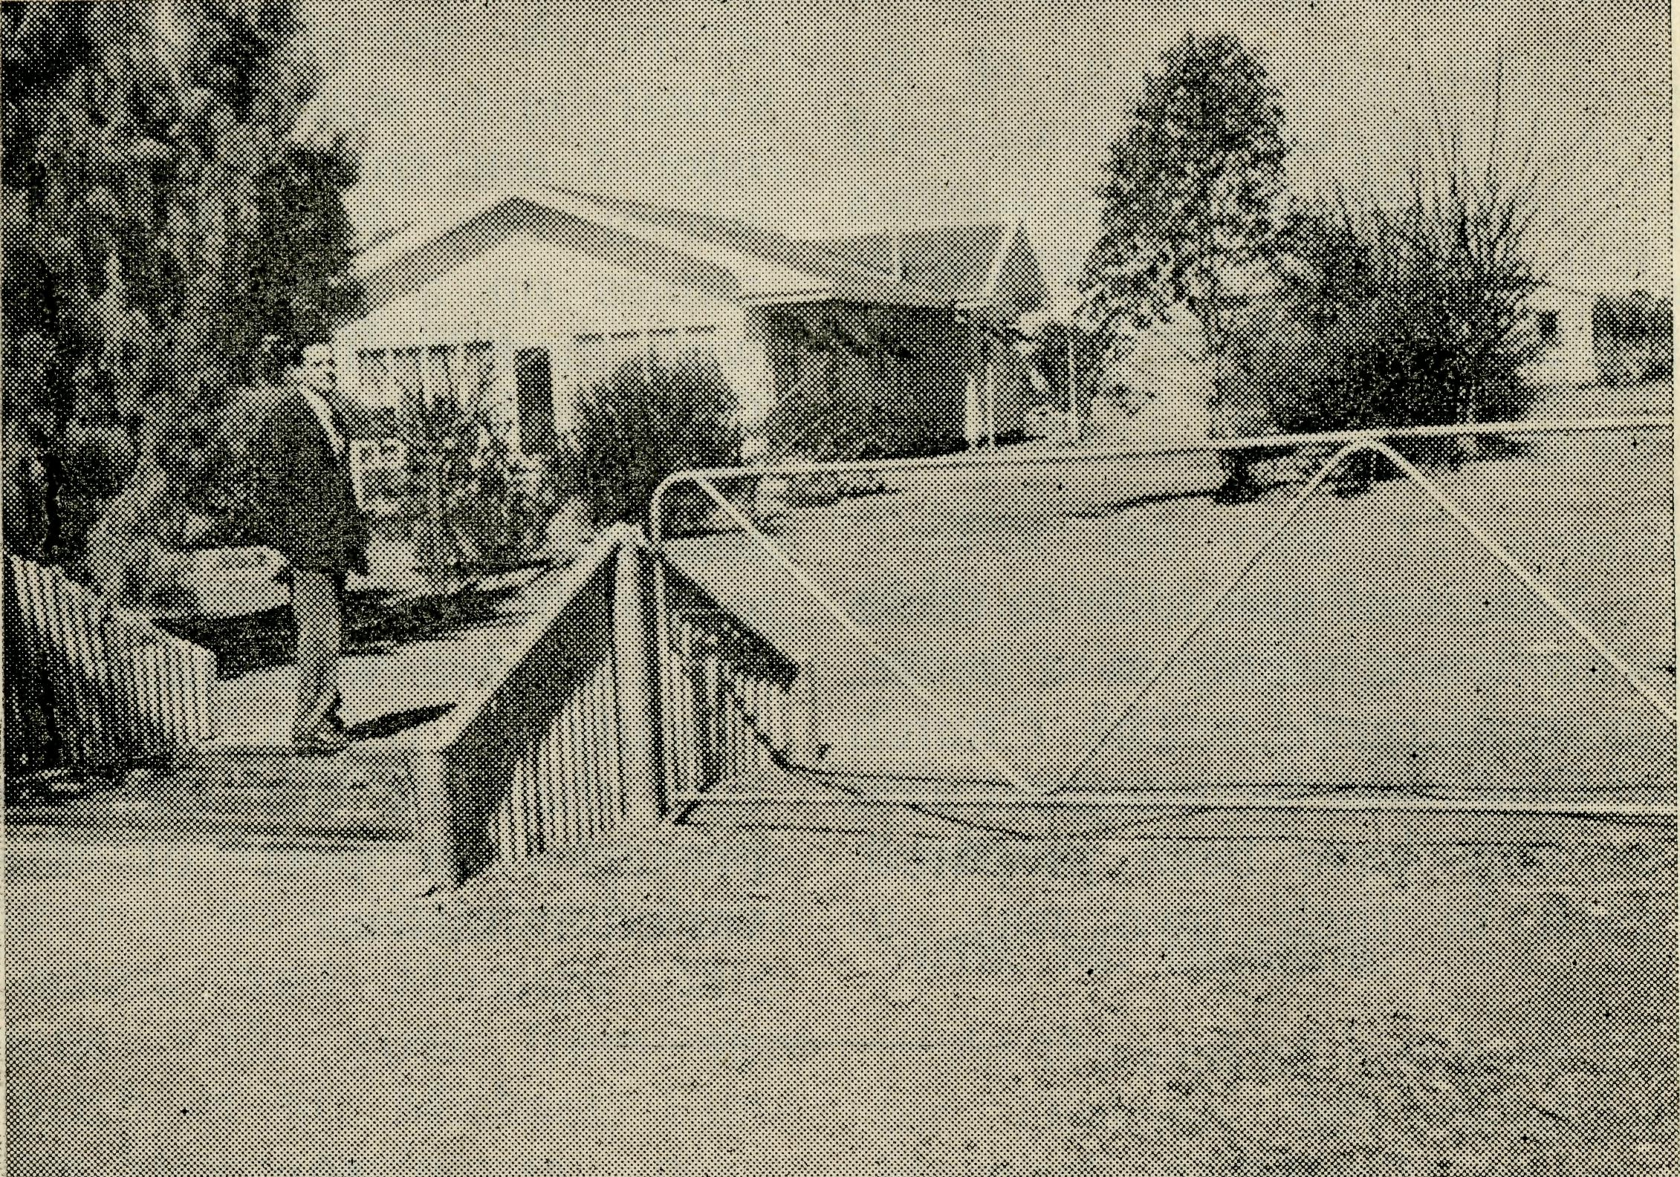
you confirmed?" he would tell you something like this, for only last month I presented this young man to the Bishop for Confirmation.
"Me! Oh, I was Confirmed on a sheep station! You see my parents worked on a large sheep station for many years. In fact the station where we were living had enough children on it for a school teacher to be appointed, so when the school was built the Education Dept. sent up a young school teacher who also lived on the
A Station Call.
choir providing the music, and the crowds of people filling every available pew. If your confirmation meant as much to you as mine did to me then you will be sure that on that day God was indeed present in your Church and as you sang "O Jesus I have promised to serve Thee to the end" you really felt that you were singing to the Master Himself.
If you were to ask a certain quiet young man that same question, "Where were
station. Each day we went to school just as we would if we had lived in the city or in a town.
"Once a month a Church of England Minister with 'Bush Church Aid Society' written on the door of his car, would visit our school for Religious Instruction. He used to stay at the homestead overnight and always held a Church Service in the classroom at night. After school on the day of his visit we would push the desks to the side and place the chairs in rows, then put the teacher's table against the end wall with a cloth upon it. We didn't have any music but we used to sing just the same and follow the service in our Prayer Books.
"One day Mum told me that 1 had never been Baptised and that she would ask the Minister to Baptise me on his next visit. So I was Baptised and then each month I had special lessons from a book called 'Confirmation Studies' and published by the same Bush Church Aid Society. In between lessons I learned my catechism and did the written work from my study book.
"Then came the month when not only the Minister
came, but with him came the Bishop and I was to be Confirmed. You see, the nearest Church to us is about 170 miles away, although there is a small chapel in a little town near here but even that is over 60 miles away.
"As usual that day after school the desks were pushed aside and the chairs and table placed so that the school room looked like a Church. The service was to begin at eight o'clock and all the station people as well as some from a nearby station were there. I sat in the front seat by myself and we waited for the Bishop and Rector to robe, not in a vestry but in the school house. There was no organ, no choir, except those people present, just the Bishop, the Rector and, of course, me. Yet it seemed to me that God was there; yes I will always remember my Confirmation.
"The strange thing will be, of course, if I ever go to live in a town with a Church, I'll have to get used to a real church building; it will be strange but I suppose that God will be there just the same as He is in our school room."

20
The Real Australian
March, 1963
March, 1963
The Real Australian
21

Prayer and Praise
For the Society.
O Lord God of our nation, Who hast commanded men to subdue and replenish the earth: Look in Thy love upon all who in distant parts of our land are striving against many difficulties, and are deprived the access of the means of grace. Strengthen and guide the Bush Church Aid Society and all members of the staff. Cheer and comfort them in discouragement and loneliness, bless their ministrations to the good of those they serve, and grant that the message of redeeming love may thus be rooted and grounded in our national life, to the glory of Thy Great Name through Jesus Christ our Lord. Amen.
For Nurses and Doctors.
O God, Who didst choose a beloved physician to set forth the life of Him Who went about doing good, grant that Thy strong tenderness and compassion may be manifest in the work of country doctors and bush nurses. Make them at all times alert to be faithful, as those whom Thou hast burdened and inspired with the honour of their calling. In lonely emergencies strengthen them with confidence that, having done all they can, they may with good conscience leave the issue to Thy power working within Thy law. Make them resourceful and of sound judgment, and hearten their labours with the energy of compassion and the firmness of duty that conquers weariness. Through Him Whose power is called forth by suffering, Jesus Christ our Lord. Amen.
For Church Life in Country Districts.
O Lord, who art present when two or three are gathered together in Thy Name, bless, we beseech Thee, the little far-scattered groups of brethren who in our wide land meet together to worship Thee. Give them a perpetual freshness of spirit, and the power to inspire in each other holiness, helpfulness, and understanding of Thy help. Refresh with the joy of enthusiasm those who endure weary journeys to Thy trysting place. Grant that these little companies of Thy servants may be united in the spirit of Christian charity, awaiting in love the time when there shall be one fold and one Shepherd. Grant that the common life of all communities may be purified by this spirit of charity from all meanness, falsehood, malice and idle gossip, and grant that they who share a common lot may draw strength from each other's virtues, and in their weakness help one another, through our one Lord, Jesus Christ. Amen.
Praise.
For the Blessings vouchsafed to .the Society, for all kindly givers, and for the joy of service.
The Bush Church Aid Society
for Australia and Tasmania
FIELD STAFF:
DIOCESE OF ADELAIDE, S.A. Ceduna-Penong, S.A.—Rev. B. Buckland, Th.L., Rev. J. Wyndham, Th.L. Minnipa, S.A.—Rev. D. W. Warburton, Th.L.
DIOCESE OF WILLOCHRA, S.A.
Leigh Creek, S.A. — Rev. R. Quorn, S.A.—Rev. A. McMahon,
Keynes, Th.L. Th.L.
Orroroo, S.A. — Rev. G. S. Gladstone, S.A. (Grant in Aid).
Thorne, B.E.
DIOCESE OF BALLARAT, VIC.
Heytesbury Mission, Vic.—Rev. E. Withington, B.A., Th.L., Timboon,
Vic.
DIOCESE OF RIVERINA, N.S.W.
Wilcannia, N.S.W.—Rev. R. Neve, Menindee.—Rev. B. Viney, Th.L. Th.L.
DIOCESE OF GIPPSLAND, DIOCESE OF TASMANIA
^{VIC}- Tarraleah, Tas,—Rev. B. J.
Croajingalong, Vic.—(Grant). O'Grady.
DIOCESE OF NORTH-WEST AUSTRALIA
Derby Mission.—Rev. N. E. Hart, Th.L., Derby, W.A.
Port Hedland Mission.—Rev. B. Woolcott, Th.L., Port Hedland, W.A.
Murchison Mission.—Rev. A. Williams, Th.L., Mount Magnet, W.A.
MAIL BAG SUNDAY SCHOOL
Director: Miss R. CAMPBELL.
OLD FOLK'S HOME (Port Lincoln, S.A.)
Mr. and Mrs. R. AVERY. Mrs. E. Eastwood.

