FLYING MEDICAL SERVICES
HOSPITAL CENTRES:
Sisters: J. MILLER, G. HITCHCOCK, B. TIERNEY, M. BELL, M. ROBEY, J. GEE.
CEDUNA, S.A.
The Murat Bay District Hospital. Matron: Sister F. DOWLING.
PENONG, S.A.
Sister: V. HOLLE.
Sisters: M. TARR and M. ROSS.
Sisters: M. HOPE and V. COCHRANE. Sister: E. THOMAS.
Matron: Sister J. ZILLMAN. Sisters: N. W'lLKINS, M. DAWSON, Misses M. SMEE, M. CHADWICK.
DENTIST: PHARMACIST:
— Mr. J. ARGALL.
PILOTS:
Mr. ALLAN CHADWICK,
Mr. JOHN LINDRIDGE,
Mr. W. BEDFORD.
The Penong Memorial Hospital.
COOK, S.A.
The Bishop Kirkby Memorial Hospital.
TARCOOLA, S.A.
The Tarcoola Hospital.
RAWLINNA, W.A.
The Nursing Hostel.
WUDINNA, S.A.
The Central Eyre Peninsula District Hospital.
MEDICAL OFFICERS:
Dr. M. MUELLER.
AIRCRAFT:
Cessna 210 VH-AEC „ VH-FMS Auster.
WIRELESS COMMUNICATIONS BASE:
Ceduna Base Operator: Mr. TOM MAYNE.
FLYING MEDICAL SERVICES CENTRE, CEDUNA, S.A.
Mr. F. BURNER (Clerical Officer).
CANN RIVER NURSING SERVICE, VIC:
Sister J. ROBERTS.
HOSTELS FOR SCHOOL CHILDREN
BOWRAL, N.S.W.
(Charlton Boys¹ Home). BROKEN HILL, N.S.W.
Mr. and Mrs. N. MELLOR. Miss A. MORLEY.
PORT LINCOLN, S.A.
Mr. and Mrs. S. HUMMERSTON and Miss D. DUVER.
MUNGINDI, N.S.W.
Mr. and Mrs. S. BENNETTS.
EDGAR BRAGG & SONS PTY. LTD., PRINTERS, SYDNEY

The Bush Church Aid Society
for Australia and Tasmania
PRESIDENT
The Most Reverend, The Archbishop of Sydney.
VICE-PRESIDENT
The Most Reverend, The Archbishop of Melbourne.
from the
"AUSTRALIA FOR CHRIST"
HON. CLERICAL SECRETARY
Rev. Canon E. Cameron.
HON. TREASURER
Mr. R. T. Stokes.
ORGANISING MISSIONER
Rev. C. W. Rich, Th.L.
N.S.W. SECRETARY
Rev. A. E. Williams, Th.L.
VICTORIAN SECRETARY
Rev. J. S'tockdale, Th.L.
HON. SOLICITOR
Messrs. Maxwell and Boyd, 141 Elizabeth St., Sydney.
HON. AUDITOR
F. W. A. Eagar & Co., 8 Belgrave St., Manly.
B.C.A. HOUSE
135 Bathurst St., Sydney.
'Phones: 26 3164, 26 3780.
Telegraphic Address: "Chaplaincy, Sydney."
VICTORIAN OFFICE
Morton House, 262 Flinders Lane, Melbourne. Telephone: 63 8962.
SOUTH AUSTRALIAN REPRESENTATIVES
Rev. T. J. Hayman, Th.L., St. Matthew's Rectory, Marryatville, S.A.
Telephone: FA 1022.
Mr. A. Kirkby,
7 Ruthven Avenue,
Glandore, S.A.
Telephone: LF 3268.
With this issue I am glad to announce the appointment of the Rev. Arthur Williams to be New South Wales Secretary of our Society.
Mr. Williams comes to us from the Murchison Mission of the Diocese of North West Australia. His length of service with the Society extends over seven years in the field in South and Western Australia. Prior to his Ordination, Mr. Williams was a B.C.A. Candidate in training and both he and his wife were members of the then existing B.C.A. Young People's Association.
We look forward to his ministry amongst us. His wealth of experience should prove invaluable to me and to the Society as a whole. Those of you who have already met him in the course of his ministry will, I know, join with us all in extending to him and his family our prayerful good wishes.
The function of the two State Secretaries, N.S.W. and Victoria, rests primarly on Deputation work. The story of the Society and its staff in action is presented faithfully by these two men where the opportunity exists.
O.M.
Both Mr. Williams and Mr. Stockdale are prepared to give of themselves and their ability, without reserve, in this task. How rewarding it is for them to meet with interest, concern and a ready response. We thank God for the many of you who have expressed interest, practical and prayerful. Those of you who are consistent in your support are the true life blood of the Society and are making possible the very things of which we read in these pages.
There are others whose interest may be only casual and who have lost the sense of concern which prompted the donation or taking of a Bark Hut which resulted in this magazine coming to you.
I trust that as we strike the emphasis of this vital aspect of our Society and its relationship with individuals, all of us will re-evaluate our concern and the contribution we are making.
Together we, and others we may influence, can join forces to bring to many fellow Australians the knowledge of the glorious liberty and life in Christ Jesus.

THE REAL AUSTRALIAN, JUNE, 1963
THE REAL AUSTRALIAN, JUNE, 1963

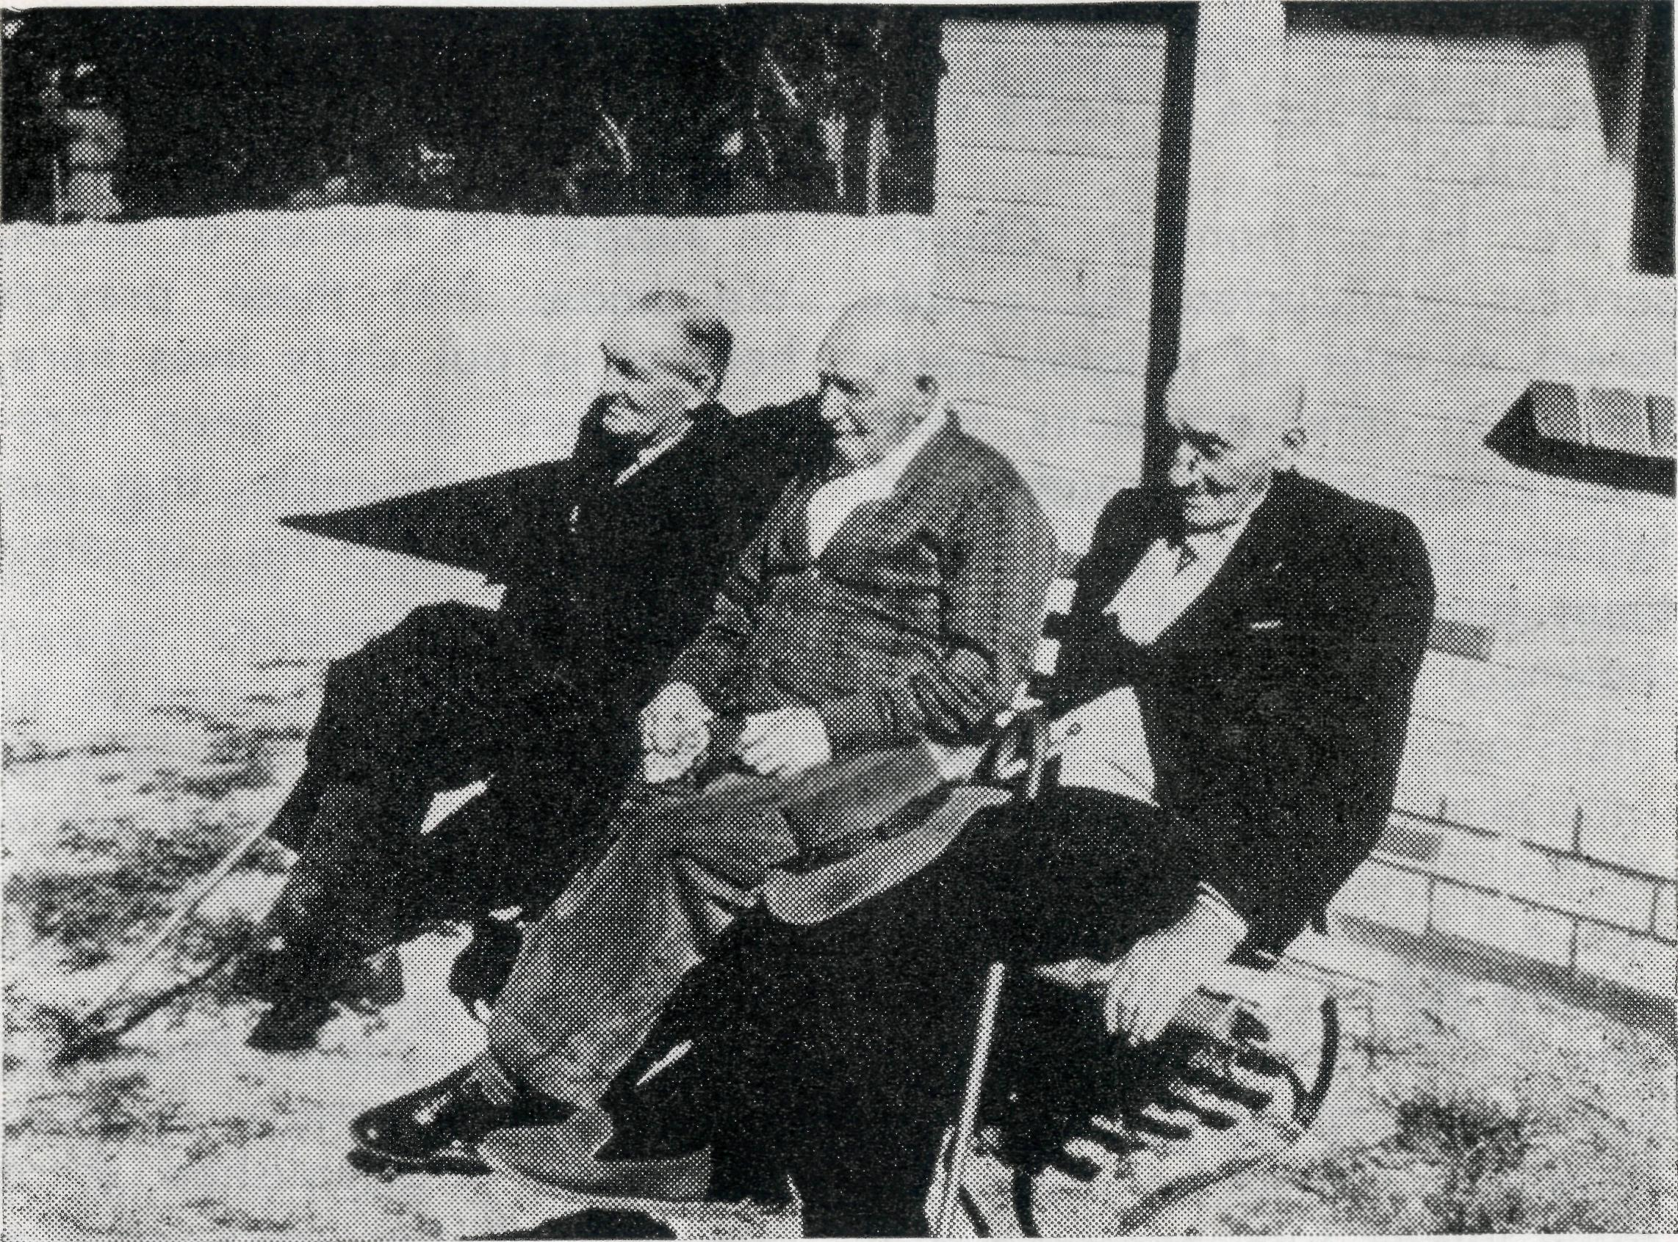
ROUTINE.
The day begins at 7.30 a.m. for the guests, who all have breakfast in bed, on a tray. This gives them an opportunity to have a doze after breakfast, before rising. Most are dressed and in the loungerooms ready for a cup of tea by ten o'clock.
You may wonder how our folk fill in their day. To some the days seem long, but others keep quite busy. The ladies sew, knit, and do other types of handcraft. One spends a lot of time caring for her garden, which is certainly a credit to her, and improves the grounds of our Home. Others read and spend quite a lot of time strolling in the grounds, which are looking very lovely now, with green lawns and bright flowers. The evening meal is at six o'clock, after which some go straight to bed, others stay up a little later, and have supper.
"I came out from England fifty years ago, and I've been taking Australia up in shovelfuls ever since".
OPPORTUNITY.
We conduct a devotional each evening, consisting of hymn, Bible reading and commentary, our organist being one of our 92-year-old guests. There are usually ten in attendance.
Ladies from various local Church guilds and other organisations, are rostered for visiting. Each week, about four ladies come, bringing a
0ld . . . but not forgotten
Owned and maintained by a local committee—staffed by our Society—the Eyre Peninsula Old Folk's Home meets a very real need today. Mr. and Mrs. Avery who write this article are in their fourth year of service and have made a tremendous contribution to the Spiritual and material welfare of those committed to their care.
We at the Old Folk's Home have had the pleasure of welcoming five more men here, as a new wing has just been completed, consisting of five bedrooms, and a spacious loungeroom, which commands a glorious view over the town and bay with Boston Island in the background.
EXPANSION.
It has been a real thrill to all concerned to see the completion of this wing, which will reduce our waiting list although there are still both men and women waiting for admission. We now have fifteen men and nine women in our care, their ages ranging from seventy to ninety-two years. We do thank God too, that we have sufficient staff here at present to cope with needs. Even though our folk are all mobile, some require more assistance than others and we have quite a lot of sickness.
"1 remember . . . . "
THE GOOD OLD DAYS.
The men are not able to fill their time in with handcrafts, but do a lot of reading, some go for long walks. When there are a group of them in the loungeroom, they reminisce together, and we often wish we had more time to sit and listen to their many and varied experiences. All have spent the greater part of their life on Eyre Peninsula and between them piece together interesting facts of "the good old days". Most have been concerned with farm work, and have had to work very hard. One continually amuses visitors when he tells,
THE REAL AUSTRALIAN, JUNE, 1963

THE REAL AUSTRALIAN, JUNE, 1963

"/ WAS IN PRISON ..."
delicious afternoon tea, and spending a couple of hours with our folk.
We have monthly Church services, conducted by a different minister of religion each time. On other occasions, visits are arranged by youth and fellowship groups, and sometimes films or colour slides are shown.
IN
THE MAIL
* "Well let's see! Usual routine, we have had our share of visitors though—-John Wynd-ham keeping us on our toes for the present. Sister Wilkins' parents travelled down from Northern N.S.W. and collected Nancy for a caravaning holiday on the way home. Sounds pretty good to us. Also survived the O.M.'s visit, the Opening (officially) of our tennis court, and the Hospital Auxiliary Social, and life is rather good."
Sister J. Zillman, C.E.P. Hospital, Wudinna, S.A.
We feel there are great opportunities for witness to these folk, and do value the prayerful support of friends of B.C.A. We know that these prayers help us in our daily lives here, as we must always keep foremost in our thoughts, that our daily lives are the greatest witness we have.
* "Went to Coober Pedy last week . . . quarterly Services have been re-established there now and if the response the other night was anything to go by, we'll be swamped."
Rev. R. Keynes, Leigh Creek, S.A.
* "An unusual sight at Penong. Two B.C.A. Planes on the Landing strip! This happened one Thursday afternoon when an acute appendix arrived from Coorabie with Dr. Mueller, and a call to Ceduna brought Dr. O'Brien and a visitor—Dr. Robinson. Three doctors in the Theatre!"
Sister V. Holle,
Far West Memorial Hospital, Penong, S.A.
THE REAL AUSTRALIAN, JUNE, 1963
When thinking of the Mail Bag Sunday School, do you imagine children who receive our lessons as living in remote parts of the outback, or on a Pacific Island? If so, you are quite right, for those are the places to which most lessons are sent—but not all. Some families live relatively close to settlement and even cities, yet on Sundays there is no means of transport. Then we have children who are suffering from —it may be a heart condition or asthma, etc., and who for some considerable time are unable to attend ordinary Sunday School. Parents who appreciate spiritual values want their children to have the advantages of consistent teaching and so they use our lessons.
From time to time there comes an exceptional request for our lessons, as when a prison chaplain asked for them. This time they were not needed for a child, but for a man serving a gaol sentence of several years. He made good use of his time of separation, realising that he had gone on the wrong track because he had practically no
THE REAL AUSTRALIAN, JUNE, 1963
knowledge of Christian beliefs. We counted it a privilege to be asked to supply him with Senior Grade lessons. While we had no direct contact with the man, from time to time a layman who was befriending him, called to report his progress and the use he was making of the lessons. Several times this man was moved from gaol to gaol, but apparently he never lost interest in the lessons, and finally word came that he had been released.
Now you may well ask—what happened after his release? He is now entering into the fellowship of an active Church and we have been told that romance has come into his life—so on every level we trust that—he will "live happily ever after"!
It was indeed a humbling experience for us to know that in a small, indirect way we had been able to enter more fully into the meaning of our Lord's words: "I was in prison and ye came unto me ... In as much as ye have done it unto one of the least of these my brethren, ye have done it unto me."

"It's bigger!"—Such was my comment as we flew over Coober Pedy and I saw again this remarkable place.
I was making my first visit as O.M. to this remote part of South Australia and flying with Allan Chadwick, Sister Dowling and Dr. O'Brien in VH-AEC on a routine medical flight.
Below us was evidence of considerable activity—the opal field itself increased in size, scars cut into the ground which bulldozers had laid bare, new buildings, some in course of construction, people moving about and a vehicle or two in motion.
I found that some 600 people now live in Coober Pedy. Many had followed the earlier pattern of living in dugouts—literally holes in the ground. A school and two stores had been added to the "civic centre" and the highlight proved to be an elderly native diligently painting the guttering on a small unpainted galvanised iron dwelling that was his. To my delight the paint he had chosen was a brilliant yellow!
A CHALLENGE
I was not a "tourist only" for whilst the medical staff was to engage itself in ministering to the large number of folk who had gathered for the regular clinic, I was to meet an enthusiastic group of local people. The Coober Pedy Progress Association has determined to build a Hospital in an effort to meet the needs of the whole community. Their purpose in meeting with me was to ask if our Society could staff such a project with two nursing sisters.
I needed no convincing of the need—six hundred people with no one amongst them who had any medical training and located nearly 200 miles from a Doctor!
Being acutely conscious of our staff situation within the network of the Flying Medical Service where we need four sisters to provide adequate staff for our existing commitments, my answer could not be definite.
To their regret and my concern, I could give no assurance of our capacity to staff their Hospital should it become a reality.
THE REAL AUSTRALIAN, JUNE, 1963
I flew from this place deter- lenge:—Will you join with me
mined to bring to bear all our in constant prayer that God will
resources to this pressing prob- raise up those who will enable
lem—Here then is the chal- us to meet this need?
CAN YOU COMPLETE THIS PICTURE?
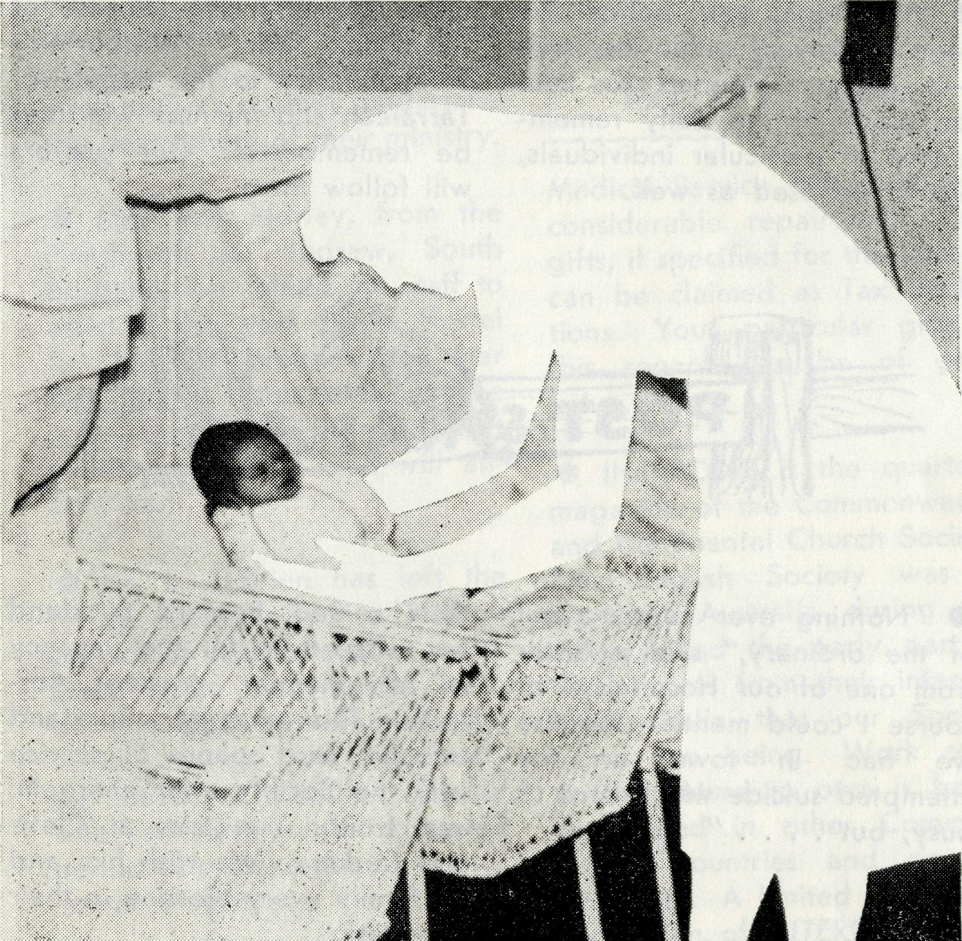
Not a puzzle, but a problem to be solved.
• THINK NOW !
• PRAY NOW !
• ACT NOW !

THE REAL AUSTRALIAN, JUNE, 1963

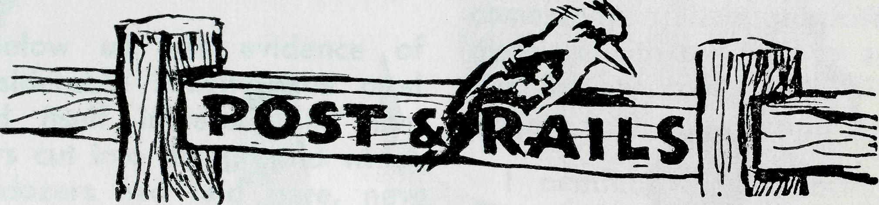
- Our sincere good wishes and prayful concern is extended to the Rev. W. G. Parsons as he has recently been installed as Principal of the Brotherhood of the Good Shepherd—may God enable him in his task.
- We hope you notice "A Page of Prayer" within the issue —it is not intended to take the place of the daily remembrance of particular individuals, but to be used as well.
# "Nothing ever happens out of the ordinary," said a Sister from one of our Hospitals—"of course I could mention the fire we had in town or the attempted suicide which kept us busy, but . . . . "
# We find that £50 each will supply a duplicator of the type that will facilitate the ministry in two of our mission areas. Leigh Creek, S.A., and Wil-cannia, N.S.W., are both in need—can some share in meeting this specific need?
• Our latest "staff member" is Stephen Argall—our congratulations and good wishes to John and Colleen.
© The Rev. W. Warburton and his family will leave the service of the Society in July to take up a parish in the Diocese of Tasmania. Mr. Warburton's virile ministry to the people of Tarraleah and Minnipa will long be remembered. Our prayers will follow them.
# The Rev. Bernard Buckland has offered to fill the vacancy at Mt. Magnet, Western Australia. This takes Mr. Buckland into his third sphere of service with the Society after energetic and fruitful ministries at Cleve and Ceduna. We wish him and his family every blessing in their new task.
® Elsewhere in this issue you will see details of the Women's Auxiliary Annual sale—your presence will be a great encouragement to all—Do come if you can.
THE REAL AUSTRALIAN, JUNE, 1963
• The Rev. R. H. Goodhew
has come to us to staff the
Ceduna Mission, South Aus
tralia, from the first week in
July. Mr. Goodhew was
ordained in 1958 and following
a Curacy at St. Matthew's,
Bondi, has been the Curate-in-
Charge of St. Bede's, Beverly
Hills, for the past four years.
He, his wife and three small
children are commended to
your prayers as they undertake
this new sphere of their ministry.
- Miss Ann Mo Hey, from the Parish of St. Andrew, South Brisbane, has joined the staff to assist in the work at the Hostel for Boys at Broken Hill. Her task (along with that of the other Hostel Folk) is a difficult one and we trust God will enable her.
- Dr. L. O'Brien has left the Flying Medical Service after a period of most welcome help. Once again Dr. Meuller is to be left alone to maintain the whole practice. How desperately we need a Christian Doctor who can serve for an extended period. Do make this an urgent matter of prayer.
® Unforeseen and most unexpected mechanical repairs have resulted in VH-AEC, our second Cessna, being grounded for the month of May. This has not only disrupted the Flying
THE REAL AUSTRALIAN, JUNE, 1963
The B.C.A. Women's Auxiliary
ANNUAL FAIR
St. Andrew's Cathedral Chapter House
FRIDAY, July 26, 1963
Official Opening at
11 a.m.
by
Mrs. F. L. Cuttriss.
Medical Service, but given us a considerable repair bill! Your gifts, if specified for the aircraft, can be claimed as Tax Deductions. Your particular gifts in this regard can be of great value.
• INTERCOM is the quarterly magazine of the Commonwealth and Continental Church Society. This English Society was at work in Australia during last century and the early part of this. It was from their interests in Australia that our Society came into being. Work of a similar nature to ours is being maintained in other Commonwealth countries and on the Continent. A limited number of each issue of INTERCOM come to us and can be re-directed to you. Here is an opportunity to learn of and pray for the wider work of the Kingdom of God. Write to us and ask for your copy of INTERCOM.

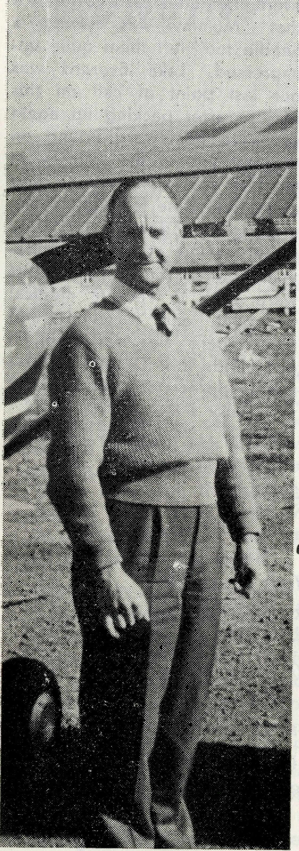
A ROUTINE FLIGHT?
On the day of the last routine medical flight to the Gawler Ranges, Dr. Mueller was alone at Ceduna, but planned to leave at the scheduled time as she was expecting a locum to arrive three hours later on the incoming airline flight to assist in the practice for nearly a month. Preparations for the flight were nearly complete and I was at the aerodrome awaiting doctor's arrival, when the 8 a.m. radio schedule completely altered the picture of the day's activities. An emergency call from Coober Pedy indicated that the Sister up there had a patient who was a possible appendicitis case, so doctor decided to divert her attention to Coober Pedy, and for this purpose we brought John Lind-ridge and our second aircraft into the picture. John flew doctor to Coober Pedy, and during the course of the flight received a second medical call,
this time from Tarcoola. They evacuated the patient from Coober Pedy, and diverted to Tarcoola en route home, where an operation for appendicitis was performed on a teenage girl. The Coober Pedy patient was brought on to Ceduna as planned where she could be kept under observation until her condition could be completely diagnosed.
With John under way, some quick calculations back here showed us that even though the airline flight was due in early, I still had time to fly to Minnipa and meet it there, collect Dr. Middleton, then carry on with the Gawler Ranges schedule from there. This move enabled us to make our first call that day at Hiltaba only two hours behind schedule instead of about four hours had it been necessary to await the arrival of Dr. Middleton at Ceduna.
The modern light aircraft has come a long way in design and performance when compared with its early counterparts: the types we were obliged to use in the early years of the Flying Medical Service. As many of you will be well aware, the interior design and appointments of our Cessna aircraft compare more than favourably with many of the rather high priced motor cars of today. What you may not already
(Allan Chadwick)
know, is that it is now mandatory to have two-way radio equipment installed in all new aircraft registered. This is very good in every way. The two points about it I want especially to stress are that by it John was able to receive the diversion call to Tarcoola mentioned earlier, and Doctor was able to speak to both the base radio station at Ceduna and Sister at Tarcoola, to give her directions for the care of the patient until she arrived; also, whilst the DC 3 and the Cessna were both converging on Minnipa, I was able to call the aircraft over the radio and ask the crew to advise Dr. Middleton that he would be met at Minnipa by the B.C.A. aircraft, and that he was required for a medical flight.
After an exchange of greetings between the respective air crew members (we have known each other for quite a long time), and also the mail freight and passenger, we all boarded our aircraft again and they were taxied back to the runway within a minute of each other. I departed first and headed north toward the Gawler Ranges, the DC 3 following me and heading west towards Ceduna.
At the various outback places we visit it is usual for a room

10
THE REAL AUSTRALIAN, JUNE, 1963
THE REAL AUSTRALIAN, JUNE, 1963
IT

to be available either in the homestead itself or in one of the outbuildings where consultations can be conducted. At one of the stations, Lake Everard, the same applies when doctor does not want the patient to be moved before he or she is seen. However, as the airstrip is 10 miles from the homestead, normally the outpatients will converge on the airstrip, to be seen by doctor there, in the shelter of a tent erected for that purpose. On our visit on this occasion, most of the patients to be treated were young children coming for their various injections who seemed to take a rather dim view of
proceedings while they lasted, even the attempted assurance that "Mummy was having a needle too" left them quite unimpressed. Lake Everard was our last point of call on this trip, so after packing up again we were homeward bound on the last leg of the journey in the late afternoon. After being away from base for eight hours, meeting our doctor along the route, calling at four consultations centres where 14 patients were able to receive medical treatment, and travelling 345 miles, there was no doubt in our minds that Dr. Middleton's much appreciated help was off to a busy start.
M "I went to Halls Creek for the first time on Friday, returned Sunday morning, 2 a.m.—It is 400 miles away, but I will try and get out there two or three times a year. At the moment there are a jew Anglican families there and they are very nice jolkr
Rev. N. Hart, Derby, W.A.
MUNGINDI
"Would you please tie this bow", asked Carol, aged 8. "But where WAS God before the world began," queried Charmaine (10). Wendy opened her mouth wide, "I've got a tooth that's ready to come out!" Wendy is 6 years old. Robbie (9) moaned. "Mum's in hospital and I've got to write a letter." "But why can't we climb trees," wailed Linda (10). "Teacher says we can get our parents to help with the composition," explained Beverley. "Can I help with the garden," pleaded John. Poor David (7), always in trouble, "I can't get this top button done up!"
Our impressions of Mungindi? The foregoing is the crux of the matter for us. Mae and I knew that Christ had begun a good work in us some time ago, but little did we know the unsearchable riches He had in store for us. We knew there was a plan for our lives and He had purpose for us. We had an inkling of this when we were accepted for service with B.C.A. But, MY! how we limited our thoughts and the opportunities open to us. We, and our two
boys—Glenn (4) and Christopher (18 months)—have suddenly, and sometimes be-wilderingly, become a family of 12! For we are just that!—and we wouldn't have it any other way!
Mungindi is a border town of 1,200 people in the northwest sheep country. It has wide streets, a dozen or so shops, and little more than the minimum for country life in its facilities. There is a bowling club, an R.S.L. hall, post office, two banks, a park, showground, two police stations (N.S.W. and Queensland), a hospital (Queensland), two Churches (Anglican and R.C.) and a school. The Barwon River flows
Regular readers will remember from our last issue that Mr. and Mrs. Bennetts have recently joined our staff. They have come to us from the Parish of Canley Vale and have a wide experience of Church Life and the Boy Scout movement behind them.
Pray with them for their ministry.
around the town and the countryside is graded to fall nine inches a mile. The mosquitoes are so big that some wear saddles to transport sand flies from victim to victim. Snakes and multitudinous frogs make up the rest of the population.

m
THE REAL AUSTRALIAN, JUNE, 1963
THE REAL AUSTRALIAN, JUNE, 1963
13

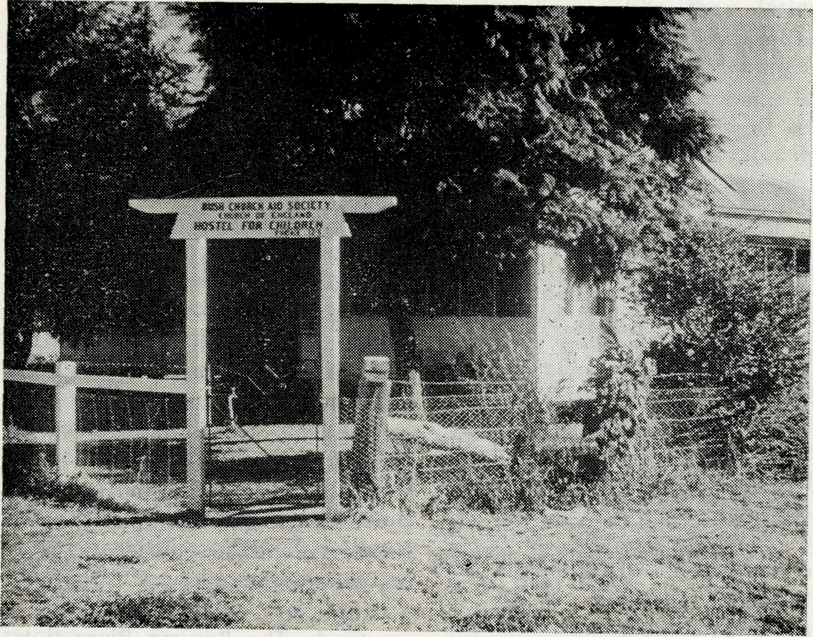
"Home away from Home"
the garden, Linda is ALMOST convinced that climbing trees isn't exactly the safest of occupations. David still has troubles with his buttons.
So, you see, we are well-occupied, well-integrated, well-purposed, well-warned and continually prayerful about the job to be done here in Mungindi. We are startled; yes, plainly startled, by the possibilities in this work of caring for children who have been placed with us while they go to school. When they openly tell us they never say grace at home—never heard of the Ten Commandments—when they look with wonder when you talk of the love of Jesus; when you see many examples as we have seen
in these last two months it is truly startling. We have knelt before God and expressed our unworthiness to be entrusted with His message. Can we put more plainly before you, supporters and staff workers alike, the need for our continual prayers for each other. We pray that in completing the good work He has begun in us we will show something of God's revelation to children who might otherwise be ignorant had not this society set up hostels like this that their secular and spiritual education may not be neglected.
This is His purpose . . . will we yet fail Him who never fails us?

The hostel is a large rambling place, fairly typical of country homes. The facilities are adequate for our task and the children help with small chores around the house. Glenn and Christopher help me with the eight "chooks". Glenn feeds them and collects the eggs while Christopher shows his regard for their labours (if one happens to stray from the fowl-yard) by hugging the creature from the front to back fence— much to the chagrin of the unfortunate fowl!
I had never pulled a tooth in my life—I have now and Wendy was quite brave. Mae's a little more fortunate in that she COULD tie a bow, but she'd never had to tie a pinafore on either Glenn or Chris. Char-maine wasn't completely satisfied that God WAS, but we pray for her in this problem that confronts her. I managed to get some sort of letter off to Mrs. Rix and to satisfy Beverley's teacher that she had some help with her "Missing Card". John is a big help in
jr "Sunday School has begun again with over forty children attending on the first day. We have four teachers and one relief teacher. Do continue to pray about this. Continue to pray regards the Rectory, the replacement of the car this year, the introduction of weekly Free Will envelopes for better giving and above all else, an increase in Church attendance and response to the claims of Christ."
Rev. B. Woolcott, Port Hedland, W.A.

14
THE REAL AUSTRALIAN, JUNE, 1963
THE REAL AUSTRALIAN, JUNE, 1963
15

TARRALEAH
(Rev. Brian O'Grady)
Once again we have moved, and are now happily settled at the beautiful area of the Tar-raleah Mission. When we first arrived, the weather was quite cool for us, and we found that we needed some radiators in order to warm our bodies, which had been used to excessive heat conditions.
The house that we are living in is quite large and comfortable; typically known as the "all electric" house. The power is the cheapest in the world, costing a little over £2 per thousand units. This makes the cooking a paradise as electric stoves are very clean as compared to fuel and gas stoves. The ladies of the parish were very kind before we came and cleaned the house throughout for us. Our new house is situated opposite the civic square which is in the centre of the Tarraleah village. In the civic centre, there is a lovely Church painted a blue-grey, which has been built from the financial
resources of the W.C.C. The school, which has about 200 pupils, is next to the Church. Both of these buildings are surrounded with nice lawns and gardens. There is a magnificent hall, and in the main auditorium there are some striking murals depicting the growth of the Hydro-Electric Schemes in these areas. We have a large supermarket which has a butcher's shop and a post office beside it; and in the centre of the civic square, there is about an acre of lawns and gardens surrounding a small fountain.
The Tarraleah village is a permanent one, and unlike other villages which are construction camps, the men of our village usually stay for longer periods. This means there is not the moving about of families, so we do not lose contact with them; and the work is more settled. Tarraleah is 1,995 feet above sea level, therefore we see a lot of cloud and rain; "snowfalls" are quite frequent in the
latter part of the winter and early spring.
Wayatinah, which is our next largest centre, is only ten miles away and yet it is 1,000 feet below Tarraleah. It is a construction camp with only about a quarter of the village permanent. This camp has a large population of school children and teen-agers, and the problem to keep the older ones entertained is a constant one. It is not a problem for God, so if we are prepared to yield ourselves to His Spirit, we shall be able to remove the stumbling block which appears at this moment to loom so largely on our spiritual horizon. At present, there are three youth groups within the mission, and like all youngsters, their enthusiasm and energy must be given direction, and a vision to follow; we know of no way, system, or machinery, which can satisfy this need other than Jesus Christ.
There are three other small centres; the largest of these being Waddamana where there are twenty-five families. It has a power station, and it is situ-
ated in a big valley; from the road, which skirts the perimeter at the top of the hills, our first impressions of this quaint "Hamlet-like" village, was that it reminded us of a hugh bowl with little toy houses and bridges nestled against dense forest growth.
Our next centre, Shannon, is only six miles up the road, but is on top of the mountain, and it is nearly 1,000 feet above Waddamana. Shannon has only eight families, and we have a service once a month. Bronte Park too has only a monthly service, and has about twelve families. In these outlying centres, the numbers in the congregations are quite good, and often there is supper after services; and at these gatherings, we find that we are able to get to know the people; they in turn learn to know us.
Like all spiritual work, the powers of Satan are continually trying to discourage and throw doubt, or shower unbelief upon and within those who would range themselves on the side of Jesus. In all our work, we covet and value your prayers.

16
THE REAL AUSTRALIAN, JUNE, 1963
THE REAL AUSTRALIAN, JUNE, 1963

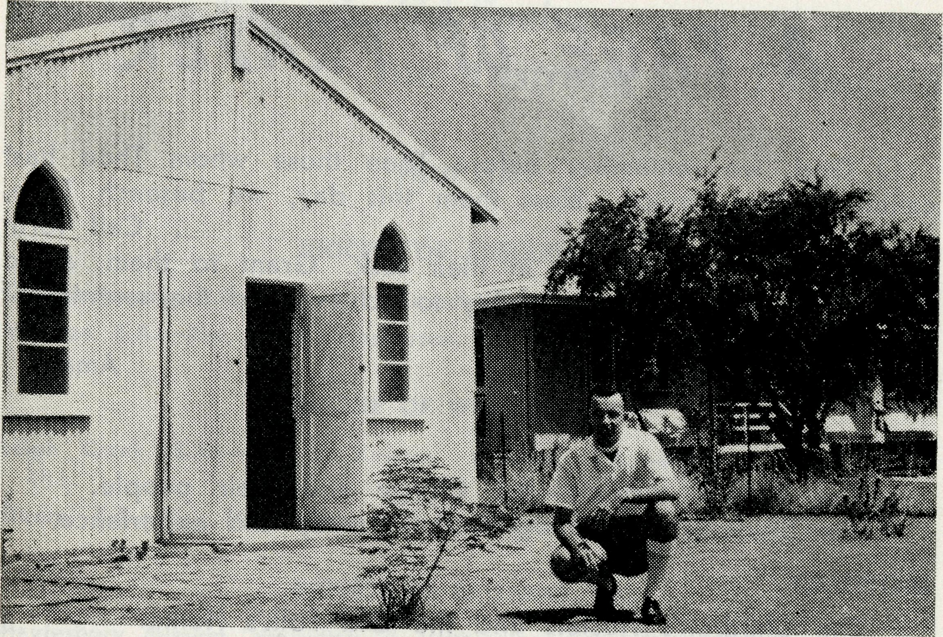
each year for the next 25 years.
That night a congregation of over 30 assembled in one of the school rooms for their fortnightly services. It was indeed a joy to be present and to see the work being done since our missioner first went to Derby.
The following morning we were again in the air back to Derby and for me an hour stay before my plane left for Broome and Port Hedland.
In many ways it would be good if all our R.A. readers could make such a visit, to see for themselves the work of which they are part by their prayers and their support.
The aircraft landed in Derby just after 4 a.m. and even at that ridiculous hour in the morning the Rev. Noel Hart met me at the airport and we drove back to the Rectory and so to bed for a few hours' sleep.
On the map Derby is shown resting on the blue waters of King Sound and one imagines a rather delightful spot with plenty of swimming and fishing and with perhaps a little surfing. When we landed it was of course quite dark and at that hour on a March morning it was warm and humid. Several hours later, after a little sleep and a shower and a good breakfast, I was anxious to see the town.
An air hostess had once described it to me as "Derby on the Marsh" and as I looked for the blue water of King Sound I saw only the marshy tidal flats. However, the tall green growth about the town was a delight for sore eyes though it was a nuisance to the gardens of the town. The new Rectory set among some trees is built, like most of the modern houses, three feet up from the ground with large shutters at the bottom of the walls which open out to catch any movement of air. Fans in each room help to create a breeze
DERBY
Rev. Arthur Williams
The next morning we were up early and out to the drome before 7.30 for the weekly trip to "the Islands". The famous Yampi Sound is just 70 miles north of Derby and the two iron ore townships of Cockatoo and Koolan Islands provide our Missioner with an opportunity and challenge. This week the visit was to Koolan Island where Australian Iron and Steel are spending £8 million developing the Iron Ore deposit.
We boarded the A.I.S. aircraft, the Scottish Pioneer, able to carry 13 passengers and a ton of cargo, and in a few yards take off were airborne. The view of Derby with the tide on the way out certainly looked like "Derby on the Marsh".
Almost an hour later we descended through the clouds and approached the string of islands just off the North-West Coast. Koolan Island looked a picture of green with rugged tree-covered hills. The Scottish Pioneer was soon taxying down the strip, built on a high ridge near the settlement.
St. Paul's Derby, Church and Rectory.
Houses on the island provided accommodation for about 30 families, while 170 single men live in log huts and a few in tents. It was warm, but not nearly as humid as Derby. The temperature on Koolan has never risen above the century and never drops below 65° in winter. It is rather a delightful spot.
We spent the morning visiting, then lunch in the mess hut while a school class was held in the afternoon before the Island manager took us to see the new wharf installations and the development of the iron deposit which will enable three million tons of ore to be shipped

18
THE REAL AUSTRALIAN, JUNE, 1963
THE REAL AUSTRALIAN, JUNE, 1963
19

A PAGE OF PRAYER
The Bush Church Aid Society
for Australia and Tasmania

O God, we remember before Thee those whom Thou hast called to Thy service. Bless them this day, we beseech Thee,
as we pray for the Call forth
others to stand with them in their task. Grant to them, as to us, the joy of service, the ability to achieve and the serenity of Thy Peace, for Jesus' sake.
Amen.
SUNDAY.
The Mission districts—the Clergy and their people. The Students in training, both in study and experience.
MONDAY.
The Children's Hostels and the Old Folk's Home.
The Warden, Matron and Staff—the people, young and old
committed to their care.
TUESDAY.
The Nurses at the Hospitals within the Flying Medical Service
and the Nursing Hostels.
The bodily and spiritual health of their patients.
WEDNESDAY.
The Doctors, Chemist and Pilots of the Flying Medical Service. The skill needed, the ability given, to be directed in wisdom.
THURSDAY.
The Radio Control Station, the Operator and the outposts. The Radio School, the Teacher and the children.
FRIDAY.
The Mail Bag Sunday School, The Director and her Assistants. The Teachers and the children under their tuition.
SATURDAY.
The Council, The Organising Missioner, the State Secretaries and their office staff.
The ever growing number of supporters and their ready response to our needs.
FIELD STAFF:
DIOCESE OF ADELAIDE, S.A.
Ceduna-Penong, S.A.—Rev. R. H. Goodhew, Th.L; Rev. J. Wyndham, Th.L. Minnipa, S.A.—Rev. D. W. Warburton, Th.L.
DIOCESE OF WILLOCHRA, S.A.
Leigh Creek, S.A.—Rev. R. Keynes, Orroroo, S.A.—Rev. G. S. Thorne,
Th.L. B.E.
Quorn, S.A.—Rev. A. McMahon, Th.L. Gladstone, S.A. (Grant in Aid).
DIOCESE OF BALLARAT, VIC. Heytesbury Mission, Vic—Rev. E. Withington, B.A., Th.L., Timboon, Vic.
DIOCESE OF RIVERINA, N.S.W.
Wilcannia, N.S.W.—Rev. R. Neve, Menindee.—Rev. B. Viney, Th.L. Th.L.
DIOCESE OF GIPPSLAND, VIC. DIOCESE OF TASMANIA
Croajingalong, Vic.— (Grant). Tarraieah, Tas.—Rev. B. J. O'Grady.
DIOCESE OF NORTH-WEST AUSTRALIA Derby Mission.—Rev. N. E. Hart, Th.L., Derby, W.A. Port Hedland Mission.—Rev. B. Woolcott, Th.L., Port Hedland, W.A. Murchison Mission.—Rev. B. R. Buckland, Th.L., Mount Magnet, W.A.
MAIL BAG SUNDAY SCHOOL
Director: Miss R. CAMPBELL.
OLD FOLK'S HOME (Port Lincoln, S.A.)
Mr. and Mrs. R. AVERY.
Miss M. Farr.
Mrs. E. Eastwood.
THE REAL AUSTRALIAN, JUNE, 1963

20
THE REAL AUSTRALIAN, JUNE, 1963

