FLYING MEDICAL SERVICES
HOSPITAL CENTRES:
Sisters: J. MILLER, G. HITCHCOCK, B. TIERNEY, M. BELL.
CEDUNA, S.A.
The Murat Bay District Hospital. Matron: Sister F. DOWLING.
PENONG, S.A.
Sister: V. HOLLE.
Sisterss V. COCHRANE, J. GEE.
Sisters* M. HOPE, A. MARTIN. Sister: E. THOMAS.
The Penong Memorial Hospital.
COOK, S.A.
The Bishop Kirkby Memorial Hospital.
TARCOOLA, S.A.
The Tarcoola Hospital.
RAWLINNA, W.A.
The Nursing Hostel.
Matron: Sister J. ZILLMAN. Sisters: N. WILKINS, B. FOX, Miss M. SMEE and Miss M. CHADWICK.
WUDINNA, S.A.
The Central Eyre Peninsula District Hospital.
PHARMACIST:
Mr. J. ARGALL.
DENTIST:
MEDICAL OFFICERS:
Dr. M. MUELLER.
PILOTS:
Mr. ALLAN CHADWICK,
Mr. JOHN LINDRIDGE,
Mr. W. BEDFORD.
AIRCRAFT:
Cessna 210 VH-AEC „ VH-FMS Auster.
WIRELESS COMMUNICATIONS BASE:
Ceduna Base Operator: Mr. TOM MAYNE.
FLYING MEDICAL SERVICES CENTRE, CEDUNA, S.A.
Mr. F. BURNER (Clerical Officer).
CANN RJVER NURSING SERVICE, VIC:
Vacant,
HOSTELS FOR SCHOOL CHILDREN
PORT LINCOLN, S.A.
Mr. and Mrs. S. HUMMERSTON and Miss D. DUVER.
BROKEN HILL, N.S.W.
Mr. and Mrs. N. MELLOR. Miss A. MORLEY.
MUNGINDI, N.S.W.
Mr. and Mrs. S. BENNETTS.
EDGAR BRAGG & SONS PTY. LTD.

The Bush Church Aid Society
for Australia and Tasmania
PRESIDENT
The Most Reverend, The Archbishop of Sydney.
VICE-PRESIDENT
The Most Reverend, The Archbishop of Melbourne.
from the
'AUSTRALIA FOR CHRIST"
HON. CLERICAL SECRETARY
Rev. Canon E. Cameron.
HON. TREASURER
Mr. R. T. Stokes.
ORGANISING MISSIONER
Rev. C. W. Rich, Th.L
N.S.W. SECRETARY
Rev. A. E. Williams, Th.L.
VICTORIAN SECRETARY
Rev. J. Stockdale, Th.L.
HON. SOLICITOR
Messrs. Maxwell and Boyd, 141 Elizabeth St., Sydney.
HON. AUDITOR
F. W. A. Eagar & Co., 8 Belgrave St., Manly.
B.C.A. HOUSE
135 Bathurst St., Sydney.
'Phones: 26 3164, 26 3780.
Telegraphic Address: "Chaplaincy, Sydney."
VICTORIAN OFFICE
Morton House, 262 Flinders Lane, Melbourne. Telephone: 63 8962.
SOUTH AUSTRALIAN REPRESENTATIVES
Rev. T. J. Hayman, Th.L., St. Matthew's Rectory, Marryatville, S.A.
Telephone: FA 1022.
Mr. A. Kirkby,
7 Ruthven Avenue,
Glandore, S.A.
Telephone: LF 3268.
WUh my first year as O.M. almost completed I look both to the past and to the future.
I would place on record my personal appreciation of the measure of support given me by the Council, Staff and not the least the many friends of the Society who will read this.
During the year I have managed to visit most of the areas where the Society is at work. I have been constantly impressed by the immensity of the task and the faithfulness of those called of God to the various spheres of ministry. Perhaps my impressions are best summed up in the words of one of our folk who said recently— "B.C.A. is a miracle." By human standards the work is impossible. There are immense areas of ministry or responsibility each with its inherent difficulties, yet so few people prepared to apply themselves to the task. Most of those who do serve are often called upon to exercise their ministry to the point of personal expenditure. Such is the sense of their calling. Their being pre-
O.M.
pared to so give of themselves is a living testimony to their faith and so God moves to achieve His purposes.
Elsewhere in the magazine you will read of various appointments for the New Year which we expect to be of great consequence for the future. Both the field work and the support from people in the cities and closer areas will advance from strength to strength as a result of these changes in structure.
Whilst we remain confident in the ability of Gcd to meet our need our great sense of concern is with regard to our nursing and medical staff of the Flying Medical Service. How desperately we need Christian nurses and a Doctor to view this work with a sense of vocation. As earnestly as I can I would appeal to you to so involve yourselves in a sense of prayer that "The Lord will thrust forward labourers into His Harvest".
Surrounded as we are by the

THE REAL AUSTRALIAN, DECEMBER, 1963
THE REAL AUSTRALIAN, DECEMBER, 1963

spirit of Christmas and its emphasis of giving, each of us can give at this time. We can give of our substance that the practical needs of the work can be met. We can give of ourselves
in service at home or in the field. We can give our time to prayer that His purposes may be accomplished.
May God bless you and us as we go forward together.
A TRIBUTE

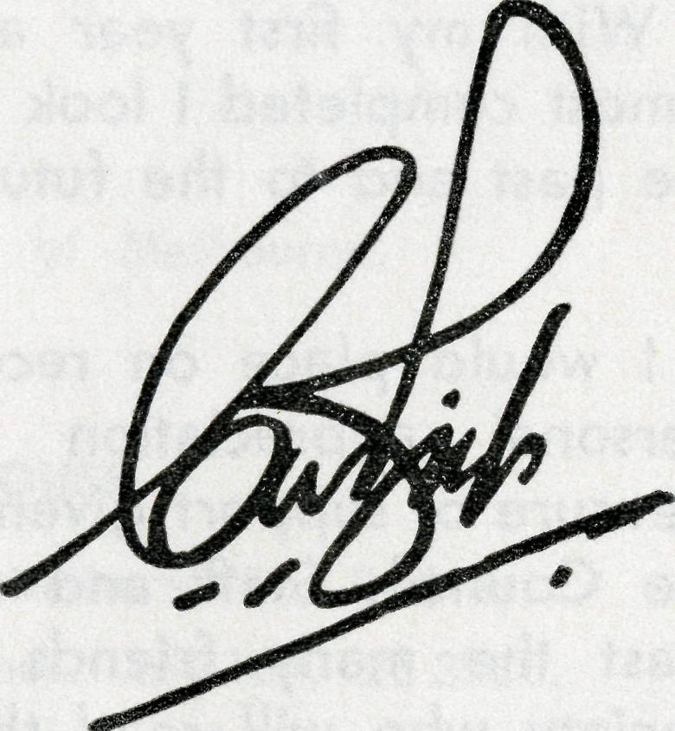
Each advance meant more work gladly accepted by both.
As O.M. for 24 years I am aware of many great sacrifices made by both of these devoted servants of Our Lord which they would never allow me to divulge to others.
They have both set a standard of Christian service that has been a challenge to all who have worked with them.
Sisters Dowling and Hitchcock are now leaving B.C.A., but the challenge of utter devotion to God's service which they have shown for so long remains.
I pray that both of these fellow servants of mine may find a new sphere in which they may be happy in the service from which they will never retire.
TOM JONES.
May the Joy of Christmas
Bring Blessing for the New Year
"Glory to God in highest heaven.
And on earth His peace for men on
whom His favour rests/'
—Luke 2:14.
FROM THE BISHOP OF WILLOCHRA
It was while I was Victorian Secretary of B.C.A. that Sisters Dowling and Hitchcock joined the staff of Ceduna Hospital. That must be 31 years ago.
In those days the hospital was a weatherboard building in which the amenities were far from perfect and the trained staff numbered two — Dowling and Hitchcock.
As the years went by the medical and hospital services of B.C.A. grew — Cook, Tarcoola, Wudinna and Rawlinna were joined with Penong and Ceduna to make a far-reaching hospital service second to none.
In 1938 came the first aeroplane to knit all together in the first Flying Medical Service. Soon followed the Radio Station.
In all the great development of the medical services of B.C.A. Sisters Dowling and Hitchcock were an inspiration.

THE REAL AUSTRALIAN, DECEMBER, 1963
THE REAL AUSTRALIAN, DECEMBER; T963

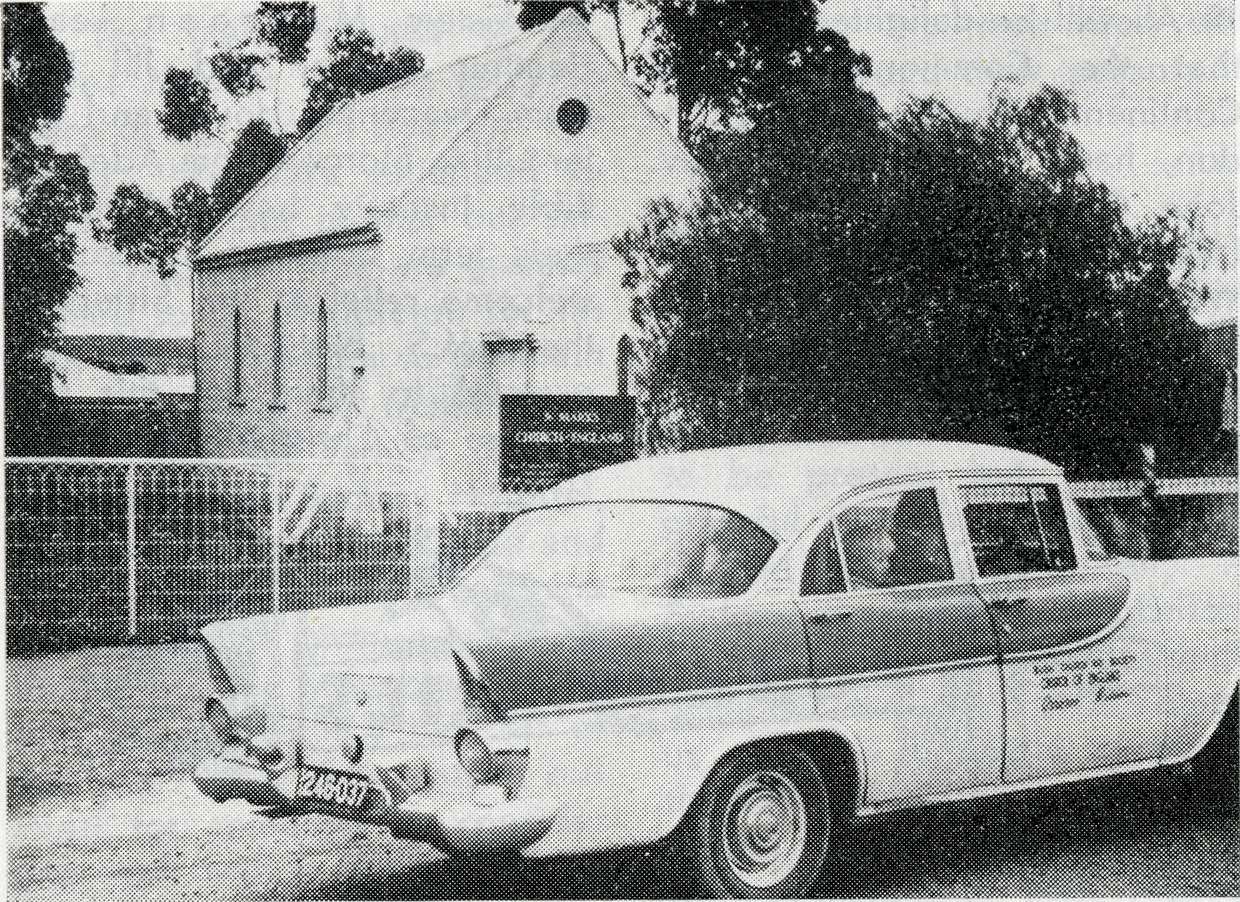
the rest of the business being done when necessary after Church. A new bell stand was made, concreted in and then found to be a donation. The ladies cleaned the Church, a new cupboard was bought, varnished and installed, white grave! was laid in front of the Church and the grass cut to the back fence. Notices were placed in the Adelaide papers inviting people to the services. The Methodists and Lutheran ladies helped by baking the cake, icing it, and giving the 75 candles.
The Sunday began with 8 a.m. Holy Communion, 24 being present. A Roman Catholic lady minded the children for the main service.
Canon Shelby-James of Jamestown came as guest preacher for the main service, which started at 2.30 p.m. A male quartette sang unaccompanied "We love the place, Oh God, wherein Thine honour dwells". The work of the women and men was
We pray that the life, witness and work of the people at Booleroo may be a means by which the work of the Holy Spirit can bring life into the rest of this Mission area.
ANNIVERSARY
REV. G. S. THORNE — ORROROO
Booleroo Centre is 25 miles West of Orrorob and about 165 miles from Adelaide. It is in the middle of a mixed farming district, wheat and sheep being the main interests.
On October 3rd, 1888, the foundation stone of St. Mary's, Booleroo, was laid, and on Sunday, September 29th this year, we held the 75th Anniversary of that occasion. The Anglican community is very small, consisting of a total of eleven women, five men, three teenagers and three children. However, what they lack in numbers they make up with their Christian fellowship, enthusiasm and co-operation.
In May this year a lady suggested we might have a special service to mark the anniversary, so a meeting was duly called. Unfortunately, when the day arrived I was stranded at Leigh Creek due to flooded creeks, so the meeting was held without me. This was the one and only official meeting held,
St. Mary's — Booleroo
certainly rewarded when the Church filled up and the service had to be amplified to the 20 outside. The Church only holds 50. Afternoon tea was held in the Institute supper room after the service.
B.C.A. GIFT SHOP
135 Bathurst Street
For Christmas shopping — opening 9 a.m. to 12 noon on
Saturdays 30th November
7th December
14th December
21st December
As well as 9 a.m. to 5 p.m. on week days.

THE REAL AUSTRALIAN, DECEMBER, 1963
THE REAL AUSTRALIAN, DECEMBER, 1963

# All will be delighted to learn that the Commonwealth and Continental Church Society, London, have appointed the Rev. John Greenwood an Honorary Life Governor of their Society. We extend our congratulations to the former O.M. as his ministry has been recognised in this way.
© St. Philip's, Eastwood (Sydney), was crowded for the recent Valedictory Service for Sister Barbara Fox, who has recently joined our staff from that Parish. Her sphere of ministry is the C.E.P. Hospital, Wudinna, S.A., and we commend her to your prayers.
© Sisters Maureen Leary, Heather Heaver and Jill Peel from Deaconess House and Sister Lillian Morgan from Adelaide Bible Institute have given up their term holidays to provide welcome relief to the Sisters of the F.M.S. Network. We are grateful to them for this fine gesture of Christian concern.
© Sisters Ross and Tarr have both been compelled to leave Cook after many years of service. Both have members of their family very ill and we trust that God will bless them as they both face new responsibilities.
• The many friends of Dr. Merna Meuller will be sorry to learn of the recent death of her father. We have extended to Doctor and her mother our sincere sympathy. We are grateful indeed to Dr. Middleton for his rush trip to Ceduna to maintain the work whilst Dr. Mueller was away with her family. Dr. S. Anderson from Sydney Hospital, Dr. Stretton from Melbourne and Dr. J. Plummer from Deaconess House have all given a month of their busy and valuable time to join Dr. Mueller for the rest of this year. How desperate is our need for someone to consider this work with a degree of permanency. Do continue to pray earnestly that this need will be met.
• We welcome to the "Junior Staff" Michael John Lindridge, Paul Andrew Avery and Philip
Goodhew. We trust God will bless them and their parents.
© Sydney and Melbourne Rallies were a time of inspiration and challenge for us all. We were very sorry that the Archbishop of Melbourne was unable to be present but were very grateful to Bishop Arnott, who chaired the Melbourne Rally. In Sydney the Rev. E. H. Felton, in the absence of the President, occupied the chair and helped us all. The principal speakers, the Rev. Jim Winter and the Rev. Arthur Williams, presented a vibrant picture of their respective ministries.
• Our congratulations and prayerful good wishes are extended to the Rev. and Mrs. John Wyndham following fheir recent marriage.

© Victorian supporters in particular will be concerned to know that Miss V. Adamthwaite from our Melbourne Office has been hospitalized as a result of an accident at Bendigo. Miss Adamthwaite expects to be away at least three months and we are most grateful to Mrs. Stock-dale for stepping intp the breach in spite of difficulties, and so keeping the office: functioning.
© The Rev. Brian O'Grady has been forced to spend some time in St. John's Hospital, Hobart, with a spinal condition. At the time of writing he expects three weeks to a month in hospital and then a considerable convalescent period before resuming his ministry at Tarraleah. We would assure him of our prayers as he faces this difficult time.
THANK YOU !
Will all our friends who have been sending in used postage stamps please accept our thanks—and keep on sending them in!

$
THE REAL AUSTRALIAN, DECEMBER, 1963
THE REAL AUSTRALIAN, DECEMBER, 1963

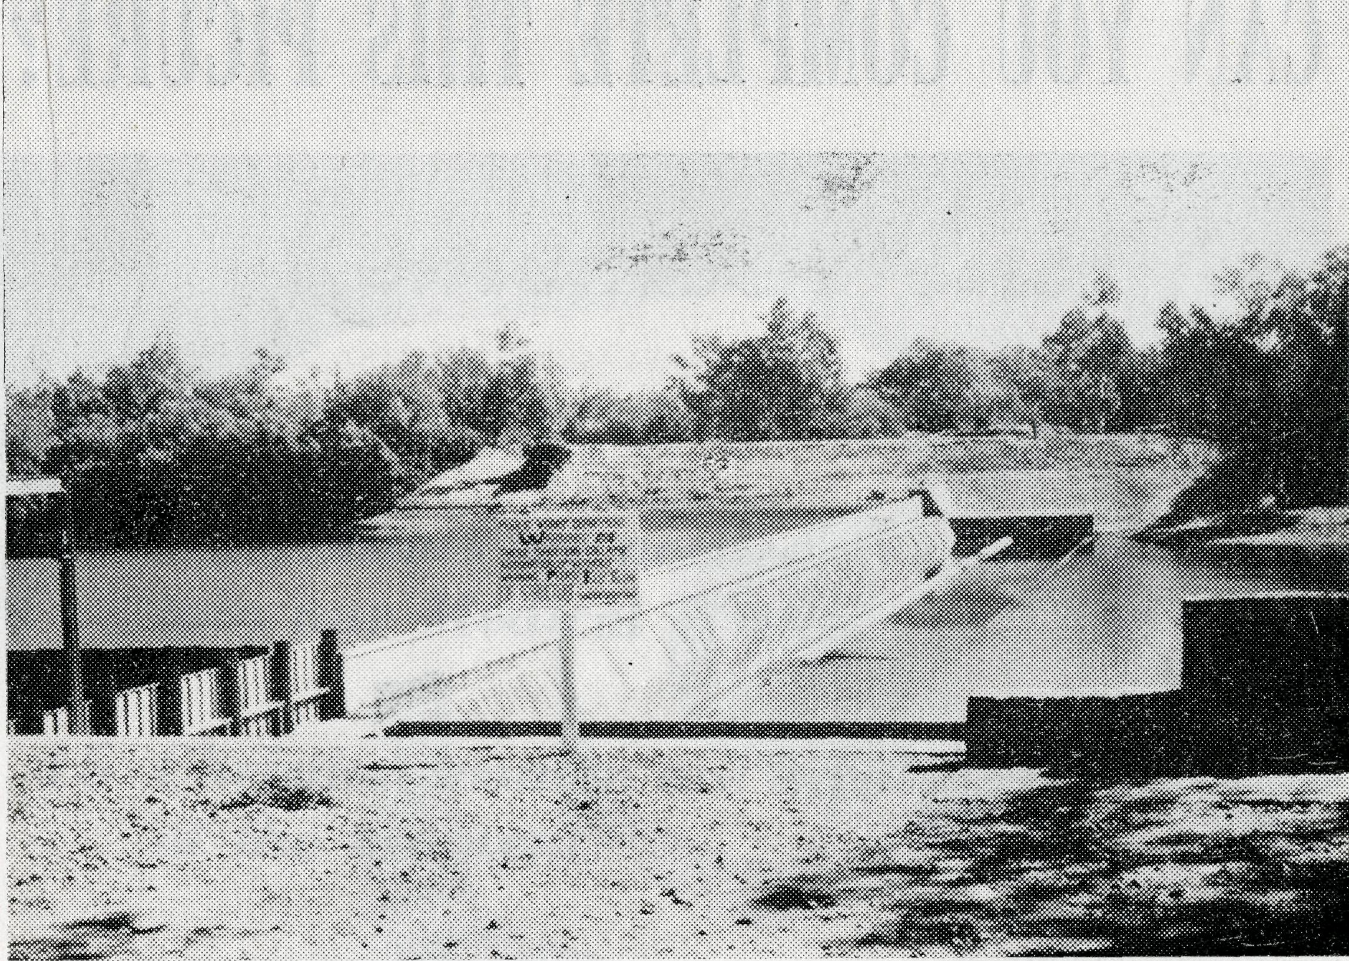
instead of four, and the other two mornings are spent giving services to the station people. It is only experimental at this stage. This B.C.A. centre is a little different from most in that there are no towns of any size to speak of other than Derby. Camballin Rice project has about 15 families and a close station with another three. Halls Creek has about the same number and Fitzroy Crossing about five families. The first service under the new arrangement was held at Camballin last week and I was delighted with the result. There were approximately 17 at the service.
Derby Services are going reasonably well. I have come to the conclusion that it is just part of the North to have the numbers alter so much from Sunday to Sunday. Some Sundays we will have twice as many at Church as the previous week. This pattern of things prevents any continuity of preaching. The monthly young people's service is still by far the best service of the month and we always get over 50 at the service. Last week the young folk were taken out for a barbecue which was very enjoyable and well attended.
We now have our new organ which greatly enriches the services. We are thankful that another organist has been found. The congregations have taken pity on the Rector sweating it out in cassock and surplice and on Saturday last I received a new white terylene cassock and surplice for the tropical climate. One feels a little "ghosty" at first but certainly the new robes are cooler.
Recently we were very pleased to have the Organising Mis-sioner visit us. First trip to Yampi by the "Pioneer" is always very enjoyable and the friendliness of the people on the islands and in Derby I am sure gave him a very favourable impression of the centre. We were pleased to learn that we will be able to go home for our first furlough
DERBY
Rev. Noel Hart
in January or February next year. This will be a very welcome break from the consistent heat which is already upon us. Derby swimming pool is finally in a usable condition. Up to now it has been very badly cared for and consistently closed by the health inspector. The water around Derby is just mud and so the fresh water baths will be a great relief to the town, i.e. until the water gets too warm.
The small confirmation class is still going satisfactorily. The scout for whom so many have been praying hasn't been coming to classes but your prayers have truly been answered in connection with the young people who are quickly finding the Church a centre for their spiritual and social lives.
I have recently changed the pattern of services in Derby. There are now only two morning Communion Services per month
"Streams in the Desert" — Camballin Rice Fields
Cockatoo Island now has its own Church Committee who take a real interest in the Church's work. The big problem there is music. We have no musical instrument and no one certain to play if one was purchased. Tape recordings have not been at all successful. We are still experimenting with tape recordings and are at the same time considering the purchase of an organ.
I trust that you will be able to sift out those things for which prayer is needed and continue to uphold us and the work in this very practical way.

THE REAL AUSTRALIAN, DECEMBER, 1963
THE REAL AUSTRALIAN, DECEMBER, 1963

CAN YOU COMPLETE THIS PICURE?

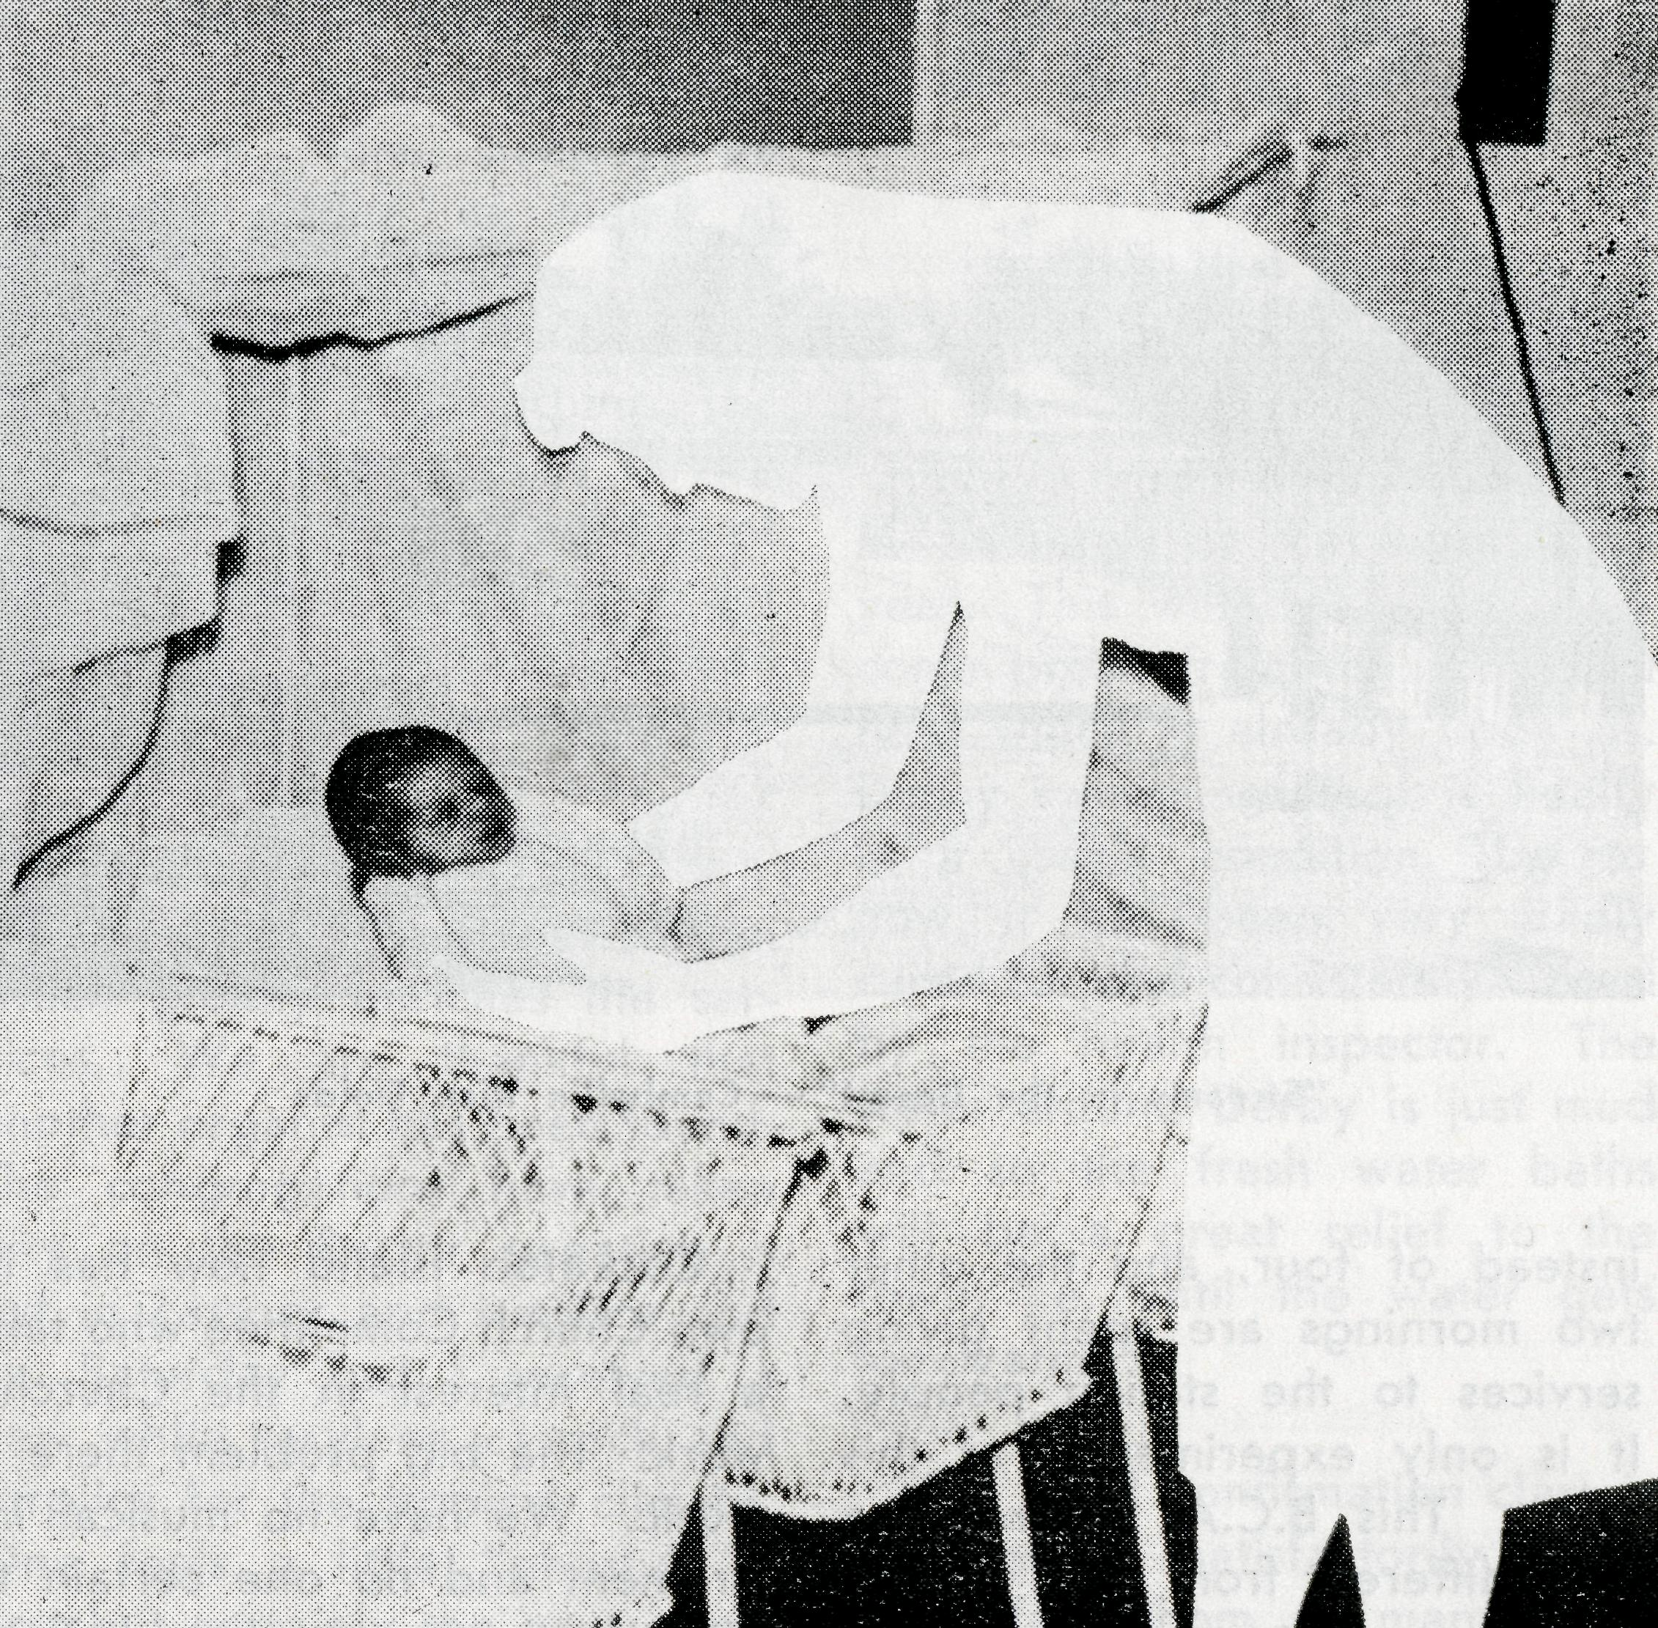
Remember this ?
21 D.C. Sisters are needed to effectively maintain our Medical Work.
15 Christian women are involved in this work at the moment.
4 Student Deaconesses have given up their holidays to enable others to have theirs.
10 D.C. Sisters will be left to carry on the task
from mid-February unless others come forward to offer their lives in service.

Not a puzzle, hut a problem to be solved.
pray

pray . . .

pray
pray . . .
ye therefore the Lord of the Harvest that He would send forth labourers into His Harvest."

“The Harvest truly is great but the labourers are few—

10
THE REAL AUSTRALIAN, DECEMBER, 1963
THE REAL AUSTRALIAN, DECEMBER, 1963
I1

A PAGE OF PRAYER
IN THE MAIL. . .

O God, we remember before Thee those whom Thou hast called to Thy service. Bless them this day, we beseech Thee,
as we pray for the , Call forth
others to stand with them in their task. Grant to them, as to us, the joy of service, the ability to achieve and the serenity of Thy Peace, for Jesus' sake.
Amen.
SUNDAY.
The Mission districts—the Clergy and their people. The Students in training, both in study and experience.
MONDAY.
The Children's Hostels and the Old Folk's Home.
The Warden, Matron and Staff—the people, young and old
committed to their care.
TUESDAY.
The Nurses at the Hospitals within the Flying Medical Service
and the Nursing Hostels.
The bodily and spiritual health of their patients.
WEDNESDAY.
The Doctors, Chemist and Pilots of the Flying Medical Service. The skill needed, the ability given, to be directed in wisdom.
THURSDAY.
The Radio Control Station, the Operator and the outposts. The Radio School, the Teacher and the children.
FRIDAY.
The Mail Bag Sunday School, The Director and her Assistants. The Teachers and the children under their tuition.
SATURDAY.
The Council, The Organising Missioner, the State Secretaries and their office staff.
The ever growing number of supporters and their ready response to our needs.
On the 15th we were called up to Cook to a patient who
had been taken off the train en route to Perth, with an internal
haemorrhage. We had only been there a short while when on
the 1 p.m. session a call came from Tarcoola where a lad of
11 years had been admitted with appendicitis. When the patient
had been operated on at Cook, we flew along to Tarcoola and
removed the offending appendix there, and so home fust before
dark. v
Allan Chadwick.
I left Mt. Magnet after lunch on Saturday for Meekatharra, arriving just before tea. On settling in at the Royal Mail I learned that George had to unload some rams (five trucks) and as he was short of helpers I went with him. We had to move the trucks, with crowbars, up to the ramp and then get in with the sheep, who had no intention of getting out, in order to pull, push or frighten them down the ramp. Two and a half weary hours later I stood under a hot shower wondering how many of my flock would be at Holy Communion next morning. The answer proved to be seven.
Sunday also meant eighteen at Sunday School. Keeping three classes going is quite a business but I still haven't found another teacher. There was a baptism at eleven and lunch at 1 p.m.
After visiting the hospital I went to the inter association football and saw more of my people in one place than I had for some time. Evening prayer saw sixteen people in St. Oswald's, which wasn't bad considering the football barbecue.
Rev. B. Buckland.
We have taken a new sideline in business, in moths, would you like a few? They are really invading us, in everything, on everything, not fust here and there but everywhere. At the moment there are about 50 in the lounge room, and that is with a quick count and not fust guessing, and everywhere is the same.
We are enjoying huge feeds of strawberries as our garden is producing plenty, the best I have seen them.
Sister Zillman.

12 THE REAL AUSTRALIAN, DECEMBER, 1963
THE REAL AUSTRALIAN, DECEMBER, 1963
13-

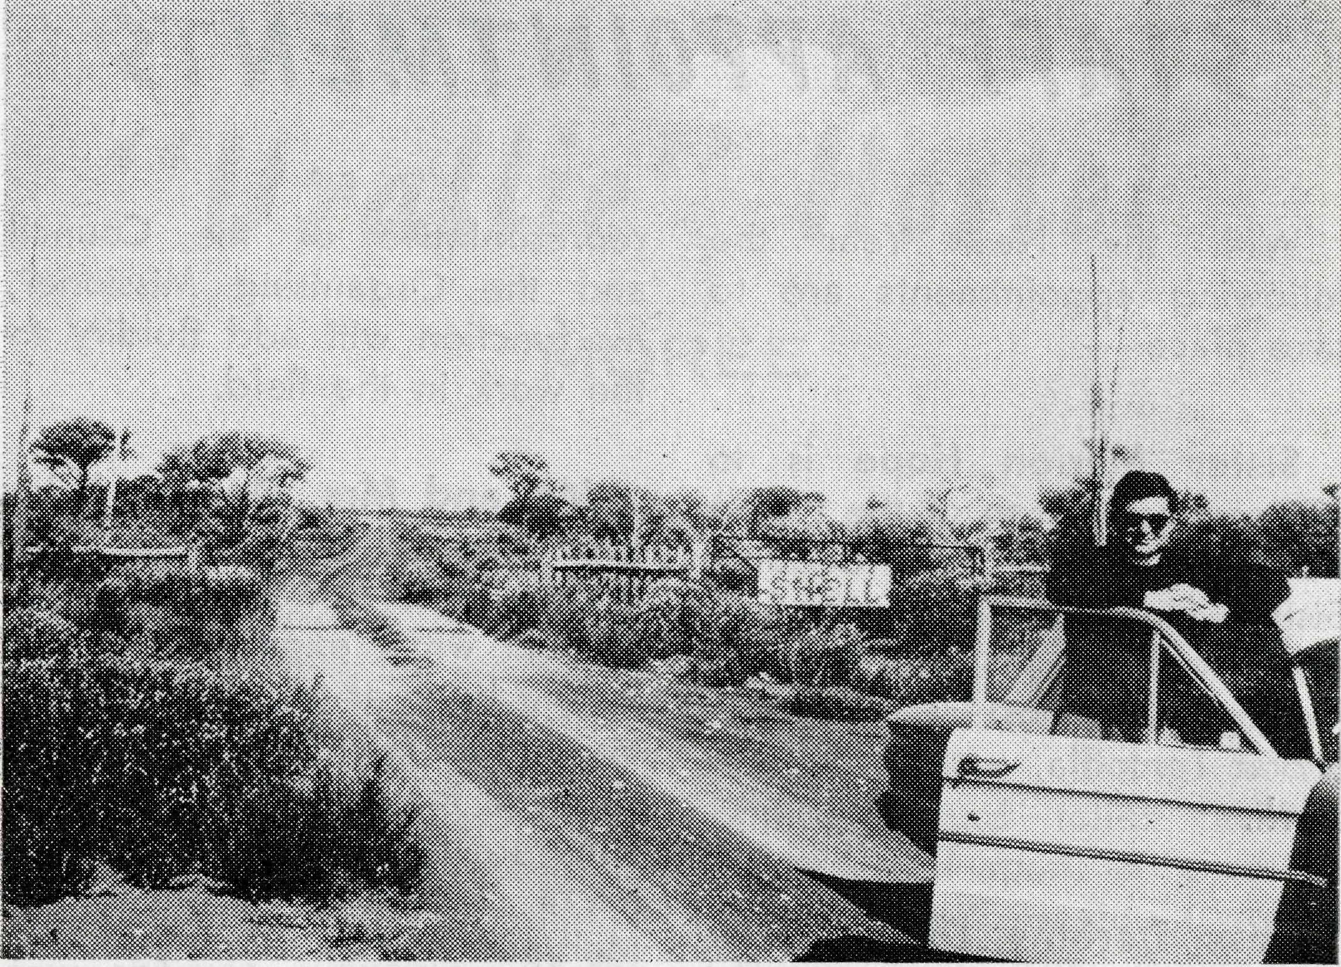
TODAY
REV. B. BUCKLAND
station shown on the map as the station homestead. By the time 1 had explored the road a little further it was dark. I tried the method of driving for 15 minutes up each track and was fortunate to find Mt. Gould (and Mr. and Mrs. Campbell) on the second track. I was thinking of what John Lindridge said to the control tower at Adelaide when his lights went out. Control tower: "You had us worried." Lindridge: "I had me worried, too." After an excellent meal and a long chat, which included a trip outside to look at snake tracks at ten minutes after midnight, I was glad to get to bed. r
Next day saw me on the road to Errabiddy, 28 miles and nicely timed for lunch. The Steadmans were shearing and very busy so again my stay was short and i pushed on to Landor, 24 miles over a lot of creek beds, some almost too steep to negotiate. At Landor I met not only the manager and the station hands but also the owner and was again warmly welcomed. Here
zines do more good than tracts.
Next day a quick run down to Yarlarweelor and Mr. and Mrs. Ross Forrester, whose boy was confirmed in the city recently. The 52 miles to be travelled meant lunch there and a passenger, a native fencer, to be taken to Meekatharra hospital. Ten miles to Bell's at Mt. Padbury and then 73 miles to Meeka, for a welcome shower and tea. Afterwards a chat with the Methodist man to help cor-erdinate our work.
This seems to be a profitable trip and I will probably concentrate on it.
EXPLORATION
Monday began the great adventure, a journey into hitherto unexplored (at least by me) station country. First, however, school classes, mail and papers to be picked up, car checked and the hospital again for last minute messages for folk along the track.
Be'ele is only 37 miles out and I arrived there for lunch. Afterwards I went across to the shearing shed and watched the various operations.
On to Koomarra and then Mt. Hale, only short trips of 16 and then 21 miles but cups of tea were welcomed by me as the magazines and books and the chance of a chat were by the people.
Moorarie is only another 17 miles further on, and then on to Mt. Gould, a further 18 miles. This is a lot of stations to visit in one day but the trip was intended to be exploratory as to area, number of people and percentage of Anglicans.
Mt. Gould was tricky as it is only a new station and the road in is neither well-worn nor marked. The outcome of this was that I missed the turn-off and then came to the old police
Mr. Buckianct "On the Track"
and at the next station I made arrangements to baptise some youngsters on my next trip (March, I think). Mt. Clere is 50 miles from Landor along a road which runs the opposite side of the Gascoyne River to that shown on the map. This is not intended to inspire confidence in the stranger.
No men at home at Mt. Clere but after tea the ladies gathered for slides and a long discussion. Many Christian books were bought. If only we had more good quality Christian magazines to give to the folk. I am convinced that the good maga-

:14
THE REAL AUSTRALIAN, DECEMBER, 1963
THE REAL AUSTRALIAN, DECEMBER, 1963
15

STAFF APPOINTMENTS

"Urallie" Hostel
MOREE
With the New Year the following appointments are to take place:—
Sister Marion Hope is to
succeed as Matron of the Flying Medical Service at Ceduna. Sister Hope has given four valuable years to the Society, having spent most of her ministry at Tarcoola, within the network.
Miss Dorothy Duver, after six years at Port Lincoln Girls' Hostel, is to undertake the arduous responsibility of cooking at the Ceduna Hospital.
Mr. Frank Burner has been appointed Book Keeper at B.C.A. House, Sydney. His local knowledge after four years as the Society's Clerical Officer at Ceduna is expected to be of great value in administration.
Mr. Stan Hummerston, after six years as Warden of the Port Lincoln Hostel, will take on a dual responsibility at Ceduna. Not only will he replace Mr. Burner in the clerical work but he will also be styled as the "Executive Officer" for the Society at Ceduna. As a direct
representative of the Council and the Organising Missioner, his function will add fluidity to the work in the field.
Mr. and Mrs. Gordon Wig* gins are to proceed to Port Lincoln Girls' Hostel. They come to us with experience after having been at the Andrew Kerr Memorial Hostel, Mornington, Victoria, for the past two years. They are to be assisted by Miss Myra Attwood, formerly of Melbourne and recently a student at Croydon Bible College.
The Rev. L J. Wiggins has
resigned from the Parish of St. Giles', Greenwich (Sydney), to join the Head Office Staff as our Deputationist. Prior to taking up his duties in this work he will spend some time in the field and it is expected that he will concentrate a fair proportion of his time in country dioceses seeking new support.
We would earnestly commend all these folk to your prayers as they undertake their new responsibilities. We are grateful to God for the fact that all are prepared to give of themselves in the way He has chosen for them.
One door closes but another opens—so it may be written of the Hostel work amongst children in the far north of N.S.W. Council very reluctantly was forced to close the Mungindi Hostel during the year due to few children available. At the same time investigations to establish another Hostel in Moree —70 miles distant—had reached the stage where it was possible for the Warden and Matron, Mr. and Mrs. Bennetts, to move directly there to begin preparation for a new sphere of ministry.
Several properties in and around Moree had been investigated and ultimately a delightful house situated in two and a half acres of ground on the outskirts of the town was purchased. The building will allow accommodation for the staff and study and recreational facilities for the boys expected to attend. The grounds are level and prove ideal sites for various playing fields. Possible extensions were
considered and finally a separate building comprising four bedrooms each to accommodate six boys, kitchen, dining room, bathroom and toilet facilities was decided upon. At a cost of £20,000 it will provide a worthy "Home away from Home" for the children of the surrounding district. Although financed in the main by the sale of the Bowral Hostel and the property at Mungindi, the initial purchase price is still to be found.
Many local expressions of goodwill have been forthcoming and as "Urallie" becomes a reality by School Term 1964 it is expected that it will be greatly appreciated by all.
In our endeavour to present a full and positive Witness to Our Lord throughout Australia we are confident that this venture will bring Glory to God as young lives are faced with the Gospel in action.

16
THE REAL AUSTRALIAN, DECEMBER, 1963
THE REAL AUSTRALIAN, DECEMBER, 1963
17

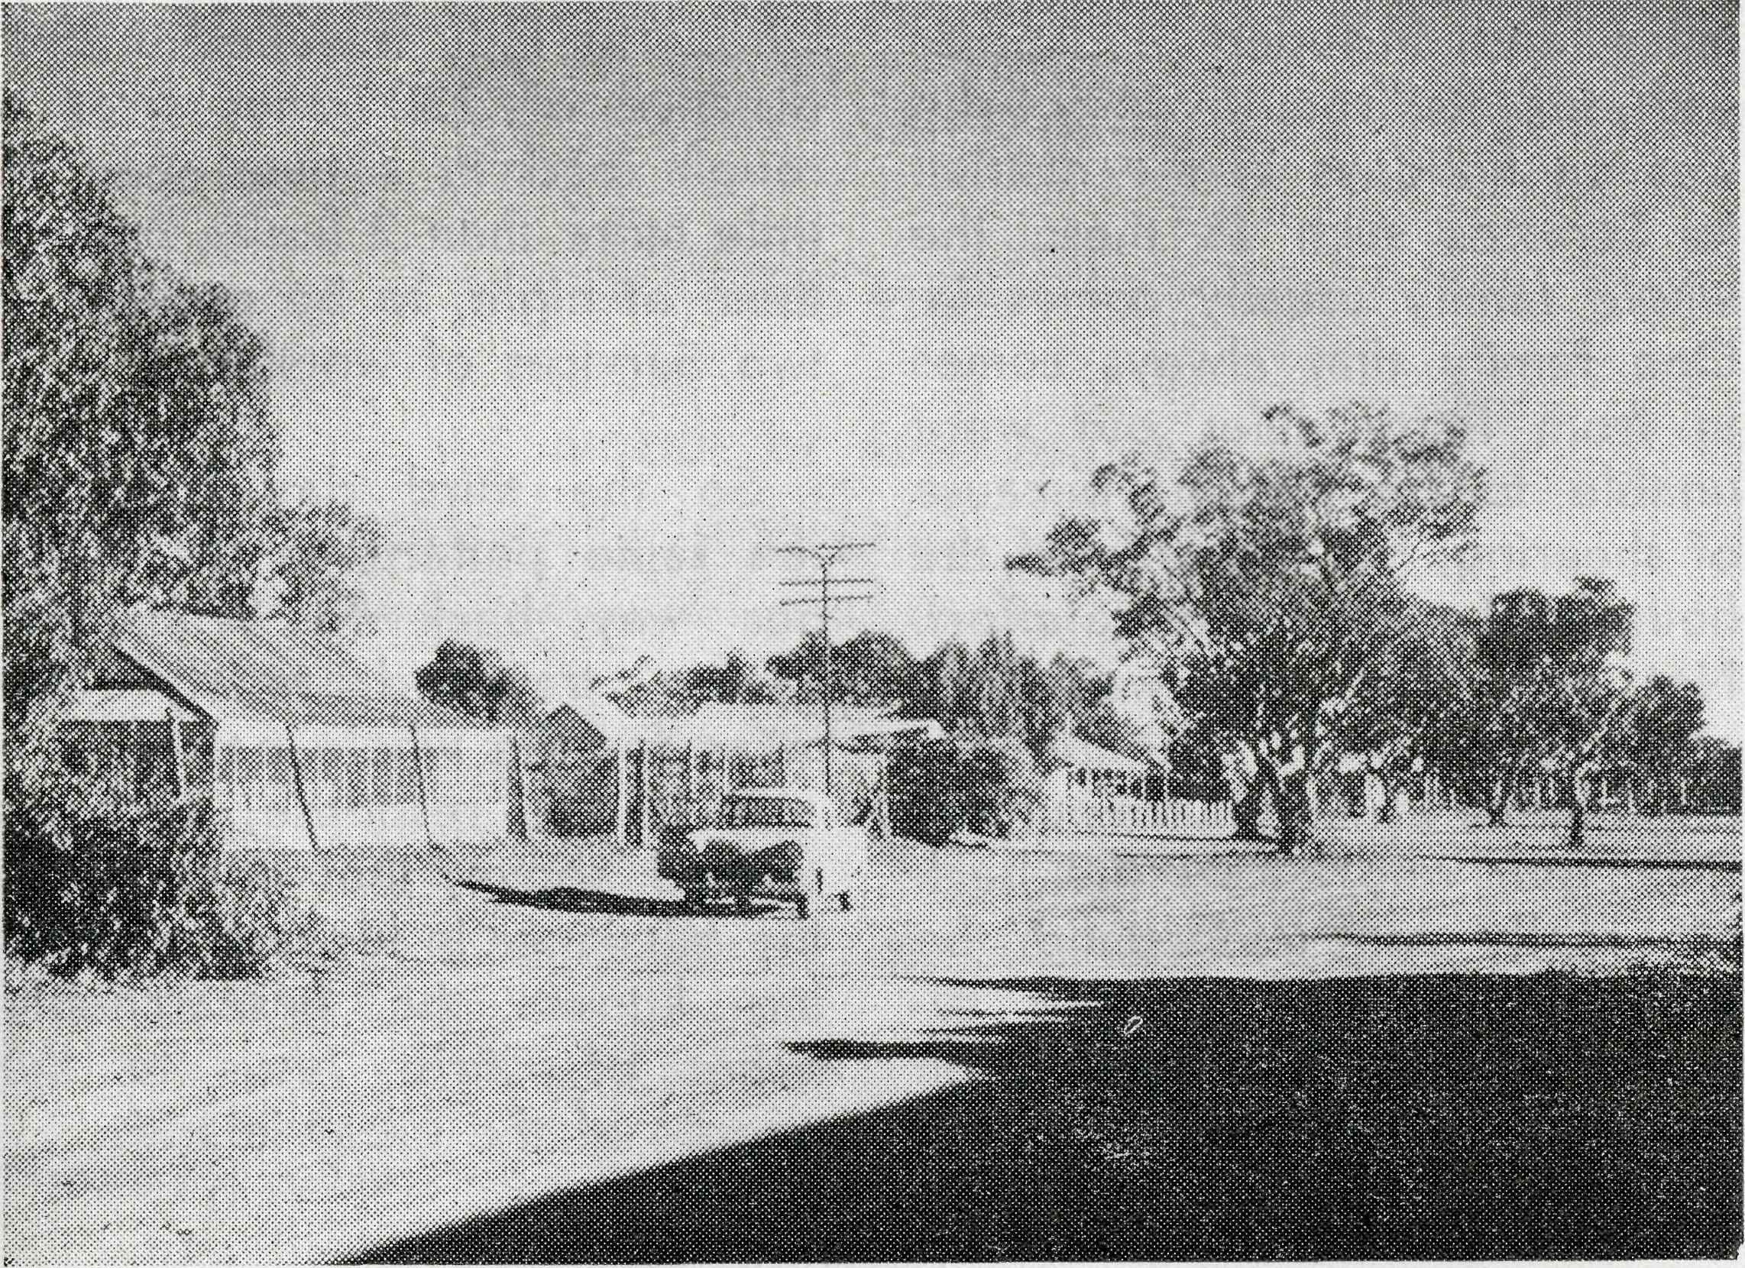
of Evening Prayer. The congregation was made up of the homestead family, several members of the family of an employee, a single man, the contractor who was building the wool shed, the wife of a kangaroo shooter and the family from the homestead thirty miles distant. So we gathered to sing His praises, to say our prayers and to hear His Word.
After the Service there was the opportunity to show coloured slides of the wider work of the Society.
The following morning and the day started with a Service of Holy Communion, an opportunity which is all too rare for many people in the outback.
As we set out on the track again an early sidelight was the stop to kill a four foot snake as it crossed the road.
Calls were made at Tongo Station and then MacDonald's where we had lunch. Again appreciation was expressed at
me visit as opportunity was found to have a quiet word on spiritual matters.
It is here that one normally crosses the Paroo Channel, but the water was too deep so we made our way further north over a rough, winding and narrow track to another possible crossing point. The Paroo River comes down from Queensland and as it comes south diverts into channels and after heavy rain they flood out covering many miles of countryside. The last time 1 had used the crossing there had been four wide and fairly deep stretches of water to cross, so we hoped for
DESTINATION TILPA
REV. RAY NEVE
During the time of this particular visit of the Bishop a three day patrol was included in the itinerary.
As preparations were being made to leave town, tradesmen brought along various packets to be delivered to stations en route, including 40 lbs. sausages for the place which was to be our destination that night. Apparently the girls in the family liked sausages as they had sent this order for £5 worth!
After several calls and 90 dusty miles we arrived at our destination. Following a welcome cup of tea we were shown over part of the property, including an inspection of a new wool shed in the course of construction.
The value of the transceiver to the outback people was emphasized as our hostess for the evening was able to speak to other members of her family in Bourke, several hundred miles distant, to receive news of her mother who was ill.
After a barbecue tea preparations were made for the Service
Tilpa !
the best. On our arrival at this part and at the conclusion of a visit to the nearby homestead, the owner kindly led us through the channel country and things now being better than anticipated we crossed the only stretch of water safely.
After one more call we finally made our destination for the night, Tilpa, a small settlement on the Darling River. That day we had travelled just on a 100 miles and visited four homesteads.
Service was held in the Hotel Lounge Room that night. People came in from as far as thirty

18
THE RfAC AUSTRALIAN, DECEMBER, 1963
THE REAL AUSTRALIAN, DECEMBER, 1963
19

DUPLICATION
Whilst every effort is made on our part to avoid any unnecessary duplication it may be that more than one copy of "The Real Australian" finds its way to your home.
Should it be so in your case and one copy would meet your needs would you be good enough to let us know, so enabling us to avoid undue expense. It would help considerably if you could return the addressed wrapper of the unwanted copy.
20 THE REAL AUSTRALIAN, DECEMBER, 1963
miles and included a mother with triplets from Sydney who was on holidays in the district. In Services such as these the whole family usually comes in. One family that always comes in from thirty miles out were unable to be present because of shearing, but the lady of the household made the extra effort. Not only that, she was back again early next morning for the Service of Holy Communion, Only one who knows the back life really can understand the extra effort and sacrifice required to make this possible on the part of both husband and
wife. The lady travelled a total distance of 120 miles over a rough road in a time span of little more than 2 hours, half of them at night, to be present at two Services of worship.
So the third day followed the same pattern as we made our way back to Wilcannia, having travelled nearly 300 miles for the whole patrol.
It is this response, such as related above, that encourages the Missioner in his task of making known the unsearchable riches of Christ Jesus to the people of the great inland.
The Bush Church Aid Society
for Australia and Tasmania
FIELD STAFF:
DIOCESE OF ADELAIDE, S.A.
Ceduna-Penong, S.A.—Rev. R. H. Goodhew, Th.L. Minnipa, S.A.—Rev. J. Wyndham, Th.L. (Locum).
DIOCESE OF WILLOCHRA, S.A.
Leigh Creek, S.A.—Rev. R. Keynes, Orroroo, S.A.—Rev. G. S. Thorne,
Th.L. B.E.
Quern, S.A.—Rev. A. McMahon, Th.L. Gladstone, S.A. (Grant in Aid).
DIOCESE OF BALLARAT, VIC. Heytesbury Mission, Vic.—Vacant.
DIOCESE OF RIVERINA, N.S.W.
Wilcannia, N.S.W.—Rev. R. Neve, Menindee.—Rev. B. Viney, Th.L. Th.L.
DIOCESE OF GIPPSLAND, VIC. DIOCESE OF TASMANIA
Croaiingalong, Vic.— (Grant). Tarraleah, Tas.—Rev. B. J. O'Grady.
DIOCESE OF NORTH-WEST AUSTRALIA
Derby Mission.—Rev. N. E. Hart, Th.L., Derby, W.A.
Port Hedland Mission.—Rev. B. Woolcott, Th.L., Port Hedland, W.A.
Murchison Mission.—Rev. B. R. Buckland, Th.L., Mount Magnet, W.A.
MAIL BAG SUNDAY SCHOOL
Director: Miss R. CAMPBELL
OLD FOLK'S HOME (Port Lincoln, S.A.)
Mr. and Mrs. R. AVERY.
Miss M. Farr.
Mrs. E. Eastwood.
THE REAL AUSTRALIAN, DECEMBER, 1963

